Instructions for Translating Documents on the Security Research Hub Data Repository

Hello and welcome to the Security Research Hub Data Repository. Here you will find our collection of websites and documents that we have curated to provide an insight into various topics relevant to security.
We recommend that while using our website you use the Google Chrome browser so that you are more easily able to translate any websites or documents you come across. Our website has a built-in translation option utilizing the Google Translation tool which makes browsing more accessible in over a hundred languages.
You can see that option here on our home page:
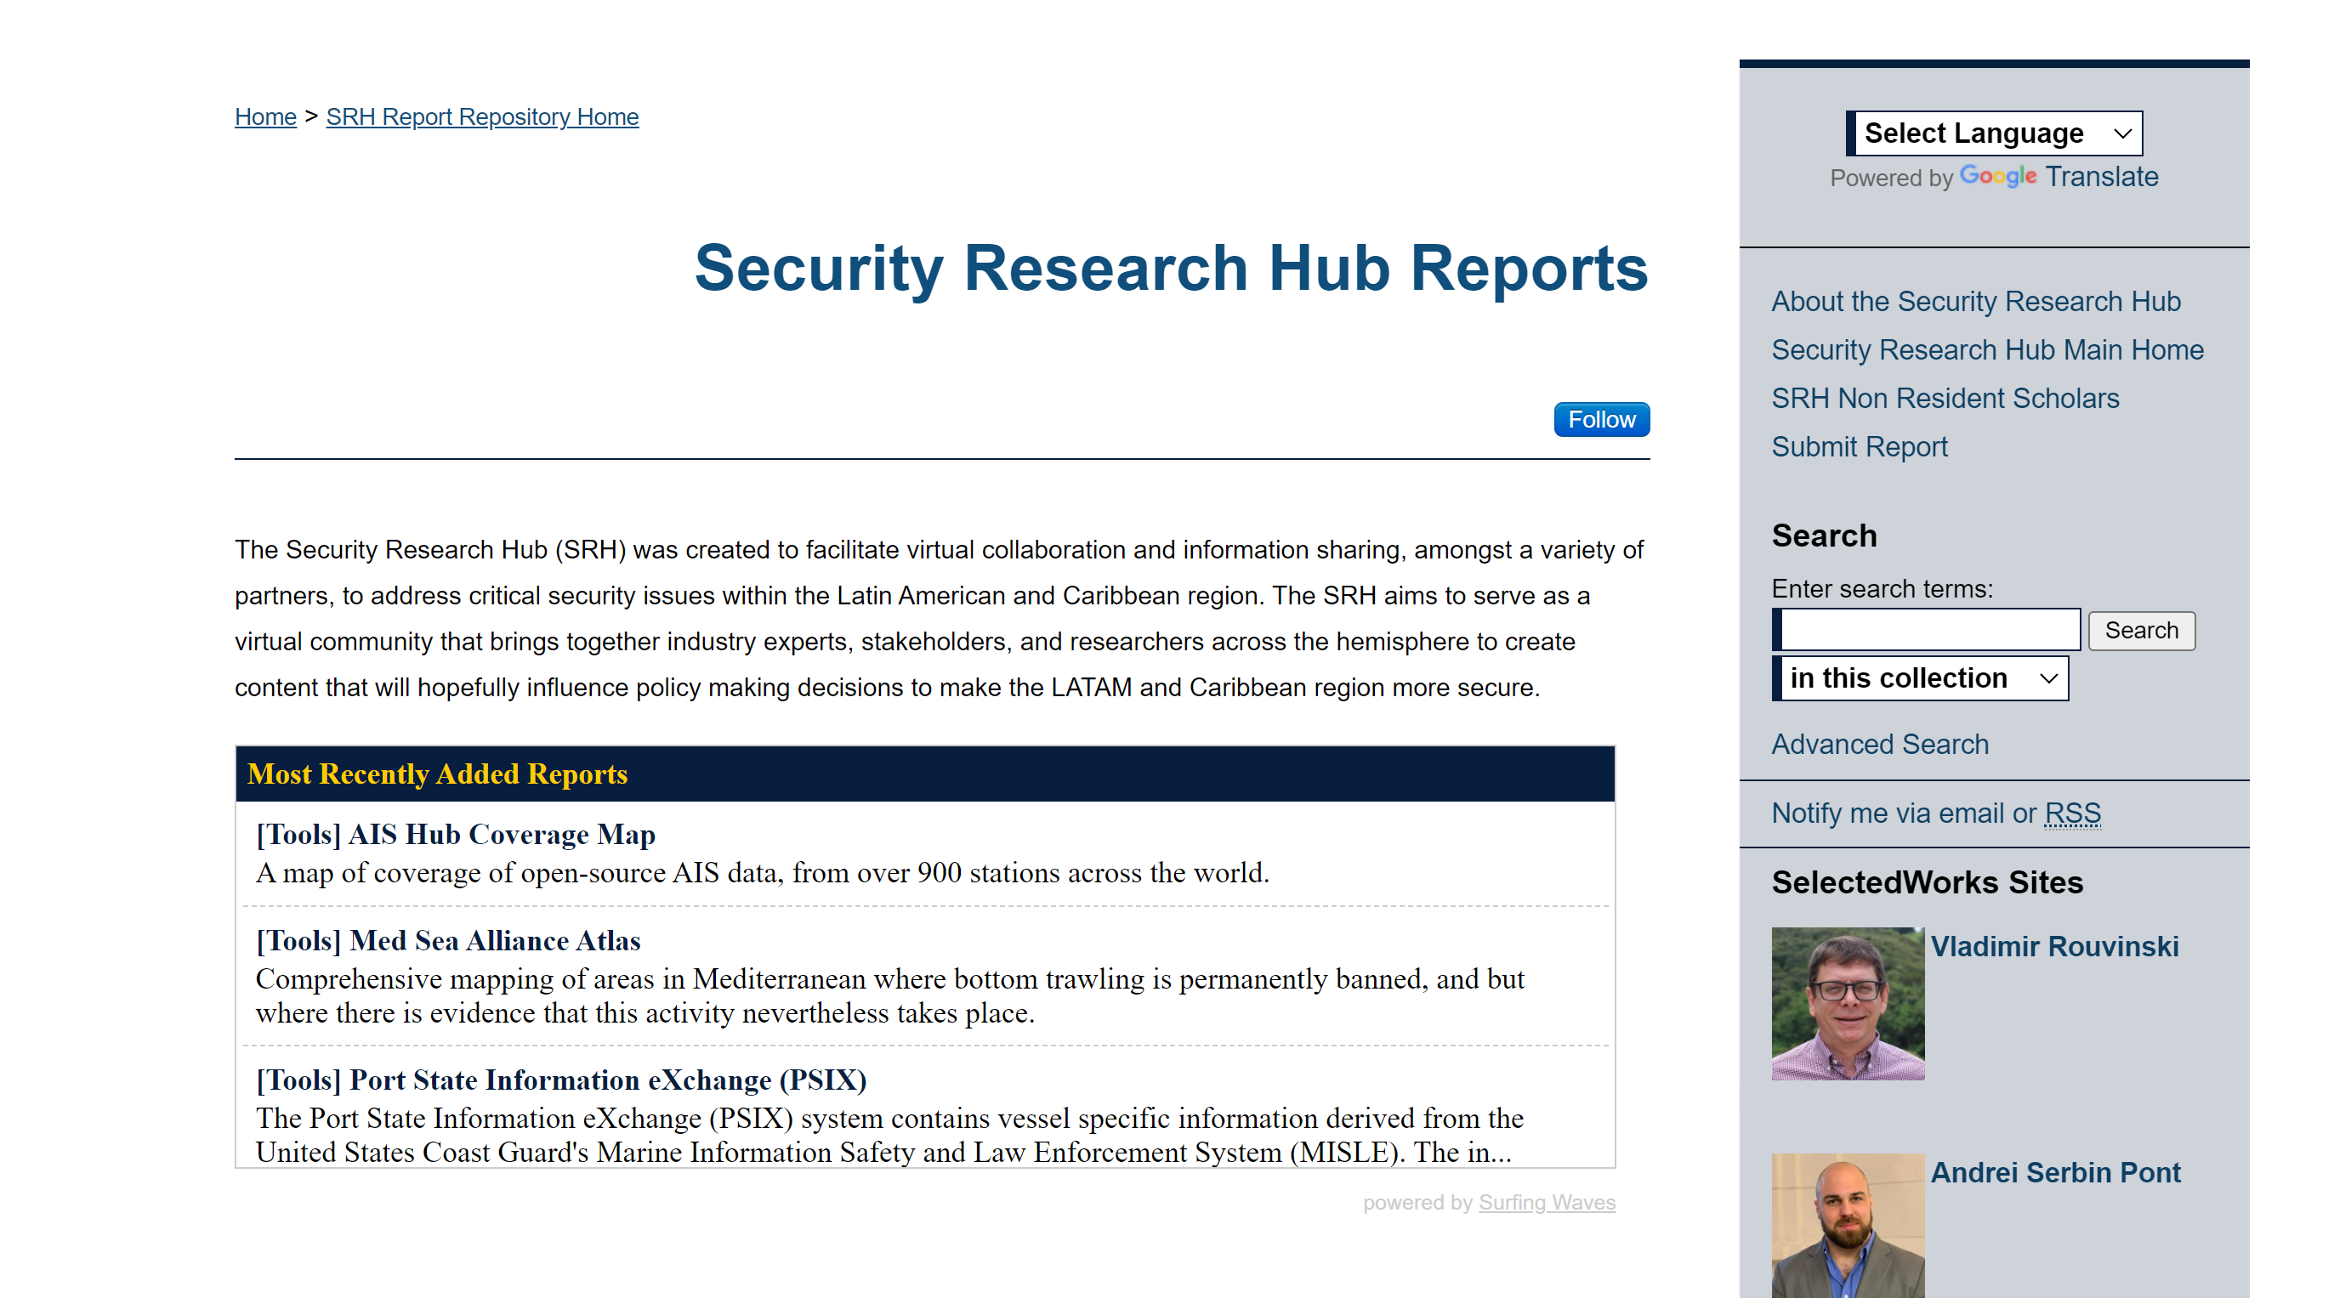
However, some documents you will come across are in English and are not automatically translated via the internet browser version of Google Translate. These directions are to help you create a translated copy of any foreign language document into one of your choosing.

Step 1:
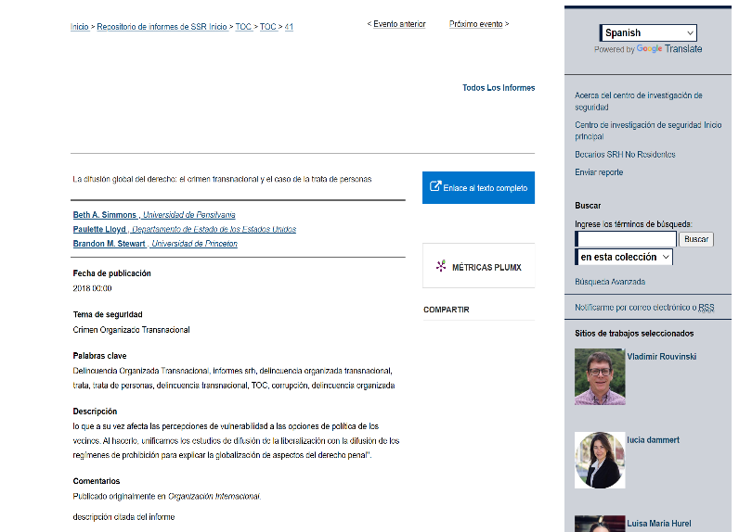
Once browsing in your relevant language (for example, Spanish), you may identify a document or PDF that is not in Spanish natively, nor automatically translated.
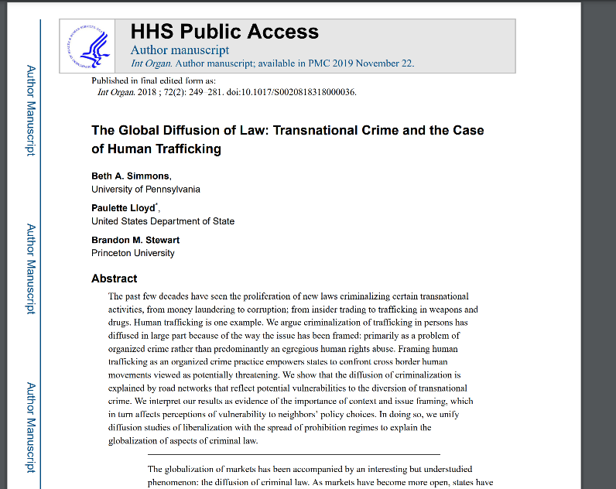

Step 2:
Download the document.
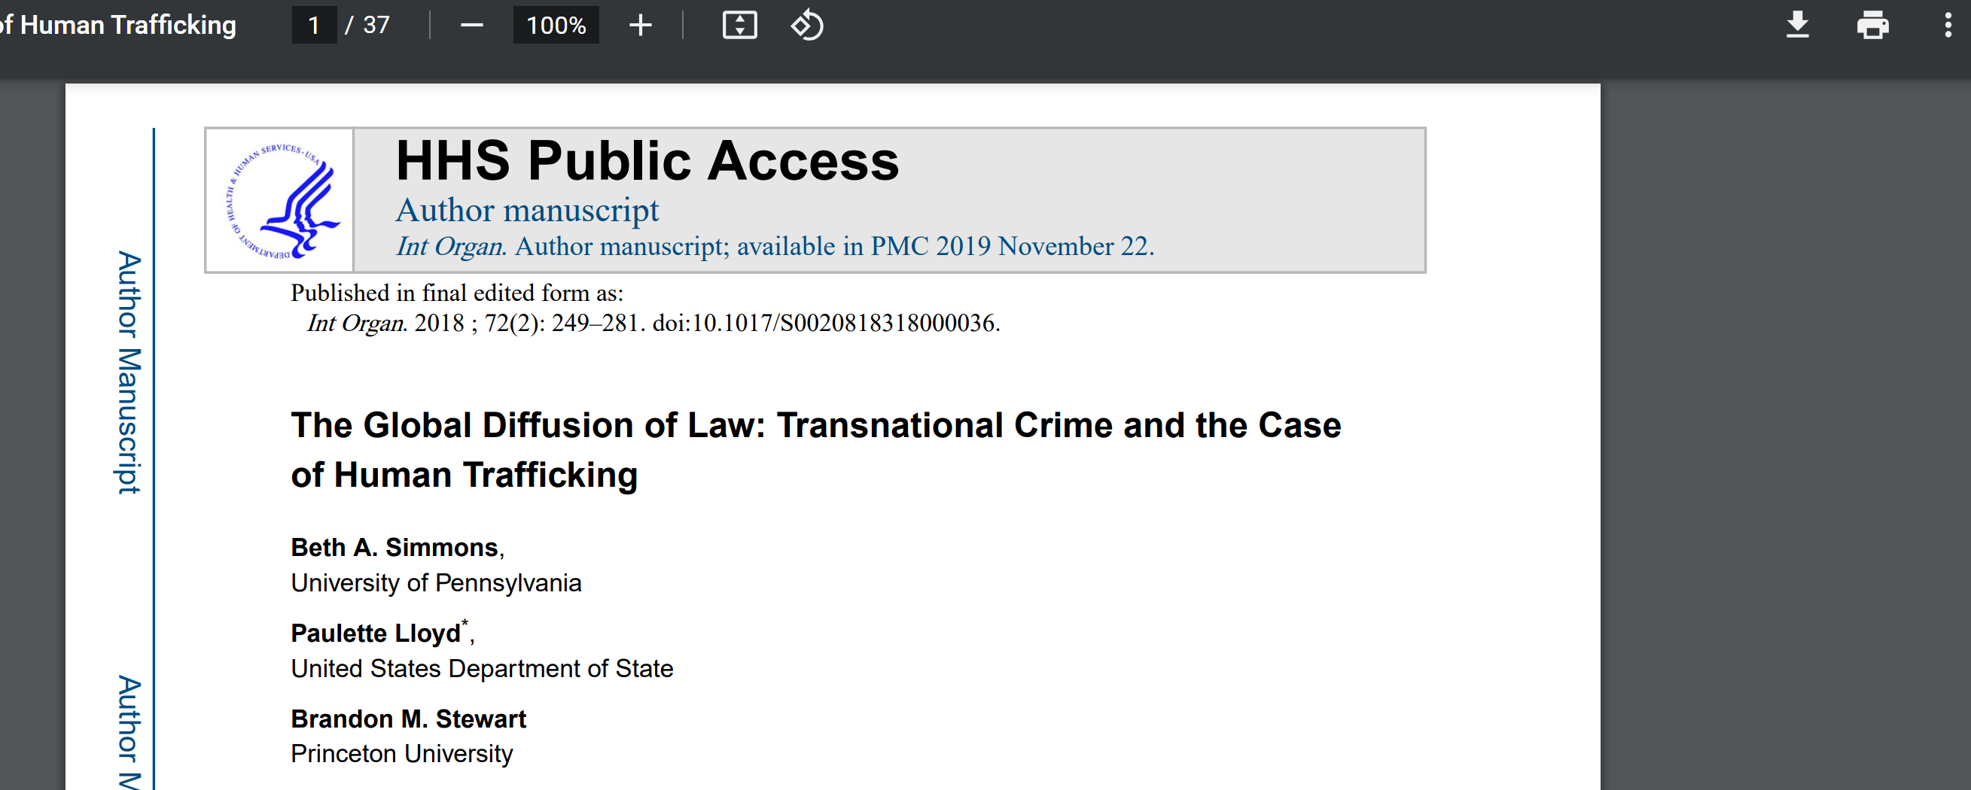

Step 3:
Open up the Google Translate webpage: https://translate.google.com/

Step 4:
Select Documents and select the downloaded document.
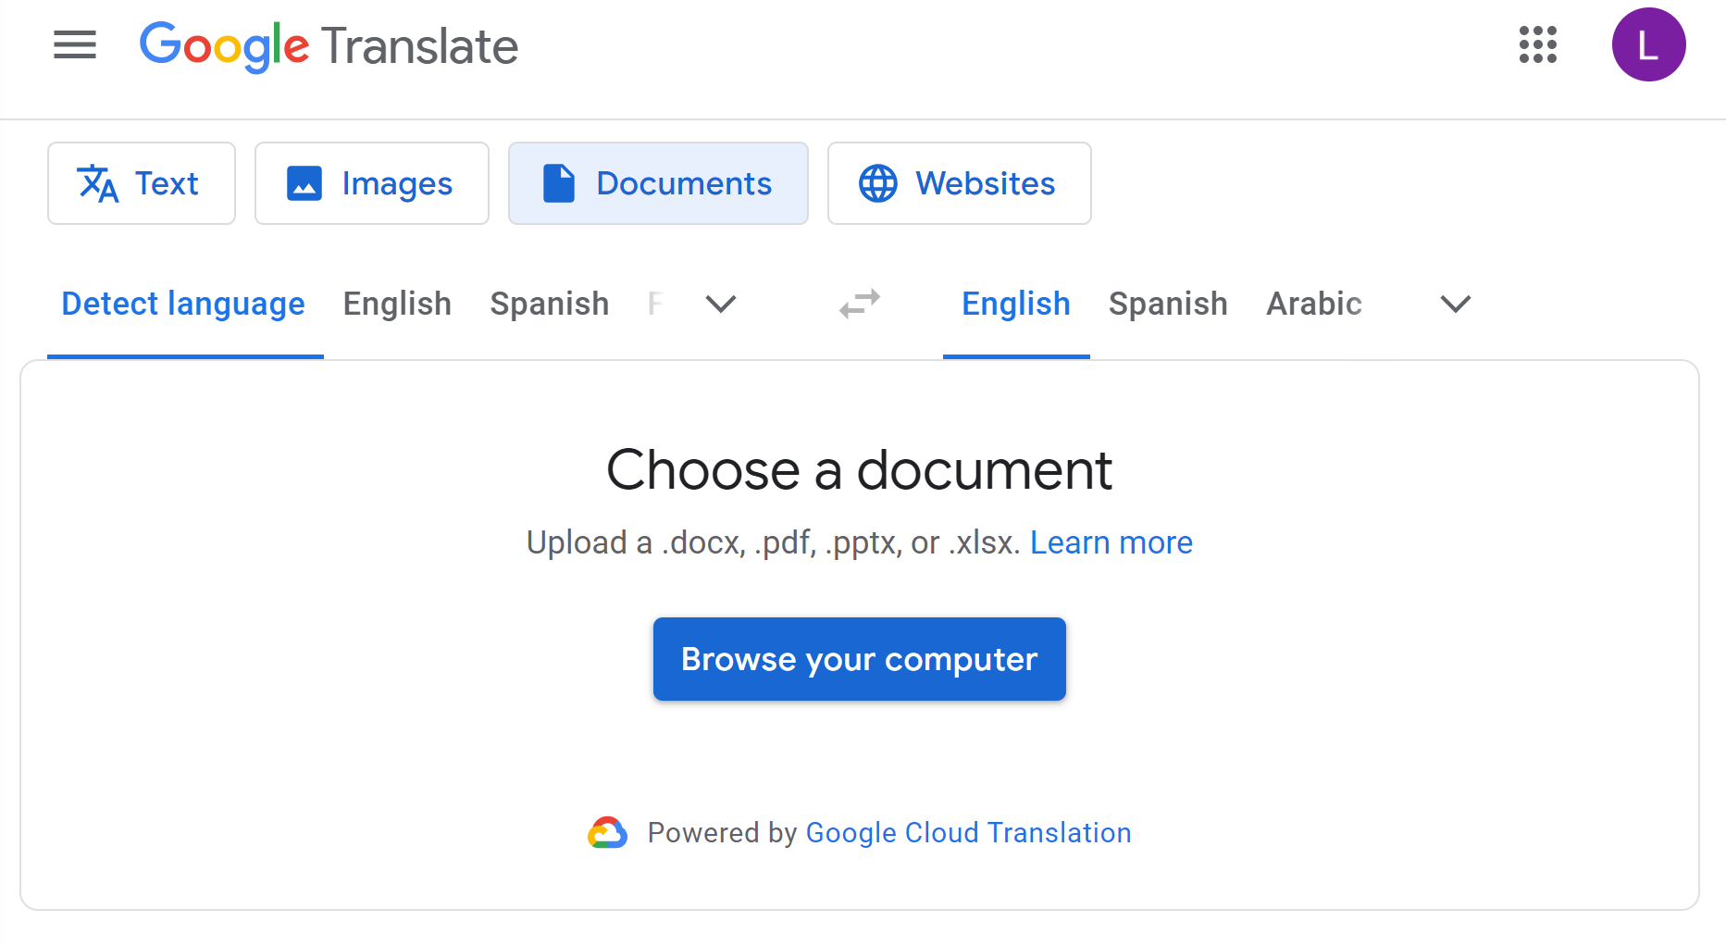

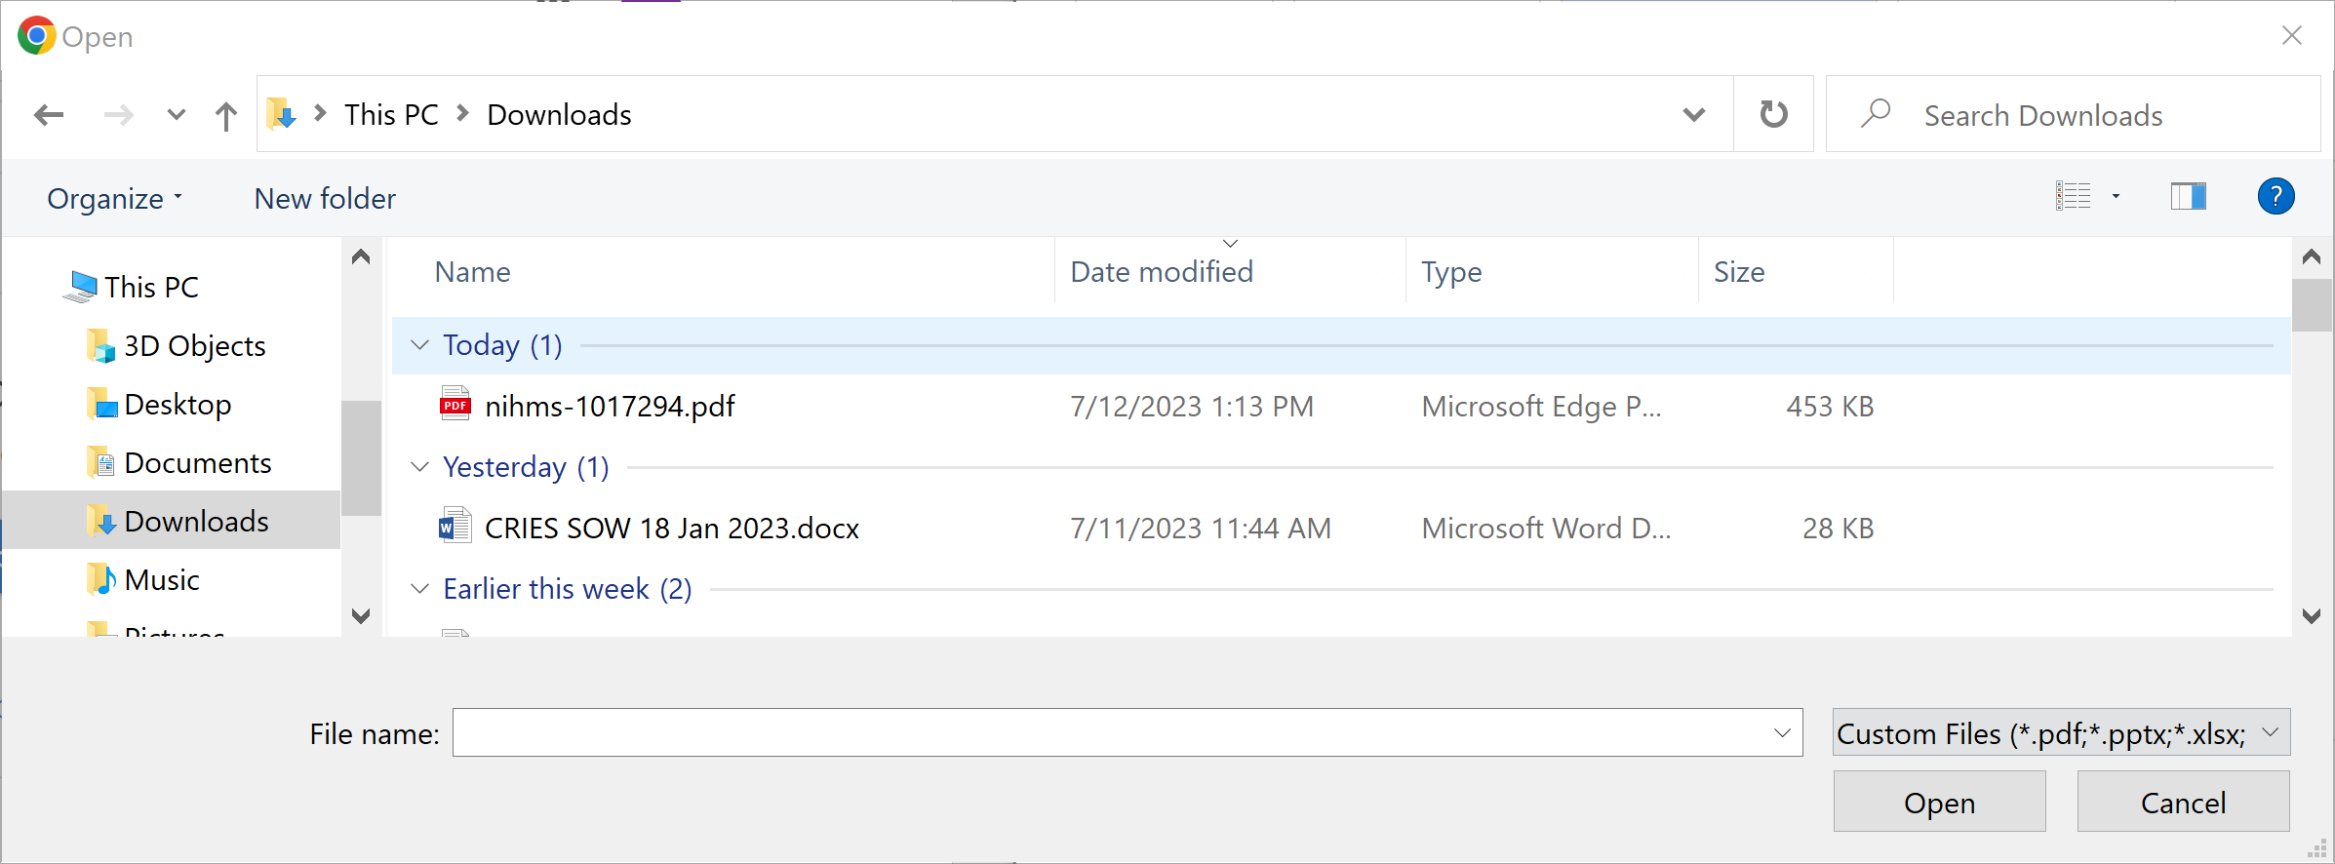

Step 5:
Click “Translate” once the file is uploaded.

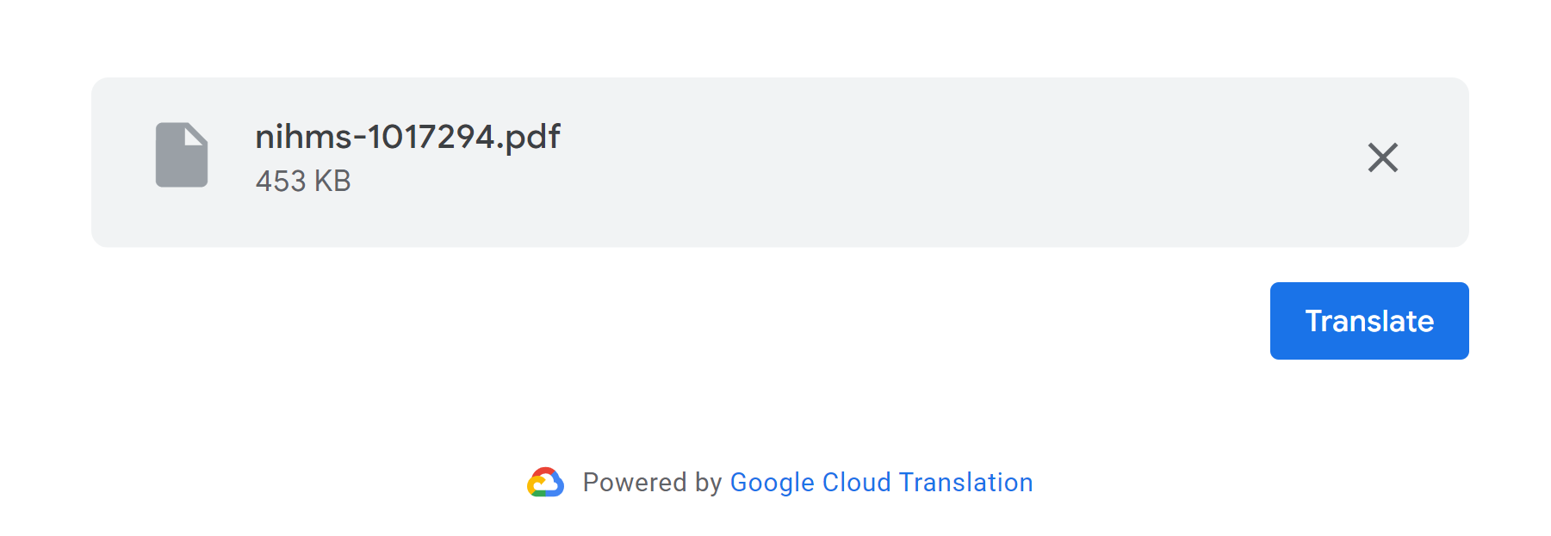

Step 6:
Once the document is done being translated, click “Download Translation”
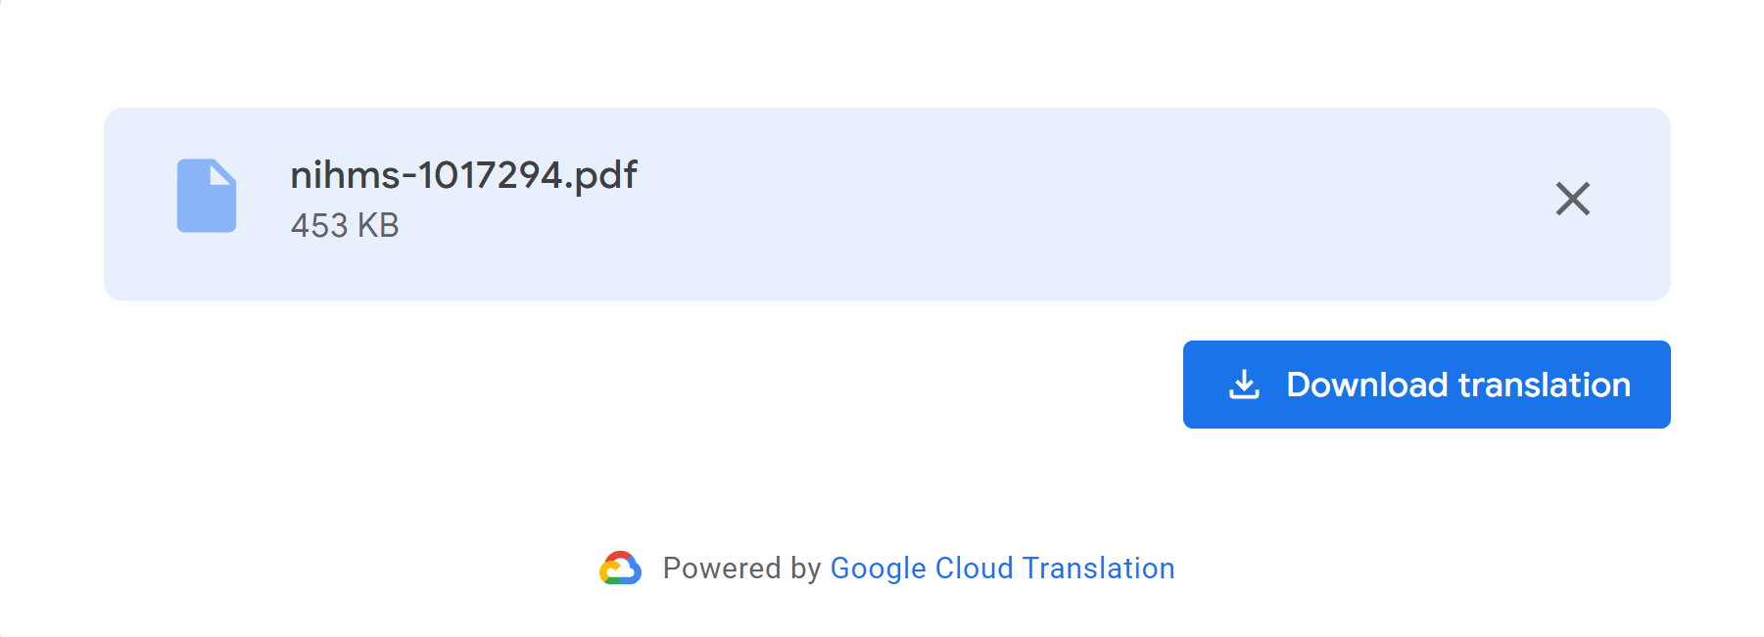

Step 7:
Open the translated document and you are ready to read.

