FLORIDA INTERNATIONAL UNIVERSITY
Miami, Florida

STATISTICAL MODELS FOR PREDICTING COLLEGE SUCCESS

A thesis submitted in partial fulfillment of the
requirements for the degree of
MASTER OF SCIENCE
in
STATISTICS
by
Yelen Nunez

2013

To: Dean Kenneth G. Furton
College of Arts and Sciences

This thesis, written by Yelen Nunez, and entitled Statistical Models for Predicting College Success, having been approved in respect to style and intellectual content, is referred to you for judgment.

We have read this thesis and recommend that it be approved.

____________________________________
B.M. Golam Kibria

____________________________________
George O’Brien

____________________________________
Sneh Gulati, Major Professor

Date of Defense: November 13, 2013

The thesis of Yelen Nunez is approved.

____________________________________
Dean Kenneth Furton
College of Arts and Sciences

____________________________________
Dean Lakshmi N. Reddi
University Graduate School

Florida International University, 2013
DEDICATION
I dedicate this thesis to my family and friends. This thesis would not have been possible without their love and support.
ACKNOWLEDGMENTS
I would like to express my gratitude to my committee members: Dr. Sneh Gulati, Dr. B.M. Golam Kibria, and Dr. George O’Brien. Thank you to my major professor, Dr. Gulati, for your guidance in finding a topic that sparked my interest and was related to my future career endeavors. I am forever indebted to you for believing in me and allowing me to teach my first college level class. It is an experience that I will forever cherish. Thank you to Dr. Kibria and Dr. O’Brien for your advice, insight and dedication. This thesis would not have been possible without your help.
I would also like to express my appreciation for the Department of Mathematics and Statistics faculty and staff. Thank you to all my professors for empowering me to work harder than I ever thought possible. I especially wanted to thank professor Domitila Fox for mentoring me throughout my undergraduate and graduate career. I wouldn’t be where I am today if it wasn’t for you believing in me and thrusting me into the limelight. I am also forever grateful to the department office staff for keeping me sane these past two years.
Lastly, I wanted to thank my family and friends for their unconditional love and support. Thank you for helping be through all the obstacles I encountered and preventing potential meltdowns. Especially, I wanted to thank my mom for being my number one fan and my brother, Jose, for always believing in me and pushing me to stop reaching for the stars when there is a universe I can be reaching for.

ABSTRACT OF THE THESIS
STATISTICAL MODELS FOR PREDICTING COLLEGE SUCCESS
by
Yelen Nunez
Florida International University, 2013
Miami, FL
Professor Sneh Gulati, Major Professor
Colleges base their admission decisions on a number of factors to determine which applicants have the potential to succeed. This study utilized data for students that graduated from Florida International University between 2006 and 2012. Two models were developed (one using SAT as the principal explanatory variable and the other using ACT as the principal explanatory variable) to predict college success, measured using the student’s college grade point average at graduation. Some of the other factors that were used to make these predictions were high school performance, socioeconomic status, major, gender, and ethnicity.
The model using ACT had a higher $R^{2}$ but the model using SAT had a lower mean square error. African Americans had a significantly lower college grade point average than graduates of other ethnicities. Females had a significantly higher college grade point average than males.

TABLE OF CONTENTS
CHAPTER PAGE
- INTRODUCTION…………………………………………………………...……1
Background and Statement of the Problem
Purpose and Significance of the Study
Primary Research Questions
Hypotheses
Research Design
- LITERATURE REVIEW…………………………………………………………5
- METHODOLOGY………………………………………………………………..9
Data Acquisition
Statistical Analysis
- RESULTS………………………………………………………………………..12
Correlations
Difference in Average Grade Point Average between 2006 and 2012
Difference in Average SAT Scores between 2006 and 2012
Difference in Average ACT Scores between 2006 and 2012
Multiple Linear Regression
SAT Linear Regression Model
ACT Linear Regression Model
Comparison of Models
- DISCUSSION……………………………………………………………………28
Limitations of the Study
Recommendations for Further Study
LIST OF REFERENCES………………………………………………………………...31
APPENDICES…………………………………………………………………………...32

LIST OF TABLES
TABLE PAGE
Table 1: Middle 50% Range for Students Admitted for Fall 2012………………………..1
Table 2: ANOVA for High School Grade Point Average, 2006-2012…………………..15
Table 3: ANOVA for College Grade Point Average, 2006-2012………………………..16
Table 4: ANOVA for SAT Scores, 2006-2012…………………………………………..18
Table 5: ANOVA for ACT Scores, 2006-2012………………………………………….20
Table 6: ANOVA for SAT Final Regression Model…………………………………….22
Table 7: ANOVA for ACT Final Regression Model…………………………………….25

LIST OF FIGURES
FIGURE PAGE
Figure 1: Linear Relationship between Quantitative Predictors and Response…………..13
Figure 2: Mean Plot for High School Grade Point Average, 2005-2012………..………14
Figure 3: Box Plots for High School Grade Point Average, 2005-2012…………...……14
Figure 4: Mean Plot for College Grade Point Average, 2005-2012………………...…...15
Figure 5: Box Plots for College Grade Point Average, 2005-2012……………………...16
Figure 6: Mean Plot for SAT Scores, 2005-2012…………………………………...…...17
Figure 7: Box Plots for SAT Scores, 2005-2012………………………………………...18
Figure 8: Mean Plot for ACT Scores, 2005-2012………………………………………..19
Figure 9: Box Plots for ACT Scores, 2005-2012…………………………………….......20
Figure 10: Residual Plot for SAT Model……………………………………………...…21
Figure 11: Predicted GPA versus College GPA using SAT Model……………………...24
Figure 12: Residual Plot for ACT Model………………………………………………..26
Figure 13: Predicted GPA versus College GPA using ACT Model……………………..27

CHAPTER I
Introduction
Background and Statement of the Problem
As admission to college becomes more competitive, colleges and universities need to rely on factors that predict college success to determine which applicants to admit to their institution. It is important to note that higher education institutions do not rely on just one factor to make an admission decision. Examples of factors used to determine whether an applicant is admitted or not are high school grade point average, Advance Placement or Dual Enrollment courses taken and passed, and standardized test scores.
Throughout the years, many studies have been done on the effect certain factors have on college success. Noble (1991) found that the use of just one factor alone to determine academic success was not as efficient as using both high school grades and ACT scores. Cohn, et. al. (2004) found that high school rank and high school grade point average were highly correlated. It is important to note that all factors will usually not be necessary to include in a model. Some factors, such as high school grade point average and rank, are so highly correlated that including both in the model will not be efficient.
Table 1: Middle 50% Range for Students Admitted for Fall 2012
Factor | Middle 50% Range
SAT | 1630-1810
ACT | 23-26
GPA | 3.5-4.1

Florida International University, like many other universities across the nation, does not provide a minimum grade point average or standardized test score requirement for admissions. All students are encouraged to apply since the decision for admittance depends on numerous factors. Instead, as depicted in Table 1, the university provides the middle 50% range for different factors for students that have been admitted for Fall 2012. However, the range provided for SAT scores is calculated counting the Mathematics, English, and Writing portions. The data that will be used for this study only includes the scores for the Mathematics and English portions.
Thus, the present study aims to determine which factors significantly affect the success of college students. College success is measured by college grade point average at graduation in the study. My study takes a closer look at standardized test scores as predictors of college success. The two standardized test scores that are used are SAT (formerly Scholastic Aptitude Test) and ACT (formerly American College Testing). In addition, the present study analyzes trends in standardized test scores, high school grade point averages, and college grade point averages throughout the years. As an increasing number of students are applying to higher education institutions, admissions becomes more competitive. Thus, it is expected that, throughout the years, there is a steady increase in standardized test scores and grade point averages of admitted students.
Purpose and Significance of the Study
South Florida is a potpourri of cultures and backgrounds. It’s unique composition makes South Florida’s population different from the rest of the nation. For this reason, this study aims to establish a significant method of predicting a student’s success at Florida International University.

Primary Research Questions
Question 1 | Can certain factors predict a student’s outgoing college grade point average?
Question 2 | Which standardized test, SAT or ACT, is better at predicting college grade point average?
Question 3 | What are the trends in standardized test scores and grade point averages throughout the years?
Hypotheses
Hypothesis 1 | Factors, such as high school grade point average, standardized test scores, socioeconomic status, Advanced Placement credits transferred, and choice of major will be significant in predicting a student’s outgoing college grade point average.
Hypothesis 2 | SAT will be a better predictor of outgoing college grade point average than ACT.
Hypothesis 3 | There will be a significant increase in standardized test scores and grade point averages throughout the years.
Research Design
College success will be measured using the grade point average at graduation calculated from courses that were taken at Florida International University. Socioeconomic status will be measured using whether or not the student received need-based financial aid. Categorical variables, such as gender, ethnicity, socioeconomic status, and major will be converted to dummy variables. Stepwise regression will be used to develop two models: one using SAT and all other significant predictors and another using ACT and all other significant predictors.
CHAPTER II
Literature Review
Performance in high school and scores on standardized tests have been used to predict how well a student will perform in college in several studies. There are also claims that college performance is not just a function of previous performance but also of situations outside of the student’s control, such as gender, socioeconomic status, and ethnicity (Sackett et. al., 2002).
Julie Noble (1991) studied how ACT scores and high school grades predicted college success. The data consisted of a student’s ACT scores in English, Mathematics, Social Studies, Natural Sciences, and the ACT composite score. Students also self-reported the grades they had received in high school English, Mathematics, Social Studies, Natural Sciences, Foreign Language, and Fine Arts courses. The students in this study took the ACT before fall 1989, when a change was made to the exam. The sample only consisted of students that took the ACT. This study was not representative of colleges that did not participate in the ACT Prediction Research Services and private institutions. The data also consisted of grades that students received in freshman level classes in college.
Several models were developed and cross-validated for prediction accuracy. Descriptive statistics were also used. The study showed that the grades in English were higher than the grades in Mathematics and Natural Science courses. However, students enrolled in more English classes had lower ACT composite scores than other subjects. Juniors had higher scores on ACT than did seniors. The study also found that course grades and grade point average overpredicted college grades for students that took the ACT during their third year in high school but not for students that took the ACT during their fourth year of high school. The models that were more accurate in predicting college success where those that separated students by grade level. The best models were those that included the ACT scores and the average of all high school grades (calculated similar to high school grade point average). The results of this study indicate that a combined model is better than only using ACT score or only using high school grades. Moreover, it is better to use an average of all high school grades than to use grades for individual courses.
Harackiewicz et. al. (2002) studied the effect that goals, interest, and high school performance have on college success. The basis for this study was to make the distinction between mastery goals and performance goals. Students with mastery goals want to learn the material for later use while students with performance goals want to learn the material to do well on an exam or assignment and do not place value on recalling the material at a later time. The sample consisted of students taking Introductory Psychology as college freshman in 2002 and were followed through the end of their college career. The data consisted of standardized test scores (ACT and SAT), high school grade point average, the motivation of the student, course choices, choice of major, final grade in Introductory Psychology, and college grades. Motivation was measured using a self-report questionnaire. Two models were developed. The short term model aimed to predict the grade the student received in Introductory Psychology while the long term model aimed to predict the college grade point average.
The study found that students with mastery goals had more interest in the course than students with work avoidance goals. Goals and previous performance were significant in predicting success. The study aimed to use a multifaceted definition of success. Success was not just measured by final performance (final grade in the class, Psychology grade point average, or general grade point average) but also by interest in the student’s chosen field of study. The study found that students with performance goals earned higher grades and gender had an effect on interest in Psychology.
Cohn et. al. (2003) studied the effect that SAT scores, high school grade point average, and high school rank have on undergraduate grade point averages. The sample consisted of students from the University of South Carolina registered in a principles of economics course between Spring 2000 and Spring 2001. Data were collected using questionnaires. The study hypothesized that SAT scores, high school rank, and high school grade point average would have a positive effect on undergraduate grade point average.
The study determined that SAT scores, high school rank, and high school grade point average were all significant in predicting college grade point average. In addition, eliminating either high school rank or high school grade point average (not both) from the model had little effect on the adjusted $R^{2}$ since the correlation between the two variables was high. The study also found that when SAT scores are not included in the model, the college grade point average is much lower. The suggests that SAT scores should not be waived from college admission decisions. The models developed in the study predicted higher college grade point averages when higher eligibility criteria are used to make admission decisions.
Sackett et. al. (2009) studied the effect that socioeconomic status has on standardized test scores and college performance. The data were collected from 28 schools between 1995 and 1997. The schools were geographically diverse, small and large schools, and private and public institutions. Performance in college was measured using freshman grades. Socioeconomic status was measured using both parents level of education and the household income acquired through a questionnaire.
The correlation between SAT scores and socioeconomic status varied among the different colleges that were included in the sample. However, the correlation was relatively high between these two variables. The authors suggest that socioeconomic status and SAT scores may affect the student’s decision to apply to a specific school. Nonetheless, the study determined that SAT scores, when controlled for socioeconomic status, were good predictors of academic success, measure by student grades.

CHAPTER III
Methodology
Data Acquisition
The data used for this study were acquired from the Office of Planning and Institutional Research at Florida International University. Data were collected from students that graduated from Florida International University between 2005 and 2012 ($N=88102$) with a Bachelor’s degree. The information that was collected from each graduate included SAT score, ACT score, the time the graduate took to complete the degree, the Advanced Placement credits that were transferred, high school grade point average, college grade point average at graduation, gender, whether or not the student received financial aid, the student’s ethnicity, the year the student earned the degree, and the student’s major. Of the graduates, 39.5% ($n=34763$) were male and 60.5% ($n=53336$) were female, with gender missing for four of the graduates. College grade point average at graduation ranged from 1.75 to 4.00, with a mean of 3.1344 (SD=0.44267). High school grade point average ranged from 0.10 to 5.00, with a mean of 3.5049 (SD=0.54802).
A random sample from the data set was selected using the SPSS select cases tool. Approximately 20% of the graduates from each year were selected ($N=17545$). Of the graduates in the sample, 39.4% ($n=6910$) were male and 60.6% ($n=10634$) were female. College grade point average at graduation in the sample ranged from 1.75 to 4.00, with a mean of 3.1363 ($SD=0.44195$). High school grade point average in the sample ranged from 0.10 to 5.00, with a mean of 3.5094 ($SD=0.55116$).

Statistical Analysis
Analysis of the data was conducted using the statistical software SPSS. The categorical variables were converted to numerical values. For gender, a zero was recorded if the graduate was a male and a one was recorded if the graduate was a female. For financial aid, a zero was recorded if the graduate had not received financial aid and a one was recorded if the graduate had received financial aid. For major and ethnicity, each category was subdivided. For instance, if the student was categorized as an African American, a one was recorded for the category African American and a zero was recorded for all other ethnicity categories. If the graduate chose to not report their ethnicity, a zero was recorded for all ethnicity categories. Majors were grouped together by category. The categories that were considered were Arts and Architecture, Business, Communications, Education, Engineering, Health Sciences, Hospitality, Sciences, and Social Sciences and Humanities. The categories and corresponding majors are listed in Appendix A, Table A1.
Multiple linear regression was used to develop models that predict college grade point average at graduation using certain factors. Separate models were created for ACT scores and SAT scores since the data consist only of the score that each student submitted during the application process. The models were developed using stepwise procedure with a level of significance of 0.05 for a factor to enter the model and 0.10 for the factor to be removed from the model.
One-way analysis of variance was used to determine if there were any significant differences between the year the student graduated and the grade point average at graduation, SAT score, and ACT score, individually. Mean plots were used initially to visualize the change throughout the years that the data was acquired. If there was a significant difference throughout the years, Tukey’s method of multiple comparisons was used to determine which years had significant changes.

CHAPTER IV
Results
Correlations
Correlations for all variables were computed. With the exception of whether the student was classified as an Alaskan Native or Native American, correlations between college grade point average and all other variables were significant($p<0.05$). However, none of the correlations between college grade point average and other variables were strong since the correlations were between -0.283 and 0.422.
College grade point average is positively correlated to SAT score ($r=0.251$), ACT score ($r=0.305$), Advanced Placement credits transferred ($r=0.211$), and high school grade point average ($r=0.422$). However, College grade point average is negatively correlated to time the student took to graduate ($r=-0.283$).
A matrix scatterplot is depicted in Figure 1 to analyze the linear relationships between the factors. With the exception of the time the student took to graduate versus the Advanced Placement credits transferred, all other relationships had an increasing trend. It is understandable that the time the student took to graduate and the Advanced Placement credits the students transferred are inversely related. Transformations to the data were attempted to improve the linear relationships. However, these transformations did not improve the linearity significantly. All tests were done using the original data.
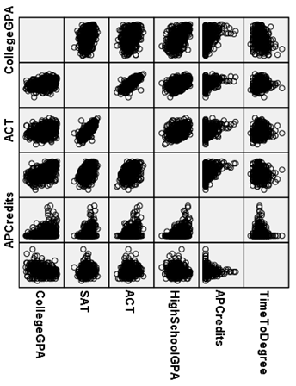
Figure 1: Linear Relationship between Quantitative Predictors and Response

Difference in Average High School Grade Point Average between 2005 and 2012
The mean plot of the average high school grade point average between 2005 and 2012 is presented in Figure 2 and the corresponding box plots are presented in Figure 3.The mean plot in Figure 2 indicates oscillation in high school grade point averages throughout the time period analyzed. The box plots in Figure 3 indicate that the variances throughout the years are very similar and that there were many lower outliers. The year with the highest average high school grade point average was for students that graduated college in 2010 and the lowest for students that graduated college in 2007.
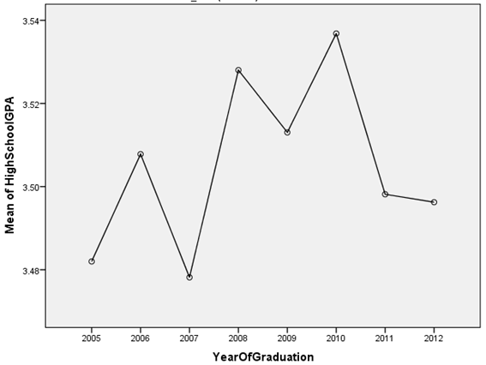
Figure 2: Mean Plot for High School Grade Point Average, 2005-2012
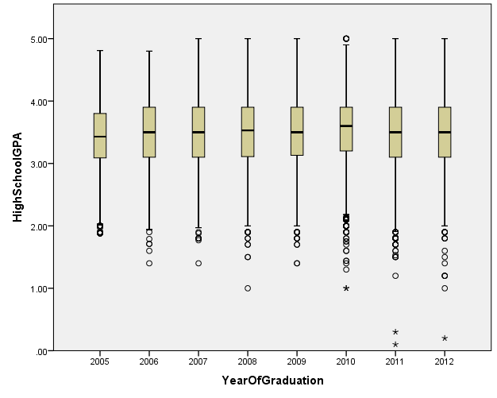
Figure 3: Box Plots for High School Grade Point Average, 2005-2012

A one-way analysis of variance was conducted on the high school grade point averages of graduates over the years. As depicted in Table 2, the analysis was not significant, $F(7, 9656)=1.581$, $p=0.136$.
Table 2: ANOVA for High School Grade Point Average, 2005-2012
Source | SS | DF | MS | F | Sig.
Between Groups | 3.360 | 7 | 0.480 | 1.581 | 0.136
Within Groups | 2931.995 | 9656 | 0.304
Total | 2935.355 | 9663

Difference in Average College Grade Point Averages between 2005 and 2012
The mean plot of the average college grade point average between 2005 and 2012 is presented in Figure 4 and the corresponding box plots are presented in Figure 5.The mean plot in Figure 4 indicates a peak during 2007 and then a downward trend. The box plots in Figure 5 indicate that the variances throughout the years are very similar. The year with the highest average college grade point average was for students that graduated college in 2007 and the lowest for students that graduated college in 2012.
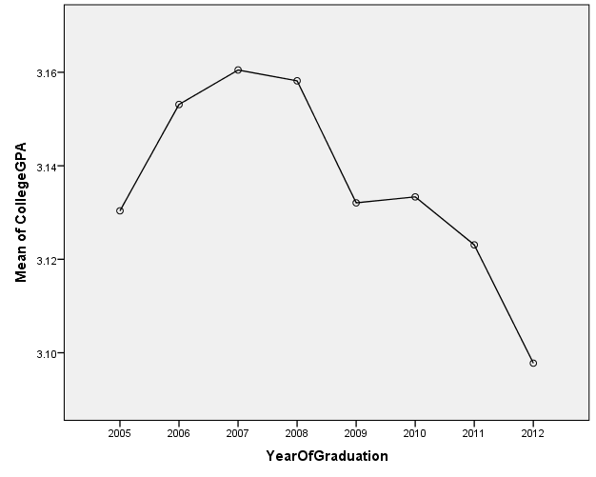
Figure 4: Mean Plot for College Grade Point Average, 2005-2012

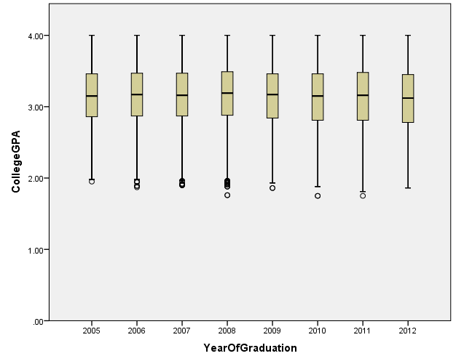
Figure 5: Box Plots for College Grade Point Average, 2005-2012

A one-way analysis of variance was conducted on the college grade point averages of graduates over the years. As depicted in Table 3, the analysis was significant, $F(7, 17500)=4.218$, $p<0.001$.
Table 3: ANOVA for College Grade Point Average, 2005-2012
Source | SS | DF | MS | F | Sig.
Between Groups | 5.76 | 7 | 0.823 | 4.218 | 0.000
Within Groups | 3413.763 | 17500 | 0.195
Total | 3419.523 | 17507

To determine which years had significant effect on grade point averages, Tukey’s Post Hoc test for multiple comparisons was conducted. Students that graduated in 2012 had significantly lower grade point averages than students that graduated in 2006 ($M=0.05534$, $SD=0.01546$) with p-value 0.008, 2007 ($M=0.06272$, $SD=0.01523$) with p-value 0.001, and 2011 ($M=0.06041$, $SD=0.01396$) with p-value less than 0.001. No other comparisons were significant. For more details, refer to Appendix B, Table B1.
Difference in Average SAT Scores between 2005 and 2012
The mean plot of the average SAT scores between 2005 and 2012 is presented in Figure 6 and the corresponding box plots are presented in Figure 7.The mean plot in Figure 6 shows a peak in in 2006. The plot indicates a steady decrease in SAT scores from 2006 to 2008 and then a steady increase. The box plots in Figure 7 indicate that the variances throughout the years are very similar and that there were many outliers above and below the box plot fences.
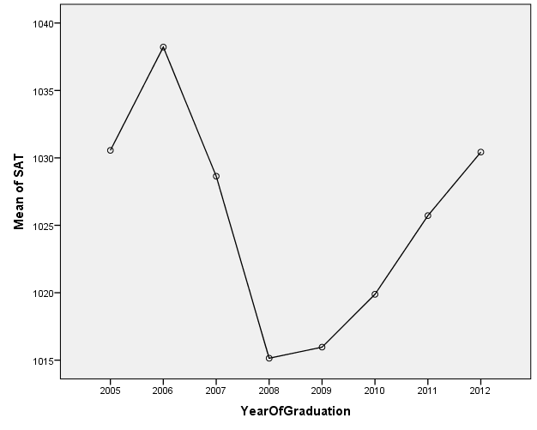
Figure 6: Mean Plot for SAT Scores, 2005-2012

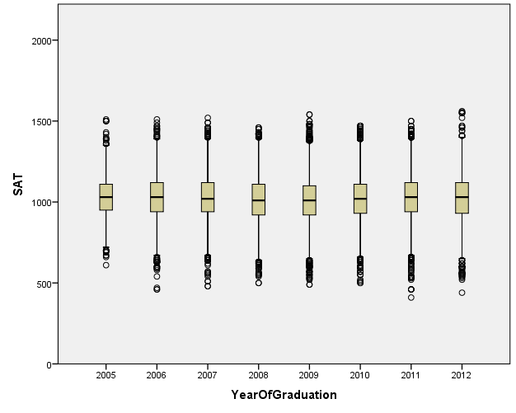

Figure 7: Box Plots for SAT Scores, 2005-2012

A one-way analysis of variance was conducted on the SAT scores of graduates from 2006 to 2012. As depicted in Table 4, the analysis was significant, $F(7, 8133)=2.794$, $p<0.007$.
Table 4: ANOVA for SAT Scores, 2005-2012
Source | SS | DF | MS | F | Sig.
Between Groups | 407043.803 | 7 | 58149.115 | 2.794 | 0.007
Within Groups | 169286393.936 | 8133 | 20814.754
Total | 169693437.740 | 8140
To determine which years had significant difference in SAT scores, Tukey’s Post Hoc test for multiple comparisons was conducted. Students that graduated in 2006 had significantly greater SAT scores than students that graduated in 2008 ($M=23.074$, $SD=7.115$) with p-value 0.026 and 2009 ($M=22.251$, $SD=6.879$) with p-value 0.027. No other comparisons were significant. For more details, refer to Appendix B, Table B2.
Difference in Average ACT Scores between 2005 and 2012
The mean plot of the average ACT scores between 2005 and 2012 is presented in Figure 8 and the corresponding box plots are presented in Figure 9.The mean plot in Figure 8 shows a steady decrease in ACT scores until 2008. The plot indicated an increasing trend in scores after 2008. The box plots in Figure 9 indicate that the variances throughout the years are very similar and that there were many high outliers.
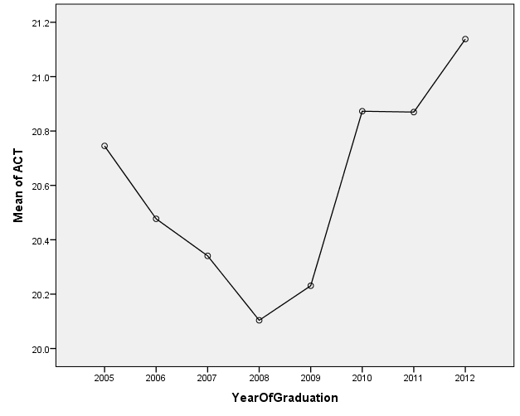
Figure 8: Mean Plot for ACT Scores, 2005-2012

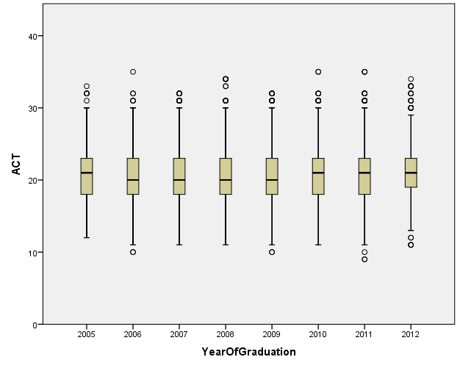
Figure 9: Mean Plot for ACT Scores, 2005-2012

A one-way analysis of variance was conducted on ACT scores of graduates over the years. As depicted in Table 5, the analysis was significant, $F(7, 3920)=5.106$, $p<0.001$.
Table 5: ANOVA for ACT Scores, 2005-2012
Source | SS | DF | MS | F | Sig.
Between Groups | 478.157 | 7 | 68.308 | 5.106 | 0.000
Within Groups | 52445.957 | 3920 | 13.79
Total | 52924.114 | 3927

To determine which years had significant difference in ACT scores, Tukey’s Post Hoc test for multiple comparisons was conducted. Students that graduated in 2008 had significantly lower ACT scores than students that graduated in 2010 ($M=0.769$, $SD=0.201$) with p-value 0.003, in 2011 ($M=0.766$, $SD=0.202$) with p-value 0.004, and in 2012 ($M=1.034$, $SD=0.245$) with p-value 0.001. Students that graduated in 2009 had significantly lower ACT scores than students that graduated in 2010 ($M=0.642$, $SD=0.203$) with p-value 0.033, in 2011 ($M=0.639$, $SD=0.204$) with p-value 0.037, and in 2012 ($M=0.907$, $SD=0.246$) with p-value 0.006. No other comparisons were significant. For more details, refer to Appendix B, Table B3.
Multiple Linear Regression
Two linear models were fit to predict college grade point average using standardized test scores (SAT scores or ACT scores), time to complete degree, year of degree completion, advanced placement credits transferred, high school grade point average, gender, ethnicity, major, and whether the student received financial aid. Indicator variables were used for ethnicity, major, whether the student received financial aid, and gender.
SAT Linear Regression Model
Stepwise regression was used to develop the model. A level of significance of 0.05 was used for a variable to enter the model and 0.10 for a variable to be removed from the model. As depicted in Table 6, the final model was significant, $F(13, 3820)=166.336$, $p<0.001$. The variables that were considered significant predictors in the final model were SAT score, the time the student took to graduate, high school grade point average, Advanced Placement credits transferred, gender, whether the student received financial aid, whether the student was African American, and some major indicators (Social Sciences, Hospitality, Communications, Business, Engineering, and Sciences).

Table 6: ANOVA for SAT Final Regression Model
Model | SS | DF | MS | F | Sig.
Regression | 244.295 | 13 | 18.792 | 166.336 | 0.000
Residual | 431.566 | 3820 | 0.113
Total | 675.861 | 3833

The fitted model with SAT and all other significant variables is:
$$\hat{y_{1}}=2.127+0.001x_{1}-0.073x_{3}+0.004x_{4}+0.236x_{5}+0.031x_{6}+0.070x_{7}-0.158x_{11}-0.213x_{16}-0.154x_{17}-0.096x_{18}-0.180x_{20}-0.280x_{22}-0.069x_{23}$$
The definition of each variable is listed in Appendix A2. According to the model, it is predicted that female students will have a grade point average that is 0.031 higher than their male counterparts. Students that received financial aid are anticipated to have a grade point average that is 0.070 higher than that of students that did not receive financial aid. A possible explanation for this is that families with low socioeconomic status may view education as their ticket to moving up the social ladder. For every additional year that a student spends in school, grade point average is predicted to decrease by 0.073. It is predicted that African American students will have grade point averages lower than other ethnicities by 0.158. The SAT score, Advanced Placement credit, and high school grade point average variables all had positive coefficients. Thus, it is predicted that an increase in these variables will lead to an increase in college grade point average.
The adjusted R-squared for this model was 0.359. The variance inflation factors were between 1.02 and 2.00. The residual plot in Figure 10 shows evidence that the residuals are all evenly scattered about zero. The normality plot in Appendix C provides evidence that the data are normally distributed.
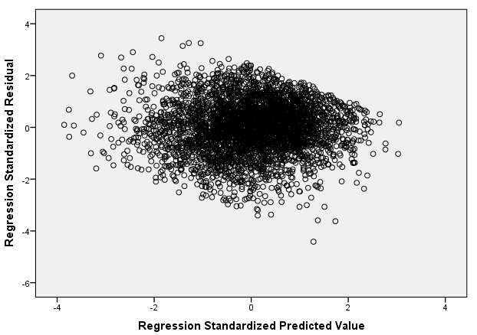
Figure 10: Residual Plot for SAT Model

As a cross-validation of the fitted model, the scatterplot of earned college grade point average versus predicted college grade point average, using SAT scores, for students not considered in the sample is present in Figure 11. It indicates a positive linear relationship that the model may have predicted grade point averages that were higher than the earned college grade point average.
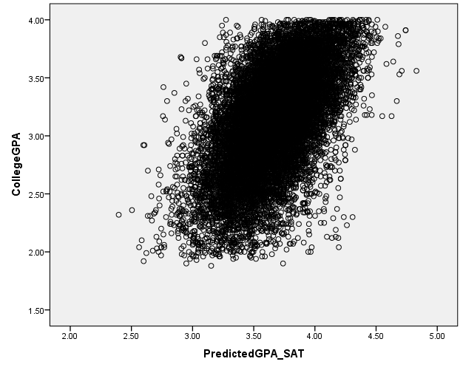
Figure 11: Predicted GPA versus College GPA using SAT Model
In addition, the mean square error was calculated for the students that were not used to fit the model, MSE=0.389, df=15470.
ACT Linear Regression Model
Stepwise regression was used to develop the model. A level of significance of 0.05 was used for a variable to enter the model and 0.10 for a variable to be removed from the model. As depicted in Table 7, the final model was significant, $F(12, 1836)=95.076$, $p<0.001$. The ACT score was used instead of SAT score as the principal explanatory variable. Gender and the indicator for whether the student was a Communication major where not significant in this model in the presence of all other variables. However, the year of completion was significant in this model and not significant in the SAT model.

Table 7: ANOVA for ACT Final Regression Model
Model | SS | DF | MS | F | Sig.
Regression | 129.811 | 12 | 10.818 | 95.076 | 0.000
Residual | 208.897 | 1836 | 0.114
Total | 338.709 | 1848

The fitted model with ACT and all other significant variables is:
$$\hat{y_{2}}=21.584+0.016x_{2}-0.063x_{3}+0.007x_{4}+0.262x_{5}+0.087x_{7}-0.159x_{11}-0.010x_{14}-0.215x_{16}-0.140x_{17}-0.096x_{18}-0.214x_{20}-0.217x_{22}$$
The definition of each variable is listed in Appendix A2. According to this model, it is predicted that students that received financial aid had a grade point average that was 0.087 higher than students that did not receive financial aid. For every additional year that a student spends in school, grade point average is predicted to decrease by 0.063. It is predicted that African American students will have grade point averages lower than other ethnicities by 0.159. The ACT score, Advanced Placement credit, and high school grade point average variables all had positive coefficients. Thus, it is predicted that an increase in these variables will lead to an increase in college grade point average.
The adjusted R-squared for this model was 0.379. The variance inflation factors were between 1.05 and 1.55. The residual plot in Figure 12 shows evidence that the residuals are all evenly scattered about zero. The normality plot in Appendix D provides evidence that the data is normally distributed.
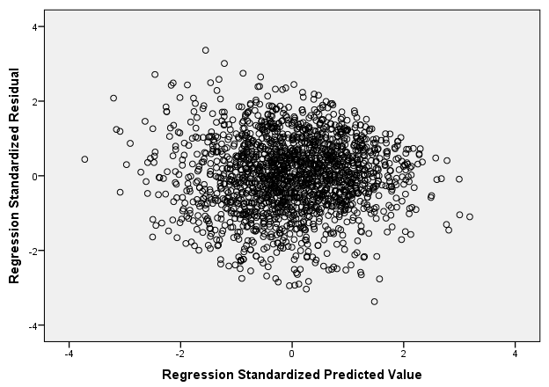
Figure 12: Residual Plot for ACT Model

As a cross validations of the fitted model, the scatterplot of earned college grade point average versus predicted college grade point average, using ACT scores, for students not considered in the sample is depicted in Figure 13. Figure 13 indicates a positive linear relationship and the model may have predicted grade point averages that were lower than the earned college grade point average.

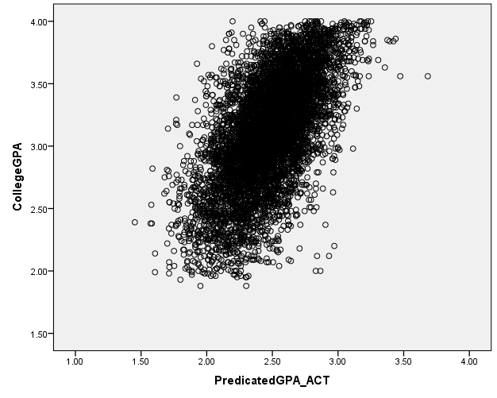
Figure 13: Predicted GPA versus College GPA using ACT Model
In addition, the mean square error was calculated for the students that were not used to fit the model, MSE=0.533, df=7300.
Comparison of Models
The final model using SAT scores had 13 variables in the model and adjusted $R^{2}=0.359$. The final model using ACT scores had 12 variables in the model and adjusted $R^{2}=0.379$. Even with one less variable, the ACT model had a higher adjusted $R^{2}$. However, the adjusted $R^{2}$ values are very similar for both models. Instead, the mean square error was calculated for both models using the data that were not used to fit the model. For the SAT model, MSE=0.389, df=15470. For the ACT model, MSE=0.533, df=7300. The SAT model had a higher mean square error and, thus, had higher predictability power.

CHAPTER V
Discussion
Interesting Findings
On the basis of South Florida’s population, it was expected that the number of Hispanic/Latino students that graduated from Florida International University would be relatively high compared to other ethnic groups. However, it was not expected that over 60% of the population would be female in comparison to roughly 40% male. Moreover, the positive slope for the gender factor indicates that females had significantly higher college grade point averages than males. A possible explanation for this can be that males may be forgoing a college degree and going into the workforce while females are choosing to complete a college degree (Bubany & Hansen, 2011). Also, because of the long held belief in the glass ceiling, females may view a college degree as a way of breaking through this glass ceiling (Yeagley, Subich, & Tokar, 2010).
An interesting finding in this study was that the African American indicator was the only ethnicity indicator that was significant in predicting college grade point average in the presence of all other predictors. Moreover, in both the SAT model and the ACT model, the slope of the predictor was negative. This may be an indication that African Americans are earning significantly lower grade point averages than other ethnicities. The relation between grade point average and standardized test scores in African Americans should be studied further using data from across the nation to determine if there is a national trend. If so, it is something that needs to be addressed.
Another interesting finding in this study was the trend in standardized test scores for graduates of Florida International University. According to the mean plots, both SAT and ACT were at an all-time low in 2008. Yet, the high school grade point averages were relatively high. Further study should be dedicated to this year to determine what caused standardized test scores to be so low and grade point average to be so high.
Limitations of the Study
The data for this study only consisted of students that had graduated from Florida International University between 2002 and 2012. South Florida’s population is distinctively immigrant and the student population is representative of that. However, as a result of the university’s unique composition of students, the results of this study can only be applied to students that have graduated from Florida International University during the years of the study.
In addition, standardized tests are constantly changing. For instance, the SAT format was changed to include an additional section, writing. Therefore, now SAT composite scores are out of 2400 instead of 1600. The present study only included students that had taken the SAT prior to admissions offices using the new format to make admissions decisions. The models developed in this study are only useful for predicting college grade point averages for students that took the SAT prior to the change in format. In order to account for the change, new models should be developed once substantial data is available for students that took the SAT after the change.
Recommendations for Further Study
For future studies, additional variables can be considered. The grade level of the student when he or she took the standardized exam might have an effect on success. To further improve accuracy, the high school grade point average may be recalculated to only include certain courses. The same approach can be used for college grade point average. Instead of including all the courses the student took, the only courses that should be considered are the ones directly related or required for the degree program the student completed. Instead of using a composite standardized test score, scores should be divided by section. For instance, for SAT the student would have a verbal score and a math score. This may suggest evidence to an accurate connection between standardized test score and choice of program.
Another topic that may be of interest is including the number of times the student changed majors. Changes in major may affect the time the student took to graduate, the student’s grade point average, and even the student’s motivation.
In this study, success was measure using college grade point average earned at graduation. An alternative approach can be to develop a logistic regression model where the response variable is whether the student graduated or withdrew from the university. Furthermore, success can also be measured by whether or not the student had a job offer after graduation or whether or not the student was admitted to a graduate program. If a model was developed with the response variable being whether or not the student had a job offer after graduation, additional variables can include a student’s participation in an internship program. A more holistic model would be a multivariate model with response variables including college grade point average, whether the student graduated, and plans after graduation.

LIST OF REFERENCES
Bubany, S. T. & Hansen, J. C. (2011). Birth Cohort Change in the Vocational Interests of Female and Male College Students. Journal of Vocational Behavior, 78(1), 59-67.

Cohn, E., Cohn S., Balch, D.C., & Bradley, J. (2004). Determinants of undergraduate GPAs: SAT scores, high school GPA and high school rank. Economics of Education Review, 23, 577-586.

FIU, Admissions Office (2012). Admissions Requirements. Retrieved from http://admissions.fiu.edu/how/freshman.php

Harackiewicz, J. M., Barron, K. E., Tauer, J. M., & Elliott, A. J. (2002). Predicting Success in College: A Longitudinal Study of Achievement Goals and Ability Measures as Predictors of Interest and Performance From Freshman Year Through Graduation. Journal of Educational Psychology, 94(3), 562-575.

Noble, J.P. (1991). Predicting college grades from ACT assessment scores and high school course work and grade information. Report No. 91-3 [50291930]. Iowa City, IA: American College Testing.

Sackett, P. R., Kuncel, N. R., Arneson, J. J., Cooper, S. R., & Waters, S. D. (2009). Does Socioeconomic Status Explain the Relationship Between Admissions Tests and Post-Secondary Academic Performance? Psychological Bulletin, 135(1), 1-22.

SPSS Inc. (2009). PASW Statistics for Windows, Version 18.0 [computer software]. Chicago: SPSS Inc.

Yeagley, E. E., Subich, L. M., & Tokar, D. M. (2010). Modeling College Women’s Perceptions of Elite Leadership Positions with Social Cognitive Career Theory. Journal of Vocational Behavior, 77(1), 30-38.

APPENDIX A
Appendix A1: Major Categories
Category | Majors
Arts and Architecture | - Architecture  - Art History & Appreciation  - Dance  - Dramatic Arts  - Interior Design  - Landscape Architecture  - Music, General  - Studio/Fine Art  - Visual Art, General
Business | - Accounting  - Business Administration and Management  - Business Marketing Management  - Finance, General  - Human Resources Management  - International Business Management  - MGMT. Info. Systems/Busi Data Proc.  - Real Estate
Communications | - Communication (Mass)  - English, General  - French  - Organizational Communication, General  - Portuguese  - Spanish
Education | - Art Teacher Ed.  - Education, Other  - Elementary Teacher Ed  - English Teacher Ed.  - Foreign Languages Teacher Ed.  - Home Economics Teacher Ed. (Vocational)  - Mathematics Teacher Ed.  - Music Teacher Ed.  - Physical Ed. Teaching & Coaching  - Pre-Elem/Early Childhood Teacher Ed.  - Recreation, Leisure Studies  - Science Teacher Ed.  - Social Science Teacher Ed.  - Special Ed, General  - Technology Education
Engineering | - Biomedical Engineering  - Civil Engineering  - Computer & Information Science  - Computer Engineering  - Construction/Building Tech.  - Electrical, Electronics Engin.  - Environmental Health Engin.  - Industrial & Systems Engin.  - Information Technology  - Mechanical Engineering
Health Sciences | - Health Science  - Health Services Administration  - Dietetics/Nutritional Services  - Exercise Sci/Physiol/Mvmnt Studies  - Health Information Management  - Nursing/Registered Nurse  - Occupational Therapy
Hospitality | - Hospitality Administration/Management  - Travel and Tourism Management
Sciences | - Applied Math/Math Sciences  - Biology, General  - Chemistry  - Environmental Science  - Environmental Studies  - Geology  - Marine/Aquatic Biology  - Mathematics, General  - Physics  - Psychology, General  - Statistics
Social Sciences and Humanities | - Asian Studies  - Criminal Justice Studies  - Economics  - Geography  - History  - Humanities  - International Relations  - Liberal Arts & Sciences  - Philosophy  - Political Science & Government  - Public Administration  - Religious Studies  - Social Work, General  - Sociology  - Women's Studies

Appendix A2: Meaning of Variables
Variable | Meaning
$$Y$$ | College grade point average
$$\hat{Y_{1}}$$ | Predicted college grade point average using SAT
$$\hat{Y_{2}}$$ | Predicted college grade point average using ACT
$$X_{1}$$ | SAT score
$$X_{2}$$ | ACT score
$$X_{3}$$ | Time to complete degree
$$X_{4}$$ | Advanced placement credits transferred
$$X_{5}$$ | High school grade point average
$$X_{6}$$ | Gender (Male=0, Female=1)
$$X_{7}$$ | Whether the student received financial aid (No=0, Yes=1)
$$X_{8}$$ | Whether the student was a Nonresident Alien (No=0, Yes=1)
$$X_{9}$$ | Whether the student was Hispanic/Latino (No=0, Yes=1)
$$X_{10}$$ | Whether the student was American Indian or Alaskan Native (No=0, Yes=1)
$$X_{11}$$ | Whether the student was African American (No=0, Yes=1)
$$X_{12}$$ | Whether the student was White (No=0, Yes=1)
$$X_{13}$$ | Whether the student was Asian (No=0, Yes=1)
$$X_{14}$$ | Year of completion of degree
$$X_{15}$$ | Whether the student was an Architecture and Arts major (No=0, Yes=1)
$$X_{16}$$ | Whether the student was Social Sciences and Humanities major(No=0, Yes=1)
$$X_{17}$$ | Whether the student was an Sciences major(No=0, Yes=1)
$$X_{18}$$ | Whether the student was a Business major (No=0, Yes=1)
$$X_{19}$$ | Whether the student was an Education major (No=0, Yes=1)
$$X_{20}$$ | Whether the student was an Engineering major (No=0, Yes=1)
$$X_{21}$$ | Whether the student was a Health Sciences major (No=0, Yes=1)
$$X_{22}$$ | Whether the student was a Hospitality and Tourism major (No=0, Yes=1)
$$X_{23}$$ | Whether the student was a Communication major (No=0, Yes=1)
$$ϵ$$ | Random error

APPENDIX B
Appendix B1: Multiple Comparisons of College Grade Point Averages, 2006-2012
(I) YearOfGraduation | (J) YearOfGraduation | Mean Difference (I-J) | Std. Error | Sig. | 95% Confidence Interval
 |  |  |  |  | Lower Bound | Upper Bound
2005 | 2006 | -.02275 | .01700 | .885 | -.0743 | .0288
2005 | 2007 | -.03012 | .01679 | .625 | -.0810 | .0208
2005 | 2008 | -.02781 | .01566 | .636 | -.0753 | .0196
2005 | 2009 | -.00171 | .01534 | 1.000 | -.0482 | .0448
2005 | 2010 | -.00298 | .01546 | 1.000 | -.0498 | .0439
2005 | 2011 | .00729 | .01551 | 1.000 | -.0397 | .0543
2005 | 2012 | .03260 | .01708 | .545 | -.0192 | .0844
2006 | 2005 | .02275 | .01700 | .885 | -.0288 | .0743
2006 | 2007 | -.00738 | .01514 | 1.000 | -.0533 | .0385
2006 | 2008 | -.00507 | .01387 | 1.000 | -.0471 | .0370
2006 | 2009 | .02104 | .01351 | .775 | -.0199 | .0620
2006 | 2010 | .01976 | .01364 | .834 | -.0216 | .0611
2006 | 2011 | .03003 | .01370 | .356 | -.0115 | .0716
2006 | 2012 | .05534* | .01546 | .008 | .0085 | .1022
2007 | 2005 | .03012 | .01679 | .625 | -.0208 | .0810
2007 | 2006 | .00738 | .01514 | 1.000 | -.0385 | .0533
2007 | 2008 | .00231 | .01361 | 1.000 | -.0389 | .0436
2007 | 2009 | .02842 | .01324 | .385 | -.0117 | .0686
2007 | 2010 | .02714 | .01338 | .462 | -.0134 | .0677
2007 | 2011 | .03741 | .01344 | .099 | -.0033 | .0781
2007 | 2012 | .06272* | .01523 | .001 | .0166 | .1089
2008 | 2005 | .02781 | .01566 | .636 | -.0196 | .0753
2008 | 2006 | .00507 | .01387 | 1.000 | -.0370 | .0471
2008 | 2007 | -.00231 | .01361 | 1.000 | -.0436 | .0389
2008 | 2009 | .02610 | .01176 | .340 | -.0096 | .0618
2008 | 2010 | .02483 | .01192 | .426 | -.0113 | .0610
2008 | 2011 | .03510 | .01199 | .067 | -.0012 | .0714
2008 | 2012 | .06041* | .01396 | .000 | .0181 | .1027
2009 | 2005 | .00171 | .01534 | 1.000 | -.0448 | .0482
2009 | 2006 | -.02104 | .01351 | .775 | -.0620 | .0199
2009 | 2007 | -.02842 | .01324 | .385 | -.0686 | .0117
2009 | 2008 | -.02610 | .01176 | .340 | -.0618 | .0096
2009 | 2010 | -.00128 | .01150 | 1.000 | -.0361 | .0336
2009 | 2011 | .00899 | .01157 | .994 | -.0261 | .0440
2009 | 2012 | .03430 | .01360 | .186 | -.0069 | .0755
2010 | 2005 | .00298 | .01546 | 1.000 | -.0439 | .0498
2010 | 2006 | -.01976 | .01364 | .834 | -.0611 | .0216
2010 | 2007 | -.02714 | .01338 | .462 | -.0677 | .0134
2010 | 2008 | -.02483 | .01192 | .426 | -.0610 | .0113
2010 | 2009 | .00128 | .01150 | 1.000 | -.0336 | .0361
2010 | 2011 | .01027 | .01172 | .988 | -.0253 | .0458
2010 | 2012 | .03558 | .01374 | .159 | -.0061 | .0772
2011 | 2005 | -.00729 | .01551 | 1.000 | -.0543 | .0397
2011 | 2006 | -.03003 | .01370 | .356 | -.0716 | .0115
2011 | 2007 | -.03741 | .01344 | .099 | -.0781 | .0033
2011 | 2008 | -.03510 | .01199 | .067 | -.0714 | .0012
2011 | 2009 | -.00899 | .01157 | .994 | -.0440 | .0261
2011 | 2010 | -.01027 | .01172 | .988 | -.0458 | .0253
2011 | 2012 | .02531 | .01380 | .596 | -.0165 | .0671
2012 | 2005 | -.03260 | .01708 | .545 | -.0844 | .0192
2012 | 2006 | -.05534* | .01546 | .008 | -.1022 | -.0085
2012 | 2007 | -.06272* | .01523 | .001 | -.1089 | -.0166
2012 | 2008 | -.06041* | .01396 | .000 | -.1027 | -.0181
2012 | 2009 | -.03430 | .01360 | .186 | -.0755 | .0069
2012 | 2010 | -.03558 | .01374 | .159 | -.0772 | .0061
2012 | 2011 | -.02531 | .01380 | .596 | -.0671 | .0165

Appendix B2: Multiple Comparisons of SAT Scores, 2006 - 2012
(I) YearOfGraduation | (J) YearOfGraduation | Mean Difference (I-J) | Std. Error | Sig. | 95% Confidence Interval
 |  |  |  |  | Lower Bound | Upper Bound
2005 | 2006 | -7.659 | 9.738 | .994 | -37.18 | 21.86
2005 | 2007 | 1.916 | 9.407 | 1.000 | -26.60 | 30.44
2005 | 2008 | 15.416 | 8.824 | .656 | -11.34 | 42.17
2005 | 2009 | 14.592 | 8.635 | .694 | -11.59 | 40.77
2005 | 2010 | 10.674 | 8.679 | .923 | -15.64 | 36.98
2005 | 2011 | 4.838 | 8.714 | .999 | -21.58 | 31.26
2005 | 2012 | .130 | 9.339 | 1.000 | -28.18 | 28.44
2006 | 2005 | 7.659 | 9.738 | .994 | -21.86 | 37.18
2006 | 2007 | 9.575 | 7.826 | .925 | -14.15 | 33.30
2006 | 2008 | 23.074* | 7.115 | .026 | 1.51 | 44.64
2006 | 2009 | 22.251* | 6.879 | .027 | 1.40 | 43.10
2006 | 2010 | 18.333 | 6.933 | .140 | -2.69 | 39.35
2006 | 2011 | 12.497 | 6.978 | .626 | -8.66 | 33.65
2006 | 2012 | 7.788 | 7.744 | .974 | -15.69 | 31.27
2007 | 2005 | -1.916 | 9.407 | 1.000 | -30.44 | 26.60
2007 | 2006 | -9.575 | 7.826 | .925 | -33.30 | 14.15
2007 | 2008 | 13.500 | 6.655 | .462 | -6.68 | 33.67
2007 | 2009 | 12.676 | 6.402 | .495 | -6.73 | 32.08
2007 | 2010 | 8.758 | 6.460 | .877 | -10.83 | 28.34
2007 | 2011 | 2.922 | 6.508 | 1.000 | -16.81 | 22.65
2007 | 2012 | -1.787 | 7.324 | 1.000 | -23.99 | 20.42
2008 | 2005 | -15.416 | 8.824 | .656 | -42.17 | 11.34
2008 | 2006 | -23.074* | 7.115 | .026 | -44.64 | -1.51
2008 | 2007 | -13.500 | 6.655 | .462 | -33.67 | 6.68
2008 | 2009 | -.823 | 5.509 | 1.000 | -17.53 | 15.88
2008 | 2010 | -4.742 | 5.577 | .990 | -21.65 | 12.17
2008 | 2011 | -10.578 | 5.633 | .566 | -27.65 | 6.50
2008 | 2012 | -15.286 | 6.558 | .277 | -35.17 | 4.60
2009 | 2005 | -14.592 | 8.635 | .694 | -40.77 | 11.59
2009 | 2006 | -22.251* | 6.879 | .027 | -43.10 | -1.40
2009 | 2007 | -12.676 | 6.402 | .495 | -32.08 | 6.73
2009 | 2008 | .823 | 5.509 | 1.000 | -15.88 | 17.53
2009 | 2010 | -3.918 | 5.273 | .996 | -19.90 | 12.07
2009 | 2011 | -9.754 | 5.331 | .600 | -25.92 | 6.41
2009 | 2012 | -14.463 | 6.301 | .296 | -33.57 | 4.64
2010 | 2005 | -10.674 | 8.679 | .923 | -36.98 | 15.64
2010 | 2006 | -18.333 | 6.933 | .140 | -39.35 | 2.69
2010 | 2007 | -8.758 | 6.460 | .877 | -28.34 | 10.83
2010 | 2008 | 4.742 | 5.577 | .990 | -12.17 | 21.65
2010 | 2009 | 3.918 | 5.273 | .996 | -12.07 | 19.90
2010 | 2011 | -5.836 | 5.401 | .961 | -22.21 | 10.54
2010 | 2012 | -10.544 | 6.361 | .715 | -29.83 | 8.74
2011 | 2005 | -4.838 | 8.714 | .999 | -31.26 | 21.58
2011 | 2006 | -12.497 | 6.978 | .626 | -33.65 | 8.66
2011 | 2007 | -2.922 | 6.508 | 1.000 | -22.65 | 16.81
2011 | 2008 | 10.578 | 5.633 | .566 | -6.50 | 27.65
2011 | 2009 | 9.754 | 5.331 | .600 | -6.41 | 25.92
2011 | 2010 | 5.836 | 5.401 | .961 | -10.54 | 22.21
2011 | 2012 | -4.708 | 6.409 | .996 | -24.14 | 14.72
2012 | 2005 | -.130 | 9.339 | 1.000 | -28.44 | 28.18
2012 | 2006 | -7.788 | 7.744 | .974 | -31.27 | 15.69
2012 | 2007 | 1.787 | 7.324 | 1.000 | -20.42 | 23.99
2012 | 2008 | 15.286 | 6.558 | .277 | -4.60 | 35.17
2012 | 2009 | 14.463 | 6.301 | .296 | -4.64 | 33.57
2012 | 2010 | 10.544 | 6.361 | .715 | -8.74 | 29.83
2012 | 2011 | 4.708 | 6.409 | .996 | -14.72 | 24.14

Appendix B3: Multiple Comparisons of ACT Scores, 2006 - 2012
(I) YearOfGraduation | (J) YearOfGraduation | Mean Difference (I-J) | Std. Error | Sig. | 95% Confidence Interval
 |  |  |  |  | Lower Bound | Upper Bound
2005 | 2006 | .268 | .317 | .990 | -.69 | 1.23
2005 | 2007 | .404 | .313 | .902 | -.54 | 1.35
2005 | 2008 | .641 | .288 | .337 | -.23 | 1.52
2005 | 2009 | .514 | .290 | .637 | -.36 | 1.39
2005 | 2010 | -.128 | .293 | 1.000 | -1.02 | .76
2005 | 2011 | -.124 | .294 | 1.000 | -1.02 | .77
2005 | 2012 | -.393 | .325 | .929 | -1.38 | .59
2006 | 2005 | -.268 | .317 | .990 | -1.23 | .69
2006 | 2007 | .136 | .264 | 1.000 | -.66 | .94
2006 | 2008 | .373 | .234 | .754 | -.34 | 1.08
2006 | 2009 | .246 | .236 | .968 | -.47 | .96
2006 | 2010 | -.396 | .240 | .720 | -1.12 | .33
2006 | 2011 | -.393 | .241 | .733 | -1.12 | .34
2006 | 2012 | -.661 | .278 | .251 | -1.50 | .18
2007 | 2005 | -.404 | .313 | .902 | -1.35 | .54
2007 | 2006 | -.136 | .264 | 1.000 | -.94 | .66
2007 | 2008 | .237 | .229 | .969 | -.46 | .93
2007 | 2009 | .110 | .230 | 1.000 | -.59 | .81
2007 | 2010 | -.532 | .235 | .312 | -1.24 | .18
2007 | 2011 | -.529 | .236 | .327 | -1.24 | .19
2007 | 2012 | -.797 | .273 | .069 | -1.63 | .03
2008 | 2005 | -.641 | .288 | .337 | -1.52 | .23
2008 | 2006 | -.373 | .234 | .754 | -1.08 | .34
2008 | 2007 | -.237 | .229 | .969 | -.93 | .46
2008 | 2009 | -.127 | .196 | .998 | -.72 | .47
2008 | 2010 | -.769* | .201 | .003 | -1.38 | -.16
2008 | 2011 | -.766* | .202 | .004 | -1.38 | -.15
2008 | 2012 | -1.034* | .245 | .001 | -1.78 | -.29
2009 | 2005 | -.514 | .290 | .637 | -1.39 | .36
2009 | 2006 | -.246 | .236 | .968 | -.96 | .47
2009 | 2007 | -.110 | .230 | 1.000 | -.81 | .59
2009 | 2008 | .127 | .196 | .998 | -.47 | .72
2009 | 2010 | -.642* | .203 | .033 | -1.26 | -.03
2009 | 2011 | -.639* | .204 | .037 | -1.26 | -.02
2009 | 2012 | -.907* | .246 | .006 | -1.65 | -.16
2010 | 2005 | .128 | .293 | 1.000 | -.76 | 1.02
2010 | 2006 | .396 | .240 | .720 | -.33 | 1.12
2010 | 2007 | .532 | .235 | .312 | -.18 | 1.24
2010 | 2008 | .769* | .201 | .003 | .16 | 1.38
2010 | 2009 | .642* | .203 | .033 | .03 | 1.26
2010 | 2011 | .003 | .209 | 1.000 | -.63 | .64
2010 | 2012 | -.265 | .250 | .965 | -1.02 | .49
2011 | 2005 | .124 | .294 | 1.000 | -.77 | 1.02
2011 | 2006 | .393 | .241 | .733 | -.34 | 1.12
2011 | 2007 | .529 | .236 | .327 | -.19 | 1.24
2011 | 2008 | .766* | .202 | .004 | .15 | 1.38
2011 | 2009 | .639* | .204 | .037 | .02 | 1.26
2011 | 2010 | -.003 | .209 | 1.000 | -.64 | .63
2011 | 2012 | -.268 | .251 | .963 | -1.03 | .49
2012 | 2005 | .393 | .325 | .929 | -.59 | 1.38
2012 | 2006 | .661 | .278 | .251 | -.18 | 1.50
2012 | 2007 | .797 | .273 | .069 | -.03 | 1.63
2012 | 2008 | 1.034* | .245 | .001 | .29 | 1.78
2012 | 2009 | .907* | .246 | .006 | .16 | 1.65
2012 | 2010 | .265 | .250 | .965 | -.49 | 1.02
2012 | 2011 | .268 | .251 | .963 | -.49 | 1.03

APPENDIX C
Appendix C1: SAT Model Summaries
Model | R | R Square | Adjusted R Square | Std. Error of the Estimate | Change Statistics
 |  |  |  |  | R Square Change | F Change | df1 | df2
1 | .461ª | .213 | .212 | .37265 | .213 | 1034.902 | 1 | 3832
2 | .541^{b} | .293 | .293 | .35319 | .080 | 434.875 | 1 | 3831
3 | .560^{c} | .314 | .313 | .34804 | .021 | 115.173 | 1 | 3830
4 | .569^{d} | .324 | .324 | .34535 | .011 | 60.940 | 1 | 3829
5 | .578e | .334 | .333 | .34302 | .009 | 53.226 | 1 | 3828
6 | .582^{f} | .339 | .338 | .34174 | .005 | 29.832 | 1 | 3827
7 | .586^{g} | .343 | .342 | .34062 | .004 | 26.072 | 1 | 3826
8 | .589^{h} | .347 | .346 | .33971 | .004 | 21.675 | 1 | 3825
9 | .593^{i} | .351 | .350 | .33866 | .004 | 24.574 | 1 | 3824
10 | .595^{j} | .354 | .353 | .33783 | .003 | 19.800 | 1 | 3823
11 | .598^{k} | .357 | .355 | .33713 | .003 | 17.013 | 1 | 3822
12 | .600^{l} | .360 | .358 | .33652 | .002 | 14.859 | 1 | 3821
13 | .601^{m} | .361 | .359 | .33631 | .001 | 5.728 | 1 | 3820
14 | .601^{n} | .362 | .359 | .33611 | .001 | 5.510 | 1 | 3819
15 | .601º | .361 | .359 | .33612 | .000 | 1.122 | 1 | 3819

Appendix C2: ANOVA for SAT Models
Model |  | Sum of Squares | df | Mean Square | F | Sig.
1 | Regression | 143.716 | 1 | 143.716 | 1034.902 | .000^{b}
1 | Residual | 532.145 | 3832 | .139
1 | Total | 675.861 | 3833
2 | Regression | 197.964 | 2 | 98.982 | 793.477 | .000^{c}
2 | Residual | 477.897 | 3831 | .125
2 | Total | 675.861 | 3833
3 | Regression | 211.915 | 3 | 70.638 | 583.140 | .000^{d}
3 | Residual | 463.945 | 3830 | .121
3 | Total | 675.861 | 3833
4 | Regression | 219.184 | 4 | 54.796 | 459.435 | .000e
4 | Residual | 456.677 | 3829 | .119
4 | Total | 675.861 | 3833
5 | Regression | 225.446 | 5 | 45.089 | 383.206 | .000^{f}
5 | Residual | 450.414 | 3828 | .118
5 | Total | 675.861 | 3833
6 | Regression | 228.930 | 6 | 38.155 | 326.716 | .000^{g}
6 | Residual | 446.931 | 3827 | .117
6 | Total | 675.861 | 3833
7 | Regression | 231.955 | 7 | 33.136 | 285.601 | .000^{h}
7 | Residual | 443.906 | 3826 | .116
7 | Total | 675.861 | 3833
8 | Regression | 234.456 | 8 | 29.307 | 253.961 | .000^{i}
8 | Residual | 441.404 | 3825 | .115
8 | Total | 675.861 | 3833
9 | Regression | 237.275 | 9 | 26.364 | 229.865 | .000^{j}
9 | Residual | 438.586 | 3824 | .115
9 | Total | 675.861 | 3833
10 | Regression | 239.535 | 10 | 23.953 | 209.875 | .000^{k}
10 | Residual | 436.326 | 3823 | .114
10 | Total | 675.861 | 3833
11 | Regression | 241.468 | 11 | 21.952 | 193.142 | .000^{l}
11 | Residual | 434.392 | 3822 | .114
11 | Total | 675.861 | 3833
12 | Regression | 243.151 | 12 | 20.263 | 178.927 | .000^{m}
12 | Residual | 432.710 | 3821 | .113
12 | Total | 675.861 | 3833
13 | Regression | 243.799 | 13 | 18.754 | 165.808 | .000^{n}
13 | Residual | 432.062 | 3820 | .113
13 | Total | 675.861 | 3833
14 | Regression | 244.421 | 14 | 17.459 | 154.540 | .000º
14 | Residual | 431.439 | 3819 | .113
14 | Total | 675.861 | 3833
15 | Regression | 244.295 | 13 | 18.792 | 166.336 | .000^{p}
15 | Residual | 431.566 | 3820 | .113
15 | Total | 675.861 | 3833

Appendix C3: SAT Final Model Coefficients
 |  | Unstandardized Coefficients |  | Standardized Coefficients | t | Sig. | 95.0% Confidence Interval for B |  | Collinearity Statistics
 |  | B | Std. Error | Beta | t | Sig. | Lower Bound | Upper Bound | Tolerance | VIF
 | (Constant) | 2.127 | .058 |  | 36.387 | .000 | 2.013 | 2.242
 | HighSchoolGPA | .236 | .013 | .292 | 18.032 | .000 | .210 | .262 | .639 | 1.564
 | TimeToDegree | -.073 | .003 | -.284 | -21.543 | .000 | -.079 | -.066 | .964 | 1.037
 | SAT | .001 | .000 | .159 | 10.317 | .000 | .000 | .001 | .705 | 1.419
 | SocialSciences | -.213 | .018 | -.207 | -11.566 | .000 | -.249 | -.177 | .523 | 1.913
 | AfricanAmerican | -.158 | .020 | -.104 | -7.960 | .000 | -.197 | -.119 | .979 | 1.021
 | Hospitality | -.280 | .035 | -.112 | -8.038 | .000 | -.348 | -.212 | .865 | 1.156
 | Engineering | -.180 | .025 | -.115 | -7.216 | .000 | -.229 | -.131 | .664 | 1.507
 | Sciences | -.154 | .019 | -.141 | -8.211 | .000 | -.191 | -.118 | .567 | 1.764
 | APCredits | .004 | .001 | .066 | 4.495 | .000 | .002 | .006 | .779 | 1.284
 | Business | -.096 | .018 | -.100 | -5.453 | .000 | -.130 | -.061 | .499 | 2.005
 | FinancialAid | .070 | .018 | .052 | 3.805 | .000 | .034 | .106 | .895 | 1.118
 | Gender | .031 | .012 | .036 | 2.494 | .013 | .007 | .055 | .797 | 1.254
 | Communications | -.069 | .023 | -.046 | -2.984 | .003 | -.115 | -.024 | .702 | 1.424

Appendix C4: SAT Model Normality Plot
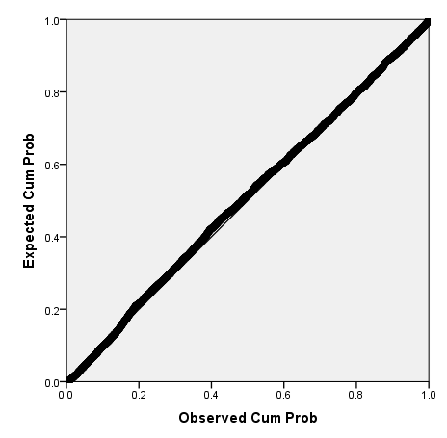
APPENDIX D
Appendix D1: ACT Model Summaries
Model | R | R Square | Adjusted R Square | Std. Error of the Estimate | Change Statistics
 |  |  |  |  | R Square Change | F Change | df1
1 | .492ª | .242 | .242 | .37282 | .242 | 589.783 | 1
2 | .551^{b} | .304 | .303 | .35733 | .062 | 164.663 | 1
3 | .568^{c} | .323 | .321 | .35266 | .018 | 50.253 | 1
4 | .579^{d} | .336 | .334 | .34934 | .013 | 36.175 | 1
5 | .593e | .351 | .349 | .34533 | .016 | 44.130 | 1
6 | .598^{f} | .358 | .355 | .34372 | .006 | 18.264 | 1
7 | .602^{g} | .363 | .360 | .34244 | .005 | 14.773 | 1
8 | .607^{h} | .368 | .365 | .34105 | .006 | 16.042 | 1
9 | .610^{i} | .373 | .369 | .33996 | .004 | 12.856 | 1
10 | .615^{j} | .379 | .375 | .33838 | .006 | 18.141 | 1
11 | .618^{k} | .381 | .378 | .33772 | .003 | 8.251 | 1
12 | .619^{l} | .383 | .379 | .33731 | .002 | 5.453 | 1

Appendix D2: ANOVA for ACT Models
Model |  | Sum of Squares | df | Mean Square | F | Sig.
1 | Regression | 81.979 | 1 | 81.979 | 589.783 | .000^{b}
1 | Residual | 256.730 | 1847 | .139
1 | Total | 338.709 | 1848
2 | Regression | 103.004 | 2 | 51.502 | 403.353 | .000^{c}
2 | Residual | 235.705 | 1846 | .128
2 | Total | 338.709 | 1848
3 | Regression | 109.254 | 3 | 36.418 | 292.828 | .000^{d}
3 | Residual | 229.455 | 1845 | .124
3 | Total | 338.709 | 1848
4 | Regression | 113.668 | 4 | 28.417 | 232.852 | .000e
4 | Residual | 225.041 | 1844 | .122
4 | Total | 338.709 | 1848
5 | Regression | 118.931 | 5 | 23.786 | 199.464 | .000^{f}
5 | Residual | 219.778 | 1843 | .119
5 | Total | 338.709 | 1848
6 | Regression | 121.089 | 6 | 20.181 | 170.821 | .000^{g}
6 | Residual | 217.620 | 1842 | .118
6 | Total | 338.709 | 1848
7 | Regression | 122.821 | 7 | 17.546 | 149.624 | .000^{h}
7 | Residual | 215.888 | 1841 | .117
7 | Total | 338.709 | 1848
8 | Regression | 124.687 | 8 | 15.586 | 133.996 | .000^{i}
8 | Residual | 214.022 | 1840 | .116
8 | Total | 338.709 | 1848
9 | Regression | 126.173 | 9 | 14.019 | 121.303 | .000^{j}
9 | Residual | 212.536 | 1839 | .116
9 | Total | 338.709 | 1848
10 | Regression | 128.250 | 10 | 12.825 | 112.004 | .000^{k}
10 | Residual | 210.459 | 1838 | .115
10 | Total | 338.709 | 1848
11 | Regression | 129.191 | 11 | 11.745 | 102.974 | .000^{l}
11 | Residual | 209.518 | 1837 | .114
11 | Total | 338.709 | 1848
12 | Regression | 129.811 | 12 | 10.818 | 95.076 | .000^{m}
12 | Residual | 208.897 | 1836 | .114
12 | Total | 338.709 | 1848

Appendix D3: ACT Final Model Coefficients
 |  | Unstandardized Coefficients |  | Standardized Coefficients | t | Sig. | 95.0% Confidence Interval for B |  | Collinearity Statistics
 |  | B | Std. Error | Beta | t | Sig. | Lower Bound | Upper Bound | Tolerance | VIF
 | (Constant) | 21.584 | 8.312 |  | 2.597 | .009 | 5.282 | 37.886
 | HighSchoolGPA | .262 | .018 | .334 | 14.603 | .000 | .227 | .298 | .643 | 1.556
 | TimeToDegree | -.063 | .005 | -.246 | -12.857 | .000 | -.072 | -.053 | .914 | 1.094
 | AfricanAmerican | -.159 | .025 | -.118 | -6.246 | .000 | -.209 | -.109 | .949 | 1.054
 | SocialSciences | -.215 | .023 | -.210 | -9.532 | .000 | -.259 | -.171 | .693 | 1.444
 | ACT | .016 | .003 | .129 | 5.903 | .000 | .010 | .021 | .701 | 1.427
 | APCredits | .007 | .001 | .102 | 4.944 | .000 | .004 | .010 | .795 | 1.258
 | Engineering | -.214 | .037 | -.114 | -5.733 | .000 | -.287 | -.141 | .856 | 1.168
 | Sciences | -.140 | .024 | -.125 | -5.789 | .000 | -.188 | -.093 | .724 | 1.382
 | Business | -.096 | .022 | -.096 | -4.370 | .000 | -.139 | -.053 | .691 | 1.447
 | Hospitality | -.217 | .049 | -.084 | -4.394 | .000 | -.313 | -.120 | .926 | 1.079
 | FinancialAid | .087 | .027 | .062 | 3.181 | .001 | .033 | .140 | .886 | 1.129
 | YearOfGraduation | -.010 | .004 | -.044 | -2.335 | .020 | -.018 | -.002 | .926 | 1.080

Appendix D4: ACT Model Normality Plot
