FLORIDA INTERNATIONAL UNIVERSITY
Miami, Florida

METHOD DEVELOPMENT FOR THE ANALYSIS OF SMOKELESS POWDERS AND ORGANIC GUNSHOT RESIDUE BY ULTRA PERFORMANCE LIQUID CHROMATOGRAPHY WITH TANDEM MASS SPECTROMETRY

A dissertation submitted in partial fulfillment of
the requirements for the degree of
DOCTOR OF PHILOSOPHY
in

CHEMISTRY
by

Jennifer L. Thomas

2013

To:

This dissertation, written by Jennifer L. Thomas, and entitled Method Development for the Analysis of Smokeless Powders and Organic Gunshot Residue by Ultra Performance Liquid Chromatography with Tandem Mass Spectrometry, having been approved in respect to style and intellectual content, is referred to you for judgment.

We have read this dissertation and recommend that it be approved.

_______________________________________
Kevin O’Shea

_______________________________________
William Hearn

_______________________________________
DeEtta Mills

_______________________________________
John Berry

_______________________________________
Bruce McCord, Major Professor

Date of Defense: November 12, 2013

The dissertation of Jennifer L. Thomas is approved.

_______________________________________

_______________________________________
Dean Lakshmi N. Reddi
University Graduate School

Florida International University, 2013

© Copyright 2013 by Jennifer L. Thomas
All rights reserved.

DEDICATION
First and foremost, I dedicate this dissertation to God, for He has made all of this possible. He has watched over me and guided my every step throughout this entire journey. Secondly, I dedicate this dissertation to my parents Donna and Lawrence Greaux, for they have raised me into the woman I am today and equipped me with the tools necessary for success. Their love, support, patience, and generosity can never be repaid. A special thank you to my sister Jacinthia Greaux-Frett for her unyielding generosity and for being a great role model. I would also like to dedicate this dissertation to my family, in-laws, friends, and loved ones who have provided words of encouragement and support throughout my academic career. As the saying goes, it takes a village to raise a child, it also takes a community of well-wishers, prayer warriors, and cheerful givers to successfully get through a PhD program. Last but not least, I dedicate this dissertation to my husband Nkosi Thomas. Even when separated by duty and miles miles of ocean, he has made my happiness, success, and wellness a priority for him.

ACKNOWLEDGMENTS
I wish to thank the members of my dissertation committee for their advice, support, and patience throughout my graduate career. Dr. William Hearn gave that real world prospective as a working toxicologist and provided samples for analysis. The gentle yet firm direction from Dr. Kevin O’Shea was needed to keep me on the path towards graduation. Dr. John Berry kindly drove between campuses to make all of my presentations and Dr. DeEtta Mills provided valuable insight so that I could meet my research goals. To my major professor Dr. Bruce McCord, thank you for your hands-on approach when it came to teaching and research. The lessons and skills learned under your advisement were helpful in shaping me into a better person and scientist.
I would also like to thank the Department of Chemistry and Biochemistry at Florida International University for providing financial support via a teaching assistantship, which helped to improve my communication and leadership skills. I wish to thank the National Institute of Justice for their research grant (2009-DN-BX-K251) that provided financial support as a research assistant. With their support and IRB approval from FIU, I was able to collaborate with the Firearm’s division of the Miami Dade Police Department, who were crucial in collecting real gunshot residue samples. Waters Corporation also awarded me a grant for purchasing research supplies and provided me with the opportunity to speak at their Forensic meeting. I would like to thank all of the organizations that also provided financial assistance so that I may attend research conferences, including FIU, NIST, and NIJ. These experiences allowed me to refine my oral and written skills and develop network connections. Lastly, thank you to my research lab group. The advice, encouragement, and friendships gained will always be cherished.
ABSTRACT OF THE DISSERTATION
METHOD DEVELOPMENT FOR THE ANALYSIS OF SMOKELESS POWDERS AND ORGANIC GUNSHOT RESIDUE BY ULTRA PERFORMANCE LIQUID CHROMATOGRAPHY WITH TANDEM MASS SPECTROMETRY
by
Jennifer L. Thomas
Florida International University, 2013
Miami, Florida
Professor Bruce McCord, Major Professor
The goal of this project was to develop a rapid separation and detection method for analyzing organic compounds in smokeless powders and then test its applicability on gunshot residue (GSR) samples. In this project, a total of 20 common smokeless powder additives and their decomposition products were separated by ultra performance liquid chromatography (UPLC) and confirmed by tandem mass spectrometry (MS/MS) using multiple reaction monitoring mode (MRM). Some of the targeted compounds included diphenylamines, centralites, nitrotoluenes, nitroglycerin, and various phthalates. The compounds were ionized in the MS source using simultaneous positive and negative electrospray ionization (ESI) with negative atmospheric pressure chemical ionization (APCI) in order to detect all compounds in a single analysis. The developed UPLC/MS/MS method was applied to commercially available smokeless powders and gunshot residue samples recovered from the hands of shooters, spent cartridges, and smokeless powder retrieved from unfired cartridges. Distinct compositions were identified for smokeless powders from different manufacturers and from separate manufacturing lots. The procedure also produced specific chemical profiles when tested on gunshot residues from different manufacturers. Overall, this thesis represents the development of a rapid and reproducible procedure capable of simultaneously detecting the widest possible range of components present in organic gunshot residue.

TABLE OF CONTENTS

CHAPTER PAGE

- Introduction 1
Overview of Firearms 3
Overview of Gunshot Residue 6
Relevance of Smokeless Powder and Gunshot Residue Analysis 15
Common Components in Smokeless Powders 20
Research Goals 21
References 23

- Instrumental Analysis of Gunshot Residue: Theory and Applications 26
Introduction 26
Sample Collection and Preparation 27
Inorganic GSR analysis 30
Organic GSR analysis 35
Summary 50
References 52

- Experimental Procedures 57
Introduction 57
Chemicals 57
Instrumentation 58
Mobile phase preparation 59
Sample preparation 60
References 62

- Analysis of Smokeless Powders by UPLC/MS/MS 63
Abstract 63
Introduction 64
Experimental 66
Results 71
Conclusions 81
References 83

- Analysis of Organic Gunshot Residue Samples 85
Introduction 85
Experimental 87
Results 92
Conclusions 138
References 139

- Discussion 140
Frame of Reference 140
Research Summary 141
Limitations of the research project 147
Recommendations 149
References 152

- APPENDICES 153

- VITA 188

LIST OF TABLES
TABLE PAGE
Table 1.1. List of characteristic organic smokeless powder constituents and their usage in smokeless powders 13

Table 4.1. Gradient method used for the separation of the GSR standards. 68

Table 4.2. MS/MS tune page conditions. 69

Table 4.3. Multiple reaction monitoring method. 72

Table 4.4. Percent composition of each organic compound present in different unburned smokeless powders 75

Table 4.5. Figures of merit for the detection of smokeless powder additives by UV. 78

Table 4.6. Figures of merit for the detection of smokeless powder additives by MS/MS. 80

Table 5.1: Gradient method used for the separation of the organic GSR samples. 88

Table 5.2: MS/MS tune page conditions. 89

Table 5.3. Types of weapons. 91

Table 5.4. Types of ammunition. 91

Table 5.5: Different extraction procedures tested for recovering organic GSR standards. 95

Table 5.6. Average UV peak areas and standard deviations (s.d.) for each extraction solvent using the cotton swabs 97

Table 5.7. Weapons and ammunition tested in firearms study. 101

Table 5.8. Average MRM peak area percentages for spent cartridge samples wiped with alcohol swabs. 119

Table 5.9. Average MRM peak area percentages for smokeless powder samples removed from each ammunition type and extracted with methylene chloride. 124

Table 5.10. MS conditions for the infusion experiments. 125

Table 5.11. MS conditions for infusion experiments of hand samples. 132
LIST OF FIGURES
FIGURES PAGE
Figure 1.1 Firearm parts: (left) revolver and (right) semi-automatic pistol 4

Figure 1.2. Examples of a rim-fire cartridge, center-fire cartridge, and primer cup (4,6,15) 7

Figure 1.3: Pipe bomb containing smokeless powder, adapted from Heramb et al 10

Figure 1.4: Decomposition pathways of diphenylamine (a) leading to the formation of the N-Nitrosodiphenylamine (b), N-NO-2-NO2-DPA (c), N-NO-4-NO2-DPA (d), 2-nitrodiphenylamine (e), 4-nitrodiphenylamine (f), and hexa-NO2-DPA (g), adapted from Laza et al 12

Figure 1.5. Common physical forms of smokeless powders, adapted from Heramb et al 14

Figure 1.6: Percentage of gun-related homicides in 2012 based on the weapon type 16

Figure 1.7: Side label of a Speer® Lawman® RHT® ammunition box showing the removal of barium, antimony, and lead from the primer. 17

Figure 1.8. Chemical structures of lead styphnate, KDNP, barium nitrate, strontium nitrate, and zinc peroxide. 18

Figure 1.9. Chemical structures of common GSR compounds and their reaction products. 20

Figure 2.1. General schematic of the solid phase extraction process. 30

Figure 2.2. Scanning electron micrograph of a GSR particle with EDX spectrum 33

Figure 2.3. Basic schematic of a liquid chromatographic system 38

Figure 2.4. General equations for calculating the retention factor, efficiency, selectivity, and resolution of peaks 40

Figure 2.5. Illustration of chromatographic separation adapted from Agilent 41

Figure 2.6. The van Deemter plot showing the effects of (A) eddy diffusion, (B) longitudinal diffusion, and (C) resistance to mass transfer on plate height (H) and linear velocity (μ), adapted from Agilent 43

Figure 2.7. General schematic of compound fragmentation by MS/MS 46

Figure 2.8. Illustration of the ESI process in the MS source and mass separation in the quadrupole 47

Figure 4.1. Chemical structures of common smokeless powder additives and residues 70

Figure 4.2. ESCi® source showing the ESI probe and corona discharge needle. 71

Figure 4.3. C18 separation of a 100 µg/mL standard GSR mixture containing 21 compounds 73

Figure 4.4. Examples of different smokeless powders 74

Figure 4.5. MRM chromatograms of smokeless powder additives identified in Brand 3 by UPLC/MS/MS. 76

Figure 5.1: Release of GSR from openings in the firearm 85

Figure 5.2. Diagram of a hand showing locations where GSR may be deposited and swabbed. 86

Figure 5.3. Diagram of the extraction process for the cotton swabs using a centrifuge 93

Figure 5.4. Extraction of 6 GSR standards using cotton swabs and acetone 94

Figure 5.5. UV chromatograms showing the difference in peak areas of samples extracted using the cotton swabs for a single and double extraction 96

Figure 5.6. UV chromatograms of three different samples: (A) isopropanol:water extraction, (B) acetonitrile extraction and (C) acetone extraction 98

Figure 5.7. Comparison of hand samples collected with cotton swabs 99

Figure 5.8. MRM chromatograms from an extracted cotton swab sample (Sample A in Figure 5.7). 100

Figure 5.9. UV chromatograms of the (A) Federal 38 special smokeless powder, (B) Federal 38 special spent cartridge, and (C) 10ppm standard GSR mixture 102

Figure 5.10. MRM chromatograms of the (A) Federal 38 special spent cartridge and (B) Federal 38 special smokeless powder confirming the presence of each compound 103

Figure 5.11. UV chromatograms of the (A) American Eagle 9mm Luger smokeless powder, (B) American Eagle 9mm Luger spent cartridge, and (C) 10ppm standard GSR mixture 105

Figure 5.12. MRM chromatograms of the (A) American Eagle 9mm Luger spent cartridge and (B) American Eagle 9mm Luger smokeless powder confirming the presence of each compound 106

Figure 5.13. Extraction process for the SEM stubs 108

Figure 5.14. Initial extraction of aluminum stubs using double extraction method by Zeichner 108

Figure 5.15. Extraction of six standards using the aluminum stubs and acetone 109

Figure 5.16. Extraction process for the tape samples 110

Figure 5.17. Comparison of hand samples collected with masking tape. 111

Figure 5.18. MRM chromatograms from extracted masking tape samples A and B in Figure 5.17. 112

Figure 5.19. Comparison of hand samples collected with masking tape 113

Figure 5.20. MRM chromatograms from extracted masking tape samples A and B in Figure 1.19. 114

Figure 5.21. UV chromatograms comparing spent cartridge cotton sample (top) to standard GSR mixture (bottom). 115

Figure 5.22. MRM chromatograms for the spent cartridge sample obtained using a cotton swab 116

Figure 5.23. UV chromatogram comparing spent cartridge polyester sample to standard GSR mixture 117

Figure 5.24. MRM chromatograms for the spent cartridge sample obtained using a polyester swab 118

Figure 5.25. Comparison of extracted smokeless powder (SP) samples 121

Figure 5.26. MRM chromatograms from an extracted SP sample using the method by Wissinger 122

Figure 5.27. MRM chromatograms from an extracted SP sample using the method by Northrop. 123

Figure 5.28. MS scan in positive ESI mode of blank (sample dilutor) and GSR standard mixure 126

Figure 5.29. MS scan in negative ESI mode of blank (sample dilutor) and GSR standard mixture. 128

Figure 5.30. MS scan in negative APCI mode of blank (sample dilutor) and GSR standard mixture 130

Figure 5.31. MS scan in positive ESI mode of GSR standard mixture. The cone voltage was set to 15 133

Figure 5.32. MS scan in negative ESI mode of GSR standard mixture 134

Figure 5.33. MS scan in negative APCI mode of GSR standard mixture 135

Figure 5.34. MS scan in positive ESI mode of a firing sample collected using tape 136

Figure 5.35. MS scan in negative ESI mode of the same firing sample collected using tape 137

LIST OF SYMBOLS

α Alpha

* Asterisk

© Copyright

° Degree

λ Lambda; Wavelength

% Percentage

® Registered Trademark

™ Trademark

† Dagger

ABBREVIATIONS AND ACRONYMS

ACN Acetonitrile
ANOVA Analysis of Variance
APCI Atmospheric Pressure Chemical Ionization
API Atmospheric Pressure Ionization
CE Capillary Electrophoresis
CRM Charged Residue Model
R² Coefficient of Determination
CI Chemical Ionization
CID Collision Induced Dissociation
DBP Dibutyl Phthalate
DEP Diethyl Phthalate
DMP Dimethyl Phthalate
2,4’-DNDPA 2,4’-Dinitrodiphenylamine
4,4’-DNDPA 4,4’-Dinitrodiphenylamine
2,3-DNT 2,3-Dinitrotoluene
2,4-DNT 2,4-Dinitrotoluene
2,6-DNT 2,6-Dinitrotoluene
3,4-DNT 3,4-Dinitrotoluene
DPA Diphenylamine
EI Electron Impact Ionization
ESI-MS Electrospray Ionization Mass Spectrometry
EC Ethyl Centralite
EG Ethylene Glycol
FBI Federal Bureau of Investigation
GC Gas Chromatography
g Gram
GSR Gunshot Residue
hr Hour
HPLC High Performance Liquid Chromatography
IED Improvised Explosive Device
IPA Isopropanol
IET Ion Evaporation Theory
kV Kilovolt
L Liter
LOD Limit of Detection
LOQ Limit of Quantitation
MS Mass Spectrometry
MS/MS Tandem Mass Spectrometry
m/z Mass-to-Charge Ratio
MeOH Methanol
MC Methyl Centralite
MEKC Micellar Electrokinetic Chromatography
μg Microgram
μL Microliter
μm Micrometer
mbar Millibar
mg Milligram
mm Millimeter
min Minute
mM Millimolar
ng Nanogram
nm Nanometer
NC Nitrocellulose
NH₄OAc Ammonium Acetate
NH₄Cl Ammonium Chloride
4-NsDPA 4-Nitrosodiphenylamine
N-NsDPA N-Nitrosodiphenylamine
2-NDPA 2-Nitrodiphenylamine
4-NDPA 4-Nitrodiphenylamine
NG Nitroglycerin
2-NT 2-Nitrotoluene
3-NT 3-Nitrotoluene
4-NT 4-Nitrotoluene
C18 Octadecylsilane
C8 Octylsilane
oGSR Organic Gunshot Residue
ppm parts per million
ppb parts per billion
psi Pounds per square inch
r Radius, Distance
RSD Relative Standard Deviation
k’ Retention Factor, Capacity Factor
t_{r} Retention Time of Solute
t_{o} Retention Time of Unretained Species
s Seconds
SPE Solid Phase Extraction
s.d. Standard Deviation
TOF Time-of-Flight
TUV Tunable Ultraviolet
μA microampere
UHPLC Ultra High-Performance Liquid Chromatography
UPLC Ultra Performance Liquid Chromatography

Chapter I. Introduction
In the past, research involving gunshot residue (GSR) has primarily focused on the analysis of the inorganic compounds present in the primer. In a typical application of the procedure, scanning electron microscopy and energy dispersive X-ray spectroscopy (SEM/EDX) are applied to the samples in order to evaluate the morphology and chemical composition of the residue particles. The presence of specific elements having the correct shape and elemental ratio in a gunshot residue sample would indicate one of three possible scenarios: the individual has recently fired a gun, the individual was in close proximity of a fired gun, or the individual came in contact with a surface containing GSR. The three main elements that firearm examiners attempt to detect include barium (Ba), antimony (Sb), and lead (Pb). With concerns being raised over the health of shooters, wildlife, and the environment, new ammunition has been introduced into the consumer market. Referred to as clean or lead-free ammunition, these ammunition types have eliminated or reduced the amount of heavy metals (e.g., lead) present in the primer and bullet. Lead, a major component in gun ammunition, is known to affect many of the physiological systems in humans and animals, including the cardiovascular, renal, reproductive and neurological systems (1,2). It is also considered a carcinogen and reproductive toxin in the state of California and by many agencies, including the United States Environmental Protection Agency (1).
With the introduction of clean ammunition, detection of gunshot residue by inorganic analytical techniques suffers because of the removal of lead and other metals used in identification. Thus, there is a need for an alternative technique to permit the determination of the presence of gunshot residue. The argument for the new technique is also strengthened by recent crime statistics from 2012, which show that the number one cause of homicides is associated with gun related incidents (3). Therefore, the major focus of this project is on the analysis and detection of smokeless powders and the residues that result from the firing of a weapon.
Smokeless powders are the propellant of choice in modern firearm ammunition, as they produce less smoke and solid reaction products when compared to black powders (4,5). When a weapon is fired, the primer and smokeless powder undergo combustion in the confinement of the ammunition cartridge, producing a large volume of gas at high temperatures (6). The buildup of pressure created by gas expansion is what forces the projectile down the spiraled barrel and out of the weapon. The smokeless powder contains a variety of additives, such as deterrents, plasticizers, and stabilizers (7). These additives contribute to the GSR deposited on the shooter’s skin and clothing and on surrounding surfaces after the firing event. Identification of these organic compounds can be valuable when trying to determine whether or not a person has fired a weapon, as they are characteristic of chemicals found in many gunpowder formulations (8). Manufacturers vary the type and percentage of each additive in the powder depending on how they would like the powder to perform. The combination of these chemicals - found on the hands of a shooter - is likely to indicate exposure to smokeless powders because they are not commonly found on hands of the general population (8). In addition, because the chemical composition of smokeless powders vary from one manufacturer to the next, results of this analysis may also be used to link a suspected shooter to a specific weapon or ammunition on the basis of the GSR profile. Characterizing powders is possible because of variations in the chemical composition between different brands and lots of smokeless powder (9-11).
The goal of my project was to develop methods for separating and identifying variations in the additive profile of different smokeless powders using ultra performance liquid chromatography (UPLC) with tandem mass spectrometry (MS/MS). By using UPLC, separations can be achieved in short analysis times due to more efficient columns and higher pressures. Confirmation of the identity of each component in the powder is then performed using mass spectrometry, which is currently the gold standard in many forensic laboratories. A variety of smokeless powders were analyzed and the chemical compositions were compared to determine differences among powders. To test the developed methods in a forensic setting, gunshot residue samples from the hands of shooters were collected and analyzed. Samples from spent casings and unfired ammunition were also examined to determine the organic composition. The resultant method provides a rapid detection method for smokeless powders and organic gunshot residue analysis.

A. Overview of Firearms
Firearms are commonly used in a variety of settings, including target shooting, hunting, military activities, law enforcement, and criminal acts (12). They range from small pistols that fit in one hand to large machine guns that are stabilized on a mount for shooting. Firearms allow individuals to discharge projectiles from a distance towards a specific target. Despite being used interchangeably with the word gun, it is important to note that there are tools that are described as guns but not firearms (e.g. nail gun). In the present paper, the term gun will only refer to a firearm.
When discussing firearms and ammunition, it is also important to know the parts and general mechanics behind them. General firearm mechanics help us understand how gunshot residue is formed, and why the particles have specific physical and chemical properties. Therefore, a brief description is given on two commonly used handguns in crimes, the semi-automatic pistol and the double-action revolver (13). Most handguns are made up of the following parts: barrel, hammer, grip, magazine (or cylinder), muzzle, sights, trigger, and trigger guard (Figure 1.1). The ammunition is loaded into the magazine or cylinder of the gun prior to shooting. The quantity and size of cartridges that it can hold will depend on a variety of factors, including the type of gun and the size of the magazine/cylinder. With the semi-automatic pistol, the first cartridge is loaded into the barrel by pulling the slide back and releasing it. After each firing, which is achieved by pulling the trigger back, a new cartridge is inserted into the barrel automatically.

Figure 1.1 Firearm parts: (left) revolver and (right) semi-automatic pistol.
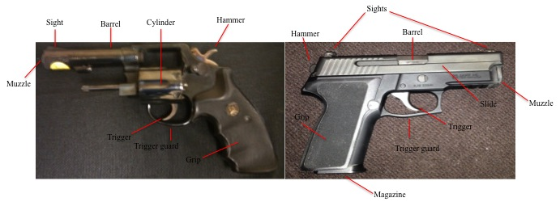
For the double-action revolver, completely depressing the trigger produces three subsequent actions: the hammer is pulled back, the cylinder rotates to the next round, and the hammer is released to fire the bullet (6). The hammer is located at the back of the barrel and its function is to strike the firing pin when the trigger is pulled. The firing pin then hits the head of the case, triggering a chain of reactions that cause the bullet to leave the gun: (1) primer ignition and (2) transfer of burning to the powder charge. The barrel is the cylindrical tube – usually metal – through which the bullet passes. Under high pressure and temperature, the projectile is forced through the barrel and out of the muzzle, which is the circular opening at the end of the barrel.

Depending on the caliber (diameter of the bore or bullet) and type of bullet (hollow point vs. frangible), damage can be inflicted on another person, animal, or object. The type of firearm used also plays a role in the amount and severity of damage. When used in crimes, recovery of the firearm can provide valuable information to law enforcement personnel. For example, the serial number of the gun can be used to identify its owner, who can then be located and questioned in the case (6). However, valuable information may also be retrieved from other pieces of evidence, including the shooter’s skin and clothing, spent casings, and unfired ammunition. The presence of gunshot residue on hands or clothing may link an individual to a crime scene.

Because spent casings and unfired ammunition may be left at crime scenes, they can also be recovered and used to tie a suspect to a crime using physical and chemical comparison methods. The cartridge casings can be inspected under a microscope and compared on the basis of insignia, writings, or other random/unique markings produced during manufacturing or through wear and tear (6, 14). There is also residue from the smokeless powder and primer present in the casings that can be extracted and the chemical profile determined. Likewise, the powder inside of the unfired ammunition can be analyzed and its profile compared to the spent casings and GSR hand profiles. Having multiple options for processing firearm evidence is important when trying to solve a crime. My project proposes methods for analyzing these different sample types.

B. Overview of Gunshot Residue
When a gun is fired, a chain of reactions occurs inside of the ammunition cartridge. The main components of the cartridge include the bullet, casing, primer, and propellant, which make it a live round (Figure 1.2). The location of the primer will depend on the type of cartridge. With rim-fire ammunition, as the name implies, the primer is embedded at the base of the cartridge in the rim cavity (6). The primer is contained in the head of the casing in center-fire ammunition (6). After depressing the trigger on a loaded weapon, the firing pin indents the primer cup located at the base (or head) of the cartridge. The primer cup is filled with shock sensitive chemicals that detonate when crushed between the shell of the cup and an anvil (4). As the primer burns, it produces a flame and hot particles that subsequently ignites the smokeless powder. The smokeless powder burns very rapidly and produces a large volume of gas. The temperature and pressure build up substantially inside of the gun. As a result of pressure, the bullet is forced down the barrel and out of the weapon.

Figure 1.2. Examples of a rim-fire cartridge, center-fire cartridge, and primer cup (4,6,15).

There is also a release of vapors and particulate from different parts of the weapon, including the muzzle, barrel/cylinder gap, and other available openings in the weapon (15). The particulates are generally deposited onto the clothing, hair, and skin of the shooter and on surrounding surfaces. These particulates are a mixture of burned, semi-burned, and unburned particles that arise from the primer, propellant, bullet, cartridge case, and firearm. However, the two major components that contribute to gunshot residue are the primer and smokeless powder. For the most part, the chemical composition of this residue will differ on the basis of ammunition used in the firearm because each manufacturer varies the chemical composition of ammunition so that it performs in a particular function.

1. Primer GSR
The inorganic constituents found in gunshot residue primarily arise from the primer, bullet, and weapon (16, Appendix A). However, the majority of these components are from the primer. The primer contains a mixture of metals that vaporize as the primer burns at high temperatures. The rapid cooling of these vaporized metals in the air form GSR particles that take on characteristic morphologies. Three types of morphologies which may be formed outside of the weapon include: regular spheroids with 1 – 10 μm round particles, nodular spheroids with small and large particles fused together, and particles containing a barium and antinomy center and a lead outer shell (15). There are other possible morphologies and surface textures that may be identified in gunshot residue; however, the bulk of GSR particles will be spheroidal in shape.
The “primer cup” is a metal cup inserted into the base of the cartridge that contains the priming composition. There are three major components in the priming composition: the initiator, oxidizer, and fuel (15). The initiator, as the name implies, produces the first explosion of heat and flame in the mixture (4). It is set off by the impact of the firing pin against the primer cup and the anvil against the priming composition. An example of an initiator is lead styphnate, a primary high explosive that is easily ignited by heat or static discharge (4). Oxygen is then added to the reaction via an oxidizer (e.g., barium nitrate). The oxygen is necessary to sustain the burning of the fuel, which is the third component in the priming composition (15). Fuel (e.g., antimony sulfide) is added to the primer because it burns very quickly and is able to ignite gunpowder (15). Because the priming composition typically contains compounds of barium, antimony, and lead, these components are used in gunshot residue identification. Other important components that may be found in the priming composition include sensitizers, frictionators, binders, coloring materials, and specific high explosives (15). Many of these components also contribute to the inorganic and organic profiles recovered from GSR.

2. Smokeless Powder GSR
The organic constituents found in gunshot residue primarily arise from the smokeless powder present in modern ammunition (16, Appendix B). The powder serves as the propellant and burns under controlled conditions to produce high amounts of pressure, which forces the projectile out of the weapon. Smokeless powders were introduced in the 19th century as a black powder replacement (7). In general, black powder contains potassium nitrate, sulfur and charcoal (4). However, there were several major drawbacks with using black powder as a propellant in firearms. After the gun is fired, a solid reaction product (approximately 55% of it’s weight) is produced that can cause weapon fouling (4). The black powder also generates a dense layer of smoke that hinders visibility and limits target accuracy (5).
Alternatively, when burned, smokeless powders produce less smoke output than black powders because the combustion products are mainly gaseous. In addition, weapon fouling is not a major concern for smokeless powders since there is less production of solid products. It is important to note though that some smoke is still produced despite being coined smokeless powders. Advancements in the manufacturing process of smokeless powders have led to more stable powders that can function under a wide range of conditions.
Smokeless powders can be divided into three main categories on the basis of the primary energetic material present. The three types include single-base, double-base, and triple-base powders (4,5). Single-base powders contain one primary energetic material, nitrocellulose (NC). Nitrocellulose is composed of guncotton (13.0 – 13.4% nitrogen content) and soluble guncotton (11 – 13% nitrogen content) and is highly flammable (17). Because it is found in many consumer products, there is not much evidentiary value in detecting NC in gunshot residue samples. Double-base powders contain nitrocellulose and nitroglycerin (NG) and are often used in pistol and shotgun ammunition (18). Nitroglycerin can also be found in explosives and pharmaceutical products; therefore, detection of NG alone has limited evidentiary value. Both single- and double-base powders can be used to make improvised explosive devices (5). One example of an improvised explosive device (IED) is a pipe bomb, shown in Figure 1.3.

Figure 1.3: Pipe bomb containing smokeless powder, adapted from Heramb et al. (7).

With IED’s, the powder is packed into a pipe and the pipe is then sealed with two end caps. The types of materials used to construct the pipe bomb may vary greatly and include glass, steel, brass, and even plastic (7). A fuse is then inserted into the pipe through a hole in end cap or in the side. The pipe bomb explodes because of the pressure buildup inside of the pipe and failure of the outer casing to contain this pressure. In triple-base powders, nitroguanidine is added to the nitrocellulose and nitroglycerine because it reduces muzzles flash and barrel temperatures. These propellants are mainly used in large caliber ammunition for military purposes (5).
In addition to the energetic material that facilitates combustion of the powder, manufacturers of smokeless powders add a number of auxiliary chemicals to the powder to optimize production and performance of the powder. Some of these additives include deterrents, flash suppressants, stabilizers, opacifiers, plasticizers, and dyes (5,7). Deterrents such as dibutyl phthalate are used to modify the burn rate of the powder, widen the pressure peak, and increase efficiency (7). The deterrent is added to the surface of the granule via a coating. The flash suppressants – as the name implies – are generally alkali or alkaline earth salts that reduce the muzzle flash by interrupting the free-radical chain reactions in the released gases post-firing (7). Flash suppressants can be found within the powder, as separate particles, or as a coating (7). During the manufacturing process, plasticizers are added to reduce the amount of volatile solvents needed during production of the powder and to extend the shelf life of the propellant (7). One essential component found in smokeless powders is the stabilizer. Stabilizers help to slow down the decomposition of the nitrocellulose and nitroglycerin in the powder by scavenging the nitrous and nitric acids present that increase decomposition. The production of acids by nitrocellulose decomposition is a continuous process unless the acids are removed (19, Appendix C).
Like the plasticizers, the stabilizers help to increase the shelf life of the powder. Diphenylamine is one common type of stabilizer that is soluble in alcohol and acids. When the smokeless powder is ignited, diphenylamine can undergo different decomposition pathways, yielding several nitro- and nitroso- reaction products. Some of these decomposition pathways have been described by Laza et al. in Figure 1.4 (20).

Figure 1.4: Decomposition pathways of diphenylamine (a) leading to the formation of the N-Nitrosodiphenylamine (b), N-NO-2-NO2-DPA (c), N-NO-4-NO2-DPA (d), 2-nitrodiphenylamine (e), 4-nitrodiphenylamine (f), and hexa-NO2-DPA (g), adapted from Laza et al. (20).
Ethyl centralite is another type of stabilizer found in smokeless powders, but it also acts as a plasticizer. Other components that may be added to the smokeless powder include graphite glazes, erosion coatings, and ignition aid coatings (7). Because each powder can contain a different mixture of organic compounds, it is possible to use the presence or absence of certain chemicals as an identifier. The decomposition products can also be used to distinguish between powders. A summary of common smokeless powder components and their purpose are given in Table 1.1.

Table 1.1. List of characteristic organic smokeless powder constituents and their usage in smokeless powders (7,8).
Compound | Abbreviation | Application
Diphenylamine | DPA | Stabilizer
N-Nitrosodiphenylamine | N-NsDPA | Stabilizer, By-product
4-Nitrosodiphenylamine | 4-NsDPA | Stabilizer, By-product
2-Nitrodiphenylamine | 2-NDPA | Stabilizer reaction product
4-Nitrodiphenylamine | 4-NDPA | Stabilizer reaction product
2,4’-Dinitrodiphenylamine | 2,4’-DNDPA | Stabilizer reaction product
4,4’-Dinitrodiphenylamine | 4,4’-DNDPA | Stabilizer reaction product
Dibutyl phthalate | DBP | Plasticizer, Deterrent
Diethyl phthalate | DEP | Plasticizer
Dimethyl phthalate | DMP | Plasticizer
Ethyl centralite | EC | Stabilizer, Deterrent, Plasticizer
Methyl centralite | MC | Stabilizer, Deterrent
Nitroglycerin | NG | Energetic, Plasticizer
2-Nitrotoluene | 2-NT | Product
3-Nitrotoluene | 3-NT | Product
4-Nitrotoluene | 4-NT | Product
2,3-Dinitrotoluene | 2,3-DNT | By-product
2,4-Dinitrotoluene | 2,4-DNT | Flash inhibitor
2,6-Dinitrotoluene | 2,6-DNT | Flash inhibitor
3,4-Dinitrotoluene | 3,4-DNT | By-product

The chemical composition is one of the most defining characteristics of a smokeless powder. However, smokeless powders can also be differentiated by their shape and application. Manufacturers vary the size and shape of the powder grains to produce specific ballistic properties (4). The shape of the powder can also be varied during the manufacturing process. As a result, propellants can have a wide range of morphologies including perforated long tubes, multi-perforated tubes, strips, cubes, ring powder, perforated short tubes, flakes, balls, and rods (4,5,7,21,22). Examples are given in Figure 1.5. Powders can also be grouped together on the basis of performance properties such as burn rate or application. Different burn rates are necessary depending on the application and intended use of the smokeless powder. For examples, there are specific powders designed for handguns, rifles, and shotguns; however, there can also be overlap in the choice of powders for each application.

Figure 1.5. Common physical forms of smokeless powders, adapted from Heramb et al. (7).

3. Scientific Working Group on Gunshot Residue
The Scientific Working Group on Gunshot Residue (SWGGSR) has published, “ASTM 1588 Standard Guide for Gunshot Residue Analysis,” which serves as a guide for examiners when processing primer or inorganic GSR evidence (23). It highlights the use of scanning electron microscopy with energy dispersive x-ray spectrometry (SEM/EDX) for GSR analysis via automated and manual methods. The guide also provides recommendations for reporting results and giving testimony or training on the matter. However, while extensive files are available on the compositional differences between smokeless powders, there are currently no analytical recommendations for the analysis and interpretation of GSR arising from these propellant powders. It is clear that organic GSR component can provide investigators with an alternative for linking a suspect to a weapon, ammunition, or crime scene (16). This procedure can be used as an alternative to inorganic analysis and in situations when hand samples are negative for inorganic GSR. Clearly, more research is needed on the methods for the detection and application of organic GSR in forensic casework.

C. Relevance of Smokeless Powder and Gunshot Residue Analysis
According to the expanded homicide table, in 2012, 69% of murders in the United States involved firearms (3). Of these murders, 72% involved handguns (Figure 1.6). Firearms have also played a significant role in robberies in the U.S. It was found that handguns were used in about 41% of cases, which is approximately the same percentage of cases in which strong arm was used. Florida has been ranked third out of all states in the number of robberies involving firearms (3). Knowing these facts, it is easy to see the importance of developing improved methods for processing evidence in firearm cases.

Figure 1.6: Percentage of gun-related homicides in 2012 based on the weapon type (3).

The importance of developing alternative methods for analyzing smokeless powders and organic gunshot residue is further augmented by the introduction of lead- and heavy metal-free ammunition for firearms. In recent years, concerns have been raised over the health and environmental impact of heavy metals released when a weapon is fired (1,24,25). Airborne pollution of heavy metals are a big concern for avid shooters and employees at indoor and outdoor ranges used for firing, but also for law enforcement personnel and the military that are constantly exposed to firearms (24,25). Lead can accumulate in our bodies and cause damage to different physiological systems, including the heart, nerves, and kidneys (1). Lead poisoning also poses a significant threat for both humans and wildlife. Consuming wildlife targeted with lead containing ammunition makes the meat less safe to consume for both the human and other preying wildlife (1).
In an attempt to reduce these hazards, heavy-metal free primers have been introduced into the market (6, Figure 1.7). “Clean” or “green” ammunition are two of the terms often given to ammunition containing heavy-metal free primers. The heavy metals are generally found in the primer mixture and bullet. In the primer mixture, 2,4,6-trinitroresorcinate (lead styphnate) has been replaced with potassium 5,7-dinitro-[2,1,3]-benzooxadiazol-4-olate 3-oxide, which is abbreviated as KDNP (26). The KDNP (Figure 1.8) is a primary explosive that exhibits high thermal stability and good safe handling characteristics (26). Barium nitrate has also been replaced with zinc peroxide or strontium nitrate in many lead-free ammunition formulations (6). To further reduce the levels of heavy metals released when firing, the bullets have also been encapsulated with copper or other less toxic metals jacket (27). However, this only reduces an individual’s lead exposure at the time of firing. Once the bullet hits the target and fragments, lead is then released into the air and can be harmful to humans.

Figure 1.7: Side label of a Speer® Lawman® RHT® ammunition box showing the removal of barium, antimony, and lead from the primer.
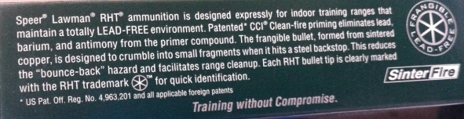

Figure 1.8. Chemical structures of lead styphnate, KDNP, barium nitrate, strontium nitrate, and zinc peroxide.

The Occupational Safety and Health Administration (OSHA) has set the permissible exposure limit to 50 μg/m³/h for lead (28). As more manufacturers switch to cleaner ammunition to reduce exposure to lead and other toxic metals, current techniques that identify inorganic metals present in the gunshot residue will become less reliable. An analyst may then deem a sample negative for GSR when in fact there may be residue present. SEM/EDX, the current method for inorganic GSR analysis, can also be a time-consuming process, which limits its efficacy in a crime lab.
Organic GSR analysis is a complimentary technique that could supplement or replace standard inorganic methods. An organic profile can be determined from the analysis of burned, partially burned, and unburned smokeless powder residue using liquid chromatography. This technique permits the sample to be separated into its individual components and then detected by their UV spectra and/or mass spectrums. Mass spectrometry provides structural information that can be used to confirm the identity of each component in the sample.
There are many advantages to focusing on the organic composition of GSR. The quantity of primer is much less than that of the propellant powder used in handgun ammunition. Consequently, it may be easier to focus on the components that make up the bulk of the residue – the gunpowder. In addition, organic GSR can be collected from multiple locations in order to obtain and compare chemical profiles. These include the shooter’s hands, the inside of spent cartridges, and the smokeless powder recovered from unfired ammunition. Comparing the composition of organic GSR to data from the spent cartridges and unfired rounds can provide investigators with additional evidence for solving a crime and linking a suspect to a specific crime scene.
My research also has relevance to the analysis of explosives. As mentioned previously, pipe bombs are often made with smokeless powders and utilized as improvised explosive devices. When detonated, powder residue gets deposited on nearby surfaces. The residue also remains on remaining fragments of the pipe bomb. Pipe bomb residue can be sampled to determine the chemical composition of the powder, providing important evidence that can be used to help determine the type and manufacturer of the powder.

D. Common Components in Smokeless Powders

A wide variety of chemical components may be found in gunshot residue, including reaction products formed after thermal decomposition (5,8,19). For my research, a total of 20 organic compounds were prepared (Table 1.1) for utilization as an external standard. While a specific powder may only contain a subset of these materials, the standard provides a useful set of potential compounds present. Manufacturing byproducts such as nitrotoluenes were also included. The chemical structures of these compounds are shown in Figure 1.9.

Figure 1.9. Chemical structures of common GSR compounds and their reaction products.

E. Research Goals
The overall goal of the current research project was to develop a rapid separation and detection method for the wide range of organic compounds that may be present in single and double base smokeless powders (SP) and gunshot residue samples using ultra performance liquid chromatography with tandem mass spectrometry. In order to achieve the overall goal, the project was divided into five component studies:

- Develop a UPLC/MS/MS method for analyzing common smokeless powder additives and their decomposition products.
- Apply the developed UPLC/MS/MS method to the analysis of commercially available smokeless powders in order to determine compositional profiles.
- Develop an extraction method for recovering organic GSR from the hands of shooters.
- Analyze live-fire residue samples from the hands of shooters using the developed UPLC/MS/MS method.

The first objective of my study was to develop a separation and detection method for analyzing smokeless powder additives. The objective was accomplished by using chemical standards of known smokeless powder components and their decomposition products. The UPLC separation was optimized by varying the column type, column temperature, flow rate, separation gradient, and mobile phase composition. Different columns were tested for their ability to separate the wide array of components present in single and double-base powders. For the mass spectrometer, the ionization mode, source temperatures, and gas flows were adjusted to improve detection. Next, different commercially available smokeless powders were analyzed by the optimized method. Each powder is made up of a variety of compounds that may differ between manufacturers and manufacturing lots. A small population study was conducted in order to identify compositional differences among powders. Extraction methods were also developed for recovering organic GSR from the hands of shooters. Different collection devices were tested as sampling media for the shooter’s hands, including masking tape, aluminum stubs, cotton swabs, and alcohol swabs. To test the practical application of the developed methods, live-fire residue samples were collected from the hands of shooters after firing, extracted, and analyzed by UPLC/MS/MS.

References
1. Bellinger DC, Bradman A, Burger J, Cade TJ et al. Health risks from lead-based ammunition in the environment – A consensus statement of scientists. UC Santa Cruz: Microbiology and Envirnomental Toxicology 2013. Retrieved from http://escholarship.org/uc/item/6dq3h64x.

2. Bellinger, DC, Burger, J, Cade TJ, Cory-Slechta DA et al. Health risks from lead-based ammunition in the environment. Environ Health Perspect 2013;121(6):A178-179.

3. United States Department of Justice, Federal Bureau of Investigation. Crime in the United States, 2012. Clarksburg: Publisher, 2013. Retrieved from http://www.fbi.gov/about-us/cjis/ucr/crime-in-the-u.s/2012/crime-in-the-u.s.-2012.

4. Davis TL. The chemistry of powder and explosives. Las Vegas: Angriff Press, 1943.

5. Beveridge A, ed. Forensic investigation of explosions. London: Taylor & Francis Inc., 1998.

6. Warlow T. Firearms, the law, and forensic ballistics. 2nd ed. Boca Raton: CRC Press, 2005.

7. Heramb RM, McCord BR. The manufacture of smokeless powders and their forensic analysis: a brief overview. Forensic Sci Commun 2002;4:1–7.

8. Northrop DM. Gunshot residue analysis by micellar electrokinetic capillary electrophoresis: assessment for application to casework. Part 1. J Forensic Sci 2001;46(3):549–59.

9. Mach MH, Pallos A, Jones PF. Feasibility of gunshot residue detection via its organic constituents. Part 1: analysis of smokeless powders by combined gas chromatography-chemical ionization mass spectrometry. J Forensic Sci 1978;23(3):433–45.

10. Martz RM, Lasswell LD. Identification of smokeless powders and their residues by capillary column gas chromatography/mass spectrometry. Proceedings of the International Symposium on the Analysis and Detection of Explosives; 1983 Mar 29–31; Quantico, VA: FBI Academy, 1983;245–54.

11. Mathis JA, McCord BR. Gradient reversed-phase liquid chromatography electrospray mass spectrometric method for the comparison of smokeless powders. J Chromatogr A 2003;988:107–16.

12. Cukier W, Sidel VW. The global gun epidemic: from Saturday night specials to AK-47s. Wesport: Greenwood Publishing Group, 2006.

13. Washington, ES. America’s most wanted guns. Time Magazine 2002 July 12.

14. Mozayani A, Noziglia C. The forensic laboratory handbook procedures and practice. Totowa: Humana Press, 2006.

15. Schwoeble AJ, Exline DL. Current methods in forensic gunshot residue analysis. Boca Raton: CRC Press, 2000.

16. Dalby O, Butler D, Birkett JW. Analysis of gunshot residue and associated materials—a review. J Forensic Sci 2010;55(4):924–43.

17. Meyer R. Explosives. 3rd revised and extended ed. Weinheim: VCH, 1987.

18. Mathis J. Development of chromatography and mass spectrometry methods for explosives analysis [dissertation]. Athens (OH): Ohio University, 2004.

19. Espinoza EO, Thornton JI. Characterization of smokeless gunpowder by means of diphenylamine stabilizer and its nitrated derivatives. Anal Chim Acta 1994;288:57–69.

20. Laza D, Nys B, Kinder JD, Kirsch D, Mesmaeker A, Moucheron C. Development of a quantitative LC-MS/MS method for the analysis of common propellant powder stabilizers in gunshot residue. J Forensic Sci 2007;52:842–50.

21. Bureau of Alcohol, Tobacco and Firearms. Arson and explosives incidents report. Washington (DC): Department of the Treasury; 1994 Report No.: ATF P3320.4.

22. Selavka CM, Strobel RA, Tontarski RE. Systematic identification of smokeless powders, an update. Proceedings of the Third Symposium on the Analysis and Detection of Explosives; 1989; Berghausen. Berghausen.:Fraunhofer Institute fur Chemische Technologie, 1989.

23. Scientific Working Group for Gunshot Residue. Guide for primer gunshot residue analysis by scanning electron microscopy/energy dispersive X-ray spectrometry 11-29-11. Cincinatti: National Institute of Justice, 2011.

24. Kardous CA, Afanuh S. Reducing exposure to lead and noise at indoor firing ranges. Cincinnati (OH): Centers for Disease Control and Prevention, National Institute for Occupational Safety and Health; 2010 Jan. Publication No.: 2010-113.

25. Kardous CA, Afanuh S. Reducing exposure to lead and noise at outdoor firing ranges. Cincinnati (OH): Centers for Disease Control and Prevention, National Institute for Occupational Safety and Health; 2012 Nov. Publication No.: 2013-104.

26. Fronabarger, JW, Williams, MD, Sanborn, WB, Parrish, DA and Bichay M. (2011), KDNP – A Lead Free Replacement for Lead Styphnate. Propellants, Explosives, Pyrotechnics, 36: 459–470. doi: 10.1002/prep.201100055

27. Martiny A, Campos APC, Sader MS, Pinto MAL. SEM/EDS analysis and characterization of gunshot residues from Brazilian lead-free ammunition. Forensic Sci Int 2008;177:e9-e17.

28.https://www.osha.gov/pls/oshaweb/owadisp.show_document?p_table=standards&p_id=10030

Chapter II. Instrumental Analysis of Gunshot Residue: Theory and Applications

A. Introduction
Over the years, a variety of techniques have been applied to the analysis of smokeless powders and gunshot residue (1-3). For smokeless powder analysis, several chromatographic and spectrometric techniques have been utilized, including Gas Chromatography (GC) (4-7), Micellar Electrokinetic Chromatography (MEKC) (8-11), High Performance Liquid Chromatography (HPLC) (12-15), and Mass Spectrometry (MS) (13,15,16). The powder additives and reaction products are extracted from the sample and separated into individual bands to confirm their presence in the powder. Some of the techniques used for inorganic GSR analysis include color tests, spectrometry, spectroscopy, and microscopy. The major focus of these inorganic methods has been on the detection of barium, antimony, lead, and other metals present in the primer residue. The current method for inorganic GSR analysis is scanning electron microscopy with energy dispersive X-ray spectrometry (SEM/EDX) (17). Using SEM/EDX, GSR particles are located in the sample and the elemental profile is then acquired for each one. As health, safety, and environmental concerns have led manufacturers to remove heavy metals from ammunition, these inorganic techniques have become ineffective.
An alternative to inorganic analysis methods is to examine the composition of the smokeless powder present in the GSR – the organic GSR. Individual brands of smokeless powders contain characteristic chemical additive packages that influence stability and burn rate. These additive packages can vary depending on the intended use of the powder. As a result, the components of the powder can provide a link from a shooter (GSR on hands) to a type of ammunition. By looking at the powder residue, it is also possible to compare other types of physical evidence that may be recovered from the crime scene, including spent cartridges and smokeless powder pulled from unfired ammunition.
In modern firearm ammunition, the ammunition cartridge will contain both primer and smokeless powder. The primer cup contains primer composition that combust when struck by the firing pin. Some of these chemicals include barium nitrate, antimony sulfide, and lead styphnate. The impact of the firing pin sets off the lead styphnate and the combustion is then fueled by antimony sulfide and barium nitrate, which provides a source of oxygen (17). The hot particles travel towards the smokeless powder and ignite it. The combustion of the powder produces an increase in temperature and pressure inside of the weapon that forces the projectile out of the weapon. Vapors and particulates released during this process get deposited on the shooter’s skin and clothing and on nearby surfaces. These particles are generally referred to as gunshot residue, which is composed of both primer and propellant powder residue. Other materials that are considered part of GSR include smoke, grease, lubricants, and metals from the bullet, cartridge, and weapon (1).

B. Sample Collection and Preparation
Sampling techniques that have been used for collecting gunshot residue include tape lifts, vacuum lifts, swabbings, glue lifts, nasal collections, and hair collections (1,2). Tape lifts can be used for the collection of both inorganic (17) and organic (9) residues. One common application is in SEM analysis, where the tape is mounted on aluminum stubs and pressed against the target surface to retrieve GSR. On the other hand, swabs are most commonly used for collecting the organic compounds in GSR, mainly those from the propellant. The type of swab, swab solvent, extraction solvent, sample clean-up procedure, and extraction process have all been evaluated for optimizing recovery of the organics. However, there are mixed reviews on what is the best method for sample collection and pretreatment. Each step is discussed briefly in order to give an overview of what has been performed in the field. The collection method applied will mainly depend on the substrate surface, available instrumentation, and handler preferences. Common surfaces include skin, clothing, and vehicles; however, sampling areas in the vicinity of the shooting are all possible targets for GSR and may be tested. It is important though to select a method that ensures maximum recovery of the gunshot residue components.
One of the first considerations to be made in the recovery of gunshot residue is the type of material used for collection. Examples include alcohol swabs, cotton balls, synthetic wool, filter paper, a piece of cloth, filter cloth, and acrilan fiber (2). Before sampling the surface for residue, the material is usually moistened with a solvent, such as acetone or water, to enhance retrieval. The choice of swabbing solvent is important for adequate transfer of the residue from the target surface to the collection device. Once the sample is collected, the organic and/or inorganic compounds are usually removed from the material using solvent. When selecting the extraction solvent, it is also important to consider what will provide maximum removal of relevant GSR compounds from the swabbing material and minimum removal of matrix interferences (e.g. oils). Some of the solvents that have been used for organic explosives and GSR recovery include acetone (18-20), acetonitrile (21), ethanol (22), methanol (11), methylene chloride (12,13,15,23) and water (19). Thompson et al. showed that by using water as the extraction solvent, there are fewer issues with matrix interferences when compared to acetone (19). DeTaTa et al. recently showed that acetonitrile, with the use of physical agitation, is excellent at extracting organic residues (21). In this article, the author also compares different swabbing materials and determined that high recoveries were possible with both cotton balls and alcohol swabs.
For sample cleanup and pretreatment, one method that has been used on organic explosives (21) and GSR samples (2) is solid phase extraction (SPE). With SPE, matrix components and interferences are separated from the compounds of interest using different sorbents and solvents. The general process of solid phase extraction is highlighted in Figure 2.1. The SPE column contains a chromatographic bed of solid particles that physically and chemically separate components in a mixture. The extraction process begins by conditioning the column with solvent to wet the bonded phase. The sample solution is next loaded into the SPE column and the undesired compounds (e.g. matrix interferences) are separated from the target compounds by flushing the column with different types and strengths of solvents. SPE allows an individual to simplify complex samples, remove or reduce matrix effects, concentrate samples, and fractionate the matrix; however, it can be a time consuming process (24). Other pretreatment methods that have been used in the past involve thin layer chromatography (25), headspace extraction (26), solid phase microextraction (27), microfilters (28), microcolumns (2, 29-33).

Figure 2.1. General schematic of the solid phase extraction process.

C. Inorganic GSR analysis
1. Overview
In the early days of inorganic GSR analysis, color tests were used to detect nitrates and nitrites in the residue using an acidified solution of diphenylamine (2). As research evolved, more specific methods were developed and applied to GSR samples. Some of these methods include Neutron Activation Analysis (NAA), Inductively Coupled Plasma-Mass Spectrometry (ICP-MS), and Atomic Absorption Spectroscopy (1,2). NAA, ICP, and AAS are bulk analysis techniques that determine the elemental composition of the entire residue, including the amount of barium, antimony, and lead present. The total content includes environmental and occupational exposure to these elements and therefore limits their usefulness. Specificity is gained by using scanning electron microscopy with energy dispersive X-ray dispersive spectroscopy because individual particles can be characterized based on their morphology and elemental composition.

2. Color Tests
Color/spot tests have been used as screening methods for gunshot residue and a few are discussed below. A list of other tests can be found in a review article by Dalby et al. (1). One of the earliest detection methods for analyzing GSR was the “dermal nitrate test,” also known as the paraffin test (2). Nitrates and nitrites in GSR reacted with an acidic solution of diphenylamine to produce a color reaction. Because of its susceptibility to false negatives and false positives, the paraffin test has been abandoned. Another color test frequently used by forensic laboratories is the modified Griess reagent. Nitrites from burnt smokeless powder react with alpha-naphthol and sulfanilic acid to produce a bright orange color (34). Gunshot residue deposited on different targets, including humans, can be evaluated for determining the distance between the shooter and target and identifying bullet holes. This is because GSR disperses as the distance between the muzzle and target increases. Specific distributions of residue are produced depending on the distance from the shooter. The major disadvantages of the color/spot tests for gunshot residue are that they are presumptive and positive results must be confirmed by more specific tests.

3. Bulk analysis techniques
Bulk techniques for the analysis of inorganic GSR determine the presence of lead, barium, and antimony in the total sample. With neutron activation analysis, the total barium and antimony content is determined by irradiating the sample with neutron bombardment and monitoring the release of X-rays as the radioisotopes de-excite (17). Copper and trace elements are also analyzed; however, this technique suffers from being expensive and time consuming (17). The usefulness of atomic absorption spectrometry has also been criticized because of extraction problems (35) and large number of false negatives (36). AAS is a bulk technique in which the overall metal concentration is determined by the absorption of light by free atoms. Inductively coupled plasma sources can also be used for determining the total barium, antimony, and lead content in primer residues. One major disadvantage of these bulk analysis techniques is that the identification of barium, antimony, and lead in a sample is non-specific. The acquired profile does not confirm whether the elements detected are independently produced or are associated as some chemical compound (17). Therefore, the results are only suggestive of the presence of GSR.

4. Particle analysis

The current standard in analytical laboratories for gunshot residue analysis is scanning electron microscopy with energy dispersive X-ray spectroscopy (SEM/EDX) (17). Unlike the bulk techniques, SEM/EDX offers specificity, as analyses are performed on individual particles. The specificity of SEM/EX analyses helps to rule out environmental and occupational sources of GSR-like particles. The GSR samples are typically collected using an aluminum stub mounted with carbon adhesive tape. The stub is pressed against the desired surface (e.g. hands), placed under the microscope, and screened for potential GSR particles using the scanning electron microscope and automated software. The microscope works by bombarding the GSR sample with a focused beam of electrons that interacts with atoms in the sample that subsequently produces an image of the particle (17). GSR particles can usually be distinguished from extraneous materials on the basis of morphology and particle population. Spheroid particles with a lead-barium-antimony composition are considered characteristic of GSR (Figure 2.22)(37).

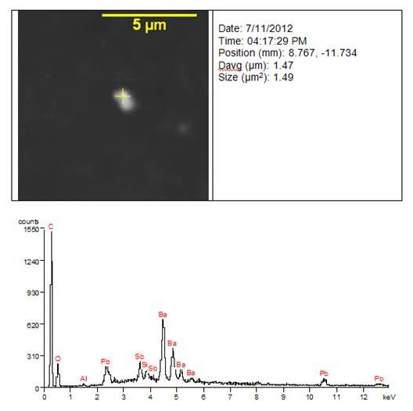
Figure 2.2. Scanning electron micrograph of a GSR particle with EDX spectrum (38).

Typically, an automated system scans a surface for the presence of particulates that may be associated with gunshot residue. Any suspect particles detected by the software are then be relocated by the examiner and the elemental spectrum is acquired using energy dispersive X-ray spectroscopy. X-rays or charged particles such as electrons or protons are beamed onto the relevant particles and electrons in the ground state get ejected from the shell. As electrons from higher energy states move to fill the holes created by the ejections, energy may be released in the form of X-rays, which can be measured (energy and wavelength) to determine the elemental composition (17). Two main advantages of using SEM/EDX for GSR analysis are that the technique is non-destructive and minimal sample preparation is required. However, there are some drawbacks of this technique. The process of scanning the stub and locating potential GSR particles can take hours for a single stub and is biased by human error. Determining the amount of particles and areas of the stub to evaluate is also a challenge. Lastly, with the removal of lead and other heavy metals from ammunition, identifying characteristic GSR particles becomes more difficult.

5. Classification of Inorganic GSR
According to Scientific Working Group for Gunshot Residue (SWGGSR), individual particles can be classified in three ways: characteristic of, consistent with, or commonly associated with GSR (37). A brief description of each category is summarized here. “Characteristic of” can be used to describe ammunition with “Sinoxid-type” formulations, ammunition with calcium silicide primers and tin foil in the primer, and tagged ammunition. “Sinoxid” formulations contain lead styphnate, tetracene, barium nitrate, lead dioxide, calcium silicide, antimony trisulfide, and powdered glass (Warlow). Characteristic GSR particles with Sinoxid-type primers must contain barium, antimony, and lead. Other major, minor, and rare elements may be found in these characteristic particles. Certain ammunition manufacturers remove antimony and instead use calcium silicide, barium nitrate, and lead styphnate. Tin foil is also added to seal the primer in its cup. Characteristic particles will include lead, barium, calcium, silicon, and tin. Lastly, particles in tagged ammunition are deemed characteristic of GSR if they contain gadolinium, titanium, and zinc (RUAG Ammotec AG ammunition) or gallium, copper, and tin (MEN GmbH ammunition). Particles that are consistent with or commonly associated with GSR may not contain all three elements (barium, antimony, and lead) that are considered components of GSR. Only one or two of these elements may be present along with other elements. It is important to mention that there are non-firearm sources that may have elemental compositions similar to GSR. Some of these include nail guns, air bag devices, fireworks, and brake pads (37). In some cases, the particles from these devices can be distinguished from firearm residue based on the morphology and the presence of rare or additional elements (37).

D. Organic GSR analysis
1. Overview
Considering the disadvantages of analyzing inorganic GSR, it is advantageous to find alternative ways of processing GSR evidence. One possibility is to identify the organic components present in the residue. The bulk of the organic content arises from the smokeless powder propellant. The propellant is the material used to generate propulsion of the bullet, typically smokeless powder in modern ammunition. Because of the wide array of compounds found in these powders, various forms of chromatography have been the method of choice for separating the organic compounds present in the powder. As a result, this section will mainly focus on chromatographic techniques. For detection and confirmation of the propellant components, separation systems are traditionally coupled to a mass spectrometer. The spectrum of each compound is obtained by MS and compared to known standards for identification. When the compound is unknown, fragmentation of the molecule is performed to determine its structure.

2. Capillary Electrophoresis Methods
A variety of techniques have been applied to the analysis of organic GSR and propellant powders. Some of these include capillary electrophoresis (CE), micellar electrokinetic chromatography (MEKC), gas chromatography, and liquid chromatography (1,2). Capillary electrophoresis relies on the separation of compounds inside of a capillary based on their charge and size. Micellar electrokinetic chromatography is a modified CE technique that involves the addition of micelles to the buffer for enhanced separation of neutral and charged species. Northrop (11) reported detection limits in the range of 0.9-3.8 picograms for standard solutions of 13 organic GSR compounds using MEKC. The MEKC technique produces high-resolution separations with very small amounts of sample and buffer for analysis but confirmation by MS is limited by the addition of surfactants in the buffer (39). The surfactants can clog the MS source and decrease the ionization of the analytes. Capillary electrochromatography (CEC) is an alternative procedure that can be applied to the analysis of commercially available smokeless powders (40); however, currently available commercial columns can be expensive and difficult to maintain.

3. Chromatography
Two chromatographic techniques that have been applied to smokeless powders and organic gunshot residue include gas chromatography and liquid chromatography. In gas chromatography, a carrier gas – typically helium – is used to transport a sample through a column (41). This column is coated with a stationary phase and placed inside of an oven. The analyte moves between the stationary phase and the mobile gas phase and gets separated into its individual components based on their affinities to each phase. The GC system utilizes high temperatures for injection of the sample and separation and as a result, thermally sensitive samples such as nitroglycerin may decompose during analysis. Limits of detection were reported by Zeichner (7) in the nanogram range for NG, 2,4-DNT, and 2,6-DNT using GC with thermal energy analysis (TEA) and ion mobility spectrometry (IMS), but NG was detected as two peaks as a result of thermal decomposition. It has also been reported in various studies that high GC temperatures can cause denitrosation of nitrosodiphenylamines; and as a result, DPA and nitrated DPA may be detected instead (2,6,42).
An alternative to GC is liquid chromatography, which has also been applied to the separation of a number of compounds, including drugs (43), pesticides (44), explosives (45), and smokeless powders (12-15). It is especially useful for compounds that are thermally labile or have difficulty transitioning into the gas phase. Mathis and McCord (13) reported an HPLC method with electrospray ionization mass spectrometry (ESIMS) for the analysis of different smokeless powders using a linear gradient of 50-95% methanol in 25 minutes.
In 2007, Laza et al. (16) published a UPLC/MS/MS method for the analysis of common propellant stabilizers in gunshot residue, including akardite II, ethyl centralite, diphenylamine, methyl centralite, N-nitrosodiphenylamine, 2-nitrodiphenylamine, and 4-nitrodiphenylamine. Limits of detection for hand samples ranged from 5 to 115 μg injected for five powder stabilizers detected after the firing of a 9mm weapon. However, the published method focused on the stabilizers present in the propellant and only monitored one MS/MS transition for confirmation of each component. Important components such as NG and DNT were not analyzed/detected. It is important in forensic investigations to monitor more than one transition in order to accurately identify each smokeless powder compound.

Figure 2.3. Basic schematic of a liquid chromatographic system.
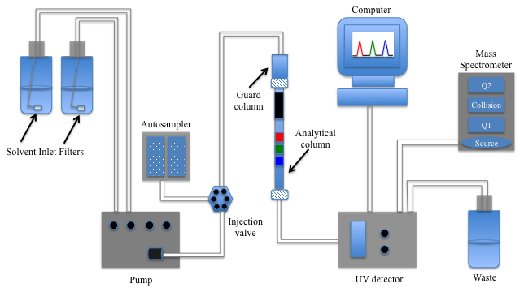

A basic schematic of a liquid chromatographic system is given in Figure 2.3. There are five main parts to the instrument: the pump, sample manager, column, mobile phase, and detector (46). The mobile phase serves different purposes. The analytes are pushed through the column towards the detector with the aid of the mobile phase. Separation is achieved through the interaction of the analytes with the mobile phase and column. Analytes with higher affinities to the mobile phase will tend to stay in the mobile phase longer and elute – or exit the column – at the beginning of the run. Those with a higher affinity to the column will be retained and elute later on in the run. The packing material of the column has a major role to play in the separation. Different particle materials can be packed inside of the analytical column to achieve specific separations. Two types of columns commonly used in liquid chromatography are reversed-phase and normal phase columns (41). Reversed phase columns contain a hydrophobic (or non-polar) stationary phase, such as an octylsilane (C8) or octadecylsilane (C18) carbon chain bonded to silica beads. A mixture of water and organic solvent is typically used for the mobile phase with reverse phase columns. On the other hand, in normal phase columns, the stationary phase is polar and contains silica sometimes modified with cyano or amino moieties. Hexane or another non-polar solvent may be used with normal phase columns. Normal phase columns while compatible with smokeless powder analysis are less used due to problems with irreversible adsorption and subsequent column degradation.
To protect LC columns, guard columns may also be installed before the analytical column to protect it from impurities and clogging. The guard columns are typically only a few millimeters in length and are made up of the same material as the analytical column. The pumping system – as the name implies – pushes the mobile phase through the LC system. When more than one mobile phase is selected, the pump is responsible for mixing the solvents at specific ratios and removing any residual air bubbles from the solvent. The sample manager is the place where samples are stored and injected into the system. The software tells the instrument the injection volume, location of the sample, and the type of separation method to perform.
In liquid chromatography, whether its HPLC or UPLC, mixtures can be separated either isocratically or with a gradient. In isocratic separations, one mobile phase is held constant throughout the entire separation. Gradient separations involve a change in mobile phase composition over time. Two or more miscible solvents may be mixed at different time intervals to enhance the separation of analytes with similar affinities to the stationary phase. The flow rate can also be adjusted to optimize the separation and decrease analysis times.
The chromatographic process can be described in different terms, including the retention factor (k’), efficiency (N), selectivity (α), and resolution (R). Each factor is also represented in an equation format and can be optimized to produce a better separation. However, it is important to keep in mind that altering one component such as selectivity can also affect the efficiency and overall resolution. Figures 2.4 and 2.5 diagram the chromatographic separation of three analytes and shows how each parameter is calculated (47).

Figure 2.4. General equations for calculating the retention factor, efficiency, selectivity, and resolution of peaks.
$k^{'}= \frac{t_{R}-t_{0}}{t_{0}}$, where t_{R} is the retention time for the sample peak and t₀ is the retention time of an unretained peak.
$N=16 {\left(\frac{t_{R}}{w_{t}}\right)}^{2}=5.54 {\left(\frac{t_{R}}{w_{1/2}}\right)}^{2}$ = $\frac{L}{dp}$, where w_{t} is the peak width at base at time t, w_{1/2} is the peak width at half height, L is column length, and dp is particle diameter.
$α= \frac{k_{2}}{k_{1}}$, where k₁ and k₂ are the retention factors for peak 1 and peak 2.
$R=\left(\frac{\sqrt{N}}{4}\right)\left(\frac{α-1}{α}\right)\left(\frac{k}{k+1}\right)=\frac{2(t_{2}-t_{1})}{w_{2}+w_{1}}$, where t₁ and t₂ are the times peak 1 and peak 2 and w₁ and w₂ are the base widths of peak 1 and peak 2.

Figure 2.5. Illustration of chromatographic separation adapted from Agilent (47).
The retention factor is a measure of the time a single component spends between the mobile and stationary phase. The distance or time between the maxima of two analyte peaks is referred to as the selectivity. The efficiency is a measure of peak shape, which broadens as it passes through the column. Compounds with strong affinity to the mobile phase will pass through quickly, whereas those with affinity for the column packing will travel slower. The result is usually a Gaussian shape peak. Lastly, the resolution describes the separation between two peaks. Higher resolutions are desired in order to reduce co-elution of similar compounds.
In Figure 2.5, there is noticeable band broadening - or broadening of the peak shape - at later times. There are a variety of kinetic factors that affect band broadening (41). These include eddy diffusion, longitudinal diffusion, and resistance to mass transfer. It is summarized in the following equation: H = A + B/μ + Cμ, where A is eddy diffusion, B/μ is longitudinal diffusion, and Cμ is resistance to mass transfer (Figure 2.6). The spreading of analyte bands because of eddy diffusion is caused by variations in individual flow paths around the column packing. Utilizing smaller particles and ensuring that the packing is uniform minimize the effects of eddy diffusion and increases efficiency (N), as efficiency is indirectly proportional to particle size (41). Longitudinal diffusion is affected by the mobile phase. In liquid chromatography, there is less molecular diffusion as liquids have lower diffusion coefficients. The approximate diffusion coefficients (cm²s⁻¹) of a gas and liquid are 10⁻¹ and <10⁻⁵, respectively (41). One of the most significant factors affecting band broadening in LC is the resistance to mass transfer. Because the transfer between the mobile and stationary phase is not instantaneous, some of the analyte components get dispersed, resulting in broader peaks. The transfer of the analyte in and out of the stationary phase is affected by the type (solid vs. liquid) and thickness of the stationary phase. On the other hand, transfer in the mobile phase is greatly affected by the temperature and viscosity of the solvent.

Figure 2.6. The van Deemter plot showing the effects of (A) eddy diffusion, (B) longitudinal diffusion, and (C) resistance to mass transfer on plate height (H) and linear velocity (μ), adapted from Agilent (47).

4. Ultra Performance Liquid Chromatography
The evolution of ultra performance liquid chromatography has been described in, “The Quest for Ultra Performance in Liquid Chromatography (48).” The UPLC came to fruition in 2004 with the help of Waters Corporation©(49). Similar to HPLC, ultra performance liquid chromatography (UPLC) can be used to separate a variety of compounds. However, the advantages of smaller particle columns make UPLC a powerful tool for separating complex samples and mixtures (50,51). As particle size decreases, there is less broadening of the sample band because the individual flow paths are more uniform. The efficiency also increases with decreasing particle size, producing narrower peak widths that allow for more components in a sample to be detected without co-elution. Traditional LC systems utilize 3-5 μm particles, whereas UPLC systems use sub-2 μm fully porous particles that produce high-resolution separations. Superficially porous particle columns help to bridge the gap between traditional LC systems and UPLC systems; however, higher loading capacities and flow rates can be achieved with ultra performance liquid chromatography (52). The UPLC systems also allow users to run at higher flow rates because they can withstand backpressures of up to 15,000 pounds per square inch (psi). The maximum backpressure that can be reached in traditional HPLC systems is 5,800 psi and in ultra high performance liquid chromatography (UHPLC) systems, 8,700 psi (51). The use of higher flow rates in UPLC subsequently produces faster analyses without diminished peak capacity, which refers to the number of peaks resolved in a certain time (53).
Though new to the market, ultra performance liquid chromatography has been applied to the analysis of different samples, including explosives (45); however, a wider scope of compounds was investigated in my project. The combination of low system dispersion, higher backpressure limits, and sub-2-μm particles make UPLC a powerful separation tool for smokeless powder and GSR analysis. The UPLC system can also be easily coupled to a multi-mode tandem mass spectrometry for confirmation of results.

5. Mass Spectrometry
For detection and confirmation of chemicals, the standard in forensic science laboratories is mass spectrometry (MS). There are several types of MS instruments available in the market, including the ion trap mass spectrometer, time-of-flight mass spectrometer (TOF-MS), and tandem mass spectrometer (MS/MS). The ion trap MS works by trapping ions in a three-dimensional space and ejecting specific ions by ramping or scanning the radiofrequency voltage (54). Time-of-flight mass spectrometry separates ions based on their mass-to-charge ratio and velocity as they travel through a flight tube and provides exact mass data for compound identification (54).
Tandem mass spectrometry is a versatile technique in which a variety of different scans can be performed for detection. One commonly used MS mode is the product (or daughter) scan, which monitors specific ions produced after fragmentation of the precursor ion. It is useful for determining the molecular structure of a compound. On the other hand, the precursor (or product) scan is used to determine precursor ions in a mixture that produce a selected product ion. The neutral loss scan utilizes both mass analyzers to scan for constant m/z differences between quadrupoles (55). The MS/MS system also allows for the monitoring of one or more precursor-to-product transitions. The two quadrupoles are fixed on the desired precursor and product ions and therefore, there is not scanning. When several transitions are monitored simultaneously, the technique is known as multiple reaction monitoring (MRM) mode. In MRM mode, a precursor ion is selected in the first quadrupole, that ion is fragmented in the collision cell (second quadrupole) using Argon gas, and a product ion is selected in the third quadrupole (Figure 2.7). Two transitions can be monitored for each compound using MRM to ensure accurate identification.

Figure 2.7. General schematic of compound fragmentation by MS/MS.

A quadrupole mass spectrometer is made up of four parallel rods. A direct current (DC) potential and radio frequency potential (RF) can be applied to the rods to allow specific ions to pass through the rods. In the first and third quadrupoles, the RF voltage can be manipulated to filter ions of different masses. The collision cell is a non-resolving quadrupole in which an applied RF potential causes the acceleration and collision of analyte ions with neutral gas molecules. This process results in bond breakage and fragmentation of the product ion selected in the first quadrupole.
Before the mass analyzer can separate a sample, it must first undergo ionization. Ionization can be performed using a variety of techniques, including electrospray ionization (ESI), electron ionization (EI), chemical ionization (CI), atmospheric pressure chemical ionization (APCI), negative ion chemical ionization, atmospheric-pressure photo ionization (APPI), matrix assisted laser desorption (MALDI), fast-atom bombardment (FAB), desorption electrospray ionization (DESI), direct analysis real time (DART), and atmospheric solids analysis probe (ASAP) (54). However, only the ESI and APCI methods will be discussed as they were utilized in my research. An illustration is given in Figure 2.8 of the electrospray ionization and mass filtering processes that occur in the mass spectrometer.

Figure 2.8. Illustration of the ESI process in the MS source and mass separation in the quadrupole (54). Q1, Q2, and Q3 refer to different quadrupoles.

The theory behind electrospray ionization has been a topic of debate for many years (56-59). Two models that have been proposed for the formation of gas phase ions in ESI mode, the charge-residue mechanism and the ion-evaporation mechanism (15). The charge-residue model states that as the droplet evaporates, the charge remains the same until the surface tension becomes too great that it undergoes Coulombic fission and explodes into smaller droplets (54). Gas phase ions then form through solvent evaporation. The process of Coulombic fission is maintained in the ion-evaporation model; however, it is believed that solvated ions can go directly into the gas phase because of the high electric field strength present at the surface of the droplet (54).
In atmospheric pressure chemical ionization, neutral analytes become gas phase ions in a heated stream of gas through various chemical reactions (60). The sample is introduced to the source through a heated capillary. Nitrogen gas is added for desolvation and chemical ionization. The APCI process has for main steps: (1) corona discharge of electrons, (2) production of primary ions (nitrogen gas), (3) production of reactant ions (mobile phase) and (4) production of analyte ions via charge or proton transfer (61). The process begins with the emission of electrons (e⁻) at the tip of the corona discharge needle, which is positioned orthogonal to the sample cone and ESI probe and ionizes the nitrogen gas (N₂) present inside of the source (60).
$$N_{2}+ e^{-} → N_{2}^{+∙ }+2 e^{-}$$
The nitrogen molecular ions then react with the mobile phase and solvated analytes to produce different charged species through charge or proton transfer. Depending on the mobile phase composition, various ion-molecule reactions may occur. Examples are given of ion-molecule reactions with nitrogen gas and water, adapted from Niessen (60):
$$N_{2}^{+∙ }+H_{2}O → H_{2}O^{+∙}+2 N_{2}$$
$$H_{2}O^{+∙}+H_{2}O → H_{3}O^{+}+HO∙$$
$$H_{3}O^{+}+{nH}_{2}O → H_{3}O^{+}∙(H_{2}{O)}_{n}$$
In my project, the mobile phases contained water, acetonitrile (ACN), methanol, and ammonium salts. During atmospheric pressure chemical ionization, protonated clusters of water and ACN, [(ACN_{m}(H2O)_{n} + H]⁺, and solvent adducts, e.g., [(ACN_{m}+NH₄]⁺, may form, where m is a value between 1 and 3 and n is a value between 0 and 1 (60). The protonated solvent cluster can transfer a proton to the analyte molecule (M) to produce an [M+H]⁺ ion in positive APCI mode or deprotonate the analyte molecule to produce an [M-H]⁻ ion in negative APCI mode. Analyte ions may also form adducts (e.g, [M+NH₄]⁺). APCI is useful for low to medium polarity molecules and analytes that do not easily transition into gas phase ions (54). The molecular ion is produced from the gain or loss of an electron.
To detect the wide array of analytes present in smokeless powders and organic gunshot residue, a new multi-mode ionization technique was employed. Known as ESCi®, the technique switches at millisecond speeds between ESI and APCI modes (54). Negative and positive polarity switching is also performed with this method. As a result, diphenylamines can be detected in positive ESI mode, nitroglycerin can be detected in negative ESI mode, and nitrotoluenes can be detected in negative APCI mode. An article by Gallagher et al. provides more information on the development of combined ESI-APCI sources and its application to LC-MS analyses (62). It is advantageous to utilize the combined source with multi-mode ionization as it provides higher sample throughput and reduced analysis times.

E. Summary
The proposed method for organic GSR analysis utilizes ultra performance liquid chromatography coupled with tandem mass spectrometry (UPLC/MS/MS). Unlike traditional HPLC systems, ultra performance chromatography utilizes sub-2-micron particle columns to improve the efficiency and resolution of separations. In addition, the system can accommodate higher backpressures, allowing increased flow rates and faster analysis times. The MS/MS provides the sensitivity and selectivity needed for confirmation of each component in the sample. Because of the wide array of potential compounds present in the powders, it was necessary to run in ESCi® mode to ensure MS detection of all analytes. In this study, ESCi® mode is run using three modes: positive electrospray ionization (ESI+), negative electrospray ionization (ESI-), and negative atmospheric pressure chemical ionization (APCI-). ESCi® mode facilitates the detection of all components in the same run. For example, positive ESI ionization can detect diphenylamines and other stabilizers, negative ESI can detect energetic compounds such as NG, and negative ESCi® ionization permits the determination of nitrotoluenes. For confirmation, two precursor-to-product transitions were monitored for most of the compounds in multiple reaction monitoring (MRM) mode. In MRM mode, the molecular ion (or adduct) is selected in the first quadrupole, the ion is fragmented in the collision cell, and a product ion is selected in the third quadrupole.
Ultra performance liquid chromatography offers an alternative technique for analyzing gunshot residue because of its high-resolution separations and fast analysis times. Compounds are detected by UV as a screening method based on their retention times. When coupled to a tandem mass spectrometer, each component in a sample can be identified and confirmed based on their retention times and monitored transitions. When coupled, UPLC/MS/MS also offers several options for analyzing GSR evidence. Analysts have the ability to process samples collected off of the shooter’s hands, spent cartridges collected at crime scenes, and smokeless powder removed from the inside of unfired cartridges. Because evidence varies between crime scenes, having these options are important to forensic investigators.

References
1. Dalby O, Butler D, Birkett JW. Analysis of gunshot residue and associated materials-a review. J Forensic Sci 2010;55(4):924–43.

2. Meng HH, Caddy B. Gunshot residue analysis – A review. J Forensic Sci 1997;42(4):553-570.

3. Romolo FS, Margot P. Identification of gunshot residue: a critical residue. Forensic Sci Int 2001;119(2):195-211.

4. Mach MH, Pallos A, Jones PF. Feasibility of gunshot residue detection via its organic constituents. Part 1: analysis of smokeless powders by combined gas chromatography-chemical ionization mass spectrometry. J Forensic Sci 1978;23(3):433–45.

5. Martz RM, Lasswell LD. Identification of smokeless powders and their residues by capillary column gas chromatography/mass spectrometry. Proceedings of the International Symposium on the Analysis and Detection of Explosives; 1983 Mar 29–31; Quantico, VA: FBI Academy, 1983;245–54.

6. Via JC, Taylor LT. Chromatographic analysis of nonpolymeric single base propellant components. J Chromatogr Sci 1992;30(3):106–10.

7. Zeichner A, Eldar B, Glattstein B, Koffman A, Tamiri T, Muller D. Vacuum collection of gunpowder residues from clothing worn by shooting suspects, and their analysis by GC/TEA, IMS, and GC/MS. J Forensic Sci 2003;48(5):1–12.

8. Northrop DM, MacCrehan WA. Separation and identification of organic gunshot and explosive constituents by micellar electrokinetic capillary electrophoresis. Anal Chem 1991;63(10):1038–42.

9. Northrop DM, MacCrehan WA. Sample collection, preparation, and quantitation in the micellar electrokinetic capillary electrophoresis of gunshot residues. J Liquid Chromatog 1992;15:1041-63.

10. Smith KD, McCord BR, MacCrehan WA, Mount K, Rowe WF. Detection of smokeless powder residue on pipe bombs by micellar electrokinetic chromatography. J Forensic Sci 1999;44(4):789–94.

11.Northrop DM. Gunshot residue analysis by micellar electrokinetic capillary electrophoresis: assessment for application to casework. Part 1. J Forensic Sci 2001;46(3):549–59.

12. Wissinger CE, McCord BR. Gradient reverse phase HPLC procedure for smokeless powder comparison. J Forensic Sci 2002;47:168–74.
13. Mathis JA, McCord BR. Gradient reversed-phase liquid chromatography electrospray mass spectrometric method for the comparison of smokeless powders. J Chromatogr A 2003;988:107–16.

14. Cascio O, Trettene M, Bortolotti F, Milana G, Tagliaro F. Analysis of organic components of smokeless gunpowders: high-performance liquid chromatography vs. micellar electrokinetic capillary chromatography. Electrophoresis 2004;10–11:1543–7.

15. Mathis JA, McCord BR. Mobile phase influence on electrospray ionization for the analysis of smokeless powders by gradient reversed phase high performance liquid chromatography-ESIMS. Forensic Sci Int 2005;154:159–66.

16. Laza D, Nys B, Kinder JD, Kirsch D, Mesmaeker A, Moucheron C. Development of a quantitative LC-MS/MS method for the analysis of common propellant powder stabilizers in gunshot residue. J Forensic Sci 2007;52:842–50.

17. Schwoeble AJ, Exline DL. Current methods in forensic gunshot residue analysis. Boca Raton: CRC Press, 2000.

18. McCord BR, Bender EC. Forensic Investigation of Explosions. In: Beveridge A, editor. London: Taylor and Francis, 1998;231-266.

19. Thompson RQ, Fetterolf DD, Miller ML, Mothershead RFJ. Aqueous recovery from cotton swabs of organic explosives residue followed by solid phase extraction. J Forensic Sci 1999;44:795-804.

20. Twibell JD, Wright T, Sanger DG, Bramley RK, Lloyd JBF, Downs
NS. The efficient extraction of some organic explosives from hand swabs for analysis by gas chromatography and thin-layer chromatography. Forensic Sci 1984; 29:277-83.

21. DeTaTa DA, Collins PA, McKinley AJ. A comparison of common swabbing materials for the recovery of organic and inorganic explosive residues. J Forensic Sci 2013;58(3):757-63.

22. Twibell JD, Home JM, Smalldon KW, Higgs DG, Hayes TS. Assessment of solvents for the recovery of nitroglycerine from hands using cotton swabs. J Forensic Sci 1982;27(4):792-800.

23. Mathis JA. Development of chromatography and mass spectrometry methods for explosives analysis. Athens (OH): Ohio University, 2004.

24. Arsenault JC. Beginner’s guide to SPE. Milford: Waters Corporation, 2012.

25. Twibell JD, Home JM, Smalldon KW, Higgs DG. Transfer nitroglycerine to hands during contact with commercial explosives. Forensic Sci 1982;27:783-91.

26. Douse JMF. Dynamic headspace method for the improved cleanup of gunshot residues prior to the detection of nitroglycerine by capillary column gas chromatography with thermal energy analysis detection. J Chromatog 1989;464:178-85.

27. Joshi M, Rigsby K, Almirall JR. Analysis of the headspace composition of smokeless powders using GC-MS, GC-μECD and ion mobility spectrometry. Forensic Sci Int 2011;208(1-3):29-36.

28. Lloyd JBF. Clean-up procedures for the examination of swabs for explosives traces by high-performance liquid chromatography with electrochemical detection at a pendant mercury drop electrode. J Chromatog 1983;261:391-406.

29. Lloyd JBF. Microcolumn clean-up and recovery techniques for organic explosives compounds and for propellant traces in firearms discharge residues. J Chromatog 1985;330:121-9.

30. Lloyd JBF. Adsorption and exclusion characteristics of nitrocellulose with reference to microcolumn clean-up technique for the detection of propellants traces in firearm discharge residues. J Chromatog 1986;351:323-30.

31. Lloyd JBF. Liquid chromatography with electrochemical detection of explosives and firearm propellant traces.

32. Lloyd JBF. Liquid chromatography of firearm propellant traces. J Energetic Materials 1986;4:239-71.

33. Lloyd JBF, King RM. One-pot processing of swabs for organic explosives and firearm residue traces. J Forensic Sci 1990;35:956-9.

34. Warlow, T. Firearms, the law, and forensic ballistics. 2nd ed. Boca Raton: CRC Press, 2005.

35. Koons RD, Havekost DG, Peters CA. Analysis of gunshot primer residue collection swabs using flameless atomic-absorption spectrophotometry; a reexamination of extraction and instrument procedures. J Forensic Sci 1987;32(4):846-65.

36. Aleksander I. Is there a way to precisely identify that the suspect fired from the firearm? Forensic Sci Int 2003;136(Suppl. 1):158-9.

37. Scientific Working Group for Gunshot Residue. Guide for primer gunshot residue analysis by scanning electron microscopy/energy dispersive X-ray spectrometry 11-29-
11. Cincinatti: National Institute of Justice, 2011.

38. http://www.gatewayanalytical.com/blog/acquisition-of-third-sem-eds-system-will-be-used-exclusively-for-the-analysis-of-forensic-gunshot-residue-evidence/

39. Terabe S. Capillary separation: micellar electrokinetic chromatography. Annu Rev Anal Chem 2009;2:99–120.

40. Perre C, Corbin I, Blas M, McCord BR. Separation and identification of smokeless gunpowder additives by capillary electrochromatography. J Chromatog A 2012; 1267:259-65.

41. Robards R, Haddad PR, Jackson PE. Principles and practices of modern chromatographic methods. Reprinted. San Diego: Elsevier Academic Press, 2004.

42. Espinoza EO, Thornton JI. Characterization of smokeless gunpowder by means of diphenylamine stabilizer and its nitrated derivatives. Anal Chim Acta 1994;288:57–69.

43. Langman LJ, Snozek CLH. LC-MS in drug analysis: methods and protocols. Totowa: Humana Press, 2012.

44. Lee H, Park S, Lim MS, Lee H, Park H, Hwang HS, Park SY, Cho DH. Multiresidue analysis of pesticides in agricultural products by a liquid chromatography/tandem mass spectrometry based method. Food Sci Biotechnol 2013;22(5):1-12.

45. Oehrle SA. Analysis of explosives using ultra performance liquid chromatography (UPLC®) with UV and/or mass spectrometry detection. J Energ Mater 2008;26:197-206.

46. Arsenault JC, McDonald PD. Beginners guide to liquid chromatography. Milford: Waters Corporation, 2009.

47. Agilent Technologies. The LC handbook: Guide to LC columns and method development. USA; 2011 Oct. Report No.: 5990-7595EN.

48. McDonald PD, Neue UW. The quest for ultra performance liquid chromatography. Milford: Waters Corporation, 2009.

49. Grumbach ES, Arsenault JC, McCabe DR. Beginners guide to UPLC. Milford: Waters Corporation, 2009.

50. Mazzeo JR, Neue UD, Kele M, Plumb RS. A new separation technique takes advantage of sub-2-um porous partiles. Anal Chem 2005; 460A-467A.

51. Mazzeo JR, Neue UD, Kele M, Plumb RS. Advancing LC performance with smaller particles and higher pressure. Anal Chem 2005;77(23):460A-467A.

52. Fountain, KJ. UPLC versus UHPLC: comparison of loading and peak capacity for small molecule drugs. Milford (MA): Waters Corporation; 2011 Feb. Report #: 720003869EN.

53. Roge AB, Firke SN, Dhane RM, Gunjkar VJ, Vadvalkar SM. Novel achievement of HPLC: UPLC. Int J PharmTech Res 2011;3(3):1423-1429.

54. Balogh MP. The mass spectrometry primer. Milford: Waters Corporation, 2009.

55. Hoffmann E. Tandem mass spectrometry: a primer. J Mass Spectrom 1996;31:129-137.

56. Kebarle P, Tang L. From ions in solution to ions in the gas phase. Anal Chem 1993; 65:A972-A986.

57. Wilm MS, Mann M. Electrospray and taylor-cone theory, dole’s beam of macromolecules at last? Int J Mass Spectrom Ion Processes 1994;136:167-180.

58. Enke CG. A predictive model for matrix and analyte effects in the electrospray ionization of singly-charged ionic analytes. Anal Chem 1997;69:4885-4893.

59. Kebarle P, Peschke M. On the mechanisms by which the charged droplets produced by electrospray lead to gas phase ions. Anal Chim Acta 2000; 406:11-35.

60. Niessen WMA. Liquid chromatography-mass spectrometry, third edition. Boca Raton: CRC press, 2006.

61. Cappiello A, ed. Advances in LC-MS instrumentation. Netherlands: Elsevier, 2007.

62. Gallagher RT, Balogh MP, Davey P, Jackson MR, Sinclair I, Southern LJ. Combined electrospray ionization-atmospheric pressure chemical ionization source for use in high-throughput LC-MS applications. Anal Chem 2003;75(4):973-977.

Chapter III. Experimental Procedures

A. Introduction
The goal of this project was to develop a method for organic GSR using UPLC/MS/MS. The research design included four major goals. The first goal was to develop a UPLC/MS/MS method for the separation and detection of smokeless powder additives. Some of the parameters that were investigated and optimized included the column type, column temperature, flow rate, separation gradient, and mobile phase composition. The second goal was to apply the developed method to the analysis of actual smokeless powders. Five different brands of powder were extracted with methylene chloride, separated by UPLC, and confirmed by MS/MS. Manufacturing lots of the same powder were also evaluated to determine differences in the additive package. The percent composition was then calculated for each component in the extracted sample using Microsoft® Excel. The compositions were compared using the t-test and analysis of variance (ANOVA) statistical tools, depending on the number of manufacturing lots.
The third goal of this project was to develop an extraction method for recovering organic gunshot residue from the hands of shooters. Different collection devices were tested and the developed extraction, separation, and detection methods were applied to the analysis of live-fire gunshot residue samples to accomplish the fourth goal.

B. Chemicals
Ammonium chloride, ammonium acetate, 2-naphthol, and LC/MS optima grade solvents (acetonitrile, methanol, and water) used to prepare the mobile phases were obtained from either Fisher Scientific or Sigma-Aldrich. The organic standards analyzed in this study were obtained from a variety of manufacturers, including Acros, Cerilliant, Fluka, Restek, and Sigma. Diphenylamine, N-nitrosodiphenylamine (N-NsDPA), 2-nitrodiphenylamine (2-NDPA), 4-nitrodiphenylamine (4-NDPA), 2,4’-dinitrodiphenylamine (2,4’-DNDPA), 4,4’-dinitrodiphenylamine (4,4’-DNDPA), 4-nitrosodiphenylamine (4-NsDPA), methyl centralite (MC), ethyl centralite (EC), dimethyl phthalate (DMP), diethyl phthalate (DEP), dibutyl phthalate (DBP), nitroglycerin, 2-nitrotoluene (2-NT), 3-nitrotoluene (3-NT), 4-nitrotoluene (4-NT), 2,3-dinitrotoluene (2,3-DNT), 2,4-dinitrotoluene, 2,6-dinitrotoluene, 3,4-dinitrotoluene (3,4-DNT), and 2-naphthol were prepared in acetonitrile as 1 mg/mL stock solutions and refrigerated. 2-naphthol was used as an internal standard. Stock solutions were then diluted using a mixture of acetonitrile and water with ammonium acetate and ammonium chloride salts added.

C. Instrumentation
A reversed phase gradient program was utilized in order to separate the wide range of analytes present in the mixtures. The details of this program are given in Table 1. Separations were carried out on an Acquity UPLCTM system (Waters) with a tunable UV (TUV) detector and a bridged ethyl hybrid (BEH, Waters) analytical column having the following specifications: C18, 2.1x100mm, and 1.7-µm particle size. A BEH C8 guard column was also installed to filter samples and protect the analytical column. The temperature of the system was kept at 40ºC and the flow rate was 0.500 ml/min.
A Quattro Micro APITM tandem mass spectrometer (Waters) controlled by Mass Lynx software (v4.1) was used for the identification of analytes following separation. The mass spectrometer was connected to a stand-alone argon source for collision gas and to a high-pressure nitrogen tank for API desolvation and cone gas. As previously stated, an ESCi® source was utilized for switching between ESI and APCI modes at high speeds all within the same source.

D. Mobile phase preparation
Different mobile phases were evaluated for separating the smokeless powder additives. The main components of the aqueous and organic mobile phases were water and acetonitrile, respectively. Organic modifiers (methanol and acetonitrile) were added to the mobile phases to minimize bacterial growth and enhance separation. Ammonium acetate and ammonium chloride were also added to both mobile phases to promote ionization of the analytes (1,2). The acetate enhances the detection of compounds such as the phthalates in positive ion mode whereas the chloride forms an adduct with nitroglycerin and makes it easier to detect NG in negative ESCi® mode. Higher amounts of ammonium chloride were investigated in order to improve the ionization of nitroglycerin. However, 0.2mM was chosen because it was easier to dissolve the salt in both mobile phases, keeping the salt content constant throughout the gradient. In addition, the lower amount of salt didn’t reduce ESI signal intensity when compared to higher amounts. The final mobile phases chosen were 90:10 water:acetonitrile for the aqueous mobile phase and 95:5 acetonitrile:methanol for the organic mobile phase, with 2 mM ammonium acetate and 0.02 ammonium chloride.

E. Sample preparation
1. Preparation of smokeless samples
In order to test the applicability of the developed UPLC/MS/MS method to actual smokeless powders, several powders were extracted and analyzed. The following smokeless powder samples were initially investigated: Red dot, IMR 485, Hodgdon H380, and Winchester 288. The powders were extracted with methylene chloride, evaporated, and reconstituted in sample dilutor. For the unburned samples, 250 μL of methylene chloride was added to 5 mg of each powder and allowed to sit overnight in the absence of light prior to evaporation (1,3). The sample dilutor was composed of 40:60 acetonitrile:water with 6mM ammonium acetate and 0.2mM ammonium chloride.

2. Preparation of organic GSR samples
The sample preparation process for the analysis of organic gunshot residue samples varied depending on the type of collection device used for sampling. The cotton swabs were extracted using either centrifuge tubes with nylon filters or syringe filters. The tubes were Costar® Spin-X non-sterile centrifuge tubes with 0.22 μm nylon filters. The syringes were BD 3 mL syringes with Luer-Lok™ tips. A 0.2 μm Anotop filter was placed at the tip of the syringe to filter samples. The aluminum stubs used in this project were GSR scanning electron microscopy stubs and were purchased from Tritech©. The stub was removed from the holding cap and placed in beakers of organic solvent for extraction. The masking tape samples were cleaned with methanol, folded into a cylinder, and extracted in 2 mL amber vials with methanol. The alcohol swabs were extracted with solvent in Costar® Spin-X non-sterile centrifuge tubes with 0.22 μm nylon filters. Different extraction solvents were tested in order to determine the best recovery method. The solvents tested include acetone, acetonitrile, ethanol, methanol, isopropanol, methylene chloride and water. Following extraction, the samples were dried with nitrogen gas and reconstituted in sample dilutor, which was composed of 40:60 acetonitrile:water with 6mM ammonium acetate and 40 mM ammonium chloride.

References

1. Mathis JA, McCord BR. Mobile phase influence on electrospray ionization for the analysis of smokeless powders by gradient reversed phase high performance liquid chromatography-ESIMS. Forensic Sci Int 2005;154:159–66.

2. Mathis JA, McCord BR. Mobile phase influence on electrospray ionization for the analysis of smokeless powders by gradient reversed phase high performance liquid chromatography-ESIMS. Forensic Sci Int 2005;154:159–66.

3. Wissinger CE, McCord BR. Gradient reverse phase HPLC procedure for smokeless powder comparison. J Forensic Sci 2002;47:168–74.

4. Northrop DM, MacCrehan WA. Separation and identification of organic gunshot and explosive constituents by micellar electrokinetic capillary electrophoresis. Anal Chem 1991;63(10):1038–42.

Chapter IV. Analysis of Smokeless Powders by UPLC/MS/MS
Some parts published in: “Thomas, J. L., Lincoln, D. and McCord, B. R. (2013), Separation and Detection of Smokeless Powder Additives by Ultra Performance Liquid Chromatography with Tandem Mass Spectrometry (UPLC/MS/MS), Journal of Forensic Sciences, 58: 609–615. doi: 10.1111/1556-4029.12096.” Supported by Award No. 2009-DN-BX-K251 awarded by the National Institute of Justice, Office of Justice Programs, and U.S. Department of Justice. The opinions, findings, and conclusions expressed in this publication/program/exhibition are those of the author(s) and do not necessarily reflect those of the Department of Justice.

A. Abstract

A reversed phase gradient ultra performance liquid chromatography tandem mass spectrometry (UPLC/MS/MS) method has been developed for the analysis of smokeless powders. A total of 20 different components were separated by UPLC and detected by MS/MS in multiple reaction monitoring (MRM) mode. These compounds included diphenylamines, centralites, nitrotoluenes, nitroglycerin, and various phthalates. Simultaneous positive and negative electrospray ionization (ESI) was used along with negative atmospheric pressure chemical ionization (APCI) to detect all compounds in a single analysis. Analysis times were under 8 min with a gradient of 10–73% organic at a flow rate of 0.500 mL/min. With this method, ultraviolet and MRM limits of detection ranging from 0.08 to 2.6 ng and 0.4–64 ng injected were respectively achieved. Commercially available smokeless powders were also extracted with methylene chloride and characterized using the developed UPLC/MS/MS method. The procedure permits the determination of compositional differences between different brands as well as lot-to-lot variations.

B. Introduction
The analysis of smokeless powders is a critical step in a number of forensic examinations. Smokeless powders are utilized in rifle, shotgun, and pistol ammunition and as such may be detected in cartridges and as organic gunshot residue (GSR) due to unburned and partially burned flakes blown free during firing. The powder can also be diverted for use as the explosive component in pipe bombs. Gas chromatography (GC) has been applied to the separation and identification of different constituents in smokeless powders (1-3). Zeichner et al. (3) reported nanogram limits of detection for nitroglycerin (NG), 2,4-dinitrotoluene (2,4-DNT), and 2,6-dinitrotoluene (2,6-DNT) using GC with thermal energy analysis and ion mobility spectrometry; however, thermal decomposition of NG limits the method's sensitivity and precision. The high GC temperatures have also been shown to cause denitrosation of nitrosodiphenylamines, and consequently, diphenylamine (DPA) and nitrated diphenylamines may be detected instead (5-7).
Micellar electrokinetic capillary electrophoresis (MEKC) and high-performance liquid chromatography (HPLC) are alternatives to GC that have been shown very useful in characterizing smokeless powders (8-13). Using MEKC, Northrop (14) was able to obtain detection limits for 13 organic GSR compounds in the range of 0.9–3.8 pg for standard solutions. The high-resolution separations and minimum sample requirements make MEKC a powerful analytical tool; however, its usefulness as a confirmatory technique is limited by the challenges that arise when coupling it to a mass spectrometer (MS) (15). More recently, a paper published by Laza et al. (16) reported the application of liquid chromatography tandem mass spectrometry (LC/MS/MS) to the detection and quantitation of powder stabilizers collected following the firing of a 9 mm weapon. The range of detection limits for the five organic compounds investigated was 5–115 μg injected, but the method only monitors one MS/MS transition for confirmation of each component.
In this paper, we propose a rapid method for comparing smokeless powders based on the ultra performance liquid chromatography (UPLC) separation and MS detection of 20 organic compounds present in single and double base smokeless powders. Smokeless powder contains a variety of additives that help to increase its effectiveness as a propellant, including stabilizers, flash suppressants, plasticizers, deterrents, opacifiers, dyes, and other components (17). Each manufacturer produces different formulations based on the desired performance and specific use of the powder. As a result, there are compositional differences in the additive profile between brands of smokeless powder. The goal for this study was to prepare a method that was applicable to the analysis of different manufacturer's smokeless powders as well as the determination of lot-to-lot variations within a brand. Furthermore, the procedure should also be applicable to future studies involving the analysis of GSR.

The chromatographic separations of the organic additives were achieved using a newer analytical technique known as UPLC. UPLC offers several advantages over traditional HPLC, including faster separations and increased resolution (18). The advances are due to the columns containing smaller particles that help to minimize band broadening and the use of pumping systems that can accommodate higher backpressures. For detection, an MS/MS was utilized because of its sensitivity, selectivity, and fast acquisition speeds. Several precursor-to-product transitions can also be monitored by this system for more accurate identification of the individual components in a mixture. Because of the wide array of analytes present in smokeless powders, it was necessary to use a dual ionization mode called ESCi® (Waters Corporation, Milford, MA) involving the combination of electrospray ionization (ESI) and atmospheric pressure chemical ionization (APCI) (http://www.waters.com/waters/promotionDetail.htm?id=10084787). Using this procedure, it is possible to switch between ESI and APCI modes at very high speeds in the same run, permitting the detection of nitrotoluenes, DPA, and nitrate esters. Furthermore, by switching between positive and negative modes, detection of all smokeless powder components was possible in a single run at optimal sensitivity. The results of this study should provide a new and facile method for smokeless powder analysis and organic GSR detection.

C. Experimental

1. Chemicals

Ammonium chloride and LC/MS optima grade solvents (acetonitrile, methanol, and water) used to prepare the mobile phases were obtained from Fisher Scientific (Pittsburgh, PA). Ammonium acetate and 2-naphthol used an internal standard were purchased from Sigma-Aldrich Corporation (St. Louis, MO). The organic standards analyzed in this study were obtained from a variety of manufacturers, including Acros Organics (Fair Lawn, NJ), Cerilliant Corporation (Round Rock, TX), Fluka Chemika (Buchs, Switzerland), Restek Corporation (Bellefonte, PA), and Sigma-Aldrich. DPA, N-nitrosodiphenylamine (N-NsDPA), 2-nitrodiphenylamine (2-NDPA), 4-nitrodiphenylamine (4-NDPA), 2,4'-dinitrodiphenylamine (2,4'-DNDPA), 4,4'-dinitrodiphenylamine (4,4'-DNDPA), 4-nitrosodiphenylamine (4-NsDPA), methyl centralite (MC), ethyl centralite (EC), dimethyl phthalate (DMP), diethyl phthalate (DEP), dibutyl phthalate (DBP), NG, 2-nitrotoluene (2-NT), 3-nitrotoluene (3-NT), 4-nitrotoluene (4-NT), 2,3-dinitrotoluene (2,3-DNT), 2,4-DNT, 2,6-DNT, 3,4-dinitrotoluene (3,4-DNT), and 2-naphthol were prepared in acetonitrile as 1 mg/mL stock solutions and refrigerated. Stock solutions were then diluted using a 40:60 mixture of acetonitrile and water with 0.6 mM ammonium acetate and 0.02 mM ammonium chloride.

2. LC conditions

A reverse phase gradient program was utilized to separate the wide range of analytes present in the mixtures. The details of this program are given in Table 4.1. Separations were carried out on an Acquity UPLCTM system (Waters Corporation, Milford MA) with a tunable ultraviolet (UV) detector and a bridged ethyl hybrid (BEH; Waters) analytical column having the following specifications: C18, 2.1 × 100 mm, and 1.7-μm particle size. A BEH C8 guard column was also installed to filter samples and protect the analytical column. The aqueous mobile phase consisted of a 90:10 solution of water and acetonitrile, whereas the organic mobile phase was a 95:5 solution of acetonitrile and methanol. Ammonium acetate and ammonium chloride were added to both mobile phases to promote ionization of the analytes (10,19). The acetate enhances the detection of compounds such as the phthalates in positive ion mode, whereas the chloride forms an adduct with NG and makes it easier to detect NG in negative ESCi® mode. Higher amounts of ammonium chloride were investigated to improve the ionization of NG. However, 0.2 mM was chosen because it was easier to dissolve the salt in both mobile phases, keeping the salt content constant throughout the gradient. In addition, the lower amount of salt did not reduce ESI signal intensity when compared to higher amounts. The temperature of the system was kept at 40°C and the flow rate was 0.500 mL/min.

Table 4.1. Gradient method used for the separation of the GSR standards.
Time (min) | Solvent A (%) | Solvent B (%)
Initial | 100 | 0
0.50 | 85 | 15
0.60 | 84 | 16
1.50 | 82 | 18
1.75 | 75 | 25
3.00 | 70 | 30
4.50 | 50 | 50
5.50 | 40 | 60
8.00 | 37 | 63
A: 90:10 water:acetonitrile + 2 mM ammonium acetate + 0.2 mM ammonium chloride
B: 95:5 acetonitrile:methanol + 2 mM ammonium acetate + 0.2 mM ammonium chloride

3. MS Conditions
A Quattro Micro APITM MS/MS (Waters Corporation) controlled by Mass Lynx software version 4.1 (Waters Corporation) was used for the identification of analytes following separation. The MS was connected to a stand-alone argon source for collision gas and to a high-pressure nitrogen tank for API desolvation and cone gas. As previously stated, an ESCi® source was utilized for switching between ESI and APCI modes at high speeds all within the same source. The MS conditions are summarized in Table 4.2.

Table 4.2. MS/MS tune page conditions.
Condition | Value
Capillary voltage (ESCi+) | 3.20 kV
Capillary voltage (ESCi-) | 4.30 kV
API current (ESCi-) | 20.0 μA
Source temperature | 125 ºC
Desolvation temperature | 400 ºC
Desolvation gas flow | 600 L/hr
Cone gas flow | 50 L/hr
Collision pressure on pirani gauge | ~3.6x10⁻³ mbar

4. Sample Preparation
Several unburned smokeless powder samples were chosen from different manufacturers for evaluation of their organic composition. These powders were obtained through collaborations with different law enforcement agencies. Both single and double base powders were selected with ages ranging from 0 to 14 years. Information on the manufacture and lot numbers were blinded to avoid discussion of commercial product compositions. Using a procedure previously applied to GS/MS and LC-UV analysis of smokeless powders, the organic compounds were extracted from each powder (2,9,13). This procedure involved adding 250 μL of methylene chloride to the individual smokeless powder sample and allowing the mixture to sit for 6 hours in the absence of light. A 200 μL aliquot was removed, placed in a clean vial, and evaporated to dryness under a gentle stream of nitrogen gas. The samples were then reconstituted to the appropriate concentration using the sample dilutor, which was a 40:60 mixture of acetonitrile and water with 0.6 mM ammonium acetate and 0.02 mM ammonium chloride. For analysis, 20 μL of the sample was injected into the system. The components of each smokeless powder were then identified based on their calculated capacity factor (k') and MRM transitions. The chemical structures for potential smokeless powder components are shown in Figure 4.1.

Figure 4.1. Chemical structures of common smokeless powder additives and residues.

D. Results
1. Infusion of Individual Standards
To determine the optimum detection conditions, the MS was tuned for each individual component present in the standard mixture. This was carried out by infusing concentrated standards directly into the MS with a syringe and adjusting the cone voltage and collision energy. The syringe was connected to the ESI probe (Figure 4.2). Multiple reaction monitoring (MRM) mode was then used to confirm the identity of all standards based on specific precursor-to-product transitions. In MRM mode, the precursor ion was selected in the first quadrupole, the ion was fragmented in the collision cell, and then a product ion was isolated in the third quadrupole. The precursor ion was selected as either the [M+H]⁺ or [M-H]⁻ ion for all of the compounds with the exception of NG. The chloride adduct was chosen for NG because it was the most intense and best suitable for fragmentation when compared to other adducts detected. The detailed MRM method is given in Table 4.3. The mass window for the instrument is 1–2 atomic mass units at baseline, and the MRM span around the precursor and product ions is 0.1–0.2.

Figure 4.2. ESCi® source showing the ESI probe and corona discharge needle.
Table 4.3. Multiple reaction monitoring method.
Compound | Ionization mode | Precursor ion (m/z) | Product ion 1  (m/z) | CV, CE*  (Voltage) | Product ion 2  (m/z) | CV, CE* (Voltage)
Diphenylamine | ES+ | 169.94 | 65.4 | 34, 40 | 92.6 | 34, 22
N-Nitrosodiphenylamine | ES+ | 198.96 | 65.7 | 18, 26 | 169.0 | 18, 10
4-Nitrosodiphenylamine | ES+ | 198.96 | 127.8 | 32, 38 | 181.1 | 32, 22
2-Nitrodiphenylamine | ES+ | 214.91 | 179.9 | 20, 18 | 197.0 | 20, 8
4-Nitrodiphenylamine | ES+ | 214.91 | 167.0 | 28, 34 | 197.9 | 28, 12
2,4'-Dinitrodiphenylamine | ES+ | 259.88 | 167.9 | 30, 24 | 242.9 | 30, 14
4,4'-Dinitrodiphenylamine | ES+ | 259.94 | 168.8 | 22, 36 | 243.0 | 22, 12
Dibutyl phthalate | ES+ | 279.02 | 148.9 | 16, 14 | 204.9 | 16, 6
Diethyl phthalate | ES+ | 222.98 | 64.8 | 14, 48 | 148.9 | 14, 18
Dimethyl phthalate | ES+ | 194.96 | 76.7 | 14, 32 | 162.9 | 14, 10
Ethyl centralite | ES+ | 269.01 | 119.8 | 20, 22 | 147.9 | 20, 12
Methyl centralite | ES+ | 240.99 | 105.8 | 20, 26 | 133.9 | 20, 14
Nitroglycerin | ES− | 262.00 | 45.6 | 8, 6 | 61.7 | 8, 4
2-Nitrotoluene | API− | 136.79 | 46.0 | 8, 10 | – | –
3-Nitrotoluene | API− | 136.79 | 46.0 | 8, 10 | – | –
4-Nitrotoluene | API− | 136.79 | 46.0 | 8, 10 | – | –
2,3-Dinitrotoluene | API− | 181.82 | 46.0 | 18, 12 | 152.0 | 18, 12
2,4'-Dinitrotoluene | API− | 181.82 | 46.0 | 18, 12 | 164.9 | 20, 10
2,6-Dinitrotoluene | API− | 181.82 | 46.0 | 18, 12 | 152.2 | 20, 10
3,4-Dinitrotoluene | API− | 181.82 | 46.0 | 18, 12 | 152.0 | 18, 12
2-naphthol | ES− | 142.85 | 64.6 | 44, 24 | 114.8 | 44, 24
* Cone voltages (CV) and collision energies (CE) were determined via infusion of each compound directly into the MS.

2. Detection of Smokeless Powder Standards by UPLC/MS/MS
Standard GSR mixtures were separated on a C18 column and detected by UV in less than 8 min using the gradient described in Table 4.1. This separation can be seen in Fig. 4.3, with numbers corresponding to each compound in the mixture. All of the compounds could be separated with the exception of 3,4-DNT, 2,3-DNT, and 2-NT which co-eluted as one peak. Specific MRM transitions were also monitored for each compound following separation (Table 4.3). On the basis of the capacity factor obtained by LC analysis and the presence of two MRM signals, one can accurately identify the different organic compounds present in the smokeless powder additive package.

Figure 4.3. C18 separation of a 100 µg/mL standard GSR mixture containing 21 compounds. Approximately 50 ng of each compound was injected into the system and detected by UV at a wavelength of 210 nm.

3. Smokeless Powder Analysis
Various smokeless powder samples, including examples of both single and double base composition, were extracted and analyzed to determine the relative composition of the additive package (Figure 4.4). This was an important step because it evaluates the practical application of the method in powder analysis. Quantitative results for the smokeless powder samples are given in Table 4.4 and are based on the detected UV signal. The MS data were used though to confirm peak identity.
Despite the limited number or samples, differences between brands (numbered) and manufacturing lots (letters) of smokeless powders were determined in this study. For example, NG is absent in Brand 3 because it is a single base powder (Fig. 4.5); the other brands are double base powders, and as a result, they exhibit a peak for NG. Brand 3 is also the only powder investigated that contained 2,4-DNT, which is used as a plasticizer or burn rate modifier. Brands 1 and 5 have similar additive profiles but are able to be differentiated based on the varying levels of each organic compound. On average, Brand 5 has a higher concentration of EC and 2-NDPA, whereas Brand 1 has higher levels of 4-NDPA and NG.

Figure 4.4. Examples of different smokeless powders.
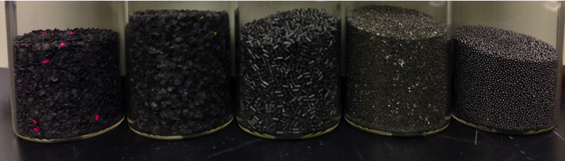

Table 4.4. Percent composition of each organic compound present in different unburned smokeless powders. The powders were extracted with methylene chloride and analyzed by UPLC/MS/MS with a C18 BEH column.
Powder | 1a | 1b | 2a | 2b | 2c | 2d | 3a | 3b | 3c | 4a | 4b | 5a | 5b
Compound | % | % | % | % | % | % | % | % | % | % | % | % | %
2,4-DNT |  |  |  |  |  |  | 4.4ª | 4.1ª | 5.6ª
NG | 14 | 12 | 16 | 16 | 16 | 16 |  |  |  | 10 | 9.2 | 11 | 11
3-NT | 0.30^{b} | 0.60^{b}
MC |  |  |  |  |  |  |  | 0.01^{b}
4-NDPA | 0.14 | 0.12 |  |  |  |  | 0.02 | 0.02 | 0.02 | 0.13^{b} | 0.03 | 0.04 | 0.04
N-NsDPA | 0.14ª | 0.03ª |  |  |  |  | 0.12 | 0.10 | 0.10 | 0.22 | 0.26 | 0.39 | 0.39
DPA | 0.61ª | 0.19ª | 0.04ª | 0.04ª | 0.01ª |  | 0.56 | 0.53 | 0.60 | 0.74 | 0.62 | 0.76 | 0.81
EC | 0.20ª | 0.86ª | 0.91ª | 1.08ª | 1.19ª | 1.20ª |  |  |  | 0.02 | 0.02 | 2.80ª | 2.98ª
2-NDPA | 0.08ª | 0.05ª |  | 0.30 |  |  | 0.04 | 0.03 | 0.04 | 0.09 | 0.07 | 0.29 | 0.30
DBP |  |  |  |  |  |  |  |  |  | 5.3 | 4.6 | 0.16 | 0.14
RSD range (%) | 13–26 | 0.7–28 | 5.3–7.0 | 1.2–7.1 | 1.5–17 | 2.0–2.5 | 2.3–20 | 5.9–19 | 20–26 | 13–20 | 5.4–17 | 3.0–11 | 4.4–23
ª On the basis of ANOVA (3+ lots) and t-test (2 lots) results of the means at the 95% confidence level, these lots showed significant differences in composition of specific compounds.
^{b} These compounds have a relative standard deviation (RSD) value that fell in the range of 88–170%.

Figure 4.5. MRM chromatograms of smokeless powder additives identified in Brand 3 by UPLC/MS/MS. Each individual chromatogram is the result of two precursor-to-product transitions (Table 4.3).

To further characterize the powders, significance testing was carried out on the means of each lot at a 95% confidence level. All powders showed some variation (p < 0.05) between lots except for Powder 4. Powder 1 had the most variation between lots with DPA, 2-NDPA, N-NsDPA, and EC showing significant differences in percent composition. The large difference in N-NsDPA between lots in Powder 1 can be attributed to the degradation of DPA, resulting in higher amounts of the nitroso product. For the range of smokeless powders tested, the calculated percentages were also consistent with the ones found in the manufacturer's material safety data sheets. This method is therefore applicable to the analysis of smokeless powder samples recovered in firearm cases. Future studies are necessary to show that the method can also be applied to GSR samples collected post firing.

4. Validation of the UPLC/MS/MS method
The linearity, repeatability, and sensitivity of the developed UPLC/MS/MS method were investigated using sample concentrations ranging from c. 0.2 to 5 μg/mL, with 2–50 ng injected into the system. The linearity was measured by examining at the coefficient of determination (R²), y-intercept, slope, and standard error of the slope. To determine the system's ability to detect trace amounts of smokeless powder components, the limit of detection (LOD, three times the standard deviation of the background noise) and limit of quantitation (LOQ, 10 times the standard deviation) were calculated using the standard deviation of replicate samples at low concentration and the slope of the calibration curve. Because they co-elute, 2,3-DNT, 3,4-DNT, and 2-NT were analyzed individually to determine sensitivity. Detection and quantitation limits as low as 0.08 ng and 0.5 ng injected were determined by UV at a wavelength of 210 nm with this method (Table 4.5). The relative standard deviation (RSD) ranged from 0.020 to 0.069% for the capacity factor and 0.78 to 5.6% for the peak area.
Table 4.5. Figures of merit for the detection of smokeless powder additives by UV (n ≥ 3).
Compound | Capacity factor, k’ | k’ RSD (%) | Area RSD (%) | Linearity |  |  |  | Sensitivity
 |  |  |  | R² | y-intercept | Slope | Standard Error  of the Slope | LOD (ng) | LOQ (ng)
DMP | 5.7 | 0.053 | 0.78 | 0.9773 | 159 | 775 | 59 | 0.33 | 1.1
2-naphthol | 7.0 | 0.040 | 0.92 | 0.9777 | 457 | 2154 | 163 | 0.39 | 1.3
2,4-DNT | 8.0 | 0.023 | 1.7 | 0.9777 | 156 | 691 | 52 | 0.76 | 2.5
2,6-DNT | 8.1 | 0.036 | 1.6 | 0.9781 | 177 | 778 | 58 | 0.70 | 2.3
2,3-DNT | 8.3 | 0.043 | 1.6 | 0.9768 | 511 | 2286 | 176 | 0.15 | 0.5
3,4-DNT | 8.3 | 0.043 | 1.6 | 0.9768 | 511 | 2286 | 176 | 2.6 | 8.7
2-NT | 8.3 | 0.043 | 1.6 | 0.9768 | 511 | 2286 | 176 | 0.08 | 0.3
4-NT | 8.5 | 0.049 | 2.1 | 0.9795 | 132 | 617 | 45 | 0.89 | 3.0
NG | 8.6 | 0.069 | 1.4 | 0.9762 | 57 | 249 | 19 | 0.61 | 2.0
3-NT | 8.7 | 0.055 | 1.3 | 0.9769 | 242 | 1103 | 85 | 0.54 | 1.8
4-NsDPA | 8.9 | 0.054 | 0.92 | 0.9777 | 89 | 433 | 33 | 0.39 | 1.3
DEP | 9.3 | 0.048 | 1.3 | 0.9784 | 176 | 736 | 55 | 0.56 | 1.9
MC | 9.5 | 0.040 | 3.1 | 0.9769 | 233 | 934 | 72 | 1.4 | 4.5
4,4’-DNDPA | 10.2 | 0.065 | 1.8 | 0.9803 | 194 | 945 | 67 | 0.75 | 2.5
4-NDPA | 10.7 | 0.039 | 1.2 | 0.9779 | 238 | 912 | 69 | 0.54 | 1.8
N-NsDPA | 10.8 | 0.030 | 1.2 | 0.9783 | 237 | 1115 | 83 | 0.50 | 1.7
2,4-DNDPA | 10.9 | 0.029 | 1.0 | 0.9787 | 169 | 794 | 59 | 0.44 | 1.5
DPA | 11.3 | 0.026 | 2.3 | 0.9770 | 395 | 1615 | 124 | 1.0 | 3.4
EC | 11.9 | 0.035 | 1.1 | 0.9765 | 213 | 875 | 68 | 0.46 | 1.5
2-NDPA | 12.1 | 0.020 | 2.5 | 0.9767 | 201 | 1025 | 79 | 1.0 | 3.5
DBP | 15.0 | 0.042 | 5.6 | 0.9537 | 248 | 623 | 69 | 2.6 | 8.8

The MS data provided detection and quantitation limits in the low nanogram range (Table 4.6). Nitroglycerin and 4,4’-dinitrodiphenylamine were analyzed at higher concentrations to determine sensitivity and linearity. RSD values for the MS retention times were very low for all of the compounds; on the other hand, peak areas for the MS data resulted in higher RSD values. NG and 4,4'-DNDPA gave the highest percentages with 43% RSD and 61% RSD, respectively. These two compounds may have higher detection limits due to higher temperatures used in the source to minimize solvent accumulation on the corona pin. In addition, the reproducibility and sensitivity suffer slightly as a result of the ionization mode utilized in this study. With ESCi®, the MS changes between each ionization mode at high speeds during sampling, and it is expected that slight variations in signal intensity may occur between runs. The scan speed is also lower because of the number of components sampled. Future studies will be conducted to improve the sensitivity for specific target compounds found in smokeless powders to perform trace detection.

Table 4.6. Figures of merit for the detection of smokeless powder additives by MS/MS (n ≥ 3).
Compound | Average Retention  Time (min) | Time RSD (%)  † RSD< 0.01 | Area  RSD (%) |  | Linearity |  |  | Sensitivity
 |  |  |  | R² | y-intercept | Slope | Standard Error of the Slope | LOD (ng) | LOQ (ng)
DMP | 3.07 | 0.0 | 7.3 | 0.9549 | 699 | 7309 | 794 | 2.9 | 10
2-naphthol | 3.71 | 0.0 | 3.5 | 0.9806 | 750 | 2724 | 191 | 1.4 | 4.7
2,4-DNT | 4.27 | 0.0 | 11 | 0.9507 | 300 | 1302 | 148 | 5.3 | 18
2,6-DNT | 4.31 | 0.0 | 15 | 0.9744 | 198 | 1035 | 84 | 6.9 | 23
2,3-DNT | 4.28 | 0.0 | 12 | 0.9806 | 2313 | 468 | 163 | 2.4 | 8.0
3,4-DNT | 4.27 | 0.0 | 13 | 0.9864 | 2494 | 465 | 147 | 0.4 | 1.3
2-NT | 4.30 | 0.0 | 25 | 0.9827 | 74 | -7 | 5 | 8.1 | 27
4-NT | 4.29 | 0.0 | 19 | 0.9538 | 8 | 94 | 10 | 6.9 | 23
NG | 4.53 | 0.0 | 61 | 0.9712 | -121 | 11 | 1.3 | 64 | 213
3-NT | 4.30 | 0.0 | 28 | 0.9975 | -6 | 85 | 2 | 9.1 | 30
4-NsDPA | 4.60 | 0.0 | 5.8 | 0.9478 | 78135 | 96822 | 11360 | 3.9 | 13
DEP | 4.67 | 1.8 | 21 | 0.8096 | 384 | 1364 | 331 | 9.6 | 32
MC | 4.93 | 0.0 | 3.2 | 0.9843 | 6703 | 24295 | 1532 | 1.5 | 5.1
4,4’-DNDPA | 5.57 | 0.0 | 43 | 0.8833 | -154 | 42 | 6.8 | 17 | 57
4-NDPA | 5.53 | 0.0 | 10 | 0.9834 | 163 | 937 | 61 | 4.8 | 16
N-NsDPA | 5.36 | 4.2 | 11 | 0.9876 | 133 | 376 | 21 | 4.9 | 16
2,4-DNDPA | 5.45 | 2.1 | 22 | 0.9502 | 22 | 64 | 7 | 12.3 | 41
DPA | 5.81 | 0.0 | 25 | 0.9871 | 33 | 140 | 8 | 13.3 | 44
EC | 5.82 | 0.0 | 20 | 0.9431 | 8457 | 37285 | 4580 | 7.4 | 25
2-NDPA | 6.10 | 0.0 | 16 | 0.9874 | 46 | 234 | 13 | 6.7 | 22
DBP | 7.33 | 0.0 | 8.2 | 0.9801 | 40095 | 53181 | 3786 | 5.2 | 17

E. Conclusions
Using the method outlined in this paper, 18 of the 21 compounds analyzed could be separated on a C18 column in under 8 min. As seen in Fig. 2, one peak in the chromatogram was due to the co-elution of 3,4-DNT, 2,3-DNT, and 2-NT. These compounds however are manufacturing impurities that are only present in trace levels in certain smokeless powders. All other compounds could be individually characterized by their LC capacity factor and MS data and were detectable at the low nanogram levels. This is an improvement over other published LC/MS/MS methods because of the wide array of analytes that can be separated and detected in a quick and efficient manner. In addition, the method is programed to monitor two MRM transitions for peak confirmation.

The ability to characterize different types of powder was tested with a variety of smokeless powder samples. Each additive was identified based on the capacity factor and MRM chromatograms. The percent composition for each compound present was calculated, and the results showed differences among brands and even manufacturing lots of smokeless powder. On the basis of presence or absence of specific additives, it was possible to distinguish between particular brands. For those powders with similar compositions, the proportions of each organic compound present in the powder were determined to differentiate the brands. Statistical testing was also conducted, and the method detected significant variations between lots of most of the powders. However, a larger population of smokeless powders must be sampled to fully characterize the method's discriminatory power. Last, the low limits of detection obtained using this UPLC/MS/MS procedure should permit its application to trace assays including post blast analysis of pipe bombs and GSR samples collected from the hands of shooters. This will be the subject of future research.

References
1. Dalby O, Butler D, Birkett JW. Analysis of gunshot residue and associated materials—a review. J Forensic Sci 2010;55(4):924–43.

2. Mach MH, Pallos A, Jones PF. Feasibility of gunshot residue detection via its organic constituents. Part 1: analysis of smokeless powders by combined gas chromatography-chemical ionization mass spectrometry. J Forensic Sci 1978;23(3):433–45.

3. Martz RM, Lasswell LD. Identification of smokeless powders and their residues by capillary column gas chromatography/mass spectrometry. Proceedings of the International Symposium on the Analysis and Detection of Explosives; 1983 Mar 29–31; Quantico, VA: FBI Academy, 1983;245–54.

4. Zeichner A, Eldar B, Glattstein B, Koffman A, Tamiri T, Muller D. Vacuum collection of gunpowder residues from clothing worn by shooting suspects, and their analysis by GC/TEA, IMS, and GC/MS. J Forensic Sci 2003;48(5):1–12.

5. Espinoza EO, Thornton JI. Characterization of smokeless gunpowder by means of diphenylamine stabilizer and its nitrated derivatives. Anal Chim Acta 1994;288:57–69.

6. Meng H, Caddy B. Gunshot residue analysis—a review. J Forensic Sci 1997;42(4): 553–70.

7. Via JC, Taylor LT. Chromatographic analysis of nonpolymeric single base propellant components. J Chromatogr Sci 1992;30(3):106–10.
8. Cascio O, Trettene M, Bortolotti F, Milana G, Tagliaro F. Analysis of organic components of smokeless gunpowders: high-performance liquid chromatography vs. micellar electrokinetic capillary chromatography. Electrophoresis 2004;10–11:1543–7.

9. Mathis JA, McCord BR. Gradient reversed-phase liquid chromatography electrospray mass spectrometric method for the comparison of smokeless powders. J Chromatogr A 2003;988:107–16.

10. Mathis JA, McCord BR. Mobile phase influence on electrospray ionization for the analysis of smokeless powders by gradient reversed phase high performance liquid chromatography-ESIMS. Forensic Sci Int 2005;154:159–66.

11. Northrop DM, MacCrehan WA. Separation and identification of organic gunshot and explosive constituents by micellar electrokinetic capillary electrophoresis. Anal Chem 1991;63(10):1038–42.

12. Smith KD, McCord BR, MacCrehan WA, Mount K, Rowe WF. Detection of smokeless powder residue on pipe bombs by micellar electrokinetic chromatography. J Forensic Sci 1999;44(4):789–94.

13. Wissinger CE, McCord BR. Gradient reverse phase HPLC procedure for smokeless powder comparison. J Forensic Sci 2002;47:168–74.

14. Northrop DM. Gunshot residue analysis by micellar electrokinetic capillary electrophoresis: assessment for application to casework. Part 1. J Forensic Sci 2001;46(3):549–59.

15. Terabe S. Capillary separation: micellar electrokinetic chromatography. Annu Rev Anal Chem 2009;2:99–120.

16. Laza D, Nys B, Kinder JD, Kirsch D, Mesmaeker A, Moucheron C. Development of a quantitative LC-MS/MS method for the analysis of common propellant powder stabilizers in gunshot residue. J Forensic Sci 2007;52:842–50.

17. Heramb RM, McCord BR. The manufacture of smokeless powders and their forensic analysis: a brief overview. Forensic Sci Commun 2002;4:1–7.

18. Rathore AS, Wood R, Sharma A, Dermawan S. Case study and application of process analytical technology (PAT) towards bioprocessing: II. Use of ultra-performance liquid chromatography for making real-time pooling decisions for process chromatography. Biotechnol Bioeng 2008;101(6):1366–74.

19. Mathis JA, McCord BR. The analysis of high explosives by liquid chromatography/electrospray ionization mass spectrometry: multiplexed detection of negative ion adducts. Rapid Commun Mass Spectrom 2005;19:99–104.

Additional information and reprint requests:
Bruce R. McCord, Ph.D.
Professor of Analytical/Forensic Chemistry
Florida International University, Department of Chemistry and Biochemistry
11200 SW 8th Street, CP 304
Miami, FL 33199

E-mail: mccordb@fiu.edu

Chapter V. Analysis of Organic Gunshot Residue Samples

A. Introduction

The extraction of samples involves the process of separating specific compounds from a matrix. The extract can then be concentrated to enhance detection of these compounds. In this study, various collection devices and extraction solvents were tested for recovering smokeless powder additives and their decomposition products from organic gunshot residue (GSR) samples. The organic compounds present in the residue primarily arise from the smokeless powders, which are used as propellants in modern ammunition. When a gun is fired, the primer and smokeless powder combust to produce a large volume of gas that forces the projectile out of the gun. In addition to the projectile, a plume of gaseous particulates is released. The plume can be seen around the weapon and shooter’s hands (Figure 5.1). The particulates released after firing a gun are generally composed of both primer and propellant compounds. Identification of these compounds on a shooter’s hands can be used to determine whether or not an individual has fired or held a recently fired weapon.

Figure 5.1: Release of GSR from openings in the firearm.



Inorganic techniques for the analysis of primer residue involve scanning electron microscopy with electron dispersive X-ray spectroscopy (SEM/EDX). However, the introduction of lead-free primers have made it difficult to perform SEM/EDX analyses, as the trio particle (barium:antimony:lead) may not be present. An alternative is to collect the organic gunshot residue, consisting of particles of burned and unburned smokeless powder residue deposited on the shooter after firing a gun. The goal of this study was to test the practicality of the previously developed UPLC/MS/MS method by Thomas et al. using actual GSR samples collected off of the hands of shooters, with focus on the web, back, and palm of the hand (1).

The samples were collected from the shooter’s hands using different devices, including aluminum stubs, tape, cotton swabs, and alcohol swabs. Figure 5.2 shows the specific locations that are expected to be GSR-rich. Each swabbing method was tested in order to determine the procedure that provided the highest recovery of organic GSR. This study was made possible through collaboration with the Miami Dade Police Department and their Firearms and Toolmark Division.

Figure 5.2. Diagram of a hand showing locations where GSR may be deposited and swabbed.

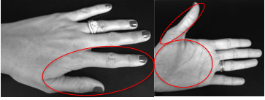

B. Experimental

1. Chemicals
In order to develop an extraction procedure, 1 mg/mL stock solutions of common smokeless powder additives and their decomposition products were prepared in acetonitrile, combined to form a mixture, and diluted using a 40:60 mixture of acetonitrile and water with 6 mM ammonium acetate and 40 mM ammonium chloride. The standard GSR mixture included diphenylamine (DPA), N-nitrosodiphenylamine (N-NsDPA), 2-nitrodiphenylamine (2-NDPA), 4-nitrodiphenylamine (4-NDPA), 2,4-dinitrodiphenylamine (2,4-DNDPA), 4,4'-dinitrodiphenylamine (4,4'-DNDPA), 4-nitrosodiphenylamine (4-NsDPA), methyl centralite (MC), ethyl centralite (EC), dimethyl phthalate (DMP), diethyl phthalate (DEP), dibutyl phthalate (DBP), NG, 2-nitrotoluene (2-NT), 3-nitrotoluene (3-NT), 4-nitrotoluene (4-NT), 2,3-dinitrotoluene (2,3-DNT), 2,4-DNT, 2,6-DNT, 3,4-dinitrotoluene (3,4-DNT), and 2-naphthol, which was used as an internal standard. These standards were obtained from a variety of manufacturers, including Acros Organics (Fair Lawn, NJ), Cerilliant Corporation (Round Rock, TX), Fluka Chemika (Buchs, Switzerland), Restek Corporation (Bellefonte, PA), and Sigma-Aldrich. The ammonium chloride and LC/MS optima grade solvents (acetonitrile, methanol, and water) used to prepare the mobile phases and sample dilutor were obtained from Fisher Scientific (Pittsburgh, PA). The ammonium acetate and 2-naphthol were purchased from Sigma-Aldrich Corporation (St. Louis, MO). All of the solutions were refrigerated until analysis.

2. LC conditions

The reversed phase gradient method previously developed for the analysis of smokeless powders was applied to the organic gunshot residue samples (1). The details of the gradient program are given in Table 5.1. Separations were carried out on an Acquity UPLCTM system (Waters Corporation, Milford MA) with a tunable ultraviolet (UV) detector and a bridged ethyl hybrid (BEH; Waters) analytical column having the following specifications: C18, 2.1 × 100 mm, and 1.7-μm particle size. A BEH C8 guard column was also installed to filter samples and protect the analytical column. The composition of the aqueous mobile phase was a 90:10 mixture of water and acetonitrile, whereas the organic mobile phase was a 95:5 mixture of acetonitrile and methanol. To enhance ionization of the analytes, 2 mM ammonium acetate and 0.02 mM ammonium chloride were added to both mobile phases (2,3). The temperature of the system was kept at 40°C and the flow rate was 0.500 mL/min. The y-axis is in minutes for all UV data.

Table 5.1: Gradient method used for the separation of the organic GSR samples.

Time (min) | Solvent A (%) | Solvent B (%)
Initial | 100 | 0
0.50 | 85 | 15
0.60 | 84 | 16
1.50 | 82 | 18
1.75 | 75 | 25
3.00 | 70 | 30
4.50 | 50 | 50
5.50 | 40 | 60
8.00 | 37 | 63
A: 90:10 water:acetonitrile + 2 mM ammonium acetate + 0.2 mM ammonium chloride
B: 95:5 acetonitrile:methanol + 2 mM ammonium acetate + 0.2 mM ammonium chloride

3. MS Conditions
For confirmation of the organic compounds, the UPLC system was coupled to a Quattro Micro APITM Tandem Mass Spectrometer (MS/MS, Waters Corporation) controlled by Mass Lynx software (Waters Corporation, version 4.1). The mass spectrometer was also connected to a stand-alone argon source that provided collision gas. A 230-liter high-pressure liquid nitrogen tank provided nitrogen gas for API desolvation and cone gas. Ionization of the analytes was achieved using an ESCi® source, which contains an electrospray ionization (ESI) probe and a corona discharge needle. ESCi® is a multi-mode ionization technique that allows users to switch between ESI and atmospheric pressure chemical ionization (APCI) modes at high speeds during a single analysis. The ability to switch between ionization modes allowed us to detect a wide array of compounds, saving both time and sample. The MS conditions used in this study are summarized in Table 5.2. The y-axis is in minutes for all MRM chromatograms and data.

Table 5.2: MS/MS tune page conditions.
Condition | Value
Capillary voltage (ESCi+) | 3.20 kV
Capillary voltage (ESCi-) | 4.30 kV
API current (ESCi-) | 20.0 μA
Source temperature | 125 ºC
Desolvation temperature | 400 ºC
Desolvation gas flow | 600 L/hr
Cone gas flow | 50 L/hr
Collision pressure on pirani gauge | ~3.6x10-3 mbar

4. Sample Collection
Participants fired weapons selected from Table 5.3 using each applicable type of ammunition from Table 5.4. GSR samples were then obtained from their hands using different sampling techniques and collection devices. In order to minimize contamination, nitrile gloves were worn during sampling and changed after each firing episode. Sample collection was performed at a table in the hallway outside of the indoor range. Four sample collection procedures were used in this study. The first method utilized dry and wet cotton swabs attached to wooden sticks (FisherBrand). For the wet swabs, the tip was placed in a solution of isopropanol and water (25:75). The front and back of the shooter’s hands were swabbed and the tip was cut and placed into a clean centrifuge tube. The scissors were cleaned with methanol before and after each sampling. The tubes were stored in the refrigerator at 4° C until they were ready to be extracted and analyzed.
The second method involved the use of aluminum stubs with carbon adhesive tape, which were pressed against the shooter’s hands for sample collection. The tape was cleaned by sonicating the stub in a beaker of methanol for 15 minutes. The third collection device used in the study was masking tape. The tape was cleaned by sonicating in methanol prior to collection at room temperature. The tape was folded into a cylinder for cleaning and allowed to dry before placing it in a 2 mL amber sample for storage and transportation. Tweezers were used to hold the tape and press it against the shooter’s skin. The last device used was pre-moistened alcohol swabs (25% isopropanol, 75% water), which were purchased from Walgreens. Each swab was cut into four equal square sections. The front and back of the shooter’s hands were then wiped and the swab was placed into a clean centrifuge tube. The tubes were stored a 4° C refrigerator until they were ready to be extracted and analyzed.

Table 5.3. Types of weapons.
Type of Weapon | A | B | C
45 ACP | Glock (20) | Colt 1911 (20) | Smith&Wesson (20)
9mm | Glock (20) | Colt (20) | Smith&Wesson (20)

Table 5.4. Types of ammunition.
Ammunition | A | B | C
45 ACP | Federal | Winchester | Remington
9mm | Blazer | American Eagle | Remington

The shooter washed and dried their hands prior to firing each round of ammunition. The shooter was also required to wash and dry their hands before and after shooting so that blank samples could be collected. A range safety officer certified to handle and shoot the weapons also cleaned the weapon prior to firing. Spent casings and smokeless powder were collected in order to compare the powder present in these samples to the powder found on the shooter’s hands. The unfired ammunition cartridges were pulled apart to retrieve the smokeless powder. Approximately 200 mg of the gunpowder was sealed in a nylon bag and transported back to the lab for further analysis.

5. Sample preparation

The organic compounds were extracted from the swabs using different organic solvents. To the centrifuge tube, 500 μL of solvent was added and allowed to sit or sonicate for 15 minutes. Following this, the tubes were centrifuged (Eppendorf 5415 D) for 5 minutes at 9,000 revolutions per minute (rpm). The extract was then transferred to a clean 2 mL amber vial, evaporated to dryness under a gentle stream of nitrogen gas, and reconstituted in sample dilutor. The dilutor was 40:60 acetonitrile:water with 6 mM ammonium acetate and 40 mM ammonium chloride. For the tape samples, 1.5 mL of methanol was added to the vial containing the tape. The vial was sonicated for 15 minutes to enhance extraction of the organic compounds. The tape was then removed from the vial and the extract dried using nitrogen gas. The residue was reconstituted in a solution of 40:60 acetonitrile:water with 6 mM ammonium acetate and 40 mM ammonium chloride. Finally, the stub containing tape was placed in a beaker of methanol to sonicate for 15 minutes. The stub was removed and the liquid was evaporated using nitrogen gas. The residue was reconstituted in a solution of 40:60 acetonitrile:water with 6 mM ammonium acetate and 40 mM ammonium chloride.

C. Results
1. Cotton extractions
The first extraction study was performed using cotton swabs attached to a wooden stick. Six standards were spiked onto the swab, including diphenylamine (DPA), nitroglycerin (NG), ethyl centralite (EC), dibutyl phthalate (DBP), 4-nitrodiphenylamine (4-NDPA), and 2,4-dinitrotoluene (2,4-DNT). The general extraction procedure for the cotton swabs is shown in Figure 5.3. The tips of the swab were cut, spiked with different standards, and placed into a 2mL costar® Spin-X HPLC centrifuge tube containing a 0.2 µm Nylon filter. The standards were then extracted twice with acetone, each time for 5 minutes in the centrifuge. The centrifuge speed was set to 9,000 rpm. The liquids were then transferred to a small sample vial, evaporated to dryness under a stream of nitrogen gas, and then reconstituted in the sample dilutor.

Figure 5.3. Diagram of the extraction process for the cotton swabs using a centrifuge.

To prepare the spiked hand samples – such as those seen in Figure 5.4 – the hand was swabbed first with the cotton swab prior to spiking it with the standards. Then the swab was treated as discussed above. Studies were done using a syringe to push the solvent past the cotton samples but the extraction efficiency was much less when compared to the ones extracted with the centrifuge tubes. A study was also performed to test for interferences from the wood attached to the cotton swab and it was determined that no significant interferences occurred.

Figure 5.4. Extraction of 6 GSR standards using the cotton swabs and acetone. The peaks in the spiked samples are identified in the box above the chromatograms. It can be seen that the hand matrix does not produce any major interferences in the UV chromatograms.

Another extraction study was conducted by adjusting the amount of solvent and centrifuge time used for the extraction (Table 5.5). The general extraction procedure for the cotton swabs was as follows. The tips of the dry swab were cut, spiked with different standards, and placed in a centrifuge tube containing a 0.22 µm Nylon filter. The standards were then extracted with acetone and centrifuged. The liquid was transferred to a small sample vial, evaporated to dryness under a stream of nitrogen gas, and then reconstituted in the sample dilutor. Hand samples were prepared using this same method; however, the hand was swabbed first with the cotton or aluminum stub prior to spiking it with the standards. A full explanation of what the stubs are and how they are extracted are given in section 2 of the extraction methods.

Table 5.5: Different extraction procedures tested for recovering organic GSR standards.
Collection device | Step 1 | Step 2 | Step 3 | Step 4
Cotton | 500µL acetone | Centrifuge  5 min | ---- | -----
Cotton | 500µL acetone | Centrifuge  5 min | 500 µL acetone | Centrifuge  5 min
Cotton | 500µL acetone | Centrifuge  2.5 min | 500 µL acetone | Centrifuge  2.5 min
Cotton | 1000µL acetone | Let sit in syringe | Filter | -----
Stub | 5000µL acetone | Sonicate for 5 min | Filter with syringe | -----

The signal intensities of each compound in the mixture were obtained from the UV chromatograms to determine the best extraction procedure. Overall, the cotton swabs provided higher recoveries than the stub samples. The stubs showed a consistent recovery of only about 50%. Therefore, the cotton swabs were the preferred media for GSR collection. The swabs are also easier to work with when compared to the stubs. The syringe procedure for the cotton swabs was ruled out because it is tedious and there is more deviation in recovery of the organic compounds. The first method listed in Table 5.5 was selected as the best cotton extraction procedure because it provided similar results as the other swab methods and it was the easiest technique. An improvement in the peak area and height was seen when the sample was extracted twice with acetone (double extraction, Figure 5.5). This was done by centrifuging the sample one time with 500uL of acetone and then adding another 500uL of acetone and centrifuging it again.
Figure 5.5. UV chromatograms showing the difference in peak areas of samples extracted using the cotton swabs for a single and double extraction. The red numbers are the peak areas.

Another experiment was performed to determine if recoveries could be improved by adjusting the extraction solvent. Three different solvents were tested: acetone, acetonitrile, and a 75:25 mixture of isopropanol and water. In previous work by DeTata et al (4), a mixture of water and ethanol and acetonitrile were used for extracting organic explosives, including NT, DNT, and NG (4). Acetone was initially chosen for previous studies based on its polarity and volatility, which make it a popular extraction solvent for explosive compounds. The general extraction procedure consisted of swabbing the hand with a cotton swab and then spiking the swab with 25uL of the standard mixture of organic GSR compounds. Following this, the cotton tips were cut and placed into a 2mL centrifuge tube. To each tube, 500uL of the extraction solvent was added and then centrifuged for 5 minutes at 9,000 rpm. The extract was then transferred to a clean amber vial, dried under nitrogen gas, and reconstituted in a 40:60 mixture of acetonitrile and water with ammonium acetate and ammonium chloride. Higher recoveries were seen with acetonitrile for most of the compounds in the mixture (see Table 5.6 and Figure 5.6).

Table 5.6. Average UV peak areas and standard deviations (s.d.) for each extraction solvent using the cotton swabs. The red values indicate the solvent that showed the highest peak area for each compound.
Chemical | Acetone |  | Acetonitrile |  | Isopropanol:Water
Chemical | Area | s.d. | Area | s.d. | Area | s.d.
DMP | 2174 | 300 | 2778 | 19 | 1721 | 69
2-napthol | 5686 | 350 | 6309 | 300 | 5175 | 130
2,4-DNT | 1840 | 230 | 2466 | 11 | 1397 | 130
2,6-DNT | 1983 | 280 | 2748 | 410 | 982 | 160
3,4-DNT;2,3-DNT;2-NT | 6766 | 1730 | 10215 | 910 | 3691 | 210
4-NT | 1245 | 190 | 2409 | 290 | 3062 | 3860
NG | 686 | 680 | 2549 | 1390 | 7 | 4.0
3-NT | 1946 | 45 | 2065 | 69 | 1881 | 57
4-NsDPA | 1854 | 180 | 2143 | 100 | 1523 | 30
DEP | 2857 | 220 | 3152 | 180 | 2628 | 83
MC | 2233 | 79 | 2489 | 170 | 37 | 20
4,4-DNDPA | 3212 | 140 | 3580 | 160 | 2058 | 51
4-NDPA | 1724 | 240 | 2642 | 640 | 3008 | 69
N-NSDPA | 2506 | 290 | 2847 | 230 | 1313 | 82
2,4-DNDPA | 120 | 170 | 154 | 90 | 2467 | 26
DPA | 5224 | 480 | 6388 | 290 | 4135 | 280
EC | 2580 | 180 | 2762 | 180 | 2343 | 53
2-NDPA | 2473 | 190 | 2876 | 190 | 2195 | 52
DBP | 1793 | 90 | 1852 | 51 | 1574 | 39

Figure 5.6. UV chromatograms of three different samples: (A) isopropanol:water extraction, (B) acetonitrile extraction and (C) acetone extraction. Each swab was spiked with 25μL of a 1mg/mL standard mixture. The response areas are given above each peak.
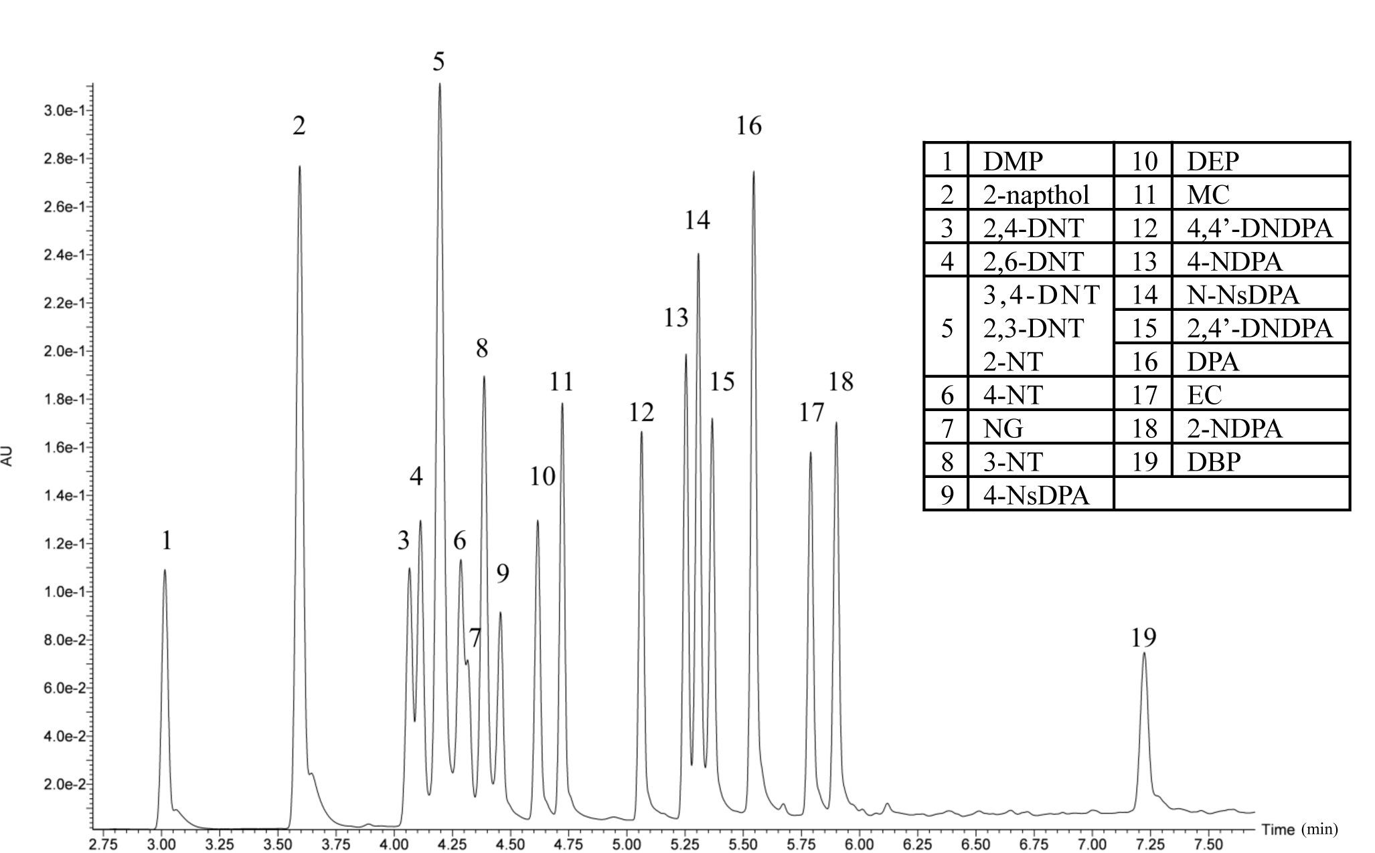
5
2 19
16
1 3,4 8 91011 1213,14 17 18
6-7 15

A

B

C

Results from live-fire residue samples that were collected using cotton swabs are shown in Figures 5.7-5.12. Samples were collected from live firing exercises using a Smith and Wesson revolver with Remington ammunition and cotton swabs. The cotton was wet with a 75:25 solution of isopropanol and water. The tips of the swab were cut and placed in a centrifuge tube containing a 0.22 µm Nylon filter following collection. The organic compounds were then extracted with 500 uL of acetone and centrifuged for 5 minutes. The liquid was transferred to a small sample vial, evaporated to dryness under a stream of nitrogen gas, and then reconstituted in the sample dilutor. Figure 5.7 gives three different UV chromatograms for the cotton swabs.

Figure 5.7. Comparison of hand samples collected with cotton swabs. The UV chromatograms are for (A) Sample collected after firing, (B) Blank cotton swab, and (C) Standard GSR mixture.
By comparing the samples collected after shooting to the standard GSR mixture, we can identify different organic GSR compounds present. Slight variations in retention time were observed due to a problem with pump seals. However, the application of mass spectrometry confirms the presence of the compounds. Background peaks from the cotton swab and hand can also be seen in the samples but do not interfere with peak identification. The firing sample (Sample A, Figure 5.7) was positive for nitroglycerin, N-nitrosodiphenylamine, ethyl centralite, and dibutyl phthalate (Figure 5.8). The N-NsDPA only exhibited one MRM transition due to low amounts present in the sample.

Figure 5.8. MRM chromatograms for the extracted cotton swab sample (Sample A) in Figure 5.7.

One final study was done using the weapons and ammunition in Table 5.7. MDPD personnel cleaned both weapons prior to firing each type of ammunition. Other studies were done but inconsistent and poor results were obtained and therefore, not presented. The sample collection process is given below. Cotton swabs with wooden handles were used to collect blank and firing samples off of the shooter’s hands. These swabs were moistened with a 75:25 mixture of isopropanol and water to increase recovery of the organic GSR.

1. The shooter washed and dried his hands and a blank sample was collected using a wet cotton swab.
2. The shooter entered the indoor firing range and fired 3 rounds of one type of ammunition.
3. Samples were collected from the shooter’s right and left hands (2 different swabs) with a wet cotton swab.
4. Each swab was cut and placed into a clean centrifuge tube.
*This collection process was repeated five times for each ammunition type. All of the samples were then transported back to the laboratory for analysis.

Table 5.7. Weapons and ammunition tested in firearms study.
Weapon | Ammunition
Smith & Wesson 10-8 | Federal 38 special (+P)  158 grain
Glock 19 | American Eagle 9mm Luger  147 grain

The general extraction process used to recover the organic compounds from the swab is as follows. To each tube, 500uL of acetonitrile was added. The tubes were sonicated for 15 minutes and then centrifuged for 5 minutes at 9,000 rpm. The extract was transferred to a clean amber vial, dried under nitrogen gas, and reconstituted in 1mL of a 60:40 mixture of water and acetonitrile with ammonium acetate and ammonium chloride.
For the spent cartridges, a wet swab was passed along the inside of the cartridge, placed in a centrifuge tube, and extracted using the same process described above. The smokeless powders were also extracted the same way but by placing 5mg of the powder in the centrifuge tube instead. This was done so that each type of sample went through a similar extraction process. The results are shown in Figures 5.9–12.

Figure 5.9. UV chromatograms of the (A) Federal 38 special smokeless powder, (B) Federal 38 special spent cartridge, and (C) 10ppm standard GSR mixture. All experiments were performed using residue from a Smith & Wesson revolver.
NG EC

DPA 2NDPA
NG EC

2NDPA

DPA
2,6DNT?

5
2 14 16
1 3,4 8 10 11 12 1315 17 18 19
6,7 9
A

B

C

The Federal 38 special fired with the Smith & Wesson firearm produced high levels of ethyl centralite (EC) and nitroglycerine (NG). These were both identified and confirmed by mass spectrometry in the spent cartridge samples and the smokeless powder samples pulled from the cartridge (Figure 5.10). Lower levels of 2-nitrodiphenylamine (2NDPA) and 4-nitrodiphenylamine (4NDPA) were also seen in the samples.
Figure 5.10. MRM chromatograms of the (A) Federal 38 special spent cartridge and (B) Federal 38 special smokeless powder confirming the presence of each compound. All experiments were performed using residue from a Smith & Wesson revolver.
Some differenes were also noticeable between the spent cartridge and powder samples of the Federal 38 special. The spent cartridges appear to have 2-NT and DBP, whereas the powder samples show 4-NT and MC. The presence of nitrotoluene may be due to the decomposition of 2,6-DNT; however, DNT could only be confirmed by UV. Methyl centralite (MC) showed up in the MS of the powder sample. It is very interesting to have found both ethyl and methyl centralite in the powder samples, as only one is commonly seen in each powder.
For the American Eagle ammunition used with the Glock 19, lower levels of nitroglycerin, ethyl centralite and diphenylamine were seen in the spent cartridge and smokeless powder samples when compared to the Smith & Wesson Federal ammunition (Figures 5.11-12). The Federal brand also showed nitrotoluene products in the MRM chromatograms, none of which were detected in the American Eagle ammunition.
In the American Eagle 9mm Luger ammunition, decomposition products of DPA were identified by UV in both the spent cartridge and smokeless powder samples. These included 4-nitrodiphenylamine (4-NDPA), N-Nitrosodiphenylamine (N-NsDPA), 2-NDPA, and 4-NDPA. Only the DPA, 4-NDPA, and N-NsDPA were confirmed by MS, in addition to EC and DBP. NG was seen in the MRM of the powder but not in the spent cartridge sample. Even though American Eagle is now part of Federal ammunition, differences are visible between ammunition types.

Figure 5.11. UV chromatograms of the (A) American Eagle 9mm Luger smokeless powder, (B) American Eagle 9mm Luger spent cartridge, and (C) 10ppm standard GSR mixture. All experiments were performed using residue from a Glock 19 pistol.
NG DPA

4NDPA
NNsSPA
DBP
EC 2NDPA

5
14 16
2
3,4 8 10 11 12 13 15 17 18
1 9 19
6,7
NG

4NDPA
NNsDPA DPA
EC 2NDPA DBP

A

B

C

C

Figure 5.12. MRM chromatograms of the (A) American Eagle 9mm Luger spent cartridge and (B) American Eagle 9mm Luger smokeless powder confirming the presence of each compound. All experiments were performed using residue from a Glock 19 pistol.

By comparing the two different ammunition types, clear differences can be seen in the profiles of the spent cartridges and smokeless powders pulled from the cartridge. It appears that the Smith & Wesson samples using the Federal ammunition produced more NG and EC when compared to the Glock samples using the American Eagle ammunition. On the other hand, the Glock samples showed DPA and some of its decomposition products that weren’t as noticeable in the Smith & Wesson samples. These differences must be measured quantitatively in order to determine whether or not they are significant.
In summary, we have developed a new extraction method using acetonitrile to recover organic GSR compounds from cotton swabs. This method has been applied to spent cartridges, unburned smokeless powders, and samples collected from the hands of a shooter. We have been successful in identifying differences between ammunition with the acetonitrile extraction. Further optimization of the swab extraction is needed to improve recovery of the organic GSR. Future work will involve the analysis of additional hand samples to create a database of compositional differences between various powders.

2. Stub extractions
The aluminum stubs used in this study were purchased from Tri-Tech Forensics©. An example of the stub is given in Figure 5.13. It is covered with black double-sided adhesive carbon tape, which helps to grab the particles off of the hands of the shooter. Traditionally, these stubs are used for collecting inorganic GSR and are analyzed using scanning electron microscopy with energy dispersive X-ray spectroscopy. In this study, they were evaluated for use in collecting organic GSR. It may be possible to collect residues and perform both inorganic and organic analyses on the sample in cases of false negatives with SEM/EDX due to lead-free primers.
For the stub samples, a double extraction procedure was found in the literature for trace explosives (5). First, the stub was spiked with standards and extracted with a mixture of 80% water (with 0.1% azide) and 20% ethanol using sonication. Following this, a liquid/liquid extraction was performed using the solution from part one and methylene chloride. This procedure however did not produce efficient extractions in our laboratory. Figure 5.14 shows the results from this study. I suspected that the sample needed additional time and/or a different solvent to increase the recovery of the powder residue from the carbon tape on the stub. Because the acetone worked well for the cotton swabs, a similar procedure was examined for use with the aluminum stubs (Figure 5.13).
Figure 5.13. Extraction process for the SEM stubs.
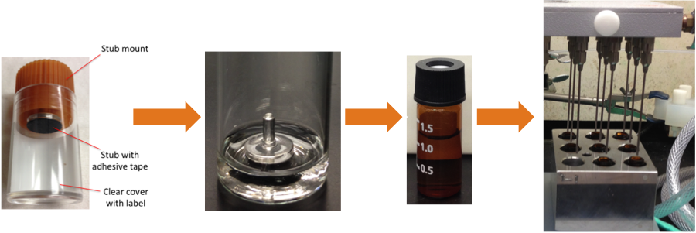

Figure 5.14. Initial extraction of aluminum stubs using double extraction method by Zeichner (5).

Because the stubs were too large to fit directly into the centrifuge tube, they were placed in a beaker of 5 mL acetone. The beaker was then sonicated for 10 minutes and the liquid was filtered using a syringe and 0.2 µm Anotop filters. Similar to the cotton swabs, the extracted sample was transferred to a small vial, evaporated to dryness, and then reconstituted in the sample dilutor. The results for the extraction studies are given below. Using the new technique, all six standards were extracted. The results can be seen in Figure 5.15. Further studies must be conducted to improve extraction efficiency (extract twice or use another solvent) and decrease the background noise (likely from the stub).

Figure 5.15. Extraction of six standards using the aluminum stubs and acetone. There are some background peaks that appear to be from the stub.

3. Masking tape
The masking tape (Figure 5.16) was cleaned in methanol and allowed to air-dry prior to sample collection. The tape was then cut and placed in clean vials for sample collection. Using a tweezers to hold the tape, the shooter’s hands were processed for organic GSR. The extraction process for the tape samples is shown in Figure 5.16. Figure 5.17 compares a standard GSR mixture to a blank tape sample, a blank tape sample of the shooter’s hand after washing with soap, and a tape sample collected after firing the Revolver. It is important to emphasize that these tape samples were stored for 4 months prior to extraction and analysis.

Figure 5.16. Extraction process for the tape samples.
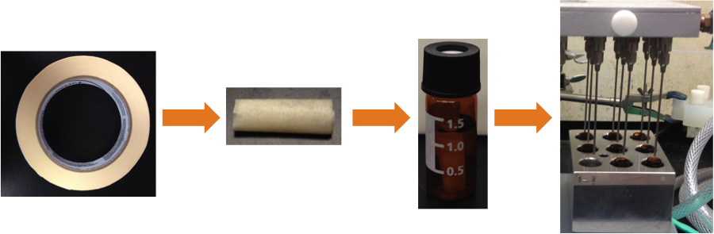
The results of the extraction from the tape samples collected after firing (sample A) shows several organic GSR compounds. MRM comparisons of the blank hand sample and the firing sample can be seen in Figure 5.18. The red circles indicate the location of the peak for each compound in the MRM chromatograms. This tape sample was positive for nitroglycerine, 2-nitrodiphenylamine, 4-nitrodiphenylamine, ethyl centralite, and dibutyl phthalate. The presence of DBP is seen in lower levels of most samples as a background contaminant because it is used in a wide array of materials, including plastics. By comparing background levels to levels seen in a GSR sample, one can determine if DBP is actually present. However, care must be taken when making these measurements due to the ubiquitous nature of the DBP.

Figure 5.17. Comparison of hand samples collected with masking tape. The UV chromatograms are given below for several analyses: (A) Sample collected after firing, (B) Blank hand sample, (C) Blank tape sample, and (D) Standard GSR mixture.

Figure 5.18. MRM chromatograms from extracted masking tape samples A and B in Figure 5.17.
Figure 5.19 compares a standard GSR mixture to a blank tape sample, a blank tape sample of the shooter’s hand after washing with soap, and a tape sample collected after firing the Revolver. It is important to emphasize that these tape samples were stored for 4 months prior to extraction and analysis.
Despite the long period of time in-between analysis, the tape sample collected after firing (sample A) shows several organic GSR compounds. MRM comparisons of the blank hand sample and the firing sample can be seen in Figure 5.20. The red circles indicate the location of the peak for each compound. This tape sample is positive for nitroglycerine, 2-nitrodiphenylamine, 4-nitrodiphenylamine, ethyl centralite, and dibutyl phthalate. DBP is also present at an elevated level when compared to the blank.
Figure 5.19. Comparison of hand samples collected with masking tape. The UV chromatograms are given below for several analyses: (A) Sample collected after firing, (B) Blank hand sample, (C) Blank tape sample, and (D) Standard GSR mixture.

Figure 5.20. MRM chromatograms from extracted masking tape samples A and B in Figure 1.19.

5. Spent cartridges
Spent cartridges were collected after shooting and the insides were swabbed for organic GSR. Wet cotton swabs and polyester swabs were used for sampling. The inside of the cartridges were swabbed and the tip of the swab was cut and placed in a 2mL centrifuge tube. 500 uL of acetone was added to the tube and centrifuged for 5 minutes. The extract was then removed, dried under nitrogen gas, reconstituted in sample dilutor, and analyzed by UPLC/MS/MS. Results are given in Figures 5.21-24.

Figure 5.21. UV chromatograms comparing spent cartridge cotton sample (top) to standard GSR mixture (bottom).

Figure 5.22. MRM chromatograms for the spent cartridge sample obtained using a cotton swab. In this figure, both transitions are shown for each compound. Red circles are MS peaks.

Figure 5.23. UV chromatogram comparing spent cartridge polyester sample to standard GSR mixture. The extraction process for the polyester swabs was the same as the one for the cotton swabs.

Figure 5.24. MRM chromatograms for the spent cartridge sample obtained using a polyester swab. In this figure, both transitions are shown for each compound.

It can be seen that both swabs were efficient at recovering different organic compounds from the inside of a spent cartridge. From the preliminary data, it appears that the polyester swab is able to recover more of these compounds, as their MS intensities are greater than the ones for the cotton extractions. Hand samples were also collected using the polyester swabs; however, the processed ones were negative for all of the compounds.
Because the alcohol swabs worked for extracting the organic GSR compounds from the hands of shooters, these swabs were used to recover organic GSR from spent cartridges. Table 5.8 shows the average MRM peak area percentages for spent cartridge samples wiped with alcohol swabs. Four different ammunition types were analyzed, including Remington ammunition, Speer Gold Dot ammunition, Remington, and Federal. The peak area percentages were calculated by dividing the peak area of each compound by the sum of the areas for all detected peaks. The results show differences in additive composition between ammunition brands for the same weapon and different weapons.

Table 5.8. Average MRM peak area percentages for spent cartridge samples wiped with alcohol swabs. The standard deviations are given in parentheses.
Compound | Glock |  | Smith & Wesson
Compound | Remington | Speer | Remington | Federal
Diphenylamine | 0.91 % (54) | 3.1 % (140)
N-Nitrosodiphenylamine | 2.1 % (310) | 4.8% (460)
4-Nitrosodiphenylamine | 0.41 % (78) | 1.4 % (37) | 0.0058 % (163) | 0.54 % (290)
2-Nitrodiphenylamine | 0.76 % (120) | 0.80 % (58) | 0.0061 % (96) | 0.11 % (55)
4-Nitrodiphenylamine | 1.0 % (190) | 0.54 % (42) | 0.013 % (240) | 0.76 % (430)
2,4’-Dinitrodiphenylamine | 0.62 % (52)
Dibutyl phthalate | 7.6 % (280) | 24 % (1100) | 0.46 % (340) | 14 % (420)
Diethyl phthalate |  |  | 0.038 % (1300) | 1.7 % (2400)
Dimethyl phthalate |  |  | 0.0022 % (11) | 0.067 % (64)
Ethyl centralite | 84 % (2800) | 64 % (1400) | 99% (2600000) | 74 % (37000)
Methyl centralite |  |  |  | 0.12 % (92)
Nitroglycerin | 2.9 % (250) | 1.5 % (100) | 0.68 % (5200) | 8.7 % (4400)

6. Recovery of Organic Chemicals from Smokeless Powder Pulled from a Cartridge
Bullets were pulled apart to retrieve some of the smokeless powder (SP) for analysis. Approximately 5 mg was added to a clean vial and extracted using two different methods:
(i.) Extract for 6 hours in methylene chloride in the absence of light (13)
(ii.) Extract for 15 minutes in methanol (MeOH) with sonication (11)

The extracts were transferred to a clean vial, evaporated to dryness using nitrogen gas, and then reconsituted in sample dilutor. 2-napthol was added to all of the extracts to ensure that the UPLC-MS/MS method was working. The two methods were compared to determine which one provided higher recoveries. The UV chromatograms of the standard GSR mixture and two smokeless powder samples are shown in Figure 5.25. The MRM chromatograms for the powders can be seen in Figures 5.26 and 5.27.

Figure 5.25. Comparison of extracted smokeless powder (SP) samples. The UV chromatograms are: (A) SP extracted with MeOH, (B) SP extracted with methylene chloride, and (C) Standards.

Figure 5.26. MRM chromatograms from an extracted SP sample using the method by Wissinger.

Figure 5.27. MRM chromatograms from an extracted SP sample using the method by Northrop.

After comparing the two extraction methods for the smokeless powder samples, it appears that the Wissinger method recovers more of the extracted components. The required extraction time is longer though for this method. It will be valuable to test if Northrop’s method will recover equal, more, or less organic compounds if allowed to sonicate for the 6-hour period. Finally, the peak area percentages for two different smokeless powders were calculated using the MRM data. The results are presented in Table 5.9. The powders were extracted by placing 5 mg directly into a centrifuge tube with nylon filter and adding 500 uL of methylene chloride. After sonicating for 15 minutes, the tube was centrifuged for 5 minutes at 9,000 rpm. The liquid was then transferred to a 2 mL amber vial, evaporated until dry, and reconstituted in a 40:60 solution of 40:60 acetonitrile and water with 6 mM ammonium acetate and 40 mM ammonium chloride. Results also show differences between smokeless powders removed from ammunition used in different weapons. For example, the Remington ammunition for the Glock pistol shows diphenylamine and N-Nitrosodiphenylamine, which are negative in the MRM’s for the Smith & Wesson Remington powder. Similar to the spent cartridge samples, the peak area percentages were calculated by dividing the peak area of each compound by the sum of the areas for all detected peaks. The results show differences in additive composition between ammunition brands for different weapons.

Table 5.9. Average MRM peak area percentages for smokeless powder samples removed from each ammunition type and extracted with methylene chloride.
Compounds | Glock |  | Smith & Wesson
 | Remington | st.dev. | Remington | st.dev.
Diphenylamine | 1.8 % | 16000
N-Nitrosodiphenylamine | 1.4 % | 2400
4-Nitrosodiphenylamine | 0.0086 % | 75 | 0.00039 % | 43
2-Nitrodiphenylamine | 0.081 % | 100 | 0.0089 % | 48
4-Nitrodiphenylamine | 0.034 % | 160 | 0.011 % | 160
2,4’-Dinitrodiphenylamine | 0.0026 % | 24 | 0.0039 % | 480
Dibutyl phthalate | 0.13 % | 170 | 0.022 % | 850
Diethyl phthalate | 0.0049 % | 37 | 0.00070 % | 22
Dimethyl phthalate |  |  | 0.00033 % | 22
Ethyl centralite | 96 % | 1400000 | 99 % | 430000
Methyl centralite |  |  | 0.0015 % | 66
Nitroglycerin | 1.0 % | 1010 | 0.39 % | 2400

7. Infusion as screening tool
It would be very useful to have a rapid method whereby GSR samples could be quickly screened for organic compounds. One method to do this would be to solubilize the extract and directly infuse it into the tandem mass spectrometer. While the sample is being infused into the MS, a spectrum can be collected for 0.5 min in each ionization mode: ESI+, ESI-, and APCI-. This must be done because the tandem mass spectrometer does not permit users to perform an MS scan in ESCi mode (all 3 ionization modes to run simultaneously) directly from the tune page. Nevertheless, it takes less than 10 minutes to acquire a spectrum of a sample in each ionization mode, extract the data, and search for the compounds of interest. This includes running a blank of sample dilutor before each run in all 3 ionization modes. The general MS conditions used for the infusion experiments are summarized in Table 5.10. The only difference between each ionization mode was the voltage applied on the capillary or corona discharge pin (APCI). The extracted spectrum for a standard GSR mixture analyzed in ESI+, ESI-, and APCI- modes are given in Figure 5.28, 5.29, and 5.30, respectively. The MS scans were collected over an m/z range of 30 to 300 amu.

Table 5.10. MS conditions for the infusion experiments.
Condition | Value | Condition | Value
ESI capillary voltage (+) | 3.20 | High mass resolution | 15
ESI capillary voltage (-) | 4.30 | Ion energy | 0.6
APCI current (-) | 20.0 | Entrance | 50
Extractor | 3 V | Collision | 3
RF lens | 0.1 V | Exit | 50
Source temperature | 125 ºC | LM resolution 2 | 14
Desolvation temperature | 225 ºC | HM resolution 2 | 14
Desolvation gas flow | 425 L/hr | Ion energy 2 | 0.6
Cone gas flow | 50 L/hr | Multiplier | 650
Low mass resolution | 15 | Collision pirani | ~3.6x10^3

Figure 5.28. MS scan in positive ESI mode of blank (sample dilutor) and GSR standard mixure. The parent ions for 2,4- and 4,4’-dinitrodiphenylamine are not as pronounced as the other compounds. It is believed that this is a concentration issue, as a more defined peak is visible in the spectrum when each standard is run alone.
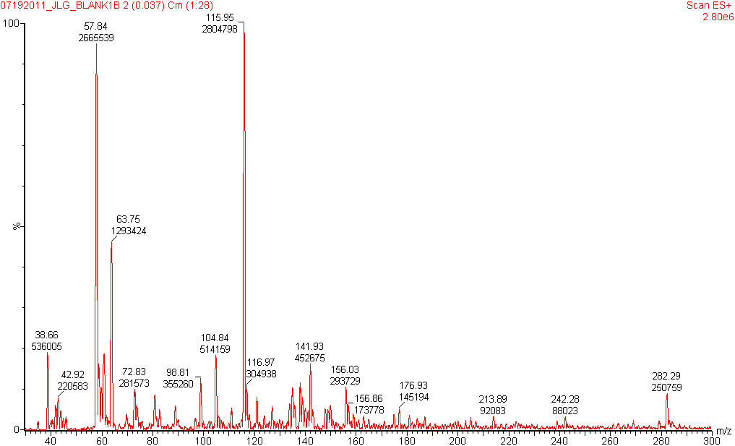
Blank

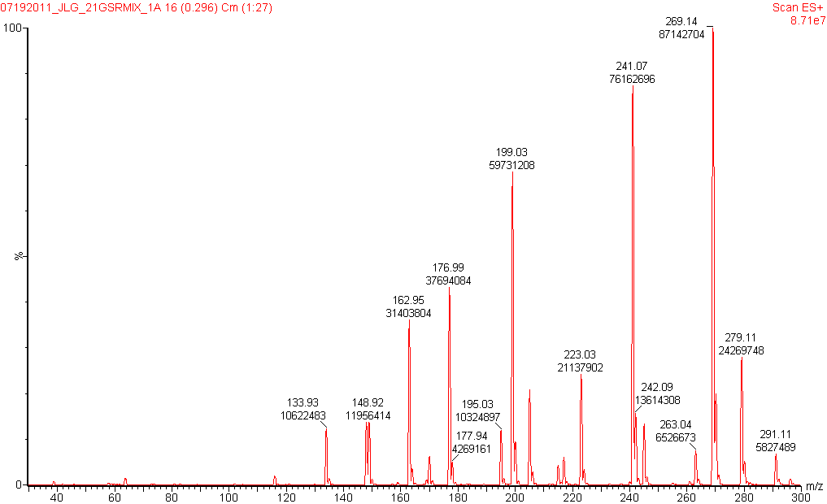
EC
MC

Nitroso-DPA

DBP
DEP

DMP

DPA Nitro-DPA
GSR mixture

Figure 5.29. MS scan in negative ESI mode of blank (sample dilutor) and GSR standard mixture. For nitroglycerin, we can see the chloride adduct at m/z 262 and the two fragments used in the MRM method: m/z 46 peak (NO₂) and m/z 62 (NO₃). For 2-naphthol, we can see the parent ion at m/z 143 and one of its fragments at m/z 65.

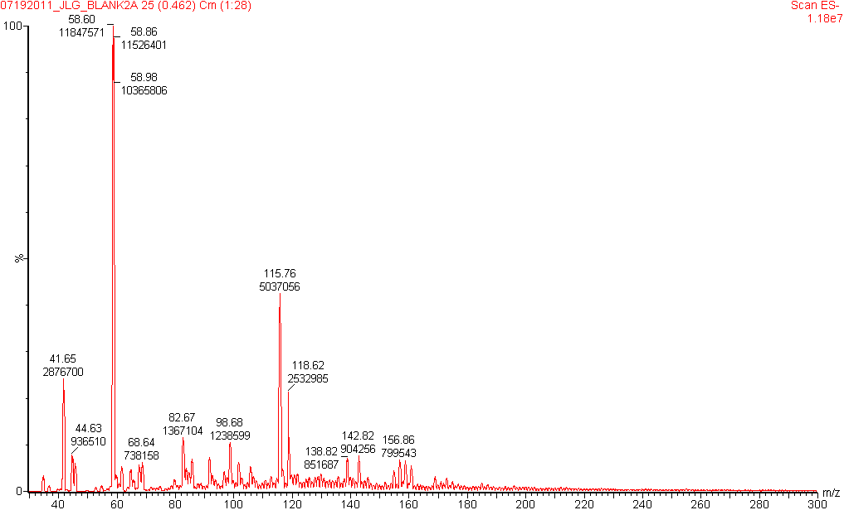
Blank

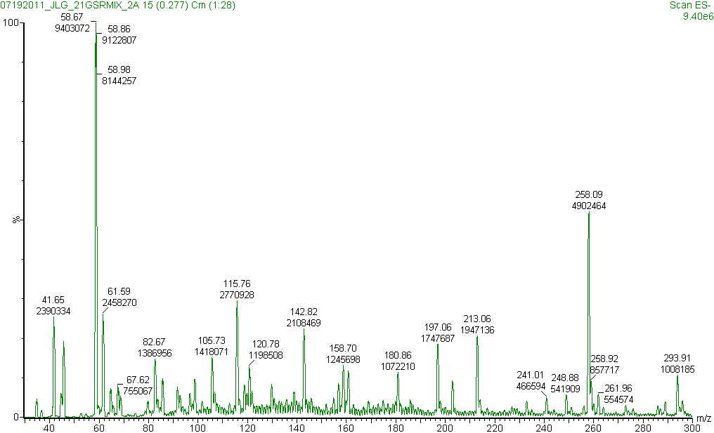
65
46
GSR mixture

Figure 5.30. MS scan in negative APCI mode of blank (sample dilutor) and GSR standard mixture. In the spectrum, we see the parent ion of nitrotoluene at m/z 137, the parent ion of dinitrotoluenes at m/z 182, and the common daughter ion of them both at m/z 46 peak, which is indicative of NO₂. We also identified other ions used detected for dinitrotoluenes (circled in spectrum; m/z 46, m/z 152, m/z 165).
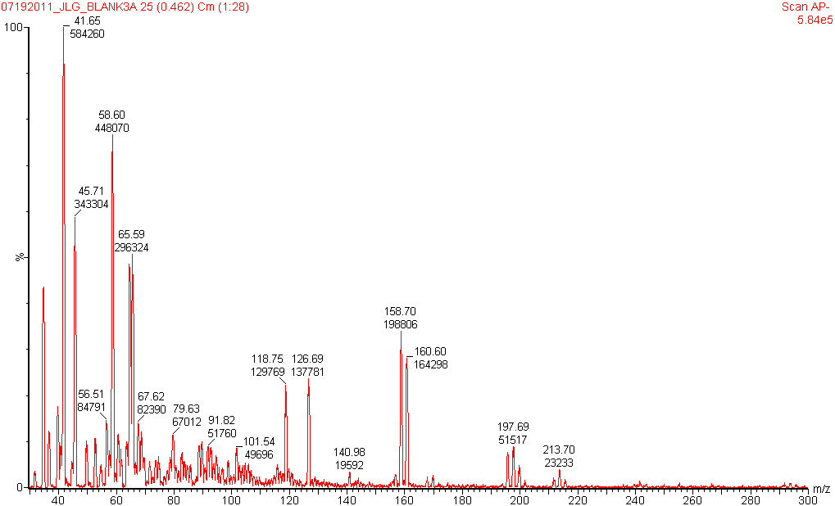
Blank

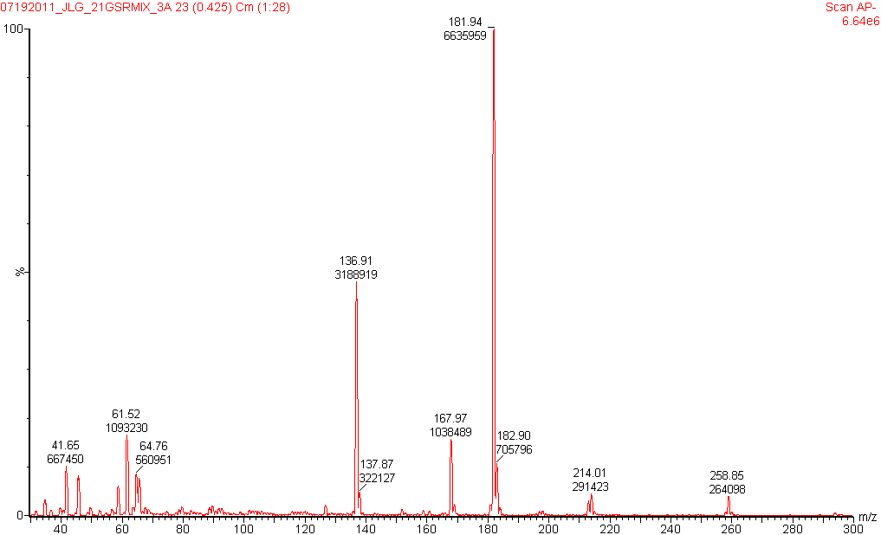
46
152 165
GSR mixture

The next step was to apply the infusion method to the analysis of hand samples. The tape samples were chosen for this study because compounds have been detected by UPLC on the tape months after collection. These samples were refrigerated to minimize decomposition. The hand samples were collected after shooting by swabbing the fronts and backs of the shooter’s hand. For the samples below, three shots were fired and then a hand sample was collected for gunshot residue. Blank samples were also obtained prior to shooting and after hand washing.
The organic compounds on the tape samples were extracted with methanol in a 2mL amber vial. After 15 minutes, the tape was removed from the vial and the liquid was dried under a stream of nitrogen gas. The dried extract was then reconstituted in sample dilutor and analyzed via direct infusion into the mass spectrometer. To increase MS detection of the extracted compounds, lower temperatures and gas flows were used (see Table 5.11). A 30 second run was performed in three ionization modes: ESI+, ESI-, and APCI-. Each spectrum was then examined for the parent compound of the smokeless powder additive. The results can be seen in Figures 5.32-35.

Table 5.11. MS conditions for infusion experiments of hand samples.
Condition | Value | Condition | Value
ESI capillary voltage (+) | 3.20 | Low mass resolution | 15
ESI capillary voltage (-) | 4.30 | High mass resolution | 15
APCI current (-) | 20.0 | Ion energy | 0.6
Extractor | 3 V | Entrance | 50
RF lens | 0.1 V | Collision | 3
Source temperature | 125 ºC | Exit | 50
Desolvation temperature | 225 ºC | LM resolution 2 | 14
Desolvation gas flow | 425 L/hr | HM resolution 2 | 14
Cone gas flow | 50 L/hr | Ion energy 2 | 0.6
Collision pirani | ~3.6x10⁻³ mbar | Multiplier | 650

Figure 5.31. MS scan in positive ESI mode of GSR standard mixture. The cone voltage was set to 15. All of the parent ions were visible for those compounds that ionize in ESI+ mode.

MC EC
Nitroso-DPA

DEP

DMP

DBP

DPA Nitro-DPA
Dinitro-DPA

Figure 5.32. MS scan in negative ESI mode of GSR standard mixture. A cone voltage of 10 was used for this experiment. For nitroglycerin, we can see the chlorine adduct at m/z 262 and the two fragments used in the MRM method: m/z 46 peak (NO₂) and m/z 62 (NO₃). For 2-naphthol, we can see the parent ion at m/z 143 and its fragments at m/z 65 and m/z 115.
62
46
65
11555
143

Figure 5.33. MS scan in negative APCI mode of GSR standard mixture. A cone voltage of 15 was used for this experiment. In the spectrum, we see the parent ion of nitrotoluene at m/z 137, the parent ion of dinitrotoluenes at m/z 182, and the common daughter ion of them both at m/z 46 peak, which is indicative of NO₂. We also see some of the ions used for the dinitrotoluenes in the MRM method, such as m/z 152.

137
152

Figure 5.34. MS scan in positive ESI mode of a firing sample collected using tape. No peak at m/z 170 (DPA) was seen in the spectrum. However, possible reaction product peaks for Nitroso-DPA (m/z 199) and Nitro-DPA (m/z 215) are present. Peaks are also visible in the spectrum at the same masses as EC (m/z 269) and DBP (m/z 279). Fragmentation must be done on this sample to determine if these parent peaks are actually smokeless powder additives.

269

Figure 5.35. MS scan in negative ESI mode of the same firing sample collected using tape. The parent ion of nitroglycerin cannot be seen in the chromatogram. Peaks at m/z 46 and 62 may be due to the fragmentation of NG. The peak at m/z 143 is the internal standard added to the sample.

Based on the results from the tape samples, it appears that the organic GSR is poorly detected by this technique. This may be due to very dilute samples, higher source temperatures, or problems with the extraction technique. However, the complex nature of the residue samples may preclude this sort of analysis as a standard procedure.

D. Conclusions

The previously developed UPLC/MS/MS method for smokeless powder analysis (1) was applied to the analysis of live-fire residue samples. Different extraction techniques were tested for sample collection and it was found that the cotton and alcohol swabs provided the best recoveries. The aluminum stubs used for collecting inorganic GSR produced low recoveries of organic GSR compounds. It was also challenging to extract the residue in beakers, as the tape would sometimes get stuck in the beaker and leach matrix interferences. However, there is an advantage to using the aluminum stubs, as it permits the simultaneous collection of both organic and inorganic GSR. The tape was also very challenging to use for sample collection and didn’t provide recoveries as high as the cotton swabs in this study. However, it appeared that the organic GSR compounds remained stable over months via refrigeration.

References
1. Thomas, J. L.; McCord, B. R.; Lincoln, D. L. Separation and Detection of Smokeless Powder Additives by Ultra Performance Liquid Chromatography with Tandem Mass Spectrometry. J Forensic Sci 2013, 58, 609-615.

2. Mathis JA, McCord BR. Mobile phase influence on electrospray ionization for the analysis of smokeless powders by gradient reversed phase high performance liquid chromatography-ESIMS. Forensic Sci Int 2005;154:159-166.

3. Mathis JA, McCord BR. The analysis of high explosives by liquid chromatography/ electrospray ionization mass spectrometry: multiplexed detection of negative ion adducts. Rapid Commun Mass Spectrom 2005;19:99-104.

4. DeTaTa DA, Collins PA, McKinley AJ. A comparison of common swabbing materials for the recovery of organic and inorganic explosive residues. J Forensic Sci 2013;58(3):757-63.

5. Zeichner A, Eldar B. A novel method for extraction and analysis of gunpowder residues on double-side adhesive coated stubs. J Forensic Sci 2004;49(6):1194-206.

Chapter VII. Discussion

A. Frame of Reference
The analysis of smokeless powders is important in a number of forensic investigations. Smokeless powders are used in pipe bombs as the explosive component. When detonated, fragments of the bombs can be collected and sampled to identify the type of explosive used in the bomb. Smokeless powders are also used in firearm ammunition as the propellant.
This research project is important for a number of reasons. The introduction of “clean” heavy-metal free ammunition into U.S. markets has decreased the utility of conventional techniques. Heavy metals such as lead have been removed from many ammunition types over health and safety concerns for the shooter and the environment. At outdoor ranges, the metals may buildup and leach into the groundwater causing significant environmental hazards. There are also health hazards present at indoor ranges, as shooters and workers may be exposed to high levels of lead. Lead has been known to cause damage to various physiological systems in humans, including kidney and heart problems. With the change in content of metals in ammunition, there is less of a chance of identifying the “unique” GSR particle that has a spheroid morphology and barium, antimony, and lead content.
The standard technique for inorganic GSR analysis can take several hours for a single stub sample. The instrument must first scan the stub to find GSR particles having the correct morphology and then confirm the particle, all of which can be a time consuming process. Color/spot tests for GSR detection are quick but are presumptive in nature and may produce both false positives and negatives. Because of these shortcomings, it is evident that there is a need for an alternative method for analyzing gunshot residue. By focusing on the organic compounds present in smokeless powders, one can identify and characterize GSR. In addition, it may be possible to identify the manufacturer or type of ammunition based on compositional differences in the powders between brands and manufacturing lots.

B. Research Summary
A rapid separation and detection method has been developed for the analysis of standard organic compounds that may be present in organic gunshot residue. Standard mixtures were created and separated on a C18 column using ultra performance liquid chromatography (UPLC). The mobile phases were: (A) 90:10 water:acetonitrile and (B) 95:5 acetonitrile:methanol. Both mobile phases contained 2mM ammonium acetate and 0.2mM ammonium chloride to enhance MS ionization and were run at 0.5mL/min. For detection, a tandem mass spectrometer (MS/MS) with an ESCi® source was utilized for switching between electrospray ionization (ESI) and atmospheric pressure chemical ionization (APCI) modes at high speeds all within the same source, allowing the detection of a wide array of compounds in a single run. Confirmation was achieved by monitoring two MRM transitions for most of the compounds. Limits of detection for the UV and MRM method ranged from 0.08 to 2.6 ng injected and 0.4 to 64 ng injected, respectively (1). Based on these results, it can be seen that the method is fast and sensitive for the identification of common smokeless powder additives.
The developed UPLC/MS/MS method was then successfully applied to the analysis of five different brands of smokeless powders. The percent composition was calculated for each component in the sample and powder comparisons showed differences between brands and even manufacturing lots of the same powder. The results were also consistent with information found in the material safety data sheets obtained from the manufacturer’s websites.
In addition to testing pre-fired powders, the developed UPLC/MS/MS method was applied to the analysis of live-fire residue samples. Different extraction techniques were tested for sample collection, including using aluminum stubs, masking tape, cotton swabs, and alcohol swabs. The cotton and alcohol swabs facilitated the easiest to collect and extract the organic compounds; however, the highest recoveries of organic GSR were from extractions with the alcohol swabs. The aluminum stubs used for collecting inorganic GSR produced low recoveries and it was challenging to extract from the carbon adhesive tape. However, it may be beneficial to reevaluate the use of the aluminum stubs to standardize collection of both inorganic and organic analytical techniques. In cases where a lead-free primer is used, organic GSR analysis may provide results that can be used in identifying suspects. The tape was also very challenging to use for sample collection and provided lower recoveries than the cotton and alcohol swabs in this study.

1. Development of the UPLC/MS/MS for smokeless powder analysis
The research design included four major steps. The first step was to develop a UPLC/MS/MS method for the separation and detection of the organic smokeless powder additives. Some of the parameters that were investigated and optimized included the column type, column temperature, flow rate, separation gradient, and mobile phase composition. Different columns were tested for their ability to separate the different components. The 100 mm BEH C18 column with 1.7 μm particles from Waters Corporation provided the best separation. The final parameters that were selected for the UPLC separation were: flow rate of 0.5 mL/min, UV wavelength of 210 nm, column temperature of 40 °C, aqueous mobile phase consisting of 90:10 water:acetonitrile with 2mM ammonium acetate and 0.2mM ammonium chloride, and organic mobile phase consisting of 95:5 acetonitrile:methanol with 2mM ammonium acetate and 0.2mM ammonium chloride. Samples were prepared for injection in a mixture of 40:60 acetonitrile:water with 6mM ammonium acetate and 40 mM ammonium chloride. Increasing the amount of ammonium chloride in the sample helped to increase the detection of nitroglycerin. The ammonium chloride provides a source of chloride ions that nitroglycerin can use to form stable adducts.
The final parameters that were selected for the MS/MS detection were: capillary voltage of 3.20 kV (ESCi+) and 4.30 kV (ESCi-), corona current of 20.0 μA, desolvation gas temperature of 500 °C, source temperature of 150 °C, desolvation gas flow of 850 L/hr, cone gas flow of 50 L/hr, and collision cell pirani pressure of ~3.6x10⁻³ mbar. The limits of detection for the UV data ranged from 0.08 to 2.6 ng injected, whereas the MS data limits of detection ranged from 0.4 to 64 ng injected. The UV limits of detection are better in some cases than the MS limits because there is some loss in sensitivity when switching between ionization mode using ESCi®. Additionally, there is some loss in sensitivity because of the salts added to enhance ionization of specific compounds. Nevertheless, it can be seen that this method is fast and sensitive for the separation and detection of common smokeless powder additives.

2. Analysis of smokeless powders by UPLC/MS/MS
The second step of the research project was to apply the developed method to the analysis of actual smokeless powders. Five different brands – including differing lots of each powder - were extracted with methylene chloride for 6 hours in the absence of light, separated by UPLC, and confirmed by MS/MS. The percent composition was then calculated for each component in the sample. The compositions were compared using the t-test and ANOVA, depending on the number of lots. Based on the results, it can be seen that this method is applicable to the analysis of smokeless powders. Single and double base powders can be differentiated based on the presence of NG in double base powders. Furthermore, powders with similar additive profiles can be differentiated based on the percentages of each component in the sample (1). These results demonstrate the effectiveness of the technique; however, a larger population study would be needed to determine the method’s full discrimination power.

3. Development of extraction methods for organic GSR recovery
The third step in this project involved the development of an extraction method for recovering the organic gunshot residue from the hands of shooters. Cotton swabs, masking tape, aluminum stubs with carbon tape, and alcohol swabs were tested as collection devices. For the cotton swabs, two devices were tested for the extraction: syringes with filter tips and centrifuge tubes with nylon filters. The centrifuge tubes proved to be easier and more efficient at extracting the smokeless powder standards. The extraction procedure for the centrifuge tubes involved spiking the cotton tip with a standard mixture of common smokeless powder additives and reaction products, adding organic solvent, sonicating the tube for 15 minutes, and then centrifuging the tube for 5 minutes at 5,000 rpm. Following this step, the extract was collected, evaporated to dryness under a gentle stream of nitrogen gas, and reconstituted in sample dilutor containing 40:60 acetonitrile:water with 6 mM ammonium acetate and 40 mM ammonium chloride. Masking tape was also used for sample collection. Small pieces of tape (1cmx1cm) were rolled up, cleaned via sonication in methanol for 15 minutes, and allowed to dry. The tape was then spiked with the GSR standard mixture and placed in a clean vial with 1.5 mL of methanol to extract the organic compounds. After sonicating for 15 minutes, the tape was removed and the extract was evaporated until dry and reconstituted in the same sample dilutor as the cotton samples. However, it was very difficult to use the tape for collection of hand samples and perform the extraction, as the tape would stick to the individual collecting the sample and the vial it was placed in.
Aluminum stubs were also evaluated because they are currently used by law enforcement for the collection of inorganic GSR. These stubs are mounted with double-sided carbon tape and dabbed against the hands or clothing of the shooter. For analysis, the stubs are placed under a scanning electron microscope and examined for GSR particles that are spheroidal and exhibit signs of haven been molten, as required by the Scientific Working Group for Gunshot Residue. Other particles around the suspect particle must also be considered, as fireworks and other products may show GSR-like particles. Once a particle has been identified, energy dispersive X-ray spectrometry (EDX) is applied to the sample in order to determine the elemental composition. This process takes several hours to complete and only identifies the metallic content of the sample. Aluminum stubs were evaluated for concomitant collection of organic GSR. GSR standards were spiked onto the stub and extracted with organic solvent. Results showed significant background interferences and low recoveries. The final device that was tested for organic GSR collection was an alcohol swab. The alcohol swabs were pre-moistened with 70:30 isopropanol:water. These swabs were cut into four pieces and each piece was spiked with the standard GSR mixture. The swab was then placed in a centrifuge tube and extracted with organic solvent. After centrifuging the tubes, the extract was removed, evaporated until dry, and reconstituted in sample dilutor. Higher recoveries were seen with the alcohol swabs when compared to the cotton swabs. When comparing the extraction solvent, ethanol provided the highest recoveries. However, methylene chloride was chosen as the extraction solvent for several reasons. The methylene chloride samples took 3-4 minutes to evaporate, whereas the ethanol samples took approximately 20 minutes to evaporate the same volume. Using methylene chloride also provided me with a method whereby I can analyze both smokeless powders and organic GSR samples and compare results.

4. Analysis of live-fire samples by UPLC/MS/MS
The final step was to apply the optimized extraction, separation, and detection methods to the analysis of live-fire residue samples. The live-fire samples were samples collected from the hands of shooters. These samples were collected with the assistance of the Firearms Division of the Miami Dade Police Department Crime Laboratory under the guidance of appropriate Institutional Review Board (IRB) protocols. Their indoor firing range and personnel were used for the sample collection. The cotton, tape, and alcohol samples all showed positive results for organic GSR and indicated the capability of the procedure to accurately detect residue during the live-fire exercises.
In conclusion, this project has demonstrated the applicability of UPLC/MS/MS with multimode ESCi® ionization. Unlike many previous studies on organic GSR, this procedure permits the determination of all applicable chemical components in the additive package of each powder. Positive ESI ionization can detect diphenylamines and other stabilizers, negative ESI can detect nitroglycerine, and ESCi® ionization permits the determination of nitrotoluenes. The procedure is sensitive and specific, permitting the determination of lot-to-lot differences between similar bulk powders. Testing the procedure following live fire of ammunition demonstrates the successful use of the technique for detecting the presence of organic gunshot residue. Overall, this procedure should provide laboratories performing explosives residue detection and GSR analyses with an additional and powerful tool for the determination of GSR and smokeless powder based evidence.

C. Limitations of the research project
There are several limitations to this and similar studies that focus on gunshot residue detection. In many cases, the shooter may not be apprehended immediately after the incident in order to obtain a hand sample. During that time, the shooter may touch other people and/or objects or even wash their hands. As a result, some of the residue may be lost or fall below detectable limits. It is further complicated by the fact that some of the components present in smokeless powders can be obtained through environment and occupational exposure. However, studies have been conducted to test the prevalence of organic GSR on random individuals as well as on the hands of police officers (2-5). Northrop et al. conducted a study on the prevalence of gunpowder additives on the hands of the general population and found that no organic GSR compounds were present in the 100 individuals tested, regardless of occupation (2). Surveys looking at background levels of explosives in public places (3) and in the environment (4) showed that traces of explosives are rare. Turner et al. conducted a study on the prevalence of GSR on the hands of police officers, but found that the majority of the officers tested had little to no inorganic GSR present on their hands (4). The study attributed the lack of GSR to frequent hand washing.
Nevertheless, when analyzing and reporting GSR results, several considerations must be kept in mind. Some of these considerations are highlighted in the literature and listed below for organic GSR analysis. This list is not exhaustive of all considerations.

1. The powder residue collected after firing is expected to be chemically identical to the virgin powder (6).
2. It is possible that powder GSR may be contaminated with particles from a previous firing in which a different ammunition type was used and as a result hinders identification (6).
3. One assumes that the manufacturer only uses one kind of smokeless powder to fill the cartridge (7).
4. According to the FBI, “the presence of primer residue on a person’s hand is consistent with that person having discharged a firearm, having been in the vicinity of a firearm when it was discharged, or having handled an item with primer residue on it (3).” Conversely, negative GSR reports often contain a qualifying statement, such as “the absence of gunshot residue on a person’s hands does not eliminate that individual from having discharged a firearm (3).”

5. False positives may be due to transfer of GSR from the arresting officer (5), transfer inside of the police vehicle or at the station, through occupational or environmental exposure (2), or by handling a recently fired weapon. Contamination can be minimized by requiring officers to clean their hands and wear gloves when collecting samples and to perform the collection as soon as possible after apprehension. Sampling should be avoided at the police station. In addition, safeguards should be put into action at the analyzing laboratory to reduce chances of contamination.
6. False negatives may be due to washed hands and routine activity post-firing.

D. Recommendations
The results of this study can be used in a multitude of forensic investigations, including gunshot residue detection, analysis of spent cartridges, and pipe bomb determinations. The project permits an increase in the accuracy of determination of GSR by providing an alternative to traditional inorganic analysis. The procedure will assist investigators in situations in which there is limited inorganic residue available. Low limits of detection achieved by UPLC/MS/MS permit for trace detection of explosives. MEKC results from gunpowder components show low picogram limits of detection (2); however, it lacks MS confirmation. In addition, the quantitative aspects of the UPLC/MS/MS results will permit determination of small variations in manufacturing of different lots of powder.
The development of optimized methods for gunshot residue analysis is also of direct interest to society. The procedures can help to determine individuals responsible for significant crimes of violence – specifically those involving guns – and assist in the definition of the cause of death by suicide. The project will also enhance the field of separation science and forensic explosives analysis by providing new methods for the analysis of smokeless powders.
The advantage of using UPLC/MS/MS for organic GSR analysis is that spent cartridges and smokeless powder from live cartridges recovered at crime scenes can be analyzed. When a weapon is fired, the GSR is released and deposited onto the shooter’s hands and clothing. The spent cartridge may be ejected and recovered for processing. If any intact cartridges are found, the powder can be removed and analyzed by UPLC/MS/MS. The GSR profiles of all of these samples can be compared and used to link an individual to a crime. Having the cartridge and powder profiles can help to substantiate that a person actually fired the weapon and therefore, provide an alternative method for analyzing GSR evidence.
One recommendation for future studies of smokeless powders would involve testing a larger population study of unburned smokeless powders. This is necessary in order to fully characterize the method’s discriminatory power. The goal would be to create a library of results from various smokeless powders that could be used for comparing gunshot residue samples and defining the class and/or brand of powder used. That study is beyond the scope of this research, but similar data obtained via GC/MS has been published on the Technical Working Group for Fire and Explosions (TWGFEX) web site. The UPLC results obtained in this study are less affected by pyrolysis in the GC and should be more quantitative.

References
1. Thomas JL, McCord BR, Lincoln DL. Separation and Detection of Smokeless Powder Additives by Ultra Performance Liquid Chromatography with Tandem Mass Spectrometry. J Forensic Sci 2013, 58, 609-615.

2. Mach MH, Pallos A, Jones PF. Feasibility of gunshot residue detection via its organic constituents, Part 1 – Analysis of smokeless powders by combined gas chromatography - chemical ionization mass spectrometry. J Forensic Sci 1978; 23:433-445.

3. (http://www.fbi.gov/stats-services/publications/law-enforcement-bulletin/may_2011/The%20 Current%20Status%20of%20GSR%20Examinations)

4. Northrop DM. Gunshot residue analysis by micellar electrokinetic capillary electrophoresis: assessment for application to casework. Part 1. J Forensic Sci 2001;46(3):549–559.

5. Cullum HE et al. A second survey of high explosives traces in public places. J Forensic Sci 2004;49(4):684-690.

6. Lahoda, KG et al. A survey of background levels of explosives and related compounds in the environment. J Forensic Sci 2008;53(4):802-806.

7. Turner EN, Trimpe MA. Prevalence of GSR on the hands of police officers. NIJ trace evidence symposium. Kansas City, MO; August 2011.

Some parts of this thesis were published in: “Thomas JL, Lincoln D, McCord, BR. Separation and Detection of Smokeless Powder Additives by Ultra Performance Liquid Chromatography with Tandem Mass Spectrometry (UPLC/MS/MS). J Forensic Sci 2013;58:609–615. doi: 10.1111/1556-4029.12096.” It was also supported by Award No. 2009-DN-BX-K251, which was awarded by the National Institute of Justice, Office of Justice Programs, and U.S. Department of Justice. The opinions, findings, and conclusions or recommendations expressed in this thesis are those of the author and do not necessarily reflect those of the Department of Justice.

APPENDICES

APPENDIX A

Inorganic compounds that may be contribute to GSR, adapted from:
Dalby O, Butler D, Birkett JW. Analysis of gunshot residue and associated materials—a review. J Forensic Sci 2010;55(4):924–43.
Compound | Source of Compound
Aluminum | Primer/case
Aluminum sulfide | Primer mix
Antimony | Case/bullet
Antimony sulfide | Primer mix
Antimony sulfite | Primer mix
Antimony trisulfide | Primer mix
Arsenic | Case
Barium nitrate | Primer mix/propellant powder
Barium peroxide | Primer mix
Bismuth | Case
Boron | Primer mix
Brass | Case
Bronze | Bullet
Calcium carbonate | Propellant powder
Calcium silicide | Primer mix
Chromium | Bullet
Copper | Bullet jacket/primer cup/case
Copper thiocyanate | Primer mix
Cupro-nickel | Bullet jacket
Gold | Primer mix
Ground glass | Primer mix
Iron | Rust inside barrel, bullet
Lead | Bullet
Lead azide | Primer mix
Lead dioxide | Primer mix
Lead nitrate | Primer mix
Lead peroxide | Primer mix
Lead stifinate (styphnate) | Primer mix
Magnesium | Primer mix
Mercury | Primer mix
Mercury fulminate | Primer mix
Nickel | Case
Nitrate | Black powder
Phosphorus | Case
Potassium chlorate | Primer mix
Potassium nitrate | Propellant powder/ primer mix
Prussian blue | Primer mix
Red brass | Bullet jacket
Silicon | Primer mix
Sodium nitrate | Primer mix
Sodium sulphate | Propellant powder
Steel | Bullet core/case
Strontium nitrate | Primer mix
Sulfur | Primer mix/black powder
Tin | Primer mix
Titanium | Primer mix/Lead free primer mix
Tungsten | Bullet
Yellow brass | Bullet jacket/case
Zinc | Primer cup
Zinc peroxide | Primer mix
Zirconium | Primer mix

APPENDIX B

Organic compounds that may be contribute to GSR, adapted from:
Dalby O, Butler D, Birkett JW. Analysis of gunshot residue and associated materials—a review. J Forensic Sci 2010;55(4):924–43.
Compound | Source of Compound
2,4,6-Trinitrotoluene (TNT) | Propellant powder/primer mix
2,4-Dinitrodiphenylamin (2,4-DPA) | Propellant powder
2,3-Dinitrotoluene (2,3-DNT) | Propellant powder
2,4-Dinitrotoluene (2,4-DNT) | Propellant powder
2,6-Dinitrotoluene (2,6-DNT) | Propellant powder
2-Nitrodiphenylamin (2-NDPA) | Propellant powder
4-Nitrodiphenylamin (4-NDPA) | Propellant powder
Akaridte (AKII) | Propellant powder
Butyl phthalate | Propellant powder
Butylcentralite (N,N-Dibutylcarbanilide) | Propellant powder
Camphor | Propellant powder
Carbanilide | Propellant powder
Carbazole | Propellant powder
Charcoal (major carbon) | Black powder
Cresol | Propellant powder
Dextrin | Primer mix
Diazodinitrophenol | Primer mix
Diazonitrophenol | Primer mix
Dibutyl phthalate | Propellant powder
Diethyl phthalate | Propellant powder
Dimethyl phthalate | Propellant powder
Dimethylsebacate | Propellant powder
Dintrocresol | Propellant powder
Diphenylamine (DPA) | Propellant powder
Ethyl centralite (N,N-Diethylcarbanilide) | Propellant powder
Ethyl phthalate | Propellant powder
Ethylene glycol dinitrate | Propellant powder
Gum Arabic | Primer mix
Gum tragacanth | Primer mix
Karaya gum | Primer mix
Methyl cellulose | Propellant powder
Methyl centralite (N,N-Dimethylcarbanilide) | Propellant powder
Methyl phthalate | Propellant powder
Nitrocellulose (NC) | Propellant powder/primer mix
Nitroglycerine | Propellant powder/primer mix
Nitroguanidine | Propellant powder
Nitrotoluene | Propellant powder
N-nitrosodiphenylamine (N-NDPA) | Propellant powder
Pentaerythritol tetranitrate (PETN) | Propellant powder
Picric acid | Propellant powder
RDX (Cyclonite) | Propellant powder
Resorcinol | Propellant powder
Rubber cement | Primer mix
Sodium alginate | Primer mix
Starch | Propellant powder
Tetracene | Propellant powder/primer mix
Tetryl | Propellant powder/primer mix
Triacetin | Propellant powder

APPENDIX C
Decomposition of nitrocellulose, adapted from:
Espinoza EO, Thornton JI. Characterization of smokeless gunpowder by means of diphenylamine stabilizer and its nitrated derivatives. Anal ChimActa1994;288:57–69.
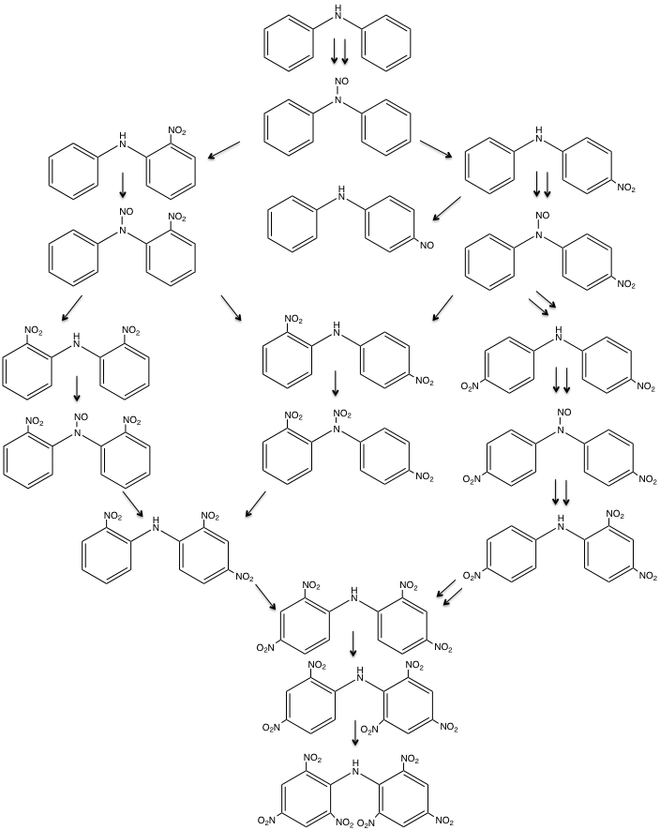
APPENDIX D

These are instructional guidelines for the usage of a Waters Acquity Ultra Performance Liquid Chromatographic (UPLC) system and a Waters Quattro Micro API Tandem Mass Spectrometer (MS/MS). From top to bottom, the UPLC system includes a compartment for mobile phase bottles, a tunable ultraviolet (TUV) detector, one temperature regulated column compartment for a Waters certified column, a sample manager with two removable trays, and a binary pump with 2 primary and 2 accumulator heads. The autosampler is maintained at 22 ºC and the column temperature at 40 ºC. The mass spectrometer is equipped with an ESCi® source that allows for switching between ESI and APCI modes – both positive and negative – in the same analysis. MS scans and multiple reaction monitoring mode were both used for monitoring ions. Nitrogen gas was used for desolvation of analytes, whereas argon gas was used for collision-induced dissociation.
- Instrument Setup
  - Turn on the Lenovo computer
    - Press the power button at the front of the computer’s central processing unit
    - Press the power button for the desktop monitor
    - Sign into the computer once it starts
      - Wait 2 minutes to allow all programs to load
      - Keep Ethernet cable unplugged from the computer at all times
        - Only plug in to update Microsoft Office, McAfee anti-virus, and Java or send emails
          - Remove Ethernet cable when finished with the Internet to reduce virus attacks
  - Turn on the MS
    - Move the switch at the bottom of the instrument to the on position
  - Turn on the UPLC
    - Press the power buttons for the sample manager
      - Press the power button for the binary pump and TUV detector once the sample manager status light turns green
  - Sign into Desktop computer
    - To ensure that the instrument is communicating, go to the Start Menu
      - Click Run
        - Type ping epc –t and clink Enter
          - Let commands pop up until it fills a whole page
            - Close window
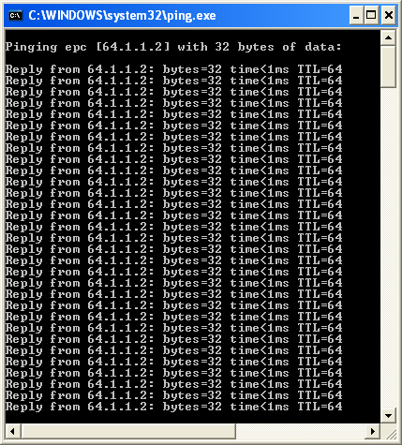
      - To reboot system, Click Run
        - Type telnet epc –t
          - A dialog window has opened with an arrow and blinking line
            - Type reboot
              - Click Enter (window should automatically close and instrument will beep)
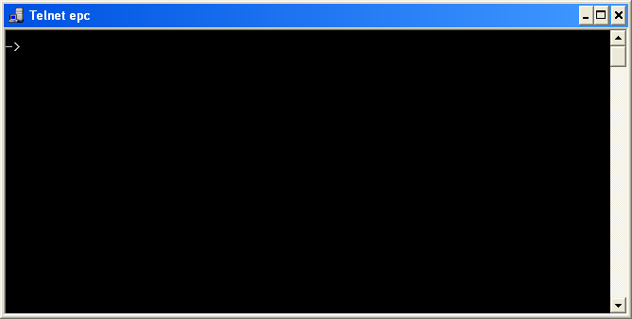

  - Open Mass Lynx
    - Double click the Mass Lynx software icon on the Desktop screen
    - The MassLynx window contains the following information:
      - Banner – Name of current project and sample list
      - Menu bar – Access to program files and features
      - Tool bar – Shortcuts to common features such as the run (play) button
      - Sample List menu bar – Provides editing options for the sample list and links to view a spectrum or chromatogram
      - Information bar – Displays the status of the sample in queue
      - Status bar – Displays MassLynx’s current status and program shutdown status
      - MassLynx bar – Provides access to programs for developing separation, detection, and analysis methods and includes 4 sections: Instrument, Tools, QuanLynx, and SDMS
      - Sample List editor – Displays information about each sample, which can be edited directly in the Sample list or via the Sample List menu bar
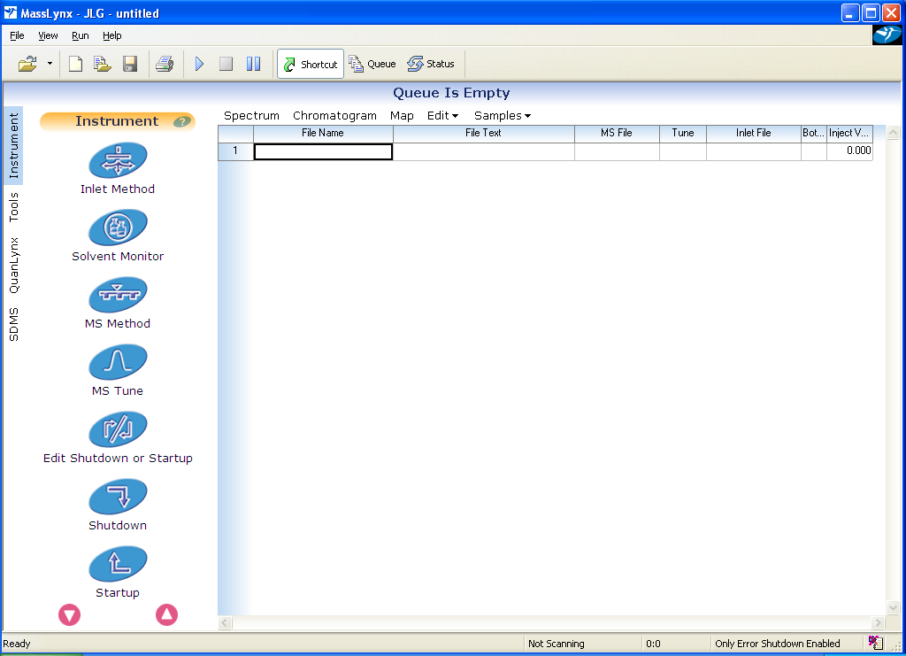
Banner Menu bar Tool bar Sample List menu bar Information bar
Status bar MassLynx bar Sample List editor

- Creating a method
  - Create a new project for each user
    - Go to the menu bar. Click File.
        - Select Project Wizard
          - Select Yes on the pop-up warning message
            - Type new project name in the Create Project dialog box
              - Select the Directory where you would like the project saved
                - Select Next and then Select one of the following options:
                - Completely new project
                - Use current project as template
                - Use existing project as template
                - Select Finish
      - A directory will be created using the new project’s name (e.g., Projectname.pro) and will contain the following sub-directories:
        - Acqudb – Acquisition information
        - Curvedb – Calibration curve information
        - Data – Raw data files
        - Methdb – Method files
        - Peakdb – Peak list files
        - Sampledb – Sample lists

  - Create a new project list
    - Go to the menu bar. Select File.
      - Select New
        - A blank page has opened. In each column, define conditions for analysis.
          - File name – Name attached to the acquired data
          - Sample description – Gives information about the sample
          - MS method - Tells instrument what type of MS scan to perform on the sample (e.g., product scan, multiple reaction monitoring mode)
          - MS tune conditions - Tells instrument what tune setting to use for detection (e.g., ionization mode, capillary voltage, corona current, and cone voltage)
          - Inlet file – Tells instrument which mobile phases, separation conditions, and UV detection conditions to use when analyzing a sample
          - Bottle – Location of sample vial in the Autosampler (e.g., 1:1). The left number refers to the tray number (1 or 2), whereas the right number refers to the exact location in the tray (48 different positions).
          - Injection volume – Amount of sample injected. The maximum amount will depend on the size of the sample loop.
    - Editing a sample list - See Section C, D, and E below for detailed steps on creating the inlet method, MS method, and MS tune method. Once created, they can be added to the project list using the following commands.
      - Add an MS method
        - Right-click in cell under the MS file column
          - Click Browse
            - A dialog window has opened with various MS methods
              - Select desired MS method file
                - Click Open
      - Add an MS tune file
        - Right-click in cell under the MS tune column.
          - Click Browse
            - A dialog window has opened with various tune files
              - Select desired MS tune file
                - Click Open
      - Add an Inlet method
        - Right-click in cell under the Inlet File column
          - Click Browse
            - A dialog window has opened with various inlet methods
              - Select desired inlet method
                - Click OK

      - Add samples to the Sample List
        - On the Sample List menu bar, click Samples
          - Click Add
            - Enter the number of samples to add
              - Click OK
      - Automatically fill cells to save time
        - Via Insert Option
          - Right-click on the row below the row to be copied
            - Click Insert.
              - New row appears above the row selected for insertion
        - Via Copy option
          - Right-click on row(s) to be copied
            - Click Copy
              - Select row where new cells will be placed.
                - Right-click on row
                - Click Paste
                - Click on either In Selected Range, Before Selected Range, or After Selected Range
                - Click OK
        - Fill down
          - Use to insert contents of one cell into other cells in subsequent rows.
          - Select a column of cells, with the first one being the cell to copy
            - Right-click on the first cell
              - Click on Fill Down
        - Fill series
          - Use to insert contents of one cell into other cells in subsequent rows
          - Increments the numerical values for each cell (e.g., 1.1, 1.2, 1.3)
          - Select a column of cells, with the first one being the cell to copy
            - Right-click on the first cell
              - Click on Fill Series…
    - Customizing the Sample List menu bar
      - Click on Samples on the Sample List menu bar
        - Click Format.
          - Click Customize.
            - Select which columns you would like to be visible.
              - Use the arrow up and arrow down buttons to move the location of each field

  - Create a new UPLC inlet method
    - Go to the Mass Lynx menu bar. Select Inlet method.
    - A dialog window has opened with different selections.
      - Status Page
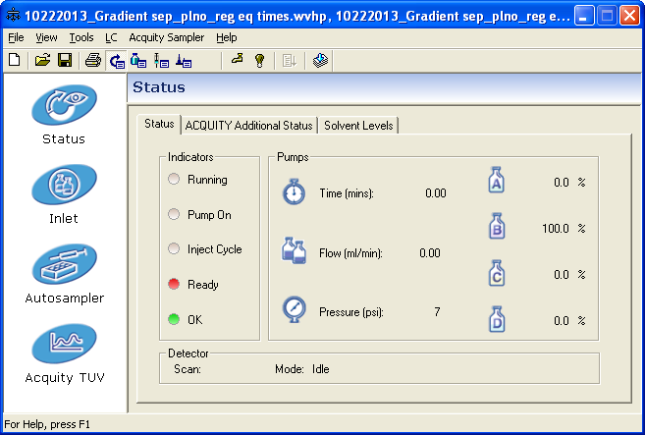
      - Select Inlet icon
        - Select two mobile phases for separation (A1, B1, A2, B2)
        - Input gradient conditions (e.g. time, flow rate, % solvent A, % solvent B, and curve profile)
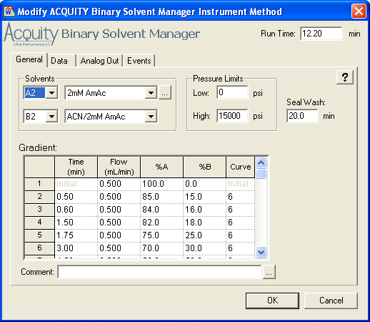
      - Select Autosampler icon
        - Select injection mode based on loop volume and recommended range
          - Partial loop
            - Injects the volume specified in sample list followed by weak wash solvent
            - Use 20-75% of loop volume for the injection volume
          - Partial loop with needle overfill
            - Injects the volume specified in sample list followed by an additional 15 μL to flush the needle
            - Use 20-75% of loop volume for the injection volume
          - Full loop – injects the maximum amount of sample the sample loop can hold
        - Select column temperature
        - Select sample manager temperature
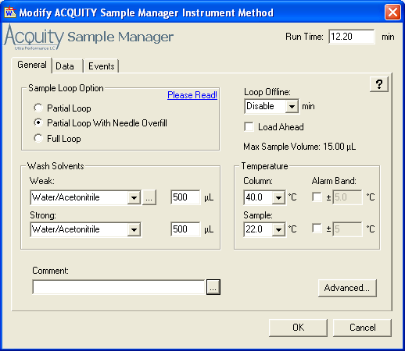
      - Select TUV detector icon
        - Select Lamp On to turn on or off the lamp
        - Select Single or Dual for one or two wavelengths
        - Input optimum wavelength(s) for sample detection
        - Input sampling rate
        - Click AutoZero on Inject Start to Zero the UV baseline
        - Click OK.
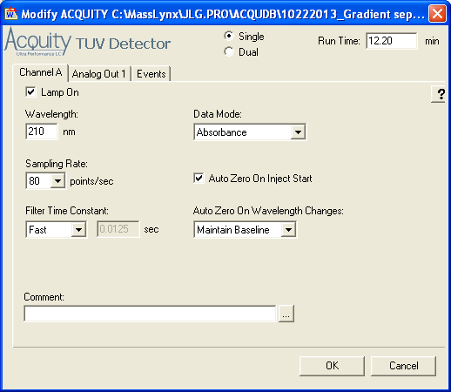
    - Go to the Menu bar. Select File
      - Select Save As
        - A dialog window has opened.
          - Type a new name for the inlet method.
            - Select Save.
    - Close the Inlet method window.

  - Create a new MS method for sample detection
    - Go to the Mass Lynx menu bar. Select MS method.
    - An Experiment Setup window has opened.
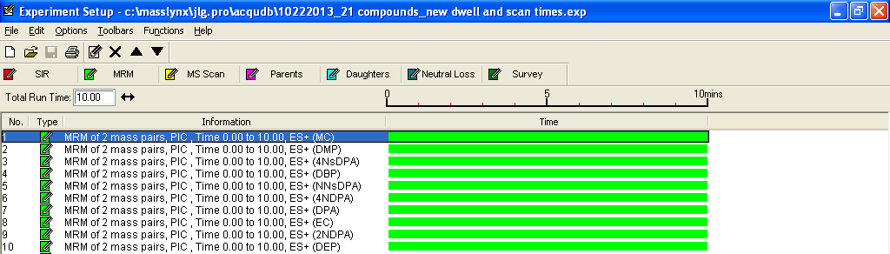
    - Select scan mode depending:
      - Selection ion recording (SIR) mode
      - Multiple reaction monitoring (MRM) mode
      - MS Scan
      - Parents
      - Daughters
      - Neutral Loss
    - Go to the Menu bar. Select File
      - Select Save As.
        - Type a new name for the experiment file
          - Select Save.
    - Close the Experiment Setup window.

  - Create a new MS tune page with detection conditions
    - Go to the Mass Lynx menu bar. Select MS tune.
    - A dialog window has opened.
      - There are 3 pages in the MS tune window
        - Source
        - Analyzer
        - Diagnostics
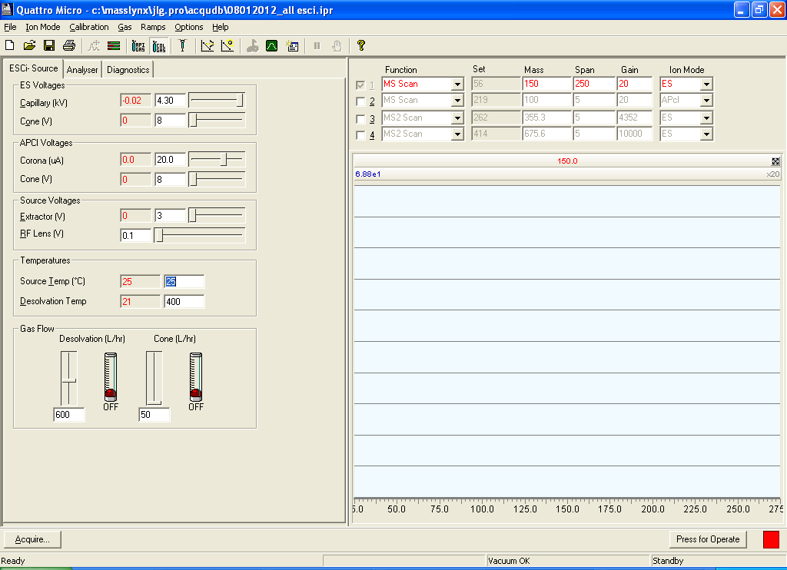
      - Source page
        - Set the capillary, corona needle, and source voltages
        - Set the source temperature, desolvation temperature, desolvation gas flow, and cone gas flows
      - Analyzer page
        - Input conditions for the mass analyzers
        - Initial conditions to start with include:
          - Resolutions for LM and HM 1 = 15.0
          - Resolutions for LM and HM 2 = 14.0
          - Ion energies = 0.6
          - Entrance, collision, and exit will vary depend on MS scan chosen
          - Multiplier = 650
          - Syringe flow rate (μL/min) will vary depending on how much you want to inject
          - Gas cell pirani = 3x10⁻³ mbar
            - Can be adjusted using the black knob at the left of the ESI probe
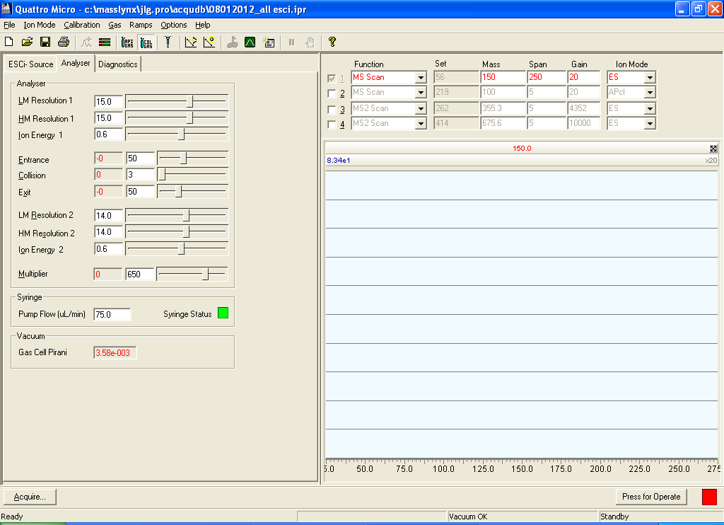
      - Select Diagnostics
        - View the turbo pump speeds and other diagnostic information about the mass spectrometer
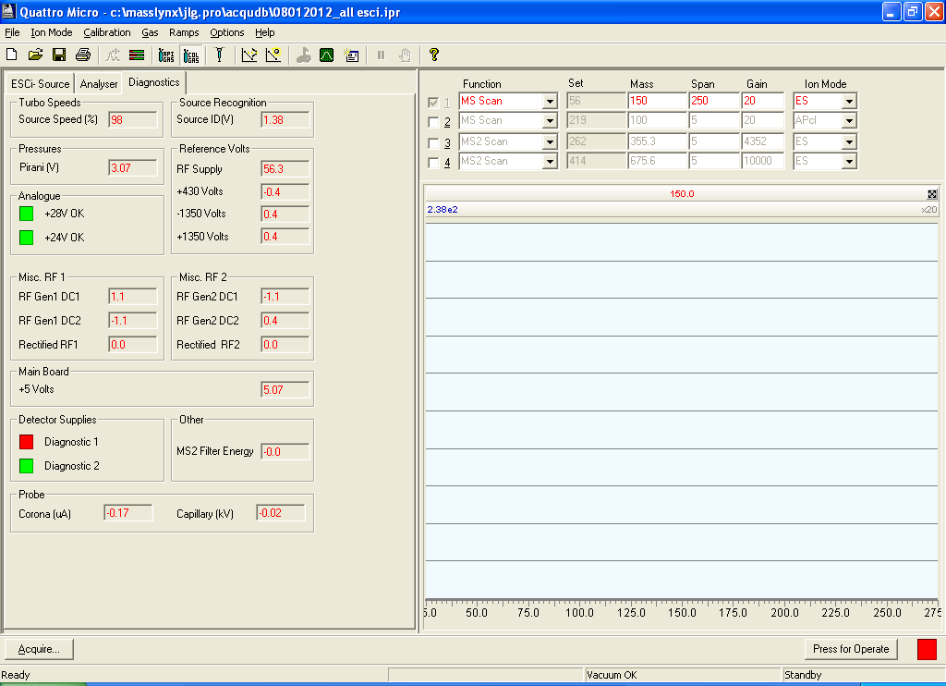
    - After inputting all of the information for sample detection on each page, Go to the Menu bar.
      - Click Save As.
        - Type a new name for the MS tune (instrument parameter) file.
          - Click Save
    - To change the ionization mode, go to the MS Tune page menu bar and Click Options
      - Click Multiple ion modes to turn on or off ESCi mode
      - When ESCi is off, you can select single ionization modes
        - From the Menu bar, Click Ion Mode
          - Click: ESI+, ESI-, APCI+, or APCI-
    - Use AutoTune to determine initial conditions for MS detection
      - Select Options on the tool bar
        - Click Autotune
          - Input MS conditions
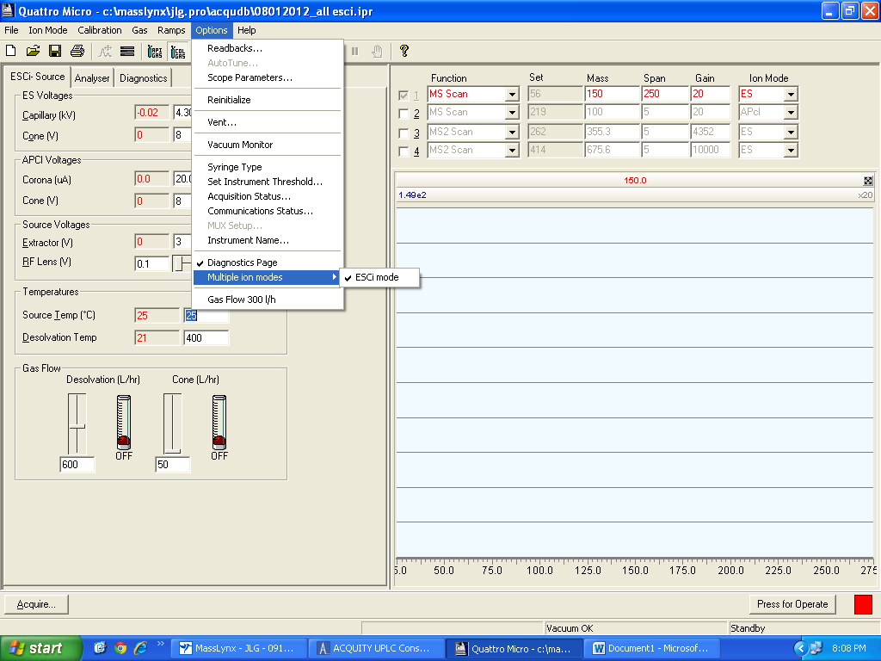

- Running a method.
  - UPLC alone
    - Click the Load button on the outside of the mass spectrometer
    - Go to the Mass Lynx window. Select Inlet method.
      - Check that the desired method is loaded and conditions are right.
      - Go to the File menu. Click Save. Minimize window.
    - In the Mass Lynx window, go to the File menu. Select Open Project.
      - Find an existing project list or make a new one following the steps in Section 2C.
      - Click Open.
    - Select the samples to run by highlighting the row numbers.
    - Click the Play button on the menu bar.
    - A dialog window has opened. Check Acquire Sample Data
      - Ensure that the correct sample range is listed in the Start Sample List window.
      - Select Ok
        - A dialog window may open to let you know that the MS is in standby mode
          - Click Yes to continue without using the MS
        - A dialog window may open to let you know that the MS is in standby mode
          - Click Yes to save the project list

  - UPLC/MS/MS
    - Click the Inject button on the outside of the mass spectrometer
    - Set up and MS methods
      - Acquiring data from the tune page window
        - Select MS tune on the Instrument tab of the Mass Lynx bar to open the tune window
        - Switch from Standby mode to Operate mode by selecting Operate and check that the indicator turns green
        - Select Acquire, an Acquisition dialog box should open
        - Enter the desired setting for the acquisition, such as the scan range.
        - Select Start
        - Keep Tune window open while acquiring data
      - Acquiring data from the sample list
        - Select MS Method on the MassLynx bar

  - MS alone – used for infusing samples directly into the MS
    - Open the MS tune page
    - Go to the menu bar. Select File
      - Select Method
        - Select Open
          - Choose the correct method file
          - Go to the menu bar. Select Control
    - Select Direct Control
      - Select Load
        - Open instrument lid
        - Place vials in the appropriate position
        - Close instrument lid
      - Select Run…

- Starting Instrument
  - Run System Startup at the beginning of the day to prime the system with fresh solvents
    - On the Acquity UPLC Console page, select Acquity UPLC System
      - Click Control
        - Click System Startup
          - Fill in the necessary information and click Start
            - Click Close when finished
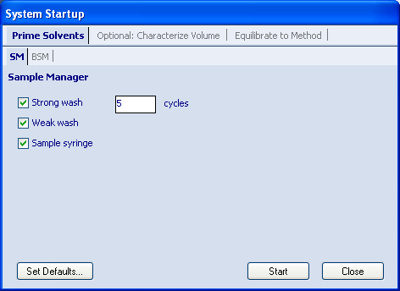

- Shutting Down Instrument
  - Setup up shutdown process to automatically turn off the UPLC and MS
    - Select Shutdown on the Status bar on the MassLynx home page
    - Use Auto Control Tasks to designate actions for shutdown or startup
    - Type in time to shutdown after the batch has completed
    - Click File on the menu bar
      - Click Save
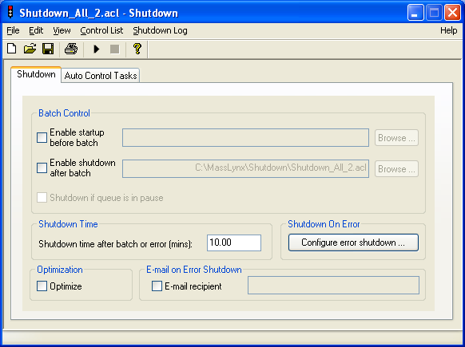
- Instrument Maintenance
  - UPLC
A detailed guide on setting up the UPLC (TUV, column, sample manager, and binary pump), configuring the system’s software, maintaining the system, and trouble shooting can be found at: http://www.waters.com/webassets/cms/support/docs/71500082502rc.pdf
    - When separation and contamination issues arrive, refer to the article by Waters on Controlling Contamination in Ultra Performance LC®/MS and HPLC/MS Systems:
http://www.waters.com/webassets/cms/support/docs/715001307d_cntrl_cntm.pdf
    - Flush all solvent lines with at least 20 column volumes of water to remove any salt residue followed by 20 column volumes of acetonitrile at the end of the day and keep the column plugged with acetonitrile
    - For tips on cleaning and regeneration of analytical columns, see Chapter 3 at:
http://www.waters.com/webassets/cms/support/docs/WA40001.pdf
    - Mobile phase and sample preparation tips
      - Use only ultra-pure solvents in the instrument
      - Filter samples and solvents when possible
      - Use in-line filters (binary pump) and solvent filters to reduce clogging
      - Minimize bacterial growth in aqueous mobile phases by adding 5-10% organic solvent
      - Prepare the sample in the running mobile phase or a weaker mobile phase
      - Prepare mobile phases fresh every 24-48 hours, especially for aqueous phases and avoid topping off mobile phases
      - Wash bottles thoroughly and heat at high temperatures in a kiln to dry and remove interfering compounds
    - Check pump fittings and lines regularly for leaks
      - Place pH paper near the connectors to detect leak
      - Run static and dynamic leak tests
        - On the Acquity page, Select static leak test.
          - A dialog window has opened. Select pump A.
          - Click Start.
          - Check that all items have passed the test.
          - Repeat steps ii-iii for Pump B
        - On the Acquity page, Select dynamic leak test.
          - A dialog window has opened. Select pump A.
          - Click Start.
          - Check that all items have passed the test.
          - Repeat steps ii-iii for Pump B

  - Tandem MS
A detailed guide on setting up the MS, configuring the system’s software, tuning, data acquisition, mass calibration, maintaining the system, and troubleshooting can be found at: http://www.ecs.umass.edu/eve/facilities/equipment/Quattromicro/Quattro_Micro_API_guide_rev_A.pdf
    - Clean sample cone and corona pin at least once a month; more if running a lot of samples or analyzing dirty samples
    - Gas ballast the turbo pump once a week to recycle oil trapped in the filter
      - Check level of oil in pump weekly
        - Vent instrument and add more oil when level is less than half
          - Use Edwards 19 ultragrade pump oil for the Edwards E2M28 pump
    - Change the ESI capillary if the tip look damaged or very dirty
    - Clean the source components and all components up to the first hexapole according to the UPLC System Operator’s Guide at least twice a year
http://www.waters.com/webassets/cms/support/docs/71500082502rc.pdf
    - For detection issues, please refer to the article by Waters on Controlling Contamination in Ultra Performance LC®/MS and HPLC/MS Systems:
http://www.waters.com/webassets/cms/support/docs/715001307d_cntrl_cntm.pdf

  - General Maintenance
    - For communication errors, reset the software, MS, and UPLC
      - Mass Lynx reset
        - Close Mass Lynx window
          - Close Acquity window
            - Close Chromatogram window
              - Close Spectrum window
                - Close MS tune page window
                - Select Shortcut to StopAcquity processes on the Desktop main screen
      - UPLC reset
        - For simple software issues, close all MassLynx windows.
          - Reopen MassLynx software
            - Run method
        - When closing and reopening Mass Lynx does not work, use the following procedure.
          - On the Desktop screen, select Start
            - Select Shutdown
              - Press the power button on the sample manager, binary pump, and TUV detector - in that order - to turn them off
                - Wait 5 minutes
                - Press the power button on the computer to turn it back on
                - Sign into the computer
                - Press the power button on the sample manager
                - Once the light on the sample manager turns green, press the power button for the binary pump and TUV detector
                - Wait for all status lights on the power button to turn green
        - To check communication, select Start.
          - Select Run.
            - A dialog window has opened. Type ping epc –t
              - Wait until the window is filled with communication signals and the time is <1ms
                - Close window
                - Click on the Mass Lynx icon and run a test sample to determine if problem is fixed.
      - MS reset
        - Soft reboot using software
          - On the Desktop main screen, select Start and Run
            - Type telnet epc
              - A dialog window has opened. Type reboot in window.
                - Click Enter.
        - Soft reboot using the MS
          - Press reset button by softly inserting peek tubing into the tiny hole at the bottom right corner of the MS instrument
            - Remove tubing immediately after pressing reset button
            - Holding the peek tubing for a long time will cause the instrument to vent
              - Wait for the mass spectrometer to beep a few times
        - Hard reboot
          - Move the switch at the bottom of the instrument to the off position
            - Wait 5 minutes
              - Move the switch at the bottom of the instrument to the on position
                - Wait 5 minutes and reopen MassLynx
    - Hazardous Waste
      - Use 4 liter glass bottle
        - Place yellow hazardous waste label from Environmental Health & Safety on the bottle over the original label.
          - Fill out everything on the label
            - Attach additional sheets if needed
      - Hazardous waste bottle contents
        - UPLC solvent line
          - Solvents routed through UPLC to waste bottle during priming
        - MS line
          - When in the Load position, liquids from the connected UPLC are rerouted into the hazardous waste bottle.
          - When in the Inject position, liquids from the connected UPLC are injected into the MS.
        - Degasser line kept under the UPLC

VITA

JENNIFER L. THOMAS

Born, St. Thomas, United States Virgin Islands

2002-2006 B.S., Chemistry
University of the Virgin Islands
St. Thomas, U.S. Virgin Islands

2007 Teaching Assistant
University of the Virgin Islands
St. Thomas, U.S. Virgin Islands

2006-2013 Doctoral Candidate
Florida International University
Miami, Florida

Research Assistant
Florida International University
Miami, Florida

Teaching Assistant
Florida International University
Miami, Florida

PUBLICATIONS AND PRESENTATIONS

Thomas JL, McCord BR, Lincoln DL. Separation and Detection of Smokeless
Powder Additives by Ultra Performance Liquid Chromatography with Tandem Mass Spectrometry. J Forensic Sci 2013;58:609-615.

Greaux JL. A Rapid UPLC/MS/MS Method for the Analysis of Smokeless Powders and Organic Gunshot Residue. Presented at the Annual International Association for Identification International Educational Conference, Providence, RI, August 8, 2013.

Greaux JL. The Application of UPLC/MS/MS to Explosive Residue Detection. Presented at the Waters Corporation Forensic Seminar, Springfield, VA, May 9, 2012.

Greaux JL. The Application of UPLC/MS/MS to the Analysis of Smokeless Powders and Gunshot Residue Samples. In Criminalistics, Proceedings of the American Academy of Forensic Sciences 64th Annual Scientific Meeting, Atlanta, GA, February 20-25, 2012; A104, 86.

Greaux JL. Analysis of Smokeless Powders and Gunshot Residue Samples by
UPLC/MS/MS. Presented at the Annual South Florida Discipline Meeting in the Miami
Dade Police Department, Miami, FL, February 2, 2012.

Greaux JL, Lincoln D, McCord BR. Method Development for the Rapid Separation and Detection of Organic Gunshot Residue by UPLC/MS/MS. Presented at the National Institute of Justice Trace Evidence Symposium, Kansas City, MO, August 8-11, 2011; 13.

Greaux JL, Lincoln D, McCord BR. Method Development for the Rapid Separation and
Detection of Organic Gunshot Residue by UPLC/MS. Presented at the Florida Annual
Meeting and Exposition, Tampa, FL, May 12-14, 2011.

Greaux JL, Lincoln D, McCord BR. Method Development for the Rapid Separation and
Detection of Organic Gunshot Residue by UPLC/MS. Presented at Florida International
University Annual Scholarly Forum; Miami, FL, March 28-29, 2011.

Greaux JL, McCord BR. Rapid Screening and Confirmation of Organic Gunshot Residue using Electrospray Mass Spectrometry. Presented at the American Academy of Forensic Sciences 63rd Annual Scientific Meeting during the National Institute of Justice Grantee Meeting, Chicago, IL, February 21-26, 2011.

Greaux JL, Lincoln D, McCord BR. Method Development for the Rapid Separation and Detection of Organic Gunshot Residue by UPLC/MS. In Criminalistics, Proceedings of the American Academy of Forensic Sciences 63rd Annual Scientific Meeting, Chicago, IL, February 21-26, 2011; A85, 65.

Greaux JL, McCord BR. The Application of CE- and CEC-TOF/MS to the Analysis of Non-traditional Drugs used to Facilitate Sexual Assault. In Toxicology, Proceedings of the American Academy of Forensic Sciences 62nd Annual Scientific Meeting, Seattle, WA, February 22-27, 2010; K24, 454.

Greaux JL, McCord BR. The Application of CE- and CEC-TOF/MS to the Analysis of Non-traditional Drugs used to Facilitate Sexual Assault. Presented at Florida International University Annual Scholarly Forum, Miami, FL, March 22, 2010.

Greaux JL, McCord BR. Method Development for the Analysis of Non-traditional Drugs used to Facilitate Sexual Assault. In Toxicology, Proceedings of the American Academy of Forensic Sciences 61st Annual Scientific Meeting, Denver, CO, February 16-21, 2009; K20, 401.

