Assay Replicability in β-Glucosidase Enzyme Kinetics Across Laboratories
Nicole Najam, Jaime Mayoral, Olga Capurro
Biological Sciences, Florida International University

ABSTRACT

Replicability is the foundation of research in any scientific discipline. Despite this, few studies address experimental variability within and across multiple institutions that operate under the same protocol. While consistency is usually well documented within the same lab, multi-institutional experiments may introduce new variables and, therefore, variability that may lead to inconsistent results. This study seeks to explore intra- and interinstitutional variability among enzyme catalytic efficiency values (K_{M} and k_{cat}/K_{M}) for the wild type of β-Glucosidase derived from Paenibacillus polymyxa. A standardized protocol for the assay was provided to all institutions that participated in the study. The analysis was conducted using data from 9 laboratories across the United States. The information was collected through the Design2Data CURE database. Our analysis showed an interlaboratory variability of 46.77% for K_{M}, 215,38% for k_{cat}, and 186.07% for k_{cat}/ K_{M}. Meanwhile, the intra-laboratory variability ranged between 18.98% and 61.74% for K_{M}, 3.73% to 113.93% for k_{cat}, and 24.64% and 111.37% for k_{cat}/ K_{M}. These results show high variability in the kinetic parameters analyzed across and within institutions, with some values (i.e. K_{M}) going up to 10 times higher. High variability may be a concern when data is interpreted across institutions. This specific assay is used as a control for other, more complex assays in the CURE network and, therefore, the variability found can potentially lead to incorrect interpretation of results. It also highlights the high variability of a simple enzymatic assay when it is replicated in laboratories with different reagents, personnel, and equipment, regardless of using the same standardized protocol.
Key Words— replicability, beta-glucosidase, intra-laboratory, inter-laboratory

Introduction
The correlation between primary structure and 3D protein folding is widely acknowledged in the field of biochemistry. Despite this recognition, understanding the intricacies of said correlation remains a difficult endeavor. To address these challenges, various software programs have been developed to predict enzyme-folded structures based on their amino acid sequences. Tools in this category include AlphaFold2, RoseTTAFold, intFOLD7, MULTIFold, and other advanced solutions (Schutze et al, 2022; Outeiral et al, 2022).
Among these programs, certain ones, such as AlphaFold2 and RoseTTAFold, use pattern recognition (Chakravarty et al, 2022) or deep learning (Miller et al, 2021) to decipher the folding pathways of enzymes. Nonetheless, these computational tools sometimes fail to take into account the ensemble of protein structures and neglect characteristics, such as biophysics and "two-state" processes (Outeiral et al, 2022). Similarly, FoldIt Standalone is a graphical interface derived from the RoseTTA molecular predicting mechanism meant to allow users to mutate known enzyme structures. The program offers molecular stability predictions by generating an energy score indicative of thermostability (Kleffner et al, 2017). Nonetheless, FoldIt Standalone also has some drawbacks, as it uses computational algorithms to estimate the score.
In response to these limitations, multi-laboratory databases like D2D CURE have emerged to amass experimental data on protein folding. D2D CURE is a multi-laboratory network with the primary goal of characterizing the enzyme β-glucosidase by mutating its amino acid residues (Huang et al, 2020) while providing an immersive experience in research to STEM undergraduates.
β-Glucosidases are a multi-organism enzyme family responsible for the hydrolysis of glycoside, oligosaccharides, and cellulose, cleaving the glycosidic bond and having glucose as an end-product (Cairns et al, 2010). The presence of glucose inhibits the chemical reaction (Singhania et al, 2012). They are present in all domains of life, although their starting product differs based on the organism of origin. Due to its widespread occurrence and enzymatic activity, this family is a subject of interest in various fields, such as agriculture, engineering, and medicine. In humans, decreased hydrolysis of glucocerebrosides is the cause of Gaucher’s disease, as leukocyte β-Glucosidase has a lower enzymatic activity (Beutler et al, 1971). β-Glucosidase also has an application in oenology, as it is capable of hydrolyzing monoterpenes without altering the taste of wine and grapes (Rosi et al, 1994).
Through the introduction of variant amino acids, it becomes possible to gather ample data concerning the enzyme's expression patterns, thermostability, catalytic efficiency, and substrate affinity. This collected information is then used to determine whether the FoldIt Standalone application has made a valid, algorithm-based estimate of its energy score and expression. Any discrepancies are reported to better the algorithm.
For the data to be efficiently collected, a comparison must be made to a wild-type beta-glucosidase. Since D2D is a multi-institutional network, multiple laboratories must develop their own wild-type per the network-wide procedures. The data from each laboratory is then uploaded to D2D for the historical control to be determined, which serves as a comparison baseline for the website. Consequently, the ability of all laboratories to produce similar and efficient results becomes of paramount importance within this approach.
As such, it becomes of interest to explore the variability across multiple laboratories in a nationwide network in order to determine the feasibility of replicability. Previous analyses have been performed which indicated that even with standardized protocols, results tend to diverge in intra and inter-laboratory experiments (Pan et al, 2010), though the sources of error vary. Our paper aims to further investigate these conclusions by bringing forth a new protocol and data network.

Methods and Procedures

Pre-design stage

A comprehensive and detailed set of sequential instructions for the bioengineering of β-glucosidase was transmitted to a conference of eleven institutions actively engaged in the Design2Data (D2D) data collection initiative, which spans diverse geographical domains within the United States. Along with the experiment protocol, the institutions were also provided with a list of approved distributors whom they could purchase reagents, materials, and cell cultures from.

Wild-Type Bioengineering
Each laboratory was mandated to culture a wild-type beta-glucosidase strain in tandem with its corresponding mutant strains. Beginning with a computationally guided design of the desired amino acid substitutions, oligonucleotide chains consisting of 33 base pairs were procured from subsidized suppliers. Leveraging single-stranded DNA (ssDNA) derived from an Escherichia coli CJ236 strain, these oligonucleotides were subject to annealing and subsequent phosphorylation procedures.
The pET-29b+ plasmid was utilized as a vector to incorporate the wild-type gene, enabling gene expression and conferring resistance to Kanamycin. Subsequently, transformation processes involving DH5𝛼 E. coli was orchestrated. Once colonies were isolated from the growth plate, they were subjected to an overnight cultivation regimen in the laboratory, allowing for optimal plasmid DNA expression.
Following this propagation phase, plasmid DNA underwent purification procedures subsequent to the lysis of E. coli cells. In a sequential step, BLR chemically competent E. coli cells were employed to effectuate a secondary transformation. Colonies from this transformation were plated onto petri dishes treated with kanamycin at concentrations of 50 and 100 μg/mL. From this array, a single viable colony was selected and proliferated overnight.
Cell lysis was initiated upon achieving sufficient cell density, facilitating the subsequent tagging of the wild-type BgIB variant with a His-tag. This distinctive molecular marker then enabled the application of immobilized metal ion affinity chromatography employing Ni-NTA, affording the opportunity for protein purification. The culminating product, the purified wild-type BgIB protein, underwent resolution through SDS-PAGE analysis, a technique employed alongside other BgIB variants for comprehensive comparative insights.

Kinetic and Thermostability Assay
To assess the enzymatic activity of BgIB, the substrate of choice was 4-nitrophenyl-β-D-glucopyranoside. This compound served as the substrate for cleavage reactions. Following enzymatic activity and subsequent hydrolysis of the bond linking the nitrophenyl group and the sugar component in the molecule, a marked change in coloration was noted. This visual alteration served as the basis for quantifying enzyme activity across discrete time intervals.
A spectrometer operating at a specific wavelength of 420 nm was employed to streamline the quantification process. Subsequently, the amassed data points were systematically integrated into the Design2Data (D2D) repository. These data were then harnessed to construct graphical representations.

Interpretation of nationwide results
Results were collected from the Design2Data (D2D) online platform and subjected to rigorous scrutiny to assess the extent of variability inherent within the dataset. Employing the statistical tool SPSS, a comprehensive analysis was undertaken, culminating in the creation of Whisker Plots. These plots, adorned with a 90% confidence interval, were adeptly constructed to offer an enhanced visual representation of value dispersion across both laboratories within the same institution and laboratories spanning distinct institutions.

Results
The results of thermostability and kinetic assays for the Wild-Type of β-Glucosidase B (BgIB) for parameters K_{M}, k_{cat}/K_{M}, and T₅₀ were subjected to extensive statistical analysis. The samples included in this study were derived from both curated and non-curated datasets and were sourced from 11 distinct institutions located within the United States.
An Independent-Samples Kruskal-Wallis Test was conducted using the SPSS computational tool to assess the validity of the reported data. The test was conducted under the assumption of a null hypothesis, positing that the data points were uniformly distributed across institutions within each category. The confidence interval was set at 90%, and the significance level was chosen as 0.050. The analysis was performed on three distinct variables: K_{M}, k_{cat}/K_{M}, and T₅₀.
For the K_{M} parameter, the computed significance value was 0.886, based on a total sample size (n) of 114. The Kruskal-Wallis test statistic yielded a value of 5.077ª, corresponding to a degree of freedom of 10. The statistical analysis resulted in the retention of the null hypothesis. This indicates that no significant differences were observed in the distribution of Km values across the various institutions.
In the case of k_{cat}/K_{M}, the computed significance value was found to be less than 0.001, considering a total sample size (n) of 115. The Kruskal-Wallis test statistic was calculated as 37.531ª, accompanied by a degree of freedom of 10. As a result of this analysis, the null hypothesis was rejected. This implies the existence of statistically significant differences in the distribution of k_{cat}/K_{M} values across the studied institutions.
The T₅₀ variable yielded a significance value of 0.002, derived from a total sample size (n) of 62. The Kruskal-Wallis test statistic was calculated to be 22.346a, with a degree of freedom of 7. Consequently, the null hypothesis was rejected. This outcome indicates the presence of statistically significant differences in the distribution of T₅₀ values among the institutions.
Furthermore, for a more nuanced understanding of the relationships between institutions based on asymptotic significance, pairwise comparison diagrams were employed. These diagrams provide insights into the specific pairs of institutions that exhibit significant differences in their variable distributions.

Diagram 1.0
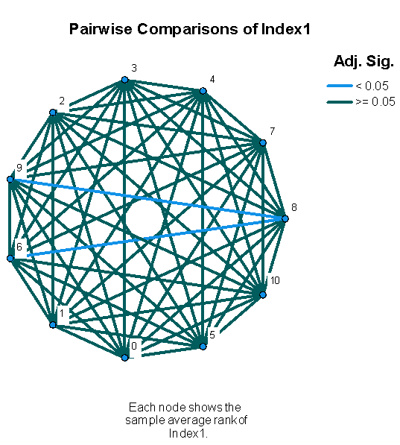
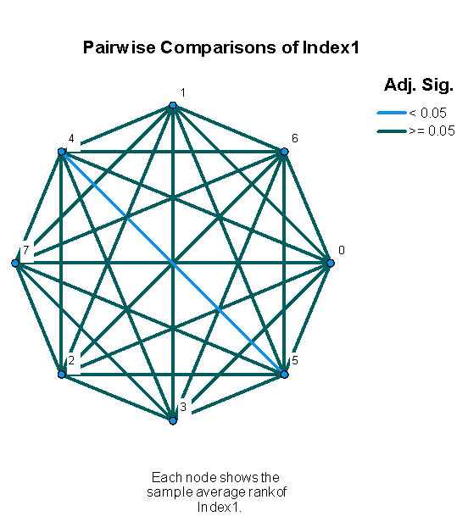
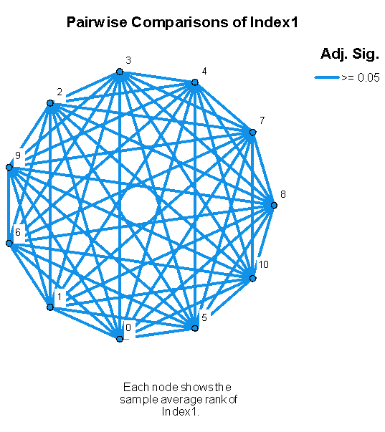
Note: Pairwise comparison diagrams were provided for the 3 parameters: T50, Km, and kcat/Km. Significance values were adjusted based on the Bonferroni correction when running multiple tests.
Similarly, Whisker Plots with a confidence interval of 90% were constructed in order to better visualize the variability across institutions. The median values are represented on the graphs.

Figure 1.0
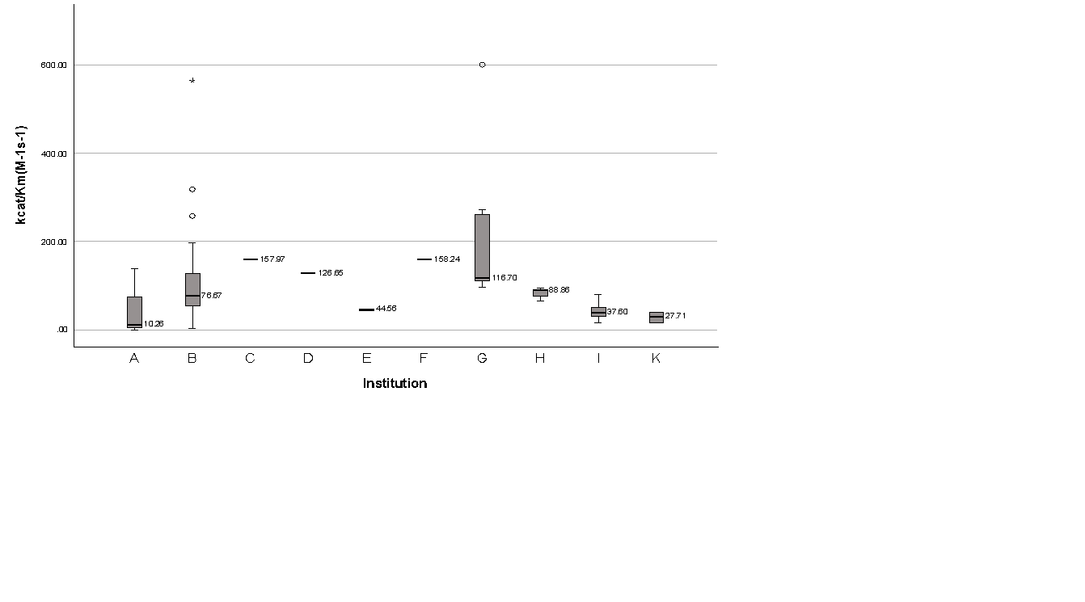
Note: Whisker plot (90% confidence) for k_{cat}/K_{M} from eleven institutions. Participating institutions are labeled A-K. Circles represent outliers considered reasonable errors, asterisks depict outliers identified by SPSS as deviating significantly from the dataset’s norm. An aberrant value from Institution A was excluded from the graph. Institution K was omitted from the graph in order to ensure readability.

Figure 2.0
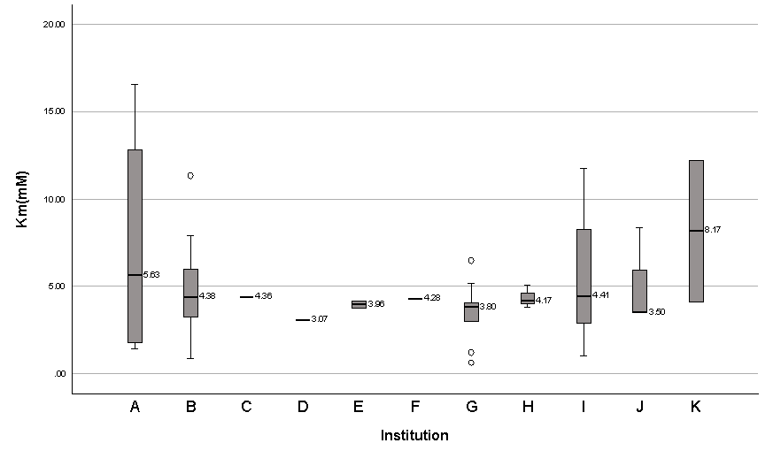
Note: Whisker Plots (90% confidence) for K_{M} values from eleven institutions. Participating institutions are labeled A-K. Circles represent outliers considered reasonable errors, asterisks depict outliers identified by SPSS as deviating significantly from the dataset’s norm.

Figure 3.0
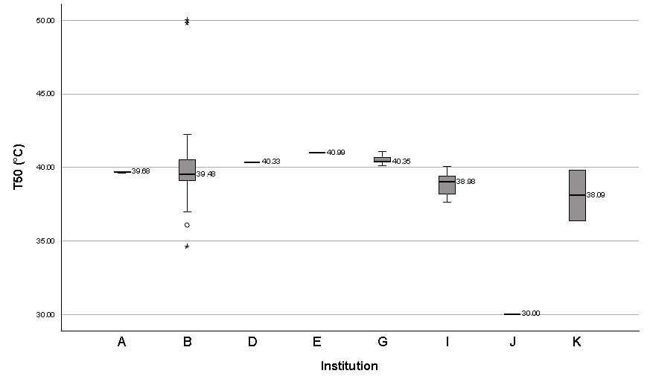
Note: Whisker plots (90% confidence) for T50 values from eight institutions. Participating institutions are labeled A-K. Circles represent outliers considered reasonable errors, asterisks depict outliers identified by SPSS as deviating significantly from the dataset’s norm. Some institutions did not report T₅₀ values.

Table 1.0
 | Average K_{M} (mM) | Average k_{cat}/K_{M} (M-1s-1) | Average T₅₀ | Interval K_{M} (mM) | Interval k_{cat}/K_{M} (M-1s-1) | Interval T₅₀
Curated | 4.32 | 117.22 | 39.76 | 2.90-6.50 | 49.71-197.96 | 38.83-40.80
Non-Curated | 4.77 | 126.39 | 39.55 | 2.19-7.25 | 18.91-184.37 | 37.79-40.99
Note: This table presents the calculated wild-type average values along with their corresponding 90% confidence intervals for both curated and noncurated datasets across all participating institutions. Notably, one specific data point originating from University A was deliberately excluded from the calculations. The decision to exclude this data point was based on its substantial influence, which was observed to significantly impact the resulting average values.
The wild-type average value for the k_{cat}/K_{M} for curated data was 117.22, and the 90% confidence interval was 49.71-197.96. The recorded non-curated data reported an average of 126.39 with a 90% confidence interval of 18.91-184.37. Based on a total sample size of 115, this indicated high levels of variability between institutions, as shown in Figure 1. An aberrant value from Institution A was excluded from the graph.
The wild-type average K_{M} value for the curated data set was 4.32, and the 90% confidence interval range of 2.90-6.50. The average K_{M} value for the non-curated data-set was 4.77, and the 90% confidence interval range of 2.19-7.25. This analysis was conducted on a comprehensive sample pool consisting of 115 data points. Notably, the reported findings vividly demonstrated substantial variability, as depicted in Figure 2.
Among the 11 participating institutions, T₅₀ values were reported based on data from 8 of them. This was due to the fact that only half of the wild-type thermostability assays, totaling 62 samples, included the necessary T₅₀ value. Within this sample pool, 20 samples were curated and had associated T₅₀ values. For the curated data subset, the average T₅₀ value was determined to be 39.76, with a 90% confidence interval spanning from 38.83 to 40.80. Conversely, the non-curated data subset exhibited an average T₅₀ value of 39.55, accompanied by a 90% confidence interval ranging from 37.79 to 40.99.

Discussion
The analysis of both curated and noncurated datasets extracted from the Design2Data database reveals a notable degree of intra-institutional variability in the obtained results. This observation underscores the complex nature of enzyme kinetics experiments, where numerous factors such as experimental conditions, equipment calibration, and sample preparation can introduce variations. The identification of outliers through statistical methods, facilitated by SPSS, provides a mechanism to pinpoint and investigate discrepancies in reported data. These outliers can now be subjected to closer scrutiny within their respective laboratories, enabling the identification of potential sources of error and the refinement of experimental procedures.
The Independent-Samples Kruskal-Wallis Test illustrates the areas which contain a raised degree of variability, specifically the measurement for k_{cat}/K_{M} and T₅₀. The measurement for K_{M}, despite showing a wide range of values, is consistent across institutions. This suggests that the variability for k_{cat}/K_{M} is more closely related to the value of the turnover number, k_{cat}.
Our analysis brings to light the existence of institutions that deviate from the reported averages of their counterparts. Notably, Institution K reports k_{cat}/K_{M} values that are 1000 times higher than the average values reported by other universities. Institution G, on the other hand, reports k_{cat}/K_{M} values that range from 2 to 4 times higher than the established norm. Possible explanations for these discrepancies include variations in the number of wild-type contributions, differing wild-type enzyme dilution factors, or instances of human error in measurement and data recording due to different curriculum prerequisites for the lab. The considerable impact of these factors on enzymatic parameter determination underscores the importance of meticulous protocol execution and adherence to standardized methodologies.
Interestingly, some institutions within the dataset omit the reporting of T₅₀ values or the quantity of wild-type enzyme expressed in their assays. The absence of these details hinders a comprehensive analysis and comparison of experimental outcomes. This highlights the necessity for complete and transparent data submission to enable a holistic evaluation of enzymatic kinetics results and to foster reproducibility across research endeavors.
A significant finding emerges from the analysis of curated data, which displays a narrower range for the majority of parameters studied. This phenomenon emphasizes the value of meticulous data curation in maintaining the quality and relevance of the information stored in the D2D database. The curated data's reduced variability further emphasizes the importance of standardizing experimental procedures and adhering to reporting guidelines, ultimately enhancing the reliability and credibility of enzymatic kinetics research findings.
The provision of 90% confidence intervals for K_{M}, k_{cat}/K_{M} and T₅₀ parameters serves as a valuable resource for guiding new institutions in designing and executing their enzyme kinetics experiments. These intervals offer a robust framework for assessing the precision and reliability of reported results, contributing to the establishment of standardized practices in the field.
In conclusion, this study's multifaceted analysis of the D2D database illuminates various aspects of enzyme kinetics research. The provision of confidence intervals aids in guiding new institutions, the observation of intra-institutional variability prompts introspection and improvement, and the identification of deviations and outliers underscores the need for standardized practices and transparent reporting. Furthermore, the absence of key data points and the narrower range exhibited by curated data collectively emphasize the significance of meticulous data curation and adherence to protocols. As the field of enzymatic kinetics advances, these insights contribute to refining methodologies and bolstering the integrity of research outcomes.

References
- Beutler E, Kuhl W, Trinidad F, Teplitz R, Nadler H. Beta-glucosidase activity in fibroblasts from homozygotes and heterozygotes for Gaucher's disease. Am J Hum Genet. 1971 Jan;23(1):62-6. PMID: 5581982; PMCID: PMC1706631.
- Carlos Outeiral and others, Current structure predictors are not learning the physics of protein folding, Bioinformatics, Volume 38, Issue 7, March 2022, Pages 1881–1887, https://doi.org/10.1093/bioinformatics/btab881
- Chakravarty D, Porter LL. AlphaFold2 fails to predict protein fold switching. Protein Sci. 2022 Jun;31(6):e4353. doi: 10.1002/pro.4353. PMID: 35634782; PMCID: PMC9134877.
- Huang P, Chu SKS, Frizzo HN, Connolly MP, Caster RW, Siegel JB. Evaluating Protein Engineering Thermostability Prediction Tools Using an Independently Generated Dataset. ACS Omega. 2020 Mar 20;5(12):6487-6493. doi: 10.1021/acsomega.9b04105. PMID: 32258884; PMCID: PMC7114132.
- Johanna L. Miller; Deep learning opens up protein science’s next frontiers. Physics Today 1 October 2021; 74 (10): 14–17. https://doi.org/10.1063/PT.3.4850
- Ketudat Cairns, J.,R., & Esen, A. (2010). [Beta]-glucosidases. Cellular and Molecular Life Sciences, 67(20), 3389-405. doi:https://doi.org/10.1007/s00018-010-0399-2
- Mirdita, M., Schütze, K., Moriwaki, Y. et al. ColabFold: making protein folding accessible to all. Nat Methods 19, 679–682 (2022). https://doi.org/10.1038/s41592-022-01488-1
- Pan Y, Bodrossy L, Frenzel P, Hestnes AG, Krause S, Lüke C, Meima-Franke M, Siljanen H, Svenning MM, Bodelier PL. Impacts of inter- and intralaboratory variations on the reproducibility of microbial community analyses. Appl Environ Microbiol. 2010 Nov;76(22):7451-8. doi: 10.1128/AEM.01595-10. Epub 2010 Sep 24. PMID: 20870788; PMCID: PMC2976186.
- Robert Kleffner and others, Foldit Standalone: a video game-derived protein structure manipulation interface using Rosetta, Bioinformatics, Volume 33, Issue 17, September 2017, Pages 2765–2767, https://doi.org/10.1093/bioinformatics/btx283
- Rosi I, Vinella M, Domizio P. Characterization of beta-glucosidase activity in yeasts of oenological origin. J Appl Bacteriol. 1994 Nov;77(5):519-27. doi: 10.1111/j.1365-2672.1994.tb04396.x. PMID: 8002477.
- Singhania RR, Patel AK, Sukumaran RK, Larroche C, Pandey A. Role and significance of beta-glucosidases in the hydrolysis of cellulose for bioethanol production. Bioresour Technol. 2013 Jan;127:500-7. doi: 10.1016/j.biortech.2012.09.012. Epub 2012 Sep 14. PMID: 23069613.

