Introduction
The South Florida region has long been a vibrant hub of economic and cultural activity. However, this prosperity has come at a cost. The escalating usage of vehicles has resulted in a substantial increase in air pollution and a decrease in public health, especially for individuals who reside near major roadways (Zhang & Batterman, 2013). Traffic congestion in the region negatively impacts air quality, affecting both the local environment and neighboring areas. The Tampa Bay Estuary Program, for example, attributed 17% of all nitrogen pollution to vehicle emissions (Lewis, 2019). As the consequences of air pollution become increasingly inevitable, innovative solutions are necessary to create a more sustainable path for the region. Addressing these emissions sources has become a top priority for policymakers, researchers, and local communities.
Vehicle emissions contribute significantly to environmental degradation, releasing pollutants that cause eye irritation, coughing, vomiting, and unpleasant odors (Ogur & Kariuki, 2014). Long-term exposure increases the risk of chronic illnesses, including cardiovascular and pulmonary diseases due to sulfur dioxide (SO₂) (Adeyanju, 2018). Nitrous Oxides (NO_{x}), when combined with water, forms toxins contributing to ozone formation, which, when inhaled, leads to various adverse health effects, including lower immune system effectiveness and respiratory problems, particularly in children (US EPA, 2017). Long-term exposure to ozone can cause uncontrollable asthma in adults(Jacquemin et al., 2012). Particulate matter under 2.5 microns in diameter (PM_{2.5}), emitted from automobiles, can penetrate deep into the lungs, leading to chronic illnesses, including an 8% increase in breast cancer incidence in areas with high PM_{2.5} exposure (National Cancer Institute, 2023).
In recent years, electric vehicles (EVs) have emerged as a solution to transportation emissions. Unlike internal combustion engine vehicles (ICEVs), which use gasoline or diesel, EVs run on electricity, offering lower emission factors per mile traveled (VMT) (Choma et al., 2020) The United States incentivizes EV adoption through tax credits and other benefits, including enhanced access to public chargers and education (House, 2023). As of June 2022, Florida had 167,900 registered EVs, less than 1% of the state's total vehicle population (U.S. Department of Energy, 2023).
While EVs reduce emissions compared to ICEVs, they don't eliminate them entirely. EVs still emit particulate matter through brake and tire wear. Additionally, electricity generation for EVs can involve emission-producing sources, and increased EV charging will raise emission outputs from electricity generation in Florida. Counties may have electricity generating resources within their regions but oftentimes also import electricity across their boundaries. The electricity generating resources in Florida include nuclear, biomass, photovoltaic, natural gas fired combined cycle (gas-cc), natural gas combustion turbine (gas-ct), coal, and hydroelectric (Gagnon et al., 2023).
Air pollution-related public health costs include direct medical costs and indirect costs associated with loss of productivity (Birnbaum et al., 2020). Poor air quality frequently results in higher healthcare costs for hospital stays, therapies, and medication for affected individuals and communities (Liu et al., 2021). In this study, public health costs refer to additional expenses incurred within a county due to vehicle-generated pollutant concentrations. These costs extend beyond figures, impacting individuals with respiratory conditions or residing in areas with poor air quality, reducing their quality of life and overall well-being. Pollutant emission altitude affects dispersion and impacts. Ground-level emissions like brake and tire wear (BTW) have immediate, localized effects, while mid-level emissions from sources like EV charging or fuel production can disperse widely in the atmosphere.

We provide a thorough examination of health implications related to current vehicle emissions in South Florida's Broward, Collier, Miami-Dade, and Monroe counties. By analyzing average emission rates of pollutants from vehicles and energy demand, we offer insights into their public health impact. Additionally, predictive analysis extending to 2050 assesses the impact of EV adoption, forecasting emissions with increasing EV usage using the Estimating Air Pollution Social Impact Using Regression (EASIUR) model. Our aim is to underscore the urgent need for sustainable transportation policies, including greater use of renewable resources, to protect the region's well-being. This research enhances our understanding of pollutant impacts, informing targeted interventions and policies for a healthier, more sustainable future in South Florida.

Methods
Base Emissions
This study investigates the changes in emissions over time resulting from the adoption of EVs and assesses their impact on human health in the South Florida Region. To achieve this, we analyzed county travel patterns, vehicle emissions rates, grid emissions, and utilized the EASIUR model.
The breakdown of total VMT in 2019 for various vehicle types and roadways was sourced from the Florida Department of Transportation (FDOT) (Federal Highway Administration, 2020) and cross referenced amongst historical county mileage in 2019 (Florida Department of Transportation, 2019). This study considered motorcycles, passenger cars, light duty trucks (LDT), single-unit trucks (MHDVs), combination trucks (HHDVs), and transit buses. Roadways included interstate systems, turnpike & freeways, other principal arterials, minor arterials, major collectors, minor collectors, and local roadways as listed by the FDOT. The GREET (2022) model from Argonne National Laboratory provided a comprehensive life-cycle analysis for assessing environmental impact. It incorporated emission factors accounting for usage-related emissions, which were aggregated to quantify total pollutant output specific to each vehicle and county. Emission factors for ICEVs include BTW and exhaust, while those for EVs include BTW and charging emissions. The emissions factors for BTW and ICEV exhaust are shown in Table 1.

Table 1.
Emissions rates from internal combustion engine vehicle (ICEV) exhaust and brake and tire wear (BTW) and electric vehicle (EV) BTW.
Vehicle Type | ICEV Exhaust  g-NO_{x}/mile | ICEV Exhaust  g-PM_{2.5}/mile | ICEV Exhaust  g-SO₂/mile | ICEV BTW  g- PM_{2.5}/mile | EV BTW  g- PM_{2.5}/mile
Motorcycle | 0.090 | 0.002 | 0.002 | 0.004 | 0.004
Car | 0.090 | 0.002 | 0.002 | 0.004 | 0.004
LDT | 0.093 | 0.003 | 0.003 | 0.004 | 0.004
Bus | 2.106 | 0.004 | 0.011 | 0.013 | 0.014
MHDV | 1.105 | 0.010 | 0.011 | 0.015 | 0.014
HHDV | 2.386 | 0.004 | 0.016 | 0.026 | 0.027
Note: Nitrogen oxide (NO_{x}); particulate matter under 2.5 microns in diameter (PM_{2.5}); Sulfur Dioxide (SO₂); milligram (mg); Passenger car (Car); Light Duty Truck (LDT); Single-unit Truck (MHDV); Combination Truck (HHDV); all values are from GREET (2022).
Electric Vehicle Charging
Charging schedules for EVs were developed to account for time-of-day emissions profiles. This modeling incorporated trip and dwell time data for passenger cars and LDTs from the National Household Travel Survey (NHTS) (2017), while schedules for MHDVs and HHDVs utilized the Fleet DNA database (2022) from the National Renewable Energy Laboratory. Transit bus charging schedules were based on 2017 NHTS travel behavior data. The charging schedules are shown in Figure 1.

Figure 1.
Charging schedule for each vehicle category.
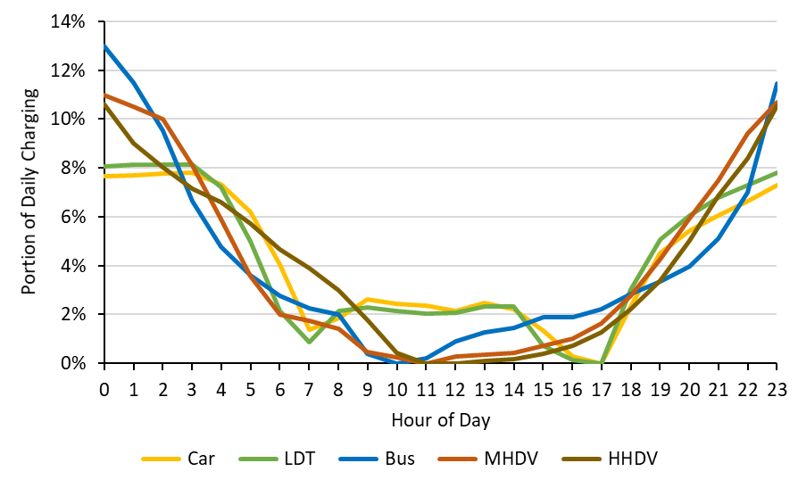
Note: Passenger car (Car); Light Duty Truck (LDT); Single-unit Truck (MHDV); Combination Truck (HHDV).
The forecasted electricity grid mix from 2022 to 2050 was developed from the National Renewable Energy Laboratory's (NREL) Cambium data sets using the mid-case scenario (Gagnon et al., 2023). The average grid mix from Cambium was utilized to estimate the marginal grid mix induced from EV charging. These projections were resolved hourly from each electricity producing resources (EPR) within the state of Florida as shown in Figure 2.
The electricity factor links vehicle travel to total power generation per county relative to the state total, assuming uniform EV adoption rates across counties. Emission factors for grid resources in the Southeastern Electric Reliability Council region were sourced from Ecoinvent 3.8, covering only operating emissions (Wernet et al., 2016). Total power generation capacity for each EPR was determined using the U.S. Energy Atlas, which maps energy infrastructure and resources nationwide (U.S. Energy Atlas, 2023b).
Figure 2.
Average electricity mix in Florida from 2024 to 2050.
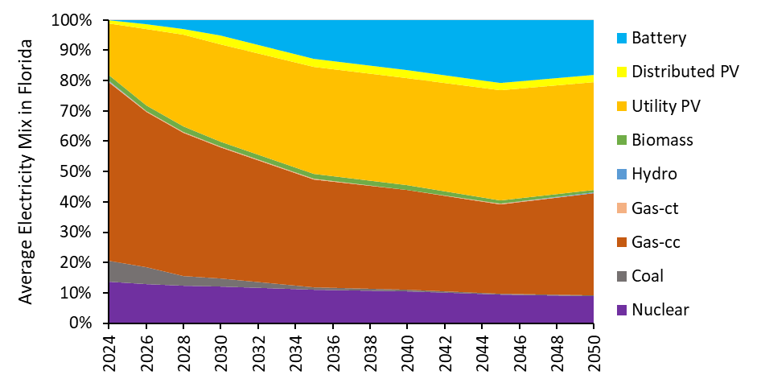
Note: photovoltaics (PV); natural gas combined cycle (Gas-cc); natural gas combustion turbine (Gas-ct).
Hourly grid mixes were coupled with the hourly charging schedules to assess emissions. For the counties in this study, the EPRs with operational emissions located within the counties included biomass, gas-cc, and gas-ct (Gagnon et al., 2023). The Florida electricity mix was then used to predict electricity emissions within each county due to EV charging. An electricity factor for each county was computed to estimate the energy generation from the counties’ EPRs.
The electricity factor relates vehicle travel to the total electricity generation per county relative to the state total, assuming each county adopts EVs at the same rate. Emissions factors for various grid resources in the Southeastern Electric Reliability Council region were obtained from Ecoinvent 3.8, encompassing only operating emissions (Wernet et al., 2016). Total power generation capacity for each EPR was determined using the U.S. Energy Atlas which shows all energy infrastructure and resources layers within the U.S. (U.S. Energy Atlas, 2023b). The electricity factor was calculated for each county (c) with Equation 1 using the VMT and total nameplate capacity of each EPR in the county and state (s) from Table 2.
Equation 1. ${Electricity Factor}_{c}=\frac{{VMT}_{s}}{{VMT}_{c}}×\frac{{capacity}_{c}}{{capacity}_{s}}$
Table 2.
County and state vehicle miles traveled (VMT) and nameplate capacity of electric generation resources.
Input | Broward County | Collier County | Miami-Dade County | Monroe County | Florida
VMT per year | 1.76 ×10¹⁰ (a) | 3.88×10⁹ (a) | 2.04 ×10¹⁰ (a) | 1.13 ×10⁹ (a) | 2.26 ×10¹¹ (a)
Gas-cc capacity | 14896.2 (b) | 0 (b) | 0 (b) | 0 (b) | 53942.6 (c)
Gas-ct capacity | 1215.9 (b) | 0 (b) | 0 (b) | 0 (b) | 53942.6 (c)
Biomass capacity | 77.2 (b) | 4 (b) | 89.8 (b) | 0 (b) | 814.10 (c)
Note: natural gas combined cycle (Gas-cc); natural gas combustion turbine (Gas-ct); megawatt (MW); a (Florida Department of Transportation, 2019); b (U.S. Energy Atlas, 2023b); c (U.S. Energy Atlas, 2023a).
The charging emissions per kWh (Charging) were calculated based the electricity factor (EF), portion of the grid mix (mix%) by year (y) and time-of-day (h), portion of daily charging (chg) by each vehicle category (v), VMT of each vehicle category, energy efficiency (EE) of each vehicle category (car: 0.31 kWh/mile; LDT: 0.48 kWh/mile; Bus: 2.2 kWh/mile; MHDV: 1.1 kWh/mile; HHDV: 2.2 kWh/mile), and emissions intensity (int) for each EPR (R) and county (c) using Equation 2. The charging emissions were calculated for the following pollutants (p) with emissions intensities shown in Table 3: PM_{2.5}, NO_{x}, and SO₂.
Equation 2. ${Charging}_{p, y}=\sum_{h,v,R}{{EF}_{c,R}×{mix\%}_{y,h,R}×{chg}_{v,h}×{int}_{p,R}×{VMT}_{v,y}×{EE}_{v}}$

Table 3.
Emissions intensity of electric power resources.
Resource | tonnes-NO_{x}/MWh | tonnes-PM_{2.5}/MWh | tonnes-SO₂/MWh
Gas-cc | 3.07×10⁻⁴ | 1.69×10⁻⁵ | 3.23×10⁻⁴
Gas-ct | 5.69×10⁻⁴ | 3.04×10⁻⁵ | 5.65×10⁻⁴
Biomass | 9.48×10⁻⁴ | 6.73×10⁻⁵ | 8.29×10⁻⁵
Note: Megawatt-hour (MWh); nitrogen oxides (NO_{x}); particulate matter under 2.5 microns in diameter (PM_{2.5}); sulfur dioxide (SO₂); natural gas combined cycle (Gas-cc); natural gas combustion turbine (Gas-ct).

Electric Vehicle Adoption
Predictive insights on electric vehicle adoption were obtained from NREL (Mai et al., 2018). This predictive model compared anticipated electric vehicle adoption (Figure 3) with historical county VMT data from 2019 (Figure 4). Forecasting through 2050 included projections for both EVs and ICEVs based on 2019 VMT, capturing the evolving vehicular landscape and its impact on emissions trajectories.
Figure 3.
Electric vehicle adoption projection by vehicle category.
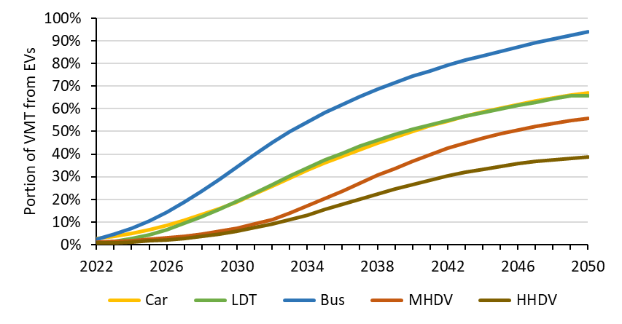
Note: Passenger car (Car); Light Duty Truck (LDT); Single-unit Truck (MHDV); Combination Truck (HHDV); vehicle miles traveled (VMT); electric vehicle (EV).

Health Impact
Incremental change in societal well-being resulting from a change in ambient air quality in the United States was modeled using the EASIUR model (Heo et al., 2016). This study focused on 3 pollutants: primary 2.5 (Elemental Carbon: EC), sulfur dioxide (SO₂), and nitrogen oxides (NO_{x}). EC represents particulate matter with 2.5 μm diameter (PM_{2.5}) that is being directly emitted into the atmosphere as opposed to being emitted as a combination of a gaseous form of another pollutant that later produces PM_{2.5} in the atmosphere.
Marginal damages (MD) are calculated based on 2005 meteorological conditions and emissions, categorized by county and emission height. The height of pollutant emissions influences dispersion, impacting exposure levels and health effects on nearby populations. Ground-level area emissions include BTW and exhaust, while EV charging emissions are considered mid-level. EASIUR marginal damages were published using a value of $8.8M 2010 U.S. Dollar (USD) for value of statistical life (VSL) and a relative risk of 1.06 for CR. An adjusted EASIUR marginal damage (MD’) using a different VSL was calculated with Equation 3 (Heo & Adams, 2015.).
Equation 3. $MD^{'}=MD* \frac{VSL}{\$8.8M}$
The U.S. EPA’s official VSL is reflected in this model, which is $4.8M in 1990 USD and income level. (G) represents the Gross Domestic Product (GDP) deflators adopted from the Bureau of Economic Analysis (BEA Interactive Data Application, n.d.) and (I) represent income level adjustments adopted from the EASIUR manual. The total emission from vehicle usage between 2019 and 2050 for each county was multiplied by the adjusted public health cost. To adjust for the 2019-dollar year and accommodate variations in income levels and inflation, factors were modified to ensure data is reflective of economic changes over time. The adjusted VSL (VSL’) was calculated using Equation 4.
Equation 4. $VSL^{'}=\$4.8M* \frac{G_{2019}}{G_{1990}}*\frac{I_{2019}}{I_{1990}}$

Results
The results from this study are presented in two sections: pollutant inventory and public health cost. The pollutant inventory section presents the change to emissions levels from 2022 to 2050 with varying levels of EV adoption. The public health costs are then determined for 2022 and 2050 based on the pollutant inventory of each county.

Pollutant Inventory
This section includes the emissions of PM_{2.5}, NO_{x}, and SO₂ induced from vehicle travel in Broward, Collier, Miami-Dade, and Monroe counties. The emissions from vehicle travel are due to BTW, exhaust from ICEVs, and BTW and charging from EVs. The respective amount of vehicle travel from ICEVs and EVs was determined based on EV adoption projections (Figure 3) and county level VMT (Table 1). The change to emissions levels varies by county due to the different EPRs within each county as shown in Figure 4, Figure 5, and Figure 6.
Figure 4.
Sulfur dioxide emissions in Broward, Collier, Miami-Dade, and Monroe counties from 2022 to 2050.
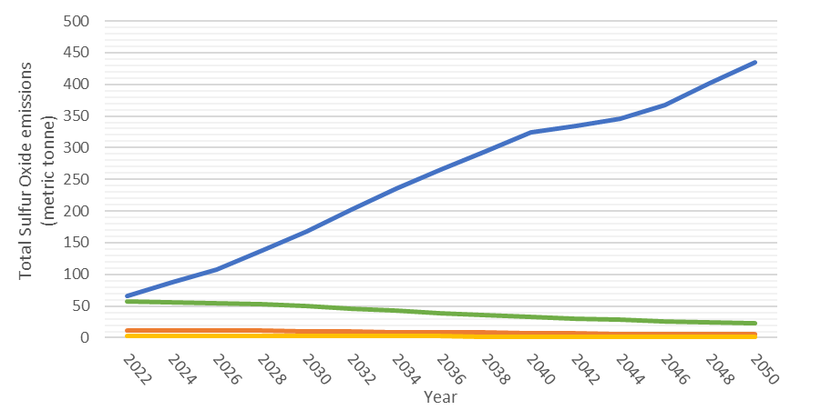
Note: Blue – Broward, Orange – Collier, Green – Miami-Dade, Yellow – Monroe.
Figure 5.
Nitrogen Oxide emissions in Broward, Collier, Miami-Dade, and Monroe counties from 2022 to 2050.
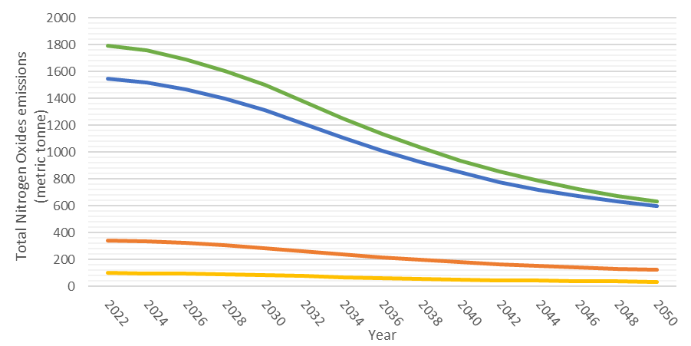
Note: Blue – Broward, Orange – Collier, Green – Miami-Dade, Yellow – Monroe.
Figure 6.
Particulate Matter 2.5 emissions in Broward, Collier, Miami-Dade, and Monroe counties from 2022 to 2050.
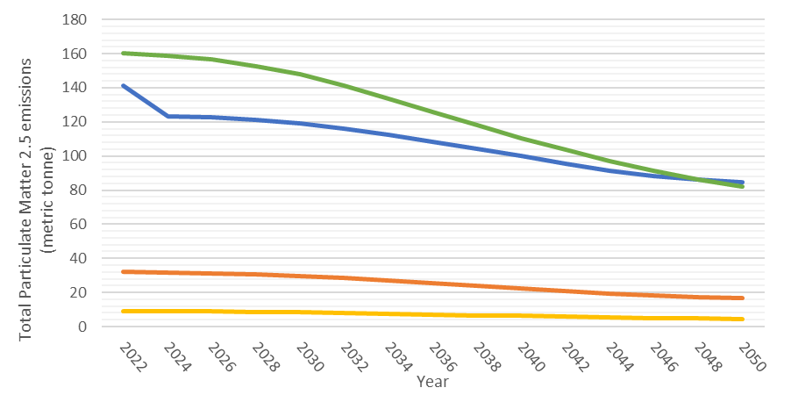
Note: Blue – Broward, Orange – Collier, Green – Miami-Dade, Yellow – Monroe.

Health Impacts
The health impact associated with the adoption of EVs was determined using the EASIUR model in 2022 and 2050. Values have been updated to reflect current Value of Statistical Life (VSL) and adjusted to the 2019-dollar year. The adoption of EVs is shown to reduce total human health impact costs from on-road vehicles in 2050 for each county, as shown in Figure 7.
Figure 7.
Assessment of the Public Health Impact of EV adoption in each county for 2022 and 2050.
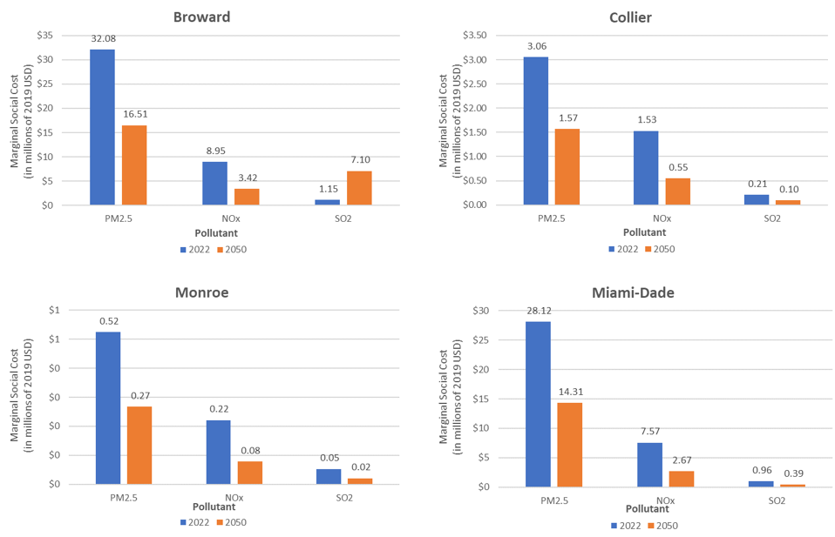Note: Public health costs of emissions in 2022 and 2050. USD represents U.S. dollar.

Discussion
The findings of this study shed light on the crucial intersection of vehicle emissions, EV adoption, and their impact on human health. Our analysis reveals insights into the public health implications of transitioning to EVs and underscores the potential health benefits associated with such a shift in South Florida.
In all counties examined, the total pollutant output of both PM_{2.5} and NO_{x} are projected to decrease by nearly half by 2050 compared to 2022 levels due to the adoption of EVs. The trends depicted in Figures 4-6 suggest that this decline in emissions may continue beyond the analyzed timeframe. Specifically, Figure 6 illustrates a consistent downward trend in PM_{2.5} emissions in Collier, Miami-Dade, and Monroe counties. This reduction is attributed not only to decreased emissions from ICEVs but also to a reduced dependency on gas-cc as a source of electricity for EVs. Counties with higher total VMT, such as Broward and Miami-Dade County, exhibit larger declines in total emissions, subsequently yielding greater benefits in emission reduction within the region. When analyzing SO₂ emissions, Collier, Miami-Dade, and Monroe counties demonstrate a consistent decline over time. However, Broward County experiences a sharp increase upon the introduction of EVs. This can be attributed to the distribution of EPRs within the county, which heavily relies on gas-cc as a primary electricity source. Gas-cc in Broward alone accounts for 28% of Florida’s gas-cc mix. Natural gas often contains up to 20% sulfur content and its combustion may lead to its release into the ambient atmosphere despite regulated pipelines. (Jafarinejad, 2016).

The reduction in vehicular pollution has led to a considerable decrease in the public health costs associated with ambient air quality across the region, as show in Figure 7. Particularly noteworthy is the significant savings in public health costs attributed to NO_{x} emissions in each county. For instance, Miami-Dade alone saved $4.9 million USD from NO_{x} emissions in 2050 compared to 2022. The results indicate that PM_{2.5} is the most significant pollutant burden across all counties. Broward’s heightened dependence on gas-cc increased SO₂ emissions and the associated public health cost from SO₂ within the region. However, in combination with NO_{x} and PM_{2.5} reductions, the total public health cost is reduced in Broward.

Switching to renewable sources of electricity, as observed in other counties throughout Florida, holds the potential to alleviate the burden of polluting EPRs. This would ultimately translate to better public health outcomes and an improved quality of life for residents. Cleaner air fosters healthier communities and alleviates the strain on healthcare systems, enabling individuals to flourish in a more conducive environment.

Conclusion
In the pursuit of understanding and mitigating the environmental impact of vehicular emissions, this study employed a comprehensive approach that utilizes historical data in conjunction with predictive models to shed light on the dynamics between transportation habits, emissions, and their societal costs in the South Florida region. The adoption of EVs can be an impactful approach in curbing NO_{x}, SO₂, PM_{2.5} emissions, resulting in considerable health-related cost savings across all the counties. This study not only anticipates the future of emissions but also advocates for a conscious shift towards cleaner technologies and habits to improve ambient air quality.

References
Adeyanju, A. A. (2018). Effects of Vehicular Emissions on Human Health. Journal of Clean Energy Technologies, 411–420. https://doi.org/10.18178/JOCET.2018.6.6.499
Birnbaum, H. G., Carley, C. D., Desai, U., Ou, S., & Zuckerman, P. R. (2020). Measuring The Impact Of Air Pollution On Health Care Costs. Health Affairs, 39(12), 2113–2119. https://doi.org/10.1377/hlthaff.2020.00081
Choma, E. F., Evans, J. S., Hammitt, J. K., Gómez-Ibáñez, J. A., & Spengler, J. D. (2020). Assessing the health impacts of electric vehicles through air pollution in the United States. Environment International, 144, 106015. https://doi.org/10.1016/j.envint.2020.106015
Federal Highway Administration. (2020). DISTRIBUTION OF ANNUAL VEHICLE DISTANCE TRAVELED - 2019 [dataset]. https://www.fhwa.dot.gov/policyinformation/statistics/2019/vm4.cfm
Florida Department of Transportation. (2019). Public Road Mileage and Miles Traveled. https://ftp.fdot.gov/public/folder/RedkVJJQbE_ZL0_9HyAF-A/Public_Roads/2019_Public.pdf
Gagnon, P., Cowiestoll, B., & Schwarz, M. (2023). Cambium 2022 Scenario Descriptions and Documentation (NREL/TP-6A40-84916, 1915250, MainId:85689; p. NREL/TP-6A40-84916, 1915250, MainId:85689). https://doi.org/10.2172/1915250
Heo, J., & Adams, P. J. (2015). EASIUR User’s Guide Version 0.2. https://barney.ce.cmu.edu/~jinhyok/easiur/EASIUR-Users-Guide-200505-Jinhyok.pdf
Heo, J., Adams, P. J., & Gao, O. (2016). Reduced-form modeling of public health impacts of inorganic PM2.5 and precursor emissions. https://www.sciencedirect.com/science/article/pii/S1352231016303090
House, T. W. (2023, April 17). FACT SHEET: Biden-Harris Administration Announces New Private and Public Sector Investments for Affordable Electric Vehicles. The White House. https://www.whitehouse.gov/briefing-room/statements-releases/2023/04/17/fact-sheet-biden-harris-administration-announces-new-private-and-public-sector-investments-for-affordable-electric-vehicles/
Jacquemin, B., Kauffmann, F., Pin, I., Le Moual, N., Bousquet, J., Gormand, F., Just, J., Nadif, R., Pison, C., Vervloet, D., Künzli, N., Siroux, V., & Epidemiological study on the Genetics and Environment of Asthma (EGEA). (2012). Air pollution and asthma control in the Epidemiological study on the Genetics and Environment of Asthma. Journal of Epidemiology and Community Health, 66(9), 796–802. https://doi.org/10.1136/jech.2010.130229
Jafarinejad, S. (2016). Control and treatment of sulfur compounds specially sulfur oxides (SOx) emissions from the petroleum industry: A review. Chemistry International, 2, 242–253.
Lewis, M. (2019, October 15). Florida’s auto emissions have skyrocketed since 1990. Electrek. https://electrek.co/2019/10/15/florida-auto-emissions-skyrocket-since-1990/
Liu, H., Hu, T., & Wang, M. (2021). Impact of Air Pollution on Residents’ Medical Expenses: A Study Based on the Survey Data of 122 Cities in China. Frontiers in Public Health, 9, 743087. https://doi.org/10.3389/fpubh.2021.743087
Mai, T. T., Jadun, P., Logan, J. S., McMillan, C. A., Muratori, M., Steinberg, D. C., Vimmerstedt, L. J., Haley, B., Jones, R., & Nelson, B. (2018). Electrification Futures Study: Scenarios of Electric Technology Adoption and Power Consumption for the United States (NREL/TP-6A20-71500). National Renewable Energy Lab. (NREL), Golden, CO (United States). https://doi.org/10.2172/1459351
National Cancer Institute. (2023, September 13). High Levels of Particulate Air Pollution Associated with Increased Breast Cancer Incidence—NCI (nciglobal,ncienterprise) [cgvBlogPost]. https://dceg.cancer.gov/news-events/news/2023/particulate-air-pollution-breast-cancer-risk
Ogur, E., & Kariuki, S. (2014). Effect of Car Emissions on Human Health and the Environment. International Journal of Applied Engineering Research, 9, 11121–11128.
U.S. Department of Energy. (2023). Electric Vehicle Registration by State [dataset].
U.S. Energy Atlas. (2023a). Existing Nameplate and Net Summer Capacity by Energy Source, Producer Type and State. https://www.eia.gov/electricity/data/state/
U.S. Energy Atlas. (2023b, April 20). All Energy Infrastructure and Resources. https://atlas.eia.gov/apps/5039a1a01ec34b6bbf0ab4fd57da5eb4/explore
US EPA, O. (2017). Air Emissions Sources [Policies and Guidance]. https://19january2017snapshot.epa.gov/air-emissions-inventories/air-emissions-sources
Wernet, G., Bauer, C., Steubing, B., Reinhard, J., Moreno Ruiz, E., & Weidema, B. (2016). The ecoinvent database version 3 (Part I): Overview and methodology. The International Journal of Life Cycle Assessment, 21, 1–13. https://doi.org/10.1007/s11367-016-1087-8
Zhang, K., & Batterman, S. (2013). Air pollution and health risks due to vehicle traffic. The Science of the Total Environment, 0, 307–316. https://doi.org/10.1016/j.scitotenv.2013.01.074

