Introduction
Biscayne Bay is a federally protected, subtropical coastal estuary located in southeastern Florida. Due to its ecological and economic services, Biscayne Bay is one of Florida’s most important resources, supporting a variety of flora and fauna (Lee & Bwenge, 2006). Underlying and adjacent to Biscayne Bay is the Biscayne aquifer, a karst (Meeder and Harlem, 2019), shallow, and permeable aquifer that millions of people rely on for domestic, industry, and agricultural use (Alarcon et al., 2022). The Biscayne Aquifer is known to discharge freshwater into Biscayne Bay (Abd-Elaty et al., 2022; Stalker et al., 2009). Historically, precipitation, surface water that would drain from the Everglades, and groundwater were the main sources of freshwater input into Biscayne Bay (Langevin, 2001; Langevin 2003). However, due to the increase in the human population in South Florida over the last two centuries, canals and levees were built to redirect water from flowing south into the Everglades to discharge directly to the coast (Caccia & Boyer, 2007; Langevin, 2001; Langevin, 2003). What was once the transverse glades (low-lying areas that ran parallel to the Florida coastline), were dredged to build canals that would drain the wetlands and control flooding. In doing so, the groundwater table was lowered and increasing the risk of saltwater intrusion and dehydrating many existing wetlands (Langevin, 2001; Langevin 2003). The water management operations in south Florida resulted in increasing the direct inputs of freshwater via canals into Biscayne Bay while decreasing the quantity of groundwater discharge (Caccia & Boyer, 2007; Stalker et al., 2009). The quality, timing, and quantity of freshwater in the bay are crucial to the health and biodiversity of this ecosystem (Caccia & Boyer, 2007; Stalker et al., 2009).
Deering Estate, adjacent to Biscayne Bay, is a Miami-Dade County Park and the area of study of this paper. Deering Estate is part of the Biscayne Bay Coastal Wetlands project (BBCW) (PLAN, 2007) which is a project under the Comprehensive Everglades Restoration Plan (CERP). The aforementioned plan is to divert direct canal inputs into the bay by redirecting canal water into freshwater and salt water wetlands. Rehydrating the coastal wetlands, like the Deering Glade and Cutler Slough, promotes groundwater flow to the bay, and minimizes the discharge of point source pollution from canal water into the bay (https://www.saj.usace.army.mil/BBCW/; PLAN, 2007, Lin et al., 2004). Geochemical tracers have been used to differentiate freshwater endmembers like precipitation from groundwater, or surface water (Swart and Price, 2002; Stalker et al., 2009, Stalker et al., 2014). Geochemical tracers such as the stable isotopes of oxygen and hydrogen (δ¹⁸O and δ²H), and strontium and calcium (Sr²⁺/Ca²⁺) ratios are tools that help to differentiate, and understand the quality and quantity of freshwater sources (Meyers et al., 1993, Stalker et al., 2014; Stalker et al., 2009; Yang et al., 2019). Those geochemical tracers were used in this investigation to determine the sources of freshwater inputs to Biscayne Bay, within the Deering Estate area. Providing this research will inform of the area’s restoration progression and how current freshwater inputs are interacting with one another.
Figure 1.
Water sampling sites
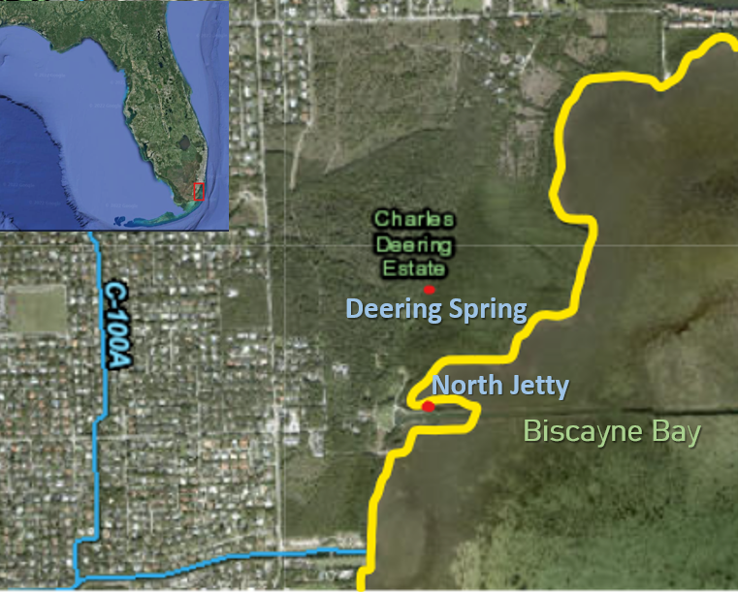

Note: This map demonstrates the two water sampling sites in Deering Estate, adjacent to Biscayne Bay, using two red dots to indicate the sites and study area of this paper.

Methods

Sample Collection and Analysis
Water sampling occurred at two sites at the Deering Estate: one site was a freshwater inland spring inside a mangrove preserve, and the second site was on the western shore of Biscayne Bay (Figure 1). Surface water sampling occurred for two and a half months, in the 2022 wet season (May to August) and in the 2023 dry season (January to March). Water samples were collected two to three times a week. Prior to collecting water samples, the date and time were recorded. Other field parameters such as the salinity, temperature, and specific conductivity of the sites were collected using a PRO 2030 YSI. The surface water samples were collected with a syringe, rinsed three times with water from the site, and then the water was filtered through a 0.45 µm filter to filter out any sediment and particles present in the water. Water samples were kept in polyethylene bottles of 125 mL (two bottles per site) and rinsed three times with surface water from the site before collection. The samples were then stored in a cooler with ice until transported to a refrigerator for long-term storage at Florida International University’s (FIU) Hydrogeology Lab.
Both wet and dry season water samplings were analyzed for stable isotopes of oxygen (δ¹⁸O) and hydrogen (δ²H) with the Los Gatos Liquid Isotope Analyzer in the Hydrogeology Lab at the Modesto A. Maidique (MMC) Campus of FIU. Additionally, water samples were analyzed in FIU’s CREST CAChE Lab located on the Biscayne Bay Campus (BBC) and the Hydrogeology Lab at MMC for cations (e.g. magnesium, calcium, strontium, and sodium). Water samples to be analyzed for cations were acidified to a pH of 2 to prevent adsorption of the cations to the sides of the bottles and to ensure accuracy of results. The cation samples were then diluted to 1/100 of the sample that had acid added. Two binary mixing models were used to identify the sources of freshwater discharge into Biscayne Bay and Deering Spring.
Linear Regression Isotope Method
The δ¹⁸O and δ²H values were both compared to the salinity of the water samples that was recorded the day of collection of the water samples. There were three endmembers of freshwater inputs to the bay, groundwater, canal water, and rain water. The salinity of the three freshwater endmembers were given a value of 0. The isotropic values of these three endmembers were collected from Stalker (et al., 2009) to compare where the Biscayne Bay and the freshwater inland spring samples lie within these three endmembers and how the inputs change with salinity. The wet and dry season data was divided and plotted to determine the δ¹⁸O and δ²H values at a zero-salinity intercept. This method allows the use of the isotopic signature of water to differentiate freshwater sources like precipitation and groundwater from each other. In this paper, using δ¹⁸O and δ²H values of the water samples will allow us to differentiate the three freshwater endmembers from each other.
Cation Mixing Model
Underlying Biscayne Bay is the Biscayne Aquifer, a limestone aquifer composed of minerals like calcite and other minor minerals like aragonite. Strontium (Sr²⁺) ions can be found in soil and rocks and commonly replace calcium (Ca²⁺) ions in calcium carbonate minerals during the recrystallization process. Therefore, Sr²⁺/Ca²⁺ ratios can be used to determine freshwater inputs as there is a relationship between the host rock of Biscayne Bay and local groundwater (Swart et al. 2001; Meyers et al. 1993). The data points of the water samples were plotted with the three endmembers mixing with seawater against salinity to identify how the three freshwater endmembers are interacting with one another at the two sites of study in this paper. Due to scientific instrument issues, the dry season data results have to be retested.
Results and Discussion
Stable Isotopes of Oxygen and Hydrogen
The wet season results of the δ¹⁸O signature (Figure 2) for Biscayne Bay water samples demonstrated, with a linear regression, that most data points fell within the Miami rainwater freshwater endmember. For the Deering Spring water samples, most data points fell within a mix of the three freshwater endmembers (e.g. rainwater, groundwater, and canal water). For the results of δ²H signature (Figure 3) for Biscayne Bay water samples demonstrated a similar result from Figure 2, in which most bay water samples fell within the linear regression of Miami rainwater and Deering spring water samples fell within all three freshwater endmembers (e.g. rainwater, groundwater, and canal water). This supports the idea that precipitation is the dominant freshwater input for Biscayne Bay and Deering Spring. During the wet season, it is common for large amounts of rainfall to occur throughout the months of May through August at the time that the water samples were collected. It is estimated that about 75% of the total rainfall throughout the year occurs during the wet season (Alarcon et al., 2022). Figure 4 compares the annual average isotopic signatures of δ¹⁸O and δ²H, the solid black line represents the global meteoric water line (GMWL), which rainwater lies on. Below the GMWL is the evaporation line, on which groundwater and canal water lies and so do many data points of the Biscayne Bay and Deering water sample data points lie as well. The evaporation line in Figure 4 allows us to see the isotropic signatures of the different freshwater endmembers and how to differentiate them from each other (Bowen et al., 2018).
Dry season water sample results from the δ¹⁸O signature demonstrated (Figure 5) using a linear regression that major inputs of freshwater came from groundwater for the Biscayne Bay site. For Deering Spring, major inputs of freshwater came from canal water with the other freshwater endmembers still contributing as freshwater inputs. Results from the δ²H (Figure 6) showed similar results from Figure 5: the linear regression of the Biscayne Bay samples demonstrated that Biscayne Bay received a majority of freshwater input from groundwater. While Deering Spring received major inputs from canal water and minor contributions of freshwater inputs from groundwater and precipitation. During the dry season, there is much less precipitation during this time of the year, as most of the rainfall occurs during the wet season, therefore there is minimal inputs from precipitation into the bay. This supports the idea that progress towards the rehydration of wetlands and bringing groundwater flow back to Biscayne Bay is occurring within this area. Figure 7 compares the isotropic signatures of the water samples’ δ¹⁸O and δ²H to the GMWL. Below the GMWL is the evaporation line and there lies the three freshwater endmembers (the dashed-line linear regression), in which Biscayne Bay and Deering Spring data points also lie. Supporting that groundwater, canal water, and rainwater are being traced within the dry season.

Figure 2.
Wet season isotope of oxygen data
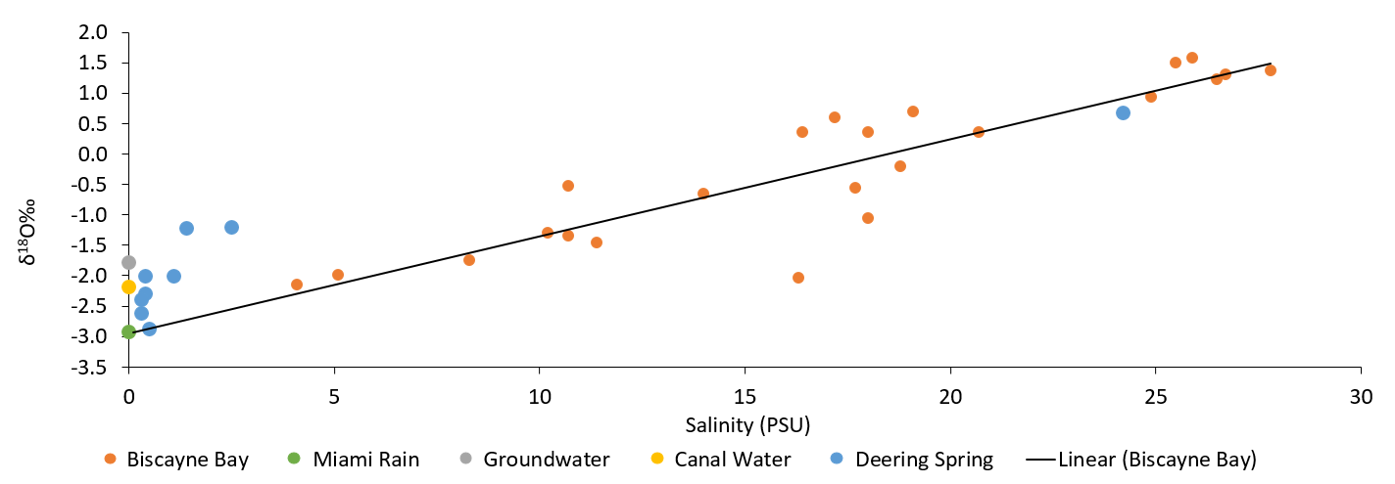

Note: The wet season results of δ¹⁸O values of Biscayne Bay and Deering Spring water samples, plotted against three freshwater endmembers (groundwater, Miami rain, and canal water). The solid line represents a linear regression of the bay samples.
Figure 3.
Wet season isotope of hydrogen data
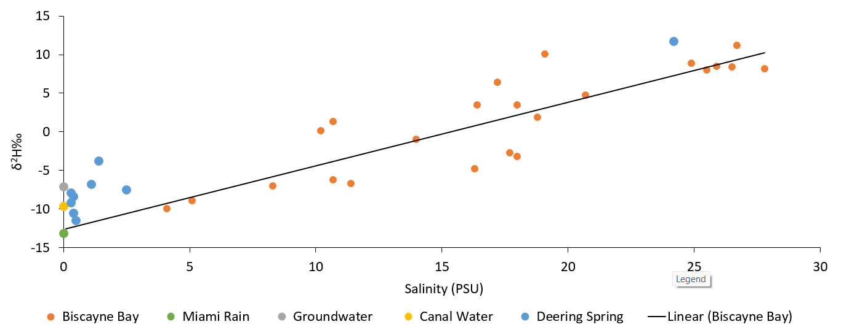

Note: The wet season results of δ²H values of Biscayne Bay and Deering Spring water samples, plotted against three freshwater endmembers (groundwater, Miami rain, and canal water). The solid line represents a linear regression of the bay samples.

Figure 4.
Global Meteoric Water Line Graph for wet season results
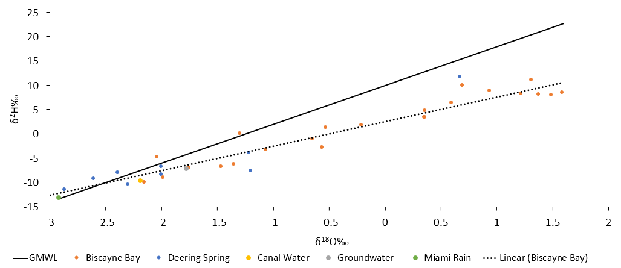

Note: Mixing with seawater and evaporative processes (below the GMWL), the data points near the solid line are influenced by rain. Groundwater and canal water reside on the evaporation line. The dashed line represents linear regression of Biscayne Bay samples.
Figure 5.
Dry season isotope of oxygen data
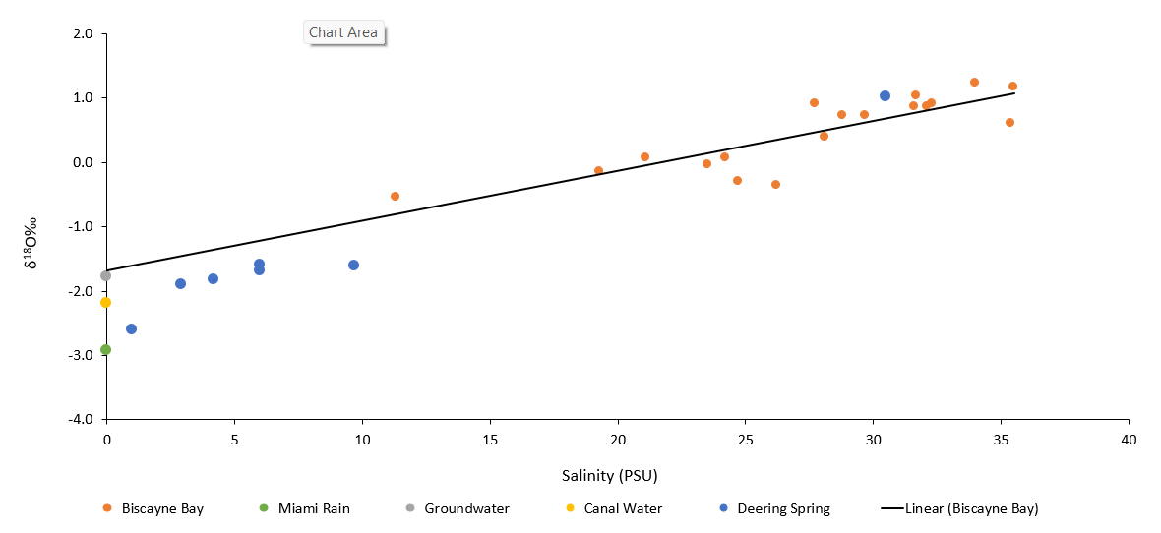

Note: Dry season δ¹⁸O values plotted against the salinity of Biscayne Bay and Deering Spring water samples, and show a linear regression line through the Biscayne Bay samples. The water samples are compared against the three freshwater endmembers.
Figure 6.
Dry season isotope of hydrogen data
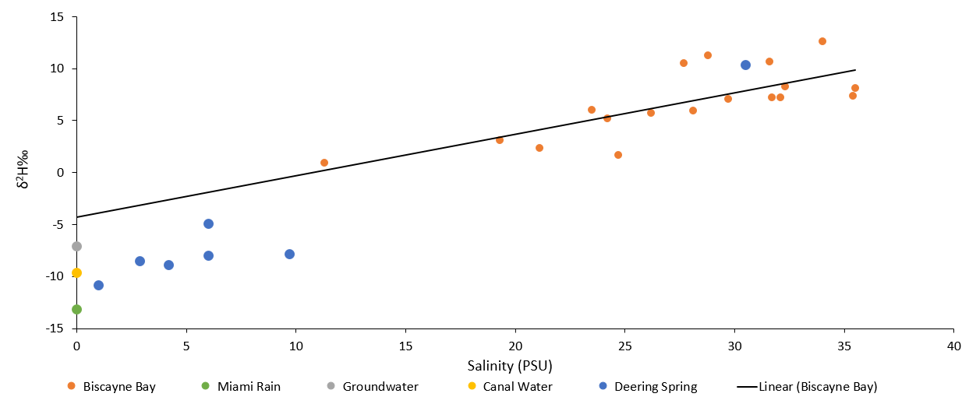

Note: Dry season δ²H values plotted against salinity of Biscayne Bay and Deering water samples. Linear
regression is shown through the Biscayne Bay samples. The water samples are compared to three freshwater endmembers found to be freshwater inputs in the bay.
Figure 7.
Global Meteoric Water Line Graph for dry season results
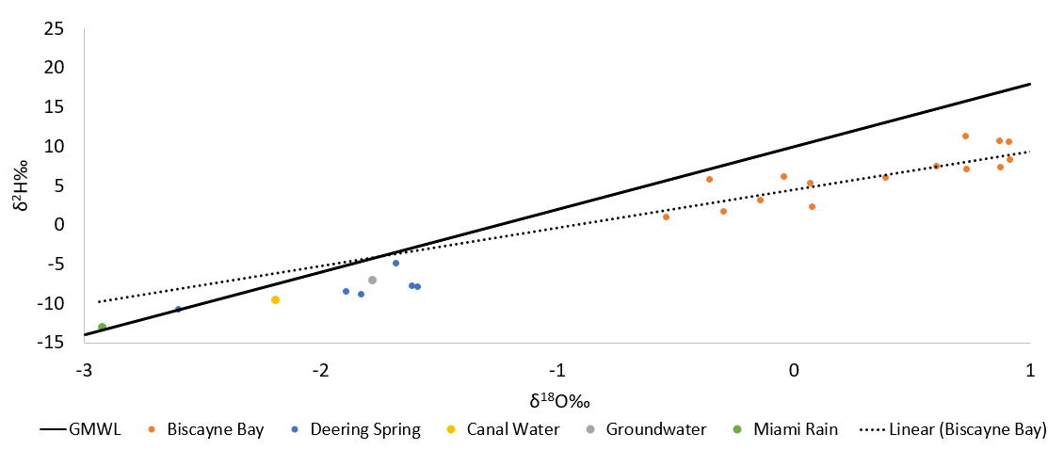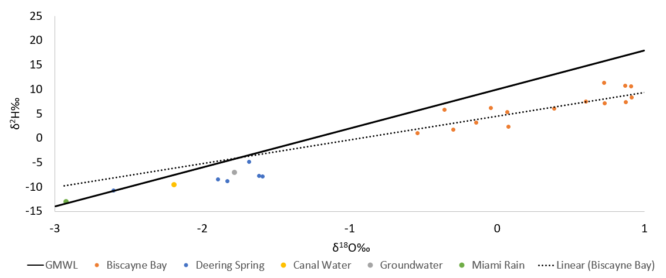

Note: Mixing with seawater and evaporative processes (below the GMWL), the data points near the solid line are influenced by rain. Groundwater and canal water reside on the evaporation line. The dashed line represents linear regression of Biscayne Bay samples.
Cation Mixing Model
The strontium and calcium results from the wet season (Figure 8) demonstrated how the three freshwater endmembers mixing with seawater, relate to the Biscayne Bay and Deering Spring water samples. Some data points do not directly lie on the curves but lie between two curves within the graph. That can be interpreted as more than one freshwater endmember is interacting with one another and discharging into the collection sites. The dry season results were inconclusive. However, using the isotope model may very well be a good tool to predict the outcome of the strontium to calcium ratio mixing model. The only limitation is that the isotopic linear regression model does not accurately show how the different freshwater endmembers may be interacting with one another.
Figure 8.
Wet season strontium to calcium mixing ratio model
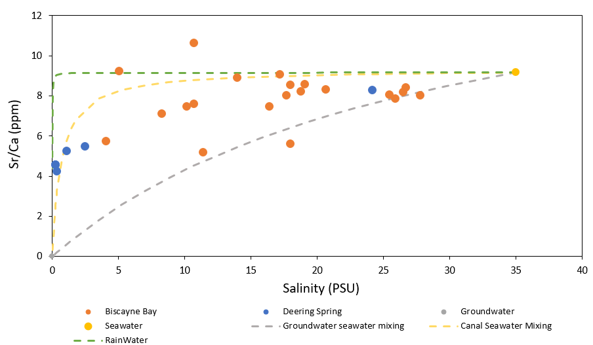
Note: The wet season results of the strontium/calcium ratio mixing model between the three freshwater endmembers mixing with seawater plotted against the salinity of the water samples. The three dashed lines represent canal water, groundwater, and precipitation as the freshwater endmembers mix with sea water.
Salinity
During the wet season, the salinity ranges of the Deering Spring water samples site ranged from 0.3 to 24.2 PSU, which was lower than the salinity range of the Biscayne Bay water samples site which was 4.1 to 27.8 PSU. Most high and low salinities recorded were before and after a rainstorm, respectively. During the dry season, the salinities of the Deering Spring water samples site ranged from 0.8 to 30.5 PSU, while the Biscayne Bay site had a salinity range of 11.3 to 35.5 PSU.
Conclusion
The isotopic linear regression model demonstrates that rainwater is the original source of freshwater for Biscayne Bay, and canal and groundwater are contributing sources to these sites. During the wet season, a consistent source of freshwater input for Biscayne Bay is rainwater, and for Deering Spring is canal water. During the dry season, groundwater is a major source of freshwater input for Biscayne Bay, and canal water remains a major source of freshwater input for Deering Spring. The idea to restore groundwater flow back to Biscayne Bay through the Deering Estate wetlands is currently happening. It can be seen in how canal water is found in isotopic signatures and cation ratio mixing ratio in Deering Spring and Biscayne Bay, especially during the dry season when precipitation occurrence is lower than in the wet season. Further research should include nutrient input from the wetlands into Biscayne Bay within the Deering Estate area to understand how this may be affecting the water quality, and properties of soil of the wetlands and Biscayne Bay.

References
Abd-Elaty, I., Straface, S., & Kuriqi, A. (2021). Sustainable saltwater intrusion management in coastal aquifers under climatic changes for humid and hyper-arid regions. Ecological Engineering, 171, 106382.
Alarcon, V. J., Linhoss, A. C., Mickle, P. F., Kelble, C. R., & Fine, A. (2022). Estimation of groundwater and salinity for the Central Biscayne Bay Coast, Florida, USA. Computational Science and Its Applications – ICCSA 2022 Workshops, 594–606. https://doi.org/10.1007/978-3-031-10545-6_40
Biscayne Bay Coastal Wetlands Project. Ecosystem Restoration. (n.d.). https://www.saj.usace.army.mil/BBCW/
Bowen, G. J., Putman, A., Brooks, J. R., Bowling, D. R., Oerter, E. J., & Good, S. P. (2018). Inferring the source of evaporated waters using stable H and O isotopes. Oecologia, 187(4), 1025–1039. https://doi.org/10.1007/s00442-018-4192-5
Caccia, V. G., & Boyer, J. N. (2007). A nutrient loading budget for Biscayne Bay, Florida. Marine Pollution Bulletin, 54(7), 994–1008. https://doi.org/10.1016/j.marpolbul.2007.02.009
Langevin, C. D. (2001). Simulation of ground-water discharge to Biscayne Bay, southeastern Florida (No. 4251). US Department of the Interior, US Geological Survey.
Langevin, C. D. (2003). Simulation of submarine ground water discharge to a marine estuary: Biscayne Bay, Florida. Groundwater, 41(6), 758-771.
Lee, D. J., & Bwenge, A. (2006). Economic Value of Ecosystem Restoration in Biscayne Bay, Florida: FE662/FE662, 8/2006. EDIS, 2006(15).
Lin, H.-C. J., Cheng, H.-P. (Pearce), Edris, E. V., & Yeh, G.-T. (George). (2004). Modeling surface and subsurface hydrologic interactions in a South Florida watershed near the Biscayne Bay. Computational Methods in Water Resources: Volume 2, Proceedings of the XVth International Conference on Computational Methods in Water Resources, 1607–1618. https://doi.org/10.1016/s0167-5648(04)80170-9
Meeder, JF, Harlem, PW. (2019). Origin and development of true karst valleys in response to late Holocene sea-level change, the Transverse Glades of southeast Florida, USA. Depositional Rec. 2019; 5: 558– 577. https://doi.org/10.1002/dep2.84
Meyers, J. B., Swart, P. K., & Meyers, J. L. (1993). Geochemical evidence for groundwater behavior in an unconfined aquifer, south Florida. Journal of Hydrology, 148(1-4), 249-272.
PLAN, R. (2007). Biscayne Bay Coastal Wetlands.
Stalker, J. C., Price, R. M., Rivera-Monroy, V. H., Herrera-Silveira, J., Morales, S., Benitez, J. A., & Alonzo-Parra, D. (2014). Hydrologic Dynamics of a subtropical estuary using geochemical tracers, Celestún, Yucatan, Mexico. Estuaries and Coasts, 37(6), 1376–1387. https://doi.org/10.1007/s12237-014-9778-5
Stalker, J. C., Price, R. M., & Swart, P. K. (2009). Determining spatial and temporal inputs of freshwater, including submarine groundwater discharge, to a subtropical estuary using geochemical tracers, Biscayne Bay, South Florida. Estuaries and Coasts, 32(4), 694–708. https://doi.org/10.1007/s12237-009-9155-y
Swart, P.K., and R.M. Price. 2002. Origin of salinity variations in Florida Bay. Limnology and Oceanography 47:1234–1241.
Yang, K., Han, G., Song, C., & Zhang, P. (2019). Stable H-O Isotopic Composition and Water Quality Assessment of Surface Water and Groundwater: A Case Study in the Dabie Mountains, Central China. International journal of environmental research and public health, 16(21), 4076. https://doi.org/10.3390/ijerph16214076

