Introduction
Importance
In the last few decades, the problems caused by antibiotic-resistant bacteria have grown exponentially. After erroneous usage of antibiotics by the human population over many years, bacteria are now adapting in novel ways to combat what once before were very successful antibiotic therapies, costing millions of lives in the process (Pulingam T, et al, 2021). Given this, millions of dollars are being spent in research to find new types of drugs or antibiotics that the bacteria have not adapted to. One of these are what are classified as topoisomerase inhibitors. Topoisomerase inhibitors are compounds that stop the function of any type of topoisomerase enzyme; common types already available for the general public include ciprofloxacin, irinotecan, topotecan, etoposide, and teniposide (LiverTox, 2020). Although these antibiotics are effective therapies for bacterial infection treatment, they are all inhibitors of TopI and TopII enzymes. Much less is known about inhibitors of type IA topoIII enzymes, and discovery of a new type of inhibitor for this enzyme could prove to be extremely beneficial at expanding the options of therapeutics available.
Types of topoisomerases and their mechanism of action
Topoisomerases play crucial roles in the growth and development of every organism alive. These enzymes are part of the required proteins for DNA processing, both in bacteria and in humans. The processing that occurs in DNA replication and transcription involves dealing with DNA structures which sometimes suffer from topological constraints. When two separate strands of DNA interact with one another, they spontaneously induce torsion to form structures that are more favorable for DNA usage and processing (Bar, A. et. al, 2011). These torsions are known as supercoils, which is a normal process for DNA; however, supercoiled DNA is unable to be used for replication or transcription purposes. Negatively supercoiled DNA is needed for replication and transcription; however, enzymes required for DNA processing can’t bind to the supercoiled DNA strands, hence, topoisomerases locate themselves ahead of the transcription or replication fork and introduce or relieve supercoiling for correct DNA processing (Fogg, JM. Et al, 2021). Hence, the role of topoisomerases is crucial in organism development.
Topoisomerase enzymes are broken down into two distinct subtypes: Type I and Type II, each with its own specific subgroups. Type II topoisomerases catalyze topological changes in the DNA strands by means of a transient double-strand break and religation mechanism. Type I topoisomerases are responsible for relieving negative supercoiling by means of a single stranded cleavage, followed by a strand passage and religation mechanism. Type I enzymes are divided into three different subtypes, type IA, IB, and IC (Baker NM et. al, 2009). They catalyze topological changes in DNA by binding only one DNA strand, termed the “G” segment, and cleaving the phosphodiester bond via a nucleophilic attack with a tyrosine residue, which leaves a transient break. When the DNA is cleaved, the phosphodiester-enzyme intermediate is located at the top of a structure called a toroid, which acts like a lock that opens and closes. When the tyrosine binds to the DNA, the toroid hole opens and attracts the other DNA strand, the “T” or transport strand, across the hole via positively charged amino acid residues on the other side of the toroid (Tse-Dinh, Y.C., et. al, 2020) . Once the “T” strand passes through the opening, the toroid closes and the phosphodiester intermediate at the “G” strand religates, reforming an intact “G” strand (McKie, S. et. al, 2021) . This process allows for the supercoil to be reduced by one turn, successfully decreasing negative supercoiling.

Figure 1
Topoisomerase Type I cleavage and religation mechanism
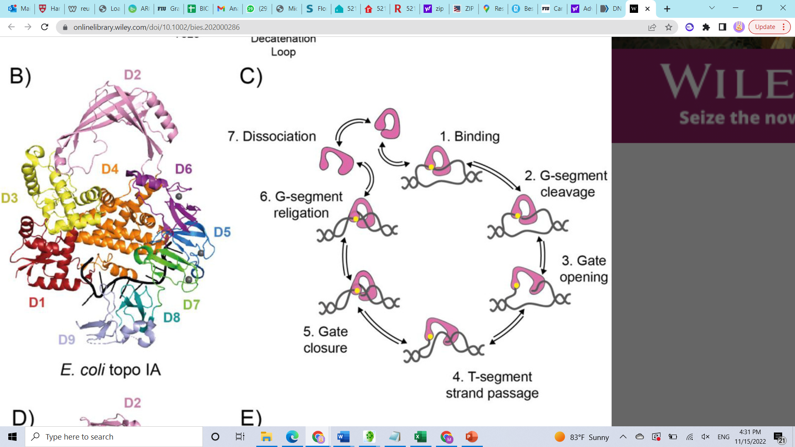
Note: Source from McKie, S. et. al, 2021
Literature Review
One subtype of topoisomerase type IA enzyme is of special importance for replication and transcription: Topoisomerase III. Topoisomerase III is present in both eukaryotic and prokaryotic organisms, in prokarya it exists only as topoIII, and in eukarya as topoIIIα or topoIIIβ. In prokaryotes, specifically Escherichia coli, there are two topoisomerase IA enzymes: EtopI and EtopIII. EtopI is one of the main enzymes behind unwinding negative DNA supercoils and plays a well-studied role in DNA unwinding. On the other hand, EtopIII’s main role is unlinking two circular pieces of DNA from each other, also known as catenates. Because of this, EtopIII’s role is mainly as a decatenase enzyme. One of the major roles where a decatenase activity is required is the segregation of the sister chromosomes into daughter cells after replication (Shapiro L., et. al, 1999), where EtopIII plays a considerable role. The role of EtopIII in vivo is further corroborated by its ability to only bind single-stranded DNA sequences, which allows it to mainly handle and unwind precatenanes. Precatenanes are intertwining structures between the parent DNA strand and the newly synthesized DNA strand that form behind the replication fork because of the severe positive overwinding of the DNA helix ahead of the replication fork (Champoux, J. J. et al, 1980). EtopIII is one of the main enzymes that resolve precatenanes in-vivo, preventing incorrect chromosomal segregation due to precatenane presence before chromosomal separation.
Figure 2
Model of EtopIII resolving precatenane formation behind the replication fork.

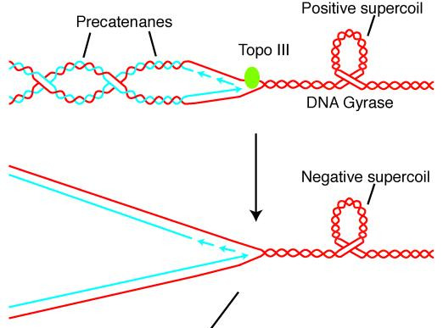
Note: Adapted from Perez-Cheeks BA, et al, 2012.

This enzyme’s RNA-binding capabilities have been studied and determined in the past, as the protein was able to unknot a cyclic RNA structure, a feat that can only be done with an enzyme that can perform a strand passage mechanism (Wang H, et al, 1996). Thus, the RNA-binding capabilities of EtopIII could be further studied.
Figure 3
Structure comparison of different Type 1A Topoisomerase proteins
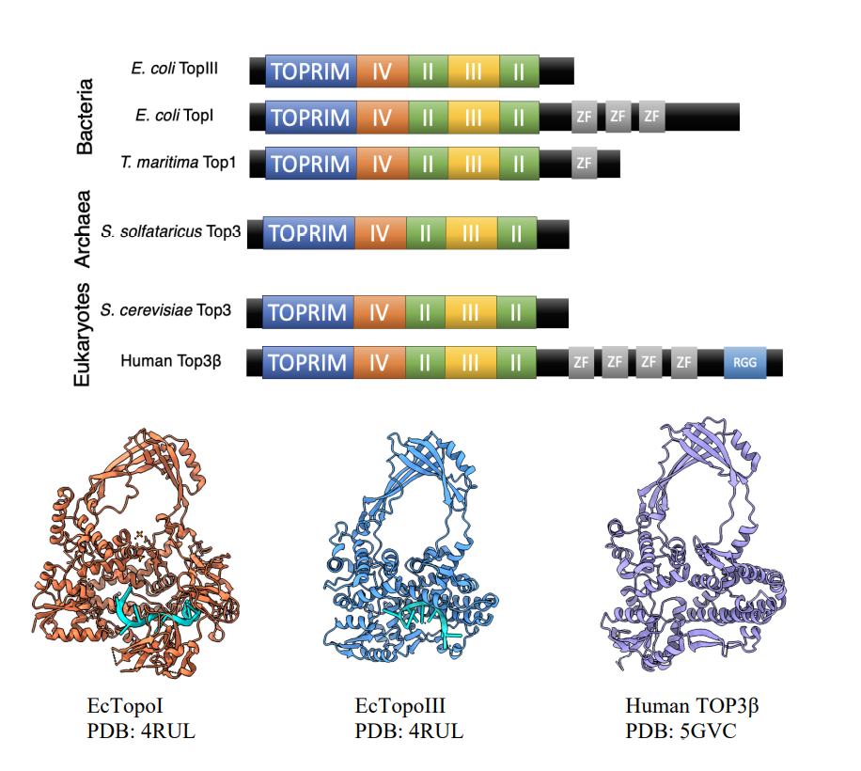
Note: Structure is mostly conserved except for unique C-terminus domains Adapted from Ahmad, et al, 2017

A possible factor that could be targeted to expand the scope of the RNA binding capabilities of EtopIII would be by visualizing a complex between the EtopIII enzyme and an RNA substrate. This could be done by performing crystallization experiments on the protein. Crystallization is a widely used tool to visualize the three-dimensional structure of the protein-ligand complex. Crystallization relies on the concept of supersaturation to occur reliably (McPherson A, et al, 2014). Supersaturation is a non-equilibrium state of a system in which solute molecules are present in an amount exceeding their solubility limit concentration. Different compounds and macromolecules have unique complications when forming stable crystal structures. For example, an ionic salt compound such as NaCl forms stable lattices by the strong ionic interactions between the ions in the structure. On the other hand, it is known that large macromolecules like proteins do not share the same strong ionic interactions between themselves, rather limited to hydrogen bonding, salt-bridges, and hydrophobic interactions to aggregate.
It is due to this difference in bonding interactions that forming a stable protein lattice is a difficult process, with varying degrees of lattice formation depending on the amount of these bonds formed in each type of protein studied (Chernov, A. et al, 2003). The process for forming these bonds in crystallization happens in 2 different steps; the first one, nucleation, is the initial formation of the pseudo-crystal structure. In this step protein particles randomly attract each other with macromolecular interactions (H-bonds, ionic interactions, etc.) and form aggregates of protein. Despite this attraction, the entropy of the system favors the interaction of individual protein molecules and the solvent they are in, as the entropy is favored when individual particles form hydrogen bonds with water molecules. For a stable crystal to form, the energy created during crystal formation must exceed the energy created by the interaction of the water molecules with the individual protein molecules (Chernov, A. et al, 2003). The second step is the growing of the crystal, which happens after a semi-stable structure (nucleus) is formed. Other protein molecules will randomly aggregate and detach from the growing nucleus. After a critical mass is reached in the nucleus, it will add protein molecules at certain points in the lattice structure until a stable crystal forms, this is known as growth by two and three-dimensional nucleation.
The nucleation and growth steps can only occur, as previously mentioned, under supersaturating conditions. Supersaturation of a solution is done by changing the environment of the solvent. In terms of protein crystal formation, the main ways to do so are to either change the ability of the solvent molecules to solubilize the protein, or to change the interaction of the protein molecules so they interact stronger with each other than with the solvent. Some ways that this is done in the laboratory are: changing the pH of the solvent; changing salt concentration of the solvent; or adding molecules which will change the interactions of the protein with the solvent, such as certain polymers (McPherson A, et al, 2014). However, these are only a narrow range of ways the researcher could change conditions for crystallization.
Figure 4
Phase diagram of the crystallization of macromolecules
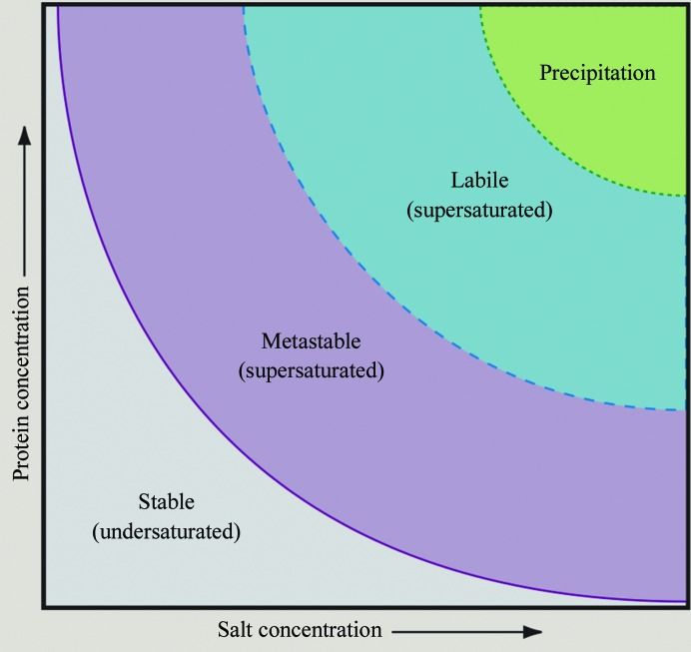
Note: Phase diagram showing the different stages of supersaturation by the addition of salt. Adapted from McPherson A, et al, 2014.
With this mechanism for protein crystallization, it is easy to picture how larger proteins are harder to crystallize (Abdallah, B. et al, 2013). Larger proteins would have more entropic energy when in contact with the solvent since their surface area is greater, so making the crystal structure becomes harder as the energy to create the crystal is larger for bigger proteins than smaller ones. Furthermore, an area that is not static in the protein structure would increase the entropy of the system and would not create proper areas of nucleation; this phenomenon is visualized in Intrinsically Disordered Proteins (IDPs), which lack tertiary and even secondary structure, leading to high disorder and thus yield lower to null protein crystallization. (Musselman, C, et. al, 2021). However, if these sections were truncated, the intrinsically disordered region (IDR) would no longer be inhibiting the formation of the crystal. Given that the majority of these IDRs are present in the N and C- terminus of the proteins, sometimes truncating these loose amino acid chains is beneficial for the overall crystal formation (Cooper C.D.O. et al, 2017).
Once a stable crystal is formed and correctly visualized in high-imaging pictures, the three-dimensional structure of the enzyme can be analyzed. Doing so will allow for visualization of areas that are involved in the DNA/RNA processing. Once these areas are visualized, it could be possible to create a compound that could selectively bind to these areas and inhibit them. Previous research has shown compounds that have been isolated using Structure Based Drug Design (SBDD) techniques, with more than 40 compounds passing FDA clearance for testing in the general public that were found using this method (Hardy, L. W., et al, 2003).
Even if the whole druggable pocket is not able to be fully occupied by the inhibitor molecule, some binding to part of a molecule would give enough information to then build up on (Blundell, T. et al, 2004). Much like with a puzzle, connecting one of the relevant pieces of the puzzle helps visualize what the next piece could be. A schematic of this is shown in Figure 5.

Figure 5
Model showing different structure-based drug design techniques.
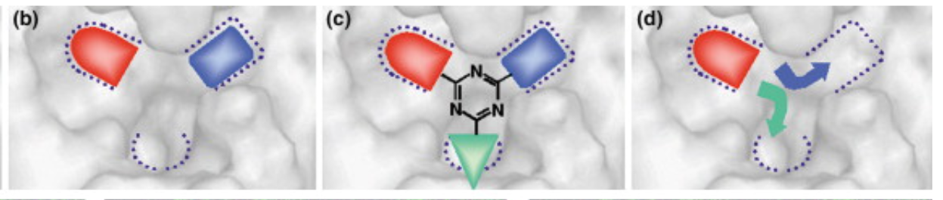
Note: Adapted from Blundell, T. et al, 2004.
Despite this, the C-terminus tail of the EtopIII protein has already been identified to have some role in the binding of the DNA and RNA substrates. Literature indicates that extensive cleaving of the C-terminus region in the EtopIII enzyme leads to proportional loss in the ability of the enzyme to bind DNA or RNA substrates (Zhang HL, et al, 1994) (Zhang HL, et al. 1996) (Li, Z., et al, 2000). So to determine the amount of activity, if any, present in the truncated EtopIII mutant compared to wild type, a series of activity assays must be run.

Methods
Transformation of competent cells
First, the competent Rosetta 2DE3 (Novagen®) cells were thawed on ice. After, 1 µl of the purified pET15tbEtop621 plasmid was added to the cells. These cells and the plasmid were placed into an ice bath for 5 minutes. After, they were heated for 30 seconds in a 42 degree Celsius water bath, followed by placing them back on ice for 2 minutes. After this, 250 µl of SOC medium was added. The solution was mixed and serially diluted into different agar plates which contained 50 µg/ml carbenicillin (carb), 34 µg/ml chloramphenicol (chl), and 1% glucose. Cells were allowed to grow overnight. 12 colonies were picked out and re-streaked into fresh carb/chl/glucose plates. Plates were incubated at 37° C until colonies grew.
Checking for expression of recombinant protein from transformed competent cells
Four colonies were picked out from the new plate to check for their expression.. The day after, 60 µl of this media was transferred to 6 mls of a new batch of media. These new cells were then incubated at 37° C until they reached an OD₆₀₀ between 0.4-0.5. After, Isopropyl β-d-1-thiogalactopyranoside (IPTG) was added to each of the 4 batches to a final concentration of 1mM. After the addition of IPTG, the OD₆₀₀ was allowed to reach 1.8-2.0
To check for protein concentration an SDS-PAGE gel was run; the gel was made with 12% Protogel Quick-Cast solution from National Diagnostics, as well as TEMED and API, reagents necessary for the polymerization of the gel.

Large scale preparation of protein culture
Once expression confirmed in a colony, the transformant was used to scale up the protein purification to 1L, followed by 3L cultures. A loopful of bacteria was taken from the master plate from the identified colonies and swirled in 15 mL of 50 µg/ml carb, 34 µg/ml chl, and 1% glucose. Cells were allowed to grow overnight. The day after, 7.5 ml of this culture was transferred into two different 1L flasks, each containing 750 mL of sterilized, autoclaved media (17.25 g LB, 7.45 g NaCl) . These cultures were allowed to reach OD₆₀₀ of 0.4-0.5. After this, IPTG 1mM was then added to the beakers until OD₆₀₀ of ~2 was reached. Cells were then transferred to 500 ml centrifuge tubes, and were centrifuged at 6000 G’s for 15 mins at 4°C, the supernatant was discarded and the pellets frozen at -80°C.
Protein purification process
After the pellet was collected, the cells were resuspended in lysozyme buffer (1 mg/ml final concentration) + 1X LEW buffer (50mM NaH₂PO₄ + 300Mm NaCl at pH 8.0). This lysate sample was then placed in ice for 30 mins. Afterwards, they were sonicated in 40% power, in 15 second intervals for 3 minutes. After, the samples were centrifugated at 32,000 rpm for 2 hours in the Thermo Scientific Sorvall RC6+ Centrifuge and the supernatant was collected. This supernatant was then run through a Nickel-binding column and the flowthrough, wash, and elution samples were collected.
Each of the fractions (flowthrough, wash, and elution) were ran through an SDS-PAGE gel to check protein presence. After, they were concentrated by centrifuging spin-down columns with a 30kD filter cutoff at 5000 rpm for 5 minutes at 4°C. The concentration of the protein was then assessed with a Bradford Assay.
Protein Processing with TEV Digest and SEC Column
When the protein concentration was determined, A Tobacco Etch Virus (TEV) Digestion was done to cleave off the His-tag in the protein. TEV protease was added to the protein, following a ratio of 1:25 TEV to protein. This solution was then left at room temperature for ~6 hours, and later transferred to the cold room overnight. The protein-TEV solution was ran through the nickel affinity column again to separate the His-tag from the protein. An SDS-PAGE gel was run to check for the cleavage of the His-tag. Once this was confirmed, the flowthrough and wash fractions were concentrated, and the protein was ran through a Cytiva AKTA Protein Purification System with a Size Exclusion Chromatography column attached to it. The protein was then run in different solutions of SEC Buffer (Wash and Elution buffers) and collected in different fractionating columns. Purity was checked using a Bradford Assay as well as SDS-PAGE gels.
Relaxation Assay
The relaxation assay with the truncated protein was done by making a serial dilution of the enzyme from the previous pool of protein. The final concentration of the serial dilutions used in the assay were 100 ng, 80 ng, 60 ng, 40 ng and 20 ng. A DNA control was also included as well as an EtopIII control. Two different buffers were also used: Stop buffer (100mM EDTA, 0.1% Bromophenol blue, water) and 10x reaction buffer (HEPES-KOH 400mM, Mg-acetate 10mM, water). These buffers were combined in different ratios with DNA and enzyme to make the reaction happen. The mixture was incubated at 52°C for 10 minutes. After that, each 20 µl sample was loaded onto a 1% agarose, 5 µg/ml chloroquine gel, running it at 20V for 24 hours.

Results
Figure 6
Pre- and post- induction samples SDS-PAGE gel
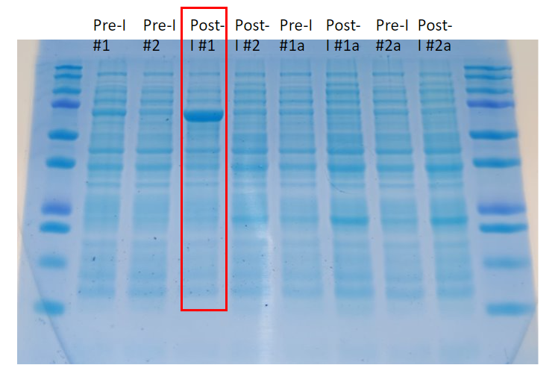
SDS-PAGE gel showing the pre and post- induction samples of different colonies. Protein was overexpressed in colony #1, with a size of ~73.2 kDa.

Figure 7
Whole cell and Soluble cell lysate samples SDS-PAGE gel
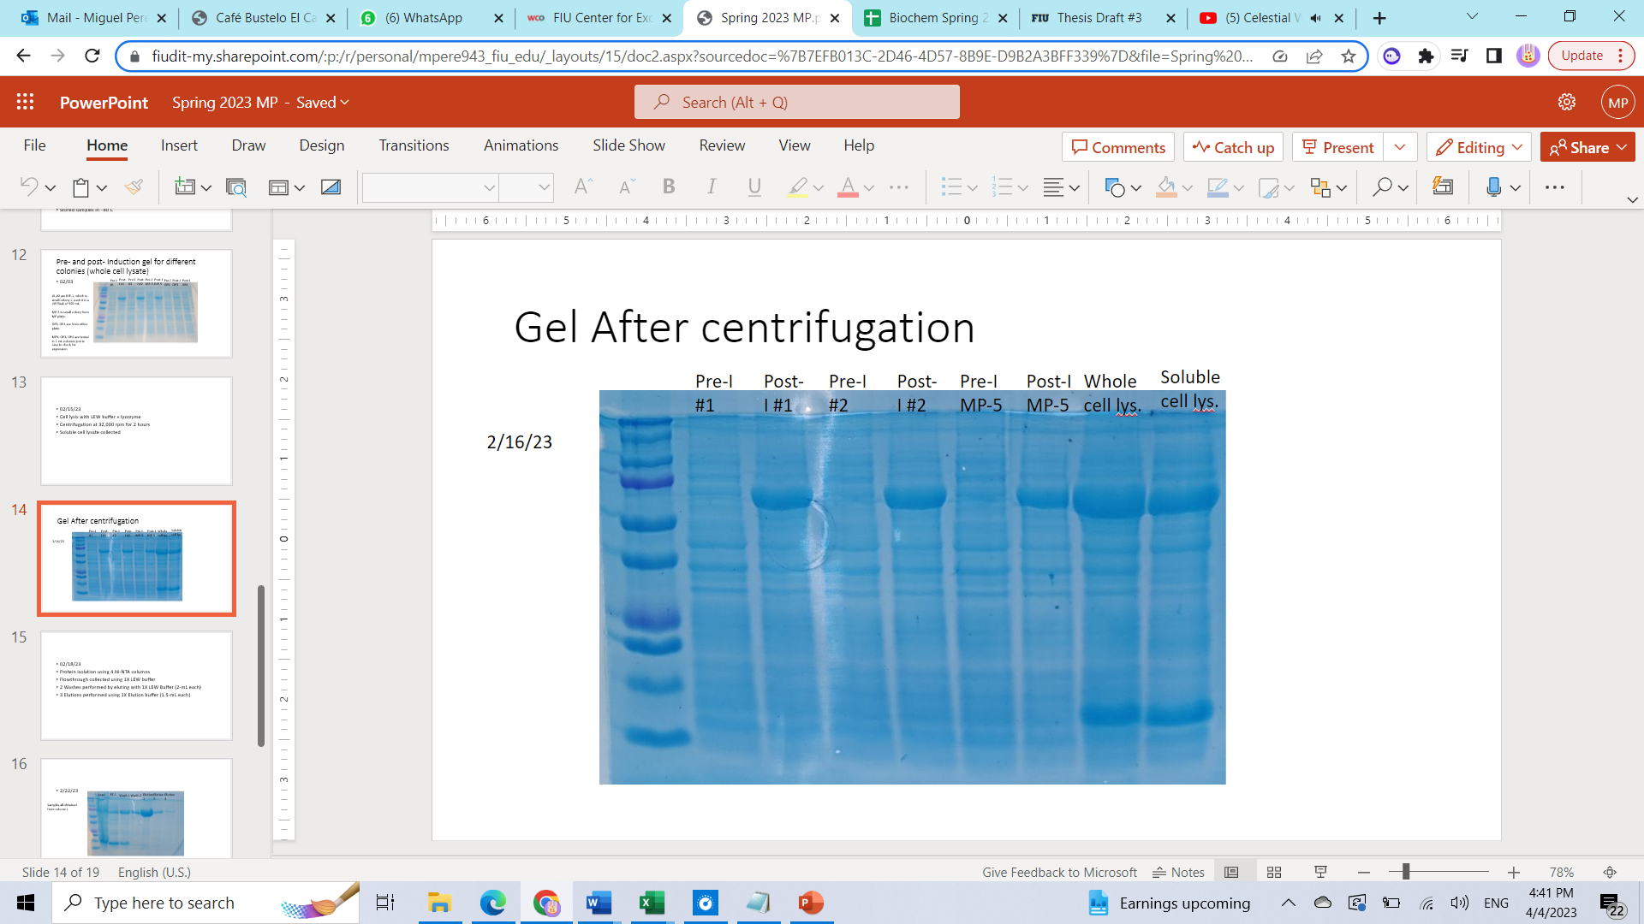
Note: Gel showing the presence of the recombinant protein in whole and soluble cell lysates after lysozyme treatment. Previous pre and post-induction samples included for reference.
Figure 8
SDS-PAGE gel showing samples after Ni-NTA column elution

Note: Gel after the different elutions with Nickel-NTA binding column (Column 1). Most protein was present in Elution 1, similar results for the other columns. Standard ladder from another gel included for reference.
Figure 9
Standard Bovine Serum Albumin (BSA) Curve
Curve Name | Curve Formula | A | B | R2
StdCurve | Y=A*X+B | 1.46 | 0.0887 | 0.963
Note: Using relevant software, the protein was found to have a concentration of 0.75 mg/ml in pool 1, and 0.20 mg/ml for sample 2. Total amount of protein present was 28.15 mg for pool 1, and 6.42 for pool 2.

Figure 10
Relaxation Assay Results
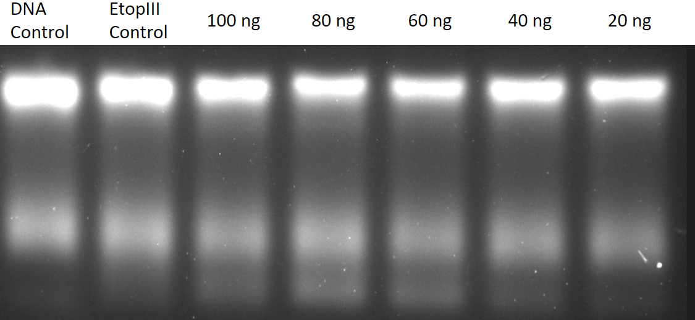
Relaxed DNA
fragments
Supercoiled DNA fragments
Note: Relaxation Assay showing the activity of the truncated EtopIII protein. Relaxed DNA fragments present as smaller bands at the bottom of the gel.

Discussion
Overall, the results indicate that the Topoisomerase III protein was successfully purified and isolated in enough concentration to send for crystallization. The total amount of protein gotten from Pool 1 was 28.15 (0.75mg/ml in 37.5 ml total volume), whereas Pool 2 had a total 6.42 mg of protein (0.20 mg/ml in 32 ml total volume).
Crystallization results are partially pending on the work of Dr. Kemin Tam at Argonne National Laboratory. The substrates used for the co-crystallization of the protein were the following: Top3RNA8merC (CGCAACUU), Top3RNA8mer (AACUGUUG), Top3BDNA8merC (CGCAACTT) and Top3DNA8mer (AACTGTTG). Initial results show that there were aggregations in the RNA nucleotide Top3RNA8mer condition. These aggregations indicate that the protein did not crystallize favorably. Instead of uniform crystals, the RNA ligand solutions formed white, cloudy precipitate structures. While the reasons for this are still unknown, it could be possible that the pH of the buffer (8.0) in which the proteins are in could have contributed to the aggregation.
Conclusion
With the preliminary results received from Dr. Tan’s Lab about the aggregation of the protein in one of the RNA substrate conditions, the need arises for more protein to be purified in order for more experiments to be run with it. The next step is to re-start the protein purification prep process with another 3L of bacterial culture. In this new preparation, the final buffer used should have a pH of 7.6 to prevent the aggregation of the protein in the crystallization assays.
The results from the relaxation assay indicate that the protein can still relax some DNA, this is seen in lanes 3-6. It is seen that there is a slight relaxation of the DNA, seen as the low-intensity band denoted by the red rectangle in Figure 10. The possible implications of this result are that even with the deletion of the 31 amino acids from the intrinsically disordered region in the C-terminus of the EtopIII protein, the enzyme was still able to bind DNA and relax it.
References
1. Bar, Amir & Kabakçıoğlu, Alkan & Mukamel, David. (2011). Denaturation of Circular DNA: Supercoil Mechanism. Physical review. E, Statistical, nonlinear, and soft matter physics. 84. 041935. 10.1103/PhysRevE.84.041935.
2. Fogg, J.M., Judge, A.K., Stricker, E. et al. Supercoiling and looping promote DNA base accessibility and coordination among distant sites. Nat Commun 12, 5683 (2021). https://doi.org/10.1038/s41467-021-25936-2
3. Baker NM, Rajan R, Mondragón A. Structural studies of type I topoisomerases. Nucleic Acids Res. 2009 Feb;37(3):693-701. doi: 10.1093/nar/gkn1009. Epub 2008 Dec 23. PMID: 19106140; PMCID: PMC2647283.
4. Tse-Dinh YC, Dasgupta T, Ferdous S. Mechanism of Type IA Topoisomerases. Molecules. 2020 Oct 17;25(20):4769. doi: 10.3390/molecules25204769. PMID: 33080770; PMCID: PMC7587558.
5. McKie, S. J., Neuman, K. C., & Maxwell, A. (2021). DNA topoisomerases: Advances in understanding of cellular roles and multi-protein complexes via structure-function analysis. BioEssays, 43, e2000286. https://doi.org/10.1002/bies.202000286
6. Ahmad, M., Xu, D., & Wang, W. (2017). Type IA topoisomerases can be magicians for both DNA and RNA in all domains of life. RNA Biology, 14(7), 854-864.
7. Rasmus B Jensen, Lucy Shapiro, Chromosome segregation during the prokaryotic cell division cycle, Current Opinion in Cell Biology, Volume 11, Issue 6, 1999, Pages 726-731, ISSN 0955-0674,
8. Li, Z., Mondragón, A., Hiasa, H., Marians, K. J., & DiGate, R. J. (2000). Identification of a unique domain essential for Escherichia coli DNA topoisomerase III‐catalysed decatenation of replication intermediates. Molecular Microbiology, 35(4), 888-895.
9. Wang H, Di Gate RJ, Seeman NC. An RNA topoisomerase. Proc Natl Acad Sci U S A. 1996 Sep 3;93(18):9477-82. doi: 10.1073/pnas.93.18.9477. PMID: 8790355; PMCID: PMC38453.
10. Alexander A Chernov, Protein crystals and their growth, Journal of Structural Biology, Volume 142, Issue 1, 2003, Pages 3-21, ISSN 1047-8477, https://doi.org/10.1016/S1047-8477(03)00034-0.
11. McPherson A, Gavira JA. Introduction to protein crystallization. Acta Crystallogr F Struct Biol Commun. 2014 Jan;70(Pt 1):2-20. doi: 10.1107/S2053230X13033141. Epub 2013 Dec 24. PMID: 24419610; PMCID: PMC3943105.
12. Bahige G. Abdallah, Christopher Kupitz, Petra Fromme, and Alexandra Ros Crystallization of the Large Membrane Protein Complex Photosystem I in a Microfluidic Channel. ACS Nano 2013 7 (12), 10534-10543. DOI: 10.1021/nn402515q
13. Catherine A. Musselman, Tatiana G. Kutateladze, Characterization of functional disordered regions within chromatin-associated proteins, iScience, Volume 24, Issue 2, 2021, 102070, ISSN 2589-0042, https://doi.org/10.1016/j.isci.2021.102070.
14. Cooper, C.D.O., Marsden, B.D. (2017). N- and C-Terminal Truncations to Enhance Protein Solubility and Crystallization: Predicting Protein Domain Boundaries with Bioinformatics Tools. In: Burgess-Brown, N. (eds) Heterologous Gene Expression in E.coli. Methods in Molecular Biology, vol 1586. Humana Press, New York, NY. https://doi.org/10.1007/978-1-4939-6887-9_2
15. Zhang HL, DiGate RJ. The carboxyl-terminal residues of Escherichia coli DNA topoisomerase III are involved in substrate binding. J Biol Chem. 1994 Mar 25;269(12):9052-9. Erratum in: J Biol Chem. 1995 Sep 1;270(35):20870. PMID: 7510701.
16. Zhang HL, Malpure S, Li Z, Hiasa H, DiGate RJ. The role of the carboxyl-terminal amino acid residues in Escherichia coli DNA topoisomerase III-mediated catalysis. J Biol Chem. 1996 Apr 12;271(15):9039-45. doi: 10.1074/jbc.271.15.9039. PMID: 8621552.
17. Pulingam T, Parumasivam T, Gazzali AM, Sulaiman AM, Chee JY, Lakshmanan M, Chin CF, Sudesh K. Antimicrobial resistance: Prevalence, economic burden, mechanisms of resistance and strategies to overcome. Eur J Pharm Sci. 2022 Mar 1;170:106103. doi: 10.1016/j.ejps.2021.106103. Epub 2021 Dec 20. PMID: 34936936.
18. LiverTox: Clinical and Research Information on Drug-Induced Liver Injury [Internet]. Bethesda (MD): National Institute of Diabetes and Digestive and Kidney Diseases; 2012–. Topoisomerase Inhibitors. 2020 Sep 12. PMID: 31643693.
19. Perez-Cheeks BA, Lee C, Hayama R, Marians KJ. A role for topoisomerase III in Escherichia coli chromosome segregation. Mol Microbiol. 2012 Nov;86(4):1007-22. doi: 10.1111/mmi.12039. Epub 2012 Oct 16. Erratum in: Mol Microbiol. 2012 Dec;86(6):1548. PMID: 23066834; PMCID: PMC3549057.
20. Champoux, J. J., & Been, M. D. (1980). Mechanistic studies of DNA replication and genetic recombination. In ICN-UCLA symposia on molecular and cellular biology (pp. 809-815). New York: Academic.
21. Hardy, L. W., & Malikayil, A. (2003). The impact of structure-guided drug design on clinical agents. Curr. Drug Discov, 3, 15-20.
22. Tom L Blundell, S Patel, High-throughput X-ray crystallography for drug discovery, Current Opinion in Pharmacology, Volume 4, Issue 5, 2004, Pages 490-496, ISSN 1471-4892

