Introduction
Groundwater serves as a crucial source of freshwater for coastal communities throughout the United States, especially in regions like Florida, which has an oceanic peninsular geography. In Florida, the majority of freshwater used for human activities, including drinking water and irrigation for agriculture, is obtained from groundwater sources (Marella, 2004). Agriculture accounts for a significant portion, approximately 39%, of the total water usage. However, this heavy reliance on groundwater has led to a pressing environmental issue: saltwater intrusion within the Florida aquifer system.
Saltwater intrusion occurs when seawater infiltrates freshwater aquifers, resulting in increased salinity levels and degradation of water quality (Weissman et al., n.d.). The main factors contributing to this problem are climate change, human activities, sea-level rise, extreme weather events, and excessive pumping of groundwater (Government of Prince Edward Island, 2011). The movement of saltwater inland not only affects groundwater but also leads to the deposition of salts in coastal soils, causing soil salinization.
Soil salinization poses a significant challenge for agriculture as high levels of salts in the soil disrupt the nutrient balance, leading to plants absorbing sodium and chloride ions instead of essential nutrients like potassium. This, in turn, causes nutrient deficiencies and ion toxicity, negatively impacting crop production. Crops, such as beans, which are not salt-tolerant, are particularly vulnerable, creating a need for long-term solutions to address this problem (Haimanote et al., 2022).
Efforts have been underway since the 1950s to develop crops that can thrive in saline conditions, and recent trends have focused on integrated farm management practices tailored to specific environments (Negacz et al., 2021). One potential solution lies in the tomato crop, which exhibits mechanisms to combat salt stress, such as accumulating excess sodium in older leaves (Khelil et al., 2007). Given the substantial economic value of Florida's tomato production, which exceeded $300 million in 2022 (United States Department of Agriculture [USDA], 2023), the development of salt-tolerant tomato varieties holds promise for protecting the state's agricultural industry amid increasing soil salinity.
Coastal regions, such as Florida, heavily rely on groundwater as a vital freshwater source for both anthropogenic and agricultural activities (Marella, 2004). However, increasing saltwater intrusion into the Florida aquifer system due to climate change and human activities poses a growing environmental challenge. Saltwater intrusion can lead to soil salinization, adversely affecting crop production in these regions.
Tomatoes, especially the cherry tomato variety, hold significant economic value in Florida, making it crucial to understand their responses to short-term below-ground saline water exposure for the development of sustainable agricultural practices in saline environments. Previous research indicates that cherry tomato varieties exhibit better salt tolerance than normal-fruit varieties under certain conditions, owing to their ability to regulate osmotic balance and ion transport mechanisms (Khelil et al., 2007). However, the impacts of short-term saltwater exposure on cherry tomato growth and health warrant further investigation, as additional stressors like disease outbreaks could influence plant responses. Moreover, exploring how plants adapt to varying salt concentrations and nutrient availability in the root zone could provide valuable insights into enhancing their resilience to salt stress (Negacz et al., 2021).
The goal of this study was to assess how short-term exposure to saltwater intrusion affects the immediate growth and health of cherry tomato plants, a common crop in Florida. The objectives of our study are 1) to monitor the growth and physiology of tomato plants growing under salt stress, 2) evaluate the macro and micronutrient concentration in the treated soils and plants. The research is significant to South Florida because understanding the effects of salinization on tomato plants will provide valuable insights for developing strategies to enhance their salt tolerance and ensure the continued productivity of Florida's agricultural sector in the face of rising salinity levels.
Materials and Methods
Experimental Setup
Twenty cherry tomato plants were grown from seed for one month within the outdoor shade house of the FIU organic garden. The tomato plants 30 days after sowing (DAS) were transplanted into three-gallon nursery pots and set on two raised platforms of at least 4 ft in height. Using containers atop platforms allowed us to exert better control over the experimental conditions. The plants were irrigated daily with a mix of rainwater and recycled well water, ensuring consistent hydration.
To simulate saltwater stress resulting from groundwater salinity, we set up ten greenhouse trays, each capable of accommodating two pots, for a total of twenty pots. The experimental design included one control group and four treatment groups, each consisting of four plants. The treatment groups were exposed to increasing concentrations of salt, achieved by adding different amounts of 99% pure NaCl to the trays, as outlined in Table 1. The mass of NaCl added for group T2, T3, T4, and T5 was calculated from the ideal electric conductivity of 2 dS/M, 4 dS/M, 6 dS/M, and 8 dS/M, respectively using formulas (1) and (2).

Table 1: Electroconductivity of Tray Solutions
Treatment NaCl added (g/L) Total Dissolved Solids (ppm 500 scale)

CT1 | 0 | 353.5
T2 | 1.28 | 1810
T3 | 2.56 | 3040
T4 | 4.81 | 3815
T5 | 6.4 | 4435

Formulas from the University of California (Division of Agriculture and Natural Resources, 2023).

TDS (mg/L or ppm) = EC (dS/m) x 640 (EC from 0.1 to 5 dS/m) (1)

TDS (mg/L or ppm) = EC (dS/m) x 800 (EC > 5 dS/m) (2)

To ensure homogeneity, the salt solutions were thoroughly mixed until the salt dissolved completely. An EC meter was used to measure the electrical conductivity of each tray solution, and the measurements were recorded. The tomato pots were then placed in the trays and allowed to soak for six hours before being removed to drain. This approach, inspired by similar studies on canola crops (Hanley et al., 2020), aimed to mimic short-term below-ground salt exposure, reducing the risk of oxygen-deficiency and contamination across treatment groups. To minimize the impact of soil inundation, the selected trays were shallow, with a height of approximately 2.5 inches. The salt soak treatments were applied once on Week 1 and twice on Week 3 for a total of three salt treatments.
Data Collection
Plant Measurements
Before each salt treatment and on a weekly basis, we measured the height and leaf chlorophyll concentrations of each plant using a measuring tape and a SPAD-502 meter (Porro et al., 2000). The SPAD meter provides a quantifiable measure of leaf chlorophyll concentration, which is indicative of nitrogen deficiencies and overall plant health over time. At the beginning and end of the experiment, leaf spectral reflectance for each individual plant was recorded using a Spectral Evolution spectrometer. Leaf spectral reflectance provides valuable information on overall plant health and helps identify water-stressed plants (Sun et al., 2021).
Chemical Analysis
At the end of the experiment period, the entire shoot of each plant was harvested, dried, and ground up for subsequent analysis. Additionally, soil samples were collected from the top two inches of soil in fifteen of the twenty pots (three pots from each experimental group). The soil samples were air dried, and sieved using a 2mm sieve. The soil samples were then analyzed for percentages of essential plant nutrients such as carbon and nitrogen using inductively coupled plasma mass spectrometry (ICP-MS), TCN analyzer. ICP-MS is a powerful technique that enables the identification and measurement of elements within a sample, providing insights into soil quality and nutrient content beyond visual plant performance (Thomas et al., 2017).
Statistical Analysis
The collected data was subjected to statistical analysis using Minitab software (version 21). One-way analysis of variance (ANOVA) was conducted to compare the mean values of plant height, leaf chlorophyll concentration, and leaf spectral reflectance among the control group and the treatment groups (T2, T3, T4, and T5) at a 5% confidence level. The Tukey's test was performed for multiple comparisons if the ANOVA results indicated significant differences between the groups. Similarly, ANOVA was applied to assess variations in cation exchange capacity (CEC) and nutrient concentration among the soil samples from different treatment groups, and Tukey's test was used to identify specific differences.

Results

Plant Measurements
Statistical analysis using Minitab software revealed no significant effect of the saltwater treatments on observed plant height and leaf chlorophyll concentrations (Figure 1 & 2). However, at Week 3, an outlier was identified, with average height and SPAD units across all experimental groups decreasing before the application of the second salt treatment. This sudden decline in plant health was attributed to the occurrence of early leaf blight disease, marked by distinct brown, necrotic "bullseye" lesions and leaf yellowing (Chaerani & Voorrips, 2006).
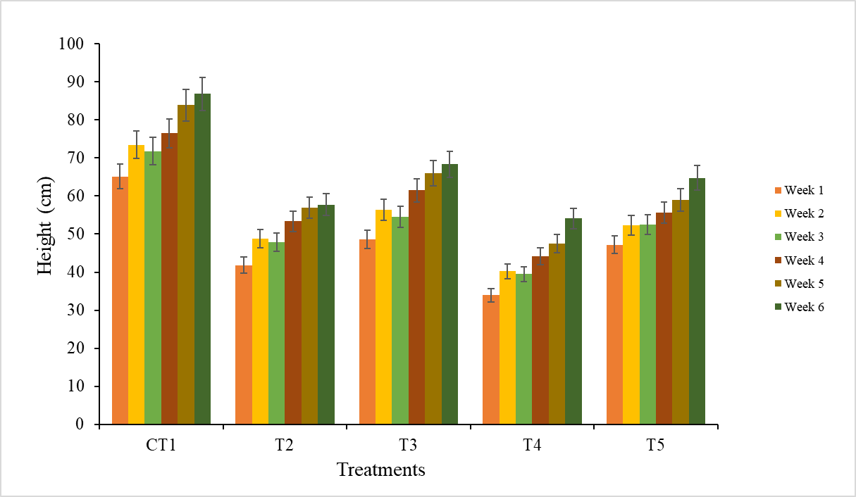
Figure 1: Effect of Salt Concentration on Plant Height
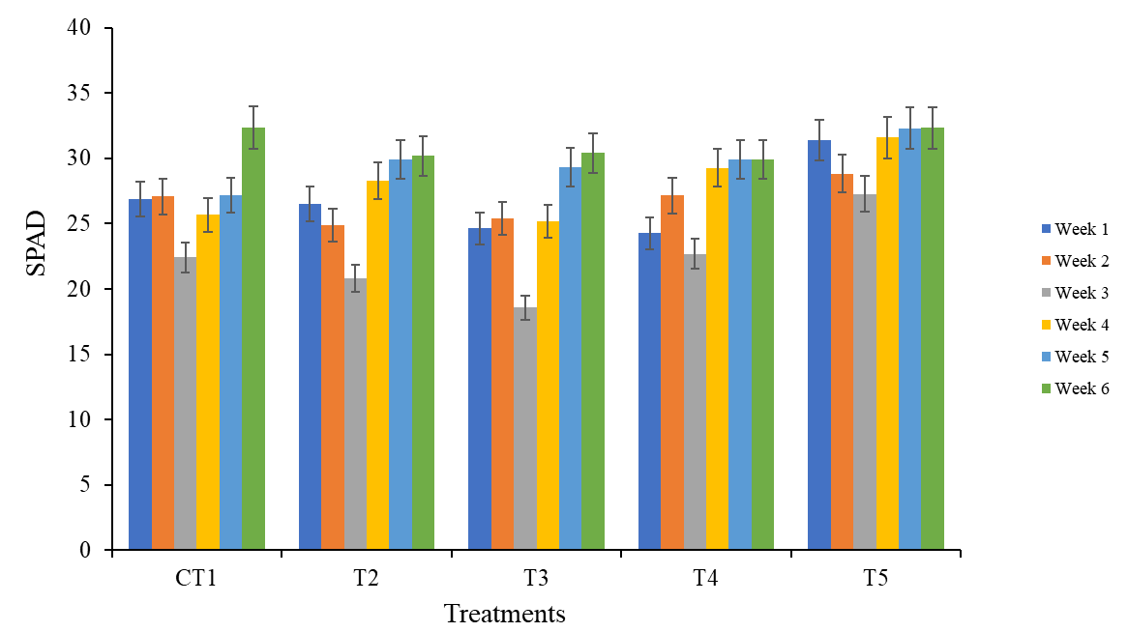
Figure 2: Effect of salt concentration on chlorophyll concentration (SPAD value)
Intriguingly, a significant difference in the percentage of phosphorus was found between the T2 test group and the T3 test group in plant shoot tissue, as revealed by the Tukey's test (Table 2).

Table 2: Results of the Tukey’s Test for plant tissue spectrometry (ICP-MS)

Treatment | N (%) | Ca (%) | K (%) | Mg (%) | P (%) | S (%)
CT1 | 1.756 (± 0.1204) A | 1.556 (±0.281) AB | 4.163 (±0.284) A | 0.5503 (±0.032) A | 0.754 (±0.0906) A | 0.385 (±0.049) A
T2 | 1.903 (±0.952) A | 1.4403 (±0.1271) B | 3.746 (±0.688) A | 0.4705 (±0.1151) A | 0.6358 (±0.1654) A | 0.2875 (±0.0538) A
T3 | 1.725 (±0.563) A | 2.37 (±0.66) A | 3.996 (±0.317) A | 0.68 (±0.284) A | 0.838 (±0.358) A | 0.475 (±0.207) A
T4 | 2.2918 (±0.172) A | 2.15 (±0.229) AB | 4.04 (±0.386) A | 0.7548 (±0.0461) A | 0.9985 (±0.0971) A | 0.5285 (±0.0697) A
T5 | 1.851 (±0.371) A | 2.479 (±0.419) A | 4.4747 (±0.1504) A | 0.7452 (±0.0858) A | 0.8908 (±0.0395) A | 0.4615 (±0.0662) A
Note. Groupings are signified by letters: Means that do not share a letter are significantly different.

Results of the Tukey’s Test for plant tissue spectrometry (ICP-MS) continued
Treatment | B,ppm | Fe,ppm | Mn,ppm | Zn,ppm | Cu,ppm | Na(%)
CT1 | 26.66 (±3.81) AB | 64.53 (±8.89) A | 17.276 (±1.091) A | 77.2 (±29.2) A | 4.746 (±1.129) A | 0.0454 (±0.00678) A
T2 | 19.07 (±3.94) B | 60.6 (±33.2) A | 14.727 (±1.715) A | 63.22 (±19.87) A | 4.888 (±1.345) A | 0.06028 (±0.01596) A
T3 | 31.16 (±8.85) A | 54.92 (±9.78) A | 20.46 (±6.74) A | 76.8 (±51.3) A | 6.32 (±2.19) A | 0.0483 (±0.0253) A
T4 | 26.76 (±1.065) AB | 52.65 (±3.3) A | 21.781 (±1.068) A | 99.12 (±19.6) A | 7.4 (±2.74) A | 0.1236 (±0.0366) A
T5 | 26.05 (±3.16) AB | 52.041 (±0.796) A | 17.24 (±2.08) A | 82.39 (±18.85) A | 6.93 (±2.88) A | 0.1108 (±0.01863) A
Note. Groupings are signified by letters: Means that do not share a letter are significantly different.
However, no significant difference was observed in soil nutrient concentration, pH, and other measured parameters among the experimental groups (Table 3).

Table 3: Results of the Tukey’s Test for soil spectrometry (ICP-MS)

Treatments | pH | % N | P (ppm) | K (ppm) | Ca (ppm)
CT1 | 7 | 0.888 (±0.01572) A | 289.08 (±16.72) A | 671.5 (±116.7) A | 17469 (±30.1) A
T2 | 7 | 0.9363 (±0.0855) A | 287.45 (±12.79) A | 690.9 (±61.2) A | 17480 (±52.3) A
T3 | 7 | 0.948 (±0.1004) A | 287.82 (±7.91) A | 739 (±106.7) A | 17506 (±18.5) A
T4 | 7 | 0.8503 (±0.0914) A | 292.88 (±9.21) A | 701.6 (±100.3) A | 17551 (±11.9) A
T5 | 7 | 0.889 (±0.0617) A | 293 (±26.6) A | 738 (±322) A | 17534 (±49) A
Note. Groupings are signified by letters: Means that do not share a letter are significantly different.

Results of the Tukey’s Test for soil spectrometry (ICP-MS) continued
Treatments | Mg (ppm) | Zn (ppm) | Na (ppm) | % OM | CEC
CT1 | 1031.5 (±63) A | 13.98 (±0.71) A | 132.9 (±23.8) A | 27.87 (±2.28) A | 97.661 (±0.966) A
T2 | 1015.1 (±47.5) A | 13.822 (±0.467) A | 135.52 (±11.48) A | 30.51 (±2.48) A | 97.63 (±0.793) A
T3 | 1058.6 (±18.4) A | 14.333 (±0.318) A | 153.5 (±30.2) A | 32.01 (±4) A | 98.244 (±0.32) A
T4 | 1063.6 (±11) A | 14.4 (±0.531) A | 163.85 (±13.26) A | 27.74 (±4.18) A | 98.419 (±0.35) A
T5 | 1066.7 (±75.4) A | 14.188 (±0.284) A | 174.5 (±81.9) A | 29.559 (±1.673) A | 98.452 (±1.499) A
Note. Groupings are signified by letters: Means that do not share a letter are significantly different.

Additionally, we calculated a nutrient ratio to assess nutrient uptake and adaptation to salt exposure within the root zone, and the nutrient ratio for Ca was found to be less than 1 for experimental groups CT1 and T2 (Table 4).

Table 4: Calculated Ratio of Nutrients of the Tukey’s Test for soil spectrometry (ICP-MS)
Treatment | Nutrient Ratio
 | N | P | K | Ca | Mg | Na | Zn
CT1 | 1.98 | 26.08 | 62.00 | 0.89 | 5.33 | 3.42 | 5.52
T2 | 2.03 | 22.12 | 54.22 | 0.82 | 4.64 | 4.45 | 4.57
T3 | 1.82 | 29.12 | 54.07 | 1.35 | 6.42 | 3.15 | 5.36
T4 | 2.70 | 34.09 | 57.58 | 1.23 | 7.10 | 7.54 | 6.88
T5 | 2.08 | 30.40 | 60.63 | 1.41 | 6.99 | 6.35 | 5.81
Note. Formula for Nutrient Ratio = (nutrient concentration in plants) / (nutrient concentration in soil)

In terms of leaf spectral reflectance, the control group exhibited significantly lower reflectance within the range of interest (approximately 350-650nm) compared to the other experimental groups (Figure 3 & 4). Further analysis of the Green Normalized Difference Vegetation Index (GNDVI) indicated a significant increase in GNDVI for all experimental groups at the end of the experiment, suggesting improved plant health despite salt stress. However, no significant relationship was found between water salinity and GNDVI (Figure 5).

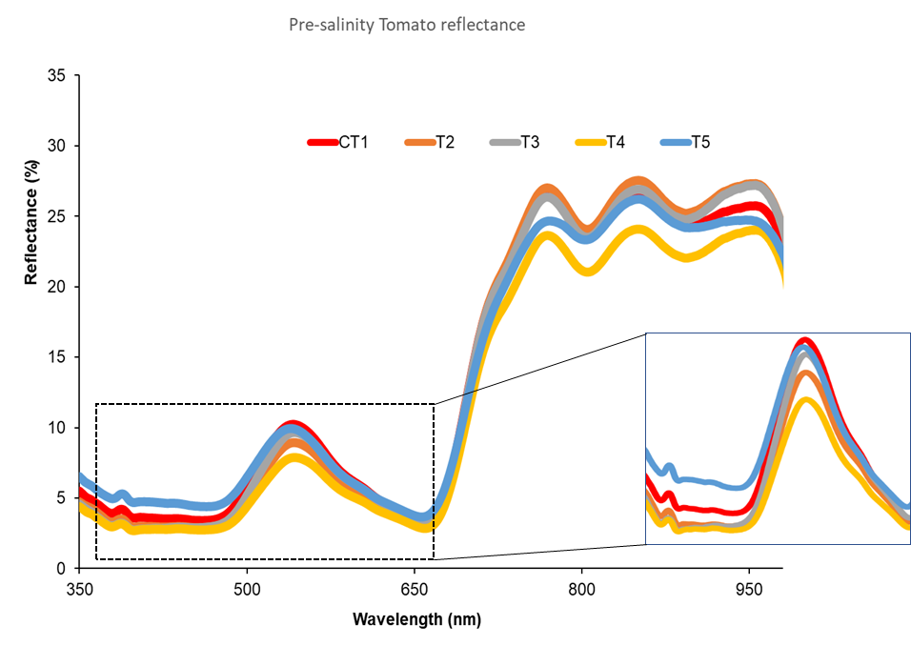
Figure 3: Spectral reflectance of tomatoes before salination

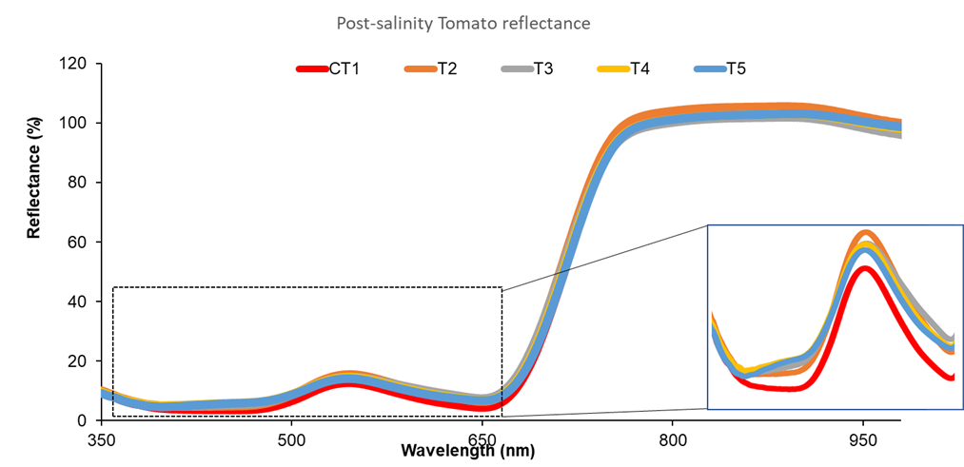
Figure 4: Spectral reflectance of tomatoes after salination

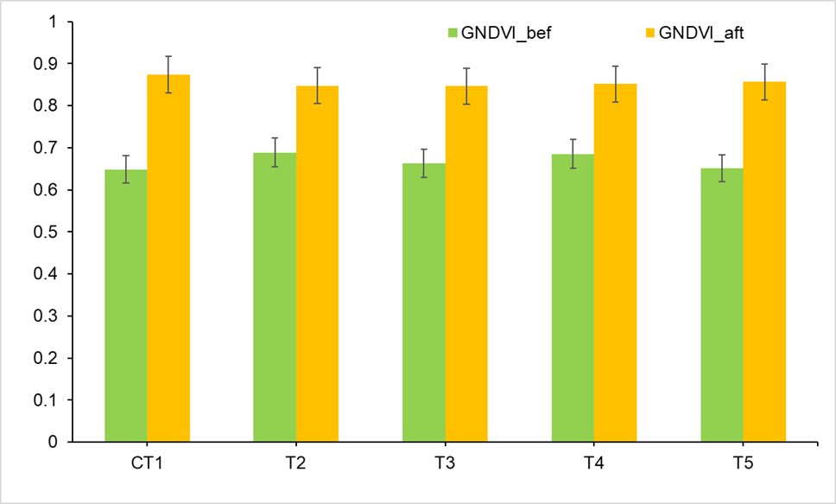
Figure 5: GNDVI spectral indices before and after salination

Discussion
Plant Measurements
The results presented in this study offer valuable insights into the impact of short-term below-ground saline water exposure on cherry tomato plants. The observed lack of significant effects on plant height and leaf chlorophyll concentrations suggests that cherry tomato plants exhibit a certain level of tolerance to the tested salt concentrations. This resilience could be attributed to the cherry tomato's ability to regulate osmotic balance and ion transport mechanisms, enabling the plants to maintain their growth and physiological functions under mild salt stress conditions (Munns & Tester, 2008). However, the unexpected decline in plant health during the third week, coinciding with early leaf blight disease, raises important questions about the interactions between salt stress and disease development (Chourasia et al. 2022). Further research is warranted to better understand and manage the implications of such interactions on tomato crop management.
Chemical Analysis
The significant difference in phosphorus levels in plant shoot tissue between certain treatment groups highlights the plants' response to the varying salt concentrations. Phosphorus is essential for various biochemical processes, including energy transfer and DNA synthesis, and its altered availability under salt stress may impact plant growth and overall health (Marschner, 2012). Understanding the specific mechanisms underlying this differential response to phosphorus could inform targeted fertilizer application strategies and enhance the plants' nutrient-use efficiency in saline environments.

Interestingly, no significant differences were observed in soil nutrient concentration and other measured parameters among the experimental groups, indicating that short-term saltwater exposure did not exert a pronounced effect on the analyzed soil properties. However, the nutrient ratio results for calcium (Ca) revealed differences in nutrient uptake patterns and adaptation strategies among the experimental groups. The plants in groups CT1 and T2 exhibited nutrient ratios below 1, indicating that they might have experienced limitations in calcium uptake under the prevailing salt stress conditions. Calcium is crucial for cell wall integrity, signaling pathways, and enzymatic activities, and its deficiency could affect plant cell functions and overall health (White & Broadley, 2003). Developing tailored soil amendments or calcium application strategies could help improve calcium availability and enhance the resilience of cherry tomato plants to salt stress.
Spectral Reflectance
The observations related to leaf spectral reflectance provide valuable information about the plants' response to salt stress and potential changes in their overall health. The significantly lower reflectance within the range of interest in the control group could be indicative of early stress responses, such as changes in leaf pigments and cellular structures (Lichtenthaler, 1987). The significant increase in Green Normalized Difference Vegetation Index (GNDVI) across all experimental groups at the end of the experiment suggests that the plants exhibited improved vigor despite exposure to saltwater treatments. These findings suggest that cherry tomato plants may possess mechanisms to mitigate the adverse effects of salt stress on their physiological processes.

Therefore, this study offers important insights into the responses of cherry tomato plants to short-term below-ground saline water exposure. The results contribute to our understanding of plant resilience to salt stress and provide a basis for further investigations on managing early leaf blight disease and optimizing nutrient uptake strategies in saline environments. The implications of leaf spectral reflectance changes and the increase in GNDVI warrant further exploration to identify the underlying mechanisms involved. These findings hold practical significance for agricultural practices in coastal regions or areas facing saltwater intrusion challenges. Overall, our study underscores the importance of considering short-term and localized salt stress effects in the context of agricultural sustainability and food security.
Conclusion
This study provides valuable insights into the responses of cherry tomato plants to short-term below-ground saline water exposure and its implications for agricultural practices in saline environments. The results demonstrate the cherry tomato's tolerance to mild salt stress, as evidenced by the lack of significant effects on plant height and leaf chlorophyll concentrations. However, the unexpected decline in plant health during the third week, coinciding with early leaf blight disease, calls for further investigation into the interactions between salt stress and disease development. The differential response of cherry tomato plants to varying salt concentrations in terms of phosphorus levels highlights their ability to adapt to changing environmental conditions. Understanding these mechanisms could guide targeted nutrient management strategies. The findings emphasize the importance of considering short-term and localized salt stress effects on crop performance and the potential benefits of selecting salt-tolerant cherry tomato varieties for cultivation in saline environments. Ultimately, this research contributes to the broader goal of developing resilient agricultural practices to ensure food security in the face of global climate change.
.

References
Besri, M. (1993). Effects of salinity on plant diseases development. Towards the rational use of high salinity tolerant plants: Vol. 2 Agriculture and forestry under marginal soil water conditions, 67-74.
Caro, M., Cruz, V., Cuartero, J., Estan, M. T., & Bolarin, M. C. (1991). Salinity tolerance of normal-fruited and cherry tomato cultivars. Plant and soil, 136, 249-255.
Carter, G. A. (1991). Primary and Secondary Effects of Water Content on the Spectral Reflectance of Leaves. American Journal of Botany, 78(7), 916–924. https://doi.org/10.2307/2445170
Chaerani, R., & Voorrips, R. E. (2006). Tomato early blight (Alternaria solani): the pathogen, genetics, and breeding for resistance. Journal of general plant pathology, 72, 335-347.
Government of Prince Edward Island. (2011). SALTWATER INTRUSION and CLIMATE CHANGE. http://www.gov.pe.ca/photos/original/cle_WA1.pdf
Haimanote K. Bayabil, Yuncong Li, Jonathan H. Crane, Bruce Schaffer, Ashley R. Smyth, Shouan Zhang, Edward A. Evans, and Trent Blare. (2022). Saltwater intrusion and flooding: Risks to South Florida’s agriculture and potential management practices. https://edis.ifas.ufl.edu/publication/AE572
Hanley, M. E., Hartley, F. C., Hayes, L., & Franco, M. (2020). Simulated seawater flooding reduces oilseed rape growth, yield and progeny performance. Annals of botany, 125(2), 247–254.
Khelil, A., Menu, T., & Ricard, B. (2007). Adaptive response to salt involving carbohydrate metabolism in leaves of a salt-sensitive tomato cultivar. Plant Physiology and Biochemistry, 45(8), 551-559.
Marella, Richard L. Water withdrawals, use, discharge, and trends in Florida, 2000. Vol. 4, no. 4. US Department of the Interior, US Geological Survey, 2004.
Munns, R., & Gilliham, M. (2015). Salinity tolerance of crops–what is the cost?. New phytologist, 208(3), 668-673.
Munns, R., & Tester, M. (2008). Mechanisms of salinity tolerance. Annu. Rev. Plant Biol., 59, 651-681.
Negacz, K., Vellinga, P., Barrett-Lennard, E., Choukr-Allah, R., & Elzenga, T. (2021). 1.1 INITIATIVES TO GROW CROPS UNDER SALINE CONDITIONS. Future of sustainable agriculture in Saline Environments (p. 5). essay, CRC Press.
Porro, D. U. I. L. I. O., Dorigatti, C. I. N. Z. I. A., Stefanini, M. A. R. C. O., & Ceschini, A. N. D. R. E. A. (2000). Use of SPAD meter in diagnosis of nutritional status in apple and grapevine. In IV International Symposium on Mineral Nutrition of Deciduous Fruit Crops 564 (pp. 243-252).
Rengasamy, P. (2010). Soil processes affecting crop production in salt-affected soils. Functional Plant Biology, 37(7), 613-620.
Sun, J., Yang, L., Yang, X., Wei, J., Li, L., Guo, E., & Kong, Y. (2021). Using spectral reflectance to estimate the leaf chlorophyll content of maize inoculated with arbuscular mycorrhizal fungi under water stress. Frontiers in Plant Science, 12, 646173
Thomas, S., Thomas, R., Zachariah, A. K., & Mishra, R. K. (2017). Chapter 8 - Inductively Coupled Plasma Mass Spectrometry. In Spectroscopic methods for nanomaterials characterization (pp. 163–194). essay, Elsevier Ltd.
United States Department of Agriculture. (2023). 2022 State Agriculture Overview. USDA/NASS 2022 State Agriculture Overview for Florida. https://www.nass.usda.gov/Quick_Stats/Ag_Overview/stateOverview.php?state=FLORIDA
University of California. (2023). Salinity measurement and unit conversion. Salinity Management. Retrieved March 5, 2023, from https://ucanr.edu/sites/Salinity/Salinity_Management/Salinity_Basics/Salinity_measurement_and_unit_conversions/
Vegetation indices and their interpretation: NDVI, GNDVI, MSAVI2, NDRE, and Ndwi. Auravant. (n.d.). https://www.auravant.com/en/articles/precision-agriculture/vegetation-indices-and-their-interpretation-ndvi-gndvi-msavi2-ndre-and-ndwi/#:~:text=GNDVI%20is%20the%20green%20vegetation,has%20a%20higher%20saturation%20point.
Weissman, D., Tully K., McClure K. (n.d.). Saltwater intrusion: A growing threat to coastal agriculture. Saltwater Intrusion: A Growing Threat to Coastal Agriculture | USDA Climate Hubs. (n.d.).https://www.climatehubs.usda.gov/hubs/northeast/topic/saltwater-intrusion-growing-threat-coastal-agriculture#:~:text=As%20sea%20levels%20rise%20along,table%20below%20the%20soil%20surface

