Parental Education to Increase the Rate of Flu Vaccination in Children Ages Six Months to 17 Years: A Quality Improvement Project

A Scholarly Project Presented to the Faculty of the Nicole Wertheim College of Nursing and Health Sciences

Florida International University

In partial fulfillment of the requirements
For the Degree of Doctor of Nursing Practice

By
Naghmana Chughtai

Supervised By
Dr. Mechell Duran

Approval Acknowledged: _______________________________, DNP Program Director
Date: _________________________

Table of Contents
Abstract 4
Introduction 5
Problem Statement/Significance 7

Problem Identification 7

Background 8

Scope of the Problem 10

Consequences of the Problem

Physical Consequences 11

Mental/Emotional Consequences 12

Social/Economic Consequences 14

Knowledge Gaps 15

Proposed Solution 16
Summary of the Literature 16
Search Strategy 16
Findings of the Literature Review 17
Literature Synthesis 23
Purpose/PICO/Objectives 25
Research Questions 25
PICO Question 25
Objectives 25
Definition of Terms 26
Conceptual Underpinning and Theoretical Framework 27
Theory Overview 28
Theory Application 29
Methodology 31
Setting and Participants 32
Approach Description and Project Procedures 34
Protection of Human Subjects 36
Data Collection 37
Data Management and Analysis 38
Results 39
Descriptive Data Analysis 39
Inferential Data Analysis 41
Pre- to Post Intervention Question Analysis 42
Discussion 46
Discussion of Results 46
Implementation Discussion 47
Project Implementation 48
Influencing Factors 49
Monitoring 51
Project Maintenance 51
Limitations 53
Areas for Future Research 54
Recommendations 55
Interpretation of Findings 56
Changes in Patient Care/Healthcare Setting 57
Transferability 58
Cost Effectiveness 59
Recommendations 60
Plans for Dissemination 61
Implications for Advanced Nursing Practice 62
Education 62
Clinical Practice 63
Administration 63
Leadership 64
Conclusion 64
References 66
Appendix A: Literature Matrix 78
Appendix B:Facility Letter of Support 82
Appendix C: IRB Approval Letter 83
Appendix D: Telephone Recruitment Script 85
Appendix E: Verbal Informed Consent Form 86
Appendix F: Pre-/Post-Intervention Assessment Form 89

Abstract
Background: Seasonal influenza is often considered by many to be a minor inconvenience that can result in temporary discomfort and loss of productivity. While most individuals who contract the flu will experience these outcomes, for high-risk groups including the elderly, pregnant women, and children, seasonal flu can be costly and deadly. For children who are eligible for the vaccine, consent to vaccinate must be provided by parents. Consequently, increasing vaccine uptake in children requires healthcare providers to work with parents and to educate them about the risks and benefits of vaccination. Because vaccination rates among children are often low, a quality improvement project to educate parents about vaccinating their children against influenza was constructed.
Objective: Increasing vaccination uptake in these populations is viewed as an important foundation for reducing the disease and economic burden of seasonal influenza.
Research Method: A quasi-experimental pre-/post-intervention approach was selected to evaluate changes in parental knowledge regarding flu vaccination before and after an educational program provided over the telephone.
Conclusion: The results of the project indicate a significant increase in post-intervention knowledge that were statistically significant: p = 0.001. Based on the results, increased parental knowledge should lead to an increase in vaccination rates for children.
Implications: When the results of this project are combined with current evidence on the topic, there is ample support for building practice change that would include parental education to increase knowledge and influenza vaccine uptake for children.
Keywords: influenza, children, parental education, vaccine, quality improvement

Parental Education to Increase the Rate of Flu Vaccination in Children Ages Six Months to 17 Years: A Quality Improvement Project
Influenza (flu) is a contagious respiratory disease that is caused by a virus which infects the nose, throat, and/or lungs (Schmid et al., 2017). While the disease is highly transmissible, it is often viewed as having little impact on individual health outside of being little more than a minor inconvenience (Rizzo et al., 2018). In most individuals, infection with the flu does not result in serious symptoms that warrant treatment or hospitalization (Schmid et al., 2017). Even though this information appears to provide comfort for many, the reality is that each year influenza takes a significant individual and public health toll across the globe, primarily in vulnerable populations including children, older adults 65-years-of-age and older, and individuals with compromised immune systems (Paules et al., 2018). In fact, current evidence demonstrates that seasonal influenza epidemics cause three to five million cases of the disease each year and result in 500,000 deaths globally (Paules et al., 2018). In the United States, annual influenza-related hospitalizations average between 140,000 and 170,000 and can result in as many as 56,000 deaths (Paules et al., 2018).
The epidemiology of influenza hospitalizations and deaths in the United States provides additional insight into the population groups that are impacted by this virus. Specifically, data indicate that in the 2019-2020 flu season, children under the age of four years were hospitalized at a rate of 80.1 per 100,000 children, the highest rate ever on record (Wyckoff, 2020). This number exceeds that of older adults, who are more likely to die from the disease (Wyckoff, 2020). Further, data indicate that during the 2019-2020 influenza season, 189 children under the age of five died because of the disease (Wyckoff, 2020). While older adults—i.e., those 65 years of age and older—typically have the highest mortality rate from the virus, children, including those 17 years of age and younger, are the second largest group to be impacted by this pathogen (Wyckoff, 2020).
Although the overall impact of influenza on children in terms of hospitalization and mortality is important to consider, scholars reviewing this topic have been quick to note that when children contract the flu, it can have a systemic impact on families, communities, and society in general. Willis et al. (2019) note that increased rates of childhood influenza often result in increased antibiotic use within the community, as well as increased rates of student and parental absenteeism. Heikkinen et al. (2016) contend that parental absenteeism associated with influenza in children results in significant losses in economic productivity for society, while also increasing the burden of healthcare costs borne by society. When combined, the impact of influenza on children can be both significant and systemic.
Although influenza poses a unique threat to children, research consistently demonstrates that influenza vaccination can markedly reduce both the health and socioeconomic impact of this virus (Heikkinen et al., 2016). Influenza vaccinations have proven to be extremely safe and effective for preventing severe disease and for reducing hospitalizations and mortality associated with the pathogen (Dominguez et al., 2016). Unfortunately, vaccine hesitancy among parents remains a significant concern that can often limit the ability and willingness of parents to seek vaccination for their children (Santibanez et al., 2020). Vaccine hesitancy has been shown to have myriad root causes, including parental health literacy regarding the impact of influenza and the efficacy of the vaccine (Facciola et al., 2019). To overcome these issues and to increase vaccination rates in children under the age of 17 years, parental education has been proposed and successfully used to help increase vaccination rates in this vulnerable population (Rao et al., 2018).
In light of the health and socioeconomic impact that influenza can have on children and the efficacy of parental education to increase influenza vaccination rates, it would seem that healthcare providers should implement practice change to educate parents about this topic. With these issues in mind, this Doctor of Nursing Practice (DNP) quality improvement project aimed to evaluate the use of a parental education program to help increase influenza vaccination rates in children 17 years of age and younger. Included in this document is a review of the problem of vaccine hesitancy, the significance of the issue, the scope and consequences of the problem, a summary of the literature to support practice change, the purpose of the project including a PICO (population, intervention, comparison, outcome) question, definition of terms, underpinning theory, methodology, results, and a discussion of the results for advanced practice nursing.
Problem Statement/Significance
According to Melnyk and Fineout-Overholt (2019), every evidence-based practice (EBP) change begins with the identification of a problem that needs to be solved. Problems must be researchable such that data and evidence can be collected and analyzed to determine the correct course of action for solving the problem (Melnyk & Fineout-Overholt, 2019). Defining the problem and identifying its significance are critical to building a foundation for practice change. Consequently, these issues are addressed here, including the problem identification, background to the problem, scope of the problem, and significance of the problem.
Problem Identification
The problem being investigated in this quality improvement project focused on increasing influenza vaccination rates among children aged 17-years-of-age and younger. Current evidence indicates that children are more susceptible to influenza infection (Meade et al., 2020). This is primarily because children often have underdeveloped immune systems which can hinder their ability to mount an effective immune response following contact with the virus (Meade et al., 2020). While vaccination can significantly reduce disease severity, preventing complications, hospitalization, and increased mortality, current data provided by the Centers for Disease Control and Prevention ([CDC], 2020a) indicate that during the 2019-2020 influenza season only 21% of children were vaccinated against the flu. For children to receive the vaccine, parental consent is typically needed (Kang et al., 2017). Consequently, if parents are not willing to allow their child to be vaccinated, this will have a significant impact on vaccination rates in children (Kang et al., 2017). Additionally, vaccine hesitancy has increased among parents and the public in recent years (McClure et al., 2017). Often, vaccine hesitancy is fueled by a lack of information or misinformation regarding how vaccines work and the impact or severity of influenza on individual and population health (Geoghegan et al., 2020).
Background
The identified problem of vaccine hesitancy among the general population is one that has a long and tenuous history, especially in the United States. Scholars note that following the advent of the first vaccines for smallpox in England in the 19th century, these tools had poor safety records and often resulted in debilitating side effects (Callender, 2016). Although scientific advancements have resulted in improvements in vaccine safety, the lessons learned from the first vaccinations shaped public opinion, which resulted in building resistance to this medical advancement (Callender, 2016). Further complicating public views of vaccination have been actions taken by the government which have eroded public trust in the healthcare system. One notable example provided in the literature is the Tuskegee Syphilis Experiment (Goldenberg, 2016). This project, which lasted 40 years and ended in 1972, resulted in the infection of hundreds of African American men in order to understand the long-term impact of syphilis on the human body (Goldenberg, 2016). Even when treatment for syphilis was made available in 1943, patients enrolled in the study were not provided with treatment and were not told about their exposure to the pathogen (Goldenberg, 2016).
More recently, vaccine hesitancy has been fueled by concerns over the link between the measles, mumps, rubella (MMR) vaccine and autism. Scholars note that in 1998, Andrew Wakefield and several colleagues published an article in a highly regarded, peer-reviewed journal indicating that the MMR vaccine was directly associated with increasing rates of autism (Kennedy, 2020). While the article and its contents were subsequently retracted, the impact of this article on the collective psyche of both parents and the public in general served to fuel distrust in the government and the healthcare system (Smith, 2017). Even though various high-quality epidemiological studies regarding vaccination and autism have been published demonstrating that there is no definitive causal link between vaccines and autism, public concerns over this issue have further intensified vaccine hesitancy and the unwillingness of parents to seek vaccination for their children (DeStefano & Shimabukuro, 2019).
Concerns over vaccine hesitancy among parents is a growing problem as this barrier to care does have an impact on both individual and public health. Estimates provided by Pezzotti et al. (2018) indicate that over the last 115 years, vaccines have resulted in a reduction of more than four million deaths among children. Further evidence indicates that, when it comes to vaccine-preventable diseases in children, 81% of these events occur in children who have not been vaccinated (Williamson et al., 2017). When it comes to influenza, vaccine hesitancy among parents continues to have a devastating toll on population health outcomes. Influenza-related hospitalizations among children ages five years of age and younger living in the U. S. range from 7,000 to 26,000 annually (CDC, 2020b). Globally, the influenza virus results in the hospitalization of about 870,000 children annually (El Guerche-Séblain et al., 2019). During the 2019-2020 flu season for example, 189 pediatric flu deaths were reported (CDC, 2020a). Among these deaths, 42% occurred in children younger than 5 years old, 58% in 5-17 years olds, and 44% had a pre-existing medical condition (CDC, 2020a). Currently the CDC recommends that all individuals six months of age and older receive an annual flu vaccine (CDC, 2020a).
Scope of the Problem
The scope of the problem can be seen when reviewing national and international data regarding influenza infections and their implications for public health. Current data provided by the World Health Organization ([WHO], 2021) indicates that over one billion cases of influenza are reported annually, with severe cases ranging between three to five million and resulting in 290,000 and 650,000 deaths annually. Additional data provided by the CDC (2020a), indicate that in the 2019-2020 flu season, there were roughly 38 million cases of influenza in the U.S., resulting in 400,000 hospitalizations and 22,000 deaths. As noted, in younger children influenza can be particularly problematic due to an immature immune system response (Meade et al., 2020). Despite the risks of influenza for child hospitalization and death, current statistics provided by the CDC not only indicate that only 21% of children were vaccinated during the 2019-2020 influenza season, but this vaccination rate is similar to previous years, indicating that little progress has been made toward enhancing vaccination rates in this population group (CDC, 2020a).
While current evidence indicates the influenza virus has a global impact on individual and public health, the specific issue of vaccine hesitancy has also been shown to have a global reach as well. Even though vaccine hesitancy is commonly viewed as being a problem for developed nations, in actuality, vaccine hesitancy persists across the globe (Lane et al., 2018). To illustrate this point, Marti et al. (2017) surveyed vaccine hesitancy in 194 WHO/UNICEF Member States to identify the main causes of vaccine hesitancy. Results obtained by Marti et al. indicate that across all 188 nations completing the survey, three common themes for vaccine refusal emerged: risk/benefit of vaccination; knowledge and awareness of vaccines; and religious, cultural, or socioeconomic factors. What this data suggests is that vaccine hesitancy is not only prevalent across the globe, but also the reasons for vaccine hesitancy and refusal are similar.
Consequences of the Problem
Consequences represent the challenges and issues that can arise as a result of failing to address the problem through meaningful action (Melnyk & Fineout-Overholt, 2019). When it comes to fully understanding the failure of parents to vaccinate their children, exploring the consequences of the problem can be useful. This section reviews the mental and emotional consequences of failing to address the problem along with the social and economic consequences, knowledge gaps related to the problem, and the proposed solution to improve vaccination rates among children 17-years-of-age and younger.
Physical Consequences
The physical consequences of the flu virus include short term and long term impacts on health as well as on comorbidities. Based on the American Lung Association (2021), complications of the flu include pneumonia, ear or sinus infections, dehydration, and worsening of chronic conditions such as congestive heart failure, asthma and diabetes. Furthermore, the flu can be fatal in elderly adults with chronic disease or in those with previously weakened immune systems. These same conditions apply to children with pre-existing conditions or weakened immune systems. There is an impact on daily activities because the symptoms associated with the flu can lead a child to miss school, limit engagement with other children resulting in decreased physical activity and an overall negative feeling on their well-being. Children are also unable to voice their concerns/symptoms such as muscle aches and this will leave them feeling physically unwell for an extended period of time.
Mental/Emotional Consequences
The mental and emotional consequences of influenza infections in children can be reviewed in terms of both the direct implications for the child and for overall population health and well-being. Current evidence indicates that there are several emotional and mental consequences associated with the flu among children (Commodari, 2017; Yeung et al., 2018). Children with influenza tend to experience anxiety as well as worsening mood during infection (Yeung et al., 2018). These feelings can result from an experience of uncertainty regarding what will happen in light of physical symptoms associated with the disease (Commodari et al., 2017). Psychopathology can be exacerbated in children who have pre-existing psychiatric syndromes (Yeung et al., 2018). Although data regarding the long-term implications of influenza on a child’s mental health is limited, Chen et al. (2017) report that in patients who are hospitalized with acute respiratory illnesses, psychological symptoms may persist for as long as two years after recovery from an illness. Hospitalization can give rise to trauma, especially in young children who may lack the coping tools needed to process what is occurring (Doupnik et al., 2017). Given that children are the largest group, per capita, to be hospitalized with influenza, these outcomes suggest that by preventing influenza and further reducing hospitalizations associated with the disease, mental health in children could be improved.
Psychological implications for parents and families may also arise as a result of a child becoming ill from influenza. Research does suggest that hospitalization of a child with influenza can lead to significant anxiety, stress, and grief for parents (Biezen et al., 2018). Parents may also experience feelings of regret and frustration if their child gets the flu and falls very sick or even dies (Vanderslott, 2019). This is especially true if parents have refused influenza vaccination for their child (Vanderslott, 2019). Marotta (2016) acknowledges that most parents believe that annual flu vaccines for children are not a priority, since most children are healthy and that, statistically, the chances of contracting the disease are very low. While these perceptions often fuel parental behavior, the infection and subsequent illness, hospitalization, and/or death of a child due to influenza can have a devastating emotional toll on parents (Marotta, 2016).
While the psychological implications of influenza can be significant for both children and families, the impact also extends to the psychology of the community. Even though recent influenza outbreaks have not resulted in the need for wide-spread community lockdowns, research does indicate that throughout the 20th century, public health measures, including quarantine, have been utilized to help mitigate the spread of influenza within the community (Stanwell-Smith et al., 2019). As the COVID-19 pandemic has shown, while public health measures including social isolation and social distancing can be effective, these actions can have a devastating toll on community and child mental health (Liu et al., 2020). For children, social isolation can lead to lapses in social and emotional growth, while also potentiating the onset of mental health issues such as depression and anxiety (Liu et al., 2020).
Even though the full impact of social isolation for children has not been fully articulated in the literature, there is an extant body of literature describing the long-term physical and mental health sequela that occurs when mental health issues occur in childhood (Tillman et al., 2018). In particular, research suggests that the onset of mental health issues in childhood can adversely impact neurocognitive development, resulting in changes in intelligence, personality, and behavior (Oh et al., 2018). If mental health issues are not effectively treated in childhood, this can result in the need for long-term healthcare for children as they enter into adulthood (Oh et al., 2018). Mental illness has also been associated with inflammation in the body as well as with a wide range of physical health issues, including heart disease and type 2 diabetes (Furman et al., 2019). When children develop mental health issues which are not treated, this can result in the early onset of chronic health issues that will impact the child throughout adulthood (Furman et al., 2019).
Social/Economic Consequences
The seasonal flu is associated with significant costs in America. In total, the yearly economic burden of this illness to society and the healthcare system is about $11.2 billion (Putri et al., 2018). While indirect costs are estimated to be $8 billion, direct medical costs amount to about $3.2 billion (Putri et al., 2018). These costs are estimated based on the number of days of lost productivity, deaths, hospitalizations, emergency department visits, office-based outpatient visits, and ill non-medically attended patients (Putri et al., 2018). Additional data provided by Sah et al. (2019) indicates that if the United States could reach an annual influenza vaccination rate totaling 75% or more of the population, it would be possible to reduce the incidence of hospitalization due to the virus, leading to an annual savings of $3 billion in direct medical costs. Based on this assessment, Sah et al. argue that the cost of vaccinating all individuals six months of age and older could have a significant impact on reducing healthcare costs associated with this virus.
While reducing the direct medical costs associated with the flu is an important consideration for improving healthcare economics, it is also helpful to consider the indirect costs of influenza and their implications for society. Data provided above by Putri et al. (2018) indicates that the indirect costs associated with the flu are much higher than the direct medical costs to treat the condition. Scholars reviewing this issue assert that much of the social and economic impact of the flu stems from lost productivity and work time related to the inability of patients and caregivers to go to work (Smith et al., 2019). When children are infected with the flu, this issue is particularly acute as research does indicate that parents must often miss work to care for their child (Heikkinen et al., 2016). On average, parents miss 3.5 days of work as a result of providing care for a child who contracts the flu (Heikkinen et al., 2016).
Knowledge Gaps
Although a considerable amount is currently known about the impact of influenza on the physical, psychological, social, and economic well-being of children, families, and society, what is not as widely identified are the solutions to solving this problem. Vaccine hesitancy among parents has been noted to be a factor contributing to a low rate of annual flu vaccination among children (Santibanez et al., 2020). However, the root causes of vaccination hesitancy have been noted to be variable (Marti et al., 2017). While some parents may choose to forego vaccination due to misinformation regarding vaccines and their effects on children, others may have personal religious or cultural beliefs that may impact their willingness to seek out education (Marti et al., 2017). Further complicating this issue is the fact that some parents and families may face economic obstacles preventing them from accessing vaccines (Marti et al., 2017). Combined, these issues must be addressed in order to enhance parent awareness of the impact of the flu, the safety of vaccines, and the importance of seeking vaccination as a cost benefit for both the child and society.
Proposed Solution
Although vaccine hesitancy among parents can be fueled by various factors, a lack of information or misinformation regarding vaccines and their safety often play a significant role in the decision of the parent to provide consent for their child to receive any vaccination (Tomljenovic et al., 2020). If parents are unwilling to provide consent for their child to be vaccinated, vaccine uptake will be low and the incidence of infections, hospitalizations, and deaths will increase (Kang et al., 2017). Scholars reviewing this topic have consistently noted that parental education can be a useful method for increasing vaccination rates of children (Cataldi et al., 2020; Frew & Lutz, 2017). Consequently, the proposed solution that was evaluated in this DNP quality improvement project involved the use of parental education.
Summary of the Literature
This section of the paper provides a review of the extant literature on the topic of parental education for increasing influenza vaccination rates in children. Available literature on the topic was reviewed and evaluated, and this section documents the current state of the science regarding research on the topic. In addition to providing a review of the search strategy employed, this section reviews the results of the literature search and provides a synthesis of the evidence to demonstrate the feasibility of undertaking parental education to increase influenza vaccination rates among children 17-years-of-age and younger.
Search Strategy
When identifying the relevant articles for review, a specific search strategy was adopted. Initially, articles were searched only in scholarly and reputable databases, including MEDLINE/PubMed, Cochrane Library, Cumulative Index to Nursing and Allied Health Literature (CINAHL), and EMBASE. Using multiple databases made it possible to find high-quality, peer-reviewed articles for inclusion in this review. The electronic databases identified for searching were recognized as being extensively utilized by nurses, students, and nurse researchers. A number of search terms were utilized, including parental education, flu vaccine, influenza inoculation, flu vaccination, parent information, improve vaccination, childhood vaccination, and childhood immunization. Often, search terms were connected by Boolean operators, including AND OR, with examples such as: parental education AND improve vaccination, childhood immunization OR vaccination, and parent OR parental education. Synonyms were also used in the search. Finally, several search limitations were used. Specifically, only those articles that were full text, published in the English language, and not older than 10 years were selected for review. A summary table of the articles reviewed below is included in Appendix A.
Findings of the Literature Review
Various scholars have examined the impact of educational interventions on the uptake of the flu vaccine. In one study, Choi et al. (2017) investigated how parent education impacted the decisions of parents with children aged under five years to have them vaccinated against the flu. In the study, an educational intervention was conducted over the phone, where the parents took part in the study through telephone interviews. Data was collected using pre- and post-educational surveys (Choi et al., 2017). The length of the interviews was not specified in the article. The content of the educational sessions comprised general easy-to-understand information regarding inoculation and influenza, and highlighted the severity of the flu in children, as well as the significance of immunization. In addition, the educational sessions provided information on the potential side effects of vaccinations, how the side effects could be prevented, and how they could be managed in case they arose (Choi et al., 2017). The questionnaire surveys used the Health Belief Model and evaluated the knowledge of the parents regarding flu infection and immunization, susceptibility of their child to the flu, severity of the sickness, as well as obstacles to childhood immunization. The findings revealed that out of the 639 participating parents, 105 reported that they did not agree to vaccinate their children against the disease prior to the educational intervention. However, of the 105 respondents, 46 of them changed their views as regarding the vaccination for children after the intervention (Choi et al., 2017).
In another study, Danchin (2019) investigated the effects of one-to-one education or information provided to parents or pregnant mothers to improve beliefs or attitudes regarding vaccination, understanding or knowledge of vaccination, children’s vaccination status, and intention to vaccinate in Australia. The intervention that was completed was face-to-face communication delivered to parents who have infants or young children. The delivered content comprised the importance of vaccines including routine vaccinations, when, how, and where to access vaccination services, and addressed concerns and uncertainty regarding the efficacy and safety of vaccines (Danchin, 2019). The duration of the educational interventions ranged from two to three weeks, with each session lasting for about 40 minutes. The results revealed that face-to-face educational interventions may improve the vaccination status of children. They also demonstrated that education could marginally improve parents’ understanding and knowledge regarding vaccination. The research indicated that education may somewhat improve the intention of parents to vaccinate their children (Danchin, 2019).
A randomized controlled trial (RCT) on the topic was conducted in Hong Kong by Yeung et al. (2018). The intervention entailed giving the parents in the intervention group an information sheet regarding the flu and the vaccination for it, text message reminders for vaccination, and contacts to inexpensive Vaccination Subsidy Scheme (VSS) clinics. Parents in the control group were only given publicly available handouts regarding the clinics. The mothers who took part in the study had children aged between one and two years (Yeung et al., 2018). The results showed that the intervention improved the uptake of the flu vaccine by 25 percent at two years and 22 percent at one year of age. Moreover, the self-efficacy of the mothers as regards the utilization of the vaccine in their children, including confidence and belief in their own capacity to make a good decision, improved in the intervention group. Overall, their findings indicated that parent education is crucial in improving the uptake of the flu vaccine in children (Yeung et al., 2018).
Scott et al. (2019) investigated how a parental educational intervention regarding the flu impacted receipt of childhood vaccines. The participants included parents who had children aged at least six months. Those in the control group received care as usual, while those in the intervention group received an educational leaflet regarding the flu (Scott et al., 2019). The results indicated that participants who received the educational intervention, in comparison to those in the care as usual group, had a higher likelihood of receiving childhood influenza vaccine before the flu season ended: 74.9% as compared to 65.4% (Scott et al., 2019). In general, the findings suggest that offering an educational intervention to parents in the waiting room prior to visiting a pediatric medical professional can be helpful in increasing childhood vaccine rates. Gargano et al. (2013) stated that educational interventions geared towards parents are more likely to succeed if they inform parents of the advantages of vaccination. The researchers also stressed that doctors play an integral role in offering education on the benefits of adolescent vaccination (Gargano et al., 2013).
In their research, Sampson et al. (2011) investigated the reasons given by parents for not accepting the flu immunization in children, who are one of the most at-risk groups. Researchers sent questionnaires to parents of children who had not received the flu vaccine and conducted follow-up interviews. Findings revealed that more and better tailored information and educational delivery to patients and parents could improve the rates of flu vaccination in children who are considered as being at-risk. These researchers also noted that the education should be tailored to address the specific concerns of parents, given that some do not believe that vaccines is important for children, some believe the vaccine could negatively impact the development of the immune system of the child, and others have not placed any priority on making sure their children are protected through the vaccine (Sampson et al., 2011). Carlson et al. (2019) argue that improving the knowledge of parents regarding the benefits, efficacy, and safety of the vaccine must be prioritized in order to boost vaccine coverage.
Frew and Lutz (2017), in a systematic review of the literature, examined findings on childhood vaccination outcomes from various intervention strategies. The researchers specifically identified and analyzed vaccination studies whose focus was on increasing the rates of inoculation and uptake amongst infants and/or pre-adolescent young children aged seven years and under. The studies in question were published between 1990 and 2017. Studies that were excluded in the review include those that did not test an intervention, were published more than 30 years prior, and focused solely on adolescents. In total, 66 articles were reviewed, comprising a combination of quasi-experimental and randomized controlled trials (RCTs). The interventions in the reviewed studies were delivered to caregivers, guardians, and parents. Among the interventions found to be effective was parental education, which was delivered through conversations with a healthcare provider and using conventional educational materials like webpages, brochures, and vaccine information sheets, information handouts, posters, and educational videos, as well as informational advertisements in the exam and waiting rooms (Frew & Lutz, 2017).
The findings reported by Frew and Lutz (2017) revealed that educating parents about vaccines and the schedule for inoculation empowered them to make informed decisions for their children. Consequently, pediatric vaccine uptake increased (Frew & Lutz, 2017). One of the reviewed studies used a stepwise education intervention in which interactive education was delivered at various time points including prenatal, postpartum, and one month following birth, with the results showing that adherence to the inoculation schedule improved considerably. Further, another reviewed study revealed that 90 percent of children whose parents had obtained prenatal vaccination education were fully vaccinated by one year of age, in comparison to 83 percent of children whose parents did not take part in the intervention (Frew & Lutz, 2017). In addition, children who were in the intervention group were more than three times more likely to complete the full immunization series and more than twice as likely to complete it on time when compared to those whose parents never received the intervention (Frew & Lutz, 2017). Overall, the educational intervention significantly contributed to an increase in vaccination rates in children whose parents received the intervention.
In another study, Mora and Trapero-Bertran (2018) investigated how education affects access to childhood inoculation. Specifically, they sought to find out if parental education influences their children’s use of public healthcare in terms of uptake of immunization and, therefore, assess if parents who are more educated utilize public health resources more often during childhood vaccination schedules. The setting of the study was the Spanish region of Catalonia, and findings revealed that the educational level of the mother is linked to vaccination uptake. In particular, the higher the level of the mother’s educational accomplishment, the higher the likelihood of their children being immunized in a government vaccination program. In addition, when mothers were educated about childhood inoculation, their chances of accepting the vaccination for their children increased. This education was delivered through healthcare providers, and it led to an increase in the rate of childhood inoculation (Mora & Trapero-Bertran, 2018). This highlights the significance of parental education, particularly the importance of educating mothers about immunization and its significance.
While most studies on the topic have been conducted largely in developed countries, Oyo-Ita et al. (2016) carried out a study in the context of low- and middle-income countries (LMICs). This study was aimed at evaluating the efficacy of intervention strategies for boosting and sustaining high childhood vaccination coverage within these nations, specifically Zimbabwe, Nicaragua, Mexico, India, Honduras, Pakistan, Nepal, Ghana, Mali, and Georgia. These researchers conducted a systematic review of literature by first identifying relevant studies from Medline, Cochrane, CINAHL, ProQuest, and other scholarly electronic databases. The selection criteria for the articles included those carried out in LMICs, controlled before-after studies, RCTs, as well as non-RCTs that involved children from birth to four years, healthcare providers, and caregivers (Oyo-Ita et al., 2016). Some of the interventions used in the studies comprised family-based health education, community-based health education, facility-based education, home visits, and regular vaccination outreach sessions (Oyo-Ita et al., 2016). According to findings, there was moderate-certainty evidence showing that providing parents with health education at home or at village meetings helps to increase coverage with three dosages of pertussis, tetanus, and diphtheria vaccines. In addition, the researchers learned that there is low-certainty evidence showing that facility-based health education can improve coverage of the vaccines (Oyo-Ita et al., 2016). This indicates that an educational intervention for parents may not always be very effective in increase childhood vaccine uptake.
Harvey et al. (2015) carried out a meta-analysis and systematic review of various parental interventions aimed at improving the uptake of vaccines in young children between birth and 5 years of age. In total, the researchers identified 26 studies which focused on interventions such as education and reminders. The articles were found from scholarly databases including CINAHL, Medline, EMBAR, PsychINFO, and EMBASE (Harvey et al., 2015). In studies that provided education, the intervention entailed vaccination education within the hospital at birth and postnatal health education at home three months after birth. Pictorial information cards about the advantages of vaccines were provided. There were also home visits conducted by mid-wives who covered issues such as vaccination. In addition, one-on-one interactive educational information on vaccinations, including scheduling, side effects, effectiveness, and vaccine types was offered to the parents. On the whole, the education provided the parents with accurate information about vaccines (Harvey et al., 2015). The findings showed that in the study where health education was provided to mothers, there was a substantial uptake in vaccination rates.
Literature Synthesis
Synthesis of the evidence provided here indicates that there is strong evidence to support the use of parental education to not only increase parental knowledge of vaccines (Choi et al., 2017; Danchin, 2019; Frew & Lutz, 2017) but also to increase vaccine uptake (Harvey et al., 2015; Mora & Trapero-Bertran, 2015; Yeung et al., 2018). A few studies only estimated vaccine uptake based on parental knowledge gains (Oyo-Ita et al., 2015; Scott et al., 2019). Overall, the literature supports the use of parental education as a means to improve vaccination rates among children. Even though the literature supports parental education, a closer examination of the literature on this topic does indicate that the specific method of parental education has not been definitively determined. Danchin (2019), for instance, utilized a face-to-face intervention to educate parents, while other researchers noted that direct conversations with parents (Choi et al., 2017; Frew & Lutz, 2017) or providing educational materials such as pamphlets and web resources were also effective methods for intervention to increase parental knowledge and vaccine uptake in children (Frew & Lutz, 2017; Harvey et al., 2015; Oyo-Ita et al., 2016; Scott et al., 2019; Yeung et al., 2018).
While controversy over the specific method of education for increasing parental knowledge and vaccine uptake remains a concern, evidence provided by Sampson et al. (2011) does indicate that tailored information and educational delivery methods may be most effective for achieving desired educational and vaccination uptake results. Despite a lack of clear direction regarding what method of education works best to increase vaccination rates among children, the evidence strongly indicates that almost any type of educational intervention for parents will be effective in increasing knowledge and vaccine uptake (Frew & Lutz, 2017; Harvey et al., 2015; Oyo-Ita et al., 2016; Scott et al., 2019; Yeung et al., 2018). Given these findings, there is a clear impetus to implement the solution in practice with the idea that education will have a positive and systemic impact on child, family, community, and population health.
Purpose/PICO/Objectives
The purpose of the quality improvement project was to improve flu vaccination rates in children ages six months to 17 years through parental education. Parental education has been noted to be a factor in vaccine hesitancy (Facciola et al., 2019). Further, various types of parental education programs have been shown to be effective for increasing parental knowledge of vaccines, increasing intent to vaccinate rates, and increasing actual vaccination rates among children (Frew & Lutz, 2017; Harvey et al., 2015; Oyo-Ita et al., 2016; Scott et al., 2019; Yeung et al., 2018).
Research Questions
To guide the current quality improvement project, two research questions were identified as follows:
- Will a parental educational intervention improve flu vaccination rate in children?
- Will an educational intervention be effective in improving the beliefs, attitudes, and knowledge of parents regarding the influenza vaccine?
PICO Question
The PICO (population, intervention, comparison, and outcome) question is noted by Melnyk and Fineout-Overholt (2019) as providing a structured method for identifying both the problem and solution to a clinical issue. Utilizing the background and evidence provided regarding parental vaccination to improve parental knowledge and vaccination uptake rates among children, the following PICO question was identified:
- In parents of children between the ages of six months to 17 years seen in a primary care community health center (P), will the implementation of a phone education program (I), result in an improvement in parental knowledge of flu vaccination (O) from baseline to post-education (C)?
The population included parents of children between ages of six months to 17 years seen in primary care community health centers, while the intervention included parental education. This was compared with baseline knowledge and child vaccination rates before the educational intervention was provided. The outcome measured includes changes in parental knowledge following the educational seminar with the idea that these changes will result in higher influenza vaccination rates for children in the coming weeks and months.
Objectives
Objectives for this project involved recruiting parents to participate in the educational program, designing the educational program, and delivering the intervention. Outcomes for these objectives were measured based on changes in parental knowledge and rates of childhood flu vaccination. In summary, the objectives for this quality improvement project included the following:
- To recruit a sample of 21 parents living in the community to participate in the educational program.
- To construct an educational program that could be delivered to parents telephonically.
- To deliver the educational program to parents and to evaluate outcomes for parental knowledge and vaccination rates among children.
Definition of Terms
For the purposes of this quality improvement project, the following terms are defined:
- Influenza or flu: A highly contagious respiratory disease that affects the lungs, nose, and throat (Schmid et al., 2017). Common symptoms of the flu include fever/chills, body aches, headache, and fatigue (Schmid et al., 2017).
- Vaccination: Substance that is used to stimulate an immune response to help protect an individual from a pathogen that can induce disease (Poland, 2018).
- Flu vaccination: A vaccine that specifically targets the influenza virus (Poland, 2018).
- Vaccine hesitancy: The delay or refusal of a vaccine despite the availability of a vaccine to control disease (Poland, 2018).
- Parental education: Any educational intervention aimed at improving the ability of a parent to provide care for a child (Jespersen et al., 2021).
Conceptual Underpinning and Theoretical Framework
Building an effective quality improvement and evidence-based practice project requires a consideration of the theoretical foundations that underpin the methodology and interpretation of results (Melnyk & Fineout-Overholt, 2019). For the purposes of this quality improvement project, the theory of reasoned action/theory of planned behavior (TRA/TBP) was selected for use. In this section, an overview of the theory is presented, along with a consideration of how this theory currently applies to the quality improvement project.
Theory Overview
A review of the theory of reasoned action indicates that the theory was initially developed to better understand the relationship between individual attitudes and behaviors (Kim et al., 2016). More specifically, the theory posits that individuals will behave based on their current attitudes and knowledge of a topic (Kim et al., 2016). Efforts to change individual attitudes and improve knowledge could therefore have a notable impact on behavior (Kim et al., 2016). Behavioral beliefs and the individual’s evaluation of those beliefs will shape the attitude of the individual and his or her intention to perform or not to perform a specific behavior. While a person’s underlying attitude is viewed as being the most significant contributor to behavior, scholars examining the theory also note that social norms may also play some role in predicting how an individual will behave or respond in a given situation (Kim et al., 2016). Normative beliefs and the motivation or desire to comply with what everyone else is doing will create a subjective norm that will influence the intention to perform or not perform a specific behavior (Kim et al., 2016).
Although the theory of reasoned action provides a foundation for understanding some components of human behavior, the theory has subsequently been combined with the theory of planned behavior to create a comprehensive model for understanding all the factors that can contribute to individual behavior (Hagger et al., 2016). The theory of planned behavior considers other external variables that may impact perceived control of the individual (Hagger et al., 2016). Control beliefs are issues that may facilitate or impede the ability of the individual to engage in behavior (Hagger et al., 2016). These beliefs can be impacted by perceived power or the belief that the individual can control outcomes (Hagger et al., 2016). Combined, these issues also have an impact on behavioral intention and behavior outcomes (Hagger et al., 2016). Figure 1, provided below, summarizes the contributions of TRA and TPB on behavioral outcomes for the individual.
Figure 1
Theory of Reasoned Action/Theory of Planned Behavior
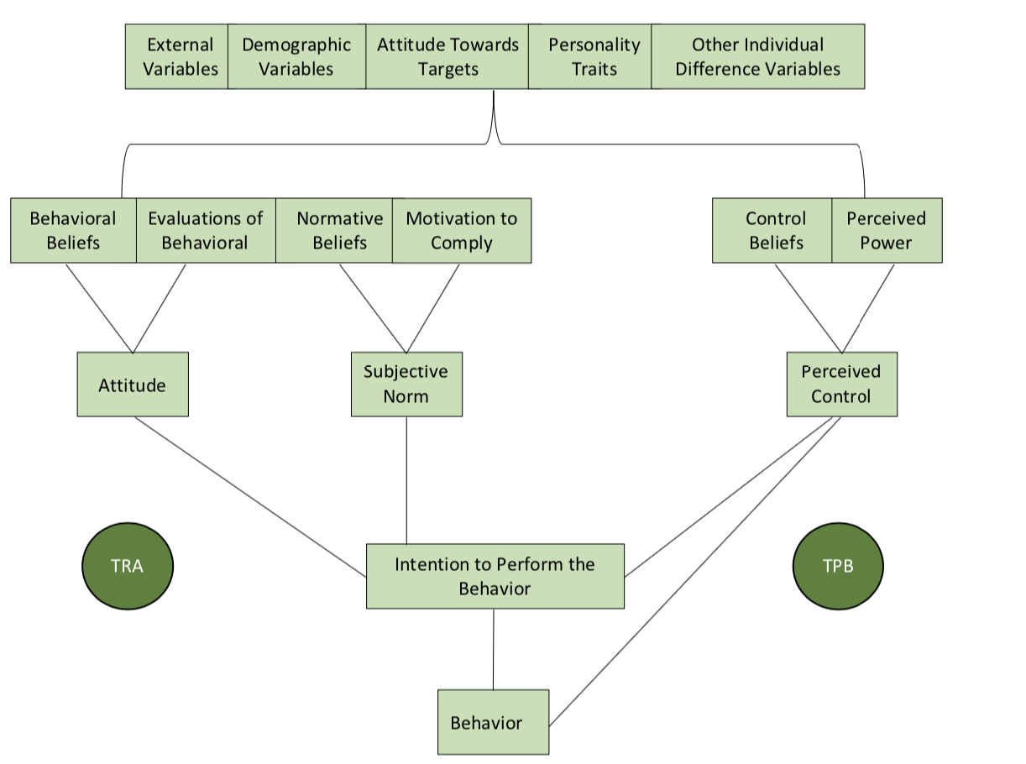
Note: Figure obtained from https://www.researchgate.net/figure/The-theory-of-reasoned-action-and-planned-behavior-Revised-from-Health-behavior-and_fig1_308784496. Open access.

Theory Application
The theory of planned behavior and the theory of reasoned action have both been extensively applied in healthcare to bring about changes in health behavior for patients (Howland et al., 2016; Winter et al., 2016). Winter et al. (2016) note the use of both TPA and TPB in the prevention and treatment of cardiovascular disease in adults. The authors note that cardiovascular disease is often the result of modifiable lifestyle behaviors, indicating that, by changing patient views and attitudes toward these issues, it should be possible to prevent this disease and improve treatment outcomes in patients who have developed it. Howland et al. (2016) further consider the use of TPB for improving physical activity levels in patients at-risk for chronic health issues. The results of the study indicate that, through the use of supports to change attitudes—i.e., observations of others and education—physical activity levels in patients increased. While this research demonstrates the utility of TPB/TRA for changing health behavior, the research also supports the use of education as a foundation for fostering behavior change.
Not surprisingly, a review of the literature regarding the theory of planned behavior and reasoned action demonstrates that health education has been extensively noted as foundational to operationalizing these theories. Siuki et al. (2019), for example, investigated the use of a health education program underpinned by the theory of planned behavior to prevent HIV through proactive behaviors. The results of the study indicated that, following the educational intervention, participants were more likely to take precautions to prevent the spread of HIV. Education underpinned by the theory of planned behavior was also found to increase positive oral health behaviors among children (Soltani et al., 2018) and to improve dietary consumption patterns among adolescents (Mirkarimi et al., 2016). Based on these results, it becomes evident that educating patients about health behaviors can have a positive impact on knowledge and understanding, leading to positive behavior changes that will improve health.
The current use of the theory of reasoned action and theory of planned behavior in improving health behaviors demonstrates the utility of patient education. The current quality improvement project proposed to utilize an educational intervention to increase parent knowledge of, and uptake of, influenza vaccination for their children. When this project is viewed in light of the current evidence regarding TBP/TRA it becomes clear that this theoretical framework should provide a useful foundation for building the project and evaluating the results obtained.
Methodology
The methodology being utilized for this project was a quasi-experimental pre-/post-intervention design. A review of this methodology indicates that it involves the selection of a sample that is evaluated before and following an intervention (Schweizer et al., 2016). In the current project, parents of children between the ages of six months and 17 years of age were contacted to participate in the study. Parents who agreed were asked to complete an assessment of their baseline knowledge of influenza vaccination. Parents who completed the assessment were then provided with an educational intervention via phone. After which, those completing the educational intervention had their knowledge reassessed utilizing a post-test questionnaire. Comparison of the results between the pre- and post-intervention phase provided the basis for determining if the educational intervention was effective. While outside of the timeframe for the current project, the rate of influenza vaccination among the sample educated should be tracked to determine if vaccination rates increased because of the educational program.
The quasi-experimental pre-/post-intervention approach is noted in the literature to provide a pragmatic framework for testing an intervention (Schweizer et al., 2016). The approach is not as rigorous or time consuming as a randomized controlled trialed and is generally noted to have good internal validity (Schweizer et al., 2016). A quasi-experimental study also provides a useful foundation upon which to utilize a comparison group which does strengthen the design and allow for certain features of causality to be supported (Schweizer et al., 2016). Even though these advantages for the methodology are present, there are some drawbacks for using the approach in practice. In particular, the sample for most quasi-experimental studies is not randomized and will not be representative of the overall population (Schweizer et al., 2016). The quasi-experimental design can also engender various biases, including maturation and instrumentation bias. Maturation occurs when a sample changes over time and the changes are not the result of the intervention employed (Schweizer et al., 2016). Instrumentation bias occurs when participants exposed to a pre-test utilize knowledge and familiarity with the assessment to augment their scores on the post-test (Schweizer et al., 2016). Both type of bias may have been present in the current quality improvement project.
To provide a more comprehensive review of the methodology that was employed in this quality improvement project, this section includes a review of pertinent elements of the approach and how the project was carried out. More specifically, this section includes a review of the setting and participants, the approach and procedures used, protection of human subjects, data collection, and data management and analysis. A review of each of these issues will provide a complete overview of how the quality improvement project was implemented in the selected clinical setting.
Setting and Participants
The setting for this quality improvement project included a federally qualified health center (FQHC) currently operating in Miami, Florida: Empower Community Health Center. The organization agreed to allow the quality improvement project to be conducted at the site. A letter of support from Belita Wyatt, the Chief Executive Officer at the facility, is provided in Appendix B. Empower Community Health Center is a FQHC that currently provides care for underserved communities in the Miami metro area, including communities of color that are dominated by African-American and Latino/Hispanic groups. Current data from the facility indicates that in a given year, providers deliver care to more than 1,500 children between the ages of six months and 17 years. Although the facility provides care for a large number of children, data from the facility indicates that, during the 2018-2019 flu season, only 13% of children were vaccinated. Table 1, provided below, includes a review of the total number of parents that had their child vaccinated at the facility during the 2018-2019 flu season.
Table 1
Number of Children at Empower Community Health Center Vaccinated during the 2018-2019 Flu Season by Gender and Race
 | Parent Ethnicity Description
Parent Gender Description | Latino/Hispanic | Non-Hispanic Black | White | Other | Refused to mention race | Total
Female | 34 | 62 | 1 | 4 | 7 | 108 vaccinated out of 904 children seen, or 12%.
Male | 19 | 64 | 0 | 2 | 5 | 90 out of 630 children seen or 14.3%.
Total | 53 | 126 | 1 | 6 | 12 | 198 out of 1,534 children seen or 13%.

The participants for this quality improvement project included parents of children between the ages of six months and 17 years of age. Those sought to participate in the educational intervention included parents with children in this age range who had sought care at the facility in the last year, who did not have their child vaccinated during the previous influenza season, and who had provided their contact information and agreed to be contacted by the facility. Sampling involved a convenience approach which focused on the use of program participants who are readily accessible to the researcher (Etikan et al., 2016). Parents must provide consent for their children to acquire vaccination and therefore were the most appropriate participants for this quality improvement project (Kang et al., 2017). About 150 phone calls were made and 21 respondents were recruited in this quality improvement project.
Approach Description and Project Procedures
As noted in the introduction to this section, a quasi-experimental pre-/post-intervention approach was employed. The project was initiated by first acquiring approval from the facility to conduct the quality improvement project (Appendix B). Once approval from the practice site was granted, an application for Institutional Review Board (IRB) approval was made to Florida International University (FIU) on February 12, 2021. Approval from the IRB was acquired on July 19, 2021. The approval letter can be found in Appendix C to this work. Following approval of the IRB, it was possible to begin recruitment of parents for the educational intervention. As previously noted, parents of children between the ages of six months and 17 years of age, who had been seen in the facility in the past year, did not have their child vaccinated during the previous influenza season, and who had provided their contact information and agreed to be contacted by the facility were recruited for this project. Due to ongoing concerns regarding the COVID-19 pandemic, all potential project participants were contacted via phone using a telephone recruitment script provided in Appendix D. During this initial phone contact with the parent, willingness to participate in the project, as well as vaccination history of the child, was acquired. Parents were excluded if they refused to participate and/or had had their child vaccinated at a site other than Empower Community Health Center.
For those who met the inclusion criteria for the project, the co-investigator sought verbal informed consent via the FIU adult verbal consent form to participate in a research study (Appendix E). Potential participants were asked to provide verbal consent to indicate understanding of the study objectives, purpose, risks, and benefits as well as the patient’s rights. Following the acquisition of informed consent, participants were enrolled in the study and asked if they could complete the pre-intervention assessment and undergo education during the phone call. It was anticipated that pre-intervention assessment and education would take between 30 and 45 minutes to complete. Participants who could complete this portion of the project were assessed and educated. For those who could not complete these steps, a time was scheduled for a follow-up phone call. If participants could not be contacted or if they refused to participate in an additional phone call, their data was removed from the project.
On average, each intervention took approximately 15 minutes but could take upwards of 30 minutes. All participants who completed the pre-intervention assessment and educational intervention were asked to schedule a post-intervention assessment. The education intervention consisted of intervention materials such as a guide for parents including information on the flu, the spread of the flu, the perceived severity of the flu pre-intervention, ways to protect children from the flu, benefits of the flu vaccine and the safety/efficacy of the vaccine. The assessment was scheduled for one to two weeks following the initial education session at a time that was convenient for the participant. Because the post-intervention assessment utilized the same questions included on the pre-intervention assessment, providing follow-up assessment a week or two between initial and final assessment helped to reduce instrumentation bias that can result from participant exposure to the assessment tool (Schweizer et al., 2016). Participants who were unwilling or unable to complete the post-intervention assessment during this time period had their data removed from the project.
Pre-intervention and post-intervention assessment occurred using a 12-item measure that was developed specifically for this project. The assessment, located in Appendix F, was constructed by the co-investigator and reviewed by three advanced practice nurses currently working at the practice site to ensure content validity. Changes recommended by the advanced practice nurses were incorporated to ensure that the questions being asked were clear and precise. The first question on the assessment is for informational purposes. The remaining 11 questions were scored as correct (1 point) or incorrect (0 points). Total scores for the assessment range between 0 (none correct) and 11 (all items correct). High scores are indicative of greater knowledge and a positive attitude for vaccination of their child which should lead to an increase in influenza vaccination rates. All questions were asked verbally over the phone and the responses were manually recorded by the co-investigator.
Protection of Human Subjects
The protection of human subjects was addressed through several different approaches. Potential participants for the study were identified via current medical records at the practice site which included consent of the patient’s parents to be contacted by the facility for healthcare programs and projects that may improve their health. This standard waiver is included in all patient electronic health records and provided the co-investigator access to the patient’s health record and contact information. Only those patients who had previously agreed to be contacted by the facility were considered for inclusion in the project.
Additionally, IRB approval for the project was sought and it was granted on July 19, 2021. IRB approval ensured that the project was deemed to be ethically sound and safe for those who were participating in the project. Further, verbal informed consent was obtained from all individuals expressing an interest in the project. Informed consent helped to ensure that participants were aware of their rights and responsibilities for participating in the project, as well as the risks and benefits of project participation. Each parent agreeing to participate in the study was asked to provide verbal informed consent. If potential participants were unwilling to provide this consent, this resulted in removing participant data from the project.
To further protect participant privacy and confidentiality, the project did not use any participant identifying information during data collection. Parents who agreed to participate in the project were assigned a three-digit random code that was used as the sole identifier for conducting recruitment and follow-up. The code was associated with the participant’s phone number, which was not disclosed when reporting results from the project. Participant phone numbers and associated identifying codes were stored in an Excel file on a password protected laptop to which only the co-investigator had access. Once a parent agreed to participate in the project, all demographic information regarding their child, including age, gender, and race, was obtained from the electronic health record. This information also was stored on a password protected laptop to which only the researcher had access. Demographic data was deidentified and was not associated with a specific parent/patient name, telephone number, or any other personal identifying information.
As noted, data from all pre- and post-intervention assessments was collected over the phone manually by the co-investigator. To ensure confidentiality and privacy of the participant, these forms were coded with a three-digit random code assigned to the participant. The scores of the pre- and post-intervention assessment were stored in an Excel file on a password protected laptop to which only the co-investigator had access. Hard copies of the scored assessments were kept in a locked filing cabinet at the practice site, and only the co-investigator had access to these files. These hardcopy files were retained to verify that information from the scored assessments were entered accurately into Qualtrics.
Data Collection
Data collection for this quality improvement project included acquiring participant demographic information from the electronic health record and from the 12-item pre-/post-intervention assessment form (Appendix F). Once a parent agreed to participate in the project, demographic information from the patient’s chart, including age, gender, and race, was acquired and placed in Qualtrics. During the pre- and post-intervention, assessment phone calls using the 12-item assessment form were manually completed by the co-investigator. More specifically, the co-investigator asked the participant the question as stated on the form and recorded the answer provided by the participant. All recorded data was stored in an Excel spreadsheet on a password-protected laptop that was accessible only by the co-investigator.
Data Management and Analysis
Data management for this project included securing all hardcopy and electronic data collected for this project. As previously noted, all hardcopy assessment forms completed for this project were deidentified using a random three-digit code associated only with the participant’s phone number. All hardcopy data was stored in a locked filing cabinet at the practice site that was accessible only by the co-investigator. Matched pre- and post-assessment scores were entered manually into an Excel spreadsheet on a password protected laptop to which only the co-investigator had access. Electronic data, including demographic information from the participant’s electronic health record, was stored on this password protected laptop to ensure that no one outside of the project had access to this data. All data from the project will be destroyed five years following the completion of the project. Hardcopy data will be shredded and the hard drive from the laptop will be removed and scrubbed by a computer technician.
Data analysis for this project included the use of descriptive (mean, frequency, standard deviation) statistics for evaluating demographic characteristics of the sample. Descriptive statistics, including mean score, were also used to evaluate pre- and post-intervention assessment scores. Descriptive data calculations were performed using Qualtrics. Inferential statistics were used to compare pre- and post-intervention assessment scores. Because the sample was estimated to include > 30 participants, this would meet the threshold for normality in the data, indicating parametric tests for determining statistical significance would be appropriate (Hazra & Gogtay, 2016). A paired t-test was used to compare pre- and post-intervention assessment scores and to determine if their value changed because of the educational intervention. A paired t-test is appropriate for the evaluation of normally distributed data that is collected from a matched sample (Hazra & Gogtay, 2016). To assess for statistical significance, a p value of < 0.05 was utilized. A comparison of mean scores obtained from descriptive data were used to determine if the scores on the post-intervention assessment increased or decreased following education. Again, all calculations for the paired t-test were performed in Qualtrics.
Results
Based on the methodology reviewed and the evidence presented here, it is possible to provide a review of the data that is anticipated because of completing this quality improvement project. The results presented here include demographic data from participants (parents) agreeing to undergo the educational intervention as well as a review of pre- and post-education knowledge scores for parents and their statistical significance.
Descriptive Data Analysis
As noted, demographic data for this project was collected using the electronic health record of the patient. Using a sample size of 21, Table 2 includes a review of the potential data that was collected as part of this project. The data indicates that of the 21 participants included in project (parents), the mean age was 32.5 years with a standard deviation of 1.23 years. The sample was equally split with 50% males and females. African Americans and Hispanics/Latinos each comprised 95% of the sample and Whites and Other races each comprised 5% of the sample.
Table 2
Demographic Characteristics of the Project Sample (n = 21)
Characteristic | Number (n = 21)
Age | 32.5 years (s.d. 1.23)
Gender
Male | 10 (48%)
Female | 11 (52%)
Race
White | 1 (5%)
African American | 16 (76%)
Hispanic/Latino | 4 (19%)
Other | 0 (0%)

Mean scores for the pre- and post-intervention assessments were also tabulated and presented in Figure 2. This figure includes a bar graph that illustrates trends in the scores: i.e., an increase from the pre- to post-intervention. Evaluation of the mean score is needed to provide an indication of how the educational intervention impacted the overall knowledge of participants enrolled in the project. The mean pre-intervention score calculated was 0.48 and the mean post intervention score was calculated at 0.76.

Figure 2
Bar Graph Comparing Pre- and Post-Intervention Scores for Project Participants (n = 21)
Pre-Intervention Scale for Parent Willingness to Vaccinate their Children. Do you agree to your child receiving the flu vaccine?

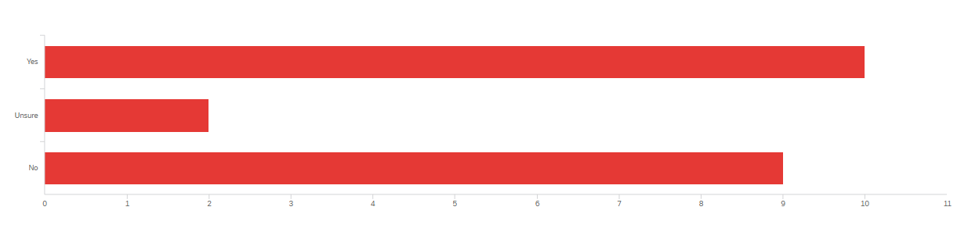
- Post-Intervention Scale for Parent Willingness to Vaccinate their Children. Do you agree to your child receiving the flu vaccine?
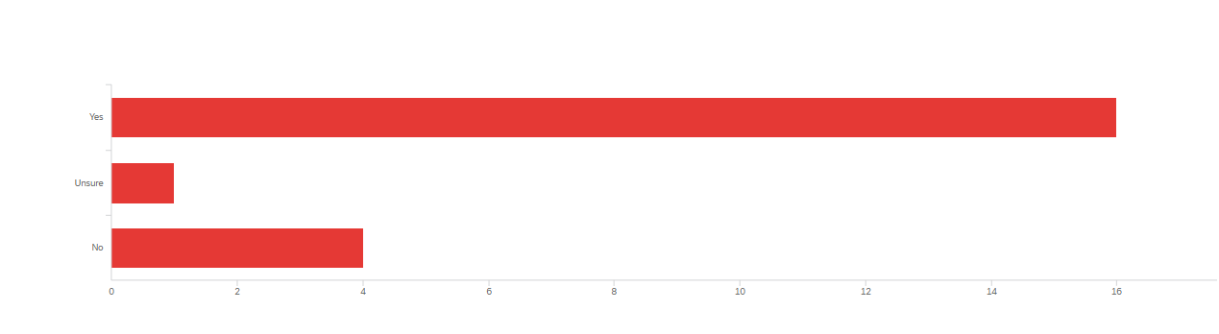
Inferential Data Analysis
Inferential data analysis, including the use of a paired t-test, was conducted in this project. Table 3, below, includes an overview of potential data that could be presented following an analysis of the pre- and post-intervention scores. Because there was such a notable increase in scores from the pre- to post-intervention phases, it was assumed that the result would be statistically significant at the p < 0.05 level. The p-value calculated was 0.001 indicating the increase in scores was statistically significant.
Table 3
Mean Pre- and Post-Intervention Scores and P-value
 | Mean Pre-Intervention Knowledge Scores | Mean Post-Intervention Knowledge Scores | P-Value
Sample (n = 21) | 0.48 | 0.76 | P = .001

Pre- to Post- Intervention Question Analysis
The above analysis can be attributed to the impact of education on parental knowledge as evaluated below.
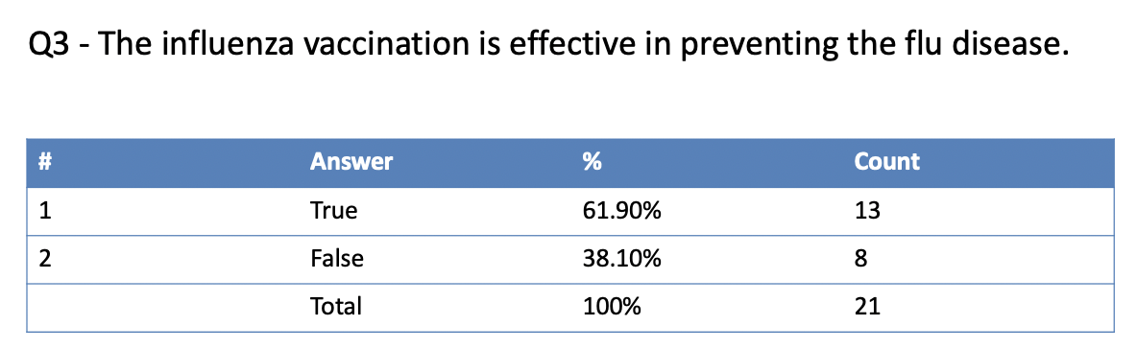
Figure 3a. Pre-Intervention Analysis for Question 3.

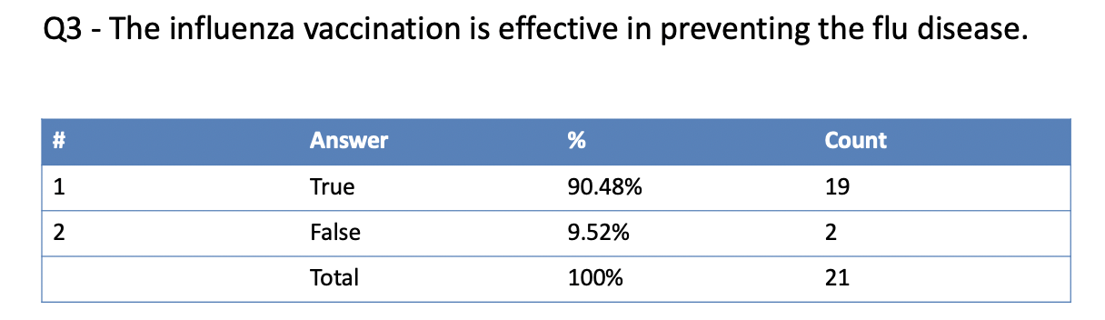
Figure 3b. Post-Intervention Analysis for Question 3.

As seen in the comparison of the influenza vaccination effectiveness in preventing the flu disease, there is a significant difference in the parental knowledge after education. This indicates that the lack of knowledge about the effectiveness of the flu vaccine plays a role in the decision making of the parents to have their child vaccinated.

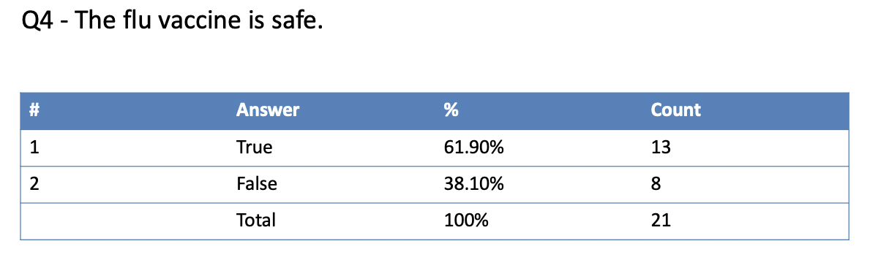
Figure 4a. Pre-Intervention Analysis for Question 4.

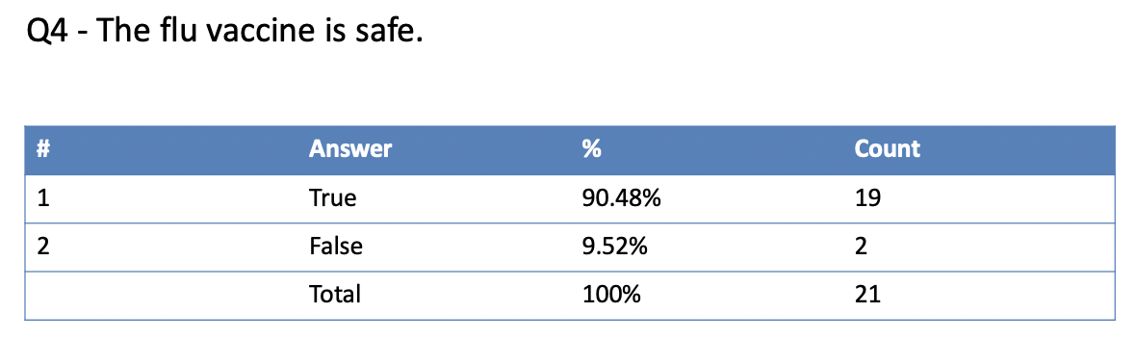
Figure 4b. Pre-Intervention Analysis for Question 4.

This interpretation of parental knowledge is again seen here when asked if the flu vaccine is safe. After receiving education, a significant difference is noted in the determination of whether the vaccine is safe. This plays a pivotal role in deciding if the child should receive the vaccine but also the efficacy of the vaccine in preventing complications from the vaccine vs complications from the flu in unvaccinated children.

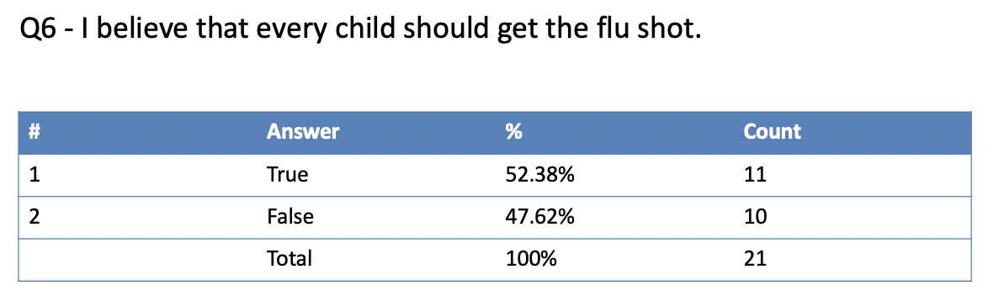
Figure 5a. Pre-Intervention Analysis for Question 6.
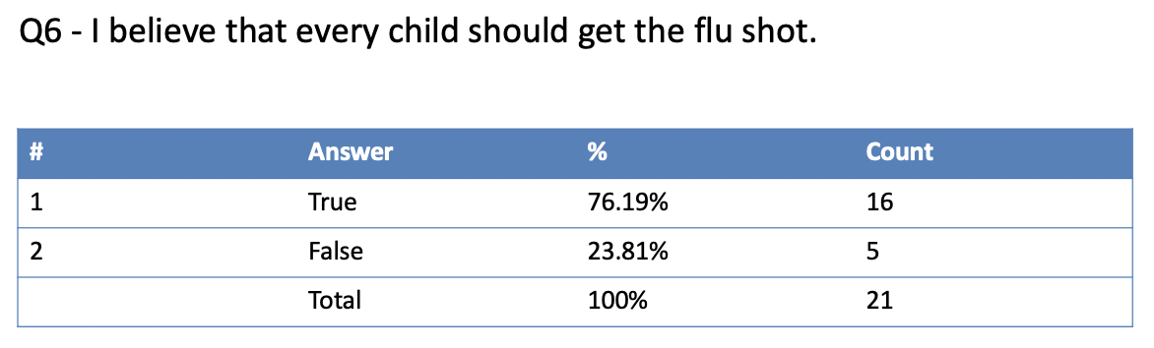
Figure 5b. Pre-Intervention Analysis for Question 6.

In Figure 5a and 5b, the pre-intervention revealed a near equal divide between the belief that every child should receive the vaccine. With educational intervention, this divide becomes significant, emphasizing the importance of education from a social standpoint. If there is a shared belief that children should get the flu shot, there will be fewer reparations in terms of disease spread.

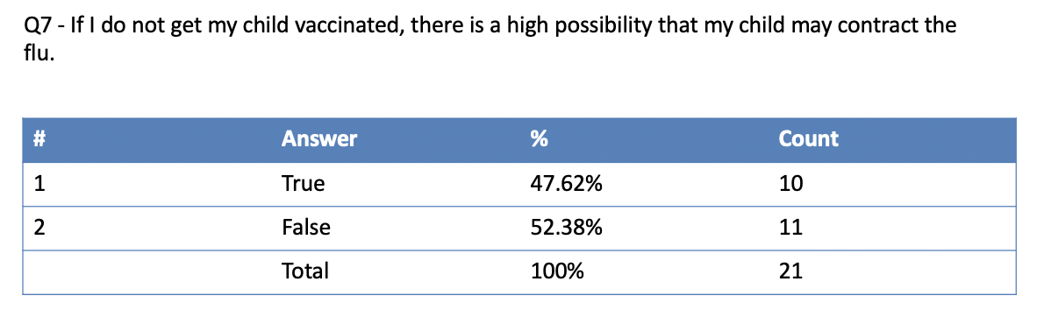
Figure 6a. Pre-Intervention Analysis for Question 7.

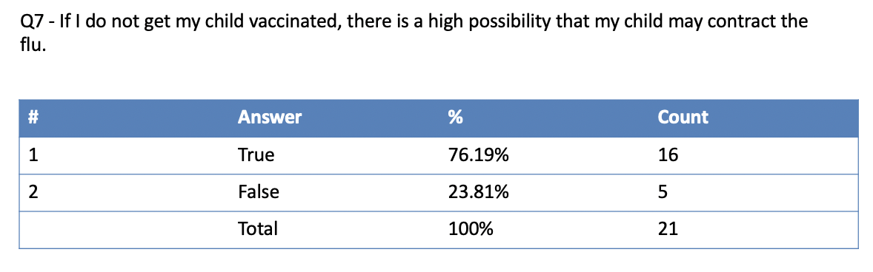
Figure 6b. Pre-Intervention Analysis for Question 7.

More that half of the sample size believed that if their child did not receive the vaccine, there is not a high possibility that the child would contract the flu. However, with intervention, parents better understand the risk of contracting the flu if their child is not vaccinated.

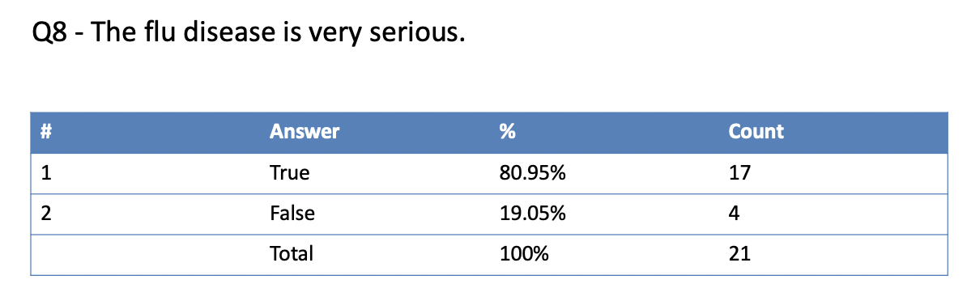
Figure 7a. Pre-Intervention Analysis for Question 8.

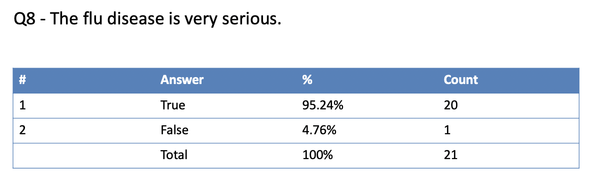
Figure 7b. Pre-Intervention Analysis for Question 8.

Figure 7a and 7b do not represent a statistically significant different between pre-and post- intervention but it does highlight that education can maintain the understanding of the seriousness of the flu.

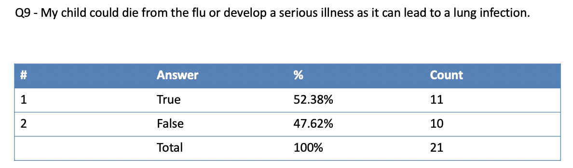
Figure 8a. Pre-Intervention Analysis for Question 9.

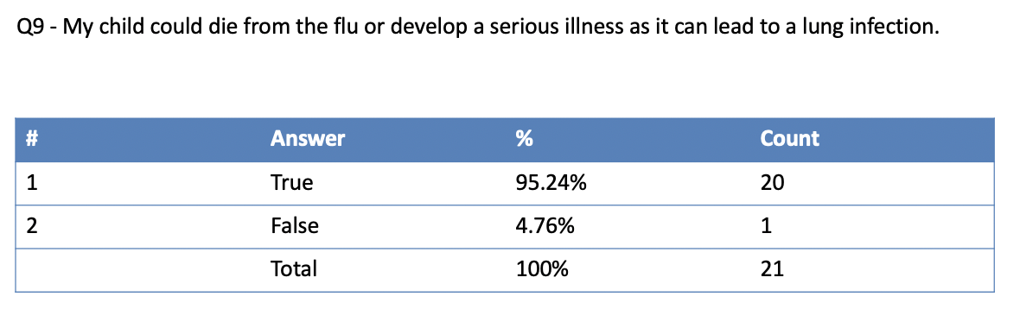
Figure 8b. Pre-Intervention Analysis for Question 9.

Finally, question nine represents the most statistical significance of education in terms of the flu. Parents who did not know or understand the serious illnesses associated with the flu did acquire this knowledge with intervention and therefore 95% of the sample population agreed that children can suffer serious illness from the flu. This is important because once a parent understands the health problems associated with acquiring the flu, they will be more perceptive to the importance of the flu vaccine.
Discussion
With the results of the project provided here, it is possible to offer a discussion of the results to better understand what was shown, the challenges of implementing the project, and what additional action should be taken based on the results. The discussion section is noted to be an important foundation for communicating meaning in the results of a research study or quality improvement project (Attia & Edge, 2017). Included in this section is a discussion of the results from the project along, with a discussion of the process of implementation, the limitations of the project, areas for future research, and recommendations for the future of this project.
Discussion of Results
The results obtained from this project indicated there was an increase in mean knowledge scores from the pre- (0.48) to post-intervention (0.76) phases (Table 3). This increase was also found to be statistically significant: p = 0.001 (Table 3) suggesting that the intervention, parental education, played some role in improving knowledge scores. The results are aligned with the evidence collected to support this quality improvement project. More specifically, the current literature does indicate that parental knowledge regarding yearly influenza vaccination often serves as a barrier to parents seeking this health support for their children (Oyo-Ita et al., 2016; Scott et al., 2019). Further, the literature indicates that parental education can increase knowledge of this topic for parents (Choi et al., 2017; Danchin, 2019). This project further adds to the growing evidence base which supports the use of parental education as a means to improve knowledge for yearly influenza vaccination in children.
The literature regarding the use of parental education to increase knowledge of flu vaccination also indicates that following an educational program, more parents report an intention to vaccinate their child (Choi et al., 2017; Danchin, 2019) and further, follow through with plans to vaccinate their children (Harvey et al., 2015; Mora & Trapero-Bertran, 2015; Yeung et al., 2018). Although these outcomes were not directly measured in this quality improvement project, the significant increases in parental knowledge should theoretically translate into an increased rate of annual child influenza vaccinations. The co-investigator continues to work at the project site and will have the opportunity to measure the long-term impact of the intervention to determine if child vaccination rates among parents who did participate in the educational program do indeed increase.
Implementation Discussion
Although the results of the project were aligned with the literature, in actuality, the implementation of the project had similarities and differences when compared with the literature on the topic. To illustrate what worked and what challenges were encountered, a discussion of the project’s implementation is provided here. Also included in this section is a consideration of factors that influenced implementation, how the project was monitored, and how the project will be maintained over the long-term.
Project Implementation
Project implementation began with recruiting parents from the practice site to participate in an educational intervention. Recruitment proved challenging due to the number of parents contacted who did not want to participate in the study. Even though parents were told that the purpose of the educational program was to provide them with information regarding vaccination for their child, many viewed the topic as being too political and refused, stating that it would not be possible to change their minds about vaccination. In general, parents refusing to participate in the educational program expressed negative attitudes toward vaccines. This increased the amount of time required to recruit participants, requiring an extra week to complete this element of the quality improvement project.
Project implementation was also hindered by the method of providing education to patients. As noted in the methodology, the decision was made to provide one-on-one education to parents via the telephone. In addition to the fact that this educational delivery model has been supported in the literature (Choi et al., 2017), and in light of the ongoing COVID-19 pandemic, the use of this approach was viewed as necessary to help ensure that participants would feel safe during the educational session. Although telephone education ultimately proved to be effective—as post-intervention knowledge scores did increase for participants—providing education via the telephone was somewhat challenging. Participants were frequently distracted by other variables in the home including email, texts, children, etc. Further, telephone education may not have been the preferred learning method for many participants, limiting the impact of the intervention on learning.
Scheduling factors were also a challenge when it came to providing education to participants and completing follow-up assessments of knowledge. To help ensure that participants had retained the knowledge acquired during the educational session, follow-up phone calls to assess knowledge were planned for one week following the educational session. In most instances, participants made themselves available. However, there were six instances in which it took more than a week to reconnect with the participant. Scheduling time for providing education was equally challenging, as participant schedules often required follow-up calls to be placed on evenings and weekends to complete the project. Meeting the scheduling needs of a sample of 21 participants was therefore challenging and prompted a consideration of how this process could be streamlined in the future.
Despite these challenges, all parents who initially agreed to participate in the project did complete all elements of the pre-intervention, educational program, and post-intervention assessments. Consequently, all project participants were retained, and it was not necessary to drop any individuals from the project. Additionally, while it is possible that other educational delivery methods—i.e., video conferencing, group education, or face-to-face instruction—may have resulted in greater learning for participants, the results clearly show a notable increase in knowledge scores, indicating that the approach selected for delivering education was effective to some degree. Thus, although pertinent implementation challenges were noted, the results do indicate that the educational intervention was efficacious.
Influencing Factors
Several influencing factors played a role in shaping the scope, direction, and focus of this quality improvement project. As noted, the ongoing COVID-19 pandemic played a substantial role in the choice of educational content delivery selected: i.e., telephone education. Although this approach to parent education has been used successfully in the past (Choi et al., 2017), the evidence collected for this project indicated that there were several different modalities utilized to provide parental education (Danchin, 2019; Frew & Lutz, 2017; Harvey et al., 2015; Oyo-Ita et al., 2016; Scott et al., 2019; Yeung et al., 2018). When reviewing the literature, it was not possible to determine from the existing evidence which method of parental education worked best for enhancing knowledge. However, research does indicate that when it comes to education, individual learning styles and preferences do shape how learning occurs, as well as the retention of knowledge (Quinn et al., 2018). If the pandemic were not a factor influencing this project, it may have been possible to provide more options for parent education.
Also of concern for this project was the delay in IRB approval from FIU. Despite beginning the IRB approval process in February of 2021, the process took much longer than anticipated. This had an impact on the amount of time available to collect data and to provide participant education. This influencing factor also resulted in considerable frustration to complete participant recruitment, education, and data collection before the end of the academic term. The IRB process was not streamlined, and the program underwent a system upgrade which took several weeks to complete. All of the factors contributed to the investigator’s inability to start the data collection process when desired. With more time, it may have been possible to recruit more participants for the project.
The final influencing factor for this project involved firmly held beliefs of parents regarding vaccination. As noted, when discussing the project implementation, recruitment of participants for the project was challenging due to the fact that so many parents had firmly held values and beliefs regarding vaccination and were not willing to listen to an educational program. Some parents contacted for participation in the program argued that the educational program was only designed to change their minds and they, therefore, had no intention of participating. What was surprising was the degree to which such a large number of parents held these views. This also raised questions of whether an educational program provided in a face-to-face environment that utilized a conversation would be more effective for engaging parents who have such strongly held beliefs against vaccination.
Monitoring
Project monitoring occurred through several different internal and external supports. At FIU, the quality improvement project was monitored by faculty who provided guidance and deadlines for the completion of various elements of the report. This monitoring provided a useful structure for the investigator to complete elements of the project that did not require IRB approval. At the practice site, the site mentor held regular meetings with the investigator every 7 to 10 days. In the first months of the project, these meetings generally lasted between 15 and 30 minutes and focused primarily on the evidence base that would be used to structure the project. Following IRB approval when the project could be implemented at the site, weekly meetings with the site mentor were held. These meetings generally lasted 30 minutes and a discussion of the challenges involved with implementing the project—i.e., recruitment, scheduling, etc.—were frequently had. While the site mentor was able to provide some helpful supports for overcoming some of the challenges encountered in the project, the site mentor was also able to provide psychological support and motivation for the investigator to persist during the project’s implementation.
Project Maintenance
Project maintenance has been discussed with the site mentor and would include several different steps to help ensure that the benefits of the program are retained over the long-term. First, the co-investigator will continue to work at the practice site following the completion of this quality improvement project. Consequently, it will be possible for the co-investigator to track parents who received education to determine if they follow through on having their child vaccinated. Collection of this data would be helpful to justify the continuation of the program at the site. Continuation of the program will require dedicated resources, including staffing costs to provide parent education. For this reason, demonstrating the salience of the project in terms of vaccination rates will be useful for encouraging leaders at the site to adopt the program as a part of standard patient care, while maintaining gains made through the program over the long-term.
Additionally, it will be important to consider other modalities for the delivery of parental education. As previously noted, recruitment of parents for the project was hindered by strongly held beliefs of parents, typically against vaccination. Over the phone it may be easier for parents to refuse to engage with healthcare providers to discuss this topic. However, by creating an in-person educational program in which providers can have a direct conversation with parents, and further, present visual educational materials highlighting key elements of the educational program, may be helpful for not only overcoming parental resistance to education and vaccination but also for increasing the knowledge of more parents, with the result of increasing child vaccination rates. Efforts to expand the program to include a face-to-face component for recruitment and education of parents may be helpful.
Project maintenance could also be supported using an organizational policy that changes practice and standards of care to make parental education mandatory. A policy to provide this type of education would ensure that both the time and resources needed (i.e., staffing) to deliver this educational program are included in the budget of the facility. This would help to ensure that the project is maintained, as the standard of care would dictate that all parents seeking care for their children at the practice site are given the education needed to help them make an informed decision regarding the vaccination of their child.
Limitations
The limitations of the current project must be considered in light of the findings. The first limitations identified were the small sample size and the fact that the sample was selected from a single site. These factors would indicate that the sample was not representative of the larger population of parents with children between the ages of six months and 17 years of age. Samples that are representative of the population from which they were drawn reduce possible bias that may result and help to ensure that the results of a study are generalizable (Sarstedt et al., 2017). Because of the methodology used for recruiting participants for the study, representativeness of the sample was limited, which have implications for the ability of the investigator to state with certainty that the same results would be achieved if the educational intervention were applied in other, similar settings.
The findings from the quality improvement project are also limited as a result of the challenges of recruiting participants by phone. As noted, many parents contacted about the educational project refused to participate due to strongly held beliefs regarding the adverse impact of vaccines and their necessity. These issues may have served to limit the representativeness of the sample as well. To overcome this issue, it would be useful to utilize alternative recruitment and educational programs that are provided in a personalized face-to-face environment. Recruiting a larger, more diverse sample, including parents with strongly held views against vaccination, may ensure that the results can be generalized to other practice settings in the future.
The project is also limited by a lack of a control group. Control groups are often used for comparing results from a project to determine the extent of an intervention’s impact (Handley et al., 2018). Control groups isolate the effect of the independent variable, which in the current study was the educational intervention (Handley et al., 2018). By isolating the effect of the independent variable, it is possible to state that a cause-effect relationship occurred, indicating that the results of a study are caused by the intervention, rather than other factors. Quasi-experimental methodologies have a plethora of limitations due to threats to internal validity (Handley et al., 2018). Specific threats to internal validity that may have been present in the current study include participant maturation and test bias (Handley et al., 2018). Participant maturation includes growth or learning outside of the intervention that may influence knowledge, while test bias may result from exposure of the participants to the instrument used to evaluate pre- and post-intervention outcomes (Handley et al., 2018). Control groups will also experience similar effects, negating the impact of these influences on outcomes when results are compared (Handley et al., 2018). The current project did not use a control group which does limit the ability to state with certainty that the results achieved were caused solely by the intervention.
Areas for Future Research
The discussion of the results obtained from this project, along with a discussion of the project’s implementation and limitations, provides a useful foundation upon which to identify areas for future research on the topic. Future research should include the use of a larger sample, preferably one that is selected from more than one practice site. Geographical diversity in the sample settings for the project would help to increase representativeness of the sample and make the results generalizable to the broader population. A change in methodology should also be considered to include the use of a control group that is not provided with education. A randomized controlled trial should be considered not only to improve the representativeness of the sample but also to ensure that a control group is used. These elements of the methodology will help to guarantee that the results are generalizable and that causality for the educational intervention can be proven (Deaton & Cartwright, 2018).
Future research for the project could also consider multiple methods for providing parental education to determine which approach works best for increasing knowledge. A review of the literature indicated that several different approaches to education were utilized to increase parent knowledge of annual flu vaccinations for children (Choi et al., 2017; Frew & Lutz, 2017; Harvey et al., 2015; Oyo-Ita et al., 2016; Scott et al., 2019; Yeung et al., 2018). Presently, there is a dearth of evidence to support a particular method of education. Therefore, trialing various approaches to education in this participant group may provide additional insight into what works best for optimizing learning and knowledge gains. Educational techniques, such as assessing learning preferences of parents, may also be helpful for determining the optimal method for providing education for parents. What is evident is that some effort must be made to determine what works best for meeting the educational needs of parents when it comes to annual flu vaccines.
Recommendations
Because the results from the project demonstrate notable gains in knowledge for parents, there is an impetus to consider expanding and improving the current project to collect additional data to understand the impact of parental education on knowledge of influenza vaccination. Recommendations for improving the current project would include seeking IRB approval earlier to help ensure that the project could be completed in the allotted time. This would safeguard that the co-investigator had ample time to recruit needed participants and to carry out the educational intervention in a manner that resulted in less frustration for participants and the investigator. Additionally, an effort should be made to recruit participants in person in an attempt to overcome any parental bias that may limit parental engagement in the educational program. Parents need to be aware that the educational program is intended only to help them make an informed choice regarding vaccination.
Recommendations for the project also include ongoing monitoring of parents who did receive education to determine if they did indeed have their child vaccinated in the upcoming flu season, given that many of these parents will seek ongoing care at the practice site, making it possible to track them through the facility’s electronic health record. For project participants who do not return to the facility for care, follow-up calls to assess their child’s vaccination status following the influenza season may be helpful for acquiring a more complete understanding of how parental education shapes vaccination rate outcomes. This assessment would be used to support practice change to include parental education to increase influenza vaccination uptake within the facility. Additionally, this data can be compared with the literature to determine if the outcomes of the educational program are aligned with current evidence.
Interpretation of Findings
With a discussion of the results from the project provided, it is now possible to consider an interpretation of the findings. Interpretations of the findings are needed to evaluate how the results should impact broader outcomes, including changes to practice (Melnyk & Fineout-Overholt, 2019). Included in this section is a review of the changes to patient care and healthcare that should result as a consequence of the findings from this project, the transferability of the results, the cost effectiveness of the project, and the recommendations for using project results in practice and in healthcare.

Change to Patient Care/Healthcare
The results of the project support the use of a telephone education program to improve parental knowledge of influenza vaccination in children between the ages of six months and 17 years of age. While the results may not be applicable outside of the setting, when the results of the study are combined with the current literature on the topic of parental education for increasing knowledge and parental uptake of the influenza vaccine, it becomes evident that there is a large and formidable evidence base to support a change in practice. All parents should be provided with education, with parental education integrated as part of a standard of care for the patient. By making this education an integrated part of the care delivered to parents and children, it should be possible to increase influenza vaccination rates for children both at the current practice setting and across the entire healthcare system.
The proposed change/improvement to healthcare that would result from making parental education a standardized component of care delivery is aligned with current evidence regarding the need to address this topic in practice. Bambery et al. (2018) argue that current strategies to increase influenza vaccination rates are often directed at healthcare workers, the elderly, and other high-risk groups, such as pregnant women. According to these authors, children are often not considered when seeking to expand vaccination rates, despite the fact that this group often has higher rates of infection and mortality than other population groups, such as healthcare workers (Bambery et al., 2018). By utilizing the foundations of this project and other evidence-based research supporting the use of parental education to increase vaccination rates, it may be possible to increase uptake of these vaccines and to improve individual and population health across the entire country.

Transferability
Transferability of the results from this project was discussed when evaluating the methodological limitations of the study. As previously noted, the generalizability or transferability of the findings to other practice settings may not result in similar outcomes being achieved. The sample used for this project was not representative, and further, the sample was relatively small when compared with the population: i.e., parents of children between the ages of six months and 17 years of age. These limitations impede the ability of the investigator to state with certainty that the same program implemented in a different practice site would result in such notable and statistically significant gains in knowledge for parents.
Even though the results of this project cannot be easily transferred to other practice sites, there are various elements of the educational program that can be easily transferred to other practice sites to improve practice. Specifically, the educational intervention and the assessment tool developed for this quality improvement project could be readily transferred for use in another practice setting. The decision to use phone calls to provide parental education was based on current evidence (Choi et al., 2017) and experience from the project suggests that providing this type of education is both feasible and reasonable within the context of the role of the registered or advanced practice nurse. Facilities that have nursing staff who are capable of providing this type of education could easily adopt the intervention to increase parent knowledge of the influenza vaccine. Further, the tool developed for the assessment of parental knowledge in this project (Appendix F) does not require any specialized knowledge or supports to use in practice. Consequently, nurses using this form to assess parental knowledge before and following the educational intervention should not experience any challenges in completing this task.

Cost Effectiveness
Assessing the cost effectiveness of providing parental education to increase knowledge of the flu vaccine for children requires a consideration of both the costs to provide education and the costs associated with care for a child infected with the influenza virus. The costs for this project were minimal, due primarily to the fact that telephone education was provided on a voluntary basis. However, if the project were to be adopted by the current facility or other facilities, staffing costs associated with providing education would need to be considered. In this project, 21 parents were assessed and educated with the process taking approximately 15 minutes per parent recruited. If the hourly cost of an RN to perform this education is taken into consideration—i.e., $60 per hour—it could be assumed that the costs to provide education to 50 parents would total $3,000. These costs could be further defrayed by utilizing group education to include more than one parent at a time. Reducing the costs of the program should make it more pragmatic for use in diverse practice settings.
The costs to provide healthcare for an unvaccinated child will depend on the severity of the disease that develops. Putri et al. (2018) provide an overview of costs for the individual family resulting from influenza cases that occur in children who have not been vaccinated. The authors report that total direct care expenses for children with influenza who require an office visit can range from $93 to $127, while costs for an emergency room visit can range from $560 to $6,000. Costs for hospitalizing children who develop a severe case of the flu can average $9,100 (Putri et al., 2018). If moderate disease can be prevented in all 21 children whose parents were educated through the program—i.e., patients who would require an office visit—this could result in a cost savings between $4,650 and $6,350. The costs for preventing the need for emergency room care and/or hospitalization are even greater. What this indicates is that the educational program for parents is cost effective and should be considered in light of what it costs to treat an influenza infection in children who have not been vaccinated.
Recommendations
Recommendations for this project are based on the limitations of the project and in light of the robust evidence base that exists for supporting parental education for increasing vaccine knowledge and uptake among children. While the results of this project alone are not transferable, the results do indicate that further investigation of the topic is warranted. When reviewing areas for future research, it was noted that an effort should be made to increase the number of participants, while also expanding the project beyond the current practice site. These recommendations should be implemented in an effort to evaluate the salience of phone education for parents. Additionally, alternative methods for education should be considered and compared to assess which educational modalities and settings would be best for optimizing parent learning. All of these steps would strengthen what has been noted in this project to reinforce the use of the selected approach for parental education.
As noted, the results of the project are not generalizable and transferable to other practice settings. However, when the results of this project are integrated with the existing evidence base on the topic of parental education to increase vaccine knowledge and uptake, it seems reasonable to argue that there is a formidable foundation upon which to build a practice change that includes parental education as part of increasing influenza vaccination uptake among children. The evidence base consistently supports the use of parental education, and this project contributes to this evidence base, demonstrating that nurses, leaders, and organizational administrators should consider this change to enhance practice, as well as to improve patient and population health. The existing evidence can be used to support a practice change and this change should be considered not only at the practice site, but also across all primary care facilities and clinics operating in the United States.
Plans for Dissemination
Plans for dissemination of the results would include internal and external approaches to sharing the project results. Internally, an abstract summary of the project and its results would be emailed to all staff at the practice site. Additionally, a PowerPoint presentation would be scheduled for the fall of 2021 to present the results of this project to staff. Staff would be encouraged to focus on parent education during care encounters as a means for increasing flu vaccination uptake among parents with children 17-years-of-age and younger.
Externally, the results from this project would be disseminated through the use of publication in a peer-reviewed journal. For peer-reviewed publication, the journal Vaccine would be considered. The journal is currently published by Elsevier (2021) and includes a broad range of articles from all medical and healthcare disciplines relevant to the field of virology. Guidelines for the journal and submission can be completed online and a cursory overview of past articles published in this journal does indicate that studies examining parental education for increasing vaccine uptake have been previously accepted (Bekkat-Berkani et al., 2018; Francis et al., 2018).
In addition to seeking publication of the project in a peer-reviewed journal, an effort would be made to present the results obtained at a national nursing conference through a poster presentation. Specifically, the 5th Nursing World Conference hosted by the Magnus Group (2021) would be considered. This conference attracts nurses from across the globe to provide a forum for information sharing and practice improvement (Magnus Group, 2021). In 2021 the conference is being held in Orlando, Florida, between October 18 and 21 (Magnus Group, 2021). Presentation of this project at a national conference via a poster presentation will expand nurse access to this vital information to help promote parental education to increase child vaccination rates.
Implications for Advanced Nursing Practice
The results are likely to reveal that the educational intervention may positively impact the uptake of childhood flu vaccination. These results will have major implications for advanced nursing practice. In order to better understand the ways in which this project will impact advance nursing practice, the implications in the areas of education, clinical practice, administration, and leadership are reviewed in this section.
Education
First, the findings from this project will shed light on the need for nurses to provide an educational intervention to vaccine-hesitant parents so that they can choose to vaccinate their children against the flu. Parental education is a major vehicle towards changing the views of parents concerning the flu vaccination. Choi et al. (2017) mentioned that many parents usually choose to vaccinate their children after they have been adequately informed of the advantages of vaccination and their concerns properly addressed. Therefore, the findings will have positive implications for evidence-based nursing practice and the need for educational interventions.
Second, Advanced Practice Nurses (APNs) generally play an essential role in health promotion and disease prevention. In this role, they act as educators. APNs spend a substantial amount of time with patients and their families providing anticipatory guidance regarding safety, medications, dietary and nutrition information, and immunizations (Kemppainen et al., 2013). In this regard, APNs can provide education to vaccine-hesitant parents about the influenza immunization to improve the uptake of childhood flu vaccination. By acting as educators, APNs can effectively help to change the behaviors, beliefs, and attitudes of parents with respect to the health of their children.
Clinical Practice
The project findings highlight the need for expanding nursing education curricula to encourage graduates to practice patient-centered care that involves going out of the way to ensure patients have taken all the recommended preventive measures (Danchin, 2019). When treating children, it is important to ask the parents if their children are up to date with their vaccines and address any barriers for vaccination, including those that are related misinformation. Promoting preventive healthcare services, such as vaccinations, has proven benefits, of which parents may be unaware. Nurse educators should encourage their students to promote such knowledge and awareness among patients for the overall health benefits. Using the evidence resulting from this quality improvement practice should spur practice changes in clinical practice settings in order to better enhance the quality of care being delivered to patients.
Administration
The implications for advanced nursing practice as a result of the findings of this project extend into the area of organizational leadership. Administrators need to consider means of adopting practice changes at facilities. At the current practice site, administrators may wish to consider adding a policy which adopts this educational intervention for parents of children and adolescents. By moving towards a formal policy, administrators can take steps to better educate parents regarding the need for immunizations, as well as promoting increased compliance with CDC flu vaccine recommendations.

Leadership
Perhaps the most important aspect of advanced nursing practice is that of leadership, as APNs are expected to lead the way in designing quality improvement projects intended to improve care and change practice within a facility. The success of this educational intervention should lead to greater efforts in this area of parental education and vaccine compliance, which can, in turn, be disseminated to the wider scientific community in order to spur greater change. Therefore, not only does this current project demonstrate leadership within the APN role, but it should also serve as a catalyst for future research and change.
Conclusion
Despite often being dismissed as being a slightly more serious version of the common cold, influenza (flu) remains a highly transmissible, often fatal disease that can have a serious impact on certain vulnerable populations, including small children. Hospitalization rates for children often exceed those of adults, which can have systemic implications on entire families and communities. Given that parents are often the primary caregiver of their children, a child’s illness can lead to lost economic productivity.
Further, parents are most likely to approve vaccinations for their children but are often hampered by a lack of understanding regarding the efficacy of vaccines and their potential impact in preventing disease. An extensive review of the literature consistently demonstrates the effectiveness of educational interventions among parents. Such programs increase both parental knowledge of vaccines as well as vaccine uptake rates. Given the purpose of this project, the PICO question that was derived from the literature sought to determine whether a phone education program for parents of children between the ages of six months and 17 years seen in primary care would result in increased knowledge. It is theorized that, as a result of this increased knowledge, influenza vaccine rates would correspondingly increase as well.
The theory of reasoned action, combined with the theory of planned behavior, was chosen as a conceptual framework for this project because of their ability to lead to changed outcomes on the part of participants. Use of the theory supports the notion that, following the educational intervention, parents will be more likely to immunize their children against influenza. The use of a quasi-experimental pre-/post-intervention design at the Empower Community Health Center in Miami, Florida. Providing a phone-based educational intervention for parents of identified minor patients should demonstrate statistical significance in providing this type of intervention.
The results of this study will then be disseminated through several professional channels, first through an abstract summary and PowerPoint presentation for all staff at Empower Community Health Center, followed by conference presentation and publication. Preliminary results indicate that there is a real potential for positively impacting advanced nursing practice through the use of education to increase vaccine awareness and efficacy. This increased knowledge will not only have systemic implications for children and their families, including decreasing costs associated with influenza treatment and resulting absenteeism. As the results of this project become apparent, integrating changes into practice can lead to new policies designed by leaders and administrators to better improve patient care.

References
Attia, M., & Edge, J. (2017). Be(coming) a reflexive researcher: A developmental approach to research methodology. Open Review of Educational Research, 4(1), 33-45. https://doi.org/10.1080/23265507.2017.1300068
Bambery, B., Douglas, T., Selgelid, M. J., Maslen, H., Giubilini, A., Pollard, A. J., & Savulescu, J. (2018). Influenza vaccination strategies should target children. Public Health Ethics, 11(2), 221-234. https://doi.org/10.1093/phe/phx021
Bekkat-Berkani, R., & Romano-Mazzoti, L. (2018). Understanding the unique characteristics of seasonal influenza illness to improve vaccine uptake in the US. Vaccine, 36(48), 7276-7285. https://doi.org/10.1016/j.vaccine.2018.10.027
Biezen, R., Grando, D., Mazza, D., & Brijnath, B. (2018). Why do we not want to recommend influenza vaccination to young children? A qualitative study of Australian parents and primary care providers. Vaccine, 36(6), 859-865. https://doi.org/10.1016/j.vaccine.2017.12.066
Callender, D. (2016). Vaccine hesitancy: More than a movement. Human Vaccines & Immunotherapeutics, 12(9), 2464-2468. https://doi.org/10.1080/21645515.2016.1178434
Carlson, S. J., Scanlan, C., Marshall, H. S., Blyth, C. C., Macartney, K., & Leask, J. (2019). Attitudes about and access to influenza vaccination experienced by parents of children hospitalized for influenza in Australia. Vaccine, 37(40), 5994-6001. https://doi.org/10.1016/j.vaccine.2019.08.021
Cataldi, J. R., Mattie, K., & O’Leary, S. T. (2020). Evidence-based strategies to increase vaccination uptake: A review. Current Opinion in Pediatrics, 32(1), 151-159. https://doi.org/10.1097/MOP.0000000000000843
Centers for Disease Control and Prevention. (2020a). Vaccines for children. https://www.cdc.gov/vaccines/parents/diseases/flu.html
Centers for Disease Control and Prevention. (2020b). Influenza (flu): Young children. https://www.cdc.gov/flu/highrisk/children.htm#:~:text=Since%202010%2C%20CDC%20estimates%20that,simply%20because%20of%20their%20age.
Chen, J., Wu, J., Hao, S., Yang, M., Lu, X., Chen, X., & Li, L. (2017). Long-term outcomes in survivors of epidemic influenza A (H7N9) virus infection. Scientific Reports, 7, 17275-17284. https://doi.org/10.1038/s41598-017-17497-6
Choi, A., Kim, D. H., Kim, Y. K., & Eun, B. W. (2017). The impact of an educational intervention on parents' decisions to vaccinate their <60-month-old children against influenza. Korean Journal of Pediatrics, 60(8), 254–260. https://doi.org/10.3345/kjp.2017.60.8.254.
Commodari, E. (2017). The role of sociodemographic and psychological variables on risk perception of the flu. SAGE Open, 7(3), 1-10. https://doi.org/10.1177/2158244017718890
Danchin, M. (2019). Does informing or educating parents about early childhood vaccination improve uptake? Journal of Pediatrics and Child Health, 55(9), 23-29. https://doi.org/10.1002/14651858.CD010038.pub3
Deaton, A., & Cartwright, N. (2018). Understanding and misunderstanding randomized controlled trials. Social Science & Medicine, 210, 2-21. https://doi.org/10.1016/j.socscimed.2017.12.005
DeStefano, F., & Shimabukuro, T. T. (2019). The MMR vaccine and autism. Annual Review of Virology, 6(1), 585-600. https://doi.org/10.1146/annurev-virology-092818-015515
Dominguez, A., Godoy, P., & Torner, N. (2016). The effectiveness of influenza vaccination in different groups. Expert Review of Vaccines, 15(6), 751-764. https://doi.org/10.1586/14760584.2016.1142878
Doupnik, S. K., Henry, M. K., Bae, H., Litman, J., Turner, S., Sharako, A. M., & Feudtner, C. (2017). Mental health conditions and symptoms in pediatric hospitalizations: A single-center point prevalence study. Academic Pediatrics, 17(2), 184-190. https://doi.org/10.1016/j.acap.2016.08.009
El Guerche-Séblain, C., Moureau, A., & Schiffler, C. (2019). Epidemiology and burden of influenza in healthy children aged 6 to 35 months: Analysis of data from the placebo arm of a phase III efficacy trial. BMC Infectious Diseases, 19(308), 34-42. https://doi.org/10.1186/s12879-019-3920-8
Elsevier. (2021). Vaccine: Journal information. https://www.journals.elsevier.com/vaccine
Etikan, I., Abubakar, S., Musa, S. A., & Alkassim, R. S. (2016). Comparison of convenience sampling and purposive sampling. American Journal of Theoretical and Applied Sciences, 5(1), 1-4. https://doi.org/10.11648/j.ajtas.20160501.11
Facciola, A., Visalli, G., Orland, A., Bertuccio, M. P., Spataro, P., Squeri, R., Picerno, I., & Di Pietro, A. (2019). Vaccine hesitancy: An overview on parents' opinions about vaccination and possible reasons of vaccine refusal. Journal of Public Health Research, 8(1), 1436. https://doi.org/10.4081/jphr.2019.1436
Francis, M. R., Nohynek, H., Larson, H., Balraj, V., Mohan, V. R., Kang, G., & Nuorti, J. P. (2018). Factors associated with routine childhood vaccine uptake and reasons for non-vaccination in India: 1998–2008. Vaccine, 36(44), 6559-6566. https://doi.org/10.1016/j.vaccine.2017.08.026
Frew, P. M., & Lutz, C. S. (2017). Interventions to increase pediatric vaccine uptake: An overview of recent findings. Human Vaccines & Immunotherapeutics, 13(11), 2503-2511. https://doi.org/10.1080/21645515.2017.1367069
Furman, D., Campisi, J., Verdin, E., Carrera-Bastos, P., Targ, S., Franceschi, C., Ferrucci, L., Gilroy, D. W., Fasano, A., Miller, G. W., Miller, A. H., Mantovani, A., Weyand, C. M., Barzilai, N., Goronzy, J. J., Rando, T. A., Effros, R. B., Lucia, A., Kleinstreuer, N., & Slavich, G. M. (2019). Chronic inflammation in the etiology of disease across the life span. Nature Medicine, 25, 1822-1832. https://doi.org/10.1038/s41591-019-0675-0
Gargano, L. M., Herbert, N. L., Painter, J. E., Sales, J. M., Morfaw, C., & Rask, K. (2013). Impact of a physician recommendation and parental immunization attitudes on receipt or intention to receive adolescent vaccines. Human Vaccines & Immunotherapeutics, 9(12), 2627-2633. https://doi.org/10.4161/hv.25823
Geoghegan, S., O’Callaghan, K. P. O., & Offit, P. A. (2020). Vaccine safety: Myths and misinformation. Frontiers in Microbiology, 11, 1-9. https://doi.org/10.3389/fmicb.2020.00372
Goldenberg, M. J. (2016). Public misunderstanding of science? Reframing the problem of vaccine hesitancy. Perspectives in Science, 24(5), 552-581. https://doi.org/10.1162/POSC_a_00223
Hagger, M. S., Chan, D. K. C., Protogerou, C., & Chatzisarantis, N. L. D. (2016). Using meta-analytic path analysis to test theoretical predictions in health behavior: An illustration based on meta-analyses of the theory of planned behavior. Preventive Medicine, 89, 154-161. https://doi.org/10.1016/j.ypmed.2016.05.020
Handley, M. A., Lyles, C. R., McCulloch, C., & Cattamanchi, A. (2018). Selecting and improving quasi-experimental designs in effectiveness and implementation research. Annual Review of Public Health, 39, 5-25. https://doi.org/10.1146/annurev-publhealth-040617-014128
Harvey, H., Reissland, N., & Mason, J. (2015). Parental reminder, recall and educational interventions to improve early childhood immunization uptake: A systematic review and meta-analysis. Vaccine, 33(25), 2862-2880. https://doi.org/10.1016/j.vaccine.2015.04.085
Hazra, A., & Gogtay, N. (2016). Biostatistics service module 3: Comparison groups, numerical values. Indian Journal of Dermatology, 61(3), 251-260. https://doi.org/10.4103/0019-5154.182416
Heikkinen, T., Silvennoinen, H., Heinonen, S., & Vuorinen, T. (2016). Clinical and socioeconomic impact of moderate-to-severe versus mild influenza in children. European Journal of Clinical Microbiology & Infectious Diseases, 35(7), 1107-1113. https://doi.org/10.1007/s10096-016-2641-9
Howland, M., Farrell, A. K., Simpson, J. A., Rothman, A. J., Burns, R. J., Fillo, J., & Wlaschin, J. (2016). Relational effects on physical activity: A dyadic approach to the theory of planned behavior. Health Psychology, 35(7), 733-741. http://dx.doi.org/10.1037/hea0000334
Jespersen, J. E., Morris, A. S., Hubbs-Tait, L., & Washburn, I. J. (2021). Evaluation of a parent education program emphasizing responsive parenting and mindfulness: An inclusive randomized controlled trail. Child & Youth Care Forum, 1-12. Advance online publication. https://doi.org/10.1007/s10566-021-09597-2
Kang, G. J., Culp, R. K., & Abbas, K. M. (2017). Facilitators and barriers of parental attitudes and beliefs toward school-located influenza vaccination in the United States: Systematic review. Vaccine, 35(16), 1987-1995. https://doi.org/10.1016/j.vaccine.2017.03.014
Kemppainen, V., Tossavainen, K., & Turunen, H. (2013). Nurses' roles in health promotion practice: an integrative review. Health Promotion International, 28(4), 490–501. https://doi.org/10.1093/heapro/das034
Kennedy, J. (2020). Vaccine hesitancy: A growing concern. Pediatric Drugs, 22, 105-111. https://doi.org/10.1007/s40272-020-00385-4
Kim, S. C., Yoon, D., & Han, E. K. (2016). Antecedents of mobile app usage among smartphone users. Journal of Marketing Communications, 22(6), 653-670. https://doi.org/10.1080/13527266.2014.951065
Lane, S., MacDonald, N. E., Marti, M., & Dumolard, L. (2018). Vaccine hesitancy around the globe: Analysis of three years of WHO/UNICEF Joint Reporting Form data-2015–2017. Vaccine, 36(26(, 3861-3867. https://doi.org/10.1016/j.vaccine.2018.03.063
Learn about flu. American Lung Association. (n.d.). Retrieved November 28, 2021, from https://www.lung.org/lung-health-diseases/lung-disease-lookup/influenza/learn-about-influenza.
Liu, J. J., Bao, Y., Huang, X., Shi, J., & Lu, L. (2020). Mental health considerations for children quarantines because of COVID-19. The Lancet Child & Adolescent Health, 4(5), 347-349. https://doi.org/10.1016/S2352-4642(20)30096-1
Magnus Group. (2021). 5th Nursing World Conference. https://nursingworldconference.com/
Marotta, S. A. (2016). To vaccinate or not—Insights from a mother who lost a child to influenza. Narrative Inquiry in Bioethics, 6(3), 3-5. https://doi.org/10.1353/nib.2016.0064
Marti, M., de Cola, M., MacDonald, N. E., Dumolard, L., & Duclos, P. (2017). Assessments of global drivers of vaccine hesitancy in 2014—Looking beyond safety concerns. PLoS ONE, 12(3), e0172310. https://doi.org/10.1371/journal.pone.0172310
McClure, C. C., Cataldi, J. R., & O’Leary, S. T. (2017). Vaccine hesitancy: Where we are and where we are going. Clinical Therapeutics, 39(8), 1550-1562. https://doi.org/10.1016/j.clinthera.2017.07.003
Meade, P., Kuan, G., Strohmeier, S., Maier, H. E., Amanat, F., Balmaseda, A., Ito, K., Kirkpatrick, E., Javier, A., Gresh, L., Nachbagauer, R., Gordon, A., & Krammer, F. (2020). Influenza virus infection induces a narrow antibody response in children but a broad recall response in adults. mBio, 11(1), 1-15. https://doi.org/10.1128/mbio.03243-19
Melnyk, B. M., & Fineout-Overholt, E. (2019). Evidence-based practice in nursing & healthcare: A guide to best practice (4th ed.). Lippincott Williams & Wilkins.
Mora, T., & Trapero-Bertran, M. The influence of education on the access to childhood immunization: the case of Spain. BMC Public Health, 18(892),72-79. https://doi.org/10.1186/s12889-018-5810-1
Mirkarimi, K., Mansourian, M., Kabir, M. J., Ozouni-Davaji, R. B., Eri, M., Hosseini, S. G., Qorbani, M., Safari, O., Mehr, B. R., Noroozi, M., Charkazi, A., & Shahanazi, H. (2016). Fast food consumption behaviors in high-school students based on the theory of planned behavior (TPB). International Journal of Pediatrics, 4(7), 2131-2142. https://ijp.mums.ac.ir/article_7011_621845a1fc55f1fdb45468b967824eb5.pdf
Oh, D., L., Jerman, P., Marques, S. S., Koita, K., Boparai, S. K. P., Harris, N. B., & Bucci, M. (2018). Systematic review of pediatric health outcomes associated with childhood adversity. BMC Pediatrics, 18, 83-92. https://doi.org/10.1186/s12887-018-1037-7
Oyo-Ita, A., Wiysonge, C. S., Oringanje, C., Nwachukwu, C. E., Oduwole, O., & Meremikwu, M. M. (2016). Interventions for improving coverage of childhood immunization in low- and middle-income countries. The Cochrane Database of Systematic Reviews, 7(7), CD008145. https://doi.org/10.1002/14651858.CD008145.pub3
Paules, C. I., Sullivan, S. G., Subbarao, K., & Fauci, A. S. (2018). Chasing seasonal influenza—The need for a universal influenza vaccine. New England Journal of Medicine, 387, 7-9. https://doi.org/10.1056/NEJMp1714916
Pezzotti, P., Bellino, S., Prestinaci, F., Iacchini, S., Lucaroni, F., Camoni, L., Barbieri, M. M., Ricciardi, W., Stefanelli, P., & Rezza, G. (2018). The impact of immunization programs on 10 vaccine preventable diseases in Italy: 1900–2015. Vaccine, 36, 1435-1443. https://doi.org/10.1016/j.vaccine.2018.01.065
Poland, G. A. (2018). Influenza vaccine failure: Failure to protect or failure to understand? Expert Review of Vaccines, 17(6), 495-502. https://doi.org/10.1080/14760584.2018.1484284
Putri, W., Muscatello, D. J., Stockwell, M. S., & Newall, A. T. (2018). Economic burden of seasonal influenza in the United States. Vaccine, 36(27), 3960–3966. https://doi.org/10.1016/j.vaccine.2018.05.057
Quinn, M. M., Smith, T., Kalmar, E. L., & Burgoon, J. M. (2018). What type of learner are your students? Preferred learning styles of undergraduate gross anatomy students according to the Index of Learning Style Questionnaire. Anatomical Sciences Education, 11, 358-365. https://doi.org/10.1002/ase.1748
Rao, S., Fischman, V., Kaplan, D. W., Wilson, K. M., & Hyman, D. (2018). Evaluating interventions to increase influenza vaccination rates among pediatric patients. Pediatric Quality & Safety, 3(5), e102. https://doi.org/10.1097/pq9.0000000000000102
Rizzo, C., Rezza, G., & Ricciardi, W. (2018). Strategies in recommending influenza vaccination in Europe and U.S. Human Vaccines & Immunotherapeutics, 14(3), 693-698. https://doi.org/10.1080/21645515.2017.1367463
Sah, P., Alfaro-Murillo, J. A., Fitzpatrick, M. C., Neuzil, K. M., Meyers, L. A., Singer, B. H., & Galvani, A. P. (2019). Future epidemiological and economic impacts of universal influenza vaccines. Proceedings of the National Academy of Sciences of the United States of America, 116(14), 20786-20792. https://doi.org/10.1073/pnas.1909613116
Salkind, N. J. (2010). Analysis of gain scores. SAGE Publishers. https://dx.doi.org/10.4135/9781412961288.n162
Sampson, R., Wong, L., & MacVicar, R. (2011). Parental reasons for non-uptake of influenza vaccination in young at-risk groups: A qualitative study. British Journal of General Practice, 61(588), 386-391. https://doi.org/10.3399/bjgp11X583155
Santibanez, T. A., Nguyen, K. H., Greby, S. M., Fisher, A., Scanlon, P., Bhatt, A., Srivastav, A., & Singleton, J. A. (2020). Parental vaccine hesitancy and childhood influenza vaccination. Pediatrics, 146(6), e2020007609. https://doi.org/10.1542/peds.2020-007609
Sarstedt, M., Bengart, P., Shaltoni, A. M., & Lehmann, S. (2017). The use of sampling methods in advertising research: A gap between theory and practice. International Journal of Advertising, 37(4), 650-663. https://doi.org/10.1080/02650487.2017.1348329
Schweizer, M. L., Braun, B. I., & Milestone, A. M. (2016). Research methods in healthcare epidemiology and antimicrobial stewardship—Quasi experimental designs. Infection Control and Hospital Epidemiology, 37(10), 1135-1140. https://doi.org/10.1017/ice.2016.117
Schmid, P., Rauber, D., Betsch, C., Lidolt, G., & Denker, M. (2017). Barriers of influenza vaccination intention and behavior—A systematic review of influenza vaccine hesitancy, 2005-2016. PLoS ONE, 12(1), e0170550. https://doi.org/10.1371/journal.pone.0170550
Scott, V. P., Opel, D. J., Reifler, J., Rikin, S., Pethe, K., Barrett, A., & Stockwell, M. (2019). Office-based educational handout for influenza vaccination: A randomized controlled trial. Pediatrics, 144(2), 80-89. https://doi.org/10.1542/peds.2018-2580
Siuki, H. A., Peyman, N., Vahedian-Shahroodi, M., Gholian-Aval, M., & Tehrani, H. (2019). Health education intervention on HIV/AIDS prevention behaviors among health volunteers in healthcare centers: Applying the theory of planned behavior. Journal of Social Service Research, 45(4), 582-588. https://doi.org/10.1080/01488376.2018.1481177
Smith, T. C. (2017). Vaccine rejection and hesitancy: A review and call to action. Open Forum Infectious Diseases, 4(3), ofx146. https://doi.org/10.1093/ofid/ofx146
Smith, K. M., Machalaba, C. C., Seifman, R., Feferholtz, Y., & Karesh, W. B. (2019). Infectious disease and economics: The case for considering multi-sectoral impacts. One Health, 7, 100080. https://doi.org/10.1016/j.onehlt.2018.100080
Soltani, R., Sharifirad, G., Mahaki, B., & Eslami, A. A. (2018). Determinants of oral health among preschool children: Application of the theory of planned behavior. Journal of Dentistry, 19(4), 273-279. https://www.ncbi.nlm.nih.gov/pmc/articles/PMC6338687/
Stanwell-Smith, R. (2019). Influenza pandemics—Feared but not so easily forgotten. Perspectives in Public Health, 139(5), 210-220. https://doi.org/10.1177/1757913919863717
Tillmann, S., Tobin, D., Avison, W., & Gilliland, J. (2018). Mental health benefits of interaction with nature in children and teenagers: A systematic review. Journal of Epidemiology & Community Health, 72, 958-966. https://doi.org/10.1136/jech-2018-210436
Tomljenovic, H., Bubic, A., & Erceg, N. (2020). It just doesn’t feel right—The relevance of emotions and intuition for parental vaccine conspiracy beliefs and vaccination uptake. Psychology & Health, 35(5), 538-554. https://doi.org/10.1080/08870446.2019.1673894
Vanderslott, S. (2019). Exploring the meaning of pro-vaccine activism across two countries. Social Science & Medicine, 222, 59-66. https://doi.org/10.1016/j.socscimed.2018.12.033
World Health Organization. (2021). Global influenza strategy 2019-2020. https://www.who.int/influenza/Global_Influenza_Strategy_2019_2030_Summary_English.pdf?ua=1#:~:text=Strategy%202019%2D2030-,Influenza%20is%20a%20serious%20global%20health%20threat%20that%20impacts%20all,influenza%2Drelated%20respiratory%20deaths%20worldwide.
Williamson, G., Ahmed, B., Kumar, P. S., Ostrov, B. E., & Ericson, J. E. (2017). Vaccine-preventable diseases requiring hospitalization. Pediatrics, 140(3), e20170298. https://doi.org/10.1542/peds.2017-0298
Willis, G. A., Preen, D. B., Richmond, P. C., Jacoby, P., Effler, P. V., Smith, D. W., Robins, C., Borland, M. L., Levy, A., Keil, A. D., Blyth, C. C., & WAIVE Study Team (2019). The impact of influenza infection on young children, their family and the health care system. Influenza and Other Respiratory Viruses, 13(1), 18–27. https://doi.org/10.1111/irv.12604
Winter, S. J., Sheats, J. L., & King, A. C. (2016). The use of behavior change techniques and theory in technologies for cardiovascular disease prevention and treatment in adults: A comprehensive review. Progress in Cardiovascular Disease, 58(6), 605-612. https://doi.org/10.1016/j.pcad.2016.02.005
Wyckoff, A. S. (2020). Flu figures show 125 child deaths, record high hospitalizations in young children. American Academy of Pediatrics. https://www.aappublications.org/news/2020/02/28/flu022820
Yeung, K., Tarrant, M., Chan, K. C. C., Tam, W. H., & Nelson, A. S. (2018). Increasing influenza vaccine uptake in children: A randomized controlled trial. Vaccine, 36(37), 5524-5535. https://doi.org/10.1016/j.vaccine.2018.07.066.

Appendix A: Literature Matrix
 | Citation | Purpose | Methods | Results | Comments
1 | Choi, A., Kim, D. H., Kim, Y. K., & Eun, B. W. (2017). The impact of an educational intervention on parents' decisions to vaccinate their <60-month-old children against influenza. Korean journal of pediatrics, 60(8), 254–260. https://doi.org/10.3345/kjp.2017.60.8.254 | To identify the hindrances and drivers to immunization.  To explore how an educational intervention impacts on the decisions of parents to vaccinate their children aged below 5 years against the flu. | In the study, 639 mothers and fathers took part in the pre- and post-educational survey, and 450 took part through phone interviews. Parents completed a questionnaire survey, and pre- and post-intervention scores were compared. | The results showed that 105 out of 639 respondents before the educational intervention indicated that they declined to have their children vaccinated against the flu. Out of those 105, 46 of them changed their views regarding the immunization after the intervention. | This research seems to demonstrate that a specific educational intervention that involves caregivers effectively increases the flu immunization coverage of children aged below 5 years.
2 | Danchin, M. (2019). Does informing or educating parents about early childhood vaccination improve uptake? Journal of Pediatrics and Child Health, 55(9), 23-29. https://doi.org/10.1002/14651858.CD010038.pub3 | To determine the impact of face-to-face education/ information provided to parents or people who are expecting a child to increase beliefs or attitudes regarding vaccination, understanding or knowledge of inoculation, vaccination status of children, as well as intention to immunize. | Face-to-face interventions for educating/ informing parents as regards childhood inoculation. | Face-to-face education or information can improve immunization status. It improves the understanding or knowledge of parents about childhood immunization to some extent. It can also somewhat improve the intention of parents to vaccinate. Additionally, it results in little difference in parents’ anxiety or attitudes pertaining to the intervention. | An educational intervention provided to parents face-to-face is slightly effective in improving parental knowledge or understanding of vaccination and intention to vaccinate.
3 | Leung, K. C., Mui, C., Chiu, W. Y., Chen, M., Lam, S. S., & Wong, K. Y. (2017). Impact of patient education on influenza vaccine uptake among community dwelling elderly: A randomized controlled trial. Health Education Research, 32(5), 455-464. https://doi.org/10.1093/her/cyx053 | To establish how effective concise face-to-face patient education is in improving the rate of flu vaccination amongst community-dwelling older adults. | Randomized controlled trial. The researchers randomly assigned 529 patients to the control or intervention group. A leaflet about the influenza inoculation and a verbal one-on-one education that lasted for three minutes were provided to patients in intervention group. No intervention was offered to those in the control group. | The rate of immunization was significantly higher in the intervention group than in the control group. | This study suggests that face-to-face patient education effectively increases the rate of influenza vaccine uptake among older adults in the community.
4 | Gargano, L. M., Herbert, N. L., Painter, J. E., Sales, J. M., Morfaw, C., & Rask, K. (2013). Impact of a physician recommendation and parental immunization attitudes on receipt or intention to receive adolescent vaccines. Human Vaccines & Immunotherapeutics, 9(12), 2627-2633. https://www.tandfonline.com/doi/full/10.4161/hv.25823 | To identify the attitudes that parents have towards adolescent inoculation, their reasons for refusing or accepting vaccination, as well as the effect of a doctor recommendation for immunization. | A cross-sectional survey was conducted. The participants included parents of teenagers in a particular county in the state of Georgia. | A major reason for receipt or intention to receive any vaccination was recommendation by a doctor. Unlike parents who had no intention of having their adolescents vaccinated, those who had the intention reported higher perceived benefit of immunization, and higher perceived severity or susceptibility of illness. | Any vaccination effort geared towards parents should address the benefits of inoculation and enhance social norms. Medical doctors can play an integral role in delivering the education.
5 | Scott, V. P., Opel, D. J., Reifler, J., Rikin, S., Pethe, K., Barrett, A., & Stockwell, M. (2019). Office-based educational handout for influenza vaccination: A randomized controlled trial. Pediatrics, 144(2), 80-89. https://doi.org/10.1542/peds.2018-2580 | To evaluate how an educational intervention regarding the flu illness delivered to parents impacts on the receipt of child vaccine. | Parents of children aged at least six months were selected through convenience sampling method. They were assigned randomly to an intervention group that received an educational handout or the usual care group. | By the ending of the flu season, parents in the intervention group, compared to those in the usual care group, had higher chances of receiving the child flu immunization but not on the day of visiting the clinic. | The findings seem to imply that delivering an educational intervention inside the waiting room before the parent visits a pediatric provider can improve the receipt of child flu vaccine.
6 | Yeung, K., Tarrant, M., Chan, K. C. C., Tam, W. H., & Nelson, A. S. (2018). Increasing influenza vaccine uptake in children: A randomized controlled trial. Vaccine, 36(37), 5524-5535. https://doi.org/10.1016/j.vaccine.2018.07.066. | To determine if the uptake of the flu vaccine in children in Hong Kong can be increased by a simple intervention package. | Mothers were assigned to either the control or intervention group. There were 833 subjects. Those in intervention group were provided with a handout regarding the flu and its vaccination, text message reminders for inoculation, forms to use a government subsidy, and contacts of inexpensive Vaccination Subsidy Scheme (VSS) health facilities. Mothers in the control group were only given handouts about VSS. | Thanks to the intervention package, the uptake of the flu vaccine increased by 25 percent and 22 percent at one and two years of age respectively. Moreover, the self-efficacy of the parent about the utilization of the vaccine in their children improved owing to the intervention. | The findings suggest that an intervention package comprising of four components is effective in improving the uptake of childhood flu vaccine.
7 | Sampson, R., Wong, L., & MacVicar, R. (2011). Parental reasons for non-uptake of influenza vaccination in young at-risk groups: A qualitative study. British Journal of General Practice, 61(588), 386-391. https://doi.org/10.3399/bjgp11X583155 | To determine the reasons given by parents for their refusal to accept childhood flu immunization in young at-risk groups. | Data was gathered through the use of questionnaire surveys and follow-up interviews were conducted. | The reasons for non-uptake of childhood inoculation included lack of parental priority, challenges with access, issues that pertain to health beliefs, issues of choice, and uncertainty concerning the indication for immunization. | The findings indicate that efforts for improving the rate of vaccination should address the many decision-making processes that parents undertake. More tailored and better information and educational delivery to parents can improve the flu inoculation uptake rates.

Appendix B: Facility Letter of Project Support

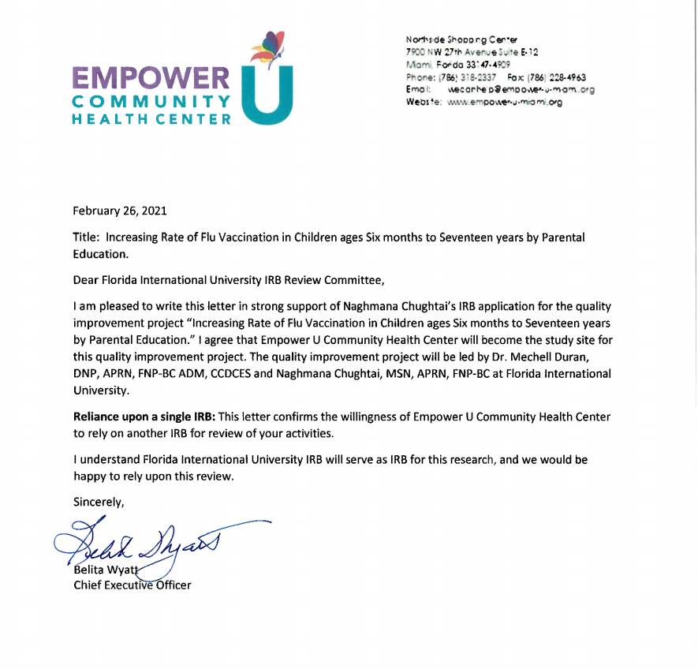

Appendix C: IRB Approval Letter
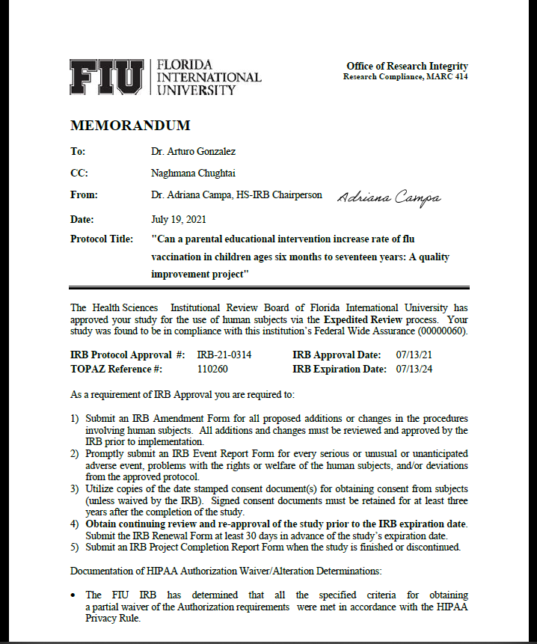

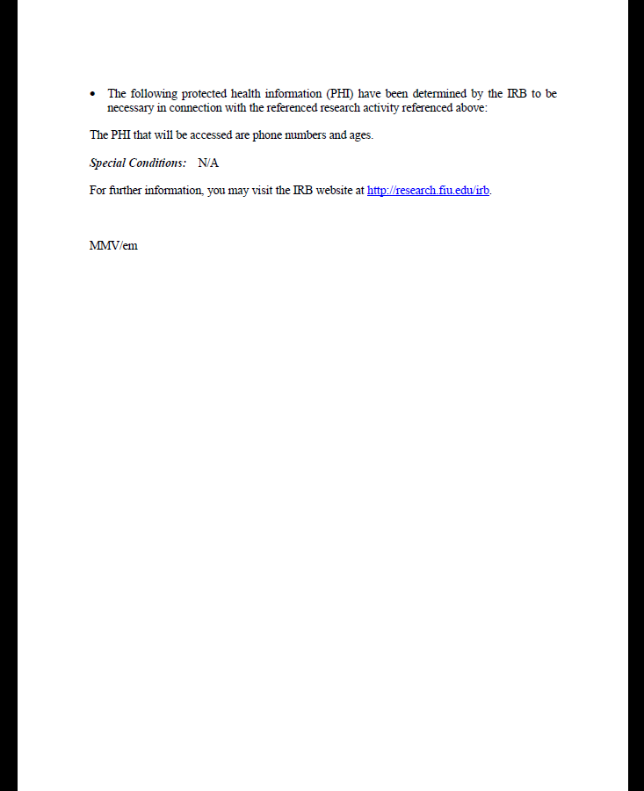
Appendix D: Telephone Recruitment Script
You are being asked to be in a quality improvement project. You have been selected to participate in this quality improvement study as your child is currently registered in Empower U CHC. The principal investigator of this project is Dr. Duran, a faculty member at FIU and the co-investigator is Naghmana Chughtai, a doctoral candidate at FIU. The project will include approximately 30 participants. Your participation will require a total of 30 minutes of your time. You will be given a pre-test and a posttest to evaluate your knowledge and attitudes in vaccinating your child against influenza after you participate in a presentation about influenza disease and flu vaccine. The purpose of this quality improvement project is to learn how to best educate parents on flu vaccination and improve flu vaccination rate in children ages six months to seventeen years.
Your completion of the quality improvement project is completely voluntary
If you choose to participate in the study and complete the pre and post survey all your responses will be strictly confidential. Only Dr. Duran and Naghmana Chughtai will see the individual surveys. The information gathered from this study will be shared only in summary form or in research reports. No information will be made available that could identify the responses of either an individual or small group of individuals. There are no foreseeable risks, but you may improve your knowledge and efficiency of flu vaccine importance in children.
If you to participate in the quality improvement project, please complete over the phone, the pre-survey regarding your knowledge about influenza and flu vaccine in children. After completing the pre-survey, you will participate in a 15-minute presentation on influenza, flu vaccine benefits and be given a post survey. We are interested in your response to all questions even if you are unsure of the best answer. If you decide to participate in the project, you are free to withdraw at any time without any negative effect on your relationship with EUCHC, FIU and all of the investigators involved in the study.
Thank you for your participation and I am here to answer any questions while taking part. If you have questions at later date, you may contact Dr. Duran at 305-348-4513 and Naghmana Chughtai at 954-404-3723. If you would like to talk with someone about your rights of being a research subject in this research study, you may contact the FIU Office of Research Integrity by phone at 305-348-2494 or by email at ori@fiu.edu. I will provide you with a copy of this page for your records if requested.

Appendix E: Verbal Informed Consent Form

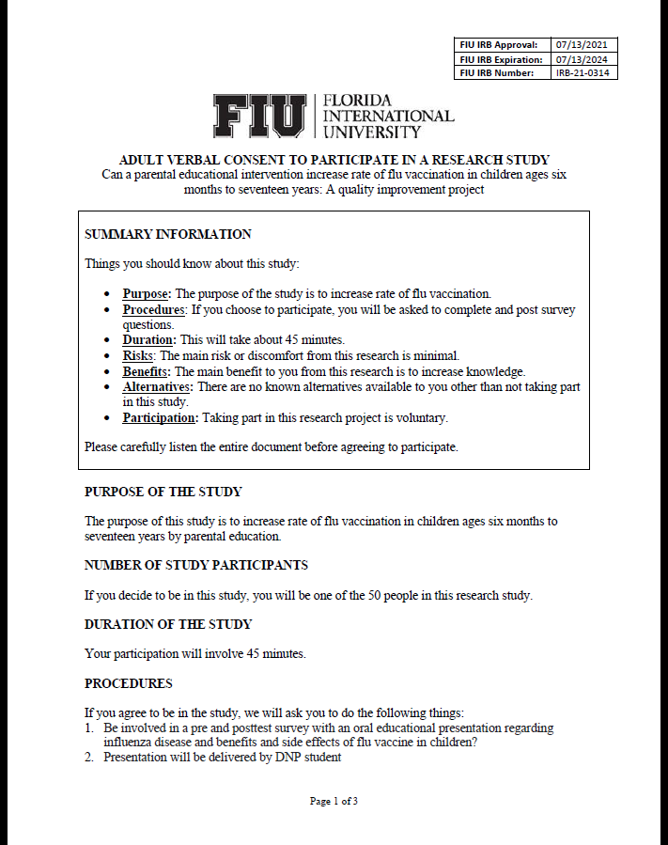
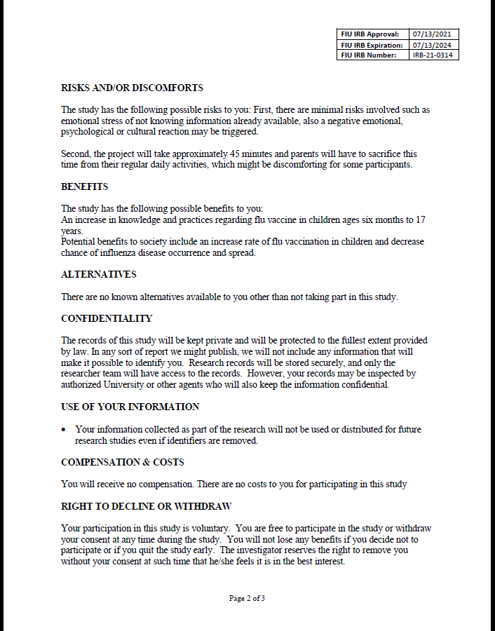

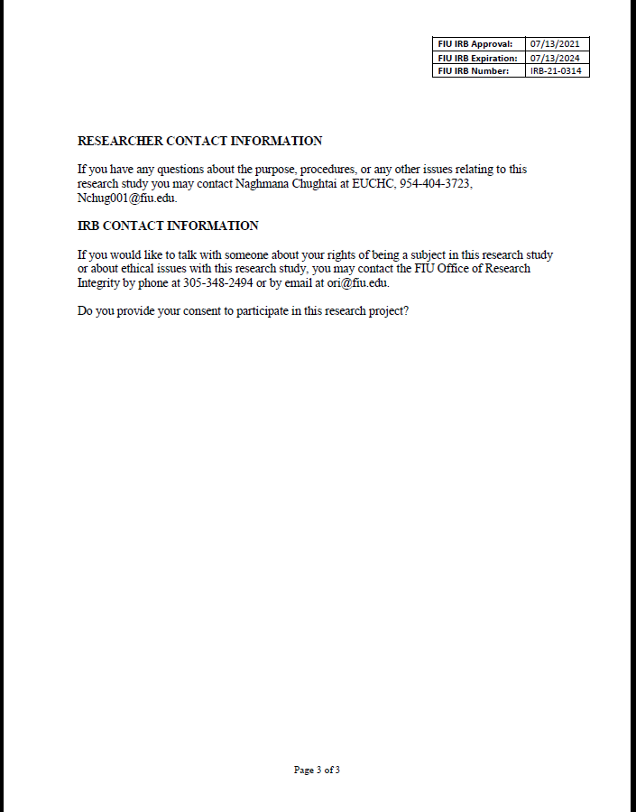

Appendix F: Pre-/Post-Intervention Assessment Form

- What is the age of your child?
□ < 6 months □ 7 months to 2 years □ > 2 years < 5 years □ 5 > years
- Vaccinations help to prevent certain diseases.
□ True □ False
- The influenza vaccination is effective in preventing the flu disease.
□ True □ False
- The flu vaccine is safe.
□ True □ False
- The vaccine has serious adverse effects that can harm children.
□ Yes □ Unsure □ No
- I believe that every child should get the flu shot.
□ True □ False
- If I do not get my child vaccinated, there is a high possibility that my child may contract the flu.
□ True □ False
- The flu disease is very serious.
□ True □ False
- My child could die from the flu or develop a serious illness as it can lead to a lung infection.
□ True □ False
- I can get my child vaccinated on time.
□ True □ False
- It is not difficult for me to get my child vaccinated.
□ True □ False
- Will you agree to your child receiving the flu vaccine?
□ Yes □ Unsure □ No

