DNP Project Report
Alexandra Castillo
November 30th, 2021
Nicole Wertheim College of Nursing and Health Sciences
Florida International University
NGR 7942C Section RVO

Improving nurses’ knowledge of aspiration pneumonia prevention for stroke patients with dysphagia: A quality improvement project

A Scholarly Project Presented to the Faculty of the
Nicole Wertheim College of Nursing and Health Sciences

Florida International University

In partial fulfillment of the requirements
For the Degree of Doctor of Nursing Practice

By

Alexandra Castillo, MSN, AGPCNP-C, APRN

Supervised By

Rosa Roche, PhD, PPCNP-BC

Approval Acknowledged: _______________________________, DNP Program Director

Date: _________________________
Abstract
Extensive literature reviewed suggests that aspiration pneumonia in patients with stroke is a significant complication due to dysphagia. Furthermore, lack of extensive large sample research in aspiration prevention measures in stroke patients with dysphagia paves the way for inconsistency in nursing care guidance. The lack of evidence-based guidance compounded with increasing patient ratios and expanding interdisciplinary teams suggests the need for formal training programs. This paper responds to these challenges by proposing a formal training program for nurses caring for stroke patients with dysphagia who are at high risk for developing aspiration pneumonia. The main contribution of this program is to provide nurses with consistent, evidence-based information that can then be disseminated with other healthcare workers, patients, and family members. The program also encourages interdisciplinary teamwork and communication. The data from this paper suggests that the training program not only increased knowledge base, but also increased nursing’s perceived confidence in delivering care and educating patients or families. This paper concludes with demonstrating the need for similar training programs with larger sample sizes to close the gap in nursing knowledge deficit and aspiration pneumonia rates in stroke patients with dysphagia.
Keywords: nursing knowledge, evidence-based, training program, dysphagia, stroke, aspiration pneumonia, enteral feeding
Introduction/Problem Statement/Significance
Aspiration pneumonia in patients with stroke is a significant complication due to dysphagia. According to Peterson (2016), the severity of dysphagia is further complicated by functional capacity, dementia, glucose control, and gastroesophageal reflux. In the presence of dysphagia, aspiration pneumonia is increased seven-fold. In nursing homes, complications related to dysphagia can be as high as 50 to 75%. Often times in elderly patients, half of incidences of aspiration related to dysphagia is silent meaning the occurrence is not overt and often goes unnoticed. From admission to acute care to post-hospitalization, interventions for aspiration in stroke patients with dysphagia are often reactive versus proactive.
This is particularly relevant in patients with percutaneous endoscopic gastrostomy (PEG) tube. While literature demonstrates there has been an immediate decrease in risk of aspiration pneumonia with PEG tubes when compared to oral feeding, the long-term data has not been very positive. The long-term risk in aspiration pneumonia with enteral feedings has been due to: a) inconsistency in keeping the head of the bed above 30 degrees at all times; b) lack of tight glucose control; c) poor functional capacity of the patient, poor oral care regimens; d) poor management of feeding residual control; e) tube placement (Thomas et al., 2019).
Contributing factors to non-adherence of nursing and medical interventions can be attributed to many barriers such as lack of training, transitions into multiple phases of care, and patient functional capacity. Thomas and colleagues (2019) explain that interventions are often not done due to lack of hospital-wide training, clutter in the electronic health record (EHR) with precaution orders, and lack of nursing staff availability at meal time for one-on-one feeding. However, above everything else, the greatest contributor has been lack of consistency in guidance from the literature. A patient in these cases passes through many hands and departments without any clear direction for the staff to care for dysphagia patients and enteral feeding management. While aspiration pneumonia with enteral feeding is not a novel issue, the ability to comprise a definitive protocol for nurses to use to advocate for their patient still remains ambiguous. There is conflicting data regarding residual feeding management and the difference in efficacy of tube placement.
Nurses are the eyes for the patient and the medical team. If nurses do not have a definitive guidance, patients will continue to decompensate due to secondary complications of their stroke. Decompensation leads to frequent readmissions and increased length of stay, which is costly both monetarily and emotionally for all involved. According to Thomas and colleagues (2019), aspiration complications due to tube feedings often lead to respiratory distress syndrome and has a reported mortality rate as high as 70%. In the United States, pneumonia results in more than one million admissions annually and accounts for more than $10 billion. Nation-wide, the 30-day readmission rates for aspiration pneumonia is 16.5% (Lindenauer et al., 2018).
This quality-improvement project aimed to identify an evidence-based training program that increases nursing knowledge regarding dysphagia and enteral feeding management in order to promote early nursing intervention, patient advocacy, overall reduction of aspiration risk, and improvement of patient outcome long-term.
Summary of the literature/Evidence related to the clinical question
The literature review for the proposed project was aimed to help provide answers to the PICO questions, but also help demonstrate the significance of the project by demonstrating gaps in the current evidence. Throughout the literature review, articles contained answers to parts of the PICO question, but not in its totality. Some of the articles discussed aspiration precaution strategies, dysphagia screenings reviews, tube feeding placements, and the overall poor outcome for stroke patients with secondary complication of aspiration pneumonia; however, only one of the articles actually proposed an algorithm of detecting and managing stroke patients with dysphagia. Additionally, many of the articles were unable to provide definitive direction for enteral feeding management or feeding residual management.
Diagnosing Dysphagia in Stroke Patients
Preventing aspiration pneumonia in stroke patients starts at the very moment that the patient is admitted for acute care. The nurses play an integral part in assessing the patients’ ability to swallow with the bedside dysphagia screening tool. The screening tool assessed the alertness of the patient, if the patient had any modified feeding before admission, and the ability to drink 3 oz of water in a short amount of time without coughing (Immovilli et al., 2021). Immovilli and colleagues (2021) suggest that the bedside dysphagia screening tool demonstrated high sensitivity and yielded no false negatives. Moreover, the researchers go on to explain how the dysphagia screen serves as the first trigger point should the patient fail to get speech therapy on board to further evaluate and treat the patient.
Smith and colleagues (2018) performed a systematic review on dysphagia screening protocols and their ability to reduce the incidence of pneumonia, death, and dependency after admission. The systematic review revealed that there needs to be more randomized controlled studies to provide more sufficient data on the direct correlation between the dysphagia protocols and decreasing incidence of aspiration pneumonia. Of the randomized control studies included in the review, the data suggested that dysphagia screenings were able to reduce death rates, intubation rates, and dependency rates but were unable to demonstrate sufficient decrease in pneumonia rates. Researchers did mention that the studies that did yield promising results could hold greater influence if the sample sizes were larger.
Factors Associated with Aspiration Pneumonia
Throughout the literature review, there were several factors that were identified to contribute to aspiration pneumonia. These factors include lack of glucose control, gastroesophageal reflux, lack of keeping the head of the bed above 30 degrees at all times, poor functional capacity of the patient, poor oral care regimens, poor management of feeding residual control, and tube placement (Thomas et al., 2019). Watanabe and colleagues (2014) point out some other unique factors such as male gender, poor denture fitting, microorganism growth on dentures, cerebral atrophy functional disorders, and basal ganglia infarcts. These are additional factors and triggers for nursing to be more alert to. However, even with nursing training and education with staffing shortages and high patient ratios it can be difficult for nurses to be able to spend that needed time to care for the patient so extensively. Additionally, with the added barrier of no visitors during the COVID-19 pandemic, it can be difficult to educate caregivers who will be feeding and caring for the patient after discharge.
Placement of Feeding Tubes
While aspiration pneumonia with dysphagia and enteral feeding is not a novel issue, the ability to comprise a definitive protocol with trigger points for nurses to use to advocate for their patient still remains ambiguous. There has been conflicting data regarding when an alternative mode of feeding is indicated, how to manage residuals with feeding and the difference in efficacy of tube placement sites (Thomas et al., 2019). Some literature suggested that residual over 200 cc should be a trigger point for intolerance while others suggested that the data to support this notion is not statistically significant and additionally motility agents such as metoclopramide have not yet been proven consistently to make a difference in enteral feeding management. What shows to be more useful is maintaining the bed above 30 degrees at all times, tight glucose control, and management of gastroesophageal reflux or gastritis (Liu et al., 2021).
Through this quality improvement project, this student hoped to provide more data regarding feeding residuals and an effective management. Liu and colleagues (2021) performed a promising systematic review and meta-analysis regarding the advantages and disadvantages of different tube placements. The data suggested that post-pyloric tube placement has been shown to significantly decrease the incidence of aspiration when compared to PEG tubes. Additionally, the data suggested that total nutrition is achieved with less time in post-pyloric feeding than PEG feeding. This is an interesting consideration for high-risk dysphagia stroke patients.
Purpose/ PICO Clinical Question/Objectives
Purpose
The purpose of this quality-improvement project was to provide nurses with a cohesive direction to gain confidence and allow nurses to advocate for stroke patients with dysphagia. This begins from the moment they are admitted until they are ready to transition to post-acute care. Nurses and the interdisciplinary team need to have the power, backed by evidence, to be proactive rather than reactive in caring for high-risk aspiration patients. From the moment the patient is discovered to have a modified swallow, a cascade should be initiated so that the patient is well taken care of in a timely fashion in order to meet nutritional need and prevent aspiration pneumonia. While it would be unrealistic to say that the training program would prevent all cases of aspiration pneumonia, the program will raise awareness among staff through consistent, evidence-based training which is allow staff to be more equipped to care for this patient population.
PICO Question
The PICO question that will is guiding this project is:
Will the implementation of a dysphagia training program improve nursing knowledge and perceived confidence in aspiration pneumonia prevention measures?
P- Inpatient stoke nurses
I- Evidence-based high aspiration risk training program
C- Nursing knowledge and perceived confidence
O- Improve nursing knowledge and perceived confidence
Objectives
The objectives for the proposed project will be as follows:
- Nurses will able to accurately identify high-risk aspiration patients on admission using the bedside dysphagia screening tool.
- Nurses will be able to verbalize aspiration precaution measures while in bed and during feedings.
- Nurses will be able to collaborate with dieticians and speech therapists to help safely meet patient nutritional needs.
- Nurses will be able to verbalize when patients are not tolerating enteral feedings and how to advocate for their patients.
- Nursing knowledge and perceived confidence in aspiration prevention measures will improve.
Definition of Terms
When evaluating the project and its goals, it is important to define a few terms. The first term is dysphasia. Dysphasia refers to patients who have difficulty swallowing food or liquids at a normal consistency. For instance, if a patient coughs with thin liquids such as water, that would suggest that the fluid might be leaking into the trachea rather than the esophagus. This can be due to many diseases; however, in the setting of a stroke, the issue is most likely due to neurological damage from the stroke that is causing a delay in the swallow reflex. The coughing reflex most likely indicates that the patient needs thickened liquids to assist with the swallow delay to prevent the liquids from going down the trachea (“Adult Dysphagia”, 2021). If the liquids or food enter the trachea rather than the esophagus, that means the patient aspirated and can lead to pneumonia. If the patient does not cough, it does not necessarily mean the swallow is intact. In fact, the patient could be silently aspirating because the patient does not cough to let the nurse know something is wrong. The next term to discuss is “high risk aspiration”. The term is for patients who are either on modified food/liquid consistency or are on enteral feeding. These patients are at high risk because the patient has already been identified to have a defective swallow reflex and so these patients need to be monitored closely. Lastly, it is important to discuss residual management. Residual management refers to the measurement of how much enteral feeding is in the stomach. This is done by pulling back with a syringe on the PEG tube. If the residual is high, that suggests that the patient is not tolerating the feeding because the feeding is not being digested at the same rate as the feeding is entering the stomach. The exact number to define a “high residual” is not clearly defined in the literature but will hopefully be better defined by this project.
Conceptual Underpinning and Theoretical Framework of the Project
The theoretical frameworks used as inspiration for the proposed project are Ida Jean Orlando’s Nursing Process Theory and Jean Watson’s Philosophy and Theory of Transpersonal Caring. The combination of these two theories allows nurses to be goal-oriented, evidence-based, and patient-oriented. Orlando’s Nursing Process theory is patient-centered and aimed to provide a systematic guide through the use of five steps: assessment, diagnosis, planning, implementation, and evaluation (Toney-Butler & Thayer, 2020).
The assessment step involves the collection of subjective and objective data. The subjective data is based on what the nurse is seeing and what the patient or family is reporting. The objective data is based on data collected from the electronic health record (EHR). Nurses then use their clinical judgement and critical-thinking to formulate a nursing diagnosis using the North American Nursing Diagnosis Association (NANDA) list. The nurses identify patient needs to care plan with patient-centered outcomes.
The next stage is planning in which goals and expected outcomes are formulated in order to directly impact patient care based on evidence-based guidelines. These goals must use the SMART model in that they must be specific, measurable, attainable, realistic, and timely. This allows nurses to develop a clearly defined plan with due dates. Which allows for a smooth transition to the next step which is implementation. During the implementation phase, staff put to planning into fruition. Lastly, leaders must evaluate the interventions and the relation with positive patient outcomes. If needed, the care plan can be adjusted to address the identified issues (Toney-Butler & Thayer, 2020).
Watson’s Philosophy and Theory of Transpersonal Caring stresses caring, empathy, and developing a trusting relationship with the patient. Watson urges nurses to look beyond the patient’s disease and treat the patient with their needs in mind. Through the application of Watson’s ten caritas, the nurse is more open to practicing with caring conscious and caring healing modalities. Watson also explains that the use of the ten caritas enhances thinking skills and personal growth. Nurses will be able to connect with their patients on a spiritual level to identify their needs and incorporate them in their care plan (Alligood, 2018).
Methodology
Section A.
The general phases on the proposed quality improvement project will follow a PDSA cycle, or Plan, Do, Study, Act. The planning stage was collecting data from the literature and immersion site regarding aspiration pneumonia prevention strategies. Furthermore, this information was be used to develop an evidence-based training program. The planning stage was also to create the pre and post-surveys regarding nursing knowledge about aspiration pneumonia, confidence in prevention strategies, and their confidence level recognizing and preventing aspiration. The “do” stage was training the staff, performing the pre-surveys, and implementing the program. The “study” phase was collecting data from the post-surveys. Based on the information collected and feedback from the staff, the “act” stage was immediately followed in making adjustments in the program as needed. The data collected was made available to staff to show the impact of their work as motivation.
Section B.
    - Study design: The study incorporated the pre and post-surveys design. The nurses were evaluated on their knowledge in patient care and their ability to care for stroke patients with dysphagia.
    - Setting: Inpatient stroke unit at Memorial Hospital West.
    - Sample: The sample being studied were nurses caring for stroke patients with dysphagia that are at high risk for aspiration. The sample size was estimated to be from 20-30. Inclusion data were full-time and part-time nurse with at least one-year experience working on the inpatient stroke unit. Exclusion data included newly graduated nurses or newly hired nurses. This criterion was to hopefully reduce the chance of error due to inexperience.
    - Intervention: The proposed intervention includes education to nurses. Nurses were trained via powerpoint, recorded zoom presentations, and live zoom instruction to make sure the nurses understood and could teach back the material. The information included how to perform the bedside dysphagia screening, perform an accurate calorie count, and implement effective aspiration precautions during feeding. Lastly, the nurses were briefed on trigger points associated with needed intervention. Pamphlet copies of the education were also available to the unit for reference. The intervention was performed one-time over 6 weeks. The intervention was conducted by nurses with the reinforced knowledge of when to recruit the help of speech therapy, dieticians, physicians, and patient care assistants.
    - Measures/Instruments: For the proposed project, the data was collected with online surveys from participants. The surveys were used to measure nursing knowledge about aspiration and their perceived confidence levels for caring for these patients. Heale and Twycross (2015) discuss the criteria for establishing validity and reliability. Validity measures the extent in which a concept in a quantitative study is measured. In order to establish validity, the measure must pass three levels of evidence: a) The measure have homogeneity, which means the measure focuses on one construct; b) Convergence is when difference measurements can be established on multiple instruments; c) Theory evidence ensures that the measures are reflective in everyday life. For instance, if a nurse scores high in confidence in the ability to take care of patients, then the nurse should actually be confident in their day-to-day work environment.
Reliability refers to the consistency of a measure. If the intervention is reliable the intervention will receive the same results every time. The measure of reliability for the project will be stability testing using the pre and post testing. Through multiple repetitions of the surveys, a statistical analysis is performed. If the correlation coefficient if less than 0.3, the correlation is weak. If the correlation coefficient is 0.5 or greater, the correlation is strong and thus has high reliability (Heale & Twycross, 2015).
    - Data collection procedures: The methods for recruiting a sample were via zoom and e-mail by discussing the project with the unit manager and clinical managers to perform the project on one of the shifts (day or night). Once the sample was determined, the nurses took their pre-survey to reduce the chance of influence from the training. The platforms for education were powerpoint, recorded zoom lecture, and a live zoom teach back session. As the staff were being trained, they took a post survey immediately after. After the 6 weeks, another post survey was taken for comparison.
    - Data analysis: For the data analysis of the surveys, the first half of the survey was knowledge-based so the answers were either correct or incorrect. The data was then collected in the form of how many nurses got each question correct. The second half of the survey was based on the nurse’s perception on a 0-5 scale with 5 being the most confident. This data was averaged by question. To describe the sample, the demographics were include age, gender, ethnicity, and number of years of experience. All of this information was placed in Qualtrics to keep track of the data and determine the normal distribution of the variables with parametric data. Parametric data allows reviewers to see the distribution of the data and provides more confidence and strength in the conclusions made from the data. The data for the staff demographics were categorized into ordinal variables and the data from the surveys had categorical variables.
    - Protection of Human Subjects Informed consent were provided with the e-mail and Qualtrics link. It was possible for the investigator to link participants to their e-mail; however, no personal identifiers were collected during the survey data collection process and the surveys were submitted anonymously. The informed consent also informed the potential participant that there were minimal risks to the participants. Potential risks to participants included loss of privacy related to discussion of personal opinions/knowledge of aspiration pneumonia strategies. The information related to their responses were stored on the Qualtrics database anonymously. No personal identifiers were necessary for data input or collection. All communication was encrypted for the protection of the participants. Lastly, the value from the information gained was the efficacy of the training program and its ability to influence high-quality nursing care for stroke patients with dysphagia. If adapted, society as a whole can benefit from improving their quality of care and extended the quality of life for these stroke patients.
Results
The original sample size for this project was 17 (n=17) with 16 females and 1 male. Most participants were between the ages of 20 and 30. The average years of experience in stroke specialty was 5.29 years. The ethnicity of the sample encompassed a wide variety (figure 1).
Figure 1
Throughout the project, some participants were lost due to loss of nursing staff to travel/crisis staffing assignments. The subsequent testing samples for the post-test and 6-week post-test consisted of 13 participants (n=13). The pre and post-test results were as follows:
Figure 2
The results displayed in Figure 2 suggest a positive correlation in not only accuracy of knowledge-based questions, but also in perceived confidence in caring for this patient population. Additionally, there was a significant increase in the number of participants who recognized the program as formal training. Originally, only 41.18% of participants felt they had received formal dysphagia training. After the project, 76.92% of participants felt they had received formal dysphagia training.
The testing questions were split into four main categories: identification of dysphagia, nursing interventions, enteral feeding management, and perceived confidence. Throughout the progression of the project, the data demonstrates an upwards of a 38% improvement between the pre-test and the post-test. The 6-week post-test results did show a slightly decline in the percentage of improvement, but none the less maintained up to a 22% improvement with information retention. It is important to note the change in sample size from n=17 to n=13 which could potentially skew the numbers, but the data is still significant. Moreover, the data suggests that the training program was able to meet its primary objectives which were that nurses will able to accurately identify high-risk aspiration patients, will be able to identify aspiration precaution measures while in bed and during feedings, will be able to collaborate with dieticians and speech therapists to help safely meet patient nutritional needs, will be able to identify when patients are not tolerating enteral feedings and how to advocate for their patients, and perceived confidence in aspiration prevention measures will improve.
Discussion
The data suggests that there is a positive correlation between the training program and increase in nursing knowledge and perceived confidence in caring for stroke patients with dysphagia. Additionally, there was a significant increase in the number of participants who recognized the program as formal training. The real test was the results 6 weeks after the program was completed. As discussed, despite slight decrease in average percentage in questions answered correctly, there was still a significant margin of improvement maintained. There were some limitations which will be discussed along with the implications for practice and future research.
Limitations
There were two main limitations for this project: sample size and lack of in-person communication. Sample size varied from pre-test to the two post-tests due to loss of staff for travel/crisis staffing assignments and lack of incentive for participation. Nursing staffing at my facility is at a critically low level due to high-influx of COVID-19 infection and need for travel nurses with higher pay. Due to low staffing, nurses were having to work overtime with higher patients rations. Participants have expressed extreme fatigue and feelings of burnout. The combination of burnout with lack of participation incentive for completion motivation can be difficult. Additionally, due to the pandemic, there was no in-person contact with the participants for safety precaution. This limited the opportunity for the researcher to develop a rapport with the participants. Crisis staffing and patient overload also made it difficult to coordinate live video sessions with participants thus pre-recording lectures were provided. This limited the ability to ask questions and provide live feedback. Moving forward, researchers should provide incentive with a larger sample size to assess the efficacy of the training program on a large scale.
Implications For Practice
The most important step after this primary quality improvement (QI) project is to develop a sustainability QI plan to expand the validity and reliability of the study. Additionally, it allows the program structure to grow and evolve with the needs of the implementing facilities to promote the most current evidence-based practice with adaptability to the facility’s workflow. The quality improvement plan started by collaborating with executive and clinical leadership for consult and approval. The plan worked to address operational and clinical activities. It placed a focus on the clinical topic with effected departments and the allocated time needed for the current and subsequent calendar years. The quality improvement sustainability plan for this project includes the following: a) a systematic process with effective workflow, b) use of data and measurable outcomes to determine progress toward evidence-based objectives, c) continuous process that is adaptive to improvement and positive patient care outcomes (HRSA, 2011).
The next step for this projects plan is to disseminate the information on professional platforms and to keep the QI project implemented at the current facility. Sharing the information on professional platforms allows for more growth of small-scale projects and potentially large-scale projects. Within the current facility, after presenting the positive initial findings, executive and clinical leadership can work to prioritize the resources needed to keep the project going. It is important for leadership to assess the facilities’ readiness for change. This can be done by assessing the facility’s current aspiration rate and the leadership’s ability to promote the efficacy of the training measures. For cost and resource purposes, the lectures and testing should remain online. The Directors of Nursing for the respective involved units (intensive care, stroke unit, emergency) should oversee the project implementation and resources allocated. The clinical educators will be responsible for updating the content, collecting feedback, and providing the information on an accessible platform annually. The nurse managers will ensure that pertinent staff attend the trainings annually and as needed with new hires. Nurse managers can also address resistance to change and other potential barriers. The clinical managers will help the staff and serve as resources in the daily bedside implementation of the material. Clinical manager can also serve as daily encouragement for change and communicate opportunities for improvement with other leadership. The cost to the facilities will be minimal. Employees will be compensated for the 60-90 minutes to complete the training and testing. Clinical educators will be able to update the training materials as part of their job description. Employees will be able to do the class at home without the need for training space reservations or extra payment for clinical training staff. Incorporation of relevant departments such a neurology or speech therapy should be considered for a more robust and rounded training. Additionally, stroke program coordinators and quality improvement leadership within the hospital can then take the measure a step further in measuring the current aspiration pneumonia rate and then compare it to after training has been implemented system-wide to relevant departments.
Based on the data collected during this quality improvement project and ability to expand the project with retrospective patient outcome analysis, this carries great implications for Advanced Practice Nursing (APN). This creates an APN role that combines education with evidence-based practice. The education is not only amongst the clinical staff, but also amongst patients and family members. If clinical staff is not only implicating the measures in the hospitals but are also empowering patients and families to continue these practices and advocate for their safety outside the hospital, clinicians have the ability to lower readmission rates and improve the patients’ quality of life long-term. This not only provides the best outcomes for the patients but also saves the hospitals money in the long run. If enough data and systematic reviews are generated, this project could even develop into a guideline and could be expanded to non-stroke related areas of dysphagia such has mouth and throat cancer or traumatic brain injuries.
Most importantly, many facilities with stroke specialty units have to be certified by a certifying body, such as Joint Commission. As a part of the maintenance of the certification, facilities have to show dysphagia training, but the guidelines do not specify the contents of the training (Joint Commission, 2021). This program would serve as a useful base to train staff and show its positive impact on the facilities ability to care for stroke patients.
Conclusions
Extensive literature reviewed suggests that aspiration pneumonia in patients with stroke is a significant complication due to dysphagia. Furthermore, lack of extensive large sample research in aspiration prevention measures in stroke patients with dysphagia paves the way for inconsistency in nursing care guidance. The lack of evidence-based guidance compounded with increasing patient ratios and expanding interdisciplinary teams suggests the need for formal training programs. The data from this project suggests that there is a positive correlation between the training program and increase in nursing knowledge and perceived confidence in caring for stroke patients with dysphagia. Additionally, there was a significant increase in the number of participants who recognized the program as formal training. There were two main limitations for this project: sample size and lack of in-person communication. Sample size varied from pre-test to the two post-tests due to loss of staff for travel/crisis staffing assignments and lack of incentive for participation. Additionally, due to the pandemic, there was no in-person contact with the participants for safety precaution. This limited the opportunity for the researcher to develop a rapport with the participants. Moving forward, researchers should provide incentive with a larger sample size to assess the efficacy of the training program on a large scale.
Appendix
Memorial Hospital West Letter of Support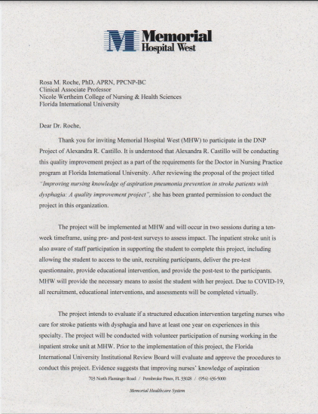
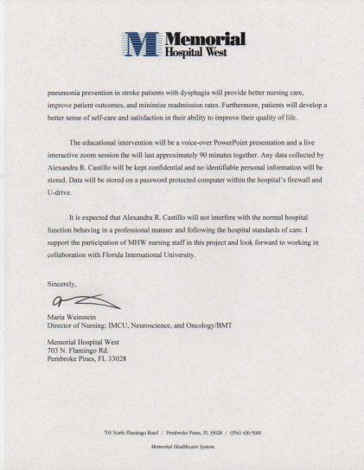

MHS IRB Approval Letter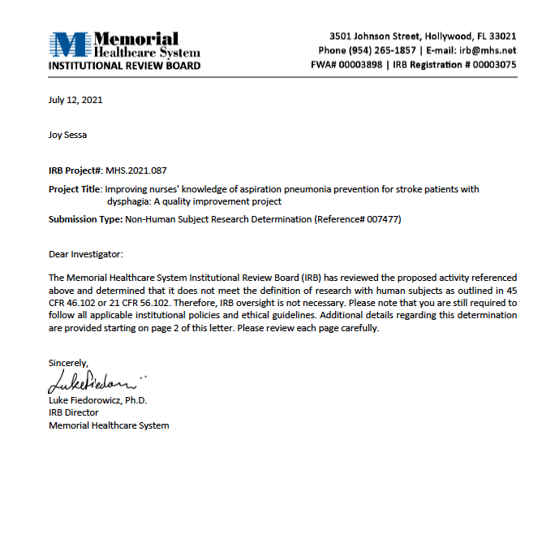
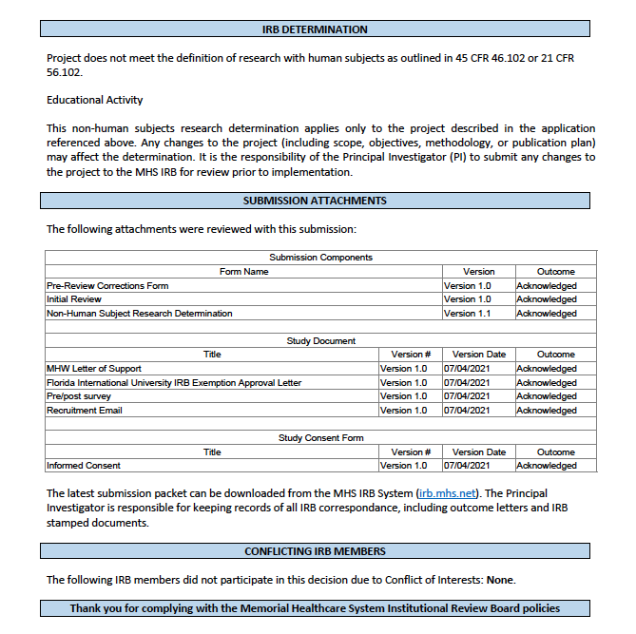

FIU IRB Approval Letter

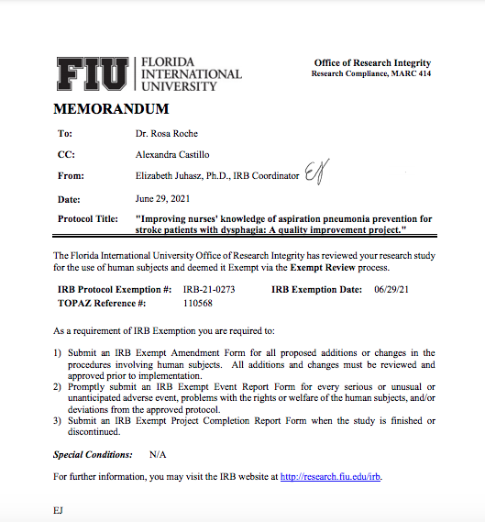

Pre-Post Survey

Improving nursing knowledge of aspiration pneumonia prevention in stroke patients with dysphagia: A quality improvement project
Introduction:
This survey is an essential part of the quality improvement project aiming to increase nursing knowledge of aspiration pneumonia prevention strategies in stroke patients with dysphagia.
Please answer to the best of your knowledge. Do not use outside sources or collaboration to complete the survey. Your response will help to understand gaps in knowledge and areas for improvement. The questions are structured to assess your understanding of identifying dysphagia, aspiration pneumonia prevention measures, nursing interventions, enteral feeding management, and perceptions regarding ability to care for stroke patients with dysphagia.
- Please do not write your name or other personal identifiable information on this survey
- Your answers are anonymous and will be kept confidential.
- Your participation is voluntary and will not have any bearing on your position.
Demographic:
Gender: Female ___ Male ___ Other ___ Wish not to disclose ___
Age: 20-30 yrs. ___ 30-40 yrs. ___ 40-50 yrs. ___ >50 yrs. ___
How long have you worked in this specialty (stroke)? ____
Ethnicity: White ___ Black ___ Hispanic ___ Asian ___ Other ___
Position: RN ___ APRN ___ Other ___
Survey:
Identification of Dysphagia in Stroke Patients
- What initial assessment tool should a nurse use when evaluating for dysphagia in stroke patients?
- NIH stroke scale
- Bedside dysphagia screening
- Cough reflex assessment
- None of the above. Patient should be NPO until evaluated by speech therapy.
- All of the steps below are part of the bedside dysphagia screening EXCEPT:
- Evaluating the patient’s level of alertness.
- Evaluating if the patient can sit up for exam.
- Evaluating if the patient can tolerate swallowing 90 oz of water in a short period of time.
- Evaluating if the patient has any modified feeding before admission.
- If the patient fails the bedside dysphagia screening, what should the nurse do first?
- Call the physician.
- Try thickened foods such as applesauce or pudding.
- Consult speech therapy.
- Place the patient on NPO status.
- The bedside dysphagia screening tool is highly sensitive and often leads to false positives.
True ___ False ___
- The bedside dysphagia screening tool is not highly sensitive and often leads to false negatives.
True__ False___
- Risk for dysphagia include the following EXCEPT:
- Poor mentation
- Facial droop
- Delayed gag reflex
- Absence of cough reflex
- A hallmark sign of dysphagia is coughing during feeding.
True ___ False ___
- If a stroke patient is admitted with a modified diet prior to admission, the modified diet should be continued on admission until speech therapy evaluates the patient.
True___ False ___
- What percentage of acute ischemic stroke patients are likely to have dysphagia?
  - 20-30 %
  - 10-15 %
  - 40-80 %
  - 5-10 %
- Dysphagia accounts for an estimated 25 % of stroke-related mortality.
True ___ False __
Aspiration Pneumonia Prevention/Nursing Interventions
- The head of the bed should be kept at least at ___ degrees at all times.
- 30
- 35
- 45
- None of the above.
- The head of the bed can be lowered for certain activities such as sleeping.
True ___ False ___
- If a patient with dysphagia are alert and oriented, what should be the level of supervision during feeding or drinking?
- No supervision is required.
- Check on the patient every 15 minutes.
- Check on the patient every 30 minutes.
- Patient should be supervised through the entire feeding or drinking.
- The following should alert the nurse for aspiration risk EXCEPT:
- Residual food in mouth after swallowing
- Previous diagnosis of alzheimer’s/dementia
- Poor oral care
- Presence of vesicular breath sounds after feeding.
- Oral care is essential in preventing aspiration pneumonia.
True ___ False ___
- Straws are a helpful tool in minimizing the risk for aspiration.
True ___ False ___
- Patients with gastrointestinal tubes remove the risk for aspiration by bypassing the pharynx, larynx, and esophagus.
True ___ False ___
- Your patient starts coughing while feeding. The nurse should:
- Use smaller bites.
- Re-consult speech therapy.
- Call the physician.
- Encourage more liquids.
- It is good practice to provide oral suction after each feeding.
True __ False __
- The following is a sign of feeding tolerance:
- Residual food in mouth after swallowing.
- Lack of cough with swallowing.
- Ability to eat over 50% of meal.
- None of the above.
Enteral Feeding (Tube Feeding) Management
- What amount of tube feeding residual should alert the nurse of feeding intolerance?
- 75
- 100
- 150
- 200
- All of the following factors increase aspiration risk in patients with enteral feeding EXCEPT:
- Decreased mental status
- Post-pyloric tube placement
- Poor glucose control
- Gastroesophageal reflux
- The goal glucose level for patients on enteral feeding is:
- Less than 120
- Less than 100
- Less than 150
- Less than 200
- How often should tubing residual be checked?
- Daily
- Once a shift
- Every 4 hours
- Every 2 hours
- With a tube feeding residual of 100, the tube feeding should be stopped, and the nurse should call the physician.
True___ False___
- If residuals continue to remain high after stopping the tube feeding, what should the nurse do next?
- Continue holding trial.
- Increase water flushes.
- Continue feeding.
- Contact physician to request a gut motility stimulating medication.
- It is not necessary to perform oral care for patients on tube feedings due to lack of oral nutrition.
True___ False___
- It is important to still monitor clearance of oral secretions and suction as needed even if the patient has a gastrointestinal tube.
True___ False___
- The following is a measure to prevent aspiration in patients with a tube feeding:
- Keeping the head of the bed at 25 degrees at all times.
- Tight glucose control.
- Avoiding oral care with liquid agents.
- Continuing feeding during bed baths and turning.
- Post-pyloric tube placement has been shown to be more effective in preventing aspiration pneumonia.
True___ False___
Perceptions (0=Strongly disagree; 5=Strongly agree)
- Have you received formal training for aspiration prevention care?
Yes ___ No ___
- I feel confident in my ability to identify a patient with dysphagia.
0 1 2 3 4 5
- I feel confident in my ability to perform a bedside dysphagia screening.
0 1 2 3 4 5
- I feel confident in my ability to educate patients/families regarding aspiration prevention.
0 1 2 3 4 5
- I feel confident in my ability to feed patients with a modified diet.
0 1 2 3 4 5
- I feel confident in my ability to identify intolerance of a modified diet.
0 1 2 3 4 5
- I feel confident in my ability to manage enteral feedings (tube feeding).
0 1 2 3 4 5
- I feel confident in my ability to identify enteral feeding (tube feeding) intolerance.
0 1 2 3 4 5
- I feel confident in my ability to relay assessment data to other clinicians (i.e. physicians, speech therapists).
0 1 2 3 4 5
- I feel confident identifying the different levels of liquid consistency.
0 1 2 3 4 5
- I feel confident identifying the different levels of diet consistency.
0 1 2 3 4 5

References
“Adult Dysphagia”. (2021). American Speech-Language-Hearing Association. Retrieved from https://www.asha.org/practice-portal/clinical-topics/adult-dysphagia/#collapse_1
Alligood, M. (2018). Nursing Theorists and Their Work (9th Ed.). St. Louis, MO: Elsevier.
Immovilli, P., Rota, E., Morelli, N., Marchesi, E., Terracciano, C., Zaino, D., Ferrari, G., Antenucci, R., & Guidetti, D. Diagnostic accuracy of a bedside screening tool for dysphagia (BSTD) in acute stroke patients. Journal of Stroke and Cerebrovascular Disease, 30(2). https://doi.org/10.1016/j.jstrokecerebrovasdis.2020.105470
Lindenauer, P., Strait, K., Grady, J., Ngo, C., Parisi, M., Metersky, M., Ross, J., Bernheim, S., & Dorsey, K. (2018). Variation in the diagnosis of aspiration pneumonia and association with hospital pneumonia outcomes. Annals of the American Thoracic Society, 15(5). https://doi.org/10.1513/AnnalsATS.201709-728OC
Liu, Y., Wang, Y., Zhang, B., Wang, J., Sun, L. & Xiao, Q. Gastric-tube versus post-pyloric feeding in critical patients: a systematic review and meta-analysis of pulmonary aspiration- and nutrition-related outcomes. European Journal of Clinical Nutrition. https://doi.org/10.1038/s41430-021-00860-2
Peterson, A. (2016). Aspiration pneumonia in the elderly tube fed patient -- avoidable or unavoidable: Considerations for the LNC. Journal of Legal Nurse Consulting, 27(3), 36-40. http://web.b.ebscohost.com.ezproxy.fiu.edu/ehost/pdfviewer/pdfviewer?vid=0&sid=a7a32239-92d1-40a6-b1dd-e4612f53130c%40sessionmgr101
Smith, E., Kent, D., Bulsara, K., Leung, L., Lichtman, J., Reeves, M., Towfighi, A., Whiteley, W., & Zahuranec, D. (2018). Effect of dysphagia screening strategies on clinical outcomes after stroke: A systematic review for the 2018 guidelines for the early management of patients with acute ischemic stroke. Stroke, 49(3), 123-128. https://doi.org/10.1161/STR.0000000000000159
The Joint Commission (2021). Stroke Measures. Retrieved from https://www.jointcommission.org/measurement/measures/stroke/
Thomas, L., Lustiber, L., Webb, C., Stephens, C., Lago, A., & Berrios, S. (2019). Aspiration prevention: A matter of life and breath. Nursing 49(3), 64-66. DOI: 10.1097/01.NURSE.0000552698.50502.75
Toney-Butler, T. & Thayer, J. (2020). Nursing Process in StatPearls. Treasure Island, FL: StatPearls Publishing. Retrieved from: https://www.ncbi.nlm.nih.gov/books/NBK499937/
U.S. Department of Health and Human Services Health Resources and Services Administration (HRSA) (2011). Developing and Implementing A QI Plan. Retrieved from https://www.hrsa.gov/sites/default/files/quality/toolbox/508pdfs/developingqiplan.pdf
Watanabe, S., Shimozato, K., Oh-Shige, H., Umemura, M., Fujiwara, S., Abe, Y., Mano, K., Goto, Y., & Oh-Iwa, I. Examination of factors associated with aspiration pneumonia following stroke. Oral Science International, 11(1), 15-21. https://doi.org/10.1016/S1348-8643(13)00009-8

