Effectiveness of standardized medication reconciliation education on provider’s compliance and medication discrepancies in an ambulatory clinic caring for post-allo HSCT patients. A quality improvement project.

A Doctor of Nursing Practice Project Presented to the Faculty of the
Nicole Wertheim College of Nursing and Health Sciences

Florida International University

In partial fulfillment of the requirements
For the Degree of Doctor of Nursing Practice

By
Meilin Diaz-Paez, MSN, APRN, FNP-BC

Supervised by
Dr. Dana Sherman, DNP, APRN, ANP-BC, FNP-BC

Approval Acknowledged:
_______________________________________________, DNP Program Director
Date:___________________________________________

Table of Contents
Abstract 5
Introduction 7
Problem Statement 8
Significance 8
Summary of the Literature 9
Background 10
Scope of the Problem 12
Consequences of the Problem 13
Knowledge Gaps 15
Collaborative Effort 15
Standardization of Process 16
Measured Outcomes 18
Types of Medication Discrepancies 19
Barriers to Medication Reconcilication 19
Purpose/PICO Clinical Questions/Objectives 20
Purpose Statement 20
PICO Clinical Question 20
Project Objectives 21
Definition of Terms 23
Conceptual Underpinning and Theoretical Framework 23
Theory Overview 24
Methodology 26
Setting and Participants 26
Procedures 27
Participant Recruitment 27
Data Collection 28
Data Analysis 28
Protection of Human Subjects 28
Data Management 29
Results 29
Demographics of the Study Population 29
Survey 30
Post-Intervention Check Off Assessment 35
Chart Audits 36
Discussion 37
Limitations 37
Implications for Practice 38
Conclusion 39
References 40
Appendix A: Literature Matrix 46
Appendix B: IRB Approval Letter 48

Appendix C: Informational Letter 49
Appendix D: Educational Presentation 50
Appendix E: Pre/Post-test Questionnaire 55
Appendix F: Check Off Assessment 58
Appendix G: Support Letter 59
Appendix H: Pre-Intervention Survey Results 61
Appendix I: Post-Intervention Survey Results 63

Abstract
Medication reconciliation is the formal process where a provider compares the medications a patient should be using, and is currently using, to the new medications that have been prescribed for the patient and addresses any discrepancies. Medication discrepancies can affect patient outcomes. The medication reconciliation process can address medication errors such as duplication of therapy, omissions, drug-drug interactions (DDI), and the need to continue or discontinue medications. It can also identify errors in medication names, dose, frequency, and route. The medication reconciliation process may not be completed appropriately by clinicians or nurses. Lack of time, patient load, and other responsibilities are some barriers to the medication reconciliation process encountered by nurses. This quality improvement project aimed to determine whether an educational intervention would lead to increase compliance of completing the medication reconciliation process by both RNs and APRNs, and a decrease in medication discrepancies in patients’ medication lists provided at the end of each encounter. A total of 21 participants were recruited into the pilot study, completed the pre- and post-intervention surveys, and watched an educational presentation on medication reconciliation. Six RNs and 7 APRNs were then evaluated in the clinical setting for skills pertaining to their role in the medication reconciliation process. This quality improvement project highlights deficiencies in the medication reconciliation process. It also demonstrates variation in existing knowledge of the medication reconciliation process. Despite the educational presentation, there was no significant improvement with compliance. Further investigation is needed to determine the best platform for educating RNs and APRNs in the medication reconciliation process. Qualitative research is also needed to address barriers to the process despite clinicians having the needed knowledge.
Key Words: Medication Reconciliation, polypharmacy, allogeneic hematopoietic stem cell transplant patients

Introduction
Allogeneic hematopoietic stem cell transplant (allo-HSCT) patients are expected to follow complex medication regimens with different dosing schedules and frequent dose adjustments. Post allo-HSCT medication regimens include antimicrobial agents to prevent possibly fatal infections and immunosuppressive agents to prevent graft-versus-host disease (GvHD). These patients experience polypharmacy. Previous studies have shown that these complex medication regimens increase the risk for medication errors (Ice at al., 2020).
The Ambulatory Treatment Center is an outpatient clinic that provides care to an average of 5-6 post allo-HSCT patients per day, with a max of 10 patients daily. During the triage process, the RN performs an intake that includes the patient’s subjective history and medication history in the electronic medical record (EMR). The medication history (MH) is obtained from the patient and/or caregiver. Information obtained is not always complete. For example, dosing and frequency may be missing for one medication. Once the patient is triaged, the APRN sees the patient. During this time, the APRN assesses the patient, reviews diagnostic studies, and makes clinical decisions based off the findings. The APRN at this time also reviews the medication history obtained during intake, and may order new medications, discontinue and/or adjust existing medications. This reconciliation of medications is not always well documented. For example, dose/frequency adjustments to immunosuppressive agents may not be documented. The EMR also has a tool where the APRN can attest medication reconciliation (MR) has been completed and the medication list in the EMR is correct. Currently there is no tracking of this attestation being completed.
At the end of the patient encounter, the patient receives an after-visit-summary (AVS) which includes an updated medication list. When there is a breakdown in the MR process, these medications lists may have discrepancies placing the patient at risk for medication errors in the home. Patients have also reported to clinical staff that their medication list in the EMR is incorrect at the time of their visits.
Problem Statement
Medication reconciliation is an important process that can prevent medication errors that have the potential to cause harm to the patient. The Institute of Medicine has recognized thousands of deaths occur annually due to medical errors in the United States. Medication errors may have a role in up to 33% of all hospital errors, and unintentional medications errors occur in about 33-66% of hospital admissions (Hron et al., 2015). Eliminating medication errors can also reduce healthcare costs (Alghanem et al., 2022). Medication reconciliation is inconsistent in the ATC where adult post allo-HSCT patients with complex medication regimens are monitored closely. To prevent medication errors in the patient’s medication list, it is important that medication reconciliation is completed properly.
Significance
Medication reconciliation is the formal process where a provider compares the medications a patient should be using, and is currently using, to the new medications that have been prescribed for the patient and addresses any discrepancies. Medication discrepancies can affect patient outcomes. The medication reconciliation process can address medication errors such as duplication of therapy, omissions, drug-drug interactions (DDI), and the need to continue or discontinue medications. It can also identify errors in medication names, dose, frequency, and route (Joint Commission, 2021).
Medication errors can result from an incomplete medication reconciliation process (Chiewchantanakit et al., 2019). Patients may be unable to provide accurate and complete information regarding their home medication regimen (Joint Commission, 2021). The medication reconciliation process may not be completed appropriately by clinicians or nurses. Lack of time, patient load, and other responsibilities are some barriers to the medication reconciliation process encountered by nurses. Healthcare providers, such as advanced practice practitioners and physicians, may assume that the medication review has been completed and is accurate (Alghanem et al., 2022). One study showed that nurses and physicians spend less time on medication reconciliation due to the barriers mentioned above (Aghajani et al., 2015).
Medication reconciliation is a national patient safety goal, with its focus on maintaining and communicating a complete and accurate medication profile during transitions of care (Joint Commission, 2021). The identified problem is prevalent at the ambulatory treatment center where immediate post allo-HSCT adult patients receive follow-up care. These patients experience polypharmacy with frequent medication adjustments and are at high risk for medication errors in the home (Ice at al., 2020). It is imperative that the medication reconciliation process occurs at each encounter and the patient is provided with a correct, and up-to-date medication list for home reference.
Summary of the Literature
There is little literature on medication reconciliation within the hematopoietic stem cell transplant recipient population. Studies were found regarding noncompliance to the medication regimen, but these were related to a patient’s behavior and not as a direct result of an incorrect medication list that was provided by a provider to the patient at the end of their visit encounter. However, this noncompliance did demonstrate increased risk for complications in the post-transplant period.
Based off the literature review, it is evident that knowledge regarding the effect of medication reconciliation on medication errors in the hematopoietic stem cell transplant patient is warranted. Most important to note is the known polypharmacy in this population, and the dire consequences that medication errors can have on their overall survival and outcomes. Medications that are commonly used in these patients can be costly. As noted in Alghanem et al. (2022), cost savings regarding medications can be seen when medication reconciliation is done properly and is able to discontinue duplicate therapies and medications that are no longer warranted or effective. Cost savings regarding medication use is another area of interest that is a beneficial outcome from appropriate medication reconciliation in this patient population.
Background
Medication error is a preventable occurrence. Any medication error has the potential to cause patient harm along a spectrum. A medication error can lead to emergency room visits and readmission to the hospital. As a result, a medication error has the potential to increase healthcare costs and use of healthcare resources (Chiewchantanakit et al., 2019). Many of these incidences occur because of poor communication during transitions of care. In a group of patients discharged from a hospital, 23% of patients experienced an adverse event; about ¾ of these events were medication related. In another group, 67% of patients had discrepancies identified during the medication reconciliation process (Elbeddini et al., 2021). In the United States, medication discrepancies were identified in 33-66% of hospital admissions (Hron et al., 2015).
A standardized medication reconciliation process can decrease patient risk for medication errors, reduce hospital readmissions, and improve patient outcomes (Elbeddini et al., 2021). The Joint Commission (2021) recognizes there are challenges with medication reconciliation. This national patient safety goal has been a common topic since 2005 and has been updated to address these challenges (AHRQ, 2019). The goal focuses on organizations decreasing negative patient outcomes stemming from medication discrepancies (Joint Commission, 2021). It is also an objective for the Centers for Medicare and Medicaid Services’ Meaningful Use (Hron et al., 2015).
Maintaining an accurate medication list can be challenging in patients with polypharmacy and complex medication regimens (Alghanem et al., 2022)., such as in the post allo-HSCT adult patient. The post allo-HSCT adult patient will have multiple medications with frequent dose and scheduling adjustments. The overall survival of these patients depends on proper medication management and adherence. Previous studies have shown that medication errors increase with frequent dosing schedules and high number of medications. In the adult allo-HSCT patient, medication errors can range from 20-95%. A medication error, of an immunosuppressant agent for example, can be associated with increased risk for graft-versus-host disease (GvHD) and can be fatal. Antimicrobial prophylaxis is imperative to prevent infection in these immune-compromised patients (Ice et al., 2020). For this reason, medication reconciliation is a priority for ambulatory patient safety and providing an accurate medication list is imperative in providing excellent care and achieving optimal patient outcomes.
Jones et al. (2022) identified various contributing factors leading to improper medication reconciliation including patients’ not being knowledgeable of their medications, lack of a standardized medication reconciliation process in a healthcare organization, and knowledge deficit amongst healthcare providers on how to perform a proper medication reconciliation. Various studies have looked at medication reconciliation practices involving clinical pharmacists, electronic medical records, amongst other interventions and all have been correlated with a decreased risk in medication discrepancies and reduction in adverse events. Lack of staff training on medication reconciliation was identified as a major barrier and Jones at al. (2021) designed and implemented a pharmacist-led education program for the healthcare staff in the ambulatory clinical setting.
Similar reviews and studies were found relating to medication reconciliation in patients with polypharmacy who suffer from chronic conditions. However, no studies have observed medication reconciliation within the HSCT patient community and its effects of medication errors in this population.
Scope of the Problem
Adverse drug events such as medication errors during the post-discharge phase can cause harm to the patient and can increase healthcare costs due to emergency room visits or rehospitalization. It is estimated that 4.5-24% of hospital readmissions in the post-discharge phase are related to medication errors in the home. Polypharmacy is a risk factor, amongst others. Medication reconciliation has gained popularity in the past 20 years and has been recognized by various national patient safety organizations to improve medication safety at any point of transition in care (Bajeux et al., 2022).
Many hospitals have implemented interventions to reduce the incidence of medication errors after discharge, usually a collaborative effort between the clinician and the pharmacist (Bajeux et al., 2022). The Institute of Medication released To Err is Human approximately 15 years ago. This publication addressed the tens of thousands of patient deaths that happened each year as a result to medication errors in United States’ hospitals. Recent reviews report that the number may be greater than 400,000 per year. Medication errors account for 33% of all hospital related errors, and medication errors occur in 33-66% of hospital admissions (Hron et al., 2022).
Medication reconciliation has become a National Patient Safety Goal for the Joint Commission (TJC). It is also a goal for the Centers for Medicare and Medicaid Services’ Meaningful Use (Hron et al., 2022). The French National Authority for Health made initial recommendations for medication reconciliation in its healthcare facilities in 2016 (Bajeux et al., 2022). In a systematic review conducted by Chiewchantanakit et al., (2020), several studies were identified to show positive effects of medication reconciliation on reducing medication discrepancies by 42%. Furthermore, a decrease in hospital/emergency room visits and hospital readmission related to adverse drug events was reported. These findings were apparent in developed countries where electronic medical records (EMRs) and information technology were common. However, low-middle income countries have limited access to EMRs and medication sharing processes.
Alghanem et al. (2022) conducted a retrospective observational study at an ambulatory dialysis center where a new medication reconciliation process was implemented. In this study it was reported that medication reconciliation led to an overall decrease in medication costs of $85.33 per patient for 1 month and $511.979 per patient for 6 months. A similar study conducted by Najafzadeh et al. (2016) also supported the cost-effectiveness of a pharmacist-led medication reconciliation process. The projected total cost of preventable adverse drug event was estimated to be $472 per patient with standard of care within 30 days of discharge. They reported medication reconciliation would reduce medication errors by 52%, therefore the cost could be reduced to an average of $266.
Consequences of the Problem
Medication reconciliation is an important aspect of quality patient care. It is noted that patients may have 1.2-5.3 discrepancies between home and hospital-based medications at the time of discharge (Tamblyn, Abrahamowicz, and Buckeridge, 2019). After discharge from the hospital, patients and their caregivers assume the responsibility of managing their home medication regimen (Morrison et al., 2017). Many patients depend on the written medication list provided to them by their provider at the end of each encounter. Any discrepancies that are not resolved can result in an incorrect medication list for the patient.
Medications that are taken without prescription also pose harm, and medication reconciliation can help identify if patients are taking non-prescribed over the counter medications such as antacids, supplements (vitamins and herbal), and pain medications such as non-steroidal anti-inflammatory medications. These medications can have significant organ toxicity in the post allo-HSCT patient and increase the risk of DDI and medication errors because of increased polypharmacy. Patients who suffered adverse drug events from medication error were 4-7 times more likely to die (Lermontov et al., 2018).
Dr. Amy Harper stated that the most common breakdown in the medication reconciliation process was related to the transcription/order entry process at the beginning of the encounter. Home medications were not being documented correctly or omitted. Patient harm because of medication errors will continue to affect patient outcomes and be a cause of rehospitalization. One study identified 93 serious adverse drug events related to medication reconciliation errors within Pennsylvania hospitals. Two resulted in death and one case led to permanent neurological deficits (Joint Commission, 2021a).
If medication reconciliation continues to be suboptimal, medication errors will persist to be an issue. This can have detrimental consequences on patient outcomes during their post allo-HSCT period. Medication errors in this patient population can increase the risk for complications such as infection, graft-versus-host disease, and organ toxicities (Ice et al., 2020). These complications can result in readmission to the hospital, increase in medication use, and therefore increase healthcare costs. Overall survival rates and frequency of complications that are reported to the Center for International Blood and Marrow Transplant Research (CIBMTR) can essentially be skewed as these types of errors are preventable. Statistical data will be affected.
Knowledge Gaps
Evidence supports that medication reconciliation decreases medication errors. Studies have been conducted in the adult and pediatric setting. Most studies have observed the effects of implementing a pharmacy-led medication reconciliation process, while others have implemented an educational program to teach clinical staff on how to properly conduct medication reconciliation. Other studies have looked at the impact of medication reconciliation using electronic medical records or similar technology. Studies have been conducted in the ambulatory setting as well as inpatient setting, in a myriad of specialties including internal medicine, intensive care units, emergency department and oncology. It is a global concern, and studies have been conducted throughout the United States, Canada, Europe, Asia, and Australia.
Collaborative Effort
It is evident that a collaborative effort amongst the clinical team is needed for MR to be accurate and beneficial to all stakeholders. Most of the literature implemented a team effort approach in completing MR. A systematic review highlighted the importance of incorporating the entire health team in efforts to decrease medication errors and implement preventive strategies (Lermontov et al., 2018). (Holt et al. (2018) states research has shown that training members of the healthcare team on the MR process improves accuracy and increases patient safety. Their internal medicine clinic historically had physicians completing MR and documenting medications in the EMR. They incorporated the nursing staff (licensed practical nurse, RN, and certified medical assistants) and clinical pharmacists into the MR process. Russ et al. (2020) also used a team approach to the MR process which included the RN, physician, and clinical pharmacist. However, their closed-loop process added a final member, the patient/caregiver. In this new process, the nurses would complete a final MR with the patient/caregivers once admission orders were placed. Kern at al., (2017) identified medical assistants as the first staff members to encounter patients at clinic visits. They initiated the MR process by interviewing the patient to obtain a medication history. The RNs, physicians, and pharmacists continued to play a role in MR. Lea et al. (2016) support the inclusion of pharmacists working conjunctively with RNs, and physicians to improve MR and patient safety during hospitalization. Parallel to Lea et al. (2016), McDonald et al. (2020) provided educational training and implemented a pocket card for RNs to use when conducting MR. Lester et al. (2019) further supported that MR is a collaborative effort by providing an education module to physicians, advanced practice providers (physician assistants and APRNs), and clinical pharmacists in all settings.
Standardization of Process
A standardized MR process can help reduce patient risk, decrease hospital readmissions, and optimize care during transitions of care (Elbeddini et al., 2021). Holt et al. (2018) also recognized the importance of standardizing the MR process. Each member of the nursing staff was educated by the clinical pharmacist on proper MR. After the educational component, each staff member underwent a check-off to ensure understanding and compliance with the steps presented to them to complete MR appropriately. The importance of this standardization put this MR education as part of new hire training and part of the staff annual competency. In-services were also provided periodically throughout the year. Lea et al. (2016) similarly provided non-mandatory education sessions for physicians and RNs as well as implementing a checklist. However, compliance became an issue with the checklist in the ED. The study did not significantly demonstrate an improvement, in part to the lack of compliance from staff to the standardization process, further supporting the importance of standardizing a workflow process.
Russ et al. (2020) also identified deficiencies in MR documentation and addressed this by 1-on-1 and small group training sessions for the nurses regarding medication history documentation and their role in the MR process. A reference tool within the EMR was used in the training. Variation in conducting MR was also recognized amongst the physicians, and educational training was provided to them. McDonald et al. (2020) not only provided education and training, but they also created a pocket card for the nurses as part of the education provided.
In the study conducted by Anderson & Ferguson (2020) a workflow process for standardized MR was designed using evidence-based practice. This allowed for consistent MR across a skilled nursing facility (SNF) on all newly admitted patients. The participant in this study was one APRN which could have also influenced optimal standardization of the MR process. This consistency proves to be beneficial. Kern et al. (2017) also supported an educational intervention that standardized the MR process for its staff members. There were also changes in the EMR platform to standardize attestation of MR by physicians and standardize the process of printing the medication list at the end of each encounter visit. Marvin et al. (2016) disclosed improvement in MR documentation when education and training of the staff on new medication documentation templates were introduced. Variation was noted in the results despite training but was noted to be during periods of changeover of new doctors which further supports the importance of the staff practicing the same workflow.

Measured Outcomes
The Joint Commission has recognized the importance of MR through their National Patient Safety Goals. National Patient Safety Goal 03.06.01 addresses MR in the outpatient and inpatient setting; its goal is to “maintain and communicate accurate patient medication information”. Discrepancies in medication orders/lists at transitions of care can have a detrimental effect on patient outcomes. Errors occurred in up to 70% of patients, with an estimated 1/3 of these causing potential harm to the patient (Russ et al., 2020). Preventable medication errors and hospital readmissions can be avoided when MR is properly done (Holt et al., 2018). Anderson & Ferguson (2020) established the importance effect MR can have on hospital readmissions. Their study demonstrated that consistent and proper MR at admission to their SNF caused a 29.7% reduction in hospital readmission within a 30-day period.
A complete medication list derived from proper MR can decrease the incidence of drug-drug interactions, drug-disease interactions, adverse drug events (ADEs), and polypharmacy. Holt et al. (2018) study demonstrated that MR identified hundreds of medication discrepancies among 2700 patients. A decrease in MR errors was also noted after standardization and education of MR was implemented in the Russ et al. (2020) study. Kern at el. (2017) also observed decreases in errors when MR was completed accordingly with a noted increase in physician attestation that medication history and medication prescribed were reviewed. McDonald et al. (2020) also measured medication discrepancies and noted a decrease in errors along with an increase in MR documentation. Lea at al. (2016) also measured medication discrepancies as an outcome of MR, however, positive results were not appreciated as compliance to the intervention was not followed.

Types of Medication Discrepancies
Medication reconciliation is the process of obtaining patient’s current medication list, developing a list of medication to be prescribed, and comparing these two lists and decide which medications should be continued, adjusted, or discontinued. When this process is not completed accurately, discrepancies can occur (McDonald et al., 2018). When the current medication list is being reviewed, it is important to include prescribed medications, over-the-counted medications, herbal or other types of supplements, etc. Name, dose, route, frequency, and indication should be noted. It is also vital to include when the last dose was taken (Lester et al., 2019). Properly reconciled medication lists should not include duplicate medications (Kern et al., 2017). Examples of discrepancies that can result from improper MR include wrong or omitted medications, errors or omissions in dosing, routes, timing/frequency, and unrecognized drug-drug interactions (McDonald et al., 2018).
Barriers to Medication Reconciliation
Several barriers may occur preventing MR from being completed accurately. A complete MR can be time-consuming and difficult. The Joint Commission recognizes there are barriers in obtaining a complete and accurate medication list for patients. For this reason, a good faith effort at MR meets the intent of requirement listed in the Ambulatory Health Care National Patient Safety Goals (Holt et al., 2018).
Obtaining an accurate medication history is the initial barrier encountered by the clinical staff. Medication history is dependent on the information provided by the patient, the caregiver, pharmacies, and external providers who also care for the patient (McDonald et al., 2018). When the source of the medication history is the patient or the caregiver, there is a higher risk of omissions as patients/caregivers may not recall the name of a medication, dose, or scheduling. This is when providers may need to contact the patient’s pharmacy for assistance, which can be time consuming. Lack of education, and lack of understanding of roles and responsibilities pertaining to MR can also pose hurdles (Kern et al., 2017). Therefore, education of the clinical staff is imperative to validate the importance of MR.
Purpose
The purpose of this quality improvement project is to improve compliance of medication reconciliation (MR) and decrease discrepancies in patients’ medication lists by educating the registered nurses (RNs) and advanced practice registered nurses (APRNs) in the ATC that cares for adult allo-HSCT patients. Furthermore, it will improve patient medication safety for adult allo-HSCT patients. These patients experience polypharmacy and are at increased risk for medication errors and ADEs (Ice at al., 2020).
PICO Clinical Question
Will an educational presentation on standardized medication reconciliation process to RNs & APRNs in the adult allo-HSCT ambulatory clinic improve compliance and decrease discrepancies in patients’ medication list?
The population (P) are RNs and APRNs that provide care to the post adult allo-HSCT patient in the ATC. The RN, as part of the hospital’s standard of care, is the first healthcare provider (HCP) to interview the patient during the medical intake process. During this process, the RN begins the medication reconciliation process by asking and documenting all prescribed and non-prescribed medications the patient reports. Following the intake, the patient is then seen by the APRN who then may adjust and/or discontinue current medications and/or prescribed new medications.
The intervention (I) is education to the RNs and APRNs on a standardized medication reconciliation process, and on the integration of the medication reconciliation tool, offered in the electronic medication record (EMR) platform, in clinical practice.
The outcomes (O) are the rate of compliance of completing the medication reconciliation (MR) process and the frequency of medication discrepancies on the patient’s medication list. The secondary endpoints are evaluating the different types of medication errors encountered: medication name, dose, route, frequency, time of last dose, and omission. Discrepancies related to allergies and allergic reactions will also be included. The rate of compliance with MR will be sorted by role: RN and APRN.
Objectives
For the purposes of this DNP quality improvement project, the following SMART objectives were identified:
- Create a standardized medication reconciliation process in ATC within 1 week of starting the quality improvement project. Standardizing the medication reconciliation process will promote consistent clinical practices within the clinical staff and has the potential to increase efficiency, productivity, and decrease medication errors.
- Create an educational presentation to disseminate the information to the RNs and APRNs within 2 weeks of starting quality improvement project. A presentation will be created to provide education on the medication reconciliation process. It will illustrate the steps in completing medication reconciliation by roles in a sequential format.
- Educate the RNs & APRNs in the ATC about proper medication reconciliation within 4 weeks of starting the quality improvement project. Formal training of the RNs and APRNs will allow all parties to understand each other’s roles in the medication reconciliation process and what is expected of them. It will also reinforce the importance of the quality improvement project related to patients and medication safety.
- Evaluate the RNs and APRNs in the ATC on their ability and compliance of medication reconciliation process within 5 weeks of starting the quality improvement project. A check-off assessment will be completed on each individual to assess their ability and compliance of medication reconciliation. Feedback and re-education will be provided as applicable.
- Review/audit the medication history completed by the RNs in ATC for the first 50 patients following the intervention, within 6 weeks of starting the quality improvement project. The medication history will be reviewed to assess completeness of the following components: medication name, dose, route, frequency, status (taking or not taking), and RN notes/comments (if applicable).
- Measure the frequency to which the APRNs attest MR completion for the first 50 patients following the intervention, within 6 weeks of starting the quality improvement project. A report will be created from the EMR to measure if the attestation button in the EMR was clicked on by the APRN at the time of the encounter.
- Review/audit the medication lists provided to the first 50 patients following the intervention. The medication list provided to the patient will be reviewed to assess the completeness of the following components: medication name, dose, route, frequency. It will also be compared to the progress note of that visit to verify the medication list correlates with any adjustments documented in the progress note.
- Review the results and decide if the intervention was effective within 8 weeks of starting the quality improvement project. A review of the data collected will reflect whether the intervention was effective in improving medication reconciliation compliance and decreasing medication discrepancies in patients’ medication lists.
Definition of Terms
- Medication reconciliation: the process of creating the most accurate list of medications a patient is taking and comparing that list against the currently prescribed medications regimen (Lester et al., 2019), recognizing any discrepancies and documenting any changes (Marvin et al., 2016) at clinical transition points (Kern et al., 2017).
- Medication history: obtain and review all current medications a patient is taking from patient/caregiver (Kern at al., 2017), including prescribed and non-prescribed, scheduled and PRN (as needed) medications, and supplements.
- Medication discrepancy: inaccuracies or omissions in medication lists (McDonald et al., 2018).
- Polypharmacy: the regular use of five or more medications (Halli-Tierney, Scarbrough, & Carroll, 2019).
- Clinical transition point: any transition, transfer of care or handoff such as discharge from the hospital setting (Kern at al., 2017; Marvin et al., 2016). For outpatient care, each clinic visit represented a transition point (Kern et al., 2017).
Conceptual Underpinning and Theoretical Framework of the Project
Theoretical frameworks provide a formal process that appraises evidence to improve practice efficiency and effectiveness and provide a guide to incorporate such evidence into practice. Theoretical frameworks help organize and assist clinicians to ask clinical questions, evaluate new evidence, and to make changes in the clinical setting. Most theoretic frameworks include the following steps: identification of a clinical problem/question, search for best evidence, critical appraisal of evidence, recommendation for intervention based on the appraisal of evidence, implementation of intervention, and evaluation of intervention in relationship to desired outcomes (White, 2019). Rosswurm & Larrabee’s Model for EBP Change is the theoretical framework chosen to guide this DNP project.
Theory Overview
Rosswurm and Larrabee established a model for EBP change in 1999. The model entails six sequential steps to help facilitate change from a practice of tradition and intuition to a practice based on evidence. The model has been used in the acute care clinical setting, but adjustable to be used in the primary care setting (White, 2019).
The first step in the model is to evaluate the need for a change in practice. Internal data is collected to verify a problem in a clinical practice. Stakeholders are involved to further discuss the problem. Evidence of the clinical problem can be found in quality improvement or risk management data, staff performance, customer satisfaction surveys, and agency resources. This internal data is then compared with external data in benchmarking databases. This data collection can support current practice or a need for change (Rosswurm & Larrabee, 1999).
The second step is to link the problems with interventions and outcomes. The problem should be defined according to standardized classifications and then link it with intervention and outcomes classification. This process helps define key concepts of nursing science and organize the knowledge. Patient outcomes can also be linked to intervention and demonstrate accountability for cost effectiveness and quality of care. Nursing outcomes Classification (NOC) and Nursing Interventions Classifications (NIC) can be used to link the problem with outcomes and interventions appropriately (Rosswurm & Larrabee, 1999).
The third step is to research the best evidence. The problem, intervention, and desired outcomes become the variables for review of the literature. The literature is critically appraised, strengths and weaknesses evaluated, gaps in knowledge identified, and any conflicts appreciated. This information is summarized and documented and includes a rating for the quality of evidence. The strength of the evidence will determine whether a change in practice is warranted (Rosswurm & Larrabee, 1999).
The fourth step is to design a change in practice. The intervention should be described in a detailed sequence in the format of a protocol. The intervention reviewed in the evidence would be included and should address populations like those also mentioned in the evidence. If the change in practice affects a standard of care in a large setting, then a pilot demonstration is recommended (Rosswurm & Larrabee, 1999).
The fifth step is to implement and evaluate the change in practice. The pilot study would be most successful if the coordinator was readily available to monitor its process and assist the staff should any questions arise. Once the intervention has been in place for its designated time, the data is collected, evaluated, and interpreted. Feedback is obtained from the stakeholders. Feasibility, benefits, and risks are considered. Based on this evaluation of the data, a recommendation is made to modify, implement, or reject the intervention (Rosswurm & Larrabee, 1999).
The sixth and final step is to integrate and maintain the change in practice. This is the step where the processes to implement the change are initiated. It is important to consider the setting and the culture as the implementation begins. Acceptability of the change is higher when stakeholders have been involved in the change. It is important to understand the organization’s operations and approval processes to ensure a smooth implementation of the change into standard of care. Continuing education of the staff helps maintain the change and reinforce the new evidence-based practice (Rosswurm & Larrabee, 1999).
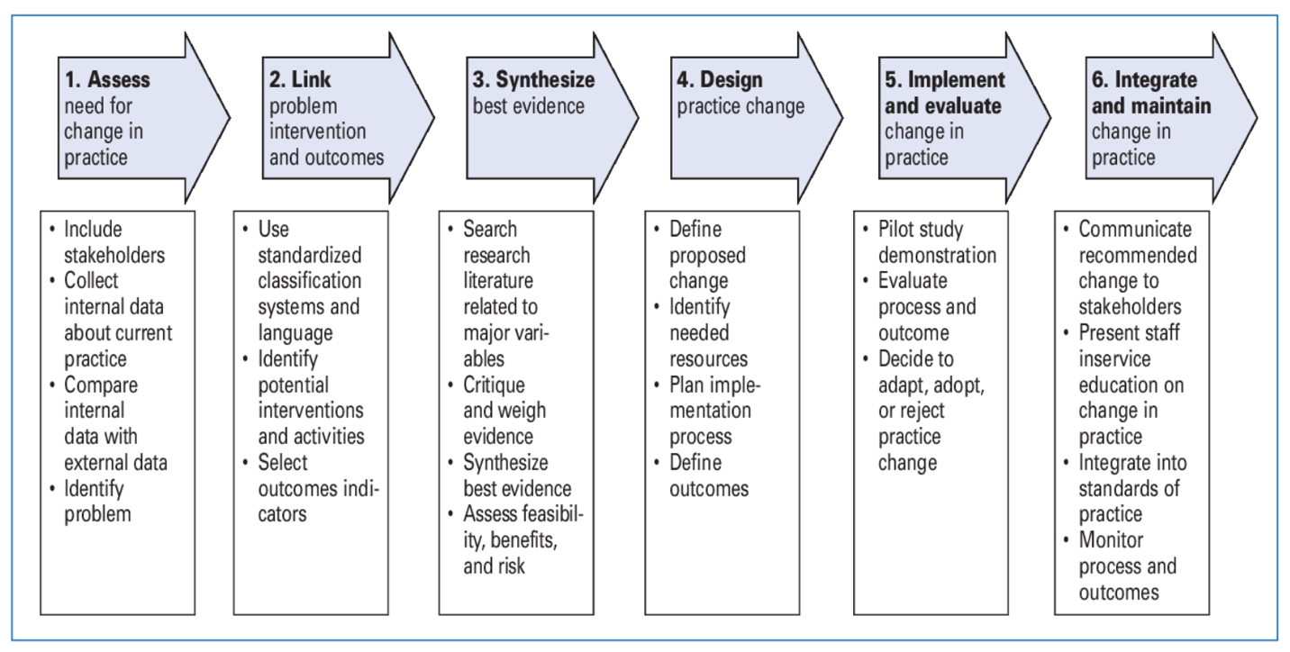
Figure 1: Theoretical Framework
Methodology
Setting and Participants
This study will focus on the RNs and APRNs in the ATC in the Department of Transplantation and Cellular Therapy at University of Miami Sylvester Comprehensive Cancer Center in Miami, Florida. All RNs and APRNs, full-time, part-time, per-diem, will be recruited to participate in this quality improvement project via convenience sampling. Medication reconciliation is an important aspect in delivering healthcare, and in the ambulatory setting it is completed with every patient encounter. This allows for a high number of opportunities to evaluate the medication reconciliation process in the short-time period that is allotted for this pilot study. The sample size also favors the opportunity to collect precise data given that some data would be collected manually in the allotted time for this pilot study.
Procedures
This study is of a quasi-experimental research design. All participants belong to the intervention group; there is no control group and no randomization. The participants will have pre-/post-intervention evaluation for data collection (Dang & Dearholt, 2018). An education presentation will be implemented to impact the compliance of completing medication reconciliation and reduce the number of medication discrepancies in patients’ medication lists. Participants will be recruited via convenience sampling, the staff that is currently provided care in the ATC within the Department of Transplantation and Cellular Therapy at the University of Miami Sylvester Comprehensive Cancer Center. An e-mail communication describing the educational presentation along with the project’s objectives will be provided. Each staff member will be presented with the opportunity to participate and provide informed consent as applicable. Each participant will answer a pre-test assessing their knowledge of the medication reconciliation process. The primary investigator will provide the intervention to all participants. Following the intervention, each participant will answer a post-test assessing their knowledge of the medication reconciliation process. After the completion of the intervention, data will be collected measuring compliance with completion and attestation of medication reconciliation, and medication discrepancies noted in patients’ medication lists.
Participant Recruitment
All RNs and APRNs that work in the ATC will be asked to participate in the study. Information regarding the pilot study will be disseminated via e-mail communication. Details of the pilot study to be shared with the candidates include a brief introduction of the problem and its consequences, the purpose of the study, the intervention being evaluated, and the timeframe expected for completion.
Data Collection
Demographic data will be collected through the pre-intervention questionnaire. Participants will answer questions regarding their age, sex, languages spoken, and years of experience. Participants will be completing a pre- and post- questionnaire that will assess their knowledge of the medication reconciliation process. These tests will be provided via Qualtrics. Tests will be scored and compared before and after the intervention to evaluate the effectiveness of the intervention in knowledge of medication reconciliation.
Other data to be collected will be provided by the university’s information technology (IT) department pre- and post-intervention. A project request with the university was submitted for assistance in collecting reports available in the EMR platform, EPIC, that measure outcomes of interest: completion of medication history and attestation of medication reconciliation. Other outcomes of interest will be collected manually by the primary investigator, these include medication discrepancies.
Data Analysis
To analyze the effectiveness of the education presentation, the following data will be analyzed prior to the intervention and then after the intervention was implemented: questionnaire scores, compliance of medication reconciliation by the RN, attestation of medication reconciliation by the APRN, and medication discrepancies in the patients’ medication lists provided in the AVS. Since this is a pilot study, statistical significance will be reported. When analyzing the different types of discrepancies identified, chi square testing will be used.
Protection of Human Subjects
The pilot study received Institutional Review Board (IRB) approval at Florida International University (FIU). The pilot study does not pose any harm or risk to the participants, therefore a request for exemption will be submitted. Participation in this pilot study is voluntary, and informed consent will be obtained from each participant. All participant information will be kept confidential and secured using password protected technology. Participants will be given a random identification number to track participation, pre- and post-intervention evaluation.
Data Management
Data will be stored within the provided cloud-storage solution provided by Florida International University Information Technology (IT) department, OneDrive. This cloud-storage is password protected and requires multi-factor authentication via Duo. Once the project is completed, the data will be deleted from OneDrive. Each participant will be assigned an identification number for tracking of pre- and post-intervention questionnaires, and check-off assessments.
Results
Demographics of the Study Population
The sample consisted of 7 RNs and 14 APRNs. Demographics included 17 females and 4 males; 7 were between the ages of 18-30 years, 10 were between the ages of 31-40 years, 2 were between the ages of 41-50 years, and 2 were between the ages of 51 years and older; 3 identified themselves as Caucasian, 6 as African Americans, and 12 as Hispanics; all 21 participants speak/write/read English fluently, 11 of them speak/write/read Spanish fluently, and 3 of them speak/write/read Creole fluently. In terms of years of experience in their role, 7 reported they had been in their role for 0-5 years, 10 reported they had been in their role for 6-10 years, 1 reported they had been in their role for 11-15 years, 2 reported they had been in their role for 16-20 years, and 1 reported they had been in their role for 20 years or more.

Diagram 1. Participants’ years of experience in their role.
Survey
Twenty-one (n=21) surveys were completed. The survey assessed five categories: the participants’ knowledge of 1) current organizational policy, requirement, and reporting on/of medication reconciliation, 2) polypharmacy, 3) care of the post- allogeneic HSCT adult patient, 4) medication reconciliation process, and 5) medication discrepancies.
The first set of questions on the pre/post-intervention survey sought to evaluate the participants’ knowledge of the organization’s medication reconciliation policy and their belief if medication reconciliation is standardized at the organization. The survey showed that most participants, 19 out of 21 (90.4%), reported the organization had a policy addressing the medication reconciliation process, however only 8 (38%) had read it. The pre- and post- intervention survey showed all participants reported that medication reconciliation is a Joint Commission requirement. The pre-intervention survey showed twenty participants reported that both the RN and APRN were responsible for medication reconciliation, however following the intervention eighteen reported this same response. Twelve participants reported that medication reconciliation was standardized at the organization, while 9 reported that it was not. Following the intervention, this number decreased with only 6 participants reporting that medication reconciliation was not standardized. There was no statistical significance in the first set of questions (p= .329) pre/post intervention.

Diagram 2. Summary of survey answers regarding current organizational policy, requirement, and reporting on/of medication reconciliation.
The second set of questions sought to evaluate the participants’ knowledge of polypharmacy. The pre-intervention survey showed: 16 out of 21 correctly defined polypharmacy; 17 out of 21 correctly identified high risk populations for polypharmacy; and 18 out of 21 correctly identified consequences of polypharmacy. Following the intervention, all participants correctly defined polypharmacy and identified consequences of polypharmacy. However, there was a decrease in correctly identifying high risk populations for polypharmacy; 2 participants identified healthy adults as high risk, while 3 failed to identify allogeneic HSCT adult patients and 1 failed to identify patients with comorbidities. There was no statistical significance in the second set of questions (p= .649) pre/post intervention.

Diagram 3. Summary of survey answers regarding polypharmacy.
The third set of questions sought to evaluate the participants’ general knowledge of medication regimens in the post-allogeneic HSCT adult patient. The pre-intervention survey showed: all participants correctly reported that post-allogeneic HS adult patients experience polypharmacy, take medication that require monitoring of therapeutic ranges, and have the potential for drug-drug interactions; 19 out of 21 correctly described the medications regimens as complex and frequently changing, while only 2 described them as complex. Following the intervention, 20 out of 21 correctly described the medications regimens as complex and frequently changing, while only 1 described them as complex. There was no statistical significance in the third set of questions (p= .329) pre/post intervention.

Diagram 4. Summary of survey answers regarding medications in the post-ALLO HSCT care setting.
The fourth set of questions sought to evaluate the participants’ knowledge of the medication reconciliation process. The pre-intervention survey showed: 20 out of 21 correctly identified what medications are included in the medication reconciliation process, all the participants correctly identified what information is obtained during the medication history interview; and 5 out of 21 correctly ordered the steps of the medication reconciliation process. Following the intervention, all participants correctly identified what medications are included in the medication reconciliation process, but more notably12 out of 21 correctly ordered the steps of the medication reconciliation process, an increase of 33.3%. There was no statistical significance in the fourth set of questions (p= .329) pre/post intervention.

Diagram 5. Summary of survey answers regarding medication reconciliation process.
The last set of questions sought to evaluate the participants’ knowledge on medication discrepancies. The pre-intervention survey showed: 18 out of 21 correctly defined medication discrepancy, and 20 out of 21 correctly identified the different types of medication discrepancies. Following the intervention, the number of participants correctly defining medication discrepancy decreased from 18 to 9 out of 21. However, all participants post-intervention correctly identified the different types of medication discrepancies correctly. There was a statistical significance in the last set of questions (p= .002) pre/post intervention.

Diagram 6. Summary of survey answers regarding medication discrepancy.
Post-Intervention Check Off Assessment
The post-intervention check off assessment’s goal was to determine the extent to which the educational intervention was transitioned into clinical practice. Only six of the 7 RNs were available for check off assessment. All RNs (n=6) completed each item on this assessment successfully: 1) each patient was interviewed regarding current medications he/she were taking, 2) medications’ name, dose, frequency, and route were documented on the medication history list, 3) medications were marked as “taking” or “not taking”, and 4) the medication history list was marked as complete at the conclusion of the medication history interview process. There was a 100% compliance amongst the registered nurses’ role in the medication reconciliation process.
Out of the 14 APRNs included in the study, seven of them are full-time, outpatient. These seven outpatient APRNs completed the post-intervention check off assessment (n=7). Five out of seven APRNs completed each item on this assessment successfully: 1) medication list was reviewed by the APRN with the patient, 2) new medications were prescribed (as applicable), 3) adjustments/discontinuation of medications were documented in the medication list (as applicable), 4) final medication list was reviewed by the APRN, 5) medication reconciliation attestation was completed. In two encounters the APRN did not adjust the dose of a medication he/she had decreased at the time of the patient visit on the patient’s medication list. In addition, in one of those encounters the APRN did not attest that medication reconciliation was completed at the time of the patient visit. Further qualitative studies in indicated to assess barriers in completing the medication reconciliation process.
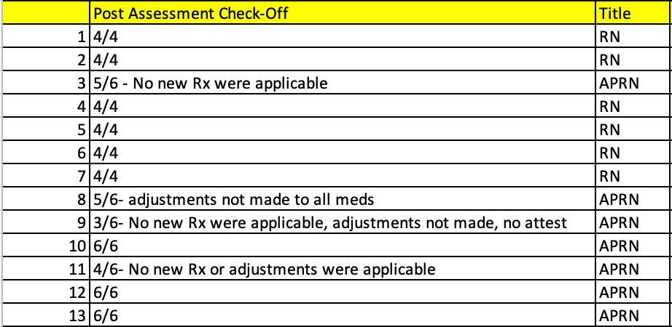
Table #1. Post assessment check off results.
Chart Audits
One hundred and thirty-eight charts were reviewed prior to and post the intervention. The charts were reviewed to determine if 1) medication history was completed by the RN, 2) medication attestation was completed by the APRN, and 3) if the patient was provided with an AVS at the time of discharge. Medication history was completed with a reported frequency of 95.7% pre- and post- intervention. Medication attestation was completed with a reported frequency of 71.7% pre-intervention, and 73.2% post-intervention. The AVSs were provided to the patients with a reported frequency of 46.4% pre-intervention, and 44.9% post-intervention. There was no statistical significance noted in the completion of medication history (p= 1.000), medication attestation (p= 0.890), and AVS (p= 0.902).
Discussion
This quality improvement project aimed to determine whether an educational intervention would lead to increase compliance of completing the medication reconciliation process by both RNs and APRNs, and a decrease in medication discrepancies in patients’ medication lists provided at the end of each encounter. A total of 21 participants were recruited into the pilot study, complete the pre- and post-intervention surveys, and watched an education presentation on medication reconciliation. Six RNs and 7 APRNs were then evaluation in the clinical setting for skills pertaining to their role in the medication reconciliation process. The results fail to reject the null hypothesis. There was no significant improvement in the dependent variables examined in the survey; in fact, one area saw a decrease in knowledge that was reported as significant. Despite these results, there is evidence of lack of knowledge and need/room for improvement.
Limitations
Initially one of the objectives of the study was to examine the quality of the medication reconciliation process by examining the medication discrepancies (if any) in the patients’ AVS. However, this was not feasible to do retrospectively. This data would have provided valuable information on the quality of medication reconciliation by examining if medication lists at the end of the patient encounter was correct when compared to the assessment/plan of the APRN.

Implications for Advanced Practice Nursing
In 2005, the Joint Commission identified medication reconciliation as one of the 2005 National Patient Safety Goals. This called for all organizations to “accurately and completely reconcile medications across the continuum of care”. The following year, all accredited organizations were required to “implement a process for obtaining and documenting a complete list of patient’s current medication upon the patient’s admission to the organization and with the involvement of the patient” and to communicate “a list of the patient’s medications to the next provider of service when a patient is referred or transferred to another setting, service, practitioner or level of care within or outside the organization” (Agency for Healthcare Research and Quality [AHRQ], 2019). The tools necessary to meet this goal are in place within this organization, however, this study’s purpose was to determine if these tools were being utilized optimally and if the outcome was producing quality care.
The core feature is the medication process being standardized into a workflow that can be completed by a medical assistant, a licensed practical nurse, an RN, etc. The same concept applies to the APRN role, as this role in the medication reconciliation can be completed by a clinician role such as a physician assistant or physician. Cross-training staff within their scope will ensure that medication reconciliation gets completed even if staff shortage is present. This process can then be translated into standard of care/guideline for the ambulatory setting.
This quality improvement project highlights deficiencies in the medication reconciliation process. It also demonstrates variation in existing knowledge of the medication reconciliation process. Despite the educational presentation, there was no significant improvement with compliance. It is known that medication reconciliation programs can help reduce medication errors, but the effectiveness of such programs has not been established (Gonzalez-Carrascosa Vega et al., 2016). Further investigation is needed to determine the best platform for educating RNs and APRNs in the medication reconciliation process. Qualitative research is also needed to address barriers to the process despite clinicians having the needed knowledge.
Conclusion
Medication reconciliation is a process that is globally recognized as an important patient safety measure. It plays a major role in improving patient outcomes and decreasing healthcare costs. Numerous studies and systematic reviews have been conducted to determine the best way to complete medication reconciliation, and what effect medication reconciliation has on patient care and outcomes. Within patients with polypharmacy, medication reconciliation can be complex and a daunting process for the clinical staff caring for the patient. Polypharmacy and complex medication regimens are a commonality within the allo-HSCT patient, placing them at high risk for medication errors, ADEs, and DDIs. For this reason, it is important to evaluate the medication reconciliation process within this patient population and explore opportunities that would prevent medication errors from occurring. It is important that the clinical providers understand how to properly conduct a medication reconciliation on a patient and document appropriately to ensure patients’ medication lists are correct.

References
Agency for Healthcare Research and Quality. (2019, September 7). Medication Reconciliation. https://psnet.ahrq.gov/primer/medication-reconciliation
Aghajani, M. H., Ghazaeian, M., Mehrazin, H. R., Sistanizad, M., & Miri, M. (2016). Errors related to medication reconciliation: a prospective study in patients admitted to the post ccu. Iranian Journal of Pharmaceutical Research, 15(2), 599-604. https://www.ncbi.nlm.nih.gov/pmc/articles/PMC5018288/
Alghanem, S. S., Bayoud, T., Taher, S., Al-Hazami, M., Al-Kandari, N., & Al-Sharekh, M. (2022). Introduction of an ambulatory care medication reconciliation service in dialysis patients: positive impact on medication prescribing and economic benefit. Journal of Patient Safety, 18(2), e489-e495. https://doi.org/10.1097/PTS.0000000000000853
American Nursing Credentialing Center. (n. d.). ANCC magnet recognition program. https://www.nursingworld.org/organizational-programs/magnet/
Anderson, R., & Ferguson, R. (2020). A nurse practitioner-led medication reconciliation process to reduce hospital readmissions from a skilled nursing facility. Journal of the American Association of Nurse Practitioners, 32(2), 160-167. https://doi.org/10.1097/JXX. 0000000000000264
Bajeux, E., Alix, L., Cornee, L., Barbazan, C., Mercerolle, M., Howlett, J., Cruveilhier, V., Line-Iehl, C., Cador, B., Jego, P., Gicquel, V., Schweyer, F. X., Marie, V., Hamonic, S., Josselin, J. M., Somme, D., & Hue, B. (2022). Pharmacist-led medication reconciliation at patient discharge: a tool to reduce healthcare utilization? an observation study in patients 65 years or older. BMC Geriatrics, 22, 1-13. https://doi.org/10/1186/s12877-022-03192-3
Chiewchantanakit, D., Meakchai, A., Pituchaturont, N., Dilokthornsakul, P., & Dhippayom, T. (2020). The effectiveness of medication reconciliation to prevent medication error: a systematic review and meta-analysis. Research in Social and Administrative Pharmacy, 16, 886-894. https://doi.org/10.1016/j.sapharm.2019.10.004
Dang, D. & Dearholt, S. L. (2018). John Hopkins nursing evidence-based practice: model and guidelines (3rd ed.). Sigma Nursing.
Elbeddini, A., Almasalki, S., Prabaharan, T., Tran, C., Gazarin, M., & Elshahawi, A. (2021). Avoiding a med-wreck: a structured medication reconciliation framework and standardized auditing tool utilized to optimize patient safety and reallocate hospital resources. Journal of Pharmaceutical Policy and Practice, 14(10), 1-10. https://doi.org/10.1186/s40545-021-00296-w
Halli-Tierney, A. D., Scarbrough, C., & Carroll, D. (2019). Polypharmacy: evaluating risks and deprescribing. https://www.aafp.org/pubs/afp/issues/2019/0701/p32.html
Hron, J. D., Manzi, S., Dionne, R., Chiang, V. W., Brostoff, M., Altavilla, S. A., Patterson, A., & Harper, M. B. (2015). Electronic medication reconciliation and medication errors. International Journal for Quality in Health Care, 27(4), 314-319. https://doi.org/ 10.1093/intqhc/mzv046
Ice, L. L., Bartoo, G. T., McCullough, K. B., Wolf, R. C., Dierkhising, R. A., Mara, K. C., Jowsey-Gregoire, S. G., Damlaj, M., Litzow, M. R., & Merten, J. A. (2020) A prospective survey of outpatient medication adherence in adult allogeneic hematopoietic stem cell transplantation patients. Biology of Blood and Marrow Transplantation, 26(9), 1627-1634. https://doi.org/10.1016/j.bbmt.2020.05.020
Joint Commission. (2021). National Patient Safety Goals. Joint Commission. https://www.jointcommission.org/-/media/tjc/documents/standards/national-patient-safety-goals/2022/npsg_chapter_hap_jan2022.pdf
Joint Commission (2021a). Improving the medication reconciliation process. The Source, 19(7), 7-11. https://store.jcrinc.com/assets/1/7/TS_19_2021_07.pdf
Jones, L. K., Hayduk, V., Romagnoli, K. M., Flango, A., Marks, J., Graham, J., & Gionfriddo, M. R. (2022). Evaluation of an education strategy to improve medication reconciliation in ambulatory care. Journal of the American Pharmacists Association, 62, 1179-1188. https://doi.org/10.1016/j.japh.2022.01.010
Kern, E., Dingae, M. B., Langmack, E. L., Juarez, C., Cott, G., & Meadows, S. K. (2017). Measuring to improve medication reconciliation in a large subspecialty outpatient practice. The Joint Commission Journal on Quality and Patient Safety, 43, 212-223. https://doi.org/10/1016.j.jcjq.2017.02.005
Lea, M., Barstad, I., Mathiesen, L., Mowe, M., & Molden, E. (2016). Effect of teaching and checklist implementation on accuracy of medication history recording at hospital admission. International Journal of Clinical Pharmacy, 38, 20-24. https://doi.org/ 10.1007/s11096-015-0218-9
Lermontov, S. P., Brasil, S. C., & de Carvalho, M. R. (2019). Medication errors in the context of hematopoietic stem cell transplantation. Cancer Nursing, 42(5), 365-372. https://doi.org/10.1097/NCC.0000000000000613
Lester, P. E., Sahansra, S., Shen, M., Becker, M., & Islam, S. (2019). Medication reconciliation: an educational module. MedEdPORTAL, Article 15:10852. https://doi.org/10.15766/mep_2374-8265.10852
Lombardi, D. N., & Slonim, A. D. (2014). Manual of Healthcare Leadership: Essential Strategies for Physician and Administrative Leaders. McGraw Hill. https://accessmedicine-mhmedical-com.access.library.miami.edu/content.aspx?bookid=957&sectionid=53481389
Mardani, A., Griffiths, R., & Vaismoradi, M. (2020). The role of the nurse in the management of medicines during transitional care: a systemic review. Journal of Multidisciplinary healthcare, 13, 1347-1361. https://doi.org/10/2147/JMDH.S276061
Marvin, V., Kuo, S., Poots, A. J., Woodcock, T., Vaughan, D. B. (2016). Applying quality improvement methods to address gaps in medicines reconciliation at transfers of care from an acute UK hospital. BMJ Open, Article 6:e010230. https://doi.org/10.1136/bmjopen-2015-010230
McDonald, D., Mansukhani, R., Kokotajlo, S., Diaz, F., & Robinson, C. (2018). Effect of nursing education on optimization of medication reconciliation in the pediatric emergency department. The Journal of Pediatric Pharmacology and Therapeutics, 23(3), 203-208. https://doi.org/10.5863/1551-6776-23.3.203
Morrison, C. F., Martsolf, D. M., Wehrkamp, N., Tehan, R., & Pai, A. L. H. (2017). Medication adherence in hematopoietic stem cell transplantation: a review of the literature. Biology of Blood and Marrow Transplantation, 23, 562-568. https://doi.org/10.1016. j.bbmt.2017.01.008
Najafzadeh, M., Schnipper, J. L., Shrank, W. H., Kymes, S., Brennan, T. A., & Choudhry, N. K. (2016). Economic value for pharmacist-led medication reconciliation for reducing medication errors after hospital discharge. The American Journal of Managed Care, 22(10), 654-661. https://www.ajmc.com/view/economic-value-of-pharmacist-led-medication-reconciliation-for-reducing-medication-errors-after-hospital-discharge
National Institute of Health. (2019, June 24). NCI-designated cancer centers. https://www.cancer.gov/research/infrastructure/cancer-centers
Rosswurm, M. A., & Larrabee, J. H. (1999). A model for change to evidence-based practice. The Journal of Nursing Scholarship, 31(4), 317-322.
Rouen, P. (2019). Aligning, design, method, and evaluation with the clinical question. In K. Moran, R. Burson, & D. Conrad (Eds.)., The doctor of nursing practice project (3rd ed., pp. 154-185). Jones & Bartlett Learning.
Russ, C. M., Stone, S., Treseler, J., Vincuilla, J., Partin, L., Jones, E., Chu, E., Currier, D., & Kelly, D. P. (2020). Quality improvement incorporating a feedback loop for accurate medication reconciliation. Pediatrics, 146(6), Article e20192464. https://doi.org/10.1542/peds.2019-2464
Tamblyn, R., Abrahamowicz, M., Buckeridge, D. L., Bustillo, M., Foster, A. J., Girard, N., Habib, B., Hanley, J., Huang, A., Kurteva, S., Lee. T. C., Meguerditchian, A. N., Moraga, T., Motulski, A., Petrella, L., Weir, D. L., & Winslade, N. (2019). Effect of an electronic medication reconciliation intervention on adverse drug events. JAMA Network Open, 2(9), Article e1910756. https://doi.org/10.1001/jamanetworkopen.2019.10756
University of Miami Health Systems. (n.d.). Mission, vision, and values. https://umiamihealth.org/en/sylvester-comprehensive-cancer-center/about-sylvester/mission,-vision-,-a-,-values
Gonzalez-Carrascosa Vega, T., Sierra-Sanchez, J. F., Martinez-Bautista, M. J., Garcia-Martin, F., Suarez-Carrascosa- F., & Baena-Canada, J. M., (2016). Medication reconciliation in oncological patients: a randomized clinical trial. Journal of Managed Care & Specialty Pharmacy, 22(6), 734-740.
White, K. M. (2019). Evidence-based practice. In. K. M. White, S. Dudley-Brown, & M. F. Terhaar (Eds.), Translation of evidence into nursing and healthcare (3rd ed., pp. 3-25). Springer Publishing Company.

Appendix A
Literature Matrix
First Author/Year | Purpose/ Problem/ Objective/ Aims | Study Design | Sample (Setting) | Data Collection Measures | Results | Strengths/ Limitations | Relationship to Project | Level of Evidence/ Quality Ranking
Anderson (2019) | Quality improvement project implementing APRN-led MR to reduce readmission rate to hospital | Pre & post | Skilled nursing facility (SNF) | Rate of MR completion within time frame. Rate of readmission to hospital within 30 days. | Hospital readmission rate decreased. | No data collection when APRN was not scheduled because no one else did the MR. Small sample size. | MR educational training to APRNs | Level II  Grade B
Holt (2018) | Assess effectiveness of implementing a MR process | Pre & post | Internal medicine (IM) clinic | Rate & type of errors. Number of MR completed. | MR performed by nursing staff increased. The number of MR completions did not match the number of patients seen in the clinic reflecting lack of compliance. | No data collection regarding physician/advanced practice provider (APP) completion of MR. Not all stakeholders were on board with intervention. Frequent staff changing due to new incoming medication residents. EPIC (EMR) tool does not guarantee that MR took place. Only 12% of patient data was captured. | MR educational sessions to nursing staff | Level II  Grade C
Kern (2017) | Standardize MR process and set up a measure to capture MD in the daily workflow. | Interrupted time series | 2 subspecialty outpatient clinics within a hospital/large health care system | Rate of MR attestation. Rate & type of MR error. Number of patients received printed reconciled medication list. Number of patients received medication safety handout. | Attestation of MR completion increased. Number of patients who received printed reconciled medication list increased. MR errors decreased.  Number of patients who received medication safety handout varied but was overall improved. | Physicians and RNs were not required to attend educational intervention. Baseline assessment on several measures were not available because the measure was the actual intervention: this limited causality inference. There was some loss in interim data due to lack of communication with the IT team. It is only a single center study in the ambulatory setting. | MR education to clinic team | Level II  Grade B
Lea (2016) | Investigate the effect of teaching & checklist implementation on accuracy of MR at hospital admission | Pre & post | IM ward | Number of medication discrepancies | No significant reduction in medication discrepancies | Lack of compliance of intervention. Implementation model was not optimal. Lack of control group and randomization. | Teaching lesson to physicians and nurses on MR. Checklist tool to be used in the ER. | Level II Grade C
Lester (2019) | Improve knowledge of MR | Pre & post | Health care organization | Correct answers on knowledge assessment test. | Increase in knowledge and high perception by participants would improve their future MR efforts | Did not match each individual for testing results in comparing individual knowledge gained by attending educational session. More preintervention assessments than postintervention assessments. | Instructional method via PowerPoint to teach the importance of MR | Level II  Grade B
Marvin (2016) | Improve documentation of reliable MR | Pre & post/mixed | Acute hospital | Reduce MR discrepancies. Improve MR documentation. Improve communication of changes to medication in hospital discharge summary. | All measures indicate sustained improvement. | Unable to show causality but suggest a link between pharmacist involvement and decrease in errors. | MR education to staff. Introduction of | Level II  Grade B
McDonald (2018) | Evaluate impact of education on MR | Pre & post | Pediatric emergency department (ED) | Distribution & type of medication discrepancies. | Identification of discrepancies decreased, and completeness of MR improved. | Inability to quantify the clinical impact of discrepancy identification, potential for harm was not measured. Convenience sampling was used due to time constraint. | Education to nurses on MR | Level II  Grade C
Russ (2020) | Quality improvement project to reduce errors in admission medication reconciliation (MR) | Pre & post | Pediatric intermediate care unit (IMCU) | Rate of admission MR errors | MR error decreased | Minimal data was collected from night shift. Certain medications were excluded. Patients who were transferred into IMCU were excluded. | MR educational training to APRNs and RNs | Level II  Grade B

Appendix B
IRB Approval Letter
Appendix C

Informational Letter
Effectiveness of standardized medication reconciliation education on provider’s compliance and medication discrepancies in an ambulatory clinic caring for post-allo HSCT patients: A quality improvement project
You have been chosen to be in a research study about improving medication reconciliation and patient medication safety. The purpose of this quality improvement project is to improve patient medication safety by educating the registered nurses (RNs) and advanced practice registered nurses (APRNs) on medication reconciliation in an Ambulatory Treatment Clinic (ATC) that cares for adult allo-HSCT patients. If you decide to be in this study, you will be one of fifteen people in this research study. Participation in this study will take approximately 30-45 minutes of your time. If you agree to be in the study, I will ask you to do the following things:
- Complete an online pre-test evaluating your knowledge on medication reconciliation, followed by watching a 10-minute voice-over PowerPoint presentation on medication reconciliation, and immediately after completing an online post-test on medication reconciliation.
- Complete an in-person check off assessment on the medication reconciliation process.

There are no foreseeable risks or benefits to you for participating in this study. It is anticipated that the intervention will lead to increase compliance of completing the medication reconciliation process by both RNs and APRNs, and a decrease in medication discrepancies in patients’ medication lists provided at the end of each encounter.
There is no cost or payment to you. If you have questions while taking part, please stop me and ask. You will remain anonymous.
If you have questions for one of the researchers conducting this study, you may contact the primary investigator Dana Sherman, DNP, ARNP, ANP-BC at (305) 348-2247, FNP-BC or Meilin Diaz-Paez ARNP, MSN, DNP student at (786) 763-9914.
If you would like to talk with someone about your rights of being a subject in this research study or about ethical issues with this research study, you may contact the FIU Office of Research Integrity by phone at 305-348-2494 or by email at ori@fiu.edu or by mail at 11200 SW 8th Street, AH3-522, Miami, Florida 33199.
Your participation in this research is voluntary, and you will not be penalized if you refuse to participate or decide to stop. By clicking the button below, you acknowledge that your participation in the study is voluntary, you are 18 years of age, and that you are aware you may choose to terminate your participation in the study at any time and for any reasons.
Appendix D
Educational Presentation
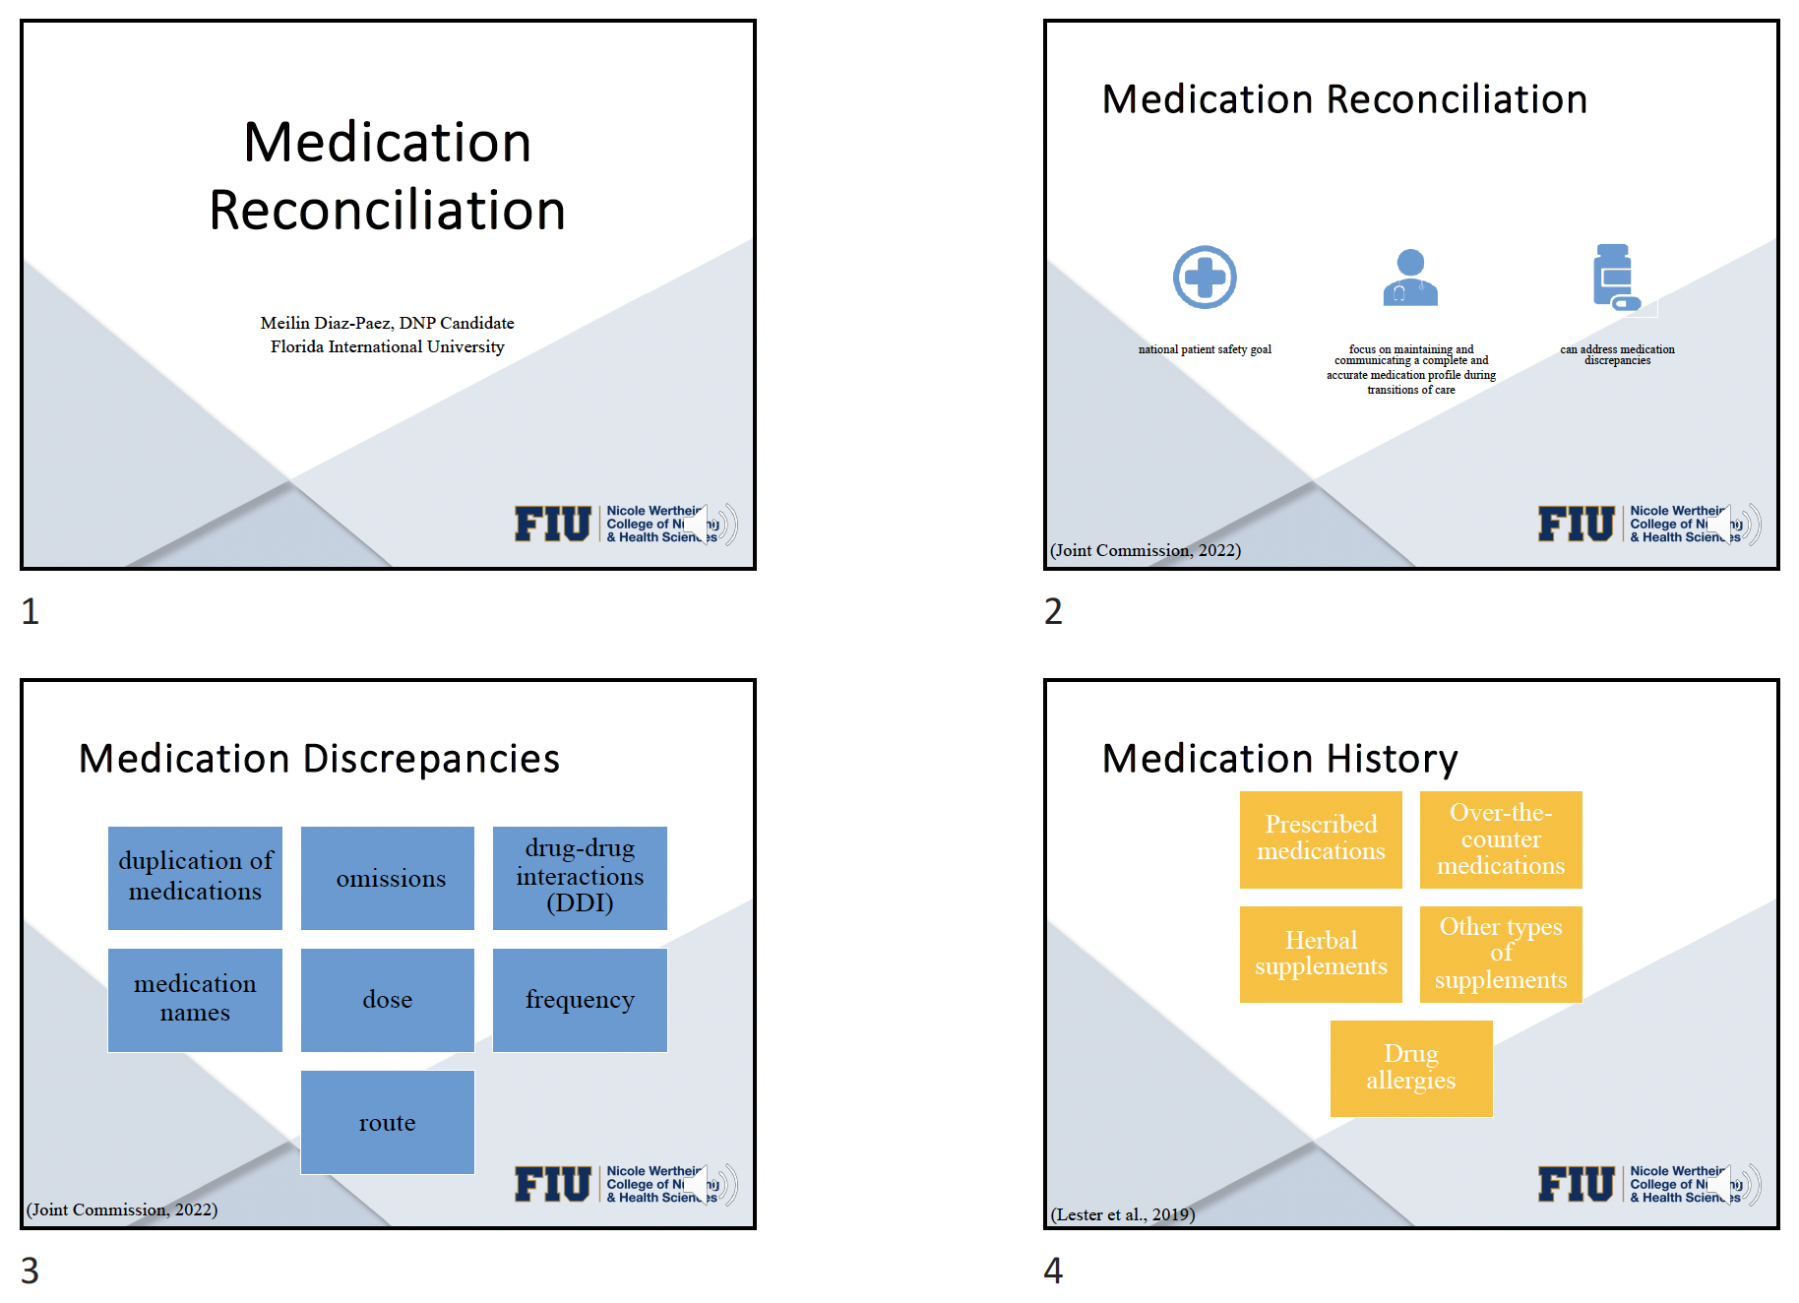
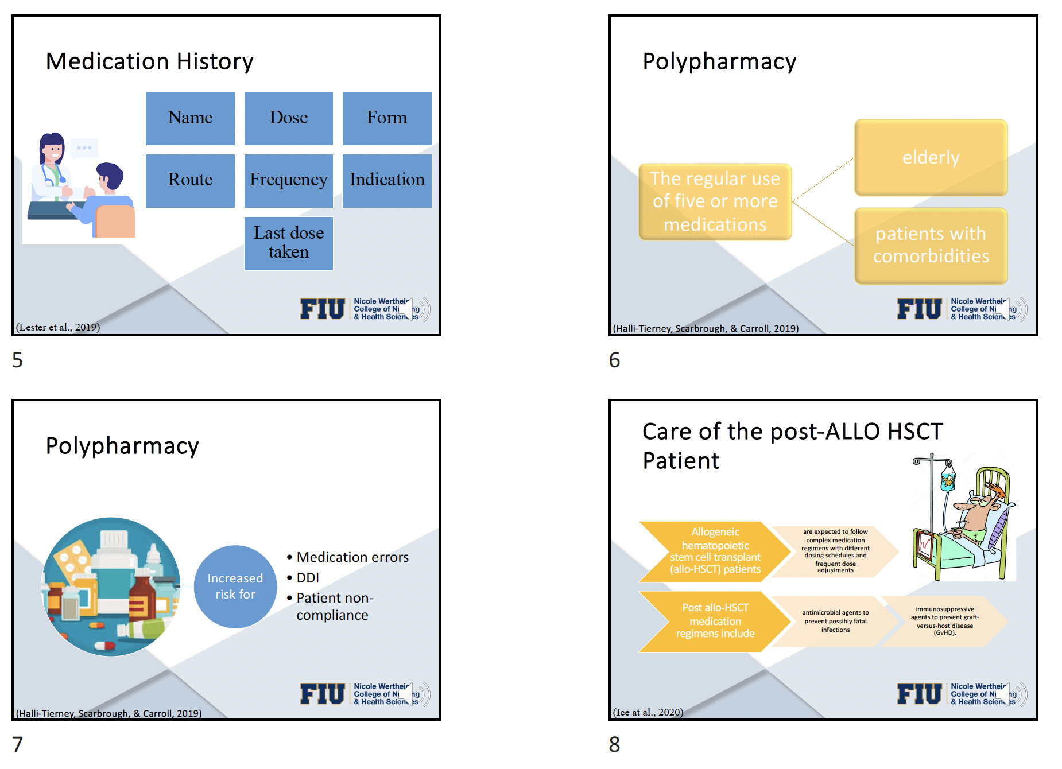
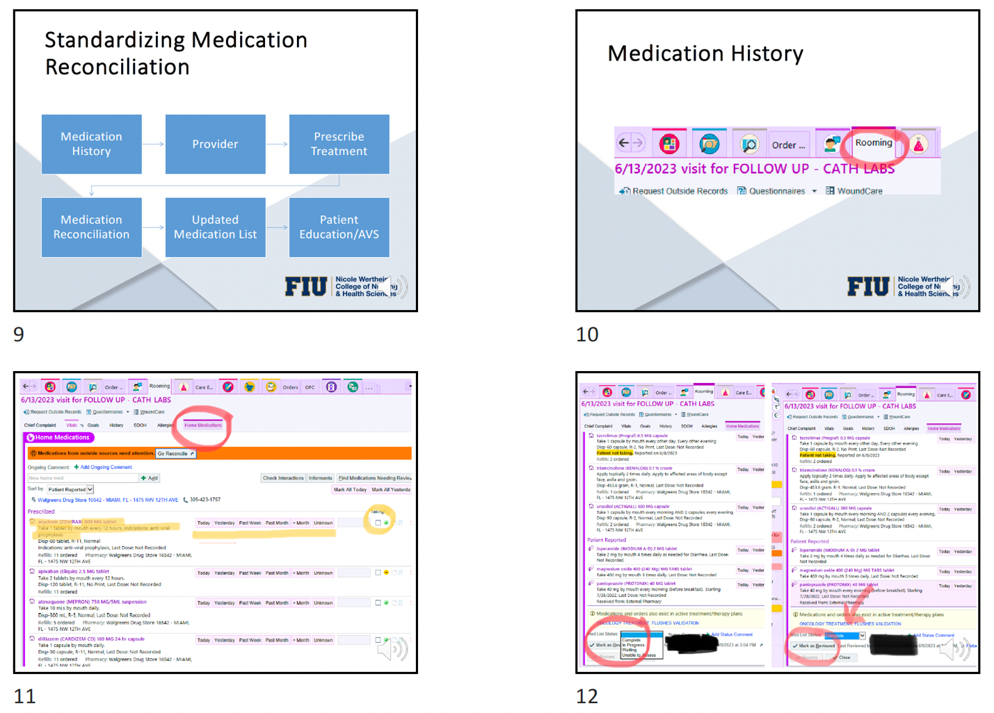
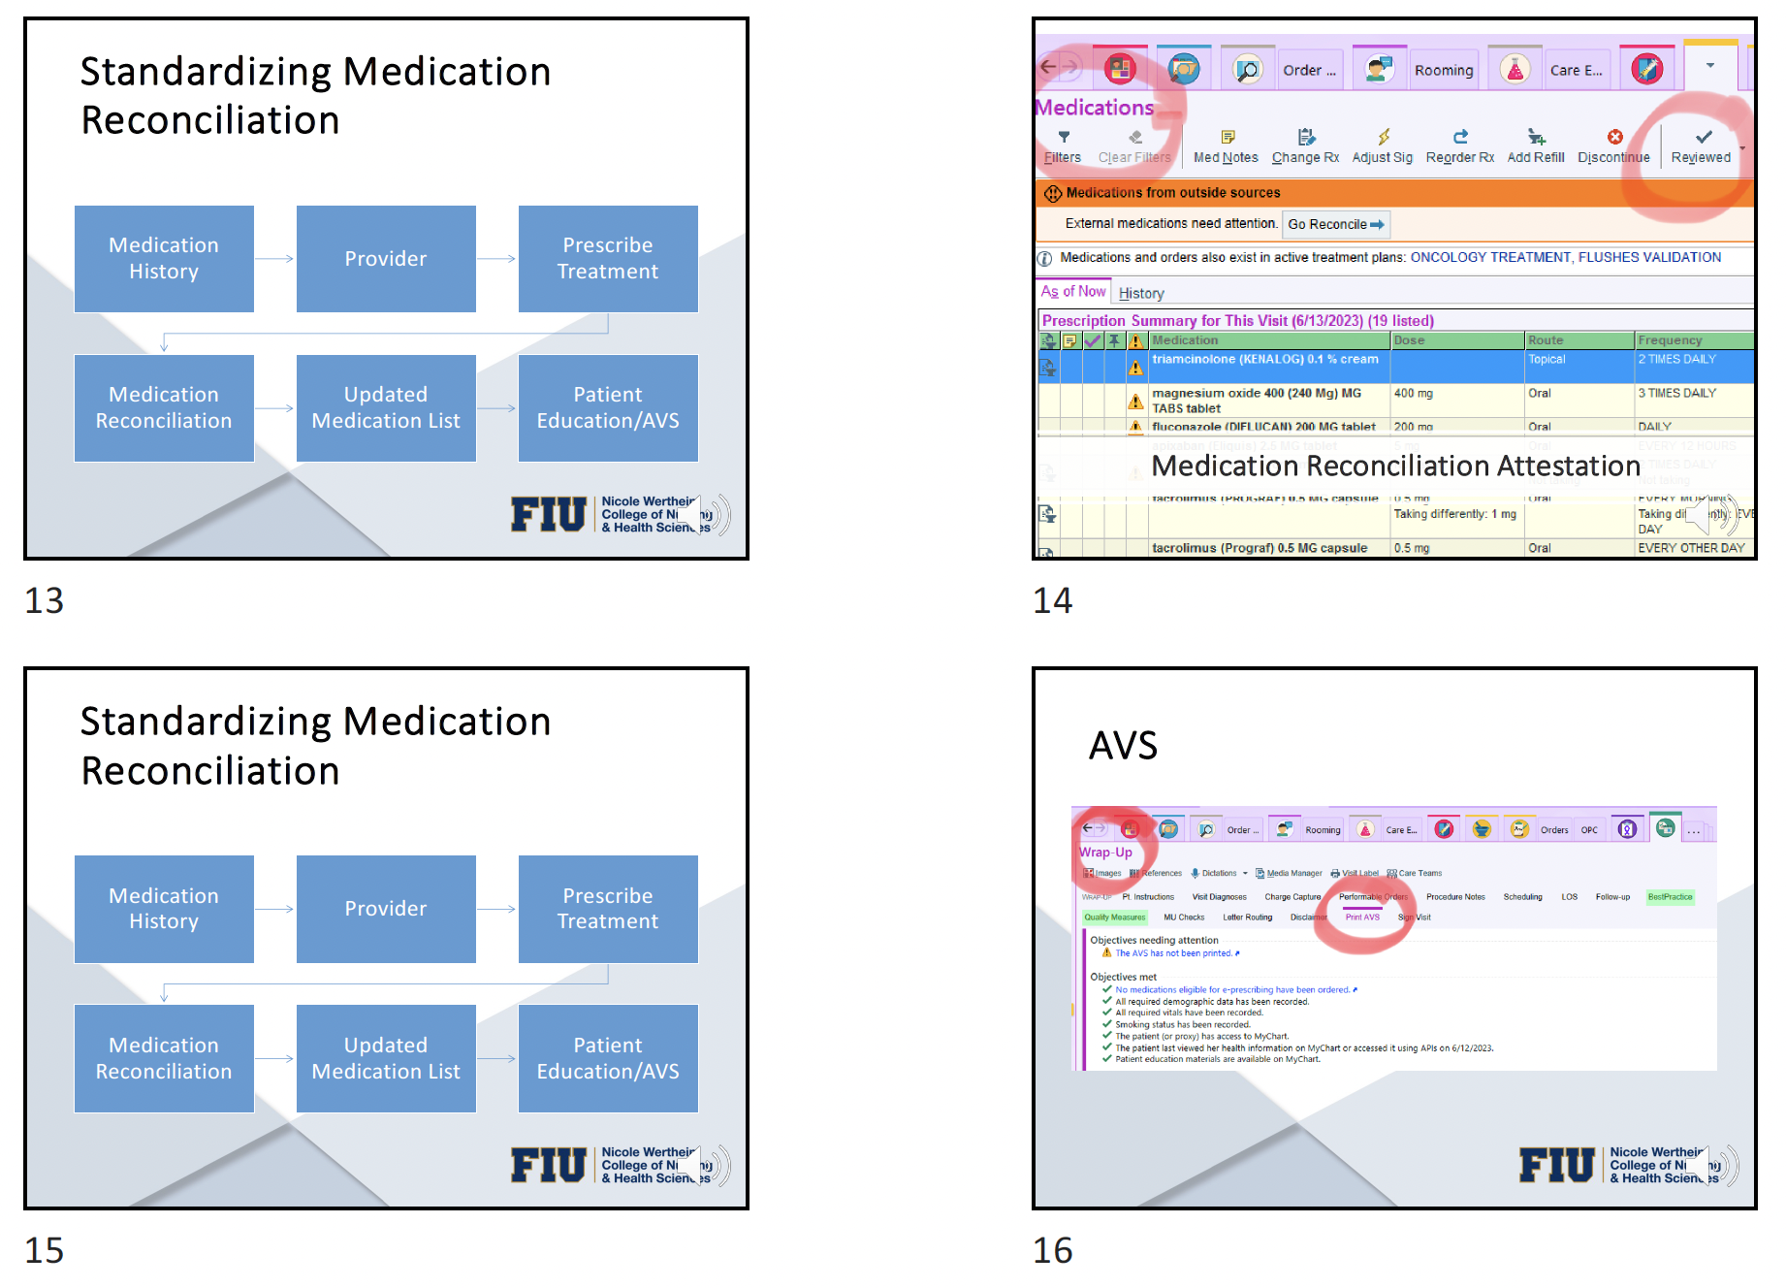
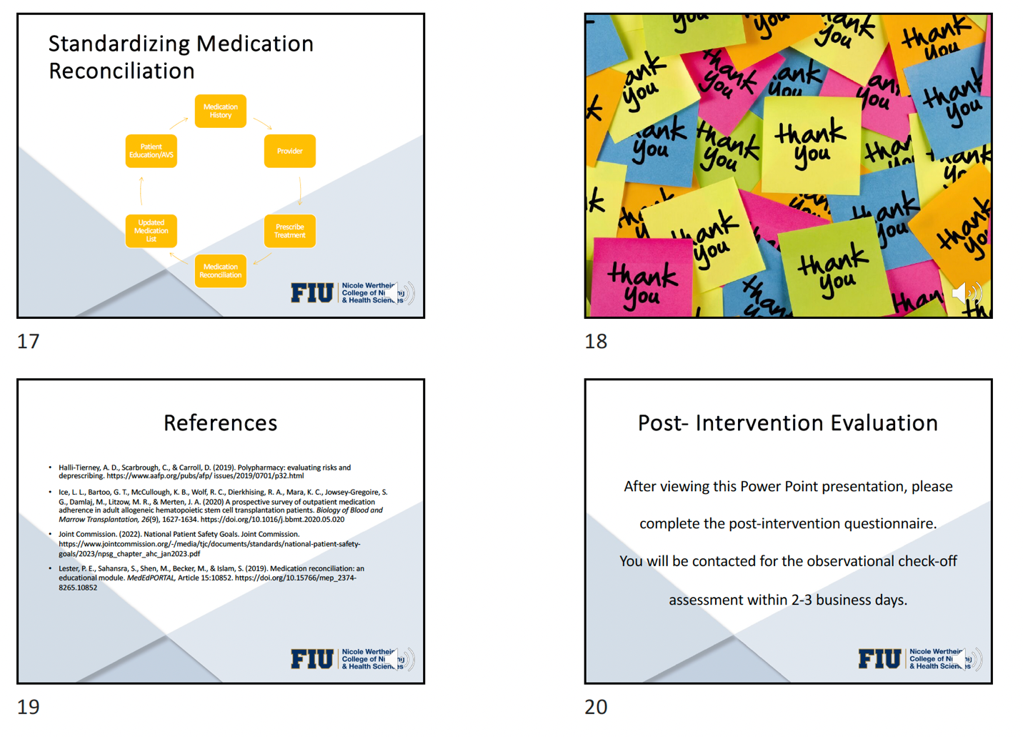

Appendix E
Questionnaire
Demographic:
Gender: Female ____ Male ____ Other ____ Do not wish to disclose ____
Age: 18-30 yrs. ____ 31-40 yrs. ____ 41-50 yrs. ____ >50 yrs. ____
Ethnicity: Caucasian ____ African American ____ Hispanic ____ Asian ____ Other ____
Languages Spoken Fluently (Spoken/Written/Reading): English ____ Spanish ____ Creole
What is your title? RN ____ APRN ____
How long have you been an RN or APRN? 0-5 yrs. ____ 6-10 yrs. ____11- 15 yrs. ____ 16-20 yrs. ____ >20 yrs. ____
Pre & Post Questionnaire:
Current Organizational Policy, Requirement, & Reporting
- Does your organization have a policy addressing medication reconciliation process in your setting? Yes ____ No ____ If Yes, have you read it? Yes ____ No ____ N/A ____
- Is medication reconciliation a Joint Commission requirement? Yes ____ No ____
- Who is responsible for medication reconciliation?
  - RN
  - APRN
  - Both
- Do you feel medication reconciliation is standardized at your organization?
Yes ___ No ____

Medication Reconciliation Process
- What medications are included in the medication reconciliation process? Select all that apply. Prescribed ____ Over-the-counter ____ Herbs/Supplements ____
- What information is obtained during the medication history interview?
  - Current medications the patient is prescribed
  - Medication name, dose, route, frequency
  - Is the patient currently taking the medication or not
  - All the above

- Place the steps of the medication reconciliation process in order (1-5)
____ Patient is provided with a printed medication list
____ Patient’s medication history is obtained
____ Provider prescribes/adjust/discontinues medications
____ Patient medication history is compared to provider’s plan
____ A new medication list is created
Medication Discrepancies
- What is a medication discrepancy?
  - An error in the patient medication list
  - Patient not taking medication as prescribed
  - Patient taking too many medications
- What are the different types of medication discrepancies?
  - Wrong Medication
  - Omitted medications
  - Duplicate medications (same route)
  - Medications with drug-drug interactions
  - Any incorrect/omitted information such as dose, frequency, route
  - All the above

Polypharmacy
- What is polypharmacy?
  - Patient gets their medication from more than one pharmacy
  - Patient takes 1-2 medications
  - Patients takes 5 or more medications
- Who is at high risk for polypharmacy? Select all that apply.
  - Elderly
  - Patient with comorbidities
  - An allogeneic HSCT patient
  - Healthy adult
- What are some consequences of polypharmacy? Select all that apply.
  - None
  - Drug drug interactions
  - Organ toxicity
  - Medication error
  - Patient Non-compliance

Care of the post-ALLO HSCT adult patient
- Does the post-ALLO HSCT adult patient experience polypharmacy? Yes ____ No ___
- Does the post-ALLO HSCT adult patient take medications that require monitoring of therapeutic ranges? Yes ___ No ___
- Does the post-ALLO HSCT adult patient take medications that have the potential for drug-drug interactions? Yes ____ No ____
- How would you describe the medication regimen for the post-ALLO HSCT Patient?
  - Simple
  - Complex
  - Stable
  - Frequently changing
  - A & C
  - B & D

Appendix F

Check Off Assessment
Medication History (RN)
- Patient is interviewed regarding current medication he/she is taking
- Medication name, dose, frequency, route is documented
- Medication is marked as taking or not taking
- Medication history is marked as complete
Reconciliation of Medications (APRN)
- Medication list is reviewed by provider with the patient
- New medications are prescribed (if applicable)
- Adjustments or discontinuation of medications are documented in the medication list
- Medication is list is reviewed by the provider
- Medication list is marked as reviewed by the provider
- AVS is printed and provided to the patient

Appendix G
Support Letter from Facility
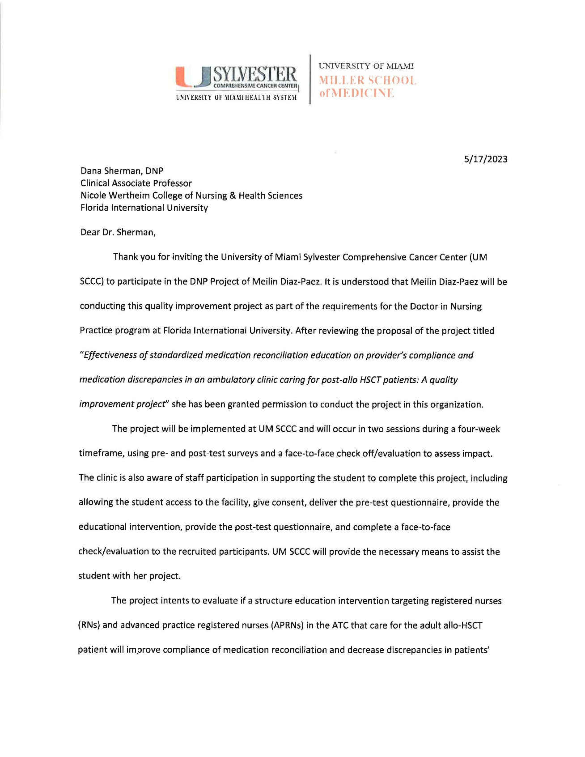
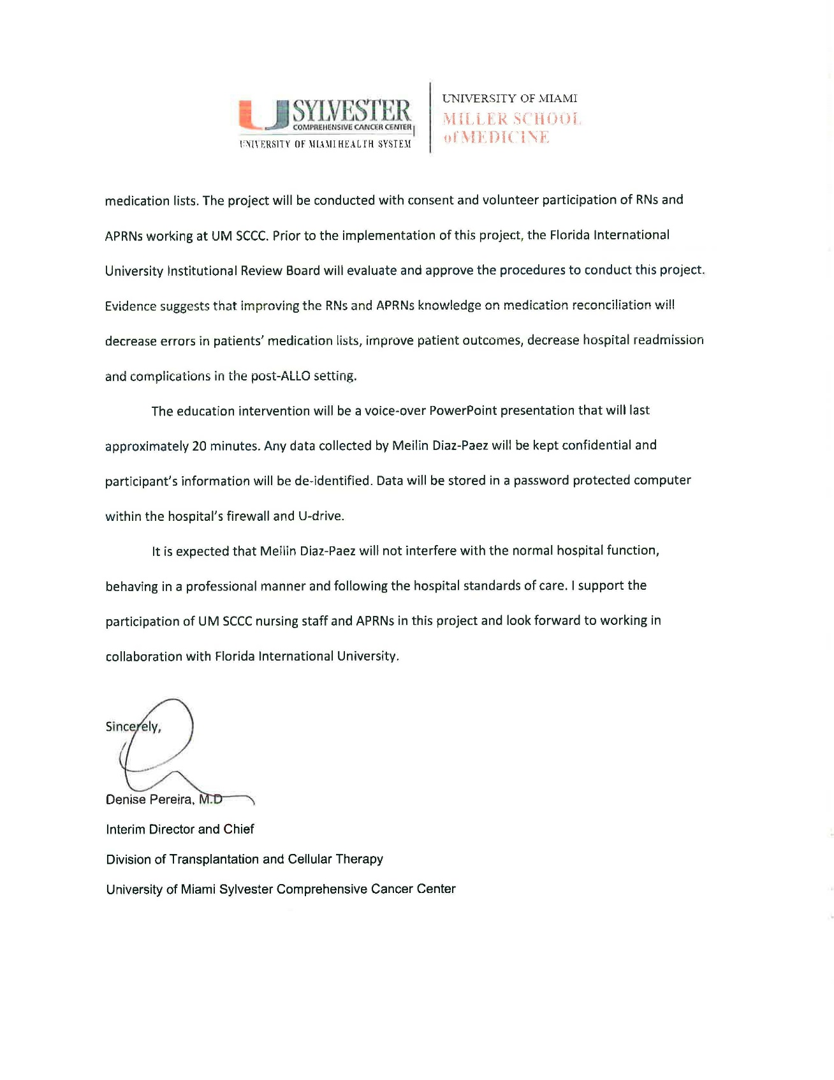

Appendix H
Pre-Intervention Survey Results
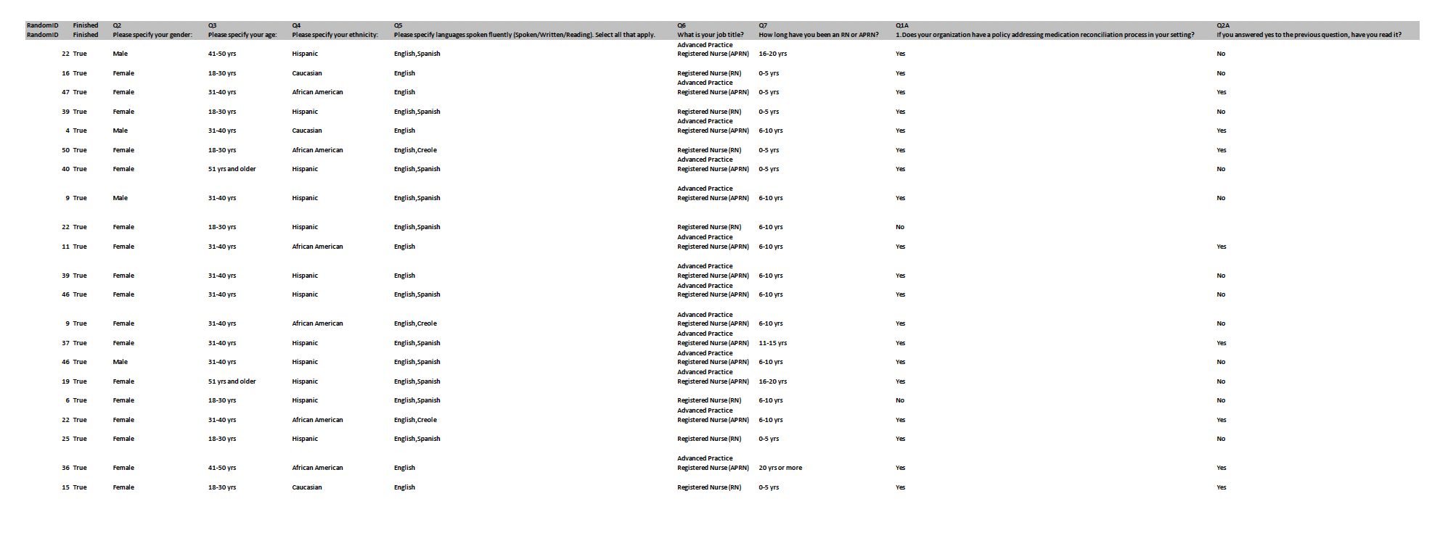
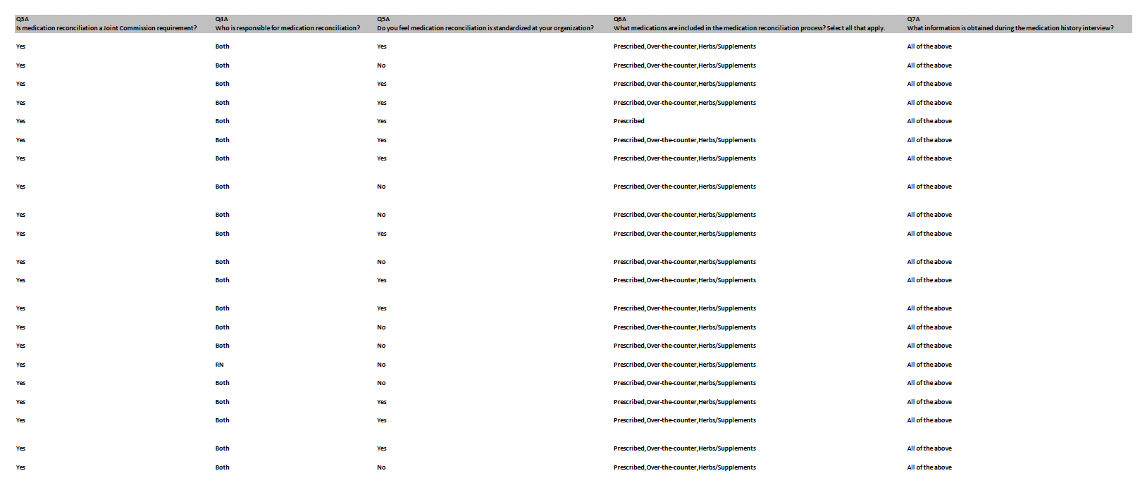
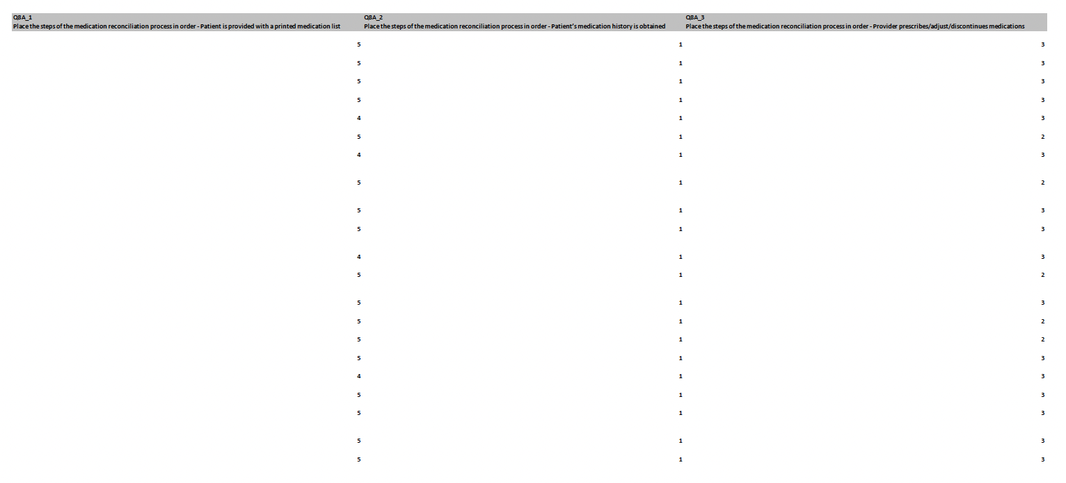
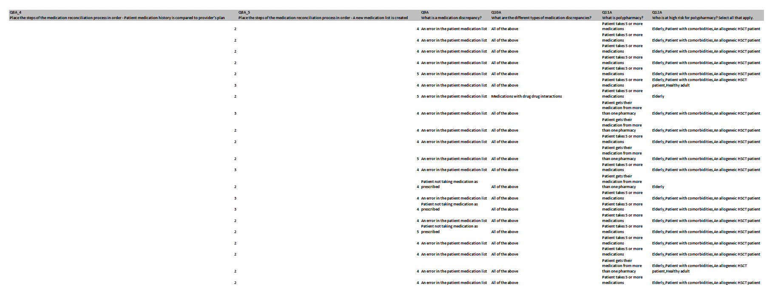
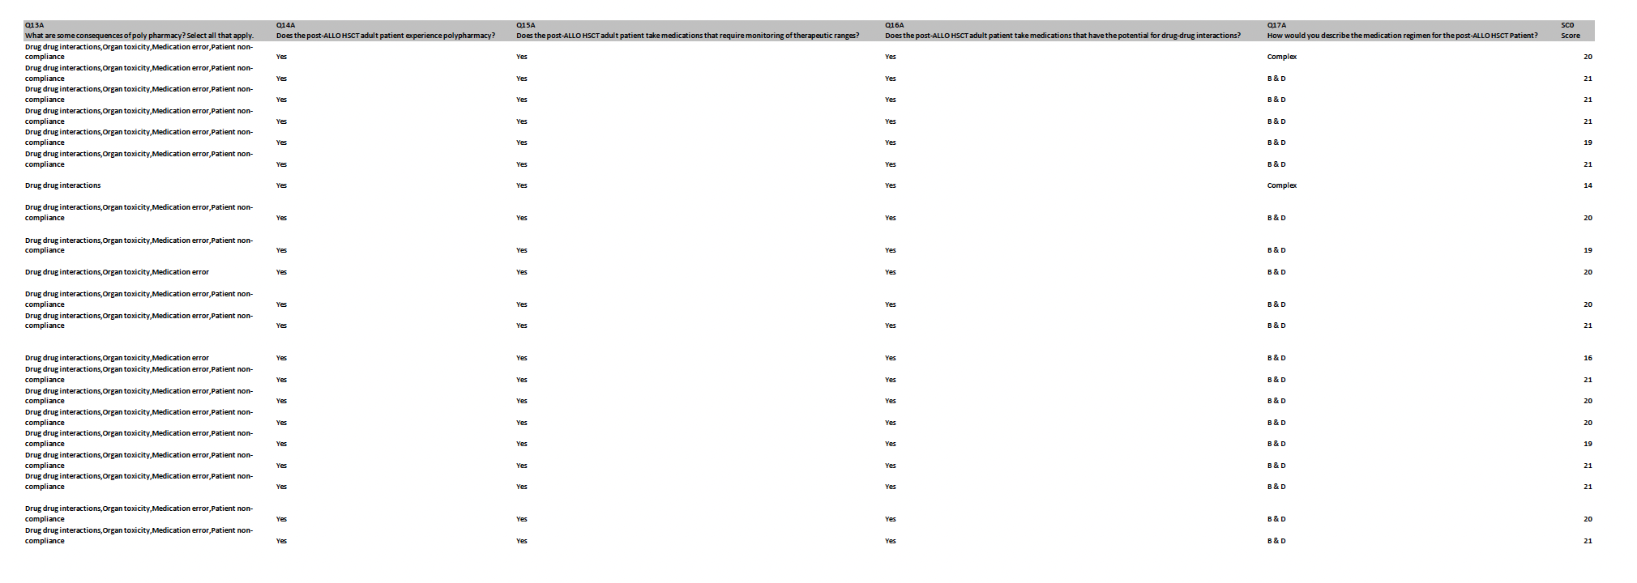

Appendix I
Post-Intervention Survey Results
