Introduction

In recent years the international media is full of stories on rising tide of immigrant workers in the global system, their struggles, trials and tribulations, and the widespread repression and hostility they face everywhere from authoritarian states and racist publics. Some of the stories from around the world that have made headlines are: the crisis, largely contrived, of Central American child migration and the fiasco of “comprehensive immigrant reform” in the United States; the rising tide of racist violence against immigrant workers in North America, Europe, Israel and elsewhere; the tragedy of thousands of Africans drowning in the Mediterranean as they attempt to reach Europe; pogroms against Southern African immigrant workers in South African cities; and the suicide of dozens of internal immigrant workers in China’s coastal sweatshops, among others. Everywhere, borders are militarized, states are stepping up repressive anti-immigrant controls, and native publics are turning immigrants into scapegoats for the spiraling crisis of global capitalism. Yet everywhere, there is the rise of immigrant justice movements and workers’ fight-backs in which immigrant workers play a pivotal and often leading role.
As we shall discuss in this article, the massive displacement and primitive accumulation unleashed by free trade agreements and neo-liberal policies, as well as state and “private” violence has resulted in a virtually inexhaustible immigrant labor reserve for the global economy. In turn, repressive state controls over immigration and migrant labor have several functions for the system. First, state repression and criminalization of undocumented immigration make these immigrants vulnerable and deportable, and therefore subject to conditions of super-exploitation, super-control and hyper-surveillance. Second, anti-immigrant repressive apparatuses and social control systems are themselves ever more important sources of accumulation, ranging from private, for-profit immigrant detention centers, to the militarization of borders, and the purchase by states of military hardware and systems of surveillance. Third, the anti-immigrant policies associated with repressive state apparatuses help turn attention away from the crisis of global capitalism among more privileged sectors of the working class, such as middle layers in the global South or white workers in the North, and convert immigrant workers into scapegoats for the crisis, thus deflecting attention from the root causes of the crisis and undermining working class unity.
The story of immigrant labor in the twenty-first century is therefore absolutely central to that of the new global capitalism and also to that of the struggles of the global working class for justice and emancipation. This article will reflect on a portion of this story with a particular focus on structural and historical underpinnings of the phenomenon of immigrant labor in the new global capitalist system and on the United States as an illustration of the larger worldwide situation with regard to migration and immigrant justice.

Capitalism, the World Labor Market, and Migration/Immigration

Perhaps the most pressing problem the capitalist system faces is how to secure a politically and economically suitable supply of labor. But what does securing “suitable” labor mean? In the first place, it means uprooting people from their land and other means of livelihood, or what is known as primitive accumulation, so that they have no other choice but to work for capital if they want to survive. Second, it means generating a large enough pool of labor so that this pool can be dipped into as needed and later these same workers can be disposed of when not needed. Third it means generating the means and conditions to deploy that labor wherever it is needed around the world. Finally, it means developing systems of repression and ideological hegemony to assure that workers are tightly controlled, disorganized, disciplined and obedient.
Central to the formation of the world capitalist system was the creation of a world market in labor. Securing this politically and economically suitable labor supply has historically been a key function of colonialism and imperialism. Dominant groups have created and constantly recreated this market in over the past five centuries of world capitalism through the most violent and destructive processes imaginable. As figure one shows, the formation of a world market in labor has involved such mechanisms as: the kidnapping and forced removal of some 20 million Africans to the New World: the internal transfer in this New World of tens of millions of indigenous populations; the displacement from their lands of millions of European peasants by the forces of capitalist expansion and their migration around the world as laborers; and the so-called second slavery from the 1870s into the 1930s of millions of “coolie” labor from India and China who, under the weight of colonialism, found themselves displaced, dispossessed and swept up by international labor recruiters by hook and crook to build railroads or work plantations in Africa, Asia and the Western hemisphere.

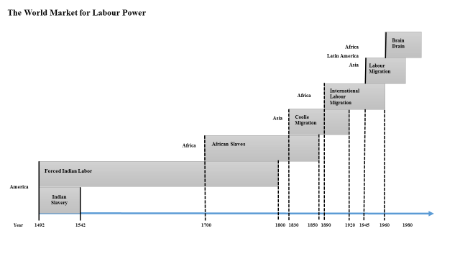
Source: Lydia Potts, The World Labor Market.

This creation of a world labor market is simultaneously the history of migration, and is the history of the racialization of global class relations through the creation by dominant groups of racial and ethnic hierarchies within the labor pools that the system has brought into being and sustained over the 500 years of its existence. If migration/immigration has thus been central to the creation of the world capitalist system, today it is just as crucial to the reproduction of the new global capitalism. However, under capitalist globalization a new global immigrant labor supply system has come to replace earlier direct colonial and racial caste controls over labor worldwide. There is a new global working class that labors in the factories, farms, commercial establishments and offices of the global economy – a working class that faces conditions of precariousness, is heavily female, and for the purposes of this article, is increasingly based on immigrant labor.
The rise of new systems of transnational labor mobility and recruitment have made it possible for dominant groups around the world to reorganize labor markets and recruit transient labor forces that are disenfranchised and easy to control. The latter decades of the twentieth century began a period of massive new migrations worldwide. The United Nations, in a low-end estimate, suggested that there were some 200 million immigrant workers worldwide in 2005, double the figure from 1980. The International Labor Organization then put the figure for 2014 at 232 million. Moreover, these figures do not take into account the tens of millions of Chinese who have migrated from the interior of that country to the coastal cities to work in the industrial sweatshops that now serve as the leading workshop of the world, and who constitute in the practice an immigrant workforce as a result of Chinese internal pass and residency laws, known as the hukou system.
Historically immigrant labor has flowed from the colonized regions to the metropolitan countries. Still today, as figure two shows, major transnational migrant flows are from Latin America and Asia into North America, from Africa, the Middle East and South Asia into Europe, and so on – that is, from the traditional peripheries to the traditional cores of the world capitalist system. However, that pattern is rapidly changing. Now we see that major axes of accumulation in the global economy attract immigrant labor from neighboring regions. Intense transnational corporate activity, wherever it takes place in the new global economy - from the factories along China’s southern coastal belt, to the South African mines and farms, the Middle East oil meccas, and Costa Rica’s service industry – become magnets drawing in immigrant workers. And wherever these workers end up they face the same conditions: relegation to low-paid, low status jobs, the denial of labor rights, political disenfranchisement, state repression, racism, bigotry, and nativism.

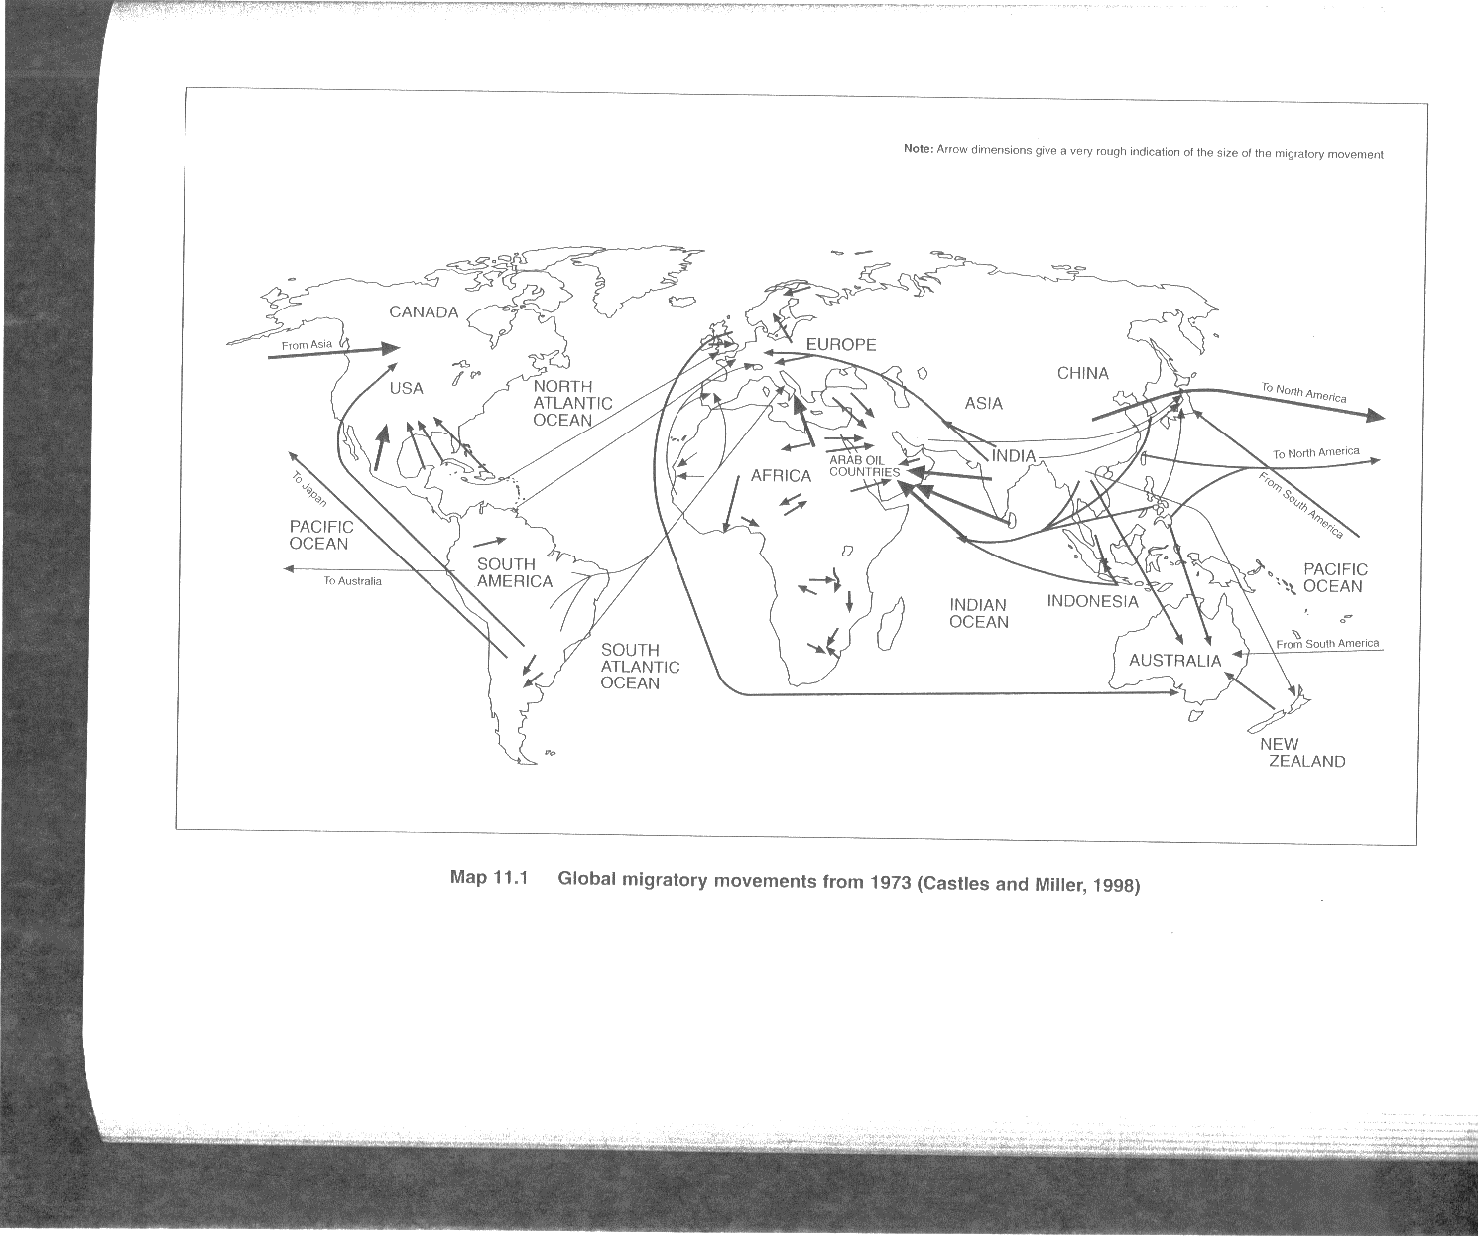
Source: Castles and Miller, The Age of Migration.

Nicaraguans migrant to Costa Rica, Bolivians to Argentina, Peruvians to Chile, Southern and Central Africans to South Africa, Indians, Pakistanis and Sri Lankans to the Middle East oil producers, Indonesians to Malaysia and Myanmar to Thailand. Israel has recently become a major importer of transnational immigrant labor from Asia and North Africa (this is a particularly attractive option for Israel because it does away with the need for politically troublesome Palestinian labor). Over 300,000 immigrant workers from Thailand, China, Nepal and Sri Lanka now form the predominant labor force in Israeli agribusiness in the same way as Mexican and Central American immigrant labor does in U.S. agribusiness, and under the same precarious conditions of super-exploitation and discrimination. The Philippines presents an extreme case: the Philippine government and private recruitment firms organize the export of Philippine workers to some 200 countries around the world. These labor migrations are not voluntary in the sense that the structural violence of the system is what forces people to migrate. It is important to see transnational immigrant labor therefore as a form of coerced labor.
Once they arrive at their destinations, undocumented immigrants join the ranks of a super-exploitable labor force available for transnational corporations, local employers, and native middle classes. It is often said that while capital has torn down national barriers to its global mobility and it is now free to cross borders at will – and this is quite true – it is also true that labor is globally mobile, not it the sense that it can freely cross borders but in the sense that in the practice the structural conditions of capitalist globalization not only make possible but actually facilitate the worldwide deployment of immigrant labor as needed by capital worldwide. Immigrant workers are globally mobile, but under conditions of extreme repressive control over the movement and over their very existence. Borders and the international state system are essential for capitalist domination over workers and the creation and reproduction of a global reserve army of immigrant workers.

Globalization and the Creation of “Immigrant Labor”

Global capitalism is characterized by a number of fundamental changes in the capitalist system that have implications for how we understand the role of labor and the struggle for social justice. Among these changes is the rise of truly transnational capital and the integration of every country into the new system of globalized production, finances, and services and the rise of a transnational capitalist class (TCC). The TCC is a new class group grounded in global over local or national circuits of accumulation and which, together with transnationally-oriented state bureaucrats and politicians, is the manifest agent of capitalist globalization.
Capital responded to the worldwide structural crisis of the 1970s by “going global” in an attempt to break through the constraints that the nation-state – that is, the working and popular classes operating at the nation-state level – placed on accumulation. These working and popular classes were unwilling to shoulder the burden of the crisis and so long as they could pressure states to place constraints on capital they could sustain a stand-off with capital that generated “stagflation,” a decline in profits, and a growing political and ideological crisis of hegemony. In response, dominant groups called for a vast restructuring of world capitalism. With the election of Ronald Reagan in the United States and Margaret Thatcher in Britain they launched the “neo-liberal counterrevolution” as an offensive against working and popular classes everywhere, involving the dismantling of developmentalist, socialist, and redistributve projects.
The global mobility of capital associated with globalization allowed the TCC to break free of nation-state constraints to accumulation as it has restructured the world economy, fragmented production and the labor process and altered the correlation of class and social forces in its favor, at least in the momentary historic conjuncture of the late 20th and earlier 21st centuries. Free trade agreements and neo-liberal policies have displaced hundreds of millions of people around the world and generated a vast pool of under- and unemployed labor thrown into the global labor market.
As a result, the TCC has been able to forge a new capital-labor relation based on the “flexibilization” or “Walmartization” of labor. Under this new modality of flexible labor, workers no longer enjoy the protection of state regulation of the capital-labor relation. They face conditions of deunionization, are informalized, casualized, part-time, contract and temporary. Workers have increasingly become a commodified input into production just as any other raw material. They can be hired and fired at will and enjoy no stability, what many are now referring to the new “precariate” or the proletariat that labors under conditions of permanent insecurity and precariousness. Crucial to the new labor relations of global capitalism is the elimination of any reciprocity between capital and labor; capital bears no responsibility for the social reproduction of labor, on the one hand, and on the other, the state abandons redistributive policies that recirculates value back to labor in the form of the social wages and instead subsidizes capital.
These new class relations of global capitalism have been made possible in part by capital’s newfound mobility and in part by the dramatic expansion of the global superfluous population – that portion marginalized and locked out of productive participation in the capitalist economy and constituting some one-third of humanity. This mass of “supernumeraries” is of no direct use to capital. However, in the larger picture such surplus labor is crucial to global capitalism insofar as it places downward pressure on wages everywhere – especially to the extend that global labor markets can be tapped and labor can be mobilized throughout the global economy – and allows transnational capital to impose discipline over those who remain active in the labor market.
There is a broad social and political base, therefore, for the maintenance of a flexible, super-controlled and super-exploited immigrant labor pools. The system cannot function without it. But if global capital needs the labor power of transnational migrants, this labor power belongs to human beings who must be tightly controlled, given the special oppression and dehumanization involved in extracting their labor power as non-citizen immigrant labor. The state must play a balancing act by finding a formula for a stable supply of cheap labor to employers and at the same time for greater state control over immigrants. The dilemma for capital, dominant groups, affluent and privileged strata become how to assure a steady supply of immigrant labor while at the same time promoting anti-immigrant practices and ideologies. The instruments for achieving the dual goals of super-exploitability and super-controllability are: 1) the division of the working class into immigrant and citizen, and; 2) racialization and criminalization of the former. In this way race and class converge. Racialization is an instrument in the politics of domination.
Criminalization and militarization increasingly drive undocumented immigrants around the world underground, where they become vulnerable to intermediaries in the quest for survival, such as gangs, drug traffickers, sexual exploitation, shady temporary labor agencies, and unscrupulous employers. The array of state and other institutional controls over immigrants further drive down black and informal market wages, working and living conditions and give employers an ever freer hand. At the same time, borders, in order to be effective instruments for regulating and controlling the supply of immigrant labor, must be militarized. The U.S.-Mexico border, for instance, is one of the most militarized stretches of land in the world, with 10 guards for every mile for the length of the 2,000-mile border. Many stretches along the frontier are akin to a war zone.
A key point here is that the globalization of production, finances, and services has increased transnational capital’s ability to fragment labor markets in each locale and to create and reproduce new forms of labor market segmentation at the trans-border level. There are particular institutional arrangements through which this worldwide deployment of immigrant labor occurs: “immigrant labor” is created by states as a distinct juridical category of labor. State policies make this category of labor distinct from native (citizen) labor. This is a major new axis of inequality worldwide. In this age of globalization, the creation of these two distinct categories of labor around the world (“immigrant” and “citizen”) constitutes a new, rigid caste system that has become central to the global economy and worldwide capital accumulation.
State controls over immigrant labor and the denial of civil, political, and other citizenship rights to immigrant workers are intended not to prevent but to control the transnational movement of labor and to lock that labor into a situation of permanent insecurity and vulnerability. The global working class thus becomes divided between “citizen” and “immigrant” labor. The creation of these distinct categories (“immigrant labor”) replaces earlier direct colonial and racial caste controls over labor worldwide. The struggle of immigrant workers is therefore at the cutting edge of popular struggles worldwide against the depredations of global capitalism.
The super-exploitation of an immigrant workforce would not be possible if that workforce had the same civil, political and labor rights as citizens, if it did not face the insecurities and vulnerabilities of being undocumented or “illegal.” Granting full citizenship rights to the hundreds of millions of immigrants and their families would undermine the division of the global working class into immigrants and citizens. Reproducing the division of workers into immigrants and citizens requires contradictory practices on the part of states. The state must provide capital with immigrant labor but must also in its ideological activities generate a nationalist hysteria by propagating such images as “out of control borders” and “invasions of illegal immigrants” in order to legitimate the mechanisms of control and surveillance.
States practice a “revolving door” function in the era of globalization – opening and shutting the flow of immigration in accordance with needs of capital accumulation during distinct periods. Immigrants are sucked up when their labor is needed and then spit out when they become superfluous or potentially destabilizing to the system. The condition of deportable must be created and then reproduced – periodically refreshed with new waves of “illegal” immigrants –since that condition assures the ability to super-exploit with impunity and to dispose of without consequences should this labor become unruly or unnecessary. Driving immigrant labor deeper underground and absolving the state and employers of any commitment to the social reproduction of this labor allows for its maximum exploitation together with its disposal when necessary.
Labor supply through transnational migration constitutes the export of commodified human beings. This commodification goes beyond the more limited concept first developed by Marx, in which the worker’s labor power is sold to capital as a commodity. To Marx we must add Foucaultian insights, in particular, recognition that control reaches beyond the productive structure, beyond consumption and social relations, to encompass the body itself (hence “biopolitics”). In the classical Marxist construct, the worker faces alienation and exploitation during the time s/he sells this commodity to capital, that is, during the work shift. In between this regularized sale of labor power s/he is not a commodity but an alienated human being, “free” to rest and replenish in the sphere of social reproduction.
In its archetypical form, the new immigrant worker as a mobile input for globalized circuits of accumulation is not just selling commodified labor during the time s/he is working; the whole body becomes a commodity, mobilized and supplied in the same way as are raw materials, money, intermediate goods, and other inputs. It is, after all, the whole body that must migrate and insert itself into the global accumulation circuits as immigrant labor. Hence, even when each regular sale of labor power concludes – i.e., after each work period – the worker is not “free” to rest and replenish as in the traditional Marxist analysis of labor and capital since s/he remains immigrant/undocumented labor 24-hours a day, unable to engage in the “normal” channels of rest and social reproduction due to the whole set of institutional exclusions, state controls, racialized discrimination, xenophobia, and oppression that the undocumented immigrant worker experiences in the larger social milieu. The worldwide immigrant labor regime becomes the very epitome of transnational capital’s naked domination in the age of globalization.
In the United States and Europe and in a number of countries in Latin America and Asia, immigrants have been denied access to basic social services and benefits, that is, to the social wage. The immigrant labor force in these countries becomes responsible for its own maintenance and reproduction and also – through remittances – for their family members abroad. This makes immigrant labor low-cost and flexible for capital and also costless for the state compared to native born labor. Immigrant workers become the archetype of the new global class relations; the quintessential workforce of global capitalism. They are yanked out of relations of reciprocity rooted in social and political communities that have historically been institutionalized in nation-states. As well, immigrant workers send billions of dollars home to their families and communities. These monies make possible social reproduction in home countries and this alleviate pressures that may otherwise generate political crises, and allow receiving families to consume goods made in the Global Factory and distributed in the Global Mall. These transnationally recycled wages also enter the financial system and help balance state budgets and achieve macroeconomic stability.

Anti-Immigrant Politics and the Immigrant Justice Movement: The Case of the United States

As the United States has led the way in globalization it has also led the way in the construction of a new transient labor system. During the 1980s eight million Latin American emigrants arrived in the United States as globalization, neo-liberalism and global labor market restructuring induced a wave of outmigration from Latin America. This was nearly equal to the total figure of European immigrants who arrived on U.S. shores during the first decades of the 20th century and made Latin America the principal origin of migration into the United States. Some 36 million immigrant workers were in the United States in 2010, at least 20 million of them from Latin America.
Right-wing politicians, law-enforcement agents, and neo-fascist anti-immigrant movements may intentionally generate racist hostility towards Latinos and other immigrants. The U.S. Southern Command has gone so far as to frame migration as a national security threat, calling it – in the words of Gen. John Kelly – a “crime-terror convergence.” Yet this anti-immigrant hostility may also be the effect of the structural and legal-institutional subordination of immigrant workers and their communities, or simply an unintended (although not necessarily unwelcomed) byproduct of the state’s coercive policies. Embodied in this structural condition is the rise and the ongoing recomposition of an internally stratified global working class controlled by political borders, state repression, criminalization and militarization. The state’s war on immigrants in the United States, including an escalation of workplace and community raids, detentions and deportations, racial profiling, new surveillance systems (such as e-Verify), police abuse, and so forth, has fed hate crimes against immigrants and hostility towards Latino/a communities.
The activities of the American Legislative Exchange Council, or ALEC, expose the inner connections between corporate interests, the state, militarization and policing, and anti-immigrant and other neo-fascist tendencies in civil society. ALEC brings together state and federal elected officials and law enforcement and criminal justice system representatives with some 200 of the most powerful transnational corporations, among them, ATT, Coca Cola, Exxon Mobile, Pfizer, Kraft Foods, Walmart, Bank of America, Microsoft, Nestle, AstraZeneca, Dow Chemical, Sony, and Koch Industries, this latter one of the biggest ALEC funders. ALEC develops legislative initiatives that advance the transnational corporate agenda, hammering out in its gatherings draft criminal justice, anti-union, tax reform, financial and environmental deregulation and related bills that are then tabled by state and local elected officials associated with ALEC. These bills have included the notorious “three strikes law,” that mandates 25 years to life sentences for those committing a third offense (even for minor drug possession), and “truth in sentencing,” that requires people to serve all of their time with no chance of parole.
State assemblyman Russell Pearce, an ALEC board member, first introduced the notorious anti-immigrant law SB1070, passed in Arizona in 2010, into the state legislature. In 2009 ALEC members, including Pearce and representatives from the Corrections Corporation of America (CCA), the largest private prison operator in the United States, drafted a model anti-immigrant law. Pearce then introduced the bill into the Arizona legislature with the support of 36 co-sponsors, 30 of whom received campaign contributions from CCA lobbyists as well as from lobbyists for two other private prison companies, Geo Group and Management and Training Corporation, and then signed by Arizona governor Jan Brewer, who herself has close ties to CCA and to ALEC. The CAA has received lucrative contracts to run immigrant detention centers in Arizona. SB1070 legalized racial profiling by instructing state law enforcement agents to detain and question anyone who appeared to be undocumented and authorizing anyone to sue police who fail to do so, requiring in effect everyone to carry proof of citizenship or legal residence at all times. Among other stipulations, it also required teachers to compile lists of suspected immigrant children and directed emergency rooms and social service agencies to deny care to those who cannot prove citizenship or legal residence.
Although some of the most draconian provisions were struck down later by federal courts the Arizona law became a model for “copycat” legislation passed in five other states and introduced in several dozen more. The magazine Mother Jones built a database of hundreds of repressive local and state level anti-immigrant laws introduced around the U.S. in the wake of SB1070, including 164 such laws passed by state legislatures in 2010 and 2011 alone. The database as well uncovered the extensive interlocking of far-right organizations comprising the anti-immigrant movement, other neo-fascist organizations in civil society, government agencies and elected officials (local and federal), politicians, and corporate and foundation funders, lobbies, and activists.
Immigrant labor is extremely profitable for the transnational corporate economy in double sense. First, it is labor that is highly vulnerable, forced to exist semi-underground, and deportable, and therefore super-exploitable. Second, the criminalization of undocumented immigrants and the militarization of their control not only reproduce these conditions of vulnerability but also in themselves generate vast new opportunities for accumulation. The private immigrant detention complex is a boom industry. Undocumented immigrants constitute the fastest growing sector of the U.S. prison population and are detained in private detention centers and deported by private companies contracted out by the U.S. state. As of 2010 there were 270 immigration detention centers that caged on any given day over 30,000 immigrants. Under Obama, more immigrants have been detained and deported than at any time in the past half a century. Some detention centers house entire families, so that children are behind bars with their parents. Since detainment facilities and deportation logistics are subcontracted to private companies, capital has a vested interest in the criminalization of immigrants and in the militarization of control over immigrants – and more broadly, therefore, a vested interest in contributing to the neo-fascist anti-immigrant movement.
A month after SB1070 became law, Wayne Callabres, the president of Geo Group held a conference call with investors and explained his company’s aspirations. “Opportunities at the federal level are going to continue apace as a result of what’s happening,” he said, referring to the Arizona law. “Those people coming across the border being caught are going to have to be detained and that to me at least suggests there’s going to be enhanced opportunities for what we do.” The 2005 annual report of the CCA stated with regard to the profit-making opportunities opened up by the prison-industrial complex: “Our growth is generally dependent upon our ability to obtain new contracts to develop and manage new correctional and detention facilities…The demand for our facilities and services could be adversely affected by the relaxation of enforcement efforts, leniency in conviction and sentencing practices or through the decriminalization of certain activities that are currently proscribed by our criminal laws.”
By the second decade of the twenty-first century over 350,000 immigrants were going through privately run prions for the undocumented each year, and as table one shows, record numbers were being deported, even though the absolute number of immigrants has declined. The United States spends more on immigration enforcement than all other enforcement activities of the federal government combined, including the FBI, the Drug Enforcement Administration and the Bureau of Alcohol, Tobacco, Firearms and Explosives.

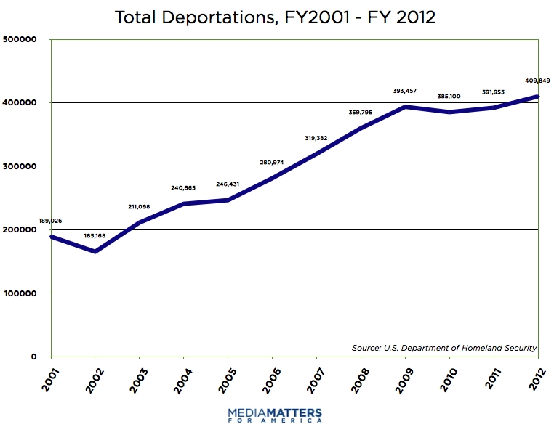
The Immigrant Justice Movement

As anti-immigrant scapegoating and racism heightened in the latter part of the 20th century so too did resistance on the part of immigrant and their supporters, alongside labor struggles in which immigrant workers have played an-ever more prominent role. In the United States, an immigrant justice movement dates back decades and had been building as part of the Central American solidarity movement of the 1980s. In 1986, under pressure from this movement, the U.S. Congress passed the Immigration Reform and Control Act (IRCA), which set up a onetime amnesty process for several million undocumented immigrants but also set up new “guest worker” [read: peonage labor] programs, penalized employers for hiring undocumented worker and required them to check the immigration status of every worker, and expanding border militarization and control over immigrant communities. As journalist and immigrant rights activist David Bacon has noted, the IRCA “set in place the basic dividing line in the modern immigrant rights movement.”
The immigrant justice movement exploded into mass protests in the United States in spring 2006, triggered by the introduction in the U.S. Senate of a draconian piece of draft legislation, known as the Sensenbrenner bill for the name of the sponsoring senator, that would have criminalized undocumented immigrants and their supporters. These mass protests of spring 2006 helped defeat the Sensenbrenner bill but also sparked an escalation of state repression and racist nativism and fuelled the neo-fascist anti-immigrant movement. The backlash has involved, among other things, stepped-up raids on immigrant workplaces and communities, mass deportations, an increase in the number of federal immigration enforcement agents, the deputizing of local police forces as enforcement agents, the further militarization of the U.S.-Mexico border, anti-immigrant hysteria in the mass media, and the introduction at the local, state, and federal levels of a slew of discriminatory anti-immigrant legislative initiatives.
In the face of what can only be described as a terror campaign against immigrant communities a split occurred. In simplified terms, the more “moderate” or liberal wing of the leadership pursued a strategy of seeking allies in the halls of power and limiting mass mobilization to a pressure mechanism on elites to open up space at the table for the Latino/a establishment, while the more radical, grassroots-oriented wing insisted on building a mass movement for immigrant rights and social justice from the ground up. The liberal camp has sought allies in Congress, among the Democrats, organized labor, and mainstream civil rights and public advocacy organizations, to negotiate more favorable immigrant reform legislation. This camp has been willing to sacrifice the interests of some immigrants in order to win concessions from mainstream allies, such as forsaking full legalization for all immigrants in exchange for dubious “paths to citizenship,” and to compromise over such issues such as “guest workers programs,” which have been condemned as indentured servitude and have been shown to place the labor movement in a more vulnerable position.
The radical grassroots camp was not against lobbying or attempting to penetrate the halls of power but insisted on prioritizing a permanent mass movement from below that subordinates alliances with liberals to the interests of the disenfranchised majority of immigrant workers and their families. This camp has also insisted on the need to link the immigrant rights movement more openly and closely with other popular, labor and resistance struggles around the world for global justice.
These distinct strategies represent, in the broader analysis, two different class projects within the multi-class community of immigrants and their supporters: the former, those middle class strata who aspire to remove racist and legal impediments to their own class condition; the latter, a mass immigrant working class that faces not just racism and legal discrimination but as well the acute labor exploitation and survival struggles imposed on them by a rapacious global capitalism. On the one side, notes Bacon, are “well-financed advocacy organizations in Washington, D.C. with links to the Democratic Party and the business community. They formulate and negotiate immigration reform proposals that combine labor supply programs and increased enforcement against the undocumented.” On the other side are “organizations based in immigrant communities and among labor and political activists, who defend undocumented immigrants, and who resist proposals for greater enforcement and labor programs with diminished rights.”
This dividing line has been played out over the past decade in a succession of “comprehensive immigration reform” (CIR) bills that have been introduced into Congress. Although to date none have passed, almost all of them have involved a greatly expanded militarization of the border (“securing the border”), the expansion of “guest worker” programs, the introduction and expansion of other repressive state controls over immigrant communities and work centers, in exchange for extremely limited concessions with regard to the legalization of a small portion of the 12+ million undocumented immigrants.
While Democratic Party and Latino establishment organizations and leaders push the CIR strategy, the grassroots immigrant justice movement has been expanding struggles in a variety of fronts. Tens of thousands of young immigrants known as the “DREAMERs” have been marching, holding sits ins, collective civil disobedience, lobbying and letter writing around the struggle for the DREAM Act (Development, Relief, and Education for Alien Minors), which would allow undocumented students graduating from high school to apply for permanent residence if they complete two years of college or two years of service in the U.S. military. Immigrant workers centers have sprung up in every locale across the United States where immigrant workers are present, and many of them have become organized into the National Day Labor Organizing Committee and the National Domestic Workers Alliance. The Binational Front of Indigenous Organizations works transnationally among immigrant sending communities in Mexico and immigrant workers communities in the United States. The “Dignity Campaign” is a loose coalition of local and national immigrant justice and fair trade organizations proposing alternatives to CIR bills that stress “border enforcement” and criminalization of immigrant communities and encourages the movement to see immigrant in global context and to draw out the connections between trade policies, displacement, and migration.
Both the immigrant justice struggle and the anti-immigrant backlash came together in spring and summer of 2014 in the so-called “invasion” of Central American children, a fabricated story and a classical example of how a “moral panic” is generated by the moral entrepreneurs of the state and dominant groups and manipulated from above. As Bacon has shown, the “story” began when U.S. immigration officials gave to a Tea Party media outlet in Texas photos showing children in immigration detention centers, in what appeared to be a well-planned strategy to whip up a “moral panic,” to place the immigrant justice movement onto the defensive, to undermine immigration reform in Congress, and above all to legitimate a new spiral of militarization and criminalization.
Fanned by propaganda from the anti-immigrant movement, for several months the mainstream media plastered the public with sensationalist stories of an invasion by Central American children. These sensationalist accounts provided no context with regard to the roots of such migration in the long history of U.S. intervention in the region, the devastation U.S. counterinsurgency wars followed by free trade, neo-liberal policies, and renewed militarization that have left the region in economic devastation, spreading social violence, and despair. The media also ignored that there was nothing “new” about the surge; such migration has been taking place for years and steadily increasingly since 2000. The “moral panic” gave anti-immigrant forces the opportunity to stage some of the most venial racist public demonstrations in recent years.
We witnessed one such action on July 2, 2014, as participants in a counteraction in support of the arriving immigrants. Undeterred by July’s hot blistering sun in the City of Murrieta in Southern California, nestled between Los Angeles and San Diego, close to 200 predominantly Anglo protestors showed up in front of the Murrieta Immigration Detention Center to protest the transfer of undocumented immigrants from Texas. Proudly displaying America Flags and a plethora of pickets with slogans such as “Stop Illegal Immigration,” “What part of Illegal don’t you understand?”, “Keep driving 100 miles to the Border”, they opposed the transfer of Central American immigrant children from Texas.
As the three white-colored Department of Homeland Security buses arrived, the protestors created a human roadblock to stop their advancement. Even though some law enforcement officers, such as the Riverside County Sheriffs and the agents of Homeland Security, attempted to clear a path for the buses so they can reach their destination, undeterred the protestors continued their civil disobedience tactics. Visibly Frustrated and angry some of the protestors shouted, “Illegals bring diseases!” “USA! USA!” “Go back where you came from!” among other nativist-racial and anti-immigrant epithets. Others hit the buses with their hands or picket signs, while others forcefully displayed their American flags on the buses’ windshields. The right-wing protesters tried to take pictures of the refugees and at times stuck the middle finger at the passengers. A small pocket of immigrant-right supporters including the well-known Mexican recording artist Lupillo Rivera challenged the opposition by reminding them that immigrants are an integral part of the US service sector. However, law enforcement constantly turned a blind eye to some of the protestors who physically hit and spit on immigration supporters. Even though the protestors outnumbered and often times assaulted the supporters, the police arrested 5 supporters for “obstructing” them.

Conclusions: Working Class Hegemony, Global Citizenship, and Universal Human Rights

Criminalization and militarized control over immigrant labor reflects a broader militarization of the global economy. Beyond the United States, major sectors of the TCC are becoming dependent on local, regional, and global violence, conflict, and inequalities, and in fact push for such conflict through their influence on states and in political and cultural systems. This militarized accumulation is characteristic of the entire global economy. We are increasingly living in a global war economy, and certain states, such as the US and Israel, are key gears in this machinery. Militarized accumulation to control and contain the downtrodden and marginalized and to sustain accumulation in the face of crisis lend themselves to fascist political tendencies or what some of us have referred to as “21st century fascism.” A key element of this global war economy is the transnational immigrant detention and repression complex.
A mass immigrant rights movement is at the cutting edge of the struggle against transnational corporate exploitation. Granting full citizenship rights to the hundreds of millions of immigrants around the world would undermine the division of the global working class into immigrants and citizens. That division is a central component of the new class relations of global capitalism, predicated on a casualized and “flexible” mass of workers who can be hired and fired at will, are de-unionized, and face precarious work conditions, job instability, a rollback of benefits, and downward pressures on wages.
The strategic challenge of the immigrant justice movement in the United States as elsewhere is how to achieve the hegemony of the mass worker base within the movement. The expanding crisis of global capitalism opens up grave dangers – for immigrants and for all of humanity – but also opens up opportunities. It is not to the political parties of the status quo (e.g., the Democratic Party in the United States), to the TCC, or to the halls of establishment power but to the mass base of this movement – the communities of poor immigrant workers and their families who swell the cities and rural towns of the world – to whom we must turn to reverse the anti-immigrant onslaught.
More broadly – and although this idea might clash with progressives who for decades have fought for citizenship rights for all – the whole notion of national citizenship needs to be questioned. Borders are not in the interests of the global working class; they should be torn down. So long as the rights we associate with citizenship are seen to adhere to a limited group of people who belong to a nation there will always be those who fall outside of the nation and excluded from these rights; there will always be Others. We must consider citizenship rights as universal human rights for all people who for whatever reason happen to reside in a particular territory. We must replace the whole concept of national citizenship with that of global citizenship. This is a truly revolutionary rallying cry. And it is the only one that can assure justice and equality for all.

One superb study on the creation of a world market in labor is Lydia Potts, The World Labor Market: A History of Migration, London: Zed, 1990.
ILO, data posted at ILO web page: http://www.ilo.org/global/topics/labour-migration/lang--en/index.htm
See, e.g., Kam Wing Chan, Cities with Invisible Walls: Reinterpreting Urbanization in Post-1949 China, Hong Kong: Oxford University Press, 1994; more recently, Chan, “China: Internal Migration,” in in Immanuel Ness and Peter Bellwood (eds.), The Encyclopedia of Global Human Migration, Hoboken, NJ: Wiley-Blackwell, 2013
See Robyn Magalit Rodriguez, Migrants for Export: How the Philippine State Brokers Labor to the World, Minneapolis: University of Minnesota Press, 2010.
On the new global capitalism, see in particular, William I. Robinson, A Theory of Global Capitalism: Production, Class, and State in a Transnational World, Baltimore: Johns Hopkins University Press, 2004.
See, inter-alia, David Harvey, A Brief History of Neoliberalism, New York: Oxford University Press, 2005.
Guy Standing, The Precariate: The New Dangerous Class, New York: Bloomsbury Academic, 2014 updated edition.
The ILO reported that in the late 20th century some one-third of the global labor force was unemployed. International Labor Organization (ILO), World Employment Report 1996-97, (Geneva: ILO/United Nations, 1997).
See inter-alia Southern Poverty Law Center. “Center Exposes Exploitation of Immigrant workers” (posted August 16, 2006) and “Rebuilding New Orleans” (posted August 19, 2006), Center reports posted at Center website http://www.splcenter.org/ and retrieved on 10/28/06. There is evidence that as Latinos came to constitute the principal labor force for the reconstruction of New Orleans in the wake of the destruction wrought by Hurricane Katrina in 2005, employers turned to such practices as refusing to pay immigrant workers after they had rendered services, turning them over to immigration authorities for deportation, and employing them in an array of slave-labor like conditions.
For details, see, inter-alia, Nevins, Operation Gatekeeper.
E.g., In 1994 the government launched “Operation Gatekeeper,” which accelerated militarization of the U.S.-Mexico border (see Joseph Nevins, Operation Gatekeeper: The rise of the ‘Illegal Alien’ and the Making of the U.S.-Mexico Boundary. New York: Routledge, 2002;). Two years later the Clinton government passed the Illegal Immigration Reform and Immigrant Responsibility Act (IIRIRA), which tightened asylum claims, increased penalties on undocumented immigrants, and led to a massive increase in deportations. In that same year, the Welfare Reform Act excluded even legal immigrants from unemployment or health benefits. And in 2005 the U.S. legislature approved the Real ID Act that prohibited undocumented immigrants from holding driver’s licenses.
Supplying global capital with immigrant labor is now a multibillion dollar industry. Globally-organized networks of “migration merchants,” or usurious middlemen, provide a full range of legal and illegal services needed for migration, including the supply of passports, visas, work permits, cash advances, safe houses, above ground and clandestine transport, border crossing by coyotes, and employment opportunities in countries of destination, all for fees that can add up to tens of thousands of dollars and in many cases place the transnational migrant in a situation of indentured servitude for many years. But these illicit and often underground profit-making ventures are dwarfed by the accumulation opportunities opened up to transnational corporate capital by the war on immigrants.
As cited in David Bacon, “Debunking 8 Myths About Why Central American Children are Migrating,” In These Times, on line edition, http://inthesetimes.com/article/16919/8_reasons_u.s._trade_and_immigration_policies_have_caused_migration_from_ce.
For an excellent brief documentary on ALEC, anti-immigrant legislation, and the vested corporate interest in the war on immigrants, see “Immigrants for Sale,” http://www.youtube.com/watch?v=vuGE1VxVsYo (viewed on 1/13/2013). The documentary was produced by Brave New Foundation (http://www.bravenewfoundation.org/). See also http://www.mycuentame.org/immigrantsforsale
For these details, see an October 28, 2010 report by National Public Radio (NPR), and reported at the NPR website, http://www.npr.org/2010/10/28/130833741/prison-economics-help-drive-ariz-immigration-law, accessed on January 13, 2013. Also see Mother Jones magazine at http://www.motherjones.com/politics/2012/03/john-tanton-anti-immigration-laws, accessed on January 13, 2013. Note that after a number of media exposes of ALEC in 2012 some 40 of these corporations withdrew their funding. The list of those corporations that withdrew as well as more details on ALEC can be found at the Sourcewatch website, http://www.sourcewatch.org/index.php/ALEC_Corporations.
See http://www.motherjones.com/politics/2012/03/john-tanton-anti-immigration-laws, accessed on January 13, 2013.
Alexander, The New Jim Crow, pp. 231.
See, among other items, David Bacon, “Immigrant Labor, Immigrant Rights,” NACLA Report on the Americas, 47(1), 2014: 64-69 (quote from page 64); Bacon, Illegal People: How Globalization Creates Migration and Criminalizes Immigrants, New York: Beacon Press, 2009; Bacon, The Children of NAFTA: Labor Wars on the U.S./Mexico Border, Berkeley: University of California Press, 2004.
On the spring 2006 immigrant uprising and its aftermath, see Alfonos Gonzales, Reform Without Justice: Latino Migrant Politics and the Homeland Security State, New York: Oxford University Press, 2014.
Bacon, “Immigrant Labor, Immigrant Rights,” pp. 65.
For a good summary, see Aviva Chomsky, “The United States’ Continuing Border Crisis: The Real Story Behind the “Invasion” of the Children,” TomDispatch, 25 August 2014, http://www.tomdispatch.com/blog/175885/
David Bacon, Tea Party and Border Patrol Spin the Story of Children in Detention, Counterpunch, 26 June 2014, http://www.counterpunch.org/2014/06/26/tea-party-and-border-patrol-spin-the-story-of-children-in-detention/
On these points, see William I. Robinson, Global Capitalism and the Crisis of Humanity, New York: Cambridge University Press, 2014.

