“There are certain products that shift the way we look at technology and the role it plays in our lives.”—Tim Cook

Introduction

On June 5, 2023, Apple opened its 34th annual World Wide Developers Conference (WWDC) with a music video prelude, a regular feature initiated during the Covid-19 pandemic, when the face-to-face event went virtual. In the video, set to Nick Leng’s “Spirals,” a young man sitting in front of his computer pauses while coding (we see the words “bubble shape” on screen). Two transparent bubbles appear over his shoulder before merging with a larger one above his head (see Fig. 1), which then floats out an open window. Intent on catching it, the man chases the bubble as it floats through an urban landscape. He passes by other people with smaller bubbles over their heads and a group, like him, trying to reach another bubble pinned to a wall just outside their grasp. We get it: the bubbles are ideas and the humans want to possess them. The man’s pursuit is desperate: he engages in escalating feats of athleticism—racing through streets, scaling fences, climbing fire escape stairs—until he finds himself on a rooftop. As the bubble drifts off into the atmosphere, he leaps after it, clings on, and floats into space (see Fig. 2). The worlds “Dream It. Chase It. Code It” appear on screen before the camera descends to Apple Park and finds its object: CEO Tim Cook standing under the centerpiece rainbow sculpture to welcome developers (and consumers) to the event.


Figure 1 © Apple 2023


Figure 2 © Apple 2023

The subsequent presentation follows the now-standard, post-pandemic script: Apple representatives introduce the latest upgrades to its existing technology and software in a carefully crafted sequence of filmed announcements, culminating in a “one more thing” surprise, a practice famously inaugurated when founder Steve Jobs unveiled the Apple Cinema Display at the MacWorld expo in 1999 and revived in 2014 when Tim Cook revealed the Apple Watch. At WWDC 2023, Cook announced the creation of a device as potentially disruptive as the personal computer and the iPhone: Apple Vision Pro, the company’s long-awaited entry into the virtual reality/augmented reality space. From the opening video to the “one more thing” reveal, Apple’s filmed event simultaneously publicized and embodied its retreat from a shared space grounded in the physical world where technology is secondary to human activity and community to an individual space shaped and dominated by audio-visual media, where human interaction is secondary.

The young man in the opening video previews this shift: he flees his apartment, the city, and the world itself, supported by a computer-generated simulation of a bubble. In a sense, this replicates the world created previously by Apple in its slickly produced product and design videos. In an earlier article, “Apple ‘Porn’: Design Videos as Seduction and Exploitation” (Ferriss 2018), I argued that Apple crafted seductive audiovisual narratives about its life-enhancing products which it represented as magically transforming work and home life, while erasing the actual human labor required to design and produce the devices, not to mention operate them. Its latest narratives further relegate human work and community to the margins by presenting human experience as thoroughly mediated by computer-enhanced simulation, its pinnacle achieved through its Vision Pro headset that turns the home and workspace into one immersive audiovisual world. Rather than its devices and software becoming an inseparable part of our personal and shared spaces, they become the spaces. We no longer live with the technology, we live in it, with occasional reminders of the other humans who share our spaces, interactions that are themselves mediated through simulations. In other words, this is Apple “Porn” 2.0.

Introducing the Apple Vision Pro, Cook says, “I believe that augmented reality is a profound technology. Blending digital content with the real world can unlock experiences like nothing we’ve ever seen.” However, it does not take the appearance of Apple’s latest product to make this point. Everything we witness prior to the arrival of “one more thing” demonstrates the same seamless “blending of the real world with the digital world.”

As a taped and edited presentation, the event itself is a simulation, the filmed equivalent of what used to be a live presentation before an assembled audience of Apple employees, developers, and journalists. The presenters in the live stream of the WWDC 2023 “event” are not, in fact, live. Instead, they offer carefully scripted and choreographed speeches. In place of live demonstrations of products and software on stage, the presenters segue to prerecorded videos. Some, like the appearances of Senior Vice President Craig Federighi, incorporate special effects: an iPad appears to fly into his grasp at one moment; he reappears in costume with a three-necked guitar in another and, as he appears to play, a pan transitions to an animated sequence of rows of colorful horizontal lines which dissolve into the exterior lines of the circular building at the center of the park.

In other words, a profound shift occurred in Apple’s ongoing transition from live presentations before an audience of employees and developers to filmed presentations broadcast to an audience that includes its consumers. The chart below maps the stages in the shift along a continuum from fact to fiction, as the corporation has increasingly integrated the audiovisual strategies essential to cinematic experiences (scripted content, professional cinematography, editing, special effects, set design, lighting, sound, music, etc.). As will become clear in what follows, the WWDC 2023 “event” integrates multiple layers and levels of filmmaking, blurring the boundaries between life, performance, and digital simulation. Crucially, while spectators of Hollywood cinema knowingly suspend their disbelief, recognizing at the outset that they are viewing a fictional film, Apple’s audience comes with a different set of expectations: to receive information about its latest products. Instead, however, the audience experiences a package of digitally produced content more akin to cinema, and, in some cases, indistinguishable from it. In simple terms, the presentation mirrors the products on offer, “blending digital content with the real world,” with the seductive promise that simulation is life. At its apex, it is Apple “porn,” where “cinematic strategies of seduction—from lighting to pacing to sound—resemble those employed in erotic films” (Ferriss 2018). The effect, though, is to erase—not romanticize—the material experience of live, human bodies, from actual users to the laborers who design, engineer, and manufacture Apple products.

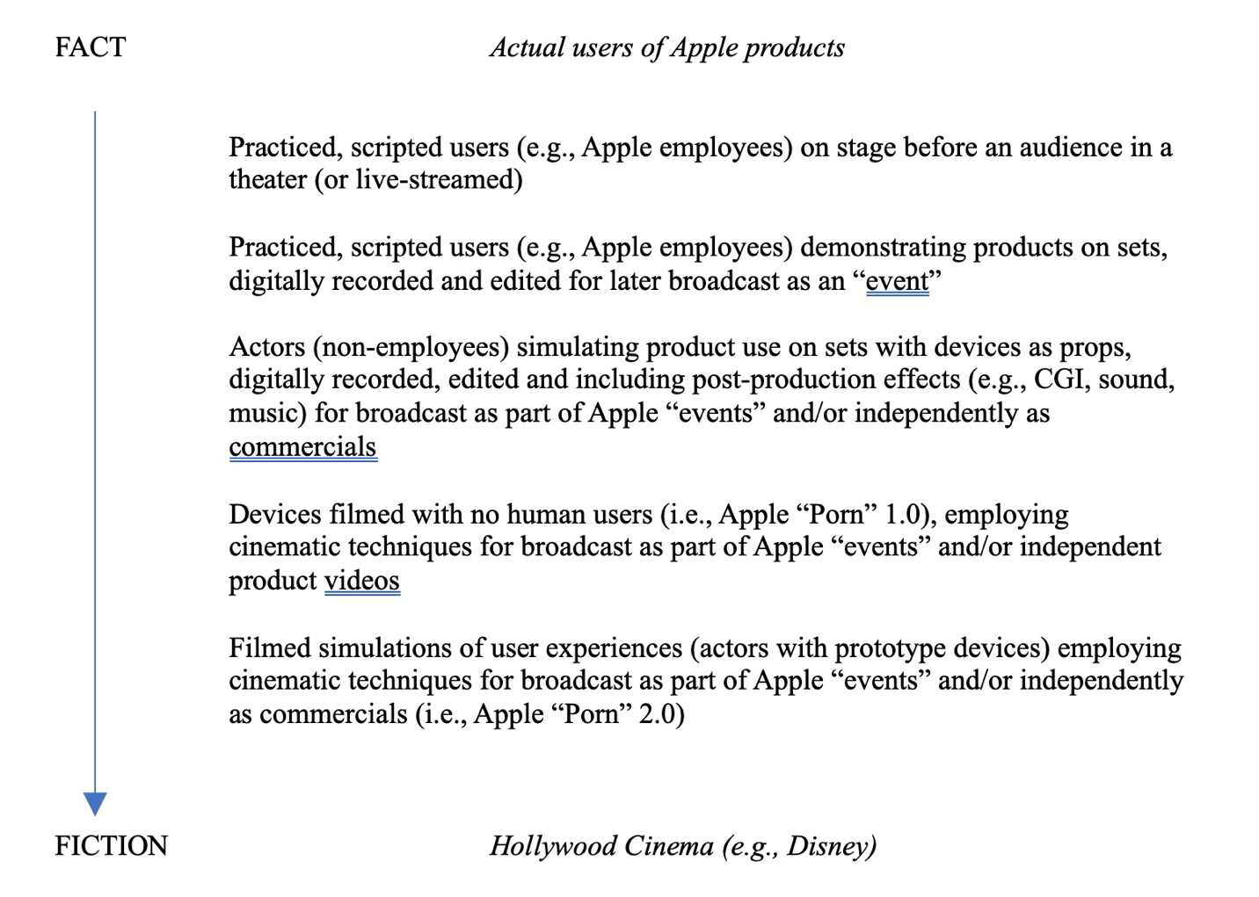

In the WWDC “event,” the spaces and the humans that populate them are all simulations. Apple’s headquarters, no longer void of humans owing to the pandemic, is still empty. Its unpopulated spaces serve as sets. The presenters effortlessly move through them, coming from behind a prop wall or appearing/disappearing as if by magic through editing. What seems to be a wall is a blank white rectangle, a digital projection that itself morphs. It is a basic white screen for text at some moments, a simulation of a computer display at others. Often it appears as an oversize version of the iconic white box housing Apple’s latest products, such as the 15-inch MacBook Air.

The “demonstrations” are equally fantastical. They employ actual sets, pristine replicas of workspaces and homes. They are constructed according to idealized modern interior design. The industrial chic offices feature exposed pipe and brick, with tidily organized benches where workers stand before screens. The kitchens and living rooms are sleekly mid-century modern, sparely decorated in either classic variations of leather and dark wood or subtle shades of white and light wood. Personal items are carefully arranged to give the appearance of human habitation.

Just as the spaces imply effortlessness and simplicity, the software demonstrations stress seamless ease of use. Animated iPhone screens show improved searches, absent of errors or frustration with poor results. Scrolling takes milliseconds, landing accurately each time. Audio messages are perfectly transcribed. In a recorded hands-on demonstration of the new Live Stickers function, the presenter removes the background from a photo, creates a new sticker, and pastes it into a message in three easy steps—no time lost in finding the right image, isolating the figure, or fumbling to paste it on the message. Voila! A sticker of Craig Federighi tosses a basketball from hand to hand endlessly.

The Apple executive did not need to be transformed into a live sticker, for in the presentation, he, like the other presenters, is already a carefully crafted avatar, a figure that fits into the perfectly choreographed activities that occur in the idealized spaces. Despite differences in job, race, gender or age, the presenters, like the sets, model simplicity and modernity. With minimal divergences, they adopt a similar wardrobe, heavy on jeans and sneakers, and low on personal style. Accessorizing—apart from wearing an Apple watch—is absent or understated. They are individualized, “diverse” variations of the same Cupertino employee.

This diversity is equally choreographed. Male team leaders pass off to female teammates. The rotating array checks all the boxes: Asian, Black, Caucasian. The “users” featured in demonstrations include an equally diverse blend of age, race, and sex, a simulated world of casual, harmonious community. Just as the technology operates easily, the interactions it facilitates are absent of conflict or difficulty.

The anchor, it appears, is the family—the nuclear family, the workplace “family,” and the “framily,” an extended network of friends. Demonstrations feature family photos, voicemail, and texts. Despite the enviable diversity of actors, the scenarios sustain uniformly middle-class values of engaged, companionable work relations, active friendships, and harmonious, children-centered nuclear families—all bolstered by Apple’s products and software. In one, an unseen working mother uses the new Live Voicemail transcription during a meeting to realize she does need to take a call from her son, who is about to bathe the racoons he’s discovered in their basement. Friends “gather” virtually via FaceTime on Apple TV to watch their favorite show (an embedded ad for Platonic joins repeated shout outs to Ted Lasso in shots of the Apple TV+ interface) and will be able to track each other’s arrivals home after a night out using Check In. From the coder in the opening video to the father drafting a surfboard in its final commercial for Apple Vision Pro, the workers—including actual Apple employees featured as presenters—are happily immersed in creative projects supported by genial colleagues, as evidenced by shots of text exchanges, digital presentations, and FaceTime calls. Apple’s software and products (including its filmed content) are, presumably, the engine for creativity, productivity, and flourishing personal relationships. They are not sources of frustration, distraction, discord, or alienation.

Embedded inserts of filmed commercials reinforce these values and Apple’s promise of frictionless lives. Marked as scripted content—introduced as ads—they are merely iterations of filmed content: compressed distillations of the simulations of devices, their human operators, and the world they occupy that we have already seen, though edited for greater emotional impact to music (songs available in Apple Music).

In other words, the filmed “event” embodies the lure of what Nick Srnicek (2017) has dubbed “platform capitalism.” He defines platforms as digital infrastructures that act as “intermediaries that bring together different users: customers, advertisers, service providers, producers, suppliers, and even physical objects. More often than not, these platforms also come with a series of tools that enable their users to build their own products, services, and marketplaces” (30). Apple has not only created a platform through its applications and iCloud services but offered its users an enhanced impression of seamless integration through its devices, while tying “users and software developers increasingly into its ecosystem” (32). As Matthew Wizinsky (2022) explains, this technological landscape has, in the process, blurred “distinctions between work and personal life while further entangling our daily lives with commercial activity—including the pervasive extraction of personal data that fuels much of today’s digital economy. Connectivity has created new and constantly open portals between private life and work as well as between private life and the market” (112). The products and applications in Apple’s “event” video, vaunted as seamlessly integrating work, family and friends, at work and at home, realize this goal if users are part of its branded ecosystem—if, that is, they purchase its products: its devices, applications, music, and video content.

Wizinsky focuses on the role of design in enabling this shift. He argues, “human-centered design and, later, design thinking became largely co-opted for consumer-oriented
design” (144). The products enable consumption of other products in the ecosystem:

Carefully designed experiences that seamlessly unify products and services reward users who connect in multiple ways to one platform …To get the most out of these systems, you must be all in. Designers help create the product-and-service ecosystems that lure users, sometimes through free services, into the enclosed space of the platform. The digital products and services sector may be incredibly lucrative—more than physical products alone are; however, physical products are often the vehicles for a new kind of “enclosure.” This enclosure into intricately connected product–service ecosystems limits choices and makes opting out nearly impossible. (Wizinsky 2022, 151)

Unsurprisingly, Wizinsky’s example is Apple’s ecosystem and he identifies iPhone as the seminal device for “the extraction of both data and money”: “The smartphone ensures we are always connected, always available, and always contributing to the endless apparatus of producing social content, generating surplus behavioral data, and opening new avenues for financial extraction. This constant connectivity also makes the smartphone the ideal tool for labor flexibility by essentially eliminating the distinction between work, personal time, and play. Production and consumption are fused” (153).

Wizinsky does not, however, consider how Apple’s “events” and promotional videos are themselves designed. They are branded content that augments the promised “seamlessness” of its products employing the techniques of fiction film. Video, scripted and edited, of actual employees shot on constructed sets simulating product uses, augmented by CGI blurs into promotional content of actors engaged in the same actions employing the same filmic techniques, with only one difference: the addition of music. Both film technology and the deliberate mixing of content convey an illusory image of work as simple and engaging, family as unified and harmonious, and society as absent of division by race, ethnicity, gender, or class.

Vision Pro

The “one more thing” sequence about the Apple Vision Pro takes “seamless” one step further and tightens the ecosystem’s enclosure. Apple envisions a more radical shift where the device is no longer a separate entity controlled at a proximate distance but grafted onto its human operator. It is not, like the iPhone, an extension of the body, but part of the body, a wearable akin to the Apple Watch (featured prominently, as we’ve seen, on each presenter). Yet, as its name suggests, the Vision Pro is “the first Apple product you look through and not at.”

However, the presentation inevitably involves looking at the device and through simulated representations of its use. More profoundly, the device, despite claims to that it more seamlessly integrates technology into human experience, relies on simulations that may, in fact, do the reverse.

Apple claimed that its entry into augmented reality was both a new product and a new platform, a progression from previous revolutions in computing: the Mac introduced personal computing, the iPhone mobile computing, and the Vision Pro “spatial computing.” Each shift depends on a new input model: for the Mac, it was the mouse; for the iPod, the click wheel; for the iPhone, multi-touch. But the Vision Pro has no physical controller. Instead, users interact with it using “natural and intuitive” tools: “eyes, hands, and voice.” It is a “three-dimensional interface … magically controlled with just your eyes, hands, and voice.” Sensing the direction of your eyes and recognizing simple hand gestures, the device responds to your commands. With the goggles as the display, obviating the need for external monitors, “your surroundings become an infinite canvas.” By wearing the device, “your entire world is a canvas for apps,” as they appear superimposed on your surroundings, thus achieving the integration of the digital and the real Cook promised at the start.

Presentations of the device “in action,” however, problematize such integration. Previous products, such as the HomePod or Home app, were shown in use on a set offering a side view of a simulated home, with common spaces visible as individual rooms separated by walls but linked by devices and by actors occupying and moving through the spaces (see Fig. 3). By contrast, the Vision Pro demonstrations take place on a virtual set composed of a series of black boxes, each containing one representative space—a hotel room, an office, a living room (see Fig. 4). They are a spatial realization of the promise that, through Vision Pro, apps occupy space “centered around you.” With the individual user at the center of the experience, space itself is transformed, reduced to the immediate surroundings contained within a single room, or even a small space within it, such as a desk or couch.


Figure 3 © Apple 2023

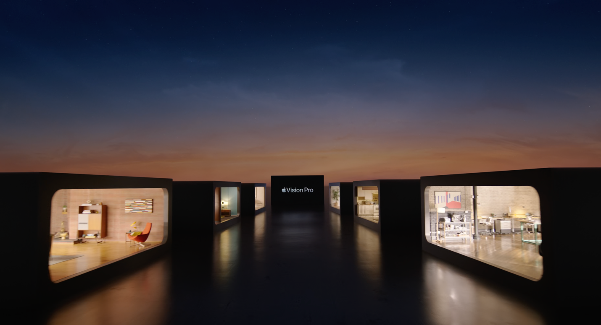
Figure 4 © Apple 2023

The presentations of simulated uses alternate between shots of actors in a room wearing the device, filmed representations of what they are presumably seeing, hearing, and doing, and shots of presenters speaking from outside the room as the actors pose or move behind them (see Fig. 5). These three distinct filmic spaces enforce boundaries, reminding us of the simulated nature of our experience: the presenters are outside the room, which is a set containing actors, the entire presentation a filmed simulation of the device in “action.”

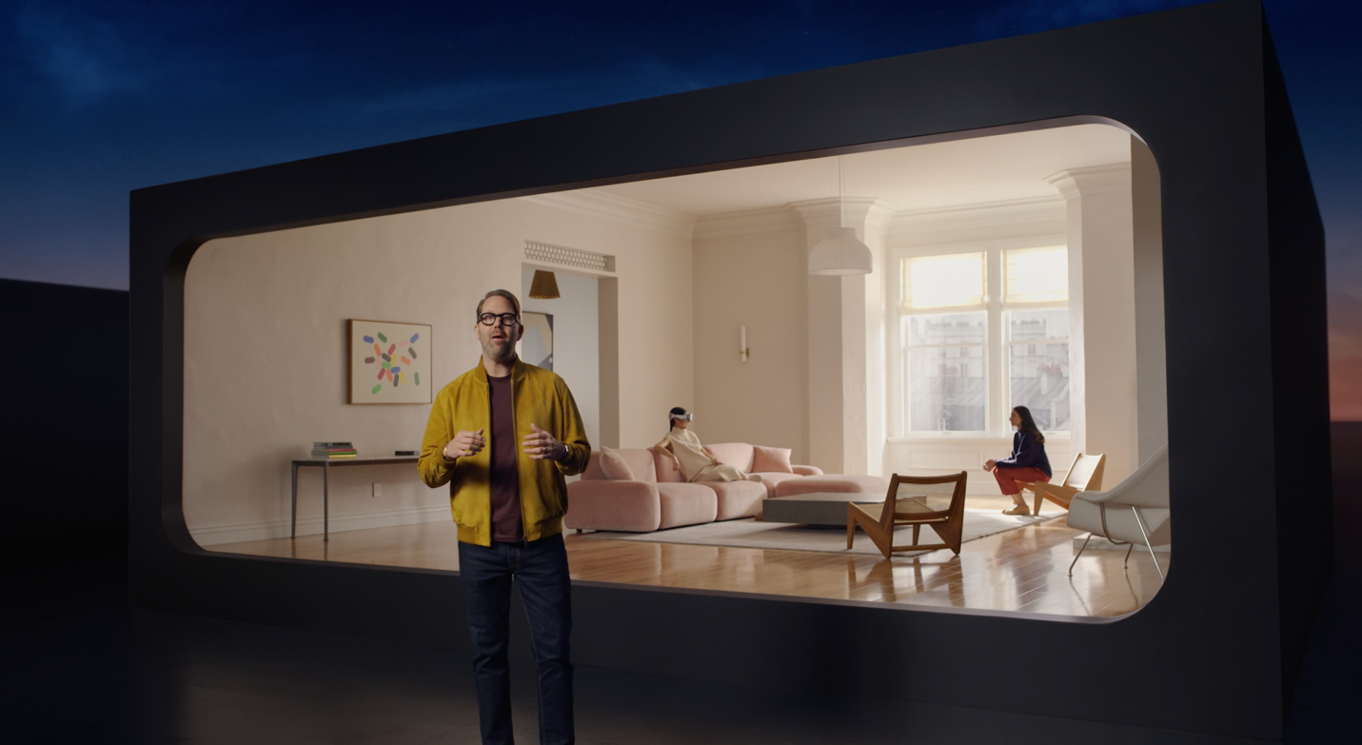Figure 5 © Apple 2023

However, the presenters make the claim repeatedly that the achievement of Vision Pro is that “you’re never isolated from the people around you. You can see them and they can see you.” They demonstrate by showing a woman on a couch. She is dressed in a spare architecturally constructed dress that matches the modernist furniture and décor, all in the same pale shades. The Vision Pro goggles appear as an accessory matching her Apple watch, reinforcing Apple’s vision of a seamlessly integrated world of technological modernism. Another woman enters the room and a shot shows that the woman in white can see her approach through her goggles (see Fig. 6). A cut shows that the approaching woman can see the other’s eyes through the googles (see Fig. 7). The presenter claims, “it reveals your eyes” and gives “cues to others about what you’re focused on.” Just as the actress is seamlessly integrated into the space through costume and design, the wearer of Vision Pro experiences no separation from her surroundings or those around her. “Because you can see the world clearly while wearing Vision Pro, you remain present in your space and connected to others,” the presenter says.

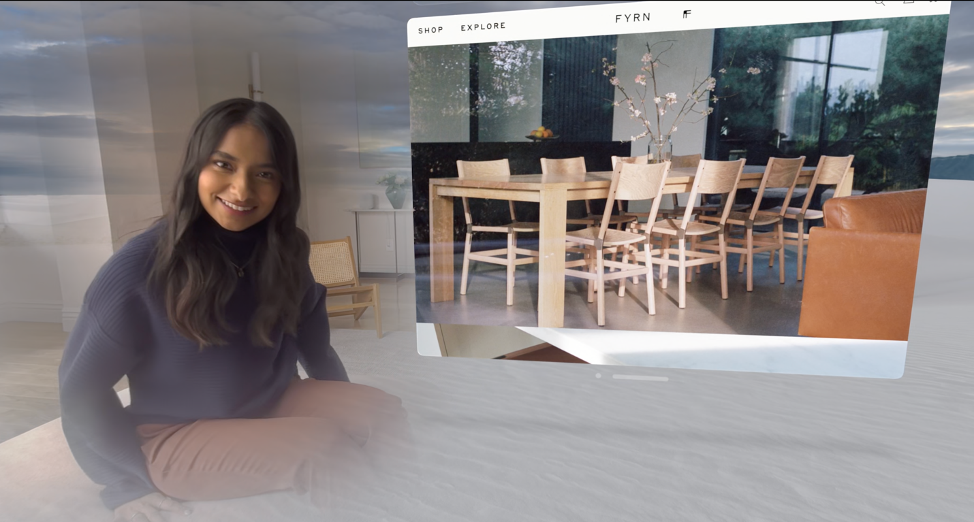
Figure 6 © Apple 2023

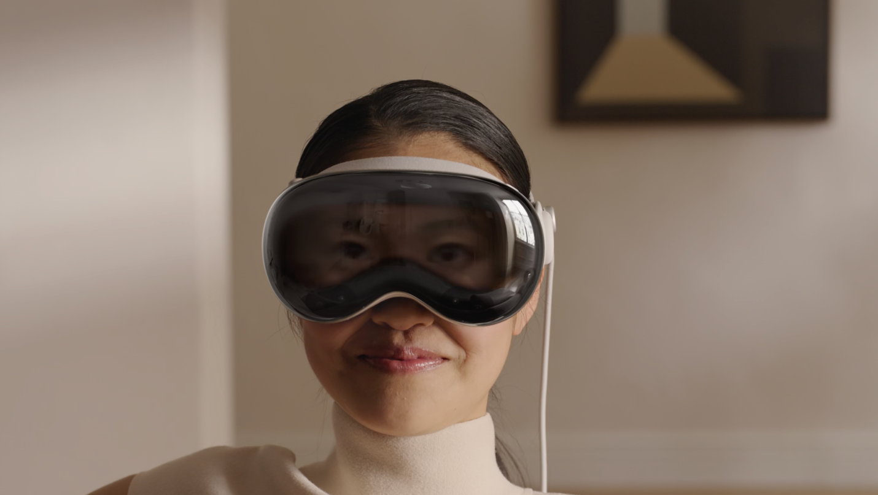
Figure 7 © Apple 2023

But this is, in fact, not the case, in terms of the device’s actual operation. Many initial reporters were so seduced by the simulated presentation that they somehow missed clear signs in the demonstration scenes and in the discussion of EyeSight later in the presentation that both seeing and being seen were themselves simulations, and that in operation the device offered options for divorcing oneself entirely from one’s surroundings.

Many were taken in by the false equivalence in the claim “You can see them and they can see you.” You can, if you wish, see them through the lenses of the device, but they only see a 3D projection of your upper face and eyes on the front panel of the device. Mike Rockwell, VP, Technology Development Group, explained late in the presentation that “EyeSight utilizes a unique curved OLED panel with a lenticular lens to project the correct perspective of your eyes to each person looking at you. The result is a 3D display that makes the device look transparent.” It only seems, but is not in fact, transparent. The upper part of the face that is projected is a part of the “digital persona” created for FaceTime interactions. Vision Pro “goes beyond conveying just your eyes and creates an authentic representation of you.” He explains that you have no video conferencing camera looking at you and that you are wearing something over your eyes. Descriptions of the device’s construction make it clear that the wearer sees through openings for the eyes, the rest of the upper face covered by the device itself (see Fig. 8). Instead, the system uses an “advanced encoder-decoder neural network to create your digital persona” and “delivers a natural representation” of you, a 3D avatar.

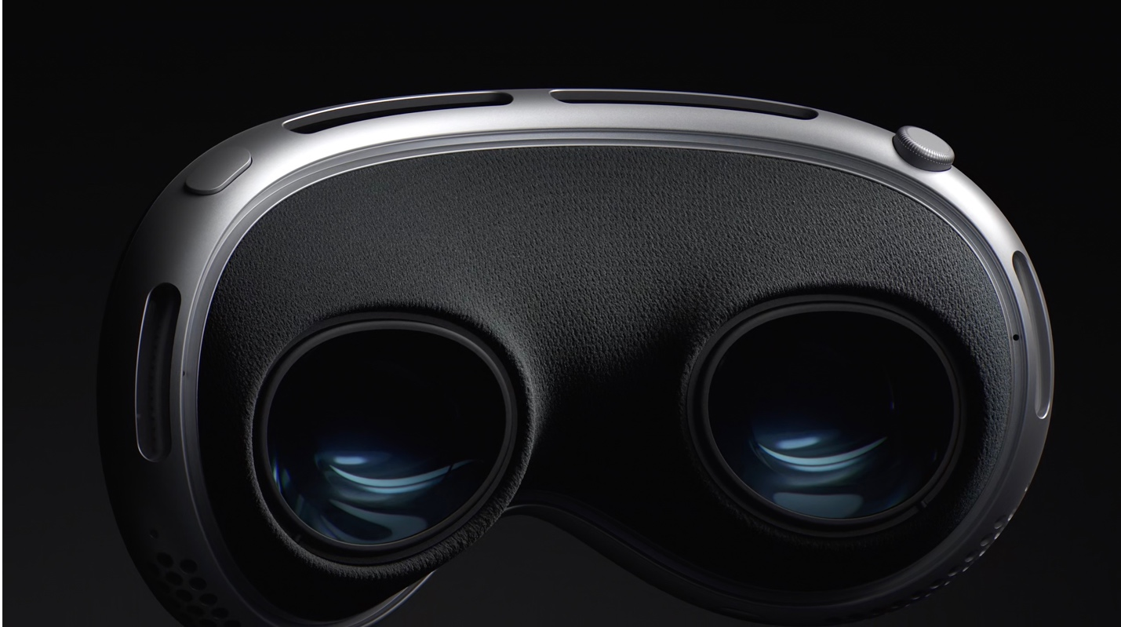
Figure 8 © Apple 20023

It understandable that viewers were misled—by the presenters’ words and by the compelling filmed simulations of the product and its use. A carefully crafted sequence reinforced the message that “it’s just you and your content. It’s remarkable, and it feels like magic,” that “the combination of hands and eyes together truly feels like magic—as if your mind is guiding the experience.” The presentation first showed a series of simulated scenes of the Vision Pro “in action,” then a slick design video of the product, followed by a longer video that appeared to pull back the curtain to reveal the wizardry of its operation, each increasingly illusory.

The “in action” sequences featured an actor in each room. In the office, a worker used Apple’s apps (Safari, Freeform, Messages, Notes) “freed from the confines of a display,” and operating in sync with all his other Apple devices (Mac, iPad, iPhone) through iCloud. In a hotel room, a woman conducted a FaceTime call while reviewing a Keynote presentation. Together, they showed how Vision Pro could create the “ultimate workspace, for whatever you want to do, wherever you are,” implying that it could confer a type of freedom. But the “magic” really happens at home. In the living room, a father shows how “you can capture and experience photos and videos in magical new ways.” Panoramas “expand and wrap around you life-size” so that “you can feel like you’re standing right where you took them.” Using Vision Pro, “Apple’s first 3D camera,” you can capture a fun 3D video of your kids to share with your family (but only if they too have the Vision Pro device). “It’s magical, and impossible to fully appreciate on a two-dimensional screen.” A woman in the combined kitchen/living room space of an apartment showcases how you can “turn any room into your own personal movie theater.” Using Environments, you can obscure the vision of the real room and substitute Mount Hood; on an airplane, you can use the same feature to make the seats and passengers disappear. Magic! You can “can be at the game without leaving home” or “have a National Geographic Adventure without leaving your couch.” As Bob Iger, the chairman of Disney explains in his own segment to close out the sequence, you can “bring Disney World into your world” for “real life magic.”

The insertion of Disney is apt—and not simply because it underscores the video event’s equivalences with Hollywood cinema. Disneyland was Jean Baudrillard’s example of the “hyperreal” created through simulation and its power to seduce consumers. As I discussed when describing Apple “Porn” 1.0, Baudrillard (1988) argued that in the space of simulation, the imaginary world of the hyperreal, “everything appears more engaging and stimulating than the banal realities of everyday life and thus exerts a seductive power over consumers. Consumers are seduced more by the fantasy image of the object created on film than by the commodity itself” (Ferriss 2018). That remains true of the filmed representations of the Vision Pro. However, the device itself creates a radical space of simulation that is not, as with the videos, an alternative for the banal realities of everyday existence, but a substitute for it. Virtual and augmented reality have identifiable definitions and borders: the virtual reality space is readily acknowledged as a substitute distinct from the real that stands apart from it. One can escape into and from it. Augmented reality places digital content within an existing space recognizable as lived reality. Digital objects appear alongside actual objects. The Vision Pro ignores the implied contract between audience and performer, between user and device as an intermediary. An amorphous amalgam of virtual and augmented reality, it transcends borders, encompassing and eclipsing the actual world.

Contrary to assurances that users remain tethered to the real world, the sequence of simulated use cases presents users as increasingly disconnected. Through “real life magic”—i.e., Apple’s technology—Disney’s world becomes the world, supplanting not only the user’s room during film viewing but a visit to the Magic Kingdom. It offers a seemingly more benign version of the experience described in Ernest Cline’s Ready Player One (2011), where the protagonist immerses himself in VR video gaming to blot out the poverty and violence of his life in the “stacks,” a towering grouping of trailers created in a near future world shocked by a Global Energy Crisis. However, while the gamer’s retreat had clear psychosocial motivations, it is harder to justify the father’s decision to don his Vision Pro to tape as his daughter blows out the candles on her birthday cake so that later he will be able to “relive” the experience to “peer into that memory.” The father becomes a voyeur, rather than a participant, despite the assurance that “EyeSight makes it clear” when you are capturing video. He is a spectator of the event and his own mental processes. He’s watching a memory rather than recalling it.

The immersive, escapist thrust of the presentation is underscored by the short design video that follows. In the classic style of Apple “Porn” 1.0, the camera pans fluidly over the device, which is shorn of its human user, as buttons depress themselves, the digital crown rotates unaided, the band and battery connector click themselves into place. CGI enables fluid transitions to reveal interior parts invisible to the naked eye: the spatial audio speakers, the lenses, and the cameras and sensors, which we are told “need to have a view of the world,” granting the device agency. The extended discussion of the device’s technology that follows provides greater detail, simulations of video resolution and animations of spatial audio, with clusters of pulsating white dots representing the sound waves emitted from the tiny over-ear speakers. As in earlier demonstrations of FaceID, another animated sequence depicts the front sensors scanning the wearer’s face, rays emitted from the goggles morphing into pixels that form themselves into his “Persona,” an avatar of his face and hands. Rather than the user creating an avatar in the Metaverse, for instance, the Vision Pro creates the user as an avatar, a simulated, truncated replicant of his head, shoulders and hands to appear in FaceTime calls and, it’s worth emphasizing, an excerpted version of the upper face for EyeSight. In other words, Apple’s solution to the potential barriers of wearing goggles during human interaction is to introduce additional layers of distance through digital simulation. The design video’s erasure of the human wearer is, in a sense, prescient.

Apple’s “Vision”

Without question, the device, as represented, is a technological achievement, and if, as Arthur C. Clarke said, “any new technology is indistinguishable from magic,” it is, as Apple repeatedly states, magical. Some of the short previews of use cases created by developers do have potential value: a simulated 3D heart to use for medical education, modeling software for industrial design, etc. But the presentation and its concluding commercial stress personal entertainment. Viewers are left with a slickly produced ad, powerfully edited to the words and rhythms of Supertramp’s “Dreamers,” which playfully counters the song’s lyrics: “Can you put your hands in your head? Oh, no.” With the Vision Pro, you can, by employing hand gestures to control the display. The ad’s climax occurs as a woman on a plane blots out her fellow passengers to watch Everything Everywhere All at Once, her transition into the film world coinciding with the character’s propulsion into the multiverse. The equivalence is intentional.

The sales pitch that precedes the commercial similarly emphasizes consumer entertainment. An Apple representative justifies the $3499 US price by claiming the purchase of Vision Pro is equivalent to the purchase of “a new state of the art TV, surround sound system, computer with multiple high-definition displays, high-end camera and more.” In addition to featuring its own products working in unison with the Vision Pro, Apple plugs its native applications. The embedded simulations engage in additional product placement: actors scroll through online text featuring Waka Waka, Sight Unseen, Fyrn, and other retailers—the same furniture brands showcased in the “rooms,” and view entertainment content on Apple’s streaming platform produced by the company (e.g., Ted Lasso, Platonic) or Disney, such as Avatar: The Way of Water (produced by 20th Century Studios, which Disney owns). In fact, Variety claimed that, owing to Iger’s performance, the device “came across as nothing less than a game-changing new medium for entertainment” (Wallenstein 2023).

The future promised by Apple is one where the digital world intersects with the real to advance consumer capitalism. Its “vision” for a technologically enhanced future places the individual at the center of an experience that is personally customizable and designed exclusively for consumption, affordable only to those of means. Consider, for instance, that the device is not promoted as an assistive device for the disabled, including ALS patients who could regain communicative agency through an interface controlled by eye movement. As the Vision Pro inaugurates a new augmented-reality platform and the device is still a prototype, it is possible that developers in the audience for the event will recognize alternative uses such as these. Perhaps, as Tim Cook suggests, “blending digital content with the real world can unlock experiences like nothing we’ve ever seen.” Apple’s vision, though, looks like an augmented reality of what we’ve already seen: a technologically empowered consumer culture centered on the individual untethered from lived experience in a community of others.

References

Baudrillard, Jean (1988) “Simulacra and Simulations.” Jean Baudrillard: Selected Writings. Ed. Mark Poster. Stanford: Stanford University Press. pp.166-184. Online at https://web.stanford.edu/class/history34q/readings/Baudrillard/Baudrillard_Simulacra.html

--- (2001) Seduction. Trans. Brian Singer. Montreal: New World Perspectives.

Cline, Ernest (2011) Ready Player One. New York: Random House.

Ferriss, Suzanne E. (2018) "Apple ‘Porn’: Design Videos as Seduction and Exploitation." Class, Race and Corporate Power. Vol. 6, No. 1, Article 1. Online at: http://digitalcommons.fiu.edu/classracecorporatepower/vol6/iss1/1

Srnicek, Nick (2017) Platform Capitalism. Polity.

Wallenstein, Andrew (2023) “What a Disney-Powered Vision Pro Means for Entertainment’s Future.” Variety.com, June 6. Online at https://variety.com/vip/vision-pro-disney-apple-bob-iger-future-entertainment-1235634051/

Wizinsky, Matthew (2022) Design after Capitalism: Transforming Design Today for an Equitable Tomorrow. Cambridge: MIT Press.

Srnicek cites Apple’s ecosystem but, owing to Apple’s vaunted concerns about user privacy, he does not equate the company with other platforms such as Meta or Google. Srnicek’s identifies Advertising Platforms (e.g., Google, Meta), Cloud Platforms (e.g., AWS), Industrial Platforms (e.g., GE, Siemens), Product Platforms (e.g., Spotify), and Lean Platforms (e.g., Uber, Airbnb).
It’s likely that the goggles were mockups, akin to ski goggles, with the actor’s eyes visible at all times.
Granted the same criticisms could be directed at tourists snapping photos on their or concertgoers filming the performance for later consumption rather rather than immersing themselves directly in the experiences of travel or musical performance.
Variations on the word magic (magic, magical) occur eight times in presentation, concentrated in the section on the Vision Pro. Variations on seamless (seamless, seamlessly) occur six times.
Wallenstein (2023) unintentionally alluded to the filmic nature of the “event” when he wrote, Iger “almost stole the show from Tim Cook. The Apple CEO may have played the leading man in this particular production, but Iger is a lock to win best supporting actor.” He added that the video “made wearing the device sound something like clamping an Imax screen to your face.”

