A Walkthrough of Runaways: A History of Bahamian Enslavement
Runaways: A History of Bahamian Enslavement is a digital project that is a collection of runaway slave advertisements. It was conceived to amplify the covered voices of runaway slaves in the archive in and through The Bahamas. Runaway slave advertisements are important to see those who otherwise might be hidden from the historical narrative. In Bahamian history, runaway slave advertisements from The Bahamas are one of the only ways to see the enslaved persons’ actions clearly from primary source documents. The digital exhibit is split up into multiple pages which will be covered in this walk-through. The first section of this article is explaining the creation and conception of Runaways. The second section covers the design details of Runaways. With the third section, I elaborate on the content of each of the pages of Runaways. I end the article with discussing additional changes to Runaways, and how it fits into my longer Digital Humanities (DH) goal.
Conception and Creation
Runaways builds upon the shell website, Facets, that is a theme for Wax sites. Facets allows users to broswe through a collection using facets, or filters. When one is browsing through a collection of cultural artifacts, often there is a desire to want to reduce the number of objects in front of us to a small collection that fits a very specific criterion. Faceted browsing allows viewers to browse using filters you select. In Facets this can be achieved using drop-down menus where you can select the categories you want to browse by. Facets is a Wax theme. Wax in turn relies on Jekyll. Therefore to use Facets for site creation, you need to be familiar with both Jekyll and Wax.
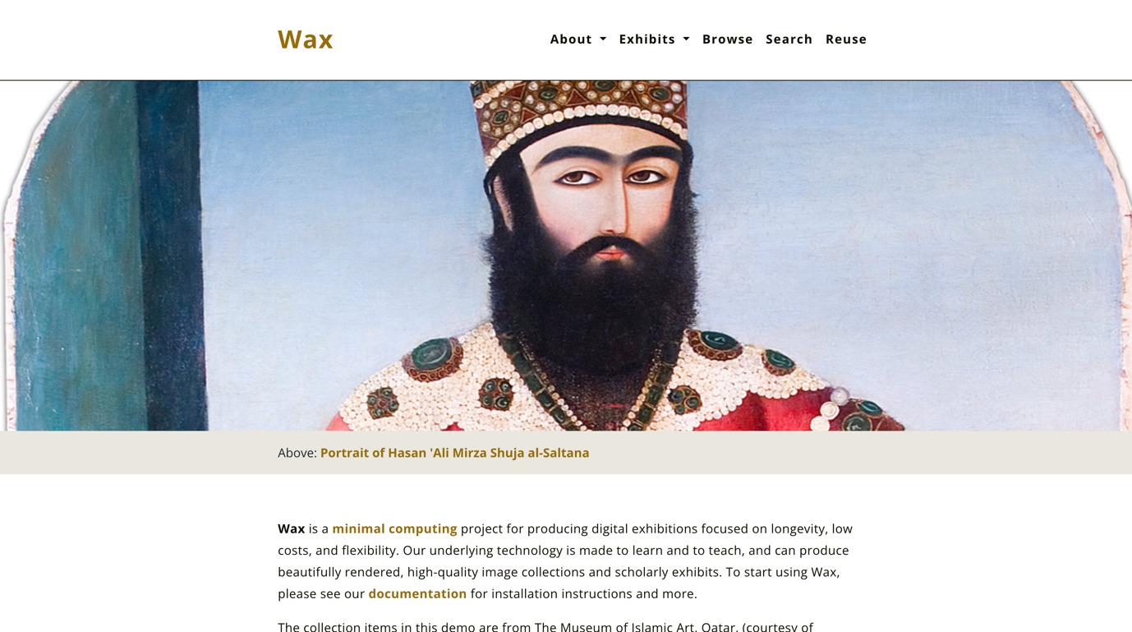
Figure 1: Base Wax Site from GitHub
As with other Wax sites, Facets depends on the metadata you create. Let's assume you are using Comma-Separated Value (CSV) data file to record data for your collection. In order for Facets to work, that CSV must have designated columns for each large category you want to "facet" by. The columns then become the facet headers at the top of the drop-down menus above the gallery. Each of these columns then accepts a small range of sub-categories, or facet values. The facet values become the check boxes. From there, a user can begin to conceptualize how to structure their static site.
The concept for Runaways was birthed when I started doing research for my master’s thesis, “Freedom Through Connection: Runaway Slaves in an Urban Environment in Nassau, New Providence, 1784-1812,” in the Summer of 2022. As I began researching runaway slave advertisements in The Bahamas in Bahamian published newspapers, I wondered how it would look to conceptualize visually the networks these enslaved people created. Thinking of lines appearing across the archipelagic colony to see the flight of these persons sparked excitement within me.
I have been fascinated with the digital humanities after taking a class called “Digitizing the Archive” in the spring of 2022. The culmination of the class was a digital archive and exhibit surrounding a West Indian Playwright’s life in Panama during the creation of the Panama Canal. Carrying the idea of building my skills in the digital humanities realm and desiring to work on a project with runaway slaves in The Bahamas, I decided to apply for the Caribbean Digital Scholarship Collective Summer Institute (CDSCsi) for the summer of 2024. I got accepted into the ‘Minimal Computing’ class and brought the concept of Runaways with me to the institute.
In the Minimal Computing class, students were under Dr. Alex Gil, a Senior Researcher in the Digital Humanities at Yale University, and Dr. Schuyler Esprit, founder and Director of Create Caribbean Research Institute – the first Digital Humanities Centre in the Caribbean. Students were tasked with building their own web projects that catalogue and present digital cultural artifacts using minimal computing principles. In the process, participants learned the fundamentals of data preparation and management, static site generation, and version control. The result was an impactful presentation as well as a portable data set—both of which can be repurposed and preserved without relying on institutional resources. Using these principles, the CDSC hopes to equip Caribbean scholars with tools to use while having access to less resources.
The Minimal Computing class helped equip me to navigate the digital landscape efficiently and sustainably with practical skills while working through a technological deficit of being in the Caribbean. Learning how to work with less was and is important to me as a scholar who is from the Caribbean. Digital projects, like Runaways, help with historical engagement among laypersons and the preservation of overlooked history. After being accepted into the class and completing the institute, I have been slowly working on Runaways alongside my other commitments.
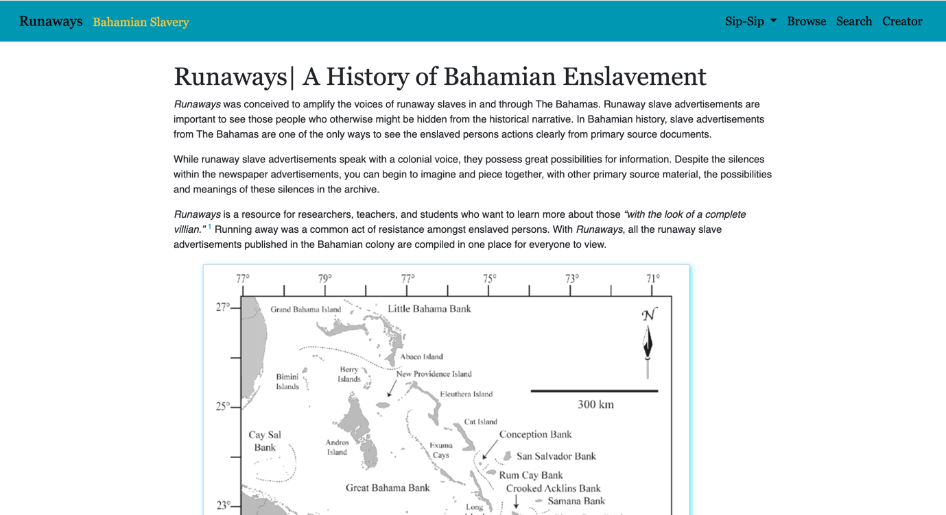
Figure 2: Front Page of Runaways.
Design Details
The colour scheme of Runaways harkens back to The Bahamas’ flag colours. I wanted to keep pointing back to the nation that developed out of this history, and that functions within the ramifications of its colonialized past today. Originally Runaways was supposed to have a mapping element alongside it. The idea was to have viewers visually see the paths of supposed flight these enslaved people were taking. Viewers would be able to click on a drop-point on a plantation or in town and see different flight paths that runaways took from that point. It is a long-term goal of mine to add that visually mapping element to Runaways.
I embedded a map of The Bahamas and Turks and Caicos directly on the front page of the project because it is important for viewers to immediately get a sense of geography of The Bahamas. The Bahamas is an archipelago, and because it is made up of many islands and cays, it mean that flight could take place across land or sea. In line with visualizing the physical geography of the colony, I included a photo album component from University of Cambridge’s Digital Library. They have a collection of photography from Jacob Frank Coonley in The Bahamas spanning 1890-1895. A tab attached to the photographs tells a brief story of Jacob Frank Coonley’s journey from New York to The Bahamas. The photographs are labelled with the location where they were taken, but they do not name the subjects in the photographs, many of whom are Black Bahamians.
I posit the photographs alongside the narrative of runaways and my speculative text to help readers visualize the late eighteenth and early nineteenth century Bahamas. While the photographs are taken almost fifty years after the end of enslavement in the British Caribbean, they help readers to begin to see and understand the colonial Bahamas as it was back in the nineteenth century. It is important to humanize the historical subjects, even as we study them. As readers use their imagination with the help of these aids to visualize life back then. They will be able to more fully understand the hardship of an enslaved person’s flight, and the danger of running away in the archipelagic colony.
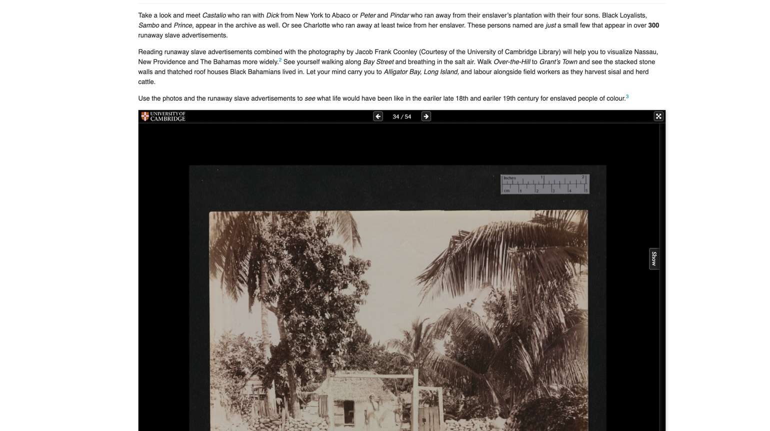
Figure 3: The Jacob Frank Coonley Photo Album on Runaways.
The main page ends with an effort to promote Bahamian Creole in an academic setting. As a Bahamian historian of Bahamian history, I believe it is imperative that Bahamian Creole be seen, read, heard, and understood as a language that is not less than American or British English. While this paper is in British English for the sake of the journal and its primarily American readers, I am for writing Bahamian Creole into academic and popular publications. 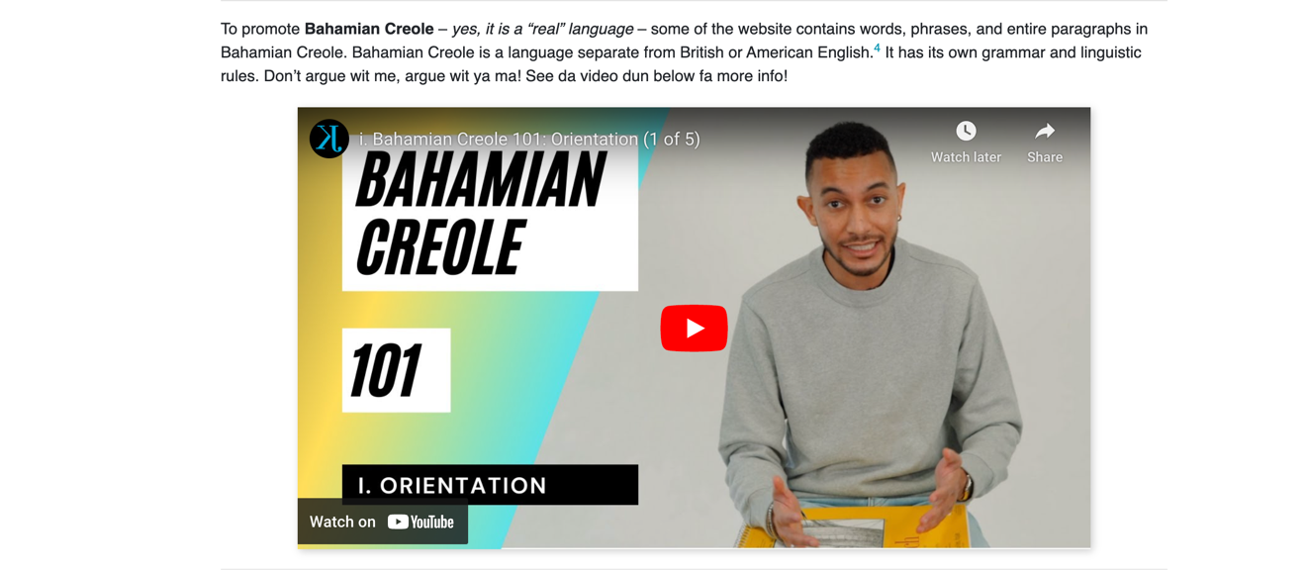
Figure 4: A Youtube Video that Gives a Brief Overview of Bahamian Creole.

Contents of Each Section
Runaways has the main collection of runaway advertisements but also essay pages talking about enslavement and runaway slaves, newspaper production, and location in The Bahamas. In all the essay pages, where I bring historiographical conversations or mention specific historical actors, I cite with footnotes. Every essay page has a notes section at the bottom, in an effort to promote viewers to do more research and to share historical knowledge.
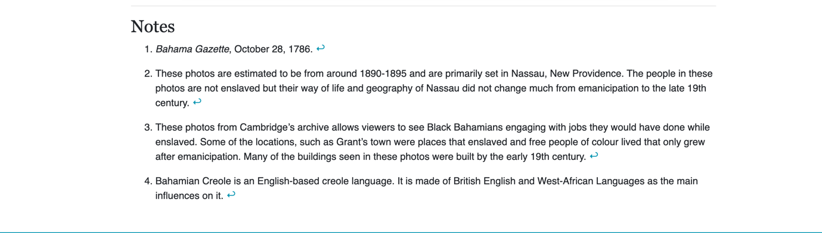
Figure 5: Footnotes from the main page of Runaways.
From the main page, viewers can navigate to the essay pages by clicking on ‘Sip-Sip.’ From ‘Sip-Sip,’ viewers can begin to delve deeper into the historical context of Bahamian slavery and the history of the newspapers used for Runaways. There is also a “Location”
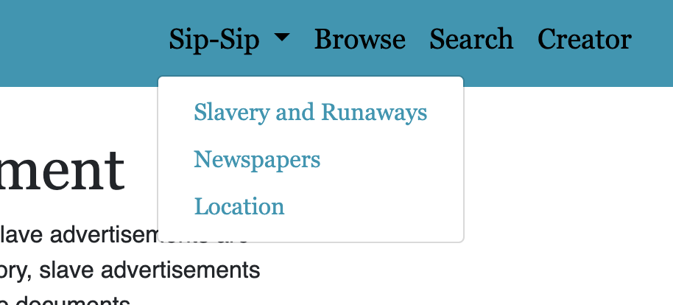
Figure 6: A Screen Capture of the Navigation Tabs on Runaways.
tab to bring in the idea of geography without the mapping element. The “Browse,” “Search,” and “Creator” sections each function as their label suggestions. The “Browse” section has a paragraph written in Bahamian Creole, explaining where the newspapers were sourced from and how to use the “Browse” feature. Within “Browse,” there are three search tabs: “Publisher,” “Decade,” and “Tags.” These three search tabs are all attached to metadata associated with the advertisements.
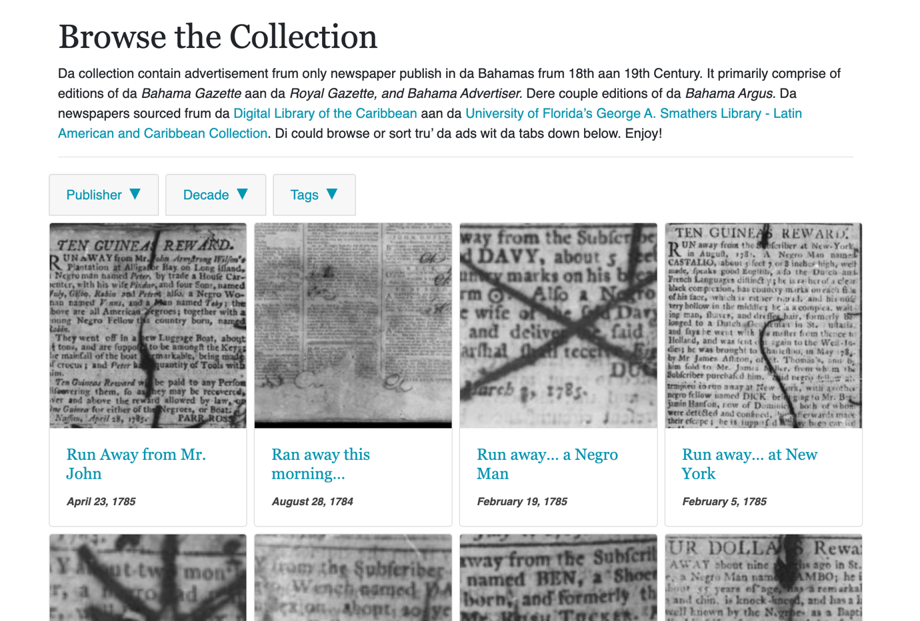
Figure 7: A look at the “Browse” Section with Search Tabs Closed.
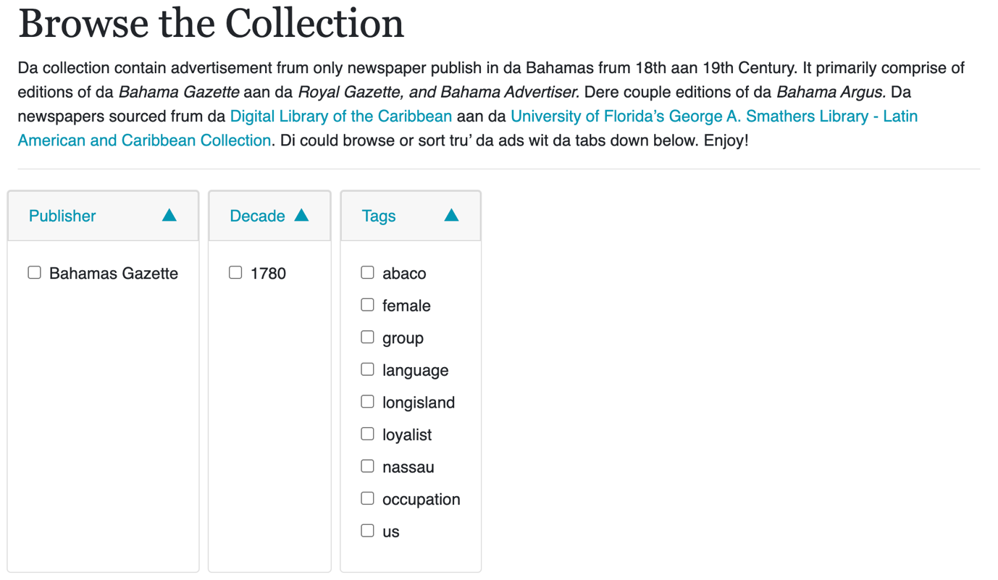
Figure 8: A look at the “Browse” Section with Search Tabs Open.
The “Search” section allows viewers to search by any word that appears in the metadata for the advertisements. If one were to search for a specific person’s name that would pull all the advertisements with that name. However the search display still needs to be edited to fix the default metadata, from the default GitHub page, that appears in the search engine when you use it. 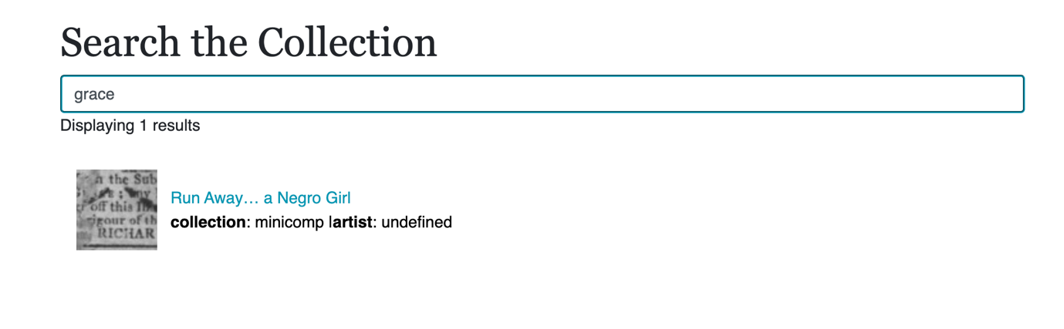Figure 9: A look at the “Search” Section.

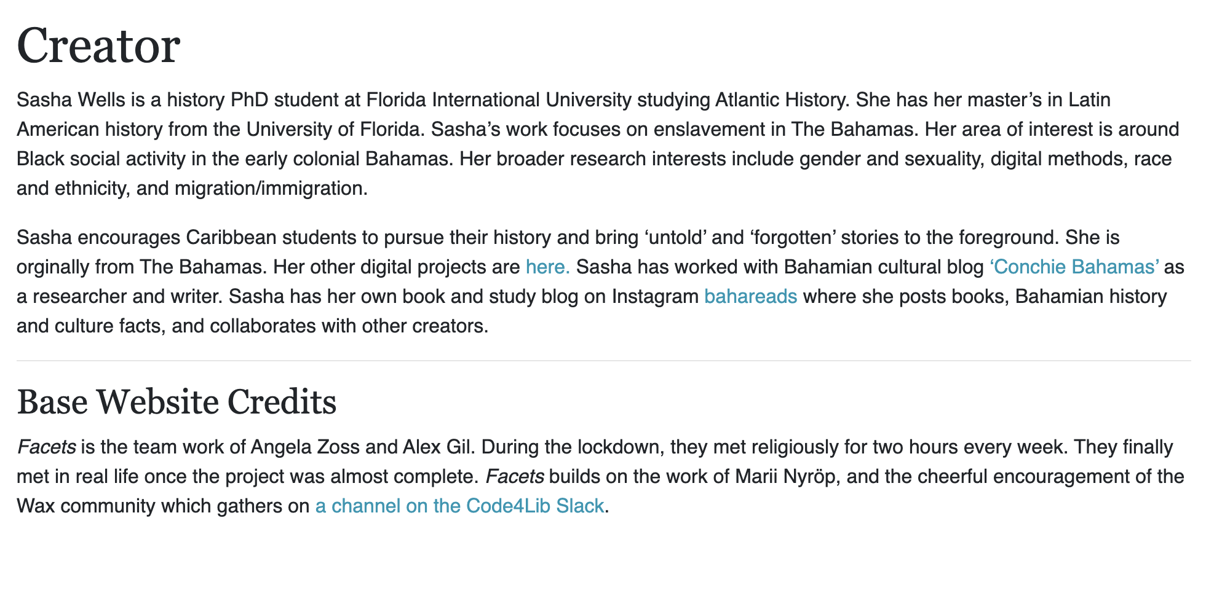
Figure 10: A look at the “Creator” Section.
In the “Creator” section, I have a short introduction of myself as the creator of the exhibit. It gives information on myself, my research interests, and my brief experience in the Digital Humanities. I also have a message of encouragement for Caribbean students to pursue and learn their history. In this section, I kept the Base Website Credits which direct any viewers to more information about the creators of the shell Wax website. It was important for me to keep this information in Runaways to help direct anyone who was interested in creating their own website.
Originally the set of essays (Slavery and Runaways and Bahamian Newspapers) had lofty comments on the historiographical debates that thread in Bahamian historiography regarding enslavement and maroons. I decided to forego these essays for more basic informational essays to reach all levels of education. The hope is to keep viewers engaged with the site by keeping technical jargon to minimal usage. The newer essays include word definitions and basic facts of Bahamian history.
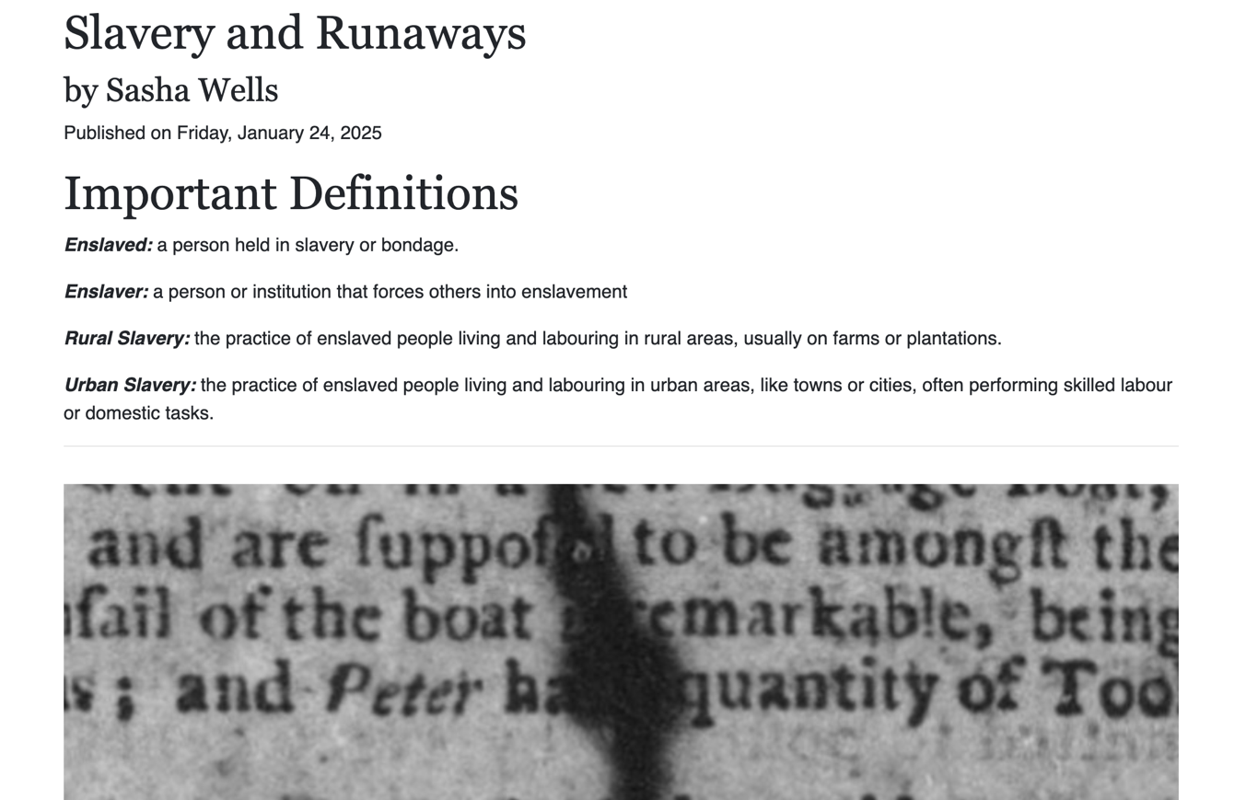
Figure 11: A look at the “Slavery and Runaways” Section and Parallax Image.
The first essay, “Slavery and Runaways,” starts with definitions of words and terms that appear in the essay for readers who have never heard them before. The first photo is a parallax image which moves when viewers continue to scroll. The second photo is an inline photo that does not move as viewers scroll. The essay covers a very brief history of The Bahamas’ European colonization and the start of African enslavement in The Bahamas. It covers rural and urban enslavement in The Bahamas as well. The importance of runaway slave advertisements and how it allows researchers to see enslaved life in The Bahamas is emphasized in the essay. The importance of all these subjects in Bahamian history is felt throughout the text.
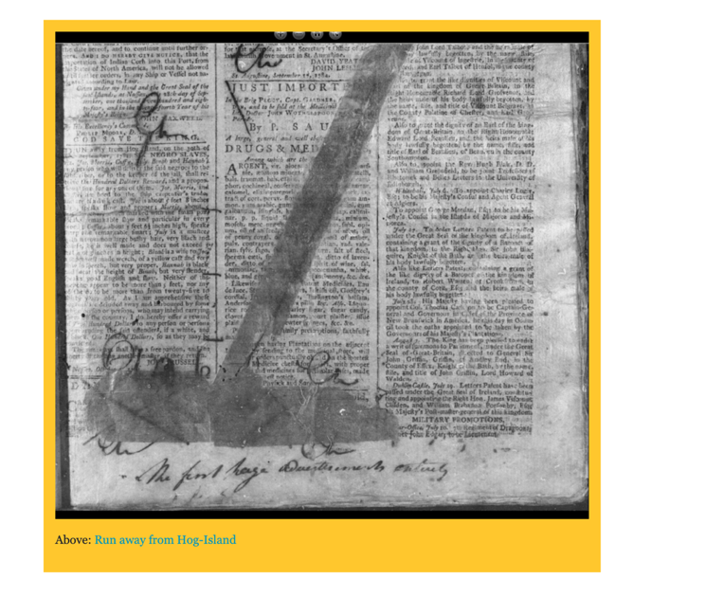
Figure 12: A look at the “Slavery and Runaways” Section’s Inline Image.
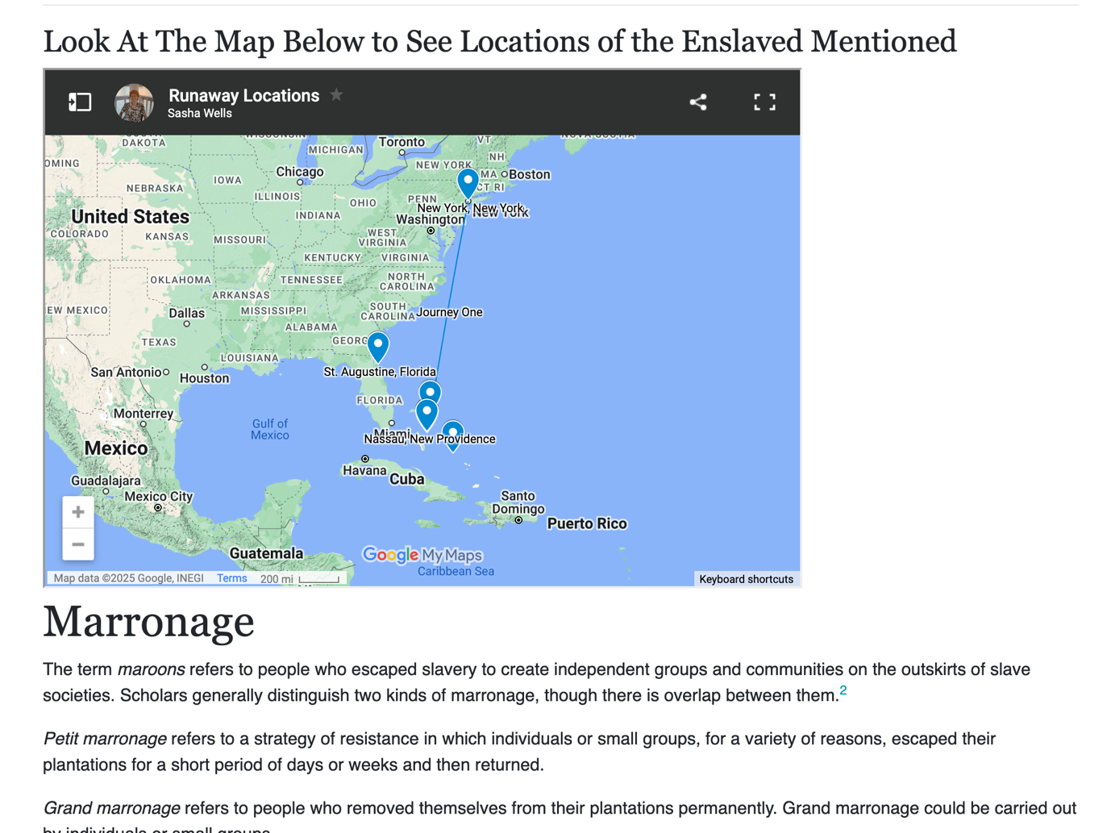
Figure 13: A look at the “Slavery and Runaways” Section’s Google Map.
A google map was included to show the locations mentioned in the runaway slave advertisements already in the exhibit in lieu of the lack of the originally conceived visual elements. The essay ends with a section on marronage, giving a brief description of it. The essay ends with my assumptions on how it should be categorized in The Bahamas.
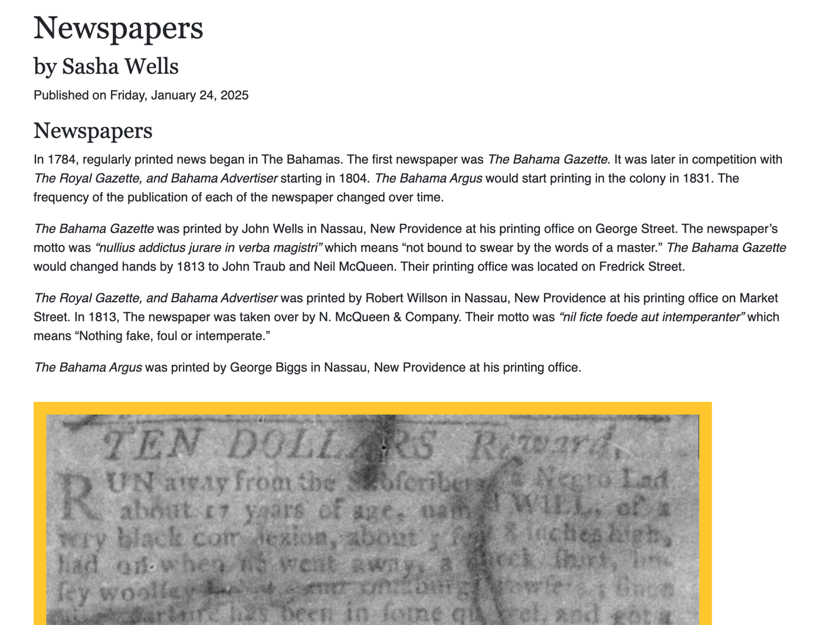
Figure 14: A look at the “Newspapers” Section.
The “Newspapers” essay covers the creation of The Bahama Gazette, The Royal Gazette, and Bahama Advertiser, and The Bahama Argus from their editors to their printing offices’ location in Nassau, New Providence. From there the essay includes a brief overview of runaway slave advertisements’ history in The Bahamas. It starts with the 1767 Act which legislated that enslaved people who were absent for more than fourteen days had to be advertised in the “usual public places.” It informs readers that before the creation of printing shops in The Bahamas, ads were posted at Vendue House which was the marketplace in the town of Nassau. Major identifiable patterns in the runaway advertisements are mentioned in the essay. It is meant to be a guide for people who do not have experience viewing or working with runaway slave advertisements. The essay ends with a historical contemporary’s observation of a sale of enslaved people in The Bahamas. He describes the scene in detail, only briefly given in the essay on the site.
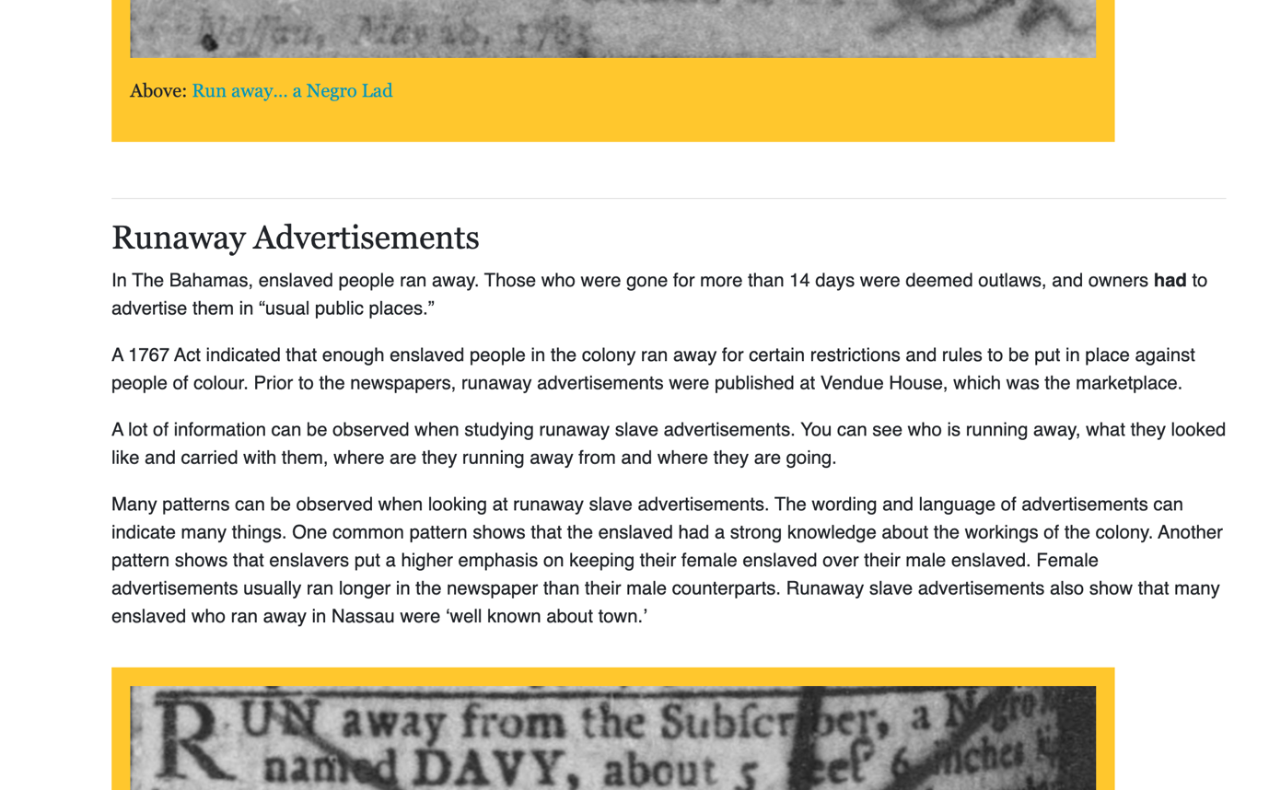
Figure 15: A look at the “Newspapers” Section’s Essay.
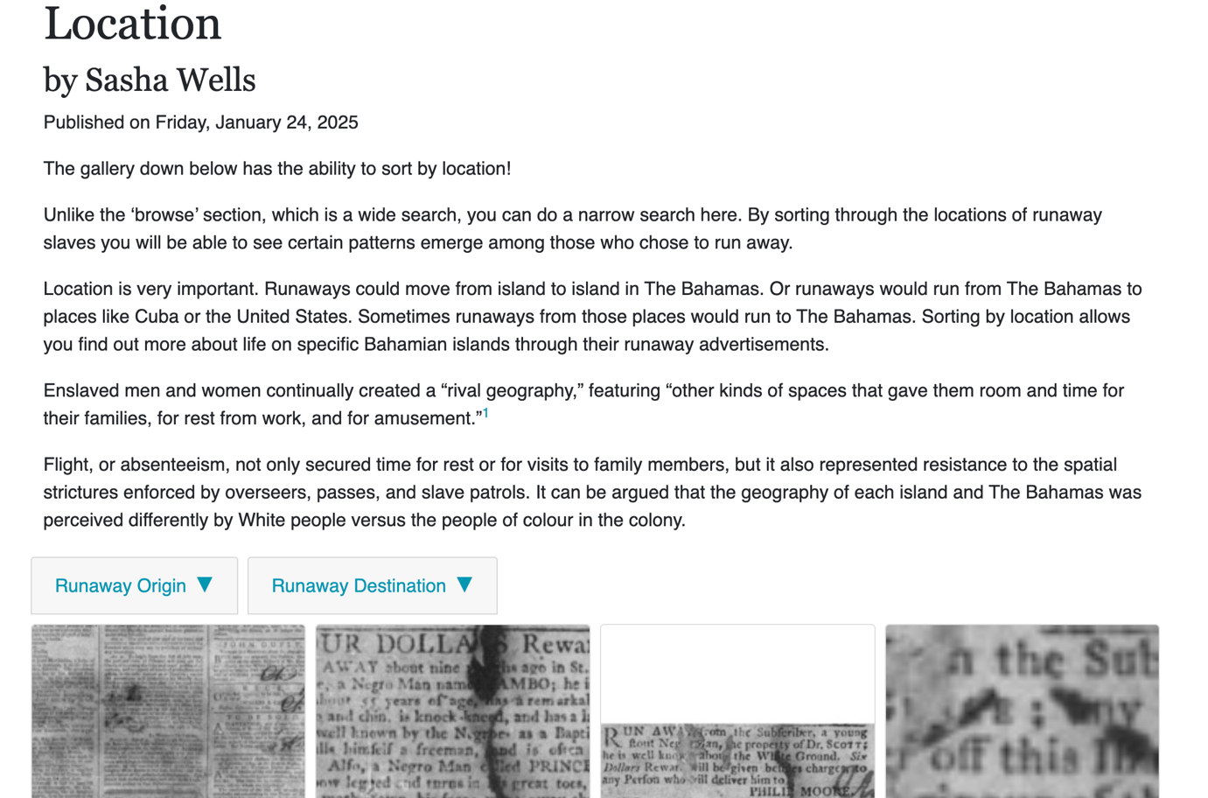
Figure 16: A look at the “Location” Section.
The “Location” section’s essay and the accompanied newspaper gallery stress the importance of location of the runaway slave and scholarly ideas, before sorting through the advertisements by location. The advertisements can be casually scrolled through as well. The “Location” essay covers the idea of rival geography and how flight was not just for resistance but also for rest.
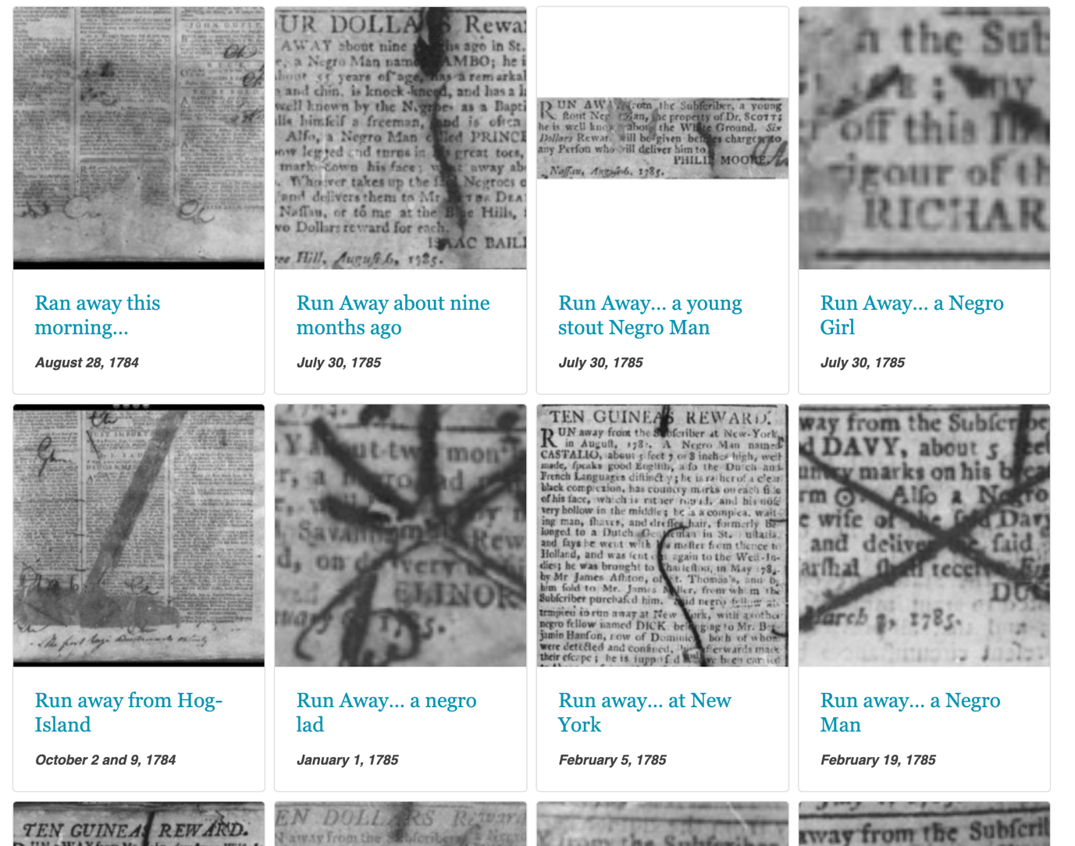
Figure 17: A look at the “Location” Newspaper Gallery.
These open tabs show all the locations mentioned in the advertisements.
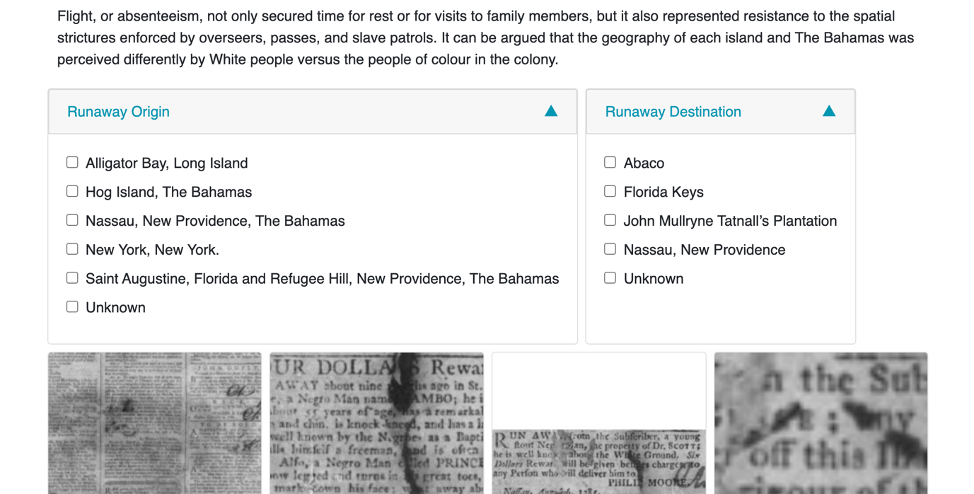
Figure 18: A look at the “Location” Newspaper Galley Browsing Tabs.
The advertisements are taken and cropped from their sourced newspapers. There are navigation controls to zoom, un-zoom, scroll through advertisements if there were multiple pages, and a home button. There is also a scroll option to go from advertisement to advertisement.
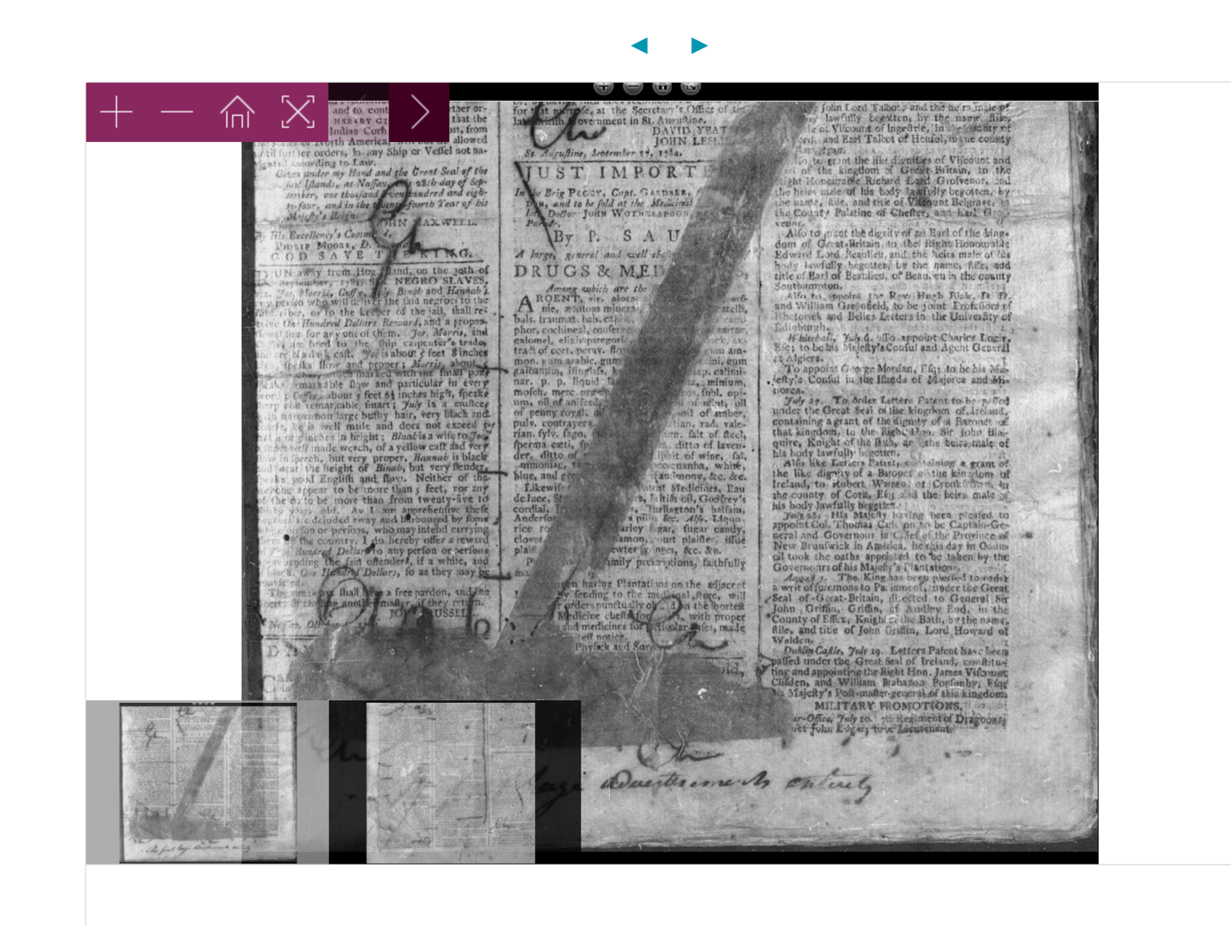
Figure 19: A look at a Newspaper Containing a Runaway Slave Advertisement
Each advertisement is named by the few words the advertisement begins with. When conceptualizing the metadata, I focused on the idea of humanization and humanizing historical actors, particularly the enslaved. In my effort to do that, there is a focus on names, location, and other humanizing elements like occupation and gender that make up the bulk of the metadata.
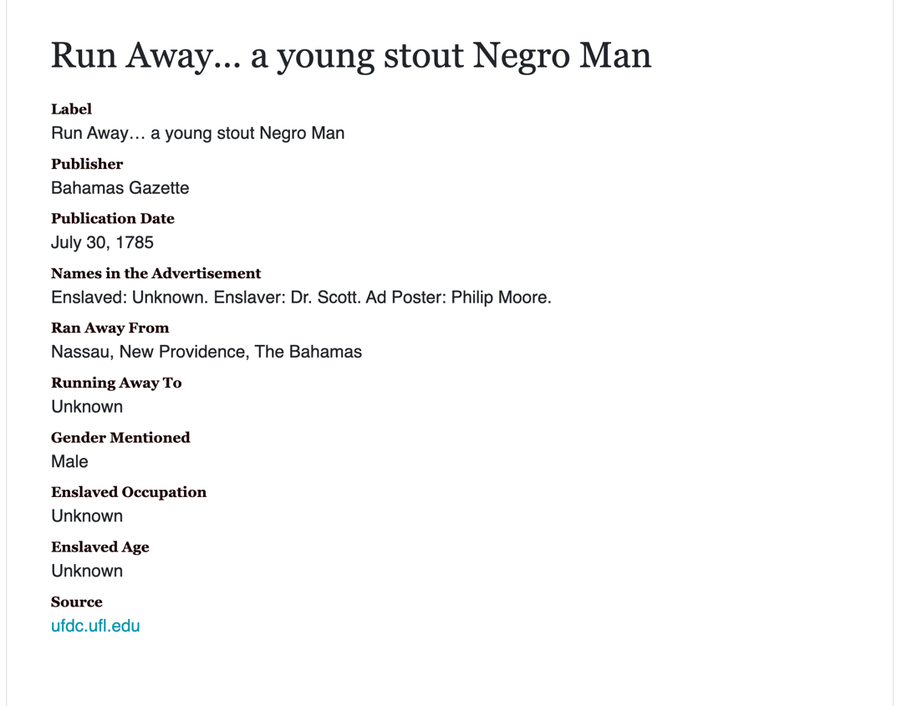
Figure 20: A look at Metadata.
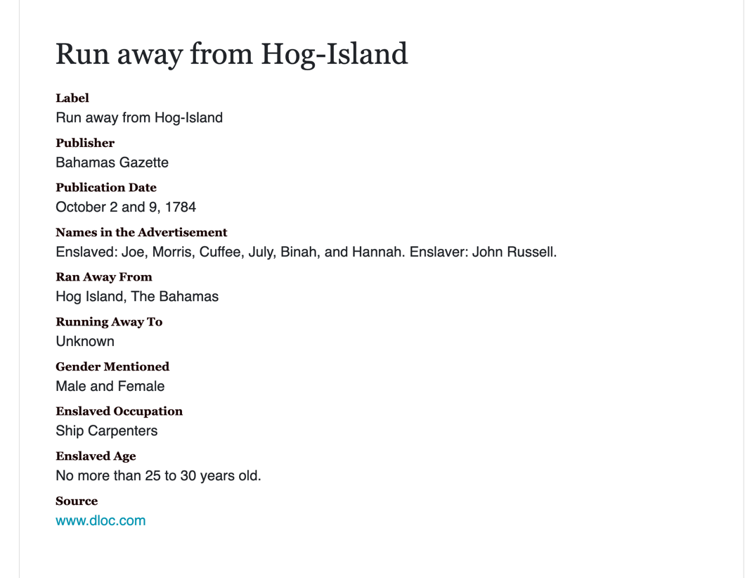
Figure 21: A look at Metadata.
In case none of the essay pages load, for a bit of fun and in the spirit of the Bahamian Creole initiative, the error page has a Bahamian saying on it.
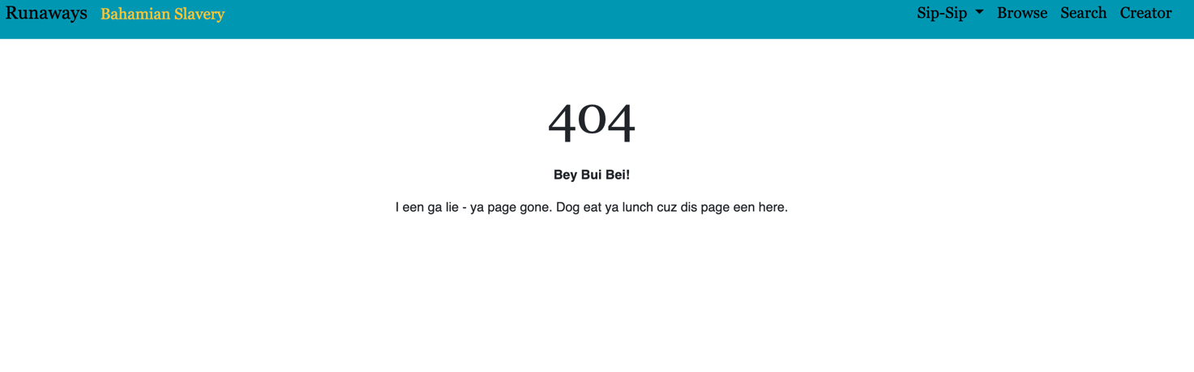
Figure 21: Runaways Error Page.
Conclusion and Next Steps
Runaways is academic act of love. I enjoy doing historical research and sharing Bahamian history with the public. The Digital Humanities is a realm I am trying to get into in the scholarly world. I loved being able to create Runaways and continuing to work on it while I grow my DH abilities. The next step for Runaways is to fix the minute details. The website icon needs to change from a bee to something relatable to the context of the website. I need to change the PNGs for the advertisement navigations as well. They are currently a purple colour, which does not go with the rest of the colour scheme of the website. I also need to fix the metadata that appears in the search bar, as mentioned above.
Runaways was a passion, hopefully turned useful tool, project. With runaway slave advertisements, this project illuminates the actions and agency of enslaved individuals as they are often marginalized or hidden in historical narratives. As someone who wants to engage in the public history sphere, I see the need to educate the Bahamian public on their own history while preserving it. Using the tools given to me, by scholars passionate about Caribbean studies, I want to give back to the scholarship and people I am studying. Runaways reflects my dedication to making the stories of the enslaved visible and preserving their legacy within the broader scope of Bahamian and Caribbean history.

Works Referenced
Coonley, Jacob Frank. “Photographs of the Bahamas.” 1890-1895. Cambridge University Library: Royal Commonwealth Society Library. http://cudl.lib.cam.ac.uk/view/PH-Y-03071-A/1.
Kincaid, Chet. “Bahamian Creole 101: Orientation.” Posted January 12, 2021, by The Kincaid Journal. Youtube. https://youtu.be/Sw2DZ8U48Wk?si=_YtFmKGRCt2M8dHH
Rosenberg, Leah, Dinalo Chakma, Sayantika Chakraborty, Chandler Mordecai, Noah Mullens, Jacob Senory, Sasha Wells, and Brooke Whitaker. “Milton Garvey: A Case Study of West Indian Culture and Labour.” Storymaps. https://storymaps.arcgis.com/stories/77771e31a06e449088023434e6cf2c02.
Visconti, Amanda. Programming Historian. https://programminghistorian.org/
Wells, Sasha C. “Runaways: A History of Bahamian Enslavement.” https://sashacat9.github.io/minicomp/
Wells, Sasha C. “Freedom Through Connection: Runaway Slaves in an Urban Environment in Nassau, New Providence, 1784-1812.” Master’s Thesis, University of Florida, 2023. https://ufdcimages.uflib.ufl.edu/UF/E0/06/04/24/00001/Wells_S.pdf

Wax sites consist of flat HyperText Markup Language (HTML) meaning that it does not depend on anything external for content, Cascading Style Sheet (CSS; a computer language for laying out and structuring web pages made of HMTL), and JavaScript files (JavaScript is a programming language primarily used to add interactivity and dynamic behaviour to websites.)
Jekyll is a static site generator. It takes text written in your favourite markup language and uses layouts to create a static website. You can tweak the site's look and feel, URLs, the data displayed on the page, and more.
To learn more about setting up and using Wax visit the Wax wiki. You can learn more about using Jekyll on the Jekyll docs, or in this great tutorial by Amanda Visconti at Programming Historian.
Metadata is data that provides context and information about other data. It describes details like the source, type, owner, and relationships of the data, helping to understand its relevance and how to use it.
A CSV (comma-separated values) file is a text file that has a specific format which allows data to be saved in a table structured format.
A static or flat web page is one that is delivered to a web browser exactly stored. Static web pages can be contrasted by dynamic web pages which are generated by a web application.
See Sasha C. Wells, “Freedom Through Connection: Runaway Slaves in an Urban Environment in Nassau, New Providence, 1784-1812” (Master’s Thesis, University of Florida, 2023). https://ufdcimages.uflib.ufl.edu/UF/E0/06/04/24/00001/Wells_S.pdf
See Leah Rosenberg, Dinalo Chakma, Sayantika Chakraborty, Chandler Mordecai, Noah Mullens, Jacob Senory, Sasha Wells, and Brooke Whitaker, “Milton Garvey: A Case Study of West Indian Culture and Labour” Storymaps, https://storymaps.arcgis.com/stories/77771e31a06e449088023434e6cf2c02.
In computing, minimalism refers to the application of minimalist philosophies and principles in the design and use of hardware and software. Minimalism, in this sense, means designing systems that use the least hardware and software resources possible.
Data preparation is the process of cleaning and transforming raw data prior to processing and analysis. A static site generator is a tool that generates a full static HTML website based on raw data and a set of templates. Version control is a system that tracks and manages changes to files over time, allowing teams to collaborate effectively and easily revert to previous versions if needed.
The Bahamian flag colors are aquamarine, gold, and black.
The Bahamas during the period of the enslavement and newspaper publishing (1784-1834) included what is now the Turks and Caicos Islands.
Jacob Frank Coonley was an American-born photographer who moved to Nassau, The Bahamas where he chronicled the people and the landscape during the end of the 19th century.
“sip-sip” is a Bahamian Creole term for gossip.
Bahamian historiography here means (1) work focused on The Bahamas by Bahamians and (2) work solely focused on The Bahamas by non-Bahamians.
A parallax image is a visual effect where background elements move at a different speed than foreground elements when the user scrolls, creating an illusion of depth. An "inline image" in HTML is an image that is placed directly within the flow of the text on a webpage. It means the image will be displayed alongside the text as if it's part of a single line.

