Experiences in Early Graduate Student Research: The Center for Southwest Research and Special Collections, 2019 versus 2024

Archives are unavoidable for historians. Scholars move in and out of archives of all kinds: the traditional national archive, local archives, and alternative archives that live in the smallest spaces or virtually in the digital space. Though archives acquire new materials and re-organize collections, they stay mainly still. It is the scholar who changes the archive, bringing out its content in new ways with each project that references the materials. Historiography is proof that humans change over time, and how we interact with archival materials changes over time too, even when dealing with the exact same materials.
Change in usage can largely be attributed to changes in interpretation, but sometimes the background of the user changes the archival experience. It is safe to say that I had no archival experience when I first visited the Center for Southwest Research and Special Collections (CSWR) at the University of New Mexico. It was the summer of 2019 and I was about to enter my fourth and final year of undergrad at the University of Florida. I received a generous scholarship from the History Department at UF to complete archival research for my undergraduate honors thesis. Admittedly, I had little idea of what the thesis would be about, but I had enough to convince a group of reviewers that I needed to go to that certain archive. Not only was this my first trip to an archive, but it was my first out-of-state trip on my own at that point. The thrill of booking accommodations, flights, and a rental car greatly obscured the daunting nature of doing primary research in an archive. I was looking at sixteenth and seventeenth-century documents from the Spanish colonial period; the word “paleography” was not even in my vocabulary at that point.
I had scheduled four days in the archive. In retrospect, the first day was an excellent indicator of the week to come. I had failed to check the collection’s hours of operation and calendar and found it closed for the entire day. Slightly discouraged but still optimistic, I returned the next day. The student assistant at the front desk helped me check in and store my items in a locker, but after that I was on my own. From a very precursory look at the finding aid, I ordered multiple boxes of documents that “sounded” promising. Many of these were copies of documents in the AGI (the largest Spanish colonial archive) and involved the kings of Spain; I thought that following royalty would be the safest option. Feeling both excited and overwhelmed, I took photos of every page of every document in those boxes. I was operating with the “more is more” mindset, thinking the more primary sources I was able to collect, the better my thesis would be. For days I sat, took photos, and repeated from 10 am to 3 pm. Spoiler alert: I never used a single one of those documents in my final thesis.
My first archival trip taught me that the archive, traditional and non-traditional, is really what you make of it. The materials have no legs, no voices to shout “look at me!” from the boxes on the back shelves. Though their creation in the past and their presence in the archive represent the many varied dynamics of history and history-telling, they can do little without the eyes and words of the historian. Archivists act as their intermediary between the shadows and the light. Durba Ghosh, for example, found that archivists and other scholars of British imperial history pushed her away from her preferred research topic because it was not "particularly savory or respectable.” Ghosh felt a Foucauldian surveillance in the form of unwanted advice and interference. During my first archival trip in 2019, I may have welcomed some advice and interference. I was left alone for the most part; the documents were under surveillance rather than myself, or at least that is what it felt like.
Despite the objectively unproductive nature of the 2019 trip, I returned to the same CSWR in 2024. I knew what sources I wanted to see, where they were located, and for what purposes I planned to use them. The experience was entirely different. I left with a smaller quantity of materials, but greater confidence in myself as a researcher. The biggest indicator of success from that trip might have been when the archivist asked me what I was using the materials for, and I was able to tell her and watch her face light up with interest. At that moment, the Foucodian surveillance felt like a welcomed stage spotlight.
Unfortunately, I have no better advice for first-time archive users like my 2019 self other than “fail.” Bringing life into the archives requires an energy that is cultivated over time and through mistakes. In retrospect, funding archival visits for first-time users, regardless of the project, is funding the first step in a long journey of personal change. Changes in the researchers themselves change the archive. If I return to CSWR for a third time, the same materials will tell a different story, a different history.
Check out some pictures included in this piece that illustrate my journey with the CSWR.

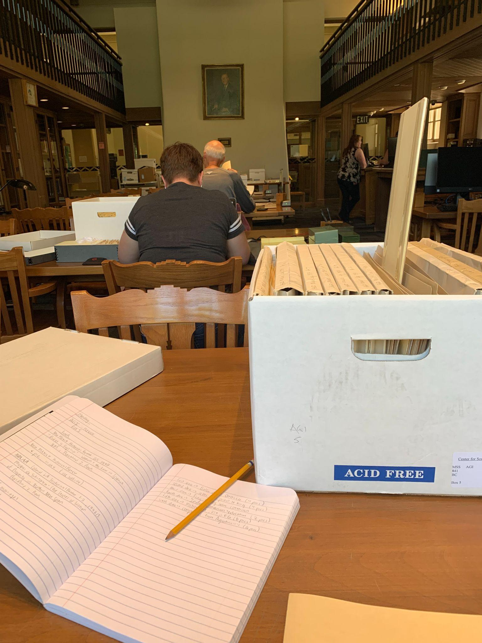

This was the first photo I took during my first visit in 2019. I took the pencil-and-paper rule very seriously.
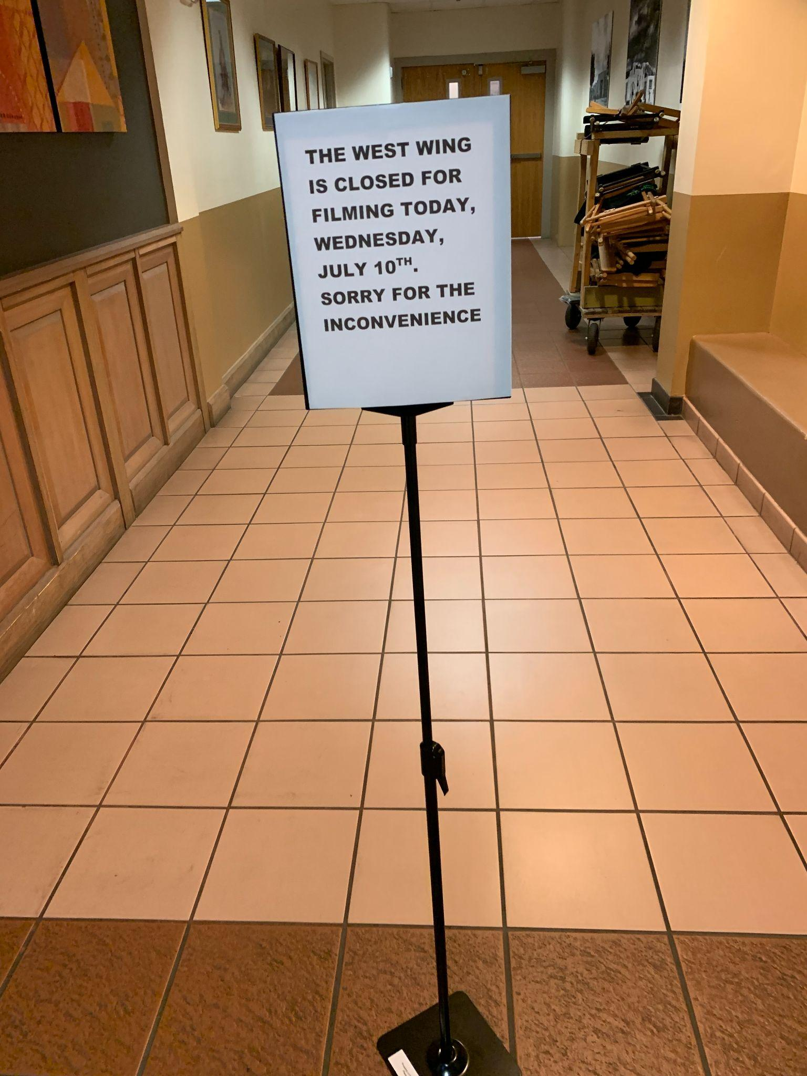
This is the moment I learned to always check the hours of operations before planning a visit.
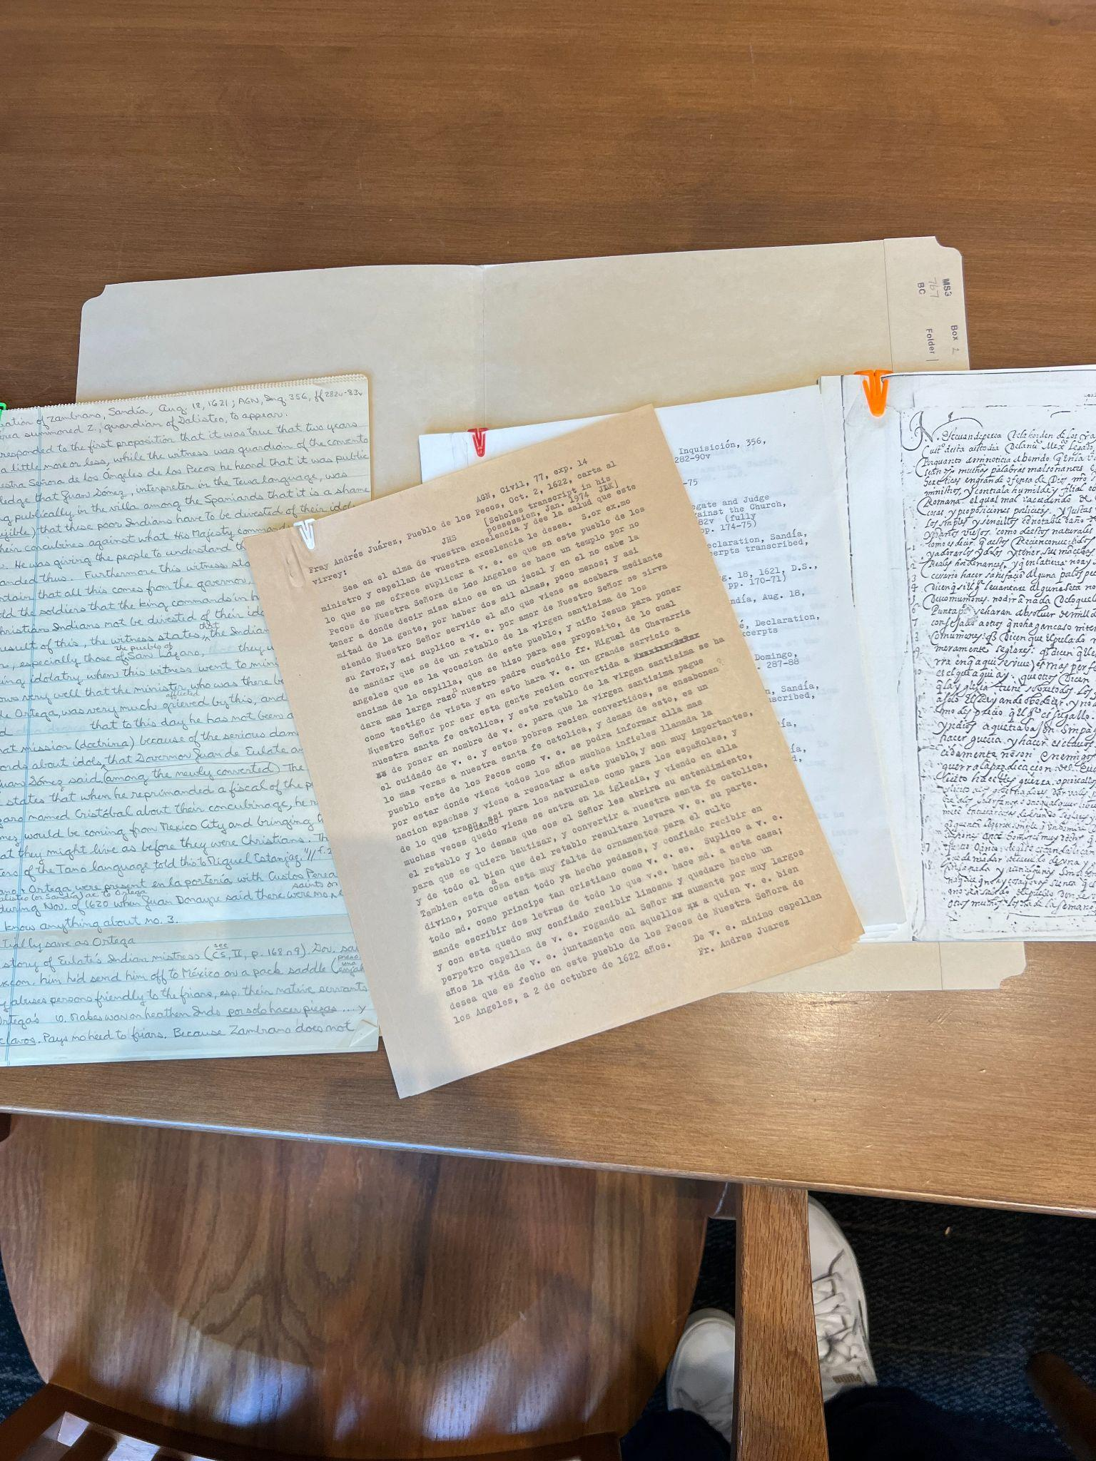
These are documents from John L. Kessell papers collection at the CSWR. Here you can see the historian’s thought process from source, to translation, and to annotations.

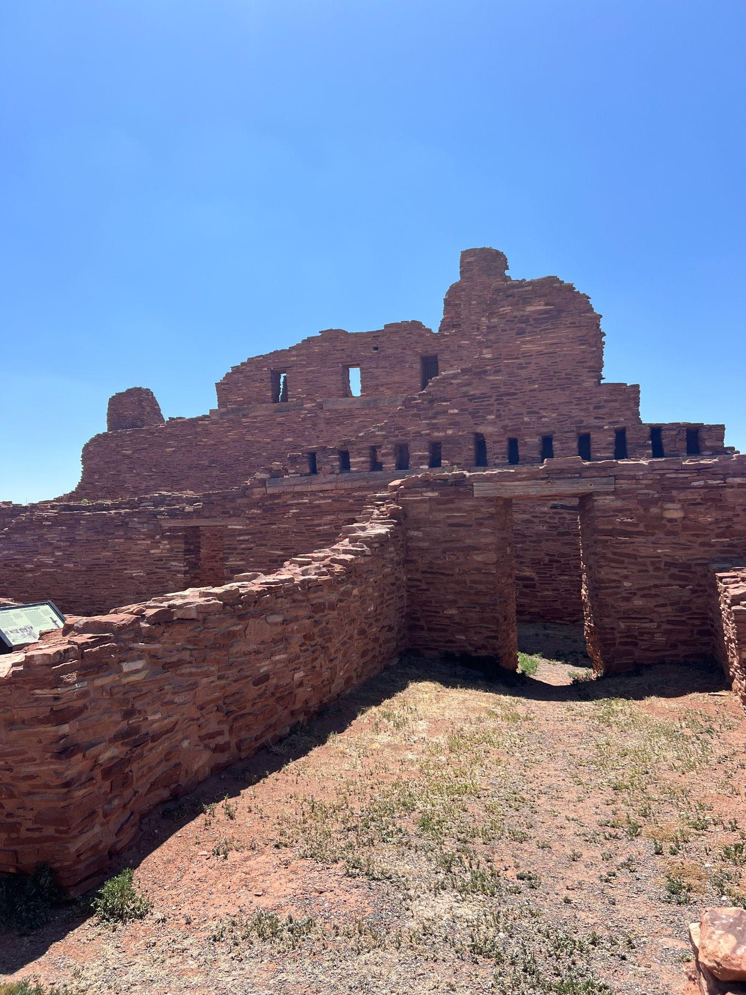
I coupled my 2024 archival visit with a trip to a mission outside of Albuquerque. This is what remains of one of the missions I was researching.

Bibliography
Ghosh, Durba, and Antoinette Burton. “National Narratives and the Politics of Miscegenation: Britain and India.” In Archive Stories: Facts, Fictions, and the Writing of History, edited by Antoinette Burton, 27–44. Durham, NC: Duke University Press, 2005.
Foucault, Michel. Discipline and Punish: The Birth of the Prison. Translated by Alan Sheridan. New York: Vintage Books, 1995.

In her Archives Stories article, describes how different archivists and librarians pushed and pulled in various directions based on national interests as she attempted to research a transnational history of India and Britain during the first century of British imperial rule in India. Some pushed her away from researching the interracial relationships during this time period; Ghosh believes this was because she was a young Hindu woman. Ghosh Durba Ghosh and Antoinette Burton, “National Narratives and the Politics of Miscegenation: Britain and India” in Archive Stories ( New York, USA: Duke University Press, 2020), 30.
“Foucauldian surveillance” refers to the concept of the Panopticon, an architectural design for prisoners in which prisoners were separated from each other but were able to be under constant surveillance by the guards. Michel Foucault, of course, is well-known for his theory that punishment transformed from physical, public acts to private, psychological acts done in the name of “discipline.” The latter, he argues, was not more humane than the first; both were exercises of power.
https://elibrary.unm.edu/cswr/
https://www.cultura.gob.es/cultura/areas/archivos/mc/archivos/agi/portada.html

