“An Ex Vivo Capillary-Arteriole Preparation To Investigate Neurovascular Coupling”​ Karen Colmenares, Ela Nunez, Katherine Lopez, Nikolaos M. Tsoukias
Department of Biomedical Engineering, Florida International University

Neurovascular Coupling (NVC) is a multifaceted mechanism that links neural activity to changes in cerebral brain blood flow, playing a pivotal role in maintaining normal brain function. ​This interplay between neurons and the vasculature is often impaired in neurodegenerative disorders and stroke, underlining its significance in neurological health. ​  In response to neuronal activity, various mediators are released to influence arteriolar smooth muscle tone and local blood flow.​ Understanding of capillary-mediated NVC is limited due to the inaccessibility of capillaries for experimental observation and the scarcity of suitable experimental assays. ​Our aim in this study is to advance a recently proposed ex vivo isolated Capillary-Arteriole preparation for quantifying Kir-mediate signaling in the cerebral microcirculation.​  The experiments involve using a C57BL6 mice and genetically modified Kir2.1 knockout mice. Kir-KO mice are generated by crossing mice expressing CRE recombinase under an endothelial-specific promoter Cadherin 5 with a Kir 2.1 floxed Tg mice, where exon 1 of the Kir 2.1 gene is flanked by LoxP sites. A homozygous LoxP mouse with CRE is obtained after two generations of breeding. Brain isolation is performed following euthanization, using micro-forceps, the Middle Cerebral artery (MCA) is excised from the Circle of Willis and traced until reaching smaller pial vessels at the top of the brain. A small piece of tissue at the end of the isolated vasculature is preserved and carefully disrupted using forceps.​ The isolate is placed on the surface of aCSF solution. Surface tension enhances the removal of parenchymal tissue and stresses the isolated capillary-arteriole network. ​We plan to utilize the CaPA prep to:​  Investigate the determinants and quantify electrical propagation in brain capillaries, and test the role of Kir channel in electrical signaling in the brain capillaries.​ This will allow us to determine stimulatory requirements, electrical propagation distances and resistivities in WT and Tg mice. ​ We will deduce parameters to inform the model and test model predictions. ​ | 
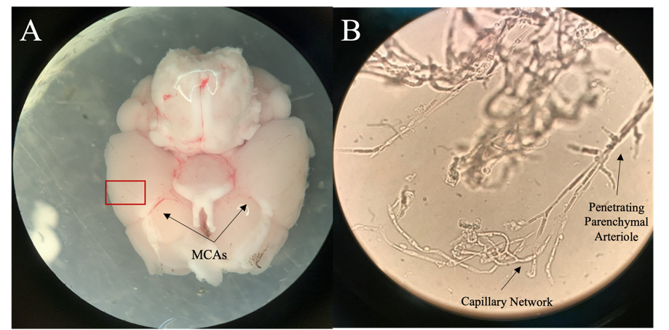

Figure 1: Isolated Mouse Brain and Capillary Network A) Basal view of an Image of the isolate mouse brain showing the depicting Circle of Willis and the Middle Cerebral Arteries (MCA) from which stems isolate capillaries. A pial artery branching out of the MCA and surrounding tissue is dissected (red box.) B) An Image of penetrating PAs branching out of MCA and stemming into isolated capillary networks with its feeding Parenchymal arteriole. The arrow points to the capillary network branching out of the PA.

Acknowledgement
The work is supported by the National Institute of Neurological Disorders and Stroke, and the National Institute of Aging of the NIH under award number R01NS119971.
References
Rosehart, A. C. et al., (2019). Ex Vivo Pressurized Hippocampal Capillary-Parenchymal Arteriole Preparation for Functional Study. Journal of visualized experiments : JoVE, (154), 10.3791/60676. https://doi.org/10.3791/60676
Moshkforoush , A et al., (2020, June 19). The capillary Kir channel as sensor and amplifier of neuronal signals: Modeling insights on K+-mediated neurovascular communication.” PNAS. https://www.pnas.org/doi/10.1073/pnas.2000151117

