ONLINE DATING DURING A PANDEMIC

By

Evangely E. Santiago Duclerc

Chair: Aileen Izquierdo, MS
Committee Member: Aileen Izquierdo, MS

A PROFESSIONAL PROJECT PRESENTED TO THE SCHOOL OF COMMUNICATION+JOURNALISM
OF FLORIDA INTERNATIONAL UNIVERSITY
IN PARTIAL FULFILLMENT OF THE REQUIREMENTS FOR THE DEGREE OF MASTER OF SCIENCE

FLORIDA INTERNATIONAL UNIVERSITY

[FALL 2020]

PUR 6956_Fall B 2020 Professor Hugo H. Ottolenghi

Abstract
Over 32 million Americans have used online dating applications in 2020 alone. This year has been one of many changes and challenges ever since the coronavirus made its way into the United States spreading to every state, killing millions of people. Due to the nature of the virus, states were forced to lockdown and residents had no choice but to social distance, quarantine, and abide by city curfews. Because this virus is relatively new, little research to no research has been conducted to examine the impact the pandemic has had on the online dating culture, specifically in South Florida. The purpose of this study is to examine young people’s current experiences with online dating, their needs, and what the future of online dating may look like moving forward depending on those needs. To answer these questions, the researcher created an anonymous online survey based on the uses and gratification theory. The survey was completed by 34 young adults residing in Miami-Dade/Broward counties, recruited via social Instagram. The findings of this survey indicate that: young adults have adapted to the changes and continued to seek gratification through online dating, many people that it is the currently the safest way to date, and desire for the online dating experience to be enhance by providing “safe-dating” recommendations for users and games that allow for connection building. Future qualitative research should be conducted to further explore how users’ experiences and desires continue to change throughout the stages of a global pandemic.

Table of Contents
Introduction …………………………………………………………………………………4
Literature Review …………………………………………………………………………..5
Methods……………………………………………………………………………………..8
Results ……………………………………………………………………………………...10
Discussion ………………………………………………………………………………….20
Conclusion …………………………………………………………………………………28
References ……………………………………………………………………………...….30
Appendix …………………………………………………………………………………..33

Introduction
The coronavirus (COVID-19) pandemic is a major health crisis that has affected countries all over the world. The virus has spread and infected over 41.9 million people worldwide, and led to over 1.4 million deaths. In Miami-Dade County, Florida (currently the fourth state with the highest cases of positive cases in the US), there have been over 180,000 cases and over 3,500 deaths. (CDC, n.d.)
During the coronavirus pandemic that caused a shutdown all over the world, people were forced to rely on online dating apps more than ever for a human connection. The lack of face-to-face interaction, number of closed businesses, and city curfews, has led young adults in South Florida to seek comfort and conversation with others going through the same thing. Although there has been a vast amount of research done on dating apps, the world of online dating during a pandemic is one that has not yet been tapped into. In a world where residents in South Florida are having to adhere to social distancing regulations, singles are having to find ways to continue having their needs met even though many of the places they once knew and enjoyed going to have either become strict with their safety protocols or have closed altogether.
This project explores how online dating has changed for young adults in South Florida since the pandemic. This project will evaluate whether they feel that COVID-19 has made online dating the preferred platform for meeting people during these unprecedented times.
Problem
Though dating apps can expand dating options, the ease and instant availability for a connection may lead people to lose interest in creating relationships face to face once the pandemic is over. Some young adults may feel that the pandemic has changed the way they interact with others online, positively or negatively. Because people may have their “guard up” due to the nature of COVID-19 and how easily it can spread from person to person, there is the chance that young adults may not be as eager to meet the person they match with in person. Moreover, even if there are online daters who are still open to the idea of meeting their matches in person, they may feel limited with the options available due to CDC guidelines and many places such as bars, restaurants, and business still being closed. Although some have already opened and others are starting to, this study will explore how young singles have adapted to dating during the pandemic, whether online dating apps have become their go-to dating platforms, and how they see themselves dating once the pandemic is over. The study hopes to answer the following questions:
- How has online dating changed during the COVID-19 pandemic?
- Are young adults’ needs being met during the pandemic?
- What does dating look like for young adults once the pandemic is over?

This is important because the online dating realm has changed rapidly and continues to change as we maneuver through dating during a global pandemic. As it continues to evolve, it is imperative to understand what this means for the future of dating in South Florida.
Literature Review
Online dating has become part of the young adult culture and has been a route they take in order to form connections with others. (Whitty & Carr, 2006). Unlike traditional dating where people can meet potential romantic partners face-to-face without computer-mediated communication, online dating allows people to connect with others without the pressure of initially meeting-face-to-face (Finkel, 2012) Finkel (2012) explains that online dating sites gain popularity depending on whether people perceive they can successfully match with someone and grow a romantic relationship. Online dating sites have changed significantly since the launch of match.com in 1995, which set the stage for all the others to come. (History of internet, n.d.) Twenty-five years later, and people are still looking to online dating sites to meet their needs.
There are many dating apps to choose from in today’s day and age, and people can instantly “match” with people with a single finger swipe. Phone applications like Tinder and Bumble let people filter their potential matches to fit their needs and desires in a potential partner. For example, users can be specific with what level of education, height, religion, or distance they are looking for. Bumble allows people to choose whether they are looking for “something casual”, “something serious”, or if they are “not sure yet.” Online dating sites have even adapted to the needs and desires of their users and even created applications specific for certain groups of people such as Christian people, vegans, and Black people. This provides users with the opportunity to connect with people who are aligned with their personal wants which would result in their gratification. Grindr, an online dating application geared towards gay and bisexual men, has been successful in catering to the specific needs of their users. The app provides a platform for men to feel comfortable with starting conversations with other men who share the same ideas, beliefs, and sexual orientation. (Kennedy, 2010) Kennedy (2010) explains that applications that are specific with the audience they are targeting, decrease the level of uncertainty between users which helps users satisfy their needs more easily.
Currently, the applications currently dominating the online dating world are Tinder, OKCupid, Grindr, and Bumble. People view and decide if they like the singles presented within seconds. Bumble, the newest online dating app, is currently one of the most popular among young adults. Whitney Wolfe, co-founder and employee, worked for Tinder until she was sexually harassed by another co-founder, which led her to create her own online dating application that offered the same “swipe right” and “swipe left” matching feature. (Alter, 2015) On Bumble, once a match is made, the woman has 24 hours to message the man first in order for a conversation to start. The male then has an additional 24 hours to respond to her message or the match disappears. This kind of messaging feature allows the women to feel like they are in control of who is messaging them. In a generation where the feminist movement has taken a new wave and given a voice to women, Bumble has done what is necessary for women to feel like they are being heard and meet their needs through online dating.
The Uses and Gratification studies first began as a theoretical appeal in the beginning stages of mass communication. (Ruggiero, 2000) Later on, an approach that was used for print media, radio, and television was used to understand human needs and motivations. (Matei, 2010) The uses and gratification principles revolve around the idea that people look for media that will satisfy their needs and lead to their gratification. (Ruggiero, 2000) This theory can be used to uncover the possible consequences of people who are influenced to act on their needs. (Blumler, Katz & Gurevith, 1974) Young adults on online dating sites may be seeking love, friendship, or even just entertainment to pass the time.
A study conducted by Kang and Holfman (2011) showed that what a person does on the internet is a significant factor of why they make online dating profiles. The study explored users’ motivations for online dating. The findings included finding a lifelong partner, casual sex, entertainment, and the desire to avoid the pressure of meeting someone face to face. A similar study conducted by Couch and Liamputtong (2008) showed that people sought relationships online because of their lack of personal time, social peer pressure to be with someone, wanting to have a family, or having a previous relationship end. Although dating apps allow users to explore potential matches outside of the user’s proximity, the study showed that online daters are looking for someone nearby. (Couch & Liamputtong, 2008)
Uses and Gratification theory provides an adequate understanding for exploring why young adults choose to make online dating profiles. This theory places an emphasis on the audience and supports the notion that media users are conscious of their decisions online in order to satisfy their specific needs. (Katz et al., 1974) Katz (1973) explains that needs are a mix of psychological nature, sociological influences, and environmental factors. Katz, Hass, Gurevitch (1973) discovered 35 needs people try to fulfill through media use and divided them into five categories: emotional, tension release, cognitive, personal integrative, and social integrative. McQuail (1983) also identified that the four main reasons for media use are: integration and social interaction, information, personal identity, and entertainment.
Online dating has tremendously changed since the early phases of eHarmony and match.com, and continues to find ways to appeal to its users so that their needs continue to be met. The Uses and Gratification Theory plays a factor in online dating and is a critical role in this research because it will allow for understanding in regard to the motivations of South Florida young adults during a global pandemic.
Methods
In order to answer the above questions, this study administered a web-based survey using Florida International University's Qualtrics Survey System. The researcher used a non-probability convenience sample for this study, consisting of voluntary participants recruited on Instagram, a social media site. The sample consisted of participants ages 18-35 that reside in South Florida, and have used online dating apps between March 15, 2020, and November 5, 2020. The survey received 34 responses.
Protection of Participants
An online link to the survey was posted on the researcher’s Instagram page, along with the following information:
Hi! I am Evangely Santiago and I am a graduate student at Florida International University. I am currently working on my Senior capstone project for my master’s in Global Strategic Communications. I am seeking participants ages 18-30 who reside in South Florida and have used online dating apps throughout the pandemic (March 15, 2020 - November 5, 2020). This survey will take approximately 10 minutes to complete. Your responses will be used to analyze how young adults’ view of online dating has changed due to the pandemic and what features online dating apps should consider in order to enhance the online dating experience during these unprecedented times. If you wish to participate, the link has been posted on my bio. I would appreciate your responses! If you have any questions or comments about the survey or study, please contact me via email at esant148@fiu.edu or send a direct message to this account. Thank you for your time!
If someone chose to participate, they clicked on the link where they would then anonymously answer the questions. Participants' names were not obtained. If a participant was willing to answer any of the researcher’s follow-up questions, they had the option of including their email address. Only completed surveys would be considered for research data.
Data Collection
The researcher collected data using Florida International University’s Qualtrics Survey System which analyzed participants' responses.
Instrument. The 13-question survey had multiple choice questions and included a blank box to allow the participant to elaborate on their answer.
Process. Users participated by clicking on the survey link located in the researcher’s profile. Completed surveys were then automatically saved in the Qualtrics software. The researcher then looked for trends in the data using the Qualtrics’ systems Results Reporting Feature. If the researcher wanted more information, the participant was contacted through email using the following script:
Good afternoon,
I hope this email finds you well. This is Evangely Santiago, graduate student at Florida International University. Thank you for your participation in this research based on online dating during the pandemic. There are some questions that I would like for you to elaborate on. The more specific responses I receive, the better I am able to understand how the pandemic may have changed South Floridian young adult’s perspectives and intentions with online dating and what features would enhance the online dating experience during this COVID-19 season. Any additional information would be helpful for this study. If you are available and would like to schedule a phone interview, please contact me at (786)***-****. If you are available, but would prefer to answer questions through email, please let me know as well.
Participants were given a Google voice number to protect the researcher’s personal contact information. The interviewee could also feel more comfortable answering questions through a phone call rather than a Zoom call. Personal information was not required as the researcher wanted to keep the anonymity of the participants.
Results
The purpose of this study was to analyze how online dating has evolved during the pandemic and what can be done to improve. The questions were also designed to determine how the changes in online dating before and during the pandemic, and if they are being effective in satisfying users. Charts and tables are organized by question and are provided in the Appendix.
Research Question 1. What is your age? Of the 34 respondents, 15 (45.5%) were from the ages 18-23, 15 (45.5%) were 24-29, and 3 (9%) were 30-35.
Research Question 2. What do you like most about dating apps? The largest group of respondents, 11 (32.35%) said that they liked being able to connect with others in a different area. There were 7 (20.59%) respondents who like that there was less pressure with online dating apps, and 7 (20.59%) chose that there were more options. Three (8.85%) participants most like that they do not have to leave their house and 6 (17.65%) chose the “other” option.
Respondent 15 stated, “There’s definitely less pressure with online dating because I can see if there is a connection first before meeting in person.” Participant 8 responded, “Dating apps have allowed me to meet people I would not have met otherwise.” Similarly, Participant 25 stated, “There are not a lot of people I would date around the area I live, so it is nice to see who’s out there in other places.” Users mentioned that they liked to use the “distance feature” that allows them to decide the proximity of other singles. People on the apps are able to view others within a 10 mile radius, up to anyone around the country. Participant 25, further elaborated that she tries to see who is available within 10 miles, and then increases the distance if there is no one she likes.
Interestingly, the 3 participants who most liked not having to leave their houses were the 3 participants in the 30-35 age bracket. Respondent 7 explained, “My job requires a lot of my time, so I enjoy the time I get to spend at home, and online dating apps make dating convenient.” Of the 6 participants that chose “other”, 2 decided to elaborate on what they liked. Respondent 11 explained, “I like that I do not feel like I have to commit to online dating. If it goes south, chances are, I will never have to see them again.” Respondent 9 responded, “With online dating, I get to control how much information they know about me. Almost like a clean slate.” Answers for this question showed a trend of users wanting to feel as if they are in control of their relationships and romantic encounters.
Research Question 3. Since the COVID-19 pandemic, how often do you use dating apps? 7 individuals responded that they had either never or rarely used them. This was followed by 24 individuals, who account for 71% of the participant samples, responded they either have often or sometimes used online dating applications during the pandemic. This shows that most of the sample group has resorted to using apps during the pandemic. Upon further probing, those that reported they logged on often, spent more than 10 minutes at a time on the app versus those that rarely used them, were on the apps for just 2-3 minutes before exiting. Three individuals responded that they always use online dating applications since the COVID-19 pandemic happened. Respondent 8 explained:
“At first, I did not spend too much time on the apps, but the more I kept swiping, the more people I saw that I was interested in. I eventually got the hang of how to start a conversation without it being awkward, and it actually became fun. If you actually invest some time into the conversations, then it becomes more enjoyable. A little addicting at times, too.”
Interestingly, those that reported not using the apps much are the ones that complained they did not match with other singles they liked. The individuals who spent more time on the apps, although there were many singles they did not like, they reported finding some they did.
Research Question 4. Which 2 dating apps do you use the most? Match and OKCupid were the least used by the participants with a combined percentage of 14.7%. Hinge was chosen 13 times (19.12%) as a one of the participants top two online dating applications. Bumble and Tinder were chosen as top two choices with 22 (64.71%) of the responses being Tinder and 28 (82.35%) of the responses being Bumble. Most of the participants who used Bumble the most said they discovered the app through advertisements on Snapchat, a popular social media platform. Four women explained that they liked Bumble because they did not have to worry about receiving unwanted messages and they were given the upperhand. One respondent shared, “On Bumble, even if I swipe right on someone, I still have time to decide if I actually want to message someone. If I don’t, Bumble removes them for me and I don’t have to worry about it.” Participants also described Bumble as a “much friendlier app”. A few of the men stated that the “women message first” feature sometimes felt “restricting.” One participant shared, “I don’t like to have to wait for her to message me. Sometimes cute girls let the match die, and there’s nothing I can do about it.”
Research Question 5. What are you currently looking for on online dating applications? The largest group made up of 14 (41.18%), said that they were seeking a committed relationship. A committed relationship was defined as an interpersonal relationship where persons agree to commit to one another involving love, trust, honesty, openness, or some other behavior. A committed relationship may include a close friendship, long-term relationship, engagement, marriage, and civil unions.
Respondent 4, respondent 26, and respondent 30 shared that they had friends who met their current boyfriend or girlfriend on an online dating application and were hopeful the same could happen to them. Respondent 26 explained, “ My college buddy met his girlfriend on Bumble. It could work if both people put the effort in.”
Of the 14 respondents who are seeking a committed relationship, 6 expressed that the pandemic has made them want a partner to go through “quarantine season” with. Respondent 28 stated, “This pandemic has hit everyone pretty hard. I wouldn’t mind having someone there to just go through this with.” Respondents 33 and 14 held similar beliefs and expressed that online dating is “the best way to potentially meet” their next boyfriend due to CDC regulations and the shutdown of many public places. There were 9 (26.47%) respondents who were seeking a casual relationship and shared similar responses to those seeking a committed relationship. Respondent 13 shared, “I just do not want to be alone through this.”
In contrast, some participants said they are not seeking any sort of romantic relationship while using online dating apps during the COVID-19 pandemic. 3 (8.82%) respondents are seeking friendship with the people they match with online. Respondent 31 explained that he uses the “BFF” option on Bumble so that he matches with people who are “looking for friends only.”
Four respondents are currently seeking casual sex partners on online dating apps. Respondent 9 explained that “everyone's a little paranoid with what’s going on, but it’s worth a try.” Of the 4 (11.76%) respondents who responded “other”, 2 expressed they were on online dating apps for “networking.” Those 2 explained that they keep their Bumble account set on “Bizz-mode”, a setting that allows them to connect with potential partners or employers. Users still get to “swipe left and right”, but all parties are conscious that it is for business opportunities. This shows that Bumble has been strategically adjusting their services to the needs of their users, whether that’s a romantic relationship, friendship, or networking.
Research Question 6. Prior to the pandemic, did you meet someone face-to-face after matching with them on an online dating site? This question was used to investigate whether there had been a change in face-to-face meetings before and after the COVID-19 pandemic reached South Florida. when residents in South Florida were suddenly restricted with regard to social interactions. Prior to the pandemic, 27 (79.41%) of the respondents had met with someone face to face after matching with them. In contrast, 7 (20.59%) respondents had not met anyone. Respondent 34 expressed, “If I match with someone I like, the goal is always to go on a date in person to see if it’s something worth pursuing.” Before March 15, 2020, most users were meeting people they met online. They claimed to go on dates to the movies, restaurants, bars, and comedy shows. Participant 16 expressed, “I loved meeting new people. It was exciting and there were a lot of options when deciding what to do with the person.” Participant 27 shared, “Up until March, I was going on 5-10 dates a month with people I met. Some with the same person.” Responses showed that South Floridian residents were more comfortable with arranging dates in person before the pandemic.
Research Question 7. Have you since developed a committed relationship with anyone after matching with them on an online dating site? Eighteen (52.94%) participants responded that , since the pandemic, they had met with someone. That is a 33% decrease than those who had met with someone prior to the pandemic. Respondent 1 explained that he had not met with anyone because “there’s not a lot to do until this virus leaves.” Respondent 9 also expressed, “I am okay with meeting if we wear masks, but I know a lot of people aren’t willing to risk it.” Respondent 34 and respondent 2 both expressed that although they had matched with people, they were waiting until a COVID-19 vaccine becomes available.
Some who chose “yes” elaborated on what their dates entailed. Respondent 19 explained that he discussed with the person prior to the meeting and asked what she was comfortable with, and agreed to meet at a public park. Respondent 19 elaborated, “At least outside, we can both keep our masks on and have fresh air.” Respondent 23 similarly stated that she “would not want to go on any dinner or bar dates unless they were eating outside”. Upon further discussion, respondent 6, respondent, 29, and respondent 33 agreed that they had met with dates in outside settings and avoided taking their masks off. Respondent 33 went into more detail and explained that they rented a kayak so that “it could still be a fun time” for both of them.
Research Question 8. Have you since developed a committed relationship with anyone you have met on an online dating site? This question was used to discover whether online dating is still being effective for helping people find romantic partners and how they have managed to date. Seven (20.59%) participants said that they had developed a committed relationship with someone they matched with online since the pandemic. Respondent 23 felt that:
“although there is not much to do, we still find activities to do outside like picnics, taking our dogs to the park, or eating at places that have outside seating. It’s all about finding out what you are both okay with doing. I’ve met guys who would rather be in open air places and others that are fine with anything. If you are creative enough, the COVID-19 does not have to make dating boring. Just be smart about it, so you are still being safe.”

Respondent 7 explained that although they have established a committed relationship, they have not yet met in person and are relying on Facetime, a video chat feature on iPhones. The researcher asked respondents what dates they had during the pandemic. Responses included: going to the park, outside seating bars and restaurants, ordering takeout, and going to the beach. Participants’ answers were consistent with the fact that they would rather participate in open-air dates than indoor. Because South Florida has had strict regulations in regard to restaurants, bars, and business, options were limited for online daters.
Research Question 9. Would you agree that online dating has helped you feel more connected with others on a more personal level knowing you are both going through a pandemic? The largest group of participants, 15 (44.12%) agreed, and 1 (2.94%) strongly agreed. Several participants acknowledged that the pandemic has served as a “great conversation starter” and has given them “common ground.” Participant 34 stated, “I usually start a conversation by asking how they are keeping busy through the pandemic. It gets the conversation going.” Participant 2 explained that she likes to ask for ideas on how to pass the time while being stuck at home. The person said, “You’d be surprised at how engaging the other person will be if you start mentioning the pandemic. The second largest group of 9 (26.47%) neither agreed nor disagreed that the pandemic had made them feel any more or less connected with others on a more personal level. In contrast to the largest group, 5 (14.71%) responded that they disagree and 4 (11.76%) strongly disagreed. Respondent 29 expressed, “It is still difficult to connect through a screen. Pandemic or not.”
Research Question 10. Would you agree that online dating during the pandemic has made you feel less lonely romantically? This question was used to assess whether online dating applications were being effective in satisfying the people seeking casual or romantic relationships. After all, dating apps lure people into using them with the idea that there is a possibility for them to find love. Of the 34 respondents, 15 (44.12%) agreed that the apps have made them feel less lonely romantically, and 1 (2.94%) strongly agreed. Respondents’ answers included that the apps made them feel “liked”, and they could see who finds them attractive. Respondent 10 shared that “some girls start the conversation flirty which is nice.” Respondent 10 added hat with online dating “you have to be patient and eventually you kick it off with someone who likes you and you like them. During the pandemic, it’s been good to not so lonely when you see all your friends quarantining with their significant other.” Eight (23.53%) respondents neither agreed nor disagreed with that statement expressed things felt the same for them. 6 (17.65%) respondents disagreed and 4 (11.76%) respondents strongly disagreed. Respondent 7 expressed, “It’s still just as hard to make a meaningful connection with someone through a screen, especially a romantic one.”
Research Question 11. Would you agree that online dating is currently the safest way to date? Because the COVID-19 pandemic is known to spread between people who are positive and within 6 feet, some residing in South Florida who are not willing to be exposed would feel safer with online dating. Out of the 34 respondents, 12 (35.29%) of them agreed and 4 (11.76%) strongly agreed that online dating is currently the safest way to date. Many respondents mentioned that because places are closed and the virus is highly contagious, there are not many alternatives available to meet people. Participant 4 expressed, “If you’re at home meeting people then you have peace knowing you are not going to get the virus since you are not having any real contact.” Eight (23.53%) participants neither agreed nor disagreed. Eight (23.53%) answered that they disagree, and 2 (5.88%) replied that they strongly disagree. Of the participants who disagreed or strongly disagreed, it was mentioned that if you are wearing a mask you are still safe. Respondent 7 expressed,
“I personally feel the same towards online dating and in person, but I would say that you are less likely to catch the virus if you are home. As long as people are responsible, they should be okay.”
This statement offers a different perspective from respondent 14 who explained,
“If you have no real need to leave your house then you should be staying home. Online dating has been my go-to during these times. I can always meet the people I vibe with in person once this passes and it’s safe. Until then, this is my best bet.”

Research Question 12. Many online dating sites have added a video chat feature this year. Would you agree that this has helped you connect with others and helped give a face-to-face feel? The largest group made up of 16 (47.06%) of respondents neither agreed nor disagreed that the video chat features have helped. Upon further probing, many of them had been unaware that there was a video chat feature. Five (14.71%) respondents disagreed and 3 (8.82%) strongly disagreed that the video chat features were helpful. Some participants expressed that they found it creepy.
Nevertheless, 8 (23.53%) participants agreed and 2 (5.88%) strongly agreed that the video chat feature helped them connect and provide a face-to-face experience. Participants expressed that they liked being able to see the person and hear what their voice sounds like. Participant 30 expressed, “I like it because the conversation is more authentic and I can hold off on having to give matches my phone number.” Moreover, Participant 6 expressed, “I was once talking to a girl who was not very expressive with the chat option, but when we talked with through video chat, it was great.” The participants who agreed held the belief that it was better than having to give out their personal phone number and expressed that there was more to talk about through video than through text messages.
Research Question 13. When the pandemic is over, places open up, and people are not required to wear masks, how likely are you to keep using online dating sites and your preferred method? The largest group made up of 12 (35.29%) respondents agreed and 5 (14.71%) strongly agreed that they are likely to keep using online dating sites as their preferred method of dating. Participants' responses showed a trend of them “not wanting to risk it”, and held the belief that the COVID-19 pandemic “will not end for a while.” Multiple participants expressed that “It’s going to take a while for people to not be paranoid.” Nine (24.47%) respondents were unsure if online dating would remain their preferred method of dating, 6 expressed it was unlikely, and 2 (5.88%) responded it was extremely unlikely. Multiple participants expressed that online dating was “temporary” and they are “just waiting it out.” Respondent 16 explained,
“Online dating has been great for the season we are all in, but eventually we have to go back to meeting people in person. At some point you want to see if the person you talk to online looks and acts the same in person. People forget that online dating should be a phase of dating and you should not just stay stuck there.”
Other participants who were less likely or extremely unlikely to keep using online dating as their preferred method once places open up argued that online dating “is not the same” and that “in person dating will always be better.” Participant 32 elaborated:
“I think everyone is going to want to be cautious at first. COVID-19 numbers are going to have to be really low for people to start to let their guard down. I am always worried to let me guard down and then a new wave comes unexpectedly.”

Research Question 14. What additional features do you think dating apps should consider in order to make dating easier and provide a better experience? This question was optional, and many left it blank or said that “dating apps are fine the way they are.” However, 5 respondents suggested online games, date ideas per location, and quarantine challenges. Respondents 6 and 32 agreed that games would improve the online dating experience. Respondent 6 explained that “apps should have games that help you get to know the other person and break the ice. It would be a lot more interesting and engaging than just sending a stranger a message.” Respondent 8, 14, and 22 suggested in-person dating ideas should be listed in the apps once you match with someone near you. Respondent 14 explained that “it is really hard to figure out what dates to plan that are still aligned with CDC recommendations. Apps should have an option where you get options of places and activities to do.” Respondent 29 explained that quarantine challenges would “help create some friendly competition and give you something to do together or in your own homes.”
Discussion
The responses to the survey questions, specifically the open ended ones, provided insight into the world of online dating during a pandemic and revealed overlapping themes.
Dating during the pandemic. Responses to questions 1, 2, 3 reveal the habits of young people in online dating. Most active daters in South Florida said they have used online dating applications either sometimes, often, or always, since the COVID-19 pandemic began. These results show that many have not been discouraged from meeting people even though county restrictions, closings, and curfews have made it more difficult for potential matches to meet in person and date. The findings are consistent with previous studies regarding young people’s motivations on online dating applications. For example, Bumble and Tinder were the two applications used the most in order to satisfy a person’s needs. Tinder’s popularity is not in question as previous research has shown that the dating app has over 50 million people a month, many which are found to be young adults. (Schacter, 2015) In this study, we see that the participants have used 5 different online dating applications during the COVID-19 pandemic. Although previous research has shown Tinder to be the most popular, Bumble had a greater usage rate by 17.64%. This shows that users are satisfied with the “women message first” feature, one that was meant to create an equal playing field for both men and women.
Moreover, this suggests that most young individuals residing in Miami-Dade/Broward counties have been using online dating apps often. There was an evident correlation between matches made and time spent on the dating apps. Those who spent more time on the dating apps, made more matches, and had gone on dates. Those that did not spend enough time on the app, did not make many matches, which discouraged them from using the apps frequently.
Many of them agreed that their goal is to eventually meet people in person after matching. However, since the pandemic hit South Florida counties, there has been a significant decrease in the number of users meeting anyone face to face after matching with them on an online dating site. Most believe that there is not much to do until COVID-19 is no longer a concern. There was a prevalent theme of “not wanting to risk it.” Some online application users are certain that they will want to meet someone in person, but they are waiting until the virus is no longer a threat or a vaccine is proven to be safe and distributed. The young adults who have indeed gone on dates with people they matched with online this year have had to rely on creativity and the outdoors to safely date. There are some who have felt they should ask the person prior to meeting face to face on what they were comfortable with. Although the majority are willing to meet are trying to work around restrictions, curfews, and closures, they are only open to meeting for activities outdoors and wearing a mask is a must. Daters have tried to avoid removing masks as much as possible and have resorted to restaurants that offer outdoor seating, public parks, and activities like kayaking. Although some individuals are holding off on meeting in person, those that are still eager to not let restrictions stop them from having a good time and reaching gratification. Active daters in South Florida admit that they are still able to date safely if they are conscious about not being irresponsible amidst the COVID-19 pandemic.
Those that are not meeting in person, are still actively seeking connections online, but are waiting until a vaccine is released. They are aware that the vaccine might take a while to be created and distributed, but they are continuing to invest in their online connections until then. This shows that although not everyone has felt comfortable with in-person dating, they are still online trying to establish relationships.
Needs and gratification during the pandemic. Meeting potential dating partners has changed considering counties in South Florida experienced lockdowns and were encouraged to quarantine and practice social distancing. Since then, singles in South Florida have looked to satisfy their needs through online dating apps. Although it may not be exactly the same as meeting someone face to face, online dating has provided users with certain advantages. Users most like that online dating provides them the opportunity to connect with others in a different area. Many of them also enjoy using online dating apps because there is less pressure and more options. They feel that, overall, online dating apps during the pandemic have allowed them to expand on their potential dating partners without the pressure of having to meet them in person. Active daters in South Florida agreed that they like to see if they are able to establish a connection before moving things further and scheduling to meet up in person. They explained that they do not know many people they would be interested in dating in their current social circles. Those who like that they are able to date from the comfort of their home explained that they have busy work schedules and like that online dating apps are more convenient for them. There was an evident trend of daters enjoying the ease that the applications provide. The apps eliminate the stress of having to get dressed, take time out of their schedules, and try to establish connections in person firsthand with the options in front of them. In a world where more than 5 million people own a smartphone, online dating apps have successfully become convenient by allowing people to participate in dating as if they were online shopping-- on their own time, on their own terms.
The primary reasons for South Floridian young people’s usage of online dating applications found in this study were developing casual/committed relationships. This finding supports the concepts of the Uses and Gratification theory, such as the idea that media users are aware of the decisions they make online in order to satisfy their needs. (Katz et al., 1974) The participants were also conscious with having their needs and desires met being a primary goal.
The participants’ responses were also aligned with Gurevitch’s (1973) identified needs: emotional, tension release, cognitive, personal integrative, and social integrative.These findings also go against the common belief that those on online dating sites are mostly just seeking casual sex with their matches. Most participants said they were seeking a friendship, casual/committed relationship, and only a few indicated they were seeking casual sex during the global pandemic. Those who expressed they were seeking casual sex have not had any luck with meeting people in-person. This suggests that the pandemic has had an effect on “hook-up” culture.
Since the pandemic, there have been a few daters who have established a committed relationship with someone they had met on an online dating site. Those that have been consistently dating their partner have gone to the park, bars and restaurants that offer outdoor seating, ordered takeout, and gone to the beach. Daters understand that options are limited, but still participate in safe dates. Safe being expressed as “open-air and with masks.” The individuals who describe themselves as being in a committed relationship with someone they met on an online dating site once COVID-19 reached South Florida, are relying on video chat features to communicate and further develop their connection with their significant other. Users have used Facetime, a video chat feature on iPhone that allows for unlimited calls when connected to a wireless internet server.
The pandemic has become common ground for online daters and allowed them to start conversations. South Floridian young adults have realized that conversations with online daters become more interesting and engaging once the pandemic is mentioned. Because everyone in Miami-Dade/Broward counties experienced the sudden shutdown, talking about the pandemic has allowed users to have something to connect on. Over half of young daters agree or strongly agree for this to be true.
Furthermore, a significant number of users also agree that online dating during the pandemic has made them feel less lonely romantically. Young adults expressed that using the apps made them feel liked and they enjoyed seeing who found them physically attractive. Although most of them agree that online dating has made them feel less lonely, a small group disagrees and does not credit online dating for making them feel less lonely. Those who disagreed are convinced that online dating still brings challenges in regard to trying to establish a meaningful connection that makes them feel less lonely romantically. The users who believe this to be true, reported rarely or never using the dating apps. This suggests that they already hold the belief that online dating apps will not satisfy their needs, therefore they do not use them often, if at all.
Future of Online Dating
The coronavirus is known to easily spread between people who carry the virus and have close physical contact with someone else. This can easily cause paranoia and concerns in young adults residing in South Florida where the number of positive virus carriers keeps increasing by the day. This showed to be true when most online daters agreed that online dating is currently the safest way to date. Many are conscious of the probabilities of catching the virus in person and would rather not leave their homes unless necessary.
Fortunately, online dating apps have adjusted to the changes and updated their features to compensate for the lack of in person interactions most online users would get after developing a connection with a match. Although most users would neither agree nor disagree that the recently added video chat feature has helped them connect with others, there is a significant number of them that would agree that it has helped provide a face-to-face feel. Users believe that the video chat option allows them to engage in a more authentic conversation that would be hard to have with just a chat box. Most users are unsure if online dating will remain their preferred method of dating once the pandemic is over, places open up, and masks are no longer required. Although many agree that it is currently their safest method of dating, it does not replace meeting a person face to face. Young adults residing in Miami-Dade/Broward counties are not expecting to be able to let their guard down soon, and will keep using online dating apps for the time being until meeting face to face eventually becomes an option.
Online dating applications have been South Floridians go-to dating method during county lockdowns. However, there are features that they would like for online dating apps to consider adding to their apps including online games, date ideas specific to the user’s locations, and quarantine challenges Although some active daters have gotten creative with in person dates that adhere to CDC recommendations, they would like it if the apps themselves would offer activities. Users also expressed that the games and quarantine challenges would help them feel more comfortable while getting to know the other person. Although online applications were created primarily for just presenting other singles, users are wanting more from “help” from these apps as they navigate through a global pandemic. Date options and games would help people not only start conversations at ease, but give them ideas and promote in person dating. Although users have stuck to outdoor dates, they would like for the apps to do more research on their part to make the dating process easier.
Recommendations
Online dating apps should consider going beyond just being a platform for singles to meet each other, especially during these unprecedented times. As many users shared, many places are closed, and they are dating outside and with masks. They are doing this because although they still want to meet their needs of establishing relationships, they also want to feel safe from COVID-19. Therefore, apps might benefit from offering date options for their users. The dating platforms can do a screening of what businesses, restaurants, and activities are open and considered safe, and provide recommendations to their users based on their location. For example, if someone lives in Homestead, the application could offer a list of “pre approved” dates that a person may feel comfortable in participating in. Additionally, a COVID-19 testing feature could be added where users can submit proof of their last coronavirus test and their results (positive or negative). If daters see that someone has proof of when they last tested negative, and are given ideas of reduced risk dates, they may be more willing to continue or begin meeting their matches. Applications who do this, will not only be adjusting to the times we are living in and helping meet the current needs of their users, but they would also be standing out as the app that is moving along with the changes while the virus continues to linger around Florida.
Limitations

Although this study has a number of strengths, it also has its limitations. The strengths of this study are its convenience and anonymity. The survey was online and could easily be accessed through the link that was posted on Instagram. Participants may have felt more comfortable completing it because it could be done on their laptops or phones, and they could choose which answers they wanted to elaborate on. The questions and answers were worded with simple language allowing the participants to easily express their experiences and thoughts of online dating during the COVID-19 pandemic. Because the survey was anonymous, they were able to be open and honest without feeling the pressure of the researcher knowing their identity. Those who were comfortable with being interviewed were able to leave their email where they could be contacted to answer any further questions.
A final strength of this research is that this research explored relatively “new territory” as the COVID-19 pandemic reached the United States in the beginning of 2020 and states like Florida were not on lockdown until March 15, 2020. Therefore, this study taps into new research that helps discover and define how dating has changed, specifically in South Florida where shutdowns were experienced, and what the dating process could look like moving forward, online and in person.
The pandemic is an ongoing situation with a change in numbers daily, and new research released weekly. Consequently, a major limitation of this study is that it was conducted in an 8-week span and it cannot cover the entirety of dating during the pandemic. It is evident that further research must be conducted to fully comprehend how the online dating process will change for young adults as they navigate through the unclear future of the coronavirus. Future studies should be qualitative in order to allow participants to continue sharing their experiences and changes in the dating game can be tracked. Furthermore, because of time restraints, the current study sample focused only on people residing in South Florida between the ages of 18-35, and cannot represent how people in other age groups and geographic locations are adjusting to the changes and their perception on dating. Continued and current experiences will provide online dating sites the information necessary to understand what young adults would like to see in their applications in order to continue dating successfully.
Further Research
If further research were to be conducted on this topic, the focus should be on dating has changed for young adults after a vaccine has been distributed. Then, people might feel more comfortable meeting in person with their online matches. Studies should then be conducted to evaluate whether dating looks the same as it once did pre-pandemic or individuals are still resorting to online dating as their preferred method of meeting people. A larger sample should also be used. Researchers could also analyze whether there is a difference in what men and women are seeking during the pandemic and whether that changes once a vaccine is made available and the chances of meeting a person face-to-face have changed.
Conclusion
Understanding how the world of online dating is moving through this pandemic is valuable and helps bring clarity on how young adults are adapting, if their needs are being met, and what can be done to improve the experience as the situation in South Florida continues to change everyday. The significance of this research rests in knowing that dating today is not the same as yesterday and may be different even tomorrow. There is still much to be tapped into in regard to online dating during a global pandemic that has shifted the way people live and meet others. While COVID-19 has certainly made dating difficult, it has not made it impossible. There is promise in knowing that just as the virus is changing everyday, so are the ways in which things were done before. People have proven that they are able to adapt to even the worst circumstances. In terms of what should be done to continue to provide pleasant dating experiences for singles, this study reveals that people just want to feel like they have control in reducing the risk of them becoming positive. They want to feel safe. With their experiences, online dating applications will be able to review and consider how to continue to appeal to their audience’s needs.

References
Allen, J. (2008). Attachment in adolescence. In J. Cassidy and P. Shaver (Eds.),
Handbook of Attachment: theory, research and clinical implications (2nd ed.)., (pp. 419-435). New York: Guilford Press
Alter, C. (2015, May 15). This hot new dating app puts women in control. Retrieved May 21, 2016, from http://time.com/3851583/bumble-whitney-wolfe/
Chamorro-Premuzic, T. (2014, January 17). The Tinder effect: Psychology of dating in the technosexual era. Retrieved October 15, 2020, from http://www.theguardian.com/media- network/media-network-blog/2014/jan/17/tinder-dating-psychology-technosexual
Couch, D., & Liamputtong, P. (2008). Online Dating and Mating: The Use of the Internet to Meet Sexual Partners. Qualitative Health Research, 18 (2), 268-279.
Kambara, K. (2005). The social construction of online dating: Towards an understanding of technological use and consumption, American Sociological Association, 1-21.
Kang, T., & Hoffman, L. (2011). Why Would You Decide to Use an Online Dating Site? Factors That Lead to Online Dating. Communication Research Reports 28 (3), 205-213.
Katz, E., Blumler, J., & Gurevitch, M. (1974). Utilization of mass communication by the individual. In J. Blumler & E. Katz (Eds.), The uses of mass communication: Current perspectives on gratifications research. Beverly Hills, CA: Sage.
Katz, E., Haas, H., & Gurevitch, M. (1973). On the Use of the Mass Media for Important Things. American Sociological Review. 38, 164–181.

Kennedy, B. (2010, September 22). A history of the digital self: The evolution of online dating. Psychology Today. Retrieved May 20, 2016, from https://www.psychologytoday.com/blog/the-digital-self/201009/history-the-digital-self- the-evolution-online-dating
McQuail, D. (1983). Mass Communication Theory (1st ed.). London: Sage.
Matei, S. (2010, July 29). What can uses and gratifications theory tell us about social media? Retrieved from http://matei.org/ithink/2010/07/29/what-can-uses-and-gratifications- theory-tell-us-about-social-media/
Noë, B., Turner, L. D., Linden, D. E. J., Allen, S. M., Winkens, B., & Whitaker, R. M. (2019). Identifying Indicators of Smartphone Addiction Through User-App Interaction. Computers in Human Behavior, 99, 56–65. https://doi-org.ezproxy.fiu.edu/10.1016/j.chb.2019.04.023
Ruggiero, E.T. (2000). Uses and gratifications theory in the 21st century. Mass Communication & Society, 3, 3-37.
Smith, A., & Duggan, M. (2013, October 20). Online Dating & Relationships. Retrieved from http://www.pewinternet.org/2013/10/21/online-dating-relationships/.
Ward, J. (n.d.). Swiping, matching, chatting: Self-presentation and self-disclosure on mobile dating apps. Humanit, 13(2). Retrieved from https://humanit.hb.se/article/view/516
Weller, C. (2017, February 18). eHarmony is gearing up for a battle to win back millennials from Tinder and Bumble. Retrieved from http://www.businessinsider.com/eharmony-win- back-millennials-2017-2

Appendix
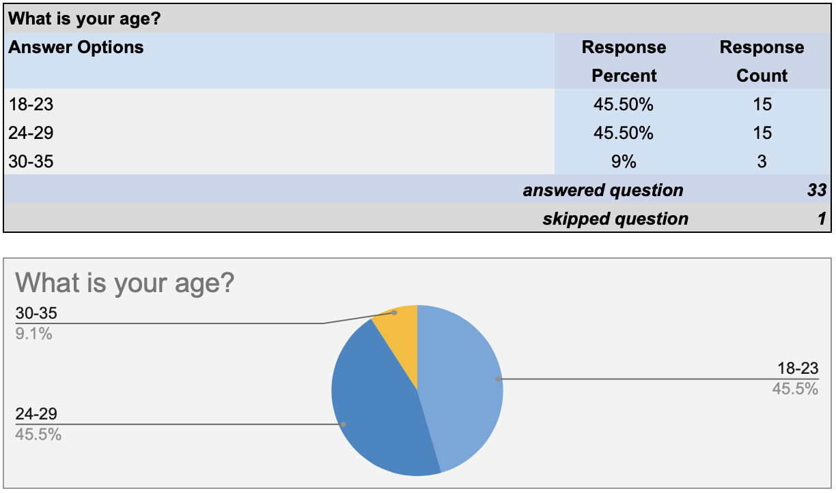
Figure 1

Figure 2
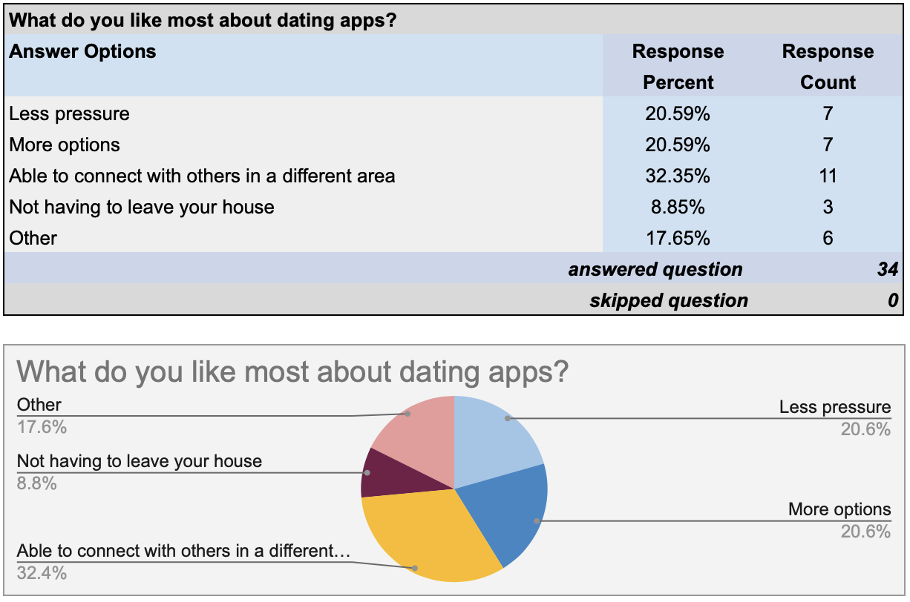

Figure 3
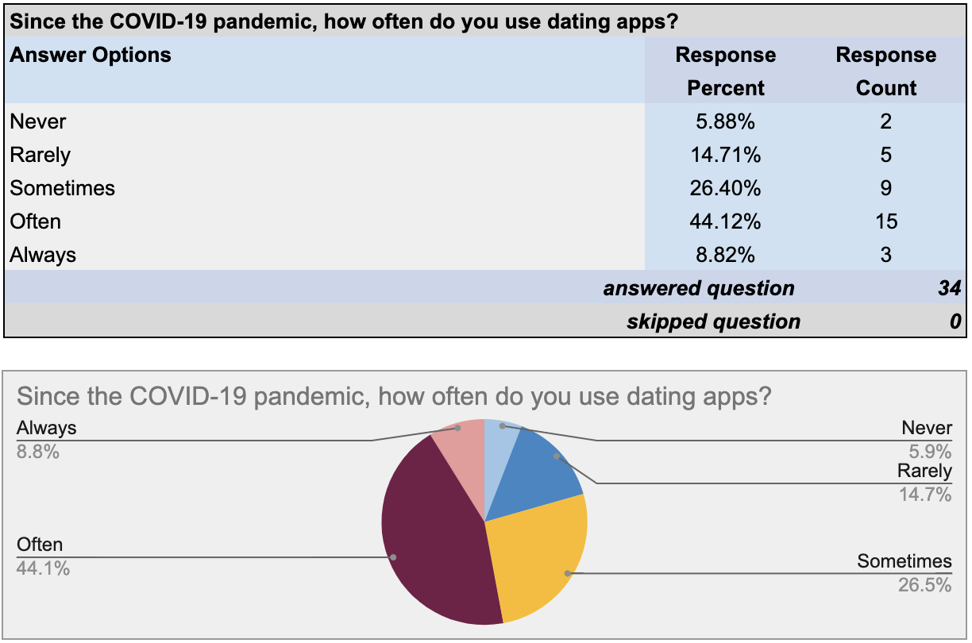
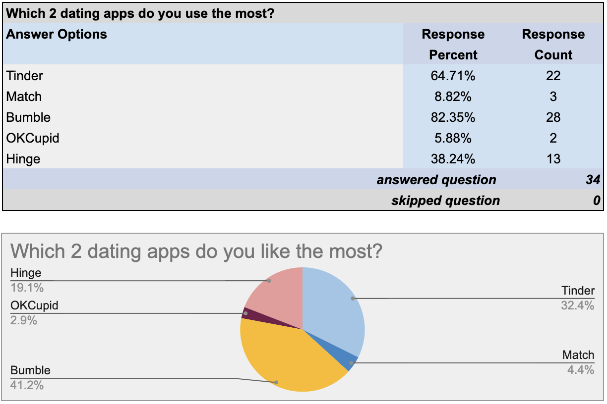
Figure 4

Figure 5
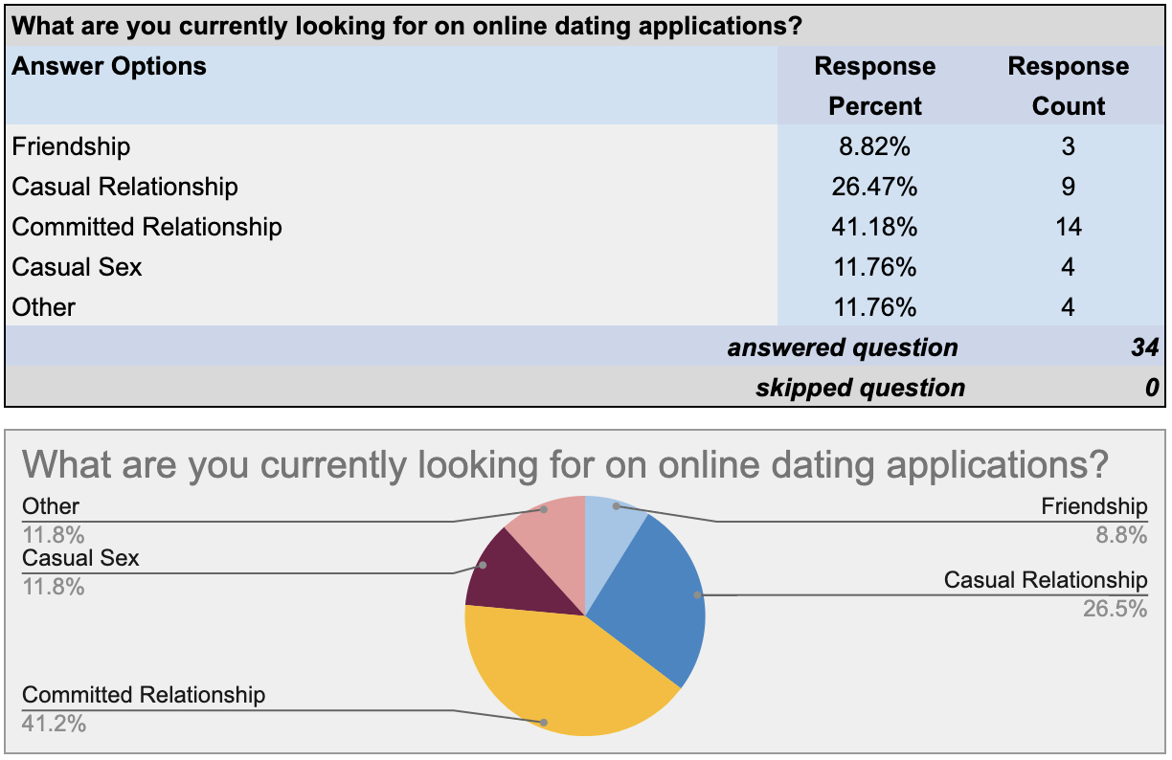
Figure 6
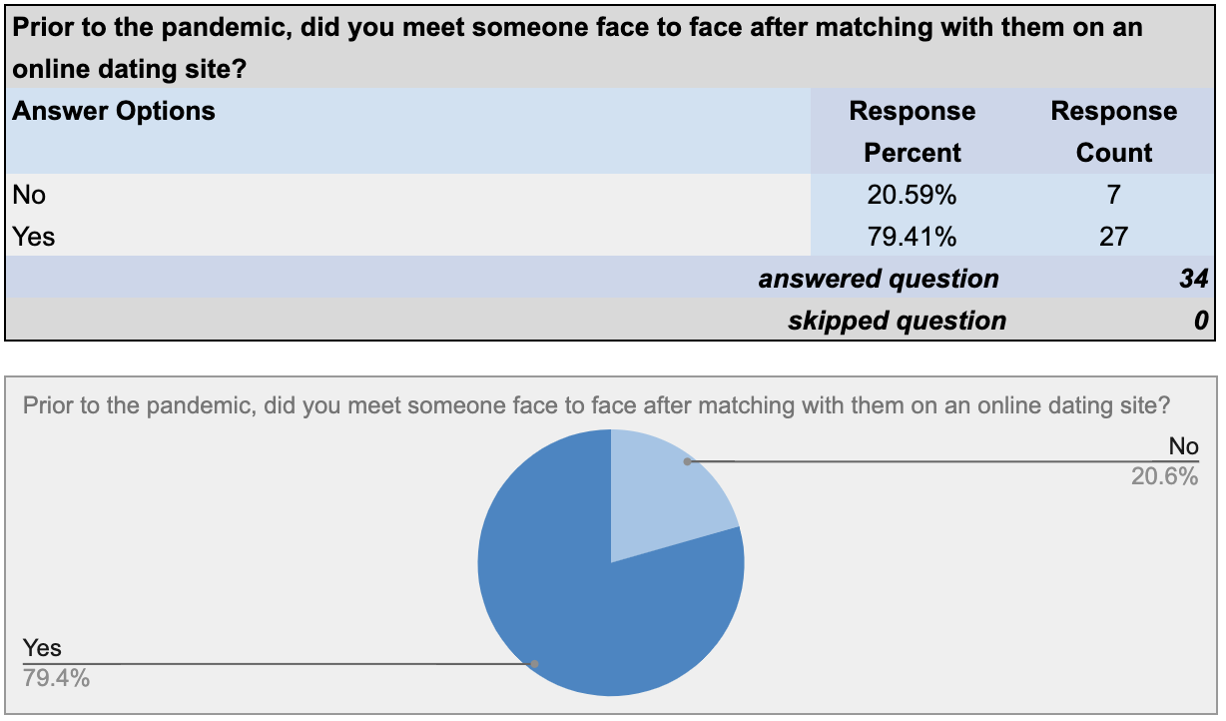

Figure 7
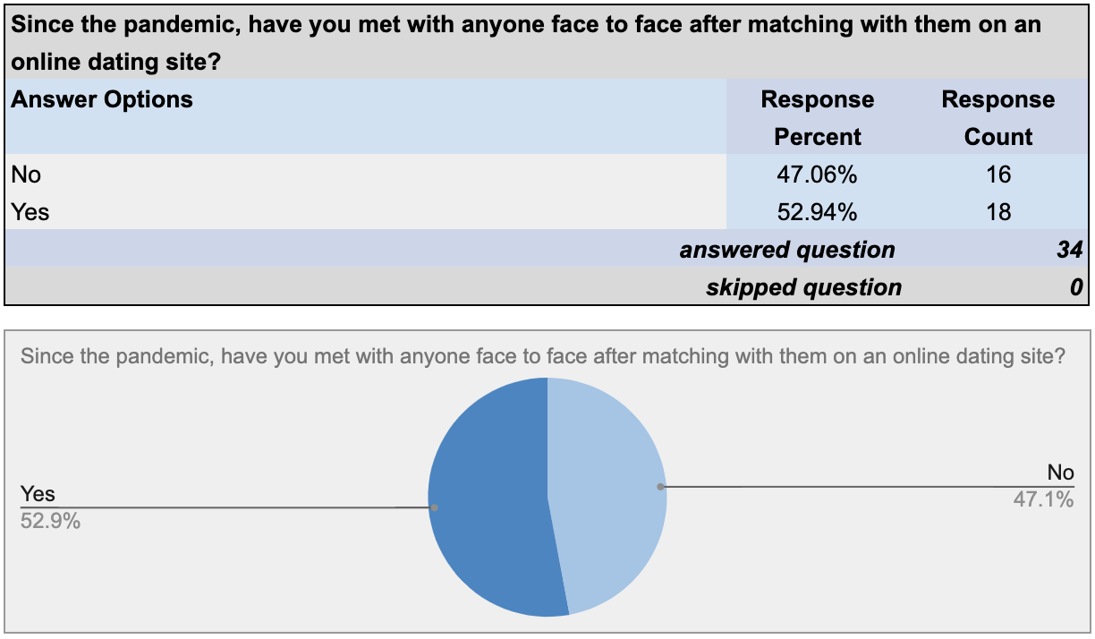
Figure 8
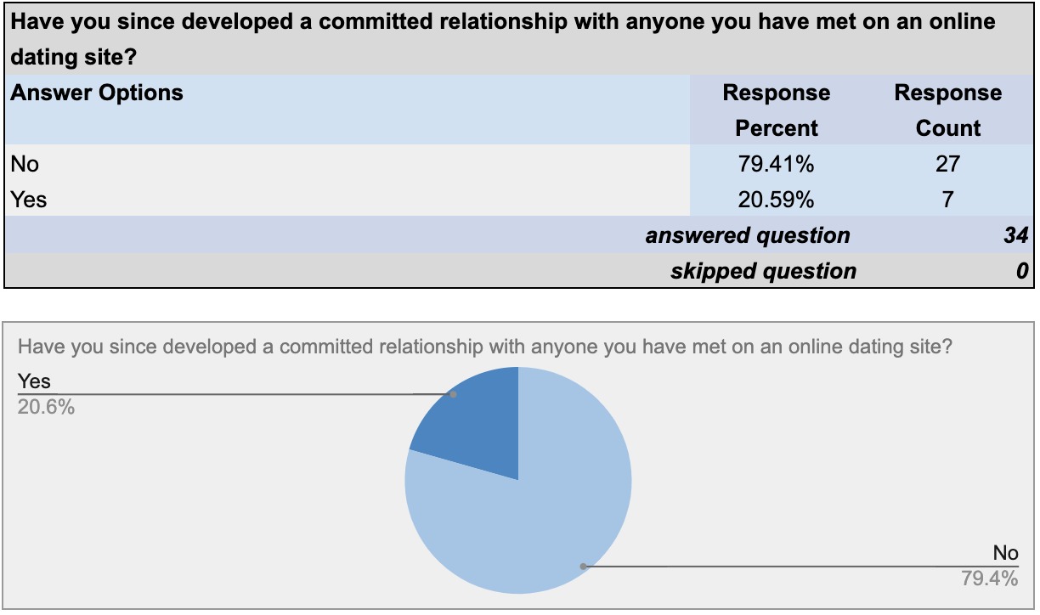

Figure 9
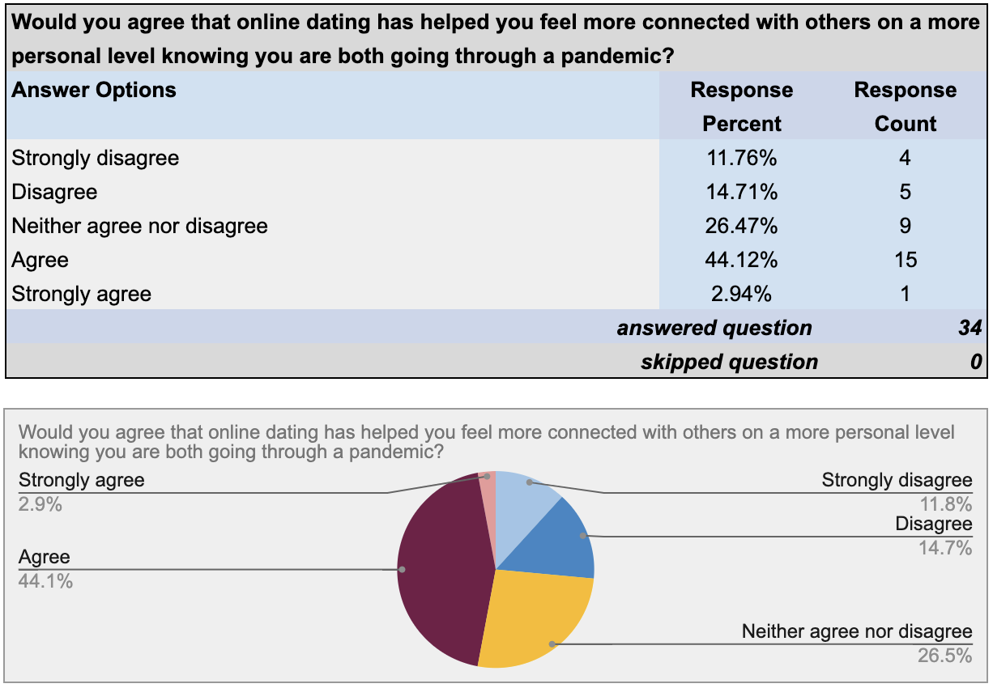
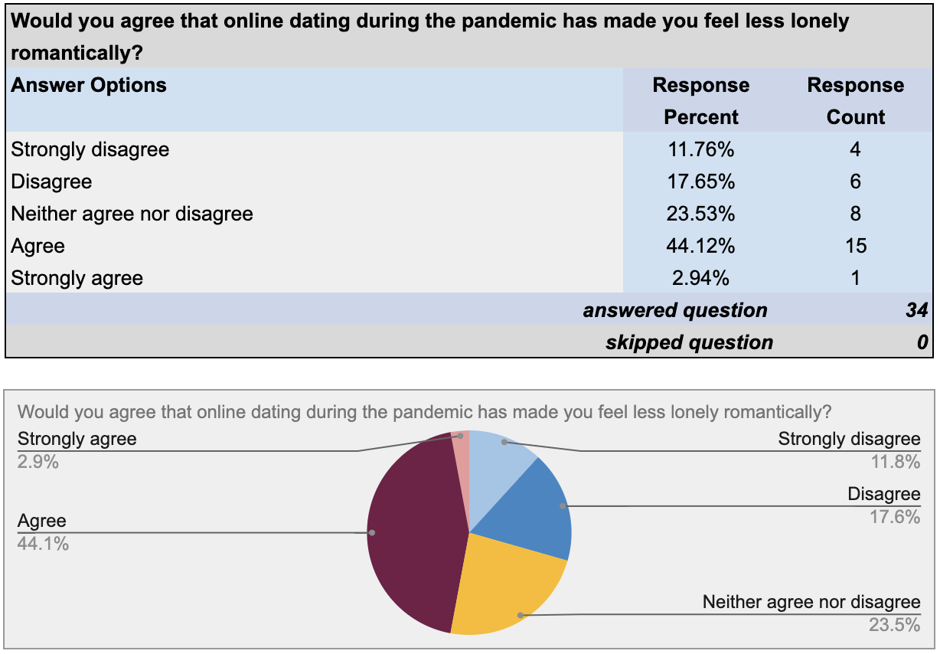
Figure 10

Figure 11
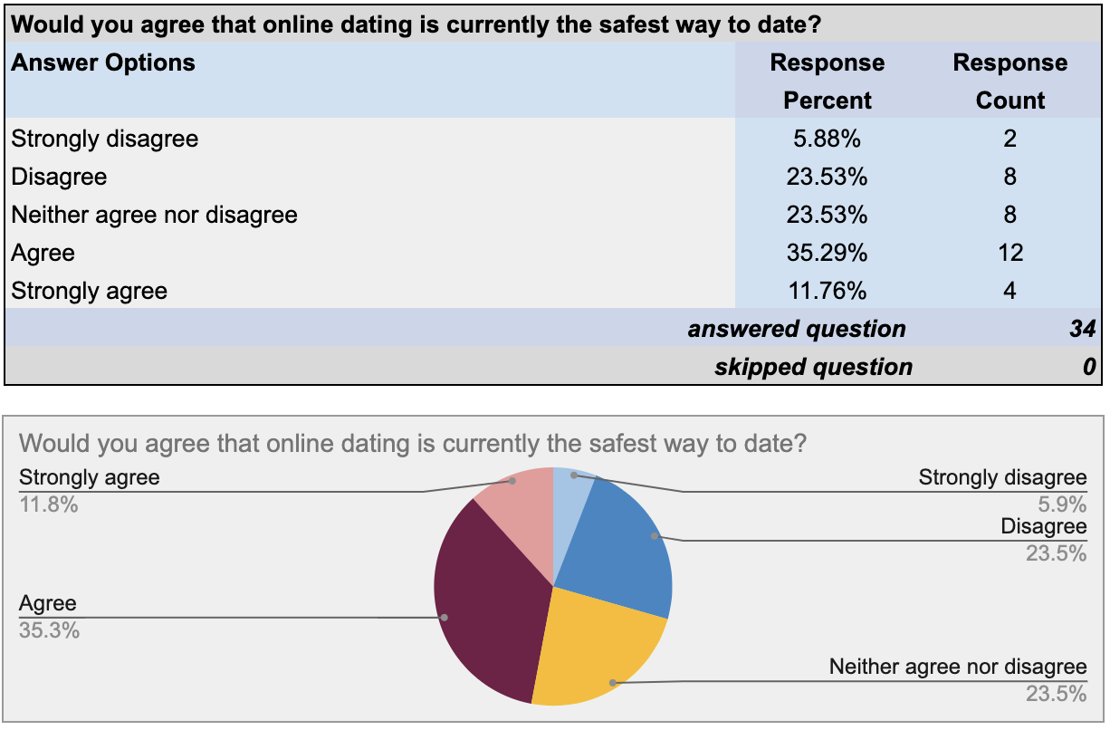
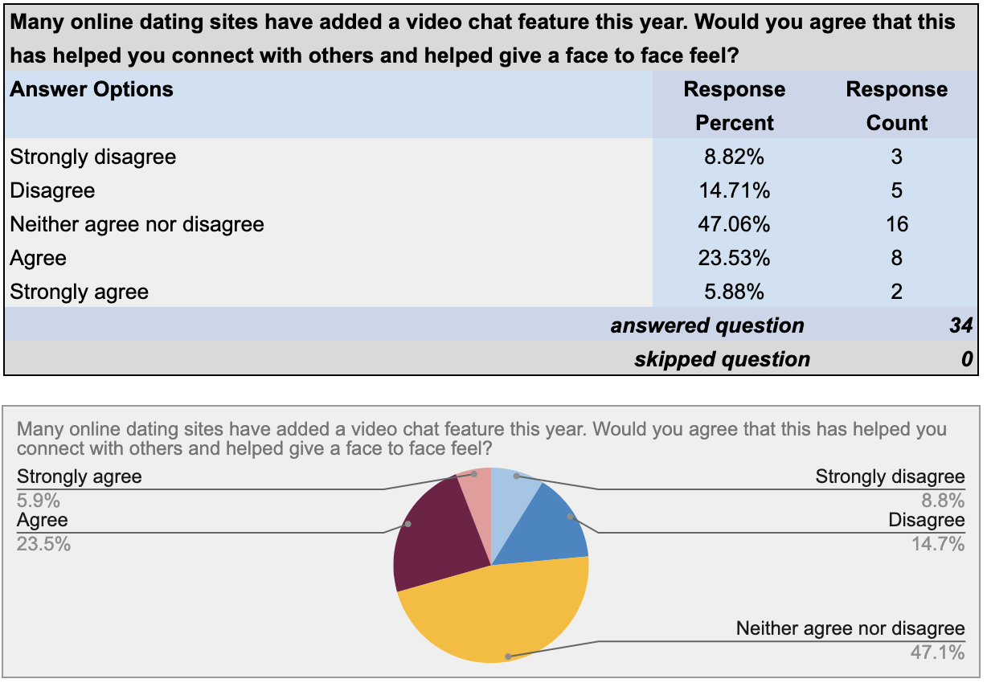
Figure 12

Figure 13
