Growing Natty (Natural): A Campaign to Move Beyond Steroids and Self Harm
By: Charles Harris

Instructor: Professor Hugo Ottolenghi

A PROFESSIONAL PROJECT PRESENTED TO THE SCHOOL OF COMMUNICATION AND JOURNALISM OF FLORIDA INTERNATIONAL UNIVERSITY IN PARTIAL FULFILLMENT OF THE REQUIREMENTS FOR THE DEGREE OF
MASTER OF SCIENCE

FLORIDA INTERNATIONAL UNIVERSITY

FALL 2023

Table of Contents

Executive Summary____________________________________________________________4
Introduction___________________________________________________________________5
Opportunity Statement__________________________________________________________5
Situation Analysis______________________________________________________________6
Organizational Analysis___________________________________________________6
History_____________________________________________________6
Alliances____________________________________________________7
Anabolic Steroid Analysis_______________________________________________________8
Product___________________________________________________________8
History___________________________________________________________9
Generation Z Steroid Analysis___________________________________________________11
Methodology_________________________________________________________________12
Quantitative Findings__________________________________________________________13
Qualitative Findings___________________________________________________________27
Implications__________________________________________________________________41
SWOT Analysis for 16–30-year-old males_____________________________________42
Strength__________________________________________________________43
Weakness_________________________________________________________43
Opportunities________________________________________________________43
Threats___________________________________________________________43
Strategy_____________________________________________________________________45
IMC Objectives_____________________________________________________44
IMC Strategies______________________________________________________45
Tactics______________________________________________________________________48
Schedule____________________________________________________________________51
Budget______________________________________________________________________52
Evaluation___________________________________________________________________53
Methods, pre/post testing, concept evaluation_________________________________54
References___________________________________________________________________55
Appendix A: Survey___________________________________________________________59
Appendix B: Interviews________________________________________________________73
Anthony Interview______________________________________________________73
Frank Interview_________________________________________________________92
Appendix C: ________________________________________________________________100
Biograpy___________________________________________________________________101

Executive Summary
Nothing has changed as far the obsession with beauty and fit bodies many have. What the increased popularity of gyms and the explosion of social media have done is exacerbate that obsession, and some may argue, the dysmorphia associated with how we see ourselves through others. Women are often at the forefront of body image issues, and positivity campaigns as well, but men not nearly at the same rate, often ignoring men struggle as well. No generation present understands their peers in a social media sphere as well as in the local fitness facilities like Generation Z, who dominate 16–30-year males as the largest users of anabolic steroids. This report contains a survey with these findings. A campaign has been created to target anabolic steroid for Generation Z gym goers in the high concentration of places: high schools, fitness facilities, and social media platforms such as Tik Tok, Instagram, and Reddit. An awareness campaign on behalf of U.S. Immigration and Customs (ICE) targeting the full spectrum of this demographic can decrease steroid use and aide in decreasing the illegal trafficking of the Class C drug into the United States.

Introduction

Steroid use is nothing new, especially among athletes in competitive sports. The drug is used to give the user an accelerated amount of strength and muscle mass, in a shorter time and often beyond the capabilities of their body's performance in its natural state. Doping is a name for it when reported about in these instances, attributed to the fall and public disgrace of some of the most celebrated sportsmen, yet has continued to be the open secret in the sporting community. The disgrace, the health risk, and the classification of anabolic steroids hasn't slowed down the trafficking or sales of these Class C illegal drug. It has grown, expanding their reach and popularity to non-competitive gym goers who aim to build the muscle mass that they feel is unobtainable as they age, especially Generation Z.

Generation Z teens and young male gym goers are among the fastest growing group of anabolic steroid users, and there are a few factors that can contribute to this rise. Social media influencers and platforms algorithms influence on body image are undeniable. The National Library of Medicine attests this by saying, “The pressure caused by social media has a particular impact here, in which the ideal figure associated with a flat belly, low percentage of body fat, and a visibly muscular body is widely promoted, or even normalized.” (Kaunas, 2023). Most importantly, the transactional communication between peers and dealers that hook and often sustain teens and men in anabolic steroid use and addiction are vital to examine.

Opportunity Statement

ICE, armed with the information given them by the Federal Drug Administration (FDA), arrests smugglers and confiscate illegal anabolic steroids, that are often smuggled with Class A drugs such as cocaine and heroin. The law is clear on the legal ramifications of trafficking steroids, however, the missing communication piece that the U.S. Immigration and Customs can help communicate is the dangers of this drug and how it is smuggled into their hands. U.S. Immigration and Customs can partner with schools, gyms, social media influencers, and places that Generation Z frequent to change the narrative on illegal anabolic steroid usage and provide safe spaces and information proactively to produce better choices.

Situation Analysis

Organization Analysis
History

ICE, is one of the government's youngest agencies with a 2001 inception. After the tragic events of September 11th, the agency was created to combat illegal immigration, and therefore an added layer of protection from enemies both foreign and domestic. Before the creation of ICE, these duties were the responsibility of Immigration and Naturalization, better known by the acronym INS, a branch of the U.S Department of Justice.

ICE is an agency that relies heavily on the research and intelligence of other departments, often collaborating with other government enforcement entities for the shared interest of infiltrating and eliminating organized crime and drug rings. However, I.C.E. has endured much criticism in how they've carried out their operations, and strong opinions.

During Donald Trump's presidency, I.C.E. carried out a series of deportation orders that subsequently separated families, including young children from their parents. Although I.C.E. has previously executed deportation orders, under Trump's presidency, coupled with his campaign messaging, registered with the media and human rights groups as overly aggressive and deliberately targeted. Immigrant communities with non-criminal backgrounds unfortunately felt targeted as well. Some call for ICE to be dissolved altogether, or at least restructured with a humanitarian purpose that will position them to aid and change the perception of hostility.

I.C.E. Alliances

ICE carries out numerous missions that are intricate, and often rely on the intelligence and manpower of other government agencies to execute those missions. The Food and Drug Agency, better known as the FDA is an example of this. They operate separately from I.C.E. and have no direct relationship, however, collaborative efforts can be created to take down drug operations.

The FDA test, and approves and bans food and medications that may be deemed hazardous to the public. For example, the study of products that was marketed as a dietary supplement up until 2017 called Flex/Big Dan’s Fitness, AndroPharm and Hardcore Formulations. After a numerous number of complaints, the FDA concluded that all three products contained illegal anabolic steroids. The F.D.A. does not test supplements that are marketed as “natural” until a pattern of illnesses has been established to the F.D.A. A warning is sent out by the agency to the public the three products to the public for its safety, and now any trafficking and selling of these products is illegal. I.C.E. acts as an enforcer to prevent trafficking of such illegal products like Flex/Big Dan’s Fitness, AndroPharm, and Hardcore from getting into the hands of the public.

Anabolic Steroids Analysis
Product
Whether taken by pill, injection, cream, topical gel, skin patches, or implantable pellets, anabolic steroids are synthetic testosterones used under the care of physicians and misused by men looking for better performance or muscle gain. Termed anabolic-androgenic steroid, or AAS, the anabolic mechanism is the tissue-building component or muscle building and testosterone is the androgen for masculine characteristics. (Cleveland Clinic)

Anabolic steroids are prescribed under a physician's care and approved by the FDA to treat some of the following: primary male hypogonadism, delayed puberty, hormone deficiency, breast cancer in women, endometriosis, osteopetrosis, and muscle atrophy due to complications from cancer or AIDS. When taken unprescribed, anabolic steroids increase strength and lean muscle mass to achieve a more muscular look. (Cleveland Clinic)

History
AAS dates back 6,000 years when farmers discovered the benefits of animal castration to domesticate animals. Synthetic developments of the drug were used as with the likes of Egyptians and Romans holding high regard for the discovery, testifying of its healing, and using the combination of testicles and plant extract to formulate the drug for competitive sports. (Dotson,2007)

Fast-forward to 1896 when an Austrian physiologist won a Nobel Peace Prize in 1923 for being the first to inject testosterone into himself and physician partner Fitz Pregel's middle finger using testosterone extracts from bulls. It was Ozark who initiated the idea of injecting athletes with testosterone for optimum performance. (Dotson, 2007) A French cyclist succumbed in 1896 to what was believed to have been a thyroid fever, but others closer to the situation attributed his death to a steroid called trimethyl, the first death directly blamed for steroid usage in sports. (Sports Illustrated, 2008).

Anabolic steroids expanded during World War II, as Hitler experimented with drugs on not only prisoners but himself as well. The root of this was for strength and a more aggressive attitude for the soldiers during the war. In retrospect, experts in the study believe Hitler suffered from the side effects associated with heavy AAS usage, which can include mania, suicidal, thoughts, and overly aggressive behaviors. (Sports Illustrated, 2008).

By the mid-1950s and into the 1960s, anabolic steroid use had successfully infiltrated competitive sports with the then Soviet Union dominating the powerlifting sport. Sports Illustrated published an article that brought the drug and others to the forefront about competitive athletes, ultimately producing a three-part investigation of what Sports Illustrated called "an epidemic". (Sports Illustrated, 2008)

It wasn't until 1974 that the Olympic officials banned the use of anabolic steroid use, which included anything derived from testosterone for sports that included cycling, soccer, and volleyball. The ‘80s ushered in high-profile sports celebrities such as Ben Johnson and Carl Lewis, who were both stripped of medals for using the anabolic steroid Stanzol that was detected in their urine. (Sports Illustrated, 2008)

However, it wasn't until the 1990s that pharmaceutical companies discontinued production of AAS due to U.S. Congress classifying the drug as Schedule III in the Control Substance Act of the Anabolic Control Substance Act, banning it altogether. (Dotson, 2007)

By the end of the late ‘90's and early 2000s, more than 1 million men were abusing anabolic steroids. Unfortunately, high school and college athletes were included in that number. Many argue that the numbers do not match up with the real totals on the black market, but no one is arguing the rise of AAS use and abuse among young users and gym goers.

Generation Z Steroid Analysis

The U.S. Department of Justice states that the age group that use anabolic steroids the most are between the ages of 19-30. Generation Z age is 16-25 currently, and they dominate the age bracket reported. If Gen Z AAS users are using the drug in competitive sports, it’s at the high school and college levels. The non-competing AAS user numbers are far exceeding those in sports probably due the regulations surrounding steroid use on campuses. And although the desired results may overlap, the reasoning for use is clear between the non-competitive and competitive Generation Z AAS user.

Competitive athletes use AAS drugs for mainly strength and endurance while playing professional sports. The non-athletic AAS user has a different agenda, and that's mainly for aesthetical purposes. According to Alshareef, Srinivasa, Gokarakanda, and Marwaha of The National Library of Medicine, "Non-athletic people misuse anabolic steroids to increase body weight and lean muscle mass without increasing fat mass in the body. " (National Library of Medicine, 2023)

Usually the “cycles” are started with two, sometimes more at a time, known as “stacking”. Increases to higher dosages between 6 to 12 weeks are common, along with gradual decrease at the end of a cycle in doses. This is said to help users manage the increases from first half of the cycle, better known in the steroid community as pyramiding. (Dotson, 2007)

Methodology
A survey was formulated and distributed among groups where Generation Z weightlifters are the most active online such, as Instagram and Reddit. The quantitative survey was including 134 participants, with a total of 81 surveyed that qualified for the data needed for this research. The 18-question survey included a few Likert Scale questions to better gauge attitudes towards anabolic steroids and accessibility.

Two sit down and in-person interviews were conducted for qualitative research. Both interviewees were guaranteed their anonymity and aware that the interviews were recorded for the purpose of this research. Each participant was encouraged to speak as freely and honestly about their experience with steroids; their actual names are not included in this research for the sake of their privacy.

Quantitative Findings
Figure 1: The 81 qualified participants were moved on to complete the survey, and being the Generation Z male demographic studied, which makes up 60% of the total amount who initially engaged. The remaining 40% were disqualified by age and gender.

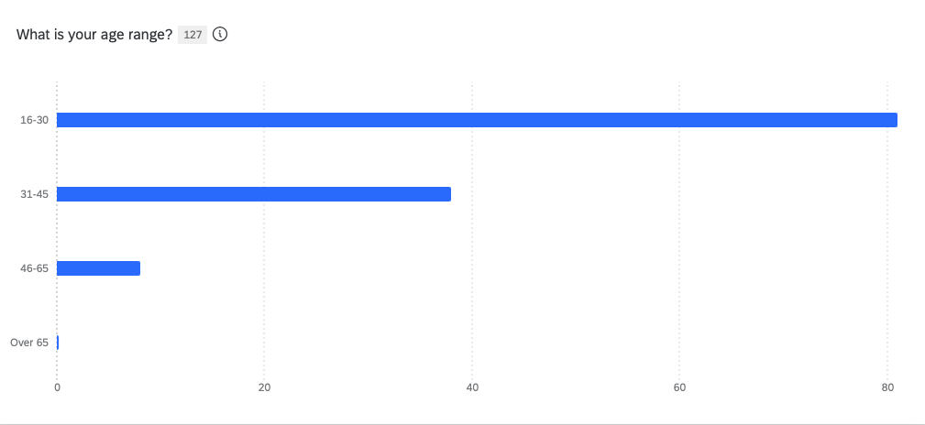

Figure 2: 87% of respondents using a membership gym facility; automatically placing them in an environment with others that, generally, have the same aspirations for body improvement, transformation, and peer communication.

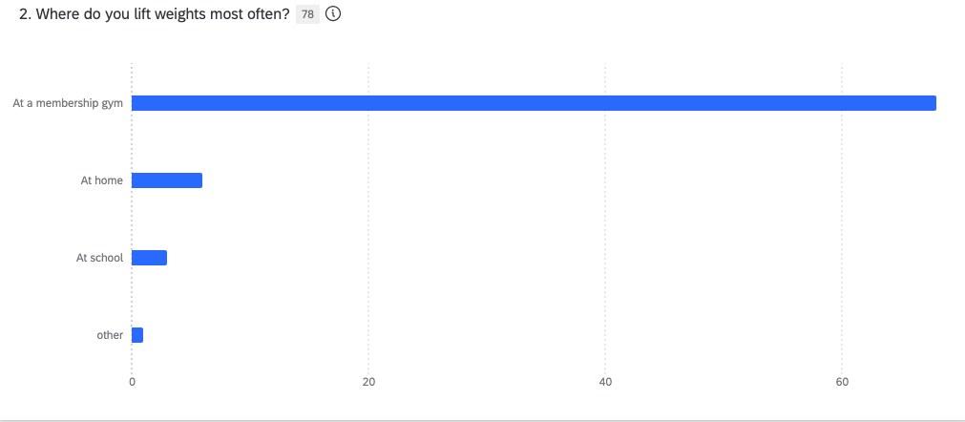

Figure 3: Indicates the percentage of importance to body image and view of self. When asked about the importance, of body image to how they view themselves, the responses generate an overwhelming importance with 83% agreeing that it’s either of great importance, or very important.

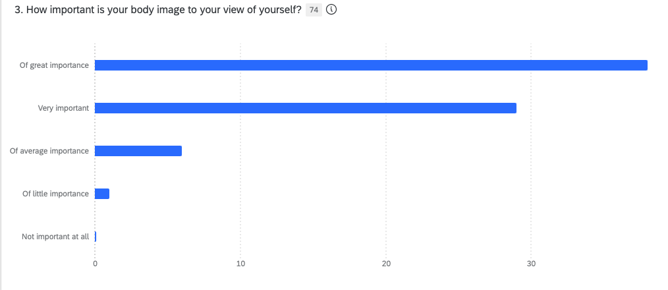

Figure 4: When asked about the importance of social media to their view of personal body image, over 50% fell in the range of slightly important to extremely important. And although extremely important has the lowest number, most within the 53% are shaped in their view of body image by social media.

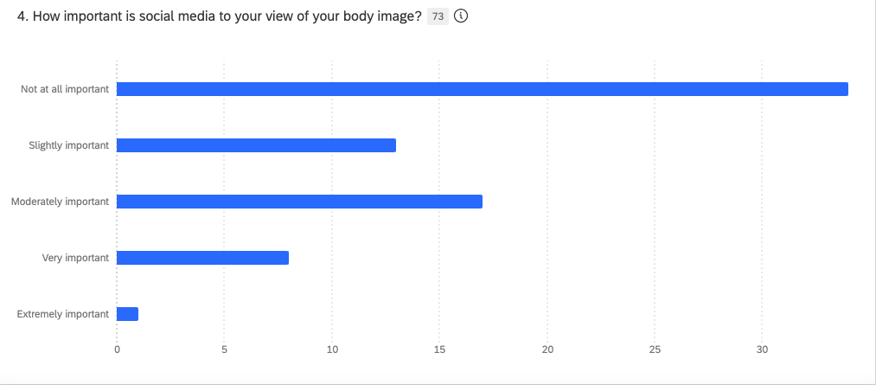

Figure 5: With an almost 90% (87%) of 16–30-year-old teens and young men using gym membership facilities to muscle train, the graph below charts how they’re influenced by others at the gym regarding their own body image. Almost 70% (68%) are influenced slightly to extremely important to how they view their bodies.

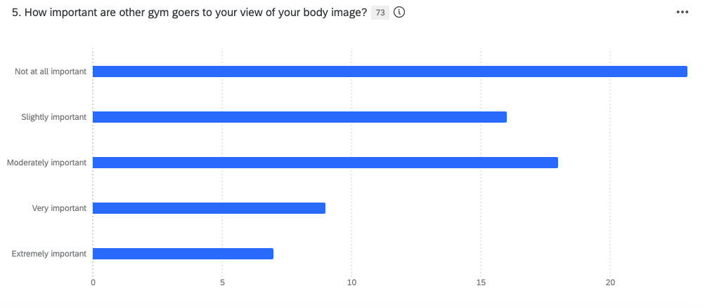

Figure 6: When asked about the importance of social media to their view of personal body image, over 50% fell in the range of slightly important to extremely important. And although extremely important has the lowest number, most within the 53% are shaped in their view of body image by social media.

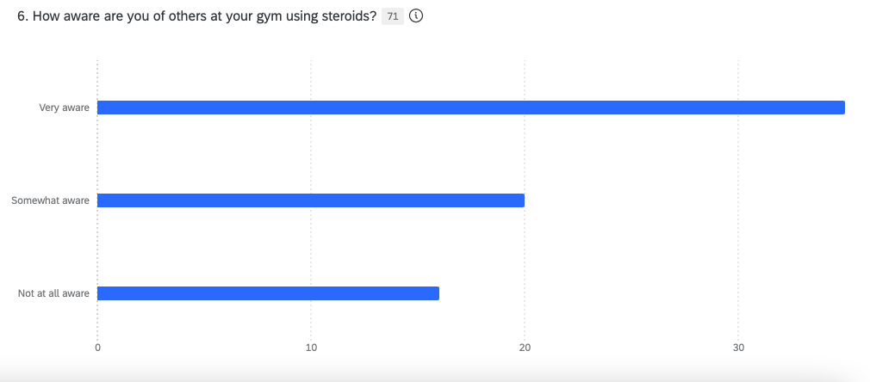

Figure 7: Why Generation Z men consider steroids is important. The respondents were allowed to click all that applied to their consideration. Muscle growth was to top consideration at 91% with body image not far behind at 88%. Being competitive had the lowest percentage at 42%; showing how Generation Z prioritize why steroids would be a consideration.

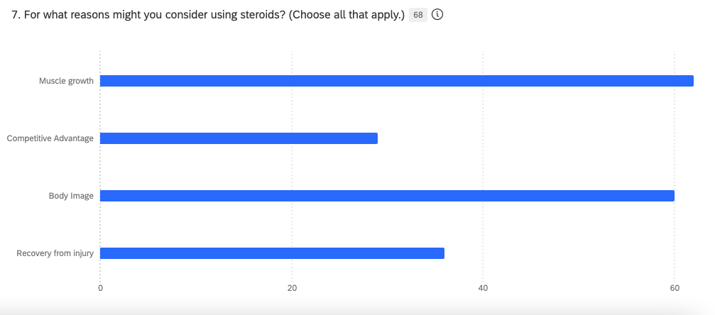

Figure 8: 78% of those admitted to steroid usage.

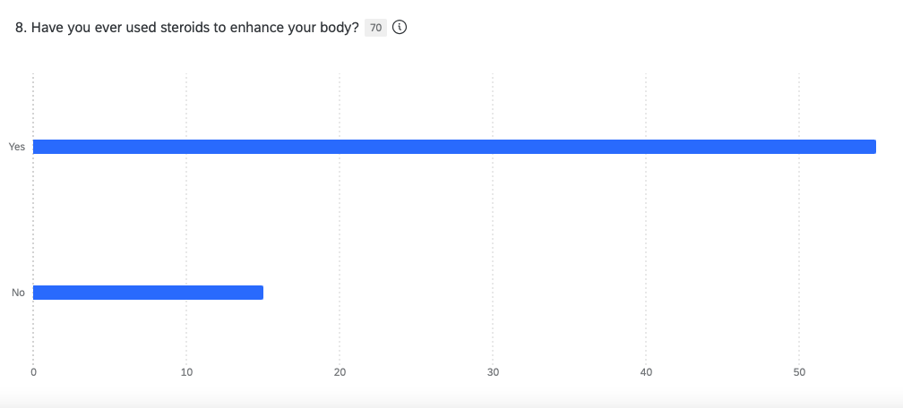

Figure 9: 89% are using steroids for at least 3 months or longer.

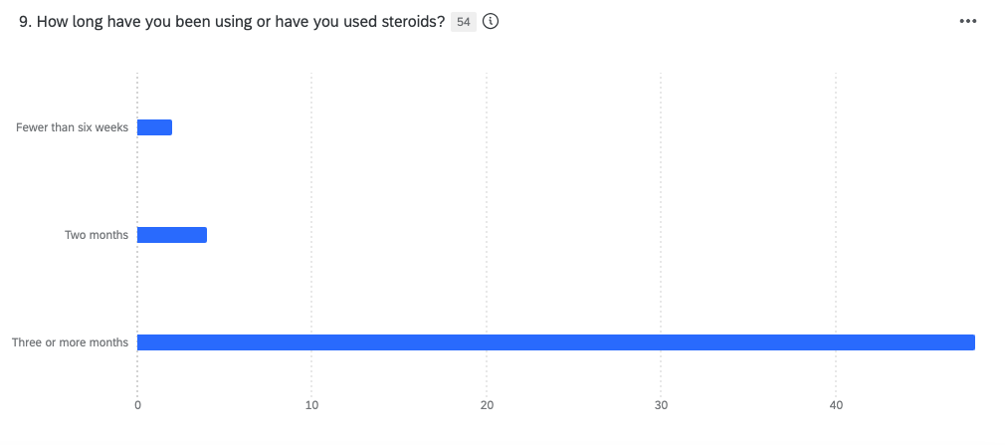

Figure 10: When asked if users were stacking, meaning that they’re using 2 or more steroids at one time, almost 70% responded yes.

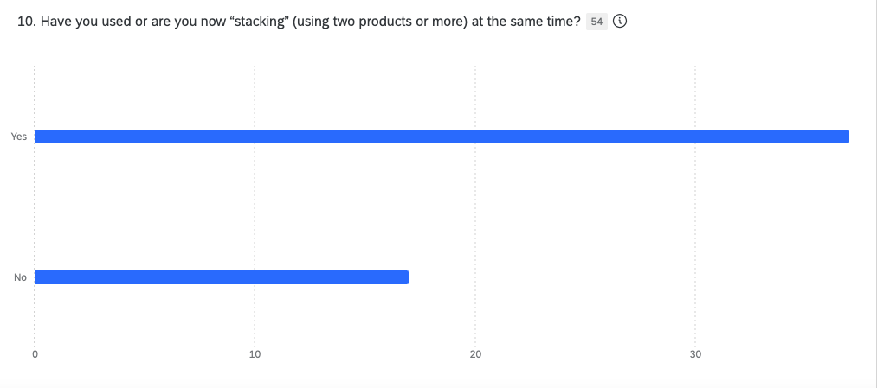
Figure 11: To find out what is the leading contributor to use steroids, those surveyed were allowed to check all that apply. Body image was leading contributor with 67% feeling this applied to them.

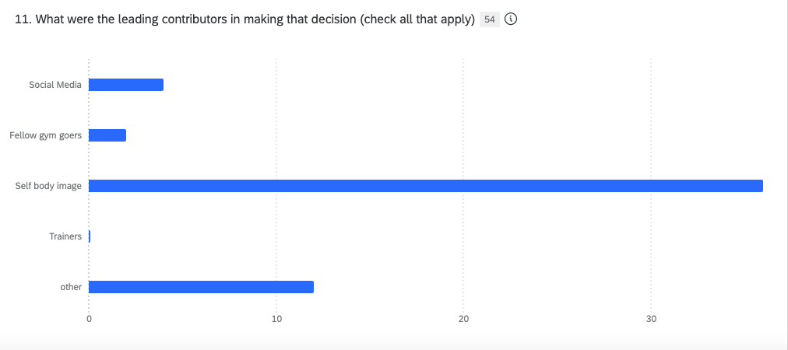

Figure 14: 89% answered that biohazardous boxes are not present at their gyms.

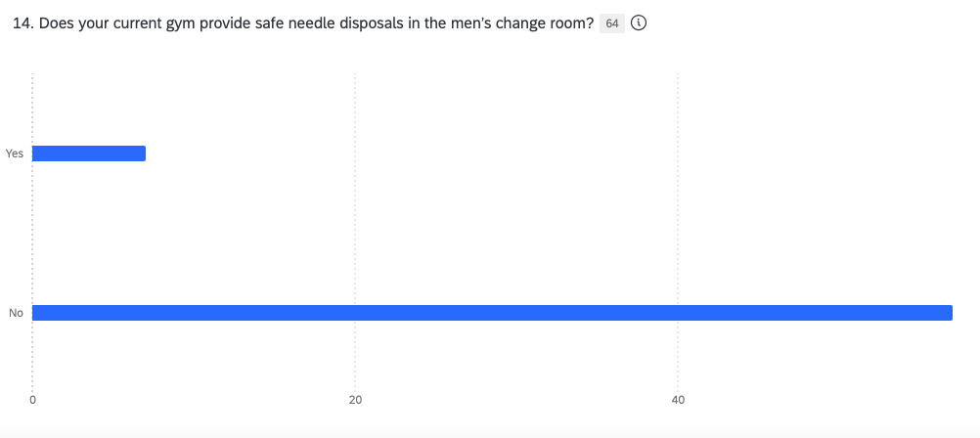

Figure 15: 91% of those surveyed had never seen steroid educational materials at their local gym.

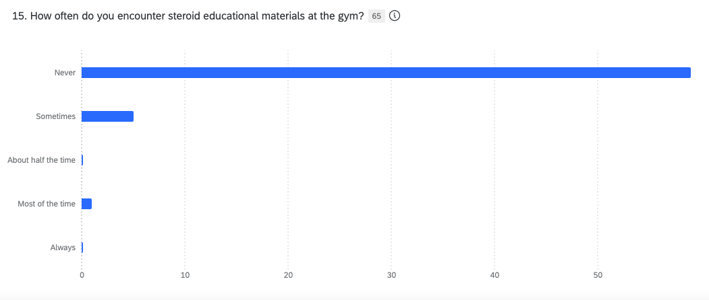

Figure 16: About 17% have never seen steroid educational materials, where over half (52%) have only seen the sometimes. 12% answered that they encounter steroid education half of the time.

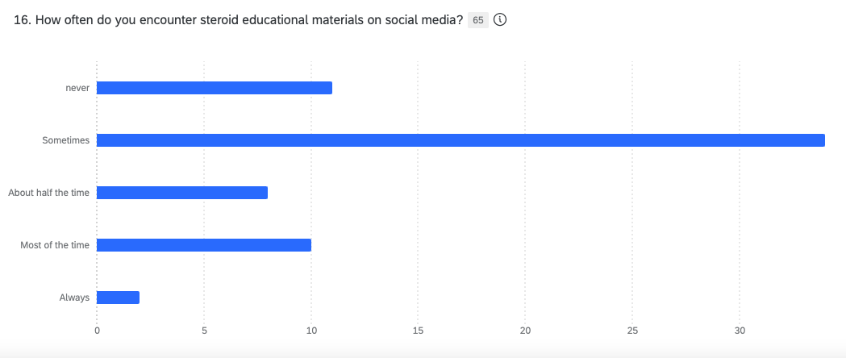

Figure 17: When measuring the importance of educational materials in deciding whether to use steroids, 50% indicated it’s very important or extremely important.

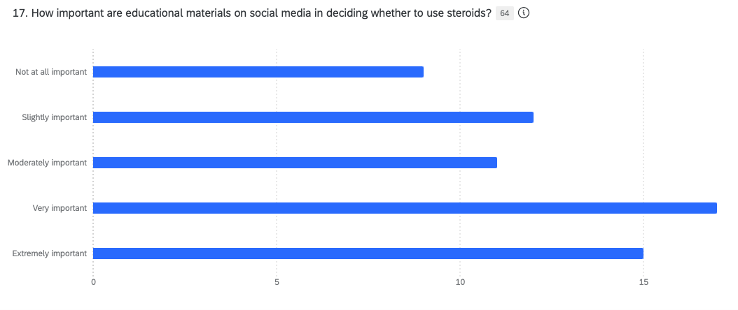

Qualitative Findings

To better understand communication, transactions, and the transfer of steroids between user and dealer, 2 interviews were conducted. It important to know how one contemplates usage of steroids, to the influence and the motivation pieces communicated from buyer to seller. Each interview was conducted in person and to be completely free and transparent as an impromptu conversation. Both interviewees were reiterated of their privacy and anonymity. There were questions that were drafted from the secondary research that both were asked, but much of the information was given by each interviewee unprovoked and inspired by their experience and own will to give raw insight.

Anthony: is the name given to the first interview given to protect his identity. He’s a former anabolic steroid user who is now 30, reflecting on his experience with steroids. He’s now an owner of multiple personalized fitness facilities, one in which his interview is conducted. “Anthony” was interviewed November 8th, 2023, at 8:00 am with a phone recording of the conversation.

The initial exposure to how “Anthony” was first exposed to steroids was asked to understand where the communication starts.
Anthony: I was working out at the gym, and I saw this guy that looked humongous, and I was like man, I want to look like this guy. At first, he told me to eat a lot, eat a lot. Then eventually, one day I saw him reach up for something on top of the lockers and took something done, like money. Someone else had come in and put the money up there, and he put steroids up there. He then told me, yea, I actually sell steroids. He then pointed and said this guy and that guy is on them too. Once I found that out, I did very little research.”
Interviewer: “What kind of research did you do?”

Anthony: “I literally just Googled; I think that the second link that I had found was where you can buy them online. They deliver, it was called Juice Monster. I thought steroids was just one thing but apparently there’s fucking hundreds. There’s like Decca, Trend… I thought it was just one thing like a steroid is a steroid. You can’t just take one, say if you’re taking Decca, you need to take something else to backpack it.

Interviewer: “So that’s called stacking?”
Anthony: Yes, you do that, so the side effects don’t happen. You also take this other pill called Novadex so it doesn’t fuck with your estrogen too much. So now you’re not taking one thing you’re taking two things, and the third thing of for you to not affect your body too much.

Interviewer: “So, being that the guy was the dealer, I’m assuming that you started getting steroids from him?”

Anthony: “No, because he seemed sketchy. Grabbing things from the top of a locker. So, I was doing body building competitions because I wasn’t big enough. So, a lady that I was talking to that I wanted to coach me told that If I wanted to be competitive, that I need to take steroids.”

Interviewer: “How old were you then?

Anthony: “I was 22.”

Interviewer: “How often would you inject?”

Anthony: “Twice a week. So, I started that for about 4 weeks. So, I told another coach what I was taking, and I told him (about Test 400). …He told me that I was going to get pains and I had all of them. He said it’s the worst one you can take. So, he put me on a different test called Decca. Decca is supposed to make you feel a lot better. So, this is where it got crazy. I remember I saw my friend Jason on a Wednesday; Saturday, I some people over and he saw me and was like What The Hell! I had gained about 12 pounds in three days.”

Interviewer: Were you taking them both at the same time?

Anthony: “Yes, two at the same time. Then I told someone else that I was feeling a little weird still and they asked If I was taking Novadex. I was like no, I don’t know what that is. He told me that I must take Novadex, the pill, to help with the kidney and liver and side effects like acne and all of that. It keeps everything somewhat normal. I was like, oh fuck, I didn’t know all of that. So, I was taking that as well to block estrogen. I don’t think it helped.”

Interviewer: From a communication perspective, what did your steroid transaction look like?

Anthony: “So, this is crazy. She (the trainer) had taken me to the guy she uses. Now this guy…. had a whole set up in his basement. So, I went over to his house. This is beautiful. This is insane. So, do you know how he weed shops (dispensaries) are all set up with all white and glass? Well, it’s just like that, but it was in his basement with marble floors and everything. It was insane. Now, I never handed him money. I would always give it to her (the trainer) at her house and she would give it to him.”

Interviewer: “So that way he’s not liable for the transaction in any way?

Anthony: “I think so.”

Interviewer: Did steroids alter your self-esteem a bit?

Anthony: “Yes, overall, you have a different level of confidence. It’s like overly confident. You feel like you’re on top of the world because you have big muscles. You still must work out when you’re on steroids, if not, it turns into fat.

Interviewer: “How tall are you?

Anthony: “5ft 3 inch and got to 200lbs, just over. When I started (steroids), I was just 160 lbs. It was a 40 lbs gain of mass with steroids… ridiculous.”

Interviewer: Do you think you were addicted at this point?

Anthony: “100 percent! I kept seeing strength gains and my own gains. I was wearing an extra-large t-shirt, and it was tight. Once I was on and seeing the results, there’s no stopping. Then I said that I would take less, but I always ended up taking the exact same amount.”

Interviewer: How did you communicate with your other peers about steroids? Was this something that you talked about with them?

Anthony: “It was open. Once they started to see the drastic changes and asked. I was like, I’m taking steroids. Now there were saying that they must get these and where can they find them. I was like, I know someone. So, I got my friends on to them (steroids).

Interviewer: Were they (Anthony’s friends) competing?

Anthony: “No, there just some random guys that were going to the gym, and they were young. They’re like 21 as well. I started at 22 (years old) and stopped at the end of 23.

Interviewer: You are 23, you’re still on steroids. At this point, what happens?

Anthony: I was two weeks out from competing, and I woke up deathly ill. I was puking blood. I was gray. I was weak …. I thought maybe I pulled something… as soon as I ate, everything went through me. I thought that if I go to sleep and wake up the next day, I’d be fine. Woke up the next day and it was the same. All of this was happening for three weeks until I finally decided to go to the hospital.

Interviewer: Between the time you first felt ill, until the time you went to the hospital was three weeks?

Anthony: “Yes, I was wondering, what the fuck am I going to do?

Interviewer: Were you still taking steroids?

Anthony: “No, I stopped at that point. I had lost about 13 pounds. I would still try to work out too. They put me on one antibiotic, but three months after that I was still sick. I knew it was serious when I stood up at the kitchen table and fell over. I couldn’t do anything. I luckily had my phone nearby and called my dad and he took me to the hospital. The nurse saw me, and they admitted me right away.

Interviewer: Wait, at this point it’s been three months?

Anthony: Yes, it was three months.

Interviewer: How much weight have you lost at this point?

*Anthony*: “I lost 65 pounds.”

Interviewer: Your body is completely rejecting itself?

*Anthony*: Yes, and everything. So, they have given me the coloscopy and was then like... we must check his blood. They came back in and said that my blood was 65.

Interviewer: Wow, just to put this into context, you need to be at 90,

*Anthony*: Yes, at 64 you’re like dead. And I didn’t know what that meant.

Interviewer: What was your weight when you started feeling better?

*Anthony*: “About 145 lbs”

Interviewer: When you started steroids what was your weight?

*Anthony*: “It was 160 lbs.”

Interviewer: So, you were in a deficit?

*Anthony*: “Yes”

Interviewer: If you had to do it all over again, would you have done it (steroids)?

*Anthony*: “No”

Interviewer: So how would you communicate that to someone that is 21 years old and looking at these guys with fantastic bodies and thinking about doing cycles?

*Anthony*: “I wouldn’t recommend it to anyone. It’s not worth it.”

Interviewer: Do you think there’s enough information out there to discourage anabolic steroid use for guys between the ages of 16-30?

*Anthony*: “Definitely not. Because most people that hear about it like I did, it’s from people they see. There going based off their look and not the side effects. People are seeing these guys that are jacked (muscular). No one is talking about the fact that their dick may not work. Then some guys will tell you it’s OK if they can’t get hard because they have Cialis (ED medication).

The second interview was with “Frank”, also a name given to protect his identity. As an active dealer of anabolic steroids and a few other Class A drugs, a name changes and anonymity were guaranteed before proceeding. “Frank” has over 20 years of anabolic steroid use and dealing. His interview was conducted at a coffee shop on November 9, 2023, at 6:30 pm with a phone recording conversation as well.
Interviewer: When did you start steroids?

Frank: I want to say, in my early twenties, so about thirty something years ago.

Interviewer: How were you introduced to them?

*Frank*: I got into professional sports, professional wrestling. It was either eat 100 pounds a week or get on steroids to maintain.”

Interviewer: Was it friend that introduced you to them (steroids)?

*Frank*: “No, it was another wrestler. I can say that I’ve been on and off cycles for about thirty years.”

Interviewer: Which demographic do you sell to?

*Frank*: “Mainly under thirty, although I get plenty of guys that are over 30, too. Teen guys come to me to buy, but I just don’t sell to them.”

Interviewer: When guys come to you for steroids, do they know what they want?

*Frank*: “A lot of people don’t. So, education is king… especially if you’re injecting something or popping something. I ask them where they want to be and look at their body. Like a guy that is 300 lbs and obese wanting to do steroids is a no. I tell them they need cardio. It’s pointless to add. It shows you’re not discipline already because you’re not working out. You still must do the work.”

Interviewer: How do they find you? What does that communication piece look like?

Frank: “A lot of guys ask me at the gym because I’ve been around for a while. They see that I’m in shape, but most people can put two and two together. I can walk into the gym and tell you who’s taking gear (steroids). Word of mouth as well.”

Interviewer: The average guy spends about how much per month?

Frank: “About $200 USD per month. I always tell them that quality I king.”

Interviewer: In recommending a quality cycle, what do you tell them?

Frank: “Quality is in who makes it. It’s so much garbage, period, in drugs. So, find a reliable source. I’ve taken the time over the years to educate myself on it because people are buying from me, and many walk up to me not knowing what they want, but I still want the sale. Somebody can also fuck themselves up with this. I’m careful, I want to make some of these guys better.”
Interviewer: The supply chain, how do you get your supply? Is there someone you call to be supplied?

Frank: “Oh yes, I have a guy that I call and get it from, and he ships it to me. He makes money off me, and I make money off the product.

Interviewer: What is your customer retention like?

Frank: “I have some guys that have been dealing with me for 20 years. They know when they come to me, the product is spot on. I also go by the model, 8 o’clock is 8 o’clock, don’t show up late. For me is a business and a respectable business. I value my time and they must as well; I value their time too.”

Have you seen guys abuse steroids?

Frank: “Yes, I had this kid, he wasn’t a kid because he was about 30, that was at my house four times a day picking G or coke.

Interviewer: You deal G (Gamma- Hydroxybutyrate) and coke (cocaine) too?

*Frank*: “Well, yes.”

Interviewer: Has anyone come back to you with issues due to usage?

*Frank*: “I’ve a had a couple of people come back to me, and the truth is, sometimes the chemicals just don’t gel with everyone.”

Interviewer: It’s normally a friend that hears about you from another friend to purchase steroids.

Frank: “Yes, word of mouth is how things happen. I don’t put ads up. I don’t look for business because business finds me. I get a text that ask me if I have a supply because the person or their buddy needs some.

Interviewer: Are you ever out of stock?

Frank: “Oh yea, all the time. I can put an order in for $5,000 worth of stuff and I’ve liquidated that in a day. I don’t overprice and I don’t underprice, and sometimes I’ve shipped to users. Look, I’ve done very well in the business. I just bought a Jaguar. Went into the dealership and gave him a bank draft (certified check) that very day. I guess crime pays.”

Interviewer: Do you feel that gyms should have a disposable box for needles (Bio Box)?
Frank: “Absolutely they should. They shouldn’t be buried in a bathroom stall. It should be placed on the bathroom wall for everyone to see. There should be Bio boxes in the gyms.”

Implications

The primary research with the survey and interviews is consistent with the secondary research of anabolic steroid usage among 16- 30-year-old teens and young men, predominantly Generation Z men. They are trending higher than any demographic in initial steroid experimentation and retention; thus, needing the education to properly implement awareness tactics for prevention.

When surveyed, over 90 percent of 16–30-year-olds are gym membership users. The survey also concluded that this demographic’s communication surrounding steroids happens in these facilities, often meeting others that using steroids, and subsequently dealing as well. Many gyms have an underground culture of steroid use, which, according to the survey, lack any educational materials about the effects of anabolic steroid use to rival the peer influence that Generation Z young men are exposed to.

The research also revealed that social media platforms and influencers effect a sizable amount of 16–30-year-old’s male body image of themselves, with 53% falling within the range of somewhat important to very important impact on how they view their bodies, increasing the probability of peer influence with detrimental health occurrences like the interviewee, “Anthony”.
SWOT Analysis for 16–30-year-old males
The SWOT analysis is an in-depth examination on the communication surrounding steroids and its influence on Generation Z males, particularly those that are active gym goers that often congregate with peers that share their same goals.
Strengths
Generation Z males are active gym goes, and, according to the survey, 90% belong to a membership fitness facility. They’re also aware of that steroid usage exist, even at their local gym. They’re also technology savvy, and engage on Reddit, Tik Tok, and Instagram quite regularly to be informed on a variety of subjects, including weightlifting.
Weakness
Over 52% of men that qualified for the surveyed answered that they never encounter materials in their local gym about the dangers of steroid use. Furthermore, 89% state that biohazardous boxes for needle disposal are not present at all in their gyms, yet 79% of those polled have tried anabolic steroids. With over 90% answering in the survey that body image is at least of great importance; educational materials of anabolic steroids and influencers are at a great deficit as Generation Z males seek to enhance their body composition.
Opportunities
Partnering with high schools to give valuable information about steroid use is a great start. Most steroid use for Generation Z starts in high school, so an awareness campaign with former users sharing their experience can be impactful. Also, a social media campaign sharing the dangers of steroid use can reach Generation Z men on platforms such as TikTok and Instagram. Biohazardous needle disposal boxes can provide a safe handling of used needles in gyms. This can possibly prevent infections.
Threats
The message around steroid use is strong, with fitness social media influencers admitting that they’re on steroids. There are other fitness influencers and trainers with steroid injected bodies that are masquerading as natural athletes, diluting what a naturally muscular physique looks like. Furthermore, young athletes look for that competitive edge over their component in sports. They’re aware that steroids can give them that.

Strategy
IMC Objectives
The campaign’s Integrated Marketing Strategy is educating Generation Z males about the dangers of anabolic steroid use in spaces where they congregate the most. The 16- to- 30 age range is dominated by Generation Z, so a strategic communication outreach must be targeted to reach males in the infancy of their bodybuilding journey and to those that have are more seasoned lifters with adequate means to implement changes, even when exposure to steroid use has begun. This awareness campaign aims to shift attitudes about body image in relation to anabolic steroid use when measuring physique achievements.

By partnering with high schools, athletic programs will help emphasize the importance of natural body building, especially when competing. By creating the conversation in this environment, a learning space, athletic young men and those that have started weightlifting can shift the narrative of what healthy bodybuilding is truly supposed to look and feel like naturally.

A social media awareness campaign where Generation Z males receive their information and engage will inform and give analytics about the target market and effectiveness of messaging to the target market. By monitoring the campaign’s progress on social media sites, key analytic information will be great indicators of the social media awareness penetration to the target market.

The goal, to present U.S. Immigration and Customs as not just an enforcer of cross border trafficking, but as an agency that is aggressive about educating prospective uses and targeting demographics and educating about anabolic steroids. The aim is to decrease the sales and trafficking of steroids, that are often sold with Class A drugs as stated by interviewee “Frank”, who sales both Class A drugs along with anabolic steroids.

IMC Strategies
According to ESPN, California is the steroid capital of the United States, with the bulk of steroid trade running through Mexico get to California. (Ferry, 2023) The IMC strategy is to assimilate information where it is needed the most first. A San Francisco and Los Angles high school campus educational tour will target the youngest of the Generation Z population, and real-life influencers with experience and personal journeys will be most effective. A partnership with the largest school districts in each city is key, Los Angeles Unified School district for Los Angeles, and the San Francisco Unified School District for San Francisco. Both districts have a total of 103 high schools with Los Angeles totaling 86 and San Francisco with 17.
A proposal to each district on behalf of the client is created to start the health initiative tour with interviewee “Anthony” and a representative of ICE to share their experience and provide information about drug trafficking.

The proposal:
Subject: Combating Anabolic Steroid Use and Abuse

Greetings (School Administrator)

I’m writing you to propose a health initiative to combat steroid use among Generation Z males. Most steroid use and abuse start in high school and is trafficked from the land border of Mexico into California, now the leading state in the United States with steroid users. With your partnership, we can assemble valuable information about steroids to combat abuse in a demographic that has experienced the largest increase in users historically. A campus tour would include a former steroid abuser and a I.C.E. agent that will inform about the dangers of steroids and the illegal transport of the Class C drugs that are often smuggled into the country through California with Class A drugs such as cocaine and heroin.
The Benefits
- Ongoing conversation about healthy muscle training when competing.
- Strong relationship with I.C.E. and the school district to combat steroid trafficking.
- Building a community united in steroid prevention where usage starts.
Timeline
Campus tours would start January 2024 and continue until the end of the school year, concluding before summer. Workout facilities peak in membership sign-ups and participation in this time span, so the proposed time coincide with gym member largest hike in facility utilization.

Our partnership can foster the kind of education and prevention that we all aim to achieve with students as they navigate sports and personal fitness goals. The collaboration we forge can change narratives surrounding fitness and shift the conversation to healthy and natural body training.

Thank you kindly for considering this proposal. I look forward to our collaboration soon.
All The Best,
Along with this partnership, additional awareness materials will be sent to each school. Most high school require a physical education class for graduation. A total of 6 rounds of steroid information will follow-up the campaign and distributed by physical education teachers to reinforce the key message of building naturally. Distributions will begin at that start of the school year in August of 2024 and end January of 2025.
Tactics
The other tactical target is an online social media campaign for the men that within the 16–30-year-old male demographic. According to Pew Research, adults under 30 use Instagram, TikTok, and Snapchat the most. (Auxier, Anderson, 2021) The awareness campaign will show images of former users as they’d journey through steroid use from the start to their sickness, with clear message to avoid anabolic steroid use.

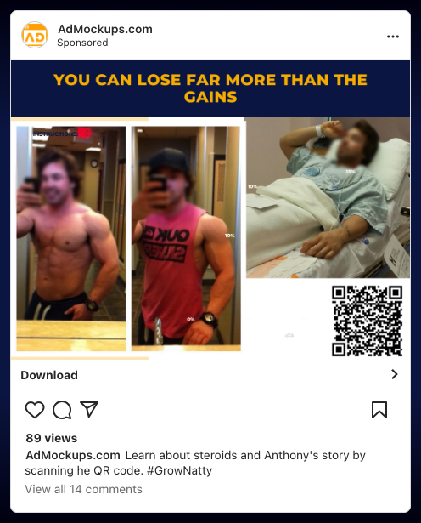

Here are the images that “Anthony” contributed to this research that tells a visual story about the consequential decision to use steroids.
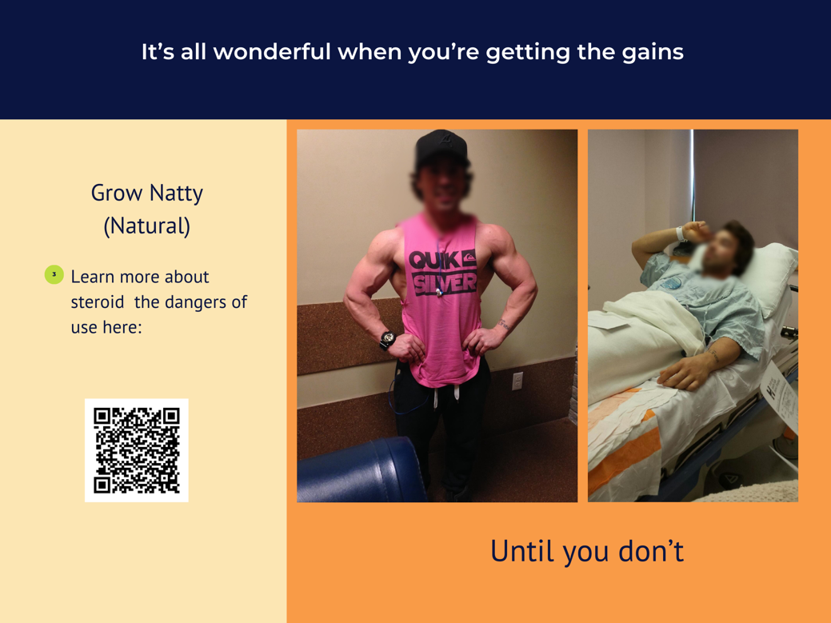
The last initiative is to set up a pilot program in both the Los Angeles and San Francisco gym membership markets biohazardous box in men locker rooms. According to the survey, over 90% surveyed recorded that needle disposal boxes are not present in their local gyms. May will use steroids beyond the education, or lack of education, that they receive, so safe disposal of needles is viable to every fitness facility for the safety of others exposure to germs.
A cost-effective box such as this for $10.99 will be distributed to local gyms along with a poster containing a QR with the above pictures and information on anabolic steroid use and abuse. With 90% surveyed never encountering steroid education materials at their gym, posters and biohazardous boxes will bring safety and awareness locally.

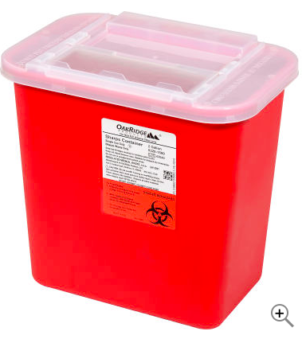
Schedule
January 27-31, 2024 | 17 Los Angeles High Schools
February 24-28, 2024 | 17 Los Angeles High Schools
March 24-28, 2024 | 17 Los Angeles High Schools
April 21-25, 2024 | 17 Los Angeles High Schools
May-26-30, 2024 | 17 San Francisco High Schools
June 2-6, 2024 | 17 Los Angeles High Schools

Each awareness campaign is a week-long designed to cover 17 high schools within that week, with an hour worth of information given. The presentations will include materials for each student along with a question-and-answer segment.
A total of 500 biohazardous with anabolic steroid information posters will start shipping to local gyms in January and conclude in February. San Francisco will receive 300 kits, and Los Angeles gyms will receive 200, as San Francisco contains the most gyms of any other city in the United States according to business insider. (Warren, 2020)

Budget

Air fare | $10,000 (includes all 6 trips for 2)
Hotel | $16,000 (includes a week stay per month for 2 January-June)
Awareness Materials | $28,000 for printed materials with QR codes for students in both L.A. and San Francisco school districts. Includes two rounds of information.
Travel expenses | $7,500 (4,500 for food and 3, 000 for car rental services)
Biohazardous boxes | $7,000 (buy and ship boxes)
Gym posters with QR code | $50,000 ($100 each and distributed to 500 gyms targeted in both Los Angeles and San Francisco.)

TOTAL BUDGET= $108, 500

Evaluation
Using the two largest cities to roll out an awareness campaign in California has multiple purposes. Both Los Angeles and San Francisco has the largest number of gyms in the country; and subsequently in the state that leads the illegal trafficking of steroids into the United States. The success of this campaign can be the model to penetrate other major markets, and ultimately change attitudes towards the government agency, I.C.E. Assimilating the message of steroids’ dangers will have to be continued through the social media sites; engaging those that use the QR code to for information.
The Los Angeles school district and the San Francisco School district will be aware of the coming tour with information about steroid given to physical education teachers for their students. When the tour starts, it is expected that conversation has taken place, allowing facilitators to be more informative with the presentations and materials that will assist them.
Methods, pre/post testing, concept testing
A pre-survey will be conducted that gauges the knowledge of steroids for the students in the L.A. and San Francisco districts. Once the campaign is complete in June, a post-campaign survey will be sent to the same students. With the post-survey and the results from the pre-survey, a measurement of effectiveness will be reviewed on the attitudes toward steroids and the knowledge contained.
Each social media platformed utilized for the online campaigned will be monitored weekly after biohazardous boxes and posters have been received by both L.A. and San Francisco gym markets. The analytics will review and monitor traffic, along with which post resonate best among the audience. Social media sites, such as Instagram, TikTok, and Reddit, will be updated with real stories and information, along with up-to-date crisis management for current users.

References

“FDA Issues warning about body-building products labeled to contain steroid and steroid like substances” U.S. Food and Drug Administration 6 20, 2017
https://www.fda.gov/drugs/drug-safety-and-availability/fda-issues-warning-about-body-building-products-labeled-contain-steroid-and-steroid-substances#:~:text=FDA%20recommends%20consumers%20immediately%20stop,and%20stroke%2C%20and%20shrinkage%20of

Cleveland Clinic “Anabolic Steroids “
https://my.clevelandclinic.org/health/treatments/5521-anabolic-steroids

Dotson J.L., Brown R.T. “The History of the Development of Anabolic-Androgenic Steroids”
(2007) Pediatric Clinics of North America, 54 (4) , pp. 761-769.
https://www.sciencedirect.com/science/article/pii/S0031395507000624

AlShareef S, Gokarakonda SB, Marwaha R. “Anabolic Steroid Use Disorder”. [Updated 2023 Jun 20]. In: StatPearls [Internet]. Treasure Island (FL): StatPearls Publishing; 2023 Jan-. Available from: https://www.ncbi.nlm.nih.gov/books/NBK538174/

Stojko M, Nocoń J, Piłat P, Szpila G, Smolarczyk J, Żmudka K, Moll M, Hawranek M. Innovative Reports on the Effects of Anabolic Androgenic Steroid Abuse-How to Lose Your Mind for the Love of Sport. Medicina (Kaunas). 2023 Aug 8;59(8):1439. doi: 10.3390/medicina59081439. PMID: 37629729; PMCID: PMC10456445.

Sports Illistrated “How We Got Here” 2008 11, March SI Staff Writer
https://www.si.com/more-sports/2008/03/11/steroid-timeline#:~:text=1935%20German%20scientists%2C%20led%20by,cumulative%20findings%20in%20sex%20hormones.

Passage Immigration Law “The History of ICE in American Immigration History
https://www.passage.law/blog/the-history-of-ice-in-american-immigration-history#:~:text=ICE%20was%20created%20in%202003,of%20the%20Department%20of%20Justice.

Tom Ferry ESPN November 17th, 2023
Http://www.espn.com/columns/farrey_tom/1655597.html#:~:text=California%20is%20the%20world%20capital,Dianabol%20Chargers%20of%20the%201960s.

High Schools in San Francisco Unified School District
https://www.usnews.com/education/best-high-schools/california/districts/san-francisco-unified-school-district-111777

High Schools in Los Angeles Unified School District
https://www.usnews.com/education/best-high-schools/california/districts/los-angeles-unified-school-district-106440

Auxier, Brook and Anderson, Monica “Social Media Use” 2021 Pew Research
https://www.pewresearch.org/internet/2021/04/07/social-media-use-in-2021/#:~:text=Adults%20under%2030%20stand%20out,of%20Instagram%2C%20Snapchat%20and%20TikTok

Warren, Katie San Francisco has 16 gyms and wellness facilities per square mile, more than any city” Business Insider January 24, 2020
https://www.businessinsider.com/san-francisco-gyms-fitness-millennials-wellness-2020-1#:~:text=San%20Francisco%20has%2016%20gyms,than%20any%20other%20US%20city.

Appendix A: Survey Responses

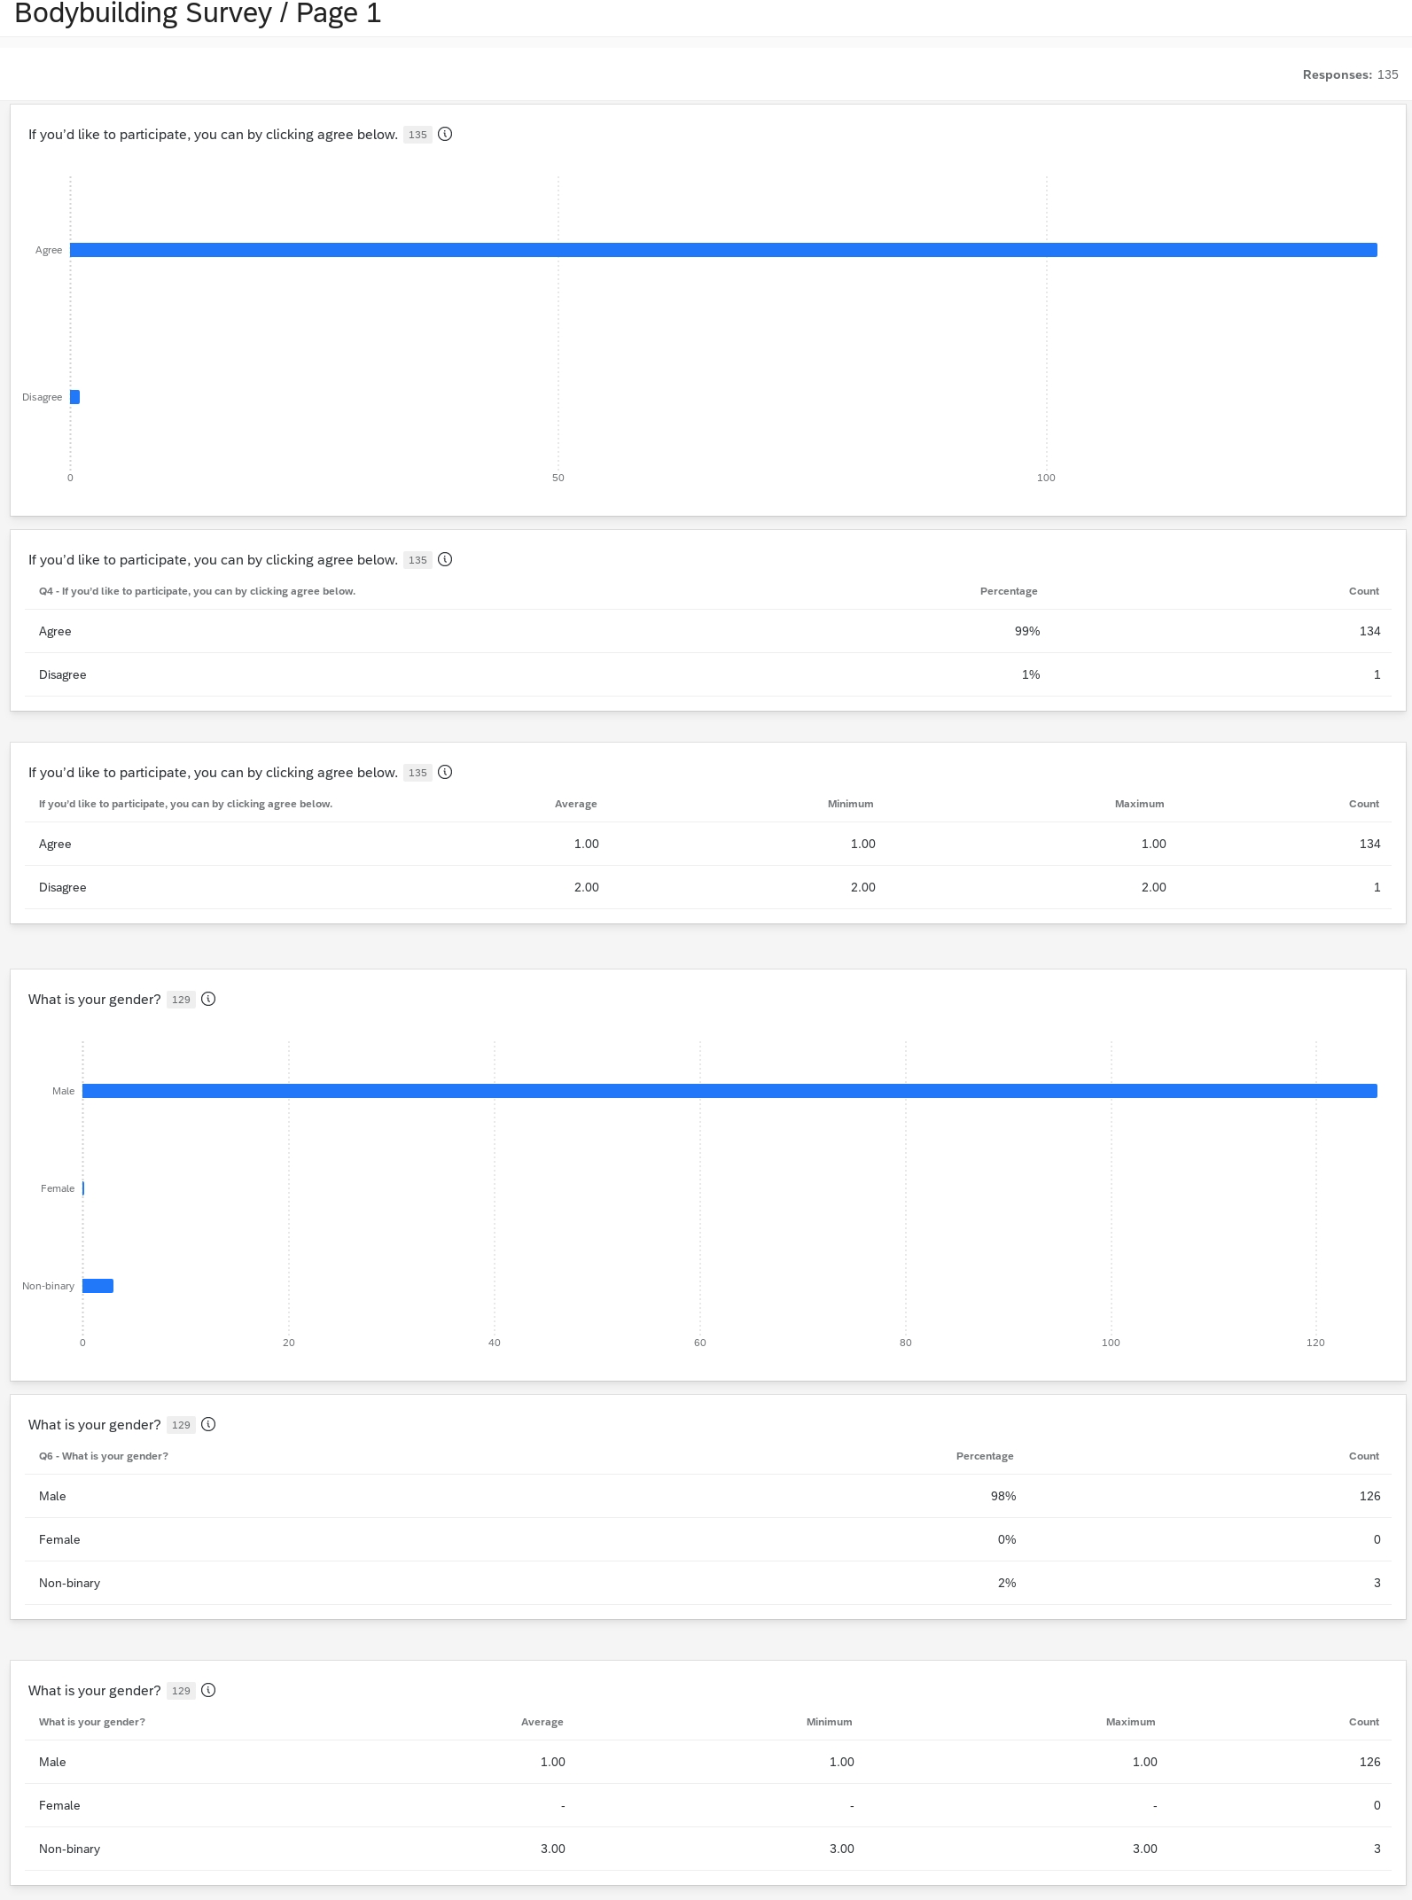
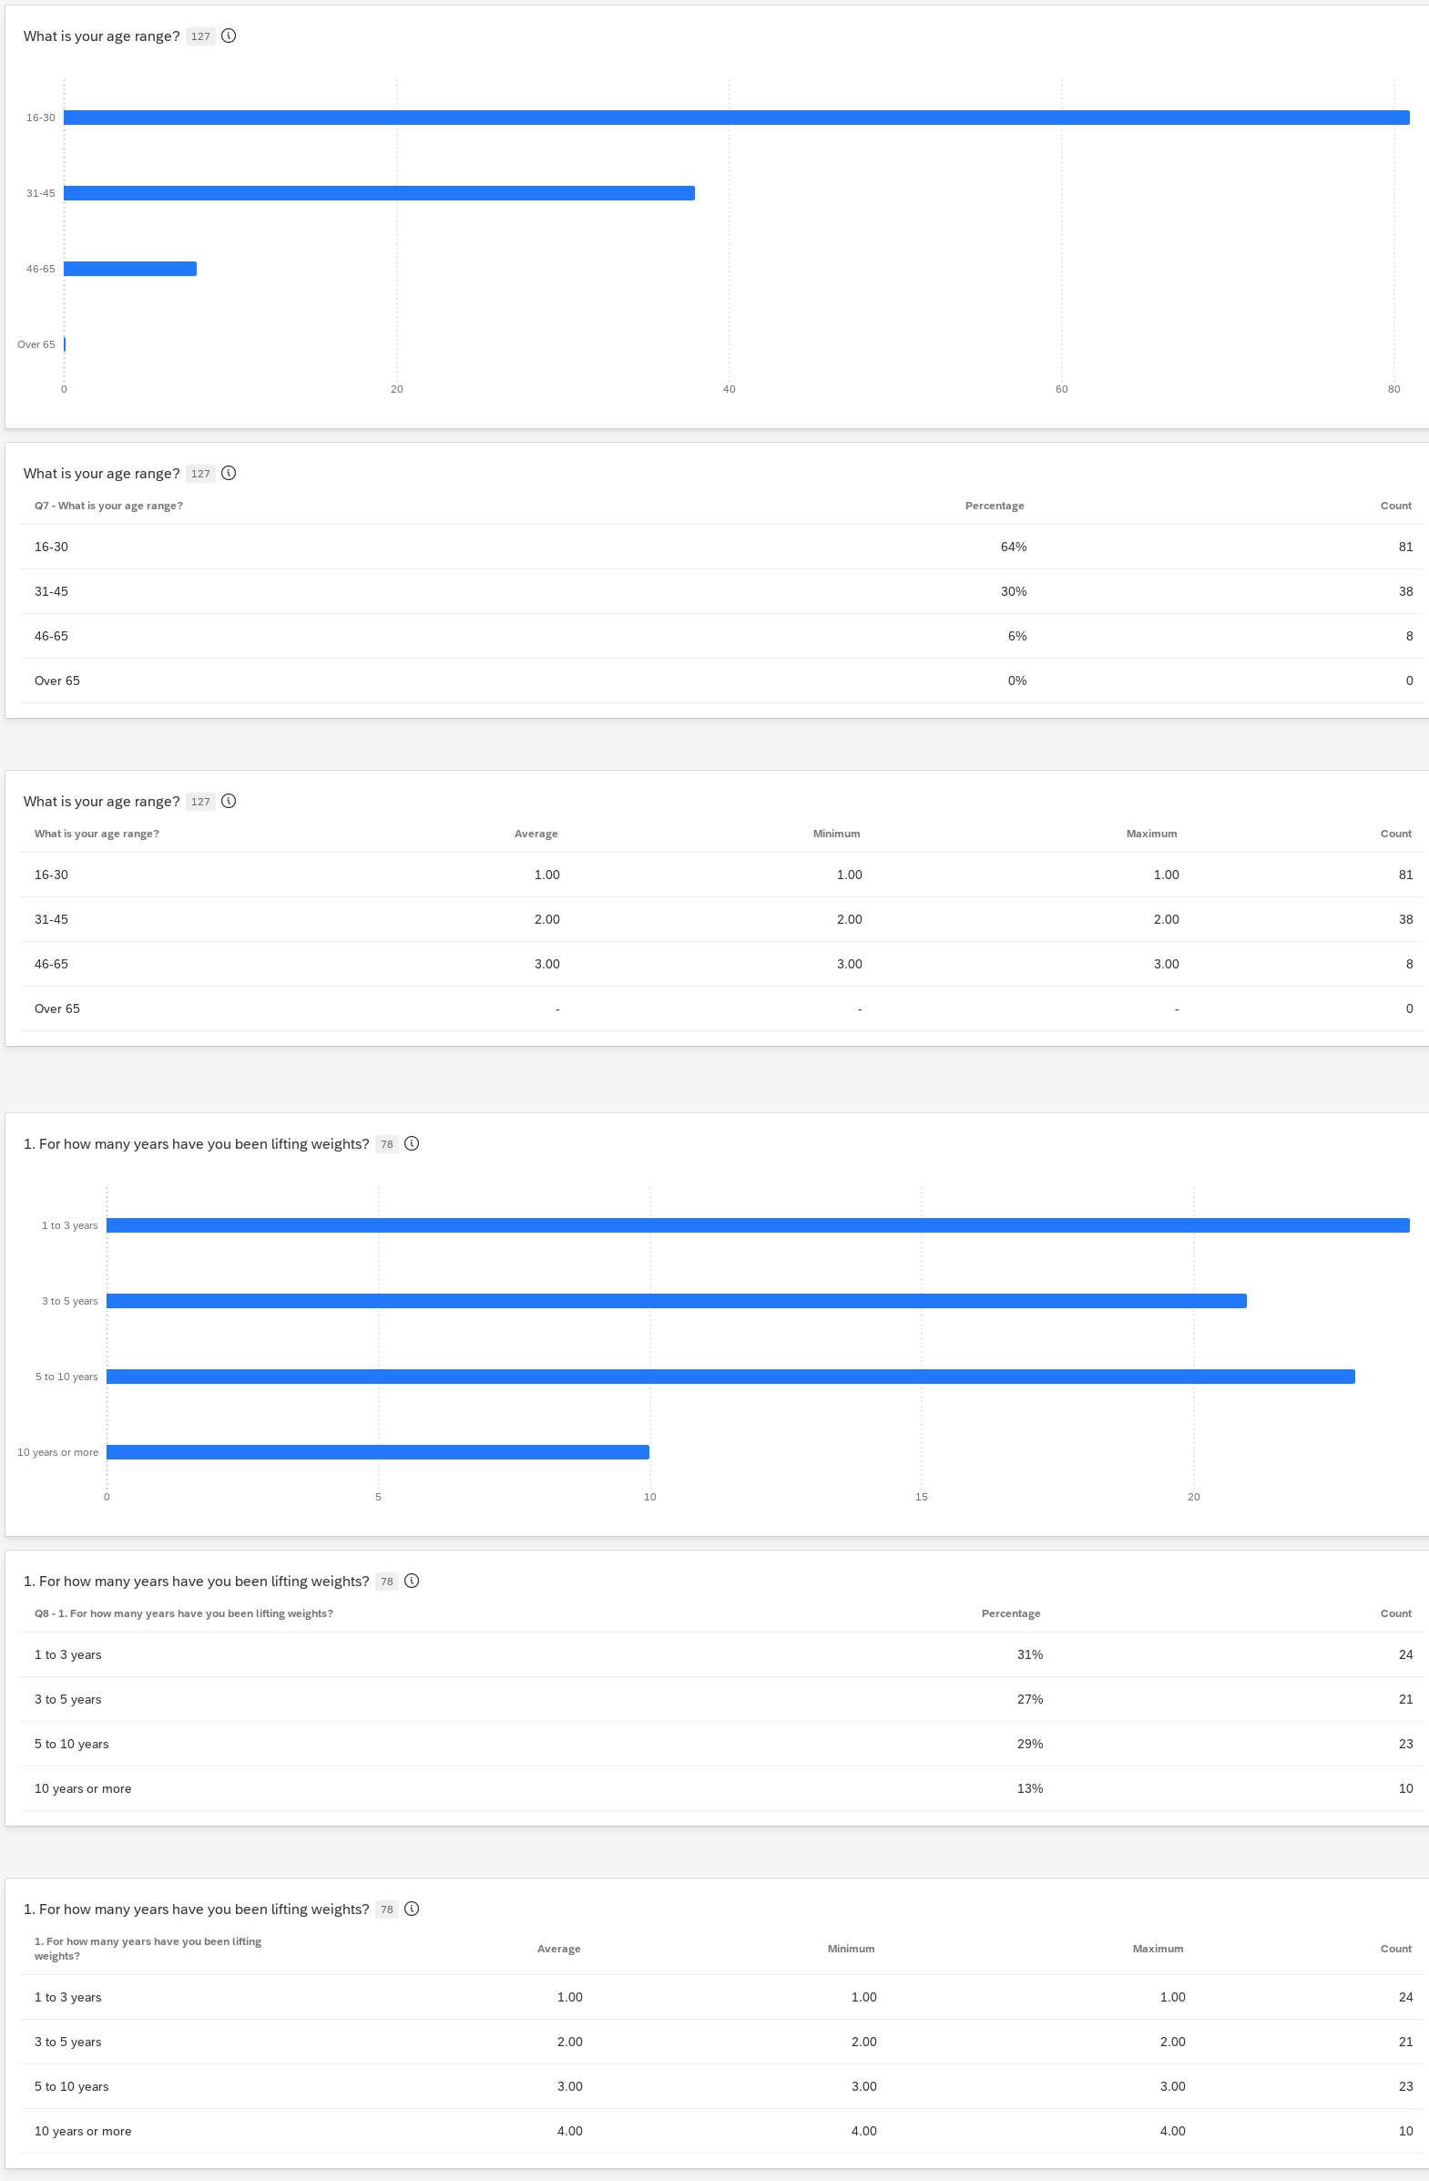
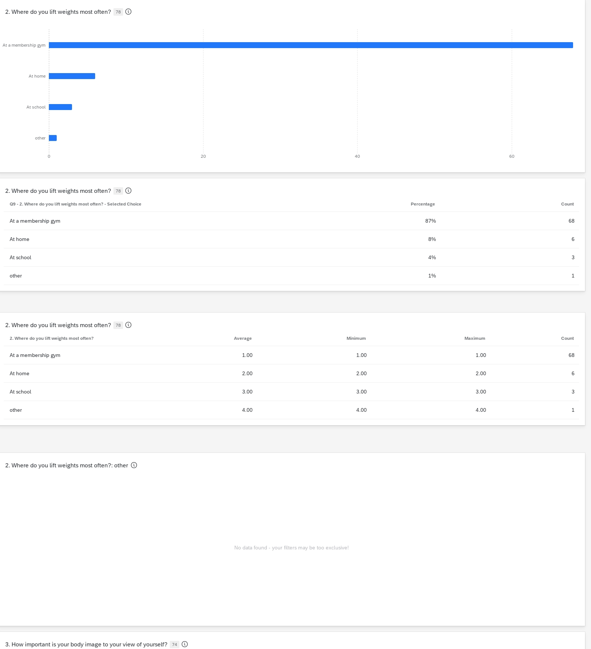

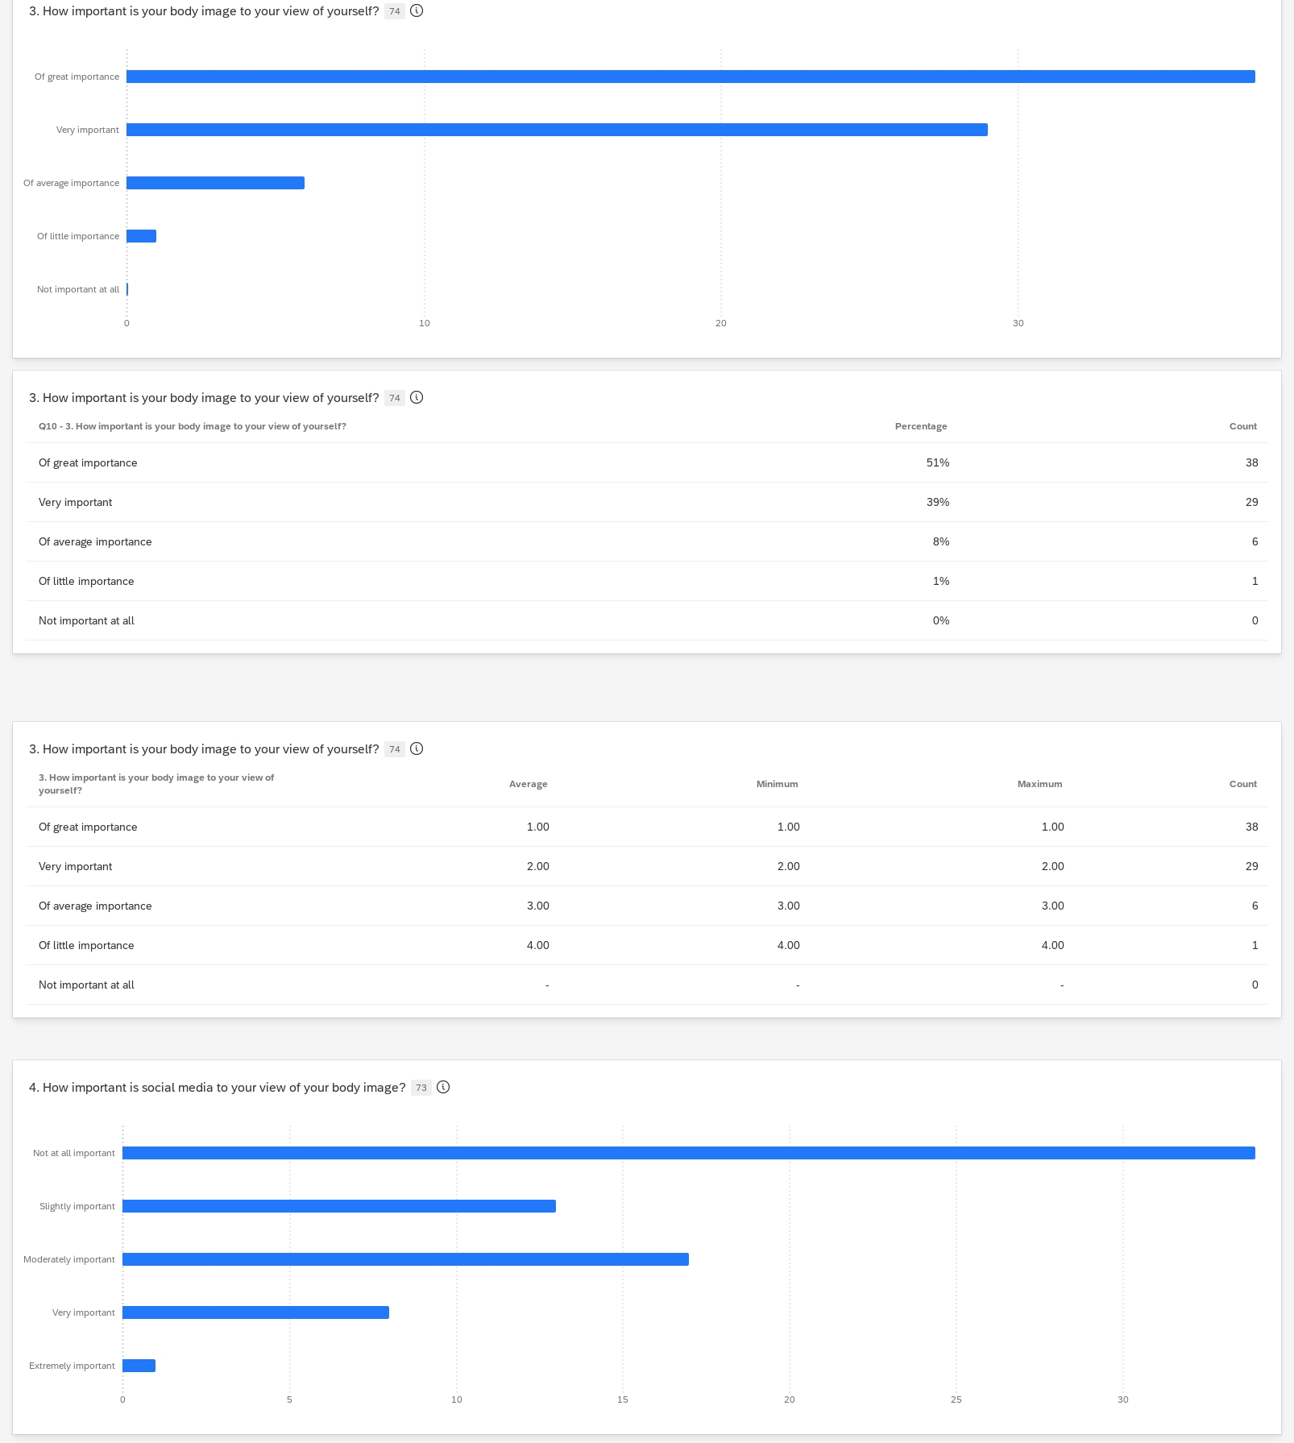
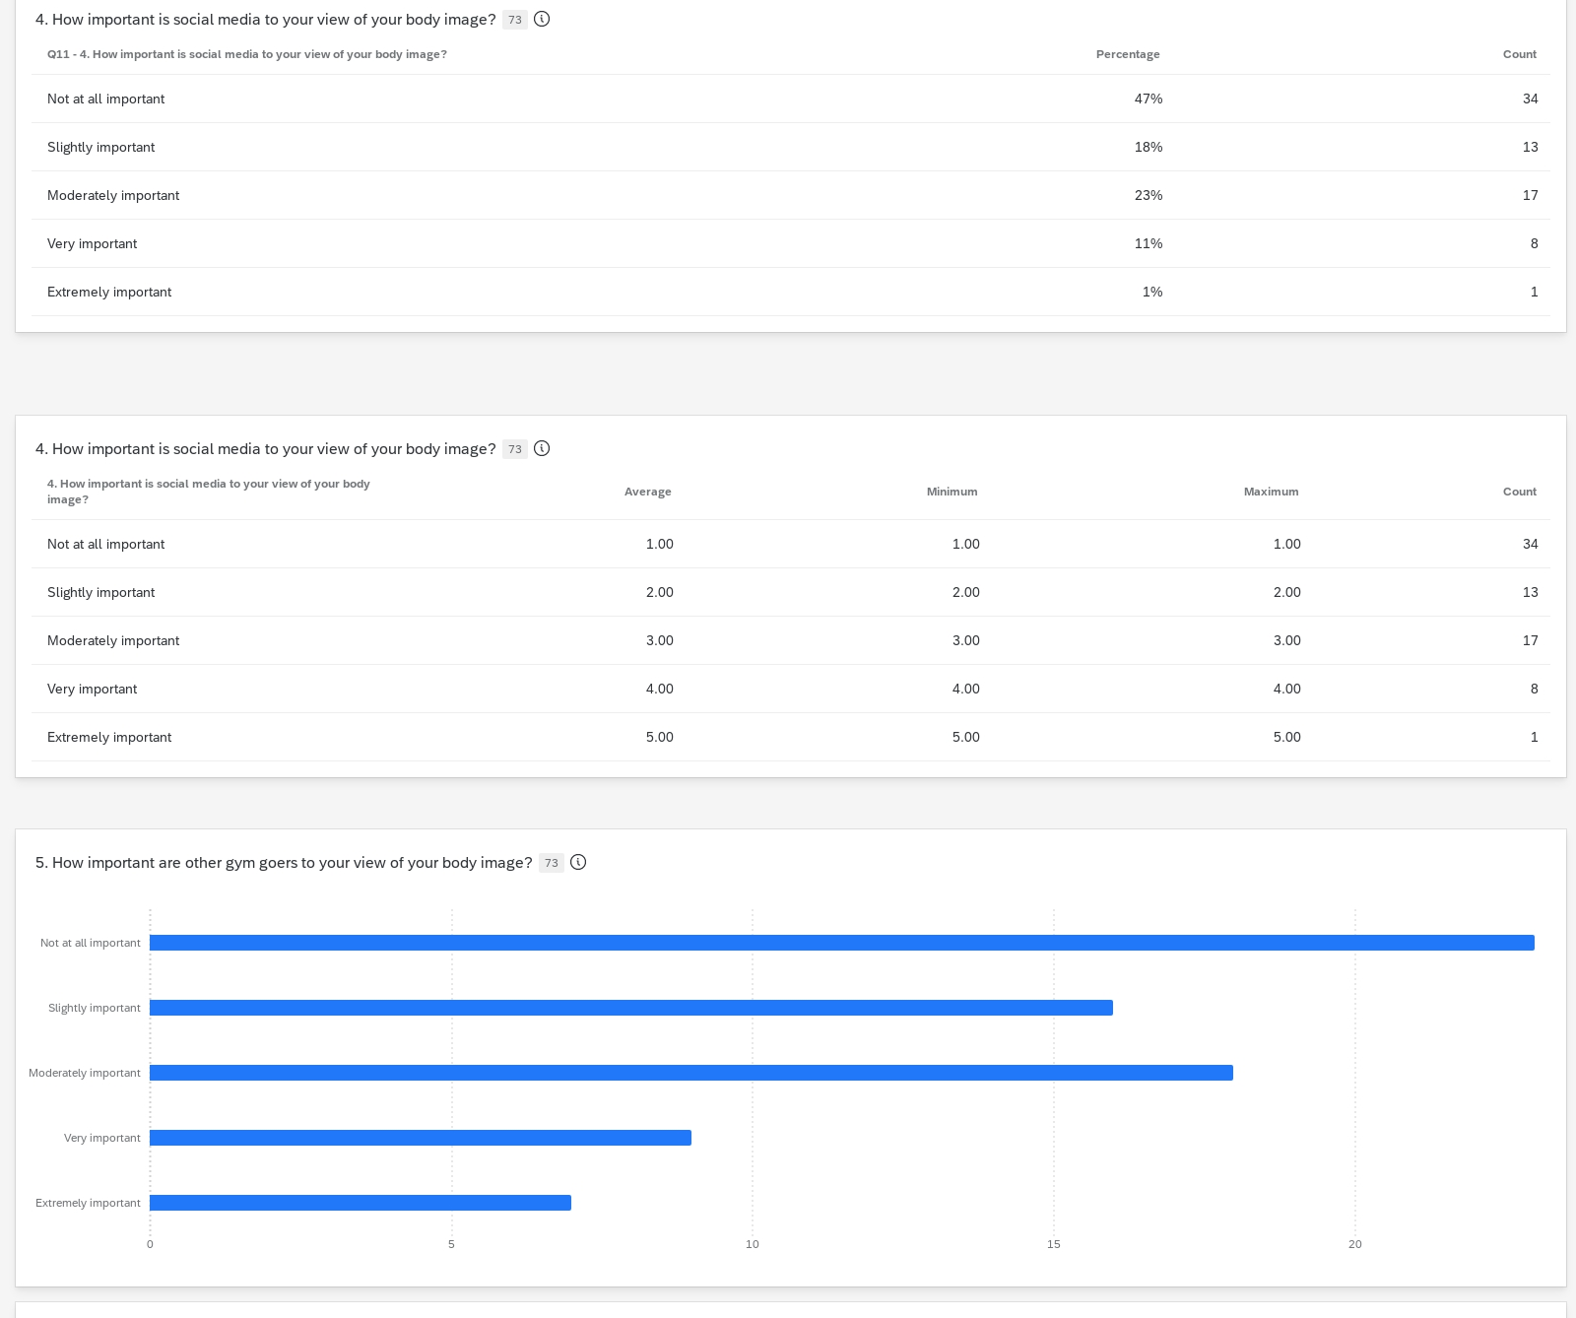

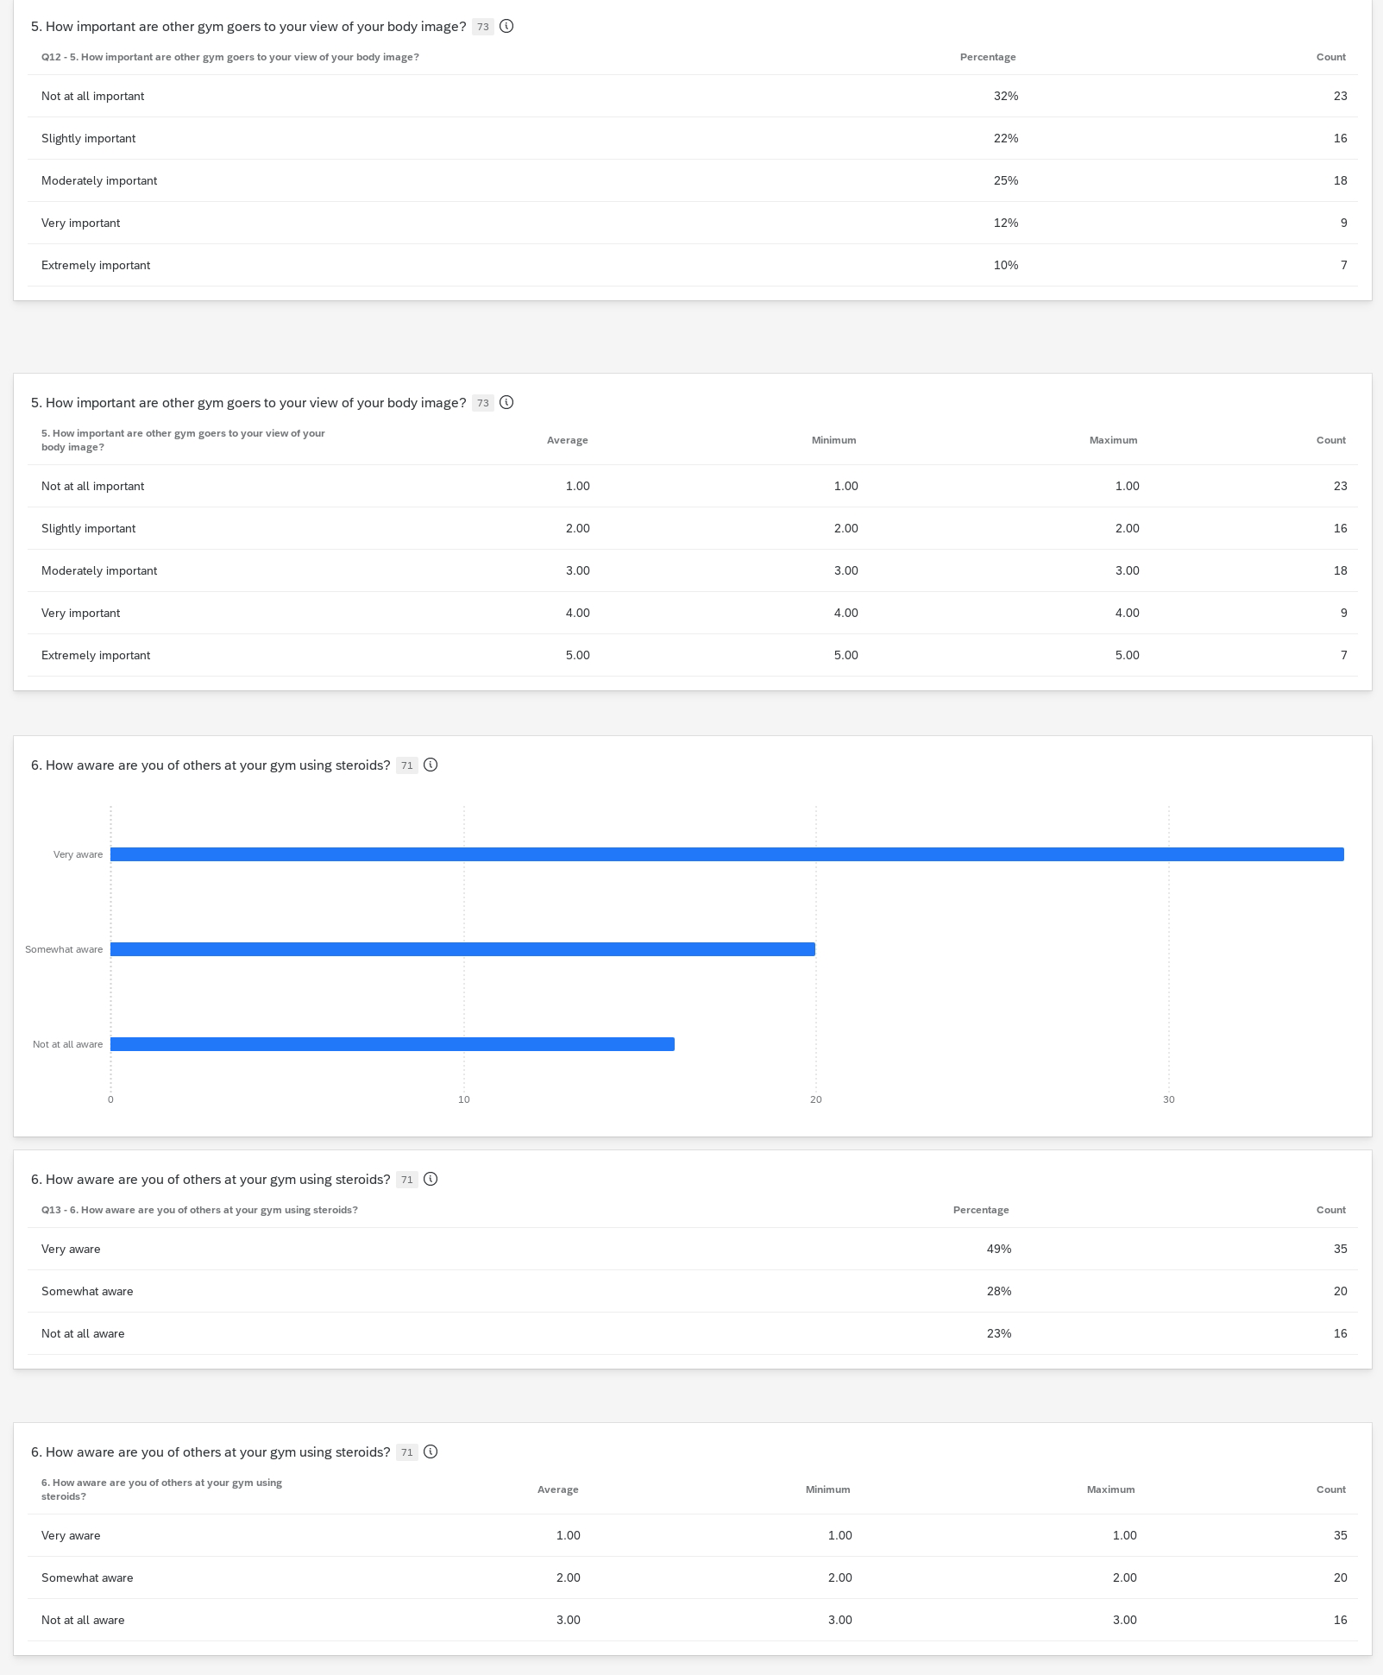
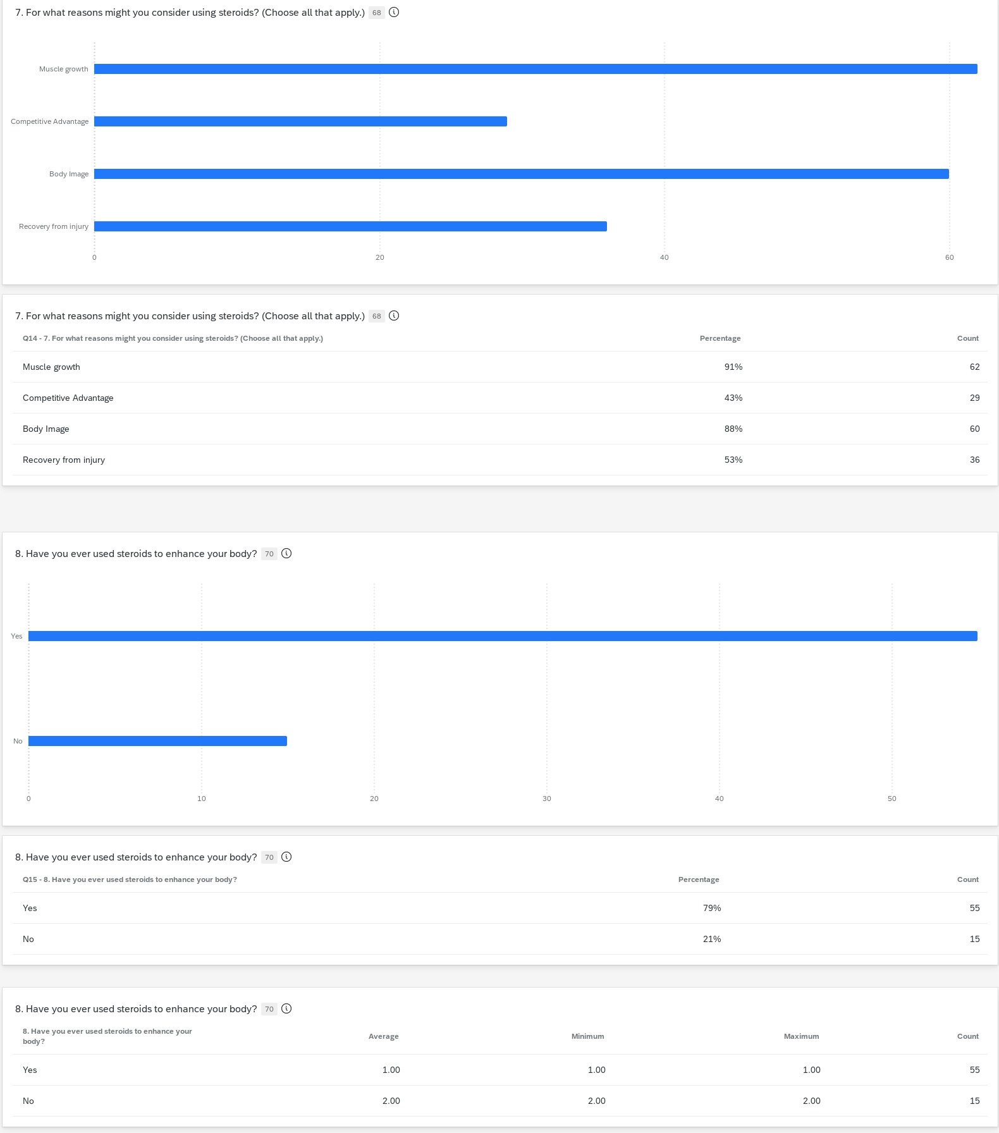

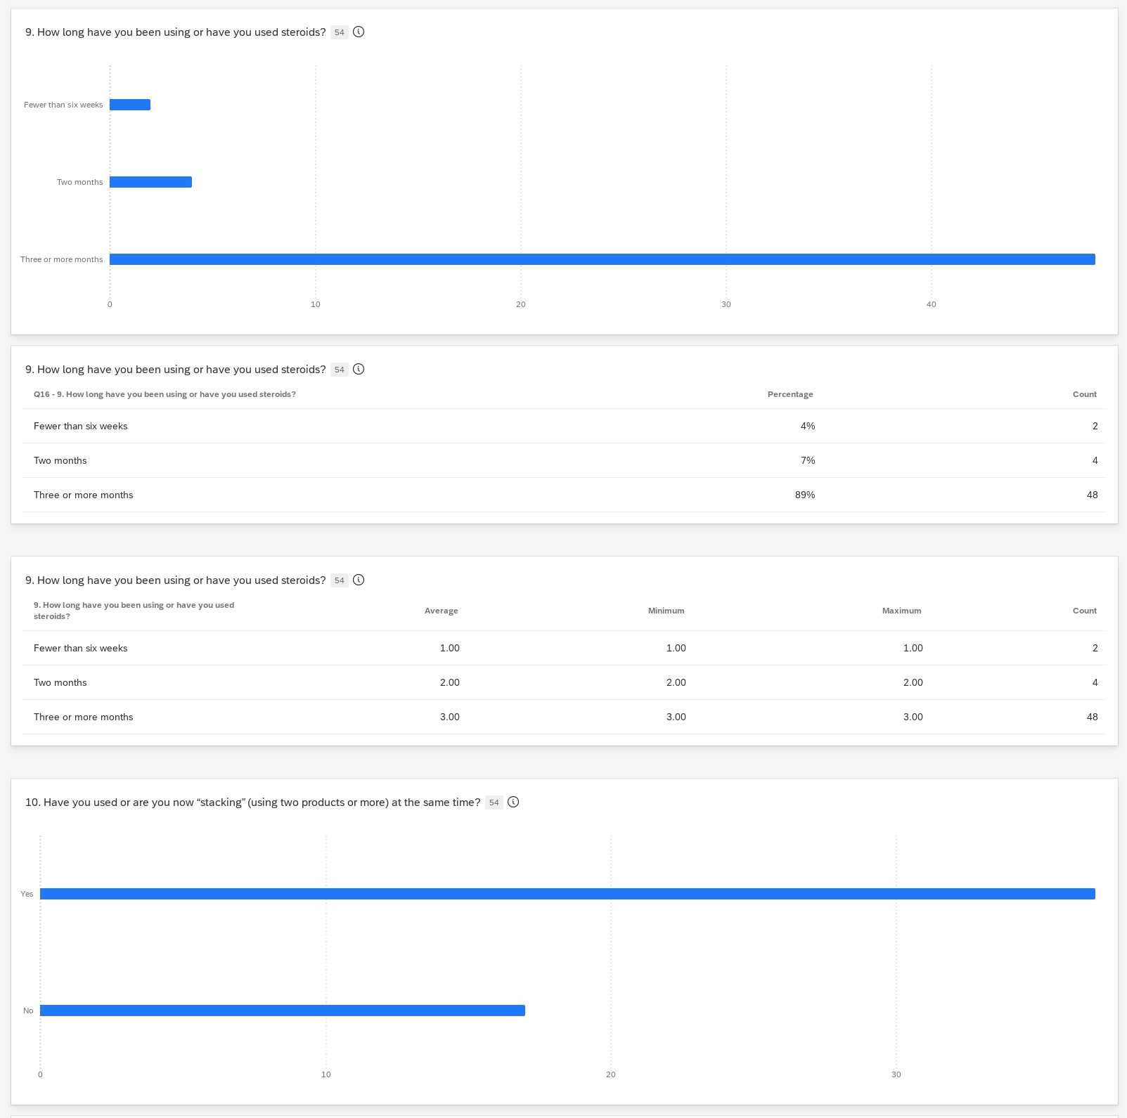

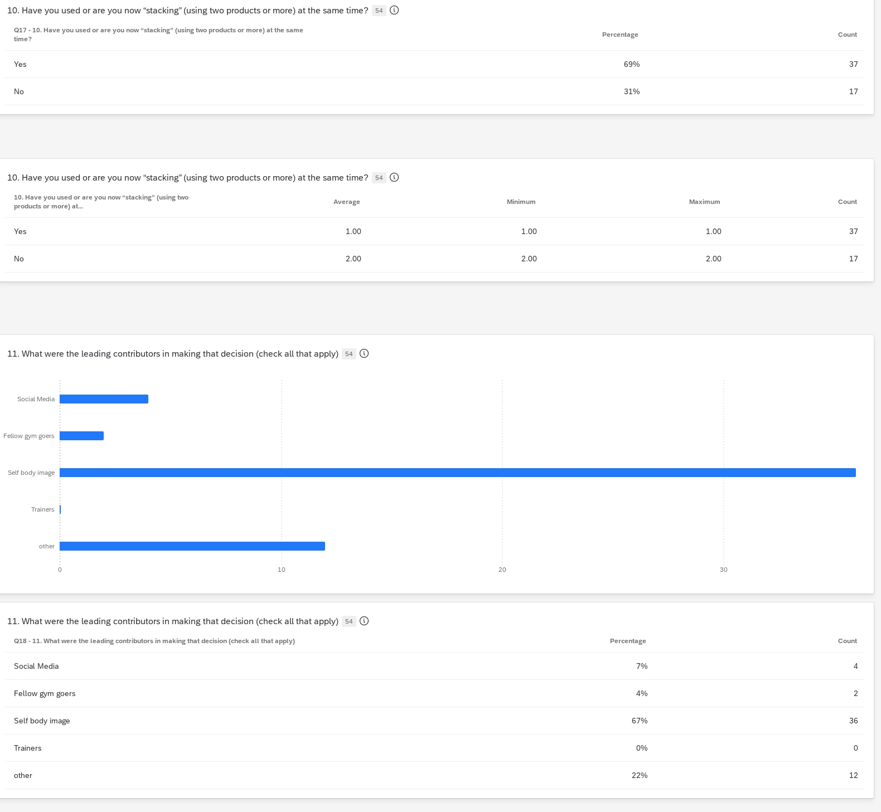

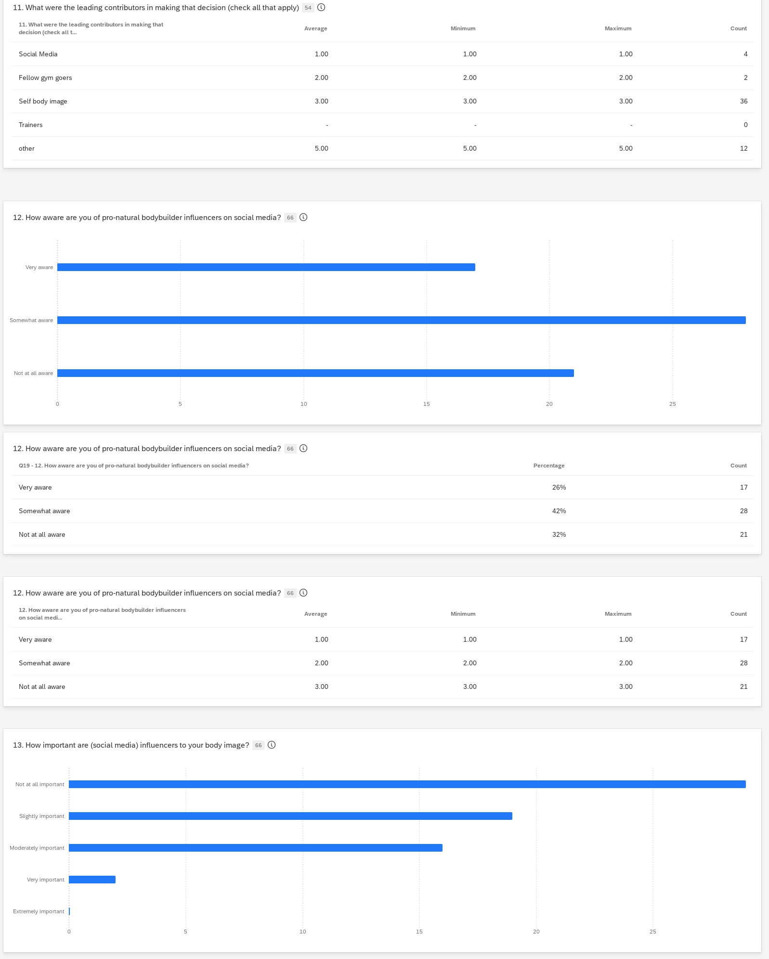
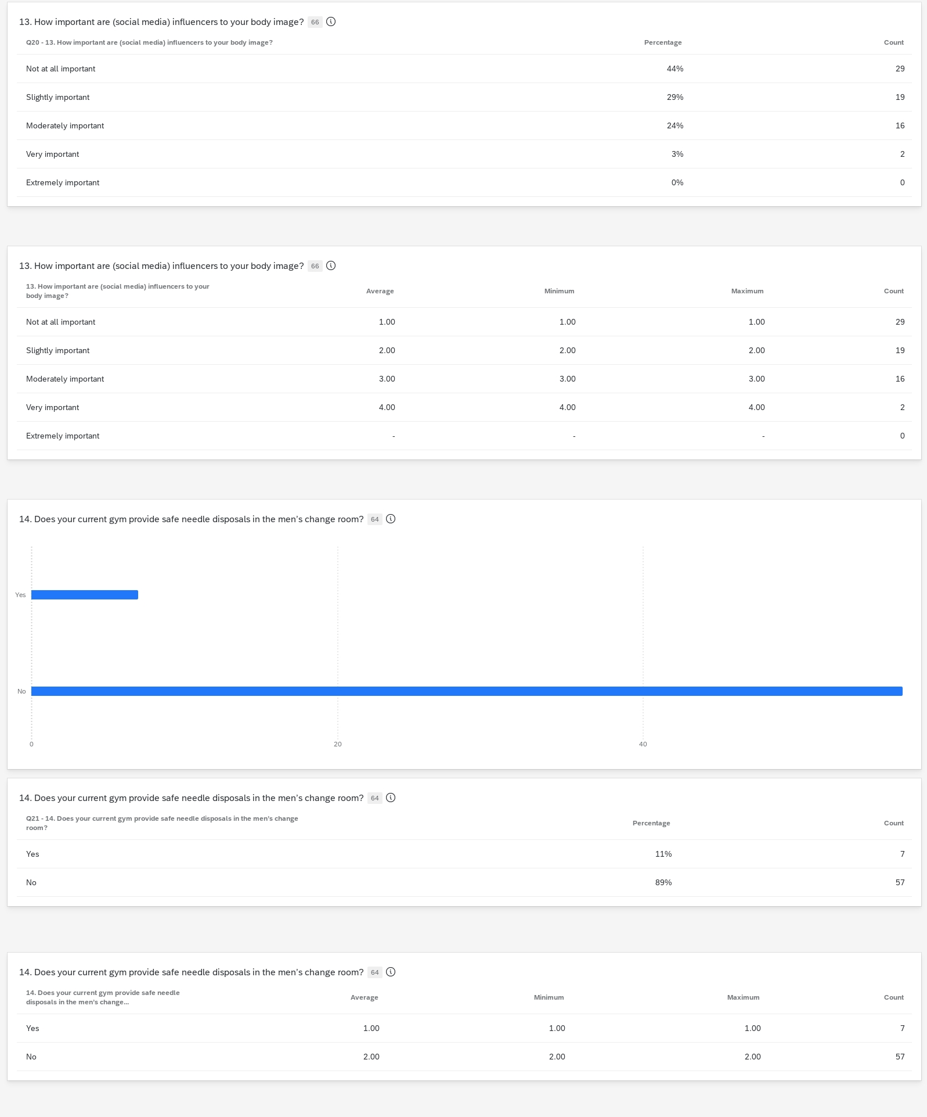
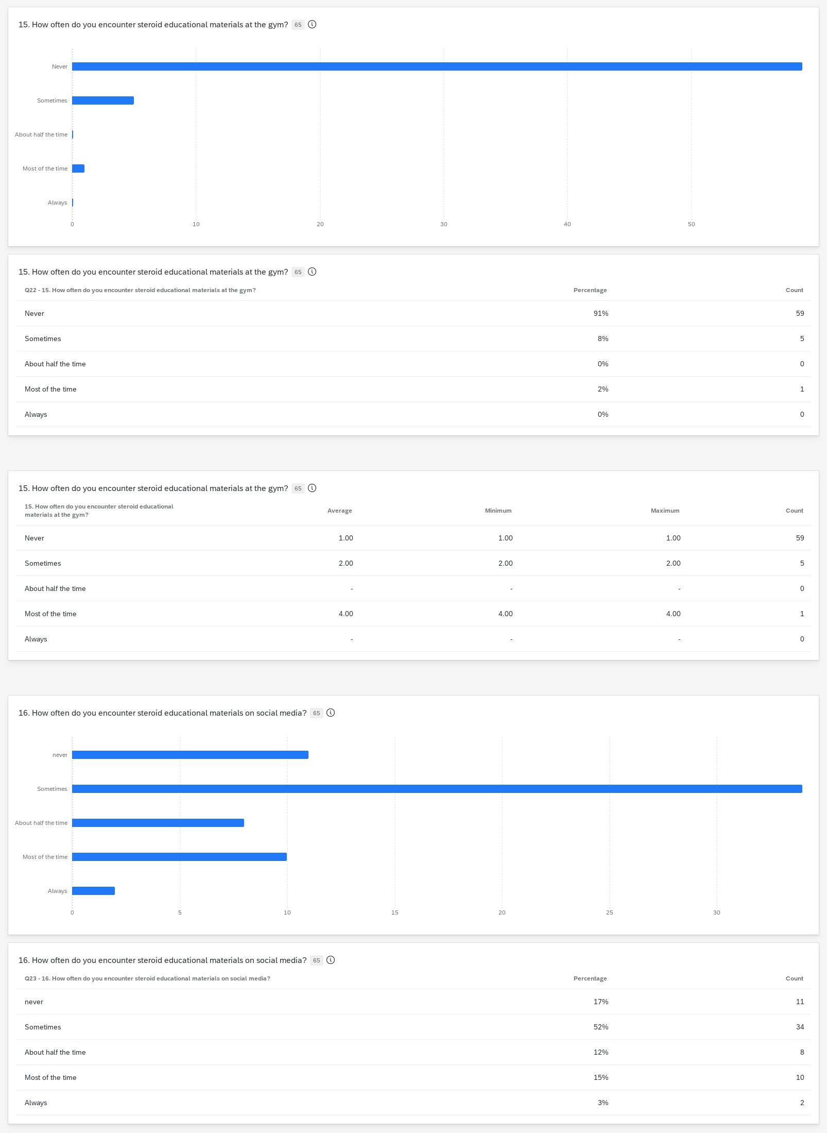
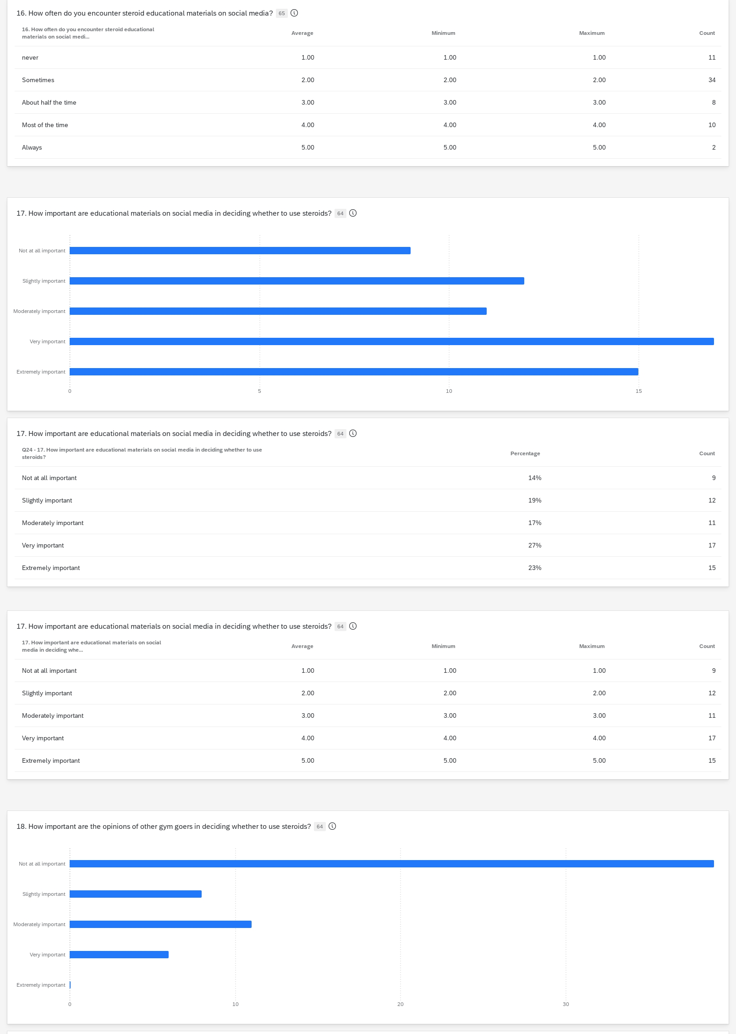
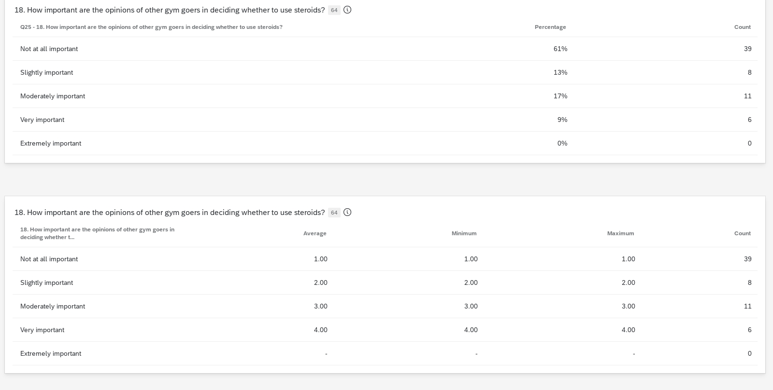

Appendix B: Interviews
Interview 1
“Anthony” is a Generation Z ex steroid user that has weight trained since high school. He shares his experience as user and his almost fatal reaction to the drugs.

“How did you hear about steroids?”

“Anthony: “I was working out at the gym, and I saw this guy that looked humongous, and I was like man, I want to look like this guy. At first, he told me to eat a lot, eat a lot. Then eventually, one day I saw him reach up for something on top of the lockers and took something done, like money. Someone else had come in and put the money up there, and he put steroids up there. He then told me, yea, I sell steroids. He then pointed and said this guy and that guy is on them too. Once I found that out, I did very little research.”

“What kind of research did you do?”

Anthony: “I literally just Googled; I think that the second link that I had found was where you can buy them online. They deliver, it was called Juice Monster. I thought steroids was just one thing but apparently there’s *expletive” hundreds. There’s like Decca, Trend… I thought it was just one thing like a steroid is a steroid. You can’t just take one, say if you’re taking Decca, you need to take something else to backpack it.

“So that’s called stacking.”
Anthony” Yes, you do that, so the side effects don’t happen. You also take this other pill called novadex, so it doesn’t *expletive” with your estrogen too much. So now you’re not taking one thing you’re taking two things, and the third thing of for you to not affect your body too much.

“So, three?”
Anthony: “Yea, some people take a lot more?”

“SO, being that, that guy was the dealer, I’m assuming that you started getting steroids from him?”

Anthony:
“No, because he seemed sketchy. Grabbing things from the top of a locker. So, I was doing body building competitions because I wasn’t big enough. So, a lady that I was talking to that I wanted to coach me told that If I wanted to be competitive, that I need to take steroids.”

“So, the trainer told you that?”
Yea

“What made you think that you weren’t big enough? Was it obvious to you?

Anthony: “Yes… and I wanted to be competitive, and I was like everyone else is doing them and in order to get on stage and be like them the is what I have to do. She (the trainer) was like this is what you must take.

How old were you then?

Anthony: “I was 22. She started me off with this one. She didn’t know any better. It’s called Test 400.

What is Test 400 and how do you take it?

Anthony: “You inject it through a syringe needle.”

Where is the injection sight?

Anthony: “I was doing it in my leg. It took me two hours before I put it in myself because I was so scared. I remember two hours later; my leg was so sore, and I couldn’t walk for like two days. I was limping.

How often would you have to inject that (Test 400)?

Anthony: “Twice a week. So, I started that for about 4 weeks. So, I told another coach what I was taking, and I told him (about Test 400). …He told me that I was going to get pains and I had all of them. He said it’s the worst one you can take. So, he put me on a different test called Decca. Decca is supposed to make you feel a lot better. So, this is where it got crazy. I remember I saw my friend Jason on a Wednesday; Saturday I some people over and he saw me and was like What the Hell! I had gained about 12 pounds in three days.”

In three days?

Anthony: “It was all water weight, but I had ballooned out because of this Decca.”

So, at this point, you’re taking two (steroids)?

Anthony: “Yes”

Were you taking them both at the same time?

Anthony: “Yes, two at the same time. Then I told someone else that I was feeling a little weird still and they asked If I was taking Novadex. I was like no, I don’t know what that is. He told me that I must take Novadex the pill to help with the kidney and liver and side effects like acne and all of that. It keeps everything somewhat normal. I was like, oh (expletive), I didn’t know all of that. So, I was taking that as well to block estrogen. I don’t think it helped. I think it was too late.”

When you say it as too late?

Anthony: “My nipples were getting so sensitive that it (nipples) was bleeding. I had like bumps. It was abnormally sensitive, like strange.”

So, trainers influenced you to start?

Anthony: “Oh Yea”

So, if I’m starting steroids for the first time, what does a transaction look like? How does one find a dealer?

Anthony: So, this is crazy. She (the trainer) had taken me to the guy she uses. Now this guy…. had a whole set up in his basement. So, I went over to his house. This is beautiful. This is insane. So, do you know how he weed shops (dispensaries) are all set up with all white and glass? Well, it’s just like that, but it was in his basement with marble floors and everything. It was insane. Now I never handed him money. I would always give it to her (the trainer) at her house and she would give it to him.

So that way he’s not liable for the transaction in any way?

Anthony: “I think so.”

Very similar to the way a (street) drug dealer handles transactions?

Anthony: “Very much so. I also tried getting them online. So, I went on to Juice Monster, and was like, how does this work? So, you put in your order, then you transfer money directly to them. They’re also like a book of knowledge. You can call this guy (Juice Monster) and he’ll tell you what you should take. Much more knowledgeable than the other people. I would have the steroids at my door in three days.”

On an average, how much do you think you were spending on steroids?

Anthony: “About $300 a month. They’re cheaper than I thought they’d be. I thought they’d break my bank account. I wasn’t taking the max though.”

So even with stacking, you were taking the max?

Anthony: “I was taking very little, but I was four times my strength, veins were popping out everywhere…. I was getting big and lean at the same time.

So now the look is there, do you think you were addicted to the look?

Anthony: “Absolutely, I got addicted to the look and the way I felt.

How did people react to your gains?

Anthony: “Very shocked! My dad hadn’t seen me in a while, so when he saw me, he was like holy *expletive* you’re big.

Did he suspect you were using steroids?

Anthony: “No, He just thought I was eating a lot of food and working out.”

It (steroids) plays with your self-esteem a bit?

Anthony: “Yes, overall, you have a different level of confidence. It’s like overly confident. You feel like you’re on top of the world because you have big muscles. You still must work out when you’re on steroids, if not, it turns into fat.

Were you competing?

Anthony: “I hadn’t done a competition yet while on steroids and I got up to 200 lbs.”

How tall are you?

Anthony: “5ft 3 inch and got to 200lbs, just over. When I started (steroids), I was just 160 lbs. So, it was a 40 lbs gain of mass with steroids… ridiculous.”

What was your body fat percentage?

Anthony: “I’m going to say about 3 to 4 percent”

With steroids, when you stop, what happens to those gains?

Anthony: “Well once again, there’s this little magic pill you can take that will help you hold on to everything, and there’s PCT which stands for Post Cycle Therapy. You inject yourself with some kind of water and something else. So, you mix it in a bottle and inject that twice a day for two weeks after you’re done with a cycle.”

How long were your cycles?

Anthony: “Well, I never got off”

Do you think you were addicted at this point?

Anthony: “100 percent! I kept seeing strength gains and my own gains. I was wearing an extra-large t-shirt, and it was tight. Once I was on and seeing the results, there’s no stopping. Then I said that I would take less, but I always ended up taking the exact same amount.”

How did you communicate with your other peers about steroids? Was this something that you talked about with them?

Anthony: “It was open. Once they started to see the drastic changes and asked. I was like, I’m taking steroids. Now there were saying that they must get these and where can they find them. I was like, I know someone. So, I got my friends on to them (steroids).

Were they (Anthony’s friends) competing?

Anthony: “No, there just some random guys that were going to the gym, and they were young. They’re like 21 as well. I started at 22 (years old) and stopped at the end of 23.

When doing your research, did any of it talk about the dangers of steroids?

Anthony: “Yes, but I thought I was person that it (the dangers) wouldn’t happen to me.

What did that research look like?

Anthony: “I found that it listed more benefits to using (steroids) than not. The risk seemed so little.”

You are 23, you’re still on steroids at this point, what happens?

Anthony: “I was two weeks out from competing, and I woke up deathly ill. I was puking blood. I was gray. I was weak …. I thought maybe I pulled something… as soon as I ate, everything went through me. I thought that if I go to sleep and wake up the next day, I’d be fine. Woke up the next day and it was the same. All of this was happening for three weeks until I finally decided to go to the hospital.”

Between the time you first felt ill, until the time you went to the hospital was three weeks?

Anthony: “Yes, I was wondering, what the *expletive* am I going to do?

Were you still taking steroids?

*Anthony*: “No, I stopped at that point. I had lost about 13 points. I would still try to work out too. Um, because I was addicted. I would get pale. When I went to the hospital, the nurse told me that I have travellers’ disease. Which I knew was impossible because I haven’t been travelling. They gave me three different anti-biotics hoping that they would work. I took them for two weeks and nothing happened.

Where you still in the hospital at this point?

*Anthony*: No, I was back home. I just went in for visits. It was two weeks later that I went back, and I was asked by the doctors about what I was taking. I showed them and they asked me why I was taking these. I was told that I should never take three antibiotics because you won’t know which one will work. They did an x-ray and an MRI and then they found nothing. That was the weird thing I thought I ripped something inside. They put me on one antibiotic but three months after that I was still sick. I knew it was serious when I stood up at the kitchen table and fell over. I couldn’t do anything. I luckily had my phone nearby and called my dad and he took me to the hospital. The nurse saw me, and they admitted me right away. The next day gave me a colonoscopy.

Wait, at this point it’s been three months?

*Anthony*: “Yes it was three months?”

How much weight have you lost at this point?

*Anthony*: “I lost 65 pounds.”

Your body is completely rejecting itself?

*Anthony*: Yes, and everything. So, they have given me the coloscopy and was then like... we must check his blood. They came back in and said that my blood was 65.

Wow, just to put this into context, you need to be at 90,

*Anthony*: Yes, at 64 you’re like dead. And I didn’t know what that meant. The lady (nurse) came in and told me that I needed a blood transfusion. My dad was in the room, and it was the first time that I saw him cry. The started the transfusions but as much blood was going in me, it was coming out of me. It was a constant battle and non-stop.”

When were they able to stabilize you as far as the blood?

*Anthony*: “They had to do three bags (of blood) back-to-back. That got me “normal”. That got me to 75, but I was at the 65 to 70 level for a month and a half.

You were still in the hospital during this?

*Anthony*: Yes, Um…. Then I was obviously hungry but all I could eat was chicken noodle soup. No bread because it was too filling.

Now how much do you weigh?

*Anthony*: I was about 140 pounds from about 200.

All your gains were gone.

Now do they (medical professionals) know that you were on steroids?

*Anthony*: “I told them, but they had figured it out. The one doctor was very smart, and he knew right away. With the weight loss happening that fast… he knew. I then told my dad. Then I think I was three or four transfusions down, and then I continued to try eating I was…umm…I continued more transfusions so I could get better. They had me on prednisone. They had me on so much.

Ironically a steroid of a different kind.

*Anthony*: “Yea exactly, another steroid but not anabolic.” *laughs* It had stopped the bleeding minorly, but I had started gaining weight because of the prednisone and I was very puffy. But that only worked for about two weeks. It was quick think that only worked for a week. I was able to go home. I thought I was all good and ok. The prednisone didn’t work.
So, then I went back to the hospital then the smart doctor put me on Remacay, and it took two hours to go through me. After taking it. I felt normal.

Was this the end of your illness?

*Anthony*: “We thought it was. We thought we figured out the magic solution. I had to take it every two weeks, then every four weeks. I was still receiving blood transfusions while on this stuff. So, at this point, I’ve had about 17 blood transfusions. This was my path to start getting better.

From the first time that you discovered you were sick, to time you got better, how long was that period?

*Anthony*: The whole thing was about 8 months.
What was your weight when you started feeling better?

*Anthony*: “About 145 lbs”

When you started steroids what was your weight?

*Anthony*: “It was 160 lbs.”

So, you were in a deficit?

*Anthony*: “Yes”

If you had to do it all over again, would you have done it (steroids)?

*Anthony*: “No”

So how would you communicate that to someone that is 21 years old and looking at these guys with fantastic bodies and thinking about doing cycles?

*Anthony*: “I wouldn’t recommend it to anyone. It’s not worth it.”

Do you think there’s enough information out there to discourage anabolic steroid use for guys between the ages of 16-30?

*Anthony*: “Definitely not. Because most people that hear about it like I did, it’s from people they see. They’re going based off their look and not the side effects. People are seeing these guys that are jacked (muscular). No one is talking about the fact that their dick may not work. Then some guys will tell you it’s ok if they can’t get hard because they have Cialis (ED medication).

Do steroids shrink your balls?

*Anthony*: “Oh yea, but just your balls.”

That’s a common side effect?

*Anthony*: “Oh yea, everyone.”

As a trainer, do you find that steroid usage has increased?

*Anthony*: It has absolutely 100% increased

Why do you think it has, give me your opinion?

*Anthony*: “Confidence issues because people are looking on social media, like Instagram.

So, you think social media plays a role in usage increase?

*Anthony*: “Yes, and more people are open about taking steroids and they look at these guys and think that if they can take it, so can I. Many of those guys on social media with those bodies are influencers, and they get paid to do that with all the time in the world to work out and post. They get sponsorships and they can’t stop.

Do you think steroids are more accessible now?

*Anthony*: “For sure! Even more so now because you can order them online and have them delivered to your door. They take credit cards now.
Interview 2

Frank is an anabolic steroid user and dealer with at least two decades of doing both. This interview was designed to gain perspective from “Frank” about the communication pieces that surround the trafficking of steroids to users from open to close of sale. Also, to gain insight on clients and retention levels.

When did you start steroids?

*Frank*: “I want to say, in my early twenties, so about thirty something years ago.”

How did you get introduced to them?

*Frank*: I got into professional sports, professional wrestling. It was either eat 100 pounds a week or get on steroids to maintain.”

Was it friend that introduced you to them (steroids)?

*Frank*: “No, it was another wrestler. I can say that I’ve been on and off cycles for about thirty years.”

Which demographic do you sell to?

*Frank*: “Mainly under thirty, although I get plenty of guys that are over 30 too. Teen guys come to me to buy, but I just don’t sell to them.”

When guys come to you for steroids, do they know what they want?

*Frank*: “A lot of people don’t. So, education is king… especially if you’re injecting something or popping something. I ask them where they want to be and look at their body. Like a guy that is 300 lbs and obese wanting to do steroids is a no. I tell them they need cardio. It’s pointless to add. It shows you’re not discipline already because you’re not working out. You still have to do the work. ‘

How do they find you? What does that communication piece look like?

*Frank*: “A lot of guys ask me at the gym because I’ve been around for a while. They see that I’m in shape, but most people can put two and two together. I can walk into the gym and tell you who’s taking gear (steroids). Word of mouth as well.

What is the most popular steroid?

*Frank*: “Ethanate or Susanon those are popular are two of the big ones. Decca is another one with 10 different elements to it. Tran (Trenbolone) is another one big, guys love it.”
Why do they love that one in particular?

*Frank”: “You get quick results with it. I always tell guys to do a good 6-to-8-week cycle when you’re on its hard core then come off it. If not, it’ll start effecting your organs like your kidneys and stuff.”

The average guy spends about how much per month?

*Frank*: “About 200 per month. I always tell them that quality I king.”

In recommending a quality cycle, what do you tell them?

*Frank*: “Quality is in who makes it. It’s so much garbage period in drugs. So, find a reliable source. I’ve taken the time over the years to educate myself on it because people are buying from me, and many walk up to me not knowing what they want, but I still want the sale. Somebody can also *expletive* themselves up with this. I’m careful, I want to make some of these guys better.”

The supply chain, how do you get your supply? Is there someone you call to be supplied?

*Frank*: “Oh yes, I have a guy that I call and get it from, and he ships it to me. He makes money off me, and I make money off the product.

What is your customer retention like?

*Frank*: “I have some guys that have been dealing with me for 20 years. They know when they come to me, the product is spot on. I also go by the model, 8 o’clock is 8 o’clock, don’t show up late. For me is a business and a respectable business. I value my time and they must as well; I value their time too.

Have you seen guys abuse steroids?

*Frank*: “Yes, I had this kid, he wasn’t a kid because he was about 30, that was at my house four times a day picking G or coke.

So, you deal G (Gamma- Hydroxybutyrate) and Coke (cocaine) too?

*Frank*: “Well, yea but I was watching this guy self-destruct on the stuff. I had to cut him off.

How often are guys buying cycles?

*Frank*: “Whenever someone feels like they need a cycle, guaranteed they will find me. I know my product well, and I’ve also done all my product. Not the illicit stuff, but steroids.

Ok, say I’m your new customers, what would you start me on?

*Frank*: “Well I’ve seen your body in the gym. You’re in good shape with a great foundation. You do work out and I see you in the gym, so I know you work out. You’re not a guy that’s in the gym that’s going to inject and not workout. Many guys suffer from psychosis, So I’d tell you if you want 15 to 20 lbs of mass, stick to that and don’t do anymore. I’ve seen too many guys want more and more. Taking steroids is an opportunity to enhance your body.”

Has anyone come back to you with issues due to usage?

*Frank*: “I’ve a had a couple of people come back to me, and the truth is, sometimes the chemicals just don’t gel with everyone.”

It’s normally a friend that hears about you from another friend to purchase steroids.

*Frank*: “Yes, word of mouth is how things happen. I don’t put ads up. I don’t look for business because business finds me. I get a text that ask me if I have a supply because the person or their buddy needs some.

Do you give them your name?

*Frank*: “Oh hell yea, I do! I have no issue with it.

The first transaction you don’t disclose personal information, correct?

*Frank*: No, but by the second one, I will.

Are you ever out of stock?

*Frank*: “Oh yea, all the time. I can put an order in for $5,000 worth of stuff and I’ve liquidated that in a day. I don’t overprice and I don’t underprice, and sometimes I’ve shipped to users. Look, I’ve done very well in the business. I just bought a Jaguar. Went into the dealership and gave him a bank draft (certified check) that very day. I guess crime pays.”

Do you feel that gyms should have a disposable box for needles (Bio Box)?

*Frank*: “Absolutely they should. They shouldn’t be buried in a bathroom stall. It should be placed on the bathroom wall for everyone to see. There should be Bio boxes in the gyms.

Appendix C
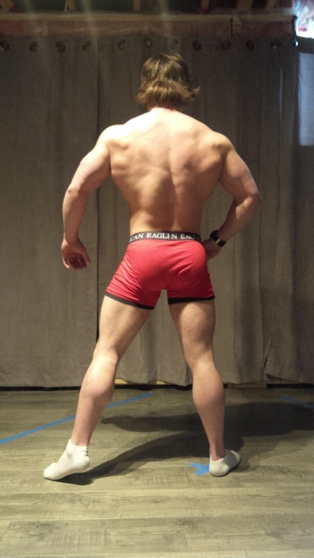
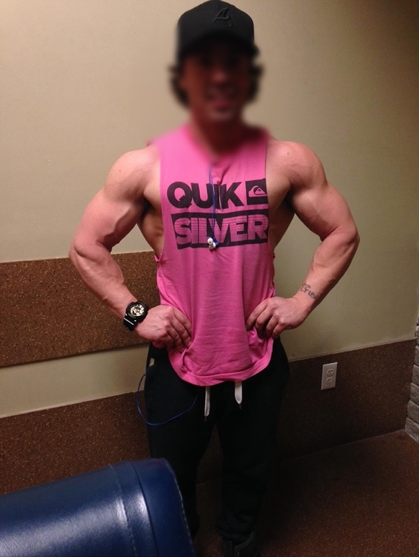
Biography

Charles Harris is a dynamic individual whose life journey has been marked by a deep commitment to global engagement and service. Born with a natural curiosity for the world, Charles cultivated this passion into a remarkable life story.

Hailing from Detroit, Michigan, Charles moved to Florida, where he graduated with a Bachelor of Arts in Organizational Communications from Florida International University. However, his education extended far beyond the classroom. His insatiable wanderlust led him to explore over 40 countries, where he immersed himself in diverse cultures and broadened his understanding of the world.

Driven by a profound sense of empathy and a desire to make a difference, Charles dedicated himself to humanitarian efforts. He volunteered extensively to assist African refugees, offering his time and skills to support and uplift those in need.

Charles's remarkable experiences caught the attention of Travel Noire, a prestigious travel platform, which featured his adventures and insights. His storytelling abilities and keen observations about different cultures allowed him to contribute his writing skills to various travel and lifestyle publications, sharing his experiences and encouraging others to explore the world with an open mind.

Beyond his travels, Charles displayed a deep commitment to community engagement and social impact. He worked tirelessly with autistic youth and adults, focusing on academic and life skills programming. His dedication to this cause not only showcased his empathy and patience but also highlighted his ability to create meaningful connections and foster personal growth in others.

His involvement with Florida International University's Ferre Institute as a fellow Communication Chair underscored his leadership and dedication to fostering a vibrant academic environment. Charles's contributions were instrumental in shaping communication strategies and promoting initiatives that aimed to enhance educational experiences.

Charles Harris continues to be an inspiring example of a global citizen, blending his passion for communication, travel, and humanitarianism to create positive change in the world. His multifaceted experiences and unwavering commitment to serving others stand as a testament to his character and the impact one individual can have on the world.

