FLORIDA INTERNATIONAL UNIVERSITY
Miami, Florida

Evaluation of Non-Contact Sampling and Detection of Explosives using Receiver Operating Characteristic Curves

A dissertation submitted in partial fulfillment of
the requirements for the degree of
DOCTOR OF PHILOSOPHY
in
CHEMISTRY
by
Mimy Young

2013

To: choose the name of dean of your college/school
choose the name of your college/school

This dissertation, written by Mimy Young, and entitled Evaluation of Non-Contact Sampling and Detection of Explosives using Receiver Operating Characteristic Curves, having been approved in respect to style and intellectual content, is referred to you for judgment.

We have read this dissertation and recommend that it be approved.

_______________________________________
Yong Cai

_______________________________________
Anthony DeCaprio

_______________________________________
Rudolf Jaffe

_______________________________________
Wenzhi Li

_______________________________________
José R. Almirall, Major Professor

Date of Defense: November 7, 2013

The dissertation of Mimy Young is approved.

_______________________________________
choose the name of dean of your college/school
choose the name of your college/school

_______________________________________
Dean Lakshmi N. Reddi
University Graduate School

Florida International University, 2013

Dedication
I would like to dedicate this dissertation to my parents. They both came into this country without anything in their name and worked very hard to gain opportunities they would never have in their home country. They brought me to this world and country to provide a greater education and opportunities they never had in their lifetime.
Most importantly, I would like to dedicate this dissertation to my father who passed away early during my Doctoral career. Although he is not physically here, his guidance and support has helped me become the person I am today.

Acknowledgments
I would like to expresses my deepest gratitude to my committee members for their constant support and commitment during my entire Doctoral career in Chemistry. Dr. Yong Cai, Dr. Anthony DeCaprio, Dr. Rudolf Jaffe, and Dr. Wenzhi Li have included me in their busy schedule and provided with the much needed feedback to make my Doctoral career a success. I would like to give special thanks to Dr. José R. Almirall, my major professor, for his endless support and for the great opportunities and resources he has provided to make this research possible. His confidence in my talents and abilities has helped me grow and succeed during graduate school and help develop skills needed for my future career.
I would like to acknowledge the University Graduate School of Florida International University for the Doctoral Evidence Acquisition Fellowship awarded in the fall semester of 2013. I am thankful for their financial support in order to help acquire data outside of the laboratory setting including the Tyndall Air Force Base (Panama City, FL) and the University of Rhode Island (Kingston, RI) in completion of my research studies. Moreover, I would like to thank Dr. Amy Bauer from Tyndall Air Force Base and Dr. Jimmie Oxley from University of Rhode Island for providing me with the necessary resources and helpful discussions to complete my dissertation study.
Furthermore, I would like to express gratitude to Field Forensics, Inc., especially Dr. Patricia Guerra-Diaz for her helpful discussions and financial support to help sponsor my participation at the Gordon Research Conference in Les Dialebrets, Switzerland. Patricia Guerra-Diaz has been very helpful with the first developments of the novel sampling substrate and I have continued her transfer of technology research for the applications of the commercialized device. I would also like to thank Dr. Hanh Lai and Dr. Monica Joshi-Kumar for their initial guidance during the start of my graduate career and continued their support from long distances.
Most importantly, I would also like to thank my family, colleagues, friends and loved ones for their support during my entire Ph. D. career, especially during my last year of my Doctoral career. My family has been very compassionate and have helped me endured all the hardships and tough times I have faced in the past years. My colleagues, the “A-Team,” (especially Howard Holness, Seongshin Gwak, Anamary Tarifa, Tatiana Trejos, Emily Schenk, Sarah Jantzi and Rhett Williamson) have been a second family to me and been very supportive, from proofreading my work to developing a friendship outside the laboratory setting. Non-A-Team members, such as Lauren, Takezo, Chris, Leo and Iris, have been long-term friends and have been very helpful with the production of this dissertation. Special thanks to my colleague Wen Fan, whom started the graduate journey with me and has not left my side since then. We experienced unforgettable memories throughout the years, from staying late at night running experiments to traveling to Europe for conferences. She has been a sister to me and I am looking forward to continuing our lifelong friendship we built during graduate school. Last but not least, I would like to thank my boyfriend, David Goldberg, for helping me during the last year of my graduate career. His strength and courage helped during one of the toughest times I had to endure in my personal and professional life.

Abstract of Dissertation
Evaluation of Non-Contact Sampling and Detection of Explosives using Receiver Operating Characteristic Curves
by
Mimy Young
Florida International University, 2013
Miami, Florida
Professor José R. Almirall, Major Professor
The growing need for fast sampling of explosives in high throughput areas has increased the demand for improved technology for the trace detection of illicit compounds. Detection of the volatiles associated with the presence of the illicit compounds offer a different approach for sensitive trace detection of these compounds without increasing the false positive alarm rate. This study evaluated the performance of non-contact sampling and detection systems using statistical analysis through the construction of Receiver Operating Characteristic (ROC) curves in real-world scenarios for the detection of volatiles in the headspace of smokeless powder, used as the model system for generalizing explosives detection. A novel sorbent coated disk coined planar solid phase microextraction (PSPME) was previously used for rapid, non-contact sampling of the headspace containers. The limits of detection for the PSPME coupled to IMS detection was determined to be 0.5-24 ng for vapor sampling of volatile chemical compounds associated with illicit compounds and demonstrated an extraction efficiency of three times greater than other commercially available substrates, retaining >50% of the analyte after 30 minutes sampling of an analyte spike in comparison to a non-detect for the unmodified filters. Both static and dynamic PSPME sampling was used coupled with two ion mobility spectrometer (IMS) detection systems in which 10-500 mg quantities of smokeless powders were detected within 5-10 minutes of static sampling and 1 minute of dynamic sampling time in 1-45 L closed systems, resulting in faster sampling and analysis times in comparison to conventional solid phase microextraction-gas chromatography-mass spectrometry (SPME-GC-MS) analysis. Similar real-world scenarios were sampled in low and high clutter environments with zero false positive rates. Excellent PSPME-IMS detection of the volatile analytes were visualized from the ROC curves, resulting with areas under the curves (AUC) of 0.85-1.0 and 0.81-1.0 for portable and bench-top IMS systems, respectively. Construction of ROC curves were also developed for SPME-GC-MS resulting with AUC of 0.95-1.0, comparable with PSPME-IMS detection. The PSPME-IMS technique provides less false positive results for non-contact vapor sampling, cutting the cost and providing an effective sampling and detection needed in high-throughput scenarios, resulting in similar performance in comparison to well-established techniques with the added advantage of fast detection in the field.

Table of Contents
CHAPTER PAGE
Introduction 1
CHAPTER 1. Research Motivation 7
1.1 Statement of the Problem 7
1.1.1 Explosives 8
1.1.2 Illicit Drugs 10
1.2 Significance of Study 12
1.3 Project Goals and Hypothesis 13
CHAPTER 2. Chemistry of Illicit Compounds 16
2.1 Chemistry of Explosives 16
2.1.1 Smokeless Powders 18
2.1.2 Military Explosives 21
2.1.3 Improvised Homemade Explosives 25
2.2 Chemistry of Illicit Drugs 27
2.2.1 Cocaine 29
2.2.2 3,4-Methylenedioxy-N-methylamphetamine 32
CHAPTER 3. Sampling & Preconcentration of Illicit Compounds 35
3.1 Solid Phase Microextraction 36
3.1.1 Solid Phase Microextraction Applications 40
3.2 Planar Solid Phase Microextraction 41
3.2.1 Sol-gel Technology 41
3.2.2 The Process of PSPME Fabrication 43
3.2.3 PSPME and Ion Mobility Spectrometry Detection of Illicit Substances 46
3.2.4 PSPME with Other Analytical Instruments 48
3.2.5 PSPME and SPME Comparison 49
CHAPTER 4. Detection of Explosives and Illicit Drugs 53
4.1 Ion Mobility Spectrometry 54
4.1.1 Ionization Sources 58
4.1.2 Dopants 65
4.1.3 IMS as Trace Explosive Detectors 67
4.2 Gas Chromatography Mass Spectrometry 69
4.2.1 Gas Chromatography 70
4.2.2 Mass Spectrometry 72
4.3 High Speed Gas Chromatography-Differential Mobility Spectrometry 76
4.3.1 High Speed Gas Chromatography 76
4.3.2 Differential Mobility Spectrometry 78
4.4 Evaluation of Detection Systems 81
CHAPTER 5. Methodology 88
5.1 Instrumentation 88
5.1.1 Ion Mobility Spectrometry Systems 88
5.1.2 SPME-GC-MS Detection 93
5.1.3 GC-DMS Detection 94
5.1.4 Vacuum Air Sampler for Dynamic Extraction 94
5.2 Microdrop Generation Technology 98
5.2.1 VaporJet Vapor Calibrator 104
5.2.2 Microdrop Generator and Vapor Generator Parameters 105
5.3 Receiver Operating Characteristic Curves Study 108
CHAPTER 6. Results and Discussion 112
6.1 Calibration and Evaluation of PSPME 112
6.1.1 Optimization of Microdrop Vapor Generator Parameters 112
6.1.2 Limits of Detection of PSPME of Vapors Associated with Illicit Substances 117
6.1.3 PSPME Extraction Performance Evaluation 123
6.1.4 PSPME Retention of Analytes Associated with Illicit Drugs 130
6.1.5 Conclusions 133
6.2 Evaluation of Techniques using Receiver Operating Characteristic Curves 134
6.2.1 Sensitivity of Trace Detection Instruments 135
6.2.2 Optimization of Defined Parameters of Real World Scenarios 140
6.2.3 True Positives Rate Studies of Smokeless Powders 163
6.2.4 False Positive Rate Studies 168
6.2.5 Receiver Operating Characteristic Curves 178
6.2.6 Conclusions 182
CHAPTER 7. Concluding Remarks 185
7.1 Vapor Calibration and Evaluation of PSPME 185
7.2 Receiver Operating Characteristic Curves for Trace Detection Systems 185
7.3 Future Directions of the Research Study 186
References 189
VITA 213

List of Figures
FIGURE PAGE
Figure 2.1 Decomposition mechanism of cocaine. Pathway (a) result with the methyl benzoate and pathway (b) results in ecgonidine methyl ester. Adapted from [97] 31
Figure 2.2 Synthetic route of MDMA through reductive amination of 1-(3,4-methylenedioxyphenyl)-2-propanone (MD-P2P) [113] 33
Figure 3.1 (a) Different SPME geometry including fiber, particles, stirrer, and capillary (from left to right); (b) direct immersion and headspace sampling using SPME fibers [119]. 37
Figure 3.2 Gas chromatograph of 10 min extraction of 10 mg All Unique smokeless powder to compare the performance of PDMS (green chromatogram) and PDMS/DVB (red chromatogram) SPME fibers for detection of volatile organic compounds of smokeless powders. 39
Figure 3.3 Diagram of the PDMS incorporated sol-gel mechanism. Figure adapted from Liu et al. [145] 43
Figure 3.4 Microscope images of the surface and cross-section of an uncoated glass filter, (a) and (b) respectively; images of the surface and cross-section of a coated PSPME devices, (c) and (d) respectively. 45
Figure 3.5 Detection of volatile organic compounds from the headspace of smokeless powders from 10 min static extraction or 30 s dynamic PSPME extractions. Above lists the number of smokeless powder that alarmed for the particular volatile chemical compound, with 22 of 24 smokeless powders resulting with a positive alarm. 47
Figure 3.6 The different geometry of the PSPME device can be modified to fit the sample desorption unit (by using the geometry as the default substrate) of different explosives trace detectors without further modification. 48
Figure 3.7 Percent recovery comparison of PSPME and SPME by different static extraction time (0.5 – 30 minutes) of 100 ng TATP. 50
Figure 3.8 SPME and PSPME extraction signals for 10 min. static extractions of 400 ng of TNT and 2,4-DNT. 52

Figure 4.1 Schematic of an IMS instrument; adapted from [64]. Different analytes, depicted in different colors and shape, are formed in the reaction region (left section of the drift tube). The ion shutter (dotted line) allows for a pool of ions to enter the drift region composed of an electric field gradient. Analytes travel at different speeds depending on their shape and charge, in which detection results in a peak corresponding to their drift time (output on right). 54
Figure 4.2 Schematic of the electrospray ionization source, adapted from [153]. 59
Figure 4.3 (a) Schematics of the low temperature plasma probe and (b) photo of LTP using Helium gas at a flow rate of 600 mL min⁻¹. Schematics adapted from [164] 62
Figure 4.4 (a) Low temperature plasma (LTP) source coupled to a mass spectrometer to monitor the ions in the positive polarity; (b) changes in the discharge flow rate of the LTP source results in different intensities of cluster ions. 64
Figure 4.5 Mass spectra for the ionization of straight-chain ketones using the LTP source. 64
Figure 4.6 TATP headspace calibration obtained from 5 minute static PSPME headspace extraction of TATP (spiking 5 µL of solutions of the following concentrations: 5, 10, 15, 20, 25, 30 ng µL⁻¹ in acetonitrile). 67
Figure 4.7 Commercial (a) bench-top (Smiths IONSCAN) and (b) portable IMS systems (Morpho Hardened MobileTrace) [148, 170] 68
Figure 4.8 Schematic of a gas chromatography-mass spectrometry instrument. 70
Figure 4.9 Cross-section of a quadrupole ion trap mass analyzer. Ions travel in figure-of-eight trajectories along the r₀ and z₀. When the ion trajectory exceeds r₀ or z₀, the ions are ejected from the lower cap electrode. Figure adapted from [154] 75
Figure 4.10 Schematics of a differential ion mobility spectrometer instrument [186]. 79
Figure 4.11 Topograph obtained in the EGIS Defender for (a) a blank sample in the positive mode and (b) 200 ng of DPA detected with the detection window of DPA (black rectangle labeled on each topograph). 80
Figure 4.12 Generation of the ROC curve by using different alarm threshold (t₁ – t₅) of the instruments [210] 84
Figure 4.13 ROC curves for two different instrument performance; (a) accurate performance (AUC ≈ 1) and (b) random performance (AUC ≈ 0.5) 86
Figure 5.1 Different substrates for the portable IMS system include PSPME, uncoated glass filter and Teflon-coated fiberglass (left to right) with the SEM [1] and microscope imaging of the surface of the different substrates (bottom). 90
Figure 5.2 Dyson vacuum in the MAX setting and Barringer air sampler comparison in detection of NG from 100 mg of AU smokeless powder in quart cans (n=3). 97
Figure 5.3 Printing system of a piezoelectric drop-on-demand microdrop generator, adapted from [228] 101
Figure 5.4 Bipolar pulse for generation of microdrops [230] 102
Figure 5.5 (a) The calibration of the computer screen to determine the pixels per mm is used to determine the (b) volume and velocity measurements from different strobe delays. 103
Figure 5.6 Instrumental components of the VaporJet vapor calibrator. (a) Overall VaporJet components with (b) close-up to the jetting device configuration [228]. 104
Figure 5.7 (a) Original configuration of the VaporJet Calibrator vapor-generating chamber and (b) modified physical configuration of the VaporJet Calibrator vapor-generating chamber. 108
Figure 6.1 Response curves of TNT in IMS using the (a) dose mode and (b) continuous mode. Different amounts of drops of 100 ppm TNT solution (in 2-butanol) were jetted onto the heating element with the programmed profile: T_{base} = 25 °C, T_{evap} = 50 °C, T_{vap} =150 °C, T_{clean} =300 °C. 113
Figure 6.2 Signal response of the IMS instrument of TNT vapors collected at different elapsed time (n = 3) to determine the steady-state delivery of analyte using the vapor generator. 114
Figure 6.3 Signal response of IMS instrument with different extraction time to observe air flow rate effects. 115
Figure 6.4 IMS signal response for PSPME extractions of TNT vapors using two different VaporJet physical configurations. 116
Figure 6.5 PSPME desorption profiles for (a) TNT, (b) 2,4-DNT, (c) DPA and (d) EC. Multiple desorptions for DPA and EC was performed to fully desorb the analyte from the PSPME device. 118
Figure 6.6 (a) PSPME desorption profiles for TATP from VaporJet delivery and manual spiking; (b) IMS plasmagrams of TATP from headspace extraction and VaporJet extraction. 119
Figure 6.7 PSPME desorption profiles for (a) methyl benzoate and (b) piperonal. 122
Figure 6.8 Signal responses comparison between vapors generated calibration (solid line) and direct liquid spiking (dotted line) on PSPME. 125
Figure 6.9 Extraction efficiency for different substrates for (a) methyl benzoate and (b) piperonal. 128
Figure 6.10 IMS plasmagrams for 30 second dynamic extractions of 100µg methyl benzoate (spiked in a quart can and equilibrated for 10 minutes) using three different substrates. 130
Figure 6.11 Retention capabilities of different substrates for (a) 50 ng of methyl benzoate and (b) 20 ng of piperonal. 132
Figure 6.12 1 µL spike of 15 ng uL-1 onto the (a) ticket and (b) PSPME device; (c) static extractions of 100 mg of a commercial smokeless powder containing NG and DPA resulted with similar NG detection using the default substrate and the PSPME device. 138
Figure 6.13 Calibration curves of (a) 2,4-DNT, (b) DPA and (c) NG in GC-MS. The detection limits were 2.4 ng for 2,4-DNT, 9.9 ng for DPA and 3.0 ng for NG. 139
Figure 6.14 Headspace equilibrium for (a) NG from 100 mg AU smokeless powder and (b) 2,4-DNT from 100 mg IMR 4198 smokeless powder in a quart can (n=3). 141
Figure 6.15 Headspace equilibrium studies for (a) NG and DPA from 100 mg AU smokeless powders in gallon cans (n=3). Amount detected at equilibrium point (> 24 hours) was approximately 6 ng for DPA and 150 ng for NG and (b) 2,4-DNT. 142
Figure 6.16 Equilibrium curve for EC from 500 mg RD in quart can (n=3). Signals observed in 10 minute static PSPME extractions were plotted to establish the equilibrium curve. 144
Figure 6.17 IMS signal observed for smokeless powders at different sampling times. 146
Figure 6.18 (a) Setup of cardboard boxes with (insert) display of PSPME suspension on the top flap of the boxes suspended with tape; (b) Plastic container, 15-5/8" x 13-1/8" x 13-1/4", used in this study with AU smokeless powder placed in petridish at the bottom of the container (top right) and PSPME suspended above the container using dental floss and binder clips for static extractions (bottom right). 148
Figure 6.19 IMS plasmagram for detection of NG and DPA from 1h static PSPME sampling from 500 mg AU smokeless powder after 24 hours of equilibrium time. 149
Figure 6.20 Plasmagrams for different sampling times for 500 mg AU in cardboard boxes. 150
Figure 6.21 Static sampling time optimization for cardboard boxes for (a) NG & (b) DPA from 1 g AU and (c) 2,4-DNT from 1 g IMR 4198 smokeless powders. 151
Figure 6.22 Headspace equilibrium of (a) NG and DPA from 500 mg AU smokeless powder and (b) 2,4-DNT from 500 mg IMR 4198 smokeless powder in a plastic container (n=1). 154
Figure 6.23 Headspace equilibrium for NG and DPA from 100 mg of AU smokeless powder in a plastic container (n=1); black diamond denotes the signal observed after 1 desorption of PSPME, white square denotes sum of signals from all desorptions. 155
Figure 6.24 Volatile compounds detected in (a) quart cans and (b) gallon cans. 156
Figure 6.25 Chromatograms of plastic containers (1-2 hours static extractions using SPME). 158
Figure 6.26 True positive rates for the (a) portable and (b) bench-top IMS systems. Comparison of true positive rates for the two extraction methods are shown with varying alarm threshold. 164
Figure 6.27 SPME-GC-MS true positive rates with varying equivalent mass threshold for (a) NG, (b) DPA and (c) 2,4-DNT. 166
Figure 6.28 Plasmagrams for dynamic PSPME sampling (1 min.) in clutter environments from a local shipping facility. Sampling was performed in LD3 (4500 L) containers and LD8 (6880 L) containers as well as open air sampling of the location. 169
Figure 6.29 Plasmagrams of gasoline interferences from 10 min PSPME static extractions in the (a) positive and (b) negative mode for the portable IMS instrument. 171
Figure 6.30 Suppression of 2,4-DNT IMS signal with the presence of dilute (1:10) gasoline from PSPME 10 min static extractions. 173
Figure 6.31 Plasmagrams of coffee interferences in the (a) positive and (b) negative mode for the bench-top IMS instrument. 176
Figure 6.32 Plasmagrams of coffee (with 1-3 h equilibrium time in metal quart cans) 10 min PSPME static extractions in the (a) positive and (b) negative mode for the portable IMS instrument. 177
Figure 6.33 Plasmagrams of coffee (with 1-3 h of equilibrium time in metal quart cans) 1 min dynamic extractions in the (a) positive and (b) negative mode for the portable IMS instrument. 178
Figure 6.34 ROC curves for the portable (a) and bench-top (b) IMS systems. These ROC curves were constructed using JMP software from 360 samples including all defined scenarios. 180
Figure 6.35 Receiver operating characteristic curve for SPME-GC-MS systems. These ROC curves were constructed using JMP software from 140 samples including all defined scenarios. 181
Figure 6.36 Receiver operating characteristic curve for (a) portable and (b) bench-top IMS systems with only static extraction studies (n = 180) 182
Figure 7.1 Field sampling of 500 mg of TATP in a cardboard box (approximately 2 ft x 2 ft x 3 ft); (a) experimental setup and (b) IMS detection from PSPME headspace sampling at varying positions and varying extraction times. 187

List of Tables
TABLE PAGE
Table 1.1 Number of reported explosives incidents in the United States to the U.S. Bomb Data Center per fiscal year [23]. (*) indicates data for 2012 only includes incidents from January 1 to October 31, 2012. 9
Table 2.1 Properties of different explosives. [*] denotes K₀ values as programmed in the Smiths Detection IONSCAN IMS instrument. 17
Table 2.2 Different commercial smokeless powder brands with their corresponding shape and manufacturer information. 19
Table 2.3 Vapor pressure and reduced mobility (if applicable) for volatile chemicals associated with the illicit drug. [*] denotes K₀ values as programmed in the Smiths Detection IONSCAN IMS instrument. 28
Table 3.1 Percent recovery comparison of PSPME and SPME by 5 minutes static extraction of different amount of TATP. 51
Table 4.1 Instrument performance and other specifications. 53
Table 4.2 Operating parameters for home-built LTP source. 63
Table 4.3 Characteristics and performance of the different GC systems [179, 180]. 77
Table 4.4 Confusion matrix for ROC curves. TP = true positive (alarm for positive cases), FP = false positive (alarm for negative cases), FN = false negative (no alarm for positive cases), TN = true negative (no alarm for negative cases), D+ and D- is the total positive conditions and total negative conditions, T+ and T- is the total positive results and total negative results. 83
Table 5.1 Operating conditions for the IMS instruments used in the experiments. 89
Table 5.2 Bench-top (IONSCAN 400B) and portable (Hardened MobileTrace) IMS instrument parameters. (*) indicates default parameters undisclosed to the user. 91
Table 5.3 Alarm threshold for analytes of interest for bench-top and portable IMS systems. Military explosives were only detected using the portable IMS, thus, parameters for these analytes are only shown for the portable IMS. 92
Table 5.4 Alarms windows for target analytes and added alarm windows on GC-DMS instruments for detection of smokeless powders. 94
Table 5.5 Comparison performance study of Dyson and Barringer dynamic sampling devices. 95
Table 5.6 Operating conditions of the VaporJet Calibrator instrument. 107
Table 6.1 Limits of detection and precision (as RSD, %) for explosives and illicit drugs from vapor and liquid calibrations. 123
Table 6.2 Extraction efficiency for the different substrates from 10 µL spike of standard solutions ranging from 10 – 100 ng µL⁻¹. 129
Table 6.3 Limits of detection and dynamic ranges for the analytes of interest in the bench-top and portable instruments. 136
Table 6.4 Ethyl centralite sampling time optimization in quart cans (n=3). 144
Table 6.5 (a) Optimization of SPME-GC-MS analysis on the basis of the extraction profile for All Unique smokeless powder, (b) extraction profile for IMR 4198 smokeless powder, and (c) extraction profile for Red Dot smokeless powder 158
Table 6.6 Equilibrium time for NG, DPA, 2,4-DNT, and EC. 160
Table 6.7 Detection of analytes of interest (NG and DPA from All Unique smokeless powder; 2,4-DNT from IMR 4198 smokeless powder) for different sampling parameters. 161
Table 6.8 True positive rates for smokeless powders in different containers (1-45 L) for bench top and portable IMS systems with 60 replicates. (*) denotes n=30 165
Table 6.9 True positive rate studies for military explosives using 1 minute dynamic PSPME extractions and portable IMS detection. 167
Table 6.10 True positive (TN), true negative (FN), false positive (FP) and false negative (FN) values for all instruments with corresponding area under the curve generated from the ROC studies. 183

ACRONYMS AND Abbreviations
2,4-Dinitrotoluene | 2,4-DNT
Alliant Unique smokeless powder | AU
Area under the curve | AUC
Commercial-off-the-self | COTS
Differential mobility spectrometry | DMS
Diphenylamine | DPA
Divinylbenzene | DVB
Ethyl centralite | EC
Ethylene glycol dinitrate | EDGN
Electrospray ionization | ESI
Erythritol tetranitrate | ETN
False negative rate | FNR
False positive rate | FPR
Gas chromatography | GC
Hexamethylene triperoxide diamine | HMTD
High-speed gas chromatography | HSGC
IMR Powder Co. 4198 | IMR 4198
Ion mobility spectrometry | IMS
Low temperature plasma | LTP
3,4-Methylenedioxy-N-methylamphetamine | MDMA
1-(3,4-methylenedioxyphenyl)-2-propanone | MD-P2P
Mass spectrometry | MS
Methyltrimethoxysiloxane | MTMOS
Nitroglycerin | NG
Polydimethylsiloxane | PDMS
Pentaerythritol tetranitrate | PETN
Poly(methylhydrosiloxane) | PMHS
Planar solid phase microextraction | PSPME
Red Dot smokeless powder | RD
Cyclotrimethyl-enetrinitramine (Research Department Explosive) | RDX
Receiver Operating Characteristic | ROC
Relative standard deviation | RSD
Solid phase microextraction | SPME
Triacetone triperoxide | TATP
Trifluoroacetic acid | TFA
True negative rate | TNR
2,4,6-Trinitrotoluene | TNT
True positive rate | TPR
Voltage compensation | VC

Introduction
Security concerns have grown over the years in consequence of the extreme use of violence against civilians and/or property perpetrated by individuals and groups seeking to coerce others into accepting their religious, racial or anti-federal government ideology. The detection of explosives and illicit drugs are a socially important issue because these harmful chemicals can help deter crime and save many lives. Many challenges are faced when detecting these illicit substances as a result of the limited sampling methods, the insufficient sensitivity from detector systems and the low vapor pressures of the target compounds. The major concern is the lack of a fast sampling and detection system for analyzing the millions of cargo transported to the United States each year. Sampling techniques practiced today include particle swabbing which requires physical contact with the subject or object; unfortunately, the swab sampling technique has led to many false positive results, requiring further analysis using expensive, sophisticated techniques which slows down the screening process. Headspace sampling offers an alternative non-contact technique for the detection of the target compounds.
Although many explosives are characterized to have low volatility, different volatile organic chemicals associated with the explosive or illicit drug compound have been reported and currently used as a target for detection of these compounds by law enforcement personnel. Detection and identification of the volatiles offers a different approach for sensitive trace sensor systems to detect these compounds without increasing the false positive alarm rate. For example, smokeless powders are comprised of nitrocellulose and other binders that are nonvolatile; however, research has shown that the headspace, or the vapor sample, of these explosives can provide detection from other volatile odors such as stabilizers and explosive compounds, which can provide a chemical profile of smokeless powder and information regarding its manufacturer.
The development of the solid-phase microextraction (SPME) revolutionized the headspace sampling technique, resulting in preconcentration from a sorbent coated fiber. The limitations faced when using SPME as a sampling technique led to the development of a novel sorbent coated disk, referred to as planar solid phase microextraction (PSPME), which was developed for non-contact sampling of volatile organic compounds associated with explosives [1-3]. The PSPME device is a sol-gel PDMS coating on a glass filter, offering a much greater surface area and phase volume for fast sampling and larger capacity than the widely accepted SPME sampling technique. The PSPME sampling substrate can be coupled to commercially available ion mobility spectrometry (IMS) instruments without further modification. Unlike particle swabbing, PSPME targets at the headspace of large containers with rapid preconcentration of the target volatiles. Many research studies and publications have shown its superior headspace sampling performance in a laboratory setting [1, 2, 4]; however, the transfer of the technology to the field requires further studies to evaluate its performance in real-world settings.
The different sampling techniques can be used in conjunction with various detection systems which include IMS, gas chromatography-mass spectrometry (GC-MS) and differential mobility spectrometry (DMS). Much success has been reported for the detection of explosives and illicit drugs through the conventional use of SPME coupled to GC-MS as well as SPME with IMS through the introduction using a modified thermal desorber. The advantage of using PSPME coupled to IMS is no prior modification of the instrument is required for PSPME analysis. Furthermore, the PSPME geometry can be modified to successfully be introduced through the different desorption modes of various commercial IMS and DMS instruments.
The main purpose of my study is to develop Receiver Operating Characteristic (ROC) curves for the evaluation of non-contact sampling and detection of explosives. Several sampling and detection methods will be evaluated under defined parameters including sample sizes of 10-500 mg of smokeless powder, volume sizes of 1-45 L containers enclosing the explosives, 5-10 static and one minute dynamic sampling times, and equilibrium times of no more than 24 hours. One of the techniques that were evaluated includes PSPME static and dynamic headspace sampling with IMS detection. Two different IMS systems, a bench-top and portable IMS instrument, will be evaluated for sensitivity and specificity of the defined parameters. The ROC curves were also determined for SPME-GC-MS, a more well-established technique used in the analytical chemistry field. The comparison of performances by ROC curves study of PSPME-IMS with SPME-GC-MS were studied to compare reliability and sensitivity of the two techniques; however, the main advantage of PSPME-IMS is the analysis time of approximately one minute, in comparison to SPME-GC-MS which requires more than 20 minutes to achieve similar results.
Prior to the development of the ROC curves, the sampling techniques as well as the detection systems were evaluated to determine the sensitivity for detection of the compounds of interest. Many studies have been reported on the calibration and sensitivity of SPME; on the other hand, the novel PSPME substrate was evaluated as a non-contact sampling technique for different detector systems. Calibration of vapors was performed and determined the limits of detections ranging from 0.5-24 ng for vapors associated with the targeted illicit substances. The PSPME extraction efficiencies were determined for volatile associated with explosives ranging from 7% to 24% and for volatiles associated with illicit drugs ranging from 51% to 80%. Furthermore, the evaluation of PSPME as an alternative substrate for IMS detection was evaluated and compared with the performance of well-established sampling substrates currently used in IMS systems. The PSPME device offers about three times better sample recovery compared to other OEM substrates, providing greater signal for the same sampling time in comparison to performance of the manufacturer’s substrates with similar surface areas. For the analysis of illicit drugs, the PSPME device is capable of retaining greater than 50% of the sample after 30 min. after the analyte spike in comparison to a non-detect for the unmodified filters.
The use of ROC curves allow for the evaluation of several detection systems, displaying the performance trade-offs on the basis of the sensitivity and the specificity. Evaluation of the PSPME-IMS as a non-contact trace vapor detector displayed excellent reliability and sensitivity of the technique for fast detection of volatiles associated with explosives, achieving a true positive of 0.23-1.0 for the bench-top IMS system and 0.07-1.0 for the portable IMS system for all possible scenarios. The low true positive rate values are as a result of poor detection of diphenylamine; however, it was also present with the presence of nitroglycerin and resulted with positive alarms for the presence of the explosives. Detection using SPME-GC-MS resulted with a true positive rate of 0.58-1.0 for static sampling for the selected parameters. Similar real-world scenarios were sampled in low and high clutter environments with zero false positive rates. Furthermore, sampling of military explosives was performed using PSPME-IMS headspace sampling and detection technique with non-volatile explosives, observing poor detection and low true positive rates. The resulting ROC curves displayed area under the curves (AUC) of 0.85-1.0 and 0.81-1.0 for portable and bench-top IMS systems, respectively. Detection of SPME-GC-MS displayed AUC of 0.95-1.0, a slight improvement from PSPME-IMS detection.
The present study provides a fast, non-contact PSPME sampling technique as an alternative sampling device that can be used in current IMS instruments without further modification. By targeting the volatile chemical compounds in the headspace rather than particle swabbing, PSPME with IMS detection provides high sensitivity and specificity, as displayed in the ROC curves. The sampling and analysis time takes less than one minute, in order to conclude with similar outcomes using well-established techniques.
The first chapter will discuss the security concerns which lead to aims of the dissertation study. After that, Chapter 2 will discuss the chemistry of explosives and illicit drugs, focusing on the volatile organic compounds in the headspace for vapor detection. The discussion on vapor sampling and preconcentration through SPME and PSPME is discussed in Chapter 3, which will focus on the development of the sol-gel technology for the fabrication of the PSPME sampling device. After the preconcentration of vapors, the substrate is analyzed through various analytical techniques, as discussed in Chapter 4. Furthermore, Chapter 4 will focus on the background of ROC curves and their application in the evaluation of detection systems. Chapter 5 will discuss the methodology of the study in which give an in-depth summary regarding the optimization of the vapor calibration instrument for the evaluation of PSPME device as well as the optimization of the different experimental parameters (sample size, volume size, etc.) for the ROC curves study. The results of the study are shown in Chapter 6, which determines the extraction efficiency and limits of detection of the vapors for the PSPME device with IMS detection. The study was done in parallel to the study of different manufactured substrates typically used in the IMS detector for extraction and retention performance evaluation. Additionally, ROC curves were fabricated through the determination of the true positive rates and false positive rate for different target volatiles in smokeless powder, the model system of explosives used in this study. Finally, the conclusions are discussed in Chapter 7, with future directions of this research study.

Research Motivation

1.1 Statement of the Problem
More than 48 million cargo containers are moved internationally through global seaports. Of the 6 million that arrive at United States ports only about 2 percent are inspected [5]. The high volume of uninspected containers arriving on US soil makes the country susceptible to the smuggling of illicit substance and terrorist attacks. Because of the large amounts of cargo and shipments entering the U. S. on a daily basis, the reliability of an instrument to detect potential chemical and biological threats is crucial in checkpoint locations, especially homeland and transportation security.
The growing need for fast sampling and detection in high throughput areas has increased the demand for improved technology for the trace detection of explosives and illicit compounds. Although many technologies exist for bulk detection of explosives, the trace detection of these harmful chemicals is just as beneficial since it involves the detection of explosives residues resulting from the involvement and handling of explosives. Trace detection mainly involves the detection of volatile organic compounds which can serve as a chemical signature for a particular explosive. Current methods of detection include colorimetric tests [6, 7], chemiluminescence sensors [8-10], canines [11-13], ion mobility spectrometry [14, 15] and mass spectrometry [16-18]. Among these, many have limited range of analytes and are greatly affected by human factors and sampling technique. Even though trace detectors have high sensitivity, poor sampling results in ineffectively detecting the analytes of interest [19]. Research and improvement in sampling is needed for the trace detection of explosives.

1.1.1 Explosives
The detection of explosives can help deter crime and save many lives. Explosives have been misused by extreme political groups, terrorists, and individuals who inappropriately want to communicate their views. In addition, many land mines and undetonated hidden explosives exist in countries of conflict; thus, detection of these explosives will allow for identification and removal of the explosive to return the land for civilian use [20]. Explosives as a threat became a major issue during the beginning of the 21st century, after the September 11, 2001 attack. As a result of this incident, the need for more sophisticated security technology increased, particularly in aviation security. Many terrorists and extremists have changed to other targets, such as symbolic monuments, cargo, and mass transportation. In 2006, the threat of liquid explosives tightened security in aviation which gave rise to the “3-1-1 Rule,” limiting the amount of liquids that passengers are allowed to carry on their carry-on luggage.
The major issue in the detection of explosives is the ever-expanding cornucopia of creative ways belligerents hide them. The use of plastic explosives grew in popularity among terrorist groups because of their nonvolatile properties and ability to be molded and easily concealed [21]. As a countermeasure, the Convention on the Marking of Plastic Explosives for the Purpose of Detection stated that all military explosives, particularly plastic explosives, require a characteristic taggant in order for the explosives to be detected by conventional air-sampling devices [22]. Although most commercial and military explosives can be easily detected as a result of their abundance in the nitro group and volatile taggants, most terrorist groups have migrated to using improvised explosives which are nonvolatile and lack in nitro functional groups. The increase in popularity of improvised homemade explosives is in consequence of the simplicity of the synthesis of many improvised explosives fabricated with common household and industrial chemicals and easy access of the instructions via the Internet, making these favorable to terrorists worldwide.
Table 1.1 Number of reported explosives incidents in the United States to the U.S. Bomb Data Center per fiscal year [23]. (*) indicates data for 2012 only includes incidents from January 1 to October 31, 2012.
Year | No. of Explosives Incidents | No. of Injuries | No. of Fatalities
2012* | 4,033 | 37 | 1
2011 | 5,219 | 36 | 5
2010 | 4,897 | 99 | 22
2009 | 3,886 | 57 | 4
2008 | 4,198 | 97 | 15
2007 | 3,143 | 60 | 15
2006 | 3,797 | 135 | 14
2005 | 4,031 | 148 | 19
2004 | 3,919 | 263 | 36

Although there is an increase in security screening, the Bureau of Alcohol, Tobacco, Firearms and Explosives and the U.S. Bomb Data have reported an alarming number of explosives-related incidents in the past decade (Table 1.1). Moreover, the increasing availability of sensitive and sophisticated technology for screening of explosives has led to an increase in false positive alarms results. False positive alarms of innocent passengers are not only a nuisance for passengers, but increase in the cost and efforts of enforcements, requiring additional security screenings and more trained personnel. Current research for detection of explosives involves the improvement of current technologies as well as the development of new technologies with the following characteristics [19]: (1) obtain high sensitivity for detection of hidden explosives while lowering false positive alarms from interfering substances; (2) automation; (3) development of new technologies to compliment current methods, (4) evaluate current methods in order to determine their weaknesses, and (5) decreasing the human factor in the results. Although many technologies have been developed for bulk detection of explosives, the detection of trace explosives is just as beneficial since it involves in the detection of explosives residues resulting from the construction or concealment of explosives. Trace detection mainly involves the detection of volatile organic compounds which can serve as a chemical signature for a particular explosive. Even though trace detectors have high sensitivity, poor sampling will result in ineffectively detecting the analytes of interest [19]. Thus, improved sampling is necessary for trace detection of the analytes of interest. Current methods of detection include colorimetric tests [6, 7], chemiluminescence sensors [8-10], canines [11-13], ion mobility spectrometry [14, 15] and mass spectrometry [16-18]. Among these, many have limited range of analytes and are greatly affected by human factors and sampling technique. Research and improvement is sampling is needed for the trace detection of explosives.

1.1.2 Illicit Drugs
More than 50% of crimes in the United States are related to the possession or abuse of illicit drugs [24]. From 230 million people, about 5% of the adult population has used illicit drugs in 2012 and about 0.6 percent of the adult population has been reported to have drug abuse problems, killing about 0.2 million people each year [25]. The United States Coast Guard is the lead federal agency in charge of drug prohibition and key role in prevention of drug smuggling. Smuggling of illicit substances began in the late 1800s when China started transporting opium in cargo containers [24]. Since then, the focus has shifted to cocaine, amphetamine-type stimulants and marijuana. The Coast Guard Removal Statistics stated that the smuggling of drugs, especially cocaine, has not ceased and continues to be an issue in the US, having acquired more than 800,000 pounds of cocaine and 300,000 pounds of marijuana illicitly since 1997 [24]. Between 2001-2010, the amount of cocaine seizures intensified caused by the increase in drug control and security from the U.S. government [25], particularly monitoring shipments from South American countries whom are reported to be the world’s leading producers.
Over the years, drug and explosive detection canines have been the primary trace detection system because of their non-invasive nature and high detection sensitivity of the vapors associated with illicit substances. Although the applicability of canine detection has expanded immensely in recent years [26, 27], drug detection canines have produced a large amount of false positive results concluding that detector dogs are only as good as their handler for the handler’s belief will affect the results [28]. Studies showed more correct searches were obtained from situations without labeled markers; however, the handlers reported that the dogs alarmed for the incorrectly marked territories for scenarios containing marked conditions that included decoys and incorrectly labeled markers.

For the fiscal year of 2013, the U. S. president budgeted an increase of 2.5% with a total of $3.7 billion from the Federal budget to the Homeland Security and Defense in order to deter drug trafficking [29]. They are targeting the transportation systems and port of entries, increasing the security checkpoints in the borders and ports of entry through air and water transportation. Similarly to explosives, screening of illicit drugs involves several sensor screening instruments and canines, which can lead to high false alarm rates as a result of the human factor.

1.2 Significance of Study
The purpose of the present research is to provide a fast, reliable sensor system for the detection of socially important threats, including explosives and illicit drugs. Ion mobility spectrometry (IMS) is the technique typically used in high throughput environments because of fast analysis, robustness and portability making these instruments reliable in the field for explosive detection. Unfortunately, these sensitive trace detectors have shown high false positives in high clutter environments from particle swabbing and poor sampling techniques [19, 30]. A novel sorbent coated disk, coined planar solid phase microextraction (PSPME), was previously developed for non-contact sampling of volatile organic compounds associated with explosives [1-3]. Unlike particle swabbing, PSPME targets at the headspace of large containers with fast preconcentration ability. Moreover, PSPME offers greater surface area and phase volume for fast sampling in comparison to the widely accepted solid phase microextraction (SPME). Although extensive studies have shown its superior performance in a laboratory setting, further studies are needed to evaluate its performance in real-world settings. The purpose of the current study is to evaluate the performance of the PSPME sampling device for the detection of explosives and illicit substances. In doing so, PSPME with IMS detection will provide a sensitive, non-contact sampling with feasible fast detection using commercial-off-the-shelf (COTS) IMS instruments for real-world environments. The PSPME sampling technique will provide less false positive results and facilitates in the sampling process, cutting the cost and more effective sampling in high-throughput scenarios.

1.3 Project Goals and Hypothesis
Lucero pointed out several required specifications for preconcentrating sampling devices for explosives vapor systems [31], stating the importance of fast sampling with low false positive rate results. Furthermore, the Advance Planning Briefing for Industry, sponsored by the Combating Terrorism Technical Support Office placed a Broad Agency Announcement for the need of explosive sampling materials and devices with the following requirement [32]: (1) Fast contact sampling (<10 seconds) which is faster, cheaper, and effective in collecting the analyte of interest compared to present methods of sampling, (2) high volume sampling for particle or vapors or both for small containers (shoes of an individual) to large cargo containers, and (3) non-contact sampling should result with the same results with different operators and should be able to be integrated with current detection methods such as ion mobility spectrometers (IMS) or mass spectrometers (MS).
The PSPME device has been shown to provide fast non-contact sampling of the volatile organic compounds associated with illicit drugs and explosives. Coupling of PSPME with commercial IMS systems provides fast, high volume detection of particle and vapor for various concealed volumes. The experiments designed in this study are to evaluate the following hypothesis:
The PSPME device is a sensitive, non-contact sampling device and its figures of merit determined for vapor sampling of volatile chemical compounds associated with explosives and illicit drugs will demonstrate its capability as an alternative substrate for IMS detection through calibration and comparison of performance with different substrates. The evaluation of different detector systems performed using statistical analysis through the construction of Receiver Operating Characteristic (ROC) curves in order to display its sensitivity and reliability in real-world scenarios will determine the high sensitivity of the PSPME and IMS detector system as a fast, non-contact detection of vapors associated with explosives. Its performance will be evaluated in comparison to SPME-GC-MS to result in comparable true positive and false positive rates for vapors associated with explosives.
In the fulfillment of this study, the performance of the novel PSPME will be evaluated and compared using different analytical techniques. Since the commercialization of the PSPME, further studies are required to determine the reliability of the PSPME with a trace detector system in high throughput areas and real world scenarios. Furthermore, the performance with other substrates will prove that PSPME coated surface provides absorptive properties ideal for the extraction of vapors for analytes of interest. Finally, the performance will be analyzed by the construction of ROC curve, which will display the true performance in real-world scenarios. In completion of this study, the PSPME with IMS instruments will provide the necessary requirements needed for fast, non-contact sampling of high-throughput area for the detection of illicit substances.

Chemistry of Illicit Compounds
Detection of illicit compounds has been very difficult caused by poor sampling techniques as described previously and the low vapor pressures of the analytes of interest. One way to overcome the problem is to target the volatile chemical compound exhausted by the target compound, rather than targeting the parent compound. Canine detection dogs have been shown to target volatile organic compounds that are associated with the given compound and training kits have been designed to contain the chemical compound rather than the illicit substance itself. Similarly, trace detection systems can be programmed to detect the volatile chemicals associated with the illicit compounds rather than the parent compound [33, 34].

2.1 Chemistry of Explosives
The creation of explosives dates back in the early 11th century from the creation of black powder [19]. Although the origin of black powder is ambiguous, Roger Bacon was one of the first pioneers in experimenting with black powder, formulating the composition of the black powder that was used for many centuries [35]. After its discovery, the invention of the gun and gunpowder started the beginning of explosives.
Explosives can be characterized by their velocities (low or high explosive) or on their production and usage (commercial, military or improvised explosives). Low explosives are typically commercial propellants and tend to deflagrate rather than detonate. High explosives are those in which the velocity is greater than the speed of sound and result in detonation by initiation of a shock wave.
Table 2.1 Properties of different explosives. [*] denotes K₀ values as programmed in the Smiths Detection IONSCAN IMS instrument.
Name | Chemical Structure | Vapor pressure, Torr (25 °C) | Reduced mobility, K₀ (cm² V⁻¹ s⁻¹) | Ref.
2,4-Dinitrotoluene (2,4-DNT) |  | 2.1 x 10⁻⁴ | 1.68, 2.10 (air, 200°C) | [36, 37]
Diphenylamine (DPA) |  | 2.7 x 10⁻³ | 1.6082* | [38, 39]
Ethyl centralite (EC) |  | n/a | 1.2450* | [38]
Nitroglycerin (NG) |  | 1.8 x 10⁻³ | 1.2720* (NG-NO₃) &  1.3385* (NG-Cl); 1.32 (NG-Cl) & 1.34 (NG-NO₃) (air, 150°C) | [37, 40, 41]
Erythritol tetranitrate (ETN) |  | 2.4 x 10⁻⁵ | 1.8842* | [42]
Pentaerythritol tetranitrate (PETN) |  | 1.2 x 10⁻⁸ | 1.0999* | [40, 41]
Cyclotrimethyl-enetrinitramine (RDX) |  | 3.3 x 10⁻⁹ | 1.3129* | [40, 41]
2,4,6-Trinitrotoluene (TNT) |  | 8.8 x 10⁻⁶ | 1.4488*, 1.45 (air, 166 °C), 1.49, 1.54, 1.59 | [36, 37, 40, 41]
Ethylene glycol dinitrate (EGDN) |  | 7.7x 10⁻² | 1.53 (100 °C) | [36, 41, 43]
Triacetone triperoxide (TATP) |  | 4.6 x 10⁻² | 1.36 (100 °C) | [41, 44, 45]
Hexamethylene triperoxide diamine (HMTD) |  | n/a | 1.50 (100-130 °C) | [44, 45]
High explosives can be further classified as primary or secondary explosives. Primary explosives are those that do not have very high detonation energy but sensitive to friction. Alternatively, secondary explosives are relatively insensitive to shock and friction, requiring an initiation to start the reaction, but result in greater detonation energy [19]. Ion mobility spectrometry (IMS) systems are typically used as screening techniques for the detection of trace amounts of explosives, whose reduced mobility (K₀) is used for detection and identification of the compound in IMS systems. The detection of the volatile explosives and target chemical compounds are shown in Table 1.1, which includes their respective reduced mobility as well as their vapor pressures for the analytes suitable for vapor detection.

2.1.1 Smokeless Powders
Smokeless powders are low explosives that have been used as improvised explosives for pipe bombs and most recently, used by the suspects in the Boston marathon bombing [46]. Smokeless powders are composed of different chemicals such as the energetics, stabilizers, plasticizers, and many others which vary upon each individual retailer. The energetics is typically the explosive medium that facilitates in the explosion, typically the combination of nitrocellulose, nitroglycerin (NG) and/or nitroguanidine for elasticity, extrudability, and improved flamed temperature. The combination of the three propellants can be used to classify the smokeless powder as single-base (containing nitrocellulose only), double-base (containing nitrocellulose and nitroglycerin), or triple-base (containing nitrocellulose, nitroglycerin and nitroguanidine). Triple-base powders contain nitroguanidine to lower flame temperature and create more gas production for greater projectile force than single and double-base powders, thus nitroguanidine is typically used for larger military weapons [35, 47]. Stabilizers are typically present in order to avoid decomposition of the propellant from the nitric and nitrous acids produced by the nitro-containing chemicals [47]. Some of the common stabilizers include diphenylamine (DPA), methyl centralite and ethyl centralite (EC). Moreover, flash suppressants are added to avoid secondary flash and deterrents that are coated on the surface of the granules for reducing the initial burning rate and flame temperature. There are many other chemicals also used in the production of smokeless powders such as dyes, graphite glaze and various coatings for identification and improved performance.
Table 2.2 Different commercial smokeless powder brands with their corresponding shape and manufacturer information.
 | Smokeless Powder Name | Shape | Manufacturer
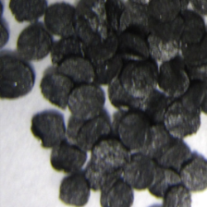 | Alliant Powder Unique | disc | Alliant Powder (Radford, VA, USA)
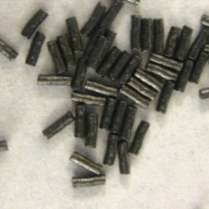 | IMR Powder Co. 4198 | tubular | IMR Powder Co. (Shawnee Mission, KS, USA)
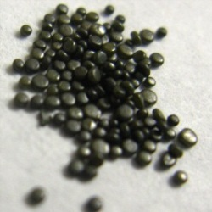 | B Winchester 452AA | flattened ball | Winchester Smokeless Propellants (Shawnee, KS, USA)

Smokeless powders come in many shapes and sizes. Currently, the Federal Bureau of Investigation (FBI) has a database of smokeless powders in order to classify the different manufacturers of smokeless powders. Some are available in the database compiled by the Technical Working Group for Fire and Explosives [48] in which the database includes the morphology and chemical composition of each smokeless powder. One way to characterize smokeless powder is on the basis of their morphology and brand. The production of smokeless powder comes from many manufacturers in varying shapes including disc, tubular, lamella or ball [49]. Some common manufacturers with the name and shape of the smokeless powder are shown in Table 2.2.
Although the smokeless powder explosive itself is nonvolatile, there are many different chemical substituents that make up the smokeless powder, some being volatile, and are emitted constantly [50, 51]. Among them include stabilizers such as DPA and EC or energetics such as NG and 2,4-dinitrotoluene (2,4-DNT) have relatively low vapor pressure which makes it easily detectable in the headspace of a concealed container [38, 51]. The vapor pressures for these target compounds are shown in Table 2.1. Interest in the detection of smokeless powders have increased in recent years because of their use in pipe bombs and improvised explosives from recent tragic events. Detection of the volatile organic compounds associated with smokeless has been reported by Joshi and colleagues [51], developing a volatile chemical profile for the relative abundance of the volatiles present in the headspace of the smokeless powder from solid-phase microextraction (SPME) headspace sampling followed by gas chromatography-mass spectrometry (GC-MS) analysis. Moreover, she was able to report the different analytes detectable using a commercial IMS detector system [38], using a novel SPME thermal desorption unit [52].

2.1.2 Military Explosives
Military explosives are high explosives that detonate at high speeds (3.0 x 10⁻⁸ m s⁻¹ or greater) and are strictly limited to military use such as construction, demolition or shell fillings. The first ancestor to military explosives is black powder. The propellant dates back in to the late 9th century where the Chinese army discovered its shock properties and used it for weapons [53]. Although black powder is mainly composed of oxidizers, scientists and inventors discovered that the different characteristics of the explosive can be controlled by the different chemical compositions. Changing the composition of black powder resulted in the development of other explosives that are commonly used today, including military explosives.
Since the first preparation of 2,4,6-trinitrotoluene (TNT) by Dr. Wilbrand [54], it has become one of the most popular military explosive in consequence of its wide range in the melting and decomposition temperatures, low cost and fairly high explosive power. The low vapor pressure of TNT (Table 2.1) requires a sensitive detector system to detect TNT vapors in the concentration of part-per-billion range [55], thus many trace detection systems involve in the particle detection of the semi-volatile explosive. Detection of TNT has been successful over the years, many involving sensors and optical sensor systems to facilitate officials in the trace detection of these chemical compounds without the use of complicated or expensive equipment [56, 57]. Although the explosive has a low vapor pressure, the manufacturing of TNT results in several impurities such as mononitrotoluenes and dinitrotoluenes [58], having a high enough vapor pressure to be detected by vapor sensors. It was reported that out of all the isomers, the most abundant vapors detected were 2,4-dinitrotoluene (2,4-DNT).
Cyclotrimethyl-enetrinitramine was synthesized during the World War period, in which was referred to as Research Department Explosive (RDX). Cyclotrimethyl-enetrinitramine is considered a secondary high explosive and is stable with no degradation at temperatures up to 135 °C. Because of its high brisance and friction sensitivity, it was mainly mixed with other chemicals to reduce its sensitivity [35]. It was heavily used in World War II and its use was mainly composed of mixtures of RDX with TNT known as Composition B. Moreover, the vapor pressure is very low, classifying RDX as a nonvolatile explosive and making it difficult to detect in the vapor phase. Although the pure compound has a very low vapor pressure, the Composition B mixture has been reported to emit vapors of cyclohexanone from the decomposition byproducts of RDX and TNT [59, 60]. Implications of taggants in plastic explosives allowed for easy vapor detection for most military and plastic explosives. Composition C (C-4) plastic explosives, consisting of RDX and other plasticizers, can be detected from the taggant chemical 2,3-dimethyl-2,3-dinitrobutane (DMNB). Further studies have shown that untagged C-4 explosives can be detected from volatile organic chemicals such as cyclohexanone and 2-ethyl-1-hexanol [26, 61].
Pentaerythritol tetranitrate (PETN) was first synthesized in 1891 by Tollens and Wigand [62] initially used as detonating cord and blasting caps. Similar to RDX, PETN suffered from high sensitivity to friction and mainly used as a mixture with TNT to produce an explosive called Pentollite [63]. Other variations PETN mixtures include nitrocellulose to produce the plastic explosive Detasheet and mixtures with RDX to produce Semtex [63]. Detasheet has been reported to be tagged with DMNB; however, untagged Detasheet can also be detected from volatile organic chemicals emitted from the other substituents of the explosive which include 2-ethyl-1-hexanol, 1-butanol, acetic acid ester and 2-ethyl-1-hexanol acetic acid [11, 34]. Semtex is a plastic explosive which typically contains either DMNB or ethylene glycol dinitrate (EGDN) as a taggant, making these explosives detectable from vapor sampling. Furthermore, untagged Semtex explosive can be detected from 2-ethyl-1-hexanol, a common volatile chemical compound emitted from plasticizers [11].
Ethylene glycol dinitrate (EGDN) and nitroglycerin (NG) was first reported W. H. Rikenbach in 1927 [35] from the synthesis using ethylene glycol and nitric acid. Ethylene glycol dinitrate is a liquid explosive and has a high vapor pressure with similar explosive energy as nitroglycerin but more stable. Similar to nitroglycerin, this liquid explosive is used in for the development of low-freezing dynamites and currently used as one of the chemical taggants for explosive detection because of its high volatility. It has been reported that EGDN was emitted from Semtex and C-4 plastic explosives [43], which can be detected by ion mobility spectrometry (IMS) having a reduced mobility of 1.528. Detection of EGDN and other taggants require lower drift tube temperatures (50 – 100 °C) in comparison to the default set temperatures for most commercial IMS instruments in the explosives detection mode. Optimization studies resulted with an optimum drift tube temperature of 55 °C reaching limits of detection of 0.1 ng [43]. Although drift tube temperature should not affect the mass of the ion, the clustering observed in the reaction and drift region of the IMS affects the reduced mobility and drift time. Using air as the dopant, an increase in drift tube temperatures result in a decrease in the reduced mobility caused by the decluttering affects and results with ions traveling through the drift tube region at a faster speed, which might result in an unresolved peak from the reactant ion peak. A decrease in temperature of the drift tube will result in higher clustering and slower drift time, allowing for detection on the IMS instrument [64].
Detection of military explosives mainly is on the basis of bulk detection which includes x-ray [65, 66], neutron activation or scattering [67-69], and terahertz imaging [70, 71]. These techniques are quite expensive and some rely on explosives with the presence of nitro functional groups. Although ion mobility spectrometry and gas chromatography provide great sensitivity in the sub-nanogram detection, these techniques rely on the vapor detection and can be difficult to detect from these explosives that have low vapor pressures. Nevertheless, instruments such as gas chromatography-mass spectrometry [11, 26, 72] and ion mobility spectrometry [34] as well as canine detection have shown promising results. Direction of focus on detection of military explosives have been mainly using stand-off detection techniques [73, 74], increasing the distance of the explosive device will reduce the exposure and risk of potentially harmful chemicals. Cavity ring down spectroscopy allows for the trace detection of on the basis of the light absorption of the molecule [20, 75]. Molecules with weak absorption spectra are able to be detected because of the enhanced signal from the resonant optical cavity, resulting with an enhanced signal and high sensitivity of explosives that are typically not observed by light absorption.

2.1.3 Improvised Homemade Explosives
Large number of explosives cases involve improvised homemade explosives (HMEs). Most bomb makers know the basic components of explosives: an oxidizer and fuel source. The oxidizers provide the rapid oxidation of the fuel source to result in violent exothermic reaction or combustion. Improvised explosives are produced from readily available chemicals that do not require any special license or equipment to produce and synthesized in clandestine laboratories. Because of the simple synthesis process by combination of chemicals from household products, these explosives are unstable and unpredictable. One of the newest developed explosives are peroxide explosives, which are becoming very popular among young scientists and terrorist groups. Although peroxide explosives have been developed for over a century, popularity in these explosives has increased in the recent years because of its simple synthesis from relatively common household chemicals. There are two main peroxide explosive which include triacetone triperoxide (TATP) and hexamethylene triperoxide diamine (HMTD).
Triacetone triperoxide (TATP), first discovered and prepared in 1895 by Wolffenstein [76], is one of the most common homemade explosives as a result of its relatively simple synthesis from hydrogen peroxide and acetone, two commercially available chemicals. As a primary explosive, it is extremely sensitivity to friction, shock and impact making it unfavorable for military use [76]; however, the ease of synthesis from readily available chemicals and the detonation effects have led to increased use among terrorist groups [77, 78]. The peroxide explosive is synthesized from acetone and hydrogen peroxide, along with the assistance of sulfuric acid [79]. Acetone is a common household chemical used in hardware stores and in beauty salons for removal of paint. Hydrogen peroxide can be found in many products with varying ranges in concentration. Many terrorist groups have been known to obtain their supplies from beauticians and beauty salons since the two chemical compounds are relatively available.
Another recently synthesized improvised explosive is hexamethylene triperoxide diamine (HMTD), produced with the mixtures of hexamine and hydrogen peroxide [19]. The peroxide explosive has a white crystalline powder texture, similar to flour, which is similar to TATP; however, it has been reported to be more sensitive to shock. Comparing the two explosives, TATP has been more popular in use regards to HMTD explosive. The sensitive HMTD explosive has been reported to undergo a slow decomposition process, decomposing within several hours with the presence of salts and in an acidic environment. Upon decomposition, it has been reported that HMTD releases a pungent fish-like odor from the hexamine chemical. Hexamine is readily available as camp stove tablets in which its odors resemble that of aged HTMD explosives. One of the major disadvantage of detection of this explosive is the low vapor pressure and decomposition at elevated temperatures, making it difficult to produce training kits for detector dogs. Oxley et al. reported decomposition of HTMD release the chemical vapors of N,N’-dimethylformamide, N,N’-methylenebis(formamide), trimethylamine and hexamine and can be used as volatile organic chemical markers for the vapor detection of HMTD explosives [44].
Various unconventional analytical methods have been developed for the detection and characterization of TATP and other peroxide explosives in consequence of the lack of nitro group and aromatic functional groups resulting in poor detection using well-established techniques for the nitro-containing explosives [80, 81] . Presumptive tests such as chemiluminescense sensors have been used for easily detecting these compounds from the characteristic properties of hydrogen peroxide [82]. Traditional analytical techniques such as liquid chromatography (LC) [83] and gas chromatography (GC) [84] have been reported for the analysis and a separation technique for TATP. Additionally, Oxley and other scientists has characterized TATP using Infrared [80] and Raman spectroscopy [80, 85, 86]. Peroxide explosives can also be detected and analyzed by mass spectrometry which includes desorption electrospray ionization (DESI) [87] and selected ion flow tube (SIFT) [88]. Mass spectrometric analysis can provide further information regarding the peroxide explosive, including synthesis impurities and degradation products, which can help determine the route of synthesis and origin to help deter crime. The high vapor pressure of TATP (Table 2.1), comparable to 2,4-DNT, allows for vapor detection GC-MS analysis [84], with improved sensitivity by preconcentration using polydimethylsiloxane (PDMS)-based solid-phase microextraction (SPME) [89].

2.2 Chemistry of Illicit Drugs
The major issue in detection of drugs is the detection of the parent compound, in which often times have low vapor pressures and contain other additives and impurities that might result in a false positive result. Profiling of illicit drugs has been performed for many target analytes which include cocaine [90], marijuana [91], heroin [92, 93], and 3,4-methylenedioxy-N-methylamphetamine (MDMA) [94-96]. Therefore, the different impurities and intermediate chemicals can be identified and help understand the different synthetic routes in order to achieve a common source.
Table 2.3 Vapor pressure and reduced mobility (if applicable) for volatile chemicals associated with the illicit drug. [*] denotes K₀ values as programmed in the Smiths Detection IONSCAN IMS instrument.
Drug | Volatile Organic Compounds | Vapor pressure, Torr (25 °C) | Reduced mobility, K₀ | Ref.
Cocaine | methyl benzoate | 1.4 x 10⁻¹ | 1.55 (air, 190 °C) | [97, 98]
Marijuana | α and β-pinene | 3.5 and 2.4 (respectively) | 1.26 and 1.28 (110 °C) | [97, 99, 100]
Marijuana | limonene | 1.5 | 1.26 (110 °C) | [97, 101]
3,4-methylenedioxy-N-methylamphetamine (MDMA) | piperonal | 1.0 x 10⁻² | 1.51 (80 °C) | [97, 102]

Some of the volatile organic compounds that have been identified for these illicit drugs are shown in Table 2.3. In the current research the detection of cocaine and MDMA is targeted, thus a more thorough understanding regarding the chemistry of these illicit compounds will be discussed in this chapter.

2.2.1 Cocaine
Cocaine, a natural drug from the Erythroxylum coca plant, was used in ancient civilization for ceremonial purposes; later used by the Spaniards as a stimulant for the native workers. In 1855, cocaine was isolated by Friedrich Gaedcke [103] and used as an anesthetic. Although it was initially used for medicinal purposes, the potential toxicity and abuse raised awareness in which the U. S. Government and the Drug Enforcement Administration (DEA) implemented the U. S. Controlled Substances Act in which categorized cocaine as a Schedule II controlled substance. The Act regulated the controlled substances on the basis of their degree of dependence and its medicinal purposes.
Consequently, because of the dangerous effects of the drug to the human body, many analytical methods for the detection of cocaine have been developed for toxicological screenings of cocaine and its metabolites [104]. Many analytical tests involve the analysis of biological specimens, where urine and blood samples are the most common in laboratory analysis, and used as a screening tool for the presence of cocaine and other illicit drugs [104, 105]. Alternative biological samples include saliva and sweat [104, 106], requiring high sensitivity for detection of low nanomole quantities.
Despite the efforts for detection of intoxication of the illicit drug, trace detection of the illicit drug can help identify the criminals handling and distributing the drugs. The main route of entry of cocaine and other illicit substances involve marine shipment through large cargo containers. The cumbersome process of manual inspection can be expensive and time consuming for sampling the millions of cargo containers that enter the U.S. ports on a daily basis. The low volatility of cocaine makes headspace extractions of cocaine quite ineffective; however, studies have shown that canine detection dogs give an alert for cocaine, not by the cocaine chemical compound itself, but accomplished by targeting methyl benzoate, a decomposition product of cocaine [107]. Cocaine decomposes to benzoic acid and ecgonidine methyl ester as shown in the flowchart in Figure 2.1. The illicit production of cocaine requires several extraction and purification from the natural coca paste, resulting with the crude product, cocaine base or “crack” cocaine [108]. Cocaine is further purified using Hydrochloric acid extraction, obtaining fine crystal powders known as cocaine HCl. Although purification is performed, the presence of impurities and unreacted reactants persists in the end-product. Under these acidic conditions, benzoic acid can undergo esterification to form methyl benzoate. The two decomposition compounds of cocaine have a higher volatility and offer target chemical markers for the detection of cocaine. Ecgonidine methyl ester has been identified in the headspace of bulk cocaine samples, having a vapor pressure of 5 orders of magnitude greater than that of cocaine [109]. Ecgonidine methyl ester is also one of the metabolites of cocaine, detected from hair and urine samples of people that smoke “crack,” a cocaine product [110, 111]. A different approach on cocaine profiling involves the profiling of the headspace of the seized drug for the solvent used during the extraction and recrystallization process. Statistical analysis of the results was able to classify several different routes of clandestine manufacturing.

(b)
(a)
+ CH₃OH
H⁺
Methyl benzoate
Cocaine
Ecgonidine methyl ester
Figure 2.1 Decomposition mechanism of cocaine. Pathway (a) result with the methyl benzoate and pathway (b) results in ecgonidine methyl ester. Adapted from [97]
Although the of ecgonidine methyl ester has acceptable vapor pressure for detection by headspace sampling, the most prominent compound found in the headspace of cocaine is methyl benzoate. Studies have shown that the production of methyl benzoate from cocaine is predominantly produced with no relative humidity at a rate of 1.89 ng min⁻¹, emitting at a faster rate at elevated temperatures and with the presence of humidity [108]. Thus, the detection of methyl benzoate can be a good volatile chemical marker for the identification and detection of cocaine. Detection of methyl benzoate has been shown to provide a good marker for cocaine detection and is currently used as a volatile organic compound marker for canine training kits. Furthermore, methyl benzoate has been successfully detected using ion mobility spectrometry when using a SPME interface to desorb the analytes on the SPME fiber and introduce it to the IMS system [52]. The SPME interface allows for SPME analysis on a commercial IMS instrument without further modification.

2.2.2 3,4-Methylenedioxy-N-methylamphetamine
The drug 3,4-methylenedioxy-N-methylamphetamine (MDMA), more commonly known as “Ecstasy,” is one of the most frequently seized drugs in the United States. Law enforcement agencies confiscate over 5 million pounds a year. The synthesis of MDMA was first patented in 1927 by Merck, a German pharmaceutical company [112] in their plan to find a competitive drug for blood-clotting. Although the patent states one route of synthesis, many different routes have been reported many of which have been developed using common chemicals that can be easily acquired, making it possible to synthesize MDMA in clandestine laboratories [113]. Figure 2.2 shows two of the most common pathways for the synthesis of MDMA in which uses piperonal and isosafrole as the starting material, two chemical compounds that can be easily synthesized and extracted from household spices and products [114]. Many of the synthetic routes result with the intermediate 1-(3,4-methylenedioxyphenyl)-2-propanone (MD-P2P), another controlled substance. Reduction reactions of this MD-P2P then result with the final product containing trace amounts of impurities and intermediate products.

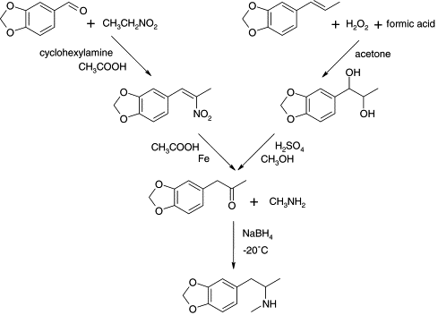
Figure 2.2 Synthetic route of MDMA through reductive amination of 1-(3,4-methylenedioxyphenyl)-2-propanone (MD-P2P) [113]
Profiling of illicit clandestine drugs have been performed in order to determine the impurities observed and get an understanding in the synthetic route of MDMA in hope to identify and lead to a common source. Most MDMA profiling techniques involve the analysis of the precursor chemicals, such as sassafras oils [115] and other impurities [116] for identifying the synthetic route. The results suggest information regarding the location of the manufacturer can be made by using sophisticated analytical techniques such as 2-dimensional gas chromatography and traditional GC-MS with different sampling techniques.
Furthermore, headspace profiling of MDMA allows for the identification of volatile organic compounds present which can help in the development of training kits for canine detection and vapor trace detectors. Methamphetamine has been reported to be one of the chemicals found in the headspace [117]; however, the different synthetic routes does not result in detection on a consistent basis. Other volatile chemical compounds that have been reported include: benzaldehyde, acetic acid, camphor, piperonal, isosafrole, MD-P2P and the reduced alcohol form of this ketone (MD-phenyl-2-propanol) [16, 17, 18].
Detection of the volatile organic compounds to target MDMA have been accomplished through headspace extraction techniques including SPME [95, 96] as well as microwave-assisted extraction/headspace-SPME [94] with the conventional gas chromatography mass spectrometry techniques. Detection using ion mobility spectrometry was achieved with the development of a SPME interface as an alternative sample introduction source for commercial ion mobility spectrometry (IMS) instruments. Lai et al. [33, 97] was able to achieve nanogram detection of piperonal by lowering the drift tube temperature as well as using different dopants than the manufacturers.

Sampling & Preconcentration of Illicit Compounds
Sampling preparation is a crucial procedure for analytical experiments in order to obtain reliable results, which requires isolation of the analyte(s) from the sample matrix as well as preconcentrating the analyte(s) in order to be able to be detected by the analytical instrument. Most sample preparation techniques require the use of solvents that might result in loss or hindrance of detection. Ideally, sample preparation methods should be solvent-free, inexpensive, simple and compatible with the analytical instrument.
Besides the different types of sampling techniques used, headspace analysis requires the use of a preconcentrating factor in order to effectively detect the vapors of interest. One of the major drawbacks in the headspace analysis of vapors is the fact that there is a large dilution factor, such as the use of activated charcoal strips extracts the headspace vapors on the basis of their relative abundance in the sample. Although this technique efficiently extracts a chemical profile of the compounds in the headspace, the headspace extraction takes substantial time (more than 6 h) and the compounds extracted from the activated charcoal using a solvent system are diluted to concentrations that may result in poor to no detection using the analytical techniques for the analytes that are in the nanogram range.

3.1 Solid Phase Microextraction
Pre-enrichment of volatile organic compounds has become essential for trace detection of illicit compounds. Many extraction techniques such as liquid-liquid extraction, solid phase extraction, purge and trap, activated charcoal strip and such have been used traditionally but are not favorable since many require the use of organic solvents, they are time-consuming and sensitivity is lost as a consequence of the dilution factor of the use of solvents. The biggest revolution in sample preparation was the development of solid phase microextraction (SPME) by Pawliszyn [118], allowing for solvent-free sampling and preconcentration of analytes. The SPME sampling technique uses a coated fused silica fiber for preconcentration of the volatiles of interest into the fiber, where the favorable coating chemistry is dependent on the chemistry of the analyte of interest. Solid phase microextraction comes in different geometries (Figure 3.1a) which include but is not limited to fiber coated with SPME phase, particles coated with SPME phase and SPME-coated stirring bars. The most commonly used geometry is with the extraction phase coated on a silica fiber in the shape of a syringe for analysis in GC-MS without further modification. Extraction is performed by exposing the fiber to the sample matrix in which the analytes with high affinity with the sorbent will be extracted onto the fiber. The fiber is then withdrawn by retracting the syringe plunger to provide protection from loss (Figure 3.1b). All the analytes are then thermally desorbed when introduced to the inlet of the instrument.
Unlike solid phase extraction, SPME is a microextraction technique and is not exhaustive extraction; thus, only a small percentage of the sample is collected onto the fiber. During the extraction process, there are three different equilibria taking place: equilibrium between the fiber and the sample, equilibrium between the sample and the sample matrix, and equilibrium between the fiber and the sample matrix. Quantitation of the analyte in the SPME can be determined by the following equation:
$$\text{n=}\frac{{\text{K}}_{\text{fs}}{\text{V}}_{\text{f}}{\text{V}}_{\text{s}}{\text{C}}_{\text{0}}}{{\text{K}}_{\text{fs}}{\text{V}}_{\text{f}}\text{+}{\text{V}}_{\text{s}}}$$ | (3-1)
where K_{fs} is the equilibrium constant of the fiber and the sample, V_{f} is the volume of the fiber, V_{s} is the volume of the sample, and C₀ is the initial concentration of the sample. Since the volume of the fiber is negligible in comparison to the sample volume, the following equation can be reduced to:
$$\text{n=}{\text{K}}_{\text{fs}}{\text{V}}_{\text{f}}{\text{C}}_{\text{0}}$$ | (3-2)
From the above equation, it can be concluded that SPME can be used for quantitation studies without dependence on the volume of the extraction phase or the sample of the volume.
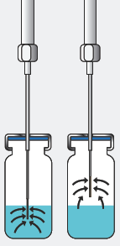
(a)
(b)
Sample Flow
= Sample
=SPME phase
Figure 3.1 (a) Different SPME geometry including fiber, particles, stirrer, and capillary (from left to right); (b) direct immersion and headspace sampling using SPME fibers [119].
Preconcentration with SPME can be performed in various ways, including headspace sampling for sampling volatile organic compounds or direct immersion extraction involves the immersion of the SPME fiber into the sample matrix where analytes transfer from the sample matrix to the extraction phase (Figure 3.1b). Headspace extraction has been shown to be most useful for gaseous samples with high volatility. Headspace extraction mode not only protects the coated fibers from different matrices and media, but also is selective for the target volatile chemicals without the interference of non-volatiles or high molecular mass compounds. Since more volatile compounds are found to be at higher concentration in the headspace, it is expected to see greater mass transfer to the extraction phase from volatile compounds in comparison to the less volatile compounds.
Various different chemistry and polarity of the extraction phase have been developed for SPME which use different extraction mechanism. Polydimethylsiloxane (PDMS) is considered as a universal chemistry used for headspace extractions as a result of its nonpolar nature. The liquid phase allows the analytes to partition from the coating to the sample matrix. Liquid sorbent films undergo partitioning; therefore, the extraction of the analytes is relative to the distribution coefficient of the analyte with the extraction phase and the sample matrix. The solid sorbents interact with the analyte through adsorption onto the active sites or cavities in the sorbent [120]. The volatile analytes compete for the limited capacity of the active sites available in the solid sorbent in which analytes with stronger affinity to the active sites will be retained to the surface of the solid phase. Although solid adsorbent fibers offer high sensitivity, the liquid absorbent film offer higher capacity and increased dynamic range.
Some of the commercial SPME fibers offer PDMS of different coating thicknesses. As a general rule, thinner PDMS coatings result in the extraction of higher molecular weight compounds. For gaseous, low molecular weight analytes, the analytes are unaffected by the polarity of the sorbent phase and carboxen (CAR) adsorbent films are typically used [121]. The inclusion of different coating chemistry such as carboxen with polar divinylbenzene (CAR/DVB) offer different adsorption sites of different polarities, increasing the molecular mass range.

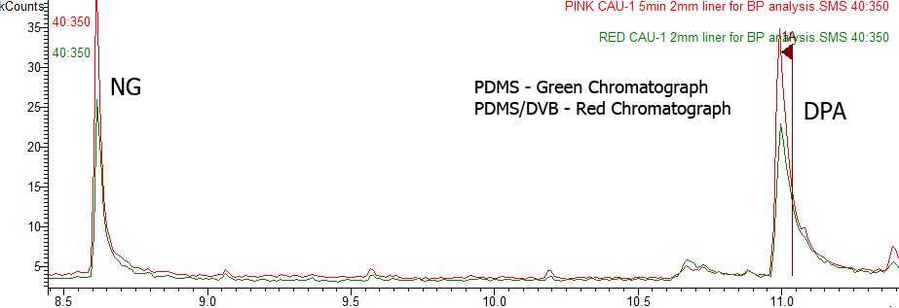
Figure 3.2 Gas chromatograph of 10 min extraction of 10 mg All Unique smokeless powder to compare the performance of PDMS (green chromatogram) and PDMS/DVB (red chromatogram) SPME fibers for detection of volatile organic compounds of smokeless powders.
For example, the extraction of the volatile chemical compounds found in smokeless powders (Figure 3.2) was performed using a PDMS and PDMS/DVB coated SPME fiber. The PDMS/DVB SPME fiber was observed to produce greater extraction and higher sensitivity in comparison to the PDMS fiber because of the bipolar nature of the SPME/DVB fiber allowing the extraction of the volatiles with polar and nonpolar functional groups, such as the amine group in diphenylamine (DPA) and the nitro groups in nitroglycerin.

3.1.1 Solid Phase Microextraction Applications
Since the development of SPME, the use of SPME as sample preparation and pre-treatment grew in popularity because of its widespread applicability which include biological specimens [122, 123], food analysis [124-126], environmental chemistry [127-129] and forensic chemistry [130, 131]. The fiber-based geometry of the SPME device is compatible with many commercial analytical techniques such as gas chromatography and high performance liquid chromatography. One particular field of interest is forensic toxicology which involves complex matrices of bodily fluids. Although direct immersion can be used for sampling, headspace sampling is preferred to avoid damaging the SPME coating. Headspace extraction is sufficient for the detection and quantification of several antidepressant and anesthetic drugs in biological samples [132]; however, some drugs are non-volatile and require derivatization for headspace sampling. Fiber chemistry selection is essential in order to absorb or adsorb the analyte of interest as well as the addition of salts can contribute in the efficiency of the SPME technique in extraction of the drug samples.
Coupling of SPME with IMS detectors was successful with a novel thermal desorption device developed by Perr and her colleagues [52], which allows for the coupling of SPME with a commercial IMS instrument without further modification. The success of coupling SPME and IMS allowed SPME as a preconcentrating tool for fast screening and detection volatile chemical markers associated with illicit compounds [33, 34, 51].

3.2 Planar Solid Phase Microextraction
Although SPME has been shown to be applied to many scientific fields, many drawbacks were faced when using SPME, which includes fiber breakage, expensive, limited operating temperatures, and limited to injection ports designed for syringes. The success of the SPME extraction device in the analytical field has led to the development of the novel planar solid phase microextraction (PSPME) by the Almirall research group [1, 4]. A glass fiber disk was coated with a sol-gel PDMS, resulting in a SPME device in a planar geometry [4], allowing for direct analysis with IMS instruments without further modification.

3.2.1 Sol-gel Technology
Sol-gel technology was applied in SPME to overcome many of the drawbacks such as the instability and swelling in organic solvents as well as operation at low temperature (less than 280 °C). Sol-gel technology was first reported in the 1800s; however, it was not used until a century later by a glass company [133]. Since then, sol-gel technology became very popular in stationary phases for high performance liquid chromatography (HPLC) and gas chromatography (GC) because of the high thermal stability and ability to synthesize hybrid inorganic/organic phases for efficient separation [134, 135]. The use of sol-gel with SPME was first reported by Chong et al. [136] which resulted with higher thermal stability (> 320 °C) for SPME-GC analysis. After that, many synthesized different sol-gel phase chemistry such as the incorporation of polyethylene glycol [137], various crown ethers [138-143], and amino [144] groups to achieve high selectivity for the analytes of interest in various applications.
The sol-gel synthesis requires several key chemicals which include: (1) a precursor (typically a metal alkoxide), (2) a solvent system, and (3) a catalyst which can be acid or base with water. The possible mechanism of the PDMS incorporated sol-gel reaction has been proposed previously [136, 145] in which the sol-gel precursor methyltrimethoxysiloxane (MTMOS) is hydrolyzed resulting in polycondensation reactions followed by the cross-linking of the vinyl groups in stationary phase of the vinyl terminated polydimethylsiloxane (vt-PDMS). The trifluoroacetic acid (TFA) acts as a catalyst, producing linear branched polymer by increasing the rate of hydrolysis of the precursor rather than the condensation reaction [136]. The condensation reactions, the sol, increase the viscosity of the solution to form a rigid three-dimensional network, the gel, hence the name sol-gel [133]. The exposed silanol groups from the glass surface undergo similar condensation reactions to serve as an anchor for the polymeric network. A deactivating agent, such as poly(methylhydrosiloxane) (PMHS), is used to end-cap and derivatize the unreacted silanol groups. Unlike PMHS in GC chromatography, which is used to avoid column-solute interactions, the purpose of the PMHS in SPME is to maintain the desired polarity in the SPME fiber [136]. After the gelation process, the sol-gel is typically “cured” in order to remove volume shrinkage by aging, drying and conditioning the sol-gel using different methods [24], including placing them in the desiccator for a prolonged period of time or placing them in the oven at elevated temperatures and cooled slowly to avoid cracking. The diagram of the reaction mechanism is shown in Figure 3.3.
PMHS
TFA
MTMOS
vt-PDMS
Figure 3.3 Diagram of the PDMS incorporated sol-gel mechanism. Figure adapted from Liu et al. [145]

3.2.2 The Process of PSPME Fabrication
The process of making PDMS incorporated sol-gel in a glass fiber disk has been described previously [1, 4, 145] but the procedures were optimized to decrease the production time and increase efficiency. Prior to coating, the glass filter (Fisher Scientific, Fair Lawn, NJ, USA) is pre-cut if necessary and then acid-cured with 2:1 mixtures of sulfuric acid (Fisher Scientific, Fair Lawn, NJ, USA) and 30% hydrogen peroxide (Fisher Scientific, Fair Lawn, NJ, USA) solution to remove impurities. The sulfuric acid and hydrogen peroxide solution is an exothermic reaction, in which the glass filters were dipped and agitated gently in the solution for 10 minutes. The glass filters are then rinsed under 18mΩ deionized water until the glass filters were at a neutral pH and then dipped in a 1M sodium hydroxide solution for 1 hour to expose the silanol groups. Afterwards, the glass filters were rinsed once again to a neutral pH level and dried in a GC oven at 80 °C for 2 hours. The sol-gel solution was prepared by mixing 3.22 g vinyl terminated polydimethylsiloxane (vt-PDMS) (Gelest, Morrisville, PA, USA) with 3.89 mL of methylene chloride (Fisher Scientific, Fair Lawn, NJ, USA) which is used as the solvent system for the reaction. Subsequently, 1.71 mL of the precursor MTMOS (Fluka, Steinheim, Germany) is added and mixed vigorously, followed by 0.83 mL of PMHS (Sigma-Aldrich, St. Louis, MO, USA), and a mixture of 1.37 mL acidic catalyst TFA (Acros, St. Louis, MO, USA) with 5% water (v/v). The solution was left alone for 30 minutes in order to undergo the sol-gel reaction mechanism. After 30 minutes and the glass filters have been completely dried, the glass filters were spin-coated using a WS-400B-6NPP-LITE spin-coater (Laurell Technologies, North Wales, PA, USA) in which the glass filter was placed atop a round glass slide that was held into the chuck of the instrument by a vacuum. Different volumes of the solution were spiked on top of the glass filters, depending on the size of the glass filter, ranging from 0.8-2.1 µL of sol-gel solution for 25-420 mm glass filter in diameter. The spin-coater was programmed to spin at 1000 rpm for 1 minute. After that, the coated glass filters were placed in a vacuum desiccator for 1 hour followed by rinsing the coated glass filters in excess methylene chloride for 10 minutes to remove excess sol-gel solution. The methylene chloride was evaporated overnight by placing the coated glass filters in a GC oven at 40 °C for a minimum of 6 hours. The gelation process was performed in a GC oven that was programmed to 120 °C for 60 minutes, 240 °C for 60 minutes, and finally 300 °C for 180 minutes with an air flow of nitrogen to ~10 mL min⁻¹ to avoid oxidation reactions during the curing process. The oven was then slowly cooled at 8 °C min⁻¹ until it reached a final temperature of 25-30 °C. The slow cooling process is very important as to avoid cracking of the surface of the sol-gel.

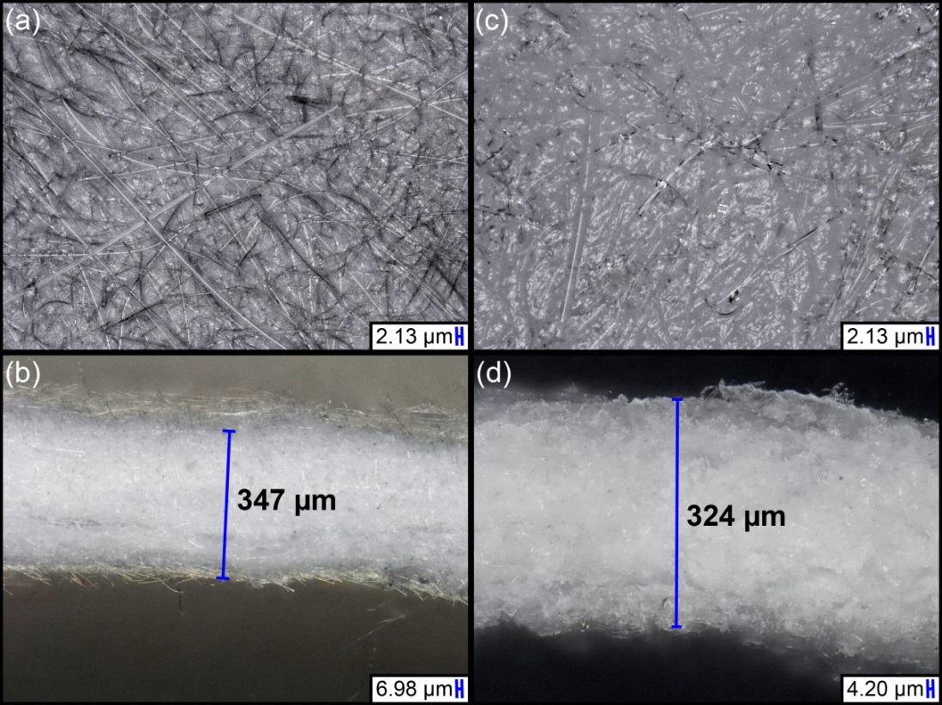
Figure 3.4 Microscope images of the surface and cross-section of an uncoated glass filter, (a) and (b) respectively; images of the surface and cross-section of a coated PSPME devices, (c) and (d) respectively.
The end product sol-gel PDMS coated glass filter and cross section are shown in Figure 3.4 (c) and (d). Digital microscope imaging (Keyence, Itasca, IL, USA) was performed to characterize the surface of the PSPME in comparison to the uncoated glass filter (Figure 3.4 (a) and 3.4 (b)). The cross-section thickness of a PSPME device was determined to be ~ 324 µm (Figure 3.4 (d)) while an uncoated glass filters had a cross-section thickness of ~ 347 µm (Figure 3.4 (b)). No increase in cross-sectional thickness indicates the sol-gel based PDMS is well incorporated into the glass-filter surface. Furthermore, surface images (Figure 3.4 (a) and (c)) show increased thickness of the glass fibers by ~ 2 µm in PSPME, thus enhancing the capacity and phase volume for the different fibers in the glass filter.
The PSPME device has a 2 x 10⁴ fold increase (0.15 m²) in surface area than SPME fiber (9.5 x 10⁻⁶ m²) and the extraction phase volume of a planar SPME disk is calculated to be approximately 300 mm³, in comparison to the commercial fiber SPME with a maximum phase volume of 0.6 mm³ [146], offering greater than 500 times more volume capacity. Further surface analysis studies showed a decrease in glass filter surface area after coating, declining from 5.244 m²/g (uncoated glass filter) to 2.196 m²/g (coated glass filter), in agreement with the thickness measurements of the PSPME in Keyence digital microscope (Figure 3.4). Moreover, one of the major advantages of the PSPME over SPME is the ability to allow airflow for fast dynamic extraction of the available headspace. Similar to SPME, PSPME extraction can be performed statically in which the PSPME is exposed to the headspace of the sample and allowed to extract statically for a certain amount of time; however, to achieve fast sampling of high volumes, the use of a remote DC air sampler (Smiths Detection, USA) at 0.17 L s⁻¹ allows for detection of analytes of interest within less than 1 minute of sampling time.

3.2.3 PSPME and Ion Mobility Spectrometry Detection of Illicit Substances
Detection of the volatile chemical markers of smokeless powders have been previously reported to be successfully performed within seconds [1]. A more in-depth study was presented for profiling of smokeless powders using planar solid-phase microextraction (PSPME) sampling and IMS detection for 22 of the 24 smokeless powders, most being doubled-based containing nitroglycerin and many using diphenylamine as a stabilizer. Although not all the volatile target chemicals reported in GC-MS were detected in IMS, most of the smokeless powder resulted in a positive alarm for the presence of the explosive compound (Figure 3.5). The different composition of the volatile organic compounds present in each individual smokeless powder can provide manufacturing and origin information.
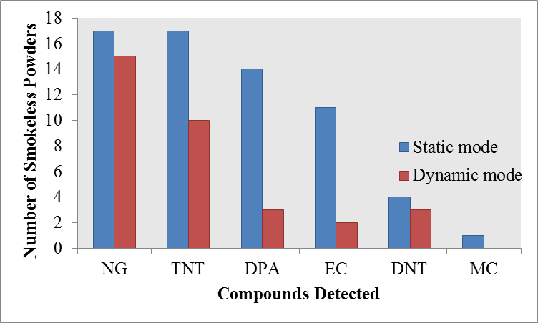
Figure 3.5 Detection of volatile organic compounds from the headspace of smokeless powders from 10 min static extraction or 30 s dynamic PSPME extractions. Above lists the number of smokeless powder that alarmed for the particular volatile chemical compound, with 22 of 24 smokeless powders resulting with a positive alarm.
Fast detection of TATP vapors was achieved with the introduction of PSPME coupled with ion mobility spectrometry (IMS) [3], with detection of nanogram quantities of TATP within seconds. Furthermore, sampling collection was further improved by using PSPME followed by IMS detection in which provided significant increase in sensitivity for detection of illicit drugs. The increased capacity allowed for fast sampling of piperonal [147], providing detection with nanogram quantities spiked into a closed system. In addition to the detection of MDMA from static headspace sampling, dynamic extractions provided fast detection of seized MDMA tablets with 10-second dynamic sampling of the headspace followed by IMS detection [1].

3.2.4 PSPME with Other Analytical Instruments
The benefit of using PSPME is the ability to modify its geometry and be used as a sampling technique in conjunction with other analytical techniques without further modification. Figure 3.6 displays two default commercial sample substrate (“Sample Trap” (Morpho Detection) and “Ticket” (Thermo Fisher) that are typically used for particle swabbing for explosive trace detectors; the sol-gel based PSPME can be coated in the surface of the glass substrate of different sizes to make it applicable to any sample inlet system.
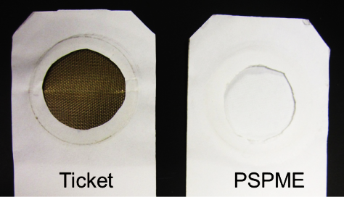
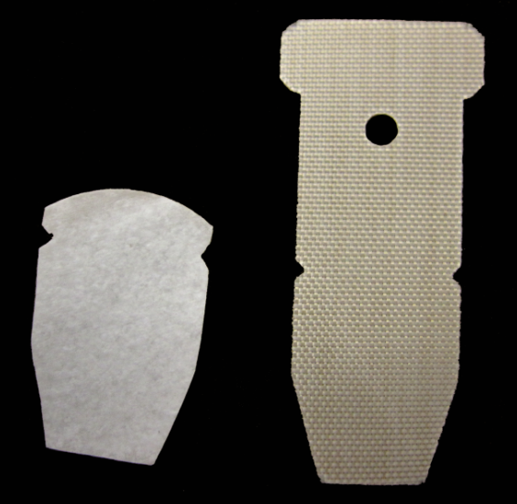
3.25 cm
Ticket
Sample Trap
Teflon holder
Figure 3.6 The different geometry of the PSPME device can be modified to fit the sample desorption unit (by using the geometry as the default substrate) of different explosives trace detectors without further modification.
The geometry of the glass filter can be modified before or after coating to achieve the desired geometry. Different manufacturers produce glass filter discs of different diameter, which can be used without further modification or cut to have the exact diameter as that of the default sample substrate used in the IMS system. A PSPME device with 3.25 cm was originally used in order to be analyzed by the commercial Smiths IONSCAN 400B bench-top IMS system. Moreover, a Teflon holder was fabricated by Field Forensics, Inc. for easier PSPME handling and compatible for either static or dynamic sampling. For substrates of irregular geometry i.e., the “sample traps” in the commercial Morpho detection IMS systems, the PSPME geometry can be modified after the coating process in order to achieve the same geometry (Figure 3.6, right).

3.2.5 PSPME and SPME Comparison
The extraction performance of PSPME and SPME was compared using an IMS and GC-MS as a detector for PSPME and SPME, respectively, using TATP liquid standards (AccuStandard, New Haven, CT, USA). Minimum amount of extraction time for detection of 100 ng of the explosive triacetone triperoxide (TATP) for PSPME was observed to be 0.5 minutes compared to 5 minutes using SPME (Figure 3.7). Comparison of the extraction recovery, defined as the amount of analyte extracted over the amount of analyte available, by varying concentration of TATP was performed by spiking different nanogram-levels of TATP standards and extracting for five minutes. Minimum amount of TATP required to be spiked into the cans in order for detection of TATP was 100 ng. The amount of TATP recovered using PSPME was calculated by using an external calibration curve with the regression line in Equation 3-3. Extractions with SPME with GC-MS analysis used the linear regression curve in Equation 3-4:
(y) = 22.58 (x) – 384.5, r² = 0.986 | (3-3)
(y) = 2539 (x) - 3592, r² = 0.988 | (3-4)
Recovery of TATP on PSPME and SPME was determined to be approximately 15% and 5% respectively as shown in Table 3.1. Thus, the increased surface area and phase volume of PSPME offers much greater extraction efficiency (fraction of the amount extracted and the total amount available) and faster detection in comparison to the commercially available fiber-based SPME.

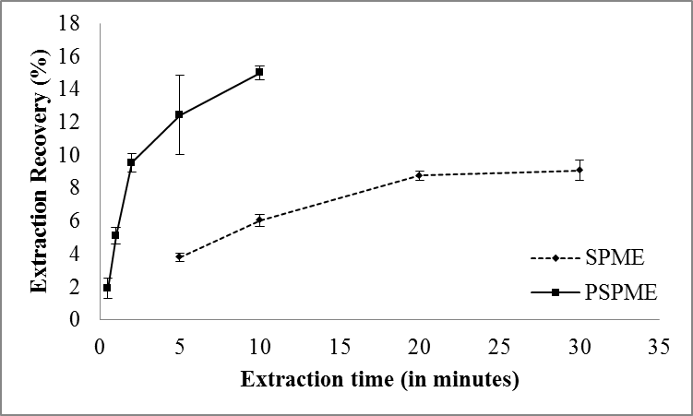
Figure 3.7 Percent recovery comparison of PSPME and SPME by different static extraction time (0.5 – 30 minutes) of 100 ng TATP.

Table 3.1 Percent recovery comparison of PSPME and SPME by 5 minutes static extraction of different amount of TATP.
 | PSPME |  | SPME
Amt. spiked in can (ng) | Amt. of TATP recovered (ng) | Recovery % | Amt. of TATP recovered (ng) | Recovery %
50.0 | 2.58 | 5.2% | 2.63 | 5.3%
75.0 | 4.63 | 6.2% | 4.26 | 5.7%
100 | 9.00 | 9.0% | 3.45 | 3.5%
150 | 21.0 | 14. % | 7.03 | 4.7%
200 | 35.1 | 18.% | 9.35 | 4.7%
300 | 61.8 | 21.% | 13.2 | 4.4%
400 | 79.2 | 20.% | 16.9 | 4.3%

Furthermore, extraction of sub-microgram quantities of explosives have shown improved extraction efficiency using PSPME in comparison to SPME using IMS detectors. For 10 minute headspace extraction of 400 ng TNT and 2,4-DNT spiked standard solutions (Cerilliant, Round Rock, TX, USA), increased detection was observed from the IMS instrument (Figure 3.8). A commercial IMS instrument containing both thermal desorbers for planar substrates and SPME analysis achieved greater detection from the PSPME static extraction of the same analytes as SPME static extraction. The semi-volatile TNT showed good extraction capability from the PDMS chemistry for both PSPME and SPME devices; however, the desorption interface for planar substrates was not well sealed in which loss of the vapors can be observed upon heating the substrate. The SPME interface design is a closed system and allows for all the thermally desorbed vapors to directly enter the IMS instrument. Because of this, the study is not a correct representation of the sensitivity of PSPME because similar results are obtained for the TNT extractions. Conversely, improved performance from the enhanced surface area and phase capacity is observed from the detection of 2,4-DNT.
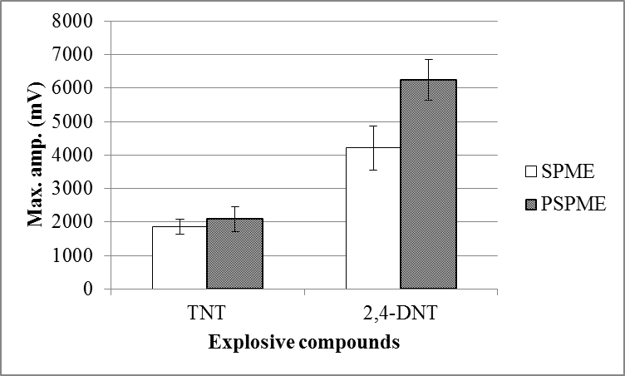
Figure 3.8 SPME and PSPME extraction signals for 10 min. static extractions of 400 ng of TNT and 2,4-DNT.

Detection of Explosives and Illicit Drugs
The detection of trace amounts of explosives from field-portable sensor systems has been of great interest, particularly for the military and homeland security, as these systems can be used to detect land mines, improvised explosives and other hidden substances that are being smuggled across the U.S. borders. Moreover, the ability to detect trace amounts of explosives in the field has been found to be advantageous for forensic investigations as these portable instruments can be used for pre- and post-blast screenings. A sensor system that is field-portable is of great benefit as it can also be used at various locations, such as airports and seaports, to detect different analytes of interest.
Table 4.1 Instrument performance and other specifications.
Instrument | Cost | Maintenance | Ease of use/Analysis time | Portability
Ion mobility spectrometer (IMS) | ~ $30,000 | Low/moderate maintenance (dependent upon ion source) | Simple & fast (~ sec) | Commercially available as handheld and transportable instrument [148]
Gas chromatograph – mass spectrometer (GC-MS) | ~ $100,000 | High maintenance | Complex & long (~ mins) | Commercially available as transportable and bench-top instrument [149]
Gas chromatograph – differential mobility spectrometer (GC-DMS) | ~ $50,000 | Low/moderate maintenance | Simple & fast (~ sec) | Commercially available as transportable instrument [150]

There are many different types of instruments that can be used to detect various analytes of forensic interest; however, with each instrument there are associated performance and accuracy trade-offs resulting in the use of different instruments to be used in different scenarios. Although there are many conventional and unconventional methods for detection of illicit substances, the current study will focus on ion mobility spectrometry (IMS), gas chromatography-mass spectrometry (GC-MS) and gas chromatography-differential mobility spectrometry (GC-DMS). The specification for each instrument summarized in Table 4.1.

4.1 Ion Mobility Spectrometry
Drift time (ms)
Voltage (mV)
Voltage
Figure 4.1 Schematic of an IMS instrument; adapted from [64]. Different analytes, depicted in different colors and shape, are formed in the reaction region (left section of the drift tube). The ion shutter (dotted line) allows for a pool of ions to enter the drift region composed of an electric field gradient. Analytes travel at different speeds depending on their shape and charge, in which detection results in a peak corresponding to their drift time (output on right).
Ion mobility spectrometry (IMS) has been used in the analytical field for several years and is recognized as a well-established sensor system with high throughput because of fast analysis times, portability, and robustness [64]. The main principle of this technique is to characterize chemicals on the basis of their mobility through an electric field under atmospheric pressure. A schematic of the instrument’s basic function is illustrated in Figure 4.1.
The sample is typically introduced through thermal desorption by heating the substrate containing the sample and vaporizing the analytes into a gas phase. The analytes travel to the reaction region where they are ionized by colliding with reactant ions. The reactant ions are formed through the release of high energy electrons from an ion source which interacts with molecules in the atmosphere rendering a chain of ion-molecule reactions consisting of nitrogen, oxygen, and water. A reservoir of H⁺(H₂O)_{n} and O₂⁻(H₂O)_{n} ions are generated for positive and negative polarity, respectively, known as the reactant ion peak. Equations 4-1 and 4-2 represent the reaction that takes place in positive and negative mode, respectively, where M represents the analyte.
$$\text{M+}{\text{H}}^{\text{+}}{\left({\text{H}}_{\text{2}}\text{O}\right)}_{\text{n}}\text{→}{\text{MH}}^{\text{+}}{\left({\text{H}}_{\text{2}}\text{O}\right)}_{\text{n}}\text{→}{\text{MH}}^{\text{+}}{\left({\text{H}}_{\text{2}}\text{O}\right)}_{\text{n-x}}\text{+x}{\text{H}}_{\text{2}}\text{O}$$ | (4-1)
$$\text{M+}{{\text{O}}_{\text{2}}}^{\text{-}}{\left({\text{H}}_{\text{2}}\text{O}\right)}_{\text{n}}\text{⇌}\left[{{\text{MO}}_{\text{2}}}^{\text{-}}{\left({\text{H}}_{\text{2}}\text{O}\right)}_{\text{n}}\right]\text{+Z→}{{\text{MO}}_{\text{2}}}^{\text{-}}{\left({\text{H}}_{\text{2}}\text{O}\right)}_{\text{n-x}}\text{+x}{\text{H}}_{\text{2}}\text{O+Z}$$ | (4-2)
In the positive mode, the analyte bonds with the reactant ions to form cluster and product ions. Reactions in the negative mode include charge transfer (M⁻) or proton abstraction (M-H)⁻. As the spectrum is collected, a depletion of the reactant ions generates a product ion peak that corresponds to the analyte. Within the drift tube region, a highly concentrated sample may cause multiple peaks to form dimers and trimers. Increased concentration of the analyte ions present in the reaction region produce greater amounts of dimers, as observed in the instrument with an increase in the intensity of the dimer peak and a decrease of the monomer peak.
The ion shutter, which divides the reaction and drift region, controls the release of ions into the drift tube where they are separated by the electric field and other atmospheric parameters. The drift region, composed of conducting and insulating rings, provides a decreasing voltage gradient for ion mobility. Moreover, a counter drift gas is used to maintain a clean gas environment and also allows for additional separation of the ions as they travel through the drift tube. The ions are separated by their shape and charge therefore, smaller molecules will travel faster than those that are larger because of the collisions that occur with the counter drift gas (as shown in Figure 4.1, where the smaller analytes (indicated in red) travel faster than the bulky analytes (indicated in blue). When the packet of ions travel down the drift tube to the detector, the ions send a signal in the form of a current that is amplified and then plotted based upon the ions’ drift time and intensity. The drift time (t_{d}) of the ions is the time needed for the ions to travel down the drift region (d) and is usually in the millisecond range. Ions with different mobilities will experience differences in velocity (v_{d}) as they travel through the drift region (Equation 4-3).
$${\text{t}}_{\text{d}}\text{=}\frac{\text{d}}{{\text{v}}_{\text{d}}}$$ | (4-3)
The drift velocity of the ions (v_{d}) is proportional to the electric field (E) gradient and the mobility coefficient (K), unique for different ions at fixed temperatures (Equation 4-4).
$${\text{v}}_{\text{d}}\text{=KE}$$ | (4-4)
The mobility coefficient (K) is dependent on different properties of the ion species, such as the density of drift gas molecules (N), the reduced mass (µ), temperature of the drift gas (T_{eff}) and collisional cross-section (Q_{D}), which is the shape of the ion species, as shown in Equation 4-5, where e is the ion charge and k is the Boltzmann constant [64, 151].
$$\text{K=}\frac{\text{3e}}{\text{16N}}\sqrt{\frac{\text{2π}}{\text{μk}{\text{T}}_{\text{eff}}}}\frac{\text{1}}{{\text{Q}}_{\text{D}}}$$ | (4-5)
The mobility coefficient can be normalized to standard temperature and pressure to determine the reduced mobility coefficient (K₀) [64]:
$${\text{K}}_{\text{0}}\text{=}\frac{\text{K}\left(\frac{\text{273}}{\text{T}}\right)}{\left(\frac{\text{P}}{\text{760}}\right)}$$ | (4-6)
in which T is the temperature (Kelvin), P is the gas atmospheric pressure (torr). The reduced mobility coefficient is specific for each particular ion and is related to the property of the ion such as the shape and size. To determine the reduced mobility coefficient of an unknown compound, a reference analyte with a known reduced mobility coefficient can be used. Once the system has been calibrated, the reduced mobility coefficient for the new analytes can be calculated using Equation 4-7 [33]:
$${\text{K}}_{\text{0 (Analyte)}}\text{=}{\text{K}}_{\text{0 (Calibrant)}}\frac{{\text{t}}_{\text{d (Calibrant)}}}{{\text{t}}_{\text{d (Analyte)}}}$$ | (4-7)

4.1.1 Ionization Sources

Radioactive Ni-63 ionization source
The most common ionization source used in commercial IMS systems is the radioactive Ni-63 source because of its reliability to produce ions without an external power source and requires minimal maintenance [64]. The radioactive source emits beta particles at an average of 17 eV generating cluster and secondary ions as they collide with the ambient molecules. The pool of ions reacts with the analyte molecules to form cluster ions as shown in Equation 4-1.
The drawbacks with using a radioactive Ni-63 source are the health risks and the handling and disposal of radioactive materials. Although the ionization source is sensitive for detection of analytes of forensic interest, the linear range is limited by the pool of ions in the reaction region. Once the ion pool reserve is depleted, the linearity and quantitation analysis is compromised. As a result, alternative ionization sources have been coupled to IMS system. Although ionization occurs at ambient pressure, the ion formation chemistry varies for different ionization sources because of the mechanism required for ion production.

Electrospray ionization
Originally developed by Dole [152] for the ionization of macromolecules, electrospray ionization (ESI) was developed to create gas phase ions from a liquid sample. Electrospray ionization is a soft ionization source resulting in an intact molecular species and a simpler ion spectrum unlike electron impact which causes extensive fragmentation of the molecular ion.

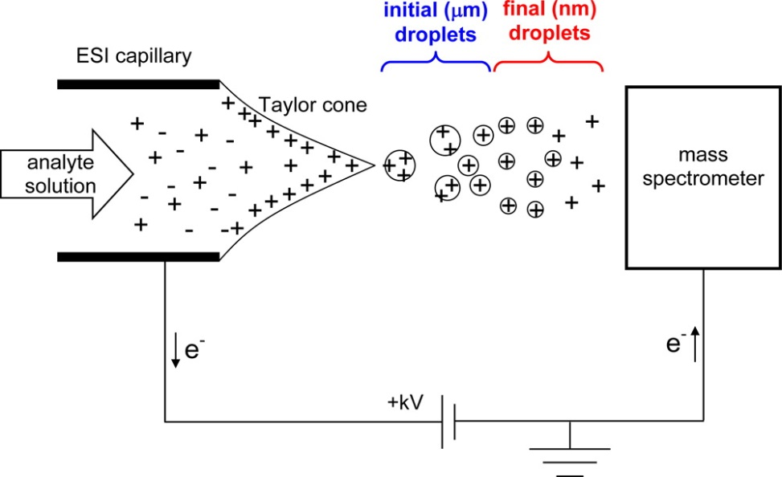
mass detector
Figure 4.2 Schematic of the electrospray ionization source, adapted from [153].
Charged ions are formed from at the tip of a capillary needle that has an applied voltage in the kV range, in addition, there is a counter electrode at ground which produces a high electric field, as shown in Figure 4.2 [153]. The high electric field causes a distortion at the capillary tip with the solvent forming a Taylor cone which emits a fine mist of droplets. The microdroplets undergo evaporation with the use of a counter gas or heat forming smaller microdroplets until charges within the droplet come together and causes an increase in the Columbic repulsion. When the droplets reach the Raleigh-limit, the destabilization from the charges, as well as the surface tension in the ion, results in the production of a new offspring of ions; this cycle is repeated until small nanodroplets are formed in the gas phase [154].
There are two different theories in regards to the formation of small, highly charged ion species: the ion evaporation model and the charge residue model. The ion evaporation model was first proposed by Dole et al. [152] where it was suggested that small molecular weight ions are formed through the evaporation or ejection of the ion from the Raleigh-charged microdroplets. Larger molecular species were observed to undergo charge residue model [155] in which the droplet completely evaporated, leaving charges on the surface of the macromolecule.
The soft ionization technique of ESI coupled to IMS systems has become quite popular, particularly in the field of proteomics. The introduction of the ESI with IMS allowed for more applications including analysis of biomolecules with a molecular size of the MDa range as well as environmental applications which typically involve inorganic matrices [156]. The first development of the ESI-IMS was reported by Gieniec et al. but later improved by Dr. Hill and his colleagues [157]. The development of this technique resulted in the analysis of multi-charged macromolecular species which produced a similar ion formation that was observed with mass spectrometry. Moreover, the ESI allowed for the analysis of liquid samples including water for the analysis of inorganic salts [158] and trace chemical compounds [159, 160].

Laser Desorption Ionization
Laser sources have been successfully used for the fast generation of atom ions from solid samples and have been used greatly for elemental analysis. As a result, interfacing a laser desorption and ionization (LDI) source with different detector systems has been widely investigated. Lubman and Kronick [161] were one of the first pioneers to couple an ultraviolet laser source, which allowed for the photoionization of large molecules, typically aromatic compounds with low ionization potentials, to an IMS detector providing them with the ability to directly analyze organic compounds. Laser desorption and ionization sources employ a laser beam to desorb a solid sample and produce vapor phase ions. For organic compounds, using laser beams as desorption and ionization sources for organic compounds offers simpler spectra with no reactant peak interferences [162], as well as a larger dynamic range and higher selectivity than that seen with photoionization sources [161]. Furthermore, laser desorption and ionization sources allow for the analysis of nonvolatile and/or thermally labile compounds, producing very little or no fragmentation with the selection of the beam energy from the laser source. An advantage of using laser sources is the ability to desorb, vaporize and ionize the sample with a single laser pulse, offering almost nondestructive analysis of solid, liquid, or gas samples. Since ions are produced with a laser pulse, the instrument design becomes simpler since the use of an ion shutter is unnecessary. Additionally, molecules in the environment are not ionized with a laser source since the power level output is greater than is needed for organic molecules, resulting in a simpler spectrum without interfering peaks for low molecular weight molecules [161, 162].

Low Temperature Plasma
Low temperature plasma (LTP), which is similar to glow discharge, is an ionization source first developed by McLuckey et al. [163] that produces a plasma at ambient pressures. Further studies were performed by Harper et al. [164] where the LTP ionization source was interfaced with a mass spectrometer to perform surface analysis at ambient pressure and simply required an alternating current (AC) power supply and discharge gas to produce ions from different surfaces. The simple ionization source generates a low temperature plasma, with temperatures ranging from 25-30°C, that is extruded from a glass probe and has nondestructive properties. Currently, studies have found LTP coupled to a mass spectrometer to be a successful ionization technique for explosives and illicit drugs; however, there has been little to no studies reporting the use of an LTP source with an IMS detector. A home-built LTP source was developed in order to characterize the ionization source and further pursue the ability to interface it with a home-built IMS system using a power source similar to that of Harper and colleagues [164], shown in Figure 4.3 (a). The home-built power supply allowed for variable frequency and voltages to be used in order to determine the best ionization setting when using different discharge gases which included helium, air, and nitrogen; it was concluded that helium provided the best visual and ionizing plasma plume and was used for the remainder of this study (Figure 4.3 (b)).
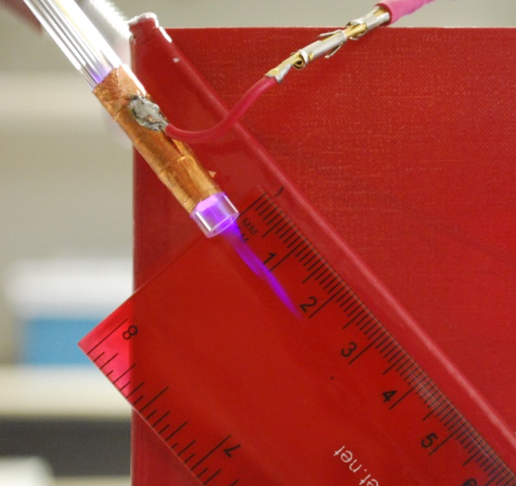
Discharge gas
(500-1000 mL min⁻¹)
Ground electrode
High voltage electrode
3-5 kV_{p-p}
3-5 kHz
LTP
Figure 4.3 (a) Schematics of the low temperature plasma probe and (b) photo of LTP using Helium gas at a flow rate of 600 mL min⁻¹. Schematics adapted from [164]
Table 4.2 Operating parameters for home-built LTP source.
Operating parameters for LTP | Setting
Power supply voltage | 3-5 kV_{p-p}
Power supply frequency | 3-5 kHz
Discharge gas | Helium
Discharge gas flow | 500-1000 mL min⁻¹

Collaboration with Dr. Eiceman’s research group allowed for successful characterization of the LTP source using a Q1SCAN triple-quadrupole mass spectrometer (Las Cruces, NM). Similar to the Ni-63 sources, the LTP ion source produces cluster ions from molecules in the ambient environment. It was observed that the changes in the frequency and alternating voltage peaks as well as the flow rate of the discharge gas resulted in different composition and intensity patterns for the reactant ions (Figure 4.4 (b)). The background ions observed corresponded to water cluster ions [(H₂O)_{n}+H]⁺ in the positive polarity mode and oxygen species [O₂]⁻, [NO₂]⁻ and [NO₃]⁻ in the negative polarity mode. Furthermore, ionization of various chemicals, including straight-chain ketones and explosives, were investigated. The detection of the monomer and dimer ions ([M+H]⁺ and [2M+H]⁺ respectively) were observed under the mass spectrometer in the positive polarity mode for some explosives and ketones; however, fragmentation of the ketone chains showed that the ionization source was not very soft, inducing fragmentation which might complicate the IMS spectrum (Figure 4.5). Moreover, ionization of straight-chain hydrocarbons resulted in a decreased ionization as the molecular weight increased, with no ionization for hydrocarbons containing greater than 12 carbons.
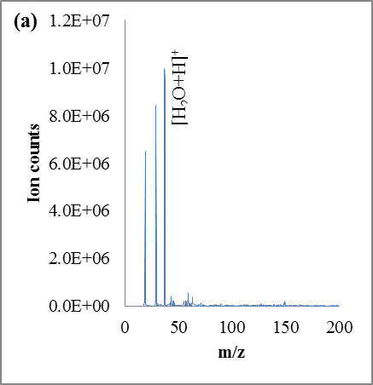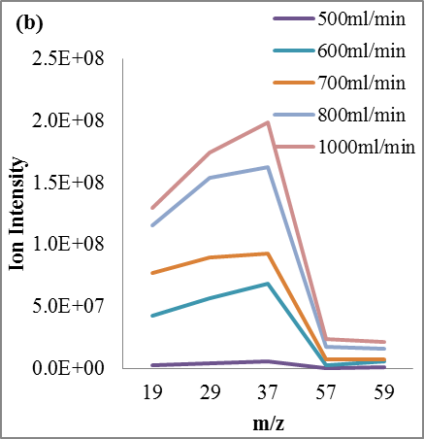
Figure 4.4 (a) Low temperature plasma (LTP) source coupled to a mass spectrometer to monitor the ions in the positive polarity; (b) changes in the discharge flow rate of the LTP source results in different intensities of cluster ions.
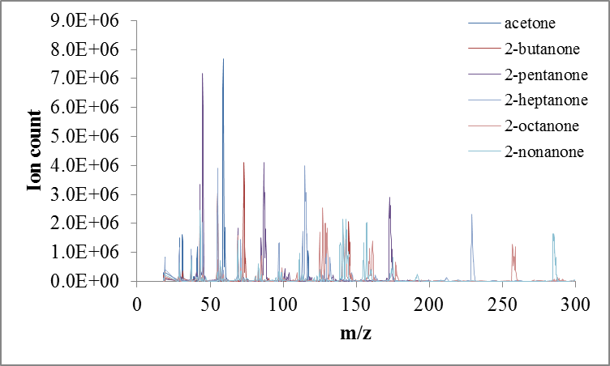
Figure 4.5 Mass spectra for the ionization of straight-chain ketones using the LTP source.
One of the biggest challenges of interfacing the IMS with the LTP is overcoming the effects of the countering discharge gas from the LTP source with the drift gas of the IMS. The two gases flow in opposite directions which could cause the plasma plume to blow out if the drift gas is set too high or there is a disruption in the ion separation because of the LTP torch operating at a high flow rate. The interface of the LTP source with an IMS system was performed by Jafari [165] in which a conical ring was used in the reaction region so that the drift gas was allowed to be exhausted prior to entering the reaction region, thus resulting in minimal disruption of the LTP plasma plume. The IMS design showed promising results, producing water cluster ions and negative-charged oxygen species. The reduced mobility of explosives and illicit drugs from the LTP source were similar to the previously reported values, forming similar cluster ions as from traditional IMS ionization sources with figures of merit similar to that of LTP-MS instruments [166].

4.1.2 Dopants
In IMS, once the ions are ionized in the reaction region, the ions are pulsed into the drift tube where the separation takes place. The presence of a counter drift gas as well as chemical dopants plays an important role in the separation chemistry of the ion mobility spectrometer. A dopant is introduced using permeation tubes, which allow for a steady gas emission, to increase the sensitivity, as well as specificity, of the gas-phase chemistry [64]. The dopant is combined with the inert drift gas which collides and reacts with the ions that are present in the drift tube as they travel down the electric field.
Dopant selection is essential for optimal instrument performance in order to form stable and identifiable analyte ions while suppressing ionization of unwanted analytes. The general chemistry in selecting a dopant is dependent upon proton affinity, where analytes with proton affinities lower than that of the dopant will result in little to no response [64], thus removing interference and other unwanted background ions. In the positive polarity, typically ammonia based dopants are used to produce cluster ions and in the negative mode, chlorocarbons are typically used to form chloride ions. Dopants chosen in the positive polarity are typically used to enhance specificity for detection of a particular analyte of interest; for example, most commercial IMS instruments use dopants that target illicit drugs and explosives. Furthermore, reactant gases can be used to selectively react with co-eluting product ions, resulting in the separation of the two molecular isomers [167].
The positive mode of the IMS allows for the detection of positive ion forming explosives and illicit drugs; thus, an alternative dopant has been proposed for efficient ion formation for nitrogen containing narcotic species and positive ion forming explosive species. Nicotinamide is typically used in commercial IMS instruments for the ionization of narcotics and explosives; however, this dopant limits ionization to nitrogen-containing compounds. A proposed isobutyramide dopant was used for the calibration of TATP because it was reported to be more accurate for the detection of peroxide-based explosives without loss of sensitivity for narcotics detection [168]. Response curves from a commercial bench-top IMS instrument using the nicotinamide and isobutyramide are given in Equation 4-8 and 4-9 respectively:
(y) = 20.04 (x) – 272.3, r² = 0.986 | (4-8)
(y) = 22.58 (x) – 384.5, r² = 0.986 | (4-9)
The response signals observed in the IMS were similar using either the nicotinamide or the isobutyramide dopant, thus the performance was not enhanced for the detection of positive ion forming explosives. Furthermore, no decrease in background signal was observed. After 5 minutes of static PSPME extractions, the minimum amount of detectable TATP when spiked in a quart metal can, using both dopants was determined to be approximately 19 ng, as shown in Figure 4.6.

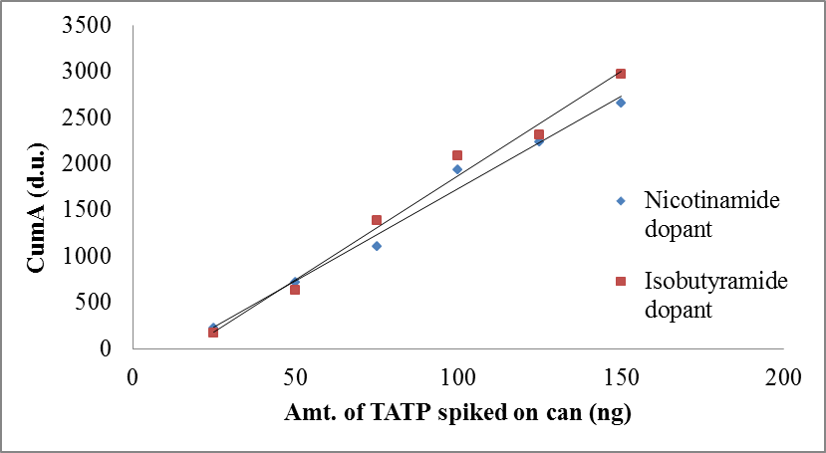
Figure 4.6 TATP headspace calibration obtained from 5 minute static PSPME headspace extraction of TATP (spiking 5 µL of solutions of the following concentrations: 5, 10, 15, 20, 25, 30 ng µL⁻¹ in acetonitrile).

4.1.3 IMS as Trace Explosive Detectors
Due to the demand of fast and reliable sensor systems that can be used in the field for the detection of illicit substances, research in IMS has increased rapidly, especially to enhance sensitivity and to improve the alarms library of compounds of interest. Several commercial IMS systems have been developed over the years in order to improve sensitivity and portability while minimizing invasiveness of the technique. Ion mobility spectrometer instruments with a heated inlet were developed in the 1980s for the analysis of particles in order to detect explosives with low vapor pressures. The bench-top design was ideal for inanimate objects, requiring physical contact by swabbing a particular area of interest and introducing it to the heated inlet and introduced to the IMS system (Figure 4.7 (a)). Thereafter, IMS portals were developed for human screening at security checkpoints which provided high throughput analysis in a noninvasive manner [169]. Increasing demand for analysis in the field led to the miniaturization of the technique.

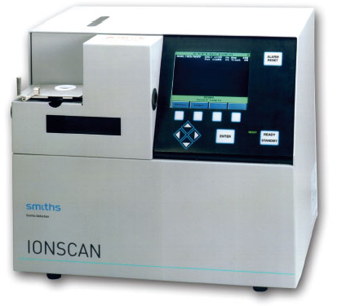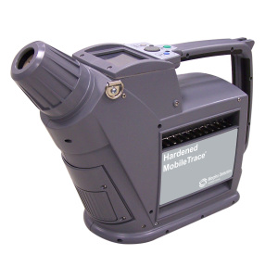
(a)
(b)
Figure 4.7 Commercial (a) bench-top (Smiths IONSCAN) and (b) portable IMS systems (Morpho Hardened MobileTrace) [148, 170]
One of the first portable IMS systems developed was the Vapor Tracer (GE Interlogix) which allowed for vapor sampling of explosives in the field and can be used for the on-site analysis of post-detonation areas and verifying clear zones [64]. Morpho Detection (Boston, MA, US) developed a portable IMS called Hardened MobileTrace (Figure 4.7 (b)) which functions the same way as the bench-top IMS; however, advances in the field allowed for dual detection in the positive and negative polarity mode, as well as ruggedness for the analysis in high clutter environments. Furthermore, this instrument can be used in dual sampling modes, particle and vapor sampling which increases its applicability in the field. The ruggedized version of the IMS comes with rechargeable batteries and only takes a couple of minutes to stabilize and reach appropriate temperatures. A unique feature of the portable IMS system is the membrane-based inlet which contains a thin membrane that interfaces the inlet of the instrument with the ambient atmosphere, preventing excess moisture from entering the system [148] and allowing for more stable conditions in the drift tube region since the sensitivity of the technique is affected by any changes in the ambient environment.

4.2 Gas Chromatography Mass Spectrometry
Gas chromatography coupled to mass spectrometry (GC-MS) is considered the “gold standard” for the chemical identification of analytes that are of forensic interest. It is used in many forensic laboratories for the trace analysis of illicit drugs and explosives, providing high sensitivity and broad spectral library for definite identification of the analyte. A schematic of the instrument is shown in Figure 4.8. The analyte(s) are first introduced to the gas chromatograph where it separates the different compounds within the sample through a capillary column that is heated through an oven programmed at different temperatures profile. Each individual analyte is transferred to the mass spectrometer through a transfer line where it is then ionized and the ions are further separated through a mass analyzer. The resulting chromatograph will contain information of the different compounds that were present in the sample and based upon their fragmentation pattern which reveals their potential identity.

PC Output
Electron Multiplier
Ion mass analyzer
Focusing rings
Ionization source
Capillary column
Injection inlet
Carrier gas
GC Oven
GAS CHROMATOGRAPHY
MASS SPECTROMETRY
Figure 4.8 Schematic of a gas chromatography-mass spectrometry instrument.

4.2.1 Gas Chromatography
The word “chromatography” originates from the early 1900s meaning “separation of colors.” The term is still used today to describe the same principle observed by the scientist Mikhail Tsvet [171], the separation process by the partitioning between two phases. In gas chromatography, the gas phase ions pass through a coated capillary column, separating the gas molecules because of the interactions with the stationary phase in the coating of the capillary walls and the mobile phase, typically an inert gas. The sample is introduced in an inlet which is responsible for vaporizing and thermally desorbing the analytes from a substrate to be introduced into a capillary column that can be open tubular or packed, varying in coating thickness, length, and diameter depending on the application and chemistry of the analytes of interest.
The way in which the chemicals are separated depends on the partitioning of the analyte with the stationary phase and the mobile phase. The equilibrium of the two phases is described as the distribution coefficient, K_{D}, which is defined as:
$${\text{K}}_{\text{D}}\text{=}\frac{\text{concentration of analyte in the stationary phase}}{\text{concentration of analyte in the mobile phase}}\text{=}\frac{{\text{c}}_{\text{S}}}{{\text{c}}_{\text{M}}}$$ | (4-10)
Analytes that are adsorbed by the stationary phase will have a higher equilibrium constant and higher retention time. Simultaneously, the mobile phase, an inert gas, is constantly flowing through the capillary column, moving the analyte towards the detector. The amount of time the analyte spends in the capillary column is its retention time which is defined as:
$${\text{t}}_{\text{R}}\text{' =}{\text{ t}}_{\text{R}}-{\text{t}}_{\text{M}}$$ | (4-11)
in which the adjusted retention time (t_{R}’) is the difference between the retention time of the analyte (t_{R}) and the void volume (t_{M}), or the time for the carrier gas to reach the detector. Ideally, identical molecules will travel down the capillary in a tight band, resulting in a sharp peak; however, band broadening from eddy diffusion, longitudinal diffusion, and band broadening caused by the resistance of mass transfer from the stationary and mobile phase as well as other factors result in a Gaussian peak will be observed [172]. The column of the gas chromatograph is the most essential part of the GC technique. Although packed columns were initially used and continue to be used today, the more modern gas chromatographic techniques use open tubular columns which consists of a fused silica column that is coated with a stationary phase that could vary in chemistry, diameter of the capillary column and thickness of the coated phase for different column efficiency required for the particular application. The stationary phase thickness has a certain capacity to retain the analyte and induce separation of the different chemicals present. The Van Deemter equation can be used to determine the optimum efficiency, the lowest point of the curve, achieved for the analyte(s) of interest when the right phase volume and diameter is selected to avoid band broadening [173]. Essentially, columns with smaller inner diameters provide high resolving power; however, the analysis time is compromised and longer retaining compounds are susceptible to band broadening. Larger diameter columns are typically used for simple mixtures as they offer fast analysis and allow for the use of high flow rates.

4.2.2 Mass Spectrometry
Mass spectrometry (MS) is an analytical technique that provides structural information on the basis of the fragmentation patterns of the particular ion. In the late 1960s, gas chromatography became a well-accepted separation technique, but lacked in the identification of analytes from complex mixtures [174]. Since the first production of the GC-MS, it has revolutionized the scientific community and soon became a necessary instrument in most analytical and forensic laboratories.
The separated gas phase analytes in the gas chromatographic column are transferred to the mass spectrometer reaction region, which provides identification of the analyte. Structural information on the analyte is obtained through the use of an electron impact (EI) ionization source. The EI source bombards the analyte with 70 eV of energy from a filament source, causing fragmentation from a series of radical reactions. Primarily, the bombardment of electrons result in a molecular ion with the loss of electron followed by a series of extensive fragmentation reactions, collisions, and rearrangement reactions [175]:
ABCD + e- ABCD^{•+} + 2e- (molecular ion)
ABCD^{•+} A⁺ + BCD• (fragmentation ions)
A• + BCD⁺ BC⁺ + D• B• + C⁺
AB• + CD⁺ C⁺ + D•
- ADBC^{•+} AD⁺ + BC• (rearrangement)
The relative intensity of each fragmentation peak is determined by the stability of the ion, in which the base peak, the peak with the highest abundance, will set the maximum relative abundance. The unique mass spectrum is matched with several spectral databases to correspond to the structure of the molecule. Because of these extensive fragmentation reactions, the resulting mass spectra can give unambiguous identification of the analyte.

Mass Spectrometry Mass Analyzers
Currently, there are several mass analyzers that offer different resolution and scan speed, the rate in which the mass analyzer measures the particular mass range. Mass analyzers can be separated into two different categories: time-resolved or space-resolved separation [154]. Time-resolved mass analyzers act as a mass filter, only allowing selective ions to pass through the flight tube at a different elapsed time. Space-resolved separation involves the presence of all ions in a confined area and the ions of a specified mass-to-charge ratio are dispersed in space towards the detector.
Quadrupole mass analyzers are most commonly used as they are compact, less expensive, and have lower scan times, making it particularly useful for chromatographic techniques [154]. The quadrupole mass analyzer acts a mass filter, separating ions on the basis of the stability of the trajectory as it travels down four parallel rods with alternating electric fields. The concept of the quadrupole mass analyzer was first discovered by Paul and Steinwegen [176] in their attempt to focus ions, and later commercialized by Finnigan [174]. The ion trajectories through the four parallel rods can be summarized in the derivatization of the Paul and Mathieu equation [154]:
$$\text{U=}{\text{a}}_{\text{u}}\frac{\text{m}}{\text{z}}\frac{{\text{ω}}^{\text{2}}{\text{r}}_{\text{0}}^{\text{2}}}{\text{8e}}$$ | (4-12)
$$\text{V=}{\text{q}}_{\text{u}}\frac{\text{m}}{\text{z}}\frac{{\text{ω}}^{\text{2}}{\text{r}}_{\text{0}}^{\text{2}}}{\text{4e}}$$ | (4-13)
where U is the applied DC voltage and V is the applied RF voltage. In a three-dimensional plane where the ion travels down the z-plane, the potentials applied to the parallel rods in the x-plane are of opposite voltage to those in the y-plane, resulting in the oscillation of the ion as it travels towards the detector. While controlling the DC and RF voltages, analyte trajectories in the x-plane and y-plane reach r₀ will most likely get neutralized and not reach the detector; on the other hand, ions whose trajectories of x-plane and y-plane never reach r₀ results in reaching the detector, whose signal corresponds to their mass and charge.
According to the above equations, the ion trajectory is dependent upon several independent variables as well as the mass (m) and charge (z) of the ion. By controlling the U/V ratio, the ions of a particular mass and charge ratio can be selectively allowed to travel down the electrodes and reach the detector. One of the drawbacks of the quadrupole mass spectrometer is that it has a limited mass detection of approximately 3000 m/z and has a limited mass resolution to 1 mass unit. Nonetheless, the fast scan speed and compact size makes it suitable for chromatographic analysis.

Figure 4.9 Cross-section of a quadrupole ion trap mass analyzer. Ions travel in figure-of-eight trajectories along the r₀ and z₀. When the ion trajectory exceeds r₀ or z₀, the ions are ejected from the lower cap electrode. Figure adapted from [154]
Ion trap mass analyzers, unlike quadrupole mass analyzers which acts as a mass filter, trap the ions in 2 or 3 dimensions which are expelled by the oscillating electric field. The ion trap functions in a similar concept as that of the quadrupole mass analyzer, in which the quadrupole ion trap is shaped like a quadrupole with two electrodes in the upper and lower end; however, the middle electrodes are bent into a ring electrode to form a closed loop. Rather than traveling down the electrodes, the ions are all stored in the ion trap, repelling each other and their trajectories expanding. The electrodes are applied a variable RF and DC potential which affects the trajectories of the ions. Ions whose trajectories are stable are those whose trajectories do not exceed z₀ or r₀ (added dimension from their trajectories in 3-dimension) as shown in Figure 4.9. Ejected ions are then transferred to the electron multiplier detector.
The ion trap offers several advantages over quadrupole mass spectrometers. Its compact size allows for miniaturization of the instrument, which has been done successfully by Drs. Lee [177] and Cooks [178]. Although analysis is performed under vacuum conditions, the ion trap mass analyzer is more tolerable to higher pressures, making it suitable for portable high vacuum systems. Moreover, the presence of the all the ions in the trap allows for tandem mass spectrometry to select an ion to do further ion fragmentation through the introduction of a collision gas which provides further structural information of the analyte.

4.3 High Speed Gas Chromatography-Differential Mobility Spectrometry

4.3.1 High Speed Gas Chromatography
The Van Deemter equation shows the different factors in regards to band broadening using chromatographic techniques. It was concluded that increased theoretical plates are observed from smaller capillary diameters. The recent advances in separation science and technology allowed for the manufacturing of smaller inner diameter capillary columns with advanced pressure controls to develop a high speed GC, allowing for the ability to perform chromatographic analysis in a manner of seconds.
Table 4.3 Characteristics and performance of the different GC systems [179, 180].
 | Ultrafast module-GC | Fast-GC | Short column (conventional)-GC | Conventional GC
Column length (m) | 2–10 | 5–15 | 5 | 25–30
Column internal diameter (mm) | 0.05–0.10 | 0.10–0.25 | 0.25 | 0.25–0.32
Analysis time (min) | <1 | <10 | 3–15 | 10–60
Heating rate (°C min⁻¹) | >60 | 15–60 | 5–40 | 1–10
Average peak width (s) | 0.05–0.2 | 0.5–2 | 1–5 | 1–10

Over the years, several developments of different GC systems were performed in order to produce fast analysis without compromising the separation power. Table 4.3 displays the different classifications of GC systems in their approach to achieve the shortest analysis time possible while obtaining good separation results. Since the theoretical understanding of capillary columns by Golay [181], developments of fast GC systems were observed. The conference proceedings from Blumberg et al. [182] defined the different aspects of fast GC, in which GC analysis produces a peak in less than one second. Small diameter GC capillary columns (< 0.1 mm inner diameter) provide high efficiency, and thus the column length can be shortened to decrease the analysis time without sacrificing the separation performance. Other ways to improve speed of a GC analysis were to increase the gas flow rate, increase the heating rate programmed in the GC oven, decrease the thickness of the stationary phase and using detector systems that are tolerant of high pressures [183]. ThermoFinnigan [180, 184] as well as other well-known liquid and gas chromatographic manufacturers [185] have developed ultra-fast GC systems that have good separation with comparable performance as that of a conventional GC system.

4.3.2 Differential Mobility Spectrometry
Unlike IMS, differential mobility spectrometry (DMS) uses alternating voltages to achieve separation in the drift region. Similarly, the ions are created in a reaction region with the use of a radioactive Ni-63 source and are transported through the drift region as shown in the schematics in Figure 4.10; however the main difference between IMS and DMS is that the drift region is comprised of two parallel plates serving as electrodes. One electrode is held at ground and the other is applied an RF electric field in a waveform function generating a nonlinear high electric field causing an oscillation of ions between plates. Depending on the ions’ shape and charge, the total displacement between the two plates will vary as they travel towards the drift tube. Ions with a net displacement lower than the distance of the upper plate will be detected and neutralizing all the other ions. A plot of the different compensation voltage and the signal detected gives a characteristic differential ion mobility spectrograph, in which the composition voltage (VC), the measurement unit corresponding to the analyte peak, can be used to identify a particular analyte. Unlike IMS systems, DMS does not have an ion shutter system; ions are constantly analyzed and the alternating electric field causes a mass filtering affect, similar to a quadrupole mass analyzer, to only allow a particular analyte to be detected, allowing for the detection of ions of both polarities.

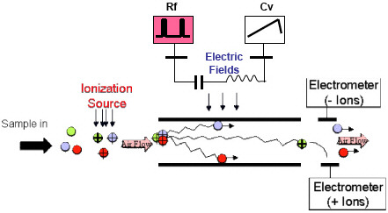
Figure 4.10 Schematics of a differential ion mobility spectrometer instrument [186].
A commercial high speed gas chromatograph (GC) coupled with a differential ion mobility spectrometer (DMS) known as an Egis Defender (Thermo Scientific, Franklin, MA, USA) is a trace detection system for explosives and illicit drugs [150]. The high-speed system performs analyses in little time generating a two-dimensional plot that provides indiscriminate identification of an analyte. One of the advantages of the DMS instrument is the ability to simultaneously obtain positive and negative polarity results, which is a drawback for many conventional IMS systems. Furthermore, it provides separation prior to analysis, offering high resolution and specificity.
The sample is deposited onto Teflon coated fiberglass substrate, referred to as “ticket,” which is then introduced to the system by thermal desorption. The gas phase analytes undergo separation by the high speed GC system followed by DMS analysis. The data obtained is a 2D topograph containing the data for the GC and DMS studies. The intensity of the peaks is observed from the different color gradient. The instrument results with an alarm for a particular analyte when the analyte contains the target compensation voltage (VC) and gas chromatographic retention provided in the alarm window in which it is expected to be seen as shown in Figure 4.11.
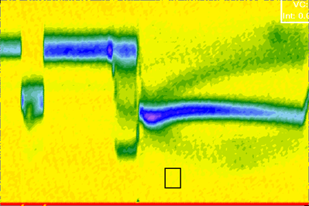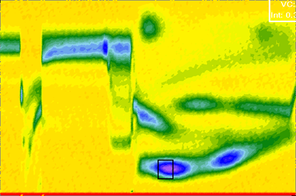
(b)
(a)
Figure 4.11 Topograph obtained in the EGIS Defender for (a) a blank sample in the positive mode and (b) 200 ng of DPA detected with the detection window of DPA (black rectangle labeled on each topograph).

4.4 Evaluation of Detection Systems
Different statistical and data mining tools are used to characterize and evaluate different detection systems. Evaluation of explosive detection systems has been achieved through the use of principal component analysis, partial least squares discriminant analysis and other sophisticated statistical tools for different analytical techniques [187-190]. The most common way of evaluating the sensitivity of trace detectors is through the use of calibration curves to determine the limits of detection, often defined as three times the standard deviation of the background noise [191]. Although calibration curves are useful for the comparison of different analytical methods, these statistical studies focus on identification of false positive rate (FPR) values. Hubaux and Vos reported a different method of determining the detection limits which include both the true positive rate (TPR) and false positive rate based on the confidence limits [192]. Nonetheless, the major drawback of calibration curves is that the instrumental detection limit calculated is usually lower than the actual value, observing 50% accurate detection of the analyte [193]. Furthermore, most sensor and detection systems include dichotomous processes, the classification of either the presence or absence of a target analyte.
The use of receiver operating characteristic (ROC) curves are an efficient method to visualize the trade-offs for the performance of a particular technique or sensor system for a given set of sensor conditions. Receiver operating characteristic curves were developed by the U.S. military to differentiate radar signals and noise [194, 195] and the use of ROC curves as an sensor performance evaluation tool has grown in popularity for use in medical diagnostic testing [196-199]. The medical field used ROC curves as a method to quantify how accurately the use of instrumental tools was able to make discriminations between two conditions or diagnosis [200]. The correlation of the data-based diagnostics and the actual results from the current patients used ROC curves analysis to evaluate the performance of medical diagnostic systems. The increase in data analysis using ROC curves in other clinical fields as well as non-clinical fields including psychiatry [201-203], explosives detection [190, 204, 205] and computer sciences [206-208] results from the ability to visualize the performance of dichotomous decisions. The Department of Defense (DoD) conducted the Chemical and Biological Sensor Standards Study [209] in which ROC curve studies for sensor devices were proposed depending on a wide range of sensitivities and false positive rates. These statistical curves can be constructed to display the instrument performance trade-offs of sensitivity and specificity from the true positive and false positive rates. From the DoD study, Cotte-Rodriguez and his colleagues constructed ROC curves for a portable mass spectrometer system to evaluate the real-time detection of toxic compounds [194]. Fraga et al. [193] also developed ROC curves for a portable IMS for vapor sampling of diesel fuels. This study shows promising results of the IMS system using a non-contact sampling technique to determine the detection limits under different defined scenario and in low clutter and high clutter environments.
The use of ROC curves is a great way to test the sensitivity and specificity of an instrument. The construction of a ROC curve is composed of four individual components: the true positive rate (TPR), false positive rate (FPR), true negative rate (TNR) and false negative rate (FNR). For a given classifier, there are four possible outcomes; if the true condition is positive and the test results are also positive, then it is considered a true positive (TP) whereas negative test results is considered a false negative (FN). Similarly, when the true conditions are negative, positive test results are considered a false positive (FP) and negative test results are considered true negative (TN). The different values for each outcome are typically placed in a confusion matrix table as shown in Table 4.4.
Table 4.4 Confusion matrix for ROC curves. TP = true positive (alarm for positive cases), FP = false positive (alarm for negative cases), FN = false negative (no alarm for positive cases), TN = true negative (no alarm for negative cases), D+ and D- is the total positive conditions and total negative conditions, T+ and T- is the total positive results and total negative results.
 |  | True Condition |  | Total
 |  | Positive | Negative | Total
Test Results | Positive | TP | FP | T+
Test Results | Negative | FN | TN | T-
Total |  | D+ | D-

The confusion matrix can help determine the overall performance of the instrument. The sensitivity, or true positive rate (TPR), and specificity, true negative rate (TNR) defined in equation 4-12 and 4-13, respectively.
TPR = TP / D+ | (4-12)
TNR = TN / D- | (4-13)
where D+ and D- is defined as the total number of positive and negative conditions, respectively. The sum of the TPR and the FNR will equal to 1, similarly the TNR and FPR will give a similar result in which the TPR can be defined as the sensitivity of the instrument and the TNP is the specificity of the instrument. The ROC curve is plotted with the sensitivity (TPR values) in the y-axis in respect to 1-specificity (FPR values) in the x-coordinate which is constructed using different alarm threshold of the instrument in order to determine the TPR and FPR for a given alarm threshold. At different sensitivity levels (alarm threshold), the instrument has a corresponding specificity where increasing the sensitivity of the instrument compromises the specificity for detection of the particular analyte, resulting with false positive values.
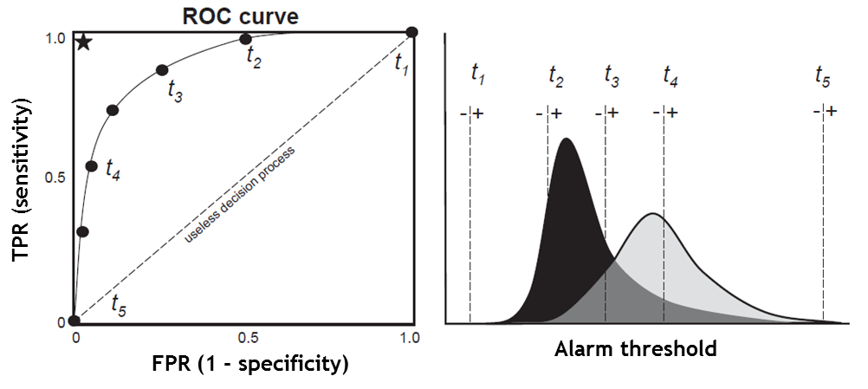
Figure 4.12 Generation of the ROC curve by using different alarm threshold (t₁ – t₅) of the instruments [210]
Figure 4.12 displays different alarm threshold selected which corresponds to a point in the ROC curve. At a high alarm threshold, the instrument has poor sensitivity which is not able to correctly alarm for the presence of the target analyte; however, the instrument has high specificity without any false positive values (t₁). As the alarm threshold of the instrument is decreased, the instrument’s sensitivity is increased to provide true positive values; however, decreasing the alarm threshold might compromise the specificity for detection of the target analyte in which the lowest possible alarm threshold (t₅) will result in large amount of true and false positives. Typically, a diagonal line is used as a reference, as shown in Figure 4.12, going through the coordinates (0,0) and (1,1) which corresponds to the lowest performance of the instrument. The final ROC curve is then a representation of a binomial Gaussian distribution: one distribution curve represents the true positive results and the other distribution represents the false positive results. For example, in the assumption of two binomial Gaussian distribution curves for an explosive sensor system, one of the distribution curves is from the positive alarm outcomes with the presence of explosives and the second distribution from the positive alarm outcomes without the presence of any explosives. Figure 4.13 shows two very different performances of two sensor systems. The two distributions, the red indicating the true positive results and the blue indicating the false positive results, contribute to the performance of the instrument. The green line can be moved left and right to set different alarm threshold of the instrument, which represent the different data points in the ROC curve. A high threshold will result in almost no false positive but the instrument will not be able to alarm for the true positive results either. The lower the threshold, the higher sensitivity of the instrument; however, it is more susceptible to false positive results.

(a)
(b)
Figure 4.13 ROC curves for two different instrument performance; (a) accurate performance (AUC ≈ 1) and (b) random performance (AUC ≈ 0.5)
The area under the curve (AUC) is the measure of the overall performance for the diagnostic test. The AUC ranges from 0.5 to 1, in which an AUC of 1 results with perfect performance and 0.5 for random performance with 50% sensitivity and 50% specificity. The AUC can be seen as the probability of correctly classifying true positive and false positive results. Figure 4.13 (a) shows the performance of an accurate instrument with an AUC of 0.98. The first sensor system can distinguish the false positives and true negatives, generating little overlap in which the threshold can be set at a sensitivity threshold high enough and still observe a small fraction of false positives. The example shows that at the selected threshold, the instrument results with high sensitivity (TPR = 0.947) with very low false positives (FPR = 0.052). On the other hand, a poorly performing instrument will not be able to correctly classify the presence of an explosive as shown in Figure 4.13 (b). The AUC for this instrument is 0.55, in which increasing the TPR also compromises the TNR, resulting with a high rate of false positives. The second sensor system’s performance (Figure 4.13 (b)) shows the two binomial distributions practically overlap and therefore the instrument cannot differentiate between false positives and true positives. As a result, the sensor system is useless in which the system will result with 50% correct diagnostics. Furthermore, two diagnostic tests that results with the same AUC does not necessarily mean that both instruments perform identically; however, their overall performance is the same [211]. The individual peaks in the ROC curve corresponds to the probability of positive events over negative events. For two ROC curves with similar AUC, the individual values of positive and negative values are different. Evaluation of two ROC curves with similar AUC can be performed using bivariate statistical analysis [212], in which the standard error between the differences of the two AUC can be used to determine whether the two areas are statistically different [195].

Methodology

5.1 Instrumentation
The research study involves three major sections:
- Characterization and evaluation of PSPME as a headspace sampling and preconcentrating technique
- Evaluation of PSPME in comparison with other substrates
- Evaluation of the performance of PSPME-ion mobility spectrometry (IMS) systems and SPME- gas chromatography-mass spectrometry (GC-MS) systems.
The different sections of this study involve different instruments used in order to validate the performance of the PSPME device. For the first study, two bench-top IMS systems were used in order to detect all the necessary volatile chemical compounds of explosives and illicit drugs. The second study involves the use of different substrates that were analyzed using a portable IMS system in order to compensate for the loss observed in the thermal desorption interface from the preceding model. The evaluation of the PSPME-IMS and SPME-GC-MS involve the use of two IMS systems, a bench-top and portable system, as well as a commercial bench-top GC-MS system.

5.1.1 Ion Mobility Spectrometry Systems
The following series of experiments was accomplished using various commercial IMS systems of different manufacturers to produce the necessary data which includes: (1) the Smiths Detection IONSCAN 400B (Smiths Detection, Warren, NJ), (2) GE Itemiser 2 (GE Securities, Wilmington, MA) and (3) Morpho Detection Hardened MobileTrace (Morpho Detection, Newark, CA). The different IMS systems offer software accessibility to achieve the desired results. Thus, in the characterization of the PSPME studies, two bench-top IMS instruments were used, the IONSCAN® 400B ion mobility spectrometer was used for the detection of the explosive vapors (TNT, 2,4-DNT, DPA, EC) collected by the PSPME device in either the positive mode or the negative mode and an Itemiser 2 IMS was used for the analysis of the volatile chemical compounds associated with cocaine and MDMA, methyl benzoate and piperonal, respectively, since detection of piperonal and methyl benzoate required a lower drift tube temperature (80 °C) as well as modification of other instrumental parameters for the targeting compounds [33]. The IMS operating conditions for both commercial instruments are shown in Table 5.1.
Table 5.1 Operating conditions for the IMS instruments used in the experiments.
IMS operating conditions | IONSCAN® 400B IMS | Itemiser 2 IMS
Polarity | Positive (+) | Negative (-) | Positive (+) | Positive (+)
Desorber temperature (°C) | 250 | 300 | 150 | 197
Drift tube temperature (°C) | 235 | 115 | 80 | 190
Sample flow (mL min⁻¹) | 200 | 500 | 500 | 1000
Drift flow (mL min⁻¹) | 300 | 350 | 350 | 250
Reagent gas | Nicotinamide | Hexachloro-ethane | Nicotinamide | None
Compounds detected | DPA, TATP, EC | 2,4-DNT, TNT | Piperonal | Methyl benzoate

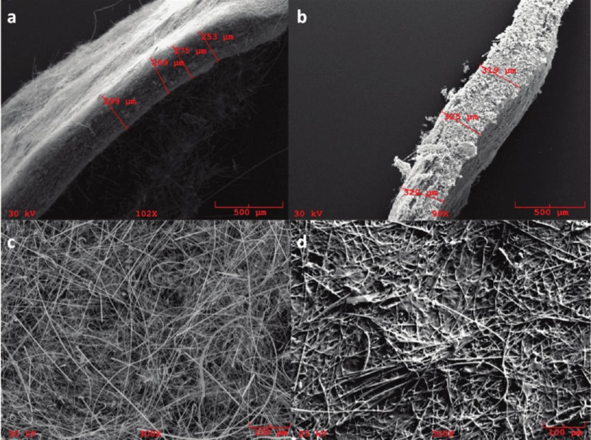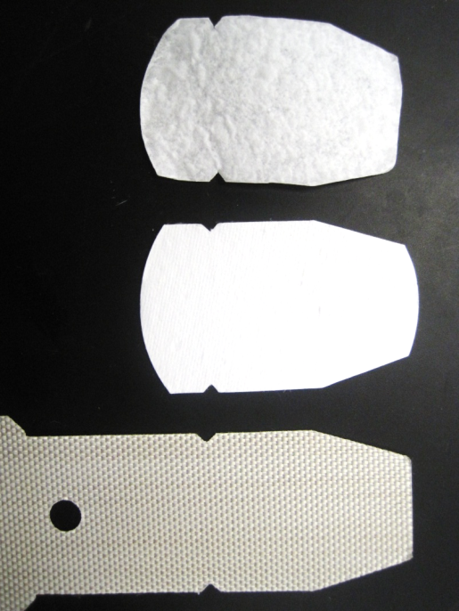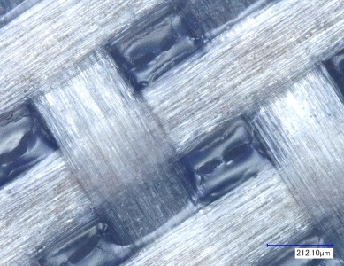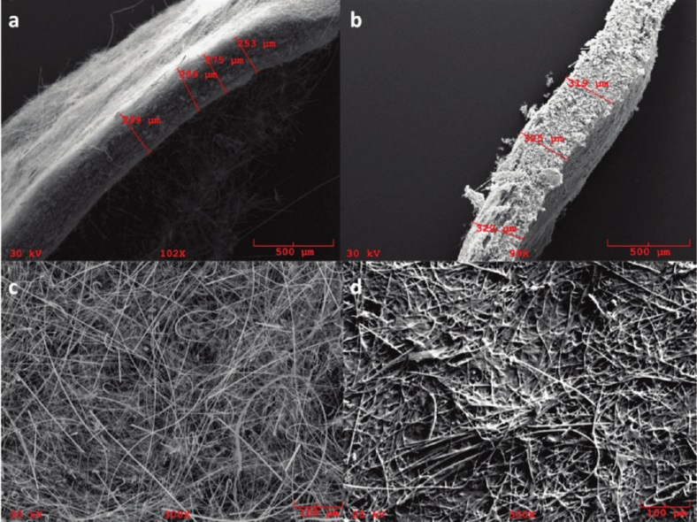
PSPME
Glass Filter
Teflon Coated Fiberglass
Figure 5.1 Different substrates for the portable IMS system include PSPME, uncoated glass filter and Teflon-coated fiberglass (left to right) with the SEM [1] and microscope imaging of the surface of the different substrates (bottom).
The comparison of the PSPME performance with various manufactured substrates was performed using a Hardened MobileTrace portable IMS system (Morpho Detection, Newark, CA) in the Narcotics particle mode, modifying the drift tube temperature to 150 °C and without the presence of any dopants for the detection of methyl benzoate and piperonal simultaneously. The rest of the instrumental parameters were kept as the original default parameters. Alarms were added to the system for piperonal (t_{d} = 5.47 ms) and methyl benzoate (t_{d} = 5.38 ms) from standard solutions. Extraction volatiles of illicit drugs study was performed using the PSPME substrates as well as others including the manufactured Teflon coated fiberglass, referred to as ‘Teflon traps,’ purchased from Morpho Detection (Safran Group, Newark, CA) and uncoated glass fiber filters which are used without further treatment. The cotton swabs were purchased from Smith Detection (Smiths Detection, Warren, NJ). Other than the Teflon traps, the substrate’s geometry was modified in order to fit the desorption inlet of the IMS system (Figure 5.1).
Table 5.2 Bench-top (IONSCAN 400B) and portable (Hardened MobileTrace) IMS instrument parameters. (*) indicates default parameters undisclosed to the user.
 | IONSCAN 400B |  | Hardened MobileTrace
Instrument mode | Positive mode | Negative mode | Explosives Particle mode
Tube temperature (°C) | 115 | 235 | 162
Inlet temperature (°C) | 250 | 250 | *
Desorber temperature (°C) | 300 | 300 | 235
Calibrant temperature (°C) | 70 | 70 | *
Flow (mL min⁻¹) | 350 | 300 | *
Reagent gas(es) | Nicotinamide | Hexachloroethane | Ammonia & Dichloromethane

Evaluation of the PSPME performance was achieved by the construction of Receiver Operating Characteristic (ROC) curves using a bench-top and portable ion mobility spectrometer. The bench-top IMS system used was the same as previously mentioned, the IONSCAN® 400B (Smiths Detection, Warren, NJ), which was used both in the negative and positive polarity with nicotinamide and hexachloroethane dopants, as recommended by the manufacturer. Similarly, the portable IMS is the same as previously mentioned, the Hardened MobileTrace (Morpho Detection, Newark, CA), and operated in the Explosives Particle Mode with dichloromethane (VICI Metronics, Inc., Poulsbo, WA, USA) and ammonia (Real Sensors, Inc., Hayward, CA, USA) dopants. For all instruments, the instrumental parameters were kept at the manufacturer’s default parameters (Table 5.2). Alarms for compounds not present in the library were added and the parameters used were similar to the alarms already present in the library. The alarm thresholds for the analyte of interest were modified to the minimum alarm threshold for the true positive and false positive rate studies. Further information on the alarm threshold for each analyte in both IMS systems are detailed in Table 5.3.
Table 5.3 Alarm threshold for analytes of interest for bench-top and portable IMS systems. Military explosives were only detected using the portable IMS, thus, parameters for these analytes are only shown for the portable IMS.
 | Smiths Detection IONSCAN 400B |  |  |  | Morpho Detection Hardened MobileTrace
Alarm | Reduced mobility (K₀) | Variability (µs) | Amplitude threshold (d.u.) | Full width half max (µs) | Drift time (ms) | Variability (ms) | Method of detection and threshold
(+) DPA | 1.6082 | 50 | 30 | 327 | 6.080 | 0.040 | Height (100)
(-) 2,4-DNT | 1.5660 | 50 | 30 | 253 | 5.548 | 0.040 | Height (300)
(-) NG-N  (-) NG-C | 1.2720  1.3385 | 45  45 | 25  50 | 335  305 | 3.833 | 0.035 | Height (700)
(-) ETN |  |  |  |  | 4.672 | 0.040 | Height (100)
(-) PETN |  |  |  |  | 7.991 | 0.040 | Height (500)
(-) RDX |  |  |  |  | 6.333 | 0.040 | Slope (1000)
(-) TNT |  |  |  |  | 6.076 | 0.040 | Height (300)

5.1.2 SPME-GC-MS Detection
The evaluation of SPME-GC-MS was also performed by construction of ROC curves for comparative studies. The GC-MS studies were performed using a Varian (Palo Alto, CA, USA) CP 3800 gas chromatograph coupled to a Saturn 2000 ion trap mass spectrometer and equipped with an CP 8400 autosampler (Varian Inc., Walnut Creek, CA, USA). The sample was introduced to gas chromatograph with an inlet temperature of 180 °C (split ratio 5:1) and analyzed using a 30 m x 0.25 mm ID x 0.25 µm DB-5MS UI (Agilent Technologies, Inc., Santa Clara, CA, USA) with a constant flow rate of Helium at 2.0 mL min⁻¹. The method length was 29.3 minutes, in which the GC oven started at a temperature of 40 °C and held for 1 minute, followed a ramp to 200 °C at 15 °C min⁻¹, then held for 1 minute, another ramp to 240 °C at 15 °C min⁻¹, held for 5.5 minutes, a third ramp to 270 °C at 25 °C min⁻¹, then a final ramp to 280 °C at 5 °C min⁻¹, held for 4 minutes. The transfer line to the ion trap was set to 280 °C and the ion trap was maintained at 180 °C. Each compound of interest was identified by the retention of their pure standards and identifying the resulting peak using the NIST mass spectral library.
Analysis of SPME-GC-MS was performed using polydimethylsiloxane (PDMS) and PDMS/divinylbenzene (DVB) SPME fibers (Supelco, Sigma-Aldrich Corp., St. Louis, MO, USA) were both tested for the headspace preconcentration and they showed very similar results for the interested volatile compounds; however, PDMS/DVB SPME fibers showed slightly higher integrated area in the chromatograms and were used for the duration of the SPME-GC-MS ROC studies.

5.1.3 GC-DMS Detection
The default parameters were used in this instrument for the detection of explosives; however, alarms for the volatile organic compounds associated with smokeless powders were added (Table 5.4).
Table 5.4 Alarms windows for target analytes and added alarm windows on GC-DMS instruments for detection of smokeless powders.
Alarm | VC | GC
2,4-DNT | 75 | 28
DPA | 78 | 14
EC | 120 | 64
NG | 56 | 50

The instrument was used in the explosives mode in which the GC method and DMS parameters have been optimized for explosives detection. The PSPME device was developed as described previously (Section 3.2.2) and mounted onto the same cardboard holder as used for the Teflon coated fiberglass sampling swab. The Teflon coated fiberglass was removed and the PSPME was replaced and held in place by the adhesive used to hold the Teflon swab. The PSPME was backed with a white sheet of copy paper in order to avoid damage and breakage as experienced previously.

5.1.4 Vacuum Air Sampler for Dynamic Extraction
Two different dynamic vacuum sampling devices were used, the Dyson DC34 (Dyson Inc., Chicago, IL, USA) handheld vacuum and Barringer DC Remote Particle Sampler (Smiths Detection). Originally, dynamic sampling was performed using the DC Remote Particle Sampler air sampler at low flow rates. The Dyson DC34 was an alternative dynamic sampling system that is inexpensive and that offers higher flow rates for faster sampling time. Their performance was evaluated using an anemometer (Model EA-3010U, La Crosse Technology, USA) to measure the airspeed flowing through the nozzle of both sampling instruments. The comparison results are summarized in Table 5.5.
Table 5.5 Comparison performance study of Dyson and Barringer dynamic sampling devices.
 | Dyson DC34 Handheld Vacuum | Barringer DC Remote Particle Sampler
Flow rate (w/o PSPME)  (L s⁻¹) | Normal: 15  MAX: 18 | 5.3
Flow rate (w/ PSPME)  (L s⁻¹) | Normal: 5.2  MAX:5.6 | 0.07 (with PSPME holder)  0.3 (without PSPME holder)
Battery life (minutes) | Normal: 16  MAX: 7 | 11
Battery charging time (hours) | 4 | < 1
NG detected from 30s sampling from 100 mg AU in quart can | Normal: 7 ± 2 ng  MAX: 17 ± 2 ng | 96 ± 4 ng

Since both systems are battery-operated, a decrease in performance is seen with prolonged use and diminished battery power. The Dyson vacuum can be operated in two different settings, normal and MAX. The normal setting was observed to have a flow rate of 14.8 L s⁻¹ for the first 11 minutes, decreasing to a flow rate of approximately 13 L s⁻¹ after 11 minutes of continuous use. For the MAX setting, a higher flow rate of 18.4 L s⁻¹ was observed; however, quickly dropped to 17 L s⁻¹ after 5 minutes of use. Moreover, the flow rate drastically dropped with the introduction of the PSPME device to 5.2 and 5.6 L s⁻¹ for the normal and MAX setting, respectively. The observed flow rate for the Barringer air pump sampler was lower than that in comparison to the Dyson without the presence of the PSPME, approximately 5.3 L s⁻¹. Although the flow rate is high without the presence of the PSPME, the flow rate dropped to approximately 0.07 L s⁻¹ when the PSPME was held in place with the assistance of the Teflon PSPME holder or a flow rate of 0.3 L s⁻¹ without the use of a Teflon PSPME holder (for applications that require larger PSPME devices). The results agreed with reported [1, 213] flow rate of the Barringer air sampler to be approximately 0.35 L s⁻¹. Although the flow rate with PSPME was observed to be lower than the reported value, the flow rate fluctuated from 0.07-0.4 L s⁻¹ with a maximum of 1.1 L s⁻¹.
Dynamic headspace extractions of 100 mg AU smokeless powders were performed for 30 seconds to compare the extraction efficiency. The amount of nitroglycerin detected for the Dyson vacuum from the two settings were lower than the signal observed using the Barringer air sampler, as shown in Table 5.5. For a 30-second dynamic headspace sampling, the amount of NG detected from the Dyson vacuum dynamic extraction was determined to be 7 ± 2 ng for the standard flow rate and 17 ± 2 ng for the max flow rate. The Barringer air pump sampler detected 96 ± 4 ng of NG for the same amount of sampling time as well as detection of DPA. Different sampling times were studied in order to further compare the results and make sure no possible breakthrough is observed from the increased flow rate. Observations were plotted in terms of the volume extracted (Figure 5.2).
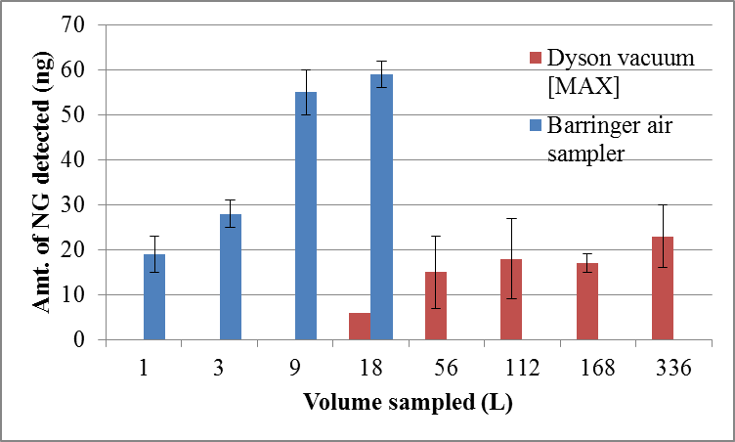
Figure 5.2 Dyson vacuum in the MAX setting and Barringer air sampler comparison in detection of NG from 100 mg of AU smokeless powder in quart cans (n=3).
Although similar volume is sampled in 60 s with Barringer air sampler and 3 s with the Dyson vacuum at the max setting, the amount of NG detected is significantly greater for the Barringer air sampler in comparison to the Dyson vacuum. Even though the flow rate is approximately 20 times greater for the Dyson vacuum, the pulling power, or the vacuum force in order to provide suction, seems to be greater for the Barringer dynamic sampler, resulting in greater extraction of NG from the same amount of volume sampled (Figure 5.2). In addition, the Barringer air sampler interface design is better suited for air sampling because the commercial Dyson vacuum is not designed for this particular application, further improvement in the PSPME or substrate introduction of the Dyson vacuum sampling device is needed for efficient sampling of high volumes.

5.2 Microdrop Generation Technology
Evaluation of the performance of the PSPME device requires a means of generating reliable amounts of standards. Calibration and quantitation methods for solid phase microextraction (SPME) have been proposed [147, 214] as a non-exhaustive extraction from the low sample volume [120, 214], where the phase volume of the SPME fiber is negligible. The PSPME preconcentrating mechanism is similar to a SPME fiber; however, the quantitation and calibration for a PSPME device is much difficult to determine because of the enlarged surface area and phase volume. Consequently, a vapor generator which can accurately deliver trace amount of volatile organic compounds of explosives and illicit drugs into the headspace were used to evaluate the extraction performance for the newly developed preconcentration devices.
Great efforts have been made to generate consistent vapors of various compounds for landmine determination [215], environmental chemical monitoring [216], explosives detection [217-220] and sensor calibration [221] throughout the past decades. One technique such as Controlled Odor Mimic Permeation Systems (COMPS) uses a thin plastic film to release vapors generated from the solid compounds into the headspace at a fixed rate [11, 222]. Another technique by Bonnot et al. has been developed specifically for explosives with low vapor pressure, such as 1,3,5-trinitroperhydro-1,3,5-triazine (RDX), 2,4,6-trinitrotoluene (TNT) and pentaerythritol tetranitrate (PETN) [223]. The explosive vapor generation device has proven to be suitable for generating controlled vapors for analysis of explosives with low vapor pressure at elevated temperatures; however, the device requires large amount of explosives to perform the calibration.
Piezoelectric nozzles, a similar technology to that used in inkjet printers, have been used for precise picoliter volume depositions on a surface [221]. Uniform-sized microdrops with well-defined trajectories and known amounts of volume can be delivered by the user in amounts as low as one drop to a rapid, steady stream of drops at will [224]. The drop volume can be determined by gravimetric methods as well as by imaging the droplet morphology and dispensing dynamics [225, 226]. Various piezoelectric delivery devices are currently commercially available for the evaluation of trace detectors in part-per-trillion levels using liquid standards; however, in order to appropriately evaluate a vapor collecting device, a calibrator for generating and extracting vapors is needed. A home-built design by Verkouteren et al. [221, 227] from the National Institute of Standards and Technology (NIST) utilizes the technology of the piezoelectric microdispenser with a heated ceramic plate for generating precisely controlled amounts of vapors. Similar to the technology at NIST, a commercial instrument developed by MicroFab Technologies also allows users to generate precise amount of vapors for research purposes. The heating element is set to a temperature above the boiling points of the solvent and the analytes of interest in order to generate the analyte vapors.
Microdrop printing has been greatly applied in sciences of many fields, including pure sciences for theoretical observations and applied sciences [224] because of its ability to precisely deliver identical droplets at will. For microdrop generation, numerous technologies have been reported [224]; however, thermal inkjets and piezoelectric pulses are the most commonly used. In general, all the technologies use the common principles of pressurizing a fluid through a small hole, resulting in a drop when the weight of the drop exceeds the surface tension forces holding it at the orifice. Piezoelectric nozzles are currently used for inkjet printing for precise deliver of fluids on demand. The microdrop generating technology uses a piezoelectric element to change to volume of the ink reservoir for ejection or retraction of the fluid droplet. Although there are many different designs, the most commonly used is the tubular reservoir design which allows the analysis of chemically inert fluids and is relatively inexpensive [224]. The tubular design is composed of a glass capillary nozzle, or “print head,” with different orifice sizes, where the fluid flows and will result in the relative size of the drops. Attached, contains the piezoelectric elements in order to apply a voltage pulse, resulting in a propagation of pressure pulses. At the nozzle orifice, the different pressure waves causes the fluid to drop and retract, forming singular drops. The microdrops are visualized using CCD and strobe illuminations in sync with the microdrop generation. The microdrops are then deposited on a specific location of a substrate.
Microdrop printing can be achieved in two ways: continuously or drop on demand. For a continuous stream of uniform and monodispersed droplets, the fluid jet is broken by acoustic excitation. Drop-on-demand, similar technique used in inkjet printers, uses a single voltage pulse to produce one single droplet (Figure 5.3). One of the main advantages of the piezoelectric element is the ability to optimize the drop size and volume without producing satellites by changing the pressure rise and fall times. MicroFab technologies developed a commercial drop-on-demand microdrop printing using the piezoelectric technology.

Figure 5.3 Printing system of a piezoelectric drop-on-demand microdrop generator, adapted from [228]
The viscosity and surface tension of the liquid will affect the drop formation, where the viscosity must be low enough to be able to flow through the nozzle without clogging and the surface tension should be high with pressure low to hold the droplets in place [229]. Optimization of printing parameters in order to generate uniform spherical droplets without formation of satellites is performed by adjusting several parameters such as the amplitude (voltage), pulse shape and pressure fluid which are displayed in a trapezoidal waveform as shown in Figure 5.4. A bipolar waveform is typically used in order to remove residual acoustic oscillations. Typically, for fluid from a tubular piezoelectric technology, the bipolar pulse will have positive and negative amplitude of equal voltages and the second dwell time will be twice as long as the initial dwell time. Prior to optimizing the microdrop generation parameters, the backpressure is adjusted to balance the capillary and hydrostatic forces. The same phenomenon is observed when the meniscus of the droplet is flat in the capillary; otherwise, the fluid will drip or be pulled back in the glass tube result in no droplet generation. In the initial rise time, the fluid is expanding through a negative pressure. The dwell time is the delay for pressure wave propagation. The fall voltage corresponds to the compression of the fluid in which maximizes the velocity of the droplet. The echo time, which is when the voltage is at its lowest point, cancels any residual pressure from the drop generation. The purpose of the echo time is to remove residual satellites from forming. The optimized parameters comprises of uniform-sized droplets formed with the highest drop velocity. The parameters will differ for the different compounds because of different physical properties of different organic fluids.

Figure 5.4 Bipolar pulse for generation of microdrops [230]

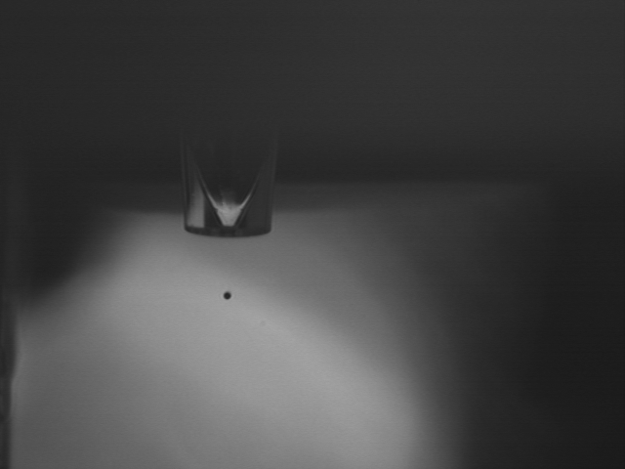
91.601 mm
91.401mm
91.301mm
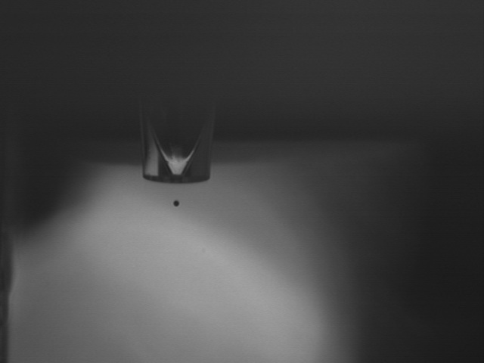
100 µs
200 µs
400 µs
(b)
Figure 5.5 (a) The calibration of the computer screen to determine the pixels per mm is used to determine the (b) volume and velocity measurements from different strobe delays.
The measurement of the volume of the droplets can be cumbersome using microbalance system. According to Wu et al. [226], the droplet morphology can be analyzed by a computer simulation system. The calculations are performed by adjusting the stage at different heights (Figure 5.5 (a)) and the images are captured using the CCD camera. In doing so, the pixels in the screen can be calibrated to a length measurement. The volume of the droplets can be measured similarly using the pixels and the formula for the volume of a sphere. Capturing the droplets at different strobe delays (Figure 5.5 (b)) was used to calculate the distance traveled by the droplet and determine the velocity of the droplet as it lands on the substrate.

5.2.1 VaporJet Vapor Calibrator
MicroFab technology developed a commercial piezoelectric printer in the form of a vapor from recent developments at NIST [221]. The vapor generator uses the same piezoelectric technology to form uniform-sized microdrops. A similar waveform is used for generation of uniform-sized droplets without formation of satellites. The liquid drops are then converted to vapors by depositing the drops into a heating element, in which the vapors are carried by a flow of gas towards the exit window to be detected by the analytical instrument. Similarly, the visualization of the droplets is achieved using a CCD camera, allowing precise microdrop formation. The components of the VaporJet vapor calibrator is shown in Figure 5.6 (a) with a close-up to the main components in Figure 5.6 (b). All the major components of the instrument are controlled through computer software in order to obtain a user-defined profile specific for the user’s specifications. The liquid solution is contained in a reservoir connected with tubing to allow for the solution to flow through the piezoelectric orifice.
(a)
(b)
Figure 5.6 Instrumental components of the VaporJet vapor calibrator. (a) Overall VaporJet components with (b) close-up to the jetting device configuration [228].
In order to avoid overloading the heating element with solution, the heating element can be retracted and a sample vial can be inserted as a waste reservoir as well as the ability to obtain weight measurements for volume calculations. Once the optimized parameters used result in a steady stream of droplets with no satellites, then the heating element can be repositioned for vapor production.
The VaporJet Calibrator allows two jetting modes, dose mode and continuous mode. Dose mode generates a burst of drops onto the heating element and the drops are heated and evaporated by a user-defined temperature profile. The heating profile is a series of ramps that are defined as T_{base} (ambient temperature in order to prevent any variation from the environmental temperature), T_{evap} (temperature of evaporation of the solvent), T_{vap} (temperature of vaporization for analyte of interest) and T_{clean} (elevated temperatures to remove any residual chemicals from the run). The dose operational mode allows a preprogrammed temperature gradient for evaporation of the solvent and analyte separately which is beneficial for detectors that are sensitive to the analyte solvent. The other mode, continuous mode, vaporizes the droplets in a continuous manner where the heater is set at a constant temperature, producing a continuous stream of vapors.

5.2.2 Microdrop Generator and Vapor Generator Parameters
A commercial piezoelectric printer was used to generate ultra-low quantities of target analyte mass in the form of a vapor in order to evaluate the mass calibration and extraction efficiency of vapors in PSPME devices coupled to ion mobility spectrometry (IMS) systems, allowing precise control of known amounts of vapors to be released and subsequently extracted by the PSPME. Compounds of interest include explosives such as 2,4,6-trinitrotoluene (TNT) and TATP as well as volatile stabilizers found in smokeless powders such as 2,4-dinitrotoluene (2,4-DNT), diphenylamine (DPA) and ethyl centralite (EC). The volatile chemical compounds of explosives provide the identification of smokeless powders which are typically used as improvised explosives [51] and will be used as a model for explosive detection. Signature volatile vapors associated with the illicit drugs cocaine (methyl benzoate) and MDMA (piperonal) were also targeted rather than the active drug by itself [61, 107].
A Jetlab® 4 (MicroFab Technologies Inc., Plano, Texas) Microdrop printer was used to print ultra-low volumes of standard solutions on a PSPME device. A VaporJet Calibrator (MicroFab Technologies Inc., Plano, Texas) was used to print ultra-low quantities of target analyte mass in the form of a vapor, collected by a PSPME device at the opening of the chamber. Both instruments utilize piezoelectric nozzles for delivery of picoliter of standard solutions. The microdrop generation experiments utilized a 60 µm piezoelectric nozzle was used whereas the vapor generator was configured with a 40 µm piezoelectric nozzle. Microdrop generating instruments conditions were optimized by using 2-butanol as the solvent to print reproducible droplets with similar sizes and velocities. The bipolar waveform conditions were also adjusted in order to produce consistent droplets, where the drop volume was calculated by using the volume of a sphere [147]. Other operation conditions applied on the vapor generator are shown in Figure 5.6. Temperature was chosen for both printing stability and compound stability. The boiling points of most of the analytes exceed 100 °C; however, the vapor pressure of most compounds is sufficiently high at the selected elevated temperature resulting in primarily existing as vapors in the chamber with minor analyte decomposition.
Table 5.6 Operating conditions of the VaporJet Calibrator instrument.
Jetting parameters | Original Configuration | Modified Configuration
Flow rate (mL min−1) | 50 | 50
Heater temperature (°C) | 100 | 100
Frequency (Hz) | 300 | 300
Drop volume (µL/s) | 0.025 ± 0.003 | 0.018 ± 0.003

Two different physical configurations of the vapor generator instrument were evaluated to optimize the performance for vapor production and collection. The original configuration arranges the microdrop orifice to generate the microdrops vertically (Figure 5.7 (a)). A modified configuration was also used in which placed the chamber at a 90° angle where the microdrop nozzle generated microdrops horizontally in order for the vapors to exit from the top of the jetting device (Figure 5.7 (b)) as proposed in similar technology developed at NIST [221, 231]. Because of the physical configuration modification, higher droplet velocity was required in the new setup in order to successfully target the droplets onto the heating element, resulting in smaller drop volume. Drop volume for the microdrops produced using the original physical configuration was calculated to be 0.025 ± 0.003 µL s⁻¹ and the modified physical configuration was calculated to have a drop volume of 0.018 ± 0.003 µL s⁻¹.

(a)  Air Flow  Vapor Generation  Heating element  Jetting device | (b)  Air Flow  Vapor Generation  Heating element  Jetting device
Figure 5.7 (a) Original configuration of the VaporJet Calibrator vapor-generating chamber and (b) modified physical configuration of the VaporJet Calibrator vapor-generating chamber.

5.3 Receiver Operating Characteristic Curves Study
The research study reports, for the first time, the development of ROC curves of the non-contact sampling of PSPME coupled with IMS detection including real-world sampling scenarios. Receiver Operating Characteristic (ROC) curves were constructed to evaluate the performance of two field-portable sampling systems and explosive detection systems with defined real-world scenarios for the detection of smokeless powders as a model for explosives. Smokeless powders are typically encountered in gunshot residues and have been used in improvised explosives [51, 232]. Although smokeless powders are nonvolatile, volatile chemicals associated with the propellants and stabilizers can be used as target analytes for the detection of this class of explosives [38]. The performance of the PSPME-IMS technique was also compared with conventional fiber SPME extraction coupled to gas chromatography mass spectrometry (GC-MS) when calculating true-positive detection rates. Furthermore, several military-grade explosives were also sampled to evaluate the performance of the PSPME-IMS as a non-contact vapor sampling technique for the detection of military explosives.
The ROC curves are developed under defined scenarios. In the following chapter (Chapter 6.2.2), optimization studies were performed in order to establish a set of parameters that result with close to the sensitivity of the instrument system. The development of the ROC curves will be performed with the following defined parameters: (1) volume size, (2) sample size, (3) sampling time (static and dynamic) and (4) equilibrium time.
The ROC studies were performed for the PSPME coupled with IMS system (bench-top and portable) and SPME coupled to GC-MS. The PSPME fabrication has been previously described (Section 3.2.2) and the geometry was modified to each specific IMS system. The geometry of the PSPME was modified to a similar shape as the sampling substrate in order to fit the geometry of the MobileTrace desorbing system. The PSPME for the bench-top instrument was introduced with the assistance of a Teflon holder (Field Forensics, FL, USA) without further modification.
The different containers of varying materials and volumes sizes were used in this study, which includes metal quart and gallon cans (All-American Containers, Miami, FL, USA) of 0.94 and 3.8 L, respectively, as well as polypropylene plastic containers of 45 L (15.625 x 13.125 x 13.25 inches in dimension). Prior to use, the metal cans were baked at 100°C for over 24 hours in order to remove residual volatiles from the manufacturing process and any background volatiles adsorbed on the surfaces of the cans. The plastic containers were used without further modification but blank samples revealed no interfering compounds. A small amount of smokeless powders ranging from 10-500 mg of Alliant Powder Unique (AU) (Radford, VA, USA), IMR Powder Co. 4198 (Shawnee Mission, KS, USA) was placed in the container itself or first in a petridish (Fisher Scientific, USA) then in the container and immediately sealed. Equilibrium studies were performed by static headspace sampling of 10 minutes at different elapsed time (0-72 hrs) in triplicates. The observed signal was then plotted with respect to the elapsed time to determine the headspace equilibrium within a given volume. Headspace PSPME extractions were performed statically, in which the PSPME is exposed to the headspace of the closed system for a given amount of time, as well as dynamically with the assistance of air flow using the Barringer remote DC sampler at 0.17 L s⁻¹ for no more than 1 minute. Dynamic extractions were performed by lifting the lid of the containers and sampling with the lid on top of the sampling device in order to contain the vapors. Thirty replicates were performed for the TPR studies for the different defined scenarios.
Solid phase microextraction (SPME) with GC-MS detection were performing using the same quart and gallon cans as used for the PSPME-IMS studies; however, a hole was punctured on the top lid of each container and sealed with a red rubber sleeve stopper which was used for introduction of the SPME fiber into the sealed system for the headspace extraction. Exposure of the fiber for certain amount of time (5-60 mins), it was retracted and then analyzed by GS-MS. Similarly, a hole on top of the cardboard boxes were punctured and sealed with a red rubber sleeve stopper. Plastic containers did not require any modification as the SPME fiber was adhered to the top lid of the container using adhesive tape.
Military explosives including cyclotrimethyl-enetrinitramine (RDX), pentaerythritol tetranitrate (PETN), erythritol tetranitrate (ETN), nitroglycerin (NG) and ethylene glycol dinitrate (EGDN) were synthesized and characterized by the Tyndall Air Force Base (Panama City, FL, USA). All handling and disposing of the explosives were carried out by explosives team. The solid explosives were weighed to 500 mg and placed in a glass watch glass or small plastic container and then placed in the 3-4 L plastic container (Sterilite Corporation, Townsend, MA, USA). For the liquid explosives (NG & EGDN), the plastic bottle originally containing the explosive itself was directly placed in the 3-4 L plastic container with the removal of the bottle lid. Empty explosive wrappers (TNT and C4) were placed in a plastic bag in order to allow for headspace equilibrium. Sampling was performed by opening the plastic bag and placing the nose of the air sampler at the opening of the plastic bag. Detection of these explosives was performed in the portable IMS. Equilibrium time of maximum 2 hours was given for the different military explosives as a consequence of the time restriction of this research in order to obtain reasonable amount of replicates for the TPR study.

Results and Discussion

6.1 Calibration and Evaluation of PSPME
Calibration of the PSPME for vapors of explosives and volatile chemical compounds associated with explosives and illicit drugs was performed using the vapor calibrator. Microdrop printing onto the substrate allowed for the evaluation of the extraction efficiency and the limits of detection for the PSPME and IMS detection. Furthermore, extraction efficiency and retention studies were performed in comparison with other substrates to validate the sorbent PDMS phase performance for headspace analysis.

6.1.1 Optimization of Microdrop Vapor Generator Parameters
Prior to utilizing the vapor generator for calibration and evaluation of the PSPME sampling substrate, several parameters were optimized for optimum vapor generation.

6.1.1.1 Dose versus continuous mode
The evaluation of the two different operating mode was performed by reproducing a calibration curve in the dose mode using a 100 ng µL⁻¹ TNT solution (Figure 6.1 (a)) and IMS detector with different extraction times in comparison to the continuous mode using a 10 ng uL⁻¹ TNT solution (Figure 6.1 (b)). The results were plotted with the observed signal in the IMS system (CumA, d.u.) and showed that the dose mode was inadequate for the evaluation purpose because of the high RSD observed between experiments. The poor precision could be caused by co-evaporation of analytes and solvent and loss of signal to the chamber surrounding during the vapor generation period.
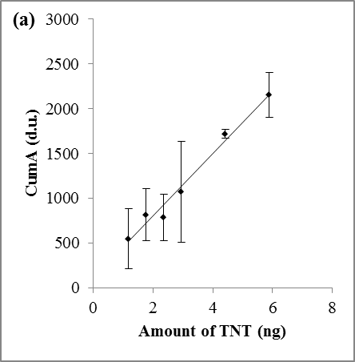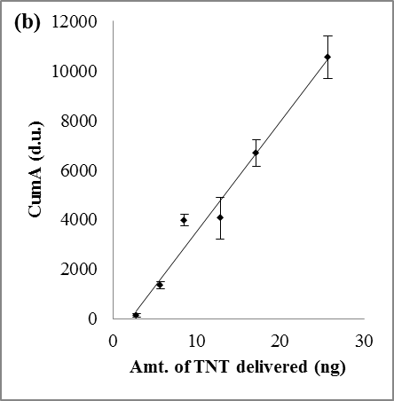
Figure 6.1 Response curves of TNT in IMS using the (a) dose mode and (b) continuous mode. Different amounts of drops of 100 ppm TNT solution (in 2-butanol) were jetted onto the heating element with the programmed profile: T_{base} = 25 °C, T_{evap} = 50 °C, T_{vap} =150 °C, T_{clean} =300 °C.

6.1.1.2 Steady-state delivery
When using the vapor generating device in the continuous mode, a constant delivery of the analyte onto the PSPME device depends on the equilibrium established in the system chamber. Five seconds extraction was performed at different elapsed time to evaluate when the system reaches the steady state. The response signal corresponding to the elapsed time is shown in Figure 6.2. Steady-state delivery of the analyte was reached after 30 minutes of continuous jetting.

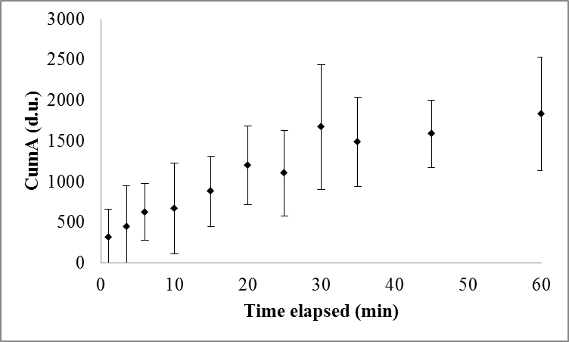
Figure 6.2 Signal response of the IMS instrument of TNT vapors collected at different elapsed time (n = 3) to determine the steady-state delivery of analyte using the vapor generator.

6.1.1.3 Effect of flow rate
Air flow is utilized for the assistance of vapors to exit from the open end of the chamber. The effect of air flow rates on amount delivered on the PSPME device was monitored by collecting the vapors at the opening of the vapor generator chamber at different time periods and detecting with an IMS instrument. Air flow rates of 10, 30, and 50 mL min⁻¹ were used to optimize the amount of analyte (TNT) delivered (Figure 6.3). The optimum air flow rate was determined to be 30 ml min⁻¹ while higher air flow rates, such as 50 mL min⁻¹, were observed to have similar effects as that of 30ml min⁻¹ resulting with a minimum flow rate of 30 mL min⁻¹ is required for the maximum amount of vapors to exit the chamber.

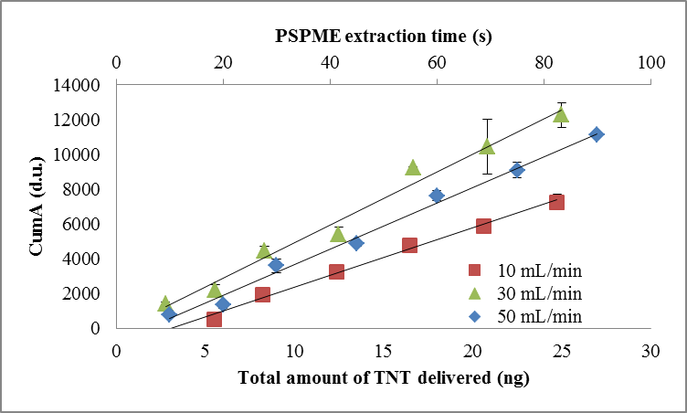
Figure 6.3 Signal response of IMS instrument with different extraction time to observe air flow rate effects.

6.1.1.4 VaporJet chamber orientation
The physical configuration of the vapor generating instrument was modified by turning the chamber in such a way that the thermal vapors exit the chamber from the desired position (top) rather than the side as done in the original configuration. The horizontal configuration was used in previous studies by Verkouteren et al. [221, 227] and a comparison study of the two configurations was investigated.
The modified physical configuration required an increase in the velocity of the microdrop in order for the microdrops traveling horizontally to come into contact with the heated ceramic plate and successfully vaporize the droplet and generate vapors. The increase in velocity of the microdrops resulted in greater volume and mass of the analyte delivered on the PSPME compared to the similar extraction time performed using the original configuration. Figure 6.4 shows the response curves of TNT on the PSPME using the two different configurations. Although the intensity detected was greater for the modified physical configuration of the vapor generator when extracting the vapors for the same amount of time, the amount of vapors generated in the chamber was also greater for the modified physical configuration. Comparing both configurations shows that the instrument performs similarly regardless which configuration is applied. Accordingly, the following experiments were conducted in the original physical configuration of the vapor generating instrument.

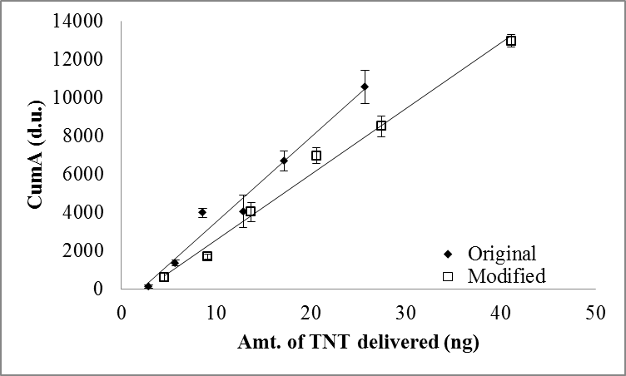
Figure 6.4 IMS signal response for PSPME extractions of TNT vapors using two different VaporJet physical configurations.

6.1.2 Limits of Detection of PSPME of Vapors Associated with Illicit Substances

6.1.2.1 Limit of detection for explosives and their associated volatile compounds
Extraction curves of the explosive vapors were generated by extracting the vapors generated using the PSPME device for different extraction times. The amount of analyte vapors generated by the instrument was determined by calculating the total volume of the microdrops generated from the vapor calibrator orifice at a constant jetting frequency for different extraction times (Figure 6.5). The response curve was used to calculate the limit of detection (LOD) as well as the precision in the form of relative standard deviation (RSD) for the vapors associated with the explosive. The limits of detection for TNT (Figure 6.5 (a)) and 2,4-DNT (Figure 6.5 (b)) vapors by PSPME were noted to be 2.3 ng with an RSD of ~7% and 3.7 ng with an RSD of ~10%, respectively.
One desorption was inadequate to completely desorb the DPA and EC when extracted by PSPME (Figure 6.5 (a) and (b)), causing further detection and alarm for these analytes after subsequent desorptions. Multiple desorption of the PSPME allowed for semi-quantitative analysis of the vapors collected via PSPME. As a result, the limit of detection of DPA was 24 ng with RSD value of 12%; the limit of detection for EC was 0.5 ng with a RSD of 8%.

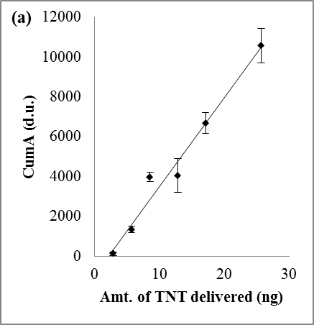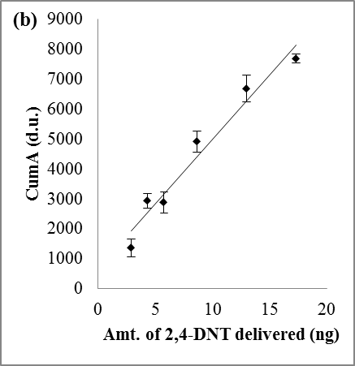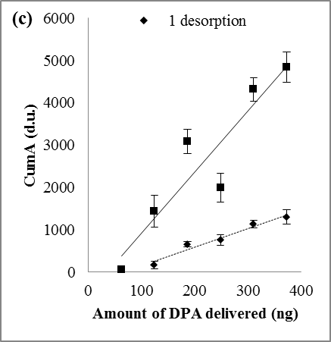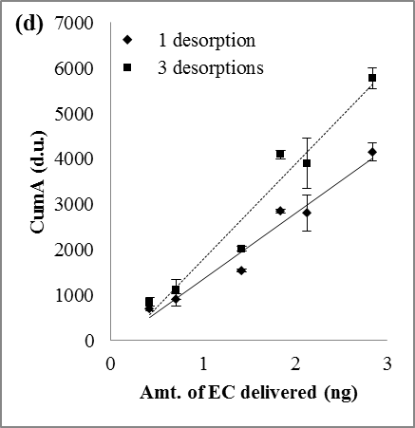
Figure 6.5 PSPME desorption profiles for (a) TNT, (b) 2,4-DNT, (c) DPA and (d) EC. Multiple desorptions for DPA and EC was performed to fully desorb the analyte from the PSPME device.

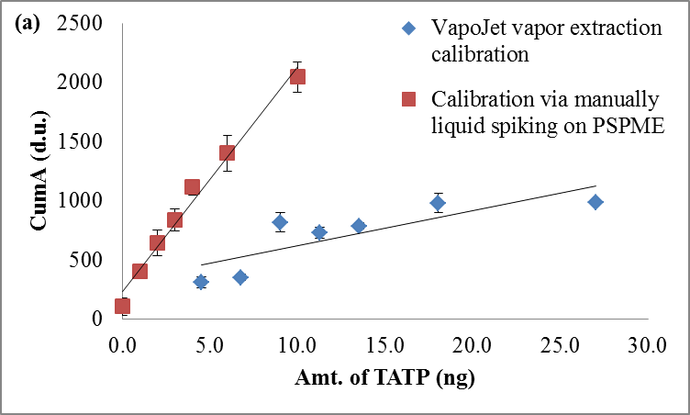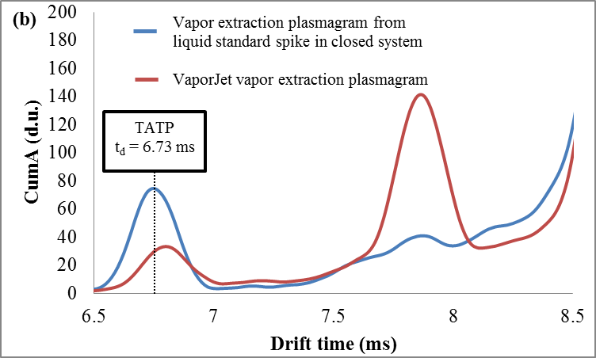
Figure 6.6 (a) PSPME desorption profiles for TATP from VaporJet delivery and manual spiking; (b) IMS plasmagrams of TATP from headspace extraction and VaporJet extraction.
Although the vapor generating instrument was capable of producing reproducible vapors for most explosives, this technique is not suitable for thermally labile compounds such as TATP [233]. A comparison of the IMS response curves observed for manually delivering liquid standard solutions of varying concentrations of TATP onto the PSPME and vapors collected on the PSPME via the generated vapors is shown in Figure 6.6 (a). Since the vapor generating mechanism for the vapor calibrator requires thermal heating upon deposition on the heating plate, decomposition is evident on the IMS plasmagram for vapor extractions using the vapor calibrator, obtaining decreased signal for similar vapor extraction technique performed by depositing the same amount of TATP in a closed system and extracted for 5 minutes (Figure 6.6 (b)). Furthermore, the ions observed in the IMS instrument result in a signal with a different drift time and detection window (6.73 ms) as well as a more pronounced unidentified decomposition signal (~7.85 ms). The difference in drift time and presence of other species from thermal vapor generation signifies that a different ionic species is being formed with a different collisional cross-section rather than the TATP ions typically observed from the explosive headspace.

6.1.2.2 Limit of detection for illicit drugs and their associated volatile signatures
Methyl benzoate and piperonal, the volatile chemical compounds associated with cocaine and MDMA, were detected using the GE Itemiser 2 IMS because of the ability to adjust to the desired drift tube temperature and instrumental air flows necessary for detection. Signal response of the IMS instrument (in Height, mV) were plotted to determine the desorption profiles using the vapor calibrator (Figure 6.7) and the limits of detection for these two analytes were observed as 14 ng (RSD 2%) and 2.8 ng (RSD 10%) for methyl benzoate and piperonal, respectively. The detection limits for illicit drugs were higher than those of explosives which could be as a result of the different thermal desorption mechanism of the two commercial instruments. The IONSCAN 400B introduces the substrate into a closed system where the heated anvil comes in contact with the substrate to allow prevent loss of analyte. The desorbing interface of the Itemiser 2 could provide some loss since its design is primarily for particle swabbing and for larger substrates [234]. The thermal desorption unit is not a closed system which can allow loss of vapors entering the IMS detector upon heating the substrate.
The limits of detection calculated from the generated vapors are higher compared to the liquid standards delivered on the PSPME by microdrop printing which is because of the distribution of the vapors of the analyte of interest with the PDMS-sorbent on the PSPME device rather than absolute deposition of analyte on the PSPME device. However, vapor calibration is a more accurate representation of the limits of detection of vapors for the PSPME headspace sampling. The VaporJet calibrator has proven to produce reproducible results with low RSD values (Table 6.1) with the average values of less than 12%. The use of piezoelectric microdrop vapor generating device allows for the determination of the limits of detection of the vapors generated from an explosive or illicit substance by PSPME followed by IMS detection.

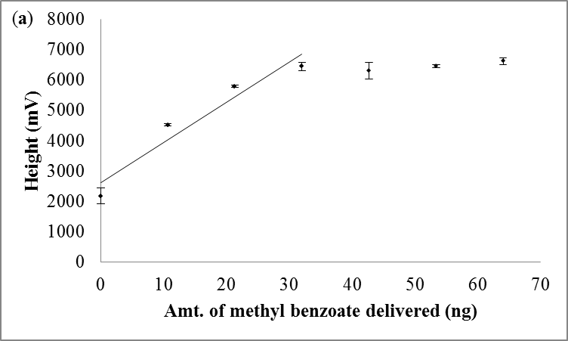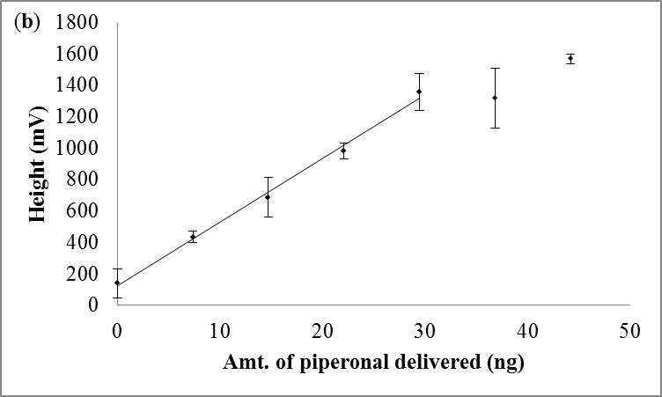
Figure 6.7 PSPME desorption profiles for (a) methyl benzoate and (b) piperonal.

Table 6.1 Limits of detection and precision (as RSD, %) for explosives and illicit drugs from vapor and liquid calibrations.
 |  |  | RSD (%) |  | Extraction Efficiency (%)
 | Compound | LOD (ng) | Range | Average | Average
Vapor calibration using Vapor Calibrator | TNT | 2 | 1-5 | 3 | 18
Vapor calibration using Vapor Calibrator | 2,4-DNT | 4 | 2-7 | 5 | 24
Vapor calibration using Vapor Calibrator | DPA | 24 | 5-16 | 9 | 7
Vapor calibration using Vapor Calibrator | TATP | 17 | 1-9 | 6 | n/a
Vapor calibration using Vapor Calibrator | EC | 0.5 | 1-14 | 6 | 19
Vapor calibration using Vapor Calibrator | Methyl benzoate | 14 | 1-4 | 2 | 51
Vapor calibration using Vapor Calibrator | Piperonal | 3 | 2-14 | 8 | 80
Direct deposition using microdrop generation/Manual spiking(*) | TNT | 0.4 | 4-11 | 8
 | 2,4-DNT | 0.5 | 6-30 | 15
 | DPA | 10 | 3-16 | 9
 | TATP* | 1 | 2-9 | 3
 | EC | 0.4 | 5-12 | 7
 | Methyl benzoate | 0.5 | 0.5-10 | 5.5
 | Piperonal | 4 | 4-21 | 11

6.1.3 PSPME Extraction Performance Evaluation
Calibration curves of the analytes of interest were also generated by using the microdrop generator or direct spiking using a micropipette in order to determine the extraction efficiency of the analyte of interest by PSPME, which is defined as the mass detected divided by the mass available. The use of a microdispenser for delivery of picoliter volumes of analyte allows for a more accurate response of the analyte with no or little interferences caused by solvents [147]. A summary of the limits of detection and RSD values obtained from the microdrop printing are also shown in Table 6.1. The extraction efficiency of the PSPME varies for each analyte in consequence of the analyte-phase chemistry selectivity [235]. The coating of the PSPME is a sol-gel based PDMS [37, 38] which is widely used for general applications as well as detection of non-polar volatile components in explosives and drugs [34, 35]. The calculated extraction efficiencies for the analytes of interest are summarized in Table 6.1 as well. For most of the analytes associated with explosives, the extraction efficiency was observed to be approximately 20%, while diphenylamine showed a much lower recovery (7%). The lower recovery of the analyte could be caused by the higher partitioning coefficient (K) between the sample and the PSPME coating resulting in lower recovery of the analyte [235, 236] as well as loss of analyte between multiple desorptions, as previously observed. Furthermore, extraction efficiencies for TNT using the two different physical configurations of the instrument allow further evaluation of the physical configurations of the instrument. Using the original configuration, the recovery of TNT was determined to be 18% which was slightly higher compared to the modified physical configuration (15%) recovery of TNT; however, the extraction efficiency of both physical configuration concluded to similar results.
Signature compounds associated with illicit drugs the extraction efficiencies were much higher than the previous calculated extraction efficiencies of explosives and their volatile signature compounds, resulting with 51% for methyl benzoate and 80% for piperonal. Calibration curves produced by direct spiking of standard solutions on the PSPME surface using a micropipette caused decreased responses from competitive ionization between analytes and solvent [81, 120, 121] which suppressed the analyte signal. Vapor extractions were done in the presence of very low amount of solvents which did not suffer from signal suppression, as shown in Figure 6.8. Calibration for methyl benzoate and piperonal were also performed using the microdrop generator using higher concentration solutions onto a PSPME device, observing less interference observed from the solvent. The extraction efficiencies for explosives and illicit drugs has shown to decrease the sampling time, providing approximately twenty fold increase in extraction efficiency from the enhanced surface area and phase volume of the PSPME comparison to the commercial SPME [1].

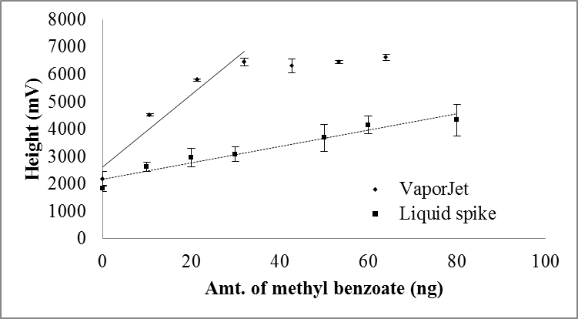
Figure 6.8 Signal responses comparison between vapors generated calibration (solid line) and direct liquid spiking (dotted line) on PSPME.

6.1.3.1 Performance comparison of different substrates
The extraction and retention capabilities of PSPME were compared to other sampling substrates such as the commercially used Teflon coated swabs and uncoated glass filters. These filters are the default manufactured substrates typically used for particle swabbing. A variety of different methods can be used to introduce the sample into the IMS detection instrument. Since particle swabbing has led to high false positives in high clutter environments [30], static and dynamic extractions using PSPME and the other substrates were used for the extraction efficiencies and retention of volatile organic compounds associated with the illicit substances cocaine and MDMA.
The performance of PSPME was compared with an uncoated glass filter in order to observe the extraction improvements upon coating with the sol-gel based PDMS. Furthermore, two different particle swabbing substrates from two commercial IMS systems were used in this comparison study. A common sampling substrate for particle sampling is Teflon coated fiberglass, used in the Morpho Detection IMS instruments as well as the Thermo Egis Defender (GC-DMS). The Teflon coated fiberglass contains a Teflon coating which makes it relatively inert with other chemical compounds. The porous surface allows for complete desorption of the analytes adsorbed to the surface (Figure 5.1). Another substrate is a common substrate used for by Smiths Detection IONSCAN 400B instruments which comprises of cellulosic fabric with adsorptive and absorptive properties able to withstand high heat [237]. The cotton swab has an air permeability of 125 ft³ min⁻¹ (3500 L min⁻¹), allowing for vapor and particle sampling.

Static headspace extractions studies
Static headspace extractions were performed by spiking standard solutions of varying concentrations 10-100 ng µL⁻¹) in a quart metal can and allowed to equilibrate for 10 minutes. The responses of 10 minute static extractions from the different substrates are shown in Figure 6.9for methyl benzoate and piperonal, (a) and (b) respectively. A more detailed summary of the results for methyl benzoate is summarized in Table 6.2. The PSPME device was observed to have the highest extraction efficiency of approximately 19% for methyl benzoate whereas the other substrates which include the manufacturers’ filters resulted with 3% and 6% recovery of methyl benzoate for the cotton swab and Teflon trap, respectively. The uncoated glass filters was determined to have an extraction efficiency of approximately 6%, thus the PDMS coating offers greater than 3 fold increase in extraction efficiency as compared to the untreated glass filter.
Furthermore, the extraction efficiency of PSPME from the extraction of piperonal was observed to be approximately 6%, offering 6 time fold increase of in comparison to the OEM filters (resulting with <1% extraction performance). Unfortunately, the background of the uncoated glass filters observed a background signal similar to piperonal, obtaining false negative results and the extraction efficiency for the uncoated glass filter substrate were terminated. Overall, the PSPME resulted in greater extraction performance in comparison to the other substrates used in commercial IMS instruments. The Teflon sampling device was determined to have the worst headspace extraction performance, having an average extraction efficiency of 3.2% for methyl benzoate. The inert Teflon surface had in poor retention of vapors of methyl benzoate containing polar carbonyl functional groups. The cotton filter, which can be used for both vapor and particle sampling, resulted with an extraction efficiency of 6%, requiring a minimum of 300 ng of piperonal for detection in the headspace. The cellulosic fabric contains some active polar sites that provide adsorption of polar compounds and the porous surface allows absorption, combining different modes of interaction with the analyte. However, the different chemistry provided by this sampling swab did not provide greater extraction efficiency from the porous sol-gel PDMS surface.
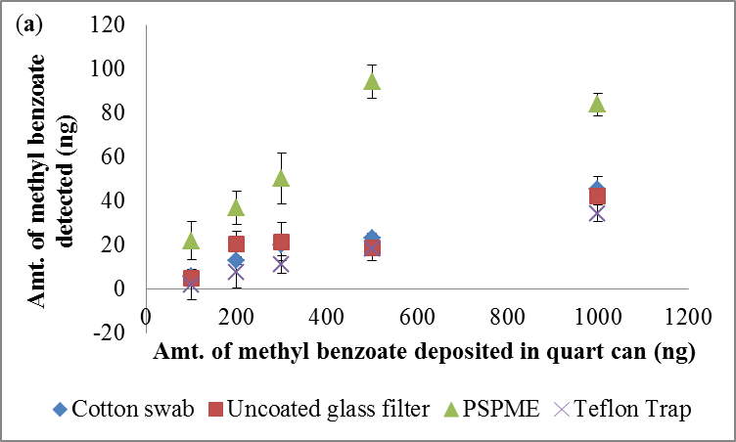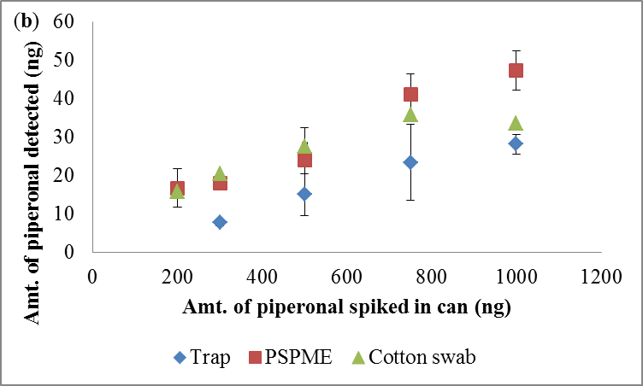
Figure 6.9 Extraction efficiency for different substrates for (a) methyl benzoate and (b) piperonal.

Table 6.2 Extraction efficiency for the different substrates from 10 µL spike of standard solutions ranging from 10 – 100 ng µL⁻¹.
 | Cotton filter |  | PSPME |  | Uncoated glass filter |  | Teflon Trap
Amount of methyl benzoate (ng) | Amount extract-ed (ng) | Extract-ion efficien-cy % | Amount extract-ed (ng) | Extract-ion efficien-cy % | Amount extract-ed (ng) | Extract-ion efficien-cy % | Amount extract-ed (ng) | Extract-ion efficien-cy %
100 | 6.0 | 6.0 | 22 | 22 | 4.8 | 4.8 | 2.0 | 2.0
200 | 13 | 6.5 | 37 | 18 | 21 | 10 | 7.4 | 3.7
300 | 20 | 6.7 | 50 | 17 | 22 | 7.2 | 11 | 3.7
500 | 23 | 4.6 | 94 | 19 | 19 | 3.7 | 18 | 3.7
1000 | 45 | 4.5 | 84 | 8.4 | 42 | 4.2 | 34 | 3.4
Average Extract-ion Efficiency | 6.0 |  | 19 |  | 6.5 |  | 3.2

Dynamic headspace extraction studies
Dynamic extractions of 10-30 second of methyl benzoate were sufficient for the detection in IMS systems using PSPME (depleting the reactant ion peak) as shown in Figure 6.10. The uncoated glass filter resulted with detection but poor sensitivity and large background whereas the Teflon trap required more than 30 seconds dynamic extraction for detection of methyl benzoate. In addition, the depletion of the reactant ion peak using the manufacturer sampling swabs signifies that these substrates are extracting other vapors and/or particles that are not readily detected using the IMS system as well as possible breakthrough from the large sampling volume. The dynamic headspace sampling using the cotton, Teflon or uncoated glass filter does not have preferential extraction of the target analytes as observed using a PDMS surface chemistry from the PSPME device. Increased extraction time will show small improvement in the detection of the target analytes since the pool of ions responsible for ionization of the vapors entering the system is depleted from the ionization of other unwanted vapors and will not be sufficient to ionize the target analytes.
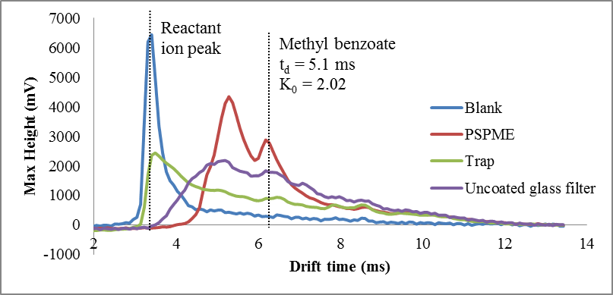
Figure 6.10 IMS plasmagrams for 30 second dynamic extractions of 100µg methyl benzoate (spiked in a quart can and equilibrated for 10 minutes) using three different substrates.

6.1.4 PSPME Retention of Analytes Associated with Illicit Drugs
Retention capability of methyl benzoate (Figure 6.11 (a)) was performed by spiking 50ng of methyl benzoate unto the different substrates and the signal was recorded after a given elapsed time from initial spike. From this study, it is shown that the PSPME device is capable of retaining more than 50% of the sample after 1 hr of delayed analysis time. The PSPME device is capable of retaining methyl benzoate after 30 minutes, whereas methyl benzoate is depleted for most of the untreated substrates after the same delayed analysis time. The retention of methyl benzoate was the worst for the Teflon trap and cotton swab, only retaining about 30% of the sample after a delayed detection of 5 minutes. The absorptive effects of the PDMS sol-gel phase are able to retain better than the adsorptive surface chemistry in the Teflon traps and uncoated cotton and glass filters. Teflon is relatively chemically inert and hydrophobic [238], resulting in little adsorption to the methyl benzoate vapor molecules. Cotton swabs and uncoated glass filters contain some alcohol and exposed silanol groups that offer some adsorptive properties with methyl benzoate; however, the retention power for these target analytes are greater for the sol-gel PDMS phase chemistry of the PSPME device.
Similarly, retention capability of piperonal was analyzed for the different substrates in which 20ng of piperonal were spiked onto the surface of the different substrates and their signal was recorded for different amount of elapsed time. The PSPME device performed similarly as that with methyl benzoate in which greater than 50% of the sample was retained after 1 hour of delayed detection (Figure 6.11 (b)). An increase in signal observed after 5 minutes of delay could be caused by the suppression of signal typically observed in IMS instruments from solvents and matrix effects [81, 122]. The cotton swabs performed well obtaining with similar retention capabilities as PSPME with short elapsed time (0-20 minutes); however, after 30 minutes, the retention greatly decreased with depletion of piperonal after 1 hour of delayed detection for both OEM filters. Thus, the absorptive interaction of the volatile organic compounds with the PDMS phase in the PSPME is much stronger and better retention versus the adsorptive properties of the Teflon coated fiberglass. The uncoated glass filter achieved some retention of piperonal but less than the amount extracted unto the PSPME device which could be because of the exposed silanol groups present in the surfaces of both substrates which has an affinity to the polar aldehyde functional group in the piperonal molecule. Retention of piperonal on the glass filter was not very reproducible with non-detect for the other replicates.
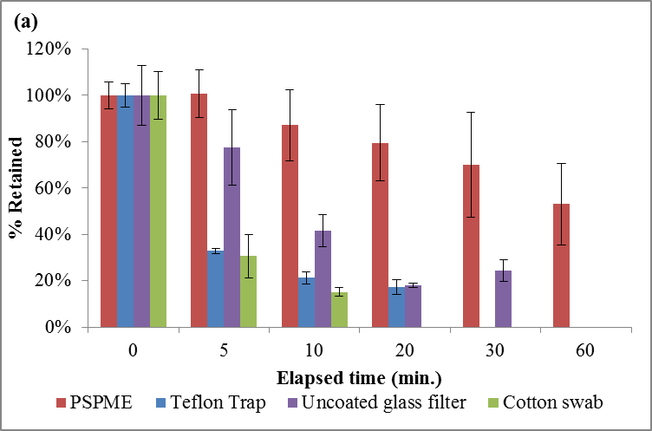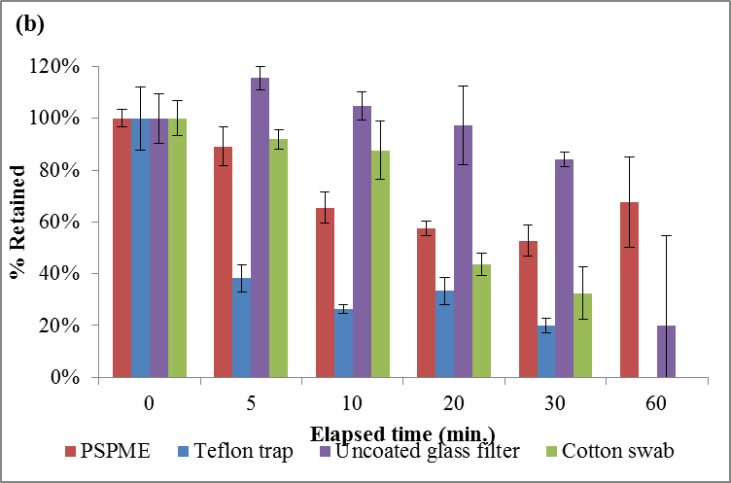
Figure 6.11 Retention capabilities of different substrates for (a) 50 ng of methyl benzoate and (b) 20 ng of piperonal.

6.1.5 Conclusions
The PSPME devices have been proven to be a universal pre-concentrator for different headspace volatiles above explosives and illicit drugs. The PSPME devices were calibrated by vapor generation using liquid standards to deliver precise amounts of the analytes in the form of vapor onto the PSPME surfaces followed by IMS detection. The PSPME extraction performance were determined for TNT, 2,4-DNT, DPA and EC ranging from 7 to 24% and for methyl benzoate and piperonal were 51% and 80%, respectively. The explosive TATP is a thermally labile chemical and decomposes on the ceramic plate during the vapor generation process; as a result, the extraction performance for this analyte was not obtained in this experiment. Moreover, the PSPME devices were calibrated using a piezoelectric microdrop printing instrument and evaluated using a vapor generating instrument for different headspace compounds related to both explosives and illicit drugs. The high surface area and phase volume allows higher capacity for the adsorption of the volatile compounds onto the PSPME surface, achieving higher extraction efficiencies, as low as 7% for DPA and as high as 24% for 2,4-DNT, with low limits of detections ranging as low as 0.5 ng for EC and a maximum of 24 ng for diphenylamine.
In conclusion, the planar solid phase microextraction (PSPME) device provides greater sensitivity and faster sampling time for the detection of volatile chemical markers associated with illicit drugs (methyl benzoate and piperonal) with increased surface area and phase volume of the PDMS extraction phase. Comparison of the manufacturer’s substrates with similar surface areas, the PSPME device offers about three times better sample recovery, providing greater signal for the same sampling time. Dynamic sampling (<10 s) of methyl benzoate obtained high sensitivity detection with detection of methyl benzoate whereas the other substrates were not successful. The uncoated glass filters and manufactured filters resulted in little to no detection with high background from extraction of unwanted vapors and particles, requiring greater sampling time for detection in the same IMS system.
Retention capability studies have been performed previously for explosives demonstrating how PSPME is capable of retaining the sample after 6 days from the initial spike [239]. For the analysis of illicit drugs, the PSPME device is capable of retaining greater than 50% of the sample after 30 min. after the analyte spike in comparison to a non-detect for the unmodified filters. The PSPME device showed superior retention capabilities for methyl benzoate; however, similar performance for the uncoated glass filter as that of the PSPME device could be because of the similar surface chemistry as that of the PSPME device, containing silanol groups that retain the polar functional groups in the piperonal molecule.

6.2 Evaluation of Techniques using Receiver Operating Characteristic Curves
Evaluation of the different techniques was achieved by determining the sensitivity of the technique on the basis of the limits of detection from the calibration curve. The ROC curves were constructed from 30 different replicates produced from the defined parameters in terms of sample volume size (0.95 – 45 L), sample size (10-500 mg), and static and dynamic sampling times (10 min static and 1 min dynamic) in terms of the true positive and false positive rate values.

6.2.1 Sensitivity of Trace Detection Instruments

6.2.1.1 PSPME-IMS sensitivity of explosives
Calibrations of ion mobility spectrometers using PSPME as the substrate show high sensitivity for the volatile organic compounds associated with explosives and illicit drugs. The calibration curves were produced by manual liquid 1 µL spikes of standard dilutions onto the PSPME substrate. High sensitivity of ethyl centralite and 2,4-DNT was observed using the bench-top IMS, with limits of detection in the sub nanogram range (Table 6.3); however, the portable IMS instrument offers similar sensitivity for NG and DPA volatile compounds. The data obtained for the bench-top IMS also agrees with the reported values from the direct deposition of microdrops onto the PSPME filter. Nitroglycerin was observed to have two dynamic ranges, one in the low concentration ranges and another dynamic range at high concentrations caused by the limited ion pool of the reactant ion peak. Calibration curves were produced on a weekly basis in order to ensure the reproducibility in the quantitation of the IMS instruments.

Table 6.3 Limits of detection and dynamic ranges for the analytes of interest in the bench-top and portable instruments.
Instrument | Compound | Linear equation | Limit of Detection (ng) | Dynamic range (ng)
IONSCAN 400B (Smiths Detection, Warren, NJ) | DPA | y = 92.887x - 407.03  R² = 0.9517 | 5 | 5-25
IONSCAN 400B (Smiths Detection, Warren, NJ) | 2,4-DNT | (y) = 918.27(x) + 3802.1  r² = 0.9997 | 0.5 | 2-15
IONSCAN 400B (Smiths Detection, Warren, NJ) | EC | y = 2978.6x + 39.2  R² = 0.9413 | 0.1 | 0.2-0.7
IONSCAN 400B (Smiths Detection, Warren, NJ) | NG | (y) = 564.25(x) + 395.17  r² = 0.9946 | 2 | 5-20
IONSCAN 400B (Smiths Detection, Warren, NJ) | NG | (y) = 169.82(x) + 8818.9  r² = 0.9829 | 2 | 20-100
Hardened MobileTrace (Morpho Detection, Newark, CA) | DPA | (y) = 89.733(x) + 251.22  r² = 0.9992 | 5 | 5-15
Hardened MobileTrace (Morpho Detection, Newark, CA) | 2,4-DNT | y = 24.124x + 173.16  R² = 0.9968 | 3 | 5-50
Hardened MobileTrace (Morpho Detection, Newark, CA) | EC | y = 154.79x + 54.46  R² = 0.9905 | 1 | 0.5-6
Hardened MobileTrace (Morpho Detection, Newark, CA) | NG | (y) = 95.103(x) - 6.6667  r² = 0.9594 | 5 | 5-20
Hardened MobileTrace (Morpho Detection, Newark, CA) | NG | (y) = 25.555x + 1444.2  r² = 0.9053 | 5 | 20-100
Hardened MobileTrace (Morpho Detection, Newark, CA) | Methyl benzoate | (y) = 23.781(x) + 219.64  r² = 0.9945 | 5 | 5-50
Hardened MobileTrace (Morpho Detection, Newark, CA) | Piperonal | (y) = 15.207(x) + 241.73  r² = 0.9517 | 3 | 10-30

6.2.1.2 PSPME-GC-DMS sensitivity of explosives
Calibration curves for the GC-DMS using the PSPME device instrument were not performed because of the poor reproducibility with limits of detection in the nanogram range. The thermal desorption interface of the instrument was not suitable for the PSPME device; the pressure applied from the heating anvil resulted in breaking the PSPME multiple times. The sampling swab was backed with a white sheet of paper with an open diameter smaller than that of the desorption anvil to prevent further destruction of the PSPME device. Another problem observed was the presence of a leakage from the poor sealing mechanism when the thermal anvil is in contact with the PSPME surface. The decrease in the desorber pressure caused a loss of analyte and decreased signals from the detector. Moreover, the 2D topograph was also affected in which the compensation voltage (VC), and the GC retention time were different from the target alarm window, as shown for the detection of TNT in Figure 6.12 (a) and (b) using the ticket and PSPME substrates, respectively. The original alarm window as set by the manufacturer gave an alarm for TNT on the ticket substrate but not on the PSPME substrate since the peak appeared outside of the alarm window. In order to use the PSPME device as a substrate, the alarms for the analytes of interest was required to be modified to compensate the pressure loss. Preliminary static extraction studies were performed with 100 mg of Red Dot smokeless powder to observe the performance of the PSPME in comparison to the default substrate. With 10 minutes of extraction time VC and the GC retention obtained similar extraction intensities for detection of NG (Figure 6.12 (b)); however, the ticket was able to extract diphenylamine vapors; on the other hand, diphenylamine vapors were not detected from the PSPME device. Thus, further true positive rate studies for PSPME coupled to the GC-DMS instrument was terminated until a better PSPME introduction mechanism is developed.

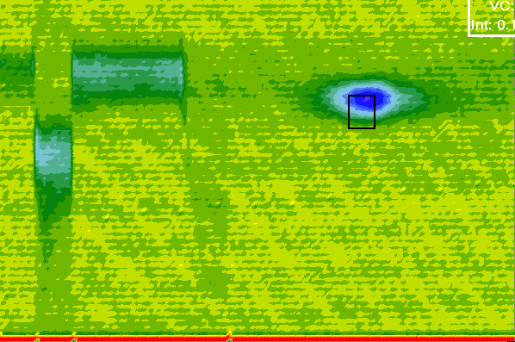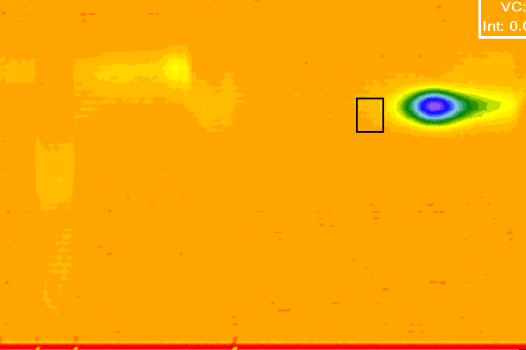
(a)
(b)
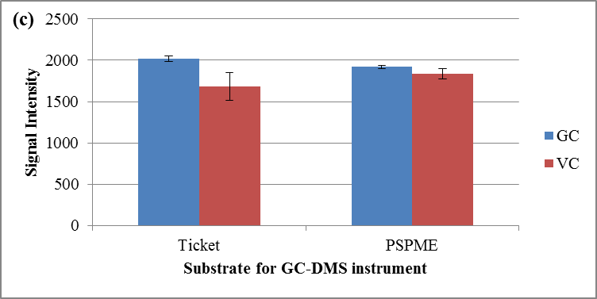
Figure 6.12 1 µL spike of 15 ng uL-1 onto the (a) ticket and (b) PSPME device; (c) static extractions of 100 mg of a commercial smokeless powder containing NG and DPA resulted with similar NG detection using the default substrate and the PSPME device.

6.2.1.3 SPME-GC-MS sensitivity of explosives
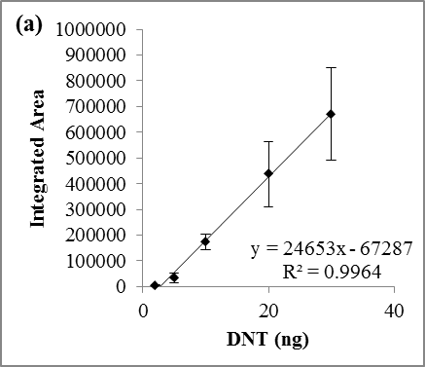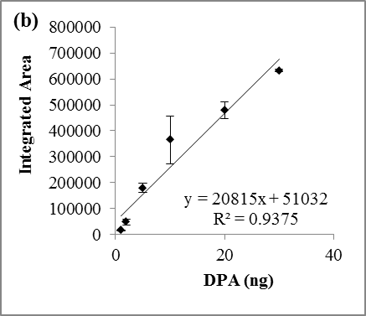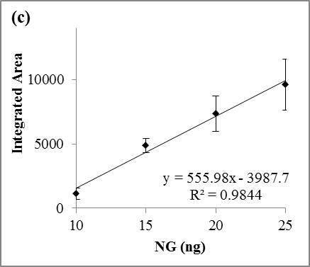
Figure 6.13 Calibration curves of (a) 2,4-DNT, (b) DPA and (c) NG in GC-MS. The detection limits were 2.4 ng for 2,4-DNT, 9.9 ng for DPA and 3.0 ng for NG.
Calibration curve for 2,4-DNT (Figure 6.8a), DPA (Figure 6.8b) and NG (Figure 6.8c) were graphed on the basis of the 1 µL direct injection in GC-MS. Concentration ranges of 1-30 ng µL⁻¹ were used for 2,4-DNT and DPA; whereas a range of 5-30 ng µL⁻¹ was used for NG from dilutions with acetonitrile as the solvent. Good linear ranges for 2,4-DNT and DPA were observed under the selected concentrations (Figure 6.13 (a) and Figure 6.13 (b), respectively); however, NG was observed to have a narrow dynamic range, as shown in Figure 6.13 (c).

6.2.2 Optimization of Defined Parameters of Real World Scenarios

6.2.2.1 Quart cans and gallon cans (0.94 and 3.8 L) for PSPME-IMS
Equilibrium was performed in the different containers as to determine the amount of time required in order to achieve optimum detection of the containers of interest. In order to establish equilibrium of nitroglycerin (NG) and diphenylamine (DPA) in quart cans, 10-100 mg of AU was placed in the quart can and sealed. At different elapsed time, the quart can was re-opened in order to place and remove the PSPME for a 10 minute static extraction. Equilibrium studies were also repeated for IMR 4198 for headspace equilibrium of 2,4-dinitrotoluene (2,4-DNT). The amount of the analyte detected was calculated to construct the equilibrium curve (Figure 6.14) using the calibration curves with the following regression line:
2,4-DNT: y = 137.88x + 243.82, r² = 0.9903 (Dynamic range: 2-20 ng) | (6-1)
NG: y = 77.35x + 165, r² = 0.9746 (Dynamic range: 10-30 ng) | (6-2)
NG: y = 11.346x + 2060.7, r² = 0.9852 (Dynamic range: 30-100 ng) | (6-3)
Equilibrium for NG was reached in approximately 2 hours; however, detection of DPA was not observed until after 24 hours of equilibrium time and 2,4-DNT required longer equilibrium time of 10 hours. Because detection of DPA required 24 hours of headspace equilibrium time, further studies needed to be performed in order to determine the headspace equilibrium for DPA but 24 hour equilibrium time was used for quart cans. Furthermore, studies of the same quart cans for greater than 24 h resulted in similar signal for NG and slightly higher signal for DPA with no observed depletion in the signal of NG or DPA in the smokeless powders.
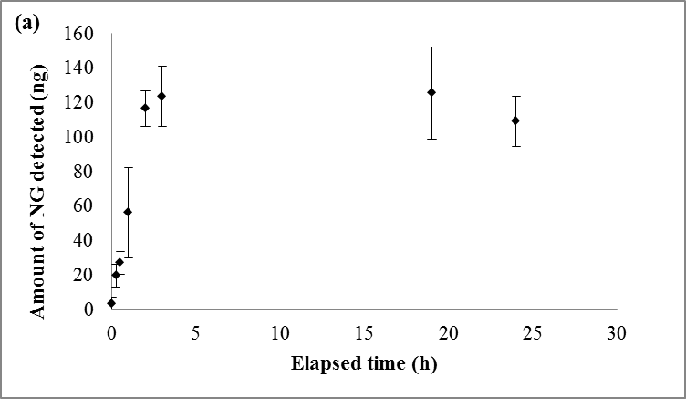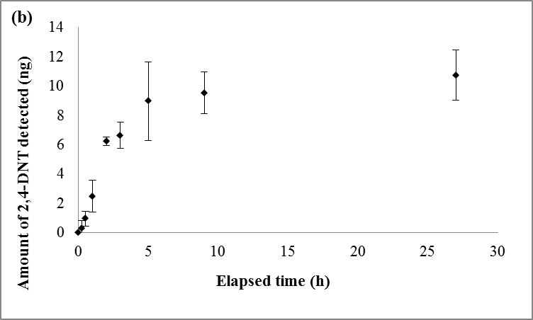
Figure 6.14 Headspace equilibrium for (a) NG from 100 mg AU smokeless powder and (b) 2,4-DNT from 100 mg IMR 4198 smokeless powder in a quart can (n=3).

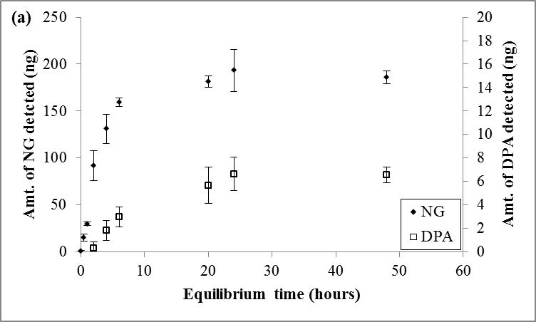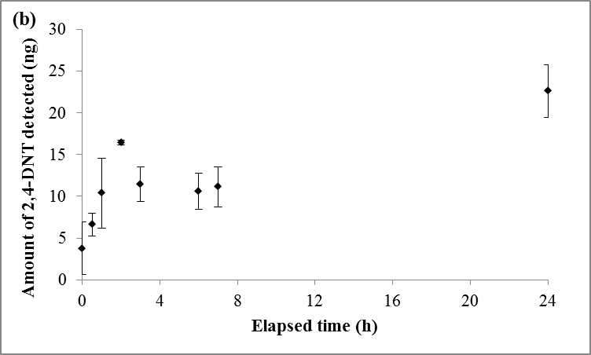
Figure 6.15 Headspace equilibrium studies for (a) NG and DPA from 100 mg AU smokeless powders in gallon cans (n=3). Amount detected at equilibrium point (> 24 hours) was approximately 6 ng for DPA and 150 ng for NG and (b) 2,4-DNT.
Additionally, optimization studies was reproduced in gallon metal cans in which 10-100 mg of AU smokeless powders was placed in the container and sealed with minor interruptions from static extractions performed in between establishing equilibrium. Equilibrium curves for DPA and NG from AU and 2,4-DNT from IMR 4198 are shown in Figure 6.15 for 100 mg of smokeless powder. Nitroglycerin was detectable without any equilibrium time, but the optimum equilibrium time was determined to be 6 hours. Unlike the quart cans, DPA was detected after 2 hours of equilibrium time, reaching equilibrium at approximately 24 hours. Thus, gallon cans studies were performed after 24 hours of equilibrium time.
The combination of low vapor pressure of ethyl centralite (EC) and relative low abundance in comparison to the other volatile chemical components in commercially available smokeless powders makes EC very hard to detect. Red Dot (RD) smokeless powder (Alliant Powder, Radford, VA, USA) was used to test PSPME performance for EC detection in which 100 mg and 500 mg of the smokeless powder were placed and sealed. All detection was conducted at least 24 hours after the cans were sealed. Equilibrium of EC using the portable IMS as the detector required a minimum sampling time of 30 minutes in order to detect EC vapors extracted on the PSPME substrate. Detection of EC in the headspace was observed after 154 hours (6-7 days) of equilibrium time. The poor sensitivity of the portable IMS system and small quantities of EC available in the headspace of the smokeless powder required further studies to be performed in the in bench-top instrument.
The bench-top IMS was used in the positive mode using the default instrument parameters and alarm for EC was added from a standard spike. Since EC is detected within 10 minutes of static headspace extraction, headspace extractions were performed for 10 minutes followed by analysis via IMS. It was observed that EC requires 72-96 hours (3-4 days) of equilibrium time in a quart can (Figure 6.16) with a detection of 3 ± 1 ng. The results of experiments for static and dynamic extractions of EC are summarized in Table 6.4.

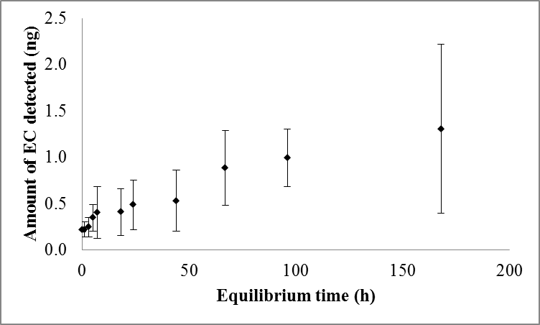
Figure 6.16 Equilibrium curve for EC from 500 mg RD in quart can (n=3). Signals observed in 10 minute static PSPME extractions were plotted to establish the equilibrium curve.
Table 6.4 Ethyl centralite sampling time optimization in quart cans (n=3).
Container | Equilibrium time (h) | Extraction | Sample size (mg) | Sampling time (min) | Amt. of EC detected from RD (in ng)
Quart can (0.94 L) | 72-96 | static | 10 | 5
Quart can (0.94 L) | 72-96 | static | 50 | 10
Quart can (0.94 L) | 72-96 | static | 100 | 10 | 0.8 ± 0.2  (27%)
Quart can (0.94 L) | 72-96 | dynamic | 10 | 1
Quart can (0.94 L) | 72-96 | dynamic | 100 | 0.5 | 0.05 ± 0.09  (173%)
 |  |  |  | 1 | 0.4 ± 0.5  (121%)

Once the equilibrium time was established, optimization of sampling times was determined for the static and dynamic extraction of smokeless powders. Because of the high signal observed from 100 mg of smokeless powders, decreased amounts of smokeless powders were used in the quart and gallon cans in order to determine the optimum sampling size. It was observed that 10 mg of smokeless powders was sufficient for detection in the bench-top IMS for NG, 2,4-DNT and DPA; however, 50 mg of smokeless powder was necessary for detection of DPA in the portable IMS system. Equilibrium experiments were repeated with 10 mg and 50 mg of AU in a gallon can and resulted in good detection of NG and 2,4-DNT from 10 min static extractions. Although detection of DPA was not favorable under these conditions, the presence of the propellant itself is a good indication of the presence of an explosive and the presence of the stabilizer DPA can be used for further confirmation of the presence of a smokeless powder.
Optimization of dynamic sampling times were performed for smokeless powders AU, RD and IMR 4198 (both AU and RD have NG and DPA whereas IMR 4198 has 2,4-DNT). The different smokeless powders (100 mg) were placed in a quart-sized can and sealed for 24h in order to establish equilibrium. After that, the cans were sampled for varying sampling times (10-180 s) in triplicates. As a result, fast detection was achieved for NG after 10 s sampling of AU and RD as well as 2,4-DNT from IMR 4198; however, the optimal sampling time was observed to be 60 s in which results with the detection of all the compounds of interest: NG, 2,4-DNT and DPA with the minimum sampling volume (Figure 6.17). Increased sampling time resulted in higher IMS signals for DPA; however, similar to the results reported above for NG, the signal for NG and 2,4-DNT reached a maximum because of the limited dynamic range of the IMS instruments. Moreover, no breakthrough was observed from longer (>5 mins) sampling times.
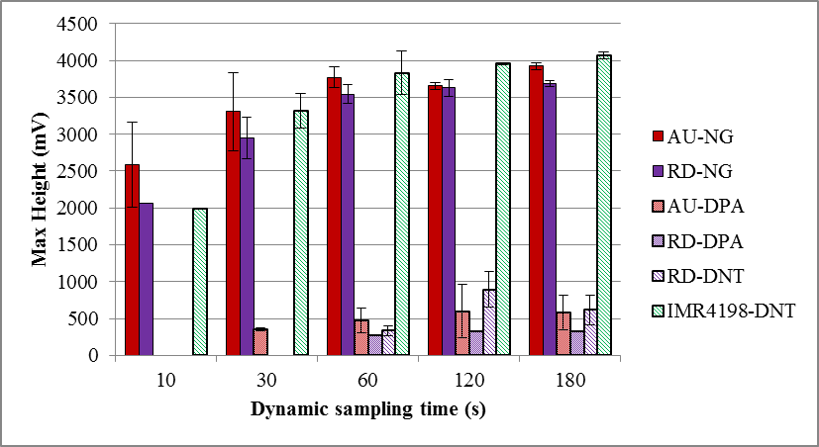
Figure 6.17 IMS signal observed for smokeless powders at different sampling times.

6.2.2.2 Cardboard boxes for PSPME-IMS
Cardboard boxes were also used for detection of the smokeless powders. Preliminary equilibrium studies have been performed using 500 mg of AU and IMR placed in quart cans and petridishes. Unfortunately, detection of NG or DPA by the portable IMS instrument has been unsuccessful because of the absorption of the volatile analytes by the porous material of the cardboard box [240]. The experiment was repeated using 1.0 g of smokeless powder placed on a petridish inside the cardboard box and sampled for 10 minutes static extraction by placing the PSPME on the top flap of the box as shown in Figure 6.18 (a).
Preliminary studies in the placement of the smokeless powder, either by initially placing the smokeless powder in a petri dish or a baked metal can, were undergone in order to observe if loss of signal for analytes of interest were observed from the adsorption to the metal can walls. It is possible to observe adsorption of the volatile organic compounds into the surface of the container enclosing the explosive. The plasmagrams obtained from 1 hour static sampling was shown that the detection of the smokeless powders was not affected by the way smokeless powder is introduced into a can (Figure 6.19); thus, further studies were prepared by placing the smokeless powder in a petri dish inside the large container. The highest signal obtained was observed with no equilibrium time, resulting with little to no detection for NG or DPA after any given elapsed time. The result of poor detection of these compounds in cardboard box is not known; however, it could be hypothesized that the nitroglycerin and other analytes have an absorption affinity to the glucose-base structures of the plant cell walls [240].
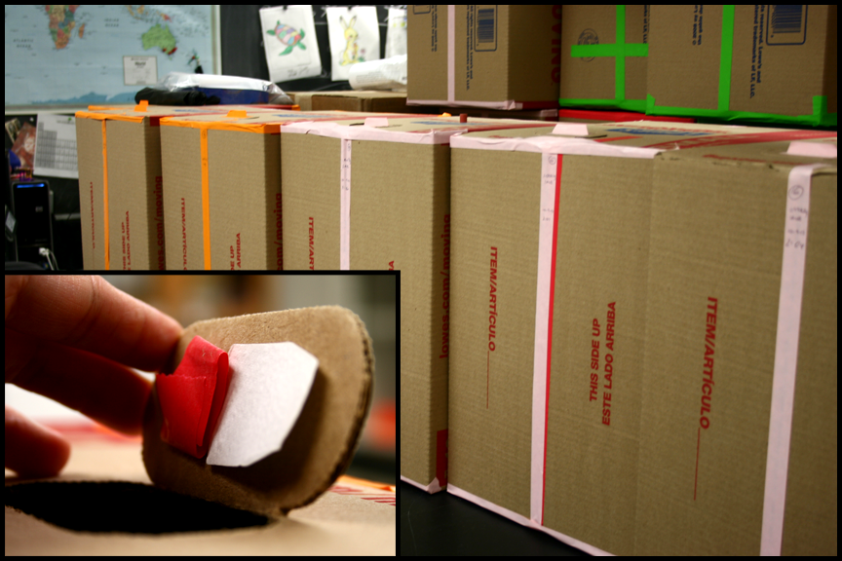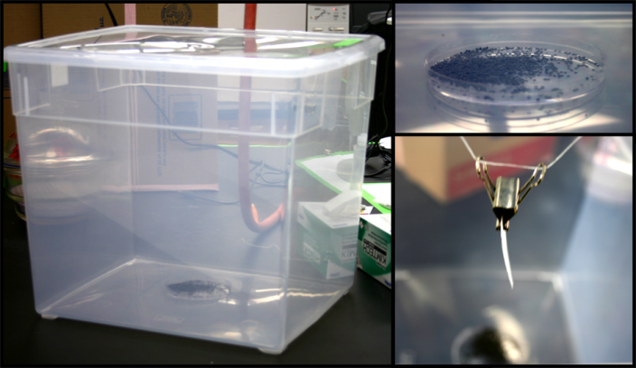
(b)
(a)
Figure 6.18 (a) Setup of cardboard boxes with (insert) display of PSPME suspension on the top flap of the boxes suspended with tape; (b) Plastic container, 15-5/8" x 13-1/8" x 13-1/4", used in this study with AU smokeless powder placed in petridish at the bottom of the container (top right) and PSPME suspended above the container using dental floss and binder clips for static extractions (bottom right).

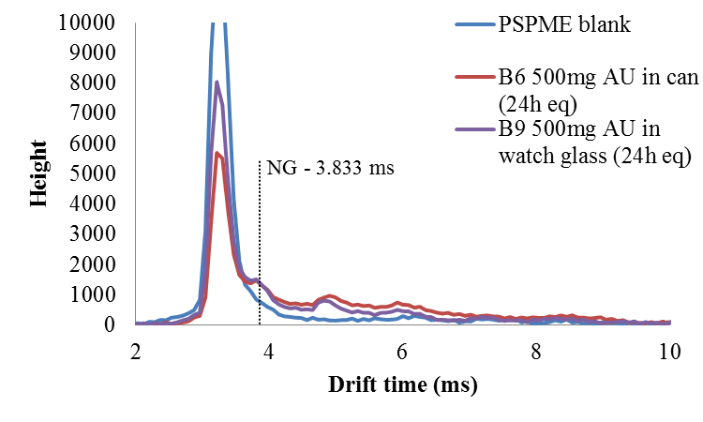
Figure 6.19 IMS plasmagram for detection of NG and DPA from 1h static PSPME sampling from 500 mg AU smokeless powder after 24 hours of equilibrium time.
Optimization of sampling size and sampling time were performed for cardboard boxes in order to obtain reliable detection of the analytes of interest within 10 minutes of static extraction that was sufficient for similar volume containers. The amount of smokeless powders ranged from 100 – 1000 mg with sampling time of 10 minutes to 120 minutes. The sampling time studies were performed after the smokeless powders have established equilibrium in the cardboard box (greater than 72 hours). After sampling, the PSPME device was detected via IMS and repeated in triplicates. Studies performed with 500 mg of AU or less resulted with poor detection of NG even after 1 hour of static extractions (Figure 6.20). A small peak was detected for NG; however, did not result with an alarm for the explosive compound since it was below the alarm threshold in the default settings.

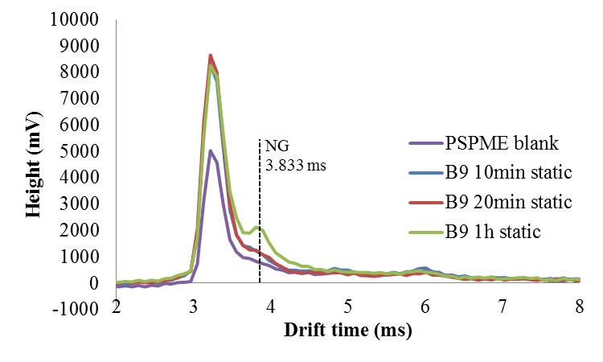
Figure 6.20 Plasmagrams for different sampling times for 500 mg AU in cardboard boxes.
The sample size was increased to 1 g of smokeless powder in the cardboard boxes in order to obtain an alarm from the minimum amount of sampling time. The optimum sampling time for NG and DPA from 1 g of AU was observed to be 60 minutes static extraction, detecting 70 ± 15 ng of NG and 0.6 ± 0.4 ng of DPA. Static extractions of 60 minutes are also adequate for IMR 4198, detecting 2 ± 0.7 ng of 2,4-DNT from 1g IMR 4198 (Figure 6.21 (a) and (b)); however, detection of DPA (approximately 1 ng) from IMR 4198 was successful after 120 minute static extraction (Figure 6.21 (c)). One possible conclusion of the observed results could be due to the small amount of DPA present in this brand of smokeless powder [241] but the alarm for 2,4-DNT confirms the presence of an explosive and longer sampling time is not necessary. Thus, the minimum extraction time is 60 minutes in cardboard boxes for the detection of the 3 analytes of interest (DPA, 2,4-DNT, and NG).
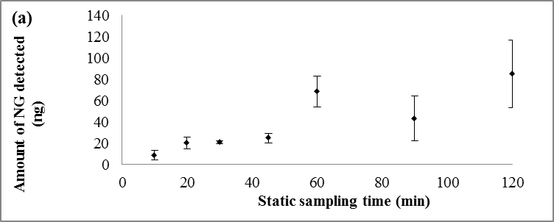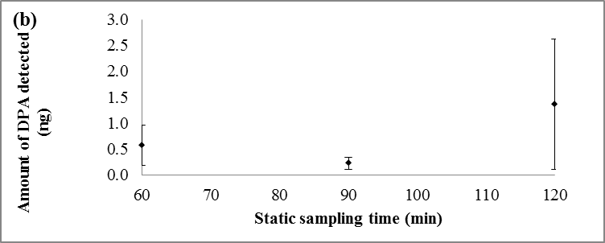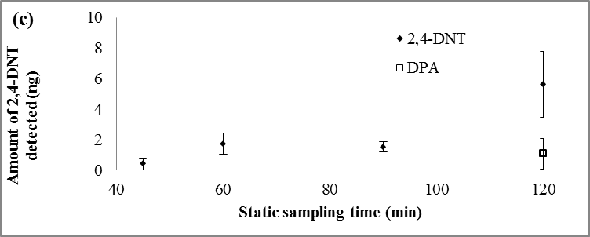
Figure 6.21 Static sampling time optimization for cardboard boxes for (a) NG & (b) DPA from 1 g AU and (c) 2,4-DNT from 1 g IMR 4198 smokeless powders.
Dynamic headspace sampling for NG and DPA was also performed for the optimization of dynamic sampling. The same cardboard containers containing 1 g of AU smokeless powders was used for the detection of NG and DPA. Dynamic sampling was performed using the Barringer air pump sampler for dynamic sampling of 10 – 120 seconds in triplicates. The lowest dynamic sampling time required for detection of NG was observed to be 60 seconds which was close to the detection limit and alarm threshold, resulting in some false negative alarms. DPA was not detected after 120 seconds of dynamic extractions.

6.2.2.3 Large plastic containers (45 L) for PSPME-IMS
Preliminary equilibrium experiments for the large plastic containers utilized five plastic containers without modification and each experiment was performed in a single replicate as a result of limited containers. Analysis of the All Unique (AU) smokeless powder was completed by placing 500 mg of AU was placed in the plastic container and sealed with minor interruptions of static sampling. Static PSPME extractions were performed in a similar fashion in which the PSPME device was suspended above the source; however, binder chips were used to suspend the PSPME vertically as shown in Figure 6.18 (b). The signal recorded by the portable IMS instrument and recalculated into the amount detected using a calibration curve constructed on the same day. Equilibrium analysis of 2,4-DNT was observed using IMR 4198 smokeless powder via detection from the bench-top IMS. Similarly, the signal recorded was recalculated into the amount detected using a calibration curve constructed on the same week.
Equilibrium results are shown in Figure 6.22 for smokeless powders (a) AU containing NG and DPA and (b) IMR 4198 containing 2,4-DNT. Nitroglycerin was shown to be quite volatile even in the polypropylene containers with detection and alarm for NG with no equilibrium time. Unlike cardboard containers, the polypropylene does not show a depletion of signal for the analytes of interest. Equilibrium of NG is reached after 6 hours with detection of approximately 80 ng; however, an estimated 0.04 ng DPA is detected after 24 hours, below the limit of detection for the instrument. Equilibrium time of 72 hours is sufficient with detection of 0.5 ng of diphenylamine. Although greater than 72 hours the signal for DPA continues to increase, the increase in signal is not significant to prolong the equilibrium time; thus, 72 hours would be the ideal equilibrium time for detection of NG and DPA in the plastic containers. Equilibrium studies for 2,4-DNT showed two data points collected at 7 and 8 h to seem as outlier; however, the data could be improved if more replicates were obtained. Overall, it was observed that 24 hours would be sufficient time for headspace equilibrium. The high sensitivity of NG and DPA in this volume and container material led to further studies performed with smaller quantities of smokeless powders in order to determine the limit of detection for detection of these compounds in polypropylene containers. The same experiment was repeated for 100 mg of smokeless powder with one replicate. Unfortunately, only NG was detected and required longer equilibrium time (>2 days) as shown in Figure 6.23. Thus, 500 mg was determined to be the optimum sample size for the ROC studies.
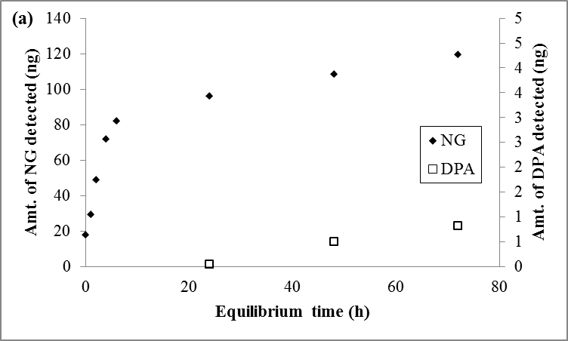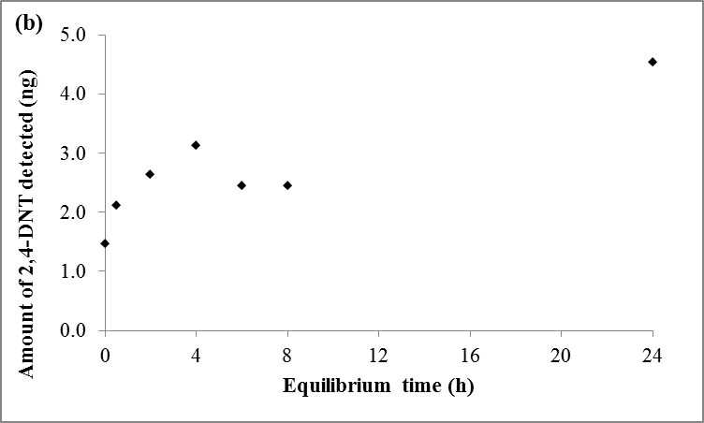
Figure 6.22 Headspace equilibrium of (a) NG and DPA from 500 mg AU smokeless powder and (b) 2,4-DNT from 500 mg IMR 4198 smokeless powder in a plastic container (n=1).

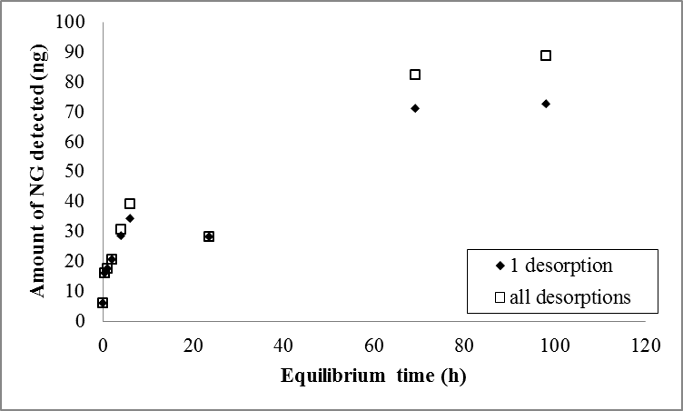
Figure 6.23 Headspace equilibrium for NG and DPA from 100 mg of AU smokeless powder in a plastic container (n=1); black diamond denotes the signal observed after 1 desorption of PSPME, white square denotes sum of signals from all desorptions.

6.2.2.4 Optimization of SPME-GC-MS detection
After the calibration and determination of limits of detection for the analytes of interest in the GC-MS, the extractions were performed with PDMS/DVB SPME fibers in the same quart cans and gallon cans used for PSPME extractions. Approximately 10-100 mg of smokeless powders (Alliant Unique and IMR 4198 separately) were placed in the quart can and then sealed immediately to establish equilibrium. For the gallon cans, 10-100 mg of smokeless powders (AU and IMR) were prepared in petri dishes and placed inside the can.

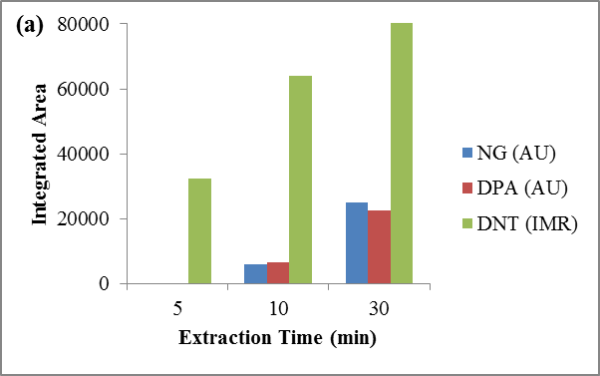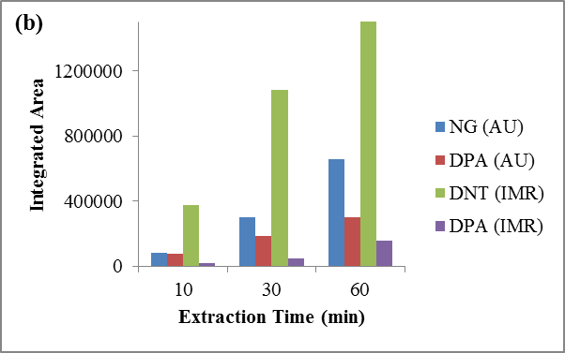
Figure 6.24 Volatile compounds detected in (a) quart cans and (b) gallon cans.
Different sampling times (5 min, 10 min and 30 min static extractions) were performed in the quart cans. From the chromatograms obtained from the analysis, it was observed that 2,4-DNT in IMR can be detected within 5 min extraction; on the other hand, NG and DPA required longer extraction times for detection (Figure 6.24 (a)). Longer extraction times (10 min, 30 min and 60 min extractions) were performed for the smokeless powders in the gallon cans because of the greater headspace volume available. Unlike detection in the quart cans, the volatile organic compounds of the smokeless powders were easily detected in the gallon cans. With only 10 min of static extractions, NG and DPA were detected from AU smokeless powder and 2,4-DNT and DPA from IMR 4198 smokeless powder (Figure 6.24 (b)). Detection of DPA in IMR 4198 can provide additional confirmation for a positive detection and identification of the smokeless powder; however, it was not necessary to have a positive alarm with the presence of both analytes to result with the presence of an explosive in the container.
Cardboard boxes were observed to have a relatively low background noise in comparison to the quart and gallon metal cans; however, the low background did not improve the extraction performance. The cardboard boxes containing All Unique smokeless powder required at least 3 hours of static extraction time for detection of NG and DPA. Unlike All Unique smokeless powder, 2,4-DNT and DPA in IMR 4198 can be easily detected with only 1 hour extraction.
Within the four different containers, the plastic containers were observed to have the highest background was seen in the chromatograph Figure 6.25; however, the large background noise did not affect the detection of NG and DPA. These compounds were detected within 30 min of extraction time. Unfortunately, 2,4-DNT was observed to have a similar retention time as that of a background peak; thus the mass spectrum was carefully examined for confidence detection and identification of the presence of 2,4-DNT.
Solid phase microextraction (SPME) was used with GC-MS detection for the extractions of NG, DPA, 2,4-DNT and ethyl centralite (EC) from All Unique, IMR 4198 and Red Dot smokeless powders. The extraction profile was shown in Table 6.5 for (a) All Unique, (b) IMR 4198 and (c) Red Dot.
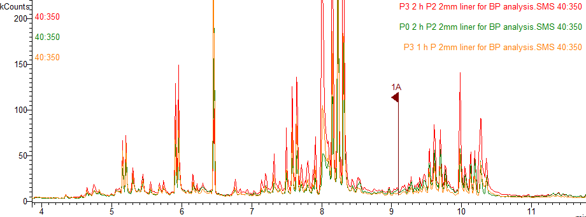
Figure 6.25 Chromatograms of plastic containers (1-2 hours static extractions using SPME).
Table 6.5 (a) Optimization of SPME-GC-MS analysis on the basis of the extraction profile for All Unique smokeless powder, (b) extraction profile for IMR 4198 smokeless powder, and (c) extraction profile for Red Dot smokeless powder
(a) |  |  | 5 min | 10 min | 30 min | 60 min | 120 min | 180 min
AU | Quart Can | 10 mg | NG | NG | NG
AU | Quart Can | 50 mg | NG, DPA | NG, DPA | NG, DPA
AU | Quart Can | 100 mg | NG, DPA | NG, DPA | NG, DPA
AU | Gallon Can | 10 mg | NG | NG | NG | NG, DPA
AU | Gallon Can | 50 mg | NG, DPA | NG, DPA | NG, DPA | NG, DPA
AU | Gallon Can | 100 mg | NG, DPA | NG, DPA | NG, DPA | NG, DPA
AU | Plastic Container | 100 mg |  |  | NG | NG, DPA | NG, DPA
AU | Plastic Container | 500 mg |  |  | NG, DPA | NG, DPA | NG, DPA
AU | Cardboard Box | 1 g |  |  |  | NG, DPA | NG, DPA | NG, DPA

(b) |  |  | 5 min | 10 min | 30 min | 60 min | 120 min | 180 min
IMR 4198 | Quart Can | 10 mg | 2,4-DNT | 2,4-DNT, DPA | 2,4-DNT, DPA
IMR 4198 | Quart Can | 100 mg | 2,4-DNT, DPA | 2,4-DNT, DPA | 2,4-DNT, DPA
IMR 4198 | Gallon Can | 10 mg | 2,4-DNT | 2,4-DNT | 2,4-DNT | 2,4-DNT
IMR 4198 | Gallon Can | 100 mg | 2,4-DNT | 2,4-DNT, DPA | 2,4-DNT, DPA | 2,4-DNT, DPA
IMR 4198 | Plastic Container | 100 mg |  |  | 2,4-DNT | 2,4-DNT | 2,4-DNT
IMR 4198 | Plastic Container | 500 mg |  |  | 2,4-DNT | 2,4-DNT | 2,4-DNT
IMR 4198 | Card-board Box | 1 g |  |  | 2,4-DNT | 2,4-DNT | 2,4-DNT, DPA | 2,4-DNT, DPA

(c) |  |  | 5 min | 10 min | 30 min | 60 min
Red Dot | Quart Can | 100 mg | NG, DPA | NG, DPA | NG, DPA | NG, DPA
Red Dot | Quart Can | 500 mg | NG, DPA | NG, DPA | NG, DPA, EC | NG, DPA, EC

The minimum sample size of 10 mg of smokeless powder in both quart cans and gallon cans, NG, DPA and 2,4-DNT was successfully detected within 10 min extraction for all the smokeless powders which include All Unique, IMR 4198 and Red Dot. Larger volume of headspace required longer extraction time with a minimum of 30 min in the plastic container and 60 min for cardboard box extractions showed confident detection for detection of NG, DPA and 2,4-DNT in the GC-MS, while decreased extraction time results in reduced true positive rate. Since NG, DPA and 2,4-DNT have very different composition in the smokeless powders, not all the target analytes were successfully detected within a short period of time. Diphenylamine in both smokeless powders required much longer extraction time in order to be detected in the GC-MS instrument. Presence of both headspace volatile compounds at the same time was not a criterion for the confirmation of the presence of smokeless powder, thus, the extraction time could be significantly reduced.
Detection of ethyl centralite (EC) was challenging using the smokeless powder currently available in the laboratory. With 500 mg of Red Dot in the smallest volume container (quart metal can), at least 30 min extraction time was necessary to have a weak detection in the GC-MS (Table 6.5 (c)).

6.2.2.5 Optimized parameters summary
In conclusion, different volume containers required different amount of time to establish equilibrium, depending on the amount of explosives available in the headspace as well as the material of the container. The overall equilibrium time for the different containers for the optimized sampling size is summarized in Table 6.6.
Table 6.6 Equilibrium time for NG, DPA, 2,4-DNT, and EC.
Container | Smokeless powder amount (mg) | Equilibrium time (h)
Container | Smokeless powder amount (mg) | NG | DPA | 2,4-DNT | EC
Quart can | 10 | 7 | - | 24 | -
Quart can | 50 | 7 | 24 | - | -
Quart can | 500 | - | - | - | 168
Gallon can | 100 | 24 | 24 | 24 | -
Cardboard box | 1000 | 24 | 98 | 72 | -
Plastic container | 100 | 48 | - | 24 | -
Plastic container | 500 | 8 | 48 |  | -

Equilibrium time of 24 hours was sufficient time for the target volatile chemicals to establish equilibrium for all the containers; however, detection of the analytes of interest can be detected within 1 hour of equilibrium. The optimized sampling time and sampling size conditions for the PSPME-IMS and SPME-GC-MS techniques are summarized in Table 6.7. For the 3 different volume sizes used in this study, the optimum static sampling was observed to be 10 minutes (SPME-GC-MS & PSPME-IMS) and 1 minute for dynamic sampling (PSPME-IMS) and a sample size ranging from 10-500 mg for both smokeless powders.
Table 6.7 Detection of analytes of interest (NG and DPA from All Unique smokeless powder; 2,4-DNT from IMR 4198 smokeless powder) for different sampling parameters.
Container | Equili-brium time (h) | Extraction | Sample size (mg) | Sampling time (min) | Instruments & analytes detected
 |  |  |  |  | PSPME- IMS (portable) | PSPME-IMS (bench top) | SPME-GC-MS (bench top)
Quart can (0.94 L) | 24 | static | 10 | 10 | NG, 2,4-DNT | NG, DPA, 2,4-DNT | NG, 2,4-DNT
Quart can (0.94 L) | 24 | static | 50 | 10 | NG, DPA, 2,4-DNT | NG, DPA, 2,4-DNT | NG, DPA, 2,4-DNT
Quart can (0.94 L) | 24 | dynamic | 10 | 1 | NG, 2,4-DNT | NG, DPA, 2,4-DNT | n/a
Quart can (0.94 L) | 24 | dynamic | 50 | 1 | NG, DPA, 2,4-DNT | NG, DPA, 2,4-DNT | n/a
Gallon can (3.8 L) | 24 | static | 10 | 10 | NG, 2,4-DNT | NG, DPA, 2,4-DNT | NG, 2,4-DNT
Gallon can (3.8 L) | 24 | static | 50 | 10 | NG, DPA, 2,4-DNT | NG, DPA, 2,4-DNT | NG, DPA, 2,4-DNT
Gallon can (3.8 L) | 24 | dynamic | 10 | 1 | NG, 2,4-DNT | NG, 2,4-DNT | n/a
Gallon can (3.8 L) | 24 | dynamic | 50 | 1 | NG, DPA, 2,4-DNT | NG, DPA, 2,4-DNT | n/a
Plastic container (45L) | 24-48 | static | 500 | 10 | N, 2,4-DNT | NG, 2,4-DNT | n/a
Plastic container (45L) | 24-48 | dynamic | 500 | 1 | NG, DPA, 2,4-DNT | NG, DPA, 2,4-DNT | n/a

Nitroglycerin (NG) and 2,4-dinitrotoluene (2,4-DNT) were observed to be the most abundant analytes in the headspace of smokeless powders, resulting in detection within 10 minutes of static extraction with a minimum of 10 mg of smokeless powder present in different containers. Dynamic extractions of 1 minute were sufficient for detection of NG and 2,4-DNT from 10mg of smokeless powders. The sensitivity for detection of DPA was greater in the bench top IMS, resulting in detection of DPA for all the different defined volumes. On the other hand, DPA detection required a minimum of 50 mg of AU smokeless powder in quart and gallon cans for the portable IMS detection system. Detection of DPA was difficult for the large volume containers in which DPA was not detected after 10 minutes of static sampling but detected within 1 minute of a dynamic extraction.
Detection of NG, DPA and 2,4-DNT were successful after a 10 min extraction for all the smokeless powders with as low as 10 mg of smokeless powder in both quart and gallon cans when SPME-GC-MS was used; however, the sampling of large volume containers required longer extraction times (30 minutes) for detection using the SPME-GC-MS, reducing the true positive detection rates (TPR) for large containers.
The absorptivity effects observed from cardboard boxes and the time-restraint of this experiment resulted in the termination of ROC studies for the cardboard boxes. Moreover, as stated previously, detection of ethyl centralite from the commercially available smokeless powder in the laboratory required a prolonged period of time. Since Red Dot smokeless powder contains NG and DPA, detection of ethyl centralite was not necessary for this smokeless powder and the ROC Curve studies were not continued for detection of EC vapors. Detection of smokeless powders using SPME-GC-MS in large containers (volume is greater than 4 L) required longer than the optimum sampling time of 10 minutes, thus ROC curve studies for SPME-GC-MS does not include the data for plastic containers.

6.2.3 True Positives Rate Studies of Smokeless Powders

6.2.3.1 PSPME coupled with IMS
PSPME coupled with both portable and bench-top IMS systems achieved excellent detection performance for both 2,4-DNT and NG. The TPR values were calculated based on the number of fraction containers containing smokeless powders that resulted with a maximum signal (in Height, mV) above the given alarm threshold value. The TPR curves with respect to the alarm threshold set on the instrument for NG for both IMS systems are shown in Figure 6.26. The TPR decreases with increased alarm threshold with a TPR of 1.0 observed with a minimum detection equivalent to 8 ng and 2 ng of NG in the portable and bench-top IMS, respectively. A complete list of the TPRs results for the different scenarios for the three analytes of interest with the minimum alarm threshold are shown in Table 6.8. Static extractions for both IMS instruments showed a greater TPR values in comparison to dynamic extractions, nevertheless, the TPRs for 2,4-DNT and NG in the two systems for all the different set conditions were greater than 0.80.
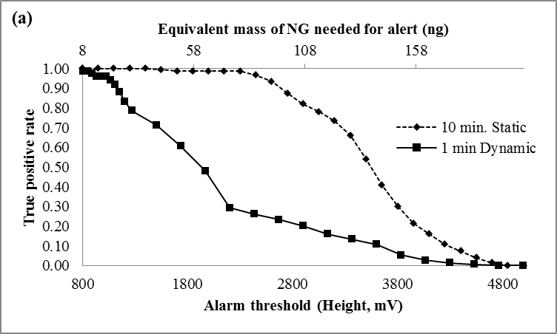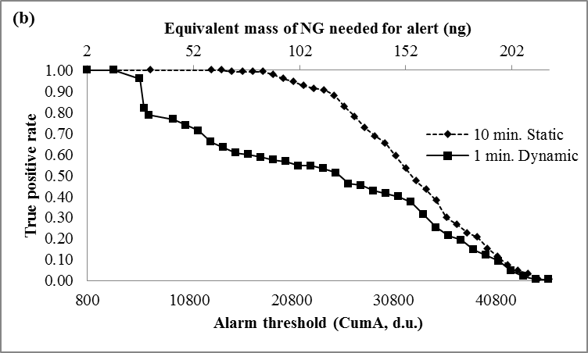
Figure 6.26 True positive rates for the (a) portable and (b) bench-top IMS systems. Comparison of true positive rates for the two extraction methods are shown with varying alarm threshold.
Detection of DPA was not very successful with the highest TPR of 0.82 for static extractions and 0.53 for dynamic extractions in the bench top IMS system. The highest TPRs for the DPA detection were 0.58 and 0.47 from static and dynamic extractions in the portable IMS system, respectively. Detection of DPA was hindered in the plastic containers for the bench-top IMS, with no detection in the static mode and a TPR of 0.23 for the dynamic mode, whereas the portable IMS system performed with a greater TPR of 0.7 and 0.47 for static and dynamic extractions, respectively. Since DPA is a stabilizer [19, 232] in the smokeless powders, the presence of other chemicals such as the energetic material NG is required for a positive alarm of low explosives. The presence of DPA can be used as a confirmation for the detection of smokeless powders.

Table 6.8 True positive rates for smokeless powders in different containers (1-45 L) for bench top and portable IMS systems with 60 replicates. (*) denotes n=30
 |  | Bench top IMS |  | Portable IMS
Container volume (L) | Analyte | Static | Dynamic | Static | Dynamic
0.94 | NG | 1.0 | 1.0 | 1.0 | 1.0
0.94 | DPA | 0.70 | 0.37 | 0.58 | 0.15
0.94 | 2,4-DNT | 1.0 | 1.0 | 1.0 | 0.87
3.8 | NG | 1.0 | 1.0 | 1.0 | 1.0
3.8 | DPA | 0.82 | 0.53 | 0.25 | 0.08
3.8 | 2,4-DNT | 1.0 | 1.0 | 0.98 | 0.98
45* | NG | 1.0 | 1.0 | 1.0 | 1.0
45* | DPA | 0.0 | 0.23 | 0.07 | 0.47
45* | 2,4-DNT | 1.0 | 1.0 | 0.80 | 0.98

6.2.3.2 SPME coupled with GC-MS
The same headspace extraction time of 10 minutes was repeated for the SPME-GC-MS TPR studies because of the limited static extraction mode of the fiber-based SPME sampling device. The TPR curves dependent on the equivalent mass detection (from the integrated area) of the target analytes are shown in Figure 6.27. In comparison to the PSPME-IMS studies, SPME-GC-MS led to poorer sensitivity with a TPR of 0.88 and a minimum detection of 17 ng for NG and a TPR of 1.0 with equivalent mass detection of 6 ng for 2,4-DNT. Detection of DPA was slightly better with a TPR of 0.58 with detection equivalent to 2 ng of DPA. These results show that the SPME-GC-MS system is sensitive for 2,4-DNT and DPA; however, detection of NG is much more sensitive using PSPME coupled with commercial IMS.

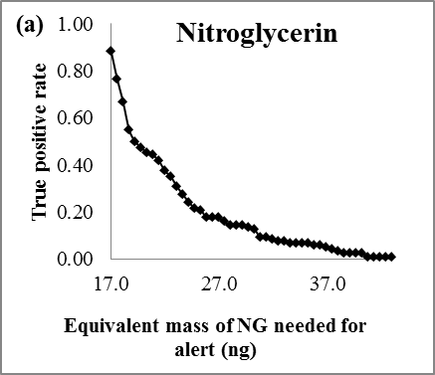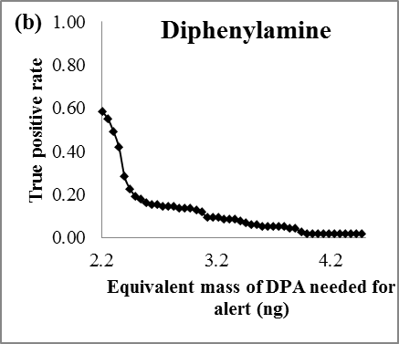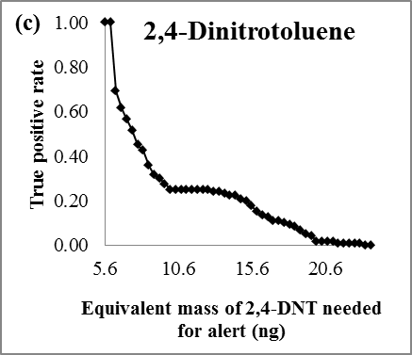
Figure 6.27 SPME-GC-MS true positive rates with varying equivalent mass threshold for (a) NG, (b) DPA and (c) 2,4-DNT.

6.2.3.3 True positive rate studies of military explosives
For the military explosives study, 1 minute dynamic extractions followed by IMS detection using the portable system was performed with a maximum of 16 replicates for the different explosives available. Most of the military explosives were not detected in the portable IMS system because of their low vapor pressure. A true positive rate of 0 was determined for the vapor sampling of 500 mg of ETN, PETN and RDX in a 3-4 L plastic container (Table 6.9). Volatile explosives such as NG and EGDN lead to excellent detection performance with a TPR of 1.0 with EDGN and NG producing an alarm in the IMS for the NITRO alarm set. The high volatility of these explosives allowed for relatively large amounts of the volatiles to be preconcentrated onto the PSPME device. Additionally, wrappers of explosives were sampled obtaining a TPR of 0.60 for TNT, in which the alarm was from the detection of 2,4-DNT, the primary volatile organic compound associated with TNT [61] from the headspace of the wrappers. The C4 explosives are primarily composed of RDX, thus, resulting in no detection of explosives from the wrappers. Detection of the 2,3-dimethyl-2,3-dinitrobutane (DMNB) taggant present in plastic explosives was possible; however, when a lower drift tube temperature was used as previously reported [34].
Table 6.9 True positive rate studies for military explosives using 1 minute dynamic PSPME extractions and portable IMS detection.
 | Blank | ETN | PETN | RDX | NG | EGDN | TNT wrappers | C4 wrappers
Total true positive/Total samples | 0/10 | 0/16 | 0/8 | 0/12 | 12/12 | 12/12 | 3/5 | 0/3
TPR | 0 | 0 | 0 | 0 | 1.0 | 1.0 | 0.60 | 0

6.2.4 False Positive Rate Studies
False positive rates (FPR) were determined in replicates under the same conditions as the TPRs studies but in the absence of explosives. These measurements were collected in the laboratory (relatively low clutter) as well as an outside loading dock area (high particle clutter) in order to simulate real-world scenarios and observe typical backgrounds from cluttered shipping environments. A total of 10 replicates measurements were collected for each defined container size. Furthermore, interference studies of two common household products were investigated using both IMS systems.

6.2.4.1 Real-world false-positive studies
Sampling in a high-clutter environment was performed in a scientific loading dock where shipments are transported in order to simulate the type of clutter typically observed in real-world settings. Similarly, the FPR values were calculated based on the number of fraction containers without the presence of explosives that resulted with a maximum signal (in Height, mV) above the given alarm threshold value. The portable IMS system obtained no false positives from 10 replicates of 1 min dynamic extractions in shipping facilities. Several background peaks were observed; however, the peaks had a relatively low signal and did not interfere with the drift time of any of the analytes of interest. Since the alarm threshold was decreased for the bench-top IMS, the FPR was observed to be 0.06. By increasing the minimum alarm threshold of the analytes of interest will still achieve a TPR of 1.0 (>800 d.u.) and the FPR can be decreased to 0.
False positive rate studies were also performed in a local commercial shipping facility in which several different containers were sampled as well as the headspace of the open area with only the portable IMS used in this part of the study. One-minute dynamic sampling with IMS detection was performed in open areas as well as inside LD3 containers. Plasmagrams of the negative mode for the portable IMS shows some detected signal (t_{d} = 8.6 ms) reflecting the presence of background volatiles in the headspace of the LD3 containers (Figure 6.28); however, none of the signals obtained from the background interfered with the analytes of interest. Moreover, from a total of 32 background samples that were sampled by PSPME-IMS in this highly cluttered environment did not cause a false positive alarm.
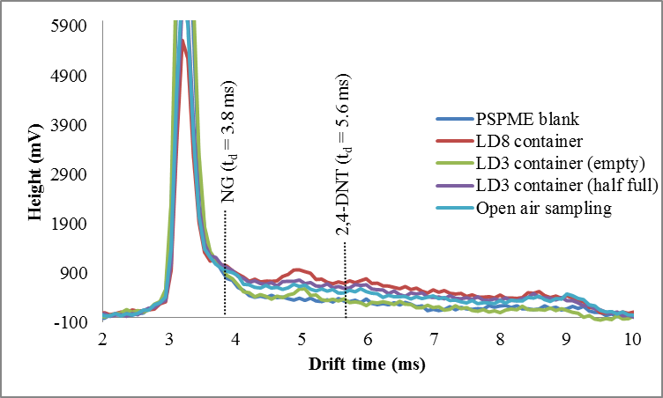
Figure 6.28 Plasmagrams for dynamic PSPME sampling (1 min.) in clutter environments from a local shipping facility. Sampling was performed in LD3 (4500 L) containers and LD8 (6880 L) containers as well as open air sampling of the location.

6.2.4.2 Interference studies
Possible interfering compounds were investigated to observe the odors that are extracted by the PSPME device and detected in the IMS. Interference studies were done in quart-sized cans in which a 10-500 mg of the coffee grounds (Classic Roast, Folgers) or 10 µL of 1:10-1:100 and pure gasoline solutions were placed and sealed. Static extractions of 10 mins were detected with no equilibrium time or 1h of equilibrium time followed by static extractions of 10 mins.

Interference Study of Gasoline
Gasoline was used as one of the possible interfering compounds. Gasoline is a common interfering compound found in most transportation and shipping facilities, containing volatile chemicals that might interfere with the detection of drugs and explosives [112, 123, 124]. Gasoline was obtained and diluted 1:10 and 1:100 with hexane (Reagent Grade ACS, Pharco-AAPER). Sampling was performed by spiking 10 µL of 1:100, 1:10, and pure gasoline on a baked metal quart can and sealed with a PSPME for 10 mins, followed by detection via IMS. The diluted gasoline extractions were observed to have little to no interference in the positive and negative mode (Figure 6.29) for the portable IMS instrument. Static extractions of pure gasoline resulted with a broad peak at approximate 5.8 ms in the positive mode which increased in signal once it reached equilibrium (1 hr). There was no false alarm for DPA when performing static headspace extractions; however, a false alarm for DPA was observed when gasoline was directly spiked into the PSPME device and detected by the portable IMS system. These results signify that particle swabbing is susceptible to false positive alarms.
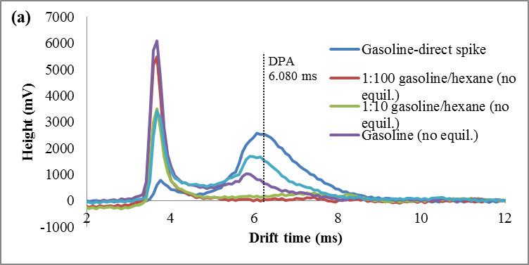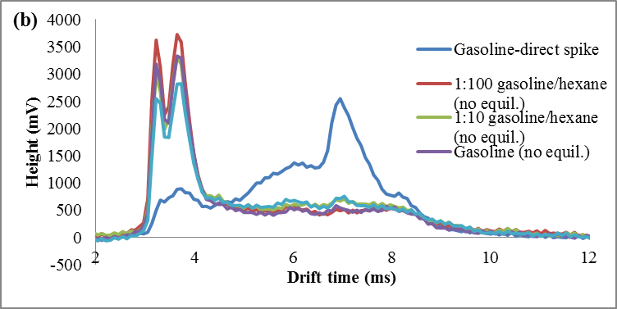
Figure 6.29 Plasmagrams of gasoline interferences from 10 min PSPME static extractions in the (a) positive and (b) negative mode for the portable IMS instrument.
No interference was observed in the negative mode unless gasoline is directly introduced to the IMS instrument. Although interferences were seen when directly spiked and desorbed into the system, no alarms were triggered for any compound of interest. Similar to the plasmagrams obtained in the positive mode, a large interfering peak in the negative mode from particle swabbing would result in depletion of the reactant ion peak and limit the analytes that are detected in the IMS instrument. The bench-top IMS instrument also obtained some small interfering peaks; however, did not result with a false alarm.
Although the presence of gasoline did not obtain a false alarm unless directly spiked, there was an observed depletion of the reactant ion peak, almost completely depleting the reactant ion peak in the negative mode for the bench-top IMS instrument. As a result, a suppressed signal was observed when 10 µL of 1:10 gasoline/hexane was present in the extraction of 1 µg 2,4-DNT (10 µL of 100ppm 2,4-DNT in methanol) as shown in Figure 6.30. A possible conclusion could be that the PSPME retains some gasoline volatile chemicals which are not detected in the IMS, observing decreased retention of 2,4-DNT vapors. Analysis of gasoline and ignitable fluids is commonly performed using SPME with PDMS sorbent coating [242, 243]; thus, the surface chemistry of the PSPME device will also retain these volatiles in gasoline. Another possible reason for decreased detection of 2,4-DNT is the limited pool of ions in the reactant ion peak that can interact and ionize with the sample. Competitive ionization for unwanted vapors and 2,4-DNT vapors caused a decreased signal for the analytes of interest.

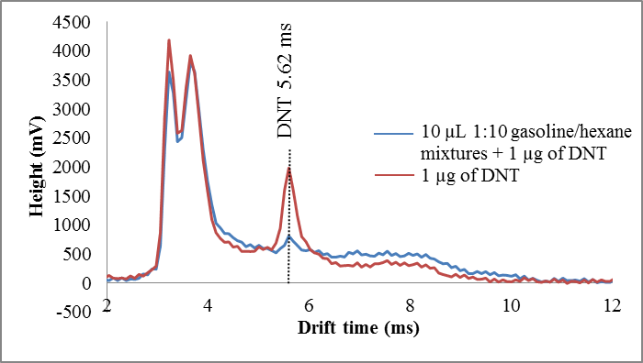
Figure 6.30 Suppression of 2,4-DNT IMS signal with the presence of dilute (1:10) gasoline from PSPME 10 min static extractions.

Interference Study of Coffee
Similar to the gasoline studies, coffee was used as interference for explosives and/or drug detection in IMS instruments. Coffee is a potential interferent since it is a common household good that is commonly shipped via cargo containers and emits a strong odor of furans, ketones, pyrazines and many other volatiles [244] that might interfere with the odors of interest. In addition, coffee volatiles have been shown to be well extracted using a PDMS sorbent phase [245] and can potentially decrease the signal for a compound of interest. Different amounts of ground coffee (100 mg, 500 mg and 1g) were placed in metal quart-sized cans and sealed to reach equilibrium for a minimum of 1 hour, followed by PSPME 10 min static extractions or 60 s dynamic extractions and detection using the 2 IMS instruments.
Static extraction of 10 mins of 100 mg coffee with detection using the bench-top IMS instrument acquired a false alarm for amphetamine (10.6 ms). However, when All Unique (AU) smokeless powder containing nitroglycerin (NG) and diphenylamine (DPA) and coffee were present in the metal quart can together, the amphetamine peak disappeared. The large amount of volatiles present in smokeless powder and preferential absorption of volatiles from AU smokeless powder by PSPME could be responsible for the diminished signal of amphetamine. Furthermore, 10 min static extractions of 100 mg AU with the presence of 100 mg coffee observed suppressed detection of DPA and detection of a peak resulting in a false alarm for MDMA at a drift time of 12.1 ms (Figure 6.31 (a)), which was not present when either coffee or AU smokeless powder were analyzed. The observed phenomenon could be possibly from the volatile components of coffee and the volatile components in smokeless powder that are both preferentially extracted by the PSPME device. Upon desorbing the PSPME and introducing the vapors into the reaction region, along with presence of the water cluster ions, the outcome can be chemical transformation reactions and forming new ion clusters with different collisional cross-sections and drift times [246]. In contrast, the negative mode did not result with much interference and did not have difficulty in the detection of NG (Figure 6.31 (b)). Although several peaks were observed from the extraction of coffee, PSPME extractions showed a preferential extraction of nitroglycerin, suppressing the rest of the unidentified peaks and having a small affect in the signal intensity for nitroglycerin detection.
The portable IMS instrument also obtained a false alarm for the explosive methyl ethyl ketone peroxide (MEKP) at 4.47 ms, increasing signal with increasing amount of coffee (Figure 6.32 (a)), as well as a broadened peak around 5.5 ms which poses as an interference for the detection of diphenylamine. Dynamic extractions alarmed for MEKP only when large amounts of coffee were present (1g) (Figure 6.33 (a)). Similar to the bench-top IMS system, very little interference is observed in the negative mode and detection of NG from 100 mg of AU with the presence of 100 mg coffee was successful both in the static (Figure 6.32 (b)) and dynamic (Figure 6.33 (a)) sampling modes. Since higher signal is acquired from static extractions, larger background noise was observed from the static sampling of coffee (Figure 6.32); however, did not result in a false alarm for any of the compounds of interest.

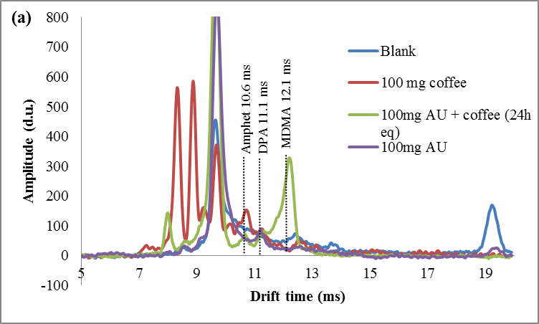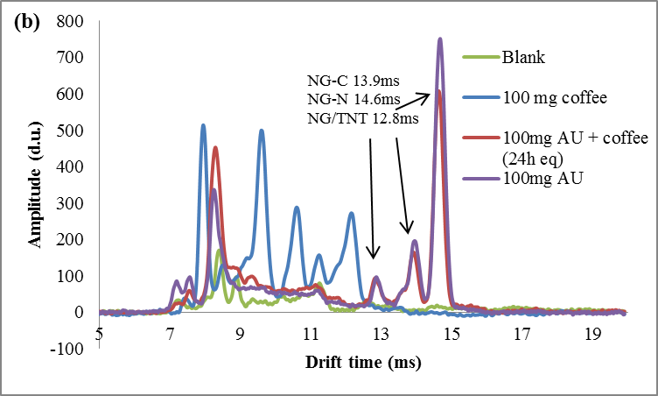
Figure 6.31 Plasmagrams of coffee interferences in the (a) positive and (b) negative mode for the bench-top IMS instrument.

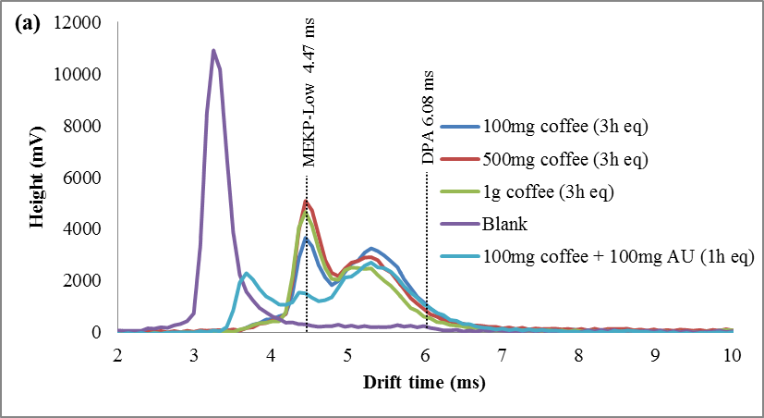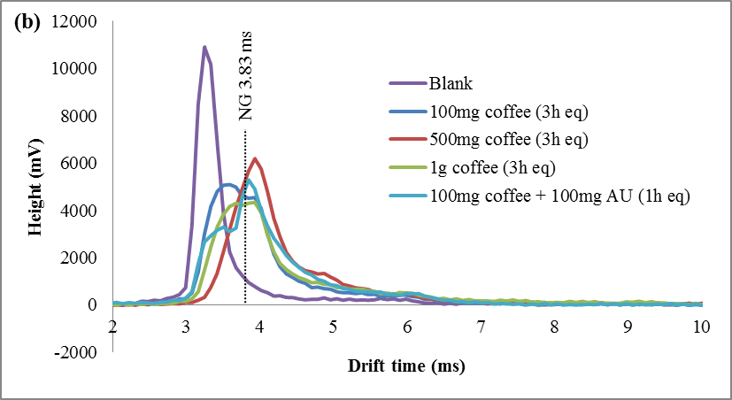
Figure 6.32 Plasmagrams of coffee (with 1-3 h equilibrium time in metal quart cans) 10 min PSPME static extractions in the (a) positive and (b) negative mode for the portable IMS instrument.
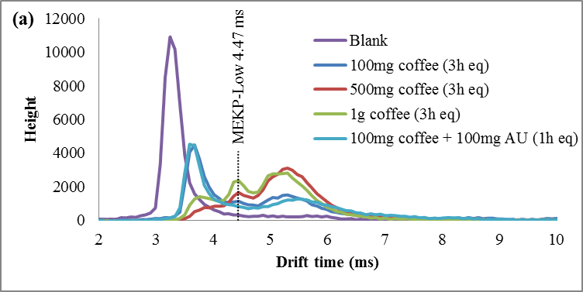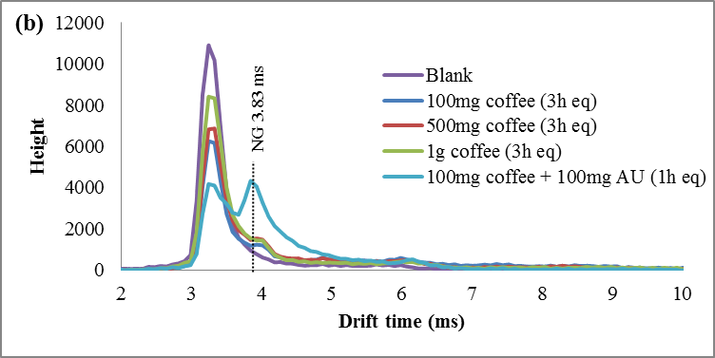
Figure 6.33 Plasmagrams of coffee (with 1-3 h of equilibrium time in metal quart cans) 1 min dynamic extractions in the (a) positive and (b) negative mode for the portable IMS instrument.

6.2.5 Receiver Operating Characteristic Curves

6.2.5.1 Receiver Operating Characteristic Curves for PSPME-IMS systems
The ROC curves were developed for both bench-top and portable IMS systems when coupled with PSPME devices from the all the defined scenarios and replicates to determine the overall performance for detection of the target analytes for the different sampling and detection techniques. From a total of 360 samples for all the different replicates and the different defined scenarios, the ROC curves for the two instruments were constructed for the 3 target analytes using JMP (version 10) software. The results for the different scenarios were used to determine the sensitivity (TPR) and specificity (1-FPR) trade-offs for the target analytes as shown in Figure 6.34 (a) and (b) for the portable and bench-top IMS, respectively. The bench-top IMS showed better sensitivity in comparison to the portable IMS for 2,4-DNT and both instruments obtained similar performance for detection of NG and DPA. The excellent performance of the bench-top IMS achieved perfect ROC curves under the defined scenarios with area under the curves (AUC) of 1.0 for 2,4-DNT and NG detection and AUC of 0.81 for DPA detection. The portable IMS obtained excellent performance as well with a perfect ROC curve for NG detection (AUC = 1.0) and AUC of 0.87 and 0.85 for 2,4-DNT and DPA detection. The results indicate that the portable PSPME-IMS system achieved similar detection performance for DPA as the benchtop PSPME-IMS instrument because of similar sensitivity and limits of detection for the two instruments; however, increased positive alarms from the portable PSPME-IMS in the plastic containers (TPR = 0.27) in comparison to the benchtop PSPME-IMS instrument (TPR = 0.12) under the same scenario showed slightly improved performance for the portable PSPME-IMS. The overall performance of the two PSPME-IMS systems showed excellent performance, with similar or greater performance of the benchtop PSPME-IMS in comparison to the portable PSPME-IMS system.
NG
DPA
2,4-DNT
NG
DPA
2,4-DNT
(b)
(a)
Figure 6.34 ROC curves for the portable (a) and bench-top (b) IMS systems. These ROC curves were constructed using JMP software from 360 samples including all defined scenarios.

6.2.5.2 Receiver Operating Characteristic Curves for SPME-GC-MS systems
Receiver operating characteristic curves were also constructed for the SPME-GC-MS systems. Since only static samples were performed, a total of 140 samples were performed, which are summarized in the ROC curve in Figure 6.35. Sensitive detection of 2,4-DNT by SPME-GC-MS achieved an AUC of 1.0, whereas the false negative results decreased the AUC to 0.94 and 0.97 for DPA and NG, respectively. The poor sensitivity of NG in the SPME-GC-MS technique obtained poorer performance in comparison to IMS detection systems.

NG
DPA
2,4-DNT
Figure 6.35 Receiver operating characteristic curve for SPME-GC-MS systems. These ROC curves were constructed using JMP software from 140 samples including all defined scenarios.
A comparison of with SPME-GC-MS was determined by ROC studies with only static extractions of PSPME-IMS resulted with a greater AUC than previously observed (Figure 6.36), including the dataset for the plastic containers. Using these parameters, the AUC for NG was 1.0 for both IMS systems. The AUC for 2,4-DNT was observed to be 0.85 and 1.0 for the portable and bench-top IMS system, respectively. The AUC was lower for static PSPME extractions of 2,4-DNT since detection is more reliable for the dynamic extraction mode. Additionally, improvement in the AUC for DPA was observed for both IMS instruments, 0.94 for the portable IMS and 0.82 for the bench-top IMS. Overall, the SPME-GC-MS resulted with excellent performance for all the analytes of interest under the defined scenarios as expected for a sensitive, laboratory based instrument; however, PSPME-IMS offers similar non-contact sampling and detection performance to a well-established technique with the added advantage of fast detection in the field.
NG
DPA
2,4-DNT
NG
DPA
2,4-DNT
(b)
(a)
Figure 6.36 Receiver operating characteristic curve for (a) portable and (b) bench-top IMS systems with only static extraction studies (n = 180)

6.2.6 Conclusions
The performance of the planar solid phase microextraction (PSPME) non-contact sampler/extraction device coupled to COTS ion mobility spectrometers (IMS) to detect the presence of explosives was evaluated through the development of receiver operating characteristic (ROC) curves. A total of 360 replicate measurements were collected for different scenarios varying container volume (0.94 – 45 L) and amount of smokeless powders concealed within the container (10-500 mg). True positive rate (TPR) analysis suggested the optimum alarm threshold and detection limits for each individual compound.
Table 6.10 True positive (TN), true negative (FN), false positive (FP) and false negative (FN) values for all instruments with corresponding area under the curve generated from the ROC studies.
 | Alarm | TP | TN | FP | FN | AUC
Bench-top PSPME-IMS | 2,4-DNT | 300 | 60 | 0 | 0 | 1.0
Bench-top PSPME-IMS | DPA | 152 | 60 | 0 | 148 | 0.81
Bench-top PSPME-IMS | NG | 300 | 60 | 0 | 0 | 1.0
Portable PSPME-IMS | 2,4-DNT | 287 | 60 | 0 | 13 | 0.87
Portable PSPME-IMS | DPA | 80 | 60 | 0 | 220 | 0.85
Portable PSPME-IMS | NG | 300 | 60 | 0 | 0 | 1.0
SPME-GC-MS | 2,4-DNT | 120 | 20 | 0 | 0 | 1.0
SPME-GC-MS | DPA | 71 | 20 | 0 | 49 | 0.94
SPME-GC-MS | NG | 106 | 20 | 0 | 14 | 0.97

Receiver operating characteristic curves are found useful to illustrate the detector system performance in terms of true and false positive probabilities. A summary of the performance of the different instruments investigated in this study is shown in Table 6.10. The portable IMS produced a slightly reduced performance in comparison to the bench-top IMS; however, the instrument performed well with high sensitivity for NG (AUC = 1.0) and 2,4-DNT (AUC = 0.87). The AUC of DPA was lower (0.85) for both instruments in consequence of the large amount of false negatives. The bench top IMS resulted in improved sensitivity with an area under the curve (AUC) of 1.0 for NG and 2,4-DNT as well as an AUC of 0.81 for DPA. Even though poor detection was observed for DPA for both IMS instruments, the presence of NG from the same smokeless powders was sufficient for a positive alarm, suggesting the presence of an explosive. The performance of the SPME-GC-MS proved to have great sensitivity for all the target analytes with an AUC of 1.0 for 2,4-DNT and similar performance for NG and DPA (0.97 and 0.94, respectively). Using the same static headspace sampling conditions for PSPME-IMS as SPME-GC-MS obtained high sensitivity for NG and similar performance in regards to the area under the curve.
The ROC curves studies illustrate how well the preconcentration power of the PSPME is able to perform in brief (1 min.) static and dynamic extractions with high sensitivity and high specificity; however, detection of explosives with low vapor pressure by non-contact sampling was not successful, with little to no detection for ETN, PETN, RDX, TNT and C4. Further optimization studies will be investigated in order to construct ROC curve studies on the basis of the volatile organic compounds associated with these low vapor explosives. Similar performances were observed from PSPME-IMS systems as the widely accepted technique under the same conditions; thus, PSPME-IMS can be used in high-throughput clutter environments to obtain similar results at the fraction of the sampling time. Overall, the PSPME-IMS technique provides less false positive results for non-contact vapor sampling, cutting the cost and providing an effective sampling and detection needed in high-throughput scenarios with excellent potential to be a used as a sensor system for the detection of volatile chemicals associated with explosives.

Concluding Remarks

7.1 Vapor Calibration and Evaluation of PSPME
This research reports the performance of the planar solid-phase microextraction (PSPME) sampling and preconcentrating device for the detection of volatile explosives as well as volatile organic compounds associated with explosives and illicit drugs. The calibration of the PSPME device using a vapor generator determined the limits of detection for the vapors of target analytes to be in the low nanogram range. Furthermore, extraction efficiencies of the analytes of interest were approximately 20%, offering greater than 10 times higher extraction efficiency than the conventional solid phase microextraction (SPME) technique.
The comparison of extraction and retention performance of the PSPME was proven to be superior to other substrates widely used for sampling with IMS systems. The absorptive properties of the sol-gel PDMS chemistry offer greater extraction capability and better retention of the target analyte. Dynamic extractions using the untreated substrates result in the extraction of unwanted vapors with high background causing a depletion of the reactant ion peak and limited detection for the analytes of interest. The use of PSPME provides faster sampling time with preferential extraction of the target volatiles, with detection with as little as 10 s of dynamic sampling.

7.2 Receiver Operating Characteristic Curves for Trace Detection Systems
Receiver operating characteristic curves were constructed for PSPME with different IMS detection systems as well as SPME with GC-MS detection to evaluate the performance of the different detection systems. Overall, the PSPME-IMS offers fast, non-contact sampling with an area under the curve (AUC) of greater than 0.81 for volatiles of smokeless powder, the model system of explosives for the ROC study. Although SPME-GC-MS studies of the same defined parameters achieved a greater AUC than PSPME-IMS (greater than 0.95), the non-contact sampling requires longer analysis time and longer extraction times due to its limited static extraction mode, with a minimum of 20 minutes for the analysis of one sample using the sensitive detection system. In conclusion, the PSPME-IMS is a reliable sensor system for fast, non-contact sampling of volatiles associated with explosives, offering excellent performance for the detection of smokeless powders.

7.3 Future Directions of the Research Study
The use of ROC curves offers a great way to evaluate the performance of detection systems based on the sensitivity and specificity for a given set of conditions. Future studies include to determination of ROC curves for homemade explosives and military explosives under real-world sampling conditions. Preliminary field studies of TATP resulted with positive detection of 500 mg TATP sampling in a large volume cardboard box (Figure 7.1). The high volatility of TATP makes it available for detection via PSPME headspace extraction and IMS detection. Although preliminary studies military explosives were poorly detected using the previous method, optimization of the instrumental method is required for the detection of the reported volatiles associated with these explosives. Many of the target volatiles for military explosives require lower drift tube temperatures and modified flows and dopants. Further investigation will be required for the fabrication of ROC curves for the nonvolatile military explosive.

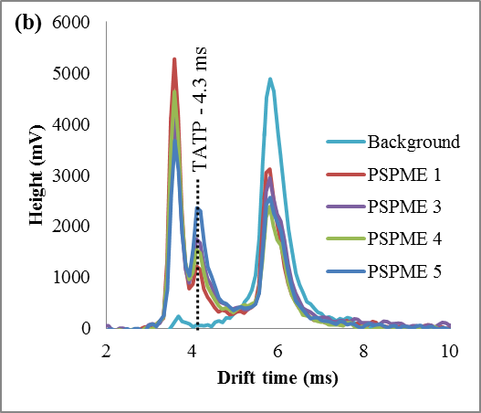
(a)
Figure 7.1 Field sampling of 500 mg of TATP in a cardboard box (approximately 2 ft x 2 ft x 3 ft); (a) experimental setup and (b) IMS detection from PSPME headspace sampling at varying positions and varying extraction times.
The fabrication of ROC curves can also be constructed for the detection of illicit drugs using the same instrumental parameters as performed in this study. Illicit drug detection is also of social importance since much of the smuggling and crimes are through cargo shipments. Fast detection of the target analytes facilitate in the screening process and further improve in the sampling process of the currently used screening techniques.
The use of PSPME-IMS in security checkpoints provides another much needed rapid, sensitive detection tool for explosives and illicit drug detection by targeting the volatiles associated with the presence of explosives. The application of PSPME in security systems does not require new instrumentation but rather takes advantage of existing infrastructure that is currently in use in these high throughput areas, allowing for fast sampling of the headspace of various scenarios and containers, ranging from a small purse to large cargo containers. Furthermore, headspace sampling of explosive vapors using PSPME with IMS detection provides similar reliability and performance as SPME-GC-MS at the fraction of the cost and analysis time. This research study shows that the PSPME device would be an excellent addition to the commercial-of-the-shelf IMS instruments with excellent potential to be a used as a sensor system for the detection of volatile chemicals associated with illicit compounds.

References
1. Guerra-Diaz, P.; Gura, S.; Almirall, J. R., Dynamic Planar Solid Phase Microextraction−Ion Mobility Spectrometry for Rapid Field Air Sampling and Analysis of Illicit Drugs and Explosives. Anal. Chem. 2010, 82 (7), 2826-2835.
2. Gura, S.; Guerra-Diaz, P.; Lai, H.; Almirall, J. R., Enhancement in sample collection for the detection of MDMA using a novel planar SPME (PSPME) device coupled to ion mobility spectrometry (IMS). Drug Testing and Analysis 2009, 1 (7), 355-362.
3. Fan, W.; Young, M.; Canino, J.; Smith, J.; Oxley, J.; Almirall, J., Fast detection of triacetone triperoxide (TATP) from headspace using planar solid-phase microextraction (PSPME) coupled to an IMS detector. Anal. Bioanal. Chem. 2012, 403 (2), 401-408.
4. Guerra, P.; Lai, H.; Almirall, J. R., Analysis of the volatile chemical markers of explosives using novel solid phase microextraction coupled to ion mobility spectrometry. J. Sep. Sci. 2008, 31 (15), 2891-2898.
5. Sprouse, D., Screening Cargo Containers to Remove a Terrorist Threat. Science & Technology 2004.
6. Upadhyayula, V. K. K., Functionalized gold nanoparticle supported sensory mechanisms applied in detection of chemical and biological threat agents: A review. Anal. Chim. Acta 2012, 715, 1-18.
7. Ionita, P., An enhanced colorimetric chemosensor for the detection of various nitro-explosives. Tetrahedron Lett. 2012, 53 (52), 7143-7146.
8. Meaney, M.; McGuffin, V., Luminescence-based methods for sensing and detection of explosives. Anal. Bioanal. Chem. 2008, 391 (7), 2557-2576.
9. Donaldson, D. N.; Barnett, N. W.; Agg, K. M.; Graham, D.; Lenehan, C. E.; Prior, C.; Lim, K. F.; Francis, P. S., Chemiluminescence detection of 1,3,5-trinitro-1,3,5-triazacyclohexane (RDX) and related nitramine explosives. Talanta 2012, 88, 743-748.
10. Li, X. H.; Zhang, Z. J.; Tao, L., A novel array of chemiluminescence sensors for sensitive, rapid and high-throughput detection of explosive triacetone triperoxide at the scene. Biosensors & Bioelectronics 2013, 47, 356-360.
11. Harper, R. J.; Almirall, J. R.; Furton, K. G., Identification of dominant odor chemicals emanating from explosives for use in developing optimal training aid combinations and mimics for canine detection. Talanta 2005, 67 (2), 313-327.
12. Curran, A. M.; Prada, P. A.; Furton, K. G., Canine human scent identifications with post-blast debris collected from improvised explosive devices. Forensic Sci. Int. 2010, 199 (1-3), 103-108.
13. Grate, J. W.; Ewing, R. G.; Atkinson, D. A., Vapor-generation methods for explosives-detection research. Trac-Trends in Analytical Chemistry 2012, 41, 1-14.
14. Buryakov, I. A., Detection of explosives by ion mobility spectrometry. J. Anal. Chem. 2011, 66 (8), 674-694.
15. Makinen, M.; Nousiainen, M.; Sillanpaa, M., ION SPECTROMETRIC DETECTION TECHNOLOGIES FOR ULTRA-TRACES OF EXPLOSIVES: A REVIEW. Mass Spectrom. Rev. 2011, 30 (5), 940-973.
16. Morelato, M.; Beavis, A.; Kirkbride, P.; Roux, C., Forensic applications of desorption electrospray ionisation mass spectrometry (DESI-MS). Forensic Sci. Int. 2013, 226 (1-3), 10-21.
17. Ifa, D. R.; Jackson, A. U.; Paglia, G.; Cooks, R. G., Forensic applications of ambient ionization mass spectrometry. Anal. Bioanal. Chem. 2009, 394 (8), 1995-2008.
18. Badjagbo, K.; Sauve, S., Mass Spectrometry for Trace Analysis of Explosives in Water. Crit. Rev. Anal. Chem. 2012, 42 (3), 257-271.
19. Beveridge, A., Forensic Investigation of Explosions, Second Edition. CRC PressINC: 2011.
20. Steinfeld, J. I.; Wormhoudt, J., EXPLOSIVES DETECTION: A Challenge for Physical Chemistry. Annu. Rev. Phys. Chem. 2003, 49 (1), 203-232.
21. Pinnaduwage, L. A.; Boiadjiev, V.; Hawk, J. E.; Thundat, T., Sensitive detection of plastic explosives with self-assembled monolayer-coated microcantilevers. Appl. Phys. Lett. 2003, 83 (7), 1471-1473.
22. Secretary-General Illicit manufacturing of and trafficking in explosives by criminals and their use for criminal purposes; United Nations Economic and Social Council: January 23, 2002, 2002.
23. Bureau of Alcohol, Tobacco, Firearms and Explosives Fact Sheet. http://www.atf.gov/publications/factsheets/factsheet-us-bomb-data-center.html (accessed August 9, 2013).
24. Drug Interdiction. http://www.uscg.mil/hq/cg5/cg531/drug_interdiction.asp (accessed 8/8/2013).
25. United Nations Office on Drugs and Crime: World Drug Report 2012; 2012.
26. Furton, K. G.; Myers, L. J., The scientific foundation and efficacy of the use of canines as chemical detectors for explosives. Talanta 2001, 54 (3), 487-500.
27. Cablk, M. E.; Szelagowski, E. E.; Sagebiel, J. C., Characterization of the volatile organic compounds present in the headspace of decomposing animal remains, and compared with human remains. Forensic Sci. Int. 2012, 220 (1-3), 118-125.
28. Lit, L.; Schweitzer, J.; Oberbauer, A., Handler beliefs affect scent detection dog outcomes. Anim Cogn 2011, 14 (3), 387-394.
29. National Drug Control Strategy: FY 2013 Budget and Performance Summary. Executive Office of the President, N. D. C. P., Ed. 2012; pp 7-8.
30. Verkouteren, J. R.; Coleman, J. L.; Fletcher, R. A.; Smith, W. J.; Klouda, G. A.; Gillen, G., A method to determine collection efficiency of particles by swipe sampling. Meas. Sci. Technol. 2008, 19 (11), 115101.
31. Lucero, D. P., User Requirements and Performance Specifications for Explosive Vapor Detection Systems. J. Test. Eval. 1985, 13 (3), 222-233.
32. Advance Planning Briefing for Industry. Office, C. T. T. S., Ed. 2013.
33. Lai, H.; Guerra, P.; Joshi, M.; Almirall, J. R., Analysis of volatile components of drugs and explosives by solid phase microextraction-ion mobility spectrometry. J. Sep. Sci. 2008, 31 (2), 402-412.
34. Lai, H.; Leung, A.; Magee, M.; Almirall, J., Identification of volatile chemical signatures from plastic explosives by SPME-GC/MS and detection by ion mobility spectrometry. Anal. Bioanal. Chem. 2010, 396 (8), 2997-3007.
35. United States. Dept. of the, A., Military Explosives. Headquarters, Department of the Army: 1989.
36. Pella, P. A., Measurement of the vapor pressures of tnt, 2,4-dnt, 2,6-dnt, and egdn. The Journal of Chemical Thermodynamics 1977, 9 (4), 301-305.
37. Fetterolf, D. D.; Clark, T. D., Detection of Trace Explosive Evidence by Ion Mobility Spectrometry. J. Forens. Sci. 1993, 38 (1), 28-39.
38. Joshi, M.; Delgado, Y.; Guerra, P.; Lai, H.; Almirall, J. R., Detection of odor signatures of smokeless powders using solid phase microextraction coupled to an ion mobility spectrometer. Forensic Sci. Int. 2009, 188 (1-3), 112-118.
39. Stull, D. R., Vapor Pressure of Pure Substances Organic Compounds. Ind. Eng. Chem. 1947, 39, 517-540.
40. Dionne, B. C.; Rounbehler, D. P.; Achter, E. K.; Hobbs, J. R.; Fine, D. H., Vapor pressure of explosives. Journal of Energetic Materials 1986, 4 (1), 447-472.
41. Östmark, H.; Wallin, S.; Ang, H. G., Vapor Pressure of Explosives: A Critical Review. Propellants Explos. Pyrotech. 2012, 37 (1), 12-23.
42. Oxley, J. C.; Smith, J. L.; Brady, J. E.; Brown, A. C., Characterization and Analysis of Tetranitrate Esters. Propellants Explos. Pyrotech. 2012, 37 (1), 24-39.
43. Yinon, J., Forensic and Environmental Detection of Explosives. Wiley: 1999; p 182.
44. Oxley, Jimmie C.; Smith, James L.; Luo, W.; Brady, J., Determining the Vapor Pressures of Diacetone Diperoxide (DADP) and Hexamethylene Triperoxide Diamine (HMTD). Propellants Explos. Pyrotech. 2009, 34 (6), 539-543.
45. Marr, A. J.; Groves, D. M., Ion mobility spectrometry of peroxide explosives TATP and HMTD. International Journal for Ion Mobility Spectrometry 2003, 6 (2), 59-62.
46. Borenstein, S., Boston Bombs Were In Pressure Cookers And Hidden In Black Duffel Bags, Says Person Briefed On Probe. Huffington Post 2013.
47. Heramb, R. M.; McCord, B. R. The Manufacture of Smokeless Powders and their Forensic Analysis: A Brief Review. http://www.fbi.gov/about-us/lab/forensic-science-communications/fsc/april2002/mccord.htm (accessed 06-19-2013).
48. Smokeless Powder Database. http://www.ilrc.ucf.edu/powders/index.php (accessed August 16, 2013).
49. Moorehead, W., Characterization of Smokeless Powders. In Forensic Analysis on the Cutting Edge, John Wiley & Sons, Inc.: 2007; pp 241-268.
50. Fetterolf, D. D., Forensic applications of mass spectrometry. J Yinon ed.; CRC Press: Boca Raton, 1995.
51. Joshi, M.; Rigsby, K.; Almirall, J. R., Analysis of the headspace composition of smokeless powders using GC–MS, GC-μECD and ion mobility spectrometry. Forensic Sci. Int. 2011, 208 (1), 29-36.
52. Perr, J. M.; Furton, K. G.; Almirall, J. R., Solid phase microextraction ion mobility spectrometer interface for explosive and taggant detection. J. Sep. Sci. 2005, 28 (2), 177-183.
53. Lee, T. W., Military Technologies of the World. ABC-CLIO: 2008.
54. Wilbrand, J., Notiz über Trinitrotoluol. Justus Liebigs Annalen der Chemie 1863, 128 (2), 178-179.
55. Ewing, R. G.; Waltman, M. J.; Atkinson, D. A.; Grate, J. W.; Hotchkiss, P. J., The vapor pressures of explosives. TrAC, Trends Anal. Chem. 2012, (0).
56. Salinas, Y.; Martinez-Manez, R.; Marcos, M. D.; Sancenon, F.; Costero, A. M.; Parra, M.; Gil, S., Optical chemosensors and reagents to detect explosives. Chem. Soc. Rev. 2012, 41 (3), 1261-1296.
57. Germain, M. E.; Knapp, M. J., Optical explosives detection: from color changes to fluorescence turn-on. Chem. Soc. Rev. 2009, 38 (9), 2543-2555.
58. Smith, G. C., TNT, Trinitrotoluenes, and Mono- and Dinitrotoluenes: Their Manufacture and Properties. Constable and Company: London, 1918.
59. Jenkins, T. F.; O’Reilly, W. F.; Murrmann, R. P.; Leggett, D. C.; Collins, C. I. Analysis of vapors emitted from military mines; U.S. Army Cold Regions Research and Engineering Laboratory: Hanover, 1973.
60. O'Reilly, W. F.; Jenkins, T. F.; Murrmann, R. P.; Leggett, D. C.; Barrierra, R. Exploratory Analysis of Vapor Impurities from TNT, RDX and Composition B; U.S. Army Cold Regions Research and Engineering Laboratory: Hanover, 1973.
61. Lorenzo, N.; Wan, T.; Harper, R.; Hsu, Y.-L.; Chow, M.; Rose, S.; Furton, K., Laboratory and field experiments used to identify Canis lupus var. familiaris active odor signature chemicals from drugs, explosives, and humans. Anal. Bioanal. Chem. 2003, 376 (8), 1212-1224.
62. Tollens, B.; Wigand, P., Ueber den Penta-Erythrit, einen aus Formaldehyd und Acetaldehyd synthetisch hergestellten vierwerthigen Alkohol. Justus Liebigs Annalen der Chemie 1891, 265 (3), 316-340.
63. Ledgard, J., The Preparatory Manual of Explosives. Jared Ledgard: 2007; p 346.
64. Eiceman, G.; Karpas, Z., Ion mobility spectrometry. 2 ed.; CRC Press: 2005.
65. Wells, K.; Bradley, D. A., A review of X-ray explosives detection techniques for checked baggage. Appl. Radiat. Isot. 2012, 70 (8), 1729-1746.
66. Meaney, M. S.; McGuffin, V. L., Luminescence-based methods for sensing and detection of explosives. Anal. Bioanal. Chem. 2008, 391 (7), 2557-2576.
67. Runkle, R. C.; White, T. A.; Miller, E. A.; Caggiano, J. A.; Collins, B. A., Photon and neutron interrogation techniques for chemical explosives detection in air cargo: A critical review. Nuclear Instruments & Methods in Physics Research Section a-Accelerators Spectrometers Detectors and Associated Equipment 2009, 603 (3), 510-528.
68. Papp, A., Studies on the detection of concealed objects using the neutron reflection method. Appl. Radiat. Isot. 2013, 75, 26-29.
69. McFee, J. E.; Faust, A. A.; Andrews, H. R.; Clifford, E. T. H.; Mosquera, C. M., Performance of an improved thermal neutron activation detector for buried bulk explosives. Nuclear Instruments & Methods in Physics Research Section a-Accelerators Spectrometers Detectors and Associated Equipment 2013, 712, 93-101.
70. Hai-Bo, L.; Zhong, H.; Karpowicz, N.; Chen, Y.; Xi-Cheng, Z., Terahertz Spectroscopy and Imaging for Defense and Security Applications. Proceedings of the IEEE 2007, 95 (8), 1514-1527.
71. Davies, A. G.; Burnett, A. D.; Fan, W.; Linfield, E. H.; Cunningham, J. E., Terahertz spectroscopy of explosives and drugs. Mater. Today 2008, 11 (3), 18-26.
72. Furton, K. G.; Harper, R. J.; Perr, J. M.; Almirall, J. R. In Optimization of biological and instrumental detection of explosives and ignitable liquid residues including canines, SPME/ITMS and GC/MSn, 2003; pp 183-192.
73. Wallin, S.; Pettersson, A.; Östmark, H.; Hobro, A., Laser-based standoff detection of explosives: a critical review. Anal. Bioanal. Chem. 2009, 395 (2), 259-274.
74. Gottfried, J. L.; De Lucia Jr., F. C.; Harmon, R. S.; Munson, C. A.; Winkel Jr., R. J.; Miziolek, A. W. Detection of Energetic Materials and Explosive Residues With Laser-Induced Breakdown Spectroscopy: I. Laboratory Measurements; U.S. Army Research Laboratory: 2007.
75. Stacewicz, T.; Wojtas, J.; Bielecki, Z.; Nowakowski, M.; Mikołajczyk, J.; Mędrzycki, R.; Rutecka, B., Cavity ring down spectroscopy: detection of trace amounts of substance. Opto-Electron. Rev. 2012, 20 (1), 53-60.
76. Beveridge, A. B., Forensic Investigation of Explosions. Taylor & Francis Group: 1998.
77. Naughton, P., TATP is suicide bombers' weapon of choice. Times Online 2005.
78. Townsend, M., The real story of 7/7. The Observer 2006.
79. Woodfin, R. L., Trace Chemical Sensing of Explosives. Wiley: 2006; p 54-63.
80. Buttigieg, G. A.; Knight, A. K.; Denson, S.; Pommier, C.; Bonner Denton, M., Characterization of the explosive triacetone triperoxide and detection by ion mobility spectrometry. Forensic Sci. Int. 2003, 135 (1), 53-59.
81. Schulte-Ladbeck, R.; Kolla, P.; Karst, U., A field test for the detection of peroxide-based explosives. Analyst 2002, 127 (9), 1152-1154.
82. Mills, A.; Grosshans, P.; Snadden, E., Hydrogen peroxide vapour indicator. Sensors and Actuators B: Chemical 2009, 136 (2), 458-463.
83. Schulte-Ladbeck, R.; Edelmann, A.; QuintÃ¡s, G.; Lendl, B.; Karst, U., Determination of Peroxide-Based Explosives Using Liquid Chromatography with On-Line Infrared Detection. Analytical Chemistry 2006, 78 (23), 8150-8155.
84. Stambouli, A.; El Bouri, A.; Bouayoun, T.; Bellimam, M. A., Headspace-GC/MS detection of TATP traces in post-explosion debris. Forensic Sci. Int. 2004, 146 (Supplement 1), S191-S194.
85. Wackerbarth, H.; Salb, C.; Gundrum, L.; Niederkruger, M.; Christou, K.; Beushausen, V.; Viol, W., Detection of explosives based on surface-enhanced Raman spectroscopy. Appl. Opt. 2010, 49 (23), 4362-4366.
86. Oxley, J.; Smith, J.; Brady, J.; Dubnikova, F.; Kosloff, R.; Zeiri, L.; Zeiri, Y., Raman and Infrared Fingerprint Spectroscopy of Peroxide-Based Explosives. Appl. Spectrosc. 2008, 62 (8), 906-915.
87. Cotte-Rodriguez, I.; Hernandez-Soto, H.; Chen, H.; Cooks, R. G., In Situ Trace Detection of Peroxide Explosives by Desorption Electrospray Ionization and Desorption Atmospheric Pressure Chemical Ionization. Anal. Chem. 2008, 80 (5), 1512-1519.
88. Sovova, K.; Dryahina, K.; Spanel, P.; Kyncl, M.; Civis, S., A study of the composition of the products of laser-induced breakdown of hexogen, octogen, pentrite and trinitrotoluene using selected ion flow tube mass spectrometry and UV-Vis spectrometry. The Analyst 2010, 135 (5), 1106-1114.
89. Kende, A.; Lebics, F.; Eke, Z.; Torkos, K., Trace level triacetone-triperoxide identification with SPME–GC-MS in model systems. Microchim. Acta 2008, 163 (3-4), 335-338.
90. Moore, J. M.; Casale, J. F., IN-DEPTH CHROMATOGRAPHIC ANALYSES OF ILLICIT COCAINE AND ITS PRECURSOR, COCA LEAVES. J. Chromatogr. A 1994, 674 (1-2), 165-205.
91. Brenneisen, R.; Meyer, P.; Chtioui, H.; Saugy, M.; Kamber, M., Plasma and urine profiles of Delta(9)-tetrahydrocannabinol and its metabolites 11-hydroxy-Delta(9)-tetrahydrocannabinol and 11-nor-9-carboxy-Delta(9)-tetrahydrocannabinol after cannabis smoking by male volunteers to estimate recent consumption by athletes. Anal. Bioanal. Chem. 2010, 396 (7), 2493-2502.
92. Chan, K. W.; Tan, G. H.; Wong, R. C. S., ICP-MS METHOD VALIDATION FOR THE ANALYSIS OF TRACE ELEMENTS IN ILLICIT HEROIN. Anal. Lett. 2012, 45 (9), 1122-1132.
93. Chan, K. W.; Tan, G. H.; Wong, R. C. S., Gas chromatographic method validation for the analysis of major components in illicit heroin seized in Malaysia. Sci. Justice 2012, 52 (1), 9-16.
94. Giebink, P. J.; Smith, R. W., Development of Microwave-Assisted Extraction Procedure for Organic Impurity Profiling of Seized 3,4-Methylenedioxymethamphetamine (MDMA). J. Forensic Sci. 2011, 56 (6), 1483-1492.
95. Bonadio, F.; Margot, P.; Deleont, O.; Esseiva, P., Optimization of HS-SPME/GC-MS analysis and its use in the profiling of illicit ecstasy tablets (Part 1). Forensic Sci. Int. 2009, 187 (1-3), 73-80.
96. Bonadio, F.; Margot, P.; Delemont, O.; Esseiva, P., Headspace solid-phase microextraction (HS-SPME) and liquid-liquid extraction (LLE): Comparison of the performance in classification of ecstasy tablets (Part 2). Forensic Sci. Int. 2008, 182 (1-3), 52-56.
97. Lai, H.; Corbin, I.; Almirall, J., Headspace sampling and detection of cocaine, MDMA, and marijuana via volatile markers in the presence of potential interferences by solid phase microextraction–ion mobility spectrometry (SPME-IMS). Anal. Bioanal. Chem. 2008, 392 (1), 105-113.
98. ChemSpider: Methyl Benzoate CSID:6883. http://www.chemspider.com/Chemical-Structure.6883.html (accessed August 27, 2013).
99. ChemSpider: beta-pinene CSID:14198. http://www.chemspider.com/Chemical-Structure.14198.html (accessed August 27, 2013).
100. ChemSpider: alpha-pinene CSID:6402.
101. ChemSpider: Limonene CSID:20939. http://www.chemspider.com/Chemical-Structure.20939.html (accessed August 27, 2013).
102. Perry, R. H.; Green, D. W.; Maloney, J. O., Perry's Chemical Engineers' Handbook. 6th ed.; McGraw-Hill Book Company: 1984; p 3-60.
103. Gay, G. R.; Inaba, D. S.; Sheppard, C. W.; Newmeyer, J. A.; Rappolt, R. T., Cocaine: History, Epidemiology, Human Pharmacology, and Treatment. A Perspective on a New Debut for an Old Girl. Clinical Toxicology 1975, 8 (2), 149-178.
104. Janicka, M.; Kot-Wasik, A.; Namiesnik, J., Analytical procedures for determination of cocaine and its metabolites in biological samples. Trac-Trends in Analytical Chemistry 2010, 29 (3), 209-224.
105. Hsu, M. C.; Chen, D. P.; Liu, R. H., Detection of Abused Drugs in Urine by GC-MS. Journal of Food and Drug Analysis 2009, 17 (4), 233-245.
106. De Giovanni, N.; Fucci, N., The Current Status of Sweat Testing For Drugs of Abuse: A Review. Current Medicinal Chemistry 2013, 20 (4), 545-561.
107. Furton, K. G.; Hong, Y. c.; Hsu, Y. L.; Luo, T.; Rose, S.; Walton, J., Identification of Odor Signature Chemicals in Cocaine Using Solid-Phase Microextraction-Gas Chromatography and Detector-Dog Response to Isolated Compounds Spiked on U.S. Paper Currency. J. Chromatogr. Sci. 2002, 40 (3), 147-155.
108. Casale, J. F.; Klein, R. F. X., Illicit Production of Cocaine. Forensic Science Review 1993, 5, 95-107.
109. Neudorfl, P.; Hupé, M.; Pilon, P.; Lawrence, A. H., Determination of Ecgonidine Methyl Ester Vapor Pressure Using a Dynamic Gas Blending System and Gas Chromatographic Analysis. Anal. Chem. 1997, 69 (20), 4283-4285.
110. Ambre, J.; Fischman, M.; Ruo, T.-i., Urinary Excretion of Ecgonine Methyl Ester, a Major Metabolite of Cocaine in Humans. J. Anal. Toxicol. 1984, 8 (1), 23-25.
111. Ambre, J. J.; Ruo, T.-I.; Smith, G. L.; Backes, D.; Smith, C. M., Ecgonine Methyl Ester, A Major Metabolite of Cocaine. J. Anal. Toxicol. 1982, 6 (1), 26-29.
112. Freudenmann, R. W.; Öxler, F.; Bernschneider-Reif, S., The origin of MDMA (ecstasy) revisited: the true story reconstructed from the original documents*. Addiction 2006, 101 (9), 1241-1245.
113. Świst, M.; Wilamowski, J.; Zuba, D.; Kochana, J.; Parczewski, A., Determination of synthesis route of 1-(3,4-methylenedioxyphenyl)-2-propanone (MDP-2-P) based on impurity profiles of MDMA. Forensic Sci. Int. 2005, 149 (2–3), 181-192.
114. Gallagher, R.; Shimmon, R.; McDonagh, A. M., Synthesis and impurity profiling of MDMA prepared from commonly available starting materials. Forensic Sci. Int. 2012, 223 (1–3), 306-313.
115. Schäffer, M.; Gröger, T.; Pütz, M.; Zimmermann, R., Forensic profiling of sassafras oils based on comprehensive two-dimensional gas chromatography. Forensic Sci. Int. 2013, 229 (1–3), 108-115.
116. Stojanovska, N.; Fu, S.; Tahtouh, M.; Kelly, T.; Beavis, A.; Kirkbride, K. P., A review of impurity profiling and synthetic route of manufacture of methylamphetamine, 3,4-methylenedioxymethylamphetamine, amphetamine, dimethylamphetamine and p-methoxyamphetamine. Forensic Sci. Int. 2013, 224 (1–3), 8-26.
117. Vu, D.-T. T., SPME/GC-MS Characterization of Volatiles Associated with Methamphetamine: Toward the Development of a Pseudomethamphetamine Training Material. J. Forensic Sci. 2001, 46 (5), 1014–1024.
118. Arthur, C. L.; Pawliszyn, J., Solid phase microextraction with thermal desorption using fused silica optical fibers. Anal. Chem. 1990, 62 (19), 2145-2148.
119. The Combi PAL-xt: SPME Option. http://www.labsphere.biz/pdf/CTC/SPME-option-brochure.pdf (accessed August 29, 2013).
120. Pawliszyn, J., Chapter 13 Solid phase microextraction. In Comprehensive Analytical Chemistry, Pawliszyn, J., Ed. Elsevier: 2002; Vol. Volume 37, pp 389-477.
121. Selection Guide for Supelco SPME Fibers. http://www.sigmaaldrich.com/analytical-chromatography/sample-preparation/spme/selecting-spme-fiber.html#tips (accessed August 31, 2013).
122. Kataoka, H.; Saito, K., Recent advances in SPME techniques in biomedical analysis. J. Pharm. Biomed. Anal. 2011, 54 (5), 926-950.
123. Pragst, F., Application of solid-phase microextraction in analytical toxicology. Anal. Bioanal. Chem. 2007, 388 (7), 1393-1414.
124. Nicolotti, L.; Cordero, C.; Bicchi, C.; Rubiolo, P.; Sgorbini, B.; Liberto, E., Volatile profiling of high quality hazelnuts (Corylus avellana L.): Chemical indices of roasting. Food Chem. 2013, 138 (2-3), 1723-1733.
125. Petisca, C.; Perez-Palacios, T.; Farah, A.; Pinho, O.; Ferreira, I., Furans and other volatile compounds in ground roasted and espresso coffee using headspace solid-phase microextraction: Effect of roasting speed. Food and Bioproducts Processing 2013, 91 (C3), 233-241.
126. Habibi, H.; Mohammadi, A.; Hoseini, H.; Mohammadi, M.; Azadniya, E., Headspace Liquid-Phase Microextraction Followed by Gas Chromatography-Mass Spectrometry for Determination of Furanic Compounds in Baby Foods and Method Optimization Using Response Surface Methodology. Food Analytical Methods 2013, 6 (4), 1056-1064.
127. Pena-Pereira, F.; Duarte, R.; Duarte, A. C., Considerations on the application of miniaturized sample preparation approaches for the analysis of organic compounds in environmental matrices. Central European Journal of Chemistry 2012, 10 (3), 433-449.
128. Popiel, S.; Sankowska, M., Determination of chemical warfare agents and related compounds in environmental samples by solid-phase microextraction with gas chromatography. J. Chromatogr. A 2011, 1218 (47), 8457-8479.
129. Aufartova, J.; Mahugo-Santana, C.; Sosa-Ferrera, Z.; Santana-Rodriguez, J. J.; Novakova, L.; Solich, P., Determination of steroid hormones in biological and environmental samples using green rnicroextraction techniques: An overview. Anal. Chim. Acta 2011, 704 (1-2), 33-46.
130. Furton, K. G.; Wang, J.; Hsu, Y. L.; Walton, J.; Almirall, J. R., The use of solid-phase microextraction-gas chromatography in forensic analysis. J. Chromatogr. Sci. 2000, 38 (7), 297-306.
131. Gaurav; Kaur, V.; Kumar, A.; Malik, A. K.; Rai, P. K., SPME-HPLC: A new approach to the analysis of explosives. J. Hazard. Mater. 2007, 147 (3), 691-697.
132. Pawliszyn, J.; Royal Society of, C., Applications of Solid Phase Microextraction. Royal Society of Chemistry: 1999.
133. Kumar, A.; Gaurav; Malik, A. K.; Tewary, D. K.; Singh, B., A review on development of solid phase microextraction fibers by sol–gel methods and their applications. Anal. Chim. Acta 2008, 610 (1), 1-14.
134. Kim, T.-Y.; Alhooshani, K.; Kabir, A.; Fries, D. P.; Malik, A., High pH-resistant, surface-bonded sol–gel titania hybrid organic–inorganic coating for effective on-line hyphenation of capillary microextraction (in-tube solid-phase microextraction) with high-performance liquid chromatography. J. Chromatogr. A 2004, 1047 (2), 165-174.
135. Alhooshani, K.; Kim, T.-Y.; Kabir, A.; Malik, A., Sol–gel approach to in situ creation of high pH-resistant surface-bonded organic–inorganic hybrid zirconia coating for capillary microextraction (in-tube SPME). J. Chromatogr. A 2005, 1062 (1), 1-14.
136. Chong, S. L.; Wang, D.; Hayes, J. D.; Wilhite, B. W.; Malik, A., Sol−Gel Coating Technology for the Preparation of Solid-Phase Microextraction Fibers of Enhanced Thermal Stability. Anal. Chem. 1997, 69 (19), 3889-3898.
137. Wang, Z.; Xiao, C.; Wu, C.; Han, H., High-performance polyethylene glycol-coated solid-phase microextraction fibers using sol–gel technology. J. Chromatogr. A 2000, 893 (1), 157-168.
138. Zeng, Z.; Qiu, W.; Yang, M.; Wei, X.; Huang, Z.; Li, F., Solid-phase microextraction of monocyclic aromatic amines using novel fibers coated with crown ether. J. Chromatogr. A 2001, 934 (1–2), 51-57.
139. Yu, J.; Dong, L.; Wu, C.; Wu, L.; Xing, J., Hydroxyfullerene as a novel coating for solid-phase microextraction fiber with sol–gel technology. J. Chromatogr. A 2002, 978 (1–2), 37-48.
140. Yun, L., High extraction efficiency solid-phase microextraction fibers coated with open crown ether stationary phase using sol–gel technique. Anal. Chim. Acta 2003, 486 (1), 63-72.
141. Li, X.; Zeng, Z.; Gao, S.; Li, H., Preparation and characteristics of sol–gel-coated calix[4]arene fiber for solid-phase microextraction. J. Chromatogr. A 2004, 1023 (1), 15-25.
142. Yu, J.; Wu, C.; Xing, J., Development of new solid-phase microextraction fibers by sol–gel technology for the determination of organophosphorus pesticide multiresidues in food. J. Chromatogr. A 2004, 1036 (2), 101-111.
143. Zhou, X.; Xie, P.-f.; Wang, J.; Zhang, B.-b.; Liu, M.-m.; Liu, H.-l.; Feng, X.-h., Preparation and characterization of novel crown ether functionalized ionic liquid-based solid-phase microextraction coatings by sol–gel technology. J. Chromatogr. A 2011, 1218 (23), 3571-3580.
144. Bagheri, H.; Babanezhad, E.; Khalilian, F., A novel sol–gel-based amino-functionalized fiber for headspace solid-phase microextraction of phenol and chlorophenols from environmental samples. Anal. Chim. Acta 2008, 616 (1), 49-55.
145. Liu, W.; Hu, Y.; Zhao, J.; Xu, Y.; Guan, Y., Physically incorporated extraction phase of solid-phase microextraction by sol-gel technology. J. Chromatogr. A 2006, 1102 (1-2), 37-43.
146. Pawliszyn, J., Applications of solid phase microextraction. Royal Society of Chemistry: 1999.
147. Gura, S.; Joshi, M.; Almirall, J., Solid-phase microextraction (SPME) calibration using inkjet microdrop printing for direct loading of known analyte mass on to SPME fibers. Anal. Bioanal. Chem. 2010, 398 (2), 1049-1060.
148. HARDENED MOBILETRACE®: THREAT DETECTOR FOR CHALLENGING ENVIRONMENTS. Morpho Detection: 2013.
149. Tridion-9 GC-TMS. Inc., T. T., Ed. Torion Technologies Inc.: American Fork, 2012.
150. Thermo Scientific EGIS Defender. Inc., T. F. S., Ed. Thermo Fisher Scientific Inc.: Franklin, 2008.
151. McDaniel, W.; Mason, E. A., The mobility and diffusion of ions in gases. Wiley: 1973.
152. Dole, M.; Mack, L. L.; Hines, R. L.; Mobley, R. C.; Ferguson, L. D.; Alice, M. B., Molecular Beams of Macroions. The Journal of Chemical Physics 1968, 49 (5), 2240-2249.
153. Konermann, L.; Ahadi, E.; Rodriguez, A. D.; Vahidi, S., Unraveling the Mechanism of Electrospray Ionization. Anal. Chem. 2012, 85 (1), 2-9.
154. Hoffmann, E. d.; Stroobant, V., Mass spectrometry: principles and applications. 3 ed.; Wiley-Interscience: 2007; p 489.
155. Winger, B. E.; Light-Wahl, K. J.; Ogorzalek Loo, R. R.; Udseth, H. R.; Smith, R. D., Observation and implications of high mass-to-charge ratio ions from electrospray ionization mass spectrometry. J. Am. Soc. Mass. Spectrom. 1993, 4 (7), 536-545.
156. Armenta, S.; Alcala, M.; Blanco, M., A review of recent, unconventional applications of ion mobility spectrometry (IMS). Anal. Chim. Acta 2011, 703 (2), 114-123.
157. Wittmer, D.; Chen, Y. H.; Luckenbill, B. K.; Hill, H. H., Electrospray Ionization Ion Mobility Spectrometry. Anal. Chem. 1994, 66 (14), 2348-2355.
158. Jafari, M. T.; Torki, F.; Saraji, M., Simultaneous Determination of Nitrite and Nitrate in Potato and Water Samples Using Negative Electrospray Ionization Ion Mobility Spectrometry. Anal. Sci. 2012, 28 (4), 391-395.
159. Steiner, W. E.; Clowers, B. H.; Matz, L. M.; Siems, W. F.; Hill, H. H., Rapid Screening of Aqueous Chemical Warfare Agent Degradation Products: Ambient Pressure Ion Mobility Mass Spectrometry. Anal. Chem. 2002, 74 (17), 4343-4352.
160. Li, S.; Jia, J.; Gao, X. G.; He, X. L.; Li, J. P., Analysis of antibiotics from liquid sample using electrospray ionization-ion mobility spectrometry. Anal. Chim. Acta 2012, 720, 97-103.
161. Lubman, D. M.; Kronick, M. N., Plasma chromatography with laser-produced ions. Anal. Chem. 1982, 54 (9), 1546-1551.
162. Eiceman, G. A.; Vandiver, V. J.; Leasure, C. S.; Anderson, G. K.; Tiee, J. J.; Danen, W. C., Effects of laser beam parameters in laser-ion mobility spectrometry. Anal. Chem. 1986, 58 (8), 1690-1695.
163. McLuckey, S. A.; Glish, G. L.; Asano, K. G.; Grant, B. C., Atmospheric sampling glow discharge ionization source for the determination of trace organic compounds in ambient air. Anal. Chem. 1988, 60 (20), 2220-2227.
164. Harper, J. D.; Charipar, N. A.; Mulligan, C. C.; Zhang, X.; Cooks, R. G.; Ouyang, Z., Low-Temperature Plasma Probe for Ambient Desorption Ionization. Anal. Chem. 2008, 80 (23), 9097-9104.
165. Jafari, M. T., Low-Temperature Plasma Ionization Ion Mobility Spectrometry. Anal. Chem. 2011, 83 (3), 797-803.
166. Jafari, M. T., Low-Temperature Plasma Ionization Ion Mobility Spectrometry. Anal. Chem. 2010, null-null.
167. Holness, H.; Jamal, A.; Mebel, A.; Almirall, J., Separation mechanism of chiral impurities, ephedrine and pseudoephedrine, found in amphetamine-type substances using achiral modifiers in the gas phase. Anal. Bioanal. Chem. 2012, 404 (8), 2407-2416.
168. Stott, W. R.; Nacson, S.; Eustatiu, G. I. Chemical identification of peroxide-based explosives. 2006.
169. Smiths Detection launches Sentinel II. http://www.flightglobal.com/news/articles/smiths-detection-launches-sentinel-ii-151842/ (accessed August 13, 2013).
170. IONSCAN 400B: DESKTOP NARCOTICS AND EXPLOSIVE TRACE DETECTOR. Smiths Detection: 2008.
171. Deutsche Botanische, G., Berichte der Deutschen Botanischen Gesellschaft. Gebrüder Borntræger: 1906.
172. Lake, R. How do small particle size columns increase sample throughput? http://www.restek.com/Technical-Resources/Technical-Library/Pharmaceutical/pharm_A016 (accessed August 27, 2013).
173. Robards, K.; Haddad, P.; Jackson, P., Principles and practice of modern chromatographic methods. Academic Press: 1994.
174. Finnigan, R. E., Quadrupole mass spectrometers. Anal. Chem. 1994, 66 (19), 969A-975A.
175. Skoog, D.; Holler, F.; Crouch, S., Principles of instrumental analysis. 6 ed.; Brooks/Cole: 2006.
176. Paul, W.; Steinwedel, H., Ein neues Massenspektrometer ohne Magnetfeld. Zeitschrift für Naturforschung A 1953, 8 (7), 448-450.
177. Contreras, J.; Murray, J.; Tolley, S.; Oliphant, J.; Tolley, H. D.; Lammert, S.; Lee, E.; Later, D.; Lee, M., Hand-portable gas chromatograph-toroidal ion trap mass spectrometer (GC-TMS) for detection of hazardous compounds. J. Am. Soc. Mass. Spectrom. 2008, 19 (10), 1425-1434.
178. Ouyang, Z.; Noll, R. J.; Cooks, R. G., Handheld Miniature Ion Trap Mass Spectrometers. Anal. Chem. 2009, 81 (7), 2421-2425.
179. Magni, P.; Facchetti, R.; Cavagnino, D.; Trestianu, S. In Optimization of Analytical Conditions to Maximize Separation Power in Ultra-Fast GC, 25th International Symposium of Capillary Chromatography, Riva del Garda, Italy, Riva del Garda, Italy, 2002.
180. Bicchi, C.; Brunelli, C.; Cordero, C.; Rubiolo, P.; Galli, M.; Sironi, A., Direct resistively heated column gas chromatography (Ultrafast module-GC) for high-speed analysis of essential oils of differing complexities. J. Chromatogr. A 2004, 1024 (1–2), 195-207.
181. Golay, M. J. E., Theory of chromatography in open and coated tubular columns with round and rectangular cross-sections. D. H. Desty ed.; Butterworths, London, 1968.
182. Blumberg, L. M.; Klee, M. S. 20th International Symposium of Capillary Chromatography, Riva del Garda, Italy, Riva del Garda, Italy, 1998.
183. Klee, M. S.; Blumberg, L. M., Theoretical and Practical Aspects of Fast Gas Chromatography and Method Translation. J. Chromatogr. Sci. 2002, 40, 234-247.
184. Chromatography. Filtration & Separation 2006, 43 (7), 32-34.
185. Eiceman, G. A.; Gardea-Torresdey, J.; Overton, E.; Carney, K.; Dorman, F., Gas Chromatography. Anal. Chem. 2004, 76 (12), 3387-3394.
186. Kirleis, E., On-Site Trace Chemical Detection, Part 1: Understanding Ion Mobility and Differential Ion Mobility Spectroscopy. Sensors 2008.
187. Bosco, F. G.; Bache, M.; Hwu, E. T.; Chen, C. H.; Andersen, S. S.; Nielsen, K. A.; Keller, S. S.; Jeppesen, J. O.; Hwang, I. S.; Boisen, A., Statistical analysis of DNT detection using chemically functionalized microcantilever arrays. Sensors and Actuators B: Chemical 2012, 171–172 (0), 1054-1059.
188. Hwang, J.; Choi, N.; Park, A.; Park, J.-Q.; Chung, J. H.; Baek, S.; Cho, S. G.; Baek, S.-J.; Choo, J., Fast and sensitive recognition of various explosive compounds using Raman spectroscopy and principal component analysis. J. Mol. Struct. 2013, 1039 (0), 130-136.
189. DeLucia, F. C., Jr.; Samuels, A. C.; Harmon, R. S.; Walters, R. A.; McNesby, K. L.; LaPointe, A.; Winkel, R. J., Jr.; Miziolek, A. W., Laser-induced breakdown spectroscopy (LIBS): a promising versatile chemical sensor technology for hazardous material detection. Sensors Journal, IEEE 2005, 5 (4), 681-689.
190. De Lucia, F. C.; Gottfried, J. L.; Munson, C. A.; Miziolek, A. W., Multivariate analysis of standoff laser-induced breakdown spectroscopy spectra for classification of explosive-containing residues. Appl. Opt. 2008, 47 (31), G112-G121.
191. Miller, J. N.; Miller, J. C., Statistics and Chemometrics for Analytical Chemistry. Pearson/Prentice Hall: 2005; p 121-135.
192. Hubaux, A.; Vos, G., Decision and detection limits for calibration curves. Anal. Chem. 1970, 42 (8), 849-855.
193. Fraga, C. G.; Melville, A. M.; Wright, B. W., ROC-curve approach for determining the detection limit of a field chemical sensor. Analyst 2007, 132 (3), 230-236.
194. Cotte-Rodriguez, I.; Justes, D. R.; Nanita, S. C.; Noll, R. J.; Mulligan, C. C.; Sanders, N. L.; Cooks, R. G., Analysis of gaseous toxic industrial compounds and chemical warfare agent simulants by atmospheric pressure ionization mass spectrometry. Analyst 2006, 131 (4), 579-589.
195. van Schalkwyk, J.; Hopley, L. The magnificent ROC (Receiver Operating Characteristic curve). http://www.anaesthetist.com/mnm/stats/roc/Findex.htm (accessed 6/18/2013).
196. Zou, K. H.; O’Malley, A. J.; Mauri, L., Receiver-Operating Characteristic Analysis for Evaluating Diagnostic Tests and Predictive Models. Circulation 2007, 115 (5), 654-657.
197. Zweig, M. H.; Campbell, G., Receiver-operating characteristic (ROC) plots: a fundamental evaluation tool in clinical medicine. Clin. Chem. 1993, 39 (4), 561-77.
198. Marin, D.; Ibrahim, A. R.; Lucas, C.; Gerrard, G.; Wang, L. H.; Szydlo, R. M.; Clark, R. E.; Apperley, J. F.; Milojkovic, D.; Bua, M.; Pavlu, J.; Paliompeis, C.; Reid, A.; Rezvani, K.; Goldman, J. M.; Foroni, L., Assessment of BCR-ABL1 Transcript Levels at 3 Months Is the Only Requirement for Predicting Outcome for Patients With Chronic Myeloid Leukemia Treated With Tyrosine Kinase Inhibitors. Journal of Clinical Oncology 2012, 30 (3), 232-238.
199. Jilaihawi, H.; Kashif, M.; Fontana, G.; Furugen, A.; Shiota, T.; Friede, G.; Makhija, R.; Doctor, N.; Leon, M. B.; Makkar, R. R., Cross-Sectional Computed Tomographic Assessment Improves Accuracy of Aortic Annular Sizing for Transcatheter Aortic Valve Replacement and Reduces the Incidence of Paravalvular Aortic Regurgitation. Journal of the American College of Cardiology 2012, 59 (14), 1275-1286.
200. Hanley, J. A., Receiver operating characteristic (ROC) methodology: the state of the art. Crit. Rev. Diagn. Imaging 1989, 29 (3), 307-335.
201. Kessler, R. C.; Andrews, G.; Colpe, L. J.; Hiripi, E.; Mroczek, D. K.; Normand, S. L. T.; Walters, E. E.; Zaslavsky, A. M., Short screening scales to monitor population prevalences and trends in non-specific psychological distress. Psychological Medicine 2002, 32 (6), 959-976.
202. Kessler, R. C.; Barker, P. R.; Colpe, L. J.; Epstein, J. F.; Gfroerer, J. C.; Hiripi, E.; Howes, M. J.; Normand, S. L. T.; Manderscheid, R. W.; Walters, E. E.; Zaslavsky, A. M., Screening for serious mental illness in the general population. Archives of General Psychiatry 2003, 60 (2), 184-189.
203. Lowe, B.; Spitzer, R. L.; Grafe, K.; Kroenke, K.; Quenter, A.; Zipfel, S.; Buchholz, C.; Witte, S.; Herzog, W., Comparative validity of three screening questionnaires for DSM-IV depressive disorders and physicians' diagnoses. Journal of Affective Disorders 2004, 78 (2), 131-140.
204. Michalopoulou, Z. H.; Mukherjee, S.; Hor, Y. L.; Su, K.; Liu, Z. W.; Barat, R. B.; Gary, D. E.; Federici, J. F., RDX Detection with THz Spectroscopy. Journal of Infrared Millimeter and Terahertz Waves 2010, 31 (10), 1171-1181.
205. Jander, P.; Noll, R., Automated Detection of Fingerprint Traces of High Explosives Using Ultraviolet Raman Spectroscopy. Appl. Spectrosc. 2009, 63 (5), 559-563.
206. Perez-Garrido, A.; Helguera, A. M.; Borges, F.; Cordeiro, M.; Rivero, V.; Escudero, A. G., Two New Parameters Based on Distances in a Receiver Operating Characteristic Chart for the Selection of Classification Models. Journal of Chemical Information and Modeling 2011, 51 (10), 2746-2759.
207. Oh, H. J.; Pradhan, B., Application of a neuro-fuzzy model to landslide-susceptibility mapping for shallow landslides in a tropical hilly area. Computers & Geosciences 2011, 37 (9), 1264-1276.
208. Brozell, S. R.; Mukherjee, S.; Balius, T. E.; Roe, D. R.; Case, D. A.; Rizzo, R. C., Evaluation of DOCK 6 as a pose generation and database enrichment tool. J. Comput. Aided Mol. Des. 2012, 26 (6), 749-773.
209. Carrano, J., Chemical and Biological Sensor Standards Study. Defense, U. S. D. o., Ed. DARPA Microsystems Technology Office: Arlington, 2005.
210. Brown, C. D.; Davis, H. T., Receiver operating characteristics curves and related decision measures: A tutorial. Chemometrics and Intelligent Laboratory Systems 2006, 80 (1), 24-38.
211. Park, S. H.; Goo, J. M.; Jo, C.-H., Receiver Operating Characteristic (ROC) Curve: Practical Review for Radiologists. Korean J Radiol 2004, 5 (1), 11-18.
212. Hanley, J. A.; McNeil, B. J., The meaning and use of the area under a receiver operating characteristic (ROC) curve. Radiology 1982, 143 (1), 29-36.
213. Diaz, P. Improved sampling, pre-concentration, and detection of hidden explosives and illicit drugs by a novel solid phase microextraction geometry coupled to ion mobility spectrometry. 3420032, Florida International University, United States -- Florida, 2010.
214. Ai, J., Headspace Solid Phase Microextraction. Dynamics and Quantitative Analysis before Reaching a Partition Equilibrium. Anal. Chem. 1997, 69 (16), 3260-3266.
215. Kapoor, J. C.; Kannan, G. K., Landmine detection technologies to trace explosive vapour detection techniques. Def. Sci. J. 2007, 57 (6), 797-810.
216. Rana, P.; Kannan, G. K.; Bhalla, R.; Kapoor, J. C., Standardisation of a Vapour Generator for Calibration of Environmental Monitoring Instruments. 2003; Vol. 53.
217. Eiceman, G. A.; Preston, D.; Tiano, G.; Rodriguez, J.; Parmeter, J. E., Quantitative calibration of vapor levels of TNT, RDX, and PETN using a diffusion generator with gravimetry and ion mobility spectrometry. Talanta 1997, 45 (1), 57-74.
218. Davies, J. P.; Blackwood, L. G.; Davis, S. G.; Goodrich, L. D.; Larson, R. A., Design and calibration of pulsed vapor generators for 2,4,6-trinitrotoluene, cyclo-1,3,5-trimethylene-2,4,6-trinitramine, and pentaerythritol tetranitrate. Anal. Chem. 1993, 65 (21), 3004-3009.
219. Moorman, M.; Robinson, A.; Manginell, R. P.; Tappan, A. S.; Linker, K. In Microfabricated Chip for Calibration of Field Instruments, Technologies for Homeland Security, 2007 IEEE Conference on, 16-17 May 2007; 2007; pp 34-38.
220. Zhang, G.; Pitchimani, R.; Weeks, B. L., A simple and flexible thin film evaporating device for energetic materials. Rev. Sci. Instrum. 2008, 79 (Copyright (C) 2012 American Chemical Society (ACS). All Rights Reserved.), 096102/1-096102/3.
221. Verkouteren, R. M.; Gillen, G.; Taylor, D. W., Piezoelectric trace vapor calibrator. Rev. Sci. Instrum. 2006, 77 (8), 085104-6.
222. Macias, M. S.; Guerra-Diaz, P.; Almirall, J. R.; Furton, K. G., Detection of piperonal emitted from polymer controlled odor mimic permeation systems utilizing Canis familiaris and solid phase microextraction-ion mobility spectrometry. Forensic Sci. Int. 2010, 195 (1-3), 132-138.
223. Bonnot, K.; Cottineau, T.; Shankar, M. V.; Keller, V.; Spitze, D. In Characterization of materials as highly selective and sensitive sensors to detect energetic compounds in the vapor phase at trace levels, MRS Spring Meeting, San Francisco, CA, USA, San Francisco, CA, USA, 2010.
224. Lee, E. R., Microdrop generation. CRC Press: Boca Raton, 2003.
225. Verkouteren, R. M.; Verkouteren, J. R., Inkjet Metrology: High-Accuracy Mass Measurements of Microdroplets Produced by a Drop-on-Demand Dispenser. Anal. Chem. 2009, 81 (20), 8577-8584.
226. Wu, H. C.; Hwang, W. S.; Lin, H. J., Development of a three-dimensional simulation system for micro-inkjet and its experimental verification. Mater. Sci. Eng., A 2004, 373 (1-2), 268-278.
227. Verkouteren, M.; Staymates, M.; Fletcher, R.; MacCrehan, B.; Staymates, J.; Anderson, J.; Najarro, M.; Brewer, T.; Gillen, G. In The NIST Inkjet Trace Explosives Vapor Generator, Trace Explosive Detection Workshop, Portland, Oregon, Portland, Oregon, 2011.
228. Explosive Vapor Generator; MicroFab Technologies, Inc.: 2009.
229. Calvert, P., Inkjet Printing for Materials and Devices. Chem. Mater. 2001, 13 (10), 3299-3305.
230. MicroFab Technote 99-03: Drive Waveform Effects on Ink-Jet Device Performance; MicroFab Technologies, Inc.: 1999.
231. Verkouteren, R. M.; Fletcher, B.; Brazin, J.; Windsor, E.; Najarro, M.; Maditz, R.; Smith, W.; Verkouteren, J.; Gillen, G. In Ink-Jet Metrology and Standards for Ion Mobility Spectrometry, International Society of Ion Mobility Spectrometry Conference, Oahu, HI, Oahu, HI, 2006.
232. Heramb, R. M.; McCord, B. R., The Manufacture of Smokeless Powders and their Forensic Analysis: A Brief Review. Forensic Science Communications 2002, 4 (2).
233. Oxley, J. C.; Smith, J. L.; Chen, H., Decomposition of a Multi-Peroxidic Compound: Triacetone Triperoxide (TATP). Propellants Explos. Pyrotech. 2002, 27 (4), 209-216.
234. Sorentrue, J., Airport screeners start random swab tests. Palm Beach Post March 2, 2010, 2010.
235. Wilson, C. L.; Pawliszyn, J., Comprehensive analytical chemistry. Elsevier: 2002.
236. Gorecki, T., Effect of Sample Volume on Quantitative Analysis by Solid-phase MicroextractionPart 1. Theoretical Considerations. Analyst 1997, 122 (10), 1079-1086.
237. Bozenbury Jr., R. H.; Debono, R. F.; Danylewych-may, L. L.; Fricano, L.; Kim, L. Sampling swab. 2005.
238. Clark, J. The non-stick properties of PTFE. http://www.chemguide.co.uk/qandc/ptfe.html (accessed September 2, 2013).
239. Lapierre, R.; Almirall, J. R., Retention Time Study of TNT using Dynamic Planar Solid Phase Micro-Extraction paired with Ion Mobility Spectrometry. Florida International University: Miami, 2012.
240. Vallejo, F.; Beaudry, R., Depletion of 1-MCP by ‘non-target’ materials from fruit storage facilities. Postharvest Biology and Technology 2006, 40 (2), 177-182.
241. Joshi-Kumar, M. Headspace analysis of smokeless powders: Development of mass calibration methods using microdrop printing for chromatographic and ion mobility spectrometric detection. 3470225, Florida International University, United States -- Florida, 2010.
242. Steffen, A.; Pawliszyn, J., Determination of liquid accelerants in arson suspected fire debris using headspace solid-phase microextraction. Anal. Commun. 1996, 33 (4), 129-131.
243. Tankiewicz, M.; Morrison, C.; Biziuk, M., Application and optimization of headspace solid-phase microextraction (HS-SPME) coupled with gas chromatography–flame-ionization detector (GC–FID) to determine products of the petroleum industry in aqueous samples. Microchem. J. 2013, 108 (0), 117-123.
244. Gonzalez-Rios, O.; Suarez-Quiroz, M. L.; Boulanger, R.; Barel, M.; Guyot, B.; Guiraud, J.-P.; Schorr-Galindo, S., Impact of “ecological” post-harvest processing on coffee aroma: II. Roasted coffee. Journal of Food Composition and Analysis 2007, 20 (3–4), 297-307.
245. Petisca, C.; Pérez-Palacios, T.; Farah, A.; Pinho, O.; Ferreira, I. M. P. L. V. O., Furans and other volatile compounds in ground roasted and espresso coffee using headspace solid-phase microextraction: Effect of roasting speed. Food and Bioproducts Processing 2013, 91 (3), 233-241.
246. Wissdorf, W.; Seifert, L.; Derpmann, V.; Klee, S.; Vautz, W.; Benter, T., Monte Carlo Simulation of Ion Trajectories of Reacting Chemical Systems: Mobility of Small Water Clusters in Ion Mobility Spectrometry. J. Am. Soc. Mass. Spectrom. 2013, 24 (4), 632-641.

Copyright Clearance from Journal of Analytical and Bioanalytical Chemistry
SPRINGER LICENSE
TERMS AND CONDITIONS

Sep 25, 2013

This is a License Agreement between Mimy Young ("You") and Springer ("Springer") provided by Copyright Clearance Center ("CCC"). The license consists of your order details, the terms and conditions provided by Springer, and the payment terms and conditions.

All payments must be made in full to CCC. For payment instructions, please see information listed at the bottom of this form.

License Number | 3236031311286
License date | Sep 25, 2013
Licensed content publisher | Springer
Licensed content publication | Analytical and Bioanalytical Chemistry
Licensed content title | Fast detection of triacetone triperoxide (TATP) from headspace using planar solid-phase microextraction (PSPME) coupled to an IMS detector
Licensed content author | Wen Fan
Licensed content date | Jan 1, 2012
Volume number | 403
Issue number | 2
Type of Use | Thesis/Dissertation
Portion | Figures
Author of this Springer article | Yes and you are a contributor of the new work
Order reference number
Title of your thesis / dissertation | Evaluation of Non-Contact Sampling and Detection of Explosives using Receiver Operating Characteristic Curves
Expected completion date | Dec 2013
Estimated size(pages) | 225
Total | 0.00 USD

Terms and Conditions

Introduction
The publisher for this copyrighted material is Springer Science + Business Media. By clicking "accept" in connection with completing this licensing transaction, you agree that the following terms and conditions apply to this transaction (along with the Billing and Payment terms and conditions established by Copyright Clearance Center, Inc. ("CCC"), at the time that you opened your Rightslink account and that are available at any time at http://myaccount.copyright.com).

Limited License
With reference to your request to reprint in your thesis material on which Springer Science and Business Media control the copyright, permission is granted, free of charge, for the use indicated in your enquiry.

Licenses are for one-time use only with a maximum distribution equal to the number that you identified in the licensing process.

This License includes use in an electronic form, provided its password protected or on the university’s intranet or repository, including UMI (according to the definition at the Sherpa website: http://www.sherpa.ac.uk/romeo/). For any other electronic use, please contact Springer at (permissions.dordrecht@springer.com or permissions.heidelberg@springer.com).

The material can only be used for the purpose of defending your thesis, and with a maximum of 100 extra copies in paper.

Although Springer holds copyright to the material and is entitled to negotiate on rights, this license is only valid, subject to a courtesy information to the author (address is given with the article/chapter) and provided it concerns original material which does not carry references to other sources (if material in question appears with credit to another source, authorization from that source is required as well).

Permission free of charge on this occasion does not prejudice any rights we might have to charge for reproduction of our copyrighted material in the future.

Altering/Modifying Material: Not Permitted
You may not alter or modify the material in any manner. Abbreviations, additions, deletions and/or any other alterations shall be made only with prior written authorization of the author(s) and/or Springer Science + Business Media. (Please contact Springer at (permissions.dordrecht@springer.com or permissions.heidelberg@springer.com)

Reservation of Rights
Springer Science + Business Media reserves all rights not specifically granted in the combination of (i) the license details provided by you and accepted in the course of this licensing transaction, (ii) these terms and conditions and (iii) CCC's Billing and Payment terms and conditions.

Copyright Notice:Disclaimer
You must include the following copyright and permission notice in connection with any reproduction of the licensed material: "Springer and the original publisher /journal title, volume, year of publication, page, chapter/article title, name(s) of author(s), figure number(s), original copyright notice) is given to the publication in which the material was originally published, by adding; with kind permission from Springer Science and Business Media"

Warranties: None

Example 1: Springer Science + Business Media makes no representations or warranties with respect to the licensed material.

Example 2: Springer Science + Business Media makes no representations or warranties with respect to the licensed material and adopts on its own behalf the limitations and disclaimers established by CCC on its behalf in its Billing and Payment terms and conditions for this licensing transaction.

Indemnity
You hereby indemnify and agree to hold harmless Springer Science + Business Media and CCC, and their respective officers, directors, employees and agents, from and against any and all claims arising out of your use of the licensed material other than as specifically authorized pursuant to this license.

No Transfer of License
This license is personal to you and may not be sublicensed, assigned, or transferred by you to any other person without Springer Science + Business Media's written permission.

No Amendment Except in Writing
This license may not be amended except in a writing signed by both parties (or, in the case of Springer Science + Business Media, by CCC on Springer Science + Business Media's behalf).

Objection to Contrary Terms
Springer Science + Business Media hereby objects to any terms contained in any purchase order, acknowledgment, check endorsement or other writing prepared by you, which terms are inconsistent with these terms and conditions or CCC's Billing and Payment terms and conditions. These terms and conditions, together with CCC's Billing and Payment terms and conditions (which are incorporated herein), comprise the entire agreement between you and Springer Science + Business Media (and CCC) concerning this licensing transaction. In the event of any conflict between your obligations established by these terms and conditions and those established by CCC's Billing and Payment terms and conditions, these terms and conditions shall control.

Jurisdiction
All disputes that may arise in connection with this present License, or the breach thereof, shall be settled exclusively by arbitration, to be held in The Netherlands, in accordance with Dutch law, and to be conducted under the Rules of the 'Netherlands Arbitrage Instituut' (Netherlands Institute of Arbitration).OR:

All disputes that may arise in connection with this present License, or the breach thereof, shall be settled exclusively by arbitration, to be held in the Federal Republic of Germany, in accordance with German law.

VITA
MIMY YOUNG
Born in Bayamón, Puerto Rico

EDUCATION

2005-2009 B.Sc., Chemistry
Florida International University
Miami, FL
2009-2013 Doctoral Candidate, Chemistry
Florida International University
Miami, FL

PRESENTATIONS

- Mimy Young, Wen Fan and Jose Almirall “Detection of Explosives in Large Volumes Using Planar Solid Phase Microextraction (PSPME) Followed by IMS.” 19th International Conference on Ion Mobility Spectrometry, July 18-22, 2010 (Albuquerque, NM)
- Mimy Young, Wen Fan and Jose Almirall “Detection of Explosives in Large Volumes Using Planar Solid Phase Microextraction (PSPME) Followed by IMS.” Florida International University GPSC Scholarly Forum, March 28-29, 2011 (Miami, FL)
- Mimy Young, Wen Fan, Jon Canino, James Smith, Jimmie Oxley and Jose Almirall “Improved Sampling and Preconcentration of Volatiles from Explosives using Planar Solid Phase Microextraction (PSPME) in Comparison to Fiber SPME.” Gordon Research Conference 2011, June 26-30, 2011 (Lucca, Italy)
- Jose Almirall, Wen Fan, and Mimy Young “Performance Evaluation and Calibration of Planar Solid Phase Microextraction (PSPME) Using Vapors of Standards Followed by Ion Mobility Spectrometry (IMS) Detection.” Gordon Research Conference 2011, June 26-30, 2011 (Lucca, Italy)
- Wen Fan, Mimy Young and Jose Almirall “Headspace Profiling of Volatile Compounds from Explosives Using Planar Solid Phase Microextraction (PSPME) Followed by Ion Mobility Spectrometer (IMS) Detection.” Gordon Research Conference 2011, June 26-30, 2011 (Lucca, Italy)
- Mimy Young, Wen Fan and Jose Almirall “Analysis of Gunshot Residue (GSR) from Discharged Firearms by Laser Induced Breakdown Spectroscopy (LIBS)” 3rd North American Symposium on Laser-Induced Breakdown Spectroscopy, July 18-20, 2011 (Clearwater Beach, FL)
- Mimy Young, Wen Fan, Jon Canino, James Smith, Jimmie Oxley and Jose Almirall “Improved Sampling and Preconcentration of Volatiles from Explosives using Planar Solid Phase Microextraction (PSPME) in Comparison to Fiber SPME.” Florida International University GPSC Scholarly Forum, February 27-28, 2012 (Miami, FL)
- Mimy Young, Wen Fan and José R. Almirall “Evaluation and Comparison of Planar Solid Phase Microextraction (PSPME) with Other Substrates for Headspace Sampling of Cocaine and MDMA Coupled to Ion Mobility Spectrometry” 21st International Conference on Ion Mobility Spectrometry, July 22-26, 2012 (Walt Disney World, FL)
- Mimy Young, Anna Raeva, Wen Fan and Jose Almirall “Development of Receiver Operating Characteristic (ROC) Curves for Explosives Detection for Different Sampling and Detection Techniques.” Gordon Research Conference 2013, May 26-31, 2013 (Les Diablerets, Switzerland)

AWARDS

2013 Awarded the Data Evidence Acquisition Fellowship at Florida International University
2013 Awarded best poster presentation at the Gordon Research Conference (Les Dialebrets, Switzerland)
2013 Awarded 2nd place in the poster presentation for the FIU Scholarly Forum
2011 Awarded the Carl Storm Underrepresented Minority Fellowship to attend the Gordon Research Conference (Lucca, Italy)
2009 Recipient of the Outstanding Chemistry Graduating Senior Award in Bachelor of Science

PUBLICATIONS

- Fan, W.; Young, M.; Canino, J.; Smith, J.; Oxley, J.; Almirall, J., Fast detection of triacetone triperoxide (TATP) from headspace using planar solid-phase microextraction (PSPME) coupled to an IMS detector. Anal. Bioanal. Chem. 2012, 403 (2), 401-408. (Original article)
- Young, M., Fan, W., and Almirall, J. R. Calibration and Evaluation of Planar Solid Phase Microextraction (PSPME) with Comparison of Other Substrates for Headspace Sampling of Explosives and Illicit Drugs to Ion Mobility Spectrometry. In preparation.
- Young M., Fan W., Raeva A., Almirall J. R. Development of Receiver Operating Characteristic (ROC) Curves for Explosives Detection for Different Sampling and Detection Techniques. Accepted for publication on December 2, 2013 to Sensors.

EXTRACURRICULAR ACTIVITIES

2012-2013 Chemistry Graduate Student Organization, Treasurer
Florida International University
Miami, FL

