FLORIDA INTERNATIONAL UNIVERSITY
Miami, Florida

EFFECTS OF DROUGHT STRESS ON SECONDARY METABOLITE PRODUCTION AND YIELD IN OCIMUM BASILICUM

A thesis submitted in partial fulfillment of
the requirements for the degree of
MASTER OF SCIENCE
in
ENVIRONMENTAL STUDIES
by
Daniela Maria Menendez

2023
To:

This thesis, written by Daniela Maria Menendez, and entitled Effects of Drought Stress on Secondary Metabolite Production and Yield in Ocimum Basilicum, having been approved in respect to style and intellectual content, is referred to you for judgment.

We have read this thesis and recommend that it be approved.

Mahadev Bhat

Diego Salazar Amoretti

Krishnaswamy Jayachandran, Major Professor

Date of Defense: March 31, 2023

The thesis of Daniela Maria Menendez is approved.

Andrés G. Gil
Vice President for Research and Economic Development
and Dean of the University Graduate School

Florida International University, 2023

ACKNOWLEDGMENTS
I would like to graciously thank my major advisor Dr. Krishnaswamy Jayachandran and committee members Dr. Diego Salazar Amoretti and Dr. Mahadev Bhat for their assistance and guidance during the process of conducting this research. I would like to recognize and thank the United States Department of Agriculture’s National Institute of Food and Agriculture for funding this project through the Hispanic Serving Institution Higher Education Grants Program (2021-77040-34876). I would also like to thank Dr. Katherine Holmes, Christopher Sorich, and Leslie Anet Toll Roque for their assistance and patience during the chemical analysis of my samples in Dr. Salazar’s lab. I am grateful to the undergraduate and graduate students of FIU’s Agroecology program for supporting me throughout this long and arduous journey. I am forever grateful for my parents and family for supporting me with their unconditional love, wisdom, and aid throughout the duration of this project. I would like to thank my dear friends for supporting me during this endeavor too, especially for listening to me talk about basil chemistry and climate change for several months. Finally, I would like to thank my online friends for motivating me to complete my thesis and keeping my spirits high during the longest stretches of this project. I look forward to celebrating the end of this project by indulging in writing creative fiction at your encouragement.

DECLARATION STATEMENT
I, Daniela Maria Menendez, declare that the thesis entitled “Effects of Drought Stress on Secondary Metabolite Production and Yield in Ocimum Basilicum” is the result of my original research work and it has been written by myself under the supervision of my advisor, Dr. Krishnaswamy Jayachandran. Reference to the literature, and acknowledgement of collaborative research and discussions are made and appropriate credit has been given within this thesis. I confirm that this work has not been submitted for any other degree qualification.

ABSTRACT OF THE THESIS
EFFECTS OF DROUGHT STRESS ON SECONDARY METABOLITE PRODUCTION AND YIELD IN OCIMUM BASILICUM
by
Daniela Maria Menendez
Florida International University, 2023
Miami, Florida
Professor Krishnaswamy Jayachandran, Major Professor
This research was meant to elucidate the relationship between drought stress, secondary metabolite production, and yield in sweet basil (Ocimum basilicum). To explore this relationship, a drip irrigation system that emitted water at different time intervals was designed, with four different treatment groups. There was no significant relationship between leaf chlorophyll concentration and the drought stress treatments. There was a significant relationship between the final height, dry and wet yield, and chemical concentration of the different water stress treatments. One of the most interesting findings of the study was that the high note of sweet basil, a phenylpropanoid known as eugenol, was found in similarly high concentrations throughout the different treatment groups. There were significant differences in concentration across terpenoids such as eucalyptol, germacrene D, and linalool. This study showed that there were significant effects on the yield and concentration of phytochemicals produced by sweet basil from drought stress.

TABLE OF CONTENTS
INTRODUCTION 1
Objectives 3
Hypothesis 3
LITERATURE REVIEW 3
Basil 3
Botany and Uses of Basil 3
U.S Production and Importation of Culinary Herbs 4
Role of Secondary Metabolites in Basil 7
Water Stress 8
Implications for U.S Agriculture 8
Effects on Yield in Sweet Basil 9
Effects on Photosynthesis in Sweet Basil 10
Effects on Secondary Metabolite Production in Basil 10
METHODOLOGY 11
Site Description 11
Experimental Design 12
Water Stress Treatments 14
Sampling and Data Collection 15
Yield and Height 15
Leaf Chlorophyll Concentration 15
Biomass Collection for Secondary Metabolite Analysis 16
Sample Preparation 16
Secondary Metabolite Extraction 16
GC/MS Analysis 17
Statistical Analysis 17
RESULTS AND DISCUSSION 18
Physical Results 18
Height and Leaf Chlorophyll 18
Dry Yield 20
Wet Yield 23
Chemical Results 24
Discussion 26
CONCLUSIONS 29
REFERENCES 32

TABLE OF FIGURES
Figure 1: Seed starting trays for sweet basil seeds. Left: Trays on 8/31/2022. 15
Figure 2: Potted sweet basil seedlings. 16
Figure 3: Boxplot graphs of the SPAD measurements and final heights. 21
Figure 4: Boxplots of the dry yield of the different treatment groups in grams (g). 23
Figure 5: Boxplots of the wet yield of the different treatment groups in grams (g). 25
Figure 6: Boxplots of detected amounts of chemicals in analyzed samples. 26
Figure 7: Primary Component Analysis of chemicals. 27
Figure 8: Heat-Map Visualization of GC-MS data of analyzed basil samples. 28

INTRODUCTION
Climate change is predicted to dramatically increase the agricultural inputs necessary to maintain a consistent supply of agricultural products to consumers (Howden et al. 2009). More frequent and intense drought periods are predicted to challenge farmers to produce a similar level of crop quality and quantity, especially small farmers, who consist of 91% of all farmers in the United States of America (Hoppe et al. 2010). Increasing global evapotranspiration rates have pressured farmers to reconsider their irrigation strategies to prevent excess water stress from causing larger crop losses due to widespread drought (Chaves et al. 1992). Thus, agricultural producers need to understand how water stress will alter the quality and quantity of their crops.
Plants utilize secondary metabolites to defend against pathogens and pests, to manage abiotic and biotic stressors, and to manage their interactions with other organisms. Abiotic stressors, such as water stress, are known to influence the production of secondary metabolites in plants, resulting in the activation or deactivation of genes that produce various classes of chemicals. The expression of genes linked to phenylpropanoid production, a class of chemicals that protect against UV radiation, has been shown to be tied to water stress in plants such as sweet basil (Ocimum basilicum) (Mandouloukai et al. 2017) and licorice (Glycyrrhiza glabra) (Nasrollahi 2014). Similarly, the production of terpenoids has been connected to drought stress in crops such as oregano (Morshedloo et al. 2017) and white grapes (Savoi et al. 2016). Stomatal closure due to water stress in sage resulted in increased terpenoid production; closing more stomata resulted in an elevated ratio of NADPH+H to NADP, which in turn led to the synthesis of higher concentrations of secondary metabolites (Selmar and Kleinwachter 2012).
Given the effect that drought can have on the production of specialized metabolites, one of the major agricultural industries that could be affected by climate change could be the spice and herb industry. Species like basil could face unique challenges under drought stress, specifically a reduction in essential oil production, overall yield, and reduced defenses to pest and disease infections. Purple basil (Ocimum basilicum var. purpurascens), for example, demonstrates a decrease in essential oil production and slows the development of new leaves under drought stress (Ekren et al. 2012). Sweet basil is more vulnerable to pest infestations and disease infection when exposed to water and heat stress, most prominently downy mildew (Roberts 2005).
However, it is worth noting that certain studies have found that deficit irrigation, the practice of withholding irrigation to induce water stress, can increase the production of certain secondary metabolites and antioxidants (Khalid et al. 2006, Khan et al. 2012) in sweet basil. This information may be valuable to agricultural stakeholders who produce different chemical products from basil, such as medicine, fragrances, and cleaning products (Simon et al. 1990).
This study examined the effects of controlled water stress treatments on sweet basil’s production of economically valuable secondary metabolites, overall plant health, and harvestable material to address this gap in sweet basil research. Sweet basil (Ocimum basilicum) is a model leafy vegetable to examine due to its gastronomic ubiquity, its rapid growth cycle, and its popularity among farmers and consumers (Simon et al. 1999).

Objectives
The central goal of this drought experiment was to demonstrate how water stress affects the growth of sweet basil, while noting any significant changes in its phytochemistry and physical growth. Specific objectives include:
- To understand the effects of different levels of water stress on sweet basil’s physical height and harvestable yield
- To understand the effects of different levels of water stress on sweet basil’s leaf chlorophyll
- To understand the effects of different levels of water stress on sweet basil’s secondary metabolite production and concentration

Hypothesis
      - The exposure of sweet basil to different levels of water stress will have significant effects on its phytochemical composition.
      - There will be a significant correlation between the magnitude of these changes and the intensity of the water stress. The water stress treatments will have a significant effect on plant biomass production.

LITERATURE REVIEW

Basil

Botany and Uses of Basil
Ocimum basilicum, commonly known as sweet basil, is a popular member of the genus Ocimum (Simon et al. 1999). Members of the Ocimum genus are endemic to warm, temperate environments. It belongs to the mint family, Lamiaceae, which consists of plants that typically have square stems, aromatic qualities, and bisexual flowers with fused petals (ARS-GRIN 2004). Sweet basil is a tender herbaceous plant that can be grown as a perennial or annual plant in different regions of the world (Putievsky et al. 1999). Sweet basil does best in warmer climates, with long summer days being ideal for healthy growth. Sweet basil is intolerant of water stress and is successful in humid environments with consistent rainfall (Putievsky et al. 1999). Greenhouse production of sweet basil is overtaking outdoor production as the most common production method for basil, due to controlled environment agriculture owing more protection from pests and diseases and profit to basil greenhouse operations (Walters and Lopez 2022). Hydroponic production is commonly utilized for sweet basil production as well (Walters and Currey 2015).
Sweet basil is notable for its versatility as a product. Sweet basil is produced as a culinary herb, as a source of chemicals for pharmaceutical and cosmetic products, as an ornamental plant, and as a source of essential oils (Simon et al. 1999). Sweet basil is utilized as a fresh-market herb in restaurants and sold in grocery stores (Simon et al. 1990). Sweet basil can also be dried and processed into various food products, such as pesto, or added into soups and broths.

U.S Production and Importation of Culinary Herbs
The fresh herb market in the United States is a steadily growing industry, according to a UNESCO Acceso Market Brief. There is steady growth in demand for more fresh herbs in the United States, with a jump in growth of 10-12% from 2004 to 2014 (UNESCO Acceso Market Brief #20 2014). Most culinary herbs imports are sourced from Central America, South America, and the Middle East. UNESCO notes that a United States International Trade Commission report from 2013 showed that the top importers of basil into the United States were Mexico (42%) and Egypt (39%), with Colombia, Peru and Israel trailing behind.
Year-round demand for fresh herbs is constrained by the geographical limitations of most of the United States, even with the advent of controlled environment agriculture in major metropolitan regions across the country (Benke et al. 2017). California and Florida lead the United States in culinary herb production (specifically for basil production), most likely due to their favorable warm, humid climates and long growing seasons (FDACS Florida Agriculture Overview and Statistics, CDFA California Agricultural Production Statistics). The National Agricultural Statistics Service’s 2017 Census shows that most fresh-cut herb production (quantified in farms per state) comes from California, Florida, Oregon, New York, Oregon, Michigan, Massachusetts, North Carolina, and Wisconsin (NASS 2017). It is worth noting that there are few to no central sources of consumer market research on individual culinary herb products within the United States, so there is a limited understanding of the annual demand for specific culinary herbs and their byproducts (UNESCO Acceso Market Brief #20 2014).
Economically Important Secondary Metabolites in Sweet Basil
Basil is rich in phenylpropanoids and terpenoids, two classes of secondary metabolites produced by the leaves of sweet basil. Various terpenoids and phenylpropanoids are responsible for the unique flavor and smell of sweet basil. (Simon et al. 1990, Hiltunen 1999). Most of these chemicals are extracted from the essential oil of sweet basil via steam distillation (Charles and Simon 1990).
Methyl chavicol, otherwise known as estragole, is used in various fragrances for perfumes, soaps, and aromatherapy products, and in food and alcoholic products as a flavoring agent (Merck 2013, Kirk-Othmer 2006). Eugenol is a phenylpropanoid utilized in perfumes, a type of antiseptic for dental work, a flavoring agent, an ingredient in several cleaning and cosmetic products, a dehydrating agent, and more (Merck 2013, Kirk-Othmer 2006). Linalool is a monoterpenoid used in perfumes, household cleaning products, detergents, pet care products, perfumes, pesticides, and flavoring agents for food (Merck 2013, Hawley 2007, Kirk-Othmer 2006). Methyl eugenol is a phenylpropanoid utilized as an insect attractant and flavoring agent, and is present as an ingredient in perfumes, cleaning supplies, and animal anesthetic (Merck 2013, Kirk-Othmer 2006). Eucalyptol is a monoterpenoid used in cleaning supplies, candy, cough drugs and cough syrup, flavoring agents in medicine, and fragrances (Merck 2013, Hawley 2007, Kirk-Othmer 2006). Beta-caryophyllene is a sesquiterpene that is used as a flavoring agent in food and medicine, in cleaning products, and in perfumes (Merck 2013, Hawley 2007, Kirk-Othmer 2006). There are various other phenylpropanoids, terpenoids, and secondary metabolites that fall under neither of those definitions that are present in sweet basil. However, they are typically present in smaller concentrations, so they are not specifically bred for higher concentrations in sweet basil. Other Ocimum species, however, have different secondary metabolite profiles than sweet basil. For example, the essential oil of camphor basil (Ocimum kilimandscharicum Guerke) possesses higher amounts of camphor than that of sweet basil (Chaturvedi et al. 2018).

Role of Secondary Metabolites in Basil
Kessler and Baldwin 2022 posit that plants utilize volatile organic compounds in reaction to various abiotic and biotic stresses, from drought stress to cold stress, to pathogens, to herbivory and more. Basil similarly has been shown to produce terpenoids and phenylpropanoids in response to abiotic and biotic stress, in addition to aiding their reproductive strategies. Methyl eugenol and linalool has been shown to be a pollinator attractant in Ocimum species, to the point of sweet basil being utilized as a companion plant to attract pollinators for other crops (Jiang et al. 2016). Ocimum species have also been planted to attract predatory insects towards other crops planted in a similar space, and to act as banker plants for agricultural pests due to their unique phytochemical composition (Gang 2005, Yarou et al. 2020, Yarou et al. 2018, Song et al. 2013, Batista et al. 2017, Dicke and Baldwin 2010). Similarly, secondary metabolites have been connected to owing plants anti-bacterial, anti-viral, and anti-fungal defenses against various pathogens (Quinata-Rodriguez et al. 2018, Dicke and Baldwin 2010). Basil and derivatives of its secondary metabolites have been specifically known to harbor defenses against specific pathogens. Methyl chavicol has been shown to protect different Ocimum species from pathogens like Colletotrichum gloeosporioides (Costa et al. 2015), Moniliophthora perniciosa (Costa et al. 2015), and Botrytis fabae (in addition to linalool) (Oxenham et al. 2005). In regards to the central focus of this experiment, there is evidence that suggests that sweet basil produces increased levels of methyl chavicol and methyl eugenol under heightened water stress (Mandoukolakani et al. 2017, Ekren et al. 2012). However, Rastogi et al. 2019 found that cold stress, flooding stress, drought stress and salinity stress reduced the expression of genes correlated to the production of certain secondary metabolites (like eugenol and methyl eugenol). There is no conclusive answer as to why the results of these different studies differ, but it could possibly be due to differing experimental methods and different forms of analysis.

Water Stress

Implications for U.S Agriculture
Scientists have predicted that climate change will have significant effects on agriculture within the United States, in addition to the rest of the world (Adams et al. 1988, Rosenzweig and Parry 1994, Rosenzweig et al. 2001). Two of the largest agricultural producers in the United States, Florida, and California, are uniquely at risk from climate change (Her et al. 2017, Lobell et al. 2006). California has severe issues with water scarcity, in terms of allocating its limited water resources to its various industries (Tanaka et al. 2006). California also relies on irrigated agriculture for a sizable amount of its revenue (Dinar and Crowley 2020), especially with variable rainfall rates affecting the crops still utilizing rainfed agriculture (Lobell et al. 2007). California’s most prolific crops are strawberries, almonds, grapes, pistachios, peaches, and olives, according to a 2021 report from the California Department of Food and Agriculture. California has also experienced more severe natural disasters because of climate change, such as flooding, severe heat waves, and wildfires (AghaKouchak et al. 2018). Different parts of Florida experience both reduced and increased rainfall rates, both due to climate change (Schwartz and Bosart 1979). Florida’s severe thunderstorms and tropical storm systems have increased in severity with the increasing effects of global warming (Malmstadt et al. 2009, Carlton and Jacobson 2013). As of 2020, according to Florida’s Department of Agriculture, Florida’s largest agricultural crops are tomatoes, oranges, bell peppers, grapefruits, strawberries, sugar cane and watermelons. Climate change has already resulted in decreased productivity of some of Florida and California’s most important agricultural exports (Her et al. 2017, Lobell et al. 2006). Climate change has been directly linked to lower yields and decreased productivity in sugarcane (Zhao and Li 2015) and citrus in Florida (Miller 1991, Rosensweig et al. 1996). Climate change has also been directly tied to lower yields and decreased productivity in some of California’s most important crops, such as grapes (Jones 2004, Pathak et al. 2018) and fruits like peaches and avocados (Pathak et al. 2018).

Effects on Sweet Basil Yield
Water content is one of the largest limiting factors to plant growth. Vascular plants have adapted to survive with less and less water in times of drought (Xu et al. 2010). However, this can have serious consequences for modern agricultural practices and global agricultural supply chains that rely on stable production cycles to feed the rest of the world (Howden et al. 2007, Ahmed and Stepp 2016). Water stress generally results in lower yields overall in vascular plants, in addition to culinary herbs and sweet basil itself. Water stress has been connected to lower overall yields on crops such as wheat (Mirabhar et al. 2009), summer savory (Baher et al. 2002), chickpea (Mafakheri et al. 2010), potato (Onder et al. 2005), maize (Khan et al. 2001), sunflowers (Aladadi and Oraki 2011), and more. Water stress has been connected to lower yields in various species of Ocimum in addition to Ocimum basilicum (Gurav et al. 2022, Ekren et al. 2012, Khalid 2006).

Effects on Photosynthesis in Sweet Basil
Water stress has largely been tied to lower rates of photosynthesis and lower concentrations of chlorophyll in vascular plants (Xu et al. 2010, Kawamitsu et al. 2000) At a certain threshold, water stress results in greater stomatal closure in plants, to conserve water (Boyer 1970). Water stress can damage or negatively affect the chloroplast organs in the plant, preventing it from executing photosynthesis at a more productive rate (Iturbe Ormaetxe et al. 1998). Leaf chlorophyll is an indicator of overall plant health, with certain non-destructive tools capable of measuring the average amount of chlorophyll in a plant (Wu et al. 2010, Blacker and Schepers 1995). This enables agriculturalists to precisely schedule fertilizer routines to their own needs.
Water stress has been connected to lower photosynthetic rates and lower chlorophyll concentrations in crops such as maize (Sanchez et al. 1983), chickpea (Mafakheri et al. 2010), soybean (Egli and Bruening 2004), pea plants (Noguees et al 1998), and more. Similarly, lower photosynthetic rates and chlorophyll concentrations have been connected to Ocimum species such as in Ocimum gratissimum (Hazzoumi et al. 2015), and Ocimum basilicum (Heidari and Golpayegani 2012, Agami et al. 2016), though there is a distinct lack of literature on this specific topic.

Effects on Secondary Metabolite Production in Basil
Selmar and Kleinwachter 2012 gives an explanation as to why drought stress results in increased production of secondary metabolites. Stomatal closure due to water stress in different plants can increase the production of secondary metabolites; closing more stomata results in an elevated ratio of NADPH+H to NADP, which in turn led to the synthesis of higher concentrations of secondary metabolites, such as simple phenols, complex phenols, terpenoids, and alkaloids (Selmar and Kleinwachter 2012). Water stress is connected to higher concentrations of secondary metabolites in crops like licorice (Nasrollahi 2014), oregano ((Morshedloo et al. 2017), white grapes (Savoi et al. 2016), and many more. Specifically, phenylpropanoids and terpenoids have been found to be positively correlated with water stress in several crops, with drought stress being linked to higher expression rates in genes associated with the production of those secondary metabolites (Selmar and Kleinwachter 2012, Gang et al. 2001, Iijima et al. 2004). Water stress has also been connected to higher concentrations of secondary metabolites (typically terpenoids and phenylpropanoids) in Ocimum species, as seen in Gang et al. 2001, Iijima et al. 2004, Gurav et al. 2022, Mandoulakani et al. 2017, Simon et al. 1992, Khalid 2006, Fuller et al. 2018, and more. However, it should be noted that Mandoulakai et al. 2017 found that certain secondary metabolites such as eugenol, a phenylpropanoid, decreased in concentration with increased water stress in sweet basil. It is inconclusive as to why these differences occur among similar groups of phenylpropanoids within sweet basil.

METHODOLOGY

Site Description
The basil seeds for the study were initially germinated at Florida International University’s (FIU) Organic Garden. This location is found at SW 17th Street, Miami, FL 33174, with the coordinates of 25.754169, -80.345069.
The basil plants were ultimately transplanted twice and grown to harvest under the experimental treatments at Florida International University’s (FIU) Biology Greenhouse, not to be confused with the Wertheim Conservatory close to it. The Biology Greenhouse is utilized for student projects, class experiments and exercises in botany and horticulture, and for faculty projects. This greenhouse is 1390 square feet in area, with the growing bench utilized being 50 square feet in area (10 feet long and 5 feet wide). The greenhouse is a gable-rigid frame greenhouse made of steel structural supports and ultraviolet-stabilized polyethylene. Average daytime temperature was kept at 82 degrees Fahrenheit (28 degrees Celsius) with a range of 75 to 90 degrees Fahrenheit throughout the year. The relative humidity fluctuated around 45% to 70% throughout the year, which would shift towards the higher end during outdoor rainfall. There was no supplemental lightning in the greenhouse, but the constant cleaning of the polyethylene panels prevents them from blocking any sunlight from outside. This location is found at 11200 SW 8th Street, Miami, FL 33199, and the coordinates are 25.75900636929717, -80.37307136549764.

Experimental Design
In the FIU Organic Garden, seven 72 cell trays from The Bootstrap Farmer were filled with Burpee Organic Seed Starting mix and sown with sweet basil seeds from Burpee, coming to a total of 504 basil seedlings. A germination rate of 70% was assumed when sowing the seeds. The basil plants were placed under humidity domes from The Bootstrap Farmer after one week to encourage growth and reduce contamination (Shao et al. 2018). The humidity domes were removed once the first cotyledons emerged. 108 of the tallest germinated seedlings with the most leaves were chosen to be transplanted into 426 ml cells in the Biology Greenhouse. The total time between initial seed sowing and first transplanting was three weeks.
After two more weeks, each plant was transplanted into their final half-gallon sized plastic pot. The soil was a homogenized mix, at a 3:2:1 ratio of potting soil (Jolly Gardener’s Pro-Line C/B Growing Mix), sand (Sakrete Multi-Purpose Sand) and perlite (American Garden Perlite). This resulted in a potting mix that held less water than the average potting mix, reducing the carryover nuisance effects of the different irrigation events on the basil plants.
Each plant was given two tablespoons of fertilizer p and treated with an organic pesticide (Bonide Neem Oil) once transplanted. Water stress treatments were initiated 25 days after the final transplanting occurred to prevent extra stress from affecting the plants. The water stress treatments lasted 70 days. From first sowing to termination, 131 days passed, while 94 days passed between final transplanting to termination.
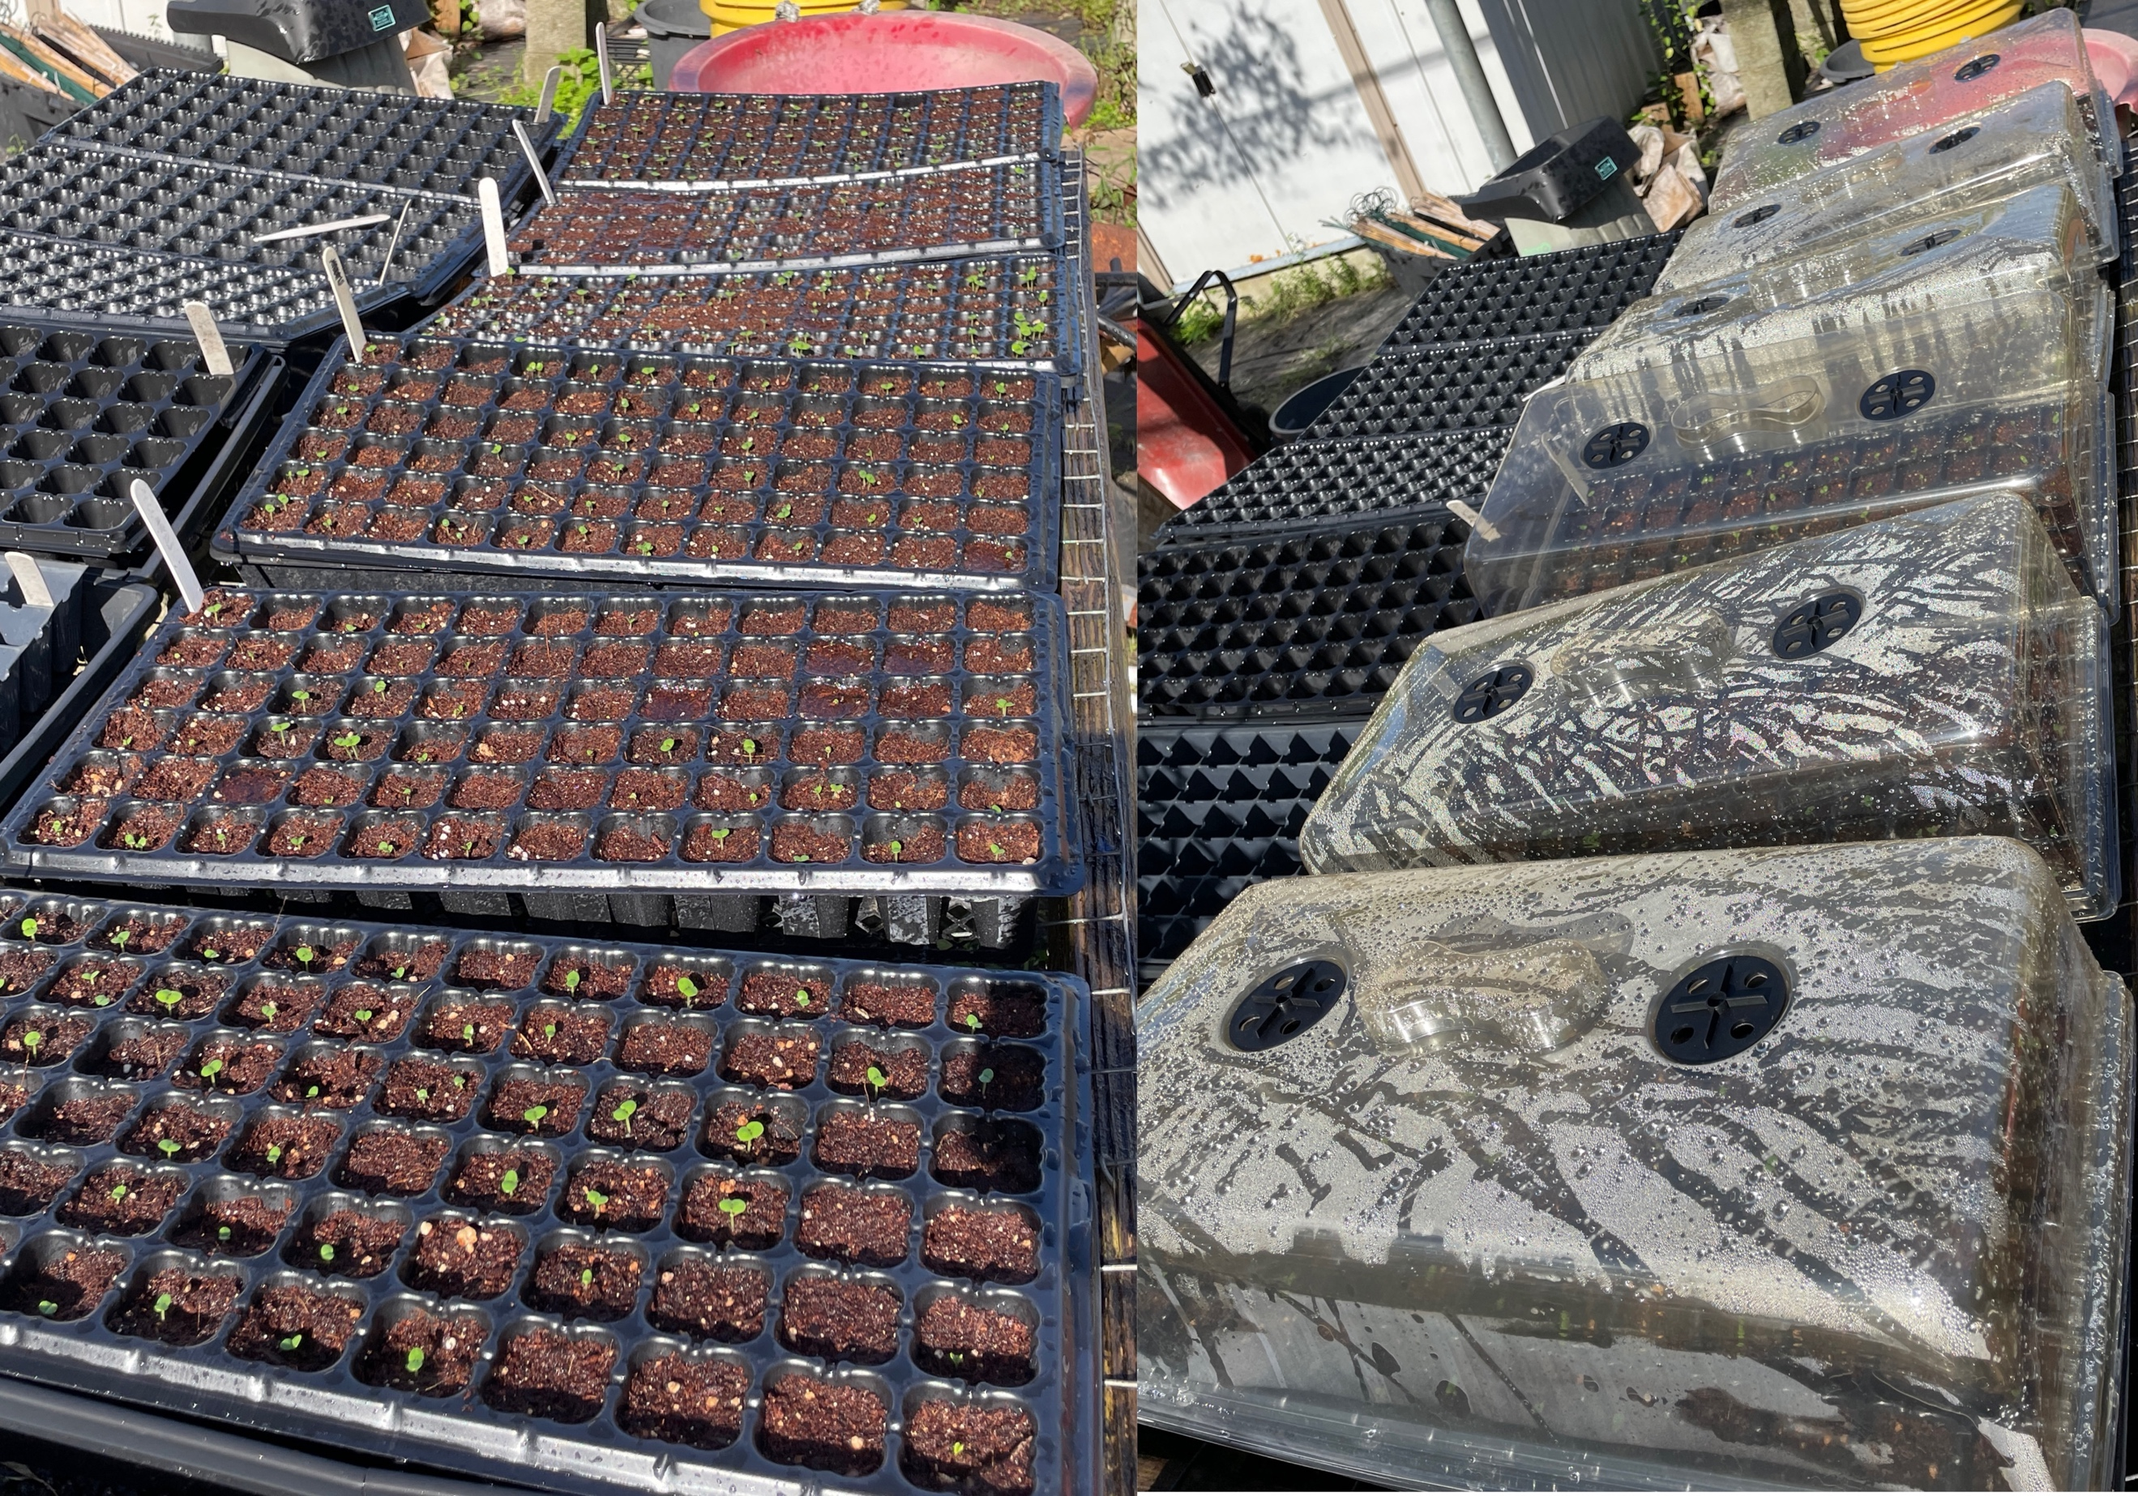
Figure 1 Seed starting trays for sweet basil seeds. Left: Trays on 8/31/2022.

Water Stress Treatments
To examine the effects of water stress on sweet basil, a gradient of water stress across four separate treatments was created. Each treatment consisted of 27 basil plants, which were 61 days old at the beginning of the treatments, for a total of 108 plants. Each treatment group had a drip irrigation system consisting of vinyl tubing (Everbilt Clear Vinyl, ¼ inch), three nine-port irrigation manifolds (Rain Bird, 9 Outlet Pressure Regulating Manifold On/Off), and a B09D Digital Hose End Timer (DIG) to control the emission of “irrigation events” across different amounts of time. Each plant had one dripper (Rain Bird, 2.0 GPH Spot Watering Emitters) which was connected to the hose timer, at a rate of two gallons per hour (GPH). The central difference between each treatment was the amount of time that passed between each “irrigation event”, which was defined as when the timer goes off and irrigates the plant for five minutes. Each irrigation event emitted approximately 126 ml of water at the base of the plant. One treatment (1D) was watered every day, another treatment (2D) was watered every two days, the 4D treatment was watered every four days, and the 8D treatment was watered every eight days.
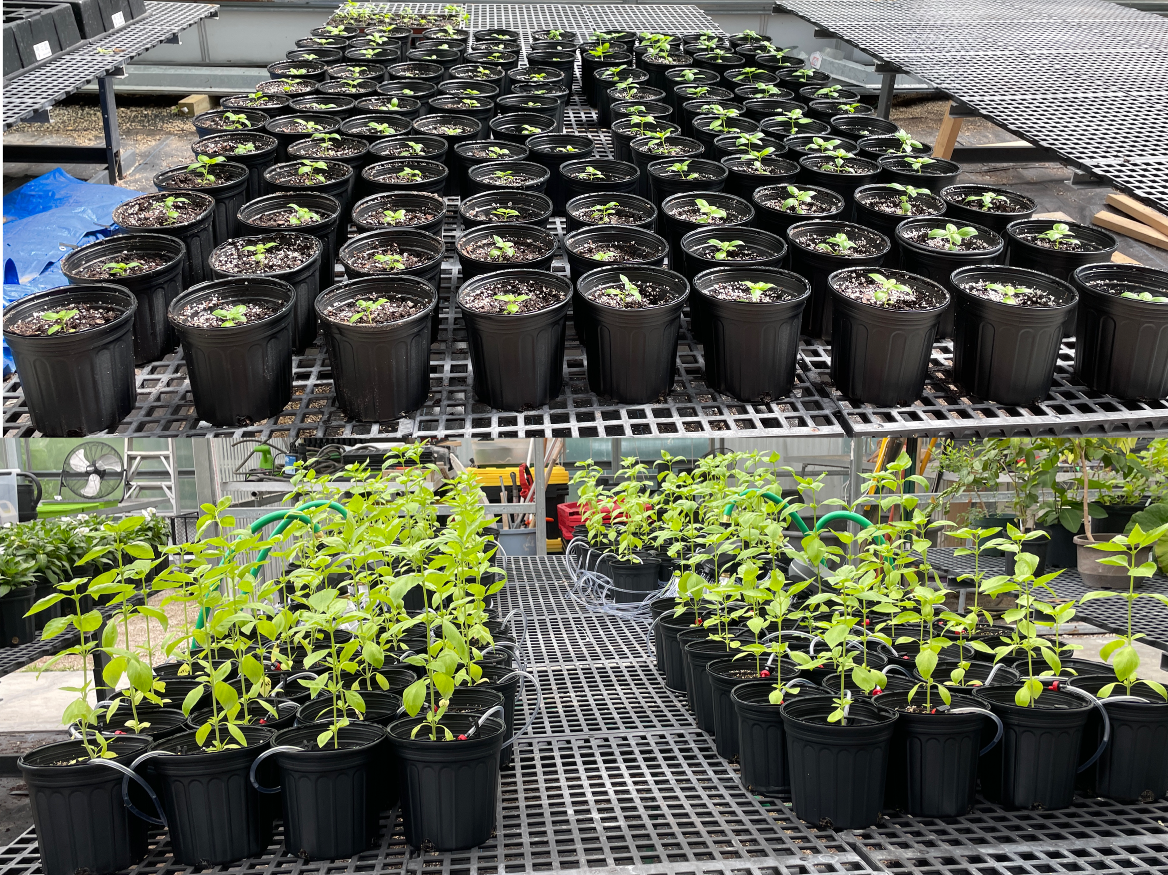
Figure 2 Potted sweet basil seedlings. Above: Transplanted seedlings in half-gallon pots on 9/30/22. Below: Sweet basil plants at beginning of water stress treatments.

Yield and Height
A tape measure was used to measure the height of each basil plant in centimeters (cm) at the beginning of the treatments, and when each basil plant was harvested and terminated. Each plant was measured from the top of the soil to the tallest apical bud on the basil plant.
Upon termination, each basil plant was cut from down to a height of 15 centimeters. The branches and leaves of each plant were cut from the central stem of the plant and bagged separately from the stems. This was done to measure yield of the leaves and branches as their own product, versus the whole plant itself. The whole plant yield was still measured during the data analysis stage. The wet weight of each plant’s leaves and branches were weighed separately in grams (g) from the central stems on a scale that measured up to two significant figures after the decimal point. To calculate the dry weight of the harvested material, the bagged stems and leaves plus branches were inserted into a Lingberg/Blue oven at 45 degrees Celsius for 72 hours. The harvested material was then reweighed in a similar fashion to the wet weight initially.
Sampling and Data Collection

Leaf Chlorophyll Concentration
Following Friedenrich’s protocol (Freidenrich et al. 2019), the Soil Plant Analysis Development sensor (SPAD-502) was utilized to monitor the concentration of leaf chlorophyll in each treatment group. Once treatments were initiated, the SPAD sensor was used to non-destructively measure a representative sample of each treatment group each week until termination. Nine random plants per treatment group were screened weekly with the SPAD sensor, with three different mature leaves from the middle to top canopy of the plant sampled. The sensor of the SPAD reader was placed in the center of the leaf each time.

Biomass Collection for Secondary Metabolite Analysis
Within the same week as the termination of the basil plants, two leaves of each plant were taken from the third node from the top of the plant. These leaves were individually collected and stored in 2 mL plastic tubes, marked with an individual treatment and plant identification code. These tubes were frozen in liquid nitrogen preserve the current chemical properties of the plant tissue samples.
Secondary Metabolite Analysis

Sample Preparation
The collected samples were placed into a freeze drier (Harvest Right Freeze Dryer) for 48 hours at -65 degrees Celsius. The dry samples were ground into a homogenized powder by adding two ceramic beads to each sample tube and inserting the tubes into a Fisher Scientific Bead Mill 24. The bead mill was set to a speed of 3.10 for one minute, for three cycles and 30 seconds of dwell time between cycles. 50 mg of ground sample material was weighed out into new 2 mL tubes with an analytical scale. This procedure was developed and modified by Dr. Diego Salazar-Amoretti.

Secondary Metabolite Extraction
The sample tubes were pulsed in a centrifuge and knocked on a hard surface to collect the tissue powder at the bottom. Two new ceramic beads were added to the sample tubes. A repeater pipet with a 10 mL pipet tip was utilized to pipet 1 mL of solvent into each tube (Lisec et al. 2006). The solvent was a 1:1 mixture of dichloromethane and ethanol, with caryophyllene oxide included as an internal standard (0.01 mg/mL). The sample tubes were then placed into the same bead mill, at a speed 2.10, for 15 seconds per cycle, a dwell time of 1 minute, for a total of 10 cycles. Those same tubes were then placed in a centrifuge at 14.8 rpm for 5 minutes, and 600 μL of supernatant was transferred into autosampler vials.
GC/MS Analysis
Chemical analysis was performed using GCMS (Agilent 7860B with a 5977A mass detector) equipped with an HP-5MS capillary column (30m, 0.250 mm, 0.25 um) and helium as a carrier gas (1.2 ml/min flow). For each sample, 1.2uL was injected into a 4 mm ID single taper inlet liner with wool (Restek) in splitless mode, with the inlet kept at a constant temperature of 250 degrees. The oven was heated as follows: 50°C, hold for 2 min; ramp 1: 5°C min⁻¹ to 75°C; ramp 2: 7°C min⁻¹ to 240°C; ramp 3: 10°C min⁻¹ to 275°C, hold for 6 minutes. The mass spectrometer was used at the following conditions: electron ionization source with positive ionization, 70 eV, full scan (30–650 a.m.u).

Statistical Analysis
Data analysis was conducted with SPSS Statistics 28 (IBM) for the data analysis. One-way ANOVA tests were conducted to analyze the significance of the differences between treatment groups in terms of height, yield and leaf chlorophyll content. An alpha level of ∝=0.05 was utilized for determining if the results were statistically significant.
Chemical data collected via GCMS was extracted in CDF file format and processed in RStudio (R version 4.2.1) with the package MetaMS to identify compound retention times and peak areas. Accuracy of peak detection was checked against the original data, and chromatographic artefacts removed. Compound identities were assigned using the mass spectral library published by the National Institute of Standards and Technology (NIST). Final dataset was centered and normalized. Missing values were addressed using a mean interpolation approach.
The effect of the experimental treatments on the major aroma components of the experimental basil cultivar were assessed using ANOVA and post-hoc all-pairs mean comparison (JMP 16). A metabolomic approach was also used to determine the overall change in the volatile chemical profile of basil across the watering gradient. An untargeted multivariate approach we used via principal component analysis (JMP 16).

RESULTS AND DISCUSSION

Physical Results

Height and Leaf Chlorophyll
With a One-Way Analysis of Variance Test (ANOVA) it was found that the SPAD measurements of the four different treatments taken across the growing period were not statistically significant from one another (p=0.144). Using post-hoc tests with Tukey HSD, there were similarly no statistically significant differences between the four treatments, with the most significant difference being between Treatment 1D and 8D (p=0.028). It should be noted that the Tukey HSD test cannot be used to analyze the differences between the different treatments since the initial ANOVA test did not prove the treatments to be statistically significantly different from one another. The greatest average SPAD measurements over the growth period were, in order, Treatment 8D (35.15±1.673), Treatment 4D (33.19±1.53), Treatment 2D (31.69±1.555), and Treatment 1D (30.26±1.264). The average SPAD measurement of the whole group was 32.573±0.782.
The final heights of all the treatments were found to be statistically significant from one another (p=<0.001), and statistically different from their starting heights as well. The Tukey HSD test found the mean differences between the different treatments to be statistically significantly different from one another, except for Treatment 1D and Treatment 4D not being statistically significantly different from one another (p=0.938). The highest average final heights for the different treatments are, in order: Treatment 2D (85.22±1.09 cm), Treatment 4D (77.47±2.78 cm), Treatment 1D (76.167±2.075 cm) and Treatment 8D (64.85±1.229 cm). The average final height for all replicants was 75.998±1.179 cm. The treatment groups that grew the most on average are, in order: Treatment 2D (56.370 cm), Treatment 4D (53.0556 cm), Treatment 1D (47.167 cm), and Treatment 8D (36.926 cm).
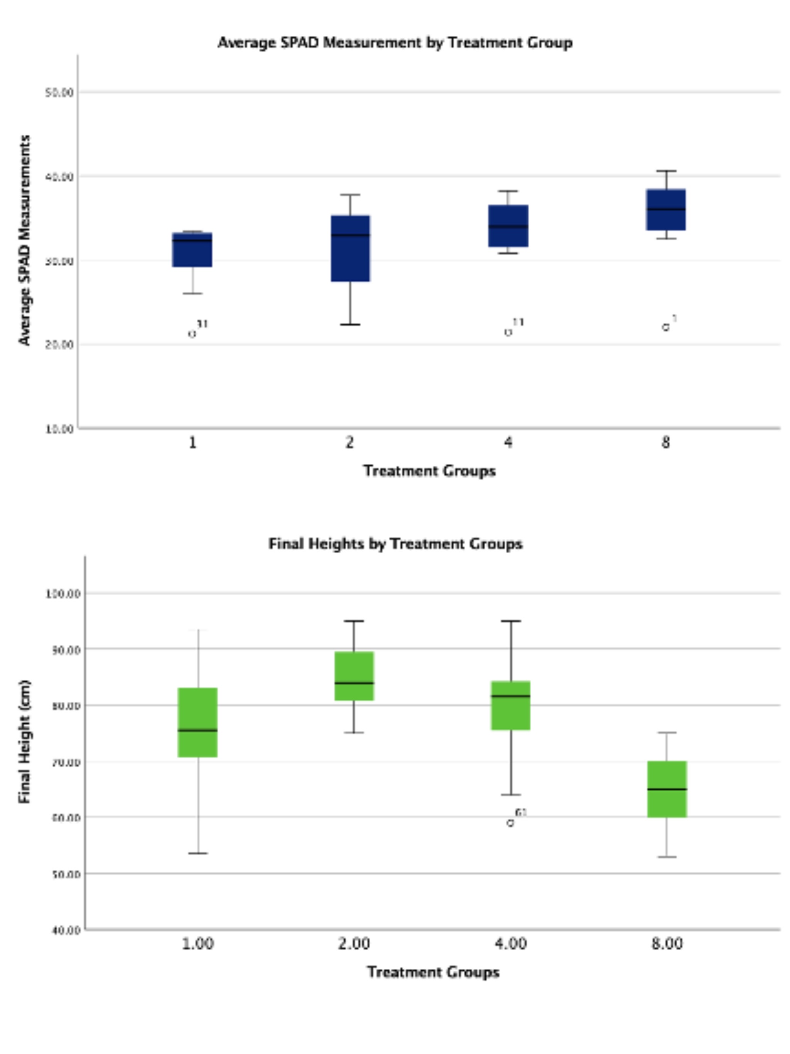
Figure 3 Boxplot graphs of the SPAD measurements and final heights of the sweet basil treatment groups. Above: Average SPAD measurements of each treatment group across the stress experiment. Below: Average final heights of each treatment group.

Dry Yield
The average mass of dry stems of the four treatment groups were all statistically significantly different from one another (p=<0.001). The mean differences of the average dry stem mass of Treatments 1D, 2D, and 4D were all statistically significantly different from Treatment 8D, but not from one another. The average mass of the leaves and branches of the different treatment groups were statistically significantly different from one another (p=<0.001). The average mean differences of the leaves and branches that were statistically significantly different were Treatment 1D from Treatment 8D, Treatment 2D from Treatment 4D, and Treatment 4D from Treatment 2D and Treatment 8D. The total dry mass of the different treatment groups was statistically significantly different across the different treatment groups (p=<0.001). The statistically significant mean differences between the different treatment groups with Tukey’s HSD test were Treatment 8D against Treatments 1D, 2D and 4D. The mean difference between Treatments 2D and 4D was also statistically significant as well.
The greatest means for the total dry mass of each treatment group is, in descending order: Treatment 4D (16.119±1.54 g), Treatment 1D (13.640±1.236 g), Treatment 2D (10.989±0.667 g, and Treatment 8D (5.156±0.326 g).
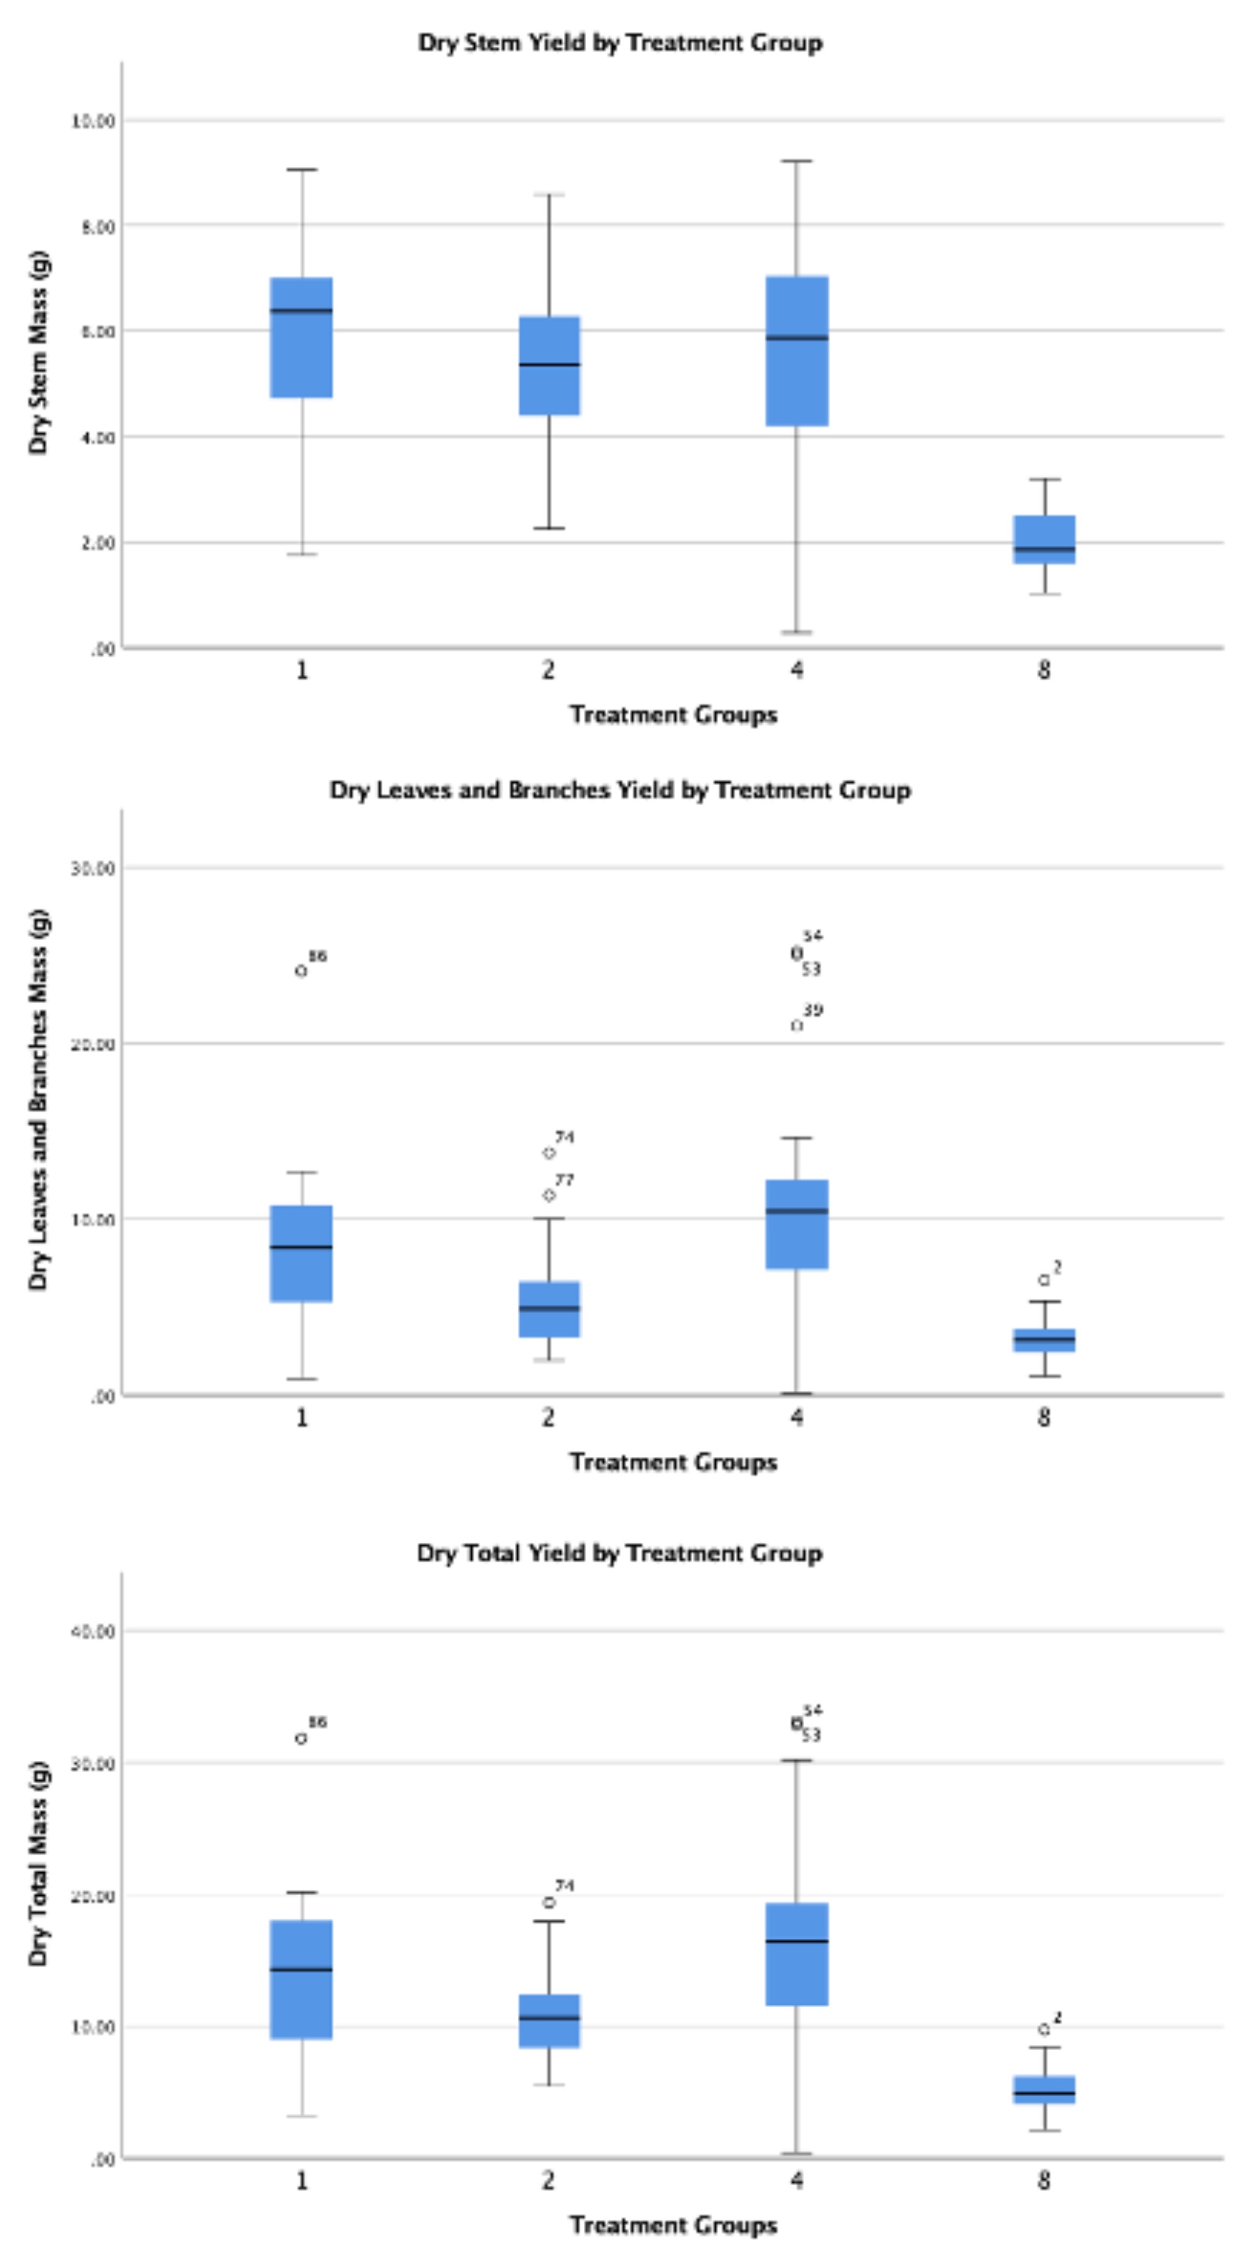
Figure 4 Boxplots of the dry yield of the different treatment groups in grams (g). Above: Dry stem yield by treatment group. Middle: Dry leaves and branches yield by treatment group. Bottom: Dry total yield by treatment group.

Wet Yield
An ANOVA test found that the average masses of the wet stems, wet leaves and branches, and wet total mass across the different treatments were all statistically significantly different from one another (p=<0.004). Using Tukey’s HSD test, the only statistically significant mean differences for the wet stem masses of the different treatment groups were that of Treatment 8D against Treatments 1D, 2D, and 4D. For the wet masses of the leaves and branches, the mean differences between the different treatment groups were all statistically significant, except for the difference between Treatment 4D and 1D. This statement also directly applies to the mean differences between the average total wet mass of the different treatment groups.
The greatest means for the total wet mass of each treatment group is, in descending order: Treatment 4D (92.817±7.878 g), Treatment 1D (83.459±6.185 g), Treatment 2D (61.056±4.396 g), and Treatment 8D (17.602±3.903 g).
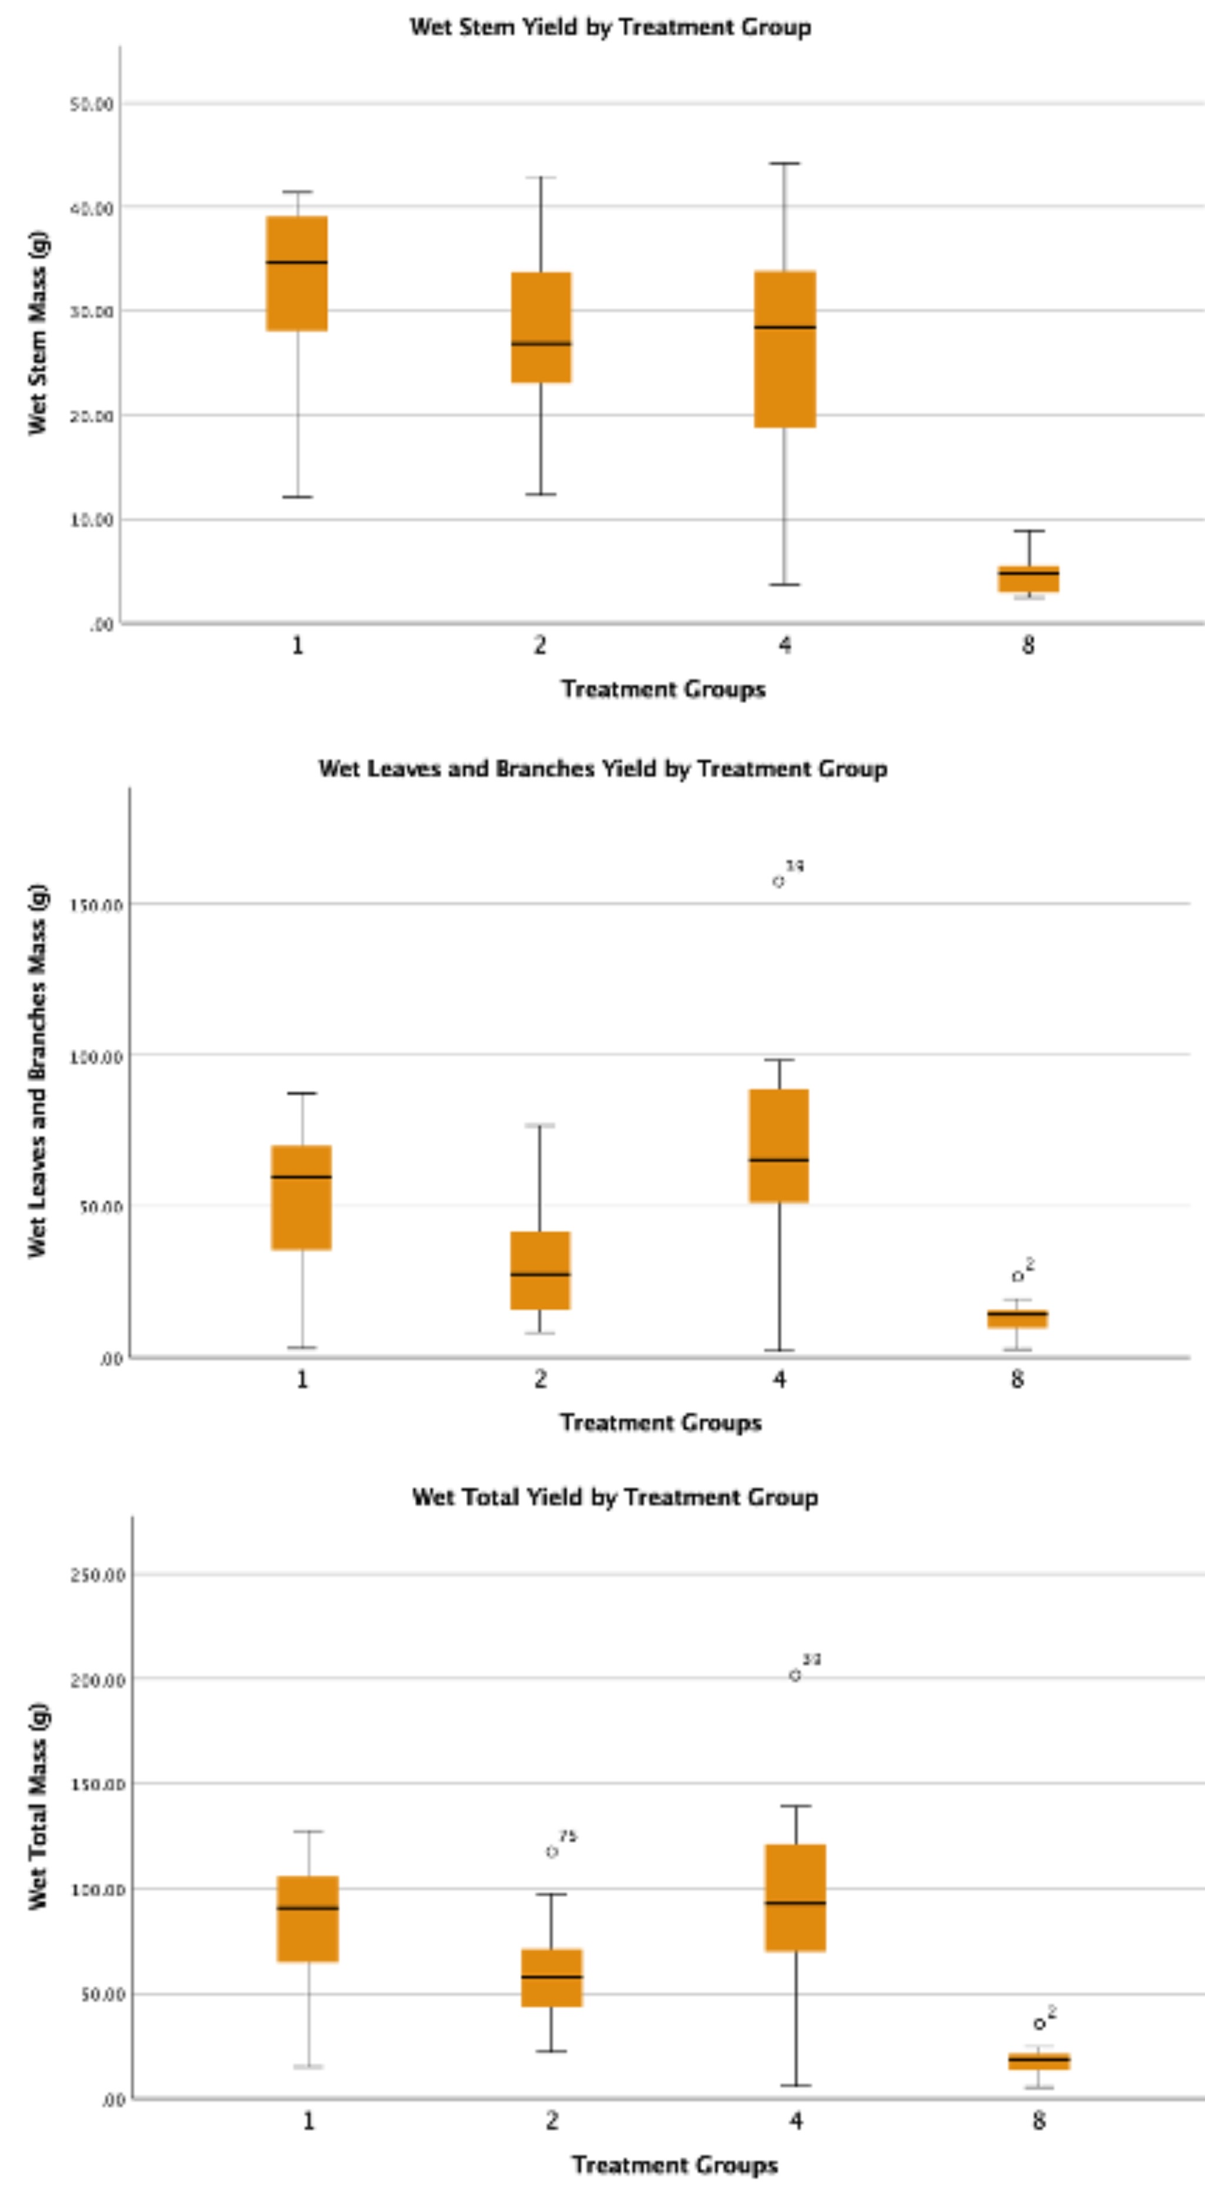
Figure 5 Boxplots of the wet yield of the different treatment groups in grams (g). Above: Wet stem yield by treatment group. Middle: Wet leaves and branches yield by treatment group. Bottom: Wet total yield by treatment group.

Chemical Results
The most chemicals present in the highest concentrations of all four treatment groups include eucalyptol, linalool, germacrene D, eugenol, and linolenic acid. Eucalyptol, linalool, and germacrene D are all terpenoids, while eugenol as a phenylpropanoid and linolenic acid is a fatty acid.
The three terpenoids mentioned all gradually decreased in concentration as the water stress treatments increased in severity, only to unexpectedly increase in the most severe treatment of the group, Treatment 8D (p<0.0001). Eugenol, however, maintained the same concentration across all four treatments, with no statistically significant differences between them (p<0.45). Linolenic acid concentrations in Treatments 1D and 2D were both lower than Treatments 4D and 8D.
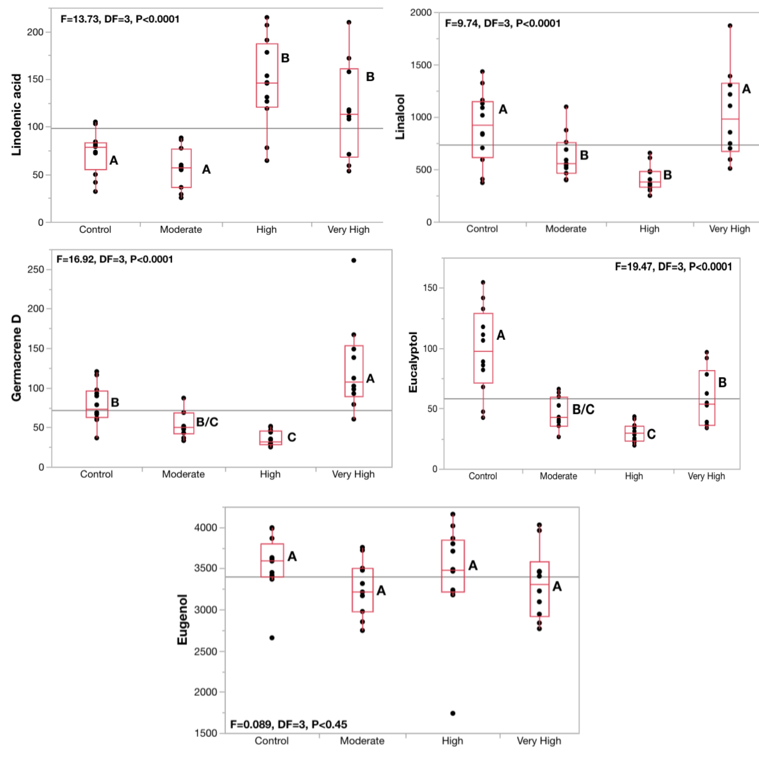
Figure 6 Boxplots of detected amounts of linolenic acid, linalool, germacrene D, eucalyptol, and eugenol in the analyzed samples. Corresponding letters correlate with similar levels.

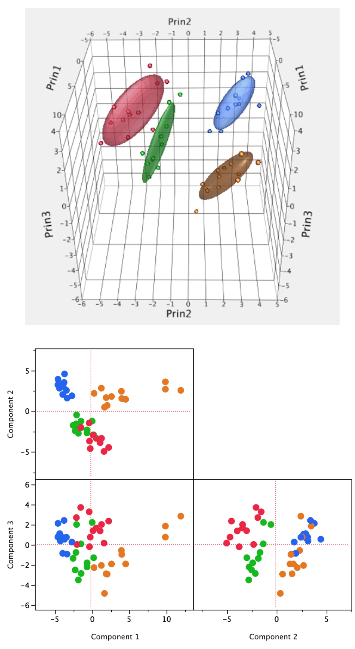
Figure 7 Primary Component Analysis of chemicals more prevalent in the sweet basil samples analyzed. Top: Three-dimensional representation of the chemical data. Bottom: Two-dimensional representation of the chemical data.

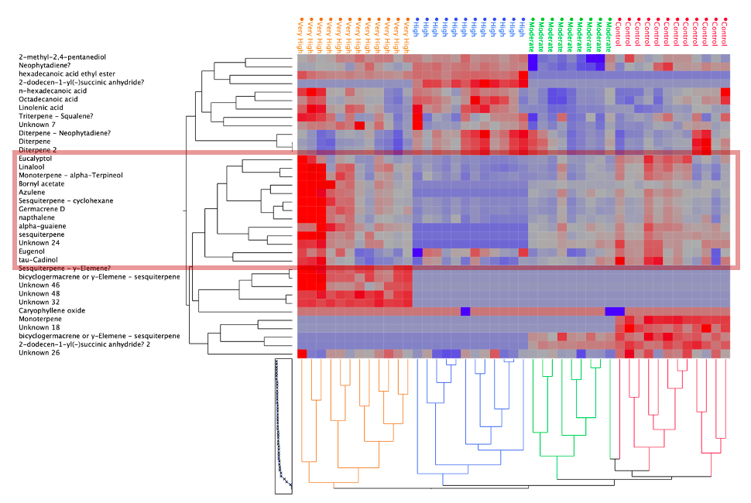
Figure 8 Heat-Map Visualization of GC-MS data of analyzced basil samples.

Discussion
In the literature the effects of water stress on the photosynthetic rates of Ocimum species, including sweet basil, there is no data that suggests that photosynthesis rates would increase or improve under water stress, in addition to the literature that suggests otherwise for different crops (Heidari and Golpayegani 2012). This leads us to believe that this result may have come from a malfunction with the SPAD meter utilized in this study, or some unknown mechanism tied to chlorophyll production and water stress that needs to be elucidated on. The tallest treatment group was Treatment 2D, with the highest average final height at harvest and the highest difference between the starting height and the end height.
Treatment 4D had the highest total wet and dry mass out of all the treatment groups, in addition to having the highest mass of wet and dry leaves and branches. This does not fit into the original hypothesis posed here; one possible explanation for the increased overall yield of Treatment 4D is that Treatments 1D and 2D experienced significant leaf drop due to overwatering. There is evidence for this claim in photos taken of the different groups later during the application of the treatments, which show the bottom half of the basil plants in Treatment 1D and 2D bereft of leaves and branches when compared to Treatment 4D and 8D.
One of the most interesting departures from the literature discussed here is the lack of expected phenylpropanoids in the basil plants analyzed. Eugenol is considered a “high note” in sweet basil and is maintained in the same pathway as other phenylpropanoids, which has been known to increase in concentration when under severe water stress (Mandoulakani et al. 2017). However, there was no significant difference in the concentration of eugenol throughout the different replicants and treatment groups sampled. One possible explanation for this could be tied to the specific seed source and origin of the basil replicants, Burpee Seeds and Plants. The basil seeds utilized for this experiment were likely bred to maintain the key traits of sweet basil for consumers against abiotic and biotic stress. Thus, eugenol would be the perfect candidate as a chemical to selectively breed for, as the chemical analysis shows that through the different water stress treatments, it stays the same. The terpenoids that appear in the chemical analysis demonstrate strange behavior under the most severe water stress condition by increasing in concentration. Germacrene D, linalool, and eucalyptol are important chemicals in sweet basil that could still be bred for in different cultivars and varieties for a more unique fragrance, which is noteworthy for plant breeders and stakeholders who are interested in developing new fragrances and products with a more unique scent profile. Understanding how water stress further increases the concentration of terpenoids in different cultivars and varieties of basil is crucial to innovating new and exciting flavors and fragrances from members of the Ocimum genus.
It is worth noting that the heat-map visualization of the chemicals analyzed demonstrated the clustering of the different treatments across multivariate chemical space. This shows that changes in chemistry across the experimental treatments are systemic and “hard wired”, as all samples in the same treatment respond similarly in terms of their chemistry. The data here shows the same plant exhibiting two types of survival strategies under water stress: the “moderate” response to cease production of certain secondary metabolites to focus resources elsewhere, or the “chronic” response to increase secondary metabolite production. The switch from the moderate stress response to the chronic stress response can be clearly seen in the concentrations of linalool, linolenic acid, eucalyptol, and germacrene D, while the concentrations of eugenol remain constant throughout the different stress treatments.

CONCLUSION
Sweet basil is an exciting culinary herb with massive amounts of potential for agricultural shareholders, plant breeders, and fragrance developers. In this experiment, four different treatments of water stress were applied to twenty-seven replicants of sweet basil plants each. These water stress treatments involved increasing the gap in time between irrigation events, starting with one day, two days, four days, and eight days. The drought gradient created during the growth period demonstrated statistically significant differences in height, dry and wet yield, and secondary metabolite concentration. Leaf chlorophyll was measured throughout the growth period but there was no statistically significant difference between the average leaf chlorophyll measurements taken during this experiment. In direct opposition of the literature available on sweet basil and the secondary metabolites produced under increased water stress, there was a distinct lack of high concentrations of phenylpropanoids in the basil plants sampled. In addition to this, the most notable phenylpropanoid present (eugenol) was found in high concentrations across all four treatments, with no statistically significant differences in concentration across the different treatments.
This study and its unique water stress application method have interesting implications for future studies. Using a gradient of water stress with a drip irrigation system is a relatively straightforward method to replicate for future experiments with different parameters. More precise drip irrigation applicators could examine the effects of water stress to a more exact degree. Chemical samples could be taken throughout the entire water stress experiment to examine how the chemistry of the basil changes over time, lending greater insight into the different survival mechanisms within sweet basil. Different Ocimum species could also be analyzed, such as those that possess less common secondary metabolites and less common combinations and concentrations of secondary metabolites. Different propagative sources of basil could also be utilized; using clones of a single basil plant versus standard seeds of a basil plant could elucidate any genetic differences and mutations that may appear. Finally, examining less economically important species and cultivars of basil with this method could provide agricultural stakeholders, fragrance developers and plant breeders valuable knowledge about new agricultural products. Species such as Ocimum kilimandscharicum and Ocimum gratissimum are not sought after as widely as sweet basil for its flavor and fragrance. Using the method listed in this study could help understand the key to the next big culinary herb responsible for a consumer’s new favorite scent.

REFERENCES
Wu, C., Wang, L., Niu, Z., Gao, S., & Wu, M. (2010). Nondestructive estimation of canopy chlorophyll content using Hyperion and Landsat/TM images. International Journal of Remote Sensing, 31(8), 2159-2167.m1

Selmar, Dirk, and Maik Kleinwächter. “Influencing the Product Quality by Deliberately Applying Drought Stress during the Cultivation of Medicinal Plants.” Industrial Crops and Products 42 (March 2013): 558–66. https://doi.org/10.1016/j.indcrop.2012.06.020.

Freidenreich, A., Barraza, G., Jayachandran, K., & Khoddamzadeh, A. A. (2019). Precision Agriculture Application for Sustainable Nitrogen Management of Justicia brandegeana Using Optical Sensor Technology. Agriculture, 9(5), 98. MDPI AG. Retrieved from http://dx.doi.org/10.3390/agriculture9050098

Blackmer, T. M., & Schepers, J. S. (1995). Use of a chlorophyll meter to monitor nitrogen status and schedule fertigation for corn. Journal of production agriculture, 8(1), 56-60.

Said-Al Ahl, H. A. H., & Abdou, M. A. A. (2009). Impact of water stress and phosphorus fertilizer on fresh herb and essential oil content of dragonhead. International Agrophysics, 23(4), 403-407.

Sanchez, R. A., Hall, A. J., Trapani, N., & de Hunau, R. C. (1983). Effects of water stress on the chlorophyll content, nitrogen level and photosynthesis of leaves of two maize genotypes. Photosynthesis research, 4(1), 35–47. https://doi.org/10.1007/BF00041799

Mirbahar, A. A., Markhand, G. S., Mahar, A. R., Abro, S. A., & Kanhar, N. A. (2009). Effect of water stress on yield and yield components of wheat (Triticum aestivum L.) varieties. Pak. J. Bot, 41(3), 1303-1310.

Baher, Z.F., Mirza, M., Ghorbanli, M. and Bagher Rezaii, M. (2002), The influence of water stress on plant height, herbal and essential oil yield and composition in2 L.. Flavour Fragr. J., 17: 275-277. https://doi.org/10.1002/ffj.1097

Mafakheri, A., Siosemardeh, A. F., Bahramnejad, B., Struik, P. C., & Sohrabi, Y. (2010). Effect of drought stress on yield, proline and chlorophyll contents in three chickpea cultivars. Australian journal of crop science, 4(8), 580-585.

Zahran, Eman Maher, Usama Ramadan Abdelmohsen, Hany Ezzat Khalil, Samar Yehia Desoukey, Mostafa Ahmed Fouad, and Mohamed Salah Kamel. “Diversity, Phytochemical and Medicinal Potential of the Genus Ocimum L. (Lamiaceae).” Phytochemistry Reviews 19, no. 4 (August 2020): 907–53. https://doi.org/10.1007/s11101-020-09690-9.

Gurav, Tanuja P., Bhushan B. Dholakia, and Ashok P. Giri. “A Glance at the Chemodiversity of Ocimum Species: Trends, Implications, and Strategies for the Quality and Yield Improvement of Essential Oil.” Phytochemistry Reviews 21, no. 3 (June 2022): 879–913. https://doi.org/10.1007/s11101-021-09767-z.

Abdollahi Mandoulakani, Babak, Elham Eyvazpour, and Morteza Ghadimzadeh. “The Effect of Drought Stress on the Expression of Key Genes Involved in the Biosynthesis of Phenylpropanoids and Essential Oil Components in Basil (Ocimum Basilicum L.).” Phytochemistry 139 (July 2017): 1–7. https://doi.org/10.1016/j.phytochem.2017.03.006.

Putievsky, E., & Galambosi, B. (1999). Production systems of sweet basil. In basil (pp. 47-73). CRC press.

Roberts, P. (2005). 2005 Florida Plant Disease Management Guide: Sweet Basil. Department of Plant Pathology document PP113. Florida Cooperative Extension Service, Institute of Food and Agricultural Sciences, University of Florida.

Lisec, J., Schauer, N., Kopka, J. et al. Gas chromatography mass spectrometry–based metabolite profiling in plants. Nat Protoc 1, 387–396 (2006). https://doi.org/10.1038/nprot.2006.59

Her, Young Gu, Kenneth Boote, Kati Migliaccio, Clyde Fraisse, David Letson, Odemari Mbuya, Aavudai Anandhi, Hongmei Chi, Lucy Ngatia, and Senthold Asseng. “Climate Change Impacts and Adaptation in Florida’s Agriculture.” In Florida’s Climate: Changes, Variations, & Impacts, by Florida Climate Institute. Florida Climate Institute, 2017. https://doi.org/10.17125/fci2017.ch08.

Selena Ahmed, John Richard Stepp; Beyond yields: Climate change effects on specialty crop quality and agroecological management. Elementa: Science of the Anthropocene 1 January 2016; 4 000092. doi: https://doi.org/10.12952/journal.elementa.000092

USDA NASS (National Agricultural Statistics Service). 2017. Census of Agriculture.Washington, DC: USDA NASS.

USDA NASS (National Agricultural Statistics Service). 2019. Census of Agriculture.Washington, DC: USDA NASS.

Ekren, Sıdıka, Çiğdem Sönmez, Emrah Özçakal, Yasemin S. Kukul Kurttaş, Emine Bayram, and Hatice Gürgülü. “The Effect of Different Irrigation Water Levels on Yield and Quality Characteristics of Purple Basil (Ocimum Basilicum L.).” Agricultural Water Management 109 (June 2012): 155–61. https://doi.org/10.1016/j.agwat.2012.03.004.

Simon, J.E. 1990. Essential oils and culinary herbs. p. 472-483. In: J. Janick and J.E. Simon (eds.), Advances in new crops. Timber Press, Portland, OR.

Simon, James E., et al. "Basil: A source of aroma compounds and a popular culinary and ornamental herb." Perspectives on new crops and new uses 16 (1999): 499-505.

Putnam, A. (2015), 2015 Annual Report., Florida Department of Agriculture and Consumer Services, Tallahassee, FL.

Howden, S. M., J.-F. Soussana, F. N. Tubiello, N. Chhetri, M. Dunlop, and H. Meinke (2007), Adapting agriculture to climate change, Proceedings of the National Academy of Sciences, 104(50), 1969119696.

Hoppe, Robert A., James M. MacDonald, and Penni Korb. “Small Farms in the United States: Persistence Under Pressure.” SSRN Electronic Journal, 2010. https://doi.org/10.2139/ssrn.1557208.

Muhammad Mumtaz Khan. “Variations in Basil Antioxidant Contents in Relation to Deficit Irrigation.” Journal of Medicinal Plants Research 6, no. 11 (March 23, 2012). https://doi.org/10.5897/JMPR12.007.

M. M. CHAVES, J. S. PEREIRA, Water Stress, CO₂ and Climate Change, Journal of Experimental Botany, Volume 43, Issue 8, August 1992, Pages 1131–1139, https://doi.org/10.1093/jxb/43.8.1131

Khalid K. Influence of water stress on growth, essential oil, and chemical composition of herbs (Ocimum sp.). Int. Agrophys. 2006;20(4):289-296.

Abdollahi Mandoulakani, Babak, Elham Eyvazpour, and Morteza Ghadimzadeh. “The Effect of Drought Stress on the Expression of Key Genes Involved in the Biosynthesis of Phenylpropanoids and Essential Oil Components in Basil (Ocimum Basilicum L.).” Phytochemistry 139 (July 2017): 1–7. https://doi.org/10.1016/j.phytochem.2017.03.006.

Souza, João V. R. S., Lin Chau Ming, Marcos A. L. Santos, James E. Simon, Hector R. Juliani, and João C. C. Saad. “Effect of Water Regime and Harvest Stage on Essential Oil Accumulation in Basil Plant Growing in Sandy Soil.” Irrigation Science 39, no. 4 (July 2021): 493–503. https://doi.org/10.1007/s00271-021-00719-1.

Falkenmark, Malin. "Growing water scarcity in agriculture: future challenge to global water security." Philosophical Transactions of the Royal Society A: Mathematical, Physical and Engineering Sciences 371.2002 (2013): 20120410. https://doi.org/10.1098/rsta.2012.0410

Savoi, S., Wong, D.C.J., Arapitsas, P. et al. Transcriptome and metabolite profiling reveals that prolonged drought modulates the phenylpropanoid and terpenoid pathway in white grapes (Vitis vinifera L.). BMC Plant Biol 16, 67 (2016). https://doi.org/10.1186/s12870-016-0760-1

Morshedloo, Mohammad Reza, et al. "Effect of prolonged water stress on essential oil content, compositions and gene expression patterns of mono-and sesquiterpene synthesis in two oregano (Origanum vulgare L.) subspecies." Plant physiology and biochemistry 111 (2017): 119-128.

Nasrollahi, Vida, et al. "The effect of drought stress on the expression of key genes involved in the biosynthesis of triterpenoid saponins in liquorice (Glycyrrhiza glabra)." Phytochemistry 103 (2014): 32-37.

Walters, Kellie J., and Christopher J. Currey. “Hydroponic Greenhouse Basil Production: Comparing Systems and Cultivars.” HortTechnology 25, no. 5 (October 2015): 645–50. https://doi.org/10.21273/HORTTECH.25.5.645.

Darrah, H. H. (1974). Investigation of the cultivars of the basils (Ocimum). Economic Botany, 63-67.

Darrah, H. H. (1980). Cultivated basils

Walters, Kellie J., and Roberto G. Lopez. “Basil Seedling Production Environment Influences Subsequent Yield and Flavor Compound Concentration during Greenhouse Production.” PLOS ONE 17, no. 8 (August 25, 2022): e0273562. https://doi.org/10.1371/journal.pone.0273562.

Kessler, A., & Baldwin, I. T. (2001). Defensive function of herbivore-induced plant volatile emissions in nature. Science (New York, N.Y.), 291(5511), 2141–2144. https://doi.org/10.1126/science.291.5511.2141

https://web.archive.org/web/20140103194112/http://www.ars-grin.gov/cgi-bin/npgs/html/genus.pl?8358

Morgan, L. 2005. Fresh culinary herb production. Suntec NX Ltd., Tokomaru, New Zealand.

Benke, K., & Tomkins, B. (2017). Future food-production systems: vertical farming and controlled-environment agriculture. Sustainability: Science, Practice and Policy, 13(1), 13-26.

National Agricultural Statistics Service (2017) Certified Organic Floriculture Crops, Nursery Crops, Mushrooms, and Vegetables/Herbs Under Protection Produced and Value of Sales. Retrieved from https://www.nass.usda.gov/Publications/AgCensus/2017/Full_Report/Volume_1,_Chapter_1_US/usv1.pdf

Florida Department of Agriculture & Consumer Services. (n.d.). Florida agriculture overview and Statistics. Florida Agriculture Overview and Statistics - Florida Department of Agriculture & Consumer Services. Retrieved February 20, 2023, from https://www.fdacs.gov/Agriculture-Industry/Florida-Agriculture-Overview-and-Statistic

California Department of Food and Agriculture. (n.d.). California Agricultural Production Statistics. CDFA. Retrieved February 20, 2023, from https://www.cdfa.ca.gov/statistics/

Merck Index - O'Neil MJ, Heckelman PE, Dobbelaar PH, Roman KJ (eds). The Merck Index, An Encyclopedia of Chemicals, Drugs, and Biologicals, 15th Ed. Cambridge, UK: The Royal Society of Chemistry, 2013.

Hawley - Lewis RJ. _Hawley's Condensed Chemical Dictionary, _15th Ed. New York: John Wiley & Sons, 2007.

Sell CS; Terpenoids. Kirk-Othmer Encyclopedia of Chemical Technology (1999-2015). John Wiley & Sons, Inc. Online Posting Date: September 15, 2006

The Chemical and Products Database, a resource for exposure-relevant data on chemicals in consumer products, Scientific Data, volume 5, Article number: 180125 (2018), DOI:10.1038/sdata.2018.125

Hiltunen, R.; Holm, Y. Basil: the Genus Ocimum-Medicinal and Aromatic Plants-Industrial Profiles; Harwood Academic Publishers: New York, 1999.

Charles, D. J., & Simon, J. E. (1990). Comparison of extraction methods for the rapid determination of essential oil content and composition of basil. Journal of the American Society for Horticultural Science, 115(3), 458-462.

Chaturvedi, T., Kumar, A., Kumar, A., Verma, R. S., Padalia, R. C., Sundaresan, V., ... & Venkatesha, K. T. (2018). Chemical composition, genetic diversity, antibacterial, antifungal and antioxidant activities of camphor-basil (Ocimum kilimandscharicum Guerke). Industrial Crops and Products, 118, 246-258.

Gang, D. R., Wang, J., Dudareva, N., Nam, K. H., Simon, J. E., Lewinsohn, E., & Pichersky, E. (2001). An Investigation of the Storage and Biosynthesis of Phenylpropenes in Sweet Basil. Plant Physiology, 125(2), 539–555.

Iijima, Y., Davidovich-Rikanati, R., Fridman, E., Gang, D. R., Bar, E., Lewinsohn, E., & Pichersky, E. (2004). The Biochemical and Molecular Basis for the Divergent Patterns in the Biosynthesis of Terpenes and Phenylpropenes in the Peltate Glands of Three Cultivars of Basil. Plant Physiology, 136(3), 3724–3736. https://doi.org/10.1104/pp.104.051318

Khakdan, F., Govahi, M., Mohebi, Z., & Ranjbar, M. (2021). Water deficit stress responses of monoterpenes and sesquiterpenes in different Iranian cultivars of basil. Physiologia Plantarum, 173(3), 896-910.

Rezaie, R., Abdollahi Mandoulakani, B. & Fattahi, M. Cold stress changes antioxidant defense system, phenylpropanoid contents and expression of genes involved in their biosynthesis in Ocimum basilicum L.. Sci Rep 10, 5290 (2020). https://doi.org/10.1038/s41598-020-62090-z

Oksman-Caldentey, K. M., & Inzé, D. (2004). Plant cell factories in the post-genomic era: new ways to produce designer secondary metabolites. Trends in plant science, 9(9), 433-440.

Uddling, J., Gelang-Alfredsson, J., Piikki, K. et al. Evaluating the relationship between leaf chlorophyll concentration and SPAD-502 chlorophyll meter readings. Photosynth Res 91, 37–46 (2007). https://doi.org/10.1007/s11120-006-9077-5

Tholl D. (2015). Biosynthesis and biological functions of terpenoids in plants. Advances in biochemical engineering/biotechnology, 148, 63–106. https://doi.org/10.1007/10_2014_295

Ramakrishna Akula & Gokare Aswathanarayana Ravishankar (2011) Influence of abiotic stress signals on secondary metabolites in plants, Plant Signaling & Behavior, 6:11, 1720-1731, DOI: 10.4161/psb.6.11.17613

Kohli, A., Sreenivasulu, N., Lakshmanan, P. et al. The phytohormone crosstalk paradigm takes center stage in understanding how plants respond to abiotic stresses. Plant Cell Rep 32, 945–957 (2013). https://doi.org/10.1007/s00299-013-1461-y

Reddy VA, Li C, Nadimuthu K, Tjhang JG, Jang IC, Rajani S. Sweet Basil Has Distinct Synthases for Eugenol Biosynthesis in Glandular Trichomes and Roots with Different Regulatory Mechanisms. Int J Mol Sci. 2021 Jan 12;22(2):681. doi: 10.3390/ijms22020681. PMID: 33445552; PMCID: PMC7826958.

Maurya, S., Chandra, M., Yadav, R.K. et al. Interspecies comparative features of trichomes in Ocimum reveal insights for biosynthesis of specialized essential oil metabolites. Protoplasma 256, 893–907 (2019). https://doi.org/10.1007/s00709-018-01338-y
Deschamps, C., Simon, J.E. (2010). Phenylpropanoid Biosynthesis in Leaves and Glandular Trichomes of Basil (Ocimum basilicum L.). In: Fett-Neto, A. (eds) Plant Secondary Metabolism Engineering. Methods in Molecular Biology, vol 643. Humana Press, Totowa, NJ. https://doi.org/10.1007/978-1-60761-723-5_18
Jiang Y, Ye J, Li S, Niinemets Ü. Regulation of Floral Terpenoid Emission and Biosynthesis in Sweet Basil (Ocimum basilicum). J Plant Growth Regul. 2016 Dec;35(4):921-935. doi: 10.1007/s00344-016-9591-4. Epub 2016 Mar 19. PMID: 29367803; PMCID: PMC5777610.

Gurav, Tanuja P., Bhushan B. Dholakia, and Ashok P. Giri. “A Glance at the Chemodiversity of Ocimum Species: Trends, Implications, and Strategies for the Quality and Yield Improvement of Essential Oil.” Phytochemistry Reviews 21, no. 3 (June 2022): 879–913. https://doi.org/10.1007/s11101-021-09767-z.

Yarou BB, Bawin T, Boullis A, Heukin S, Lognay G, Verheggen FJ, Francis F (2018) Oviposition deterrent activity of basil plants and their essentials oils against Tuta absoluta (Lepidoptera: Gelechiidae). Environ Sci Pollut Res 25:29880–29888

Yarou BB, Bokonon-Ganta AH, Verheggen FJ, Lognay GC, Francis F (2020) Aphid behavior on Amaranthus hybridus L. (Amaranthaceae) associated with Ocimum spp. (Lamiaceae) as repellent plants. Agronomy 10:736

Song B, Tang G, Sang X, Zhang J, Yao Y, Wiggins N (2013) Intercropping with aromatic plants hindered the occurrence of Aphis citricola in an apple orchard system by shifting predator–prey abundances. Biocontrol Sci Technol 23:381–395

Batista MC, Fonseca MCM, Teodoro AV, Martins EF, Pallini A, Venzon M (2017) Basil (Ocimum basilicum L.) attracts and benefits the green lacewing Ceraeochrysa cubana Hagen. Biol Control 110:98–106

Dicke M, Baldwin IT (2010) The evolutionary context for herbivore-induced plant volatiles: beyond the ‘cry for help.’ Trends Plant Sci 15:167–175

Quintana-Rodriguez E, Rivera-Macias LE, Adame-Alvarez RM, Torres JM, Heil M (2018) Shared weapons in fungus-fungus and fungus-plant interactions? Volatile organic compounds of plant or fungal origin exert direct antifungal activity in vitro. Fungal Ecol 33:115–121

Costa LCB, Pinto JEBP, Bertolucci SKV, Costa JCDB, Alves PB, Niculau EDS (2015) In vitro antifungal activity of Ocimum selloi essential oil and methylchavicol against phytopathogenic fungi. Rev Cieˆnc Agron 46:428–435

Oxenham SK, Svoboda KP, Walters DR (2005) Antifungal activity of the essential oil of basil (Ocimum basilicum). J Phytopathol 153:174–180

Rastogi S, Shah S, Kumar R, Vashisth D, Akhtar MQ, Kumar A, Dwivedi UN, Shasany AK (2019) Ocimum metabolomics in response to abiotic stresses: cold, flood, drought and salinity. PLoS ONE 14:e0210903

Lobell, D. B., Field, C. B., Cahill, K. N., & Bonfils, C. (2006). Impacts of future climate change on California perennial crop yields: Model projections with climate and crop uncertainties. Agricultural and Forest Meteorology, 141(2-4), 208-218.

Adams, R. M., McCarl, B. A., Dudek, D. J., & Glyer, J. D. (1988). Implications of global climate change for western agriculture. Western Journal of Agricultural Economics, 348-356.

Rosenzweig, C., & Parry, M. L. (1994). Potential impact of climate change on world food supply. Nature, 367(6459), 133-138.

Tanaka, S. K., Zhu, T., Lund, J. R., Howitt, R. E., Jenkins, M. W., Pulido, M. A., ... & Ferreira, I. C. (2006). Climate warming and water management adaptation for California. Climatic Change, 76, 361-387.

Reints, J., Dinar, A., & Crowley, D. (2020). Dealing with water scarcity and salinity: adoption of water efficient technologies and management practices by California avocado growers. Sustainability, 12(9), 3555.

Lobell, D. B., Cahill, K. N., & Field, C. B. (2007). Historical effects of temperature and precipitation on California crop yields. Climatic change, 81(2), 187.

AghaKouchak, A., Huning, L. S., Chiang, F., Sadegh, M., Vahedifard, F., Mazdiyasni, O., ... & Mallakpour, I. (2018). How do natural hazards cascade to cause disasters?.

Schwartz, B. E., & Bosart, L. F. (1979). The diurnal variability of Florida rainfall. Monthly Weather Review, 107(11), 1535-1545.

Rosenzweig, C., Iglesius, A., Yang, X. B., Epstein, P. R., & Chivian, E. (2001). Climate change and extreme weather events-Implications for food production, plant diseases, and pests.

Malmstadt, J., Scheitlin, K., and Elsner, J. (2009). Florida hurricanes and damage costs. Southeastern Geographer, 49(2):108–131.

Carlton, S. J., & Jacobson, S. K. (2013). Climate change and coastal environmental risk perceptions in Florida. Journal of environmental management, 130, 32-39.

Zhao, D., & Li, Y. R. (2015). Climate change and sugarcane production: potential impact and mitigation strategies. International Journal of Agronomy, 2015, 1-10.

Miller, K. A. (1991). Response of Florida citrus growers to the freezes of the 1980s. Climate Res, 1, 133-144.

Rosenzweig, C., Phillips, J., Goldberg, R., Carroll, J., & Hodges, T. (1996). Potential impacts of climate change on citrus and potato production in the US. Agricultural Systems, 52(4), 455-479.

Jones, G. V. (2004, June). Climate change in the western United States grape growing regions. In VII International Symposium on Grapevine Physiology and Biotechnology 689 (pp. 41-60).

Pathak, T. B., Maskey, M. L., Dahlberg, J. A., Kearns, F., Bali, K. M., & Zaccaria, D. (2018). Climate change trends and impacts on California agriculture: a detailed review. Agronomy, 8(3), 25.

Solecka, D. Role of phenylpropanoid compounds in plant responses to different stress factors. Acta Physiol Plant 19, 257–268 (1997). https://doi.org/10.1007/s11738-997-0001-1

Hammock HA, Kopsell DA and Sams CE (2021) Narrowband Blue and Red LED Supplements Impact Key Flavor Volatiles in Hydroponically Grown Basil Across Growing Seasons. Front. Plant Sci. 12:623314. doi: 10.3389/fpls.2021.623314

Niinemets, Ü., Arneth, A., Kuhn, U., Monson, R. K., Peñuelas, J., and Staudt, M.: The emission factor of volatile isoprenoids: stress, acclimation, and developmental responses, Biogeosciences, 7, 2203–2223, https://doi.org/10.5194/bg-7-2203-2010, 2010.

Ramakrishna A, Ravishankar GA. Influence of abiotic stress signals on secondary metabolites in plants. Plant Signal Behav. 2011 Nov;6(11):1720-31. doi: 10.4161/psb.6.11.17613. Epub 2011 Nov 1. PMID: 22041989; PMCID: PMC3329344.

Xu Z, Zhou G, Shimizu H. Plant responses to drought and rewatering. Plant Signal Behav. 2010 Jun;5(6):649-54. doi: 10.4161/psb.5.6.11398. Epub 2010 Jun 1. PMID: 20404516; PMCID: PMC3001553.

Simon, J. E., Reiss-Bubenheim, D., Joly, R. J., & Charles, D. J. (1992). Water Stress-Induced Alterations in Essential Oil Content and Composition of Sweet Basil. Journal of Essential Oil Research, 4(1), 71–75. https://doi.org/10.1080/10412905.1992.9698013

Iijima Y, Davidovich-Rikanati R, Fridman E, Gang DR, Bar E, Lewinsohn E, Pichersky E. The biochemical and molecular basis for the divergent patterns in the biosynthesis of terpenes and phenylpropenes in the peltate glands of three cultivars of basil. Plant Physiol. 2004 Nov;136(3):3724-36. doi: 10.1104/pp.104.051318. Epub 2004 Oct 29. PMID: 15516500; PMCID: PMC527170.

Walters, K. J., & Lopez, R. G. (2022). Hydroponic Basil Production: Temperature Influences Volatile Organic Compound Profile, but Not Overall Consumer Preference. Horticulturae, 8(1), 76. MDPI AG. Retrieved from http://dx.doi.org/10.3390/horticulturae8010076

Chang, X., Alderson, P., & Wright, C. (2005). Effect of temperature integration on the growth and volatile oil content of basil (Ocimum basilicumL.). The Journal of Horticultural Science and Biotechnology, 80(5), 593–598. doi:10.1080/14620316.2005.11511

Kulak, M. (2020). Recurrent drought stress effects on essential oil profile of Lamiaceae plants: An approach regarding stress memory. Industrial Crops and Products, 154, 112695. doi:10.1016/j.indcrop.2020.112695

da Costa AS, Arrigoni-Blank Mde F, de Carvalho Filho JL, de Santana AD, Santos Dde A, Alves PB, Blank AF. Chemical diversity in basil (Ocimum sp.) germplasm. ScientificWorldJournal. 2015;2015:352638. doi: 10.1155/2015/352638. Epub 2015 Jan 1. PMID: 25629084; PMCID: PMC4299303.

Gang, D. R. (2005). Evolution of flavors and scents. Annu. Rev. Plant Biol., 56, 301-325.

Avetisyan, A., Markosian, A., Petrosyan, M. et al. Chemical composition and some biological activities of the essential oils from basil Ocimum different cultivars. BMC Complement Altern Med 17, 60 (2017). https://doi.org/10.1186/s12906-017-1587-5

Pandey, A. K., Singh, P., & Tripathi, N. N. (2014). Chemistry and bioactivities of essential oils of some Ocimum species: an overview. Asian Pacific Journal of Tropical Biomedicine, 4(9), 682-694.

Das, S., Barman, S., Teron, R., Bhattacharya, S. S., & Kim, K. H. (2020). Secondary metabolites and anti-microbial/anti-oxidant profiles in Ocimum spp.: Role of soil physico-chemical characteristics as eliciting factors. Environmental Research, 188, 109749.

Khan, M. B., Hussain, N., & Iqbal, M. (2001). Effect of water stress on growth and yield components of maize variety YHS 202. Journal of Research Science, 12(1), 15-18.

Alahdadi, I., & Oraki, H. (2011). Effect of water stress on yield and yield components of sunflower hybrids. African Journal of Biotechnology, 10(34), 6504-6509.

Wilhelm, C., Selmar, D., 2011. Energy dissipation is an essential mechanism to sustain the viability of plants: the physiological limits of improved photosynthesis. J. Plant Physiol. 168 (2), 79–87.

Chaves MM, Maroco JP, Pereira JS. Understanding plant response to drought-from genes to the whole plant. Funct Plant Biol 2003; 30:239 - 264

Boyer JS (1970) Leaf enlargement and metabolic rates in corn, soybean, and sunflower at various leaf water potentials. Plant Physiol. 46: 233-235.

Flexas J, Bota J, Loreto F, Cornic G, Sharkey TD (2004) Diffusive and metabolic limitations to photosynthesis under drought and salinity in C3 plants. Plant Biology 6: 1–11.

Flexas J, Medrano H (2002). Drought-inhibition of photosynthesis in C-3 plants: Stomatal and nonstomatal limitation revisited. Ann. Bot. 89: 183-1890

Kawamitsu Y, Driscoll T, Boyer JS (2000) Photosynthesis during desiccation in an Intertidal Alga and a Land Plant. Plant Cell Physiol. 41 (3): 344-353.

Ramakrishna Akula & Gokare Aswathanarayana Ravishankar (2011)
Influence of abiotic stress signals on secondary metabolites in plants, Plant Signaling &
Behavior, 6:11, 1720-1731, DOI: 10.4161/psb.6.11.17613

Egli, D. B., & Bruening, W. P. (2004). Water stress, photosynthesis, seed sucrose levels and seed growth in soybean. The Journal of Agricultural Science, 142(1), 1-8.

Noguees S, Allen DJ, Morison JIL, Baker NR. Ultraviolet-B radiation effects on water relations, leaf development and photosynthesis in droughted pea plants. Plant Physiol 1998; 117:173-81;
PMID:9576786

Hazzoumi, Z., Moustakime, Y., hassan Elharchli, E. et al. Effect of arbuscular mycorrhizal fungi (AMF) and water stress on growth, phenolic compounds, glandular hairs, and yield of essential oil in basil (Ocimum gratissimum L). Chem. Biol. Technol. Agric. 2, 10 (2015). https://doi.org/10.1186/s40538-015-0035-3

Agami, R. A., Medani, R. A., Abd El-Mola, I. A., & Taha, R. S. (2016). Exogenous application with plant growth promoting rhizobacteria (PGPR) or proline induces stress tolerance in basil plants (Ocimum basilicum L.) exposed to water stress. Int J Environ Agri Res, 2(5), 78.

Heidari, M., & Golpayegani, A. (2012). Effects of water stress and inoculation with plant growth promoting rhizobacteria (PGPR) on antioxidant status and photosynthetic pigments in basil (Ocimum basilicum L.). Journal of the Saudi Society of Agricultural Sciences, 11(1), 57-61.

