FLORIDA INTERNATIONAL UNIVERSITY
Miami, Florida

WATER QUALITY ANALYSIS OF THE ST. LUCIE ESTUARY: A STATISTICAL AND REMOTE SENSING APPROACH

A dissertation submitted in partial fulfillment of
the requirements for the degree of
DOCTOR OF PHILOSOPHY
in
EARTH SYSTEMS SCIENCE
by
Angelica Moncada

2023

To: Dean Michael R. Heithaus
College of Arts, Sciences and Education

This dissertation, written by Angelica Moncada, and entitled Water Quality Analysis of the St. Lucie Estuary: A Statistical and Remote Sensing Approach, having been approved in respect to style and intellectual content, is referred to you for judgment.

We have read this dissertation and recommend that it be approved.

_______________________________________
René M. Price

_______________________________________
Leonard J. Scinto

_______________________________________
Daniel Gann

_______________________________________
Assefa M. Melesse, Major Professor

Date of Defense: March 28, 2023

The dissertation of Angelica Moncada is approved.

_______________________________________
Dean Michael R. Heithaus
College of Arts, Science and Education

_______________________________________
Andrés G. Gil
Vice President for Research and Economic Development
and Dean of the University Graduate School

Florida International University, 2023

DEDICATION
To my parents, María del Rosario and Geovany, who have always encouraged my aspirations and propelled me forward with their unconditional love, and to my husband, Fernando, who fully supported me in this endeavor and continuously inspired me with his exemplary work ethic.
A mis padres, María del Rosario y Geovany, quienes han apoyado todas mis aspiraciones y que, con su amor incondicional, me impulsan hacia adelante, y a mi esposo, Fernando, quien me apoyó completamente a lo largo de este trabajo y me inspira continuamente con su profesionalismo.

ACKNOWLEDGMENTS
I am deeply thankful to my advisor, Dr. Assefa Melesse, for his patience, mentorship, and guidance. His support and encouragement helped me all through this journey. I extend my appreciation to my dissertation committee, Dr. Daniel Gann, Dr. René M. Price, and Dr. Leonard J. Scinto. A special thank you to Dr. Daniel Gann for his countless hours of dedicated mentorship and for offering me a research assistantship. His commitment to students and enthusiasm for research is admirable. I thank Dr. Rene Price for her crucial input to my first manuscript and for supporting my fieldwork. I thank Dr. Scinto for his valuable suggestions for improving my dissertation work. I am grateful to all professors who, with their dedication, educated and inspired me. Special thanks to Dr. Elizabeth Anderson for the constant encouragement and for being a role model.
I want to acknowledge the FIU CREST– Center for Aquatic Chemistry and Environment program for supporting me through their fellowship and providing fieldwork and travel funds. Thanks to the CREST leadership for their continuous support, especially to Brad Schonhoff for all his help. I am also grateful to the University Graduate School for awarding me the Dissertation Year Fellowship that facilitated the completion of my study. Thank you to the Department of Earth and Environment for supporting me through the Graduate Teaching Assistantship. I want to also acknowledge Dr. John Jones and Steven Hak from the U.S. Geological Survey for providing satellite images from a commercial satellite.
A big thank you to my fellow graduate students and colleagues for inspiring me with their work and supporting me during my time at FIU. Special thanks to Himadri Biswas, Joshua Linenfelser, Ximena Mesa, Ikechukwu Onwuka, Manzar Abbas, Dr. Ariel Freidenreich, Nicholas Charles, Ethiopia Bisrat, Tania Islam, and Mekdelawit Deribe. Thanks also to Gail Excell and all the administrative staff for their guidance and friendliness.
Lastly, I thank all my family and friends for their constant encouragement.

DECLARATION STATEMENT
I, Angelica Moncada, declare that the dissertation entitled Water Quality Analysis of the St. Lucie Estuary: A Statistical and Remote Sensing Approach is the result of my original research work and it has been written by myself under the supervision of my advisor, Assefa Melesse. Reference to the literature, and acknowledgement of collaborative research and discussions are made and appropriate credit has been given within this dissertation. I confirm that this work has not been submitted for any other degree qualification.

ABSTRACT OF THE DISSERTATION
WATER QUALITY ANALYSIS OF THE ST. LUCIE ESTUARY: A STATISTICAL AND REMOTE SENSING APPROACH
by
Angelica Moncada
Florida International University, 2023
Miami, Florida
Professor Assefa M. Melesse, Major Professor
Nutrient enrichment has triggered substantial ecological changes in coastal waterbodies. The St. Lucie Estuary in Florida, USA, is one of many with reported increases in toxic algal bloom events, low oxygen, and declines in fish populations. Extensive hydrologic modifications and increased population have created a hydrologically and ecologically complex system. As such, water quality monitoring and mitigation efforts are of utmost importance. Long-term water quality data and remote sensing technologies can improve our understanding of water quality fluxes in complex systems. The present study used two robust datasets, including real-time sensor data, WorldView-2 (WV-2) and Landsat-8 images, to assess the variation of water quality constituents and their effects on surface water reflectance (R_{rs}). Principal component analysis and nonparametric trend tests were applied to a 20-year dataset (1999 – 2019) of ten water quality variables covering ten sampling sites. Nutrients were negatively correlated with pH and dissolved oxygen (DO). Phosphorus and nitrogen had moderately decreasing trends at the North Fork, while DO and pH had moderately increasing trends. Inflows from Lake Okeechobee were characterized by high turbidity, while higher phosphorus and color in platinum-cobalt units (PCU) concentrations characterized inflows from other tributaries. Field spectra and simultaneous water quality samples were collected from various sites to assess their relationships. The field-simulated WV-2 coastal blue-to-green and coastal blue-to-red band ratios captured differences in chlorophyll-a and turbidity in the North and South Forks of the estuary. Significant limitations with WV-2 images impacted results, including negative values, insufficient images, and unsuitable atmospheric correction models. However, correlations between R_{rs} and water quality constituents showed that color PCU had a strong inverse correlation (p < 0.001) with WV-2 coastal blue band (R = -0.83), WV-2 blue band (R = -0.73), and Landsat-8 green/red band ratio (R = -0.76). Salinity was positively correlated with the Landsat-8 green/red band ratio. A forward stepwise multiple regression analysis using Landsat-8 bands revealed the best-fitted linear model (R² = 0.67) for fluorescent dissolved organic matter in the estuary was developed using 18 Landsat-8 images with the green-to-red, coastal aerosol-to-red, and blue-to-NIR bands. Larger in situ-satellite matchups and exploration of nonlinear relationships could potentially improve the prediction models.

TABLE OF CONTENTS
CHAPTER PAGE
1 Chapter I: Introduction 1
1.1 Background 1
1.2 Water quality challenges in the St. Lucie Estuary 4
1.3 Dissertation Outline 5
References 6
2 Chapter II: Long-Term Assessment of Surface Water Quality in a Highly Managed Estuary Basin 9
Abstract 9
2.1 Introduction 10
2.2 Materials and Methods 12
2.2.1 Study Setting 12
2.2.2 Land Cover 14
2.3 Data 14
2.3.1 Rainfall and Flow 14
2.3.2 Water Quality Data 15
2.4 Statistical Methods 19
2.4.1 Assessment of Rainfall and Flow Data 19
2.4.2 Assessment of Physicochemical Variables 20
2.4.3 Principal Component Analysis (PCA) 23
2.4.4 Correlation and Trend Analyses 23
2.5 Results 24
2.5.1 Assessment of Rainfall and Flow Data 24
2.5.2 Assessment of Physicochemical Variables 26
2.5.3 Principal Component Analysis (PCA) 28
2.5.4 Correlation of Physicochemical Variables 32
2.5.5 Trend Analysis 34
2.6 Discussion 35
2.6.1 Seasonality of Freshwater Inputs 35
2.6.2 Seasonality of Water Quality 37
2.6.3 Spatial Variability of Physicochemical Variables 39
2.6.4 Monotonic Trends 42
2.7 Conclusions 43
References 45
3 Chapter III: Variations in Water Reflectance in the St. Lucie Estuary: Using Field Spectra and Worldview-2 Images 52
Abstract 52
3.1 Introduction 53
3.1.1 Worldview-2 Imagery 55
3.2 Materials and Methods 56
3.2.1 Study Site 56
3.2.2 Discrete water sampling and hyperspectral field data 57
3.2.3 Water quality datasets 59
3.2.4 Satellite Images 64
3.2.5 Statistical Analyses 67
3.3 Results and Discussion 68
3.3.1 Coefficients of variation for water quality constituents 68
3.3.2 Discrete water quality sampling and synchronous field spectra 72
3.3.3 Worldview-2 reflectance and field spectra comparison 76
3.3.4 Relationships between WV-2 reflectance and water quality characteristics 80
3.4 Conclusion 83
References 86
4 Chapter IV: Using Real-Time Sensors to Establish a Relationship Between Colored Dissolved Organic Carbon and Landsat-8 Reflectance in an Optically Complex Waterbody 91
Abstract 91
4.1 Introduction 92
4.1.1 Landsat 8 for fDOM detection 94
4.2 Materials and Methods 95
4.2.1 Site selection and description 95
4.2.2 Water quality dataset 96
4.2.3 Satellite Images 97
4.2.4 In situ water quality and Landsat-8 pairs 98
4.2.5 Statistical Analyses 101
4.3 Results and Discussion 103
4.3.1 Correlation of Landsat-8 and fDOM 103
4.4 Conclusion 108
References 109
5 Chapter V: Conclusions and Recommendations 111
References 116
VITA 118

LIST OF TABLES
TABLE PAGE

Table 2.1 Location of water monitoring stations. 15

Table 2.2 Test methods are the methods used by the chemistry laboratory to obtain the values for each variable. 16

Table 2.3 Percentage of data below the detection limit (BDL) and the number of samples (N) for each station and variable. 18

Table 2.4 The monthly mean (x̅), standard deviation (SD), median (Med) and interquartile range (IQR) for dry and wet months of all physicochemical variables analyzed for all stations from November 1999 to October 2019. 21

Table 2.5 The monthly mean (x ̅) standard deviation (SD), median (Med), minimum (Min), and maximum (Max) for rainfall and canal flow values for the period of November 1999–October 2019. 25

Table 2.6 Variable loadings to the first three dimensions. 31

Table 2.7 The Seasonal Mann–Kendall test and the Sen’s slope were performed for the twenty years for each variable in each station to test for the significance, direction, and magnitude of non-seasonal trends. 34

Table 3.1 Worldview-2 image specifications. 56

Table 3.2 Specifications of the two datasets used for statistical analyses. 60

Table 3.3 The descriptive statistics of water quality dataset 1 for each sensor in the five years. 61

Table 3.4 Dates of satellite images and paired in situ data. 62

Table 3.5 The water quality data were downloaded from the SFWMD's repository (dataset 2). NA indicates that there were no in situ data available for that date. 63

Table 3.6 Water quality constituents from dataset 2. The test methods used by the laboratory for each variable. Abbreviations are those used in this paper, not by the management agency. 63

Table 3.7 Worldview-2 image dates and sections of the estuary covered. 65

Table 3.8 Coefficients of variation of hourly values in a day, 7 days, and 14 days for CDOM, chl-a, salinity, and turbidity. 71

Table 3.9 Pearson's correlation coefficient (R) between concentrations measured at the specific time and day with the daily average of the hourly collected values and those collected 7 and 14 days later. 71

Table 3.10 The laboratory results of the discrete sampling collected simultaneously with field spectrum measurement and the data reported by the SFWMD some days prior. 72

Table 3.11 Comparison between field spectra and WV-2 band ratios. Field spectra were gathered on 2021-08-18 and WV-2 on 2021-08-11. 76

Table 3.12 Correlation matrix between Worldview-2 band reflectance, band ratios, and water quality constituents. 81

Table 3.13 Coefficient of determination and RMSE for Color PCU and WV-2 bands and band ratios regression 82

Table 4.1 Landsat-8 specifications 94

Table 4.2 Summary statistics of water quality parameters at sensors 96

Table 4.3 Acquisition dates of Landsat-8 images and their cloud cover 98

Table 4.4 In situ data for the three sensors captured simultaneously with the 18 satellite images. NAs represent unavailable data or flagged as possible error. 100

Table 4.5 Pearson's correlation coefficients between water constituents and band and band ratios 103

Table 4.6 Results of the simple and forward stepwise linear regressions for fDOM 105

LIST OF FIGURES
FIGURE PAGE

Figure 1.1 Diagram of the interaction between radiation, remote sensing indicators of lake ecology, and sensors from Dörnhöfer and Oppelt, 2016. 3

Figure 2.1 The St. Lucie Estuary Basin in the eastern Florida Peninsula, USA, the eleven water monitoring stations for water quality, the sub-basins, and the major canals draining the estuary. 13

Figure 2.2 The four geographical sections of the St. Lucie Estuary, Florida, USA. 14

Figure 2.3 Biplot of PCA of samples from the four main surface tributaries of the St. Lucie Estuary. 29

Figure 2.4 Biplot of PCA of samples taken from the St. Lucie Estuary. 31

Figure 2.5 The scree plots of the PCA of samples from the tributaries (left) and those from the estuary (right) indicate the percent variance explained by each dimension. 31

Figure 2.6 Pairs plot displaying Kendall’s tau correlation coefficient and p-value between water quality variables from 1999 to 2019. Central diagonal: variable names and histograms with a density line. Upper right half: Kendall’s tau correlation coefficient and p-value. Lower left half: scatter plots with loess smoothing. For *** p < 0.001, ** p < 0.01, * p < 0.05. 34

Figure 3.1 The St. Lucie Estuary, its geographic sections, and sampling locations. 57

Figure 3.2 Collection sites of field spectra and discrete water samples. 58

Figure 3.3 Photos of the field campaign on August 17 and 18. A) Site SE 09, B) Site SE 06, C) Data collectors, D) Site SE 01, E) Abovewater image, F) Underwater image. 59

Figure 3.4 The five RGB Worldview-2 images. Red dots represent the SFWMD stations. The color was stretched for high contrast between land and water body. The dates of each image are in Table 3.5. 65

Figure 3.5 Time series plot of CDOM, chl-a, salinity, and turbidity at the SLE-ME sensor. 69

Figure 3.6 Time series plot of CDOM, chl-a, salinity, and turbidity at the SLE-NF sensor. 70

Figure 3.7 Time series plot of CDOM, chl-a, salinity, and turbidity at the SLE-SF sensor. 70

Figure 3.8 Abovewater field reflectance ratio from August 17, 2021. Corresponding Worldview-2 band spectral ranges are indicated in light gray. 74

Figure 3.9 Abovewater field reflectance ratio from August 18, 2021. Corresponding Worldview-2 band spectral ranges are indicated in light gray. 75

Figure 3.10 Spectral curves from Worldview-2 on August 11, 2021. Reflectance is the remote sensing reflectance ratio after atmospheric correction. 78

Figure 4.1 The locations of the three sensors in the St. Lucie Estuary. 96

Figure 4.2 The three sensors, a) SLE-ME, b) SLE-NF, c) SLE-SF from the Indian River Lagoon Observatory Network (IRLON). Image credit: https://irlon.org 97

Figure 4.3 a-c Time series plot of water quality constituents for sensors a) SLE-ME, b) SLE-NF, and c) SLE-SF. The blue vertical lines show Landsat-8 image dates. 100

Figure 4.4 Correlation between the measured and estimated fDOM by applying equations 4.4 and 4.5 to atmospherically corrected Landsat-8 images. 107

Figure 4.5 Residual vs. Fitted and Quantile–quantile plots for regression between the estimated fDOM using equation 3 with in situ values. 107

ABBREVIATIONS AND ACRONYMS

BDL | Below the detection limit
CDOM | Colored dissolved organic matter
Chl-a | Chlorophyll-a
CV | Coefficients of variation
DCVP | Data Collection/Validation Preprocessing
DO | Dissolved oxygen
FDEP | Florida Department of Environmental Protection
fDOM | Fluorescent Dissolved Organic Matter
FLAASH | Fast Line-of-sight Atmospheric Analysis of Spectral Hypercubes
GVA | Graphical Verification Analysis
IQR | Interquartile range
IRLON | Indian River Lagoon Observatory Network
m | Meter
MODIS | Moderate Resolution Imaging Spectroradiometer
N+N | Nitrate + nitrite
NH₃ | Ammonia
NIR | Near-infrared
OACs | Optically active constituents
OP | Orthophosphate
PCA | Principal Component Analysis
PCU | Platinum-cobalt units
QA/QC | Quality assurance/quality control
ROS | Robust regression on order statistics
R_{rs} | Remote sensing reflectance
S | Test statistic
SD | Secchi Disk Depth
SFWMD | South Florida Water Management District
Sp. Con. | Specific Conductivity
SWT | Surface water temperature
TKN | Kjeldahl Nitrogen
TMDL | Total maximum daily loads
TN | Total nitrogen
TP | Total phosphorus
TSS | Total suspended solids
Turb. | Turbidity
µg L⁻¹ | Microgram per liter
τ | Kendall’s tau correlation coefficient

Chapter I: Introduction

Background
The water quality of coastal areas is vital for maintaining ecosystem functions and services on which our society relies. Nevertheless, our use and development of coastal watersheds continue to cause significant ecological changes (Bricker et al., 2008; Hopkinson and Vallino, 1995; Le Moal et al., 2019). Losses of natural habitats due to increased urban populations, drainage canals, and agricultural activities have impacted the quality, quantity, timing, and distribution of freshwater inputs to estuaries (Benson, 1981; Kemp et al., 2005; Poff et al., 2006). Modified water inputs to estuaries have triggered the loss of seagrasses, hypoxia, fish kills, and algal blooms (Glibert, 2017; Lee et al., 2006). The St. Lucie Estuary, in east-central Florida, is one of many coastal areas displaying undesirable ecological shifts due to anthropogenic eutrophication and modified freshwater regimes. Modifications to the estuary's basin, channelized runoff, and increased population have created a hydrologically and ecologically complex system. All estuary sections have been considered impaired under the Florida Department of Environmental Protection (FDEP) Impaired Waters Rule since 2008. (Florida Department of Environmental Protection., 2020; South Florida Water Management District., 2002).
Mitigating such negative impacts on water resources has become a focal point of water resource restoration and mitigation efforts. Continuous monitoring of local watersheds is integral to effective restoration plans (Arabi et al., 2020; Briciu-Burghina et al., 2014). Analysis of robust local datasets can highlight characteristics and needs unique to the area of interest (Shrestha et al., 2008; Trim and Marcus, 1990). While previous studies of the estuary have found essential characteristics of the St. Lucie Estuary Basin using various statistical techniques (Doering, 1996; Florida Department of Environmental Protection., 2020; Qian et al., 2007; Sepulveda et al., 2012), there are no published statistical approaches that reduce the dimensionality of the data to distinguish the main physicochemical variables characterizing the water quality of the tributaries and the estuary. Long-term relationships among the water quality constituents have not been explored in recent years.
In situ sampling is the most common water quality monitoring approach and has been pivotal for water quality restoration efforts. However, it has also proven to be labor and resource-intensive (Parmer et al., 2008; South Florida Water Management District., 2002). Due to limited resources, discrete water quality sampling is done only once a month in the St. Lucie Estuary by the South Florida Water Management District (SFWMD) at ten stations. Thus, in situ samples are spatially and temporally limited. Remote sensing technologies such as satellite images offer an opportunity to capture the status of the entire body and, together with in situ sampling, increase our understanding of water quality fluxes. Spaceborne sensors, for example, have been used to detect critical events in aquatic environments, such as primary production shifts (Abbas et al., 2019; Su et al., 2021; Wang et al., 2018), the effects of gold mines on river sediment (Lobo et al., 2015), and municipal wastewater plumes (DiGiacomo et al., 2004), among others. Only one study has previously used remote sensing to estimate water quality in the St. Lucie Estuary. Wang et al., 2012 used Moderate Resolution Imaging Spectroradiometer, MODIS-Aqua, to characterize turbidity from 2002 to 2010. They used the remote sensing reflectance (R_{rs}) from wavelength 645 nm as a water turbidity index, but no in situ data from the St. Lucie Estuary were used for finding empirical relationships or validation. Due to the coarse spatial resolution of MODIS-Aqua of 250 m (bands 1-2), 500 m (bands 3-7), and 1000 m (bands 8-36), their assessment had to be done at the outer part of the estuary, by the Atlantic Ocean inlet, instead of within the estuary. The river-estuary system has narrow channels of 45 meters in length, which cannot be captured with a coarse spatial resolution. For this reason and other hydrogeological conditions of the area, the authors found it difficult to discern the spatial characteristics using MODIS-Aqua. Thus, remote sensing studies of higher spatial resolution are needed to explore the applications of such technologies at such sites.
Water quality constituents of water bodies have been assessed using the R_{rs} from high spatial resolution airborne and spaceborne sensors (Gholizadeh et al., 2016). However, the reflectance, absorption, and transmittance of electromagnetic radiation by water are contingent on the concentrations and types of constituents in the water (Figure 1.1) (Dörnhöfer and Oppelt, 2016). Constituents in the water column absorb and scatter visible light and infrared radiation at different wavelengths, affecting the amount and spectral character of the light reflected toward the satellite sensors (Ritchie et al., 2003).
Figure 1.1 Diagram of the interaction between radiation, remote sensing indicators of lake ecology, and sensors from Dörnhöfer and Oppelt, 2016.
In optically complex water bodies like the St. Lucie Estuary, absorption is driven by phytoplankton, non-algal pigments, colored dissolved organic matter (CDOM), and water. At the same time, scattering is mainly controlled by suspended sediments and turbidity (van der Meer and de Jong, 2001). Due to the compounding of factors affecting the R_{rs} of coastal systems, pairing satellite images with in situ data is imperative for future model development. No current universal models exist to estimate water quality constituents in coastal waters, and the performance of the most robust algorithms depend on local conditions (Topp et al., 2020; Wang and Yang, 2019). Thus, coastal areas with robust in situ data, such as the St. Lucie Estuary, are prime candidates for exploring remote sensing applications. No studies have paired the long-term, continuous water quality datasets collected by the SFWMD from the St. Lucie Estuary with satellite data and no studies have explored the R_{rs} of this system.
These considerations for optically complex waters highlight the importance of further exploring relationships between optical properties and water quality constituents. To better understand the water quality fluxes of the St. Lucie Estuary and their effect on surface water reflectance, this study explores two robust continuous datasets. It pairs them with field spectra and high- and medium-spatial satellite imagery. The specific objectives of this study were to characterize the water quality of the St. Lucie Estuary from 1999 to 2019, evaluate the variation in water reflectance in relation to water quality constituents, and investigate the relationship between CDOM from automated sensors using reflectance medium spatial-resolution imagery.

Water quality challenges in the St. Lucie Estuary
The St. Lucie Estuary is now a phytoplankton-based system that no longer supports permanent or extensive populations of oysters and seagrass (Chamberlain and Hayward, 1996; Wilson et al., 2005). The estuary receives freshwater inputs from canals, precipitation, and groundwater, but 70% of its freshwater inputs are from drainage canals (Morris, 1986; Ji et al., 2007), including an artificial connection to Lake Okeechobee. Muck and suspended sediments from Lake Okeechobee and excessive runoff nutrients have significantly impacted this system's ecological balance (Kramer et al., 2018; Qian et al., 2007). Studies by Hampel et al., 2020, Kramer et al., 2018, and Oehrle et al., 2017 demonstrated the crucial role of nitrogen species and salinity in toxic Microcystis blooms in the lake–estuary continuum.
Because of these water quality challenges, the South Florida Water Management District and the Florida Department of Environmental Protection created and implemented comprehensive management plans in 2013. Still, nutrient concentrations continue above the recommended levels (Armstrong et al., 2019). Qian et al., 2007 assessed long-term data (1979 to 2004) of water quality constituents in major canals and found that almost all nutrient species had significantly higher concentrations in the wet than in the dry season. Studies by Doering, 1996 and Chamberlain and Hayward, 1996 recommended a more stable, lower flow from canals to improve water quality and attain resource management goals. Improving the monitoring capacities for the water quality of the St. Lucie Estuary is essential for management purposes.

Dissertation Outline
This dissertation is organized into five chapters. The first chapter introduces the main topics related to the study, an overview of the selected study area, the objective of the dissertation, and an outline. The following three chapters will have introductions with background information on the topic to investigate, the identified challenges, and the objectives of the chapter. The materials and methods sections describe the study area, procedures, techniques, and applied statistical analyses. The study area is the same for the three chapters and has been extensively described in chapters 1 and 2, so it will only be briefly described in the other two. The results and discussion sections contain the study's outputs and discuss the results drawing from previous studies and the research objectives. Lastly, the conclusions of each chapter summarize the main findings and make recommendations based on the chapter's objectives.
Chapter two uses a long-term monthly dataset to characterize the water quality of the St. Lucie Estuary Basin from 1999 to 2019. The seasonality of flow and water quality constituents were assessed using time-series charts and Kendall's tau correlation coefficient. Principal Component Analysis was used to identify the water quality constituents that characterize the estuary, and trends were assessed with the Mann–Kendall test and Sen's slope. Chapter two provided information as the backdrop for the following two chapters. It highlighted the primary water quality constituents that are problematic to the area and their spatial distribution. This information aided the development of hypotheses for chapters 3 and 4. Part of the dataset collected for this chapter was also used for chapter three.
Chapter three explores the water reflectance variations of the St. Lucie Estuary through field spectroscopy and high spatial resolution satellite imagery. The variability analysis of an hourly, continuous dataset served to decide on the days between satellite and in situ matchups. Large discrepancies in the blue parts of the spectrum were found between field spectra and satellite images. The satellite blue, NIR-2, and Red bands correlated with color platinum-cobalt unit (PCU) values.
For chapter four, real-time sensors and medium spatial-resolution satellite imagery were used to establish relationships between reflectance and fluorescent dissolved organic matter (fDOM). Pearson's correlation and forward stepwise regression detect relationships between bands or band ratios with fDOM. The estimated values of fDOM from the model with the highest adjusted coefficient of determination were compared with in situ fDOM values.
Lastly, chapter five summarizes the findings of the dissertation based on the results from chapters two to four, and concluding remarks and recommendations are made.

References
Arabi, B., Salama, M.S., Pitarch, J., Verhoef, W., 2020. Integration of in-situ and multi-sensor satellite observations for long-term water quality monitoring in coastal areas. Remote Sens. Environ. 239, 111632. https://doi.org/10.1016/j.rse.2020.111632
Armstrong, C., Zheng, F., Wachnicka, A., Khan, A., Chen, Z., Baldwin, L., 2019. Chapter 8C: St. Lucie and Caloosahatchee River Watersheds Annual Report, in: South Florida Environmental Report. South Florida Water Management District, West Palm Beach, FL, USA, pp. 1–44.
Benson, N.G., 1981. The Freshwater-Inflow-To-Estuaries Issue. Fisheries 6, 1971–1973. https://doi.org/10.1577/1548-8446
Briciu-Burghina, C., Sullivan, T., Chapman, J., Regan, F., 2014. Continuous high-frequency monitoring of estuarine water quality as a decision support tool: A Dublin Port case study. Environ. Monit. Assess. 186, 5561–5580. https://doi.org/10.1007/s10661-014-3803-9
Bricker, S.B., Longstaff, B., Dennison, W., Jones, A., Boicourt, K., Wicks, C., Woerner, J., 2008. Effects of nutrient enrichment in the nation’s estuaries: A decade of change. Harmful Algae 8, 21–32. https://doi.org/10.1016/j.hal.2008.08.028
Chamberlain, R., Hayward, D., 1996. Evaluation of Water Quality and Monitoring in the St. Lucie Estuary, Florida. J. Am. Water Resour. Assoc. 32, 681–696. https://doi.org/10.1111/j.1752-1688.1996.tb03466.x
Doering, P.H., 1996. Temporal Variability of Water Quality in the St. Lucie Estuary, South Florida. J. Am. Water Resour. Assoc. 32, 1293–1306. https://doi.org/10.1111/j.1752-1688.1996.tb03498.x
Dörnhöfer, K., Oppelt, N., 2016. Remote sensing for lake research and monitoring - Recent advances. Ecol. Indic. 64, 105–122. https://doi.org/10.1016/j.ecolind.2015.12.009
Gholizadeh, M.H., Melesse, A.M., Reddi, L., 2016. A comprehensive review on water quality parameters estimation using remote sensing techniques. Sensors (Switzerland) 16. https://doi.org/10.3390/s16081298
Glibert, P.M., 2017. Eutrophication, harmful algae and biodiversity — Challenging paradigms in a world of complex nutrient changes. Mar. Pollut. Bull. 124, 591–606. https://doi.org/10.1016/j.marpolbul.2017.04.027
Hampel, J.J., McCarthy, M.J., Aalto, S.L., Newell, S.E., 2020. Hurricane Disturbance Stimulated Nitrification and Altered Ammonia Oxidizer Community Structure in Lake Okeechobee and St. Lucie Estuary (Florida). Front. Microbiol. 11, 1541. https://doi.org/10.3389/fmicb.2020.01541
Hopkinson, C.S., Vallino, J.J., 1995. The relationships among man’s activities in watersheds and estuaries: A model of runoff effects on patterns of estuarine community metabolism. Estuaries 18, 598–621. https://doi.org/10.2307/1352380
Kemp, W.M., Boynton, W.R., Adolf, J.E., Boesch, D.F., Boicourt, W.C., Brush, G., Cornwell, J.C., Fisher, T.R., Glibert, P.M., Hagy, J.D., Harding, L.W., Houde, E.D., Kimmel, D.G., Miller, W.D., Newell, R.I.E., Roman, M.R., Smith, E.M., Stevenson, J.C., 2005. Eutrophication of Chesapeake Bay: Historical trends and ecological interactions. Mar. Ecol. Prog. Ser. 303, 1–29. https://doi.org/10.3354/meps303001
Kramer, B.J., Davis, T.W., Meyer, K.A., Rosen, B.H., Goleski, J.A., Dick, G.J., Oh, G., Gobler, C.J., 2018. Nitrogen limitation, toxin synthesis potential, and toxicity of cyanobacterial populations in Lake Okeechobee and the St. Lucie River Estuary, Florida, during the 2016 state of emergency event. PLoS One 13, e0196278. https://doi.org/10.1371/journal.pone.0196278
Le Moal, M., Gascuel-Odoux, C., Ménesguen, A., Souchon, Y., Étrillard, C., Levain, A., Moatar, F., Pannard, A., Souchu, P., Lefebvre, A., Pinay, G., 2019. Eutrophication: A new wine in an old bottle? Sci. Total Environ. 651, 1–11. https://doi.org/10.1016/j.scitotenv.2018.09.139
Lee, S.Y., Dunn, R.J.K., Young, R.A., Connolly, R.M., Dale, P.E.R., Dehayr, R., Lemckert, C.J., McKinnon, S., Powell, B., Teasdale, P.R., Welsh, D.T., 2006. Impact of urbanization on coastal wetland structure and function. Austral Ecol. 31, 149–163. https://doi.org/10.1111/j.1442-9993.2006.01581.x
Morris, F.W., 1986. Bathymetry of the St. Lucie Estuary, Water Resources Division. South Florida Water Management District, West Palm Beach, FL, USA.
Oehrle, S., Rodriguez-Matos, M., Cartamil, M., Zavala, C., Rein, K.S., 2017. Toxin composition of the 2016 Microcystis aeruginosa bloom in the St. Lucie Estuary, Florida. Toxicon 138, 169–172. https://doi.org/10.1016/j.toxicon.2017.09.005
Parmer, K., Laskis, K., Mctear, R., Peets, R., Gihring, J., 2008. FLORIDA DEPARTMENT OF ENVIRONMENTAL PROTECTION TMDL Report Nutrient and Dissolved Oxygen TMDL for the St. Lucie Basin.
Poff, N.L.R., Bledsoe, B.P., Cuhaciyan, C.O., 2006. Hydrologic variation with land use across the contiguous United States: Geomorphic and ecological consequences for stream ecosystems. Geomorphology 79, 264–285. https://doi.org/10.1016/j.geomorph.2006.06.032
Qian, Y., Migliaccio, K.W., Wan, Y., Li, Y.C., Chin, D., 2007. Seasonality of Selected Surface Water Constituents in the Indian River Lagoon, Florida. J. Environ. Qual. 36, 416–425. https://doi.org/10.2134/jeq2006.0185
Ritchie, J.C., Zimba, P. V., Everitt, J.H., 2003. Remote Sensing Techniques to Assess Water Quality. Photogramm. Eng. Remote Sens. 69, 695–704. https://doi.org/10.14358/PERS.69.6.695
Shrestha, S., Kazama, F., Newham, L.T.H., 2008. A framework for estimating pollutant export coefficients from long-term in-stream water quality monitoring data. Environ. Model. Softw. 23, 182–194. https://doi.org/10.1016/j.envsoft.2007.05.006
South Florida Water Management District., 2002. Technical Documentation to Support Development of Minimum Flows for the St. Lucie River and Estuary, Water Supply Department. South Florida Water Management District, West Palm Beach, FL, USA.
Topp, S.N., Pavelsky, T.M., Jensen, D., Simard, M., Ross, M.R.V., 2020. Research trends in the use of remote sensing for inland water quality science: Moving towards multidisciplinary applications. Water (Switzerland) 12, 1–34. https://doi.org/10.3390/w12010169
Trim, A.H., Marcus, J.M., 1990. Integration of long-term fish kill data with ambient water quality monitoring data and application to water quality management. Environ. Manage. 14, 389–396. https://doi.org/10.1007/BF02394207
Wang, M., Nim, C.J., Son, S.H., Shi, W., 2012. Characterization of turbidity in Florida’s Lake Okeechobee and Caloosahatchee and St. Lucie Estuaries using MODIS-Aqua measurements. Water Res. 46, 5410–5422. https://doi.org/10.1016/j.watres.2012.07.024
Wang, X., Yang, W., 2019. Water quality monitoring and evaluation using remote-sensing techniques in China: A systematic review. Ecosyst. Heal. Sustain. 5, 47–56. https://doi.org/10.1080/20964129.2019.1571443
Wilson, C., Scotto, L., Scarpa, J., Volety, A., Laramore, S., Haunert, D., 2005. Survey of Water Quality, Oyster Reproduction and Oyster Health Status in the St. Lucie Estuary. J. Shellfish Res. 24, 157–165. https://doi.org/10.2983/0730-8000(2005)24[157:SOWQOR]2.0.CO;2

Chapter II: Long-Term Assessment of Surface Water Quality in a Highly Managed Estuary Basin

Abstract
Anthropogenic developments in coastal watersheds cause significant ecological changes to estuaries. Since estuaries respond to inputs on relatively long time scales, robust analyses of long-term data should account for seasonality, internal cycling, and climatological cycles. This study characterizes the water quality of a highly managed coastal basin, the St. Lucie Estuary Basin, FL, USA, from 1999 to 2019 to detect spatiotemporal differences in the estuary’s water quality and tributaries. The estuary is artificially connected to Lake Okeechobee and receives fresh water from an external basin. Monthly water samples collected from November 1999 to October 2019 were assessed using principal component analysis, correlation analysis, and the Seasonal Kendall trend test. Nitrogen, phosphorus, color, total suspended solids, and turbidity concentrations varied seasonally and spatially. Inflows from Lake Okeechobee were characterized by high turbidity, while higher phosphorus concentrations characterized inflows from tributaries within the basin. Differences among tributaries within the basin may be attributed to flow regimes (e.g., significant releases vs. steady flow) and land use (e.g., pasture vs. row crops). Over the long term, decreasing trends for orthophosphate, total phosphorus, and color and increasing trends for dissolved oxygen were found. Decreases in nutrient concentrations over time could be due to local mitigation efforts. Understanding the differences in water quality between the tributaries of the St. Lucie Estuary is essential for overall water quality management.

Keywords: nutrients; statistical analysis; St. Lucie Estuary Basin; spatiotemporal trend; water quality; water pollution; dimensionality reduction

Introduction
Robust datasets produced by continuous water monitoring contain vital information for identifying water quality variability and improving local management plans. Using multivariate statistical analyses on local continuous sampling data has proven effective in characterizing the water quality of coastal systems (Bachmann et al., 2012; Dodds and Smith, 2016; Grizzetti et al., 2005; Hajigholizadeh and Melesse, 2017). Multi-year water quality data from water bodies across the US and elsewhere have been valuable for a better understanding regional systems (Boyer et al., 1999; Bugica et al., 2020; Romero et al., 2016; Stets et al., 2015). Multivariate statistical analyses and nonparametric tests are effective at summarizing robust datasets. For example, Stets, Kelly, and Crawford, 2015 used correlation and principal component analysis to analyze sixty-three years of nitrate data from 22 sites across the US. They found nitrate was strongly related to agriculture, higher in the mid-west and less in the east and west. Similarly, Boyer, Fourqurean, and Jones, 1999 characterized the water quality of three distinct zones of Florida Bay using a 6-year dataset and found that turbidity increased by a factor of 20 at one of the bay areas.
Furthermore, a 20-year water quality dataset from various Texas Gulf coastal sites analyzed by Bugica et al., 2020 revealed that two waterbodies showed signs of eutrophication throughout the study period even though river inputs did not influence them. They concluded that non-point and point-source loads and residence time were the main factors driving eutrophication at those sites. Romero et al., 2016 used a 40-year water quality dataset of the lower Seine River in France. After implementing a phosphate ban, they found that ammonium and phosphate concentrations decreased in the river. Point source contaminants were lowered before water was released onto the river. In contrast, nitrate inputs increased due to agricultural practices. These findings exemplify the effectiveness of applying statistical analyses to multi-year datasets, especially in areas of water quality deterioration.
The South Florida Water Management District (SFWMD) and the Florida Department of Environmental Protection (FDEP) have continuously assessed the water quality of the estuary and the lake since the 1970s, which has generated a robust historical dataset from which long-term patterns can be extracted. Studies by Hampel et al., 2020, Kramer et al., 2018, and Oehrle et al., 2017 demonstrated the crucial role of nitrogen species and salinity in toxic Microcystis blooms in the lake–estuary continuum. The latest publicly available document by the FDEP, the updated 2020 St. Lucie River and Estuary Basin Management Action Plan (Florida Department of Environmental Protection., 2020), assessed nutrient loadings after the implementation of total maximum daily loads (TMDL) in 2013 (Florida Department of Environmental Protection., 2013a) and summarized the current standing of management plans. While previous studies have established essential characteristics of the St. Lucie Estuary Basin using various statistical techniques (Doering, 1996; Florida Department of Environmental Protection., 2020; Qian et al., 2007; Sepulveda et al., 2012), there are no published statistical approaches that reduce the dimensionality of the data to distinguish the main physicochemical variables characterizing the water quality of the tributaries and the estuary. Long-term relationships among the physicochemical variables of water quality from 1999 to 2019 have not been explored either.
The general objective of this study was to characterize the water quality of the St. Lucie Estuary Basin, with particular attention to the surface tributaries from 1999 to 2019. Three specific objectives were framed: (1) characterize the seasonality of flow values of the major surface tributaries; (2) identify the principal water quality constituents; and (3) evaluate monotonic trends of all physicochemical variables for 20 years. Multivariate statistical approaches, nonparametric tests, and trends were used in this study.

Materials and Methods

Study Setting
The St. Lucie Estuary is on the southern tip of the Indian River Lagoon, on the eastern coast of the Florida Peninsula, USA (Figure 2.1). The 28 km² estuary is in the tidewater area at the junction of the North and South Forks of St. Lucie River and the Indian River Lagoon. The two forks converge along US-1, and the estuary extends another 9.7 km downstream to the Indian River Lagoon, connected to the Atlantic Ocean through the St. Lucie Inlet. A humid, subtropical climate prevails in this area, which is characterized by warm, wet summers (May to October) and mild, relatively dry winters (November to April) (Doering, 1996). The annual atmospheric temperature ranges between 19 C and 29 C. The long-term total rainfall in the basin is 1234 mm per year, with 78% in the wet and 22% in the dry seasons (Armstrong et al., 2019).
The St. Lucie Estuary has four main geographical sections: the North Fork, the South Fork, the Mid-Estuary, and the Lower Estuary (Figure 2.2), where salinity has intra-annual fluctuations. Salinity patterns affect the estuary's productivity, population distribution, community composition, and food web structure. In shallow and highly managed estuaries, such as the St. Lucie Estuary, salinity is driven mainly by hydrologic events and water management practices and can range from <1 to >35 parts per thousand (Byrne et al., 2004; Duan et al., 2016). Vertical stratification generally happens during large freshwater releases from Lake Okeechobee. The Lower Estuary, the area closest to the ocean inlet, generally has the highest median salinity. The lowest salinity values are in the North and South Forks, furthest from the ocean inlet (Phlips et al., 2002).
Figure 2.1 The St. Lucie Estuary Basin in the eastern Florida Peninsula, USA, the eleven water monitoring stations for water quality, the sub-basins, and the major canals draining the estuary.

Figure 2.2 The four geographical sections of the St. Lucie Estuary, Florida, USA.

Land Cover
The St. Lucie Estuary receives approximately 70% of its freshwater from four surface tributaries (Ji et al., 2007): the Ten Mile Creek, Canal-24 (C-24), Canal-23 (C-23), and Canal-44 (C-44). Water inputs from the Ten Mile Creek, C-24, and C-23 are solely from within the estuary’s drainage basin (Steward et al., 1989), while those from C-44 include periodic releases from Lake Okeechobee. The major land cover classes for the St. Lucie Estuary Basin are cultivated crops, hay/pasture, and (United States Geological Survey, 2016). The Ten Mile Creek sub-basin is 158 km², and its major land-cover classes are cultivated crops (50%), hay/pasture cover (34%), developed-open space (6%), woody wetlands (5%), and developed-low intensity (2%). Sub-basin C-23 is 448 km2, and its major land cover classes are hay/pasture (38%), cultivated crops (24%), woody wetlands (23%), emergent herbaceous wetlands (4%), and developed open space (3%). Similar to C-23, sub-basin C-24 is 425 km², and its major land cover classes are hay/pasture (38%), woody wetlands (26%), cultivated crops (17%), developed open space (4%), and low intensity urban development (3%) (United States Geological Survey, 2016). C-44 combines basin runoff from sub-basin C-44 with Lake Okeechobee releases. This artificial connection with Lake Okeechobee brings in water from a 14,000 km2 area where 36% are improved pastures, 21% wetlands/water bodies, 16% rangeland/unimproved, pasture, 10% forested uplands, 5% citrus, and 3% urban.

Data

Rainfall and Flow
Rainfall (mm day⁻¹) and canal flow (m3 s⁻¹) for the 20 years of November 1999 to October 2019 were queried from the SFWMD’s publicly available repositories. Rainfall was obtained from the NEXRAD repository (South Florida Water Management District, 2020a) using the polygon selection tool of the same extent as the estuary basin. The flow was gathered from the hydrogeologic database DBHYDRO (South Florida Water Management District, 2020b) for stations named by the SFWMD as GORDYRD, C23S48, C24S49, and C44S80.

Water Quality Data
Physicochemical data for 20 years (November 1999–October 2019) from ten water
monitoring stations were also obtained from the SFWMD’s publicly available repository DBHYDRO (https://my.sfwmd.gov/dbhydroplsql/show_dbkey_info.main_menu; South Florida Water Management District, 2020c). The monitoring stations were selected based on data continuity over the 20 years and their distribution throughout the basin. C23S48, C24S49, GORDYRD, and C44S80 by the SFWMD represent the freshwater tributaries C-23, C-24, Ten Mile Creek, and C-44, respectively. Stations C23S48, C24S49, and GORDYRD are on canals that drain from within the estuary basin, while station C44S80 is downstream of Lake Okeechobee. Stations named by the SFWMD as SE 01, SE 02, SE 03, SE 06, SE 09, and SE 11 are in different regions of the St. Lucie Estuary. Station SE 06 is in the North Fork, SE 09 is in the South Fork, SE 02 and SE 03 are in the Mid-Estuary, and SE 01 and SE 11 are in the Lower Estuary (Table 2.1).
Table 2.1 Location of water monitoring stations.
Monitoring Stations | Location | Latitude (N) | Longitude (W)
C23S48 | C-23 | 27.2019 | 80.2992
C24S49 | C-24 | 27.2614 | 80.3593
C44S80 | C-44 | 27.1116 | 80.2850
GORDYRD | Ten Mile Creek | 27.4030 | 80.3990
SE 01 | Lower Estuary | 27.1803 | 80.1939
SE 02 | Mid-Estuary | 27.2137 | 80.2148
SE 03 | Mid-Estuary | 27.2028 | 80.2592
SE 06 | North Fork Estuary | 27.2717 | 80.3220
SE 09 | South Fork Estuary | 27.1237 | 80.2625
SE 11 | Lower Estuary | 27.1653 | 80.1694

Water samples were collected monthly by the SFWMD and analyzed in their analytical laboratory. The SFWMD followed either the Standard Methods (Rice et al., 2017), the United States Environmental Protection Agency (1987, 1979), or the SFWMD’s field sampling quality manual (SFWMD-FSQM) depending on the measured variable (Table 2.2). Values for eleven physicochemical variables were used: ammonia (NH₃), color, dissolved oxygen (DO), nitrate + nitrite (N+N), pH, orthophosphate (OP), total phosphorus (TP), specific conductivity, total nitrogen (TN), total suspended solids (TSS), turbidity, and surface water temperature (SWT). The samples from canals were collected at 0.5 m below the water surface, and those at the estuary were from the middle of the total depth of the water column at the time of collection. The mean depth of the estuary is 2.4 m (Morris, 1986).
Water quality variable abbreviations are those used in this paper and not by the management agency.
Table 2.2 Test methods are the methods used by the chemistry laboratory to obtain the values for each variable.
Variables | Abbreviations | Reporting Units | Test Methods | Minimum Detection Limit
Ammonia | NH₃ | mg L⁻¹ | SM * 4500-NH3 H | 0.009 (1999–2007);  0.005 (2007–2019)
Color | Color | PCU ** | SM 2120 C | 1
Dissolved  oxygen | DO | mg L⁻¹ | SFWMD-FSQM | NA
Nitrate + nitrite | N+N | mg L⁻¹ | SM 4500-NO3-F | 0.004 (1999–2004);  0.006 (2004–2007);  0.005 (2007–2019)
pH, field | pH | NA | SFWMD-FSQM | NA
Orthophosphate | OP | mg L⁻¹ | SM 4500-P F | 0.004 (1999–2007);  0.002 (2007–2019)
Total  phosphorus | TP | mg L⁻¹ | SM 4500-P F | 0.004 (1999–2007);  0.002 (2007–2019)
Specific  conductivity | Specific  conductivity | mS cm⁻¹ | SFWMD-FSQM | NA
Total nitrogen | TN | mg L⁻¹ | Total Kjeldahl nitrogen (EPA 351.2) + nitrate + nitrite (1999-2014);  Modified SM 4500-NC (2014-2019) | 0.05 (1999–2014);  0.02 (2014–2019)
Total suspended solids | TSS | mg L⁻¹ | EPA 160.2 (1999–2007);  SM 2540 D (2007–2019) | 3
Surface water temperature | SWT | Celsius | SFWMD-FSQM | NA
Turbidity | Turbidity | NTU | SM 2130 B | 0.1

TN values from November 1999 to September 2014 were unavailable from the SFWMD’s
repository, but total Kjeldahl Nitrogen (TKN) and N+N were. Therefore, for that period, TN was calculated by the authors by adding the TKN and N+N values available from the repository. This procedure was consistent with the SFWMD (Walker, 2014). TN values from 2014 to 2019 were downloaded from the repository. For the most part, SFWMD collected one sample monthly from each station from November 1999 to October 2019.
The SFWMD staff uses the Data Collection/Validation Preprocessing (DCVP) system to perform quality assurance/quality control (QA/QC) on instrument readings before data archiving. Preliminary time-series data are extracted from the DCVP and subjected to an initial QA/QC check to ascertain or improve data quality through the Graphical Verification Analysis (GVA) Program. The GVA application is used for the validation of the data. Data are uploaded into the DBHYDRO database after the GVA analysis (South Florida Water Management District, 2020d).
The sample sizes of the physicochemical variables differed among stations. Table 2.3 details the sample size for each variable at each station. There were long gaps, spanning several months, in sample collection for specific stations. These gaps caused some stations to have smaller sample sizes. The largest gap in the collection was at station SE 06 from July 2012 to March 2015. As a result, the sample size for NH₃ was 173 versus a sample size of 242 at GORDYRD for the same variable.
Some datasets had values below the detection limit (BDL), also called nondetects (Table 2.3). For the summary statistics, the substitution of values BDL was based on the percent contained in each dataset. Simple substitution to half the minimum detection limit value was used where nondetects comprised 10% or less of the dataset. The values used for simple substitution are specified in Table 2.3. For the summary statistics of datasets containing over 10% of nondetects, robust regression on order statistics (ROS) was used. The robust ROS uses the sample data that are not BDL to assume the distribution and to assign values to those non-detects as described and suggested by Helsel and Cohn, 1988 and Helsel et al., 2012 for summary statistics.
Table 2.3 Percentage of data below the detection limit (BDL) and the number of samples (N) for each station and variable.
Stations | Water Quality Constituents
Stations | NH₃ | Color | DO | N+N | pH | OP | TP | Sp.  Con. | SWT | TN | TSS | Turb
GORDYRD
% BDL | 0 | 0 | 0 | 2 | 0 | 0 | 0 | 0 | 0 | 0 | 51 | 0
N | 242 | 252 | 257 | 249 | 259 | 252 | 260 | 258 | 261 | 253 | 251 | 252
C24S49
% BDL | 11 | 0 | 0 | 28 | 0 | 1 | 0 | 0 | 0 | 0 | 43 | 0
N | 231 | 241 | 238 | 231 | 240 | 239 | 242 | 241 | 242 | 235 | 238 | 239
C23S48
% BDL | 12 | 0 | 0 | 23 | 0 | 0 | 0 | 0 | 0 | 0 | 40 | 0
N | 221 | 232 | 231 | 226 | 232 | 232 | 234 | 233 | 233 | 229 | 230 | 230
C44S80
% BDL | 11 | 0 | 0 | 13 | 0 | 0 | 0 | 0 | 0 | 0 | 8 | 0
N | 233 | 245 | 241 | 242 | 246 | 245 | 246 | 246 | 246 | 243 | 244 | 243
SE 09
% BDL | 11 | 0 | 0 | 11 | 0 | 0 | 0 | 0 | 0 | 0 | 11 | 0
N | 213 | 223 | 222 | 220 | 225 | 220 | 218 | 224 | 225 | 218 | 219 | 224
SE 06
% BDL | 9 | 0 | 0 | 29 | 0 | 0 | 0 | 0 | 0 | 0 | 5 | 0
N | 175 | 193 | 191 | 186 | 194 | 190 | 188 | 193 | 194 | 183 | 193 | 194
SE 03
% BDL | 8 | 0 | 0 | 11 | 0 | 0 | 0 | 0 | 0 | 0 | 4 | 0
N | 212 | 225 | 222 | 221 | 224 | 222 | 220 | 226 | 224 | 219 | 224 | 225
SE 02
% BDL | 14 | 1 | 0 | 20 | 0 | 0 | 0 | 0 | 0 | 0 | 9 | 0
N | 206 | 223 | 225 | 217 | 224 | 222 | 219 | 226 | 224 | 216 | 224 | 224
SE 01
% BDL | 23 | 13 | 0 | 30 | 0 | 1 | 0 | 0 | 0 | 0 | 5 | 0
N | 204 | 222 | 221 | 216 | 224 | 219 | 216 | 222 | 224 | 216 | 222 | 224
SE 11
% BDL | 36 | 26 | 0 | 33 | 0 | 6 | 0 | 0 | 0 | 1 | 7 | 0
N | 202 | 222 | 224 | 216 | 224 | 220 | 211 | 225 | 226 | 218 | 225 | 225

Statistical Methods

Assessment of Rainfall and Flow Data
All statistical analyses were done using R Version 3.5.2. Descriptive statistics of rainfall and flow were calculated for the 20 years, and the intra-annual variability for each canal was assessed visually using time-series charts. The correlation between canal flow and rainfall was assessed with Kendall’s tau correlation coefficient (τ) (Kendall, 1938). Kendall’s tau correlation coefficient indicated the strength of monotonic correlations (linear and nonlinear) between rainfall and flow. Tau is commonly used in water quality data analyses because it resists data skewness and outliers (Bartholomay et al., 2012; Meals et al., 2011; Russell, 2013). Kendall’s tau (τ) correlation coefficient is a rank-based procedure where the test statistic (S) is calculated by subtracting discordant pairs from the number of concordant pairs. S is then divided by the number of possible comparisons to be made among the n data pairs as detailed in Equation (1): Kendall’s tau correlation coefficient
τ = S/(n(n−1)/2) (2.1)
where a τ value close to −1 or 1 indicates strong negative or strong positive monotonic relationships between the variables, respectively, and τ values close to or equal to 0 indicate no relationship between them. However, due to its ranking nature, τ coefficients are smaller than those of the more commonly applied linear correlation coefficients such as Pearson’s R. A strong linear correlation of 0.9 or above corresponds to τ values of about 0.7 or above (Helsel et al., 2020). In this study, when τ is between 0.7 and 1, it is considered a strong correlation; between 0.4 and 0.7 a moderate correlation; and between 0.2 and 0.4 a weak correlation.

Assessment of Physicochemical Variables
Histograms were used to explore the distribution of the values of each physicochemical variable at each station when selecting the appropriate statistical analyses. The summary statistics for the physicochemical variables were reported separately for the wet (May-Oct) and dry (Nov–Apr) seasons for each station (Table 2.4). The arithmetic mean, the standard deviation, the median, and the interquartile range were reported for each water quality variable for the 20 years. The mean and interquartile range (IQR) for pH were determined as the negative logarithm of the average hydrogen ion concentration.

Table 2.4 The monthly mean (x̅), standard deviation (SD), median (Med) and interquartile range (IQR) for dry and wet months of all physicochemical variables analyzed for all stations from November 1999 to October 2019.
Variables |  | Tributaries |  |  |  |  |  |  |  | Estuary
 |  | GORDYRD |  | C24S49 |  | C23S48 |  | C44S80 |  | SE 09 |  | SE 06 |  | SE 03 |  | SE 02 |  | SE 01 |  | SE 11
 |  | Dry | Wet | Dry | Wet | Dry | Wet | Dry | Wet | Dry | Wet | Dry | Wet | Dry | Wet | Dry | Wet | Dry | Wet | Dry | Wet
NH₃  mg L⁻¹ | x̅ | 0.05 | 0.1 | 0.04 | 0.1 | 0.04 | 0.1 | 0.03 | 0.07 | 0.04 | 0.09 | 0.03 | 0.07 | 0.04 | 0.09 | 0.03 | 0.08 | 0.02 | 0.06 | 0.01 | 0.04
NH₃  mg L⁻¹ | SD | 0.05 | 0.09 | 0.05 | 0.1 | 0.04 | 0.1 | 0.03 | 0.08 | 0.04 | 0.07 | 0.03 | 0.07 | 0.04 | 0.07 | 0.03 | 0.08 | 0.02 | 0.07 | 0.02 | 0.06
NH₃  mg L⁻¹ | Med | 0.05 | 0.09 | 0.02 | 0.08 | 0.02 | 0.09 | 0.02 | 0.04 | 0.03 | 0.07 | 0.02 | 0.05 | 0.03 | 0.07 | 0.02 | 0.06 | 0.01 | 0.03 | 0.005 | 0.02
NH₃  mg L⁻¹ | IQR | 0.06 | 0.1 | 0.05 | 0.2 | 0.04 | 0.2 | 0.02 | 0.07 | 0.05 | 0.09 | 0.03 | 0.09 | 0.04 | 0.08 | 0.03 | 0.09 | 0.03 | 0.08 | 0.01 | 0.06
N + N  mg L⁻¹ | x̅ | 0.09 | 0.1 | 0.1 | 0.05 | 0.2 | 0.07 | 0.3 | 0.2 | 0.1 | 0.1 | 0.04 | 0.06 | 0.08 | 0.1 | 0.06 | 0.08 | 0.04 | 0.06 | 0.02 | 0.04
N + N  mg L⁻¹ | SD | 0.07 | 0.1 | 0.1 | 0.07 | 0.2 | 0.1 | 0.2 | 0.2 | 0.1 | 0.1 | 0.05 | 0.07 | 0.1 | 0.1 | 0.09 | 0.09 | 0.07 | 0.08 | 0.04 | 0.06
N + N  mg L⁻¹ | Med | 0.09 | 0.09 | 0.09 | 0.03 | 0.1 | 0.05 | 0.3 | 0.1 | 0.1 | 0.07 | 0.01 | 0.04 | 0.03 | 0.06 | 0.02 | 0.05 | 0.02 | 0.03 | 0.006 | 0.02
N + N  mg L⁻¹ | IQR | 0.1 | 0.1 | 0.2 | 0.06 | 0.3 | 0.08 | 0.3 | 0.2 | 0.2 | 0.1 | 0.05 | 0.09 | 0.1 | 0.1 | 0.09 | 0.1 | 0.05 | 0.09 | 0.03 | 0.05
TN  mg L⁻¹ | x̅ | 0.81 | 1.2 | 1.2 | 1.4 | 1.1 | 1.4 | 1.2 | 1.3 | 1.0 | 1.3 | 0.78 | 1.0 | 0.70 | 1.1 | 0.58 | 0.91 | 0.46 | 0.73 | 0.35 | 0.55
TN  mg L⁻¹ | SD | 0.24 | 0.41 | 0.27 | 0.37 | 0.34 | 0.41 | 0.33 | 0.38 | 0.29 | 0.64 | 0.18 | 0.25 | 0.30 | 0.34 | 0.27 | 0.36 | 0.29 | 0.36 | 0.27 | 0.36
TN  mg L⁻¹ | Med | 0.75 | 1.2 | 1.3 | 1.5 | 1.1 | 1.5 | 1.2 | 1.3 | 0.99 | 1.3 | 0.80 | 1.0 | 0.67 | 1.0 | 0.59 | 0.89 | 0.47 | 0.74 | 0.34 | 0.52
TN  mg L⁻¹ | IQR | 0.34 | 0.53 | 0.42 | 0.56 | 0.44 | 0.56 | 0.40 | 0.43 | 0.29 | 0.30 | 0.24 | 0.38 | 0.39 | 0.51 | 0.38 | 0.50 | 0.38 | 0.54 | 0.27 | 0.48
OP  mg L⁻¹ | x̅ | 0.13 | 0.28 | 0.091 | 0.23 | 0.14 | 0.27 | 0.062 | 0.12 | 0.09 | 0.14 | 0.11 | 0.20 | 0.08 | 0.16 | 0.06 | 0.13 | 0.04 | 0.10 | 0.019 | 0.052
OP  mg L⁻¹ | SD | 0.084 | 0.22 | 0.086 | 0.16 | 0.099 | 0.16 | 0.031 | 0.09 | 0.03 | 0.06 | 0.05 | 0.10 | 0.03 | 0.075 | 0.03 | 0.08 | 0.03 | 0.08 | 0.026 | 0.055
OP  mg L⁻¹ | Med | 0.10 | 0.22 | 0.075 | 0.22 | 0.11 | 0.26 | 0.059 | 0.08 | 0.08 | 0.12 | 0.09 | 0.18 | 0.08 | 0.14 | 0.06 | 0.12 | 0.03 | 0.08 | 0.013 | 0.031
OP  mg L⁻¹ | IQR | 0.10 | 0.19 | 0.097 | 0.16 | 0.12 | 0.24 | 0.030 | 0.09 | 0.04 | 0.08 | 0.05 | 0.13 | 0.03 | 0.097 | 0.03 | 0.09 | 0.03 | 0.09 | 0.020 | 0.066
TP  mg L⁻¹ | x̅ | 0.18 | 0.35 | 0.14 | 0.31 | 0.20 | 0.35 | 0.13 | 0.20 | 0.16 | 0.21 | 0.16 | 0.27 | 0.12 | 0.22 | 0.09 | 0.18 | 0.06 | 0.14 | 0.037 | 0.084
TP  mg L⁻¹ | SD | 0.099 | 0.23 | 0.094 | 0.18 | 0.11 | 0.18 | 0.05 | 0.10 | 0.06 | 0.07 | 0.05 | 0.11 | 0.04 | 0.089 | 0.03 | 0.09 | 0.04 | 0.09 | 0.029 | 0.072
TP  mg L⁻¹ | Med | 0.14 | 0.31 | 0.12 | 0.29 | 0.17 | 0.33 | 0.11 | 0.16 | 0.15 | 0.19 | 0.15 | 0.26 | 0.12 | 0.21 | 0.09 | 0.16 | 0.06 | 0.11 | 0.032 | 0.060
TP  mg L⁻¹ | IQR | 0.12 | 0.23 | 0.12 | 0.18 | 0.15 | 0.27 | 0.05 | 0.13 | 0.05 | 0.08 | 0.06 | 0.14 | 0.04 | 0.12 | 0.03 | 0.10 | 0.03 | 0.10 | 0.025 | 0.069
DO  mg L⁻¹ | x̅ | 4.7 | 3.0 | 6.7 | 4.4 | 7.1 | 5.3 | 6.9 | 5.3 | 6.6 | 4.8 | 6.5 | 4.6 | 6.9 | 5.4 | 6.9 | 5.7 | 6.9 | 5.8 | 7.0 | 6.1
DO  mg L⁻¹ | SD | 1.8 | 1.9 | 1.8 | 2.7 | 1.5 | 1.7 | 1.5 | 1.8 | 1.2 | 1.7 | 1.2 | 1.4 | 0.91 | 1.1 | 0.94 | 0.99 | 0.94 | 0.81 | 0.95 | 0.86
DO  mg L⁻¹ | Med | 4.6 | 2.6 | 6.5 | 4.0 | 7.1 | 5.2 | 6.8 | 5.0 | 6.8 | 4.8 | 6.5 | 4.5 | 3.9 | 5.3 | 6.7 | 5.8 | 6.9 | 5.9 | 7.0 | 6.1
DO  mg L⁻¹ | IQR | 2.4 | 2.2 | 2.6 | 3.7 | 2.0 | 2.0 | 2.1 | 2.5 | 1.8 | 2.6 | 1.7 | 1.9 | 1.1 | 1.2 | 1.2 | 1.1 | 1.0 | 0.99 | 0.89 | 0.83
Color  PCU | x̅ | 38 | 71 | 100 | 150 | 97 | 149 | 46 | 70 | 51 | 103 | 44 | 79 | 30 | 69 | 23 | 59 | 14 | 44 | 7.8 | 26
Color  PCU | SD | 19 | 40 | 60 | 98 | 52 | 90 | 21 | 44 | 31 | 78 | 22 | 39 | 23 | 51 | 23 | 50 | 21 | 45 | 17 | 32
Color  PCU | Med | 32 | 62 | 77 | 147 | 77 | 144 | 39 | 55 | 43 | 68 | 39 | 69 | 25 | 55 | 16 | 41 | 9 | 26 | 3 | 11
Color  PCU | IQR | 21 | 55 | 83 | 171 | 65 | 174 | 20 | 54 | 23 | 97 | 17 | 55 | 17 | 68 | 16 | 68 | 16 | 60 | 8 | 34
TSS  mg L⁻¹ | x̅ | 3 | 5 | 3 | 4 | 3 | 5 | 12 | 13 | 10 | 10 | 7 | 8 | 10 | 12 | 9 | 9 | 9 | 9 | 11 | 8
TSS  mg L⁻¹ | SD | 7 | 7 | 2 | 5 | 3 | 7 | 16 | 15 | 11 | 8 | 4 | 4 | 8 | 8 | 9 | 6 | 7 | 7 | 9 | 7
TSS  mg L⁻¹ | Med | 1 | 4 | 2 | 3 | 2 | 4 | 8 | 8 | 7 | 7 | 6 | 8 | 8 | 11 | 6 | 8 | 8 | 7 | 8 | 7
TSS  mg L⁻¹ | IQR | 2 | 5 | 3 | 4 | 3 | 4 | 9 | 11 | 6 | 7 | 4 | 5 | 7 | 9 | 6 | 5 | 4 | 5 | 8 | 6
Turb.  NTU | x̅ | 2.8 | 3.8 | 3.1 | 3.2 | 4.4 | 3.9 | 17 | 15 | 10 | 8.8 | 4.1 | 5.3 | 6.7 | 10 | 4.5 | 7.1 | 4.2 | 6.1 | 3.9 | 4.9
Turb.  NTU | SD | 4.2 | 3.7 | 1.4 | 1.8 | 2.7 | 2.8 | 22 | 17 | 16 | 10 | 1.3 | 2.0 | 9.5 | 9.7 | 3.2 | 5.7 | 2.1 | 4.5 | 3.1 | 4.3
Turb.  NTU | Med | 2.3 | 2.8 | 2.9 | 2.8 | 3.8 | 3.3 | 9.4 | 8.9 | 4.8 | 5.6 | 4.1 | 5.1 | 4.2 | 7.2 | 3.7 | 5.0 | 3.7 | 4.8 | 3.4 | 3.9
Turb.  NTU | IQR | 1.8 | 2.6 | 1.8 | 1.1 | 2.2 | 1.6 | 12 | 9.7 | 3.5 | 5.3 | 1.6 | 2.2 | 3.2 | 5.5 | 2.2 | 4.8 | 2.3 | 3.1 | 2.0 | 3.4
pH** | x̅ | 7.3 | 7.1 | 7.6 | 7.2 | 7.9 | 7.2 | 7.6 | 7.3 | 7.6 | 7.2 | 7.5 | 7.3 | 7.8 | 7.5 | 7.9 | 7.6 | 7.9 | 7.7 | 7.9 | 7.8
pH** | SD | 0.2 | 0.2 | 0.4 | 0.5 | 0.3 | 0.4 | 0.3 | 0.4 | 0.2 | 0.4 | 0.3 | 0.3 | 0.1 | 0.3 | 0.1 | 0.2 | 0.2 | 0.2 | 0.2 | 0.2
pH** | Med | 7.4 | 7.2 | 7.8 | 7.3 | 7.8 | 7.4 | 7.8 | 7.5 | 7.6 | 7.5 | 7.6 | 7.4 | 7.8 | 7.6 | 7.9 | 7.8 | 8.0 | 7.9 | 8.0 | 7.9
pH** | IQR | 7.6 | 7.5 | 7.7 | 7.1 | 7.7 | 7.2 | 7.9 | 7.5 | 7.8 | 7.6 | 7.7 | 7.5 | 8.1 | 7.8 | 8.3 | 8.1 | 8.4 | 8.2 | 8.3 | 8.2
Sp. Cond  mS cm⁻¹ | x̅ | 2.0 | 1.6 | 1.2 | 1.1 | 0.79 | 0.83 | 0.74 | 0.66 | 11 | 6.7 | 15 | 7.4 | 31 | 20 | 37 | 27 | 45 | 36 | 49 | 43
Sp. Cond  mS cm⁻¹ | SD | 0.51 | 0.58 | 0.34 | 0.45 | 0.20 | 0.31 | 0.25 | 0.31 | 8.5 | 8.5 | 10 | 8.8 | 11 | 14 | 11 | 15 | 9.0 | 15 | 7.1 | 12
Sp. Cond  mS cm⁻¹ | Med | 2.0 | 1.6 | 1.2 | 0.97 | 0.78 | 0.82 | 0.70 | 0.56 | 11 | 0.92 | 13 | 2.8 | 32 | 19 | 40 | 28 | 47 | 41 | 51 | 47
Sp. Cond  mS cm⁻¹ | IQR | 0.74 | 0.76 | 0.47 | 0.71 | 0.25 | 0.41 | 0.40 | 0.38 | 15 | 12 | 16 | 11 | 13 | 24 | 14 | 26 | 8.3 | 23 | 5.3 | 16
SWT  °C | x̅ | 20.9 | 27.8 | 21.6 | 28.6 | 21.7 | 28.4 | 22.0 | 28.7 | 22.1 | 28.9 | 22.0 | 28.7 | 21.6 | 28.4 | 21.6 | 28.3 | 21.9 | 27.9 | 22.3 | 27.5
SWT  °C | SD | 2.9 | 1.6 | 2.6 | 1.7 | 2.6 | 1.6 | 2.7 | 1.7 | 2.6 | 1.7 | 2.8 | 2.0 | 2.7 | 1.7 | 2.7 | 1.6 | 2.6 | 1.5 | 2.4 | 1.5
SWT  °C | Med | 21.1 | 28.0 | 21.9 | 28.8 | 21.9 | 28.7 | 22.0 | 29.0 | 22.3 | 29.0 | 22.2 | 28.8 | 21.8 | 28.7 | 21.8 | 28.6 | 22.2 | 28.2 | 22.4 | 27.7
SWT  °C | IQR | 4.0 | 2.0 | 3.2 | 2.3 | 3.4 | 2.1 | 3.2 | 2.1 | 3.6 | 2.3 | 3.7 | 2.3 | 3.7 | 2.3 | 3.6 | 2.3 | 3.4 | 2.2 | 2.9 | 2.0
* Numbers in bold are the largest mean values of a physicochemical variable for a tributary station and an estuary station.
** The average and IQR for pH were determined as the negative logarithm of the average hydrogen ion concentration

Principal Component Analysis (PCA)
PCA has proven to reduce the redundancy of large multivariate water quality datasets for identifying and summarizing patterns (de Souza Pereira et al., 2019; Duan et al., 2016). The noise is reduced by transforming the original variables into new uncorrelated variables, called principal components or dimensions, while preserving as much of the data’s variation as possible (Vega et al., 1998). Each monthly water sample was a variable in this study, and each physicochemical variable was a factor. PCAs were done separately for tributary and estuary samples to identify the principal variables that characterize the water in these different areas. The physicochemical variables used in the PCA were NH₃, N+N, TN, OP, TP, color, TSS, turbidity, DO, and pH.

Correlation and Trend Analyses
The correlation and trend tests performed were selected based on the nonparametric nature of the datasets. The strength of monotonic correlations between the physicochemical variables and flow was measured using Kendall’s tau correlation coefficient (𝞽). The R script for the pair plots was modified from Ryberg, 2017. The Kendall’s tau correlation and significance were assessed for the physicochemical variables from tributary samples. Only tributary samples were chosen because they presented stronger associations in the PCA than samples from the estuary and greater applicability in water management, as these inputs are essential drivers of the estuary’s water quality. NH₃, color, DO, pH, TP, specific conductivity, SWT, TN, turbidity, and flow were assessed for the 20 years.
The monotonic trends of variables for the 20 years were assessed using the Seasonal Kendall trend test (Sk) (Hirsch et al., 1982), which accounts for seasonality by calculating the Mann–Kendall statistic (Mann, 1945) for each month separately and then combining the results. The Mann–Kendall follows the same principle as Kendall’s tau but with time as the x-variable. The Mann–Kendall determines whether the central value (median) changes over time. The S statistic, Si, for each month is summed to form the overall statistic Sk as in Equation (2):
$S_{k}=\sum_{i=1}^{m}{S_{i}}$ (2.2)
The equation was applied to data collected monthly. For example, all data obtained in May were compared to similar data collected in May throughout the 20-year study period. The process was repeated for data collected in June and so on for all the months. Since this method works best with no missing data, missing values were filled in using a predictive mean matching (PMM) imputation approach. Differently from ROS, PMM fills the values with the already available data in the time series using a simulated regression model (Campion and Rubin, 1989), thereby maintaining the seasonality accounted for by the Seasonal Kendall trend test (Worku et al., 2019; Oyerinde et al., 2021).
The magnitude of the trend was evaluated by calculating Sen’s slope (Sen, 1968) for those variables showing significant Sk. The nonparametric Sen’s method estimates the slope for the sets of pairs (i, $x_{i}$), where $x_{i}$ is a time series. The Sen slope is calculated by:
$=Median\left(\frac{x_{j} - x_{i}}{j- i}\right), j>i$ (2.3)
where $x_{j}$and $x_{i}$ are the data values at times j and i, respectively. The is the median of all the slopes calculated for the selected time series. For this study, the period for each slope was one year. The Sen’s slope represents the median change per year for the 20-year study period. > 0 indicates an upward trend.

Results

Assessment of Rainfall and Flow Data
The summary statistics (Table 2.5) showed higher rainfall values from May to October, with August having the highest mean of 194 mm and a median of 179 mm. Lower rainfall values were from November to April, with February having the lowest mean rainfall of 43.6 mm and a median of 42.2 mm. Mean monthly flow values for June to October at C-23, C-24, and Ten Mile Creek were higher than the remaining months. In the wettest months, flow values at C-23 and C-24 were two to five times greater than their dry-month flow values. However, flow at Ten Mile Creek did not display such intra-annual differences. The Ten Mile Creek station displayed a steady flow with few peaks and zero no-flow conditions. At C-44, the mean monthly flow was highest from July to August, with some monthly values two- or three-fold higher than those of the other tributaries. C-44 had long periods of no flow combined with abrupt spikes of very high flow (150 m³ s⁻¹) compared to the other tributaries. Moreover, most of the observed peaks at C-44 coincided with the end of the wet season (October) and reflected large sporadic releases from Lake Okeechobee.
Rainfall and flow were strongly correlated at tributaries C-23 and C-24 and weakly correlated at Ten Mile Creek. Rainfall and flow had a 𝞽 of 0.53 for C-24, 0.51 for C-23, and 0.37 for Ten Mile Creek at α = 0.001. C-44 flow had a negligible 𝞽 of 0.15, α = 0.01.
Table 2.5 The monthly mean (x ̅) standard deviation (SD), median (Med), minimum (Min), and maximum (Max) for rainfall and canal flow values for the period of November 1999–October 2019.
 |  | Wet Season |  |  |  |  |  |  |  | Dry Season
 |  | May |  |  | Jun | Jul | Aug | Sep | Oct | Nov | Dec | Jan | Feb | Mar | Apr
Rain  (mm) | $$\overline{x}$$ |  | 109 | 175 |  | 165 | 194 | 178 | 95.3 | 48.3 | 46.7 | 47.7 | 43.6 | 63.7 | 61.5
Rain  (mm) | SD |  | 83.8 | 55.4 |  | 46.6 | 79.2 | 87.6 | 79.7 | 38.1 | 33.4 | 56.4 | 27.0 | 49.4 | 28.7
Rain  (mm) | Med |  | 83.6 | 160 |  | 152 | 179 | 157 | 77.0 | 30.1 | 39.4 | 29.1 | 42.2 | 50.7 | 53.7
Rain  (mm) | Min |  | 25.0 | 112 |  | 82.9 | 91.8 | 87.9 | 9.50 | 7.10 | 5.50 | 3.00 | 3.70 | 9.80 | 0.0
Rain  (mm) | Max |  | 407 | 324 |  | 246 | 421 | 416 | 268 | 147 | 140 | 231 | 97.2 | 180 | 117
Ten Mile Creek  Flow  (m³ s⁻¹) | $$\overline{x}$$ |  | 3.6 | 5.4 |  | 5.9 | 7.1 | 7.8 | 6.3 | 4.6 | 4.3 | 4.5 | 4.1 | 3.2 | 3.4
Ten Mile Creek  Flow  (m³ s⁻¹) | SD |  | 3.6 | 3.4 |  | 3.1 | 5.8 | 7.3 | 4.4 | 3.7 | 3.7 | 4.1 | 3.2 | 2.8 | 2.8
Ten Mile Creek  Flow  (m³ s⁻¹) | M |  | 2.5 | 3.9 |  | 4.9 | 4.9 | 5.5 | 4.7 | 2.8 | 3.2 | 2.5 | 3.6 | 2.2 | 2.0
Ten Mile Creek  Flow  (m³ s⁻¹) | Min |  | 0.1 | 1.3 |  | 2.3 | 2.0 | 2.7 | 1.1 | 0.6 | 0.7 | 1.4 | 0.8 | 0.9 | 1.2
Ten Mile Creek  Flow  (m³ s⁻¹) | Max |  | 14 | 13 |  | 15 | 28 | 35 | 15 | 13 | 15 | 14 | 12 | 11 | 10
C-24  Flow  (m³ s⁻¹) | $$\overline{x}$$ |  | 2.1 | 6.3 |  | 8.7 | 11 | 14 | 8.3 | 3.6 | 2.0 | 1.6 | 1.6 | 1.3 | 0.8
C-24  Flow  (m³ s⁻¹) | SD |  | 4.5 | 6.2 |  | 7.4 | 8.5 | 13 | 9.3 | 6.5 | 2.9 | 3.9 | 2.7 | 2.9 | 1.5
C-24  Flow  (m³ s⁻¹) | M |  | 0.6 | 4.4 |  | 6.7 | 9.0 | 10 | 5.5 | 1.2 | 0.6 | 0.2 | 0.1 | 0.1 | 0.0
C-24  Flow  (m³ s⁻¹) | Min |  | 0.0 | 0.0 |  | 0.0 | 0.0 | 1.2 | 0.0 | 0.0 | 0.0 | 0.0 | 0.0 | 0.0 | 0.0
C-24  Flow  (m³ s⁻¹) | Max |  | 19 | 24 |  | 25 | 34 | 61 | 29 | 27 | 11 | 17 | 11 | 9.6 | 5.5
C-23  Flow  (m³ s⁻¹) | $$\overline{x}$$ |  | 1.5 | 5.6 |  | 6.5 | 9.8 | 13 | 7.9 | 3.4 | 1.3 | 1.4 | 1.4 | 1.3 | 0.7
C-23  Flow  (m³ s⁻¹) | SD |  | 3.8 | 6.6 |  | 6.6 | 7.0 | 14 | 9.3 | 7.4 | 1.6 | 3.2 | 2.3 | 2.7 | 1.1
C-23  Flow  (m³ s⁻¹) | M |  | 0.2 | 3.2 |  | 3.8 | 6.9 | 11 | 4.9 | 1.0 | 0.7 | 0.5 | 0.3 | 0.3 | 0.1
C-23  Flow  (m³ s⁻¹) | Min |  | 0.0 | 0.0 |  | 0.4 | 2.4 | 2.1 | 0.2 | 0.0 | 0.0 | 0.0 | 0.0 | 0.0 | 0.0
C-23  Flow  (m³ s⁻¹) | Max |  | 17 | 27 |  | 22 | 31 | 65 | 35 | 33 | 5.3 | 14 | 9.7 | 11 | 4.4
C-44  Flow  (m³ s⁻¹) | $$\overline{x}$$ |  | 10 | 12 |  | 17 | 19 | 26 | 24 | 18 | 9.0 | 4.7 | 9.1 | 7.5 | 5.9
C-44  Flow  (m³ s⁻¹) | SD |  | 15 | 18 |  | 32 | 32 | 27 | 39 | 33 | 17 | 8.1 | 25 | 13 | 10
C-44  Flow  (m³ s⁻¹) | M |  | 0.2 | 0.1 |  | 5.8 | 4.4 | 19 | 5.1 | 1.2 | 0.6 | 0.6 | 0.4 | 0.0 | 0.0
C-44  Flow  (m³ s⁻¹) | Min |  | 0.0 | 0.0 |  | 0.0 | 0.0 | 0.0 | 0.0 | 0.0 | 0.0 | 0.0 | 0.0 | 0.0 | 0.0
C-44  Flow  (m³ s⁻¹) | Max |  | 43 | 52 |  | 128 | 122 | 99 | 144 | 104 | 69 | 32 | 112 | 52 | 32

Assessment of Physicochemical Variables
The values of the physicochemical variables conformed to various distribution types. However, for most stations, nutrient species, TSS, and turbidity values conformed to log-normal and exponential distributions, while DO and pH values were normally distributed. At tributary stations, specific conductivity values were right-skewed for some stations and normally distributed for others while left-skewed at all estuary stations. The summary statistics for physicochemical variables were reported based on the intra-annual analysis of rainfall by separately evaluating the wet and dry seasons’ values.
Nutrient concentrations were higher at the tributaries than at the estuary, and values were higher in the wet season, except for N+N, which was higher in the dry season for most stations. Nutrient species concentrations differed among the tributaries. Basin tributaries (C-23, C-24, and Ten Mile Creek) displayed higher nutrient concentrations than C-44 (influenced by Lake Okeechobee releases) except for N+N, which was highest at C-44. C-24 and C-23 had the highest concentrations of NH₃ and TN of all stations; the mean value for NH₃ was 0.1 mg L⁻¹ at both stations, and the medians were 0.08 mg L⁻¹ and 0.09 mg L⁻¹ at C-24 and C-23, respectively. Similarly, the mean concentration of TN was 1.4 mg L⁻¹, and the median was 1.5 mg L⁻¹ at both stations. C-23 and Ten Mile Creek had the highest OP and TP mean concentrations of 0.28 mg L⁻¹ and 0.35 mg L⁻¹, respectively, but C-23 had the highest medians of 0.26 mg L⁻¹ for OP, and 0.33 mg L⁻¹ for TP C-44 had the highest N+N concentration with the same value of 0.3 mg L⁻¹ for the mean and median. The lowest NH₃ (0.03 mg L⁻¹), OP (0.062 mg L⁻¹), and TP (0.13 mg L⁻¹) mean concentrations were in the dry season at C-44. The lowest N+N (0.05 mg L⁻¹) mean concentration was at C-24 in the wet season. TN (0.81 mg L⁻¹) was lowest at Ten Mile Creek in the dry season.
Nutrient concentrations in the estuary generally decreased with proximity to the ocean inlet as specific conductivity increased. Accordingly, the Lower Estuary had the lowest nutrient concentrations. NH₃ was highest in the wet season at both the Mid-Estuary and South Fork with a mean concentration of 0.09 mg L⁻¹ and median of 0.07 mg L⁻¹. N+N and TN were highest at the South Fork with a mean of 0.1 mg L⁻¹ and median of 0.07 mg L⁻¹ for N+N and a mean and median of 1.3 mg L⁻¹ for TN; OP and TP were highest at the North Fork with a mean of 0.20 mg L⁻¹ and median of 0.18 mg L⁻¹ for OP and mean of 0.27 mg L⁻¹, and median of 0.26 mg L⁻¹ for TP.
Color values were highest at the tributaries and decreased with proximity to the ocean inlet. The highest color values were at C-23 and C-24 in the wet season, with a mean of 150 PCU and 149 PCU, respectively. TSS and turbidity were generally higher at the estuary than at the tributaries; however, tributary C-44 had substantially higher values than other areas. In the wet season, the mean values of TSS at C-44 were 13 mg L⁻¹, and the median was 8 mg L⁻¹, while at the other tributaries, the mean values were between 3–5 mg L⁻¹ and median values were between 1–4 mg L⁻¹. The highest mean turbidity value was also at C-44 (17 NTU); however, it was lower in the dry than in the wet season in most stations. The mean turbidity at the other tributaries ranged between 2.8 and 4.4 NTU, with median values between 2.3 and 3.8 NTU. In the estuary, color, and turbidity values were highest at the South Fork, but the highest mean color values (103 PCU) were in the wet season, while the highest turbidity values (10 NTU) were in the dry season. The lowest color values were at the Lower Estuary, with a mean of 7.8 PCU. TSS values were lowest at Ten Mile Creek, with a mean value of 3 mg ⁻¹L and a median of 1 mg L⁻¹.
DO, pH, and specific conductivity values were generally higher in the dry season and at the estuary compared to the tributaries. The DO and pH values had lower variances at the estuary than at the tributaries. The highest DO and mean pH values were at C-23 and the Lower Estuary, with a mean of 7.0 mg L⁻¹ for DO and 7.9 for pH in the dry season. DO and pH was lowest at Ten Mile Creek, with a mean of 3 mg L⁻¹ for DO and 7.1 for pH in the wet season. Specific conductivity was highest at the Lower Estuary in the dry season with a mean value of 49 mS cm⁻¹ and median of 51 mS cm⁻¹, and lowest at C-44 in the wet season with a mean of 0.66 mS cm⁻¹ and median of 0.56 mS cm⁻¹. The SWT did not vary significantly across the tributaries nor the estuary, ranging between 21.1 and 22.4 °C in the dry season and 28.0 and 29 °C in the wet season.

Principal Component Analysis (PCA)
The PCA biplots (Figures 2.3 and 2.4) display the transformed data in the first two dimensions. The scree plots (Figure 2.5) showed the percentage of variance accounted for by each dimension, and the loadings to each dimension are shown in Table 2.6. The variables with more weight on the dimension were depicted with longer arrows than those with less weight on the biplots. Small angles between vectors represented a positive correlation, while those close to 180° were negatively correlated. The scree plots showed that the first three dimensions of the tributaries accounted for 79.3% of the total variance, and the first three dimensions of the estuary accounted for 76.8%. However, the first two dimensions were examined more for general characterization because they explained close to 70% of the variance. The eigenvalue of dimension 3 was lower than 1 for both the tributaries and estuary samples.
Figure 2.3 Biplot of PCA of samples from the four main surface tributaries of the St. Lucie Estuary.
The PCA biplot of the tributaries (Figure 2.3) showed a pronounced difference between basin runoff (C-23, C-24, and Ten Mile Creek) and Lake Okeechobee inputs (C-44). Dimension 1 (Dim1) explained 44.9% of the variance. The highest positive loads for Dim1 of the tributaries (Table 2.6) were TP (0.43), OP (0.42), color (0.38), and NH₃ (0.38), and the greatest negative loads were pH (−0.37) and DO (−0.32). Dimension 2 (Dim2) explained 24.4% of the variance among tributary samples, with turbidity (0.60), TSS (0.56), and N+N (0.42) contributing the largest loads.
b
Figure 2.4 Biplot of PCA of samples taken from the St. Lucie Estuary.
Figure 2.5 The scree plots of the PCA of samples from the tributaries (left) and those from the estuary (right) indicate the percent variance explained by each dimension.
Table 2.6 Variable loadings to the first three dimensions.
Variables | Tributaries |  |  | Estuary
Variables | Dim1 | Dim 2 | Dim 3 | Dim 1 | Dim 2 | Dim 3
NH₃+ | 0.383 | −0.046 | −0.094 | −0.340 | 0.132 | 0.208
N+N | 0.047 | 0.424 | −0.264 | −0.245 | −0.322 | 0.481
TN | 0.327 | 0.338 | −0.345 | −0.373 | −0.157 | 0.152
OP | 0.423 | −0.068 | −0.022 | −0.410 | 0.147 | 0.051
TP | 0.427 | 0.008 | 0.009 | −0.422 | 0.030 | −0.034
DO | −0.324 | 0.132 | −0.554 | 0.248 | −0.322 | 0.463
Color | 0.377 | −0.009 | −0.414 | −0.398 | 0.071 | 0.063
TSS | −0.011 | 0.564 | 0.307 | −0.029 | −0.542 | −0.543
Turbidity | −0.022 | 0.600 | 0.240 | −0.153 | −0.603 | −0.131
pH | −0.367 | 0.068 | −0.415 | 0.308 | −0.119 | 0.410

Samples from tributaries draining the basin were spread throughout the Dim1 axis but stayed close to zero on the Dim2 axis. This distribution indicated a large variance in phosphorus, color, and NH₃ values and a relatively small variance in turbidity and TSS. Inversely, the samples from C-44, influenced by lake releases, varied more across the Dim2 axis while tightly grouping in quadrant II. The spread across axis Dim2 of the C-44 samples indicated a large variance in turbidity, TSS, and N+N and comparatively low variance and values for TP, PO, color, and NH₃.
The biplot of the estuary (Figure 2.4) showed the North Fork (SE 06) to be influenced by high values and variance in phosphorus, color, TN, and NH₃, and low variance in turbidity and TSS values. The Mid-Estuary (SE 03 and SE 02) also showed more variance in Dim1 than Dim2; however, notable outliers were driven by turbidity and TSS. The Lower Estuary samples are most tightly grouped to the right of Dim1 origin and have low variance in both dimensions. Samples from the Lower Estuary were tightly grouped on Dim1, where pH and DO have the greatest loading. The South Fork (SE 09), downstream of lake inflows, showed high variances for all variables. However, samples were mainly distributed to the left of Dim1′s origin, indicating a greater influence from phosphorus and its related variables than pH and DO. There were notable outliers driven by phosphorus and its associated variables and outliers driven by turbidity and TSS. For the PCA of the estuary, Dim1 explained 47.1% of the variance with TP (−0.42), OP (−0.41), color (−0.40), and TN (−0.37) the greatest negative loads and pH (0.31) and DO (0.25) the only positive loads. Dim2 explained 21.1% of the variance, with turbidity (−0.60) and TSS (−0.54) contributing the highest loadings.
An inverse relationship between phosphorus and the variables pH and DO was observed on the PCAs of the tributaries and the estuary. The relationships between those dimensions characterizing the estuary were like those of the tributaries, with the difference that the correlations were more pronounced in the tributary dataset.

Correlation of Physicochemical Variables
Kendall’s tau coefficient’s strongest significant positive correlation was between DO and pH (0.73) with a linear relationship (Figure 2.6). The next greatest positive tau coefficients were between NH₃ and color (0.67), TP (0.63), and TN (0.55). The relationships among these variables were nonlinear. Moderate positive relationships (τ > 0.55) were indicated among color, TP, and TN with nonlinear relationships. TP and TN had a weak positive association with SWT and a moderate negative relationship with pH and DO. Strong negative correlations were found between pH and TP (-0.60) and between pH and color (-0.51), with nonlinear relationships. Specific conductivity was moderately negatively related to color (-0.46) and TN (-0.55). The relationships among the other variables were weak with a tau (τ) correlation coefficient below 0.5.
Figure 2.6 Pairs plot displaying Kendall’s tau correlation coefficient and p-value between water quality variables from 1999 to 2019. Central diagonal: variable names and histograms with a density line. Upper right half: Kendall’s tau (τ) correlation coefficient and p-value. Lower left half: scatter plots with loess smoothing. For *** p < 0.001, ** p < 0.01, * p < 0.05.

Trend Analysis
The Seasonal Mann–Kendall and Sen’s slope tests were mostly insignificant except at Ten Mile Creek and SE 06, located in the North Fork (Table 2.7). Significant trends were weak, with only one moderate coefficient observed for OP at Ten Mile Creek. Other areas of the estuary basin showed significant but weak trends for certain variables.
Table 2.7 The Seasonal Mann–Kendall test and the Sen’s slope were performed for the twenty years for each variable in each station to test for the significance, direction, and magnitude of non-seasonal trends.
 | South Fork |  | Tributaries |  | North Fork |  | Mid-Estuary |  | Lower Estuary
 | C-44 | SE 09 | C-23 | C-24 | Ten Mile Creek | SE 06 | SE 03 | SE 02 | SE 01 | SE 11
NH₃  τ  slope | NT | ▵  0.14  −5 *${10}^{-4}$ | NT | NT | NT | ▼ *  −0.27  −5 *${ 10}^{-4}$ | NT | NT | NT | NT
N+N  τ  Slope | NT | NT | NT | NT | ▽  −0.10  −1 *${ 10}^{-3}$ | ▼  −0.18  −2 *${ 10}^{-4}$ | NT | ▿  −0.14  −5 *${ 10}^{-4}$ | ▼  −0.22  −6 *${ 10}^{-4}$ | ▼  −0.25  −6 *${10}^{-4}$
TN  τ  Slope | ▼  −0.16  −1 *${ 10}^{-2}$ | NT | NT | ▿  −0.09  −6 *${10}^{-3}$ | ▼  −0.19  −1 *${ 10}^{-2}$ | NT | ▽  −0.14  −8 *${ 10}^{-3}$ | ▽  −0.14  −9 *${ 10}^{-3}$ | ▼  −0.16  −1 * ${10}^{-2}$ | ▼  −0.21  −2 *${ 10}^{-2}$
OP  τ  Slope | ▽  −0.14  1 *${ 10}^{-3}$ | NT | ▿  −0.11  −2 *${10}^{-3}$ | ▽  −0.15  −2 *${10}^{-3}$ | ▼  −0.45  −8 *${ 10}^{-3}$ | ▼  −0.30  −4 *${ 10}^{-3}$ | NT | NT | NT | NT
TP  τ  Slope | NT | NT | ▿  −0.11  −2 *${ 10}^{-3}$ | ▽  −0.15  −3 *${ 10}^{-3}$ | ▼  −0.36  −8 *${ 10}^{-3}$ | ▼  −0.27  −4 *${ 10}^{-3}$ | ▽  −0.13  −1 *${ 10}^{-3}$ | NT | NT | ▿  −0.11  −7 *${ 10}^{-4}$
Color  τ  slope | NT | NT | NT | NT | ▼  −0.22  −0.820 | NT | ▿  −0.10  −0.330 | ▿  −0.10  −0.390 | ▽  −0.14  −0.330 | ▼  −0.17  −0.090
DO  τ  Slope | NT | NT | NT | NT | ▲  0.19  0.073 | △  0.13  0.047 | ▵  0.12  0.023 | △  0.13  0.027 | ▲  0.19  0.030 | NT
pH  τ  Slope | NT | ▵  0.11  4 *${10}^{-3}$ | NT | ▵  0.09  7 *${ 10}^{-3}$ | ▲  0.25  8 *${ 10}^{-3}$ | ▲  0.34  2 *${ 10}^{-2}$ | NT | NT | NT | NT
Temp.  τ  Slope | NT | ▵  0.11  0.04 | NT | △  0.13  0.03 | ▲  0.28  0.08 | ▵  0.12  0.05 | NT | NT | NT | △  0.15  0.05
Sp. Con τ  slope | NT | NT | ▲  0.28  12.4 | ▿  −0.10  −7.0 | ▲  0.25  30.5 | NT | NT | NT | NT | NT
Turb.  τ  Slope | NT | NT | NT | NT | ▲  0.31  0.10 | ▵  0.12  0.00 | NT | NT | ▼  −0.16  −0.08 | ▽  −0.14  −0.07
TSS  τ  Slope | NT | NT | NT | NT | NT | NT | NT | NT | NT | NT
* Kendall’s tau statistic (τ) is the number on top, and Sen’s slope is the bottom one. Symbols ▲▼ indicate an increasing or decreasing trend, respectively, at significance p < 0.001. Symbols ▽△ represent p < 0.01, and ▵▿ represent p < 0.05. NT indicates no significant (p < 0.05) monotonic trend.
The Ten Mile Creek had moderate (−0.45) decreasing trends in OP values and weak decreasing trends in TP (−0.36) and color (−0.22) values. The estimated Sen’s slope for OP and TP at this station showed a monthly decrease of 0.008 mg L⁻¹ per month. This tributary also had increasing trends in DO (0.19), pH (0.25), SWT (0.28), and turbidity (0.31) values. The physicochemical variables at SE 06 typically showed the same trends as the Ten Mile Creek except for some variables which did not have significant trends.
Weak decreasing trends of TN concentration were detected at all sections of the basin. The Lower Estuary had the strongest decreasing coefficients for TN (−0.21), and N+N (−0.25), with Sen’s slopes indicating a decrease of 0.02 mg L⁻¹ and 0.0006 mg L⁻¹ per month, respectively.

Discussion

Seasonality of Freshwater Inputs
Rainfall is one of the main factors influencing temporal variability in water quality in the St. Lucie Estuary. Rainy months increase runoff and leachates, coinciding with higher temperatures and lower salinity upstream (Buzzelli et al., 2013; Chamberlain and Hayward, 1996; Doering, 1996; Qian et al., 2007). Thus, the assessment of rainfall allowed for the differentiation of variable concentrations for the wet and dry seasons. Intra-annual rainfall values for the selected period are consistent with a study by Qian et al., 2007, where the wet season was defined from May 27 to November 7 and the dry season from November 8 to May 26. However, between 1979 and 2004, June had the highest mean monthly rainfall (192 mm), and December had the lowest (49 mm). Our study (1999–2019) found that August had the highest mean monthly rainfall (193.6 mm) and February had the lowest (43.6 mm). Our results suggest a shift of two months in the wettest and driest months since Qian et al., 2007.
While these differences in monthly rainfall could be explained by different sample sizes or regular multidecadal oceanic and atmospheric patterns (Abiy et al., 2019a; Alexander et al., 2014), they can also be explained by a shift in precipitation patterns observed in Florida. Late onset of the wet season has been reported for some areas in the state, with a decrease in mean precipitation in May (Irizarry-Ortiz et al., 2013; Martinez et al., 2012). Moreover, statistically significant increases in rainfall for June and August were reported for South Florida by Abiy et al. (2019) from 1906 to 2016. Their study coincides with our observed highest rainfall in August and the lowest rainfall month (February) to be later in the water year than previously reported.
At the St. Lucie Estuary Basin, rainfall was highly correlated with the flow of tributaries C-23 and C-24 but weakly associated with the flow at Ten Mile Creek and C-44. The differences in flow among the tributaries could be due to varying physical structures and management schemes. Canals C-23 and C-24 were constructed mainly to remove excess water from the basin. These linear canals are responsive to rainfall events and efficiently discharge runoff (Cooper and Ortel, 1988; South Florida Water Management District., 2002). The C-44 canal is structurally similar to C-23 and C-24; however, its functions include discharging water from Lake Okeechobee and providing a navigable waterway from the lake to the coast. Thus, the C-44 is larger with a greater flow and water-holding capacity. For C-44 to sustain a navigable waterway, it has months with no-flow values to maintain the stage level. Unlike the previously discussed tributaries, Ten Mile Creek is a more natural watercourse, mostly with a riparian buffer and some channelized sections. The lack of channelization may explain the weaker correlation with rainfall and low monthly flow variance observed for Ten Mile Creek since channelization generally increases flood peaks and diminishes low flow values (Wilcock and Wilcock, 1995) as observed with the canals.

Seasonality of Water Quality
Seasonality was evident in the values of the physicochemical variables and their correlations. Mean and median concentrations of NH₃, TN, N+N, OP, TP, color, TSS, and turbidity were generally higher in the wet season. In contrast, mean and median values for DO, pH, specific conductivity, and SWT were higher in the dry season. Seasonality was also evident in the correlation analysis among these variables; NH₃, TP, TN, and color values were positively correlated with each other and negatively correlated with DO and pH. Higher concentrations of color and nutrients in the wet season are consistent with the results of previous studies done in the surface water of the St. Lucie Estuary Basin. A multiple regression that included freshwater discharge, water quality constituents, and salinity in seasonal time scales (wet and dry seasons) by Doering, 1996 explained up to 93% of the variation in estuarine water quality, suggesting that transport processes and mixing with ocean were relatively less critical on seasonal than on monthly time scales in the St. Lucie Estuary.
Previous studies have proposed multiple factors affecting the estuary's water quality to explain the higher concentrations of nutrients in the wet season. Higher rainfall can lead to increased infiltration through soils in the basin, thereby mobilizing nutrients from fertilizers placed in the soils and increasing the groundwater table to compromise shallow septic tank systems (Barile, 2018; Lapointe et al., 2012; Li et al., 2017, 2016; Millie et al., 2004). Li et al., 2017, 2016 measured different phosphorus and nitrogen species across the basin and found them positively correlated with rainfall. They also found that phosphorus concentration was highest after the first runoff events after applying fertilizers. Millie et al., 2004 found higher nutrient enrichment in the wet season at the North Fork. It attributed it to the releases of runoff from drainage canals into the estuary during periods of high rainfall. In addition to surface water discharges, groundwater seepage from septic systems in the St. Lucie Estuary Basin is a significant nutrient-loading source that varies seasonally (Barile, 2018; Lapointe et al., 2017). Lapointe et al., 2017 and Barile, 2018, attributed an increased mobilization of NH₃ in the wet season to a decrease in retention time due to higher water tables. This decrease in retention time was also associated with higher N+N concentrations during the dry season at the tributaries. Higher retention rates in the dry season at the septic systems allow for nitrification and converting NH₃ to N+N. Additionally, Li et al., 2016 associated higher nitrate leaching in the dry season with minimal plant uptake in agricultural areas and a slower nitrification rate due to higher soil moisture in the wet season.
Increased inputs from Lake Okeechobee in the wet season and resuspension of sediment and non-point source runoff from agricultural fields and point sources from stormwater, wastewater, and aquaculture are also considered sources of nutrients to the St. Lucie Estuary (Badruzzaman et al., 2012; Lapointe et al., 2012). Lapointe et al., 2012 found higher turbidity, nitrate, and dissolved inorganic nitrogen values at the South Fork than at the North Fork and Mid-Estuary after large discharges from the lake in the wet season. Additionally, Buzzelli et al., 2013 found that when flushing times of the St. Lucie Estuary were lower than ten days, which is especially common in the wet season with increased discharges, resulted in a spike in autotrophy and increased N₂ fixation, which could further increase nitrogen concentrations.
DO, pH, specific conductivity, and SWT values were generally higher in the dry season at most sites and were negatively correlated with nutrients. Lower DO and pH values in the wet season could be attributed to higher SWT and higher dissolved organic matter content in the water column (Boto and John, 1981; Graves et al., 2004; United States Environmental Protection Agency., 2006). Warmer water has a lower capacity for maintaining dissolved oxygen than colder water, and a high content of dissolved organic matter may increase microbial activity and lower DO concentration. The negative correlation between pH and nutrients may be due to an elevated amount of humic acid, fulvic acid, and tannins, weak acids, from dissolved organic matter in the wet season. These weak acids lower the pH in mangrove areas such as the North and South Forks of the estuary and organic matter increases the concentration of nutrients.

Spatial Variability of Physicochemical Variables
The physicochemical variables differed among the sampling stations. Mean and median phosphorus concentrations, nitrogen, color, TSS, and turbidity were higher in the tributaries and decreased downstream. At the same time, DO, pH, and specific conductivity were higher in the estuary and were negatively correlated with nutrients. Differences in nutrient concentrations and DO between the tributaries and the lower estuary may be attributed to dilution, tidal mixing, internal nutrient cycling, and settlement of suspended solids, among other processes (Sarma et al., 2010). Specific conductivity and pH were greatest in the Lower Estuary. A pH value of 8 and specific conductivity between 30–50 mS cm⁻¹ were consistent with values typically observed in ocean water (Jiang et al., 2019).
Phosphorus concentrations at basin tributaries and high turbidity at C-44 were the principal factors distinguishing basin and lake inflows by the PCA. Runoff from the basin tributaries (Ten Mile Creek, C-23, and C-24) had higher TP, OP, NH₃, and TN, while lake inflows (C-44) had higher turbidity, TSS, and N+N. Mean TP at the basin tributaries was double that of C-44 in the wet season, while turbidity at C-44 was two- to three-fold that of basin tributaries.
Differences among the tributaries may reflect the land-cover types and the agricultural practices of their respective sub-basins. Higher phosphorus from basin tributaries compared to lake inflows is in line with findings by Zheng et al., 2016, where the mass ratio of TN:TP indicated that water from the St. Lucie Basin tributaries was relatively enriched with TP compared to that from Lake Okeechobee. Lapointe et al., 2012 found phosphorus was higher at the North Fork than the South Fork during large discharges from the lake, attributing it to fertilizer applications from golf courses, citrus, and row crops adjacent to C-23 and C-24. The main spatial differences among the basin tributaries were higher OP and TP at Ten Mile Creek and C-23 and higher TN, NH₃, and color at C-23 and C-24. Graves et al., 2004 found row cropland contained significantly higher phosphorus than other land uses, which is in line with higher OP and TP at Ten Mile Creek, where cultivated crops make up the largest cover type (50%), followed by hay/pasture (34%). C-23 and C-24 basins did not have such a dominating land-cover type, but their largest cover type was hay/pasture with 38%, followed by cultivated crops at 25%. A larger hay/pasture area could explain higher TN and NH₃ concentrations at C-23 and C-24. Graves et al., 2004 found that runoff from hay/pasture contained twice the nitrogen of runoff from cropland and had higher leaching of humic and tannic acids related to color. Similarly, the highest N+N values observed at C-44 may be related to the back-pumping of agricultural runoff into the lake, where 36% are improved pastures and 16% are range land/unimproved pastures. Yang et al., 2013 also attributed variations in dissolved nitrogen to applying fertilizers, tillage management, and crop types.
Within the estuary, the North Fork had the lowest mean and median concentrations of DO, reflecting the values of its tributary, Ten Mile Creek, and the estuarine circulation. Ten Mile Creek had the lowest DO values of all sites, with a mean of 3 mg L⁻¹ and a median of 2.6 mg L⁻¹ in the wet season. The low DO in this tributary may be related to enhanced primary productivity due to high phosphorus concentrations or low wind-induced mixing. Wan et al. (2012) estimated low DO conditions in the North Fork during large discharges from both the basin and the lake, attributing them to a complex circulation pattern where large inflows from the lake combined with the tide and push water into the North Fork, thereby affecting vertical mixing.
Of all sites, C-44 had the highest turbidity and TSS values. High turbidity in in-flows from Lake Okeechobee was documented by James, Havens, Zhu, & Qin, 2009 and Wang, Nim, Son, & Shi, 2012 and was explained as a result of the resuspension of sediments in the lake water column due to wind-driven waves. Highly turbid inflows from the lake have been deemed undesirable in this estuary because they decrease light penetration to the bottom and impact submerged aquatic vegetation and bottom dwellers (Sime, 2005), thereby affecting biogeochemical feedback at the sediment-water interface (Buzzelli et al., 2013).
The North Fork had the highest TP and OP concentrations and the lowest DO and color values among the estuary sites. The high phosphorus concentrations at the North Fork may be due to its upstream tributary, Ten Mile Creek, and groundwater seepage from adjacent urban areas. Seepage of reactive phosphorus from septic systems that are either existing or removed is an important source of reactive phosphorus in the North Fork (Lapointe et al., 2017; Ye et al., 2017). Lapointe et al., 2017 found that reactive phosphorus was significantly higher in residential sites than in non-residential sites due to septic systems. Their study sites were located adjacent to the St. Lucie Estuary. Ye et al., 2017 found that the septic systems' proximity (length of flow path) to the estuary was a determinant of the loading potential. The proximity and high phosphorus seepage from septic systems may play an important role in phosphorus concentrations in the North Fork. A final source of phosphorus in the St. Lucie estuary could be the resuspension of sediments from the bottom of the estuary, which have high concentrations of water-soluble phosphorus within the upper 1 m (He et al., 2006).
NH₃, N+N, and TN concentrations were highest at the South Fork and the Mid-Estuary. These high concentrations coincide with high concentrations from tributaries draining upstream but also with adjacent septic systems, previously mentioned, which are also significant sources of nitrogen in this area (Ji et al., 2007; Lapointe et al., 2017; Ye et al., 2017). Lapointe et al., 2017 observed that nitrogen was also seeping predominantly from residential sites. Ye et al., 2017 also found septic systems a significant source of nitrogen loading relative to other agricultural and natural lands. The spatial variance of different nitrogen forms in this estuary is vital in mitigating harmful algal blooms. Nitrogen can promote cyanobacterial blooms in the lake and the estuary. TN, microcystin, and toxic Microcystis strains are highly and significantly correlated across the lake and estuary gradient. In addition, the competition between cyanobacteria and nitrifiers for ammonium impacts the system's denitrification capacity (Hampel et al., 2020; Kramer et al., 2018).
The FDEP set Total Maximum Daily Loads (TMDL) as water quality targets for both TN (0.720 mg L⁻¹) and TP (0.081 mg L⁻¹) in the St. Lucie Estuary (Florida Department of Environmental Protection., 2013a). The mean and median concentrations for TN computed for this study for 1999 to 2019 exceeded the TMDL year-round at all tributaries and the estuary's North Fork (SE 09) and South Fork (SE 06). Mean, and median TN concentrations also exceeded the Mid-Estuary stations (SE 03, SE 02) and the Lower Estuary (SE 01) but only in the wet season. Mean values of TN at the most downstream Lower Estuary (SE 11) remained below the TMDL. The mean and median concentrations of TP also exceeded the TMDL year-round at all tributaries, the South Fork, the North Fork, and the Mid-Estuary. TP TMDL concentrations at the Lower Estuary (SE 01 and SE 11) were only exceeded in the wet season. Our observations of mean seasonal TP being consistently higher than the TMDL for all stations upstream of the Lower Estuary indicates that releasing phosphorus into the estuary is a concern year-round.

Monotonic Trends
The observed monotonic decreases of NH₃, N+N, N, OP, TP, and color at various sections of the St. Lucie Estuary, particularly in the North Fork basin, could be due to shifts in flow management and the implementation of the St. Lucie River and Estuary Basin Management Action Plan (BMAP) (Florida Department of Environmental Protection., 2013b) by the FDEP. Best management practices for decreasing nutrient loading and changes in hydrology have been effective methods for improving water quality at the Chesapeake Bay (Zhang et al., 2018) and the Kissimmee River (Lin et al., 2020; Liu et al., 2015). The observed decreasing trends in TP at the North Fork in this study were also reported in the 5-Year Review of the St. Lucie BMAP (Florida Department of Environmental Protection., 2018). Their analysis of the Seasonal Kendall test for 2008 to 2017 showed a tau of −0.255 (p < 0.05) for TP in station SE 06. However, the 5-Year Review did not find significant increasing or decreasing trends in the values of any variables at the tributaries. The difference between this study’s findings and the SFWMD may be due to sample sizes. The FDEP assessed trends for a 9-year dataset, while this study analyzed 20 years. Future research should implement change point detection methods to identify if significant decreases or increases in values of the physicochemical variables happen at one point in time.
The monotonic increase of pH and DO values at Ten Mile Creek and North Fork could be due to increased tidal mixing with seawater, characterized by higher pH and DO values. Another factor explaining higher pH and DO could be increased submerged aquatic vegetation or algae in the North Fork. While there are no recent studies on submerged aquatic vegetation that we could find at the North Fork, there have been reports of moderately dense beds from the 1940s to the 1960s and un-confirmed reports of dense growths upstream of the estuary (URS Greiner Woodward Clyde., 1999). Increases in photosynthetic activity in the water column could lead to increases in pH and DO due to carbon dioxide removal (Axelsson, 1988). It would also coincide with the monotonic nutrient concentration decreases in this area.

Conclusions
Shifts in rainfall and flow affect water quality and should be considered in long-term water quality analyses. Spatial differences in the flow and water quality constituents were observed across the St. Lucie Estuary Basin. Seasonality was evident in canal flow and for most water quality constituents. Flow values of basin-only canals were correlated with rainfall but flow at canal C-44, which connects to Lake Okeechobee, was not. The sporadic releases of lake water affect the estuary's salinity gradient and decrease the water column's sunlight penetration due to suspended solids. Changes in the salinity gradient and decreases in sunlight penetration negatively impact the oyster populations and the establishment of seagrasses. Management efforts should focus on the regulation of flows to mimic a natural pattern.
Most water quality constituents were higher in the wet season, likely due to increased infiltration, groundwater levels, and runoff. There were distinct spatial differences in water quality constituents across the tributaries, which could be explained by land cover and the different management regimes of the tributaries. The principal variables driving the water quality at the basin tributaries were OP, TP, color, and NH₃+, while those driving Lake Okeechobee’s discharges were TSS and turbidity.
Canals draining the central basins had the highest nitrogen and color mean values, while Ten Mile Creek had the highest OP and TP values. These findings align with previous results showing basin-only canals and septic tanks are significant sources of nutrient contributions to the estuary. The main contribution from Lake Okeechobee is total suspended solids and unnatural flow patterns. Mean concentrations of TSS and turbidity on C-44 were two- or three-fold of those from basin runoff canals and canal flow was not correlated with rainfall. Water quality improvement efforts should focus on the phosphorus and nitrogen sources within the natural basin and decreasing turbidity from Lake Okeechobee releases.
Nutrients were negatively correlated with pH and DO, possibly due to the seasonality of water temperature, dissolved organic matter, and microbial activity. OP, TP, and TN had moderately decreasing trends at the Ten Mile Creek and the North Fork. At the same time, DO, and pH had moderately increasing trends due to changes in estuarine circulation, restoration efforts, and increased submerged aquatic vegetation at these sites. It should be a management priority to understand which drivers are most related to the observed trends.
Multivariate data analysis tools such as PCA and nonparametric tests for monthly water quality data are essential tools that should be more broadly applied in robust datasets. Results from PCA and trend analyses provide water managers with more information for guiding management plans. However, monthly data and data with minimum detection limits have limitations and bring challenges for analysis as these can be misleading or special cases. Studying the data distributions and the correct interpretations of nonparametric tests is an important step.

References
Abiy, A.Z., Melesse, A.M., Abtew, W., 2019a. Teleconnection of regional drought to ENSO, PDO, and AMO: Southern Florida and the Everglades. Atmosphere (Basel). 10, 1–15. https://doi.org/10.3390/atmos10060295
Abiy, A.Z., Melesse, A.M., Abtew, W., Whitman, D., 2019b. Rainfall trend and variability in Southeast Florida: Implications for freshwater availability in the Everglades. PLoS One 14, e0212008. https://doi.org/10.1371/journal.pone.0212008
Alexander, M.A., Halimeda Kilbourne, K., Nye, J.A., 2014. Climate variability during warm and cold phases of the Atlantic Multidecadal Oscillation (AMO) 1871-2008. J. Mar. Syst. 133, 14–26. https://doi.org/10.1016/j.jmarsys.2013.07.017
Armstrong, C., Zheng, F., Wachnicka, A., Khan, A., Chen, Z., Baldwin, L., 2019. Chapter 8C: St. Lucie and Caloosahatchee River Watersheds Annual Report, in: South Florida Environmental Report. South Florida Water Management District, West Palm Beach, FL, USA, pp. 1–44.
Axelsson, L., 1988. Changes in pH as a measure of photosynthesis by marine macroalgae. Mar. Biol. 97, 287–294. https://doi.org/10.1007/BF00391314
Bachmann, R.W., Bigham, D.L., Hoyer, M. V., Canfield, D.E., 2012. Factors determining the distributions of total phosphorus, total nitrogen, and chlorophyll a in Florida lakes. Lake Reserv. Manag. 28, 10–26. https://doi.org/10.1080/07438141.2011.646458
Badruzzaman, M., Pinzon, J., Oppenheimer, J., Jacangelo, J.G., 2012. Sources of nutrients impacting surface waters in Florida: A review. J. Environ. Manage. 109, 80–92. https://doi.org/10.1016/j.jenvman.2012.04.040
Barile, P.J., 2018. Widespread sewage pollution of the Indian River Lagoon system, Florida (USA) resolved by spatial analyses of macroalgal biogeochemistry. Mar. Pollut. Bull. 128, 557–574. https://doi.org/10.1016/j.marpolbul.2018.01.046
Bartholomay, R.C., Davis, L.C., Fisher, J.C., Tucker, B.J., Raben, F.A., 2012. Water-Quality Characteristics and Trends for Selected Sites At and Near the Idaho National Laboratory, Idaho, 1949 - 2009, United States Geological Survey. United States Geological Survey, Reston, VA, USA. https://doi.org/10.3133/sir20125169
Boto, K.G., John, S.B., 1981. Dissolved oxygen and pH relationships in northern Australian mangrove waterways. Limnol. Oceanogr. 26, 1176–1178. https://doi.org/10.4319/lo.1981.26.6.1176
Boyer, J.N., Fourqurean, J.W., Jones, R.D., 1999. Seasonal and long-term trends in the water quality of Florida Bay (1989–1997). Estuaries 1999 222 22, 417–430. https://doi.org/10.2307/1353208
Bugica, K., Sterba-Boatwright, B., Wetz, M.S., 2020. Water quality trends in Texas estuaries. Mar. Pollut. Bull. 152, 110903. https://doi.org/10.1016/J.MARPOLBUL.2020.110903
Buzzelli, C., Wan, Y., Doering, P.H., Boyer, J.N., 2013. Seasonal dissolved inorganic nitrogen and phosphorus budgets for two sub-tropical estuaries in south Florida, USA. Biogeosciences 10, 6721–6736. https://doi.org/10.5194/bg-10-6721-2013
Byrne, B.M.J., Patino, E., Norton, G.A., 2004. Hydrologic Data Summary for the St . Lucie River Estuary, Martin and St . Lucie Counties, Florida, 1998-2001, United States Geological Survey. USGS, Reston, VA, USA.
Campion, W.M., Rubin, D.B., 1989. Multiple Imputation for Nonresponse in Surveys. J. Mark. Res. 26, 485. https://doi.org/10.2307/3172772
Chamberlain, R., Hayward, D., 1996. Evaluation of Water Quality and Monitoring in the St. Lucie Estuary, Florida. J. Am. Water Resour. Assoc. 32, 681–696. https://doi.org/10.1111/j.1752-1688.1996.tb03466.x
Cooper, R.M., Ortel, T.W., 1988. An atlas of St. Lucie County surface water management basins: technical memorandum, Water Resources Division. South Florida Water Management District, West Palm Beach, FL, USA.
de Souza Pereira, M.A., Cavalheri, P.S., de Oliveira, M.Â.C., Magalhães Filho, F.J.C., 2019. A multivariate statistical approach to the integration of different land-uses, seasons, and water quality as water resources management tool. Environ. Monit. Assess. 191, 539. https://doi.org/10.1007/s10661-019-7647-1
Dodds, W.K., Smith, V.H., 2016. Nitrogen, phosphorus, and eutrophication in streams. Inl. Waters 6, 155–164. https://doi.org/10.5268/IW-6.2.909
Doering, P.H., 1996. Temporal Variability of Water Quality in the St. Lucie Estuary, South Florida. J. Am. Water Resour. Assoc. 32, 1293–1306. https://doi.org/10.1111/j.1752-1688.1996.tb03498.x
Duan, W., He, B., Nover, D., Yang, G., Chen, W., Meng, H., Zou, S., Liu, C., 2016. Water quality assessment and pollution source identification of the eastern poyang lake basin using multivariate statistical methods. Sustain. 8, 1–15. https://doi.org/10.3390/su8020133
Florida Department of Environmental Protection., 2020. St. Lucie River and Estuary Basin Management Action Plan. Florida Department of Environmental Protection, Tallahassee, FL, USA.
Florida Department of Environmental Protection., 2018. 5-Year Review of the St. Lucie River and Estuary Basin Management Action Plan, Division of Environmental Assessment and Restoration. Florida Department of Environmental Protection, Tallahassee, FL, USA.
Florida Department of Environmental Protection., 2013a. St. Lucie River and Estuary Basin Management Action for the Implementation of Total Maximum Daily Loads for Nutrients and Dissolved Oxygen, Division of Environmental Assessment and Restoration. Florida Department of Environmental Protection, Tallahassee, FL.
Florida Department of Environmental Protection., 2013b. Basin Management Action Plan for the Implementation of Total Maximum Daily Loads for Nutrients and Dissolved Oxygen by the Florida Department of Environmental Protection in the St. Lucie River and Estuary Basin, Division of Environmental Assessment and Restoration. Florida Department of Environmental Protection, Tallahassee, FL, USA.
Graves, G.A., Wan, Y., Fike, D.L., 2004. Water quality characteristics of storm water from major land uses in South Florida. J. Am. Water Resour. Assoc. 40, 1405–1419. https://doi.org/10.1111/j.1752-1688.2004.tb01595.x
Grizzetti, B., Bouraoui, F., de Marsily, G., Bidoglio, G., 2005. A statistical method for source apportionment of riverine nitrogen loads. J. Hydrol. 304, 302–315. https://doi.org/10.1016/j.jhydrol.2004.07.036
Hajigholizadeh, M., Melesse, A.M., 2017. Assortment and spatiotemporal analysis of surface water quality using cluster and discriminant analyses. Catena 151, 247–258. https://doi.org/10.1016/j.catena.2016.12.018
Hampel, J.J., McCarthy, M.J., Aalto, S.L., Newell, S.E., 2020. Hurricane Disturbance Stimulated Nitrification and Altered Ammonia Oxidizer Community Structure in Lake Okeechobee and St. Lucie Estuary (Florida). Front. Microbiol. 11, 1541. https://doi.org/10.3389/fmicb.2020.01541
He, Z.L., Zhang, M., Stoffella, P.J., Yang, X.E., 2006. Vertical distribution and water solubility of phosphorus and heavy metals in sediments of the St. Lucie Estuary, South Florida, USA. Environ. Geol. 50, 250–260. https://doi.org/10.1007/s00254-006-0205-5
Helsel, D.R., 2012. Statistics for Censored Environmental Data Using Minitab and R, 2nd ed. John Wiley & Sons, Inc., New York, NY.
Helsel, D.R., Cohn, T.A., 1988. Estimation of descriptive statistics for multiply censored water quality data. Water Resour. Res. 24, 1997–2004. https://doi.org/10.1029/WR024i012p01997
Helsel, D.R., Hirsch, R.M., Ryberg, K.R., Archfield, S.A., Gilroy, E.J., 2020. Statistical Methods in Water Resources: U.S. Geological Survey Techniques and Methods, book 4, chapter A3. United States Geological Survey, Reston, VA, USA. https://doi.org/https://doi.org/10.3133/tm4A3
Hirsch, R.M., Slack, J.R., Smith, R.A., 1982. Techniques of trend analysis for monthly water quality data. Water Resour. Res. 18, 107–121. https://doi.org/10.1029/WR018i001p00107
Irizarry-Ortiz, M.M., Obeysekera, J., Park, J., Trimble, P., Barnes, J., Park-Said, W., Gadzinski, E., 2013. Historical trends in Florida temperature and precipitation. Hydrol. Process. 27, 2225–2246. https://doi.org/10.1002/hyp.8259
James, R.T., Havens, K., Zhu, G., Qin, B., 2009. Comparative analysis of nutrients, chlorophyll and transparency in two large shallow lakes (Lake Taihu, P.R. China and Lake Okeechobee, USA). Hydrobiologia 627, 211–231. https://doi.org/10.1007/s10750-009-9729-5
Ji, Z.G., Hu, G., Shen, J., Wan, Y., 2007. Three-dimensional modeling of hydrodynamic processes in the St. Lucie Estuary. Estuar. Coast. Shelf Sci. 73, 188–200. https://doi.org/10.1016/j.ecss.2006.12.016
Jiang, L.-Q., Carter, B.R., Feely, R.A., Lauvset, S.K., Olsen, A., 2019. Surface ocean pH and buffer capacity: past, present and future. Sci. Rep. 9, 18624. https://doi.org/10.1038/s41598-019-55039-4
Kendall, M.G., 1938. A New Measure of Rank Correlation. Biometrika 30, 81–93. https://doi.org/10.1093/biomet/30.1-2.81
Kramer, B.J., Davis, T.W., Meyer, K.A., Rosen, B.H., Goleski, J.A., Dick, G.J., Oh, G., Gobler, C.J., 2018. Nitrogen limitation, toxin synthesis potential, and toxicity of cyanobacterial populations in Lake Okeechobee and the St. Lucie River Estuary, Florida, during the 2016 state of emergency event. PLoS One 13, e0196278. https://doi.org/10.1371/journal.pone.0196278
Lapointe, B.E., Herren, L.W., Bedford, B.J., 2012. Effects of Hurricanes, Land Use, and Water Management on Nutrient and Microbial Pollution: St. Lucie Estuary, Southeast Florida. J. Coast. Res. 285, 1345–1361. https://doi.org/10.2112/jcoastres-d-12-00070.1
Lapointe, B.E., Herren, L.W., Paule, A.L., 2017. Septic systems contribute to nutrient pollution and harmful algal blooms in the St. Lucie Estuary, Southeast Florida, USA. Harmful Algae 70, 1–22. https://doi.org/10.1016/j.hal.2017.09.005
Li, L., He, Z., Li, Z., Li, S., Wan, Y., Stoffella, P.J., 2017. Spatiotemporal change of phosphorous speciation and concentration in stormwater in the St. Lucie Estuary watershed, South Florida. Chemosphere 172, 488–495. https://doi.org/10.1016/j.chemosphere.2017.01.020
Li, L., He, Z., Li, Z., Zhang, S., Li, S., Wan, Y., Stoffella, P.J., 2016. Spatial and temporal variation of nitrogen concentration and speciation in runoff and storm water in the Indian River watershed, South Florida. Environ. Sci. Pollut. Res. 23, 19561–19569. https://doi.org/10.1007/s11356-016-7125-z
Lin, Q., Zhang, Y., Marrs, R., Sekar, R., Luo, X., Wu, N., 2020. Evaluating ecosystem functioning following river restoration: the role of hydromorphology, bacteria, and macroinvertebrates. Sci. Total Environ. 743, 140583. https://doi.org/10.1016/j.scitotenv.2020.140583
Liu, Y., Bralts, V.F., Engel, B.A., 2015. Evaluating the effectiveness of management practices on hydrology and water quality at watershed scale with a rainfall-runoff model. Sci. Total Environ. 511, 298–308. https://doi.org/10.1016/j.scitotenv.2014.12.077
Mann, H.B., 1945. Nonparametric Tests Against Trend. Econometrica 13, 245–259. https://doi.org/10.2307/1907187
Martinez, C.J., Maleski, J.J., Miller, M.F., 2012. Trends in precipitation and temperature in Florida, USA. J. Hydrol. 452–453, 259–281. https://doi.org/10.1016/j.jhydrol.2012.05.066
Meals, D.W., Spooner, J., Dressing, S.A., Harcum, J., 2011. Statistical analysis for monotonic trends, Tetra Tech, Inc. United States Environmental Protection Agency, Fairfax, VA, USA.
Millie, D.F., Carrick, H.J., Doering, P.H., Steidinger, K.A., 2004. Intra-annual variability of water quality and phytoplankton in the North Fork of the St. Lucie River Estuary, Florida (USA): A quantitative assessment. Estuar. Coast. Shelf Sci. 61, 137–149. https://doi.org/10.1016/j.ecss.2004.04.010
Morris, F.W., 1986. Bathymetry of the St. Lucie Estuary, Water Resources Division. South Florida Water Management District, West Palm Beach, FL, USA.
Oehrle, S., Rodriguez-Matos, M., Cartamil, M., Zavala, C., Rein, K.S., 2017. Toxin composition of the 2016 Microcystis aeruginosa bloom in the St. Lucie Estuary, Florida. Toxicon 138, 169–172. https://doi.org/10.1016/j.toxicon.2017.09.005
Oyerinde, G.T., Lawin, A.E., Adeyeri, O.E., 2021. Multi-variate infilling of missing daily discharge data on the Niger basin. Water Pract. Technol. 16, 961–979. https://doi.org/10.2166/wpt.2021.048
Phlips, E.J., Badylak, S., Grosskopf, T., 2002. Factors affecting the abundance of phytoplankton in a restricted subtropical lagoon, the Indian River Lagoon, Florida, USA. Estuar. Coast. Shelf Sci. 55, 385–402. https://doi.org/10.1006/ecss.2001.0912
Qian, Y., Migliaccio, K.W., Wan, Y., Li, Y.C., Chin, D., 2007. Seasonality of Selected Surface Water Constituents in the Indian River Lagoon, Florida. J. Environ. Qual. 36, 416–425. https://doi.org/10.2134/jeq2006.0185
Rice, E.W., Baird, R.B., Eaton, A.D., 2017. Standard Methods for the Examination of Water and Wastewater, 23rd ed. American Public Health Association, American Water Works Association, Water Environment Federation, Washington DC, USA.
Romero, E., Le Gendre, R., Garnier, J., Billen, G., Fisson, C., Silvestre, M., Riou, P., 2016. Long-term water quality in the lower Seine: Lessons learned over 4 decades of monitoring. Environ. Sci. Policy 58, 141–154. https://doi.org/10.1016/j.envsci.2016.01.016
Russell, I.A., 2013. Spatio-temporal variability of surface water quality parameters in a South African estuarine lake system. African J. Aquat. Sci. 38, 53–66. https://doi.org/10.2989/16085914.2012.742006
Ryberg, K.R., 2017. Multivariate Statistical Analysis in Water Quality, in: National Water Quality Monitoring Council Webinar Series (Fully-Online). United States Geological Survey, p. 35.
Sarma, V.V.S.S., Prasad, V.R., Kumar, B.S.K., Rajeev, K., Devi, B.M.M., Reddy, N.P.C., Sarma, V.V., Kumar, M.D., 2010. Intra-annual variability in nutrients in the Godavari estuary, India. Cont. Shelf Res. 30, 2005–2014. https://doi.org/10.1016/j.csr.2010.10.001
Sen, P.K., 1968. Estimates of the Regression Coefficient Based on Kendall’s Tau. Source J. Am. Stat. Assoc. 63, 1379–1389. https://doi.org/10.1080/01621459.1968.10480934
Sepulveda, N., Tiedeman, C., O’Reilly, A.M., Davis, J.B., Burger, P., 2012. Groundwater Flow and Water Budget in the Surficial and Floridan Aquifer Systems in East-Central Florida, Scientific Investigations Report 2012 - 5161. United States Department of the Interior, Reston, VA, USA. https://doi.org/10.3133/ofr20121132
Sime, P., 2005. St. Lucie Estuary and Indian River Lagoon conceptual ecological model. Wetlands 25, 898–907. https://doi.org/10.1672/0277-5212(2005)025[0898:SLEAIR]2.0.CO;2
South Florida Water Management District., 2002. Technical Documentation to Support Development of Minimum Flows for the St. Lucie River and Estuary, Water Supply Department. South Florida Water Management District, West Palm Beach, FL, USA.
South Florida Water Management District, 2020a. Radar Rainfall [WWW Document]. URL https://apps.sfwmd.gov/nexrad2/nrdmain.action (accessed 5.4.20).
South Florida Water Management District, 2020b. DBHYDRO Surface Water Hydrological & Physical Data - Surface Water Data [WWW Document]. URL https://my.sfwmd.gov/dbhydroplsql/show_dbkey_info.web_qry_form?v_category=SW&v_js_flag=Y&v_paramStr=station&v_param_value= (accessed 5.4.20).
South Florida Water Management District, 2020c. DBHYDRO Water Quality Data - Grab Samples [WWW Document]. URL https://my.sfwmd.gov/dbhydroplsql/water_quality_interface.main_page (accessed 1.4.20).
South Florida Water Management District, 2020d. DBHYDRO Browser User’s Guide. West Palm Beach, FL, USA.
Stets, E.G., Kelly, V.J., Crawford, C.G., 2015. Regional and Temporal Differences in Nitrate Trends Discerned from Long‐Term Water Quality Monitoring Data. JAWRA J. Am. Water Resour. Assoc. 51, 1394–1407. https://doi.org/10.1111/1752-1688.12321
Steward, J., Higman, J., Morris, F., Sargent, W., Virnstein, R., Lund, F., VanArman, J., 1989. Surface Water Improvement and Management (SWIM) Plan for the Indian River Lagoon. South Florida Water Management District.
United States Environmental Protection Agency., 2006. Voluntary Estuary Monitoring Manual, A Methods Manual: Chapter 11 - pH and Alkalinity, United States Environmental Protection Agency. United States Environmental Protection Agency, Washington DC, USA.
United States Geological Survey, 2016. The National Land Cover Database [WWW Document]. 2016. URL https://www.mrlc.gov/data?f%5B0%5D=category%3Aland cover&f%5B1%5D=year%3A2016 (accessed 5.6.20).
URS Greiner Woodward Clyde., 1999. Distribution of Oysters and Submerged Aquatic Vegetation in the St. Lucie Estuary, Report. South Florida Water Management District, Tampa, FL, USA.
Vega, M., Pardo, R., Barrado, E., Debán, L., 1998. Assessment of seasonal and polluting effects on the quality of river water by exploratory data analysis. Water Res. 32, 3581–3592. https://doi.org/10.1016/S0043-1354(98)00138-9
Walker, R., 2014. Total Nitrogen Methods Fact Sheet, in: Technical Oversight Committee. South Florida Water Management District, p. 5.
Wan, Y., Ji, Z.-G., Shen, J., Hu, G., Sun, D., 2012. Three dimensional water quality modeling of a shallow subtropical estuary. Mar. Environ. Res. 82, 76–86. https://doi.org/10.1016/j.marenvres.2012.09.007
Wang, M., Nim, C.J., Son, S.H., Shi, W., 2012. Characterization of turbidity in Florida’s Lake Okeechobee and Caloosahatchee and St. Lucie Estuaries using MODIS-Aqua measurements. Water Res. 46, 5410–5422. https://doi.org/10.1016/j.watres.2012.07.024
Wilcock, D., Wilcock, F., 1995. Modelling the hydrological impacts of channelization on streamflow characteristics in a Northern Ireland catchment, in: Modelling and Management of Sustainable Basin-Scale Water Resource Systems. IAHS, Boulder, CO, pp. 41–48.
Worku, G., Teferi, E., Bantider, A., Dile, Y.T., 2019. Observed changes in extremes of daily rainfall and temperature in Jemma Sub-Basin, Upper Blue Nile Basin, Ethiopia. Theor. Appl. Climatol. 135, 839–854. https://doi.org/10.1007/s00704-018-2412-x
Yang, Y., He, Z., Wang, Y., Fan, J., Liang, Z., Stoffella, P.J., 2013. Dissolved organic matter in relation to nutrients (N and P) and heavy metals in surface runoff water as affected by temporal variation and land uses – A case study from Indian River Area, south Florida, USA. Agric. Water Manag. 118, 38–49. https://doi.org/10.1016/j.agwat.2012.12.001
Ye, M., Sun, H., Hallas, K., 2017. Numerical estimation of nitrogen load from septic systems to surface water bodies in St. Lucie River and Estuary Basin, Florida. Environ. Earth Sci. 76, 32. https://doi.org/10.1007/s12665-016-6358-y
Zhang, Q., Murphy, R.R., Tian, R., Forsyth, M.K., Trentacoste, E.M., Keisman, J., Tango, P.J., 2018. Chesapeake Bay’s water quality condition has been recovering: Insights from a multimetric indicator assessment of thirty years of tidal monitoring data. Sci. Total Environ. 637–638, 1617–1625. https://doi.org/10.1016/j.scitotenv.2018.05.025
Zheng, F., Bertolotti, L., Doering, P., Chen, Z., Orlando, B., Ollis, S., Robbins, R., Thomas, C., Wan, Y., Welch, B., 2016. South Florida Environmental Report: Chapter 10 - St. Lucie and Caloosahatchee River Watershed Protection Plan Annual Updates, South Florida Water Management District. South Florida Water Management District, West Palm Beach, FL, USA.

Chapter III: Variations in Water Reflectance in the St. Lucie Estuary: Using Field Spectra and Worldview-2 Images

Abstract
Coastal waters are especially vulnerable to pollution due to high human population densities and freshwater inputs with unnatural nutrient levels. Monitoring the water quality of estuaries and bays has become imperative to mitigation efforts. While in situ sampling is highly accurate, remote sensing offers an advantage for large-scale monitoring of these waterbodies. This study uses field spectroscopy, WorldView-2 imagery, and two water quality datasets to evaluate the variation in water reflectance and its relationship with water quality constituents in St. Lucie Estuary, Florida. In situ water quality datasets were obtained for optically active constituents or those directly affecting optical properties, including chlorophyll-a, color in platinum-cobalt unit, Secchi disk depth, salinity, total suspended solids, and turbidity. A 14-day threshold was used for satellite-in situ pairs after inspecting the variability of key constituents. The field reflectance values ranged from 0.5% to 7.5% and peaked at the red part of the spectrum. These reflectance curves were similar across sites even when sites were over 22 km apart, but slight spatial variations were detected using four WorldView-2-simulated band ratios from field spectra. The coastal blue-to-green and coastal blue-to-red ratios captured differences in chlorophyll-a and turbidity in the North and South Forks of the estuary. The mid- and lower estuary did not have notable differences in band ratios. The WorldView-2 correlation analysis showed that the color PCU had a strong inverse correlation with the WorldView-2 coastal blue (R = -0.83) and blue bands (R = -0.73). The relationship between the coastal blue band and water quality constituents using field spectra and WorldView-2 data is notable because it can facilitate the differentiation between chlorophyll-a and color PCU estimation. This study demonstrates the importance of comparing spaceborne-derived data with field data in complex water bodies, especially when applying new or emerging technologies such as high-resolution imagery for water quality monitoring. The difference in field and space-borne reflectance highlights the need to look at additional atmospheric correction models for WorldView-2 data in optically complex water.
Keywords
Water quality; Remote Sensing; CDOM; WorldView-2; Case 2 waters; Estuary

Introduction
Water quality degradation threatens marine environments and human health, so monitoring campaigns have become crucial in mitigating efforts. Coastal waters are especially vulnerable to pollution due to high population densities and freshwater inputs from the littoral zone. Satellite remote sensing technology has opened a venue for monitoring since the early 1970s. Phytoplankton and water clarity are commonly used ecological indicators (Bay, 2005; Boyer et al., 1999; Harding et al., 2019; Hart et al., 2015) that can be directly estimated with remote sensing technologies due to their active optical properties. Phytoplankton are widely used indicators of eutrophication and trophic status as they are rapidly affected by nutrient enrichment (Cloern et al., 2014). Water clarity, a determinant of light availability for primary productivity, is primarily measured via Secchi disk depth and is affected by suspended solids and colored dissolved organic matter (Smith et al., 2006). Differences in spectral signatures from these constituents in the water column generally become the basis for developing algorithms to estimate them (Richardson and Ledrew, 2006).
However, satellite-derived data differ substantially in coastal waters. Reflectance from coastal zones such as estuaries and bays is more optically complex than from open ocean water. In these aquatic environments, the contribution of colored dissolved organic matter (CDOM) and chlorophyll-a (chl-a) to the total absorption can drastically change at both regional and temporal scales. Morel and Prieur, 1977 first classified water into Case 1 and Case 2 based on its optical properties. Case 1 waters are deep ocean waters dominated by phytoplankton, detritus particles, and dissolved organic matter. Case 2 waters contain the same optically active constituents (OACs), resuspended bottom sediments, terrigenous and littoral CDOM, and anthropogenic materials (Bowers et al., 2000). An important difference between remotely sensed data in Case 2 waters is the assumption that water-leaving radiance in the near-infrared (NIR) region is equal to zero, which is generally the case in open water. This assumption is based on the strong absorption coefficient of water with increasing wavelength. However, suspended sediments, particles, and bottom reflectance in coastal waters generally have reflectance values above zero at the NIR part of the spectrum. Another vital consideration for Case 2 waters is the effect of CDOM. This constituent strongly absorbs light in the ultraviolet and blue regions. The combined effect of CDOM and sediments in the water column turbidity shifts the reflectance peak toward the red part of the spectrum (Choubey, 1994; Yu et al., 2022). Therefore, it is vital to identify the temporal variability of water quality components, availability of in situ data, and local physical characteristics to develop suitable predictive models.
To add to the complexity of water quality estimation using remote sensing in complex waterbodies, the accuracy of remote sensing-derived products is highly dependent on atmospheric correction and the availability of in situ data matchups. Atmospheric effects constitute most of the at-satellite reflectance over water and can add varying amounts of error (Darecki and Stramski, 2004; International Ocean Color Coordinating Group, 2000; Yang et al., 2022). Most atmospheric models can correct and estimate accurate reflectance values for inland features; reflectance is commonly over- and underestimated. The need for in-situ data becomes even more pressing due to the potential sources of error in complex water reflectance extraction. These optical considerations for complex waters highlight the importance of further exploring the relationships between optical properties and water quality constituents.
This study evaluates the variation in water reflectance and its relationship with water quality constituents in St. Lucie Estuary, Florida. The three objectives of the study are to 1) assess the variability of the optically active constituents to decide on the maximum time between satellite and in situ pairs, 2) compare reflectance gathered from the field with that from a spaceborne sensor, and 3) explore the relationships between optically active water quality constituents and water reflectance.

Worldview-2 Imagery
Most applications of spaceborne spectral reflectance for water quality have been performed using medium and coarse spatial resolution sensors for chlorophyll-a and suspended sediments in Case 2 water. The most broadly used sensors include SeaWiFS with a 1.1-km resolution, MODIS with a 250-m resolution, MERIS with a 260-m resolution, and Landsat 5, 7, and 8 (L8) with a 30-m resolution (Abbas et al., 2019; Barnes et al., 2014; Darecki and Stramski, 2004; Gholizadeh et al., 2016; Gholizadeh and Melesse, 2017). High spatial resolution sensors such as Worldview or Geo Eye have been explored in a few studies that have proven their usefulness in estimating OACs for inland waters and rivers, but few have applied them in coastal waters (Dorji and Fearns, 2017; Eugenio et al., 2013; Maglione et al., 2014). This may be due to the cost of fine-resolution imagery and the relatively recent expansion of this technology. Therefore, more assessments of this resource are valuable.
The most appealing features of the WorldView-2 sensor are its 2-m spatial resolution and 16-bit radiometric resolution, which can detect small changes in reflectance in small areas. Dorji and Fearns, 2017 compared WorldView-2 with MODIS-Aqua and Landsat-8 OLI to extract total suspended sediments (TSS) from the coastal waters of Onslow, Australia, and found that higher spatial resolution satellite sensors were able to predict higher TSS values and detailed plumes. Thus, the spectral characteristics of this satellite were deemed appropriate for the purpose and location of this study. The high CDOM absorption associated with coastal water lakes results in low reflectance and requires high radiometric sensitivity satellite measurements. In addition to the fine spatial and radiometric resolution, Worldview-2 has eight spectral bands in the visible to near-infrared (NIR) (Table 3.1). These sensor characteristics are advantageous compared to conventional satellites such as MODIS, SPOT and IKONOS because the eight spectral bands enable more band combinations, and the high spatial resolution allows data extraction from narrow estuary sections.
Few studies have used Worldview-2 because the satellite must be tasked for each collection, which is costly. The author leveraged an existing collaboration with the USGS to obtain images for the study at no cost.
Table 3.1 Worldview-2 image specifications.
Worldview-2
Band | Spectral range (nm) | Central wavelength (nm) | Spatial resolution at nadir (m)
1 (Coastal blue) | 400-450 | 425 | 1.8
2 (Blue) | 450-510 | 480 | 1.8
3 (Green) | 510-580 | 545 | 1.8
4 (Yellow) | 585-625 | 605 | 1.8
5 (Red) | 630-690 | 660 | 1.8
6 (Red edge) | 705-745 | 725 | 1.8
7 (Near IR-1) | 770-895 | 833 | 1.8
6 (Near IR-2) | 860-1040 | 950 | 1.8

Materials and Methods

Study Site
The St. Lucie Estuary is at the southern tip of the Indian River Lagoon on the eastern coast of the Florida Peninsula, USA. The estuary is 28 km² and is in the tidewater area at the junction of the North and South Forks of St. Lucie River. The estuary has four main geographical sections: the North Fork, the South Fork, the Mid-Estuary, and the Lower Estuary (Figure 3.1). The South Fork is connected to Lake Okeechobee, and the North Fork receives runoff from the watershed through a network of drainage canals.
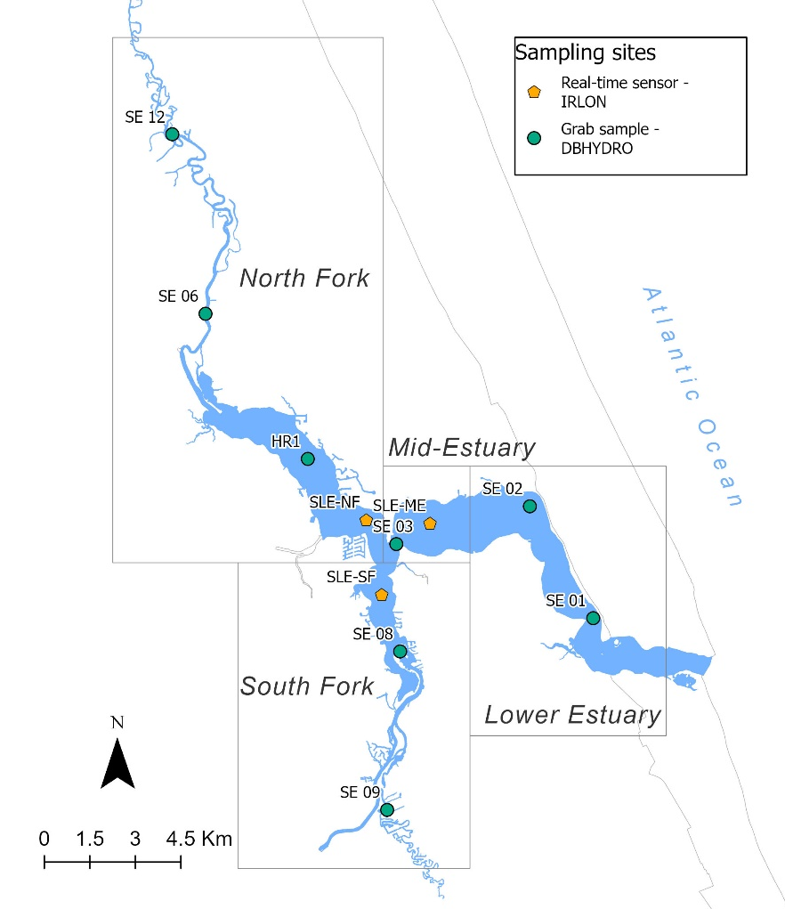
Figure 3.1 The St. Lucie Estuary, its geographic sections, and sampling locations.

Discrete water sampling and hyperspectral field data
Discrete water sampling and field spectra were collected at five established SFWMD sites: SE 01, SE 02, SE 03, SE 06, and SE 09 (Figure 3.2). Collections were performed by the author and a volunteer from a boat on August 17 and 18, 2021 (Figure 3.3). Two water samples per site were gathered in polyethylene bottles each day for 60 samples, kept in dark coolers with ice, and taken to the laboratory on the second day. Water samples were analyzed for total nitrogen (TN), total phosphorus (TP), and chlorophyll a (chl-a) at the CAChE Nutrient Analysis Core Facility, a NELAC-accredited nutrient analysis laboratory at Florida International University. Chl-a was analyzed according to Standard Methods 10200 H (APHA, 1998), TN according to ASTM D5176, and TP according to EPA 365.1. Chl-a was extracted on the boat by filtering 120 ml of water using a syringe and a paper filter and storing it in a 90% acetone solution.
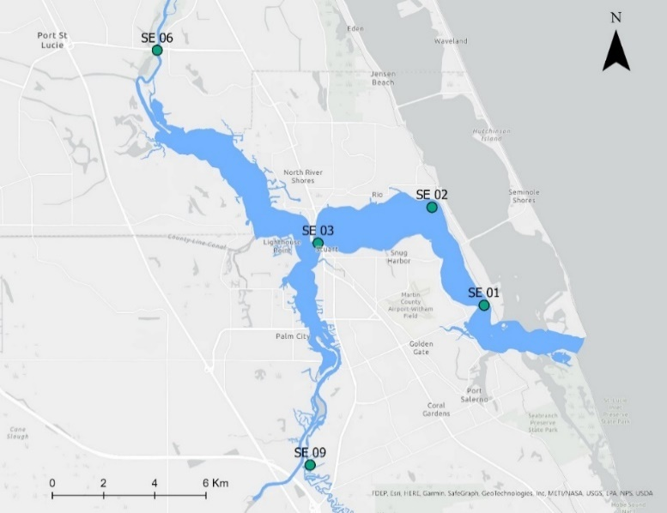
Figure 3.2 Collection sites of field spectra and discrete water samples.
Simultaneous with water sampling, above-water hyperspectral measurements were collected using an ASD FieldSpec® HandHeld 2™ spectroradiometer. Hyperspectral remote sensing analyzes and evaluates the reflected radiation detected by a high number of narrow, contiguous, and continuous spectral bands. The instrument measured continuously in the 325 – 1075 nm wavelength range, with a spectral resolution of 0.3 nm and a sampling interval of 1.5 nm. Above-water spectral measurements were taken with the spectrometer pointed 15-20° from nadir, and the boat's shadow was avoided by facing the boat side measured toward the sun. Before gathering spectra, the reflectance was calibrated by measuring the upwelling radiance of a white Spectralon reflectance panel (99% reflectance). Errors from changing cloud reflectance were minimized by taking measurements within a 5-min period and alternating scans between the calibration panel and water; however, environmental conditions could have affected measurements on August 17, as there were strong winds, overcast conditions, and sporadic sunlight windows. The normalized reflectance ratio was generated by the software package ViewSpecPro® ASD using the upwelling radiance and Spectralon readings. An average of 20 optical measurements were gathered per site within 3 hours of solar noon, and abnormal values from wave action were eliminated during data analysis.
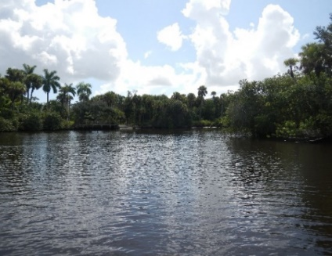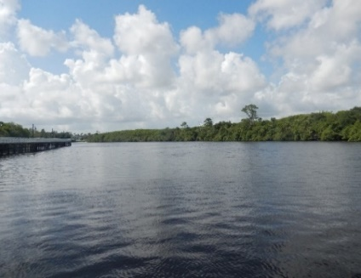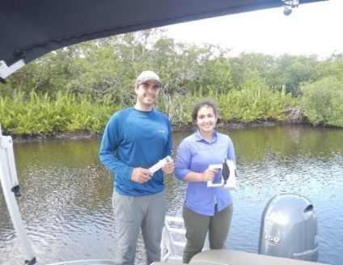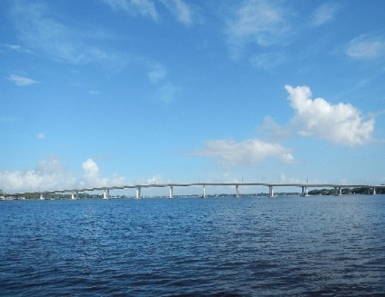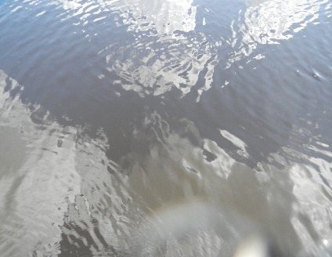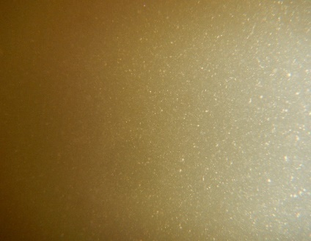
F
B
A
D
C
E
Figure 3.3 Photos of the field campaign on August 17 and 18. A) Site SE 09, B) Site SE 06, C) Data collectors, D) Site SE 01, E) Abovewater image, F) Underwater image.

Water quality datasets
This study used two publicly available datasets from two different institutions for two different purposes. The first dataset consisted of hourly data from real-time sensors to assess the variability of water quality constituents in the estuary within a day, a week, and two weeks—the variability assessment aimed to maximize the satellite and in situ data matchups. The second dataset consisted of monthly grab samples and was used to assess the relationships between remote sensing reflectance and the concentrations of quality constituents. The water quality constituents downloaded from both repositories were those directly associated with the optical characteristics of the water, including chl-a, CDOM, color PCU, Secchi disk depth (SD), salinity, total suspended solids (TSS), and turbidity. Details of these datasets are included in Table 3.2. The calculations for average channel depths were obtained from the SFWMD Geospatial Services, Morgan & Eklund Inc. 1998, and ancillary data from in situ sampling by the SFWMD. Channel widths were estimated from satellite imagery.
Table 3.2 Specifications of the two datasets used for statistical analyses.
Dataset | Sampling  Stations | Operating Agency | Estuary Location | Latitude | Longitude | Channel width (m) | Channel depth (m) | Temporal resolution | Temporal  coverage | Water quality parameters
1 | SLE-ME | FAU | Mid-Estuary | 27.2089 | -80.248 | 1,805 | 4.5 | Hourly | 2016 - 2021 | CDOM (ppb QSDE⁻¹), salinity (PSU), and turbidity (NTU)
1 | SLE-NF | FAU | North Fork | 27.2100 | -80.2692 | 870 | 4.2 | Hourly | 2016 - 2021 | CDOM (ppb QSDE⁻¹), salinity (PSU), and turbidity (NTU)
1 | SLE-SF | FAU | South Fork | 27.1878 | -80.2642 | 909 | 3.1 | Hourly | 2016 - 2021 | CDOM (ppb QSDE⁻¹), salinity (PSU), and turbidity (NTU)
2 | SE 01 | SFWMD | Lower Estuary | 27.1803 | -80.1939 | 420 | 4.27 | Once a month | 2014 - 2021 | Chl-a (μg L⁻¹), color (PCU), SD (m), salinity (PSU), TSS (mg/l), and turbidity (NTU)
2 | SE 02 | SFWMD | Mid-Estuary | 27.2137 | -80.2148 | 1,457 | 2.44 | Once a month | 2014 - 2021
2 | SE 03 | SFWMD | Mid-Estuary | 27.2028 | -80.2592 | 304 | 5.3 | Once a month | 2014 - 2021
2 | SE 06 | SFWMD | North Fork | 27.2717 | -80.3220 | 88 | 3.96 | Once a month | 2014 - 2021
2 | SE 08 | SFWMD | South Fork | 27.1707 | -80.2581 | 503 | 2.44 | Once a month | 2014 - 2021
2 | SE 09 | SFWMD | South Fork | 27.1237 | -80.2625 | 43 | 1.50 | Once a month | 2014 - 2021
2 | SE 12 | SFWMD | North Fork | 27.3246 | -80.3332 | 48 | 2.59 | Once a month | 2014 - 2021
2 | HR1 | SFWMD | North Fork | 27.2281 | -80.2885 | 1,178 | 2.74 | Once a month | 2014 - 2021

Water quality dataset 1
Dataset 1 was downloaded from publicly accessible hourly data collected from three real-time sensors located on three sections of the estuary, the mid-estuary (sensor SLE-ME), the north fork (sensor SLE-NF), and the south fork (sensor SLE-SF), spanning from September 2015 to June 2022. These sensors are part of the Indian River Lagoon Observatory Network (IRLON) (https://irlon.org/), a monitoring program operated by the Harbor Branch Oceanographic Institute at Florida Atlantic University. These environmental sensors measure the fluorescence from chl-a (range of 0.02 – 400 μg L⁻¹) and fDOM (range of 0.36 – 500 ppb QSDE⁻¹), referred to as CDOM in this study. The sensors report salinity from conductivity, temperature, and pressure data, also collected by the sensors, ranging from 0.02 to 400 μg L⁻¹. Turbidity values from the sensors can range from 0.013 to 25 NTU.
IRLON staff conduct quality control assessments of the sensors by visiting each site every 4-6 weeks to validate instrument readings and collect discrete samples for laboratory analysis. In addition, data are flagged as pass, suspect, or fail after real-time QA/QC tests are applied following Integrated Ocean Observing System (IOOS) Quality Assurance/Quality Control of Real-Time Oceanographic Data (QARTOD) protocols. Only data with pass flags were used. Chl-a, CDOM, salinity, and turbidity were downloaded for this study, as these constituents directly affect the water column's optical properties. Table 3.3 summarizes the parameter concentrations by location.
Table 3.3 The descriptive statistics of water quality dataset 1 for each sensor in the five years.
WQ Parameters | Statistic | SLE-ME | SLE-NF | SLE-SF
CDOM (QSDE) | Mean | 33.6 | 41.6 | 40.0
CDOM (QSDE) | SD | 25.2 | 27.7 | 26.3
CDOM (QSDE) | Min | 0.88 | 12.3 | 13.2
CDOM (QSDE) | Max | 123.5 | 127.4 | 134.0
Chl-a  (µg L⁻¹) | Mean | 4.48 | 6.26 | 6.04
Chl-a  (µg L⁻¹) | SD | 1.80 | 2.96 | 2.29
Chl-a  (µg L⁻¹) | Min | 0.09 | 2.39 | 2.65
Chl-a  (µg L⁻¹) | Max | 9.01 | 15.1 | 11.6
Salinity (PSU) | Mean | 17.5 | 16.1 | 14.2
Salinity (PSU) | SD | 7.43 | 9.80 | 8.38
Salinity (PSU) | Min | 0.23 | 0.44 | 0.21
Salinity (PSU) | Max | 27.0 | 41.7 | 25.3
Turbidity (NTU) | Mean | 10.9 | 8.11 | 24.8
Turbidity (NTU) | SD | 9.35 | 4.55 | 19.4
Turbidity (NTU) | Min | 1.95 | 1.83 | 4.51
Turbidity (NTU) | Max | 40.0 | 20.3 | 79.8

Water quality dataset 2
The second dataset used in this study was retrieved from the South Florida Water Management District's (SFWMD) public repository, DBHYDRO (https://my.sfwmd.gov/dbhydroplsql/show_dbkey_info.main_menu). This dataset was paired with satellite data because of its temporal and spatial coverage and broad range of available water quality constituents. A 14-day threshold was used to increase the in situ-satellite pairs, but 70% of the matchups were within a 7-day threshold (Table 3.4). The SFWMD has collected and analyzed water grab samples monthly from stations spread across the St. Lucie Estuary since 1990. Data were filtered by date and stations to match four Worldview-2 images for 28 cloud-free satellite-in situ pairs (Table 3.5). Differences in the amount of in situ data matching each of the images were due to satellite images not covering the entire estuary in most cases or because cloud cover or sampling did not occur within a 14-day window.
Table 3.4 Dates of satellite images and paired in situ data.
Satellite dates | In situ month-day
Satellite dates | SE 01 | SE 02 | SE 03 | SE 06 | HR1 | SE 12 | SE 08 | SE 09
2014-12-03 | N/A* | 12-09 | 12-09 | 12-09 | 12-09 | 12-09 | N/A | N/A
2015-05-01 | N/A | N/A | 05-05 | N/A | 05-05 | N/A | 05-05 | 05-05
2021-05-26 | N/A | N/A | 05-13 | 05-13 | 05-12 | N/A | 05-12 | 05-13
2021-08-11 | 08-16 | 08-16 | 08-12 | 08-16 | 08-12 | 08-16 | 08-12 | 08-12
2021-09-28 | N/A | 09-27 | 09-13 | 09-27 | 09-13 | 09-27 | 09-13 | 09-13
* N/A indicates that the satellite image did not cover that site, no water quality data were available within 14 days of the image, or cloud cover
Table 3.5 The water quality data were downloaded from the SFWMD's repository (dataset 2). NA indicates that there were no in situ data available for that date.
Date | Station | Chl-a (µg L⁻¹) | Color  (PCU) | SD  (m) | Salinity  (PSU) | TSS  (mg L⁻¹) | Turbidity (NTU)
2014-12-03 | SE 03 | 3.09 | 16 | 1.3 | 24.7 | 9 | 3.9
2014-12-03 | SE 06 | 8.28 | 40 | 0.9 | 12.3 | 7 | 3.5
2014-12-03 | HR1 | 6.14 | NA | 1.65 | 18.4 | 6 | 2.6
2014-12-03 | SE 12 | 19.4 | 36 | 0.8 | 0.9 | 9 | 5.7
2015-05-01 | SE 03 | 5.18 | 24 | 0.7 | 17.4 | 8 | 6
2015-05-01 | SE 08 | 29.4 | 39 | 1 | 4.1 | 6 | 5.7
2015-05-01 | SE 09 | NA | 48 | 0.9 | 0.61 | 5 | 9.9
2015-05-01 | HR1 | 19.1 | 31 | 1 | 13.3 | 5 | 3.8
2021-05-26 | SE 03 | 7.24 | 19 | 0.8 | 24.6 | 11 | 7.6
2021-05-26 | SE 06 | 17.5 | 39 | 1 | 10.9 | 7 | 4
2021-05-26 | SE 08 | 20.8 | 30 | 0.8 | 16.4 | 16 | 9.3
2021-05-26 | SE 09 | 53.8 | 36 | 0.7 | 9.8 | 10 | 6.8
2021-05-26 | HR1 | 15 | 24 | 1.3 | 19.7 | 9 | 5.2
2021-08-11 | SE 01 | 3.6 | 54 | 0.8 | 15.3 | 6 | 5.6
2021-08-11 | SE 02 | 3.02 | 82 | 0.6 | NA | 7 | 8.3
2021-08-11 | SE 03 | 4.14 | 89 | 0.8 | 7.4 | 12 | 8.8
2021-08-11 | SE 06 | 15.2 | 63 | 0.7 | 0.6 | 10 | 6.3
2021-08-11 | SE 08 | 7.52 | 72 | 0.8 | 6.3 | 13 | 9.9
2021-08-11 | SE 09 | 17.6 | 56 | 0.6 | 2.6 | 18 | 11.2
2021-08-11 | SE 12 | 15.6 | 55 | 0.7 | 0.6 | 12 | 8.2
2021-08-11 | HR1 | 12.9 | 112 | 0.9 | 2.6 | NA | 2.7
2021-09-28 | SE 02 | 2.68 | 94 | 0.8 | 5.4 | 5 | 6.2
2021-09-28 | SE 03 | 5.3 | 118 | 0.5 | 4.8 | 7 | 5.5
2021-09-28 | SE 06 | 4.03 | 108 | 0.9 | 0.4 | 6 | 4.6
2021-09-28 | SE 08 | 3.25 | 92 | 0.6 | 0.3 | 15 | 12.2
2021-09-28 | SE 09 | 9.91 | 69 | 0.7 | 0.4 | 9 | 7
2021-09-28 | SE 12 | 3.88 | 101 | 0.8 | 0.5 | 7 | 6.4
2021-09-28 | HR1 | 8.25 | 113 | 1 | 2.6 | 3 | 2.3

The specifications of the water quality constituents downloaded, which include chl-a, color PCU, Secchi disk depth (SD), salinity (PSU), total suspended solids (TSS), and turbidity (NTU), are shown in Table 3.6.
Table 3.6 Water quality constituents from dataset 2. The test methods used by the laboratory for each variable. Abbreviations are those used in this paper, not by the management agency.
Water quality variables | Abbreviations | Reporting Units | Test Methods | Minimum Detection Limits
Chlorophyll-a | chl-a | µg L⁻¹ | EPA 447.0 | 0.018
Color | color PCU | PCU** | SM* 2120 C | 1
Secchi disk depth | SD | meters | FSQM*** | NA
Salinity | salinity | PSU | FSQM | NA
Total suspended solids | TSS | mg L⁻¹ | SM 2540 D | 3
Turbidity | turbidity | NTU | SM 2130 B | 0.1
* SM = standard method by EPA; ** PCU = platinum cobalt unit; ***FSQM = SFWMD’s field sampling quality manual. NA indicates not applicable.

The SFWMD staff uses the Data Collection/Validation Preprocessing (DCVP) system to perform quality assurance/quality control (QA/QC) on instrument readings before data archiving. Preliminary time-series data are extracted from the DCVP and subjected to an initial QA/QC check to ascertain or improve data quality through the Graphical Verification Analysis (GVA) Program. Data were uploaded into the DBHYDRO database after GVA analysis (South Florida Water Management District, 2020d). Only unflagged data were downloaded.

Satellite Images
Five WorldView-2 satellite images (Figure 3.4) were downloaded from the USGS' image repository, EarthExplorer (https://earthexplorer.usgs.gov/): December 3, 2014 (2014-12-03), May 1, 2015 (2015-05-01), May 26, 2021 (2021-05-26), August 11, 2021 (2021-08-11), and September 28, 2021 (2021-09-28) (Table 3.7). The data were resampled to 2.0 m spatial resolution and 11-bit data in eight spectral bands: coastal (400 – 450 nm), blue (450 – 510 nm), green (510 – 580 nm), yellow (585 – 625 nm), red (630 – 690 nm), red edge (705 – 745 nm), near-IR1 (770 – 895 nm), and near-IR2 (860 – 1040 nm).
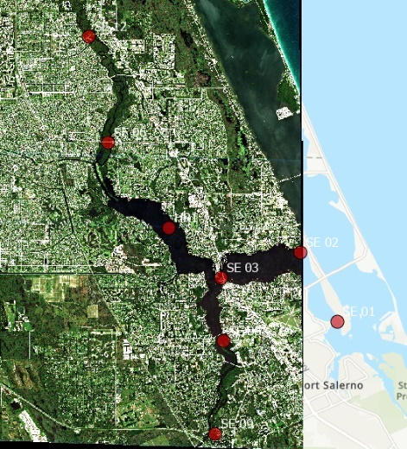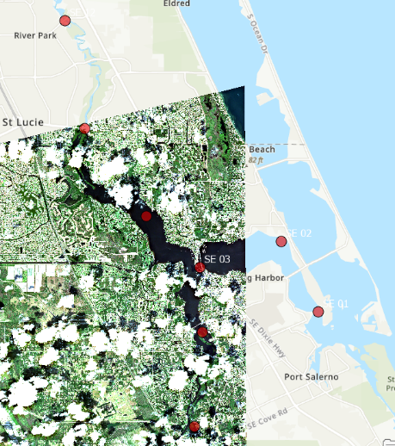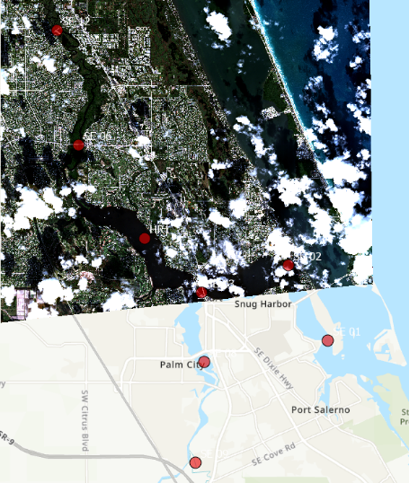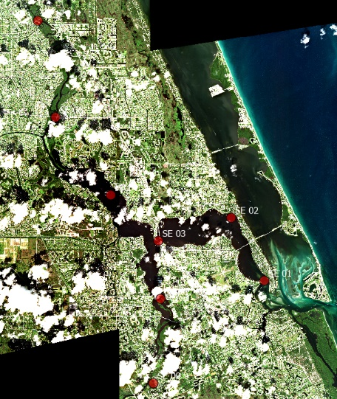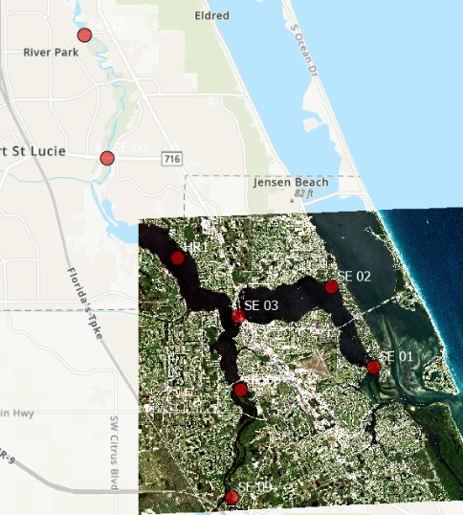
E
D
A
B
C
Figure 3.4 The five RGB Worldview-2 images. Red dots represent the SFWMD stations. The color was stretched for high contrast between land and water body. The dates of each image are in Table 3.5.
Table 3.7 Worldview-2 image dates and sections of the estuary covered.
Img | Date Acquisition | Estuary Section(s) Covered
A | 2014-12-03 | Mid-Estuary and North Fork
B | 2015-05-01 | Lower Estuary, Mid-Estuary, and North Fork
C | 2021-05-26 | Mid-Estuary and South Fork
D | 2021-08-11 | Lower Estuary, Mid-Estuary, North Fork, and South Fork
E | 2021-09-28 | Mid-Estuary, North Fork, and South Fork

ENVI (by Research Systems) and ACOLITE (by the Royal Belgian Institute of Natural Sciences) software were compared to preprocess two of the five WorldView satellite images. In ENVI, geometric calibration was performed using the orthorectification module with GCPs. Radiometric calibration was performed with the Radiometric Calibration module, where the input is radiance, and Fast Line-of-sight Atmospheric Analysis of Spectral Hypercubes (FLAASH) settings were applied. Atmospheric correction was performed using FLAASH, which incorporates the MODTRAN 4 radiative transfer code with all atmosphere and aerosol types. FLAASH outputs were in scaled radiance reflectance.
ACOLITE is based on atmospheric correction algorithms and processing software developed at the Royal Belgian Institute of Natural Sciences for aquatic applications of meter and decameter satellite data and is suitable for turbid waters and small inland water bodies. ACOLITE performs atmospheric calibration using the Dark Spectrum Fitting algorithm (Vanhellemont, 2020). The 2021-08-11 WV image was used to compare the atmospheric models and select one to apply to all images. The reflectance values obtained after applying ACOLITE were compared with those obtained using ENVI's preprocessing tools, and there were substantial differences in values for Bands 1 and 2. ACOLITE outputs had more extremely negative values for bands 1 and 2 than ENVI outputs, but the reflectance values for the other visible bands were similar. Due to these factors and ENVI's long literature record, ENVI software was chosen to correct the rest of the images. After atmospheric correction, all images were shifted using Daniel Gann's R script and mosaicked using ENVI.
Radiometric normalization with pseudoinvariant features, a standard preprocessing step for multitemporal satellite image analysis (Xu et al., 2021), was applied to all images to decrease radiance inconsistencies. Pseudoinvariant features shared by all images were selected, and the reflectance data were extracted for each image. Image 2015-05-01 was selected as the base image because it was cloud-free, and its values for bands 3 – 8 of the pseudoinvariant features and water reflectance were theoretically sound. The images were normalized using the equations from linear models between each band of the base image and those of the other images.

Statistical Analyses
Eighteen dates and times were selected from the hourly dataset to assess the variability of CDOM, chl-a, salinity, and turbidity in a day (intraday), seven days, and fourteen days. Coefficients of variation (CV),
$CV=\frac{σ}{μ}$, (3.1)
A standardized value useful for comparing the spread of values across variables with different units of measure was used to compare the spread across time frames and sites. The CV is a statistical measure of the relative dispersion of data points around the mean (µ) in a data series. The hourly values' mean and standard deviation (σ) were calculated for every water quality constituent for each of the 18 selected dates, typically 23 values at each site. The hourly values for the six days following the selected dates were used to calculate the 7-day (N = 161) means and standard deviations and the 13 following days were used for the 14-day (N = 322) calculations to obtain CVs. Therefore, a CV value was produced for each selected date (intraday variability) and the preceding 7 and 14 days for each water quality constituent at each site. Because of the size of the tables containing CVs for every time frame, the mean CVs from the 18 dates were reported for each site and variable.
Pearson's correlation coefficients (R),
$R= \frac{∑(x_{i}-\overset{̿}{x} )(y_{i}-\overset{̿}{y}) }{\sqrt{∑{\left(x_{i}-\overset{̿}{x} \right)}^{2} ∑{(y_{i}-\overset{̿}{y})}^{2}}}$ (3.2)
were then calculated between values corresponding to a specific time of day with its day mean, the day mean seven days later, and the day mean 14 days later for each of the four water quality constituents. The correlations were performed using day means to reduce the effect of outliers and were indiscriminate in location. There were 54 samples for each constituent for each of the three sensors.

Results and Discussion

Coefficients of variation for water quality constituents
The 5-year time series for each constituent for each sensor were plotted for visual assessment of patterns, and vertical lines were drawn to indicate the 18 selected dates for the variability assessments (Figures 3.5, 3.6, and 3.7). The variation coefficient for CDOM was low across the three measured time frames: within a day, over seven days, and 14 days (Table 3.8). The lowest CV for CDOM was 0.06 at SLE-NF for intraday values, and the highest CV was 0.16 at SLE-ME for 14 days. Complementary to low variability across dates and sites, CDOM values at a specific time were highly correlated with those observed 7 and 14 days later, with a correlation coefficient of 0.94 (p value <0.001) (Table 3.9). These low CVs and high correlation coefficients for CDOM values suggest that this constituent stays constant across two weeks and in these estuary sections. From a remote-sensing perspective, the low variability allows longer time windows to pair in situ data and satellite images. Satellite images taken up to 14 days before or after in situ collection could be paired with such data.
The intraday chl-a and salinity values had low to medium CVs ranging from 0.16 to 0.24, and a high correlation was found between the values at a given time in the day and the day means (R > 0.9). Differently from CDOM, however, the variability of chl-a and salinity for the 7-day periods was notably greater than intraday. At SLE-ME, for example, the intraday CV for chl-a was 0.16, while the CV for the seven days was 0.23. Salinity displayed similar results: the intraday CV was 0.18, while that for the seven days was 0.28. However, while the CVs were similar for chl-a and salinity, the correlation coefficients for chl-a were much lower than those for salinity across the time frames. Chl-a values seven days apart had an R of 0.47, while salinity values had an R of 0.89.
These results point toward a low to medium intraday variability of chl-a and salinity, where measurements from a specific time in the day could be a good representation of that day's values.
This higher variability for the 7- and 14-day periods was also reflected in lower correlation coefficients between the values. These medium CVs and correlation coefficients for the 7- and 14-day periods suggest that in situ chl-a and salinity should be as close to the date of the satellite as possible.
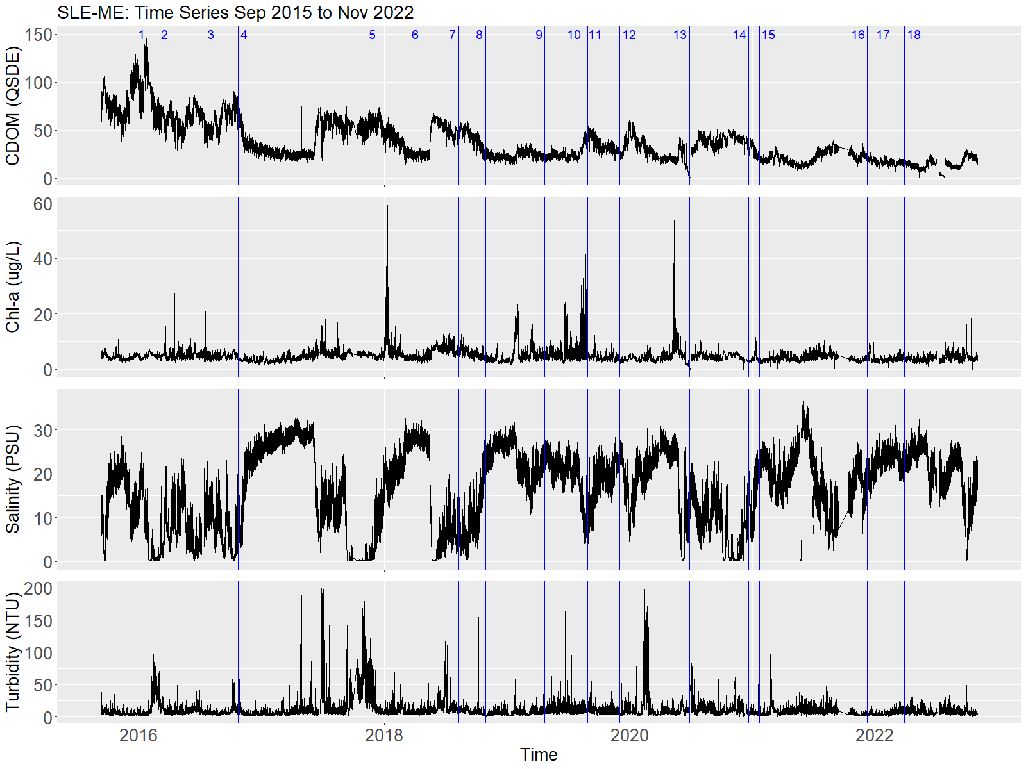
Figure 3.5 Time series plot of CDOM, chl-a, salinity, and turbidity at the SLE-ME sensor.

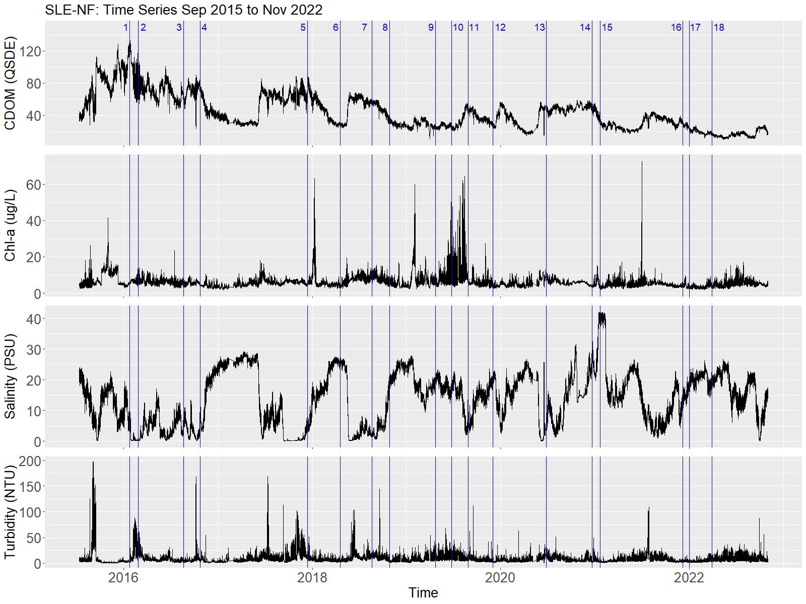
Figure 3.6 Time series plot of CDOM, chl-a, salinity, and turbidity at the SLE-NF sensor.

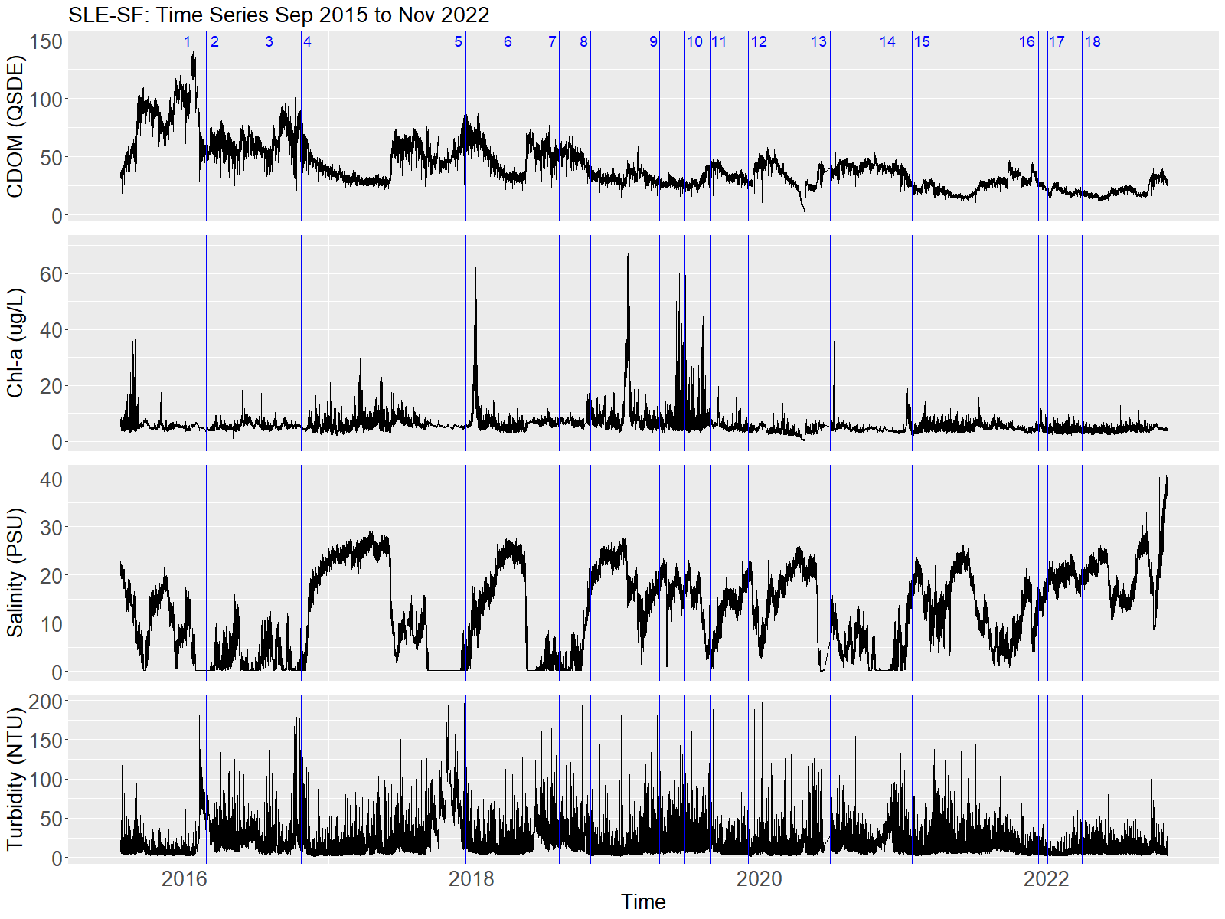
Figure 3.7 Time series plot of CDOM, chl-a, salinity, and turbidity at the SLE-SF sensor.

Table 3.8 Coefficients of variation of hourly values in a day, 7 days, and 14 days for CDOM, chl-a, salinity, and turbidity.
Time frame | CDOM | Chl-a | Salinity | Turbidity
SLE-ME
In a day | 0.09 | 0.16 | 0.18 | 0.44
In 7 days | 0.16 | 0.23 | 0.28 | 0.53
In 14 days | 0.16 | 0.23 | 0.34 | 0.55
SLE-NF
In a day | 0.06 | 0.19 | 0.17 | 0.40
In 7 days | 0.06 | 0.21 | 0.19 | 0.47
In 14 days | 0.08 | 0.24 | 0.26 | 0.52
SLE-SF
In a day | 0.08 | 0.17 | 0.24 | 0.71
In 7 days | 0.09 | 0.20 | 0.38 | 0.77
In 14 days | 0.10 | 0.23 | 0.47 | 0.80

Table 3.9 Pearson's correlation coefficient (R) between concentrations measured at the specific time and day with the daily average of the hourly collected values and those collected 7 and 14 days later.
Correlated variables | CDOM (QSDE) | Chl-a  (µg L⁻¹) | Salinity (PSU) | Turbidity (NTU)
Value at a specific time vs. Day Average | 0.995** | 0.918** | 0.982** | 0.787**
Value at a specific time vs. 7-day Average | 0.936** | 0.466** | 0.886** | 0.37*
Value at a specific time vs. 14-day Average | 0.822** | 0.589** | 0.870** | 0.22
* p value <0.001, *p value <0.05, N=54
Turbidity had the highest coefficients of variation and the lowest correlation coefficients across sites and time variables. The variability in turbidity values was exceptionally high at site SLE-SF for all timeframes, with a CV of 0.71 for intraday, 0.77 for seven days, and 0.80 for 14 days. Pearson's correlation coefficients also reflected a high variability in turbidity values for all time frames, but especially for the 14 days, no significant correlation was found. Turbidity at St. Lucie is related to Lake Okeechobee releases, which occur in both seasons and enter the estuary through the South Fork. A 14-day threshold was deemed appropriate for pairing CDOM with remote sensing data, and a 7-day threshold for chl-a and salinity was based on the observed variation from the hourly data of IRLON sensors.

Discrete water quality sampling and synchronous field spectra
The discrete samples gathered by the author on August 17 and 18, 2021, were compared with data gathered by the SFWMD at the same sites on August 16, 2021, and August 12, 2021 (Table 3.10). Chl-a concentrations varied across these four dates even when the collection had a 24-hour difference and the same sampling and analytical methods. For example, at SE 09, the chl-a concentration decreased from 11.2 µg L⁻¹ on August 17 at 11:00 AM to 1.8 µg L⁻¹ on August 18 at 12:30 PM from samples gathered by the author. Similarly, at site SE 06, the chl-a concentration decreased from 24.8 µg L⁻¹ on August 17 at 12:24 PM to 16.4 µg L⁻¹ on August 18 at 11:28 AM. Chl-a concentrations also differed between samples taken by the SFWMD and those taken by the author. For instance, at station SE 02, the SFWMD chl-a concentration was 3.0 µg L⁻¹ on August 16, then 6.7 µg L⁻¹ on August 17, and 6.7 µg L⁻¹ the day after, August 18. These observed intraday variations in chl-a concentrations are natural in estuarine waters because of the susceptibility of phytoplankton to wind, sunlight, and temperature variations (de Eyto et al., 2019; Litaker et al., 1987). While it is likely that the natural variation explains these differences in concentrations, it is also possible that they are influenced by the water column depth at which samples were taken since the SFWMD samples were from the middle of the water column while the author did from the water surface. Since both laboratories followed analytical methods developed by Standard Methods, EPA, or/and ASTM International, gold standards for sample analyses, these differences are unlikely from analytical methods.
Table 3.10 The laboratory results of the discrete sampling collected simultaneously with field spectrum measurement and the data reported by the SFWMD some days prior.
Sampling sites | Date, Time | Sampling Depth (m) | Sampling entity | Chl-a  (µg L⁻¹) | TN  (ppm) | TP  (ppm) | Color  (PCU) | Turbidity  (NTU)
SE 01 | 2021-08-16, 9:00 AM | 1.5 | SFWMD | 3.6 | 0.82 | 0.140 | 54 | 5.6
SE 01 | 2021-08-17, 2:00 PM | 0.1 | Author | 6.1 | 0.78 | 0.178 | NA | NA
SE 01 | 2021-08-18, 9:20 AM | 0.1 | Author | 6.3 | 0.60 | 0.139 | NA | NA
SE 02 | 2021-08-16, 9:31 AM | 1 | SFWMD | 3.0 | 1.11 | 0.198 | 82 | 8.3
SE 02 | 2021-08-17, 1:45 PM | 0.1 | Author | 6.7 | 0.91 | 0.191 | NA | NA
SE 02 | 2021-08-18, 9:45 AM | 0.1 | Author | 9.2 | 0.88 | 0.211 | NA | NA
SE 03 | 2021-08-12, 10:12 AM | 2 | SFWMD | 4.1 | 1.15 | 0.202 | 89 | 8.8
SE 03 | 2021-08-17, 1:16 PM | 0.1 | Author | 6.1 | 1.05 | 0.235 | NA | NA
SE 03 | 2021-08-18, 10:04 AM | 0.1 | Author | 6.8 | 1.00 | 0.240 | NA | NA
SE 06 | 2021-08-16, 10:30 AM | 1.9 | SFWMD | 15.2 | 0.99 | 0.150 | 63 | 6.3
SE 06 | 2021-08-17, 12:27 PM | 0.1 | Author | 24.8 | 0.79 | 0.164 | NA | NA
SE 06 | 2021-08-18, 10:41 AM | 0.1 | Author | 16.4 | 0.78 | 0.156 | NA | NA
SE 09 | 2021-08-12 11:25 AM | 0.5 | SFWMD | 17.6 | 1.21 | 0.272 | 56 | 11.2
SE 09 | 2021-08-17 11:20 AM | 0.1 | Author | 11.2 | 1.00 | 0.181 | NA | NA
SE 09 | 2021-08-18 11:50 PM | 0.1 | Author | 1.8 | 0.90 | 0.184 | NA | NA

There were also spatial variations in these water variables for these four dates. The highest chl-a concentration (24.8 µg L⁻¹) measured was at site SE 06 in the North Fork, while the lowest (1.8 µg L⁻¹) was at SE 09 in the South Fork. The TN and TP concentrations stayed mostly constant across dates at each site. The TN and TP concentrations were highest at site SE 09 on August 12 (1.21 ppm and 0.272 ppm, respectively) and lowest at SE 01 on August 18 (0.60 ppm and 0.139 ppm, respectively). The highest color PCU concentration measured by the SFWMD was at SE 03 (89 PCU), and the lowest was at SE 01 (54 PCU). The highest turbidity was at SE 09 (11.2 NTU), and the lowest was at SE 01 (5.6 NTU).
The spectroradiometer reflectance is a ratio of the total amount of radiation, as light, reflected by the water surface to the total amount of radiation incident on the surface. Field spectra were collected in the visible and near-infrared (NIR) range from 300 to 1100 nm; however, the signal-to-noise ratio at the high and low ends was very high, so only the spectral range from 400 to 900 nm was presented for both collection dates. The magnitude of reflectance differed between the two dates, but the curves had similar shapes across sites and dates. (Figures 3.8 and 3.9). All reflectance curves had the lowest reflectance values below ~500 nm and increased to a peak at approximately 690 nm and a subsequent pronounced dip at the red-edge region from ~700 nm to ~740 nm. m−3. This peak results from high backscattering and a minimum absorption by all optically active constituents, including pure water (Gitelson, 1992). Reflectance magnitudes from August 17 doubled or tripled those from August 18. The lowest reflectance value of the curve at SE 06 on August 17, for example, was approximately 0.027 and peaked at approximately 0.045, while the lowest reflectance the next day was ~0.001 and peaked at ~0.012.
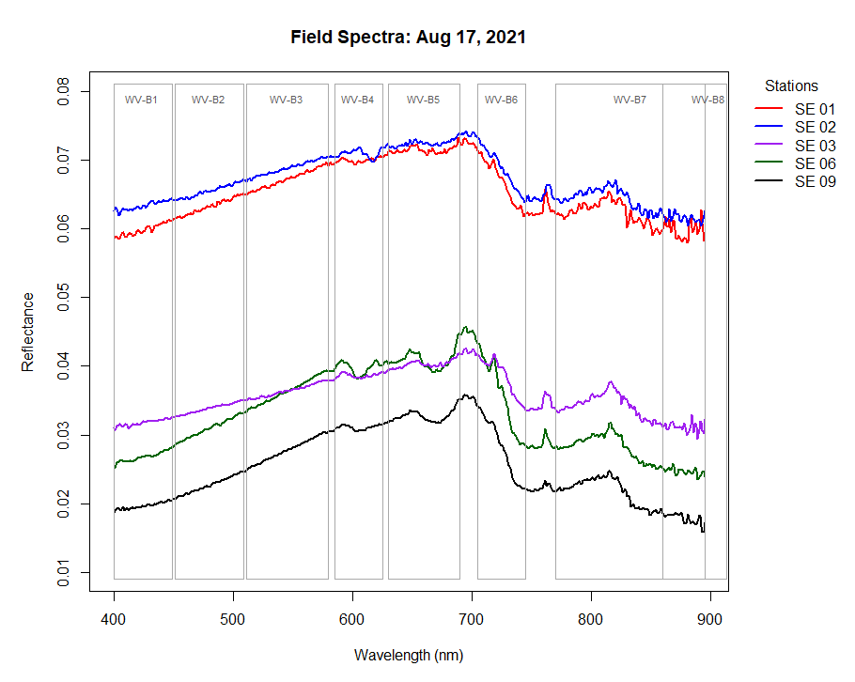
Figure 3.8 Abovewater field reflectance ratio from August 17, 2021. Corresponding Worldview-2 band spectral ranges are indicated in light gray.
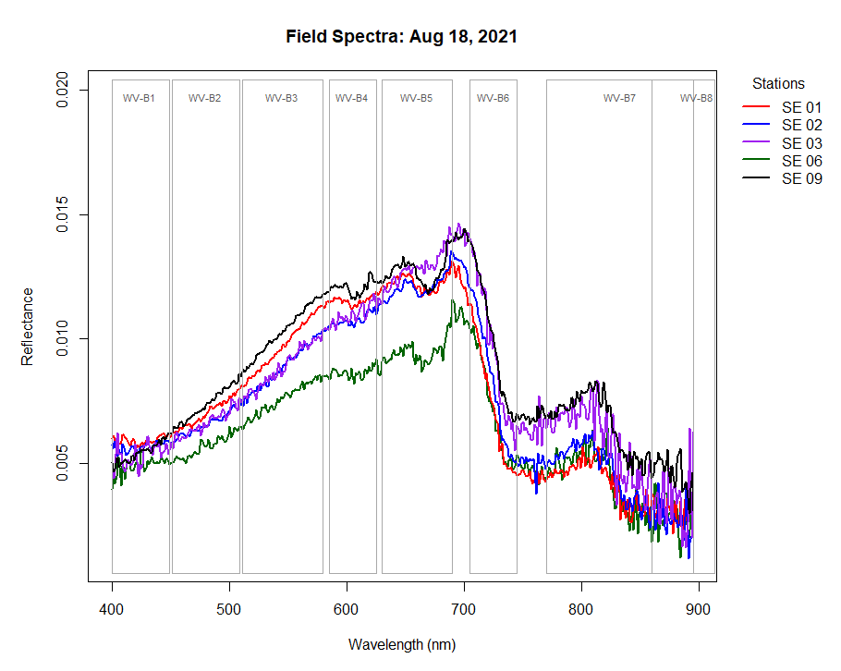
Figure 3.9 Abovewater field reflectance ratio from August 18, 2021. Corresponding Worldview-2 band spectral ranges are indicated in light gray.
Differences in the reflectance magnitudes may be due to skylight reflection not being accounted for in the reflectance calculations or human error. While the viewing geometry of the above-water measurements minimized error (Garaba and Zielinski, 2013; Wang et al., 2018), wind gusts and overcast conditions could have affected the magnitude of values (Zhang et al., 2017). The environmental conditions were more variable on August 17 than on August 18. August 17 had some periods of direct sunlight and others overcast and wind gusts of up to 8 m s⁻¹, while August 18 had generally stable sunny conditions with wind gusts under 5 m s⁻¹. These unaccounted-for environmental conditions or gathering geometry may be the reason for the spatial variability and higher reflectance values on August 17. Nevertheless, the spectral shapes and magnitudes presented here are within the ranges of those gathered by other authors who measured and accounted for the reflectance of skylight in their calculations in case 2 waters (Banerjee and Shanmugam, 2021; Fang et al., 2009; Lubac and Loisel, 2007; Menken et al., 2006).
The peak at approximately 650 nm was present at all sites and suggested strong absorption at wavelengths shorter than 600 nm and a maximum transmission wavelength toward the red part of the spectrum due to CDOM and suspended solids (Kowalczuk et al., 2005; Luo et al., 2018). Spectral curves with the same shapes and magnitudes have been reported for the St. Louis River Estuary, MN, the Tamar Estuary, UK, and Saginaw Bay of Lake Huron, USA (Brezonik et al., 2015; Chen et al., 2017; Doxaran et al., 2005). Low reflectance in the blue region of the spectrum is characteristic of waterbodies with higher CDOM or chl-a, as the absorption coefficient of said constituents decreases reflectance at shorter wavelengths.

Worldview-2 reflectance and field spectra comparison
A WorldView-2 image from 6 days before the field campaign, on 2021-08-11, and field spectra were compared using reflectance ratios between selected bands and pairing them with water quality variables. Water quality values were from the SFWMD dataset collected on August 12 and 16, as specified in Table 3.10. Chl-a values synchronous to field collection were included for comparison with the field-simulated band ratios, as the coefficients of variability for this constituent were high. While turbidity also had high coefficients of variability, synchronous field data were unavailable for this variable, so SFWMD turbidity data were used. Due to the differences in reflectance magnitudes between the field and WV-2, comparisons were made using ratios rather than individual bands. Field spectra values were grouped following the wavelength ranges of WV-2 bands, and the mean value of each group was used to calculate the ratios. These ratios were then compared with the water quality constituents at each site (Table 3.11).
Table 3.11 Comparison between field spectra and WV-2 band ratios. Field spectra were gathered on 2021-08-18 and WV-2 on 2021-08-11.
Water constituents and band ratios | Lower Estuary | Mid-Estuary | Mid-Estuary | North Fork | South Fork
Water constituents and band ratios | SE 01 | SE 02 | SE 03 | SE 06 | SE 09
Field Chl-a (µg L⁻¹) | 6.3 | 9.2 | 6.7 | 16.4 | 1.8
WV-2 Chl-a (µg L⁻¹) | 3.6 | 3 | 4.1 | 15.2 | 17.6
Color (PCU) | 54 | 82 | 89 | 63 | 56
SD (m) | 0.8 | 0.6 | 0.8 | 0.7 | 0.6
Salinity (PSU) | 15.3 | NA | 7.4 | 0.6 | 2.6
Turbidity (NTU) | 5.6 | 8.3 | 8.8 | 6.3 | 11.2
Simulated B1/B3 | 0.61 | 0.64 | 0.60 | 0.66 | 0.39
WV-2 B1/B3 | 0.70 | 0.80 | 0.70 | 0.90 | 0.80
Simulated B1/B5 | 0.48 | 0.47 | 0.42 | 0.53 | 0.30
WV-2 B1/B5 | 1.30 | 1.10 | 0.80 | 1.30 | 0.80
Simulated B3/B5 | 0.79 | 0.73 | 0.69 | 0.80 | 0.76
WV-2 B3/B5 | 1.90 | 1.50 | 1.10 | 1.40 | 1.10
Simulated B6/B5 | 0.60 | 0.68 | 0.75 | 0.77 | 0.74
WV-2 B6/B5 | 0.67 | 0.74 | 0.72 | 0.71 | 0.76

There is a notable difference between field spectra and the Worldview reflectance in the blue wavelengths (Figure 3.10). The 2021-08-11 WV-2 image shows a spike at band 2 (blue), which is not present in the field spectra. This water body is expected to have low reflectance in the blue region of the spectrum because CDOM absorption effects are greatest at the two shorter wavelength bands (Liew and Chang, 2012). Therefore, the high reflectance in the blue band is likely due to inadequate radiometric correction models. Atmospheric correction of blue wavelengths (WV-2 bands 1 and 2) has been problematic for various spaceborne sensors in turbid waters with low reflectance (Coffer et al., 2020; Kutser et al., 2005). A study at St. Joseph Bay by Coffer et al., 2020 found that the mean absolute deviation and bias for the coastal blue and blue spectral bands of Worldview-2 were nearly 0.03 and 0.025, respectively, while those for the remaining bands fell below 0.015. These biases translated to an overprediction in shorter wavelengths and an underprediction in longer wavelengths. Glint effects are also a source of error and are greatest in the UV and blue parts of the spectrum and decrease with increasing wavelength (Vahtmäe and Kutser, 2013).
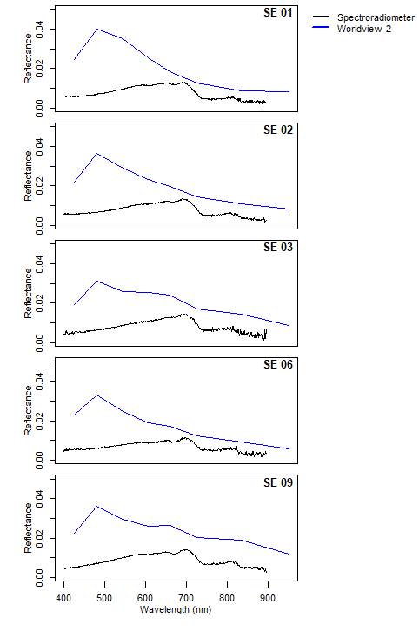
Figure 3.10 Spectral curves from Worldview-2 on August 11, 2021. Reflectance is the remote sensing reflectance ratio after atmospheric correction.
While WV-2 reflectance in the shorter wavelengths seems incorrect, the reflectance values at wavelengths greater than 600 nm generally agree with field spectra as reflectance values decrease with increasing wavelengths. Therefore, WV-2 ratios were estimated and compared with field-simulated band ratios. There were spatial variations in the ratio values, but the ratios were greatest at site SE 06. It can be observed from the field spectral plot from August 17 that the reflectance values at SE 06 from wavelengths ~400 nm to ~ 650 nm are attenuated in comparison to the other sites. This apparent attenuated reflectance contributes to the higher ratios at this site. Notably, chl-a values were much higher (16.4 µg L⁻¹ ) at SE 06 than at the other sites during the field campaign. Since chl-a has an absorption maximum at 675 nm in the red part of the spectrum, the higher band ratios may be related to the combined effect of chl-a and color PCU (Gitelson et al., 2008). Color PCU is high across the estuary, including at SE 06, but with higher chl-a concentrations at this site, reflectance is further attenuated at the red parts of the spectrum.
Site SE 09 had the lowest field-simulated band 1 (B1)/band 3 (B3) (0.39) and B1/band 5 (B5) (0.30) ratios. Similarly, the WV-2 B1/B3 was highest at SE 06. These two simulated ratios did not vary much across the remaining sites. The lower B1/B3 and B1/B5 ratios at SE 09 indicate a larger difference between the reflectance at the coastal blue band (B1) and that of the green band (Band 3) and red band (Band 5) in relation to site SE 06, which had the highest ratio values. The SE 06 and SE 09 sites are at opposite ends of the estuary, approximately 22 km away. Two different constituents influence the water quality variability of these two locations. The SE 06 site is mainly influenced by color PCU while the SE 09 site is influenced by turbidity and TSS (Moncada et al., 2021). SE 06 had the highest field-chl-a (16.4 µg L⁻¹), around nine times that of SE 09. SE 09, on the other hand, had the lowest field-chl-a (1.8 µg L⁻¹) values and the highest turbidity (11.2 NTU). Thus, the higher reflectance in simulated bands 3 and 5 at SE 09 could be associated with having the field campaign's lowest chl-a and highest turbidity values. High turbidity is related to a scattering effect in yellow-red light, and the low chl-a values may not have a significant absorption effect in the red part of the spectrum (Dogliotti et al., 2015; Miglino et al., 2022). It is important to note that chl-a and turbidity values varied greatly, even within a day. Therefore, these apparent relationships of low B1/B3 and B1/B5 ratios are based on the best available data. More simultaneous field spectra studies at this site would improve confidence in these relationships.
The simulated B3 (green)/B5(red) ratio was lowest at SE 03 (0.69) but did not vary much across sites. The WV-2 B3 (green)/B5(red) was similar among sites and did not have a clear pattern. Both the simulated (0.60) and WV-2 (0.67) B6 (red-edge)/B5 (red) were lowest at SE 01 but otherwise very similar across sites. The green/red and red-edge/red ratios have been linked with various water quality constituents, including chl-a, SD, turbidity, and color PCU in optically complex water bodies (Gholizadeh et al., 2016). Turbidity and CDOM have a combined effect on the magnitude and shape of the spectra, creating a shift of the reflectance peak toward the red part of the spectrum (Choubey, 1994; Yu et al., 2022). The low simulated green/red ratio at SE 03 coincides with the field campaign's highest color PCU (89 PCU) values. As CDOM increases, more of the green light, compared with the red light, will be absorbed, and thus relatively more red light, compared with green, is reflected (Al-Kharusi et al., 2020). Such a shift may result in a smaller green/red ratio at SE 03.
The simulated B6 (red-edge)/B5(red) ratio was the smallest at SE 01, the site with the greatest salinity and lowest turbidity values, and was highest at SE 06, the site with the highest chl-a. The red edge band has been primarily linked to chl-a as a linear relationship with the primary chl-a scattering range in the red edge (700 to 705 nm) and the primary chl-a absorption range in the red (675 to 680 nm) (Ritchie et al., 2003; Tan et al., 2015; Wang et al., 2018). However, the red-edge/red ratio has also been used to estimate turbidity due to suspended sediments' high scattering at wavelengths of 400 to 700 nm (Qing et al., 2021; Yigit Avdan et al., 2019). Accordingly, low turbidity at SE 01 may explain the lowest simulated and WV-2 B6/B5 ratios, while high chl-a at SE 06 explains the highest ratio.

Relationships between WV-2 reflectance and water quality characteristics
A correlation analysis was applied to all bands from the five Worldview-2 images and selected band ratios with water quality constituents (Table 3.12). The band ratios tested here were based on the literature where correlation coefficients and coefficients of determination were found to be above 0.6 (Gholizadeh and Melesse, 2017; Menken et al., 2006; Olmanson et al., 2016; Slonecker et al., 2016). Strong correlation coefficients are defined here as those over 0.7. Only three strong correlations were observed: two strong inverse correlations between color and coastal blue (-0.83) and blue bands (-0.73) and color with the NIR-2/red band ratio (0.70).
Table 3.12 Correlation matrix between Worldview-2 band reflectance, band ratios, and water quality constituents.
Bands and ratios | Band names | Chl-a | Color | SD | Salinity | TSS | Turb.
WV2-B1 | Coastal blue | 0.58 | -0.83 | 0.35 | 0.67 | 0.25 | 0.05
WV2-B2 | Blue | 0.44 | -0.73 | 0.16 | 0.65 | 0.42 | 0.19
WV2-B3 | Green | 0.36 | -0.67 | 0.08 | 0.64 | 0.45 | 0.24
WV2-B4 | Yellow | 0.35 | -0.65 | 0.05 | 0.62 | 0.51 | 0.30
WV2-B5 | Red | 0.35 | -0.57 | -0.05 | 0.56 | 0.61 | 0.37
WV2-B6 | Red-edge | 0.18 | -0.31 | -0.19 | 0.33 | 0.65 | 0.44
WV2-B7 | NIR-1 | 0.22 | -0.33 | -0.10 | 0.42 | 0.55 | 0.27
WV2-B8 | NIR-2 | -0.13 | 0.22 | -0.33 | -0.07 | 0.46 | 0.30
WV2-B3/WV2-B5 | Green/Red | 0.33 | -0.59 | 0.23 | 0.53 | 0.10 | 0.03
log(WV2-B3)/log(WV2-B5) | log(Green)/log(Red) | -0.31 | 0.47 | 0.23 | -0.40 | -0.63 | -0.41
WV2-B1/WV2-B5 | Coastal Blue/Red | 0.43 | -0.63 | 0.20 | 0.50 | 0.18 | 0.12
log(WV2-B1)/(WV2-B5) | log(Coastal blue)/(Red) | 0.44 | -0.58 | 0.25 | 0.40 | 0.07 | 0.01
WV2-B1/WV2-B3 | log(Coastal blue)/(Green) | 0.35 | -0.51 | -0.05 | 0.23 | 0.23 | 0.18
WV2-B8/WV2-B5 | Red-edge/Red | -0.32 | 0.56 | -0.17 | -0.34 | 0.06 | -0.08
log(WV2-B8)/log(WV2-B5) | log(NIR-2)/log(Red) | -0.34 | 0.70 | -0.11 | -0.56 | -0.20 | -0.20

The strong inverse relationship between WV-2 blue bands and color, while theoretically sound (Slonecker et al., 2016), was surprising, given the difference between WV-2 and field spectra in the blue part of the spectrum. This correlation is noteworthy because using coastal blue (Band 1) and smaller wavelengths in the UV part of the spectrum in conjunction with other bands can facilitate the separation of chl-a from color PCU in optically complex waters. A recent study by Harringmeyer et al., 2021 found that using UV, blue, and red reflectance improved CDOM estimations in Santa Monica Bay, California. It is possible that while there were atmospheric errors in the blue bands, errors propagated equally across images, still capturing the variability in relation to color PCU values. Salinity was also correlated with the coastal blue band, and coefficients decreased with longer wavelengths. This relationship aligns with the inverse relationship between salinity and optically active water quality constituents. At higher salinities, the concentrations of color PCU and chl-a decrease, so absorption effects in the blue spectrum are minimized. However, some of the correlation results were not aligned with previous reports, likely due to the overestimation in the blue bands. For example, chl-a was correlated with coastal blue but had no other notable correlation. Turbidity and SD did not show any strong or medium correlation with any of the bands or band ratios.
Table 3.13 Coefficient of determination and RMSE for Color PCU and WV-2 bands and band ratios regression
Bands and ratios | Band names | R | R² | p-value | RMSE
WV2-B1 | Coastal blue | -0.83 | 0.37 | <0.001 | 1.5
WV2-B2 | Blue | -0.73 | 0.10 | 0.055 | 1.6
Log(WV2-8/WV2-B5) | Log(NIR-2/ Red) | 0.70 | 0.36 | <0.001 | 0.20

The coefficients of determination and RMSE were calculated for the log-transformed bands and band ratios (Table 3.13) with strong correlation coefficients (>0.7) with log-transformed Color PCU. The coefficients of determination were low for the three pairs with strong correlation. Of the three regressions, Coastal Blue had the highest coefficient of determination (0.37), while the blue band had the lowest (0.10). The NIR-2/Red ratio had the highest RMSE (0.20) and a coefficient of determination of 0.36. The NIR/Red ratio has been effective for chl-a estimation in coastal waters with other sensors due to the strong absorption by chl-a in the red region (670 nm) and the peak in reflectance in the NIR region caused by the progressively decreasing absorption by chl-a and increasing absorption by water (Huang et al., 2014; Moses et al., 2019). However, this absorption in the red and peak in the NIR is not observed here. Instead, the NIR-red ratio and color PCU relationship is given by the peak in the red and dip in the NIR-2.

Conclusion
Monitoring coastal water bodies is essential for implementing mitigation plans to improve the quality of coastal waters. Combining in-situ sampling and remote sensing technologies can increase the capacity to monitor the ecological health of estuaries and bays. With this purpose, exploring the effects and relationships that water quality constituents have with reflectance in complex water bodies helps advance the applications and shortcomings of different sensors and sources of error. This study investigated the water reflectance in an optically complex estuary using field spectroscopy, high spatial resolution satellite imagery, and in situ datasets. The main objective of this chapter was to evaluate the variation in water reflectance and its relationship with water quality constituents in St. Lucie Estuary, Florida. For this purpose, the variability of optically active constituents was assessed, field spectra were compared with WV-2 reflectance, and the correlation between water quality constituents and reflectance was assessed.
The daily and weekly variability of optically active constituents was assessed using an hourly dataset for selecting an appropriate time frame for in situ-satellite pairs. This variability assessment showed that CDOM values vary very little in 14 days, while turbidity values vary greatly within a day. These results helped us use in situ-satellite pairs of up to 14 days to maximize the available data on CDOM. Understanding the variability of optically active constituents in the water has a broader impact on remote sensing. Depending on the constituent of interest, knowing its variability can allow for more time between the image and in situ or dictate the need for simultaneous capture. The availability of hourly datasets and their accuracy play a critical role in this process.
Various field-simulated band ratios were used to observe spatial differences across the estuary. These ratios showed that the North Fork, site SE 06, and South Fork, site SE 09, were the most optically distinct sites. The SE 06 site had the highest chl-a concentration and lowest salinity, while the SE 09 site had the highest turbidity values in the field campaigns. The simulated coastal blue/green and coastal blue/red ratios captured these optical differences between sites. The three other sites in the middle and lower estuary did not have such notable differences in band ratios. The green/red and red-edge/red ratios did not vary much across sites, emphasizing the potential of coastal blue ratios for this water body.
Then, the reflectance from WV-2 was compared with the spectra gathered from the field. These reflectance data were only six days apart with similar water quality conditions; however, essential differences in the magnitude and shape of the spectral curves were found. The main difference between these reflectance data was in the blue part of the spectrum. Field spectra detected very low reflectance from the short wavelengths and had a reflectance peak at the red part of the spectrum, while the Worldview image had a reflectance peak at the blue part. These differences are likely attributed to the field spectra and the satellite image radiometric correction. Remote sensing reflectance and field spectra discrepancies have been reported even after the highest-standard preprocessing (Coffer et al., 2020; Wei et al., 2020). A study by Eugenio et al., 2020, found a good correlation between field spectra in turbid water and Worlview-2 reflectance when using the 6S (Second Simulation of a Satellite Signal in the Solar Spectrum) radiative transfer code for atmospheric radiometric data. However, the 6S application uses the FORTRAN programming language, which was a limiting factor for its application in this study. This atmospheric model should be tested on WV-2 images in future studies.
The correlation between optically active water quality constituents and WV-2 bands showed that color was the only optically active constituent strongly correlated with bands and band ratios. Color PCU was inversely related to the coastal blue (-0.83) and blue bands (-0.73). The strong correlation between coastal blue and CDOM aligns with the strong absorbance properties of this constituent in the short wavelengths of the spectrum. This relationship could potentially be used for further exploration of algorithms when atmospheric correction errors are minimized.
There are substantial limitations to implementing Worldview-2 in continuous water quality monitoring programs. One limitation is that the most commonly used and user-friendly atmospheric correction models could not correct the atmospheric noise from the water surface reflectance. One study successfully corrected the images using the 6S model, but this uses the FORTRAN programming language, which is a technical limitation for many water management agencies. Another limitation is the small amounts of images that the sensor can gather due to the high cost and cloud cover. While the WV2 images were free-of-charge for this study, the federal government pays to task the sensor and the price increase with tasking frequency. Lastly, the area coverage of the WV-2 did not encompass the entire waterbody and sampling stations for most dates which decreased the number of in situ pairs. Due to these limitations, the WV-2 sensor is a better fit for specific studies in a smaller area with more technical and time resources than as a monitoring tool.

References
Abbas, M.M., Melesse, A.M., Scinto, L.J., Rehage, J.S., 2019. Satellite Estimation of Chlorophyll-a Using Moderate Resolution Imaging Spectroradiometer (MODIS) Sensor in Shallow Coastal Water Bodies: Validation and Improvement. Water 11, 1621. https://doi.org/10.3390/w11081621
Al-Kharusi, E.S., Tenenbaum, D.E., Abdi, A.M., Kutser, T., Karlsson, J., Bergström, A.K., Berggren, M., 2020. Large-Scale Retrieval of Coloured Dissolved Organic Matter in Northern Lakes Using Sentinel-2 Data. Remote Sens. 12. https://doi.org/10.3390/rs12010157
Banerjee, S., Shanmugam, P., 2021. Novel method for reconstruction of hyperspectral resolution images from multispectral data for complex coastal and inland waters. Adv. Sp. Res. 67, 266–289. https://doi.org/10.1016/j.asr.2020.09.045
Barnes, B.B., Hu, C., Holekamp, K.L., Blonski, S., Spiering, B.A., Palandro, D., Lapointe, B., 2014. Use of Landsat data to track historical water quality changes in Florida Keys marine environments. Remote Sens. Environ. 140, 485–496. https://doi.org/10.1016/j.rse.2013.09.020
Bay, D., 2005. Phytoplankton and zooplankton as indicators of water quality in Phytoplankton and zooplankton as indicators of water quality in Discovery Bay , Jamaica. https://doi.org/10.1007/s10750-005-2676-x
Bowers, D.G., Harker, G.E.L., Smith, P.S.D., Tett, P., 2000. Optical Properties of a Region of Freshwater Influence (The Clyde Sea). Estuar. Coast. Shelf Sci. 50, 717–726. https://doi.org/10.1006/ecss.1999.0600
Boyer, J.N., Fourqurean, J.W., Jones, R.D., 1999. Seasonal and long-term trends in the water quality of Florida Bay (1989–1997). Estuaries 1999 222 22, 417–430. https://doi.org/10.2307/1353208
Brezonik, P.L., Olmanson, L.G., Finlay, J.C., Bauer, M.E., 2015. Factors affecting the measurement of CDOM by remote sensing of optically complex inland waters. Remote Sens. Environ. 157, 199–215. https://doi.org/10.1016/j.rse.2014.04.033
Chen, J., Zhu, W.N., Tian, Y.Q., Yu, Q., 2017. Estimation of Colored Dissolved Organic Matter from Landsat-8 Imagery for Complex Inland Water: Case Study of Lake Huron. IEEE Trans. Geosci. Remote Sens. 55, 2201–2212. https://doi.org/10.1109/TGRS.2016.2638828
Choubey, V.K., 1994. The effect of properties of sediment type on the relationship between suspended sediment concentration and radiance. Hydrol. Sci. J. 39, 459–470. https://doi.org/10.1080/02626669409492768
Cloern, J.E., Foster, S.Q., Kleckner, A.E., 2014. Phytoplankton primary production in the world’s estuarine-coastal ecosystems. Biogeosciences 11, 2477–2501. https://doi.org/10.5194/bg-11-2477-2014
Coffer, M.M., Schaeffer, B.A., Zimmerman, R.C., Hill, V., Li, J., Islam, K.A., Whitman, P.J., 2020. Performance across WorldView-2 and RapidEye for reproducible seagrass mapping. Remote Sens. Environ. 250. https://doi.org/10.1016/j.rse.2020.112036
Darecki, M., Stramski, D., 2004. An evaluation of MODIS and SeaWiFS bio-optical algorithms in the Baltic Sea. Remote Sens. Environ. 89, 326–350. https://doi.org/10.1016/j.rse.2003.10.012
de Eyto, E., Kelly, S., Ryder, E., Dillane, M., Archer, L., O’Cathain, D., Daly, S., Lyons, K., Obrador, B., Brentrup, J., Naumoski, A., Poole, R., Lucy, F.E., Jennings, E., 2019. High frequency monitoring reveals fine scale spatial and temporal dynamics of the deep chlorophyll maximum of a stratified coastal lagoon. Estuar. Coast. Shelf Sci. 218, 278–291. https://doi.org/10.1016/j.ecss.2018.12.010
Dogliotti, A.I., Ruddick, K.G., Nechad, B., Doxaran, D., Knaeps, E., 2015. A single algorithm to retrieve turbidity from remotely sensed data in all coastal and estuarine waters. Remote Sens. Environ. 156, 157–168. https://doi.org/10.1016/j.rse.2014.09.020
Dorji, P., Fearns, P., 2017. Impact of the spatial resolution of satellite remote sensing sensors in the quantification of total suspended sediment concentration: A case study in turbid waters of Northern Western Australia. PLoS One 12, 1–24. https://doi.org/10.1371/journal.pone.0175042
Doxaran, D., Cherukuru, R.C.N., Lavender, S.J., 2005. Use of reflectance band ratios to estimate suspended and dissolved matter concentrations in estuarine waters. Int. J. Remote Sens. 26, 1763–1769. https://doi.org/10.1080/01431160512331314092
Eugenio, F., Martin, J., Marcello, J., Bermejo, J.A., 2013. Worldview-2 high resolution remote sensing image processing for the monitoring of coastal areas. Eur. Signal Process. Conf.
Fang, L.G., Chen, S. Sen, Li, D., Li, H.L., 2009. Use of reflectance ratios as a proxy for coastal water constituent monitoring in the pearl river estuary. Sensors 9, 656–673. https://doi.org/10.3390/S90100656
Garaba, S., Zielinski, O., 2013. Methods in reducing surface reflected glint for shipborne above-water remote sensing. J. Eur. Opt. Soc. - Rapid Publ. 8. https://doi.org/10.2971/jeos.2013.13058
Gholizadeh, M.H., Melesse, A.M., 2017. Study on Spatiotemporal Variability of Water Quality Parameters in Florida Bay Using Remote Sensing. J. Remote Sens. GIS 06. https://doi.org/10.4172/2469-4134.1000207
Gholizadeh, M.H., Melesse, A.M., Reddi, L., 2016. A comprehensive review on water quality parameters estimation using remote sensing techniques. Sensors (Switzerland) 16. https://doi.org/10.3390/s16081298
Gitelson, A., 1992. The peak near 700 nm on radiance spectra of algae and water: relationships of its magnitude and position with chlorophyll concentration. Int. J. Remote Sens. 13, 3367–3373. https://doi.org/10.1080/01431169208904125
Gitelson, A.A., Dall’Olmo, G., Moses, W., Rundquist, D.C., Barrow, T., Fisher, T.R., Gurlin, D., Holz, J., 2008. A simple semianalytical model for remote estimation of chlorophyll-a in turbid waters: Validation. Remote Sens. Environ. 112, 3582–3593. https://doi.org/10.1016/j.rse.2008.04.015
Harding, L.W., Mallonee, M.E., Perry, E.S., Miller, W.D., Adolf, J.E., Gallegos, C.L., Paerl, H.W., 2019. Long-term trends, current status, and transitions of water quality in Chesapeake Bay. Sci. Reports 2019 91 9, 1–19. https://doi.org/10.1038/s41598-019-43036-6
Harringmeyer, J.P., Kaiser, K., Thompson, D.R., Gierach, M.M., Cash, C.L., Fichot, C.G., 2021. Detection and Sourcing of CDOM in Urban Coastal Waters With UV–Visible Imaging Spectroscopy. Front. Environ. Sci. 9, 1–21. https://doi.org/10.3389/fenvs.2021.647966
Hart, J.A., Phlips, E.J., Badylak, S., Dix, N., Petrinec, K., Mathews, A.L., Green, W., Srifa, A., 2015. Phytoplankton biomass and composition in a well-flushed, subtropical estuary: The contrasting effects of hydrology, nutrient loads and allochthonous influences. Mar. Environ. Res. 112, 9–20. https://doi.org/10.1016/j.marenvres.2015.08.010
Huang, C., Zou, J., Li, Y., Yang, H., Shi, K., Li, J., Wang, Y., Chena, X., Zheng, F., 2014. Assessment of NIR-red algorithms for observation of chlorophyll-a in highly turbid inland waters in China. ISPRS J. Photogramm. Remote Sens. 93, 29–39. https://doi.org/10.1016/j.isprsjprs.2014.03.012
International Ocean Color Coordinating Group, 2000. Remote sensing of ocean colour in coastal, and other opticallycomplex, waters. Dartmouth, Canada.
Kowalczuk, P., Olszewski, J., Darecki, M., Kaczmarek, S., 2005. Empirical relationships between coloured dissolved organic matter (CDOM) absorption and apparent optical properties in Baltic Sea waters. Int. J. Remote Sens. 26, 345–370. https://doi.org/10.1080/01431160410001720270
Kutser, T., Pierson, D.C., Kallio, K.Y., Reinart, A., Sobek, S., 2005. Mapping lake CDOM by satellite remote sensing. Remote Sens. Environ. 94, 535–540. https://doi.org/10.1016/j.rse.2004.11.009
Liew, S.C., Chang, C.W., 2012. Detecting submerged aquatic vegetation with 8-band WorldView-2 satellite images. Int. Geosci. Remote Sens. Symp. 3, 2560–2562. https://doi.org/10.1109/IGARSS.2012.6350957
Litaker, W., Duke, C.S., Kenney, B.E., Ramus, J., 1987. Short-term environmental variability and phytoplankton abundance in a shallow tidal estuary - I. Winter and summer. Mar. Biol. 96, 115–121. https://doi.org/10.1007/BF00394844
Lubac, B., Loisel, H., 2007. Variability and classification of remote sensing reflectance spectra in the eastern English Channel and southern North Sea. Remote Sens. Environ. 110, 45–58. https://doi.org/10.1016/j.rse.2007.02.012
Luo, Y., Doxaran, D., Ruddick, K., Shen, F., Gentili, B., Yan, L., Huang, H., 2018. Saturation of water reflectance in extremely turbid media based on field measurements, satellite data and bio-optical modelling. Opt. Express 26, 10435. https://doi.org/10.1364/oe.26.010435
Maglione, P., Parente, C., Vallario, A., 2014. Coastline extraction using high resolution WorldView-2 satellite imagery. Eur. J. Remote Sens. 47, 685–699. https://doi.org/10.5721/EuJRS20144739
Menken, K.D., Brezonik, P.L., Bauer, M.E., 2006. Influence of chlorophyll and colored dissolved organic matter (CDOM) on lake reflectance spectra: Implications for measuring lake properties by remote sensing. Lake Reserv. Manag. 22, 179–190. https://doi.org/10.1080/07438140609353895
Miglino, D., Jomaa, S., Rode, M., Isgro, F., Manfreda, S., 2022. Monitoring Water Turbidity Using Remote Sensing Techniques, in: EWaS5. MDPI, Basel Switzerland, p. 63. https://doi.org/10.3390/environsciproc2022021063
Moncada, A.M., Melesse, A.M., Vithanage, J., Price, R.M., 2021. Long-Term Assessment of Surface Water Quality in a Highly Managed Estuary Basin. Int. J. Environ. Res. Public Heal. 18, 9417. https://doi.org/10.3390/ijerph18179417
Morel, A., Prieur, L., 1977. Analysis of variations in ocean color1. Limnol. Oceanogr. 22, 709–722. https://doi.org/10.4319/lo.1977.22.4.0709
Moses, W.J., Saprygin, V., Gerasyuk, V., Povazhnyy, V., Berdnikov, S., Gitelson, A.A., 2019. Olci-based nir-red models for estimating chlorophyll-a concentration in productive coastal waters—a preliminary evaluation. Environ. Res. Commun. 1. https://doi.org/10.1088/2515-7620/aaf53c
Olmanson, L.G., Brezonik, P.L., Finlay, J.C., Bauer, M.E., 2016. Comparison of Landsat 8 and Landsat 7 for regional measurements of CDOM and water clarity in lakes. Remote Sens. Environ. 185, 119–128. https://doi.org/10.1016/j.rse.2016.01.007
Qing, S., Cui, T., Lai, Q., Bao, Y., Diao, R., Yue, Y., Hao, Y., 2021. Improving remote sensing retrieval of water clarity in complex coastal and inland waters with modified absorption estimation and optical water classification using Sentinel-2 MSI. Int. J. Appl. Earth Obs. Geoinf. 102, 102377. https://doi.org/10.1016/j.jag.2021.102377
Richardson, L.L., Ledrew, E.F., 2006. Remote sensing of aquatic coastal ecosystem processes, Libro. https://doi.org/10.1007/1-4020-3968-9
Ritchie, J.C., Zimba, P. V., Everitt, J.H., 2003. Remote Sensing Techniques to Assess Water Quality. Photogramm. Eng. Remote Sens. 69, 695–704. https://doi.org/10.14358/PERS.69.6.695
Slonecker, E.T., Jones, D.K., Pellerin, B.A., 2016. The new Landsat 8 potential for remote sensing of colored dissolved organic matter (CDOM). Mar. Pollut. Bull. 107, 518–527. https://doi.org/10.1016/j.marpolbul.2016.02.076
Smith, L.M., Engle, V.D., Summers, J.K., 2006. Assessing Water Clarity as a Component of Water Quality in Gulf of Mexico Estuaries. Environ. Monit. Assess. 115, 291–305. https://doi.org/10.1007/s10661-006-6555-3
South Florida Water Management District, 2020. DBHYDRO Browser User’s Guide. West Palm Beach, FL, USA.
Tan, J., Cherkauer, K.A., Chaubey, I., 2015. Using hyperspectral data to quantify water-quality parameters in the Wabash River and its tributaries, Indiana. Int. J. Remote Sens. 36, 5466–5484. https://doi.org/10.1080/01431161.2015.1101654
Vahtmäe, E., Kutser, T., 2013. Classifying the baltic sea shallow water habitats using image-based and spectral library methods. Remote Sens. 5, 2451–2474. https://doi.org/10.3390/rs5052451
Vanhellemont, Q., 2020. Sensitivity analysis of the dark spectrum fitting atmospheric correction for metre- and decametre-scale satellite imagery using autonomous hyperspectral radiometry. Opt. Express 28, 29948. https://doi.org/10.1364/OE.397456
Wang, X., Gong, Z., Pu, R., 2018. Estimation of chlorophyll a content in inland turbidity waters using WorldView-2 imagery: a case study of the Guanting Reservoir, Beijing, China. Environ. Monit. Assess. 190, 620. https://doi.org/10.1007/s10661-018-6978-7
Wei, J., Yu, X., Lee, Z., Wang, M., Jiang, L., 2020. Improving low-quality satellite remote sensing reflectance at blue bands over coastal and inland waters. Remote Sens. Environ. 250, 112029. https://doi.org/10.1016/j.rse.2020.112029
Xu, H., Wei, Y., Li, X., Zhao, Y., Cheng, Q., 2021. A novel automatic method on pseudo-invariant features extraction for enhancing the relative radiometric normalization of high-resolution images. Int. J. Remote Sens. 42, 6155–6186. https://doi.org/10.1080/01431161.2021.1934912
Yang, H., Kong, J., Hu, H., Du, Y., Gao, M., Chen, F., 2022. A Review of Remote Sensing for Water Quality Retrieval: Progress and Challenges. Remote Sens. 14. https://doi.org/10.3390/rs14081770
Yigit Avdan, Z., Kaplan, G., Goncu, S., Avdan, U., 2019. Monitoring the Water Quality of Small Water Bodies Using High-Resolution Remote Sensing Data. ISPRS Int. J. Geo-Information 8, 553. https://doi.org/10.3390/ijgi8120553
Yu, Z., Wang, J., Li, Y., Shum, C.K., Wang, B., He, X., Xu, H., Xu, Y., Zhou, B., 2022. Remote sensing of suspended sediment in high turbid estuary from sentinel-3A/OLCI: A case study of Hangzhou Bay. Front. Mar. Sci. 9, 1–17. https://doi.org/10.3389/fmars.2022.1008070
Zhang, X., He, S., Shabani, A., Zhai, P.-W., Du, K., 2017. Spectral sea surface reflectance of skylight. Opt. Express 25, A1. https://doi.org/10.1364/oe.25.0000a1

Chapter IV: Using Real-Time Sensors to Establish a Relationship Between Colored Dissolved Organic Carbon and Landsat-8 Reflectance in an Optically Complex Waterbody

Abstract
Monitoring colored dissolved organic matter (CDOM) is essential for assessing water quality because its optical properties affect underwater sunlight penetration and limit primary productivity. Additionally, the dissolved organic carbon pool has been found to comprise most of the organic carbon in the oceans, which, if released in the form of CO2, can have severe consequences for the climate. Thus, monitoring this water quality constituent is of utmost importance. Combined with satellite imagery, automated environmental monitoring sensors are promising water quality monitoring tools. This study investigates the relationship between fluorescent dissolved organic matter (fDOM) from automated sensors and reflectance from spaceborne medium spatial-resolution imagery bands and band ratios. The Landsat-8 OLI green/red band ratio was strongly correlated with salinity (R = 0.79) and inversely correlated with fDOM (R = -0.76). No other correlation was found between Landsat-8 OLI bands or band ratios and fDOM. A forward stepwise regression analysis showed the Landsat-8 B3(green)/B4(red) and B1(coastal)/B4(red) band ratios as significant explanatory variables fDOM. The best model with the highest R² (0.67) used the log-transformed coastal, blue, green, and red bands. The residual plots of the estimated values from the selected model with situ values showed various outliers at the lower and upper ends, suggesting that the linear model may not be robust enough to estimate low and high values of colored dissolved organic matter. A larger sample of in situ-satellite matchups and exploration of nonlinear relationships could potentially improve the coefficient of determination of prediction models in this estuary.
Keywords

Landsat-8; fDOM; band ratios; water quality.

Introduction
Monitoring colored dissolved organic matter (CDOM) is vital for comprehensive studies of water bodies. CDOM is a proxy for dissolved organic carbon (Kutser et al., 2015), and as such, estimating it has implications for carbon cycling studies. The dissolved organic carbon pool has been found to comprise the majority of the organic carbon in the oceans, which, if released in the form of CO₂, can have severe consequences for climate change (Aurin et al., 2018). Monitoring CDOM is also essential for assessing water quality because its optical properties affect underwater sunlight penetration, limiting primary productivity. CDOM absorbs light in the ultraviolet to blue wavelengths, while pure water absorbs red light. Pure water appears blue, while murky coastal water ranges from yellow to brown (Slonecker et al., 2016). The fluorescence property of CDOM translates to incoming energy being absorbed and longer wavelength energy emitted, reducing the amount of blue light available for reflection out of the water column and the amount of green light reaching bottom communities.
Traditionally, CDOM has been estimated from in situ grab samples, but remote sensing technology has become a promising tool for detecting changes with good results. CDOM concentrations have been estimated using satellite images in optically complex water with varied results (Brezonik et al., 2015; Griffin et al., 2011; Kutser et al., 2005; Olmanson et al., 2016). Authors have reported medium-strong correlations between CDOM and Red/Green, Green/Yellow, and Blue/Red. For example, Brezonik et al., 2005 reported a strong relationship between Landsat-5 blue and near-infrared bands with CDOM at 15 Minnesota lakes, and Kowalczuk et al., 2005 found a coefficient of determination of 0.63 between in situ and estimated CDOM values from a Blue/Green ratio using field spectroscopy in the Baltic Sea. Due to the lack of a universal CDOM estimation algorithm or index, these analyses are still necessary at the local level.
The availability of in situ-satellite pairs and good-quality satellite data is crucial for accurate assessments. Satellite images need to be paired with in situ data within hours or days, depending on the waterbody, and satellite data need to be radiometrically and atmospherically calibrated. While water quality data availability has been on the rise, a challenge remains for CDOM datasets: the variety of names and techniques used to report it. Depending on the entity, CDOM may be expressed as a function of color at 440 nm, measured by absorbance at 240 to 800 nm, or expressed as color PCU, among others (Downing et al., 2012; Slonecker et al., 2016). Combining in situ datasets of the same area may not always be feasible, so in situ-satellite pairs cannot be gathered for accuracy assessments. In addition to uniformity in reporting data, CDOM monitoring through satellite images also depends on good-quality satellite data availability. Cloud cover, atmospheric effects, aerosols, and other light scattering variables can limit data use because they interfere with reflectance signals reaching the sensors. Even when variables are rectified with image post-processing tools, the temporal and spatial resolutions of satellite data need to be aligned to meet the needs of the study. The spatial resolution of imagery may need to be higher for small study areas, for example, or a weekly return interval may not capture phenomena spanning only a few days.
Automated environmental monitoring sensors, combined with satellite imagery, are a promising combination that can alleviate previously discussed data challenges. With more data, the application of remote sensing technologies will increase along with our understanding of CDOM distribution and the environmental factors affecting aquatic DOM. In recent years, fluorescent dissolved organic matter (fDOM) data have become a proxy for CDOM grab sampling and a promising tool for advancing water quality monitoring through remote sensing. The collection of fDOM data has boomed due to automated sensor networks for monitoring purposes (Mukhopadhyay and Mason, 2013; Yaroshenko et al., 2020). These sensors are generally less resource intensive than grab samples, and their technologies can be as accurate as discrete sampling. One of the most significant advantages of the sensors is their temporal resolution. As more data from automated sensors become available, the opportunities for in situ satellite pairings increase.
This study investigates the relationship between fDOM from automated sensors and reflectance from spaceborne medium spatial-resolution imagery bands and band ratios. The study has three objectives: 1) determine if the relationship between reflectance and optically active water quality constituents decreased as the time between in situ and image collection increased, 2) determine which Landsat-8 bands are related to fDOM, and 3) evaluate the model-derived data from Landsat-8 imagery against in situ fDOM.

Landsat 8 for fDOM detection
The spatial, temporal, and radiometric resolutions of Landsat-8 make it a good candidate for estimating CDOM in medium-sized water bodies. Landsat-8 was launched in 2013 with two passive sensors: the Operational Land Imager (OLI) and the Thermal InfraRed Sensor (TIRS). The OLI has seven bands (Table 4.1) ranging from ~440 nm to ~2200 nm, of which four have been correlated with CDOM in previous studies (Gholizadeh et al., 2016; Olmanson et al., 2016; Slonecker et al., 2016). Its 16-day temporal resolution is appropriate for monitoring CDOM, as the variability of this constituent is small within a 14-day window (Chapter 3 of this dissertation). Additionally, the 16-bit radiometric resolution of OLI has improved the CDOM estimation in a wide range of water conditions compared with previous 8-bit images by preceding Landsat sensors (Kutser et al., 2005). In addition, Landsat-8 surface reflectance data available for download from the USGS repository, EarthExplorer, have been preprocessed with a newly developed atmospheric correction model (U.S. Geological Survey, 2021).
Table 4.1 Landsat-8 specifications
Landsat-8
Bands | Spectral range (nm) | Central wavelength (nm) | Pixel size (m)
Band 1 – Coastal aerosol | 430 - 450 | 440 | 30
Band 2 - Blue | 450 - 510 | 480 | 30
Band 3 - Green | 530 - 590 | 560 | 30
Band 4 -Red | 640 - 670 | 655 | 30
Band 5 - NIR | 850 - 880 | 865 | 30
Band 6 -SWIR1 | 1057 - 1065 | 1610 | 30
Band 7 - SWIR2 | 2011 - 2029 | 2200 | 30

CDOM in inland water has been estimated with good results by Olmanson et al., 2016 and Slonecker et al., 2016 in Minnesota lakes and New Jersey and New York Bays. Empirical models to detect CDOM were developed for Lake Huron, where the best band ratio was Green/Red (Chen et al., 2017). The encouraging results from previous studies and the previously mentioned Landsat-8 features make it appropriate for fDOM estimation in the St. Lucie Estuary. The 30-m spatial resolution is a good fit for this area since the width of river and estuary channels ranges from 43 to 1,457 meters.

Materials and Methods

Site selection and description
This study focuses on the North Fork, South Fork, and Mid-Estuary of the St. Lucie River Estuary, USA (Figure 4.1). The South Fork receives continuous inflows from Lake Okeechobee, the North Fork receives runoff from the watershed through a network of drainage canals, and both forks converge at the mid-estuary. The water quality of this system is highly influenced by CDOM and total suspended solids (Florida Department of Environmental Protection., 2020; Moncada et al., 2021).
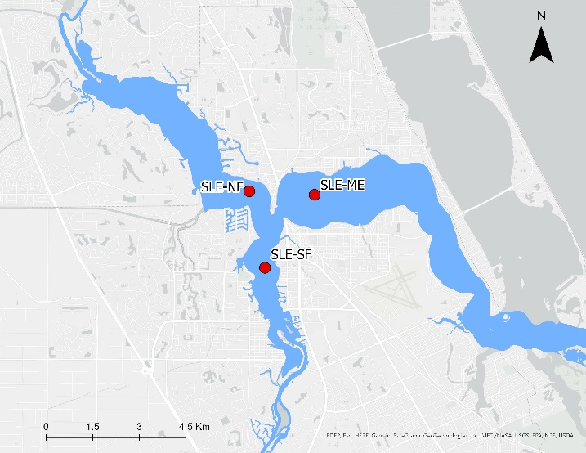
Figure 4.1 The locations of the three sensors in the St. Lucie Estuary.

Water quality dataset
Data from January 2016 to April 2022 of fDOM, salinity, and turbidity were downloaded from three underwater sensors in the South, North, and Mid-Estuary, respectively (Table 4.2, and Figure 4.2). Sensors were 2.5 meters below the water surface. Hourly datasets were downloaded from the Indian River Lagoon Observatory Network (IRLON) (https://irlon.org/), a monitoring program operated by the Harbor Branch Oceanographic Institute at Florida Atlantic University. The IRLON instruments comprise three optical sensors designed for simultaneous, multiple-sensor determination of fluorescence and turbidity every hour. The instruments estimated fDOM from 0.36 to 500 ppb QSDE⁻¹, Chl-a from 0.02 to 400 μg L⁻¹, and turbidity from 0.013 to 25 NTU. Quality control assessments of the sensors occur every 4-6 weeks to validate instrument readings and collect discrete samples for laboratory analysis. In addition to the field assessments, data are assessed through real-time QA/QC tests following Integrated Ocean Observing System (IOOS) Quality Assurance/Quality Control of Real-Time Oceanographic Data (QARTOD) protocols and are flagged as pass, suspect, or fail. Only data with pass flags were used.
Table 4.2 Summary statistics of water quality parameters at sensors
Image date | Sensor | Mean | SD | Min | Max | CV
fDOM  (QSDE) | SLE-ME | 39.6 | 27.7 | 15.0 | 126 | 0.70
fDOM  (QSDE) | SLE-NF | 47.2 | 28.1 | 16.0 | 127 | 0.60
fDOM  (QSDE) | SLE-SF | 45.2 | 28.2 | 18.0 | 135 | 0.62
Salinity  (PSU) | SLE-ME | 16.2 | 7.17 | 0.37 | 27.5 | 0.44
Salinity  (PSU) | SLE-NF | 12.9 | 8.50 | 0.33 | 27.9 | 0.66
Salinity  (PSU) | SLE-SF | 11.8 | 7.67 | 0.21 | 24.8 | 0.65
Turbidity  (NTU) | SLE-ME | 10.1 | 8.92 | 2.32 | 35.5 | 0.89
Turbidity  (NTU) | SLE-NF | 8.08 | 5.75 | 2.52 | 22.9 | 0.71
Turbidity  (NTU) | SLE-SF | 20.1 | 13.2 | 5.5 | 46.1 | 0.66

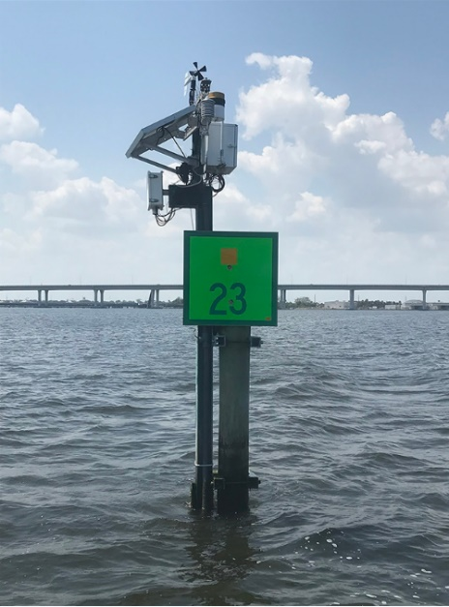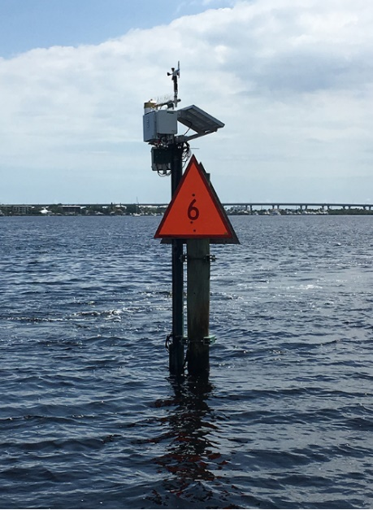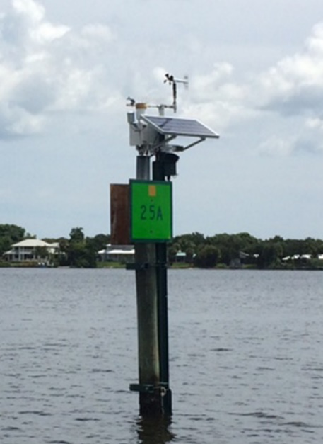
c
b
a
Figure 4.2 The three sensors, a) SLE-ME, b) SLE-NF, c) SLE-SF from the Indian River Lagoon Observatory Network (IRLON). Image credit: https://irlon.org

Satellite Images
Eighteen Landsat-8 images were downloaded from Earth Explorer (https://earthexplorer.usgs.gov/) (Table 4.3). All images were level-2 products, radiometrically and atmospherically corrected for surface reflectance. The USGS uses the LaSRC v1.4.1 model for atmospheric correction of level-2 OLI products (U.S. Geological Survey, 2021). The surface reflectance values estimate the Earth's surface spectral reflectance without atmospheric distortions as unsigned 16-bit integers ranging from 1-65455. Using a raster calculator on ArcGIS Pro, a scale factor of 0.0000275 + - 0.2 (U.S. Geological Survey 2021) was applied to pixel values for each image. After applying the scale factor, many values for bands 1 and 2 became negative. Strong absorption in the blue bands is expected due to the constituents in this waterbody, so error in the shortwave bands is significant.
Table 4.3 Acquisition dates of Landsat-8 images and their cloud cover
No. | Date Acquisition | Cloud Cover (%) |  | No. | Date Acquisition | Cloud Cover (%)
1 | 2016-01-24 | 31.5 |  | 10 | 2019-06-25 | 12.2
2 | 2016-02-25 | 2.32 |  | 11 | 2019-08-28 | 10.7
3 | 2016-08-19 | 6.09 |  | 12 | 2019-12-02 | 8.94
4 | 2016-10-22 | 2.55 |  | 13 | 2020-06-27 | 10.3
5 | 2017-12-12 | 0.43 |  | 14 | 2020-12-20 | 18.5
6 | 2018-04-19 | 3.12 |  | 15 | 2021-01-21 | 0.471
7 | 2018-08-09 | 3.56 |  | 16 | 2021-12-07 | 1.57
8 | 2018-10-28 | 12.9 |  | 17 | 2021-12-31 | 2.44
9 | 2019-04-22 | 14.6 |  | 18 | 2022-03-29 | 0.040

In situ water quality and Landsat-8 pairs
The hourly time series of fDOM, salinity, and turbidity were plotted against the collection dates (identified as blue lines) of Landsat 8 images (Figure 4.3) for a visual assessment of the water quality conditions at the time of image collection and the variation between sites. The in situ data coinciding with the time of the satellite image were then extracted and paired with the reflectance from Landsat 8 images (Table 4.4). The series plots and extracted values indicated that Landsat 8 images captured important variations in water quality over time. The fDOM data ranged from 15 to 130 QSDE, salinity from 0.20 to 27 PSU, and turbidity from 2 to 46 NTU. Differences across stations could also be observed. For example, the turbidity maximum at SLE-SF (46.1 NTU) was double that at SLE-NF (22.9 NTU).
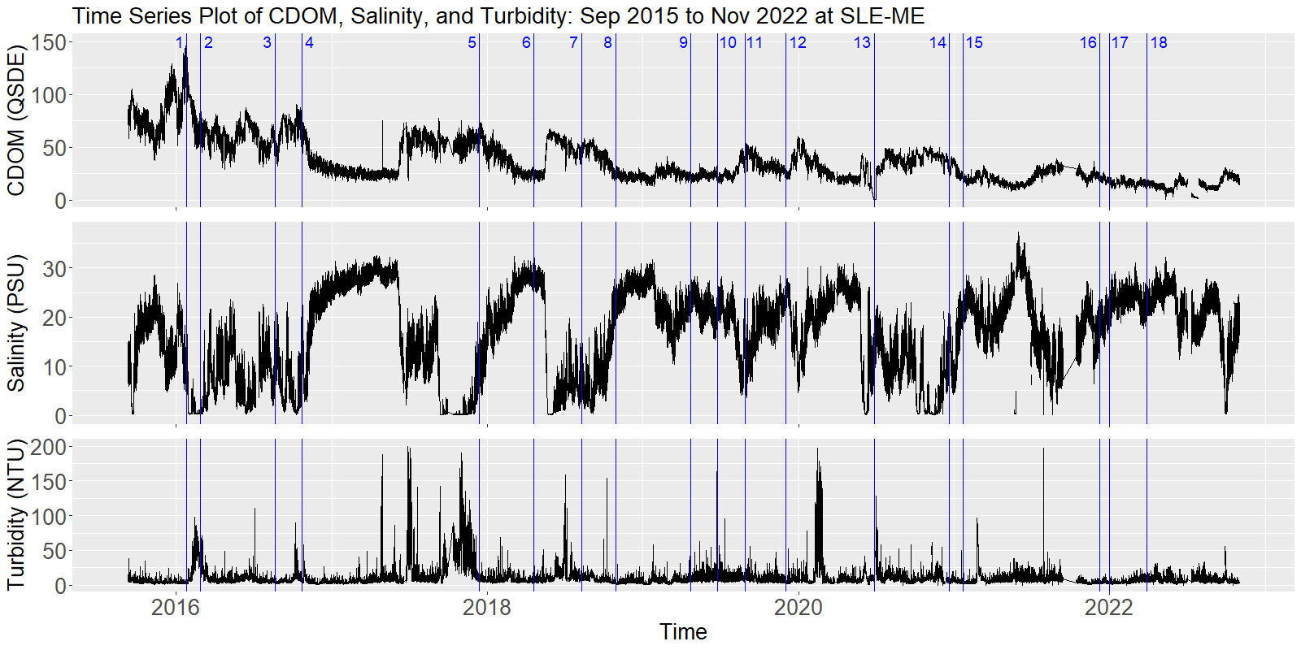
a
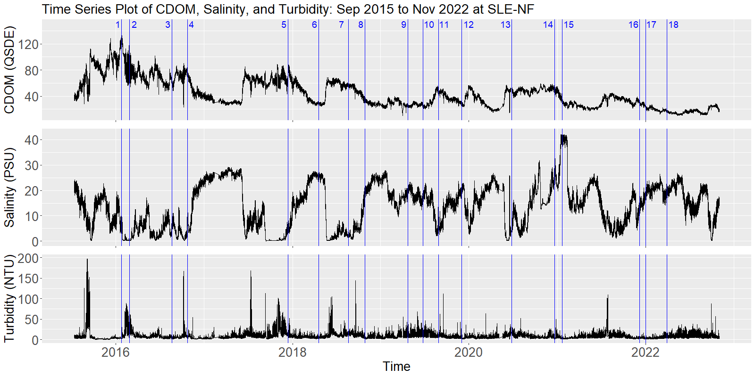
b
c
Figure 4.3 a-c Time series plot of water quality constituents for sensors a) SLE-ME, b) SLE-NF, and c) SLE-SF. The blue vertical lines show Landsat-8 image dates.
Table 4.4 In situ data for the three sensors captured simultaneously with the 18 satellite images. NAs represent unavailable data or flagged as possible error.
Image number | Image date | Sensor | CDOM (QSDE) | Salinity (PSU) | Turbidity (NTU)
1 | 2016-01-24 | SLE-ME | 126 | 10.33 | 4.3
1 | 2016-01-24 | SLE-NF | 127 | 4.70 | 4.6
1 | 2016-01-24 | SLE-SF | 135 | 2.89 | 5.5
2 | 2016-02-25 | SLE-ME | 69 | 0.37 | 35.5
2 | 2016-02-25 | SLE-NF | 91 | 0.33 | 22.9
2 | 2016-02-25 | SLE-SF | 59 | 0.21 | 46.1
3 | 2016-08-19 | SLE-ME | 48 | 11.64 | 4.4
3 | 2016-08-19 | SLE-NF | 61 | 6.16 | 3.9
3 | 2016-08-19 | SLE-SF | 59 | 4.99 | 15.6
4 | 2016-10-22 | SLE-ME | 57 | 14.03 | 5.7
4 | 2016-10-22 | SLE-NF | 76 | 6.21 | 4.8
4 | 2016-10-22 | SLE-SF | 78 | 5.03 | 28.6
5 | 2017-12-12 | SLE-ME | 61 | 8.24 | 11.9
5 | 2017-12-12 | SLE-NF | 57 | 4.60 | 12.8
5 | 2017-12-12 | SLE-SF | 72 | 2.95 | 41.5
6 | 2018-04-19 | SLE-ME | 25 | 27.47 | 4.6
6 | 2018-04-19 | SLE-NF | 29 | 25.41 | 4.3
6 | 2018-04-19 | SLE-SF | 33 | 24.77 | 11.9
7 | 2018-08-09 | SLE-ME | 47 | 6.05 | 13.0
7 | 2018-08-09 | SLE-NF | 55 | 2.96 | 11.9
7 | 2018-08-09 | SLE-SF | 50 | 1.01 | 42.4
8 | 2018-10-28 | SLE-ME | 26 | 21.64 | 2.3
8 | 2018-10-28 | SLE-NF | 33 | 18.49 | 3.6
8 | 2018-10-28 | SLE-SF | 39 | 17.31 | 9.5
9 | 2018-04-22 | SLE-ME | 23 | 22.55 | 9.9
9 | 2018-04-22 | SLE-NF | 26 | 19.54 | 10.6
9 | 2018-04-22 | SLE-SF | 29 | 18.52 | 19.5
10 | 2019-06-25 | SLE-ME | 21 | 21.89 | 22.8
10 | 2019-06-25 | SLE-NF | 24 | 18.11 | 13.6
10 | 2019-06-25 | SLE-SF | 26 | 18.23 | 19.0
11 | 2019-08-28 | SLE-ME | 37 | 14.81 | 9.4
11 | 2019-08-28 | SLE-NF | 46 | 7.45 | 10.8
11 | 2019-08-28 | SLE-SF | 35 | 7.64 | 36.9
12 | 2019-12-02 | SLE-ME | 28 | 22.31 | 6.6
12 | 2019-12-02 | SLE-NF | 27 | 19.18 | 4.7
12 | 2019-12-02 | SLE-SF | 28 | 19.40 | 15.6
13 | 2020-06-27 | SLE-ME | NA | 11.34 | 24.2
13 | 2020-06-27 | SLE-NF | 49 | 6.22 | 17.0
13 | 2020-06-27 | SLE-SF | 40 | 10.33 | 20.4
14 | 2020-12-20 | SLE-ME | 31 | 15.08 | 4.3
14 | 2020-12-20 | SLE-NF | 47 | 27.92 | 4.0
14 | 2020-12-20 | SLE-SF | 37 | 10.41 | 13.5
15 | 2021-01-21 | SLE-ME | 20 | 21.50 | 3.3
15 | 2021-01-21 | SLE-NF | 32 | NA | 2.5
15 | 2021-01-21 | SLE-SF | 26 | 17.35 | 11.3
16 | 2021-12-07 | SLE-ME | 21 | 18.56 | 5.1
16 | 2021-12-07 | SLE-NF | 29 | 14.47 | 3.8
16 | 2021-12-07 | SLE-SF | 29 | 13.75 | 7.6
17 | 2021-12-31 | SLE-ME | 18 | 20.68 | 3.7
17 | 2021-12-31 | SLE-NF | 24 | 18.14 | 2.9
17 | 2021-12-31 | SLE-SF | 21 | 17.79 | 5.6
18 | 2022-03-29 | SLE-ME | 15 | 23.29 | 10.1
18 | 2022-03-29 | SLE-NF | 16 | 19.83 | 6.9
18 | 2022-03-29 | SLE-SF | 18 | 19.92 | 11.8

Statistical Analyses
Pearson's correlation analysis was calculated to determine the relationship between water quality parameters and Landsat 8 bands. Equation (4.1) represents the basic form of Pearson's correlation as follows:
$$R= \frac{(X_{band}- \overline{X_{band}})(Y_{WQP}- \overline{Y_{WQP}})}{\sqrt{{(X_{band}- X_{band})}^{2}+{(Y_{WQP}- Y_{WQP})}^{2}}}$$ | (4.1)
$X_{band}$ is the value of corrected reflectance, $\overline{X_{band}}$ is the mean value of the corrected reflectance, $Y_{WQP}$ = water quality parameters, and $Y_{WQP}$ is the mean value of the in situ WQP data from monitoring stations.
Forward stepwise linear regression analysis was performed between fDOM and unscaled reflectance values of bands 1 – 5 and between log-transformed fDOM and unscaled reflectance values to discern the spectral regions and band ratios most related to fDOM. The fDOM values were the dependent variable, and the unscaled band values and ratios were the independent variables. The unscaled reflectance values were used because of the large number of negatives resulting from the scaling in bands 1 and 2. Forward stepwise linear regression builds a model by adding or removing the predictor variables in succession and testing for statistical significance after each iteration with this equation:
$$fDOM= β_{0}+ β_{1}x_{1}+β_{2}x_{2}+… β_{n}x_{n}$$ | (4.2)
where $βᵢ$ are the regression coefficients and xᵢ are bands or band indices. P values greater than 0.05 were considered a limit for factor addition (Gholizadeh and Melesse, 2017; Olmanson et al., 2016). The reported adjusted R-squared is a modified R-squared that adjusts for the number of explanatory terms in a model. It was computed using:
$$Adjusted R^{2}=1-(1-R^{2})\frac{N-1}{N-k-1'}$$ | (4.3)

where $R^{2}$ is the square of the sample correlation coefficient between the bands/indices and fDOM, N is the sample size, and $k$ is the number of predictors.

Results and Discussion

Correlation of Landsat-8 and fDOM
Pearson's correlation was used to detect relationships between reflectance values of Landsat-8 bands, band ratios, and water quality constituent concentrations collected on the same day, a week later, and two weeks after the satellite image (Table 4.5). The independent variables were Landsat-8 bands, selected band ratios, and their log-transformed values, and the dependent variables were the water quality parameters and their log-transformed values. The band ratios tested were based on those that have shown strong correlation coefficients and coefficients of determination above 0.6 when assessed for the water quality constituents collected for this study in optically complex waters (Hajigholizadeh and Melesse, 2017; Menken et al., 2006; Olmanson et al., 2016; Slonecker et al., 2016). No differences were found between correlation coefficients for analyses performed using log-transformed rather than raw values.
Table 4.5 Pearson's correlation coefficients between water constituents and band and band ratios
Bands and Ratios | fDOM |  |  | Salinity |  |  | Turbidity
Bands and Ratios | Same  day | 7  days | 14  days | Same  day | 7  days | 14  days | Same  day | 7  days | 14  days
B1  Coastal | 0.06 | 0.03 | 0.02 | 0.00 | 0.04 | 0.06 | 0.47 | 0.24 | 0.20
B2  Blue | 0.00 | -0.04 | -0.04 | -0.02 | 0.02 | 0.04 | 0.54 | 0.29 | 0.28
B3  Green | -0.07 | -0.10 | -0.10 | -0.06 | -0.02 | 0.00 | 0.59 | 0.31 | 0.33
B4  Red | 0.07 | 0.03 | 0.04 | -0.20 | -0.15 | -0.13 | 0.66 | 0.42 | 0.44
B5  NIR | -0.01 | -0.03 | -0.03 | -0.15 | -0.10 | -0.09 | 0.55 | 0.27 | 0.31
B6  SWIR1 | -0.11 | -0.13 | -0.12 | -0.07 | -0.01 | 0.00 | 0.49 | 0.15 | 0.18
B7  SWIR2 | -0.09 | -0.11 | -0.10 | -0.08 | -0.02 | -0.01 | 0.50 | 0.17 | 0.20
B1/B4  Coastal /Red | -0.05 | -0.03 | -0.04 | 0.31 | 0.27 | 0.27 | -0.55 | -0.39 | -0.45
B2/B3  Blue/Green | 0.16 | 0.17 | 0.16 | 0.13 | 0.09 | 0.09 | -0.42 | -0.19 | -0.28
B2/B4  Blue/Red | -0.17 | -0.16 | -0.17 | 0.43 | 0.39 | 0.38 | -0.61 | -0.46 | -0.52
B3/B4  Green/Red | -0.76 | -0.74 | -0.74 | 0.79 | 0.78 | 0.76 | -0.62 | -0.73 | -0.70
B3/B5 Green/NIR | -0.12 | -0.12 | -0.12 | 0.30 | 0.26 | 0.26 | -0.36 | -0.17 | -0.21
B2/B5 Blue/NIR | 0.00 | 0.00 | -0.01 | 0.25 | 0.21 | 0.21 | -0.43 | -0.20 | -0.26
B5/B4 NIR/Red | -0.16 | -0.15 | -0.14 | -0.03 | 0.00 | 0.00 | 0.20 | -0.08 | -0.03

The green/red ratio was the only strongly correlated (p<0.001) variable with water quality constituents. This ratio had a strong positive correlation with salinity and an inverse correlation with fDOM and turbidity. The green/red ratio correlation coefficients with fDOM and salinity decreased slightly as the time between in situ collection increased, but they stayed strong. The Green/Red ratio has been widely used to estimate fDOM (Brezonik et al., 2005; Chen et al., 2017). The Landsat-8 OLI green/red ratio has been correlated with fDOM at the New York and New Jersey Bays (Slonecker et al., 2016) and various lakes in east-central Minnesota (Menken et al., 2006) and Finland (Kutser et al., 2005). The green/red ratio is generally better suited in coastal water than those using blue bands due to the weak remotely sensed signal at the lower ends of the visible spectrum and atmospheric error. Atmospheric correction of satellite imagery at blue wavelengths has a higher error in waters with low reflectance such as those with high fDOM (Kutser et al., 2005). The correlation between the Green/Red ratio and salinity aligns with the negative correlation between color and salinity in chapter 1. Freshwater inputs from the watershed lower salinity and increase fDOM values (Moncada et al., 2021). Interestingly, the correlation coefficient for turbidity was lower for in situ images taken the same day as the satellite image than for the 7- and 14-day values. This might be due to the high variability of turbidity values observed in chapter 3.
As with Pearson's correlation analysis, all Landsat-8 bands and the selected band ratios were used for the forward stepwise regression analysis (Table 4.6). Forward stepwise regression was performed between raw fDOM without outliers and unscaled reflectance values. Then a second analysis was performed with log-transformed fDOM without outliers and reflectance values to identify the best fit. Simple linear regression between fDOM and the Green/Red ratio was also assessed for raw and log-transformed values. This ratio had the strongest relationship in the previous correlation analysis with fDOM. Models from the multiple and simple regressions with p values < 0.05 are reported in Table 4.6. Regressions with fDOM outliers generally had low coefficients of determination and high P values, so they were omitted.
Table 4.6 Results of the simple and forward stepwise linear regressions for fDOM
Linear Regressions for fDOM
Simple linear regression in the form y = mx + b
Multiple linear regression in the form y = b₀ + b₁(x₁) + b₂(x₂) + b₃(x₃) …
Independent variable | N | Dependent variables (xᵢ) ¹ | Model | Adjusted R² and R²
log(fDOM) w/o outliers | 50 | log(B3 green)/log(4 red),  log(B1 coastal)/log(B4 red),  log(B2 blue)/log(B5 NIR) | log(fDOM) = 294 + -325*(x₁) + 56*(x₂) + -21*(x₃) | 0.67
fDOM w/o outliers | 50 | B3 green/B4 red,  B1 coastal/B4 red | fDOM = 1319 + -1423(x₁) + 160(x₂) | 0.66
log(fDOM) w/o outliers | 50 | log (B3/B4) | y = -28.98x + 3.65 | 0.57
log(fDOM) w/o outliers | 50 | log (B3)/log (B4) | y = -28.97x + 32.62 | 0.56
fDOM w/o outliers | 50 | B3/B4 | y = -1186x + 1219 | 0.56
fDOM w/outliers | 53 | B3/B4 | y = 1222x + -1174 | 0.22
log(fDOM) w/outliers | 53 | log (B3)/log(B4) | y = 32.61x + -28.88 | 0.37
¹The band or band ratio represents the x in the equation. A comma separates each dependent variable.
Both stepwise regression models had higher coefficients of determination than the single-band ratio regressions. The results for both forward stepwise models showed the B3(green)/B4(red) and B1(coastal)/B4(red) band ratios as significant explanatory variables for fDOM concentrations. The relationship between the green and red bands and fDOM was observed in the correlation analysis previously discussed. While the coastal/red band ratio did not appear to be related to fDOM from the correlation analysis results, theoretically, the ratio between the coastal part of the spectrum and the red part is affected by fDOM due to its high absorption effects at the lower wavelengths. The best fDOM model for Landsat 8 used the log-transformed coastal, blue, green, and red bands (bands 1, 2, 3, and 4, respectively), and the second best used the coastal, green, and red bands (bands 1, 3, and 4 respectively). The regression equation with the highest R² (0.67) was:
$$log\left(fDOM\right)= -325*\frac{log{(R}_{Green})}{log{(R}_{Red})} + 56*\frac{log{(R}_{Coastal})}{log{(R}_{Red})} -21*\frac{log{(R}_{Blue})}{log{(R}_{NIR})}+ 294$$ | (4.4)

The regression equation with the second highest R² (0.66) was:
$$fDOM= -1423*\frac{R_{Green}}{R_{Red}} + 160*\frac{R_{Coastal}}{R_{Red}} + 1319$$ | (4.5)

Equations 4.4 and 4.5 were plotted against in situ values using 50 Landsat-8 reflectance pairs (Figure 4.4). The model regressions showed that the performance of equation 3 (R² = 0.69, p < 0.05) was slightly better than that of equation 4 (R² = 0.67, p < 0.05). The mean absolute percentage error (MAPE) was calculated rather than the RMSE for each model, given that the first one used the log-transformed fDOM values while the values for the second regression were not transformed. The MAPE for the first model was 6.14%, while that for the second one was 23.9%. Therefore, the model using the log-transformed values showed to fit the data better. The quantile–quantile and residual plots of equation 4.4 regression against in situ values (Figure 4.5) showed that residuals had an overall normal distribution. However, there were various outliers at the lower end and one severe outlier at the upper end. This suggests that the model may not be robust enough for lower fDOM values.
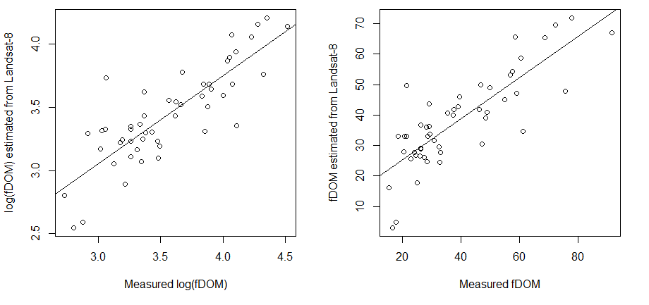
Figure 4.4 Correlation between the measured and estimated fDOM by applying equations 4.4 and 4.5 to atmospherically corrected Landsat-8 images.
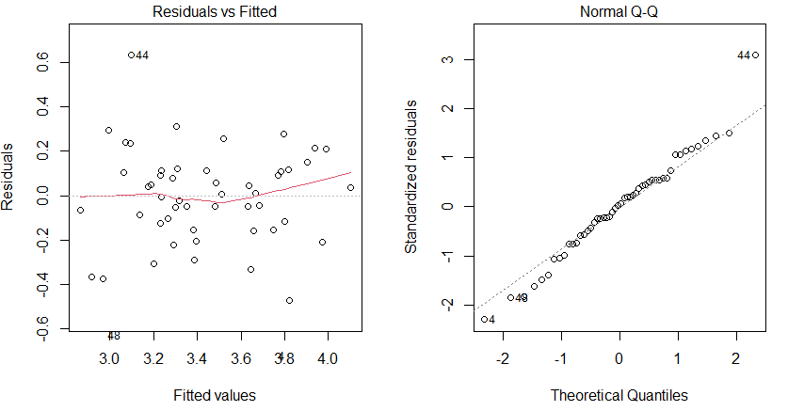
Figure 4.5 Residual vs. Fitted and Quantile–quantile plots for regression between the estimated fDOM using equation 3 with in situ values.
While the coefficients of determination resulting from the forward stepwise models were not strong for a robust predictive model, it was useful in identifying some of the bands that can be potentially be used for future research. Previous studies successfully adopted the relationship between the Green/Red ratio and fDOM to derive CDOM for freshwater environments (Brezonik et al., 2005; Kutser et al., 2005). For instance, Slonecker et al., 2016, reported a weak (R² = 0.23) power relationship between the Landsat-8 Green/Red ratio and fDOM. Their study also found that Landsat-8 Band 1 was correlated with fDOM. While a relationship with Band 1 alone was not found in this study, the band1/band4 ratio was the second variable in the first model. A dataset with greater variation in fDOM concentrations would be appropriate to assess other models, including non-linear ones. Chen et al. 2017, for example, found that an exponential function using the green/red ratio worked best for fDOM estimation in Lake Huron.

Conclusion
Colored dissolved organic matter is an essential constituent in ecological water quality assessments. This constituent is typical of fresh and coastal waters, and accurate monitoring is useful for improving resource management strategies. Remote sensing is a valuable tool for monitoring this constituent because it simultaneously captures information from large areas. However, in situ data availability is essential to develop accurate prediction models using space-borne sensors, especially for optically complex waters. Combining space-borne and real-time sensors is a promising technique to maximize satellite-based observations and accuracy assessments.
In this chapter, the relationship between fDOM and water reflectance was investigated from automated sensors and reflectance from Landsat-8 imagery. The green/red ratio was inversely correlated with fDOM and positively correlated with salinity up to 14 days between satellite image and in situ collection. The best model to estimate fDOM from the forward stepwise regression used the log-transformed coastal, blue, green, and red reflectance values with a moderate coefficient of determination (0.67) and a MAPE of 6.14%. The Q-Q plot of the regression between the estimated fDOM using the best model with in situ values showed severe outliers at the lower and upper ends. Outliers may suggest that the model may not be robust enough to estimate high and low fDOM values.
With water-leaving signals from blue bands being weaker, it is recommended that the green/red ratios be favored for future model development for CDOM-rich complex water such as this estuary. Previous studies have demonstrated that CDOM could contribute 10% to 40% of the total absorption at the green band for inland water and even higher in the blue band (Chen et al. 2017). For this CDOM-rich waterbody, the absorption is strong throughout the blue and green portion of the spectrum. While the forward stepwise regression model results indicated that the blue and coastal-blue bands are useful for fDOM prediction, the green/red ratio was selected as the most robust. In addition, chl-a, as CDOM, also absorbs light strongly at the blue portion of the spectrum. In order to differentiate fDOM from chl-a, the use of the green and red bands, rather than the blue band, is recommended.

References
Aurin, D., Mannino, A., Lary, D.J., 2018. Remote sensing of CDOM, CDOM spectral slope, and dissolved organic carbon in the global ocean. Appl. Sci. 8. https://doi.org/10.3390/app8122687
Brezonik, P., Menken, K.D., Bauer, M., 2005. Landsat-based Remote Sensing of Lake Water Quality Characteristics, Including Chlorophyll and Colored Dissolved Organic Matter (CDOM). Lake Reserv. Manag. 21, 373–382. https://doi.org/10.1080/07438140509354442
Brezonik, P.L., Olmanson, L.G., Finlay, J.C., Bauer, M.E., 2015. Factors affecting the measurement of CDOM by remote sensing of optically complex inland waters. Remote Sens. Environ. 157, 199–215. https://doi.org/10.1016/j.rse.2014.04.033
Chen, J., Zhu, W.N., Tian, Y.Q., Yu, Q., 2017. Estimation of Colored Dissolved Organic Matter from Landsat-8 Imagery for Complex Inland Water: Case Study of Lake Huron. IEEE Trans. Geosci. Remote Sens. 55, 2201–2212. https://doi.org/10.1109/TGRS.2016.2638828
Florida Department of Environmental Protection., 2020. St. Lucie River and Estuary Basin Management Action Plan. Florida Department of Environmental Protection, Tallahassee, FL, USA.
Gholizadeh, M.H., Melesse, A.M., 2017. Study on Spatiotemporal Variability of Water Quality Parameters in Florida Bay Using Remote Sensing. J. Remote Sens. GIS 06. https://doi.org/10.4172/2469-4134.1000207
Griffin, C.G., Frey, K.E., Rogan, J., Holmes, R.M., 2011. Spatial and interannual variability of dissolved organic matter in the Kolyma River, East Siberia, observed using satellite imagery. J. Geophys. Res. 116, G03018. https://doi.org/10.1029/2010JG001634
Gholizadeh, M.H., Melesse, A.M., Reddi, L., 2016. A comprehensive review on water quality parameters estimation using remote sensing techniques. Sensors (Switzerland) 16. https://doi.org/10.3390/s16081298
Hajigholizadeh, M., Melesse, A.M., 2017. Assortment and spatiotemporal analysis of surface water quality using cluster and discriminant analyses. Catena 151, 247–258. https://doi.org/10.1016/j.catena.2016.12.018
Kowalczuk, P., Olszewski, J., Darecki, M., Kaczmarek, S., 2005. Empirical relationships between coloured dissolved organic matter (CDOM) absorption and apparent optical properties in Baltic Sea waters. Int. J. Remote Sens. 26, 345–370. https://doi.org/10.1080/01431160410001720270
Kutser, T., Pierson, D.C., Kallio, K.Y., Reinart, A., Sobek, S., 2005. Mapping lake CDOM by satellite remote sensing. Remote Sens. Environ. 94, 535–540. https://doi.org/10.1016/j.rse.2004.11.009
Menken, K.D., Brezonik, P.L., Bauer, M.E., 2006. Influence of chlorophyll and colored dissolved organic matter (CDOM) on lake reflectance spectra: Implications for measuring lake properties by remote sensing. Lake Reserv. Manag. 22, 179–190. https://doi.org/10.1080/07438140609353895
Moncada, A.M., Melesse, A.M., Vithanage, J., Price, R.M., 2021. Long-Term Assessment of Surface Water Quality in a Highly Managed Estuary Basin. Int. J. Environ. Res. Public Heal. 18, 9417. https://doi.org/10.3390/ijerph18179417
Mukhopadhyay, S.C., Mason, A., 2013. Smart Sensors for Real-Time Water Quality Monitoring, Smart Sensors, Measurement and Instrumentation. Springer Berlin Heidelberg, Berlin, Heidelberg. https://doi.org/10.1007/978-3-642-37006-9
Olmanson, L.G., Brezonik, P.L., Finlay, J.C., Bauer, M.E., 2016. Comparison of Landsat 8 and Landsat 7 for regional measurements of CDOM and water clarity in lakes. Remote Sens. Environ. 185, 119–128. https://doi.org/10.1016/j.rse.2016.01.007
Slonecker, E.T., Jones, D.K., Pellerin, B.A., 2016. The new Landsat 8 potential for remote sensing of colored dissolved organic matter (CDOM). Mar. Pollut. Bull. 107, 518–527. https://doi.org/10.1016/j.marpolbul.2016.02.076
U.S. Geological Survey, 2021. Landsat collection 2 (No. fs20213002), Landsat collection 2. Earth Resources Observation and Science (EROS) Center. https://doi.org/10.3133/fs20213002
Yaroshenko, I., Kirsanov, D., Marjanovic, M., Lieberzeit, P.A., Korostynska, O., Mason, A., Frau, I., Legin, A., 2020. Real-Time Water Quality Monitoring with Chemical Sensors. Sensors 20, 3432. https://doi.org/10.3390/s20123432

Chapter V: Conclusions and Recommendations
The St. Lucie Estuary, Florida, is an important coastal ecosystem supporting thousands of residents' livelihoods and many ecologically essential organisms (Chamberlain and Hayward, 1996; Wilson et al., 2005). Hydrological modifications, land use, and urbanization have negatively impacted the water quality of this system. Most estuary sections have been considered impaired under the Florida Department of Environmental Protection (FDEP) Impaired Waters Rule since 2008. This estuary is one of two estuaries at the receiving end of Lake Okeechobee releases. Its artificial connection with Lake Okeechobee brings in water from a 14,000 km² area, including cattle pastures and citrus plantations (Kramer et al., 2018; Qian et al., 2007). Periodic lake releases complicate the management and mitigation efforts of the system. The complexity of this system makes it deserving of further research and efforts.
The primary goal of this work was to understand the main constituents driving this estuary's water quality and their relationship with surface water reflectance. With this purpose, publicly available in situ datasets curated by the South Florida Water Management District (SFWMD) and Florida Atlantic University and water reflectance data from a field spectroradiometer, the WorldView-2 satellite, and the Landsat-8 satellite were analyzed to assess the water quality of the St. Lucie Estuary.
Statistical techniques, including correlation analysis, principal component analysis (PCA), and Mann-Kendall trends, were applied to evaluate the spatiotemporal variations in the surface water quality of the estuary and its main tributaries using 20 years (1999 – 2019) datasets of 10 water quality variables covering ten sampling sites. The dataset showed that most water quality constituents were higher in the wet season, likely due to increased infiltration, groundwater levels, and runoff. The correlation analysis and the PCA revealed that color PCU had a strong positive relationship with all phosphorus species and a negative correlation with dissolved oxygen (DO) and pH. The PCA revealed phosphorus concentrations at basin tributaries, and high turbidity at the Lake Okeechobee canal were the principal factors distinguishing the basin from lake inflows. The principal variables driving the water quality at the basin tributaries were orthophosphate, total phosphorus, color PCU, and NH₃+, while those driving Lake Okeechobee’s discharges were total suspended solids and turbidity. The basins' land-cover types and agricultural practices reflected higher phosphorus from basin tributaries than lake inflows.
Non-point contamination impacts the ecology of this estuary as the nutrient concentrations across the different estuary sections and tributaries vary with land use and water management. Agriculture and urban centers are significant sources of nutrient pollution. The efforts of the FDEP and local water management district to curtail the nutrient loadings to the estuary through best management practices and Stormwater Treatment Areas is of great importance for maintaining the ecosystem services of this estuary.
The Mann-Kendall trend tests revealed significant increases in pH and DO values and decreases in NH₃, nitrate-nitrite, total nitrogen, orthophosphate, and total phosphorus at the North Fork of the Estuary in the 20 years. These trends may be due to the implementation of Best Management Practices, and the implementation of minimum flows by the Environmental Protection Agency and the SFWMD (South Florida Water Management District., 2002). Another possibility is increased tidal mixing with seawater due to rising sea levels, increasing salinity, pH, and DO values, and decreasing CDOM. This chapter demonstrates the value of dimensionality reduction techniques and nonparametric trend analysis on large datasets for water quality research. Management agencies should implement dimensionality reduction tools to explore the large datasets they store. These tools can better guide their prioritization of geographic areas of the water body or water quality constituents to target.
The previously described spatiotemporal assessment of water quality highlighted the optical complexity of the estuary, which was essential for selecting the sensors explored in the following chapters. The variation in water reflectance and its relationship with water quality constituents in St. Lucie Estuary was evaluated using field spectroscopy and high spatial-resolution satellite imagery. In situ datasets were obtained from the local water management district of optically active constituents or those directly affecting optical properties, including chlorophyll-a, color PCU, Secchi Disk Depth, salinity, total suspended solids, and turbidity.
The variability of the optically active constituents was done using hourly data from three real-time sensors located on three sections of the estuary, the mid-estuary, the north fork, and the south fork spanning from September 2015 to June 2022. The variations of water quality constituents were evaluated to decide on an appropriate time between in situ data and satellite pairs. Colored dissolved organic matter and salinity values had very low variability in the 14-day periods, while turbidity and chlorophyll-a values showed high variability. Because of the optical dominance of color PCU in this system and its low variability, a 14-day threshold was used for satellite-in situ pairs. The low variability of CDOM has important implications for remote sensing purposes. It indicates the water column significantly attenuates the light penetration throughout the year. Since lower light penetration affects the benthic communities, it is crucial to understand the origin and mechanism of the high and persistent CDOM concentrations.
All curves had low reflectance values in regions below ~500 nm, with a peak at approximately 650 nm and a pronounced dip at the red-edge region from ~700 nm to ~740 nm. This spectral curve is typical of waters dominated by colored dissolved organic matter or color PCU due to its strong water absorption at the blue part of the spectrum. While these field spectra curves and magnitudes aligned with those found in the literature, environmental conditions and technical limitations could have added errors. Potential sources of error for field spectra could include the viewing geometry of the above-water measurements, wind gusts, and overcast conditions.
When comparing the field spectra with WorldView-2-derived surface reflectance, there were notable differences in the blue wavelengths and reflectance magnitudes. Worldview-2 at wavelengths greater than 600 nm agreed more with field spectra as reflectance values decrease with increasing wavelengths. The WorldView-2 image has its reflectance peak at Band 2 (Blue), likely a radiometric correction error since the estuary’s optical properties are dominated by CDOM which absorbs energy in the blue part of the spectrum. Atmospheric correction of blue wavelengths has been problematic for turbid waters with low reflectance, and this estuary is not an exception. Two atmospheric models were tried for the WorldView images, with similar results in overestimating the blue part of the spectrum. WorldView Band 1 (Coastal blue) can become important for estimating CDOM and distinguishing it from chlorophyll-a and suspended solids, as Bands 3 and 5 can be affected by multiple constituents, but an appropriate atmospheric model is imperative. One study successfully corrected the images using the 6S model, but this uses the FORTRAN programming language, which is a technical limitation for many water management agencies. Another limitation of WV-2 for continuous monitoring is the small amounts of images that the sensor can gather due to the high cost and cloud cover. While the WV2 images were free-of-charge for this study, the federal government pays to task the sensor and the price increase with tasking frequency. Also, the area coverage of the WV-2 did not encompass the entire waterbody and sampling stations for most dates which decreased the number of in situ pairs. Due to these limitations, the WV-2 sensor is a better fit for specific studies in a smaller area with more technical and time resources than as a monitoring tool.
While the possibility of error from inadequate atmospheric correction was high for Band 1 and 2, the correlation analysis revealed that color PCU had a strong inverse correlation with the coastal blue (-0.83) and blue bands (-0.73). This correlation is noteworthy because UV (Band 1) reflectance can facilitate the separation of chlorophyll-a from color PCU in optically complex waters since various constituents influence the green and red bands. The correlation analysis did not show a correlation between the Green/Red band and any of the constituents, which was expected as this ratio is the most widely reported related to optically active constituents. Due to the possible inconsistencies with previous results, the WorldView-2 images were not further explored for model development because the in-situ sampling matchups were insufficient for a statistically significant model. Nevertheless, these results demonstrate the importance of comparing spaceborne-derived data with field data in complex water bodies, especially when applying new or emerging technologies such as high-resolution imagery for water quality monitoring.
As discussed previously, the water quality of the St. Lucie Estuary is highly influenced by colored dissolved organic matter or color PCU. For this reason, the last chapter of the dissertation focused on investigating the possibility of estimating colored dissolved organic matter using real-time sensors with hourly data and reflectance from medium spatial-resolution imagery. The selection of Landsat-8 OLI was based on its return interval of 16 days and its record in estimating water quality constituents by previous authors. One of the objectives of this study was to assess the relationship between reflectance and optically active water quality constituents and if this relationship changed as the time between in situ and image collection increased. Differently from WorldView-2 analysis, colored dissolved organic matter, salinity, and turbidity were strongly related to the Landsat-8 Green/Red ratio. For colored dissolved organic matter and salinity, this strong relationship was maintained with a 14-day difference between the satellite image and in situ values.
The forward stepwise regression analysis showed the Landsat-8 B3(Green)/B4(Red) and B1(Coastal)/B4(Red) band ratios as significant explanatory variables for colored dissolved organic matter. The best model with the highest R² (0.67) used the log-transformed coastal, blue, green, and red bands. The residual plots of the estimated values from the selected model with situ values showed various outliers at the lower and upper ends, suggesting the model may not be robust enough to estimate low and high values of colored dissolved organic matter. Nevertheless, the linear model indicated the potential of four Landsat-8 bands for further exploration. A greater variability in the values for satellite matchups and the exploration of nonlinear relationships could potentially improve the coefficient of determination of prediction models in this estuary.
Further studies should focus on cross-validation of the fDOM model for Landsat-8, not Worldview-2, for implementing satellite imagery for continuous monitoring. Additional in situ fDOM data should be collected from areas closer to tributaries in the South and North Forks to obtain a broader concentration range. Developing a model with low uncertainties will provide a good tool for systematically mapping fDOM and enhancing mitigation efforts. A validated model could be used to map the temporal changes in fDOM and see the decreasing trends in the North Fork.

References
Chamberlain, R., Hayward, D., 1996. Evaluation of Water Quality and Monitoring in the St. Lucie Estuary, Florida. J. Am. Water Resour. Assoc. 32, 681–696. https://doi.org/10.1111/j.1752-1688.1996.tb03466.x
Kramer, B.J., Davis, T.W., Meyer, K.A., Rosen, B.H., Goleski, J.A., Dick, G.J., Oh, G., Gobler, C.J., 2018. Nitrogen limitation, toxin synthesis potential, and toxicity of cyanobacterial populations in Lake Okeechobee and the St. Lucie River Estuary, Florida, during the 2016 state of emergency event. PLoS One 13, e0196278. https://doi.org/10.1371/journal.pone.0196278
Qian, Y., Migliaccio, K.W., Wan, Y., Li, Y.C., Chin, D., 2007. Seasonality of Selected Surface Water Constituents in the Indian River Lagoon, Florida. J. Environ. Qual. 36, 416–425. https://doi.org/10.2134/jeq2006.0185
Wilson, C., Scotto, L., Scarpa, J., Volety, A., Laramore, S., Haunert, D., 2005. Survey of Water Quality, Oyster Reproduction and Oyster Health Status in the St. Lucie Estuary. J. Shellfish Res. 24, 157–165. https://doi.org/10.2983/0730-8000(2005)24[157:SOWQOR]2.0.CO;2

VITA
ANGELICA MONCADA

Born, West Palm Beach, Florida

2013 B.A., Environmental Science
University of Florida
Gainesville, Florida

2013-2017 Biological Science Technician
U.S. Department of Agriculture, Florida

2017-2019 Research Fellow
Florida International University
Miami, Florida

2020 M.S., Environmental Studies
Florida International University
Miami, Florida

2020-2023 Doctoral Candidate
Florida International University
Miami, Florida

Research and Teaching Assistant
Florida International University
Miami, Florida

PUBLICATIONS AND PRESENTATIONS

Moncada, A. M., Melesse, A. M., Vithanage, J., & Price, R. M. (2021). Long-Term Assessment of Surface Water Quality in a Highly Managed Estuary Basin. International Journal of Environmental Research and Public Health, 18(17), 9417, p. 24. https://doi.org/10.3390/ijerph18179417.

Hajigholizadeh, M., Moncada, A., Kent, S., & Melesse, A. M. (2021). Land–Lake Linkage and Remote Sensing Application in Water Quality Monitoring in Lake Okeechobee, Florida, USA. Land, 10(2), 147, p. 17. https://doi.org/10.3390/land10020147. Land, 10(2), 147, p. 17. https://doi.org/10.3390/land10020147.

Moncada, A. (2019). Theme 4: What Does Diversity Require of Us? Fisheries, 44(8), 373-374. https://doi.org/10.1002/fsh.10312.

