FLORIDA INTERNATIONAL UNIVERSITY
Miami, Florida

ECOLOGICAL MODELING IN THE OCEANIC ZONE: A GULF OF MEXICO CASE STUDY

A dissertation submitted in partial fulfillment of
the requirements for the degree of
DOCTOR OF PHILOSOPHY
in
BIOLOGY
by
Matthew Stephen Woodstock

2022

To: Dean Michael R. Heithaus
College of Arts, Sciences and Education

This dissertation, written by Matthew Stephen Woodstock, and entitled Ecological Modeling in the Oceanic Zone: A Gulf of Mexico Case Study, having been approved in respect to style and intellectual content, is referred to you for judgment.

We have read this dissertation and recommend that it be approved.

_______________________________________
Kevin Boswell

_______________________________________
Jeremy Kiszka

_______________________________________
Jennifer Rehage

_______________________________________
Tracey T. Sutton

_______________________________________
Yuying Zhang, Major Professor

Date of Defense: October, 10, 2022

The dissertation of Matthew Stephen Woodstock is approved.

_______________________________________
DeDeanasdnfklasdjDDD;a

_______________________________________
Andrés G. Gil
Vice President for Research and Economic Development
and Dean of the University Graduate School

Florida International University, 2022

© Copyright 2022 by Matthew Stephen Woodstock
All rights reserved.

DEDICATION
To my parents, William and Karen, my grandma, Ruth Ann, and my sister, Sarah.

ACKNOWLEDGMENTS
A PhD requires time management skills, perseverance, and adaptability, but most importantly, it requires help from a community of people. First, I want to thank my main advisor, Yuying Zhang for being receptive when I first walked into your office and told you that I wanted to develop models in the deep sea. You have been instrumental in developing my ecological modeling knowledge and our conversations about quantifying uncertainty and being critical of our models. Thank you for always being supportive, responsive, and willing to discuss new ideas. Dr. Tracey Sutton, who initially took me on as a master’s student in 2015, was the first to teach me about oceanic ecology, made space for me on research cruises, and then agreed to stay on for my PhD committee. Dr. Kevin Boswell whose conservations about vertical layering in open-ocean systems and examining systems at different scales were invaluable. Dr. Jeremy Kiszka for your knowledge and conversations about marine mammals, conservation, and nutrients. Dr. Jenn Rehage for your thoughts about fish ecology and ecosystem processes. I hope to continue our collaborations in the future, applying ecological models in different systems and answering different questions.
There are also numerous collaborators to thank, many of which have been co-authors on the publications resulting from this work. I would especially like to thank the DEEPEND team, from FIU or otherwise, for your support and feedback during meetings and cruises. Thank you to Drs. Adina Paytan, Adrienne Sponberg and Mike Pace for setting up ASLO’s Limnology and Oceanography Research Exchange Program (LOREX; NSF Award #1831075), where I partnered with Dr. Katja Fennel and Bin Wang to acquire physical-biogeochemical model output that was applied in chapters 3 and 4 of this dissertation. These healthy collaborations truly elevated this dissertation, and my ability as a researcher.
I would also like to thank the many friends that made FIU a home, particularly: Courtney, Brian, Frances, Megan, Serena, Martin, Zach, Liberty, Peter, Lanie, and many others that I do not have space to mention here, who were always available to debrief with beers, discuss teaching techniques, celebrate during holidays and minor accomplishments, and watch my dog when I would go away for weeks at a time. Your presence in my life aided in maintaining my sanity, improving as an educator and a researcher, and enjoying my time in South Florida.
To my friends from back home, especially the men of the Alpha Zeta Chapter of Sigma Chi and Beloit College baseball team. Thank you for the great times and creating an atmosphere for personal growth, in particular, Jake Parrott, Andrew Kane, and Jim Leyhane.
Additionally, I would like to thank my family who raised me to work hard, remain open-minded, value education, and instill my love of nature early on, especially my parents, Bill and Karen Woodstock, my grandmother Ruth Ann Montgomery, and my sister, Sarah Mueller, to whom this dissertation is dedicated to. I finally would like to thank my girlfriend, Ashley, who ever since we have met, has been supportive, loving, and further fueled my passion for research.
This dissertation was funded through several outlets, including FIU teaching and research assistantships, the FIU Provost Employer Supported Tuition Fellowship, FIU Coastlines and Oceans Division and College of Arts and Science travel awards, an American Fisheries Society travel award, and FIU professional development grant.
ABSTRACT OF THE DISSERTATION
ECOLOGICAL MODELING IN THE OCEANIC ZONE: A GULF OF MEXICO CASE STUDY
by
Matthew Stephen Woodstock
Florida International University, 2022
Miami, Florida
Professor Yuying Zhang, Major Professor
Ecological modeling is a popular tool to assess the functionality of marine ecosystems and quantify an ecosystem’s response to anthropogenic stressors (e.g., fishing, oil spills, climate change). However, much of the global modeling effort has been focused on coastal regions that are generally more data-rich than the area seaward of the continental shelf (i.e., oceanic zone). A concerted effort has been placed on collecting holistic, ecosystem-scale data in the oceanic, northeast Gulf of Mexico since the 2010 Deepwater Horizon oil spill (DWHOS), particularly in the deep-pelagic zone (water column deeper than 200m depth), which has notably experienced declines in several mesopelagic micronekton (organisms 2–20cm) populations since 2011. Because of this effort, sufficient data now exist to develop ecological models in the oceanic Gulf of Mexico to evaluate the ecosystem-level effects of observed population trends and quantify the consumer-mediated transport of nutrients from the near-surface waters to the deep sea, and vice versa.
This dissertation consists of five chapters: two utilizing the ecosystem modeling software, Ecopath with Ecosim, to quantify potential trophic structure changes in the oceanic zone following the DWHOS (Chapter 1) and predict the mortality exerted on mesopelagic micronekton since the oil spill to forecast population trends to 2030 (Chapter 3), two bioenergetic models focused on consumer-mediated nutrient transport by mesopelagic fishes (Chapter 2) and oceanic cetaceans (Chapter 4) to quantify the active vertical transport of carbon and nitrogen, respectively, by these two assemblages. This dissertation concludes with a systematic literature review of ecosystem-based modeling in the deep sea that discusses a 47-year history of ecosystem modeling in the deep-sea, and ideas to how these efforts can become more inclusive of all geographical regions, more accurate, and more robust to uncertainty, which is necessary for ecosystem-based resource management among the several, synergistic stressors on oceanic regions. The oceanic, northeast Gulf of Mexico is a data-rich system relative to many other open-ocean regions, making this system a suitable case study for ecological modeling in the oceanic zone.

TABLE OF CONTENTS
CHAPTER PAGE
AN EARLY WARNING SIGN: TROPHIC STRUCTURE CHANGES IN THE OCEANIC GULF OF MEXICO FROM 2011–2018 1
Abstract 2
Introduction 2
Methods 6
Results 16
Discussion 25
Acknowledgments 29
Literature Cited 30
Appendix 38
A TRAIT-BASED CARBON EXPORT MODEL FOR MESOPELAGIC FISHES IN THE GULF OF MEXICO WITH CONSIDERATION OF ASYNCHRONOUS VERTICAL MIGRATION, FLUX BOUNDARIES, AND FEEDING GUILDS 80
Abstract 81
Introduction 82
Methods 86
Results 93
Discussion 104
Acknowledgements 109
Literature Cited 109
Appendix 115
MESOPELAGIC MICRONEKTON MORTALITY REGIMES AND ECOSYSTEM FUNCTIONING IN THE OCEANIC GULF OF MEXICO FOLLOWING THE 2010 DEEPWATER HORIZON OIL SPILL 181
Abstract 182
Introduction 183
Methods 186
Results 193
Discussion 204
Acknowledgments 209
Literature Cited 209
Appendix 218
THE CETACEAN PUMP: CETACEAN-BASED NITROGEN TRANSPORT IN THE OCEANIC GULF OF MEXICO 244
Abstract 245
Introduction 246
Methods 248
Results 256
Discussion 264
Acknowledgments 267
Literature Cited 268
Appendix 274
TOWARDS ECOSYSTEM MODELING IN THE DEEP SEA: A REVIEW OF PAST EFFORTS AND PRIMER FOR THE FUTURE 289
Abstract 290
Introduction 291
Methods 292
A Global View of Past Efforts 293
Outlook Toward the Future 318
Conclusion 324
Acknowledgements 325
Literature Cited 325
Appendix 346
VITA 377

LIST OF TABLES
TABLE PAGE
CHAPTER I
Table 1. Input values of the original Ecopath model. Values estimated by the software
are in bold. Trophic level is derived as a fractionated value from the diet matrix. 10
Table 2. Contingency table of the number of functional group interactions that showed
a change throughout the time series. The total number of interactions is in parentheses. 22
Table A1. Life history parameters for multi-stanza groups in the model 38
Table A2. Initial diet matrix of the oceanic Gulf of Mexico Ecopath with Ecosim
model. Prey groups are rows and predator groups are columns. Fisheries landings and dead discards are the final column. "-" = No predator/prey relationship. All values are
percent diet composition (% weight) 63

CHAPTER II
Table 1. The relative abundance and biomass (expressed as %) of modeled individuals organized by family for the families that amounted to greater than 1% of the relative abundance. The proportions of vertical migrators for both family abundance and
biomass are listed as well. “-” means no migrators. 95
Table 2. The carbon transport of vertically migrating mesopelagic families is ordered
by the sample size of vertical migrators only. Assemblage values are in bold. Flux
values are in the units mg C m⁻² d⁻¹ (mean ± sd). Percent values are the proportion of
the total assemblage carbon flux for each scenario 102
Table 3. Results in terms of the particulate organic carbon contribution to the
assemblage from a sensitivity analysis of a 30 mm SL Lampanyctus alatus retained
at the same depths, longitude, and latitude for 1,000 iterations. Low and High factors
are the values multiplied by the default value for that parameter. Values in italics are
the actual value used in the scenario, rather than a multiplicative parameter. Ratios
were calculated as the simulated value divided by a base scenario (all default
parameters) 104
Table A1. Model parameters, abbreviations, values, units, and sources. Prey specific parameters are ordered as: crustacean, fish, cephalopod, gelatinous zooplankton, and detritus 119
Table A2. The trait database used in the carbon export model. NA values for the
length-frequency parameter indicate that a lognormal distribution was not used to
gather the length of an individual in the model. Day (D.) and Night (N.) are
abbreviated. Where multiple depth sources exist, the most inclusive depth range was utilized. The Length-Weight conversion was only used to convert wet weight to dry weight if applicable. Feeding guilds are abbreviated for crustacean (crust.),
cephalopod (ceph.), and gelatinous (gel.) guilds. 122
Table A3. The diet composition for each species included in the model……………....159
Table A4. Species-specific relationships of prey consumed (mg C) to body length
(mm standard length). Each species was fit to the equation: Consumption = b + m1*length + m2*length². All species with greater than 10 individuals were assessed.
“-“=no relationship, “*” = p<0.05, ”**” = p<0.01, “***” = p<0.001 171

CHAPTER III
Table 1. The Ecopath inputs in the base model. Estimated values are in bold, and a description of input parameters in the Supplemental Material. TL = trophic level; B = biomass; P/B = production/biomass; Q/B = consumption/biomass; EE = ecotrophic efficiency………………………………………………………………………………..189
Table 2. The count of successful mortality regime scenarios for each functional group and mortality regime shape (50,000 scenarios for each shape). The “All Fit” row indicates that the simulation was successful for all functional groups 195
Table 3. The basic Ecopath statistics that display holistic ecosystem functioning. Mean (± 1 standard deviation) is reported for all parameters…………………………………….201
Table 4. The keystone index values (Libralato et al. 2006) for all functional groups sorted by the base model (2011) values. Index values are the mean (± 1 standard deviation) for the final modeled year (2030) from all successful scenarios. The keystone rank for both the exponential and stepwise scenarios is shown to display shifts in the relative importance of functional groups throughout the simulation 203

CHAPTER IV
Table 1. The traits of the 19 species in the model. Abundance refers to the number of animals and the coefficient of variation (CV) from the latest stock assessment. Mean weights are reported in kg. The diets refer to the proportion of each prey taxa in the species’ diet 250
Table 2. The standardized amount of nitrogen (kg N km⁻² d⁻¹) that each species actively transported in regions shallower than 1000-m (“Shallow”) and deeper than 1000-m (“Deep”). Standard deviations are in parentheses 263
Table A1. The dive depths (means, standard deviations, and maximums), dive durations, and surface intervals for deep and shallow dives (if applicable) are shown in Table S1. Sources for dive information are listed as footnotes. The number of dives d⁻¹ was either gathered from the same literature source as the dive information or calculated as a function of the surface and dive intervals, which were also gathered from the same literature source as the dive information………………………………………………..275

CHAPTER V
Table 1. List of Abbreviations used in this review 293

LIST OF FIGURES
FIGURE PAGE
CHAPTER I
Figure 1. Map of the model domain. This model includes the area of the U.S.
Exclusive Economic Zone of the northern Gulf of Mexico, seaward of the 1000-m isobath. Color shading is included to show bathymetry. The average depth of the
model domain is 2,297 m. 8
Figure 2. Shade plot of the trophic level decomposition for each functional group based on diet composition. Red values are positive, shaded to proportion. Functional groups with positive values in multiple trophic levels indicate feeding on a variety of trophic levels (i.e., omnivory). Weighted averages equate to the mean trophic level of the functional group in Table 1. 18
Figure 3. Trophic level and biomass changes between 2011 and 2018. Functional
groups are ordered by trophic level. “A” and “J” correspond to “adult” and “juvenile”
as determined by the age of maturity. Error bars are 95% confidence intervals
originating from 1000 model iterations. A) Mean trophic level by functional group for 2011 (red) and 2018 (blue). B) Relative biomass calculated as: (final – initial) / initial. 19
Figure 4. Ordination plots of the upper trophic level organisms (TL > 3.5) according to Bray-Curtis similarity matrices. Guilds are displayed by ellipses. The prey groups that explained the majority of the matrix structure are shown as blue vectors and labeling. Predator groups are distinguished by taxon: blue = marine mammals, red = seabirds, purple = tunas; green = billfishes; yellow = other fishes. 21
Figure 5. Matrix of the trend observed in all functional group pairs over time. The background colors represent the initial role that functional group serves in the
interaction: dark blue = prey (bottom-up), dark red = predator (top-down), light blue
= indirect bottom-up, light red = indirect top-down. Lines represent the trend in the interaction over time: flat = no change, increasing = strengthened, decreasing = weakened. Numbers correspond to functional groups in Table 1. F1 corresponds to the U.S. Pelagic Longline fishing fleet. 23
Figure 6. Stacked barplots showing the proportion of interactions that changed for
each functional group between 2011 and 2018. Values to the right of 0 represent the functional group acting as the impacting group, and values to the left of 0 are when
the group is the impacted group. Total bar height is the overall proportion of changed interactions (0-1). Colors represent the directionality of change, where red indicates interactions that strengthened and blue indicates interactions that weakened. Vertical black lines mark 10 and 100% of interactions for readability. Functional groups are organized in descending order by trophic level. A) Direct top-down interactions, B)
direct bottom-up interactions, C) indirect top-down interactions, and D) indirect
bottom-up interactions…….………………………………………………………...…...24
Figure A1. Histogram of modeled input parameters for toothed whales. 43
Figure A2. Histogram of modeled input parameters for baleen whales. 43
Figure A3. Histogram of modeled input parameters for dolphins. 44
Figure A4. Histogram of modeled input parameters for seabirds. 44
Figure A5. Histogram of modeled input parameters for sea turtles. 45
Figure A6. Histogram of modeled input parameters for oceanic sharks. 45
Figure A7. Histogram of modeled input parameters for adult albacore. 46
Figure A8. Histogram of modeled input parameters for juvenile albacore. 46
Figure A9. Histogram of modeled input parameters for adult bigeye. 47
Figure A10. Histogram of modeled input parameters for juvenile bigeye. 47
Figure A11. Histogram of modeled input parameters for adult bluefin. 48
Figure A12. Histogram of modeled input parameters for juvenile bluefin. 48
Figure A13. Histogram of modeled input parameters for adult sailfish. 49
Figure A14. Histogram of modeled input parameters for juvenile sailfish 49
Figure A15. Histogram of modeled input parameters for adult yellowfin. 50
Figure A16. Histogram of modeled input parameters for juvenile yellowfin. 50
Figure A17. Histogram of modeled input parameters for adult swordfish. 51
Figure A18. Histogram of modeled input parameters for juvenile swordfish. 51
Figure A19. Histogram of modeled input parameters for adult white marlin. 52
Figure A20. Histogram of modeled input parameters for juvenile white marlin. 52
Figure A21. Histogram of modeled input parameters for adult skipjack. 53
Figure A22. Histogram of modeled input parameters for juvenile skipjack. 53
Figure A23. Histogram of modeled input parameters for adult blue marlin. 54
Figure A24. Histogram of modeled input parameters for juvenile blue marlin. 54
Figure A25. Histogram of modeled input parameters for small tunas and other large predators. 55
Figure A26. Histogram of modeled input parameters for dragonfishes. 55
Figure A27. Histogram of modeled input parameters for other mesopelagic zooplanktivores. 56
Figure A28. Histogram of modeled input parameters for epipelagic forage feeders. 56
Figure A29. Histogram of modeled input parameters for other mesopelagic micronektonviores. 57
Figure A30. Histogram of modeled input parameters for hatchetfishes. 57
Figure A31. Histogram of modeled input parameters for bristlemouths. 58
Figure A32. Histogram of modeled input parameters for lanternfishes. 58
Figure A33. Histogram of modeled input parameters for leptocephali. 59
Figure A34. Histogram of modeled input parameters for pelagic cephalopods. 59
Figure A35. Histogram of modeled input parameters for pelagic decapods. 60
Figure A36. Histogram of modeled input parameters for euphausiids. 60
Figure A37. Histogram of modeled input parameters for mesozooplankton. 61
Figure A38. Histogram of modeled input parameters for ichthyoplankton. 61
Figure A39. Histogram of modeled input parameters for gelatinous zooplankton. 62
Figure A40. Histogram of modeled input parameters for microzooplankton. 62

CHAPTER II
Figure 1. Map of the model domain. The model is bounded inshore by the 1000 m
isobath (white line). Trawl locations are denoted as black circles, sized to deployment frequency. Other isobaths are denoted as black lines representing the 500, 1,500,
2,000, 2,500, and 3,000 m isobaths moving seaward. Bathymetry data were queried
from the R “marmap” package…………………………………………………………..87
Figure 2. A flow chart showing the model process for each scenario. For each individual, the algorithm looped 730 times to simulate day and night for 365 calendar days. One hundred thousand individuals were run for each scenario. 89
Figure 3. The % bodyweight consumed per feeding interval by functional group and feeding guild. Absent feeding guilds exist when a species does not fit that category. Asterisks represent significance in within-group comparisons……………………………..96
Figure 4. The frequency of days rest in between migrations for all asynchronous vertical migrators (n = 28). The x-axis values represent the maximum values per family. Unaggregated results for all asynchronous vertical migrating species are shown in Figure S2. 98
Figure 5. The carbon budget for the vertically migrating assemblage. Flows are represented by arrows, with the orange arrow portraying carbon entering the assemblage and blue arrows showing carbon exported by the assemblage. Values correspond to the 150-m flux boundary scenario and the contribution of diel vertical migrators only. The Diaphus mollis image is courtesy of Danté Fenolio and the DEEPEND Consortium. 100
Figure A1. The relative abundance from the survey data and the model after 100,000 model iterations. This figure only shows the 15 most-abundant species from the survey data. “Sternoptyx” and “Pleuronectiformes” represents juvenile individuals that were not identifiable to species. 171
Figure A2. The days rest between diel vertical migration for all asynchronous migrating species in the model (n=28). Different x-axis scales represent the maximum value for each species, and species are colored by family: Myctophidae (light blue) and Stomiidae (dark blue). 177

CHAPTER III
Figure 1. A flow chart showing the modeling process conducted in this study. 188
Figure 2. The relative change in biomass for each micronekton group that was expressed additional mortality for the successful mortality regime scenarios that produced population sizes within the uncertainty range of the empirical data (vertical black lines). Each scenario is represented by a gray line, while the annual mean population size values are bold black lines. A) The outcomes from the successful stepwise mortality regimes (n=75). B) The outcomes from the successful exponential mortality regimes (n=33). “Sm” refers to “small”, “Meso” refers to “mesopelagic” 196
Figure 3. The relative biomass for each functional group ±1 standard deviation at the start (2011) and end of this simulation (2030) for the successful stepwise (dark blue) and exponential (light blue) scenarios. “lg” refers to “large”, “sm” refers to “small”, “epi” refers to “epipelagic”, “meso” refers to “mesopelagic”, “gel” refers to “gelatinous”, “MT” refers to “mixotrophic”, and “DOM” refers to “dissolved organic matter”. 197
Figure 4. The energy throughput (sum of all energy flows; t km⁻² yr⁻¹) for each functional group. A) Log-transformed throughput values from the initial 2011 model. Mesopelagic functional groups are colored while the rest are grey. B) The relative change (2030/2011) in energy throughput for each functional group ±1 standard deviation for the stepwise (dark blue) and exponential (light blue) scenarios. “Lg” refers to “large”, “Sm” refers to “small”, “Epi” refers to “epipelagic”, “Meso” refers to “mesopelagic”, “Gel” refers to “gelatinous”, “MT” refers to “mixotrophic”, and “DOM” refers to “dissolved organic matter”…………………………………………………………………………………..200
Figure 5. The relationships between: A) cumulative biomass and trophic level in the exponential scenarios, B) cumulative production and cumulative biomass in the exponential scenarios, C) cumulative biomass and trophic level in the stepwise
scenarios, D) cumulative production and cumulative biomass in the stepwise
scenarios as defined by Link et al. (2015) to show ecosystem responses to
perturbations. 202
Figure A1. The relative biomass for all declined mesopelagic micronekton groups
from 50,000 constant mortality scenarios. Each scenario is represented by a gray line. The target biomasses are represented by the dashed vertical lines. A horizontal line intersecting the y-axis of 1 (i.e., no biomass change) is for readability. 236
Figure A2. The relative biomass for all declined mesopelagic micronekton groups
from 50,000 exponential mortality scenarios. Each scenario is represented by a gray
line. The target biomasses are represented by the dashed vertical lines. A horizontal
line intersecting the y-axis of 1 (i.e., no biomass change) is for readability…………...238
Figure A3. The relative biomass for all declined mesopelagic micronekton groups
from 50,000 random mortality scenarios. Each scenario is represented by a gray line.
The target biomasses are represented by the dashed vertical lines. A horizontal line intersecting the y-axis of 1 (i.e., no biomass change) is for readability. 238
Figure A4. The relative biomass for all declined mesopelagic micronekton groups
from 50,000 stepwise mortality scenarios. Each scenario is represented by a gray
line. The target biomasses are represented by the dashed vertical lines. A horizontal
line intersecting the y-axis of 1 (i.e., no biomass change) is for readability. 239

CHAPTER IV
Figure 1. The modeled cetacean community composition in the oceanic Gulf of
Mexico, including species’ abundance (A), biomass (B), group size (C), and the
number of groups (D). Variation is associated with differences among 1,000 model iterations. Black horizontal lines separate families, while grey horizontal lines
separate species. 257
Figure 2. The nitrogen transported from each depth bin by all cetacean species
(kg N d⁻¹). Each panel displays a different cetacean species that was a dominant contributor of the nutrient movement: Benthopelagic) Common bottlenose dolphin (Tursiops truncatus); Lower Epipelagic) Pantropical spotted dolphin (Stenella
attenuata); Upper Mesopelagic) Melon-headed whale (Mesoplodon densirostris);
Lower Mesopelagic) Sperm whale (Physeter macrocephalus); Bathypelagic)
Cuvier’s beaked whale (Ziphius cavirostris).…………………………………………..259
Figure 3. The nitrogen transported by each cetacean species from different depth
bins. A) The amount of nitrogen transported (kg N d⁻¹) by each species. The error
bars and outliers are associated with variation among each model iteration (n=1,000).
B) The proportional amount of nitrogen transported by depth bin for each species.
Colors reflect different depth bins, dark horizontal lines separate families, and grey horizontal lines separate species within family for readability. 260
Figure 4. The spatial allocation of cetacean-based nitrogen transport (kg N d⁻¹) that originated from each depth bin for all species. Values are the mean of all model
iterations (n=1,000). Dark blue represents high amounts of nitrogen and white
represents no nitrogen was moved from that depth bin and latitude-longitude
coordinate. Contour lines represent the 200-m and 1,000-m isobaths. Species-
specific results are available in the Supplemental Material………………….……………………………………………………………...262
Figure 5. A histogram of the added nutrient concentration (cetacean-based nitrogen transported / BGC model ammonium concentration) for the oceanic (light blue) and
the continental slope (dark blue) regions. Values are binned each 1% increase. 263
Figure 6. The Cohen’s d effect size of each tested parameter in the sensitivity
analysis. A Cohen’s d value of 1 indicates that the parameter produces results 1
standard deviation greater than the base scenario. 264
Figure A1. The spatial allocation of vertical nitrogen transport by depth layer for Blainville’s beaked whale. 275
Figure A2. The spatial allocation of vertical nitrogen transport by depth layer for
clymene dolphin. 276
Figure A3. The spatial allocation of vertical nitrogen transport by depth layer for common bottlenose dolphin. 277
Figure A4. The spatial allocation of vertical nitrogen transport by depth layer for
Cuvier’s beaked whale. 278
Figure A5. The spatial allocation of vertical nitrogen transport by depth layer for
dwarf sperm whale. 278
Figure A6. The spatial allocation of vertical nitrogen transport by depth layer for
false killer whale. 279
Figure A7. The spatial allocation of vertical nitrogen transport by depth layer for
Fraser’s dolphin 279
Figure A8. The spatial allocation of vertical nitrogen transport by depth layer for
Gervais’ beaked whale. 280
Figure A9. The spatial allocation of vertical nitrogen transport by depth layer for
killer whale. 281
Figure A10. The spatial allocation of vertical nitrogen transport by depth layer for
melon-headed whale. 282
Figure A11. The spatial allocation of vertical nitrogen transport by depth layer for pantropical spotted dolphin. 282
Figure A12. The spatial allocation of vertical nitrogen transport by depth layer for
pygmy killer whale. 283
Figure A13. The spatial allocation of vertical nitrogen transport by depth layer for
pygmy sperm whale. 283
Figure A14. The spatial allocation of vertical nitrogen transport by depth layer for
Rice’s whale. 284
Figure A15. The spatial allocation of vertical nitrogen transport by depth layer for
Risso’s dolphin. 284
Figure A16. The spatial allocation of vertical nitrogen transport by depth layer for
short-finned pilot whale. 285
Figure A17. The spatial allocation of vertical nitrogen transport by depth layer for
sperm whale. 286
Figure A18. The spatial allocation of vertical nitrogen transport by depth layer for
spinner dolphin. 287
Figure A19. The spatial allocation of vertical nitrogen transport by depth layer for
striped dolphin 288

CHAPTER V
Figure 1. Summarized results of the publications discovered by the literature review
in this study. A) The cumulative number of publications beginning in the year 1975 through October 2021. The gradient blue line represents studies that incorporate a
deep-sea component, while the dotted red line represents the studies that had a deep-
sea focus. B) The software used to develop the model in each publication.
“Conceptual box model” and “Size-structured” do not represent specific software,
but instead characterize the model that was generally developed independently by
the author(s). C) A spatial overview of all models that included a deep-sea
component with dark blue being the most publications (n = 40) and white being the
least publications (n = 0). The dividing lines are from Sutton et al. (2017). Models
that occupied more than one region are incorporated as present in all zones
represented. 295

PREFACE
The following chapters have been accepted for publication and have been formatted for those volumes.
CHAPTER I
Woodstock, M.S., T.T. Sutton, T. Frank, Y. Zhang. (2021). An early warning sign: trophic structure changes in the oceanic Gulf of Mexico from 2011–2018. Ecological Modelling. 445:109509. https://doi.org/10.1016/j.ecolmodel.2021.109509
CHAPTER II
Woodstock, M.S., T.T. Sutton, Y. Zhang. (2022). A trait-based carbon export model for mesopelagic fishes in the Gulf of Mexico with consideration of asynchronous vertical migration, flux boundaries, and feeding guilds. Limnology and Oceanography. 67: 1443–1455. https://doi.org/10.1002/lno.12093
CHAPTER V
Woodstock, M.S., Y. Zhang. (2022). Towards ecosystem modeling in the deep sea: A review of past efforts and primer for the future. Deep-Sea Research Part I.

Permission has been granted by the editors of these volumes to print Chapters I, II, AND V of this dissertation.

CHAPTER I

AN EARLY WARNING SIGN: TROPHIC STRUCTURE CHANGES IN THE OCEANIC GULF OF MEXICO FROM 2011–2018

Abstract
Ecosystem-based modeling is rapidly becoming an established technique to investigate the health and stability of ecosystems. In the Gulf of Mexico, ecosystem models are applied to neritic systems, but less focus has been placed on the oceanic domain. Since 2011, severe declines have been observed in many micronekton groups that occupy the mesopelagic zone (200 – 1000 m depth). Here we present an ecosystem model for the oceanic northern Gulf of Mexico for the year 2011, simulate that model according to micronekton trends through 2018, and quantify the top-down and bottom-up impacts that each functional group has on one another. These trends were examined to determine whether interactions between the two groups have changed directionally over time. In 2011, zooplankton (trophic level =2) occupied greater than one-third of the total metazoan biomass, and also 40% of the total energy throughput ascended to higher trophic levels in the system. Of the 1849 possible functional group interactions (most of which are indirect), approximately 27% showed significant changes between 2011 and 2018, which were related to shifts in biomass and diet throughout the simulation. Direct top-down interactions changed more frequently than other types of trophic relationships. The frequency of direct changes that occurred in the simulation was not observed evenly among all functional groups, as opposed to indirect interactions. These changes between functional group interactions can be used to further examine potential shifts in the trophic structure of marine ecosystems under various forcing scenarios.

Introduction
The open ocean is Earth’s largest biome. This complex and dynamic consortium of ecosystems is subject to continual anthropogenic inputs and disturbances. Globally, anthropogenic stressors have influenced commercial fisheries stocks (Hilborn, 2011), non-commercial species’ populations (Guinotte and Fabry, 2008), and abiotic drivers (Hoegh-Goldberg and Bruno, 2010) in marine systems. Increased stress exerted on an ecosystem reduces the system’s stability and resiliency towards future disturbances (Costanza and Magaeu, 1999). In order to examine the health and stability of an ecosystem, a multi-species modeling approach is useful to track the interactions of many species within the same model. Ecosystem modeling is a tool that combines information regarding all known biotic and abiotic components of an ecosystem with the goal of quantifying ecosystem services and food-web topology (Levin et al., 2008). In ecosystem models, both direct (trophic connection exists) and indirect interactions (no trophic interaction between species) can be investigated (Monaco and Ulanowicz, 1997). However, ecosystem models require many input values, and simulations involve the changing of many parameters. This increases the uncertainty of an ecosystem model when compared to a single-species model. Due to a lack of sufficient data, there are few ecosystem models for the oceanic realm (seaward of the 200-m isobath) when compared to neritic zones (Webb et al., 2010). A lack of ecosystem models hinders our ability to predict shifts in the trophic structure of oceanic ecosystems over time.
The trophic structure of an ecosystem is often classified as a series of “top-down” and “bottom-up” interactions among species and is associated with predator and prey abundances within the system (Verity and Smetacek, 1996). Fluctuations in the population size of a predator species may have an impact on the population size of a prey species, but this effect is not equal across all prey of a single predator species (Worm and Myers, 2003). Ulanowicz and Puccia (1990) developed the mixed trophic impact measurement (MTI): a metric to determine the effect an infinitesimal increase in the population size of one functional group would have on each other functional group within an ecosystem. This index ranges from -1 to 1, where large negative values indicate top-down feedback and large positive values indicate bottom-up feedback. MTI has been used extensively in ecosystem models to recognize keystone species (Libralato et al., 2006), important trophic connections (Sagarese et al., 2017), and the importance of fishing pressure towards the future status of a fishery (Walters et al., 1997). Given that the MTI is a measure of the relative effect of one functional group on another within the ecosystem, changes in MTIs among multiple pairs of functional groups over time indicate changes to the system’s trophic structure. When simulating an ecosystem across time, it may be valuable to model a series of individual time steps as static ecosystems and analyze this positioning as a time series. This method is usually developed for ecosystem-level indicators, such as biomass (Coll and Steenbeek, 2017), yield (Coll et al., 2008), and trophic level (Shannon et al., 2014). Calculating MTI at each time step in the simulation may reveal potential trends in the top-down/bottom-up impacts one species exerts on another (relative to other species within the model).
Akin to other low-latitude systems, large finfishes (e.g., tunas, billfishes, and sharks) are the predominant apex predators in the epipelagic (0 – 200 m depth) Gulf of Mexico (GoM, hereafter), while marine mammals exist in lower abundances. Many of these upper trophic level predators make routine dives into mesopelagic depths to prey upon micronekton assemblages (Watwood et al., 2006; Wilson and Block, 2009). Many mesopelagic organisms (particularly those in the deep-scattering layer) ascend into the epipelagic zone during nighttime to prey upon zooplankton or other mesopelagic migrators and descend back into mesopelagic depths during the daytime to avoid predators (Frost and McCrone, 1978). Deeper-dwelling pelagic predators (e.g., swordfishes) make a diel vertical migration into the epipelagic zone during the night as well, presumably following micronekton prey (Lerner et al., 2013). However, the micronekton assemblage is diverse, and predators are likely not confined to a single prey source. Instead, upper trophic level predators in the upper ocean are likely opportunistically feeding on the entire assemblage, suggesting the ecosystem may be resilient to severe declines in a singular functional group (Ménard et al., 2006). Micronekton feed on diverse zooplankton and micronekton assemblages in a manner that may be taxon- or size-class-specific to partition resources among species (Hopkins and Sutton, 1998). Overall, the food web of the oceanic GoM is complex, with depth layers connected by vertical migrations. Changes in the population size of functional groups within the ecosystem may alter the trophic structure of the system.
Recently, a large emphasis has been placed on ecosystem-based management in the northern GoM (Grüss et al., 2016). This emphasis can be attributed to the large amounts of data collected since the 2010 Deepwater Horizon oil spill and an increase in data sharing capabilities through online data repositories, such as GRIIDC (www.data.gulfresearchintiative.org). These models have focal points that address ecosystem restoration (de Mutsert et al., 2012), harmful algal blooms (Perryman et al., 2020), hypoxia (de Mutsert et al., 2016), fishery policy decisions (Chagaris et al., 2015), and trophic interactions (Geers et al., 2016). Ecosystem models constructed in the GoM have primarily focused on the coastal realm, with just a few exceptions expanding into the open ocean (Vidal and Pauly, 2004; Ainsworth et al., 2015). Rigorous data collection of non-commercial species in the open ocean since 2011 has filled data gaps, providing data necessary to develop an ecosystem model for this domain (Sutton et al., 2020). A model devoted to the offshore GoM would highlight the importance of micronekton as prey resources and predators of other organisms in the ecosystem, as is apparent in other oceanic systems (Griffiths et al., 2013; Choy et al., 2016).
In this study, we present the first ecosystem model in the northern GoM devoted to the offshore waters seaward of the 1000-m isobath. The model is simulated from 2011 to 2018, using observed trends in mesopelagic micronekton as the driver of the simulation. We explore the uncertainty in input parameters and use this potential error to provide confidence intervals towards model output results. The trophic structure of the ecosystem is characterized in the context of relative top-down and bottom-up relationships among species. We estimate how these trophic interactions have changed from 2011 to 2018. Finally, we discuss these changes in the context of ecosystem health and stability.

Methods

Model structure
The modeled area encompasses the GoM portion of the U.S. Exclusive Economic Zone, seaward of the 1000-m isobath, approximately 350,000 km² (Zeller and Pauly, 2015; Figure 1). The vertical domain of the model region is from the surface to 1000-m depth. The functional groups in the ecosystem model included all species that occupy the ecosystem at any time throughout the year. Nine species: yellowfin tuna (Thunnus albacares), blue marlin (Makaira nigricans), bigeye tuna (Thunnus obesus), white marlin (Kajikia albidus), swordfish (Xiphias gladius), sailfish (Istiophorus albicans), bluefin tuna (Thunnus thynnus), albacore tuna (Thunnus alalunga), and skipjack tuna (Katsuwonus pelamis) were each divided into two-stage multi-stanza groups (juvenile and adult) to account for ontogenetic changes in diet and fishing selectivity. Larval conspecifics were included in the juvenile life stage, as tuna and billfish larval stages are much shorter than one year and growth rates are rapid (Fromentin and Powers, 2005; Sponaugle et al., 2010). The age of each multi-stanza division was determined by the age at maturity referenced in stock assessments. Roundscale spearfish (Tetrapturus georgii) is included with white marlin because of difficulties in distinguishing between the two species by fishers (Shivji et al., 2006). Mesopelagic fishes included the four biomass-dominant fish families in the GoM (Myctophidae, Sternoptychidae, Gonostomatidae, and Stomiidae). Mesopelagic fishes from other families were aggregated based on the known (Hopkins et al., 1996) or assumed trophic positions. Juvenile neritic fishes that either migrate or are advected offshore by currents were included in the epipelagic forage feeder group, as this would be their ecological role. Aggregate groups of invertebrates and primary producers were necessary to complete the food web. The resulting model consists of 42 functional groups, including three marine mammal groups, sea turtles, seabirds, 29 fish groups (10 of which are larval or juvenile), six invertebrate groups, one primary producer, and one detritus group. Additionally, one fishery is included in the model.

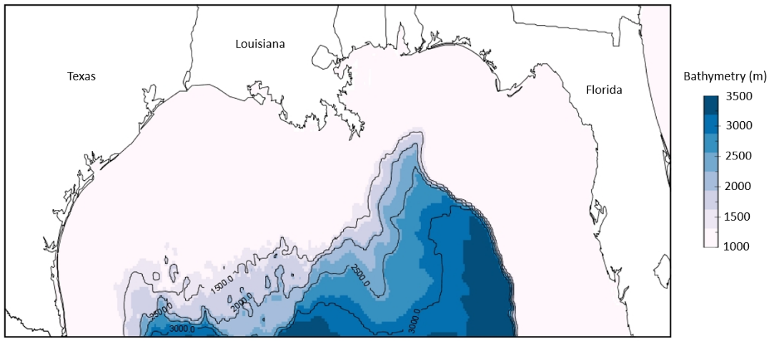
Figure 1. Map of the model domain. This model includes the area of the U.S. Exclusive Economic Zone of the northern Gulf of Mexico, seaward of the 1000-m isobath. Color shading is included to show bathymetry. The average depth of the model domain is 2,297 m.

Ecopath with Ecosim
Ecopath with Ecosim (EwE) is a mass-balanced ecosystem software that assumes the ecosystem is in equilibrium. EwE was initially developed as a method to provide information about the standing stock of functional groups and the flow of energy throughout an ecosystem (Polovina, 1984). Since its initial release, EwE has undergone extensive development with the inclusion of additional plug-in procedures (Steenbeek et al., 2016), but the original framework still exists in the current software. Two master equations control the mass-balance assumption within Ecopath: One describes production, and the second describes energy balance (sensu Christensen et al., 2008). Four Ecopath parameters are necessary for each group: Biomass (B), Production/Biomass (P/B), Consumption/Biomass (Q/B), and Ecotrophic Efficiency (EE; Table 1). Ecotrophic efficiency is defined as the proportion of production that is used within the system and is best calculated as an estimated parameter when all other information is known. A Biomass Accumulation (BA) parameter can be included to reflect population trends leading into the initial model year and can increase the reliability of model results in data-limited ecosystems (Natugonza et al., 2020). Ecopath once required the assumption of a steady state (Polovina, 1984), but advancements have reduced this assumption so that each functional group must achieve mass balance throughout each time step in the model and can otherwise be dynamic. An additional input parameter is the diet composition (i.e., the proportion of annual diet by biomass) of each predator group on each prey group in the model. The diet of each functional group must be entered and cannot be estimated (including cohorts of multi-stanza groups). In this model, diet information is provided from bibliographic sources (Supplementary Material A).

Table 1. Input values of the original Ecopath model. Values estimated by the software are in bold. Trophic level is derived as a fractionated value from the diet matrix.
Group No. | Group name | Trophic level | Biomass (t/km²) | P/B (/year) | Q/B (/year) | EE | P/Q (/year) | BA rate (/year)
1 | Toothed Whales | 4.50 | 1.10E-03 | 0.020 | 4.113 | 0.021 | 0.005 | -
2 | Baleen Whales | 4.15 | 2.21E-04 | 0.020 | 4.684 | 0.000 | 0.004 | -
3 | Dolphins | 4.22 | 1.39E-02 | 0.020 | 14.119 | 0.357 | 0.001 | -
4 | Seabirds | 3.76 | 1.66E-03 | 0.300 | 1.000 | 0.100 | 0.300 | -
5 | Sea Turtles | 3.43 | 1.21E-02 | 0.190 | 0.950 | 0.100 | 0.200 | -
6 | Oceanic Sharks | 4.63 | 3.11E-03 | 0.454 | 3.165 | 0.100 | 0.144 | -
7 | Adult Albacore | 4.46 | 4.87E-04 | 0.550 | 11.024 | 0.345 | 0.050 | 2.30E-06
8 | Juvenile Albacore | 4.03 | 9.23E-04 | 0.750 | 20.819 | 0.361 | 0.036 | 2.30E-06
9 | Adult Bigeye | 4.25 | 2.81E-05 | 0.700 | 6.915 | 0.259 | 0.101 | -9.00E-07
10 | Juvenile Bigeye | 3.80 | 1.85E-05 | 0.800 | 12.889 | 0.051 | 0.062 | -9.00E-07
11 | Adult Bluefin | 4.07 | 7.07E-04 | 0.500 | 4.815 | 0.168 | 0.104 | 4.10E-06
12 | Juvenile Bluefin | 3.62 | 3.04E-02 | 0.700 | 9.243 | 0.038 | 0.076 | 4.10E-06
13 | Adult Sailfish | 4.05 | 2.99E-03 | 0.407 | 7.216 | 0.245 | 0.056 | 3.50E-04
14 | Juvenile Sailfish | 3.73 | 7.92E-04 | 0.356 | 12.350 | 0.317 | 0.029 | 3.50E-04
15 | Adult Yellowfin | 3.93 | 1.09E-01 | 0.477 | 10.820 | 0.058 | 0.044 | -5.50E-03
16 | Juvenile Yellowfin | 3.82 | 1.02E-01 | 1.179 | 20.106 | 0.125 | 0.059 | -5.50E-03
17 | Adult Swordfish | 4.15 | 2.46E-02 | 0.679 | 8.339 | 0.106 | 0.081 | -2.40E-03
18 | Juvenile Swordfish | 3.56 | 2.50E-02 | 0.448 | 15.087 | 0.054 | 0.030 | -2.40E-03
19 | Adult White Marlin | 4.24 | 5.71E-03 | 0.350 | 8.132 | 0.256 | 0.043 | 4.50E-05
20 | Juvenile White Marlin | 3.81 | 1.99E-04 | 0.550 | 18.358 | 0.093 | 0.030 | 4.50E-05
21 | Adult Skipjack | 3.75 | 3.69E-05 | 1.441 | 14.564 | 0.039 | 0.099 | -8.10E-06
22 | Juvenile Skipjack | 3.49 | 5.37E-06 | 0.864 | 30.778 | 0.010 | 0.028 | -8.10E-06
23 | Adult Blue Marlin | 4.19 | 1.26E-03 | 0.500 | 5.580 | 0.349 | 0.090 | 3.90E-05
24 | Juvenile Blue Marlin | 3.81 | 4.92E-04 | 0.600 | 10.066 | 0.123 | 0.060 | 3.90E-05
25 | Small Tunas and Other Large Predators | 4.05 | 6.36E-03 | 1.069 | 8.342 | 0.400 | 0.128 | -
26 | Dragonfishes | 3.95 | 2.70E-03 | 1.119 | 5.595 | 0.800 | 0.200 | -
27 | Other Mesopelagic Zooplanktivores | 3.30 | 2.43E-02 | 1.138 | 3.498 | 0.950 | 0.325 | -
28 | Epipelagic Forage Feeders | 3.15 | 3.30E+00 | 1.017 | 22.122 | 0.600 | 0.046 | -
29 | Other Mesopelagic Micronektonivores | 3.91 | 5.13E-02 | 0.875 | 2.915 | 0.950 | 0.300 | -
30 | Hatchetfishes | 3.33 | 1.10E-02 | 4.588 | 15.293 | 0.403 | 0.300 | -
31 | Bristlemouths | 3.27 | 7.92E-02 | 3.386 | 11.288 | 0.247 | 0.300 | -
32 | Lanternfishes | 3.31 | 2.22E-02 | 3.600 | 12.000 | 0.718 | 0.300 | -
33 | Leptocephali | 2.07 | 4.00E-02 | 0.381 | 1.270 | 0.200 | 0.300 | -
34 | Cephalopods | 3.30 | 1.66E+00 | 4.000 | 20.000 | 0.700 | 0.200 | -
35 | Decapods | 2.65 | 1.16E-02 | 6.000 | 20.000 | 0.916 | 0.300 | -
36 | Euphausiids | 2.42 | 6.79E-02 | 22.500 | 75.000 | 0.950 | 0.300 | -
37 | Mesozooplankton | 2.11 | 2.50E+00 | 22.000 | 67.000 | 0.950 | 0.328 | -
38 | Ichthyoplankton | 2.50 | 2.32E+00 | 15.000 | 45.000 | 0.990 | 0.333 | -
39 | Gelatinous zooplankton | 2.47 | 8.02E-01 | 37.000 | 80.000 | 0.990 | 0.463 | -
40 | Microzooplankton | 2.00 | 1.96E+00 | 36.000 | 89.000 | 0.990 | 0.404 | -
41 | Phytoplankton | 1.00 | 2.55E+00 | 160.000 |  | 0.650
42 | Detritus | 1.00 | 5.00E+00 |  |  | 0.993
“P/B” = Production/Biomass, “Q/B” = Consumption/Biomass, “EE” = Ecotrophic Efficiency, “P/Q” = Production/Consumption, “BA” = Biomass Accumulation

Walters et al. (1997) developed Ecosim, a temporal-dynamic model that uses input parameters from a balanced Ecopath model and estimates changes in an ecosystem over time. The dynamics of an Ecosim model are expressed through two differential equations, one that estimates changes in biomass over time, and another that estimates changes in consumption rates at each time step (sensu Christensen et al., 2008). During an Ecosim simulation, additional parameters monitor the change in a predator’s ability to find and consume prey. The changes in consumption rates are derived from the foraging arena concept (Walters and Juanes, 1993), where prey groups can shift between vulnerable (available to the predator) and invulnerable (unavailable to the predator) states. A high vulnerability parameter signifies top-down control, while a low vulnerability parameter is indicative of bottom-up forcing. Vulnerability parameters were estimated for each functional group using an iterative fitting procedure (Christensen et al., 2008). This procedure tests different vulnerability values for each species and searches for the values that provide the best statistical fit towards a reference time series (Heymans et al., 2016). The vulnerability of larval and juvenile fishes was set at 1 (bottom-up forcing), which significantly improved model performance towards expected adult tuna and billfish trends.

Parameterization
Information regarding specific sources used to parameterize the model are in Supplementary Material B. Biomass (B; metric tons km⁻²) values derive from single-species stock assessments or from fisheries-independent survey data. The finfish stock assessment species that occupy the oceanic GoM have a wider distribution than the model domain. The adult biomass for each multi-stanza group was determined as the quotient of nominal catch in the GoM and exploitation rate that occurs in the model domain (B = C/F). Exploitation rate was calculated as the product of the proportion of catches in the GoM relative to the entire stock and the fishing mortality of the entire stock. The data originate from the International Commission for the Conservation of Atlantic Tunas (ICCAT; www.iccat.int/en/). This calculation forces the assumption that standardized catches throughout a stock are a suitable proxy for the distribution of the stock and was chosen in favor of assuming the stock is distributed uniformly across the stock area. Marine mammal and micronekton functional group biomasses were calculated as the product of the standardized abundance (N individuals km⁻²) and mean weight of an organism from either literature values (Trites and Pauly, 1998; NMFS 2019) or survey data. The production/biomass ratio (P/B; year⁻¹) or total mortality (Z; year⁻¹) is calculated as the sum of natural mortality and fishing mortality from stock assessments or through empirical relationships (Pauly, 1980; Equation 1):
Eq. 1 $M=K^{0.65}*L_{∞}^{-0.279}*T_{C}^{0.463}$
where M is natural mortality (year⁻¹), K is the curvature parameter from the von Bertalanffy growth equation, L∞ is the asymptotic length, and T_{c} is the mean water temperature in Celsius. Consumption values (Q/B) were estimated based on empirical relationships concerning diet, morphometrics, and water temperature at mean depth (Palomeres and Pauly, 1989; Equation 2):
Eq. 2 $\log\left(\frac{Q}{B}\right)=5.847+0.280logZ-0.152logW_{∞}-1.360T^{'}+0.062A+0.510h+0.390d$
where W∞ is the asymptotic weight (g), T’ is the mean water temperature expressed as 1000/temperature in Kelvins, A is the aspect ratio, and h and d are factors correcting for herbivores and detritivores. The values input into Equation 6 are derived from FishBase (Froese and Pauly, 2019).
The diet compositions of all functional groups were estimated from literature values and adjusted to match the requirements of input into an Ecopath model (% weight in diet). To account for uncertainty among input values, each parameter was assigned a rank in EwE’s pedigree table, which places a confidence interval around the input value to be used along with resampling techniques. Trophic levels are calculated as fractional values (Odum and Heald, 1975) for use in simulation-based analyses. For energy flow related results (i.e., non-Ecosim), a trophic aggregation technique (Ulanowicz, 1995) reorganized functional groups into integer-based trophic levels, as first described in Lindeman (1942).
One commercial fishing fleet was incorporated: U.S. Pelagic Longline. Landings and fishing effort (No. of hooks) from the longline fleet was obtained from ICCAT databases for the years 2011-2018. Bycatch values for the U.S. Pelagic Longline fleet and bycatch mortality rates were gathered from literature sources (Pacheco et al., 2011; Kerstetter and Graves, 2008; Garrison and Stokes, 2014). If bycatch data were not available for a functional group or fishing fleet, all catches were assumed to be landed. The resulting model requires model balancing, a systematic process in which the parameters that were believed to have the greatest uncertainty were adjusted first.

Time series
The EwE model was developed with the reference year of 2011 and simulated through 2018. The Ecosim model was calibrated to 25 time series of relative changes in catch and biomass values over the eight-year period. Declines in the biomass of five micronekton groups (lanternfishes, bristlemouths, hatchetfishes, decapods, and euphausiids) were forced during simulations (i.e., the user controls the value at each time step; Christensen et al. 2008) according to survey information in 2011 and 2015–2018 (Cook and Sutton, 2017a; Cook and Sutton, 2017b; Sutton et al., 2017; Cook and Sutton, 2018; Cook and Sutton, 2020). Time-series biomass values for micronekton groups were calculated as the product of the median standardized abundance and the average weight of an individual of that functional group per sampled year. Only “Gulf Common Water” sampling stations (sensu Johnston et al., 2019) were included in micronekton biomass calculations to reduce sample bias caused by the Loop Current. Euphausiid biomass values were estimated at the start of the simulation, so the forced change over time is relative to the initial start value. Dragonfish (Stomiidae) biomass values were not forced during simulations because a significant portion of the population is believed to avoid capture by 10-m² MOCNESS deployments (the standard gear used to catch micronekton in the modelled region; Marks et al., 2020). Due to an absence of reference data, changes in biomass for micronekton functional groups from 2012–2014 are assumed to be a linear function between 2011 and 2015. Interannual changes in the fishing effort for the longline fleet were also forced.

Shifts in trophic structure
Using the aforementioned pedigree as a guide for confidence intervals and the original input parameter as a prior value, Monte Carlo simulations (1000 iterations) were run to explore the variation in final output based on original uncertainty (Heymans et al., 2016). Variance among input parameters from the Monte Carlo iterations is displayed in Supplementary Material C. Similar to Choy et al. (2016), feeding guilds were established for all functional groups with a trophic level greater than 3.5 to differentiate among feeding of top predators. A trophic level of 3.5 was chosen as a cut-off because this group contains adult cohorts of tunas and billfishes, micronektivorous fishes, and marine mammals. We employed this method for both 2011 (start of simulation) and 2018 (end of simulation) to identify trophic shifts among top predators in the ecosystem. The average diet matrix (mean of 1000 iterations) for each year was calculated. A hierarchical clustering method performed on a Bray-Curtis similarity matrix determined the feeding guilds in each year using 60% similarity as a cut-off (Clarke and Gorley, 2006). These guilds were overlaid with fitted eigen vectors on an MDS plot to aid in the interpretation of clustering results. All multivariate analyses were conducted using the R vegan package (Oksanen et al., 2019).
The mixed trophic impact (MTI) was calculated (Ulanowicz and Puccia, 1990) individually for each iteration, for each functional group pair in the model (N = 1849), and for each year (n = 8). Averages and standard deviations were calculated for every functional group pair every year, treating the iterations as replicates. For each pair, a linear model was developed to examine whether the trend in MTI was a significant change or not. A p-value of less than 0.05 was considered statistically significant. The code used to calculate the MTI from the Monte Carlo model output is available as an R Markdown document on GitHub (www.github.com/mwood078-oGom-EwE).

Results

Ecopath results
The model comprises approximately five trophic levels, with sharks, marine mammals, and adult tunas and billfishes occupying the top of the food web. The micronekton groups that were forced in this simulation occupied trophic levels ranging from 2.42 to 3.33. A decomposition of the origin of flows by integer-based trophic level for each functional group revealed that for all mesopelagic zooplanktivorous fish functional groups, greater than 75% of the energy they receive placed them in the third trophic level (Figure 2). The two primary producer groups (including detritus) accounted for 29.1% of the total standing stock biomass in the system, while upper trophic level organisms (TL > 4) amounted to just 10.1% of the total biomass. The largest proportion of biomass was zooplankton (TL = 2), which accounted for 35.9% of the total biomass in the system. Zooplankton was responsible for 38.4% of the total system throughput (sum of consumption by predators, export, flow to detritus, and respiration), while upper trophic level organisms were only responsible for 3.7% of the total throughput. Detritus was the origin of a significant proportion of the total flow through the system (36%), which can be a sign of a mature ecosystem (Odum and Heald, 1975) and highlights the importance of detritus in the oceanic GoM.
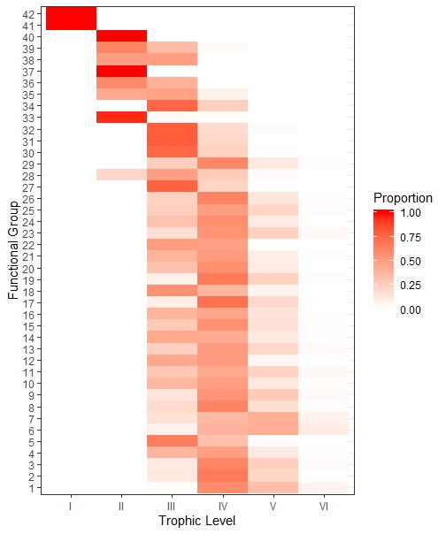
Figure 2. Shade plot of the trophic level decomposition for each functional group based on diet composition. Red values are positive, shaded to proportion. Functional groups with positive values in multiple trophic levels indicate feeding on a variety of trophic levels (i.e., omnivory). Weighted averages equate to the mean trophic level of the functional group in Table 1.

Simulated processes
Throughout the eight-year simulation, all functional groups experienced some change in their biomass and trophic level, but many changes were discrete (Figure 3). Thirty-one of the 42 functional groups within the model showed a decrease in biomass throughout the simulation. The three functional groups that benefited the most throughout the simulation were juvenile skipjack (13.18% increase), oceanic sharks (7.79% increase), and mesozooplankton (3.01% increase). The most negatively affected functional groups in terms of percentage change were decapod crustaceans (81.10% decrease), bristlemouths (65.2% decrease), and dragonfishes (61.5% decrease). Twenty-five functional groups experienced a decrease in trophic level throughout the simulation. The largest overall changes in trophic level (TL) occurred in fishes that rely heavily on mesopelagic micronekton as a prey source: adult albacore tuna (0.08 TL decrease), juvenile albacore tuna (0.08 TL decrease), and dragonfishes (0.04 TL increase). In general, 19 functional groups decreased in both trophic level and biomass, while just eight increased in both (Figure 3).
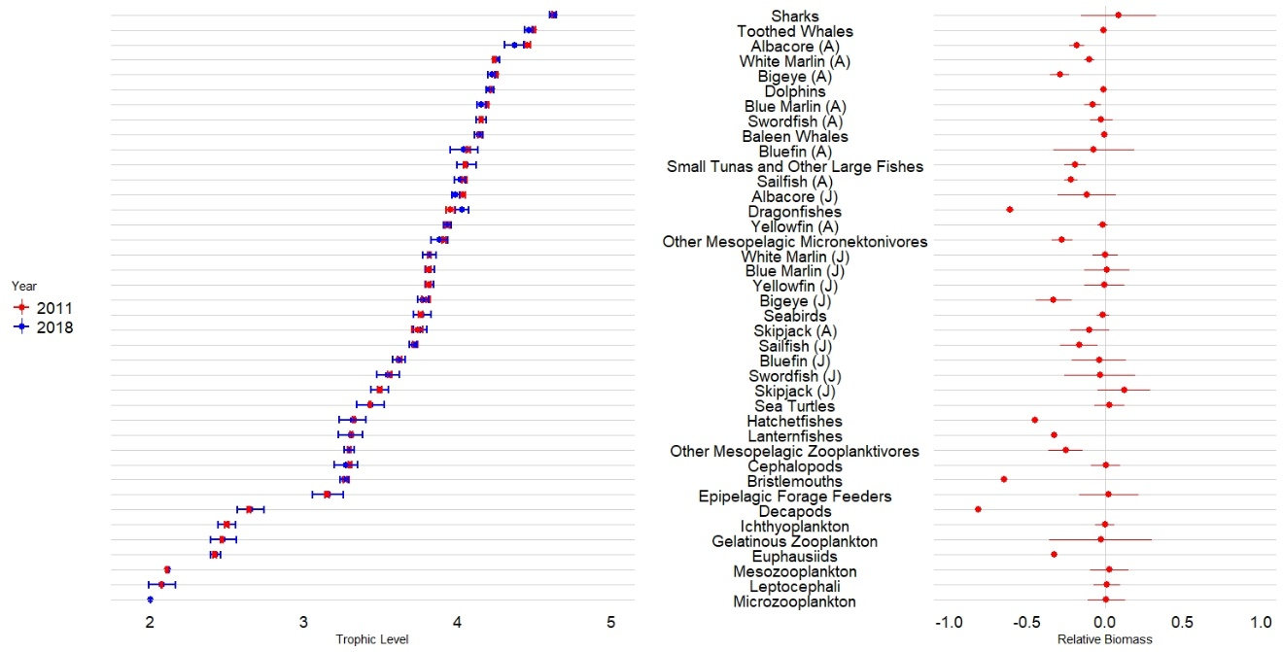
Figure 3. Trophic level and biomass changes between 2011 and 2018. Functional groups are ordered by trophic level. “A” and “J” correspond to “adult” and “juvenile” as determined by the age of maturity. Error bars are 95% confidence intervals originating from 1000 model iterations. A) Mean trophic level by functional group for 2011 (red) and 2018 (blue). B) Relative biomass calculated as: (final – initial) / initial.

Shifts in diet
The underlying mechanics behind an Ecopath with Ecosim model rely on the predator-prey relationships driven by the diet matrix. Any change in the trophic structure that is not captured by changes in the trophic level of a functional group should be reflected in the diet matrix as a significant shift in prey taxa consumed (% biomass) relative to other predators at a similar trophic level. To target the effect of declines in micronekton biomass, two sets of feeding guilds were established for functional groups with a trophic level greater than 3.5. In 2011, 12 feeding guilds were established based on the similarity of diets (Figure 4a). Predation on bristlemouths, decapod crustaceans, epipelagic forage feeders, cephalopods, ichthyoplankton, and dragonfishes best explained the food web structure. Lanternfishes are notably absent from this list because they are eaten by nearly all upper trophic level organisms, and do not contribute to diverging diets. Although marine mammals consume mesopelagic prey, their diets were separated from many tuna and billfish species because of an affinity for cephalopods and larval fishes (Figure 4a). Seven single-group feeding guilds were present: oceanic sharks, adult albacore tuna, adult bigeye tuna, adult bluefin tuna, adult white marlin, small tunas and other large predators, and dragonfishes. An epipelagic-fish feeding guild was composed of seabirds, juvenile bluefin tuna, and juvenile yellowfin tuna. Dragonfishes were a bit of an outlier among the other functional groups, as their diet composition is primarily mesopelagic zooplanktivores. Other diets are more diverse than dragonfishes, including cephalopods and micronektonivores, so the dragonfish placement in this plot was more indicative of a vastly different diet compared to other top predators in the ecosystem. 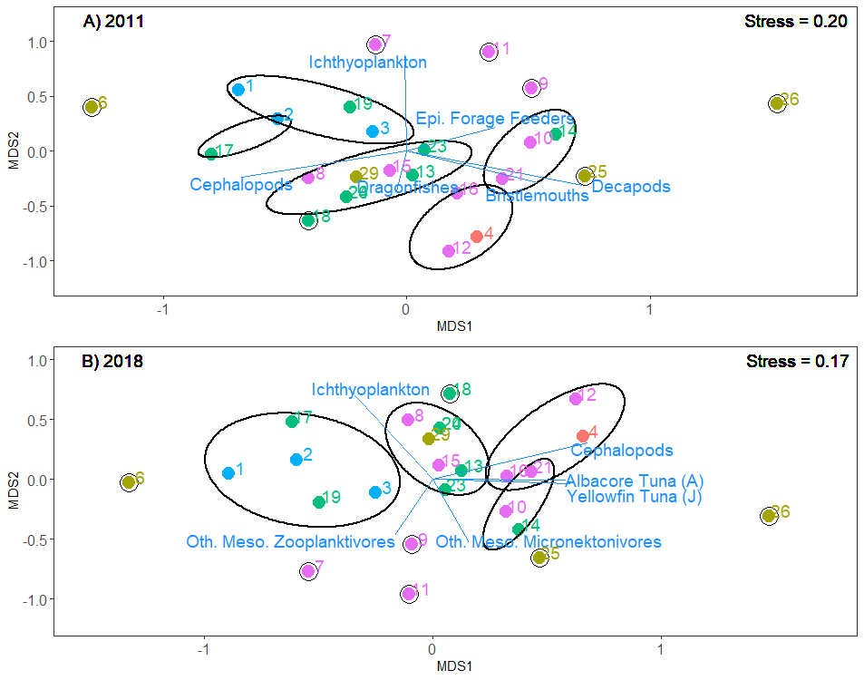
Figure 4. Ordination plots of the upper trophic level organisms (TL > 3.5) according to Bray-Curtis similarity matrices. Guilds are displayed by ellipses. The prey groups that explained the majority of the matrix structure are shown as blue vectors and labeling. Predator groups are distinguished by taxon: blue = marine mammals, red = seabirds, purple = tunas; green = billfishes; yellow = other fishes.

In 2018, eleven feeding guilds were recognized, and some functional groups have transitioned to have similar diets to other functional groups (i.e., changed feeding guild; Figure 4b). Decapod crustaceans, bristlemouths, and dragonfishes no longer explained the majority of the food web structure, and instead were replaced by adult albacore tuna, juvenile yellowfin tuna, and other mesopelagic fishes. Compared to 2011, other upper trophic level organisms explained more of the food web structure than mesopelagics, which can be interpreted as a reduction in the mesopelagic biomass constricting the diversity of prey available to top predators.

Mixed trophic impact analysis
Individual linear models (n = 1849) indicated that there was a change in 27.3% of the functional group interactions during this simulation (Figure 5). Although each functional group acted as both the impacting and impacted group towards each other functional group in the model, a change in one end of the interaction was reciprocated with a change in the other side of the relationship 47 times, which is likely an indication ecosystem complexity. Of the interactions where there was a direct trophic relationship (i.e., predator-prey interaction; n = 505), 32.3% of the interactions showed a change from 2011-2018 (Table 2). An uneven number of direct top-down and bottom-up interactions was the result of cyclical relationships (e.g., “cannibalism”). During the simulation, direct relationships strengthened more frequently than they weakened for both top-down and bottom-up interactions (Table 2). Contrary to direct interactions, indirect interactions weakened more frequently than strengthened (Table 2). Indirect interactions were the most common type of relationship (n = 1344) and changed less frequently than direct interactions (24.7% frequency). Direct top-down interactions changed more than the other three types of interactions, suggesting these types of relationships are more labile in the oceanic GoM.
Table 2. Contingency table of the number of functional group interactions that showed a change throughout the time series. The total number of interactions is in parentheses.
Interaction | Strengthened | Weakened | Unchanged
Direct Top-Down (318) | 30.82% | 18.87% | 50.31%
Direct Bottom-Up (323) | 8.98% | 6.19% | 84.83%
Indirect Top-Down (618) | 9.71% | 12.62% | 77.67%
Indirect Bottom-Up (590) | 5.42% | 21.69% | 72.88%

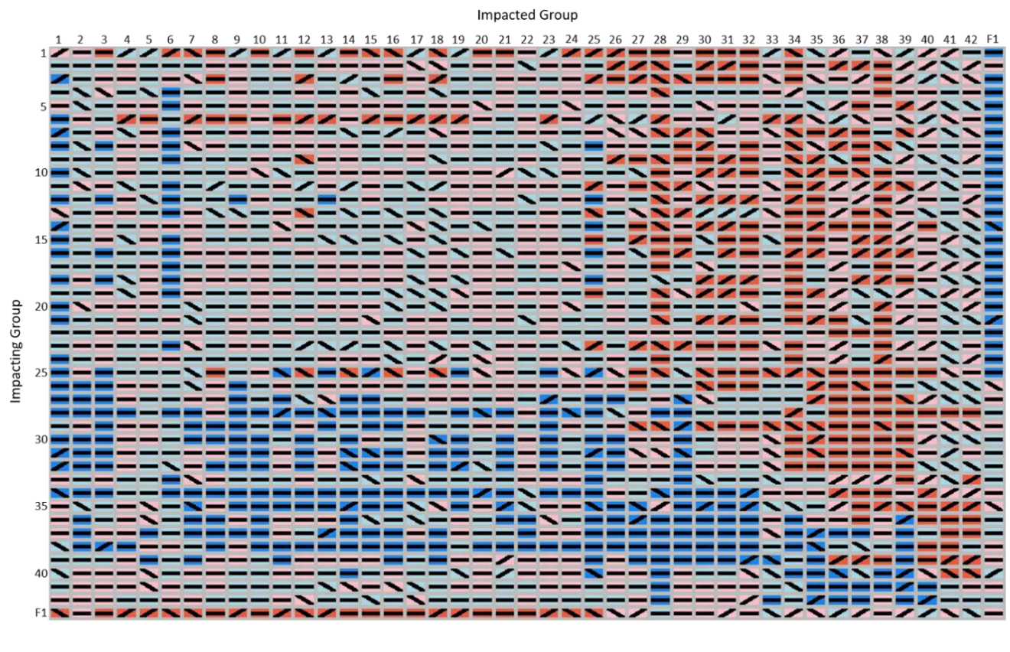
Figure 5. Matrix of the trend observed in all functional group pairs over time. The background colors represent the initial role that functional group serves in the interaction: dark blue = prey (bottom-up), dark red = predator (top-down), light blue = indirect bottom-up, light red = indirect top-down. Lines represent the trend in the interaction over time: flat = no change, increasing = strengthened, decreasing = weakened. Numbers correspond to functional groups in Table 1. F1 corresponds to the U.S. Pelagic Longline fishing fleet.
When organizing groups by trophic level, there was no apparent trend in the proportion of changed interactions related to a functional group role in the ecosystem (Figure 6). The changes seen in direct interactions were focused on certain functional groups, as opposed to being shared across all groups in the system (i.e., some functional groups had zero interactions change, while others had many). Changes among direct top-down interactions were more frequent than among direct bottom-up interactions (Figure 6). Both types of indirect interactions (top-down and bottom-up) changed in small proportions for all functional groups in the model, suggesting that the entire ecosystem experienced some change between 2011 and 2018. The preponderance of weakening indirect interactions (and scarcity of strengthening) suggests ecosystem resiliency has decreased (Bertness et al., 2015), as future ecosystem processes will now be more driven by direct interactions.
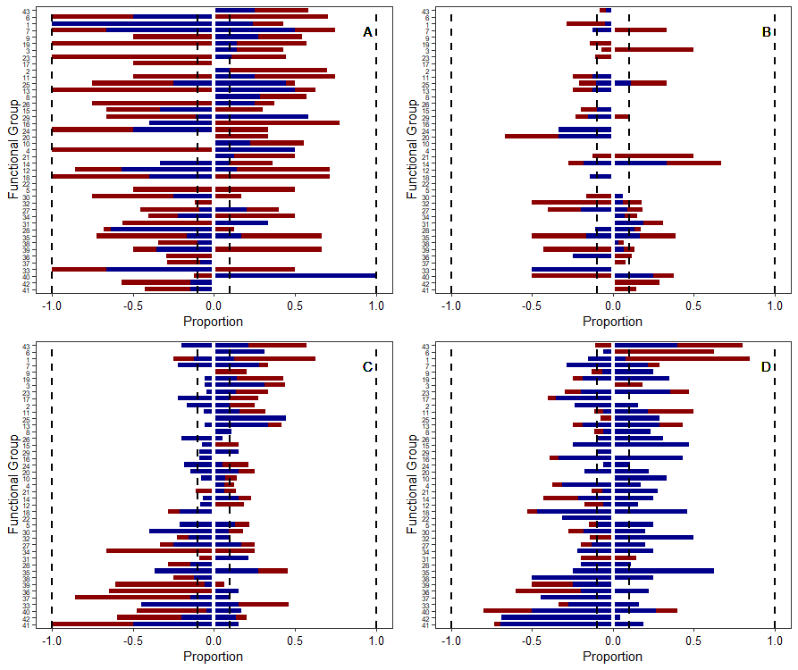
Figure 6. Stacked barplots showing the proportion of interactions that changed for each functional group between 2011 and 2018. Values to the right of 0 represent the functional group acting as the impacting group, and values to the left of 0 are when the group is the impacted group. Total bar height is the overall proportion of changed interactions (0-1). Colors represent the directionality of change, where red indicates interactions that strengthened and blue indicates interactions that weakened. Vertical black lines mark 10 and 100% of interactions for readability. Functional groups are organized in descending order by trophic level. A) Direct top-down interactions, B) direct bottom-up interactions, C) indirect top-down interactions, and D) indirect bottom-up interactions.

Discussion
The role of mesopelagic micronekton as ‘wasp-waist’ controllers in pelagic ecosystems is well documented (Griffiths et al., 2013; Choy et al., 2016). Compared to neritic habitats, pelagic organisms have less specific diets, but preferential preys exist (Drazen and Sutton, 2017). The feeding guilds that mesopelagic fishes can occupy are limited because the concentration of particulates in the water column is too low for filter feeding at mesopelagic depths (Herring, 2002), and herbivory is rare (Robison, 1984). Thus, carnivory dominates the feeding mode of mesopelagic fishes. Just three of the direct top-down interactions that involve myctophids, sternoptychids, gonostomatids, and other mesopelagic zooplanktivores as predators strengthened throughout the simulation, while seven weakened (all from the aggregate group). A dearth of change among these functional groups, which had significant declines in biomass, is evidence of a poor ability to switch prey among a diminished prey field. These restricted diet options, combined with declines in macrozooplankton populations, will likely inhibit the recovery of micronekton fish populations as food is less prevalent. Furthermore, the direct top-down interactions exerted on the mesopelagic zooplanktivorous fish groups strengthened in 23 of 60 possible interactions and weakened in only five. Decreased mesopelagic zooplanktivorous fish populations in the oceanic GoM should hypothetically be relieved of predation pressure (regardless of where the population was pre-2011), but in many instances, the role they provide as prey has become more intense. Similar to the euphausiid-capelin (Mallotus villosus) trophic relationship in Newfoundland waters (Obradovich et al., 2014), a persistent decline in micronekton populations may have inauspicious effects on predator population growth.
Zooplankton populations are pivotal to the stability of oceanic ecosystems, as they are the food-web link between autotrophic organisms and secondary consumers. Filter-feeding zooplankton package pico- (10⁻¹² m) and nano-size particles (10⁻⁹ m) into a consumable material for other consumers. Others, such as decapod crustaceans and some euphausiids, consume microzooplankton and mesozooplankton, occasionally competing with small fishes (Heffernan and Hopkins, 1981; Kinsey and Hopkins, 1994; Hopkins and Sutton, 1998). This wide niche breadth throughout the trophic level is why approximately two-fifths of the total system throughput occurs at the zooplankton trophic level. Similar to fishes, the direct interactions involving zooplankton were labile. Therefore, pelagic zooplankton was predicted to experience greater predation pressure in 2018 despite their population decline. However, an underrepresented portion of many food-web models is the role of gelatinous zooplankton in the transfer of energy through the ecosystem. Although this model incorporates occurrences of gelatinous feeding by upper trophic level organisms (Cardona et al., 2012), these values are believed to be heavily underreported in the literature (Drazen and Sutton, 2017). The stability of the oceanic GoM ecosystem is dependent on the stability of the zooplankton trophic level, so it is imperative to understand the interactions that control their population dynamics.
Approximately one-quarter of all possible trophic interactions in the oceanic GoM changed between 2011 and 2018. For each functional group pair, i and j, there are two types of interactions. One interaction is where group i is the group exerting impact on group j, and another is where group i is receiving the impact from group j. In an ecosystem with high modularity (i.e., several guilds of organisms only interact with each other), a change in the top-down impact of one group to another should result in a change of the bottom-up impact in the reciprocating interaction, as a result of ecosystem simplicity. However, in this exercise, a change in the interaction between two groups did not often result in a change in the opposite direction. For example, the direct top-down pressure that dragonfishes exert on hatchetfishes weakened, but the direct bottom-up support hatchetfishes provide to dragonfishes did not change from 2011–2018. This phenomenon is likely attributable to the complexity of the oceanic GoM micronekton assemblage (Hopkins and Lancraft 1984) that allows upper trophic level predators to shift their diet to new preys rather than starve. The importance of mesopelagic micronekton in the diet of apex predators in the oceanic zone suggests that changes in population sizes within the micronekton community could have a direct impact on the predatory success of these apex predators (Duffy et al., 2017), as this exercise shows. Declined predator success will result in declined biomass, but GoM-specific abundance indices suggest that yellowfin and bluefin tuna populations may be relatively stable or increasing (Anon, 2017; Anon, 2019). The potential underestimates in apex predator biomass is likely a product of an inability to model an “open-system” where organisms could leave but suggests that the results related to the top-down pressure on micronekton may be conservative. In reality, opportunistic predation and long-distance migrations by apex predators likely provide a buffer towards the stability of these predator populations (Ménard et al., 2006), despite declines in major prey resources in the GoM. These diet shifts were reflected in the calculation of the MTI as the declined prey group was predicted to experience less predation pressure from the predator, and the predator now benefits less from the existence of the former prey group (lower diet contribution). In stable ecosystems, individual populations can fluctuate because species that occupy a similar niche can replace declining populations (Holling, 1973). In the context of this exercise, changes among top-down and bottom-up effects may not reflect permanent changes to the trophic structure of the ecosystem, but instead, a temporary change based on fluctuations in prey abundances. However, simulated biomass declines in other micronekton groups (e.g., dragonfishes, cephalopods, and other mesopelagic micronektivorous fishes) indicates the northern GoM may no longer be a plentiful foraging ground for upper trophic level organisms compared to 2011.
Changes in the MTI of one functional group on another will mostly be influenced by changes in diet and biomass. Significant changes in diet (relative to the rest of the ecosystem) should adjust the trophic level of a functional group throughout a simulation, and diet is influenced by shifts in the biomass of prey groups over time (Shannon et al., 2014). Declines in several micronekton groups in this model led to a slight increase in the biomass of groups of a similar niche that were not forced (e.g., mesozooplankton), but to a decline in those dependent on mesopelagic micronekton as a prey resource (e.g., dragonfishes). An investigation of the MTI over time provides a more refined view into potential shifts in the role of each organism relative to others within the system and could be used to assess other oceanic ecosystems.
The total effort of fishers on an annual basis is a dynamic process influenced by the availability of target fishes, length of the fishing season, and unexpected shutdowns (Monroy et al., 2010). In an ecosystem model, the role of each fishing fleet is to remove biomass (similar to an apex predator). Fluctuations in the effort of a fishing fleet influence the amount of fishing pressure exerted on each commercial species. Since 2011, the fishing effort by the U.S. Pelagic Longline Fleet in the GoM has declined as a response to fishing regulations implemented in the region to reduce bluefin tuna bycatch (NMFS, 2020). This decline in the fishing effort has lessened the fishing mortality exerted on commercial groups, having a negative indirect effect on many intermediate trophic level groups. Micronekton interact on a much smaller spatial scale than large pelagic fishes but exist in large numbers as a well-dispersed assemblage (Milligan and Sutton, 2020). Still, the commercial impact of declines in mesopelagic micronekton in the GoM is untested. Future addenda to management and conservation policies in the oceanic GoM should be cognizant of declined prey abundances that could influence the direct trophic relationships with species of economic concern and energy flows throughout the ecosystem.
The 2010 Deepwater Horizon oil spill likely had an immediate negative impact on oceanic biota (Abbriano et al., 2011), but intense data collection regimes began after the disturbance (Sutton et al., 2020). Without a pre-disturbance reference point, it is difficult to discern between natural changes and human-influenced changes. Therefore, this exercise does not imply that anthropogenic impacts are responsible for changes within the ecosystem. Instead, these results may provide an example of the dynamic nature of complex ecosystems with opportunistic apex predators and diverse intermediate trophic level communities.

Acknowledgments
This research was made possible in part by a grant from The Gulf of Mexico Research Initiative and in part by a grant from the NOAA RESTORE Science Program. Data are publicly available through the Gulf of Mexico Research Initiative Information & Data Cooperative (GRIIDC) at https://data.gulfresearchinitiative.org (doi: 10.7266/N7VX0DK2; 10.7266/N70P0X3T; 10.7266/N7XP7385; 10.7266/N7902234; 10.7266/n7-ac8e-0240). This is contribution #233 from the Center for Coastal Oceans Research in the Institute of Water and Environment at Florida International University. We are grateful for Rosanna Milligan, April Cook, Walt Ingram, and Skyler Sagarese for their discussions about parameterization of this model. The authors are thankful to an anonymous reviewer for helpful comments on the manuscript. All authors declare no conflict of interest.
Literature Cited
Abbriano, R. M., M. M. Carranza, S. L. Hogle, R. A. Levin, A. N. Netburn, K. L. Seto, S. M. Snyder, and P.J.S. Franks. 2011. Deepwater Horizon oil spill: A review of the planktonic response. Oceanogr. 24: 294–301. http://dx.doi.org/10.5670/oceanog.2011.80.
Ainsworth, C. H., M. J. Schirripa, and H. N. Morzaria-Luna. 2015. An Atlantis ecosystem model for the Gulf of Mexico supporting integrated ecosystem assessment. NOAA Technical Memorandum. NMFS-SEFSC-676. http://doi.org/10.7289/V5X63JVH
Anon. 2017. Report of the 2017 ICCAT Bluefin Stock Assessment Meeting. Madrid, Spain. www.iccat.int. Last Accessed 04/13/2020.
Anon. 2019. Report of the 2019 ICCAT Yellowfin Tuna Stock Assessment Meeting. Grand-Bassam, Cote d’Ivoire. www.iccat.int. Accessed 04/13/2020.
Bertness, M. D., C. P. Brisson, and S. M. Crotty. 2015. Indirect human impacts turn off reciprocal feedbacks and decrease ecosystem resilience. Oecologia. 178: 231–237. https://doi.org/10.1007/s00442-014-3166-5
Cardona, L., I. A. De Quevedo, A. Borrell, and A. Aguilar. 2012. Massive consumption of gelatinous plankton by Mediterranean apex predators. PloS one. 7: e31329. https://doi.org/10.1371/journal.pone.0031329
Chagaris, D. D., B. Mahmoudi, C. J. Walters, and M. S. Allen. 2015. Simulating the trophic impacts of fishery policy options on the West Florida Shelf using Ecopath with Ecosim. Mar. Coastal Fish. 7: 44–58. https://doi.org/10.1080/19425120.2014.966216
Choy, C. A., B. N. Popp, C. C. S. Hannides, and J. C. Drazen. 2016. Trophic structure and food resources of epipelagic and mesopelagic fishes in the North Pacific Subtropical Gyre ecosystem inferred from nitrogen isotopic compositions. Limnol. Oceanogr. 60: 1156–1171. https://doi.org/10.1002/lno.10085
Christensen, V., C. J. Walters, D. Pauly, and R. Forrest. 2008. Ecopath with Ecosim version 6: a User’s guide, November 2008 edition. Vancouver, Canada: University of British Columbia Fisheries Centre.
Clarke, K. R., and R. N. Gorley. 2006. PRIMER V6: user manual and tutorial. Primer-E, Plymouth, UK
Coll, M., N. Bahamon, F. Sardá, I. Palomera, S. Tudela, P. Suuronen. 2008. Improved trawl selectivity: effects on the ecosystem in the South Catalan Sea (NW Mediterranean). Mar. Ecol. Prog. Ser. 355: 131–147. https://doi.org/10.3354/meps07183
Coll, M., and J. Steenbeek. 2017. Standardized ecological indicators to assess aquatic food webs: The ECOIND software plug-in for Ecopath with Ecosim models. Environ. Modell. Software. 89: 120–130. https://doi.org/10.1016/j.envsoft.2016.12.004
Cook, A., and T. T. Sutton. 2017a. Inventory of Gulf oceanic fauna data including species, weight, and measurements. Cruises DP01 May 1-8, 2015 and DP02 August 9-21, 2015 R/V on the Point Sur in the Northern Gulf of Mexico. Distributed by: Gulf of Mexico Research Initiative Information and Data Cooperative (GRIIDC), Harte Research Institute, Texas A&M University-Corpus Christi. https://doi.org/10.7266/N70P0X3T
Cook, A., and T. T. Sutton. 2017b. Inventory of Gulf of Mexico oceanic fauna data including species, weight, and measurements from R/V Point Sur (Cruises DP03 and DP04) May-August, 2016. Distributed by: Gulf of Mexico Research Initiative Information and Data Cooperative (GRIIDC), Harte Research Institute, Texas A&M University-Corpus Christi. https://doi.org/10.7266/N7XP7385
Cook, A., and T. T. Sutton. 2018. Inventory of oceanic fauna data including species, weight, and measurements from R/V Point Sur (Cruise DP05) in the Gulf of Mexico from 2017-05-01 to 2017-05-11. Distributed by: Gulf of Mexico Research Initiative Information and Data Cooperative (GRIIDC), Harte Research Institute, Texas A&M University-Corpus Christi. https://doi.org/10.7266/N7902234
Cook, A., and T. T. Sutton 2020. Inventory of oceanic fauna data including species, weight, and measurements from R/V Point Sur cruise PS19-04 (DP06) in the Gulf of Mexico from 2018-07-19 to 2018-08-01. Distributed by: Gulf of Mexico Research Initiative Information and Data Cooperative (GRIIDC), Harte Research Institute, Texas A&M University-Corpus Christi. https://doi.org/10.7266/n7-ac8e-0240
Costanza, R. and M. Mageau, M. 1999. What is a healthy ecosystem?. Aquat. Ecol. 33: 105–115. https://doi.org/10.1023/A:1009930313242
de Mutsert, K., J. H. Cowan Jr., and C. J. Walters. 2012. Using Ecopath with Ecosim to explore nekton community response to freshwater diversion into a Louisiana estuary. Mar. Coastal Fish. 4: 104–116. https://doi.org/10.1080/19425120.2012.672366
de Mutsert, K., J. Steenbeek., K. Lewis, J. Buszowski, J. H. Cowan Jr., and V. Christensen. 2016. Exploring effects of hypoxia on fish and fisheries in the northern Gulf of Mexico using a dynamic spatially explicit ecosystem model. Ecol. Modell. 331: 142–150. https://doi.org/10.1016/j.ecolmodel.2015.10.013
Drazen, J. C., and T. T. Sutton. 2017. Dining in the Deep: The Feeding Ecology of Deep-Sea Fishes. Annu. Rev. Mar. Sci. 9: 337–366. https://doi.org/10.1146/annurev-marine-010816-060543
Duffy, L. M., P. M. Kuhnert, H. R. Pethybridge, J. W. Young, R. J. Olson, J. M. Logan, N. Goñi, E. Romanov, V. Allain, M. D. Staudinger, M. Abecassis, C. A. Choy, A. J. Hobday, M. Simier, F. Galván-Magaña, M. Potier, and F. Ménard. 2017. Global trophic ecology of yellowfin, bigeye, and albacore tunas: Understanding predation on micronekton communities at ocean-basin scales. Deep Sea Res., Part II. 140: 55–73. https://doi.org/10.1016/j.dsr2.2017.03.003
Fromentin, J. M., and J. E. Powers. 2005. Atlantic bluefin tuna: population dynamics, ecology, fisheries and management. Fish Fish. 6: 281–306. https://doi.org/10.1111/j.1467-2979.2005.00197.x
Froese, R., and D. Pauly. Editors. 2019. FishBase. World Wide Web electronic publication. www.fishbase.org, version (12/2019).
Frost, B. W., and L. E. McCrone. 1978. Vertical distribution, diel vertical migration, and abundance of some mesopelagic fishes. Fish. Bull. 76: 751–770.
Garrison, L. P., and L. Stokes. 2014. Estimated bycatch of marine mammals and sea turtles in the US Atlantic pelagic longline fleet during 2013. NOAA technical memorandum NMFS-SEFSC-672. https://doi.org/10.7289/V50C4SQB
Geers, T. M., E. K. Pikitch, and M. G. Frisk. 2016. An original model of the northern Gulf of Mexico using Ecopath with Ecosim and its implications for the effects of fishing on ecosystem structure and maturity. Deep Sea Res., Part II. 129: 319–331. https://doi.org/10.1016/j.dsr2.2014.01.009
Griffiths, S. P., R. J. Olson, and G. M. Watters. 2013. Complex wasp-waist regulation of pelagic ecosystems in the Pacific Ocean. Rev. Fish Biol. Fish. 23: 459–475. https://doi.org/10.1007/s11160-012-9301-7
Grüss, A., E. A. Babcock, S. R. Sagarese, M. Drexler, D. D. Chagaris, C. H. Ainsworth, B. Penta, S. Derada, and T. T. Sutton. 2016. Improving the spatial allocation of functional group biomasses in spatially-explicit ecosystem models: insights from three Gulf of Mexico models. Bull. Mar. Sci. 92: 473–496. https://doi.org/10.5343/bms.2016.1057
Guinotte, J. M., and V. J. Fabry. 2008. Ocean acidification and its potential effects on marine ecosystems. Ann. N. Y. Acad. Sci. 1134: 320–342. https://doi.org/10.1196/annals.1439.013.
Heffernan, J. J., and T. L. Hopkins. 1981. Vertical distribution and feeding of the shrimp genera Gennadas and Bentheogennema (Decapoda: Penaeidea) in the eastern Gulf of Mexico. J. Crustacean Biol. 1: 461–473. https://doi.org/10.2307/1548124
Herring, P. 2002. The biology of the deep ocean. Oxford University Press.
Heymans, J. J., M. Coll, J. S. Link, S. Mackinson, J. Steenbeek, C. Walters, and V. Christensen. 2016. Best practice in Ecopath with Ecosim food-web models for ecosystem-based management. Ecol. Modell. 331: 173–184. https://doi.org/10.1016/j.ecolmodel.2015.12.007
Hilborn, R., 2011. Overfishing: What Everyone Needs to Know. Oxford University Press.
Hoegh-Guldberg, O., and J. F. Bruno. 2010. The impact of climate change on the world’s marine ecosystems. Sci. 328: 1523–1528. https://doi.org/10.1126/science.1189930
Holling, C. S. 1973. Resilience and stability of ecological systems. Annual review of ecology and systematics. 4: 1–23. https://doi.org/10.1146/annurev.es.04.110173.000245
Hopkins T. L., and T. M. Lancraft. 1984. The composition and standing stock of mesopelagic micronekton at 27° N 86° W in the eastern Gulf of Mexico. Contr. Mar. Sci. 27: 143–158.
Hopkins, T. L., and T. T. Sutton. 1998. Midwater fishes and shrimps as competitors and resource partitioning in low latitude oligotrophic ecosystems. Mar. Ecol. Prog. Ser. 164: 37–45. https://doi.org.10.3354/meps164037
Hopkins, T. L., T. T. Sutton, and T. M. Lancraft. 1996. The trophic structure and predation impact of a low latitude midwater fish assemblage. Prog. Oceanogr. 38: 205–239. https://doi.org/10.1016/S0079-6611(97)00003-7
Johnston, M. W., R. J. Milligan, C. G. Easson, S. deRada, D. C. English, B. Penta, and T. T. Sutton. 2019. An empirically validated method for characterizing pelagic habitats in the Gulf of Mexico using ocean model data. Limnol. Oceanogr.: Methods. 17: lom3.10319. https://doi.org/10.1002/lom3.10319
Kerstetter, D. W., and J. E. Graves. 2008. Postrelease Survival of Sailfish Caught by Commercial Pelagic Longline Gear in the Southern Gulf of Mexico. North Am. J. Fish. Manage. 28: 1578–1586. https://doi.org/10.1577/M07-202.1
Kinsey, S. T. and T. L. Hopkins, 1994. Trophic strategies of euphausiids in a low-latitude ecosystem. Mar. Biol. 118: 651–661. https://doi.org/10.1007/BF00347513
Lerner, J. D., D. W. Kerstetter, E. D. Prince, L. Talaue-McManus, E. S. Orbesen, A. Mariano, D. Snodgrass, and G. L. Thomas. 2013. Swordfish vertical distribution and habitat use in relation to diel and lunar cycles in the western North Atlantic. Tran. Am. Fish. Soc. 142: 95–104. https://doi.org/10.1080/00028487.2012.720629
Levin, P. S., M. J. Fogarty, G. C. Matlock, and M. Ernst. 2008. Integrated ecosystem assessments. NOAA Technical Memorandum. NMFS-NWFSC-92. Available at: https://swfsc.noaa.gov/publications/FED/01272.pdf.
Libralato, S., V. Christensen, V. and D. Pauly. 2006. A method for identifying keystone species in food web models. Ecol. Modell. 195: 153–171. https://doi.org/10.1016/j.ecolmodel.2005.11.029
Lindeman, R. L. 1942. The Trophic-Dynamic Aspect of Ecology. Ecol. 23: 399–417. https://doi.org/10.2307/1930126
Marks, A. D., D. W. Kerstetter, D. M. Wyanski, and T. T. Sutton. 2020. Reproductive Ecology of Dragonfishes (Stomiiformes: Stomiidae) in the Gulf of Mexico. Front. Mar. Sci. 7: 1–17. https://doi.org/10.3389/fmars.2020.00101
Ménard, F., C. Labrune, Y. J. Shin, A. S. Asine, and F. X. Bard. 2006. Opportunistic predation in tuna: a size-based approach. Mar. Ecol. Prog. Ser. 323: 223–231. https://doi.org/10.3354/meps323223
Milligan, R. J., and T. T. Sutton. 2020. Dispersion Overrides Environmental Variability as a Primary Driver of the Horizontal Assemblage Structure of the Mesopelagic Fish Family Myctophidae in the Northern Gulf of Mexico. Front. Mar. Sci. 7: 1–13. https://doi.org/10.3389/fmars.2020.00015
Monaco, M. E., and R. E. Ulanowicz. 1997. Comparative ecosystem trophic structure of three US mid-Atlantic estuaries. Mar. Ecol. Prog. Ser. 161: 239–254. https://doi.org/10.3354/meps161239
Monroy, C., S. Salas, and J. Bello-Pineda. 2010. Dynamics of fishing gear and spatial allocation of fishing effort in a multispecies fleet. North Am. J. Fish. Manage. 30: 1187–1202. https://doi.org/10.1577/M09-101.1
National Marine Fisheries Service (NMFS). 2019. US Atlantic and Gulf of Mexico Marine Mammal Stock Assessments – 2019. NOAA Technical Memorandum NMFS-NE-264. Available at: https://www.fisheries.noaa.gov/national/marine-mammal-protection/marine-mammal-stock-assessment-reports-region.
National Marine Fisheries Service (NMFS). 2020. Atlantic Highly Migratory Species; Atlantic Bluefin Tuna Fisheries; Pelagic Longline Fishery Management. Federal Register Document No: 85 FR 18812. Available at: https://www.federalregister.gov/documents/2020/04/02/2020-06925/atlantic-highly-migratory-species-atlantic-bluefin-tuna-fisheries-pelagic-longline-fishery.
Natugonza, V., C. Ainsworth, E. Sturludóttir, L. Musinguzi, R. Ogutu-Ohwayo, T. Tomasson, C. Nyamweya, and G. Stefansson. 2020. Ecosystem modelling of data-limited fisheries: How reliable are Ecopath with Ecosim models without historical time series fitting?. J. Great Lakes Res. 46: 414–428. https://doi.org/10.1016/j.jglr.2020.01.001
Obradovich, S. G., E. H. Carruthers, and G. A Rose. 2014. Bottom-up limits to Newfoundland capelin (Mallotus villosus) rebuilding : the euphausiid hypothesis. ICES J. Mar. Sci. 71: 775–783.
Odum, W. E., and E. J. Heald. 1975. The detritus-based food web of an estuarine mangrove community. Estuar. Res. Chem. Biol. Estuar. Syst. 1: 265–286.
Oksanen, J, F. G. Blanchet, M. Friendly, R. Kindt, P. Legendre, D. McGlinn, P. R. Minchin, R. R. O’hara, G. L. Simpson, P. Solymos, M. H. H. Stevens, E. Szoecs, H. Wagner. 2019. vegan: Community Ecology Package. R package version 2.5-6 https://CRAN.R-project.org/package=vegan
Pacheco, J. C., D. W. Kerstetter, F. H. Hazin, H. Hazin, R. S. S. L. Segundo, J. E. Graves, F. Carvalho, and P. E. Travassos. 2011. A comparison of circle hook and J hook performance in a western equatorial Atlantic Ocean pelagic longline fishery. Fish. Res. 107: 39–45. https://doi.org/10.1016/j.fishres.2010.10.003
Pauly, D. 1980. On the interrelationships between natural mortality, growth parameters, and mean environmental temperature in 175 fish stocks. ICES J. Mar. Sci. 39: 175–192. https://doi.org/10.1093/icesjms/39.2.175
Palomares, M. L., and D. Pauly. 1989. A multiple regression model for predicting the food consumption of marine fish populations. Aust. J. Mar. Freshwater Res. 40: 259–273. https://doi.org/10.1071/MF9890259
Perryman, H. A., J. H. Tarnecki, A. Grüss, E. A. Babcock, S. R. Sagarese, C. H. Ainsworth, and A. M. Gray DiLeone. 2020. A revised diet matrix to improve the parameterization of a West Florida Shelf Ecopath model for understanding harmful algal bloom impacts. Ecol. Modell. 416: 108890. https://doi.org/10.1016/j.ecolmodel.2019.108890
Polovina, J. J. 1984. An overview of the ECOPATH model. Fishbyte. 2: 5–7.
Robison, B. H. 1984. Herbivory by the myctophid fish Ceratoscopelus warmingii. Mar. Biol. 84: 119–123. https://doi.org/10.1007/BF00392995
Sagarese, S. R., M. V. Lauretta, and J. F. Walter III. 2017. Progress towards a next-generation fisheries ecosystem model for the northern Gulf of Mexico. Ecol. Modell. 345: 75–98. https://doi.org/10.1016/j.ecolmodel.2016.11.001
Shannon, L., M. Coll, A. Bundy, D. Gascuel, J. J. Heymans, K. Kleisner, C. P. Lynam, C. Piroddi, J. Tam, M. Travers-Trolet, and Y. J. Shin. 2014. Trophic level-based indicators to track fishing impacts across marine ecosystems. Mar. Ecol. Prog. Ser. 512: 115–140. https://doi.org/10.3354/meps10821
Shivji, M. S., J. E. Magnussen, L. R. Beerkircher, G. Hinteregger, D. W. Lee, J. E. Serafy, and E. D. Prince. 2006. Validity, identification, and distribution of the Roundscale Spearfish, Tetrapturus Georgii (Teleostei: Istiophoridae): Morphological and molecular evidence. Bull. Mar. Sci. 79: 483–491.
Sponaugle, S., K. D. Walter, K. L. Denit, J. K. Llopiz, and R. K. Cowen. 2010. Variation in pelagic larval growth of Atlantic billfishes: The role of prey composition and selective mortality. Mar Biol 157: 839–849. https://doi.org/10.1007/s00227-009-1366-z
Steenbeek, J., J. Buszowski, V. Christensen, E. Akoglu, K. Aydin, N. Ellis, D. Felinto, J. Guitton, S. Lucey, K. Kearney, S. Mackinson, M. Pan, M. Platts, and C. J. Walters. 2016. Ecopath with Ecosim as a model-building toolbox: source code capabilities, extensions, and variations. Ecol. Modell. 319: 178–189. https://doi.org/10.1016/j.ecolmodel.2015.06.031
Sutton, T. T., A. Cook, J. Moore, T. Frank, H. Judkins, M. Vecchione, M. Nizinski, and M. Youngbluth. 2017. Inventory of Gulf oceanic fauna data including species, weight, and measurements. Meg Skansi cruises from Jan. 25 - Sept. 30, 2011 in the Northern Gulf of Mexico. Distributed by: Gulf of Mexico Research Initiative Information and Data Cooperative (GRIIDC), Harte Research Institute, Texas A&M University-Corpus Christi. https://doi.org/10.7266/N7VX0DK2
Sutton T. T., T. Frank, H. Judkins, I. C. Romero. 2020. As gulf oil extraction goes deeper, who is at risk? community structure, distribution, and connectivity of the deep-pelagic fauna. In S. Murawski, C. H. Ainsworth, S. Gilbert, D. J. Hollander, C. B. Paris, M. Schlüter, D. L. Wetzel [eds.]. Scenarios and Responses to Future Deep Oil Spills. Springer, Cham. https://doi.org/10.1007/978-3-030-12963-7_24
Trites, A., and D. Pauly. 1998. Estimating mean body masses of marine mammals from maximum body lengths. Can. J. Zool. 76: 886–896. https://doi.org/10.1139/z97-252
Ulanowicz, R. 1995. Ecosystem trophic foundations: Lindeman exonerata. In: B. C. Patten, S. E. Jorgensen [eds.]. Complex Ecology: The Part–Whole Relation in Ecosystems. 549–560.
Ulanowicz, R. E., and C. J. Puccia. 1990. Mixed Trophic Impacts in Ecosystems. Coenoses. 5: 7–16.
Walters, C., V. Christensen, and D. Pauly. 1997. Structuring dynamic models of exploited ecosystems from trophic mass-balance assessments. Rev. Fish Biol. Fish. 7: 139–172. https://doi.org/10.1023/A:1018479526149
Walters, C. J., and F. Juanes. 1993. Recruitment limitation as a consequence of natural selection for use of restricted feeding habitats and predation risk taking by juvenile fishes. Can. J. Fish. Aquat. Sci. 50: 2058–2070. https://doi.org/10.1139/f93-229
Watwood, S. L. P. J. O. Miller, M. Johnson, P. T. Madsen, and P. L. Tyack. 2006. Deep‐diving foraging behaviour of sperm whales (Physeter macrocephalus). J. Anim. Ecol. 75: 814–825. https://doi.org/10.1111/j.1365-2656.2006.01101.x
Webb, T. J., B. E. Vanden, R. and O’Dor. 2010. Biodiversity’s big wet secret: the global distribution of marine biological records reveals chronic under-exploration of the deep pelagic ocean. PLoS One. 5: e10223. https://doi.org/10.1371/journal.pone.0010223
Wilson, S. G., and B. A. Block. 2009. Habitat use in Atlantic bluefin tuna Thunnus thynnus inferred from diving behavior. Endangered Species Res. 10: 355–367. https://doi.org/10.3354/esr00240
Worm, B., and R. A. Myers. 2003. Meta-analysis of cod-shrimp interactions reveals top-down control in oceanic food webs. Ecol. 84: 162–173. https://doi.org/10.1890/0012-9658(2003)084[0162:MAOCSI]2.0.CO;2
Verity, P. G., and V. Smetacek. 2002. Status, trends and the future of the marine pelagic ecosystem. Environ. Conserv. 29: 207–237. https://doi.org//10.3354/meps130277
Vidal, L., and D. Pauly. 2004. Integration of subsystems models as a tool toward describing feeding interactions and fisheries impacts in a large marine ecosystem, the Gulf of Mexico. Ocean Coastal Manage. 47: 709–725. https://doi.org/10.1016/j.ocecoaman.2004.12.009
Zeller, D., and D. Pauly. 2015. Methods-EEZ-LME-area-parameters-www.seaaroundus.org Exclusive Economic Zones (EEZ).

Appendix

EwE Functional Group Descriptions

Multi-Stanza Groups
Large pelagic finfishes that are managed by ICCAT are divided into multi-stanza groups to allow for differences in diet and fishing selectivity. Multi-stanza groups are not allowed to use a set EE to estimate other input parameters. Biomass values for adults are calculated as the quotient of yield by the US Pelagic Longline fleet and fishing mortality within the Gulf of Mexico. Fishing mortality within the Gulf of Mexico was calculated as the product of the proportion of nominal catches for the stock that occur in the Gulf of Mexico (www.iccat.int) and overall fishing mortality of the stock in 2011. Juvenile biomass values are estimated within the multi-stanza using the K curvature parameter of a Von Bertalanffy growth equation, relative biomass accumulation rate (5-year trend in abundance indices from 2006-2010), and ratio of weight at maturity and weight at a maximum length (L_{inf}; Table A1). Total mortality values are the sum of natural and fishing mortality from stock assessments (both age classes). Q/B values are entered for adult life stages according to empirical relationships (assuming an average water temperature of 25° C; Pauly et al. 1980), and estimated for juveniles through the multi-stanza. Diets for all large pelagic finfishes are generally small-medium sized schooling fishes and cephalopods (Ménard et al. 2000; Portier et al. 2007; Logan et al. 2013). Juveniles utilize pelagic invertebrates as part of their diet as well (Llopiz et al. 2015).
Table A1. Life history parameters for multi-stanza groups in the model
Species | K | L_{inf} (cm) or L_{mat} | W_{mat} / W_{inf} | Aspect Ratio
Albacore | 0.21 | 122.2; 90.0 | 0.431 | 7.43
Bigeye | 0.28 | 179.9; 110.0 | 0.227 | 6.77
Bluefin | 0.22 | 270.6; 200.0 | 0.413 | 6.43
Skipjack | 0.52 | 80.0; 43.5 | 0.137 | 6.84
Yellowfin | 0.44 | 175.0; 115.0 | 0.291 | 8.70
Blue Marlin | 0.32 | 367.0; 206.0 | 0.170 | 7.77
Sailfish | 0.36 | 206.8; 142.1 | 0.358 | 5.52
Swordfish | 0.12 | 256.0; 110.0 | 0.067 | 8.89
White Marlin | 0.58 | 261.0; 151.0 | 0.124 | 6.93

Non-multi-stanza epipelagic fish groups
Five fish groups are representative of the epipelagic zone that do not include the multi-stanza groups mentioned above: pelagic sharks, small tunas and other large predators, epipelagic forage feeders, leptocephali, and ichthyoplankton. All groups have estimated input parameters, as they are all aggregate groups. Leptocephali are separate from other functional groups because larval eels are translucent (lower mortality) and efficient swimmers (lower consumption rate necessary; Bishop and Torres 2001). Ichthyoplankton represent a diverse assemblage of larval fishes that have a different diet and predators than their juvenile and adult conspecifics. The P/B and Q/B parameters for the oceanic sharks, small tunas, and epipelagic forage feeders groups, as well as the P/B ratio for leptocephali, are from empirical relationships calculated from values from Fishbase. Leptocephali P/Q is set at 0.3, resulting in a Q/B value of 1.270. The P/B and Q/B values for ichthyoplankton are assumed values. The diet of the five groups differs greatly, as oceanic sharks prey upon a variety of schooling fishes and invertebrates (Camhi et al. 2008), small tunas prey upon epipelagic fishes and micronekton (Franks et al. 2008), epipelagic forage feeders primarily prey upon small schools of fish and invertebrates (Rooker 2006), leptocephali eat detritus and occasionally microzooplankton (Ayala et al. 2018), and ichthyoplankton are assumed to be first-order consumers.

Marine Mammals
Three marine mammal functional groups are included in this model: Toothed Whales, Baleen Whales, and Dolphins. Only those mammals that occur within the model domain are considered in this model (i.e., no contribution from neritic species). The toothed whale group is composed of eleven species: Pygmy Sperm Whale (Kogia breviceps), Dwarf Sperm Whale (Kogia sima), Sperm Whale (Physeter macrocephalus), Blainville’s Beaked Whale (Mesoplodon densirostris), Cuvier’s Beaked Whale (Ziphius cavirostris), Gervais Beaked Whale (Mesoplodon europaeus), Melon-headed Whale (Peponocephala electra), Killer Whale (Orcinus orca), Pygmy Killer Whale (Feresa attenuata), False Killer Whale (Pseudorca crassidens), and Short-finned Pilot Whale (Globicephala macrorhynchus). The baleen whale functional group is composed of a monospecific Bryde’s Whale (Balaenoptera edeni). The dolphins functional group is composed of seven species that occupy the offshore Gulf of Mexico: Bottlenose Dolphin (Tursiops truncatus; offshore stock), Pantropical spotted dolphin (Stenella attenuata), Risso’s dolphin (Grampus griseus), Rough-toothed dolphin (Steno bredanensis), Clymene dolphin (Stenella clymene), Spinner dolphin (Stenella longirostris), and Striped dolphin (Stenella coeruleoalba). To calculate the biomass of each functional group, the abundance measurement in the latest NOAA-NMFS stock assessment for the species (Hayes et al. 2018) was divided by the total area of the model domain (350,000 km²), resulting in values of 0.0011, 0.000221, and 0.0139 for toothed whales, baleen whales, and dolphins. This density value was then multiplied by the estimated mean weight of an individual of that species (Trites and Pauly 1998). The P/B of all marine mammal functional groups is set at 0.2, which is half of the estimated maximum population growth rate for each population. Q/B was calculated by converting a daily consumption rate pre individual (kg/day) to an annual consumption rate for the population (t/year) and dividing by biomass, resulting in Q/B rates of 4.113, 4.684, and 14.12 for toothed whales, baleen whales, and dolphins respectively. Since toothed and baleen whales have very few natural predators (including fishing), their EE value is 0.21 and 0.00 respectively, while the EE for dolphins is 0.353 (primarily because they are prey for toothed whales and oceanic sharks). The diet of each marine mammal group was determined by creating weighted values (by relative biomass contribution towards the functional group) from Pauly et al. (1998) and adjusting to fit the functional groups of prey items in the model.

Other Pelagic Vertebrates
Globally, information on sea turtles in the oceanic zone is lacking compared to many commercial fishes and marine mammals. The main contributor towards the sea turtle functional group in this model is believed to be the leatherback sea turtle (Dermochelys coriacea). The biomass estimate is estimated at 0.010 (t/km²) and is a function of the other input parameters (P/B, Q/B, and EE). The P/B estimate was set at 0.19 to match the leatherback sea turtle parameter from Robinson et al. (2016). An EE value of 0.1 and a P/Q value of 0.2 were set to reflect the low mortality rate (once adults) and slow growth rate of the species. A P/Q of 0.2 creates a Q/B value of 0.950 for the functional group. The diet of leatherback sea turtles is primarily gelatinous zooplankton, but sea butterflies (i.e., mesozooplankton) exist in the diet as well (Dodge et al. 2011).
As with sea turtles, little information is known about the life history of seabirds in the oceanic Gulf of Mexico. The seabirds in this model are predominately birds that are making migratory flights across the Gulf of Mexico and rarely interact with the underwater environment (except to feed in the top few meters). The biomass of the seabird functional group was estimated at 0.002 t/km² from other input parameters in the model. A P/B value of 0.3 was chosen to match the seabird functional group in Perryman et al. (2020). An EE of 0.1 and a P/Q of 0.3 were estimated to account for a small rate of mortality and a P/Q ratio that is agreeable with most vertebrates (Christensen and Walters 2004). The seabird diet is comprised exclusively of small fishes that occupy the near-surface waters (surface - 10 m).

Forced Micronekton Groups
An assemblage of micronekton groups (lanternfishes, hatchetfishes, bristlemouths, decapods, and euphausiids) whose nearly full size range is captured in MOCNESS (Multiple Opening and Closing Environmental Sampling System) have forced biomasses in this model according to the product of standardized abundance and mean weight of an individual in that functional group. The data originate from DEEPEND sampling (Cook and Sutton 2017a; Cook and Sutton 2017b; Sutton et al. 2017; Cook and Sutton 2018; Cook and Sutton 2020). This calculation was completed for 2011, 2015, 2016, 2017, and 2018. The biomass in 2012-2014 is assumed to be a linear trend between 2011 and 2015. The Q/B values of lanternfishes, hatchetfishes, and bristlemouths are calculated through an empirical relationship where data originate from Fishbase. Fishes were set with a P/Q ratio of 0.3, which produced P/B values of 3.600, 4.588, and 3.386 for lanternfishes, hatchetfishes, and bristlemouths respectively. Decapods and euphausiids each have an assumed Q/B value of 20.0 and 75.0 respectively that chosen based on macrozooplankton groups in studies in other oligotrophic ecosystems and the northern Gulf of Mexico (Harford 2013; Robinson et al. 2015; Perryman et al. 2020). P/Q ratios of 0.3 correspond to a P/B value of 6.000 and 22.500 for pelagic decapods and euphausiids. The diet of fish groups originated from Hopkins et al. (1996). Pelagic decapods and euphausiid diet values came from Heffernan and Hopkins (1981) and Kinsley and Hopkins (1994) respectively.

Non-forced micronekton groups
Mesopelagic fish groups that were not forced were species that may not have been accurately sampled by the MOCNESS (missing significant portions of the size range; Marks et al. 2019). Three groups, dragonfishes, other mesopelagic micronektonivores, and other mesopelagic zooplanktivores had estimated biomass values based on other input parameters. The Q/B value for each group and P/B of the other mesopelagic zooplanktivores group were estimated through an empirical relationship using values from Fishbase. The dragonfishes and other mesopelagic micronektonivores group had a P/Q ratio set at 0.3 and 0.2 respectively, resulting in P/B ratios of 1.119 and 0.875. Dragonfish diets originate from Sutton and Hopkins (1996), and the diet of other fish groups comes from averaged values of families from Hopkins et al. (1996).

Other Invertebrates
Other invertebrates are a collection of aggregate functional groups that are divided based on taxonomy, diet, and life history. The biomass of invertebrate groups that were not forced during simulations are all estimated according to other Ecopath input parameters. Gelatinous zooplankton P/B and Q/B values are from Perryman et al. (2020). Cephalopods, mesozooplankton, and microzooplankton had P/B values from Geers et al. (2014). The cephalopod diet is derived from Passarella and Hopkins (1991). The diet values for other zooplankton groups are assumed from literature values of similar groups (Kleppel 1993; Pomeroy et al. 2001).

Non-Metazoan Groups
Non-metazoan functional groups require less input parameters, as they do not consume prey, but EE must be estimated by the model. Living non-metazoan groups (i.e., phytoplankton) must have an assigned P/B ratio, which in this study was 160.0 after Perryman et al. (2020). Hypothetically, in a mature aquatic ecosystem, almost all phytoplankton and detritus material is ascended up the food web (Odum 1972). In an Ecopath context, that refers an EE value that is approaching 1.

Histograms of Input Parameters
Histograms of input parameter values resulting from 1000 Monte Carlo iterations.

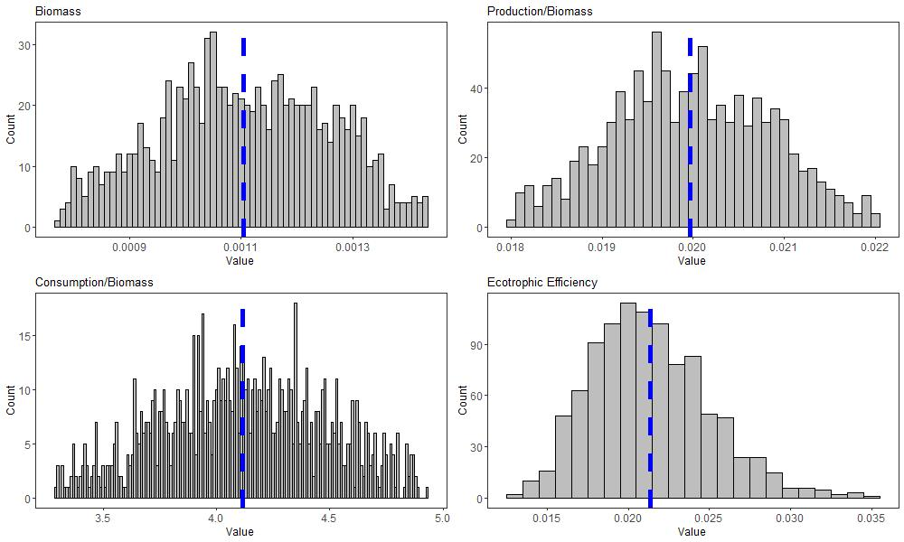
Figure A1. Histogram of modeled input parameters for toothed whales.

Baleen Whales
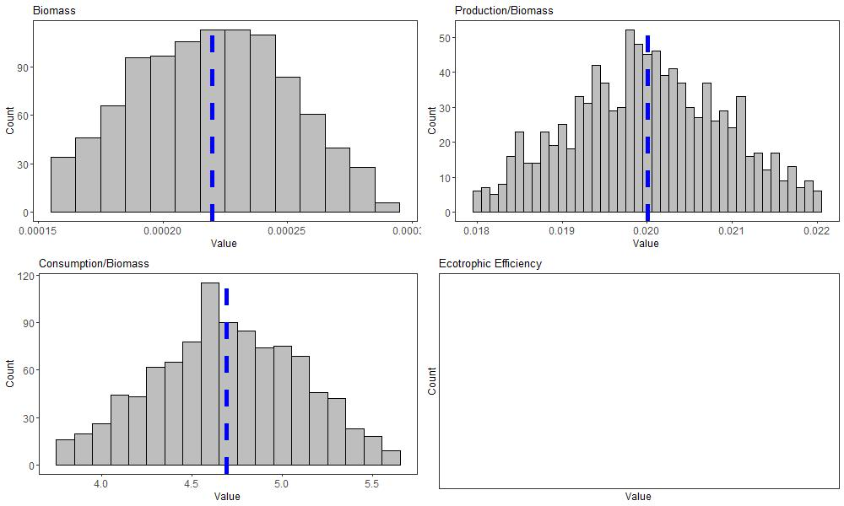
Figure A2. Histogram of modeled input parameters for baleen whales.
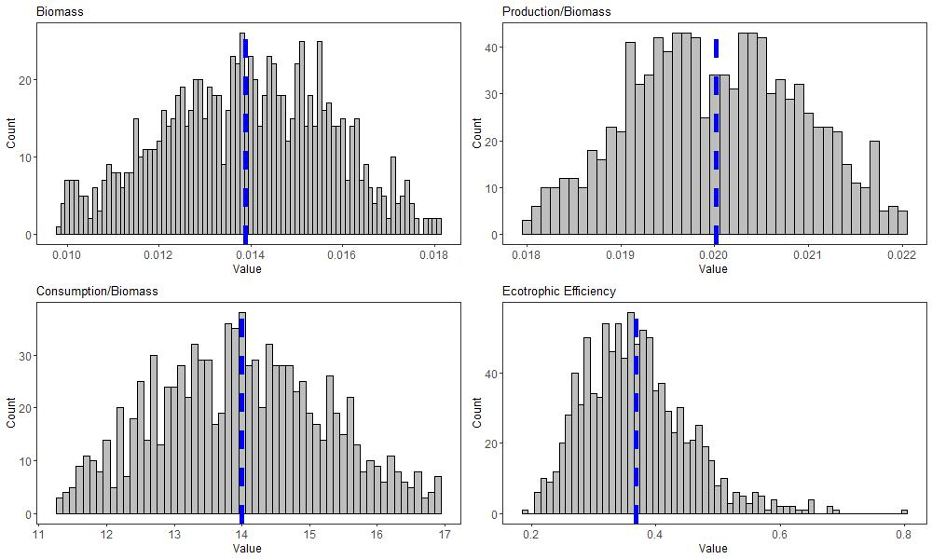
Figure A3. Histogram of modeled input parameters for dolphins.
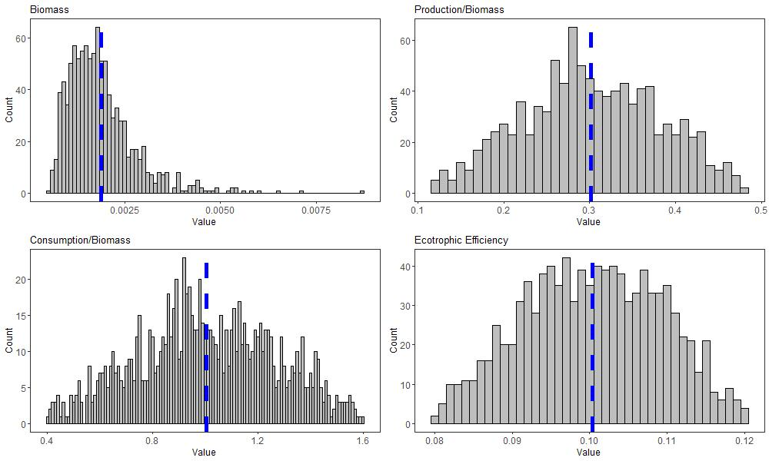
Figure A4. Histogram of modeled input parameters for seabirds.

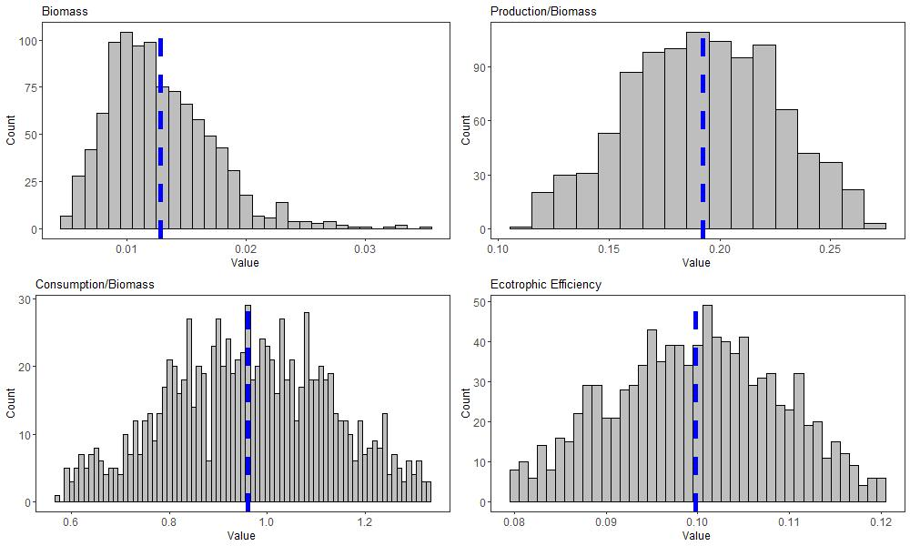
Figure A5. Histogram of modeled input parameters for sea turtles.
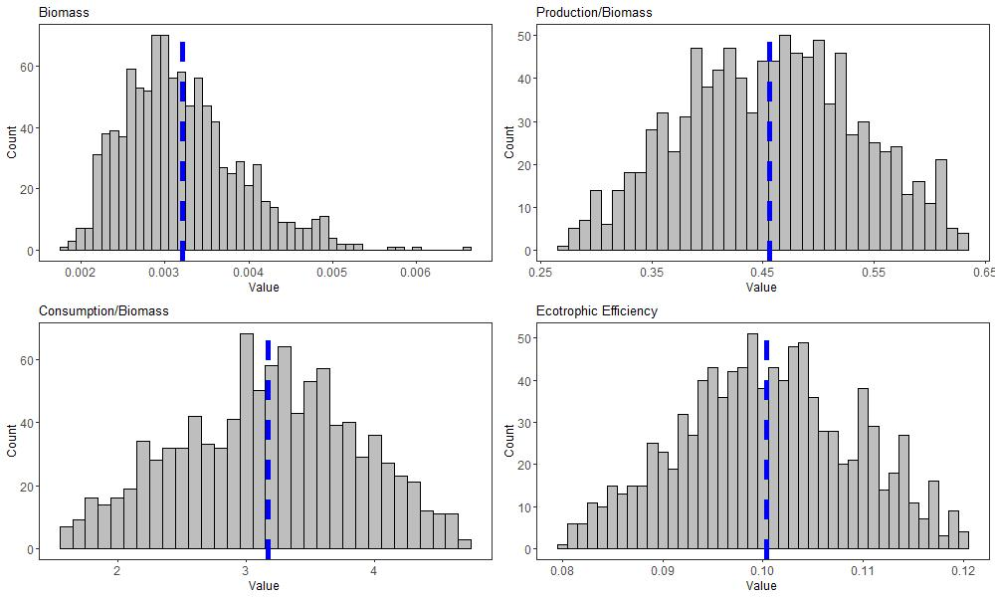
Figure A6. Histogram of modeled input parameters for oceanic sharks.
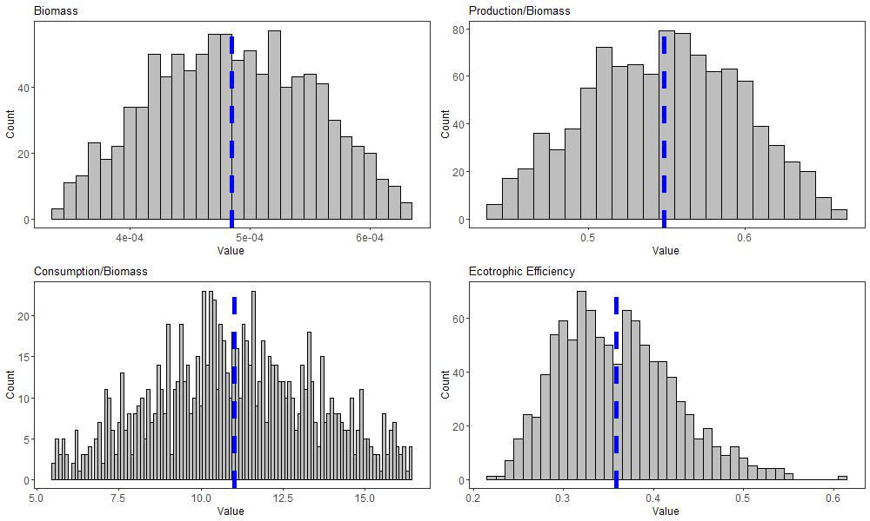
Figure A7. Histogram of modeled input parameters for adult albacore.
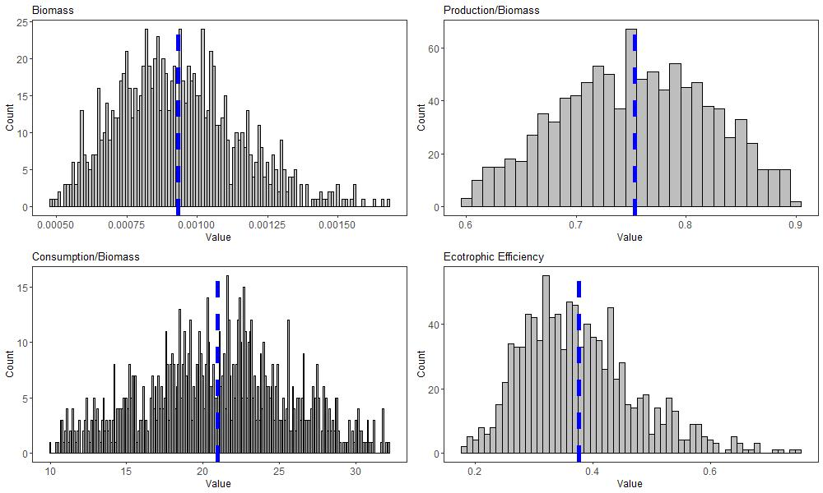
Figure A8. Histogram of modeled input parameters for juvenile albacore.
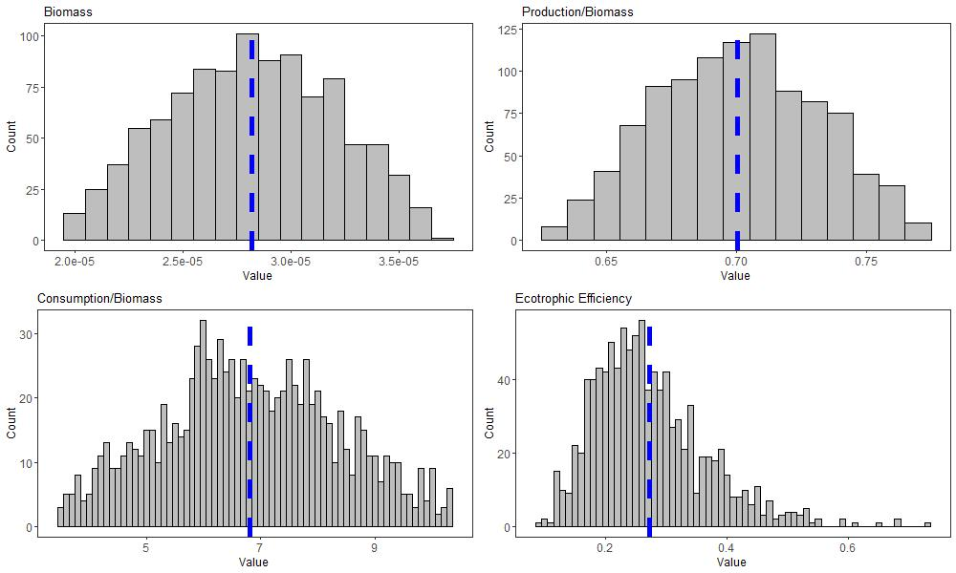
Figure A9. Histogram of modeled input parameters for adult bigeye.
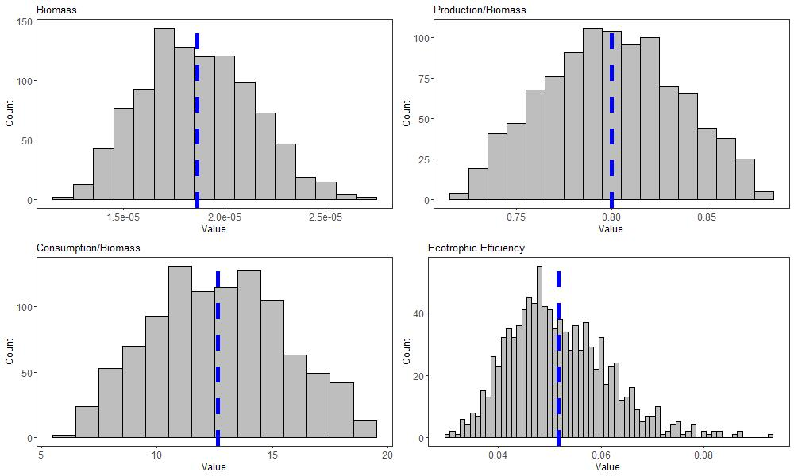
Figure A10. Histogram of modeled input parameters for juvenile bigeye.
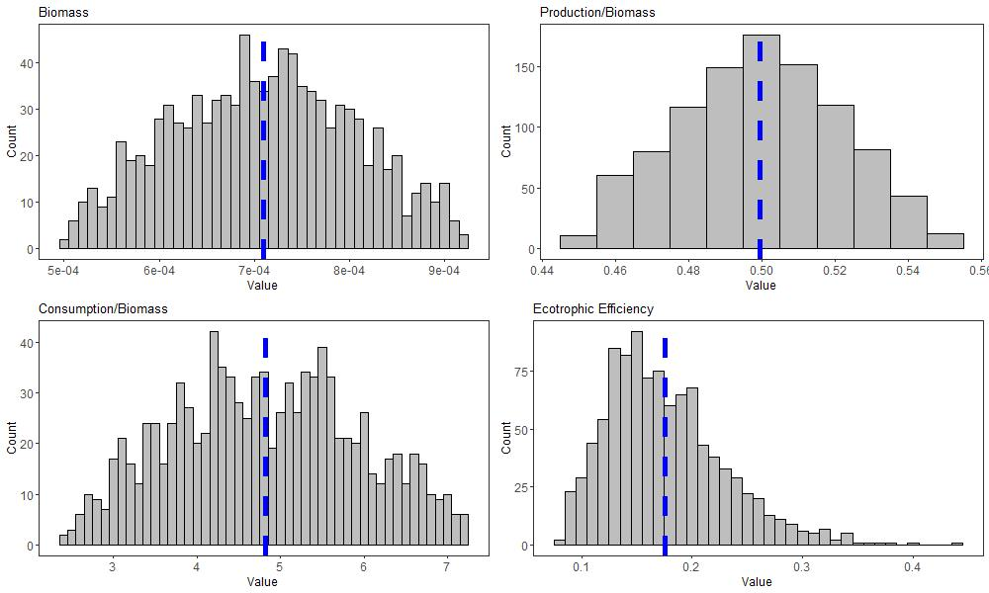
Figure A11. Histogram of modeled input parameters for adult bluefin.

Juvenile Bluefin
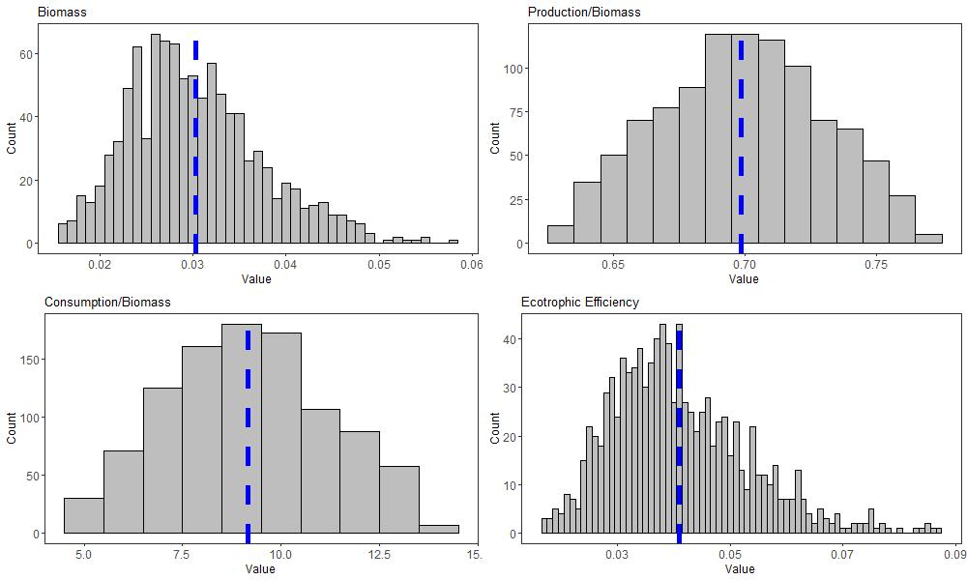
Figure A12. Histogram of modeled input parameters for juvenile bluefin.
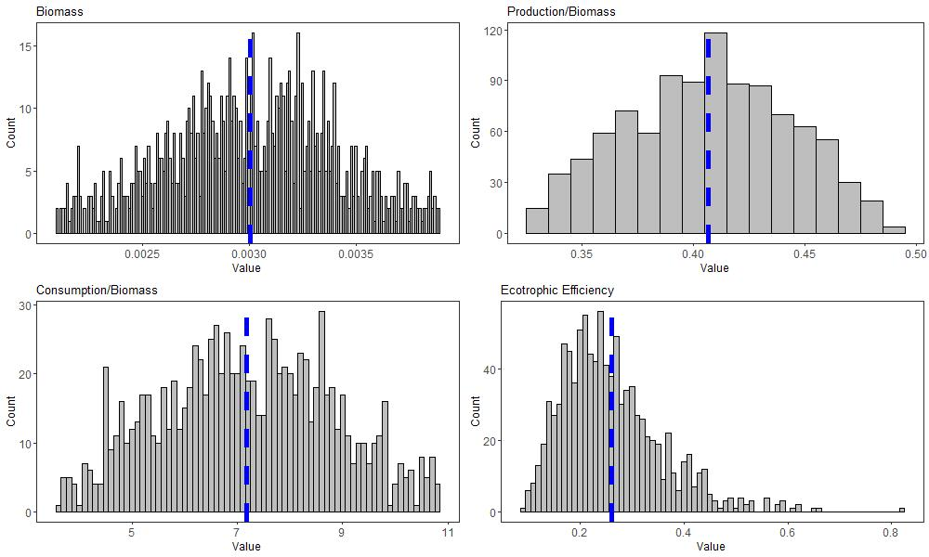
Figure A13. Histogram of modeled input parameters for adult sailfish.

Juvenile Sailfish
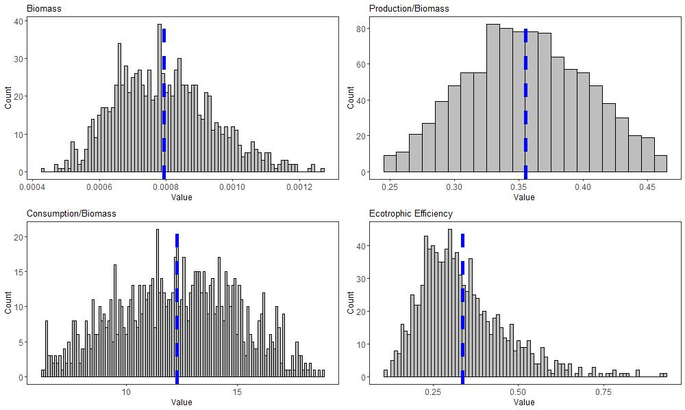
Figure A14. Histogram of modeled input parameters for juvenile sailfish
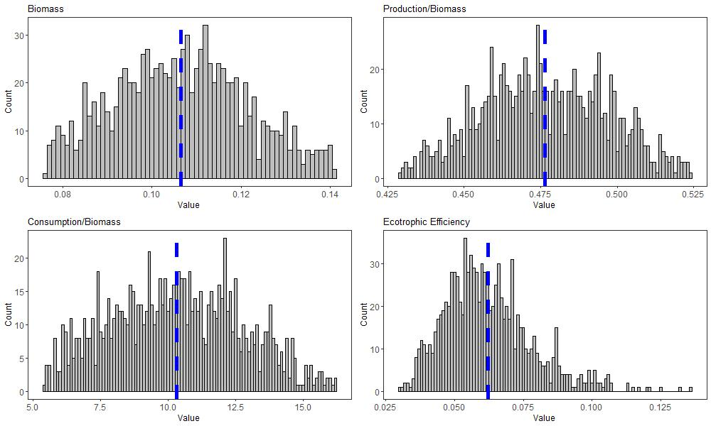
Figure A15. Histogram of modeled input parameters for adult yellowfin.
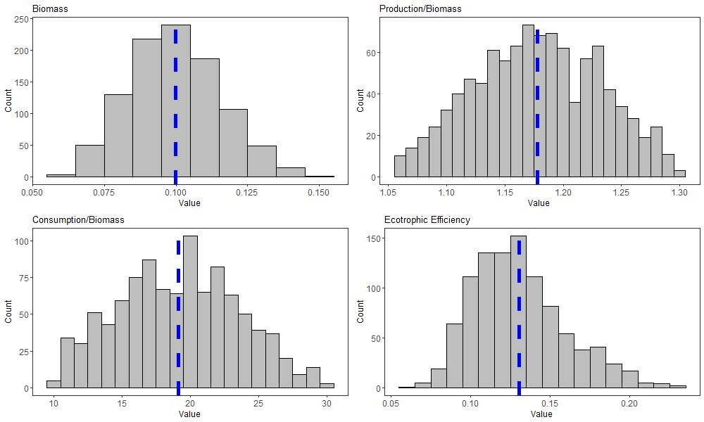
Figure A16. Histogram of modeled input parameters for juvenile yellowfin.

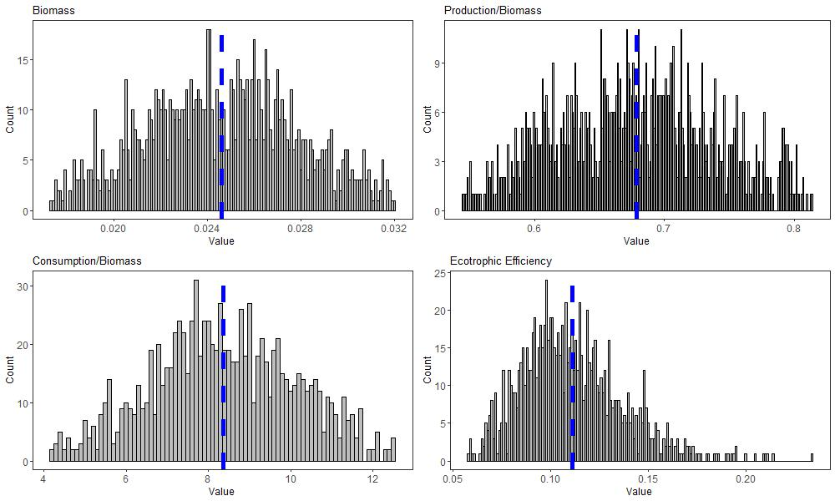
Figure A17. Histogram of modeled input parameters for adult swordfish.
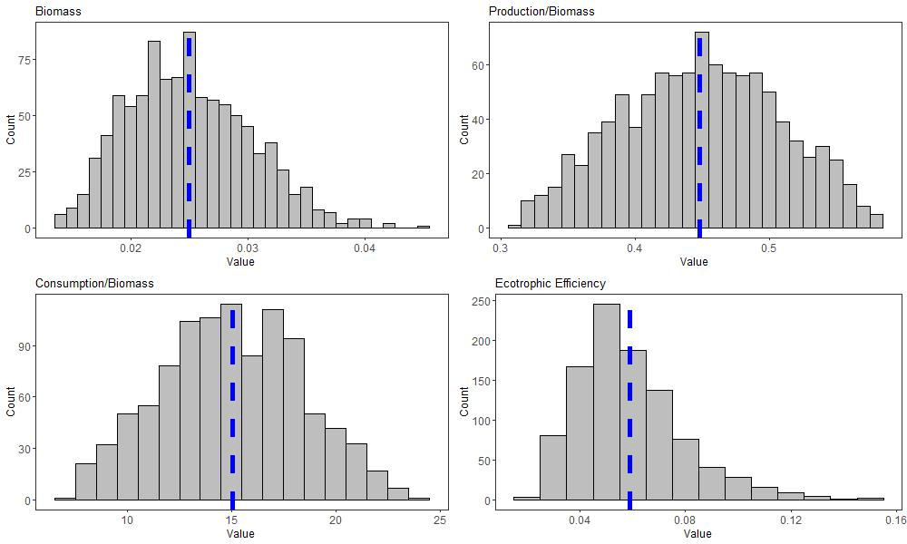
Figure A18. Histogram of modeled input parameters for juvenile swordfish.
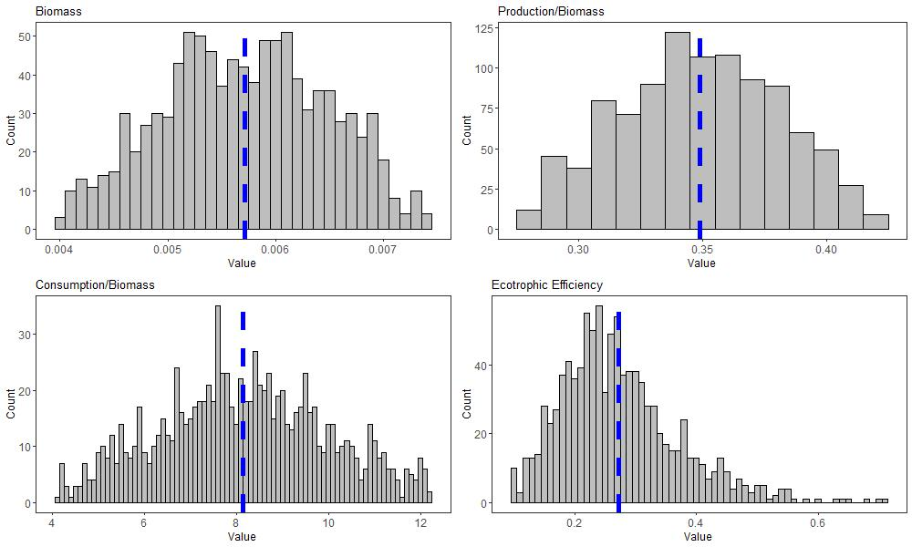
Figure A19. Histogram of modeled input parameters for adult white marlin.
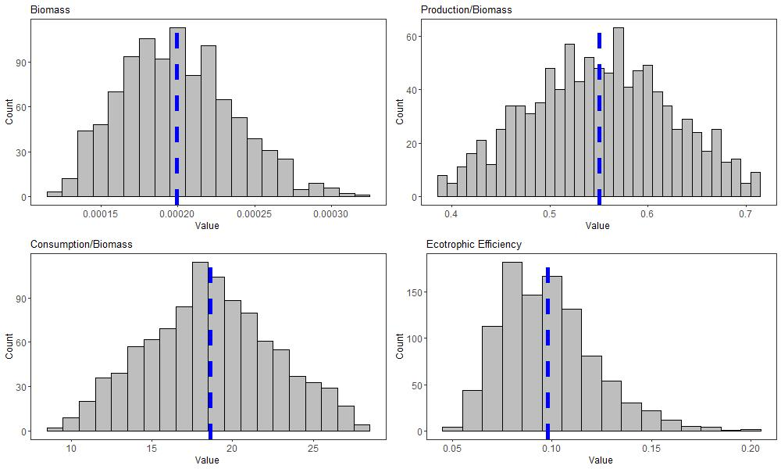
Figure A20. Histogram of modeled input parameters for juvenile white marlin.
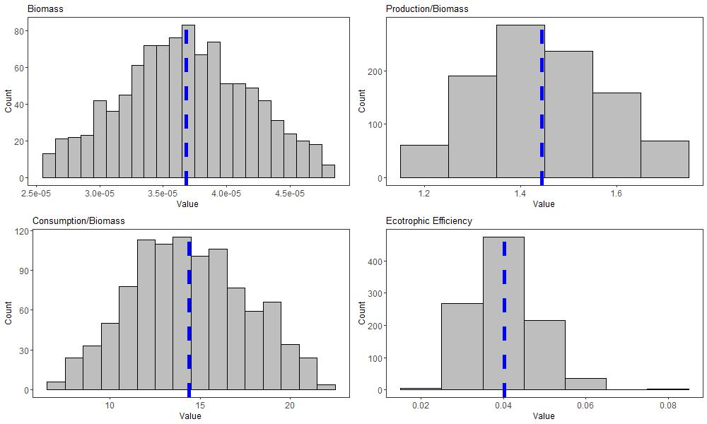
Figure A21. Histogram of modeled input parameters for adult skipjack.

Juvenile Skipjack
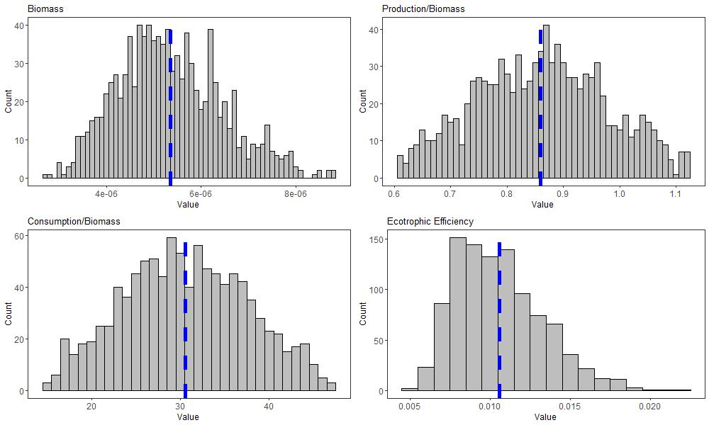
Figure A22. Histogram of modeled input parameters for juvenile skipjack.

Adult Blue Marlin
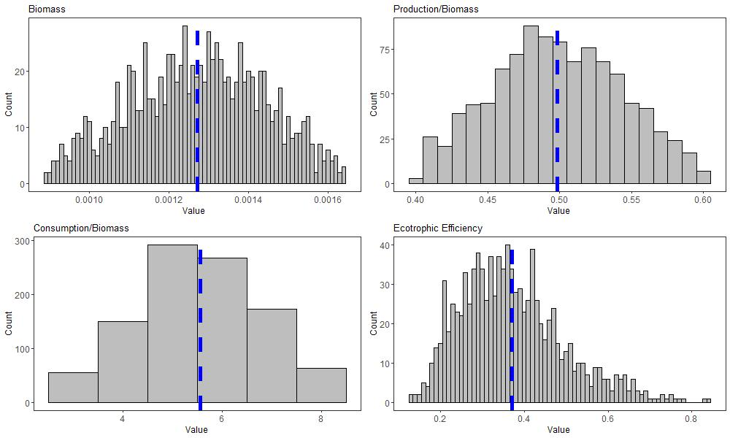
Figure A23. Histogram of modeled input parameters for adult blue marlin.
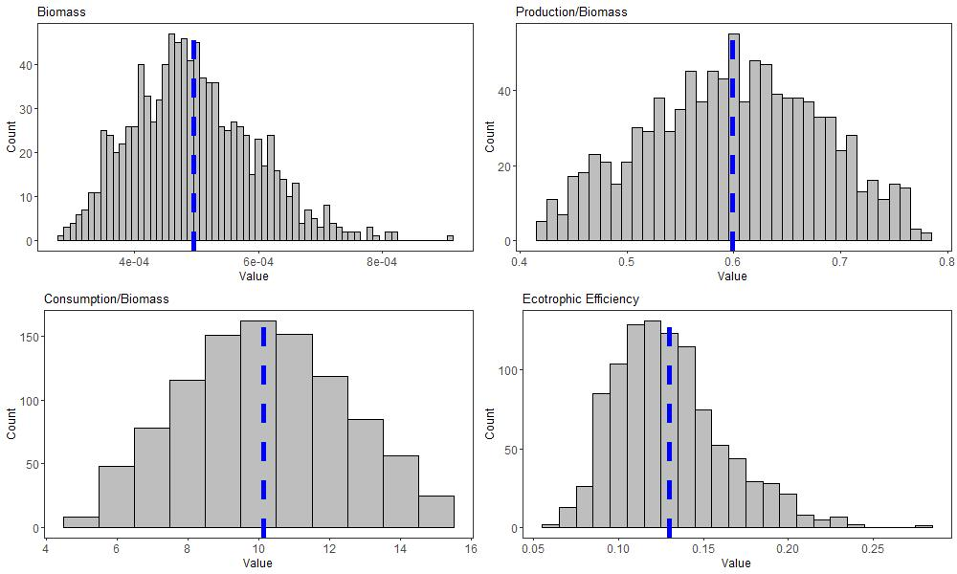
Figure A24. Histogram of modeled input parameters for juvenile blue marlin.
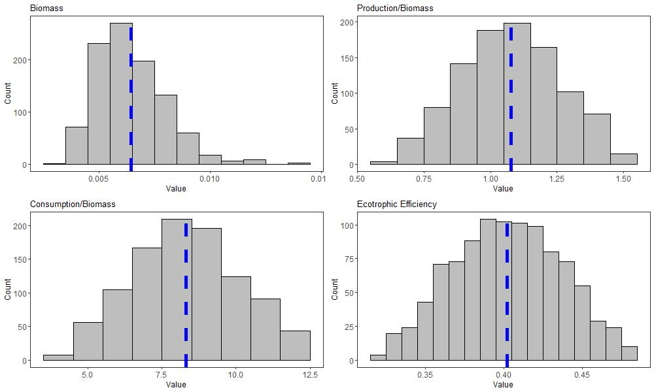
Figure A25. Histogram of modeled input parameters for small tunas and other large predators.

Dragonfishes
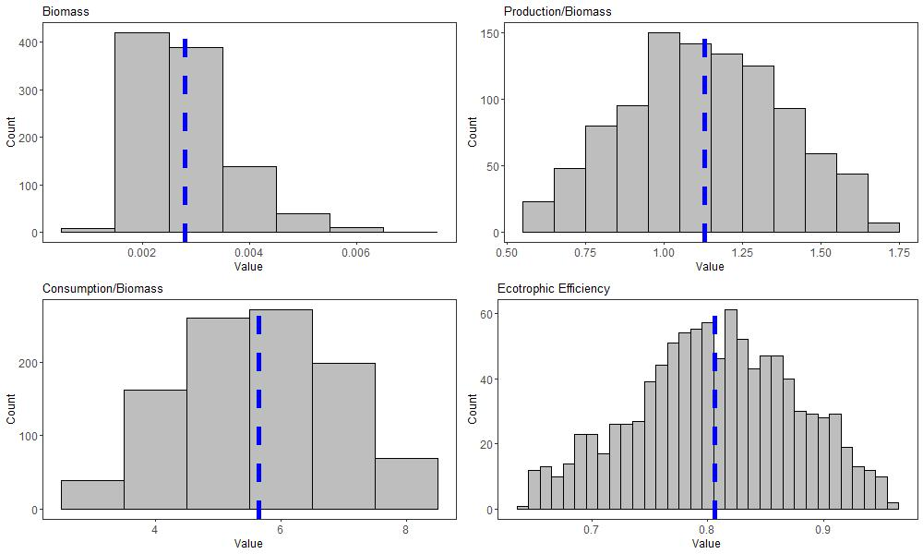
Figure A26. Histogram of modeled input parameters for dragonfishes.
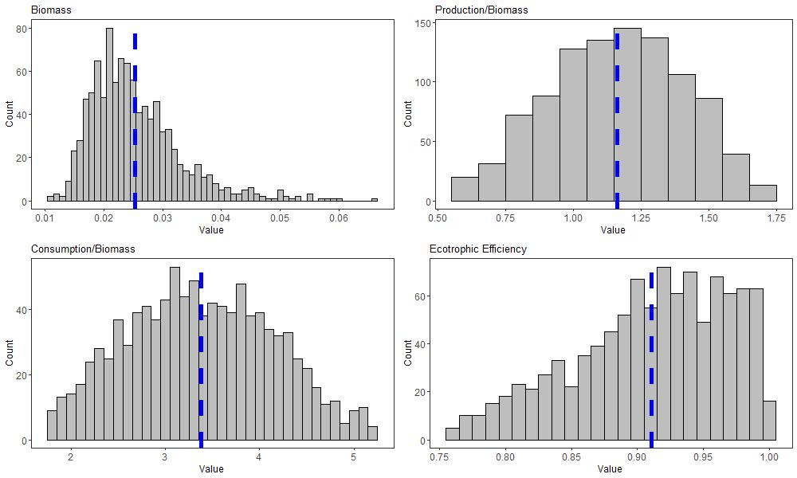
Figure A27. Histogram of modeled input parameters for other mesopelagic zooplanktivores.
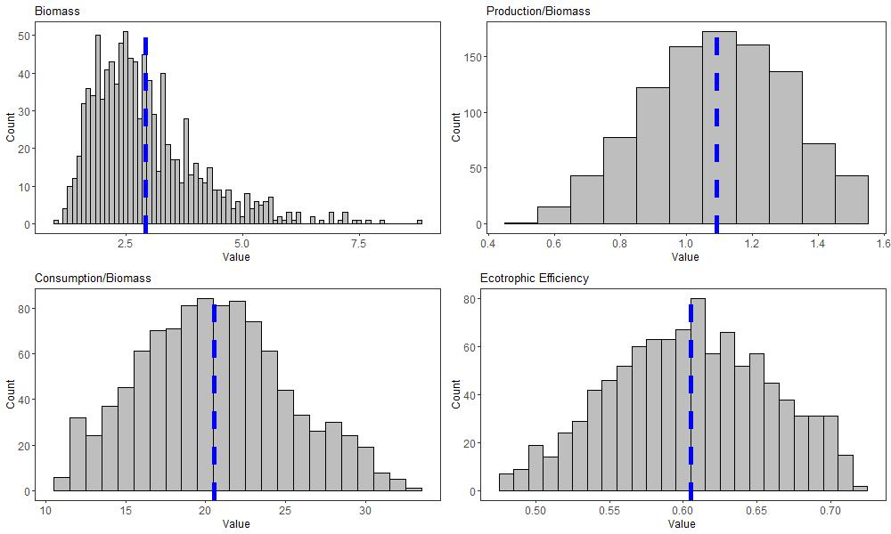
Figure A28. Histogram of modeled input parameters for epipelagic forage feeders.
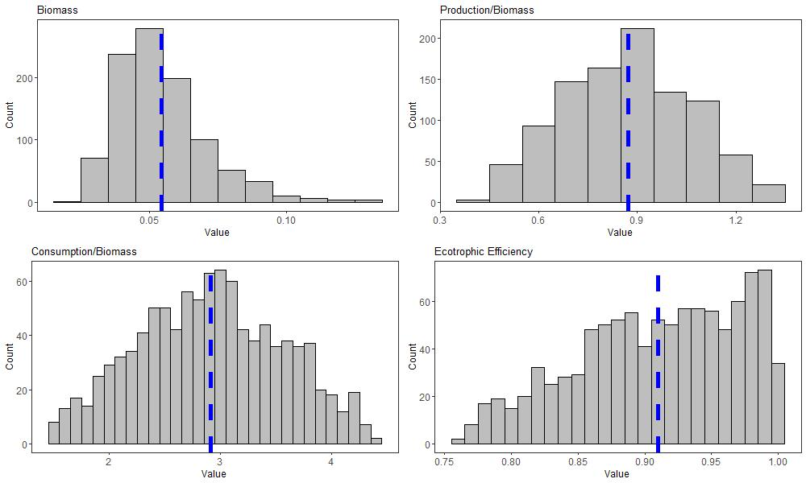
Figure A29. Histogram of modeled input parameters for other mesopelagic micronektonviores.
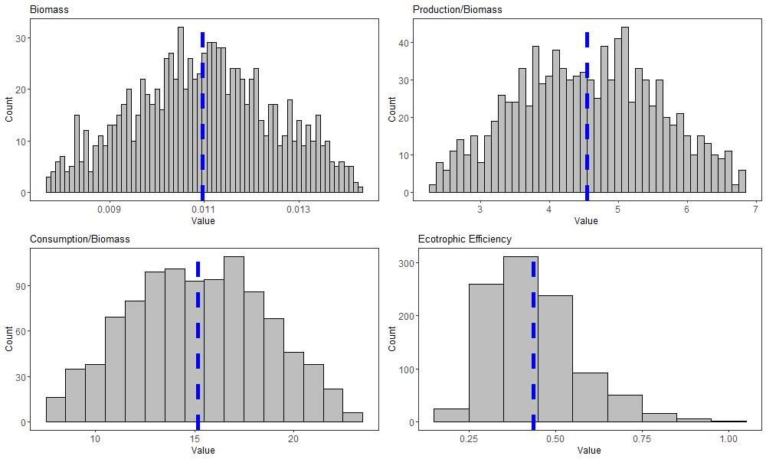
Figure A30. Histogram of modeled input parameters for hatchetfishes.
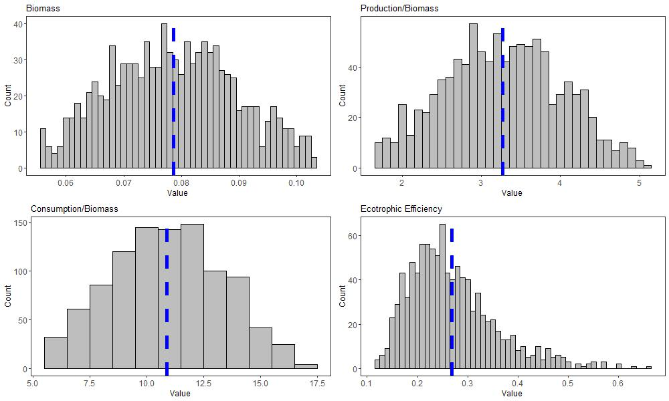
Figure A31. Histogram of modeled input parameters for bristlemouths.
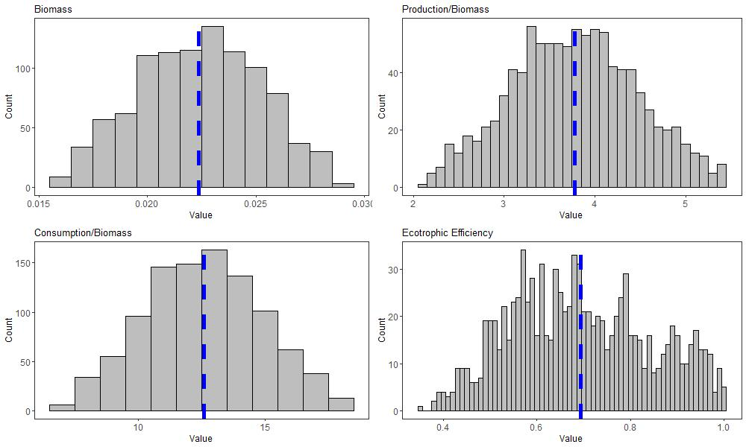
Figure A32. Histogram of modeled input parameters for lanternfishes.
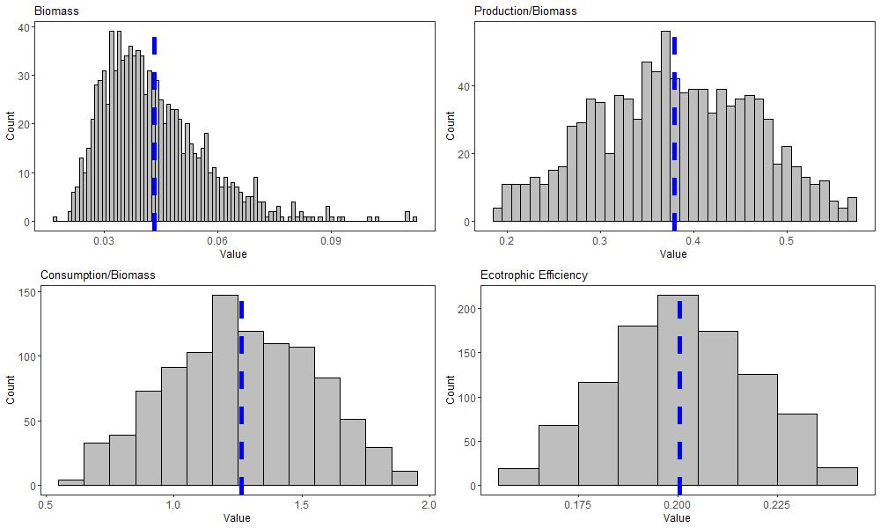
Figure A33. Histogram of modeled input parameters for leptocephali.
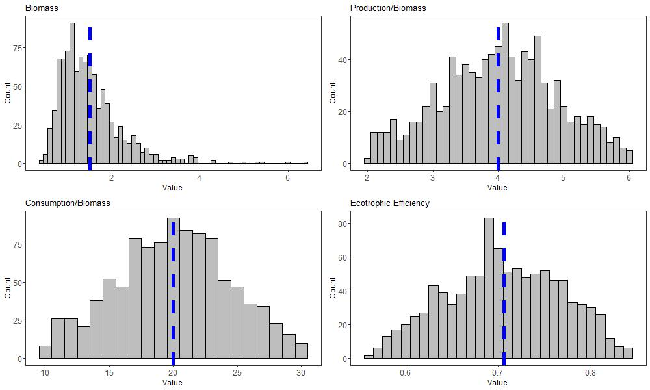
Figure A34. Histogram of modeled input parameters for pelagic cephalopods.

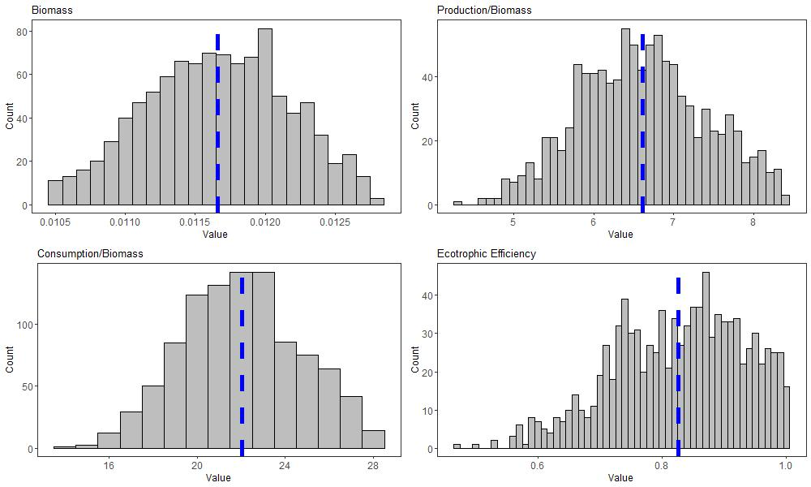
Figure A35. Histogram of modeled input parameters for pelagic decapods.
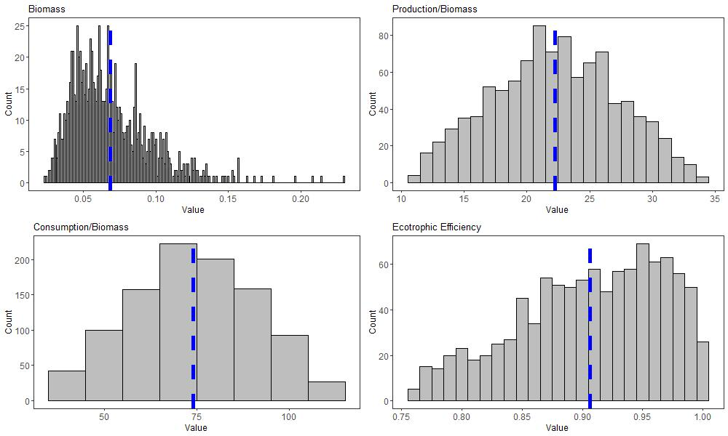
Figure A36. Histogram of modeled input parameters for euphausiids.

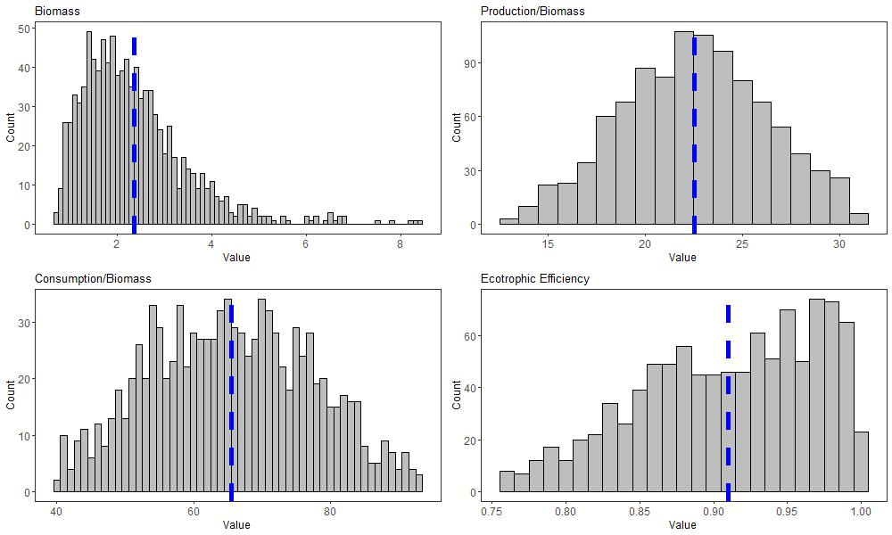
Figure A37. Histogram of modeled input parameters for mesozooplankton.
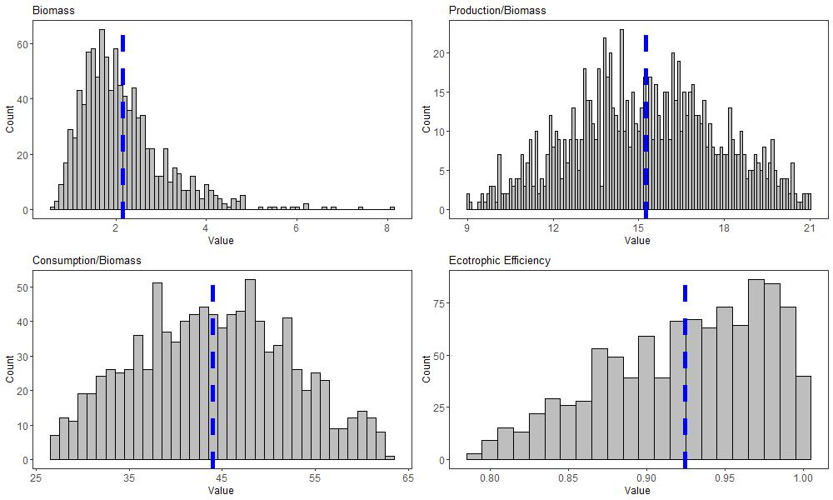
Figure A38. Histogram of modeled input parameters for ichthyoplankton.

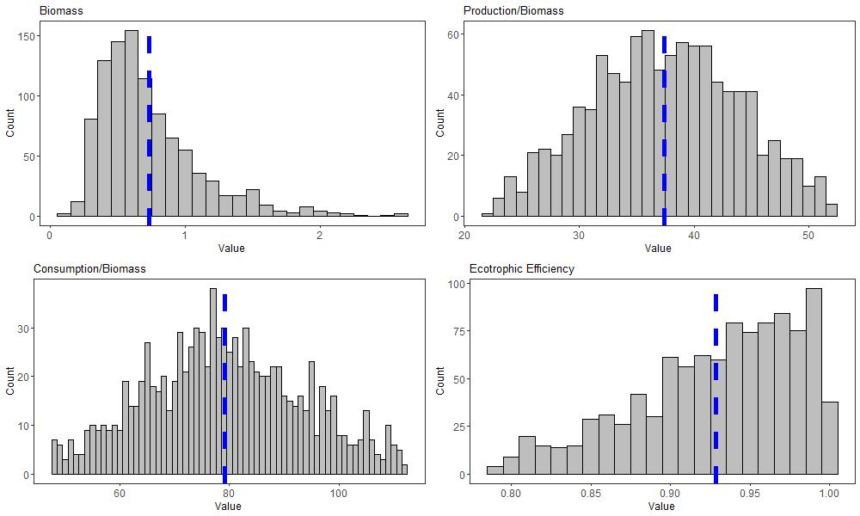
Figure A39. Histogram of modeled input parameters for gelatinous zooplankton.
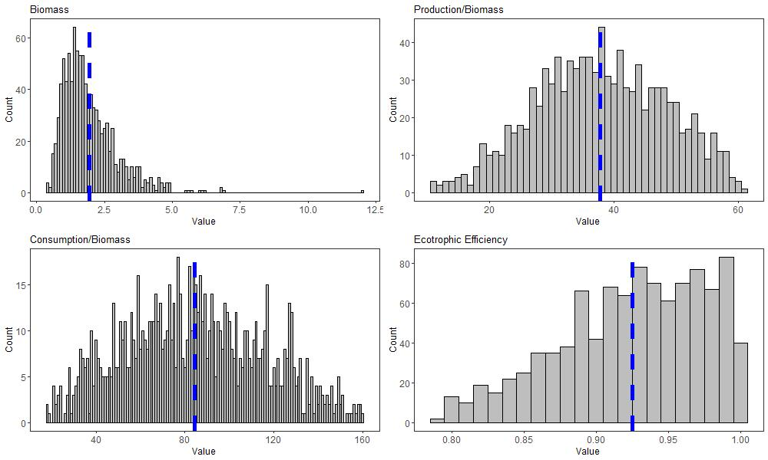
Figure A40. Histogram of modeled input parameters for microzooplankton.

Diet Matrix
Table A2. Initial diet matrix of the oceanic Gulf of Mexico Ecopath with Ecosim model. Prey groups are rows and predator groups are columns. Fisheries landings and dead discards are the final column. "-" = No predator/prey relationship. All values are percent diet composition (% weight)
Prey \ predator | Toothed Whales | Baleen Whales | Dolphins | Seabirds | Sea Turtles | Oceanic Sharks
Toothed Whales | - | - | - | - | - | -
Baleen Whales | - | - | - | - | - | -
Dolphins | 0.022 | - | - | - | - | -
Seabirds | - | - | - | - | - | 0.005
Sea Turtles | - | - | - | - | - | 0.020
Oceanic Sharks | 0.011 | - | - | - | - | -
Adult Albacore | 0.000 | - | - | - | - | 0.001
Juvenile Albacore | 0.000 | - | 0.001 | - | - | 0.001
Adult Bigeye | - | - | - | - | - | 0.001
Juvenile Bigeye | 0.000 | - | - | - | - | -
Adult Bluefin | - | - | - | - | - | 0.005
Juvenile Bluefin | 0.007 | - | 0.000 | - | - | 0.010
Adult Sailfish | - | - | - | - | - | 0.030
Juvenile Sailfish | 0.003 | - | - | - | - | -
Adult Yellowfin | 0.021 | - | - | - | - | 0.200
Juvenile Yellowfin | 0.100 | - | 0.061 | - | - | 0.177
Adult Swordfish | - | - | - | - | - | 0.096
Juvenile Swordfish | 0.011 | - | 0.000 | - | - | 0.040
Adult White Marlin | - | - | - | - | - | 0.050
Juvenile White Marlin | 0.001 | - | - | - | - | -
Adult Skipjack | 0.000 | - | - | - | - | -
Juvenile Skipjack | - | - | - | - | - | -
Adult Blue Marlin | - | - | - | - | - | 0.020
Juvenile Blue Marlin | 0.003 | - | - | - | - | -
Small Tunas and Other Large Predators | 0.054 | - | 0.002 | - | - | -
Dragonfishes (Stomiidae) | 0.092 | 0.010 | 0.010 | - | - | -
Other Mesopelagic Zooplanktivores | 0.001 | 0.010 | 0.007 | - | - | -
Epipelagic Forage Feeders | 0.079 | 0.080 | 0.313 | 0.400 | - | 0.040
Other Mesopelagic Micronektonivores | - | - | 0.009 | - | - | -
Hatchetfishes (Sternoptychidae) | 0.011 | 0.010 | 0.020 | - | - | -
Prey \ predator | Adult Albacore | Juvenile Albacore | Adult Bigeye | Juvenile Bigeye | Adult Bluefin | Juvenile Bluefin
Toothed Whales | - | - | - | - | - | -
Baleen Whales | - | - | - | - | - | -
Dolphins | - | - | - | - | - | -
Seabirds | - | - | - | - | - | -
Sea Turtles | - | - | - | - | - | -
Oceanic Sharks | - | - | - | - | - | -
Adult Albacore | - | - | - | - | - | -
Juvenile Albacore | - | - | - | - | - | -
Adult Bigeye | - | - | - | - | - | -
Juvenile Bigeye | - | - | - | - | - | -
Adult Bluefin | - | - | - | - | - | -
Juvenile Bluefin | - | - | 0.001 | - | - | -
Adult Sailfish | - | - | - | - | - | -
Juvenile Sailfish | - | - | - | - | - | -
Adult Yellowfin | - | - | - | - | - | -
Juvenile Yellowfin | - | - | - | - | - | -
Adult Swordfish | - | - | - | - | - | -
Juvenile Swordfish | - | - | - | - | - | -
Adult White Marlin | - | - | - | - | - | -
Juvenile White Marlin | - | - | - | - | - | -
Adult Skipjack | - | - | - | - | - | -
Juvenile Skipjack | - | - | - | - | - | -
Adult Blue Marlin | - | - | - | - | - | -
Juvenile Blue Marlin | - | - | - | - | - | -
Small Tunas and Other Large Predators | - | - | - | - | 0.020 | -
Dragonfishes (Stomiidae) | - | - | 0.100 | - | - | -
Other Mesopelagic Zooplanktivores | - | - | 0.050 | - | 0.073 | -
Epipelagic Forage Feeders | 0.094 | - | 0.172 | 0.200 | 0.163 | 0.125
Other Mesopelagic Micronektonivores | 0.560 | 0.064 | 0.080 | - | 0.206 | -
Hatchetfishes (Sternoptychidae) | 0.001 | 0.203 | 0.150 | 0.050 | - | 0.010
Prey \ predator | Adult Sailfish | Juvenile Sailfish | Adult Yellowfin | Juvenile Yellowfin | Adult Swordfish | Juvenile Swordfish
Toothed Whales | - | - | - | - | - | -
Baleen Whales | - | - | - | - | - | -
Dolphins | - | - | - | - | - | -
Seabirds | - | - | - | - | - | -
Sea Turtles | - | - | - | - | - | -
Oceanic Sharks | - | - | - | - | - | -
Adult Albacore | - | - | - | - | - | -
Juvenile Albacore | - | - | - | - | - | -
Adult Bigeye | - | - | - | - | - | -
Juvenile Bigeye | - | - | - | - | - | -
Adult Bluefin | - | - | - | - | - | -
Juvenile Bluefin | 0.020 | - | - | - | - | -
Adult Sailfish | - | - | - | - | - | -
Juvenile Sailfish | - | - | - | - | - | -
Adult Yellowfin | - | - | - | - | - | -
Juvenile Yellowfin | - | - | - | - | - | -
Adult Swordfish | - | - | - | - | - | -
Juvenile Swordfish | - | - | - | - | - | -
Adult White Marlin | - | - | - | - | - | -
Juvenile White Marlin | - | - | - | - | - | -
Adult Skipjack | - | - | - | - | - | -
Juvenile Skipjack | - | - | - | - | - | -
Adult Blue Marlin | - | - | - | - | - | -
Juvenile Blue Marlin | - | - | - | - | - | -
Small Tunas and Other Large Predators | 0.007 | - | 0.001 | - | - | -
Dragonfishes (Stomiidae) | - | - | - | - | - | -
Other Mesopelagic Zooplanktivores | - | 0.100 | 0.010 | - | - | -
Epipelagic Forage Feeders | 0.265 | 0.200 | 0.249 | 0.400 | 0.022 | -
Other Mesopelagic Micronektonivores | 0.133 | - | 0.010 | 0.009 | - | -
Hatchetfishes (Sternoptychidae) | - | 0.020 | - | - | - | 0.010

Prey \ predator | White Marlin (A) | White Marlin (J) | Skipjack (A) | Skipjack (J) | Blue Marlin (A)
Toothed Whales | - | - | - | - | -
Baleen Whales | - | - | - | - | -
Dolphins | - | - | - | - | -
Seabirds | - | - | - | - | -
Sea Turtles | - | - | - | - | -
Oceanic Sharks | - | - | - | - | -
Adult Albacore | - | - | - | - | -
Juvenile Albacore | - | - | - | - | -
Adult Bigeye | - | - | - | - | -
Juvenile Bigeye | - | - | - | - | -
Adult Bluefin | - | - | - | - | -
Juvenile Bluefin | - | - | - | - | -
Adult Sailfish | - | - | - | - | -
Juvenile Sailfish | - | - | - | - | -
Adult Yellowfin | - | - | - | - | -
Juvenile Yellowfin | - | - | - | - | -
Adult Swordfish | - | - | - | - | -
Juvenile Swordfish | - | - | - | - | -
Adult White Marlin | - | - | - | - | -
Juvenile White Marlin | - | - | - | - | -
Adult Skipjack | - | - | - | - | -
Juvenile Skipjack | - | - | - | - | -
Adult Blue Marlin | - | - | - | - | -
Juvenile Blue Marlin | - | - | - | - | -
Small Tunas and Other Large Predators | 0.010 | - | - | - | 0.070
Dragonfishes (Stomiidae) | - | - | - | - | -
Other Mesopelagic Zooplanktivores | - | - | - | - | 0.050
Epipelagic Forage Feeders | 0.300 | 0.109 | 0.200 | - | 0.250
Other Mesopelagic Micronektonivores | - | - | - | - | 0.100
Hatchetfishes (Sternoptychidae) | 0.020 | - | 0.020 | - | 0.020

Prey \ predator | Juvenile Blue Marlin | Small Tunas and Oth. Lg. Predators | Dragonfishes | Other Mesopelagic Zooplanktivores
Toothed Whales | - | - | - | -
Baleen Whales | - | - | - | -
Dolphins | - | - | - | -
Seabirds | - | - | - | -
Sea Turtles | - | - | - | -
Oceanic Sharks | - | - | - | -
Adult Albacore | - | - | - | -
Juvenile Albacore | - | 0.000 | - | -
Adult Bigeye | - | - | - | -
Juvenile Bigeye | - | - | - | -
Adult Bluefin | - | - | - | -
Juvenile Bluefin | - | 0.004 | - | -
Adult Sailfish | - | - | - | -
Juvenile Sailfish | - | 0.001 | - | -
Adult Yellowfin | - | - | - | -
Juvenile Yellowfin | - | 0.006 | - | -
Adult Swordfish | - | - | - | -
Juvenile Swordfish | - | 0.001 | - | -
Adult White Marlin | - | - | - | -
Juvenile White Marlin | - | - | - | -
Adult Skipjack | - | - | - | -
Juvenile Skipjack | - | - | - | -
Adult Blue Marlin | - | - | - | -
Juvenile Blue Marlin | - | - | - | -
Small Tunas and Other Large Predators | - | 0.003 | - | -
Dragonfishes (Stomiidae) | - | - | - | -
Other Mesopelagic Zooplanktivores | - | 0.006 | 0.023 | -
Epipelagic Forage Feeders | 0.109 | 0.692 | - | -
Other Mesopelagic Micronektonivores | - | - | - | -
Hatchetfishes (Sternoptychidae) | - | 0.015 | 0.050 | -

Prey \ predator | Epi. Forage Feeders | Other Meso. Micronektonivores | Hatchetfishes | Bristlemouths | Lanternfishes
Toothed Whales | - | - | - | - | -
Baleen Whales | - | - | - | - | -
Dolphins | - | - | - | - | -
Seabirds | - | - | - | - | -
Sea Turtles | - | - | - | - | -
Oceanic Sharks | - | - | - | - | -
Adult Albacore | - | - | - | - | -
Juvenile Albacore | - | - | - | - | -
Adult Bigeye | - | - | - | - | -
Juvenile Bigeye | - | - | - | - | -
Adult Bluefin | - | - | - | - | -
Juvenile Bluefin | - | - | - | - | -
Adult Sailfish | - | - | - | - | -
Juvenile Sailfish | - | - | - | - | -
Adult Yellowfin | - | - | - | - | -
Juvenile Yellowfin | - | - | - | - | -
Adult Swordfish | - | - | - | - | -
Juvenile Swordfish | - | - | - | - | -
Adult White Marlin | - | - | - | - | -
Juvenile White Marlin | - | - | - | - | -
Adult Skipjack | - | - | - | - | -
Juvenile Skipjack | - | - | - | - | -
Adult Blue Marlin | - | - | - | - | -
Juvenile Blue Marlin | - | - | - | - | -
Small Tunas and Other Large Predators | - | - | - | - | -
Dragonfishes (Stomiidae) | - | - | - | - | -
Other Mesopelagic Zooplanktivores | - | 0.073 | - | - | -
Epipelagic Forage Feeders | 0.010 | 0.050 | - | - | -
Other Mesopelagic Micronektonivores | - | 0.014 | - | - | -
Hatchetfishes (Sternoptychidae) | - | 0.020 | - | - | -

Prey \ predator | Leptocephali | Cephalopods | Decapods | Euphausiids | Mesozooplankton
Toothed Whales | - | - | - | - | -
Baleen Whales | - | - | - | - | -
Dolphins | - | - | - | - | -
Seabirds | - | - | - | - | -
Sea Turtles | - | - | - | - | -
Oceanic Sharks | - | - | - | - | -
Adult Albacore | - | - | - | - | -
Juvenile Albacore | - | - | - | - | -
Adult Bigeye | - | - | - | - | -
Juvenile Bigeye | - | - | - | - | -
Adult Bluefin | - | - | - | - | -
Juvenile Bluefin | - | - | - | - | -
Adult Sailfish | - | - | - | - | -
Juvenile Sailfish | - | - | - | - | -
Adult Yellowfin | - | - | - | - | -
Juvenile Yellowfin | - | - | - | - | -
Adult Swordfish | - | - | - | - | -
Juvenile Swordfish | - | - | - | - | -
Adult White Marlin | - | - | - | - | -
Juvenile White Marlin | - | - | - | - | -
Adult Skipjack | - | - | - | - | -
Juvenile Skipjack | - | - | - | - | -
Adult Blue Marlin | - | - | - | - | -
Juvenile Blue Marlin | - | - | - | - | -
Small Tunas and Other Large Predators | - | - | - | - | -
Dragonfishes (Stomiidae) | - | - | - | - | -
Other Mesopelagic Zooplanktivores | - | - | - | - | -
Epipelagic Forage Feeders | - | - | - | - | -
Other Mesopelagic Micronektonivores | - | - | - | - | -
Hatchetfishes (Sternoptychidae) | - | - | - | - | -

Prey \ predator | Ichthyoplankton | Gelatinous zooplankton | Microzooplankton
Toothed Whales | - | - | -
Baleen Whales | - | - | -
Dolphins | - | - | -
Seabirds | - | - | -
Sea Turtles | - | - | -
Oceanic Sharks | - | - | -
Adult Albacore | - | - | -
Juvenile Albacore | - | - | -
Adult Bigeye | - | - | -
Juvenile Bigeye | - | - | -
Adult Bluefin | - | - | -
Juvenile Bluefin | - | - | -
Adult Sailfish | - | - | -
Juvenile Sailfish | - | - | -
Adult Yellowfin | - | - | -
Juvenile Yellowfin | - | - | -
Adult Swordfish | - | - | -
Juvenile Swordfish | - | - | -
Adult White Marlin | - | - | -
Juvenile White Marlin | - | - | -
Adult Skipjack | - | - | -
Juvenile Skipjack | - | - | -
Adult Blue Marlin | - | - | -
Juvenile Blue Marlin | - | - | -
Small Tunas and Other Large Predators | - | - | -
Dragonfishes (Stomiidae) | - | - | -
Other Mesopelagic Zooplanktivores | - | - | -
Epipelagic Forage Feeders | - | - | -
Other Mesopelagic Micronektonivores | - | - | -
Hatchetfishes (Sternoptychidae) | - | - | -

Prey \ predator | Toothed Whales | Baleen Whales | Dolphins | Seabirds | Sea Turtles | Oceanic Sharks
Bristlemouths (Gonostomatidae) | 0.011 | 0.010 | 0.066 | - | - | -
Lanternfishes (Myctophidae) | 0.054 | 0.030 | 0.040 | - | - | -
Leptocephali (Anguilliformes) | - | - | - | - | - | 0.061
Pelagic Cephalopods | 0.518 | 0.700 | 0.378 | - | - | 0.244
Pelagic Decapods | - | - | - | - | - | -
Euphausiids | - | 0.030 | - | - | - | -
Mesozooplankton | - | 0.050 | - | - | 0.100 | -
Ichthyoplankton | - | 0.070 | 0.093 | 0.600 | - | -
Gelatinous zooplankton | - | - | - | - | 0.900 | -
Microzooplankton | - | - | - | - | - | -
Phytoplankton | - | - | - | - | - | -
Pelagic Detritus | - | - | - | - | - | -

Prey \ predator | Adult Albacore | Juvenile Albacore | Adult Bigeye | Juvenile Bigeye | Adult Bluefin
Bristlemouths (Gonostomatidae) | - | - | 0.100 | 0.050 | -
Lanternfishes (Myctophidae) | - | 0.050 | 0.050 | 0.050 | -
Leptocephali (Anguilliformes) | - | - | - | - | -
Pelagic Cephalopods | 0.180 | 0.298 | 0.130 | 0.100 | 0.112
Pelagic Decapods | 0.001 | - | 0.111 | 0.150 | 0.036
Euphausiids | 0.029 | 0.012 | - | 0.150 | -
Mesozooplankton | 0.088 | 0.001 | 0.056 | 0.100 | -
Ichthyoplankton | - | 0.372 | - | 0.150 | 0.020
Gelatinous zooplankton | 0.046 | - | - | - | 0.370
Microzooplankton | - | - | - | - | -
Phytoplankton | - | - | - | - | -
Pelagic Detritus | - | - | - | - | -

Prey \ predator | Juvenile Bluefin | Adult Sailfish | Juvenile Sailfish | Adult Yellowfin | Juvenile Yellowfin
Bristlemouths (Gonostomatidae) | 0.010 | - | 0.010 | 0.010 | 0.010
Lanternfishes (Myctophidae) | 0.020 | - | 0.020 | 0.005 | 0.005
Leptocephali (Anguilliformes) | - | - | - | - | -
Pelagic Cephalopods | 0.011 | 0.192 | 0.100 | 0.317 | 0.100
Pelagic Decapods | 0.010 | 0.001 | 0.100 | 0.005 | 0.001
Euphausiids | - | - | 0.100 | - | -
Mesozooplankton | - | 0.002 | 0.150 | 0.039 | 0.122
Ichthyoplankton | 0.814 | 0.380 | 0.100 | 0.355 | 0.347
Gelatinous zooplankton | - | - | - | - | 0.006
Microzooplankton | - | - | 0.100 | - | -
Phytoplankton | - | - | - | - | -
Pelagic Detritus | - | - | - | - | -

Prey \ predator | Adult Swordfish | Juvenile Swordfish | Adult White Marlin | Juvenile White Marlin | Adult Skipjack
Bristlemouths (Gonostomatidae) | - | 0.020 | 0.010 | - | 0.010
Lanternfishes (Myctophidae) | - | 0.020 | 0.110 | - | 0.020
Leptocephali (Anguilliformes) | - | - | - | - | -
Pelagic Cephalopods | 0.805 | 0.200 | 0.517 | 0.305 | 0.100
Pelagic Decapods | - | - | 0.033 | - | 0.100
Euphausiids | - | - | - | - | 0.250
Mesozooplankton | - | 0.350 | - | - | -
Ichthyoplankton | 0.173 | 0.300 | - | 0.586 | 0.300
Gelatinous zooplankton | - | 0.100 | - | - | -
Microzooplankton | - | - | - | - | -
Phytoplankton | - | - | - | - | -
Pelagic Detritus | - | - | - | - | -

Prey \ predator | Juvenile Skipjack | Adult Blue Marlin | Juvenile Blue Marlin | Small Tunas and Oth. Lg. Predators | Dragonfishes
Bristlemouths (Gonostomatidae) | - | 0.010 | - | 0.010 | 0.135
Lanternfishes (Myctophidae) | - | 0.070 | - | 0.020 | 0.300
Leptocephali (Anguilliformes) | - | - | - | 0.006 | -
Pelagic Cephalopods | - | 0.200 | 0.305 | 0.064 | -
Pelagic Decapods | - | - | - | 0.030 | 0.383
Euphausiids | 0.032 | - | - | 0.014 | 0.039
Mesozooplankton | 0.008 | - | - | 0.030 | 0.011
Ichthyoplankton | 0.959 | 0.230 | 0.586 | 0.085 | 0.060
Gelatinous zooplankton | - | - | - | 0.006 | -
Microzooplankton | - | - | - | 0.006 | -
Phytoplankton | - | - | - | - | -
Pelagic Detritus | - | - | - | - | -

Prey \ predator | Other Mesopelagic Zooplanktivores | Epi. Forage Feeders | Other Meso. Micronektonivores | Hatchetfishes | Bristlemouths
Bristlemouths (Gonostomatidae) | - | - | 0.050 | - | -
Lanternfishes (Myctophidae) | - | - | 0.050 | - | -
Leptocephali (Anguilliformes) | - | - | 0.014 | - | -
Pelagic Cephalopods | - | 0.050 | 0.270 | 0.013 | 0.003
Pelagic Decapods | 0.101 | - | 0.001 | 0.056 | 0.020
Euphausiids | 0.202 | 0.005 | 0.018 | 0.142 | 0.377
Mesozooplankton | 0.506 | 0.159 | 0.003 | 0.453 | 0.520
Ichthyoplankton | 0.140 | 0.197 | 0.422 | 0.164 | 0.079
Gelatinous zooplankton | 0.051 | 0.357 | 0.015 | 0.172 | 0.002
Microzooplankton | - | 0.013 | - | - | -
Phytoplankton | - | 0.160 | - | - | -
Pelagic Detritus | - | 0.050 | - | - | -

Prey \ predator | Lanternfishes | Leptocephali | Cephalopods | Decapods | Euphausiids | Mesozooplankton
Bristlemouths (Gonostomatidae) | - | - | - | - | - | -
Lanternfishes (Myctophidae) | - | - | - | - | - | -
Leptocephali (Anguilliformes) | - | - | - | - | - | -
Pelagic Cephalopods | 0.066 | - | - | - | - | -
Pelagic Decapods | 0.030 | - | - | - | - | -
Euphausiids | 0.188 | - | 0.010 | - | - | -
Mesozooplankton | 0.596 | - | 0.460 | 0.200 | 0.200 | 0.100
Ichthyoplankton | 0.031 | - | 0.480 | 0.100 | - | -
Gelatinous zooplankton | 0.089 | 0.050 | - | 0.050 | - | -
Microzooplankton | - | - | 0.050 | 0.200 | 0.200 | -
Phytoplankton | - | - | - | 0.300 | 0.400 | 0.500
Pelagic Detritus | - | 0.950 | - | 0.150 | 0.200 | 0.400

Prey \ predator | Ichthyoplankton | Gelatinous zooplankton | Microzooplankton
Bristlemouths (Gonostomatidae) | - | - | -
Lanternfishes (Myctophidae) | - | - | -
Leptocephali (Anguilliformes) | - | - | -
Pelagic Cephalopods | - | - | -
Pelagic Decapods | - | - | -
Euphausiids | - | 0.005 | -
Mesozooplankton | - | 0.100 | -
Ichthyoplankton | - | 0.038 | -
Gelatinous zooplankton | - | 0.050 | -
Microzooplankton | 0.500 | 0.220 | -
Phytoplankton | 0.500 | 0.163 | 0.600
Pelagic Detritus | - | 0.425 | 0.400

Literature Cited
Ayala DJ, Munk P, Lundgreen RBC, Traving SJ, Jaspers C, Jørgensen TS, Hansen LH, Riemann L (2018) Gelatinous plankton is important in the diet of European eel (Anguilla anguilla) larvae in the Sargasso Sea. Sci Rep 8:1–10. https://doi.org/doi:10.1038/s41598-018-24388-x
Bishop RE, Torres JJ (2001) Leptocephalus energetics: assembly of the energetics equation. Mar Biol 138:1093–1098. https://doi.org/doi:10.1007
Camhi MD, Pikitch EK, Babcock EA (2009) Sharks of the Open Ocean. https://doi.org/10.1002/9781444302516.ch28
Christensen, V., and C. J. Walters. 2004. Ecopath with Ecosim: methods, capabilities and limitations. Ecological modelling, 172: 109-139. https://doi.org/10.1016/j.ecolmodel.2003.09.003
Cook, A., and T. T. Sutton. 2017a. Inventory of Gulf oceanic fauna data including species, weight, and measurements. Cruises DP01 May 1-8, 2015 and DP02 August 9-21, 2015 R/V on the Point Sur in the Northern Gulf of Mexico. Distributed by: Gulf of Mexico Research Initiative Information and Data Cooperative (GRIIDC), Harte Research Institute, Texas A&M University-Corpus Christi. https://doi.org/10.7266/N70P0X3T
Cook, A., and T. T. Sutton. 2017b. Inventory of Gulf of Mexico oceanic fauna data including species, weight, and measurements from R/V Point Sur (Cruises DP03 and DP04) May-August, 2016. Distributed by: Gulf of Mexico Research Initiative Information and Data Cooperative (GRIIDC), Harte Research Institute, Texas A&M University-Corpus Christi. https://doi.org/10.7266/N7XP7385
Cook, A., and T. T. Sutton. 2018. Inventory of oceanic fauna data including species, weight, and measurements from R/V Point Sur (Cruise DP05) in the Gulf of Mexico from 2017-05-01 to 2017-05-11. Distributed by: Gulf of Mexico Research Initiative Information and Data Cooperative (GRIIDC), Harte Research Institute, Texas A&M University-Corpus Christi. https://doi.org/10.7266/N7902234
Cook, A., and T. T. Sutton 2020. Inventory of oceanic fauna data including species, weight, and measurements from R/V Point Sur cruise PS19-04 (DP06) in the Gulf of Mexico from 2018-07-19 to 2018-08-01. Distributed by: Gulf of Mexico Research Initiative Information and Data Cooperative (GRIIDC), Harte Research Institute, Texas A&M University-Corpus Christi. https://doi.org/10.7266/n7-ac8e-0240
Dodge KL, Logan JM, Lutcavage ME Foraging ecology of leatherback sea turtles in the Western North Atlantic determined through multi-tissue stable isotope analyses. https://doi.org/doi:10.1007/s00227-011-1780-x
Franks JS, Hoffmayer ER, Ballard JR, Garber NM, Garber AF (2008) Diet of Wahoo, Acanthocybium solandri, from the Northcentral Gulf of Mexico. Proc 60th Gulf Caribb Fish Institute 2007:353–362.
Geers TM, Pikitch EK, Frisk MG (2016) An original model of the northern Gulf of Mexico using Ecopath with Ecosim and its implications for the effects of fishing on ecosystem structure and maturity. Deep Res Part II Top Stud Oceanogr 129:319–331. https://doi:10.1016/j.dsr2.2014.01.009
Harford WJ (2013) Trophic modeling of shortfin Mako (Isurus oxyrinchus) and Bluefish (Pomatomus saltatrix) interactions in the western North Atlantic Ocean. Bull Mar Sci 89:161–188. https://doi.org/doi:10.5343/bms.2011.1150
Hayes SA, Josephson E, Maze-Foley K, Rosel PE, Byrd B, Chavez-Rosales S, Vn Cole T, Garrison LP, Hatch J, Henry A, Horstman SC, Litz J, Lyssikatos MC, Mullin KD, Orphanides C, Pace RM, Palka DL, Powell J, Wenzel FW, Ross WL, Jacobs N, Oliver C (2019) US Atlantic and Gulf of Mexico Marine Mammal Stock Assessments-2018. US DEPARTMENT OF COMMERCE National Oceanic and Atmospheric Administration National Marine Fisheries Service.
Heffernan JJ, Hopkins TL (1981) Vertical Distribution and Feeding of the Shrimp Genera Gennadas and Bentheogennema (Decapoda : Penaeidea ) in the Eastern Gulf of Mexico. J Crustac Biol 1:461–473.
Hopkins TL, Sutton TT, Lancraft TM (1996) The trophic structure and predation impact of a low latitude midwater fish assemblage. Prog Oceanogr 38:205–239.
Kinsey ST, Hopkins TL (1994) Trophic strategies of euphausiids in a low-latitude ecosystem. Mar Biol 118:651–661. https://doi.org/doi:10.1007/BF00347513
Kleppel GS (1993) On the diets of calanoid copepods. Mar Ecol Prog Ser 99:183–195.
Llopiz JK, Muhling BA, Lamkin JT (2015) Feeding dynamics of atlantic Bluefin tuna (Thunnus thynnus) larvae in the Gulf of Mexico. Sci Pap ICCAT 71:1710–1715.
Logan JM, Toppin R, Smith S, Galuardi B, Porter J, Lutcavage M (2013) Contribution of cephalopod prey to the diet of large pelagic fish predators in the central North Atlantic Ocean. Deep Sea Res Part II Top Stud Oceanogr 95:74–82. https://doi.org/doi:10.1016/j.dsr2.2012.06.003
Marks, A. D., D. W. Kerstetter, D. M. Wyanski, and T. T. Sutton. 2020. Reproductive Ecology of Dragonfishes (Stomiiformes: Stomiidae) in the Gulf of Mexico. Frontiers in Marine Science 7:1–17. https://doi.org/10.3389/fmars.2020.00101
Ménard, F., A. Fonteneau, D. Gaertner, V. Nordstrom, B. Stéquert, and E. Marchal Ménard. 2000. Exploitation of small tunas by a purse-seine fishery with fish aggregating devices and their feeding ecology in an eastern tropical Atlantic ecosystem. ICES Journal of Marine Science 57:525–530. https://doi.org/10.1006/jmsc.2000.0717
Odum, W. E., and E. J. Heald. 1972. Trophic analyses of an estuarine mangrove community. Bulletin of Marine Science 22: 671–738.
Passarella KC, Hopkins TL (1991) Species composition and food habits of the micronektonic cephalopod assemblage in the eastern Gulf of Mexico. Bull Mar Sci 49: 638-659.
Pauly, D. 1980. On the interrelationships between natural mortality, growth parameters, and mean environmental temperature in 175 fish stocks. ICES Journal of Marine Science. 39: 175–192. https://doi.org/10.1093/icesjms/39.2.175
Pauly D, Trites AW, Capuli E, Christensen V (1998) Diet composition and trophic level of marine mammals. ICES J Mar Sci 55:467–481.
Perryman, H. A., J. H. Tarnecki, A. Grüss, E. A. Babcock, S. R. Sagarese, C. H. Ainsworth, and A. M. Gray DiLeone. 2020. A revised diet matrix to improve the parameterization of a West Florida Shelf Ecopath model for understanding harmful algal bloom impacts. Ecological Modelling 416:108890. https://doi.org/10.1016/j.ecolmodel.2019.108890
Pomeroy LR (2001) Caught in the food web: Complexity made simple? Sci Mar 65:31–40. https://doi.org/doi:10.3989/scimar.2001.65s231
Potier, M., F. Marsac, Y. Cherel, V. Lucas, R. Sabatié, O. Maury, and F. Ménard. 2007. Forage fauna in the diet of three large pelagic fishes (lancetfish, swordfish and yellowfin tuna) in the western equatorial Indian Ocean. Fisheries Research 83:60–72. https://doi.org/10.1016/j.fishres.2006.08.020
Robinson KL, Ruzicka JJ, Hernandez FJ, Graham WM, Decker MB, Brodeur RD, Sutor M (2015) Evaluating energy flows through jellyfish and gulf menhaden (Brevoortia patronus) and the effects of fishing on the northern Gulf of Mexico ecosystem. ICES J Mar Sci 72:2301–2312. https://doi.org/doi:10.1093/icesjms/fsv088
Rooker JR, Turner, Jason P, Holt SA (2006) Trophic ecology of Sargassum-associated fishes in the Gulf of Mexico determined from stable isotopes and fatty acids. Mar Ecol Prog Ser 313:249–259.
Sutton, T. T., A. Cook, J. Moore, T. Frank, H. Judkins, M. Vecchione, M. Nizinski, and M. Youngbluth. 2017. Inventory of Gulf oceanic fauna data including species, weight, and measurements. Meg Skansi cruises from Jan. 25 - Sept. 30, 2011 in the Northern Gulf of Mexico. Distributed by: Gulf of Mexico Research Initiative Information and Data Cooperative (GRIIDC), Harte Research Institute, Texas A&M University-Corpus Christi. https://doi.org/10.7266/N7VX0DK2
Sutton TT, Hopkins TL (1996) Trophic ecology of the stomiid (Pisces: Stomiidae) fish assemblage of the eastern Gulf of Mexico: strategies, selectivity and impact of a top mesopelagic predator group. Mar Biol 127:179–192.
Trites AW, Pauly D (1998) Estimating mean body masses of marine mammals from maximum body lengths.

CHAPTER II

A TRAIT-BASED CARBON EXPORT MODEL FOR MESOPELAGIC FISHES IN THE GULF OF MEXICO WITH CONSIDERATION OF ASYNCHRONOUS VERTICAL MIGRATION, FLUX BOUNDARIES, AND FEEDING GUILDS

Abstract
Fish-mediated carbon export provides a significant proportion of the biological carbon pump in oligotrophic regions. Bioenergetic models estimate this carbon transport, but many lack species-specific traits and no carbon export model has been developed in the mesopelagic Gulf of Mexico. Intensive mesopelagic sampling efforts in the northern and eastern Gulf of Mexico have provided high-resolution information regarding community composition, species’ vertical migratory characteristics, diel depth occupancies, and diets. A stochastic, individual-based model was developed for deep-pelagic fishes in the northern Gulf of Mexico to estimate bioenergetic rates and carbon export fluxes. Fishes that ate gelatinous zooplankton consumed more mass per body weight per day than predators of cephalopods and fishes, ostensibly to increase the throughput of prey with less carbon (gelata) or more refractory materials (Crustacea). A dynamic energy budget submodel indicated that during 81% of occurrences, asynchronous vertically migrating fishes rested for one day before migrating again, but migrations on successive days were possible. In terms of carbon export, myctophids and stomiids contributed greater than 53% and 12% of the active carbon flux for the entire assemblage in all scenarios. The assemblage-wide carbon export rate driven by vertically migrating fishes was 0.14–0.72 mg C m⁻² d⁻¹, 61% of the ingested carbon by the assemblage. Incorporating species-specific traits and individual variability in bioenergetic models allows for more complex research questions (e.g., the effect of feeding guilds and asynchronous migration on carbon export) compared to the carbon export models that otherwise assume all fishes within a functional group are equivalent.

Introduction
The increase in anthropogenic CO₂ in the atmosphere and its effect on the environment have prompted urgent interest in the global carbon cycle. Carbon is actively transported in the deep sea by vertically migrating organisms, namely zooplankton, pelagic shrimps, fishes, and cephalopods (Ducklow et al. 2001; Lomas et al. 2010; Judkins 2014). More specifically, fishes contribute to active carbon flux by respiring CO₂, defecating fecal pellets, excreting calcium carbonate, sinking upon mortality, and being consumed in the deep sea (Radchenko 2007; Wilson et al. 2009). The fish biomass in the mesopelagic zone (200–1000 m depth) has been estimated from 1.8–16 Gt, dominating the global fish biomass and suggesting that they are an integral contributor to the sequestration of carbon into the deep sea (Irigoien et al. 2014; Proud et al. 2019). Estimations of fish-mediated carbon export are typically developed through bioenergetic models, but these models often lack species-specific traits that likely influence carbon flux estimates.
Bioenergetic models are based on quantitative rate processes of fishes and the abundance of each trophic guild within fish assemblages. Calculating biological rates (e.g., metabolism, respiration) for deep-pelagic fishes in the field is untenable due to the difficulty of obtaining unstressed, living individuals from field surveys. Therefore, bioenergetic rate estimates for deep-sea fishes are derived from the metabolic theory of ecology, which is a function of temperature, animal mass, and depth (Gillooly et al. 2001; Ikeda 2016). Reduced metabolism at depth has also been hypothesized to result from a logarithmic decline of food energy available at increasing depth (Haedrich 1996) and the preponderance of gelatinous zooplankton in the deep pelagial (Sutton 2013), which results in an alternative trophic pathway in oceanic ecosystems (Haddock 2004; Choy et al. 2017). From the metabolic rate estimate, ingestion and respiration rates can also be estimated (Brett and Groves 1979; Davison et al. 2013). Laboratory techniques have been used to estimate the activity of the electron transport chain as a proxy for respirometry (Childress and Somero 1979; Gibbs and Somero 1989), but these methods do not always agree with regression-based estimates (Hernández-León et al. 2019a). Fishes excrete carbon through two pathways, either as dissolved organic carbon through gut fluids or inorganic calcium carbonate excretion through the alimentary canal. These excretion rates can be estimated as a function of temperature and animal mass (Wilson et al. 2009). Defecation rates are ideally calculated as a function of the digestion rate of the prey and the gut evacuation rate of the predator. Gut evacuation rates for mesopelagic fishes range between 2 and 10 hours (Clarke 1978; Pakhomov et al. 1996; Hudson et al. 2014), but digestion rates are unknown. Instead, defecation rates can be estimated as a function of ingestion rates and the proximate composition of the preys (Davison et al. 2013). Although limited to empirical estimates of bioenergetic rates, introducing species-specific diets, depth distributions, and diel vertical migratory behaviors into carbon export models should provide fish-mediated carbon flux estimates with consideration to the diverse life histories of mesopelagic fishes.
Diel vertical migration is often considered a binary trait, where species are classified as synchronous vertical migrators (migrate each day) or non-migrators. However, several core assemblage members are classified as asynchronous vertical migrators, where only a portion of the population migrates each night (Gartner Jr et al. 1987). While these fishes are not migrating, they are believed to be “fasting” until they need to consume their next meal (Sutton and Hopkins 1996). Foraging decisions can be incorporated into dynamic energy budget models as a probabilistic function where the amount of energy in reserve dictates the probability of an animal deciding to forage (Kooijman 2010). In asynchronous migrating organisms, stored lipid concentrations sharply increase in response to feeding events and gradually decline with maintenance costs (e.g., metabolism; Pearre 2003), indicating that lipid concentrations are a suitable proxy to control the probability of foraging, and associated vertical migration, by asynchronous vertical migrators. The periodicity at which a fish migrates is expected to influence the carbon the fish actively transports.
The depth at which carbon is considered “exported” into the deep sea may influence the carbon export model output when considering species-specific depth distributions and migratory behavior. In models, flux boundaries are typically set at the shallowest depth sampled via sediment traps, but the actual depth of a flux boundary is likely a function of dynamic oceanographic characteristics (Buesseler et al. 2020). The flux boundary may also be disparate for different energetic processes, as waste products have varying densities that result in different sinking velocities (Yoon et al. 2001). In carbon export models, flux boundary depths are generally between 100–200 m, but a direct comparison of flux boundary variation is lacking (Saba et al. 2021).
Carbon export models utilize empirical relationships and physiological rates in concert with fish biomass estimates to quantify carbon transfer through fish feeding. The accuracy of these models relies on the accuracy of the data and relationships that are used to build them. Physiological rates can vary by a factor of c. 2 (Q10 Rule; Eppley 1972), while biomass estimates may vary by orders of magnitude on small scales (e.g., 10 m; Angel 1993). Therefore, the accuracy of carbon export models is more reliant on biomass estimates than physiological rate estimates. Between 2011 and 2021, two sampling programs, ONSAP and DEEPEND (www.deependconsortium.org), have quantitatively sampled and developed a time series of discrete-depth fish abundances in the mesopelagic Gulf of Mexico (Cook et al. 2020; Sutton et al. 2020), resulting in perhaps the largest deep-pelagic fish collection of its kind in oceanographic history. These unparalleled community data allow for the construction of more comprehensive bioenergetic and carbon export models than previously possible.

Objectives
In this study, we developed a trait-based model that estimates fish energetic rates (i.e., defecation, excretion, metabolism, ration, respiration) according to empirical relationships. Fishes were assigned to feeding guilds and then compared to determine if the interplay between prey quality and feeding rate influences carbon flux. Species-specific, size-based regressions were performed to investigate the change in feeding rate as a function of fish size. An important differentiation was made during the modeling process between synchronous vertical migrators, asynchronous vertical migrators, and non-migrators to increase the precision of carbon flux estimation and determine how energy storage affects the vertical migration periodicity of asynchronous migrators (days between feeding intervals). Finally, the amount of carbon transported across multiple flux boundaries was determined to identify the key species in carbon transposition, and this amount was elevated to the assemblage scale to provide an assemblage-based carbon export estimate for mesopelagic fishes in the northern and eastern Gulf of Mexico.

Methods

Sample collection
Micronekton were collected from 2011–2018 on various cruises aboard the research vessels Meg Skansi and Point Sur in the oceanic Gulf of Mexico (Cook et al. 2020). This sampling primarily occurred seaward of the 1000-m isobath within a spatial grid bound by -90W, -84W, 26N, and 30N (Figure 1), which is used as the model domain. The main gear type of these surveys was a 10-m² Multiple Opening and Closing Environmental Sensing System (MOCNESS) that sampled discrete depth intervals from the surface to 1500 m. This model restricts those data to the top 1000 m of the water column (epipelagic and mesopelagic zones) and only considers “Gulf Common Water” sampling stations (sensu Johnston et al. 2019). From this subset, the relative abundance that each species contributes to the micronekton fish assemblage was calculated. Prior to fixation, each fish was measured to the nearest 1 mm standard length. All biological data are publicly available through the GRIIDC data repository (https://data.gulfresearchinitiative.org/).
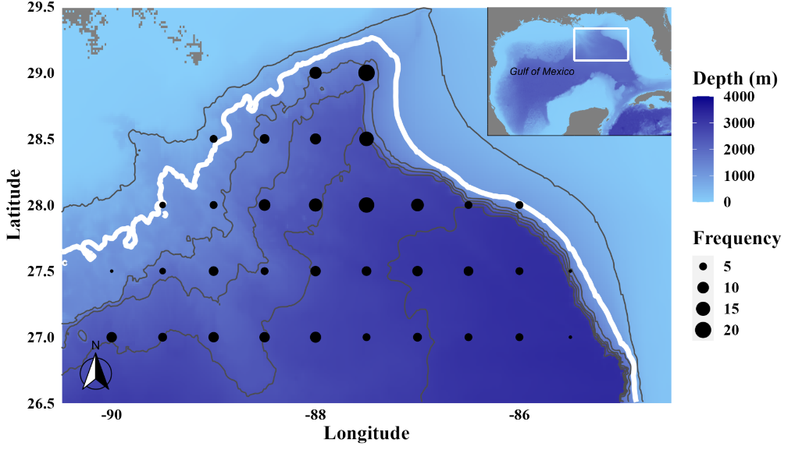
Figure 1. Map of the model domain. The model is bounded inshore by the 1000 m isobath (white line). Trawl locations are denoted as black circles, sized to deployment frequency. Other isobaths are denoted as black lines representing the 500, 1,500, 2,000, 2,500, and 3,000 m isobaths moving seaward. Bathymetry data were queried from the R “marmap” package.

Temperature data
Temperature data were collected from the HYCOM hourly dataset GOM10.04 (www.hycom.org). This dataset includes 26 depth intervals in the top 1000 m, with a horizontal spatial resolution of 1/25°. Data were gathered from January 1st, 2015, to December 31st, 2018. Hourly temperature averages were calculated as the geometric mean for each node on the 3-dimensional grid from the four years. Daily daytime and nighttime temperatures were calculated from the hourly temperatures as the geometric mean of the hours between 0700 and 1900 (local daytime) and 2000 to 0600 (local nighttime). These temperatures were applied to individuals in the model (Figure 2).

Model description
A trait-based model was developed that incorporates species-specific differences at an individual scale (Figure 2). Individual fishes were simulated from January 1st to December 31st on a diel time interval (day and night; 12-hour time steps). At each time step, fishes undergo processes of vertical migration, ingestion, respiration, carbonate excretion, defecation, and mortality. For each iteration, the species and all associated traits were assigned according to the relative abundance from field surveys (i.e., a species that contributed 5% of the total number of fishes caught had a 5% chance of being selected in each iteration). This process weights all results by the relative abundance in the net-caught assemblage (Figure S1). Leptocephali (i.e., anguilliform eel larvae) were excluded from the model because they allocate most of their ingested energy into metabolism (>60%), while non-leptocephalus larvae allocate more energy towards growth (Bishop and Torres 2001). Length-frequency distributions for species that amounted to greater than 25 individuals during sampling were fit to lognormal distributions to which the length of the modeled individual was chosen randomly (Figure 2). Since random selection from a lognormal distribution has a small probability of selecting an unrealistically high value, the maximum length of a species was capped at 5% greater than the largest fish captured during sampling. For species that amounted to less than 25 individuals, the length was randomly selected between the minimum and maximum lengths captured. Length-weight regressions were gathered from literature sources and used to estimate weight from length. This model utilizes dry weights, so if only a length-wet weight regression was available for a species, a mass conversion factor was applied according to the proximate composition of mesopelagic fishes in the eastern Gulf of Mexico (Stickney and Torres 1989). Species that were missing life history information were assigned parameters from closely related species.
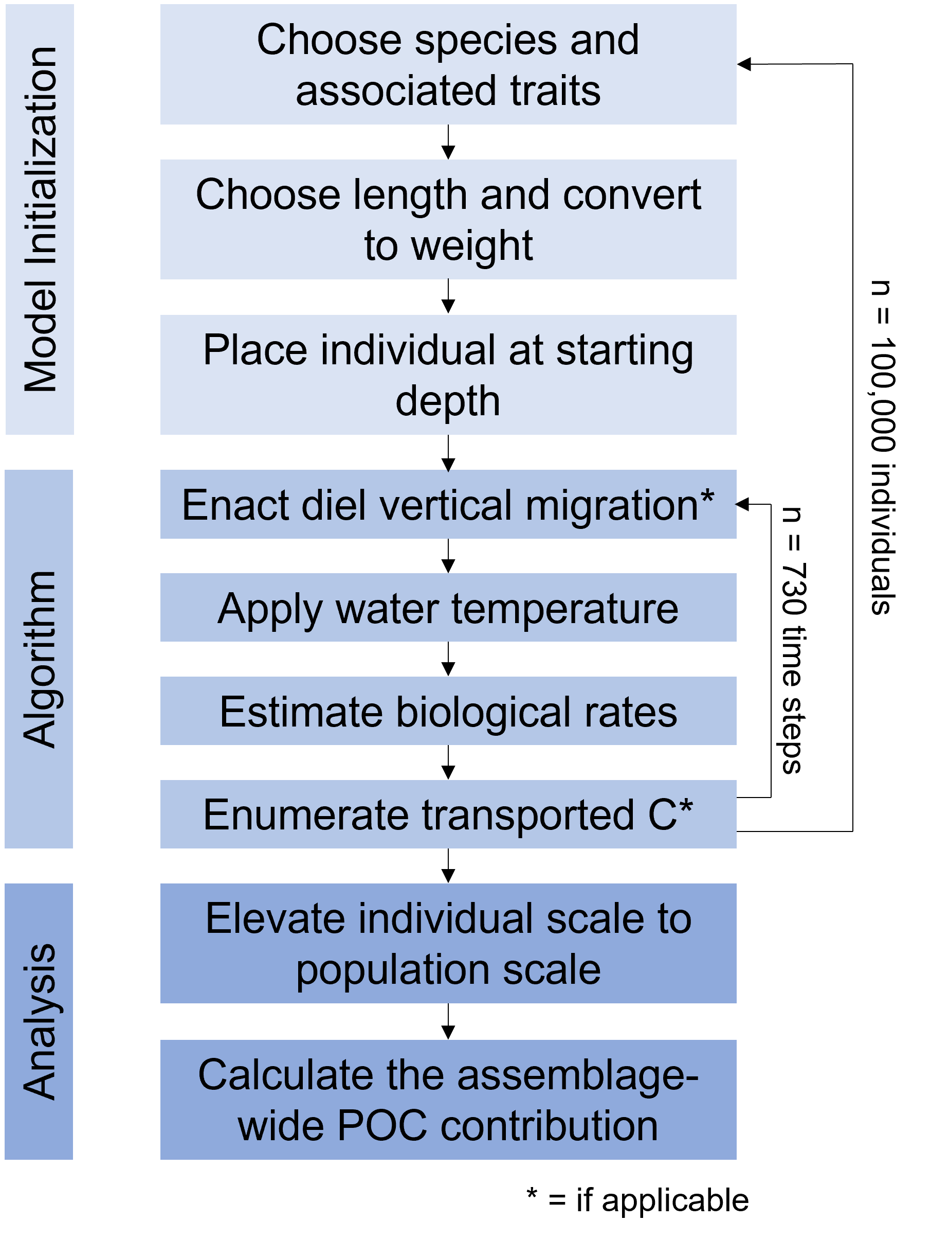
Figure 2. A flow chart showing the model process for each scenario. For each individual, the algorithm looped 730 times to simulate day and night for 365 calendar days. One hundred thousand individuals were run for each scenario.

The type of diel vertical migration behavior and depth ranges (both daytime and nighttime) were gathered from literature and survey data. The depth of an individual at a particular time step was a random value between the minimum and maximum depth for that species and the diel period (Table S2). The individual was placed at a random latitude and longitude within the domain boundaries to incorporate the potential effect of environmental spatial heterogeneity within the northern Gulf of Mexico.

The simulation started after the individual was characterized and assigned a location within the 3-dimensional grid (Figure 2). Vertical migration occurred at the beginning of each time step, but the migration decision of asynchronous vertical migrators (i.e., decision to migrate that night or not) was driven by a dynamic energy budget submodel that estimated the fish’s storage energy (Supplemental Material; Kooijman 2010; Jusup et al. 2011). In this submodel, the fish’s reserve energy was increased during feeding events and decreased at all time steps to cover metabolic costs. A lesser amount of stored energy equated to a greater probability that fish would migrate during that time step, and a large amount of stored energy (e.g., the fish ate the night before) resulted in a nearly zero chance the fish would migrate, which aligns with the hunger-satiation hypothesis (Pearre 2003; Bos et al. 2021). A temperature value was applied to the fish according to the latitude, longitude, depth, diel period, and day of the year using a trilinear interpolation method that calculates a weighted average according to the fish’s location within a grid cell (Johnston and Bernard 2017). All equations and parameters were described in the Supplemental Material. The resting metabolic rate (RMR; µl O₂ h⁻¹; Ikeda 2016) was estimated as a function of body mass, temperature, and depth. RMR was converted into KJ h⁻¹ using a conversion into g O₂ l⁻¹ of 1.43 (Gillooly et al. 2001) and an oxycalorific coefficient of 13.6 KJ g⁻¹ (Brett and Groves 1979). The active metabolic rate (AMR; migration and feeding) and standard metabolic rate (SMR; non-feeding) were calculated as the RMR multiplied by a factor of 4 and 0.5 respectively (Winberg 1956; Brett and Groves 1979).
For vertically migrating fishes, a predation success rate of 90% (i.e., the fish had a 90% chance of feeding) was utilized at night to incorporate the possibility of predation failure. A daytime predation success rate was set at 5% because of the possibility that fishes feed at depth (Pearcy et al. 1979). Given that fishes undergo vertical migration to enhance predation success, it was assumed unlikely that daytime feeding is as intense as nighttime feeding. Asynchronous migrating fishes that did not migrate had a 5% chance of predation regardless of the diel period. Non-migrating fishes had a 90% chance of feeding during each stage of the diel period but were restricted to one meal in a 24-hour period. If the fish fed, an ingestion rate (KJ timestep⁻¹) was calculated as the product of metabolic rate (MR), and an ingestion coefficient specific to vertical migration habit. The MR applied depended on the activity of the individual during that time step. Vertically migrating fishes spent four hours migrating at dawn and dusk, cumulatively (Bianchi and Mislan 2016).
Carbon was only considered “exported” if first consumed above a flux boundary (default = 150 m) and then moved deeper. A daily feeding ration (mg C d⁻¹) was calculated as the quotient of the ingestion rate and the caloric value of prey. Each species had a proportional prey diet according to literature values (Table S3). Juvenile conspecifics of epipelagic fishes were assumed to have a diet consisting of either crustaceans or fishes. To include the influence of different fish feeding guilds (>50% prey weight), prey quality was a function of the proximate composition of preys. The percent bodyweight consumed per feeding interval was calculated as the quotient of the biomass consumed per feeding interval and fish weight. Carbon respiration (mg C timestep⁻¹) was estimated using a respiratory quotient (0.9), oxycalorific coefficient, and MR. Carbon defecated above the flux boundary is passively exported into the deep via fast-sinking rates (Robison and Bailey 1981), while defecation below the flux boundary has been actively transported, but these are treated as one entity in this model. Defecated carbon (mg C day⁻¹) was a function of feeding ration, digestion efficiencies, and conversions of macromolecules to both prey weight and carbon. Macromolecule to carbon conversions were derived from the proximate composition of the prey taxa and digestion efficiencies (Brett and Groves 1979). Carbon excreted as calcium carbonate (mg C timestep⁻¹) was estimated as a function of body mass and temperature (Wilson et al. 2009).
Exported carbon associated with fish mortality below the flux boundary (mg C d⁻¹) is the function of a growth function, carbon-dry weight conversion of the fish, and specific energy content of fish. Growth was calculated as the product of the ingestion rate and 0.16 (Davison et al. 2013). Fish mortality (M) was a stochastic procedure where the daily probability of M occurring was estimated as the proportion of total mortality not derived from epipelagic predators in an ecosystem model for the region (derived from Woodstock et al. 2021). The values for M were 0.143, 0.227, 0.378, 0.0925, 0.15, and 0.427 for gonostomatids, myctophids, sternoptychids, stomiids, other mesopelagic micronektonivores (cephalopod and fish feeding guilds), and other mesopelagic zooplanktivores, respectively.
The daily carbon export for a fish is the sum of carbon exported via defecation, excretion, respiration, and mortality processes. A vertically integrated abundance (n m⁻²) was calculated from trawl data for each species from 2015–2018, and a 14% capture efficiency was used and applied to the abundance estimates (Koslow et al. 1997). Prior sampling years were excluded from the abundance calculation because of a noted population decline of many mesopelagic fish taxa (Sutton et al. submitted). The daily carbon export was multiplied by the species’ abundance to create a population-scale carbon export estimate (mg C m⁻² d⁻¹). Assemblage-wide particulate organic carbon (POC) estimates were calculated as the sum of all population contributions. A daily POC estimate for the model domain was obtained from the Copernicus Marine Environment Monitoring Service (CMEMS; http://marine.copernicus.eu/; Sauzède et al. 2020). The assemblage POC was divided by the particulate organic carbon estimate below the flux boundary to calculate the %POC derived from mesopelagic fishes. Although excretory carbon (calcium carbonate) and respiratory carbon (CO₂) produce different compounds, these were still calculated in relation to water column POC for comparative purposes.
The model was run under three scenarios to explore the effect different flux boundaries have on carbon export estimates. Each scenario included 100,000 iterations to assure that the modeled assemblage resembles the sampled micronekton assemblage. Flux boundaries of 100 m, 150 m, and 200 m were examined. Additionally, several parameters were adjusted to calculate the model’s sensitivity to temperature, activity rates, ingestion coefficients, respiratory quotient, predation success, prey quality, and fish mortality probability. For the sensitivity analysis, a 30 mm standard length Lampanyctus alatus was retained at a depth of 400 m during the day, 50 m depth during the night, and a geographic location of -88ºW and 28ºN to reduce stochasticity. However, mortality and predation success were stochastic processes that could not be ignored, so 1,000 iterations were run for each sensitivity scenario to mitigate the effect of this random process. The total flux contribution was compared to a base model, and the deviations revealed the sensitivity.

Results

Assemblage structure
After 100,000 iterations, the modeled species composition reasonably matched the net-caught species composition, indicating that the modeled assemblage reflects the oceanic Gulf of Mexico micronektonic fish assemblage. The most abundant family, Gonostomatidae, amounted to 60.5% of the relative abundance and 32.7% of the relative biomass (Table 1). The Gonostomatidae was dominated by six species in the genus Cyclothone, which alone accounted for 25.1% of the assemblage biomass because of their high relative abundance. Two gonostomatids accounted for greater than 10% of the assemblage biomass each: Cyclothone pallida and Sigmops elongatus. Myctophids (10.9%), sternoptychids (10.5%), and carangids (3.2%) were the next most abundant families in the model (Table 1). All carangids were larval or juvenile stages of holoepipelagic fishes remaining in the epipelagic zone throughout the day and accounted for 0.4% of the modeled assemblage biomass. Stomiids accounted for 1.7% of the abundance, but their large body sizes represented the fourth greatest biomass proportion of all families (6.7%). The eight most abundant families amounted to 90.8% of the assemblage abundance and 82.7% of the relative weight in the model (Table 1), indicating that this diverse assemblage is dominated by just a few main families.

Table 1. The relative abundance and biomass (expressed as %) of modeled individuals organized by family for the families that amounted to greater than 1% of the relative abundance. The proportions of vertical migrators for both family abundance and biomass are listed as well. “-” means no migrators.
Family | Relative Abundance | Proportion Migratory Abundance | Relative Weight | Proportion Migratory Biomass
Gonostomatidae | 60.5 | 2.0 | 32.7 | 34.0
Myctophidae | 10.9 | 94.9 | 27.4 | 77.0
Sternoptychidae | 10.5 | 16.1 | 13.2 | 58.7
Carangidae | 3.2 | - | 0.4 | -
Stomiidae | 1.7 | 89.3 | 6.7 | 94.4
Melamphaidae | 1.5 | 69.2 | 1.8 | 40.4
Phosichthyidae | 1.3 | 98.1 | 0.5 | 99.0

Ration
For 61.7% of all modeled species with a sample size greater than 10 (n = 142), larger fishes consumed more carbon per feeding interval than smaller conspecifics (Table S4). Exceptions to this relationship were generally fishes with a narrow size range that did not allow for a broad investigation into size-specific relationships, or a wide depth range that created uncertainty from the metabolic rate equation. All relationships between fish standard length and consumed carbon were best fit to a second-degree polynomial function.
Differences in species’ diets and diel vertical migratory behavior influenced the feeding rations of mesopelagic fishes. The percent bodyweight consumed per feeding interval varied among functional groups (p < 0.001; Figure 3). The median percent bodyweight consumed of synchronous migrators (3.1% ± 1.3), asynchronous migrators (3.4% ± 1.1), and holoepipelagic non-migrating fishes (4.0% ± 1.9) appear to be consistent. Mesopelagic non-migrating fishes had a lower percent bodyweight consumed (0.9% ± 0.4) than the other functional groups. The percent bodyweight consumed per feeding interval varied according to the feeding guild for all groups (p < 0.001). Fishes within the gelatinous zooplankton feeding guild (diet > 50% gelatinous zooplankton) had rations that were factors of 2.2, 1.7, and 2.2 greater than cephalopod, crustacean, and fish predators in mesopelagic non-migrators, respectively. Among the four most abundant mesopelagic fish families, the percent bodyweight consumed per feeding interval was 1.0% (± 0.4), 3.8% (± 1.3), 1.2% (± 0.8), and 1.8% (± 1.0) bodyweight for the Gonostomatidae, Myctophidae, Sternoptychidae, and Stomiidae, respectively. Within-family variation was caused by the presence of both vertical migrators and non-migrators and species-specific trait differences. Synchronous and asynchronous migrating fishes may consume a similar percent bodyweight per feeding interval, but a greater migration frequency by synchronous migrators indicates these fishes have a greater per capita predation impact on prey communities than asynchronous migrating fishes.
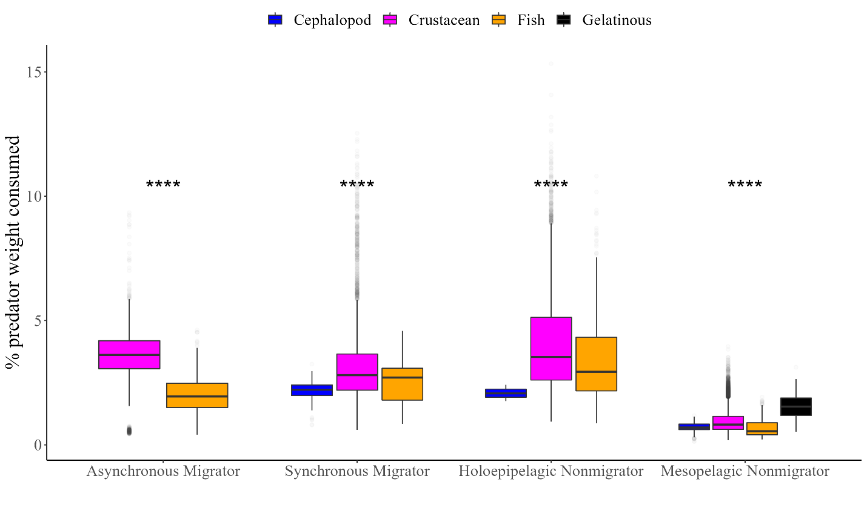
Figure 3. The % bodyweight consumed per feeding interval by functional group and feeding guild. Absent feeding guilds exist when a species does not fit that category. Asterisks represent significance in within-group comparisons.

Asynchronous migration periodicity
Asynchronous vertically migrating fishes rested for one day before migrating again during 81% of potential migrating events (Figure 4). Fishes migrated on successive nights (i.e., zero days off between migrations) during 10% of the possible migrating events. On just one occurrence (8 × 10⁻⁵ %), a Lampadena luminosa waited seven days before migrating again. There was no difference in asynchronous migration periodicity among species (p = 0.48; Figure S2) or within any species, ostensibly because energy assimilation and usage are a function of body size. The consumption of larger prey items (i.e., higher ration) did not significantly increase the wait time between migration (p = 0.5). Although counterintuitive, this model does not incorporate satiation by individuals that consume more than the amount required for their energetic demand. Therefore, the asynchronous migration periodicity for this model can be interpreted as the average frequency for a healthy fish that both assimilate the required energy and meets metabolic demands.
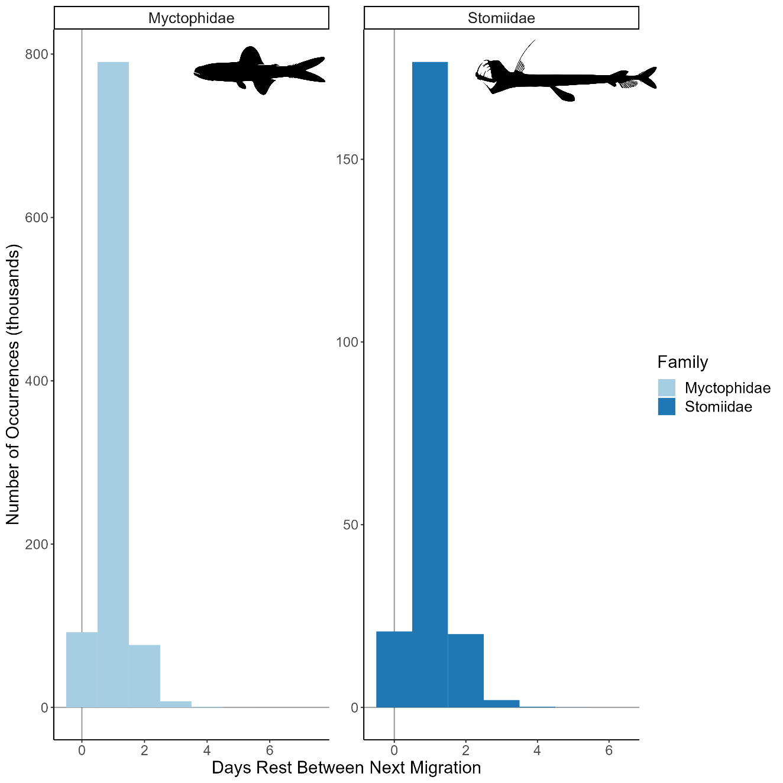
Figure 4. The frequency of days rest in between migrations for all asynchronous vertical migrators (n = 28). The x-axis values represent the maximum values per family. Unaggregated results for all asynchronous vertical migrating species are shown in Figure S2.

Carbon export scenarios
The particulate organic carbon transported across the flux boundary was not different among the three depth scenarios (100, 150, and 200 m). Defecated carbon was added to the water column by vertical migrators at rates of 0.41 (± 0.18), 0.39 (± 0.18), and 0.36 (± 0.18) mg C m⁻² d ⁻¹ for the 100-m, 150-m, and 200-m boundary scenarios, respectively, with no signal of seasonality. On average, the contribution of defecated C to the particulate organic carbon in the water column ranged from 4.0–8.6%, with a maximum daily contribution of 25.3%. Excretory flux as calcium carbonate for the assemblage amounted to less than 0.1% of the total particulate organic carbon contribution in all scenarios. Carbon lost from the assemblage through mortality contributed just 0.05 (±0.02) mg C m⁻² d⁻¹ but is associated with a considerable amount of uncertainty that is caused by the stochastic nature of individual mortality (Figure 5). Carbon was respired at rates of 0.57 (± 0.31), 0.65 (± 0.30), and 0.63 (± 0.30) mg C m⁻² d⁻¹ for the 100-m, 150-m, and 200-m scenarios, respectively. However, just 0.3 (53%), 0.49 (75%), and 0.44 (70%) mg C m⁻² was respired below the flux boundaries, and thus considered transported. The mean respiratory fluxes relative to the water column particulate organic carbon ranged from 7.3–15.2%, and the maximum was 45.8%. The respiratory flux contribution to the water column was 1.7 times the fecal contribution for the vertically migrating fish assemblage (Figure 5). Considering all bioenergetic processes, 61% of ingested carbon was lost from the assemblage, while 39% was retained (Figure 5). The total contribution to the particulate organic carbon pool by mesopelagic fishes in the Gulf of Mexico ranged from 11.4–23.9%, with the possibility to be 71.1% at the upper limit of uncertainty.
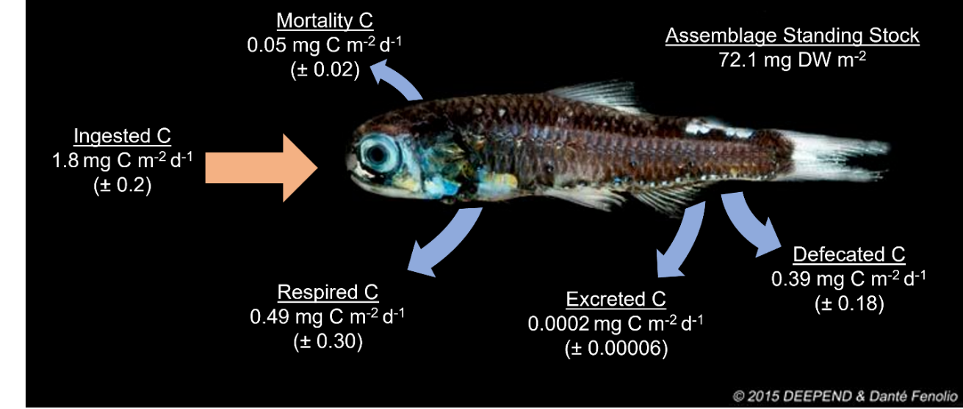
Figure 5. The carbon budget for the vertically migrating assemblage. Flows are represented by arrows, with the orange arrow portraying carbon entering the assemblage and blue arrows showing carbon exported by the assemblage. Values correspond to the 150-m flux boundary scenario and the contribution of diel vertical migrators only. The Diaphus mollis image is courtesy of Danté Fenolio and the DEEPEND Consortium.

The total carbon flux for the mesopelagic assemblage was 0.70 (± 0.54), 0.88 (± 0.74), and 0.80 (± 0.64) mg C m⁻² d⁻¹ for the 100-m, 150-m, and 200-m scenarios, respectively (Table 2). The family Myctophidae accounted for at least 53% of the assemblage carbon flux in all three scenarios (Table 2). Two myctophids, Lepidophanes guentheri and Lampanyctus alatus each contributed greater than 10% of the total carbon flux in the 150-m flux scenario. The 30 most abundant species accounted for 41.5% of the assemblage carbon export. Although the Gonostomatidae accounted for greater than 60% of the relative assemblage abundance, this family contributed just 8.2%, 6.1%, and 6.3% of the carbon flux in the 100-m, 150-m, and 200-m scenarios (Table 2). The gonostomatid contribution was largely Sigmops elongatus, which accounted for 0.050 (±0.092), 0.045 (± 0.084), and 0.042 (± 0.078) mg C m⁻² d⁻¹ in the 100-m, 150-m, and 200-m scenarios. Despite occupying just 1.7% of the assemblage abundance, stomiids accounted for greater than 12% of the total carbon flux by the assemblage in all scenarios (Table 2). Individually, the most abundant species in the ecosystem made a large proportion of the carbon flux, but the assemblage diversity and the large body size of rare species also elevated the assemblage-based carbon export value.

Table 2. The carbon transport of vertically migrating mesopelagic families is ordered by the sample size of vertical migrators only. Assemblage values are in bold. Flux values are in the units mg C m⁻² d⁻¹ (mean ± sd). Percent values are the proportion of the total assemblage carbon flux for each scenario
 | 100 m |  | 150 m |  | 200 m
Family | Value | % | Value | % | Value | %
Assemblage | 7.1 × 10⁻¹±5.4 × 10⁻¹ | - | 8.8 × 10⁻¹±7.4 × 10⁻¹ | - | 8.0 × 10⁻¹±6.4 × 10⁻¹ | -
Myctophidae | 3.7 × 10⁻¹±2.7 × 10⁻¹ | 53.1% | 5.4 × 10⁻¹±4.5 × 10⁻¹ | 61.6% | 5.0 × 10⁻¹±3.7 × 10⁻¹ | 62.2%
Stomiidae | 1.6 × 10⁻¹±1.1 × 10⁻¹ | 22.7% | 1.4 × 10⁻¹±1.1 × 10⁻¹ | 15.9% | 1.3 × 10⁻¹±1.0 × 10⁻¹ | 15.7%
Gonostomatidae | 5.8 × 10⁻²±9.4 × 10⁻² | 8.2% | 5.3 × 10⁻²±8.5 × 10⁻² | 6.1% | 5.0 × 10⁻²±7.9 × 10⁻² | 6.3%
Sternoptychidae | 1.0 × 10⁻²±1.4 × 10⁻² | 1.4% | 4.4 × 10⁻²±6.0 × 10⁻² | 5.1% | 3.4 × 10⁻²±4.4 × 10⁻² | 4.2%
Melamphaidae | 1.5 × 10⁻²±5.7 × 10⁻³ | 2.2% | 3.0 × 10⁻²±7.8 × 10⁻³ | 3.5% | 3.1 × 10⁻²±9.3 × 10⁻³ | 3.9%
Scopelarchidae | 1.9 × 10⁻²±1.3 × 10⁻² | 2.6% | 1.5 × 10⁻²±8.5 × 10⁻³ | 1.7% | 1.4 × 10⁻²±9.5 × 10⁻³ | 1.7%
Paralepididae | 1.5 × 10⁻²±4.5 × 10⁻³ | 2.1% | 1.3 × 10⁻²±2.9 × 10⁻³ | 1.5% | 1.4 × 10⁻²±2.9 × 10⁻³ | 1.7%
Phosichthyidae | 1.3 × 10⁻²±4.7 × 10⁻³ | 1.8% | 8.5 × 10⁻³±5.2 × 10⁻³ | 1.0% | 6.4 × 10⁻³±3.9 × 10⁻³ | 0.8%
Chiasmodontidae | 1.1 × 10⁻²±1.2 × 10⁻² | 1.6% | 8.6 × 10⁻³±5.5 × 10⁻³ | 1.0% | 6.2 × 10⁻³±7.6 × 10⁻³ | 0.8%
Notosudidae | 7.8 × 10⁻³±3.0 × 10⁻³ | 1.1% | 7.5 × 10⁻³±3.1 × 10⁻³ | 0.9% | 7.0 × 10⁻³±2.4 × 10⁻³ | 0.9%
Bregmacerotidae | 9.4 × 10⁻³±5.0 × 10⁻³ | 1.3% | 6.9 × 10⁻³±4.4 × 10⁻³ | 0.8% | 7.2 × 10⁻³±3.7 × 10⁻³ | 0.9%
Percophidae | 8.9 × 10⁻³±1.7 × 10⁻³ | 1.3% | 6.9 × 10⁻³±1.3 × 10⁻³ | 0.8% | 5.2 × 10⁻³±1.3 × 10⁻³ | 0.6%
Evermannellidae | 1.7 × 10⁻³±6.6 × 10⁻⁴ | 0.2% | 1.5 × 10⁻³±7.8 × 10⁻⁴ | 0.2% | 1.3 × 10⁻³±4.7 × 10⁻⁴ | 0.2%
Gempylidae | 7.2 × 10⁻⁴±4.2 × 10⁻⁴ | 0.1% | 6.9 × 10⁻⁴±5.8 × 10⁻⁴ | 0.1% | 5.3 × 10⁻⁴±4.1 × 10⁻⁴ | 0.1%
Trichiuridae | 1.3 × 10⁻³±1.1 × 10⁻⁴ | 0.2% | 1.1 × 10⁻³±9.7 × 10⁻⁵ | 0.1% | 9.2 × 10⁻⁴±9.6 × 10⁻⁵ | 0.1%
Howellidae | 1.6 × 10⁻⁶±1.5 × 10⁻⁷ | <0.1% | 1.6 × 10⁻⁶±1.3 × 10⁻⁷ | <0.1% | 1.5 × 10⁻⁶±1.3 × 10⁻⁷ | <0.1%

Sensitivity analysis
A sensitivity analysis revealed the parameters that most influenced the model (Table 3). Temperature changes resulted in a 51% increase in particulate organic carbon flux contribution when increased by 20% and a 34% reduction when the temperature was decreased by 20%. Activity rate parameters (e.g., AMR, and migration time) changed the carbon export value by 15% (Table 5). Interestingly, the model was similarly sensitive to ingestion coefficients and prey quality (for a crustacean eater). Adjustments to the predation success parameters did not influence the model results by more than 3% in any scenario (Table 3), suggesting that a 10% deviation to predation success does not significantly impact carbon flux rates. The model’s sensitivity is related to the use of a metabolic rate equation to regulate all other bioenergetic processes in the model.
Table 3. Results in terms of the particulate organic carbon contribution to the assemblage from a sensitivity analysis of a 30 mm SL Lampanyctus alatus retained at the same depths, longitude, and latitude for 1,000 iterations. Low and High factors are the values multiplied by the default value for that parameter. Values in italics are the actual value used in the scenario, rather than a multiplicative parameter. Ratios were calculated as the simulated value divided by a base scenario (all default parameters)
Parameter | Low Factor | High Factor | Low:Base | High:Base
Active Metabolic Rate | 0.8 | 1.2 | 0.85 | 1.15
Caloric Content of Prey | 0.8 | 1.2 | 0.89 | 1.17
Ingestion Coefficient | 0.8 | 1.2 | 1.23 | 0.85
Migration Time | 3 | 5 | 0.85 | 1.15
Mortality | 0.8 | 1.2 | 0.96 | 1.05
Predation Success Day | 0 | 0.1 | 1.00 | 0.99
Predation Success Night | 0.8 | 1 | 0.97 | 1.03
Respiratory Quotient | 0.7 | 1 | 0.98 | 1.01
Standard Metabolic Rate | 0.8 | 1.2 | 0.95 | 1.05
Temperature | 0.8 | 1.2 | 0.66 | 1.51

Discussion
The development of a trait-based bioenergetic model for individual mesopelagic fishes advances understanding of open carbon export by incorporating species-specific characteristics and stochasticity into the equation. Including species-specific differences in diel depth occupancy and vertical migratory behavior along with randomness within depth ranges influences the metabolic rate estimates in the RMR equation that was used (Ikeda 2016). Similarly, differences in prey quality affect the amount of carbon an individual ingests per feeding period, which is a more realistic estimation than assuming all species ingest the same prey taxa. The uncertainty in bioenergetic rates estimated by this model is greater than other carbon export models that use a similar algorithm (Hidaka et al. 2001; Davison et al. 2013). However, this decrease in precision is partially caused by individual variability, differences in diet among species, diel depth differences, diel vertical migratory behavior, which are all present factors in oceanic ecosystems. Individual variability and ontogenic changes in depth occupancy, migratory behavior, and diet are not fully resolved within the assemblage, but do exist (Lancraft et al. 1988; Hopkins and Gartner 1992; Christiansen et al. 2021), indicating that this modeling framework could be advanced pending a sufficient amount of life history information. To understand bioenergetic rates at a population, community, or global scale, it is imperative to understand the variation caused by individuals within a species to calculate the magnitude of this variation at a higher order.

Bioenergetic rates
The use of metabolic rates to estimate ingestion rates produces values comparable to empirical and model estimates. In this study, myctophid daily rations range from 0.3–8.5%, with a geometric mean of 3.0%. In other regions, myctophid rations range from 0.2–4.4% bodyweight consumed (Pakhomov et al. 1996; Pusch et al. 2004; Tanaka et al. 2013). The myctophid species with rations beyond the literature values are synchronous migrators that ascend above the thermocline each night (e.g., Myctophum affine; Hopkins and Gartner 1992), experiencing the most extreme metabolic requirements. Stomiids in the Gulf of Mexico have average instantaneous rations that range from 2.1–7.6, but their maximum rations (largest % bodyweight observed) can be as high as 99% bodyweight (Sutton and Hopkins 1996). In this study, stomiid percent bodyweight consumed per feeding interval ranged from 0.3–3.5% with a geometric mean of 1.9% for all species, suggesting that stomiids likely consume more than is necessary to meet their minimum energetic requirement. Alternatively, this model may underestimate activity rates that would increase their metabolic requirements, and subsequently feeding rations.
Although prey taxa were coarse (e.g., crustacean, fish, cephalopod, gelatinous zooplankton), the type of prey a fish predominantly consumed influenced the percent bodyweight consumed per feeding interval. Gelatinous zooplankton is historically underrepresented in diet studies because of rapid digestion rates and difficulties with taxonomic identification, creating the “jelly web” (Robison 2004). These soft-bodied taxa may represent a greater proportion of diets than are able to be incorporated here, and our results suggest that the inclusion of lower quality prey increases rations. Essentially, the consumption of lesser quality prey (lower caloric content per g of prey) leads to a fish having to consume more biomass to acquire a sufficient number of resources for their energetic demand. The modeled rations align with empirical daily ration estimates that are typically derived from stomach fullness values and gut evacuation rates, indicating that these methods are comparable to simulations developed from metabolic theory.

Asynchronous vertical migration
The periodicity of asynchronous vertical migration is an important carbon budget parameter, as mesopelagic fishes will only actively transport carbon if they ascend beyond the flux boundary. In this model, the process of asynchronous vertical migration was driven by the energy reserves an individual fish was currently storing. Energy assimilation and usage were both functions of body mass, and therefore all species had a similar asynchronous migration periodicity. On 81% of occasions, fishes took one day of rest before migrating again. Davison et al. (2013) used the difference between “shallow” and “deep” micronekton trawls to estimate that ~50% of the vertically migrating mesopelagic biomass migrates each night in the California current region, which could be interpreted as a migration periodicity of one day’s rest per individual, similar to the results of this model. This model indicates that fishes may migrate on successive nights (10% likelihood), but it is possible that they rest for a full week. Sutton and Hopkins (1996) estimated that stomiids in the Gulf of Mexico only feed once every eight days based on their instantaneous ration and gastric evacuation rates. Hypothetically, stomiids may have a larger ration (Sutton and Hopkins 1996) and lower activity rates (i.e., sit-and-wait predation strategy; Feagans-Bartow and Sutton 2014) than modeled in this study. The realistic asynchronous migration periodicity is reliant on enigmatic, species-specific activity rates, which could not be modeled in this study. However, assuming that the entirety of a population migrates each night, instead of a proportion, may inflate nutrient flux and other bioenergetic rate estimates.

Flux boundaries in carbon export models
Adjusting the flux boundary did not reveal differences in carbon export rates within species, which were retained at the assemblage scale. However, in the 150-m and 200-m flux boundary scenarios, greater than 70% of the respired carbon occurred below the flux boundary, as opposed to 53% in the 100-m flux boundary. Although counterintuitive, the shallowest fishes in the water column experience the warmest temperatures and have the highest respiration rates, relative to deeper-dwelling fishes. Species-specific differences among flux boundary scenarios were a product of the depth ranges of organisms (e.g., some fishes only migrate to 175 m at night; Hopkins and Gartner 1992), which is reflected at the assemblage scale. Therefore, vertically migrating fishes ascending above the 100-m depth boundary (i.e., fishes considered in the 100-m flux boundary scenario) may respire a lesser proportion of carbon below the flux boundary when compared to the 150-m and 200-m flux boundary scenarios. The depth a fish ascends to during diel vertical migration is primarily a light-driven process (Boswell et al. 2020), but other factors can influence individual fish behavior as well, such as the presence of predators and fish size (Urmy and Benoit-Bird 2021), indicating that the inclusion of a singular nighttime depth for all mesopelagic fishes will introduce uncalculated error in bioenergetic models. Refinement of depth distribution information and increased understanding of flux boundary depths will enhance fish-mediated carbon export modeling efforts in the open ocean.

Comparison to other carbon export studies
Carbon export by mesopelagic fishes contributes significantly to the carbon transported into the mesopelagic zone, particularly in oligotrophic regions. The fecal contribution to the total particulate organic carbon standing stock in the water column ranged from 0.04–25.3%. A previous fecal carbon contribution estimate for mesopelagic fishes in the eastern Gulf of Mexico was 0.5–0.9 mg C m⁻² d ⁻¹ (Hopkins et al. 1996). The fecal carbon flux rate in this model ranged from 0.18–0.57 mg C m⁻² d ⁻¹. Although the upper confidence levels of all scenarios do enter the range of the previous estimate, the mean values are below 0.5. Any difference in carbon export is most likely explained by the previous standing stock estimate of 296 mg DW m⁻², 4.1 times greater than the current modeled standing stock estimate. The difference in standing stock values may be attributed to 1) the difference between the biomass estimated from the direct weighing of trawl catches and length-weight regression estimates based on measuring trawl catches and 2) a decline in mesopelagic fish biomass in the Gulf of Mexico that has occurred since 2011 (Sutton et al. submitted). Although model uncertainty and a lack of flux boundary depth confirmation remove our ability to determine if the fecal carbon contribution has declined, further exploration is required given the mean and lower confidence level limits to all scenarios.
The fish-mediated carbon flux estimates for the northern Gulf of Mexico are reasonable compared to other localities. The fish-mediated carbon export rates in other oligotrophic, open-ocean regions range from 0.04 mg C m⁻² d⁻¹ near the Mid-Atlantic Ridge (Hudson et al. 2014) to 11.5 mg C m⁻² d⁻¹ in the tropical Atlantic Ocean (Hernández-León et al. 2019b). In the oceanic Gulf of Mexico, the vertically migrating fish assemblage contributed between 0.14–0.72 mg C m⁻² d⁻¹. Respiratory flux ranged from 0.03–45.8% POC, depending on the scenario. Estimates for respiratory flux range from 1.2–10.4% POC in the Canary Islands (Ariza et al. 2015), 12–32% POC in the tropical Atlantic Ocean Hernández-León et al. (2019b), and 1–47% POC in the Scotia Sea (Belcher et al. 2019). There is a wide range in the results of carbon export models due to the differences in the use of bioenergetic rate equations, fish communities, and environmental conditions (i.e., water temperature). Consistency among these modeling objectives will be critical to estimate the contribution of mesopelagic fishes to the global carbon budget, but the regional mesopelagic community and biogeochemical differences may also influence local carbon export rates.

Acknowledgements
This paper is a result of research funded by the National Oceanic and Atmospheric Administration's RESTORE Science Program under award NA19NOS4510193 to Nova Southeastern University and The Gulf of Mexico Research Initiative. This is publication #1433 from the Institute of Environment at Florida International University. The authors are grateful to Kevin Boswell for comments on the model framework.
Literature Cited
Angel, M. V. 1993. Biodiversity of the pelagic ocean. Conserv. Biol. 7: 760–772. doi:10.1046/j.1523-1739.1993.740760.x

Archibald, K. M., D. A. Siegel, and S. C. Doney. 2019. Modeling the impact of zooplankton diel vertical migration on the carbon export flux of the biological pump. Global Biogeochem. Cycles 33: 181–199. doi:10.1029/2018GB005983

Ariza, A., J. C. Garijo, J. M. Landeira, F. Bordes, and S. Hernández-León. 2015. Migrant biomass and respiratory carbon flux by zooplankton and micronekton in the subtropical northeast Atlantic Ocean (Canary Islands). Prog. Oceanogr. 134: 330–342. doi:10.1016/j.pocean.2015.03.003

Belcher, A., R. A. Saunders, and G. A. Tarling. 2019. Respiration rates and active carbon flux of mesopelagic fishes (Family Myctophidae) in the Scotia Sea, Southern Ocean. Mar. Ecol. Prog. Ser. 610: 149–162. doi:10.3354/meps12861

Bianchi, D., and K. A. S. Mislan. 2016. Global patterns of diel vertical migration times and velocities from acoustic data. Limnol. Oceanogr. 61: 353–364. doi:10.1002/lno.10219

Bishop, R. E., and J. J. Torres. 2001. Leptocephalus energetics: assembly of the energetics equation. Mar. Biol. 138: 1093–1098. doi:https://doi.org/10.1007/s002270100541

Bos, R. P., T. T. Sutton, and T. M. Frank. 2021. State of satiation partially regulates the dynamics of vertical migration. Front. Mar. Sci. 8: 1–11. doi:10.3389/fmars.2021.607228

Boswell, K. M., M. D’Elia, M. W. Johnston, J. A. Mohan, J. D. Warren, R. J. D. Wells, and T. T. Sutton. 2020. Oceanographic structure and light levels drive patterns of sound scattering layers in a low-latitude oceanic system. Front. Mar. Sci. 7: 51. doi:10.3389/fmars.2020.00051

Brett, J., and T. Groves. 1979. Physiological energetics: volume VIII, bioenergetics and growth, p. 280–352. In W.S. Hoar, D.J. Randall, and J.R. Brett [eds.], Fish Physiology. Academic Press.

Buesseler, K. O., P. W. Boyd, E. E. Black, and D. A. Siegel. 2020. Metrics that matter for assessing the ocean biological carbon pump. Proc. Natl. Acad. Sci. 117: 9679–9687. doi:10.1073/pnas.1918114117/-/DCSupplemental

Childress, J. J., and G. N. Somero. 1979. Depth-related enzymic activities in muscle, brain and heart of deep-living pelagic marine teleosts. Mar. Biol. 52: 273–283. doi:https://doi.org/10.1007/BF00398141

Choy, C. A., S. H. D. Haddock, and B. H. Robison. 2017. Deep pelagic food web structure as revealed by in situ feeding observations. Proc. R. Soc. B 284: 20172116. doi:10.1098/rspb.2017.2116

Christiansen, S., T. A. Klevjer, A. Røstad, D. L. Aksnes, and S. Kaartvedt. 2021. Flexible behaviour in a mesopelagic fish (Maurolicus muelleri). ICES J. Mar. Sci. doi:10.1093/icesjms/fsab075

Clarke, T. M. 1978. Dial feeding patterns of 16 species of mesopelagic fishes from Hawaiian waters. Fish. Bull. 76: 495–513.

Cook, A. B., A. M. Bernard, K. M. Boswell, and others. 2020. A multidisciplinary approach to investigate deep-pelagic ecosystem dynamics in the Gulf of Mexico following Deepwater Horizon. Front. Mar. Sci. 7: 1–14. doi:10.3389/fmars.2020.548880

Davison, P. C. C., D. M. M. Checkley, J. A. A. Koslow, and J. Barlow. 2013. Carbon export mediated by mesopelagic fishes in the northeast Pacific Ocean. Prog. Oceanogr. 116: 14–30. doi:10.1016/J.POCEAN.2013.05.013

Ducklow, H. W., D. K. Steinberg, and K. O. Buesseler. 2001. Upper ocean carbon export and the biological pump. Oceanography 14: 50–58.

Eppley, R. W. 1972. Temperature and phytoplankton growth in the sea. Fish. Bull. 70: 1063–1085.

Feagans-Bartow, J. N., and T. T. Sutton. 2014. Ecology of the oceanic rim: pelagic eels as key ecosystem components. Mar. Ecol. Prog. Ser. 502: 257–266. doi:10.3354/meps10707

Gartner Jr, J. V., T. L. Hopkins, R. C. Baird, and D. M. Milliken. 1987. The lanternfishes (Pices: Myctophidae) of the Eastern Gulf of Mexico. Fish. Bull. 35: 81–98.

Gibbs, A., and G. N. Somero. 1989. Pressure adaptation of Na+/K+-ATPase in gills of marine teleosts. J. Exp. Biol. 143: 475–492. doi:10.1242/jeb.143.1.475

Gillooly, J., J. Brown, G. West, and others. 2001. Effects of size and temperature on metabolic rate. Science (80-. ). 293: 2248–2251. doi:10.1126/science.1061967

Haddock, S. H. D. 2004. A golden age of gelata: Past and future research on planktonic ctenophores and cnidarians. Hydrobiologia 530–531: 549–556. doi:10.1007/s10750-004-2653-9

Haedrich, R. L. 1996. Deep-water fishes: Evolution and adaptation in the earth’s largest living spaces. J. Fish Biol. 49: 40–53. doi:10.1111/j.1095-8649.1996.tb06066.x

Hernández-León, S., S. Calles, and M. Luz Fernández De Puelles. 2019a. The estimation of metabolism in the mesopelagic zone: Disentangling deep-sea zooplankton respiration. Prog. Oceanogr. 178: 102163. doi:10.1016/j.pocean.2019.102163

Hernández-León, S., M. P. Olivar, M. L. Fernández de Puelles, A. Bode, A. Castellón, C. López-Pérez, V. M. Tuset, and J. I. González-Gordillo. 2019b. Zooplankton and micronekton active Flux across the tropical and subtropical Atlantic Ocean. Front. Mar. Sci. 6: 1–20. doi:10.3389/fmars.2019.00535

Hidaka, K., K. Kawaguchi, M. Murakami, and M. Takahashi. 2001. Downward transport of organic carbon by diel migratory micronekton in the western equatorial pacific: Its quantitative and qualitative importance. Deep. Res. Part I Oceanogr. Res. Pap. 48: 1923–1939. doi:10.1016/S0967-0637(01)00003-6

Hopkins, T. L., and J. V Gartner. 1992. Resource-partitioning and predation impact of a low-latitude myctophid community. Mar. Biol. 114: 185–197. doi:10.1007/BF00349518

Hopkins, T. L., T. T. Sutton, and T. M. Lancraft. 1996. The trophic structure and predation impact of a low latitude midwater fish assemblage. Prog. Oceanogr. 38: 205–239.

Hudson, J. M., D. K. Steinberg, T. T. Sutton, J. E. Graves, and R. J. Latour. 2014. Myctophid feeding ecology and carbon transport along the northern Mid-Atlantic Ridge. Deep. Res. Part I Oceanogr. Res. Pap. 93: 104–116. doi:10.1016/j.dsr.2014.07.002

Ikeda, T. 2016. Routine metabolic rates of pelagic marine fishes and cephalopods as a function of body mass, habitat temperature and habitat depth. J. Exp. Mar. Bio. Ecol. 480: 74–86. doi:10.1016/j.jembe.2016.03.012

Irigoien, X., T. A. Klevjer, A. Røstad, and others. 2014. Large mesopelagic fishes biomass and trophic efficiency in the open ocean. Nat. Commun. 5: 3271. doi:10.1038/ncomms4271

Johnston, M. W., and A. M. Bernard. 2017. A bank divided: quantifying a spatial and temporal connectivity break between the Campeche Bank and the northeastern Gulf of Mexico. Mar. Biol. 164: 1–15. doi:10.1007/s00227-016-3038-0

Johnston, M. W., R. J. Milligan, C. G. Easson, S. deRada, D. C. English, B. Penta, and T. T. Sutton. 2019. An empirically validated method for characterizing pelagic habitats in the Gulf of Mexico using ocean model data. Limnol. Oceanogr. Methods 17: lom3.10319. doi:10.1002/lom3.10319

Judkins, D. C. 2014. Geographical distribution of pelagic decapod shrimp in the Atlantic Ocean. Zootaxa 3895: 301–345. doi:10.11646/zootaxa.3895.3.1

Jusup, M., T. Klanjscek, H. Matsuda, and S. A. L. M. Kooijman. 2011. A full lifecycle bioenergetic model for bluefin tuna. PLoS One 6: e21903. doi:10.1371/journal.pone.0021903

Kooijman, S. A. L. M. 2010. Dynamic Energy Budget theory for metabolic organisation : Summary of concepts of the third edition, Cambridge University Press.

Koslow, J. A., R. J. Kloser, and A. Williams. 1997. Pelagic biomass and community structure over the mid-continental slope off southeastern Australia based upon acoustic and midwater trawl sampling. Mar. Ecol. Prog. Ser. 146: 21–35. doi:10.3354/meps146021

Lancraft, T., T. L. Hopkins, and J. J. Torres. 1988. Aspects of the ecology of the mesopelagic fish Gonostoma elongatum (Gonostomatidae, Stomnformes) in the eastern Gulf of Mexico. Mar. Ecol. Prog. Ser. 49: 27–40. doi:10.3354/meps049027

Lomas, M. W., D. K. Steinberg, T. Dickey, C. Carlson, N. Nelson, R. Condon, and N. Bates. 2010. Increased ocean carbon export in the Sargasso Sea linked to climate variability is countered by its enhanced mesopelagic attenuation. Biogeosciences 7: 57–70. doi:10.5194/bg-7-57-2010

Pakhomov, E. A., R. Perissinotto, and C. D. McQuaid. 1996. Prey composition and daily rations of myctophid fishes in the Southern Ocean. Mar. Ecol. Prog. Ser. 134: 1–14. doi:10.3354/meps134001

Pearcy, W. G., H. V Lorz, and W. Peterson. 1979. Comparison of the Feeding Habits of Migratory and Non-Migratory Stenobrachius leucopsarus (Myctophidae). Mar. Biol. 51: 1–8.

Pearre, S. 2003. Eat and run? The hunger/satiation hypothesis in vertical migration: History, evidence and consequences. Biol. Rev. Camb. Philos. Soc. 78: 1–79. doi:10.1017/S146479310200595X

Proud, R., N. O. Handegard, R. J. Kloser, M. J. Cox, A. S. Brierley, and D. Demer. 2019. From siphonophores to deep scattering layers: Uncertainty ranges for the estimation of global mesopelagic fish biomass. ICES J. Mar. Sci. 76: 718–733. doi:10.1093/icesjms/fsy037

Pusch, C., P. A. Hulley, and K. H. Kock. 2004. Community structure and feeding ecology of mesopelagic fishes in the slope waters of King George Island (South Shetland Islands, Antarctica). Deep. Res. Part I Oceanogr. Res. Pap. 51: 1685–1708. doi:10.1016/j.dsr.2004.06.008

Radchenko, V. I. 2007. Mesopelagic fish community supplies “Biological Pump.” Raffles Bull. Zool. 14: 265–271. doi:https://doi.org/10.1038/274362a0

Robison, B. H. 2004. Deep pelagic biology. J. Exp. Mar. Bio. Ecol. 300: 253–272. doi:10.1016/j.jembe.2004.01.012

Robison, B. H., and T. G. Bailey. 1981. Sinking rates and dissolution of midwater fish fecal matter. Mar. Biol. 65: 135–142. doi:10.1007/BF00397077

Saba, G. K., A. B. Burd, J. P. Dunne, and others. 2021. Toward a better understanding of fish-based contribution to ocean carbon flux. Limnol. Oceanogr. 1–26. doi:10.1002/lno.11709

Sauzède, R., J. E. Johnson, H. Claustre, G. Camps-Valls, and A. B. Ruescas. 2020. Estimation of oceanic particulate organic carbon with machine learning. ISPRS Ann. Photogramm. Remote Sens. Spat. Inf. Sci. 2: 949–956. doi:10.5194/isprs-annals-V-2-2020-949-2020

Stickney, D. G., and J. J. Torres. 1989. Proximate composition and energy content of mesopelagic fishes from the eastern Gulf of Mexico. Mar. Biol. 103: 13–24. doi:10.1007/BF00391060

Sutton, T. T. 2013. Vertical ecology of the pelagic ocean: classical patterns and new perspectives. J. Fish Biol. 83: 1508–1527. doi:10.1111/jfb.12263

Sutton, T. T., T. Frank, H. Judkins, and I. C. Romero. 2020. As gulf oil extraction goes deeper, who is at risk? community structure, distribution, and connectivity of the deep-pelagic fauna., In S. Murawski, C.H. Ainsworth, S. Gilbert, D.J. Hollander, C.B. Paris, M. Schlüter, and D.L. Wetzel [eds.], Scenarios and Responses to Future Deep Oil Spills. Springer.

Sutton, T. T., and T. Hopkins. 1996. Trophic ecology of the stomiid (Pisces: Stomiidae) fish assemblage of the eastern Gulf of Mexico: strategies, selectivity and impact of a top mesopelagic predator group. Mar. Biol. 127: 179–192. doi:https://doi.org/10.1007/BF00942102

Tanaka, H., C. Sassa, S. Ohshimo, and I. Aoki. 2013. Feeding ecology of two lanternfishes Diaphus garmani and Diaphus chrysorhynchus. J. Fish Biol. 82. doi:10.1111/jfb.12051

Urmy, S. S., and K. J. Benoit-Bird. 2021. Fear dynamically structures the ocean’s pelagic zone. Curr. Biol. 31: 1–7. doi:10.1016/j.cub.2021.09.003

Wilson, R. W., F. J. Millero, J. R. Taylor, P. J. Walsh, V. Christensen, S. Jennings, and M. Grosell. 2009. Contribution of fish to the marine inorganic carbon cycle. Science (80-. ). 323: 359–362. doi:10.1016/j.pepi.2008.05.007

Winberg, G. G. 1956. Rate of metabolism and food requirements of fish. Fish. Res. Board Canada 194: 1–253.

Woodstock, M. S., T. T. Sutton, T. Frank, and Y. Zhang. 2021. An early warning sign: trophic structure changes in the oceanic Gulf of Mexico from 2011–2018. Ecol. Modell. 445: 109509. doi:10.1016/j.ecolmodel.2021.109509

Yoon, W., S. Kim, and K. Han. 2001. Morphology and sinking velocities of fecal pellets of copepod, molluscan, euphausiid, and salp taxa in the northeastern tropical Atlantic. Mar. Biol. 139: 923–928. doi:10.1007/s002270100630

Appendix

Methods Additional

Model Algorithm
To estimate the bioenergetic rates of mesopelagic fishes, several equations were applied and the description for each parameter are in table S1. Temperature data originated from the HYCOM hourly dataset GOM10.04 (www.hycom.org), which includes 26 depth intervals (of varying resolution) in the top 1000 m, and a horizontal spatial resolution of 1/25°. Since individuals were allowed to be within grid nodes, a trilinear interpolation method created the weighted average of all surrounding temperature values (Equation 1);
$T= t_{000}\left(1-x\right)\left(1-y\right)\left(1-z\right)+ t_{100}x\left(1-y\right)\left(1-z\right)+t_{010}\left(1-x\right)y\left(1-z\right)+t_{001}\left(1-x\right)\left(1-y\right)z+t_{101}x\left(1-y\right)z+t_{011}\left(1-x\right)yz+t_{110}xy\left(1-z\right)+t_{111}xyz$ (1)
where T is the temperature experienced by the individual, x, y, and z correspond to the proportional distance between nodes, and t_{xxx} are the eight surrounding temperature values. This temperature value was applied to a resting metabolic rate (RMR; µl O₂ h⁻¹) equation that was a function of animal mass (DW; mg dry weight), temperature, and depth (Equation 2; Ikeda 2016).
$ln⁡(RMR)= 27.667+\left(0.881*ln\left(DW\right)\right)+\left(-7.833*\frac{1000}{T+273}\right)+ \left(-0.114*ln\left(Depth\right)\right)$(2)
The RMR equation ultimately determined the other bioenergetic rates in the model. Active (AMR) and standard metabolic (SMR) rates were utilized in further processes when the fish was feeding or migrating (AMR) and when the fish was not feeding or migrating (SMR). If a fish fed during a particular timestep, the ingestion rate of a fish (KJ timestep⁻¹) was a function of the metabolic rate combination (MR) and an ingestion coefficient (ing_coef; Table S1). Ingestion coefficients were different for vertical migrators and non-migrators (Davison et al. 2013).
$Ing_rate= \frac{12}{ing_coef}*MR$ (3)
This ingestion rate was converted into mg C timestep⁻¹ by dividing by the weighted caloric content of the prey (Equation 4; cal_dw; Table S1). For example, if a fish’s diet consisted of 80% crustaceans and 20% fish, then the caloric content consumed would be weighted accordingly (Table S3). Both timesteps were summed to estimate a daily ration (DR), but generally fishes only fed once per day.
$DR=\frac{Ing_rate}{cal_dw}$ (4)
The respired carbon (C_{resp}; mg C timestep⁻¹) was a function of metabolic rates, a respiratory quotient (resp_q) and an oxycalorific coefficient (oxycal; Equation 5; Table S1). As with the ingestion rate, AMR and SMR were both used according to activity rates.
$C_{resp}= 12*\left(\frac{12*resp_q}{32*oxycal}\right)*MR$ (5)
The daily ingested carbon was then defecated at a rate according to the digestion efficiencies (digeff_{prey}), carbon to macromolecule conversions (c2macro), prey-specific macromolecule to dry weight conversions (macro2dw_{prey}), and the daily carbon consumed (Equation 6). As with the daily ration calculation, the defecation rate (C_{defec}; mg C timestep⁻¹) was a weighted average according to the diet composition of the fish.
$C_{defec} =DR*(({lip2dw}_{prey}*c2lip*(1-{digeff}_{lip} ))+({pro2dw}_{prey}*c2prot*(1-{digeff}_{pro}))+({carb2dw}_{prey}*c2carb*(1-{digeff}_{carb})))$ (6)
Carbon excreted (C_{exc}; mg C timestep⁻¹) as calcium carbonate through the alimentary canal was estimated as a function of body mass and temperature (Equation 7; Wilson et al. 2009). Since this equation was developed for the use of wet weights, the dry weight of a fish had to be converted into wet weights (WW). Previous bioenergetic models have indicated that calcium carbonate excretion accounts for less than 4% of the total carbon release by a fish (Davison et al. 2013). Dissolved organic carbon excreted as urea, creatine, creatinine, and TMAO was not accounted for, as it accounts for a negligible amount of carbon excretion (Davison et al. 2013).
$C_{exc}=9.809 ×{10}^{8}*{WW}^{-0.25}*e^{-4727*\left(\frac{1}{T+273}\right)}$ (7)
Exported carbon associated with fish mortality below the flux boundary (mg C d⁻¹) is the function of a growth function (G), carbon-dry weight conversion of the fish (c2dw_{fish}), and specific energy content of fish (Q; Equation 8; Table S1). Growth was calculated as 16% of the ingestion rate. This is a simplification from Davison et al. (2013), where metabolism was calculated as 57% of the ingestion rate and growth was calculated as 28% of metabolism. Fish mortality (M) was a stochastic procedure where the probability of M occurring on a particular day was estimated as the proportion of total mortality not derived from epipelagic predators (i.e., mortality associated with predation in the mesopelagic zone and dead fish falls; Woodstock et al. 2021). Although this may be associated with uncertainty, a sensitivity analysis determined that a 20% derivation in mortality probability was associated with a less than 5% change in carbon export.
$C_{mort}=G*\frac{{c2dw}_{fish}}{Q}$ (8)
The individual carbon release rates were elevated to the assemblage level by calculating the species’ average from all modeled individuals and then multiplying the species average by a vertically integrated abundance (n m⁻²). The abundance values were derived from discrete-depth, MOCNESS sampling tows conducted by the DEEPEND consortium (www.deependconsortium.org). All trawl and biotic data from these cruises are available on the GRIIDC data repository (https://data.gulfresearchinitiative.org/). The assemblage values were calculated as the sum of all species. Particulate organic carbon (POC) estimates for the top 1000m of the water column were calculated from a spatialized POC dataset from the Copernicus Marine Environment Monitoring Service (CMEMS; http://marine.copernicus.eu/; Sauzède et al. 2020). This dataset only includes weekly values for areas seaward of the 1,500-m isobath, so the weekly geometric mean for the entire model domain was calculated and used in comparisons. Since areas between 1,000–1,500 m are excluded from this dataset, it is possible that the actual POC value is slightly different than the estimate used here. All carbon release processes were divided by POC values to gather the percent contribution that the mesopelagic fish assemblage contributes to the water column daily.
$\%POC= \frac{\sum{C_{process}}}{POC}$ (9)

Table A1. Model parameters, abbreviations, values, units, and sources. Prey specific parameters are ordered as: crustacean, fish, cephalopod, gelatinous zooplankton, and detritus
Parameter | Symbol | Value | Units
Active metabolic rate | AMR | 4*RMR | KJ h⁻¹
Daily carbon defecation | C_defec |  | mg C d⁻¹
Daily non-fecal excreted carbon | C_exc |  | mg C d⁻¹
Daily carbon mortality | C_mort |  | mg C d⁻¹
Daily carbon respiration | C_resp |  | mg C d⁻¹
Caloric value of prey | cal_dw | 13.65; 13.91; 22.72; 1.24; 0.60 | KJ g⁻¹
Carbon to carbohydrate conversion | c2carb | 0.44¹
Carbon to dry weight conversion for fish | c2dw_fish
Carbon to lipid conversion | c2lip | 0.78¹
Carbon to protein conversion | c2prot | 0.53¹
Carbohydrate to dry weight conversion (prey specific) | carb2dw_prey | 0.007²;0.009³;0.019⁴;0.008⁵;0.024⁶
Digestion efficiency of carbohydrates | digeff_carb | 0.4⁷
Digestion efficiency of lipids | digeff_lip | 0.85⁷
Digestion efficiency of proteins | digeff_pro | 0.9⁷
Daily ration | DR |  | mg C d⁻¹
Dry weight of an individual | DW |  | mg
Growth function | G | I*0.16
Ingestion coefficient for non-migrators | Ing_coef_nm | 0.43⁸
Ingestion coefficient for vertical migrators | Ing_coef_vm | 0.29⁸
Ingestion rate | Ing_rate |  | KJ d⁻¹
Lipid to dry weight conversion (prey specific) | lip2dw_prey | 0.18²;0.097³;0.377⁴;0.014⁵;0.131⁶
Oxycalorific coefficient | oxy_cal | 13.6⁷ | KJ g⁻¹
Protein to dry weight conversion (prey specific) | pro2dw_prey | 0.46²;0.645³;0.603⁴;0.044⁵;0.169⁶
Specific energy content of fish | Q | 5.84⁹ | KJ g⁻¹
Respiratory quotient | resp_q | 0.9⁷
Resting metabolic rate | RMR |  | KJ h⁻¹
Standard metabolic rate | SMR | RMR/2 | KJ h⁻¹
Temperature applied to individual | T |  | °C
¹ = Harris et al. (2000); ² = Donnelly et al. (1993); ³ = Stickney and Torres (1989); ⁴ = Sinclair et al. (2015);
⁵ = Bailey et al. (1995); ⁶ = Lesser and Slattery (2015); ⁷ = Brett and Groves (1979); ⁸ = Davison et al. (2013); ⁹ = Childress and Nygaard (1973)

Dynamic Energy Budget Submodel
According to the hunger-satiation hypothesis, an organisms decision to migrate is likely related to energy storage (i.e., reserve lipid concentration), where organisms that have a high reserve energy level will not endure the risk of vertical migration (e.g., increased energy usage, higher density of predators in the epipelagic zone; Pearre, 2003). Dynamic energy budget models are capable of estimating temporal shifts in energy allocation and release according to an organisms life history (Kooijman 2010). A dynamic energy budget submodel was developed to complement the larger bioenergetic model as a means to regulate asynchronous vertical migration periodicity. The submodel framework is adapted from a dynamic energy budget model for Pacific bluefin tuna (Thunnus orientalis; Jusup et al., 2011). The submodel is capable of including a Holling type II functional response curve (f; Equation 10) that utilizes food density (X) and a half-saturation constant (X_{K}). Food density did not vary in this model and was assumed to be 1. The half-saturation constant was calculated as the proportion of individual fish length and the maximum possible fish length for that species in the model. It follows that larger conspecifics have a smaller f value than smaller conspecifics, corresponding to lesser handling time (i.e., greater predation efficiency).
$f= \frac{X}{X_{K}+X}$ (10)
A shape correction function (M₁), which is necessary to estimate the amount of assimilated energy, was calculated as the quotient of fish length (L) and an assumed hatch length of 3 mm (Equation 11).
$M_{1}=\frac{L}{3}$ (11)
The assimilated energy (E_{A}; J) was estimated as the product of the shape correction function, functional response curve, fish length, and the maximum surface-area-specific assimilation rate (P_{a}; 224.0 J cm⁻² d⁻¹; Equation 12).
$E_{a}= M_{1}P_{a}fL^{2}$ (12)
The energy utilized for stomatic maintenance (E_{S}; J) was estimated as a function of fish length, the internal heat production efficiency (M₂; 1), the volume-specific somatic maintenance rate (P_{M}; 17.9 J cm⁻³ d⁻¹), and the surface-area-specific somatic maintenance rate (P_{T;} 2282 J cm⁻² d⁻¹; Equation 13).
$E_{S}= P_{M}L^{3}+M_{2}P_{T}L^{2}$ (13)
The energy utilized per day (E_{U}; J) was estimated based on the current energy reserve level (E), M₁, L, E_{S}, an energy conductance coefficient (v; 0.33 cm d⁻¹), the proportion of reserve energy dedicated to stomatic maintenance (k; 0.7807), and the volume-specific cost of structure (G; 8828 J cm⁻³; Equation 14).
$E_{U}=E\left(\frac{M_{1}vGL^{2}+E_{S}}{kE+GL^{3}}\right)$ (14)
The initial energy reserve level was equivalent to the assimilated energy from one meal (E_{a}). The energy reserve changed daily as the difference between daily assimilated energy and daily utilized energy (Equation 15).
$\frac{dE}{dt}=E_{A}-E_{U}$ (15)
The probability of a fish executing diel vertical migration (P) was applied as the quotient between the current energy reserve level and the initial energy reserve level (Equation 16). It is possible for E to ascend above the initial energy reserve level, but this simply leads to a 0% probability of a fish migrating that night. The reserve energy was not allowed to go below 0. If the energy reserve level reached 0, the fish had a 100% chance of migrating the next night.
$P= 1-\frac{E}{E_{a}}$ (16)

Trait Databases
Two trait databases were constructed for this model, one that has all standard life history traits (e.g., depth, migration habit) and a second that has proportional diet information. When species-specific information was not available, traits from a similar species were used. This model incorporates daytime depth, nighttime depth, vertical migratory behavior, length-frequency, minimum size, and maximum size information from all species, diet information from 70% of species, and length-weight regressions from 20% of species.

Table A2. The trait database used in the carbon export model. NA values for the length-frequency parameter indicate that a lognormal distribution was not used to gather the length of an individual in the model. Day (D.) and Night (N.) are abbreviated. Where multiple depth sources exist, the most inclusive depth range was utilized. The Length-Weight conversion was only used to convert wet weight to dry weight if applicable. Feeding guilds are abbreviated for crustacean (crust.), cephalopod (ceph.), and gelatinous (gel.) guilds.
Species | Family | Relative Abundance | Length Frequency Mean | Length Frequency SD
Cyclothone pallida | Gonostomatidae | 3.31E-01 | 3.40E+00 | 2.92E-01
Cyclothone pseudopallida | Gonostomatidae | 1.10E-01 | 3.37E+00 | 2.05E-01
Cyclothone acclinidens | Gonostomatidae | 4.85E-02 | 3.43E+00 | 1.47E-01
Cyclothone alba | Gonostomatidae | 4.84E-02 | 3.15E+00 | 1.53E-01
Cyclothone braueri | Gonostomatidae | 4.49E-02 | 3.12E+00 | 1.29E-01
Argyropelecus hemigymnus | Sternoptychidae | 2.07E-02 | 2.73E+00 | 3.91E-01
Sternoptyx | Sternoptychidae | 2.04E-02 | 2.15E+00 | 2.44E-01
Valenciennellus tripunctulatus | Sternoptychidae | 1.97E-02 | 3.12E+00 | 2.00E-01
Lampanyctus alatus | Myctophidae | 1.80E-02 | 3.40E+00 | 2.83E-01
Sternoptyx diaphana | Sternoptychidae | 1.78E-02 | 2.78E+00 | 3.83E-01
Ceratoscopelus warmingii | Myctophidae | 1.58E-02 | 3.23E+00 | 2.75E-01
Argyropelecus aculeatus | Sternoptychidae | 1.54E-02 | 3.23E+00 | 5.47E-01
Pleuronectiformes |  | 1.26E-02 | 2.63E+00 | 4.82E-01
Benthosema suborbitale | Myctophidae | 1.24E-02 | 3.07E+00 | 2.29E-01
Sigmops elongatus | Gonostomatidae | 1.22E-02 | 4.12E+00 | 6.80E-01
Bothus | Bothidae | 1.16E-02 | 2.60E+00 | 2.73E-01
Selene setapinnis | Carangidae | 1.07E-02 | 2.42E+00 | 5.96E-01
Diaphus dumerilii | Myctophidae | 9.41E-03 | 3.15E+00 | 3.32E-01
Lepidophanes guentheri | Myctophidae | 9.05E-03 | 3.47E+00 | 3.73E-01
Carangidae | Carangidae | 8.70E-03 | 2.67E+00 | 4.21E-01
Notolychnus valdiviae | Myctophidae | 8.34E-03 | 2.95E+00 | 1.13E-01
Melamphaes simus | Melamphaidae | 7.76E-03 | 2.99E+00 | 2.32E-01
Lutjanus campechanus | Lutjanidae | 7.28E-03 | 2.62E+00 | 2.19E-01
Sternoptyx pseudobscura | Sternoptychidae | 7.01E-03 | 3.02E+00 | 3.50E-01
Cyclothone obscura | Gonostomatidae | 6.88E-03 | 3.40E+00 | 3.23E-01
Chauliodus sloani | Stomiidae | 6.61E-03 | 3.97E+00 | 7.89E-01
Vinciguerria poweriae | Phosichthyidae | 5.41E-03 | 3.04E+00 | 2.63E-01
Pollichthys mauli | Phosichthyidae | 4.75E-03 | 3.36E+00 | 3.12E-01
Canthigaster | Tetraodontidae | 4.44E-03 | 2.09E+00 | 4.28E-01
Scombridae | Scombridae | 4.13E-03 | 2.47E+00 | 2.40E-01
Selene | Carangidae | 4.04E-03 | 2.04E+00 | 2.10E-01
Hygophum taaningi | Myctophidae | 3.64E-03 | 3.17E+00 | 3.09E-01
Diaphus mollis | Myctophidae | 3.51E-03 | 3.47E+00 | 3.65E-01
Euthynnus alletteratus | Scombridae | 3.51E-03 | 2.80E+00 | 5.17E-01
Caranx crysos | Carangidae | 3.46E-03 | 3.55E+00 | 4.19E-01
Caranx | Carangidae | 2.80E-03 | 2.37E+00 | 1.80E-01
Vinciguerria nimbaria | Phosichthyidae | 2.75E-03 | 3.21E+00 | 2.30E-01
Acanthurus | Acanthuridae | 2.62E-03 | 2.19E+00 | 3.49E-01
Myctophum affine | Myctophidae | 2.44E-03 | 3.19E+00 | 3.46E-01
Nannobrachium | Myctophidae | 2.31E-03 | 3.26E+00 | 2.36E-01
Scopeloberyx opisthopterus | Melamphaidae | 2.22E-03 | 3.13E+00 | 1.49E-01
Diplospinus multistriatus | Gempylidae | 2.17E-03 | 3.10E+00 | 7.70E-01
Balistidae | Balistidae | 2.17E-03 | NA | NA
Hygophum benoiti | Myctophidae | 2.09E-03 | 2.91E+00 | 2.13E-01
Bolinichthys photothorax | Myctophidae | 2.00E-03 | 3.19E+00 | 3.01E-01
Photostomias guernei | Stomiidae | 1.91E-03 | 4.21E+00 | 3.76E-01
Omosudis lowii | Omosudidae | 1.86E-03 | 2.83E+00 | 2.96E-01
Benthodesmus | Trichiuridae | 1.69E-03 | 3.94E+00 | 2.92E-01
Nannobrachium lineatum | Myctophidae | 1.64E-03 | 3.90E+00 | 4.15E-01
Saurida | Synodontidae | 1.60E-03 | NA | NA
Stomias affinis | Stomiidae | 1.60E-03 | 3.80E+00 | 5.70E-01
Chlorophthalmus agassizi | Chlorophthalmidae | 1.51E-03 | 3.26E+00 | 2.79E-01
Synagrops spinosus | Acropomatidae | 1.51E-03 | 2.72E+00 | 3.31E-01
Lobianchia gemellarii | Myctophidae | 1.46E-03 | 3.22E+00 | 3.60E-01
Bonapartia pedaliota | Gonostomatidae | 1.46E-03 | 3.34E+00 | 4.25E-01
Perciformes |  | 1.42E-03 | NA | NA
Chloroscombrus chrysurus | Carangidae | 1.42E-03 | 2.97E+00 | 4.50E-01
Melamphaes | Melamphaidae | 1.42E-03 | 2.78E+00 | 1.22E-01
Scopeloberyx robustus | Melamphaidae | 1.42E-03 | 2.93E+00 | 2.31E-01
Notoscopelus resplendens | Myctophidae | 1.33E-03 | 3.25E+00 | 2.80E-01
Engraulidae | Engraulidae | 1.33E-03 | NA | NA
Argyropelecus gigas | Sternoptychidae | 1.33E-03 | 2.84E+00 | 5.24E-01
Diogenichthys atlanticus | Myctophidae | 1.29E-03 | 2.95E+00 | 1.25E-01
Lampadena luminosa | Myctophidae | 1.29E-03 | 3.21E+00 | 2.74E-01
Nemichthys curvirostris | Nemichthyidae | 1.24E-03 | 5.25E+00 | 5.75E-01
Lestidiops affinis | Paralepididae | 1.15E-03 | 3.76E+00 | 2.93E-01
Diaphus splendidus | Myctophidae | 1.11E-03 | 3.41E+00 | 3.76E-01
Scorpaenidae | Scorpaenidae | 1.11E-03 | 2.16E+00 | 3.83E-01
Dolicholagus longirostris | Microstomatidae | 1.06E-03 | 3.66E+00 | 5.50E-01
Diaphus lucidus | Myctophidae | 1.06E-03 | 3.82E+00 | 5.32E-01
Saurida brasiliensis | Synodontidae | 1.06E-03 | 3.28E+00 | 7.85E-02
Myctophidae | Myctophidae | 1.02E-03 | 2.69E+00 | 2.66E-01
Bolinichthys supralateralis | Myctophidae | 1.02E-03 | 3.31E+00 | 4.09E-01
Polyipnus clarus | Sternoptychidae | 1.02E-03 | 2.84E+00 | 5.09E-01
Melamphaidae | Melamphaidae | 1.02E-03 | 2.80E+00 | 2.36E-01
Cryptopsaras couesii | Ceratiidae | 1.02E-03 | 2.56E+00 | 1.29E-01
Hygophum macrochir | Myctophidae | 9.32E-04 | 3.12E+00 | 3.03E-01
Lestrolepis intermedia | Paralepididae | 9.32E-04 | 3.63E+00 | 2.67E-01
Eustomias | Stomiidae | 9.32E-04 | 4.22E+00 | 3.06E-01
Howella atlantica | Howellidae | 9.32E-04 | 3.30E+00 | 2.67E-01
Centropyge | Pomacanthidae | 9.32E-04 | 2.27E+00 | 3.32E-01
Anthiinae | Serranidae | 8.87E-04 | 2.73E+00 | 1.40E-01
Hygophum hygomii | Myctophidae | 8.87E-04 | 3.16E+00 | 3.94E-01
Maurolicus weitzmani | Sternoptychidae | 8.43E-04 | 2.86E+00 | 2.41E-01
Ariomma bondi | Ariommatidae | 7.99E-04 | 4.17E+00 | 1.05E-01
Stephanolepis hispidus | Monacanthidae | 7.99E-04 | 2.87E+00 | 4.06E-01
Margrethia obtusirostra | Gonostomatidae | 7.54E-04 | 3.06E+00 | 3.63E-01
Chaetodontidae | Chaetodontidae | 7.10E-04 | 2.08E+00 | 1.54E-01
Synagrops bellus | Acropomatidae | 7.10E-04 | 2.77E+00 | 2.92E-01
Stomiiformes |  | 6.66E-04 | 2.72E+00 | 2.55E-01
Engraulis eurystole | Engraulidae | 6.66E-04 | NA | NA
Stomiidae | Stomiidae | 6.66E-04 | NA | NA
Lampanyctus nobilis | Myctophidae | 6.21E-04 | 3.49E+00 | 2.89E-01
Pristipomoides | Lutjanidae | 6.21E-04 | 3.15E+00 | 1.92E-01
Kaupichthys hyoproroides | Chlopsidae | 5.77E-04 | 3.71E+00 | 9.42E-02
Astronesthes niger | Stomiidae | 5.77E-04 | 3.28E+00 | 1.00E-01
Aluterus scriptus | Monacanthidae | 5.77E-04 | 2.74E+00 | 2.01E-01
Bregmaceros atlanticus | Bregmacerotidae | 5.77E-04 | 3.38E+00 | 1.47E-01
Scopeloberyx | Melamphaidae | 5.77E-04 | NA | NA
Oneirodidae | Oneirodidae | 5.77E-04 | 2.46E+00 | 3.62E-01
Bregmaceros | Bregmacerotidae | 5.77E-04 | 3.51E+00 | 2.47E-01
Scopelarchus analis | Scopelarchidae | 5.32E-04 | 3.73E+00 | 3.16E-01
Taaningichthys bathyphilus | Myctophidae | 5.32E-04 | 3.57E+00 | 2.66E-01
Centropyge argi | Pomacanthidae | 5.32E-04 | 2.30E+00 | 3.08E-01
Diaphus | Myctophidae | 5.32E-04 | NA | NA
Argyropelecus affinis | Sternoptychidae | 5.32E-04 | 2.74E+00 | 3.31E-01
Coccorella atlantica | Evermannellidae | 4.88E-04 | 3.50E+00 | 2.18E-01
Vinciguerria attenuata | Phosichthyidae | 4.88E-04 | 3.07E+00 | 3.07E-01
Nesiarchus nasutus | Gempylidae | 4.88E-04 | 2.71E+00 | 3.31E-01
Cantherhines pullus | Monacanthidae | 4.44E-04 | 3.27E+00 | 5.15E-01
Astronesthes macropogon | Stomiidae | 4.44E-04 | 3.31E+00 | 2.49E-01
Scopelogadus mizolepis | Melamphaidae | 4.44E-04 | 3.49E+00 | 5.75E-01
Linophrynidae | Linophrynidae | 3.99E-04 | 2.86E+00 | 1.87E-01
Teleostei |  | 3.99E-04 | NA | NA
Stephanolepis setifer | Monacanthidae | 3.99E-04 | 3.47E+00 | 5.22E-01
Foetorepus | Callionymidae | 3.99E-04 | NA | NA
Helicolenus dactylopterus | Scorpaenidae | 3.99E-04 | NA | NA
Scopelarchidae | Scopelarchidae | 3.99E-04 | NA | NA
Xenolepidichthys dalgleishi | Grammicolepididae | 3.99E-04 | 2.65E+00 | 4.78E-01
Scopelosaurus mauli | Notosudidae | 3.55E-04 | 3.90E+00 | 1.51E-01
Melanonus zugmayeri | Melanonidae | 3.55E-04 | 4.22E+00 | 6.23E-01
Sudis atrox | Paralepididae | 3.11E-04 | NA | NA
Diaphus rafinesquii | Myctophidae | 3.11E-04 | NA | NA
Argyropelecus | Sternoptychidae | 3.11E-04 | NA | NA
Xanthichthys ringens | Balistidae | 3.11E-04 | NA | NA
Gonichthys cocco | Myctophidae | 3.11E-04 | NA | NA
Antigonia combatia | Caproidae | 3.11E-04 | NA | NA
Astronesthes similus | Stomiidae | 3.11E-04 | NA | NA
Centropyge aurantonotus | Pomacanthidae | 3.11E-04 | NA | NA
Echiostoma barbatum | Stomiidae | 3.11E-04 | NA | NA
Chiasmodon niger complex | Chiasmodontidae | 3.11E-04 | 3.54E+00 | 3.78E-01
Malacosteus niger | Stomiidae | 3.11E-04 | 4.00E+00 | 4.43E-01
Bathophilus pawneei | Stomiidae | 3.11E-04 | 3.39E+00 | 1.83E-01
Stylephorus chordatus | Stylephoridae | 3.11E-04 | 4.75E+00 | 6.94E-01
Diodon holocanthus | Diodontidae | 3.11E-04 | NA | NA
Hygophum reinhardtii | Myctophidae | 2.66E-04 | NA | NA
Diaphus perspicillatus | Myctophidae | 2.66E-04 | NA | NA
Cubiceps pauciradiatus | Nomeidae | 2.66E-04 | 2.82E+00 | 2.19E-01
Alepisaurus ferox | Alepisauridae | 2.66E-04 | 2.73E+00 | 1.95E-01
Anoplogaster cornuta | Anoplogastridae | 2.66E-04 | NA | NA
Ichthyococcus ovatus | Phosichthyidae | 2.66E-04 | NA | NA
Cetostoma regani | Cetomimidae | 2.66E-04 | NA | NA
Chilorhinus suensonii | Chlopsidae | 2.66E-04 | NA | NA
Aristostomias xenostoma | Stomiidae | 2.66E-04 | NA | NA
Gonostoma atlanticum | Gonostomatidae | 2.66E-04 | 3.14E+00 | 4.73E-01
Diaphus termophilus | Myctophidae | 2.66E-04 | 3.13E+00 | 2.95E-01
Thunnus atlanticus | Scombridae | 2.66E-04 | NA | NA
Apogon | Apogonidae | 2.66E-04 | NA | NA
Centrobranchus nigroocellatus | Myctophidae | 2.66E-04 | NA | NA
Symphysanodon berryi | Symphysanodontidae | 2.66E-04 | NA | NA
Nealotus tripes | Gempylidae | 2.22E-04 | NA | NA
Platytroctidae | Platytroctidae | 2.22E-04 | NA | NA
Poecilopsetta | Poecilopsettidae | 2.22E-04 | NA | NA
Antennariidae | Antennariidae | 2.22E-04 | NA | NA
Diaphus brachycephalus | Myctophidae | 2.22E-04 | 3.45E+00 | 3.69E-01
Scopeloberyx rubriventer | Melamphaidae | 2.22E-04 | NA | NA
Polyipnus | Sternoptychidae | 2.22E-04 | NA | NA
Nannobrachium cuprarium | Myctophidae | 2.22E-04 | 3.68E+00 | 2.61E-01
Melanocetus | Melanocetidae | 2.22E-04 | NA | NA
Brama | Bramidae | 2.22E-04 | NA | NA
Moringua edwardsi | Moringuidae | 2.22E-04 | NA | NA
Photonectes leucospilus | Stomiidae | 2.22E-04 | NA | NA
Myctophum nitidulum | Myctophidae | 2.22E-04 | NA | NA
Lampanyctus tenuiformis | Myctophidae | 2.22E-04 | NA | NA
Diaphus taaningi | Myctophidae | 2.22E-04 | NA | NA
Argyropelecus sladeni | Sternoptychidae | 2.22E-04 | NA | NA
Polymixia lowei | Polymixiidae | 1.77E-04 | NA | NA
Bathylagidae | Bathylagidae | 1.77E-04 | NA | NA
Scopelarchoides danae | Scopelarchidae | 1.77E-04 | NA | NA
Astronesthes richardsoni | Stomiidae | 1.77E-04 | NA | NA
Astronesthes | Stomiidae | 1.77E-04 | NA | NA
Lobianchia dofleini | Myctophidae | 1.77E-04 | NA | NA
Gigantura | Giganturidae | 1.77E-04 | NA | NA
Fistularia | Fistulariidae | 1.77E-04 | NA | NA
Canthidermis sufflamen | Balistidae | 1.77E-04 | NA | NA
Chaetodon | Chaetodontidae | 1.77E-04 | NA | NA
Bathophilus digitatus | Stomiidae | 1.77E-04 | NA | NA
Aristostomias | Stomiidae | 1.77E-04 | NA | NA
Trachurus lathami | Carangidae | 1.77E-04 | NA | NA
Ditropichthys storeri | Cetomimidae | 1.77E-04 | NA | NA
Apogonidae | Apogonidae | 1.77E-04 | NA | NA
Nannobrachium atrum | Myctophidae | 1.77E-04 | NA | NA
Poromitra "Gibbsi" Keene | Melamphaidae | 1.77E-04 | NA | NA
Nezumia | Macrouridae | 1.77E-04 | NA | NA
Epigonus | Epigonidae | 1.77E-04 | NA | NA
Epigonus pandionis | Epigonidae | 1.77E-04 | NA | NA
Cookeolus japonicus | Priacanthidae | 1.77E-04 | NA | NA
Psenes | Nomeidae | 1.77E-04 | 2.34E+00 | 1.44E-01
Anthias | Serranidae | 1.77E-04 | NA | NA
Pristigenys alta | Priacanthidae | 1.33E-04 | NA | NA
Bramidae | Bramidae | 1.33E-04 | NA | NA
Melanolagus bericoides | Bathylagidae | 1.33E-04 | NA | NA
Thunnus | Scombridae | 1.33E-04 | NA | NA
Parasudis truculenta | Chlorophthalmidae | 1.33E-04 | NA | NA
Melanostomias tentaculatus | Stomiidae | 1.33E-04 | NA | NA
Leptostomias | Stomiidae | 1.33E-04 | NA | NA
Leptostomias bermudensis | Stomiidae | 1.33E-04 | NA | NA
Diaphus subtilis | Myctophidae | 1.33E-04 | NA | NA
Bembrops | Percophidae | 1.33E-04 | NA | NA
Lampanyctus festivus | Myctophidae | 1.33E-04 | NA | NA
Himantolophidae | Himantolophidae | 1.33E-04 | NA | NA
Gigantura indica | Giganturidae | 1.33E-04 | NA | NA
Dolichopteryx longipes | Opisthoproctidae | 1.33E-04 | NA | NA
Caranx bartholomaei | Carangidae | 1.33E-04 | NA | NA
Canthidermis maculata | Balistidae | 1.33E-04 | NA | NA
Cyclopsetta | Paralichthyidae | 1.33E-04 | NA | NA
Desmodema polystictum | Trachipteridae | 1.33E-04 | NA | NA
Caulolatilus | Malacanthidae | 1.33E-04 | NA | NA
Baldwinella aureorubens | Serranidae | 1.33E-04 | NA | NA
Oneirodes | Oneirodidae | 1.33E-04 | NA | NA
Diodontidae | Diodontidae | 1.33E-04 | NA | NA
Taaningichthys | Myctophidae | 1.33E-04 | NA | NA
Liopropoma | Serranidae | 1.33E-04 | NA | NA
Dicrolene introniger | Ophidiidae | 1.33E-04 | NA | NA
Dicrolene | Ophidiidae | 1.33E-04 | NA | NA
Paralepididae | Paralepididae | 1.33E-04 | NA | NA
Antigonia capros | Caproidae | 1.33E-04 | NA | NA
Pseudoscopelus | Chiasmodontidae | 1.33E-04 | NA | NA
Synodus | Synodontidae | 1.33E-04 | NA | NA
Diaphus problematicus | Myctophidae | 1.33E-04 | NA | NA
Ceratias | Ceratiidae | 8.87E-05 | NA | NA
Barbourisia rufa | Barbourisiidae | 8.87E-05 | NA | NA
Pseudoscopelus scriptus | Chiasmodontidae | 8.87E-05 | NA | NA
Borostomias | Stomiidae | 8.87E-05 | NA | NA
Astronesthes micropogon | Stomiidae | 8.87E-05 | NA | NA
Astronesthes oligoa | Stomiidae | 8.87E-05 | NA | NA
Astronesthes | Stomiidae | 8.87E-05 | NA | NA
Scopelarchus guentheri | Scopelarchidae | 8.87E-05 | NA | NA
Evermannella melanoderma | Evermannellidae | 8.87E-05 | NA | NA
Odontostomops normalops | Evermannellidae | 8.87E-05 | NA | NA
Centrophryne spinulosa | Centrophrynidae | 8.87E-05 | NA | NA
Katsuwonus pelamis | Scombridae | 8.87E-05 | NA | NA
Idiacanthus fasciola | Stomiidae | 8.87E-05 | NA | NA
Eustomias schmidti | Stomiidae | 8.87E-05 | NA | NA
Eustomias variabilis | Stomiidae | 8.87E-05 | NA | NA
Flagellostomias boureei | Stomiidae | 8.87E-05 | NA | NA
Bathophilus proximus | Stomiidae | 8.87E-05 | NA | NA
Photostomias goodyeari | Stomiidae | 8.87E-05 | NA | NA
Chlopsis dentatus | Chlopsidae | 8.87E-05 | NA | NA
Lagocephalus | Tetraodontidae | 8.87E-05 | NA | NA
Holacanthus | Pomacanthidae | 8.87E-05 | NA | NA
Myctophum selenops | Myctophidae | 8.87E-05 | NA | NA
Haplophryne mollis | Linophrynidae | 8.87E-05 | NA | NA
Alepisaurus | Alepisauridae | 8.87E-05 | NA | NA
Tetragonurus atlanticus | Tetragonuridae | 8.87E-05 | NA | NA
Benthodesmus tenuis | Trichiuridae | 8.87E-05 | NA | NA
Clupeidae | Clupeidae | 8.87E-05 | NA | NA
Anthias nicholsi | Serranidae | 8.87E-05 | NA | NA
Kaupichthys nuchalis | Chlopsidae | 8.87E-05 | NA | NA
Antennarius | Antennariidae | 8.87E-05 | NA | NA
Uncisudis advena | Paralepididae | 8.87E-05 | NA | NA
Histrio histrio | Antennariidae | 8.87E-05 | NA | NA
Benthodesmus simonyi | Trichiuridae | 8.87E-05 | NA | NA
Ogcocephalidae | Ogcocephalidae | 8.87E-05 | NA | NA
Dicrolene kanazawai | Ophidiidae | 8.87E-05 | NA | NA
Pomacanthidae | Pomacanthidae | 8.87E-05 | NA | NA
Melanocetus murrayi | Melanocetidae | 8.87E-05 | NA | NA
Magnisudis atlantica | Paralepididae | 8.87E-05 | NA | NA
Melamphaes longivelis | Melamphaidae | 8.87E-05 | NA | NA
Canthigaster rostrata | Tetraodontidae | 8.87E-05 | NA | NA
Lagocephalus lagocephalus | Tetraodontidae | 8.87E-05 | NA | NA
Poromitra megalops | Melamphaidae | 8.87E-05 | NA | NA
Bregmaceros | Bregmacerotidae | 8.87E-05 | NA | NA
Symphysanodon | Symphysanodontidae | 8.87E-05 | NA | NA
Scopelogadus beanii | Melamphaidae | 8.87E-05 | NA | NA
Selene vomer | Carangidae | 8.87E-05 | NA | NA
Oneirodes carlsbergi | Oneirodidae | 8.87E-05 | NA | NA
Serraninae | Serranidae | 8.87E-05 | NA | NA
Notoscopelus caudispinosus | Myctophidae | 8.87E-05 | NA | NA
Taractes asper | Bramidae | 8.87E-05 | NA | NA
Chaunacidae | Chaunacidae | 8.87E-05 | NA | NA
Canthidermis | Balistidae | 8.87E-05 | NA | NA
Leptochilichthys | Leptochilichthyidae | 8.87E-05 | NA | NA
Sphyraena guachancho | Sphyraenidae | 8.87E-05 | NA | NA
Echiodon dawsoni | Carapidae | 8.87E-05 | NA | NA
Sudis hyalina | Paralepididae | 8.87E-05 | NA | NA
Aluterus monoceros | Monacanthidae | 8.87E-05 | NA | NA
Bassozetus | Ophidiidae | 8.87E-05 | NA | NA
Diplophos taenia | Gonostomatidae | 8.87E-05 | NA | NA
Lutjanidae | Lutjanidae | 8.87E-05 | NA | NA
Diaphus anderseni | Myctophidae | 8.87E-05 | NA | NA
Syacium | Paralichthyidae | 8.87E-05 | NA | NA
Symbolophorus rufinus | Myctophidae | 8.87E-05 | NA | NA
Eutaeniophorus festivus | Cetomimidae | 8.87E-05 | NA | NA
Ocyurus chrysurus | Lutjanidae | 4.44E-05 | NA | NA
Monacanthidae | Monacanthidae | 4.44E-05 | NA | NA
Holocentridae | Holocentridae | 4.44E-05 | NA | NA
Luciobrotula corethromycter | Ophidiidae | 4.44E-05 | NA | NA
Uncisudis quadrimaculata | Paralepididae | 4.44E-05 | NA | NA
Oneirodes eschrichtii | Oneirodidae | 4.44E-05 | NA | NA
Spectrunculus grandis | Ophidiidae | 4.44E-05 | NA | NA
Oxyporhamphus micropterus similis | Hemiramphidae | 4.44E-05 | NA | NA
Lutjanus | Lutjanidae | 4.44E-05 | NA | NA
Caristiidae | Caristiidae | 4.44E-05 | NA | NA
Bodianus | Labridae | 4.44E-05 | NA | NA
Apogon maculatus | Apogonidae | 4.44E-05 | NA | NA
Diretmoides pauciradiatus | Diretmidae | 4.44E-05 | NA | NA
Dysalotus alcocki | Chiasmodontidae | 4.44E-05 | NA | NA
Mulloidichthys martinicus | Mullidae | 4.44E-05 | NA | NA
Brama caribbea | Bramidae | 4.44E-05 | NA | NA
Borostomias mononema | Stomiidae | 4.44E-05 | NA | NA
Astronesthes gemmifer | Stomiidae | 4.44E-05 | NA | NA
Evermannellidae | Evermannellidae | 4.44E-05 | NA | NA
Myctophum asperum | Myctophidae | 4.44E-05 | NA | NA
Scopelosaurus | Notosudidae | 4.44E-05 | NA | NA
Brinkmannella elongata | Epigonidae | 4.44E-05 | NA | NA
Monolene sessilicauda | Bothidae | 4.44E-05 | NA | NA
Hygophum | Myctophidae | 4.44E-05 | NA | NA
Citharichthys spilopterus | Paralichthyidae | 4.44E-05 | NA | NA
Gadomus | Macrouridae | 4.44E-05 | NA | NA
Macrouridae | Macrouridae | 4.44E-05 | NA | NA
Dysomma | Synaphobranchidae | 4.44E-05 | NA | NA
Stemonosudis bullisi | Paralepididae | 4.44E-05 | NA | NA
Paralichthyidae | Paralichthyidae | 4.44E-05 | NA | NA
Citharichthys | Paralichthyidae | 4.44E-05 | NA | NA
Melanostomias | Stomiidae | 4.44E-05 | NA | NA
Eustomias fissibarbis | Stomiidae | 4.44E-05 | NA | NA
Eustomias acinosus | Stomiidae | 4.44E-05 | NA | NA
Eustomias brevibarbatus | Stomiidae | 4.44E-05 | NA | NA
Eustomias dendriticus | Stomiidae | 4.44E-05 | NA | NA
Leptostomias gladiator | Stomiidae | 4.44E-05 | NA | NA
Narcetes stomias | Alepocephalidae | 4.44E-05 | NA | NA
Photonectes margarita | Stomiidae | 4.44E-05 | NA | NA
Pachystomias microdon | Stomiidae | 4.44E-05 | NA | NA
Bathophilus brevis | Stomiidae | 4.44E-05 | NA | NA
Photonectes achirus | Stomiidae | 4.44E-05 | NA | NA
Aristostomias polydactylus | Stomiidae | 4.44E-05 | NA | NA
Bathophilus longipinnis | Stomiidae | 4.44E-05 | NA | NA
Bregmaceros mcclellandii | Bregmacerotidae | 4.44E-05 | NA | NA
Photostylus pycnopterus | Alepocephalidae | 4.44E-05 | NA | NA
Chaetodon sedentarius | Chaetodontidae | 4.44E-05 | NA | NA
Porogadus miles | Ophidiidae | 4.44E-05 | NA | NA
Malacocephalus | Macrouridae | 4.44E-05 | NA | NA
Halosauridae | Halosauridae | 4.44E-05 | NA | NA
Tiluropsis | Halosauridae | 4.44E-05 | NA | NA
Chlopsis bicolor | Chlopsidae | 4.44E-05 | NA | NA
Robinsia catherinae | Chlopsidae | 4.44E-05 | NA | NA
Nansenia atlantica | Microstomatidae | 4.44E-05 | NA | NA
Melanocetus johnsonii | Melanocetidae | 4.44E-05 | NA | NA
Evermannella | Evermannellidae | 4.44E-05 | NA | NA
Gigantactinidae | Gigantactinidae | 4.44E-05 | NA | NA
Ophidiiformes |  | 4.44E-05 | NA | NA
Anthias woodsi | Serranidae | 4.44E-05 | NA | NA
Mentodus facilis | Platytroctidae | 4.44E-05 | NA | NA
Diaphus effulgens | Myctophidae | 4.44E-05 | NA | NA
Holtbyrnia | Platytroctidae | 4.44E-05 | NA | NA
Rondeletia bicolor | Rondeletiidae | 4.44E-05 | NA | NA
Percoidei |  | 4.44E-05 | NA | NA
Serranidae | Serranidae | 4.44E-05 | NA | NA
Melamphaes typhlops | Melamphaidae | 4.44E-05 | NA | NA
Scomberomorus | Scombridae | 4.44E-05 | NA | NA
Rhynchactis macrothrix | Gigantactinidae | 4.44E-05 | NA | NA
Oneirodes theodorittissieri | Oneirodidae | 4.44E-05 | NA | NA
Rhynchohyalus natalensis | Opisthoproctidae | 4.44E-05 | NA | NA
Gigantactis microdontis | Gigantactinidae | 4.44E-05 | NA | NA
Nannobrachium achirus | Myctophidae | 4.44E-05 | NA | NA
Dibranchus | Ogcocephalidae | 4.44E-05 | NA | NA
Lampanyctus | Myctophidae | 4.44E-05 | NA | NA
Holtbyrnia innesi | Platytroctidae | 4.44E-05 | NA | NA
Himantolophus | Himantolophidae | 4.44E-05 | NA | NA
Paralepis brevirostris | Paralepididae | 4.44E-05 | NA | NA
Lestidiops jayakari | Paralepididae | 4.44E-05 | NA | NA
Tetraodontiformes |  | 4.44E-05 | NA | NA
Taaningichthys minimus | Myctophidae | 4.44E-05 | NA | NA
Brama dussumieri | Bramidae | 4.44E-05 | NA | NA
Lestidium atlanticum | Paralepididae | 4.44E-05 | NA | NA
Dolichopteryx | Opisthoproctidae | 4.44E-05 | NA | NA
Talismania antillarum | Alepocephalidae | 4.44E-05 | NA | NA
Lampadena anomala | Myctophidae | 4.44E-05 | NA | NA
Vinciguerria | Phosichthyidae | 4.44E-05 | NA | NA
Gadiformes |  | 4.44E-05 | NA | NA
Bathygadus | Macrouridae | 4.44E-05 | NA | NA
Neobythites gilli | Ophidiidae | 4.44E-05 | NA | NA
Coelorinchus | Macrouridae | 4.44E-05 | NA | NA
Trichiuridae | Trichiuridae | 4.44E-05 | NA | NA
Stemonosudis intermedia | Paralepididae | 4.44E-05 | NA | NA
Neobythites marginatus | Ophidiidae | 4.44E-05 | NA | NA
Promethichthys prometheus | Gempylidae | 4.44E-05 | NA | NA
Melichthys niger | Balistidae | 4.44E-05 | NA | NA

Species | Min Size | Max Size | Migrator | Functional Group
Cyclothone pallida | 2 | 32 | FALSE | Mesopelagic Nonmigrator
Cyclothone pseudopallida | 3 | 50 | FALSE | Mesopelagic Nonmigrator
Cyclothone acclinidens | 2 | 44 | FALSE | Mesopelagic Nonmigrator
Cyclothone alba | 9 | 32 | FALSE | Mesopelagic Nonmigrator
Cyclothone braueri | 11 | 35 | FALSE | Mesopelagic Nonmigrator
Argyropelecus hemigymnus | 5 | 92 | FALSE | Mesopelagic Nonmigrator
Sternoptyx | 5 | 97 | FALSE | Mesopelagic Nonmigrator
Valenciennellus tripunctulatus | 7 | 33 | FALSE | Mesopelagic Nonmigrator
Lampanyctus alatus | 12 | 53 | TRUE | Synchronous Migrator
Sternoptyx diaphana | 6 | 45 | FALSE | Mesopelagic Nonmigrator
Ceratoscopelus warmingii | 15 | 77 | A | Asynchronous Migrator
Argyropelecus aculeatus | 5 | 73 | TRUE | Synchronous Migrator
Pleuronectiformes | 6 | 55 | FALSE | Holoepipelagic Nonmigrator
Benthosema suborbitale | 12 | 33 | A | Asynchronous Migrator
Sigmops elongatus | 14 | 322 | TRUE | Synchronous Migrator
Bothus | 7 | 22 | FALSE | Holoepipelagic Nonmigrator
Selene setapinnis | 3 | 42 | FALSE | Holoepipelagic Nonmigrator
Diaphus dumerilii | 11 | 63 | TRUE | Synchronous Migrator
Lepidophanes guentheri | 15 | 208 | A | Asynchronous Migrator
Carangidae | 6 | 32 | FALSE | Holoepipelagic Nonmigrator
Notolychnus valdiviae | 10 | 27 | TRUE | Synchronous Migrator
Melamphaes simus | 9 | 29 | TRUE | Synchronous Migrator
Lutjanus campechanus | 8 | 23 | FALSE | Holoepipelagic Nonmigrator
Sternoptyx pseudobscura | 6 | 43 | FALSE | Mesopelagic Nonmigrator
Cyclothone obscura | 12 | 54 | FALSE | Mesopelagic Nonmigrator
Chauliodus sloani | 10 | 287 | A | Asynchronous Migrator
Vinciguerria poweriae | 11 | 37 | TRUE | Synchronous Migrator
Pollichthys mauli | 15 | 50 | TRUE | Synchronous Migrator
Canthigaster | 4 | 23 | FALSE | Holoepipelagic Nonmigrator
Scombridae | 8 | 18 | FALSE | Holoepipelagic Nonmigrator
Selene | 6 | 11 | FALSE | Holoepipelagic Nonmigrator
Hygophum taaningi | 11 | 43 | A | Asynchronous Migrator
Diaphus mollis | 10 | 58 | A | Asynchronous Migrator
Euthynnus alletteratus | 7.31 | 79.11 | FALSE | Holoepipelagic Nonmigrator
Caranx crysos | 7 | 67 | FALSE | Holoepipelagic Nonmigrator
Caranx | 8 | 14 | FALSE | Holoepipelagic Nonmigrator
Vinciguerria nimbaria | 13 | 39 | TRUE | Synchronous Migrator
Acanthurus | 5 | 19 | FALSE | Holoepipelagic Nonmigrator
Myctophum affine | 11 | 60 | TRUE | Synchronous Migrator
Nannobrachium | 15 | 45 | FALSE | Mesopelagic Nonmigrator
Scopeloberyx opisthopterus | 16 | 30 | FALSE | Mesopelagic Nonmigrator
Diplospinus multistriatus | 6 | 157 | FALSE | Holoepipelagic Nonmigrator
Balistidae | 5 | 8 | FALSE | Holoepipelagic Nonmigrator
Hygophum benoiti | 9 | 48 | A | Asynchronous Migrator
Bolinichthys photothorax | 12 | 50 | TRUE | Synchronous Migrator
Photostomias guernei | 38 | 120 | A | Asynchronous Migrator
Omosudis lowii | 10 | 30 | FALSE | Mesopelagic Nonmigrator
Benthodesmus | 31 | 87 | FALSE | Holoepipelagic Nonmigrator
Nannobrachium lineatum | 22 | 146 | FALSE | Mesopelagic Nonmigrator
Saurida | 22 | 39 | FALSE | Holoepipelagic Nonmigrator
Stomias affinis | 14 | 159 | A | Asynchronous Migrator
Chlorophthalmus agassizi | 16 | 56 | FALSE | Holoepipelagic Nonmigrator
Synagrops spinosus | 6 | 32 | FALSE | Holoepipelagic Nonmigrator
Lobianchia gemellarii | 12 | 46 | TRUE | Synchronous Migrator
Bonapartia pedaliota | 16 | 61 | FALSE | Mesopelagic Nonmigrator
Perciformes | 6 | 14 | FALSE | Holoepipelagic Nonmigrator
Chloroscombrus chrysurus | 10 | 45 | FALSE | Holoepipelagic Nonmigrator
Melamphaes | 13 | 20 | TRUE | Synchronous Migrator
Scopeloberyx robustus | 13 | 35 | FALSE | Mesopelagic Nonmigrator
Notoscopelus resplendens | 16 | 53 | TRUE | Synchronous Migrator
Engraulidae | 12 | 18 | FALSE | Holoepipelagic Nonmigrator
Argyropelecus gigas | 6 | 108 | FALSE | Mesopelagic Nonmigrator
Diogenichthys atlanticus | 13 | 24 | A | Asynchronous Migrator
Lampadena luminosa | 19 | 60 | A | Asynchronous Migrator
Nemichthys curvirostris | 20 | 544 | FALSE | Mesopelagic Nonmigrator
Lestidiops affinis | 25 | 78 | FALSE | Holoepipelagic Nonmigrator
Diaphus splendidus | 18 | 69 | A | Asynchronous Migrator
Scorpaenidae | 4 | 16 | FALSE | Holoepipelagic Nonmigrator
Dolicholagus longirostris | 21 | 138 | FALSE | Mesopelagic Nonmigrator
Diaphus lucidus | 19 | 160 | TRUE | Synchronous Migrator
Saurida brasiliensis | 22 | 30 | FALSE | Holoepipelagic Nonmigrator
Myctophidae | 9 | 21 | TRUE | Synchronous Migrator
Bolinichthys supralateralis | 16 | 87 | A | Asynchronous Migrator
Polyipnus clarus | 9 | 42 | FALSE | Mesopelagic Nonmigrator
Melamphaidae | 12 | 25 | TRUE | Synchronous Migrator
Cryptopsaras couesii | 10 | 16 | FALSE | Mesopelagic Nonmigrator
Hygophum macrochir | 15 | 46 | TRUE | Synchronous Migrator
Lestrolepis intermedia | 22 | 74 | FALSE | Holoepipelagic Nonmigrator
Eustomias | 35 | 125 | FALSE | Mesopelagic Nonmigrator
Howella atlantica | 13 | 58 | TRUE | Synchronous Migrator
Centropyge | 5 | 23 | FALSE | Holoepipelagic Nonmigrator
Anthiinae | 10 | 19 | FALSE | Holoepipelagic Nonmigrator
Hygophum hygomii | 15 | 50 | TRUE | Synchronous Migrator
Maurolicus weitzmani | 12 | 36 | TRUE | Synchronous Migrator
Ariomma bondi | 48 | 74 | FALSE | Holoepipelagic Nonmigrator
Stephanolepis hispidus | 9 | 48 | FALSE | Holoepipelagic Nonmigrator
Margrethia obtusirostra | 7 | 37 | FALSE | Mesopelagic Nonmigrator
Chaetodontidae | 6 | 11 | FALSE | Holoepipelagic Nonmigrator
Synagrops bellus | 10 | 36 | FALSE | Holoepipelagic Nonmigrator
Stomiiformes | 11 | 34 | FALSE | Mesopelagic Nonmigrator
Engraulis eurystole | 11 | 40 | FALSE | Holoepipelagic Nonmigrator
Stomiidae | 22 | 56 | TRUE | Synchronous Migrator
Lampanyctus nobilis | 19 | 52 | A | Asynchronous Migrator
Pristipomoides | 17 | 35 | FALSE | Holoepipelagic Nonmigrator
Kaupichthys hyoproroides | 33 | 47 | FALSE | Holoepipelagic Nonmigrator
Astronesthes niger | 20 | 31 | A | Asynchronous Migrator
Aluterus scriptus | 13 | 24 | FALSE | Holoepipelagic Nonmigrator
Bregmaceros atlanticus | 23 | 38 | TRUE | Synchronous Migrator
Scopeloberyx | 13 | 23 | FALSE | Mesopelagic Nonmigrator
Oneirodidae | 6 | 18 | FALSE | Mesopelagic Nonmigrator
Bregmaceros | 20 | 48 | TRUE | Synchronous Migrator
Scopelarchus analis | 27 | 90 | TRUE | Synchronous Migrator
Taaningichthys bathyphilus | 27 | 63 | FALSE | Mesopelagic Nonmigrator
Centropyge argi | 5 | 18 | FALSE | Holoepipelagic Nonmigrator
Diaphus | 10 | 27 | TRUE | Synchronous Migrator
Argyropelecus affinis | 11 | 38 | TRUE | Synchronous Migrator
Coccorella atlantica | 23 | 45 | TRUE | Synchronous Migrator
Vinciguerria attenuata | 12 | 40 | TRUE | Synchronous Migrator
Nesiarchus nasutus | 9 | 31 | FALSE | Holoepipelagic Nonmigrator
Cantherhines pullus | 12 | 54 | FALSE | Holoepipelagic Nonmigrator
Astronesthes macropogon | 19 | 43 | TRUE | Synchronous Migrator
Scopelogadus mizolepis | 13 | 83 | TRUE | Synchronous Migrator
Linophrynidae | 11 | 23 | FALSE | Mesopelagic Nonmigrator
Teleostei | 15 | 45 | FALSE | Mesopelagic Nonmigrator
Stephanolepis setifer | 13 | 60 | FALSE | Holoepipelagic Nonmigrator
Foetorepus | 10 | 18 | FALSE | Mesopelagic Nonmigrator
Helicolenus dactylopterus | 7 | 24 | FALSE | Holoepipelagic Nonmigrator
Scopelarchidae | 17 | 22 | FALSE | Holoepipelagic Nonmigrator
Xenolepidichthys dalgleishi | 8 | 52 | FALSE | Holoepipelagic Nonmigrator
Scopelosaurus mauli | 40 | 71 | TRUE | Synchronous Migrator
Melanonus zugmayeri | 30 | 156 | FALSE | Mesopelagic Nonmigrator
Sudis atrox | 12 | 39 | FALSE | Holoepipelagic Nonmigrator
Diaphus rafinesquii | 17 | 86 | A | Asynchronous Migrator
Argyropelecus | 6 | 87 | FALSE | Mesopelagic Nonmigrator
Xanthichthys ringens | 9 | 14 | FALSE | Holoepipelagic Nonmigrator
Gonichthys cocco | 19 | 51 | TRUE | Synchronous Migrator
Antigonia combatia | 5 | 32 | FALSE | Holoepipelagic Nonmigrator
Astronesthes similus | 19 | 46 | A | Asynchronous Migrator
Centropyge aurantonotus | 7 | 13 | FALSE | Holoepipelagic Nonmigrator
Echiostoma barbatum | 31 | 320 | TRUE | Synchronous Migrator
Chiasmodon niger complex | 16 | 53 | FALSE | Mesopelagic Nonmigrator
Malacosteus niger | 28 | 100 | FALSE | Mesopelagic Nonmigrator
Bathophilus pawneei | 25 | 48 | A | Asynchronous Migrator
Stylephorus chordatus | 25 | 100 | FALSE | Mesopelagic Nonmigrator
Diodon holocanthus | 8 | 18 | FALSE | Holoepipelagic Nonmigrator
Hygophum reinhardtii | 18 | 45 | A | Asynchronous Migrator
Diaphus perspicillatus | 21 | 69 | TRUE | Synchronous Migrator
Cubiceps pauciradiatus | 13 | 24 | FALSE | Holoepipelagic Nonmigrator
Alepisaurus ferox | 11 | 22 | FALSE | Mesopelagic Nonmigrator
Anoplogaster cornuta | 35 | 153 | FALSE | Mesopelagic Nonmigrator
Ichthyococcus ovatus | 8 | 39 | FALSE | Mesopelagic Nonmigrator
Cetostoma regani | 50 | 110 | FALSE | Mesopelagic Nonmigrator
Chilorhinus suensonii | 27 | 47 | FALSE | Holoepipelagic Nonmigrator
Aristostomias xenostoma | 31 | 73 | TRUE | Synchronous Migrator
Gonostoma atlanticum | 12 | 67 | TRUE | Synchronous Migrator
Diaphus termophilus | 15 | 37 | TRUE | Synchronous Migrator
Thunnus atlanticus | 6.82 | 9.69 | FALSE | Holoepipelagic Nonmigrator
Apogon | 14 | 18 | FALSE | Holoepipelagic Nonmigrator
Centrobranchus nigroocellatus | 22 | 39 | TRUE | Synchronous Migrator
Symphysanodon berryi | 8 | 23 | FALSE | Holoepipelagic Nonmigrator
Nealotus tripes | 9 | 40 | TRUE | Synchronous Migrator
Platytroctidae | 16 | 25 | FALSE | Mesopelagic Nonmigrator
Poecilopsetta | 17 | 60 | FALSE | Holoepipelagic Nonmigrator
Antennariidae | 7 | 15 | FALSE | Holoepipelagic Nonmigrator
Diaphus brachycephalus | 12 | 41 | TRUE | Synchronous Migrator
Scopeloberyx rubriventer | 14 | 22 | FALSE | Mesopelagic Nonmigrator
Polyipnus | 13 | 13 | FALSE | Mesopelagic Nonmigrator
Nannobrachium cuprarium | 26 | 67 | FALSE | Mesopelagic Nonmigrator
Melanocetus | 8 | 25 | FALSE | Mesopelagic Nonmigrator
Brama | 8 | 30 | FALSE | Holoepipelagic Nonmigrator
Moringua edwardsi | 32 | 50 | FALSE | Holoepipelagic Nonmigrator
Photonectes leucospilus | 25 | 53 | TRUE | Synchronous Migrator
Myctophum nitidulum | 19 | 44 | A | Asynchronous Migrator
Lampanyctus tenuiformis | 22 | 30 | TRUE | Synchronous Migrator
Diaphus taaningi | 36 | 72 | TRUE | Synchronous Migrator
Argyropelecus sladeni | 14 | 41 | FALSE | Mesopelagic Nonmigrator
Polymixia lowei | 13 | 42 | FALSE | Holoepipelagic Nonmigrator
Bathylagidae | 22 | 29 | FALSE | Mesopelagic Nonmigrator
Scopelarchoides danae | 20 | 58 | TRUE | Synchronous Migrator
Astronesthes richardsoni | 23 | 68 | A | Asynchronous Migrator
Astronesthes | 18 | 30 | A | Asynchronous Migrator
Lobianchia dofleini | 14 | 26 | TRUE | Synchronous Migrator
Gigantura | 10 | 29 | FALSE | Mesopelagic Nonmigrator
Fistularia | 55 | 70 | FALSE | Holoepipelagic Nonmigrator
Canthidermis sufflamen | 16 | 25 | FALSE | Holoepipelagic Nonmigrator
Chaetodon | 7 | 15 | FALSE | Holoepipelagic Nonmigrator
Bathophilus digitatus | 28 | 73 | TRUE | Synchronous Migrator
Aristostomias | 32 | 32 | FALSE | Mesopelagic Nonmigrator
Trachurus lathami | 22 | 77 | FALSE | Holoepipelagic Nonmigrator
Ditropichthys storeri | 29 | 54 | FALSE | Mesopelagic Nonmigrator
Apogonidae | 9 | 15 | FALSE | Holoepipelagic Nonmigrator
Nannobrachium atrum | 27 | 87 | TRUE | Synchronous Migrator
Poromitra "Gibbsi" Keene | 23 | 101 | FALSE | Mesopelagic Nonmigrator
Nezumia | 26 | 73 | FALSE | Mesopelagic Nonmigrator
Epigonus | 13 | 29 | FALSE | Holoepipelagic Nonmigrator
Epigonus pandionis | 12 | 21 | FALSE | Holoepipelagic Nonmigrator
Cookeolus japonicus | 7 | 22 | FALSE | Holoepipelagic Nonmigrator
Psenes | 8 | 14 | FALSE | Holoepipelagic Nonmigrator
Anthias | 15 | 21 | FALSE | Holoepipelagic Nonmigrator
Pristigenys alta | 10 | 20 | FALSE | Holoepipelagic Nonmigrator
Bramidae | 8 | 12 | FALSE | Holoepipelagic Nonmigrator
Melanolagus bericoides | 30 | 162 | FALSE | Mesopelagic Nonmigrator
Thunnus | 9.76 | 14.59 | FALSE | Holoepipelagic Nonmigrator
Parasudis truculenta | 24 | 52 | FALSE | Holoepipelagic Nonmigrator
Melanostomias tentaculatus | 34 | 205 | FALSE | Mesopelagic Nonmigrator
Leptostomias | 37 | 72 | FALSE | Mesopelagic Nonmigrator
Leptostomias bermudensis | 57 | 74 | TRUE | Synchronous Migrator
Diaphus subtilis | 20 | 77 | A | Asynchronous Migrator
Bembrops | 11 | 14 | TRUE | Synchronous Migrator
Lampanyctus festivus | 21 | 46 | FALSE | Mesopelagic Nonmigrator
Himantolophidae | 11 | 25 | FALSE | Mesopelagic Nonmigrator
Gigantura indica | 51 | 60 | FALSE | Mesopelagic Nonmigrator
Dolichopteryx longipes | 50 | 105 | FALSE | Mesopelagic Nonmigrator
Caranx bartholomaei | 7 | 26 | FALSE | Holoepipelagic Nonmigrator
Canthidermis maculata | 5 | 29 | FALSE | Holoepipelagic Nonmigrator
Cyclopsetta | 12 | 19 | FALSE | Holoepipelagic Nonmigrator
Desmodema polystictum | 20 | 29 | FALSE | Holoepipelagic Nonmigrator
Caulolatilus | 11 | 15 | FALSE | Holoepipelagic Nonmigrator
Baldwinella aureorubens | 18 | 25 | FALSE | Holoepipelagic Nonmigrator
Oneirodes | 14 | 23 | FALSE | Mesopelagic Nonmigrator
Diodontidae | 5 | 5 | FALSE | Holoepipelagic Nonmigrator
Taaningichthys | 24 | 26 | FALSE | Mesopelagic Nonmigrator
Liopropoma | 10 | 20 | FALSE | Holoepipelagic Nonmigrator
Dicrolene introniger | 30 | 37 | FALSE | Mesopelagic Nonmigrator
Dicrolene | 34 | 37 | FALSE | Mesopelagic Nonmigrator
Paralepididae | 13 | 36 | FALSE | Mesopelagic Nonmigrator
Antigonia capros | 12 | 15 | FALSE | Holoepipelagic Nonmigrator
Pseudoscopelus | 14 | 100 | TRUE | Synchronous Migrator
Synodus | 26 | 27 | FALSE | Holoepipelagic Nonmigrator
Diaphus problematicus | 49 | 59 | TRUE | Synchronous Migrator
Ceratias | 38 | 48 | FALSE | Mesopelagic Nonmigrator
Barbourisia rufa | 20 | 159 | FALSE | Mesopelagic Nonmigrator
Pseudoscopelus scriptus | 11 | 16 | FALSE | Holoepipelagic Nonmigrator
Borostomias | 36 | 36 | FALSE | Mesopelagic Nonmigrator
Astronesthes micropogon | 25 | 46 | TRUE | Synchronous Migrator
Astronesthes oligoa | 25 | 102 | A | Asynchronous Migrator
Astronesthes | 18 | 69 | A | Asynchronous Migrator
Scopelarchus guentheri | 51 | 58 | TRUE | Synchronous Migrator
Evermannella melanoderma | 24 | 27 | TRUE | Synchronous Migrator
Odontostomops normalops | 24 | 45 | TRUE | Synchronous Migrator
Centrophryne spinulosa | 32 | 36 | FALSE | Mesopelagic Nonmigrator
Katsuwonus pelamis | 8.77 | 10.55 | FALSE | Holoepipelagic Nonmigrator
Idiacanthus fasciola | 30 | 294 | A | Asynchronous Migrator
Eustomias schmidti | 63 | 250 | A | Asynchronous Migrator
Eustomias variabilis | 71 | 74 | TRUE | Synchronous Migrator
Flagellostomias boureei | 44 | 110 | TRUE | Synchronous Migrator
Bathophilus proximus | 26 | 28 | FALSE | Mesopelagic Nonmigrator
Photostomias goodyeari | 52 | 73 | TRUE | Synchronous Migrator
Chlopsis dentatus | 39 | 45 | FALSE | Holoepipelagic Nonmigrator
Lagocephalus | 11 | 12 | FALSE | Holoepipelagic Nonmigrator
Holacanthus | 7 | 16 | FALSE | Holoepipelagic Nonmigrator
Myctophum selenops | 15 | 32 | TRUE | Synchronous Migrator
Haplophryne mollis | 15 | 16 | FALSE | Mesopelagic Nonmigrator
Alepisaurus | 11 | 25 | FALSE | Mesopelagic Nonmigrator
Tetragonurus atlanticus | 16 | 27 | FALSE | Mesopelagic Nonmigrator
Benthodesmus tenuis | 61 | 70 | TRUE | Synchronous Migrator
Clupeidae | 11 | 11 | FALSE | Holoepipelagic Nonmigrator
Anthias nicholsi | 10 | 17 | FALSE | Holoepipelagic Nonmigrator
Kaupichthys nuchalis | 35 | 46 | FALSE | Holoepipelagic Nonmigrator
Antennarius | 11 | 15 | FALSE | Holoepipelagic Nonmigrator
Uncisudis advena | 22 | 34 | TRUE | Synchronous Migrator
Histrio histrio | 20 | 20 | FALSE | Holoepipelagic Nonmigrator
Benthodesmus simonyi | 184 | 219 | FALSE | Mesopelagic Nonmigrator
Ogcocephalidae | 5 | 20 | FALSE | Holoepipelagic Nonmigrator
Dicrolene kanazawai | 30 | 34 | FALSE | Mesopelagic Nonmigrator
Pomacanthidae | 6 | 6 | FALSE | Holoepipelagic Nonmigrator
Melanocetus murrayi | 17 | 40 | FALSE | Mesopelagic Nonmigrator
Magnisudis atlantica | 31 | 45 | FALSE | Mesopelagic Nonmigrator
Melamphaes longivelis | 19 | 24 | TRUE | Synchronous Migrator
Canthigaster rostrata | 19 | 23 | FALSE | Holoepipelagic Nonmigrator
Lagocephalus lagocephalus | 11 | 12 | FALSE | Holoepipelagic Nonmigrator
Poromitra megalops | 22 | 48 | FALSE | Mesopelagic Nonmigrator
Bregmaceros | 29 | 68 | TRUE | Synchronous Migrator
Symphysanodon | 4 | 15 | FALSE | Holoepipelagic Nonmigrator
Scopelogadus beanii | 19 | 22 | FALSE | Mesopelagic Nonmigrator
Selene vomer | 7 | 19 | FALSE | Holoepipelagic Nonmigrator
Oneirodes carlsbergi | 19 | 20 | FALSE | Mesopelagic Nonmigrator
Serraninae | 26 | 26 | FALSE | Holoepipelagic Nonmigrator
Notoscopelus caudispinosus | 30 | 57 | TRUE | Synchronous Migrator
Taractes asper | 11 | 17 | FALSE | Holoepipelagic Nonmigrator
Chaunacidae | 8 | 20 | FALSE | Holoepipelagic Nonmigrator
Canthidermis | 5 | 5 | FALSE | Holoepipelagic Nonmigrator
Leptochilichthys | 45 | 48 | FALSE | Mesopelagic Nonmigrator
Sphyraena guachancho | 25 | 30 | FALSE | Holoepipelagic Nonmigrator
Echiodon dawsoni | 43 | 67 | FALSE | Holoepipelagic Nonmigrator
Sudis hyalina | 18 | 32 | FALSE | Holoepipelagic Nonmigrator
Aluterus monoceros | 39 | 42 | FALSE | Holoepipelagic Nonmigrator
Bassozetus | 20 | 41 | FALSE | Holoepipelagic Nonmigrator
Diplophos taenia | 49 | 49 | TRUE | Synchronous Migrator
Lutjanidae | 30 | 30 | FALSE | Holoepipelagic Nonmigrator
Diaphus anderseni | 20 | 32 | FALSE | Mesopelagic Nonmigrator
Syacium | 11 | 13 | FALSE | Holoepipelagic Nonmigrator
Symbolophorus rufinus | 24 | 26 | TRUE | Synchronous Migrator
Eutaeniophorus festivus | 20 | 39 | FALSE | Mesopelagic Nonmigrator
Ocyurus chrysurus | 16 | 16 | FALSE | Holoepipelagic Nonmigrator
Monacanthidae | 6 | 6 | FALSE | Holoepipelagic Nonmigrator
Holocentridae | 9 | 10 | FALSE | Holoepipelagic Nonmigrator
Luciobrotula corethromycter | 20 | 68 | FALSE | Holoepipelagic Nonmigrator
Uncisudis quadrimaculata | 41 | 41 | TRUE | Synchronous Migrator
Oneirodes eschrichtii | 33 | 33 | FALSE | Mesopelagic Nonmigrator
Spectrunculus grandis | 36 | 36 | FALSE | Mesopelagic Nonmigrator
Oxyporhamphus micropterus similis | 52 | 52 | FALSE | Holoepipelagic Nonmigrator
Lutjanus | 7 | 16 | FALSE | Holoepipelagic Nonmigrator
Caristiidae | 9 | 9 | FALSE | Holoepipelagic Nonmigrator
Bodianus | 15 | 15 | FALSE | Holoepipelagic Nonmigrator
Apogon maculatus | 21 | 21 | FALSE | Holoepipelagic Nonmigrator
Diretmoides pauciradiatus | 15 | 15 | FALSE | Holoepipelagic Nonmigrator
Dysalotus alcocki | 47 | 47 | FALSE | Mesopelagic Nonmigrator
Mulloidichthys martinicus | 46 | 46 | FALSE | Holoepipelagic Nonmigrator
Brama caribbea | 10 | 44 | FALSE | Holoepipelagic Nonmigrator
Borostomias mononema | 34 | 37 | A | Asynchronous Migrator
Astronesthes gemmifer | 35 | 35 | TRUE | Synchronous Migrator
Evermannellidae | 14 | 14 | FALSE | Holoepipelagic Nonmigrator
Myctophum asperum | 19 | 38 | TRUE | Synchronous Migrator
Scopelosaurus | 40 | 40 | TRUE | Synchronous Migrator
Brinkmannella elongata | 25 | 25 | FALSE | Mesopelagic Nonmigrator
Monolene sessilicauda | 34 | 34 | FALSE | Holoepipelagic Nonmigrator
Hygophum | 9 | 50 | TRUE | Synchronous Migrator
Citharichthys spilopterus | 8 | 8 | FALSE | Holoepipelagic Nonmigrator
Gadomus | 57 | 57 | FALSE | Mesopelagic Nonmigrator
Macrouridae | 30 | 78 | FALSE | Mesopelagic Nonmigrator
Dysomma | 40 | 106 | FALSE | Holoepipelagic Nonmigrator
Stemonosudis bullisi | 43 | 67 | FALSE | Holoepipelagic Nonmigrator
Paralichthyidae | 37 | 37 | FALSE | Holoepipelagic Nonmigrator
Citharichthys | 15 | 17 | FALSE | Holoepipelagic Nonmigrator
Melanostomias | 46 | 46 | FALSE | Mesopelagic Nonmigrator
Eustomias fissibarbis | 61 | 68 | FALSE | Mesopelagic Nonmigrator
Eustomias acinosus | 59 | 103 | TRUE | Synchronous Migrator
Eustomias brevibarbatus | 78 | 81 | FALSE | Mesopelagic Nonmigrator
Eustomias dendriticus | 78 | 81 | FALSE | Mesopelagic Nonmigrator
Leptostomias gladiator | 76 | 76 | TRUE | Synchronous Migrator
Narcetes stomias | 33 | 33 | FALSE | Mesopelagic Nonmigrator
Photonectes margarita | 47 | 49 | FALSE | Holoepipelagic Nonmigrator
Pachystomias microdon | 33 | 34 | FALSE | Mesopelagic Nonmigrator
Bathophilus brevis | 27 | 47 | FALSE | Mesopelagic Nonmigrator
Photonectes achirus | 19 | 19 | FALSE | Holoepipelagic Nonmigrator
Aristostomias polydactylus | 33 | 37 | A | Asynchronous Migrator
Bathophilus longipinnis | 24 | 69 | FALSE | Mesopelagic Nonmigrator
Bregmaceros mcclellandii | 72 | 72 | FALSE | Holoepipelagic Nonmigrator
Photostylus pycnopterus | 59 | 101 | FALSE | Mesopelagic Nonmigrator
Chaetodon sedentarius | 15 | 15 | FALSE | Holoepipelagic Nonmigrator
Porogadus miles | 68 | 68 | FALSE | Mesopelagic Nonmigrator
Malacocephalus | 56 | 56 | FALSE | Holoepipelagic Nonmigrator
Halosauridae | 141 | 320 | FALSE | Mesopelagic Nonmigrator
Tiluropsis | 141 | 320 | FALSE | Holoepipelagic Nonmigrator
Chlopsis bicolor | 50 | 50 | FALSE | Holoepipelagic Nonmigrator
Robinsia catherinae | 52 | 55 | FALSE | Holoepipelagic Nonmigrator
Nansenia atlantica | 44 | 44 | FALSE | Mesopelagic Nonmigrator
Melanocetus johnsonii | 14 | 47 | FALSE | Mesopelagic Nonmigrator
Evermannella | 27 | 45 | FALSE | Mesopelagic Nonmigrator
Gigantactinidae | 15 | 18 | FALSE | Mesopelagic Nonmigrator
Ophidiiformes | 22 | 22 | FALSE | Mesopelagic Nonmigrator
Anthias woodsi | 12 | 12 | FALSE | Holoepipelagic Nonmigrator
Mentodus facilis | 27 | 34 | FALSE | Mesopelagic Nonmigrator
Diaphus effulgens | 28 | 74 | TRUE | Synchronous Migrator
Holtbyrnia | 50 | 50 | FALSE | Mesopelagic Nonmigrator
Rondeletia bicolor | 60 | 60 | FALSE | Mesopelagic Nonmigrator
Percoidei | 12 | 17 | FALSE | Holoepipelagic Nonmigrator
Serranidae | 17 | 17 | FALSE | Holoepipelagic Nonmigrator
Melamphaes typhlops | 29 | 29 | TRUE | Synchronous Migrator
Scomberomorus | 22 | 22 | FALSE | Holoepipelagic Nonmigrator
Rhynchactis macrothrix | 41 | 41 | FALSE | Mesopelagic Nonmigrator
Oneirodes theodorittissieri | 12 | 12 | FALSE | Mesopelagic Nonmigrator
Rhynchohyalus natalensis | 55 | 55 | FALSE | Mesopelagic Nonmigrator
Gigantactis microdontis | 30 | 42 | FALSE | Mesopelagic Nonmigrator
Nannobrachium achirus | 62 | 62 | FALSE | Mesopelagic Nonmigrator
Dibranchus | 25 | 25 | FALSE | Mesopelagic Nonmigrator
Lampanyctus | 22 | 22 | TRUE | Synchronous Migrator
Holtbyrnia innesi | 41 | 41 | FALSE | Mesopelagic Nonmigrator
Himantolophus | 8 | 8 | FALSE | Mesopelagic Nonmigrator
Paralepis brevirostris | 27 | 38 | FALSE | Mesopelagic Nonmigrator
Lestidiops jayakari | 33 | 33 | FALSE | Mesopelagic Nonmigrator
Tetraodontiformes | 10 | 10 | FALSE | Holoepipelagic Nonmigrator
Taaningichthys minimus | 25 | 25 | TRUE | Synchronous Migrator
Brama dussumieri | 13 | 13 | FALSE | Holoepipelagic Nonmigrator
Lestidium atlanticum | 36 | 36 | FALSE | Holoepipelagic Nonmigrator
Dolichopteryx | 52 | 52 | FALSE | Mesopelagic Nonmigrator
Talismania antillarum | 50 | 76 | FALSE | Mesopelagic Nonmigrator
Lampadena anomala | 28 | 49 | FALSE | Mesopelagic Nonmigrator
Vinciguerria | 11 | 20 | TRUE | Synchronous Migrator
Gadiformes | 11 | 39 | FALSE | Mesopelagic Nonmigrator
Bathygadus | 35 | 35 | FALSE | Mesopelagic Nonmigrator
Neobythites gilli | 20 | 20 | FALSE | Holoepipelagic Nonmigrator
Coelorinchus | 26 | 27 | FALSE | Holoepipelagic Nonmigrator
Trichiuridae | 24 | 29 | FALSE | Holoepipelagic Nonmigrator
Stemonosudis intermedia | 100 | 100 | FALSE | Holoepipelagic Nonmigrator
Neobythites marginatus | 44 | 44 | FALSE | Mesopelagic Nonmigrator
Promethichthys prometheus | 13 | 13 | FALSE | Holoepipelagic Nonmigrator
Melichthys niger | 10 | 10 | FALSE | Holoepipelagic Nonmigrator

Species | D.  Min Depth | D. Max Depth | N. Min Depth | N. Max Depth | Depth Source
Cyclothone pallida | 200 | 1000 | 200 | 1000 | Stickney and Torres 1989
Cyclothone pseudopallida | 200 | 600 | 200 | 600 | MOCNESS
Cyclothone acclinidens | 600 | 1000 | 600 | 1000 | Hopkins and Sutton 1998
Cyclothone alba | 200 | 600 | 200 | 600 | MOCNESS
Cyclothone braueri | 200 | 600 | 200 | 600 | MOCNESS
Argyropelecus hemigymnus | 350 | 500 | 350 | 500 | Hopkins and Baird 1985
Sternoptyx | 200 | 1000 | 200 | 1000 | MOCNESS
Valenciennellus tripunctulatus | 200 | 500 | 200 | 500 | Hopkins and Baird 1981
Lampanyctus alatus | 600 | 800 | 0 | 200 | Gartner et al. 1987; Hopkins and Gartner 1992
Sternoptyx diaphana | 500 | 800 | 500 | 800 | Hopkins and Baird 1985
Ceratoscopelus warmingii | 650 | 1000 | 0 | 125 | Gartner et al. 1987; Hopkins and Gartner 1992
Argyropelecus aculeatus | 200 | 500 | 100 | 200 | Hopkins and Baird 1985
Pleuronectiformes | 0 | 200 | 0 | 200 | MOCNESS
Benthosema suborbitale | 400 | 600 | 0 | 200 | Gartner et al. 1987; Hopkins and Gartner 1992
Sigmops elongatus | 425 | 725 | 25 | 325 | Lancraft et al. 1988
Bothus | 0 | 200 | 0 | 200 | MOCNESS
Selene setapinnis | 0 | 200 | 0 | 200 | MOCNESS
Diaphus dumerilii | 300 | 600 | 0 | 200 | Gartner et al. 1987; Hopkins and Gartner 1992
Lepidophanes guentheri | 550 | 650 | 0 | 200 | Gartner et al. 1987; Hopkins and Gartner 1992
Carangidae | 0 | 200 | 0 | 200 | MOCNESS
Notolychnus valdiviae | 300 | 400 | 0 | 175 | Gartner et al. 1987; Hopkins and Gartner 1992
Melamphaes simus | 200 | 1000 | 0 | 600 | MOCNESS
Lutjanus campechanus | 0 | 200 | 0 | 200 | MOCNESS
Sternoptyx pseudobscura | 800 | 1200 | 800 | 1200 | Hopkins and Baird 1985
Cyclothone obscura | 900 | 1000 | 900 | 1000 | MOCNESS
Chauliodus sloani | 450 | 700 | 20 | 300 | Sutton and Hopkins 1996
Vinciguerria poweriae | 300 | 600 | 50 | 200 | Brooks and Saenger 1991
Pollichthys mauli | 150 | 600 | 0 | 150 | Brooks and Saenger 1991
Canthigaster | 0 | 200 | 0 | 200 | MOCNESS
Scombridae | 0 | 200 | 0 | 200 | MOCNESS
Selene | 0 | 200 | 0 | 200 | MOCNESS
Hygophum taaningi | 500 | 700 | 50 | 125 | Gartner et al. 1987
Diaphus mollis | 400 | 550 | 25 | 175 | Gartner et al. 1987; Hopkins and Gartner 1992
Euthynnus alletteratus | 0 | 200 | 0 | 200 | MOCNESS
Caranx crysos | 0 | 200 | 0 | 200 | MOCNESS
Caranx | 0 | 200 | 0 | 200 | MOCNESS
Vinciguerria nimbaria | 200 | 600 | 0 | 200 | MOCNESS
Acanthurus | 0 | 200 | 0 | 200 | MOCNESS
Myctophum affine | 400 | 500 | 0 | 25 | Gartner et al. 1987; Hopkins and Gartner 1992
Nannobrachium | 600 | 1000 | 600 | 1000 | MOCNESS
Scopeloberyx opisthopterus | 600 | 1000 | 600 | 1000 | MOCNESS
Diplospinus multistriatus | 0 | 200 | 0 | 200 | MOCNESS
Balistidae | 0 | 200 | 0 | 200 | MOCNESS
Hygophum benoiti | 550 | 600 | 50 | 125 | Gartner et al. 1987
Bolinichthys photothorax | 550 | 700 | 50 | 125 | Gartner et al. 1987; Hopkins and Gartner 1992
Photostomias guernei | 20 | 300 | 650 | 850 | Sutton and Hopkins 1996
Omosudis lowii | 600 | 1000 | 600 | 1000 | MOCNESS
Benthodesmus | 0 | 200 | 0 | 200 | MOCNESS
Nannobrachium lineatum | 200 | 1000 | 200 | 1000 | Gartner et al. 1987
Saurida | 0 | 200 | 0 | 200 | MOCNESS
Stomias affinis | 20 | 300 | 550 | 850 | Sutton and Hopkins 1996
Chlorophthalmus agassizi | 0 | 200 | 0 | 200 | MOCNESS
Synagrops spinosus | 0 | 200 | 0 | 200 | MOCNESS
Lobianchia gemellarii | 300 | 450 | 75 | 150 | Gartner et al. 1987; Hopkins and Gartner 1992
Bonapartia pedaliota | 200 | 600 | 200 | 600 | MOCNESS
Perciformes | 0 | 200 | 0 | 200 | MOCNESS
Chloroscombrus chrysurus | 0 | 200 | 0 | 200 | MOCNESS
Melamphaes | 600 | 1000 | 0 | 200 | MOCNESS
Scopeloberyx robustus | 600 | 1000 | 600 | 1000 | MOCNESS
Notoscopelus resplendens | 900 | 1000 | 0 | 200 | Gartner et al. 1987; Hopkins and Gartner 1992; MOCNESS
Engraulidae | 0 | 200 | 0 | 200 | MOCNESS
Argyropelecus gigas | 200 | 600 | 200 | 600 | MOCNESS
Diogenichthys atlanticus | 550 | 600 | 65 | 125 | Gartner et al. 1987
Lampadena luminosa | 600 | 650 | 75 | 125 | Gartner et al. 1987
Nemichthys curvirostris | 200 | 600 | 200 | 600 | MOCNESS
Lestidiops affinis | 0 | 200 | 0 | 200 | MOCNESS
Diaphus splendidus | 400 | 550 | 50 | 110 | Gartner et al. 1987
Scorpaenidae | 0 | 200 | 0 | 200 | MOCNESS
Dolicholagus longirostris | 600 | 1000 | 600 | 1000 | MOCNESS
Diaphus lucidus | 450 | 600 | 75 | 200 | Gartner et al. 1987; Hopkins and Gartner 1992
Saurida brasiliensis | 0 | 200 | 0 | 200 | MOCNESS
Myctophidae | 600 | 1000 | 0 | 200 | MOCNESS
Bolinichthys supralateralis | 250 | 600 | 60 | 250 | Gartner et al. 1987
Polyipnus clarus | 200 | 600 | 200 | 600 | MOCNESS
Melamphaidae | 600 | 1000 | 0 | 200 | MOCNESS
Cryptopsaras couesii | 600 | 1000 | 600 | 1000 | MOCNESS
Hygophum macrochir | 500 | 650 | 50 | 100 | Gartner et al. 1987
Lestrolepis intermedia | 0 | 200 | 0 | 200 | MOCNESS
Eustomias | 200 | 1000 | 200 | 1000 | MOCNESS
Howella atlantica | 600 | 1000 | 0 | 600 | MOCNESS
Centropyge | 0 | 200 | 0 | 200 | MOCNESS
Anthiinae | 0 | 200 | 0 | 200 | MOCNESS
Hygophum hygomii | 550 | 700 | 50 | 100 | Gartner et al. 1987; Brooks and Saenger 1991
Maurolicus weitzmani | 200 | 600 | 0 | 200 | MOCNESS
Ariomma bondi | 0 | 200 | 0 | 200 | MOCNESS
Stephanolepis hispidus | 0 | 200 | 0 | 200 | MOCNESS
Margrethia obtusirostra | 200 | 600 | 200 | 600 | MOCNESS
Chaetodontidae | 0 | 200 | 0 | 200 | MOCNESS
Synagrops bellus | 0 | 200 | 0 | 200 | MOCNESS
Stomiiformes | 200 | 1000 | 200 | 1000 | MOCNESS
Engraulis eurystole | 0 | 200 | 0 | 200 | MOCNESS
Stomiidae | 200 | 1000 | 0 | 600 | MOCNESS
Lampanyctus nobilis | 800 | 1000 | 100 | 150 | Gartner et al. 1987
Pristipomoides | 0 | 200 | 0 | 200 | MOCNESS
Kaupichthys hyoproroides | 0 | 200 | 0 | 200 | MOCNESS
Astronesthes niger | 200 | 1000 | 0 | 200 | MOCNESS
Aluterus scriptus | 0 | 200 | 0 | 200 | MOCNESS
Bregmaceros atlanticus | 600 | 1000 | 0 | 200 | MOCNESS
Scopeloberyx | 600 | 1000 | 600 | 1000 | MOCNESS
Oneirodidae | 600 | 1000 | 600 | 1000 | MOCNESS
Bregmaceros | 600 | 2000 | 0 | 200 | MOCNESS
Scopelarchus analis | 200 | 1000 | 0 | 200 | MOCNESS
Taaningichthys bathyphilus | 600 | 1000 | 600 | 1000 | Gartner et al. 1987
Centropyge argi | 0 | 200 | 0 | 200 | MOCNESS
Diaphus | 600 | 1000 | 0 | 200 | MOCNESS
Argyropelecus affinis | 200 | 600 | 200 | 600 | MOCNESS
Coccorella atlantica | 600 | 1000 | 0 | 200 | MOCNESS
Vinciguerria attenuata | 350 | 600 | 0 | 600 | Brooks and Saenger 1991
Nesiarchus nasutus | 0 | 200 | 0 | 200 | MOCNESS
Cantherhines pullus | 0 | 200 | 0 | 200 | MOCNESS
Astronesthes macropogon | 400 | 700 | 0 | 200 | Sutton and Hopkins 1996
Scopelogadus mizolepis | 800 | 1000 | 400 | 600 | Stickney and Torres 1989
Linophrynidae | 900 | 1000 | 900 | 1000 | MOCNESS
Teleostei | 200 | 1000 | 200 | 1000 | MOCNESS
Stephanolepis setifer | 0 | 200 | 0 | 200 | MOCNESS
Foetorepus | 200 | 600 | 200 | 600 | MOCNESS
Helicolenus dactylopterus | 0 | 200 | 0 | 200 | MOCNESS
Scopelarchidae | 0 | 200 | 0 | 200 | MOCNESS
Xenolepidichthys dalgleishi | 0 | 200 | 0 | 200 | MOCNESS
Scopelosaurus mauli | 600 | 1000 | 200 | 600 | MOCNESS
Melanonus zugmayeri | 600 | 1000 | 0 | 600 | MOCNESS
Sudis atrox | 0 | 200 | 0 | 200 | MOCNESS
Diaphus rafinesquii | 400 | 500 | 100 | 150 | Gartner et al. 1987
Argyropelecus | 200 | 600 | 200 | 600 | MOCNESS
Xanthichthys ringens | 0 | 200 | 0 | 200 | MOCNESS
Gonichthys cocco | 200 | 600 | 0 | 25 | Gartner et al. 1987
Antigonia combatia | 0 | 200 | 0 | 200 | MOCNESS
Astronesthes similus | 500 | 700 | 0 | 200 | Sutton and Hopkins 1996
Centropyge aurantonotus | 0 | 200 | 0 | 200 | MOCNESS
Echiostoma barbatum | 900 | 1000 | 0 | 300 | Sutton and Hopkins 1996
Chiasmodon niger complex | 200 | 1000 | 200 | 1000 | MOCNESS
Malacosteus niger | 500 | 700 | 500 | 700 | Sutton and Hopkins 1996
Bathophilus pawneei | 500 | 700 | 0 | 200 | Sutton and Hopkins 1996
Stylephorus chordatus | 200 | 600 | 200 | 600 | MOCNESS
Diodon holocanthus | 0 | 200 | 0 | 200 | MOCNESS
Hygophum reinhardtii | 550 | 700 | 100 | 150 | Gartner et al. 1987
Diaphus perspicillatus | 300 | 600 | 100 | 125 | Gartner et al. 1987; Hopkins and Gartner 1992
Cubiceps pauciradiatus | 0 | 200 | 0 | 200 | MOCNESS
Alepisaurus ferox | 600 | 1000 | 600 | 1000 | MOCNESS
Anoplogaster cornuta | 600 | 950 | 600 | 950 | Stickney and Torres 1989
Ichthyococcus ovatus | 200 | 600 | 200 | 600 | MOCNESS
Cetostoma regani | 900 | 1000 | 900 | 1000 | MOCNESS
Chilorhinus suensonii | 0 | 200 | 0 | 200 | MOCNESS
Aristostomias xenostoma | 400 | 700 | 0 | 200 | Sutton and Hopkins 1996
Gonostoma atlanticum | 200 | 600 | 0 | 200 | MOCNESS
Diaphus termophilus | 200 | 600 | 75 | 150 | Gartner et al. 1987
Thunnus atlanticus | 0 | 200 | 0 | 200 | MOCNESS
Apogon | 0 | 200 | 0 | 200 | MOCNESS
Centrobranchus nigroocellatus | 400 | 550 | 0 | 25 | Gartner et al. 1987; Hopkins and Gartner 1992
Symphysanodon berryi | 0 | 200 | 0 | 200 | MOCNESS
Nealotus tripes | 200 | 600 | 0 | 200 | MOCNESS
Platytroctidae | 600 | 1000 | 600 | 1000 | MOCNESS
Poecilopsetta | 0 | 200 | 0 | 200 | MOCNESS
Antennariidae | 0 | 200 | 0 | 200 | MOCNESS
Diaphus brachycephalus | 350 | 600 | 125 | 200 | Gartner et al. 1987
Scopeloberyx rubriventer | 600 | 1000 | 600 | 1000 | MOCNESS
Polyipnus | 200 | 600 | 200 | 600 | MOCNESS
Nannobrachium cuprarium | 600 | 1000 | 600 | 1000 | Gartner et al. 1987
Melanocetus | 600 | 1000 | 600 | 1000 | MOCNESS
Brama | 0 | 200 | 0 | 200 | MOCNESS
Moringua edwardsi | 0 | 200 | 0 | 200 | MOCNESS
Photonectes leucospilus | 200 | 600 | 0 | 200 | MOCNESS
Myctophum nitidulum | 600 | 1000 | 0 | 25 | Gartner et al. 1987
Lampanyctus tenuiformis | 600 | 1000 | 100 | 150 | Gartner et al. 1987
Diaphus taaningi | 400 | 500 | 75 | 100 | Gartner et al. 1987; Hopkins and Gartner 1992
Argyropelecus sladeni | 200 | 600 | 200 | 600 | MOCNESS
Polymixia lowei | 0 | 200 | 0 | 200 | MOCNESS
Bathylagidae | 200 | 1000 | 200 | 1000 | MOCNESS
Scopelarchoides danae | 200 | 1000 | 0 | 200 | MOCNESS
Astronesthes richardsoni | 200 | 1000 | 0 | 200 | MOCNESS
Astronesthes | 200 | 1000 | 0 | 200 | MOCNESS
Lobianchia dofleini | 100 | 750 | 0 | 100 | Gartner et al. 1987
Gigantura | 600 | 1000 | 600 | 1000 | MOCNESS
Fistularia | 0 | 200 | 0 | 200 | MOCNESS
Canthidermis sufflamen | 0 | 200 | 0 | 200 | MOCNESS
Chaetodon | 0 | 200 | 0 | 200 | MOCNESS
Bathophilus digitatus | 200 | 600 | 0 | 200 | MOCNESS
Aristostomias | 600 | 1000 | 600 | 1000 | MOCNESS
Trachurus lathami | 0 | 200 | 0 | 200 | MOCNESS
Ditropichthys storeri | 600 | 1000 | 600 | 1000 | MOCNESS
Apogonidae | 0 | 200 | 0 | 200 | MOCNESS
Nannobrachium atrum | 200 | 850 | 0 | 200 | Gartner et al. 1987
Poromitra "Gibbsi" Keene | 600 | 1000 | 600 | 1000 | MOCNESS
Nezumia | 600 | 1000 | 600 | 1000 | MOCNESS
Epigonus | 0 | 200 | 0 | 200 | MOCNESS
Epigonus pandionis | 0 | 200 | 0 | 200 | MOCNESS
Cookeolus japonicus | 0 | 200 | 0 | 200 | MOCNESS
Psenes | 0 | 200 | 0 | 200 | MOCNESS
Anthias | 0 | 200 | 0 | 200 | MOCNESS
Pristigenys alta | 0 | 200 | 0 | 200 | MOCNESS
Bramidae | 0 | 200 | 0 | 200 | MOCNESS
Melanolagus bericoides | 200 | 1000 | 200 | 1000 | MOCNESS
Thunnus | 0 | 200 | 0 | 200 | MOCNESS
Parasudis truculenta | 0 | 200 | 0 | 200 | MOCNESS
Melanostomias tentaculatus | 200 | 600 | 200 | 600 | MOCNESS
Leptostomias | 200 | 300 | 200 | 300 | Sutton and Hopkins 1996
Leptostomias bermudensis | 600 | 1000 | 0 | 200 | MOCNESS
Diaphus subtilis | 400 | 600 | 100 | 325 | Gartner et al. 1987
Bembrops | 0 | 200 | 0 | 200 | MOCNESS
Lampanyctus festivus | 600 | 1000 | 600 | 1000 | Gartner et al. 1987
Himantolophidae | 600 | 1000 | 600 | 1000 | MOCNESS
Gigantura indica | 600 | 1000 | 600 | 1000 | MOCNESS
Dolichopteryx longipes | 200 | 600 | 200 | 600 | MOCNESS
Caranx bartholomaei | 0 | 200 | 0 | 200 | MOCNESS
Canthidermis maculata | 0 | 200 | 0 | 200 | MOCNESS
Cyclopsetta | 0 | 200 | 0 | 200 | MOCNESS
Desmodema polystictum | 0 | 200 | 0 | 200 | MOCNESS
Caulolatilus | 0 | 200 | 0 | 200 | MOCNESS
Baldwinella aureorubens | 0 | 200 | 0 | 200 | MOCNESS
Oneirodes | 900 | 1000 | 900 | 1000 | MOCNESS
Diodontidae | 0 | 200 | 0 | 200 | MOCNESS
Taaningichthys | 600 | 1000 | 600 | 1000 | Gartner et al. 1987
Liopropoma | 0 | 200 | 0 | 200 | MOCNESS
Dicrolene introniger | 600 | 1000 | 600 | 1000 | MOCNESS
Dicrolene | 600 | 1000 | 600 | 1000 | MOCNESS
Paralepididae | 200 | 1000 | 200 | 1000 | MOCNESS
Antigonia capros | 0 | 200 | 0 | 200 | MOCNESS
Pseudoscopelus | 600 | 1000 | 0 | 600 | MOCNESS
Synodus | 0 | 200 | 0 | 200 | MOCNESS
Diaphus problematicus | 400 | 550 | 80 | 150 | Gartner et al. 1987
Ceratias | 600 | 1000 | 600 | 1000 | MOCNESS
Barbourisia rufa | 600 | 1000 | 600 | 1000 | MOCNESS
Pseudoscopelus scriptus | 0 | 200 | 0 | 200 | MOCNESS
Borostomias | 200 | 900 | 200 | 900 | Sutton and Hopkins 1996
Astronesthes micropogon | 400 | 700 | 0 | 200 | Sutton and Hopkins 1996
Astronesthes oligoa | 600 | 1000 | 0 | 200 | MOCNESS
Astronesthes | 200 | 1000 | 0 | 200 | MOCNESS
Scopelarchus guentheri | 200 | 600 | 0 | 200 | MOCNESS
Evermannella melanoderma | 600 | 1000 | 0 | 200 | MOCNESS
Odontostomops normalops | 600 | 1000 | 0 | 600 | MOCNESS
Centrophryne spinulosa | 600 | 1000 | 600 | 1000 | MOCNESS
Katsuwonus pelamis | 0 | 200 | 0 | 200 | MOCNESS
Idiacanthus fasciola | 600 | 1000 | 0 | 200 | Sutton and Hopkins 1996
Eustomias schmidti | 500 | 700 | 0 | 200 | Sutton and Hopkins 1996
Eustomias variabilis | 200 | 600 | 0 | 200 | MOCNESS
Flagellostomias boureei | 600 | 1000 | 0 | 200 | Sutton and Hopkins 1996
Bathophilus proximus | 200 | 600 | 200 | 600 | MOCNESS
Photostomias goodyeari | 600 | 1000 | 200 | 600 | MOCNESS
Chlopsis dentatus | 0 | 200 | 0 | 200 | MOCNESS
Lagocephalus | 0 | 200 | 0 | 200 | MOCNESS
Holacanthus | 0 | 200 | 0 | 200 | MOCNESS
Myctophum selenops | 200 | 600 | 60 | 150 | Gartner et al. 1987
Haplophryne mollis | 900 | 1000 | 900 | 1000 | MOCNESS
Alepisaurus | 600 | 1000 | 600 | 1000 | MOCNESS
Tetragonurus atlanticus | 200 | 600 | 200 | 600 | MOCNESS
Benthodesmus tenuis | 200 | 600 | 0 | 200 | MOCNESS
Clupeidae | 0 | 200 | 0 | 200 | MOCNESS
Anthias nicholsi | 0 | 200 | 0 | 200 | MOCNESS
Kaupichthys nuchalis | 0 | 200 | 0 | 200 | MOCNESS
Antennarius | 0 | 200 | 0 | 200 | MOCNESS
Uncisudis advena | 200 | 600 | 0 | 200 | MOCNESS
Histrio histrio | 0 | 5 | 0 | 5 | MOCNESS
Benthodesmus simonyi | 200 | 600 | 200 | 600 | MOCNESS
Ogcocephalidae | 0 | 200 | 0 | 200 | MOCNESS
Dicrolene kanazawai | 600 | 1000 | 600 | 1000 | MOCNESS
Pomacanthidae | 0 | 200 | 0 | 200 | MOCNESS
Melanocetus murrayi | 600 | 1000 | 600 | 1000 | MOCNESS
Magnisudis atlantica | 600 | 1000 | 600 | 1000 | MOCNESS
Melamphaes longivelis | 700 | 800 | 100 | 130 | Stickney and Torres 1989
Canthigaster rostrata | 0 | 200 | 0 | 200 | MOCNESS
Lagocephalus lagocephalus | 0 | 200 | 0 | 200 | MOCNESS
Poromitra megalops | 600 | 1000 | 600 | 1000 | MOCNESS
Bregmaceros | 900 | 1000 | 0 | 200 | MOCNESS
Symphysanodon | 0 | 200 | 0 | 200 | MOCNESS
Scopelogadus beanii | 600 | 1000 | 600 | 1000 | MOCNESS
Selene vomer | 0 | 200 | 0 | 200 | MOCNESS
Oneirodes carlsbergi | 600 | 1000 | 600 | 1000 | MOCNESS
Serraninae | 0 | 200 | 0 | 200 | MOCNESS
Notoscopelus caudispinosus | 600 | 1000 | 60 | 150 | Gartner et al. 1987
Taractes asper | 0 | 200 | 0 | 200 | MOCNESS
Chaunacidae | 0 | 200 | 0 | 200 | MOCNESS
Canthidermis | 0 | 200 | 0 | 200 | MOCNESS
Leptochilichthys | 600 | 1000 | 600 | 1000 | MOCNESS
Sphyraena guachancho | 0 | 200 | 0 | 200 | MOCNESS
Echiodon dawsoni | 0 | 200 | 0 | 200 | MOCNESS
Sudis hyalina | 0 | 200 | 0 | 200 | MOCNESS
Aluterus monoceros | 0 | 200 | 0 | 200 | MOCNESS
Bassozetus | 0 | 200 | 0 | 200 | MOCNESS
Diplophos taenia | 900 | 1000 | 0 | 1000 | MOCNESS
Lutjanidae | 0 | 200 | 0 | 200 | MOCNESS
Diaphus anderseni | 200 | 600 | 200 | 600 | MOCNESS
Syacium | 0 | 200 | 0 | 200 | MOCNESS
Symbolophorus rufinus | 600 | 1000 | 50 | 250 | Gartner et al. 1987
Eutaeniophorus festivus | 900 | 1000 | 900 | 1000 | MOCNESS
Ocyurus chrysurus | 0 | 200 | 0 | 200 | MOCNESS
Monacanthidae | 0 | 200 | 0 | 200 | MOCNESS
Holocentridae | 0 | 200 | 0 | 200 | MOCNESS
Luciobrotula corethromycter | 0 | 200 | 0 | 200 | MOCNESS
Uncisudis quadrimaculata | 200 | 600 | 0 | 200 | MOCNESS
Oneirodes eschrichtii | 600 | 1000 | 600 | 1000 | MOCNESS
Spectrunculus grandis | 600 | 1000 | 600 | 1000 | MOCNESS
Oxyporhamphus micropterus similis | 0 | 200 | 0 | 200 | MOCNESS
Lutjanus | 0 | 200 | 0 | 200 | MOCNESS
Caristiidae | 0 | 200 | 0 | 200 | MOCNESS
Bodianus | 0 | 200 | 0 | 200 | MOCNESS
Apogon maculatus | 0 | 200 | 0 | 200 | MOCNESS
Diretmoides pauciradiatus | 0 | 200 | 0 | 200 | MOCNESS
Dysalotus alcocki | 600 | 1000 | 600 | 1000 | MOCNESS
Mulloidichthys martinicus | 0 | 200 | 0 | 200 | MOCNESS
Brama caribbea | 0 | 200 | 0 | 200 | MOCNESS
Borostomias mononema | 200 | 600 | 0 | 200 | MOCNESS
Astronesthes gemmifer | 600 | 1000 | 0 | 600 | MOCNESS
Evermannellidae | 0 | 200 | 0 | 200 | MOCNESS
Myctophum asperum | 300 | 400 | 0 | 25 | Gartner et al. 1987
Scopelosaurus | 200 | 600 | 0 | 200 | MOCNESS
Brinkmannella elongata | 200 | 600 | 200 | 600 | MOCNESS
Monolene sessilicauda | 0 | 200 | 0 | 200 | MOCNESS
Hygophum | 600 | 1000 | 0 | 200 | Gartner et al. 1987
Citharichthys spilopterus | 0 | 200 | 0 | 200 | MOCNESS
Gadomus | 600 | 1000 | 600 | 1000 | MOCNESS
Macrouridae | 200 | 1000 | 200 | 1000 | MOCNESS
Dysomma | 0 | 200 | 0 | 200 | MOCNESS
Stemonosudis bullisi | 0 | 200 | 0 | 200 | MOCNESS
Paralichthyidae | 0 | 200 | 0 | 200 | MOCNESS
Citharichthys | 0 | 200 | 0 | 200 | MOCNESS
Melanostomias | 600 | 1000 | 600 | 1000 | MOCNESS
Eustomias fissibarbis | 600 | 1000 | 600 | 1000 | MOCNESS
Eustomias acinosus | 600 | 1000 | 200 | 600 | MOCNESS
Eustomias brevibarbatus | 600 | 1000 | 600 | 1000 | MOCNESS
Eustomias dendriticus | 600 | 1000 | 600 | 1000 | MOCNESS
Leptostomias gladiator | 600 | 1000 | 0 | 200 | MOCNESS
Narcetes stomias | 600 | 1000 | 600 | 1000 | MOCNESS
Photonectes margarita | 100 | 130 | 100 | 130 | Sutton and Hopkins 1996
Pachystomias microdon | 200 | 250 | 200 | 250 | Sutton and Hopkins 1996
Bathophilus brevis | 200 | 600 | 200 | 600 | MOCNESS
Photonectes achirus | 0 | 200 | 0 | 200 | MOCNESS
Aristostomias polydactylus | 700 | 800 | 0 | 300 | Sutton and Hopkins 1996
Bathophilus longipinnis | 200 | 600 | 200 | 600 | MOCNESS
Bregmaceros mcclellandii | 0 | 200 | 0 | 200 | MOCNESS
Photostylus pycnopterus | 600 | 1000 | 600 | 1000 | MOCNESS
Chaetodon sedentarius | 0 | 200 | 0 | 200 | MOCNESS
Porogadus miles | 600 | 1000 | 600 | 1000 | MOCNESS
Malacocephalus | 0 | 200 | 0 | 200 | MOCNESS
Halosauridae | 600 | 1000 | 600 | 1000 | MOCNESS
Tiluropsis | 0 | 200 | 0 | 200 | MOCNESS
Chlopsis bicolor | 0 | 200 | 0 | 200 | MOCNESS
Robinsia catherinae | 0 | 200 | 0 | 200 | MOCNESS
Nansenia atlantica | 200 | 600 | 200 | 600 | MOCNESS
Melanocetus johnsonii | 600 | 1000 | 600 | 1000 | MOCNESS
Evermannella | 600 | 1000 | 600 | 1000 | MOCNESS
Gigantactinidae | 900 | 1000 | 900 | 1000 | MOCNESS
Ophidiiformes | 200 | 1000 | 200 | 1000 | MOCNESS
Anthias woodsi | 0 | 200 | 0 | 200 | MOCNESS
Mentodus facilis | 900 | 1000 | 900 | 1000 | MOCNESS
Diaphus effulgens | 330 | 500 | 110 | 330 | Gartner et al. 1987
Holtbyrnia | 600 | 1000 | 600 | 1000 | MOCNESS
Rondeletia bicolor | 200 | 1000 | 200 | 1000 | MOCNESS
Percoidei | 0 | 200 | 0 | 200 | MOCNESS
Serranidae | 0 | 200 | 0 | 200 | MOCNESS
Melamphaes typhlops | 600 | 1000 | 0 | 600 | Brooks and Saenger 1991
Scomberomorus | 0 | 200 | 0 | 200 | MOCNESS
Rhynchactis macrothrix | 600 | 1000 | 600 | 1000 | MOCNESS
Oneirodes theodorittissieri | 200 | 600 | 200 | 600 | MOCNESS
Rhynchohyalus natalensis | 200 | 600 | 200 | 600 | MOCNESS
Gigantactis microdontis | 600 | 1000 | 600 | 1000 | MOCNESS
Nannobrachium achirus | 400 | 500 | 400 | 500 | Gartner et al. 1987
Dibranchus | 600 | 1000 | 600 | 1000 | MOCNESS
Lampanyctus | 200 | 1000 | 0 | 200 | Gartner et al. 1987
Holtbyrnia innesi | 600 | 1000 | 600 | 1000 | MOCNESS
Himantolophus | 900 | 1000 | 900 | 1000 | MOCNESS
Paralepis brevirostris | 600 | 1000 | 600 | 1000 | MOCNESS
Lestidiops jayakari | 200 | 1000 | 200 | 1000 | MOCNESS
Tetraodontiformes | 0 | 200 | 0 | 200 | MOCNESS
Taaningichthys minimus | 600 | 1000 | 0 | 200 | Gartner et al. 1987
Brama dussumieri | 0 | 200 | 0 | 200 | MOCNESS
Lestidium atlanticum | 0 | 200 | 0 | 200 | MOCNESS
Dolichopteryx | 200 | 600 | 200 | 600 | MOCNESS
Talismania antillarum | 600 | 1000 | 600 | 1000 | MOCNESS
Lampadena anomala | 600 | 1000 | 600 | 1000 | Gartner et al. 1987
Vinciguerria | 200 | 600 | 0 | 200 | MOCNESS
Gadiformes | 200 | 1000 | 200 | 1000 | MOCNESS
Bathygadus | 200 | 600 | 200 | 600 | MOCNESS
Neobythites gilli | 0 | 200 | 0 | 200 | MOCNESS
Coelorinchus | 0 | 200 | 0 | 200 | MOCNESS
Trichiuridae | 0 | 200 | 0 | 200 | MOCNESS
Stemonosudis intermedia | 0 | 200 | 0 | 200 | MOCNESS
Neobythites marginatus | 600 | 1000 | 600 | 1000 | MOCNESS
Promethichthys prometheus | 0 | 200 | 0 | 200 | MOCNESS
Melichthys niger | 0 | 200 | 0 | 200 | MOCNESS

Species | Feeding Guild | Length Weight a | Length Weight b | Length-Weight Conversion | Length-Weight Source
Cyclothone pallida | Crust. | 3.90E-06 | 2.88E+00 | 3.24E-01 | Similar Species
Cyclothone pseudopallida | Crust. | 3.90E-06 | 2.88E+00 | 3.24E-01 | Similar Species
Cyclothone acclinidens | Crust. | 3.51E-05 | 2.08E+00 | 3.24E-01 | Similar Species
Cyclothone alba | Crust. | 3.90E-06 | 2.88E+00 | 3.24E-01 | Similar Species
Cyclothone braueri | Crust. | 3.90E-06 | 2.88E+00 | 3.24E-01 | Similar Species
Argyropelecus hemigymnus | Crust. | 1.63E-05 | 2.55E+00 | 1.00E+00 | Hopkins and Baird 1985
Sternoptyx | Crust. | 1.17E-06 | 3.10E+00 | 2.83E-01 | Similar Species
Valenciennellus tripunctulatus | Crust. | 1.17E-06 | 3.10E+00 | 2.97E-01 | Similar Species
Lampanyctus alatus | Crust. | 1.81E-05 | 2.69E+00 | 1.00E+00 | Hopkins and Baird 1985b
Sternoptyx diaphana | Crust. | 3.78E-06 | 3.19E+00 | 1.00E+00 | Hopkins and Baird 1985
Ceratoscopelus warmingii | Crust. | 3.20E-07 | 3.52E+00 | 1.00E+00 | Lopez-Perez et al. 2020
Argyropelecus aculeatus | Crust. | 8.94E-06 | 2.88E+00 | 1.00E+00 | Hopkins and Baird 1985
Pleuronectiformes | Crust. | 4.87E-04 | 2.84E-01 | 2.22E-01 | Similar Species
Benthosema suborbitale | Crust. | 3.50E-07 | 3.54E+00 | 1.00E+00 | Lopez-Perez et al. 2020
Sigmops elongatus | Crust. | 2.30E-06 | 2.63E+00 | 1.00E+00 | Lancraft et al. 1988
Bothus | Crust. | 8.90E-07 | 3.12E+00 | 2.22E-01 | Similar Species
Selene setapinnis | Crust. | 2.00E-06 | 2.94E+00 | 2.22E-01 | Similar Species
Diaphus dumerilii | Crust. | 2.54E-06 | 3.08E+00 | 1.00E+00 | Lopez-Perez et al. 2020
Lepidophanes guentheri | Crust. | 4.30E-07 | 3.39E+00 | 1.00E+00 | Lopez-Perez et al. 2020
Carangidae | Crust. | 1.48E-06 | 2.94E+00 | 2.22E-01 | Similar Species
Notolychnus valdiviae | Crust. | 2.89E-06 | 2.96E+00 | 1.00E+00 | Lopez-Perez et al. 2020
Melamphaes simus | Crust. | 4.12E-06 | 3.20E+00 | 3.44E-01 | Similar Species
Lutjanus campechanus | Crust. | 1.55E-06 | 3.01E+00 | 2.22E-01 | Similar Species
Sternoptyx pseudobscura | Crust. | 3.78E-06 | 3.19E+00 | 1.00E+00 | Hopkins and Baird 1985
Cyclothone obscura | Crust. | 3.90E-06 | 2.88E+00 | 3.24E-01 | Similar Species
Chauliodus sloani | Fish | 2.38E-06 | 2.54E+00 | 1.00E+00 | Sutton and Hopkins 1996
Vinciguerria poweriae | Crust. | 1.77E-06 | 3.01E+00 | 1.00E+00 | Lopez-Perez et al. 2020
Pollichthys mauli | Crust. | 5.25E-06 | 2.31E+00 | 2.55E-01 | Similar Species
Canthigaster | Crust. | 8.50E-07 | 2.81E+00 | 2.22E-01 | Similar Species
Scombridae | Fish | 2.09E-06 | 3.08E+00 | 2.22E-01 | Similar Species
Selene | Crust. | 1.80E-06 | 2.84E+00 | 2.22E-01 | Similar Species
Hygophum taaningi | Crust. | 1.81E-05 | 2.86E+00 | 1.38E-01 | Eduardo et al. 2020
Diaphus mollis | Crust. | 2.47E-06 | 3.09E+00 | 1.00E+00 | Lopez-Perez et al. 2020
Euthynnus alletteratus | Fish | 1.95E-06 | 2.95E+00 | 2.22E-01 | Similar Species
Caranx crysos | Crust. | 2.24E-06 | 2.96E+00 | 2.22E-01 | Similar Species
Caranx | Crust. | 1.77E-06 | 2.94E+00 | 2.22E-01 | Similar Species
Vinciguerria nimbaria | Crust. | 1.77E-06 | 3.01E+00 | 1.00E+00 | Lopez-Perez et al. 2020
Acanthurus | Crust. | 4.90E-07 | 2.95E+00 | 2.22E-01 | Similar Species
Myctophum affine | Crust. | 4.90E-08 | 3.51E+00 | 1.00E+00 | Lopez-Perez et al. 2020
Nannobrachium | Crust. | 4.12E-07 | 3.25E+00 | 2.35E-01 | Similar Species
Scopeloberyx opisthopterus | Crust. | 7.00E-06 | 3.20E+00 | 9.80E-02 | Similar Species
Diplospinus multistriatus | Fish | 3.09E-06 | 3.00E+00 | 2.55E-01 | Similar Species
Balistidae | Crust. | 7.80E-07 | 2.91E+00 | 2.22E-01 | Similar Species
Hygophum benoiti | Crust. | 1.21E-06 | 3.15E+00 | 2.45E-01 | Similar Species
Bolinichthys photothorax | Crust. | 1.21E-06 | 3.18E+00 | 1.00E+00 | Lopez-Perez et al. 2020
Photostomias guernei | Crust. | 3.89E-07 | 2.94E+00 | 1.00E+00 | Sutton and Hopkins 1996
Omosudis lowii | Ceph. | 6.20E-07 | 1.92E+00 | 2.22E-01 | Similar Species
Benthodesmus | Crust. | 6.00E-06 | 3.00E+00 | 2.22E-01 | Similar Species
Nannobrachium lineatum | Crust. | 4.90E-06 | 3.25E+00 | 2.35E-01 | Similar Species
Saurida | Crust. | 3.90E-06 | 3.09E+00 | 2.22E-01 | Similar Species
Stomias affinis | Fish | 2.02E-07 | 3.07E+00 | 1.00E+00 | Sutton and Hopkins 1996
Chlorophthalmus agassizi | Crust. | 7.80E-07 | 3.11E+00 | 2.22E-01 | Similar Species
Synagrops spinosus | Crust. | 4.12E-07 | 3.04E+00 | 2.22E-01 | Similar Species
Lobianchia gemellarii | Crust. | 1.74E-06 | 3.15E+00 | 3.12E-01 | Similar Species
Bonapartia pedaliota | Crust. | 3.90E-08 | 2.88E+00 | 3.23E-01 | Similar Species
Perciformes | Crust. | 1.79E-06 | 3.00E+00 | 2.22E-01 | Similar Species
Chloroscombrus chrysurus | Crust. | 6.90E-07 | 2.77E+00 | 2.22E-01 | Similar Species
Melamphaes | Crust. | 5.60E-06 | 3.20E+00 | 3.44E-01 | Similar Species
Scopeloberyx robustus | Crust. | 4.12E-06 | 3.20E+00 | 9.80E-02 | Similar Species
Notoscopelus resplendens | Crust. | 1.79E-06 | 3.11E+00 | 1.00E+00 | Lopez-Perez et al. 2020
Engraulidae | Crust. | 8.00E-07 | 3.09E+00 | 2.22E-01 | Similar Species
Argyropelecus gigas | Crust. | 7.80E-07 | 3.37E+00 | 3.05E-01 | Similar Species
Diogenichthys atlanticus | Crust. | 1.28E-06 | 3.52E+00 | 2.35E-01 | Similar Species
Lampadena luminosa | Crust. | 7.90E-07 | 3.15E+00 | 2.91E-01 | Similar Species
Nemichthys curvirostris | Crust. | 1.62E-07 | 3.00E+00 | 2.22E-01 | Similar Species
Lestidiops affinis | Fish | 1.61E-06 | 2.93E+00 | 2.22E-01 | Similar Species
Diaphus splendidus | Crust. | 7.90E-06 | 3.10E+00 | 2.36E-01 | Eduardo et al. 2020
Scorpaenidae | Crust. | 5.50E-06 | 3.04E+00 | 2.22E-01 | Similar Species
Dolicholagus longirostris | Gel. | 3.48E-05 | 3.00E+00 | 2.22E-01 | Similar Species
Diaphus lucidus | Crust. | 1.61E-05 | 2.82E+00 | 2.36E-01 | Eduardo et al. 2020
Saurida brasiliensis | Crust. | 6.39E-06 | 2.99E+00 | 2.22E-01 | Similar Species
Myctophidae | Crust. | 2.20E-06 | 3.15E+00 | 2.35E-01 | Similar Species
Bolinichthys supralateralis | Crust. | 1.90E-06 | 3.04E+00 | 2.41E-01 | Similar Species
Polyipnus clarus | Crust. | 7.80E-07 | 2.55E+00 | 2.97E-01 | Similar Species
Melamphaidae | Crust. | 8.04E-06 | 3.00E+00 | 2.65E-01 | Similar Species
Cryptopsaras couesii | Ceph. | 4.12E-06 | 3.00E+00 | 2.22E-01 | Similar Species
Hygophum macrochir | Crust. | 1.90E-06 | 3.14E+00 | 1.00E+00 | Lopez-Perez et al. 2020
Lestrolepis intermedia | Fish | 7.60E-07 | 2.95E+00 | 2.22E-01 | Similar Species
Eustomias | Fish | 5.00E-07 | 2.74E+00 | 1.00E+00 | Sutton and Hopkins 1996
Howella atlantica | Crust. | 2.42E-05 | 1.54E-01 | 2.55E-01 | Similar Species
Centropyge | Crust. | 1.00E-05 | 2.56E+00 | 2.22E-01 | Similar Species
Anthiinae | Crust. | 3.90E-06 | 2.61E+00 | 2.22E-01 | Similar Species
Hygophum hygomii | Crust. | 2.57E-06 | 3.15E+00 | 1.92E-01 | Similar Species
Maurolicus weitzmani | Crust. | 8.30E-07 | 3.23E+00 | 3.12E-01 | Similar Species
Ariomma bondi | Crust. | 2.75E-06 | 2.92E+00 | 2.22E-01 | Similar Species
Stephanolepis hispidus | Crust. | 1.79E-06 | 2.89E+00 | 2.22E-01 | Similar Species
Margrethia obtusirostra | Crust. | 3.90E-08 | 2.88E+00 | 3.23E-01 | Similar Species
Chaetodontidae | Crust. | 1.70E-06 | 3.03E+00 | 2.22E-01 | Similar Species
Synagrops bellus | Crust. | 6.10E-07 | 3.04E+00 | 2.22E-01 | Similar Species
Stomiiformes | Crust. | 3.90E-06 | 3.00E+00 | 2.22E-01 | Similar Species
Engraulis eurystole | Crust. | 2.18E-05 | 2.95E+00 | 2.22E-01 | Similar Species
Stomiidae | Fish | 4.12E-06 | 2.79E+00 | 1.00E+00 | Sutton and Hopkins 1996
Lampanyctus nobilis | Crust. | 6.10E-07 | 3.21E+00 | 1.00E+00 | Lopez-Perez et al. 2020
Pristipomoides | Crust. | 9.66E-05 | 2.97E+00 | 2.22E-01 | Similar Species
Kaupichthys hyoproroides | Crust. | 2.10E-06 | 2.01E+00 | 2.22E-01 | Similar Species
Astronesthes niger | Crust. | 1.04E-06 | 3.04E+00 | 1.00E+00 | Sutton and Hopkins 1996
Aluterus scriptus | Crust. | 9.60E-07 | 1.81E+00 | 2.22E-01 | Similar Species
Bregmaceros atlanticus | Crust. | 8.50E-07 | 2.96E+00 | 2.55E-01 | Similar Species
Scopeloberyx | Crust. | 7.80E-07 | 3.20E+00 | 9.80E-02 | Similar Species
Oneirodidae | Crust. | 6.90E-07 | 2.42E+00 | 2.22E-01 | Similar Species
Bregmaceros | Crust. | 7.08E-06 | 3.15E+00 | 2.55E-01 | Similar Species
Scopelarchus analis | Fish | 2.45E-06 | 3.31E+00 | 2.55E-01 | Similar Species
Taaningichthys bathyphilus | Crust. | 4.70E-07 | 3.15E+00 | 1.15E-01 | Similar Species
Centropyge argi | Crust. | 4.00E-07 | 2.56E+00 | 2.22E-01 | Similar Species
Diaphus | Crust. | 6.84E-06 | 3.02E+00 | 2.36E-01 | Similar Species
Argyropelecus affinis | Crust. | 4.00E-06 | 3.37E+00 | 3.05E-01 | Similar Species
Coccorella atlantica | Ceph. | 1.23E-06 | 3.01E+00 | 2.55E-01 | Similar Species
Vinciguerria attenuata | Crust. | 4.70E-09 | 3.32E+00 | 2.55E-01 | Similar Species
Nesiarchus nasutus | Fish | 1.29E-05 | 3.09E+00 | 2.22E-01 | Similar Species
Cantherhines pullus | Crust. | 2.10E-06 | 2.56E+00 | 2.22E-01 | Similar Species
Astronesthes macropogon | Crust. | 1.04E-06 | 3.04E+00 | 1.00E+00 | Sutton and Hopkins 1996
Scopelogadus mizolepis | Crust. | 4.00E-07 | 3.28E+00 | 9.80E-02 | Bartow (2010 unpublished thesis FAU)
Linophrynidae | Crust. | 3.83E-06 | 2.92E+00 | 2.22E-01 | Similar Species
Teleostei | Crust. | 2.42E-06 | 3.00E+00 | 2.22E-01 | Similar Species
Stephanolepis setifer | Crust. | 2.04E-06 | 3.06E+00 | 2.22E-01 | Similar Species
Foetorepus | Crust. | 1.36E-06 | 2.72E+00 | 2.22E-01 | Similar Species
Helicolenus dactylopterus | Crust. | 9.00E-07 | 3.10E+00 | 2.22E-01 | Similar Species
Scopelarchidae | Fish | 6.90E-07 | 3.31E+00 | 2.55E-01 | Similar Species
Xenolepidichthys dalgleishi | Crust. | 1.45E-05 | 2.89E+00 | 2.22E-01 | Similar Species
Scopelosaurus mauli | Crust. | 3.09E-06 | 3.50E+00 | 2.55E-01 | Similar Species
Melanonus zugmayeri | Crust. | 1.28E-06 | 2.54E+00 | 2.55E-01 | Similar Species
Sudis atrox | Fish | 3.90E-06 | 2.93E+00 | 2.22E-01 | Similar Species
Diaphus rafinesquii | Crust. | 2.42E-06 | 3.11E+00 | 1.00E+00 | Lopez-Perez et al. 2020
Argyropelecus | Crust. | 2.19E-06 | 3.37E+00 | 3.05E-01 | Similar Species
Xanthichthys ringens | Crust. | 1.82E-06 | 2.91E+00 | 2.22E-01 | Similar Species
Gonichthys cocco | Crust. | 1.32E-06 | 3.15E+00 | 3.02E-01 | Similar Species
Antigonia combatia | Crust. | 1.22E-06 | 3.07E+00 | 2.22E-01 | Similar Species
Astronesthes similus | Fish | 1.04E-06 | 3.04E+00 | 1.00E+00 | Sutton and Hopkins 1996
Centropyge aurantonotus | Crust. | 8.50E-07 | 2.56E+00 | 2.22E-01 | Similar Species
Echiostoma barbatum | Fish | 5.00E-07 | 2.74E+00 | 1.00E+00 | Sutton and Hopkins 1996
Chiasmodon niger complex | Fish | 4.70E-07 | 2.90E+00 | 2.22E-01 | Similar Species
Malacosteus niger | Fish | 4.24E-07 | 3.03E+00 | 1.00E+00 | Sutton and Hopkins 1996
Bathophilus pawneei | Fish | 4.24E-07 | 3.03E+00 | 1.00E+00 | Sutton and Hopkins 1996
Stylephorus chordatus | Crust. | 5.10E-06 | 3.19E+00 | 2.22E-01 | Similar Species
Diodon holocanthus | Crust. | 4.65E-06 | 2.83E+00 | 2.22E-01 | Similar Species
Hygophum reinhardtii | Crust. | 1.92E-06 | 3.15E+00 | 1.38E-01 | Similar Species
Diaphus perspicillatus | Crust. | 1.32E-06 | 3.14E+00 | 2.36E-01 | Similar Species
Cubiceps pauciradiatus | Crust. | 1.31E-06 | 2.95E+00 | 2.22E-01 | Similar Species
Alepisaurus ferox | Fish | 8.50E-07 | 3.00E+00 | 2.22E-01 | Similar Species
Anoplogaster cornuta | Fish | 8.40E-07 | 3.00E+00 | 2.29E-01 | Similar Species
Ichthyococcus ovatus | Crust. | 7.80E-07 | 3.32E+00 | 2.22E-01 | Similar Species
Cetostoma regani | Crust. | 7.00E-07 | 3.10E+00 | 2.55E-01 | Similar Species
Chilorhinus suensonii | Crust. | 6.20E-07 | 3.00E+00 | 2.22E-01 | Similar Species
Aristostomias xenostoma | Fish | 4.24E-07 | 3.03E+00 | 1.00E+00 | Sutton and Hopkins 1996
Gonostoma atlanticum | Crust. | 4.12E-07 | 2.88E+00 | 3.21E-01 | Similar Species
Diaphus termophilus | Crust. | 3.48E-05 | 3.02E+00 | 2.36E-01 | Similar Species
Thunnus atlanticus | Fish | 7.66E-06 | 3.04E+00 | 2.22E-01 | Similar Species
Apogon | Crust. | 5.90E-06 | 3.08E+00 | 2.22E-01 | Similar Species
Centrobranchus nigroocellatus | Crust. | 5.10E-06 | 3.15E+00 | 3.05E-01 | Similar Species
Symphysanodon berryi | Crust. | 4.14E-06 | 3.08E+00 | 2.22E-01 | Similar Species
Nealotus tripes | Fish | 2.88E-06 | 3.22E+00 | 2.55E-01 | Similar Species
Platytroctidae | Crust. | 2.57E-06 | 2.34E+00 | 2.22E-01 | Similar Species
Poecilopsetta | Crust. | 1.60E-06 | 3.04E+00 | 2.22E-01 | Similar Species
Antennariidae | Crust. | 1.32E-06 | 3.00E+00 | 2.22E-01 | Similar Species
Diaphus brachycephalus | Crust. | 1.31E-06 | 3.34E+00 | 1.00E+00 | Lopez-Perez et al. 2020
Scopeloberyx rubriventer | Crust. | 1.17E-06 | 3.20E+00 | 9.80E-02 | Similar Species
Polyipnus | Crust. | 1.10E-06 | 2.55E+00 | 2.97E-01 | Similar Species
Nannobrachium cuprarium | Crust. | 1.03E-06 | 3.25E+00 | 2.35E-01 | Similar Species
Melanocetus | Fish | 8.70E-07 | 6.14E-01 | 2.22E-01 | Similar Species
Brama | Crust. | 6.60E-07 | 3.02E+00 | 2.22E-01 | Similar Species
Moringua edwardsi | Crust. | 5.80E-07 | 3.00E+00 | 2.22E-01 | Similar Species
Photonectes leucospilus | Fish | 4.24E-07 | 3.03E+00 | 1.00E+00 | Sutton and Hopkins 1996
Myctophum nitidulum | Crust. | 8.40E-08 | 3.31E+00 | 1.00E+00 | Lopez-Perez et al. 2020
Lampanyctus tenuiformis | Crust. | 7.40E-06 | 3.06E+00 | 2.87E-01 | Similar Species
Diaphus taaningi | Crust. | 4.51E-06 | 3.02E+00 | 2.36E-01 | Similar Species
Argyropelecus sladeni | Crust. | 4.14E-06 | 2.95E+00 | 1.00E+00 | Lopez-Perez et al. 2020
Polymixia lowei | Crust. | 2.20E-06 | 3.06E+00 | 2.22E-01 | Similar Species
Bathylagidae | Gel. | 2.20E-06 | 3.13E+00 | 2.35E-01 | Similar Species
Scopelarchoides danae | Fish | 1.29E-06 | 3.31E+00 | 2.55E-01 | Similar Species
Astronesthes richardsoni | Crust. | 1.04E-06 | 3.04E+00 | 1.00E+00 | Sutton and Hopkins 1996
Astronesthes | Crust. | 1.04E-06 | 3.04E+00 | 1.00E+00 | Sutton and Hopkins 1996
Lobianchia dofleini | Crust. | 9.00E-07 | 3.45E+00 | 1.00E+00 | Lopez-Perez et al. 2020
Gigantura | Fish | 8.50E-07 | 5.19E-01 | 2.22E-01 | Similar Species
Fistularia | Crust. | 7.80E-07 | 2.84E+00 | 2.22E-01 | Similar Species
Canthidermis sufflamen | Crust. | 6.60E-07 | 3.30E+00 | 2.22E-01 | Similar Species
Chaetodon | Crust. | 6.20E-07 | 3.01E+00 | 2.22E-01 | Similar Species
Bathophilus digitatus | Fish | 4.24E-07 | 3.03E+00 | 1.00E+00 | Sutton and Hopkins 1996
Aristostomias | Fish | 4.24E-07 | 3.03E+00 | 1.00E+00 | Sutton and Hopkins 1996
Trachurus lathami | Crust. | 7.40E-08 | 3.03E+00 | 2.22E-01 | Similar Species
Ditropichthys storeri | Crust. | 2.42E-05 | 3.26E+00 | 2.22E-01 | Similar Species
Apogonidae | Crust. | 2.18E-05 | 3.13E+00 | 2.22E-01 | Similar Species
Nannobrachium atrum | Crust. | 1.43E-05 | 3.00E+00 | 2.35E-01 | Similar Species
Poromitra "Gibbsi" Keene | Crust. | 6.17E-06 | 3.20E+00 | 2.94E-01 | Similar Species
Nezumia | Crust. | 5.90E-06 | 2.93E+00 | 2.22E-01 | Similar Species
Epigonus | Crust. | 4.60E-06 | 3.18E+00 | 2.22E-01 | Similar Species
Epigonus pandionis | Crust. | 4.57E-06 | 3.26E+00 | 2.22E-01 | Similar Species
Cookeolus japonicus | Crust. | 4.37E-06 | 2.84E+00 | 2.22E-01 | Similar Species
Psenes | Crust. | 4.27E-06 | 2.73E+00 | 2.22E-01 | Similar Species
Anthias | Crust. | 3.98E-06 | 2.61E+00 | 2.22E-01 | Similar Species
Pristigenys alta | Crust. | 2.57E-06 | 2.84E+00 | 2.22E-01 | Similar Species
Bramidae | Crust. | 2.15E-06 | 3.02E+00 | 2.22E-01 | Similar Species
Melanolagus bericoides | Gel. | 2.04E-06 | 3.00E+00 | 2.35E-01 | Similar Species
Thunnus | Fish | 2.04E-06 | 2.89E+00 | 2.22E-01 | Similar Species
Parasudis truculenta | Crust. | 1.36E-06 | 3.24E+00 | 2.22E-01 | Similar Species
Melanostomias tentaculatus | Fish | 5.00E-07 | 2.74E+00 | 1.00E+00 | Sutton and Hopkins 1996
Leptostomias | Fish | 5.00E-07 | 2.74E+00 | 1.00E+00 | Sutton and Hopkins 1996
Leptostomias bermudensis | Fish | 5.00E-07 | 2.74E+00 | 1.00E+00 | Sutton and Hopkins 1996
Diaphus subtilis | Crust. | 8.50E-09 | 3.02E+00 | 2.36E-01 | Similar Species
Bembrops | Crust. | 4.82E-04 | 3.07E+00 | 2.55E-01 | Similar Species
Lampanyctus festivus | Crust. | 4.12E-04 | 3.06E+00 | 2.87E-01 | Similar Species
Himantolophidae | Crust. | 4.12E-04 | 1.17E+00 | 2.22E-01 | Similar Species
Gigantura indica | Crust. | 3.50E-04 | 2.32E+00 | 2.22E-01 | Similar Species
Dolichopteryx longipes | Fish | 2.57E-04 | 3.00E+00 | 2.22E-01 | Similar Species
Caranx bartholomaei | Crust. | 2.37E-04 | 2.80E+00 | 2.22E-01 | Similar Species
Canthidermis maculata | Crust. | 2.20E-04 | 2.84E+00 | 2.22E-01 | Similar Species
Cyclopsetta | Crust. | 2.20E-04 | 3.15E+00 | 2.22E-01 | Similar Species
Desmodema polystictum | Crust. | 2.19E-04 | 2.95E+00 | 2.22E-01 | Similar Species
Caulolatilus | Crust. | 1.79E-04 | 3.13E+00 | 2.22E-01 | Similar Species
Baldwinella aureorubens | Crust. | 1.61E-04 | 3.15E+00 | 2.22E-01 | Similar Species
Oneirodes | Crust. | 1.41E-04 | 2.42E+00 | 2.22E-01 | Similar Species
Diodontidae | Crust. | 1.03E-04 | 2.79E+00 | 2.22E-01 | Similar Species
Taaningichthys | Crust. | 9.30E-05 | 3.15E+00 | 1.15E-01 | Similar Species
Liopropoma | Crust. | 8.50E-05 | 3.03E+00 | 2.22E-01 | Similar Species
Dicrolene introniger | Crust. | 6.60E-05 | 3.18E+00 | 2.22E-01 | Similar Species
Dicrolene | Crust. | 4.80E-05 | 3.18E+00 | 2.22E-01 | Similar Species
Paralepididae | Fish | 2.18E-05 | 2.95E+00 | 2.22E-01 | Similar Species
Antigonia capros | Crust. | 1.35E-05 | 2.85E+00 | 2.22E-01 | Similar Species
Pseudoscopelus | Fish | 1.07E-05 | 2.90E+00 | 2.55E-01 | Similar Species
Synodus | Crust. | 1.07E-05 | 3.20E+00 | 2.22E-01 | Similar Species
Diaphus problematicus | Crust. | 4.37E-06 | 2.82E+00 | 1.00E+00 | Lopez-Perez et al. 2020
Ceratias | Ceph. | 2.37E-06 | 3.05E+00 | 2.22E-01 | Similar Species
Barbourisia rufa | Crust. | 1.36E-06 | 3.00E+00 | 2.22E-01 | Similar Species
Pseudoscopelus scriptus | Fish | 1.36E-06 | 2.90E+00 | 2.22E-01 | Similar Species
Borostomias | Fish | 1.04E-06 | 3.04E+00 | 1.00E+00 | Sutton and Hopkins 1996
Astronesthes micropogon | Crust. | 1.04E-06 | 3.04E+00 | 1.00E+00 | Sutton and Hopkins 1996
Astronesthes oligoa | Crust. | 1.04E-06 | 3.04E+00 | 1.00E+00 | Sutton and Hopkins 1996
Astronesthes | Fish | 1.04E-06 | 3.04E+00 | 1.00E+00 | Sutton and Hopkins 1996
Scopelarchus guentheri | Fish | 1.01E-06 | 3.31E+00 | 2.55E-01 | Similar Species
Evermannella melanoderma | Ceph. | 9.60E-07 | 3.01E+00 | 2.55E-01 | Similar Species
Odontostomops normalops | Ceph. | 9.60E-07 | 3.01E+00 | 2.55E-01 | Similar Species
Centrophryne spinulosa | Crust. | 9.30E-07 | 3.17E+00 | 2.22E-01 | Similar Species
Katsuwonus pelamis | Fish | 7.40E-07 | 3.26E+00 | 2.22E-01 | Similar Species
Idiacanthus fasciola | Fish | 5.00E-07 | 2.74E+00 | 1.00E+00 | Sutton and Hopkins 1996
Eustomias schmidti | Fish | 5.00E-07 | 2.74E+00 | 1.00E+00 | Sutton and Hopkins 1996
Eustomias variabilis | Fish | 5.00E-07 | 2.74E+00 | 1.00E+00 | Sutton and Hopkins 1996
Flagellostomias boureei | Fish | 5.00E-07 | 2.74E+00 | 1.00E+00 | Sutton and Hopkins 1996
Bathophilus proximus | Fish | 4.24E-07 | 3.03E+00 | 1.00E+00 | Sutton and Hopkins 1996
Photostomias goodyeari | Crust. | 3.89E-07 | 2.94E+00 | 1.00E+00 | Sutton and Hopkins 1996
Chlopsis dentatus | Crust. | 0.00E+00 | 3.00E+00 | 2.22E-01 | Similar Species
Lagocephalus | Crust. | 5.01E-04 | 2.84E+00 | 2.22E-01 | Similar Species
Holacanthus | Crust. | 4.12E-04 | 2.90E+00 | 2.22E-01 | Similar Species
Myctophum selenops | Crust. | 3.89E-04 | 2.09E+00 | 2.06E-01 | Similar Species
Haplophryne mollis | Crust. | 3.00E-04 | 3.00E+00 | 2.22E-01 | Similar Species
Alepisaurus | Fish | 2.42E-04 | 3.00E+00 | 2.22E-01 | Similar Species
Tetragonurus atlanticus | Crust. | 2.20E-04 | 3.00E+00 | 2.22E-01 | Similar Species
Benthodesmus tenuis | Crust. | 2.20E-04 | 3.00E+00 | 2.55E-01 | Similar Species
Clupeidae | Crust. | 2.20E-04 | 3.06E+00 | 2.22E-01 | Similar Species
Anthias nicholsi | Crust. | 2.20E-04 | 2.61E+00 | 2.22E-01 | Similar Species
Kaupichthys nuchalis | Crust. | 2.18E-04 | 1.40E+00 | 2.22E-01 | Similar Species
Antennarius | Crust. | 1.41E-04 | 3.00E+00 | 2.22E-01 | Similar Species
Uncisudis advena | Fish | 1.36E-04 | 2.95E+00 | 2.55E-01 | Similar Species
Histrio histrio | Crust. | 1.32E-04 | 3.00E+00 | 2.22E-01 | Similar Species
Benthodesmus simonyi | Crust. | 1.28E-04 | 3.00E+00 | 2.22E-01 | Similar Species
Ogcocephalidae | Crust. | 1.28E-04 | 3.05E+00 | 2.22E-01 | Similar Species
Dicrolene kanazawai | Crust. | 1.26E-04 | 3.18E+00 | 2.22E-01 | Similar Species
Pomacanthidae | Crust. | 1.26E-04 | 2.80E+00 | 2.22E-01 | Similar Species
Melanocetus murrayi | Fish | 9.60E-05 | 3.30E+00 | 2.22E-01 | Similar Species
Magnisudis atlantica | Fish | 9.60E-05 | 2.95E+00 | 2.22E-01 | Similar Species
Melamphaes longivelis | Crust. | 9.60E-05 | 3.20E+00 | 3.44E-01 | Similar Species
Canthigaster rostrata | Crust. | 8.50E-05 | 2.81E+00 | 2.22E-01 | Similar Species
Lagocephalus lagocephalus | Crust. | 8.10E-05 | 3.30E+00 | 2.22E-01 | Similar Species
Poromitra megalops | Crust. | 7.80E-05 | 3.20E+00 | 2.94E-01 | Similar Species
Bregmaceros | Crust. | 7.80E-05 | 3.15E+00 | 2.55E-01 | Similar Species
Symphysanodon | Crust. | 7.80E-05 | 3.08E+00 | 2.22E-01 | Similar Species
Scopelogadus beanii | Crust. | 7.60E-05 | 3.20E+00 | 3.23E-01 | Similar Species
Selene vomer | Crust. | 7.40E-05 | 2.82E+00 | 2.22E-01 | Similar Species
Oneirodes carlsbergi | Crust. | 6.83E-05 | 2.42E+00 | 2.22E-01 | Similar Species
Serraninae | Crust. | 6.80E-05 | 3.03E+00 | 2.22E-01 | Similar Species
Notoscopelus caudispinosus | Crust. | 6.20E-05 | 3.15E+00 | 2.05E-01 | Similar Species
Taractes asper | Crust. | 5.25E-05 | 3.02E+00 | 2.22E-01 | Similar Species
Chaunacidae | Crust. | 5.20E-05 | 2.87E+00 | 2.22E-01 | Similar Species
Canthidermis | Crust. | 5.10E-05 | 2.84E+00 | 2.22E-01 | Similar Species
Leptochilichthys | Crust. | 8.39E-06 | 3.00E+00 | 2.22E-01 | Similar Species
Sphyraena guachancho | Crust. | 4.70E-05 | 2.88E+00 | 2.22E-01 | Similar Species
Echiodon dawsoni | Crust. | 4.40E-05 | 3.00E+00 | 2.55E-01 | Similar Species
Sudis hyalina | Fish | 3.20E-05 | 2.93E+00 | 2.22E-01 | Similar Species
Aluterus monoceros | Crust. | 2.10E-05 | 2.85E+00 | 2.22E-01 | Similar Species
Bassozetus | Crust. | 1.83E-05 | 3.18E+00 | 2.22E-01 | Similar Species
Diplophos taenia | Crust. | 1.61E-05 | 2.80E+00 | 2.35E-01 | Eduardo et al. 2020
Lutjanidae | Crust. | 1.02E-05 | 2.95E+00 | 2.22E-01 | Similar Species
Diaphus anderseni | Crust. | 8.20E-06 | 3.02E+00 | 2.36E-01 | Similar Species
Syacium | Crust. | 8.20E-06 | 3.00E+00 | 2.22E-01 | Similar Species
Symbolophorus rufinus | Crust. | 6.83E-06 | 3.00E+00 | 2.35E-01 | Similar Species
Eutaeniophorus festivus | Crust. | 6.00E-06 | 3.00E+00 | 2.22E-01 | Similar Species
Ocyurus chrysurus | Crust. | 2.95E-06 | 2.79E+00 | 2.22E-01 | Similar Species
Monacanthidae | Crust. | 2.51E-06 | 2.90E+00 | 2.22E-01 | Similar Species
Holocentridae | Crust. | 2.29E-06 | 2.98E+00 | 2.22E-01 | Similar Species
Luciobrotula corethromycter | Crust. | 2.20E-06 | 3.18E+00 | 2.22E-01 | Similar Species
Uncisudis quadrimaculata | Fish | 2.20E-06 | 2.95E+00 | 2.55E-01 | Similar Species
Oneirodes eschrichtii | Crust. | 2.00E-06 | 2.42E+00 | 2.22E-01 | Similar Species
Spectrunculus grandis | Crust. | 2.00E-06 | 3.18E+00 | 2.22E-01 | Similar Species
Oxyporhamphus micropterus similis | Crust. | 2.00E-06 | 3.08E+00 | 2.22E-01 | Similar Species
Lutjanus | Crust. | 1.91E-06 | 2.98E+00 | 2.22E-01 | Similar Species
Caristiidae | Crust. | 1.85E-06 | 3.00E+00 | 2.22E-01 | Similar Species
Bodianus | Crust. | 1.74E-06 | 3.05E+00 | 2.22E-01 | Similar Species
Apogon maculatus | Crust. | 1.58E-06 | 3.07E+00 | 2.22E-01 | Similar Species
Diretmoides pauciradiatus | Crust. | 1.53E-06 | 3.05E+00 | 2.22E-01 | Similar Species
Dysalotus alcocki | Fish | 1.36E-06 | 2.90E+00 | 2.22E-01 | Similar Species
Mulloidichthys martinicus | Crust. | 1.20E-06 | 3.10E+00 | 2.22E-01 | Similar Species
Brama caribbea | Crust. | 1.10E-06 | 3.61E+00 | 2.22E-01 | Similar Species
Borostomias mononema | Fish | 1.04E-06 | 3.04E+00 | 1.00E+00 | Sutton and Hopkins 1996
Astronesthes gemmifer | Crust. | 1.04E-06 | 3.04E+00 | 1.00E+00 | Sutton and Hopkins 1996
Evermannellidae | Ceph. | 9.60E-07 | 3.01E+00 | 2.22E-01 | Similar Species
Myctophum asperum | Crust. | 9.23E-07 | 3.01E+00 | 2.06E-01 | Similar Species
Scopelosaurus | Crust. | 9.00E-07 | 3.50E+00 | 2.55E-01 | Similar Species
Brinkmannella elongata | Crust. | 8.70E-07 | 3.18E+00 | 2.22E-01 | Similar Species
Monolene sessilicauda | Crust. | 7.90E-07 | 3.09E+00 | 2.22E-01 | Similar Species
Hygophum | Crust. | 7.80E-07 | 3.15E+00 | 1.92E-01 | Similar Species
Citharichthys spilopterus | Crust. | 7.80E-07 | 3.05E+00 | 2.22E-01 | Similar Species
Gadomus | Crust. | 7.20E-07 | 3.12E+00 | 2.22E-01 | Similar Species
Macrouridae | Crust. | 7.20E-07 | 3.12E+00 | 2.22E-01 | Similar Species
Dysomma | Crust. | 7.00E-07 | 3.16E+00 | 2.22E-01 | Similar Species
Stemonosudis bullisi | Fish | 6.80E-07 | 3.00E+00 | 2.22E-01 | Similar Species
Paralichthyidae | Crust. | 6.60E-07 | 3.15E+00 | 2.22E-01 | Similar Species
Citharichthys | Crust. | 6.30E-07 | 3.16E+00 | 2.22E-01 | Similar Species
Melanostomias | Fish | 5.00E-07 | 2.74E+00 | 1.00E+00 | Sutton and Hopkins 1996
Eustomias fissibarbis | Fish | 5.00E-07 | 2.74E+00 | 1.00E+00 | Sutton and Hopkins 1996
Eustomias acinosus | Fish | 5.00E-07 | 2.74E+00 | 1.00E+00 | Sutton and Hopkins 1996
Eustomias brevibarbatus | Fish | 5.00E-07 | 2.74E+00 | 1.00E+00 | Sutton and Hopkins 1996
Eustomias dendriticus | Fish | 5.00E-07 | 2.74E+00 | 1.00E+00 | Sutton and Hopkins 1996
Leptostomias gladiator | Fish | 5.00E-07 | 2.74E+00 | 1.00E+00 | Sutton and Hopkins 1996
Narcetes stomias | Crust. | 4.40E-07 | 3.20E+00 | 2.22E-01 | Similar Species
Photonectes margarita | Fish | 4.24E-07 | 3.03E+00 | 1.00E+00 | Sutton and Hopkins 1996
Pachystomias microdon | Fish | 4.24E-07 | 3.03E+00 | 1.00E+00 | Sutton and Hopkins 1996
Bathophilus brevis | Fish | 4.24E-07 | 3.03E+00 | 1.00E+00 | Sutton and Hopkins 1996
Photonectes achirus | Fish | 4.24E-07 | 3.03E+00 | 1.00E+00 | Sutton and Hopkins 1996
Aristostomias polydactylus | Fish | 4.24E-07 | 3.03E+00 | 1.00E+00 | Sutton and Hopkins 1996
Bathophilus longipinnis | Fish | 4.24E-07 | 3.03E+00 | 1.00E+00 | Sutton and Hopkins 1996
Bregmaceros mcclellandii | Crust. | 3.90E-07 | 3.15E+00 | 2.22E-01 | Similar Species
Photostylus pycnopterus | Crust. | 3.20E-07 | 3.22E+00 | 2.22E-01 | Similar Species
Chaetodon sedentarius | Crust. | 2.52E-07 | 3.76E+00 | 2.22E-01 | Similar Species
Porogadus miles | Crust. | 2.20E-07 | 3.18E+00 | 2.22E-01 | Similar Species
Malacocephalus | Crust. | 2.10E-07 | 3.37E+00 | 2.22E-01 | Similar Species
Halosauridae | Crust. | 2.00E-08 | 3.23E+00 | 2.22E-01 | Similar Species
Tiluropsis | Crust. | 2.00E-08 | 3.23E+00 | 2.22E-01 | Similar Species
Chlopsis bicolor | Crust. | 0.00E+00 | 3.00E+00 | 2.22E-01 | Similar Species
Robinsia catherinae | Crust. | 0.00E+00 | 3.00E+00 | 2.22E-01 | Similar Species
Nansenia atlantica | Crust. | 0.00E+00 | 3.00E+00 | 2.22E-01 | Similar Species
Melanocetus johnsonii | Fish | 4.40E-04 | 3.00E+00 | 2.22E-01 | Similar Species
Evermannella | Ceph. | 2.95E-04 | 3.01E+00 | 2.22E-01 | Similar Species
Gigantactinidae | Crust. | 2.51E-04 | 3.00E+00 | 2.22E-01 | Similar Species
Ophidiiformes | Crust. | 2.42E-04 | 3.00E+00 | 2.22E-01 | Similar Species
Anthias woodsi | Crust. | 2.42E-04 | 2.61E+00 | 2.22E-01 | Similar Species
Mentodus facilis | Gel. | 2.29E-04 | 8.22E-01 | 2.22E-01 | Similar Species
Diaphus effulgens | Crust. | 2.20E-04 | 3.02E+00 | 2.48E-01 | Similar Species
Holtbyrnia | Crust. | 2.00E-04 | 3.00E+00 | 2.22E-01 | Similar Species
Rondeletia bicolor | Crust. | 1.74E-04 | 3.00E+00 | 2.22E-01 | Similar Species
Percoidei | Crust. | 1.41E-04 | 3.00E+00 | 2.22E-01 | Similar Species
Serranidae | Crust. | 1.41E-04 | 3.03E+00 | 2.22E-01 | Similar Species
Melamphaes typhlops | Crust. | 1.20E-04 | 3.20E+00 | 3.44E-01 | Similar Species
Scomberomorus | Fish | 1.12E-04 | 2.92E+00 | 2.22E-01 | Similar Species
Rhynchactis macrothrix | Fish | 9.60E-05 | 3.00E+00 | 2.22E-01 | Similar Species
Oneirodes theodorittissieri | Crust. | 9.23E-05 | 2.42E+00 | 2.22E-01 | Similar Species
Rhynchohyalus natalensis | Crust. | 9.00E-05 | 3.00E+00 | 2.22E-01 | Similar Species
Gigantactis microdontis | Fish | 8.70E-05 | 2.06E+00 | 2.22E-01 | Similar Species
Nannobrachium achirus | Crust. | 8.51E-05 | 3.25E+00 | 2.35E-01 | Similar Species
Dibranchus | Crust. | 7.80E-05 | 3.05E+00 | 2.22E-01 | Similar Species
Lampanyctus | Crust. | 7.80E-05 | 3.06E+00 | 2.87E-01 | Similar Species
Holtbyrnia innesi | Crust. | 7.69E-05 | 3.00E+00 | 2.22E-01 | Similar Species
Himantolophus | Crust. | 7.69E-05 | 1.88E+00 | 2.22E-01 | Similar Species
Paralepis brevirostris | Fish | 7.62E-05 | 2.95E+00 | 2.22E-01 | Similar Species
Lestidiops jayakari | Fish | 7.20E-05 | 2.93E+00 | 2.22E-01 | Similar Species
Tetraodontiformes | Crust. | 7.00E-05 | 3.00E+00 | 2.22E-01 | Similar Species
Taaningichthys minimus | Crust. | 6.80E-05 | 3.15E+00 | 1.15E-01 | Similar Species
Brama dussumieri | Crust. | 6.60E-05 | 3.02E+00 | 2.22E-01 | Similar Species
Lestidium atlanticum | Fish | 6.30E-05 | 2.95E+00 | 2.22E-01 | Similar Species
Dolichopteryx | Crust. | 5.10E-05 | 3.00E+00 | 2.22E-01 | Similar Species
Talismania antillarum | Crust. | 5.00E-05 | 3.22E+00 | 2.22E-01 | Similar Species
Lampadena anomala | Crust. | 2.52E-05 | 3.15E+00 | 2.91E-01 | Similar Species
Vinciguerria | Crust. | 2.20E-05 | 3.32E+00 | 2.55E-01 | Similar Species
Gadiformes | Crust. | 1.12E-05 | 3.00E+00 | 2.22E-01 | Similar Species
Bathygadus | Crust. | 8.51E-06 | 2.92E+00 | 2.22E-01 | Similar Species
Neobythites gilli | Crust. | 7.62E-06 | 2.81E+00 | 2.22E-01 | Similar Species
Coelorinchus | Crust. | 5.10E-06 | 3.01E+00 | 2.22E-01 | Similar Species
Trichiuridae | Crust. | 5.00E-06 | 3.14E+00 | 2.22E-01 | Similar Species
Stemonosudis intermedia | Fish | 4.60E-06 | 3.00E+00 | 2.22E-01 | Similar Species
Neobythites marginatus | Crust. | 4.60E-06 | 2.98E+00 | 2.22E-01 | Similar Species
Promethichthys prometheus | Fish | 4.40E-06 | 3.00E+00 | 2.22E-01 | Similar Species
Melichthys niger | Crust. | 4.39E-06 | 2.80E+00 | 2.22E-01 | Similar Species

Table A3. The diet composition for each species included in the model.
Species | Crustaceans | Gelatinous | Fish | Cephalopod | Detritus | Source
Cyclothone pallida | 0.75 | 0 | 0 | 0 | 0.25 | Romero-Romero et al. 2019
Cyclothone pseudopallida | 0.75 | 0 | 0 | 0 | 0.25 | Romero-Romero et al. 2019
Cyclothone acclinidens | 0.75 | 0 | 0 | 0 | 0.25 | Romero-Romero et al. 2019
Cyclothone alba | 0.75 | 0 | 0 | 0 | 0.25 | Romero-Romero et al. 2019
Cyclothone braueri | 0.75 | 0 | 0 | 0 | 0.25 | Romero-Romero et al. 2019
Argyropelecus hemigymnus | 1 | 0 | 0 | 0 | 0 | Hopkins and Baird 1985
Sternoptyx | 0.6657 | 0.17 | 0.163 | 0.0013 | 0 | Hopkins et al. 1996
Valenciennellus tripunctulatus | 0.6657 | 0.17 | 0.163 | 0.0013 | 0 | Hopkins et al. 1996
Lampanyctus alatus | 0.989 | 0.009 | 0.002 | 0 | 0 | Hopkins and Baird 1985b
Sternoptyx diaphana | 0.757 | 0.123 | 0.12 | 0 | 0 | Hopkins and Baird 1985
Ceratoscopelus warmingii | 0.75 | 0.1 | 0.05 | 0.1 | 0 | McClain-Counts et al. 2017
Argyropelecus aculeatus | 0.83 | 0.075 | 0.095 | 0 | 0 | Hopkins and Baird 1985
Pleuronectiformes | 1 | 0 | 0 | 0 | 0 | Assumed
Benthosema suborbitale | 0.85 | 0.05 | 0.1 | 0 | 0 | McClain-Counts et al. 2017
Sigmops elongatus | 0.8 | 0.1 | 0.05 | 0.05 | 0 | Lancraft et al. 1988
Bothus | 1 | 0 | 0 | 0 | 0 | Assumed
Selene setapinnis | 1 | 0 | 0 | 0 | 0 | Assumed
Diaphus dumerilii | 0.9875 | 0 | 0.0125 | 0 | 0 | Woodstock et al. 2020
Lepidophanes guentheri | 0.877 | 0.087 | 0.031 | 0.005 | 0 | Hopkins et al. 1996
Carangidae | 1 | 0 | 0 | 0 | 0 | Assumed
Notolychnus valdiviae | 0.95 | 0.05 | 0 | 0 | 0 | McClain-Counts et al. 2017
Melamphaes simus | 0.82 | 0.168 | 0.012 | 0 | 0 | Hopkins et al. 1996
Lutjanus campechanus | 1 | 0 | 0 | 0 | 0 | Assumed
Sternoptyx pseudobscura | 0.58 | 0.243 | 0.177 | 0 | 0 | Hopkins et al. 1996
Cyclothone obscura | 0.75 | 0 | 0 | 0 | 0.25 | Romero-Romero et al. 2019
Chauliodus sloani | 0.061 | 0 | 0.939 | 0 | 0 | Sutton and Hopkins 1996
Vinciguerria poweriae | 0.85 | 0 | 0.15 | 0 | 0 | McClain-Counts et al. 2017
Pollichthys mauli | 0.685 | 0.016 | 0.299 | 0 | 0 | Hopkins et al. 1996
Canthigaster | 1 | 0 | 0 | 0 | 0 | Assumed
Scombridae | 0 | 0 | 1 | 0 | 0 | Assumed
Selene | 1 | 0 | 0 | 0 | 0 | Assumed
Hygophum taaningi | 0.877 | 0.087 | 0.031 | 0.005 | 0 | Hopkins et al. 1996
Diaphus mollis | 0.85 | 0.05 | 0.05 | 0.05 | 0 | McClain-Counts et al. 2017; Woodstock et al. 2020
Euthynnus alletteratus | 0 | 0 | 1 | 0 | 0 | Assumed
Caranx crysos | 1 | 0 | 0 | 0 | 0 | Assumed
Caranx | 1 | 0 | 0 | 0 | 0 | Assumed
Vinciguerria nimbaria | 0.685 | 0.016 | 0.299 | 0 | 0 | Hopkins et al. 1996
Acanthurus | 1 | 0 | 0 | 0 | 0 | Assumed
Myctophum affine | 1 | 0 | 0 | 0 | 0 | McClain-Counts et al. 2017
Nannobrachium | 0.877 | 0.087 | 0.031 | 0.005 | 0 | Hopkins et al. 1996
Scopeloberyx opisthopterus | 0.82 | 0.168 | 0.012 | 0 | 0 | Hopkins et al. 1996
Diplospinus multistriatus | 0.144 | 0 | 0.851 | 0.005 | 0 | Hopkins et al. 1996
Balistidae | 1 | 0 | 0 | 0 | 0 | Assumed
Hygophum benoiti | 1 | 0 | 0 | 0 | 0 | McClain-Counts et al. 2017
Bolinichthys photothorax | 0.877 | 0.087 | 0.031 | 0.005 | 0 | Hopkins et al. 1996
Photostomias guernei | 1 | 0 | 0 | 0 | 0 | Sutton and Hopkins 1996
Omosudis lowii | 0 | 0 | 0.323 | 0.677 | 0 | Hopkins et al. 1996
Benthodesmus | 1 | 0 | 0 | 0 | 0 | Assumed
Nannobrachium lineatum | 0.877 | 0.087 | 0.031 | 0.005 | 0 | Hopkins et al. 1996
Stomias affinis | 0.132 | 0 | 0.868 | 0 | 0 | Sutton and Hopkins 1996
Saurida | 1 | 0 | 0 | 0 | 0 | Assumed
Chlorophthalmus agassizi | 1 | 0 | 0 | 0 | 0 | Assumed
Synagrops spinosus | 1 | 0 | 0 | 0 | 0 | Assumed
Bonapartia pedaliota | 0.903 | 0.016 | 0.078 | 0.003 | 0 | Hopkins et al. 1996
Lobianchia gemellarii | 0.877 | 0.087 | 0.031 | 0.005 | 0 | Hopkins et al. 1996
Scopeloberyx robustus | 0.82 | 0.168 | 0.012 | 0 | 0 | Hopkins et al. 1996
Perciformes | 1 | 0 | 0 | 0 | 0 | Assumed
Chloroscombrus chrysurus | 1 | 0 | 0 | 0 | 0 | Assumed
Melamphaes | 0.82 | 0.168 | 0.012 | 0 | 0 | Hopkins et al. 1996
Notoscopelus resplendens | 0.877 | 0.087 | 0.031 | 0.005 | 0 | Hopkins et al. 1996
Argyropelecus gigas | 0.6657 | 0.17 | 0.163 | 0.0013 | 0 | Hopkins et al. 1996
Engraulidae | 1 | 0 | 0 | 0 | 0 | Assumed
Diogenichthys atlanticus | 0.877 | 0.087 | 0.031 | 0.005 | 0 | Hopkins et al. 1996
Lampadena luminosa | 0.877 | 0.087 | 0.031 | 0.005 | 0 | Hopkins et al. 1996
Nemichthys curvirostris | 1 | 0 | 0 | 0 | 0 | Assumed
Lestidiops affinis | 0.009 | 0 | 0.991 | 0 | 0 | Hopkins et al. 1996
Diaphus splendidus | 0.877 | 0.087 | 0.031 | 0.005 | 0 | Hopkins et al. 1996
Scorpaenidae | 1 | 0 | 0 | 0 | 0 | Assumed
Diaphus lucidus | 0.857 | 0 | 0.143 | 0 | 0 | Woodstock et al. 2020
Dolicholagus longirostris | 0.1 | 0.9 | 0 | 0 | 0 | Woodstock et al. 2020
Saurida brasiliensis | 1 | 0 | 0 | 0 | 0 | Assumed
Cryptopsaras couesii | 0.206 | 0.001 | 0 | 0.793 | 0 | Hopkins et al. 1996
Polyipnus clarus | 0.6657 | 0.17 | 0.163 | 0.0013 | 0 | Hopkins et al. 1996
Bolinichthys supralateralis | 0.877 | 0.087 | 0.031 | 0.005 | 0 | Hopkins et al. 1996
Melamphaidae | 0.82 | 0.168 | 0.012 | 0 | 0 | Hopkins et al. 1996
Myctophidae | 0.877 | 0.087 | 0.031 | 0.005 | 0 | Hopkins et al. 1996
Hygophum macrochir | 0.877 | 0.087 | 0.031 | 0.005 | 0 | Hopkins et al. 1996
Eustomias | 0 | 0 | 1 | 0 | 0 | Sutton and Hopkins 1996
Howella atlantica | 1 | 0 | 0 | 0 | 0 | Assumed
Lestrolepis intermedia | 0.009 | 0 | 0.991 | 0 | 0 | Hopkins et al. 1996
Centropyge | 1 | 0 | 0 | 0 | 0 | Assumed
Hygophum hygomii | 0.877 | 0.087 | 0.031 | 0.005 | 0 | Hopkins et al. 1996
Anthiinae | 1 | 0 | 0 | 0 | 0 | Assumed
Maurolicus weitzmani | 0.6657 | 0.17 | 0.163 | 0.0013 | 0 | Hopkins et al. 1996
Ariomma bondi | 1 | 0 | 0 | 0 | 0 | Assumed
Stephanolepis hispidus | 1 | 0 | 0 | 0 | 0 | Assumed
Margrethia obtusirostra | 0.903 | 0.016 | 0.078 | 0.003 | 0 | Hopkins et al. 1996
Synagrops bellus | 1 | 0 | 0 | 0 | 0 | Assumed
Chaetodontidae | 1 | 0 | 0 | 0 | 0 | Assumed
Stomiidae | 0.173 | 0 | 0.827 | 0 | 0 | Hopkins et al. 1996
Engraulis eurystole | 1 | 0 | 0 | 0 | 0 | Assumed
Stomiiformes | 1 | 0 | 0 | 0 | 0 | Assumed
Lampanyctus nobilis | 0.877 | 0.087 | 0.031 | 0.005 | 0 | Hopkins et al. 1996
Pristipomoides | 1 | 0 | 0 | 0 | 0 | Assumed
Astronesthes niger | 0.841 | 0 | 0.159 | 0 | 0 | Sutton and Hopkins 1996
Scopeloberyx | 0.82 | 0.168 | 0.012 | 0 | 0 | Hopkins et al. 1996
Oneirodidae | 1 | 0 | 0 | 0 | 0 | Assumed
Bregmaceros | 0.8 | 0.007 | 0.193 | 0 | 0 | Hopkins et al. 1996
Bregmaceros atlanticus | 0.8 | 0.007 | 0.193 | 0 | 0 | Hopkins et al. 1996
Aluterus scriptus | 1 | 0 | 0 | 0 | 0 | Assumed
Taaningichthys bathyphilus | 0.877 | 0.087 | 0.031 | 0.005 | 0 | Hopkins et al. 1996
Argyropelecus affinis | 0.6657 | 0.17 | 0.163 | 0.0013 | 0 | Hopkins et al. 1996
Centropyge argi | 1 | 0 | 0 | 0 | 0 | Assumed
Diaphus | 0.877 | 0.087 | 0.031 | 0.005 | 0 | Hopkins et al. 1996
Scopelarchus analis | 0 | 0.105 | 0.873 | 0.022 | 0 | Hopkins et al. 1996
Coccorella atlantica | 0 | 0 | 0.074 | 0.926 | 0 | Hopkins et al. 1996
Vinciguerria attenuata | 0.685 | 0.016 | 0.299 | 0 | 0 | Hopkins et al. 1996
Nesiarchus nasutus | 0.144 | 0 | 0.851 | 0.005 | 0 | Hopkins et al. 1996
Scopelogadus mizolepis | 0.82 | 0.168 | 0.012 | 0 | 0 | Hopkins et al. 1996
Astronesthes macropogon | 0.841 | 0 | 0.159 | 0 | 0 | Sutton and Hopkins 1996
Cantherhines pullus | 1 | 0 | 0 | 0 | 0 | Assumed
Xenolepidichthys dalgleishi | 1 | 0 | 0 | 0 | 0 | Assumed
Helicolenus dactylopterus | 1 | 0 | 0 | 0 | 0 | Assumed
Teleostei | 1 | 0 | 0 | 0 | 0 | Assumed
Foetorepus | 1 | 0 | 0 | 0 | 0 | Assumed
Linophrynidae | 1 | 0 | 0 | 0 | 0 | Assumed
Stephanolepis setifer | 1 | 0 | 0 | 0 | 0 | Assumed
Scopelarchidae | 0 | 0.105 | 0.873 | 0.022 | 0 | Hopkins et al. 1996
Melanonus zugmayeri | 1 | 0 | 0 | 0 | 0 | Assumed
Scopelosaurus mauli | 1 | 0 | 0 | 0 | 0 | Assumed
Diaphus rafinesquii | 0.877 | 0.087 | 0.031 | 0.005 | 0 | Hopkins et al. 1996
Malacosteus niger | 0.173 | 0 | 0.827 | 0 | 0 | Hopkins et al. 1996
Bathophilus pawneei | 0 | 0 | 1 | 0 | 0 | Sutton and Hopkins 1996
Echiostoma barbatum | 0.173 | 0 | 0.827 | 0 | 0 | Hopkins et al. 1996
Astronesthes similus | 0 | 0 | 1 | 0 | 0 | Sutton and Hopkins 1996
Chiasmodon niger complex | 0 | 0 | 1 | 0 | 0 | Hopkins et al. 1996
Stylephorus chordatus | 1 | 0 | 0 | 0 | 0 | Assumed
Antigonia combatia | 1 | 0 | 0 | 0 | 0 | Assumed
Argyropelecus | 0.6657 | 0.17 | 0.163 | 0.0013 | 0 | Hopkins et al. 1996
Sudis atrox | 0.009 | 0 | 0.991 | 0 | 0 | Hopkins et al. 1996
Xanthichthys ringens | 1 | 0 | 0 | 0 | 0 | Assumed
Centropyge aurantonotus | 1 | 0 | 0 | 0 | 0 | Assumed
Diodon holocanthus | 1 | 0 | 0 | 0 | 0 | Assumed
Gonichthys cocco | 0.877 | 0.087 | 0.031 | 0.005 | 0 | Hopkins et al. 1996
Sphoeroides | 1 | 0 | 0 | 0 | 0 | Assumed
Aristostomias xenostoma | 0.025 | 0 | 0.975 | 0 | 0 | Sutton and Hopkins 1996
Cetostoma regani | 1 | 0 | 0 | 0 | 0 | Assumed
Ichthyococcus ovatus | 0.685 | 0.016 | 0.299 | 0 | 0 | Hopkins et al. 1996
Symphysanodon berryi | 1 | 0 | 0 | 0 | 0 | Assumed
Cubiceps pauciradiatus | 1 | 0 | 0 | 0 | 0 | Assumed
Anoplogaster cornuta | 0.25 | 0 | 0.5 | 0.25 | 0 | Assumed
Gonostoma atlanticum | 0.903 | 0.016 | 0.078 | 0.003 | 0 | Hopkins et al. 1996
Thunnus atlanticus | 0 | 0 | 1 | 0 | 0 | Assumed
Diaphus termophilus | 0.877 | 0.087 | 0.031 | 0.005 | 0 | Hopkins et al. 1996
Alepisaurus ferox | 0 | 0 | 1 | 0 | 0 | Assumed
Apogon | 1 | 0 | 0 | 0 | 0 | Assumed
Centrobranchus nigroocellatus | 0.877 | 0.087 | 0.031 | 0.005 | 0 | Hopkins et al. 1996
Diaphus perspicillatus | 0.877 | 0.087 | 0.031 | 0.005 | 0 | Hopkins et al. 1996
Hygophum reinhardtii | 0.877 | 0.087 | 0.031 | 0.005 | 0 | Hopkins et al. 1996
Argyropelecus sladeni | 0.6657 | 0.17 | 0.163 | 0.0013 | 0 | Hopkins et al. 1996
Diaphus brachycephalus | 0.877 | 0.087 | 0.031 | 0.005 | 0 | Hopkins et al. 1996
Myctophum nitidulum | 0.877 | 0.087 | 0.031 | 0.005 | 0 | Hopkins et al. 1996
Photonectes leucospilus | 0.173 | 0 | 0.827 | 0 | 0 | Hopkins et al. 1996
Scopeloberyx rubriventer | 0.82 | 0.168 | 0.012 | 0 | 0 | Hopkins et al. 1996
Platytroctidae | 0.85 | 0.15 | 0 | 0 | 0 | Novotny 2018
Polyipnus | 0.6657 | 0.17 | 0.163 | 0.0013 | 0 | Hopkins et al. 1996
Diaphus taaningi | 0.877 | 0.087 | 0.031 | 0.005 | 0 | Hopkins et al. 1996
Lampanyctus tenuiformis | 0.877 | 0.087 | 0.031 | 0.005 | 0 | Hopkins et al. 1996
Nannobrachium cuprarium | 0.877 | 0.087 | 0.031 | 0.005 | 0 | Hopkins et al. 1996
Antennariidae | 1 | 0 | 0 | 0 | 0 | Assumed
Brama | 1 | 0 | 0 | 0 | 0 | Assumed
Nealotus tripes | 0.445 | 0 | 0.407 | 0.148 | 0 | Woodstock et al. 2020
Melanocetus | 0 | 0.01 | 0.99 | 0 | 0 | Hopkins et al. 1996
Poecilopsetta | 1 | 0 | 0 | 0 | 0 | Assumed
Lobianchia dofleini | 0.877 | 0.087 | 0.031 | 0.005 | 0 | Hopkins et al. 1996
Astronesthes richardsoni | 0.841 | 0 | 0.159 | 0 | 0 | Sutton and Hopkins 1996
Bathophilus digitatus | 0 | 0 | 1 | 0 | 0 | Sutton and Hopkins 1996
Aristostomias | 0.025 | 0 | 0.975 | 0 | 0 | Sutton and Hopkins 1996
Astronesthes | 0.841 | 0 | 0.159 | 0 | 0 | Sutton and Hopkins 1996
Ditropichthys storeri | 1 | 0 | 0 | 0 | 0 | Assumed
Cookeolus japonicus | 1 | 0 | 0 | 0 | 0 | Assumed
Polymixia lowei | 1 | 0 | 0 | 0 | 0 | Assumed
Nannobrachium atrum | 0.877 | 0.087 | 0.031 | 0.005 | 0 | Hopkins et al. 1996
Trachurus lathami | 1 | 0 | 0 | 0 | 0 | Assumed
Canthidermis sufflamen | 1 | 0 | 0 | 0 | 0 | Assumed
Apogonidae | 1 | 0 | 0 | 0 | 0 | Assumed
Bathylagidae | 0.471 | 0.527 | 0.002 | 0 | 0 | Hopkins et al. 1996
Chaetodon | 1 | 0 | 0 | 0 | 0 | Assumed
Epigonus | 1 | 0 | 0 | 0 | 0 | Assumed
Epigonus pandionis | 1 | 0 | 0 | 0 | 0 | Assumed
Fistularia | 1 | 0 | 0 | 0 | 0 | Assumed
Gigantura | 0 | 0 | 1 | 0 | 0 | Assumed
Nezumia | 1 | 0 | 0 | 0 | 0 | Assumed
Poromitra "Gibbsi" Keene | 0.82 | 0.168 | 0.012 | 0 | 0 | Hopkins et al. 1996
Psenes | 1 | 0 | 0 | 0 | 0 | Assumed
Scopelarchoides danae | 0 | 0.105 | 0.873 | 0.022 | 0 | Hopkins et al. 1996
Anthias | 1 | 0 | 0 | 0 | 0 | Assumed
Diaphus problematicus | 0.877 | 0.087 | 0.031 | 0.005 | 0 | Hopkins et al. 1996
Melanostomias tentaculatus | 0 | 0 | 1 | 0 | 0 | Sutton and Hopkins 1996
Leptostomias | 0 | 0 | 1 | 0 | 0 | Sutton and Hopkins 1996
Leptostomias bermudensis | 0.173 | 0 | 0.827 | 0 | 0 | Hopkins et al. 1996
Dicrolene introniger | 1 | 0 | 0 | 0 | 0 | Assumed
Gigantura indica | 1 | 0 | 0 | 0 | 0 | Assumed
Dolichopteryx longipes | 0 | 0 | 1 | 0 | 0 | Assumed
Melanolagus bericoides | 0.471 | 0.527 | 0.002 | 0 | 0 | Hopkins et al. 1996
Oneirodes | 1 | 0 | 0 | 0 | 0 | Assumed
Dicrolene | 1 | 0 | 0 | 0 | 0 | Assumed
Caulolatilus | 1 | 0 | 0 | 0 | 0 | Assumed
Baldwinella aureorubens | 1 | 0 | 0 | 0 | 0 | Assumed
Antigonia capros | 1 | 0 | 0 | 0 | 0 | Assumed
Taaningichthys | 0.877 | 0.087 | 0.031 | 0.005 | 0 | Hopkins et al. 1996
Diaphus subtilis | 0.877 | 0.087 | 0.031 | 0.005 | 0 | Hopkins et al. 1996
Lampanyctus festivus | 0.877 | 0.087 | 0.031 | 0.005 | 0 | Hopkins et al. 1996
Diodontidae | 1 | 0 | 0 | 0 | 0 | Assumed
Canthidermis maculata | 1 | 0 | 0 | 0 | 0 | Assumed
Bramidae | 1 | 0 | 0 | 0 | 0 | Assumed
Caranx bartholomaei | 1 | 0 | 0 | 0 | 0 | Assumed
Pseudoscopelus | 0 | 0 | 1 | 0 | 0 | Hopkins et al. 1996
Parasudis truculenta | 1 | 0 | 0 | 0 | 0 | Assumed
Himantolophidae | 1 | 0 | 0 | 0 | 0 | Assumed
Paralepididae | 0.009 | 0 | 0.991 | 0 | 0 | Hopkins et al. 1996
Cyclopsetta | 1 | 0 | 0 | 0 | 0 | Assumed
Bembrops | 1 | 0 | 0 | 0 | 0 | Assumed
Pristigenys alta | 1 | 0 | 0 | 0 | 0 | Assumed
Thunnus | 0 | 0 | 1 | 0 | 0 | Assumed
Liopropoma | 1 | 0 | 0 | 0 | 0 | Assumed
Synodus | 1 | 0 | 0 | 0 | 0 | Assumed
Desmodema polystictum | 1 | 0 | 0 | 0 | 0 | Assumed
Diplophos taenia | 0.903 | 0.016 | 0.078 | 0.003 | 0 | Hopkins et al. 1996
Borostomias | 0.173 | 0 | 0.827 | 0 | 0 | Hopkins et al. 1996
Bathophilus proximus | 0 | 0 | 1 | 0 | 0 | Sutton and Hopkins 1996
Astronesthes micropogon | 0.841 | 0 | 0.159 | 0 | 0 | Sutton and Hopkins 1996
Photostomias goodyeari | 1 | 0 | 0 | 0 | 0 | Sutton and Hopkins 1996
Idiacanthus fasciola | 0.173 | 0 | 0.827 | 0 | 0 | Hopkins et al. 1996
Astronesthes oligoa | 0.841 | 0 | 0.159 | 0 | 0 | Sutton and Hopkins 1996
Astronesthes | 0.173 | 0 | 0.827 | 0 | 0 | Hopkins et al. 1996
Eustomias schmidti | 0 | 0 | 1 | 0 | 0 | Sutton and Hopkins 1996
Eustomias variabilis | 0 | 0 | 1 | 0 | 0 | Sutton and Hopkins 1996
Flagellostomias boureei | 0.173 | 0 | 0.827 | 0 | 0 | Hopkins et al. 1996
Barbourisia rufa | 1 | 0 | 0 | 0 | 0 | Assumed
Centrophryne spinulosa | 1 | 0 | 0 | 0 | 0 | Assumed
Leptochilichthys | 1 | 0 | 0 | 0 | 0 | Assumed
Scopelogadus beanii | 0.82 | 0.168 | 0.012 | 0 | 0 | Hopkins et al. 1996
Melanocetus murrayi | 0 | 0.01 | 0.99 | 0 | 0 | Hopkins et al. 1996
Magnisudis atlantica | 0.009 | 0 | 0.991 | 0 | 0 | Hopkins et al. 1996
Barbantus curvifrons | 0.381 | 0.619 | 0 | 0 | 0 | Novotny 2018
Ceratias | 0.206 | 0.001 | 0 | 0.793 | 0 | Hopkins et al. 1996
Cetomimus | 1 | 0 | 0 | 0 | 0 | Assumed
Pseudoscopelus scutatus | 0 | 0 | 1 | 0 | 0 | Hopkins et al. 1996
Poromitra megalops | 0.82 | 0.168 | 0.012 | 0 | 0 | Hopkins et al. 1996
Oneirodes carlsbergi | 1 | 0 | 0 | 0 | 0 | Assumed
Dicrolene kanazawai | 1 | 0 | 0 | 0 | 0 | Assumed
Tetragonurus atlanticus | 1 | 0 | 0 | 0 | 0 | Assumed
Benthodesmus simonyi | 1 | 0 | 0 | 0 | 0 | Assumed
Benthodesmus tenuis | 1 | 0 | 0 | 0 | 0 | Assumed
Diaphus anderseni | 0.877 | 0.087 | 0.031 | 0.005 | 0 | Hopkins et al. 1996
Myctophum selenops | 0.877 | 0.087 | 0.031 | 0.005 | 0 | Hopkins et al. 1996
Lagocephalus | 1 | 0 | 0 | 0 | 0 | Assumed
Lagocephalus lagocephalus | 1 | 0 | 0 | 0 | 0 | Assumed
Selene vomer | 1 | 0 | 0 | 0 | 0 | Assumed
Aluterus monoceros | 1 | 0 | 0 | 0 | 0 | Assumed
Alepisaurus | 0 | 0 | 1 | 0 | 0 | Assumed
Antennarius | 1 | 0 | 0 | 0 | 0 | Assumed
Histrio histrio | 1 | 0 | 0 | 0 | 0 | Assumed
Canthidermis | 1 | 0 | 0 | 0 | 0 | Assumed
Taractes asper | 1 | 0 | 0 | 0 | 0 | Assumed
Bregmaceros | 0.8 | 0.007 | 0.193 | 0 | 0 | Hopkins et al. 1996
Carapus bermudensis | 1 | 0 | 0 | 0 | 0 | Assumed
Echiodon dawsoni | 1 | 0 | 0 | 0 | 0 | Assumed
Eutaeniophorus festivus | 1 | 0 | 0 | 0 | 0 | Assumed
Chaunacidae | 1 | 0 | 0 | 0 | 0 | Assumed
Pseudoscopelus scriptus | 0 | 0 | 1 | 0 | 0 | Hopkins et al. 1996
Clupeidae | 1 | 0 | 0 | 0 | 0 | Assumed
Evermannella melanoderma | 0 | 0 | 0.074 | 0.926 | 0 | Hopkins et al. 1996
Odontostomops normalops | 0 | 0 | 0.074 | 0.926 | 0 | Hopkins et al. 1996
Gigantura chuni | 0 | 0 | 1 | 0 | 0 | Assumed
Haplophryne mollis | 1 | 0 | 0 | 0 | 0 | Assumed
Lutjanidae | 1 | 0 | 0 | 0 | 0 | Assumed
Melamphaes longivelis | 0.82 | 0.168 | 0.012 | 0 | 0 | Hopkins et al. 1996
Notoscopelus caudispinosus | 0.877 | 0.087 | 0.031 | 0.005 | 0 | Hopkins et al. 1996
Symbolophorus rufinus | 0.877 | 0.087 | 0.031 | 0.005 | 0 | Hopkins et al. 1996
Ogcocephalidae | 1 | 0 | 0 | 0 | 0 | Assumed
Bassozetus | 1 | 0 | 0 | 0 | 0 | Assumed
Sudis hyalina | 0.009 | 0 | 0.991 | 0 | 0 | Hopkins et al. 1996
Uncisudis advena | 0.009 | 0 | 0.991 | 0 | 0 | Hopkins et al. 1996
Syacium | 1 | 0 | 0 | 0 | 0 | Assumed
Holacanthus | 1 | 0 | 0 | 0 | 0 | Assumed
Pomacanthidae | 1 | 0 | 0 | 0 | 0 | Assumed
Auxis thazard | 0 | 0 | 1 | 0 | 0 | Assumed
Katsuwonus pelamis | 0 | 0 | 1 | 0 | 0 | Assumed
Scopelarchus guentheri | 0 | 0.105 | 0.873 | 0.022 | 0 | Hopkins et al. 1996
Anthias nicholsi | 1 | 0 | 0 | 0 | 0 | Assumed
Serraninae | 1 | 0 | 0 | 0 | 0 | Assumed
Sphyraena guachancho | 1 | 0 | 0 | 0 | 0 | Assumed
Symphysanodon | 1 | 0 | 0 | 0 | 0 | Assumed
Canthigaster rostrata | 1 | 0 | 0 | 0 | 0 | Assumed
Photonectes margarita | 0.173 | 0 | 0.827 | 0 | 0 | Hopkins et al. 1996
Pachystomias microdon | 0.173 | 0 | 0.827 | 0 | 0 | Hopkins et al. 1996
Borostomias mononema | 0.173 | 0 | 0.827 | 0 | 0 | Hopkins et al. 1996
Bathophilus brevis | 0 | 0 | 1 | 0 | 0 | Sutton and Hopkins 1996
Photonectes achirus | 0.173 | 0 | 0.827 | 0 | 0 | Hopkins et al. 1996
Astronesthes gemmifer | 0.841 | 0 | 0.159 | 0 | 0 | Sutton and Hopkins 1996
Aristostomias polydactylus | 0.025 | 0 | 0.975 | 0 | 0 | Sutton and Hopkins 1996
Melanostomias | 0 | 0 | 1 | 0 | 0 | Sutton and Hopkins 1996
Bathophilus longipinnis | 0 | 0 | 1 | 0 | 0 | Sutton and Hopkins 1996
Eustomias fissibarbis | 0 | 0 | 1 | 0 | 0 | Sutton and Hopkins 1996
Eustomias acinosus | 0 | 0 | 1 | 0 | 0 | Sutton and Hopkins 1996
Eustomias brevibarbatus | 0 | 0 | 1 | 0 | 0 | Sutton and Hopkins 1996
Eustomias dendriticus | 0 | 0 | 1 | 0 | 0 | Sutton and Hopkins 1996
Leptostomias gladiator | 0 | 0 | 1 | 0 | 0 | Sutton and Hopkins 1996
Lampadena anomala | 0.877 | 0.087 | 0.031 | 0.005 | 0 | Hopkins et al. 1996
Photostylus pycnopterus | 1 | 0 | 0 | 0 | 0 | Assumed
Narcetes stomias | 1 | 0 | 0 | 0 | 0 | Assumed
Ceratias | 0.206 | 0.001 | 0 | 0.793 | 0 | Hopkins et al. 1996
Gigantactis microdontis | 0 | 0 | 1 | 0 | 0 | Assumed
Rhynchactis macrothrix | 0 | 0 | 1 | 0 | 0 | Assumed
Melanocetus johnsonii | 0 | 0.01 | 0.99 | 0 | 0 | Hopkins et al. 1996
Oneirodes eschrichtii | 1 | 0 | 0 | 0 | 0 | Assumed
Spectrunculus grandis | 1 | 0 | 0 | 0 | 0 | Assumed
Holtbyrnia | 0.85 | 0.15 | 0 | 0 | 0 | Novotny 2018
Holtbyrnia innesi | 0.85 | 0.15 | 0 | 0 | 0 | Novotny 2018
Mentodus facilis | 0.44 | 0.557 | 0.003 | 0 | 0 | Novotny 2018
Rondeletia bicolor | 1 | 0 | 0 | 0 | 0 | Assumed
Bathyclupea argentea | 1 | 0 | 0 | 0 | 0 | Assumed
Evermannella | 0 | 0 | 0.074 | 0.926 | 0 | Hopkins et al. 1996
Nannobrachium achirus | 0.877 | 0.087 | 0.031 | 0.005 | 0 | Hopkins et al. 1996
Dolichopteryx | 1 | 0 | 0 | 0 | 0 | Assumed
Lestidiops jayakari | 0.009 | 0 | 0.991 | 0 | 0 | Hopkins et al. 1996
Trachipterus arcticus | 1 | 0 | 0 | 0 | 0 | Assumed
Cynoglossidae | 1 | 0 | 0 | 0 | 0 | Assumed
Dysalotus alcocki | 0 | 0 | 1 | 0 | 0 | Hopkins et al. 1996
Gigantactinidae | 1 | 0 | 0 | 0 | 0 | Assumed
Melamphaes typhlops | 0.82 | 0.168 | 0.012 | 0 | 0 | Hopkins et al. 1996
Dibranchus | 1 | 0 | 0 | 0 | 0 | Assumed
Oneirodes theodorittissieri | 1 | 0 | 0 | 0 | 0 | Assumed
Rhynchohyalus natalensis | 1 | 0 | 0 | 0 | 0 | Assumed
Serrivomer beanii | 0 | 0 | 1 | 0 | 0 | Assumed
Paralepis brevirostris | 0.009 | 0 | 0.991 | 0 | 0 | Hopkins et al. 1996
Stemonosudis intermedia | 0.009 | 0 | 0.991 | 0 | 0 | Hopkins et al. 1996
Vinciguerria | 0.685 | 0.016 | 0.299 | 0 | 0 | Hopkins et al. 1996
Taaningichthys minimus | 0.877 | 0.087 | 0.031 | 0.005 | 0 | Hopkins et al. 1996
Diaphus effulgens | 0.877 | 0.087 | 0.031 | 0.005 | 0 | Hopkins et al. 1996
Lestidium atlanticum | 0.009 | 0 | 0.991 | 0 | 0 | Hopkins et al. 1996
Lampanyctus | 0.877 | 0.087 | 0.031 | 0.005 | 0 | Hopkins et al. 1996
Brama dussumieri | 1 | 0 | 0 | 0 | 0 | Assumed
Gadiformes | 1 | 0 | 0 | 0 | 0 | Assumed
Ophidiiformes | 1 | 0 | 0 | 0 | 0 | Assumed
Percoidei | 1 | 0 | 0 | 0 | 0 | Assumed
Tetraodontiformes | 1 | 0 | 0 | 0 | 0 | Assumed
Talismania antillarum | 1 | 0 | 0 | 0 | 0 | Assumed
Apogon maculatus | 1 | 0 | 0 | 0 | 0 | Assumed
Melichthys niger | 1 | 0 | 0 | 0 | 0 | Assumed
Monolene sessilicauda | 1 | 0 | 0 | 0 | 0 | Assumed
Brama caribbea | 1 | 0 | 0 | 0 | 0 | Assumed
Bregmaceros mcclellandii | 0.8 | 0.007 | 0.193 | 0 | 0 | Hopkins et al. 1996
Caristiidae | 1 | 0 | 0 | 0 | 0 | Assumed
Chaetodon sedentarius | 1 | 0 | 0 | 0 | 0 | Assumed
Diretmoides pauciradiatus | 1 | 0 | 0 | 0 | 0 | Assumed
Brinkmannella elongata | 1 | 0 | 0 | 0 | 0 | Assumed
Evermannellidae | 0 | 0 | 0.074 | 0.926 | 0 | Hopkins et al. 1996
Promethichthys prometheus | 0.144 | 0 | 0.851 | 0.005 | 0 | Hopkins et al. 1996
Halosauridae | 1 | 0 | 0 | 0 | 0 | Assumed
Tiluropsis | 1 | 0 | 0 | 0 | 0 | Assumed
Oxyporhamphus micropterus similis | 1 | 0 | 0 | 0 | 0 | Assumed
Himantolophus | 1 | 0 | 0 | 0 | 0 | Assumed
Holocentridae | 1 | 0 | 0 | 0 | 0 | Assumed
Bodianus | 1 | 0 | 0 | 0 | 0 | Assumed
Lutjanus | 1 | 0 | 0 | 0 | 0 | Assumed
Ocyurus chrysurus | 1 | 0 | 0 | 0 | 0 | Assumed
Bathygadus | 1 | 0 | 0 | 0 | 0 | Assumed
Coelorinchus | 1 | 0 | 0 | 0 | 0 | Assumed
Gadomus | 1 | 0 | 0 | 0 | 0 | Assumed
Macrouridae | 1 | 0 | 0 | 0 | 0 | Assumed
Malacocephalus | 1 | 0 | 0 | 0 | 0 | Assumed
Nansenia atlantica | 1 | 0 | 0 | 0 | 0 | Assumed
Monacanthidae | 1 | 0 | 0 | 0 | 0 | Assumed
Mulloidichthys martinicus | 1 | 0 | 0 | 0 | 0 | Assumed
Hygophum | 0.877 | 0.087 | 0.031 | 0.005 | 0 | Hopkins et al. 1996
Myctophum asperum | 0.877 | 0.087 | 0.031 | 0.005 | 0 | Hopkins et al. 1996
Scopelosaurus | 1 | 0 | 0 | 0 | 0 | Assumed
Luciobrotula corethromycter | 1 | 0 | 0 | 0 | 0 | Assumed
Neobythites gilli | 1 | 0 | 0 | 0 | 0 | Assumed
Neobythites marginatus | 1 | 0 | 0 | 0 | 0 | Assumed
Porogadus miles | 1 | 0 | 0 | 0 | 0 | Assumed
Stemonosudis bullisi | 0.009 | 0 | 0.991 | 0 | 0 | Hopkins et al. 1996
Uncisudis quadrimaculata | 0.009 | 0 | 0.991 | 0 | 0 | Hopkins et al. 1996
Citharichthys | 1 | 0 | 0 | 0 | 0 | Assumed
Citharichthys spilopterus | 1 | 0 | 0 | 0 | 0 | Assumed
Paralichthyidae | 1 | 0 | 0 | 0 | 0 | Assumed
Scomberomorus | 0 | 0 | 1 | 0 | 0 | Assumed
Anthias woodsi | 1 | 0 | 0 | 0 | 0 | Assumed
Serranidae | 1 | 0 | 0 | 0 | 0 | Assumed
Dysomma | 1 | 0 | 0 | 0 | 0 | Assumed
Trichiuridae | 1 | 0 | 0 | 0 | 0 | Assumed

Results Additional

The goal of model initialization was to match the modeled assemblage to the net-caught assemblage by using relative abundance to determine the probability of species selection. After a sufficient number of iterations, the relative abundance of the two assemblages converge (Figure S1), showing that the assemblages do match.

Assemblage Composition
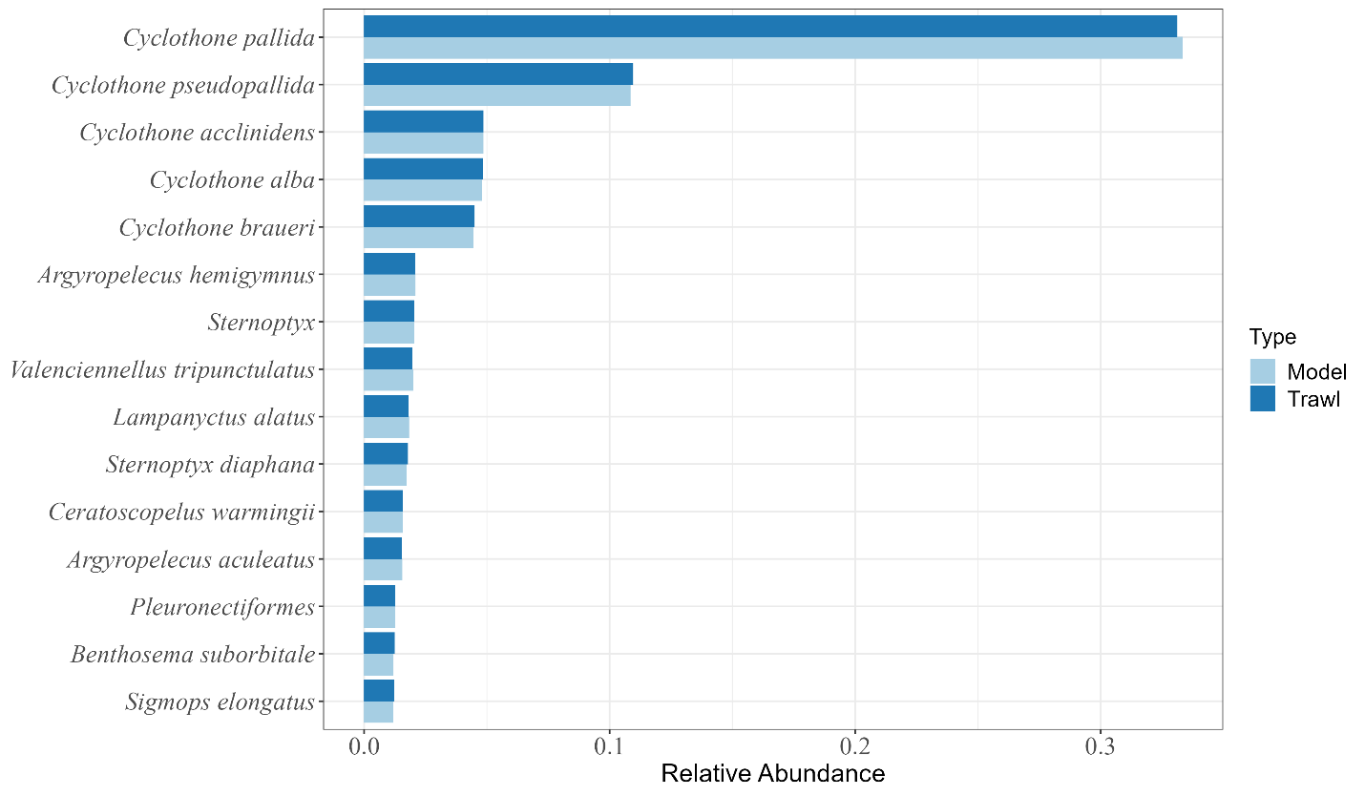
Figure A1. The relative abundance from the survey data and the model after 100,000 model iterations. This figure only shows the 15 most-abundant species from the survey data. “Sternoptyx” and “Pleuronectiformes” represents juvenile individuals that were not identifiable to species.

Ration to Length Relationship

For 61.7% of all modeled species with a sample size greater than 10 (n = 142), larger fishes consumed more carbon per feeding interval than smaller conspecifics (Table S4). All relationships between fish standard length and consumed carbon were best fit to a second-degree polynomial function, indicating the increase in feeding ration with length increase is nonadditive. Within-size class variation was caused by depth differences among individuals, so the lowest r² values are generally associated with species that experienced a wide depth range.

Table A4. Species-specific relationships of prey consumed (mg C) to body length (mm standard length). Each species was fit to the equation: Consumption = b + m1*length + m2*length². All species with greater than 10 individuals were assessed. “-“=no relationship, “*” = p<0.05, ”**” = p<0.01, “***” = p<0.001
Species | n | Range (mm) | b | m1 | m2 | r2 | Sig
Cyclothone pallida | 33145 | 8.48 - 33.68 | 1.39E-01 | 1.05E+01 | 1.76E+00 | 0.46 | ***
Cyclothone pseudopallida | 10967 | 13.78 - 52.27 | 2.60E-01 | 1.45E+01 | 3.05E+00 | 0.70 | ***
Cyclothone alba | 4981 | 11.92 - 33.59 | 1.39E-01 | 3.72E+00 | 5.76E-01 | 0.57 | ***
Cyclothone acclinidens | 4857 | 17.73 - 46.29 | 9.16E-02 | 1.71E+00 | 1.31E-01 | 0.88 | ***
Cyclothone braueri | 4379 | 13.71 - 35.88 | 1.27E-01 | 2.80E+00 | 3.74E-01 | 0.52 | ***
Argyropelecus hemigymnus | 2085 | 3.73 - 64.77 | 1.89E-01 | 8.47E+00 | 2.89E+00 | 0.97 | ***
Sternoptyx | 2007 | 3.51 - 21.55 | 4.13E-03 | 1.30E-01 | 4.35E-02 | 0.68 | ***
Valenciennellus tripunctulatus | 1906 | 12.54 - 34.55 | 7.74E-02 | 1.70E+00 | 3.14E-01 | 0.75 | ***
Lampanyctus alatus | 1778 | 11.17 - 55.58 | 5.25E+00 | 1.39E+02 | 3.14E+01 | 0.96 | ***
Sternoptyx diaphana | 1746 | 4.65 - 47.27 | 2.63E-01 | 1.31E+01 | 5.92E+00 | 0.98 | ***
Ceratoscopelus warmingii | 1584 | 10.41 - 55.34 | 1.72E+00 | 6.23E+01 | 2.38E+01 | 0.99 | ***
Argyropelecus aculeatus | 1530 | 4.29 - 76.72 | 4.40E+00 | 2.15E+02 | 8.19E+01 | 0.98 | ***
Pleuronectiformes | 1285 | 2.99 - 53.33 | 1.05E-02 | 4.13E-02 | -1.42E-02 | 0.08 | ***
Benthosema suborbitale | 1271 | 8.72 - 34.56 | 7.54E-01 | 1.76E+01 | 4.79E+00 | 0.96 | ***
Bothus | 1194 | 4.88 - 23.15 | 3.26E-02 | 7.75E-01 | 1.68E-01 | 0.70 | ***
Sigmops elongatus | 1190 | 5.36 - 326.56 | 6.57E+00 | 3.80E+02 | 1.77E+02 | 0.98 | ***
Selene setapinnis | 1092 | 1.51 - 42.55 | 5.52E-02 | 2.70E+00 | 1.28E+00 | 0.81 | ***
Diaphus dumerilii | 928 | 8.38 - 62.71 | 1.88E+00 | 5.65E+01 | 2.14E+01 | 0.98 | ***
Lepidophanes guentheri | 881 | 10.01 - 93.89 | 3.28E+00 | 1.28E+02 | 6.23E+01 | 0.98 | ***
Carangidae | 836 | 4.67 - 33.61 | 4.94E-02 | 1.37E+00 | 4.57E-01 | 0.78 | ***
Notolychnus valdiviae | 835 | 12.76 - 26.1 | 7.14E-01 | 6.16E+00 | 9.15E-01 | 0.90 | ***
Melamphaes simus | 769 | 9.74 - 30.39 | 3.99E-01 | 6.32E+00 | 1.31E+00 | 0.96 | ***
Lutjanus campechanus | 733 | 7.37 - 23.31 | 4.15E-02 | 6.57E-01 | 1.52E-01 | 0.64 | ***
Sternoptyx pseudobscura | 722 | 7.58 - 44.48 | 4.03E-01 | 1.01E+01 | 3.27E+00 | 1.00 | ***
Cyclothone obscura | 693 | 11.82 - 56.63 | 1.48E-01 | 2.74E+00 | 6.73E-01 | 1.00 | ***
Chauliodus sloani | 664 | 4.61 - 301.19 | 4.19E+00 | 1.87E+02 | 7.45E+01 | 0.98 | ***
Vinciguerria poweriae | 539 | 9.92 - 38.58 | 6.33E-01 | 9.51E+00 | 2.22E+00 | 0.96 | ***
Pollichthys mauli | 478 | 12.34 - 52.16 | 1.83E-01 | 2.28E+00 | 4.08E-01 | 0.97 | ***
Canthigaster | 474 | 2.08 - 23.36 | 5.63E-03 | 1.38E-01 | 5.65E-02 | 0.79 | ***
Selene | 435 | 3.8 - 11.58 | 7.08E-03 | 6.73E-02 | 8.26E-03 | 0.52 | **
Hygophum taaningi | 378 | 7.83 - 44.79 | 1.05E+00 | 1.41E+01 | 3.70E+00 | 0.97 | ***
Diaphus mollis | 365 | 10.04 - 59.82 | 4.28E+00 | 6.97E+01 | 2.06E+01 | 0.97 | ***
Scombridae | 363 | 5.73 - 18.07 | 4.13E-02 | 4.52E-01 | 8.90E-02 | 0.62 | ***
Caranx crysos | 349 | 12.54 - 69.97 | 6.84E-01 | 1.12E+01 | 2.91E+00 | 0.70 | ***
Euthynnus alletteratus | 340 | 5.57 - 51.69 | 1.28E-01 | 3.25E+00 | 1.38E+00 | 0.81 | ***
Caranx | 292 | 6.57 - 14.73 | 1.90E-02 | 1.43E-01 | 3.18E-02 | 0.49 | ***
Acanthurus | 285 | 4.1 - 19.68 | 5.06E-03 | 7.76E-02 | 3.44E-02 | 0.75 | ***
Vinciguerria nimbaria | 253 | 12.3 - 40.92 | 1.03E+00 | 9.72E+00 | 1.94E+00 | 0.96 | ***
Myctophum affine | 242 | 9.09 - 60.52 | 5.08E-01 | 9.89E+00 | 4.44E+00 | 0.99 | ***
Nannobrachium | 228 | 13.94 - 44.38 | 2.74E-02 | 2.67E-01 | 8.67E-02 | 0.97 | ***
Bolinichthys photothorax | 218 | 8.81 - 49.71 | 1.54E+00 | 1.85E+01 | 6.51E+00 | 0.98 | ***
Photostomias guernei | 216 | 27.46 - 126.15 | 5.91E-01 | 7.18E+00 | 1.95E+00 | 1.00 | ***
Diplospinus multistriatus | 207 | 3 - 145.21 | 1.84E+00 | 6.51E+01 | 4.57E+01 | 0.87 | ***
Hygophum benoiti | 207 | 10 - 33.53 | 1.51E-01 | 1.41E+00 | 3.55E-01 | 0.98 | ***
Balistidae | 204 | 5.02 - 7.98 | 2.28E-03 | 1.08E-02 | 5.92E-05 | 0.38 | -
Scopeloberyx opisthopterus | 193 | 13.47 - 31.1 | 9.22E-02 | 5.53E-01 | 1.31E-01 | 0.95 | ***
Omosudis lowii | 190 | 7.65 - 31.07 | 2.27E-04 | 1.48E-03 | 1.59E-04 | 0.95 | ***
Nannobrachium lineatum | 179 | 17.4 - 134.48 | 3.47E+00 | 5.66E+01 | 2.27E+01 | 0.76 | ***
Benthodesmus | 177 | 19.62 - 87.3 | 3.25E-01 | 2.00E-01 | -5.45E-02 | 0.00 | -
Synagrops spinosus | 174 | 7.13 - 32.31 | 2.37E-02 | 2.79E-01 | 9.15E-02 | 0.74 | ***
Lobianchia gemellarii | 159 | 8.93 - 47.19 | 6.25E-01 | 6.66E+00 | 1.97E+00 | 0.98 | ***
Melamphaes | 155 | 12.3 - 20.96 | 6.44E-01 | 2.49E+00 | 3.54E-01 | 0.89 | ***
Scopeloberyx robustus | 154 | 10.84 - 31.15 | 3.62E-02 | 3.05E-01 | 8.31E-02 | 0.97 | ***
Bonapartia pedaliota | 148 | 9.74 - 64.2 | 4.25E-03 | 5.72E-02 | 1.96E-02 | 0.88 | ***
Stomias affinis | 145 | 14.42 - 160.81 | 4.46E-01 | 9.46E+00 | 4.58E+00 | 0.99 | ***
Chlorophthalmus agassizi | 143 | 13.98 - 51.94 | 1.87E-01 | 1.89E+00 | 8.34E-01 | 0.72 | ***
Notoscopelus resplendens | 137 | 13.27 - 43.21 | 1.55E+00 | 1.13E+01 | 2.70E+00 | 0.97 | ***
Saurida | 134 | 22.17 - 38.89 | 9.29E-01 | 4.58E+00 | 2.47E-01 | 0.51 | -
Diaphus splendidus | 129 | 10.78 - 69.83 | 4.07E+00 | 4.90E+01 | 1.66E+01 | 0.99 | ***
Diogenichthys atlanticus | 128 | 14.47 - 25.19 | 4.48E-01 | 2.09E+00 | 3.54E-01 | 0.94 | ***
Dolicholagus longirostris | 121 | 11.21 - 132.29 | 2.12E+01 | 3.62E+02 | 1.65E+02 | 0.98 | ***
Perciformes | 120 | 6.02 - 13.78 | 3.14E-01 | 1.06E-01 | -1.41E-01 | 0.00 | -
Engraulidae | 120 | 12.01 - 17.78 | 3.22E-02 | 1.07E-01 | 1.66E-04 | 0.34 | -
Argyropelecus gigas | 117 | 1.73 - 70.74 | 1.45E-01 | 3.75E+00 | 2.07E+00 | 0.90 | ***
Lampadena luminosa | 114 | 13.27 - 46.3 | 2.90E-01 | 2.47E+00 | 6.76E-01 | 0.99 | ***
Diaphus lucidus | 114 | 11.28 - 160.35 | 7.90E+00 | 1.07E+02 | 4.95E+01 | 0.99 | ***
Chloroscombrus chrysurus | 113 | 5.65 - 38.86 | 3.13E-02 | 3.10E-01 | 6.68E-02 | 0.74 | ***
Saurida brasiliensis | 109 | 22.84 - 31.37 | 6.95E-01 | 1.59E+00 | -1.07E-01 | 0.22 | -
Polyipnus clarus | 108 | 3.65 - 38.44 | 5.97E-03 | 5.79E-02 | 1.12E-02 | 0.81 | ***
Nemichthys curvirostris | 106 | 53.15 - 527.42 | 2.70E+00 | 3.58E+01 | 1.40E+01 | 0.88 | ***
Myctophidae | 106 | 8.3 - 21.92 | 1.41E-01 | 8.66E-01 | 1.65E-01 | 0.96 | ***
Howella atlantica | 105 | 12.17 - 52.85 | 3.58E-04 | 8.54E-05 | -3.50E-05 | 0.04 | -
Bolinichthys supralateralis | 105 | 9.56 - 79.22 | 6.23E-01 | 7.42E+00 | 2.98E+00 | 0.99 | ***
Scorpaenidae | 101 | 3.59 - 15.32 | 4.52E-02 | 3.67E-01 | 1.22E-01 | 0.69 | ***
Lestidiops affinis | 97 | 21.16 - 81.14 | 6.48E-01 | 4.45E+00 | 9.17E-01 | 0.67 | **
Hygophum hygomii | 95 | 9.59 - 46.84 | 6.15E-01 | 5.72E+00 | 1.97E+00 | 0.99 | ***
Centropyge | 92 | 4.12 - 23.06 | 4.26E-02 | 3.28E-01 | 1.06E-02 | 0.69 | -
Melamphaidae | 92 | 10.53 - 25.98 | 4.44E-01 | 2.19E+00 | 4.49E-01 | 0.95 | ***
Lestrolepis intermedia | 90 | 18.61 - 70.6 | 3.30E-01 | 2.01E+00 | 6.73E-01 | 0.60 | ***
Maurolicus weitzmani | 90 | 9.64 - 29.74 | 1.63E-01 | 1.05E+00 | 3.02E-01 | 0.96 | ***
Eustomias | 88 | 24.33 - 116.21 | 3.49E-01 | 2.12E+00 | 5.87E-01 | 0.56 | **
Hygophum macrochir | 87 | 10.37 - 42.91 | 1.45E+00 | 1.04E+01 | 4.07E+00 | 0.98 | ***
Anthiinae | 83 | 10.36 - 19.42 | 4.35E-02 | 1.23E-01 | 2.20E-02 | 0.33 | -
Ariomma bondi | 82 | 47.92 - 77.01 | 2.66E+00 | 5.25E+00 | 8.11E-01 | 0.21 | -
Engraulis eurystole | 79 | 11.97 - 39.92 | 1.82E+00 | 9.75E+00 | 9.23E-01 | 0.71 | -
Synagrops bellus | 79 | 8.25 - 30.92 | 3.38E-02 | 2.99E-01 | 1.15E-01 | 0.78 | ***
Margrethia obtusirostra | 77 | 6.77 - 37.63 | 1.88E-03 | 1.34E-02 | 4.43E-03 | 0.87 | ***
Chaetodontidae | 73 | 5.69 - 10.89 | 9.29E-03 | 3.42E-02 | 1.01E-02 | 0.52 | *
Astronesthes niger | 71 | 20.65 - 31.82 | 6.83E-01 | 1.63E+00 | 6.63E-02 | 0.89 | -
Stephanolepis hispidus | 70 | 7.27 - 50.32 | 1.08E-01 | 9.40E-01 | 1.76E-01 | 0.86 | ***
Kaupichthys hyoproroides | 66 | 33.84 - 48.95 | 2.95E-02 | 4.22E-02 | -9.49E-03 | 0.17 | -
Pristipomoides | 64 | 13.92 - 36.76 | 5.89E+00 | 2.31E+01 | 2.94E+00 | 0.52 | -
Argyropelecus affinis | 63 | 7.19 - 32.98 | 2.84E-01 | 2.53E+00 | 7.60E-01 | 0.99 | ***
Diaphus | 61 | 10.23 - 26.8 | 4.65E-01 | 2.18E+00 | 3.93E-01 | 0.96 | ***
Lampanyctus nobilis | 60 | 17.71 - 51.58 | 1.55E+00 | 7.90E+00 | 2.19E+00 | 0.96 | ***
Taaningichthys bathyphilus | 57 | 16.5 - 59.83 | 3.08E-02 | 1.67E-01 | 4.38E-02 | 0.98 | ***
Centropyge argi | 56 | 5.19 - 16.7 | 2.07E-03 | 1.08E-02 | 2.28E-03 | 0.75 | **
Nesiarchus nasutus | 55 | 7.81 - 27.1 | 4.11E-01 | 2.74E+00 | 9.09E-01 | 0.86 | ***
Bregmaceros | 55 | 20.34 - 50.23 | 3.15E+00 | 1.45E+01 | 2.71E+00 | 0.97 | ***
Stomiidae | 51 | 23.01 - 55.73 | 1.35E+00 | 5.50E+00 | 8.46E-01 | 0.97 | ***
Scopelarchus analis | 51 | 17.03 - 83.67 | 5.41E+00 | 3.36E+01 | 1.27E+01 | 0.99 | ***
Bregmaceros atlanticus | 50 | 21.88 - 39.11 | 2.21E-01 | 5.78E-01 | 5.18E-02 | 0.92 | *
Foetorepus | 49 | 10.03 - 17.7 | 4.77E-03 | 1.16E-02 | -2.89E-04 | 0.67 | -
Scopeloberyx | 49 | 13.01 - 22.96 | 6.77E-03 | 2.15E-02 | 2.67E-03 | 0.96 | ***
Aluterus scriptus | 48 | 10.36 - 23.12 | 1.94E-03 | 5.88E-03 | 2.21E-03 | 0.59 | **
Coccorella atlantica | 47 | 20.82 - 45.95 | 3.29E-01 | 1.20E+00 | 2.58E-01 | 0.94 | ***
Cantherhines pullus | 46 | 10.76 - 50.63 | 1.09E-01 | 5.73E-01 | 1.43E-01 | 0.67 | *
Astronesthes macropogon | 46 | 13.32 - 43.31 | 9.14E-01 | 3.66E+00 | 8.02E-01 | 0.97 | ***
Teleostei | 44 | 15.08 - 44.98 | 6.69E-02 | -1.99E-02 | -4.70E-02 | 0.02 | -
Oneirodidae | 44 | 4.07 - 18.25 | 5.39E-04 | 2.02E-03 | 4.12E-04 | 0.97 | ***
Stephanolepis setifer | 42 | 7.27 - 50.04 | 5.52E-01 | 3.38E+00 | 1.60E+00 | 0.84 | ***
Scopelogadus mizolepis | 40 | 10.21 - 74.74 | 9.53E-02 | 7.55E-01 | 2.85E-01 | 0.99 | ***
Centropyge aurantonotus | 39 | 7.17 - 12.61 | 3.43E-03 | 7.59E-03 | 9.57E-04 | 0.48 | -
Scopelosaurus mauli | 39 | 33.94 - 69.2 | 5.82E+00 | 1.87E+01 | 4.21E+00 | 0.97 | ***
Vinciguerria attenuata | 38 | 9.06 - 40.43 | 1.57E-03 | 8.39E-03 | 2.40E-03 | 0.99 | ***
Chiasmodon niger complex | 37 | 13.97 - 49.64 | 1.87E-02 | 8.05E-02 | 3.06E-02 | 0.52 | *
Argyropelecus | 37 | 6.32 - 86.86 | 3.59E+00 | 2.47E+01 | 9.31E+00 | 0.85 | ***
Xenolepidichthys dalgleishi | 37 | 4.54 - 39.51 | 3.69E-01 | 2.91E+00 | 1.80E+00 | 0.94 | ***
Malacosteus niger | 37 | 19.17 - 96.96 | 4.93E-01 | 2.27E+00 | 6.93E-01 | 0.98 | ***
Gonostoma atlanticum | 36 | 9.29 - 67.94 | 9.20E-02 | 7.91E-01 | 3.85E-01 | 1.00 | ***
Linophrynidae | 36 | 12.59 - 22.55 | 1.88E-02 | 3.98E-02 | 4.96E-03 | 1.00 | ***
Scopelarchidae | 34 | 17.18 - 21.97 | 1.09E-01 | 9.57E-02 | -8.36E-02 | 0.11 | -
Melanocetus | 34 | 9.43 - 24.86 | 1.55E-05 | 1.11E-05 | 1.02E-06 | 0.55 | -
Stylephorus chordatus | 34 | 21.91 - 100.37 | 4.01E+00 | 1.67E+01 | 4.08E+00 | 0.80 | **
Thunnus atlanticus | 32 | 7 - 9.48 | 3.55E-02 | 2.45E-02 | 8.76E-03 | 0.05 | -
Helicolenus dactylopterus | 32 | 7.27 - 23.06 | 4.07E-02 | 2.03E-01 | 5.65E-02 | 0.72 | *
Diaphus perspicillatus | 32 | 21.41 - 68.88 | 1.65E+00 | 7.71E+00 | 1.72E+00 | 0.98 | ***
Bathylagidae | 31 | 22.11 - 28.77 | 1.66E-01 | 1.69E-01 | 1.30E-02 | 0.12 | -
Xanthichthys ringens | 31 | 9.23 - 13.88 | 1.99E-02 | 2.05E-02 | 1.62E-04 | 0.14 | -
Bathophilus pawneei | 31 | 20.17 - 44.27 | 4.37E-01 | 1.15E+00 | 1.95E-01 | 0.97 | ***
Diaphus termophilus | 31 | 12.85 - 37.61 | 3.69E+00 | 1.37E+01 | 3.38E+00 | 0.98 | ***
Aristostomias xenostoma | 29 | 33.19 - 72.65 | 2.04E+00 | 6.91E+00 | 1.12E+00 | 0.95 | ***
Alepisaurus ferox | 29 | 10.2 - 22.61 | 5.17E-03 | 1.23E-02 | 1.19E-03 | 0.96 | *
Melanonus zugmayeri | 29 | 23.19 - 154.81 | 9.23E-02 | 4.95E-01 | 1.30E-01 | 0.99 | ***
Gonichthys cocco | 29 | 19.97 - 50.68 | 2.40E+00 | 8.70E+00 | 1.78E+00 | 1.00 | ***
Hygophum reinhardtii | 28 | 18.26 - 42.79 | 5.07E-01 | 1.64E+00 | 3.76E-01 | 0.96 | ***
Diaphus rafinesquii | 28 | 21.09 - 83.06 | 1.52E+01 | 6.20E+01 | 1.74E+01 | 0.97 | ***
Astronesthes similus | 28 | 20 - 45.94 | 1.30E+00 | 4.49E+00 | 8.90E-01 | 0.97 | ***
Nealotus tripes | 28 | 10.74 - 39.88 | 9.26E-01 | 3.87E+00 | 7.93E-01 | 0.98 | ***
Cubiceps pauciradiatus | 27 | 12.97 - 21.86 | 4.89E-02 | 9.08E-02 | -9.36E-03 | 0.40 | -
Echiostoma barbatum | 27 | 31.98 - 317.76 | 1.92E+01 | 7.23E+01 | 1.55E+01 | 0.97 | ***
Brama | 25 | 8.39 - 29.01 | 4.58E-02 | 2.09E-01 | 8.51E-02 | 0.69 | *
Lampanyctus tenuiformis | 25 | 22.36 - 29.95 | 1.27E+00 | 1.22E+00 | -1.36E-01 | 0.83 | -
Photonectes leucospilus | 25 | 26.73 - 51.75 | 8.62E-01 | 2.13E+00 | 3.86E-01 | 0.95 | **
Lobianchia dofleini | 25 | 14.74 - 25.03 | 1.25E+00 | 3.30E+00 | 3.06E-01 | 0.98 | **
Centrobranchus nigroocellatus | 25 | 22.39 - 38.94 | 5.94E+00 | 1.10E+01 | 1.23E+00 | 0.99 | ***
Diodon holocanthus | 24 | 8.48 - 16.25 | 6.27E-02 | 1.40E-01 | 4.02E-02 | 0.47 | -
Chilorhinus suensonii | 24 | 27.08 - 45.8 | 2.27E-01 | 4.35E-01 | 1.15E-01 | 0.50 | -
Symphysanodon berryi | 24 | 9.42 - 22.77 | 1.52E-01 | 4.84E-01 | 9.52E-02 | 0.60 | -
Ichthyococcus ovatus | 24 | 9.13 - 36.69 | 8.15E-02 | 2.78E-01 | 5.62E-02 | 0.74 | -
Sudis atrox | 24 | 13.97 - 37.84 | 2.95E-01 | 1.00E+00 | 6.92E-01 | 0.75 | ***
Platytroctidae | 24 | 16.36 - 24.97 | 5.62E-03 | 8.09E-03 | -1.92E-05 | 0.91 | -
Nannobrachium atrum | 24 | 27.29 - 83.58 | 1.26E+01 | 5.96E+01 | 1.73E+01 | 0.99 | ***
Antennariidae | 23 | 7.34 - 14.69 | 1.83E-02 | 3.96E-02 | 3.96E-03 | 0.48 | -
Cookeolus japonicus | 23 | 7.29 - 21.81 | 6.57E-02 | 2.06E-01 | 6.64E-02 | 0.82 | **
Dicrolene introniger | 22 | 30.38 - 36.73 | 2.95E+00 | 2.69E+00 | -1.93E-01 | 0.79 | -
Cetostoma regani | 22 | 50.28 - 106 | 4.63E-01 | 1.17E+00 | 2.12E-01 | 1.00 | ***
Apogon | 21 | 14.09 - 17.76 | 1.89E-01 | 9.60E-02 | -1.38E-01 | 0.19 | *
Apogonidae | 21 | 9.1 - 14.95 | 3.30E-01 | 7.82E-01 | 2.66E-01 | 0.68 | *
Anoplogaster cornuta | 21 | 51.59 - 147.13 | 6.99E-01 | 1.94E+00 | 3.52E-01 | 0.98 | ***
Nannobrachium cuprarium | 21 | 23.52 - 69.77 | 2.41E-01 | 9.96E-01 | 3.08E-01 | 0.98 | ***
Dicrolene | 20 | 34.1 - 36.85 | 2.63E+00 | 1.92E-01 | 3.98E-01 | 0.07 | -
Psenes | 20 | 7.72 - 13.98 | 2.97E-02 | 4.51E-02 | -5.29E-03 | 0.25 | -
Anthias | 20 | 15.14 - 20.4 | 5.82E-02 | 6.62E-02 | 3.57E-02 | 0.38 | -
Epigonus pandionis | 20 | 12.07 - 20.27 | 2.40E-01 | 3.74E-01 | 1.04E-01 | 0.58 | -
Epigonus | 20 | 14.68 - 28.31 | 5.41E-01 | 9.24E-01 | -1.87E-01 | 0.58 | -
Polymixia lowei | 20 | 14.46 - 41.63 | 4.74E-01 | 1.40E+00 | 3.74E-01 | 0.63 | -
Trachurus lathami | 20 | 27.69 - 74.72 | 8.62E-02 | 2.83E-01 | 1.91E-02 | 0.64 | -
Scopeloberyx rubriventer | 20 | 16.35 - 21.78 | 1.05E-02 | 1.40E-02 | 2.06E-03 | 0.90 | -
Bathophilus digitatus | 20 | 31.57 - 72.13 | 1.99E+00 | 4.65E+00 | 9.44E-01 | 0.97 | ***
Fistularia | 19 | 55.63 - 69.82 | 5.87E-01 | 7.18E-01 | 1.91E-01 | 0.31 | -
Poecilopsetta | 19 | 17.42 - 56.33 | 6.37E-01 | 2.33E+00 | 5.08E-01 | 0.56 | -
Astronesthes | 19 | 18.79 - 29.62 | 5.62E-01 | 1.06E+00 | 2.19E-01 | 0.94 | **
Poromitra "Gibbsi" | 19 | 23.92 - 100.05 | 3.52E+00 | 1.44E+01 | 5.27E+00 | 0.97 | ***
Diaphus brachycephalus | 19 | 14.08 - 40.62 | 1.77E+00 | 6.59E+00 | 2.45E+00 | 0.97 | ***
Oneirodes | 19 | 14.63 - 22.63 | 1.35E-01 | 1.59E-01 | 6.44E-03 | 1.00 | ***
Bramidae | 18 | 8.27 - 11.27 | 2.21E-02 | 1.86E-02 | -7.68E-03 | 0.19 | -
Antigonia combatia | 18 | 8.31 - 28.88 | 1.05E-01 | 3.01E-01 | 9.34E-02 | 0.64 | -
Scopelarchoides danae | 18 | 21.01 - 57.09 | 2.17E+00 | 6.38E+00 | 1.62E+00 | 0.97 | ***
Canthidermis sufflamen | 17 | 16.07 - 24.78 | 1.02E-01 | 1.99E-01 | 3.20E-03 | 0.52 | -
Cyclopsetta | 17 | 12.38 - 17.9 | 6.15E+00 | 1.30E+01 | 7.68E-01 | 0.53 | -
Argyropelecus sladeni | 17 | 17.23 - 37.77 | 7.70E-01 | 1.40E+00 | 3.02E-01 | 0.58 | -
Bembrops | 17 | 11.16 - 13.95 | 6.90E+00 | 4.36E+00 | -1.45E-01 | 0.72 | -
Diaphus taaningi | 17 | 37.99 - 67.53 | 6.51E+00 | 1.05E+01 | 1.02E+00 | 0.97 | -
Gigantura | 16 | 10.41 - 28.91 | 1.25E-05 | 3.90E-06 | -3.90E-07 | 0.43 | -
Chaetodon | 16 | 7.39 - 14.83 | 1.04E-02 | 1.84E-02 | 9.37E-04 | 0.59 | -
Leptostomias bermudensis | 16 | 57.02 - 72.08 | 1.36E+00 | 1.00E+00 | -1.46E-01 | 0.65 | -
Caranx bartholomaei | 16 | 8.12 - 25.6 | 5.14E+00 | 1.28E+01 | 3.97E+00 | 0.79 | *
Melanostomias tentaculatus | 16 | 35.71 - 192.44 | 2.33E+00 | 5.43E+00 | 1.36E+00 | 0.90 | *
Astronesthes richardsoni | 16 | 23.72 - 66.65 | 4.50E+00 | 8.50E+00 | 2.66E+00 | 0.91 | **
Notoscopelus caudispinosus | 16 | 30.12 - 52.94 | 3.50E+01 | 6.84E+01 | 1.08E+01 | 0.96 | **
Ditropichthys storeri | 16 | 29.2 - 52.01 | 2.46E+00 | 4.71E+00 | 1.99E-01 | 0.97 | -
Lampanyctus festivus | 16 | 22.87 - 44.15 | 9.55E+00 | 2.25E+01 | 3.70E+00 | 0.99 | ***
Evermannella melanoderma | 15 | 24.08 - 26.96 | 1.04E-01 | 2.40E-02 | 9.90E-03 | 0.13 | -
Anthias nicholsi | 15 | 10.31 - 17 | 9.92E-01 | 1.05E+00 | -4.30E-01 | 0.29 | -
Desmodema polystictum | 15 | 20.2 - 28.26 | 8.54E+00 | 1.06E+01 | 5.33E+00 | 0.38 | -
Dicrolene kanazawai | 15 | 30.38 - 33.85 | 4.73E+00 | 2.06E+00 | 3.44E-01 | 0.44 | -
Liopropoma | 15 | 10.34 - 18.36 | 1.51E+00 | 2.86E+00 | 4.08E-01 | 0.47 | -
Diaphus subtilis | 15 | 22.39 - 68.01 | 1.11E-02 | 2.87E-02 | 6.50E-03 | 0.97 | ***
Myctophum nitidulum | 15 | 19.69 - 40.51 | 6.10E-01 | 1.31E+00 | 1.99E-01 | 1.00 | ***
Caulolatilus | 14 | 11.51 - 14.99 | 2.70E+00 | 1.33E+00 | 1.64E-01 | 0.00 | -
Synodus | 14 | 26.05 - 26.96 | 1.92E+00 | 1.19E+00 | -4.95E-01 | 0.09 | -
Ceratias | 14 | 38.74 - 47.7 | 1.44E-01 | 6.97E-02 | 1.65E-02 | 0.54 | -
Melanolagus bericoides | 14 | 47.67 - 154.19 | 8.91E+00 | 1.93E+01 | 6.48E+00 | 0.66 | -
Canthidermis maculata | 14 | 6.62 - 28.64 | 3.12E+00 | 1.37E+01 | 4.61E+00 | 0.96 | ***
Nezumia | 14 | 30 - 71.26 | 5.32E-01 | 1.16E+00 | 2.07E-01 | 0.98 | **
Flagellostomias boureei | 14 | 44.79 - 95.77 | 1.84E+00 | 3.67E+00 | 7.29E-01 | 0.98 | ***
Bathophilus proximus | 13 | 26.1 - 27.72 | 8.81E-02 | 3.80E-02 | 4.08E-04 | 0.10 | -
Gigantura indica | 13 | 51.19 - 59.77 | 2.52E+00 | 7.58E-01 | 1.59E-01 | 0.29 | -
Himantolophidae | 13 | 14.32 - 23.2 | 1.71E-02 | 9.22E-03 | -9.68E-04 | 0.57 | -
Myctophum selenops | 13 | 18.83 - 31.81 | 2.03E+00 | 2.61E+00 | -3.49E-03 | 0.94 | -
Parasudis truculenta | 12 | 25.22 - 50.15 | 1.13E+00 | 2.42E+00 | 7.38E-01 | 0.63 | -
Melamphaes longivelis | 12 | 19.03 - 23.81 | 1.51E+01 | 9.40E+00 | 5.14E-01 | 0.69 | -
Bregmaceros sp. | 12 | 29.94 - 60.2 | 7.25E+01 | 1.43E+02 | 1.69E+01 | 0.95 | -
Thunnus | 11 | 10.05 - 14.18 | 2.55E-02 | 2.58E-02 | -5.77E-03 | 0.23 | -
Haplophryne mollis | 11 | 15.06 - 15.8 | 4.72E-02 | -1.51E-03 | 1.37E-03 | 0.54 | *
Antigonia capros | 11 | 12.04 - 14.91 | 1.88E-01 | 1.89E-01 | 7.04E-02 | 0.56 | -
Paralepididae | 11 | 14.24 - 33.14 | 3.88E-01 | 8.45E-01 | 2.96E-01 | 0.76 | -

Asynchronous Migration Periodicity by Species
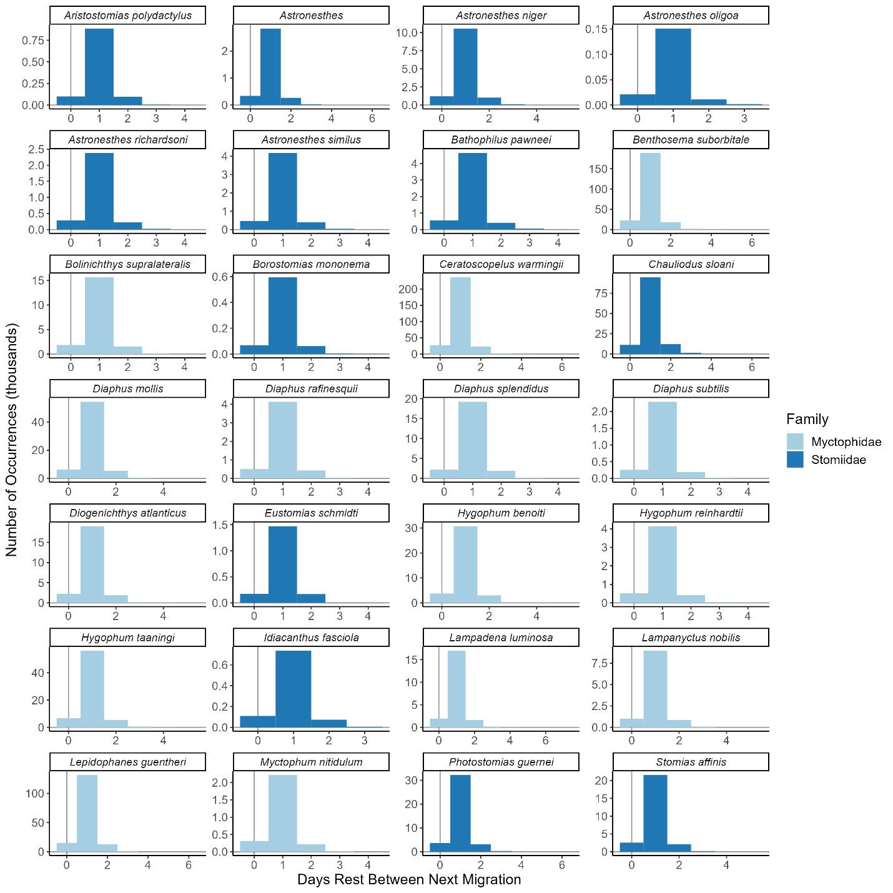
Figure A2. The days rest between diel vertical migration for all asynchronous migrating species in the model (n=28). Different x-axis scales represent the maximum value for each species, and species are colored by family: Myctophidae (light blue) and Stomiidae (dark blue).

Literature Cited
Bailey, T. G., M. J. Youngbluth, and G. P. Owen. 1995. Chemical composition and metabolic rates of gelatinous zooplankton from midwater and benthic boundary layer environments off Cape Hatteras, North Carolina, USA. Mar. Ecol. Prog. Ser. 122: 121–134. doi:10.3354/meps122121
Bartow, K. A. 2010. Taxonomy and ecology of the deep-pelagic fish family Melamphaidae, with emphasis on interactions with a mid-ocean ridge system. Florida Atlantic University.
Brett, J., and T. Groves. 1979. Physiological energetics: volume VIII, bioenergetics and growth, p. 280–352. In W.S. Hoar, D.J. Randall, and J.R. Brett [eds.], Fish Physiology. Academic Press.
Brooks, A. L., and R. A. Saenger. 1991. Vertical size-depth distribution properties of midwater fish off Bermuda, with comparative reviews for other open ocean areas. Can. J. Fish. Aquat. Sci. 41: 694–721. doi:https://doi.org/10.1139/f91-086
Childress, J. J., and M. H. Nygaard. 1973. The chemical composition of midwater fishes as a function of depth of occurrence off southern California. Deep. Res. Oceanogr. Abstr. 20: 1093–1109. doi:10.1016/0011-7471(73)90023-5
Davison, P. C. C., D. M. M. Checkley, J. A. A. Koslow, and J. Barlow. 2013. Carbon export mediated by mesopelagic fishes in the northeast Pacific Ocean. Prog. Oceanogr. 116: 14–30. doi:10.1016/J.POCEAN.2013.05.013
Donnelly, J., D. G. Stickney, and J. J. Torres. 1993. Proximate and elemental composition and energy content of mesopelagic crustaceans from the Eastern Gulf of Mexico. Mar. Biol. 115: 469–480. doi:10.1007/BF00349846
Eduardo, L. N., M. Maia, M. Flávia, and others. 2020. Length-weight relationship of twelve mesopelagic fishes from the western Tropical Atlantic. J. Appl. Ichthyol. 1–4. doi:10.1111/jai.14084
Gartner Jr, J. V., T. L. Hopkins, R. C. Baird, and D. M. Milliken. 1987. The lanternfishes (Pices: Myctophidae) of the Eastern Gulf of Mexico. Fish. Bull. 35: 81–98.
Harris, R., P. Wiebe, J. Lenz, H.-R. Skjoldal, and M. Huntley. 2000. ICES zooplankton methodology manual, Elsevier.
Hopkins, T. L., and R. C. Baird. 1981. Trophodynamics of the Fish Valenciennellus tripunctulatus. I. Vertical Distribution, Diet and Feeding Chronology. Mar. Ecol. Prog. Ser. 30: 1–10.
Hopkins, T. L., and R. C. Baird. 1985. Aspects of the trophic ecology of the mesopelagic fish Lampanyctus alatus (Family Myctophidae) in the eastern Gulf of Mexico. Biol. Oceanogr. 3: 285–313. doi:10.1080/01965581.1985.10749476
Hopkins, T. L., and R. C. Baird. 1985. Feeding ecology of four hatchetfishes (Sternoptychidae) in the eastern Gulf of Mexico. Bull. Mar. Sci. 36: 260–277.
Hopkins, T. L., and J. V Gartner. 1992. Resource-partitioning and predation impact of a low-latitude myctophid community. Mar. Biol. 114: 185–197. doi:10.1007/BF00349518
Hopkins, T., and T. Sutton. 1998. Midwater fishes and shrimps as competitors and resource partitioning in low latitude oligotrophic ecosystems. Mar. Ecol. Prog. Ser. 164: 37–45. doi:10.3354/meps164037
Hopkins, T. L., T. T. Sutton, and T. M. Lancraft. 1996. The trophic structure and predation impact of a low latitude midwater fish assemblage. Prog. Oceanogr. 38: 205–239.
Ikeda, T. 2016. Routine metabolic rates of pelagic marine fishes and cephalopods as a function of body mass, habitat temperature and habitat depth. J. Exp. Mar. Bio. Ecol. 480: 74–86. doi:10.1016/j.jembe.2016.03.012
Jusup, M., T. Klanjscek, H. Matsuda, and S. A. L. M. Kooijman. 2011. A full lifecycle bioenergetic model for bluefin tuna. PLoS One 6: e21903. doi:10.1371/journal.pone.0021903
Kooijman, S. A. L. M. 2010. Dynamic Energy Budget theory for metabolic organisation : Summary of concepts of the third edition, Cambridge University Press.
Lancraft, T., T. L. Hopkins, and J. J. Torres. 1988. Aspects of the ecology of the mesopelagic fish Gonostoma elongatum (Gonostomatidae, Stomiiformes) in the eastern Gulf of Mexico. Mar. Ecol. Prog. Ser. 49: 27–40. doi:10.3354/meps049027
Lesser, M. P., and M. Slattery. 2015. Picoplankton consumption supports the ascidian Cnemidocarpa verrucosa in McMurdo Sound, Antarctica. Mar. Ecol. Prog. Ser. 525: 117–126. doi:10.3354/meps11215
López-Pérez, C., M. P. Olivar, P. A. Hulley, and V. M. Tuset. 2020. Length–weight relationships of mesopelagic fishes from the equatorial and tropical Atlantic waters: influence of environment and body shape. J. Fish Biol. 96: 1388–1398. doi:10.1111/jfb.14307
McClain-Counts, J. P., A. W. J. Demopoulos, and S. W. Ross. 2017. Trophic structure of mesopelagic fishes in the Gulf of Mexico revealed by gut content and stable isotope analyses. Mar. Ecol. 38: e12449. doi:10.1111/maec.12449
Novotny, M. 2018. The Assemblage Structure and Trophic Ecology of a Deep-Pelagic Fish Family (Platytroctidae) in the Gulf of Mexico.
Pearre, S. 2003. Eat and run? The hunger/satiation hypothesis in vertical migration: History, evidence and consequences. Biol. Rev. Camb. Philos. Soc. 78: 1–79. doi:10.1017/S146479310200595X
Romero-Romero, S., C. A. Choy, C. C. S. Hannides, B. N. Popp, and J. C. Drazen. 2019. Differences in the trophic ecology of micronekton driven by diel vertical migration. Limnol. Oceanogr. 64: 1473–1483. doi:10.1002/lno.11128
Sauzède, R., J. E. Johnson, H. Claustre, G. Camps-Valls, and A. B. Ruescas. 2020. Estimation of oceanic particulate organic carbon with machine learning. ISPRS Ann. Photogramm. Remote Sens. Spat. Inf. Sci. 2: 949–956. doi:10.5194/isprs-annals-V-2-2020-949-2020
Sinclair, E. H., W. A. Walker, and J. R. Thomason. 2015. Body size regression formulae, proximate composition and energy density of eastern Bering Sea mesopelagic fish and squid. PLoS One 10: 1–13. doi:10.1371/journal.pone.0132289
Stickney, D. G., and J. J. Torres. 1989. Proximate composition and energy content of mesopelagic fishes from the eastern Gulf of Mexico. Mar. Biol. 103: 13–24. doi:10.1007/BF00391060
Sutton, T. T., and T. L. Hopkins. 1996. Species composition, abundance, and vertical distribution of the stomiid (Pisces:Stomiiformes) fish assemblage of the Gulf of Mexico. Bull. Mar. Sci. 59: 530–542.
Sutton, T. T., and T. L. Hopkins. 1996. Trophic ecology of the stomiid (Pisces: Stomiidae) fish assemblage of the eastern Gulf of Mexico: strategies, selectivity and impact of a top mesopelagic predator group. Mar. Biol. 127: 179–192. doi:https://doi.org/10.1007/BF00942102
Wilson, R. W., F. J. Millero, J. R. Taylor, P. J. Walsh, V. Christensen, S. Jennings, and M. Grosell. 2009. Contribution of fish to the marine inorganic carbon cycle. Science (80-. ). 323: 359–362. doi:10.1016/j.pepi.2008.05.007
Woodstock, M. S., C. A. Blanar, and T. T. Sutton. 2020. Diet and parasites of a mesopelagic fish assemblage in the Gulf of Mexico. Mar. Biol. 167: 1–9. doi:10.1007/s00227-020-03796-6
Woodstock, M. S., T. T. Sutton, T. Frank, and Y. Zhang. 2021. An early warning sign : trophic structure changes in the oceanic Gulf of Mexico from 2011–2018. Ecol. Modell. 445: 109509. doi:10.1016/j.ecolmodel.2021.109509

CHAPTER III

MESOPELAGIC MICRONEKTON MORTALITY REGIMES AND ECOSYSTEM FUNCTIONING IN THE OCEANIC GULF OF MEXICO FOLLOWING THE 2010 DEEPWATER HORIZON OIL SPILL

Abstract
Declines to mesopelagic micronekton abundance in the northern Gulf of Mexico (GoM) following the 2010 Deepwater Horizon oil spill likely affected ecosystem functioning. As of 2021, the depleted mesopelagic fish and macrocrustacean populations had not recovered, indicating that the impact on the offshore GoM may be ongoing. The additional mortality expressed on mesopelagic micronekton in the GoM has not been estimated, making it impossible to project populations or implement efforts on ecosystem restoration and fisheries management. An existing ecosystem model for the northeastern oceanic GoM has been revised, applied mortality regimes to match observed mesopelagic micronekton abundance estimates, and projected through 2030. The trend in the biomass-specific mortality rates experienced by mesopelagic micronekton is most likely either of an exponential or stepwise decline shape, meaning the population collapsed in 2011 and has since been slowly recovering as the additional mortality diminishes. However, on average, none of the depleted populations are projected to fully recover by 2030, and the most optimistic scenario required 25 years for the recovery of the decapod population. Biomass trends are related to changes in population-level energy throughput and relative ecological importance but shifts in diet likely affect the transfer efficiency of energy towards a particular group. In a holistic context, ecosystem production and energy flow rates decreased in response to mesopelagic micronekton declines, but the overall trophic connectivity remained constant. The impact of the Deepwater Horizon oil spill will affect the mesopelagic biomass in the northeastern oceanic GoM beyond 2030, but the overall trophic structure is likely to remain stable.

Introduction
The 2010 Deepwater Horizon oil spill (DWHOS) resulted in 6.4 × 10⁸ liters of oil spilling into the water column over an 87-day period (Rullkötter & Farrington 2021). Much of this oil floated to the surface, covering an 11,200 km² surface area (MacDonald et al. 2015), but a layer of particulate oil persisted in the deep-water column between 1,100–1,300-m depth and 35 km in length (Camilli et al. 2010) and an oil spill transport model suggests that the footprint may have eventually extended beyond the Gulf of Mexico (Berenshtein et al. 2020). Additionally, 2.6 × 10⁷ liters of chemical dispersant were applied to the wellhead and surface, an action intended to create marine oil-snow sedimentation and flocculent accumulation (MOSSFA) that sank to the seabed (Halanych et al. 2021). In nearshore waters, the DWHOS and associated response efforts (e.g., fisheries closures, diversion of Mississippi River discharge) affected the health of marine mammals and seabirds, inundated salt marshes with oil, and caused regime shifts in fisheries stocks (Beyer et al. 2016, Murawski et al. 2021), but the direct impact on the oceanic ecosystem is less understood. Polycyclic aromatic hydrocarbons (PAHs), a signature of the DWHOS, have been found in the muscle tissue, stomach, and eggs of deep-pelagic fishes and cephalopods as recently as 2018 (Romero et al. 2018, 2020), indicating that the effects of the oil spill may be food-web associated. The presence of PAHs in the food web may have several lethal and sub-lethal effects on the biota, including decreases in cardiac function, skeletal malformations, and immunotoxicity (Reynaud & Deschaux 2006). These effects can manifest as both direct mortality and delayed population declines as affected populations experience reduced predation and reproductive success (Peterson et al. 2003).
The structure of oligotrophic, open-ocean food webs is heavily dependent on energy fluxes from the mesopelagic zone (van Denderen et al. 2021), as mesopelagic organisms are important prey resources for upper-trophic level predators (e.g., tunas, billfishes, marine mammals; Potier et al. 2004, Watwood et al. 2006) and predators of zooplankton (Passarella & Hopkins 1991, Judkins 2014, Drazen & Sutton 2017). Depleted mesopelagic micronekton biomass in response to disturbances (e.g., oil spills) may thus affect both predator and prey species (Choy et al. 2016). Since 2011, significant declines in mesopelagic micronekton abundances have been observed in the northern Gulf of Mexico (Sutton et al. 2022). Given that there is not reported to be a significant increase in top predators to the system (Morano et al. 2020), mesozooplankton populations have remained stable (Daly et al. 2021), and environmental parameters (e.g., temperature) have not drastically changed since 2010, it is reasonable to hypothesize that the decline in mesopelagic micronekton has been caused by additional mortality from DWHOS rather than by internal food web dynamics. However, this additional mortality has not yet been quantified.
Ecosystem-based models can be utilized to forecast the biomass trends of several co-occurring populations. Forecasting models require time-series information to calibrate the simulation and estimate the dynamic, direct (e.g., predator/prey dynamics) and indirect (e.g., competition) trophic interactions, which change in a non-additive, density-dependent manner (Heymans et al. 2016). Although time-series information is historically lacking for mesopelagic biota in many oceanic regions (Webb et al. 2010), in the northern Gulf of Mexico, mesopelagic biota data has been collected from 2011 to 2021, creating one of the most robust deep-pelagic databases in existence (Cook et al. 2020). The utilization of these data in an ecosystem model context could forecast mesopelagic micronekton populations and the holistic effects on the ecosystem, but it is necessary to first estimate the non-natural effects on the biota caused by the DWHOS.
Changes to ecosystem functioning caused by population declines are commonly assessed by time-dynamic ecosystem models and associated ecological indicators. These indicators include comparative assessments of biomass, biodiversity, primary production, trophic structure, energy throughput, and several network analyses, among others (Link 2005, Heymans et al. 2014, Coll & Steenbeek 2017). In the Gulf of Mexico, ecosystem-based models have been developed for several objectives, including assessing and forecasting the status of coastal fisheries (Chagaris et al. 2015, Robinson et al. 2015, Sagarese et al. 2017), planning restoration efforts (Lewis et al. 2016, de Mutsert et al. 2017), and evaluating the neritic response to the DWHOS (Ainsworth et al. 2018, Rohal et al. 2020). In the oceanic zone, the decline in mesopelagic micronekton populations has been suggested to promote prey switching by top predators that must utilize other prey species in order to acquire a sufficient amount of nutrients, affecting individual trophic interactions (Woodstock et al. 2021), which influences the West Florida Shelf food web as well (Morzaria-Luna et al. 2022). However, the Woodstock et al. (2021) model was limited to the years of available data. A more flexible model (i.e., not dependent on having data for all years) for the oceanic Gulf of Mexico is necessary to forecast population sizes and assess ecosystem functioning relative to the immediate years following the DWHOS.

Objectives
In this study, we repurposed an ecosystem model for the northeastern oceanic Gulf of Mexico (Woodstock et al. 2021) to predict the additional mortality that has been expressed on mesopelagic micronekton populations as a result of the DWHOS, which the expectation that mortality has either diminished at a set rate (exponential mortality decline, stepwise mortality decline), diminished at a random rate, or stayed constant over time. All plausible mortality regimes were extended through 2030 to forecast micronekton population trends and determine the likelihood of population recovery for the declined functional groups. Several population- and ecosystem-level ecological indicators (e.g., biomass trends, system production, energy ascendency) were utilized to predict the possible shifts in ecosystem functioning in 2030 relative to the start year (2011), as a prolonged decline in mesopelagic micronekton biomass may alter the trophic structure of the entire system.

Methods
An Ecopath with Ecosim (EwE) model was developed for 2011 in the northeastern Gulf of Mexico bound by 26˚N, 30˚N, -84˚W, and -90˚W. The model domain was further bound by the 1,000-m isobath. Although this area is greater than the initial footprint of the DWHOS, this model domain was chosen as it is the extent of rectangular midwater trawl sampling in the region (Cook et al. 2020) and the horizontal structure of the mesopelagic assemblage is highly dispersed (Milligan & Sutton 2020). This model was a reconfiguration of a previous EwE model developed for the oceanic, northeastern Gulf of Mexico and used the same model domain (Woodstock et al. 2021; Figure 1). The Woodstock et al. (2021) model included 43 functional groups (including age-structured tuna and billfish groups) and was intended to estimate changes in individual trophic interactions in response to a depleted mesopelagic prey field. Adjustments from the previous model include: 1) condensation of tuna and billfish groups into aggregate functional groups, 2) adjusted consumption rate (Q/B) and fate of detritus values for mesopelagic fishes according to the results of a bioenergetic model for the region (Woodstock et al. 2022), 3) recalculated mesopelagic fish biomasses according to additional data for mesopelagic fish larvae (Wang et al. 2021) and a gear selectivity procedure to compare 10-m² and 1-m² Multiple Opening and Closing Environmental Sensing System (MOCNESS) data (Kotwicki et al. 2017), 4) improved microbial loop and low-trophic level components from the output of a plankton food web model in the oceanic Gulf of Mexico that quantified energy flows from primary producers to larval fishes (Stukel et al. 2021), and 5) estimated biomasses of microzooplankton, phytoplankton, suspended particulate detritus, and sinking detritus, as well as nutrient concentrations (NO₃ and NH₄) from the output from a coupled physical-biogeochemical model that estimated primary producer and microzooplankton concentrations (Wang et al. 2020). All physical-biogeochemical model output was originally 3D but was aggregated into the mean annual value of the 2D grid cells within the EwE model domain to match the input requirements for EwE (Supplemental Material). The revised oceanic Gulf of Mexico Ecopath model had 33 functional groups and was designed to focus on intermediate and low-trophic level processes (Table 1). Additional information on model parameterization is available in the Supplementary Material.
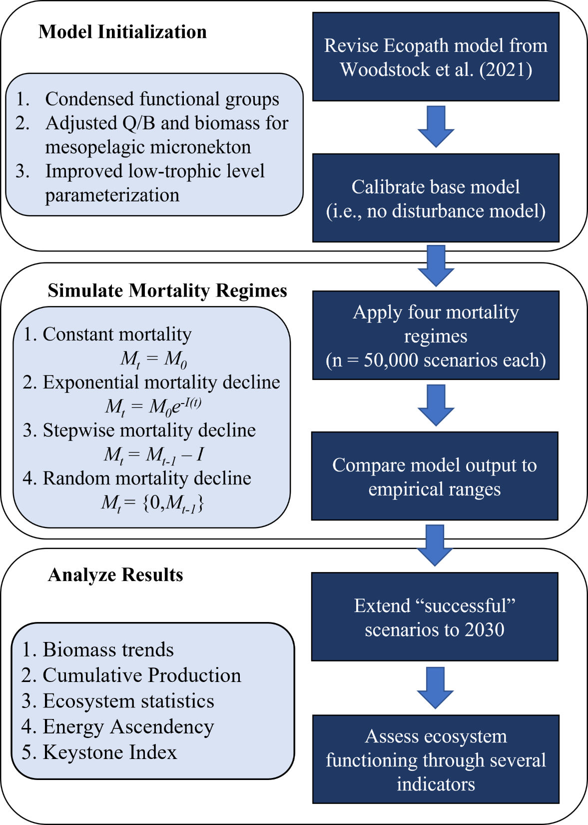
Figure 1. A flow chart showing the modeling process conducted in this study.

Table 1. The Ecopath inputs in the base model. Estimated values are in bold, and a description of input parameters in the Supplemental Material. TL = trophic level; B = biomass; P/B = production/biomass; Q/B = consumption/biomass; EE = ecotrophic efficiency

Functional Group | TL | B (t/km²) | P/B (yr⁻¹) | Q/B (yr⁻¹) | EE
Toothed whales | 5.03 | 0.0011 | 0.02 | 4.11 | 0.04
Baleen whales | 4.72 | 0.0002 | 0.02 | 4.68 | 0.00
Dolphins | 4.72 | 0.0139 | 0.02 | 14.12 | 0.01
Seabirds | 4.61 | 0.0019 | 0.30 | 1.00 | 0.10
Sea turtles | 4.14 | 0.0142 | 0.19 | 0.95 | 0.10
Oceanic sharks | 5.18 | 0.0036 | 0.45 | 3.16 | 0.10
Tunas | 4.44 | 0.0759 | 0.52 | 6.00 | 0.48
Billfishes | 4.49 | 0.0079 | 0.54 | 8.00 | 0.76
Oth lg epi fishes | 4.41 | 0.0475 | 0.20 | 3.39 | 0.40
Sm epi fishes | 3.48 | 0.5539 | 1.02 | 2.30 | 0.60
Dragonfishes | 4.51 | 0.0869 | 0.47 | 2.68 | 0.31
Oth sm meso fishes | 3.86 | 0.0311 | 1.14 | 4.42 | 0.93
Oth lg meso fishes | 4.57 | 0.0113 | 0.66 | 2.65 | 0.82
Hatchetfishes | 4.01 | 0.0329 | 1.66 | 5.84 | 0.75
Bristlemouths | 3.82 | 0.0819 | 1.20 | 3.94 | 0.65
Lanternfishes | 3.83 | 0.1096 | 1.63 | 5.44 | 0.60
Leptocephali | 2.41 | 0.1335 | 0.38 | 1.27 | 0.20
Cephalopods | 3.88 | 0.1024 | 4.00 | 20.00 | 0.70
Decapods | 2.94 | 0.0116 | 6.00 | 20.00 | 0.66
Euphausiids | 2.66 | 0.1710 | 7.33 | 45.00 | 0.26
Copepods | 2.90 | 0.6744 | 18.30 | 45.75 | 0.83
Mesozooplankton | 2.70 | 0.1691 | 26.80 | 67.00 | 0.93
Ichthyoplankton | 3.28 | 0.3035 | 15.00 | 45.00 | 0.99
Gel zooplankton | 3.66 | 0.2270 | 37.00 | 80.00 | 0.60
Appendicularians | 2.11 | 0.2976 | 7.20 | 18.00 | 0.58
Microzooplankton | 2.33 | 2.2131 | 36.00 | 89.00 | 0.25
MT flagelletes | 2.17 | 3.6000 | 200.00 | 500.00 | 0.20
Bacteria | 2.00 | 8.4860 | 68.00 | 136.00 | 0.97
Phytoplankton | 1.00 | 4.1113 | 160.00 |  | 0.76
Sargassum | 1.00 | 3.5400 | 0.22 |  | 0.10
DOM | 1.00 | 1.1190 |  |  | 0.83
Particulate detritus | 1.00 | 1.1190 |  |  | 0.47
Sinking detritus | 1.00 | 3.4320 |  |  | 0.69

Using the time-dynamic module Ecosim (Walters et al. 1997), a base model was calibrated to capture the status of the ecosystem in an undisturbed state. This was achieved by adjusting the density-dependent, predator-prey dynamics (i.e., vulnerability parameters; Heymans et al. 2016) and applying the model to Monte Carlo ensemble of model permutations (n=1,000 iterations) with the aim of creating a simulation where all populations remain relatively static throughout the simulation (<5% change in annual biomass in 2021 relative to 2011 for each functional group; i.e., no disturbance model). Within each year, populations were still allowed to fluctuate in response to monthly nutrient concentrations (NO₃ + NH₄; Supplemental Material), which were calculated as the monthly geometric mean of vertically and horizontally aggregated grid cells from the physical-biogeochemical model (Wang et al. 2020). This nutrient forcing produced small biannual amplitude cycles for low-trophic level organisms (1–4% relative biomass change). Although, the biannual cycles are the result of aggregated nutrient data (spatially and temporally) and may underestimate the magnitude of seasonal nutrient cycles in particular areas of the model domain (i.e., near the continental slope margin; Gomez et al. 2018), the inclusion of a seasonal nutrient regime is an improvement over assuming the amount of available nutrients in the system remains constant throughout the year. This seasonal nutrient cycle was applied as a forcing function in all years of the simulation (i.e., no interannual variation). The base model was then utilized as a template to which additional mortality scenarios would be applied.
To simulate the decline in mesopelagic micronekton abundance, additional annual mortality had to be added to each declined functional group (i.e., lanternfishes, bristlemouths, hatchetfishes, other small mesopelagic fishes, decapods, and euphausiids). However, the magnitude of initial additional annual mortality (M₀; yr⁻¹) and the rate of mortality decline (I) were unknown. Three mortality regime shapes were chosen; constant mortality (the expressed annual mortality is the same throughout the simulation; M_{t} = M₀), a stepwise decline in mortality (the expressed annual mortality declines at a constant rate over time; M_{t} = M_{t-1} – I), and an exponential decline in mortality (the expressed annual mortality declines at a decreasing rate over time; M_{t} = M₀e^{-I(t)}; Figure 1). The fundamental difference between the stepwise and exponential mortality scenarios is that the additional morality can reach 0 yr⁻¹ in the stepwise scenarios, but not in the exponential scenarios. An additional “random mortality regime shape” was included to address the uncertainty in our knowledge to simulate the effect of oil spills on biota (the expressed annual mortality decreases over time, but with no pre-defined order; M_{t} = {0,M_{t-1}}).
The initial mortality for each functional group during each scenario was a random value between 0–10 times the Ecopath productivity rate (P/B) for that functional group. This allowed the assessment to be scaled towards the biological turnover rate (B/P) of the functional group (e.g., an additional mortality value of 1 would affect lanternfishes (P/B = 1.63) differently than euphausiids (P/B = 7.33)). During the stepwise and exponential decline scenarios, the increments of decline (I) were a random value for each functional group between 0 and 2*P/B and 0.5*P/B, respectively. Dragonfishes, other large mesopelagic fishes, and cephalopods were not assigned any additional mortality because their net-avoidance capabilities make it difficult to determine if, and by what magnitude, these populations have declined since 2011. For each regime shape, 50,000 different scenarios were developed for each functional group (n= 200,000 total scenarios) with the objective of testing scenarios that produced results too extreme (i.e., the populations declined beyond empirical values), not extreme enough (i.e., the populations did not decline to the empirical values), and acceptable (i.e., the populations declined within the confidence limits of the empirical values). In each year of available data (2015–2018 for all declined groups and 2021 for the fish groups; Cook & Sutton 2017a, b, 2018, 2020, Sutton et al. 2017; Supplemental Material), each mesopelagic micronekton functional group’s biomass was calculated as the product of the standardized abundance from rectangular midwater trawl sampling and the mean weight of an individual for that group. The magnitude of each functional group’s decline was calculated as the biomass in each year of available data divided by the initial biomass (2011). A scenario was considered “successful” if it produced a biomass trend within the mean ± coefficient of variation (CV = 0.5) for all years of empirical data, effectively utilizing the empirical data as “gates” that the modeled population trends must pass through. The scenarios were conducted within the EwE framework using the MultiSim plug-in (Steenbeek et al. 2016).
Each successful mortality regime scenario was extended through the year 2030 to forecast mesopelagic micronekton biomass trends and ecosystem functioning (Figure 1). For each successful scenario, the final year was extracted as a separate Ecopath file using the “Ecopath from Ecosim” plug-in (Steenbeek et al. 2016) to gather the results necessary to assess ecosystem functioning changes over time. These indicators included relative trends in functional group biomass and energy throughput at the end and the start of the simulation (i.e., end/start), statistics regarding energy flow, a keystone index that assessed the relative ecological importance of functional groups compared to their overall biomass (e.g., a functional group with a small biomass and high predation impact relative to the other functional groups will have a high keystone index value; Libralato et al. 2006), and the relationships between cumulative ecosystem biomass and trophic level as well as cumulative ecosystem production and cumulative ecosystem biomass (Link et al. 2015). For each indicator, the initial condition (2011) and the final condition (2030) were compared.

Results

Mortality Regime Scenarios
Of the 200,000 mortality regime scenarios, just 108 successfully produced micronekton population trends that fell within the range of the empirical population size estimates for all micronekton groups. The stepwise mortality regime was the most successful of the four mortality types (n = 75 successful scenarios), while the exponential mortality regime also produced successful scenarios (n=33 successful scenarios; Table 2). Neither the constant nor the random mortality regime produced a successful result, although both shapes had scenarios that were successful for individual populations (Table 2). All mortality regime shapes had scenarios that produced results too extreme (i.e., the populations declined too much) or not extreme enough (i.e., the populations did not decline enough; Supplemental Material), indicating the constraints of the tested scenarios were acceptable for the present analysis. Euphausiids (9.8% success) and lanternfishes (9.1% success) were the least restrictive functional groups in the stepwise scenario, while hatchetfishes (23.8% success) and lanternfishes (23.1% success) were the least restrictive in the exponential functional groups in the exponential scenario.
There was consistency among the initial mortalities (M₀) and increments of decline (I) that produced successful simulations for each functional group. In the successful stepwise regime scenarios, the initial mortalities for expressed bristlemouths (1.96 ± 0.2 yr⁻¹), hatchetfishes (2.71 ± 0.3 yr⁻¹), lanternfishes (2.67 ± 0.3 yr⁻¹) and other small mesopelagic fishes (1.86 ± 0.2 yr⁻¹) was less than the additional initial mortality expressed on decapods (9.81 ± 1.2 yr⁻¹) and euphausiids (12.00 ± 1.5 yr⁻¹). This corresponds to average increases in productivity by 164% for all functional groups, despite having different magnitudes of population decline. The rates of stepwise mortality decline for bristlemouths (0.06 ± 0.04 yr⁻¹), hatchetfishes (0.08 ± 0.06 yr⁻¹), lanternfishes (0.08 ± 0.06 yr⁻¹), other small mesopelagic fishes (0.06 ± 0.04 yr⁻¹), decapods (0.28 ± 0.22 yr⁻¹), and euphausiids (0.34 ± 0.27 yr⁻¹) indicates that the additional mortality in the average successful scenarios will not reach 0 yr⁻¹ for 33, 34, 33, 31, 35, and 35 years for each respective functional group. The mortality did not reach 0 yr⁻¹ by 2021 for any functional group in any of the successful scenarios, despite occurring in 9410, 6357, 6341, 8637, 4492, and 3792 scenarios for bristlemouths, hatchetfishes, lanternfishes, other small mesopelagic fishes, decapods, and euphausiids, respectively. In the successful exponential mortality regime scenarios, the initial mortality rates for bristlemouths (1.78 ± 0.09 yr⁻¹), hatchetfishes (2.47 ± 0.13 yr⁻¹), lanternfishes (2.43 ± 0.13 yr⁻¹), other small mesopelagic fishes (1.69 ± 0.09 yr⁻¹), decapods (8.93 ± 0.46 yr⁻¹), and euphausiids (10.9 ± 0.57 yr⁻¹) were 147%, 142%, 140%, 147%, 147%, and 147% greater than the initial productivity rate, respectively. According to the rates of decline, the ratio of additional mortality expressed in the year 2021 (M₂₀₂₁) was 135%, 92%, 82%, 130%, 130%, and 136% greater than the productivity rate for bristlemouths, hatchetfishes, lanternfishes, other small mesopelagic fishes, decapods, and euphausiids, respectively. The successful mortality regimes can generally be characterized as having a high amount of initial mortality and a steady decrease in that mortality as time progresses.
Table 2. The count of successful mortality regime scenarios for each functional group and mortality regime shape (50,000 scenarios for each shape). The “All Fit” row indicates that the simulation was successful for all functional groups
Functional Group | Constant | Exponential | Random | Stepwise
Bristlemouths | 7,356 | 9,328 | 1 | 2,687
Decapods | 1,234 | 562 | 5 | 1,287
Euphausiids | 3,544 | 2,880 | 687 | 4,897
Hatchetfishes | 5,580 | 11,875 | 2 | 2,606
Lanternfishes | 6,247 | 11,532 | 1 | 4,555
Other small mesopelagic fishes | 4,146 | 9,016 | 0 | 910
All Fits | 0 | 33 | 0 | 75

Simulate through 2030
In 2030, the mesopelagic micronekton groups were at a constant state of decline in all successful exponential scenarios, but the successful stepwise scenarios produced population trends that suggested a greater likelihood of population recovery (Figure 2). The population recovered by 2030 in 9% (n = 7) of successful scenarios for other small mesopelagic fishes, 15% (n=11) of scenarios for bristlemouths and hatchetfishes, 20% (n = 15) of scenarios for lanternfishes, and 24% (n=18) scenarios for decapods (Figure 2A). The euphausiid population did not reach the starting biomass in any scenario by 2030 (Figure 2A). The earliest a population recovered to the 2011 population size in any stepwise scenario was 2025 (decapods). In the successful exponential scenarios, the relative biomass for mesopelagic micronekton groups in the year 2030 relative to 2011 was 0.28 ± 0.01, 0.33 ± 0.01, 0.35 ± 0.01, 0.24 ± 0.01, 0.35 ± 0.04, and 0.29 ± 0.02 for bristlemouths, hatchetfishes, lanternfishes, other small mesopelagic fishes, decapods, and euphausiids, respectively (Figure 2B). On average, none of the depleted mesopelagic micronekton populations are predicted to recover by 2030, but uncertainty in these results suggest that recovery is possible, assuming the mortality regimes being experienced by the populations decay in a stepwise pattern.
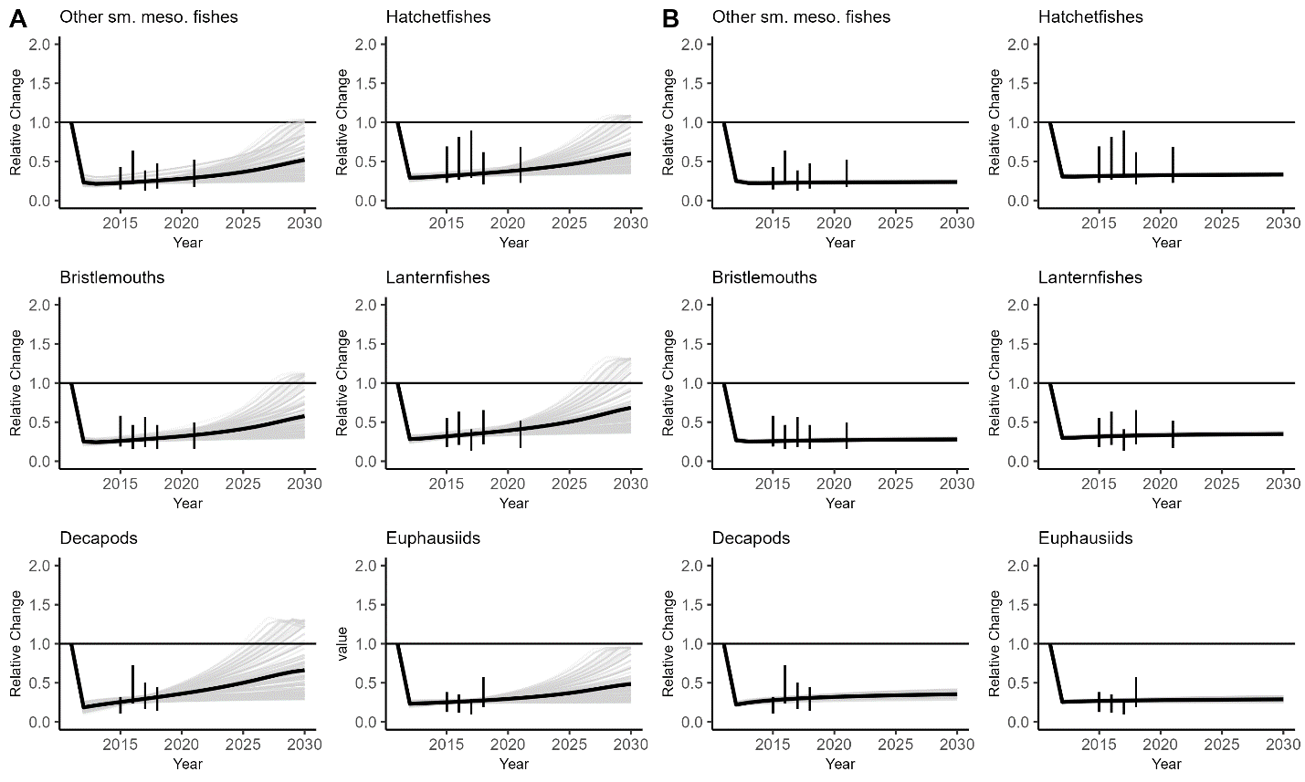
Figure 2. The relative change in biomass for each micronekton group that was expressed additional mortality for the successful mortality regime scenarios that produced population sizes within the uncertainty range of the empirical data (vertical black lines). Each scenario is represented by a gray line, while the annual mean population size values are bold black lines. A) The outcomes from the successful stepwise mortality regimes (n=75). B) The outcomes from the successful exponential mortality regimes (n=33). “Sm” refers to “small”, “Meso” refers to “mesopelagic”

Declines in mesopelagic micronekton biomass affects other populations, particularly predator groups. Dragonfishes, a mesopelagic functional group that was not expressed additional mortality, experienced a population decline more severe than the mesopelagic micronekton fishes that were expressed mortality, declining to 0.16 ± 0.01 of the 2011 biomass in the exponential scenario and 0.27 ± 0.11 in the stepwise scenario (Figure 3). The biomass of the other large mesopelagic fishes functional group increased by 19.2 ± 0.4% in the exponential scenario and 22.9 ± 2.7% in the stepwise scenario, a likely product of the extreme decline in the dragonfish population and the diet information available from this functional group. However, this increase for the large mesopelagic fishes functional group only increases the biomass to 0.01358 and 0.01389 t km⁻² in the exponential and stepwise mortality scenarios, while the dragonfish biomass remains at 0.0139 t km⁻² in 2030.
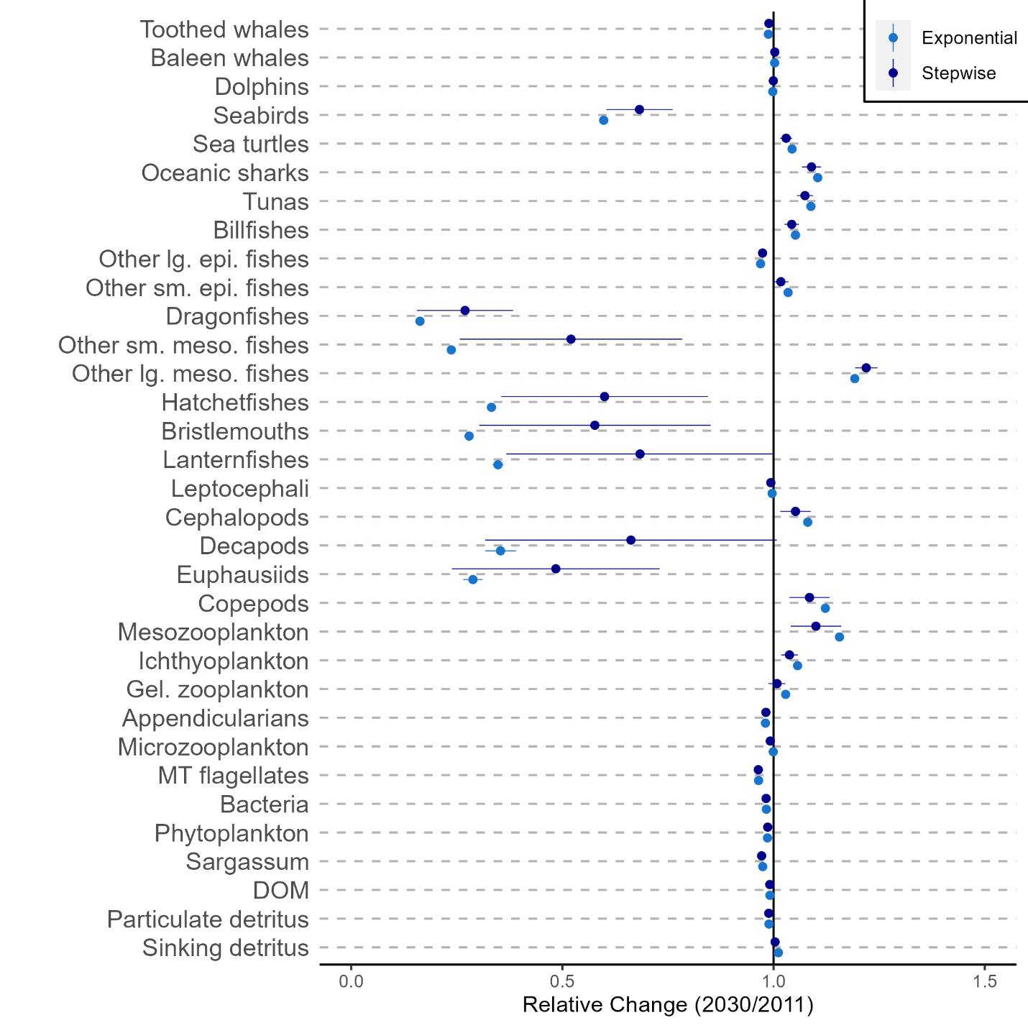
Figure 3. The relative biomass for each functional group ±1 standard deviation at the start (2011) and end of this simulation (2030) for the successful stepwise (dark blue) and exponential (light blue) scenarios. “lg” refers to “large”, “sm” refers to “small”, “epi” refers to “epipelagic”, “meso” refers to “mesopelagic”, “gel” refers to “gelatinous”, “MT” refers to “mixotrophic”, and “DOM” refers to “dissolved organic matter”.

Low trophic level organisms are the most responsible for energy throughput that ascends within the system, but population changes affect the relative amount that organisms transfer. The primary production trophic level (TL = 1) accounted for 51.9% of the system energy throughput (Figure 4A). Mixotrophic flagellates were responsible for 26.7% of the energy throughput, more than any other consumer (Figure 4A). Upper trophic level organisms (TL > 3.5) only accounted for 0.3% of the energy throughput. In the exponential scenarios, the energy throughput of 22 functional groups declined, ten increased, and one (baleen whales) stayed the same (Figure 4B). In the stepwise scenarios, the energy throughput of 20 functional groups declined, six functional groups increased, and seven stayed the same (Figure 4B). Dragonfishes had the most severe decline in energy throughput in both the exponential (85 ± 1% decline) and stepwise (69 ± 17% decline). Despite having the largest increase in biomass, the energy throughput of other large mesopelagic fishes declined (3 ± 0.3% decline) in the exponential scenario and stayed the same in the stepwise mortality scenarios, indicating that the increase in biomass did not result in enhanced energy transfer.
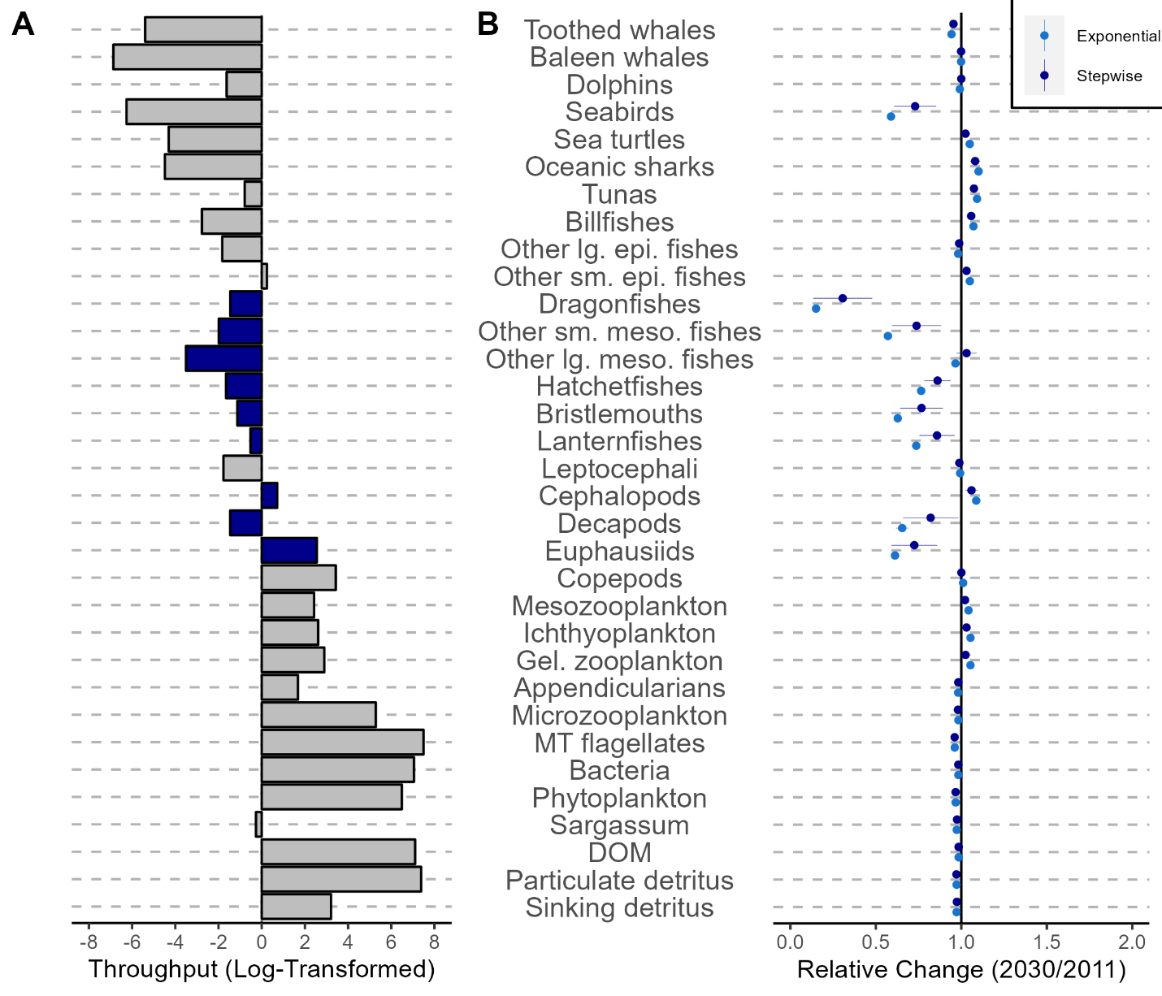
Figure 4. The energy throughput (sum of all energy flows; t km⁻² yr⁻¹) for each functional group. A) Log-transformed throughput values from the initial 2011 model. Mesopelagic functional groups are colored while the rest are grey. B) The relative change (2030/2011) in energy throughput for each functional group ±1 standard deviation for the stepwise (dark blue) and exponential (light blue) scenarios. “Lg” refers to “large”, “Sm” refers to “small”, “Epi” refers to “epipelagic”, “Meso” refers to “mesopelagic”, “Gel” refers to “gelatinous”, “MT” refers to “mixotrophic”, and “DOM” refers to “dissolved organic matter”.

Compared to 2011 both the exponential and the stepwise mortality results are consistent that the overall ecosystem functioning changed according to some indicators and not for others by 2030. The flows of energy in the form of consumption, respiration, flows to detritus, and total system throughput were lower than 2011 levels, in accordance with the biomass decline and decline in total net primary production (Table 3). However, the ratios of primary production:respiration and biomass:throughput did not change (Table 3), indicating that the ecosystem structure has remained stable despite less biomass and productivity. Connectance and the system omnivory index, both metrics of overall trophic structure, did not change throughout the simulation (Table 3). Persistent declines to mesopelagic biomass reduced several ecosystem-level indicators concerning energy throughput, but the overall ecosystem trophic structure remained intact.

Table 3. The basic Ecopath statistics that display holistic ecosystem functioning. Mean (± 1 standard deviation) is reported for all parameters
Parameter | Year 2011 | Exponential Scenario | Stepwise Scenario | Units
Sum of all consumption | 3249 | 3154 (± 1) | 3152 (± 2) | t km⁻² yr⁻¹
Sum of all exports | 70 | 71 (± 0) | 71 (± 0) | t km⁻² yr⁻¹
Sum of all respiratory flows | 589 | 565 (± 0) | 566 (± 1) | t km⁻² yr⁻¹
Sum of all flows into detritus | 2851 | 2789 (± 0) | 2786 (± 2) | t km⁻² yr⁻¹
Total system throughput | 6759 | 6579 (± 1) | 6575 (± 5) | t km⁻² yr⁻¹
Mean trophic level of the catch | 4.47 | 4.49 (± 0.00) | 4.49 (± 0.00)
Calculated total net primary production | 741 | 716 (± 0) | 716 (± 1) | t km⁻² yr⁻¹
Total primary production/total respiration | 1.2 | 1.3 (± 0) | 1.3 (± 0)
Net system production | 153 | 151 (± 0) | 151 (± 0) | t km⁻² yr⁻¹
Total primary production/total biomass | 29.5 | 29.3 (± 0) | 29.3 (± 0)
Total biomass/total throughput | 0.004 | 0.004 (± 0) | 0.004 (± 0) | t km⁻² yr⁻¹
Total biomass (excluding detritus) | 25.11 | 24.48 (± 0.02) | 24.50 (± 0.03) | t km⁻²
Total catch | 0.003 | 0.003 (± 0) | 0.003 (± 0) | t km⁻² yr⁻¹
Connectance Index | 0.28 | 0.28 (± 0) | 0.28 (± 0)
System Omnivory Index | 0.29 | 0.29 (± 0) | 0.29 (± 0)

Shifts in cumulative biomass and cumulative production are indicators of regime shifts in marine ecosystems. In this study, annual differences were observed for cumulative production, but not cumulative biomass (Figure 5). The cumulative production in the exponential scenario steadily declined from 578.2 yr⁻¹ in 2011 to 562.9 ± 5.9 yr⁻¹, but the overall shape of each curve was similar (Figure 5B). The average cumulative biomass in the successful exponential scenarios was the highest in 2011 (30.28 t km⁻²) and lowest in 2030 (30.16 ± 0.4 t km⁻²; Figure 5A), corresponding to the decline in mesopelagic biomass, but not representing a significant decline in ecosystem biomass. In the stepwise scenarios, the average cumulative biomass was highest in 2011 and lowest in 2027 (30.16 ± 0.3 t km⁻²) before beginning to increase again through 2030 (30.17 ± 0.3 t km⁻²), which also corresponds to the predicted initiation of population recovery of mesopelagic micronekton, but not a shift in ecosystem biomass. Moreover, as in the exponential scenarios, the shape of the cumulative biomass-trophic level curve is similar (Figure 5C). However, the annual cumulative production continued declined throughout the exponential scenarios, declining to 554.0 ± 8.2 yr⁻¹ despite the late stabilization of biomass (Figure 5D). Although, the cumulative biomass did not decline throughout the scenarios, declines in cumulative production in both the exponential and stepwise scenarios are influenced by population declines of particular functional groups (i.e., mesopelagic micronekton).
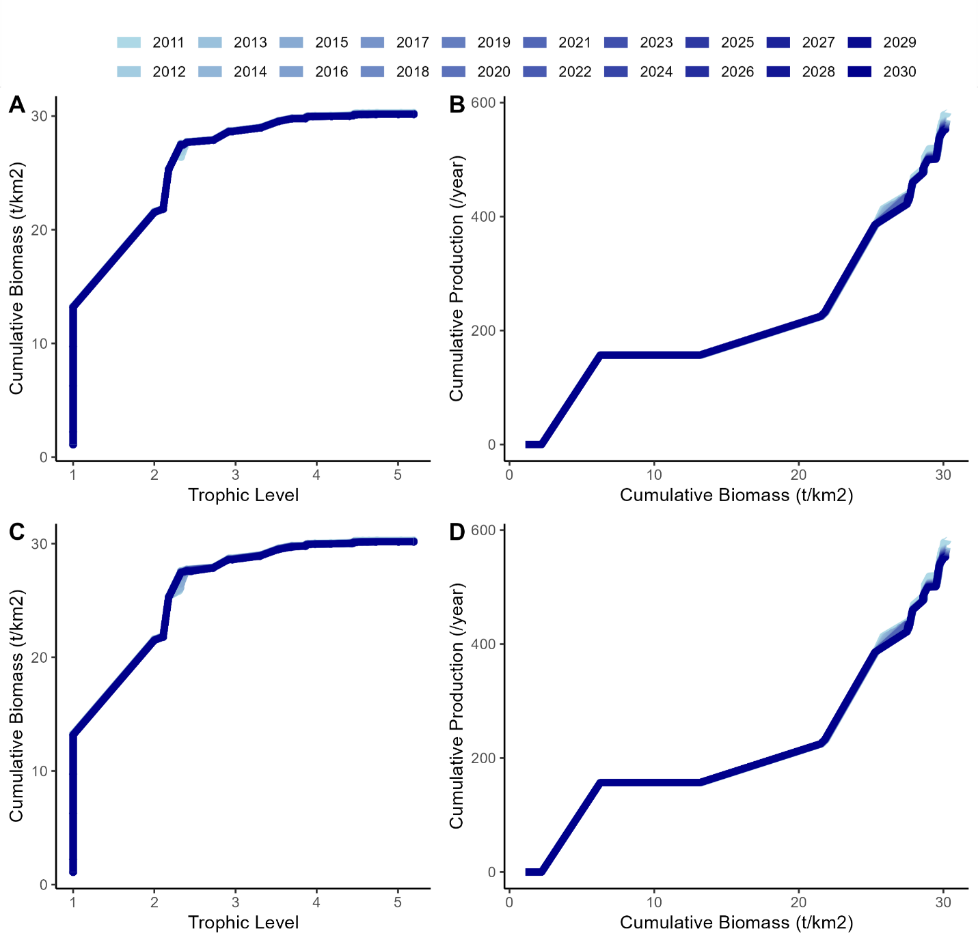
Figure 5. The relationships between: A) cumulative biomass and trophic level in the exponential scenarios, B) cumulative production and cumulative biomass in the exponential scenarios, C) cumulative biomass and trophic level in the stepwise scenarios, D) cumulative production and cumulative biomass in the stepwise scenarios as defined by Link et al. (2015) to show ecosystem responses to perturbations.

Keystone functional groups have a high impact on other functional groups relative to their biomass. Sharks and cephalopods were recognized as the most important functional groups in the oceanic Gulf of Mexico because of their ecological roles as predators (sharks and cephalopods) and prey (cephalopods) in the food web (Table 4). Functional groups that were not responsible for much ascendency (e.g., baleen whales, seabirds, Sargassum) had a low value on the keystone index (< -1). In 2030, the keystone index was predicted to change for several functional groups (Table 4). Relative to other functional groups in the system, dragonfishes and euphausiids changed the most, as they each dropped five ranks in the exponential scenarios and three and four ranks in the stepwise scenarios, respectively (Table 4). Decapods also dropped four ranks from 2011 to 2030 in the exponential scenarios, but just two ranks in the stepwise scenarios (Table 4). The aggregate small mesopelagic fish group ascended three and two spots in the keystone index rankings for exponential and stepwise scenarios, respectively, suggesting that they are benefactors in terms of their relative position within the ecosystem (Table 4). Sustained declines in micronekton biomass are reflected here as declines in the relative importance of particular functional groups towards ecosystem functioning.
Table 4. The keystone index values (Libralato et al. 2006) for all functional groups sorted by the base model (2011) values. Index values are the mean (± 1 standard deviation) for the final modeled year (2030) from all successful scenarios. The keystone rank for both the exponential and stepwise scenarios is shown to display shifts in the relative importance of functional groups throughout the simulation
 | Base |  | Exponential |  | Stepwise
Functional Group | Rank | Keystone Index | Rank | Keystone Index | Rank | Keystone Index
Oceanic sharks | 1 | 0.136 | 2 | 0.142 (3.3×10⁻³) | 2 | 0.140 (1.2×10⁻³)
Cephalopods | 2 | 0.105 | 1 | 0.200 (5.0×10⁻³) | 1 | 0.170 (2.8×10⁻²)
Tunas | 3 | 0.0775 | 3 | 0.100 (3.7×10⁻³) | 3 | 0.092 (5.8×10⁻³)
Copepods | 4 | 0.023 | 4 | 0.086 (2.2×10⁻³) | 4 | 0.051 (2.5×10⁻²)
Gelatinous zooplankton | 5 | 0.0211 | 5 | 0.040 (6.9×10⁻⁴) | 5 | 0.031 (7.3×10⁻³)
Dolphins | 6 | -0.0146 | 7 | -0.012 (7.3×10⁻⁴) | 6 | -0.015 (1.1×10⁻³)
Small epipelagic fishes | 7 | -0.0474 | 6 | -0.011 (1.9×10⁻³) | 7 | -0.027 (1.4×10⁻²)
Phytoplankton | 8 | -0.0932 | 9 | -0.056 (3.4×10⁻³) | 9 | -0.071 (1.6×10⁻²)
Ichthyoplankton | 9 | -0.0992 | 8 | -0.026 (1.8×10⁻³) | 8 | -0.057 (2.4×10⁻²)
Dragonfishes | 10 | -0.105 | 15 | -0.421 (1.7×10⁻²) | 13 | -0.338 (6.7×10⁻²)
Other large epipelagic fishes | 11 | -0.117 | 10 | -0.114 (3.5×10⁻⁴) | 10 | -0.115 (1.2×10⁻³)
Billfishes | 12 | -0.199 | 11 | -0.195 (1.6×10⁻³) | 11 | -0.198 (2.9×10⁻³)
Toothed whales | 13 | -0.299 | 12 | -0.298 (2.3×10⁻³) | 12 | -0.298 (6.6×10⁻⁴)
Lanternfishes | 14 | -0.362 | 16 | -0.431 (7.6×10⁻³) | 15 | -0.379 (2.8×10⁻²)
Mixotrophic flagellates | 15 | -0.365 | 13 | -0.352 (1.4×10⁻³) | 14 | -0.358 (6.1×10⁻³)
Euphausiids | 16 | -0.444 | 21 | -0.831 (3.1×10⁻²) | 20 | -0.687 (1.7×10⁻¹)
Other mesozooplankton | 17 | -0.459 | 14 | -0.421 (3.8×10⁻³) | 16 | -0.446 (1.4×10⁻²)
Microzooplankton | 18 | -0.545 | 17 | -0.541 (7.9×10⁻⁴) | 17 | -0.543 (2.0×10⁻³)
Bristlemouths | 19 | -0.559 | 19 | -0.653 (7.9×10⁻³) | 18 | -0.588 (3.8×10⁻²)
Appendicularians | 20 | -0.728 | 20 | -0.740 (1.7×10⁻⁴) | 21 | -0.736 (4.3×10⁻³)
Other small mesopelagic fishes | 21 | -0.745 | 18 | -0.637 (1.1×10⁻²) | 19 | -0.655 (2.3×10⁻²)
Decapods | 22 | -0.749 | 26 | -1.064 (3.7×10⁻²) | 24 | -0.920 (1.4×10⁻¹)
Hatchetfishes | 23 | -0.788 | 23 | -0.978 (6.8×10⁻³) | 23 | -0.889 (6.2×10⁻²)
Bacteria | 24 | -0.88 | 22 | -0.884 (1.7×10⁻⁴) | 22 | -0.884 (1.9×10⁻³)
Sargassum | 25 | -1.019 | 25 | -1.054 (1.8×10⁻³) | 26 | -1.041 (1.3×10⁻²)
Other large mesopelagic fishes | 26 | -1.069 | 24 | -0.982 (2.8×10⁻³) | 25 | -0.993 (9.4×10⁻³)
Leptocephali | 27 | -1.298 | 27 | -1.291 (5.0×10⁻⁴) | 27 | -1.297 (5.2×10⁻³)
Sea turtles | 28 | -1.46 | 28 | -1.445 (3.0×10⁻³) | 28 | -1.452 (5.5×10⁻³)
Seabirds | 29 | -2.016 | 29 | -2.008 (3.1×10⁻¹) | 29 | -2.060 (1.1×10⁻²)
Baleen whales | 30 | -2.515 | 30 | -2.454 (1.2×10⁻²) | 30 | -2.473 (1.9×10⁻²)

Discussion
This ecosystem model was capable of estimating the mortality that is being expressed on mesopelagic micronekton from the DWHOS. The overall success of mortality regimes was low (108/200,000 scenarios), but this was intentional as the main objective of this study was to estimate the constraints of initial mortality and the rate of mortality decline for each functional group. It is now possible to apply these mortality regimes in future modeling efforts to incorporate the effect of the DWHOS on mesopelagic micronekton in the oceanic Gulf of Mexico. Another modeling effort to estimate the effect of the DWHOS on the mesopelagic community applied growth and mortality forcing functions on deep-sea fishes and revealed that a depleted deep-sea prey field may have impacted the Gulf of Mexico food web beyond the direct footprint of the DWHOS (Morzaria-Luna et al. 2022). However, that study assumed a worst-case PAH-response scenario, while the present study estimates the range of mortalities that are possible given the available data. Both modeling approaches are valuable towards understanding the DWHOS impact on the oceanic Gulf of Mexico as the Atlantis framework utilized by Morzaria-Luna et al. (2022) is more complex and capable of explicitly simulating both lethal (mortality) and sub-lethal (growth) effects independently (as in Ainsworth et al. 2018, Dornberger et al. 2020), while the Ecopath with Ecosim framework is less complex modeling framework that still incorporates the most well-understood components of the system (standing stocks and energy flows; Hopkins et al. 1994, 1996, Sutton et al. 2022) and can test numerous decadal-scale simulations rapidly (in seconds as opposed to hours/days). The quantification of the mortality exerted on the mesopelagic biota after DWHOS is critical in understanding the impact of the DWHOS on the oceanic Gulf of Mexico.
Among the four mortality regime shapes, the stepwise and exponential shapes were the most logical. These types of regimes were characterized by high initial mortality and then reductions in mortality over time. In the stepwise scenarios, it was possible for mortality to reach zero beyond the year 2018, but none of the successful scenarios reached zero additional mortality prior to 2021 (the last year of available empirical data). In the exponential scenarios, additional mortality could never fully reach zero but could have diminished to a negligible value. All successful mortality scenarios led to population trends displaying a sharp collapse in 2011, minimum population numbers in 2012, and then a slow recovery thereafter. Snappers, groupers, and elasmobranchs in the northern Gulf of Mexico have also been modeled with a steep decline and slow, steady recovery following the DWHOS, but the recovery time for specific populations may be related to species turnover rates (Ainsworth et al. 2018). The most optimistic scenario in this study indicated it would take 25 years for the decapod population to recover, but on average in the stepwise scenarios, additional mortality was still being expressed greater than 30 years after 2011 (2041+). The exponential mortality scenarios were less optimistic and more precise, suggesting that if the mesopelagic micronekton response follows this mortality regime, the impact will be more severe than estimated by the stepwise mortality regime. The consistency among the suite of successful exponential and stepwise mortality regimes indicates the impact of the 2010 Deepwater Horizon oil spill will still be affecting the oceanic food web beyond 2030.
Dragonfishes and other large mesopelagic fishes (together, mesopelagic nekton fishes) were not applied additional mortality but responded to the decline in mesopelagic micronekton biomass. By 2021, dragonfishes had declined to the equivalent level of the euphausiid population but did so in a more subtle trend than the micronekton. This decline persisted through 2030 and influenced the dragonfish energy throughput, and ecological importance relative to other functional groups. Concurrently, large mesopelagic fishes increased in biomass, but their energy throughput declined, which is likely a result of shifts in diet that affects the transfer efficiency of energy to that functional group. The depleted micronekton populations accounted for 36% and 25% of dragonfish and other large mesopelagic fishes diets at the onset of the simulation. These values were set according to published literature (Hopkins et al. 1996, Sutton & Hopkins 1996), but it was assumed that much of the fish feeding by the aggregate large mesopelagic fish group was directed towards the ichthyoplankton functional group given the taxonomic resolution of these diet studies. Regardless, the increase in the relative biomass of other large mesopelagic fishes is likely caused by the population decline in their main competitor, dragonfishes, as depletions to ¼ of a predator’s prey field should have otherwise resulted in declines to that predator population. Furthermore, net avoidance behavior inhibits the capture of large-size classes within the MOCNESS (Marks et al. 2020). This creates a data gap for the life histories of large (fast) species and conspecifics of mesopelagic nekton fishes, particularly other large mesopelagic fishes. Although further investigation is required, the biomass decline for dragonfishes, despite including no additional mortality, is concerning given their high biomass, predation impact (Sutton & Hopkins 1996, Choy et al. 2012, Richards et al. 2019) and species richness (Fricke et al. 2021) in deep-pelagic systems.
By 2030, the overall ecosystem structure (connectance, omnivory) and ecosystem biomass did not change, but the system productivity and energy flows to consumption and respiration did decrease. A small decline in system biomass was expected as it was the objective of the model framework but increases to the biomasses of a few functional groups (e.g., other large mesopelagic fishes) and stability of others (cephalopods) replaced this lost biomass. A decline of cumulative production could be an indicator of regime shifts within the ecosystem, but significant perturbations are generally also associated with changes in cumulative biomass and the translocation of the inflection point in the cumulative biomass-cumulative production curve (Link et al. 2015, Pranovi et al. 2019). Only the decrease in cumulative production was predicted in this study, but the declines to cumulative production and total energy throughput indicate that other functional groups did not completely replace the depleted functional groups in terms of their energy throughput. Persistent (> 20 years) population changes are positively related to fluctuations in overall ecosystem functioning that affect biodiversity, biomass, and trophic connectivity (Shannon et al. 2004, Travers et al. 2010, Piroddi et al. 2017). In this study, individual trophic interactions were capable of changing throughout the simulation, and this influenced the strength of trophic interactions (Woodstock et al. 2021), but the system remained highly connected, and trophic levels did not change. The presence of alternative energy pathways in oceanic systems (McCormack et al. 2020) may buffer the overall trophic structure amidst mesopelagic abundance declines, but the functions provided that are a result of production and energy flows to detritus (e.g., carbon sequestration) have likely been reduced.
Measuring the impact of anthropogenic stressors on mesopelagic communities is critical in understanding open-ocean food web dynamics and ecosystem functioning. Mesopelagic organisms are important in the diet of federally protected species, including tunas, billfish, seabirds, and cetaceans (Watwood et al. 2006, Logan et al. 2013, Watanuki & Thiebot 2018). These protected species are managed by national (i.e., NOAA) and international fisheries management organizations (i.e., ICCAT). In this model, apex predator diets were allowed to shift focal prey groups to acquire nutrients based on size-selectivity, as opposed to taxon-specific feeding (Menard et al. 2006). If apex predators are not actually capable of shifting their diets, declines in mesopelagic prey availability could hypothetically affect growth rates (Madigan et al. 2018), species’ distributions (Farmer et al. 2017), and survivability. Since the DWHOS, oil exploitation in the Gulf of Mexico has continued to expand into deeper waters (greater than 2000 m), which increases the risk of a spill and the vulnerability of deep-sea populations to toxicological effects(Halanych et al. 2021, Woodyard et al. 2022). Additionally, experimental mesopelagic fisheries and deep-sea mining are expected to commence, which are predicted to negatively affect mesopelagic biota in perturbed regions (Drazen et al. 2020, Gjerde et al. 2021). The decline in mesopelagic biomass affects other functional groups as well, despite the potential for diet shifts, indicating that anthropogenic events that reduce mesopelagic biomass will affect the rest of the ecosystem.

Acknowledgments
This paper is a result of research funded by the National Oceanic and Atmospheric Administration’s RESTORE Science Program under award NA19NOS4510193 to Nova Southeastern University, as well as funding by The Gulf of Mexico Research Initiative and the Association for the Sciences of Limnology and Oceanography (ASLO) LOREX fellowship, NSF-OISE # 1831075. This manuscript was in part supported through the financial support of a Florida International University Provost Employer Supported Tuition Fellowship. Data are publicly available through the Gulf of Mexico Research Initiative Information & Data Cooperative (GRIIDC) at https://data.gulfresearchinitiative.org (doi: 10.7266/N7VX0DK2; 10.7266/N70P0X3T; 10.7266/N7XP7385; 10.7266/N7902234; 10.7266/n7-ac8e-0240; 10.7266/n7-dp76-tz89; 10.7266/n7-1v14-fc70). This is contribution #X from the Center for Coastal Oceans Research in the Institute of Water and Environment at Florida International University.
Literature Cited
Ainsworth CH, Paris CB, Perlin N, Dornberger LN, Patterson Iii WF, Chancellor E, Murawski S, Hollander D, Daly K, Romero IC, Coleman F, Perryman H (2018) Impacts of the Deepwater Horizon oil spill evaluated using an end-to-end ecosystem model. PLoS One 13:e0190840.

Annasawmy P, Ternon JF, Marsac F, Cherel Y, Béhagle N, Roudaut G, Lebourges-Dhaussy A, Demarcq H, Moloney CL, Jaquemet S, Ménard F (2018) Micronekton diel migration, community composition and trophic position within two biogeochemical provinces of the South West Indian Ocean: Insight from acoustics and stable isotopes. Deep-Sea Research Part I: Oceanographic Research Papers 138:85–97.

Berenshtein I, Paris CB, Perlin N, Alloy MM, Joye SB, Murawski S (2020) Invisible oil beyond the Deepwater Horizon satellite footprint.

Beyer J, Trannum HC, Bakke T, Hodson P V., Collier TK (2016) Environmental effects of the Deepwater Horizon oil spill: A review. Marine Pollution Bulletin 110:28–51.

Boswell KM, D’Elia M, Johnston MW, Mohan JA, Warren JD, Wells RJD, Sutton TT (2020) Oceanographic structure and light levels drive patterns of sound scattering layers in a low-latitude oceanic system. Front Mar Sci 7:51.

Camilli R, Reddy CM, Yoerger DR, van Mooy BAS, Jakuba M v, Kinsey JC, Mcintyre CP, Sylva SP, Maloney J v (2010) Tracking Hydrocarbon Plume Transport and Biodegradation at Deepwater Horizon. Science (1979) 1195223:1–4.

Chagaris DD, Mahmoudi B, Walters CJ, Allen MS (2015) Simulating the Trophic Impacts of Fishery Policy Options on the West Florida Shelf Using Ecopath with Ecosim. Marine and Coastal Fisheries 7:44–58.

Choy CA, Davison PC, Drazen JC, Flynn A, Gier EJ, Hoffman JC, McClain-Counts JP, Miller TW, Popp BN, Ross SW, Sutton TT (2012) Global Trophic Position Comparison of Two Dominant Mesopelagic Fish Families (Myctophidae, Stomiidae) Using Amino Acid Nitrogen Isotopic Analyses. PLoS ONE 7:e50133.

Choy CA, Wabnitz CCC, Weijerman M, Woodworth-Jefcoats PA, Polovina JJ (2016) Finding the way to the top: how the composition of oceanic mid-trophic micronektno groups determines apex predator biomass in the central North Pacific. Marine Ecology Progress Series 549:9–25.

Coll M, Steenbeek J (2017) Standardized ecological indicators to assess aquatic food webs: The ECOIND software plug-in for Ecopath with Ecosim models. Environmental Modelling and Software 89:120–130.

Cook A, Sutton T (2017a) Inventory of Gulf oceanic fauna data including species, weight, and measurements. Cruises DP01 May 1-8, 2015 and DP02 August 9-21, 2015 R/V on the Point Sur in the Northern Gulf of Mexico. Distributed by: Gulf of Mexico Research Initiative and Data Cooperative (GRIIDC), Harte Res.

Cook A, Sutton T (2017b) Inventory of Gulf of Mexico oceanic fauna data including species, weight, and measurements from R/V Point Sur (Cruises DP03 and DP04) May-August, 2016. Distributed by: Gulf of Mexico Research Initiative Information and Data Cooperative (GRIIDC), Harte Res.

Cook A, Sutton T (2018) Inventory of oceanic fauna data including species, weight, and measurements from R/V Point Sur (Cruise DP05) in the Gulf of Mexico from 2017-05-01 to 2017-05-11. Distributed by: Gulf of Mexico Research Initiative Information and Data Cooperative (GRIIDC),.

Cook A, Sutton T (2020) Inventory of oceanic fauna data including species, weight, and measurements from R/V Point Sur cruise PS19-04 (DP06) in the Gulf of Mexico from 2018-07-19 to 2018-08-01. Distributed by: Gulf of Mexico Research Initiative Information and Data Cooperative (.

Cook AB, Bernard AM, Boswell KM, Bracken-Grissom H, D’Elia M, DeRada S, Easson CG, English D, Eytan RI, Frank T, Hu C, Johnston MW, Judkins H, Lembke C, Lopez J v., Milligan RJ, Moore JA, Penta B, Pruzinsky NM, Quinlan JA, Richards TM, Romero IC, Shivji MS, Vecchione M, Weber MD, Wells RJD, Sutton TT (2020) A Multidisciplinary Approach to Investigate Deep-Pelagic Ecosystem Dynamics in the Gulf of Mexico Following Deepwater Horizon. Front Mar Sci 7:1–13.

Cury P, Bakun A, Crawford RJM, Jarre A, Quiñones RA, Shannon LJ, Verheye HM (2000) Small pelagics in upwelling systems: Patterns of interaction and structural changes in “wasp-waist” ecosystems. ICES Journal of Marine Science 57:603–618.

Cushing DH (1975) Marine Ecology and Fisheries. Cambridge University Press.
Czudaj S, Giesemann A, Hoving H, Koppelmann R, Lüskow F, Möllmann C, Fock HO (2020) Spatial variation in the trophic structure of micronekton assemblages from the eastern tropical North Atlantic in two regions of differing productivity and oxygen environments. Deep Sea Research I 163:103275.

Daly KL, Remsen A, Outram DM, Broadbent H, Kramer K, Dubickas K (2021) Resilience of the zooplankton community in the northeast Gulf of Mexico during and after the Deepwater Horizon oil spill. Marine Pollution Bulletin 163:111882.

van Denderen PD, Petrik CM, Stock CA, Andersen KH (2021) Emergent global biogeography of marine fish food webs. Global Ecology and Biogeography 30:1822–1834.

Dornberger LN, Ainsworth CH, Coleman F, Wetzel DL (2020) A Synthesis of Top-Down and Bottom-Up Impacts of the Deepwater Horizon Oil Spill Using Ecosystem Modeling. In: Deep Oil Spills. Springer International Publishing, p 536–550

Drazen JC, Smith CR, Gjerde KM, Haddock SHD, Carter GS, Anela Choy C, Clark MR, Dutrieux P, Goetze E, Hauton C, Hatta M, Anthony Koslow J, Leitner AB, Pacini A, Perelman JN, Peacock T, Sutton TT, Watling L, Yamamoto H (2020) Midwater ecosystems must be considered when evaluating environmental risks of deep-sea mining. Proc Natl Acad Sci U S A 117:17455–17460.

Drazen JC, Sutton TT (2017) Dining in the deep: the feeding ecology of deep-Sea fishes. Annual Review of Marine Science 9:337–366.

Eldridge PM, Roelke DL (2010) Origins and scales of hypoxia on the Louisiana shelf: Importance of seasonal plankton dynamics and river nutrients and discharge. Ecological Modelling 221:1028–1042.

Eppley R w., Peterson BJ (1979) Particulate organic matter flux and planktonic new production in the deep ocean. Nature 282:677.

Farmer NA, Noren DP, Fougères EM, Machernis A, Baker K (2017) Resilience of endangered sperm whales (Physeter macrocephalus) to foraging disturbance in the Gulf of Mexico, USA: A bioenergetics approach. Marine Ecology Progress Series 589:241–261.

Gjerde KM, Wright G, Durussel C (2021) Strengthening high seas governance through enhanced environmental assessment processes. A case study of mesopelagic fisheries and options for a future BBNJ treaty. 56.

Gomez FA, Lee S-K, Liu Y, Hernandez FJ, Muller-Karger FE, Lamkin JT (2018) Seasonal patterns in phytoplankton biomass across the northern and deep Gulf of Mexico: a numerical model study. Biogeosciences 15:3561–3576.

Halanych KM, Ainsworth CH, Cordes EE, Dodge RE, Huettel M, Mendelssohn IA, Murawski SA, Paris-Limouzy CB, Schwing PT, Shaw RF, Sutton T (2021) Effects of petroleum by-products and dispersants on ecosystems. Oceanography 34:152–163.

Heffernan JJ, Hopkins TL (1981) Vertical Distribution and Feeding of the Shrimp Genera Gennadas and Bentheogennema ( Decapoda : Penaeidea ) in the Eastern Gulf of Mexico. Journal of Crustacean Biology 1:461–473.

Herring P (2002) The Biology of the Deep Ocean. Oxford University Press, New York.
Heymans JJ, Coll M, Libralato S, Morissette L, Christensen V (2014) Global patterns in ecological indicators of marine food webs: A modelling approach. PLoS ONE 9.

Heymans JJ, Coll M, Link JS, Mackinson S, Steenbeek J, Walters C, Christensen V (2016) Best practice in Ecopath with Ecosim food-web models for ecosystem-based management. Ecological Modelling 331:173–184.

Hopkins TL, Flock ME, Jr JVG, Torres JJ (1994) Structure and trophic ecology of a low latitude midwater decapod and mysid assemblage. Marine Ecology Progress Series 109:143–156.
Hopkins TL, Sutton TT, Lancraft TM (1996) The trophic structure and predation impact of a low latitude midwater fish assemblage. Progress in Oceanography 38:205–239.

Judkins DC (2014) Geographical distribution of pelagic decapod shrimp in the Atlantic Ocean. Zootaxa 3895:301–345.

Kinsey ST, Hopkins TL (1994) Trophic strategies of euphausiids in a low-latitude ecosystem. Marine Biology 118:651–661.

Kotwicki S, Lauth RR, Williams K, Goodman SE (2017) Selectivity ratio: A useful tool for comparing size selectivity of multiple survey gears. Fisheries Research 191:76–86.

Lasker R (1988) Studies on the northern Anchovy; Biology, Recruitment, and Fishery Oceanography.

Lewis KA, de Mutsert K, Steenbeek J, Peele H, Cowan JH, Buszowski J (2016) Employing ecosystem models and geographic information systems (GIS) to investigate the response of changing marsh edge on historical biomass of estuarine nekton in Barataria Bay, Louisiana, USA. Ecological Modelling 331:129–141.

Libralato S, Christensen V, Pauly D (2006) A method for identifying keystone species in food web models. Ecological Modelling 195:153–171.

Link JS (2005) Translating ecosystem indicators into decision criteria. ICES Journal of Marine Science 62:569–576.

Link JS, Pranovi F, Libralato S, Coll M, Christensen V, Solidoro C, Fulton EA (2015) Emergent Properties Delineate Marine Ecosystem Perturbation and Recovery. Trends in Ecology and Evolution 30:649–661.

Logan JM, Toppin R, Smith S, Galuardi B, Porter J, Lutcavage M (2013) Contribution of cephalopod prey to the diet of large pelagic fish predators in the central North Atlantic Ocean. 95:74–82.

MacDonald IR, Garcia-Pineda O, Beet A, Saneshgar Asl S, Feng L, Graettinger G, French-Mccay D, Holmes J, Hu C, Huffer F, Leifer I, Muller-Karger F, Solow A, Silva M, Swayze G (2015) Natural and unnatural oil slicks in the Gulf of Mexico. Journal of Geophysical Research: Oceans 120:8364–8380.

Madigan DJ, Li M, Yin R, Baumann H, Snodgrass OE, Dewar H, Krabbenhoft DP, Baumann Z, Fisher NS, Balcom P, Sunderland EM (2018) Mercury Stable Isotopes Reveal Influence of Foraging Depth on Mercury Concentrations and Growth in Pacific Bluefin Tuna. Environmental Science and Technology 52:6256–6264.

Marks AD, Kerstetter DW, Wyanski DM, Sutton TT (2020) Reproductive Ecology of Dragonfishes (Stomiiformes: Stomiidae) in the Gulf of Mexico. Front Mar Sci 7:1–17.

McCormack SA, Melbourne-Thomas J, Trebilco R, Blanchard JL, Constable A (2020) Alternative energy pathways in Southern Ocean food webs: Insights from a balanced model of Prydz Bay, Antarctica. Deep-Sea Research Part II: Topical Studies in Oceanography 174:104613.

Menard F, Labrune C, Shin Y-J, Asine A-S, Bard F-X (2006) Opportunistic predation in tuna: a size-based approach. Marine Ecology Progress Series 323:223–231.

Milligan RJ, Sutton TT (2020) Dispersion Overrides Environmental Variability as a Primary Driver of the Horizontal Assemblage Structure of the Mesopelagic Fish Family Myctophidae in the Northern Gulf of Mexico. Front Mar Sci 7:1–13.

Morano JL, Tielens JT, Muirhead CA, Estabrook BJ, Sullivan PJ, Dugan PJ, Clark CW, Rice AN (2020) Seasonal movements of Gulf of Mexico sperm whales following the Deepwater Horizon oil spill and the limitations of impact assessments. Marine Pollution Bulletin 161:111627.

Morzaria-Luna HN, Ainsworth CH, Scott RL (2022) Impacts of deep-water spills on mesopelagic communities and implications for the wider pelagic food web. Marine Ecology Progress Series 681:37–51.

Murawski SA, Kilborn JP, Bejarano AC, Chagaris D, Donaldson D, Jr FJH, Macdonald TC, Newton C, Peebles E, Robinson KL (2021) A Synthesis of Deepwater Horizon Impacts on Coastal and Nearshore Living Marine Resources. Front Mar Sci 7.

de Mutsert K, Lewis K, Milroy S, Buszowski J, Steenbeek J (2017) Using ecosystem modeling to evaluate trade-offs in coastal management: Effects of large-scale river diversions on fish and fisheries. Ecological Modelling 360:14–26.

Nirazuka S, Makabe R, Swadling KM, Moteki M (2021) Phyto-detritus feeding by early-stage larvae of Electrona antarctica (Myctophidae) off Wilkes Land in the Southern Ocean, austral summer 2017. Polar Biology.

Passarella KC, Hopkins TL (1991) Species composition and food habits of the micronektonic cephalopod assemblage in the eastern Gulf of Mexico. Bulletin of Marine Science 49:638–659.

Peterson CH, Rice SD, Short JW, Esler D, Bodkin JL, Ballachey BE (2003) Long-Term Ecosystem Response to the Exxon Valdez Oil Spill. Science (1979) 302:2082–2086.

Pianka ER (1973) The Structure of Lizard Communities. Annual Review of Ecology and Systematics 4:53–74.

Piroddi C, Coll M, Liquete C, Macias D, Greer K, Buszowski J, Steenbeek J, Danovaro R, Christensen V (2017) Historical changes of the Mediterranean Sea ecosystem: Modelling the role and impact of primary productivity and fisheries changes over time. Scientific Reports 7:1–18.

Potier M, Marsac F, Lucas V, Sabatie R, Hallier J, Ménard F (2004) Feeding Partitioning among Tuna Taken in Surface and Mid-water Layers: The Case of Yellowfin ( Thunnus albacares ) and Bigeye ( T. obesus ) in the Western Tropical Indian Ocean. Western Indian Ocean Journal of Marine Science 3:51–62.

Potier M, Ménard F, Cherel Y, Lorrain A, Sabatié R, Marsac F (2007) Role of pelagic crustaceans in the diet of the longnose lancetfish Alepisaurus ferox in the Seychelles waters. African Journal of Marine Science 29:113–122.

Pranovi F, Libralato S, Zucchetta M, Anelli Monti M, Link JS (2019) Cumulative biomass curves describe past and present conditions of Large Marine Ecosystems. Global Change Biology:gcb.14827.

Reynaud S, Deschaux P (2006) The effects of polycyclic aromatic hydrocarbons on the immune system of fish: A review. Aquatic Toxicology 77:229–238.

Richards TM, Gipson EE, Cook A, Sutton TT, Wells RJD, Anderson E (2019) Trophic ecology of meso- A nd bathypelagic predatory fishes in the Gulf of Mexico. ICES Journal of Marine Science 76:662–672.

Robinson KL, Ruzicka JJ, Hernandez FJ, Graham WM, Decker MB, Brodeur RD, Sutor M (2015) Evaluating energy flows through jellyfish and gulf menhaden (Brevoortia patronus) and the effects of fishing on the northern Gulf of Mexico ecosystem. ICES Journal of Marine Science 72:2301–2312.

Robison BH (1984) Herbivory by the myctophid fish Ceratoscopelus warmingii. Marine Biology 84:119–123.

Rohal M, Ainsworth C, Lupher B, Montagna PA, Paris CB, Perlin N, Suprenand PM, Yoskowitz D (2020) The effect of the Deepwater Horizon oil spill on two ecosystem services in the Northern Gulf of Mexico. Environmental Modelling and Software 133:104793.

Romero IC, Judkins H, Vecchione M (2020) Temporal Variability of Polycyclic Aromatic Hydrocarbons in Deep-Sea Cephalopods of the Northern Gulf of Mexico. Front Mar Sci 7:1–10.

Romero IC, Sutton T, Carr B, Quintana-Rizzo E, Ross SW, Hollander DJ, Torres JJ (2018) Decadal Assessment of Polycyclic Aromatic Hydrocarbons in Mesopelagic Fishes from the Gulf of Mexico Reveals Exposure to Oil-Derived Sources. Environmental Science and Technology 52:10985–10996.

Romero-Romero S, Choy CA, Hannides CCS, Popp BN, Drazen JC (2019) Differences in the trophic ecology of micronekton driven by diel vertical migration. Limnology and Oceanography 64:1473–1483.

Rullkötter J, Farrington JW (2021) What was released? Assessing the physical properties and chemical composition of petroleum and products of burned oil. Oceanography 34:44–57.

Sagarese SR, Lauretta M V., Walter JF (2017) Progress towards a next-generation fisheries ecosystem model for the northern Gulf of Mexico. Ecological Modelling 345:75–98.

Shannon LJ, Christensen V, Walters CJ (2004) Modelling stock dynamics in the southern Benguela ecosystem for the period 1978-2002. African Journal of Marine Science 26:179–196.

Steenbeek J, Buszowski J, Christensen V, Akoglu E, Aydin K, Ellis N, Felinto D, Guitton J, Lucey S, Kearney K, Mackinson S, Pan M, Platts M, Walters C (2016) Ecopath with Ecosim as a model-building toolbox: Source code capabilities, extensions, and variations. Ecological Modelling 319:178–189.

Stukel MR, Gerard T, Kelly TB, Knapp AN, Laiz-Carrión R, Lamkin JT, Landry MR, Malca E, Selph KE, Shiroza A, Shropshire TA, Swalethorp R (2021) Plankton food webs in the oligotrophic Gulf of Mexico spawning grounds of Atlantic bluefin tuna. Journal of Plankton Research 00:1–19.

Sutton T, Cook A, Moore J, Frank T, Judkins H, Vecchione M, Nizinski M, Youngluth M (2017) Inventory of Gulf oceanic fauna data including species, weight, and measurements. Meg Skansi cruises from Jan. 25 - Sept. 30, 2011 in the Northern Gulf of Mexico. Distributed by: Gulf of Mexico Research Initiative Information and Data Cooperative (GRIIDC).

Sutton TT, Hopkins T (1996) Trophic ecology of the stomiid (Pisces: Stomiidae) fish assemblage of the eastern Gulf of Mexico: strategies, selectivity and impact of a top mesopelagic predator group. Marine Biology 127:179–192.

Sutton TT, Milligan RJ, Daly K, Boswell KM, Cook AB, Cornic M, Frank T, Frasier K, Hahn D, Hernandez F, Hildebrand J, Hu C, Johnston MW, Joye SB, Judkins H, Moore JA, Murawski SA, Pruzinsky NM, Quinlan JA, Remsen A, Robinson KL, Romero IC, Rooker JR, Vecchione M, Wells RJD (2022) The Open-Ocean Gulf of Mexico After Deepwater Horizon: Synthesis of a Decade of Research. Front Mar Sci 9.

Travers M, Watermeyer K, Shannon LJ, Shin YJ (2010) Changes in food web structure under scenarios of overfishing in the southern Benguela: Comparison of the Ecosim and OSMOSE modelling approaches. Journal of Marine Systems 79:101–111.

Ulanowicz RE, Puccia CJ (1990) Mixed Trophic Impacts in Ecosystems. Coenoses:7–16.
Walters C, Christensen V (2019) Effect of non-additivity in mortality rates on predictions of potential yield of forage fishes. Ecological Modelling 410:108776.

Walters C, Christensen V, Pauly D (1997) Structuring dynamic models of exploited ecosystems from trophic mass-balance assessments. Reviews in Fish Biology and Fisheries 7:139–172.

Wang B, Fennel K, Yu L, Gordon C (2020) Assessing the value of BGC Argo profiles versus ocean colour observations for biogeochemical model optimization in the Gulf of Mexico. Biogeosciences.

Wang VH, Zapfe CR, Hernandez FJ (2021) Assemblage Structure of Larval Fishes in Epipelagic and Mesopelagic Waters of the Northern Gulf of Mexico. Front Mar Sci 8:1–15.

Watanuki Y, Thiebot J-B (2018) Factors affecting the importance of myctophids in the diet of the world’s seabirds. Marine Biology 165:79.

Watwood SL, Miller PJO, Johnson M, Madsen PT, Tyack PL (2006) Deep‐diving foraging behaviour of sperm whales (Physeter macrocephalus). Journal of Animal Ecology 75:814–825.

Webb TJ, vanden Berghe E, O’Dor R (2010) Biodiversity’s big wet secret: The global distribution of marine biological records reveals chronic under-exploration of the deep pelagic ocean. PLoS ONE 5.

Woodstock MS, Sutton TT, Frank T, Zhang Y (2021) An early warning sign: trophic structure changes in the oceanic Gulf of Mexico from 2011–2018. Ecological Modelling 445:109509.

Woodstock MS, Sutton TT, Zhang Y (2022) A trait-based carbon export model for mesopelagic fishes in the Gulf of Mexico with consideration of asynchronous vertical migration, flux boundaries, and feeding guilds. Limnology and Oceanography:1–13.

Woodyard M, Polidoro BA, Matson CW, McManamay RA, Saul S, Carpenter KE, Collier TK, di Giulio R, Grubbs RD, Linardich C, Moore JA, Romero IC, Schlenk D, Strongin K (2022) A comprehensive petrochemical vulnerability index for marine fishes in the Gulf of Mexico. Science of the Total Environment 820.

Wormuth JH, Ressler PH, Cady RB, Harris EJ (2000) Zooplankton and micronekton in cyclones and anticyclones in the northeast Gulf of Mexico. Gulf of Mexico Science 18:23–34.

Appendix

Ecopath model parameterization

Marine Mammals

Biomass
Three marine mammal functional groups are included in this model: Toothed whales, Baleen whales, and dolphins. Only those mammals that occur within the model domain are considered in this model (i.e., no contribution from neritic species). The toothed whale group is composed of eleven species: pygmy sperm whale (Kogia breviceps), dwarf sperm whale (Kogia sima), sperm whale (Physeter macrocephalus), Blainville’s beaked whale (Mesoplodon densirostris), Cuvier’s beaked whale (Ziphius cavirostris), Gervais’ beaked whale (Mesoplodon europaeus), melon-headed whale (Peponocephala electra), killer whale (Orcinus orca), pygmy killer whale (Feresa attenuata), false killer whale (Pseudorca crassidens), and short-finned pilot whale (Globicephala macrorhynchus). The baleen whale functional group is composed of a monospecific Rice’s whale (Balaenoptera ricei). The dolphins functional group is composed of seven species that occupy the offshore Gulf of Mexico: bottlenose dolphin (Tursiops truncatus; offshore stock), Fraser’s dolphin (Lagenodelphis hosei), pantropical spotted dolphin (Stenella attenuata), Risso’s dolphin (Grampus griseus), clymene dolphin (Stenella clymene), spinner dolphin (Stenella longirostris), and striped dolphin (Stenella coeruleoalba). To calculate the biomass of each functional group, the abundance estimate from the latest NOAA-NMFS stock assessment for the species (Hayes et al. 2019) was divided by the stock area and multiplied by the average weight of each species (Trites & Pauly 1998).

P/B
The production rate of each marine mammal functional group was set at 0.2, which was half of the maximum population growth rate for each species (Hayes et al. 2019).

Q/B
Annual consumption rates were calculated for each species using the equation: DR = 0.1*(body mass)^{0.8} (Heymans et al. 2016) and the functional group values were calculated as the average of all represented species weighted by relative biomass.

Diet
The diet of each marine mammal functional group was calculated as the average diet composition from each represented species (Pauly et al. 1998) weighted by relative biomass and adjusted to fit the prey groups represented in the model.

Catches
Small amounts of discards were added to each marine mammal functional group to reflect the possible source of mortality from the U.S. Pelagic Longline fleet (Garrison & Stokes 2014).

Epipelagic Fish Groups

Biomass
Several epipelagic fishes were represented in the model, including: oceanic sharks, tunas, billfishes, other large epipelagic fishes, leptocephali, ichthyoplankton, and small epipelagic fishes. The biomass of tuna and billfish functional groups are an aggregation of the age class-specific biomasses calculated for Woodstock et al. (2021). In that model, the adult biomass was estimated as the quotient yield by the U.S. pelagic longline fleet and the fishing mortality within the Gulf of Mexico (ICCAT stock assessment-derived; www.iccat.int). Fishing mortality within the Gulf of Mexico was calculated as the product of the proportion of nominal catches for the stock that occur in the Gulf of Mexico and overall fishing mortality of the stock in 2011. Juvenile tuna and billfish biomasses were estimated according to Ecopath with Ecosim’s multi-stanza routine, which utilizes von Bertalanffy growth parameters and assumes a stable age-size distribution to estimate the biomass (and consumption rate) of age classes based off the input for biomass for one age class, and total mortality for all age classes (Christensen et al. 2008). The biomasses of all other epipelagic fish groups are estimated by the software as a function of all of the other parameters in the model and the assumption of mass balance (i.e., all energy entering and leaving a functional group’s “box” must be accounted for). To achieve this, the ecotrophic efficiency (EE; proportion of total mortality consumed and harvested within the system after one year) was set at 0.1 for oceanic sharks, 0.4 for other large epipelagic fishes, 0.6 for small epipelagic fishes, 0.2 for leptocephali, and 0.99 for ichthyoplankton, equivalent to the EE values set in Woodstock et al. (2021).

P/B
The production rates for most epipelagic fishes were calculated as the empirical relationship of growth parameters and mean water temperature (Pauly 1980, Heymans et al. 2016). All aggregate groups were calculated as the average of all represented species. The P/B of ichthyoplankton was assumed to be 15 yr⁻¹, as in Woodstock et al. (2021).

Q/B
The consumption rates of epipelagic fishes were calculated as a function of growth parameters, morphometrics, water temperature, and diet (Palomares & Pauly 1989). The leptocephali consumption rate was estimated assuming a P/Q relationship of 0.3 for the functional group. The Q/B for ichthyoplankton was assumed to be 45 yr⁻¹, which corresponds to a P/Q of 0.3, a value consistent with fast-growing fishes (Heymans et al. 2016).

Diet
Where possible, the diet of all epipelagic fish groups originated from Gulf of Mexico-specific sources (Rooker et al. 2006, Franks et al. 2008, Wells & Rooker 2009, Llopiz et al. 2015). However, diet information also had to be inferred from other oceanic localities to parameterize the tuna, billfish, and oceanic shark diets (Ménard et al. 2000, Potier et al. 2007, Camhi et al. 2009, Logan et al. 2013). Leptocephali likely consume detritus and appendicularians as a major portion of their diet (Ayala et al. 2018), but much of the energy from consuming marine snow likely comes from bacteria. The ichthyoplankton diet was parameterized according to the planktonic fish group in Stukel et al. (2021).

Catches
The only fishing fleet with jurisdiction within the model domain is the U.S. pelagic longline fleet. All catch data originated from the ICCAT database (www.iccat.net), were standardized to the proper units (t km⁻² yr⁻¹) and are applied to the appropriate aggregate functional group.

Other Pelagic Vertebrates

Biomass
Sea turtles and seabirds are two relatively data poor functional groups known to occupy the northeastern oceanic Gulf of Mexico. The biomass of each group was estimated by the software with an assumed EE value of 0.1, which corresponds to 10% of the total mortality being retained in the model domain through predation or fishing mortality each year.

P/B
The productivity rates of seabirds and sea turtles were set at 0.3 and 0.19, respectively. Both values were gathered from other models in the Gulf of Mexico that likely represent the same species that occupy the current model’s domain (Robinson et al. 2015, Perryman et al. 2020).

Q/B
The consumption rates of seabirds and sea turtles were estimated assuming a P/Q ratio of 0.3 and 0.2 for each group.

Diet
Seabirds predominately consume small fishes in the near surface waters but will consume mesopelagic fishes as a significant portion of their diet in oceanic ecosystems (Gagne et al. 2018). 29% of the seabird diet is composed of mesopelagic fishes in this model, while the rest is comprised of macroinvertebrates and epipelagic fishes. The most common sea turtle within the model domain is the leatherback sea turtle (Dermochelys coriacea), which is a gelatinivore (Dodge et al. 2011), but green sea turtles (Chelonia mydas) and leatherback sea turtles (Caretta caretta) occupy the system as well, so a small proportion of the diet is allocated to mesozooplankton and Sargassum as well.

Catches
As with marine mammals, seabirds and sea turtles are not targeted by the U.S. pelagic longline fleet, but may be caught as bycatch (Garrison & Stokes 2014). A small amount of bycatch was added to both functional groups to reflect this.

Mesopelagic Fishes

Biomass
The biomasses of mesopelagic fishes were primarily calculated as the standardized abundance of fishes captured in rectangular midwater trawls multiplied by the average weight of an individual for each species. The species-specific biomasses were then summed into their respective functional groups for bristlemouths, hatchetfishes, lanternfishes, and other small mesopelagic fishes. This process is further described in “MOC1 and MOC10 Combination” section, which explains the treatment of two different sized rectangular midwater trawls to gather one biomass estimate per functional group. The biomass of dragonfishes and other large mesopelagic fishes were set the same as in Woodstock et al. (2021), which represented the same start year as the current model.

P/B
Except for lanternfishes, the productivity rate estimates for all mesopelagic fishes were calculated as a function of growth parameters and water temperature (Pauly 1980). The P/B ratio for lanternfishes was estimated using a P/Q ratio of 0.3.

Q/B
The consumption rates for all mesopelagic fishes were calculated using a trait-based, bioenergetic model for mesopelagic fishes in the northeastern Gulf of Mexico (Woodstock et al. 2022), which calculated species-specific consumption rates. The Q/B values applied to the current model are the average of the representative species in each functional group, weighted by relative biomass.

Diet
The diets of mesopelagic fishes were parameterized using gut content data for mesopelagic fishes in the northeastern Gulf of Mexico (Hopkins & Baird 1985, Hopkins et al. 1996, Sutton & Hopkins 1996a).

Macroinvertebrates

Biomass
The biomass of decapods and euphausiids was parameterized using rectangular midwater trawl data, similar to the mesopelagic micronekton fishes. Cephalopod biomass was estimated by the software with a set EE of 0.7. This EE value was set rather high because of the important cephalopod role as prey to top predators (Hopkins et al. 1996, Logan et al. 2013).

P/B
The production rates of macroinvertebrates were gathered in three different ways. The cephalopod P/B originated from the squid functional group in Geers et al. (2016). The euphausiid P/B ratio originated from the euphausiid P/B ratio in Hopkins et al. (1996). The decapod P/B ratio was estimated from a P/Q ratio of 0.3.

Q/B
The consumption rate for euphausiids originates from the euphausiid functional group in Robinson et al. (2015) and the Q/B for decapods is derived from a 6% daily ration estimate for the decapod assemblage in the northeastern Gulf of Mexico (Hopkins et al. 1994). The consumption rate of cephalopods was estimated using a P/Q ratio of 0.2.

Diet
The diets of all macroinvertebrate groups were parameterized from high-resolution diet studies in the northeastern Gulf of Mexico (Passarella & Hopkins 1991, Kinsey & Hopkins 1994, Hopkins et al. 2018).

Zooplankton and microscopic organisms

Biomass
The biomasses for copepods, mesozooplankton, and gelatinous zooplankton were set according to the biomass values in Woodstock et al. (2021), which has the same start time and occupies the same model domain. The biomass of the appendicularian functional group is derived from bongo net tows in the oceanic Gulf of Mexico (Shiroza et al. 2021: Supplementary Material). The biomass of the mixotrophic flagellates group is derived from a high-performance liquid chromatography study in the oligotrophic Gulf of Mexico (Selph et al. 2021) using conversion factors from (Travers-Trolet et al. 2014). The bacteria biomass was gathered from a plankton food web model in the oligotrophic Gulf of Mexico assuming a 5:1 Bacteria:Cyanobacteria ratio (Stukel et al. 2021). The biomasses of microzooplankton was calculated from the output of a ROMS-NPZD model of the Gulf of Mexico(Wang et al. 2020).

P/B
The productivity rate for copepods is derived from the P/B rate utilized for copepods in Hopkins et al. (1996) and the gelatinous zooplankton productivity rate originates from the carnivorous jellyfish functional group in Perryman et al. (2020). The mesozooplankton, appendicularian, and mixotrophic flagellate P/Bs were estimated assuming a P/Q ratio of 0.4.

Q/B
The consumption rate of gelatinous zooplankton is also derived from the Q/B ratio of the carnivorous jellyfish functional group in Perryman et al. (2020). The mesozooplankton Q/B is as in Woodstock et al. (2021). The appendicularian Q/B is derived from a daily ration calculation for Oikopleura vanhoeffeni in the northwest Atlantic Ocean (Deibel 1988).

Diet
The diets of all zooplankton functional groups are derived from the proportional energy flows quantified in a plankton food web model for the oceanic Gulf of Mexico (Stukel et al. 2021).

Primary Producers

Biomass
The biomass of Sargassum is derived from the results of a biomass density model for Sargassum in the Caribbean Sea and West Atlantic (Wang et al. 2018). The biomasses of phytoplankton, sinking detritus, and particulate detritus were also calculated from the output of a ROMS-NPZD model of the Gulf of Mexico, as described in the “Treatment of ROMS-BGC data” section (Wang et al. 2020).

P/B
The productivity rate of phytoplankton was assumed to be 160 yr⁻¹ (Perryman et al. 2020). The P/B for Sargassum was estimated after setting the EE to 0.1.

Diet Matrix
Table A1. The diet matrix of the initial Ecopath model. Predator groups are in columns and prey groups are in rows
Prey \ predator | Toothed whales | Baleen whales | Dolphins | Seabirds | Sea turtles | Oceanic sharks | Tunas | Billfishes | Oth lg epi fishes
Toothed whales | 0.00% | 0.00% | 0.00% | 0.00% | 0.00% | 0.00% | 0.00% | 0.00% | 0.00%
Baleen whales | 0.00% | 0.00% | 0.00% | 0.00% | 0.00% | 0.00% | 0.00% | 0.00% | 0.00%
Dolphins | 0.00% | 0.00% | 0.00% | 0.00% | 0.00% | 0.00% | 0.00% | 0.00% | 0.00%
Seabirds | 0.00% | 0.00% | 0.00% | 0.00% | 0.00% | 0.50% | 0.00% | 0.00% | 0.00%
Sea turtles | 0.00% | 0.00% | 0.00% | 0.00% | 0.00% | 2.00% | 0.00% | 0.00% | 0.00%
Oceanic sharks | 1.14% | 0.00% | 0.00% | 0.00% | 0.00% | 0.00% | 0.00% | 0.00% | 0.00%
Tunas | 13.51% | 0.00% | 6.16% | 0.00% | 0.00% | 24.40% | 0.00% | 0.10% | 0.98%
Billfishes | 1.87% | 0.00% | 0.04% | 0.00% | 0.00% | 15.10% | 0.00% | 0.00% | 0.27%
Oth lg epi fishes | 5.69% | 0.00% | 0.20% | 0.00% | 0.00% | 20.00% | 0.03% | 0.27% | 0.27%
Sm epi fishes | 8.28% | 8.00% | 35.90% | 29.00% | 0.00% | 10.00% | 30.69% | 5.86% | 67.31%
Dragonfishes | 9.02% | 1.00% | 1.00% | 0.00% | 0.00% | 0.00% | 0.00% | 0.00% | 0.00%
Oth sm meso fishes | 0.11% | 1.00% | 0.70% | 0.00% | 0.00% | 0.00% | 0.47% | 0.23% | 0.56%
Oth lg meso fishes | 0.00% | 0.00% | 0.14% | 0.00% | 0.00% | 0.00% | 0.10% | 0.86% | 0.00%
Hatchetfishes | 0.19% | 1.00% | 2.00% | 14.50% | 0.00% | 0.00% | 0.21% | 0.66% | 1.42%
Bristlemouths | 0.19% | 1.00% | 2.00% | 0.00% | 0.00% | 0.00% | 1.00% | 0.94% | 0.95%
Lanternfishes | 5.67% | 3.00% | 4.00% | 14.50% | 0.00% | 0.00% | 0.71% | 2.01% | 1.89%
Leptocephali | 0.00% | 0.00% | 0.00% | 0.00% | 0.00% | 0.00% | 0.00% | 0.00% | 6.03%
Cephalopods | 54.35% | 70.00% | 38.52% | 22.00% | 0.00% | 28.00% | 18.79% | 46.50% | 6.03%
Decapods | 0.00% | 0.00% | 0.00% | 5.00% | 0.00% | 0.00% | 0.50% | 1.00% | 1.00%
Euphausiids | 0.00% | 3.00% | 0.00% | 5.00% | 0.00% | 0.00% | 0.02% | 0.13% | 1.32%
Copepods | 0.00% | 3.00% | 0.00% | 0.00% | 0.00% | 0.00% | 4.03% | 9.95% | 1.89%
Mesozooplankton | 0.00% | 2.00% | 0.00% | 0.00% | 10.00% | 0.00% | 2.02% | 4.98% | 0.95%
Ichthyoplankton | 0.00% | 7.00% | 9.34% | 10.00% | 0.00% | 0.00% | 41.08% | 22.30% | 8.02%
Gel zooplankton | 0.00% | 0.00% | 0.00% | 0.00% | 70.00% | 0.00% | 0.00% | 0.00% | 0.00%
Appendicularians | 0.00% | 0.00% | 0.00% | 0.00% | 10.00% | 0.00% | 0.36% | 4.08% | 0.56%
Microzooplankton | 0.00% | 0.00% | 0.00% | 0.00% | 0.00% | 0.00% | 0.00% | 0.13% | 0.56%
MT flagelletes | 0.00% | 0.00% | 0.00% | 0.00% | 0.00% | 0.00% | 0.00% | 0.00% | 0.00%
Bacteria | 0.00% | 0.00% | 0.00% | 0.00% | 0.00% | 0.00% | 0.00% | 0.00% | 0.00%
Phytoplankton | 0.00% | 0.00% | 0.00% | 0.00% | 0.00% | 0.00% | 0.00% | 0.00% | 0.00%
Sargassum | 0.00% | 0.00% | 0.00% | 0.00% | 10.00% | 0.00% | 0.00% | 0.00% | 0.00%
DOM | 0.00% | 0.00% | 0.00% | 0.00% | 0.00% | 0.00% | 0.00% | 0.00% | 0.00%
Particulate detritus | 0.00% | 0.00% | 0.00% | 0.00% | 0.00% | 0.00% | 0.00% | 0.00% | 0.00%
Sinking detritus | 0.00% | 0.00% | 0.00% | 0.00% | 0.00% | 0.00% | 0.00% | 0.00% | 0.00%

Prey \ predator | Sm epi fishes | Dragonfishes | Oth sm meso fishes | Oth lg meso fishes | Hatchetfishes | Bristlemouths | Lanternfishes
Toothed Whales | 0.00% | 0.00% | 0.00% | 0.00% | 0.00% | 0.00% | 0.00%
Baleen Whales | 0.00% | 0.00% | 0.00% | 0.00% | 0.00% | 0.00% | 0.00%
Dolphins | 0.00% | 0.00% | 0.00% | 0.00% | 0.00% | 0.00% | 0.00%
Seabirds | 0.00% | 0.00% | 0.00% | 0.00% | 0.00% | 0.00% | 0.00%
Sea Turtles | 0.00% | 0.00% | 0.00% | 0.00% | 0.00% | 0.00% | 0.00%
Oceanic Sharks | 0.00% | 0.00% | 0.00% | 0.00% | 0.00% | 0.00% | 0.00%
Tunas | 0.00% | 0.00% | 0.00% | 0.00% | 0.00% | 0.00% | 0.00%
Billfishes | 0.00% | 0.00% | 0.00% | 0.00% | 0.00% | 0.00% | 0.00%
Oth Lg Epi Fishes | 0.00% | 0.00% | 0.00% | 0.00% | 0.00% | 0.00% | 0.00%
Sm Epi Fishes | 1.01% | 0.00% | 0.00% | 5.55% | 0.00% | 0.00% | 0.00%
Dragonfish | 0.00% | 0.00% | 0.00% | 0.00% | 0.00% | 0.00% | 0.00%
Oth Sm Meso | 0.00% | 2.25% | 0.00% | 8.07% | 0.00% | 0.00% | 0.00%
Oth Lg Meso | 0.00% | 1.00% | 0.00% | 1.59% | 0.00% | 0.00% | 0.00%
Hatchetfishes | 0.00% | 5.00% | 0.00% | 2.22% | 0.00% | 0.00% | 0.00%
Bristlemouths | 0.00% | 13.51% | 0.00% | 5.55% | 0.00% | 0.00% | 0.00%
Lanternfishes | 0.00% | 30.00% | 0.00% | 5.55% | 0.00% | 0.00% | 0.00%
Leptocephali | 0.00% | 0.00% | 0.00% | 1.59% | 0.00% | 0.00% | 0.00%
Cephalopods | 5.05% | 0.00% | 0.00% | 30.00% | 1.31% | 0.30% | 0.50%
Decapods | 0.00% | 10.00% | 5.00% | 0.11% | 1.00% | 1.00% | 1.00%
Euphausiids | 0.50% | 3.86% | 25.30% | 1.99% | 14.21% | 30.47% | 21.10%
Copepods | 15.11% | 1.08% | 30.02% | 1.11% | 28.01% | 41.77% | 49.30%
Mesozooplankton | 5.05% | 5.00% | 20.61% | 1.11% | 23.50% | 18.40% | 19.70%
Ichthyoplankton | 19.88% | 23.30% | 14.01% | 33.33% | 16.44% | 7.87% | 3.10%
Gel Zooplankton | 10.91% | 5.00% | 3.00% | 1.11% | 15.23% | 0.20% | 3.30%
Appendicularians | 15.01% | 0.00% | 2.06% | 1.11% | 0.30% | 0.00% | 2.00%
Microzooplankton | 1.27% | 0.00% | 0.00% | 0.00% | 0.00% | 0.00% | 0.00%
MT Flagelletes | 0.00% | 0.00% | 0.00% | 0.00% | 0.00% | 0.00% | 0.00%
Bacteria | 0.00% | 0.00% | 0.00% | 0.00% | 0.00% | 0.00% | 0.00%
Phytoplankton | 16.15% | 0.00% | 0.00% | 0.00% | 0.00% | 0.00% | 0.00%
Sargassum | 5.00% | 0.00% | 0.00% | 0.00% | 0.00% | 0.00% | 0.00%
DOM | 0.00% | 0.00% | 0.00% | 0.00% | 0.00% | 0.00% | 0.00%
Particulate Detritus | 0.00% | 0.00% | 0.00% | 0.00% | 0.00% | 0.00% | 0.00%
Sinking Detritus | 5.05% | 0.00% | 0.00% | 0.00% | 0.00% | 0.00% | 0.00%

Prey \ predator | Leptocephali | Cephalopods | Decapods | Euphausiids | Copepods | Mesozooplankton | Ichthyoplankton | Gel zooplankton
Toothed Whales | 0.00% | 0.00% | 0.00% | 0.00% | 0.00% | 0.00% | 0.00% | 0.00%
Baleen Whales | 0.00% | 0.00% | 0.00% | 0.00% | 0.00% | 0.00% | 0.00% | 0.00%
Dolphins | 0.00% | 0.00% | 0.00% | 0.00% | 0.00% | 0.00% | 0.00% | 0.00%
Seabirds | 0.00% | 0.00% | 0.00% | 0.00% | 0.00% | 0.00% | 0.00% | 0.00%
Sea Turtles | 0.00% | 0.00% | 0.00% | 0.00% | 0.00% | 0.00% | 0.00% | 0.00%
Oceanic Sharks | 0.00% | 0.00% | 0.00% | 0.00% | 0.00% | 0.00% | 0.00% | 0.00%
Tunas | 0.00% | 0.00% | 0.00% | 0.00% | 0.00% | 0.00% | 0.00% | 0.00%
Billfishes | 0.00% | 0.00% | 0.00% | 0.00% | 0.00% | 0.00% | 0.00% | 0.00%
Oth Lg Epi Fishes | 0.00% | 0.00% | 0.00% | 0.00% | 0.00% | 0.00% | 0.00% | 0.00%
Sm Epi Fishes | 0.00% | 0.00% | 0.00% | 0.00% | 0.00% | 0.00% | 0.00% | 0.00%
Dragonfish | 0.00% | 0.50% | 0.00% | 0.00% | 0.00% | 0.00% | 0.00% | 0.00%
Oth Sm Meso | 0.00% | 1.00% | 0.00% | 0.00% | 0.00% | 0.00% | 0.00% | 0.00%
Oth Lg Meso | 0.00% | 0.10% | 0.00% | 0.00% | 0.00% | 0.00% | 0.00% | 0.00%
Hatchetfishes | 0.00% | 1.00% | 0.00% | 0.00% | 0.00% | 0.00% | 0.00% | 0.00%
Bristlemouths | 0.00% | 1.00% | 0.00% | 0.00% | 0.00% | 0.00% | 0.00% | 0.00%
Lanternfishes | 0.00% | 1.00% | 0.00% | 0.00% | 0.00% | 0.00% | 0.00% | 0.00%
Leptocephali | 0.00% | 0.00% | 0.00% | 0.00% | 0.00% | 0.00% | 0.00% | 0.00%
Cephalopods | 0.00% | 0.00% | 0.00% | 0.00% | 0.00% | 0.00% | 0.00% | 0.00%
Decapods | 0.00% | 0.00% | 0.00% | 0.00% | 0.00% | 0.00% | 0.00% | 0.00%
Euphausiids | 0.00% | 1.00% | 0.00% | 0.00% | 0.00% | 0.00% | 0.00% | 0.00%
Copepods | 0.00% | 52.90% | 15.00% | 15.00% | 1.00% | 10.00% | 15.00% | 20.01%
Mesozooplankton | 0.00% | 24.13% | 5.00% | 5.00% | 1.63% | 1.37% | 10.00% | 5.00%
Ichthyoplankton | 0.00% | 10.01% | 10.00% | 0.00% | 0.00% | 0.00% | 0.00% | 20.01%
Gel Zooplankton | 0.00% | 0.00% | 0.00% | 0.00% | 10.00% | 0.00% | 5.80% | 5.00%
Appendicularians | 5.00% | 0.00% | 5.00% | 0.00% | 1.21% | 1.06% | 1.91% | 1.36%
Microzooplankton | 0.00% | 5.01% | 20.00% | 20.00% | 17.38% | 12.68% | 25.00% | 23.61%
MT Flagelletes | 0.00% | 0.00% | 0.00% | 0.00% | 17.02% | 20.00% | 10.00% | 15.01%
Bacteria | 35.00% | 2.40% | 2.50% | 2.50% | 13.99% | 7.10% | 20.00% | 10.00%
Phytoplankton | 0.00% | 0.00% | 25.00% | 40.00% | 13.69% | 30.98% | 10.00% | 0.00%
Sargassum | 0.00% | 0.00% | 5.00% | 0.00% | 0.00% | 0.00% | 0.00% | 0.00%
DOM | 0.00% | 0.00% | 0.00% | 0.00% | 0.00% | 0.00% | 0.00% | 0.00%
Particulate Detritus | 20.00% | 0.00% | 2.50% | 2.50% | 10.00% | 5.00% | 2.30% | 0.00%
Sinking Detritus | 40.00% | 0.00% | 10.00% | 15.00% | 14.08% | 11.80% | 0.00% | 0.00%

Prey \ predator | Appendicularians | Microzooplankton | MT flagelletes | Bacteria
Toothed Whales | 0.00% | 0.00% | 0.00% | 0.00%
Baleen Whales | 0.00% | 0.00% | 0.00% | 0.00%
Dolphins | 0.00% | 0.00% | 0.00% | 0.00%
Seabirds | 0.00% | 0.00% | 0.00% | 0.00%
Sea Turtles | 0.00% | 0.00% | 0.00% | 0.00%
Oceanic Sharks | 0.00% | 0.00% | 0.00% | 0.00%
Tunas | 0.00% | 0.00% | 0.00% | 0.00%
Billfishes | 0.00% | 0.00% | 0.00% | 0.00%
Oth Lg Epi Fishes | 0.00% | 0.00% | 0.00% | 0.00%
Sm Epi Fishes | 0.00% | 0.00% | 0.00% | 0.00%
Dragonfish | 0.00% | 0.00% | 0.00% | 0.00%
Oth Sm Meso | 0.00% | 0.00% | 0.00% | 0.00%
Oth Lg Meso | 0.00% | 0.00% | 0.00% | 0.00%
Hatchetfishes | 0.00% | 0.00% | 0.00% | 0.00%
Bristlemouths | 0.00% | 0.00% | 0.00% | 0.00%
Lanternfishes | 0.00% | 0.00% | 0.00% | 0.00%
Leptocephali | 0.00% | 0.00% | 0.00% | 0.00%
Cephalopods | 0.00% | 0.00% | 0.00% | 0.00%
Decapods | 0.00% | 0.00% | 0.00% | 0.00%
Euphausiids | 0.00% | 0.00% | 0.00% | 0.00%
Copepods | 0.00% | 0.00% | 0.00% | 0.00%
Mesozooplankton | 0.00% | 0.00% | 0.00% | 0.00%
Ichthyoplankton | 0.00% | 0.00% | 0.00% | 0.00%
Gel Zooplankton | 0.00% | 0.00% | 0.00% | 0.00%
Appendicularians | 0.00% | 0.00% | 0.00% | 0.00%
Microzooplankton | 0.00% | 1.90% | 0.00% | 0.00%
MT Flagelletes | 6.18% | 20.91% | 5.00% | 0.00%
Bacteria | 3.88% | 5.99% | 30.00% | 0.00%
Phytoplankton | 81.84% | 62.38% | 20.00% | 0.00%
Sargassum | 0.00% | 0.00% | 0.00% | 0.00%
DOM | 0.00% | 0.00% | 0.00% | 100.00%
Particulate Detritus | 8.10% | 3.82% | 45.00% | 0.00%
Sinking Detritus | 0.00% | 5.00% | 0.00% | 0.00%

Treatment of ROMS-BGC data
Output from a coupled regional ocean modeling system (ROMS) biogeochemical (BGC) model was used to estimate the biomasses of phytoplankton, suspended particulate detritus, sinking detritus, and microzooplankton. This biogeochemical model was run from 2010–2015, has been calibrated using BGC Argo float data, and covers the entire Gulf of Mexico large marine ecosystem using a three-dimensional, irregular grid (Wang et al. 2020). Daily model output was available. The model output for each component was averaged over the subregion of the Ecopath model domain, bound by -90˚W, -86˚W, 26˚N, 30˚N, and seaward of the 1000-m isobath. The output was then converted from mmol N m⁻³ to t km⁻² by integrating the vertical axis values (i.e., 3-D to 2-D) and using nutrient-biomass conversion factors by (Travers-Trolet et al. 2014). The Ecopath value was the geometric mean of each daily value for each component.
Nutrient concentrations (NO₃ and NH₄) were also gathered from the ROMS-BGC model but were treated differently than the biotic groups. The nutrient values needed for the Ecosim model run only needed to be relative, so no nutrient-biomass conversion was necessary as was the case for the biotic functional groups. Instead, the monthly geometric mean for each nutrient within the model domain was calculated, and the sum of both nutrient concentrations was used to create a monthly Ecosim trend. The nutrient trend was assumed to be consistent for each year in the simulation (i.e., no interannual variation in nutrient flux).

MOC1 and MOC10 Combination
Multiple Opening and Closing Environmental Sensing Systems (MOCNESS) are commonly used to sample deep-pelagic zones because of the necessity for depth-stratified sampling. Data was gathered from sampling programs using two gear sizes, 1-m² and 10-m² MOCNESS. The size of the gear corresponds to the sampling area of the frame. The 1-m² MOCNESS had nets with a 0.3-mm mesh size, and the 10-m² MOCNESS had nets with a 3-mm mesh size. The two gears thus sampled different size classes within the ecosystem, with the smaller gear catching smaller organisms than the larger gear. However, an initial investigation determined that there was overlap among several species, which made gear selectivity a challenge. Only including one gear would underestimate biomass values but adding the estimated biomass values from both gears would overestimate mesopelagic biomasses for species with considerable selectivity overlap.
A size-based approach was employed to estimate the size-specific (1-mm resolution) abundance (n m⁻²) for each species (Kotwicki et al. 2017). Only quantitative net tows (volume filtered reliable and nets fished correct depths) within Gulf Common Water (Johnston et al. 2019) were considered for this analysis. In the 1-m² MOCNESS sampling program, the first 12 fish of each species in each net were measured to the nearest 0.1 mm prior to fixation (Wang et al. 2021). If greater than 12 individuals were captured in a net, then the length of the remaining individuals was the geometric mean of the measured individuals. In the 10-m² MOCNESS program, the first 25 individuals of each species in each net were measured to the nearest 1 mm prior to fixation (Cook et al. 2020). All excess individuals were assumed to be the geometric mean of the measured individuals. This assumption originates from the procedure to measure a random subset of individuals when there are more than will be measured aboard the ship. For each gear type, the size-based abundance was calculated for each species, and the proportion of each length caught by each gear type was calculated. This proportion was used to weight each abundance estimate to find the more accurate value. The process was repeated for fishes only identified to genus and family, excluding the previously estimated species (i.e., species abundances were estimated first and then removed as not to be counted again). Abundance estimates were converted to biomass through length-weight regressions (Sutton & Hopkins 1996b, Eduardo et al. 2020, López-Pérez et al. 2020). Ideally, length-wet weight regressions were used for each species, but if only a length-dry weight regression was available, then it was converted using according to the proximate composition of mesopelagic fishes in the Gulf of Mexico (Stickney & Torres 1989). Regressions from related species (same genus or family) were used to supplement missing life history information. Biomasses were aggregated to match the EwE functional groups.
The 1-m² MOCNESS data were only available for 2011, so the micronekton decline was determined solely by the 10-m² MOCNESS data. The population ranges beyond 2011 were calculated as the proportion of abundance decline for the functional group in the 10-m² MOCNESS data, and this proportional decline was assumed to be consistent among all size classes.

Mortality scenarios
In each mortality regime shape (i.e., constant, exponential, random, and stepwise), 50,000 different scenarios were run. These scenarios differ by having different initial mortalities (M₀) and increments of decline in the expressed mortality (I), if applicable. In all four mortality regimes, the range of mortality scenarios conducted produced population trends that ranged from being too extreme and not extreme enough, indicating that the procedure was successful at exploring a full range of acceptable scenarios (Figures S1–S4).

Constant Mortality Scenarios
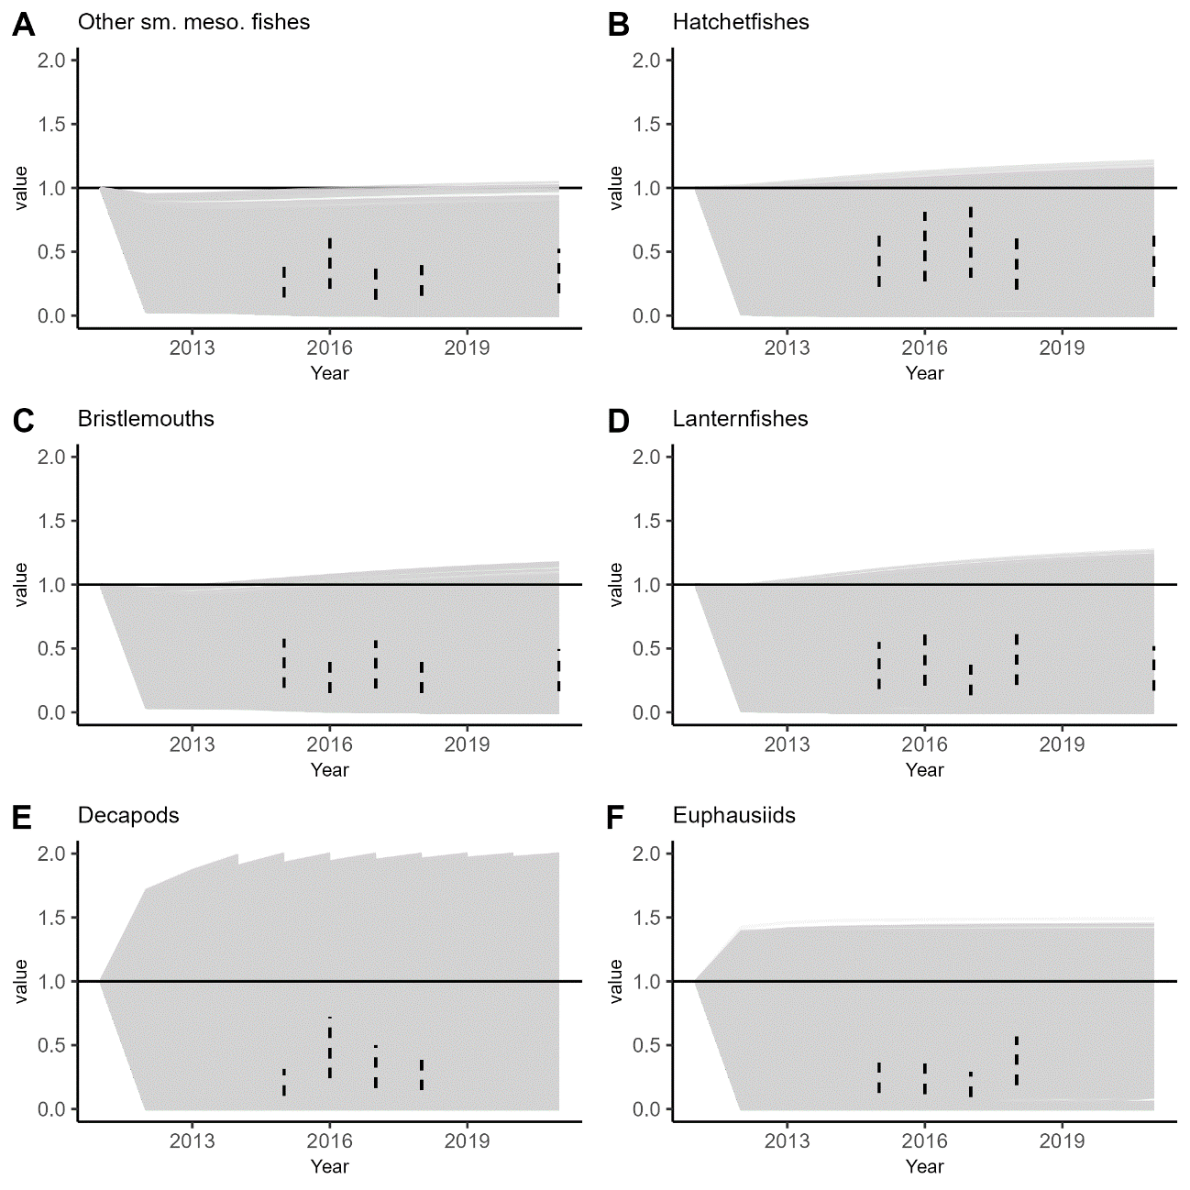
Figure A1. The relative biomass for all declined mesopelagic micronekton groups from 50,000 constant mortality scenarios. Each scenario is represented by a gray line. The target biomasses are represented by the dashed vertical lines. A horizontal line intersecting the y-axis of 1 (i.e., no biomass change) is for readability.

Exponential mortality scenarios
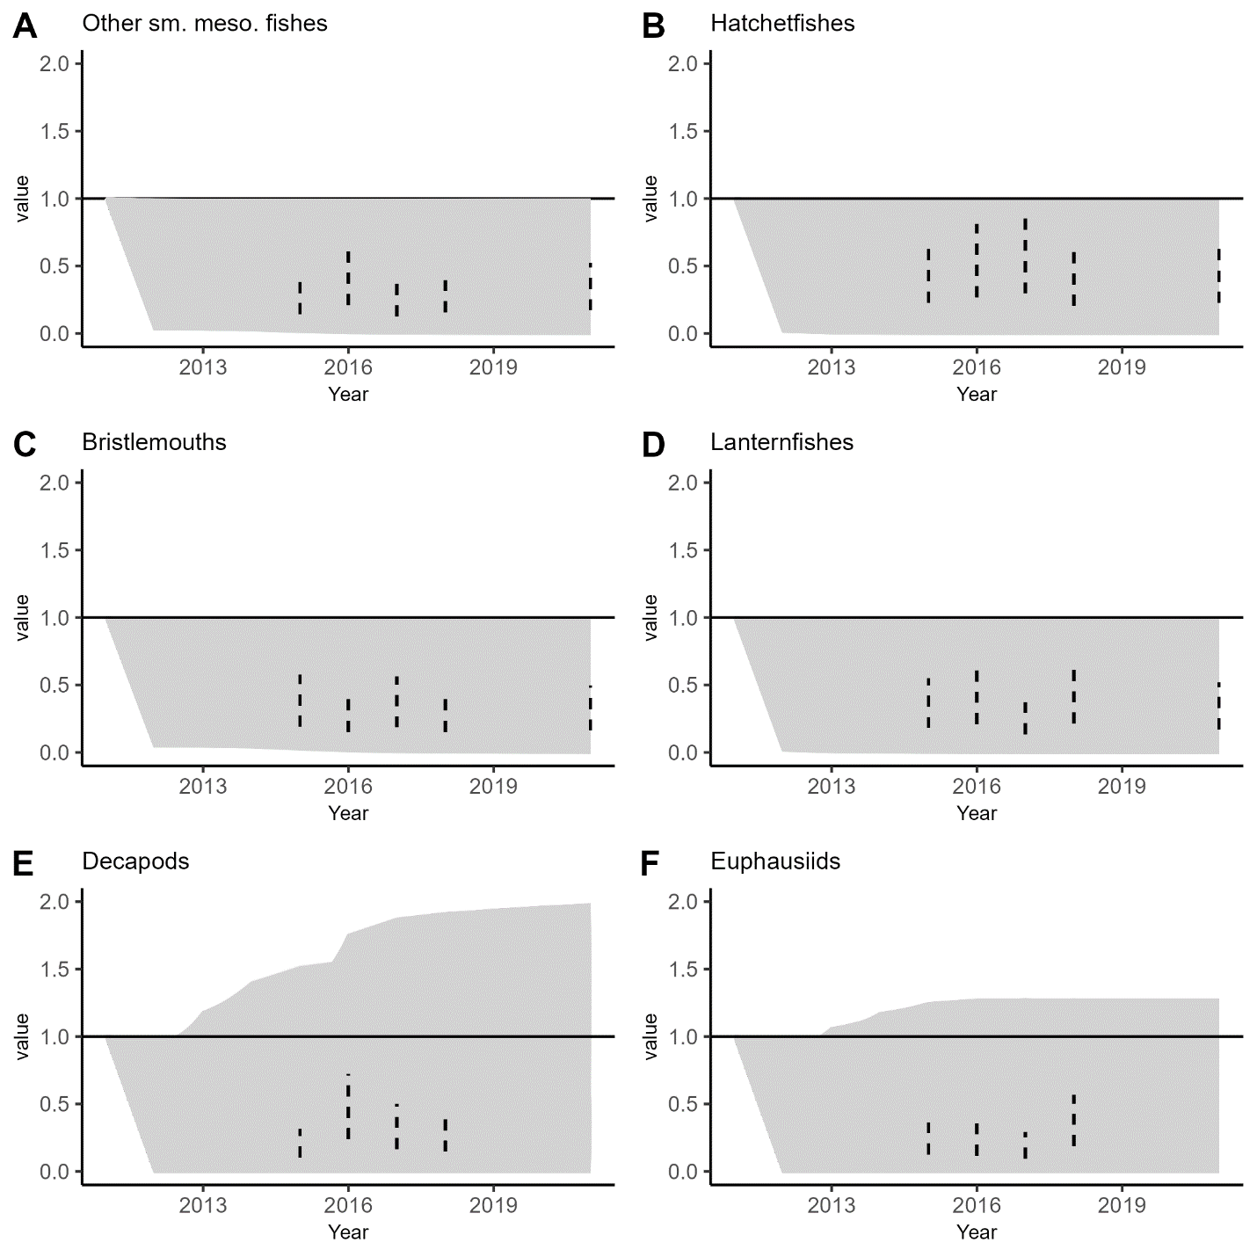
Figure A2. The relative biomass for all declined mesopelagic micronekton groups from 50,000 exponential mortality scenarios. Each scenario is represented by a gray line. The target biomasses are represented by the dashed vertical lines. A horizontal line intersecting the y-axis of 1 (i.e., no biomass change) is for readability.

Random mortality scenarios
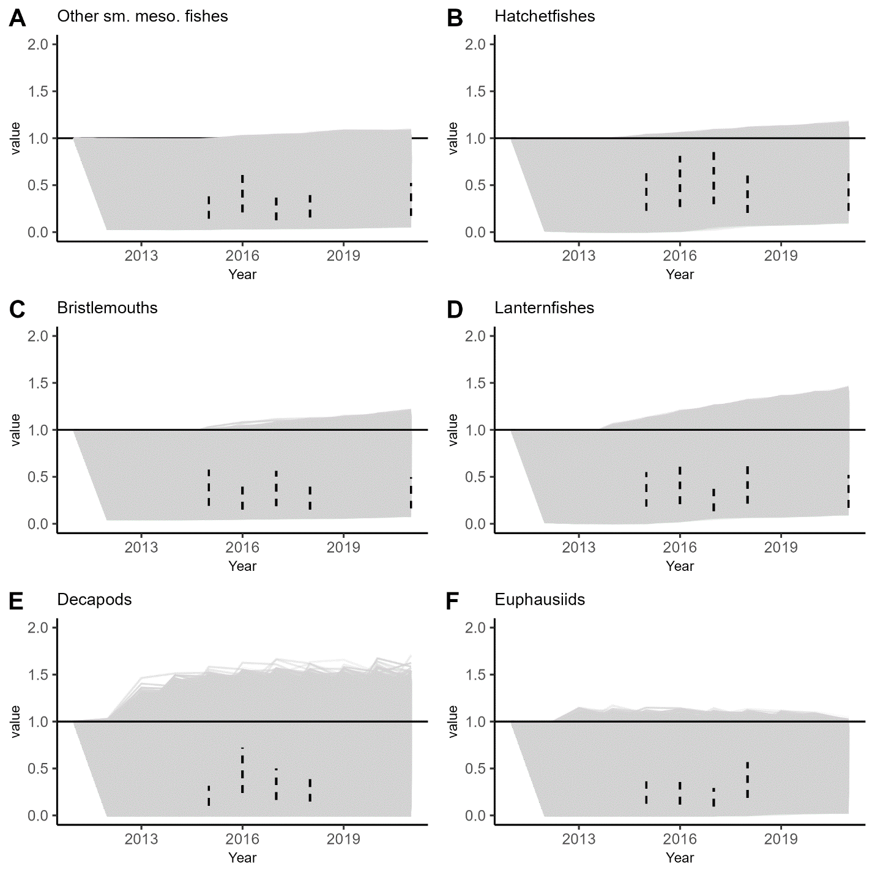
Figure A3. The relative biomass for all declined mesopelagic micronekton groups from 50,000 random mortality scenarios. Each scenario is represented by a gray line. The target biomasses are represented by the dashed vertical lines. A horizontal line intersecting the y-axis of 1 (i.e., no biomass change) is for readability.

Stepwise mortality scenarios
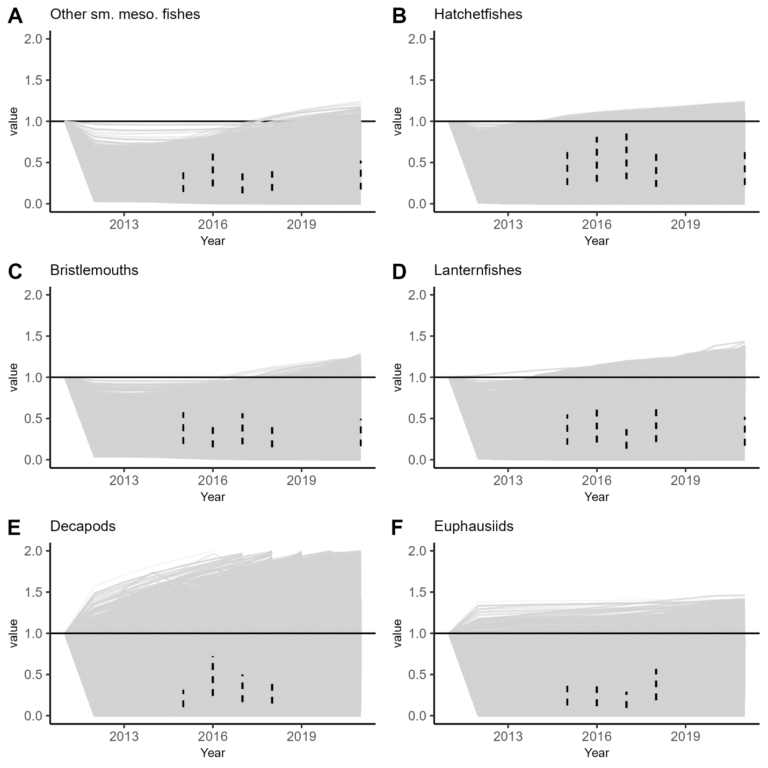
Figure A4. The relative biomass for all declined mesopelagic micronekton groups from 50,000 stepwise mortality scenarios. Each scenario is represented by a gray line. The target biomasses are represented by the dashed vertical lines. A horizontal line intersecting the y-axis of 1 (i.e., no biomass change) is for readability.

Literature Cited
Ayala DJ, Munk P, Lundgreen RBC, Traving SJ, Jaspers C, Jørgensen TS, Hansen LH, Riemann L (2018) Gelatinous plankton is important in the diet of European eel (Anguilla anguilla) larvae in the Sargasso Sea. Scientific Reports 8:1–10.

Camhi MD, Pikitch EK, Babcock EA (2009) Sharks of the Open Ocean.

Christensen V, Walters CJ, Pauly D, Forrest R (2008) Ecopath with Ecosim version 6 User Guide. Lensfest Ocean Futures Project 2008. 1–235.

Cook AB, Bernard AM, Boswell KM, Bracken-grissom H, Elia MD, Easson CG, English D, Eytan RI, Frank T, Hu C, Johnston MW, Judkins H, Lembke C, Lopez J V, Milligan RJ, Moore JA, Penta B, Pruzinsky NM, Quinlan JA, Richards TM, Romero IC, Shivji MS, Vecchione M, Weber MD, Wells RJD, Sutton TT, Clark MR (2020) A multidisciplinary approach to investigate deep-pelagic ecosystem dynamics in the Gulf of Mexico following Deepwater Horizon. Frontiers in Marine Science 7:1–14.

Deibel D (1988) Filter feeding by Oikopleura vanhoeffeni: grazing impact on suspended particles in cold ocean waters. Marine Biology 99:177–186.

Dodge KL, Logan JM, Lutcavage ME (2011) Foraging ecology of leatherback sea turtles in the Western North Atlantic determined through multi-tissue stable isotope analyses. Marine Biology 158:2813–2824.

Eduardo LN, Maia M, Flávia M, Rodrigues J, Gabriel M, Felix V, Bárbara A, Villarins T, Frédou T, Souza A, Arnaud L (2020) Length-weight relationship of twelve mesopelagic fishes from the western Tropical Atlantic. Journal of Applied Ichthyology:1–4.

Franks JS, Hoffmayer ER, Ballard JR, Garber NM, Garber AF (2008) Diet of Wahoo, Acanthocybium solandri, from the Northcentral Gulf of Mexico. Proceedings of the 60th Gulf and Caribbean Fisheries Institue 2007:353–362.

Gagne TO, David Hyrenbach K, Hagemann ME, van Houtan KS (2018) Trophic signatures of seabirds suggest shifts in oceanic ecosystems. Science Advances 4:1–9.

Garrison LP, Stokes L (2014) NOAA TECHNICAL MEMORANDUM NMFS-SEFSC-667 Estimated Bycatch of Marine Mammals and Sea Turtles in the U.S. Atlantic Pelagic Longline Fleet During 2013.

Geers TM, Pikitch EK, Frisk MG (2016) An original model of the northern Gulf of Mexico using Ecopath with Ecosim and its implications for the effects of fishing on ecosystem structure and maturity. Deep-Sea Research Part II: Topical Studies in Oceanography 129:319–331.

Hayes SA, Josephson E, Maze-Foley K, Rosel PE, Byrd B, Chavez-Rosales S, Vn Cole T, Garrison LP, Hatch J, Henry A, Horstman SC, Litz J, Lyssikatos MC, Mullin KD, Orphanides C, Pace RM, Palka DL, Powell J, Wenzel FW, Ross WL, Jacobs N, Oliver C (2019) US Atlantic and Gulf of Mexico Marine Mammal Stock Assessments-2018 with contributions from (listed alphabetically) US DEPARTMENT OF COMMERCE National Oceanic and Atmospheric Administration National Marine Fisheries Service.

Heymans JJ, Coll M, Link JS, Mackinson S, Steenbeek J, Walters C, Christensen V (2016) Best practice in Ecopath with Ecosim food-web models for ecosystem-based management. Ecological Modelling 331:173–184.

Hopkins TL, Baird RC (1985) Feeding ecology of four hatchetfishes (Sternoptychidae) in the eastern Gulf of Mexico. Bulletin of Marine Science 36:260–277.

Hopkins TL, Flock ME, Gartner J v., Torres JJ (2018) Structure and trophic ecology of a low latitude midwater decapod and myscid assemblage. Marine Ecology Progress Series 109:143–156.

Hopkins TL, Flock ME, Jr JVG, Torres JJ (1994) Structure and trophic ecology of a low latitude midwater decapod and mysid assemblage. Marine Ecology Progress Series 109:143–156.

Hopkins TL, Sutton TT, Lancraft TM (1996) The trophic structure and predation impact of a low latitude midwater fish assemblage. Progress in Oceanography 38:205–239.

Johnston MW, Milligan RJ, Easson CG, deRada S, English DC, Penta B, Sutton TT (2019) An empirically validated method for characterizing pelagic habitats in the Gulf of Mexico using ocean model data. Limnology and Oceanography: Methods 17:lom3.10319.

Kinsey ST, Hopkins TL (1994) Trophic strategies of euphausiids in a low-latitude ecosystem. Marine Biology 118:651–661.

Kotwicki S, Lauth RR, Williams K, Goodman SE (2017) Selectivity ratio: A useful tool for comparing size selectivity of multiple survey gears. Fisheries Research 191:76–86.

Llopiz JK, Muhling BA, Lamkin JT (2015) Feeding dynamics of atlantic Bluefin tuna (Thunnus thynnus) larvae in the Gulf of Mexico. Sci Pap ICCAT 71:1710–1715.

Logan JM, Toppin R, Smith S, Galuardi B, Porter J, Lutcavage M (2013) Contribution of cephalopod prey to the diet of large pelagic fish predators in the central North Atlantic Ocean. 95:74–82.

López-Pérez C, Olivar MP, Hulley PA, Tuset VM (2020) Length–weight relationships of mesopelagic fishes from the equatorial and tropical Atlantic waters: influence of environment and body shape. Journal of Fish Biology 96:1388–1398.

Ménard F, Stéquert B, Rubin A, Herrera M, Marchal É (2000) Food consumption of tuna in the Equatorial Atlantic ocean: FAD-associated versus unassociated schools. Aquatic Living Resources 13:233–240.

Palomares ML, Pauly D (1989) A Multiple Regression Model for Predicting the Food Consumption of Marine Fish Populations.

Passarella KC, Hopkins TL (1991) Species composition and food habits of the micronektonic cephalopod assemblage in the eastern Gulf of Mexico. Bulletin of Marine Science 49:638–659.

Pauly D (1980) On the interrelationships between natural mortality, growth parameters, and mean environmental temperature in 175 fish stocks. J Cons int Explor Mer 39:175–192.
Pauly D, Trites AW, Capuli E, Christensen V (1998) Diet composition and trophic level of marine mammals. ICES Journal of Marine Science 55:467–481.

Perryman HA, Tarnecki JH, Grüss A, Babcock EA, Sagarese SR, Ainsworth CH, Gray DiLeone AM (2020) A revised diet matrix to improve the parameterization of a West Florida Shelf Ecopath model for understanding harmful algal bloom impacts. Ecological Modelling 416:108890.

Potier M, Ménard F, Cherel Y, Lorrain A, Sabatié R, Marsac F (2007) Role of pelagic crustaceans in the diet of the longnose lancetfish Alepisaurus ferox in the Seychelles waters. African Journal of Marine Science 29:113–122.

Robinson KL, Ruzicka JJ, Hernandez FJ, Graham WM, Decker MB, Brodeur RD, Sutor M (2015) Evaluating energy flows through jellyfish and gulf menhaden (Brevoortia patronus) and the effects of fishing on the northern Gulf of Mexico ecosystem. ICES Journal of Marine Science 72:2301–2312.

Rooker JR, Turner JP, Holt SA, Turner, Jason P, Holt SA (2006) Trophic ecology of Sargassum-associated fishes in the Gulf of Mexico determined from stable isotopes and fatty acids. Marine Ecology Progress Series 313:249–259.

Selph KE, Swalethorp R, Stukel MR, Kelly TB, Knapp AN, Fleming K, Hernandez T, Landry MR (2021) Phytoplankton community composition and biomass in the oligotrophic Gulf of Mexico. Journal of Plankton Research:1–20.

Shiroza A, Malca E, Lamkin JT, Gerard T, Landry MR, Stukel MR, Laiz-Carrión R, Swalethorp R (2021) Active prey selection in developing larvae of Atlantic bluefin tuna ( Thunnus thynnus ) in spawning grounds of the Gulf of Mexico . Journal of Plankton Research.

Stickney DG, Torres JJ (1989) Proximate composition and energy content of mesopelagic fishes from the eastern Gulf of Mexico. Marine Biology 103:13–24.

Stukel MR, Gerard T, Kelly TB, Knapp AN, Laiz-Carrión R, Lamkin JT, Landry MR, Malca E, Selph KE, Shiroza A, Shropshire TA, Swalethorp R (2021) Plankton food webs in the oligotrophic Gulf of Mexico spawning grounds of Atlantic bluefin tuna. Journal of Plankton Research 00:1–19.

Sutton TT, Hopkins T (1996a) Trophic ecology of the stomiid (Pisces: Stomiidae) fish assemblage of the eastern Gulf of Mexico: strategies, selectivity and impact of a top mesopelagic predator group. Marine Biology 127:179–192.

Sutton TT, Hopkins TL (1996b) Species composition, abundance, and vertical distribution of the stomiid (Pisces:Stomiiformes) fish assemblage of the Gulf of Mexico. Bulletin of Marine Science 59:530–542.

Travers-Trolet M, Shin Y, Field J (2014) An end-to-end coupled model ROMS-NPZD-OSMOSE of teh southern Benguela foodweb: parameterisation, calibration and pattern-oriented validation. African Journal of Marine Science 36:11–29.

Trites AW, Pauly D (1998) Estimating mean body masses of marine mammals from maximum body lengths.

Wang B, Fennel K, Yu L, Gordon C (2020) Assessing the value of BGC Argo profiles versus ocean colour observations for biogeochemical model optimization in the Gulf of Mexico. Biogeosciences.

Wang M, Hu C, Cannizzaro J, English D, Han X, Naar D, Lapointe B, Brewton R, Hernandez F (2018) Remote Sensing of Sargassum Biomass, Nutrients, and Pigments. Geophysical Research Letters 45:12,359-12,367.

Wang VH, Zapfe CR, Hernandez FJ (2021) Assemblage Structure of Larval Fishes in Epipelagic and Mesopelagic Waters of the Northern Gulf of Mexico. Front Mar Sci 8:1–15.

Wells RJD, Rooker JR (2009) Feeding ecology of pelagic fish larvae and juveniles in slope waters of the Gulf of Mexico. Journal of Fish Biology 75:1719–1732.

Woodstock MS, Sutton TT, Zhang Y (2022) A trait-based carbon export model for mesopelagic fi shes in the Gulf of Mexico with consideration of asynchronous vertical migration, flux boundaries , and feeding guilds. Limnology and Oceanography:1–13.

CHAPTER IV

THE CETACEAN PUMP: CETACEAN-BASED NITROGEN TRANSPORT IN THE OCEANIC GULF OF MEXICO

Abstract
Consumer-mediated nutrient transport is the process of metazoans consuming nutrients in one ecosystem and traversing ecosystem boundaries with those nutrients. The vertical nitrogen movement by cetaceans can enhance localized primary production, but no such study has been done for the 19 cetacean species in the oceanic Gulf of Mexico. A spatialized, stochastic, nutrient transport model was developed using standard metabolic models, species-specific dive characteristics, and diets. Of the estimated 58,700 individuals that occupy the oceanic Gulf of Mexico, an estimated 2,550 kg N d⁻¹, or 0.06 t N yr⁻¹ ind⁻¹, is transported from depths deeper than 100 m to the surface. 72% of this N transport occurs seaward of the continental slope (deeper than the 1000-m isobath) because of the vast expanse of the ocean basin, but the transported N concentration is greater on the continental slope than the ocean basin. Surface to benthos transport (i.e., benthopelagic coupling) comprised 35.6 kg N d⁻¹, a process that was much more common on the continental slope than the open basin. Compared to an existing physical-biogeochemical model, the transported nutrients on average add 5.8% NH₄⁺ to the existing ammonium stock. The cetacean role as predators in the epipelagic zone at night, while vertically migrating deep-pelagic organisms are in the epipelagic zone, provides an additional 7,230 kg N d⁻¹, 2.8 times the transported value. Cetaceans in oceanic realms transport a considerable amount of nutrients from the deep ocean to the near-surface waters, a role supplemented by feeding in the epipelagic zone at night as cetaceans consume deep-pelagic organisms.

Introduction
As animals traverse ecosystem boundaries, they consume nutrients in one system (doner ecosystem) and excrete them in another (recipient ecosystem), allowing consumers to have a bottom-up role in aquatic ecosystems (Gravel et al. 2010; Allgeier et al. 2017). These additional nutrients are known to enhance primary production in recipient ecosystems, such as seagrass beds (Nelson et al. 2012; Allgeier et al. 2013), coral reefs (Meyer et al. 1983; Burkepile et al. 2013; Williams et al. 2018), and the open ocean (Hernández-León et al. 2008; Roman and McCarthy 2010). Open-ocean ecosystems exist away from terrigenous nutrient sources and operate with limited nutrients and high transfer efficiencies (Irigoien et al. 2014). Therefore, consumer-mediated nutrient transport may provide a considerable amount of nutrients that are necessary to maintain open-ocean ecosystem productivity.
Cetaceans have relatively high per capita consumption and metabolic rates and can potentially have high abundances in marine ecosystems. In oceanic zones, cetaceans make frequent dives to deep-pelagic depths (deeper than 200 m) to feed on mesopelagic and bathypelagic micronekton (Watwood et al. 2006; Gallo-Reynoso et al. 2009; Stimpert et al. 2014). Diel differences in dive behavior indicate that certain species may be targeting deep-scattering layers, which ascend to the surface during the night (i.e., diel vertical migration; Benoit-Bird and Au 2003; Soldevilla et al. 2017). Other species may dive to the benthos to eat benthic and demersal preys (Fitch and Brownell Jr. 1968; Davis et al. 2006). Cetaceans are required to approach the surface for respiration, where they are expected to release most of their ingested nitrogen because of higher metabolism in shallow (warmer) waters, lesser hydrostatic pressure at the surface, and decreased urine flow during dives (Kooyman et al. 1981; Katona and Whitehead 1988; Ortiz 2001). Although it is well understood that animal movement can supplement the amount of available nutrients in a recipient system, the roles that small cetaceans have in marine ecosystems as nutrient vectors and agents in benthopelagic coupling are not well understood (Kiszka et al. 2022).
The oceanic Gulf of Mexico (GoM; seaward of the 200-m isobath) is an oligotrophic region with steep continental slope boundaries and a large internal basin that contains ~97% of the GoM’s total water volume (Sutton et al. 2022). The nutrient concentrations in the open ocean are partially influenced by nutrient advection from the continental shelf (Kelly et al. 2021) and wind mixing (Jolliff et al. 2008; Huang et al. 2013). Even though 80% of the shelf nutrients may be denitrified prior to export beyond the 50-m isobath (Xue et al. 2013), the amount that is advected may support greater than 90% of the open-ocean nitrogen in the GoM (Kelly et al. 2021). However, current biogeochemical models in the oceanic GoM do not include the contribution of cetaceans (Shropshire et al. 2020; Wang et al. 2020), which excrete assimilable ammonium (NH₄⁺). Nineteen cetacean species occupy the northern portion of this area (U.S. Exclusive Economic Zone) and are believed to also occupy the southern area as well (i.e., Mexican Exclusive Economic Zone; Hayes et al. 2019). An estimate of the cetacean-based nutrient transport in the oceanic GoM is necessary to accurately quantify the positive feedback loop that cetaceans provide to the ecosystem.

Objectives
In this study, we utilized standard metabolic models to estimate the daily and annual amounts of nitrogen vertically transported by each cetacean species in the oceanic GoM. Comparisons are made among species and depth bin to determine the most important depth zone that each species moves nutrients from and the dominant contributors to the community. Oceanic (seaward of the 1000-m isobath) and continental slope (200–1000 m depth) regions are compared to associate the spatial allocation of each cetacean species with vertical nutrient movement and the magnitude of benthopelagic coupling by the cetacean community. Finally, the results are discussed in the context of the available ammonium concentrations throughout the oceanic GoM from an existing biogeochemical model (Wang et al. 2020).

Methods

Model initialization
A cetacean-based, nutrient-transport model was developed to estimate the amount of nitrogen vertically translocated in the oceanic GoM. The model domain included the entire GoM Large Marine Ecosystem, seaward of the 200-m isobath. A small portion of the Caribbean Sea was included within the domain, as a habitat suitability model suggests the cetaceans in the GoM occupy this region as well (Rafael Ramírez-León et al. 2021). The model consisted of 19 cetacean species (Table 1), with the abundances simulated as random integers from lognormal distributions. The means and coefficients of variation (CV) are collected from the latest NOAA stock assessments (Hayes et al. 2019), which estimated the dynamics of the cetacean populations in the entire GoM. Each modeled abundance was constrained by the minimum (stock-assessment derived) and maximum (mean + standard deviation) population sizes to eliminate unrealistic values. All species were divided into groups according to the means, and standard errors of group sizes in the GoM (Table 1; Maze-Foley and Mullin 2006), and the groups were assigned at a latitude-longitude weighted by the results of a MaxENT habitat suitability model (Rafael Ramírez-León et al. 2021). The MaxENT model utilized five environmental parameters (sea surface temperature, chlorophyll-a concentration, depth, slope, and distance to the 200-m isobath) and georeferenced sighting data to estimate the spatial utilization of nine cetacean species in the nutrient model. Habitat suitability maps were not available for ten species (i.e., Rice’s whale, Blainville’s beaked whale, Gervais’ beaked whale, Fraser’s dolphin, killer whale, false killer whale, pygmy killer whale, pygmy sperm whale, melon-headed whale, short-finned pilot whale), 10% of the community biomass. Rice’s whales were restricted to the upper continental slope (200–400 m) of the DeSoto Canyon region bound by -87.5˚W, -84.5˚W, 26˚N, and 30˚N (Soldevilla et al. 2017). All beaked whales were assumed to have the same distribution as Cuvier’s beaked whale. Pygmy sperm whales were applied the same distribution as dwarf sperm whales. The other five species without a habitat suitability map had a homogenous distribution (i.e., equal probability of occupying any latitude-longitude within the model domain). The group abundance was converted to biomass by multiplying the number of individuals in the group by the average mass of an individual (Table 1; Trites and Pauly 1998), assuming a sex ratio of 1:1 for all species. The model initialization was designed to create a community structure similar to the real ecosystem.

Table 1. The traits of the 19 species in the model. Abundance refers to the number of animals and the coefficient of variation (CV) from the latest stock assessment. Mean weights are reported in kg. The diets refer to the proportion of each prey taxa in the species’ diet
 | Abundance¹ |  | Group Size³
Species | (CV) | Mean Weight² | (sd) | Fish Diet⁴ | Cephalopod Diet⁴ | Crustacean Diet⁴
Balaenopteridae
Rice's whale | 51 (0.5) | 16,143 | 5 (1) | 0.60 | - | 0.40
Delphinidae
Clymene dolphin | 513 (1.03) | 47 | 325 (76) | 0.60 | 0.40 | -
Common bottlenose dolphin | 7,462 (0.31) | 188 | 220 (31) | 0.75 | 0.25 | -
Dwarf sperm whale | 336 (0.35) | 101 | 8 (1) | 0.10 | 0.80 | 0.10
False killer whale | 494 (0.79) | 578 | 70 (24) | 0.50 | 0.50 | -
Fraser's dolphin | 213 (1.03) | 95 | 117 (45) | 0.60 | 0.35 | 0.05
Killer whale | 267 (0.75) | 2,281 | 12 (5) | 0.90 | 0.10 | -
Melon-headed whale | 1,749 (0.68) | 105 | 275 (68) | 0.30 | 0.70 | -
Pantropical spotted dolphin | 37,195 (0.24) | 65 | 650 (67) | 0.50 | 0.50 | -
Pygmy killer whale | 613 (1.15) | 98 | 84 (23) | 0.50 | 0.50 | -
Pygmy sperm whale | 336 (0.35) | 177 | 8 (1) | 0.20 | 0.75 | 0.05
Risso's dolphin | 1,974 (0.46) | 224 | 40 (7) | 0.10 | 0.85 | 0.05
Short-finned pilot whale | 1,321 (0.43) | 643 | 85 (19) | 0.40 | 0.60 | -
Spinner dolphin | 2,991 (0.54) | 41 | 800 (195) | 0.60 | 0.40 | -
Striped dolphin | 1,817 (0.56) | 116 | 150 (34) | 0.60 | 0.35 | 0.05
Physeteridae
Sperm whale | 1180 (0.22) | 18,519 | 11 (2) | 0.25 | 0.70 | 0.05
Ziphiidae
Blainville's beaked whale | 98 (0.46) | 449 | 7 (1) | 0.50 | 0.50
Cuvier's beaked whale | 18 (0.75) | 829 | 4 (1) | 0.30 | 0.60 | 0.10
Gervais’ beaked whale | 20 (0.98) | 393 | 5 (1) | 0.50 | 0.50 | -
¹Hayes et al. 2019; ²Trites and Pauly 1998; ³Maze-Foley and Mullin 2006; ⁴Pauly et al. 1998

Model processes
For each group, the dive cycles, foraging, and egestion events were simulated for one day at a one-minute temporal scale. The dive depths of each species were gathered from literature and designed to reflect diel differences in dive behavior (e.g., Rice’s whale; Soldevilla et al. 2017), deep/shallow dives (e.g., beaked whales; Shearer et al. 2019), and consistent dive intervals (e.g., sperm whale; Watwood et al. 2006), where applicable. During the first timestep of the model (i.e., 00:01), each group dove to a random depth of the mean ± standard deviation and have a 5% chance of a deeper dive (i.e., up to maximum dive depth; Supplemental Material). Deeper dives were possible to incorporate the potential for cetaceans to make abnormally deep dives beyond their normal dive depths (Shearer et al. 2019). The group stayed at the depth for a random dive interval sampled from the average dive interval (literature-derived) with a built-in coefficient of variation (CV = 0.2). The group then ascended to the surface (depth = 0 m) and remained at the surface according to the randomly sampled surface interval (similar to the dive interval procedure). Local daytime was defined as 07:00–19:00, corresponding to the approximate ascension and descension times of diel vertical migration by mesopelagic organisms in the GoM (D’Elia et al. 2016). If the chosen dive depth was equal to or deeper than the bottom depth at the group’s latitude-longitude (determined by the marmap R package; Pante and Simon-Bouhet 2013), then the dive depth was changed to the bottom depth (i.e., deepest possible dive depth in that location). This cycle continued until midnight the next night (n=1,440 timesteps).

During each dive, each group consumed prey biomass (kg wet weight) randomly sampled from a normal distribution divided by the number of dives per day (mean 3% predator weight consumed per day; possible range of 1.5–4.5% predator weight consumed per day; Trites et al. 1997). The number of dives per day was a species-specific parameter that was either derived from literature or calculated according to the number of minutes in a day divided by the number of minutes spent in dive and surface intervals (Supplementary Material). Consumed biomass was converted to consumed nitrogen based on the species’ diet (Table 1), the time of day, the depth of the group, and the nitrogen concentration of each prey guild. During the day and at night, deeper than 200 m, consumed nitrogen (N₁) was calculated as a function of the biomass consumed per prey taxon (i.e., fish biomass consumed [Q_{f}], cephalopod biomass consumed [Q_{ce}], crustacean biomass consumed [Q_{cr}]; Table 1) and the nitrogen contents of fishes (N_{f}), cephalopods (N_{ce}), and crustaceans (N_{cr}; Equation 1). The nitrogen contents of prey were randomly chosen per model iteration from a normal distribution using the mean and standard deviation protein concentration (% wet weight) for fishes (Stickney and Torres 1989), cephalopods (Sinclair et al. 2015), and crustaceans (Donnelly et al. 1993). Protein was assumed to be 17% N by volume (Gaskin 1982).
$N_{1}=Q_{f}*N_{f}+Q_{ce}*N_{ce}+Q_{cr}*N_{cr}$ (1)
The nighttime micronekton community in the epipelagic zone has a vastly different species composition than the daytime because of diel vertical migrators. Thus, cetaceans feeding in the epipelagic zone at night consume vertically migrating deep-pelagic organisms, which have predominately excreted the food from their previous meal(s) (Merrett and Roe 1974). Therefore, it was necessary to calculate the proportion of the nighttime, epipelagic prey field that was comprised of vertically migrating, deep-pelagic fishes (A_{f}), cephalopods (A_{ce}), and crustaceans (A_{cr}). From 2011 to 2018, micronekton were collected using a 10-m² Multiple Opening and Closing Environmental Sensing System (MOCNESS) in the oceanic Gulf of Mexico aboard the research vessels Meg Skansi and Point Sur (Cook et al. 2020). The sampling design included day and night trawls at five discrete-depth bins (surface-200 m, 200–600 m, 600–1,000, 1,000–1,200 m, and 1,200–1,500 m) bound by -90˚W, -84˚W, 26˚N, and 30˚N. The nighttime, epipelagic, standardized abundance (n m⁻²) was calculated for each micronekton species caught during MOCNESS sampling. Each micronekton species was designated as either a diel vertical migrator or a non-migrator according to literature and trawl data. Several deep-benthic and non-migratory species were caught in the epipelagic zone at night but were considered “epipelagic” as this was likely larval organisms in the near-surface waters prior to settling (i.e., ontogenic vertical migration; Russell 1927; Pearre 1979). The proportion of the nighttime, epipelagic community comprised vertically migrating fishes, cephalopods, and crustaceans was calculated. For each modeled cetacean group, the proportion of deep-pelagic fishes (A_{f}), cephalopods (A_{ce}), and crustaceans (A_{cr}) in the epipelagic zone applied in the model was a random value sampled from a normal distribution driven by the mean and standard deviation of the net-caught assemblage to account for the likely variation in the prey community on a nightly and spatial basis. The nitrogen consumed by cetaceans in the epipelagic zone at night (N₂) was calculated similarly to during the day and at deep depths (see Equation 1), but with added multipliers to only consider the proportion of the ingested nitrogen that originated from deep-sea organisms (Equation 2).
$N_{2}= Q_{f}*N_{f}*A_{f}+Q_{ce}*N_{ce}*A_{ce}+Q_{cr}*N_{cr}*A_{cr}$ (2)
We assumed that 20% of the ingested N was retained for growth, energy reserves, and reproduction, while 80% of the ingested N was egested (Boyd et al. 1999; Roman and McCarthy 2010). Although pinniped populations egest 87% of the ingested N (Theobald et al. 2006), there is no quantitative analysis for cetacean populations and some N may be passively lost due to sinking (Roman and McCarthy 2010), so a conservative estimate was applied. The group-specific nitrogen egestion rate (d⁻¹) was calculated as the sum of each egestion event during the day. Six depth bins were considered to report the regions that nitrogen is transferred from: “Upper Epipelagic” (surface-100 m), “Lower Epipelagic” (100–200 m), “Upper Mesopelagic” (200–600 m), “Lower Mesopelagic” (600–1,000 m), “Bathypelagic” (1,000-benthos), and “Benthopelagic” (benthos). One thousand model iterations were run to quantify the combined effect of the uncertainty in all input parameters.
The results of the model (NH₄⁺_{cet}) were compared to the spatialized NH₄⁺ model output from a coupled physical-biogeochemical model (BGC) for the GoM Large Marine Ecosystem (NH₄⁺_{BGC}; Wang et al. 2020). This BGC model was run from 2010 to 2015, and has been calibrated using BGC Argo float data, and covers the entire Gulf of Mexico large marine ecosystem using a three-dimensional, irregular grid (see Wang et al. 2020 for detailed information). Daily model output was available but does not consider the contribution of cetaceans to the NH₄⁺ stock. Since the cetacean nutrient transport model did not account for seasonality and the BGC model occupied an irregular grid (i.e., the model has 36 depth observations at each latitude-longitude, but the actual depth varies across space), an annual average NH₄⁺ concentration was calculated for each latitude-longitude for all observations shallower than the chlorophyll maximum (an emergent property of the BGC model). The chlorophyll maximum depth was assumed to be 60 m, which is consistent with empirical studies in the offshore Gulf of Mexico (Cullen 2015). This converted the NH₄⁺ concentration from a 3-dimensional structure to a 2-dimensional structure. The BGC model results were then aggregated to match the coarser grid of the cetacean model by calculating the geometric mean of all BGC observations within each cetacean model grid cell. The output was then converted from mmol N m⁻² to kg N grid cell⁻¹ using the greatest circle distance to calculate the area (km²) of each cetacean-model grid cell. The percent increase of NH₄⁺ in each grid cell caused by the contribution of cetaceans was calculated as a function of the existing BGC model output (NH₄⁺_{BGC}) and the newly calculated contribution by cetaceans (NH₄⁺_{cet}; Equation 3).
$\% {NH}_{4}^{+}increase=\left[\left(\frac{{{NH}_{4}^{+}}_{cet}+{{NH}_{4}^{+}}_{BGC}}{{{NH}_{4}^{+}}_{BGC}}\right)-1\right]*100$ (3)
Since the model was stochastic and several input parameters were associated with uncertainty, a sensitivity analysis was conducted to quantify the variation caused by each parameter. Only the tested parameter was allowed to deviate during this sensitivity analysis, and all others were retained at the default value. To quicken model processing, only a 2-dimensional model structure (depth, time) was retained for the sensitivity analysis. One hundred iterations were run for each sensitivity scenario. The community-wide daily nitrogen transport results of each sensitivity scenario were compared to a base (all defaults) scenario. A Cohen’s d index (Larner 2014) was utilized to compare the means and standard deviations of the tested parameter and the base scenario (all parameters kept constant) using the “effsize” R package (Torchiano 2020).

Results

Community Composition
The cetacean community in the GoM is comprised of 5.87 × 10⁴ (± 8.8 × 10³) individuals, which corresponds to 2.95 × 10⁷ (± 3.7 × 10⁶) kg of biomass. Pantropical spotted dolphins are the most abundant cetacean species (3.72 × 10⁴ ± 4.3 × 10³ individuals), forming 63.5% of the community abundance (Figure 1A). However, their relatively small body size (65.4 kg individual⁻¹; Table 1) translates to just 8.2% of the community biomass (Figure 1B). Sperm whales dominate the community biomass at 2.91 × 10⁷ ± 2.3 × 10⁶ kg, a factor of 2.9 greater than the cumulative biomass of all other cetacean species. On average, spinner dolphins have the largest groups (2.22 × 10² ± 3.9 × 10¹ individuals), while several species (i.e., all beaked whales, sperm whale, dwarf sperm whale, killer whale, pygmy sperm whale, and Rice’s whale) have mean group sizes less than 10 (Figure 1C). 1.75 × 10³ (± 2.9 × 10²) cetacean groups exist in the GoM, with pantropical spotted dolphin (4.14 × 10² ± 4.9 × 10¹) and sperm whales (3.73 × 10² ± 4.0 × 10¹) comprising 45% of the total number of groups, integrating both abundance and group size characteristics (Figure 1D). The combination of abundance and biomass will determine the amount of daily N transported by a population, but a high number of groups allows for a wider distribution of N transport.
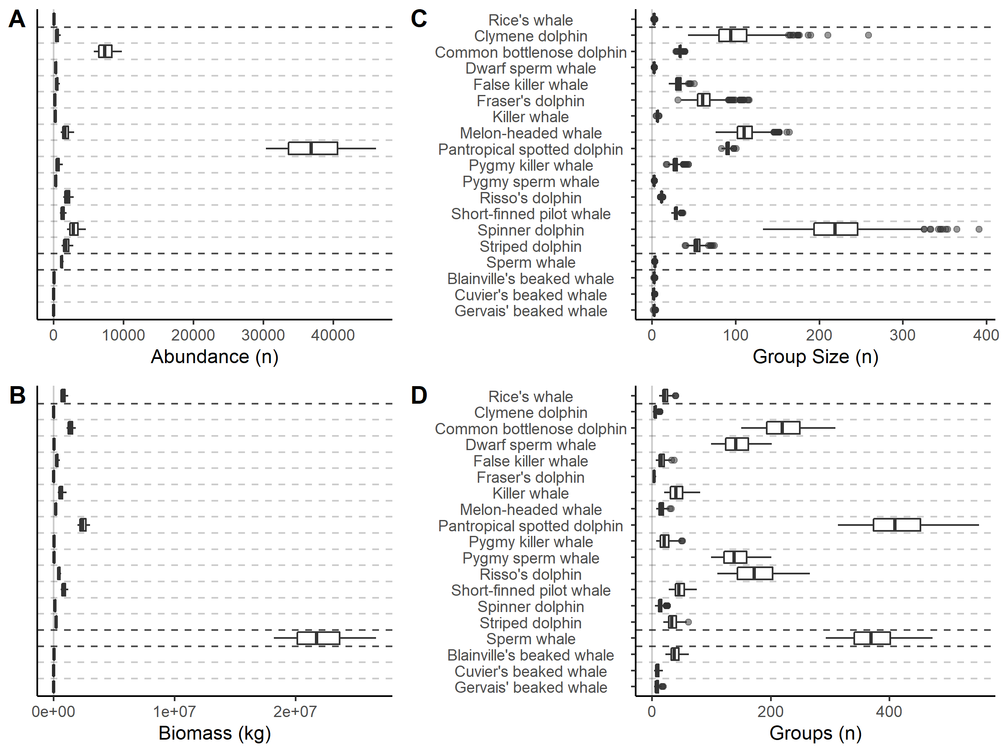
Figure 1. The modeled cetacean community composition in the oceanic Gulf of Mexico, including species’ abundance (A), biomass (B), group size (C), and the number of groups (D). Variation is associated with differences among 1,000 model iterations. Black horizontal lines separate families, while grey horizontal lines separate species.

Nitrogen consumption and Egestion
The cumulative amount of prey mass consumed by the cetacean community is 3.80 × 10⁶ (± 6.3 × 10⁵) kg prey d⁻¹. Pantropical spotted dolphins consume the most biomass (1.54 × 10⁶ ± 1.8 × 10⁵ kg prey d⁻¹), 41% of the consumption for the cetacean community. Considering species-specific diets, dive behaviors, and an 80% proportion of egested N, 9.77 × 10³ ± 2.2 × 10³ N day⁻¹ was egested by the assemblage, with pantropical spotted dolphins egesting the most N (5.73 × 10³ ± 1.4 × 10³ kg d⁻¹). The most abundant cetacean species that consume N-rich preys, intake, and egest the most N, and this is reflected at the community scale.
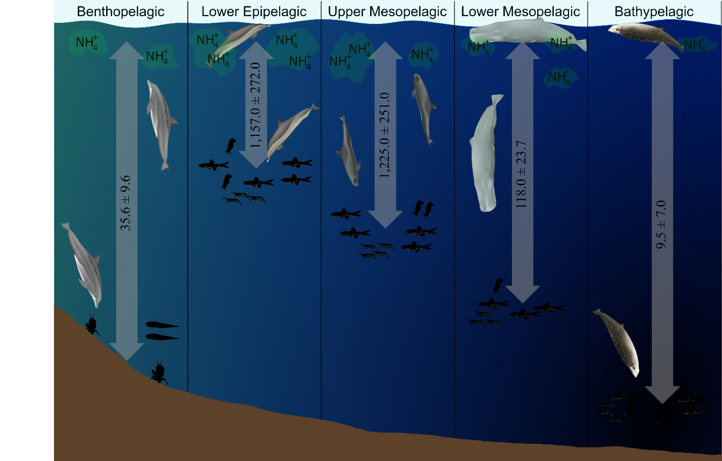
Figure 2. The nitrogen transported from each depth bin by all cetacean species (kg N d⁻¹). Each panel displays a different cetacean species that was a dominant contributor of the nutrient movement: Benthopelagic) Common bottlenose dolphin (Tursiops truncatus); Lower Epipelagic) Pantropical spotted dolphin (Stenella attenuata); Upper Mesopelagic) Melon-headed whale (Mesoplodon densirostris); Lower Mesopelagic) Sperm whale (Physeter macrocephalus); Bathypelagic) Cuvier’s beaked whale (Ziphius cavirostris)

When considering the depth of N consumption, and subsequent transfer, 2.55 × 10³ ± 5.4 × 10² kg N day⁻¹ was transported from depths deeper than 100 m to the surface (Figure 2). The majority of this N originated at the upper mesopelagic (1.23 × 10³ ± 2.5 × 10² kg N day⁻¹) and lower epipelagic (1.16 × 10³ ± 2.7 × 10² kg N day⁻¹) depth layers, 93.5% of the total transported N (Figure 2). Common bottlenose dolphins (3.94 × 10² ± 1.3 × 10¹ kg N d⁻¹) and pantropical spotted dolphins (3.37 × 10² ± 8.1 × 10¹) transported the most N from the lower epipelagic zone (Figure 3a). Common bottlenose dolphins also transported the greatest amount of N from the upper mesopelagic zone (2.68 × 10² ± 8.7 × 10¹ kg N day⁻¹), while sperm whales (2.37 × 10² ± 4.6 × 10¹) and short-finned pilot whales (2.08 × 10² ± 5.7 × 10¹ kg N d⁻¹) combined for 58.2% of the N transported from that depth bin (Figure 3). Sperm whales transport 78% of the community’s N contribution from the lower mesopelagic zone (9.33 × 10¹ ± 1.8 × 10¹ kg N d⁻¹); 26.2% of the population’s contribution. 9.5 ± 7.0 kg N d⁻¹ skipped the lower epipelagic and mesopelagic zones entirely, 48.4% of which is contributed by beaked whales (Figure 3). Including just the feeding on mesopelagic organisms at night, 7.23 × 10³ ± 1.7 × 10³ kg N day⁻¹ was consumed and excreted in the upper epipelagic zone. 74.7% of this N retention (5.40 × 10³ ± 1.3 × 10³ kg N d⁻¹) is from the pantropical spotted dolphin population. The deep-dive behavior of cetaceans in the oceanic GoM and the diel vertical movement of mesopelagic micronekton connects the surface ecosystem to the deep sea via nutrient transport.
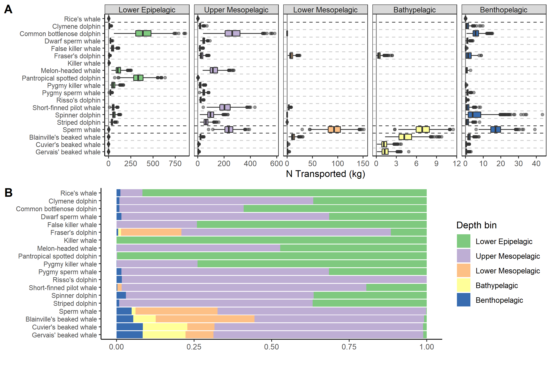
Figure 3. The nitrogen transported by each cetacean species from different depth bins. A) The amount of nitrogen transported (kg N d⁻¹) by each species. The error bars and outliers are associated with variation among each model iteration (n=1,000). B) The proportional amount of nitrogen transported by depth bin for each species. Colors reflect different depth bins, dark horizontal lines separate families, and grey horizontal lines separate species within family for readability.

The horizontal spatial distribution of each cetacean species has an influence on the N transport in different localities within the GoM. 72.1% of the overall N transport occurred in waters deeper than 1000 m (Figure 4). All but one species (common bottlenose dolphin) transported more N seaward of the 1000-m isobath than shallower waters, but when standardized per km², all species transported a greater concentration of nutrients on the continental slope than in the open ocean (Table 2). Surface-benthopelagic coupling accounted for 1.4% (3.56 × 10¹ ± 9.6 kg N day⁻¹) of the overall N transport into the near-surface waters, but most of this occurred in waters shallower than 1000 m (Figure 4), ostensibly because of the accessibility of the benthic system to cetaceans on the continental slope. 17 out of 19 cetacean species contributed to surface-benthopelagic coupling, indicating the commonality of the practice as long as dive behaviors do not vary across horizontal spatial scales. All cetacean species that occupy the oceanic GoM actively transport N from deep depths to the near-surface waters, highlighting the functional importance of these animals in oceanic systems, beyond simply being predators.
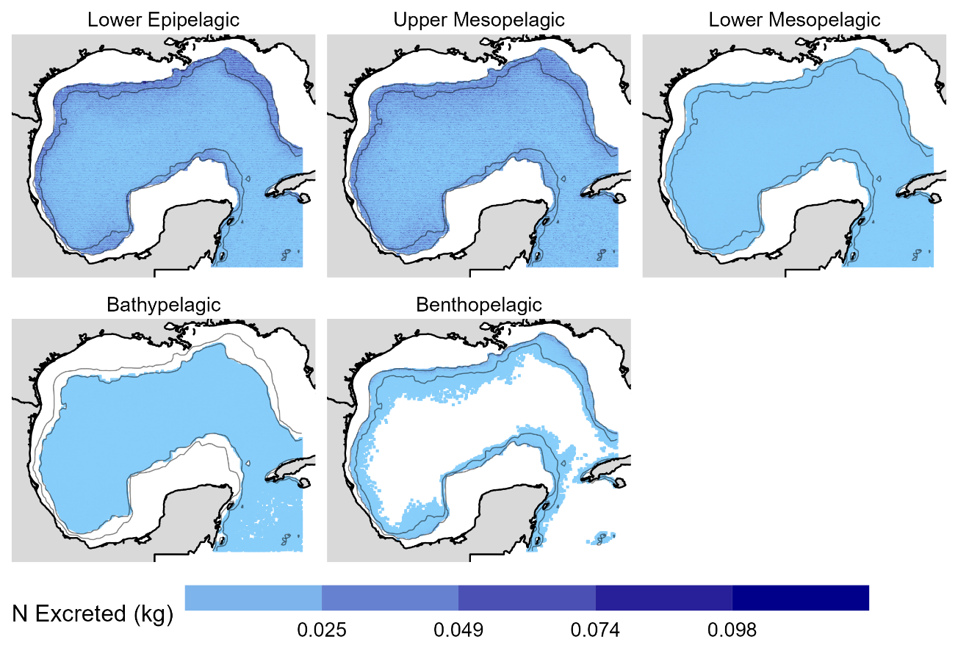
Figure 4. The spatial allocation of cetacean-based nitrogen transport (kg N d⁻¹) that originated from each depth bin for all species. Values are the mean of all model iterations (n=1,000). Dark blue represents high amounts of nitrogen and white represents no nitrogen was moved from that depth bin and latitude-longitude coordinate. Contour lines represent the 200-m and 1,000-m isobaths. Species-specific results are available in the Supplemental Material.

Table 2. The standardized amount of nitrogen (kg N km⁻² d⁻¹) that each species actively transported in regions shallower than 1000-m (“Shallow”) and deeper than 1000-m (“Deep”). Standard deviations are in parentheses
Species | Shallow | Deep
Balaenopteridae
Rice's whale | 1.12×10⁻⁴ (3.99×10⁻⁵) | -
Delphinidae
Clymene dolphin | 3.24×10⁻⁴ (2.48×10⁻⁴) | 1.65×10⁻⁴ (8.74×10⁻⁵)
Common bottlenose dolphin | 1.14×10⁻² (3.75×10⁻³) | 9.32×10⁻⁴ (3.18×10⁻⁴)
Dwarf sperm whale | 2.40×10⁻⁴ (7.14×10⁻⁵) | 1.60×10⁻⁴ (3.71×10⁻⁵)
False killer whale | 1.89×10⁻⁴ (1.35×10⁻⁴) | 1.90×10⁻⁴ (7.75×10⁻⁵)
Fraser's dolphin | 2.13×10⁻⁴ (1.28×10⁻⁴) | 9.62×10⁻⁵ (5.10×10⁻⁵)
Killer whale | 8.73×10⁻⁵ (5.54×10⁻⁵) | 9.96×10⁻⁵ (4.61×10⁻⁵)
Melon-headed whale | 5.70×10⁻⁴ (3.65×10⁻⁴) | 5.83×10⁻⁴ (2.08×10⁻⁴)
Pantropical spotted dolphin | 1.43×10⁻² (3.81×10⁻³) | 1.06×10⁻² (2.56×10⁻³)
Pygmy killer whale | 2.16×10⁻⁴ (1.55×10⁻⁴) | 2.33×10⁻⁴ (1.16×10⁻⁴)
Pygmy sperm whale | 2.42×10⁻⁴ (6.97×10⁻⁵) | 1.61×10⁻⁴ (3.90×10⁻⁵)
Risso's dolphin | 1.15×10⁻³ (3.47×10⁻⁴) | 5.07×10⁻⁴ (1.43×10⁻⁴)
Short-finned pilot whale | 5.22×10⁻⁴ (2.49×10⁻⁴) | 5.74×10⁻⁴ (1.65×10⁻⁴)
Spinner dolphin | 2.37×10⁻³ (1.22×10⁻³) | 7.19×10⁻⁴ (3.09×10⁻⁴)
Striped dolphin | 6.32×10⁻⁴ (3.54×10⁻⁴) | 6.09×10⁻⁴ (2.05×10⁻⁴)
Physeteridae
Sperm whale | 9.92×10⁻⁴ (2.17×10⁻⁴) | 6.27×10⁻⁴ (1.23×10⁻⁴)
Ziphiidae
Blainville's beaked whale | 8.89×10⁻⁵ (4.27×10⁻⁵) | 7.01×10⁻⁵ (2.17×10⁻⁵)
Cuvier's beaked whale | 1.55×10⁻⁵ (1.00×10⁻⁵) | 9.98×10⁻⁶ (4.10×10⁻⁶)
Gervais’ beaked whale | 1.88×10⁻⁵ (1.24×10⁻⁵) | 1.15×10⁻⁵ (5.60×10⁻⁶)

Combination with the BGC model
The NH₄⁺ stock shallower than the chlorophyll maximum depth across the entire ecosystem was 7.39 ± 2.8 kg NH₄⁺ km⁻² and this was enhanced by a median value of 5.8% (Figure 5). The median percent increase on the continental slope (7.9%) was greater than the oceanic zone (5.4%), but the heterogeneity of the NH₄⁺ pool and the spatial distribution of cetacean species produced uncertainty (Figure 5). Cetaceans increased the NH₄⁺ standing stock by less than 1% in just 885 of 13,749 (6%) of the grid cells in the model domain (Figure 5). In 29 grid cells (8 slope, 21 oceanic), cetaceans contributed to greater than a 50% increase in the NH₄⁺ pool, the maximum being 121% (18.8˚N, -87.1˚W; Figure 5). However, just 12 of the grid cells with a cetacean contribution greater than 50% increase were inside the Gulf of Mexico basin, while the others were in the Caribbean Sea along the Yucatan Peninsula. The addition of consumer-mediated nutrients to a BGC model in the GoM would add a non-negligible increase throughout the GoM on both the continental slope and the oceanic zones.
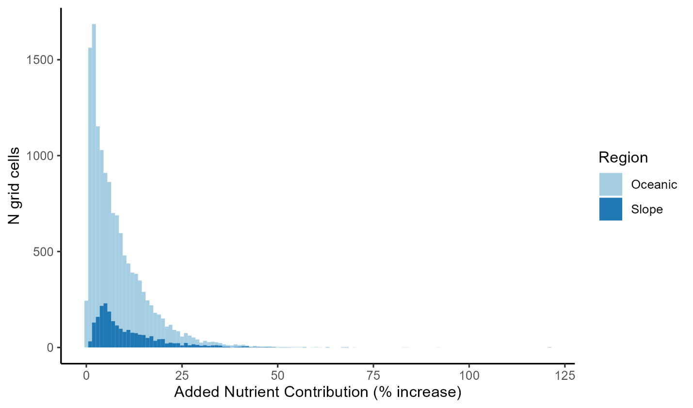
Figure 5. A histogram of the added nutrient concentration (cetacean-based nitrogen transported / BGC model ammonium concentration) for the oceanic (light blue) and the continental slope (dark blue) regions. Values are binned each 1% increase.

Sensitivity Analysis
A sensitivity analysis indicated that the model results were more sensitive to the inherent stochasticity of the model than the variation in input parameters. All tested sensitivity parameters produced Cohen’s d confidence ranges that were inclusive of zero, indicating that the potential error in those values did not significantly alter the model results (Figure 6). However, the ranges of the confidence intervals for all tested parameters were the same (± 0.28), which is a product of the uncontrolled stochasticity (e.g., dive intervals, dive depths). The most deviant parameter (species’ abundance) had a Cohen’s d index value of -0.25, indicating that on average, the variation in this parameter was ¼ of a standard deviation less than the base scenario (Figure 6). Although the variation in model parameters influences the model results, variation in dive behavior (e.g., surface/depth intervals, depth) had a greater effect on the N transported by the cetacean community.
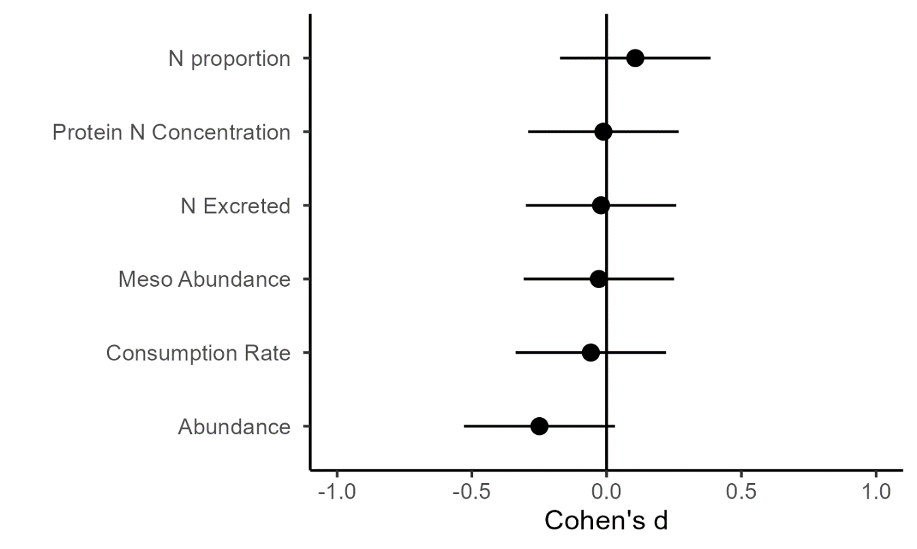
Figure 6. The Cohen’s d effect size of each tested parameter in the sensitivity analysis. A Cohen’s d value of 1 indicates that the parameter produces results 1 standard deviation greater than the base scenario.

Discussion
This model successfully quantifies the vertical nitrogen transport by cetaceans in the oceanic Gulf of Mexico. Including the nighttime feeding on vertically migrating mesopelagic organisms, 9.8 × 10³ ± 2.2 × 10³ kg N d⁻¹ are mediated by cetaceans from deep depths, although 86% of these nutrients originate in the epipelagic zone. Assuming there is no seasonal deviation, this equates to 3.6 × 10³ ± 8.0 × 10² mt N yr⁻¹. In the Gulf of Maine, cetaceans and seals add 2.3 × 10⁴ mt N yr⁻¹, enough to significantly increase the primary production in the region (Roman and Mccarthy 2010). However, toothed cetaceans in the Gulf of Maine (n=110,458 individuals) only contributed 12% of the daily N export, while pinnipeds (absent in the Gulf of Mexico) and baleen whales (only represented by Rice’s whale in the Gulf of Mexico) contributed the rest (Roman and Mccarthy 2010). However, the per capita N export for cetaceans in the Gulf of Mexico (0.06 mt N yr⁻¹) is 3 times greater than the per capita N export rate for toothed cetaceans in the Gulf of Maine (0.02 mt N yr⁻¹), ostensibly because of differences to the species that occupy the region (e.g., sperm whales in the Gulf of Mexico). Although the results of this study are limited by large variations in dive data and a lack of size-structured information for cetacean populations in the oceanic Gulf of Mexico, this study is one of the first to explicitly model the vertical nutrient transport of cetaceans, and the first in the Gulf of Mexico.
The majority of the cetacean-based nutrient transport occurred at night in the epipelagic zone as cetaceans consumed mesopelagic fishes, crustaceans, and cephalopods. Diel vertically migrating organisms actively transport nutrients from the epipelagic zones to deep depths, and their alimentary canals are generally devoid of assimilable nutrients by the time they migrate into the epipelagic zone again (Merrett and Roe 1974; Baird et al. 1975; Tyler and Pearcy 1975). Therefore, the consumption of diel vertically migrating organisms in the epipelagic zone serves to retain nutrients that would otherwise be excreted by micronekton at deep depths. In this model, the amount of nutrients retained through the nighttime consumption of deep-pelagic micronekton was 2.8 times greater than the daily N transport by the cetacean community. Assuming an opportunistic feeding strategy, cetaceans that remain in the epipelagic zone still participate in vertical nutrient transport by consuming deep-pelagic micronekton and retaining nutrients in the near-surface waters.
The effect of consumer-mediated vertical nutrient transport is not often incorporated in biogeochemical models. In this model, the cetacean community contributed an additional 5.8% (0.43 kg N km⁻²) of NH₄⁺ and appeared to fit a lognormal distribution but was highly variable (range from < 1% to 121%). This variance is likely caused by cetacean distributions (Rafael Ramírez-León et al. 2021) and the localized nutrient conditions, which are affected by advected nutrient inputs from neritic regions and passive vertical mixing (Xue et al. 2013; Kelly et al. 2018). Regardless, the comparison of consumer-mediated nutrient transport to the NH₄⁺ stock in an existing biogeochemical model indicates the community provides a non-negligible source of nutrients that is absent from standard biogeochemical models.
The cetaceans in this model contributed 35.65 ± 9.6 kg N d⁻¹ to benthopelagic coupling, and 93% of this was on the continental slope (200–1000 m depth). This is driven by the distribution of cetaceans in the Gulf of Mexico who prefer the continental shelf margins because of the bathymetric and environmental conditions (Grüss et al. 2018; Rafael Ramírez-León et al. 2021), which likely influence the spatial distribution of preys as well. Additionally, since this process is contingent on the cetaceans diving to the benthos, only beaked whales have dive maxima deeper than 2000 m (Baird et al. 2006; Shearer et al. 2019), and the deepest point in the GoM (Sigsbee Deep) is approximately 3,700 m deep, a reduction of benthopelagic coupling in the open basin was expected. However, it is possible for benthopelagic coupling in the deep basin to occur through multiple trophic pathways, as deep-demersal fishes ascend off the bottom to feed on pelagic taxa (Drazen et al. 2001), entering the dive range of cetaceans. The quantification of benthopelagic coupling is often focused on trophic interactions and fisheries and coastal regions (Marcus and Boero 1998; Agnetta et al. 2019) and this is the first study to focus on the active transport of nutrients from the benthos to the surface by cetaceans.
Cetaceans occupy an important ecological role in oceanic ecosystems as both predators and nutrient vectors. Their frequent dive behavior to deep depths and ubiquitous distribution throughout the oceanic GoM (Davis et al. 1998; Maze-Foley and Mullin 2006) indicates that cetaceans provide non-negligible, positive feedback loops throughout the oligotrophic ocean basin. Cetaceans are upper-trophic level predators in most oceanic regions (Trites et al. 1999; Piroddi et al. 2015), but their role in marine ecosystem models is poorly represented (Goedegebuure et al. 2017; Kiszka et al. 2022). Advances to our understanding of cetacean life histories, species’ abundances, species’ distributions, diets, and population age structure are necessary to better parameterize energetic models and enhance the recognized role of cetaceans in oceanic regions.

Acknowledgments
This paper is a result of research funded by the National Oceanic and Atmospheric Administration's RESTORE Science Program under award NA19NOS4510193 to Nova Southeastern University and The Gulf of Mexico Research Initiative. This is publication #XX from the Institute of Environment at Florida International University. This manuscript was in part supported through the financial support of a Florida International University Provost Employer Supported Tuition Fellowship. We also thank Uko Gorter for allowing the use of his illustrations (delphinids) in Figure 2.
Literature Cited
Agnetta, D., F. Badalamenti, F. Colloca, and others. 2019. Benthic-pelagic coupling mediates interactions in Mediterranean mixed fisheries: An ecosystem modeling approach. PLoS One 14: 1–24. doi:10.1371/journal.pone.0210659

Allgeier, J. E., D. E. Burkepile, and C. A. Layman. 2017. Animal pee in the sea: consumer-mediated nutrient dynamics in the world’s changing oceans. Glob. Chang. Biol. 23: 2166–2178. doi:10.1111/gcb.13625

Allgeier, J. E., L. A. Yeager, and C. A. Layman. 2013. Consumers regulate nutrient limitation regimes and primary production in seagrass ecosystems. Ecology 94: 521–529. doi:10.1890/12-1122.1

Baird, R., T. Hopkins, and D. F. Wilson. 1975. Diet and feeding chronology of Diaphus taaningi (Myctophidae) in the Cariaco Trench. Copeia 1975: 356.

Baird, R. W., D. L. Webster, D. J. McSweeney, A. D. Ligon, G. S. Schorr, and J. Barlow. 2006. Diving behaviour of Cuvier’s (Ziphius cavirostris) and Blainville’s (Mesoplodon densirostris) beaked whales in Hawai’i. Can. J. Zool. 84: 1120–1128. doi:10.1139/Z06-095

Benoit-Bird, K. J., and W. W. L. Au. 2003. Prey dynamics affect foraging by a pelagic predator (Stenella longirostris) over a range of spatial and temporal scales. Behav. Ecol. Sociobiol. 53: 364–373. doi:10.1007/s00265-003-0585-4

Boyd, I. L., C. Lockyer, and H. D. Marsh. 1999. Reproduction in marine mammals, p. 218–286. In J.I. Reynolds and S. Rommel [eds.], Biology of marine mammals. Smithsonian Institution Press.

Burkepile, D. E., J. E. Allgeier, A. A. Shantz, C. E. Pritchard, N. P. Lemoine, L. H. Bhatti, and C. A. Layman. 2013. Nutrient supply from fishes facilitates macroalgae and suppresses corals in a Caribbean coral reef ecosystem. Sci. Rep. 3: 19–21. doi:10.1038/srep01493

Cook, A. B., A. M. Bernard, K. M. Boswell, and others. 2020. A multidisciplinary approach to investigate deep-pelagic ecosystem dynamics in the Gulf of Mexico following Deepwater Horizon. Front. Mar. Sci. 7: 1–14. doi:10.3389/fmars.2020.548880

Cullen, J. 2015. Subsurface chlorophyll maximum layers: Enduring enigma or mystery solved. Annual Review of Marine Science. 7: 207–239. doi: 10.1146/annurev-marine-010213-135111

D’Elia, M., J. D. Warren, I. Rodriguez-Pinto, T. T. Sutton, A. Cook, and K. M. Boswell. 2016. Diel variation in the vertical distribution of deep-water scattering layers in the Gulf of Mexico. Deep. Res. Part I Oceanogr. Res. Pap. 115: 91–102. doi:10.1016/j.dsr.2016.05.014

Davis, R. W., G. S. Fargion, N. May, T. D. Leming, M. Baumgartner, W. E. Evans, L. J. Hansen, and K. Mullin. 1998. Physical habitat of cetaceans along the continental slope in the northcentral and western Gulf of Mexico. Mar. Mammal Sci. 14: 490–507. doi:10.1111/j.1748-7692.1998.tb00738.x

Davis, R. W., G. A. J. Worthy, B. Würsig, S. K. Lynn, and F. I. Townsend. 2006. Diving Behavior and At-Sea Movements of an Atlantic Spotted Dolphin in the Gulf of Mexico. Mar. Mammal Sci. 12: 569–581. doi:10.1111/j.1748-7692.1996.tb00069.x

Donnelly, J., D. G. Stickney, and J. J. Torres. 1993. Proximate and elemental composition and energy content of mesopelagic crustaceans from the Eastern Gulf of Mexico. Mar. Biol. 115: 469–480. doi:10.1007/BF00349846

Drazen, J. C., T. W. Buckley, and G. R. Hoff. 2001. The feeding habits of slope dwelling macrourid fishes in the eastern North Pacific. Deep. Res. Part I Oceanogr. Res. Pap. 48: 909–935. doi:10.1016/S0967-0637(00)00058-3

Fitch, J. E., and R. L. Brownell Jr. 1968. Fish Otoliths in Cetacean Stomachs and Their Importance in Interpreting Feeding Habits. J. Fish. Res. Board Canada 25: 2561–2574.

Gallo-Reynoso, J.-P., J. Égido-Villarreal, and E.-M. Coria-Galindo. 2009. Sperm whale distribution and diving behaviour in relation to presence of jumbo squid in Guaymas Basin, Mexico. Mar. Biodivers. Rec. 2: e139. doi:10.1017/s1755267209990571

Gaskin, D. E. 1982. The ecology of whales and dolphins, Heinemann.

Goedegebuure, M., J. Melbourne-Thomas, S. P. Corney, M. A. Hindell, and A. J. Constable. 2017. Beyond big fish: The case for more detailed representations of top predators in marine ecosystem models. Ecol. Modell. 359: 182–lim192. doi:10.1016/j.ecolmodel.2017.04.004

Gravel, D., F. Guichard, M. Loreau, and N. Mouquet. 2010. Source and sink dynamics in meta-ecosystems. Ecology 91: 2172–2184. doi:10.1890/09-0843.1

Grüss, A., M. D. Drexler, C. H. Ainsworth, and others. 2018. Improving the spatial allocation of marine mammal and sea turtle biomasses in spatially explicit ecosystem models. Mar. Ecol. Prog. Ser. 602: 255–274. doi:10.3354/meps12640

Hayes, S. A., E. Josephson, K. Maze-Foley, and others. 2019. US Atlantic and Gulf of Mexico Marine Mammal Stock Assessments-2018 with contributions from (listed alphabetically) US DEPARTMENT OF COMMERCE National Oceanic and Atmospheric Administration National Marine Fisheries Service.

Hernández-León, S., C. Fraga, and T. Ikeda. 2008. A global estimation of mesozooplankton ammonium excretion in the open ocean. J. Plankton Res. 30: 577–585. doi:10.1093/plankt/fbn021

Huang, W. J., W. J. Cai, R. M. Castelao, Y. Wang, and S. E. Lohrenz. 2013. Effects of a wind-driven cross-shelf large river plume on biological production and CO2 uptake on the Gulf of Mexico during spring. Limnol. Oceanogr. 58: 1727–1735. doi:10.4319/lo.2013.58.5.1727

Irigoien, X., T. A. Klevjer, A. Røstad, and others. 2014. Large mesopelagic fishes biomass and trophic efficiency in the open ocean. Nat. Commun. 5: 3271. doi:10.1038/ncomms4271

Jolliff, J. K., J. C. Kindle, B. Penta, R. Helber, Z. Lee, I. Shulman, R. Arnone, and C. D. Rowley. 2008. On the relationship between satellite-estimated bio-optical and thermal properties in the Gulf of Mexico. J. Geophys. Res. Biogeosciences 113: 1–27. doi:10.1029/2006JG000373

Katona, S., and H. Whitehead. 1988. Are Cetacea ecologically important? Oceanogr. Mar. Biol. Annu. Rev. 26: 553–568.

Kelly, T. B., A. N. Knapp, M. R. Landry, K. E. Selph, T. A. Shropshire, R. K. Thomas, and M. R. Stukel. 2021. Lateral advection supports nitrogen export in the oligotrophic open-ocean Gulf of Mexico. Nat. Commun. 12: 1–7. doi:10.1038/s41467-021-23678-9

Kelly, T. B., R. K. Thomas, A. N. Knapp, M. R. Landry, K. E. Selph, T. A. Shropshire, and M. R. Stukel. 2018. Lateral advection supports nitrogen export in the oligotrophic open-ocean Gulf of Mexico. Nat. Commun. 1–8. doi:10.1038/s41467-021-23678-9

Kiszka, J. J., M. S. Woodstock, and M. R. Heithaus. 2022. Functional Roles and Ecological Importance of Small Cetaceans in Aquatic Ecosystems. Front. Mar. Sci. 9. doi:10.3389/fmars.2022.803173

Kooyman, G. L., M. A. Castellini, and R. W. Davis. 1981. Physiology of diving in marine mammals. Annu. Rev. Physiol. 43: 343–356. doi:10.1146/annurev.ph.43.030181.002015

Larner, A. 2014. Effect size (Cohen’s d) of cognitive screening instruments examined in pragmatic diagnostic accuracy studies. Dementia and Geriatric Cognitive Disorders Extra. 4 236–241. doi: 10.1159/000363735

Marcus, N. H., and F. Boero. 1998. Minireview: The importance of benthic-pelagic coupling and the forgotten role of life cycles in coastal aquatic systems. Limnol. Oceanogr. 43: 763–768. doi:10.4319/lo.1998.43.5.0763

Maze-Foley, K., and K. D. Mullin. 2006. Cetaceans of the oceanic northern Gulf of Mexico: Distributions, group sizes and interspecific associations. J. Cetacean Res. Manag. 8: 203–213.

Merrett, N. R., and H. S. J. Roe. 1974. Patterns and Selectivity in the Feeding of Certain Mesopelagic Fishes. Mar. Biol. 28: 115–126.

Meyer, J. L., E. T. Schultz, and G. S. Helfman. 1983. Fish schools: An asset to corals. Science (80-. ). 220: 1047–1049. doi:10.1126/science.220.4601.1047

Nelson, J., R. Wilson, F. Coleman, C. Koenig, D. Devries, C. Gardner, and J. Chanton. 2012. Flux by fin: Fish-mediated carbon and nutrient flux in the northeastern Gulf of Mexico. Mar. Biol. 159: 365–372. doi:10.1007/s00227-011-1814-4

Ortiz, R. M. 2001. Osmoleguration in Marine Mammals. J. Exp. Biol. 204: 1831–1844.
Pante, E., and B. Simon-Bouhet. 2013. marmap: A Package for Importing, Plotting and Analyzing Bathymetric and Topographic Data in R. PLoS One 8: e735051. doi:doi:10.1371/journal.pone.0073051

Pauly, D., A. W. Trites, E. Capuli, and V. Christensen. 1998. Diet composition and trophic level of marine mammals. ICES J. Mar. Sci. 55: 467–481.

Pearre, S. 1979. Problems of detection and interpretation of vertical migration. J. Plankton Res. 1: 29–44. doi:10.1093/plankt/1.1.29

Piroddi, C., M. Coll, J. Steenbeek, D. M. Moy, and V. Christensen. 2015. Modelling the Mediterranean marine ecosystem as a whole: Addressing the challenge of complexity. Mar. Ecol. Prog. Ser. 533: 47–65. doi:10.3354/meps11387

Rafael Ramírez-León, M., M. C. García-Aguilar, A. E. Romo-Curiel, Z. Ramírez-Mendoza, A. Fajardo-Yamamoto, and O. Sosa-Nishizaki. 2021. Habitat suitability of cetaceans in the Gulf of Mexico using an ecological niche modeling approach. PeerJ 9: 1–20. doi:10.7717/peerj.10834

Roman, J., and J. J. Mccarthy. 2010. The Whale Pump: Marine Mammals Enhance Primary Productivity in a Coastal Basin. PLoS One 5: 13255. doi:10.1371/journal.pone.0013255

Russell, F. S. 1927. The vertical distribution of plankton in the sea. Biol. Rev. 2: 213–262.

Shearer, J. M., N. J. Quick, W. R. Cioffi, and others. 2019. Diving behaviour of Cuvier’s beaked whales (Ziphius cavirostris) off Cape Hatteras, North Carolina. R. Soc. Open Sci. 6: 181728.

Shropshire, T. A., S. L. Morey, E. P. Chassignet, and others. 2020. Quantifying spatiotemporal variability in zooplankton dynamics in the Gulf of Mexico with a physical-biogeochemical model. Biogeosciences 17: 3385–3407. doi:10.5194/bg-17-3385-2020

Sinclair, E. H., W. A. Walker, and J. R. Thomason. 2015. Body size regression formulae, proximate composition and energy density of eastern Bering Sea mesopelagic fish and squid. PLoS One 10. doi:10.1371/journal.pone.0132289

Soldevilla, M. S., J. A. Hildebrand, K. E. Frasier, L. A. Dias, A. Martinez, K. D. Mullin, P. E. Rosel, and L. P. Garrison. 2017. Spatial distribution and dive behavior of Gulf of Mexico Bryde’s whales: potential risk of vessel strikes and fisheries interactions. Endanger. Species Res. 32: 533–550. doi:10.3354/esr00834

Stickney, D. G., and J. J. Torres. 1989. Proximate composition and energy content of mesopelagic fishes from the eastern Gulf of Mexico. Mar. Biol. 103: 13–24. doi:10.1007/BF00391060

Stimpert, A. K., S. L. Deruiter, B. L. Southall, and others. 2014. Acoustic and foraging behavior of a Baird’s beaked whale, Berardius bairdii, exposed to simulated sonar. Sci. Rep. 4: 1–8. doi:10.1038/srep07031

Sutton, T. T., R. J. Milligan, K. Daly, and others. 2022. The Open-Ocean Gulf of Mexico after Deepwater Horizon: Synthesis of a Decade of Research. Front. Mar. Sci. 9: 1–21. doi:10.3389/fmars.2022.753391

Theobald, M. R., P. D. Crittenden, A. P. Hunt, Y. S. Tang, U. Dragosits, and M. A. Sutton. 2006. Ammonia emissions from a Cape fur seal colony, Cape Cross, Namibia. Geophys. Res. Lett. 33: 2–5. doi:10.1029/2005GL024384

Torchiano, M. 2020. effsize: Efficient Effect Size Computation. doi:10.5281/zenodo.1480624. package version 0.8.1. https://CRAN.R-project.org/package=effsize.

Trites, A. W., V. Christensen, and D. Pauly. 1997. Competition Between Fisheries and Marine Mammals for Prey and Primary Production in the Pacific Ocean. J. Northwest Atl. Fish. Organ. 22: 173–187.

Trites, A. W., P. A. Livingston, S. Mackinson, M. C. Vasconcellos, A. M. Springer, and D. Pauly. 1999. Ecosystem Change and the Decline of Marine Mammals in the Eastern Bering Sea: Testing the ecosystem shift and commercial whaling hypotheses. Fish. Cent. Res. Reports 7: 106.

Trites, A. W., and D. Pauly. 1998. Estimating mean body masses of marine mammals from maximum body lengths.

Tyler, H. R., and W. G. Pearcy. 1975. The feeding habits of three species of lanternfishes (family myctophidae) off oregon, USA. Mar. Biol. 32: 7–11. doi:10.1007/BF00395156

Wang, B., K. Fennel, L. Yu, and C. Gordon. 2020. Assessing the value of BGC Argo profiles versus ocean colour observations for biogeochemical model optimization in the Gulf of Mexico. Biogeosciences. doi:10.5194/bg-2020-137

Watwood, S. L., P. J. O. Miller, M. Johnson, P. T. Madsen, and P. L. Tyack. 2006. Deep‐diving foraging behaviour of sperm whales (Physeter macrocephalus). J. Anim. Ecol. 75: 814–825. doi:10.1111/J.1365-2656.2006.01101.X@10.1111/(ISSN)1365-2656.BIOTEL

Williams, J. J., Y. P. Papastamatiou, J. E. Caselle, D. Bradley, and D. M. P. Jacoby. 2018. Mobile marine predators: an understudied source of nutrients in an unfinished atoll. Proc. R. Soc. B 285: 20172456. doi:10.1098/rspb.2017.2456

Xue, Z., R. He, K. Fennel, W. J. Cai, S. Lohrenz, and C. Hopkinson. 2013. Modeling ocean circulation and biogeochemical variability in the Gulf of Mexico. Biogeosciences 10: 7219–7234. doi:10.5194/bg-10-7219-2013

Appendix

Dive Table
Table A1. The dive depths (means, standard deviations, and maximums), dive durations, and surface intervals for deep and shallow dives (if applicable) are shown in Table S1. Sources for dive information are listed as footnotes. The number of dives d⁻¹ was either gathered from the same literature source as the dive information or calculated as a function of the surface and dive intervals, which were also gathered from the same literature source as the dive information.
 | Deep |  |  |  |  |  |  | Shallow
 | Day |  | Night
Species | Dive  Depth  (m) | Max  Depth  (m) | Dive  Depth  (m) | Dive  Depth  (max) | Dive  Duration  (min) | Dives  d⁻¹  (N) | Surface  Interval  (min) | Dive  Depth  (m) | Max  Depth  (m) | Dive  Duration  (min) | Dives  d⁻¹  (N) | Surface  Interval  (min)
Sperm whale¹ | 523 (122) | 1500 | Same as day |  | 45.5 | 27 | 8.1 | - | - | - | - | -
Rice's whale² | 70 (35) | 271 | 30 (15) | 150 | 5 | 111 | 8 | - | - | - | - | -
Cuvier's beaked whale³ | 1456 (160) | 2800 | Same as day |  | 58.9 | 18 | 20 | 280 (40) | 320 | 18.7 | 69 | 2.2
Blainville's beaked whale⁴ | 922 (160) | 1408 | Same as day |  | 51.21 | 12 | 20 | 280 (40) | 320 | 18.7 | 69 | 2.2
Gervais’ beaked whale⁵ | 1456 (160) | 2800 | Same as day |  | 58.9 | 18 | 20 | 280 (40) | 320 | 18.7 | 69 | 2.2
Bottlenose dolphin⁶ | 25 (25) | 450 | 100 (100) | 450 | 3 | 144 | 7 | - | - | - | - | -
Pantropical spotted dolphin⁷ | 12 (2) | 122 | 57 (24) | 213 | 1.69 | 215 | 5 | - | - | - | - | -
Striped dolphin⁸ | 150 (100) | 400 | 25 (25) | 250 | 3.5 | 288 | 1.5 | - | - | - | - | -
Spinner dolphin⁹ | 150 (100) | 400 | 25 (25) | 250 | 3.5 | 288 | 1.5 | - | - | - | - | -
Clymene dolphin⁸ | 150 (100) | 400 | 25 (25) | 250 | 3.5 | 288 | 1.5 | - | - | - | - | -
Fraser's dolphin¹⁰ | 300 (300) | 600 | Same as day |  | 5 | 120 | 7 | - | - | - | - | -
Killer whale¹¹ | 14.5 (10) | 238 | Same as day |  | 5 | 96 | 10 | - | - | - | - | -
False killer whale¹² | 73 (66) | 280 | 130 (66) | 364 | 4.5 | 64 | 18 | - | - | - | - | -
Pygmy killer whale¹³ | 73 (66) | 280 | 130 (66) | 364 | 4.5 | 64 | 18 | - | - | - | - | -
Dwarf sperm whale¹⁴ | 300 (50) | 500 | 100 (50) | 500 | 5 | 50 | 24 | - | - | - | - | -
Pygmy sperm whale¹⁴ | 300 (50) | 500 | 100 (50) | 500 | 5 | 50 | 24 | - | - | - | - | -
Melon-headed whale¹⁵ | 50 (50) | 100 | 200 (50) | 400 | 5 | 120 | 7 | - | - | - | - | -
Risso's dolphin¹⁶ | 15 (5) | 500 | Same as day |  | 3 | 144 | 7 | - | - | - | - | -
Short-finned pilot whale¹⁷ | 243 (136) | 712 | Same as day |  | 7.9 | 97 | 7 | - | - | - | - | -
¹Watwood et al. 2006; ²Soldevilla et al. 2017; ³Shearer et al. 2019; ⁴Baird et al. 2006; ⁵Assumed the same as Cuvier’s beaked whale; ⁶Klatsky et al. 2007; ⁷Baird et al. 2001; ⁸Assumed the same of spinner dolphin; ⁹Benoit-Bird and Au 2003; ¹⁰Assumed; ¹¹Pitman et al. 2020; ¹²Assumed the same as pygmy killer whale; ¹³Pulis et al. 2018; ¹⁴Staudinger et al. 2014; ¹⁵Joyce et al. 2012; ¹⁶Wells et al. 2009; ¹⁷Tyson Moore et al. 2020

Species-specific nitrogen transport maps
The spatial allocation of cetacean-based nitrogen transport (kg N d⁻¹) that originated from each depth bin for all species. The five depth bins considered were: “Lower Epipelagic” (100–200 m), “Upper Mesopelagic” (200–600 m), “Lower Mesopelagic” (600–1,000 m), “Bathypelagic” (1,000-benthos), and “Benthopelagic” (benthos). All missing panels reflect that there was no transport by that species from that depth bin. Values are the mean of all model iterations (n=1,000). Dark blue represents high amounts of nitrogen, and white represents no nitrogen being moved from that depth bin and latitude-longitude coordinate. Contour lines represent the 200-m and 1,000-m isobaths.

Blainville’s beaked whale
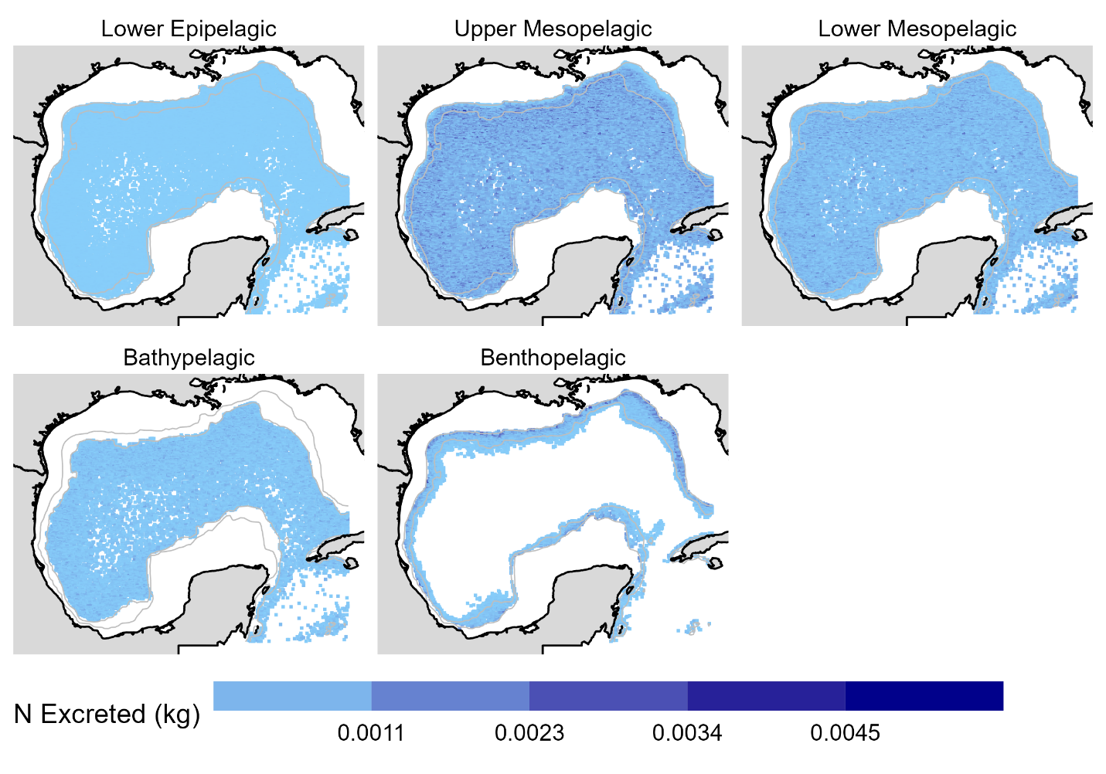
Figure A1. The spatial allocation of vertical nitrogen transport by depth layer for Blainville’s beaked whale.

Clymene dolphin
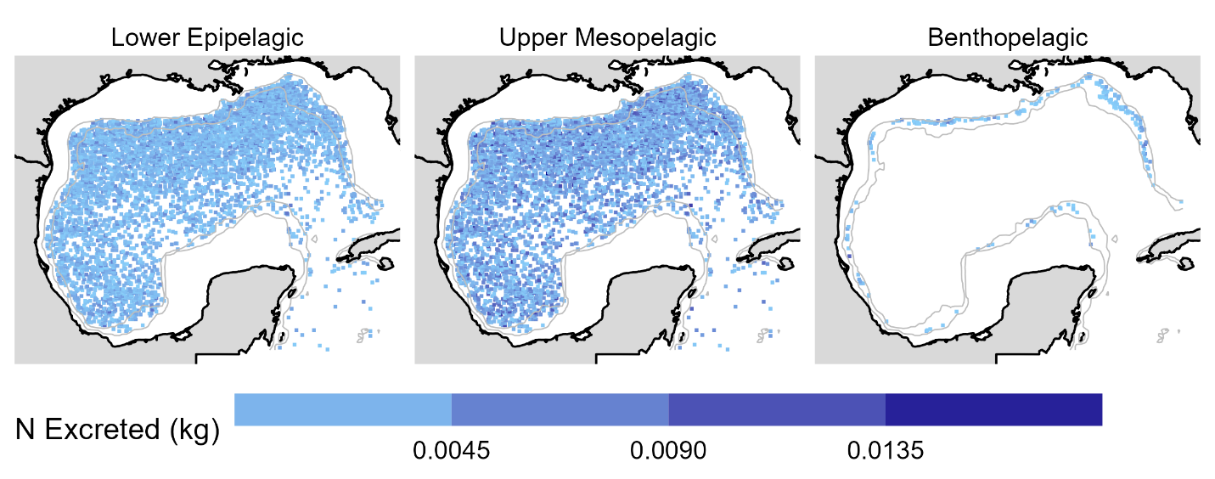
Figure A2. The spatial allocation of vertical nitrogen transport by depth layer for clymene dolphin.

Common bottlenose dolphin
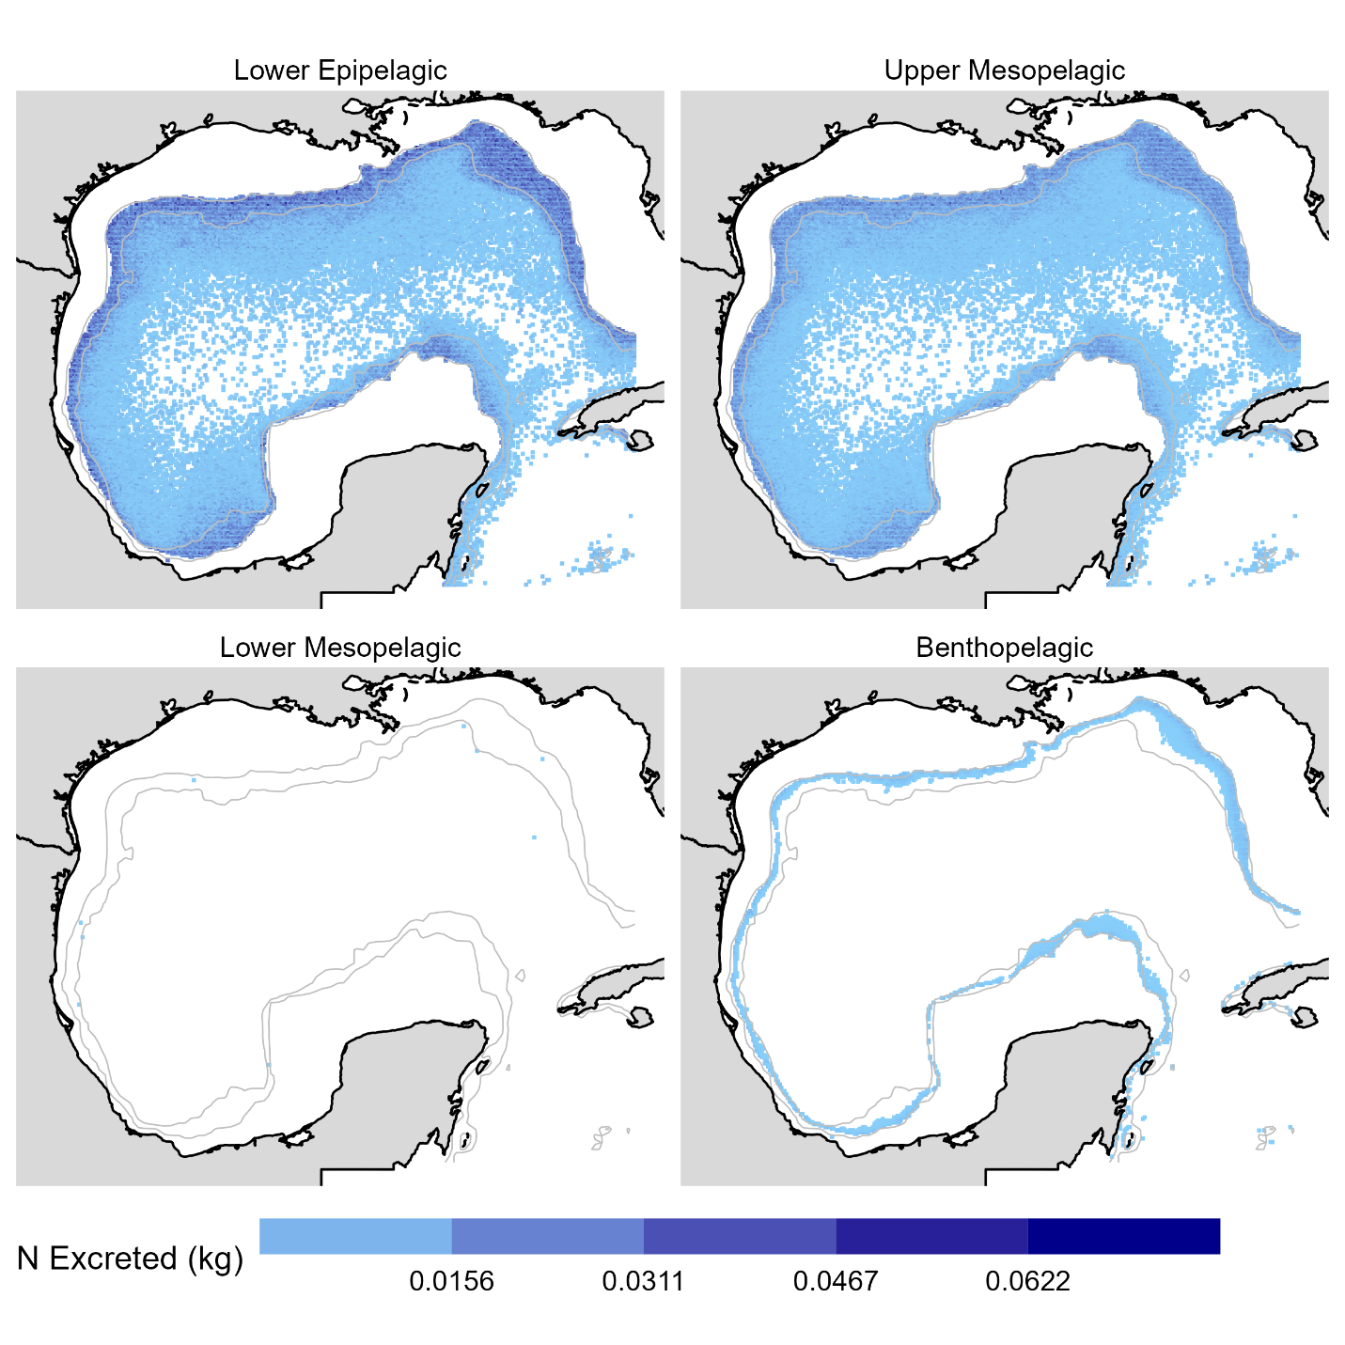
Figure A3. The spatial allocation of vertical nitrogen transport by depth layer for common bottlenose dolphin.

Cuvier’s beaked whale
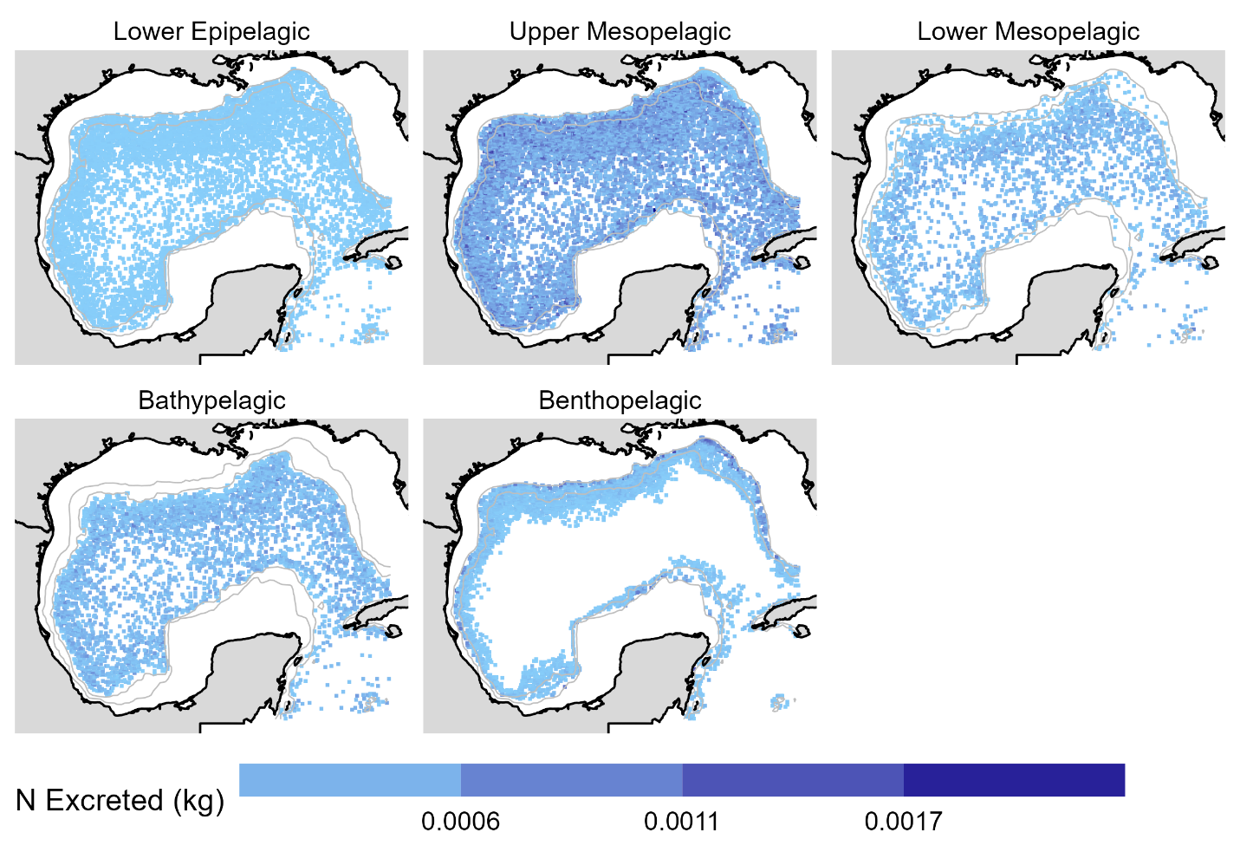
Figure A4. The spatial allocation of vertical nitrogen transport by depth layer for Cuvier’s beaked whale.

Dwarf sperm whale
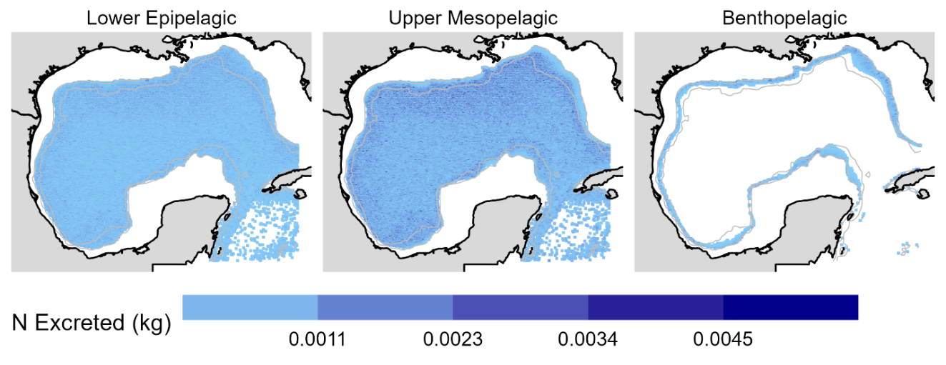
Figure A5. The spatial allocation of vertical nitrogen transport by depth layer for dwarf sperm whale.

False killer whale
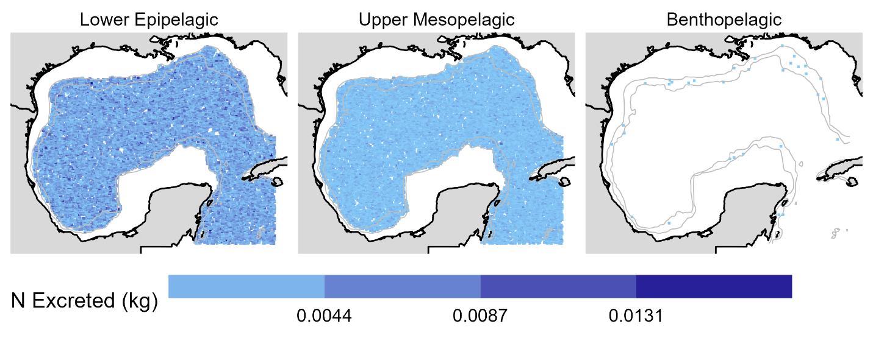
Figure A6. The spatial allocation of vertical nitrogen transport by depth layer for false killer whale.

Fraser’s dolphin
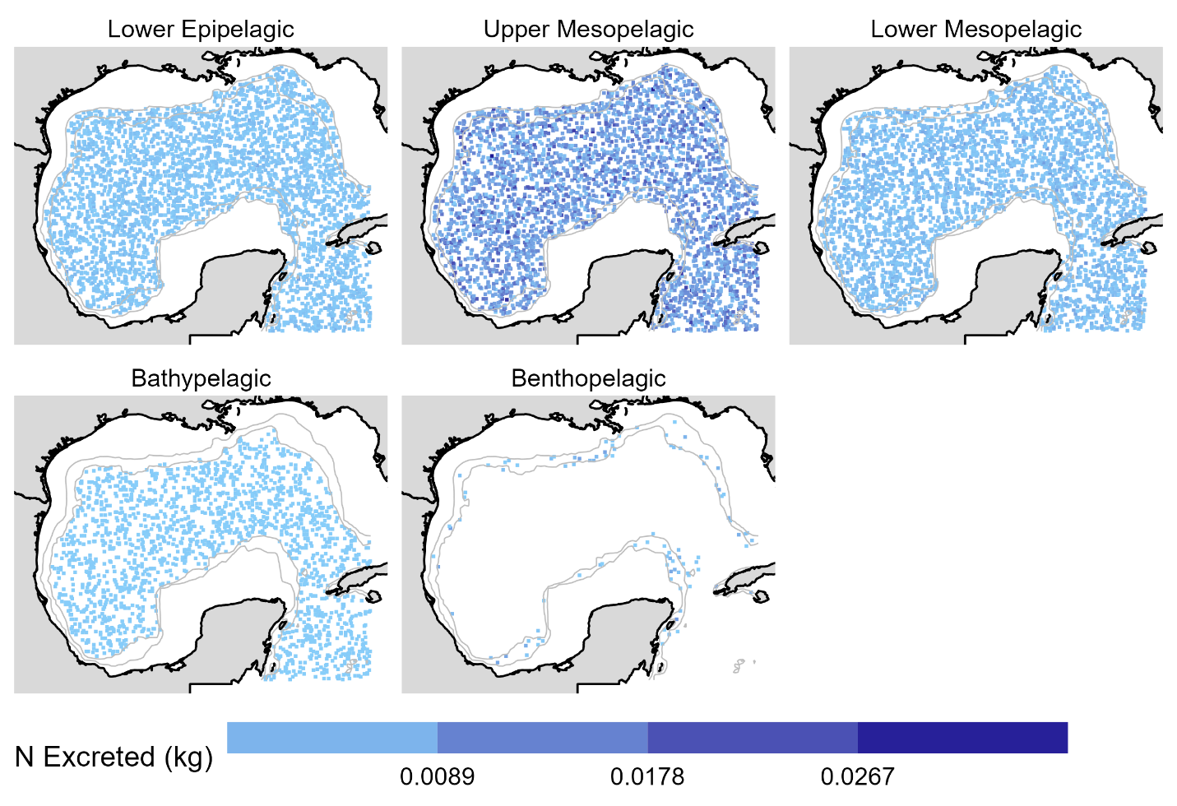
Figure A7. The spatial allocation of vertical nitrogen transport by depth layer for Fraser’s dolphin

Gervais’ beaked whale
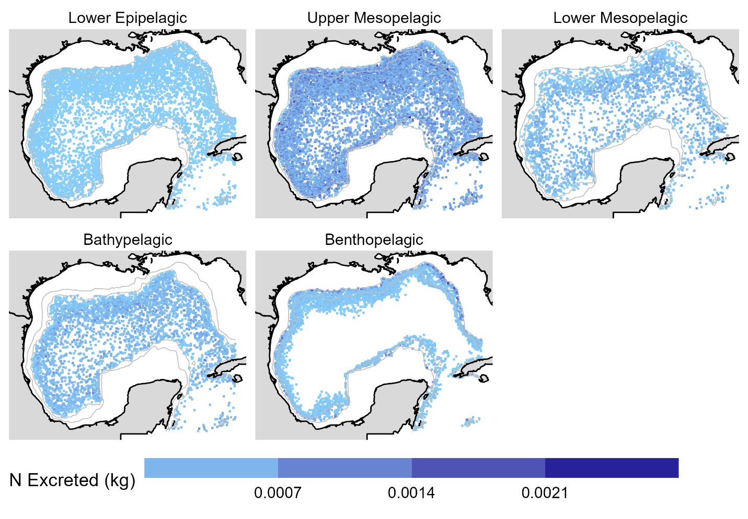
Figure A8. The spatial allocation of vertical nitrogen transport by depth layer for Gervais’ beaked whale.

Killer whale
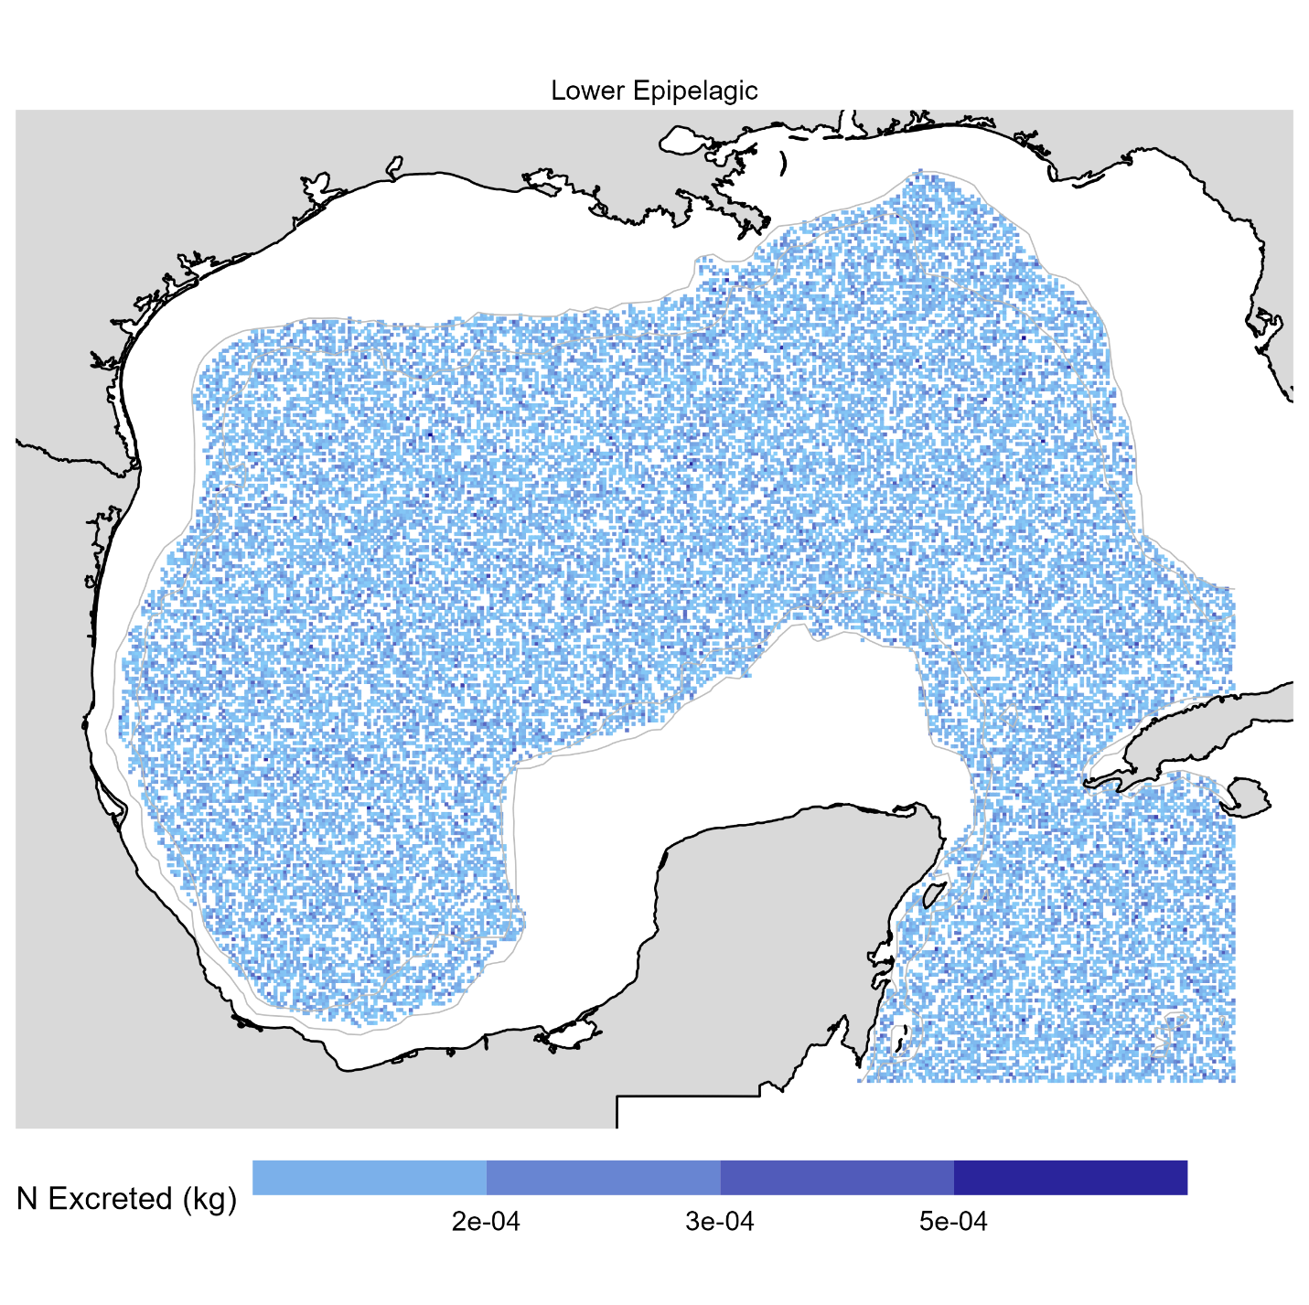
Figure A9. The spatial allocation of vertical nitrogen transport by depth layer for killer whale.

Melon-headed whale
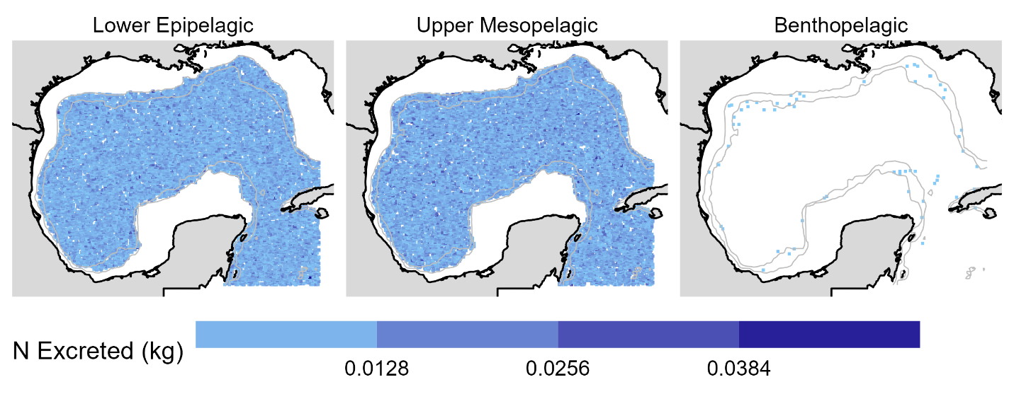
Figure A10. The spatial allocation of vertical nitrogen transport by depth layer for melon-headed whale.

Pantropical spotted dolphin
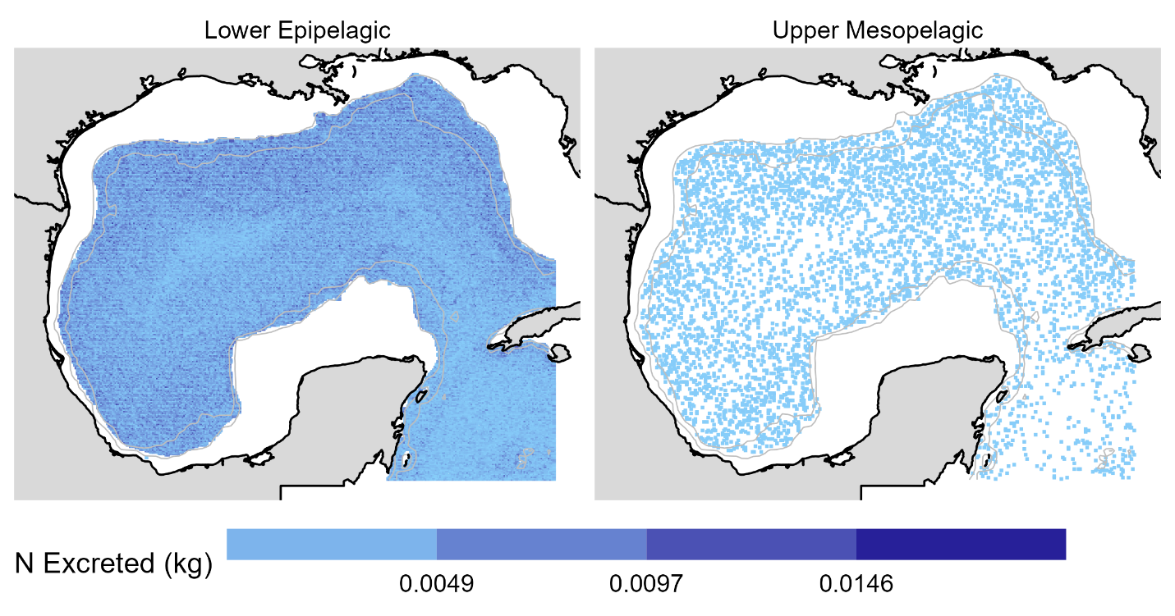
Figure A11. The spatial allocation of vertical nitrogen transport by depth layer for pantropical spotted dolphin.

Pygmy killer whale
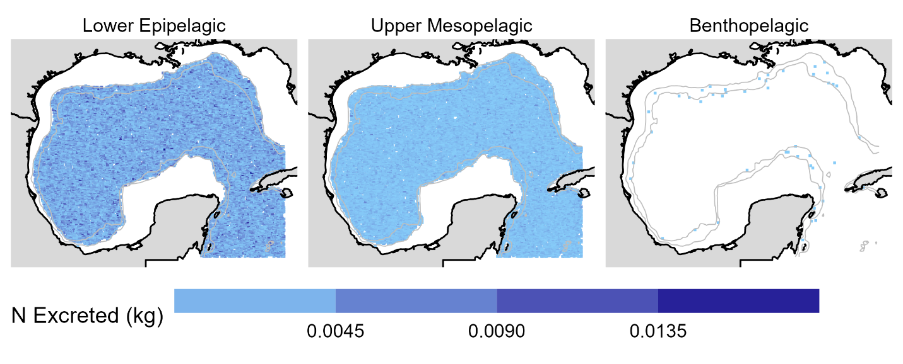
Figure A12. The spatial allocation of vertical nitrogen transport by depth layer for pygmy killer whale.

Pygmy sperm whale
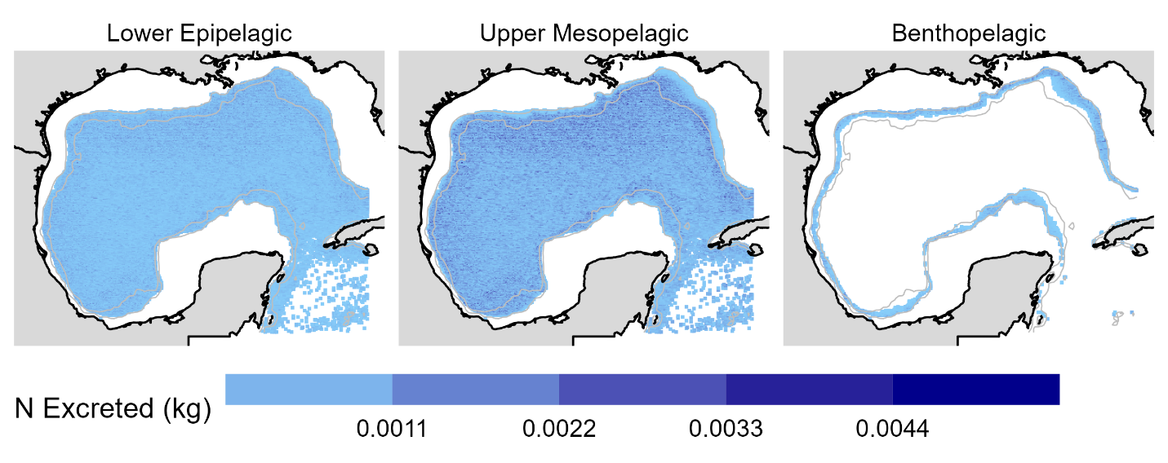
Figure A13. The spatial allocation of vertical nitrogen transport by depth layer for pygmy sperm whale.

Rice’s whale
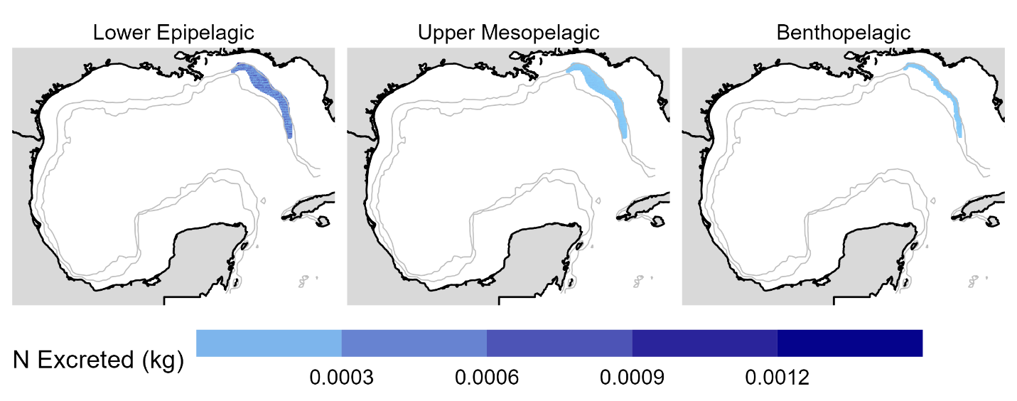
Figure A14. The spatial allocation of vertical nitrogen transport by depth layer for Rice’s whale.

Risso’s dolphin
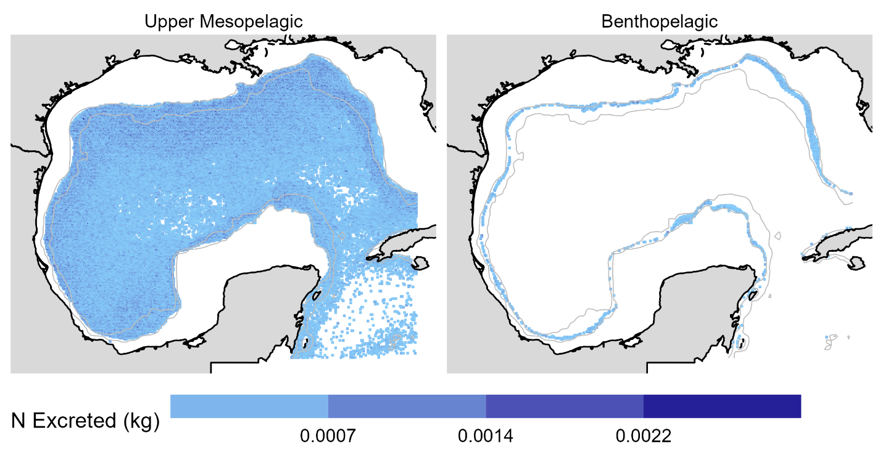
Figure A15. The spatial allocation of vertical nitrogen transport by depth layer for Risso’s dolphin.

Short-finned pilot whale
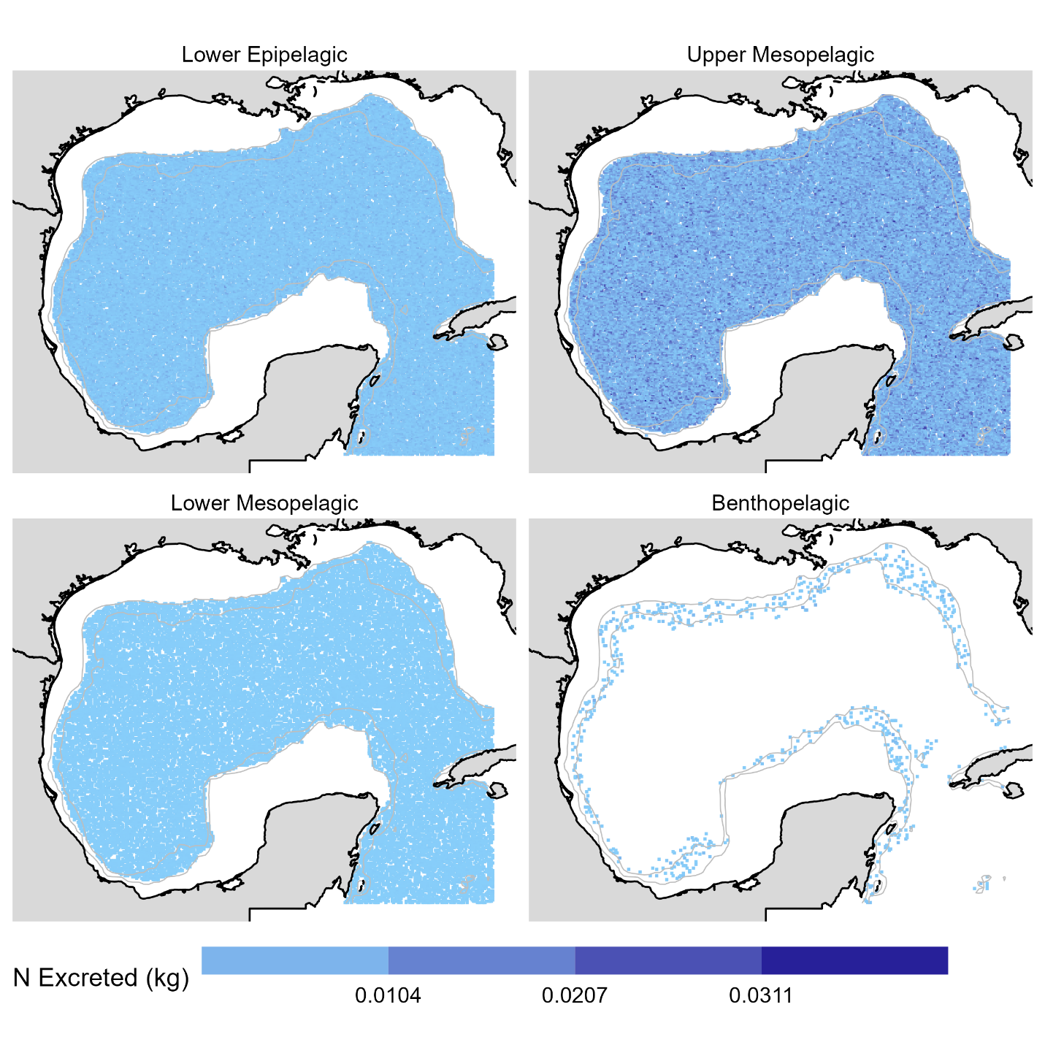
Figure A16. The spatial allocation of vertical nitrogen transport by depth layer for short-finned pilot whale.

Sperm whale
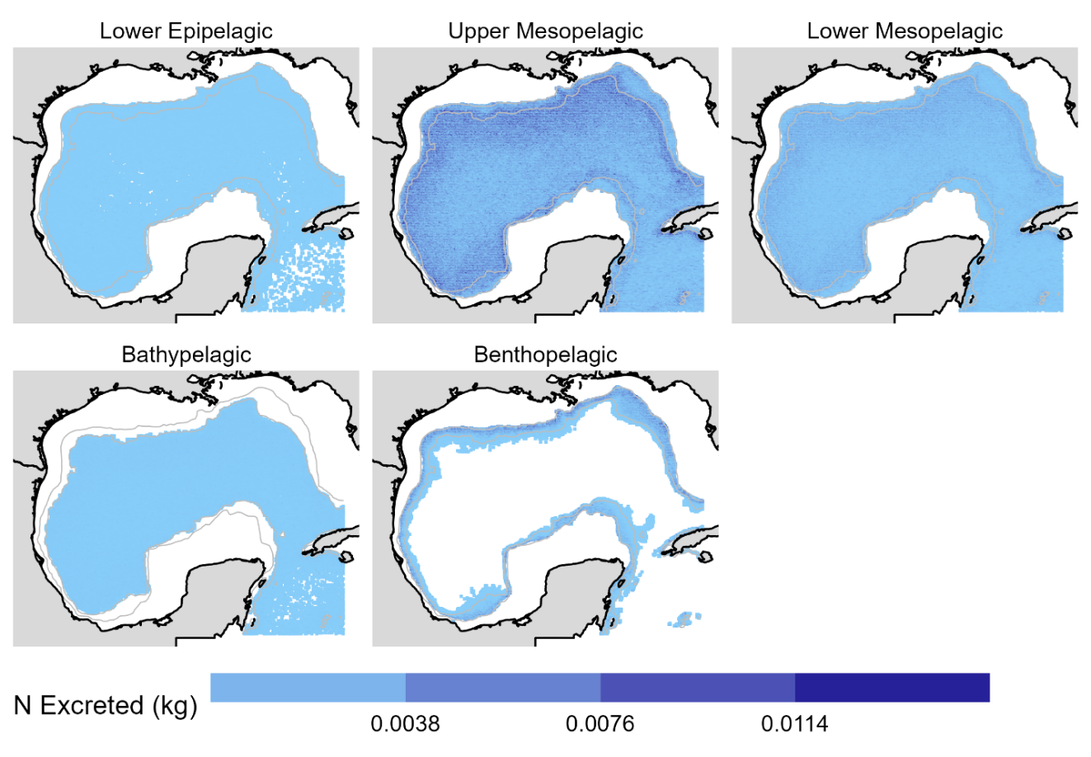
Figure A17. The spatial allocation of vertical nitrogen transport by depth layer for sperm whale.

Spinner dolphin
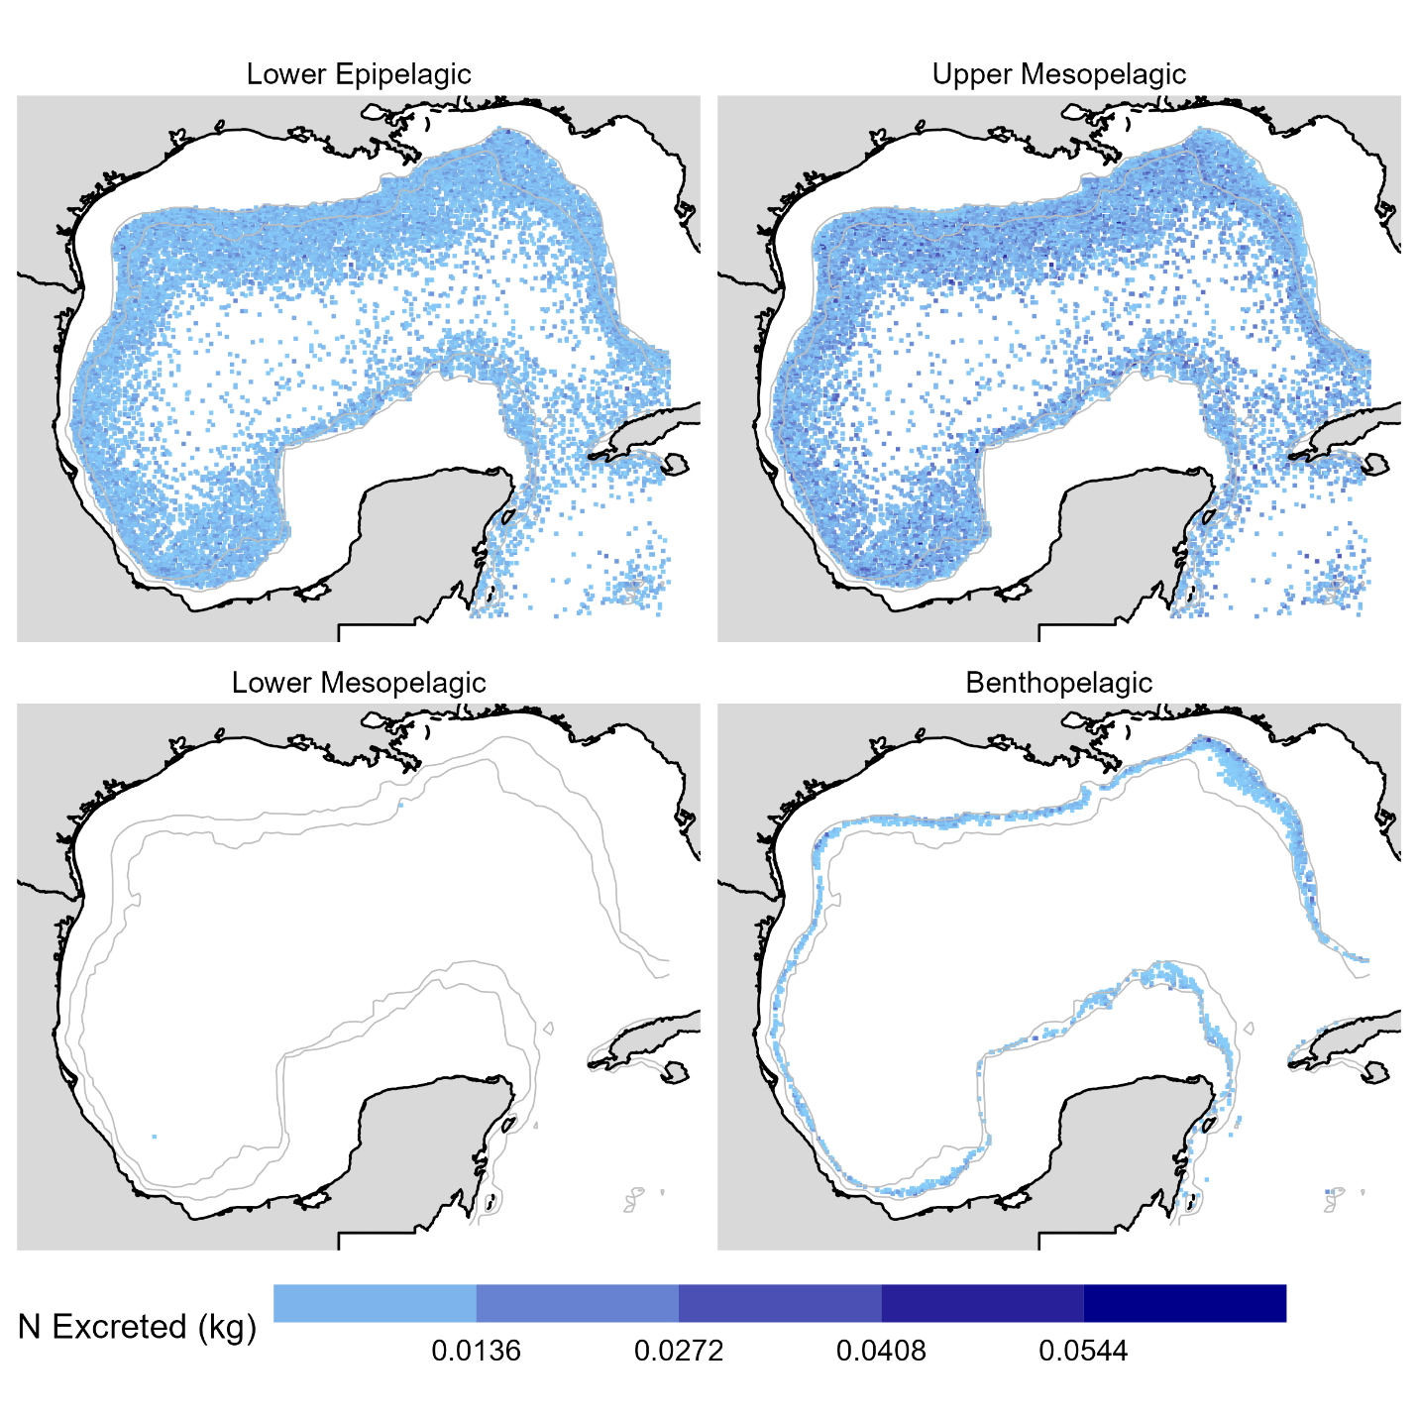
Figure A18. The spatial allocation of vertical nitrogen transport by depth layer for spinner dolphin.

Striped dolphin
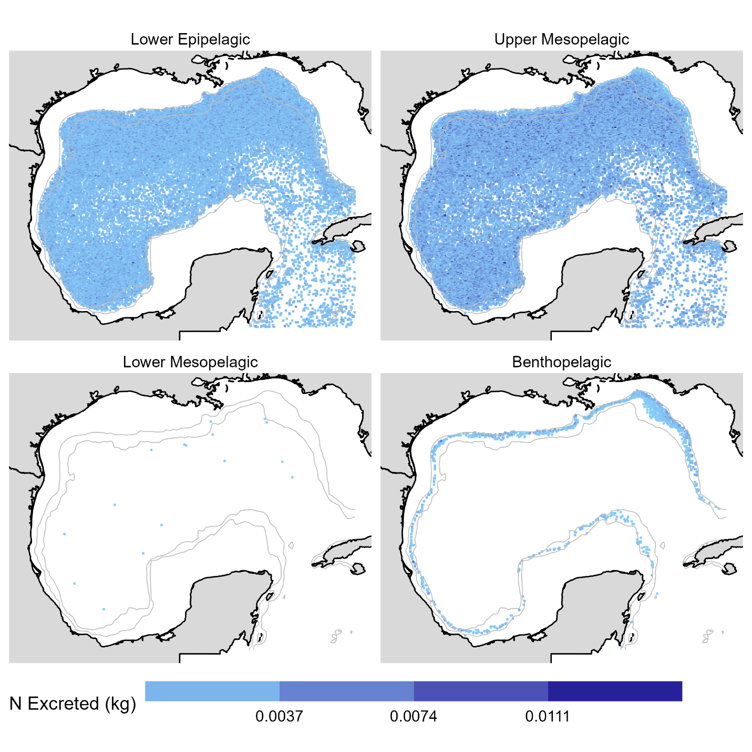
Figure A19. The spatial allocation of vertical nitrogen transport by depth layer for striped dolphin

CHAPTER V

TOWARDS ECOSYSTEM MODELING IN THE DEEP SEA: A REVIEW OF PAST EFFORTS AND PRIMER FOR THE FUTURE

Abstract
Ecosystem modeling is a popular technique to incorporate the direct and indirect interactions of all ecosystem components within a simulation. However, these models are data-intensive. Relatively data-poor, deep-sea ecosystems (with depths greater than 200 m) have not received the same modeling effort as neritic zones. Nevertheless, deep-sea ecosystems are exposed to many of the same anthropogenic stressors as nearshore systems, suggesting that the development of ecosystem models is pertinent. A literature review was conducted to explore the global deep-sea modeling effort. More than 300 modeling publications were discovered that included the deep-sea as a component, either had a functional group or explicitly mentioned depths greater than 200 m. The annual rate of new publications increased after 2000, most likely because of the advances in modeling capabilities, the growth of ecosystem modeling as a practice, and the availability of new data. Only 39% of the publications mentioned a deep-sea component as a focal point in the model, indicating that although the deep-sea is incorporated in many models, its ecosystem services are not explicitly included. Models developed with the Ecopath with Ecosim framework accounted for 59% of the publications, suggesting that multi-model “ensemble” approaches are lacking, although different frameworks have been applied. Disparity exists among the locations of models where some regions had more than 40 publications (subarctic Atlantic Ocean), while some others had 0 publications. The initial modeling effort in a region generally characterized the trophic structure, while advanced efforts conducted scenarios of ecosystem responses to stressors (e.g., fisheries, climate change, and oil spills). In general, current modeling efforts are hindered by a paucity of life history information for several deep-sea species/functional groups, unavailability of time series, and frameworks that may not properly estimate the energetics and spatial utilization of deep-sea organisms. Due to the high degree of trophic connectivity in oceanic ecosystems, the refinement of deep-sea ecosystem models is necessary to understand and combat the synergistic effects of stressors and enact ecosystem-based resource management efforts.

Introduction
Ecosystem modeling is a method to incorporate all components (biotic and abiotic) that occupy and interact in an ecosystem. This includes the smallest of picophytoplankton (picometers) to the largest of vertebrates (meters). The interest in ecosystem modeling has grown in recent decades through the conception that complex food web processes are influenced by indirect trophic interactions and risk effects to promote ecosystem stability and drive ecosystem functioning. However, this method is data-intensive and requires a basic understanding of the life history of all functional groups (i.e., aggregation of species with similar characteristics) in the system. Therefore, in particular regions, ecosystem modeling efforts are limited by the data availability, which is a challenge in the oceanic realm (seaward of the 200-m isobath) and the deep sea (deeper than 200-m depth; Webb et al., 2010). As data become available, the capacity to develop ecosystem models increases. Therefore, the continuance of deep-sea-focused data collection and understanding of ecosystem processes may lead to the advances to the configuration of existing deep-sea ecosystem models and development of models in previously unmodelled regions.
With deep-sea ecosystems globally becoming more susceptible to anthropogenic stressors, numerous consortia collecting large datasets, and advances in ecosystem modeling capabilities, it is necessary to review the past modeling effort as a mechanism to direct future effort, which to our knowledge, has not been completed. This review attempts to compile a extensive list of ecosystem models inclusive of the deep sea and discuss the efficacy of these efforts toward deep-sea conservation and resource management. We divide the globe into regions for clarity and to discuss the disparity in the global deep-sea modeling effort. Finally, we provide the directionality of future efforts to enhance our understanding of deep-sea ecology, ecosystem-based theory, and preparedness to successfully monitor sustainable resource exploitation.

Methods
A literature search was performed in October 2021 using the search engine ISI Web of Knowledge supplemented by footnote chasing (White et al., 2009). The advanced search feature was utilized using the keywords: “TS=(ecosystem) AND TS=(mesopelagic OR bathypelagic OR bathydemersal OR deep sea OR deep-sea OR lanternfish OR myctophid OR seamount OR abyssal* OR hadal*) AND TS=(model OR simulation) AND TS=(food web OR trophic)”, where a prefix followed by an asterisk corresponds to the search engine accepting any suffix involving the given prefix. The search returned 239 publications that were evaluated from the following criteria: 1) represents an ecosystem-based model, 2) quantifies the food web from the primary producers through apex predators (i.e., conceptual models must be accompanied by quantified energy flows), 3) inclusive of the deep sea either by explicitly including a deep-sea functional group (e.g., myctophid, deep-sea crustacean) or list the maximum depth of the model domain as deeper than 200 m, and 4) describes either a new model or a revised version of a preexisting one. The uses of unaltered model results in a review or for comparative purposes in a meta-analysis were not included. This search produced a collection of publications, technical reports, theses/dissertations, and grey literature. Duplicate components (e.g., dissertation chapters that were also published) were removed from the list. We do not attempt to recreate the finer intricacies of each ecosystem model, but instead provide a synthesis of the highlights that are relevant from deep-sea exploration, management, and conservation perspectives. All abbreviations in this review are listed (Table 1).
Table 1. List of Abbreviations used in this review
Abbreviation | Full Name
APECOSM | Apex Predators ECOSystem Model
BORIS | Benthic Organisms Resolved in Size
CCLAMR | Commission for the Conservation of Antarctic Marine Living Resources
EEZ | Exclusive Economic Zone
EwE | Ecopath with Ecosim
LIM | Linear Inverse Model (also called Linear Inverse Ecosystem Model)
NoBa | Norwegian and Barents Seas
OSMOSE | Object-oriented Simulator of Marine Ecosystems
SEAPODYM | Spatial Ecosystem and Population Dynamics Model

A Global View of Past Efforts
Although it is possible that the search algorithm was unsuccessful at gathering some recent, non-indexed, and not-heavily cited sources, we found 304 models that fit the literature review criteria (Supplemental Material). The earliest report on record was a conceptual box model of the Ross Sea, Antarctica, in 1975 (Green, 1975). The total number of publications slowly rose until 2000, when there is a marked shift in the rate of new publications per year that continued through 2021 (Figure 1a). A similar trend is observed for the number of deep-sea-focused publications, but to a lesser magnitude (Figure 1a). Of the 304 publications, 118 (39%) included a deep-sea identifier in the title, abstract, or keywords. There are 180 publications that utilize the Ecopath with Ecosim (EwE) or EcoOcean (a global ocean EwE model), which comprise 59% of the total (Figure 1b). Many were revised versions of earlier models to answer different research questions or improve model capability. The region with the greatest number of publications was the subarctic Atlantic Ocean (n = 40), while there were several regions in the global south that were devoid of any publications (Figure 1c). The incorporation of the deep sea in ecosystem-based modeling efforts has risen since its inception, but much of this production is focused on regions notorious for having consortiums dedicated to deep-sea exploration and the utilization of the deep sea for commercial exploitation. The following review recounts a synopsis of the ecosystem models that focused on deep-sea functional groups and energy flows that connect near-surface to deep-sea ecosystems.

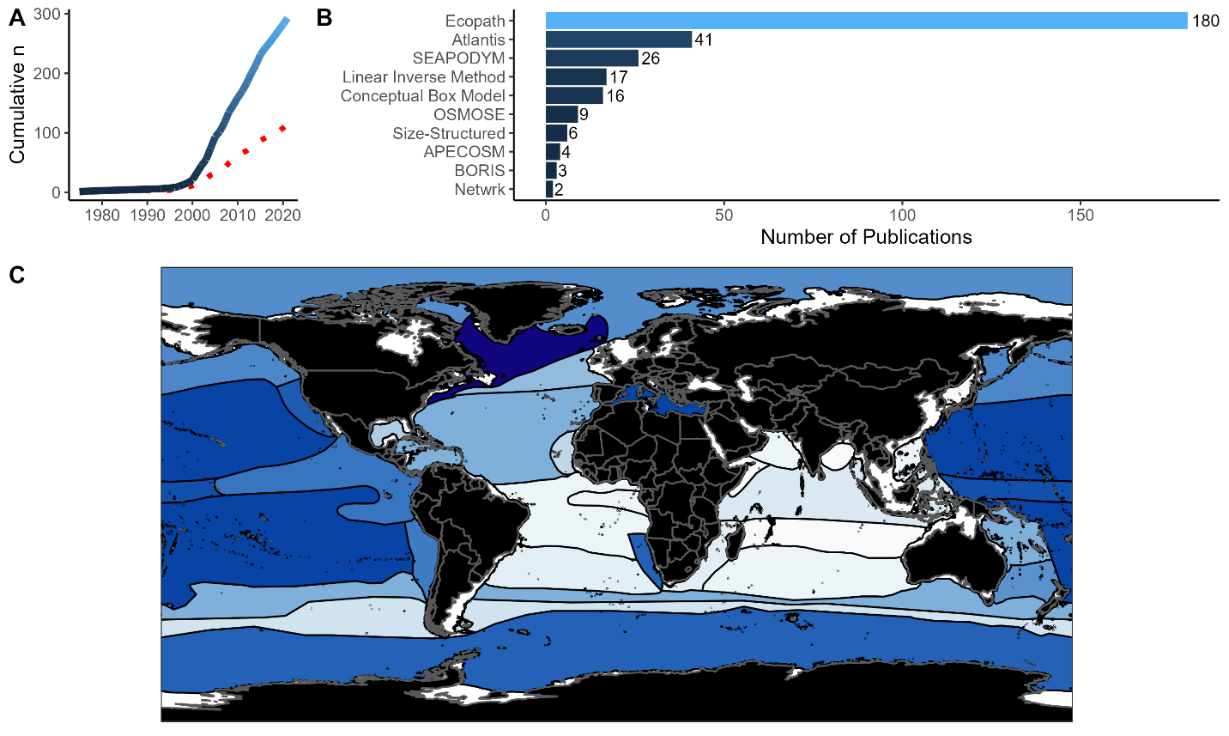
Figure 1. Summarized results of the publications discovered by the literature review in this study. A) The cumulative number of publications beginning in the year 1975 through October 2021. The gradient blue line represents studies that incorporate a deep-sea component, while the dotted red line represents the studies that had a deep-sea focus. B) The software used to develop the model in each publication. “Conceptual box model” and “Size-structured” do not represent specific software, but instead characterize the model that was generally developed independently by the author(s). C) A spatial overview of all models that included a deep-sea component with dark blue being the most publications (n = 40) and white being the least publications (n = 0). The dividing lines are from Sutton et al. (2017). Models that occupied more than one region are incorporated as present in all zones represented.

Global Models
Several global ecosystem-based models have been developed as an extension of existing earth system models for the purpose of examining climate change scenarios in the context of food web processes. The framework for global ecosystem models varies, as some are developed with a size-based structure (e.g., APESCOSM; Maury, 2010) while others are an extension of EwE or EcoOcean (Christensen et al., 2015). In these models, organisms are aggregated into broad functional groupings (e.g., mesopelagics, bathydemersals) to reduce the complexity of the overall modeling framework. The advantage of including the global expanse of the world’s oceans is thus associated with a tradeoff where fine-scale processes (species/family-specific traits) are not explicitly modeled. Global ecosystem models are suitable for holistic planetary-scale research questions, but regional modeling efforts are more apt at capturing ecosystem-based processes that may be pertinent to national or regional management organizations.

Arctic Ocean
Several ecosystem-based models have been developed for the Arctic region that covers eastern Greenland (Rowe, 1996), Iceland (Buchary, 2001), the Norwegian and Barents (NoBa) Seas (Dommasnes et al., 2001), and Norwegian fjords (Vilas et al., 2020). Production in the Arctic region varies by region, as large-cell phytoplankton are typically the dominant primary producers within the water column. However, small-cell phytoplankton is most common in the NoBa region, and 80% of the total energy flow ascends through deep-sea organisms (Wassman et al., 2006). In pelagic systems, small phytoplankton creates lengthy food chains and an ecosystem where energy must flow through numerous biotic components (Ryther, 1969), which could help explain the greater pelagic:demersal biomass ratio in the NoBa region relative to subarctic regions (Gaichas et al., 2009). Simulations of commercial fishing harvest control rules in the NoBa region indicated that there is minimal potential for yield gains in the region and that incorporating currently noncommercial species (e.g., deep sea) as target species would drastically affect ecosystem functioning and result in stock collapses (Jähkel, 2013; Nilsen, 2018; Hansen et al., 2019). In Icelandic waters, increased landings in the 1970s and 1980s led to declines in stock biomass of the bathydemersal Greenland halibut (Reinhardtius hippoglossoides; Sturludottir et al., 2018). Currently, a major issue in this region is fishing discards. Simulations involving hypothetical discard bans indicated that a full discard ban may not lead to increases in commercial fish biomass, but increased fishing selectivity (only older age classes caught) may result in greater commercial fish biomass and fisheries profit (Sturludottir, 2018). Much of the deep-sea ecosystem modeling effort in the Arctic Ocean has been focused on the holistic, ecosystem-level effects of fisheries exploitation (Sturludottir et al., 2018; Hansen et al., 2019), most likely because deep-sea fishes are currently exploited and exploratory mesopelagic fisheries are of interest (Grimaldo and Gjøsund, 2012).
Global climate change is predicted to continue rising sea surface temperatures and reducing sea ice in the Arctic region, which is expected to promote a poleward shift by generalist organisms, alter migration patterns, and increase the connectivity between benthic and pelagic food webs (Kortsch et al., 2015). Although rising sea surface temperatures may not directly affect non-vertical migratory, deep-sea organisms, shifts in food web structure may alter holistic ecosystem functioning, indirectly impacting deep-sea communities. In the NoBa system, it has been predicted that pelagic species would increase in biomass, while benthic species, including cod (Gadus morhua), would decline as a result of reductions in prey availability (Bentley et al., 2017). In deep-benthic ecosystems, the services provided are regulated by the flow of assimilable detritus (nutrients capable of being absorbed by an organism) into the system, which declines with reductions in sea ice (Van Oevelen et al., 2011a). Similarly, depleted shallow-water kelp forests (Laminaria hyperborean) are expected to decrease the nutrient import into deep-fjord ecosystems (Vilas et al., 2020). The ecosystem response to declined kelp forest production acts synergistically with climate change, indicating that deep-fjord systems face multiple stressors that have cumulative effects (Vilas et al., 2021). The environmental impacts of climate change are not homogenous across large spatial scales. Instead, environmental heterogeneity affects the food web structure of regions within ecosystems differently (Kortsch et al., 2019). Further modeling efforts directed toward the spatialized impacts of environmental heterogeneity will further delineate the predicted impacts of global climate change in the deep Arctic Ocean.

Subarctic North Atlantic
The subarctic North Atlantic Ocean comprises a cold-water-influenced region that spans from the southern portion of the Arctic Ocean to the northernmost portion of the Gulf Stream. The western portion of this region includes ecosystem-based models for the Gulf of Maine (Heymans, 2001), Newfoundland shelf (Bundy et al., 2000), Scotian shelf (Bundy, 2002), Gulf of St. Lawrence (Morissette et al., 2003), Western Greenland (0–1,500 m model depth; Pedersen and Zeller, 2001), and surrounding areas. These models were mainly developed to assess ecosystem functioning following the fisheries-induced collapse in groundfish, for example, the cod, American plaice (Hippoglossoides platessoides), and yellowtail flounder (Pleuronectes ferruginea) stocks (Bundy, 2001, 2004). Depleted groundfish stocks have transitioned several areas in the region from a demersal-feeder-dominated system to a pelagic-feeder-dominated system, a common feature of areas heavily fished with demersal gears (Savenkoff et al., 2004; Bundy, 2005; Savenkoff et al., 2007). Additionally, Greenland halibut replaced several other groundfishes as both the predator of low-trophic level organisms and a popular commercial resource within the system (Pedersen and Zeller, 2001; Savenkoff et al., 2007). There has been an extensive modeling effort in the western subarctic North Atlantic Ocean, but most of this effort has been restricted to the continental shelf, while the inclusions of the deep-sea have only been a focus when commercial fishing is considered.
The eastern subarctic North Atlantic is home to ecosystem models that focus on deep-water fisheries surrounding the Faroe Islands (Zeller and Freire, 2001), the Bay of Biscay (Ainsworth et al., 2001), and the west coast of Scotland (Heymans et al., 2011). Bottom trawl closure zones exist around the Faroe Islands, an archipelago with narrow shelf boundaries and an economy centered around fishing. These benefit several exploited demersal fish stocks (e.g., cod, haddock [Melanogrammus aeglefinus]), but extensions to current management efforts would be required to benefit deep-sea stocks (Zeller and Reinert, 2004). Off the west coast of Scotland, reductions to the total allowable catch of Centroscymnus sp. sharks could potentially have led to a partial recovery in some deep-sea species (e.g., mesopelagic fishes) relative to pre-fishing levels, but although the data existed to develop an ecosystem model, there may have been significant sources of error caused by the assumptions necessary for model development (Heymans et al., 2011), a caveat that should accompany many deep-sea ecosystem models. Nevertheless, deep-water fisheries have directly depleted deep-sea fish stocks in the eastern subarctic Atlantic Ocean, and refinement of current ecosystem models will continue to advance their effectiveness towards EBFM.
Contrary to shallow systems (< 200 m), the deep benthos is dominated by smaller organisms, a predictable phenomenon in deep-benthic ecosystems that suggests simulations of deep-benthic systems should employ a size-based approach (Kaariainen, 2006; Kelly-Gerreyn et al., 2014). The bottom habitat should also be considered, as the carbon cycling in deep-water coral communities can be two orders of magnitude greater than the surrounding area, indicating that carbon is retained within the system (van Oevelen et al., 2009). Additionally, in submarine canyons, the accretion of organic sediment creates hotspots for megafauna (Van Oevelen et al., 2011b). Deep-benthic communities are dependent on particulate organic flux from the pelagic system, suggesting that as depth increases, less carbon is available for metazoan growth (Yool et al., 2017). Reductions to surface production by 6% due to climate change could reduce deep-benthic biomass by 32% in high greenhouse gas emission scenarios (Yool et al., 2017). The modeling effort in the eastern subarctic Atlantic region has been more dedicated to the deep benthos than other regions, which interestingly utilized modeling frameworks other than EwE.

Atlantic Ocean Basin
In the Atlantic Ocean basin, at lower latitudes than subarctic and subantarctic regions, most of the deep-sea ecosystem modeling effort has been focused on the Azores Archipelago (Guénette and Morato, 2001; Morato et al., 2016) and the West African coast (Stanford et al., 2001; Guénette and Diallo, 2004; Heymans and Vakily, 2004). Seamount ecosystems have garnered plenty of attention in the Azorean exclusive economic zone (EEZ) because only 0.4% of the EEZ area is shallower than 500 m, leading to easy accessibility by researchers and fishers to the deep sea (Guénette and Morato, 2001). Seamount fisheries management is encountered with the tradeoff of maximizing economic performance at the cost of biodiversity or maximizing ecological performance while risking fisheries yield and jobs, but management plans focused on ecological objectives seem to be the most sustainable (Morato and Pitcher, 2005, 2008). Although they can be considered islands of biodiversity in the deep sea, seamounts are reliant on allochthonous nutrients to sustain the ecosystem (Morato et al., 2009), connecting the open ocean to seamount-associated systems. Open-ocean models in the north Atlantic Ocean have largely focused on tuna (Scombridae: Thunnini) and swordfish (Xiphias gladius) fisheries and population dynamics (Dragon et al., 2015; Vasconcellos and Watson, 2004), but do not fully capture the role that deep-pelagic organisms have in oceanic food webs. Limitations to quality life history information inhibit the development of deep-pelagic ecosystem models capable of executing EBFM or quantifying the magnitude of benthopelagic coupling (Morato et al., 2016). However, deep-sea fisheries have been active within the Atlantic Ocean basin. Off the west coast of Africa, deep-demersal fisheries (primarily belonging to the former Soviet Union and Spain) caused a linear decline in demersal fish biomass over three decades (Heymans and Vakily, 2004). The extension of time series and collection of life history information for deep-sea organisms will be critical in advancing EBFM efforts within the Atlantic Ocean basin.

Atlantic Marginal Seas
The Gulf of Mexico is a semi-enclosed water body influenced by deep-Atlantic water masses and receives an influx of biota from the surrounding Caribbean Sea and Atlantic Ocean Basin (Bangma and Haedrich, 2008). It also has unique, endemic faunas. In the Gulf of Mexico, ecosystem modeling has been utilized to assess the trophic structure of the system, respond to perturbations, and monitor fish stocks (O’Farrell et al., 2017). However, the deep-Gulf of Mexico has received less attention than the continental shelf, largely because of data limitations in the open-ocean basin. These limitations have been mitigated because of the scientific response to the 2010 Deepwater Horizon oil spill (Ainsworth et al., 2021). Early models that include the deep-central Gulf of Mexico utilized information from a previous model in the South China Sea to assess the trophic structure of the open Gulf of Mexico and compare it to shallow water regions (Vidal and Pauly, 2004). The modeling effort in the deep-pelagic zone was greatly improved by an ATLANTIS model for the entire Gulf of Mexico large marine ecosystem that included several deep-sea functional groups, open-ocean polygons, and multiple depth layers deeper than 200m (Ainsworth et al., 2015). Since the Deepwater Horizon oil spill, the Gulf of Mexico mesopelagic micronekton community has experienced severe population size declines, and this has potentially adjusted the trophic structure of the oceanic system (Woodstock et al., 2021), as well as the nearby West Florida Shelf food web (Morzaria-Luna et al., 2022). Additionally, a series of deep-benthic models for the Gulf of Mexico indicate that the particulate organic carbon imported into the benthic ecosystem is the main driver behind ecosystem processes and can produce amplitude cycles in macrofauna (Rowe et al., 2002; Rowe, 2013). Concurrently, the respiration rates of fishes and macrofauna become reduced at deeper depths, leaving meiofauna and bacteria to have a greater role in ecosystem functioning on the abyssal plain (Rowe et al., 2008). The deep-Gulf of Mexico is becoming a data-rich system relative to other regions and the modeling capability is high, but modeling efforts that incorporate inshore-offshore connectivity and benthopelagic coupling are either lacking or would improve with a greater understanding of the life history (e.g., diet, age/growth, reproduction) and spatial utilization of deep-sea organisms.
In the Mediterranean Sea, twenty-eight different ecosystem modeling publications include the deep sea, most likely because of narrow continental shelves, high commercial interest in deep-demersal trawling, and a propensity of biodiversity (Danovaro et al., 2010; D’Onghia et al., 2012), trophic (Tecchio et al., 2013; Guy-Haim et al., 2022), biogeochemical modeling (Kalaroni et al., 2020), and habitat utilization studies (Lauria et al., 2017; Maiorano et al., 2022; Figure 1c). On a holistic, Mediterranean Sea-scale, changes primary productivity and fishing pressure influence species population dynamics, two factors that are predicted to intensity (Piroddi et al., 2017). In the northwestern Mediterranean, primary producers, zooplankton, and benthic invertebrates are responsible for the majority of the energy flows, and benthopelagic coupling is an important driver of ecosystem functioning (Bănaru et al., 2013; Corrales et al., 2015; Agnetta et al., 2019; García-Rodríguez et al., 2021). The deep slope only provides approximately 10% of the energy throughput compared to the shelf system, but benthic and demersal organisms, which are caught in demersal trawls, are keystones (Tecchio et al., 2013). Fisheries-induced declines in deep-demersal fish biomass have indirectly affected the rest of the ecosystem (Coll et al., 2008b). Recovery of these populations would require reductions in fishing effort, even if trawl selectivity was improved (Coll et al., 2008a). The deep-central and the deep-eastern Mediterranean Sea receive less organic input than the deep-western region, and the ecosystem services provided are also lesser (Tecchio et al., 2015). In the central Mediterranean Sea, intermediate trophic level organisms constitute approximately 80% of the total energy throughput in the system (Vassallo et al., 2017) and are the main drivers and benthopelagic coupling, suggesting wasp-waist control in the system that connects the near-surface waters to the seabed (Ricci et al., 2019). Odontocetes (toothed cetaceans) and cartilaginous fishes (Chondrichthyes) are the apex predators in the system and utilize a similar prey resource to fisheries catches, but high prey diversity mitigates this overlap, particularly seaward of the continental shelf (Ricci et al., 2021a; Ricci et al., 2021b). Compared to deep-sea modeling efforts in the Gulf of Mexico, the Mediterranean Sea is more resolved and has a greater focus on the sustainability of commercial fishing. Among other Mediterranean Sea ecosystem models, a recently constructed OSMOSE model that simultaneously models 100 species on a basin-wide scale could be useful in advancing ecosystem-based fishery management and exploring climate change scenarios in the region.

Benguela and Agulhas Currents
Deep-sea fishes (e.g., lanternfish [Myctophidae], lightfish [Maurolicus muelleri], and hake [Merluccius capensis]) have been focal study groups since the inception of ecosystem modeling in the Benguela Current system, most likely because of the potential for commercial exploitation of mesopelagic fishes in the upwelling region and the established hake fishery. The Benguela current ecosystem is often compared to other upwelling regions (e.g., Peruvian upwelling; Moloney et al., 2005), but mesopelagic fishes have a greater ecological role in the Benguela system because predators (e.g., hake, seabirds, and seals) are more reliant on them and the primary production required to feed all of the predators in the Benguela system is more similar to open-ocean ecosystems than upwelling areas (Jarre-Teichmann et al., 1998; Shannon et al., 2003). Intermediate trophic level organisms, including mesopelagic fishes, likely exert wasp-waist control on the ecosystem, where the top predator populations are reliant on intermediate trophic level stocks and the low trophic level organisms are regulated by predation pressure from intermediate trophic level organisms (Shannon et al., 2000; 2008). The northern Benguela system has three times the biomass and overall production as the southern Benguela, but primary production between the two regions is equivalent (Moloney et al., 2005). The northern region was more heavily fished in the 1980s compared to the southern region, leading to stock declines of commercial groups, including hake (Shannon and Jarre-Teichmann, 1999; Heymans and Baird, 2000). During this time, the system underwent a regime shift where the overexploitation of anchovy (Engraulis capensis) and sardine (Sardinops sagax) led to increased importance in mesopelagic fishes and other small planktivorous fishes in the ecosystem functioning (Heymans et al., 2004). However, just 10% of the estimated mesopelagic fish stock was necessary to feed the higher trophic level organisms (Shannon and Jarre-Teichmann, 1999). 85% of the surface area for the northern Benguela region is deeper than 200 m, and the majority of functional groups prefer these offshore regions, including holoepipelagic organisms (solely occupy the epipelagic zone; Heymans and Sumaila, 2007). In the southern region, mesopelagics possibly had a stable population from 1978 to 2002 (Shannon et al., 2004), but this is not corroborated by empirical data and may be a model artifact. The northern and southern Benguela current systems are two separate entities with different exploitative histories, but deep-sea fishes are major components in both systems. The continuation of time series to calibrate data-driven models will be critical in advancing modeling efforts in the region.
The modeling effort in the Benguela and Agulhas current region is perpetuated by the need for EBFM. In early models, it was recognized that the culling of cape fur seals (Arctocephalus pusillus pusillus) offered more deficits than benefits associated with ecosystem-level effects (e.g., long-term decline in fisheries yield; Yodzis, 1998; 2000). Adjustments to the fishing pressure on any commercial group have an influence on the mesopelagic fish biomass, where the resulting change is generally the reciprocal of the trend in anchovy and sardine populations because they occupy a similar niche (Shannon, 2002). These results are consistent with an Object-oriented Simulator of Marine Ecosystems (OSMOSE) model for the same system, which also included a small amount of fishing mortality in the lanternfish functional group as they associate with other small pelagic fishes (Shin et al., 2004; Travers-Trolet et al., 2014). The deep-water hake (Merluccius paradoxus) population is more sensitive to increased fishing pressure in the OSMOSE model compared to the EwE, but the stock recovers after overfishing in both frameworks (Travers et al., 2010), an example of different modeling frameworks producing slightly different results but similar conclusions. A mesopelagic fishery in the Southern Benguela region would lead to a 4–10 fold increase in anchovy and sardine populations after 100 years but also a reduction in the biomass of deep-water hake (Travers et al., 2004). Incorporating fishing pressure on mesopelagic fishes is also predicted to drastically reduce the mean length of catch for mesopelagic fishes, which is a product of fisheries affecting the size structure of a population (Travers et al., 2006). A lesson learned from a comparison to pre-industrial levels is that increased fishing pressure on small pelagic fish stocks may push the ecosystem towards regulation via bottom-up control, making the environmental effects of climate change more detrimental to ecosystem functioning (Watermeyer et al., 2008). An ATLANTIS model for the southern Benguela region is divided into the westernmost Southern Benguela, a central Agulhas bank, and an eastern portion that includes the Agulhas current (Smith et al., 2015; Ortega-Cisneros et al., 2017; 2018). This framework inherently brings a spatialized perspective of comparing the ecosystem processes in the region surrounding the southernmost point of Africa and is the most extensively modeled portion of Indian Ocean waters. However, the deep-Agulhas current region has received less modeling attention than the Benguela system, but modeling efforts inclusive of the spatialized effects on mesopelagic micronekton communities and deep-pelagic trophic structure (Annasawmy et al., 2018, 2020) may offer an interesting case study.

Subarctic Pacific
The subarctic Pacific region has housed several ecosystem-based models for the Gulf of Alaska and the Bering Sea that include basins deeper than 200 m. The earliest models focused on commercially important species (e.g., cod, salmon [Oncorhynchus sp.], and halibut [Hippoglossus stenolepis]) and included mesopelagic fish groups (Pauly and Christensen, 1996; Trites et al., 1999; Aydin et al., 2002; Guénette 2005), but not as the main focal points. A later version of the western and eastern subarctic gyre model gave more focus to the role of midwater fishes in the food web and parameterized them with localized information (Aydin et al., 2003). Considering the trophic structures of the subarctic Pacific region, the eastern Bering Sea, Gulf of Alaska, and the Aleutian Islands, the three localities are most influenced by benthic, pelagic, and a balanced mix of benthic and trophic pathways, respectively (Aydin et al., 2007). Deep-sea organisms are more prevalent in the Aleutian Islands system because of a greater proportion of space below 200 m (38%) relative to the eastern Bering Sea (5%) and Gulf of Alaska (12%), and thus have a larger impact on ecosystem dynamics (Aydin et al., 2007). However, in all subarctic North Pacific systems, deep-sea demersal fishes, cephalopods, and crustaceans are vital to energy ascendency (Heymans et al., 2007). The biomass trend of the steller sea lion (Eumetopias jubatus), a predator of deep-sea organisms, is partially dependent on the competition with deep-demersal predators, halibut and arrow-tooth flounder (Reinhardtius stomias; Guénette et al., 2006), two fish stocks that have markedly increased since the 1970s (Heymans et al., 2005). Ecosystem-based modeling in the subarctic North Pacific has focused on commercial fishing effects, and model efficacy has advanced to a point where mortality estimates for commercial species align with single-species stock assessments (Gaichas et al., 2010), an encouraging sign for the resource management.

Pacific Ocean Basin
The northern Pacific Ocean is associated with ecosystem models that primarily focus on fisheries (Cox et al., 2002; Kitchell et al., 2002; Hinke et al., 2004), apex predator population dynamics (Kitchell et al., 1999), climate change effects (Woodworth-Jefcoats et al., 2015), and mercury concentrations in top predators (Ferriss and Essington, 2014). In nearly every northern Pacific Ocean model that focuses on the pelagic zone, mesopelagic organisms are recognized as an important prey resource for apex predators, which reduces the direct resource competition these predators have with fisheries (Trites et al., 1997). The importance of mesopelagic micronekton to pelagic ecosystems cannot be overstated, as a 30% decline in micronekton biomass resulted in changes in apex predator biomass (Choy et al., 2016). However, deep-pelagic organisms are often not the focal species of these models. The widest use of the Pacific Ocean basin is the application of the Spatial Ecosystem and Population Dynamics Model (SEAPODYM) model, which is a population dynamics model typically utilized for oceanic apex predators, including tunas (Lehodey, 2001; Lehodey et al., 2003; Lehodey, 2004), billfishes (Abecassis et al., 2011), and sea turtles (Abecassis et al., 2013) that takes a spatialized ecosystem-based approach to estimate the bioenergetics and spatial utilization of the focal organism. Mesopelagic and bathypelagic organisms are included in SEAPODYM models as broad functional groups that serve as a spatially refined (latitude, longitude, depth, and time) preys (Lehodey et al., 2008) with different classes of organisms representing deep scattering layers capable of predicting daytime and nighttime epipelagic and mesopelagic micronekton biomass distributions (Lehodey et al., 2015). However, these groups are not refined further, and different deep-pelagic organisms occupy different trophic guilds and depths (Hopkins and Gartner, 1992; Drazen et al., 2017). Advancements to ecosystem-based modeling in the northern Pacific Ocean should continue to focus on the trophic connectivity between the epipelagic and deep-pelagic biota with consideration to space and diel (day and night) time scales as factors influencing localized and periodic trophic connections.
In the southern Pacific Ocean, the ecosystem models that focus on the deep sea are primarily off the eastern coast of Australia, in the Coral (Receveur et al., 2021) and Tasman Seas (Bulman et al., 2006), with several pelagic models that include the mesopelagic and bathypelagic zones (Brown et al., 2010; Dambacher et al., 2010; Senina et al., 2016). Diel vertical migration causes mesopelagic organisms to be an important prey resource to epipelagic top predators, allowing them to exert wasp-waist control in complex oceanic food webs (Griffiths et al., 2010; 2013) and on the continental slope (Bulman et al., 2006). Climate change scenarios suggest that temperature and primary production changes may decrease overall mesopelagic micronekton abundance but also force individuals in the upper mesopelagic zone (< 450 m) to seek refuge in the lower mesopelagic zone (450–1000 m; Receveur et al., 2021). A multi-model (EwE and Atlantis) evaluation of harvest strategies for the southeast Australian continental shelf and slope indicated that deep-water dogsharks (Squaliformes) and other demersal fishes would severely decline in any fishing scenario not focused on mandating rebuilding or ecosystem maturity (Forrest, 2008). The only hadal trench (> 6000 m) model and one of three benthic organisms resolved in size (BORIS) models presented by this review utilize data from the Kermadec Trench, north-east of New Zealand (Ichino et al., 2015). The steepness and slope of trenches funnel organic sediment to certain locations, creating a hotspot for pelagic organisms as it does for benthic organisms (Ichino et al., 2015). The southern Pacific Ocean has had a greater amount of focus on deep-sea organisms than the north, largely because of the effort off the eastern coast of Australia. Moving forward, the development of deep-sea time series will be necessary to advance this effort from answering interesting ecological questions to EBFM.
The eastern Pacific Ocean has productive upwelling systems and steep shelf breaks that include the California and Humboldt Current regions, which include the Peruvian upwelling system. In these systems, secondary production is heavily linked to seasonal oceanographic characteristics that determine the strength of upwelling and nutrient transfer from the deep ocean to the surface (Olson and Watters, 2003; Watters et al., 2003). Ecosystem models for the eastern Pacific coast have generally included the deep sea as some component from the inception of this effort (Olivieri et al., 1993; Field and Francis, 2005; Moloney et al., 2005). Several iterations of an ATLANTIS model have explored harvest strategies for fisheries in the California Current region, showing that closure of deep-bottom trawling gears improved the habitat integrity and reduced rockfish (Sebastes sp.) bycatch without affecting economic value compared to the status quo scenario (Kaplan et al., 2012). Hypothetical simulations of deep-sea fisheries targeting small pelagic fishes, euphausiids, and demersal fishes negatively affected the abundance of other commercial and protected species, but the magnitude of this impact varied spatially (Kaplan et al., 2013; Marshall et al., 2014). An undervalued factor in many ecosystem-based models is the influence diel vertical migration has on ecosystem services, primarily because most ecosystem models are developed with annual or monthly time steps rather than diel. Linear inverse models are more flexible toward this problem, and a LIM for the California Current system suggested that vertically migrating mesozooplankton contribute 42% (18%–84%) of the daily vertical carbon flux in the system (Kelly et al., 2019). In the Gulf of California, the jumbo squid (Dosidicus gigas), which occupies mesopelagic and upper bathypelagic depths, is an important commercial resource, exerts top-down control on lanternfish and pelagic red crab (Pleuroncodes planipes) populations, and provides bottom-up control to sharks and marine mammals (Rosas-Luis et al., 2008). In the Chilean upwelling system, the hake (Merluccius gayi) fishery exerts 57% of the total mortality on individuals longer than 36 cm, but predation (including cannibalism) annually removes 3.7 t km⁻² of conspecifics less than 36 cm, indirectly affecting fishery production and the stock status (Neira et al., 2004; Neira and Arancibia, 2004). Ecosystem models for the Peruvian upwelling system have primarily focused on epipelagic forage fishes (Watters et al., 2003; Guénette et al., 2008; Hernandez et al., 2014), but an OSMOSE model exploring fishing strategies indicated that reductions in the fishing mortality of hake on the Peruvian coast could raise the hake population to acceptable levels (i.e., not overfished Marzloff et al., 2009). However, this policy action would negatively affect sardine and mackerel (Scomber japonicus) stocks in the region (Marzloff et al., 2009). Deep-sea fishing in the eastern Pacific region, whether pelagic or demersal, influences non-target populations, suggesting that future fisheries policy decisions in the eastern Pacific Ocean would benefit from ecosystem-based management strategy evaluations and explorations of ecosystem-based harvest control rules.
The western Pacific Ocean marginal seas have received less attention than the main basin regarding ecosystem-based modeling of the deep sea. One of the earliest Ecopath models developed was a characterization of the trophic structure in the South China Sea (Pauly and Christensen, 1993). This model was the first to divide a large marine ecosystem into several regions (one being the deep-oceanic basin), which served as a precursor to modernized, spatial ecosystem-based modeling that effectively divides the modeled system into regions via localized grids or polygons. A unique inclusion in ecosystem-based modeling in the South China Sea is an assessment of the trophic structure of methane seeps that reside between 750–1600-m depth (Lin et al., 2020), the only ecosystem-based model that explicitly incorporates methane seep ecosystems. A comparison between the seep-associated food web and the surrounding waters indicated high connectivity within each food web but modularity between the food webs (Lin et al., 2020). Additionally, the methane-seep food web resulted in a comparatively higher biomass density, energy throughput, and quicker transfer efficiency, suggesting that methane seep ecosystems are more productive than the abyssal plains that surround them. Our literature search did not find an ecosystem model that focuses on the Sea of Japan deep-sea ecosystem, although basin-wide models occasionally include this region as part of the model domain (Lehodey et al., 2015). The western Pacific Ocean marginal seas have unique deep faunal communities and oceanographic characteristics despite being connected to the main basin (Sutton et al., 2017). Modeling these regions as separate entities will provide greater insight into the trophic structure and ecosystem functioning of the South China Sea, Sea of Japan, and Southeast Asian Pocket Basins.
Deep-benthic food web models are not as common as pelagic ecosystem models in the Pacific Ocean, but they are unified by their noted importance of organic carbon and low trophic level processes as a driver for ecosystem functioning. The “rain” of particulate organic carbon as marine snow into deep-benthic ecosystems influences production beyond the primary consumer trophic level, and limitations to the organic fall of large organisms create a greater reliance on POC for ecosystem functioning (Rowe, 1996). Reductions to POC input result in microbes occupying a greater proportion of total system respiration while macrofauna respiration is reduced (Dunlop et al., 2016). Secondary production in deep-benthic ecosystems is also influenced by oxygen levels, where anoxic environments have less biodiversity and provide less ecosystem services (Eldridge and Jackson, 1993). Concurrently, anthropogenic pollution events that add additional organic matter to benthic food webs (oil spills, sewage) can increase ecosystem biomass and respiration flows (Rowe, 1998). Linear inverse models have reflected reductions in the carbon flow, microbial loop production, and energy throughput 26 years after a simulated manganese nodule removal (i.e., deep-sea mining) experiment in the Peru Basin abyssal plain (Stratmann et al., 2018; de Jonge et al., 2020). Advances to benthic food web modeling in the Pacific Ocean (and elsewhere) will be pertinent in future efforts to predict the effect of anthropogenic stressors on deep-sea ecosystems.

Indian Ocean
With a few exceptions, the Indian Ocean region is nearly devoid of deep-sea ecosystem-based models. The origin of the Apex PrEdators ECOSystem Model (APECOSM) framework utilized the entire Indian Ocean to model the bioenergetics and spatial utilization of tuna populations (Maury, 2010). Similar to the SEAPODYM framework, APECOSM includes migrating, and nonmigrating mesopelagic populations as potential prey for the focal, apex predatory species but does not explicitly model the population dynamics of the intermediate and low trophic level functional groups. Other ecosystem-based models in the deep-Indian Ocean include the Agulhas Current region in accordance with the Southern Benguela current region, which are described elsewhere (see Southern Benguela and Agulhas Current). Future modeling efforts should focus on combining the available life history information for deep-sea organisms and quantifying the ecosystem functioning and trophic structure within the deep-Indian Ocean.

Southern Ocean and Surrounding Waters
The Southern Ocean is a cold-water body that has been the focal point of deep-sea research because of the long-recognized potential for krill (Euphausia superbia) fisheries and the roles mesopelagic and deep-benthic organisms serve within the food web. A lengthy data collection effort, particularly by the Commission for the Conservation of Antarctic Marine Living Resources (CCAMLR), has greatly improved an understanding of the Southern Ocean food web. The first ecosystem-based model to include the deep sea (and also one of the first in the world) explored the trophic structure of the Ross Sea, a semi-enclosed area surrounding the western Antarctic peninsula (Green, 1975). Several ecosystem-based models have also characterized the trophic structure of the other sectors surrounding the Antarctic Peninsula (Erfan and Pitcher, 2005; Cornejo-Donoso and Antezana, 2008; Hoover et al., 2012), the Weddell Sea (Jarre-Teichmann et al., 1997), the Kerguelen Plateau (Subramaniam et al., 2020), and Prydz Bay (McCormack et al., 2020a). Benthic invertebrates (e.g., sea cucumbers, brittle stars, polychaetes, and crustaceans) are the dominant functional groups responsible for energy transfer near the benthos (Jarre-Teichmann et al., 1997). Benthic Antarctic systems are mainly supported by surface-derived production, similar to other deep-benthic ecosystems, but chemosynthetic production near hydrothermal vents provides an additional source of production (Bell et al., 2017). Antarctic toothfish (Dissostichus mawsoni) provide a majority of the predation pressure for other demersal fishes, suggesting that there is potential for the fishery to impact the benthic food web (Pinkerton and Bradford-Grieve, 2010). However, when considering benthopelagic coupling, the trophic interactions with Antarctic toothfish are weaker than those with intermediate trophic level organisms (Pinkerton and Bradford-Grieve, 2014). In the pelagic zone, phytoplankton, zooplankton, and krill are the dominant energy vectors (Cornejo-Donoso and Antezana, 2008). Reductions to sea ice cover and krill result in declines in biomass across all trophic levels in the system, despite an increase in salp biomass (Hoover et al., 2012; Suprenand and Ainsworth, 2017), which is likely a result of the salp-top predator energy pathway being less efficient than the krill-top predator energy pathway (Ballerini et al., 2014). However, alternative energy pathways that flow through other intermediate trophic level groups (mesopelagic fishes and cephalopods) may be equally important to krill pathways (McCormack et al., 2020a). Spatialized fisheries scenarios suggest that krill fisheries would not have a detrimental effect on top predators (e.g., seals, seabirds) unless the fisheries were concentrated close to shore (Pitcher and Erfan, 2005), indicating the importance of spatialized information in making proper management decisions. The accurate prediction of sea-ice regimes in the Southern Ocean and the effects they have on ecosystem components are critical in the design of marine protected areas and EBFM in the Southern Ocean (Dahood et al., 2019). Characterizations of the trophic structure within various Southern Ocean regions have revealed commonalities, including the importance of deep-sea organisms in energy ascendency and the causality of spatiotemporal differences in environmental conditions to ecosystem functioning.
The similarities in regional Southern Ocean ecosystem models and the seasonal presence of mobile top predators (e.g., Antarctic rorquals) suggest that basin-scale models may be reasonable to capture holistic ecosystem effects. The krill populations within the Southern Ocean are dependent on surface productivity, which may have been reduced because of decreased iron bioavailability caused by depletions to rorqual populations (Surma et al., 2014). Although commercial whale harvest has ceased, many baleen whales will not recover to their pre-exploitation population sizes by the year 2100 (Tulloch et al., 2018). Although changes in system productivity could negatively affect krill populations and cause regime shifts towards a salp-dominated system, this phenomenon could increase carbon sequestration (Trebilco et al., 2020). Contrarily, unregulated fishing of krill and Antarctic toothfish could reduce carbon sequestration (Trebilco et al., 2020). Mobile top predators transport nutrients and integrate food webs across ecosystem boundaries (Roman and McCarthy, 2010; McCormack et al., 2020b). Therefore, regional effects that influence distinct localities within the Southern Ocean differently may be partially homogenized by the recovery and movement of large marine predators in the Southern Ocean.
Several ecosystem-based models have been developed in the waters surrounding the Southern Ocean (subantarctic region, hereafter), typically near island archipelagos. On the demersal slope of southern Tasmania, two commercial fishes, the orange roughy (Hoplostethus atlanticus) and smooth oreo (Pseudocyttus maculatus), took two and five decades to recover during a moratorium fishing scenario (Bulman, 2002). However, this recovery was heavily dependent on the rate of advection of allochthonous nutrients from adjacent regions (Bulman, 2002). Southeast of New Zealand, commercially important demersal fishes, which are also the most important towards ecosystem functioning (McGregor et al., 2019), primarily consume pelagic preys (Bradford-Grieve et al., 2003), highlighting the importance of understanding benthopelagic coupling in deep-sea ecosystems. Near South Orkneys/South Georgia, an expanded krill fishery resulted in reduced top predator biomass and fish populations as a result of both depleted prey and bycatch, but the fishes and cephalopods in top predator diets reduced the effect of krill declines (Bredesen, 2003). However, this result is dependent on the ability of predators to switch preys amidst depleted krill populations (Hill et al., 2012). A similar result was observed in the Prince Edward Islands Archipelago, as land-based top predators that foraged at sea (e.g., seals, penguins, seabirds) would balance their diet between crustaceans and myctophids (Gurney, 2013). As was the case for ecosystem models in the Southern Ocean, the ecosystem functioning in the subantarctic region is heavily dependent on mesopelagic organisms in the pelagic zone and deep-demersal/benthic organisms on the benthos. Deep-sea fisheries target several ecologically important species that are integral components of subantarctic food webs, indicating that ecosystem-based fisheries management should be the goal in these regions.

Outlook Toward the Future
This literature review produced a notable lack of publications in the south Atlantic (except the Benguela Current region) and Indian Oceans, which may reflect data availability, modeling expertise, or simply the goal of research consortia in those regions. Additionally, models of chemosynthetic ecosystems are rare, even though these ecosystems are known to be highly productive biodiversity hotspots compared to the surrounding abyssal plain (Bell et al., 2017; Lin et al., 2020). The absence of data, expertise, or motivation may make it difficult to develop a model suitable enough to answer robust ecological questions worthy of publication and management consideration. However, it is notable that most ecosystem models prior to 2000 were simple quantifications of trophic structure and basic ecosystem functions (e.g., energy throughput, system biomass) with limited data for several groups. Although these models were not immediately suitable for management needs, they did express the data was lacking in these systems, aiding in the direction of data collection and research programs. In regions where there are very few ecosystem models, simple calculations of food web topology and bioenergetic rates are necessary so future efforts can build off these and produce products applicable to resource management needs. However, these efforts must be completed either by or with the significant inclusion of local researchers to increase the accuracy of model inputs, better understand local regulatory bodies, and advance the ethical practice of scientific research by avoiding “parachute science” (Stefanoudis et al., 2021).
The improvement of ecosystem-based modeling in the deep sea is a function of both advances in data availability and the modeling capacity in the region. Deep-sea exploration, particularly in the pelagic zone, has been focused on regions with large-scale consortia with the funding and resources to 1) collect several organisms useable in life-history studies, 2) sample multiple trophic levels, and 3) gather extensive, quantitative, and repeatable time series in to show population and ecosystem-scale changes in different areas around the world (Woodall et al., 2018). Missing life history information is typically supplemented by estimates from other ecosystems (i.e., parameter borrowing), or is occasionally estimated by the model framework in mass-balanced approaches (Christensen et al., 2008). Although parameter borrowing and estimation may be an acceptable practice to get models running and to make preliminary conclusions, truly robust models are reliant on localized life history information with reliable confidence intervals. Additionally, consortia will very rarely sample all trophic levels (or even the size range of a species) due to limitations in sampling gear (e.g., midwater trawls catch certain size classes of organisms; Cook et al., 2020). Due to selectivity in sampling methods, funding constraints, and the time available to researchers, the collection of holistic, ecosystem-level data (i.e., all trophic levels) requires a highly collaborative effort where entire consortia may consider sharing efforts. Finally, time series data are necessary to calibrate models and estimate parameters that may be difficult to empirically gather (Heymans et al., 2016; Oliveros-Ramos et al., 2017; Pethybridge et al., 2019). Robust fisheries models in neritic zones often have annual time series longer than 20 years, which most deep-sea regions simply do not have. The collection of data and development and/or continuation of time series is pertinent to the efficacy of ecosystem modeling, and subsequently, EBFM.

The development of ecosystem modeling frameworks has focused on shallow, coastal water systems, which are the main target audience for software developers. However, the ecosystem functioning in the deep sea may not always align with the neritic zone. For example, the oxygen consumption of non-migratory, deep-pelagic organisms decreases with increasing water depth, independent of temperature (Torres et al., 1979). According to the metabolic theory of ecology (Brown et al., 2004) and dynamic energy budget theory (Kooijman, 2010), this affects other bioenergetic rates (e.g., respiration, consumption), which would affect the energy throughput of a functional group. Metabolic rates for mesopelagic fishes may also be associated with species-specific traits, independent of body mass and water temperature (Alewijnse et al., 2021). Additionally, in the oceanic zone in general, several large pelagic finfishes in the north Atlantic Ocean do not grow according to the von Bertalanffy growth curve (Hallier et al., 2005; Ailloud et al., 2017; Pacicco et al., 2021), which is the default in several ecosystem model frameworks. Having the option to move beyond default equations (i.e., open-source software; Lucey et al., 2020) will help refine ecosystem models. Finally, most spatialized modeling frameworks operate on a 2-dimensional scale (e.g., EwE, and OSMOSE) where depth can be inferred through adjustments to diet composition or predator/prey co-availability parameters. Frameworks, where depth is explicitly modeled, are limited by the substantial amount of computer processing time needed for each additional depth layer (Fulton et al., 2011). However, resource partitioning in the deep-pelagic zone (and the oceanic zone in general) operates on a much finer scale in the vertical dimension than the horizontal scale (Angel, 1993; Hopkins and Sutton, 1998), and water masses are constantly moving, indicating that the spatialized estimation of ecosystem-based processes in the pelagic zone should incorporate four dimensions (i.e., latitude, longitude, depth, and time). Even in models where the benthos is the focal system, the importance of benthopelagic coupling to holistic ecosystem processes (Agnetta et al., 2019) indicates that depth should be explicitly incorporated into ecosystem models, where possible. To successfully implement ecosystem modeling efforts into deep-sea resource management efforts, the models must be robust to both the uncertainty of the input parameters and the accuracy of the algorithms in the framework itself.
Many data availability problems in the parameterization of deep-sea functional groups are global concerns rather than localized. In general, ecosystem-based models require some form of diet information (e.g., diet composition, predator-prey size ratio), bioenergetic rates (e.g., mortality, consumption, respiration), and community data (e.g., species composition, biomass, nutrients) for each functional group. Community data is relatively localized to the production and endemism of the system (Sutton et al., 2017) and is not very applicable to regions outside of the study area. Efforts dedicated to improving the representation of deep-sea communities in ecosystem models should utilize localized survey information with the understanding that multiple survey methods (e.g., trawls, acoustics, landers, and ROVs) reduce sampling bias and increase the accuracy of community data (Proud et al., 2019). Additionally, spatially explicit models require input from species distribution models (e.g., Lauria et al., 2017), or the parameters necessary to estimate habitat utilization, which is likely localized to the environmental conditions of a region. On the contrary, diet and bioenergetic rate information may be more malleable outside of a specific study area, assuming the deep-sea communities in the modeled region are similar to the empirically studied region in terms of ecological function. For example, lanternfish and dragonfish (Stomiidae) trophic positions are similar in different global regions (Choy et al., 2012) and energetic rates are a function of temperature and depth (Ikeda, 2016), which suggests they can be estimated regardless of locality. Localized ecological information should always be preferred, but life history information is lacking for several species globally (Caiger et al., 2021), indicating the information that does exist may have to be a suitable proxy until a regional study can be completed. Regardless, modelers of these data-poor regions should be cognizant of the localities in which parameters come from and how they were originally calculated (i.e., their initial precision) and adjust coefficients of variation accordingly.
The application of multiple ecosystem modeling methods in the same region can provide greater insight into ecosystem functioning and allow management personnel to take a hybrid, ensemble-model approach (Spence et al., 2018; Townsend et al., 2019; Perryman et al., 2021). Each modeling framework requires a slightly different set of input parameters and operates under different assumptions (Grüss et al., 2016), which is more eloquently described in the user manual of each specific framework than can be dedicated here. Regardless of the framework, the main objective of any ecological model is to simulate realistic ecosystem conditions within the confines of our current understanding. Policymakers need to make decisions based on the robustness of modeled results to both the quantified uncertainty of input parameters and the unquantified potential error associated with the assumptions from the model framework. Advancements to data collection and time-series development can improve the precision of input parameters (i.e., more precise confidence intervals), but not the inherited assumptions. Therefore, the implementation of ecosystem-based management in the deep sea will benefit from utilizing multiple modeling approaches in a particular ecosystem, including comparisons/linkage to single-species models (Howell et al., 2021). An ensemble modeling approach recently indicated that proposed nutrient reduction measures in European waters will not significantly impact the ecosystem, a result enhanced by the usage of fourteen different models to approach a similar conclusion (Piroddi et al., 2021). In terms of ecosystem-based fisheries management, ensemble modeling approaches have successfully been utilized to identify key ecological indicators that are responsive to changes in fishing pressure (e.g., biomass/catch ratio) and some that are not (mean fish length; Shin et al., 2018; Fu et al., 2019). Although each of these examples are inclusive of deep-sea ecosystem models, Ecopath models account for 59% of the models recognized in this literature review, making it is reasonable to postulate that multi-model development is lacking in several regions, inhibiting the potential for ecosystem-based resource management in the deep sea.
The management of living and non-living resources is an ecosystem-based objective in deep-sea ecosystems because of the high levels of trophic connectivity (Drazen and Sutton, 2017), the extensive vertical and horizontal migrations by biota (including large pelagics; Block et al., 2001; Cook et al., 2013), and the impacts that anthropogenic stressors have on the entire ecosystem (Drazen et al., 2020). In regions where anthropogenic stressors have been explicitly considered in model processes for deep-sea ecosystem models, the majority are focused on fisheries and climate change, while a few are focused on heavy metal contaminant tracing (Booth and Zeller, 2005), oil spills (Ainsworth et al., 2018; Woodstock et al., 2021; Morzaria-Luna et al., 2022), and deep-sea mining (Stratmann et al., 2018; de Jonge et al., 2020). The effects of other stressors (e.g., deoxygenation, microplastic contamination, noise pollution) have not been explicitly included in deep-sea ecosystem models. Variable by region, the deep-sea ecosystem is influenced by several anthropogenic stressors, and the effect of one stressor may affect the effect of another. Exploring the synergetic anthropogenic effects within a complex food web structure will aid in assessing these impacts in a holistic manner.

Conclusion
Ecosystem-based models have been developed in several regions around the globe, but most of these models have not truly focused on deep-sea organisms. Rather, the deep-sea is parameterized as a “feeder group” for the focal species to consume. The areas with extensive modeling regions (e.g., subarctic Atlantic Ocean, Benguela Current) have a similar history of model development where the initial models were basic characterizations of the system’s trophic structure and calculations of ecological processes. This effort progressed into time-dynamic models that were capable of simulating known (and projected) stressors on the ecosystem (e.g., fisheries, climate change). Recent modeling efforts advanced the efficacy of the initial models as new data became available, new threats were discovered, and modeling capabilities improved. Although several deep-sea regions are without ecosystem models, an examination of well-modeled regions provides a how-to guide for model development, even in data-depauperate systems. However, advancements do not only need to be made in model development. Further data collection, extension of time series, adjustments to model frameworks, and the collation of data into open access repositories are necessary to improve model parameterization, increase the modeler’s ability to calibrate and validate models, and specialize model processes for the physiological characteristics of deep-sea organisms. Since the deep sea is exposed to many of the same stressors as neritic regions, it can be surmised that the initial development and improvement of ecosystem models is necessary for future ecosystem-based resource management efforts.

Acknowledgements
The authors are grateful for Tracey Sutton for sharing the shapefiles used to create the map in Figure 1. This manuscript was in part supported through the financial support of a Florida International University Provost Employer Supported Tuition Fellowship. This is contribution #1,476 from the Institute of Environment at Florida International University.
Literature Cited
Abecassis, M., Lehodey, P., Senina, I., Calmettes, B., 2011. Application of the SEAPODYM model to swordfish in the Pacific Ocean. WCPFC-SC7-2011/EB-IP-07 8–10.
Abecassis, M., Senina, I., Lehodey, P., Gaspar, P., Parker, D., Balazs, G., Polovina, J., 2013. A Model of Loggerhead Sea Turtle (Caretta caretta) Habitat and Movement in the Oceanic North Pacific. PLoS One 8, e73274. https://doi.org/10.1371/journal.pone.0073274
Agnetta, D., Badalamenti, F., Colloca, F., D’Anna, G., Di Lorenzo, M., Fiorentino, F., Garofalo, G., Gristina, M., Labanchi, L., Patti, B., Pipitone, C., Solidoro, C., Libralato, S., 2019. Benthic-pelagic coupling mediates interactions in Mediterranean mixed fisheries: An ecosystem modeling approach. PLoS One 14, 1–24. https://doi.org/10.1371/journal.pone.0210659
Ailloud, L.E., Lauretta, M. V., Hanke, A.R., Golet, W.J., Allman, R.J., Siskey, M.R., Secor, D.H., Hoenig, J.M., 2017. Improving growth estimates for Western Atlantic bluefin tuna using an integrated modeling approach. Fish. Res. 191, 17–24. https://doi.org/10.1016/j.fishres.2017.02.013
Ainsworth, C., Feriss, B., Leblond, E., Guénette, S., 2001. The Bay of Biscay, France: 1998 and 1970 models. Fish. Cent. Res. Rep. 9, 271–313.
Ainsworth, C.H., Chassignet, E.P., French-Mccay, D., Beegle-Krause, C.J., Berenshtein, I., Paris, C.B., Ruzicka, J., Saul, S., Mauritzen, C., Murawski, S., Morey, S., Ozg, T., Shepherd, J., Socolofsky, S., Gabriele, H.S., Sutton, T., Weisberg, R.H., Wilson, C., Zheng, L., Zheng, Y., 2021. Ten years of modeling the Deepwater Horizon oil spill. Environ. Model. Softw. 142, 105070. https://doi.org/10.1016/j.envsoft.2021.105070
Ainsworth, C.H., Paris, C.B., Perlin, N., Dornberger, L.N., Patterson Iii, W.F., Chancellor, E., Murawski, S., Hollander, D., Daly, K., Romero, I.C., Coleman, F., Perryman, H., 2018. Impacts of the Deepwater Horizon oil spill evaluated using an end-to-end ecosystem model. PLoS One 13, e0190840. https://doi.org/10.1371/journal.pone.0190840
Ainsworth, C.H., Schirripa, M.J., Nalini, H., Luna, M., 2015. An ATLANTIS ecosystem model forr the Gulf of Mexico supporting integrated ecosystem assessment. NOAA Tech. Memo. NMFS-SEFSC-676. https://doi.org/10.7289/V5X63JVH
Alewijnse, S.R., Stowasser, G., Saunders, R.A., Belcher, A., Crimmen, O.A., Cooper, N., Trueman, C.N. Otolith-derived field metabolic rates of myctophids (family Myctophidae from the Scotia Sea (Southern Ocean). Mar. Eco. Prog. Ser 675, 113–131. https://doi.org/10.3354/meps13827.
Angel, M. V., 1993. Biodiversity of the pelagic ocean. Conserv. Biol. 7, 760–772. https://doi.org/10.1046/j.1523-1739.1993.740760.x
Annasawmy, P., Cherel, Y., Romanov, E. V, Le, F., 2020. Stable isotope patterns of mesopelagic communities over two shallow seamounts of the south-western Indian Ocean. Deep. Res. Part II 104804. https://doi.org/10.1016/j.dsr2.2020.104804
Annasawmy, P., Ternon, J.F., Marsac, F., Cherel, Y., Béhagle, N., Roudaut, G., Lebourges-Dhaussy, A., Demarcq, H., Moloney, C.L., Jaquemet, S., Ménard, F., 2018. Micronekton diel migration, community composition and trophic position within two biogeochemical provinces of the South West Indian Ocean: Insight from acoustics and stable isotopes. Deep. Res. Part I Oceanogr. Res. Pap. 138, 85–97. https://doi.org/10.1016/j.dsr.2018.07.002
Aydin, K.Y., Gaichas, S., Ortiz, I., Kinzey, D., Friday, N., Center, A.F.S., 2007. A comparison of the Bering Sea, Gulf of Alaska, and Aleutian Islands large marine ecosystems through food web modeling, NOAA Technical Memorandum NMFS-AFSC. no. 178.
Aydin, K.Y., Lapko, V.V, Radchenko, V.I., Livingston, P.A., 2002. A Comparison of the Eastern Bering and Western Bering Sea Shelf and Slope Ecosystems Through the Use of Mass-Balance Food Web Models. NOAA Tech. Memo. NMFS-AFSC-130 298.
Aydin, K.Y., Mcfarlane, G.A., King, J.R., Megrey, B.A., 2003. PICES Scientific Report No . 25 PICES-GLOBEC International program on climate change and carrying capacity. The BASS / MODEL Report on Trophic Models of the Subarctic Pacific Basin Ecosystems.

Ballerini, T., Hofmann, E.E., Ainley, D.G., Daly, K., Marrari, M., Ribic, C.A., Smith, W.O., Steele, J.H., 2014. Productivity and linkages of the food web of the southern region of the western Antarctic Peninsula continental shelf. Prog. Oceanogr. 122, 10–29. https://doi.org/10.1016/j.pocean.2013.11.007
Bănaru, D., Mellon-Duval, C., Roos, D., Bigot J.-L., Souplet, A., Jadaud, A., Beaubrun, P., Fromentin, J.-M., 2013. Trophic structure in the Gulf of Lions marine ecosystem (north-western Mediterranean Sea) and fishing impacts. J. Mar. Sys 111, 45–68. https://doi.org/10.1016/j.jmarsys.2012.09.010.
Bangma, J.L., Haedrich, R.L., 2008. Distinctiveness of the mesopelagic fish fauna in the Gulf of Mexico. Deep Sea Res. Part II Top. Stud. Oceanogr. 55, 2594–2596. https://doi.org/10.1016/j.dsr2.2008.07.008
Bell, J.B., Woulds, C., Oevelen, D. Van, 2017. Hydrothermal activity, functional diversity and chemoautotrophy are major drivers of seafloor carbon cycling. Sci. Rep. 7, 1–13. https://doi.org/10.1038/s41598-017-12291-w
Bentley, J.W., Serpetti, N., Heymans, J.J., 2017. Investigating the potential impacts of ocean warming on the Norwegian and Barents Seas ecosystem using a time-dynamic food-web model. Ecol. Modell. 360, 94–107. https://doi.org/10.1016/j.ecolmodel.2017.07.002
Block, B.A., Dewar, H., Blackwell, S.B., Williams, T.D., Prince, E.D., Farwell, C.J., Boustany, A., Teo, S.L.H., Seitz, A., Walli, A., Fudge, D., 2001. Migratory movements, depth preferences, and thermal biology of Atlantic bluefin tuna. Science (80-. ). 293, 1310–1314. https://doi.org/10.1126/science.1061197
Booth, S., Zeller, D., 2005. Mercury, food webs, and marine mammals: Implications of diet and climate change for human health. Environ. Health Perspect. 113, 521–526. https://doi.org/10.1289/ehp.7603
Bradford-Grieve, J.M., Probert, P.K., Nodder, S.D., Thompson, D., Hall, J., Hanchet, S., Boyd, P., Zeldis, J., Baker, A.N., Best, H.A., Broekhuizen, N., Childerhouse, S., Clark, M., Hadfield, M., Safi, K., Wilkinson, I., 2003. Pilot trophic model for subantarctic water over the Southern Plateau, New Zealand: A low biomass, high transfer efficiency system. J. Exp. Mar. Bio. Ecol. 289, 223–262. https://doi.org/10.1016/S0022-0981(03)00045-5
Bredesen, E.L., 2003. Krill and the Antarctic : Finding the Balance. University of British Columbia.

Brown, C.J., Fulton, E.A., Hobday, A.J., Matear, R.J., Possingham, H.P., Bulman, C., Christensen, V., Forrest, R.E., Gehrke, P.C., Gribble, N.A., Griffiths, S.P., Lozano-Montes, H., Martin, J.M., Metcalf, S., Okey, T.A., Watson, R., Richardson, A.J., 2010. Effects of climate-driven primary production change on marine food webs: Implications for fisheries and conservation. Glob. Chang. Biol. 16, 1194–1212. https://doi.org/10.1111/j.1365-2486.2009.02046.x
Brown, J.H., Gillooly, J.F., Alen, A.P., Savage, V.M., West, G.B., 2004. Toward a metabolic theory of ecology. Ecology 85, 1771–1789. https://doi.org/https://doi.org/10.1890/03-9000
Buchary, E.A., 2001. Preliminary reconstruction of the Icelandic marine ecosystem in 1950 and some predictions with time series data. Fish. Cent. Res. Reports 9, 198–206.
Bulman, C., Condie, S., Furlani, D., Cahill, M., Klaer, N., Goldsworthy, S., Knuckey, I., Research, C.M. and A., 2006. Trophic dynamics of the eastern shelf and slope of the South East Fishery: impacts of and on the fishery. Fish. Res. Dev. Corp. CSIRO Mar. Atmos. Res. Project No, 206.
Bulman, C.M., 2002. Trophic ecology and food web modelling of mid-slope demersal fishes off southern Tasmania. University of Tasmania.
Bundy, A., 2005. Structure and functioning of the eastern Scotian Shelf ecosystem before and after the collapse of groundfish stocks in the early 1990s. Can. J. Fish. Aquat. Sci. 62, 1453–1473. https://doi.org/10.1139/f05-085
Bundy, A., 2004. Mass balance models of the eastern Scotian Shelf before and after the cod collapse and other ecosystem changes. Can. Tech. Rep. Fish. Aquat. Sci. 2520, 205 pp.
Bundy, A., 2002. Exploring multispecies harvesting strategies on the eastern Scotian Shelf with Ecosim. FAO/UBC Fish. Cent. Res. Reports10 112–117.
Bundy, A., 2001. Fishing on ecosystems: The interplay of fishing and predation in Newfoundland-Labrador. Can. J. Fish. Aquat. Sci. 58, 1153–1167. https://doi.org/10.1139/cjfas-58-6-1153
Bundy, A., Lilly, G.R., Shelton, P.A., 2000. A mass balance model of the Newfoundland-Labrador Shelf, Canadian Technical Report of Fisheries and Aquatic Sciences. Fisheries and Oceans Canada.
Caiger, P.E., Lefebve, L.S., Llopiz, J.K., 2021. Growth and reproduction in mesopelagic fishes: a literature synthesis. ICES J. Mar. Sci. https://doi.org/10.1093/icesjms/fsaa247
Choy, C., Wabnitz, C., Weijerman, M., Woodworth-Jefcoats, P., Polovina, J., 2016. Finding the way to the top: how the composition of oceanic mid-trophic micronekton groups determines apex predator biomass in the central North Pacific. Mar. Ecol. Prog. Ser. 549, 9–25. https://doi.org/10.3354/meps11680
Choy, C.A., Davison, P.C., Drazen, J.C., Flynn, A., Gier, E.J., Hoffman, J.C., McClain-Counts, J.P., Miller, T.W., Popp, B.N., Ross, S.W., Sutton, T.T., 2012. Global Trophic Position Comparison of Two Dominant Mesopelagic Fish Families (Myctophidae, Stomiidae) Using Amino Acid Nitrogen Isotopic Analyses. PLoS One 7, e50133. https://doi.org/10.1371/journal.pone.0050133
Christensen, V., Coll, M., Buszowski, J., Cheung, W.W.L., Frölicher, T., Steenbeek, J., Stock, C.A., Watson, R.A., Walters, C.J., 2015. The global ocean is an ecosystem: Simulating marine life and fisheries. Glob. Ecol. Biogeogr. 24, 507–517. https://doi.org/10.1111/geb.12281
Christensen, V., Walters, C.J., Pauly, D., Forrest, R., 2008. Ecopath with Ecosim version 6 User Guide. Lensfest Ocean Futures Project 2008 1–235.
Coll, M., Bahamon, N., Sardà, F., Palomera, I., Tudela, S., Suuronen, P., 2008a. Improved trawl selectivity: Effects on the ecosystem in the South Catalan Sea (NW Mediterranean). Mar. Ecol. Prog. Ser. 355, 131–147. https://doi.org/10.3354/meps07183
Coll, M., Palomera, I., Tudela, S., Dowd, M., 2008b. Food-web dynamics in the South Catalan Sea ecosystem (NW Mediterranean) for 1978-2003. Ecol. Modell. 217, 95–116. https://doi.org/10.1016/j.ecolmodel.2008.06.013
Cook, A.B., Bernard, A.M., Boswell, K.M., Bracken-grissom, H., Elia, M.D., Easson, C.G., English, D., Eytan, R.I., Frank, T., Hu, C., Johnston, M.W., Judkins, H., Lembke, C., Lopez, J. V, Milligan, R.J., Moore, J.A., Penta, B., Pruzinsky, N.M., Quinlan, J.A., Richards, T.M., Romero, I.C., Shivji, M.S., Vecchione, M., Weber, M.D., Wells, R.J.D., Sutton, T.T., Clark, M.R., 2020. A multidisciplinary approach to investigate deep-pelagic ecosystem dynamics in the Gulf of Mexico following Deepwater Horizon. Front. Mar. Sci. 7, 1–14. https://doi.org/10.3389/fmars.2020.548880
Cook, A.B., Sutton, T.T., Galbraith, J.K., Vecchione, M., 2013. Deep-pelagic (0-3000m) fish assemblage structure over the Mid-Atlantic Ridge in the area of the Charlie-Gibbs Fracture Zone. Deep. Res. Part II Top. Stud. Oceanogr. 98. https://doi.org/10.1016/j.dsr2.2012.09.003
Cornejo-Donoso, J., Antezana, T., 2008. Preliminary trophic model of the Antarctic Peninsula Ecosystem (Sub-area CCAMLR 48.1). Ecol. Modell. 218, 1–17. https://doi.org/10.1016/j.ecolmodel.2008.06.011
Corrales, X., Coll, M., Tecchio, S., Bellido, J.M., Fernández, Á.M., Palomera, I., 2015. Ecosystem structure and fishing impacts in the northwestern Mediterranean Sea using a food web model within a comparative approach. J. Mar. Syst. 148, 183–199. https://doi.org/10.1016/j.jmarsys.2015.03.006
Cox, S.P., Essington, T.E., Kitchell, J.F., Martell, S.J.D., Walters, C.J., Boggs, C., Kaplan, I., 2002. Reconstructing ecosystem dynamics in the central Pacific Ocean, 1952-1998. II. A preliminary assessment of the trophic impacts of fishing and effects on tuna dynamics. Can. J. Fish. Aquat. Sci. 59, 1736–1747. https://doi.org/10.1139/f02-138
Dahood, A., Watters, G.M., de Mutsert, K., 2019. Using sea-ice to calibrate a dynamic trophic model for the Western Antarctic Peninsula. PLoS One 14, 1–28. https://doi.org/10.1371/journal.pone.0214814
Dambacher, J.M., Young, J.W., Olson, R.J., Allain, V., Galván-Magaña, F., Lansdell, M.J., Bocanegra-Castillo, N., Alatorre-Ramírez, V., Cooper, S.P., Duffy, L.M., 2010. Analyzing pelagic food webs leading to top predators in the Pacific Ocean: A graph-theoretic approach. Prog. Oceanogr. 86, 152–165. https://doi.org/10.1016/j.pocean.2010.04.011
Danovaro, R., Company, J. B., Corinaldesi, C., D’Onghia, G., Galil, B., Gambi, C., Gooday, A. J., Lampadariou, N. Luna, G. M., Morigi, C., Olu, K., Polymenakou, P., Ramirez-Llodra, E., Sabbatini, A., Sardà, F., Sibuet, M., Tselepides, A., 2010. Deep-Sea Biodiversity in the Mediterranean Sea: The Known, the Unknown, and the Unknowable. PLoS One 5, e11832 https://doi.org/10.1371/journal
de Jonge, D.S.W., Stratmann, T., Lins, L., Vanreusel, A., Purser, A., Marcon, Y., Rodrigues, C.F., Ravara, A., Esquete, P., Cunha, M.R., Simon-Lledó, E., van Breugel, P., Sweetman, A.K., Soetaert, K., van Oevelen, D., 2020a. Abyssal food-web model indicates faunal carbon flow recovery and impaired microbial loop 26 years after a sediment disturbance experiment. Prog. Oceanogr. 189, 102446. https://doi.org/10.1016/j.pocean.2020.102446
D'Onghia, G., Maiorano, P. Carlucci, R., Capezzuto, F., Carluccio, A., Tursi, A., Sion, L., 2012. Comparing Deep-Sea Fish Fauna between Coral and Non-Coral “Megahabitats” in the Santa Maria di Leuca Cold-Water Coral Province (Mediterranean Sea). PLoS One 7, e44509. https://doi.org/10.1371/journal.pone.0044509.
Dommasnes, A., Christensen, V., Ellertsen, B., Kvamme, C., Melle, W., Nottestad, L., Torstein, P., Tjelmeland, S., Zeller, D., 2001. An Ecopath model for the Norwegian Sea and Barents Sea. Fish. Cent. Res. Rep. 9, 213–240.
Dragon, A.C., Senina, I., Titaud, O., Calmettes, B., Conchon, A., Arrizabalaga, H., Lehodey, P., 2015. An ecosystem-driven model for spatial dynamics and stock assessment of North Atlantic albacore. Can. J. Fish. Aquat. Sci. 72, 864–878. https://doi.org/10.1139/cjfas-2014-0338
Drazen, J.C., Smith, C.R., Gjerde, K.M., Haddock, S.H.D., Carter, G.S., Anela Choy, C., Clark, M.R., Dutrieux, P., Goetze, E., Hauton, C., Hatta, M., Anthony Koslow, J., Leitner, A.B., Pacini, A., Perelman, J.N., Peacock, T., Sutton, T.T., Watling, L., Yamamoto, H., 2020. Midwater ecosystems must be considered when evaluating environmental risks of deep-sea mining. Proc. Natl. Acad. Sci. U. S. A. 117, 17455–17460. https://doi.org/10.1073/pnas.2011914117
Drazen, J.C., Sutton, T.T., 2017. Dining in the deep: the feeding ecology of deep-Sea fishes. Ann. Rev. Mar. Sci. 9, 337–366. https://doi.org/10.1146/annurev-marine-010816-060543
Dunlop, K.M., van Oevelen, D., Ruhl, H.A., Huffard, C.L., Kuhnz, L.A., Smith, K.L., 2016. Carbon cycling in the deep eastern North Pacific benthic food web: Investigating the effect of organic carbon input. Limnol. Oceanogr. 61, 1956–1968. https://doi.org/10.1002/lno.10345
Eldridge, P.M., Jackson, G.A., 1993. Benthic trophic dynamics in California coastal basin and continental slope communities inferred using inverse analysis. Mar. Ecol. Prog. Ser. 99, 115–135. https://doi.org/10.3354/meps099115
Erfan, A., Pitcher, T., 2005. An Ecosystem Model of the Antarctic Peninsula. Fish. Cent. Res. Reports 13, 5–20.
Ferriss, B.E., Essington, T.E., 2014. Does trophic structure dictate mercury concentrations in top predators? A comparative analysis of pelagic food webs in the Pacific Ocean. Ecol. Modell. 278, 18–28. https://doi.org/10.1016/j.ecolmodel.2014.01.029
Field, J., Francis, R., 2005. Mass balance models of the Northern California Current. UBC Fish. Cent. Res. Reports 13, 207–216.
Forrest, R.E., 2008. Simulation Models for Estimating Productivity and Trade-offs in the Data-limited Fisheries of New South Wales, Australia. Fac. Grad. Stud. (Resource Manag. Environ. Stud. PhD, 370.
Fu, C., Xu, Y., Bundy, A., Grüss, A., Coll, M., Heymans, J.J., Fulton, E.A., Shannon, L., Halouani, G., Velez, L., Akoglu, E., Lynam, C.P., Shin, Y.-J., 2019. Making ecological indicators management ready: Assessing the specificity, sensitivity, and threshold response of ecological indicators. Ecol. Indicators 105, 16–28. https://doi.org/10.1016/j.ecolind.2019.05.055.
Fulton, E.A., Link, J.S., Kaplan, I.C., Savina-Rolland, M., Johnson, P., Ainsworth, C., Horne, P., Gorton, R., Gamble, R.J., Smith, A.D.M., Smith, D.C., 2011. Lessons in modelling and management of marine ecosystems: The Atlantis experience. Fish Fish. 12, 171–188. https://doi.org/10.1111/j.1467-2979.2011.00412.x

Gaichas, S., Skaret, G., Falk-Petersen, J., Link, J.S., Overholtz, W., Megrey, B.A., Gjøsæter, H., Stockhausen, W.T., Dommasnes, A., Friedland, K.D., Aydin, K., 2009. A comparison of community and trophic structure in five marine ecosystems based on energy budgets and system metrics. Prog. Oceanogr. 81, 47–62. https://doi.org/10.1016/j.pocean.2009.04.005
Gaichas, S.K., Aydin, K.Y., Francis, R.C., 2010. Using food web model results to inform stock assessment estimates of mortality and production for ecosystem-based fisheries management. Can. J. Fish. Aquat. Sci. 67, 1490–1506. https://doi.org/10.1139/F10-071
García-Rodríguez, E., Coll, M., Vivas, M., Bellido, J.M., Esteban, A., Torres, M.Á., 2021. A food-web comparative modeling approach highlights ecosystem singularities of the Gulf of Alicante (Western Mediterranean Sea). J. Sea Res. 174, 102073. https://doi.org/10.1016/j.seares.2021.102073
Green, K.A., 1975. Simulation of the pelagic ecosystem of the Ross Sea, Antarctica: A time varying compartmental model. Texas A&M University.
Griffiths, S.P., Olson, R.J., Watters, G.M., 2013. Complex wasp-waist regulation of pelagic ecosystems in the Pacific Ocean. Rev. Fish Biol. Fish. 23, 459–475. https://doi.org/10.1007/s11160-012-9301-7
Griffiths, S.P., Young, J.W., Lansdell, M.J., Campbell, R.A., Hampton, J., Hoyle, S.D., Langley, A., Bromhead, D., Hinton, M.G., 2010. Ecological effects of longline fishing and climate change on the pelagic ecosystem off eastern Australia. Rev. Fish Biol. Fish. 20, 239–272. https://doi.org/10.1007/s11160-009-9157-7
Grimaldo, E., Gjøsund, S. H., 2012. Commerical Exploitation of Zooplankton in the Norwegian Sea. Func Eco. 213–228
Grüss, A., Babcock, E.A., Sagarese, S.R., Drexler, M., Chagaris, D.D., Ainsworth, C.H., Penta, B., Derada, S., Sutton, T.T., 2016. Improving the spatial allocation of functional group biomasses in spatially-explicit ecosystem models: insights from three Gulf of Mexico models. Bull Mar Sci 92, 473–496. https://doi.org/10.5343/bms.2016.1057
Guénette, S. (2005). Model of Southeast Alaska. The Steller sea lion decline: models and data of the Northeast Pacific. Fisheries Centre Research Reports 13(1). 106-178
Guénette, S., Christensen, V., Pauly, D., 2008. Trophic modelling of the Peruvian upwelling ecosystem: Towards reconciliation of multiple datasets. Prog. Oceanogr. 79, 326–335. https://doi.org/10.1016/j.pocean.2008.10.005
Guénette, S., Diallo, I., 2004. Addendum: Modèles de la côte guinéenne, 1985 et 1998. West African Mar. Ecosyst. Model. Fish. impacts. Fish Cent. Res Rep 12, 124–159.
Guénette, S., Heymans, S.J.J., Christensen, V., Trites, A.W., 2006. Ecosystem models show combined effects of fishing, predation, competition, and ocean productivity on Steller sea lions (Eumetopias jubatus) in Alaska. Can. J. Fish. Aquatic Sci 63, 2495–2517. https://doi.org/10.1139/F06-136.
Guénette, S., Morato, T., 2001. The Azores Archipelago, 1997. Fish. Cent. Res. Reports 9, 241–270.
Gurney, L.J., 2013. An Ecosystem Study of the Prince Edward Archipelago. University of British Columbia.
Guy-Haim, T., Stern, N., Sisma-Ventura, G. Trophic ecology of deep-sea megafauna in the ultra-oligotrophic Southeastern Mediterranean Sea. BioRxiv. https://doi.org/10.1101/2022.01.20.477062.
Hallier, J., Stequert, B., Maury, O., Bard, F.X., 2005. Growth of bigeye tuna (Thunnus Obesus) in the Eastern Atlantic Ocean from tagging-recapture data and otolith readings. Col. Vol. Sci. Pap. ICCAT 57, 181–194.
Hansen, C., Nash, R.D.M., Drinkwater, K.F., Hjøllo, S.S., 2019. Management Scenarios Under Climate Change – A Study of the Nordic and Barents Seas. Front. Mar. Sci. 6, 1–13. https://doi.org/10.3389/fmars.2019.00668
Hernandez, O., Lehodey, P., Senina, I., Echevin, V., Ayón, P., Bertrand, A., Gaspar, P., 2014. Understanding mechanisms that control fish spawning and larval recruitment: Parameter optimization of an Eulerian model (SEAPODYM-SP) with Peruvian anchovy and sardine eggs and larvae data. Prog. Oceanogr. 123, 105–122. https://doi.org/10.1016/j.pocean.2014.03.001
Heymans, J.J., 2001. The Gulf of Maine, 1977-1986. Fish. impacts North Atl. Ecosyst. Model. Anal. Fish Cent. Res Rep 9, 129–149.
Heymans, J.J., Baird, D., 2000. A carbon flow model and network analysis of the northern Benguela upwelling system, Namibia. Ecol. Modell. 126, 9–32. https://doi.org/10.1016/S0304-3800(99)00192-1
Heymans, J.J., Coll, M., Link, J.S., Mackinson, S., Steenbeek, J., Walters, C., Christensen, V., 2016. Best practice in Ecopath with Ecosim food-web models for ecosystem-based management. Ecol. Modell. 331, 173–184. https://doi.org/10.1016/j.ecolmodel.2015.12.007
Heymans, J.J., Guénette, S., Christensen, V., 2007. Evaluating network analysis indicators of ecosystem status in the Gulf of Alaska. Ecosystems 10, 488–502. https://doi.org/10.1007/s10021-007-9034-y

Heymans, J.J., Guénette, S., Christensen, V., Trites, A.W., 2005. Changes in the Gulf of Alaska ecosystems due to ocean climate change and fishing. ICES CM 2005(M22): 1–31.
Heymans, J. J., Howell K. L., Ayers, M., Burrows, M. T., Gordon, J. D. M., Jones, E. G., Neat, F., 2011. Do we have enough information to apply the ecosystem approach to management of deep-sea fisheries? An example from the West of Scotland. ICES J. Mar. Sci. 68, 265–280.
Heymans, J.J., Shannon, L.J., Jarre, A., 2004. Changes in the northern Benguela ecosystem over three decades: 1970s, 1980s, and 1990s. Ecol. Modell. 172, 175–195. https://doi.org/10.1016/j.ecolmodel.2003.09.006
Heymans, S.J., Vakily, J.M., 2004. Ecosystem structure and dynamics of the marine system of Sierra Leone for three time periods: 1964, 1978 and 1990. Fish. Centre, Univ. Br. Columbia, Vancouver, Canada 10.
Heymans, S.J.J., Sumaila, U.R., 2007. Updated ecosystem model for the Northern Benguela ecosystem, Namibia. INCOFISH Ecosyst. Model. Transiting from Ecopath to Ecospace. Fish. Cent. Res. Reports 15, 25–70.
Hill, S.L., Keeble, K., Atkinson, A., Murphy, E.J., 2012. A foodweb model to explore uncertainties in the South Georgia shelf pelagic ecosystem. Deep. Res. Part II Top. Stud. Oceanogr. 59–60, 237–252. https://doi.org/10.1016/j.dsr2.2011.09.001
Hinke, J.T., Kaplan, I.C., Aydin, K., Watters, G.M., Olson, R.J., Kitchell, J.F., 2004. Visualizing the food-web effects of fishing for tunas in the Pacific Ocean. Ecol. Soc. 9. https://doi.org/10.5751/ES-00626-090110
Hoover, C., Pitcher, T., Pakhomov, E., 2012. The Antarctic Peninsula marine ecosystem model and simulations: 1978-present. From Trop. to Poles Ecosyst. Model. Hudson Bay, Kaloko-Honokōhau, Hawaiʻi, Antarct. Penins. 20(2), 108–180.
Hopkins, T., Sutton, T., 1998. Midwater fishes and shrimps as competitors and resource partitioning in low latitude oligotrophic ecosystems. Mar. Ecol. Prog. Ser. 164, 37–45. https://doi.org/10.3354/meps164037
Hopkins, T.L., Gartner, J. V, 1992. Resource-partitioning and predation impact of a low-latitude myctophid community. Mar. Biol. 114, 185–197. https://doi.org/10.1007/BF00349518
Howell, D., Schueller, A.M., Bentley, J.W., Buchheister, A., Chagaris, D., Cieri, M., Drew, K., Lundy, M.G., Pedreschi, D., Reid, D.G., Townsend, H. Combining Ecosystem and Single-Species Modeling to Provide Ecosystem-Based Fisheries Management Advice Within Current Management Systems. Frontiers Mar. Sci. 7, 607831. https://doi.org/10.3389/fmars.2020.607831.
Ichino, M.C., Clark, M. r., Drazen, J.C., Jamieson, A., Jones, D.O.B., Martin, A.P., Rowden, A.A., Shank, T.M., Yancey, P.H., Ruhl, H.A., 2015. The distribution of benthic biomass in hadal trenches_ A modelling approach to investigate the effect of vertical and lateral organic matter transport to the seafloor | Elsevier Enhanced Reader. Deep Sea Res. I 100, 21–33.
Ikeda, T., 2016. Routine metabolic rates of pelagic marine fishes and cephalopods as a function of body mass, habitat temperature and habitat depth. J. Exp. Mar. Bio. Ecol. 480, 74–86. https://doi.org/10.1016/j.jembe.2016.03.012
Jähkel, A., 2013. Tuning the Diet of North-East Arctic Cod in the Barents Sea – An Exploration with the end-to-end Model ATLANTIS 87.
Jarre-Teichmann, A., Brey, T., Bathmann, U. V, Dahm, C., Dieckmann, G.S., Gorny, M., Klages, M., Pagés, F., Plötz, J., Schnack-Schiel, S.B., Stiller, M., Arntz, W.E., 1997. Trophic flows in the benthic shelf community of the eastern Weddell Sea, Antarctica, in: Antarctic Communities: Species, Structure and Survival. pp. 118–134.
Jarre-Teichmann, A., Shannon, L.J., Moloney, C.L., Wickens, P.A., 1998. Comparing trophic flows in the southern Benguela to those in other upwelling regions. South African J. Mar. Sci. 19, 391–414.
Kaariainen, J.I., 2006. Investigating and modelling the body size structure of benthic communities. (Ph.D. Thesis). Sch. Ocean Earth Sci. 204.
Kalaroni, S., Tsiaras, K., Petihakis, G., Economou-Amilli, A., Triantafyllou, G. 2020. Modelling the medterranean pelagic ecosystem using the POSEIDON ecological model. Part II: Biological dynamics. Deep-Sea Res. Part II 171, 104711. https://doi.org/10.1016/j.dsr2.2019.104711.
Kaplan, I.C., Brown, C.J., Fulton, E.A., Gray, I.A., Field, J.C., Smith, A.D.M., 2013. Impacts of depleting forage species in the California Current. Environ. Conserv. 40, 380–393. https://doi.org/10.1017/S0376892913000052
Kaplan, I.C., Horne, P.J., Levin, P.S., 2012. Screening California Current fishery management scenarios using the Atlantis end-to-end ecosystem model. Prog. Oceanogr. 102, 5–18. https://doi.org/10.1016/j.pocean.2012.03.009
Kelly-Gerreyn, B.A., Martin, A.P., Bett, B.J., Anderson, T.R., Kaariainen, J.I., Main, C.E., Marcinko, C.J., Yool, A., 2014. Benthic biomass size spectra in shelf and deep-sea sediments. Biogeosciences 11, 6401–6416. https://doi.org/10.5194/bg-11-6401-2014

Kelly, T.B., Davison, P.C., Goericke, R., Landry, M.R., Ohman, M.D., Stukel, M.R., 2019. The Importance of Mesozooplankton Diel Vertical Migration for Sustaining a Mesopelagic Food Web. Front. Mar. Sci. 6, 1–18. https://doi.org/10.3389/fmars.2019.00508
Kitchell, J.F., Essington, T.E., Boggs, C.H., Schindler, D.E., Walters, C.J., 2002. The role of sharks and longline fisheries in a pelagic ecosystem of the Central Pacific. Ecosystems 5, 202–216. https://doi.org/10.1007/s10021-001-0065-5
Kitchell, J.K., Boggs, C.H., He, X., Walters, C.J., 1999. Keystone Predators in the Central Pacific. Ecosyst. Approaches to Fish. Sea Grant Coll. Progr. 665–683. https://doi.org/10.4027/eafm.1999.47
Kooijman, S.A.L.M., 2010. Dynamic Energy Budget theory for metabolic organisation : Summary of concepts of the third edition. Cambridge University Press, Cambridge.
Kortsch, S., Primicerio, R., Aschan, M., Lind, S., Dolgov, A. V., Planque, B., 2019. Food-web structure varies along environmental gradients in a high-latitude marine ecosystem. Ecography (Cop.). 42, 295–308. https://doi.org/10.1111/ecog.03443
Kortsch, S., Primicerio, R., Fossheim, M., Dolgov, A. V., Aschan, M., 2015. Climate change alters the structure of arctic marine food webs due to poleward shifts of boreal generalists. Proc. R. Soc. B Biol. Sci. 282, 20151546. https://doi.org/10.1098/rspb.2015.1546
Lauria, V., Garofalo, G., Fiorentino, F., Massi, D., Milisenda, G., Piraino, S., Russo, T., Gristina, M. 2017. Species distribution models of two critically endangered deep-sea octocorals reveal fishing impacts on vulnerable marine ecosystems in central Mediterranean Sea. Sci. Rep 7, 8049. https://doi.org/10.1038/s41598-017-08386-z.
Lehodey, P., 2004. A Spatial Ecosystem and Population Dynamics Model (SEAPODYM) for tuna and associated oceanic top-predator species: Part II - Tuna populations and fisheries.
Lehodey, P., 2001. The pelagic ecosystem of the tropical Pacific Ocean: Dynamic spatial modelling and biological consequences of ENSO. Prog. Oceanogr. 49, 439–468. https://doi.org/10.1016/S0079-6611(01)00035-0
Lehodey, P., Chai, F., Hampton, J., 2003. Modelling climate-related variability of tuna populations from a coupled ocean-biogeochemical-populations dynamics model. Fish. Oceanogr. 12, 483–494. https://doi.org/10.1046/j.1365-2419.2003.00244.x
Lehodey, P., Conchon, A., Senina, I., Domokos, R., Calmettes, B., Jouanno, J., Hernandez, O., Kloser, R., 2015. Optimization of a micronekton model with acoustic data. ICES J. Mar. Sci. 72, 1399–1412. https://doi.org/10.1093/icesjms/fsu233
Lehodey, P., Senina, I., Murtugudde, R., 2008. A spatial ecosystem and population dynamics model (SEAPODYM) - Modeling of tuna and tuna-like populations. Prog. Oceanogr. 78, 304–318. https://doi.org/10.1016/j.pocean.2008.06.004
Lin, Z.Y., Chen, H.W., Lin, H.J., 2020. Trophic model of a deep-sea ecosystem with methane seeps in the South China Sea. Deep. Res. Part I Oceanogr. Res. Pap. 159, 103251. https://doi.org/10.1016/j.dsr.2020.103251
Lucey, S.M., Gaichas, S.K., Aydin, K.Y., 2020. Conducting reproducible ecosystem modeling using the open source mass balance model Rpath. Ecol. Modell. 427, 109057. https://doi.org/10.1016/j.ecolmodel.2020.109057
Maiorano, P., Capezzuto, F., Carluccio, A., Calculli, C. Cipriano, G., Carlucci, R., Ricci, P., Sion, L., Tursi, A., D’Onghia, G., 2022. Food from the Depths of the Mediterranean: The Role of Habitats, Changes in the Sea-Bottom Temperature and Fishing Pressure. Foods 11, 1420. https://doi.org/10.3390/foods11101420.
Marshall, K.N., Kaplan, I.C., Levin, P.S., 2014. New target fisheries lead to spatially variable food web effects in an ecosystem model of the California Current. Ecol. Modell. 289, 96–105. https://doi.org/10.1016/j.ecolmodel.2014.07.003
Marzloff, M., Shin, Y.J., Tam, J., Travers, M., Bertrand, A., 2009. Trophic structure of the Peruvian marine ecosystem in 2000-2006: Insights on the effects of management scenarios for the hake fishery using the IBM trophic model Osmose. J. Mar. Syst. 75, 290–304. https://doi.org/10.1016/j.jmarsys.2008.10.009
Maury, O., 2010. An overview of APECOSM, a spatialized mass balanced “Apex Predators ECOSystem Model”; to study physiologically structured tuna population dynamics in their ecosystem. Prog. Oceanogr. 84, 113–117. https://doi.org/10.1016/j.pocean.2009.09.013
McCormack, S.A., Melbourne-Thomas, J., Trebilco, R., Blanchard, J.L., Constable, A., 2020a. Alternative energy pathways in Southern Ocean food webs: Insights from a balanced model of Prydz Bay, Antarctica. Deep. Res. Part II Top. Stud. Oceanogr. 174, 104613. https://doi.org/10.1016/j.dsr2.2019.07.001
McCormack, S.A., Melbourne-Thomas, J., Trebilco, R., Blanchard, J.L., Raymond, B., Constable, A., 2020b. Decades of dietary data demonstrate regional food web structures in the Southern Ocean. Ecol. Evol. 1–15. https://doi.org/10.1002/ece3.7017
McGregor, V.L., Horn, P.L., Fulton, E.A., Dunn, M.R., 2019. From data compilation to model validation: A comprehensive analysis of a full deep-sea ecosystem model of the Chatham Rise. PeerJ 2019, 1–41. https://doi.org/10.7717/peerj.6517
Moloney, C.L., Jarre, A., Arancibia, H., Bozec, Y.M., Neira, S., Roux, J.P., Shannon, L.J., 2005. Comparing the Benguela and Humboldt marine upwelling ecosystems with indicators derived from inter-calibrated models. ICES J. Mar. Sci. 62, 493–502. https://doi.org/10.1016/j.icesjms.2004.11.009
Morato, T., Bulman, C., Pitcher, T.J., 2009. Modelled effects of primary and secondary production enhancement by seamounts on local fish stocks. Deep. Res. Part II Top. Stud. Oceanogr. 56, 2713–2719. https://doi.org/10.1016/j.dsr2.2008.12.029
Morato, T., Lemey, E., Menezes, G., Pham, C.K., Brito, J., Soszynski, A., Pitcher, T.J., Heymans, J.J., 2016. Food-Web and Ecosystem Structure of the Open-Ocean and Deep-Sea Environments of the Azores, NE Atlantic. Front. Mar. Sci. 3. https://doi.org/10.3389/fmars.2016.00245
Morato, T., Pitcher, T. j, 2008. Reconciling Fisheries with Conservation on Seamounts. Am. Fish. Soc. Symp. 49, 587–598.
Morato, T., Pitcher, T.J., 2005. Ecosystem simulations of management strategies ofr data-limited seamount fisheries. Fish. Assess. Manag. Data-Limited Situations Alaska Sea Grant Coll. Progr. 467–486.
Morissette, L., Despatie, S., Savenkoff, C., Hammill, M.O., Bourdages, H., Chabot, D., 2003. Data gathering and input parameters to construct ecosystem models for the northern Gulf of St . Lawrence (mid-1980s) Canadian Technical Report of Fisheries and Aquatic Sciences 2497. Can. Tech. Rep. Fish. Aquat. Sci. 2497, 94.
Morzaria-Luna, H. N., Ainsworth, C. H., Scott, R. L. 2022. Impacts of deep-water spills on mesopealgic communities and implications for the wider pelagic food web. Mar. Eco. Prog. Ser., 681, 37–51.
Neira, S., Arancibia, H., 2004. Trophic interactions and community structure in the upwelling system off Central Chile (33-39°S). J. Exp. Mar. Bio. Ecol. 312, 349–366. https://doi.org/10.1016/j.jembe.2004.07.011
Neira, S., Arancibia, H., Cubillos, L., 2004. Comparative analysis of trophic structure of commercial fishery species off Central Chile in 1992 and 1998. Ecol. Modell. 172, 233–248. https://doi.org/10.1016/j.ecolmodel.2003.09.009
Nilsen, I., 2018. Exploring Balanced Harvesting by Using an Atlantis Ecosystem Model for the Nordic and Barents Seas. https://doi.org/10.3389/fmars.2020.00070
O’Farrell, H., Grüss, A., Sagarese, S.R., Babcock, E.A., Rose, K.A., 2017. Ecosystem modeling in the Gulf of Mexico: current status and future needs to address ecosystem-based fisheries management and restoration activities. Rev. Fish Biol. Fish. 27, 587–614. https://doi.org/10.1007/s11160-017-9482-1
Oliveros-Ramos, R., Verley, P., Echevin, V., Shin, Y.J., 2017. A sequential approach to calibrate ecosystem models with multiple time series data. Prog. Oceanogr. 151, 227–244. https://doi.org/10.1016/j.pocean.2017.01.002
Olivieri, R.A., Cohen, A., Chavez, F.P., 1993. An ecosystem model of Monterey Bay, California, in: Trophic Models of Aquatic Ecosystems. ICLARM Conf. Proc. 26. pp. 315–322.
Olson, R.J., Watters, G.M., 2003. A model of the pelagic ecosystem in the eastern tropical Pacific Ocean. Inter-American Trop. Tuna Comm. Bull. 22, 135–218.
Ortega-Cisneros, K., Cochrane, K., Fulton, E.A., 2017. An Atlantis model of the southern Benguela upwelling system: Validation, sensitivity analysis and insights into ecosystem functioning. Ecol. Modell. 355, 49–63. https://doi.org/10.1016/j.ecolmodel.2017.04.009
Ortega-Cisneros, K., Cochrane, K.L., Fulton, E.A., Gorton, R., Popova, E., 2018. Evaluating the effects of climate change in the southern Benguela upwelling system using the Atlantis modelling framework. Fish. Oceanogr. 27, 489–503. https://doi.org/10.1111/fog.12268
Pacicco, A.E., Allman, R.J., Lang, E.T., Murie, D.J., Falterman, B.J., Ahrens, R., Walter, J.F., 2021. Age and Growth of Yellowfin Tuna in the U.S. Gulf of Mexico and Western Atlantic. Mar. Coast. Fish. 13, 345–361. https://doi.org/10.1002/mcf2.10158
Pauly, D., Christensen, V., 1996. Mass-Balance Models of North-eastern Pacific Ecosystems Part 1. Fish. Cent. Res. Reports 4, 16–36.
Pauly, D., Christensen, V., 1993. Stratified models of large marine ecosystems: a general approach and an application to the South China Sea, in: Large Marine Ecosystems: Stress, Mitigation and Sustainability. AAAS Press, Washington D.C., pp. 148–174.
Pedersen, S.A., Zeller, D., 2001. A mass balance model for the West Greenland marine ecosystem. Fish. Cent. Res. Reports 9.
Perryman, H.A., Hansen, C., Howell, D., Olsen, E., 2021. A Review of Applications Evaluating Fisheries Management Scenarios through Marine Ecosystem Models. Rev. Fish. Sci. Aquac. 29, 800–835. https://doi.org/10.1080/23308249.2021.1884642
Pethybridge, H.R., Weijerman, M., Perrymann, H., Audzijonyte, A., Porobic, J., McGregor, V., Girardin, R., Bulman, C., Ortega-Cisneros, K., Sinerchia, M., Hutton, T., Lozano-Montes, H., Mori, M., Novaglio, C., Fay, G., Gorton, R., Fulton, E., 2019. Calibrating process-based marine ecosystem models: An example case using Atlantis. Ecol. Modell. 412, 108822. https://doi.org/10.1016/j.ecolmodel.2019.108822
Pinkerton, M.H., Bradford-Grieve, J.M., 2014. Characterizing foodweb structure to identify potential ecosystem effects of fishing in the Ross Sea, Antarctica. ICES J. Mar. Sci. 71, 1542–1553. https://doi.org/10.1038/278097a0
Pinkerton, M.H., Bradford-Grieve, J.M., 2010. A balanced model of the food web of the Ross Sea, Antarctica. CCAMLR Sci. 17, 1–31.
Piroddi, C., Akoglu E., Andonegi, E., Bentley, J.W., Celic, I., Coll, M. Dimarchopoulou, D., Friedland, R., de Mutsert, K., Girardin, R., Garcia-Gorriz, E., Grizzetti, B., Hernvann, P.-Y., Heymans, J.J., Muller-Karulis, B., Libralato, S., Lynam, C.P., Macias, D., Miladinova, S., Moullec, F., Palialexis, A., Parn, O. Serpetti, N., Solidoro, C., Steenbeek, J., Stips, A., Tomczak, M.T., Travers-Trolet, M., Tsikliras, A.C., 2021. Effects of Nutrient Management Scenarios on Marine Food Webs: A Pan-European Assessment in Support of the Marine Strategy Framework Directive. Frontiers Mar. Sci. 8, 596797. https://doi.org/10.3389/fmars.2021.596797.
Piroddi, C., Coll, M., Liquete, C., Macias, D., Greer, K., Buszowski, J., Steenbeek, J., DAnovaro, R., Christensen, V., 2017. Historical changes of the Mediterranean Sea ecosystem: modelling the role and impact of primary productivity and fisheries changes over time. Sci. Rep 7, 44491. https://doi.org/10.1038/srep44491.
Pitcher, T., Erfan, A., 2005. The Krill Fishery in the Antarctic Peninsula: Spatial Ecosystem-Based Simulations Addressing Conservation Concerns for Charismatic Species. Fish. Cent. Res. Reports 13, 21–27.
Proud, R., Handegard, N.O., Kloser, R.J., Cox, M.J., Brierley, A.S., Demer, D., 2019. From siphonophores to deep scattering layers: Uncertainty ranges for the estimation of global mesopelagic fish biomass. ICES J. Mar. Sci. 76, 718–733. https://doi.org/10.1093/icesjms/fsy037
Receveur, A., Dutheil, C., Gorgues, T., Menkes, C., Lengaigne, M., Nicol, S., Lehodey, P., Allain, V., Menard, F., Lebourges-Dhaussy, A., 2021. Exploring the future of the Coral Sea micronekton. Prog. Oceanogr. 195, 102593. https://doi.org/10.1016/j.pocean.2021.102593
Ricci, P., Libralato, S., Capezzuto, F., D’Onghia, G., Maiorano, P., Sion, L., Tursi, A., Solidoro, C., Carlucci, R., 2019. Ecosystem functioning of two marine food webs in the North-Western Ionian Sea (Central Mediterranean Sea). Ecol. Evol. 9, 10198–10212. https://doi.org/10.1002/ece3.5527
Ricci, P., Manea, E., Cipriano, G., Cascione, D., Onghia, G.D., Ingrosso, M., Fanizza, C., Maiorano, P., Tursi, A., Carlucci, R., 2021a. Addressing Cetacean – Fishery Interactions to Inform a Deep-Sea Ecosystem-Based Management in the Gulf of Taranto ( Northern Ionian Sea , Central Mediterranean Sea ). J. Mar. Sci. Eng. 9, 872.
Ricci, P., Sion, L., Capezzuto, F., Cipriano, G., D’Onghia, G., Libralato, S., Maiorano, P., Tursi, A., Carlucci, R., 2021b. Modelling the trophic roles of the demersal Chondrichthyes in the Northern Ionian Sea (Central Mediterranean Sea). Ecol. Modell. 444, 109468. https://doi.org/10.1016/j.ecolmodel.2021.109468.
Roman, J., McCarthy, J.J., 2010. The Whale Pump: Marine Mammals Enhance Primary Productivity in a Coastal Basin. PLoS One 5, 13255. https://doi.org/10.1371/journal.pone.0013255
Rosas-Luis, R., Salinas-Zavala, C.A., Koch, V., Luna, P.D.M., Morales-Zárate, M. V., 2008. Importance of jumbo squid Dosidicus gigas (Orbigny, 1835) in the pelagic ecosystem of the central Gulf of California. Ecol. Modell. 218, 149–161. https://doi.org/10.1016/j.ecolmodel.2008.06.036
Rowe, G.T., 2013. Seasonality in deep-sea food webs-A tribute to the early works of Paul Tyler. Deep. Res. Part II Top. Stud. Oceanogr. 92, 9–17. https://doi.org/10.1016/j.dsr2.2013.01.025
Rowe, G.T., 1998. Organic carbon cycling in abyssal benthic food chains: Numerical simulations of bioenhancement by sewage sludge. J. Mar. Syst. 14, 337–354. https://doi.org/10.1016/S0924-7963(97)00034-1
Rowe, G.T., 1996. The cycling of organic matter in food-limited environments. Deep. Extrem. Shallow-Water Habitats Affin. Adapt. 233–260.
Rowe, G.T., Lohse, A., Hubbard, F., Boland, G.S., Briones, E.E., Deming, J., 2002. Preliminary trophodynamic carbon budget for the sigsbee deep benthos, northern Gulf of Mexico. Am. Fish. Soc. Symp. 2003, 225–238.
Rowe, G.T., Wei, C., Nunnally, C., Haedrich, R., Montagna, P., Baguley, J.G., Bernhard, J.M., Wicksten, M., Ammons, A., Briones, E.E., Soliman, Y., Deming, J.W., 2008. Comparative biomass structure and estimated carbon flow in food webs in the deep Gulf of Mexico. Deep. Res. II 55, 2699–2711.
Ryther, J.H., 1969. Photosynthesis and Fish Production in the Sea. Science (80-. ). 166, 72–76.
Savenkoff, C., Castonguay, M., Chabot, D., Hammill, M.O., Bourdages, H., Morissette, L., 2007. Changes in the northern Gulf of St. Lawrence ecosystem estimated by inverse modelling: Evidence of a fishery-induced regime shift? Estuar. Coast. Shelf Sci. 73, 711–724. https://doi.org/10.1016/j.ecss.2007.03.011
Savenkoff, C., Castonguay, M., Vézina, A.F., Despatie, S.P., Chabot, D., Morissette, L., Hammill, M.O., 2004. Inverse modelling of trophic flows through an entire ecosystem: The northern Gulf of St. Lawrence in the mid-1980s. Can. J. Fish. Aquat. Sci. 61, 2194–2214. https://doi.org/10.1139/F04-154
Senina, I., Lehodey, P., Calmettesa, B., Nicol, S., Caillot, S., Hampton, J., Williams, P., 2016. Predicting skipjack tuna dynamics and effects of climate change using SEAPODYM with fishing and tagging data. Sci. Comm. Twelfth Regul. Sess. 1–70.

Shannon, L., 2002. The Use of Ecosystem Models to Investigate Multispecies Management Strategies for Capture Fisheries: Report on Southern Benguela Simulations. Fish. Cent. Res. Reports 10, 118.
Shannon, L.J., Christensen, V., Walters, C.J., 2004. Modelling stock dynamics in the southern Benguela ecosystem for the period 1978-2002. African J. Mar. Sci. 26, 179–196. https://doi.org/10.2989/18142320409504056
Shannon, L.J., Cury, P.M., Jarre, A., 2000. Modelling effects of fishing in the Southern Benguela ecosystem. ICES J. Mar. Sci. 57, 720–722. https://doi.org/10.1006/jmsc.2000.0716
Shannon, L.J., Jarre-Teichmann, A., 1999. A model of trophic flows in the northern Benguela upwelling system during the 1980s. South African J. Mar. Sci. 21, 349–366.
Shannon, L.J., Moloney, C.L., Jarre, A., Field, J.G., 2003. Trophic flows in the southern Benguela during the 1980s and 1990s. J. Mar. Syst. 39, 83–116. https://doi.org/10.1016/S0924-7963(02)00250-6
Shannon, L.J., Nelra, S., Taylor, M., 2008. Comparing internal and external drivers in the southern Benguela and the southern and northern Humboldt upwelling ecosystems. African J. Mar. Sci. 30, 63–84. https://doi.org/10.2989/AJMS.2008.30.1.7.457
Shin, Y.-J., Houle J.E., Akoglu, E., Blanchard, J.L., Bundy, A., Coll, M., Demarcq, H., Fu, C., Fulton, E.A., Heymans, J.J., Salihoglu, B., Shannon, L., Sporcic, M., Velez, L., 2018. The specificity of marine ecological indicators to fishing in the face of environmental change: A multi-model evaluation. Ecol. Indicators 89, 317–326. https://doi.org/10.1016/j.ecolind.2018.01.010.
Shin, Y., Shannon, L.J., Cury, P.M., 2004. Simulations of fishing effects on the southern Benguela fish community using an individual-based model: learning from a comparison with Ecosim. African J. Mar. Sci. 26, 95–114.
Smith, M.D., Fulton, E.A., Day, R.W., 2015. Using an Atlantis model of the southern Benguela to explore the response of ecosystem indicators for fisheries management. Environ. Model. Softw. 69, 23–41. https://doi.org/10.1016/j.envsoft.2015.03.002
Spence, M.A., Blanchard, J.L., Rossberg, A.G., Heath, M.R., Heymans, J.J., Mackinson, S., Serpetti, N., Speirs, D.C., Thorpe, R.B., Blackwell, P.G., 2017. A general framework for combining ecosystem models. Fish Fish. 19, 1031–1042. https://doi.org/10.111/faf.12310.
Stanford, R., Lunn, K., Guénette, S., 2001. A preliminary ecosystem model for the Atlantic Coast of Morocco in the Mid-1980s. Fish. impacts North Atl. Ecosyst. Model. Anal. 9, 314–344.
Stefanoudis, P. V., Licuanan, W.Y., Morrison, T.H., Talma, S., Veitayaki, J., Woodall, L.C., 2021. Turning the tide of parachute science. Curr. Biol. 31, R184–R185. https://doi.org/10.1016/j.cub.2021.01.029
Stratmann, T., Lins, L., Purser, A., Marcon, Y., Rodrigues, C.F., Ravara, A., Cunha, M.R., Simon-Lledó, E., Jones, D.O.B., Sweetman, A.K., Köser, K., Van Oevelen, D., 2018. Abyssal plain faunal carbon flows remain depressed 26 years after a simulated deep-sea mining disturbance. Biogeosciences 15, 4131–4145. https://doi.org/10.5194/bg-15-4131-2018
Sturludottir, E., 2018. Exploring the effects of discarding using the ATLANTIS ecosystem model for Icelandic waters. Sci. Mar. 82, 51–62. https://doi.org/10.3989/scimar.04736.09A
Sturludottir, E., Desjardins, C., Elvarsson, B., Fulton, E.A., Gorton, R., Logemann, K., Stefansson, G., 2018. End-to-end model of Icelandic waters using the Atlantis framework: Exploring system dynamics and model reliability. Fish. Res. 207, 9–24. https://doi.org/10.1016/j.fishres.2018.05.026
Subramaniam, R.C., Corney, S.P., Swadling, K.M., Melbourne-Thomas, J., 2020. Exploring ecosystem structure and function of the northern Kerguelen Plateau using a mass-balanced food web model. Deep. Res. Part II Top. Stud. Oceanogr. 174, 104787. https://doi.org/10.1016/j.dsr2.2020.104787
Suprenand, P.M., Ainsworth, C.H., 2017. Trophodynamic effects of climate change-induced alterations to primary production along the western Antarctic Peninsula. Mar. Ecol. Prog. Ser. 569, 37–54.
Surma, S., Pakhomov, E.A., Pitcher, T.J., 2014. Effects of whaling on the structure of the Southern Ocean food web: Insights on the “krill surplus” from ecosystem modelling. PLoS One 9, 1–21. https://doi.org/10.1371/journal.pone.0114978
Sutton, T.T., Clark, M.R., Dunn, D.C., Halpin, P.N., Rogers, A.D., Guinotte, J., Bograd, S.J., Angel, M. V., Perez, J.A.A., Wishner, K., Haedrich, R.L., Lindsay, D.J., Drazen, J.C., Vereshchaka, A., Piatkowski, U., Morato, T., Błachowiak-Samołyk, K., Robison, B.H., Gjerde, K.M., Pierrot-Bults, A., Bernal, P., Reygondeau, G., Heino, M., 2017. A global biogeographic classification of the mesopelagic zone. Deep Sea Res. Part I Oceanogr. Res. Pap. 126, 85–102. https://doi.org/10.1016/j.dsr.2017.05.006
Tecchio, S., Coll, M., Christensen, V., Company, J.B., Ramírez-Llodra, E., Sardà, F., 2013. Food web structure and vulnerability of a deep-sea ecosystem in the NW Mediterranean Sea. Deep Sea Res. Part I Oceanogr. Res. Pap. 75, 1–15. https://doi.org/10.1016/j.dsr.2013.01.003
Tecchio, S., van Oevelen, D., Soetaert, K., Navarro, J., Ramírez-Llodra, E., 2013. Trophic Dynamics of Deep-Sea Megabenthos Are Mediated by Surface Productivity. PLoS One 8, e63796. https://doi.org/10.1371/journal.pone.0063796.
Tecchio, S., Coll, M., Sardà, F., 2015. Structure, functioning, and cumulative stressors of Mediterranean deep-sea ecosystems. Prog. Oceanogr. 135, 156–167. https://doi.org/10.1016/j.pocean.2015.05.018
Torres, J.J., Belman, B.W., Childress, J.J., 1979. Oxygen consumption rates of midwater fishes as a function of depth of occurrence. Deep. Res. Part A. Oceanogr. Res. Pap. 26, 185–197. https://doi.org/https://doi.org/10.1016/0198-0149(79)90075-X
Townsend, H., Harvey, C.J., deReynier, Y., Davis, D., Zador, S.G., Gaichas, S., Weijerman, M., Hazen, E.L., Kaplan, I.C., 2019. Progress on Implementing Ecosystem-Based Fisheries Management in the United States Through the Use of Ecosystem Models and Analysis. Front. Mar. Sci. 6, 1–17. https://doi.org/10.3389/fmars.2019.00641
Travers-Trolet, M., Shin, Y., Field, J., 2014. An end-to-end coupled model ROMS-NPZD-OSMOSE of teh southern Benguela foodweb: parameterisation, calibration and pattern-oriented validation. African J. Mar. Sci. 36, 11–29. https://doi.org/10.2989/1814232X.2014.883326
Travers, M., Shin, Y., Shannon, L., Cury, P., 2004. Evaluation of the sensitivity of ecological indicators to fishing using a simulation approach: application to the southern Benguela upwelling ecosystem. Ices C. 2004/ Ff 17 33.
Travers, M., Shin, Y.J., Shannon, L., Cury, P., 2006. Simulating and testing the sensitivity of ecosystem-based indicators to fishing in the southern Benguela ecosystem. Can. J. Fish. Aquat. Sci. 63, 943–956. https://doi.org/10.1139/f06-003
Travers, M., Watermeyer, K., Shannon, L.J., Shin, Y.J., 2010. Changes in food web structure under scenarios of overfishing in the southern Benguela: Comparison of the Ecosim and OSMOSE modelling approaches. J. Mar. Syst. https://doi.org/10.1016/j.jmarsys.2009.07.005
Trebilco, R., Melbourne-Thomas, J., Constable, A.J., 2020. The policy relevance of Southern Ocean food web structure: Implications of food web change for fisheries, conservation and carbon sequestration. Mar. Policy 115, 103832. https://doi.org/10.1016/j.marpol.2020.103832
Trites, A.W.., Livingston, P.A., Mackinson, S., Vasconcellos, M., Springer, A.M., Pauly, D., 1999. Ecosystem Change and the Decline of Marine Mammals in the Eastern Bering Sea : Testing the Ecosystem Shift and Commercial Whaling Hypotheses. Fish. Cent. Res. Reports 7. https://doi.org/10.14288/1.0348097
Trites, A.W., Christensen, V., Pauly, D., 1997. Competition between fisheries and marine mammals for prey and primary production in the Pacific Ocean. J. Northwest Atl. Fish. Sci. 22, 173–187. https://doi.org/10.2960/J.v22.a14
Tulloch, V.J.D., Plagányi, É.E., Matear, R., Brown, C.J., Richardson, A.J., 2018. Ecosystem modelling to quantify the impact of historical whaling on Southern Hemisphere baleen whales. Fish Fish. 19, 117–137. https://doi.org/10.1111/faf.12241
Van Oevelen, D., Bergmann, M., Soetaert, K., Bauerfeind, E., Hasemann, C., Klages, M., Schewe, I., Soltwedel, T., Budaeva, N.E., 2011a. Carbon flows in the benthic food web at the deep-sea observatory HAUSGARTEN (Fram Strait). Deep. Res. Part I Oceanogr. Res. Pap. 58, 1069–1083. https://doi.org/10.1016/j.dsr.2011.08.002
van Oevelen, D., Duineveld, G., Lavaleye, M., Mienis, F., Soetaert, K., Heip, C.H.R., 2009. The cold-water coral community as a hot spot for carbon cycling on continental margins: A food-web analysis from rockall bank (northeast atlantic). Limnol. Oceanogr. 54, 1829–1844. https://doi.org/10.4319/lo.2009.54.6.1829
Van Oevelen, D., Soetaert, K., Garcia, R., de Stigter, H.C., Cunha, M.R., Pusceddu, A., Danovaro, R., 2011b. Canyon conditions impact carbon flows in food webs of three sections of the Nazaré canyon. Deep. Res. Part II Top. Stud. Oceanogr. 58, 2461–2476. https://doi.org/10.1016/j.dsr2.2011.04.009
Vasconcellos, M., Watson, R., 2004. Mass-balance models of oceanic ecosystems of the Atlantic. Fish. Centre, Univ. Br. Columbia, Vancouver, Canada 10.
Vassallo, P., D’Onghia, G., Fabiano, M., Maiorano, P., Lionetti, A., Paoli, C., Sion, L., Carlucci, R. 2017. A trophic model of the benthopelagic fauna distributed in the Santa Maria di Leuca cold-water coral province (Mediterranean Sea). Energ. Ecol. Environ. 2, 114–124. https://doi.org/10.1007/s40974-016-0047-2.
Vidal, L., Pauly, D., 2004. Integration of subsystems models as a tool toward describing feeding interactions and fisheries impacts in a large marine ecosystem, the Gulf of Mexico. Ocean Coast. Manag. 47, 709–725. https://doi.org/10.1016/j.ocecoaman.2004.12.009
Vilas, D., Coll, M., Pedersen, T., Corrales, X., Filbee-Dexter, K., Pedersen, M.F., Norderhaug, K.M., Fredriksen, S., Wernberg, T., Ramírez-Llodra, E., 2020. Kelp-carbon uptake by Arctic deep-sea food webs plays a noticeable role in maintaining ecosystem structural and functional traits. J. Mar. Syst. 203, 103268. https://doi.org/10.1016/j.jmarsys.2019.103268
Vilas, D., Coll, M., Pedersen, T., Corrales, X., Filbee-Dexter, K., Wernberg, T., 2021. Future trajectories of change for an Arctic deep-sea ecosystem connected to coastal kelp forests. Restor. Ecol. 29, e13327. https://doi.org/10.1111/rec.13327
Wassman, P., Reigstad, M., Haug, T., Rudels, B., Carroll, M.L., Hop, H., Gabrielsen, G.W., Falk-Petersen, S., Denisenko, S.G., Arashkevic, E., Slagstad, D., Pavlova, O., 2006. Food webs and carbon flux in the Barents Sea. Prog. Oceanogr. 71, 232–287.
Watermeyer, K.E., Shannon, L.J., Griffiths, C.L., 2008. Changes in the trophic structure of the southern Benguela before and after the onset of industrial fishing. African J. Mar. Sci. 30, 351–382. https://doi.org/10.2989/AJMS.2008.30.2.11.561
Watters, G.M., Olson, R.J., Francis, R.C., Fiedler, P.C., Polovina, J.J., Reilly, S.B., Aydin, K.Y., Boggs, C.H., Essington, T.E., Walters, C.J., Kitchell, J.F., 2003. Physical forcing and the dynamics of the pelagic ecosystem in the eastern tropical Pacific: Simulations with ENSO-scale and global-warming climate drivers. Can. J. Fish. Aquat. Sci. 60, 11611175. https://doi.org/10.1139/f03-100
Webb, T.J., vanden Berghe, E., O’Dor, R., 2010. Biodiversity’s big wet secret: The global distribution of marine biological records reveals chronic under-exploration of the deep pelagic ocean. PLoS One 5. https://doi.org/10.1371/journal.pone.0010223
White, H.D., Cooper, H., Hedges, L. V, 2009. Scientific communication and literature retrieval. Handb. Res. Synth. meta-analysis 2, 51–71.
Woodall, L.C., Andradi-Brown, D.A., Brierley, A.S., Clark, M.R., Connelly, D., Hall, R.A., Howell, K.L., Huvenne, V.A.I., Linse, K., Ross, R.E., Snelgrove, P., Stefanoudis, P. V., Sutton, T.T., Taylor, M., Thornton, T.F., Rogers, A.D., 2018. A multidisciplinary approach for generating globally consistent data on mesophotic, deep-pelagic, and bathyal biological communities. Oceanography 31, 76–89. https://doi.org/10.5670/OCEANOG.2018.301
Woodstock, M.S., Sutton, T.T., Frank, T., Zhang, Y., 2021. An early warning sign : trophic structure changes in the oceanic Gulf of Mexico from 2011–2018. Ecol. Modell. 445, 109509. https://doi.org/10.1016/j.ecolmodel.2021.109509
Woodworth-Jefcoats, P.A., Polovina, J.J., Howell, E.A., Blanchard, J.L., 2015. Two takes on the ecosystem impacts of climate change and fishing: Comparing a size-based and a species-based ecosystem model in the central North Pacific. Prog. Oceanogr. 138, 533–545. https://doi.org/10.1016/j.pocean.2015.04.004
Yodzis, P., 2000. Diffuse effects in food webs. Ecology 81, 261–266. https://doi.org/10.1890/0012-9658(2000)081[0261:DEIFW]2.0.CO;2
Yodzis, P., 1998. Local trophodynamics and the interaction of marine mammals and fisheries in the Benguela ecosystem. J. Anim. Ecol. 67, 635–658. https://doi.org/10.1046/j.1365-2656.1998.00224.x
Yool, A., Martin, A.P., Anderson, T.R., Bett, B.J., Jones, D.O.B., Ruhl, H.A., 2017. Big in the benthos: Future change of seafloor community biomass in a global, body size-resolved model. Glob. Chang. Biol. https://doi.org/10.1111/gcb.13680
Zeller, D., Freire, K., 2001. A North-East Atlantic Marine Ecosystem Model for the Faroe Islands (Ices Area VB): input data. Fish. impacts North Atl. Ecosyst. Model. Anal. 9, 207–212.
Zeller, D., Reinert, J., 2004. Modelling spatial closures and fishing effort restrictions in the Faroe Islands marine ecosystem. Ecol. Modell. 172, 403–420. https://doi.org/10.1016/j.ecolmodel.2003.09.020

Appendix

Bibliography of models used in the analysis of deep-sea ecosystem models
Abecassis, M., Lehodey, P., Senina, I., & Calmettes, B. (2011). Application of the SEAPODYM model to swordfish in the Pacific Ocean. WCPFC-SC7-2011/EB-IP-07, August, 8–10. http://www.wcpfc.int/system/files/documents/meetings/scientific-committee/7th-regular-session/ecosystems-and-bycatch-mitigation-theme/EB-IP-07 [SEAPODYM - Swordfish-rev].pdf%5Cnpapers2://publication/uuid/56F734E4-FDC3-4542-95E1-090FF8113E04
Abecassis, M., Senina, I., Lehodey, P., Gaspar, P., Parker, D., Balazs, G., & Polovina, J. (2013). A Model of Loggerhead Sea Turtle (Caretta caretta) Habitat and Movement in the Oceanic North Pacific. PLoS ONE, 8(9), e73274. https://doi.org/10.1371/journal.pone.0073274
Agnetta, D., Badalamenti, F., Colloca, F., D’Anna, G., di Lorenzo, M., Fiorentino, F., Garofalo, G., Gristina, M., Labanchi, L., Patti, B., Pipitone, C., Solidoro, C., & Libralato, S. (2019). Benthic-pelagic coupling mediates interactions in Mediterranean mixed fisheries: An ecosystem modeling approach. PLoS ONE, 14(1), 1–24. https://doi.org/10.1371/journal.pone.0210659
Ainsworth, C., Feriss, B., Leblond, E., & Guénette, S. (2001). The Bay of Biscay, France: 1998 and 1970 models. Fish. Cent. Res. Rep., 9(4), 271–313.
Ainsworth, C. H., Kaplan, I. C., Levin, P. S., Cudney-Bueno, R., Fulton, E. A., Mangel, M., Turk-Boyer, P., Torre, J., Pares-Sierra, A., & Luna, H. N. M. (2011). Atlantis Model Development for the Northern Gulf of California. In NOAA Technical Memorandum NMFS-NWFSC (Vol. 110, Issue May). %3CGo%0Ato
Ainsworth, C. H., Paris, C. B., Perlin, N., Dornberger, L. N., Patterson Iii, W. F., Chancellor, E., Murawski, S., Hollander, D., Daly, K., Romero, I. C., Coleman, F., & Perryman, H. (2018). Impacts of the Deepwater Horizon oil spill evaluated using an end-to-end ecosystem model. PLoS One, 13(1), e0190840. https://doi.org/10.1371/journal.pone.0190840
Ainsworth, C. H., Schirripa, M. J., Nalini, H., & Luna, M. (2015). An ATLANTIS ecosystem model for the Gulf of Mexico supporting integrated ecosystem assessment. NOAA Technical Memorandum NMFS-SEFSC-676. https://doi.org/10.7289/V5X63JVH
Ainsworth, C., Varkey, D., & Pitcher, T. J. (2006). Preliminary Ecosystem Simulation Models for the Bird’s Head Seascape, Papua. In Preliminary ecosystem simulation models for the Bird’s Head Seascape, Papua. Mid-term narrative technical report. Birds Head Seascape Ecosystem-Based Management Project (Issue August 2016).
Akoglu, E., Salihoglu, B., Libralato, S., Oguz, T., & Solidoro, C. (2014). An indicator-based evaluation of Black Sea food web dynamics during 1960-2000. Journal of Marine Systems, 134, 113–125. https://doi.org/10.1016/j.jmarsys.2014.02.010
Allain, V., Nicol, S., Essington, T., Okey, T., Olson, B., & Kirby, D. (2007). An Ecopath with Ecosim model of the Western and Central Pacific Ocean warm pool pelagic ecosystem. In Scientific Committee, third regular session (Issue August). http://www2008.spc.int/DigitalLibrary/Doc/FAME/Meetings/WCPFC/SC3/EB_IP8.pdf
Arreguín-Sánchez, F., Arcos, E., & Chávez, E. A. (2002). Flows of biomass and structure in an exploited benthic ecosystem in the Gulf of California, Mexico. Ecological Modelling, 156(2–3), 167–183. https://doi.org/10.1016/S0304-3800(02)00159-X
Arreguín-Sánchez, F., & Calderon-Aguilera, L. E. (2002). Evaluating harvesting strategies for fisheries in the Central Gulf of California ecosystem. Fisheries Centre Research Reports, 10(2), 135.
Aumont, O., Maury, O., Lefort, S., & Bopp, L. (2018). Evaluating the Potential Impacts of the Diurnal Vertical Migration by Marine Organisms on Marine Biogeochemistry. Global Biogeochemical Cycles, 32(11), 1622–1643. https://doi.org/10.1029/2018GB005886
Aydin, K. Y., Gaichas, S., Ortiz, I., Kinzey, D., Friday, N., & Center, A. F. S. (2007). A comparison of the Bering Sea, Gulf of Alaska, and Aleutian Islands large marine ecosystems through food web modeling. In NOAA Technical Memorandum NMFS-AFSC. no. 178 (Issue 178).
Aydin, K. Y., Lapko, V. v, Radchenko, V. I., & Livingston, P. a. (2002). A Comparison of the Eastern Bering and Western Bering Sea Shelf and Slope Ecosystems Through the Use of Mass-Balance Food Web Models. NOAA Technical Memorandum NMFS-AFSC-130, July, 298. http://www.afsc.noaa.gov/Publications/AFSC-TM/NOAA-TM-AFSC-130.pdf
Aydin, K. Y., Mcfarlane, G. a, King, J. R., & Megrey, B. a. (2003). PICES Scientific Report No . 25 PICES-GLOBEC International program on climate change and carrying capacity. The BASS / MODEL Report on Trophic Models of the Subarctic Pacific Basin Ecosystems (Issue 25).
Aydin, K. Y., McFarlane, G. A., King, J. R., Megrey, B. A., & Myers, K. W. (2005). Linking oceanic food webs to coastal production and growth rates of Pacific salmon (Oncorhynchus spp.), using models on three scales. Deep-Sea Research Part II: Topical Studies in Oceanography, 52(5–6), 757–780. https://doi.org/10.1016/j.dsr2.2004.12.017
Ballerini, T., Hofmann, E. E., Ainley, D. G., Daly, K., Marrari, M., Ribic, C. A., Smith, W. O., & Steele, J. H. (2014). Productivity and linkages of the food web of the southern region of the western Antarctic Peninsula continental shelf. Progress in Oceanography, 122, 10–29. https://doi.org/10.1016/j.pocean.2013.11.007
Bǎnaru, D., Mellon-Duval, C., Roos, D., Bigot, J. L., Souplet, A., Jadaud, A., Beaubrun, P., & Fromentin, J. M. (2013). Trophic structure in the Gulf of Lions marine ecosystem (north-western Mediterranean Sea) and fishing impacts. Journal of Marine Systems, 111–112, 45–68. https://doi.org/10.1016/j.jmarsys.2012.09.010
Bell, J. B., Woulds, C., & Oevelen, D. van. (2017). Hydrothermal activity, functional diversity and chemoautotrophy are major drivers of seafloor carbon cycling. Scientific Reports, 7(1), 1–13. https://doi.org/10.1038/s41598-017-12291-w
Bentley, J. W., Serpetti, N., & Heymans, J. J. (2017). Investigating the potential impacts of ocean warming on the Norwegian and Barents Seas ecosystem using a time-dynamic food-web model. Ecological Modelling, 360, 94–107. https://doi.org/10.1016/j.ecolmodel.2017.07.002
Blanchard, J. L., Jennings, S., Holmes, R., Harle, J., Merino, G., Allen, J. I., Holt, J., Dulvy, N. K., & Barange, M. (2012). Potential consequences of climate change for primary production and fish production in large marine ecosystems. Philosophical Transactions of the Royal Society B: Biological Sciences, 367(1605), 2979–2989. https://doi.org/10.1098/rstb.2012.0231
Blanchard, J. L., Law, R., Castle, M. D., & Jennings, S. (2011). Coupled energy pathways and the resilience of size-structured food webs. Theoretical Ecology, 4(3), 289–300. https://doi.org/10.1007/s12080-010-0078-9
Booth, S., & Zeller, D. (2005). Mercury, food webs, and marine mammals: Implications of diet and climate change for human health. Environmental Health Perspectives, 113(5), 521–526. https://doi.org/10.1289/ehp.7603
Bradford-Grieve, J. M., Probert, P. K., Nodder, S. D., Thompson, D., Hall, J., Hanchet, S., Boyd, P., Zeldis, J., Baker, A. N., Best, H. A., Broekhuizen, N., Childerhouse, S., Clark, M., Hadfield, M., Safi, K., & Wilkinson, I. (2003). Pilot trophic model for subantarctic water over the Southern Plateau, New Zealand: A low biomass, high transfer efficiency system. Journal of Experimental Marine Biology and Ecology, 289(2), 223–262. https://doi.org/10.1016/S0022-0981(03)00045-5
Brand, E. J., Kaplan, I. C., Harvey, C. J., Levin, P. S., Fulton, E. A., Hermann, A. J., & Field, J. C. (2007). A Spatially Explicit Ecosystem Model of the California Current’s Food Web and Oceanography. In NOAA Technical Memorandum NMFS-NWFSC (Vol. 84, Issue October).
Bredesen, E. L. (2003). Krill and the Antarctic : Finding the Balance (Issue December). University of British Columbia.
Brown, C. J., Fulton, E. A., Hobday, A. J., Matear, R. J., Possingham, H. P., Bulman, C., Christensen, V., Forrest, R. E., Gehrke, P. C., Gribble, N. A., Griffiths, S. P., Lozano-Montes, H., Martin, J. M., Metcalf, S., Okey, T. A., Watson, R., & Richardson, A. J. (2010). Effects of climate-driven primary production change on marine food webs: Implications for fisheries and conservation. Global Change Biology, 16(4), 1194–1212. https://doi.org/10.1111/j.1365-2486.2009.02046.x
Buchary, E. A. (2001). Preliminary reconstruction of the Icelandic marine ecosystem in 1950 and some predictions with time series data. Fisheries Centre Research Reports, 9(5), 198–206.
Bulman, C., Condie, S., Furlani, D., Cahill, M., Klaer, N., Goldsworthy, S., Knuckey, I., & Research, C. M. and A. (2006). Trophic dynamics of the eastern shelf and slope of the South East Fishery: impacts of and on the fishery. Fisheries Research and Development Corporation, CSIRO Marine and Atmospheric Research, Project No(2002), 206.
Bulman, C. M. (2002). Trophic ecology and food web modelling of mid-slope demersal fishes off southern Tasmania (Issue February). University of Tasmania.
Bundy, A. (2001). Fishing on ecosystems: The interplay of fishing and predation in Newfoundland-Labrador. Canadian Journal of Fisheries and Aquatic Sciences, 58(6), 1153–1167. https://doi.org/10.1139/cjfas-58-6-1153
Bundy, A. (2002). Exploring multispecies harvesting strategies on the eastern Scotian Shelf with Ecosim. FAO/UBC Fisheries Centre Research Reports10 (2), 112–117.
Bundy, A. (2004). Mass balance models of the eastern Scotian Shelf before and after the cod collapse and other ecosystem changes. Canadian Technical Report of Fisheries and Aquatic Sciences, 2520(January 2004), 205 pp. http://onlinelibrary.wiley.com/doi/10.1002/cbdv.200490137/abstract
Bundy, A. (2005). Structure and functioning of the eastern Scotian Shelf ecosystem before and after the collapse of groundfish stocks in the early 1990s. Canadian Journal of Fisheries and Aquatic Sciences, 62(7), 1453–1473. https://doi.org/10.1139/f05-085
Bundy, A., Lilly, G. R., & Shelton, P. A. (2000). A mass balance model of the Newfoundland-Labrador Shelf. In Canadian Technical Report of Fisheries and Aquatic Sciences (Vol. 2310). Fisheries and Oceans Canada.
Cheung, W. W. L., & Pitcher, T. J. (2005a). A mass-balance model of the Falkland Islands fisheries and ecosystems. Fisheries Centre Research Reports, 13(7), 65–84.
Cheung, W. W. L., & Pitcher, T. J. (2005b). Simulations of the Falkland Islands marine ecosystem: Climate, penguins and squid fisheries. Fisheries Centre Research Reports.
Choy, C., Wabnitz, C., Weijerman, M., Woodworth-Jefcoats, P., & Polovina, J. (2016). Finding the way to the top: how the composition of oceanic mid-trophic micronekton groups determines apex predator biomass in the central North Pacific. Marine Ecology Progress Series, 549, 9–25. https://doi.org/10.3354/meps11680
Christensen, V., Coll, M., Buszowski, J., Cheung, W. W. L., Frölicher, T., Steenbeek, J., Stock, C. A., Watson, R. A., & Walters, C. J. (2015). The global ocean is an ecosystem: Simulating marine life and fisheries. Global Ecology and Biogeography, 24(5), 507–517. https://doi.org/10.1111/geb.12281
Coll, M., Bahamon, N., Sardà, F., Palomera, I., Tudela, S., & Suuronen, P. (2008). Improved trawl selectivity: Effects on the ecosystem in the South Catalan Sea (NW Mediterranean). Marine Ecology Progress Series, 355(February), 131–147. https://doi.org/10.3354/meps07183
Coll, M., Lotze, H. K., & Romanuk, T. N. (2008). Structural degradation in Mediterranean Sea food webs: Testing ecological hypotheses using stochastic and mass-balance modelling. Ecosystems, 11(6), 939–960. https://doi.org/10.1007/s10021-008-9171-y
Coll, M., Navarro, J., & Palomera, I. (2013). Ecological role, fishing impact, and management options for the recovery of a Mediterranean endemic skate by means of food web models. Biological Conservation, 157, 108–120. https://doi.org/10.1016/j.biocon.2012.06.029
Coll, M., Palomera, I., & Tudela, S. (2009). Decadal changes in a NW Mediterranean Sea food web in relation to fishing exploitation. Ecological Modelling, 220(17), 2088–2102. https://doi.org/10.1016/j.ecolmodel.2009.04.049
Coll, M., Palomera, I., Tudela, S., & Dowd, M. (2008). Food-web dynamics in the South Catalan Sea ecosystem (NW Mediterranean) for 1978-2003. Ecological Modelling, 217(1–2), 95–116. https://doi.org/10.1016/j.ecolmodel.2008.06.013
Coll, M., Palomera, I., Tudela, S., & Sardà, F. (2006). Trophic flows, ecosystem structure and fishing impacts in the South Catalan Sea, Northwestern Mediterranean. Journal of Marine Systems, 59(1–2), 63–96. https://doi.org/10.1016/j.jmarsys.2005.09.001
Coll, M., Steenbeek, J., Pennino, M. G., Buszowski, J., Kaschner, K., Lotze, H. K., Rousseau, Y., Tittensor, D. P., Walters, C., Watson, R. A., & Christensen, V. (2020). Advancing Global Ecological Modeling Capabilities to Simulate Future Trajectories of Change in Marine Ecosystems. Frontiers in Marine Science, 7(October), 1–23. https://doi.org/10.3389/fmars.2020.567877
Coll, M., Steenbeek, J., Sole, J., Palomera, I., & Christensen, V. (2016). Modelling the cumulative spatial-temporal effects of environmental drivers and fishing in a NW Mediterranean marine ecosystem. Ecological Modelling, 331, 100–114. https://doi.org/10.1016/j.ecolmodel.2016.03.020
Cornejo-Donoso, J., & Antezana, T. (2008). Preliminary trophic model of the Antarctic Peninsula Ecosystem (Sub-area CCAMLR 48.1). Ecological Modelling, 218(1–2), 1–17. https://doi.org/10.1016/j.ecolmodel.2008.06.011
Corrales, X., Coll, M., Tecchio, S., Bellido, J. M., Fernández, Á. M., & Palomera, I. (2015). Ecosystem structure and fishing impacts in the northwestern Mediterranean Sea using a food web model within a comparative approach. Journal of Marine Systems, 148, 183–199. https://doi.org/10.1016/j.jmarsys.2015.03.006
Cox, S. P., Essington, T. E., Kitchell, J. F., Martell, S. J. D., Walters, C. J., Boggs, C., & Kaplan, I. (2002). Reconstructing ecosystem dynamics in the central Pacific Ocean, 1952-1998. II. A preliminary assessment of the trophic impacts of fishing and effects on tuna dynamics. Canadian Journal of Fisheries and Aquatic Sciences, 59(11), 1736–1747. https://doi.org/10.1139/f02-138
Dahood, A., Watters, G. M., & de Mutsert, K. (2019). Using sea-ice to calibrate a dynamic trophic model for the Western Antarctic Peninsula. PLoS ONE, 14(4), 1–28. https://doi.org/10.1371/journal.pone.0214814
Dambacher, J. M., Young, J. W., Olson, R. J., Allain, V., Galván-Magaña, F., Lansdell, M. J., Bocanegra-Castillo, N., Alatorre-Ramírez, V., Cooper, S. P., & Duffy, L. M. (2010). Analyzing pelagic food webs leading to top predators in the Pacific Ocean: A graph-theoretic approach. Progress in Oceanography, 86(1–2), 152–165. https://doi.org/10.1016/j.pocean.2010.04.011
de Jonge, D. S. W., Stratmann, T., Lins, L., Vanreusel, A., Purser, A., Marcon, Y., Rodrigues, C. F., Ravara, A., Esquete, P., Cunha, M. R., Simon-Lledó, E., van Breugel, P., Sweetman, A. K., Soetaert, K., & van Oevelen, D. (2020). Abyssal food-web model indicates faunal carbon flow recovery and impaired microbial loop 26 years after a sediment disturbance experiment. Progress in Oceanography, 189(April), 102446. https://doi.org/10.1016/j.pocean.2020.102446
Dommasnes, A., Christensen, V., Ellertsen, B., Kvamme, C., Melle, W., Nottestad, L., Torstein, P., Tjelmeland, S., & Zeller, D. (2001). An Ecopath model for the Norwegian Sea and Barents Sea. Fish. Cent. Res. Rep., 9(4), 213–240.
Dragon, A. C., Senina, I., Titaud, O., Calmettes, B., Conchon, A., Arrizabalaga, H., & Lehodey, P. (2015). An ecosystem-driven model for spatial dynamics and stock assessment of North Atlantic albacore. Canadian Journal of Fisheries and Aquatic Sciences, 72(6), 864–878. https://doi.org/10.1139/cjfas-2014-0338
Dunlop, K. M., van Oevelen, D., Ruhl, H. A., Huffard, C. L., Kuhnz, L. A., & Smith, K. L. (2016). Carbon cycling in the deep eastern North Pacific benthic food web: Investigating the effect of organic carbon input. Limnology and Oceanography, 61(6), 1956–1968. https://doi.org/10.1002/lno.10345
Durden, J. M., Ruhl, H. A., Pebody, C., Blackbird, S. J., & van Oevelen, D. (2017). Differences in the carbon flows in the benthic food webs of abyssal hill and plain habitats. Limnology and Oceanography, 62(4), 1771–1782. https://doi.org/10.1002/lno.10532
Eldridge, P. M., & Jackson, G. A. (1993). Benthic trophic dynamics in California coastal basin and continental slope communities inferred using inverse analysis. Marine Ecology Progress Series, 99(1–2), 115–135. https://doi.org/10.3354/meps099115
Erfan, A., & Pitcher, T. (2005). An Ecosystem Model of the Antarctic Peninsula. Fisheries Centre Research Reports, 13(7), 5–20.
Ferriss, B. E., & Essington, T. E. (2014). Does trophic structure dictate mercury concentrations in top predators? A comparative analysis of pelagic food webs in the Pacific Ocean. Ecological Modelling, 278, 18–28. https://doi.org/https://doi.org/10.1016/j.ecolmodel.2014.01.029
Field, J. C. (2004). Application of Ecosystem-Based Fishery Management Approaches in the Northern California Current [University of Washington]. http://dx.doi.org/10.1016/j.jaci.2012.05.050
Field, J. C., Francis, R. C., & Aydin, K. (2006). Top-down modeling and bottom-up dynamics: Linking a fisheries-based ecosystem model with climate hypotheses in the Northern California Current. Progress in Oceanography, 68(2–4), 238–270. https://doi.org/10.1016/j.pocean.2006.02.010
Field, J., & Francis, R. (2005). Mass balance models of the Northern California Current. UBC Fisheries Centre Research Reports, 13, 207–216.
Forrest, R. E. (2008). Simulation Models for Estimating Productivity and Trade-offs in the Data-limited Fisheries of New South Wales, Australia. The Faculty of Graduate Studies (Resource Management and Environmental Studies), PhD(December), 370.
Forrest, R. E., Savina, M., Fulton, E. A., & Pitcher, T. J. (2015). Do marine ecosystem models give consistent policy evaluations? A comparison of Atlantis and Ecosim. Fisheries Research, 167, 293–312. https://doi.org/10.1016/j.fishres.2015.03.010
Freire, K. M. F., Christensen, V., & Pauly, D. (2008). Description of the East Brazil Large Marine Ecosystem using a trophic model. Scientia Marina, 72(3), 477–491. https://doi.org/10.3989/scimar.2008.72n3477
Fulton, E. A., Smith, A. D. M., & Punt, A. E. (2005). Which ecological indicators can robustly detect effects of fishing? ICES Journal of Marine Science, 62(3), 540–551. https://doi.org/10.1016/j.icesjms.2004.12.012
Fulton, E. A., Smith, A. D. M., & Smith, D. C. (2007). Quantitative MSE of Alternative Management Strategies for Southeast Australian Fisheries. In Australian Fisheries (Issue June).
Fulton, E. A., Smith, A. D. M., Smith, D. C., & Johnson, P. (2014). An integrated approach is needed for ecosystem based fisheries management: Insights from ecosystem-level management strategy evaluation. PLoS ONE, 9(1), e84242. https://doi.org/10.1371/journal.pone.0084242
Gaichas, S. K., Aydin, K. Y., & Francis, R. C. (2010). Using food web model results to inform stock assessment estimates of mortality and production for ecosystem-based fisheries management. Canadian Journal of Fisheries and Aquatic Sciences, 67(9), 1490–1506. https://doi.org/10.1139/F10-071
Gaichas, S. K., Odell, G., Aydin, K. Y., & Francis, R. C. (2012). Beyond the defaults: Functional response parameter space and ecosystem-level fishing thresholds in dynamic food web model simulations. Canadian Journal of Fisheries and Aquatic Sciences, 69(12), 2077–2094. https://doi.org/10.1139/F2012-099
García-Rodríguez, E., Coll, M., Vivas, M., Bellido, J. M., Esteban, A., & Torres, M. Á. (2021). A food-web comparative modeling approach highlights ecosystem singularities of the Gulf of Alicante (Western Mediterranean Sea). Journal of Sea Research, 174(June), 102073. https://doi.org/10.1016/j.seares.2021.102073
George, R., Okey, T., Reed, J., & Stone, R. (2007). Ecosystem-based fisheries management of seamount and deep-sea coral reefs in U.S. waters: conceptual models for proactive decisions. Bulletin of Marine Science, 81(3), 9–30.
Godinot, O. (2002). A preliminary Ecopath model of the warm pool pelagic ecosystem (Issue January 2002) [Wageningen University]. papers2://publication/uuid/73FBA190-582F-4268-8BA2-5D72E221ED4C
Godinot, O. (2003). The Warm Pool pelagic ecosystem. A trophic model using Ecopath (Issue March).
Goldsworthy, S. D., Bulman, C., He, X., Larcombe, J., & Littnan, C. (2003). Trophic interactions between marine mammals and australian fisheries: An ecosystem approach. In Marine Mammals (pp. 62–99).
Gontikaki, E., van Oevelen, D., Soetaert, K., & Witte, U. (2011). Food web flows through a sub-arctic deep-sea benthic community. Progress in Oceanography, 91(3), 245–259. https://doi.org/10.1016/j.pocean.2010.12.014
Green, K. (1977). Ecosystem modeling for the southern ocean. Antarctic Journal, 12(4), 34–35.
Green, K. A. (1975). Simulation of the pelagic ecosystem of the Ross Sea, Antarctica: A time varying compartmental model. Texas A&M University.
Griffith, G. P., Fulton, E. A., Gorton, R., & Richardson, A. J. (2012). Predicting Interactions among Fishing, Ocean Warming, and Ocean Acidification in a Marine System with Whole-Ecosystem Models. Conservation Biology, 26(6), 1145–1152. https://doi.org/10.1111/j.1523-1739.2012.01937.x
Griffiths, S. P., Olson, R. J., & Watters, G. M. (2013). Complex wasp-waist regulation of pelagic ecosystems in the Pacific Ocean. Reviews in Fish Biology and Fisheries, 23(4), 459–475. https://doi.org/10.1007/s11160-012-9301-7
Griffiths, S. P., Young, J. W., Lansdell, M. J., Campbell, R. A., Hampton, J., Hoyle, S. D., Langley, A., Bromhead, D., & Hinton, M. G. (2010). Ecological effects of longline fishing and climate change on the pelagic ecosystem off eastern Australia. Reviews in Fish Biology and Fisheries, 20(2), 239–272. https://doi.org/10.1007/s11160-009-9157-7
Guénette, S. (2005). Model of Southeast Alaska. The Steller sea lion decline: models and data of the Northeast Pacific. Fisheries Centre Research Reports 13(1). S. Guénette and V. Christensen: 106-178.
Guénette, S., Christensen, V., & Pauly, D. (2008). Trophic modelling of the Peruvian upwelling ecosystem: Towards reconciliation of multiple datasets. Progress in Oceanography, 79(2–4), 326–335. https://doi.org/10.1016/j.pocean.2008.10.005
Guénette, S., & Diallo, I. (2004). Addendum: Modèles de la côte guinéenne, 1985 et 1998. West African Marine Ecosystems: Models and Fisheries Impacts. Fish Centre Res Rep, 12(7), 124–159.
Guénette, S., Heymans, S. J. J., Christensen, V., & Trites, A. W. (2006). Ecosystem models show combined effects of fishing, predation, competition, and ocean productivity on Steller sea lions (Eumetopias jubatus) in Alaska. Canadian Journal of Fisheries and Aquatic Sciences, 63(11), 2495–2517. https://doi.org/10.1139/F06-136
Guénette, S., Heymans, S. J. J., Christensen, V., & Trites, A. W. (2007). Ecosystem Models of the Aleutian Islands and Southeast Alaska Show that Steller Sea Lions are Impacted by Killer Whale Predation when Sea Lion Numbers are Low. Proceeding of the Fourth Glacier Bay Science Symposium, August, 150–154.
Guénette, S., & Morato, T. (2001). The Azores Archipelago, 1997. Fisheries Centre Research Reports, 9(4), 241–270.
Gurney, L. J. (2013). An Ecosystem Study of the Prince Edward Archipelago (Issue December). University of British Columbia.
Gurney, L. J., Pakhomov, E. A., & Christensen, V. (2014). An ecosystem model of the Prince Edward Island archipelago. Ecological Modelling, 294(2014), 117–136. https://doi.org/10.1016/j.ecolmodel.2014.09.008
Haggan, N., & Pitcher, T. J. (2005). Ecosystem simulation models of Scotland’s west coast and Sea Lochs. Fisheries Centre Research Reports, 13(4), 1–71. papers2://publication/uuid/23A2FFF4-852C-4295-8477-9F6E7842D42D
Hansen, C., Drinkwater, K. F., Jähkel, A., Fulton, E. A., Gorton, R., & Skern-Mauritzen, M. (2019). Sensitivity of the Norwegian and Barents Sea Atlantis end-to-end ecosystem model to parameter perturbations of key species. PLoS ONE, 14(2), 1–24. https://doi.org/10.1371/journal.pone.0210419
Hansen, C., Nash, R. D. M., Drinkwater, K. F., & Hjøllo, S. S. (2019). Management Scenarios Under Climate Change – A Study of the Nordic and Barents Seas. Frontiers in Marine Science, 6(October), 1–13. https://doi.org/10.3389/fmars.2019.00668
Hansen, C., Skern-Mauritzen, M., van der Meeren, G. I., Jahkel, A., & Drinkwater, K. (2016). Set-up of the Nordic and Barents Seas (NoBa) Atlantis model. Fisken Og Havet, nr.2/2016(2), 110. http://www.imr.no/filarkiv/2016/04/fh-2-2016_noba_atlantis_model_til_web.pdf/nb-no
Hernandez, O., Lehodey, P., Senina, I., Echevin, V., Ayón, P., Bertrand, A., & Gaspar, P. (2014). Understanding mechanisms that control fish spawning and larval recruitment: Parameter optimization of an Eulerian model (SEAPODYM-SP) with Peruvian anchovy and sardine eggs and larvae data. Progress in Oceanography, 123, 105–122. https://doi.org/10.1016/j.pocean.2014.03.001
Heymans, J. J. (2001). The Gulf of Maine, 1977-1986. Fisheries Impacts on North Atlantic Ecosystems: Models and Analyses. Fish Centre Res Rep, 9, 129–149.
Heymans, J. J., & Baird, D. (2000a). A carbon flow model and network analysis of the northern Benguela upwelling system, Namibia. Ecological Modelling, 126(1), 9–32. https://doi.org/10.1016/S0304-3800(99)00192-1
Heymans, J. J., & Baird, D. (2000b). Network analysis of the Northern Benguela ecosystem by means of NETWRK and ECOPATH. Ecological Modelling, 131(2–3), 97–119. https://doi.org/10.1016/S0304-3800(00)00275-1
Heymans, J. J., Guénette, S., & Christensen, V. (2007). Evaluating network analysis indicators of ecosystem status in the Gulf of Alaska. Ecosystems, 10(3), 488–502. https://doi.org/10.1007/s10021-007-9034-y
Heymans, J. J., Howell, K. L., Ayers, M., Burrows, M. T., Gordon, J. D. M., Jones, E. G., & Neat, F. (2011). Do we have enough information to apply the ecosystem approach to management of deep-sea fisheries? An example from the West of Scotland. ICES Journal of Marine Science, 68(2), 265–280. https://doi.org/10.1093/icesjms/fsq065
Heymans, J. J., Shannon, L. J., & Jarre, A. (2004). Changes in the northern Benguela ecosystem over three decades: 1970s, 1980s, and 1990s. Ecological Modelling, 172(2–4), 175–195. https://doi.org/10.1016/j.ecolmodel.2003.09.006
Heymans, S. J. J. (2005a). Ecosystem model of the eastern Aleutians and central Gulf of Alaska in 1963. Fish. Cent. Res. Rep., 13(1), 83–105.
Heymans, S. J. J. (2005b). Ecosystem models of the Western and Central Aleutian Islands in 1963, 1979 and 1991. Fish. Cent. Res. Rep., 13(1), 8–82.
Heymans, S. J. J., Guénette, S., Christensen, V., & Trites, A. W. (2005). Changes in the Gulf of Alaska ecosystems due to ocean climate change and fishing. Ices Cm, ?(December 2015), 1–31. http://www.ices.dk/sites/pub/CM Doccuments/2005/M/M2205.pdf%5Cnpapers2://publication/uuid/063823E5-F271-4324-9B50-67FDDE607A77
Heymans, S. J. J., & Sumaila, U. R. (2007). Updated ecosystem model for the Northern Benguela ecosystem, Namibia. INCOFISH Ecosystem Models: Transiting from Ecopath to Ecospace. Fisheries Centre Research Reports, 15(6), 25–70.
Heymans, S. J., & Vakily, J. M. (2004). Ecosystem structure and dynamics of the marine system of Sierra Leone for three time periods: 1964, 1978 and 1990. Fisheries Centre, Univ. British Columbia, Vancouver, Canada, 10(2).
Hill, S. L., Keeble, K., Atkinson, A., & Murphy, E. J. (2012). A foodweb model to explore uncertainties in the South Georgia shelf pelagic ecosystem. Deep-Sea Research Part II: Topical Studies in Oceanography, 59–60, 237–252. https://doi.org/10.1016/j.dsr2.2011.09.001
Hinke, J. T., Kaplan, I. C., Aydin, K., Watters, G. M., Olson, R. J., & Kitchell, J. F. (2004). Visualizing the food-web effects of fishing for tunas in the Pacific Ocean. Ecology and Society, 9(1). https://doi.org/10.5751/ES-00626-090110
Hoover, C., Pitcher, T., & Pakhomov, E. (2012). The Antarctic Peninsula marine ecosystem model and simulations: 1978-present. From the Tropics to the Poles: Ecosystem Models of Hudson Bay, Kaloko-Honokōhau, Hawaiʻi, and the Antarctic Peninsula., 20(2)(March 2014), 108–180.
Horne, P. J., Kaplan, I. C., Marshall, K. N., Levin, P. S., Harvey, C. J., Hermann, A. J., & Fulton, E. A. (2010). Design and parameterization of a spatially explicit ecosystem model of the central California Current. In U.S. Department of Commerce, NOAA. Technical Memorandum (Issue NMFS-NWFSC-104). http://www.lib.noaa.gov/uhtbin/cgisirsi/x/x/0/5?searchdata1=Design+and+Parameterization+of+a+Spatially+Explicit+Ecosystem+Model+of+the+Central+California+Current
Howell, E. A., Wabnitz, C. C. C., Dunne, J. P., & Polovina, J. J. (2013). Climate-induced primary productivity change and fishing impacts on the Central North Pacific ecosystem and Hawaii-based pelagic longline fishery. Climatic Change, 119(1), 79–93. https://doi.org/10.1007/s10584-012-0597-z
Howell, K., Heymans, S., Gordon, J. D. M., Ayers, M., & Jones, E. (2009). DEEPFISH Project: Applying an ecosystem approach to the sustainable management of deep-water fisheries. Part 1: Development of an Ecopath with Ecosim model and Part 2: A new aproach to managing deep-water fisheries.
Ichino, M. C., Clark, M. R., Drazen, J. C., Jamieson, A., Jones, D. O. B., Martin, A. P., Rowden, A. A., Shank, T. M., Yancey, P. H., & Ruhl, H. A. (2015). The distribution of benthic biomass in hadal trenches: A modelling approach to investigate the effect of vertical and lateral organic matter transport to the seafloor. Deep-Sea Research Part I: Oceanographic Research Papers, 100, 21–33. https://doi.org/10.1016/j.dsr.2015.01.010
Irigoien, X., Klevjer, T. A., Røstad, A., Martinez, U., Boyra, G., Acuña, J. L., Bode, A., Echevarria, F., Gonzalez-Gordillo, J. I., Hernandez-Leon, S., Agusti, S., Aksnes, D. L., Duarte, C. M., & Kaartvedt, S. (2014). Large mesopelagic fishes biomass and trophic efficiency in the open ocean. Nature Communications, 5(May 2013), 3271. https://doi.org/10.1038/ncomms4271
Jähkel, A. (2013). Tuning the Diet of North-East Arctic Cod in the Barents Sea – An Exploration with the end-to-end Model ATLANTIS. 87.
Jarre-Teichmann, A., Brey, T., Bathmann, U. v, Dahm, C., Dieckmann, G. S., Gorny, M., Klages, M., Pagés, F., Plötz, J., Schnack-Schiel, S. B., Stiller, M., & Arntz, W. E. (1997). Trophic flows in the benthic shelf community of the eastern Weddell Sea, Antarctica. In Antarctic communities: Species, structure and survival (Issue February 2014, pp. 118–134).
Jarre-Teichmann, A., Shannon, L. J., Moloney, C. L., & Wickens, P. A. (1998). Comparing trophic flows in the southern Benguela to those in other upwelling regions. South African Journal of Marine Science, 19, 391–414.
Jennings, S., & Collingridge, K. (2015). Predicting consumer biomass, size-structure, production, catch potential, responses to fishing and associated uncertainties in the world’s marine ecosystems. In PLoS ONE (Vol. 10, Issue 7). https://doi.org/10.1371/journal.pone.0133794
Kaariainen, J. I. (2006). Investigating and modelling the body size structure of benthic communities. (Ph.D. Thesis). School of Ocean and Earth Science, 204.
Kaplan, I. C., Brown, C. J., Fulton, E. A., Gray, I. A., Field, J. C., & Smith, A. D. M. (2013). Impacts of depleting forage species in the California Current. Environmental Conservation, 40(4), 380–393. https://doi.org/10.1017/S0376892913000052
Kaplan, I. C., Gray, I. A., & Levin, P. S. (2013). Cumulative impacts of fisheries in the California Current. Fish and Fisheries, 14(4), 515–527. https://doi.org/10.1111/j.1467-2979.2012.00484.x
Kaplan, I. C., Holland, D. S., & Fulton, E. A. (2014). Finding the accelerator and brake in an individual quota fishery: linking ecology, economics, and fleet dynamics of US West Coast trawl fisheries. ICES Journal of Marine Science, 71, 308–319.
Kaplan, I. C., Holland, D. S., Taylor, I. G., Fresh, K. L., & Levin, P. S. (2012). Management Testing and Scenarios in the California Current. California Current Integrated Ecosystem Assessment: Phase II, 42. http://www.noaa.gov/iea/Assets/iea/california/Report/pdf/MSE Management Testing no Appendices CCIEA 2012.pdf
Kaplan, I. C., Horne, P. J., & Levin, P. S. (2012). Screening California Current fishery management scenarios using the Atlantis end-to-end ecosystem model. Progress in Oceanography, 102, 5–18. https://doi.org/10.1016/j.pocean.2012.03.009
Kaplan, I. C., & Leonard, J. (2012). From krill to convenience stores: Forecasting the economic and ecological effects of fisheries management on the US West Coast. Marine Policy, 36(5), 947–954. https://doi.org/10.1016/j.marpol.2012.02.005
Kaplan, I. C., & Levin, P. (2009). The Future of Fisheries Science in North America. The Future of Fisheries Science in North America, July, 77–95. https://doi.org/10.1007/978-1-4020-9210-7
Kaplan, I. C., Levin, P. S., Burden, M., & Fulton, E. A. (2010). Fishing catch shares in the face of global change: A framework for integrating cumulative impacts and single species management. Canadian Journal of Fisheries and Aquatic Sciences, 67(12), 1968–1982. https://doi.org/10.1139/F10-118
Kelly, T. B., Davison, P. C., Goericke, R., Landry, M. R., Ohman, M. D., & Stukel, M. R. (2019). The Importance of Mesozooplankton Diel Vertical Migration for Sustaining a Mesopelagic Food Web. Frontiers in Marine Science, 6(September), 1–18. https://doi.org/10.3389/fmars.2019.00508
Kelly-Gerreyn, B. A., Martin, A. P., Bett, B. J., Anderson, T. R., Kaariainen, J. I., Main, C. E., Marcinko, C. J., & Yool, A. (2014). Benthic biomass size spectra in shelf and deep-sea sediments. Biogeosciences, 11(22), 6401–6416. https://doi.org/10.5194/bg-11-6401-2014
Kitchell, J. F., Essington, T. E., Boggs, C. H., Schindler, D. E., & Walters, C. J. (2002). The role of sharks and longline fisheries in a pelagic ecosystem of the Central Pacific. Ecosystems, 5(2), 202–216. https://doi.org/10.1007/s10021-001-0065-5
Kitchell, J. F., Kaplan, I. C., Cox, S. P., Martell, S. J. D., Essington, T. E., Boggs, C. H., & Walters, C. J. (2004). Ecological and economic components of alternative fishing methods to reduce by-catch of marlin in a tropical pelagic ecosystem. Bulletin of Marine Science, 74(3), 607–619.
Kitchell, J. K., Boggs, C. H., He, X., & Walters, C. J. (1999). Keystone Predators in the Central Pacific. Ecosystem Approaches to Fisheries:Alaska Sea Grant College Program, July, 665–683. https://doi.org/10.4027/eafm.1999.47
Kortsch, S., Primicerio, R., Aschan, M., Lind, S., Dolgov, A. v., & Planque, B. (2019). Food-web structure varies along environmental gradients in a high-latitude marine ecosystem. Ecography, 42(2), 295–308. https://doi.org/10.1111/ecog.03443
Kortsch, S., Primicerio, R., Fossheim, M., Dolgov, A. v., & Aschan, M. (2015). Climate change alters the structure of arctic marine food webs due to poleward shifts of boreal generalists. Proceedings of the Royal Society B: Biological Sciences, 282(1814), 20151546. https://doi.org/10.1098/rspb.2015.1546
Lauria, V., Posen, P., & Mackinson, S. (2016). An Ecopath with Ecosim and Ecospace model for the Celtic Sea MERP-IMMERSE project final report. May, 74. https://doi.org/10.13140/RG.2.2.26937.36965
le Mézo, P., Lefort, S., Séférian, R., Aumont, O., Maury, O., Murtugudde, R., & Bopp, L. (2016). Natural variability of marine ecosystems inferred from a coupled climate to ecosystem simulation. Journal of Marine Systems, 153, 55–66. https://doi.org/10.1016/j.jmarsys.2015.09.004
Lefort, S., Aumont, O., Bopp, L., Arsouze, T., Gehlen, M., & Maury, O. (2015). Spatial and body-size dependent response of marine pelagic communities to projected global climate change. Global Change Biology, 21(1), 154–164. https://doi.org/10.1111/gcb.12679
Lehodey, P. (2001). The pelagic ecosystem of the tropical Pacific Ocean: Dynamic spatial modelling and biological consequences of ENSO. Progress in Oceanography, 49(1–4), 439–468. https://doi.org/10.1016/S0079-6611(01)00035-0
Lehodey, P. (2004). A Spatial Ecosystem and Population Dynamics Model (SEAPODYM) for tuna and associated oceanic top-predator species: Part II - Tuna populations and fisheries (Issue July).
Lehodey, P., Chai, F., & Hampton, J. (2003). Modelling climate-related variability of tuna populations from a coupled ocean-biogeochemical-populations dynamics model. Fisheries Oceanography, 12(4–5), 483–494. https://doi.org/10.1046/j.1365-2419.2003.00244.x
Lehodey, P., Conchon, A., Senina, I., Domokos, R., Calmettes, B., Jouanno, J., Hernandez, O., & Kloser, R. (2015). Optimization of a micronekton model with acoustic data. ICES Journal of Marine Science, 72(5), 1399–1412. https://doi.org/10.1093/icesjms/fsu233
Lehodey, P., Murtugudde, R., & Senina, I. (2010). Bridging the gap from ocean models to population dynamics of large marine predators: A model of mid-trophic functional groups. Progress in Oceanography, 84(February), 69–84.
Lehodey, P., & Senina, I. (2009). An update of recent developments and applications of the SEAPODYM model. WCPFC-SC5-2009/EB-WP-10, August, 8–10.
Lehodey, P., Senina, I., Calmettes, B., Hampton, J., & Nicol, S. (2013). Modelling the impact of climate change on Pacific skipjack tuna population and fisheries. Climatic Change, 119(1), 95–109. https://doi.org/10.1007/s10584-012-0595-1
Lehodey, P., Senina, I., Dragon, A. C., & Arrizabalaga, H. (2014). Spatially explicit estimates of stock size, structure and biomass of North Atlantic albacore Tuna (Thunnus alalunga). Earth System Science Data Discussions, 7(1), 169–195. https://doi.org/10.5194/essdd-7-169-2014
Lehodey, P., Senina, I., & Murtugudde, R. (2008). A spatial ecosystem and population dynamics model (SEAPODYM) - Modeling of tuna and tuna-like populations. Progress in Oceanography, 78(4), 304–318. https://doi.org/10.1016/j.pocean.2008.06.004
Lehodey, P., Senina, I., Nicol, S., & Hampton, J. (2015). Modelling the impact of climate change on south pacific albacore tuna. Deep-Sea Research Part II: Topical Studies in Oceanography, 113, 246–259. https://doi.org/10.1016/j.dsr2.2014.10.028
Lehodey, P., Senina, I., Sibert, J., Bopp, L., Calmettes, B., Hampton, J., & Murtugudde, R. (2010). Preliminary forecasts of Pacific bigeye tuna population trends under the A2 IPCC scenario. Progress in Oceanography, 86(1–2), 302–315. https://doi.org/10.1016/j.pocean.2010.04.021
Lin, Z. Y., Chen, H. W., & Lin, H. J. (2020). Trophic model of a deep-sea ecosystem with methane seeps in the South China Sea. Deep-Sea Research Part I: Oceanographic Research Papers, 159(October 2019), 103251. https://doi.org/10.1016/j.dsr.2020.103251
Link, J., Overholtz, W., O’Reilly, J., Green, J., Dow, D., Palka, D., Legault, C., Vitaliano, J., Guida, V., Fogarty, M., Brodziak, J., Methratta, L., Stockhausen, W., Col, L., & Griswold, C. (2008). The Northeast U.S. continental shelf Energy Modeling and Analysis exercise (EMAX): Ecological network model development and basic ecosystem metrics. Journal of Marine Systems, 74(1–2), 453–474. https://doi.org/10.1016/j.jmarsys.2008.03.007
Link, J. S., Fulton, E. A., & Gamble, R. J. (2010). The northeast US application of ATLANTIS: A full system model exploring marine ecosystem dynamics in a living marine resource management context. Progress in Oceanography, 87(1–4), 214–234. https://doi.org/10.1016/j.pocean.2010.09.020
Link, J. S., Gamble, R. J., & Fulton, E. A. (2011). NEUS–Atlantis: Construction, Calibration, and Application of an Ecosystem Model with Ecological Interactions, Physiographic Conditions, and Fleet Behavior. NOAA Technical Memorandum, NMFS-NE-21(January), 247 p. http://nefsc.noaa.gov/publications/tm/tm218/%5Cnhttp://www.nefsc.noaa.gov/nefsc/publications/tm/tm218/
Marshall, K. N., Kaplan, I. C., Hodgson, E. E., Hermann, A., Busch, D. S., McElhany, P., Essington, T. E., Harvey, C. J., & Fulton, E. A. (2017). Risks of ocean acidification in the California Current food web and fisheries: ecosystem model projections. Global Change Biology, 23(4), 1525–1539. https://doi.org/10.1111/gcb.13594
Marshall, K. N., Kaplan, I. C., & Levin, P. S. (2014). New target fisheries lead to spatially variable food web effects in an ecosystem model of the California Current. Ecological Modelling, 289, 96–105. https://doi.org/10.1016/j.ecolmodel.2014.07.003
Martell, S. J. D., Essington, T. E., Lessard, B., Kitchell, J. F., Walters, C. J., & Boggs, C. H. (2005). Interactions of productivity, predation risk, and fishing effort in the efficacy of marine protected areas for the central Pacific. Canadian Journal of Fisheries and Aquatic Sciences, 62(6), 1320–1336. https://doi.org/10.1139/f05-114
Marzloff, M., Shin, Y. J., Tam, J., Travers, M., & Bertrand, A. (2009). Trophic structure of the Peruvian marine ecosystem in 2000-2006: Insights on the effects of management scenarios for the hake fishery using the IBM trophic model Osmose. Journal of Marine Systems, 75(1–2), 290–304. https://doi.org/10.1016/j.jmarsys.2008.10.009
Maury, O. (2010). An overview of APECOSM, a spatialized mass balanced “Apex Predators ECOSystem Model”; to study physiologically structured tuna population dynamics in their ecosystem. Progress in Oceanography, 84, 113–117. https://doi.org/10.1016/j.pocean.2009.09.013
McCormack, S. A., Melbourne-Thomas, J., Trebilco, R., Blanchard, J. L., & Constable, A. (2020). Alternative energy pathways in Southern Ocean food webs: Insights from a balanced model of Prydz Bay, Antarctica. Deep-Sea Research Part II: Topical Studies in Oceanography, 174(February 2019), 104613. https://doi.org/10.1016/j.dsr2.2019.07.001
McCormack, S. A., Melbourne-Thomas, J., Trebilco, R., Blanchard, J. L., Raymond, B., & Constable, A. (2021). Decades of dietary data demonstrate regional food web structures in the Southern Ocean. Ecology and Evolution, 11(1), 227–241. https://doi.org/10.1002/ece3.7017
McGregor, V. L., Fulton, E. A., & Dunn, M. R. (2020). Addressing initialization uncertainty for end-to-end ecosystem models: application to the Chatham Rise Atlantis model. PeerJ, 2020(6). https://doi.org/10.7717/peerj.9254
McGregor, V. L., Horn, P. L., Fulton, E. A., & Dunn, M. R. (2019). From data compilation to model validation: A comprehensive analysis of a full deep-sea ecosystem model of the Chatham Rise. PeerJ, 2019(2), 1–41. https://doi.org/10.7717/peerj.6517
Mendy, A., & Buchary, E. (2001). Constructing an Icelandic Marine Ecosystem Model for 1997 Using a Mass-Balance Modelling Approach. Fisheries Impacts on North Atlantic Ecosystems: Models and Analyses. Fish Centre Res Rep, January 2001, 182–199.
Morato, T., Bulman, C., & Pitcher, T. J. (2009). Modelled effects of primary and secondary production enhancement by seamounts on local fish stocks. Deep-Sea Research Part II: Topical Studies in Oceanography, 56(25), 2713–2719. https://doi.org/10.1016/j.dsr2.2008.12.029
Morato, T., Lemey, E., Menezes, G., Pham, C. K., Brito, J., Soszynski, A., Pitcher, T. J., & Heymans, J. J. (2016). Food-Web and Ecosystem Structure of the Open-Ocean and Deep-Sea Environments of the Azores, NE Atlantic. Frontiers in Marine Science, 3. https://doi.org/10.3389/fmars.2016.00245
Morato, T., & Pitcher, T. (2002). Challenges and problems in modelling seamount ecosystems and their fisheries. Ices Cm, 2002/M:8(May 2014), 28 pp.
Morato, T., & Pitcher, T. J. (2005). Ecosystem simulations of management strategies for data-limited seamount fisheries. Fisheries Assessment and Management in Data-Limited Situations Alaska Sea Grant College Program, 467–486.
Morato, T., & Pitcher, T. j. (2008). Reconciling Fisheries with Conservation on Seamounts. American Fisheries Society Symposium, 49(2), 587–598.
Morissette, L. (2007). Complexity, cost and quality of ecosystem models and their impact on resilience: a comparative analysis, with emphasis on marine mammals and the Gulf of St Lawrence. October, 1–260. http://nova.wh.whoi.edu/palit/Morissette_2007_Unknown_Complexity, cost and quality of ecosystem models and their impact on resilience a comparative analysis, with emphasis on marine mammals and the Gulf of St Lawrence.PDF
Morissette, L., Castonguay, M., Savenkoff, C., Swain, D. P., Chabot, D., Bourdages, H., Hammill, M. O., & Mark Hanson, J. (2009). Contrasting changes between the northern and southern Gulf of St. Lawrence ecosystems associated with the collapse of groundfish stocks. Deep-Sea Research Part II: Topical Studies in Oceanography, 56(21–22), 2117–2131. https://doi.org/10.1016/j.dsr2.2008.11.023
Morissette, L., Despatie, S., Savenkoff, C., Hammill, M. O., Bourdages, H., & Chabot, D. (2003). Data gathering and input parameters to construct ecosystem models for the northern Gulf of St. Lawrence (mid-1980s) Canadian Technical Report of Fisheries and Aquatic Sciences 2497. Canadian Technical Report of Fisheries and Aquatic Sciences, 2497, 94.
Morissette, L., Hammill, M. O., & Savenkoff, C. (2006). The trophic role of marine mammals in the Northern Gulf of St. Lawrence. Marine Mammal Science, 22(1), 74–103. https://doi.org/10.1111/j.1748-7692.2006.00007.x
Morissette, L., Pedersen, T., & Nilsen, M. (2009). Comparing pristine and depleted ecosystems: The Sørfjord, Norway versus the Gulf of St. Lawrence, Canada. Effects of intense fisheries on marine ecosystems. Progress in Oceanography, 81(1–4), 174–187. https://doi.org/10.1016/j.pocean.2009.04.013
Moullec, F., Velez, L., Verley, P., Barrier, N., Ulses, C., Carbonara, P., Esteban, A., Follesa, C., Gristina, M., Jadaud, A., Ligas, A., Díaz, E. L., Maiorano, P., Peristeraki, P., Spedicato, M. T., Thasitis, I., Valls, M., Guilhaumon, F., & Shin, Y.-J. (2019). Capturing the big picture of Mediterranean marine biodiversity with an end-to-end model of climate and fishing impacts. Progress in Oceanography, 178, 102179. https://doi.org/10.1016/j.pocean.2019.102179
Moutopoulos, D. K., Libralato, S., Solidoro, C., & Stergiou, K. I. (2013). Toward an ecosystem approach to fisheries in the Mediterranean Sea: Multi-gear/multi-species implications from an ecosystem model of the Greek Ionian Sea. Journal of Marine Systems, 113–114, 13–28. https://doi.org/10.1016/j.jmarsys.2012.12.002
Nascimento, M. C., Velasco, G., Okey, T. A., Christensen, V., & Amaral, A. C. Z. (2012). Trophic model of the outer continental shelf and upper slope demersal community of the southeastern Brazilian Bight. Scientia Marina, 76(4), 763–779. https://doi.org/10.3989/scimar.03359.26A
Navarro, J., Coll, M., Louzao, M., Palomera, I., Delgado, A., & Forero, M. G. (2011). Comparison of ecosystem modelling and isotopic approach as ecological tools to investigate food webs in the NW Mediterranean Sea. Journal of Experimental Marine Biology and Ecology, 401(1–2), 97–104. https://doi.org/10.1016/j.jembe.2011.02.040
Neira, S., & Arancibia, H. (2004). Trophic interactions and community structure in the upwelling system off Central Chile (33-39°S). Journal of Experimental Marine Biology and Ecology, 312(2), 349–366. https://doi.org/10.1016/j.jembe.2004.07.011
Neira, S., & Arancibia, H. (2007). Modelling the food web in the upwelling ecosystem off central Chile (33 S–39 S) in the year 2000. Fisheries Centre Research Reports, 15(6), 71–86.
Neira, S., Arancibia, H., & Cubillos, L. (2004). Comparative analysis of trophic structure of commercial fishery species off Central Chile in 1992 and 1998. Ecological Modelling, 172(2–4), 233–248. https://doi.org/10.1016/j.ecolmodel.2003.09.009
Nilsen, I. (2018). Exploring Balanced Harvesting by Using an Atlantis Ecosystem Model for the Nordic and Barents Seas (Vol. 7, Issue June). https://doi.org/10.3389/fmars.2020.00070
Olivieri, R. A., Cohen, A., & Chavez, F. P. (1993). An ecosystem model of Monterey Bay, California. Trophic Models of Aquatic Ecosystems. ICLARM Conf. Proc. 26, 315–322.
Olsen, E., Fay, G., Gaichas, S., Gamble, R., Lucey, S., & Link, J. S. (2016). Ecosystem model skill assessment. Yes We Can! PLoS ONE, 11(1), 1–24. https://doi.org/10.1371/journal.pone.0146467
Olson, R., & Watters, G. (2003). A model of the pelagic ecosystem in the eastern tropical Pacific Ocean (Vol. 22, Issue 3).
Ortega-Cisneros, K., Cochrane, K., & Fulton, E. A. (2017). An Atlantis model of the southern Benguela upwelling system: Validation, sensitivity analysis and insights into ecosystem functioning. Ecological Modelling, 355, 49–63. https://doi.org/10.1016/j.ecolmodel.2017.04.009
Ortega-Cisneros, K., Cochrane, K. L., Fulton, E. A., Gorton, R., & Popova, E. (2018). Evaluating the effects of climate change in the southern Benguela upwelling system using the Atlantis modelling framework. Fisheries Oceanography, 27(5), 489–503. https://doi.org/10.1111/fog.12268
Pauly, D., & Christensen, V. (1993). Stratified models of large marine ecosystems: a general approach and an application to the South China Sea. In Large marine ecosystems: stress, mitigation and sustainability (pp. 148–174). AAAS Press. https://books.google.com.vn/books?hl=vi&lr=&id=HSnRp1m3DI4C&oi=fnd&pg=PA1&dq=xiphasia+setifer+morphology&ots=FzV5sKOfPQ&sig=SjTHQyHdWbkVwc-F5tmqPBdRoac&redir_esc=y#v=onepage&q=xiphasia setifer&f=false
Pauly, D., Christensen, V., & Haggan, N. (1996). Mass-Balance Models of Northeastern Pacific Ecosystems. Fisheries Centre Research Reports, 4(1), 131.
Pedersen, S. A., & Zeller, D. (2001). A mass balance model for the West Greenland marine ecosystem. Fisheries Centre Research Reports, 9(4).
Pinkerton, M. H., & Bradford-Grieve, J. M. (2010). A balanced model of the food web of the Ross Sea, Antarctica. CCAMLR Science, 17, 1–31.
Pinkerton, M. H., & Bradford-Grieve, J. M. (2014). Characterizing foodweb structure to identify potential ecosystem effects of fishing in the Ross Sea, Antarctica. ICES Journal of Marine Science, 71(7), 1542–1553. https://doi.org/10.1038/278097a0
Pinkerton, M. H., Bradford-Grieve, J. M., & Hanchet, S. M. (2008). A preliminary balanced trophic model of the ecosystem of the Ross Sea, Antarctica, with emphasis on apex predators. Document WG-EMM-08/42. CCAMLR, Hobart, Australia.
Piroddi, C., Coll, M., Liquete, C., Macias, D., Greer, K., Buszowski, J., Steenbeek, J., Danovaro, R., & Christensen, V. (2017). Historical changes of the Mediterranean Sea ecosystem: Modelling the role and impact of primary productivity and fisheries changes over time. Scientific Reports, 7(March), 1–18. https://doi.org/10.1038/srep44491
Piroddi, C., Coll, M., Steenbeek, J., Moy, D. M., & Christensen, V. (2015). Modelling the Mediterranean marine ecosystem as a whole: Addressing the challenge of complexity. Marine Ecology Progress Series, 533, 47–65. https://doi.org/10.3354/meps11387
Pitcher, T., & Erfan, A. (2005). The Krill Fishery in the Antarctic Peninsula: Spatial Ecosystem-Based Simulations Addressing Conservation Concerns for Charismatic Species. Fisheries Centre Research Reports, 13(7), 21–27.
Preikshot, D. (2005). Data sources and derivation of parameters for generalised Northeast Pacific Ocean Ecopath with Ecosim models. UBC Fisheries Centre Research Reports, 13, 179–206.
Pruvost, P., Duhamel, G., & Palomares, M. L. D. (2005). An ecosystem model of the Kerguelen Islands’ EEZ. Modeling Antarctic Marine Ecosystems. Fisheries Centre Research Reports, 13(7), 40–64.
Ricci, P., Libralato, S., Capezzuto, F., D’Onghia, G., Maiorano, P., Sion, L., Tursi, A., Solidoro, C., & Carlucci, R. (2019). Ecosystem functioning of two marine food webs in the North-Western Ionian Sea (Central Mediterranean Sea). Ecology and Evolution, 9(18), 10198–10212. https://doi.org/10.1002/ece3.5527
Ricci, P., Manea, E., Cipriano, G., Cascione, D., Onghia, G. D., Ingrosso, M., Fanizza, C., Maiorano, P., Tursi, A., & Carlucci, R. (2021). Addressing Cetacean – Fishery Interactions to Inform a Deep-Sea Ecosystem-Based Management in the Gulf of Taranto (Northern Ionian Sea , Central Mediterranean Sea ). Journal of Marine Science and Engineering, 9, 872.
Ricci, P., Sion, L., Capezzuto, F., Cipriano, G., D’Onghia, G., Libralato, S., Maiorano, P., Tursi, A., & Carlucci, R. (2021). Modelling the trophic roles of the demersal Chondrichthyes in the Northern Ionian Sea (Central Mediterranean Sea). Ecological Modelling, 444. https://doi.org/10.1016/j.ecolmodel.2021.109468
Roberto, C., Francesca, C., Giulia, C., Gianfranco, D. O., Carmelo, F., Simone, L., Rosalia, M., Porzia, M., Letizia, S., Angelo, T., & Pasquale, R. (2020). Assessment of cetacean–fishery interactions in the marine food web of the Gulf of Taranto (Northern Ionian Sea, Central Mediterranean Sea). Reviews in Fish Biology and Fisheries, 0123456789. https://doi.org/10.1007/s11160-020-09623-x
Rosas-Luis, R., Salinas-Zavala, C. A., Koch, V., Luna, P. D. M., & Morales-Zárate, M. v. (2008). Importance of jumbo squid Dosidicus gigas (Orbigny, 1835) in the pelagic ecosystem of the central Gulf of California. Ecological Modelling, 218(1–2), 149–161. https://doi.org/10.1016/j.ecolmodel.2008.06.036
Rowe, G. T. (1996). The cycling of organic matter in food-limited environments. Deep-Sea and Extreme Shallow-Water Habitats: Affinities and Adaptations, Thiel 1975, 233–260.
Rowe, G. T. (1998). Organic carbon cycling in abyssal benthic food chains: Numerical simulations of bioenhancement by sewage sludge. Journal of Marine Systems, 14(3–4), 337–354. https://doi.org/10.1016/S0924-7963(97)00034-1
Rowe, G. T. (2013). Seasonality in deep-sea food webs-A tribute to the early works of Paul Tyler. Deep-Sea Research Part II: Topical Studies in Oceanography, 92, 9–17. https://doi.org/10.1016/j.dsr2.2013.01.025
Rowe, G. T., Boland, G. S., & Deming, J. W. (2002). Preliminary Trophdynamic Carbon Budget for the Sigsbee Deep Benthos, Northern Gulf of Mexico. American Fisheries Society Symposium, 33(January), 215–228.
Rowe, G. T., Wei, C., Nunnally, C., Haedrich, R., Montagna, P., Baguley, J. G., Bernhard, J. M., Wicksten, M., Ammons, A., Briones, E. E., Soliman, Y., & Deming, J. W. (2008). Comparative biomass structure and estimated carbon flow in food webs in the deep Gulf of Mexico. Deep-Sea Research II, 55, 2699–2711. https://doi.org/10.1016/j.dsr2.2008.07.020
Ruzicka, J. J., Brodeur, R. D., Emmett, R. L., Steele, J. H., Zamon, J. E., Morgan, C. A., Thomas, A. C., & Wainwright, T. C. (2012). Interannual variability in the Northern California Current food web structure: Changes in energy flow pathways and the role of forage fish, euphausiids, and jellyfish. Progress in Oceanography, 102, 19–41. https://doi.org/10.1016/j.pocean.2012.02.002
Ruzicka, J. J., Brodeur, R. D., & Wainwright, T. C. (2007). Seasonal food web models for the Oregon inner-shelf ecosystem: Investigating the role of large jellyfish. California Cooperative Oceanic Fisheries Investigations Reports, 48(1), 106–128.
Savenkoff, C., Castonguay, M., Chabot, D., Hammill, M. O., Bourdages, H., & Morissette, L. (2007). Changes in the northern Gulf of St. Lawrence ecosystem estimated by inverse modelling: Evidence of a fishery-induced regime shift? Estuarine, Coastal and Shelf Science, 73(3–4), 711–724. https://doi.org/10.1016/j.ecss.2007.03.011
Savenkoff, C., Castonguay, M., Vézina, A. F., Despatie, S. P., Chabot, D., Morissette, L., & Hammill, M. O. (2004). Inverse modelling of trophic flows through an entire ecosystem: The northern Gulf of St. Lawrence in the mid-1980s. Canadian Journal of Fisheries and Aquatic Sciences, 61(11), 2194–2214. https://doi.org/10.1139/F04-154
Savenkoff, C., Swain, D. P., Hanson, J. M., Castonguay, M., Hammill, M. O., Bourdages, H., Morissette, L., & Chabot, D. (2007). Effects of fishing and predation in a heavily exploited ecosystem: Comparing periods before and after the collapse of groundfish in the southern Gulf of St. Lawrence (Canada). Ecological Modelling, 204(1–2), 115–128. https://doi.org/10.1016/j.ecolmodel.2006.12.029
Schalk, P. H., Brey, T., Bathmann, W., Arntz, W., Gerdes, D., Dieckmann, G., Ekau, W., Gradinger, R., Plötz, J., Nöthig, E. M., Schnack-Schiel, S. B., Siegel, V., Smetacek, V. S., & van Franeker, J. A. (1993). Towards a conceptual model of the Weddell Sea ecosystem, Antarctica. Trophic Models of Aquatic Ecosystems, 26(July 2014), 323–337.
Scutt Phillips, J., sen Gupta, A., Senina, I., van Sebille, E., Lange, M., Lehodey, P., Hampton, J., & Nicol, S. (2018). An individual-based model of skipjack tuna (Katsuwonus pelamis) movement in the tropical Pacific ocean. Progress in Oceanography, 164(April), 63–74. https://doi.org/10.1016/j.pocean.2018.04.007
Senina, I., Briand, G., Lehodey, P., Nicol, S., Hampton, J., & Williams, P. (2021). Reference model of bigeye tuna using SEAPODYM with catch, length and conventional tagging data . (Issue August).
Senina, I., Lehodey, P., Calmettes, B., Dessert, M., Hampton, J., Smith, N., Gorgues, T., Aumont, O., Lengaigne, M., Menkes, C., Nicol, S., & Gehlen, M. (2018). Impact of climate change on tropical Pacific tuna and their fisheries in Pacific Islands waters and high seas areas (Issue August). moz-extension://d594f6b2-f818-bc49-a376-05ca2c596475/enhanced-reader.html?openApp&pdf=https%3A%2F%2Fspccfpstore1.blob.core.windows.net%2Fdigitallibrary-docs%2Ffiles%2Fee%2Fee9c0d29f1f0690503d4a2d5bacda54f.pdf%3Fsv%3D2015-12-11%26sr%3Db%26sig%3D0TRnFYGoWqC
Senina, I., Lehodey, P., Calmettesa, B., Nicol, S., Caillot, S., Hampton, J., & Williams, P. (2016). Predicting skipjack tuna dynamics and effects of climate change using SEAPODYM with fishing and tagging data. Scientific Committee Twelfth Regular Session, August, 1–70.
Senina, I., Lehodey, P., Sibert, J., & Hampton, J. (2020). Integrating tagging and fisheries data into a spatial population dynamics model to improve its predictive skills. Canadian Journal of Fisheries and Aquatic Sciences, 77(3), 576–593. https://doi.org/10.1139/cjfas-2018-0470
Senina, I. N., Lehodey, P., Hampton, J., & Sibert, J. (2020). Quantitative modelling of the spatial dynamics of South Pacific and Atlantic albacore tuna populations. Deep-Sea Research Part II: Topical Studies in Oceanography, 175, 104667. https://doi.org/10.1016/j.dsr2.2019.104667
Senina, I., Royer, R., Lehodey, P., Hampton, J., Nicol, S., Ogura, M., Kiyofuji, H., & Sibert, J. (2012). Integrating Conventional and Electronic Tagging Data into SEAPODYM. Pelagic Fisheries Research Program University of Hawai’i at Manoa Newsletter, 16(1), 9–14.
Senina, I., Sibert, J., & Lehodey, P. (2008). Parameter estimation for basin-scale ecosystem-linked population models of large pelagic predators: Application to skipjack tuna. Progress in Oceanography, 78(4), 319–335. https://doi.org/10.1016/j.pocean.2008.06.003
Shannon, L. (2002). The Use of Ecosystem Models to Investigate Multispecies Management Strategies for Capture Fisheries: Report on Southern Benguela Simulations. Fisheries Centre Research Reports, 10(2), 118.
Shannon, L. J., Christensen, V., & Walters, C. J. (2004). Modelling stock dynamics in the southern Benguela ecosystem for the period 1978-2002. African Journal of Marine Science, 26, 179–196. https://doi.org/10.2989/18142320409504056
Shannon, L. J., Cury, P. M., & Jarre, A. (2000). Modelling effects of fishing in the Southern Benguela ecosystem. ICES Journal of Marine Science, 57, 720–722. https://doi.org/10.1006/jmsc.2000.0716
Shannon, L. J., Field, J. G., & Moloney, C. L. (2004). Simulating anchovy-sardine regime shifts in the southern Benguela ecosystem. Ecological Modelling, 172(2–4), 269–281. https://doi.org/10.1016/j.ecolmodel.2003.09.011
Shannon, L. J., & Jarre-Teichmann, A. (1999). A model of trophic flows in the northern Benguela upwelling system during the 1980s. South African Journal of Marine Science, 21(November 1998), 349–366.
Shannon, L. J., Moloney, C. L., Jarre, A., & Field, J. G. (2003). Trophic flows in the southern Benguela during the 1980s and 1990s. Journal of Marine Systems, 39(1–2), 83–116. https://doi.org/10.1016/S0924-7963(02)00250-6
Shannon, L. J., Nelra, S., & Taylor, M. (2008). Comparing internal and external drivers in the southern Benguela and the southern and northern Humboldt upwelling ecosystems. African Journal of Marine Science, 30(1), 63–84. https://doi.org/10.2989/AJMS.2008.30.1.7.457
Shin, Y., Shannon, L. J., & Cury, P. M. (2004). Simulations of fishing effects on the southern Benguela fish community using an individual-based model: learning from a comparison with Ecosim. African Journal of Marine Science, 26(September 2003), 95–114.
Sibert, J., Senina, I., Lehodey, P., & Hampton, J. (2012). Shifting from marine reserves to maritime zoning for conservation of Pacific bigeye tuna (Thunnus obesus). Proceedings of the National Academy of Sciences of the United States of America, 109(44), 18221–18225. https://doi.org/10.1073/pnas.1209468109
Sidi, M. T., & Guénette, S. (2004). Modèle trophique de la ZEE mauritanienne: comparaison de deux périodes (1987 et 1998). Fisheries Centre Research Reports, 12(7), 12–38.
Skaret, G., & Pitcher, T. (2016). An Ecopath with Ecosim model of the Norwegian Sea and Barents Sea validated against time series of abundance. In Fisken og havet (Issue December). https://doi.org/10.13140/rg.2.2.26001.84320
Smith, D. C., Fulton, E. A., Johnson, P., Jenkins, G., Barrett, N., & Buxton, C. (2011). Developing Integrated Performance Measures for Spatial Management of Marine Systems. In Fisheries Research and Development Corporation and CSIRO Wealth from Oceans National Research Flagship 2011 (Issue FRDC Project No: 2004/005).
Smith, M. D., Fulton, E. A., & Day, R. W. (2015a). An investigation into fisheries interactions effects using Atlantis. ICES Journal of Marine Science, 72(1), 275–283. https://doi.org/10.4135/9781412953924.n678
Smith, M. D., Fulton, E. A., & Day, R. W. (2015b). Using an Atlantis model of the southern Benguela to explore the response of ecosystem indicators for fisheries management. Environmental Modelling and Software, 69(July), 23–41. https://doi.org/10.1016/j.envsoft.2015.03.002
Smith, M. D., Fulton, E. A., Day, R. W., Shannon, L. J., & Shin, Y. J. (2015). Ecosystem modelling in the southern Benguela: comparisons of Atlantis, Ecopath with Ecosim, and OSMOSE under fishing scenarios. African Journal of Marine Science, 37(1), 65–78. https://doi.org/10.2989/1814232X.2015.1013501
Soetaert, K., & van Oevelen, D. (2009). Modeling food web interactions in benthic deep-sea ecosystems: A practical guide. Oceanography, 22(1), 128–143. https://doi.org/10.5670/oceanog.2009.13
Stanford, R., Lunn, K., & Guénette, S. (2001). A preliminary ecosystem model for the Atlantic Coast of Morocco in the Mid-1980s. Fisheries Impacts on North Atlantic Ecosystems: Models and Analyses, 9(4), 314–344.
Stratmann, T., Lins, L., Purser, A., Marcon, Y., Rodrigues, C. F., Ravara, A., Cunha, M. R., Simon-Lledó, E., Jones, D. O. B., Sweetman, A. K., Köser, K., & van Oevelen, D. (2018). Abyssal plain faunal carbon flows remain depressed 26 years after a simulated deep-sea mining disturbance. Biogeosciences, 15(13), 4131–4145. https://doi.org/10.5194/bg-15-4131-2018
Sturludottir, E. (2018). Exploring the effects of discarding using the ATLANTIS ecosystem model for Icelandic waters. Scientia Marina, 82(S1), 51–62. https://doi.org/10.3989/scimar.04736.09A
Sturludottir, E., Desjardins, C., Elvarsson, B., Fulton, E. A., Gorton, R., Logemann, K., & Stefansson, G. (2018). End-to-end model of Icelandic waters using the Atlantis framework: Exploring system dynamics and model reliability. Fisheries Research, 207(May), 9–24. https://doi.org/10.1016/j.fishres.2018.05.026
Subramaniam, R. C., Corney, S. P., Swadling, K. M., & Melbourne-Thomas, J. (2020). Exploring ecosystem structure and function of the northern Kerguelen Plateau using a mass-balanced food web model. Deep-Sea Research Part II: Topical Studies in Oceanography, 174(April), 104787. https://doi.org/10.1016/j.dsr2.2020.104787
Subramaniam, R. C., Pinkerton, M. H., Melbourne-Thomas, J., Corney, S. P., Swadling, K. M., & Pruvost, P. (2019). A mass-balanced ecosystem model for the Kerguelen Plateau. The Kerguelen Plateau: Marine Ecosystem + Fisheries: Proceedings of the Second Symposium, 81–91. https://doi.org/10.1016/j.marchem.2019.03.002.The
Suprenand, P. M., & Ainsworth, C. H. (2017). Trophodynamic effects of climate change-induced alterations to primary production along the western Antarctic Peninsula. Marine Ecology Progress Series, 569, 37–54. https://www.int-res.com/abstracts/meps/v569/p37-54/
Surma, S., Pakhomov, E. A., & Pitcher, T. J. (2014). Effects of whaling on the structure of the Southern Ocean food web: Insights on the “krill surplus” from ecosystem modelling. PLoS ONE, 9(12), 1–21. https://doi.org/10.1371/journal.pone.0114978
Tam, J. C., & Bundy, A. (2019). Mass-balance models of the Newfoundland and Labrador Shelf Ecosystem for 1985–1987 and 2013–2015 (Issue July).
Tam, J., Taylor, M. H., Blaskovic, V., Espinoza, P., Michael Ballón, R., Díaz, E., Wosnitza-Mendo, C., Argüelles, J., Purca, S., Ayón, P., Quipuzcoa, L., Gutiérrez, D., Goya, E., Ochoa, N., & Wolff, M. (2008). Trophic modeling of the Northern Humboldt Current Ecosystem, Part I: Comparing trophic linkages under La Niña and El Niño conditions. Progress in Oceanography, 79(2–4), 352–365. https://doi.org/10.1016/j.pocean.2008.10.007
Tarnecki, J. H., Wallace, A. A., Simons, J. D., & Ainsworth, C. H. (2016). Progression of a Gulf of Mexico food web supporting Atlantis ecosystem model development. Fisheries Research, 179, 237–250. https://doi.org/10.1016/j.fishres.2016.02.023
Taylor, M. H., Tam, J., Blaskovic, V., Espinoza, P., Michael Ballón, R., Wosnitza-Mendo, C., Argüelles, J., Díaz, E., Purca, S., Ochoa, N., Ayón, P., Goya, E., Gutiérrez, D., Quipuzcoa, L., & Wolff, M. (2008). Trophic modeling of the Northern Humboldt Current Ecosystem, Part II: Elucidating ecosystem dynamics from 1995 to 2004 with a focus on the impact of ENSO. Progress in Oceanography, 79(2–4), 366–378. https://doi.org/10.1016/j.pocean.2008.10.008
Tecchio, S., Coll, M., Christensen, V., Company, J. B., Ramírez-Llodra, E., & Sardà, F. (2013). Food web structure and vulnerability of a deep-sea ecosystem in the NW Mediterranean Sea. Deep-Sea Research Part I: Oceanographic Research Papers, 75, 1–15. https://doi.org/10.1016/j.dsr.2013.01.003
Tecchio, S., Coll, M., & Sardà, F. (2015). Structure, functioning, and cumulative stressors of Mediterranean deep-sea ecosystems. Progress in Oceanography, 135, 156–167. https://doi.org/10.1016/j.pocean.2015.05.018
Torres, M. Á., Coll, M., Heymans, J. J., Christensen, V., & Sobrino, I. (2013). Food-web structure of and fishing impacts on the Gulf of Cadiz ecosystem (South-western Spain). Ecological Modelling, 265, 26–44. https://doi.org/10.1016/j.ecolmodel.2013.05.019
Travers, M., Shin, Y. J., Shannon, L., & Cury, P. (2006). Simulating and testing the sensitivity of ecosystem-based indicators to fishing in the southern Benguela ecosystem. Canadian Journal of Fisheries and Aquatic Sciences, 63(4), 943–956. https://doi.org/10.1139/f06-003
Travers, M., Shin, Y., Shannon, L., & Cury, P. (2004). Evaluation of the sensitivity of ecological indicators to fishing using a simulation approach: application to the southern Benguela upwelling ecosystem. Ices Cm 2004/ Ff: 17, 33(January 2016).
Travers, M., Watermeyer, K., Shannon, L. J., & Shin, Y. J. (2010). Changes in food web structure under scenarios of overfishing in the southern Benguela: Comparison of the Ecosim and OSMOSE modelling approaches. Journal of Marine Systems, 79(1–2), 101–111. https://doi.org/10.1016/j.jmarsys.2009.07.005
Travers-Trolet, M., Shin, Y., & Field, J. (2014). An end-to-end coupled model ROMS-NPZD-OSMOSE of the southern Benguela foodweb: parameterisation, calibration and pattern-oriented validation. African Journal of Marine Science, 36(1), 11–29. https://doi.org/10.2989/1814232X.2014.883326
Trebilco, R., Melbourne-Thomas, J., & Constable, A. J. (2020). The policy relevance of Southern Ocean food web structure: Implications of food web change for fisheries, conservation and carbon sequestration. Marine Policy, 115(February), 103832. https://doi.org/10.1016/j.marpol.2020.103832
Trites, A. W. , Livingston, P. A., Mackinson, S., Vasconcellos, M., Springer, A. M., & Pauly, D. (1999). Ecosystem Change and the Decline of Marine Mammals in the Eastern Bering Sea : Testing the Ecosystem Shift and Commercial Whaling Hypotheses. Fisheries Centre Research Reports, 7(1). https://doi.org/10.14288/1.0348097
Trites, A. W., Christensen, V., & Pauly, D. (1997). Competition between fisheries and marine mammals for prey and primary production in the Pacific Ocean. Journal of Northwest Atlantic Fishery Science, 22, 173–187. https://doi.org/10.2960/J.v22.a14
Tsagarakis, K., Coll, M., Giannoulaki, M., Somarakis, S., Papaconstantinou, C., & Machias, A. (2010). Food-web traits of the North Aegean Sea ecosystem (Eastern Mediterranean) and comparison with other Mediterranean ecosystems. Estuarine, Coastal and Shelf Science, 88(2), 233–248. https://doi.org/10.1016/j.ecss.2010.04.007
Tulloch, V. J. D., Plagányi, É. E., Matear, R., Brown, C. J., & Richardson, A. J. (2018). Ecosystem modelling to quantify the impact of historical whaling on Southern Hemisphere baleen whales. Fish and Fisheries, 19(1), 117–137. https://doi.org/10.1111/faf.12241
van Oevelen, D., Bergmann, M., Soetaert, K., Bauerfeind, E., Hasemann, C., Klages, M., Schewe, I., Soltwedel, T., & Budaeva, N. E. (2011). Carbon flows in the benthic food web at the deep-sea observatory HAUSGARTEN (Fram Strait). Deep-Sea Research Part I: Oceanographic Research Papers, 58(11), 1069–1083. https://doi.org/10.1016/j.dsr.2011.08.002
van Oevelen, D., Duineveld, G., Lavaleye, M., Mienis, F., Soetaert, K., & Heip, C. H. R. (2009). The cold-water coral community as a hot spot for carbon cycling on continental margins: A food-web analysis from rockall bank (northeast atlantic). Limnology and Oceanography, 54(6), 1829–1844. https://doi.org/10.4319/lo.2009.54.6.1829
van Oevelen, D., Soetaert, K., Garcia, R., de Stigter, H. C., Cunha, M. R., Pusceddu, A., & Danovaro, R. (2011). Canyon conditions impact carbon flows in food webs of three sections of the Nazaré canyon. Deep-Sea Research Part II: Topical Studies in Oceanography, 58(23–24), 2461–2476. https://doi.org/10.1016/j.dsr2.2011.04.009
van Oevelen, D., Soetaert, K., & Heip, C. (2012). Carbon flows in the benthic food web of the Porcupine Abyssal Plain: The (un)importance of labile detritus in supporting microbial and faunal carbon demands. In Limnology and Oceanography (Vol. 57, Issue 2, pp. 645–664). https://doi.org/10.4319/lo.2012.57.2.0645
Vasconcellos, M., & Watson, R. (2004). Mass-balance models of oceanic ecosystems of the Atlantic. Fisheries Centre, Univ. British Columbia, Vancouver, Canada, 10(2).
Vassallo, P., D’Onghia, G., Fabiano, M., Maiorano, P., Lionetti, A., Paoli, C., Sion, L., & Carlucci, R. (2017). A trophic model of the benthopelagic fauna distributed in the Santa Maria di Leuca cold-water coral province (Mediterranean Sea). Energy, Ecology and Environment, 2(2), 114–124. https://doi.org/10.1007/s40974-016-0047-2
Velasco, G., Araújo, J., Castello, J., & Franco, M. (2007). Exploring MSY strategies for elasmobranch fishes in an ecosystem perspective. Pan-American Journal of Aquatic Sciences, 2(2), 163–178.
Vézina, A. F., & Savenkoff, C. (1999). Inverse modeling of carbon and nitrogen flows in the pelagic food web of the northeast subarctic Pacific. In Deep-Sea Research Part II: Topical Studies in Oceanography (Vol. 46, Issues 11–12). https://doi.org/10.1016/S0967-0645(99)00088-0
Vidal, L., & Pauly, D. (2004). Integration of subsystems models as a tool toward describing feeding interactions and fisheries impacts in a large marine ecosystem, the Gulf of Mexico. Ocean and Coastal Management, 47(11-12 SPEC. ISS), 709–725. https://doi.org/10.1016/j.ocecoaman.2004.12.009
Vilas, D., Coll, M., Corrales, X., Steenbeek, J., Piroddi, C., Macias, D., Ligas, A., Sartor, P., & Claudet, J. (2021). Current and potential contributions of the Gulf of Lion Fisheries Restricted Area to fisheries sustainability in the NW Mediterranean Sea. Marine Policy, 123(January 2020), 104296. https://doi.org/10.1016/j.marpol.2020.104296
Vilas, D., Coll, M., Pedersen, T., Corrales, X., Filbee-Dexter, K., Pedersen, M. F., Norderhaug, K. M., Fredriksen, S., Wernberg, T., & Ramírez-Llodra, E. (2020). Kelp-carbon uptake by Arctic deep-sea food webs plays a noticeable role in maintaining ecosystem structural and functional traits. Journal of Marine Systems, 203(November 2019), 103268. https://doi.org/10.1016/j.jmarsys.2019.103268
Vilas, D., Coll, M., Pedersen, T., Corrales, X., Filbee-Dexter, K., & Wernberg, T. (2021). Future trajectories of change for an Arctic deep-sea ecosystem connected to coastal kelp forests. Restoration Ecology, 29(S2), e13327. https://doi.org/10.1111/rec.13327
Virgili, A., Hedon, L., Authier, M., Calmettes, B., Claridge, D., Cole, T., Corkeron, P., Dorémus, G., Dunn, C., Dunn, T. E., Laran, S., Lehodey, P., Lewis, M., Louzao, M., Mannocci, L., Martínez-Cedeira, J., Monestiez, P., Palka, D., Pettex, E., … Ridoux, V. (2021). Towards a better characterisation of deep-diving whales’ distributions by using prey distribution model outputs? PLoS ONE, 16(8 August), 1–21. https://doi.org/10.1371/journal.pone.0255667
Wassman, P., Reigstad, M., Haug, T., Rudels, B., Carroll, M. L., Hop, H., Gabrielsen, G. W., Falk-Petersen, S., Denisenko, S. G., Arashkevic, E., Slagstad, D., & Pavlova, O. (2006). Food webs and carbon flux in the Barents Sea. Progress in Oceanography, 71, 232–287.
Watermeyer, K. E., Shannon, L. J., & Griffiths, C. L. (2008). Changes in the trophic structure of the southern Benguela before and after the onset of industrial fishing. African Journal of Marine Science, 30(2), 351–382. https://doi.org/10.2989/AJMS.2008.30.2.11.561
Watson, R. A., Nowara, G. B., Tracey, S. R., Fulton, E. A., Bulman, C. M., Edgar, G. J., Barrett, N. S., Lyle, J. M., Frusher, S. D., & Buxton, C. D. (2013). Ecosystem model of Tasmanian waters explores impacts of climate-change induced changes in primary productivity. Ecological Modelling, 264, 115–129. https://doi.org/10.1016/j.ecolmodel.2012.05.008
Watters, G. M., Olson, R. J., Francis, R. C., Fiedler, P. C., Polovina, J. J., Reilly, S. B., Aydin, K. Y., Boggs, C. H., Essington, T. E., Walters, C. J., & Kitchell, J. F. (2003). Physical forcing and the dynamics of the pelagic ecosystem in the eastern tropical Pacific: Simulations with ENSO-scale and global-warming climate drivers. Canadian Journal of Fisheries and Aquatic Sciences, 60(9), 11611175. https://doi.org/10.1139/f03-100
Woodstock, M. S., Sutton, T. T., Frank, T., & Zhang, Y. (2021). An early warning sign: trophic structure changes in the oceanic Gulf of Mexico from 2011–2018. Ecological Modelling, 445, 109509. https://doi.org/10.1016/j.ecolmodel.2021.109509
Woodworth-Jefcoats, P. A., Polovina, J. J., Dunne, J. P., & Blanchard, J. L. (2013). Ecosystem size structure response to 21st century climate projection: Large fish abundance decreases in the central North Pacific and increases in the California Current. Global Change Biology, 19(3), 724–733. https://doi.org/10.1111/gcb.12076
Yodzis, P. (1998). Local trophodynamics and the interaction of marine mammals and fisheries in the Benguela ecosystem. Journal of Animal Ecology, 67(4), 635–658. https://doi.org/10.1046/j.1365-2656.1998.00224.x
Yodzis, P. (2000). Diffuse effects in food webs. Ecology, 81(1), 261–266. https://doi.org/10.1890/0012-9658(2000)081[0261:DEIFW]2.0.CO;2
Yool, A., Martin, A. P., Anderson, T. R., Bett, B. J., Jones, D. O. B., & Ruhl, H. A. (2017). Big in the benthos: Future change of seafloor community biomass in a global, body size-resolved model. In Global Change Biology (Vol. 23, Issue 9, pp. 3554–3566). https://doi.org/10.1111/gcb.13680
Zeller, D., & Freire, K. (2001). A North-East Atlantic Marine Ecosystem Model for the Faroe Islands (Ices Area VB): input data. Fisheries Impacts of the North Atlantic Ecosystems: Models and Analyses, 9(4), 207–212.
Zeller, D., & Freire, K. (2002). A preliminary north-east Atlantic marine ecosystem model: the Faroe Islands and ICES Area Vb. Fisheries Centre Research Reports, 10(2), 39.
Zeller, D., & Reinert, J. (2004). Modelling spatial closures and fishing effort restrictions in the Faroe Islands marine ecosystem. Ecological Modelling, 172(2–4), 403–420. https://doi.org/10.1016/j.ecolmodel.2003.09.020

VITA

MATTHEW STEPHEN WOODSTOCK

Born, Footville, Wisconsin

2012–2015 B.Sc., Ecology, Evolution and Behavioral Biology
Beloit College
Beloit, Wisconsin

2015–2018 M.Sc., Marine Biology
Nova Southeastern University
Dania Beach, Florida

PUBLICATIONS AND SELECT PRESENTATIONS

Kiszka, J., M.S., Woodstock, M. Heithaus. (2022). Functional roles and ecological importance of small cetaceans in aquatic ecosystems. Frontiers in Marine Science. https://doi.org/10.3389/fmars.2022.803173

Sutton, T.T., A.B. Cook, K.M. Boswell, H.D. Bracken-Grissom, R. Eytan, D. Fenolio, T. Frank, D. Hahn, M.W. Johnston, H. Judkins, R.J. Milligan, J. Moore, J. Quinlan, T. Richards, I.C. Romero, M. Shivji, A. Bernard, M. Vecchione, M.S. Woodstock, Y. Zhang. (2022). Sustained observation of the deep-pelagic Gulf of Mexico: the DEEPEND|RESTORE program. ASLO Ocean Sciences Meeting. Online Presentation.

Sutton, T., Z. Milligan, K. Boswell, H. Bracken-Grissom, A. Cook, T. Frank, D. Hahn, M. Johnston, H. Judkins, J. Moore, J. Moore, J. Quinlan, P. Peres, I. Romero, M. Vecchione, M. Shivji, A. Bernard, M. D’Elia, M. Woodstock, Y. Zhang, K. Benson, M. Karnauskas, F. Parker. (2022). The state of the pelagic Gulf of Mexico: the continuing mission of the DEEPEND research consortium. The Gulf of Mexico Conference.

Woodstock, M.S., B. Wang, K. Fennel, T.T. Sutton, Y. Zhang (2020). A comparison of two ecosystem models of the oceanic Gulf of Mexico. Ocean Sciences Meeting. San Diego, CA.

Woodstock, M.S., C.A. Blanar, T.T. Sutton. (2020). Diet and parasites of a mesopelagic fish assemblage in the Gulf of Mexico. Marine Biology. 167:1–9. https://doi.org/10.1007/s00227-020-03796-6

Woodstock, M.S., C. Golightly, D. Fenolio, J.A. Moore. (2019). Larsonia pterophylla (Cnidaria, Pandeidae) parasitic on two Anguilliformes: Paraconger sp. (Congridae) and Callenchelyini sp. (Ophichthidae) in the Gulf of Mexico. Gulf and Caribbean Research. 30:SC7–10. https://doi.org/10.18785/gcr.3001.05

Woodstock, M.S., C.A. Blanar, T.T. Sutton. (2017). An examination of the parasites and trophic ecology of mesopelagic fishes. American Fisheries Society Annual Meeting. Tampa, FL.

Woodstock, M.S., J.J. Kizka, P.G.H. Evans, J.J. Waggitt, Y. Zhang. (2022). Debunking misconceptions: rising marine mammal abundances have little impact on fisheries in the southern North Sea. 24th Biennial Conference on the Biology of Marine Mammals. Palm Beach, FL.

Woodstock, M.S., T.T. Sutton, T. Frank, Y. Zhang. (2020). An early warning sign: trophic structure changes in the oceanic Gulf of Mexico from 2011–2018. Deep Sea Biology Society Meeting. Online Presentation.

Woodstock, M.S., T.T. Sutton, T. Frank, Y. Zhang. (2020). Assessing trophic structure dynamics in ecosystem models using the offshore Gulf of Mexico as an example. American Fisheries Society Annual Meeting. Online Presentation.

Woodstock, M.S., T.T. Sutton, T. Frank, Y. Zhang. (2021). An early warning sign: trophic structure changes in the oceanic Gulf of Mexico from 2011–2018. Ecological Modelling. 445:109509. https://doi.org/10.1016/j.ecolmodel.2021.109509

Woodstock, M.S., T.T. Sutton, T. Frank, Y. Zhang. (2021). Assessing trophic structure dynamics in ecosystem models using the offshore Gulf of Mexico as an example. ASLO Aquatic Sciences Meeting. Online Presentation.

Woodstock, M.S., T.T. Sutton, T. Frank, Y. Zhang. (2021). Ecosystem modeling in the oceanic zone: A Gulf of Mexico case study. 16th Deep Sea Biology Symposium. Brest, France.

Woodstock, M.S., T.T. Sutton, Y. Zhang. (2022). A trait-based carbon export model for mesopelagic fishes in the Gulf of Mexico with consideration of asynchronous vertical migration, flux boundaries, and feeding guilds. ASLO Ocean Sciences Meeting. Online Presentation.

Woodstock, M.S., T.T. Sutton, Y. Zhang. (2022). A trait-based carbon export model for mesopelagic fishes in the Gulf of Mexico with consideration of asynchronous vertical migration, flux boundaries, and feeding guilds. Limnology and Oceanography. 67:1443–1455. https://doi.org/10.1002/lno.12093

Woodstock, M.S., Y. Zhang. (2022). Towards ecosystem modeling in the deep sea: A review of past efforts and primer for the future. Deep-Sea Research Part I.

