FLORIDA INTERNATIONAL UNIVERSITY
Miami, Florida

PSYCHOLOGICAL AND AGENTIC EFFECTS OF HUMAN-BOT DELEGATION IN OPEN-SOURCE SOFTWARE DEVELOPMENT (OSSD) COMMUNITIES: AN EMPIRICAL INVESTIGATION OF INFORMATION SYSTEMS DELEGATION FRAMEWORK

A dissertation submitted in partial fulfillment of
the requirements for the degree of
DOCTOR OF PHILOSOPHY
in
BUSINESS ADMINISTRATION
by
Spurthy Dharanikota

2022

To: Dean William G. Hardin III
College of Business

This dissertation, written by Spurthy Dharanikota and entitled Psychological and Agentic Effects of Human-Bot Delegation in Open-Source Software Development (OSSD) Communities: An Empirical Investigation of Information Systems Delegation Framework, having been approved in respect to style and intellectual content, is referred to you for judgment.

We have read this dissertation and recommend that it be approved.

_______________________________________
Miguel Aguirre-Urreta

_______________________________________
Pouyan Esmaeilzadeh

_______________________________________
Tala Mirzaei

_______________________________________
Mido Chang

_______________________________________
George M. Marakas, Major Professor

Date of Defense: June 6, 2022

The dissertation of Spurthy Dharanikota is approved

_______________________________________
Dean William.G.Hardin
College of Business

_______________________________________
Andrés G. Gil
Vice President for Research and Economic Development
and Dean of the University Graduate School

Florida International University, 2022

© Copyright 2022 by Spurthy Dharanikota
All rights reserved.

DEDICATION

I dedicate this dissertation to my small and beautiful world. You have always been there at every step of this long way, and I hope this new milestone in my life makes you proud—it is as much your success as it is mine! I owe you this!
Dr. D. Ramesh Kumar, my dad, for believing in me, unconditionally supporting me to pursue my dreams, and nurturing me to strive for excellence. Thank you for your love, wisdom, and support. I feel truly blessed.
Sandhya, my mom, for imbibing a drive to triumph and inspiring me to love and enjoy working hard in life.
Abi, my spouse, has been my constant source of tremendous strength, confidence, support, motivation, and perseverance in my transformational Ph.D. experience. Thank you for teaching me that nothing is impossible!

ACKNOWLEDGMENTS

I owe a great deal of gratitude to all those who played an important role in my dissertation process. It has been a privilege to share ideas and work with my advisor, George Marakas, who has been a tremendous source of inspiration throughout my Ph.D. journey. He believed in my abilities more than ever and pushed me to excel and produce research that I can be proud of.
I am grateful to my committee members for their constructive feedback and guidance. I also owe a lot to all the faculty for making the seminars the most interesting brainstorming sessions.
I cannot thank Dr. Cynthia LeRouge enough for inspiring me with her drive, perseverance, and commitment to research. She helped me recognize the importance of due diligence and organizing research in an impactful manner. I would love to thank Dr. Pouyan Esmaeil Zadeh for sharing his knowledge and providing me with avenues to learn and contribute to research.
I also would like to acknowledge Mr. Davanum Srinivas, a major Kubernetes contributor, for tremendously helping with my data collection efforts.

ABSTRACT OF THE DISSERTATION

PSYCHOLOGICAL AND AGENTIC EFFECTS OF HUMAN-BOT DELEGATION IN OPEN-SOURCE SOFTWARE DEVELOPMENT (OSSD) COMMUNITIES: AN EMPIRICAL INVESTIGATION OF INFORMATION SYSTEMS DELEGATION FRAMEWORK
by
Spurthy Dharanikota
Florida International University, 2022
Miami, Florida
Professor George M Marakas, Major Professor
Bots are agentic AI that automatically interact with software developers also known as contributors, to coordinate work in open-source software development (OSSD). The proliferation of bots in OSSD communities like Kubernetes led them to become the disruptive new teammates, central to the coordinating mechanisms for implementing source code changes using pull requests. These bots provide procedural rationality and enhance predictability in OSSD communities akin to clerks and managers in traditional organizations. Despite acknowledging the criticality of the bots’ agentic role in coordinating the OSSD, research on the OSSD dynamics in the Information Systems literature has failed to reveal the role of bots on contributors’ behavioral outcomes.
Bot-driven OSSD communities serve as an excellent example of successful new forms of organizing that necessitate theoretical modeling of the human-bot collaboration, the central mechanism, enhancing contribution patterns, and the overall sustainability of the OSSD community. Using 289 survey responses from Kubernetes contributors, we empirically tested the model and identified the factors enabling contributors’ fit appraisal of collaborating with the bots. Contributors appraised adaptive and reliable bots that offered explainable feedback. Our findings highlight the role of contributors’ self-efficacy and their instrumentality in the project as the predictors of their fit appraisal. More importantly, the empirical results revealed the role of agentic coordination as the enabler of contributors’ satisfaction via explicit and implicit coordination mechanisms.
Furthermore, we find that contributors intend to continue contributing if satisfied with their contribution experience, leading to their commitment to the OSSD community. The model offers a more nuanced perspective of the human-bot collaboration in OSSD communities. A profound understanding of the dyadic delegation patterns, leading to contributor satisfaction, could inform researchers and practitioners in designing bots and OSSD platforms that ultimately enhance the contribution experiences, leading to their willingness to continue contributing to the OSSD community. Our results and discussion of findings offer actionable insights to enable bot design for optimal utilization in OSSD and other similar knowledge-intensive voluntary communities. The study findings offer implications for the future forms of organizing, the design of human-bot collaborative environments, and the sustainability and success of OSSD communities.

Keywords
Open-source software development (OSSD), Kubernetes, bots, delegation, agentic AI, IS Delegation Framework, fit appraisal, coordination, performance, agentic coordination, implicit coordination, and explicit coordination.

TABLE OF CONTENTS
CHAPTER 1 INTRODUCTION 1
Research Questions 7
CHAPTER 2 BACKGROUND AND LITERATURE REVIEW 8
Human-AI Collaboration Paradigm 8
Conceptualization of Collaboration in Organizations and OSSD communities 10
Agentic IS Artifacts 13
Literature Review on Agentic AI Attributes 13
OSSD Communities and PR Contribution 18
Bots in OSSD Communities 20
Role of Bots in Kubernetes like OSSD Communities 23
CHAPTER 3 THEORETICAL FOUNDATIONS 26
Delegation in OSSD Communities 26
IS Delegation Theoretical Framework 27
Delegation Mechanisms 30
Literature Review on Coordination in OSSD Communities 33
CHAPTER 4 MODEL AND HYPOTHESIS DEVELOPMENT 40
Research Model Development 40
Hypotheses Development 42
Psychological Effects 43
Personal Innovativeness in IT as contributor’s endowment 43
Contribution Self-Efficacy as Contributor’s Endowment 44
Intrinsic Motivation as Contributor’s Endowment 46
Perceived Instrumentality as Contributor’s Preference 46
Trust in Bot’s Reliability as Contributor’s Preference 47
Agentic Effects 49
Explainability as Bot’s Endowment 49
Adaptivity as Bot’s Endowment 51
Interactivity as Bot’s Endowment 52
Mediation Effect of Integrative Coordination Mechanisms 55
Contribution Continuance Intention as the Model Outcome 66
CHAPTER 5 RESEARCH METHODOLOGY 73
Constructs and Measures 74
Initial Validation 77
Face and Content Validity 77
Data Collection 80
CHAPTER 6 DATA ANALYSIS AND RESULTS 86
Data Analysis 86
Model Hypotheses Testing 92
CHAPTER 7: IMPLICATIONS FOR THEORY AND PRACTICE 96
Conclusion 106
APPENDICES 109
REFERENCES 114
VITA 132

LIST OF TABLES
TABLE PAGE
1.1 Roles and Responsibilities of Membership Levels in Kubernetes………………...1
2.1 Bot Attributes included in the Research Model ……………………….………...16
2.2 Bot challenges identified in the OSSD literature………………………………...22
5.1 Model testing phases, sample details, and associated activities…...…….............73
5.2 Model constructs, definitions, and source references…………………………....79
5.3 Demographic information of the respondent sample…………………………….84
6.1 Constructs, measures, and their factor loadings…………………………………..88
6.2 Results of convergent validity analysis…………………………………………..92
6.3 Hypotheses testing results…………………………………………………..........94
6.4 Mediation analysis results……………………………………………………......95
7.1. Proposed research questions in literature on human-AI collaboration…………...98

LIST OF FIGURES
FIGURE PAGE
1.1 Snapshot of a Manager Bot Profile on Kubernetes ……………………….…….3
2.1 A visual representation of the PR process in OSSD communities……………..12
2.2 Pull request process domains and the associated bot activity…………………..25
3.1 IS Delegation Theoretical Framework……………………………………….....31
4.1. Anatomy of a task in the AI context …………..……………………………….40
4.2. Psychological and agentic attributes that affect contributors’ fit appraisal…….43
4.3 Delegation mechanisms in the Human-Bot Delegation Model………………...56
4.4. IS Continuance Model………………………………………………………….67
4.5 Platform Commitment as a Mediator in the Model….........................................69
6.1 Model paths *p < 0.05, ***p < 0.001….……………………………………….94
7.1. Theoretical contribution to OSSD coordination literature…………………….102
7.2 Value added to OSSD contribution continuance literature……………………103

CHAPTER 1 INTRODUCTION
Highly collaborative social coding platforms like GitHub now host millions of open source software development (OSSD) projects (Example: Kubernetes), empowering knowledge sharing among often geographically distributed developers with diverse expertise (Peng and Ma 2019). OSSD is characterized by the contribution of developers, also known as contributors, who submit improvements (or changes) to a software project through pull requests (PRs), a form of distributed software development. The PR process is characterized by bot-driven collaboration between a contributor who submits the PR, members, reviewers, and approvers who review the PR to either merge (or accept) or close (or reject) the PR into the source code (Legay et al. 2018; Wessel et al. 2020; Wessel and Steinmacher 2020; Yu et al. 2015).
The four levels of contributor membership in a popular OSSD community like Kubernetes can be found in Table 1.1 (Source: https://kubernetes.io/docs/contribute/participate/roles-and-responsibilities/). Viewed as the indicators of a software project’s evolution and improvement, PRs add enormous value to any OSSD project by facilitating collaboration among contributors (Legay et al. 2018) to improve the overall code quality
Membership | Role | Responsibilities
Level 1 | Contributor | Anyone who contributes to the Kubernetes documentation by submitting a PR
Level 2 | Member | Members can assign and triage issues and provide a non-binding review on pull requests
Level 3 | Reviewer | Reviewers can lead reviews on documentation pull requests and can vouch for a change's quality
Level 4 | Approver | Approvers can lead reviews on documentation and merge changes

Table 1.1. Roles and Responsibilities of Membership Levels in Kubernetes.
These inherently collaborative platforms, traditionally maintained by human developers, are increasingly adopting bots (Wessel 2020; Wessel et al. 2018; Wessel and Steinmacher 2020; Wessel et al. 2021), defined as agentic algorithms that automatically interact with humans (Ferrara et al. 2016), to automate the software project maintenance and support developer contributions. Drawing parallels to human developers, these bots, designed with a username and profile page, carry out varying task responsibilities in the PR process. For example, Hukal et al. (2019) have identified four categories of bots named in ascending order of task complexities: checker, broker, gatekeeper, and manager bots.
On a popular OSSD community such as Kubernetes, while broker and checker play a minor role in assigning labels to the PR, gatekeeper and manager bots automatically exercise control over critical parts of the PR process and often work hand-in-hand if not supervise the PR contributors. For example, a bot named “Kubernetes Prow Robot,” also known as “k8s-ci-robot," is a manager bot that coordinates and supervises the PR progress by running the required tests and merging the approved PRs. Integrating their tasks with the pull request workflow, these bots act as an interface between contributors, developers, and services offered by OSSD to enhance and augment the overall pull request process (Hukal et al. 2019). Figure 1.1 displays the ‘k8s-ci-robot’ or manager bot profile on Kubernetes (Source: https://github.com/k8s-ci-robot)
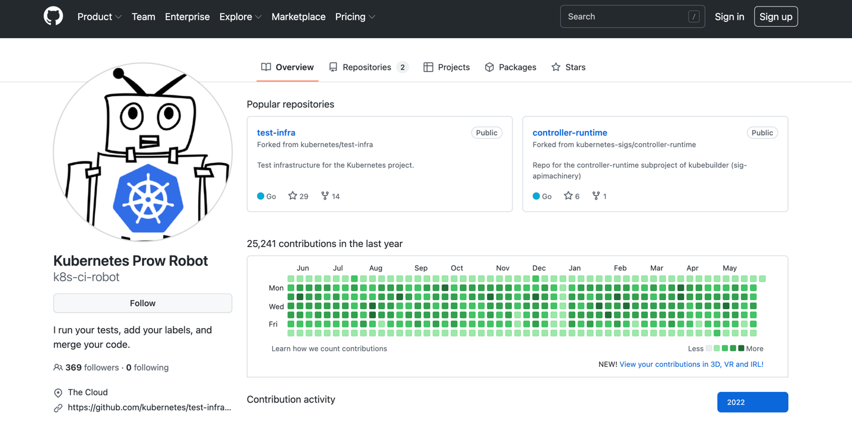
Figure 1.1 Snapshot of a Manager Bot Profile on Kubernetes.
Introduced to save the time and efforts of human agents, the bots have disrupted the OSSD community (Wessel 2020). The bot usually has a username, a profile picture, and a profile displaying previous contributions to the OSSD community over the years (as shown in Figure 1.1). Described as the “new voices” on pull requests, these bots are disrupting the OSSD communities (Monperrus 2019) by automating and streamlining the large-scale OSSD development and improving the productivity and efficiency of the developers. Despite several use cases to acknowledge the disruptive benefits of bots in the PR process, most recent research has identified the unintended consequences of bots in these knowledge intensive and collaborative OSSD contexts.
Brown and Parnin (2019) recently identified contributors’ inconvenience of dealing with PR bots, leading them to either abandon their pull requests or react negatively to PR discussions. Using qualitative interviews, Wessel and colleagues (Wessel and Steinmacher 2020; Wessel et al. 2021) have identified human-bot interaction problems in OSSD communities. According to them, contributors viewed bots’ feedback as spam, inducing communication noise, overwhelming notifications, and inflating the PR discussion, among others (Wessel and Steinmacher 2020; Wessel et al. 2021). Consequently, these negative contribution experiences, triggered by bots, may affect the overall satisfaction with the PR process and could discourage future contributions from potential contributors. However, little to no efforts were made to explore and model effective human-bot delegation for encouraging OSSD contribution and sustainability of the OSSD community.
OSSD communities thrive by continuing contribution, and popular research supports the incentivization of the OSSD contribution (Legay et al. 2018). When there is a need for incentivizing OSSD contribution to enhance software development, a PR rejection or an open PR (a PR characterized by contributor or bot inactivity and is neither merged nor rejected) could be highly demotivating to potential contributors. The PR rejection and unresponsiveness or inactivity of a PR, another form of soft rejection (Legay et al. 2018) in OSSD communities, may dishearten and dispirit the contributors (Mirhosseini and Parnin 2017; Wessel et al. 2020; Wessel and Steinmacher 2020). Consequently, contributors may undervalue their contribution to the OSSD project because of these forms of soft rejections (Legay et al. 2018), adversely affecting their overall PR satisfaction, willingness for contribution continuance, and willingness to take on advanced contributor roles in the community (for example, member, reviewer, and approver).
Furthermore, the issues associated with rejected or open PRs can be exacerbated for newcomers with little or no experience submitting PRs. Newcomers or incoming contributors are crucial for these communities to survive continually and succeed in the long-term (Steinmacher et al. 2016). Several studies on PRs in OSSD projects have highlighted the problems of newcomers, who usually require a smooth onboarding process into these specialized communities (Von Krogh et al. 2003). The newcomers, generally unfamiliar with the community practices and project values, may fail to create valid PRs. On the other end, the community reviewers and approvers can only rely on the submitted PRs to assess and judge the overall competence of the potential new contributor. This gap could result in new contributors’ dejection and frustration, refraining them from contributing to OSSD communities in the future, ultimately leading to adverse outcomes for both the contributor and the OSSD community.
The bots’ assignment of relevant and specific reviewers was the dominant factor affecting the PR latency (Yu et al. 2015), another major demotivating factor for potential incoming and new contributors. Given the bot’s ultimate authority to override a contributor’s choice of reviewers in assigning reviewers and approvers on Kubernetes, the role of bots in maintaining an active pull request discussion is irrefutable. Despite the surge in these bot-driven OSSD communities, the role of bots in shaping contributor preferences has been rarely studied in the IS literature. To address this gap, this study investigates the popular Kubernetes OSSD project to understand the contributors’ perceptions towards collaborating with bots, reviewers, and approvers in a geographically distributed virtual environment and the resulting associated outcomes.
Furthermore, despite recent calls for retheorizing in the context of bots, i.e., agentic AI, defined as IS artifacts ‘that enable the transfer of rights and responsibilities from, or even to, human agents’ (Russell 2019, Baird and Maruping 2021), scant efforts have been directed toward these calls. As User-IT interaction research continues its transition to examining agentic dyadic delegation, there is a greater need to develop an understanding of effective human-bot delegation that improves future contribution outcomes in OSSD communities like Kubernetes. A dearth of such understanding limits our ability to inform OSSD communities that thrive by consistently incoming developers’ contributions.
Understanding how the contributors perceived the collaboration patterns on Kubernetes is the first step toward designing strategies that enhance human-bot delegation, which can further improve the overall contribution patterns and sustenance of these OSSD communities. Moreover, despite widespread adoption in the OSSD communities, the role of perceived bot attributes on human-bot collaboration remains unexplored in research and practice.
This research aims to compose, describe, and test a theoretical model, namely, “The Human-Bot Delegation Model,” to model contributors’ PR satisfaction and contribution continuance willingness in OSSD communities like Kubernetes. More specifically, the study empirically ascertains the significant psychological and agentic attributes of efficient delegation mechanisms that drive overall satisfaction with the PR and contribution continuance willingness of potential developers.
The Human-Bot Delegation Model, grounded in the most recently proposed IS Delegation Framework that called for novel retheorizing of the user-IT interaction (Baird and Maruping 2021), includes constructs borrowed from the Task Technology Fit Theory (Goodhue 1995; Goodhue and Thompson 1995), Coordination Theory (Malone 1988; Malone and Crowston 1994), and Information Systems Continuance Model (Bhattacherjee 2001; Bhattacherjee et al. 2008). The dissertation intends to contribute to a theory of human-bot delegation by examining the contribution behaviors in an OSSD community. The delegation model development is therefore examined on Kubernetes, a popular OSSD community. To this end, the research aims to address the following three research questions.

Research Questions
- What are the psychological factors of contributors’ fit appraisal to enhance contributors’ satisfaction and contribution continuance willingness in OSSD communities like Kubernetes?
- What are the agentic factors of contributors’ fit appraisal to enhance contributors’ satisfaction and contribution continuance willingness in OSSD communities like Kubernetes?
- What are the delegation mechanisms driving contributors’ satisfaction in OSSD communities and what are their effects on contributor satisfaction and contribution continuance willingness in OSSD communities like Kubernetes?

CHAPTER 2 BACKGROUND AND LITERATURE REVIEW

Human-AI Collaboration Paradigm
Forecasted to rapidly expand at a compound annual growth rate (CAGR) of 40.2%, the global AI market accounted for 62.35 billion dollars in 2020 alone and is expected to reach 126 billion U.S. dollars by 2025 (Liu 2021). According to McKinsey Global Institute, AI can potentially economically offer an additional $13 trillion per year to the global output. Recent trends point to major technology companies such as Apple, Amazon, Google, and Meta investing heavily in AI-based technologies and startup acquisitions. The visible impacts of AI are not restricted to just any industry and, on the contrary, are being extended to sectors such as the banking (Castellanos 2018) and the agriculture (Bannerjee et al. 2018). To quote examples from the banking industry, Bank of America, with its virtual assistant Erica and Bank of Mellon Corp, with more than 220 “bots,” handled repetitive tasks to save costs and enhance customer satisfaction (Castellanos 2018)
The storm of interest in AI has been triggering a variety of reactions (Agrawal et al. 2017). On the one hand, a trepidation about how AI will replace humanity’s jobs and ultimately eliminate their livelihood has been rising. At the same time, there is excitement about how these AI technologies could augment and benefit human capabilities for a better world (Agrawal et al. 2018). This study extends a majorly suggested perspective that AI can radically transform the future of work in any industry by complementing and augmenting human capabilities, but not supplanting and replacing them (Wang et al. 2020)

Even after decades of predictions about how artificial general intelligence (AGI) (Pennachin and Goertzel 2007) refers to autonomous thinking machines, the concept is still yet to become a reality. For example, an AI can efficiently process 100 gigabytes of data. Still, there are instances when an AI can make sense of sarcasm or even crack a joke autonomously. While human agents are naturally creative, have intuition and judgment, leadership qualities, and work in teams, AI performs superhumanly and is designed for extensive data processing and quantitative capabilities (Wang et al. 2020). However, businesses and organizations benefit from a combination of these qualities and capabilities. Therefore, I argue for and extend a transformational research paradigm that informs the division of labor between human agents and AI for the next few decades – Human-AI collaboration in my research study.
“Hybrid intelligence” (Dellermann et al. 2021; Kamar 2016), “superteams” (al. 2020), and “new diversity” are a few novel terms being used to describe the human-AI collaboration paradigm. The primary rationale behind these concepts is that the combination of humans’ complementary intelligence or capabilities and agentic AI behave more intelligently than either in isolation (Kamar 2016). More recently, Dellermann et al. (2021) proposed the concept of socio-technological ensembles that drive collaboration among these complementary capabilities. Their idea of socio-technological ensembles highlights the significant roles played by the psychological attributes of human agents and agentic attributes of AI and the complementarities between them to achieve improved task outcomes. For example, in the context of communication between a human agent and a voice assistant like Alexa, a human agent’s self-efficacy (psychological attribute) in completing a task could be complemented by the transparency of the agentic AI (agentic attribute) for improved communication resulting in enhanced user satisfaction and other positive outcomes.
Several research efforts have been undertaken in the recent past to explore the collaboration patterns that could achieve new levels of unheard intelligence. For example, founding directors at The MIT Centre for Collective Intelligence (al. 2020) have summarized their views on the human-AI collaboration as “from humans in the loop to computers in the group,” referring to teams where agentic AI and human agents productively delegate tasks based on their complementary strengths to achieve common goals.
Accordingly, to address the growing calls for retheorizing to shed light on these novel evolving community phenomena, the study extends the human-AI collaboration paradigm to virtual OSSD communities. A brief discussion of the study’s adopted definition of collaboration can be found below.

Conceptualization of Collaboration in Organizations and OSSD communities
‘Collaboration’ in inter-organizational relationships literature has almost always been an umbrella term to describe the combination of ‘coordination’ and ‘cooperation’ among the involved parties working toward a common goal (Gulati et al. 2012). Despite several alternate definitions for collaboration in inter-organizational settings, the study relies on the most recent redefinition of collaboration that challenges the conceptual definition of collaboration as a mere sum of coordination and cooperation. Researchers have recently (Castañer and Oliveira 2020) carried out an extensive literature review spanning studies over 70 years (1948-2017) of management literature to submit their redefinition of collaboration as a distinctive concept to describe the process of – “ voluntarily helping other agents to achieve common goals or one or more of their private goals.”
Contrary to the popular literature that described coordination and cooperation as mere facets of collaboration, the review distinguished collaboration as a distinct phenomenon based on previously described conceptualizations specifically concerning the – achievement of personal goals that may not necessarily be directly related to the common goals already agreed upon (Macneil 1980; Van de Ven et al. 2000; Vlaar et al. 2007). Collaboration involves an element of intentional attitude and willingness to voluntarily act to support partners with not only common goals but also their personal goals (Castañer and Oliveira 2020). They further noted three outcomes of expectations for such an attitude to help a partner achieve one’s personal goals: altruism, reputation, and indebtedness to the partner.
Moreover, OSSD communities are driven by the “private-collective” innovation model (Hippel and Krogh 2003). Developers acquire personal benefits and rewards for compiling a code for their private use and expense while simultaneously and collectively contributing to the overall code quality of the repository. Extending the conceptualization of collaboration in inter-organizational relationships into these virtual OSSD communities, this study explores a noteworthy context to understand the determinants and outcomes of successful human-bot collaboration. We specifically examine the phenomenon of developers’ contribution to OSSD in the form of pull requests (PR). A PR offers a unique and distinctive context to understand collaboration patterns in the constantly evolving OSSD communities like Kubernetes.
On Kubernetes, a developer (aka contributor) submits a PR with the proposed code change. Bots assess the PR, choose, assign reviewers and approvers to review the PR, and constantly monitor the PR to merge the PR finally. The assigned reviewers and approvers voluntarily (a) review the PRs, (b) share their knowledge to improve the PR, (c) offer feedback on failed tests, and (d) approve or reject PRs. Finally, the PR gets either (e) merged or (f) closed. A visual representation of the PR process adapted from (Wessel et al. 2021) can be seen in Figure 2.1 adapted from (Wessel et al. 2021)
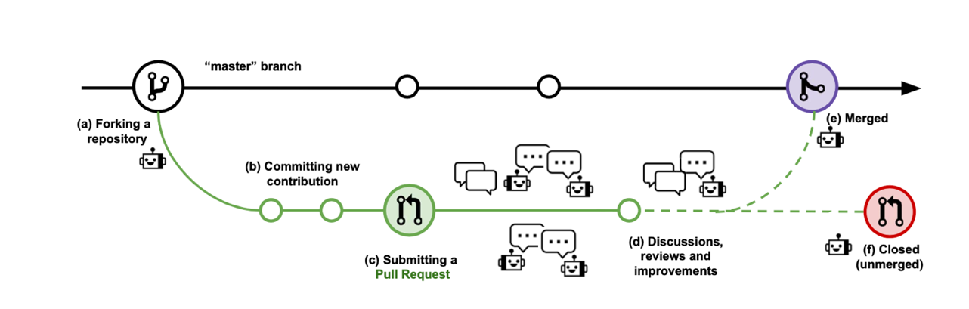
Figure 2.1 A visual representation of the PR process in OSSD communities
In this study, as I extend the concept of collaboration to virtual bot enabled OSSD communities, bots and reviewers can be seen as voluntarily working towards the overarching common goal of source code improvement and the contributor’s personal goal of merging their PRs. Extending the goal-oriented view of collaboration to OSSD communities, the personal goal of merging a specific PR may not be directly related to the overarching goal of improving the code quality.
This context also facilitated the extension and study of the popular concept of inter-organizational collaboration among human actors to large-scale virtual OSSD communities that comprise both bots (or agentic AI) and human agents (reviewers, approvers, and code owners) delegating tasks among each other (Baird and Maruping 2021)

Agentic IS Artifacts
Agentic Artificial Intelligence (Agentic AI), a form of Agentic IS artifact (Russell 2019), is designed to make rational and autonomous decisions. Agentic IS artifacts are defined as the new generation of “rational software-based agents that can perceive and act, such as take on specific rights for task execution and responsibilities for preferred outcomes” (Baird and Maruping 2021). AI most commonly refers to technologies that can perform intelligent tasks that usually require human intelligence (Rai et al. 2019; Russel and Norvig 2013), including knowledge representation, reasoning, planning, learning, behaving, and acting (robots), natural language processing, vision, perception. Bots in OSSD with varying task responsibilities exemplify the Agentic AI (Hukal et al. 2019). These bots represent a relatively less researched agentic context to develop an understanding of the effective delegation mechanisms that drive developers’ satisfaction with their contribution and willingness to continue OSSD contribution.

Literature Review on Agentic AI Attributes
The agentic AI can act autonomously, interact, adapt, learn, iterate, and assume tasks that were once only reserved for humans. Since generalizable evidence concerning Agentic AI-specific attributes is scarce, the study relied on an explorative focus to examine the literature and employ the features that describe the most common agentic elements among the host of available AI technologies.

Research on agentic AI (autonomous agents, intelligent agents, agents) is not new and spans decades. Most notably, an agent is a computer system that is reactive, autonomous, self-contained, and proactive with an ability to communicate with others (Wooldridge and Jennings 1994). Autonomous agents are “systems situated within and a part of an environment that sense that environment and act on it over time, in pursuit of its agenda and to effect what it senses in the future” (Franklin and Graesser 1996). Franklin and Graesser (1996) attempted to classify the agents based on literature. They identified nine properties of agents, including reactive (the ability to respond to the environmental changes promptly), autonomous (the ability to exercise control over its actions), goal-oriented (ability to act to attain goals), temporally continuous (ability to function continuously without rests intervals), communicative (ability to communicate with other agents or people), learning or adaptive (ability to change its behavior based on its previous experience), mobile (ability to transport itself from one machine to another), flexible (in that the agent actions are not entirely scripted) and finally character (presence of agent’s believable personality and emotional state). They further suggest that every agent should possess the first five characteristics, and the rest (mobile, flexible, and character) are not prerequisites but possible attributes of agents.
Extensive research into the foundations of agents (referred to as intelligent or autonomous or just agents) characteristics yielded the most commonly accepted definition of agentic AI as “a computer information system with abilities of autonomy, communicativeness, and learning that rests on built-in functions to carry out assigned tasks, responding to the environment in a timely, goal-directed manner” (Beale and Wood 1994; Brooks 1986; Etzioni and Weld 1995; Langton 1997; Russell and Norvig 2002; Tsang et al. 2004; Wooldridge and Jennings 1994)
Drawing on the agent definition identified in the literature, a recent study applied a combined model of TTF and TAM to examine acceptance and intention to use AI in a web-based auction task. The study employed six intelligent agent characteristics, namely autonomy, continuity, adaptivity, goal-orientation, learning ability, and communication, based on commonly accepted definitions of agents (Chang 2008).
A qualitative study explored TTF theory in the context of machine learning-based AI (ML-based AI) and identified ‘data-driven functionality’ and ‘level of automation as the two important AI (technology) characteristics that drive performance mediated by the Task-AI fit (Sturm and Peters 2020). In the context of ML-based AI, data-driven functionality encompasses the attributes of the ML algorithm that include the algorithm’s transparency, capturable complexity, the capability of handling data bias, and latency.
Engel et al. (2021) employed a qualitative case study research methodology and interviewed individuals in five organizations to identify AI characteristics, including black-box character, experimental character, learning requirements, and context sensitivity. Black box character refers to the lack of explanation facilities that offer transparency of the prediction process to the users or human agents, while context sensitivity refers to AI’s abilities that depend on the context’s data. Learning requirements are the AI capabilities of learning from the past and improving their performance, while experimental character refers to AI outcomes as being non-deterministic rather than probabilistic.
Cognitive computing systems (CCS) (Schuetz and Venkatesh 2020), a form of agentic AI, are those systems that mimic human cognitive abilities, including perception, in addition to capabilities such as knowing (a prime function of decision support systems (Decision Support Systems), reasoning (a prime role of expert systems (Expert Systems), and acting (a prime process of an intelligent agent (IA). Cognitive Computing Consortium¹ (2014) defined CCS as adaptive and interactive systems. Bot attributes included in the model, their definitions, and use case examples (Schuetz and Venkatesh 2020) are tabulated in Table 2.1
Characteristics | Description from the Consortium | Real-world examples
Adaptive | - Learn as information changes  - Learn as goals and requirements evolve  - Try to resolve ambiguity and tolerate unpredictability  - Engineered to feed on real time or near-real time data | Google maps changes its route
Interactive | - Interact with users  - Communicate smoothly to elicit user needs  - May interact with other devices, cloud services, processors | Voice assistants like Alexa use NLP to interact and communicate
Table 2.1. Bot attributes included in the research model
After an extensive literature review, the study employed the most recent classification to include adaptivity and interactivity as the key bot attributes in our model. Bot adaptivity and interactivity are the key attributes influencing the contributors’ fit appraisal. Additionally, an extensive literature review of the prominent agentic AI attributes has revealed explainability, defined as the ability to explain ‘why’ for a particular action or prediction, as a significant variable in human-AI interaction research. Markus et al. (2021) described an AI system to be explainable if it is intrinsically interpretable or if the AI system is complemented with an interpretable post-hoc explanation. Although European Union, realized the importance of explainability of an algorithm and granted the “right to explanation” to allow meaningful transfer of information about the logic behind a particular action from the agentic AI to the human agent in the General Data Protection Regulation (GDPR), the effect of agentic AI’s explainability on human agents’ preferences and resulting behaviors, specifically in OSSD like collaborative communities, remains unanswered and necessitates attention.
Explanations have always been a way to manage human-human interactions, facilitating the transfer of knowledge and as a justification for one’s actions. For example, Adadi and Berrada (2018) synthesized the literature to propose the following motivational factors for explainability: a) to justify agentic AI’s decisions, (b) to comply with the ‘right to explanation’, (c) to learn ways to improve the agentic AI’s actions, (d) to gain insights about the inner workings of agentic AI’s behavior and actions.
A human agent could be more willing to collaborate with an agentic AI that generates actionable explanations either in the form of reasons or a rationale behind a certain action. Explainability can be described as the dynamic shared meaning-making process (Ehsan et al. 2021) between the two agents and plays a central role in guiding human agents’ trust formation in the AI system. The ever-increasing relevance of explainability can be evidenced by the mounting attention and commendable progress in the field of XAI or explainable AI that generates the representations of how and why an agentic AI acts or makes predictions. Constantly under scrutiny for being dominantly centered around the algorithmic and technical aspects, these socially situated XAI approaches shed light on the gaps in understanding why these explanations are sought by the human agents (Ehsan et al. 2021).
Scholars have clearly identified the gaps in the understanding of explainability between agentic AI designers and the intended or target consumer audience and suggested that explanations of agentic AI predictions should follow an explanatory dialogue and present exemplar-based explanations for maximum utility (Miller 2019; Miller et al. 2017). Responding to this emerging need of explainability in human-AI collaborative environments, my research examines the role of bot explainability in shaping contributor’s behaviors and actions in an OSSD community like Kubernetes

OSSD Communities and PR Contribution
Improved software code quality (Wessel et al. 2018) has consistently been cited as the primary advantage of contributing to the OSSD communities. In addition to small startups, large scale organizations are increasingly leveraging the popular OSSD communities to increase the efficiency and productivity of software development, often for free (Fang and Neufeld 2009; Hahn et al. 2008; Hippel and Krogh 2003; Santos et al. 2013; Stewart and Gosain 2006; Von Krogh et al. 2003). OSSD has brought about a radical transformation in the software development landscape with its globally distributed community offering voluntary development services. Based on the Git version control system, GitHub, described as an iconic context of successful knowledge-based workspace (Dabbish et al. 2012), is a code-hosting repository that offers multiple features to enable social coding.
The success of these OSSD communities is often attributed to the size and quality of the developer community, who voluntarily and consistently contribute to the code (Aksulu and Wade 2010; Chengalur-Smith et al. 2010; Fang and Neufeld 2009; Hahn et al. 2008; Liu et al. 2017; Santos et al. 2013; Stamelos et al. 2002; Von Krogh et al. 2003; Wessel et al. 2021). However, collaborative code development is a knowledge-intensive phenomenon that often entails consistent learning and considerable domain knowledge and experience (Hippel and Krogh 2003; Von Krogh et al. 2003). Successful contribution (for example: merging a PR) is often described as a complex process, and newcomers with no or very few previous contribution instances may find it extremely arduous to join an existing community. The technical complexities (Hippel and Krogh 2003; Von Krogh et al. 2003) of comprehending the dynamic community documentation and efficiently traversing through the multi-phase contribution process pose significant barriers to successful contribution.
As these communities, primarily based on human-human collaboration, grew, the reviewers and contributors were increasingly burdened with the workload of reviewing code, checking license issues, reminding developers of project guidelines, running tests, and merging requests for source code changes, also known as “pull requests” (Wessel and Steinmacher 2020). The semi-automation of these communities by bots has become a common phenomenon to successfully address the increasing burden of maintaining the evolving large-scale OSSD communities. Some of the more popular OSSD projects of the millions hosted by GitHub include Kubernetes and jQuery (Hukal et al. 2019) which are increasingly relying on bots for their community maintenance.

Bots in OSSD Communities
Bots are integrated into OSSD communities like Kubernetes to automate routine tasks and enhance communication among the contributors, reviewers, and other community members (Wessel et al. 2018). The sophisticated bots designed to meet developers’ needs have rapidly risen to become the de-facto interfaces for the software development (Lebeuf et al. 2017b). These bots cater to a diversity of tasks and roles in the collaborative process of OSSD.
Characterizing the distinct features of these diverse bots based on their purpose, Lebeuf et al. (2017b) defined collaboration bots as those that aid in communication, coordination, and collaboration among users. Bots automating the OSSD projects are a form of collaboration bots that aim to support and improve the pull request process that requires human-human interaction (for example, communication between the reviewers and contributors).
Generally developed to minimize friction points in user communication and pull request coordination, these bots render a variety of services, including – offering transparency on the PR and visibility to PR goals, building trust, and improving coordination among team members by assigning the right reviewers and experts to manage the PR (Lebeuf et al. 2017a; Lebeuf et al. 2017b), bridge knowledge and communication gaps in OSSD (Storey and Zagalsky 2016). Employing a regression discontinuity design on 1100 GitHub projects, Wessel et al. (2020) have empirically proven that an increased PR review bot adoption increased the merged PRs, decreased the non-merged PRs, and decreased the communication barriers among developers. Nevertheless, these bots’ purpose of enhancing the efficiency and productivity of the OSSD contribution process can only be truly realized by the smooth and frictionless functioning of bots.
In these OSSD communities, developers donning different contributor, reviewer, and approver roles communicate with these sophisticated bots, often ‘listening to’ or following up on (Baird and Maruping 2021; Storey and Zagalsky 2016) the bot-offered instructions to merge a PR successfully. Although these bots play a significant role in enabling communication and coordination among the involved agents in a PR, there is not enough evidence about how and why these bots enhance the efficiency and productivity of a PR process (Lebeuf et al. 2017a; Storey and Zagalsky 2016; Wessel 2020; Wessel et al. 2018; Wessel and Steinmacher 2020; Wessel et al. 2021). Furthermore, there is rising anticipation of how bots, with a developer personality, could further disrupt these OSSD communities as the new virtual team members, positively and negatively. The study models the role of bots on contributor fit appraisal and highlights the coordination mechanisms driven by bot-enabled coordination, which is conceptualized as agentic coordination in this study.
Recent evidence from the literature on contribution patterns in OSSD sheds light on the myriad of different reactions to the bots and the disruptive integration of bots as new team members in these developer-driven communities. Investigating the human-bot interaction problems on PRs, Wessel (2020) interviewed GitHub developers who complained that bots offered poor non-comprehensive reviews while introducing communication noise on the PRs. The developers also cited a lack of information on bot interaction and found these bots less evolved than those in other customer service domains.
More recently, Wessel et al. (2021) interviewed 21 developers on GitHub to identify challenges about bot interaction, adoption, and development in OSSD communities and categorized them hierarchically. Table 2.2 displays the hierarchical order of the identified bot challenges in OSSD.
Challenge type | Context | Challenges with bots
Interaction | Expectation breakdowns | - Intimidate newcomers  - Enforce inflexible rules  - Strange to interact
Interaction | Ethical issues | - Malicious bots  - Impersonating bots  - Biased bots  - Intrusive bots
Interaction | Bot communication | - Non-comprehensive feedback  - No contextualization  - Not actionable  - inexperienced
Adoption | Discoverability issues | Difficulty in finding appropriate bot
Adoption | Managing bots’ configuration | Limited configuration
Adoption | Technical complexity | - Handling bot failures  - Monitoring bots requires more work  - Increased barriers for newcomers
Development | Platform Limitations | - Build complex bots
Table 2.2 Bot challenges identified in the OSSD literature

Given the myriad of possible outcomes of bot-enabled collaboration in OSSD presented in the literature review above, it is imperative to examine how these perceptions toward these bots shape the underlying contribution behaviors on these OSSD platforms.
With the literature review presented above, I argue that an integrated model of a contributor’s psychological attributes and a bot’s agentic attributes is necessary to understand effective human-bot collaboration and its outcomes in OSSD communities. This area of human-bot collaboration has been a less familiar topic of research in the IS literature, although significant efforts have been made in the contribution literature in other contexts of the online health information sharing (Ayabakan et al. 2017; Barua et al. 2013; Pang et al. 2013; Whiddett et al. 2006) and contributing to social media (Bulgurcu et al. 2018). The current study serves to address this gap.

Role of Bots in Kubernetes like OSSD Communities
Coined in 1998, the term Open Source (OS) referred to software development communities of developers voluntarily offering their services for code development. Ironically, given the traditional perception of these communities to be egalitarian bazaars (Raymond 1999), these communities primarily operate in a hierarchically structured (Cornford et al. 2010) and regularized manner, often reflecting organizational work practices (Hukal et al. 2019) and involving corporate engagement (Germonprez et al. 2013; Germonprez et al. 2017).
Bots (or software bots) are increasingly attracting attention as being instrumental in coordinating and structuring work in OSSD like Kubernetes (Hukal et al. 2019; Wessel 2020; Wessel et al. 2018; Wessel and Steinmacher 2020; Wessel et al. 2021). A manual search of the Kubernetes documentation on PR listed four phases of the review process, each involving significant bot activity in PR domains with increasing complexity. Hukal et al. (2019) conducted algorithmic auditing to analyze bot activity on Kubernetes source code repository on GitHub, identified four bots classes, and referred to them as checkers broker, gatekeeper, and manager to reflect their bot functionality in PR process domains. They offered a visual representation of the bot activity in every PR review domain on Kubernetes (as shown in Figure 3). The complexity of bot functionality increased as the PR progressed from submission to the source code change.
According to them, bots on Kubernetes, deployed at crucial intersections of PR process workflow, offered several functionalities to the developers: a) all the bots assisted developers in coordinating PR tasks according to the pre-defined project procedures, b) checker bots carry out repetitive and mundane tasks offering more time for developers to focus on code quality c) gatekeepers and Manager bots offer explainable reviews to contributors and reviewers on failed tests to guide the PR process d)manager bots assign reviewers, monitor and update the developers about the project e) gatekeepers and Manager bots enforce rules to maintain PR process quality clearly defined in the elaborate Kubernetes project documentation. Furthermore, bots are expected to reinforce the stability and reliability required for large-scale organizations to trust the OSSD project (Hukal et al. 2019).
In summary, the bots clearly are responsible for the procedural control in addition to maintaining and reinforcing the project’s order, which is in line with procedural rationality, a driver of complex task execution in organizations (Simon 1996). Furthermore, the bots on Kubernetes enforce procedural rationality by instantiating process intentions (Hukal et al. 2019). Figure 2.2 presents the PR workflow followed in the Kubernetes project and is adapted from (Hukal et al. 2019)
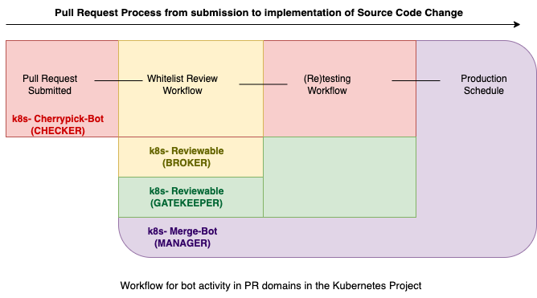
Figure 2.2 Pull request process domains and the associated bot activity
Anticipating the increased proliferation of bots in these OSSD communities to meet the growing need for software development, I argue that it is essential to investigate the effects surrounding the phenomenon of human-bot collaboration to realize the true potential offered by these bot-driven OSSD communities like Kubernetes to developers. The proposed model’s theoretical underpinnings are discussed in the next chapter.

CHAPTER 3 THEORETICAL FOUNDATIONS

The major takeaways from the literature review discussed in Chapter 2 point to the need for retheorizing the relationships between human agents and agentic AI in the form of delegation (Baird and Maruping 2021). Drawing upon established streams of literature, including the task-technology-fit (TTF) theory (Goodhue and Thompson 1995), the study uses the high-level IS Delegation Theoretical Framework (Baird and Maruping 2021) as a scaffolding to guide the study’s salient theoretical model development.
Considering developers’ evaluations of collaborating with bots in OSSD, I identified the delegation mechanisms of appraisal and coordination relevant to the human-bot collaboration in OSSD. According to the IS Delegation Framework, appraisal as a delegation mechanism occurs when a contributor assesses or evaluates delegating responsibilities to the bot and determines the appropriate responses (Fadel and Brown 2010), whereas coordination refers to the management of task interdependencies and alignment of task responsibilities among bots and contributors to achieve task goals (Gulati et al. 2012).

Delegation in OSSD Communities
Buckland and Florian (1991) suggested two factors as alternatives to or complements to AI use: Increasing user’s expertise and coping with task complexity. They further identified four courses of possible actions when an individual copes with task complexity: education, by which a user can increase his expertise and knowledge to complete the task; advice, in the form of helpful information offered by the system can inform the user; simplification, during which the complex tasks is made more straightforward for the user either with a human intermediary or an artificial front-end and finally delegation was defined as the process in which some of the complexity attributed to the task could be moved inside the system and away from the user such that the individual or human agent could feel competent to complete the task because of either of the two scenarios, decrease in task complexity or adequacy of expertise relative to the system. The current human-AI collaboration paradigm in knowledge-intensive virtual communities echoes the transfer or moving of complexity away from the user into the system. For example, in OSSD communities like Kubernetes, the redundant and mundane tasks that once burdened the human developers are now delivered by bots.
The study, therefore, highlights the relevance of the proposed definition in the context of OSSD communities, characterized by the presence of (a) at least two agents (i.e., contributors and bots) and (b) their collaboration or sharing of responsibilities (c) to complete a task. I investigate the concept of human-bot delegation, defined as the transfer of rights and responsibilities between the contributor and a bot (Baird and Maruping 2021), as the collaboration pattern for the PR process in OSSD communities.

IS Delegation Theoretical Framework
Recognizing the need for retheorizing IS use in the context of agentic IS artifacts (AI), Baird and Maruping (2021) recently offered a delegation lens to develop nuanced insights concerning the human agent-Agentic AI (previously described as user-IT) collaboration patterns. Building on delegation decision-making literature, algorithmic perceptions literature, and advice literature, the study offered an “IS Delegation Theoretical Framework” (Figure 3.1). According to them, tasks, human agents, agentic AI, and outcomes are central to achieving goal-centric outcomes.
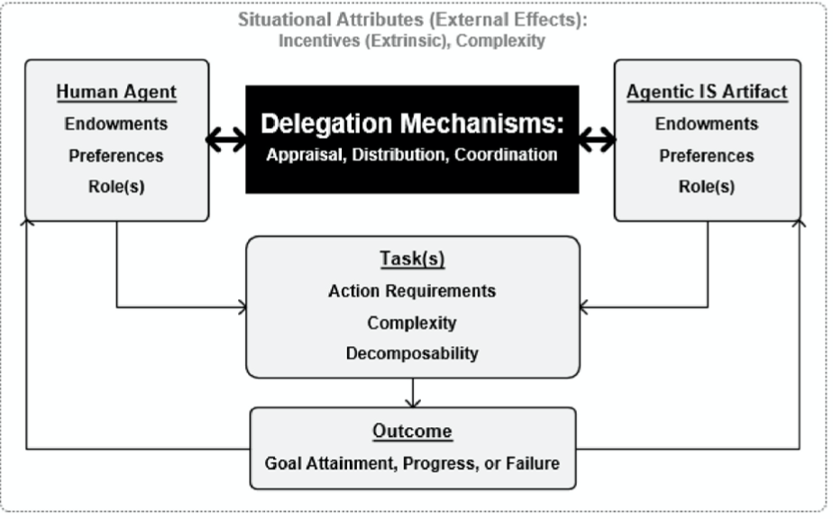
Figure 3.1 IS Delegation Theoretical Framework.
Highlighting the dyadic nature of agency in these contexts, the study defined a new set of attributes, namely endowments, preferences, and roles for each of the agents. Endowments refer to intrinsic resource-based assets and capabilities with which the agents are endowed. Thus, investigating the effects of intrinsic endowments offers the advantage of explicating distinct sub-attributes that may play a crucial role in the delegation of PR tasks among contributors and bots.
Consistent with agency theorists (Bandura 2006; Enfield and Kockelman 2017; Schlosser 2015), the Framework defines preferences as motivational factors necessary for completing a task. Preferences differ along with goal, defined as a “cognitive representation of the desired endpoint,” and decision models represent internalized representations of choice ranking. In the context of bots helping a developer attain a goal, goal-oriented preferences include the goals and perceptions concerning bot attributes, while decision model preferences are typically measured using utility functions (Enfield and Kockelman 2017; Schlosser 2015). Furthermore, these preferences are constructed, revised, and reinforced in the human-bot delegation patterns in OSSD communities.
Bots also construct preferences via task goals and decision models, highlighting the agency duality in the delegation process. For example, designers embed the agentic AI goals and boundary conditions into their designs that determine agentic AI endowments. Similarly, perceptions about the bot functions reveal the bot preferences shaped by the PR task objectives in OSSD communities like Kubernetes.
According to the IS Delegation Framework, the third attribute, “role,” which refers to the role of the human agent versus agentic AI in the delegation, forms the core of this dyadic agency delegation model. Generally, there have been two roles in an agent-based relationship: delegator(human) delegates or abdicates responsibilities to a proxy(agent) (Castelfranchi and Falcone 1998). However, the human-bot delegation in OSSD presents an interesting context of shared responsibilities where the abdication of responsibilities is mutual (Lebeuf et al. 2017a; Wessel et al. 2018), necessitating scholarly attention.

Delegation Mechanisms
Referred to as causal processes that produce the intended effect and represent the crucial elements of the causal process, mechanisms (Hedström and Ylikoski 2010) provide an understanding of the delegation process. The OSSD literature prompted me to determine and model appraisal and coordination as the key delegation mechanisms to the dyadic delegation of PR task responsibilities among the bots and contributors (Baird and Maruping 2021).
Appraisal as a Delegation Mechanism
An in-depth literature review on the interactions and behaviors in OSSD communities revealed that OSSD contributors perceived several challenges in working with the OSSD bots (Brown and Parnin 2019; Lebeuf et al. 2017a; Lebeuf et al. 2017b; Wessel 2020; Wessel and Steinmacher 2020; Wessel et al. 2021). The challenges potentially could transpire into adverse outcomes for the contributors, such as dissatisfaction with the overall PR process and reluctance to contribute actively. Furthermore, popular research also suggests that developers with positive perceptions and experiences with bots contributed more readily (Hukal et al. 2019; Lebeuf et al. 2017a; Monperrus 2019; Wessel 2020; Wessel et al. 2018) to the OSSD community.
Appraisal, defined as a mechanism of finding beneficial complementarities, captures the perception of fit between a contributor and the bots. Developers evaluate their cognitive and emotional compatibility (Baird and Maruping 2021) with bots to effectively delegate the PR responsibilities. Therefore, appraisal occupies a focal role in delegating PR responsibilities between developers and bots in OSSD communities. Task-technology fit theory (Goodhue and Thompson 1995) guides the study’s conceptualization and operationalization of the construct ‘fit appraisal’ as a delegation mechanism in the theoretical model.
As the appraisal process includes evaluating the decision-making compatibilities between contributors and bots in the form of endowments and preferences, given a particular situated task, the study conceptualizes the delegation mechanism of appraisal as a fit appraisal (Goodhue and Thompson 1995) in the study. Accordingly, I argue that a contributor evaluates and appraises the fit between their endowments and preferences to that of the bots' preferences while dyadically delegating a PR task responsibility.
Consistent with the appraisal mechanism’s description as one of finding “beneficial complementarities” (Baird and Maruping 2021), and drawing on the definition of fit from the TTF literature “as the correspondence between task requirements, individual abilities and the functionality of technology” (Goodhue and Thompson 1995), the study describes developers’ appraisal of the complementarities between bot and developer attributes as “fit appraisal” in the proposed research model.

Coordination as a Delegation Mechanism
Coordination Theory defined coordination as the effective management of interdependencies among the actors functioning toward a common goal (Malone 1988; Malone and Crowston 1994). Often described as the ‘central purpose’ of teams and organizations, coordination has been the focus of research in several disciplines such as management, psychology, Information Systems, and computer sciences, among others (Okhuysen and Bechky 2009). While coordination has been viewed as both a process and an outcome, the study adopts coordination as an outcome view, explained as the extent of effective management of interdependencies among involved actors toward a common goal (Espinosa et al. 2004).
The management literature mainly employs two dominant coordination mechanisms to explain inter-organizational coordination effectiveness. Explicit and implicit coordination mechanisms attracted a significant research focus. The older forms of organization and work, centered around hierarchies, were mainly driven by explicit forms of coordination, including well laid out plans, rules, professional roles and responsibilities, and formal communication to establish common task goals. The coordination theories and literature on inter-organizational coordination mainly focused on researching the consequences of these explicit coordination mechanisms on the team and organizational performance, communication patterns, and other possible outcomes.
However, as work forms evolved, researchers recognized the need to conceptualize the subtle interactions and voluntary behavior that drove efficient team coordination even in the absence of or with little explicit coordination. Rico et al. (2008) defined these behavioral models as implicit coordination mechanisms driven by routines and proximity. Tacit coordination is the voluntary behavior of team members to synchronize their actions towards a common goal by speculation, with little or no communication (Wittenbaum et al. 1996).
After a detailed review of coordination literature (Okhuysen and Bechky 2009), three integrative dimensions were proposed to explain coordination. Accountability enables coordination among interdependent agents by ascertaining the responsibilities of specific tasks and sub-tasks. Predictability allows the agents working on a task to anticipate subsequent actions by other involved actors and behave in a manner designed to enhance coordination. Finally, common understanding facilitates shared perspectives among interdependent actors working towards achieving task goals. The review summary highlights the critical effect of the three dimensions, separately or integrated, on the effectiveness of coordination in communities and groups.
Coordination theory (Malone 1988; Okhuysen and Bechky 2009) guided the conceptualization of coordination among contributors and bots in OSSD communities. The five integrative coordination mechanisms from the organizational literature, namely explicit accountability, explicit predictability, implicit accountability, implicit predictability, and common understanding, are adapted in this study to explain coordination as a delegation mechanism on Kubernetes PRs to achieve the desired coordination in OSSD communities, an example of a novel organizational form (Puranam et al. 2014).

Literature Review on Coordination in OSSD Communities
Drawing on the IS Delegation Framework (Baird and Maruping 2021), this study conceptualizes the dyadic delegation in the human-bot collaboration in OSSD in the form of two delegation mechanisms: fit appraisal and coordination. Most empirical studies in Coordination Theory research in software development focused on the link between inter-team coordination and the overall project performance (Faraj and Xiao 2006; Hoegl et al. 2004; Khan and Jarvenpaa 2010; Malone 1988; Malone and Crowston 1994; Yuan et al. 2009).
Moreover, most of the studies only described the effect of either one or both the popular coordination mechanisms (explicit and implicit coordination) on the team or organizational performance (Chang et al. 2017; Espinosa et al. 2004; Heylighen 2015; Im and Rai 2013; Okhuysen and Bechky 2009; Rico et al. 2008). For example, Yuan et al. (2009) examined the antecedents of coordination effectiveness in software development and identified a positive association between implicit coordination and coordination effectiveness.
However, the study failed to account for explicit coordination (or knowledge sharing) on coordination effectiveness. The finding is not coherent with popular research in OSSD that identified the significant role of ‘code base’ among other community documentation as a critical OSSD explicit coordination mechanism (Bolici et al. 2016). It is also illogical to think that explicit coordination or knowledge sharing in the form of project goals, role descriptions, and publicly accessible documentation that enforces rules and community guidelines does not affect coordination.
Furthermore, Yuan et al. (2009) also conceptualized a construct ‘coordination technology use’ as an antecedent to coordination effectiveness to indicate the “functionalities of IT that enable or support the interaction of two software developers from interacting teams in the execution of cross-team tasks.” However, the researchers found no association between coordination technology use and coordination effectiveness. The study results contrast with several empirical studies that identify bots’ irrefutable positive and negative role as transformational agents, integral to the collaboration among developers within OSSD communities (Broadbent et al. 2012; Hukal et al. 2019; Lebeuf et al. 2017a; Lebeuf et al. 2017b; Wessel 2020; Wessel et al. 2018; Wessel et al. 2020; Wessel and Steinmacher 2020; Wessel et al. 2021).
Bot-driven tasks coordinate much of the PR communication in OSSD communities. Specifically, on Kubernetes, the bots trigger several commands and extend the collaboration functionality among contributors working on a PR. For instance, bots can even trigger an image of a puppy holding a card titled “Thanks for your help” to an inactive reviewer to elicit their review efficiently. In summary, the evidence points to OSSD as a novel organizational form characterized by a) voluntary self-selection to contributor roles and b) the presence of bots in varying administrative authorities.
A recent algorithmic audit (Diakopoulos 2016) of the Kubernetes platform evidenced the radical expansion in the volume and diversity of bot commands in just over a year. The number of bot commands rose from approximately 300 in January 2017 to 5400 by September. A radical rise in the spectrum of bot functionalities is bound to make them an even more critical and significant part of the OSSD contribution research.
According to popular research on OSSD, these non-hierarchical communities differ from traditional profit-focused hierarchical organizations, including self-selection for roles, voluntary contribution behaviors, and the absence of formal control structures or central delegating authority (Espinosa et al. 2007; Hahn et al. 2008; Hippel and Krogh 2003; Moe et al. 2009; Robles et al. 2005). However, the introduction of bots to automate the contribution process on Kubernetes like OSSD platforms has radically transformed the dynamics of coordination among the involved agents, namely reviews, approvers, code owners, contributors, and bots (Hukal et al. 2019; Monperrus 2019; Wessel 2020; Wessel et al. 2018; Wessel et al. 2020; Wessel and Steinmacher 2020). Therefore, the Human-Bot Delegation Model challenges the current views on the determinants of effective coordination in these evolving bot-driven OSSD communities.
Contrary to the views presented by Puranam and colleagues (Puranam et al. 2014; Puranam et al. 2012) that task allocation in OSSD occurs through contributors’ self-selection characterized by no formal authority, the study argues that bot-enabled OSSD communities not only offer a context for contributors to volunteer or self-select PR tasks but also highlight the agentic control and authority exercised by bots in the PR process. These bots with varying task responsibilities monitor and manage the task interdependencies among contributors. For example, the Kubernetes K8s-ci-Robot, described as a ‘manager bot,’ is deployed at a crucial phase in the PR lifecycle to provide procedural control to reinforce and maintain order in the OSSD project. Similarly, ‘gatekeeper bots’ unequivocally articulate feedback about PR issues and incoming bugs to the contributors (Hukal et al. 2019). More importantly, the bots are even authorized to reject contributors’ requests for reviewers and approvers from the contributors. Nevertheless, the conceptualization of bots as an important coordination mechanism has been neglected in literature and requires examination, specifically in OSSD communities.
For example, Lindberg et al. (2016) identified “unresolved interdependencies” in OSSD communities that reflect (a) emerging or unidentified knowledge-based dependencies between community members and (b) unaccounted relationships between the ongoing community tasks. Although the scholars rightly identified the presence of these interdependencies that cannot be addressed by the OSSD communities’ ‘arm’s length coordination mechanisms,’ such as software code modularization and incremental collaboration of contributions, they failed to consider the role of bots in resolving these interdependencies. They further conceptualized these interdependencies as developer and
development interdependencies that should be addressed for effective coordination. According to them, development interdependencies occur when task progress is dependent on previously unresolved tasks. At the same time, developer interdependencies stem from the dependency of one developer on the other, usually for code reviews.
The mixed-methods study included a content analysis of the PRs, interviews with OSSD community developers, and proposed routines, ‘stable, yet evolving patterns of interdependent activities’ (Feldman 2000; Feldman and Pentland 2003), that varied in order and activity to enhance the resolution of the identified two interdependencies. Although the study offered several theorized relationships between routines, interdependencies, and the outcome of a successful PR merge; the study fails to consider the decision-making process of developers in addition to the antecedents and consequences that could have a significant effect on managing these two classes of interdependencies in addition to the role of bots as coordination mechanisms.
Although developer and development interdependencies affect coordination in OSSD, in my current study, I argue that the evolving dynamic requirements during a PR process can potentially be resolved by bot-enabled or agentic coordination that relies on explicit and implicit coordination mechanisms. More importantly, my research addresses these gaps and extends the OSSD coordination research by proposing agentic coordination as an effective coordination mechanism that addresses these developer and development interdependencies.
Additionally, the reliance of Lindberg and colleagues (Lindberg et al. 2016) on content and qualitative analyses calls for deeper investigation and understanding of the factors that constitute these interdependencies. Moreover, conceptualizing interdependencies with a quantitative proxy measure to understand the coordination mechanisms that resulted in the PR merge does not account for the human component of these complex interactions. To explain further, the study disregards the individual differences among developers, the role of bots, explicit and implicit coordination mechanisms, and agentic or bot-driven coordination that predominantly drives coordination, and ultimately effective collaboration in these new knowledge-intensive organizational forms.
To address the discussed gaps in OSSD coordination literature, the current research highlights the role of bots as a new form of coordination mechanism and conceptualizes a new construct, agentic coordination, defined as the – “perceived effectiveness of bot-driven coordination”, to address the gaps described above.
Another notable study extended the research on coordination in software development teams using the biological lens of stigmergy, defined as the ‘class of mechanisms that mediate animal-animal interactions’(Grassé 1959). Stigmergic coordination occurs when an actor's actions create changes in the environment, which in turn offer a stimulus to other actors in the environment to react to those changes. Several efforts have been made to apply this concept to the coordination dynamics in OSSD teams (Bolici et al. 2009; Bolici et al. 2016; Dalle and David 2003; den Besten et al. 2008; Heylighen 2006; Heylighen 2015; Robles et al. 2005).
The research maps the OSSD community to a stigmergic environment where developers suggest or make changes and describes how the community reacts to the change (for example, the codebase). In OSSD, coordination is usually facilitated by community and project documentation. These representations contribute to forming shared mental models of the workflow among contributors to coordinate their tasks effectively. Although gaining attention, this line of research fails to explain the role played by explicit coordination mechanisms in the form of the code base, detailed documentation, defined roles, and responsibilities that still majorly guide and directly impact contributions in OSSD communities like Kubernetes. The proposed theoretical model addresses these concerns by conceptualizing coordination in the form of five integrative dimensions of common understanding, explicit predictability and accountability, and implicit predictability and accountability, enabled by the bot or agentic coordination.
In the following chapter, I present the study’s research model and discuss the hypotheses development.

CHAPTER 4 MODEL AND HYPOTHESIS DEVELOPMENT

Research Model Development
Efforts to understand human agents as a substitute or a complement (Acemoglu and Restrepo 2018; Acemoglu and Restrepo 2019) to agentic AI has been an area of interest for decades since the term Artificial intelligence was coined. In the same direction, Agrawal and others defined the anatomy of the task (Agrawal et al. 2017; Agrawal et al. 2019) in the context of AI (Figure 4.1). This task anatomy sheds light on the irrefutable role of human judgment that acts in the context of AI prediction.
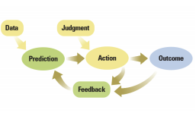
Figure 4.1 Anatomy of a task in the AI context.
In the light of prediction (the information or advice shared by the Agentic AI), human judgment, described as the process of understanding payoffs (Agrawal et al. 2017; Agrawal et al. 2019), results in one’s actions or behavior toward the AI. For example, Google Maps could suggest a ‘best route’ to reach a destination. Still, as an expert driver with experience, one might choose to discount the advice or not delegate one’s decision to Google Maps and take a different route because of their confidence to complete the task (reach the intended destination) with no advice from Agentic AI. Therefore, this study models human judgment in the form of individual characteristics and perceptions toward agentic AI.
In the light of the increasing agentic capabilities of technology, consideration of the dyadic or fluidic nature of delegation of task responsibilities between agentic AI and human agents is a requirement for AI delegation theorizing. Agentic AI and human agents delegate task rights and duties to each other. Still, the current delegation mechanisms point to an asymmetry in the roles of agentic AI and human agents. At the same time, human agents have greater flexibility in determining the roles (delegator or proxy), while agentic AI mostly tend to be rule-based and rigid in exercising their role (Baird and Maruping 2021). To explain further, human agents in their proxy role may enjoy greater flexibility in their delegation acceptance decisions because they may choose to reject a delegation. In contrast, agentic AI may not decide to reject a delegated task. Considering the asymmetry between roles, it is essential to note that the study focuses on the human agent evaluations of the task, agentic AI, and human agent characteristics to develop the study’s theoretical model.
Consequently, for theorizing the Human-Bot Delegation Model for OSSD communities, specifically Kubernetes, following the calls for retheorizing in the context of agentic AI and focusing on the contributor as the elemental case of analysis, I developed a theoretical research model presented in Figure 4.2. The following sections offer a detailed description of the model constructs and a discussion on hypotheses development.

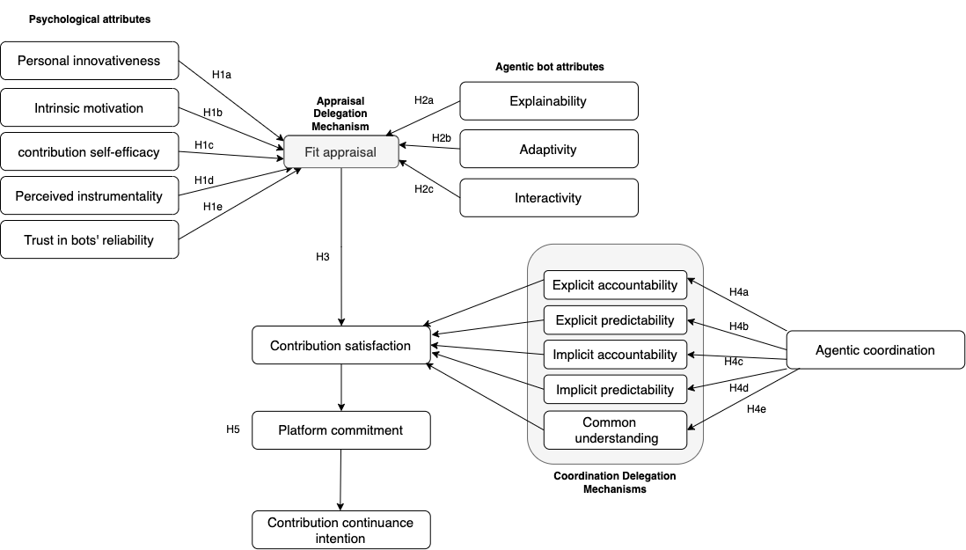
Figure 4.2. Human-Bot Delegation Model in OSSD communities

Hypotheses Development
A review of the literature on individual perceptions towards innovative technology use (Agarwal and Prasad 1998) and user evaluations of task-technology fit (Goodhue 1995; Goodhue et al. 2000; Goodhue and Thompson 1995) discussed in Chapters 2 and 3 guided the choice of contributor’s psychological attributes in the model in terms of their endowments and preferences (Baird and Maruping 2021). The psychological attributes of the contributor who submits a PR include endowments in the form of personal innovativeness in IT and intrinsic motivation to contribute. In contrast, the preferences of a contributor include their task-specific self-efficacy and their contribution’s perceived instrumentality in the OSSD project. The first set of hypotheses (H1a-H1d) models the effect of contributors’ psychological attributes on their fit appraisal, answering RQ1.

To examine the second research question, the model relies on the extensive agentic AI literature review discussed in Chapter 2 to guide the selection of agentic bot attributes. Following the popular description of these systems, OSSD bot attributes comprise interactivity, adaptivity, and explainability. The second set of hypotheses (H2a-H2d) describes the influence of these attributes on a contributor’s fit appraisal, answering RQ2.
The study’s analysis for RQ3 is guided by the hypotheses testing of H3 , (H4a-H4e) and H5 developed based on the Task-Technology Fit Theory (Goodhue and Thompson 1995) and Coordination Theory (Malone 1988; Malone and Crowston 1994) reviews discussed in Chapter 3. An in-depth summary of all the proposed hypotheses in the research model is offered below. Figure 4.3 visually represents the first and second set of hypotheses.
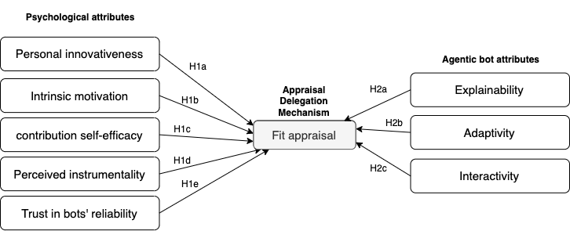
Figure 4.3 Psychological and agentic attributes of contributors’ fit appraisal

Psychological Effects

Personal Innovativeness in IT as contributor’s endowment
There is a need to examine contributors’ endowments in the form of general beliefs and assets. Personal innovativeness in information technology (PIIT) has consistently been a critical variable in studies investigating technology acceptance and use, specifically, innovations. Rogers (1995) defined PIIT as “[t] he degree at which an individual is quite early in adopting new technologies.” Bots are increasingly being introduced into OSSD platforms to automate and coordinate the PR process (Hukal et al. 2019). The sophisticated bots have taken over several crucial functions that developers previously carried out in the PR process.
Knowledge-intensive OSSD platforms, coordinating the work of thousands of developers, require the contributors to be curious and innovative with their work. A certain degree of innovativeness in IT is essential for the contributors to dyadically delegate responsibilities and collaborate with these new forms of agents voluntarily. Therefore, the differences in a contributor’s fit appraisal can potentially manifest in their innovativeness toward IT. Since collaborating with new forms of technology like bots often requires a personal drive to find new and interesting ways of solving unexpected issues, the study proposes the following.
(H1a) Personal innovativeness in IT is positively associated with the contributor’s fit appraisal of collaborating with bots.

Contribution Self-Efficacy as Contributor’s Endowment
A crucial development in the stream of extending and testing Task Technology Fit (TTF) (Goodhue and Thompson 1995) research with the goals of understanding users’ utilization choices was made when Strong et al. (2006) extended the task technology fit model with the construct of self-efficacy, defined as confidence in one’s ability to complete a task, that was found to have a direct and positive association with the perceptions of utilization. Furthermore, the extended model exhibited a greater explanatory power when compared to a TTF model, which did not consider individual endowment differences in the form of self-efficacy. Similarly, integrating TTF theory with social cognitive theory, Lin and Huang (2008) found perceived self-efficacy to affect perceived task-technology fit. Self-efficacy has consistently been found to directly influence the evaluations of fit fields (Lee et al. 2007). Furthermore, in theorizing effective delegation, Baird and Maruping (2021) consider a form of self-efficacy called coding self-efficacy, or confidence in one’s ability to write and understand software code, as an endowment that impacts a developer’s delegation mechanisms with bots.
Drawing on the same construct, the study hypothesizes self-efficacy as one of the critical determinants of developers’ appraisal of fit with bot attributes. Consistent with the conceptualization of the task-specific self-efficacy (Marakas et al. 1998) and coding self-efficacy, contribution self-efficacy is defined as the confidence to contribute to Kubernetes effectively. A PR merge into the software code can be cited as an example of effective contribution to Kubernetes in this study. A meta-regression of the task technology fit literature (Goodhue 1995; Goodhue and Thompson 1995) in the Information Systems research suggested context-specific analysis as the solution to conceptualize TTF effectively as technologies and tasks are continuously emerging. Furthermore, the study conceptualizes contribution self-efficacy as a perceptional rather than a behavioral variable, contextualized to the specific technology type and utility, such as bots, following Jeyaraj (2022). Based on the offered evidence, the study proposes the following
(H1b) Contribution self-efficacy is positively associated with the contributor’s fit appraisal of collaborating with bots.

Intrinsic Motivation as Contributor’s Endowment
An individual’s willingness to perform an activity for inherent satisfaction rather than external rewards is defined as intrinsic motivation (Davis and Bostrom 1994; Ryan and Deci 2000). The construct aligns with positive attitudes toward technology and influences acceptance and use of technology in several technologies and task contexts (Gerow et al. 2013; Rode 2016; Ryan and Deci 2000; Venkatesh 2000).
The core of the OSSD lies in the voluntary nature of the contribution. The developers are expected to contribute, ensure code quality voluntarily, and efficiently confront any unforeseen circumstances during the PR process (Choi et al. 2013; Fang and Neufeld 2009; Hippel and Krogh 2003; Santos et al. 2013). As the PR process is increasingly becoming automated with the introduction of bots, developers should be intrinsically motivated to delegate with bots and other contributors to navigate the PR process effectively.
As such, the study intends to test the following hypothesis:
(H1c) Intrinsic motivation to contribute is positively associated with the contributor’s fit appraisal of collaborating with bots.

Perceived Instrumentality as Contributor’s Preference
The primary underpinnings of motivational theories assume that individuals perform well when they ascribe an essential role to their work (Hertel et al. 2008; Kerr and Bruun 1983; Murthy and Kerr 2000). Perceived instrumentality, defined as the ‘degree of importance ascribed by a group member to his or her performance in the meeting toward achieving valued group outcome’, was conceptualized and hypothesized as an antecedent to contributor satisfaction in a collaborative idea generation and selection task via a group support system (Ivanov and Cyr 2014). Although no relationship was found between the two, the construct garnered particular attention in management and team literature to indicate an individual’s motivation to work effectively in teams.
On a Kubernetes PR process characterized by voluntary contributions of quality code, the degree to which contributors ascribe importance to their contribution to the overall value
produced by the project code and ultimately to Kubernetes could be a pronounced indicator of a contributors’ fit appraisal with bots. The study posits that any developer who perceives one’s contribution as necessary or instrumental in improving the overall code quality appraises a positive fit with bot attributes.
The offered arguments suggest that perceived instrumentality in the OSSD projects could be a salient psychological antecedent and motive to an average contributor in the PR task to perceive and appraise fit with bot attributes. This leads to the following hypothesis:
(H1d) Perceived instrumentality of contribution is positively associated with the contributor’s fit appraisal of collaborating with bots.

Trust in Bot’s Reliability as Contributor’s Preference
In human-robotic interactions, human agents’ delegation of responsibilities and rights to the robot usually rests on the belief that they will protect their interests. According to Hancock et al. (2011), trust in robots affects the delegator’s willingness to accept offered Robo predictions, follow those predictions, and ultimately improve their performance (Freedy et al. 2007). The construct ‘trust’ affects the decision-making of humans in uncertain and risky situations. In light of a difficult situation (for example, a wrong prediction), a human agent (here, contributor) may want to intervene more and delegate less to the bot in a PR process (De Visser et al. 2006).
Many research studies have empirically identified inappropriate trust as an antecedent to negative consequences such as technology misuse and disuse (Lee and See 2004; Parasuraman and Manzey 2010; Parasuraman and Riley 1997), stemming from inefficient delegation patterns of agentic AI predictions, further affecting the task performance. The automation literature found trust as a significant determinant of performance, shedding light on the role of trust as a crucial behavioral preference in collaborating with these agentic systems (Chen et al. 2007; Parasuraman et al. 2000; Parasuraman et al. 2008). Since the cruciality of task contexts manifested greater trust in the interacting agents (Hengstler et al. 2016), I argue that a human agent should trust the agentic AI’s reliability and purpose in order to delegate important tasks.
Trust in a technology’s reliability, a form of trust in technology, has been gaining attention in recent years as a significant indicator of post-adoptive use behaviors (Tams et al. 2018). Trust in technology refers to an individual’s general beliefs or expectations about leveraging the technology and plays an undeniable role in shaping behaviors toward the technology reliance (Mcknight et al. 2011; Teo et al. 2008). Reliability has gained attention in the literature as a non-functional attribute (Gebauer et al. 2008; Rodrigues et al. 2005) that influences post-adoption behaviors in the knowledge management systems (Thatcher et al. 2010). More specifically, trust in a bot’s reliability can be defined as the expectation that a bot acts consistently and predictably, as described in the Kubernetes documentation (Thatcher et al. 2010). For example, suppose a bot assigns a size XL label to a contributor’s PR with specific attributes. The bot is expected to always assign the same label to any contributor’s PRs with similar characteristics. Any inconsistency in the bots’ functioning could negatively influence a contributor’s perceptions and distrust of their reliability, ultimately affecting their fit appraisal of bot attributes.
In finding beneficial complementarities or ‘fit appraisal’ with bot attributes, a contributor who perceived the bots as unreliable may undermine collaborating with them, significantly threatening their contribution behaviors to any OSSD platform automated by bots. I test this view in my research model with the following hypothesis:
(H1e) Trust in the bot’s reliability is positively associated with the contributor’s fit appraisal of collaborating with bots.

Agentic Effects

Explainability as Bot’s Endowment
Research has established the importance of explainability on a user’s behavior. An agentic AI’s transparency or ability to explain the ‘why’ behind its actions can appeal to users in their interactions with these systems. With increased clarity of the reasoning process behind the system recommendations, users are expected to report greater perceptions of enjoyment and informativeness, resulting in higher system evaluations. Providing explanations in the form of explanation facilities to inform the user of the predictions offered received significant attention in the IS literature (Wang and Benbasat 2007; Ye and Johnson 1995).
Ye and Johnson (1995) empirically investigated the effects of explanations in the form of explanation facilities on users’ evaluations of expert systems. They found that the users more readily accepted those expert system’s predictions that were provided with explanations rather than those which came without explanations. They further identified ‘justification’ as the most compelling explanation type that induced change in user attitudes and perceptions toward the system. Therefore, contributors could be willing to collaborate with bots offering justifiable explanations for their collaborative actions (here, comments and feedback on the Kubernetes PRs)
Gregor and Benbasat (1999) encourage the provision of suitably designed explanations automatically in a context-specific manner to promote positive user perceptions about the technology. They further warn that explanations may not be used if there is greater effort expectancy to obtain them. Building on Toulmin’s model of argumentation, the researchers assert that persuasive explanations accompanying adequate justification led to greater trust, agreement, satisfaction, and acceptance of the explanation and the system.
Another study found that explanation provision promoted the user’s perception of system transparency resulting in user satisfaction (Gedikli et al. 2014). Explanations can potentially resolve any ambiguities in the comprehension of bot interaction and instill confidence in users to rely on the systems to a greater degree to achieve their goals (Arnold et al. 2006). Recognizing the significance of explainability in determining contributors’ positive attitude toward appraising the fit with bot attributes, the study extends the following hypothesis
(H1e) Bot’s explainability is positively associated with contributors’ fit appraisal of collaborating with bots

Adaptivity as Bot’s Endowment
According to the Cognitive Computing Consortium (CCC) conducted in 2014, ideal cognitive computing systems (CCS) should be adaptive (Schuetz and Venkatesh 2020). They ought to learn with changes in information that may lead to new and updated requirements as tasks evolve. Further, another expectation is that these agentic AI must adapt by feeding on dynamic real-time or near real-time data to resolve ambiguity and tolerate unpredictability (Schuetz and Venkatesh 2020).
The following agentic AI literature explicated the significance of adaptivity on human agent outcomes. For example, research on the adoption of intelligent systems to support tutoring and learning found that collaborative learning support, when adaptable, can drastically improve student learning outcomes. They identified a positive association between the system’s adaptivity and students’ test performances. Moreover, research in the robotic interaction literature showed that the adaptivity of technology influenced the use and acceptance of robots (Pew et al. 2004).
Furthermore, a longitudinal study proposed the ALMERE model to test the acceptance and use of assistive agentic AI or robots by the elderly. The perceived adaptivity of the robots has been identified as the significant factor that influenced their acceptance (Heerink et al. 2010). Adaptivity also reduced an individual's cognitive load while using a system (Rothrock et al. 2002). In this study, I examine the effect of the perceived adaptivity of bots on contributors’ fit appraisal of collaborating with bots.

Perceived adaptivity can be explained as the degree to which a human agent perceives the agentic AI to be adaptive to the evolving user’s needs and process requirements (Schuetz and Venkatesh 2020). In collaborative communities like Kubernetes characterized by voluntary contribution patterns, it is logical to assert that contributors expect the bots to adapt to the evolving PR requirements and relevantly address the needs of multiple contributors working on a PR.
For example, in the event of inactivity from the assigned reviewers to review the code, the bots on the Kubernetes PRs usually adapt to the changing requirements and assign similar reviewers in the community for the PR to progress. However, repetitive communication with the bots over assigned reviewer inactivity, the waiting time, and needing additional requests for new reviewers could be frustrating to the contributors and lead to negative contribution behaviors. The study posits that the contributor has to perceive the bots as adaptive for appraising fit with bots. Based on the offered evidence, the study extends the following hypothesis:
(H2b) Bot’s adaptivity is positively associated with the contributor’s fit appraisal of collaborating with bots.

Interactivity as Bot’s Endowment
Interactivity of technology, specifically conversational agents, has been identified as a driving factor in seamless mediations and online conversations (Robinette 2011; Zack 1993). The cognitive computing consortium described interactivity as an ideal agentic dimension highlighting the importance of interactive systems that facilitate users to elicit their needs and requirements comfortably (Schuetz and Venkatesh 2020). Previous research has noted that interactive bot conversations significantly reduced bias and satisficing attitudes while enhancing transparency (Wijenayake et al. 2020). In addition, bots build rapport with users, improve comprehension and offer adequate clarity to users (Bickmore et al. 2009), among other potential benefits. An experimental study surprisingly found that users were more willing to sign a consent form when an agent explained the contents than when they encountered a human research assistant (Bickmore et al. 2009).
We are witnessing a radical expansion of task complexities and associated bot commands on OSSD communities like Kubernetes (Hukal et al. 2019).
Although increasingly complex, these commands follow a conversational template design and may not be flexible enough to comprehend unstructured and informal conversations or questions by contributors to respond relevantly. Moreover, a stream of literature from the software engineering discipline has focused on the challenges faced by developers while interacting with the bots on these OSSD platforms(Brown and Parnin 2019; Lebeuf et al. 2017b; Wessel 2020; Wessel et al. 2018; Wessel et al. 2020; Wessel and Steinmacher 2020; Wessel et al. 2021).
Bots in their interactions were found to be biased (Peng et al. 2019) and intrusive (Brown and Parnin 2019), introduced noise (Brown and Parnin 2019; Wessel and Steinmacher 2020; Wessel et al. 2021), enforced inflexible rules (Zheng et al. 2018), and offered non-comprehensive feedback, send repetitive notifications (Mirhosseini and Parnin 2017) among others. Given the observed challenges, testing the bot interactivity effect on contributors’ fit appraisal could be of potential research value to guide the design and development of bots in collaborative virtual communities like OSSD. The mixed findings on the effect of bot interactivity on human actions and perceptions motivated the following hypothesis.
(H2c) Bot’s interactivity is positively associated with the contributor’s fit appraisal of collaborating with bots.
Fit Appraisal and Task Satisfaction

Grounded in the Expectation-Confirmation Theory (Oliver 1980), the IS Continuance model (Bhattacherjee 2001; Bhattacherjee et al. 2008) posits that intention for the continuance of IS use is predicted by a user’s degree of confirmation of IS performance and their satisfaction with the use. Confirmation can be defined as the degree of user’s perceived congruence or “fit” between their expectation of IS use and the actual performance (or value) of IS.
The model also validated a positive association between the confirmation and satisfaction, implying that the degree of user’s confirmation of initial expectations of IS use determines their satisfaction, which later plays an essential role in their intention to use again. Extant literature has confirmed this causal linkage in various technology and collaborative contexts(Xu et al. 2017). For example, research on SaaS collaboration tools found that confirmation led to the satisfaction of use (Tan and Kim 2015).
Similarly, a contributor evaluates their dyadic delegation with bots on their PR, and the confirmation or disconfirmation of the bot’s behavior in response to their PR requirements can be expected to play an undeniable role in their satisfaction with the overall PR process and could result in future behaviors. To elaborate, when contributors acquire benefits that confirm their expectations of collaborating with bots on their PRs, they are satisfied with their contribution experience. The study, therefore, hypothesizes that a contributor who appraises or confirms “fit” with bots will be more satisfied with their contribution.
(H3) Fit appraisal of collaborating with bots is positively associated with contribution satisfaction.

Mediation Effect of Integrative Coordination Mechanisms

Bots are increasingly coordinating and supporting the complex and critical workflows that allow developers to collaborate on their PRs. However, the role of bots or bot-enabled coordination has been unexplored in the OSSD research as a contributing factor to human-bot collaboration in OSSD communities. Based on the above evidence, I theorize a third form of coordination driven by the bots in addition to the explicit and implicit coordination mechanisms that drive a contributor’s satisfaction with the PR. Responding to the call for recognizing bots as a popular coordinating mechanism in distributed software development, I conceptualize the construct as agentic coordination in this study.
Research on coordination in hierarchical organizations recognized the significance of (a) plans and rules, (b) objects and representations, and (c) roles as explicit or external coordination activities catering to the three integrative coordination dimensions, namely accountability, predictability, and common understanding discussed in Chapter 3 under Coordination Theory.

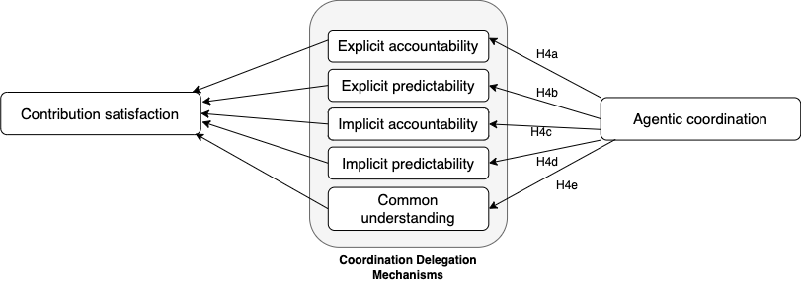
Figure 4.4 Delegation mechanisms in the Human-Bot Delegation Model
Thorough evidence of the role of bots as the drivers of both explicit and implicit coordination mechanisms in OSSD communities that ultimately result in contributor satisfaction is offered below. The following hypothesis summarizes the role of coordination as a mediating variable (as shown in Figure 4.4)
(H4) Agentic coordination positively influences contribution satisfaction, mediated by coordination delegation mechanisms
Explicit Accountability as a Mediator

Usually deemed indispensable to formal organization Field (Simon 1996), plans and rules held members accountable for their actions. The upper echelon managers were generally responsible for creating these plans and rules. Similarly, The Kubernetes Contributor Documentation (www.Kubernetes.dev/docs) (Authors 2022) is written, maintained, and updated by the SIG Docs, a special interest group within the Kubernetes community responsible for maintaining the community documentation. The detailed documentation establishes the PR contribution process's goals and objectives and guides contributors’ actions and choices for a satisfactory contribution experience. Moreover, the plans and rules available in the form of documentation make it simpler for contributors to relate to other agents’ tasks on a PR and respond appropriately, resulting in their contribution satisfaction. For example, the contributor guide offers elaborate documentation on the PR process, transferring knowledge and best practices on PR contribution patterns. The “Pull Request Process” documentation explains the best Kubernetes PR practices and is a reference for the contributors to engage in the complex sequential PR workflow efficiently. The documentation, therefore, enables and enhances explicit accountability on Kubernetes.
In addition to serving as plans and rules, the documentation also includes ‘objects and representations’ (Okhuysen and Bechky 2009) to improve coordination by offering information about the community practices.
For example, the Kubernetes contributor guide (www.Kubernetes.dev/docs) includes “Code of Conduct” and “Community Values” documentation for educating the contributors on their behavioral ethics in the community. These resources offer a common referent around which contributors collaborate on a PR.
Scholars have consistently recognized the usefulness of organizational roles, representing the duties and expectations associated with hierarchical positions, as explicit coordination facilitating mechanisms. As part of the Kubernetes documentation, the ‘Roles and responsibilities’ (kubernetes.io/docs/contribute/participate/roles-and-responsibilities/) describes the roles, requirements, and associated responsibilities of various PR contributor roles, namely members, reviewers, and approvers. The documentation serves as a publicly available efficient team task design, ascertaining various contributor role relationships and associated responsibilities, or accountability (Chang et al. 2017; Okhuysen and Bechky 2009; Yuan et al. 2009), to enable coordination among contributors. By explicating the roles and responsibilities, the documentation encourages the organizational members to align and coordinate their actions efficiently.
Although very detailed, a voluntary OSSD contributor may not take the time to carefully read and understand the documentation, failing to be accountable for their actions on the PR. Bots constantly guide the contributors on their roles and responsibilities to enhance their coordination in the PR by directing them to these documentation pages, facilitating explicit accountability. Roles also facilitated contribution behavior continuity in the past research (Füller et al. 2014), which can be attributed to contribution satisfaction.
In management literature driven by hierarchical organizations, roles enable coordination by monitoring and updating the involved actors about the task progress (Chang et al. 2017). For example, managers monitored the developers while developers updated the work progress in traditional software organizations. Although the Kubernetes documentation explains the contributor roles in detail, it is nearly impossible for the documentation alone to coordinate the work among thousands of developers who wish to contribute to and review a specific PR. For example, consider a scenario where a contributor submits a PR and waits for a review from thousands of other contributors who operate as reviewers and approvers. The documentation describes how a new PR should be reviewed and approved. Still, it offers no information or knowledge about assigning reviewers with a specific project experience, knowledge, or profile, which is central to the coordination process in a large-scale OSSD community like Kubernetes. Bots predominantly carry out these coordination functions of monitoring and updating the PR agents and developing explicit accountability.
Furthermore, Kubernetes has established a set of prerequisites as part of the “Contributor Guide” (www.Kubernetes.dev/docs) documentation to facilitate accountability, including holding a valid GitHub account and signing the Contributor License Agreement (CLA). According to the guide, the Kubernetes Prow Robot (also known as k8s-ci-robot) is tasked with ensuring that the prerequisites are met for each PR. The bot, therefore, is the first point of contact for contributors in their PR process, directing them towards the relevant documentation to ensure that the prerequisites are met.
The bots, in summary, try to translate the PR requirements to the contributors by offering explanations in the form of the objects, plans, rules, roles, and responsibilities described in the community documentation, resulting in the satisfaction of the contributor.
The study puts forward the following hypothesis.
(H4a) Agentic coordination positively influences contribution satisfaction, mediated by explicit accountability
Explicit Predictability as a Mediator

Conventional organizations adopted work plans and rules to establish predictable interrelationships among employees, to enhance their coordination effectiveness (Okhuysen and Bechky 2009). Research has shown that explicit predictability can be accomplished through organizational tools, schedules, plans, handbooks, and norms (Faraj and Sproull 2000; Faraj and Xiao 2006). Based on the coordination research, the Kubernetes documentation in the form of two different mechanisms, namely (a) plans and rules, (b) objects and representations (Okhuysen and Bechky 2009), in addition to enabling explicit accountability, assists the contributors working on the PR to anticipate subsequent and impending task requirements and coordinate effectively, developing and enhancing explicit predictability
Kubernetes documentation, comparable to the organizational plans and rules, clearly defines the PR process requirements, helps create explicit predictability, and encourages contributors to behave in a manner designed to enhance coordination on a PR. For example, a notable part of the Kubernetes contributor guide includes “Community Expectations” to understand the project code and PR review expectations. It serves as a guide for the contributors to anticipate others’ actions on the PR. More particularly, “The Testing and Merge Workflow,” part of the contributor guide, offers a sequential description of the PR workflow to aid contributors in generating PR process awareness (Blincoe and Damian 2015) on what to expect or predict for the contributors to plan their actions efficiently. The study hypothesizes that the resulting explicit predictability enhances contributor satisfaction.
Objects and representations have been found to impose order in formal organizations by offering a scaffolding or structure to a given coordinated task. Similarly, the documentation provided on the Kubernetes platform is used as a baseline scaffolding to remind the contributors of their PR requirements in terms of the timing and task order. Despite several objects and representations of the PR process, contributors may fail to adhere to them promptly. The bots coordinating the PR remind the engaged PR agents of the task progress, monitor and update the agents of the ongoing PR requirements, notify unresponsive PR agents, and assign, update and manage multiple PR agents to impose order on the PRs in the Kubernetes community and enhance explicit predictability.

Furthermore, in OSSD communities like Kubernetes, bots direct the contributors to follow the documentation to enhance contributors’ awareness of the sub-tasks in the PR workflow, resulting in predictability among the involved agents on the PR. Therefore, the bots on the PRs facilitate explicit predictability via information flows and knowledge sharing among the contributors on a PR, encouraging them to engage in dialogue and a collaborative learning experience. The study, therefore, hypothesizes that
(H4b) Agentic coordination positively influences contribution satisfaction, mediated by explicit predictability
Emerging research on online crowdsourcing communities, specifically modern coding platforms like OSSD, expounded on the role of implicit coordination, described as imperceptibly operating adjustment behaviors driven by deep cognition (Chang et al. 2017; Rico et al. 2008). Although research on organizational coordination effectiveness explicated routines and proximity as the two central implicit coordination mechanisms, the same may not be relevant in their originally defined form to the OSSD PR task context.
Implicit Accountability as a Mediator

Routines or “behavioral patterns bound by rules and customs” (Feldman 2000; Feldman and Pentland 2003; Lindberg et al. 2016) have been identified as the central tenets of successful organizations. The often visually interpretive routines served as templates for successful tasks and enabled coordination in formal organizations. The routines usually establish a sequence of activities that may slightly differ from the expected or documented ones in the context of OSSD communities like Kubernetes. For example, while the Kubernetes documentation and transparent PRs (that are closed, open, and merged) offer representations of several types of PRs, it is harder to predict if a new specific PR can follow the same performance path since the PR success is interdependent on several other factors, including PR type, size, project characteristics, assigned reviewer attributes among others. Although previous PRs and contributor documentation establish the sequential PR process and enact a way for PR agents to learn and observe the best practice, they may not be considered standard templates to follow.
Moreover, routines are conventionally formed by the same team members working on a common task together over a period when the team implicitly synchronizes their activities. However, in novel forms of organizing like OSSD communities (Puranam et al. 2014), each contribution in the form of a PR usually involves a distinct set of reviewers, approvers, and code owners working towards merging a good PR. The contextual dynamism of emerging dependencies makes it nearly impossible for a specific group of ‘team’ members to ascertain and develop routines that generally drive implicit coordination in traditional organizations.
Similarly, proximity in time and relationships, described as physical co-location, was another central implicit coordination mechanism in formal organizations. Concerning the large-scale OSSD communities that empower thousands of developers geographically distributed worldwide to share critical code and knowledge, proximity hardly plays any role in driving any form of coordination. The collaboration among the PR agents, including contributors who submitted the PR and those who reviewed, approved, and helped merge the PR, is facilitated by bots. Previously, contributors and maintainers of OSSD projects relied on written notes and emails to track the progress of the PRs (Metiu 2006). However, bots have recently taken over these communities as the principal coordination mechanism
A scholarly stream of research pointed to the role of bots in enriching the relationships among collaborating agents, specifically, PR agents in OSSD communities (Lebeuf et al. 2017a; Lebeuf et al. 2017b; Monperrus 2019; Wessel 2020; Wessel et al. 2018; Wessel et al. 2020), notably Kubernetes (Hukal et al. 2019). The current study models the role of bots in these collaborative communities based on the evidence offered below.
According to Okhuysen and Bechky (2009), hand-off work, or routines that operate as coordinating mechanisms by ascertaining how work transfers between interdependent parties. These routines allow a team to determine when one agent has finished his work and another takes over. On Kubernetes, in addition to explicit notifications from the community, often considered a noise (Brown and Parnin 2019; Wessel et al. 2020; Wessel and Steinmacher 2020; Wessel et al. 2021), bots periodically update the PR agents of the PR progress and alert them of when it is their turn to work, thereby facilitating implicit coordination. The bots on Kubernetes can also potentially assign and invite new PR agents such as reviewers and approvers in the event of inactivity of previous assignees and update them on the PR progress and their task responsibilities.
In summary, the study argues that agentic coordination enables implicit coordination, which further influences contributors’ satisfaction with the PR process and extends the following hypothesis:
(H4c) Agentic coordination positively influences contribution satisfaction, mediated by implicit accountability

Implicit Predictability as a Mediator

Scholars have begun to recognize the significance of implicit coordination, driven by group awareness, in OSSD communities (Blincoe and Damian 2015). Implicit predictability in the context of a PR offers information critical for contributors to anticipate and dynamically adjust their actions to collaborate effectively and smoothly on a PR. By providing a detailed understanding of the engaged PR agents, their role in the PR process, and possible collaboration instances, implicit predictability is essential for effective coordination in OSSD communities. Moreover, the knowledge-intensive task nature and resulting interdependencies in OSSD suggest implicit predictability as necessary for collaborative coding environments.
The ability to anticipate the upcoming actions on a PR is vital for distributed contributors to collaborate their efforts smoothly and avoid rework on a PR. Modern OSSD platforms make the contribution process more visible and transparent for anyone, aiding them in understanding the PR task components and the responsibilities associated with contributor roles. As engaging in the PR process is knowledge-intensive that requires contributors to search for innovative solutions in the face of unforeseen contingencies, the familiarity with similar issues in the openly accessible transparent PRs (both open and closed) empowers the contributors to anticipate similar contingencies in their PRs. The bots direct the PR agents to similar PR issues in the past to offer them a general view of the possible solutions and anticipate any other potential challenges to the PR, thereby facilitating implicit predictability. Examining details of similar PRs and the associated changes made to the source code can endow contributors with the understanding of required actions or adjustments to their PRs. On Kubernetes, contributors are automatically subscribed to any PRs they have submitted, reviewed, or commented on and received notifications from the bot about any progress on the PR. The bot or agentic coordination
Although a case study of an OSSD community has interestingly revealed the prominence of mailing lists, often referred to as explicit coordination mechanisms, as an effective implicit knowledge sharing mechanism, I argue with my study that bot-driven agentic coordination should be explored as an antecedent to implicit predictability and ultimately, contribution satisfaction. Consequently, I propose the following hypothesis:
(H4d) Agentic coordination positively influences contribution satisfaction, mediated by implicit predictability
Common Understanding as a Mediator

Kubernetes like OSSD communities make the PRs visible and transparent (Blincoe and Damian 2015; Dabbish et al. 2012), providing awareness to contributors about efficient PR workflows, and enhancing common understanding among the involved PR agents. Roles specify expectations and therefore offer a meaningful and hierarchical means of responsibility attribution for the plans, rules, and objectives associated with the PR task. On OSSD, like Kubernetes, the documentation, by creating a shared understanding of role-specific tasks, also aids in substituting tasks among contributors. For example, a contributor in the reviewer role may sign up to review a PR that was previously assigned to a different reviewer. Any contributor in reviewer status can choose to substitute for a reviewer who may not be active or efficient on their assigned PRs.

However, in Kubernetes, bots are the principal actors facilitating the substitution process. For example, consider an instance when a bot-assigned reviewer or approver is inactive or inefficient on a PR. Bots recognize the PR inactivity and may choose to either (a) remind the assigned reviewers of the inactivity or (b) assign new reviewers, substituting the previously assigned reviewers based on their roles and experience. Moreover, contributors who submitted the PRs may also request the bots to assign reviewers of their choice. The bots, however, may or may not accept these requests and therefore serve as the primary coordination agent, enabling the substitution of PR contributor roles.
(H4e) Agentic coordination positively influences contribution satisfaction, mediated by common understanding

Contribution Continuance Intention as the Model Outcome
To inform the understanding of contribution satisfaction on post-contribution behavior, the study draws on theories of Expectation Disconfirmation (Oliver 1993) developed in the marketing research literature and Information Systems Continuance Models (Bhattacherjee 2001; Bhattacherjee et al. 2008).

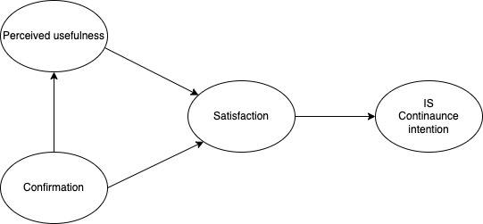
Figure 4.5: IS Continuance Model (ICM) Source: (Bhattacherjee 2001; Bhattacherjee et al. 2008)
Satisfaction with technology is a major consideration for realizing the potential of the OSSD collaboration platforms such as Kubernetes. Users’ dissatisfaction with technological features discouraged them from future use and useful post-adoption behaviors (Briggs et al. 2003; Briggs et al. 2006; Briggs et al. 2008). According to the continuance intention models, satisfaction is a significant antecedent for the intention to continue using technology in the future (Chiu et al. 2007; Zhou et al. 2012).
Within the domain of IS, the continuance use theories suggest that an individual who is satisfied with either the outcome of the process of technology use will intend to use the technology again in the future (Briggs et al. 2010; Briggs et al. 2006; Briggs et al. 2008; Reinig et al. 2008). The research has identified several contingent factors as the determinants and outcomes of satisfaction with the technology use outcomes and process.
Overall, the Continuance Use Intention model (presented in Figure 4.5) offers a sound theoretical framework to understand the link between a contributor’s satisfaction with his PR contribution and the resulting contribution behaviors in this study. Since the goal of using this framework as a basis is to examine the outcomes of contribution satisfaction better, the focus is on the validated theoretical link between satisfaction and continuance use intention. The ICM helps examine the study’s RQ3 as It allows to explore and unravel the black box that links satisfaction with the contribution process to future contribution willingness.
Platform Commitment

Team and organizational literature elucidated the cruciality of commitment in individuals or teams functioning towards common organizational goals. Commitment is characterized by strong beliefs in the project goals and values, willingness to participate in project tasks, and aspiration to maintain project membership (Mowday et al. 1979, Mohr and Nevin 1990). Commitment is defined as “the sense of duty a team feels to achieve the project’s goals and the willingness to do what is needed to make the project successful” (Ashforth and Mael 1989; Kline and Peters 1991; McDonough III 2000).
Commitment can be viewed as the degree of psychological attachment an individual feels with a collective like the Kubernetes community, determining a relevant course of his actions and behaviors. Accordingly, platform commitment, which the study describes as the commitment to the collective, such as the Kubernetes community, induces a strong willingness to engage and innovate in the project and predicts the future desire of a contributor to keep contributing to the OSSD platform or community. Platform commitment, therefore, conveys a sense of responsibility to engage within the collective based on shared membership and goals of the Kubernetes community.
Research on inter-team coordination and project commitment suggested that fascination with the innovative process and pride in process participation can give rise to feeling committed to the process (Hoegl and Gemuenden 2001; Hoegl et al. 2004). Task interdependencies and team similarities also influenced commitment formation in organizational team members (Ashforth and Mael 1989; Brewer and Gardner 1996; Stets and Burke 2000). Moreover, research in identity theories identified that project commitment minimized the substantial identity barriers in multi-team projects (Hoegl et al. 2004).
Consistent with Randall (1987), the study summarizes that commitment is associated with (1) belief and acceptance of project goals, (2) willingness to perform and innovate and (3) willingness to exercise substantial effort, (3) community membership pride and (4) desire to withhold the membership and (5) an increase in productivity by the avoidance of behaviors such as escapism, defiance, or aggression toward project tasks and team members. Teams or individuals with strong commitment have a greater focus on achieving the project goals.
There is robust and reliable empirical evidence linking task satisfaction with the future willingness to continue use (Bhattacherjee et al. 2008; Steinbart et al. 2016; Venkatesh et al. 2011; Zhou et al. 2012). Conversely, initial contribution successes or performance may not translate into contributors’ future contributions since the contribution process is highly knowledge-intensive, often requiring a contributor to keep learning and innovating to the evolving project requirements and navigating the complex PR review process driven by bots. Although it is logical to accept that task satisfaction leads to future willingness to contribute, the association seems to have a missing link, which is one of the prime focuses of this study.
Specifically, OSSD communities are driven by voluntary contribution behaviors. A successful contribution that results in a source code change to improve code quality embodies sophistication and innovation, often demanding substantial time and energy from the busy software developers. Therefore, initial satisfaction arising from initial PR successes may not entirely predict future contribution willingness and the resulting quality of contributions. Consistent with this view, I argue that solid commitment drives the desire to continue contributing to the platform. Moreover, as the volumes of developers and OSSD communities are steadily increasing, I discuss and present platform commitment as a crucial predictor of willingness to contribute to the same OSSD platform.
Furthermore, I argue for a specific link between contribution satisfaction and platform commitment in OSSD communities based on the research on the causality between job satisfaction (JS) and organizational commitment (OC) in organizations (Mowday et al. 2013). The causality between JS and OC has been well validated and tested in several organizational contexts (Vandenberg and Lance 1992). This prominent stream of research conceptualized JS as an antecedent to OC based on the argument that satisfaction is a relatively micro determinant of the OC, which is more macro in terms of an employee’s orientation to the larger organization.
Another argument that supports the JS-OC casualty is that JS forms an immediate affective response to the job and its facets (Locke 1976) while commitment slowly develops over time, often in response to not just the job but to the larger organizational system, including organizational goals, expectations, and responsibilities, and the associated outcomes. Consistent with the above arguments, Hsu and Mujtaba (2007) studied the association in software development teams and identified satisfaction as a significant predictor of commitment.
Consequently, the study suggests that a contributor will become committed to the platform to keep achieving the psychological rewards associated with knowledge-intensive community membership. For instance, a contributor obtains enormous satisfaction as his affective response to his contribution, whereas commitment forms stably over time in the OSSD community. Commitment has been generally described as a psychological bond that “stabilizes individual behavior under circumstances where the individual would otherwise be tempted to change that behavior” (Brickman 1987), p. 2).
Moreover, the publicly accessible contributor’s profile page displays several attributes, including contributions. The contributions are also rewarded by gamification elements, including badges and stars that enhance the contributor’s reputation on the social coding platform and linked social media platforms. For example, a LinkedIn profile of a contributor who submitted more than 1000 PRs to Kubernetes read “A Kubernetes guy.” As he keeps deriving the desired outcomes such as enhanced coding outcomes, reputation, and identity and reputation on the platform, I hypothesize that the contributor will become increasingly committed to the OSSD platform, which will positively influence his contribution willingness in the future.

Given this empirical evidence alongside the conclusions drawn from the popular theories, the study hypothesizes that the impact of contribution satisfaction on future willingness to contribute will be mediated by platform commitment as the final hypothesis, presented in Figure 4.6
(H5) Platform commitment mediates the effect of contribution satisfaction on future contribution willingness.
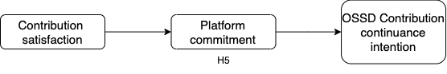
Figure 4.6. Platform Commitment as a Mediator n the Human-Bot Delegation Model

CHAPTER 5 RESEARCH METHODOLOGY
The prevalent paradigm to develop and validate constructs (Churchill Jr 1979) guided the study’s research methodology. Accordingly, model testing was carried out in three phases. The first phase of item generation involved an extensive literature review for valid instruments to measure reflective constructs, development of formative constructs and items from Kubernetes documentation, informed pilot with experts, and ensuring face and content validity of the items. Next, two rounds of Q sort procedures followed by a pilot study tested the survey for the constructs' internal consistency, reliability, and validity in the second phase of item refinement. Finally, we tested the model hypotheses using a web-based survey designed on the Qualtrics platform. Table 5.1 summarizes the study’s research methodology carried out in three phases.
Phase | Process | Sample | # | Activities
1 | Initial validation - Informed pilot | PhD students | 5 | Preliminary validation of items, dropped irrelevant items, and developed new items
2 | Q sort round 1 | PhD students | 4 | Used Qualtrics for content validity assessment and inter-rater reliability was assessed
 | Q Sort round 2 | Kubernetes contributors | 2 | Used Qualtrics for content validity assessment and inter-rater reliability was assessed
 | Expert Review | Kubernetes contributors | 5 | 1-2 hour Zoom sessions with each of the expert contributors to refine the survey instrument and flow
 | Pilot study | Kubernetes contributors | 98 | Dropped the cross-loaded items and refined the survey instrument. Validated the survey.
3 | Main study | Kubernetes contributors | 307 | Cleaned the data to include 289 valid responses in our final sample to carry out the analysis.
Table 5.1 Model testing phases, sample details, and associated activities

Constructs and Measures
This phase began with an exploration of existing measures in the Information Systems and Management works of literature to inform the development of the study’s online survey questionnaire. The psychological attributes of contributors that influence their appraisal of fit with bot attributes include personal innovativeness in IT (PIIT), contribution self-efficacy (CSE), personal motivation (PM), and perceived instrumentality (PIN). The other reflective indicators in the model include explainability, trust, interactivity, adaptivity, commitment, contribution satisfaction, willingness for contribution continuance, and explicit and implicit coordination measures.
I adapted the PIIT measures from IS literature (Agarwal and Prasad 1998; Lu et al. 2005) and motivation measures from the seminal research on the variable intrinsic motivation (Ryan and Deci 2000; Venkatesh 2000) while drawing on the fit measures of the TTF literature (Goodhue and Thompson 1995) to operationalize and measure fit appraisal. Research on group support systems has validated a six-item construct employed in this study to measure PIN based on ascribed importance to one’s contribution in a group task (Kerr and Bruun 1983; Murthy and Kerr 2000). The survey measured platform commitment with the five items developed to focus on how positively contributors relate to the OSSD community.
The scales developed and validated in IS literature to measure continuance behavioral intention were adapted to measure the study’s outcome variable, contribution continuance intention (Bhattacherjee et al. 2008; Zhou et al. 2012). The satisfaction in process scale from literature (Briggs et al. 2013) guided the study’s operationalization of contribution satisfaction. Survey measures for bot explainability from a survey developed on explainable artificial intelligence (Adadi and Berrada 2018). The bot interactivity and adaptivity are operationalized as reflective measures based on the definitions provided in the literature (Schuetz and Venkatesh 2020) on cognitive computing systems. Trust in bot’s reliability was measured with three reverse-coded items adapted from the trust in automation scale (Jian et al. 2000) developed to measure the facets of trust toward AI.
For measuring the coordination in Kubernetes among contributing developers, a multidimensional scale developed to resolve inter-organizational interdependencies was adapted and refined to measure coordination in an OSSD context-sensitive manner. Kubernetes project documentation that described the expectations and outcomes of contributors on Kubernetes guided the adaptation and refinement of the multidimensional scale. The scale includes five dimensions. These coordination dimensions, explicit predictability, explicit accountability, implicit predictability, implicit accountability, and common understanding were measured with items adapted from the multi-dimensional scale to create OSSD community coordination mechanism equivalents.
The adapted five-dimensional construct items are analogous to organizational coordination mechanisms. It was ensured to focus on key ideas that had meaning in both organizational and OSSD contexts. For example, the key concept of focus for developing implicit accountability measures involved perceptions of accountability for actions and responsibility for tasks in OSSD communities. The goal was to capture the original theoretical concept as it would be expressed in the OSSD community context in developing the survey questionnaire.
Furthermore, adaptivity measures are based on the definitions and examples offered by the cognitive computing consortium (Schuetz and Venkatesh 2020). Finally, the study advances the conceptualization and operationalization of a crucial coordination mechanism in OSSD communities driven by bots, defined as agentic coordination. The study operationalizes agentic coordination as a formative construct with eight indicators. The indicators were developed based on a comprehensive observation and review of the responsibilities and expectations of bots described in detail in the Kubernetes project documentation.
The study conceptualizes agentic coordination as a unidimensional formative causal construct to describe the perceived effectiveness of the bot as a coordination mechanism in the OSSD communities. A more profound observation and consultation of project documentation and literature on the Kubernetes bot functions led to the development of agentic coordination as a formal indicator. Assessment of the indicator wording revealed that they follow the formative construct development guidelines (Bollen 2011; Diamantopoulos et al. 2008; Diamantopoulos and Winklhofer 2001; Jarvis et al. 2003; Petter et al. 2007; Weber 2021). First, any change in each of the eight indicators ‘caused’ a difference in the overall construct meaning. Second, the indicators measure the overall bot functionality and include several of the bot’s sub-functions and therefore do not necessarily share a common theme. For example, the bot monitors the agents and updates them on any requirements in addition to assigning reviewers for the PR progress. The indicators, therefore, capture these different bot functions on a Kubernetes PR.
Third, the indicators are not interchangeable and may not covary. The indicators do not convey the same meaning, and interchanging them affects the contextual agentic coordination. Fourth, dropping any of the eight indicators operationalized to measure agentic coordination affects the construct definition as the indicators, only in combination, describe the construct. Lastly, each of the eight indicators may have different antecedents and consequences, unlike reflective constructs. The constructs and items were further refined using elaborate Q-sort procedures, expert reviews followed by informal discussions, and a pilot study as detailed below.

Initial Validation

Face and Content Validity
In phase 1, an informed pilot to ensure face and content validity was conducted with five Ph.D. students in the Information Systems Department at a U.S. University to determine the face and content validity of the survey measures.
The eight individuals include two Ph.D. students, two business faculty, and four Kubernetes contributors to ensure the content and construct validity of the survey measures and look for obvious errors in either procedure or materials. Required changes to the survey measures were then appropriately made.
Mainly, the participants were instructed to identify any questions that were confusing, leading, loaded, double-barreled, or made little sense in the survey flow. Those identified questions were dropped, and confusing items were reworded.
Q-sort Procedures
Following initial conceptual validation of face and content validity, the survey questionnaire passed through Phase 2, which included two Q-sort procedure rounds. The Q-sorting procedures validated the survey content and flow. Employing sorting surveys developed on Qualtrics, the study carried out two rounds of sorting to achieve the desired average inter-judge raw agreement score, Kappa score, and the overall placement ratio of 0.920, 0.931, and 0.942, respectively, in the final round.
In the first round, four business graduate students sorted the items into categories based on their similarities and differences and assigned a label (choosing from the listed construct labels) to each of their sorted categories. The average inter-judge raw agreement rate was calculated. The respondents also, on request, left comments and suggestions to improve ambiguous items. The items were refined based on the offered suggestions and were retained for the next round of sorting.
In the second round, two Ph.D. students sorted the revised items based on the provided definitions of constructs. Following Wang and Benbasat (2009), a “does not fit under any construct” category was provided to ensure no force on the panel to misfit the items under any constructs. The achieved validation scores confirmed the items’ discriminant validity for this round. Table 5.2 shows the model constructs and the sources used to develop the survey questionnaire
Construct | Definition | Sources
Personal innovativeness in Information Technology | Personal innovativeness is a key individual difference characteristic influencing the adoption of an innovation, and relates to the users' willingness to embrace a new information technology | (Agarwal and Prasad 1998)
Intrinsic motivation | An individual’s willingness to perform an activity for inherent satisfaction rather than external rewards is defined as intrinsic motivation | (Davis and Bostrom 1994; Ryan and Deci 2000).
Contribution self-efficacy | A belief in one’s ability to perform a task or more specifically to execute a specified behavior successfully | (Bandura, 1977, p. 79)
Perceived instrumentality | The degree of ascribed importance to one's performance in a team working toward valued group outcomes | (Hertel et al. 2008; Kerr and Bruun 1983).
Trust in bot’s reliability | trust in a bot’s reliability can be defined as the expectation that a bot acts consistently and predictably as described in the Kubernetes documentation | (Jian et al. 2000; Thatcher et al. 2010)
Fit appraisal | Degree to which the contributor emotionally or cognitively evaluates the bot endowments in relation to one’s endowments and preferences | (Baird and Maruping 2021; Zigurs and Buckland 1998)
Explainability | Perceived quality of a given explanation/feedback from the bot by the developer. | Adadi and Berrada (2018)
Interactivity | The degree of bot interactivity perceived by the developer as required to define their needs and communicate comfortably (Schuetz and Venkatesh 2020) | (Schuetz and Venkatesh 2020)
Adaptivity | Perceived adaptivity of the bots required to learn as goals change and requirements evolve in order to resolve ambiguity and tolerate unpredictability | (Schuetz and Venkatesh 2020)
Contribution  satisfaction | Contributor’s perceived satisfaction with their contribution to Kubernetes | (Briggs et al. 2013)
Contribution continuance intention | Contributor’s willingness for continuance contribution intention | (Bhattacherjee et al. 2008; Zhou et al. 2012)
Coordination
Explicit predictability (EP) | The degree to which interdependent agents can count on the successful execution of the work of others and perform their own tasks accordingly, enhancing integrating activities by explicit means | (Chang et al. 2017; Okhuysen and Bechky 2009)
Explicit accountability (EA) | The degree with which the interdependent agents ascertain PR task roles by means of PR workflow design | Chang et al. 2017; Okhuysen and Bechky 2009)
Implicit predictability (IP) | The degree to which interdependent agents anticipate and predict each other’s task requirements without any direct information | Chang et al. 2017; Okhuysen and Bechky 2009)
Implicit accountability (IA) | The degree to which interdependent agents voluntarily impose requirements on themselves to remain committed to the PR task in relation to others. | Chang et al. 2017; Okhuysen and Bechky 2009)
Common understanding | The degree to which interdependent agents share knowledge of the nature, goal, and objectives of the PR process | Chang et al. 2017; Okhuysen and Bechky 2009)

Table 5.2. Model constructs, definitions, and source references

Data Collection
Knowledge-intensive online communities like Kubernetes thrive because of contributors who are willing to coordinate their work to develop high-quality and complex code voluntarily. Potential developers and contributors on Kubernetes can choose to join a popular communication channel, Slack, which is publicly accessible for anyone to sign up. Important Kubernetes project updates are posted on the communication channel. For example, requests to participate in any research or third-party marketing activity can be posted on the #surveys channel. Similarly, on the #announcements channel that currently hosts almost 160,000 members, contributors and community managers usually post important updates concerning Kubernetes. The screenshots of the flyer posted on these channels are presented in Appendix B as recruitment materials.
Informed Pilot
An informed pilot of the initially validated survey questionnaire was then administered to Kubernetes contributors to achieve expert validation and further refinement. Reaching out to the Kubernetes Slack contributors and moderators, twelve contributors, with a pull request range of one to a thousand, accepted to participate in an Informed Pilot. An hour-long video call (using Zoom) with each interested contributor allowed for an in-depth review of each question item and the overall survey flow (including instructions). The expert feedback from contributors with varying contributor experiences informed the final survey design.
Pilot Study
The data collection for this study involved sending emails and advertising on social media sites, namely Twitter, LinkedIn, and a specific communication channel namely Slack for Kubernetes enthusiasts. The study relied on a publicly available database containing the usernames, associated email addresses, professional affiliation, and GitHub profiles of Kubernetes contributors and their number of contributions as part of the data collection efforts. The contributions can be filtered based on each contributor's number of pull requests. The GitHub profile also presents the year-wise contributions of the developers graphically.
Based on the verifiable contributor database, potential respondents were sent an email invitation with a link to the survey, a study objectives description, and a flyer inviting them to participate in the survey. Additionally, signing into Kubernetes slack, I reached out to several contributors with a flyer (presented in Appendix B) detailing the study objectives. In addition, Kubernetes slack moderators with a sizable follower size accepted and shared the advertisement on social media platforms, including Twitter and LinkedIn. Appendix B contains the recruitment materials. The survey respondents can either choose to receive an online payment of $5 or donate it to the Global Ukraine Relief Fund. The choices offered to the survey respondents included Venmo (for the respondents in the USA), PayPal (for respondents from any other country), and Paytm (for the Indian respondents). A follow-up email was sent 15 days after the first invitation email to improve the response rate.
To avoid potential validity threats, several checks and procedures were followed. The participants were offered an incentive for their participation. We ensured the quality of responses by dropping those responses with less than an 8-minute completion time. Three hundred seven responses were received, and the final sample included 289 complete usable responses. Eighteen replies were dropped due to incompleteness, straight-lining, or being outliers (i.e., value > three standard deviations from mean). In addition, to ensure randomness in the responses, the survey contained attention trap questions as a reverse Turing test. The respondents who never contributed to Kubernetes were filtered using a screening question at the beginning of the survey. In addition, the contributors had to provide links to any of their previous contributions in the last year. The links provided allowed us to ensure that the survey taker is a contributor to Kubernetes.
A pilot study was conducted to evaluate the psychometric properties of the survey items. Pilot data analysis of 98 valid surveys found solid preliminary evidence for the items’ convergent validity, reliability, and discriminant validity. The measures displayed strong reliability with values greater than 0.80 and factor loadings greater than 0.60. Discriminant validity was established in that the factor loadings were more significant than cross-loadings.
Main Data Collection Study
The final sample included 289 responses. The average survey time was 16.32 minutes, suggesting the validity of responses. Only 16.6% of females compared to 78.55% of males completed the survey. Most of them received a bachelor’s education. While 32% have master’s degrees, 53% of the sample received their bachelor’s degrees. Most respondents expressed positive experiences with their previous contributions and bots. Table 5.3 offers the demographic information of the study’s final respondent sample
Variable | Categories | Percentage | Count
Gender | Male | 78.55% | 227
 | Female | 16.61% | 48
 | Prefer not to answer | 4.84% | 14
Age | Under 15 | 0.00% | 0
 | 16-24 | 18.34% | 53
 | 25-34 | 50.87% | 147
 | 35-44 | 21.45% | 62
 | 45-50 | 1.38% | 4
 | Over 50 | 7.96% | 23
Ethnicity | White/Caucasian | 48.79% | 141
 | Asian - Eastern | 2.77% | 8
 | Asian - Indian | 30.80% | 89
 | Hispanic | 6.92% | 20
 | African American | 0.69% | 2
 | Native American | 1.04% | 3
 | Other | 0.35% | 1
 | Prefer not to answer | 8.65% | 25
Education | Master’s degree or above | 32.53% | 94
 | Bachelor’s degree | 52.94% | 153
 | Highschool | 6.57% | 19
 | Other | 0.00% | 0
 | Prefer not to answer | 7.96% | 23
Employment status | Full-time | 80.62% | 233
 | Part-time | 1.73% | 5
 | Contract/ Temporary | 0.69% | 2
 | Other | 5.19% | 15
 | Unemployed | 2.42% | 7
 | Prefer not to answer | 9.34% | 27
Annual Income | Less than $25,000 | 9.69% | 28
 | $25,000 - $50,000 | 9.34% | 27
 | $50,000 - $100,000 | 22.84% | 66
 | $100,000 - $200,000 | 28.37% | 82
 | > $200,000 | 10.03% | 29
 | Prefer not to answer | 19.72% | 57
Years of experience in OSSD | 0-1 year | 13.59% | 39
 | 1-2 years | 20.91% | 60
 | 2-3 years | 21.25% | 61
 | 3-5 years | 16.72% | 48
 | >5 years | 27.53% | 79
Experience with OSSD | Positive | 81.31% | 235
 | Negative | 18.66% | 54
Experience with bots on PRs | Positive | 77.16% | 223
 | Negative | 22.83% | 66
Number of submitted PRs | <5 | 32.87% | 95
 | 5-10 | 24.22% | 70
 | 10-50 | 32.53% | 94
 | 50-100 | 3.46% | 10
 | >100 | 6.92% | 20
Reasons to contribute | Programming is fun | 21.45% | 183
(Option to choose multiple options) | It is a noble cause. | 11.84% | 101
 | I can change/extend the software to fit my specific needs. | 12.19% | 104
 | Expect to sell products or services related to it. | 6.33% | 54
 | Helps me improve my programming skills. | 12.08% | 103
 | Build a network of peers. | 16.76% | 143
 | I am paid to do this job. | 19.34% | 165
Table 5.3 Demographic information of the respondent sample

The target sample includes Kubernetes contributors who have submitted at least one pull request on Kubernetes in the last year. All the respondents contributed to Kubernetes in the previous year. To ensure the validity of responses, the contributors had to submit the link of any of their PRs in the last year. Tracing the link to any of their PRs ensured cross-validation of the contributor identity. Following chapter discusses the data analysis and the study’s impactful findings.

CHAPTER 6 DATA ANALYSIS AND RESULTS

Data Analysis

Convergent and Discriminant Validity
Construct validity of the survey in terms of convergent and discriminant validity was assessed using exploratory factor analysis to examine the inter-item and inter-construct correlations. No cross-loadings exceeding 0.35 were identified. The study relied on SPSS 18 to compute all the statistics, including the factor analysis with Maximum Likelihood Estimation (MLE) and Varimax rotation. Four items (PI4, EA1, EP3, IA1, PC1) were dropped from the final survey questionnaire due to poor cross-loadings with other indicators. The factor loadings for all the other constructs were greater than 0.6, which confirms internal consistency. Table 6.1 displays each of the construct items and the associated factor loadings. The items dropped from analysis due to poor loading are also shown in the table.
To validate the nomological validity of the unidimensional formative construct “agentic coordination” conceptualized and operationalized in this study, popular research recommends (Diamantopoulos et al. 2008; Diamantopoulos and Winklhofer 2001) to test its association or causal linkage to at least one theoretically validated reflective construct (antecedent or outcome). The study’s model testing validates these guidelines by testing the relationship of agentic coordination with five theoretically validated reflective constructs from the model, hypothesized as H4a, H4b, H4c, H4d, and H4e. The study results validate the significance of the hypothesized relationships, establishing the nomological validity of the formative construct.
Constructs | Measures | Loading
Personal innovativeness
PI1 | If I heard about new technology like Kubernetes, I would look for ways to experiment with it | .802
PI2 | Among my peers, I am usually the first to experiment with new technology like Kubernetes | .697
PI3 | I like to experiment with new technology like Kubernetes | .663
PI4 | I am hesitant to try new technologies like Kubernetes (reverse-coded) | dropped
Intrinsic motivation
PM1 | I enjoy contributing to OSSD projects (for example: creating and merging PRs | 0.853
PM3 | Contributing to OSSD projects (for example: create and merge PRs) is fun | 0.827
PM2 | Contributing to OSSD projects (for example: create and merge PRs) is interesting | 0.791
PM5 | Contributing to OSSD projects (for example: create and merge PRs) is stimulating | 0.721
PM4 | Contributing to OSSD projects (for example: create and merge PRs) is engaging | 0.666
Trust in bot’s reliability
T1 | On Kubernetes PRs, bots are deceptive (reverse-coded) | .850
T2 | On Kubernetes PRs, bots behave in an unexpected manner (reverse-coded) | .840
T3 | On Kubernetes PRs, bots are unreliable (reverse-coded) | .747
Perceived instrumentality
PIC1 | My contribution was essential for the Kubernetes subproject (that I contributed) | .840
PIC2 | My contribution to this Kubernetes subproject was unique | .802
PIC3 | My contribution played a key role in Kubernetes subproject’s improvement | .799
PIC4 | The Kubernetes subproject’s improvement depended on my contribution | .760
PIC5 | My contribution was instrumental in the Kubernetes subproject’s improvement | .666
Contribution self-efficacy
CSE1 | I can get positive reviews from reviewers on my PR | 0.828
CSE2 | I can address issues with my PR | 0.832
CSE3 | I can effectively interact with bots and reviewers on my PR | 0.768
Interactivity
INT1 | The bots interacted effectively with me | 0.727
INT2 | The bots engaged in back-and-forth communication | 0.693
INT3 | The bots interacted promptly | 0.682
INT4 | The bots interacted accurately | 0.860
Adaptivity
ADA1 | The bots adapt to changing requirements on the PR | .826
ADA2 | The bots identify changing requirements on the PR | .807
ADA3 | The bots dynamically process PR to identify the changing requirements on the PR | .773
ADA4 | The bots adapt to changing requirements of the reviewers on the PR | .771
ADA5 | The bots adapt to evolving requirements on the PR | .759
Fit appraisal
FA1 | The bots suit the PR process on Kubernetes well | .856
FA2 | The bots match the PR process on Kubernetes well | .756
FA3 | The bots meet the PR process requirements well | .742
FA4 | The bots address the PR process requirements well | .655
FA5 | The bots are appropriate for managing the PR process requirements | .623
Explicit predictability
EP1 | Kubernetes documentation enables the agents to be clear about the PR process | .827
EP5 | Kubernetes documentation enables the agents to accomplish their role-specific tasks on PRs | .790
EP4 | Kubernetes documentation enables the agents to be clear about their role-specific expectations and responsibilities in the community | .699
EP6 | Previous PRs recorded on Kubernetes enable the agents to accomplish their role-specific tasks | .677
EP2 | Kubernetes documentation enables the agents to be clear about the expectations of conduct that govern all members of the community | .635
EP3 | Kubernetes documentation enables the agents to be clear about the expectations surrounding PR code review | dropped
Explicit accountability
EA1 | Kubernetes requires me to sign my Git commits, making me accountable for my actions on the Kubernetes PRs | dropped
EA2 | Kubernetes records the PRs transparently for everyone to view, making me accountable for my actions on the Kubernetes PRs | .855
EA3 | Kubernetes records the PRs transparently for everyone to view, making the agents accountable for their actions on the Kubernetes PRs | .796
Implicit predictability
IP3 | Involved agents on the PR voluntarily support each other to improve the PR | .831
IP4 | Involved agents on the PR proactively adapt to the requirements of the PR | .787
IP1 | Involved agents on the PR voluntarily share their knowledge to improve the PR | .663
IP2 | Involved agents on the PR voluntarily review and offer feedback on the failed tests to improve the PR | .608
Implicit Accountability
IA1 | I take full responsibility for my actions on the PR | dropped
IA2 | Almost all the involved agents on the PR are aware of the need to work responsibly | .783
IA3 | Almost all the involved agents on the PR acknowledge the expectations of merging a PR successfully | .739
IA4 | Almost all the involved agents on the PR feel accountable for their actions | .716
Common understanding
CU1 | The involved agents shared their knowledge and experience to help merge my pull request | 0.865
CU2 | Almost all the involved agents were willing to review feedback provided by other agents on the pull request discussion | 0.831
CU3 | The agents are working toward a common goal of merging the pull request. | 0.745
Platform commitment
PC2 | I feel a sense of belonging to Kubernetes community | .824
PC3 | I am committed to the Kubernetes community | .649
PC4 | I feel emotionally attached to Kubernetes community
PC5 | The Kubernetes community has a great deal of personal meaning for me | .863
PC6 | I feel a strong sense of identification with Kubernetes community | 0.793
PC1 | I am proud to be a part of Kubernetes community | dropped
Contribution
satisfaction
TS1 | I feel satisfied with the way in which my PR process progressed | .891
TS2 | I feel good about how my PR process progressed | .797
TS3 | I feel satisfied with the process followed for my PR review | .750
TS4 | I feel satisfied with the way activities required for my PR process were carried out | .719
OSSD contribution continuance intention
FW1 | I am willing to continue contributing to the Kubernetes | 0.789
FW2 | I am willing to contribute more to the Kubernetes (OSSD) projects in the future | .776
FW3 | I am willing to become an active contributor to Kubernetes projects in the future | .765
FW4 | I am willing to contribute to the Kubernetes (OSSD) projects in advanced contributor roles in the future | .622
 | Formative Construct
Agentic coordination | Measures
AC1 | The bots posted important reminders to update the involved agents of the PR progress | Nomological validity was assessed and provided below
AC2 | The bots constantly monitored and updated the PR progress | Nomological validity was assessed and provided below
AC3 | The bots assigned new reviewers, when my PR progress was unsatisfactory (or stuck) | Nomological validity was assessed and provided below
AC4 | The bots assign new reviewers of my choice when my PR progress was unsatisfactory (or stuck) | Nomological validity was assessed and provided below
AC5 | The bots request the assigned reviewers to review the PR | Nomological validity was assessed and provided below
AC6 | The bots indicate which approvers still need to approve for the PR to progress | Nomological validity was assessed and provided below
AC7 | The bots periodically warn involved agents about inactive PRs on a Kubernetes project | Nomological validity was assessed and provided below
AC8 | The bots notify unresponsive agents (reviewers and approvers) to complete their reviews efficiently | Nomological validity was assessed and provided below
Table 6.1. Constructs, measures, and their factor loadings
Secondly, Cronbach’s alpha, composite reliability (CR), and Average Variance Extracted (AVE) confirmed the internal reliability of the reflective items. All three measurements exceeded Chin’s (1998) guideline of 0.5 for each reflective construct in the model. Table 6.2 presents the validity measures for each of the reflective indicators. In addition, for each of these constructs, the square root of AVE surpassed all respective inter-construct correlations, confirming discriminant validity (Fornell and Larcker 1981). Table 6.2 displays the discriminant validity analysis.
 | Constructs | # of items | Mean | Std deviation | Alpha | AVE | VIF |  | CR
Personal innovativeness |  | 3 | 3.954 | 0.625 | 0.735 | 0.522 |  | 1.491 | 0.759
Intrinsic motivation |  | 5 | 4.326 | 0.597 | 0.831 | 0.600 |  | 2.342 | 0.746
Contribution self-efficacy |  | 3 | 4.395 | 0.511 | 0.802 | 0.780 |  | 1.821 | 0.857
Perceived instrumentality |  | 5 | 3.646 | 0.752 | 0.855 | 0.601 |  | 1.183 | 0.889
Explainability |  | 6 | 4.130 | 0.750 | 0.914 | 0.546 |  | 2.261 | 0.866
Interactivity |  | 4 | 3.989 | 0.645 | 0.771 | 0.727 |  | 2.384 | 0.831
Adaptivity |  | 5 | 3.993 | 0.823 | 0.920 | 0.593 |  | 1.917 | 0.893
Trust in bot reliability |  | 7 | 4.102 | 0.645 | 0.752 | 0.682 |  | 1.858 | 0.857
Fit appraisal |  | 6 | 4.219 | 0.691 | 0.906 | 0.860 |  | 1.471 | 0.850
Explicit predictability |  | 6 | 4.150 | 0.658 | 0.886 | 0.631 |  | 2.183 | 0.849
Explicit accountability |  | 4 | 4.363 | 0.641 | 0.822 | 0.682 |  | 1.566 | 0.811
Implicit predictability |  | 3 | 4.192 | 0.680 | 0.816 | 0.529 |  | 1.644 | 0.816
Implicit Accountability |  | 4 | 4.411 | 0.559 | 0.778 | 0.557 |  | 1.476 | 0.79
Common understanding |  | 5 | 4.178 | 0.667 | 0.809 | 0.664 |  | 1.643 | 0.856
Platform commitment |  | 6 | 4.045 | 0.749 | 0.865 | 0.618 |  | 2.576 | 0.846
Contribution  satisfaction |  | 4 | 4.263 | 0.633 | 0.881 | 0.627 |  | 1.463 | 0.781
OSSD contribution continuance intention |  | 4 | 4.423 | 0.652 | 0.853 | 0.549 |  | 1.463 | 0.778
Table 6.2 Results of Convergent Validity Analysis

Model Hypotheses Testing
The Theoretical model hypotheses testing empirically validated the novel OSSD theoretical Human-Bot Delegation Model advanced in this study. Partial least squares (PLS) path modeling analysis is a recommended methodology to explore cause-effect relationships between predictors and outcomes and to test path-specific hypotheses (Gefen et al. 2000). Further, following popular research, the primary reason for choosing PLS has primarily to do with the presence of both formative (agentic coordination) and reflective constructs (perceived instrumentality) in the study’s theoretical model. PLS is commonly used to test both reflective and formative constructs (Carter 2012)
Although researchers consider PLS analysis to be less precise (Rouse and Corbitt 2008)
compared to the popularly used covariance-based structural equation modeling techniques, PLS analysis is preferred to test models consisting of both formative and reflective constructs since problems with model identification may arise with the SEM-based analysis of these models (MacCallum and Browne 1993). Therefore, PLS analysis was employed as the relevant statistical technique to test the model. Reliance on the popular partial least squares analysis (PLS Analysis) allowed for the examination of the effect sizes and statistical significance of the hypothesized structural paths as displayed in Figure 6.1. The hypotheses analysis results are presented in Table 6.3.
The hypotheses testing results using PLS analysis found support for most of our proposed hypotheses. While no support was found for H1a (Beta β = 0.263, p =0.102) and H1b (Beta = 0.263, p = 0.258), which hypothesized relationships among personal innovativeness, personal motivation, and fit appraisal, p < 0.001). Bot’s adaptivity (H2c, Beta = 0.212, p < 0.001) significantly influenced the contributor’s fit appraisal of collaborating with bots, while contrary to our expectations, bot interactivity had no significant effect on the contributor’s fit appraisal (H2b, Beta = 0.074, p = 0.131). Contribution self-efficacy (H1c, Beta = 0.263, p <0.001) and perceived instrumentality (H1d, Beta = 0.102, p = 0.003) significantly influenced a contributor’s fit appraisal of collaborating with bots. Trust in bot’s reliability (H1e, Beta = 0.074, p = 0.131) and explainability (H2a, Beta = 0.208, p <0.01) also found support as significant predictors of a contributor’s fit appraisal in ths study. The data analysis supported H3 (Beta = 0.566, p = 0.002), according to which a contributor’s fit appraisal positively influenced their contribution satisfaction.
 | Proposed Hypotheses | SE | Beta | t value | p value | Result
H1a | PIIT Fit appraisal | .041 | .065 | 1.641 | .102 | No support
H1b | Intrinsic motivation Fit appraisal | 0.039 | .043 | 1.132 | .258 | No support
H1c | contribution self-efficacy Fit appraisal | .062 | .263 | 5.744 | .000 | Supported
H1d | Perceived instrumentality Fit appraisal | .032 | .102 | 2.947 | .003 | Supported
H1e | Reliability Trust Fit appraisal | .043 | .261 | 6.079 | .001 | Supported
H2a | Explain ability Fit appraisal | .047 | .208 | 4.058 | .000 | Supported
H2b | Interactivity Fit appraisal | .052 | .074 | 1.515 | .131 | No support
H2c | Adaptivity Fit appraisal | .037 | .212 | 4.851 | .000 | Supported
H3 | Fit appraisal contribution satisfaction | .045 | .566 | 11.62 | .002 | Supported
Table 6.3. Hypotheses testing results
To test H4 and H5, post-hoc mediation analyses computed the direct and indirect effects. Sobel statistic was then computed to assess the degree and significance of the mediation (Sobel 1987). We employed the Causal Steps Approach (Baron and Kenny 1986) and calculated the Sobel test statistic (Sobel 1987). Table 6.4 demonstrates the mediation analyses findings in the study.
 | a | SE(a) | b | SE(b) | c | c¹ | Sobel(z) | Partial mediation
H4a | .564*** | .053 | .414*** | .049 | .494*** | .366*** | 6.794*** | Supported
H4b | .459*** | .052 | .393*** | .053 | .494*** | .401*** | 5.678*** | Supported
H4c | .398*** | .057 | .367*** | .050 | .494*** | .407*** | 5.059*** | Supported
H4d | .364*** | .054 | .470*** | .052 | .494*** | .375*** | 5.404*** | Supported
H4e | .576*** | .054 | .390*** | .052 | .494*** | .636*** | 7.145*** | Supported
H5 | .418*** | .065 | 0.390*** | 0.046 | .602*** | .501*** | 5.124*** | Supported
Table 6.4. Mediation analysis results
The analysis results found partial support for all the hypothesized mediation relationships. More specifically, the Sobel test statistics z were significant at a 0.001 level of significance for all the proposed mediation relationships, confirming our hypotheses that agentic coordination indeed partially leads to contribution satisfaction via explicit predictability, explicit accountability, implicit predictability, implicit accountability, and common understanding mechanisms. Additionally, platform commitment partially mediated the effect of contributors’ satisfaction on their contribution continuance intention, evidencing the support for H5. The structural model with results can be found below in Figure 6.5.
Figure 6.5. Model paths *p < 0.05, ***p < 0.001
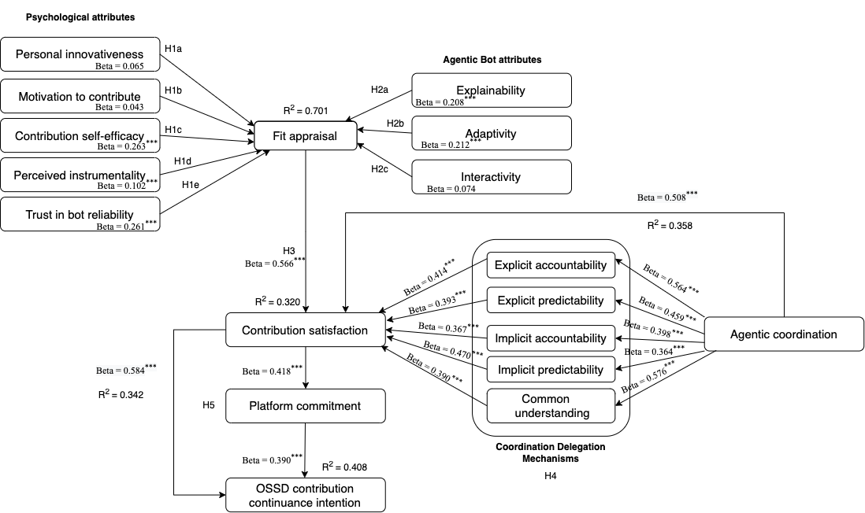

CHAPTER 7: IMPLICATIONS FOR THEORY AND PRACTICE

As individuals and organizations worldwide increasingly realize the potential of the rapidly evolving human-AI collaboration paradigm, IS research efforts are limited in their potential to examine and model these collaboration patterns for meaningful and positive outcomes, specifically in knowledge-intensive virtual forms of organizing like OSSD communities. Specifically, there have been recent calls for retheorizing the traditional technology interaction patterns (for example, IT use) in the context of this new generation of foundational technologies like agentic AI (Baird and Maruping 2021) that delegate tasks to humans. For example, Baird and Maruping (2021) note that the most widely used IS use paradigm is unsuitable for examining the human-bot relationships.
Addressing the calls for novel theorizing to explain effective collaboration, I developed the Human–Bot Delegation Model for OSSD communities like Kubernetes. By developing a theoretical model and empirically confirming its predictive validity, this study contributes to IS research in the following ways.
Theoretical Contribution

Firstly, the popular IT use paradigm ignores the transfer of rights and responsibilities between humans and bots, pointing to the need for a novel theoretical model to accommodate the collaboration patterns with new agentic capabilities. Moreover, the IS use theories like Technology Acceptance Model (Davis 1989) and UTAUT (Venkatesh et al. 2003) predominantly focus on users’ beliefs, perceptions, and attitudes but fail to consider the actions and capabilities of the agentic AI (or bots). Theoretically, the study models bot attributes as key predictors to contributors’ fit appraisal, addressing the gaps.
Furthermore, researchers recently discussed the unique opportunity these artifacts (Schuetz and Venkatesh 2020) present to IS research. They called for developing novel theories on the agentic AI-specific phenomena to render the existing IS theories inapplicable. They further proposed several research questions to aid the theory development. The current study aims to partly answer some of their submitted research questions detailed in table 7.1.
Research Questions | Relevance to the study contribution
What are the effects of agentic AI advice on individuals | The study reveals psychological and agentic effects of bot delegation on Kubernetes contributors’ outcomes
How can individuals effectively collaborate with agentic AI? | The study found support for the conceptualized human-bot collaboration in terms of fit appraisal and coordination delegation mechanisms.
What are the prerequisites of successful user-AI collaboration? | The identified psychological and agentic effects influencing productive human-bot delegation to achieve optimum performance can serve as the success factors for human-agentic AI collaboration since the goal generally is contribution continuance in OSSD like communities

Table 7.1. Proposed research questions in the literature on human-AI collaboration

These new-age bot-driven OSSD communities that support creative collaboration and co-production (Kane et al. 2014) of knowledge have only been radically growing in scope and size. Prior research has already pointed out the need for exploring and conceptualizing coordination among actors who undertake newer forms of organizing and work designs (Puranam et al. 2014; Puranam et al. 2012).

Moreover, researchers have increasingly called for new forms of theorizing in OSSD communities and are stressing the criticality of incorporating the understanding of bots while modeling the OSSD community dynamics. Recently, researchers have warned that a disregard for the role of bots in OSSD collaboration may risk the conflation of contextual or individual factors in the explanation of effective organizing and restrict the usefulness of the insights drawn from the OSSD project research (Hukal et al. 2019). The current study addresses these concerns and incorporates bot attributes in the model to examine and model effective coordination as a delegation mechanism on the PRs.
In this research, coordination has been theorized as a major delegation mechanism focusing on how contributors and bots collectively organized their interdependent tasks effectively to achieve the common goals of OSSD community management. Consequently, the study seeks to extend the inter-organizational conceptualization of human-human coordination to that of the virtual OSSD communities maintained by human developers and bots in delegating roles.
Informed by Coordination literature, this study advances IS research on human-AI collaboration by conceptualizing coordination as the major delegation mechanism between contributors and bots. This study is unique from existing literature on OSSD coordination mechanisms. It offers a comprehensive model of the potential coordination mechanisms, not just limiting to explicit and implicit coordination but also a new form of coordination enabled by bots that drive coordination effectiveness or success.

The study’s major contribution lies in identifying, conceptualizing, and operationalizing “Agentic coordination” as a unidimensional formative construct. Previous research has relied on a similar construct, ‘coordination technology use,’ to describe the coordination activities in software developer dyads. However, contrary to popular view, logic and evidence, no relationship was found between the coordination technology use and coordination effectiveness (Yuan et al. 2009). In contrast, the hypotheses results reveal the central role of agentic coordination (or bot-enabled coordination) in these distributed and knowledge-intensive communities, offering several implications for research.
OSSD communities like Kubernetes, despite being characterized by geographically and temporally distributed virtual collaboration, voluntary contribution, and informal management structures, exemplify the next-generation organizational forms enabled by sophisticated and novel alternatives to the conventional coordination mechanisms employed in organizations. This study used an exploratory approach to elicit theory on the agentic coordination that influences contributor’s satisfaction through a range of explicit and implicit coordination mechanisms adapted from the organizational literature. By validating the mediating effect of explicit and implicit coordination mechanisms on the association between agentic coordination and task satisfaction, the model potentially guides a greater understanding of these harbingers of prospective communities.
Furthermore, Software Engineering literature on OSSD communities has brought attention to the role of bots as the disruptive, new, virtual team members that are increasingly transforming contributors’ experiences (Wessel 2020; Wessel et al. 2018; Wessel et al. 2020; Wessel and Steinmacher 2020; Wessel et al. 2021). Researchers have recognized bots as the most crucial coordinating mechanism for distributed software development, a key characteristic of OSSD communities like Kubernetes. Bots are introduced to help coordinate OSSD communities by supporting complex and critical workflows.
As the number, task complexity, and functionalities of these bots are radically enhanced on these platforms; it is essential to understand the role of bots in PR collaboration. For example, in 2016, while 28% of the source code changes involved bot activity, it grew to 97% in just a year (Diakopoulos 2016; Hukal et al. 2019). These numbers point to the OSSD bots' success in improving contributors' overall satisfaction with the PR process(contribution).
Although past research has identified that bots helped with the coordination of tasks in these large communities, it has not offered any theoretical justification for how these bots coordinate the community interactions and tasks effectively for a contributor to be satisfied with the process, and derive meaningful outcomes from it, for example, platform commitment and willingness to continue contributing. Therefore, to advance theoretical knowledge in OSSD contribution and offer practical implications to bot and platform designers, the study examined how agentic coordination impacted contribution satisfaction through coordination mechanisms adapted from the organizational literature.
The study contributes to OSSD coordination research by offering more detailed, contextual, and specific explanations about how the bots coordinate in OSSD, resulting in contributors’ satisfaction with their contribution. Our results suggest that agentic coordination leads to task satisfaction via explicit and implicit coordination mechanisms. These findings offer a more refined understanding of how agentic coordination improves contributors’ satisfaction with their contributions. Figure 7.1 demonstrates the value added by our study to the OSSD coordination and IS Delegation literature.
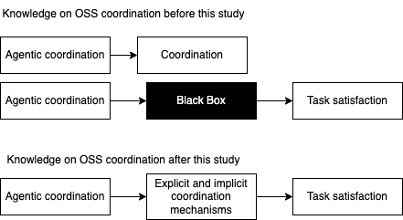
Figure 7.1. A Theoretical Contribution to OSSD Coordination Literature
Relationship between Satisfaction, Commitment, and Continuance Intention

Previously, researchers have focused on the link between satisfaction and commitment in the organizational context, and the literature shows mixed results. Our mediation analyses validated the link between contribution satisfaction and continuance intention via platform commitment. As the literature reported mixed results on the causal linkage between satisfaction and commitment, our study makes an essential contribution by validating the less prominent causal linkage view in OSSD’s novel and evolutionary organizational form.
To keep achieving the psychological rewards associated with knowledge-intensive community membership, we posit in our study that a contributor will become committed to the platform. For instance, a contributor obtains enormous satisfaction as his affective response to his contribution, whereas commitment is seen as forming stably over time in the OSSD community.
Our study confirms that contributors, to keep achieving the psychological rewards, become increasingly committed to the platform as a stabilizing behavior, leading them to continue contributing to the OSSD platform in the future. Previously, a stream of research examined the motivations in the form of reputation and altruism of the contributors but mainly focused on the first contribution. As the scope and number of these platforms are radically evolving, developers are increasingly relying on these OSSD projects for their personal and professional needs. Our results are timely in that we focus on the evolution of contribution patterns, continued contribution, retention of contributors, and sustainability of these OSSD platforms in managing contributions, extending the first contribution motivation research (Choi et al. 2013). The value added by this research is presented in Figure 7.2
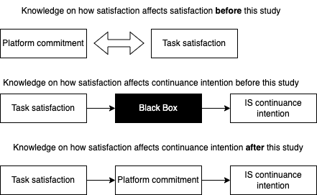
Figure 7.2. Value added to OSSD contribution continuance literature
Overall, the study theoretically advances research on voluntary contribution behaviors in OSSD communities, which previously primarily focused on the disruptive negative consequences of bots and the factors influencing a contributor’s PR acceptance, by applying a recently proposed IS Delegation Framework(Baird and Maruping 2021) that challenges the traditional IS use paradigm for agentic AI like bots, as the theoretical lens. Therefore, the study results offer an enriched theoretical explanation of the human-bot delegation in OSSD communities that predicts contributors’ satisfaction, ultimately leading to their intention to continue contributing to the OSSD platform. The theoretical specificity of a novel and evolving phenomenon like human-bot delegation in OSSD communities enable us to generate meaningful insights that can be generalizable to not only all the OSSD communities, semi-automated like Kubernetes (Hukal et al. 2019), but also to the knowledge co-producing informal newer forms of organizations, better known as communities.
Practical Contribution
The model analysis reveals salient psychological and agentic factors central to understanding Kubernetes contributors' perceptions toward bots and their possible outcomes in the community. Furthermore, the results shed light on the major psychological and agentic attributes in OSSD communities that influence a contributor’s fit appraisal and satisfaction, ultimately encouraging them to continue contributing.

Hypothesizing perceived instrumentality as contributors’ preference for contribution to OSSD equips the model to examine contributors’ choices and how they envision their task satisfaction and future willingness to contribute. This study could alert practitioners and bot designers to psychological enablers or inhibitors influencing OSSD contribution behaviors. By incorporating bot attributes into the research model, the study has the potential to offer insights into contributors’ agentic effects on their PR contribution and elicit the significance of these agentic attributes as antecedents to their fit appraisal with bots.
Further, the model analysis revealed key bot attributes in the form of endowments such as adaptivity and explainability as significant predictors of a contributor’s fit appraisal. In practice, OSSD bot designers could make efforts to code, design, and develop more adaptive bots offering justifiable explanations to enhance contributor’s confidence in delegating tasks for effective collaboration.
Our analysis found no support for the proposed hypotheses H1a, H1b, and H2b, and the reasons could inform our understanding of efficient OSSD communities. The lack of support for the effect of PIIT and personal motivation on fit appraisal could be traced to the voluntary and knowledge-intensive nature of the contribution task. Almost all the contributors are required to possess innovative knowledge and novel ways of solving unforeseen problems during their contribution to Kubernetes like OSSD platforms. Therefore, the contributors may not have perceived PIIT and motivation as distinctly significant variables that affected their fit appraisal since voluntary behavior already warrants their innovativeness and motivation. Similarly, the lack of support for the effect of bot interactivity on contributor’s fit appraisal follows popular research that bots are increasingly introducing communication noise into the pull request discussions with the non-comprehensive feedback (Wessel 2020; Wessel et al. 2018; Wessel et al. 2020; Wessel and Steinmacher 2020; Wessel et al. 2021). Our results suggest that the contributors appraise fit with bots on OSSD like Kubernetes because of their explainability and adaptivity, but not their interactivity.
The results offer insightful implications for online communities, specifically knowledge intensive like OSSD, which are struggling with their sustainability and retention of contributors. Firstly, the results inform the platform designers of the desirable perceptions of contributors that influence their satisfaction and willingness to continue contributing to the community. The study, therefore, directs the bot designers' and platform maintainers’ attention toward enhancing contributor experience by improving the explainability and adaptivity of bots. For example, bot designers can code more agency into the bot to offer greater explainability and adaptivity. In addition, care can ensure that the bots do not spam the PR discussion with notifications, potentially discouraging a contribution.
Our results validated a causal linkage from the organizational literature in Kubernetes that highlights the importance of commitment formation in OSSD communities to encourage continued contribution. The platform maintainers and bot designers could induce commitment by motivating mechanisms that enable contribution. Following widespread evidence from OSSD communities, gamification elements in the form of badges and stars to indicate the quantity and quality of contributions can be introduced as commitment-inducing mechanisms to stabilize the contribution behaviors. In OSSD communities.

Future research should apply the IS Delegation Framework to examine the human-bot delegation in dyadic and triadic agentic contexts. For example, in the current study, I applied the framework to investigate the mechanics that guided the delegation among contributors, bot, and reviewers or approvers engaged in a PR discussion. Similarly, the approach can study the collaboration patterns in fully automated OSSD communities or similar crowdsourcing contexts to understand developers’ perceptions. The results could inform the design and maintenance of these bots and platforms to drive improved performance, satisfaction, and other positive contribution outcomes.

Conclusion

Bots are prominently being integrated into the open-source software development (OSSD) communities like Kubernetes, hosted by social coding platforms like GitHub, to aid collaboration and distributed development of high-quality software code. However, research on code contribution behaviors in OSSD communities like Kubernetes has failed to consider the role of bots, the novel disruptive team members, as the major coordination enabling mechanisms, driving successful human-bot delegation for improved contributor satisfaction and consequent outcomes. Bots specifically coordinate the contribution review (or pull request (PR) process) by taking over mundane tasks, enforcing procedural control to reinforce project order, delegating responsibilities, and developing routines, ultimately facilitating the collaborative work. Bots play several complex roles with varying capabilities akin to organizational clerks and managers to enforce procedural rationality and enhance predictability. Understanding how the OSSD community members, including developers and reviewers, perceived the collaboration with the bots is the first step toward designing strategies that enhance human-bot collaboration in virtual OSSD communities.
OSSD communities like Kubernetes offer a novel model to explore the evolution of coordination practices in new-age virtual organizations.
Anticipating the increased proliferation of bots in these OSSD communities to meet the growing need for software development, the study argues that it is essential to investigate the effects surrounding effective human-bot delegation in thriving OSSD communities like Kubernetes. Pull requests on Kubernetes offer a unique context to examine developers’ perceptions of collaborating with bots and reviewers to contribute to source code. The current research study models the contribution continuance willingness of developers on Kubernetes based on their perceptions of bot (example: explainability, adaptivity, and interactivity), delegation mechanisms (fit appraisal and coordination), and their psychological characteristics. Guiding theoretical perspectives for model development include the Information Systems Delegation Framework proposed in the context of agentic AI, Coordination Theory, and Task-Technology-Fit Theory. The Human-Bot Delegation Model can guide the future design and development of bots in OSSD communities and has the potential for broader application in the domain of similar knowledge-intensive, virtual, and voluntary communities.
Limitations
As with any research, the current study contributions are naturally limited by the extent of investigation and data. First, although the research model was developed and empirically examined in a popular OSSD project, Kubernetes, described as a representative of several such OSSD projects including Node.js (https://github.com /nodejs), Bootstrap (https://github.com /twbs), and brew (https://github.com /Homebrew), the results may not fully generalize to explain human-bot delegation in other online collaborative communities. The results indicate that there could be emerging contextual interdependencies; therefore, it is unclear if only the proposed delegation mechanisms act and influence human-bot delegation in all other OSSD and similar online communities. Investigation and modeling of these emerging contextual interdependencies offer an excellent future research agenda.
Although our study offers an in-depth view and novel theoretical insights into the dyadic bot delegation in Kubernetes, I urge future researchers to validate and extend the research model to other knowledge-intensive bot-enabled collaborative contexts using both quantitative and qualitative research designs. Nevertheless, the study findings should be viewed as preliminary and future research should model and validate agentic coordination using SEM techniques which are covariance based.
Despite rigorous development and validation of the survey questionnaire by expert contributors, the survey may not capture some key attributes, processes, or mechanisms that drive the overall collaboration in these communities. Triangulation of the research with other inquiry methods could further validate our model. Future research could employ qualitative methods and ethnographic analysis to dive deep into the appraisal, coordination, and delegation mechanisms that drive successful human-bot collaboration in OSSD communities.

APPENDICES

Appendix A Dyadic delegation among bots and contributors’ screenshots presented by research (Hukal et al. 2019)

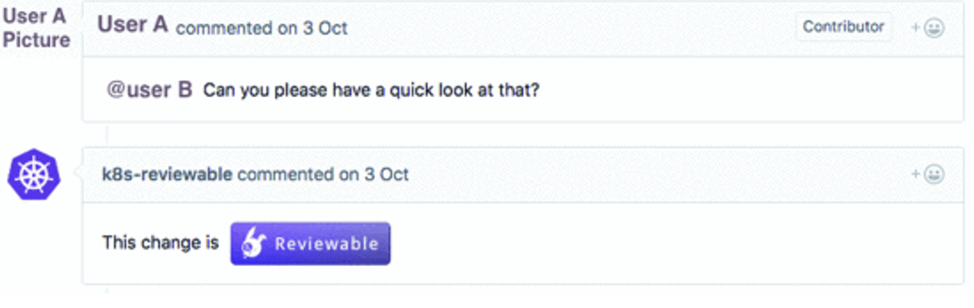

Figure A1. A broker bot automatically posts to a pull request discussion (“k8s-reviewable-bot”). (Source: Kubernetes code repository on https://github.com/.)
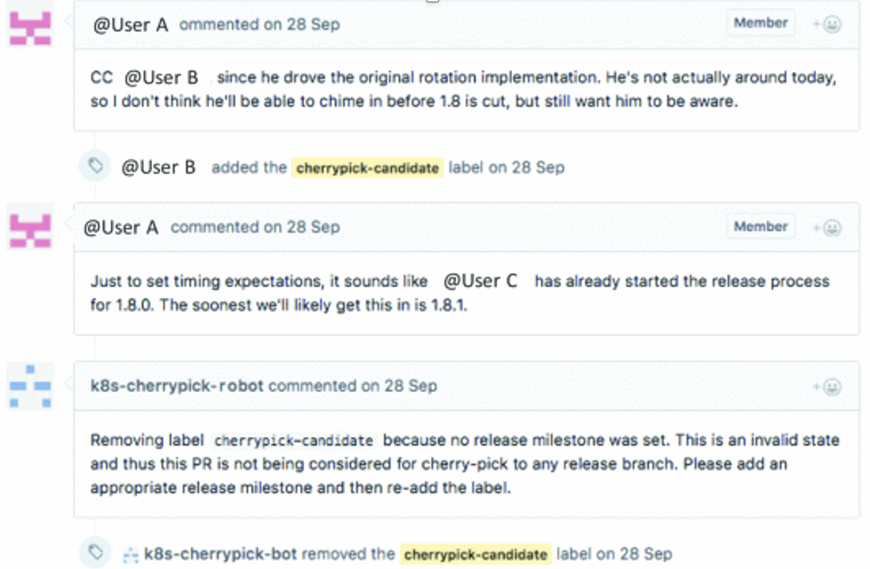
Figure A2. An instance of a checker bot posting a requirement for the contributor to follow (“k8s-reviewable-bot”). (Source: Kubernetes code repository on https://github.com/.)

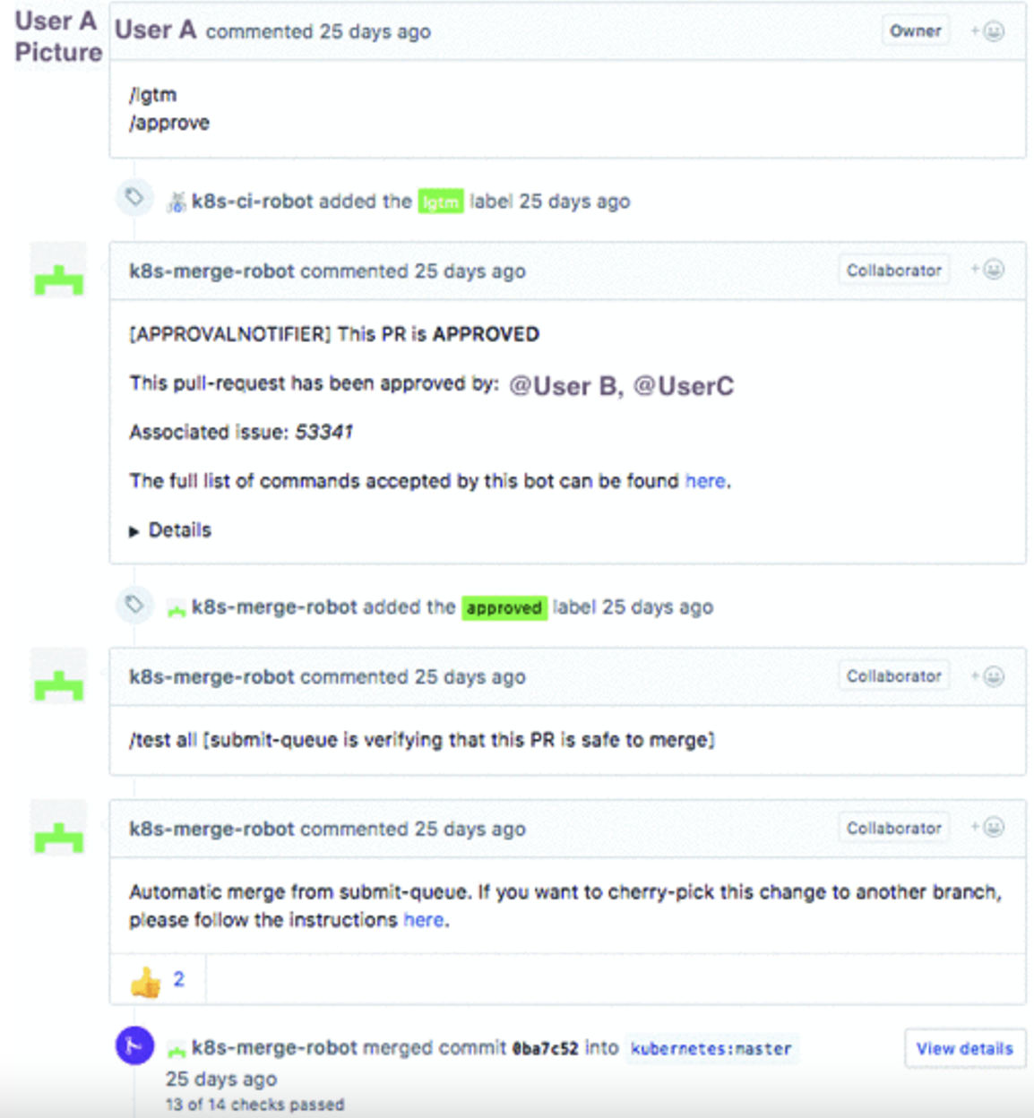

Figure A3. Manager bot coordinating and monitoring the PR to merge it (“k8s-merge-robot”). (Source: Kubernetes code repository on https://github.com/.)

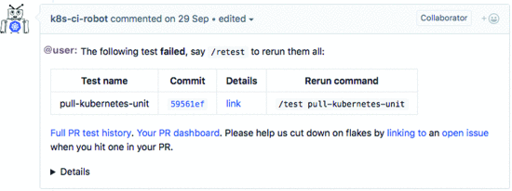
Figure A4. An instance of a Gatekeeper bot updating the contributor with automatic tests and review results (“k8s-merge-robot”). (Source: Kubernetes code repository on https://github.com/.)

Appendix B Recruitment Materials

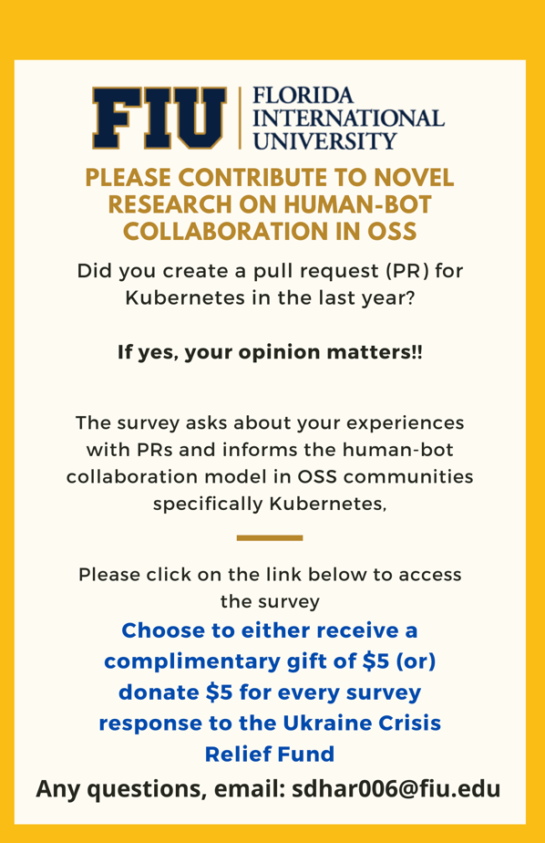
Figure B1. Flyer sample used to advertise the survey on social media.

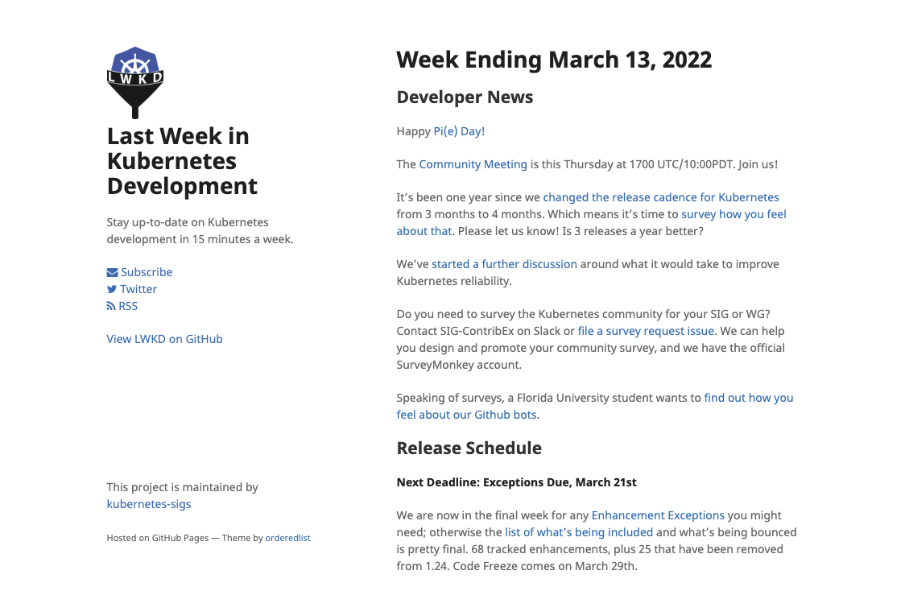
Figure B2. Survey link posted in the monthly community meeting bulletin of Kubernetes

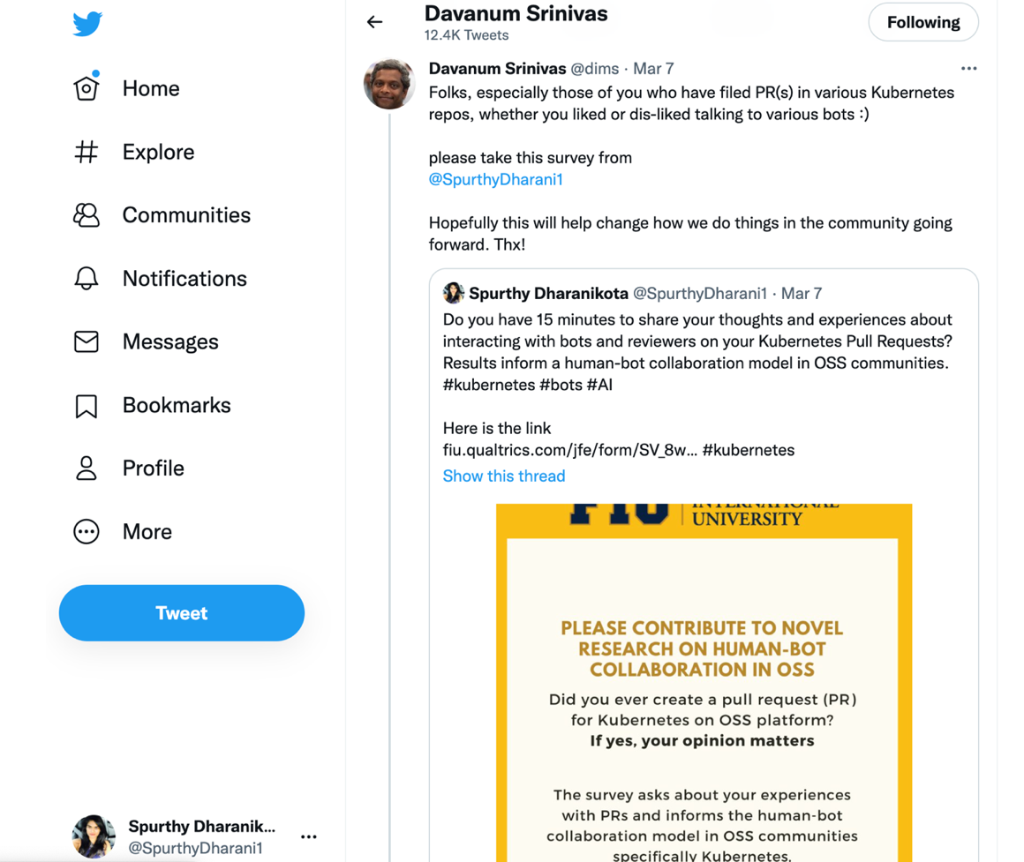
Figure B3. Social media invitation (Tweet and Retweet) to participate in the survey (Source: Twitter.com)

REFERENCES

Acemoglu, D., and Restrepo, P. 2018. "The Race between Man and Machine: Implications of Technology for Growth, Factor Shares, and Employment," American Economic Review (108:6), pp. 1488-1542.

Acemoglu, D., and Restrepo, P. 2019. 8. Artificial Intelligence, Automation, and Work. University of Chicago Press.

Adadi, A., and Berrada, M. 2018. "Peeking inside the Black-Box: A Survey on Explainable Artificial Intelligence (Xai)," IEEE access (6), pp. 52138-52160.

Agarwal, R., and Prasad, J. 1998. "A Conceptual and Operational Definition of Personal Innovativeness in the Domain of Information Technology," Information systems research (9:2), pp. 204-215.

Agrawal, A., Gans, J., and Goldfarb, A. 2017. What to Expect from Artificial Intelligence. MIT Sloan Management Review.

Agrawal, A., Gans, J., and Goldfarb, A. 2018. Prediction Machines: The Simple Economics of Artificial Intelligence. Harvard Business Press.

Agrawal, A., Gans, J. S., and Goldfarb, A. 2019. "Exploring the Impact of Artificial Intelligence: Prediction Versus Judgment," Information Economics and Policy (47), pp. 1-6.

Aksulu, A., and Wade, M. 2010. A Comprehensive Review and Synthesis of Open Source Research. researchgate.net.

al., E. V. e. 2020. "Superteams:Putting Ai in the Group." from https://www2.deloitte.com/us/en/insights/focus/human-capital-trends/2020/human-ai-collaboration.html

Arnold, V., Clark, N., Collier, P. A., Leech, S. A., and Sutton, S. G. 2006. "The Differential Use and Effect of Knowledge-Based System Explanations in Novice and Expert Judgment Decisions," Mis Quarterly), pp. 79-97.

Ashforth, B. E., and Mael, F. 1989. "Social Identity Theory and the Organization," Academy of management review (14:1), pp. 20-39.

Authors, T. K. 2022. "Kubernetes Contributor Documentation." from https://www.kubernetes.dev/docs/
Ayabakan, S., Bardhan, I., Zheng, Z., and Kirksey, K. 2017. "The Impact of Health Information Sharing on Duplicate Testing," MIS Quarterly (41:4).

Baird, A., and Maruping, L. M. 2021. "The Next Generation of Research on Is Use: A Theoretical Framework of Delegation to and from Agentic Is Artifacts," MIS Quarterly (45:1).

Bandura, A. 2006. "Toward a Psychology of Human Agency," Perspectives on psychological science (1:2), pp. 164-180.

Bannerjee, G., Sarkar, U., Das, S., and Ghosh, I. 2018. "Artificial Intelligence in Agriculture: A Literature Survey," International Journal of Scientific Research in Computer Science Applications and Management Studies (7:3), pp. 1-6.

Baron, R. M., and Kenny, D. A. 1986. "The Moderator–Mediator Variable Distinction in Social Psychological Research: Conceptual, Strategic, and Statistical Considerations," Journal of personality and social psychology (51:6), p. 1173.

Barua, M., Lu, R., and Shen, X. 2013. "Sps: Secure Personal Health Information Sharing with Patient-Centric Access Control in Cloud Computing," 2013 IEEE global communications conference (GLOBECOM): IEEE, pp. 647-652.

Beale, R., and Wood, A. 1994. "Agent-Based Interaction," BCS HCI: Citeseer, pp. 239-245.

Bhattacherjee, A. 2001. "Understanding Information Systems Continuance: An Expectation-Confirmation Model," MIS quarterly), pp. 351-370.

Bhattacherjee, A., Perols, J., and Sanford, C. 2008. "Information Technology Continuance: A Theoretic Extension and Empirical Test," Journal of Computer Information Systems (49:1), pp. 17-26.

Bickmore, T. W., Pfeifer, L. M., and Paasche-Orlow, M. K. 2009. "Using Computer Agents to Explain Medical Documents to Patients with Low Health Literacy," Patient education and counseling (75:3), pp. 315-320.

Blincoe, K., and Damian, D. 2015. "Implicit Coordination: A Case Study of the Rails Oss Project," IFIP International Conference on Open Source Systems: Springer, pp. 35-44.

Bolici, F., Howison, J., and Crowston, K. 2009. "Coordination without Discussion? Socio-Technical Congruence and Stigmergy in Free and Open Source Software Projects," Socio-Technical Congruence Workshop in conj Intl Conf on Software Engineering, Vancouver, Canada.
Bolici, F., Howison, J., and Crowston, K. 2016. "Stigmergic Coordination in Floss Development Teams: Integrating Explicit and Implicit Mechanisms," Cognitive Systems Research (38), pp. 14-22.

Bollen, K. 2011. "Evaluating Effect, Composite, and Causal Indicators in Structural Equation Models," Mis Quarterly).

Brewer, M. B., and Gardner, W. 1996. "Who Is This" We"? Levels of Collective Identity and Self Representations," Journal of personality and social psychology (71:1), p. 83.

Brickman, P. 1987. Commitment, Conflict, and Caring. Prentice Hall.

Briggs, R., Kolfschoten, G., Vreede, G. d., and ... 2013. "Facilitator-in-a-Box: Process Support Applications to Help Practitioners Realize the Potential of Collaboration Technology," … Information Systems).

Briggs, R., Vreede, G. D., and ... 2003. "Collaboration Engineering with Thinklets to Pursue Sustained Success with Group Support Systems," … management information …).

Briggs, R. O., Kolfschoten, G. L., de Vreede, G.-J., Albrecht, C. C., and Lukosch, S. G. 2010. "Facilitator in a Box: Computer Assisted Collaboration Engineering and Process Support Systems for Rapid Development of Collaborative Applications for High-Value Tasks," 2010 43rd Hawaii International Conference on System Sciences: IEEE, pp. 1-10.

Briggs, R. O., Reinig, B. A., and de Vreede, G.-J. 2006. "Meeting Satisfaction for Technology-Supported Groups: An Empirical Validation of a Goal-Attainment Model," Small Group Research (37:6), pp. 585-611.

Briggs, R. O., Reinig, B. A., and de Vreede, G.-J. 2008. "The Yield Shift Theory of Satisfaction and Its Application to the Is/It Domain," Journal of the Association for Information Systems (9:5), p. 14.

Broadbent, E., Tamagawa, R., Patience, A., Knock, B., Kerse, N., Day, K., and MacDonald, B. A. 2012. "Attitudes Towards Health‐Care Robots in a Retirement Village," Australasian journal on ageing (31:2), pp. 115-120.

Brooks, R. 1986. "A Robust Layered Control System for a Mobile Robot," IEEE journal on robotics and automation (2:1), pp. 14-23.

Brown, C., and Parnin, C. 2019. "Sorry to Bother You: Designing Bots for Effective Recommendations," 2019 IEEE/ACM 1st International Workshop on Bots in Software Engineering (BotSE): IEEE, pp. 54-58.

Buckland, M. K., and Florian, D. 1991. "Expertise, Task Complexity, and Artificial Intelligence: A Conceptual Framework," Journal of the American Society for Information Science (42:9), pp. 635-643.

Bulgurcu, B., Van Osch, W., and Kane, G. C. 2018. "The Rise of the Promoters: User Classes and Contribution Patterns in Enterprise Social Media," Journal of Management Information Systems (35:2), pp. 610-646.

Carter, M. S. 2012. "Information Technology (It) Identity: A Conceptualization, Proposed Measures, and Research Agenda,").

Castañer, X., and Oliveira, N. 2020. "Collaboration, Coordination, and Cooperation among Organizations: Establishing the Distinctive Meanings of These Terms through a Systematic Literature Review," Journal of Management (46:6), pp. 965-1001.

Castelfranchi, C., and Falcone, R. 1998. "Towards a Theory of Delegation for Agent-Based Systems," Robotics and Autonomous systems (24:3-4), pp. 141-157.

Castellanos, S. 2018. "Bank of America Tech Chief Defines Responsible Ai Projects.,").

Chang, H.-T., Lin, C.-C., Chen, C.-H., and Ho, Y.-H. 2017. "Explicit and Implicit Team Coordination: Development of a Multidimensional Scale," Social Behavior and Personality: an international journal (45:6), pp. 915-929.

Chang, H. H. 2008. "Intelligent Agent's Technology Characteristics Applied to Online Auctions’ Task: A Combined Model of Ttf and Tam," Technovation (28:9), pp. 564-577.

Chen, J. Y., Haas, E. C., and Barnes, M. J. 2007. "Human Performance Issues and User Interface Design for Teleoperated Robots," IEEE Transactions on Systems, Man, and Cybernetics, Part C (Applications and Reviews) (37:6), pp. 1231-1245.

Chengalur-Smith, I., Nevo, S., and ... 2010. "An Empirical Analysis of the Business Value of Open Source Infrastructure Technologies," … for Information Systems).

Chiu, C., Chiu, C., and Chang, H. 2007. "Examining the Integrated Influence of Fairness and Quality on Learners' Satisfaction and Web‐Based Learning Continuance Intention," Information systems journal).
Choi, J., Choi, J., Lee, H. S., Hwangbo, H., Lee, I., and Kim, J. 2013. "The Reinforcing Mechanism of Sustaining Participations in Open Source Software Developers: Based on Social Identity Theory and Organizational Citizenship Behavior Theory," Asia pacific journal of information systems (23:3), pp. 1-23.

Cornford, T., Shaikh, M., and Ciborra, C. 2010. "Hierarchy, Laboratory and Collective: Unveiling Linux as Innovation, Machination and Constitution," Journal of the Association for Information Systems (11:12), p. 4.

Dabbish, L., Stuart, C., Tsay, J., and Herbsleb, J. 2012. "Social Coding in Github: Transparency and Collaboration in an Open Software Repository," Proceedings of the ACM 2012 conference on computer supported cooperative work, pp. 1277-1286.

Dalle, J.-M., and David, P. A. 2003. "The Allocation of Software Development Resources in ‘Open Source’production Mode," SIEPR-Project NOSTRA Working Paper,(15th February)[Accepted for publication in Joe Feller, Brian Fitzgerald, Scott Hissam, Karim Lakhani, eds., Making Sense of the Bazaar, forthcoming from MIT Press in 2004] (3), p. 3.

Davis, F. D. 1989. "Perceived Usefulness, Perceived Ease of Use, and User Acceptance of Information Technology," MIS quarterly), pp. 319-340.

Davis, S., and Bostrom, R. 1994. "The Effects of an Intrinsically Motivating Instructional Environment on Software Learning and Acceptance," Information Systems Journal).

De Visser, E., Parasuraman, R., Freedy, A., Freedy, E., and Weltman, G. 2006. "A Comprehensive Methodology for Assessing Human-Robot Team Performance for Use in Training and Simulation," Proceedings of the human factors and ergonomics society annual meeting: SAGE Publications Sage CA: Los Angeles, CA, pp. 2639-2643.

Dellermann, D., Calma, A., Lipusch, N., Weber, T., Weigel, S., and Ebel, P. 2021. "The Future of Human-Ai Collaboration: A Taxonomy of Design Knowledge for Hybrid Intelligence Systems," arXiv preprint arXiv:2105.03354).

den Besten, M., Dalle, J.-M., and Galia, F. 2008. "The Allocation of Collaborative Efforts in Open-Source Software," Information Economics and Policy (20:4), pp. 316-322.

Diakopoulos, N. 2016. "Accountability in Algorithmic Decision Making," Communications of the ACM (59:2), pp. 56-62.
Diamantopoulos, A., Riefler, P., and Roth, K. P. 2008. "Advancing Formative Measurement Models," Journal of business research (61:12), pp. 1203-1218.

Diamantopoulos, A., and Winklhofer, H. M. 2001. "Index Construction with Formative Indicators: An Alternative to Scale Development," Journal of marketing research (38:2), pp. 269-277.

Ehsan, U., Liao, Q. V., Muller, M., Riedl, M. O., and Weisz, J. D. 2021. "Expanding Explainability: Towards Social Transparency in Ai Systems," Proceedings of the 2021 CHI Conference on Human Factors in Computing Systems, pp. 1-19.

Enfield, N. J., and Kockelman, P. 2017. Distributed Agency. Oxford University Press.
Engel, C., Ebel, P., and van Giffen, B. 2021. "Empirically Exploring the Cause-Effect Relationships of Ai Characteristics, Project Management Challenges, and Organizational Change,").

Espinosa, J., Slaughter, S., Kraut, R., and ... 2007. "Team Knowledge and Coordination in Geographically Distributed Software Development," … information systems).

Espinosa, J. A., Lerch, F. J., and Kraut, R. E. 2004. "Explicit Versus Implicit Coordination Mechanisms and Task Dependencies: One Size Does Not Fit All,").

Etzioni, O., and Weld, D. S. 1995. "Intelligent Agents on the Internet: Fact, Fiction, and Forecast," IEEE expert (10:4), pp. 44-49.

Fadel, K. J., and Brown, S. A. 2010. "Information Systems Appraisal and Coping: The Role of User Perceptions," Communications of the Association for Information Systems (26:1), p. 6.

Fang, Y., and Neufeld, D. 2009. "Understanding Sustained Participation in Open Source Software Projects," Journal of Management Information Systems).

Faraj, S., and Sproull, L. 2000. "Coordinating Expertise in Software Development Teams," Management science (46:12), pp. 1554-1568.

Faraj, S., and Xiao, Y. J. M. s. 2006. "Coordination in Fast-Response Organizations," (52:8), pp. 1155-1169.

Feldman, M. S. 2000. "Organizational Routines as a Source of Continuous Change," Organization science (11:6), pp. 611-629.

Feldman, M. S., and Pentland, B. T. 2003. "Reconceptualizing Organizational Routines as a Source of Flexibility and Change," Administrative science quarterly (48:1), pp. 94-118.
Ferrara, E., Varol, O., Davis, C., Menczer, F., and Flammini, A. 2016. "The Rise of Social Bots," Communications of the ACM (59:7), pp. 96-104.

Fornell, C., and Larcker, D. F. 1981. "Evaluating Structural Equation Models with Unobservable Variables and Measurement Error," Journal of marketing research (18:1), pp. 39-50.

Franklin, S., and Graesser, A. 1996. "Is It an Agent, or Just a Program?: A Taxonomy for Autonomous Agents," International workshop on agent theories, architectures, and languages: Springer, pp. 21-35.

Freedy, A., DeVisser, E., Weltman, G., and Coeyman, N. 2007. "Measurement of Trust in Human-Robot Collaboration," 2007 International Symposium on Collaborative Technologies and Systems: IEEE, pp. 106-114.

Füller, J., Hutter, K., Hautz, J., and Matzler, K. 2014. "User Roles and Contributions in Innovation-Contest Communities," … of Management Information …).
Gebauer, J., Tang, Y., and Baimai, C. 2008. "User Requirements of Mobile Technology: Results from a Content Analysis of User Reviews," Information Systems and e-Business Management (6:4), pp. 361-384.

Gedikli, F., Jannach, D., and Ge, M. 2014. "How Should I Explain? A Comparison of Different Explanation Types for Recommender Systems," International Journal of Human-Computer Studies (72:4), pp. 367-382.

Gefen, D., Straub, D., and Boudreau, M.-C. 2000. "Structural Equation Modeling and Regression: Guidelines for Research Practice," Communications of the association for information systems (4:1), p. 7.

Germonprez, M., Allen, J. P., Warner, B., Hill, J., and McClements, G. 2013. "Open Source Communities of Competitors," interactions (20:6), pp. 54-59.

Germonprez, M., Kendall, J. E., Kendall, K. E., Mathiassen, L., Young, B., and Warner, B. 2017. "A Theory of Responsive Design: A Field Study of Corporate Engagement with Open Source Communities," Information Systems Research (28:1), pp. 64-83.

Gerow, J., Ayyagari, R., and ... 2013. "Can We Have Fun@ Work? The Role of Intrinsic Motivation for Utilitarian Systems," … Journal of Information …).

Goodhue, D. L. 1995. "Understanding User Evaluations of Information Systems," Management science (41:12), pp. 1827-1844.

Goodhue, D. L., Klein, B. D., and March, S. T. 2000. "User Evaluations of Is as Surrogates for Objective Performance," Information & management (38:2), pp. 87-101.

Goodhue, D. L., and Thompson, R. L. 1995. "Task-Technology Fit and Individual Performance," MIS quarterly), pp. 213-236.

Grassé, P.-P. 1959. "La Reconstruction Du Nid Et Les Coordinations Interindividuelles Chezbellicositermes Natalensis Etcubitermes Sp. La Théorie De La Stigmergie: Essai D'interprétation Du Comportement Des Termites Constructeurs," Insectes sociaux (6:1), pp. 41-80.

Gulati, R., Wohlgezogen, F., and Zhelyazkov, P. 2012. "The Two Facets of Collaboration: Cooperation and Coordination in Strategic Alliances," Academy of Management Annals (6:1), pp. 531-583.

Hahn, J., Moon, J., and Zhang, C. 2008. "Emergence of New Project Teams from Open Source Software Developer Networks: Impact of Prior Collaboration Ties," Information Systems Research).

Hancock, P. A., Billings, D. R., Schaefer, K. E., Chen, J. Y., De Visser, E. J., and Parasuraman, R. 2011. "A Meta-Analysis of Factors Affecting Trust in Human-Robot Interaction," Human factors (53:5), pp. 517-527.

Hedström, P., and Ylikoski, P. 2010. "Causal Mechanisms in the Social Sciences," Annual review of sociology (36).

Heerink, M., Kröse, B., Evers, V., and Wielinga, B. 2010. "Assessing Acceptance of Assistive Social Agent Technology by Older Adults: The Almere Model," International journal of social robotics (2:4), pp. 361-375.

Hengstler, M., Enkel, E., and Duelli, S. 2016. "Applied Artificial Intelligence and Trust—the Case of Autonomous Vehicles and Medical Assistance Devices," Technological Forecasting and Social Change (105), pp. 105-120.

Hertel, G., Niemeyer, G., and Clauss, A. 2008. "Social Indispensability or Social Comparison: The Why and When of Motivation Gains of Inferior Group Members 1," Journal of Applied Social Psychology (38:5), pp. 1329-1363.

Heylighen, F. 2006. "Why Is Open Access Development So Successful? Stigmergic Organization and the Economics of Information," arXiv preprint cs/0612071).

Heylighen, F. 2015. "Stigmergy as a Universal Coordination Mechanism: Components, Varieties and Applications," Human Stigmergy: Theoretical Developments and New Applications; Springer: New York, NY, USA).

Hippel, E. v., and Krogh, G. v. 2003. "Open Source Software and the “Private-Collective” Innovation Model: Issues for Organization Science," Organization science (14:2), pp. 209-223.

Hoegl, M., and Gemuenden, H. G. 2001. "Teamwork Quality and the Success of Innovative Projects: A Theoretical Concept and Empirical Evidence," Organization science (12:4), pp. 435-449.

Hoegl, M., Weinkauf, K., and Gemuenden, H. G. 2004. "Interteam Coordination, Project Commitment, and Teamwork in Multiteam R&D Projects: A Longitudinal Study," Organization science (15:1), pp. 38-55.

Hsu, S.-Y. C., and Mujtaba, B. G. 2007. "Team Transformational Leadership, Trust, Satisfaction, and Commitment: The Testing of a Structural Equation Model in Software Development Teams," Review of Business Information Systems (RBIS) (11:3), pp. 17-28.

Hukal, P., Berente, N., Germonprez, M., and Schecter, A. 2019. "Bots Coordinating Work in Open Source Software Projects," Computer (52:9), pp. 52-60.

Im, G., and Rai, A. 2013. "It-Enabled Coordination for Ambidextrous Interorganizational Relationships," Information Systems Research).

Ivanov, A., and Cyr, D. 2014. "Satisfaction with Outcome and Process from Web-Based Meetings for Idea Generation and Selection: The Roles of Instrumentality, Enjoyment, and Interface Design," Telematics and Informatics (31:4), pp. 543-558.

Jarvis, C. B., MacKenzie, S. B., and Podsakoff, P. M. 2003. "A Critical Review of Construct Indicators and Measurement Model Misspecification in Marketing and Consumer Research," Journal of consumer research (30:2), pp. 199-218.

Jeyaraj, A. 2022. "A Meta-Regression of Task-Technology Fit in Information Systems Research," International Journal of Information Management (65), p. 102493.

Jian, J.-Y., Bisantz, A. M., and Drury, C. G. 2000. "Foundations for an Empirically Determined Scale of Trust in Automated Systems," International journal of cognitive ergonomics (4:1), pp. 53-71.

Kamar, E. 2016. "Directions in Hybrid Intelligence: Complementing Ai Systems with Human Intelligence," IJCAI, pp. 4070-4073.

Kane, G. C., Johnson, J., and Majchrzak, A. 2014. "Emergent Life Cycle: The Tension between Knowledge Change and Knowledge Retention in Open Online Coproduction Communities," Management Science (60:12), pp. 3026-3048.

Kerr, N. L., and Bruun, S. E. 1983. "Dispensability of Member Effort and Group Motivation Losses: Free-Rider Effects," Journal of Personality and social Psychology (44:1), p. 78.

Khan, Z., and Jarvenpaa, S. 2010. "Exploring Temporal Coordination of Events with Facebook. Com," Journal of Information Technology).

Kline, C. J., and Peters, L. H. 1991. "Behavioral Commitment and Tenure of New Employees: A Replication and Extension," Academy of Management Journal (34:1), pp. 194-204.

Langton, C. G. 1997. "Artificial Life: An Overview,").

Lebeuf, C., Storey, M.-A., and Zagalsky, A. 2017a. "How Software Developers Mitigate Collaboration Friction with Chatbots," arXiv preprint arXiv:1702.07011).

Lebeuf, C., Storey, M.-A., and Zagalsky, A. 2017b. "Software Bots," IEEE Software (35:1), pp. 18-23.

Lee, C.-C., Cheng, H. K., and Cheng, H.-H. 2007. "An Empirical Study of Mobile Commerce in Insurance Industry: Task–Technology Fit and Individual Differences," Decision support systems (43:1), pp. 95-110.

Lee, J. D., and See, K. A. 2004. "Trust in Automation: Designing for Appropriate Reliance," Human factors (46:1), pp. 50-80.

Legay, D., Decan, A., and Mens, T. 2018. "On the Impact of Pull Request Decisions on Future Contributions," arXiv preprint arXiv:1812.06269).

Lin, T.-C., and Huang, C.-C. 2008. "Understanding Knowledge Management System Usage Antecedents: An Integration of Social Cognitive Theory and Task Technology Fit," Information & management (45:6), pp. 410-417.

Lindberg, A., Berente, N., Gaskin, J., and Lyytinen, K. 2016. "Coordinating Interdependencies in Online Communities: A Study of an Open Source Software Project," Information Systems Research (27:4), pp. 751-772.
Liu, M., Hull, C., and Hung, Y. 2017. "Starting Open Source Collaborative Innovation: The Antecedents of Network Formation in Community Source," Information Systems Journal).

Liu, S. 2021. "Artificial Intelligence Software Market Revenue Worldwide 2018-2025." from https://www.statista.com/statistics/607716/worldwide-artificial-intelligence-market-revenues/

Locke, E. A. 1976. "The Nature and Causes of Job Satisfaction," Handbook of industrial and organizational psychology).

Lu, J., Yao, J. E., and Yu, C.-S. 2005. "Personal Innovativeness, Social Influences and Adoption of Wireless Internet Services Via Mobile Technology," The Journal of Strategic Information Systems (14:3), pp. 245-268.

Macneil, I. R. 1980. "Economic Analysis of Contractual Relations: Its Shortfalls and the Need for a Rich Classificatory Apparatus," Nw. UL Rev. (75), p. 1018.

Malone, T. W. 1988. "What Is Coordination Theory?,").

Malone, T. W., and Crowston, K. 1994. "The Interdisciplinary Study of Coordination," ACM Computing Surveys (CSUR) (26:1), pp. 87-119.

Marakas, G., Yi, M., and ... 1998. "The Multilevel and Multifaceted Character of Computer Self-Efficacy: Toward Clarification of the Construct and an Integrative Framework for Research," Information systems …).

Markus, A. F., Kors, J. A., and Rijnbeek, P. R. 2021. "The Role of Explainability in Creating Trustworthy Artificial Intelligence for Health Care: A Comprehensive Survey of the Terminology, Design Choices, and Evaluation Strategies," Journal of Biomedical Informatics (113), p. 103655.

McDonough III, E. F. 2000. "Investigation of Factors Contributing to the Success of Cross‐Functional Teams," Journal of Product Innovation Management: An International Publication of the Product Development & Management Association (17:3), pp. 221-235.

Mcknight, D. H., Carter, M., Thatcher, J. B., and Clay, P. F. 2011. "Trust in a Specific Technology: An Investigation of Its Components and Measures," ACM Transactions on management information systems (TMIS) (2:2), pp. 1-25.
Metiu, A. 2006. "Owning the Code: Status Closure in Distributed Groups," Organization Science (17:4), pp. 418-435.

Miller, T. 2019. "Explanation in Artificial Intelligence: Insights from the Social Sciences," Artificial intelligence (267), pp. 1-38.

Miller, T., Howe, P., and Sonenberg, L. 2017. "Explainable Ai: Beware of Inmates Running the Asylum Or: How I Learnt to Stop Worrying and Love the Social and Behavioural Sciences," arXiv preprint arXiv:1712.00547).

Mirhosseini, S., and Parnin, C. 2017. "Can Automated Pull Requests Encourage Software Developers to Upgrade out-of-Date Dependencies?," 2017 32nd IEEE/ACM International Conference on Automated Software Engineering (ASE): IEEE, pp. 84-94.

Moe, N. B., Dingsøyr, T., and Dybå, T. 2009. "Overcoming Barriers to Self-Management in Software Teams," IEEE software (26:6), pp. 20-26.

Monperrus, M. 2019. "Explainable Software Bot Contributions: Case Study of Automated Bug Fixes," 2019 IEEE/ACM 1st International Workshop on Bots in Software Engineering (BotSE): IEEE, pp. 12-15.

Mowday, R. T., Porter, L. W., and Steers, R. M. 2013. Employee—Organization Linkages: The Psychology of Commitment, Absenteeism, and Turnover. Academic press.

Murthy, U. S., and Kerr, D. S. 2000. "Task/Technology Fit and the Effectiveness of Group Support Systems: Evidence in the Context of Tasks Requiring Domain Specific Knowledge," Proceedings of the 33rd Annual Hawaii International Conference on System Sciences: IEEE, p. 10 pp. vol. 12.

Okhuysen, G. A., and Bechky, B. A. 2009. "10 Coordination in Organizations: An Integrative Perspective," Academy of Management annals (3:1), pp. 463-502.

Oliver, R. L. 1980. "A Cognitive Model of the Antecedents and Consequences of Satisfaction Decisions," Journal of marketing research (17:4), pp. 460-469.

Oliver, R. L. 1993. "Cognitive, Affective, and Attribute Bases of the Satisfaction Response," Journal of consumer research (20:3), pp. 418-430.

Pang, C. E., Neustaedter, C., Riecke, B. E., Oduor, E., and Hillman, S. 2013. "Technology Preferences and Routines for Sharing Health Information During the Treatment of a Chronic Illness," Proceedings of the SIGCHI Conference on Human Factors in Computing Systems, pp. 1759-1768.

Parasuraman, R., and Manzey, D. H. 2010. "Complacency and Bias in Human Use of Automation: An Attentional Integration," Human factors (52:3), pp. 381-410.
Parasuraman, R., and Riley, V. 1997. "Humans and Automation: Use, Misuse, Disuse, Abuse," Human factors (39:2), pp. 230-253.

Parasuraman, R., Sheridan, T. B., and Wickens, C. D. 2000. "A Model for Types and Levels of Human Interaction with Automation," IEEE Transactions on systems, man, and cybernetics-Part A: Systems and Humans (30:3), pp. 286-297.

Parasuraman, R., Sheridan, T. B., and Wickens, C. D. 2008. "Situation Awareness, Mental Workload, and Trust in Automation: Viable, Empirically Supported Cognitive Engineering Constructs," Journal of cognitive engineering and decision making (2:2), pp. 140-160.

Peng, C., Lurie, N., and ... 2019. "Using Technology to Persuade: Visual Representation Technologies and Consensus Seeking in Virtual Teams," Information Systems …).

Peng, Z., and Ma, X. 2019. "Exploring How Software Developers Work with Mention Bot in Github," CCF Transactions on Pervasive Computing and Interaction (1:3), pp. 190-203.

Pennachin, C., and Goertzel, B. 2007. "Contemporary Approaches to Artificial General Intelligence," in Artificial General Intelligence. Springer, pp. 1-30.

Petter, S., Straub, D., and Rai, A. 2007. "Specifying Formative Constructs in Information Systems Research," MIS quarterly), pp. 623-656.

Pew, R. W., Van Hemel, S. B., Behavioral, C. N. R. C. B. o., and Pew, R. W. 2004. Technology for Adaptive Aging. National Academies Press Washington, DC.

Puranam, P., Alexy, O., and Reitzig, M. 2014. "What's “New” About New Forms of Organizing?," Academy of management Review (39:2), pp. 162-180.

Puranam, P., Raveendran, M., and Knudsen, T. 2012. "Organization Design: The Epistemic Interdependence Perspective," Academy of Management Review (37:3), pp. 419-440.

Rai, A., Constantinides, P., and Sarker, S. 2019. "Editor's Comments: Next-Generation Digital Platforms: Toward Human–Ai Hybrids," Mis Quarterly (43:1), pp. iii-x.

Randall, D. M. 1987. "Commitment and the Organization: The Organization Man Revisited," Academy of management Review (12:3), pp. 460-471.

Raymond, E. 1999. "The Cathedral and the Bazaar," Knowledge, Technology & Policy (12:3), pp. 23-49.
Reinig, B. A., Briggs, R. O., and de Vreede, G.-J. 2008. "A Cross-Cultural Investigation of the Goal-Attainment-Likelihood Construct and Its Effect on Satisfaction with Technology Supported Collaboration," Proceedings of the 41st Annual Hawaii International Conference on System Sciences (HICSS 2008): IEEE, pp. 13-13.

Rico, R., Sánchez-Manzanares, M., Gil, F., and Gibson, C. 2008. "Team Implicit Coordination Processes: A Team Knowledge–Based Approach," Academy of management review (33:1), pp. 163-184.

Robinette, J. L. 2011. Understanding Interactive Experiences: Perceived Interactivity and Presence with and without Other Avatars in the Online Virtual World Second Life. University of Kentucky.

Robles, G., Merelo, J. J., and Gonzalez-Barahona, J. M. 2005. "Self-Organized Development in Libre Software: A Model Based on the Stigmergy Concept," ProSim'05 (16).

Rode, H. 2016. "To Share or Not to Share: The Effects of Extrinsic and Intrinsic Motivations on Knowledge-Sharing in Enterprise Social Media Platforms," Journal of Information Technology).

Rodrigues, G., Rosenblum, D., and Uchitel, S. 2005. "Using Scenarios to Predict the Reliability of Concurrent Component-Based Software Systems," International Conference on Fundamental Approaches to Software Engineering: Springer, pp. 111-126.

Rothrock, L., Koubek, R., Fuchs, F., Haas, M., and Salvendy, G. 2002. "Review and Reappraisal of Adaptive Interfaces: Toward Biologically Inspired Paradigms," Theoretical issues in ergonomics science (3:1), pp. 47-84.

Rouse, A., and Corbitt, B. 2008. "There’s Sem and “Sem”: A Critique of the Use of Pls Regression in Information Systems Research,").

Russel, S., and Norvig, P. 2013. Artificial Intelligence: A Modern Approach. Pearson Education Limited London.

Russell, S. 2019. Human Compatible: Artificial Intelligence and the Problem of Control. Penguin.

Russell, S., and Norvig, P. 2002. "Artificial Intelligence: A Modern Approach,").

Ryan, R. M., and Deci, E. L. 2000. "Intrinsic and Extrinsic Motivations: Classic Definitions and New Directions," Contemporary educational psychology (25:1), pp. 54-67.
Santos, C., Kuk, G., Kon, F., and Pearson, J. 2013. The Attraction of Contributors in Free and Open Source Software Projects. Elsevier.
Schlosser, M. 2015. "Agency,").

Schuetz, S., and Venkatesh, V. 2020. "The Rise of Human Machines: How Cognitive Computing Systems Challenge Assumptions of User-System Interaction," Journal of the Association for Information Systems (21:2), pp. 460-482.

Simon, H. 1996. "(1969), the Sciences of the Artificial, Cambridge Ma. & London: Mit Press,").

Sobel, M. E. 1987. "Direct and Indirect Effects in Linear Structural Equation Models," Sociological Methods & Research (16:1), pp. 155-176.

Stamelos, I., Angelis, L., Oikonomou, A., and ... 2002. "Code Quality Analysis in Open Source Software Development," Information Systems …).

Steinbart, P., Keith, M., and Babb, J. 2016. "Examining the Continuance of Secure Behavior: A Longitudinal Field Study of Mobile Device Authentication," Information Systems …).

Steinmacher, I., Conte, T. U., Treude, C., and Gerosa, M. A. 2016. "Overcoming Open Source Project Entry Barriers with a Portal for Newcomers," Proceedings of the 38th International Conference on Software Engineering, pp. 273-284.

Stets, J. E., and Burke, P. J. 2000. "Identity Theory and Social Identity Theory," Social psychology quarterly), pp. 224-237.

Stewart, K. J., and Gosain, S. 2006. "The Moderating Role of Development Stage in Free/Open Source Software Project Performance," Software Process: Improvement and Practice (11:2), pp. 177-191.

Storey, M.-A., and Zagalsky, A. 2016. "Disrupting Developer Productivity One Bot at a Time," Proceedings of the 2016 24th ACM SIGSOFT International Symposium on Foundations of Software Engineering, pp. 928-931.

Strong, D. M., Dishaw, M. T., and Bandy, D. B. 2006. "Extending Task Technology Fit with Computer Self-Efficacy," ACM SIGMIS Database: the DATABASE for Advances in Information Systems (37:2-3), pp. 96-107.

Sturm, T., and Peters, F. 2020. "The Impact of Artificial Intelligence on Individual Performance: Exploring the Fit between Task, Data, and Technology,").
Tams, S., Thatcher, J. B., and Craig, K. 2018. "How and Why Trust Matters in Post-Adoptive Usage: The Mediating Roles of Internal and External Self-Efficacy," The Journal of Strategic Information Systems (27:2), pp. 170-190.

Tan, X., and Kim, Y. 2015. "User Acceptance of Saas-Based Collaboration Tools: A Case of Google Docs," Journal of Enterprise Information Management).

Teo, T. S., Srivastava, S. C., and Jiang, L. 2008. "Trust and Electronic Government Success: An Empirical Study," Journal of management information systems (25:3), pp. 99-132.

Thatcher, J. B., McKnight, D. H., Baker, E. W., Arsal, R. E., and Roberts, N. H. 2010. "The Role of Trust in Postadoption It Exploration: An Empirical Examination of Knowledge Management Systems," IEEE Transactions on Engineering Management (58:1), pp. 56-70.

Tsang, M. M., Ho, S.-C., and Liang, T.-P. 2004. "Consumer Attitudes toward Mobile Advertising: An Empirical Study," International journal of electronic commerce (8:3), pp. 65-78.

Van de Ven, A. H., Angle, H. L., and Poole, M. S. 2000. Research on the Management of Innovation: The Minnesota Studies. Oxford University Press on Demand.

Vandenberg, R. J., and Lance, C. E. 1992. "Examining the Causal Order of Job Satisfaction and Organizational Commitment," Journal of management (18:1), pp. 153-167.

Venkatesh, V. 2000. "Determinants of Perceived Ease of Use: Integrating Control, Intrinsic Motivation, and Emotion into the Technology Acceptance Model," Information systems research).

Venkatesh, V., Morris, M. G., Davis, G. B., and Davis, F. D. 2003. "User Acceptance of Information Technology: Toward a Unified View," MIS quarterly), pp. 425-478.

Venkatesh, V., Thong, J., Chan, F., and ... 2011. "Extending the Two‐Stage Information Systems Continuance Model: Incorporating Utaut Predictors and the Role of Context," Information Systems …).

Vlaar, P. W., Van Den Bosch, F. A., and Volberda, H. W. 2007. "Towards a Dialectic Perspective on Formalization in Interorganizational Relationships: How Alliance Managers Capitalize on the Duality Inherent in Contracts, Rules and Procedures," Organization Studies (28:4), pp. 437-466.
Von Krogh, G., Spaeth, S., and Lakhani, K. R. 2003. "Community, Joining, and Specialization in Open Source Software Innovation: A Case Study," Research policy (32:7), pp. 1217-1241.

Wang, D., Churchill, E., Maes, P., Fan, X., Shneiderman, B., Shi, Y., and Wang, Q. 2020. "From Human-Human Collaboration to Human-Ai Collaboration: Designing Ai Systems That Can Work Together with People," Extended Abstracts of the 2020 CHI Conference on Human Factors in Computing Systems, pp. 1-6.

Wang, W., and Benbasat, I. 2007. "Recommendation Agents for Electronic Commerce: Effects of Explanation Facilities on Trusting Beliefs," Journal of Management Information Systems (23:4), pp. 217-246.

Weber, R. 2021. "Constructs and Indicators: An Ontological Analysis," MIS Quarterly (45:4).

Wessel, M. 2020. "Leveraging Software Bots to Enhance Developers' Collaboration in Online Programming Communities," Conference Companion Publication of the 2020 on Computer Supported Cooperative Work and Social Computing, pp. 183-188.

Wessel, M., De Souza, B. M., Steinmacher, I., Wiese, I. S., Polato, I., Chaves, A. P., and Gerosa, M. A. 2018. "The Power of Bots: Characterizing and Understanding Bots in Oss Projects," Proceedings of the ACM on Human-Computer Interaction (2:CSCW), pp. 1-19.

Wessel, M., Serebrenik, A., Wiese, I., Steinmacher, I., and Gerosa, M. A. 2020. "Effects of Adopting Code Review Bots on Pull Requests to Oss Projects," 2020 IEEE International Conference on Software Maintenance and Evolution (ICSME): IEEE, pp. 1-11.

Wessel, M., and Steinmacher, I. 2020. "The Inconvenient Side of Software Bots on Pull Requests," Proceedings of the IEEE/ACM 42nd International Conference on Software Engineering Workshops, pp. 51-55.

Wessel, M., Wiese, I., Steinmacher, I., and Gerosa, M. A. 2021. "Don't Disturb Me: Challenges of Interacting with Softwarebots on Open Source Software Projects," arXiv preprint arXiv:2103.13950).

Whiddett, R., Hunter, I., Engelbrecht, J., and Handy, J. 2006. "Patients’ Attitudes Towards Sharing Their Health Information," International journal of medical informatics (75:7), pp. 530-541.
Wijenayake, S., van Berkel, N., and Goncalves, J. 2020. "Bots for Research: Minimising the Experimenter Effect," International Workshop on Detection and Design for Cognitive Biases in People and Computing Systems (CHI’20 Workshop). ACM.

Wittenbaum, G. M., Stasser, G., and Merry, C. J. 1996. "Tacit Coordination in Anticipation of Small Group Task Completion," Journal of Experimental Social Psychology (32:2), pp. 129-152.

Wooldridge, M., and Jennings, N. R. 1994. "Agent Theories, Architectures, and Languages: A Survey," International Workshop on Agent Theories, Architectures, and Languages: Springer, pp. 1-39.

Xu, F., Tian, M., Xu, G., Ayala, B. R., and Shen, W. 2017. "Understanding Chinese Users’ Switching Behaviour of Cloud Storage Services," The Electronic Library).

Ye, L. R., and Johnson, P. E. 1995. "The Impact of Explanation Facilities on User Acceptance of Expert Systems Advice," Mis Quarterly), pp. 157-172.

Yu, Y., Wang, H., Filkov, V., Devanbu, P., and Vasilescu, B. 2015. "Wait for It: Determinants of Pull Request Evaluation Latency on Github," 2015 IEEE/ACM 12th working conference on mining software repositories: IEEE, pp. 367-371.

Yuan, M., Zhang, X., Chen, Z., Vogel, D. R., and Chu, X. 2009. "Antecedents of Coordination Effectiveness of Software Developer Dyads from Interacting Teams: An Empirical Investigation," IEEE Transactions on Engineering Management (56:3), pp. 494-507.

Zack, M. 1993. "Interactivity and Communication Mode Choice in Ongoing Management Groups," Information Systems Research).

Zheng, H., Xu, B., Hao, L., and Lin, Z. 2018. "Reversed Loss Aversion in Crowdsourcing Contest," … of Information Systems).

Zhou, Z., Fang, Y., Vogel, D., Jin, X., and ... 2012. "Attracted to or Locked In? Predicting Continuance Intention in Social Virtual World Services," … Management Information …).

Zigurs, I., and Buckland, B. K. 1998. "A Theory of Task/Technology Fit and Group Support Systems Effectiveness," MIS quarterly), pp. 313-334.

VITA

Spurthy Dharanikota
Assistant Professor
Information Systems Area
Indian Institute of Management Bangalore
India
sdhar006@fiu.edu

An Information Systems researcher with the enthusiasm and passion for identifying and solving interesting research problems in the domains of Human-Artificial Intelligence Collaboration and Healthcare Informatics. Experienced in using both quantitative and qualitative research methodologies to design research studies, I led and co-authored publications in major international conferences (AMCIS, DESRIST, AMIA) and journals (JMIR, IJMI, IT & People)

Academic positions
Florida International University, Miami, Florida
Graduate Teaching Assistant August 2018 - July 2022
Instructor on record, ISM 4400: Machine Learning for Business Analytics using R January 2021 - April 2022

Courses Overview:
Designed and developed the course syllabus to include the following topics:
Business Analytics industry use cases, Data visualization, time-series forecasting, classification, and prediction methods, supervised and unsupervised machine learning algorithms (Naïve Bayes Classifier and kNN Classifier), Regression (linear, multiple linear, logistic, multinomial logistic), Cluster analysis.

Education
Ph.D. in Information Systems and Business Analytics August 2018 - July 2022
Florida International University, Miami, Florida
Thesis title: The psychological and agentic effects of human-bot delegation in open-source software development (OSSD) communities: An empirical investigation of Information Systems Delegation Framework
Committee headed by: Professor George M. Marakas

Masters in Business Administration (MBA) August 2017
Florida International University, Miami, Florida
Master’s Project: Evolutionary versus Revolutionary Innovation: The case of 3D printing
Recipient of ‘Chapman Merit Scholarship’ for the Academic year 2016-2017
Won 2nd place at the Chapman Intercollegiate Business Case Competition, 2017
GPA: 3.9/4.0

Summer Business Program June 2017
Entrepreneurial Studies
ESADE Business School, Barcelona, Spain

Bachelor of Engineering September 2012
Chaitanya Bharathi Institute of Technology, Osmania University, Hyderabad, India
GPA: equivalent to 3.6/4.0

journal publications
- Dharanikota S, LeRouge CM, Lyon V, Durneva P, Thompson M Identifying Enablers of Participant Engagement in Clinical Trials of Consumer Health Technologies: Qualitative Study of Influenza Home Testing J Med Internet Res 2021;0(0):e0 URL: https://www.jmir.org/2021/0/e0/ DOI: 10.2196/26869
- Esmaeilzadeh, Pouyan, Tala Mirzaei, and Spurthy Dharanikota. "The impact of data entry structures on perceptions of individuals with chronic mental disorders and physical diseases towards health information sharing." International journal of medical informatics 141 (2020): 104157.
- Esmaeilzadeh, Pouyan, Spurthy Dharanikota, and Tala Mirzaei. "The role of patient engagement in patient-centric health information exchange (HIE) initiatives: an empirical study in the United States." Information Technology & People (2021).
- Esmaeilzadeh, Pouyan, Tala Mirzaei, and Spurthy Dharanikota. " Patients' perceptions toward human-Artificial Intelligence (AI) interaction in healthcare: an experimental study" Journal of Medical Internet Research (2022)

Conference presentations
- Dharanikota, Spurthy, and George M. Marakas. "Does AI Reliance lead to Performance? A Task-Technology Fit Theory Perspective." (2021). AMCIS
- Esmaeilzadeh, Pouyan, Tala Mirzaei, and Spurthy Dharanikota. "Does Data Entry Structure Influence Sharing Health Information of Patients with Chronic Health Impairment? An Experimental Study." (2020). AMCIS
- Bouayad, L., Bhattacherjee, A., Agrawal, M., Dharanikota, S., & Durneva, P. (2020, December). Technology Personalization in Health Applications for Patients with Autism Spectrum Disorder: Artifact Design and a Controlled Experiment. In International Conference on Design Science Research in Information Systems and Technology (pp. 75-80). Springer, Cham. DESRIST
- Tulu, B., LeRouge, C., King, N., & Dharanikota, S. (2019). Addressing the Challenges of Telemedicine Implementation Using a Critical Success Model Approach. In AMIA.

Professional Service
- Conference Reviews (4)
AMCIS (2021), ICIS (2020), ECIS (2021), ICIS (2021)
- Journal Reviews (2)
  - Database for Advances in Information Systems
  - Internet Research

Work experience
Principle Info-Tech, Houston, Texas September 2017 - June 2018 Business Data Analyst

Vedika, India April 2013 - May 2016
Event Organization Venture
Entrepreneur / Co-founder

Melanze Designs, India May 2012 - March 2013
Business Lead

TechnologIES
Programming Languages | R, Python, SQL
Data Visualization tools | Power BI, Tableau
Database Management | SQL, MySQL, PostgreSQL, DynamoDB, MongoDB
Machine Learning | Classification and prediction methods, supervised and unsupervised machine learning algorithms (Naïve Bayes classifier and kNN classifier), Regression (linear, multiple linear, logistic, multinomial logistic), Cluster analysis.
IDEs | Jupyter Notebooks, RStudio
Research Methodologies | Citation managers (Endnote), Dedoose and nVivo (qualitative and mixed methods), SPSS and R (quantitative)

