FLORIDA INTERNATIONAL UNIVERSITY
Miami, Florida

DUAL-BAND RF RECEIVER FOR COLLOCATED DSRC AND 5G MILLIMETER-WAVE VEHICLE-TO-VEHICLE COMMUNICATION

A dissertation submitted in partial fulfillment of
the requirements for the degree of
DOCTOR OF PHILOSOPHY
in
ELECTRICAL ENGINEERING
by
Sandhiya Reddy Govindarajulu

2022
To: Dean John Volakis
College of Engineering and Computing

This dissertation, written by Sandhiya Reddy Govindarajulu, and entitled Dual-band RF Receiver for Collocated DSRC and 5G millimeter-wave Vehicle-to-Vehicle Communication, having been approved in respect to style and intellectual content, is referred to you for judgment.

We have read this dissertation and recommend that it be approved.

_______________________________________
Dr. Kemal Akkaya

_______________________________________
Dr. Ahmed Ibrahim Mohamed

_______________________________________
Dr. Daniela Radu

_______________________________________
Dr. Elias A. Alwan, Major Professor

Date of Defense: March 30, 2022

The dissertation of Sandhiya Reddy Govindarajulu is approved.

_______________________________________
Dean John Volakis
College of Engineering and Computing

_______________________________________

Andrés G. Gil
Vice President for Research and Economic Development
and Dean of the University Graduate School

Florida International University, 2022

© Copyright 2022 by (Sandhiya Reddy Govindarajulu)
All rights reserved.

DEDICATION

ACKNOWLEDGMENTS

ABSTRACT OF THE DISSERTATION
DUAL-BAND RF RECEIVER FOR COLLOCATED DSRC AND 5G MILLIMETER-WAVE VEHICLE-TO-VEHICLE COMMUNICATION
by
Sandhiya Reddy Govindarajulu
Florida International University, 2022
Miami, Florida
Professor Elias A. Alwan, Major Professor
In recent years, vehicle crashes have taken nearly 38,000 lives in the U.S., according to the National Highway Traffic Safety Administration (NHTSA). The Federal Communications Commission (FCC) has allocated the Dedicated Short Range Communications (DSRC) frequency spectrum, viz. 5.850-5.925 GHz band for vehicular communication. However, the limited bandwidth at the DSRC band provided an impetus to explore the millimeter-wave (mm-wave) spectrum that promises much higher data rates. Nevertheless, operating in the mm-wave spectrum comes with the expense of high path loss and attenuation due to rain.
To overcome the abovementioned problems, a system that operates at both the microwave and mm-wave frequencies is of uttermost importance to support the next-generation transportation system. Notably, implementing a single platform for dual-band operation implies a reduction in the number of radios on a single-vehicle. In this dissertation, we present a communication system that consists of a novel dual-band antenna array, dual-band RF front-end, and a low-loss 3D Antenna-in-Package (AiP) integration. Notably, the receiver front-end has the capabilities to switch between the DSRC to the mm-wave bands based on the availability of the channel, especially during severe weather conditions.
This dissertation aims to design two dual-band antennas with high gain operating at 5.9 GHz DSRC and 28 GHz 5G mm-wave bands. At first, a shared aperture array with 28 GHz series fed array placed between the 5.9 GHz differentially fed patch array was fabricated. The lower band array acts as a parasitic element for the upper band array resulting in ~1.44 dBi gain improvement at 28 GHz. Next, we fabricated a low-profile single feed patch antenna operating at DSRC and 5G mm-wave. Specifically, the implemented antenna offers high gain at both the bands and rejects higher-order harmonics in between the bands. These antennas are designed on a single-layer substrate and fabricated using a low-cost printed circuit board (PCB) technique.
This dissertation also investigated the presence of mutual coupling between the antenna arrays and presented a coupling reduction technique using an open stub meandered bandstop filter. This technique offers high isolation, low envelope correlation coefficient (ECC), and high diversity gain. Further, a 60 GHz antenna array was designed with low-loss and high efficiency to interconnect heterogeneously stacked integrated circuits. The implemented array provides +45⁰ scanning and low mutual coupling between the antenna elements.
This dissertation also presents the design and indoor experimental setup of the dual-band RF front end using Commercial-off-the-shelf (COTS) components. Specifically, noise analysis, linearity, and link budget of the dual-band front end were conducted with experimental verification.

TABLE OF CONTENTS

CHAPTER PAGE

- INTRODUCTION…………………………………………………………………….1
  - Introduction to the Dual-band Antennas………………………………………………4
1.1.1 Dual-band Antennas with Small Frequency Ratio < 3…………...………… 5
1.1.2 Dual-band Antennas with Large Frequency Ratio > 3………………………8
1.2 Introduction to the RF Front End………...…………………………………………….9
1.3 Research Purpose……………………………………………………………………...9
1.4 Outline of the Dissertation…………………………………………………………...10
2 DUAL-BAND SHARED APERTURE ANTENNA ARRAY………………………...13
2.1 Design Procedure of the Shared Aperture Antenna Array……………………………15
2.1.1 Lower Band 5.9 GHz Differentially Fed Patch Array……………...……...16
2.1.2 Upper Band 28 GHz Series Fed Patch Array………………………………18
2.1.3 Implemented Shared Aperture Antenna Array…………………………….20
2.2 Fabrication and Measurement Results……………………………………….………23
2.2.1 S Parameter Measurement Results…………………………………………24
2.2.2 Radiation Pattern and Gain Measurement Results…………………………25
2.3 Summary……………………………………………………………………………..28
3 CAPACITIVELY COUPLED DUAL-BAND ANTENNA OPERATING AT 5.9 GHz AND 28 GHz…………………………………………………………………………….30
3.1 Design Procedure of the Dual-band Antenna…………………………………………31
3.1.1 Design I: Dual-band Antenna………………………………………………31
3.1.2 Design II: Dual-Wideband Patch Antenna…………………………………35
3.2 Fabricated and Measured Dual-Wideband Antenna…………………………………37
3.2.1 Measured Results…………………………………………………………..37
3.2.2 Comparison with Other Dual-Band Antennas…..…………………………41
3.3 Summary……………………………………………………………………………..42
4 MUTUAL COUPLING SUPPRESSION USING OPEN STUB MEANDERED BANDSTOP FILTER……………………………………………………………………43
4.1 Two-Element Antenna Array………………………………………………………44
4.2 Design of Open Stub Meandered Bandstop Filter (OSM-BSF)………………………46
4.2.1 Equivalent Circuit Model of the Open Stub Meandered Bandstop Filter….48
4.2.2 Transmission Line with OSM-BSF on the Ground Plane…………………..49
4.3 Mutual Coupling Reduction in Antenna Arrays……………………………………..51
4.3.1 Design of the Antenna Array with OSM-BSF on the Ground Plane……….51
4.3.2 Parametric Analysis on Element Spacing…………………………………..54
4.4 Measurement Results and Discussion………………………………………………...55
4.4.1 Measurement Results………………………………………………………55
4.4.2 Envelope Correlation Coefficient……………..…………………………...57
4.4.3 Diversity Gain…………………………………………...…………………57
4.5 Summary……………………………………………………………………………..58
5 LOW LOSS 60 GHz MILLIMETER-WAVE ANTENNA ARRAY FOR 3D ANTENNA-IN-PACKAGE APPLICATIONS………………………………………….59
5.1 Low loss 3D Antenna-in-Package AiP Approach…………………………………….61
5.1.1 Design of the Multilayer Array Stackup……………………………………62
5.1.2 Simulated Results………………………………………………………….64
5.1.3 Design of 1×4 Finite Patch Array…………………………………………65
5.2. Fabricated Design of the 1×4 Array with Corporate Feed Network………………...70
5.3. Summary…………………………………………………………………………….74
6 DUAL-BAND RF FRONT-END FOR V2V COMMUNICATION…………………..75
6.1 Architecture of the Dual-Band RF Front-End………………………………………...75
6.1.1 5.9 GHz Homodyne RF Front-End…………………………………………75
6.1.2 28 GHz Heterodyne Front-End……………………………………………..77
6.2 Important RF Front-End parameters………………………………………………….78
6.2.1 Cascade Gain……………………………………………………………….78
6.2.2 Noise Figure………………………………………………………………..80
6.2.3 1 dB Compression Point & Third-order Intercept Point……….…………..82
6.2.4 Receiver Sensitivity………………………………………………………...82
6.2.5 Link Budget Estimation…………………………………………………….83
6.3 Simulation and Experimental Setup of Dual-band RF Front-End……………………83
6.3.1 Experimental Setup of the Dual-band RF Front-End………………………84
6.3.1.1 Experimental Setup of 5.9 GHz RF Front-End Chain…………….84
6.3.1.2 Experimental Setup of 28 GHz RF Front-end Chain……………..86
6.4 Summary……………………………………………………………………………..88
7 CONCLUSION & FUTURE WORK…………………………………………………..89
7.1 Summary of this Dissertation…………………………………………………………89
7.2 Future Work………………………………………………………………………….90
REFERENCES…………………………………………………………………………..93
VITA……………………………………………………………………………………101

LIST OF FIGURES

FIGURES PAGE

1.1 Application of V2V Communication………………………………….……………….2
1.2 Dual-band receiver operating at both DSRC band 5G mm-wave band……………….3
1.3 Printed dual-band T-shaped monopole antenna operating at 2.4 GHz and 5.2 GHz with frequency ratio 2.16 [12]………………………………………………………………….5
1.4 Microstrip patch antenna for dual-band operation with slots and shorting pins and frequency ratio varying from 3 to 1.3 [13]…………………………………………………6
1.5 Multifrequency patch antenna with multiple parasitic patches and a single driven patch [15]………………………………………………………………………………………...7
1.6 Tri-band antenna with dual-band monopole and microstrip grid antenna array: a) Top view and b) side view [18]…………………………………………………………………8
1.7 Dissertation chapter’s flow diagram…………………...…………..…………………11
2.1 Configuration of the implemented dual-band shared aperture antenna array at 5.9 GHz and 28 GHz for both DSRC and future mm-wave V2V communication………………..14
2.2 Top view of the lower band 2×2 patch antenna array at 5.9 GHz…………………….16
2.3 Simulated S11 (dB) of the lower band 2×2 array…………………………………….17
2.4 Top view of the upper band 1×2 series fed array……………………………………..18
2.5 Simulated S11(dB) of the mm-wave band 1×2 array……………………….………..18
2.6 Configuration of the implemented shared aperture antenna array operating at 5.9 GHz and 28 GHz……………………………………………………………………………….19
2.7. Surface current distribution of the shared aperture array at a) 5.9 GHz b) 28GHz….20
2.8 (a) Simulated Active S11(dB) of the lower band array (b) Simulated Active S22(dB) of the upper band array…………………………………………………………………...21
2.9 Simulated S parameters (dB) of the implemented shared aperture antenna array……..22
2.10 Simulated gain (dB) a) comparison of the shared aperture array and 5.9GHz array b) comparison of the shared aperture array and 28 GHz array……………………………….22
2.11. The fabricated array prototype a) top view b) bottom view c) measurement setup of the fabricated prototype at 5.9 GHz and 28 GHz…………………………………………23
2.12 Measured S parameters (dB) of the fabricated shared aperture antenna array………24
2.13 Measured radiation pattern of the lower band array at 5.9GHz a) E plane b) H plane..25
2.14 Measured radiation pattern of the upper band array at 28 GHz a) E plane b) H plane..26
2.15 Efficiency (%) and measured gain (dBi) vs Frequency (GHz) of the shared aperture antenna array……………………………………………………………………………..27
3.1 Design I: Dual-band patch antenna operating at 5.9 GHz and 28 GHz………………..31
3.2 Surface current distribution at a) 28 GHz, t=0 and b) 5.9 GHz, t=90…………………32
3.3 Simulated S11 (dB) of the Design I: Dual-band antenna operating at 5.9 GHz and 28 GHz………………………………………………………………………………………33
3.4 Parametric study of the dual-band antenna by adjusting the length of the lower band patch, $L_{pl}$…………………………………………………………………………………33
3.5 Parametric study of the dual-band antenna by adjusting the length of the upper band patch, $L_{pu}$………………………………………………………………………………...34
3.6 Configuration of the Design II: Dual-wideband antenna…………………………….35
3.7 Simulated S11(dB) of the Design II: dual-wideband antenna………………………..36
3.8 Simulated radiation pattern of the dual-wideband antenna in both E and H planes at a) 5.9 GHz, b) 28 GHz………………………………………………………………………36
3.9 a) Fabricated dual-band antenna b) its measurement setup………..…………………37
3.10 Measured and simulated S11 (dB) of the fabricated dual-wideband antenna……...38
3.11 Normalized measured and simulated radiation patterns at lower frequency band 5.9 GHz in the a) E plane, b) H plane…………………………………………………………39
3.12 Measured and simulated gain (dBi) vs frequency of the designed dual-band antenna…………………………………………………………………………………...39
3.13 Normalized measured and simulated radiation patterns at upper band 28 GHz a) E plane, b) H plane………………………………………………………………………….40
4.1 Top view of the conventional two-element patch antenna array……………………...44
4.2 Simulated S parameters (dB) of the conventional two-element patch array………….45
4.3 Design of conventional open stub bandstop filter…………………………………….46
4.4 Design of OSM-BSF…………………………………………………………………47
4.5 Simulated S parameters (dB) of the conventional open stub filter and OSM-BSF……47
4.6 Equivalent circuit model of the designed OSM-BSF…………………………………48
4.7 Simulated S parameters (dB) of the OSM-BSF using full-wave and equivalent circuit model…………………………………………………………………………………..…49
4.8. Design of 50Ω transmission line with OSM-BSF on the ground plane………….….50
4.9. Simulated isolation S21 (dB) of the transmission line with and without OSM bandstop filter………………………………………………………………………………………50
4.10 Configuration of the antenna array with OSM-BSF in the ground plane……………51
4.11 Simulated S parameters of the antenna array with and without OSM-BSF…………………………………………………………….………………………...52
4.12 Surface current distribution of the two-element antenna array a) without OSM bandstop filter b) with OSM bandstop filter……………………………………..………52
4.13 a) simulated radiation pattern of the array with and without OSM-BSF b) Co-pol and X-pol of the array with OSM-BSF……………………………………………………….53
4.14 S21 (dB) of the antenna array with different center-to-center spacing………………54
4.15 Fabricated two-element antenna array a) top view b) bottom view…………………55
4.16 Measured S parameters (dB) of the antenna array with OSM-BSF…………………55
4.17 Measured radiation pattern at 2.42 GHz a) E plane b) H plane……………………..56
4.18 Simulated radiation efficiency of the array with and without OSM-BSF……………56
4.19 Computed ECC of the designed antenna array with OSM-BSF……………………..58
5.1 Low loss 3D system-in-package integration………………………………………….61
5.2 Fully integrated 60 GHz infinite array’s unit cell a) top view b) bottom view c) side view………………………………………………………………………………………62
5.3 3D view of the multilayer infinite array’s unit cell…………………………………..63
5.4 Simulated input impedance of the unit cell by varying the length of the stubs……...63
5.5 Simulated S11 (dB) of the designed infinite array’s unit cell………………………..64
5.6 Comparison between the gain of the patch with and without BGA, Si interposer.…65
5.7 Simulated 1×4 patch antenna array a) top view b) bottom view c) side view………..66
5.8 Simulated S parameters (dB) of the designed 1×4 array…………………………….66
5.9 Scanning performance of the 1×4 array……………………………………………...67
5.10 Simulated radiation patterns of the 1×4 array………………………………………68
5.11 Simulated gain vs frequency and the radiation efficiency of the 1×4 array………..68
5.12 Design of 1×4 patch antenna array with differential to single-ended corporate feed network…………………………………………………………………………………..69
5.13 The fabricated 1×4 array with feed network a) top view b) bottom view………….70
5.14 The measurement setup of the 60 GHz antenna array………………………………71
5.15 Measured and simulated S11 (dB) of the fabricated array with a feed network……...72
5.16 Measured E plane radiation pattern of the 1×4 array with a differential corporate feed network…………………………………………………………………………….…….73
5.17 Measured H plane radiation pattern of the 1×4 array with a differential corporate feed network…………………………………………………………………………………..73
5.18 Measured gain vs frequency of the fabricated 1×4 array with the corporate feed network………………………………………………………………………………......74
6.1 Block diagram of the dual-band V2V RF front-end…………………………………..76
6.2 Cumulative gain of the 5.9 GHz RF chain…………………………………………….79
6.3 Cumulative gain of the 28 GHz RF chain…………………………………………….79
6.4 Cumulative noise figure of the 5.9 GHz RF chain…………………………………….80
6.5 Cumulative noise figure of the 28 GHz RF chain……………………………………81
6.6 AWR simulation of the dual-band RF front-end design for V2V communication…………………………………………………………………………...84
6.7. Experimental setup of dual-band RF front-end operating at lower band 5.9 GHz……85
6.8 Screenshot of the measured power of the receiver at 5.9 GHz………………………...86
6.9 Experimental setup of dual-band RF front-end operating at 28 GHz upper band……..87
6.10 Screenshot of the measured power of the receiver at 28 GHz……………………...88
7.1 Single-fed dual-band antenna design with defected ground plane slots………………91
7.2 Simulated S11 (dB) of the single-fed dual-band antenna with defected slots in the ground plane……………………………………………………………………………..91
7.3 Simulated radiation pattern of the dual-band antenna in the H plane at 28 GHz……92

LIST OF TABLES
TABLES PAGE
2.1 Specifications of the fabricated dual-band shared aperture antenna array…………….14
2.2 Measured and simulated gain values at 5.9 GHz…………………………………….26
2.3 Measured Cross polarization discrimination and HPBW of the shared aperture array at 5.9 GHz………………………………………………………………………………..26
2.4 Measured and simulated gain values at 28 GHz……………………………………..27
2.5 Measured Cross polarization discrimination and HPBW of the shared aperture array at 28 GHz………………………………………………………………………………...27
3.1 Specifications of measured dual-wideband antenna…………………………………30
3.2 Measured and simulated S11 (dB) of Design II: Dual-wideband antenna…………….38
3.3 Comparison among various dual-band antennas with large frequency ratio……...…41
4.1. Equivalent circuit values of the OSM-BSF…………………………………………49
6.1 COTS components of the 5.9 GHz homodyne receiver chain……………………….77
6.2 COTS components of the 28 GHz heterodyne receiver chain….…………………….78
6.3 Cascade gain estimation of each RF component in the DSRC chain…………………79
6.4 Cascade gain estimation of each RF component in the mm-wave chain……………..80
6.5 Cascade noise figure estimation of each RF component in the DSRC chain…………81
6.6 Cascade NF estimation of each RF component at mm-wave chain………………….81
6.7 Measured received power at 5.9 GHz and 28 GHz RF front-end…………………….87

CHAPTER I
INTRODUCTION
According to the World Health Organization (WHO), road accidents claim almost 1.3 million lives per year worldwide, and they also cost 3% of the country's gross domestic product [1]. Indeed, saving lives and reducing pollution requires a significant budget. In the US, road traffic crashes result in 38,000 deaths every year [2]. One of the primary goals of the US Department of Transportation is to improve drivers' safety and provide a safer environment on the roads. For safety measures, vehicles are equipped with Radio Detection and Ranging (RADAR), Light Detection and Ranging (LiDAR), sensors, and cameras [3]. These technologies have certain advantages and disadvantages, among them
- A RADAR estimates the speed and position of the nearby vehicles.
Disadvantages: A RADAR requires line-of-sight (LoS) for precise identification. In addition, it fails to detect hidden objects, thus resulting in false alarms.
- A LiDAR generates 3D images of the surroundings.
Disadvantages: A LiDAR is costly and cannot operate accurately during severe weather conditions like snow and fog.
- Ultrasonic Sensors are used to identify nearby objects. They operate well even in bad weather conditions.
Disadvantages: Ultrasonic sensors have low resolution and cannot be used when vehicles are traveling at high speeds.
Given the abovementioned disadvantages, vehicles cannot solely depend on these technologies to provide maximum safety. Therefore, there is a strong need to enable
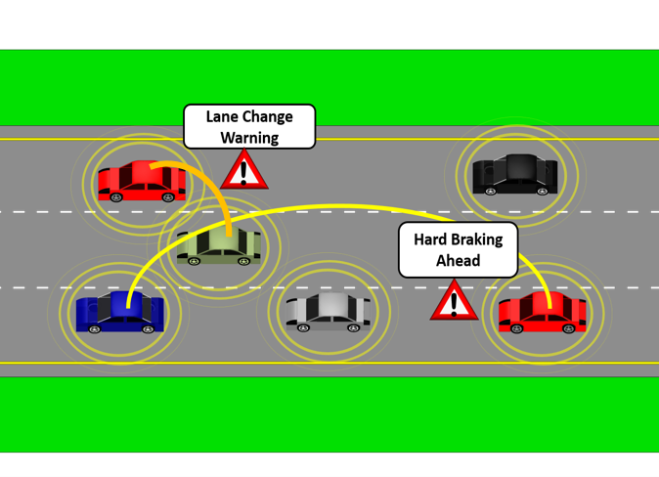
Fig. 1.1 Application of V2V Communication.

Vehicle-to-Vehicle Communication (V2V) to allow the exchange of safety information between connected vehicles, as depicted in Fig. 1.1. Indeed, vehicular communication can drastically reduce the number of road accidents, save damage costs, save fuel consumption, reduce traffic congestion. The Federal Communications Commission (FCC) allocated the frequency spectrum from 5.85 GHz to 5.925 GHz in the Dedicated Short Range Communications (DSRC) for V2V Communication [4].
Cadillac, Toyota, and other car companies utilize the DSRC band for sudden brake warnings, emergency vehicle identification, toll fee collection, and intersection warning [5]. For instance, in [6], a virtual traffic light (VTL) algorithm was developed to control traffic lights automatically using vehicular communication. The algorithm controls the traffic light on the intersections based on the 'first come, first serve.' The results showed that such a technology could save commute time from 30.7 to 18.3 minutes in Pittsburgh, while reducing carbon emission.
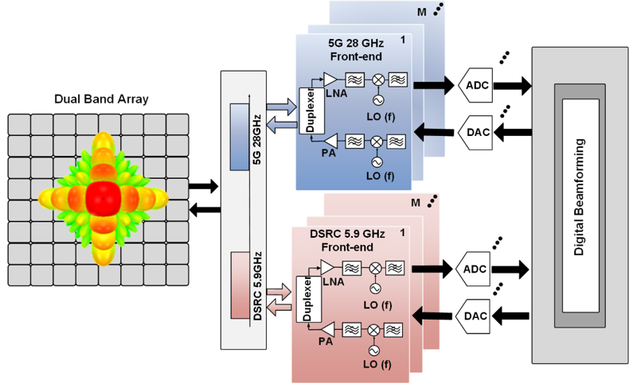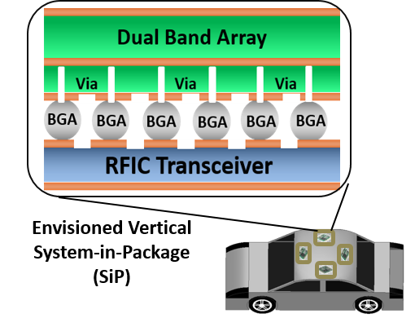
Fig. 1.2 Dual-band receiver operating at both DSRC band 5G mm-wave band.
The bandwidth allocated at the DSRC band is only 100 MHz, implying a maximum data rate of ~27 Mbps. Therefore, the DSRC band cannot accommodate high-speed video communication. On the contrary, the millimeter-wave (mm-wave) spectrum offers advantages for wider bandwidth with much higher data rate communications.
However, the signals at the mm-wave band suffer from high path loss, high penetration loss, and severe attenuation due to the rain. As such, the operation in the mm-wave band requires novel radio frequency (RF) front-ends and precise fabrication techniques. The high path loss can be mitigated using beamforming techniques and high gain antenna arrays. Therefore, we need a system capable of switching between the mm-wave band and DSRC band based on specific application requirements (viz. higher data rates) and level of attenuation due to severe weather conditions.
This dissertation presents a dual-band receiver operating at 5.9 GHz DSRC and 28 GHz 5G mm-wave bands for V2V communications, as shown in Fig. 1.2. Our goal is to 1) design and implement a high gain dual-band antenna, 2) design and implement dual-band RF front-end, and 3) integrate them in a low-loss 3D Antenna-in-Package (AiP).
  - Introduction to the Dual-band Antennas
Modern wireless communication systems primarily focus on designing multiband antennas with compact size, lightweight, and low-cost. Multiband operation can be realized using multiple antennas or single antenna structures resonating at multiple bands. Multiple antenna structures occupy more space and are costly. Conversely, using a single antenna structure for multiband operation is more efficient. Previously, several dual-band antennas with various frequency ratios were designed for different applications such as WiFi (2.4/5.2 GHz), WLAN (2.4/5.8 GHz) [7], mobile phones, synthetic aperture radar (SAR) (X/K band), etc. The term frequency ratio of the dual-band antenna is defined as
$$Frequency ratio=\frac{f_{h}}{f_{l}}$$
$f_{h}$- center frequency of the higher band
$f_{l}$ - center frequency of the lower band
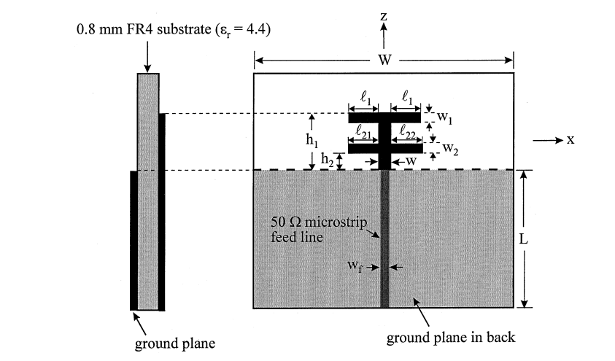
Fig. 1.3 Printed dual-band T-shaped monopole antenna operating at 2.4 GHz and 5.2 GHz with frequency ratio 2.16 [12].
Commonly reported multiband/dual-band antennas are patch [8], monopole [9], planar inverted F antenna (PIFA) [10], fractal antennas [11].
1.1.1 Dual-band Antennas with Small Frequency Ratio < 3
Dual-band operation using monopole/dipole antennas with a small frequency ratio can be achieved by adding additional resonant structures operating at different frequencies. Two designs using this technique have been reported in [9] and [12]. In [12], two simple T-shaped monopoles operating at different frequencies are integrated for dual-band operation, as shown in Fig.1.3. This antenna operates from 2.4-2.28 GHz with a gain of 1.3-1.8 dBi and 5.15-5.35 GHz with a gain of 0.8-1.5 dBi.
The patch antennas are highly preferred for dual-band applications due to their low profile, simplicity in design, and light weight. One of the techniques to achieve dual-band operation in patch antennas is by exciting two different modes. In [13], a dual-band patch
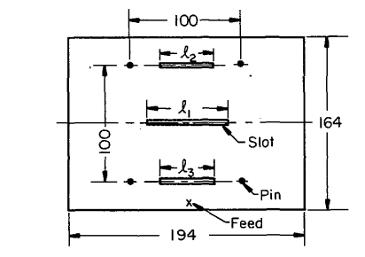
Fig. 1.4 Microstrip patch antenna for dual-band operation with slots and shorting pins and frequency ratio varying from 3 to 1.3 [13].
antenna was designed by exciting its TM01 and TM03 modes using slots and pins, as shown in Fig. 1.4. The frequency ratio of the two bands can be adjusted from 3 to 1.3 by placing the pins and slots at the appropriate positions. Another design using patch antennas is reported in [14]. The design operates from 3.45 to 3.77 GHz and 5.75 to 6.04 GHz by exciting its TM10 and TM12 modes.
Another technique to achieve multiband/dual-band operation is integrating multiple antennas on the same aperture. Different or identical antennas can be stacked or/and interleaved or perforated on the same aperture to produce multiband operation. Due to its low profile and simple fabrication, microstrip antennas are preferred for shared aperture array designs.
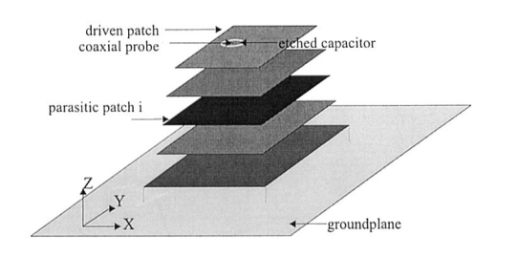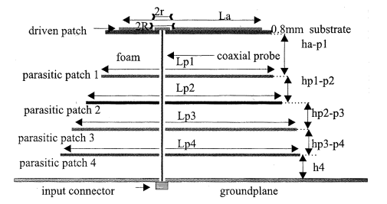
Fig. 1.5 Multifrequency patch antenna with multiple parasitic patches and a single driven patch [15].
For example, a shared aperture array with a single driven patch and multiple parasitic patches stacked together is presented in [15] for multiband operation, as shown in Fig. 1.5. The reported antenna operates at five bands with a frequency ratio varying from 1.13 to 1.4. Other designs have been reported where upper band patches are perforated on the lower band patches [16-17].

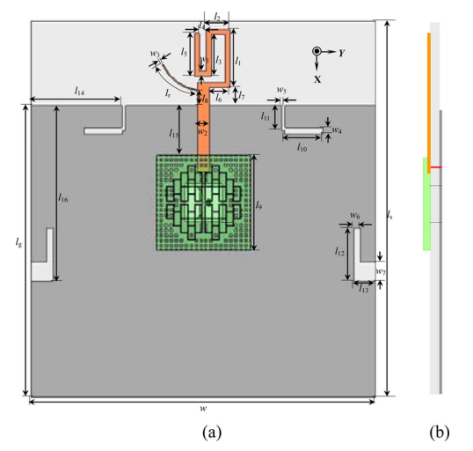
Fig.1.6 Tri-band antenna with dual-band monopole and microstrip grid antenna array: a) Top view and b) side view [18].

1.1.2 Dual-band Antennas with Large Frequency Ratio > 3
Dual-band antennas with a large frequency ratio are primarily designed to cover both the microwave and the mm-wave bands. Designing a dual-band antenna with a large frequency ratio is daunting due to the antenna size required to achieve resonance at each band. A tri-band antenna operating at both microwave and mm-wave frequencies with a large frequency ratio of 11.5 has been reported in [18]. Fig. 1.6 depicts that this antenna has a dual-band monopole operating at both 2.4 and 5.2 GHz, with the microstrip grid array operating at 60 GHz. In [19], a multiband antenna with a large frequency ratio consisting of printed monopole operating at 2.4/5.2/5.8 GHz and a higher-order mode patch operating at 60 GHz on the other side was reported. We note that microwave and mm-wave antennas can be integrated on each side with low pass and high pass filters for dual-band operation.
A shared aperture array with a frequency ratio of 37.5 was implemented in [20], which consists of a Ku band array (viz. 14.27 to 16.20 GHz) designed on top of the P band (viz. 330 to 420 MHz) patch. Notably, the lower band patch acts as a ground plane for the upper band array.
  - Introduction to the RF Front End
Typical RF front-end consists of low noise amplifier (LNA), mixers, bandpass filters (BPF), voltage controlled oscillator (VCO). There are two types of receivers: homodyne and heterodyne. Homodyne receivers, or zero-Intermediate frequency (IF), or direct conversion receivers require a single in-phase/quadrature (I/Q) mixer. Heterodyne receivers require two stages of mixing. The first mixing stage down-converts the received RF signal to an intermediate frequency (IF). The second stage is typically the I/Q mixer to downconvert the IF signal to the baseband.
1.3 Research Purpose
This research aims to develop a novel dual-band RF front-end for V2V communication to avoid road accidents, traffic congestion and improve fuel efficiency. The objective of this dissertation is to:
- Achieve significant gain dual-band antenna array
- Designing an upper band patch array in between the lower band array on a single-layer substrate and utilizing the higher-order modes of the lower band patches to achieve high gain at 28 GHz
- Designing a single-layer single-fed antenna by embedding an upper band patch inside the lower band patch to achieve dual-band operation and high gain at both the bands.
- Provide a high diversity gain system for effective communication
- The addition of an open stub meandered bandstop filter (OSM-BSF) provides high isolation between antenna elements, which further improves diversity gain.
- Implement antenna array using low-loss 3D AiP
- Integrating the antenna array and interposer using vias and ball grid arrays (BGA) prevents losses due to bond wire interconnection and enables 3D packaging.
- Design and implement a dual-band RF front-end
- Implement a dual-band RF front-end using a single platform with commercial off-the-shelf (COTS) components.
1.4 Outline of the Dissertation
This dissertation is organized as follows:
Chapter 2 outlines the design and measurements of a dual-band shared aperture antenna array on a single-layer substrate. This two-port antenna array provides dual-band operation with high isolation between the ports. A gain improvement of about ~1.44 dBi at 28 GHz is achieved by positioning the 1×2 upper band array at the center of the 2×2 lower band array and utilizing the higher-order modes of the lower band array. This array is also manufactured using a low-cost single-layer printed circuit board (PCB).
Chapter 3 covers the design and measurements of the single-fed dual-band patch antenna. This single-layer antenna consists of an inset-fed 28 GHz patch embedded onto a couple-fed 5.9 GHz patch. Further, an improvement in bandwidth at 28 GHz was realized and discussed.

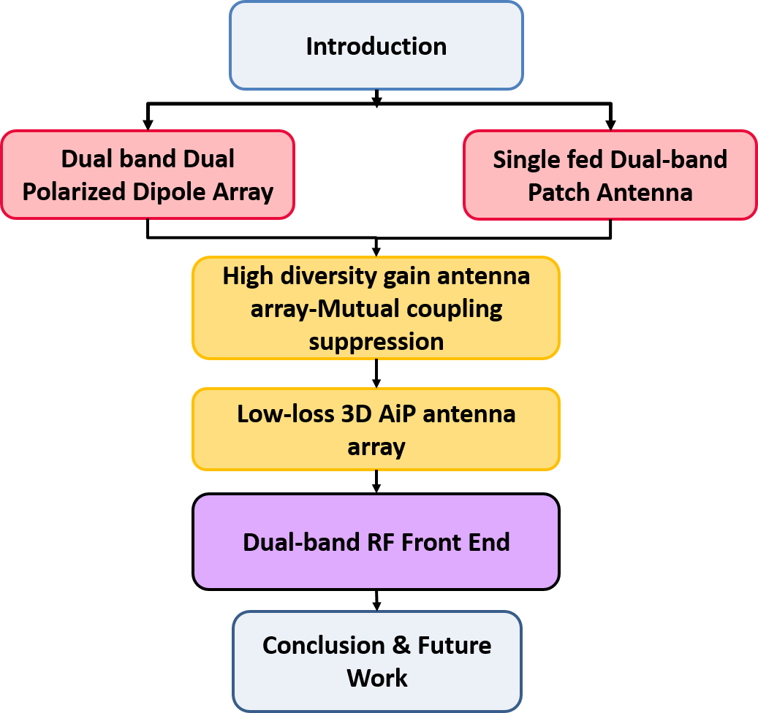
Fig. 1.7 Dissertation chapter’s flow diagram.
Chapter 4 outlines the design, and the measurements of a novel mutual coupling suppression technique using an OSM-BSF. Isolation enhancement between the antenna arrays using OSM-BSF was analyzed. This technique offers high isolation of >37 dB and a low envelope correlation coefficient (ECC) of 0.0093.
Chapter 5 outlines the design and measurements of a multilayer differentially fed patch array for the low-loss 3D AiP applications. This integration technique offers low-loss integration using BGAs and through-hole vias. The array is capable of performing +45⁰ scanning and also provides low cross-polarization levels.
Chapter 6 outlines the design and experimental setup of the dual-band RF front-end operating at 5.9 GHz and 28 GHz. The noise analysis, link budget, and receiver's linearity were analyzed. The RF receiver chains at 5.9 GHz and 28 GHz are measured using COTS components, and the measurement results were presented.
Chapter 7 summarizes this dissertation with proposed future work. It also discusses the techniques to reduce cross-polarization fields at the mm-wave band of the single-fed dual-band antenna designed in Chapter 3.

CHAPTER II
DUAL-BAND SHARED APERTURE ANTENNA ARRAY
Dual-band antennas operating at the current microwave frequency band and the new mm-wave frequency bands with frequency ratio >2 are challenging to design. Generally, dual-band operation in antennas is achieved using two separate antennas or a single structure to produce dual resonances. The most straightforward method is to use two different frequency antennas, but it occupies much space, increases weight and cost. Shared aperture antennas where multiple antennas are integrated on a single aperture are gaining much attention. In [21], a multilayer shared aperture array with C (5.3 GHz) and X (8.2 GHz) band antenna elements stacked on different substrates was reported. The array uses a separate feeding network for each band, but the isolation between the ports at both the bands remains low such as 15 dB and 20 dB. A single feed multilayer shared aperture array operating at 5.8/30 GHz was designed in [22]. However, multilayer shared aperture arrays increase the cost and complexity of the fabrication.
Single-layer low-cost PCB antennas are the best choice for commercial applications. A single layer shared aperture array with a common feeding network was used to excite 12.1 GHz patches and 17.4 GHz patches in [23]. However, the implemented configuration is restricted to the smaller frequency ratio.
This chapter presents a single layer, dual-band shared aperture array with a large frequency ratio and gain improvement for V2V communication. The simulated array consists of a four-element differentially fed patch antenna array operating at 5.84-5.94 GHz covering the DSRC band and two series fed antennas operating from 27.75 to 28.47 GHz covering the 5G mm-wave band. Fig. 2.1 displays the design of the implemented shared
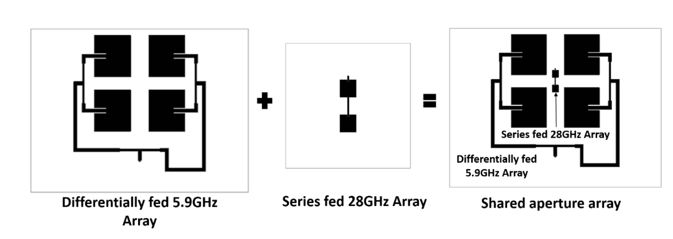
Fig. 2.1 Configuration of the implemented dual-band shared aperture antenna array at 5.9 GHz and 28 GHz for both DSRC and future mm-wave V2V communication.
aperture array, where the upper band array is placed in between the lower band array, thus saving the requirement of extra space. The radiation pattern of the arrays with and without shared aperture design was analyzed, implying that the shared aperture design does not affect the radiation pattern of the individual arrays.
Table 2.1 Specifications of the fabricated dual-band shared aperture antenna array
 | DSRC band | 5G mm-wave band
Frequency | 5.9 GHz | 28 GHz
Impedance Bandwidth | 100 MHz | 720 MHz
Array | 2×2 | 1×2
Inter-element spacing | 0.5$λ_{l}$ * | 0.65$λ_{h}$ **
Polarization | Linear polarization
Port isolation | >55 dB | >33 dB
Peak gain | 9.97 dBi | 12.3 dBi
Cross-polarization level | >16 dB | >20 dB
HPBW | 53⁰/47⁰ | 29.9⁰/60⁰
* $λ_{l}$= Operating wavelength of the lower DSRC band array $f_{l}=5.9 GHz$
** $λ_{h}$= Operating wavelength of the upper mm-wave band array $f_{h}=28 GHz$
HPBW- Half-power beamwidth
Additionally, the implemented design provides an improvement in the gain at 28 GHz due to the generation of higher-order modes at the 5.9 GHz array. The designed shared aperture array was fabricated and measured. The array provides a measured gain of 9.97 dBi at 5.9 GHz and a high gain of 12.3 dBi at 28 GHz with high port-to-port isolation of >55 dB at 5.9 GHz and >33 dB at 28 GHz. The implemented shared aperture design provides high gain, high port-to-port isolation, and high efficiency at both frequencies, as displayed in Table 2.1.
In Section 2.1, the design procedure and the configuration of the shared aperture array are presented. Further, the simulated results and the performance of the shared aperture array are compared with the individual arrays. The fabricated prototype, the measurement results, and comparison with other state-of-art designs are detailed in Section 2.2. Finally, the conclusion of this work is summarized in Section 2.3.
2.1 Design Procedure of the Shared Aperture Antenna Array
The implemented array was designed on Rogers 5880 substrate with dielectric constant 2.2 and thickness 0.52 mm, as shown in Fig. 2.1. The array consists of 5.9 GHz patches fed using differential corporate feed network and 28 GHz patches fed using series feed network. The design procedure is as follows:
Step 1: Design the lower band 5.9 GHz 2×2 patch array and excite them using the differential corporate network to create a center gap for placing the upper band array.
Step 2: Design the upper band 28 GHz 1×2 patch array and excite the elements using a series feed network.
Step 3: Position the upper band array symmetrically on the center of the lower band array.

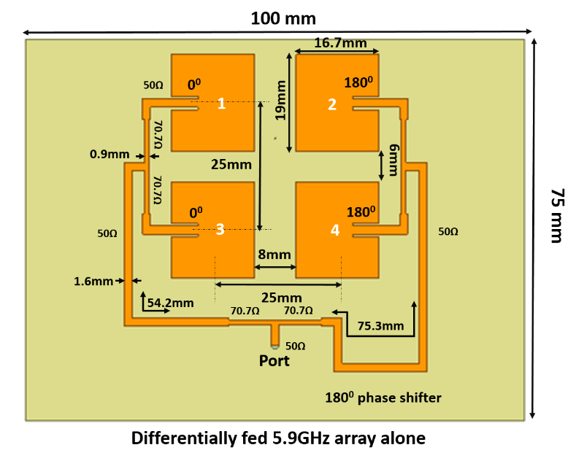
Fig. 2.2 Top view of the lower band 2×2 patch antenna array at 5.9 GHz.
2.1.1 Lower Band 5.9 GHz Differentially Fed Patch Array
As a first step, lower band 5.9 GHz was simulated, as shown in Fig. 2.2. The lower band array consists of four inset-fed patch antennas operating on their fundamental TM10 mode. The length and width of the patches are estimated using the transmission line model [24]. The length of the lower band patch $L_{pl}$ =16.7 mm and the width $W_{pl}$ =19 mm. The 5.9 GHz patches are 50Ω impedance matched using the inset feed line with a width of 1.6 mm. The patches are placed at a distance of 0.5$λ_{l}$ (center-to-center spacing) from each other.
The microstrip antennas produce higher-order modes during their operation, and the resonant frequency of their higher-order TMmn modes can be estimated using [24]
$$f_{mn}=\frac{k_{mn}c}{2π\sqrt{ϵ_{r}}}$$
$$k_{mn}=\sqrt{{\left(\frac{mπ}{L}\right)}^{2}+{\left(\frac{nπ}{W}\right)}^{2}}$$

Where $k_{mn}$ is the wave number
$ϵ_{r}$ is the dielectric constant
$c$ is the speed of the light in the free space.
The 5.9 GHz patches are excited by using a differential corporate feed network, as shown in Fig. 2.2. The designed 1:4 differential feed network provides a pair of $0^{0}$ and ${180}^{0}$ signals to feed the designed single-ended antennas. A half-wavelength transmission line was used as a ${180}^{0}$ phase shifter on one side of the feed network. The total dimensions of the array are 75 mm×100 mm (W×L).
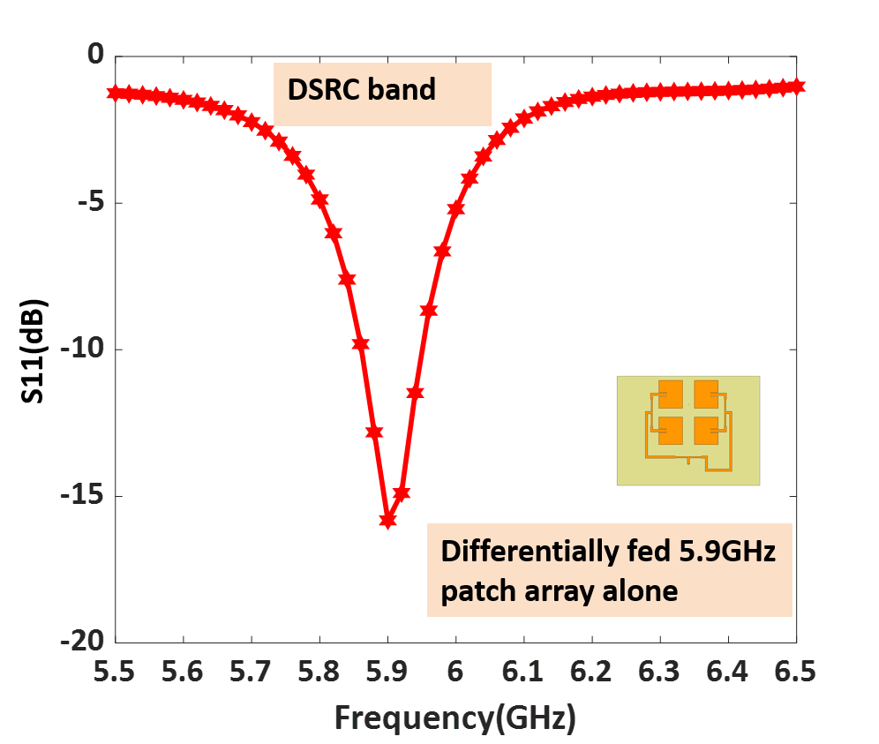
Fig. 2.3 Simulated S11 (dB) of the lower band 2×2 array.
The designed lower band array was simulated using ANSYS HFSS software. Fig 2.3 represents the simulated S11 (dB) of the lower band array, and it provides operating bandwidth from 5.86 GHz to 5.94 GHz.
2.1.2 Upper Band 28 GHz Series Fed Patch Array
The upper band array consists of a 1×2 patch array operating at 28 GHz. The inset fed patch antennas operating in their fundamental TM10 mode were designed as shown in Fig. 2.4. The patches are 50Ω impedance matched the length, and the width of the patches are 3.25mm and 3.5mm. The 28 GHz patches are excited using a series feed network. The length and the width of the series feed line are 1.2 mm and 0.3 mm. The upper band patches are maintained at a distance of 7 mm (0.65$λ_{h}$) from each other. The series feed network is so simple in design and provides low losses compared to others.
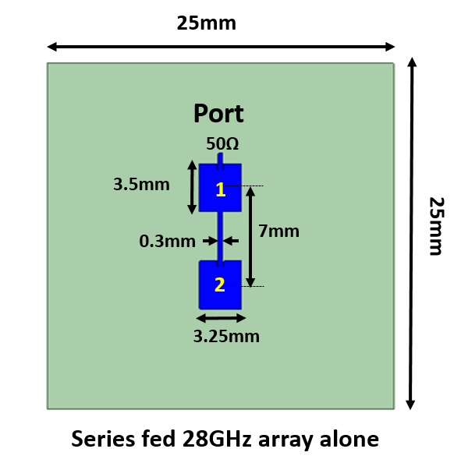
Fig. 2.4 Top view of the upper band 1×2 series fed array.

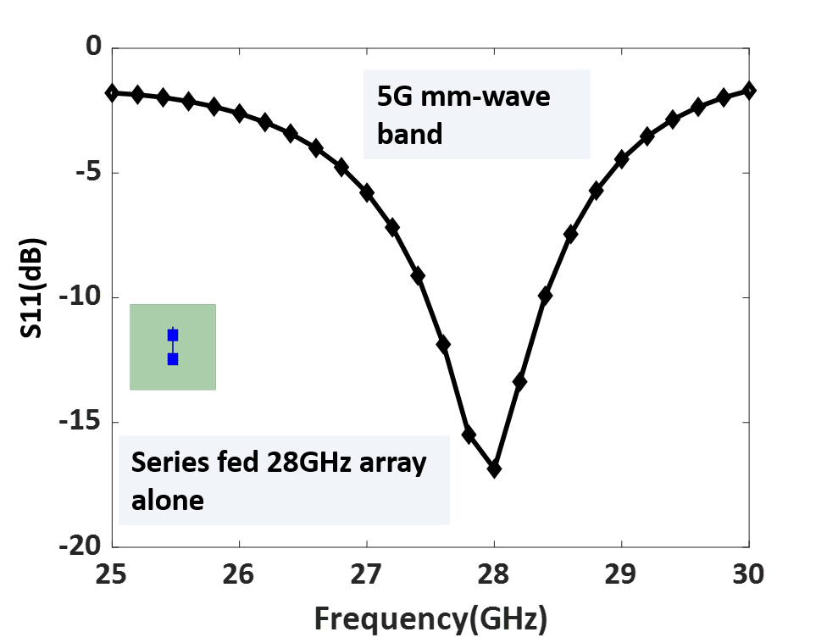
Fig. 2.5 Simulated S11(dB) of the mm-wave band 1×2 array.
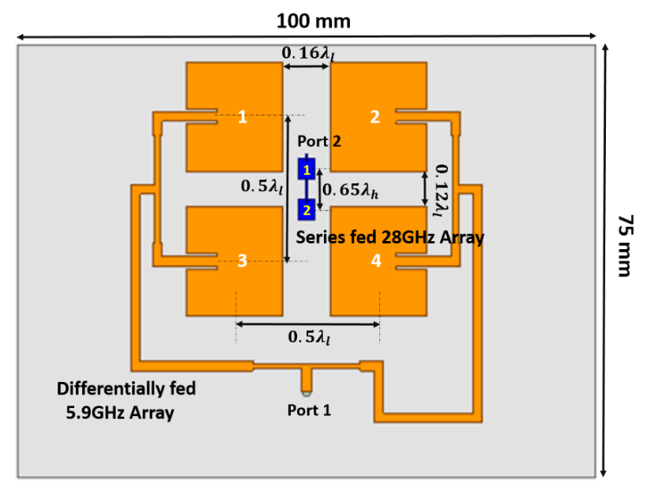
Fig. 2.6 Configuration of the implemented shared aperture antenna array operating at 5.9 GHz and 28 GHz.
Fig. 2.5 displays the S11(dB) of the upper band series fed array. The 1×2 series fed array operates from 27.46 GHz to 28.4 GHz with 50Ω impedance matching.
2.1.3 Implemented Shared Aperture Antenna Array
The series fed upper band array is placed at the center gap of the designed lower band 5.9 GHz array, as shown in Fig. 2.6. The 28 GHz array is positioned at a distance of 0.08$λ_{l}$ (center-to-center spacing) from the edges of the lower band patches. Further, the position of the upper band array is optimized. Port 1 is the feed position of the 5.9 GHz array, and port 2 is the feed position of the 28 GHz array.
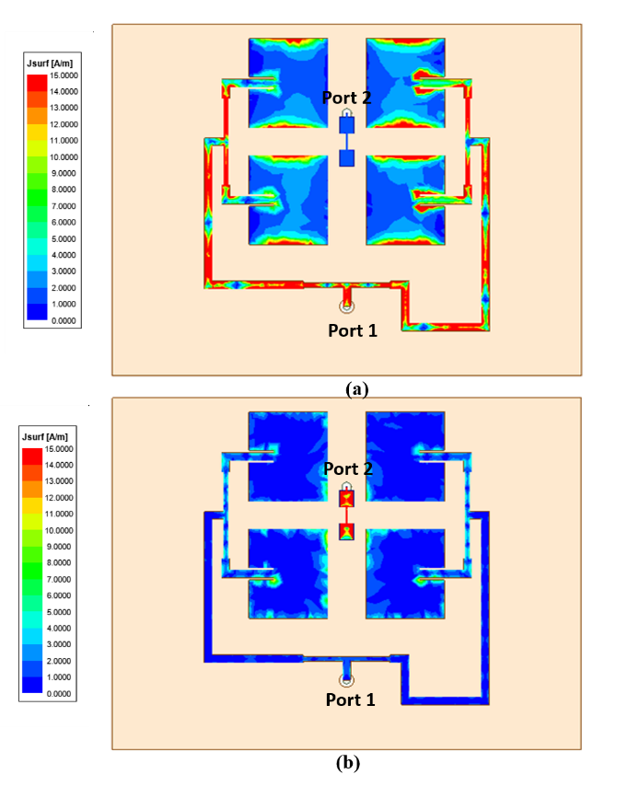
Fig. 2.7. The surface current distribution of the shared aperture array at a) 5.9 GHz b) 28GHz.
To investigate the influence of the upper band and lower band array on each other, the current distribution of the shared aperture array at 5.9 GHz and 28 GHz were analyzed as shown in Fig. 2.7. To investigate at 5.9 GHz, port 1 was excited and port 2 was terminated, the current flows through the lower band array and no current flows through the upper band array resulting in high port isolation. Similarly, at 28 GHz port 2 was excited and port 1 was terminated, higher-order modes are generated at the lower band array due to coupling resulting in additional gain at 28 GHz.
The S parameters of the simulated shared aperture array are displayed in the following figures. To achieve lower band operation, port 1 of the shared aperture array is excited and port 2 is 50Ω load terminated. Fig. 2.8 (a) shows the active S11 (dB) of the lower band array and the array operates from 5.84 GHz to 5.94 GHz with a bandwidth of 100 MHz. Similarly, to achieve upper band operation, port 2 is excited and port 1 is terminated. The simulated results show that the mm-wave array operates from 27.75-28.47 GHz with a bandwidth of 720 MHz as shown in Fig. 2.8(b).
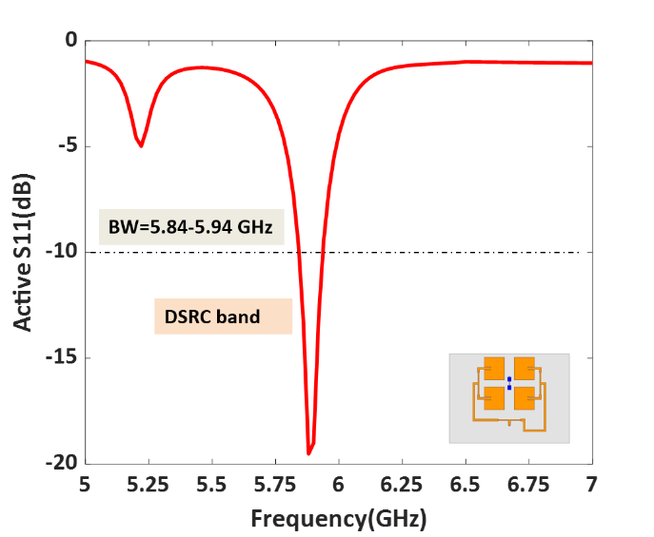 | 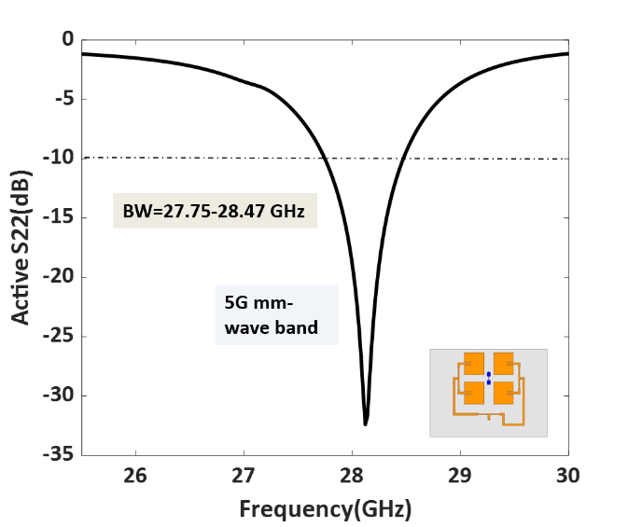
Fig. 2.8 (a) Simulated Active S11(dB) of the lower band array (b) Simulated Active S22(dB) of the upper band array.
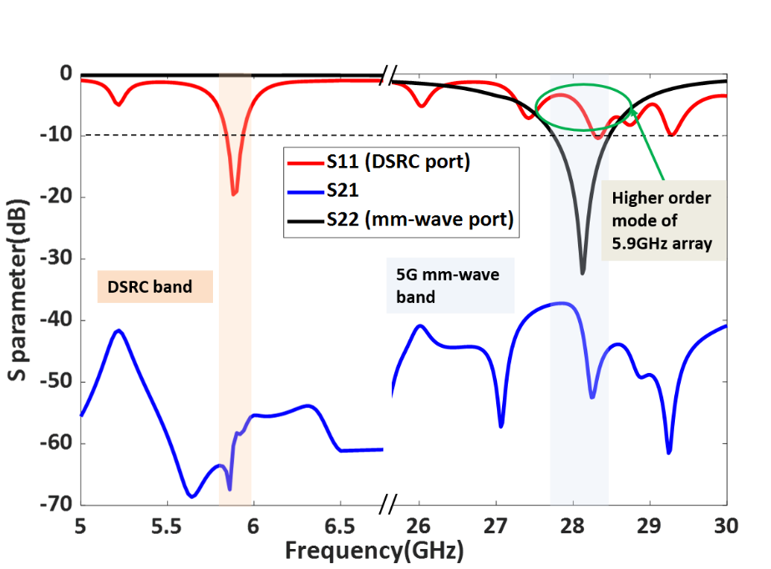
Fig. 2.9 Simulated S parameters (dB) of the implemented shared aperture antenna array.
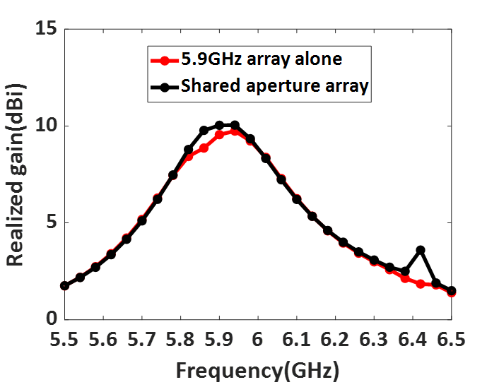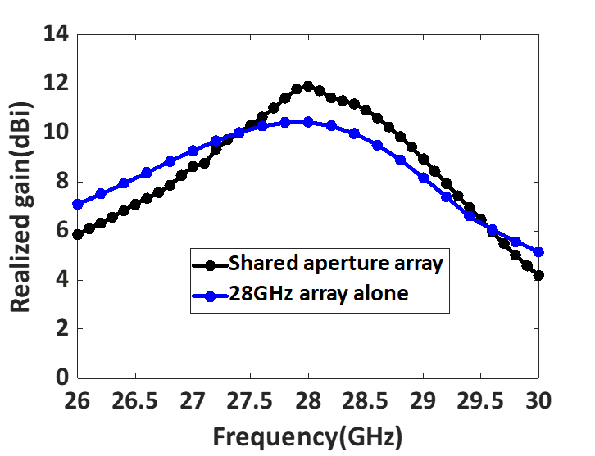
Fig. 2.10 Simulated gain (dB) a) comparison of the shared aperture array and 5.9GHz array b) comparison of the shared aperture array and 28 GHz array.

To analyze the isolation between the DSRC and mm-wave band, both the ports of the array were excited. Fig. 2.9 illustrates the S parameters (dB) of the implemented shared aperture antenna array. The ports are highly isolated at both DSRC band S21>55 dB and mm-wave band S21>38 dB.
The radiation performance of the shared aperture antenna array was analyzed and compared with the individual array designs, as shown in Fig. 2.10. The radiation pattern and the gain values of the shared aperture array remain the same as that of the individual lower band 5.9 GHz array as seen in Fig. 2.10 (a). The array provides a gain of 10 dBi at 5.9 GHz in the E plane and 9.92 dBi in the H plane.
Similarly, the performance of the upper band array was analyzed and the radiation pattern remains constant. A gain improvement of 1.44 dB is achieved at 28 GHz due to higher-order modes generation in the lower band patches. A peak gain of 11.85 dBi is obtained at 28 GHz in both E and H planes, as shown in Fig. 2.10 (b).
2.2 Fabrication and Measurement Results
The array was fabricated, measured, tested, and the fabricated prototype is shown in Fig. 2.11. The top view and bottom view of the single-layer fabricated shared aperture array are
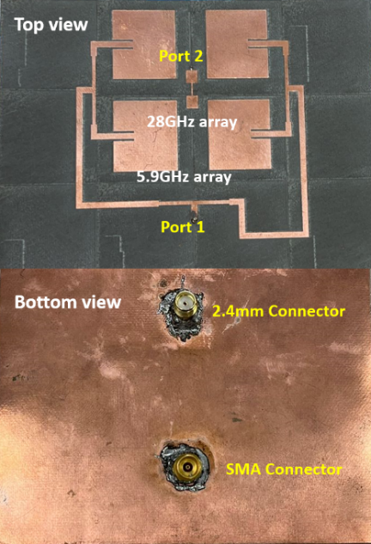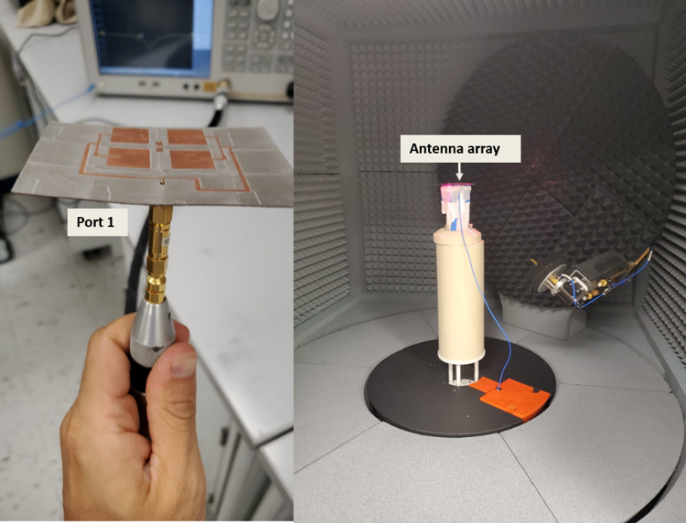
Fig. 2.11. The fabricated array prototype a) top view b) bottom view c) measurement setup of the fabricated prototype at 5.9 GHz and 28 GHz.

shown below. Fig. 2.11 c) displays the measurement setup of the fabricated array. The lower band array was measured using an SMA connector and the upper band array using a 2.4 mm connector.
2.2.1 S Parameter Measurement Results
The S parameters of the shared aperture antenna array were measured using a Vector Network Analyzer (VNA), as shown in Fig. 2.11 (c). Fig. 2.12 shows the measured and the simulated S parameters of the shared aperture antenna array. The lower band array provides -10 dB impedance bandwidth from 5.87 to 5.99 GHz when port 1 is measured. It provides a bandwidth of 120 MHz covering the DSRC band. The upper band array offers -10 dB impedance bandwidth from 27.8-28.65 GHz when port 2 is measured. The shared aperture array provides 850 MHz at the 5G mm-wave band.
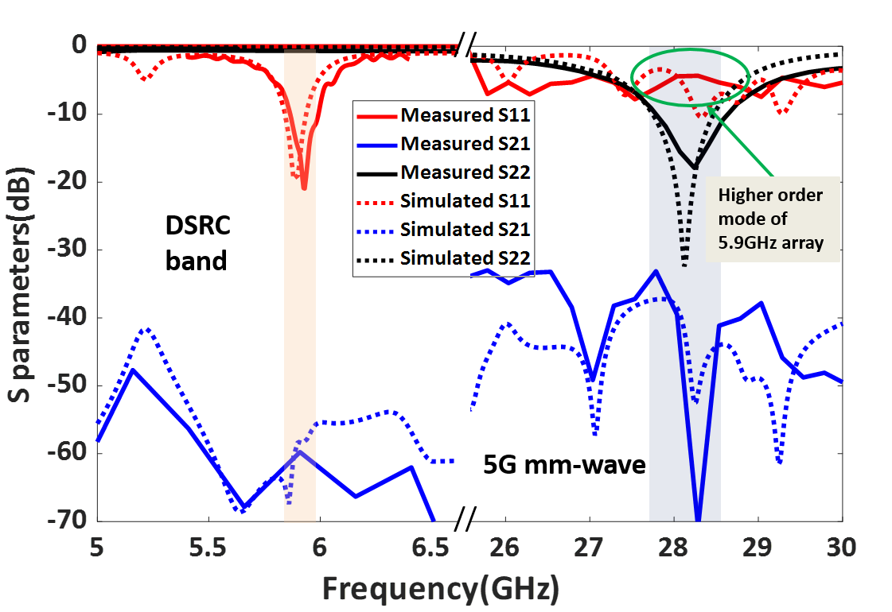
Fig. 2.12 Measured S parameters (dB) of the fabricated shared aperture antenna array.
The isolation between the antennas was measured from the S21 (dB) measurement. The ports are highly isolated such that S21>55 dB is obtained over the whole DSRC band, and S21> 33dB is obtained over the mm-wave impedance bandwidth.
2.2.2 Radiation Pattern and Gain Measurement Results
The radiation patterns of the upper and lower band arrays are measured using an anechoic chamber. To measure the lower band pattern, port 1 was excited and port 2 was terminated using a 50Ω impedance matched load. Fig. 2.13 shows the normalized measured and simulated radiation pattern of the shared aperture array at 5.9 GHz. The measured pattern agrees well with the simulated pattern in both E and H planes. The array provides a gain of 9.97 dBi in the E plane and 9.85 dBi in the H plane at 5.9 GHz as displayed in Table 2.2.
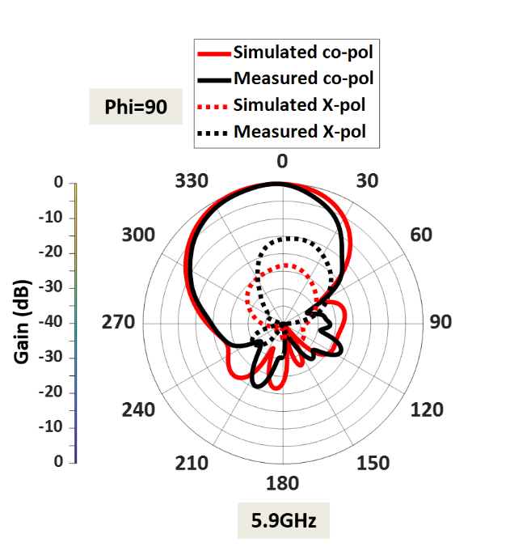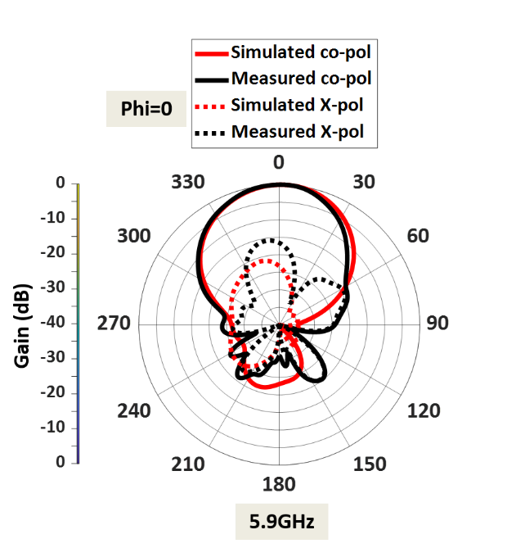
Fig. 2.13 Measured radiation pattern of the lower band array at 5.9GHz a) E plane b) H plane.

Table 2.2 Measured and simulated gain values at 5.9 GHz
5.9 GHz (DSRC band)
 | E plane | H plane
Simulated gain (dBi) | 10 dBi | 9.92 dBi
Measured gain (dBi) | 9.97 dBi | 9.85 dBi

The HPBW and cross-polarization levels of the shared aperture array at 5.9 GHz are displayed in Table 2.3. The half-power beamwidth of the shared aperture array at 5.9 GHz was ${53}^{0}$ in the E plane and ${47}^{0}$ in the H plane. The cross-polarization levels are <-16 dB in both planes.
Table 2.3 Measured Cross polarization discrimination and HPBW of the shared aperture array at 5.9 GHz
5.9 GHz (DSRC band)
 | E plane | H plane
Cross-polarization discrimination | >16 dB | >16 dB
HPBW (degree) | $${53}^{0}$$ | ${47}^{0}$
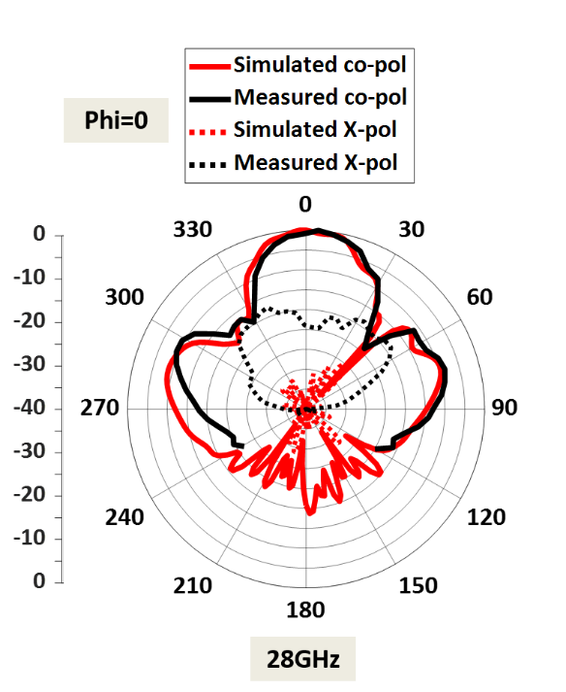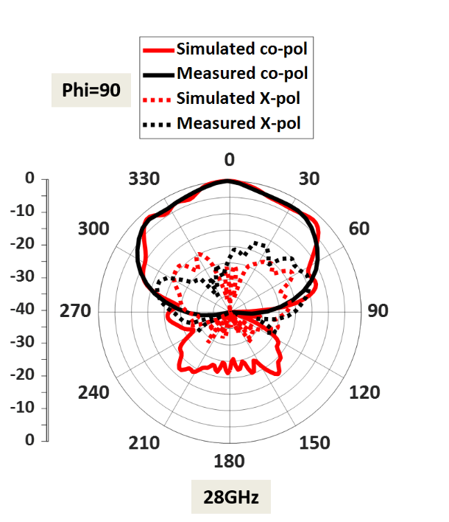
Fig. 2.14 Measured radiation pattern of the upper band array at 28 GHz a) E plane b) H plane

Table 2.4 Measured and simulated gain values at 28 GHz
28 GHz (mm-wave band)
 | E plane | H plane
Simulated gain (dBi) | 11.85 dBi | 11.85 dBi
Measured gain (dBi) | 12.3 dBi | 11.7 dBi

To measure the upper band radiation pattern, port 2 was excited, and port 1 was terminated using a 50Ω impedance matched load. The measured normalized radiation patterns at the mm-wave 28 GHz are shown in Fig. 2.14, and the upper band array provides a high gain of 12.3 dBi in the E plane 11.7 dBi in the H plane. Tables 2.4 and 2.5 summarize the measured gain (dBi), cross-polarization levels, and HPBW of the shared aperture array at 28 GHz.
Table 2.5 Measured Cross polarization discrimination and HPBW of the shared aperture array at 28 GHz
28 GHz (mm-wave band)
 | E plane | H plane
Cross-polarization discrimination | >20 dB | >20 dB
HPBW (degree) | $${29.9}^{0}$$ | ${60}^{0}$
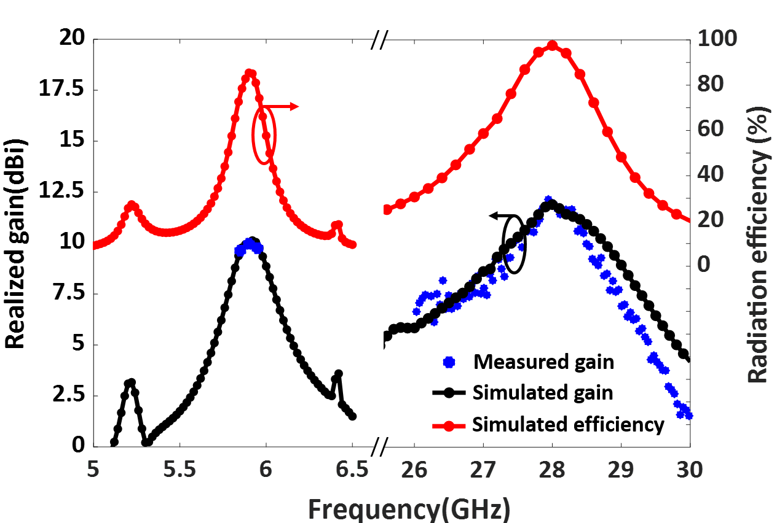
Fig. 2.15 Efficiency (%) and measured gain (dBi) vs Frequency (GHz) of the shared aperture antenna array.
The efficiency of the designed shared aperture antenna array is shown in Fig. 2.15. The shared aperture array provides 86% efficiency during lower band array operation and >96% during upper band array operation.
2.3 Summary
In this chapter, a single-layer dual-band shared aperture array with gain improvement at the mm-wave band was designed. The shared aperture array has upper band series fed 28 GHz array printed on the lower band differentially fed 5.9 GHz array. The implemented array offers
- dual-band operation from 5.87-5.99 GHz and 27.8-28.65 GHz
- gain improvement of about ~1.44 dBi at mm-wave band
- low-cost standard PCB fabrication
- highly isolated ports >55 dB at DSRC band and >33 dB at mm-wave band
- single-layer structure and simple in design

CHAPTER III
CAPACITIVELY COUPLED DUAL-BAND ANTENNA OPERATING AT 5.9 GHz AND 28 GHz
Multiband systems are either implemented using separate antennas operating at a specific band, or a single antenna structure resonating at various bands. Examples of dual-band single-fed planar antennas include patch antennas [25-26], co-planar waveguide (CPW) fed slot antennas [27], and planar inverted-F antennas (PIFA) [28]. While these dual-band antennas are compact, their frequency ratios (viz. ratio of the center frequency of the upper band to the lower band) are small, with most being less than 3.
A simple way to realize dual-band antennas with a large frequency ratio is to integrate two different frequency antennas on the same aperture [29-30]. Multiband antennas on the same aperture reduce the cost and weight of the system. A multilayer dual-band antenna with magneto-electric dipole and parallel-plate resonator on different layers operating at 5.9 GHz and 28 GHz was developed in [31]. However, the design requires expensive multilayer fabrication and also suffers from high profile (viz h=0.12 $λ_{l}$).
Indeed, designing a single-layer single-port dual-band antenna with a large frequency ratio is daunting due to the large difference in antenna dimensions. In [32], a multiband antenna with monopole and patch antenna separated by a low pass filter for 2.4, 5.5, and 28 GHz applications was designed. However, the gain at the lower bands remains low, with 1.95 dBi at 2.4 GHz and 3.76 dBi at 5.5 GHz.
In [33], a microstrip grid array antenna with parasitic patches and differential feeding network was designed to achieve dual-band operation. However, the parasitic patches increase the overall dimension of the antenna. In [34], dual-band antenna patches at 4.85 GHz with stub-loaded microstrip line at 26 GHz operating microwave patch antenna with an mm-wave antenna acting as a feed network were implemented. This antenna has a high-profile design and requires an additional feeding structure. In [35], a structure sharing a single-fed substrate integrated waveguide (SIW) slot antenna with monopole was reported. However, this antenna provides a low gain of 2.6 dBi at 2.4 GHz, and the structure is complicated.
This chapter presents a low-profile dual-band antenna with an integrated inset-fed upper band patch and a coupled-fed lower band patch antenna. The bandwidth of the upper band patch is improved from 8% to 16% by creating parallel slots near the feed line. The measured dual-band antenna provides a -10 dB impedance bandwidth from 5.8 to 6.05 GHz, covering the DSRC band, and 26.8 to 31.3 GHz, covering the 5G mm-wave band. The implemented dual-band antenna offers high gain, frequency flexibility, and higher harmonics rejection in between two bands. Table 3.1 displays the specifications of the implemented dual-wideband antenna.
Table 3.1 Specifications of measured dual-wideband antenna
 | DSRC band | 5G mm-wave band
Frequency | 5.9 GHz | 28 GHz
Impedance Bandwidth | 250 MHz | 4.5 GHz
Polarization | Linear polarization
Peak gain | 7.7 dBi | 6.38 dBi
HPBW | 92⁰/102⁰ | 22⁰/63⁰

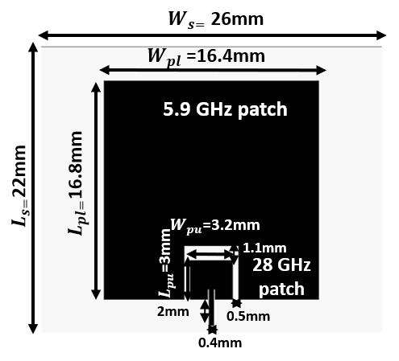
Fig. 3.1 Design I: Dual-band patch antenna operating at 5.9 GHz and 28 GHz.

The chapter is organized as follows: In Section 3.1, the configuration and design procedure of the dual-band antenna and modified dual-wideband antenna is explained. In Section 3.2, the dual-band antenna with improved bandwidth was fabricated, measured, and compared with other dual-band antennas. Finally, Section 3.3 concludes the chapter.
3.1 Design Procedure of the Dual-Band Antenna
3.1.1 Design I: Dual-Band Antenna
The dual-band antenna was designed on Rogers RT/Duroid 5800LZ with thickness t=1.27 mm, dielectric constant $ϵ_{r}$=2, and dielectric loss tangent $tanδ$=0.0021. The total dimensions of the designed single-fed dual-band antenna were 22mm×26mm×1.27 mm.
The antenna configuration consists of an upper band patch antenna embedded on
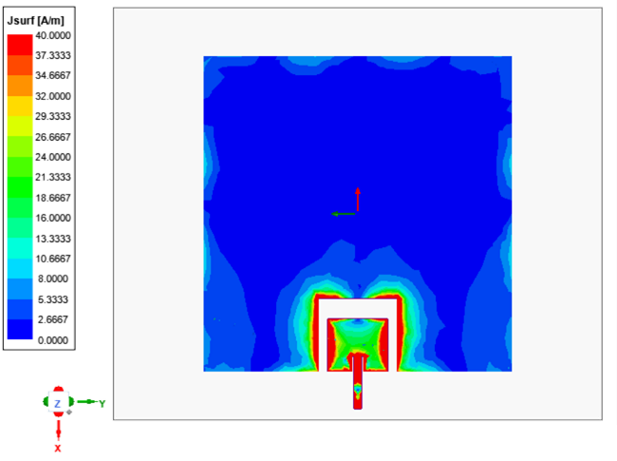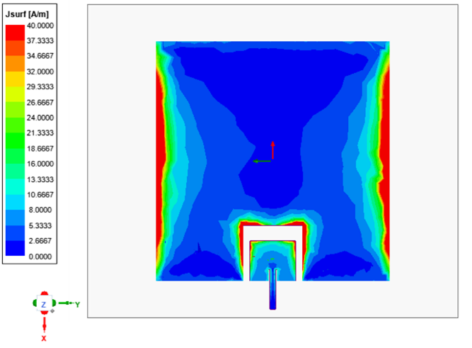
Fig. 3.2. Surface current distribution at a) 28 GHz, t=0 and b) 5.9 GHz, t=90.

the non-radiating edges of the lower band patch antenna, as displayed in Fig. 3.1. First, a 28 GHz patch antenna with an inset feed line operating at TM10 mode was designed. The length and width of the 28 GHz patch were estimated using [24]. An inset feed line was introduced to obtain 50Ω impedance matching. Next, a 5.9 GHz rectangular patch, with an optimized length $L_{pl}$ and width $W_{pl}$ was designed. Then, the designed 28 GHz patch was added on the non-radiating edges of the 5.9 GHz patch with a gap for coupled feeding. The lower band patch was excited through the coupling from the upper band patch.
Further, the surface current distribution of the designed dual-band antenna at the operating frequencies was analyzed for a better understanding. First, the current distribution at 28 GHz (t=0) was examined as shown in Fig. 3.2 (a), which clearly shows that the smaller patch controls the resonance at the upper band. Further, the upper band patch operates at its fundamental TM10 mode, whereas the lower band patch remains undisturbed. Similarly, Fig. 3.2 (b) illustrates the current distribution of the dual-band patch antenna at 5.9 GHz (t=90). It is clear that the current mainly flows over the lower band patch at 5.9 GHz through the coupling from the upper band patch.
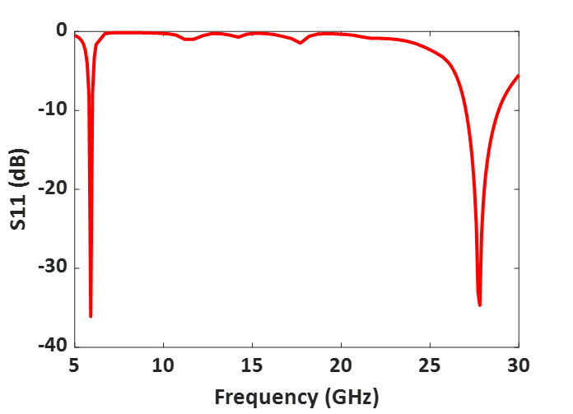
Fig. 3.3 Simulated S11 (dB) of the Design I: Dual-band antenna operating at 5.9 GHz and 28 GHz.
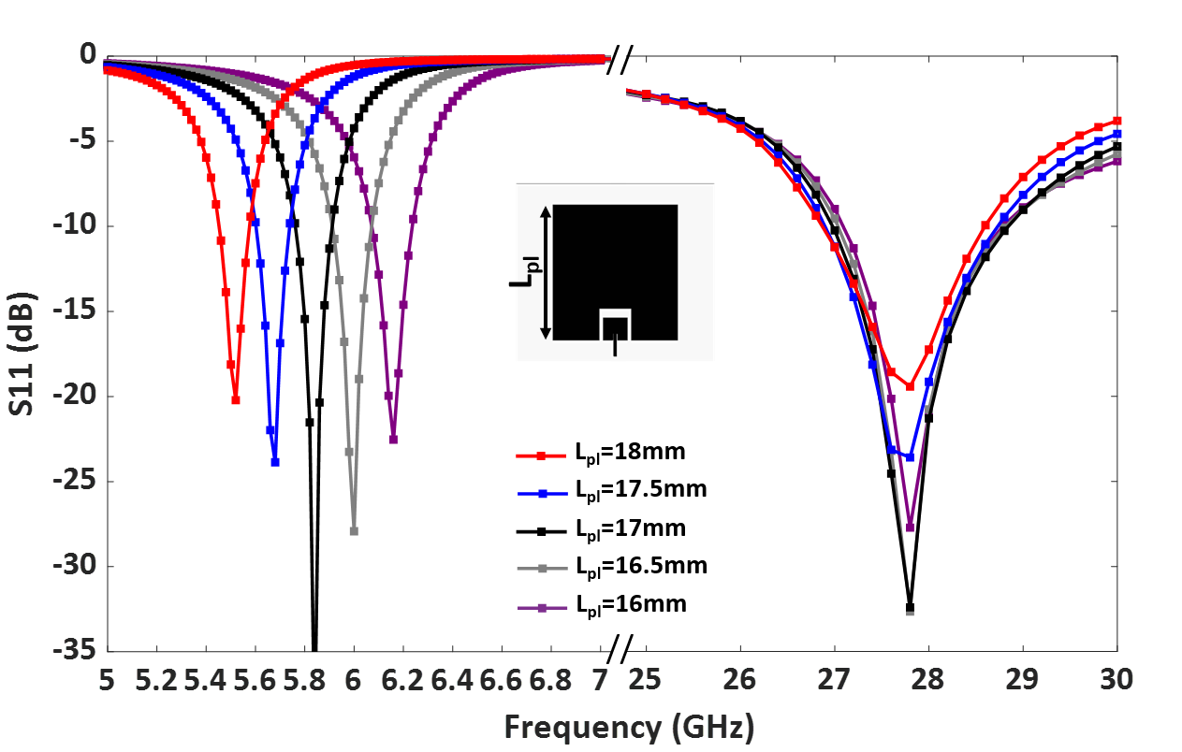
Fig. 3.4. Parametric study of the dual-band antenna by adjusting the length of the lower band patch, $L_{pl}$.
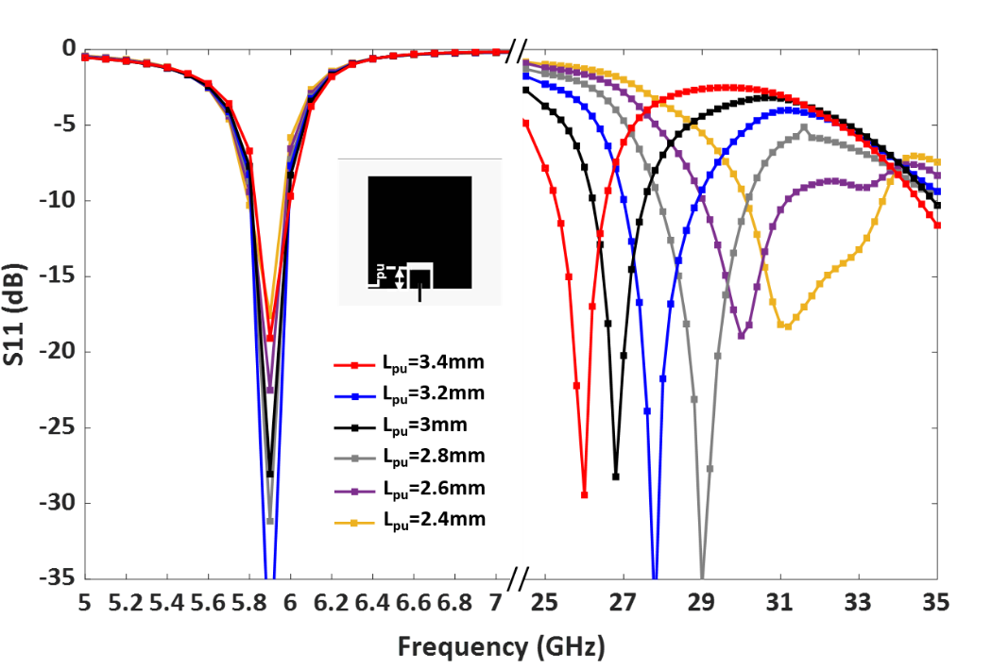
Fig. 3.5. Parametric study of the dual-band antenna by adjusting the length of the upper band patch, $L_{pu}$.

The dual-band antenna was designed and simulated using Ansys HFSS. The simulated S11(dB) of the dual-band antenna (see Fig. 3.3) shows that the antenna provides -10 dB impedance bandwidth from 5.81 to 5.99 GHz and 27.9 to 30.1 GHz. The gap between the two patches controls the shape of the radiation pattern.
A parametric study was carried out to analyze further the effect of the patch lengths on the operating frequencies. Fig. 3.4 demonstrates that by adjusting the length of the lower band patch$L_{pl}$, the lower band resonance gets shifted. Similarly, the length of the upper band patch, $L_{pu}$ controls the upper band resonance, as shown in Fig. 3.5. Therefore, the operating frequency of the upper and lower band can be tuned easily by controlling $L_{pu}$ and $L_{pl}.$

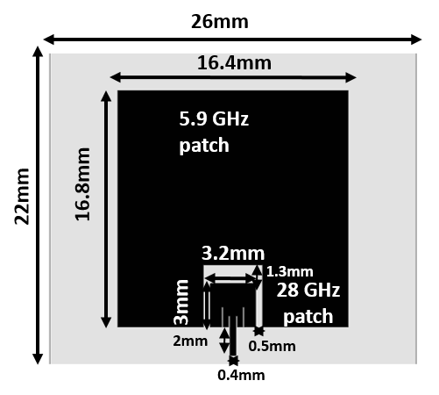
Fig. 3.6. Configuration of the Design II: Dual-wideband antenna.
3.1.2 Design II: Dual-Wideband Patch Antenna
The bandwidth of the upper band patch can be further improved by adding parallel slots near the inset feed line, as shown in Fig. 3.6. The slots are placed symmetrically from the feed line. A bandwidth improvement from 8% to 16% was achieved by using this technique.
Antenna II operates from 5.8 to 5.95 GHz and 26.8 to 31.3 GHz, as shown in Fig. 3.7. The simulated antenna provides a peak gain of 7.3 dBi in the DSRC band and 6.4 dBi in the mm-wave band. The normalized radiation patterns of antenna II at 5.9 GHz and 28 GHz in the E and H planes are shown in Fig. 3.8.
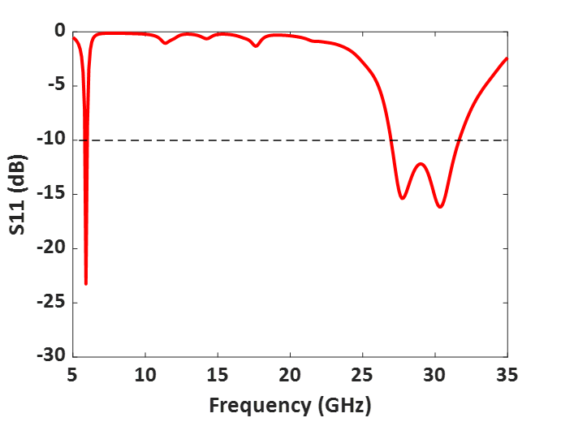
Fig. 3.7. Simulated S11(dB) of the Design II: dual-wideband antenna.
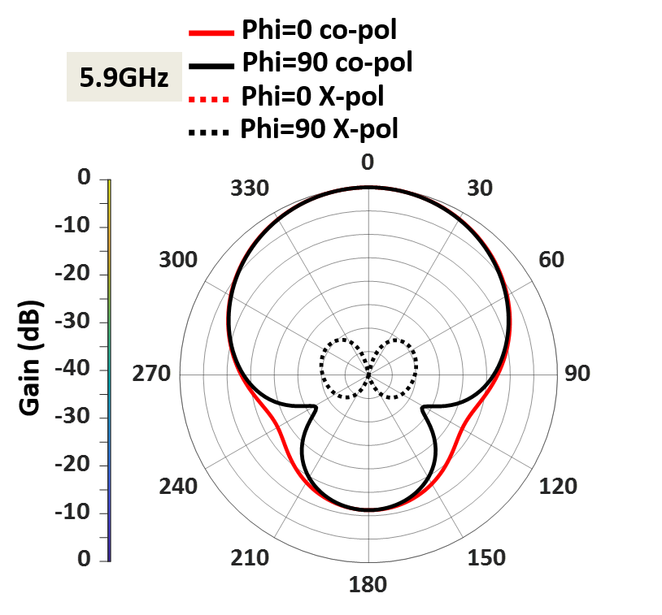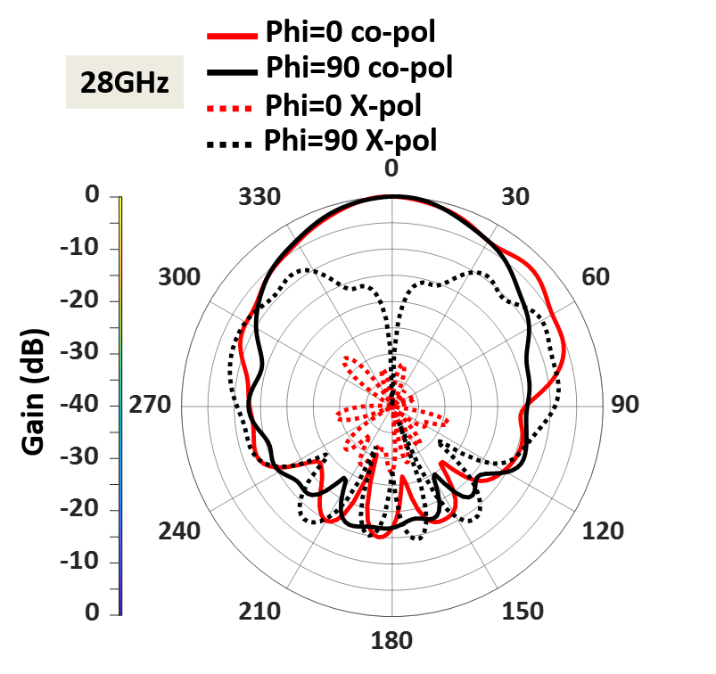
Fig. 3.8. Simulated radiation pattern of the dual-wideband antenna in both E and H planes at a) 5.9 GHz, b) 28 GHz.

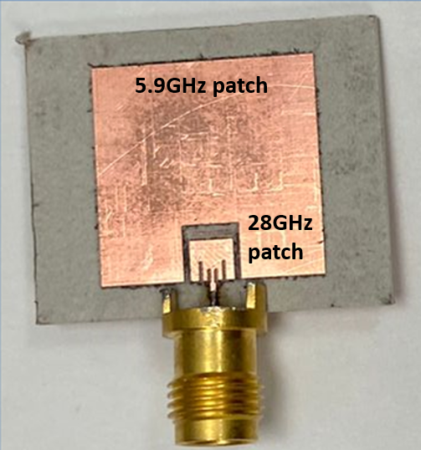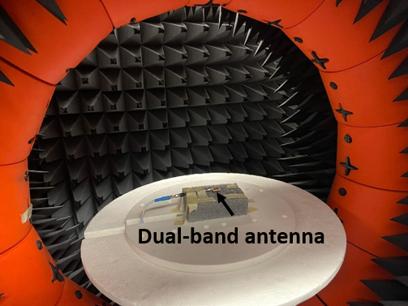
Fig. 3.9. a) Fabricated dual-band antenna b) its measurement setup.
3.2 Fabricated and Measured Dual-wideband Antenna
3.2.1 Measured Results
The designed dual-wideband antenna (design II) was fabricated and measured. The fabricated antenna prototype is shown in Fig. 3.9 (a), and its measurement setup is shown in Fig. 3.9 (b). The fabricated antenna was measured using a 2.4mm end launch connector. The input reflection coefficient of the dual-band antenna was measured using a vector network analyzer, and its radiation patterns and gains were measured using an anechoic chamber.
Fig. 3.10 illustrates the measured S11(dB) of the 50 Ω impedance matched dual-wideband antenna. Clearly, the measured S11 agrees well with the simulated one. Moreover, the fabricated antenna provides -10 dB impedance bandwidth from 5.8 to 6.05 GHz, covering the DSRC band, and 26.8 to 31.3 GHz, covering the 5G mm-wave band. Overall, the dual-band antenna provides a bandwidth of 250 MHz at the lower frequency band and a wide bandwidth of 4.5 GHz bandwidth at the mm-wave band.
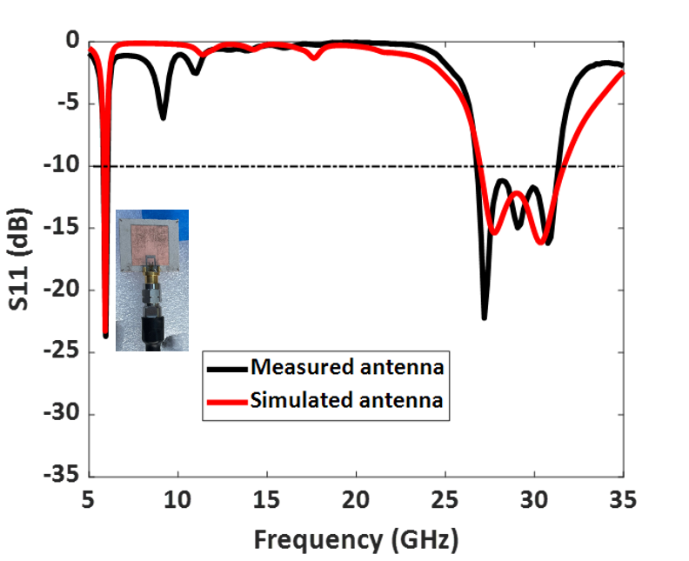
Fig. 3.10. Measured and simulated S11 (dB) of the fabricated dual-wideband antenna.
Table 3.2 Measured and simulated S11 (dB) of Design II: Dual-wideband antenna
 | DSRC band | 5G mm-wave band
Simulated frequency (GHz) | 5.81-5.99 GHz | 26.9-31.3 GHz
Measured frequency (GHz) | 5.8- 6 GHz | 26.8-31.6 GHz
The measured radiation pattern of the dual-wideband antenna at 5.9 GHz is presented in Fig. 3.11. The simulated and measured radiation patterns at 5.9 GHz agree well in both the E plane (Ф=0) and the H plane (Ф=90). Similarly, the fabricated dual-band antenna provides low cross-polarization levels at 5.9 GHz in both the E and H planes. The antenna offers a measured HPBW of 92⁰ in the E plane and 102⁰ in the H plane. A measured
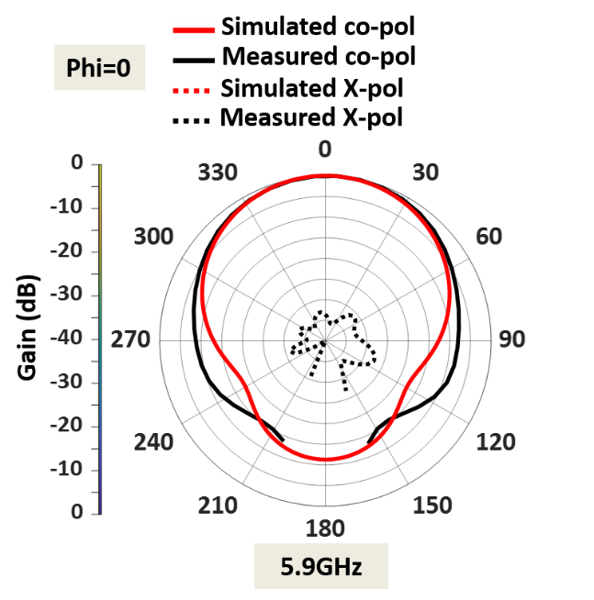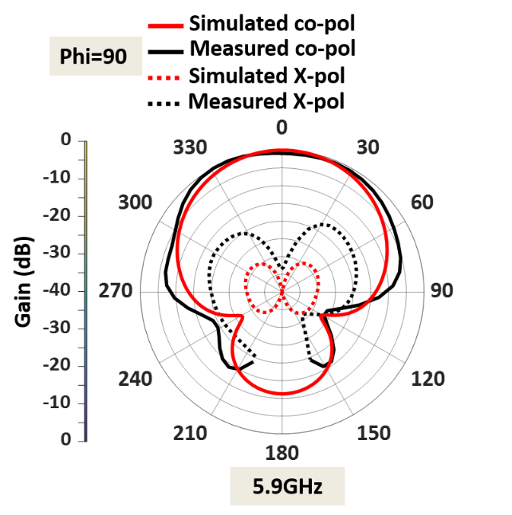
Fig. 3.11. Normalized measured and simulated radiation patterns at lower frequency band 5.9 GHz in the a) E plane, b) H plane.

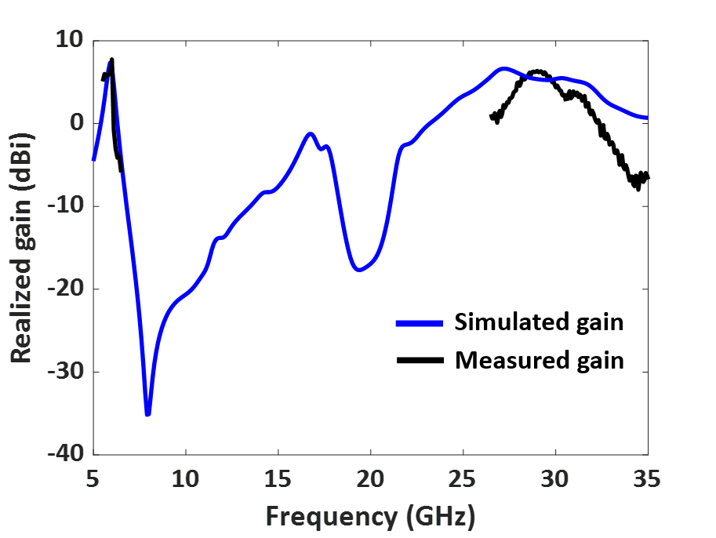
Fig. 3.12. Measured and simulated gain (dBi) vs frequency of the designed dual-band antenna.
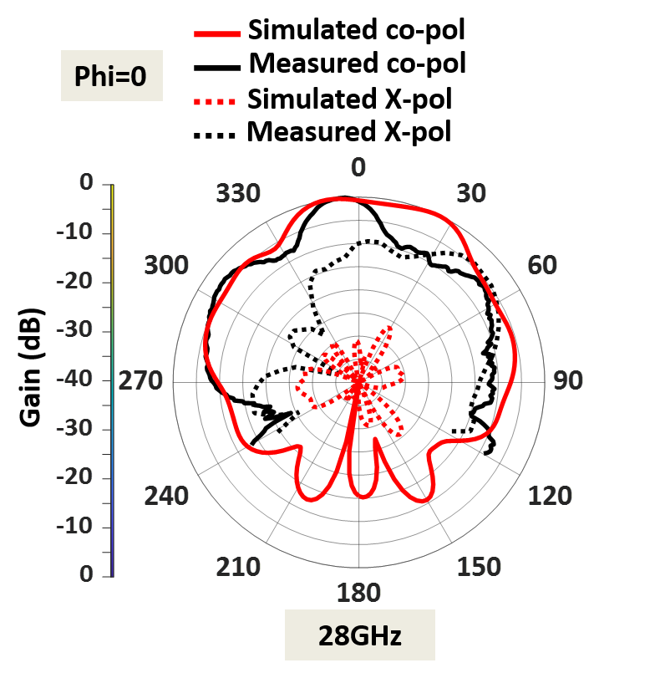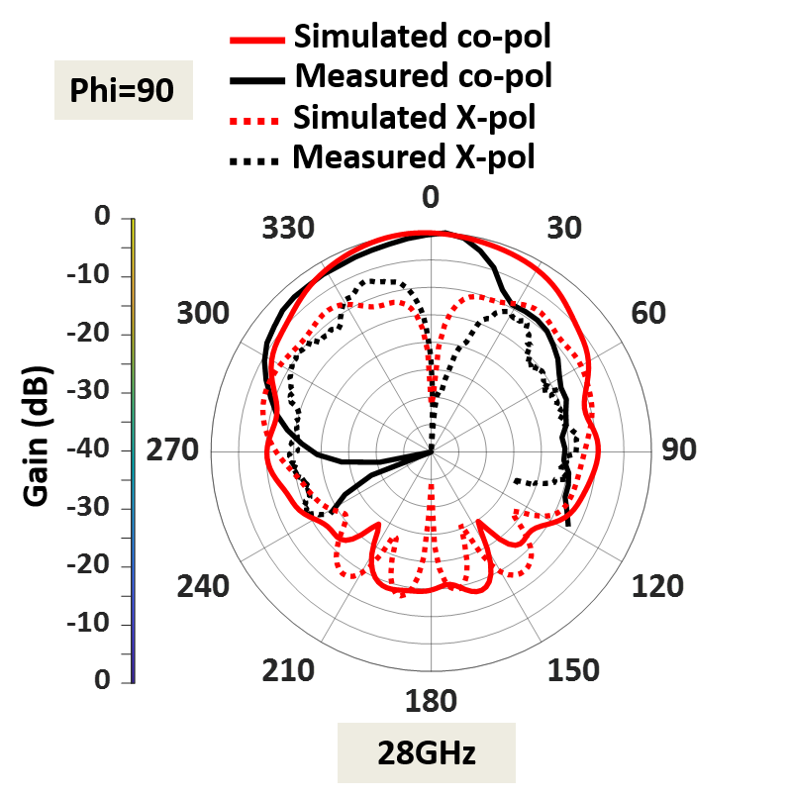
Fig. 3.13. Normalized measured and simulated radiation patterns at upper band 28 GHz a) E plane, b) H plane.

peak high gain of 7.7 dBi is observed in the lower frequency band, as shown in Fig. 3.12. The antenna has a directional radiation pattern in both frequency bands.
The measured radiation pattern of the fabricated antenna at 28 GHz is displayed in Fig. 3.13. The slight discrepancies between the measured and simulated pattern were due to fabrication errors and the presence of the connector for the mm-wave frequency. Fig. 3.13 also shows that the dual-band antenna at 28 GHz provides an HPBW of 22⁰ in the E plane and 63⁰ in the H plane.
A measured peak gain of 6.38 dBi is observed in the upper-frequency band, as displayed in Fig. 3.12. At 28 GHz, the cross-polarization levels in both the E and H planes were at acceptable levels. The cross-polarization at the upper band can be further reduced by adding DGS.

3.2.2 Comparison with Other Dual-Band Antennas
Table 3.3: Comparison among various dual-band antennas with large frequency ratio.
 | Center frequency (GHz) | Frequency ratio | Operating bandwidth | Dimensions | Peak gain (dBi) | No. of ports | Harmonics rejection
[31] | 5.9/28 | 4.74 | 47.1%/6.67% | 0.65$λ_{l}$×0.43$λ_{l}$×0.12 $λ_{l}$ | 5.8/8.46 | 2 | No
[32] | 2.4/5.5 /28 | 11.6 | 15.4%/22.2%/11.4% | 0.36$λ_{l}$×0.32$λ_{l}$×0.004$λ_{l}$ | 1.95/3.76/ 7.35 * | 1 | Yes
[35] | 2.4/28 | 11.6 | 2.6:1/8.9% | - | 2.6/6.5 | 1 | No
[19] | 2.45/60 | 24.4 | ~2.5:1/11.6% | 0.28$λ_{l}$×0.38$λ_{l}$×0.002$λ_{l}$ | 3/6 | 1 | No
This work | 5.9/28 | 4.74 | 4.2%/16% | 0.43$λ_{l}$×0.51$λ_{l}$×0.025$λ_{l}$ | 7.7/6.38 | 1 | Yes
$λ_{l}$=operating wavelength at the center frequency of the lower band
* Simulated results

The implemented dual-band antenna was compared with other dual-band antennas with a large frequency ratio in Table 3.3. The antenna gain at both bands is higher compared to other published works. The antenna in [32] rejects higher-order harmonics between the two bands; however, it requires the additional design of a compact microstrip resonant cell (CMRC) low-pass filter. The antennas in [32] and [19] were compact in size. However, they suffer from low gain at the lower bands and also require the additional design of a CMRC low-pass filter. The antenna in [31] provides good gain at both frequencies, but it requires a complicated multilayer design and expensive fabrication techniques. In contrast, the implemented dual-wideband antenna is simple to design and does not require a complicated feeding structure. Additionally, the designed antenna rejects higher-order harmonics between the bands, provides high gain, and is compact in size.
3.3 Summary
In this chapter, a single-layer single feed dual-wideband antenna was designed. The designed antenna consists of an inset-fed 28 GHz patch embedded onto the 5.9 GHz patch to provide dual-band operation. Further, the bandwidth at the upper-frequency band was improved from 8% to 16% by adding parallel slots near the inset-feed line. The fabricated antenna operates from 5.8 to 6.05 GHz and 26.8 to 31.3 GHz, covering both DSRC and 5G mm-wave bands. The designed dual-band antenna offers
- Frequency tunability,
- Reduced harmonics between the two bands,
- Bandwidth improvement at the upper band
- High gain at both the bands
- Single-layer structure, simple design, and low-cost PCB fabrication.

CHAPTER IV
MUTUAL COUPLING SUPPRESSION USING OPEN STUB MEANDERED BANDSTOP FILTER
Antenna arrays are commonly used due to their high gain, beam scanning, and multi-beam generation capabilities. To avoid grating lobes in the radiation pattern, the center-to-center spacing of the antenna elements is maintained at < 0.5$λ_{0}$, where $λ_{0}$ is the operating wavelength. However, with this spacing, the antenna elements suffer from the high mutual coupling, crosstalks from the neighboring elements. Though the mutual coupling between the antennas can be improved by increasing the distance between the antennas, it would increase the overall size of the array. Therefore, we need a compact and simple mutual coupling reduction technique. Various mutual coupling suppression techniques have been reported using electromagnetic bandgap (EBG) [36], defected ground structures (DGS) [36-37], neutralization lines [38], fractal structures, etc.
In [36], a coupling suppression technique using EBG, DGS, and vias was proposed, and an isolation improvement of 22 dB was achieved. In [39], a wall of double-layer mushroom structure was placed between the antenna elements, and high isolation of 42 dB was attained. But the placement of the wall increases the height of the whole array resulting in a high profile. A mushroom-shaped EBG is placed between the antenna elements in [40], and an 8.8 dB coupling reduction was achieved. But, the center-to-center spacing between the elements is 0.88$λ_{0}$ Furthermore, the placement of EBG requires a larger area between the antenna elements.
Another common technique to suppress mutual coupling between compact antenna elements is by using the superstrates with decoupling structures. A near field resonator (NFR) designed on the superstrate was reported in [41], and it provides isolation of about 20 dB. However, the multi-layer design requires expensive fabrication techniques. In [42],
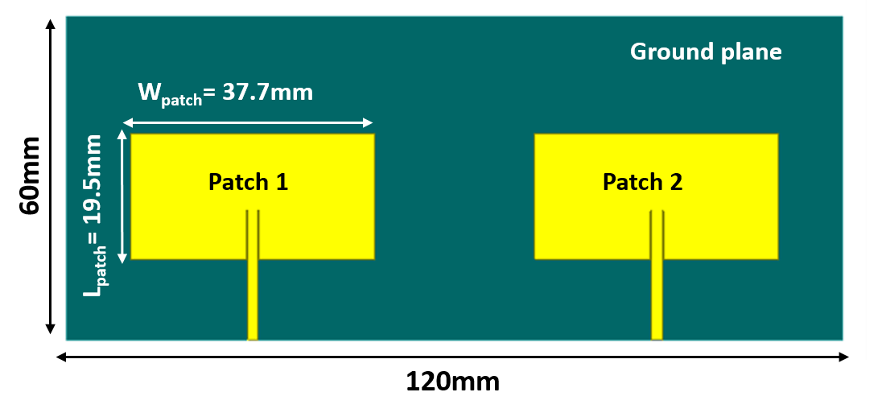
Fig. 4.1 Top view of the conventional two-element patch antenna array.

a complementary split-ring resonator (CSRR) with slots was designed to suppress the mutual coupling between the antennas. An isolation improvement of 19 dB was obtained, but the addition of CSRR results in a 1.6 dB gain reduction.
In this chapter, a simple mutual coupling suppression technique using an OSM-BSF with high isolation was implemented. An OSM-BSF with deeper rejection and wider bandwidth was designed. An antenna array with an OSM-BSF on the ground plane to suppress the electromagnetic (EM) coupling between the elements was implemented. The implemented technique provides 40 dB isolation improvement at the operating frequency of 2.42 GHz. Further, the gain values of the array remain the same even by adding the OSM-BSF on the ground plane. The designed array offers a low ECC of 0.0093 with high diversity gain of 9.99 dB.
4.1 Two-Element Antenna Array
A two-element patch antenna array without any decoupling structure operating at 2.42 GHz was designed, as shown in Fig. 4.1. A rectangular patch with an inset feed line was chosen
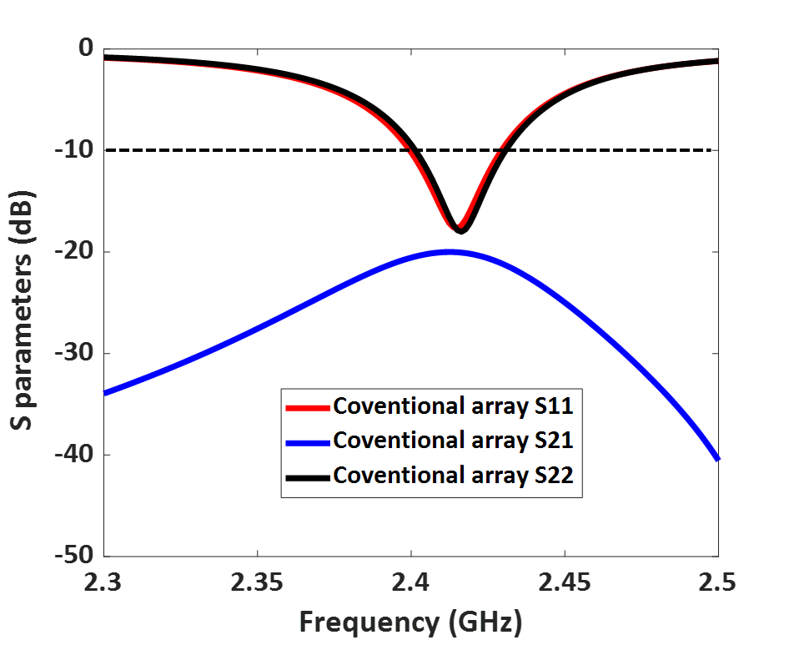
Fig. 4.2 Simulated S parameters (dB) of the conventional two-element patch array.

for the design, and it was designed on Rogers TMM 10 substrate with a thickness of 1.52mm. The length and width of the patches are 19.5 mm, and 37.7 mm, and the patches are maintained at a distance of 0.5$λ_{0}$ (center-to-center spacing). The total dimensions of the two-element patch antenna array are 120mm×60mm.
The array was simulated using Ansys HFSS software. Fig. 4.2 shows the S parameters (dB) of the conventional two-element patch antenna array. The array provides -10 dB impedance bandwidth from 2.4 GHz to 2.43 GHz. The conventional array provides isolation of almost 20 dB. However, the achieved isolation is not sufficient for multiple input multiple output (MIMO) applications; therefore, a simple decoupling structure using an OSM-BSF was used to improve the isolation.

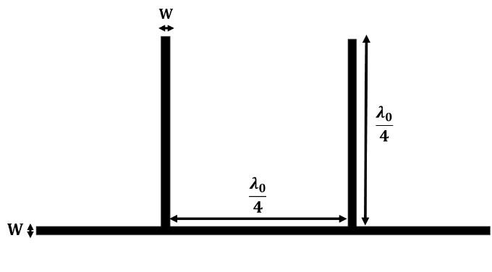
Fig. 4.3 Design of conventional open stub bandstop filter.

4.2 Design of Open Stub Meandered Bandstop Filter (OSM-BSF)
To suppress the strong electro-magnetic (EM) coupling between the antenna elements, an OSM-BSF was placed on the ground plane. The design of the OSM-BSF was discussed further. Fig. 4.3 shows the design of the conventional open stub bandstop filter. Two quarter-wavelength stubs that are placed at a distance of quarter-wavelength from each other were used to achieve bandstop characteristics [43].
A wideband characteristic can be achieved by using multiple stubs along the transmission line, but it would increase the overall size of the filter. A simpler and compact way to achieve wideband is to use meander lines in the filter. Therefore, a simple OSM-BSF was designed, as shown in Fig. 4.4. The transmission line of the filter was meandered to offer an 84% reduction in the total size of the conventional open stub filter.
To analyze the performance of the filters, the filters were designed on a TMM10 substrate with a thickness of 1.52mm, a dielectric constant $ϵ_{r}$=9.2, a dielectric loss tangent $tanδ$=0.0022. The simulated S parameters of the conventional open stub filter and OSM-
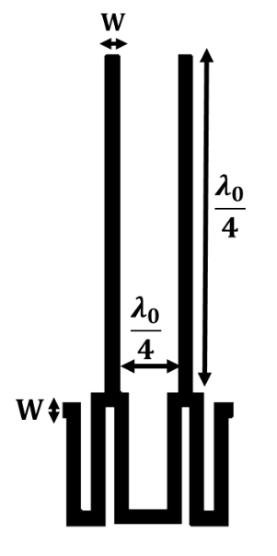
Fig 4.4 Design of OSM-BSF.
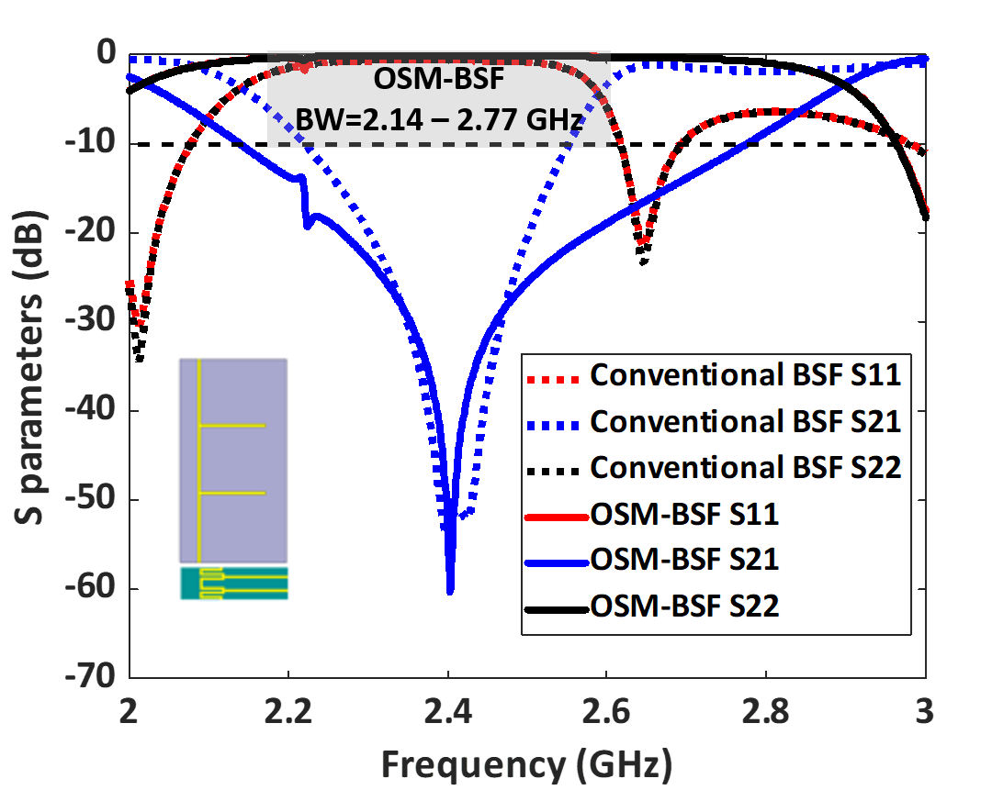
Fig. 4.5 Simulated S parameters (dB) of the conventional open stub filter and OSM-BSF.

BSF are shown in Fig. 4.5. It clearly indicates that the designed OSM-BSF filter offers wider bandwidth and deeper rejection than the conventional open stub filter. The designed 50Ω impedance matched OSM-BSF provides band rejection from 2.14 GHz to 2.77 GHz with a deeper rejection of 60 dB. Therefore, the designed OSM-BSF is compact in size, provides wider bandwidth than the conventional open stub filter.
4.2.1 Equivalent Circuit Model of the Open Stub Meandered Bandstop Filter
The equivalent circuit of the OSM-BSF was analyzed using ADS software as shown in Fig. 4.6. The open stubs can be represented as a parallel set of inductance $L_{s}$ and capacitance$C_{s}$. The resonant frequency of the open stubs can be estimated using
$$f_{c}=\frac{1}{2π\sqrt{L_{s}C_{s}}}$$
In [44], the meandered lines are represented as a transmission line with inductance $L_{tx}$ and capacitance $C_{tx}$. The equivalent circuit design of the OSM-BSF was simulated and optimized. Fig. 4.7 shows that equivalent circuit results show good agreement with the EM model. The estimated values of the components are shown in Table 4.1.
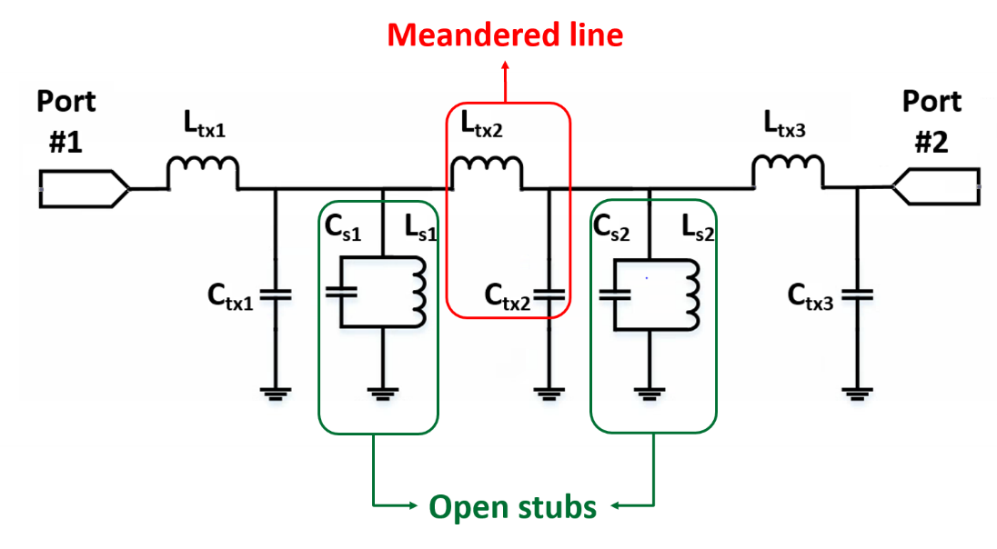
Fig. 4.6 Equivalent circuit model of the designed OSM-BSF.
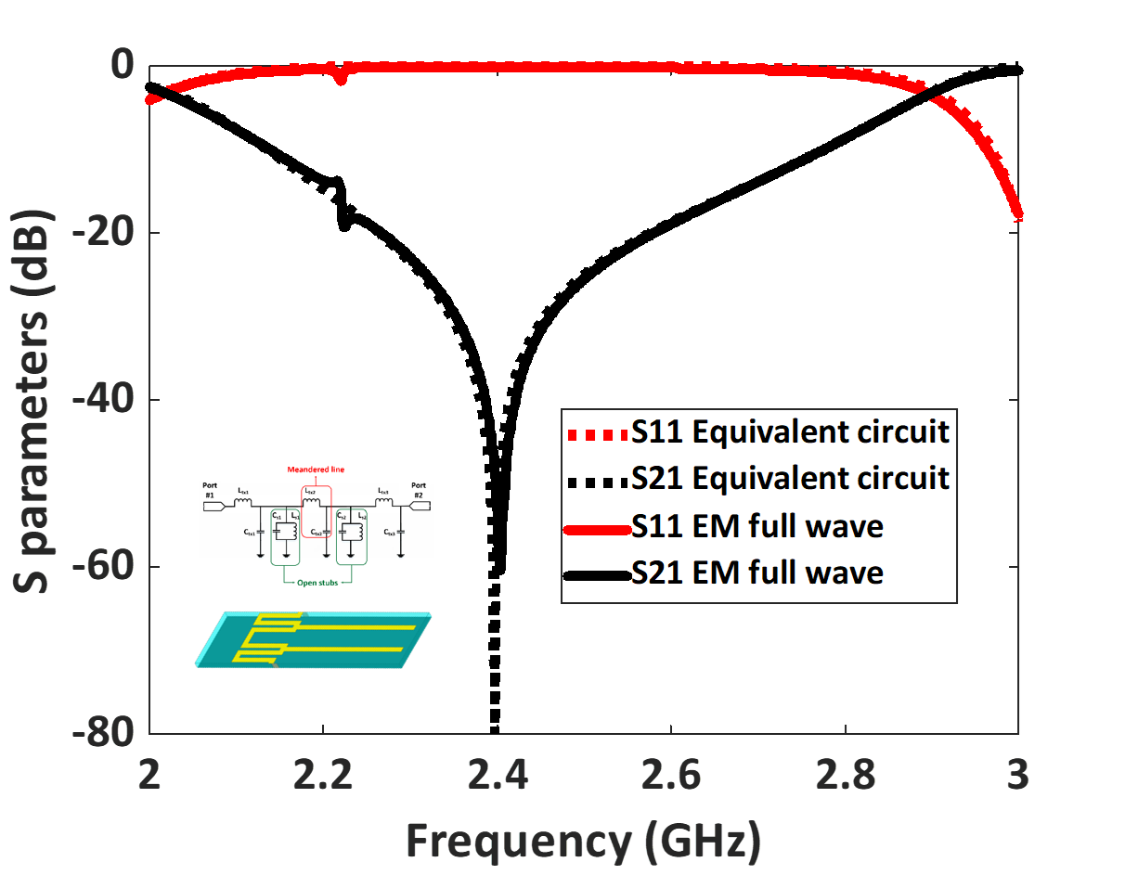
Fig. 4.7 Simulated S parameters (dB) of the OSM-BSF using full-wave and equivalent circuit model.
Table 4.1. Equivalent circuit values of the OSM-BSF
$$L_{tx1}$$ | 3.9 nH | $$C_{tx2}$$ | 25.5 pF
$$C_{tx1}$$ | 3 pF | $$L_{s2}$$ | 0.25 nH
$$L_{s1}$$ | 5.8 nH | $$C_{s2}$$ | 100 pF
$$C_{s1}$$ | 0.76 pF | $$L_{tx3}$$ | 0.6 nH
$$L_{tx2}$$ | 2.1 nH | $$C_{tx3}$$ | 6.5 pF

4.2.2 Transmission Line with OSM-BSF on the Ground Plane
To analyze the effect of the designed OSM-BSF on the ground plane, a transmission line with OSM-BSF was simulated. First, a 50Ω impedance-matched transmission line operating at 2.4 GHz was designed.
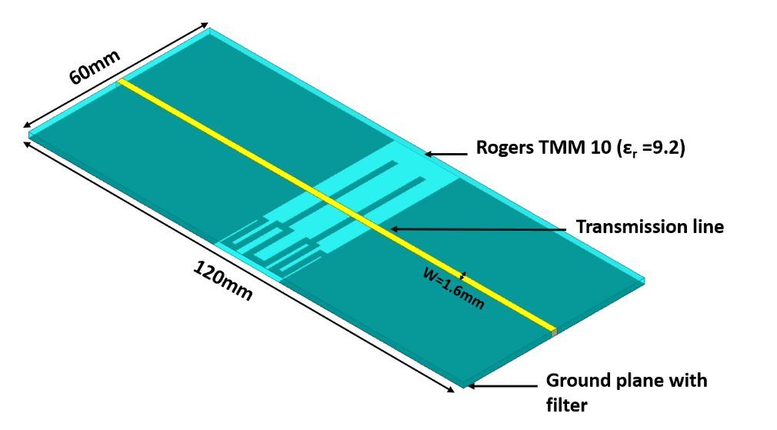
Fig. 4.8. Design of 50Ω transmission line with OSM-BSF on the ground plane.
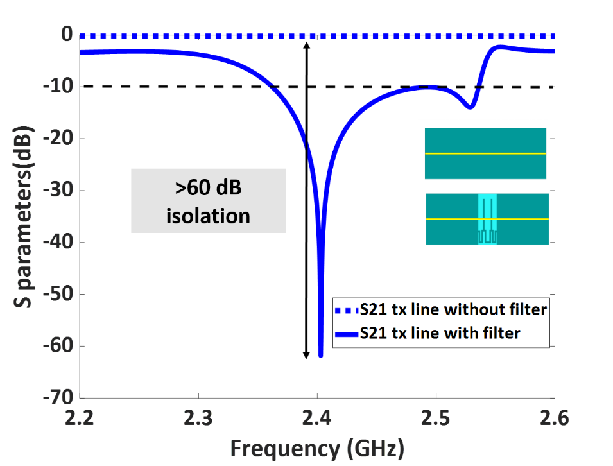
Fig. 4.9. Simulated isolation S21 (dB) of the transmission line with and without OSM bandstop filter.

Next, the designed OSM bandstop filter was placed on the ground plane by removing the center part of the ground plane, as shown in Fig. 4.8.
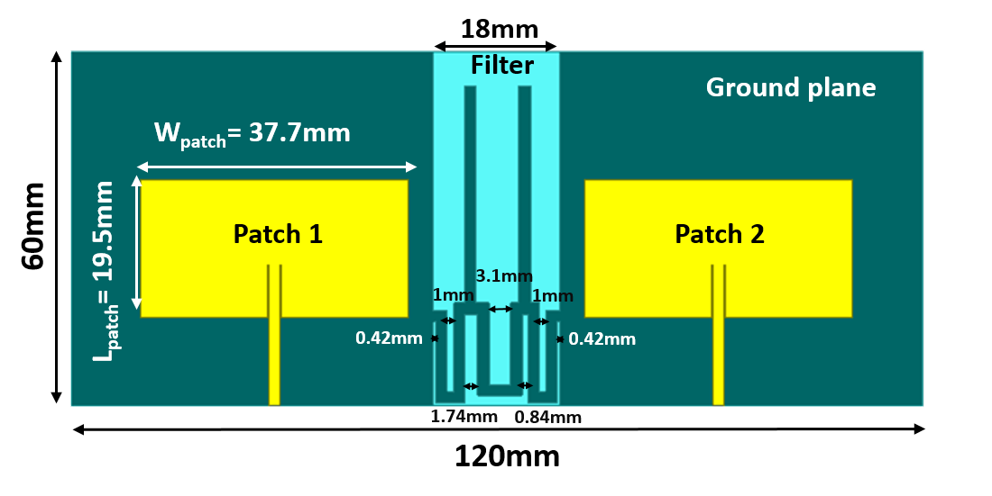
Fig. 4.10 Configuration of the antenna array with OSM-BSF in the ground plane.
The transmission line with and without OSM bandstop filter on the ground plane was simulated and analyzed. Fig. 4.9 clearly indicates that the addition of the filter in the ground plane provides >60 dB isolation between the two ports. Therefore, the addition of OSM-BSF on the ground plane offers high port-to-port isolation.
4.3 Mutual Coupling Reduction in Antenna Arrays
4.3.1 Design of the Antenna Array with OSM-BSF on the Ground Plane
Fig. 4.10 shows the configuration of a two-element antenna array with an OSM-BSF on the ground plane. The designed OSM-BSF operating at 2.42 GHz was added to the ground plane of the two-element antenna array that was designed in section 4.1.
At first, a cut of about 18mm was made on the ground plane, and then the designed OSM-BSF was added to it. The designed filter acts as a barrier between the antenna elements and restricts the current flow between them. Fig. 4.11 shows the simulated S parameters of the antenna array with and without a bandstop filter on the ground plane. It shows that the addition of OSM-BSF on the ground plane provides an isolation improvement of almost 40 dB.
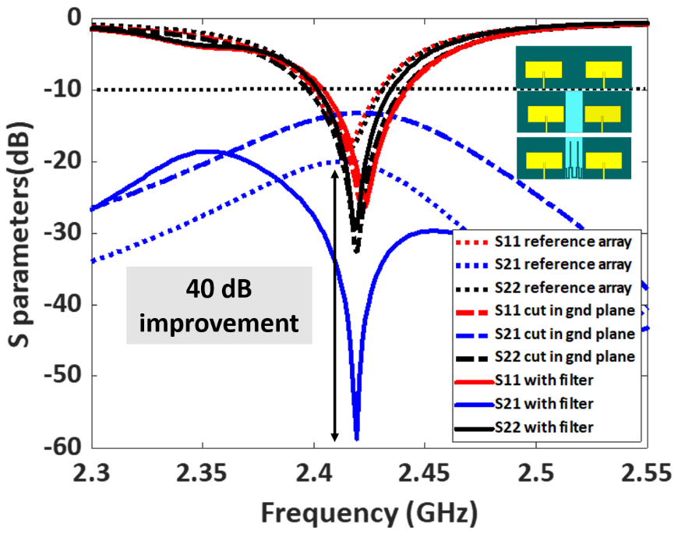
Fig. 4.11 Simulated S parameters of the antenna array with and without OSM-BSF.
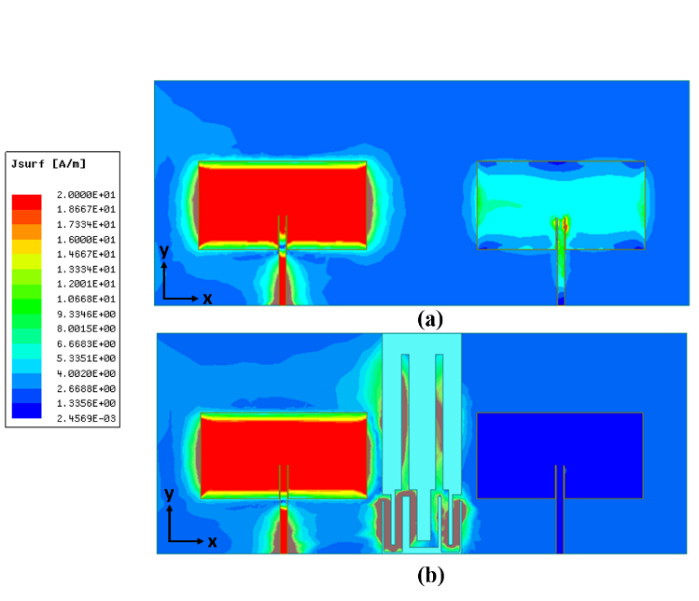
Fig. 4.12 Surface current distribution of the two-element antenna array a) without OSM bandstop filter b)with OSM bandstop filter.
.
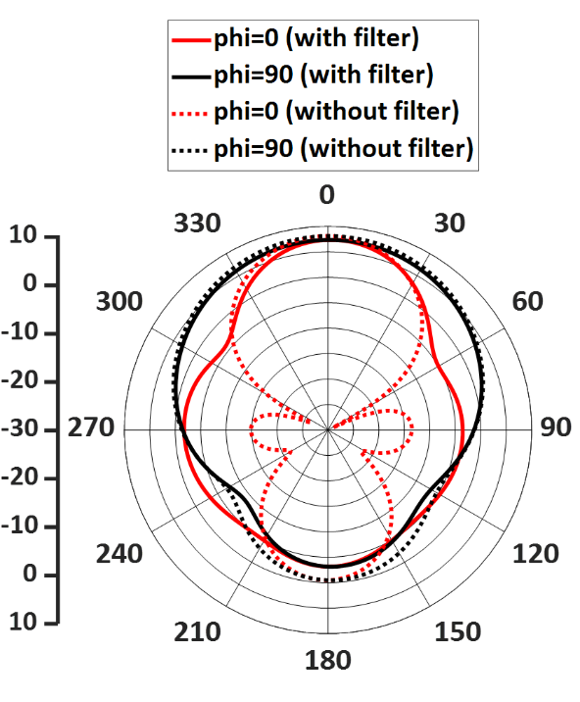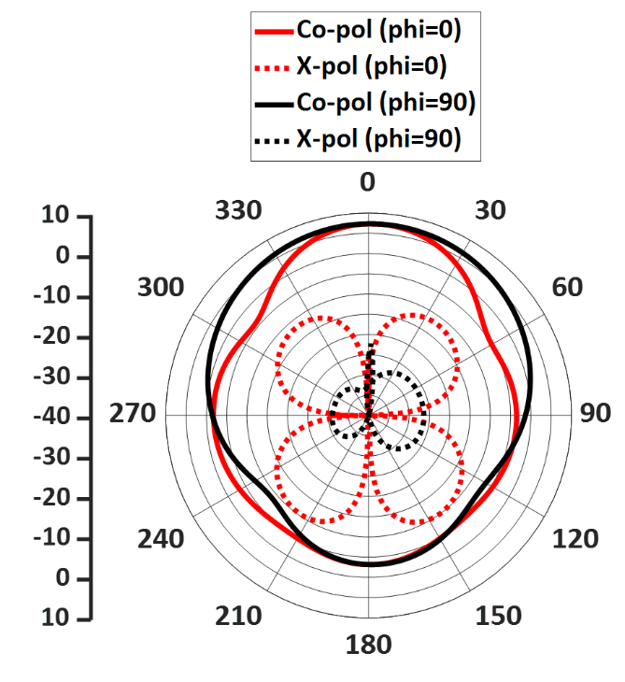
Fig. 4.13 a) simulated radiation pattern of the array with and without OSM-BSF b) Co-pol and X-pol of the array with OSM-BSF.

To investigate further, surface current distribution on the antenna array with and without OSM-BSF was analyzed. To analyze the coupling between the antenna elements, antenna 1 was excited, and antenna 2 was terminated with a 50 Ω matched load. Fig. 4.12 (a) illustrates that the terminated antenna is strongly coupled to the excited antenna without any decoupling structure. Fig. 4.12 (b) clearly shows that by placing the OSM bandstop filter on the ground plane, it prevents the flow of current to the terminated antenna. Therefore, the designed OSM-BSF provides high isolation between the antenna elements.
The radiation pattern of the implemented antenna array with and without OSM-BSF is shown in Fig. 4.13 (a). The addition of a filter to the ground plane doesn’t affect the peak gain of the array in both the E and H plane. The radiation pattern of the array with OSM-BSF remain same in the E plane, but there was a slight variation in the H plane. The side lobes at +90⁰ are due to the cut in the ground plane, and these side lobes can be
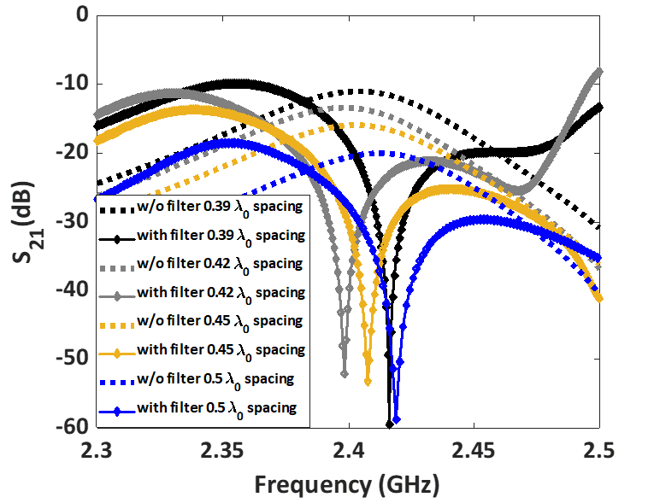
Fig. 4.14 S21 (dB) of the antenna array with different center-to-center spacing.
prevented by combining the gap between the two ground planes. Fig. 4.13 (b) depicts that the array provides low cross-polarization levels in both the E and H planes.
4.3.2 Parametric Analysis on Element Spacing
A parametric study was carried out to analyze the effect of OSM-BSF on the element-to-element spacing. By changing the center-to-center spacing of the array from 0.39$λ_{0}$ to 0.5$λ_{0}$, the isolation between the antennas was analyzed. It is clear from Fig. 4.14, that the designed coupling suppression technique provides isolation of >40 dB, irrespective of the antenna element spacing. High isolation of 48 dB was achieved when the spacing was maintained at 0.39$λ_{0}$. This implies that the designed technique can be applied to the closely spaced antennas with a minimum edge-to-edge spacing of 0.089$λ_{0}$.

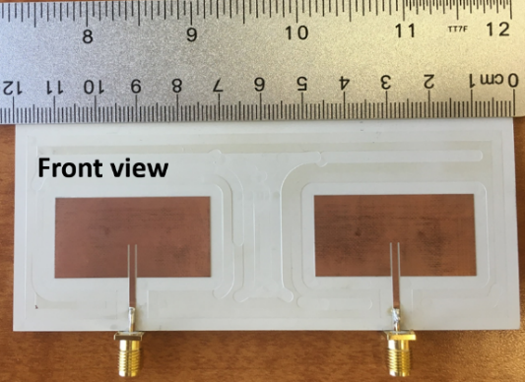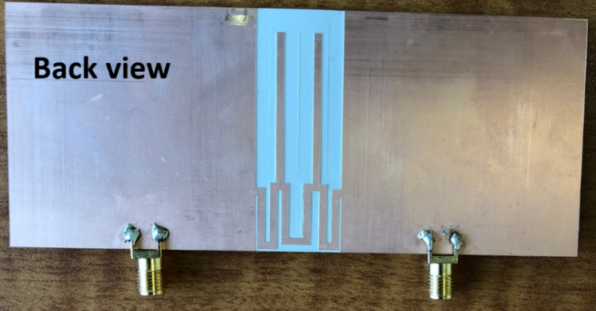
Fig. 4.15 Fabricated two-element antenna array a) top view b) bottom view.
4.4 Measurement Results and Discussion
4.4.1 Measurement Results
To validate the designed mutual coupling suppression technique, an antenna array with OSM-BSF was fabricated and measured. Fig. 4.15 shows the top view and the bottom view of the fabricated antenna array with OSM-BSF. The fabricated array’s S parameters were measured using a 2-port VNA.
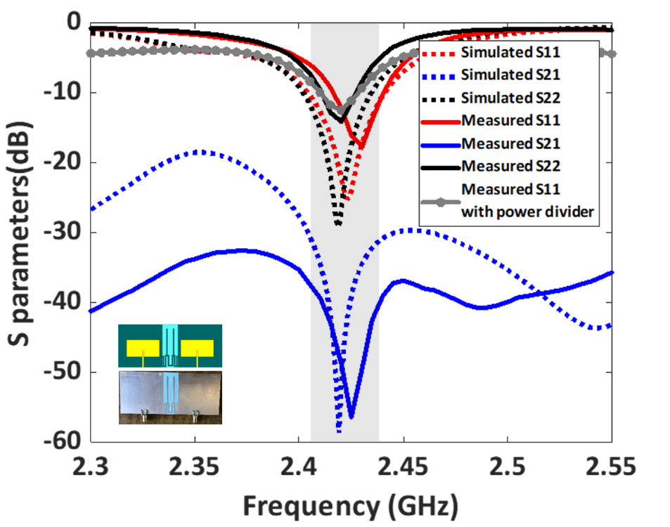
Fig. 4.16 Measured S parameters (dB) of the antenna array with OSM-BSF.

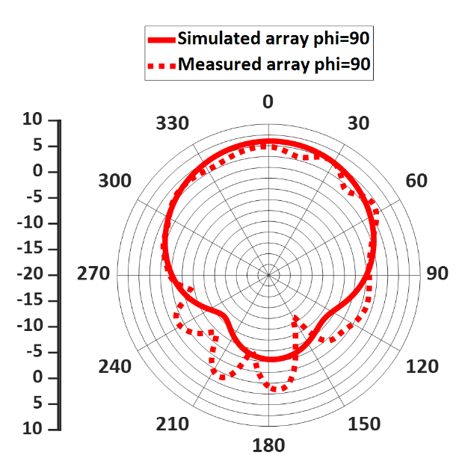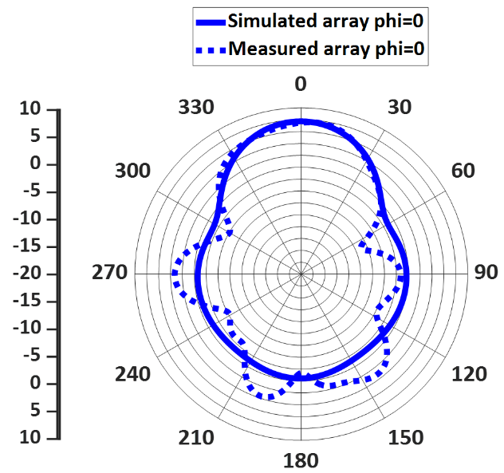
Fig. 4.17 Measured radiation pattern at 2.42 GHz a) E plane b) H plane.
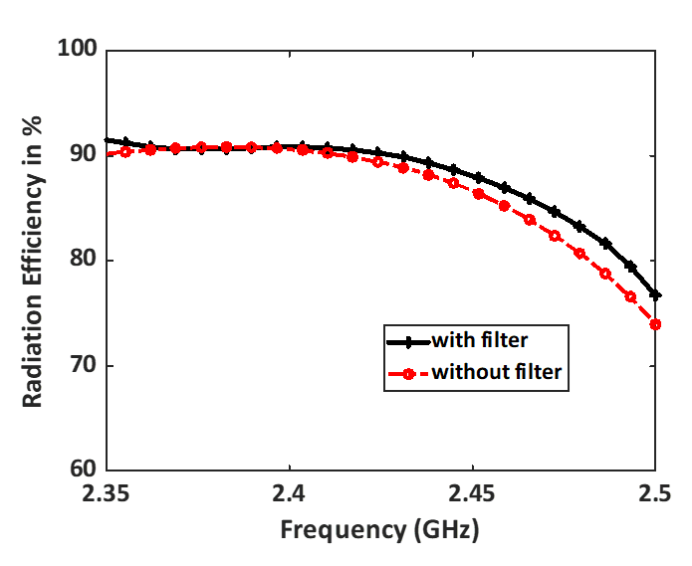
Fig. 4.18 Simulated radiation efficiency of the array with and without OSM-BSF.
Fig. 4.16 depicts that the fabricated prototype operates from 2.4-2.43 GHz with -10 dB impedance bandwidth. The measured S21 (dB) of the fabricated array was >57 dB at the operating frequency. Therefore, the implemented mutual coupling suppression technique offers a measured isolation enhancement of >37 dB.
The radiation pattern of the array was measured by connecting the two ports of the array using a power divider. The radiation pattern at 2.42 GHz of the fabricated array is shown in Fig. 4.17. It shows that the measured pattern agrees well with the simulated pattern in both E and H planes. The fabricated array provides a gain of 6.95 dBi at 2.42 GHz. The implemented array provides a radiation efficiency of >90% in their operating bandwidth as shown in Fig. 4.18.
4.4.2 Envelope Correlation Coefficient
ECC is one of the important parameters that determine the correlation between the antenna elements. For efficient MIMO communication, the ECC should be as low as possible. The ECC $ρ_{ij}$ can be computed using the far-field pattern of the antenna elements [45]
$$ρ_{ij}=\frac{{\left|\int{\int{F_{i}\left(θ,ϕ\right)*F_{j}\left(θ,ϕ\right) dΩ}}\right|}^{2}}{\int{\int{{\left|F_{i}\left(θ,ϕ\right)\right|}^{2}dΩ}} \int{\int{{\left|F_{j}\left(θ,ϕ\right)\right|}^{2}dΩ}}}$$
Where $F_{i}\left(θ,ϕ\right)$ is the complex far-field pattern of the ith element in the antenna array
$F_{j}\left(θ,ϕ\right)$ is the complex far-field pattern of the jth element in the antenna array.
Fig. 4.19 depicts the computed ECC of the two-element array with OSM-BSF based on its radiation patterns. The array provides a low ECC of 0.03 over its entire operating bandwidth and it also provides a low ECC of 0.0093 at its center frequency.
4.4.3 Diversity gain
Another important parameter to be considered to analyze the performance of the MIMO is the diversity gain (DG). The implemented antenna array provides a diversity gain of 9.99 dB.
$$DG=10\sqrt{1-ECC^{2}}$$

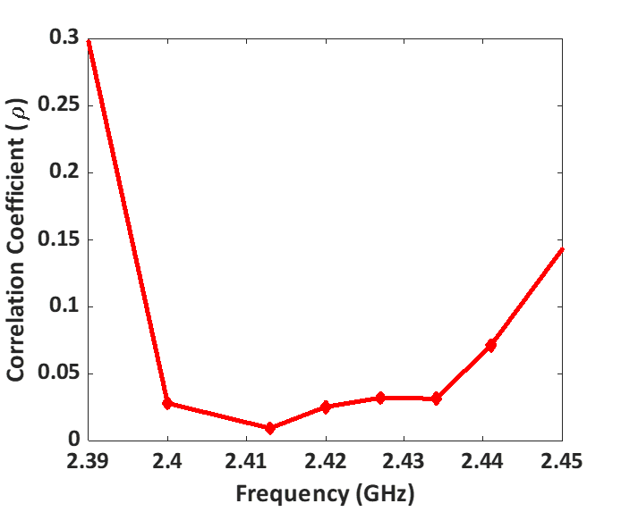
Fig. 4.19 Computed ECC of the designed antenna array with OSM-BSF.

4.5 Summary
In this chapter, a new mutual coupling technique using a simple OSM-BSF on the ground plane was implemented. The implemented technique can also be applied to the closely spaced antennas with an edge-to-edge spacing of 0.089$λ_{0}$. This technique offers a measured high isolation improvement of about 37 dB with a low ECC of 0.0093. The fabricated array is simple in design and can be fabricated using a low-cost PCB technique. The implemented technique can also be applied to different types of antennas.

CHAPTER V
LOW LOSS 60 GHz MILLIMETER-WAVE ANTENNA ARRAY FOR 3D ANTENNA-IN-PACKAGE APPLICATIONS
Since the spectrum at the lower RF band (<6 GHz) are highly congested, one of the solutions is to move towards the mm-wave bands, which offer more bandwidth with high-speed communications. The mm-wave antennas are smaller in their footprints, and it makes them an ideal candidate for the system-in-package (SiP) and system-on-chip (SoC) integration [46].
The design of on-chip antennas does not require 50Ω impedance matching; therefore, it saves cost and the number of additional components needed for impedance matching. However, most of the on-chip antennas were designed on low resistivity substrates like Silicon (Si), which affects the antenna’s gain. Further, the high dielectric constant of the Si substrate traps the radiation into the substrate, resulting in poor efficiency. Additionally, the on-chip antennas are expensive, and thereby a cost-effective approach is to integrate antennas and other RF components on the package called SiP. SiP integrates all the RF components using bond wires and flip chips, but these interconnect are lossy at higher frequencies. Recently, the 3D integrated SiP approach was gaining attention, where different ICs are stacked vertically, resulting in low loss integration approach [47]. This technique replaces lossy bond wires using Through Silicon Via (TSV) structures for vertical 3D integration and provides high efficiency with significant size reduction than the traditional 2D SiP.
An efficient 3D SiP integration requires a low profile and high-efficiency mm-wave antennas. There are a few challenges in implementing multilayer mm-wave antennas, such as expensive fabrication processes, the requirement of precise fabrication techniques due to their smaller footprints, and further inaccuracies in the fabrication would result in higher losses. Commonly, multilayer mm-wave antennas are fabricated using a low-temperature cofired ceramic (LTCC) process [48-50]. However, the LTCC fabrication technique is expensive and requires a high process temperature [51].
A low-cost, simple fabrication technique is the PCB fabrication technique. In [51], a PCB-based aperture coupled differential phased array was reported. Generally, the aperture coupled antennas suffer from low front-to-back ratios due to the back radiation from the coupling slots. Therefore, the design requires an extra substrate layer to accommodate a reflector to increase the front-to-back ratio of the radiation pattern. Thus resulting in a thicker substrate, and additionally, the design requires blind vias for the integration. In [52], a multilayer phased array with an air cavity was fabricated using an organic package method. Though the air cavity provides certain benefits, it poses particular risks when working at a higher temperature, such as delamination during soldering and bonding.
We present a simple via-coupled PCB antenna array with high efficiency and low loss for 3D AiP applications, as shown in Fig. 5.1. The design consists of a 60 GHz 4-element differential-fed antenna array integrated with a Si interposer using BGAs and Through-hole vias. This integration technique provides low loss, and as a proof of concept, the designed four-element array was fabricated using the multilayer PCB technique. Further, a differential to single-ended corporate feed network was incorporated into the array to measure it using a single-end launch connector. The measured prototype
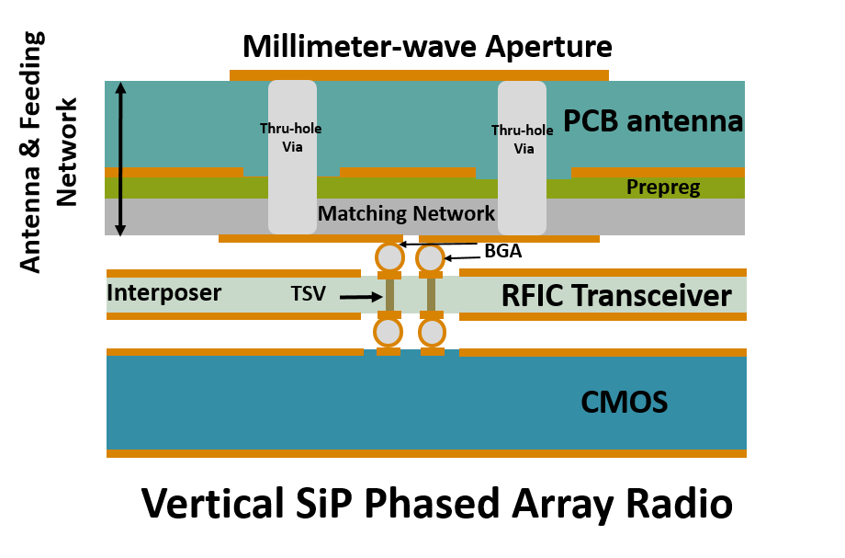
Fig. 5.1 Low loss 3D system-in-package integration.
operates from 59.3-65 GHz with a peak gain of 10.02 dBi and 90% efficiency.
This chapter is organized as follows: In Section 5.1, the design of the 60 GHz multilayer antenna array and its impedance matching technique is explained along with its simulated results. The fabricated prototype with differential to a single-ended corporate network and its measurement results are detailed in Section 5.2. At last, Section 5.3 concludes the chapter.
5.1 Low loss 3D Antenna-in-Package AiP Approach
The proposed low loss 3D SiP radio is shown in Fig. 5.1. The design architecture consists of a multilayer PCB mm-wave antenna array integrated into the Si interposer using BGAs and through-hole vias. The mm-wave antenna array comprises a patch antenna with a ground plane on substrate 1 (layer 1), prepreg layer for interconnection (layer 2), and the matching feed network for excitation on substrate 2 (layer 3). The patch antennas are excited using through-hole vias from the matching feed network on layer 3.
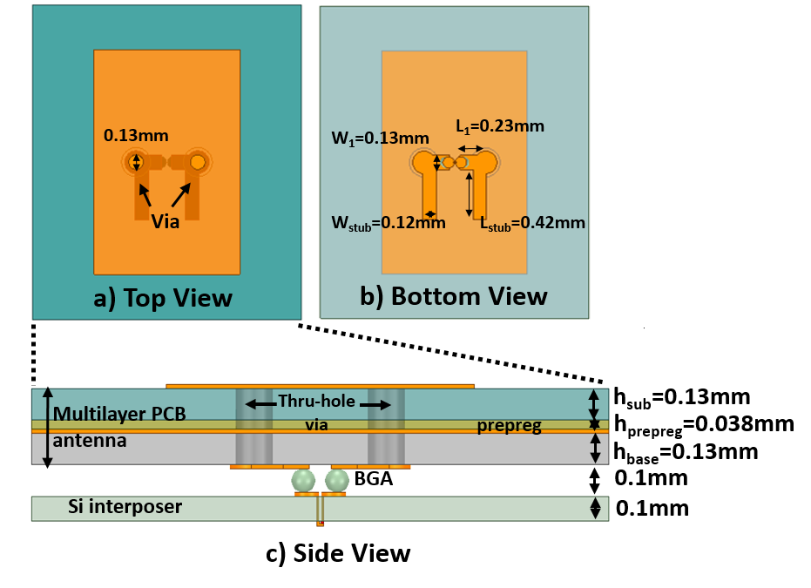
Fig. 5.2. Fully integrated 60 GHz infinite array’s unit cell a) top view b) bottom view c) side view.

5.1.1 Design of the Multilayer Array Stackup
The fully integrated antenna array’s unit cell design is shown in Fig. 5.2. The designed unit cell consists of a differentially fed patch antenna with $L_{patch}$=1.28 mm, $W_{patch}$=2 mm, and it was designed on upper Isola Tachyon substrate with a thickness of 0.13 mm, dielectric constant ($ϵ_{r}$=3.02) and loss tangent $tanδ$=0.0021. The total dimensions of the unit cell were 9.6mm×2.8mm×0.568mm (L×W×h). A 50Ω feed line was designed on the lower Isola Tachyon substrate with a thickness of 0.13 mm. A prepreg material of the same dielectric pressurized with thickness 0.038 mm was used as a bonding material between the upper and lower substrates.
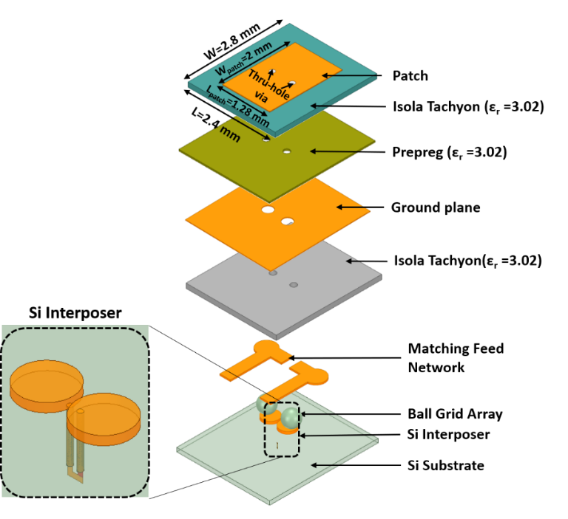
Fig. 5.3 3D view of the multilayer infinite array’s unit cell.
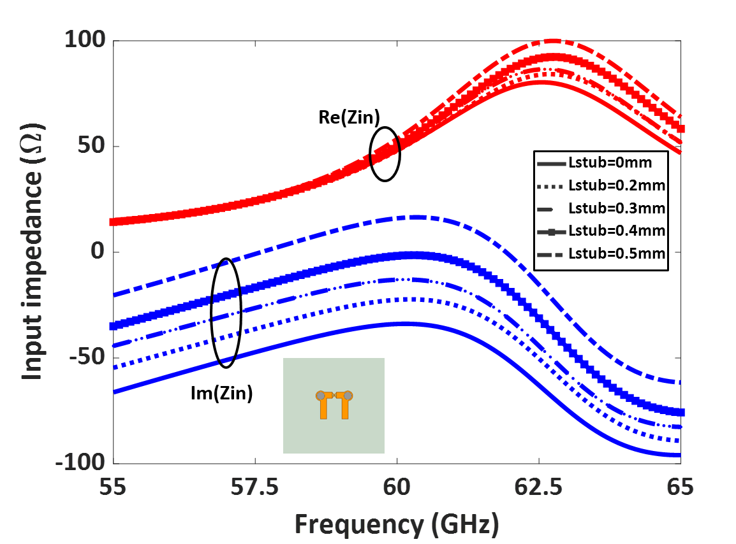
Fig. 5.4 Simulated input impedance of the unit cell by varying the length of the stubs.

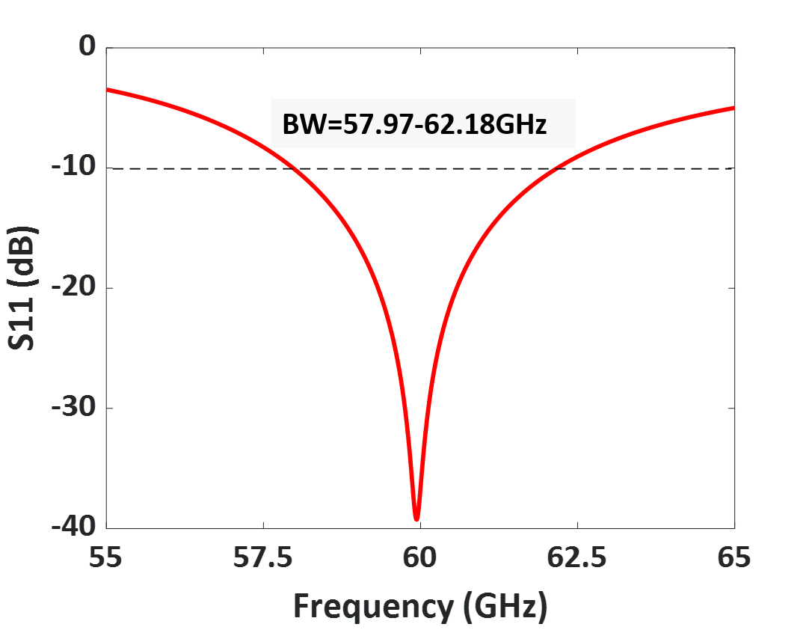
Fig.5.5. Simulated S11 (dB) of the designed infinite array’s unit cell.
The antenna was excited by the feed network using through-hole vias. A matching feed network was designed by adding open stubs on both sides, as shown in Fig. 5.3. An open stub with a length of 0.42 mm and a width of 0.12 mm was designed to compensate for the additional capacitance added by the multilayer configuration. A 50Ω input impedance matching was achieved by optimizing the length of the stub $L_{stub}$, shown in Fig. 5.4. The antenna was designed separately and can be integrated with the Si interposer using BGAs. For analysis, BGAs of diameter 0.1 mm was used.
5.1.2 Simulated Results
The designed unit cell of the infinite array was simulated using Ansys HFSS software. Fig.5.5 shows that the designed unit cell operates from 57.97 to 62.18 GHz with a bandwidth of 4.4 GHz. The designed multilayer unit cell’s gain was compared to the traditional patch antenna without BGA and Si interposer. The addition of BGA and Si
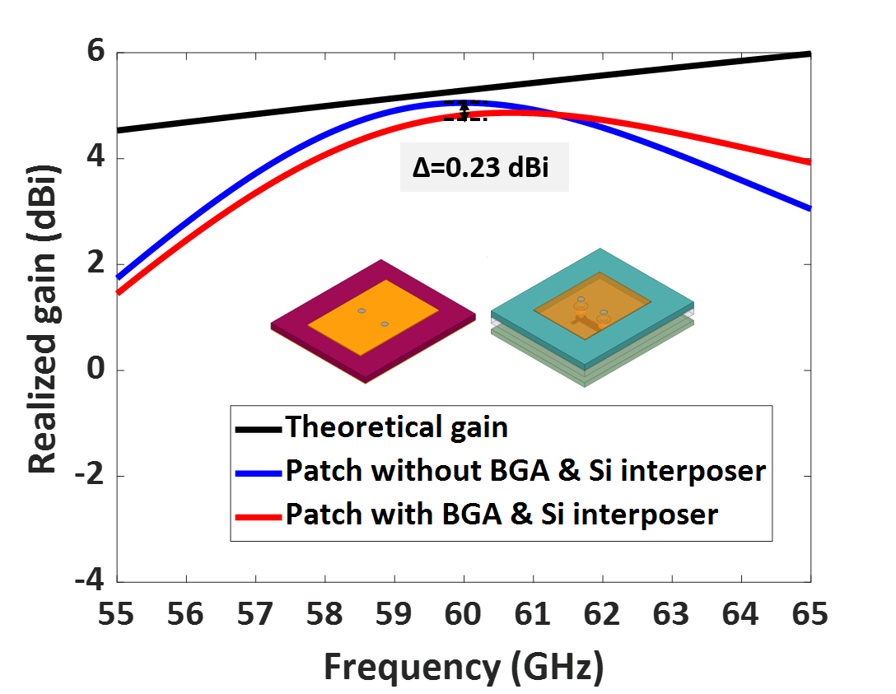
Fig.5.6 Comparision between the gain of the patch with and without BGA, Si interposer.
interposer results in just 0.23 dBi reduction in gain, as shown in Fig.5.6. The theoretical gain of the patch was estimated using the formula
$$G=\frac{4πA_{e}}{λ^{2}}$$
Where $λ$ is the operating wavelength and
$A_{e}$ is the effective aperture of the unit cell.
5.1.3 Design of 1×4 Finite Patch Array
Next, a linear patch array with four differentially fed patch antenna elements was simulated, as shown in Fig.5.7. The array consists of four patches excited differentially using through-hole vias and feed structures with open stubs. Fig.5.7 (c) represents that each antenna element is interconnected to the Si interposers using BGAs. The elements were placed at a distance of 0.48$λ$ from each other. The length and width of the open stubs are
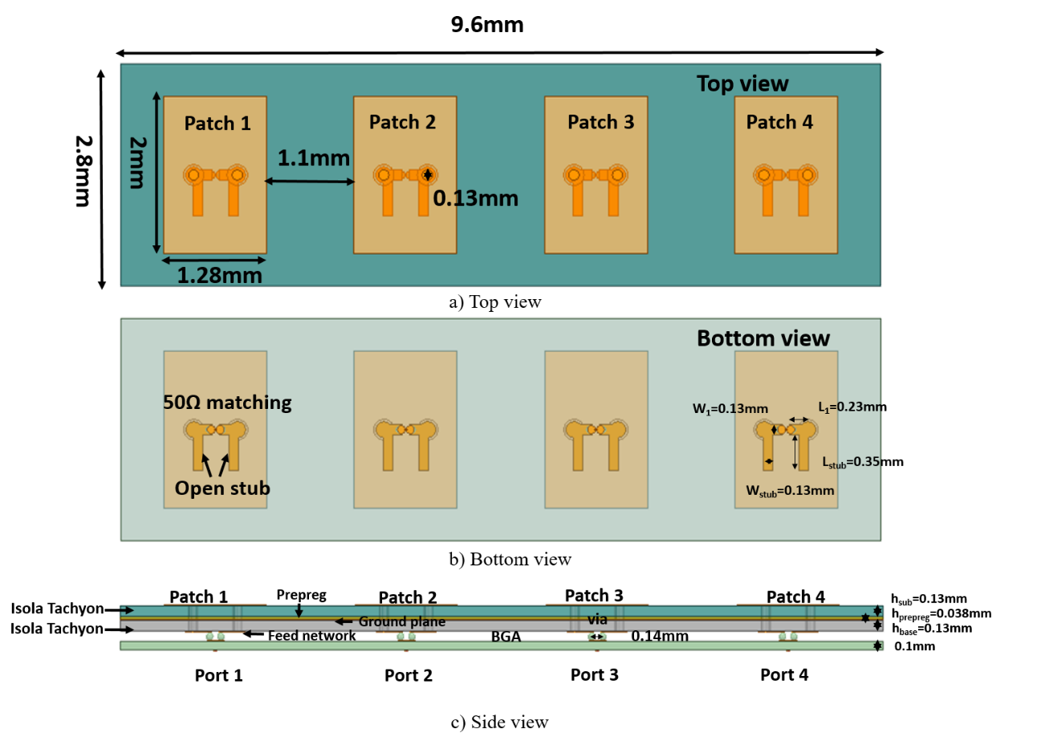
Fig.5.7. Simulated 1×4 patch antenna array a) top view b) bottom view c) side view.
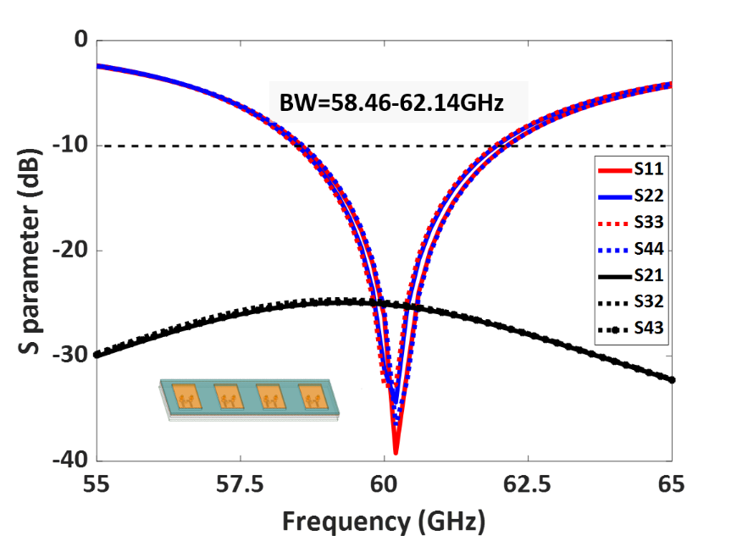
Fig. 5.8. Simulated S parameters (dB) of the designed 1×4 array.
further optimized for 50Ω impedance matching. The total dimensions of the designed 1×4 patch array are 9.6 mm×2.8 mm.
The simulated S parameters (dB) of the designed 1×4 array are shown in Fig. 5.8. The patches operate from 58.46 GHz to 62.14 GHz with S11 <-10 dB. The elements offer port-to-port isolation > 25 dB.
The scanning performance of the designed array is shown in Fig. 5.9. The antenna elements are excited by a progressive phase shift for steering the beams. The phase shift between the elements are given by
$$Δϕ=kdsinθ$$
Where $k=\frac{2π}{λ}$, d is the spacing between the elements,
$θ$is the scan angle.
The array can scan from -45⁰ to 45⁰ with a scan loss of about 2.29 dBi.
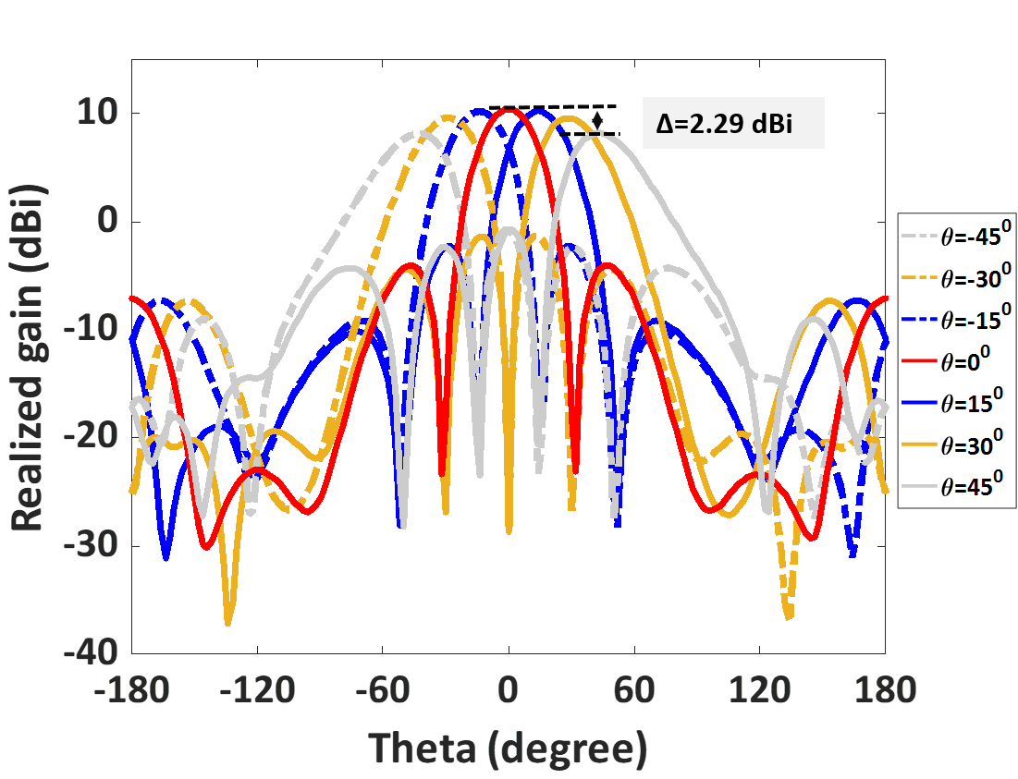
Fig. 5.9. Scanning performance of the 1×4 array.
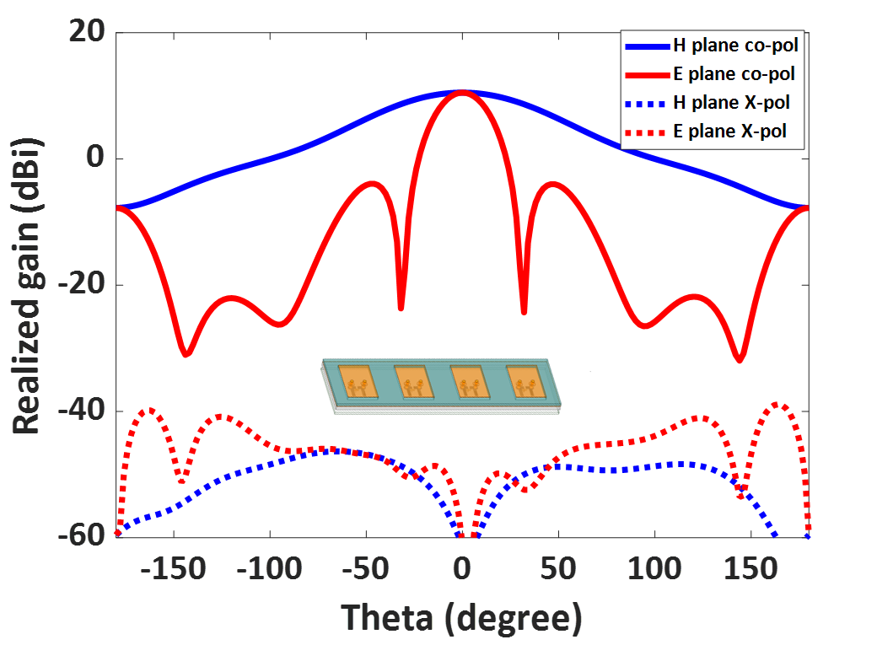
Fig. 5.10 Simulated radiation patterns of the 1×4 array.
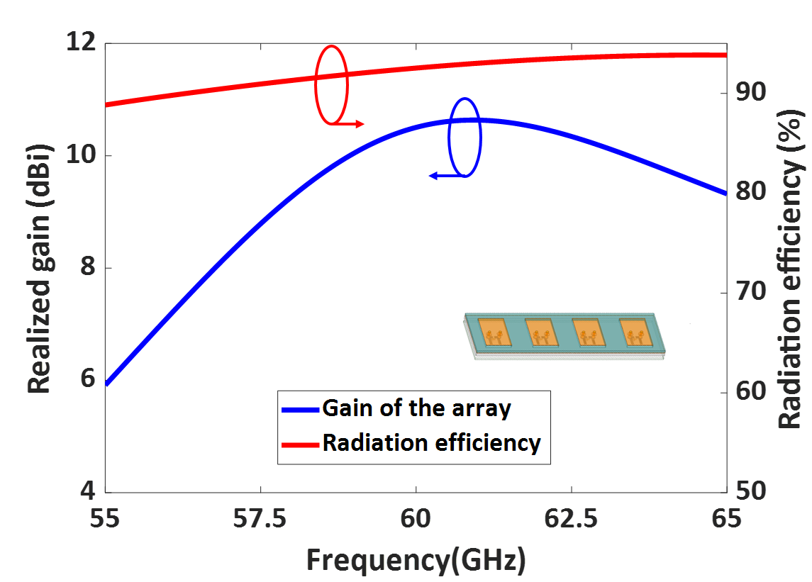
Fig. 5.11 Simulated gain vs frequency and the radiation efficiency of the 1×4 array.

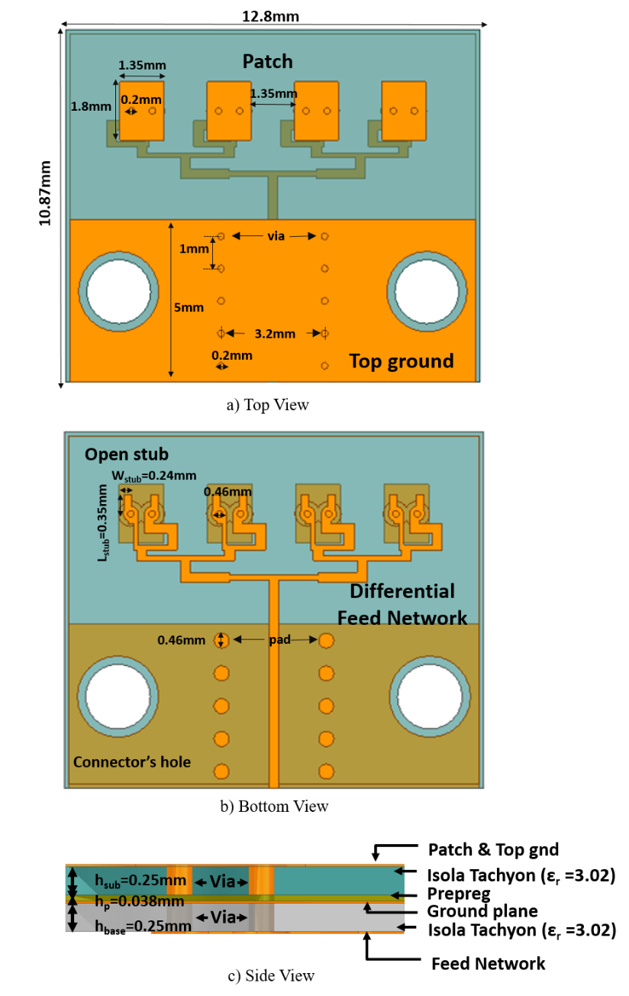
Fig. 5.12 Design of 1×4 patch antenna array with differential to single-ended corporate feed network.
The radiation pattern of the designed array is shown in Fig. 5.10. The array provides a gain of about 10.51 dBi in both the E and H plane. This array also provides low cross-polarization levels in both planes. Fig. 5.11 depicts that the array operates with >90% radiation efficiency at 60 GHz.
5.2. Fabricated Design of the 1×4 Array with Corporate Feed Network
A multilayer PCB patch array was fabricated to validate the proposed 3D Aip approach. For measurement purposes, a differential to a single-ended corporate feed network was designed. Fig. 5.12 shows the design of the multilayer 1×4 patch antenna array with a differential to a single-ended corporate feed network.
A linear patch array was designed on top Isola tachyon substrate with a thickness of 0.25 mm with the ground plane, as shown in Fig. 5.12 (a). Four patches with width 1.35 mm and length 1.8 mm were designed as shown below. Fig. 5.12 (b) shows that a corporate feed network and open stubs were designed on the bottom Isola tachyon substrate with a thickness of 0.25 mm. A prepreg material of the same dielectric constant $ϵ_{r}$=3.02 with thickness 0.038 mm was used as an interconnection between the two substrates. The antenna array is measured using a pressurized 1.85 mm edge mount connector.
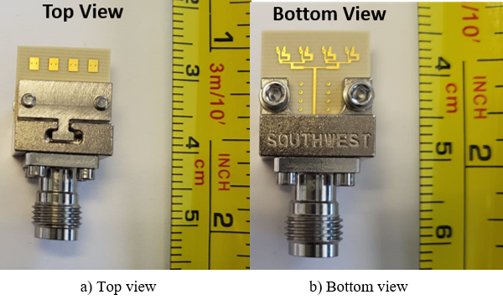
Fig. 5.13 The fabricated 1×4 array with feed network a) top view b) bottom view.

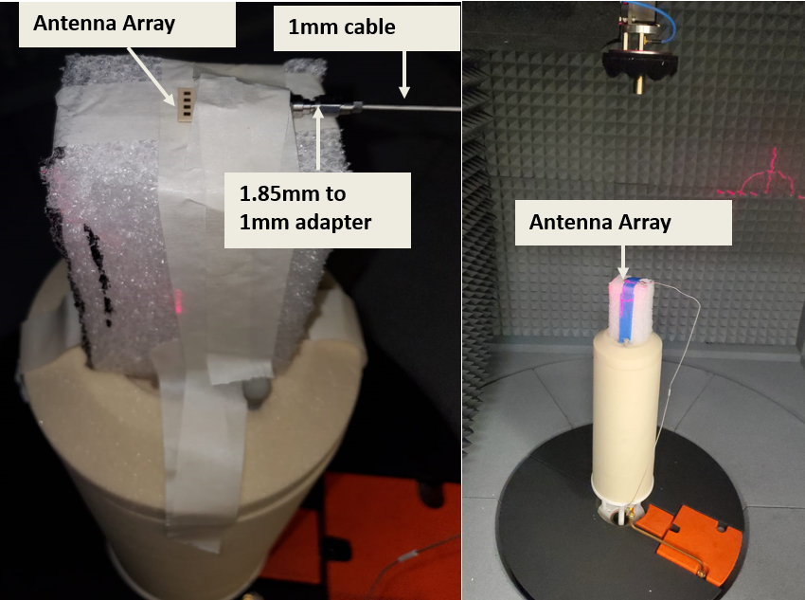
Fig. 5.14 The measurement setup of the 60 GHz antenna array.
Therefore, a ground plane with a length of 5 mm and a width of 12.8 mm was created on the top substrate for the connector’s ground connection. The connector’s ground was connected to the antenna’s ground plane using multiple vias of diameter 0.2 mm placed symmetrically on both sides.
The top and bottom view of the fabricated prototype is shown in Fig. 5.13. The measurement setup of the 60 GHz antenna array is shown in Fig. 5.14. 1.85 mm to 1mm adapter connected the antenna array to the 1mm measurement cable. The S11 of the antenna array is measured using a VNA, and the radiation patterns are measured using an anechoic chamber.
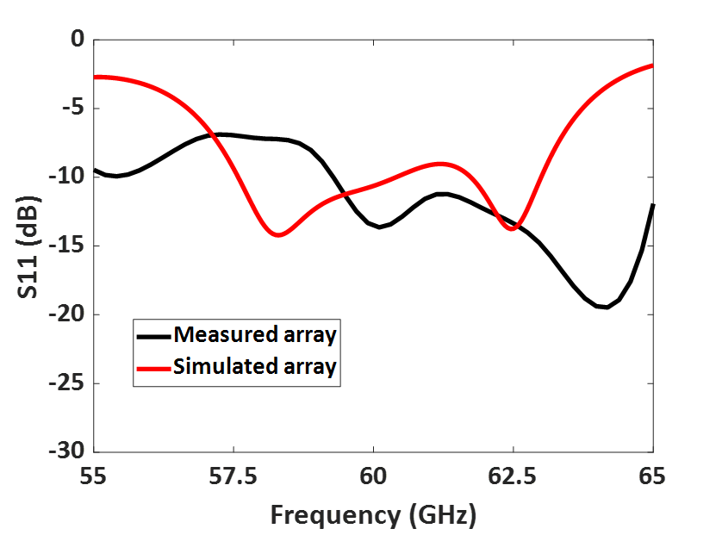
Fig. 5.15 Measured and simulated S11 (dB) of the fabricated array with a feed network.
Fig.5.15 illustrates that the fabricated prototype operates from 59.3 GHz to 65 GHz with ~5 GHz bandwidth. The measured radiation pattern of the fabricated prototype in the E plane at 60 GHz is shown in Fig. 5.16 A peak gain of 9.34 dBi is observed in the E plane of the measured array. The measured H plane radiation pattern was displayed in Fig. 5.17, and a peak gain of 10.02 dBi is obtained. The measured gain vs frequency of the fabricated array is displayed in Fig. 5.18. The array provides >90% radiation efficiency at the operating frequency.
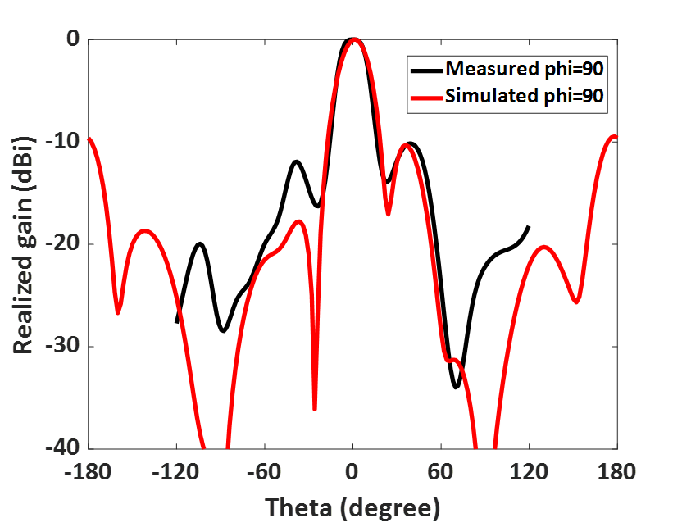
Fig. 5.16 Measured E plane radiation pattern of the 1×4 array with a differential corporate feed network.

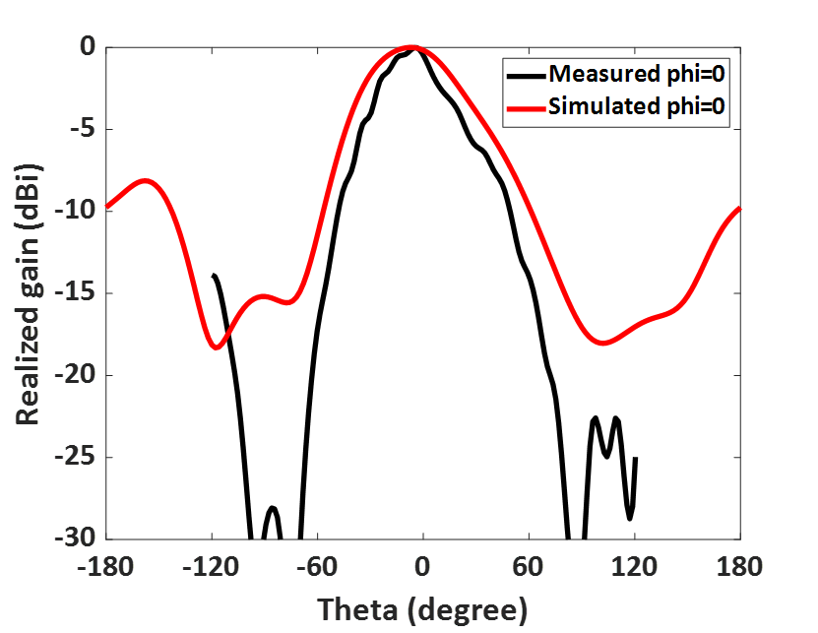
Fig. 5.17 Measured H plane radiation pattern of the 1×4 array with a differential corporate feed network.
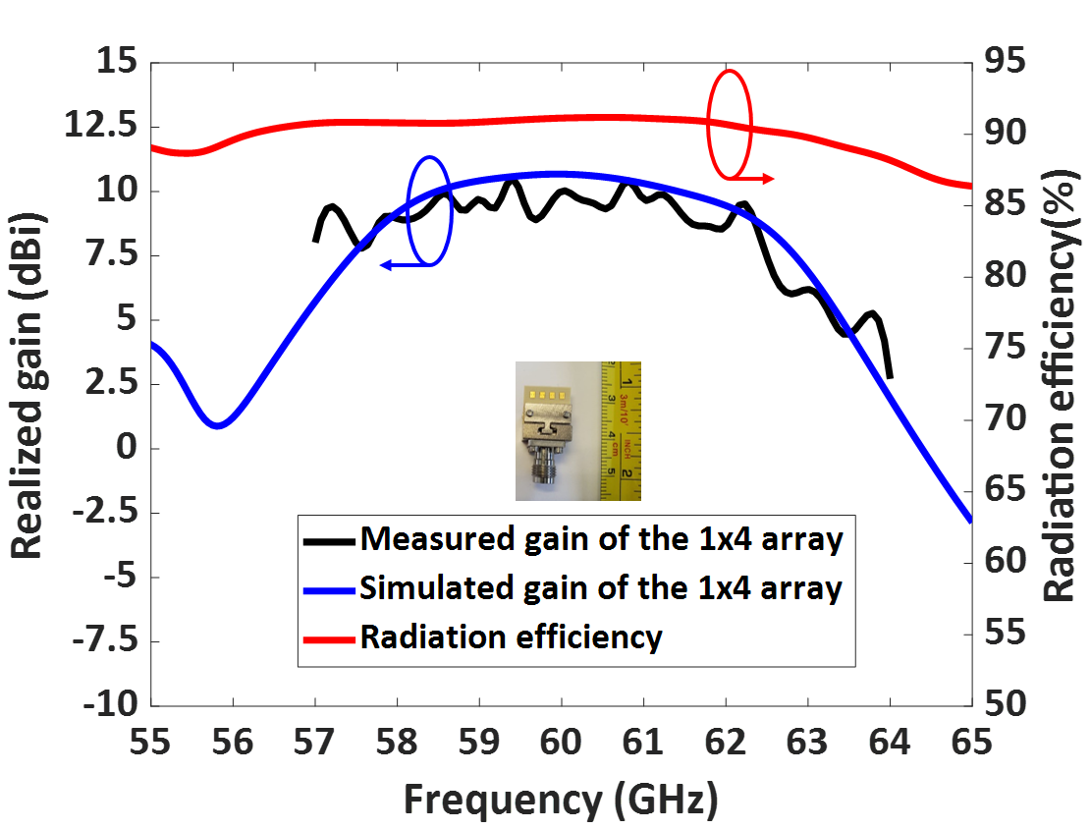
Fig. 5.18 Measured gain vs frequency of the fabricated 1×4 array with the corporate feed network.

5.3. Summary
This chapter discusses the design of a low-loss 60 GHz antenna array for 3D AiP applications. The designed differentially fed 1×4 array provides >25 dB isolation between the ports. The array provides low cross-polarization levels and operates with >90% efficiency at 60 GHz. As a proof of concept and for the measurement purpose, a patch array with a differential to a single-ended corporate feed network was fabricated. The fabricated array operates from 59.3 to 65 GHz with a peak gain of 10.02 dBi.

CHAPTER VI
DUAL-BAND RF FRONT-END FOR V2V COMMUNICATION
In this chapter, a dual-band RF front-end was designed for V2V communication covering the DSRC band and 5G mm-wave band. The architecture consists of two collocated 5.9 GHz and 28 GHz chains designed using COTS components, as shown in Fig. 6.1. The architecture consists of a homodyne 5.9 GHz receiver chain and a heterodyne 28 GHz receiver chain. The 28 GHz signal is down-converted to 5.9 GHz IF so that both upper and lower bands can share the same baseband processor to reduce cost, space, and components. We note that the RF front-end is carefully designed such that the receiver maintains high gain, low noise figure (NF), low power consumption. This chapter covers the design procedure, power budget estimation, noise analysis, and a linearity study of the dual-band RF front-end.
6.1 Architecture of the Dual-Band RF Front-End
The dual-band RF front-end consists of a single port dual-band antenna, wideband power divider, bandstop filters, LNA, down-conversion mixer. As depicted in Fig. 6.1, we designed two chains: 1) a 5.9 GHz homodyne and, 2) a 28 GHz heterodyne chain.
6.1.1 5.9 GHz Homodyne RF Front-End
Single Port Dual-Band Antenna: A single port dual-band patch antenna designed in Chapter III was used for receiving the transmitted signal at 5.9 GHz. The designed antenna provides -10 dB impedance bandwidth in the DSRC band from 5.8-6.05 GHz and a measured gain of ~5 dBi at 5.9 GHz.
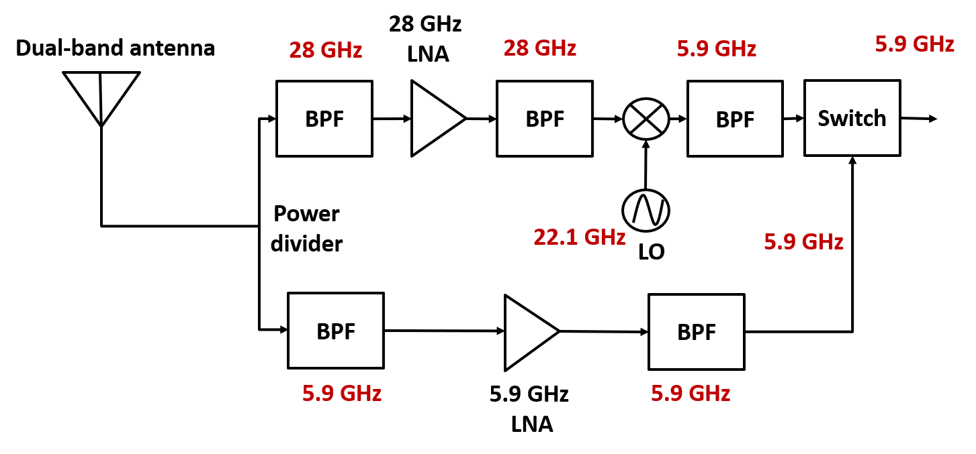
Fig. 6.1 Block diagram of the dual-band V2V RF front-end.
2-way Power Divider: A 2-way power divider with wide bandwidth operating from 2 to 40 GHz was used to separate the DSRC and mm-wave signals. The power divider offers a maximum insertion loss of 1.8 dB.
5.9 GHz Bandpass Filter: In the DSRC chain, the received signals are filtered using a bandpass filter operating from 4.9-5.9 GHz. This filter rejects the unwanted signals that can potentially saturate the LNA along with other interferences.
Here, a combline filter with a 50 ohm SMA port was used with an insertion loss of 0.75 dB and a maximum input power of 5 Watts (~7 dBm).
5.9 GHz LNA: We use a wideband LNA operating from 1.8 to 6 GHz with NF of 1.5 dB and a gain of 24.5 dB at 5.9 GHz. The LNA offers output IP3 of 21.35 dBm and output 1 dB compression point of 10.1 dBm at 5.9 GHz with 5V input.
5.9 GHz Image Filter: This filter rejects the image signals from the LNA. The filter operates from 4.9-5.9 GHz with a low insertion loss of 0.75 dB, 50 ohm impedance matching, and input power of 5 Watts (~7 dBm). Table 6.1 summarize the different components used for the 5.9 GHz RF chain along with their corresponding gain, NF, and their third order intercept points (IP3)
Table 6.1 COTS components of the 5.9 GHz homodyne receiver chain
 | Components | Gain (dB) | Noise Figure (dB) | IIP3 (dBm)
BPF | FMFL014 | -0.75 dB | 0.75 dB | NA
LNA | ZX60-63GLN+ | 24.5 dB | 1.5 dB | -3.15 dBm
BPF | FMFL014 | -0.75 dB | 0.75 dB | NA

6.1.2 28 GHz Heterodyne Front-End
Single Port Dual-Band Antenna: The dual-band single-port antenna designed in Chapter III was used to receive the 28 GHz signals. The designed antenna provides -10 dB impedance bandwidth in the 5G mm-wave band from 26.8-31.3 GHz with a measured gain of ~5 dBi at 28 GHz.
28 GHz bandpass filter: The received 28 GHz signals were filtered using the bidirectional chebyshev bandpass filter. The filter operates from 27.5-31 GHz with a maximum insertion loss of 2.5 dB.
28 GHz LNA: An LNA with a wide bandwidth operating from 18 to 32 GHz is used with a gain of 22.58 dB and a NF of 2.38 dB at 28 GHz. The LNA requires a bias voltage of 12V.
Mixer: The 28 GHz amplified signal was down-converted to 5.9 GHz and fed to the shared baseband receiver chain. We note that local oscillator (LO) operating at 22.1 GHz is used.
The LO requires a power of +15 dBm for its operation. Overall, the mixer provides a low conversion loss of 9.18 dB at 28 GHz.
5.9 GHz Bandpass Filter: This filter rejects the image signals and the higher order harmonics from the mixer. The bandpass filter operates from 4.9-5.9 GHz with an insertion loss of 0.75 dB. Table 6.2 summarize the different components used for the 28 GHz RF chain along with their corresponding gain, NF, and their third order intercept points.
Table 6.2 COTS components of the 28 GHz heterodyne receiver chain
 | Components | Gain (dB) | Noise Figure (dB) | IIP3 (dBm)
Power divider | FMDV1060 | -1.8 dB | 1.8 dB | NA
BPF | SF2393-SMA | -2.5 dB | 2.5 dB | NA
LNA | ZVE-323LN-K+ | 22.58 dB | 2.38 dB | 2.84 dBm
BPF | SF2393-SMA | -2.5 dB | 2.5 dB | NA
Mixer | ZMDB-44H-K+ | -9.18 dB | 9.18 dB | 21 dBm
BPF | FMFL014 | -0.75 dB | 0.75 dB | NA

6.2 Important RF Front-End Parameters
6.2.1 Cascade Gain:
Gain is the ratio of the output power to the input power. Generally, the gain is represented in dB. To detect the weaker signals, the receiver requires an RF front-end with high gain. The cumulative gain of a cascade system can be calculated using [1]
$$G_{cas}\left(dB\right)=G_{1} \left(dB\right)+G_{2}\left(dB\right)+G_{3}\left(dB\right)+…$$
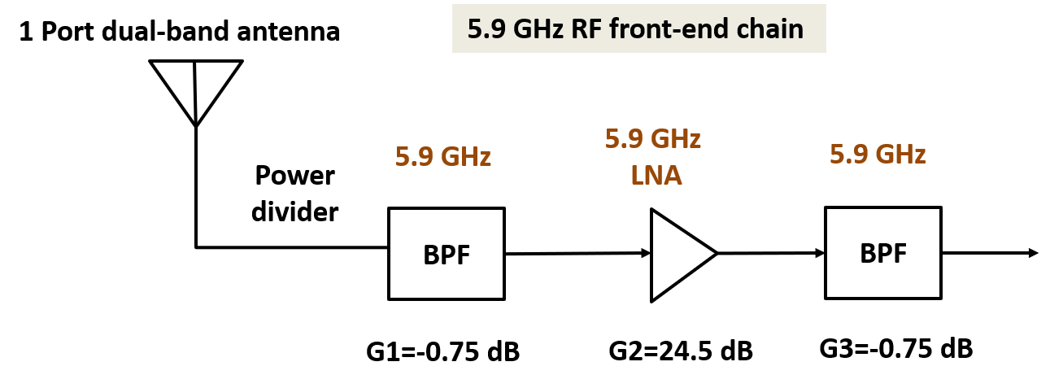
Fig. 6.2 Cumulative gain of the 5.9 GHz RF chain.
The estimated cumulative gain of the DSRC band RF chain shown in Fig. 6.2 is $G_{DSRC}$=23 dB. We note that the cascade gain is not affected by the placement of the different components in an RF chain. Table 6.3 shows the cumulative gain of the each RF component in the 5.9 GHz chain.
Table 6.3 Cascade gain estimation of each RF component in the DSRC chain
 | BPF | LNA | BPF
Gain (dB) | -0.75 dB | 24.5 dB | -0.75 dB
Cumulative gain (dB) | -0.75 dB | 23.75 dB | 23 dB
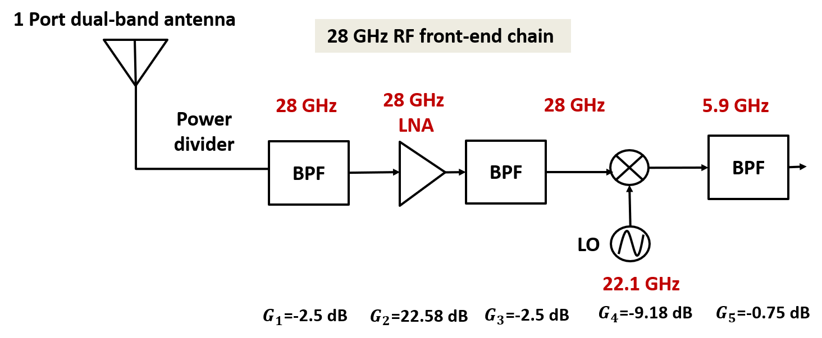
Fig. 6.3 Cumulative gain of the 28 GHz RF chain.
The estimated cumulative gain of the mm-wave band shown in Fig. 6.3 is $G_{mm-wave}$=7.65 dB. Table 6.4 displays the cumulative gain after the addition of each RF component in the 28 GHz chain.
Table 6.4 Cascade gain estimation of each RF component in the mm-wave chain
 | BPF | LNA | BPF | Mixer | BPF
Gain (dB) | -2.5 dB | 22.58 dB | -2.5 dB | -9.18 dB | -0.75 dB
Cumulative gain (dB) | -2.5 dB | 20.08 dB | 17.58 dB | 8.4 dB | 7.65 dB

6.2.2 Noise Figure
The noise figure measures the amount of noise in the components. The noise factor (F) is expressed in linear and noise figure (NF) is expressed in dB. The NF is one of the important parameters that determine the receiver’s sensitivity. Our goal is to maintain as low NF as possible. The order of the RF components in the front-end plays an important role in achieving a low noise figure. The first component in the RF front-end plays a significant role in maintaining the NF of the whole receiver, and therefore, a component with a low NF is preferred.
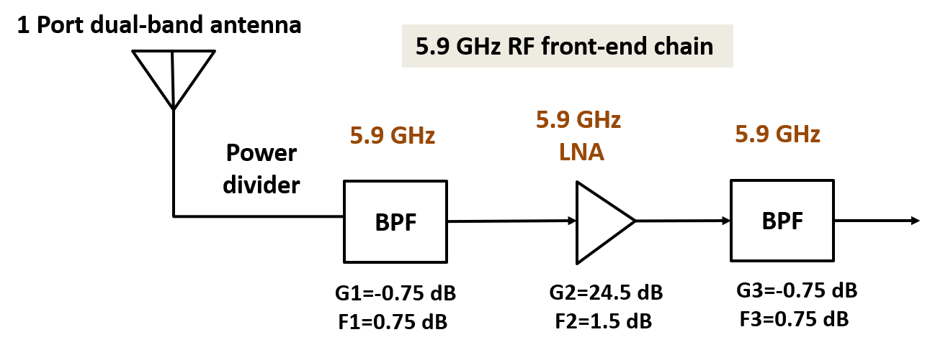
Fig. 6.4 Cumulative noise figure of the 5.9 GHz RF chain.
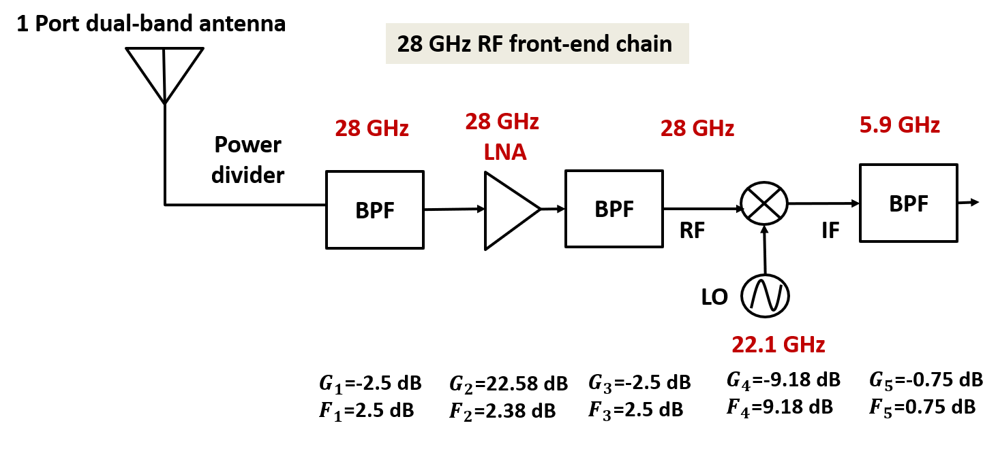
Fig. 6.5 Cumulative noise figure of the 28 GHz RF chain.
The NF of the receiver is calculated using [2]
$$F_{cas}=F_{1}+\frac{F_{2}-1}{G_{1}}+\frac{F_{3}-1}{G_{1}G_{2}}+…$$
Table 6.5 Cascade noise figure estimation of each RF component in the DSRC chain
 | BPF | LNA | BPF
Gain (dB) | -0.75 dB | 24.5 dB | -0.75 dB
Noise figure (dB) | 0.75 dB | 1.5 dB | 0.75 dB
Cumulative NF (dB) | 0.75 dB | 2.25 dB | 2.252 dB
The estimated NF of the lower band 5.9 GHz RF chain shown in Fig. 6.4 is $F_{DSRC}=2.252 dB.$The cumulative NF after the addition of each RF component in the 5.9 GHz chain is shown in Table 6.5.
Table 6.6 Cascade NF estimation of each RF component at mm-wave chain
 | BPF | LNA | BPF | Mixer | BPF
Gain (dB) | -2.5 dB | 22.58 dB | -2.5 dB | -9.18 dB | -0.75 dB
NF (dB) | 2.5 dB | 2.38 dB | 2.5 dB | 9.18 dB | 0.75 dB
Cumulative NF (dB) | 2.5 dB | 4.88 dB | 4.89 dB | 5.066 dB | 5.10 dB

The estimated NF of the 28 GHz mm-wave band RF chain shown in Fig. 6.5 is $F_{mm-wave}=5.1 dB.$ The cumulative NF after each RF component in the 28 GHz chain is displayed in Table 6.6.
The position of LNA and filter affect the NF of the whole RF front-end. The placement of filter before the LNA increases the system’s NF; however, the linearity of the system remains high.
6.2.3 1 dB compression point & third-order intercept point
Third order intercept point (IP3) and 1 dB compression point determine the linearity of the system. Our goal is to operate the system in a linear region, and prevent the onset of higher-order harmonics. The higher the value of IP3, the more linear the system is.
1 dB compression point: The point where the amplifier's output power drops by 1 dB from the first order linear line.
IP3: Third-order intercept point is where the power of third-order harmonics reaches the fundamental frequencies.
The IP3 of the whole system is calculated using [3]
$\frac{1}{IIP3_{cas}}$= $\frac{1}{IIP3_{1}}+\frac{G_{1}}{IIP3_{2}}+\frac{G_{1}G_{2}}{IIP3_{3}}$+… (3)
The input IP3 (IIP3) of the 5.9 GHz chain is -2.4 dBm, and the 28 GHz chain is 1.264 dBm.
6.2.4 Receiver sensitivity
The sensitivity of the receiver is the ability of the receiver to detect the weak signals. The receiver’s sensitivity can be estimated using
$$Receiver sensitivity=-174\frac{dBm}{Hz}+F_{cas}+SNR+10log\left(BW\right)$$
Where $F_{cas}$ is the cascaded noise figure of the system,
$SNR$ is the signal-to-noise ratio,
$BW$ is the bandwidth of the system
Considering a required SNR=12 dB and that of BW=100 MHz, the estimated sensitivity of the 5.9 GHz band is -79.74 dBm and 28 GHz chain is -76.89 dBm.
The receiver’s noise floor mainly depends on the cascade NF and the system's bandwidth. The higher the bandwidth, the higher noise floor is.
6.2.5 Link Budget Estimation
A link budget at both bands is calculated using FRISS transmission equation [53]. The power received ($P_{RX}$) at the receiver depends on the transmit power ($P_{TX}$), the gain of the transmit ${(G}_{TX })$ and the receive antennas ($G_{RX}$) and the free space path loss ($L_{FS}$)
$$P_{RX}=P_{TX}+G_{TX}+G_{RX}-L_{FS}-L_{M}$$
Where $L_{FS}=20log⁡\left(\frac{4πR}{λ}\right)$, $L_{M}$ is the receiver circuit loss
R is the distance between the transmit and the receive antenna
$λ$is the operating wavelength
6.3 Simulation and Experimental Setup of Dual-band RF Front-End
The dual-band RF front-end design was simulated using AWR software, as shown in Fig. 6.6.
We considered a dual-band signal at both DSRC and 28 GHz. The signal is divided into two separate channels using a power divider. The lower band channel consists of a 5.9 GHz bandpass filter as a first component. The BPF allows the 5.9 GHz signal, rejects the interference and upper band signals. The filtered 5.9 GHz signal is amplified, filtered, and passed through the baseband processor.
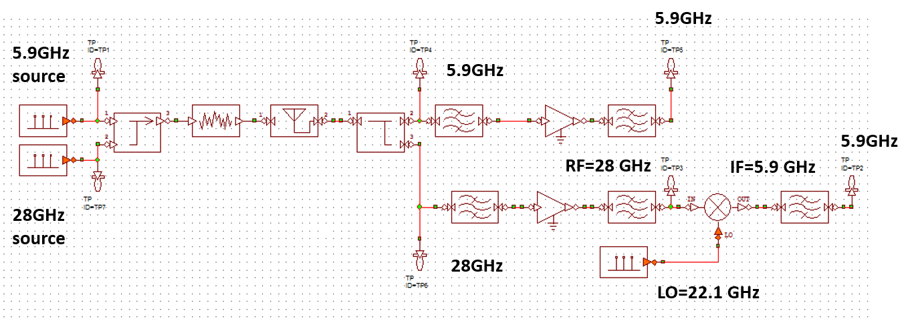
Fig. 6.6 AWR simulation of the dual-band RF front-end design for V2V communication.
The 28 GHz channel consists of a bandpass filter to reject lower band signals. The filtered 28 GHz signal is amplified and down-converted to a 5.9 GHz signal using a mixer with a 22.1 GHz LO signal. We note that the lower band 5.9 GHz ($f_{RF}-f_{LO}$) signal was filtered using a 5.9 GHz BPF.
6.3.1 Experimental Setup of the Dual-band RF Front-End
6.3.1.1 Experimental Setup of 5.9 GHz RF Front-End Chain
5.9 GHz Lower Band Transmitter:
The experimental setup of the dual-band RF front-end operating at 5.9 GHz, is shown in Fig. 6.7. An input signal of 0 dBm at 5.9 GHz is generated using a signal generator and transmitted using the horn antenna. A standard horn antenna operating from 1 to 18 GHz with gain of 12 dBi is used as a transmit antenna. The dual-band antenna designed in Chapter III is used a receiving antenna, and is placed at a distance of 120 m from the transmitter.
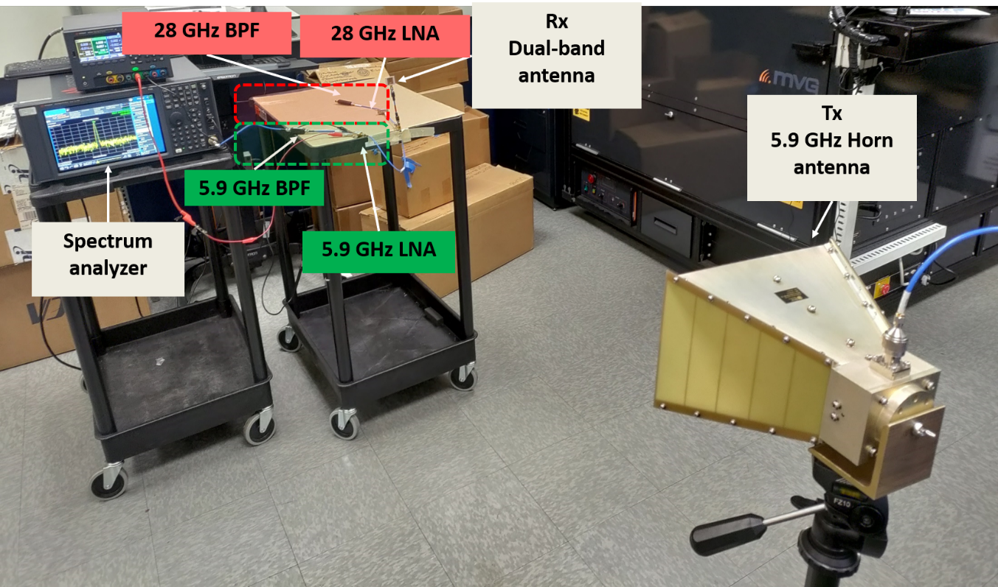
Fig. 6.7. Experimental setup of dual-band RF front-end operating at lower band 5.9 GHz.
5.9 GHz Lower Band Receiver:
The 5.9 GHz signal received by the dual-band antenna is passed through the 5.9 GHz bandpass filter to allow the 5.9 GHz signals and reject the upper band 28 GHz signals. The filtered signal is amplified using an amplifier with high gain of 24.5 dB and a biasing voltage of 5 V. The amplified signals are further filtered using 5.9 GHz BPF to reject the unwanted high power signals. The filtered signals are measured using a spectrum analyzer and the received power spectrum at 5.9 GHz is shown in Fig. 6.8. During lower band measurements, the 28 GHz RF front-end setup was terminated using 50 ohm load.
In order to protect the spectrum analyzer from the high power damage, the attenuation of the spectrum analyzer is set to 6 dB. The lower band RF front-end receives the 5.9 GHz signals with power of -26.53 dBm and noise floor of -80 dBm. Table 6.7 displays the specifications of the dual-band RF front-end.
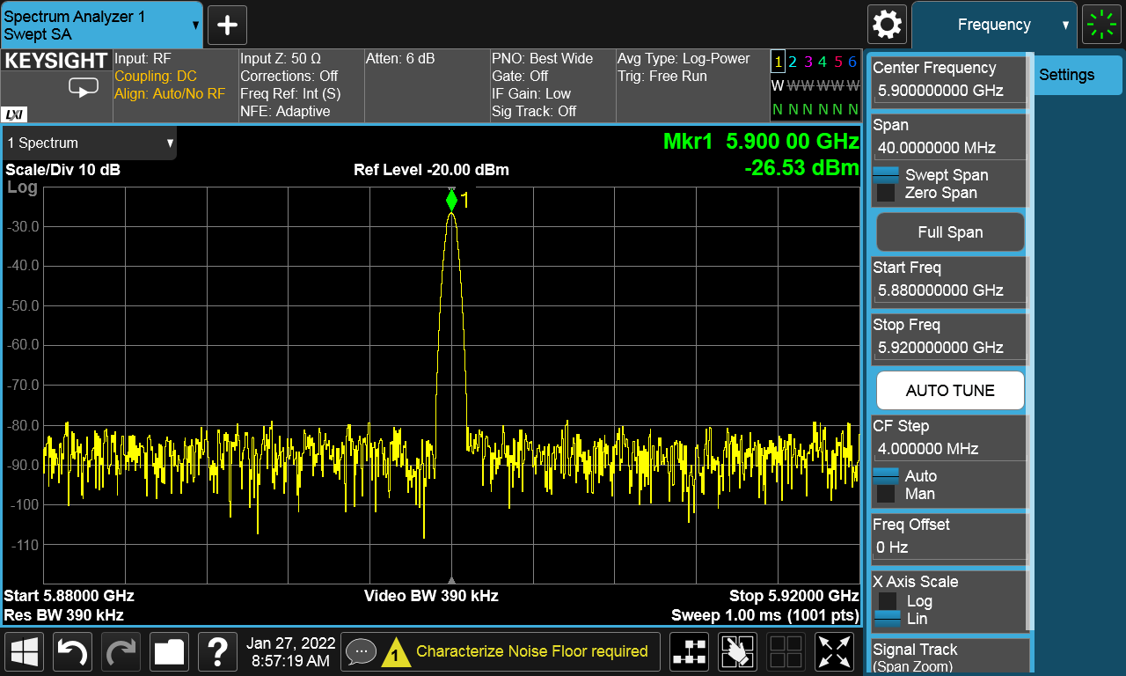
Fig. 6.8 Screenshot of the measured power of the receiver at 5.9 GHz.
6.3.1.2 Experimental Setup of 28 GHz RF Front-End Chain
28 GHz Upper Band Transmitter:
The experimental setup of the dual-band RF front-end operating at 28 GHz is shown in Fig. 6.9. To measure the upper band 28 GHz front-end, the lower band front-end chain is terminated with 50 ohm load. An input signal of 0 dBm at 28 GHz is generated using a signal generator and transmitted using the mm-wave broadband horn antenna. The latter operates from 18 to 40 GHz with a gain of 15 dBi is used as a transmit antenna. The dual-band antenna designed in Chapter III is used a receiving antenna, and it is placed at a distance of 50 m from the transmitter.
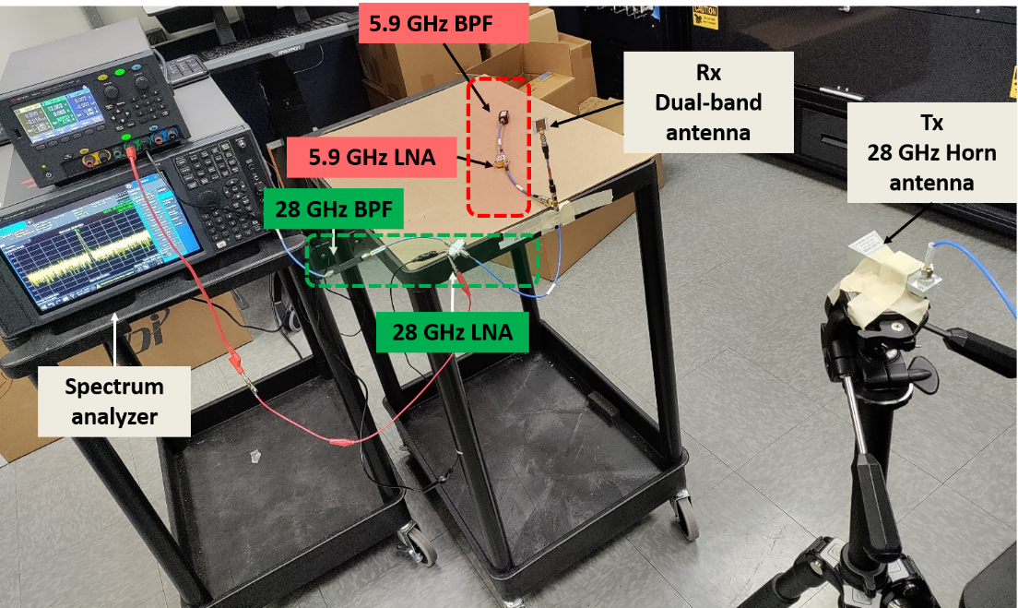
Fig. 6.9 Experimental setup of dual-band RF front-end operating at 28 GHz upper band.
Table 6.7 Measured received power at 5.9 GHz and 28 GHz RF front-end
 | 5.9 GHz link | 28 GHz link
Transmit power (dBm) | 0 dBm | 0 dBm
Transmit antenna gain (dB) | 12 dBi | 15 dBi
Receive antenna gain (dB) | 5 dBi | 5 dBi
Distance (m) | 1.2 m | 0.5 m
Attenuation (dB) | 6 dB | 6 dB
Free space path loss (dB) | 32.44 dB | 35.36 dB
Amplifier gain (dB) | 24.5 dB | 22.58 dB
Miscellaneous losses (dB) | 18 dB | 12 dB
Received power (dBm) | -26.53 dBm | -24.92 dBm

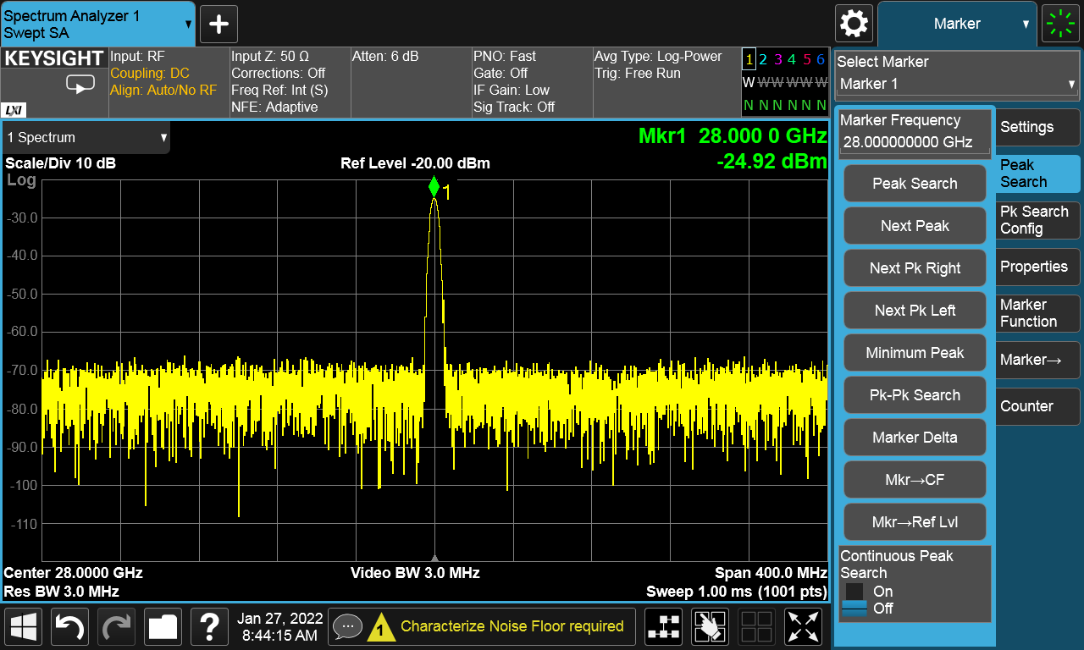
Fig. 6.10 Screenshot of the measured power of the receiver at 28 GHz.
28 GHz Upper Band Receiver:
The 28 GHz signals received by the dual-band antenna are fed to the 28 GHz chain through the power divider. The signal is then amplified using an LNA with a gain of 22.58 dB. The amplified signal is down-converted to 5.9 GHz signals using a mixer.
The amplified and filtered signal is measured using a spectrum analyzer, as shown in Fig. 6.10. The measured signal at 28 GHz has a power of -24.92 dBm and a noise floor of -70 dBm.
6.4 Summary
In this chapter, we present an experimental setup of the dual-band RF front-end using COTS components. A link budget estimation and the noise analysis was carried out by considering the specifications of the RF components. Further, the linearity of the receiver was also analyzed.
CHAPTER VII
CONCLUSIONS AND FUTURE WORK
7.1 Summary of this Dissertation
Improving the safety of the drivers is the primary goal of V2V communication. We proposed a novel dual-band receiver operating at DSRC band and mm-wave band based on the availability of the channel and attenuation due to rain. Two novel dual-band antennas have been demonstrated, and the designed antennas can be integrated with RFIC using the proposed low-loss 3D integration technique.
Antenna arrays with frequency diversity, high diversity gain have been developed. Higher-order modes of the patches are utilized in a constructive way to improve the gain and create additional resonance at the required frequency of operation. This dissertation focused on several challenges and proposed solutions to overcome them. The summary of this dissertation is:
First, a dual-band shared aperture antenna array with improvement in gain was developed in Chapter II. Two different frequency patch arrays are integrated on a single-layer substrate to achieve dual-band operation, with high port-to-port isolation and high gain at 28 GHz. The lower band array acts as a parasitic element for the upper band array and provides ~1.44 dBi enhancement in the gain at 28 GHz.
Next, a single-feed dual-band patch with a low profile was developed in Chapter III. A 28 GHz inset fed patch antenna was embedded onto the non-radiating edges of the 5.9 GHz patch. The 28 GHz patch was excited using inset feed, and 5.9 GHz was excited using a coupled feeding. An improvement in the bandwidth of about 2.3 GHz at mm-wave was obtained by adding parallel slots near the inset feed line. The antenna offers high gain at both the bands and suppresses the higher-order harmonics between the bands.
The successful implementation of high diversity gain systems requires low mutual
coupling between antenna elements reduces the ECC at the operating frequency. We implemented a novel mutual coupling suppression technique using an OSM-BSF design in Chapter VI. The designed filter provides high isolation of 60 dB at 2.4 GHz across a 30% bandwidth. The fabricated prototype provides high isolation of ≥55 dB using OSM-BSF. Besides, the fabricated array provides an extremely low ECC of 0.0093 at 2.42 GHz while maintaining edge-to-edge spacing as little as 0.19λ.
Chapter V developed a 60 GHz antenna array for low-loss 3D AiP applications. The implementation and the measurement of the array with a differential to single-ended corporate feed network were discussed. The differential antenna elements provide > 25 dB port-to-port isolation and low cross-polarization levels at 60 GHz. The measured prototype offers ~5 GHz bandwidth with a peak gain of 10.02 dBi. Notably, the array offers a radiation efficiency of >90% at the operating frequency.
Finally, an indoor measurement of the dual-band receiver has been demonstrated in Chapter VI. Transmitter and receiver chain was developed at DSRC band and mm-wave band using COTS components.
7.2 Future Work
This dissertation paves the way for further research in designing dual-band antennas at mm-wave frequencies. Future research plans include investigating the cause of high cross-polarization levels in the dual-band antenna designed in Chapter III. The dual-band
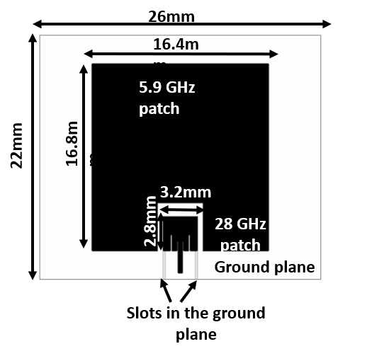
Fig.7.1 Single-fed dual-band antenna design with defected ground plane slots.
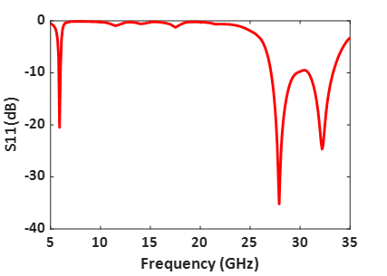
Fig. 7.2 Simulated S11 (dB) of the single-fed dual-band antenna with defected slots in the ground plane.
antenna designed in Chapter III has almost 10 dB cross-polarization discrimination levels at 28 GHz.
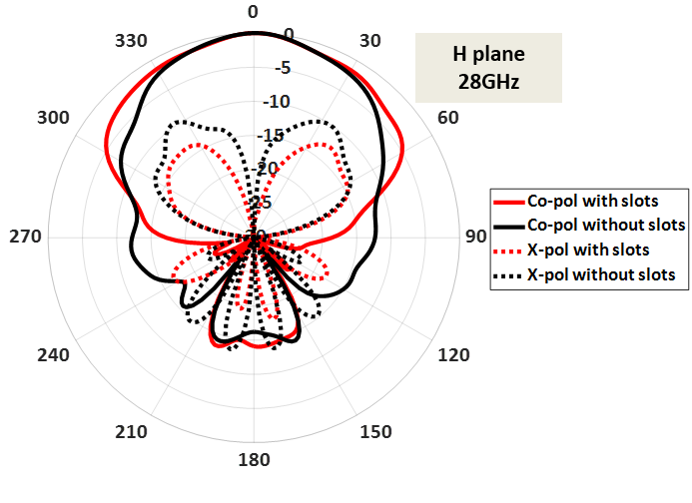
Fig. 7.3 Simulated radiation pattern of the dual-band antenna in the H plane at 28 GHz.

One reason for cross-polarized fields is the spurious radiation from the feed line [70]. The cross-polarized fields can be reduced by creating DGS near the feed line. Fig.7.1 depicts the single-fed dual-band antenna with slots in the ground plane. The simulated antenna operates in the DSRC and mm-wave bands, as shown in Fig.7.2. Fig. 7.3 illustrates that the proposed technique reduces the cross-polarization levels by about 3-4 dB. Future work will include the investigation of the effect of high order modes on the cross-polarized fields at 28 GHz and techniques to reduce them further.
Next, the gain of the dual-band antenna can be further improved by creating a larger number of antenna arrays. Future work includes designing many arrays and investigating the gain and radiation pattern at DSRC and mm-wave bands. Additionally, the effect of spacing between the antennas on the radiation pattern needs to be analyzed.

REFERENCES

[1] Road traffic injuries, World Health Organization, https://www.who.int/news-room/fact-sheets/detail/road-traffic-injuries (accessed Aug. 2 2021).
[2] Press Releases, NHTSA, https://www.nhtsa.gov/press-releases/2020-fatality-data-show-increased-traffic-fatalities-during-pandemic (accessed Aug. 2 2021).
[3] Ahangar, M. N., Qasim Z. Ahmed, Fahd A. Khan, and Maryam Hafeez. 2021. "A Survey of Autonomous Vehicles: Enabling Communication Technologies and Challenges" Sensors 21, no. 3: 706. https://doi.org/10.3390/s21030706
[4] Dedicated Short Range Communications (DSRC) Service, Federal Communications Commission, https://www.fcc.gov/wireless/bureaudivisions/mobility-division/dedicated-short-range-communications-dsrcservice (accessed Aug. 2 2021).
[5] CEN DSRC, ITS Standards, https://www.itsstandards.eu/25-2/wp-1/cen-dsrc/ (accessed Jan. 8 2022)
[6] O. K. Tonguz, "Red light, green light-no light: Tomorrow's communicative cars could take turns at intersections," in IEEE Spectrum, vol. 55, no. 10, pp. 24-29, Oct. 2018.
[7] S. He and J. Xie, "Analysis and design of a novel dual-band array antenna with a low profile for 2400/5800-MHz WLAN systems," IEEE Trans. Antennas Propag., vol. 58, no. 2, pp. 391–396, Feb. 2010.
[8] Y. T. Lo, D. Solomon, and W. F. Richards, "Theory and experiment on microstrip antennas," IEEE Trans. Antennas Propag., vol. AP-27, no. 2, pp. 137–145, Mar. 1979.
[9] Kin-Lu Wong, Gwo-Yun Lee and Tzung-Wern Chiou, "A low-profile planar monopole antenna for multiband operation of mobile handsets," in IEEE Transactions on Antennas and Propagation, vol. 51, no. 1, pp. 121-125, Jan. 2003, doi: 10.1109/TAP.2003.809044.
[10] R. R. Corbett and R. D. Murch, "A capacitively loaded PIFA for compact mobile telephone handsets," IEEE Trans. Antennas Propag., vol. 45, no. 5, pp. 837–842, May 1997.
[11] H. Kimouche, H. Zemmour, and B. Atrouz, “Dual-band fractal shape antenna design for RFID applications,” Electron. Lett., vol. 45, no. 21, pp. 1061–1063, Oct. 2009.
[12] Yen-Liang Kuo and Kin-Lu Wong, "Printed double-T monopole antenna for 2.4/5.2 GHz dual-band WLAN operations," in IEEE Transactions on Antennas and Propagation, vol. 51, no. 9, pp. 2187-2192, Sept. 2003, doi: 10.1109/TAP.2003.816391.
[13] Bao Wang and Yuen Lo, "Microstrip antennas for dual-frequency operation," in IEEE Transactions on Antennas and Propagation, vol. 32, no. 9, pp. 938-943, September 1984, doi: 10.1109/TAP.1984.1143459.
[14] N. Liu, L. Zhu, Z. Liu and Y. Liu, "Dual-Band Single-Layer Microstrip Patch Antenna With Enhanced Bandwidth and Beamwidth Based on Reshaped Multiresonant Modes," in IEEE Transactions on Antennas and Propagation, vol. 67, no. 11, pp. 7127-7132, Nov. 2019, doi: 10.1109/TAP.2019.2927646.
[15] J. Anguera, G. Font, C. Puente, C. Borja and J. Soler, "Multifrequency microstrip patch antenna using multiple stacked elements," in IEEE Microwave and Wireless Components Letters, vol. 13, no. 3, pp. 123-124, March 2003, doi: 10.1109/LMWC.2003.810126.
[16] L. L. Shafai, W. A. Chamma, M. Barakat, P. C. Strickland and G. Seguin, "Dual-band dual-polarized perforated microstrip antennas for SAR applications," in IEEE Transactions on Antennas and Propagation, vol. 48, no. 1, pp. 58-66, Jan. 2000, doi: 10.1109/8.827386.
[17] D. M. Pozar and S. D. Targonski, "A shared-aperture dual-band dual-polarized microstrip array," in IEEE Transactions on Antennas and Propagation, vol. 49, no. 2, pp. 150-157, Feb 2001, doi: 10.1109/8.914255.
[18] L. Zhang, K. Y. See, B. Zhang, and Y. P. Zhang, "Integration of dual-band monopole and microstrip grid array for single-chip tri-band application," IEEE Trans. Antennas Propag., vol. 61, no. 1, pp. 439–443, Jan. 2013.
[19] D. Wang and C. H. Chan, "Multiband antenna for WiFi and WiGig communications," IEEE Antennas Wireless Propag. Lett., vol. 15, pp. 309–312, 2016.
[20] S.-G. Zhou, P.-K. Tan, and T.-H. Chio, "Wideband, low profile P- and Ku band shared aperture antenna with high isolation and low crosspolarisation," IET Microw. Antennas Propag., vol. 7, no. 4, pp. 223–229, Mar. 2013.
[21] C. Mao, S. Gao, Y.Wang, Q. Chu and X. Yang, "Dual-Band Circularly Polarized Shared-Aperture Array for C-/X-Band Satellite Communications," in IEEE Transactions on Antennas and Propagation, vol. 65, no. 10, pp. 5171-5178, Oct. 2017, doi:10.1109/TAP.2017.2740981.
[22] B. J. Xiang, S. Y. Zheng, H. Wong, Y. M. Pan, K. X. Wang, and M. H.Xia, "A flexible dual-band antenna with large frequency ratio and different radiation properties over the two bands," IEEE Trans. Antennas Propag., vol. 66, no. 2, pp. 657-667, Feb. 2018.
[23] Jin-Dong Zhang, Wen Wu, and Da-Gang Fang, "Dual-band and dual circularly polarized shared-aperture array antennas with the single-layer substrate," IEEE Trans. Antenn. Propag. 64(1), 109-116 (2016).
[24] A. Balanis, Antenna Theory: Analysis and Design, 3rd ed. Hoboken, NJ, USA: Wiley-Interscience, April 4, 2005, ch. 14.
[25] W. C. Mok, S. H. Wong, K. M. Luk and K. F. Lee, "Single-Layer Single-Patch Dual-Band and Triple-Band Patch Antennas," in IEEE Transactions on Antennas and Propagation, vol. 61, no. 8, pp. 4341-4344, Aug. 2013, doi: 10.1109/TAP.2013.2260516.
[26] X. Y. Zhang, Y. Zhang, Y. Pan and W. Duan, "Low-Profile Dual-Band Filtering Patch Antenna and Its Application to LTE MIMO System," in IEEE Transactions on Antennas and Propagation, vol. 65, no. 1, pp. 103-113, Jan. 2017, doi: 10.1109/TAP.2016.2631218.
[27] W. Liu, C. Wu and N. Chu, "A Compact CPW-Fed Slotted Patch Antenna for Dual-Band Operation," in IEEE Antennas and Wireless Propagation Letters, vol. 9, pp. 110-113, 2010, doi: 10.1109/LAWP.2010.2044135.
[28] P. Nepa, G. Manara, A. A. Serra, and G. Nenna, “Multiband PIFA for WLAN applications,” IEEE Antennas Wireless Propag. Lett., vol. 4, pp. 349–350, 2005.
[29] S. R. Govindarajulu, R. Hokayem, M. N. A. Tarek, M. R. Guerra and E. A. Alwan, "Low Profile Dual-Band Shared Aperture Array for Vehicle-to-Vehicle Communication," in IEEE Access, vol. 9, pp. 147082-147090, 2021, doi: 10.1109/ACCESS.2021.3124311.
[30] S. R. Govindarajulu, R. Hokayem and E. A. Alwan, "Dual-Band Antenna Array for 5.9 GHz DSRC and 28 GHz 5G Vehicle to Vehicle communication," 2020 IEEE International Symposium on Antennas and Propagation and North American Radio Science Meeting, 2020, pp. 1583-1584, doi: 10.1109/IEEECONF35879.2020.9330220.
[31] Y. -X. Sun, K. W. Leung and K. Lu, "Compact Dual Microwave/Millimeter-Wave Planar Shared-Aperture Antenna for Vehicle-to-Vehicle/5G Communications," in IEEE Transactions on Vehicular Technology, vol. 70, no. 5, pp. 5071-5076, May 2021, doi: 10.1109/TVT.2021.3070353.
[32] M. E. Yassin, H. A. Mohamed, E. A. F. Abdallah, and H. S. El-Hennawy, ‘‘Single-fed 4G/5G multiband 2.4/5.5/28 GHz antenna,’’ IET Microw., Antennas Propag., vol. 13, no. 3, pp. 286–290, Feb. 2019.
[33] G. Xu, H. Peng, Z. Shao, L. Zhou, Y. Zhang, and W. Yin, “Dual-Band differential shifted-feed microstrip grid array antenna with two parasitic patches,” IEEE Trans. Antennas Propag., vol. 68, no. 3, pp. 2434–2439, Mar. 2020.
[34] Y. Q. Guo, Y. M. Pan, S. Y. Zheng and K. Lu, "A Singly-Fed Dual-Band Microstrip Antenna for Microwave and Millimeter-Wave Applications in 5G Wireless Communication," in IEEE Transactions on Vehicular Technology, vol. 70, no. 6, pp. 5419-5430, June 2021, doi: 10.1109/TVT.2021.3070807.
[35] Y. Su, X. Q. Lin and Y. Fan, "Dual-Band Coaperture Antenna Based on a Single-Layer Mode Composite Transmission Line," in IEEE Transactions on Antennas and Propagation, vol. 67, no. 7, pp. 4825-4829, July 2019, doi: 10.1109/TAP.2019.2913706.
[36] Y. Liu, X. Yang, Y. Jia and Y. J. Guo, “A Low Correlation and Mutual Coupling MIMO Antenna,” in IEEE Access, vol. 7, pp.127384-127392, 2019.
[37] A. Habashi, J. Nourinia and C. Ghobadi, “A rectangular defected ground structure (DGS) for reduction of mutual coupling between closely spaced microstrip antennas,” 20th Iranian Conference on Electrical Engineering (ICEE2012), Tehran, 2012, pp. 1347-1350.
[38] S.-W. Su, C.-T. Lee, and F.-S. Chang, ‘‘Printed MIMO-antenna system using neutralization-line technique for wireless USB-dongle applications,’’ IEEE Trans. Antennas Propag., vol. 60, no. 2, pp. 456–463, Feb. 2012.
[39] G. Zhai, Z. N. Chen and X. Qing, “Enhanced Isolation of a Closely Spaced Four-Element MIMO Antenna System Using Metamaterial Mushroom,” in IEEE Transactions on Antennas and Propagation, vol. 63, no. 8, pp. 3362-3370, Aug. 2015.
[40] Fan Yang and Y. Rahmat-Samii, "Microstrip antennas integrated with electromagnetic band-gap (EBG) structures: a low mutual coupling design for array applications," in IEEE Transactions on Antennas and Propagation, vol. 51, no. 10, pp. 2936-2946, Oct. 2003, doi: 10.1109/TAP.2003.817983.
[41] M. Li, B. G. Zhong, and S. W. Cheung, ‘‘Isolation enhancement for MIMO patch antennas using near-field resonators as coupling-mode transducers,’’ IEEE Trans. Antennas Propag., vol. 67, no. 2, pp. 755–764, Feb. 2019.
[42] Z. Qamar, L. Riaz, M. Chongcheawchamnan, S. A. Khan, and M. F. Shafique, “Slot combined complementary split ring resonators for mutual coupling suppression in microstrip phased arrays,” IET Microw. Antennas Propag., vol. 8, no. 15, pp. 1261–1267, Sep. 2014.
[43] Wen-Hua Tu and Kai Chang, “Compact microstrip bandstop filter using open stub and spurline,” in IEEE Microwave and Wireless Components Letters, vol. 15, no. 4, pp. 268-270, April 2005.
[44] R. Sato, “A Design Method for Meander-Line Networks Using Equivalent Circuit Transformations,” in IEEE Transactions on Microwave Theory and Techniques, vol. 19, no. 5, pp. 431-442, May 1971.
[45] R. G. Vaughan and J. B. Andersen, “Antenna diversity in mobile communications,” IEEE Trans. Veh. Technol., vol. VT-36, no. 4, pp.149172, Nov. 1987.
[46] H. M. Cheema and A. Shamim, “The last barrier: on-chip antennas,” in IEEE Microwave Magazine, vol. 14, no. 1, pp. 79-91, Jan.-Feb. 2013.
[47] Steve Adamshick, Robert Carroll, Megha Rao, Douglas La Tuplie, Seth Kruger, John Burke, and Michael Liehr, “High frequency electrical characterization of 3D signal/ground through silicon vias,” in Progress In Electromagnetics Research, Vol. 47, pp. 71-75, 2014,
doi:10.2528/PIERL14052704.
[48] M. Sun, Y. P. Zhang, Y. X. Guo, K. M. Chua and L. L. Wai, “Integration of Grid Array Antenna in Chip Package for Highly Integrated 60-GHz Radios,” in IEEE Antennas and Wireless Propagation Letters, vol. 8, pp. 1364-1366, 2009, doi: 10.1109/LAWP.2009.2039031.
[49] H. Y. Kim, T. H. Jang, H. H. Bae and C. S. Park, “A 60 GHz Compact Multidirectional-Beam Antenna-in-Package for Mobile Devices,” in IEEE Antennas andWireless Propagation Letters, vol. 18, no. 11, pp. 2434-2438, Nov. 2019, doi: 10.1109/LAWP.2019.2939630.
[50] W. Hong, A. Goudelev, K.-H. Baek, V. Arkhipenkov, and J. Lee, “24-element antenna-in-package for stationary 60-GHz communication scenarios,” IEEE Antennas Wireless Propag. Lett., vol. 10, pp. 738-741, 2011.
[51] T. Zhang, L. Li, H. Xia, X. Ma and T. J. Cui, “A Low-Cost and High-Gain 60-GHz Differential Phased Array Antenna in PCB Process,” in IEEE Transactions on Components, Packaging and Manufacturing Technology, vol. 8, no. 7, pp. 1281-1291, July 2018, doi: 10.1109/TCPMT.2018.2839342.
[52] D. G. Kam, D. Liu, A. Natarajan, S. K. Reynolds, and B. A. Floyd, “Organic packages with embedded phased-array antennas for 60-GHz wireless chipsets,” IEEE Trans. Compon., Packag., Manuf., Technol., vol. 1, no. 11, pp. 1806-1814, Nov. 2011.
[53] McClaning, Kevin: “Wireless Receiver Design for Digital Communications” (Telecommunications, 2012) DOI: IET Digital Library, https://digital-library.theiet.org/content/books/te/sbte009e
[54] R. Hokayem, S. R. Govindarajulu, E. A. Alwan and J. L. Volakis, "Cross-Mixing Hybrid Beamformer for Wideband Apertures," in IEEE Access, vol. 9, pp. 59456-59465, 2021, doi: 10.1109/ACCESS.2021.3073866.
[55] M. I. Pasha, C. Kumar and D. Guha, "Simultaneous Compensation of Microstrip Feed and Patch by Defected Ground Structure for Reduced Cross-Polarized Radiation," in IEEE Transactions on Antennas and Propagation, vol. 66, no. 12, pp. 7348-7352, Dec. 2018, doi: 10.1109/TAP.2018.2869252.

VITA

SANDHIYA REDDY GOVINDARAJULU

Born, Ambur, India

2009-2013 B.E., Electronics and Communication Engineering
Anna University
Chennai, India

2013-2015 M.E., Communication Systems
Anna University
Chennai, India

2015-2016 Program Analyst,
Cognizant Technology Solutions,
Chennai, India

2017-2022 Graduate Assistant
Florida International University
Miami, Florida

Research Assistant
Florida International University
Miami, Florida

PUBLICATIONS

[1] Sandhiya Reddy Govindarajulu, R. Hokayem and E. A. Alwan, "A 60 GHz Millimeter-Wave Antenna Array for 3D Antenna-in-Package Applications," in IEEE Access, vol. 9, pp. 143307-143314, 2021, doi: 10.1109/ACCESS.2021.3121320.

[2] Sandhiya Reddy Govindarajulu, R. Hokayem, M. N. A. Tarek, M. R. Guerra and E. A. Alwan, "Low Profile Dual-Band Shared Aperture Array for Vehicle-to-Vehicle Communication," in IEEE Access, vol. 9, pp. 147082-147090, 2021, doi: 10.1109/ACCESS.2021.3124311.

[3] R. Hokayem, Sandhiya Reddy Govindarajulu, E. A. Alwan and J. L. Volakis, "Cross-Mixing Hybrid Beamformer for Wideband Apertures," in IEEE Access, vol. 9, pp. 59456-59465, 2021, doi: 10.1109/ACCESS.2021.3073866.

[4] Sandhiya Reddy Govindarajulu, A. Jenkel, R. Hokayem and E. A. Alwan, "Mutual Coupling Suppression in Antenna Arrays Using Meandered Open Stub Filtering Technique," in IEEE Open Journal of Antennas and Propagation, vol. 1, pp. 379-386, 2020, doi: 10.1109/OJAP.2020.3010153.

[5] DeLong, B.J., Sandhiya Reddy Govindarajulu, Novak, M.H. et al., “A 60GHz Phased Array with Measurement and De-embedding Techniques”, Analog Integrated Circuits and Signal Processing 97, 557-563(2018).
https://doi.org/10.1007/s10470-018-1295-1

SUBMITTED PUBLICATIONS
[6] Sandhiya Reddy Govindarajulu, Marisol Roman, Asif Hassan, Md Nurul Anwar Tarek, Elias A. Alwan, “Single-Layer Dual-Band Antenna with Large Frequency Ratio for Vehicle-to-Vehicle Communication”, IEEE Access 2022

[7] Md Nurul Anwar Tarek, Rimon Hokayem, Sandhiya Reddy Govindarajulu, Markus Novak, Elias A. Alwan, “A Two-Stage Wideband RF Cancellation of Coupled Transmit Signal for BI-STATIC SIMULTANEOUS TRANSMIT AND RECEIVE SYSTEM”, IEEE Open Journal of Circuits and Systems 2021.

[8] Asif Hassan, Md. Nurul A. Tarek, Sandhiya Reddy Govindarajulu, Elias A. Alwan “A Novel MIMO System with integrated bandstop filter at W band,” Submitted to IEEE APS-URSI 2022.

CONFERENCE PRESENTATIONS

[9] S. Adamshick, Sandhiya Reddy Govindarajulu and E. A. Alwan, "A Novel Low Loss 3D System-in-Package Approach for 60GHz Antenna on Chip Applications," 2020 IEEE 63rd International Midwest Symposium on Circuits and Systems (MWSCAS), 2020, pp. 537-540, doi: 10.1109/MWSCAS48704.2020.9184617.

[10] Sandhiya Reddy Govindarajulu, R. Hokayem and E. A. Alwan, "Dual-Band Antenna Array for 5.9 GHz DSRC and 28 GHz 5G Vehicle to Vehicle communication," 2020 IEEE International Symposium on Antennas and Propagation and North American Radio Science Meeting, 2020, pp. 1583-1584, doi: 10.1109/IEEECONF35879.2020.9330220.

[11] Sandhiya Reddy Govindarajulu and E. A. Alwan, "Range Optimization for DSRC and 5G Millimeter-Wave Vehicle-to-Vehicle Communication Link," 2019 International Workshop on Antenna Technology (iWAT), 2019, pp. 228-230, doi: 10.1109/IWAT.2019.8730597.

[12] Sandhiya Reddy Govindarajulu, S. B. Venkatakrishnan and E. A. Alwan, "Millimeter-Wave Wideband Array for Vehicle to Vehicle Communication," 2018 IEEE International Symposium on Antennas and Propagation & USNC/URSI National Radio Science Meeting, 2018, pp. 1203-1204, doi: 10.1109/APUSNCURSINRSM.2018.8608898.

