FLORIDA INTERNATIONAL UNIVERSITY
Miami, Florida

DRIVERS OF EXTRACELLULAR POLYSACCHARIDE PRODUCTION BY A MAT-FORMING DIATOM

A thesis submitted in partial fulfillment of the
requirements for the degree of
MASTER OF SCIENCE
in
BIOLOGICAL SCIENCES
by
Kaitlin Auguste Stansbury

2021

To: Dean Michael Heithaus
College of Arts, Sciences and Education

This thesis, written by Kaitlin A. Stansbury, and entitled Drivers of Extracellular Polysaccharide Production by a Mat-Forming Diatom, having been approved in respect to style and intellectual content, is referred to you for judgment.

We have read this thesis and recommend that it be approved.

_______________________________________
Sparkle Malone

_______________________________________
Leonard Scinto

_______________________________________
Evelyn Gaiser, Major Professor

Date of Defense: November 9, 2021

The thesis of Kaitlin A. Stansbury is approved. Florida International University, 2021

_______________________________________
Dean Michael Heithaus
College of Arts, Sciences and Education

_______________________________________
Andrés G. Gil
Vice President for Research and Economic Development
and Dean of the University Graduate School

Florida International University, 2021
ACKNOWLEDGMENTS
Throughout the process of writing this thesis, I have received a great deal of support and assistance.
I would first like to thank my advisor, Dr. Evelyn Gaiser, whose expertise was invaluable in formulating the research questions, methodology, and writing process. Your insightful feedback pushed me to sharpen my thinking and brought my work to a higher level.
I would also like to thank Franco Tobias, Rafa Travieso, Dr. Dale Laughinghouse, and Dr. David Berthold. Your guidance and sharing of your expertise has provided insight and ideas that brought my Master’s thesis journey into fruition.
In addition, I would like to thank my parents for their wise counsel and sympathetic ear. You are always there for me. Finally, I could not have completed this dissertation without the support of my friends, Thomas Shannon, Samantha Hormiga, Meredith Emery and Paige Kleindl, who provided stimulating discussions as well as happy distractions to rest my mind outside of my research.

ABSTRACT OF THESIS
DRIVERS OF EXTRACELLULAR POLYSACCHARIDE PRODUCTION BY A MAT-FORMING DIATOM
by
Kaitlin A. Stansbury
Florida International University, 2021
Miami, Florida
Microbial biofilms are held together by extracellular polymeric substances (EPS), which can be secreted by many organisms. EPS production can facilitate intercellular communication and inter-guild microbial mutualisms, intraspecific gamete exchange, nutrient sequestration, and desiccation resistance. Benthic microbial mats (periphyton) of the Florida Everglades and other karstic wetlands contain abundant EPS generated by mat-producing filamentous blue-green algae and many other species of mat-dwelling algae, cyanobacteria, and bacteria, including the most abundant Everglades diatom, Mastagloia calcarea. The benthic diatom genus Mastogloia is characterized by several morphological and physiological features that foster production of a ‘halo’ of EPS around the frustule, but the cellular and environmental triggers of EPS production are unknown. In this study, I examined how conductivity, pH, periphyton total phosphorus, hydroperiod, reproduction, and the presence/absence of bacteria affect the presence and area of the EPS halo around M. calcarea cells. Field and cultured samples were microscopically examined, and individual M. calcarea cells with and without halos were measured and analyzed to determine environmental and population correlates to EPS production. We found that small, paired (likely copulating) cells were more likely to have EPS halos, and these were more abundant at low ionic conductivity, higher pH, and low periphyton total phosphorus concentrations. We also found evidence for reduced halo presence and size and lower population turnover when bacteria were removed from M. calcarea cultures. These results indicate that EPS production by mat-dwelling diatoms is maintained at high levels in ultraoligotrophic, carbonate-rich wetland conditions where beneficial associations with bacteria support rapid population turnover and sexual reproduction.

TABLE OF CONTENTS
CHAPTER PAGE
- INTRODUCTION…………………………………………………………….1
- METHODOLOGY……………………………………………………………5
- RESULTS……………………………………………………………………12
- DISCUSSION………………………………………………………………..14
- LIST OF REFERENCES…………………………………………………….20

LIST OF FIGURES
FIGURE PAGE
- Measurements of Mastogloia calcarea cells…………………………………….26
- Size Declination of Cells with and without EPS………………………………...28
- Distribution of Measurements in Cells from Field Samples…………………….29
- Interaction Plot and Predicted Values for EPS Area from GAM………………..31
- Interaction Plot and Predicted Values for Percentage of EPS Cells from GAM...33
- Paired and Single Cells with and without EPS Halo…………………………….34
- Distribution of Measurements in Cells from Culture Samples…………………..35
- Distribution of Measurements in Paired and Single Cells……………………….36
- Paired Cell Count and Percentage of Cells with EPS over 6 Weeks…………….37
- Paired Cell Count Comparison Between Culture Treatments…………………...38

ABREVIATIONS AND ACRONYMS
ANOVA Analysis of Variance
CERP Comprehensive Everglades Restoration Plan
DIC Differential Interface Contrast
EDEN Everglades Depth Estimation Network
EDTA Ethylenediaminetetraacetic acid
EPS Extracellular polymeric substances
FIU Florida International University
GAM Generalized Additive Model
MAP Monitoring and Assessment Program
MeCoCo Metabolically Cohesive Consortia
PSU Primary Sampling Unit
SEM Scanning Electron Microscope
TP Total Phosphorus

INTRODUCTION
Production of extracellular polymeric substances (EPS) is a distinctive feature of ‘metabolically cohesive consortia’ (MeCoCo) – interdependent microbial communities that engineer their environment by creating and consuming their own resources (Pascual-Garcia et al. 2020). In benthic aquatic ecosystems, MeCoCos may form biofilms and mats containing up to 90% extracellular polymeric substances (EPS) secreted by cyanobacteria, bacteria, and algae (O’Toole et al. 2000; Jain et al. 2007). While EPS secretion is associated with MeCoCo maturation and is understood to increase mutualistic interactions among microbes (O’Toole et al. 2000; Flemming et al. 2000), less is known about what regulates its formation, particularly in ultraoligotrophic systems where EPS-rich MeCoCOs are common.
Ultraoligotrophic karstic wetlands like the Florida Everglades harbor well-developed MeCoCos, forming expansive ‘periphyton’ mats of algae, bacteria, fungi, and detritus that float on the water surface or coat sediment and macrophyte surfaces (Browder 1994; Gaiser et al. 2015). These mats supply food and refuge for small organisms at the base of aquatic food webs, contribute to the production of detritus and marl soils, and control gas and nutrient concentrations in the water column (Williams & Trexler 2006; Neto et al. 2006; Gaiser et al. 2006). EPS comprises up to 90% of the volume of benthic periphyton mats (Donar et al. 2004), which is produced by filamentous and coccoid cyanobacteria and the most abundant diatom, Mastogloia calcarea (previously called M. smithii and M. smithii var. larcustris; Gaiser et al. 2006; Gaiser et al. 2010; Lee et al. 2014). Hagerthey et al. (2011) suggests that EPS can mediate calcium carbonate deposition (Merz 1992), increase attachment of enzymes to cell surfaces (i.e., alkaline phosphatase producing inorganic phosphate for cells) (Wright & Reddy 2001), and aid in desiccation resistance by binding of water in the EPS molecular structure (Gaiser et al. 2011). Determining the drivers of EPS production by microbes comprising periphyton mats will help unravel the ‘paradox of production’ (Gaiser et al. 2012) wherein the abundance of EPS-rich periphyton is much higher than expected in the ultraoligotrophic conditions that characterize karstic wetlands.
This study focuses on the drivers of EPS production by M. calcarea, which comprises 31% of the diatom species richness and 0.02-0.08% of the biovolume of Everglades periphyton mats (Gaiser et al. 2010; Lee et al. 2014). M. calcarea is abundant in mats in the most oligotrophic settings in the Everglades, particularly in shallow, limestone-rich areas of high conductivity and higher pH that desiccate for several months each year during the subtropical dry season (Gaiser et al. 2010). M. calcarea may be excreting EPS as a photosynthetic exudate under phosphorus scarcity much like the diatom Didymosphenia geminata (Kilroy & Bothwell 2012). The production of EPS by D. geminata occurs when photosynthetically fixed carbon accumulates within the cell (Shniukova & Zolotareva 2015). The fixed carbon cannot be used towards reproduction due to phosphorus scarcity, so it is catabolized through an enzyme pathway, which produces EPS (Kilroy & Bothwell 2012; Shniukova & Zolotareva 2015). EPS can then be released outside of the cell membrane through openings in the frustule, such as the raphe or apical pore field (Wang et al. 2000). In M. calcarea, strands of EPS have been observed in SEM imaging being released through the partectal pores (Lee et al. 2014). The presence of EPS may also be influenced by ion concentration due to the ability of EPS to form cation bridges within the mat (Swift & Nicholas 1987; Bellinger et al. 2010). Bellinger et al. (2010) found that reduced concentrations of divalent cations decreased formation of the rigid matrices of polymers that allow EPS to coagulate (Bellinger et al. 2010). Lower water pH in areas or times of high rainfall-driven hydrology, by high rates of ecosystem respiration, or in areas not underlain by limestone is also associated with low abundances of EPS-rich periphyton in karstic wetlands (Bellinger et al. 2010). Acidophilous diatom and desmid-rich wetland periphyton communities contain low abundances of Mastogloia and other diatoms known to secrete copious EPS and those that do are unable to form rigid structures (Bellinger et al. 2010). Finally, desiccation stress in short hydroperiod (flooded <6 mo. per year) wetlands where M. calcarea and periphyton mats are most abundant may trigger EPS production by M. calcarea (Iwaniec et al. 2006; Ewe et al. 2006; Gaiser et al. 2010). Increased EPS production in desiccation-prone habitats has been found in other species of algae, including Nostoc spp. (Tamaru et al. 2005). Determining how phosphorus availability, ionic conductivity, pH, and desiccation influence EPS production or indirectly trigger other processes that require EPS by this common diatom will help determine why productive MeCoCos rich in EPS can form and be sustained in ultraoligotrophic conditions.
While the environmental settings of karstic wetlands may encourage physicochemical conditions that promote EPS production, they may also create optimal conditions for diatom reproduction that may also benefit from EPS. Other Mastogloia species, such as related Mastogloia smithii (Stickle 1986) and other EPS-generating species such as Cymbella sp. (Stevenson 1990), have been found producing EPS during copulation. M. smithii, which is a species closely related to M. calcarea, was found undergoing copulation with pairs of cells encased in an EPS ‘halo’ (Stickle 1986). These species and others produce EPS in the golgi apparatus which is then transported in vesicles to the cell membrane where it is excreted as an envelope to facilitate the movement of motile gametes between the two parent cells (Wetherbee et al. 1998; Amato 2010). Containing the two parent cells within the EPS halo guarantees the zygote/frustule bond, while providing a stable environment for this process to occur.
Finally, EPS production may foster mutually beneficial relationships between algae and bacteria through passive signaling that induces carbohydrate secretion to form the matrix of the biofilm (Bruckner et al. 2011). The process of passive signaling involves bacteria producing different proteins that can bind to a receptor on the surface of diatoms that trigger complex signal cascades to produce more extracellular carbon (Clark et al. 1997; Bruckner et al. 2011). EPS production by some diatom taxa has been shown to decline in the absence of bacteria in culture (Amin et al. 2012; Windler et al. 2015). In addition to exchanging metabolites, bacteria that excrete alkaline phosphatase (Wright & Reddy 2001) may provide necessary inorganic phosphate for M. calcarea or signal the diatom to produce EPS when conditions are favorable to continue the formation and growth of the biofilm.
This study was conducted to determine potential drivers of EPS halo formation in the mat-forming, EPS-secreting diatom M. calcarea. A survey approach was used to determine whether the appearance of EPS halos in M. calcarea increases with decreasing phosphorus availability and ionic conductivity, and to measure interactions with pH and hydroperiod (as a measure of desiccation exposure). Cultured cells were also measured and cell pairs were noted to determine whether EPS halos were associated with the critical minimum cell size triggering sexual reproduction. Finally, to determine if EPS halos are reduced in the absence of bacteria, M. calcarea was grown in culture with and without antibiotic treatment. Understanding the conditions under which this diatom produces EPS will improve concepts of why EPS-production by diatoms tends to be high in benthic, oligotrophic MeCoCos.

METHODS
Sample Site
The Everglades is a karstic wetland located in southern Florida. It was formed over 5,000 years ago due to rising seas that flooded a limestone depression (Davis & Ogden 1994). Due to its karstic bedrock, this wetland is very oligotrophic and rich in calcium carbonate, which is also precipitated by the periphyton mats that cover most of the landscape (La Hée & Gaiser 2012; McCormick & O’Dell 1996; McCormick et al. 1996). The Everglades ecosystem has a broad range of environmental conditions, with freshwater wetlands inland to mangrove ecosystems closer to the coast. This leads to gradational changes in community composition for periphyton, macrophytes, and other organisms.

Field- Based Assessment of EPS Halos in M. calcarea
Field Collection
Representative periphyton samples were collected from 84 locations during the 2020 wet sampling season (September to November) as part of the Comprehensive Everglades Restoration Plan (CERP) Monitoring and Assessment Program (see Lee et al. 2013 for details). Two randomly chosen samples were collected for each site, totaling 168 samples. Briefly, the Everglades landscape was divided into a 800 m x 800 m grid stratified by landscape units and sampling locations drawn as primary sampling units (PSU) (Philippi 2005). The normal wet season occurs from May to November, but sampling occurs towards the end of the wet season due to cooler temperatures and shallower water depths. At each sampling site, water depth was measured and a water sample was taken to determine ionic conductivity (μS cm⁻¹) and pH. Days since last dry-down for each site were calculated from calibrated water level measurements that were estimated from nearby water level gauges using digital elevation models provided by the Everglades Depth Estimation Network (EDEN) (http://sofia.usgs.gov/eden/stationlist.php). Periphyton was removed from a 1 m² area with a seine, homogenized by hand, and two 120 ml samples were removed and placed on ice. One sample was frozen at -4°C freezer before further processing for diatom relative abundances, and the second was placed in a 4°C refrigerator until microscopic examination.
Sample Processing
Frozen periphyton samples were thawed in a 4°C refrigerator and then placed in a dish where all non-periphyton material and debris was removed using forceps. After homogenizing with a hand blender, a 10 ml subsample was frozen for later diatom analysis, a 40-ml subsample was dried at 50°C for 3 d and then combusted at 500°C for 1 h for dry and ash-free dry mass, and a 40-ml subsample was dried in a 50°C oven and ground in a Wiley mill for analysis of total phosphorus by the FIU CAChE Nutrient Analysis Core Facility using colorimetric analysis on the Shimadzu 2451 UV-VIS Spectrophotometer following procedures from Solórzano & Sharp (1980). The frozen diatom subsamples were thawed, oxidized using the procedure Hasle & Fryxell (1970), and permanently mounted onto a glass coverslip using Naphrax mounting medium. The number of M. calcarea valves were counted in a total count of 500 diatom valves per slide at 1000x magnification.
EPS Measurements
Refrigerated samples were hand-homogenized in the sample bag and water was removed by pipette. A drop of remaining water was placed between a microscope slide and cover slip for microscopic examination. Each M. calcarea cell encountered was photographed under brightfield and DIC filters using the Ziess AX10 with Imager.A2 light microscope under 400x magnification. A total of 100 M. calcarea cells were photographed unless densities were too low to achieve. Images were uploaded into ImageJ 4 and calibrated with a 10 µm scale bar. The following attributes were recorded: orientation (valve or girdle view), EPS halo (present/absent), and if present, number of cells per halo, valve length and width (using “straight” tool), and cell and cell plus halo area (using “freehand” tool) (Figure 1). The EPS halo area was then calculated subtracting the cell area from total area in a spreadsheet.
EPS Extractions
A second fresh periphyton subsample was homogenized using a hand blender and dried for one week in a 50°C oven. A~1 g subsample was weighed and placed into a beaker with 20 mL of deionized water and a stir bar. The homogenized solution was placed in a 50 mL tube and left for 1 h to extract water soluble EPS (Bertocchi et al. 1990). The tube was then centrifuged at 1200 x g for 15 m to separate the supernatant containing water-soluble EPS from the non-water soluble material (Bertocchi et al. 1990). The supernatant was removed by pipette and placed in a beaker for later EPS precipitation. Next, 20 mL of 0.1M EDTA was added to the non-water soluble material for 1 h to extract EPS from algal and bacterial cell walls and mucilage sheaths (Decho 1990, Underwood et al. 1995, Decho et al. 2005). This solution was centrifuged at 1200 x g for 15 m, and the EDTA-soluble supernatant was pooled with the water-soluble supernatant. EPS was extracted from the pooled supernatant by ethanal precipitation using 80 mL of 90% ethanol and placed in a 4°C refrigerator for 24 h. The solution was then transferred to a centrifuge tube and centrifuged at 3000 x g for 15 m. The supernatant was discarded. The EPS pellet was washed three times using 70% ethanol to remove any remaining EDTA (Underwood et al. 2004). The pellet was transferred into a poly-con container, lyophilized, and weighed. The lyophilized EPS sample was then ground by hand and sent to the Blue Carbon Analysis Laboratory at Florida International University for total phosphorus, nitrogen, and carbon analysis. Total carbon and nitrogen in the EPS was analyzed on the Thermo Flash 112 Elemental Analyzer using standard procedures. Total phosphorus was analyzed using colorimetric analysis on the Shimadzu 2451 UV-VIS Spectrophotometer following procedures from Solórzano & Sharp (1980).
Data Analysis
Cell length, width, and area were compared between cells with and without EPS using a two-sample t-test (n = 6961) in R (R Core Team 2020 version 1.3.1093). Assumptions of normality, independent and random sampling, continuous data values, and equal variances were met. Pearson correlation coefficients were calculated comparing conductivity, periphyton total phosphorus concentration, pH, days since last dry, and proportion of organic content. Generalized additive models (GAMs) were used to evaluate the impact of environmental, spatial and periphyton mat characteristics on EPS production and the percentage of cells producing EPS at each PSU using R. This method was used because it allows us to account for nonlinear relationships in my data, which occurred with the included environmental variables in my models. The assumption of additive functions, smooth components, and independence of observations were met. Deviance explained (analogous to variance in linear regression) was calculated for each model. Variables were selected based on its significance within the model and the change in deviance explained. The interaction effect between ionic conductivity and pH was significant and used in both GAM models. Random effects (time and location) were analyzed using a GAM, but the model was not significant, so the model was not used. An alpha of 0.05 was used to denote significance.

EPS Halo Production by M. calcarea in Culture with and without Bacteria
Culturing
Periphyton collected once on 5/12/21 from a pond located outside of the Florida City entrance to the Everglades National Park (25.858244°, -81.385071°) was sieved through a 45 µm sieve to concentrate M. calcarea cells for culturing. The sieved material was either pipetted and spread onto various solid media (BG-11 solidified with agar and agarose, Everglades source water with agar, and Everglades source water with agarose) in sterilized petri dishes or added to liquid media (liquid BG-11, filter sterilized Everglades source water, and half liquid BG-11 and half filter sterilized Everglades source water) in filter sterilized glass culture tubes and 100mL flasks. The cultures were incubated at 25°C under 40 μmol photons m⁻² s ⁻¹ fluorescent light continuously for 3 weeks. Some cultures were grown under direct light and others under indirect light to determine the best illumination conditions for growth. Each culture was then microscopically examined for viable and reproducing M. calcarea cells to determine the best media for culturing this taxon.
Agarose provided the best environment for sustained M. calcarea colony growth so six additional petri dishes containing Everglades source water with agarose were inoculated with subsamples from the Everglades agarose culture and were incubated at 25°C under 40 μmol photons m⁻² s ⁻¹ indirect fluorescent light continuously for 1 week. The six cultures were then treated with either a ½ dilution of an antibiotic containing 5 mg/mL penicillin, 5 mg/mL streptomycin, and 10 mg/mL neomycin (3 treatment cultures) or with deionized water (3 control cultures). The control and treatment cultures were then subsampled weekly for microscopic examination and continued to be incubated under the same conditions for 6 weeks.
EPS Measurements
A subsample of each culture was examined using the Ziess AX10 with Imager.A2 light microscope using 400x magnification. For each M. calcarea cell, the cell was photographed under brightfield and DIC filters to provide enough contrast to view the EPS halo if present. During the first week, 200 cells per culture were photographed due to small colony size. For the following 5 weeks, 300 cells per viable culture or at least 100 cells per senescent colony were photographed for measurements. Observation of dead cultures ceased after all M. calcarea cells were dead, which was determined by lack of chloroplast and other visible organelles.
Images taken from the microscope examination of the samples were uploaded into ImageJ 4 and calibrated with a 10 μm scale bar. Each M. calcarea cell was examined, and the following was recorded: cell viability (live or dead), motility (moving/still), EPS halo (present/absent) and number of cells per halo, cell length and width (using “straight” tool), cell and cell plus EPS halo area (using “freehand” tool) (Figure 1). EPS halo area was then calculated subtracting the cell area from total area.
Data Analysis
Welch’s two sample t-test was used to compare the length, width, and area of paired cells and single cells to determine if there was a significant difference between cells producing EPS and cells without EPS (n = 6405). This approach was used because assumptions of normality and independent, random samples were met, but there were unequal variances between samples. I also evaluated the difference in EPS production between single and paired cells using the same approach due to unequal variances. The number of paired cells per week were counted for each culture and compared to the percentage of cells with EPS in the culture by finding the correlation coefficient. This was conducted in order to determine if a correlation between these two variables supported that EPS production increased during reproduction to the percentage of cells with EPS in the culture.
Motility, percentage of living cells per sample, percentage of cells with an EPS halo per sample, and the number of paired cells per sample were tested using a repeated measures ANOVA in SPSS Statistics for Mac, Version 27 (SPSS Inc., Chicago, Ill., USA) to determine if antibiotics significantly affected cell colony growth and EPS production. The assumptions of independent observations, normality, and sphericity were met for almost all variables. Two variables (cell area and EPS area) were not normally distributed even after transformations, so a Wilcoxon Rank Sum test was used to compare culture cells grown with an antibiotic and with no treatment. The assumptions of independence and equal variance were met. An alpha of 0.05 was used to denote significance.

RESULTS
Field-Based Assessment of EPS Halos in M. calcarea
Periphyton total phosphorus concentrations, pH, days since last dry down, and organic content were correlated (Table 1). Periphyton total phosphorus concentration was positively correlated with organic content of the mat and negatively correlated with pH. Water pH was also negatively correlated with days since last dry down and organic content. Conductivity was not correlated with any of the environmental variables.
Cells with EPS halos were longer, wider, and had a greater area than cells without EPS halos (Figure 2) (Figure 3). Ionic conductivity, periphyton total phosphorus, and water pH explained 45.2% of the deviance in EPS area (Table 2). EPS halos were larger in higher pH, lower conductivity, and lower periphyton TP (<600 μg g⁻¹) settings (Figure 4). There was an interaction effect between pH and ionic conductivity (Figure 4a). Ionic conductivity, pH, and periphyton total phosphorus also explained variability in frequency of cells with EPS halos (42.8 % deviance explained, Table 3). The frequency of M. calcarea cells with EPS halos increased with a higher pH, lower conductivity, and lower periphyton TP (<600 μg g⁻¹) (Figure 5). Variability in halo area and frequency was not associated with days since last dry down, location, ash free dry mass, dried g of EPS per dried g of sample, or the periphyton organic content. These variables were removed from the final model.

EPS Halo Production by M. calcarea in Culture with and without Bacteria
Cell length and area were significantly greater in cells producing EPS than cells without EPS in the untreated culture samples (Figure 6) (Figure 7). Cell length, width, and area were significantly greater in single cells than in paired cells in the untreated culture samples (Figure 8). There was a decrease in the number of paired cells after Week 1, but by Week 3/Week 4, there was an increase in the total number of pairs (Figure 9a). With this increase in total number of pairs per plate, percentage of cells with an EPS halo decreased from Week 1 until Week 3/Week 4 (Figure 9b). There was then an increase in the percentage of cells with an EPS halo at Week 3/Week 4 followed by a decrease in the final two weeks. Over the 6 week observation period, paired cells were more likely to have EPS halos than single cells in untreated cultures (41 vs 16% respectively).
The percentage of living cells and cells producing EPS were significantly greater in cultures with no treatment than cultures treated with an antibiotic. All M. calcarea cells in antibiotic treated cultures appeared dead by Week 4, while cells in the untreated cultures were viable for the entire observation period. The percentage of motile cells did not differ between treatments. The number of paired cells in cultures with no treatment was greater than cultures treated with antibiotics. The treatment of the cultures explains 87.5% of the of variance in the number of paired cells (Figure 10).
EPS area in treated cultures was less than in untreated cultures. Cell area was greater in antibiotic treated cultures in Weeks 1 and 2, but cell area was not different between antibiotic treated and untreated cultures in Weeks 3 and 4. Overall, antibiotic treatment affected both cell area and EPS area over the observation period.

DISCUSSION
Cells of the most abundant mat-forming diatom, M. calcarea, were closely studied in the field and culture to determine relationships between EPS area and environmental gradients, reproductive stage, and bacterial presence. In my field samples, we found that EPS halo area was greatest in regions of low periphyton phosphorus content where M. calcarea is also most abundant. Much of the phosphorus that enters in the Everglades is either immediately taken up by cells within periphyton mats or coprecipitated with calcium carbonate in the mats or in the marl soils that result from mat formation (Price et al. 2006). Increases in phosphorus inputs above the ultraoligotrophic background (~6-10 µg L⁻¹) result in changes in algal community composition, including decreased abundance of M. calcarea, and eventual mat disaggregation (Gaiser et al. 2006; Marazzi et al. 2017; Bellinger et al. 2010). Previous studies examining the EPS-producing, oligotrophic diatom D. geminata found that EPS production increased with decreasing phosphorus availability (Kilroy & Bothwell 2011). Under phosphorus limitation, cells released excess carbon as EPS that would normally be used towards cellular division (Kilroy & Bothwell 2011). Although phosphorus limitation increases EPS production, it limits cellular division (Bothwell & Kilroy 2011). When concentrations increase, D. geminata colonies dissipate, much like the mats of the Everglades (Bothwell & Kilroy 2011). My data suggest that M. calcarea EPS halos may also represent an external carbon reservoir under phosphorus limitation, and if other mat-dwelling taxa are secreting EPS for similar reasons, this phenomenon may well explain why EPS is so prevalent in mats and collapse upon exposure to increased phosphorus.
EPS halos in M. calcarea also increased with declining conductivity, contrasting the study of Bellinger et al. (2010) who found that decreasing conductivity negatively affected the ability for the rigid matrices of polymers that structure EPS to form. In the Everglades, conductivity is largely driven by calcium ion abundance (Scheidt & Kalla 2007), which explains why calcareous periphyton mats with high abundances of M. calcarea are often found in areas of high conductivity. High conductivity regions are also typically phosphorus-limited (Scheidt & Kalla 2007), which was also a contributing factor to the presence of EPS halos in my study. Conductivity was not correlated with any environmental variable tested in the model, including periphyton total phosphorus. This may contribute to why conductivity and periphyton pH were included as separate variables in the GAM and not as an interaction, but both had a significant effect on explaining both EPS area and percentage of cells with EPS. While my study did not support the findings of Bellinger et al. (2010) that showed increasing conductivity increased EPS production, another study found that areas with the lowest conductivity had shorter hydroperiods and lower concentrations of phosphorus in the water column, which creates a favorable environment for M. calcarea (Browder et al. 1994).
In the GAMs, the interaction between conductivity and pH was significant to creating a model that explained patterns in EPS halo area and percentage of cells producing EPS. Water pH alone did not increase the deviance explained in my models, but in areas with low ionic conductivity and higher pH, more cells produced EPS and had a larger EPS halo. While conductivity and pH were not correlated in my study, conductivity and pH in this ecosystem are often related; the majority of the carbonate-based ecosystem ranges from pH 5.7-8.3 (Scheidt & Kalla 2007) with M. calcarea most abundant around pH 7.6 (Gaiser et al. 2010; Lee et al. 2014). Areas with a lower pH have little to no mat formation with no calcium carbonate precipitation (Gaiser et al. 2006). This produces conditions unfavorable to M. calcarea communities and thus little EPS production (Gaiser et al. 2010). Where pH is higher, calcium carbonate is precipitated, primarily by the mat-forming filamentous cyanobacteria S. calcicola and S. hofmanni (Browder et al. 1994). This process occurs by active cell membranes releasing Ca⁺³ ions in exchange for protons outside of the cell, which increases the pH within the mat and the likelihood of CaCO₃ precipitation as well as increasing conductivity (Dittrich & Obst 2004; Merz 1992). Imaging of EPS in Everglades periphyton has shown that the linked polymers within EPS of various species serves as a template for calcium carbonate deposition (Bellinger et al. 2010). EPS production by M. calcarea under higher pH might contribute to mat cohesion through this interaction with carbonates.
Contrary to the expectation that EPS halos would increase with decreasing hydroperiod (Gaiser et al. 2010), suggesting adaptation to desiccation-prone conditions, I found no relationship between halo area and hydroperiod. The organic content of the mats, which decreases as hydroperiod increases, was also unrelated to halo area. Decho (1990) and Sutherland (1999) found that total organic carbon found within the mat is partially made up of EPS. Increases or decreases in EPS production by other species may have contributed to organic content not being included in my analysis.
By examining M. calcarea in culture, I was able to measure cell size declination and replenishment during the cycle of cell division and reproduction, as well as observe copulating cells. Paired cells in EPS halos, indicating copulation, were more abundant than single cells as the culture aged. Paired cells usually occur during asexual or sexual reproduction when cells are dividing and the colony is growing. Different species of diatoms that produce EPS have been observed producing this material during copulation. Other taxa including Placoneis sp., Cymbella sp., and Gomphonema angustatum, have been observed producing an EPS envelope or other EPS structures such as tubes while undergoing copulation (Mann & Stickle 1995; Stevenson 1990). These EPS structures may aid in protecting the gametes as they are transferred from one cell to another or to keep the copulating cells together during this process (Mann 1986; Mann 1988; Danielidis & Mann 2002; Mann et al. 2003). I found an increase in the number of paired cells in each of the untreated cultures between Weeks 3 and 4 which was correlated with an increase in the percentage of cells producing EPS. This increase in paired cells and EPS production could be the restoration of colony cell size once a threshold cell size has been reached through asexual reproduction (Amato 2010). After this increase in the number of paired cells, there was a decline in paired cells and EPS area after Week 4 which could indicate that asexual reproduction is occurring, and cell size would be decreasing from the large first cells produced during sexual reproduction. While my data showed a relationship with paired cells and EPS area, more replicates in my study would have further solidified my findings.
The antibiotic treatment used to compare EPS halo area and survival of M. calcarea cells to untreated cultures suggests bacteria may enhance the production of M. calcarea EPS and overall cell survival. However, it is not clear whether the antibiotic stopped the cellular process of EPS production which then led to the death of the culture or if it slowly killed the cells which led to EPS no longer being produced. A previous study conducted by Windler et al. (2015) found that the EPS producing diatom Achnanthidium minutissimum was affected by the presence of bacteria and that the quantity of EPS increased when the diatom was cocultured with bacterial communities. Another study found that coculturing numerous algal species with bacterial colonies also increased algal biomass by 46% and lipid production by 8% (Berthold et al. 2019). The increase in algal biomass was potentially due to a mutualistic relationship with bacterial colonies that make vitamins and dissolved inorganic carbon available to algal species that promoted colony growth while algal cells that produce EPS create an organic matter base necessary for bacterial decomposition (Berthold et al. 2019; Croft et al. 2006; Kim et al. 2014). In addition to my findings on the effect of an antibiotic on EPS area and cell mortality, cell size between the two treatments in my study was different in Weeks 1 and 2 but not in Weeks 3 and 4. This may be due to a lack of cellular growth in the antibiotic treated cultures, which had cell sizes similar to those at the beginning of colony growth and when colony cell size was regenerated between Weeks 3 and 4. Bruckner et al. (2008) cultured many species of diatoms with and without bacterial communities to determine the relationship between diatoms and bacteria. Many of these species had increased cellular growth and increased EPS formation when bacteria were present (Bruckner et al. 2008). The effect of bacterial colonies on the growth of diatom colonies and EPS production may be variable among species, but the evidence provided by my culture samples indicates that there may be a relationship between bacteria and M. calcarea communities that could aid in EPS production and increase mat cohesion.
EPS production occurs in many species of diatoms, and the results from this study furthers our understanding of why this occurs. From my results, I conclude that sexual reproduction triggers the secretion of EPS in M. calcarea cells, but environmental cues such as phosphorus scarcity trigger sexual reproduction in cells that are at or below the threshold size. The production of EPS in Everglades periphyton as well as other MeCoCos is critical for the biological, chemical, and physical maintenance of these communities (Flemming et al. 2016). Many of these communities also form the base of ecosystem food webs indicating that their formation and maintenance is critical to the persistence and success of these ecosystems (Weitere et al. 2018). Understanding how changes in environmental conditions play a role in triggering sexual reproduction leading to increased EPS production gives researchers insight into how these communities are formed and sustained as the biofilm ages.

LIST OF REFERENCES
Amato, A. (2010). Diatom reproductive biology: Living in a crystal cage. Int J Plant Reprod Biol, 2, 1-10.

Amin, S. A., Green, D. H., Hart, M. C., Küpper, F. C., Sunda, W. G., & Carrano, C. J. (2009). Photolysis of iron–siderophore chelates promotes bacterial–algal mutualism. Proceedings of the National Academy of Sciences, 106(40), 17071-17076.

Bellinger, B. J., Gretz, M. R., Domozych, D. S., Kiemle, S. N., & Hagerthey, S. E. (2010). Composition of extracellular polymeric substances from Periphyton assemblages in the Florida Everglades 1. Journal of Phycology, 46(3), 484-496.

Berthold, D. E., Shetty, K. G., Jayachandran, K., Laughinghouse IV, H. D., & Gantar, M. (2019). Enhancing algal biomass and lipid production through bacterial co-culture. Biomass and bioenergy, 122, 280-289.

Bertocchi, C., Navarini, L., Cesaro, A. & Anastasio, M. 1990. Polysaccharides from Cyanobacteria. Carbohydr. Polym. 12:127–53.

Bothwell, M. L., & Kilroy, C. (2011). Phosphorus limitation of the freshwater benthic diatom Didymosphenia geminata determined by the frequency of dividing cells. Freshwater Biology, 56(3), 565-578.

Browder, J. A., Gleason, P. J., and Swift, D. R. (1994). Periphyton in the Everglades: Spatial variation, environmental correlates, and ecological implications. In S. M. Davis and J. C. Ogden (Eds.), Everglades: The ecosystem and its restoration (pp. 379–418). St. Lucie Press, Delray Beach, FL.

Bruckner, C. G., Bahulikar, R., Rahalkar, M., Schink, B., & Kroth, P. G. (2008). Bacteria Associated with Benthic Diatoms from Lake Constance: Phylogeny and Influences on Diatom Growth and Secretion of Extracellular Polymeric Substances. Applied and Environmental Microbiology, 74(24), 7740–7749.

Bruckner, C. G., Rehm, C., Grossart, H. P., & Kroth, P. G. (2011). Growth and release of extracellular organic compounds by benthic diatoms depend on interactions with bacteria. Environmental microbiology, 13(4), 1052-1063.

Clark, S. E., Williams, R. W., & Meyerowitz, E. M. (1997). The CLAVATA1gene encodes a putative receptor kinase that controls shoot and floral meristem size in Arabidopsis. Cell, 89(4), 575-585.

Croft, M. T., Warren, M. J., & Smith, A. G. (2006). Algae Need Their Vitamins. Eukaryotic Cell, 5(8), 1175–1183.

Danielidis, D. B., & Mann, D. G. (2002). The systematics of Seminavis (Bacillariophyta): the lost identities of Amphora angusta, A. ventricosa and A. macilenta. European Journal of Phycology, 37(3), 429-448.

Decho, A. W. 1990. Microbial exopolymer secretions in ocean environments: their role(s) in food webs and marine processes. Oceanogr. Mar. Biol. Annu. Rev. 28:73–153.

Decho, A. W., Visscher, P. T. & Reid, R. P. 2005. Production and cycling of natural microbial exopolymers (EPS) within a marine stromatolite. Palaeogeogr. Palaeoclimatol. Palaeoecol. 219:71–86.

Dittrich, M., and Obst, M. (2004). Are picoplankton responsible for calcite precipitation in lakes? Ambio, 33, 559–564.

Donar, C. M., Condon, K. W., Gantar, M., & Gaiser, E. E. (2004). A new technique for examining the physical structure of Everglades floating periphyton mat. Nova Hedwigia, 78(1), 107–119.

Ewe, S. M., Gaiser, E. E., Childers, D. L., Iwaniec, D., Rivera-Monroy, V. H., & Twilley, R. R. (2006). Spatial and temporal patterns of aboveground net primary productivity (ANPP) along two freshwater-estuarine transects in the Florida Coastal Everglades. Hydrobiologia, 569(1), 459-474.

Flemming, H. C., Wingender, J., Griegbe, T., & Mayer, C. (2000). Physico-chemical properties of biofilms. Biofilms: recent advances in their study and control. Amsterdam: Harwood Academic Publishers, 19-34.

Flemming, H.-C., Wingender, J., Szewzyk, U., Steinberg, P., Rice, S. A., & Kjelleberg, S. (2016). Biofilms: An emergent form of bacterial life. Nature Reviews Microbiology, 14(9), 563–575.

Gaiser, E. E., Childers, D. L., Jones, R. D., Richards, J. H., Scinto, L. J., & Trexler, J. C. (2006). Periphyton responses to eutrophication in the Florida Everglades: Cross-system patterns of structural and compositional change. Limnology and Oceanography, 51(1 part 2), 617–630.

Gaiser, E., Hée, J. M. L., Tobias, F. A. C., & Wachnicka, A. H. (2010). Mastogloia smithii var lacustris Grun.: A Structural Engineer of Calcareous Mats in Karstic Subtropical Wetlands. Proceedings of the Academy of Natural Sciences of Philadelphia, 160(1), 99–112.

Gaiser, E. E., McCormick, P. V., Hagerthey, S. E., & Gottlieb, A. D. (2011). Landscape Patterns of Periphyton in the Florida Everglades. Critical Reviews in Environmental Science and Technology, 41(S1), 92–120.

Gaiser, E., Trexler, J. C., & Wetzel, P. R. (2012). The Florida Everglades. In Inland Wetlands (pp. 231–252).

Gaiser, E. E., Gottlieb, A. D., Lee, S. S., & Trexler, J. C. (2015). The importance of species-based microbial assessment of water quality in freshwater Everglades wetlands. Microbiology of the Everglades ecosystem. CRC Press, Florida, 115-130.

Hagerthey, S. E., Bellinger, B. J., Wheeler, K., Gantar, M., & Gaiser, E. (2011). Everglades Periphyton: A Biogeochemical Perspective. Critical Reviews in Environmental Science and Technology, 41(S1), 309–343.
Hasle, G., and G. Fryxell. 1970. Diatoms: cleaning and mounting for light and electron microscopy. Transactions of the American Microscopical Society 89:470-474.

Hoagland, K. D., Rosowski, J. R., Gretz, M. R., & Roemer, S. C. (1993). Diatom extracellular polymeric substances: function, fine structure, chemistry, and physiology. Journal of phycology, 29(5), 537-566.

Iwaniec, D. M., Childers, D. L., Rondeau, D., Madden, C. J., & Saunders, C. (2006). Effects of hydrologic and water quality drivers on periphyton dynamics in the southern Everglades. Hydrobiologia, 569(1), 223-235.

Jain, A., Gupta, Y., Agrawal, R., Khare, P., & Jain, S. K. (2007). Biofilms - A microbial life perspective: A critical review. Critical Reviews in Therapeutic Drug Carrier Systems, 24(5), 393–443.

Kilroy, C., & Bothwell, M. (2011). Environmental Control of Stalk Length in the Bloom-Forming, Freshwater Benthic Diatom Didymosphenia Geminata (Bacillariophyceae)1. Journal of Phycology, 47(5), 981–989.

Kilroy, C., & Bothwell, M. L. (2012). Didymosphenia geminata growth rates and bloom formation in relation to ambient dissolved phosphorus concentration. Freshwater Biology, 57(4), 641-653.

Kim, B.-H., Ramanan, R., Cho, D.-H., Oh, H.-M., & Kim, H.-S. (2014). Role of Rhizobium, a plant growth promoting bacterium, in enhancing algal biomass through mutualistic interaction. Biomass and Bioenergy, 69, 95–105.

Lee, S. S., Gaiser, E. E., & Trexler, J. C. (2013). Diatom-based models for inferring hydrology and periphyton abundance in a subtropical karstic wetland: implications for ecosystem-scale bioassessment. Wetlands, 33(1), 157-173.

Lee, S., Gaiser, E., Van de Vijver, B., Edlund, M., & Spaulding, S. (2014). Morphology and typification of Mastogloia smithii and M. lacustris, with descriptions of two new species from the Florida Everglades and the Caribbean region. Diatom Research, 29, 1–26.

Mann, D. G. (1986). Methods of sexual reproduction in Nitzschia: systematic and evolutionary implications: (Notes for a monograph of the Bacillariaceae 3). Diatom research, 1(2), 193-203.

Mann, D. G. (1988). Sexual reproduction and systematics of Navicula protracta. Diatom research, 3(2), 227-236.

Mann, D., & Stickle, A. (1995). Sexual reproduction and systematics of Placoneis (Bacillariophyta). Phycologia, 34(1), 74–86.
Mann, D. G., Chepurnov, V. A., & Idei, M. (2003). Mating system, sexual reproduction, and auxosporulation in the anomalous raphid diatom Eunotia (Bacillariophyta) 1. Journal of Phycology, 39(6), 1067-1084.

Marazzi, L., Gaiser, E. E., & Tobias, F. A. (2017). Phosphorus scarcity and desiccation stress increase the occurrence of dominant taxa in wetland benthic primary producer communities. Aquatic Ecology, 51(4), 571-589.

Merz, M. (1992). The biology of carbonate precipitation by cyanobacteria. Facies, 26, 81–102.

Neto, R. R., Mead, R. N., Louda, J. W., & Jaffé, R. (2006). Organic Biogeochemistry of Detrital Flocculent Material (Floc) in a Subtropical, Coastal Wetland. Biogeochemistry, 77(3), 283–304.

O’Toole, G., Kaplan, H. B., & Kolter, R. (2000). Biofilm Formation as Microbial Development. Annual Review of Microbiology, 54(1), 49–79.

Pascual-García, A., Bonhoeffer, S., & Bell, T. (2020). Metabolically cohesive microbial consortia and ecosystem functioning. Philosophical Transactions of the Royal Society B, 375(1798), 20190245.

Philippi T (2005) Final report. CERP MAP Implementation: Transect and Sentinel Site Sampling Design. South Florida Water Management District Agreement CP040131.

Price, R.M., P.K. Swart, and J.W. Fourqurean. 2006. Coastal groundwater discharge - an additional source of phosphorus for the oligotrophic wetlands of the Everglades. Hydrobiologia 569:23-36.

Scheidt, D. J., & Kalla, P. I. (2007). Everglades ecosystem assessment: water management and quality, eutrophication, mercury contamination, soils and habitat: monitoring for adaptive management: a R-EMAP status report. USEPA Region 4, Athens, GA. USEPA Region, 4, 98.

Solórzano, L., & Sharp, J. H. (1980). Determination of total dissolved phosphorus and particulate phosphorus in natural waters 1. Limnology and Oceanography, 25(4), 754-758.

Stevenson, R. J. (1990). Benthic algal community dynamics in a stream during and after a spate. Journal of the North American Benthological Society, 9(3), 277-288.

Stickle, A. J. (1986). Mastogloia smithii has a method of sexual reproduction hitherto unknown in raphid diatoms. Diatom research, 1(2), 271-282.

Shniukova, E. I., & Zolotariova, Y. K. (2015). Diatom exopolysaccharides: a review. International Journal on Algae, 17(1).

Sutherland, I. W. (2001). Biofilm exopolysaccharides: a strong and sticky framework. Microbiology, 147(1), 3-9.

Swift, D. R., & Nicholas, R. B. (1987). Periphyton and water quality relationships in the Everglades Water Conservation Areas, 1978-1982. Environmental Sciences Division, Resource Planning Department, South Florida Water Management District.

Tamaru, Y., Takani, Y., Yoshida, T., & Sakamoto, T. (2005). Crucial role of extracellular polysaccharides in desiccation and freezing tolerance in the terrestrial cyanobacterium Nostoc commune. Applied and Environmental Microbiology, 71(11), 7327-7333.

Underwood, G. J. C., Paterson, D. M. & Parkes, R. J. (1995). The measurement of microbial carbohydrate exopolymers from intertidal sediments. Limnol. Oceanogr. 40:1243–53.

Underwood G. J. C., Boulcott M., Raines C. A., & Waldron K. (2004) Environmental effects on exopolymer production by marine benthic diatoms—dynamics, changes in composition and pathways of production. J Phycol 40:293–304.

Wang, Y., Chert, Y., Lavin, C. & Gretz, M.R. 2000. Extracellular matrix assembly in diatoms (Bacillariophyceae). IV. Ultrastructure of Achnanthes longipes and Cymbella cistula as revealed by high pressure freezing/freeze substitution and cryo-field emission scanning electron microscopy. J. Phycol. 3: 367–378.

Weitere, M., Erken, M., Majdi, N., Arndt, H., Norf, H., Reinshagen, M., Traunspurger, W., Walterscheid, A., & Wey, J. K. (2018). The food web perspective on aquatic biofilms. Ecological Monographs, 88(4), 543-559.

Wetherbee, R., Lind, J. L., Burke, J., & Quatrano, R. S. (1998). Minireview—the first kiss: establishment and control of initial adhesion by raphid diatoms. Journal of Phycology, 34(1), 9-15.

Williams, A. J., & Trexler, J. C. (2006). A preliminary analysis of the correlation of food-web characteristics with hydrology and nutrient gradients in the southern Everglades. Hydrobiologia, 569(1), 493–504.

Windler, M., Leinweber, K., Bartulos, C. R., Philipp, B., & Kroth, P. G. (2015). Biofilm and capsule formation of the diatom Achnanthidium minutissimum are affected by a bacterium. Journal of Phycology, 51(2), 343-355.

Wright, A. L., & Reddy, K. R. (2001). Phosphorus Loading Effects on Extracellular Enzyme Activity in Everglades Wetland Soils. Soil Science Society of America Journal, 65(2), 588–595.

FIGURES AND TABLES

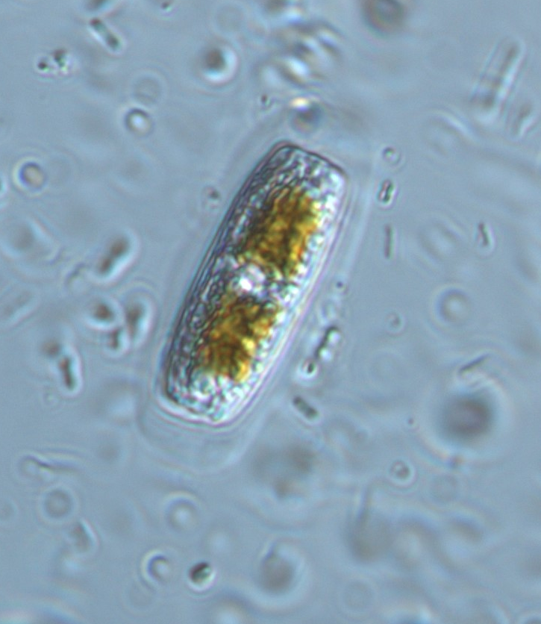
10 μm
Figure 1: Light micrograph of a M. calcarea cell from the Everlgades showing mucilage halo. Red lines indicate how cell length, width, and area and halo area were measured.

Table 1: Correlation coefficient matrix using Pearson’s correlation coefficients for the environmental variables tested in the GAM to explain EPS halo area and percentage of cells producing EPS in each PSU. Asterisk denotes significance.

 | Periphyton TP | Conductivity | pH | DSLDD | Organic Content
Periphyton TP | 1.000
Conductivity | 0.0539 | 1.000
pH | -0.2382* | 0.04045 | 1.000
DSLDD | 0.0347 | 0.01546 | -0.2133* | 1.000
Organic Content | 0.5384* | -0.04362 | -0.2767* | 0.1245 | 1.000

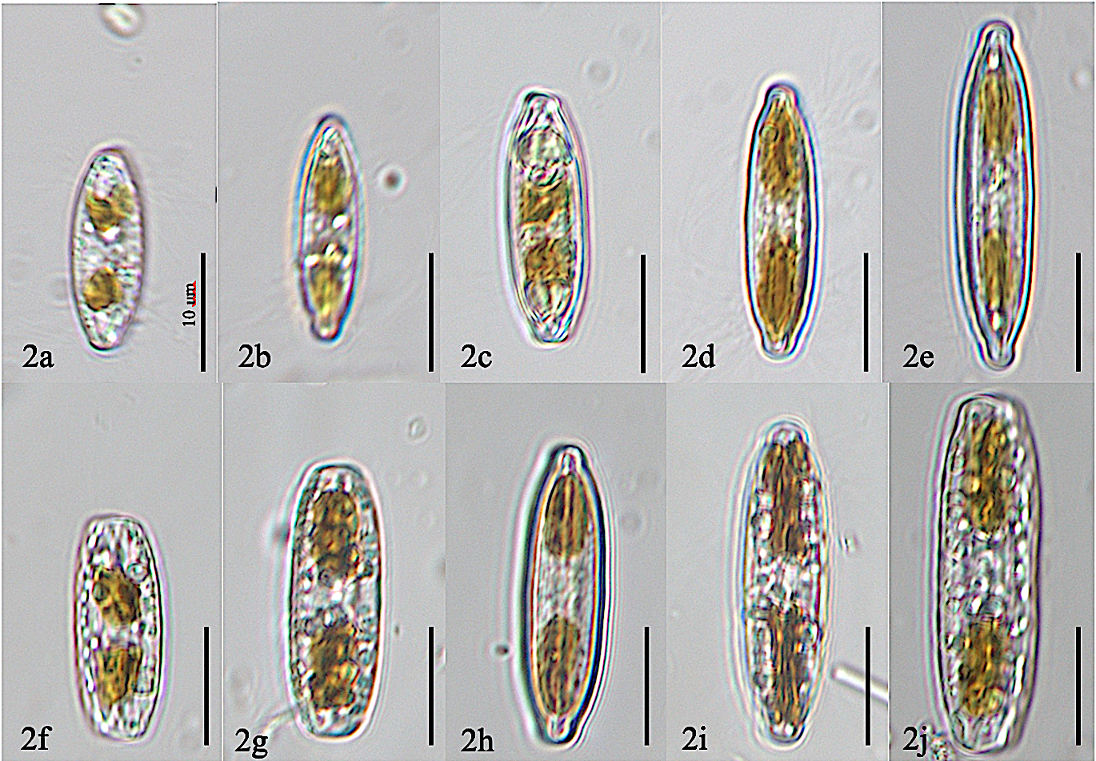
Figure 2: Example size declination series of M. calcarea cells with (2a-2e) and without (2f-2j) EPS halos.

3a
3b
3c
Figure 3: Distribution of length* (3a), width* (3b), and area* (3c) of all cells measured from field samples.

Table 2: Generalized additive model output for environmental variables and the area of EPS produced in field samples. Conductivity was kept with the model due to a large increase in the percentage of deviance explained by the model. Deviance explained is 45.2%. Asterisk denotes significance.
Parameter | df | F | p-value
Interaction (pH, Conductivity) | 15.1 | 2.3 | 0.0093*
Periphyton Total Phosphorus | 2.0 | 3.2 | 0.0725
Conductivity | 1.8 | 2.0 | 0.1468

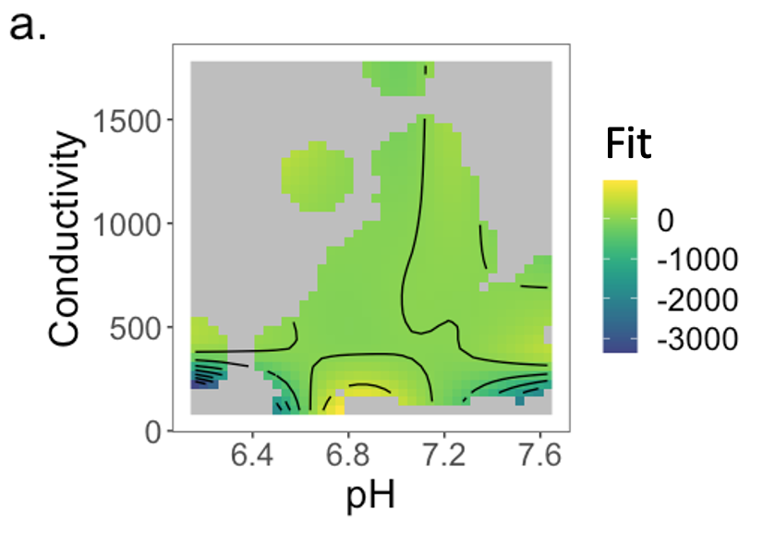
4b
4a
4c
Figure 4: (4a) Interaction plot in EPS production GAM model with pH and Conductivity. (4b) Predicted EPS Area Mean based on periphyton total phosphorus concentrations within the mat. (4c) Predicted EPS Area Mean based on conductivity.

Table 3: Generalized additive model output for environmental variables and the percentage of cells producing EPS in field samples. Deviance explained is 42.8% Asterisks denotes significance.
Parameter | df | F | p-value
Interaction (pH, Conductivity) | 14.8 | 1.8* | 0.04185*
Periphyton Total Phosphorus | 2.0 | 5.6* | 0.00827*
Conductivity | 1 | 5.0* | 0.02949*

5c
Fit
5b
5a
Figure 5: (5a) Interaction plot in percentage of M. calcarea cells with EPS GAM model with pH and conductivity. (5b) Predicted percent of M. calcarea cells with EPS based on periphyton total phosphorus concentrations. (5c) Predicted percent of M. calcarea cells with EPS based on conductivity.
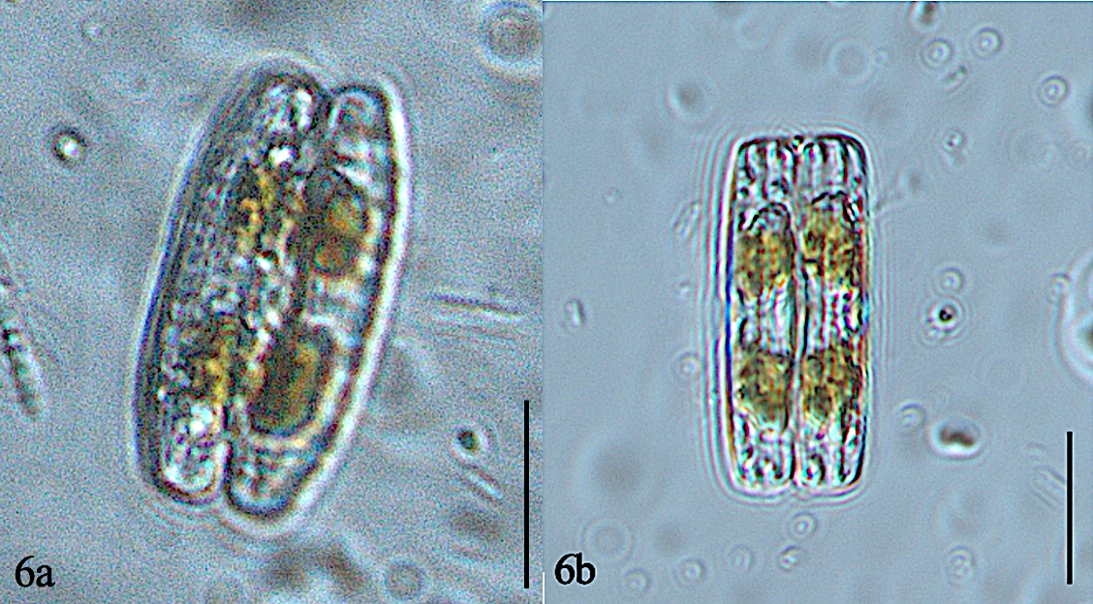
Figure 6: Pairs of M. calcarea cells in cultured samples with (6a) and without (6b) an EPS halo. Single cells in the culture samples contained in (6c) an EPS halo and (6d) without an EPS halo.

7c
7b
7a
Figure 7: Distribution of length* (7a), width (7b), and area* (7c) of all cells measured from culture samples. Asterisk denotes significance.

8c
8b
8a
Figure 8: Length* (8a), width* (8b), and area* (8c) of paired and single cells. Asterisk denotes significance.

9a
9b
Figure 9: (9a) Number of paired cells in the three untreated cultures over the 6 week observation period. There is an increase in the number of pairs around week 4 for 2 of the 3 cultures indicating the restoration of colony size. (9b) The percentage of cells with EPS present in the three untreated cultures over a 6 week observation period. There is an increase in the percentage of cells producing EPS around week 4 in 2 of the 3 cultures indicating that, along with an increase in the number of cell pairs increasing, colony restoration may be linked to EPS production. Number of cell pairs appeared to be correlated with the percentage of cells with an EPS halo in Plates 1, 2, and 3 (0.5829, 0.6491, and 0.9310 respectively).

Figure 10: Mean number of paired cells with standard error for cultures with no treatment and cultures treated with the antibiotic.

