FLORIDA INTERNATIONAL UNIVERSITY
Miami, Florida

APTAMER-BASED VOLTAMMETRIC BIOSENSING FOR THE DETECTION OF CODEINE AND FENTANYL IN SWEAT AND SALIVA

A dissertation submitted in partial fulfillment of
the requirements for the degree of
DOCTOR OF PHILOSOPHY
in
CHEMISTRY
by
Rosa LaShantez Cromartie

2021

To: Dean Michael R. Heithaus
College of Arts, Sciences and Education

This dissertation, written by Rosa LaShantez Cromartie, and entitled Aptamer-based Voltammetric Biosensing for the detection of Codeine and Fentanyl in Sweat and Saliva, having been approved in respect to style and intellectual content, is referred to you for judgment.

We have read this dissertation and recommend that it be approved.

_______________________________________
George Duncan

_______________________________________
Jaroslava Miksovska

_______________________________________
Piero Gardinali

_______________________________________
Shekhar Bhansali

_______________________________________
Bruce McCord, Major Professor

Date of Defense: November 12, 2021

The dissertation of Rosa LaShantez Cromartie is approved.

_______________________________________
Dean Michael R. Heithaus
College of Arts, Sciences and Education

_______________________________________
Andrés G. Gil
Vice President for Research and Economic Development
and Dean of the University Graduate School

Florida International University, 2021

© Copyright 2021 by Rosa LaShantez Cromartie
All rights reserved.

DEDICATION
This work is dedicated to the late memory of my maternal grandmother, Rosa Lee Spearman. Your discipline, love, and support for me and my education up until your final moments on this earth were both instrumental and motivational. I will always cherish every moment we spent together. I kept my final promise to you and successfully added Dr. to our name.
To my loving mother and my bestfriend, Darlene C. Matthews, words nor actions can adequately express how grateful and thankful that I am for you and everything you have sacrificed to support every dream I pursue. Because of you, I am who I am today! To my awesome big brother Johnathan and nephew Darien, thank you for loving, nourishing, and supporting me every moment of my life. John, your motivational speeches are always on time.
In memory of my beloved late father William Cromartie- I have held you near to my heart every day, your spirit has been one of the guiding lights during this journey. Knowing that you are cheering in every corner, helping me get through every hurdle that I ever faced has been the hidden ingredient of my success.
To my friends, family, and mentors, both near and far, this dissertation is a result of your support and encouragement throughout my graduate and undergraduate school process.
Lastly, I am dedicating this work to myself for staying motivated and seeing my dreams through. Yesterday’s dream has been fulfilled, it’s time for bigger and new dreams.
“ Yesterday’s price is not today’s price” –Fat Joe

ACKNOWLEDGMENTS
First, I would like to thank my dissertation committee for all of their help and guidance throughout my doctoral journey. Dr. Bruce McCord has given countless amounts of advice and has helped foster the scientist that I am today. After numerous emotional breakdowns, Dr. McCord has always provided support on tackle the issue and use resources to solve problems whether its experiencing unsuccessful experiments or instrumentation issues. Your excitement for forensics has allowed me to explore beyond the research beyond the standard field of study and for that I am grateful. This journey has been a rollercoaster at the best amusement park in the world, Thank you Dr. Mc! Thank you to Dr. Shekhar Bhansali for lending your laboratory and your students to me, who helped me to grasp the concepts of electrochemistry and biosensing. Your support extended beyond the laboratory, you were one of the first professors at FIU whom welcomed me with open arms and encouraged me to pursue a doctoral degree at FIU. As one of my Bridge to the Doctorate mentors, I am truly thankful for the opportunities that you have provided, including all of the letters of support and international connections in electrochemistry. Thank you to Dr. George Duncan, Dr. Piero Gardinali and Dr. Jaroslava Miksovska for all of your advice, critiques and lessons have helped me to become a better chemist. Your advice has never gone unheard and has always pushed me to seek beyond my limits.
Thank you to all of my direct lab mates and the lab mates whom I have become attached to from other laboratories across the department. The invites for food and coffee, the texts messages and memes contributed to the moments which helped me to successfully get through some of the hurdles. To my Mallory, my sweet Mallory, thank you for always being the listening ear that I needed when I needed to vent. You made time to listen and tell me the truth whether or not I always wanted to hear it. To all of those who I have met throughout my journey in the McCord lab Nicole, Kathryn, Thad, Ling, Chiara, Irene, Marco and Izabel, TJ, Mario, Hussain, Quentin, Meghan, Fabiana, Svede and more. To Michelle Torres, my favorite Firestarter, thank you for being you, an awesome person with the heart of gold! You are the ‘spark of light’ in a dark room that is always there to help brighten those gloomy days of unsuccessful research.
I would like to thank the Washington Center and the Naval Research Laboratory HBCU/MI internship program for providing me an opportunity to conduct research under mentorship of one of the mentors at NRL. Thank you to the Bridge to the Doctorate Fellowship Program, F.E.F. McKnight Doctoral Students Fellowship Program, the Delores Auzenne Fellowship at FIU, and lastly the Dissertation Year Fellowship provided by FIU for financially supporting my doctorate.
I would like to acknowledge the Bridge to the Doctorate Fellowship Program at FIU and the F.E.F McKnight Fellowship Program. Having this opportunity, not only provided financial support, I gained an external family and one of the best non-academic mentors that could ever support me during my journey. To my BD and McKnight fellows—Sana, Marcus, Ivan, Yem, Lamar, MariaCarla, Teshun, Marcela, and more… thank you for being so welcoming and supportive. To Dr. John Gibson, thank you for being one of my closest friends. You welcomed me with an open heart on my tour to FIU and has been there every step of the way; even when you are in the middle of ‘nowhere’ for work, you always are there to lend true advice. Thank you for having the same personality as me and providing the tough love and advice that I usually provide to others, to me. To Krystine and Michelle, you ladies have welcomed me with open arms from my very first BD meeting. Your drive to seeing everyone succeed is indescribable. Thank you for helping get through the tough presentations, making me think outside of just what literature has provided and going beyond.
To Dr. Sonja Montas-Hunter: from recruitment during my junior year of my undergraduate studies until now and beyond, you have continuously supported me and encouraged me to finish strong! Your dedication to bring me to FIU was overwhelming, however, I would not have chosen a better person to encourage me to go to graduate school here. Through many tears, happy and sad, you have been the support system that everyone wish they could have during trying times. Thank you for always keeping me levelheaded during this journey.
To Mrs. Vanessa William-Smith: Your call in June 2010 changed my life for the better. You have always gone above and beyond for your students; however, the outpour of support that you have showered toward me has help mold me into the outgoing person that I am today. Throughout my undergraduate and graduate journey, you have celebrated my successes and achievements, although we are hundreds of miles away from the Classic City. #GoDawgs
I’d like to acknowledge Dr. Adrienne Madison and Dr. Shanise Walker for always checking in on me. The both of you have taught me so much in academia, life and about myself. Thank you both for being there through this long journey, sharing your experiences and the knowledge that you have gained over the years. To my brother, mentor, my “homeskillet” Raymond, no words can express my gratitude to you and the contributions that you have made to my life. Whether its sharing your Hulu account, reading my papers at 2am or just taking me out to eat to make sure I am feeding myself outside of working long hours, you have been there through thick and thin. I love you three more than you will ever know!
To my UGA family, Dr. Cook, Dr. Birkes, and Mrs. Shirley, your support means the world to me, and I thank you for being apart of this journey with me. My Framily—Chelsea, Denise and Robert, I do not know where I would be without you all. Our monthly/ quarterly family check-ins have always been rewarding with laughter, venting and most of all love. The moments that we share have always kept me afloat throughout the times I felt alone in a big city.
To all of my friends back in Atlanta that has been on this journey with me, it is wonderful to have you all with me and rooting for me! To Shaeroya, you have been my ace since 10th grade and have always been there to support me, whether far or near when you have visited Miami, I just want to say I love you dearly! To my bestfriend, Christopher, our journey is just accelerating into second gear! We have a ton of memories in just 8 years, but we have a lifetime to make more. Thank you for being the shoulder that I lean on, my unofficial counselor, my venture buddy, but most importantly my BEST friend! Kimiko, I know our journey is just beginning but your support and advise is one that I’ll always cherish! Your contagious laughter, your love for chemistry and forensics, and most importantly your friendship is what I am grateful for, since meeting you in seminar!
Last, but not lease, to my family. I love you so much! To my mother and brother, thank you for being the cheer teams that has been unmatched my entirelife. Mom: your love and support for me goes unappreciated. You are my confidant, you have wiped the tears from my eyes and lifted my head when it was down. You have seen me at my worst and at my best, you continue to push me to be better than the best that I think I can be. Your love is unmatched and I am grateful that God chose you to be my mother. I love you infinity x infinity x infinity. Brother: You have been there before I was born, reading to me and talking to me, awaiting to be the best big brother there is. I love you! The accomplishments of this dissertation would not have been possible without the guidance and the help of my village. I look forward to the next chapter in my life and the continued love and support from you all.

ABSTRACT OF THE DISSERTATION
APTAMER-BASED VOLTAMMETRIC BIOSENSING FOR THE DETECTION OF CODEINE AND FENTANYL IN SWEAT AND SALIVA
by
Rosa LaShantez Cromartie
Florida International University, 2021
Miami, Florida
Professor Bruce McCord, Major Professor
Despite the many governmental and medicinal restrictions created to combat the opioid epidemic in the United States, opioid abuse and overdose rates continue to rise. The development of an aptamer-based voltammetric sensor and biosensor is described in this dissertation. The aim was to develop a low-cost, sensitive, and specific aptamer-based sensor for on-site, label-free determination of codeine and fentanyl in biological fluids. To do this, the surfaces of screen-printed carbon electrodes (SPCE) were modified with gold nanoparticles (AuNPs), followed by the addition of single-stranded DNA aptamers. These were covalently bound to the electrode surface. Operations of the sensors were collected using an electroactive solution such as ferrocyanate was aspirated onto the detector, producing a steady current due to oxidation at the electrode surface. Upon target binding, the DNA aptamers coalesce. The resultant complex decreases access to the surface due to steric hindrance with a concomitant decrease in signal. Diffusion of the electroactive solution to the electrode surface increased when more significant target drug concentrations were present in the sweat. The generated electrical current was collected and analyzed via square wave voltammetry and electrochemical impedance spectroscopy.
Applying this aptasensing approach to modified commercial SPCEs permitted the detection of nanomolar concentrations of codeine and fentanyl in biological fluids. After providing proof-of-concept with a commercial SPCE, a paper-based SPCE was developed for the aptasensing of opioids. The performance of the paper-based sensor produces a current approximately 2x less than the commercial disposable sensor. Ultimately, the fabrication and development of this novel biosensor for the detection of opioids present a novel strategy for opioid detection through the use of disposable, paper-based, screen-printed carbon electrodes. Furthermore, the low cost and convenience of this procedure should further aid the development of related screening methods for forensic and medical applications.

TABLE OF CONTENT
Chapter 1 Motivation and Objectives 2
Scope of the Dissertation 2
References 2
Chapter 2 Literature Review 2
2.1 Opioids and Opiates Overview 2
2.1.1 Opioid Binding 2
2.1.2 Opioid Metabolism 2
2.2 Codeine 2
2.2.1 Overview 2
2.2.2 Pharmacology 2
2.2.3 Usage and Position in Opioid epidemic 2
2.3 Fentanyl 2
2.3.1 Overview 2
2.3.2 Pharmacology 2
2.3.3 Analogues and Derivatives 2
2.3.4 Usage and Position in Opioid epidemic 2
2.4 Opioid Detection in Biological Matrices 2
2.4.1 Sweat 2
2.4.2 Saliva 2
2.4.3 Drug monitoring in saliva and sweat 2
2.5 Analytical Methods used for Drug Detection 2
2.5.1 Presumptive Testing 2
2.5.1.1 Colorimetric/ Spot Test for Drug Detection 2
2.5.1.2 Thin Layer Chromatography for Opioid Detection 2
2.5.1.3 Immunoassay Testing for Drug Detection 2
2.5.1.3.1 Lateral-flow Assays 2
2.5.2 Confirmatory Testing 2
2.5.2.1 Chromatographic Techniques for Opioid Detection 2
2.5.2.1.1 Gas Chromatography-Mass Spectrometry 2
2.5.2.1.2 Liquid Chromatography-Mass Spectrometry in drug detection 2
2.5.2.2 Spectroscopic Techniques for Opioid Detection 2
2.5.2.2.1 Raman Spectroscopy 2
2.6 Novel Methods for Opiate Analysis 2
2.6.1 Lab on a Chip Based Methods 2
2.6.1.1 Microfluidics 2
2.6.1.1.1 Paper-based Microfluidics 2
2.6.2 Electrochemical Methods 2
2.6.2.1 Electrochemical Systems 2
2.6.2.2 Electrochemical Measuring Techniques 2
2.6.2.2.1 Cyclic Voltammetry (CV) 2
2.6.2.2.2 Square Wave Voltammetry (SWV) 2
2.6.2.2.3 Electrochemical Impedance Spectroscopy (EIS) 2
2.6.2.2.4 Chronoamperometry (C.A.) 2
2.6.2.3 Non-electrochemical Measuring Techniques 2
2.6.2.3.1 UV-Visible Spectroscopy (UV-Vis) 2
2.6.2.3.2 Scanning Electron Microscopy (SEM) 2
2.6.2.3.3 Dynamic Light Scattering (DLS) analysis 2
2.6.2.3.4 Zeta Potential (ζ) 2
2.6.3 Electrochemical Sensors 2
2.6.3.1 Paper-based Electrochemical Sensors 2
2.6.3.2 Screen Printed Electrodes 2
2.6.4 Biosensors 2
2.6.4.1 Nanomaterials 2
2.6.4.1.1 Gold Nanoparticles 2
2.6.4.2 Antibody-based biosensor (Immunosensors) 2
2.6.4.3 Aptamer-based biosensor 2
2.6.4.3.1 Aptamers used in Opioid Detection 2
2.6.5 Forensic Electrochemistry 2
2.6.5.1 Fieldable Drug Detection 2
References 2
Chapter 3 Experimental 2
3.1 Chemical Reagents 2
3.1.1 Paper Microfluidic Devices for Serology 2
3.1.1.1 Chemicals 2
3.1.1.2 Biological Fluids 2
3.1.2 Voltammetric Opioid Detection 2
3.1.2.1 Biological Fluids 2
3.1.2.2 Chemicals 2
3.2. Electrochemical Sensing Techniques 2
3.2.1 Cyclic Voltammetry (CV) 2
3.2.2 Square Wave Voltammetry (SWV) 2
3.2.3 Electrochemical Impedance Spectroscopy (EIS) 2
3.2.4 Chronoamperometry (CA) 2
3.3 Non-electrochemical Sensing Techniques: 2
3.3.1 UV-Visible Spectroscopy (UV-Vis) 2
3.3.2 Scanning Electron Microscopy (SEM) 2
3.3.3 Dynamic Light Scattering (DLS) analysis 2
3.3.3.1 Zeta Potential (ζ) 2
References 2
Chapter 4 Development of a Microfluidic Device (μPADs) for Forensic Serological Analysis 2
4.1 Introduction 2
4.2 Experimental 2
4.2.1 Chemicals 2
4.2.1.1 Biological fluids 2
4.2.2 μPADs 2
4.2.3 Serology Colorimetric tests 2
4.2.3.1 Test development 2
4.2.3.1.1 Urine 2
4.2.3.1.2 Blood 2
4.2.3.1.3 Saliva 2
4.2.3.1.4 Semen 2
4.2.5 Interference testing 2
4.3 Results and discussion 2
4.2.4 Interference testing 2
4.3 Conclusion 2
Acknowledgments 2
References 2
Chapter 5 An aptamer-based electrochemical biosensor for label-free of codeine with gold nanoparticles amplification 2
5.1 Introduction 2
5.2 Materials and Reagents 2
5.2.1 Apparatus and Instrumentation 2
5.2.1.1 Synthesis of AuNPs 2
5.2.1.2 Design and Fabrication of the paper-based screen-printed electrode 2
5.3 Experimental 2
5.3.1 Electrode Preparation 2
5.3.1.1 Optimization of electrodeposition time and potential 2
5.3.2 Codeine sensing principle 2
5.3.3 Sample Preparation 2
5.3.4 Electrochemical Measurements 2
5.4 Results and Discussion 2
5.4.1 Sensor Surface Characterization 2
5.4.2 Aptamer Loading 2
5.4.3 Sensor Sensitivity 2
5.4.4 Sensor Specific Binding 2
5.4.5 Sensor Selectivity 2
5.4.6 Reproducibility of Sensor 2
5.4.7 Validation of paper-based sensor 2
5.5 Conclusion 2
Declaration of Interest 2
Acknowledgments 2
References 2
Chapter 6 Conclusion and Future Work 2
References 2
VITA 2

TABLE OF FIGURES
Figure 1.1 Three wave trends statistical data provided by the Center for Disease Control, which depicts the rise in opioid overdose deaths. ⁴ 2
Figure 2.1 Examples of opioid classification being either natural, semi-synthetic, and synthetic. 2
Figure 2.2 Plane, extracellular, and intracellular view of a 7-transmembrane GPCR of the μ-opioid receptor containing ligand spheres shown in green where opioids have the ability to bind. ¹³ 2
Figure 2.3: Intracellular changes involving repolarization of the K+ and depolarization Ca2+ channels at the presynaptic and postsynaptic terminals within the central nervous system upon an opioid agonist binding to the G-Protein Coupled Receptors. 2
Figure 2.4 Structure comparison of codeine to morphine 2
Figure 2.5 Metabolism process of codeine in humans, including the CYP enzymes used for forming codeine metabolites ^{25,26} 2
Figure 2.6 Structure of Fentanyl and the regions at which modification can occur for derivatives 2
Figure 2.7 Chemical structure of fentanyl and some of its foremost known analogs.³⁴ 2
Figure 2.8 Metabolic profile of fentanyl during human consumption, provided by Wilde et al. ³⁹ 2
Figure 2.9 Schematic illustration of a basic immunoassay strip test 2
Figure 2.10 Basic Lateral Flow Assay ⁷⁶ 2
Figure 2.11 μPAD developed by in this project ¹⁰³ 2
Figure 2.12 Illustration of a three-electrode electrolytic cell ¹¹¹ 2
Figure 2.13 Cyclic voltammogram that demonstrates reversibility as a result of oxidation and reduction of current and potential increasing and decreasing.¹¹² 2
Figure 2.14 Basic Nyquist plot showing the kinetic and diffusion regions and a simple Randles circuit ¹¹⁵ 2
Figure 2.15 Three essential components of the surface of a sensor: Graphene-carbon receptor, a sample analyte, and an electrode transducer. 2
Figure 2.16 Example of paper-based microfluidic electrochemical sensors provided by Henry’s research group. A) Basic design of the paper-based microfluidic electrochemical sensor and B) Three-electrode paper-based microfluidic electrochemical device that contains a hydrophilic area at the center of the device and 3 separate testing zones for glucose, lactate, and uric acid.¹¹⁹ 2
Figure 2.17A) Schematic design for a three-electrode—carbon screen-printed electrode, compromised of working electrode (WE), reference electrode (RE), and counter electrode (C.E.). This three-electrode system was designed to mimic the manufactured electrochemical systems B) provided by Zensors© ¹³⁶ 2
Figure 2.18 An architecture design of a typical biosensor and its components 2
Figure 4.1 Multi-analyte paper microfluidic testing device developed for detecting body fluids. The device consists of 4 channels with 5 locations for reagents. The area labeled A is where sodium perborate tetrahydrate is placed within a thin layer of water-based liquid glue. Area B is the location where phenolphthalein is placed. 2
Figure 4.2 The detection of urea in urine is performed using urease to decompose urea into NH₃ and HCO₃⁻ ions. 2
Figure 4.3Ammonia that is produced following the hydrolysis of urea is mixed with Nessler's reagent to produce a colorimetric reaction and a mercuric ammonia product. This process is called Nesslerization 2
Figure 4.4 Blood can be detected by the Kastle–Meyer test by using the peroxidase-like activity of hemoglobin. 2
Figure 4.5 Saliva's amylase activity was measured through the hydrolysis of the starch–iodine. 2
Figure 4.6 Semen was detected using sodium α-naphthyl phosphate with acid phosphatase and fast blue B. 2
Figure 4.7 Illustrates the presumptive test results using colorimetric testing reagents for urine at dilution ratios of: 1 : 2, 1 : 5, 1 : 10; 1 : 20, 1 : 50, 1 : 100; 1 : 200, 1 : 500, 1 : 1000. The Urease-Nessler test was used in the above figure to detect urine. 2
Figure 4.8 ImageJ semilog plots of sample concentration vs. color density 2
Figure 5.1 Three-electrode system design created using LayoutEditor Software. This electrode pattern was used to create a paper-based screen-printed electrode used as a comparison for the experiment. 2
Figure 5.2 Fabrication process involved in the making of the paper-based screen-printed electrode. For details of the various steps. A. Chromatographic paper used with ColorQube wax printer; B. ColorQube wax printed used to print the base electrode design for hydrophobic barrier; C. temperature-controlled laminator to melt the wax into the chromatographic paper; D. The Melted wax design that has formed hydrophobic barriers; E. Using the stencil design created with the Silhouette Cameo, the design is placed on top of the waxed paper, and the conductive ink is squeegeed and cured, F. A bulk of cured and ready to go electrode; G. Photograph of the final paper electrode inserted. 2
Figure 5.3 Chronoamperometry curves of electrodeposition of gold onto the bare screen-printed carbon electrode by applying different potentials. Effect of electrodeposition time employing AuNPs a standard of 40μL of 25.3μM and an E_{dep} of 500 mV for 600 s was selected. 2
Figure 5.4 Principle of confirmational structure change for the detection of codeine. Aptamers are introduced to the AuNPs that is electrodeposited onto the surface of the working electrode of the carbon screen-printed electrode system for thiol functionalization. After incubation, the electrodes are rinsed with binding buffer to remove unbound aptamers, and 6-mercapto-1-hexanol is used to block any remaining active sites and left to incubate for 1 hour. 2
Figure 5.5 SEM images of unfunctionalized AuNPs (A1) and aptamer-functionalized AuNPs (A2). B.) UV-Vis absorbance spectrum of unfunctionalized AuNPs and aptamer-functionalized AuNPs. C. Data of Dynamic light scattering (DLS) showing the size distribution and zeta potential of 50nm unfunctionalized gold nanoparticles and aptamer-functionalized gold nanoparticles. 2
Figure 5.6 Square wave voltammogram showing the detection of codeine spiked in sweat with sweat (lowest level) as a reference. Codeine was spiked in sweat through serial dilution. SWVs detected from 25ng/mL to 150ng/mL in [Fe(CN)₆] ^{3-/4-}/KCl (5 mM /0.1 M) electrolyte solution. 2
Figure 5.7 A. Cyclic voltammogram used to characterize the surface modification of the electrode.. (a)SPCE ; (b) AuNPs/SPCE (c) aptamer/ AuNPs/ SPCE; (d) MCH/aptamer/ AuNPs/ SPCE; (e) Sweat/MCH/aptamer/AuNPs/SPCE and (f) Codeine (50ng/mL)/MCH/aptamer/AuNPs/SPCE in 5mM [Fe(CN)₆]^{3−/4−} containing 0.1M KCl redox probe solution. B. EIS Representative Nyquist plots (−Z_{im} vs. Z_{re}) for the same samples used in the cyclic voltammogram. 2
Figure 5.8 Aptamer selectivity was evaluated of the label-free codeine sensor by incubated 50ng/mL codeine (Codeine 1), 150ng/mL codeine (Codeine 2) and various interferants at the concentration of 200ng/mL(a) Acetaminophen, (b) Cocaine, (c) Diazepam, (d) Fentanyl, (e) Heroin, (f) Hydrocodone, (g) Meperidine, (h) Methamphetamine, (i) Morphine, (j) Nicotine, (k) Oxycodone, (l) Phenobarbital, (m) Thebaine, (n) Tramadol, (o) Caffeine, (p) CaCl₂, and (q) Glucose were evaluated. 2
Figure 5.9 Comparison of current change of the label-free codeine sensor by incubated 50ng/mL codeine (Codeine 1), 150ng/mL codeine (Codeine 2) and various interferants at the concentration of (a) 150ng/mL Acetaminophen, (b) 150ng/mL Cocaine, (c) 150ng/mL Diazepam, (d) 150ng/mL Fentanyl, (e) 150ng/mL Heroin, (f) 150g/mL Hydrocodone, (g) 150ng/mL Meperidine, (h) 150ng/mL Methamphetamine, (i) 100ng/mL Morphine, (j) 200ng/mL Nicotine, (k) 125ng/mL Oxycodone, (l) 150ng/mL Phenobarbital, (m) 125ng/mL Thebaine, (n) 150ng/mL Tramadol, (o) 150Caffeine, (p) 150ng/mL CaCl₂, and (q) 150ng/mL Glucose were evaluated 2
Figure 5.10 A Square wave voltammogram showing the detection of codeine spiked in sweat using the paper based aptasensor. SWVs detected from 25ng/mL to 150ng/mL in [Fe(CN)₆] ^{3-/4-}/KCl (5 mM /0.1 M) electrolyte solution with a shorter change in current at 100-150ng/mL. B EIS Representative Nyquist plots (−Z_{im} vs. Z_{re}) was used to characterize the surface and various functionalization steps of the electrode. (a)SPCE ; (b) AuNPs/SPCE (c) aptamer/ AuNPs/ SPCE; (d) MCH/aptamer/ AuNPs/ SPCE; (e) Sweat/MCH/aptamer/AuNPs/SPCE and (f) Codeine (50ng/mL)/MCH/aptamer/AuNPs/SPCE in 5mM [Fe(CN)₆]^{3−/4−} containing 0.1M KCl redox probe solution. 2

TABLE OF TABLES
Table 2.1 Categories of Analytical Techniques for Identifying Drugs or Chemicals⁶⁹ 2
Table 3.1 List of non-electrochemical instrumentation used for the analysis of specific material 2
Table 4.1 Each lane of the µPAD has been separated using a hydrophobic barrier lane for initial sensitivity testing. (A) Urine (B) Blood (C) Saliva (D) Semen. 2
Table 4.2 The μPAD design used for serological analysis. The subsequent figures illustrate the device before and after the simultaneous detection of urine, blood, saliva, and semen. 2
Table 4.3 Figures of merit for each body fluid, including the curve fits for the semilog plots, the R² values for each fit, the visual limit of detection (v/v), and the minimum concentration detection limit measured using ImageJ software. 2
Table 4.4 Common test interferences obtained using the multi-analyte device 2
Table 5.1: Conductivity and pH of biological and electrochemical samples used to detect codeine using the aptasensor. 2

ABBREVIATIONS, ACRONYMS, SYMBOLS
Ab | Antibody
Ag/AgCl | Silver/Silver Chloride
Ac | Alternating Current
Apt | Aptamer
AuNPs | Gold Nanoparticles
c | Concentration of species
C₁₈H₂₁O₃N | Elemental Composition of Codeine
Ca²⁺ | Calcium Ion
CA | Chronoamperometry
CaCl₂ | Calcium Chloride
CDC | Center for Disease Control and Prevention
C_{dl} | Double Layer Capacitance
CE | Counter Electrode
CI | Chemical Ionization
Cl⁻ | Chloride Ion
CV | Cyclic Voltammetry
CYP | Cytochrome Pathway
CYP2D6 | Cytochrome P450-2D6
CYP3A4 | Cytochrome P450-3A4
D | Diffusion coefficient
DEA | Drug Enforcement Agency
DC | Direct current
DPV | Differential Pulse Voltammetry
DLS | Dynamic Light Scattering
DNA | Deoxyribonucleic Acid
E | Measured potential
E° | Standard potential
e⁻ | Electron
ECL | Electrochemiluminescence
EDTA | Ethylenediaminetetraacetic acid
EEC | Electrical Equivalent Circuit
EI | Electron impact
EIS | Electrochemical Impedance Spectroscopy
F | Faraday’s Constant (96,485 Colombs/mol)
f | Frequency
GC | Gas Chromatography
GC-MS | Gas Chromatography-Mass Spectrometry
GPCR | G-Protein Coupled Receptors
H₂SO₄ | Sulfuric Acid
HAuCl₄∙3H₂O | Gold Chloride Trihydrate
HCl | Hydrochloric Acid
HCO₃⁻ | Bicarbonate ion
Hz | Hertz
I₀ | Initial amplitude of potential signal
i_{p} | Current
I_{t} | Sinusoidal potential
ΔI | Different in Current
K₃[FeCN]₆ | Potassium Ferricyanide
K₄[FeCN]₆ | Potassium Ferrocyanide
K⁺ | Potassium Ion
K_{a} | Association constant
KCl | Potassium Chloride
K_{d} | Dissociation Constant
LC | Liquid Chromatography
LC-MS | Liquid Chromatography-Mass Spectrometry
LFA | Lateral Flow Assays
L | Liter
LOC | Lab on a Chip
LODI | Limit of Detection
6-MCH | 6-Mercapto-1-hexanol
MEMS | Microelectrochemical Systems
mL | Milliliter
mM | millimolar
Molar | M
mV | millivolts
Mg²⁺ | Magnesium Ion
MgCl | Magnesium Chloride
MSL | Multilayer Soft Lithography
n | # of moles
Na⁺ | Sodium Ion
NaCl | Sodium Chloride
NaClO₄ | Sodium Perchlorate
ng/mL | Nanogram per milliliter
NH₃ | Ammonia
nm | Nanometer
O | Oxidized species
PBS | Phosphate Buffer Solution
Q | Charge
R | Reduced species
R | Universal Gas Constant (8.314 J·K·L·mol⁻¹)
R_{ct} | Charge Transfer Resistance
RE | Reference Electrode
RNA | Ribonucleic Acid
R_{s} | Resistance of Solution
SPCE | Screen Printed Carbon Electrode
SPE | Screen Printed Electrode
SELEX | Systematic Evaluation of Ligands using Exponential Enrichment Technique
SEM | Scanning Electron Microscopy
SERS | Surface Enhanced Raman Spectroscopy
SWGDRUG | Scientific Working Group for the Analysis of Seized Drugs
SWV | Square Wave Voltammetry
TCEP·HCl | Tris(2-carboxyethyl) phosphine Hydrochloride
TE /Tris EDTA | Tris (hydroxymethyl) Aminomethane Ethylenediaminetetraacetic acid
T | Temperature in Kelvin
t | Time
TLC | Thin Layer Chromatography
Tris-HCl | Tris (hydroxymethyl) Aminomethane Hydrochloride
UGT | Uridine diphosphate-glucuronosyltransferase
UGT2B7 | Uridine 5'-diphospho-glucuronosyltransferase-2B7
UNODC | United Nations Office on Drugs and Crimes
U.S. | United States
UV-Vis | Ultraviolet-Visible Spectroscopy
WE | Working Electrode
Z_{w} | Warburg Impedance
δ | Delta
ζ | Zeta potential
κ | Kappa
μ | Mu
μA | Microamps
μL | Microliter
μM | Micromolar
μPADs | Microfluidic Paper Analytical Devices
ν | Scan rate
σ | Surface charge density
σ | Standard deviation
Ω | Ohms

Motivation and Objectives
In a most recent report released by the United Nations Office on Drugs and Crime (UNODC), nearly 300 million people misused and abused drugs worldwide in 2018.¹ The abuse of drugs has been a serious issue throughout the world, especially in the United States. In particular, opioids, known as schedule II drugs, have become one of the major sources of drug abuse. These drugs are commonly used as treatment options for pain, producing analgesic and sedative effects upon patients as they stimulate the opiate receptors in the central nervous system. By inducing the central nervous system, opioids can act as a potent agonist against the mu receptor, causing adverse effects by decreasing the level of consciousness, impairing the cognitive reaction system, and directly affecting the opioids on neurons to cause toxic effects. ^{2,3} Unfortunately, opioids have played a major role in drug hospitalization and deaths due to their users' frequency of use and abuse. During the 1990s, pharmaceutical companies began manufacturing prescription opioids on a major scale, making them widely available for healthcare providers two prescribed to their patients for pain relief. At that time, doctors were assured by the pharmaceutical industry that these drugs would not lead to patient addiction, a statement that was unfortunately incorrect. In fact, many of their patients began forming addictions due to easy access, popularity, and inadequate legal supervision of opioids being prescribed. As a result, a dramatic rise in the use and abuse of prescription opioids began across the nation. Thus, becoming a concern to the government of the United States as the number of people becoming addicted to opioids increased and the death count began to rise.
Currently, the United States is experiencing an opioid overdose epidemic. This epidemic has occurred in three waves, the first beginning during the 1990s prescription drug hiatus. A second wave began around 2010 when heroin overdoses became more frequent. As a third wave followed, the use of fentanyl and other synthetic opioid increased, increasing deaths in and around 2013. Data provided by the CDC, Figure 1.1, shows that the death count continues to rise each year due to the increase in the availability of clandestine fentanyl and the development of novel synthetic analogs of fentanyl and other opioids steadily.⁴ While opioids have been a global heartache to many nations, and the United States has particularly suffered dramatically in this public health crisis. Over the past decade, the United States has witnessed a drastic increase in the use and abuse of pharmaceutical and illicit (natural and synthetic) opioids, resulting in over 700,000 overdose deaths.⁴
Prescription opioids and illegal opioids are addictive and can result in both fatal and non-fatal opioid overdose events. In recent years, scientists throughout the U.S. have made efforts to collect overdose data which would challenge public health officials to intervene and address the lag in real-time surveillance of the opioid crisis. The standard metric for gauging opioid consumption and abuse has been through data collection of overdoses and overdose-related deaths. Active real-time surveillance of opioid consumption, excretion, and disposal should also occur, as monitoring these activities can help officials identify which geographic risk factors can be detected and mitigated. Therefore, as this epidemic continues to grow, there is a need for rapid and reliable detection of these intoxicating substances in either their parent and/or metabolized form to aid local officials in monitoring abuse.
The objective of the research described in this dissertation is to develop electroanalytical techniques to create a sensing platform that uses low sample volume to form a highly sensitive, selective, and affordable system for trace-level opioid detection in biological matrices. To this aim, selected opiate-specific aptamers were functionalized onto nanoparticles that had previously been deposited and bound to the surface of screen-printed carbon electrodes. These electrodes were then utilized for the detection of codeine in sweat and fentanyl in saliva. Detection was based on indirect sensing of these target drugs as their binding to the surface blocked access to an iron thiocyanate solution. Characterization of the electrode response was completed through voltammetric and impedance analysis of the response to various opiates and other interfering substances.

Figure 1.1 Three wave trends statistical data provided by the Center for Disease Control, which depicts the rise in opioid overdose deaths. ⁴

Scope of the Dissertation
The current chapter provides the motivation of the research work conducted for the completion of this dissertation. Chapter 2 briefly introduces electrochemistry and literature review of previous research on electrochemical sensing, biosensing, nanomaterials, aptamers, forensic electrochemical sensing, and opioids. Within Chapter 3, experimental details are provided on the chemical reagents and instrumentation. Chapter 4 details the development of a Microfluidic Paper Device (μPADs) for Forensic Serological testing. For continuity, chapter 5 details the fabrication and use of a paper-based screen-printed electrode used during the development of a label-free aptasensor is explained to detect codeine in sweat. Lastly, an overall conclusion and suggestions for future work is detailed in Chapter 6 of this thesis.

References
1. United Nations Office on Drugs and Crime UNODC World Drug Report 2020: Global Drug Use Rising; While COVID-19 Has Far Reaching Impact on Global Drug Markets. States News Service 2020.

2. Vella-Brincat, J.; MacLeod, A. D. Adverse Effects of Opioids on the Central Nervous Systems of Palliative Care Patients. Journal of pain & palliative care pharmacotherapy 2007, 21, 15-25.

3. Schiller, E. Y.; Goyal, A.; Mechanic, O. J. Opioid Overdose. In Stat Pearls [Internet]StatPearls Publishing: Treasure Island (FL), 2021

4. CDC Understanding the Epidemic | Drug Overdose | CDC Injury Center. https://www.cdc.gov/drugoverdose/epidemic/index.html (accessed Mar 16, 2021).

Literature Review

2.1 Opioids and Opiates Overview
Generally, “opiates” are alkaloids derived from the opium poppy, Papaver somniferumi, which has been used since ancient times for medicinal and food purposes.¹ The opium poppy latex, a dried yellow/brown substance, and its oil covered seeds, contains various alkaloids such as codeine, morphine, and thebaine. Opiates are often referred to as any natural narcotic alkaloid compound found within opium and its congeners, whereas opioids are both natural and synthetic compounds. The most important effect that opioids produce is their analgesic properties; however, respiratory depression, sedation, and mood-altering effects also occur.
Opium has been medicinally used since the third millennium B.C. and may have been used recreationally even earlier.² Gradually, opium has been modified in various ways to produce a variety of purified, semi-synthetic, or synthetic forms. In 1803, a German apothecary, Friedrich Sertürner isolated the main active constituent of opium and named this constituent morphine, after the Greek god of dreams, Morpheus.³ As a result of this experiment, the study of alkaloid chemistry was born and hastened the emergence of a new pharmaceutical industry. Following this study, other alkaloids with similar structures were isolated from organic substances; this separation method was also used to isolate caffeine (1820) and nicotine (1828) from their parent compounds. ⁴ It was not until 1923 that the structure of morphine was revealed and until 1952 when the complete chemical synthesis of morphine was confirmed. The elucidation of the chemical structure of morphine led to additional work involving the development of semi-synthetic and fully synthetic compounds yielding similar pharmacological actions as morphine. This work ultimately led to the development of more potent, longer-acting, and more effective opioids such as levorphanol, methadone, and fentanyl.
There are three forms of opioids which include: natural, semi-synthetic, and synthetic compounds. Natural opioids are extracted from the opium poppy seed and include compounds such as–morphine and codeine. Semi-synthetic opioids are chemically produced from natural opioids to produce similar pain relief at an adjusted potency. ⁵ Examples include oxycodone and hydrocodone. Synthetic opioids are chemically manufactured, yielding various chemical structures classified based on the number of substitutes added to the nitrogen heterocycle. Synthetic opioid analgesics include oxycodone, methadone, tramadol, and fentanyl. Opioid overdoses have reached a crisis stage, becoming the leading cause of mortality amongst drug users. Figure 2.1 shows examples of opioids and their classifications:
Figure 2.1 Examples of opioid classification being either natural, semi-synthetic, and synthetic.
Dozens of opiates have been extracted from the opium poppy seed and derived synthetically into other drugs with similar analgesic effects on the body and the brain as those naturally grown. Morphine is one of the natural opioids that continues to be the gold standard for pain management, alternative opioids such as oxycodone and methadone have become an important alternative to morphine. When morphine is excessively used, the response to the over usage of this drug can cause side effects such as opioid toxicity. Although reducing the dose of morphine consumed is most efficient in opioid toxicity management, the dependency on the drug can be hard to overcome. As a result, alternatives are sought to produce “better” outcomes, although this is not often the case. Each derived drug has similar effects to naturally occurring drugs, and caution should be taken as the potency differs amongst each drug, especially opioids, as a result of being were chemically modified.
The history of opioids has dated back to the 1800s, where the United States can be dated as far back as 1775. It was not until after a treaty between China, the British, and the United States that ended the first Opium war in 1844 after discovering opium smuggling in China from the British caused numerous health problems related to opium addiction. The first formal treaty would force China to make a series of other treaties, better known as “unequal treaties”, to avoid wars waged by the Western powers to assure the importation of goods that would give unfettered access to the European and U.S. trade markets and Chinese products. ⁶ Although treaties were made, this problem remained with the United States, and it was not until the end of the civil war that morphine became a major concern due to the large number of injured veterans who became addicted. ¹ Federal drug imports and exports would become controlled by federal regulations and tariffs, which required narcotic drugs to become labeled with their purity. As a result of addiction issues, the Harrison Narcotics Act of 1914 was used to place restrictions on opioids to help combat commercial usage and place stronger regulations on domestic trades. The Harrison Act would commercially oversee the legal trade of narcotic drugs and penalize anyone caught illegally trafficking these drugs. The U.S. government was not involved in drug enforcement, which relied on local law officials to enforce penalties that appealed the Harrison Act. As years progressed, President Lyndon B. Johnson developed a Commission on Narcotics and Drug Abuse that allowed Congress to develop the FDA Bureau of Drug Abuse Control in 1966, which created hundreds of drug laws. In order to consolidate the number of laws to regulate, Congress enacted the Comprehensive Drug Abuse Prevention and Control Act (Controlled Substance Act) in 1970. The Controlled Substance Act would list drugs that would be federally regulated, expanding beyond narcotics and include any previously regulated substances. Aimed to protect the public’s health, Congress imposed a framework that would analyze drugs, including any federally regulated substance, and labeled them as controlled substances, which means that any substance that could lead to dependency or a risk of abuse, whether medicinal or recreational, legally, or illegally distributed, this act would cover. Through further development, the Controlled Substance Act would establish a five-tier schedule of drugs based on eight factors of analysis that would label drugs and any immediate precursors as scheduled controlled substances. ⁷ However, there was a lack in considering any derivatives of the drugs listed, allowing for the use of opiates and any substance isomers to be exempt.
As the production and distribution of opioids drastically increased throughout the drug market, both legally and illegally, a significant trend in drug abuse began to range from prescription drug abuse to heroin usage to synthetic drug usage. One observed trend that continues to occur is the increasing steady rate of overdosed death from prescribed opioids. Ideally, this is a result of prescribed opioids not been closely monitored by their consumers and open distributions to anyone once the prescriptions are filled. The abuse of prescription opioids increased, which took a substantial toll on society, including treatment of patients and the prescribing of physicians. The increase in overdoses and mortality associated with opioid abuse resulted in President Richard Nixon declaring war on drugs, creating the Drug Enforcement Administration (DEA). The DEA would then monitor and regulate the Controlled Substance Act in the United States by setting national standards that provide governmental oversight to create and pass laws discouraging the abuse of controlled substances such as opioids and opioid distribution.
As the Harrison Act placed more substantial restrictions on narcotics becoming labeled under the Controlled Substance Act, new synthetic drugs would market in the pharmaceutical world. While many pharmaceutical companies heavily pushed for the use of opioids as painkillers to doctors and hospitals, they adversely omitted the potential for abuse and addiction. In 1996, OxyContin would make its way into pharmacies as a long-term pain killer, causing a significant increase in the number of prescriptions filled. The overzealous use of prescribed opioids for treatment became a profound concern to public health. Thus, in the early 2000s, the U.S. government began placing stricter guidelines on prescribing opioids and drugs alike, leading to addiction or drug dependency. With prescription drugs being regulated and the lack of adequate legal and affordable alternatives, people who have become dependent on prescription opioids for pain treatment turned to illicit street drugs, which resulted in using and abusing heroin to fill their void of addiction. Heroin was a much cheaper and readily available drug that was easier to use instead of prescribed pills. In 2010, the supply and demand for heroin increased five times higher and concomitant overdose events, some of which resulted in death. Therefore, in addition to the increase of heroin users, in 2013, there was a rise in the production and use of synthetic opioids.
Although there are numerous drawbacks to using synthetic opioids, there are a significant number of benefits that synthetic opioids have over naturally derived opioids. Synthetic opioids begin to pick up the slack of natural and semi-synthetic opioids where natural and semi-synthetic opioids rely on the absence of planting, harvesting, and cultivating a drug of interest. In contrast, synthetic opioids can be produced in larger quantities and at lower prices. While many would argue that synthetic opioids are higher in potency, which is true; however, the positive results from the higher potency of synthetic opioids mean that the administration of these drugs can help relieve chronic pain in medical situations.
Medical treatments with prescriptions are also considered semi-synthetic and synthetic opioids, and the illicit drug market sought a way to retain opioid dependents by developing synthetic street opioids. The growth in sales and demand of these opioids can rise steeply due to these drugs having an easy synthesizable process and being readily accessible. In addition, they would be distributed at a lower rate than pharmaceutical companies are profiting from people.
The increase in synthetic opioids continues to be a concern in the U.S as it contributed to the current opioid epidemic. The request for drug screening tests has become a highlighted factor in raising awareness of opioid abuse and finding initiates to address this crisis. Attention has focused on the individuals who struggle with substance abuse disorders being cognitive and determined to seek the treatment needed.

2.1.1 Opioid Binding
According to the Center for Disease Control and Prevention, opioids are classified as drugs that are used for their sedative effects while experiencing pain caused by cancer, post operations, and pain that other narcotic pain relievers do not provide relief. Unfortunately, the chronic use of opioid very often leads to addiction. The process of addiction in the body is caused by the activation of endogenous counter regulatory mechanisms. As opioids are continuously used, these regulatory mechanisms reject the effects that cause analgesia and increase tolerance levels that normally become induced after consumption. By losing the ability to suppress pain, the body becomes dependent on opioid consumption at a higher potency level. ⁸ This kind of exposure dysregulates brain circuits and lead to compulsive behavior that seeks more drugs. The addiction to opioids has caused many physicians to become reluctant to prescribe opioids which has contributed to the undertreatment of chronic pain, causing many to seek nonmedical access to these drugs.
Researchers became eager to understand the molecular nature of opioid agonist efficacy and the general effects of opioids in humans. As researchers were motivated to develop better analgesics, therapeutic effects of opioids ligand binding and the adverse and biological effects that happen upon activation were studied. Concepts of binding sites of opioids were first proposed between the mid-1950s and 1960s. After chasing this proposal, the first pharmacologic studies of opioids and the potential of ligand binding focused on opiate analgesia in humans, which later led to discovering the actual sites of binding in 1970 by opioid receptors.⁹ Following this discovery, the identification of opioid active like materials in the brain and the affinities for the receptors known as endorphins. A family of opioid peptides, endorphins were used to characterize and confirm opioid binding. The stereospecificity and saturable binding of opioid analgesics and antagonists were later observed in the brain and nervous tissues in an effort to identify nerve growth factors. ⁹
Opioid binding occurs on one of the largest, most diverse groups of 7-transmembranes in the body known as the G_{i}/ G_{o} protein-coupled receptor (referred to throughout as the G-Protein Coupled Receptor or GPCR). ¹⁰ The GPCR mediates most hormones, neurotransmitters, and drug responses for the body. There are three types of receptors where endogenous peptide to opioid binding occurs at high affinity, which has been identified as—Mu (μ), Kappa (κ), and Delta (δ). Mu receptors trigger emotional and pain responses. When an opioid is activated onto the μ-receptor, it can produce therapeutic responses such as relieving pain through supraspinal analgesia, depressing respiration, suppressing appetites, and potentially becoming a source of addiction as the brain functions become altered and led to physiological can psychological dependency on the drug. ¹¹ This receptor is primarily found in the brainstem and medial thalamus, which makes the abuse of opioids concerning. Most opioids that bind to the μ receptor are considered μ agonists. Figure 2.2 presents a plane, extracellular, and intracellular view of a 7-transmembrane GPCR of the μ-opioid receptor containing ligand binding spheres for opioid binding. As opioid binding occurs to the κ receptors, a chemical response signal is triggered. These responses are linked to mood and rewarding behaviors by constant anxiety and creating depressive-like behaviors when opioids bind and activate the kappa receptors in the limbic, brain stem, and spinal cord. When opioids bind to δ receptors, a person’s mood is regulated by increasing anxiety depressive-like behaviors, leading to convulsions such as delusions and hallucinations. ¹²
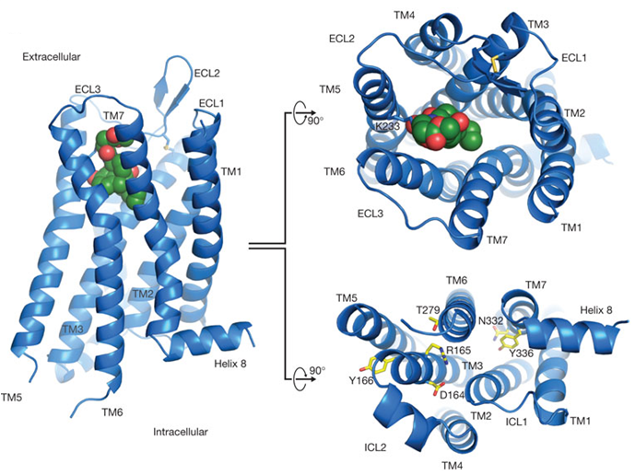
Figure 2.2 Plane, extracellular, and intracellular view of a 7-transmembrane GPCR of the μ-opioid receptor containing ligand spheres shown in green where opioids have the ability to bind. ¹³
The chemical structures of opioid ligands have been presented to impact the binding affinities of opioids to their receptors greatly. The responses of opioid binding to the receptors have been categorized into 3 types of responses: agonist, antagonist, and partial agonist responses. These categories are also used to help classify opioids. Agonists responses are often seen when binding produces its maximum effect onto the receptor. At the μ-receptor, different affinities and efficacies can be found based on the potency of the binding drug. ¹⁴ Traditionally, agonist opioids are selective for their high affinities for μ opioid receptors and their ability to bind other opioid receptors. An agonist chemical binding occurs when drugs bind to the receptor and stimulate physiological activity. Antagonists opioid binding responses have no intrinsic activity after binding to receptors and usually prevent agonist opioids access to the receptors. The most common drug that produces this response for opioids is Naloxone, a medicine used to reverse opioid overdoses. ¹⁵ Theoretically, Naloxone “pushes” opioids off the receptors, thereby reversing their effects and blocks further binding. Lastly, partial agonist responses occur in receptor binding to produce submaximal responses no matter the binding of the drug and the dosage administered. ¹⁰
Besides being in the brain, the opioid receptors are distributed throughout the central and peripheral locations of the nervous systems, lesser throughout the peripheral than the central nervous system. They are expressed widely at their presynaptic and postsynaptic terminals, as well as other non-neuronal tissues. These terminals are poised to modulate responses of perception and pain; therefore, when opioid receptors become activated, they act as neuronal inhibitors.
Presented in figure 2.3 is an illustration that represents the presynaptic and postsynaptic terminals central nervous system’s 7- transmembrane GPCR where the opioid receptors and their binding ligands (not pictured) are located. When opioids become bound to the receptors, actions occur at each terminal. ¹⁶ At the presynaptic terminal, opioids can inhibit the release of neurotransmitter neurons which causes adverse effects to the nervous system (if agonist opioids) and results in opioids being released. ^{11,16} Opioids that act at the postsynaptic terminal inhibit the release of the opioid to the body allowing for the release of neurotransmitter neurons. During opioid inhibition, neurons that release neurotransmitters are typically depolarized at each nerve terminal entry in Ca²⁺ voltage-sensitive channels, causing a reduction in the entry of neurons. An indirect effect also occurs as K⁺ current increases from neurons, thus causing a shortage in repolarization time and the opioid’s duration of the action. Opioids can produce both of these effects because GPCRs are directly attached to the K⁺ channels and voltage-gated Ca²⁺ channels, causing the opioid receptors to be directly attached to the channels as well.¹⁶
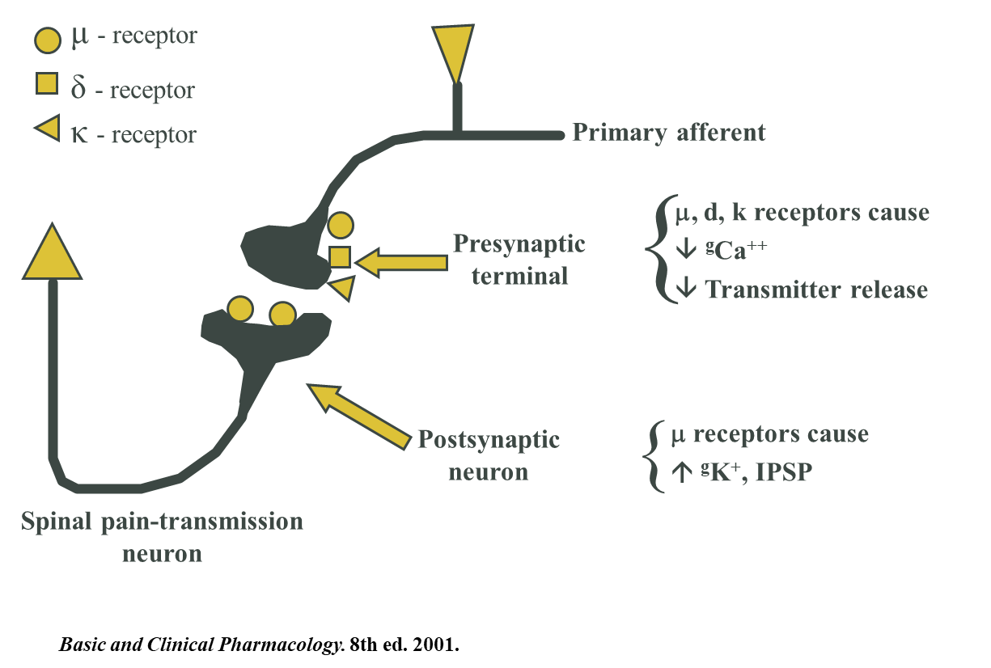
Figure 2.3: Intracellular changes involving repolarization of the K+ and depolarization Ca2+ channels at the presynaptic and postsynaptic terminals within the central nervous system upon an opioid agonist binding to the G-Protein Coupled Receptors.

2.1.2 Opioid Metabolism
Opioid have been the cornerstone of relieving pain for thousands of years, therefore, understanding the metabolism of opioids is vitally important for the public health. Metabolism allows for drugs to be biologically transformed through alterations in the drug structure as it is processed through the body. After consumption, the metabolism of opioids can result in the production of both inactive and active metabolites, which can lead to intermediate products to be produced or toxicity, or both.¹⁷
Although opioids are typically lipophilic, which enables them to cross cell membranes to reach the tissues in which they target, the majority of opioids undergo an extensive first pass metabolism in the liver before entering the systemic circulation prior to elimination.¹⁷ This process allows for the reduction of bioavailability of the opioid. The metabolism of opioids, usually involves demethylation and glucuronidation stages, in the liver, where enzymes are produced in 2 phases of metabolism: Phase 1 metabolism: modification and Phase 2 metabolism: conjugation.¹⁸
In the phase 1 metabolism, drug oxidation or hydrolysis is undergone through the cytochrome (CYP) pathway which facilitations reactions such as dealkylation, hydroxylation, oxidation, sulfoxidation, deamination, and dehalogenation. Phase 2 metabolism is not involved with the CYP system and only conjugates drugs, producing hydrophilic substances. The most important reaction in phase 2, involves the glucuronidations of 4,5-epoxymorphinan opioids which are catalyzed by the enzyme uridine diphosphate glucuronosyltransferase (UGT). This metabolic process alters phase 2 opioids to produces highly hydrophilic molecules, which then allows the kidneys to excrete the drug.
Medicinally, opioids are typically used in situations revolving around moderate to severe and chronic pain relief. However, the effects and responses induced by the use of opioids are much broader, dependent on the central nervous system response and the peripheral response effects. Understanding the efficacy and tolerability of opioids and how they are metabolized allows researchers to explore the results of drug-drug interactions. This can include studies of metabolic effects, treatment dosing and therapeutic drug monitoring.

2.2 Codeine

2.2.1 Overview
Codeine is a common narcotic analgesic that has been used as a model opiate in many studies. Between the years of 1832 and 1833, a pharmacist by the name of Pierre-Jean Robiquet worked to extract impurities of morphine from opium which led to the isolation of the chemical compound codeine. ^{19,20} Codeine, C₁₈H₂₁O₃N, is the methyl ether metabolite of morphine with analgesic, sedative, and antitussive properties, making this useful in pharmaceutical studies. ²¹ 10% of codeine that is orally consumed forms morphine, making it a vulnerable drug for abusers of morphine, heroin, and other opiates. ^{22,23}

2.2.2 Pharmacology
Like other opioids, the misuse of codeine can lead to respiratory failure, coma and eventually death as opioids have pharmacologic effects throughout the human body. The structure of codeine is similar to that of morphine, figure 2.4, but it has an affinity ~200 times less for μ-opioid receptor binding than morphine.²⁴ According to Gretler et al. the process of metabolism of codeine in humans, Figure 2.5, primarily occurs within the liver where conjugation with glucuronic acid produces inactive and active metabolites through demethylation. ^{25,26}

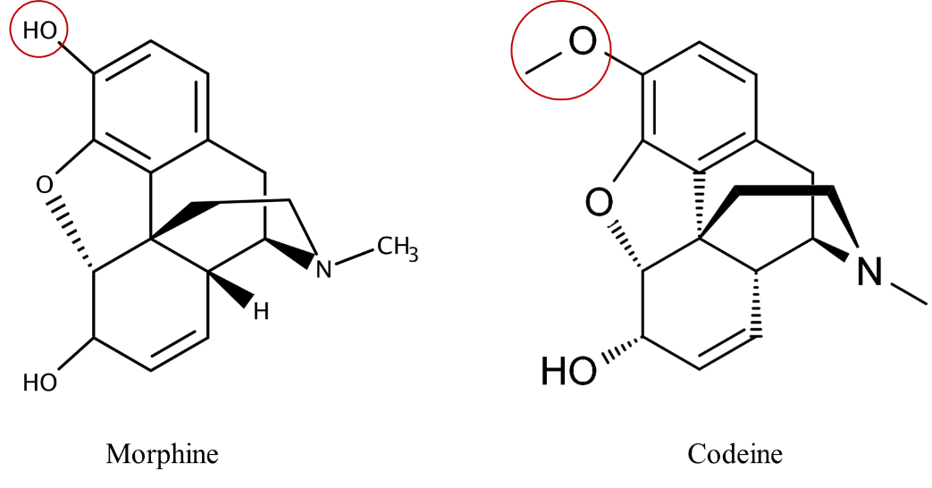
Figure 2.4 Structure comparison of codeine to morphine
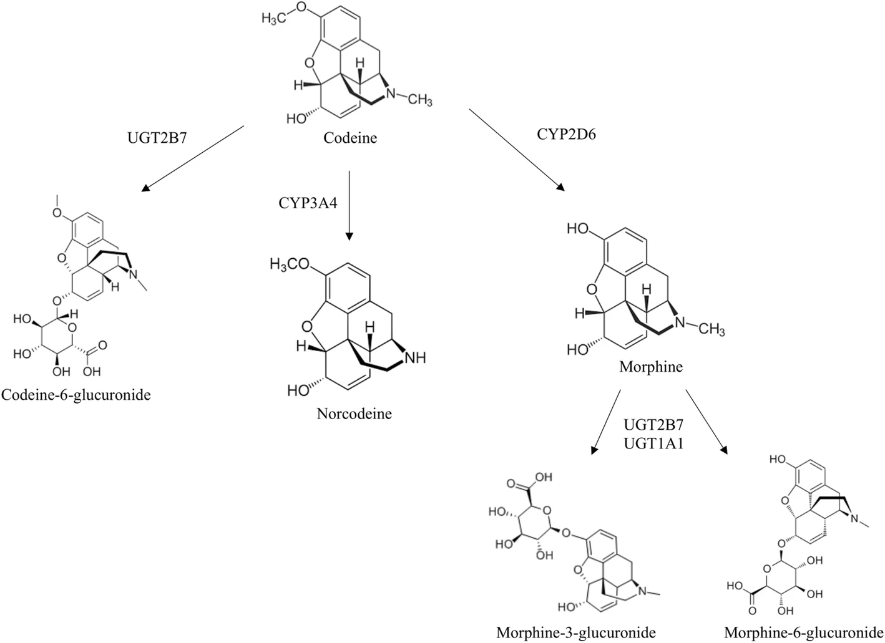
Figure 2.5 Metabolism process of codeine in humans, including the CYP enzymes used for forming codeine metabolites ^{25,26}

The majority of administered codeine becomes inactivated by the process of glucuronidation to codeine-6-glucuronide by uridine 5′-diphosphate glucuronosyltransferase-2B7 (UGT2B7) and the process of demethylation.^{24,27} The demethylation pathway processes involve the use of cytochrome P450-3A4 (CYP3A4) enzymes for N-demethylation of the tertiary amine group to transform codeine into norcodeine. The presence of norcodeine has never been detected without the presence of codeine, and therefore, the presence of norcodeine is considered evidence of codeine usage. In addition, O-demethylation of the methoxy group in the third position uses cytochrome P450-2D6 (CYP2D6) enzyme to produce morphine after metabolization.^{24,27} Only ~10% of codeine is metabolized into morphine and attributed to codeine’s analgesic effects, whereas ~50-80% is excreted as codeine.

2.2.3 Usage and Position in Opioid epidemic
Continued use of codeine increase tolerance to pain and decreases any form of discomfort that may occur. This relatively inexpensive drug is commonly prescribed for pain relief in either tablet or liquid form. The frequent usage of codeine causes many people to develop a tolerance to the euphoric effects produced by codeine. Users initially take the drug to cope with physical pain but later use it to cope with emotional pain and dependency.
Codeine has been used therapeutically to treat mild to moderate pain that is not relieved by non-opiate analgesics. It is also commonly used as a cough suppressant when mixed with other drugs. Whether used alone or in combination with other compounds, codeine administration can increase tolerance causing a risk of dependency.
Aside from its therapeutic use, as a liquid, codeine has been abused in the form of cough syrup referred to as the “Purple Drank”. The recreational usage of this drug consists of mixing prescription-grade codeine cough syrup with soft drinks in order to dilute and permit consumption of larger quantities of the drug in a tolerable form. The readily availability of this lethal cocktail within the entertainment industry has further contributed to the opioid epidemic.

2.3 Fentanyl

2.3.1 Overview
Fentanyl was first synthesized in 1960 by a group of researchers lead by Paul Janssen with the intent to develop a more powerful, narcotic drug that had fewer unwanted side effects than morphine. ^{28,29} Early studies leading to the discovery of fentanyl were initiated through an examination of the structure of meperidine, a morphine-like analgesic. The researchers found that the piperidine ring of the chemical structure produced analgesia.³⁰ They also discovered that more lipid soluble analogs enhanced the analgesic potency. After making several alterations, a new molecule was synthesized—phenoperidine, resulting in an opioid with 100 times more potency than morphine. This opioid would then lead to the synthesis of fentanyl with the main structural regions, including an amide group, aniline ring, piperidine ring, and an N-alkyl chain.³¹ (Figure 2.6) Since its synthesis and patenting in 1965 ³², fentanyl has been used medicinally for pain relief and surgical anesthesia. .³³⁻³⁵
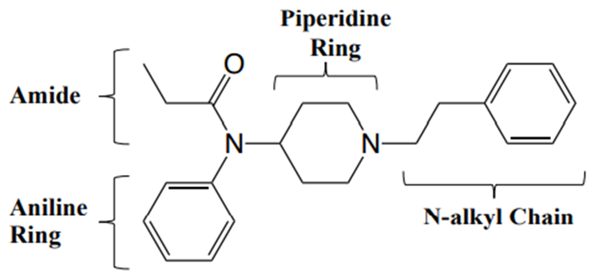
Figure 2.6 Structure of Fentanyl and the regions at which modification can occur for derivatives

2.3.2 Pharmacology
Although its initial administration was performed by medical authorities intravenously, noninvasive dosing of the drug can take place through trans dermal administration, nasal spray administration, and sublingual administration.^{36,37} ^{36,37} The synthetic drug is a lipophilic phenylpiperidine opioid agonist, and is activated by binding to the μ-opioid receptor. The binding affinity of fentanyl to the μ-opioid receptor is similar to that of morphine ²⁹; however, fentanyl is around 100-300 times more potent than morphine depending on its physical properties and how it is exposed in assay. Additionally, fentanyl has a half-life of range between 3-7 hours, with a route of elimination to occur within 3-4 days through urine; whereas morphine has a half-life range of 2-4 hours when metabolized into normorphine, with a route of elimination within 2-3 days.

2.3.3 Analogues and Derivatives
Over the past decade, the number of newly reported novel psychoactive substances, including opioids, has drastically increased and with the list of fentanyl analogs expanding to approximately 83 compounds. Following its synthesis in 1960, various synthetic approaches and structural changes have resulted in numerous fentanyl analogs and derivatives being synthesized. (Figure 2.7) Fentanyl analogs are designed to mimic the pharmacological effects of fentanyl; however, this is not always the case. In some cases the manufacturers synthesize these analogs to bypass classification and the restrictions on use. Initially, traces of illicit fentanyl and its analogs production were traced back to parts of China and Mexico, however current production is likely occurring worldwide. Synthetic drug producers have been experimenting with the chemical structures of fentanyl and its known analogs, making the slight changes to create structural modifications. The goal for this process is to create new synthetic substances for the drug market. By exploring scientific literature distributors can develop and profit from these new substances without understanding the consequences. In many cases the newly created drugs have higher potency than fentanyl itself, making them more harmful to users and hazardous to handle.
Some example compounds that have been synthesized and administered to the public for medicinal and veterinary use include remifentanil, alfentanil, sufentanil, carfentanil, and thiafentanil. Due to reports of high abuse and dependency levels, the DEA labeled these controlled substances as Schedule II drugs based on the Controlled Substances Act, while other analogs that have not been approved for human and animal administration are Schedule I drugs. As previously mentioned, fentanyl is 100 times more potent than morphine, and 50 times more potent than heroin. The fentanyl analogs remifentanil, alfentanil, and carfentanil have been reported to be 200 times, 600 times, and 10,000 times more potent than morphine.³⁸
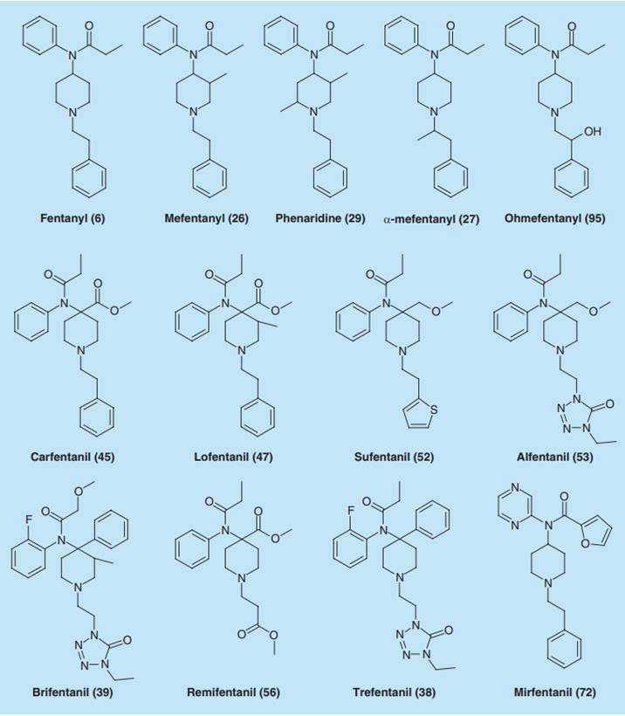
Figure 2.7 Chemical structure of fentanyl and some of its foremost known analogs.³⁴
New fentanyl analogs continue to emerge on the drug market, often adding to the number of overdose-related deaths. Eventually these drugs are added to a list of controlled substances. Unfortunately, there is rarely sufficient information on the biotransformation of drugs, the length time required for drug elimination from the body after breaking down, and what analytes are produced before and after elimination.
As opioids are considered the cornerstone of the management for pain caused by cancer, post operations, and other noncancer-related pain, it is imperative to understand the metabolism of these drugs for the safety of its consumers and administrators. Many metabolites are formed directly and indirectly from fentanyl after undergoing biotransformation through multiple rounds of hydroxylation and dealkylation. As seen in figure 2.8, after human consumption it can be seen that fentanyl metabolizes within the liver into several inactive and active metabolites. ³⁹ The inactive metabolites of fentanyl are excreted through urine and feces. In contrast, active metabolites of fentanyl are formed by undergoing dealkylation by the CYP3A4 enzyme into norfentanyl and hydrolysis of amide to undergo dealkylation into a minor metabolite hydroxynorfentanyl later.
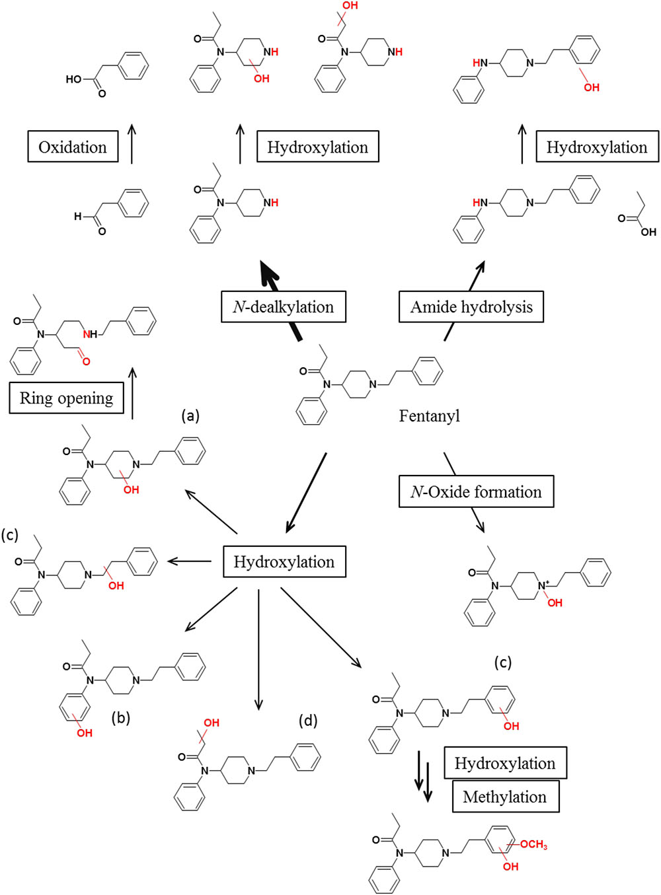

Figure 2.8 Metabolic profile of fentanyl during human consumption, provided by Wilde et al. ³⁹

2.3.4 Usage and Position in Opioid epidemic
Illicit fentanyl comes from two main sources: pharmaceutical supplies and synthetic lab manufacturing. Known to carry a high risk of side effects and lead to addiction if improperly used, fentanyl is also increasingly used in mixtures. These mixtures are sold and mislabeled as other illicit drugs. The euphoric-inducing effects that opioids such as fentanyl and its derivatives produce has played a large part in the recreational use of this drug. New fentanyl derivatives continue to appear throughout the world, which adds further fuel to the opioid epidemic. Although fentanyl has been used medicinally, its appearance as an illegally synthesized drug has posed a threat on the public health in induced several thousands of overdoses and overdose related deaths.

2.4 Opioid Detection in Biological Matrices

2.4.1 Sweat
Sweat has a fascinating potential as a noninvasive matrix for chemical monitoring during drug treatment and surveillance. Sweat is a body fluid that is naturally produced during physical exercise and emotional stress. Sweat provides thermoregulation, allowing the body to self-regulate the increase in body temperature to avoid dangerous increases that could elevate a human’s metabolic rate.⁴⁰ This fluid has physiological analytes such as Na⁺, Ca₂⁺, K⁺, Cl⁻, glucose, and lactate. ⁴¹ Although this biological fluid is often viewed as unappealing due to its tendency to accentuate body odor, sweat releases toxins from the body, which can be used as biomarkers to indicate the health of the body.
The average human body contains approximately 2-5 million sweat glands distributed unevenly over the entire body except for the lips, nipples, and external genital organs. Three different types of sweat glands are spread throughout the body: eccrine, apocrine, and apoeccrine.⁴² Eccrine glands are most common and secrete water and electrolytes through the surface of the skin. Apoeccrine glands are unclassified glands that are developed during puberty from eccrine glands. ⁴³ Although these glands are unclassified, they are larger than eccrine glands and smaller than apocrine glands and play a vital role in producing axillary sweat. ^{43,44}
Sweat is a largely unexplored body fluid used in the analysis of drugs. This clear hypotonic, odorless fluid that’s said to be similar in composition to that of plasma, without plasma proteins, and contains sodium chloride (NaCl) as the main component. ^{15,45} Sweat passes through the skin ducts very slowly, and the presence of Na⁺ and Cl⁻ ions reduce osmotic pressure of the fluid leading to water to become reabsorbed and concentrating of the other constituents such as urea, lactic acid, and potassium that was concentrated within sweat. ^{46,47} When stimulated sweat is excreted, it is in an acidic nature due to its fast transport through glandular tubules and least ability to reabsorb water. Therefore, the reabsorption of urea, lactic acid, NaCl, Ca²⁺, and K⁺ occurs in an effort to maintain a balance between sweat and blood. ^{47,48} Although the exact mechanism is not understood, the acidity in sweat can also result from acid imbalance throughout the body. Sweat is a form of a diluted electrolyte solution composed of 99% water, NaCl, Ca²⁺, K⁺, HCO₃⁻, Mg²⁺, NH₃, lactate, and urea.⁴² In addition, it is often assumed that capillary blood is at equilibrium with sweat during the formation of liquid sweat, yet the composition of sweat is not dependent on this.⁴⁹ The final composition is dependent on absorption, exchange, and concentration mechanisms. Most lipid-soluble, basic substances should undergo passive diffusion between blood to sweat because of the higher acidity of sweat in relation to the blood. Where sweat is indicated to have a pH between 4-6.8. Basic pH should favor the protonation and solubility of basic drugs in sweat to increase the free-drug sweat/plasma ratio.
The composition of sweat can provide information on the body’s physiological conditions, its health, and well-being. ⁵⁰ To permit this analysis, a variety of different sweat collection techniques and procedures have been developed of collection. The most common procedure involves using sweat patches that have been made commercially available for sweat analysis. ^{51,52} Other procedures include a variety of the wash down techniques, and the use of ‘polyethylene’ sweat collection arm bags. Unfortunately, these collection techniques can cause a delay in the analysis due to processing time. Therefore, better techniques are required to permit field testing and real-time monitoring, particularly if available at an affordable cost. A proper sampling technique is crucial since the sample needs to be collected and used at the active sensing area where the analytical signal can be generated. The flexibility of the collection and sensing mechanism is necessary to help design a viable portable sensing device for real-time detection and monitoring of drugs. One possible solution is the use of microfluidic systems, as these systems allow for the use of micro-volumes and obtain nearly the sample information as standard analytical methods.⁵³
Many challenges surround sweat analysis, including the ability to obtain a valid sample for real-time analysis. This includes the need to avoid cross-contamination of collected samples during handling and analysis. The rate of a drug’s appearance in sweat by transdermal migration would be expected to be substantially slower than the alternate sweat excretion mechanism. ⁵⁴ The affinity of the drug and the hydration levels of the epidermis's outer layer would be critical to determine the transdermal drug migration as the skin may serve as a short-term depot for some drugs. ^{54,55} Sweat was selected as the sensing medium for this project, as it is easy and noninvasive to collect compared to other biological fluids used in drug and toxicology analysis. The volume of sweat can be increased by altering environmental conditions such as increasing the temperature or humidity in the exposure location or by performing certain tasks that induce sweat.

2.4.2 Saliva
Like many of the bodily fluids produced by the human body, saliva is a complex fluid that is produced orally. Saliva is composed mainly of water which is used to transport the produced components of saliva across the salivary glands. There are two forms of saliva produced—resting and stimulated saliva. At rest, acinar secretion produces a low volume, hypotonic, neutral to the slightly acidic secretion of saliva that contains few enzymes. During stimulation, an alkaline, less hypotonic enzyme containing saliva is secreted at a higher volume.
Saliva is made up of numerous components that vary in concentration. The components are water, HCO₃⁻, mucus, enzymes, and electrolytes. The secretion of saliva is produced orally by three salivary glands—the submandibular, sublingual, and parotid glands. The ducted exocrine glands each produce slightly different secretions of saliva. The parotid glands produce enzyme rich saliva, which is ~25% of the saliva secreted. The saliva secreted from the sublingual glands produces mucus containing saliva without enzymes, thus making up ~5% of the produced saliva. Finally, the submandibular glands produce a mixture of both enzyme and non-enzyme contained saliva, making up the remaining ~70% of saliva that is secreted. This hypotonic solution contains K⁺, Na⁺, I⁻, Cl⁻ ions and HCO₃⁻ ions. The rate of saliva secretion differs depending on the person being examined and whether the oral cavity is stimulated or unstimulated.

2.4.3 Drug monitoring in saliva and sweat
In efforts to combat the war on drugs, the United States began adopting preventative strategies to address drug abuse issues. Apart from these preventative strategies came the launch of therapeutic drug monitoring programs in the 1970s. Traditionally, therapeutic drug monitoring involves measuring drug concentrations in biological fluids for therapeutic management and treatment. However, concerns continue to rise surrounding opioid therapy in relation to the adverse effects, including long-term tolerance, the potential for misuse and/or addiction, and the invasive nature of sample collection. ^{56,57} Thus, alternative biological matrices are being investigated for drug monitoring programs.
In addition to drug monitoring programs, investigators are also seeking alternative matrices for drug detection within the workforce. ^{56,58} According to Barnes et al., having alternative matrices for detecting drugs has become imperative in toxicology testing within the last decade. ⁵⁹ critical issues for noninvasive sample collection, include permeability for frequent sampling, and the ability to allow for self-sampling. Often, alternative matrices can provide longer detection windows after consumption and permit a wide range of analytical testing procedures. ⁶⁰
Saliva and sweat are the typical alternatives for analyzing biological fluids in drug monitoring programs. Because saliva collection is noninvasive, it is one of the most common biological fluids used in toxicology and drug monitoring. There are some issues with saliva testing, particularly related to the consumption methods of drugs. Drugs excreted by saliva undertake both passive diffusion and active transport. Both un-ionized, lipophilic drugs and polar drugs are excreted in saliva. When drugs are consumed orally, they are presented at higher concentrations in oral fluids rather than blood due to the residual amounts of the drugs remaining in the oral cavity. To date, drugs tested within saliva include opioids (morphine, heroin), cannabinoids, cocaine, amphetamines.
While saliva provides a short drug detection window, sweat can increase this time by wearing sweat patches. ^{59,61-63} While a systematic search of existing or historically documented collection and measurements of sweat may be challenging to find, and research has proven that drugs are detectable and quantifiable in sweat. The unequal distribution of sweat glands throughout the body may cause the production volume of sweat to be irregular and dependent on the individual.⁵⁴ However, using sweat for drug detection is less invasive, and safer ^{54,59,60}
Using several different analytical techniques, opioids and their derivatives, THC, methadone, cocaine, opiates, amphetamine, and other commonly abused drugs such as have been detected in sweat. These detection methods included the use of alternative collection methods such as sweat pads and patches, filtered paper swabs, and plastic bags under armpits for identifying and quantifying administered. ^{55,64-68} The time of excretion of drugs and the metabolites were evaluated using the application of sweat patches versus the time of administration, which showed the length of time that the drugs appeared in the sweat. ⁵⁴ After placement and several days of wear, researchers remove the sweat patches from subjects and store them in the freezer. The patches are allowed to reach room temperature before extraction, purification, evaporation, derivation, and analysis. ^{55,64-67} Experiments involving dosing studies permits the determination of the rate of excretion of drugs rose following administration.

2.5 Analytical Methods used for Drug Detection
There is an abundance of analytical techniques developed for drug detection and toxicology. Initially, these detection methods began with human observation to help identify any various attributions of the unknown compounds, such as color, structure, and texture. Unfortunately, human observation detection methods can be inaccurate. Currently two classes of detection methods are used to determine if opioids are present—presumptive or confirmative testing. This type of testing has been described and standardized by the “Scientific Working Group for the Analysis of Seized Drugs (SWGDRUG). SWGDRUG provides recommended analysis methods for the identification of drugs or chemicals, along with protocols and policies. The analytical techniques recommended by SWGDRUG are placed into three categories (seen in Table 2.1) based on the achieved level of selectivity. ⁶⁹ Category A techniques are recommended to provide the highest level of selectivity through structural information, whereas Category B provides intermediate levels of selectivity through chemical and physical characteristics. Category C selectivity is made using analytical techniques based on general or class information. Minimum analysis requirements provided by SWGDRUG suggest that a validated technique from Category A required with at least one other technique from either Category (A, B, or C) to exploit and support the identification of the analyte in question. ⁶⁹

Table 2.1 Categories of Analytical Techniques for Identifying Drugs or Chemicals⁶⁹

2.5.1 Presumptive Testing
Presumptive testing, often referred to as screening tests, involve preliminary analysis of an unknown compound for a suspected target drug that may be present. Generally, testing is less specific and usually relies on isolating a class of drugs rather than a specific target compound by producing a positive, negative, or inconclusive results. The benefit of presumptive tests is that results can be obtained at a faster turnaround time rather than the time seen within confirmatory testing. This can allow for a more targeted response once knowledge exists that substance is potentially present. Usually, the main two types of presumptive tests that are used in forensic drug testing are colorimetric and immunoassay-based testing.

2.5.1.1 Colorimetric/ Spot Test for Drug Detection
Colorimetric testing can indicate that a targeted substance is present or not present in an unknown compound, utilizing chemical or biochemical methods. This process involves introducing small quantities of the unknown to colorimetric reagents to obtain a physical reaction that indicates whether or not the substance is present chemically induced color change. Although this form of testing is fast, it lacks specificity and can produce relatively high limits of detection. Cross-reactivity to similar substances is also a problem and is why colorimetric/ spot testing lies within the reel of presumptive testing. This is why colorimetric/spot testing lies within the category of presumptive testing.

2.5.1.2 Thin Layer Chromatography for Opioid Detection
Although low in resolution, thin layer chromatography (TLC) is a popular technique used to analyze organic and inorganic materials. Its distinctive advantages are minimal sample clean-up, flexibility, low cost, and high sample capacity. Considered as a screening technique, this tool can provide a high degree of assertation of separation in bulk drug screenings. TLC is used by screening programs to analyze active substances such as drugs in bulk quantities, illicit substances, or biological samples by separation. ^{70,71} Within this process, the pH and polarity of the mixture and solvent are important for separation. ⁷² Thus, in order for this technique to be complete, a combination of mixtures must occur within two phases: stationary and mobile phase. The stationary phase consists of an absorbent coated glass or paper substrate, in which the absorbent is then dipped in a solvent or a mixture of solvents. As solvents migrate up the substrate through diffusion, individual compounds separate due to differential adsorption. The advantage of TLC is that this method can be used for screening multiple substances simultaneously.

2.5.1.3 Immunoassay Testing for Drug Detection
Immunoassays are the most commonly used technology for presumptive screening diagnosis because of their high specificity, sensitivity, and versatility. They are particularly useful in a toxicological analysis. By definition, immunoassay is a bioanalytical technique that depends on the reaction of immunoglobulin (also known as an antibody) binding to target analytes (antigens) to measure the presence or concentrations of a substance (Figure 2.9). ⁷³ Immunoassays have been engineered to perform speedy analysis, and specialized devices have been developed to maximize simplicity of use in field operations. There are still issues of cross-reactivity in immunoassay, particularly for drugs of similar structures. Therefore, it can be difficult to distinguish certain drugs with their respective analogs due to structural similarity and/or similarities in binding affinities to the antibodies used in the tests. The minimal response to an immunoassay is often referred to as the cutoff value.^{74,75} However, the response is generally semiquantitative, particularly in field testing.
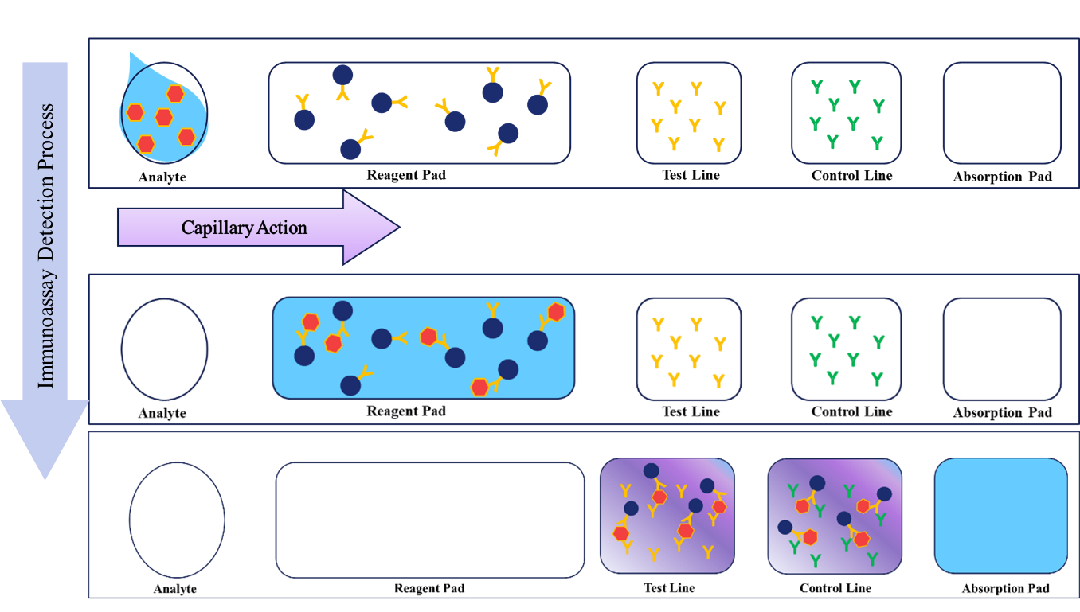
Figure 2.9 Schematic illustration of a basic immunoassay strip test

2.5.1.3.1 Lateral-flow Assays
In 1956, the idea of lateral flow assays (LFA) was initially derived from the latex agglutination test for serological diagnosis of rheumatoid arthritis to later being explored as a monitoring technique for serum protein in the late 1960s. ^{76,77} These assays are simple paper-based devices that adopted the principles of chromatography for rapid detection of liquid samples through capillary action on a solid substrate. ⁷⁷ LFAs are typically comprised of four major parts: sample pad, conjugate pad, recognition membrane, and the absorbent pad (Figure 2.10). ⁷⁶ LFAs typically comprise pre-stored reagents and different porous membranes, specifically nitrocellulose membranes with specific functions for detection. When the sample pad is introduced to fluid samples, the samples migrate through the conjugate region of the pad, activating micro-and nano-size particles to immobilize. In the conjugate region, the antibodies that are usually attached to the conjugate pad are introduced to the analyte to perform a reaction. The reaction migrates via capillary forces through the detection pad to obtain visible results to confirm the presence or absence of the targeted analyte in the sample. LFA’s ability to provide near accurate instantaneous results for on-site analysis has made these devices promising in the field of health, food, environment, and forensics.
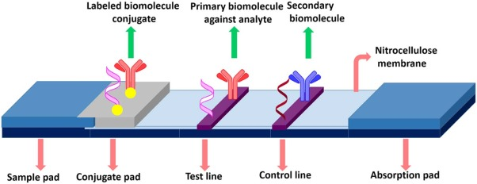
Figure 2.10 Basic Lateral Flow Assay ⁷⁶

2.5.2 Confirmatory Testing
Once positive results are obtained through presumptive testing, confirmatory testing is next applied. When combined with a positive presumptive test, a confirmatory test can be used to identify a substance being tested conclusively. These tests often utilize spectroscopic and chromatographic analysis to separate and analyze individual components of a mixture.

2.5.2.1 Chromatographic Techniques for Opioid Detection
Chromatography separates analyte and internal standards from one another and other compounds present within the sample. Chromatography works on the principle that the partition coefficient of analytes will vary between the stationary and mobile phase to absorb and desorb the analytes of interest. There are two types of chromatographic analytical techniques that are typically used, liquid chromatography (L.C.) and gas chromatography (G.C.). When combined with mass spectrometry, the sensitivity and specificity of samples being analyzed increase. The mass spectrometer used analyzes ions by size and charge, which is comprised of 3 main components: an ionization source, a mass analyzer, and a detector. Combined analytical techniques can reduce experimental errors and improve accuracy.

2.5.2.1.1 Gas Chromatography-Mass Spectrometry
Gas chromatography (G.C.) is a powerful separation technique that can be used to detect volatile compounds using an inert carrier gas. In many cases, especially toxicological analysis, G.C. is seen in a selective and sensitive technique that can detect low molecular weighted compounds that are volatile, non-polar, and thermally stable. G.C. involves the partition of an analyte between a liquid or polymer-based stationary phase in combination with a gas such as helium. The effluent of the column is subjected to electron bombardment at 70eV, permitting ionization of the sample and fragmentation to occur. Either electron impact (E.I.) or chemical ionization (CI) can identify unknowns based on fragmentation patterns of the ions produced.

2.5.2.1.2 Liquid Chromatography-Mass Spectrometry in drug detection
Liquid chromatography is one of the gold standard techniques used in drug and toxicology analysis due to its separation abilities to isolate individual components of a sample in the liquid form. This process transfers the mass of the sample’s components through an aqueous polar mobile phase mixture to a non-polar stationary phase. When combined with mass spectrometry, LC-MS becomes one of the most practical applications of analysis that can analyze large compound containing samples. LC-MS is used to separate components of a sample and identify components based on the mass of their parent and fragment ions. Unlike GC/MS, LC-MS permits the detection of thermally labile compounds, may exhibit high polarity, or have a higher molecular mass.

2.5.2.2 Spectroscopic Techniques for Opioid Detection
Spectroscopy has made progress in drug analysis, as this technique can provide useful quantitative or qualitative data of collected samples. It is assumed to be quick, precise, and sometimes non-damaging of samples during analysis. The growing interest in this technique has led to it becoming a tool for early detection and monitoring of exploited drugs. The most common method for seized drug analysis is infrared spectroscopy; however, researchers have grown interested in portable Raman spectroscopy.

2.5.2.2.1 Raman Spectroscopy
Raman spectroscopy has gained popularity in the forensic sciences during the last decade. Analysis by SERS represents a relatively inexpensive and rapid method for the characterization of trace compounds, which can reach the single-molecule detection level.⁷⁸⁻⁸⁰ This optical technique uses inelastic radiation scattering to measure vibrational motions after a focused laser is pointed onto a sample at a roughened surface or in a metallic colloidal solution, and the molecules are detected based on spectral vibrational frequencies ⁸¹ It has the ability to chemically characterize samples that are in any form with the need of little to no sample preparation. These vibrations cause a shift in energy, which is directed from the incident laser beam frequency, and characterization of each molecule can produce a Raman spectrum. Raman can easily penetrate transparent substrates for noninvasive detection. In addition, unlike infrared spectroscopy, samples can be run in an aqueous environment such as biological fluids where liquids create spectrum interferences. SERS has been used as a method for analyzing various designer drugs such as cocaine, heroin, and amphetamines, with a recent focus on opioids such as fentanyl and fentanyl mixtures. ⁸²⁻⁸⁸ Although quantitative analysis can be achieved using this technique, and this process may not be best suitable for analysis that requires intimate contact between the enhancing surface and the analyte as enhancers are dispersed in a solution.

2.6 Novel Methods for Opiate Analysis

2.6.1 Lab on a Chip Based Methods
Microelectronics was first developed in the 1960s to fabricate a technology based on semiconductor fabrication that would be used to increase the density of transistors in integrated circuits. This fabrication process led to the development of microelectromechanical systems (MEMS)—small but movable machines. Since this development of MEMS, the concept for Lab on a Chip (LOC) technology was coined as a novel fabricated technology that consisted of analytical systems that could perform mass and heat transfers as a miniaturized portable device.⁸⁹ This highly attractive technique can conserve time and be very cost-efficient. It would later be used in chemical and biological analytical applications, allowing researchers to analyze, study, and synthesize molecules and materials on these chip-like devices using micro to pico- size samples.⁸⁹ The LOC concept would later employ the use of silicon or glass as one of its main substrates needed in forming 3-D structured devices. In the continued development of these LOCs, efforts were made to study multilayer soft lithography (MSL) and fluidic flow systems and how they can be implemented in the lab chip detection design systems. These systems would later be discussed as microfluidic systems of detection. These systems have been seen in conjunction with immunoassay and colorimetric tests.

2.6.1.1 Microfluidics
Fluidic flow modeled devices, known as microfluidics, are often referred to as a combination of science with capillary flow-like behavior and designed device technology. Since being introduced by a research group led by Professor George Whiteside at Harvard University, studies using microfluidic devices have been surging.⁹⁰ This emerging technology was observed to use micro-channeling to manipulate ultra-low volumes of fluids to obtain microscopic behavior analysis. The developed device became a breakthrough in the microelectromechanical systems field, enabling the ability to integrate electronic circuits on miniaturized chip-based devices. This miniaturized technique utilizes separation and analysis of heterogeneous mixtures dissolved in a solution to obtain high recovery rates using small volumes. Microfluidics has been used as a point of care system in clinical analysis for rapid testing.^{67,91-96}

2.6.1.1.1 Paper-based Microfluidics
Paper-based chemical testing can be traced back to the 1940s, where Müller and Clegg used paper as a chromatographic medium for mixture elution and separation. ⁹⁷ Cellulose based paper is a widely used, affordable, and environmentally-friendly substrate. Its cellulose fibers provide an abundant number of pores that allow for fluids to be driven by capillary forces without any external equipment pumping. With no need for external equipment, a higher surface-area to volume ratio can be achieved, and fewer chemicals are used. This makes it possible reduce the size of each device to further lower the cost for actual application. Early examples of paper microfluidic devices were discussed by Muller et al. in 1949 as researchers sought out to make improvements to paper chromatography using microfluidic channeling. ⁹⁷ More recently, Whitesides and coworkers popularized the technique, which was said to be particularly useful for medical diagnostics in the field, where refrigeration and power are not always available. (Figure 2.11).^{89,90,98-103}
Chromatographic paper has been seen as the most common type of paper source in many paper microfluidic devices because of its high cellulose porous properties to move fluids rather than standard copy paper. In addition, thermal wax is used to create hydrophilic channels bounded by hydrophobic barriers that direct a liquid sample to multiple test wells, each with a different sensor. Chemicals are usually prepared on the μPADs and stored in testing wells, and stored until used. μPADs provide a low-cost, flexible, rapid, biodegradable platform for colorimetric detections. ^{89,91,95} Chapter 4 will discuss the use of paper microfluidics in serological testing. Later on, electrochemical analysis is was used as a method for detection on paper microfluidic-based devices.
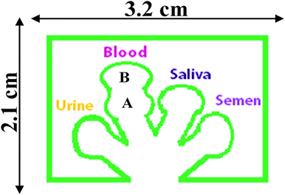
Figure 2.11 μPAD developed by in this project ¹⁰³

2.6.2 Electrochemical Methods
Electrochemistry methods provide instrumental simplicity in sensing at a moderate cost and are easily used in field applications. Detection takes place due to chemical changes that occur in oxidation-reduction reactions, which involve the transfer of electrons from one species to another. These reactions are usually not spontaneous; therefore, an electromotive force is needed. Electrochemistry is utilized in many sub-areas of chemistry for the concepts of chemistry, kinetics, electron transport, and thermodynamics, among other concepts. According to Harris, electrochemistry is referred to as a chemical reaction that uses electricity as its driving force or a chemical reaction that produces electricity. ¹⁰⁴ Oxidation-reduction reactions are also termed “redox” reactions. These kinds of reactions are characterized by the gain of electrons from one species—which is known as the reduction—and the loss of electrons by another speciation—oxidation. The equation below is a simple example of a redox reaction.
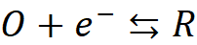
The species in the equation above is represented by O, 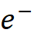 And R. The oxidized species is represented by O, where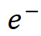 denotes the number of electrons involved within the reaction, and the R is represented as the reduced species. Redox reactions can be depicted in the form of two half-reactions to offer a more in-depth depiction of occurrences of the liquid. Under the laws of thermodynamics, the measured potential that is applied to an electrochemical system to produce a redox reaction can determine the concentration of the electroactive species using the Nernst equation (it should also be noted that the concentration can be determined at the electrode’s surface, which will later be discussed, using this equation too): ¹⁰⁵⁻¹⁰⁸
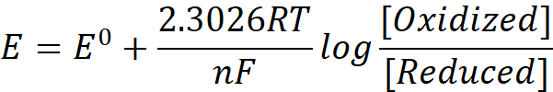
The species in the equation is represented by E, 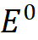, R, T, n and F. E is the measured potential, is the standard potential of the reaction, R is the universal gas constant (8.314 J∙K∙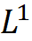∙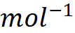), T is the temperature in Kelvin, n is the number of electrons transferred during the reaction, and F is the Faraday’s constant (96,485.33 C∙).
During an electrochemical reaction, the electric current becomes proportional to the reaction rate, giving us the ability to learn about the reaction process by measuring the current and voltage produced. The electric current measured is based on a chemical exchange that follow Faraday’s Law. Faraday’s Law states that electrochemical reactions are directly proportional to the amount of electricity that passes through a cell, while the mass of the substance that in the reaction is proportional to its formula mass and inversely proportional to the number of electrons in the half-life reaction. The relationship between an analyte’s concentration and the amount of current flowing follows this formula:
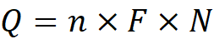
Q is the charge, n is the number of electrons in the reaction, F is Faraday’s constant –96,485 Coulombs/mol, and N is the number of moles electrolyzed in the reaction.
Electrochemistry’s versatility has allowed scientists and researchers to access various parameters to characterize redox reactions and the surfaces they occur on including changes in potential, current, and charge. These data provide unique information about the analyte.

2.6.2.1 Electrochemical Systems
Under the influence of electrode kinetics and/or mass transport, electrochemical reactions are usually set up using a working electrode (WE) where potential is measured against the reference electrode (RE) and a counter electrode (C.E.), making a complete circuit through which current can flow.¹⁰⁹ The working electrode is the location where oxidation and reduction of chemical species takes place. The construction of the working electrode can vary; however, it is commonly made up of materials such as carbon, indium tin oxide, gold, mercury, or platinum, etc. The choice of the working electrode is based on the chosen technique. The counter electrode is where the opposite redox reaction occurs. The counter electrode carries the bulk of the current instead of the reference electrode. The reference electrode provides stability to the circuit, and in theory, it provides constant potential throughout the electrode circuit. ^{104,108} The most widely used reference electrode used consists of silver-silver chloride. The reference, working, and counter electrodes create a durable, sensitive and stable platform.
Numerous electrochemical analyses primarily focus on voltammetric methods to obtain electrochemical measurements. Usually, a voltammetric measurement is collected using a potentiostat and the three-electrode system. The three-electrode acts as the power source attached to the designed circuit for signal processing, which is often called a potentiostat. ¹¹⁰ The potentiostat serves as controller for the potentials applied to the electrodes. It also measures the resulting current within the chemical system using the three-electrode system. Classical voltammetric methods involve a three-electrode electrolytic cell seen in Figure 2.12, where WE are composed of a cell that contains the analyte solution.
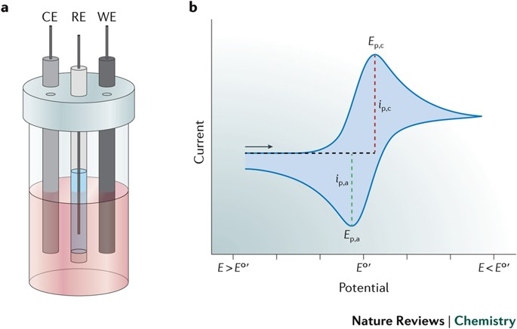
Figure 2.12 Illustration of a three-electrode electrolytic cell ¹¹¹

2.6.2.2 Electrochemical Measuring Techniques

2.6.2.2.1 Cyclic Voltammetry (CV)
Cyclic voltammetry (CV) is a commonly used voltammetric technique that uses the applied potential of the working electrode to be polarized linearly between two potentials at a specific scan rate in the forward and revere direction. CV provides the information on the location of redox potentials of electroactive compounds and the influence of the media on the redox process using an electrochemical system (potentiostat) and the three-electrode system above. A CV utilizes the change in the potential to sweep in either the positive or negative direction, reverse and sweep back in the opposite direction to produce voltammograms based on plots of current versus redox potential. As seen in figure 2.13, a cyclic voltammogram can be used to illustrate a reversible potential-excitation signal that uses peaks to characterize the oxidation and reduction of the analyte’s reactions based on potential and current increasing and decreasing. ¹¹²
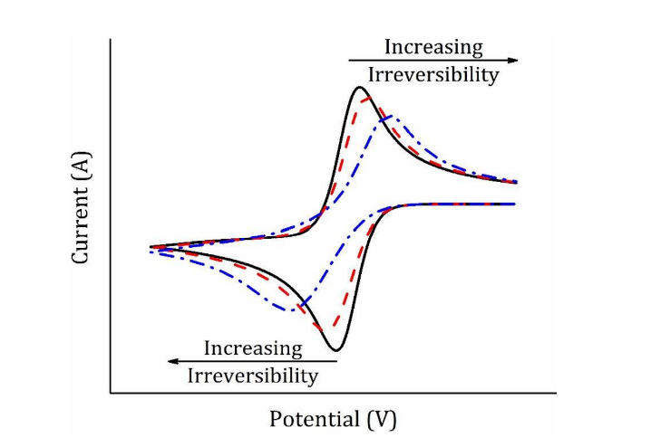
Figure 2.13 Cyclic voltammogram that demonstrates reversibility as a result of oxidation and reduction of current and potential increasing and decreasing.¹¹²

The exchange of electrons occurs by driving forces of electricity between the surface of the working electrode and the analyte solution to produce a current signal for the voltammogram. Any movement that may occur within the analyte solution, the working electrode will produce a disturbance in the signal during the measuring of CV, which becomes known as diffusion to the analyte. ¹⁰⁹ As seen in a concentration gradient, high concentrated species move to areas of low concentrations according to Fick’s law, which involves the diffusion of an analyte. In electrochemistry, Fick’s laws are used to relate the diffusive flux of a species to be oxidized to the concentration and how diffusion can cause the concentration to change over time, seen in equation 4:

Where the concentration of the oxidized species is represented as [oxidized], x is the distance from the electrode surface. The electrode surface forms the concentration gradient between the electrode and the bulk solution. ¹⁰⁸
As electrons are exchanged using driving forces of electricity between the surface of the working electrode and the analyte solution, a current signal is produced for the voltammogram. The use of cyclic voltammetry has become prevalent during the approach to explain and analyze the electrochemical behavior of an analyte on the working electrode’s surface. Cyclic voltammetric peak current helps show the relationship between the targeted species at extremely low concentrations while monitoring the Faradic current and proving that electrochemical measurements can provide similar if not better sensitivity compared to other methods measurements using the Randles-Ševčík equation:
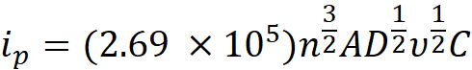
Where 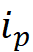 is the current, n is the number of electrons within the redox reaction, A is the area of the working electrode, D is the diffusion coefficient for the electroactive species used, is the scan rate during analysis, and C is the concentration of the electroactive species at the electrode. The Randles-Ševčík equation helps show the relationship between the targeted species at extremely low concentrations while monitoring the Faradic current and proving that electrochemical measurements can provide similar if not better sensitivity compared to other methods measurements. Allowing for the indication of free diffusion of the analyte to occur within a solution or absorption to happen on the electrode’s surface. As seen within the Randles-Ševčík equation, the scan rate is important because it controls the rate at which potential is applied to the electrode. ¹¹³ When the scan rates are fast, the diffusion decreases, and higher currents can be observed along with the reversible electron transfer process of the redox species. The Randles-Ševčík equation can be used to indicate if an analyte diffuses freely within a solution or absorption happens on the electrode’s surface. Verifying the diffusion activity on the electrode’s surface helps researchers understand the analytes in the solution and their homogenous properties. ¹¹³ When the electrode adsorbs the analyte on its surface, the current response can be described as:

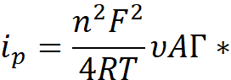

where 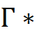 is the surface coverage of the absorbed species, F is Faraday’s constant, n is the number of electrons transferred, is the peak current, is the scan rate, and A is the electrode’s surface area. The cycles that are ramped throughout potential cycling can be repeated as many times as needed.
In addition to using cyclic voltammetry, pulse voltammetric techniques are also commonly used when analyzing species of interest using electrochemistry. Pulse voltammetry relies on the pulsing of potentials to obtain information about an analyte in a solution. These pulse techniques are used when low detection limits are desirable. In short, the pulsing technique process is a repeating process that happens when potential is quickly increased, held at that increased potential for a short period of time, and then decreased rapidly towards the baseline value. During this technique, potential increases so that probing can occur across a range of potential.
Electrochemical analyses are commonly associated with two different types of pulse voltammetry: differential pulse voltammetry (DPV) and square wave voltammetry. Information about solution-based analytes can be gained based on studying the pulse potentials of these techniques. These pulse-based techniques are desirable in analysis that looks for detection limits with minimum interference from the charging current.
Differential pulse voltammetry is a pulse technique that is used to reduce non-faradaic current as a result of its current-difference mechanism. Although two types of pulse voltammetry are used in electrochemistry differential pulse voltammetry (DPV) and square wave voltammetry (SWV), this work focuses on the use of SWV.

2.6.2.2.2 Square Wave Voltammetry (SWV)
Square wave voltammetry (SWV) is another pulse technique that uses applied potential to increase probing occurs across a range of potential in order to detect low levels of analytes. By minimizing the effects of charging current, SWV uses a fast staircase waveform with constant pulses of potential to produce a square wave cycle that has a minute increment in a potential controlled by a step size input.
SWV is a more sensitive and faster technique than differential pulse. The potential in the form of a staircase wave studies the sensitivity of the electrode by characterizing its pulse height or wave amplitude, staircase wave height, pulse time, and cycle period. SWV minimizes the capacitive contributions that occur to the current, which rejects any unwanted background signals that are generated during the redox process. ¹¹⁴ The frequency that is inputted into this technique determines the time of a half-cycle in between cycles prior to pulsing. The scan rate applied to SWV is used to control both the step size and frequency of the technique to help increase the sensitivity of the measured reaction. Using SWV, lower the limits of detection and increase the dynamic range can be determined.

2.6.2.2.3 Electrochemical Impedance Spectroscopy (EIS)
Electrochemical Impedance Spectroscopy (EIS) is a non-destructive technique used to characterize solid-liquid interfaces in terms of electrical measurements. This system of measurement responds to a range of electrical excitation signals to determine the impedance of a sample. ¹⁰⁵ In addition, this system of measurement uses impedance as a function of frequency of sinusoidal potential () from alternating current (A.C.) and direct current being imposed onto the working electrode. Thus, the sinusoidal potential excitation equation can be used:
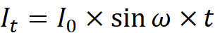
Where is the potential of time t, is the amplitude of the signal, and 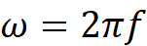 is the radial frequency, where is the frequency expressed in Hertz (Hz). EIS is based on opposition to the flow of A.C. potential using a combination of resistors, capacitors, and inductors in an electrical equivalent circuit (EEC) to determine the resistance of the electrode and electrolyte interface.
The complex response of this system uses the acquired measured impedance to graphically be represented using a semicircle-based Nyquist Data Plot and then fitted into the Randles circuit. (Figure 2.14) The Randles circuit corresponds to the basic equivalence of an electric circuit involving charge transfer resistance (R_{ct}) and double-layer capacitance (C_{dl}) between the electrolyte and the surface of the electrode (Resistance of the solution—R_{s}). Charge diffusion, represented by Warburg impedance (Z_{w}), is linear to the solution exchange with the electrode surface.

Figure 2.14 Basic Nyquist plot showing the kinetic and diffusion regions and a simple Randles circuit ¹¹⁵

2.6.2.2.4 Chronoamperometry (C.A.)
Chronoamperometry (C.A.) is one of the most commonly used electrochemical techniques aside from CV to detect various substrates. This technique allows for the applied potential to remain constant and measurements of the current to be obtained as a function of time. C.A. has proven to be useful for directly determining diffusion coefficients while studying the mechanism and kinetics of electrochemical reactions that are analyzed. ¹⁰⁸ By following the chemical changes that occur during the electrochemical analysis of a sample, the detection limit can be determined.

2.6.2.3 Non-electrochemical Measuring Techniques

2.6.2.3.1 UV-Visible Spectroscopy (UV-Vis)
UV-Visible spectral analysis measures the absorption or transmittance of light that passes through a sample. This technique involves molecules containing π-electrons or n-electrons (non-bonding) to absorb light and excite these electrons to a higher anti-bonding molecular orbital.

2.6.2.3.2 Scanning Electron Microscopy (SEM)
Scanning electron microscopy (SEM) is a form of electron microscopy that is used to produce images after scanning the surface with a focused beam of electrons. The electrons interact with the sample’s atoms to produce various signals which consists of information about the sample’s composition as well as its surface morphology.

2.6.2.3.3 Dynamic Light Scattering (DLS) analysis
When in contact with light, electromagnetic radiation interacts with colloidal particles, to scatter light. In theory, dynamic light scattering (DLS) also known as photon correlation spectroscopy, is a technique used to measure the scattering of light that produces the same frequency as incident light beamed onto a particle. Based on the random thermal motion—Brownian motion—of microscopic, spherical particles suspended in a liquid and the collisions caused by the moving particles caused by light. This noninvasive technique enables the ability to measure the size of the colloidal particles and the size distribution in suspension. Measurements were performed on the biosensing application to confirm the binding of the colloidal particle sand visualized the aggregation in the buffer.

2.6.2.3.4 Zeta Potential (ζ)
In addition to determining the size of the of metallic nanoparticles, it is necessary to understand the electrokinetics effects that is between nanoparticles. To do, two parameters are studied to model the electrokinetics nanoparticles—zeta potential (ζ) and surface charge density (σ). Zeta potential is referred to as the electrical potential between fluid in where particles are dispersed in and the layer of the surface of the particles. Knowing the zeta potential can help predict the long-term stability in suspension by measuring the net charge at the particle’s surface and how the ions of the particle are distrusted throughout the surrounding interfacial region. By understanding the magnitude of surface charge attraction and repulsion of the particles and the surrounding medium, surface charge density of the particles.

2.6.3 Electrochemical Sensors
The sensing field has become one of the fastest developing multidisciplinary fields of advancement in science and engineering. By definition, sensors are measuring devices that can detect and quantify physical aspects of life by directly reading or converting and processing the signal through an electrical, hydraulic, or pneumatic system.¹¹⁶
Ever since its first discovery in the 1800s, electrochemist’s have used chemical sensors to interact with targeted analytes and translate any chemical changes that occur by applying electrical current.¹¹⁷⁻¹¹⁹ Using a transducing element, the electrical current and the chemical changes are translated into electrical signals. In analytical chemistry, the use of chemical sensors combined with an electrode system has resulted in the development of electrochemical sensors. ¹²⁰
Electrochemical sensors are a form of chemical sensor that use redox reactions to prodvide electrical responses. ¹⁰⁶ ¹²¹ These sensors are low in cost and simple to use compared to optical, mass, or thermal sensors. ¹²² In addition, electrochemical sensors shows low detection abilities as a sensing application. Usually, these sensors are composed of 3 essential components, a receptor for analyte binding, an analyte, and a transducer for signal conversion. The receptor of the sensor is an element that is used to interact with the analytes and produce chemical change. The transducer in sensors converts the chemical response into a quantifiable physical signal, as seen in figure 2.15.
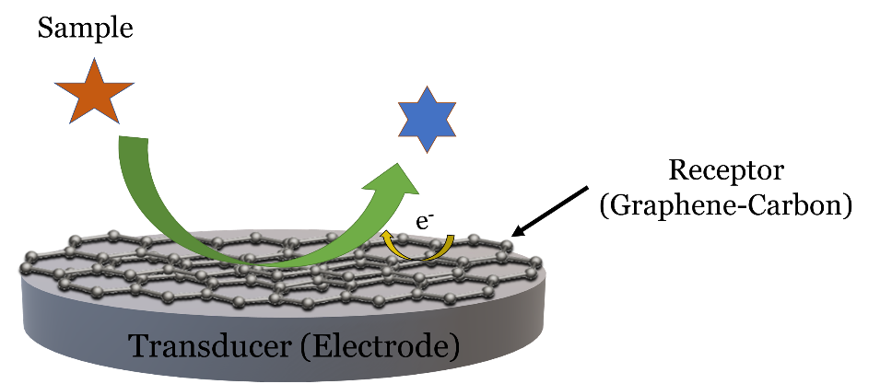
Figure 2.15 Three essential components of the surface of a sensor: Graphene-carbon receptor, a sample analyte, and an electrode transducer.

Electrochemical sensors are easily miniaturized, as the fabrication process is simple. Screen-printed technology is commonly used to prepare these devices by depositing a metal mixture, carbon mixture, and a polymeric binding mixture (or a conductive ink/paste) onto an insulating polymer or ceramic substrate that is then connected to a transducer for readout.

2.6.3.1 Paper-based Electrochemical Sensors
As previously mentioned, the use of paper as a substrate for analytical measurements has been evolving over the last 30 years. While many paper-based analytical devices are known to be used as colorimetric detectors, this mode of detection can has limited sensitivity, and poor specificity. In addition, colorimetric devices may experience color saturation, making it challenging to increase dynamic range. In an effort to overcome some of the limitations that are seen with colorimetric devices, electrochemical sensing techniques have been developed for use with paper analytical devices. Electrochemical measurement, such as current and voltage, can provide greater sensitivity in detection as opposed to light or colorimetric-based sensing. In addition, these electrochemical sensors can be produced as simple, inexpensive electronic devices that are made in bulk quantities.
Today, the construction of typical paper-based electrochemical sensors consists of placing conductive material over the paper and modifying the recognition sites. When the analyte interacts with the recognition layer, an electrical signal is produced and recorded as an analyte’s concentration. However, it was not until 2009 that Dungchai et al. and the Henry research group demonstrated the first paper-based microfluidic electrochemical detection devicse (Figure 2.16) using photolithography to place screen printed of carbon electrodes onto filter paper.¹²³ This new type of device would later be used to determine glucose, lactate, and uric acid in biological fluids. ¹²⁴ since then, electrochemical paper-based sensors have been used in a variety of detection modes, including; biosensing ¹²⁵⁻¹²⁸, electrochemiluminescence (ECL) ^{129,130}, and immuno-sensing.¹³¹⁻¹³⁴
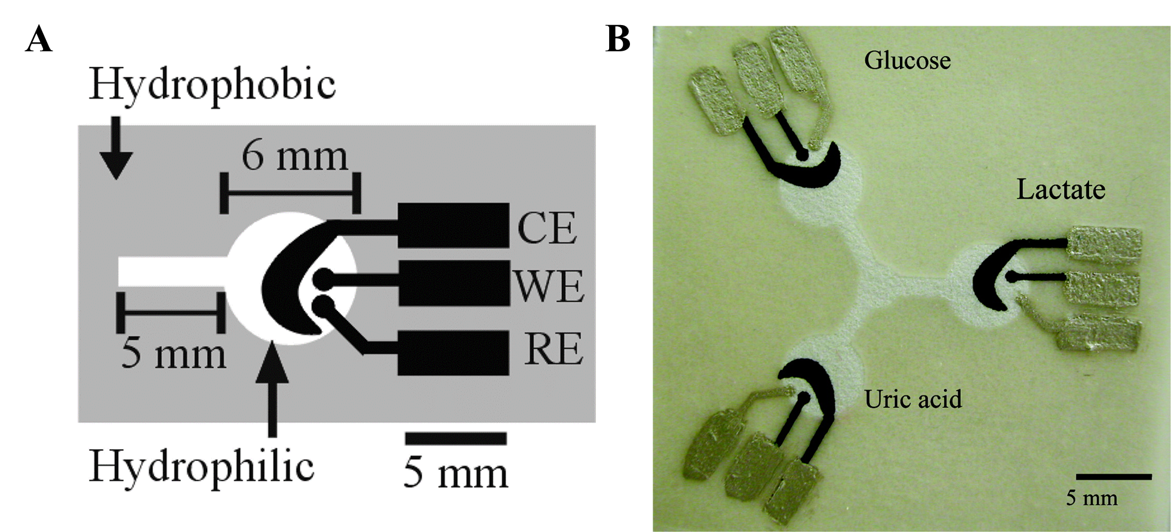
Figure 2.16 Example of paper-based microfluidic electrochemical sensors provided by Henry’s research group. A) Basic design of the paper-based microfluidic electrochemical sensor and B) Three-electrode paper-based microfluidic electrochemical device that contains a hydrophilic area at the center of the device and 3 separate testing zones for glucose, lactate, and uric acid.¹¹⁹

2.6.3.2 Screen Printed Electrodes
Many classical electrochemical sensors have become commercially available; however, their dimensions do not allow for direct measurements of small volumes of analytes such as those found at crime scenes. Recent advances in nanofabrication techniques have permitted the replacement of traditional bulky electrochemical electrodes and electronic equipment with miniaturized electrochemical systems.¹³⁵ Screen-Printed Electrodes (SPEs), seen in figure 2.17, have found wide use as sensing platforms. Amongst the first electrodes incorporated, SPEs are often single-use devices designed to work with microvolume samples.
Some of the electrochemical measurements performed in this dissertation used commercially available disposable electrodes-Zensor TE100 (Taiwan). These particular screen-printed electrodes feature carbon working (3 mm diameter) and counter electrodes and a silver/silver chloride (Ag/AgCl) pseudo-reference electrode.
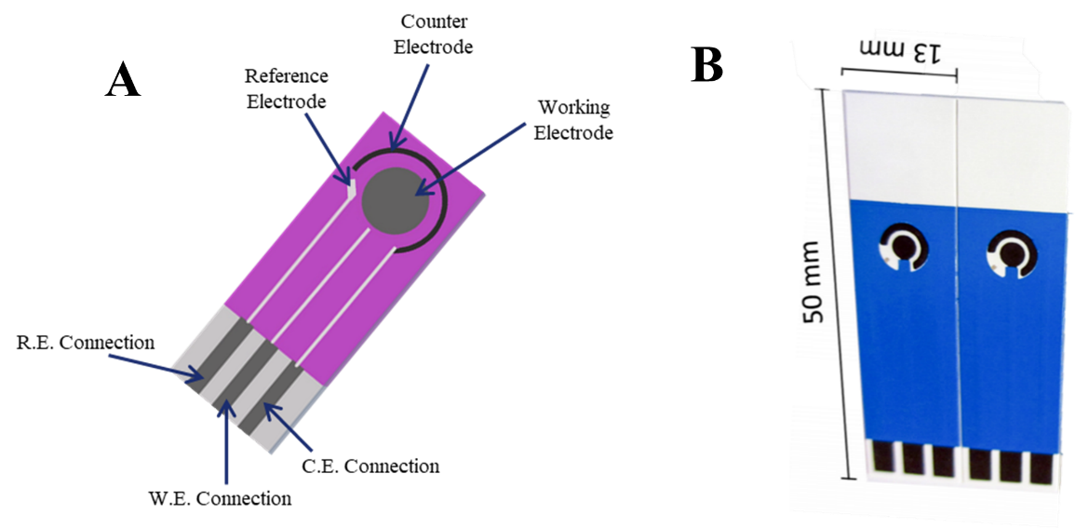
Figure 2.17A) Schematic design for a three-electrode—carbon screen-printed electrode, compromised of working electrode (WE), reference electrode (RE), and counter electrode (C.E.). This three-electrode system was designed to mimic the manufactured electrochemical systems B) provided by Zensors© ¹³⁶

2.6.4 Biosensors
As an essential class of electrochemical sensors, biosensors are often referred to as analytical tools that monitor specific biological or biochemical changes in reactions to detect chemical compounds through electrical, thermal, or optical signaling. In recent years the development of these analytical devices has evolved from basic electrochemical sensors by integrating two main components into these electronic devices. These components (Figure 2.18) are 1) a biological element (such as enzymes, antibodies, ssDNA, and microorganisms) that acts as a form of a synthetic receptor to recognize and selectively bind sensing target; and 2) a transducer or a detection element that measures and converts the binding reactions to a quantifiable signal and displayed through a signal processor.
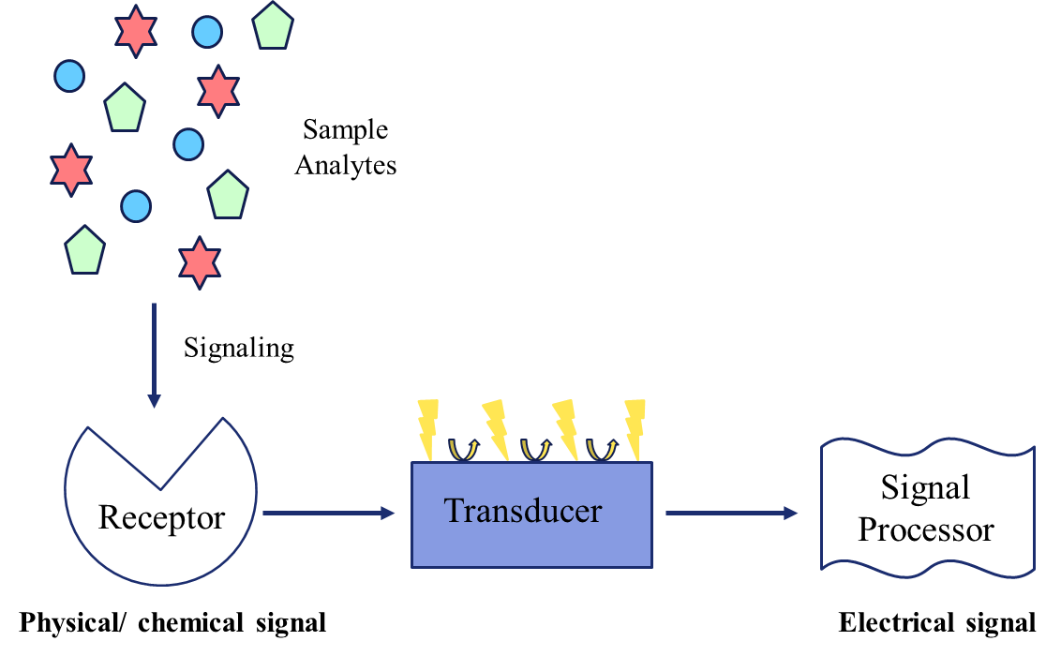
Figure 2.18 An architecture design of a typical biosensor and its components

Biosensors play a pivotal role in medicine and drug detection and monitoring due to their high sensing abilities.¹³⁷ Typically, biosensors used in these fields often use classified detection techniques commonly referred to as label-based or label-free according to their transduction methods. Labeled biosensors use signal labeling components to assist with detecting and monitoring the reaction events produced on the transducer’s surface. These labels often involve tagging/attaching the biological recognition elements to obtain specific properties needed for target detection.¹³⁸ On the other hand, the label-free biosensing technique do not use tagging or labeling, therefore allowing for direct interaction between the target and the recognition element.
The scope of the work presented in this thesis was devoted to developing a label-free gold-nanomaterial-based electrochemical sensing platform that can be used in the field of forensics.

2.6.4.1 Nanomaterials
In this dissertation, I will mainly focus on transducers suitable for electrochemical biosensing that involve the use of the nanostructured surface properties. Nanotechnology has progressed over the last decade, and nanomaterials have been developed to help improve sensing through enhanced imaging, detecting, and targeting. Different nanostructures can be prepared in a wide variety of shapes such as nanowires, nanoparticles, nanocages, and nanorods, which are examples of nanostructures.¹³⁹⁻¹⁴⁴ Nanomaterials are usually classified according to the nanostructure dimensions with typical sizes ~ >100 nm. Nanomaterials can modulate the surface area of detection in biosensors, varying in size, shape, and configuration.

Electrochemical sensors can be modified to become very sensitive and selective for forensic analysis using nanomaterials to assist with binding drugs to the electrode surface. Metallic or inorganic materials can also be used to enhance surface area properties that improve detection through increasing surface area or chemical response to electrode’s surface. ^{86,145-154}

2.6.4.1.1 Gold Nanoparticles
In electrochemical sensing, colloidal nanoparticles, such as colloidal gold, are most commonly used to immobilize the different moieties. Gold nanoparticles (AuNPs) have been used for many years in medical applications. They can be unique in chemical and physical properties, making them attractive for health diagnostics, therapy, and immunology. AuNPs are primarily used for their signaling properties as well as their biocompatibility and low toxicity in in-vitro applications.^{145,155,156}
Gold nanoparticles can produce various colors and absorb light at various wavelengths depending on their size, shape, composition, and degree of aggregation.¹⁵⁷⁻¹⁶⁰ AuNPs exhibit high extinction coefficients (~1000x greater than that of many used dyes), large surface areas, and are capable of easy surface modification. In many cases, AuNPs have been widely used as sensing elements for colorimetric and electrochemical detection of targets, including inorganic ions ¹⁶¹, metallic ions ^{157,162}, DNA ^{151,153,163}, and small molecules ^{153,159-161,163}. Modifications with nanomaterials to the surface of an electrode can enhance the surface kinetics and provide active sites for further functionalization, which can help accelerate the sensing abilities of the sensor.

2.6.4.2 Antibody-based biosensor (Immunosensors)
An immunosensor is a type of biosensor that detects the interaction between an antibody (Ab) and an antigen for binding response to produce an electrical signal. Immunosensors consist of an active site where the antigen and antibody interact and produce a signal. Antibodies are a variety of immunoglobulins (IgG, IgA, IgM, IgD, and IgE) that contain an amino acid sequence at the end of the immunoglobulin structure’s chain which is specific for a particular antigen.¹⁶⁴ Antibody-based biosensors offer many advantages in the strength of binding and show particular specificity in binding to an antigen. However, these sensors do not have great stability. Furthermore, variations in binding affinity between similar drug structures reduces the specificity of direct analysis.

2.6.4.3 Aptamer-based biosensor
Aptamers are single stranded oligonucleotides (DNA or RNA) or peptide molecules that also selectively bind to a specific target. They can be used as alternatives for antibodies. Aptamers are developed through an in vitro selection technique of Systematic Evaluation of Ligands using an Exponential Enrichment technique known as SELEX. ¹⁶⁵ Their specific target binding properties have been used in various biosensors for practical applications.¹⁶⁶ Although some have described aptamers as artificially created chemical antibodies, their advantages over antibodies include the ability to be chemically produced with rapid regeneration. ¹⁶⁷⁻¹⁷⁰ Aptamers can also be tailored to adjust binding specificity. As with antibodies, there is a wide range of applications, including clinical diagnosis of various diseases, development of medicines, detection of biowarfare agents, drug discovery, and molecular toxicology.
As biosensors and aptasensors are evolving in the research and clinical fields, they are being recognized as competitors to immunoassay techniques.¹⁷¹ Immunoassays have the ability to deliver low detection limits and allow for target molecules at low levels to be detected. Although immunoassay-based sensors have been around for decades, there are some drawbacks. Immunoassays utilize antibodies to assist with their sensing abilities and have limited stability with a lengthy development process. Aptamers are more chemically stable when placed in various temperatures and pH environments. They can also are less affected by denaturation.¹⁷¹⁻¹⁷³ However, the main advantage that aptamer-based sensors have over immunoassays is that aptamers do not require an immune response to sense. This permits aptamer-based sensors to be used in a wider variety of potential assays.
According to Kalra et al., the binding affinity of an aptamer is defined as the strength of the interaction between the targeted molecule and the aptamer. This interaction can be measured using the binding or association constant and the dissociation constant. The interaction between an aptamer and its target is dependent on the rates of the reaction. If the aptamer strongly interacts with the target, the aptamer will have a slow “off” rate, versus if the binding between the target molecules and the aptamer is weak, there will be a fast “on” rate. The “slow off” rate, results in the aptamer being highly sensitive. The following equation represents aptamer’s binding affinity:

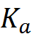 is represented in the equation as the association constant, and 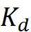 is the inverse of the association constant and is represented as the dissociation constant. At equilibrium, the association constant is equated to a ratio of the on-rate (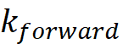) and off-rate ( 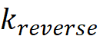). ¹⁷³ Using the above equation, the strength of how strongly an aptamer can bind can be determined.
The addition of aptamers to electrochemical sensors has shown enhancements in signals produced. For example, literature has reported that the presence of aptamers has increased the signal of an electrochemical sensor by increasing the surface area of an electrode made of gold. ^{170,174} As aptamers can offer rapid, sensitive, and specific detection of molecular targets, they also can detect trace levels of drugs. ^{170,172,175,176}
It is possible to develop electrochemical sensors that are specific for biochemical reactions. ¹⁷² Aptasensors have shown great potential in diagnosing and treating medical diseases and detecting small molecules in biological matrices. ^{172,177-179} Aptamers that interact with their specific target can create a charge exchange, permitting electrochemical signaling based on either direct or catalyzed oxidations of DNA bases and redox reactions that occur at the electrode’s surface. ^{22,146,173,175,180-184}

2.6.4.3.1 Aptamers used in Opioid Detection
De la Cruz et al. mentioned that DNA bases are electroactive and can encounter oxidation or reduction during electrochemical analysis.¹⁸⁵ As sensors are becoming increasingly popular in forensic science, aptamers for drug sensing are also becoming popular. The use of antibodies or aptamers can be used to achieve specificity of detection for drugs of interest.¹⁸⁶he small size of aptamers allows them to generally exhibit equilibrium dissociation constants in the micromolar range, about 100-fold lower than antibodies, which gives them better sensitivity for detection.¹⁸⁷ Aptamers that are used for drug detection sometimes undergo conformational changes upon target binding, which can be great for sensor analysis and confirmation binding because of the structure switching that occurs.
Several forms of opioids and their metabolic counterparts have been detected using aptamer sensing as well as with the use of electrochemical sensing. Recently Kammer and researchers used aptamers to develop a free solution assay to quantify opioids in the urine.¹⁸⁸ Saberian et al. used an RNA aptamer to detect nanomolar concentration of codeine by electrochemical analysis.²² Chemically modified aptamers can be selectively synthesized or chemically functionalized to enhance binding properties.^{172,175,189,190}

2.6.5 Forensic Electrochemistry
Electrochemical methods have become of great interest as an analytical technique for determining trace amounts of substances^{191,192} These types of sensors eliminate the need for a lengthy sample pretreatment step, and samples can be directly analyzed in a variety of matrices. Using electrochemical methods to analyze forensic evidence permits sensitive testing that is fieldable. According to Smith et al., applications of electrochemistry used in forensic sciences have taken on the term forensic electrochemistry, which has been defined as quantifying chemical species using electrochemical methods in any given matrix.¹⁹² Poisons ¹⁹³⁻¹⁹⁵, explosives ^{196,197}, gunshot residue ¹⁹⁸⁻²⁰⁰, and drugs ^{165,201-206} have all been analyzed.

2.6.5.1 Fieldable Drug Detection
The ability to perform direct analytical measurements at a crime scene eliminates potential conflicts of altering and manipulating evidence after collection. The current gold standard for analyzing drugs has been the use of chromatographic methods, optical measurements, and mass spectrometry to analyze bulk quantities of drug samples. However, these approaches can be time-consuming and costly. Electroanalytical methods have the ability to expand sample analysis without the need for sample pretreatment. ^{192,206}
Electrochemical methods have been used to detect the presence of many drugs, including cathinones, cocaine, heroin, morphine, tramadol, oxycodone, methadone, caffeine, and fentanyl.^{201-203,207-214} Simultaneous analysis of multiple drug targets is also possible. ^{67,213,215-224}
Using differential pulse voltammetry to characterize the electrochemical mechanisms of the oxidative behavior of heroin, codeine, and morphine and their metabolites, Garrido et al. proposed a new mechanism for the oxidative production of amine groups.²⁰⁸⁻²¹⁰ In addition, Asturias-Arribas et al. also demonstrated the ability to detect codeine using an enzyme-modified screen-printed carbon electrode, RNA aptamer. The authors used an isozyme to covalently bind to the modified electrode surface to demonstrate direct electron transfer. ¹⁸
While researchers are discovering many methods to enhance sensor detection and portability, many are turning to the use of aptamers. By incorporating aptamers into sensing technologies and being able to select from a variety of different electrochemical techniques, a wide range of molecular and therapeutic targets can be detected because aptamers offer high sensitivity, selectivity and can be used miniaturized devices developed at a low cost. Using the abilities of distinction for the chirality of molecules, aptamer-based biosensors are applicable in forensic for drug detection in biological fluids, environmental waters, and seized drugs. Developing a aptamer-based sensors that can contribute to fieldable drug detecting technologies, would continue opening the field of forensics to electrochemistry.

References
1. Brownstein, M. J. A Brief History of Opiates, Opioid Peptides, and Opioid Receptors. Proceedings of the National Academy of Sciences - PNAS 1993, 90, 5391-5393.
2. Dadmehr, M.; Bahrami, M. Avicenna: effects of opium on sensation and pain. Lancet neurology 2020, 19, 724a-724.
3. Bause, G. Sertürner Crystallizes Morphine. Anesthesiology 2009, 111, 1307-1307.
4. University of Chicago Medical Center As Morphine Turns 200, Drug That Blocks Its Side Effects Reveals New Secrets. https://www.sciencedaily.com/releases/2005/05/050519082756.htm (accessed Sep 7, 2021).
5. Thodey, K.; Galanie, S.; Smolke, C. D. A microbial biomanufacturing platform for natural and semisynthetic opioids. Nat Chem Biol 2014, 10, 837-844.
6. Bracken, G. Treaty Ports in China: Their Genesis, Development, and Influence. Journal of Urban History 2019, 45, 168-176.
7. Weedn, V. W.; Zaney, M. E.; McCord, B.; Lurie, I.; Baker, A. Fentanyl-related substance scheduling as an effective drug control strategy. Journal of Forensic Sciences 2021, 66, 1186-1200.
8. Hutchinson, M. R.; Shavit, Y.; Grace, P. M.; Rice, K. C.; Maier, S. F.; Watkins, L. R. Exploring the neuroimmunopharmacology of opioids: an integrative review of mechanisms of central immune signaling and their implications for opioid analgesia. Pharmacological reviews 2011, 63, 772-810.
9. Snyder, S. H.; Pasternak, G. W. Historical review: Opioid receptors. Trends in Pharmacological Sciences 2003, 24, 198-205.
10. Pathan, H.; Williams, J. Basic opioid pharmacology: an update. British Journal of Pain 2012, 6, 11-16.
11. Trescot, A. M.; Datta, S.; Lee, M.; Hansen, H. Opioid pharmacology. Pain physician 2008, 11, S133-S153.
12. Lutz, P.; Kieffer, B. L. Opioid receptors: distinct roles in mood disorders. Trends in Neurosciences 2013, 36, 195-206.
13. Manglik, A.; Kruse, A. C.; Kobilka, T. S.; Thian, F. S.; Mathiesen, J. M.; Sunahara, R. K.; Pardo, L.; Weis, W. I.; Kobilka, B. K.; Granier, S. Crystal structure of the µ-opioid receptor bound to a morphinan antagonist. Nature 2012, 485, 321-326.
14. Drewes, A. M.; Jensen, R. D.; Nielsen, L. M.; Droney, J.; Christrup, L. L.; Arendt‐Nielsen, L.; Riley, J.; Dahan, A. Differences between opioids: pharmacological, experimental, clinical and economical perspectives. British journal of clinical pharmacology 2013, 75, 60-78.
15. Olarte, O.; Chilo, J.; Pelegri-Sebastia, J.; Barbé, K.; Van Moer, W. In In Glucose detection in human sweat using an electronic nose; July 2013; , pp 1462-1465.
16. Chahl, L. A. Opioids - mechanisms of action. Australian prescriber 1996, 19, 63.
17. Smith, H. S. Opioid Metabolism. Mayo Clinic Proceedings 2009, 84, 613-624.
18. Asturias-Arribas, L.; Asunción Alonso-Lomillo, M.; Domínguez-Renedo, O.; Julia Arcos-Martínez, M. Cytochrome P450 2D6 based electrochemical sensor for the determination of codeine. Talanta 2014, 129, 315-319.
19. Mahluga, J. D. Opium Alkaloids. In Bioactive Compounds in Nutraceutical and Functional Food for Good Human HealthIntechOpen: Rijeka, 2021; pp Ch. 11.
20. Eddy, N. B.; Friebel, H.; Hahn, K.; Halbach, H. Codeine and its alternates for pain and cough relief: 1. Codeine, exclusive of its antitussive action. Bulletin of the World Health Organization 1968, 38, 673-741.
21. Hsu, A.; Liu, R. H.; Piotrowski, E. G. Conversion of codeine to morphine in isolated capsules of Papaver somniferum. Phytochemistry 1985, 24, 473-476.
22. Saberian, M.; Asgari, D.; Omidi, Y.; Barar, J.; Hamzeiy, H. Establishment of an electrochemical RNA aptamer-based biosensor to trace
nanomolar concentrations of codeine . Turkish Journal of Chemistry 2013, 37, 366-373.
23. Lemke, T. L.; Williams, D. A.; Roche, V. F.; Zito, S. W. Foye's principles of medicinal chemistry: Seventh edition; Wolters Kluwer Health Adis (ESP): 2012; .
24. Chidambaran, V.; Sadhasivam, S.; Mahmoud, M. Codeine and opioid metabolism: implications and alternatives for pediatric pain management. Current opinion in anaesthesiology 2017, 30, 349-356.
25. Gretler, S. R.; Finno, C. J.; Kass, P. H.; Knych, H. K. Functional phenotyping of the CYP2D6 probe drug codeine in the horse. BMC veterinary research 2021, 17, 77.
26. Gretler, S. R.; Finno, C. J.; McKemie, D. S.; Kass, P. H.; Knych, H. K. Metabolism, pharmacokinetics and selected pharmacodynamic effects of codeine following a single oral administration to horses. Veterinary Anaesthesia and Analgesia 2020, 47, 694-704.
27. Vree, T. B.; Wissen, Corrien P. W. G. M. Verwey-Van Pharmacokinetics and metabolism of codeine in humans. Biopharmaceutics & Drug Disposition 1992, 13, 445-460.
28. Stanley, T. H. The history and development of the fentanyl series. Journal of Pain and Symptom Management 1992, 7, S3-S7.
29. Comer, S. D.; Cahill, C. M. Fentanyl: Receptor pharmacology, abuse potential, and implications for treatment. Neuroscience & Biobehavioral Reviews 2019, 106, 49-57.
30. Stanley, T. H.; Egan, T. D.; Van Aken, H. A Tribute to Dr. Paul A. J. Janssen: Entrepreneur Extraordinaire, Innovative Scientist, and Significant Contributor to Anesthesiology. Anesthesia & Analgesia 2008, 106, 451–462.
31. Ott, C. Electrochemical detection of fentanyl using screen-printed carbon electrodes with confirmatory analysis of fentanyl and its analogs in oral fluid using liquid chromatography-tandem mass spectrometry, West Virginia University, 2019.
32. JANSSEN PAUL A. J US3164600A, 1965.
33. Sisco, E.; Verkouteren, J.; Staymates, J.; Lawrence, J. Rapid detection of fentanyl, fentanyl analogues, and opioids for on-site or laboratory based drug seizure screening using thermal desorption DART-MS and ion mobility spectrometry. Forensic Chemistry 2017, 4, 108-115.
34. Vardanyan, R. S.; Hruby, V. J. Fentanyl-related compounds and derivatives: current status and future prospects for pharmaceutical applications. Future Medicinal Chemistry 2014, 6, 385-412.
35. Ciccarone, D. The triple wave epidemic: Supply and demand drivers of the US opioid overdose crisis. Int. J. Drug Policy 2019, 71, 183-188.
36. Muijsers, R. B. R.; Wagstaff, A. J. Transdermal Fentanyl. Drugs 2001, 61, 2289-2307.
37. Kuip, E. J. M.; Zandvliet, M. L.; Mathijssen, R. H. J.; Van der Rijt, C C D Pharmacological and clinical aspects of immediate release fentanyl preparations: criteria for selection. European journal of hospital pharmacy. Science and practice 2012, 19, 38-40.
38. Hoke, J. F.; Cunningham, F.; James, M. K.; Muir, K. T.; Hoffman, W. E. Comparative Pharmacokinetics and Pharmacodynamics of Remifentanil, Its Principle Metabolite (GR90291) and Alfentanil in Dogs. The Journal of pharmacology and experimental therapeutics 1997, 281, 226-232.
39. Wilde, M.; Pichini, S.; Pacifici, R.; Tagliabracci, A.; Busardò, F. P.; Auwärter, V.; Solimini, R. Metabolic Pathways and Potencies of New Fentanyl Analogs. Front. Pharmacol. 2019, 0.
40. Coyle, S.; Benito-Lopez, F.; Radu, T.; Lau, K.; Diamond, D. Fibers and Fabrics for Chemical and Biological Sensing. Research Journal of Textile and Apparel 2010, 14, 63-72.
41. Whitehouse, A. G. R.; Haldane, J. S. The dissolved constituents of human sweat. Proceedings of the Royal Society of London. Series B - Biological Sciences 1935, 117, 139-154.
42. Kobielak, K.; Kandyba, E.; Leung, Y. Chapter 22 - Skin and Skin Appendage Regeneration. In Translational Regenerative Medicine; Atala, A., Allickson, J. G., Eds.; Academic Press: Boston, 2015; pp 269-292.
43. Wilke, K.; Martin, A.; Terstegen, L.; Biel, S. S. A short history of sweat gland biology. International Journal of Cosmetic Science 2007, 29, 169-179.
44. Cooper, G. Therapeutic Uses of Botulinum Toxin; Humana Press: Totowa, NJ, 2007; .
45. Morris, D.; Coyle, S.; Wu, Y.; Lau, K. T.; Wallace, G.; Diamond, D. Bio-sensing textile based patch with integrated optical detection system for sweat monitoring. Sensors and actuators. B, Chemical 2009, 139, 231-236.
46. Baker, L. B. Physiology of sweat gland function: The roles of sweating and sweat composition in human health. Temperature 2019, 6, 211-259.
47. Yousef, H.; Ramezanpour Ahangar, E.; Varacallo, M. Physiology, Thermal Regulation. In StatPearlsStatPearls Publishing: Treasure Island (FL), 2021; .
48. Brunet, B. R.; Barnes, A. J.; Choo, R. E.; Mura, P.; Jones, H. E.; Huestis, M. A. Monitoring Pregnant Women's Illicit Opiate and Cocaine Use With Sweat Testing. Therapeutic Drug Monitoring 2010, 32, 40–49.
49. Brown, D. J. The pharmacokinetics of alcohol excretion in human perspiration. Methods and findings in experimental and clinical pharmacology 1985, 7, 539-544.
50. Morris, D.; Schazmann, B.; Wu, Y.; Coyle, S.; Brady, S.; Fay, C.; Hayes, J.; Lau, K. T.; Wallace, G.; Diamond, D. In In Wearable technology for bio-chemical analysis of body fluids during exercise; August 2008; , pp 5741-5744.
51. Brisson, G. R.; Boisvert, P.; Peronnet, F.; Perrault, H.; Boisvert, D.; Lafond, J. S. A simple and disposable sweat collector. European journal of applied physiology and occupational physiology 1991, 63, 269-272.
52. Hayden, G.; Milne, H. C.; Patterson, M. J.; Nimmo, M. A. The reproducibility of closed-pouch sweat collection and thermoregulatory responses to exercise-heat stress. Eur J Appl Physiol 2004, 91, 748-751.
53. Busa, L. S. A.; Mohammadi, S.; Maeki, M.; Ishida, A.; Tani, H.; Tokeshi, M. Advances in Microfluidic Paper-Based Analytical Devices for Food and Water Analysis. Micromachines (Basel) 2016, 7, 86.
54. Cone, E. J.; Hillsgrove, M. J.; Jenkins, A. J.; Keenan, R. M.; Darwin, W. D. Sweat Testing for Heroin, Cocaine, and Metabolites. Journal of Analytical Toxicology 1994, 18, 298-305.
55. Schwilke, E. W.; Barnes, A. J.; Kacinko, S. L.; Cone, E. J.; Moolchan, E. T.; Huestis, M. A. Opioid Disposition in Human Sweat after Controlled Oral Codeine Administration. Clinical Chemistry 2006, 52, 1539-1545.
56. Ghareeb, M.; Akhlaghi, F. Alternative matrices for therapeutic drug monitoring of immunosuppressive agents using LC–MS/MS. Bioanalysis 2015, 7, 1037-1058.
57. Enamandram, M.; Rathmell, J. P.; Kimball, A. B. Chronic pain management in dermatology: Pharmacotherapy and therapeutic monitoring with opioid analgesia. Journal of the American Academy of Dermatology 2015, 73, 575-582.
58. Holtyn, A. F.; Toegel, F.; Novak, M. D.; Silverman, K. Factors associated with obtaining employment among opioid use disorder patients enrolled in a therapeutic workplace intervention. Drug and Alcohol Dependence 2021, 226, 108907.
59. Barnes, A. J.; De Martinis, B. S.; Gorelick, D. A.; Goodwin, R. S.; Kolbrich, E. A.; Huestis, M. A. Disposition of MDMA and Metabolites in Human Sweat Following Controlled MDMA Administration. Clinical Chemistry 2009, 55, 454-462.
60. Gallardo, E.; Queiroz, J. A. The role of alternative specimens in toxicological analysis. Biomedical Chromatography 2008, 22, 795-821.
61. Long, M.; Kidwell, D. A. Improving the Pharmcheck Sweat Patch: Reducing False Positives from Environmental Contamination and Increasing Drug Detection. 2001.
62. Kidwell, D. A.; Holland, J. C.; Athanaselis, S. Testing for drugs of abuse in saliva and sweat. Journal of Chromatography B: Biomedical Sciences and Applications 1998, 713, 111-135.
63. Kidwell, D. A.; Smith, F. P. Susceptibility of PharmChek™ drugs of abuse patch to environmental contamination. Forensic Science International 2001, 116, 89-106.
64. Burns, M.; Baselt, R. C. Monitoring Drug Use with a Sweat Patch: An Experiment with Cocaine. Journal of analytical toxicology 1995, 19, 41-48.
65. Gambelunghe, C.; Rossi, R.; Aroni, K.; Bacci, M.; Lazzarini, A.; De Giovanni, N.; Carletti, P.; Fucci, N. Sweat testing to monitor drug exposure. Annals of clinical and laboratory science 2013, 43, 22-30.
66. Huestis, M. A.; Cone, E. J.; Wong, C. J.; Umbricht, A.; Preston, K. L. Monitoring opiate use in substance abuse treatment patients with sweat and urine drug testing. J Anal Toxicol 2000, 24, 509-521.
67. Huestis, M. A.; Oyler, J. M.; Cone, E. J.; Wstadik, A. T.; Schoendorfer, D.; Joseph, R. E. Sweat testing for cocaine, codeine and metabolites by gas chromatography-mass spectrometry. J. Chromatogr. B Biomed. Sci. Appl. 1999, 733, 247-264.
68. Liberty, H. J.; Johnson, B. D.; Fortner, N. Detecting Cocaine Use Through Sweat Testing: Multilevel Modeling of Sweat Patch Length-of-Wear Data. Journal of Analytical Toxicology 2004, 28, 667-673.
69. SWGDRUG Committee Scientific Working Group for the Analysis of Seized Drugs (SWGDRUG) Recommendations for Education and Training. 2019.
70. Wolff, K.; Sanderson, M. J.; Hay, A. W. A rapid horizontal TLC method for detecting drugs of abuse. Ann Clin Biochem 1990, 27 ( Pt 5), 482-488.
71. Jain, R. Utility of thin layer chromatography for detection of opioids and benzodiazepines in a clinical setting. Addictive Behaviors 2000, 25, 451-454.
72. Howlett, S. E.; Steiner, R. R. Validation of Thin Layer Chromatography with AccuTOF-DART™ Detection for Forensic Drug Analysis*. Journal of Forensic Sciences 2011, 56, 1261-1267.
73. Darwish, I. A. Immunoassay Methods and their Applications in Pharmaceutical Analysis: Basic Methodology and Recent Advances. Int J Biomed Sci 2006, 2, 217-235.
74. Jarvis, M.; Williams, J.; Hurford, M.; Lindsay, D.; Lincoln, P.; Giles, L.; Luongo, P.; Safarian, T. Appropriate Use of Drug Testing in Clinical Addiction Medicine. Journal of addiction medicine 2017, 11, 163-173.
75. Datta, P. Chapter 9 - Immunoassay Design for Screening of Drugs of Abuse. In Critical Issues in Alcohol and Drugs of Abuse Testing (Second Edition); Dasgupta, A., Ed.; Academic Press: 2019; pp 121-128.
76. Bahadır, E. B.; Sezgintürk, M. K. Lateral flow assays: Principles, designs and labels. TrAC Trends in Analytical Chemistry 2016, 82, 286-306.
77. Koczula, K.; Gallotta, A. Lateral flow assays. Essays Biochem 2016, 60, 111-120.
78. Fox, J. D.; Waverka, K. N.; Verbeck, G. F. Gold-plating of Mylar lift films to capitalize on surface enhanced Raman spectroscopy for chemical extraction of drug residues. Forensic Science International 2012, 216, 141-145.
79. Rana, V.; Cañamares, M. V.; Kubic, T.; Leona, M.; Lombardi, J. R. Surface-enhanced Raman Spectroscopy for Trace Identification of Controlled Substances: Morphine, Codeine, and Hydrocodone. Journal of Forensic Sciences 2011, 56, 200-207.
80. Aroca, R. Surface-enhanced vibrational spectroscopy; Wiley: Chichester [u.a.], 2006.
81. Chen, C.; Liu, W.; Tian, S.; Hong, T. Novel Surface-Enhanced Raman Spectroscopy Techniques for DNA, Protein and Drug Detection. Sensors (Basel) 2019, 19.
82. Campion, A.; Kambhampati, P. Surface-enhanced Raman scattering. Chem. Soc. Rev. 1998, 27, 241-250.
83. Ryder, A. G. Surface enhanced Raman scattering for narcotic detection and applications to chemical biology. Current Opinion in Chemical Biology 2005, 9, 489-493.
84. Dijkstra, R. J.; Gerssen, A.; Efremov, E. V.; Ariese, F.; Brinkman, U. A. T.; Gooijer, C. Substrates for the at-line coupling of capillary electrophoresis and surface-enhanced Raman spectroscopy. Analytica Chimica Acta 2004, 508, 127-134.
85. Haddad, A. Raman and Surface Enhanced Raman Spectroscopy for Forensic Analysis: Case Studies on the Identification of Illicit Substances and Artist Pigments, City University of New York, 2019.
86. Haddad, A.; Comanescu, M. A.; Green, O.; Kubic, T. A.; Lombardi, J. R. Detection and Quantitation of Trace Fentanyl in Heroin by Surface-Enhanced Raman Spectroscopy. Anal. Chem. 2018, 90, 12678-12685.
87. Trachta, G.; Schwarze, B.; Sägmüller, B.; Brehm, G.; Schneider, S. Combination of high-performance liquid chromatography and SERS detection applied to the analysis of drugs in human blood and urine. Journal of Molecular Structure 2004, 693, 175-185.
88. Sägmüller, B.; Schwarze, B.; Brehm, G.; Trachta, G.; Schneider, S. Identification of illicit drugs by a combination of liquid chromatography and surface-enhanced Raman scattering spectroscopy. Journal of Molecular Structure 2003, 661-662, 279-290.
89. Lisowski, P.; Zarzycki, P. K. Microfluidic Paper-Based Analytical Devices (μPADs) and Micro Total Analysis Systems (μTAS): Development, Applications and Future Trends. Chromatographia 2013, 76, 1201-1214.
90. Whitesides, G. M. The origins and the future of microfluidics. Nature 2006, 442, 368-373.
91. Berkenbrock, J. A.; Grecco-Machado, R.; Achenbach, S. Microfluidic devices for the detection of viruses: aspects of emergency fabrication during the COVID-19 pandemic and other outbreaks. Proceedings of the Royal Society A: Mathematical, Physical and Engineering Sciences 2020, 476, 20200398.
92. Liu, S.; Su, W.; Ding, X. A Review on Microfluidic Paper-Based Analytical Devices for Glucose Detection. Sensors (Basel, Switzerland) 2016, 16, 2086.
93. Ellerbee, A. K.; Phillips, S. T.; Siegel, A. C.; Mirica, K. A.; Martinez, A. W.; Striehl, P.; Jain, N.; Prentiss, M.; Whitesides, G. M. Quantifying Colorimetric Assays in Paper-Based Microfluidic Devices by Measuring the Transmission of Light through Paper. Anal. Chem. 2009, 81, 8447-8452.
94. Dungchai, W.; Chailapakul, O.; Henry, C. S. A low-cost, simple, and rapid fabrication method for paper-based microfluidics using wax screen-printing. Analyst 2010, 136, 77-82.
95. Dungchai, W.; Chailapakul, O.; Henry, C. S. Use of multiple colorimetric indicators for paper-based microfluidic devices. Analytica Chimica Acta 2010, 674, 227-233.
96. Noiphung, J.; Songjaroen, T.; Dungchai, W.; Henry, C. S.; Chailapakul, O.; Laiwattanapaisal, W. Electrochemical detection of glucose from whole blood using paper-based microfluidic devices. Analytica Chimica Acta 2013, 788, 39-45.
97. Müller, R. H.; Clegg, D. L. Automatic Paper Chromatography. Anal. Chem. 1949, 21, 1123-1125.
98. Parolo, C.; Merkoçi, A. Paper-based nanobiosensors for diagnostics. Chem. Soc. Rev. 2012, 42, 450-457.
99. Rozand, C. Paper-based analytical devices for point-of-care infectious disease testing. Eur. J. Clin. Microbiol. Infect. Dis. 2014, 33, 147-156.
100. Musile, G.; Wang, L.; Bottoms, J.; Tagliaro, F.; McCord, B. The development of paper microfluidic devices for presumptive drug detection. Anal. Methods 2015, 7, 8025-8033.
101. Ren, K.; Zhou, J.; Wu, H. Materials for Microfluidic Chip Fabrication. Acc. Chem. Res. 2013, 46, 2396-2406.
102. Martinez, A. W.; Phillips, S. T.; Whitesides, G. M.; Carrilho, E. Diagnostics for the Developing World: Microfluidic Paper-Based Analytical Devices. Anal. Chem. 2010, 82, 3-10.
103. Cromartie, R. L.; Wardlow, A.; Duncan, G.; McCord, B. R. Development of a microfluidic device (μPADs) for forensic serological analysis. Anal. Methods 2019, 11, 587-595.
104. Harris, D. C. Quantitative Chemical Analysis ; W. H. Freeman & Co: New York, 2016; .
105. Heineman, W. R.; Kissinger, P. Laboratory techniques in electroanalytical chemistry; Second Edition, Revised and Expanded; CRC Press: United States, 2018; .
106. Wang, J. Analytical Electrochemistry; Wiley-VCH: Hoboken, 2006; .
107. Zoski, C. G. Handbook of Electrochemistry; Elsevier Science: Amsterdam, 2007; Vol. 1st ed.
108. Bard, A. J.; Faulkner, L. R. Electrochemical Methods: Fundamentals and Applications, 2nd Edition | Wiley. https://www.wiley.com/en-us/Electrochemical+Methods%3A+Fundamentals+and+Applications%2C+2nd+Edition-p-9780471043720 (accessed November 3, 2019).
109. Compton, R. G.; Banks, C. E. Understanding Voltammetry; WORLD SCIENTIFIC (EUROPE): 2017; , pp 456.
110. Skoog, D. A.; West, D. M.; Holler, F. J. Fundamentals of analytical chemistry; Cengage Learning: Belmont, CA, 2012; .
111. Lee, K. J.; Elgrishi, N.; Kandemir, B.; Dempsey, J. L. Electrochemical and spectroscopic methods for evaluating molecular electrocatalysts. Nature Reviews Chemistry 2017, 1, 1-14.
112. Anonymous11.4: Voltammetric Methods. https://chem.libretexts.org/Under_Construction/Purgatory/Book%3A_Analytical_Chemistry_2.0_(Harvey)/11_Electrochemical_Methods/11.4%3A_Voltammetric_Methods (accessed Jan 10, 2020).
113. Elgrishi, N.; Rountree, K. J.; McCarthy, B. D.; Rountree, E. S.; Eisenhart, T. T.; Dempsey, J. L. A Practical Beginner’s Guide to Cyclic Voltammetry. J. Chem. Educ. 2018, 95, 197-206.
114. Monk, P. M. S. Fundamentals of Electroanalytical Chemistry; John Wiley & Sons, Incorporated: Hoboken, 2001; .
115. Randviir, E. P.; Banks, C. E. Electrochemical impedance spectroscopy: an overview of bioanalytical applications. Anal. Methods 2013, 5, 1098-1115.
116. Nature Portfolio Sensors. Nature .
117. Lau, K. SENSORS | Overview. In Encyclopedia of Analytical Science (Second Edition); Worsfold, P., Townshend, A. and Poole, C., Eds.; Elsevier: Oxford, 2005; pp 224-231.
118. Ohashi, T.; Dai, L. Chapter 15 - C60 and carbon nanotube sensors. In Carbon Nanotechnology; Dai, L., Ed.; Elsevier: Amsterdam, 2006; pp 525-575.
119. Gil, R.; Amorim, C. G.; Araújo, A. N.; Montenegro, Maria C. B. S. M. Process Analysis | Electroanalytical Techniques☆. In Encyclopedia of Analytical Science (Third Edition); Worsfold, P., Poole, C., Townshend, A. and Miró, M., Eds.; Academic Press: Oxford, 2019; pp 384-388.
120. Stradiotto, N. R.; Yamanaka, H.; Zanoni, M. V. B. Electrochemical sensors: a powerful tool in analytical chemistry. Journal of the Brazilian Chemical Society 2003, 14, 159-173.
121. Vetelino, J.; Reghu, A. Introduction to sensors; CRC Press: Boca Raton, Fla, 2011; .
122. Janata, J. Peer Reviewed: Centennial Retrospective on Chemical Sensors. Anal. Chem. 2001, 73, 150 A-153 A.
123. Dungchai, W.; Chailapakul, O.; Henry, C. S. Electrochemical Detection for Paper-Based Microfluidics. Anal. Chem. 2009, 81, 5821-5826.
124. Nie, Z.; Nijhuis, C. A.; Gong, J.; Chen, X.; Kumachev, A.; Martinez, A. W.; Narovlyansky, M.; Whitesides, G. M. Electrochemical sensing in paper-based microfluidic devices. Lab Chip 2010, 10, 477-483.
125. Zhao, C.; Thuo, M. M.; Liu, X. A microfluidic paper-based electrochemical biosensor array for multiplexed detection of metabolic biomarkers. Science and Technology of Advanced Materials 2013, 14, 054402.
126. Colozza, N.; Kehe, K.; Dionisi, G.; Popp, T.; Tsoutsoulopoulos, A.; Steinritz, D.; Moscone, D.; Arduini, F. A wearable origami-like paper-based electrochemical biosensor for sulfur mustard detection. Biosensors and Bioelectronics 2019, 129, 15-23.
127. Sun, X.; Jian, Y.; Wang, H.; Ge, S.; Yan, M.; Yu, J. Ultrasensitive Microfluidic Paper-Based Electrochemical Biosensor Based on Molecularly Imprinted Film and Boronate Affinity Sandwich Assay for Glycoprotein Detection. ACS Appl. Mater. Interfaces 2019, 11, 16198-16206.
128. Wang, T.; Reid, R. C.; Minteer, S. D. A Paper-based Mitochondrial Electrochemical Biosensor for Pesticide Detection. Electroanalysis 2016, 28, 854-859.
129. Yan, J.; Ge, L.; Song, X.; Yan, M.; Ge, S.; Yu, J. Paper-Based Electrochemiluminescent 3D Immunodevice for Lab-on-Paper, Specific, and Sensitive Point-of-Care Testing. Chemistry – A European Journal 2012, 18, 4938-4945.
130. Wu, L.; Zhang, Y.; Wang, Y.; Ge, S.; Liu, H.; Yan, M.; Yu, J. A paper-based electrochemiluminescence electrode as an aptamer-based cytosensor using PtNi@carbon dots as nanolabels for detection of cancer cells and for in-situ screening of anticancer drugs. Microchim Acta 2016, 183, 1873-1880.
131. Ruiz-Vega, G.; Garcia-Berrocoso, T.; Montaner, J.; Baldrich, E. Paper microfluidics on screen-printed electrodes for simple electrochemical magneto-immunosensor performance. Sensors and Actuators B: Chemical 2019, 298, 126897.
132. Wang, Y.; Ping, J.; Ye, Z.; Wu, J.; Ying, Y. Impedimetric immunosensor based on gold nanoparticles modified graphene paper for label-free detection of Escherichia coli O157:H7. Biosensors and Bioelectronics 2013, 49, 492-498.
133. Ruecha, N.; Shin, K.; Chailapakul, O.; Rodthongkum, N. Label-free paper-based electrochemical impedance immunosensor for human interferon gamma detection. Sensors and Actuators B: Chemical 2019, 279, 298-304.
134. Boonkaew, S.; Teengam, P.; Jampasa, S.; Rengpipat, S.; Siangproh, W.; Chailapakul, O. Cost-effective paper-based electrochemical immunosensor using a label-free assay for sensitive detection of ferritin. Analyst 2020, 145, 5019-5026.
135. Wang, J. Portable electrochemical systems. TrAC Trends in Analytical Chemistry 2002, 21, 226-232.
136. AnonymousMetrohm DropSens----Screen-Printed electrodes. http://www.dropsens.com/en/screen_printed_electrodes_pag.html (accessed Nov 8, 2019).
137. Higson, S. Biosensors for Medical Applications; Woodhead Publishing series in biomaterials; Elsevier Science & Technology: Cambridge, 2012; Vol. 45.
138. Sang, S.; Wang, Y.; Feng, Q.; Wei, Y.; Ji, J.; Zhang, W. Progress of new label-free techniques for biosensors: a review. Critical Reviews in Biotechnology 2016, 36, 465-481.
139. Wongkaew, N.; Simsek, M.; Griesche, C.; Baeumner, A. J. Functional Nanomaterials and Nanostructures Enhancing Electrochemical Biosensors and Lab-on-a-Chip Performances: Recent Progress, Applications, and Future Perspective. Chem. Rev. 2019, 119, 120-194.
140. Holzinger, M.; Le Goff, A.; Cosnier, S. Nanomaterials for biosensing applications: a review. Front. Chem. 2014, 0.
141. Malhotra, B. D.; Ali, M. A. Chapter 1 - Nanomaterials in Biosensors: Fundamentals and Applications. In Nanomaterials for Biosensors; Malhotra, B. D., Ali, M. A., Eds.; William Andrew Publishing: 2018; pp 1-74.
142. Hu, J.; Odom, T. W.; Lieber, C. M. Chemistry and Physics in One Dimension: Synthesis and Properties of Nanowires and Nanotubes. Acc. Chem. Res. 1999, 32, 435-445.
143. Wiley, B.; Sun, Y.; Xia, Y. Synthesis of Silver Nanostructures with Controlled Shapes and Properties. Acc. Chem. Res. 2007, 40, 1067-1076.
144. Xia, Y.; Yang, P.; Sun, Y.; Wu, Y.; Mayers, B.; Gates, B.; Yin, Y.; Kim, F.; Yan, H. One-Dimensional Nanostructures: Synthesis, Characterization, and Applications. Advanced Materials 2003, 15, 353-389.
145. Kelly, K. L.; Coronado, E.; Zhao, L. L.; Schatz, G. C. The Optical Properties of Metal Nanoparticles: The Influence of Size, Shape, and Dielectric Environment. J. Phys. Chem. B 2003, 107, 668-677.
146. Jarczewska, M.; Górski, Ł; Malinowska, E. Electrochemical aptamer-based biosensors as potential tools for clinical diagnostics. Anal. Methods 2016, 8, 3861-3877.
147. Roushani, M.; Jalilian, Z.; Nezhadali, A. A novel electrochemical sensor based on electrode modified with gold nanoparticles and molecularly imprinted polymer for rapid determination of trazosin. Colloids and Surfaces B: Biointerfaces 2018, 172, 594-600.
148. Hasanpour, F.; Taei, M.; Tahmasebi, S. Ultra-sensitive electrochemical sensing of acetaminophen and codeine in biological fluids using CuO/CuFe2O4 nanoparticles as a novel electrocatalyst. Journal of Food and Drug Analysis 2018, 26, 879-886.
149. Sandström, P.; Boncheva, M.; Åkerman, B. Nonspecific and Thiol-Specific Binding of DNA to Gold Nanoparticles. Langmuir 2003, 19, 7537-7543.
150. Zhao, J.; Zhang, Y.; Li, H.; Wen, Y.; Fan, X.; Lin, F.; Tan, L.; Yao, S. Ultrasensitive electrochemical aptasensor for thrombin based on the amplification of aptamer–AuNPs–HRP conjugates. Biosensors and Bioelectronics 2011, 26, 2297-2303.
151. Vorobjev, P.; Epanchintseva, A.; Lomzov, A.; Tupikin, A.; Kabilov, M.; Pyshnaya, I.; Pyshnyi, D. DNA Binding to Gold Nanoparticles through the Prism of Molecular Selection: Sequence–Affinity Relation. Langmuir 2019, 35, 7916-7928.
152. Deiminiat, B.; Rounaghi, G. H.; Arbab-Zavar, M. H.; Razavipanah, I. A novel electrochemical aptasensor based on f-MWCNTs/AuNPs nanocomposite for label-free detection of bisphenol A. Sensors & Actuators: B. Chemical 2017, 242, 158-166.
153. Liu, M.; Yuan, M.; Lou, X.; Mao, H.; Zheng, D.; Zou, R.; Zou, N.; Tang, X.; Zhao, J. Label-free optical detection of single-base mismatches by the combination of nuclease and gold nanoparticles. Biosensors & bioelectronics 2011, 26, 4294-4300.
154. Bhalla, V.; Carrara, S.; Sharma, P.; Nangia, Y.; Raman Suri, C. Gold nanoparticles mediated label-free capacitance detection of cardiac troponin I. Sensors and Actuators B: Chemical 2012, 161, 761-768.
155. Elghanian, R.; Storhoff, J. J.; Mucic, R. C.; Letsinger, R. L.; Mirkin, C. A. Selective Colorimetric Detection of Polynucleotides Based on the Distance-Dependent Optical Properties of Gold Nanoparticles. Science 1997, 277, 1078-1081.
156. Rao, C. N. R.; Kulkarni, G. U.; Thomas, P. J.; Edwards, P. P. Size-Dependent Chemistry: Properties of Nanocrystals. Chemistry – A European Journal 2002, 8, 28-35.
157. Wang, L.; Liu, X.; Hu, X.; Song, S.; Fan, C. Unmodified gold nanoparticles as a colorimetric probe for potassium DNA aptamers. Chemical communications (Cambridge, England) 2006, 3780-3782.
158. Jana, N. R.; Gearheart, L.; Murphy, C. J. Seeding Growth for Size Control of 5−40 nm Diameter Gold Nanoparticles. Langmuir 2001, 17, 6782-6786.
159. Jena, B. K.; Raj, C. R. Electrochemical Biosensor Based on Integrated Assembly of Dehydrogenase Enzymes and Gold Nanoparticles. Analytical chemistry (Washington) 2006, 78, 6332-6339.
160. Xu, H.; Wang, Y.; Huang, X.; Li, Y.; Zhang, H.; Zhong, X. Hg2+-mediated aggregation of gold nanoparticles for colorimetric screening of biothiols. Analyst (London) 2012, 137, 924-931.
161. MIN ZHANG; LIU, Y.; YE, B. Colorimetric assay for sulfate using positively-charged gold nanoparticles and its application for real-time monitoring of redox process. Analyst (London) 2011, 136, 4558-4562.
162. Lou, T.; Chen, L.; Zhang, C.; Kang, Q.; You, H.; Shen, D.; Chen, L. A simple and sensitive colorimetric method for detection of mercury ions based on anti-aggregation of gold nanoparticles. Analytical methods 2012, 4, 488.
163. Xia, F.; Zuo, X.; Yang, R.; Xiao, Y.; Kang, D.; Vallée-Bélisle, A.; Gong, X.; Yuen, J. D.; Hsu, B. B. Y.; Heeger, A. J.; Plaxco, K. W. Colorimetric detection of DNA, small molecules, proteins, and ions using unmodified gold nanoparticles and conjugated polyelectrolytes. Proceedings of the National Academy of Sciences - PNAS 2010, 107, 10837-10841.
164. Mollarasouli, F.; Kurbanoglu, S.; Ozkan, S. A. The Role of Electrochemical Immunosensors in Clinical Analysis. Biosensors (Basel) 2019, 9, 86.
165. Mendes, L. F.; Souza e Silva, Ângela Rodrigues; Bacil, R. P.; Serrano, S. H. P.; Angnes, L.; Paixão, Thiago Regis Longo Cesar; de Araujo, W. R. Forensic electrochemistry: Electrochemical study and quantification of xylazine in pharmaceutical and urine samples. Electrochimica Acta 2019, 295, 726-734.
166. Cunha-Silva, H.; Arcos-Martinez, M. J. A disposable rhodium nanoparticle-modified screen-printed sensor for direct determination of bromide anions. Sensors and Actuators B: Chemical 2019, 282, 603-608.
167. Zhang, J.; Cao, Y. Chapter 6 - Aptasensors. In Nano-Inspired Biosensors for Protein Assay with Clinical Applications; Li, G., Ed.; Elsevier: 2019; pp 139-166.
168. Kher, G.; Trehan, S.; Misra, A. 7 - Antisense Oligonucleotides and RNA Interference. In Challenges in Delivery of Therapeutic Genomics and Proteomics; Misra, A., Ed.; Elsevier: London, 2011; pp 325-386.
169. Lakhin, A. V.; Tarantul, V. Z.; Gening, L. V. Aptamers: Problems, Solutions and Prospects. Acta Naturae 2013, 5, 34-43.
170. Zhang, Y.; Lai, B. S.; Juhas, M. Recent Advances in Aptamer Discovery and Applications. Molecules 2019, 24.
171. Jeong, S.; Rhee Paeng, I. Sensitivity and Selectivity on Aptamer-Based Assay: The Determination of Tetracycline Residue in Bovine Milk. ScientificWorldJournal 2012, 2012.
172. Moreno, M. Sensors | Aptasensors. In Encyclopedia of Analytical Science (Third Edition); Worsfold, P., Poole, C., Townshend, A. and Miró, M., Eds.; Academic Press: Oxford, 2019; pp 150-153.
173. Kalra, P.; Dhiman, A.; Cho, W. C.; Bruno, J. G.; Sharma, T. K. Simple Methods and Rational Design for Enhancing Aptamer Sensitivity and Specificity. Front. Mol. Biosci. 2018, 5.
174. Arroyo-Currás, N.; Scida, K.; Ploense, K. L.; Kippin, T. E.; Plaxco, K. W. High Surface Area Electrodes Generated via Electrochemical Roughening Improve the Signaling of Electrochemical Aptamer-Based Biosensors. Anal. Chem. 2017, 89, 12185-12191.
175. Gooch, J.; Daniel, B.; Parkin, M.; Frascione, N. Developing aptasensors for forensic analysis. TrAC Trends in Analytical Chemistry 2017, 94, 150-160.
176. Villalonga, A.; Pérez-Calabuig, A. M.; Villalonga, R. Electrochemical biosensors based on nucleic acid aptamers. Analytical and bioanalytical chemistry 2020, 412, 55-72.
177. Yugender Goud, K.; Catanante, G.; Hayat, A.; M., S.; Vengatajalabathy Gobi, K.; Marty, J. L. Disposable and portable electrochemical aptasensor for label free detection of aflatoxin B1 in alcoholic beverages. Sensors and Actuators B: Chemical 2016, 235, 466-473.
178. Roushani, M.; Shahdost-fard, F. Fabrication of an ultrasensitive ibuprofen nanoaptasensor based on covalent attachment of aptamer to electrochemically deposited gold-nanoparticles on glassy carbon electrode. Talanta 2015, 144, 510-516.
179. Malecka, K.; Mikuła, E.; Ferapontova, E. E. Design Strategies for Electrochemical Aptasensors for Cancer Diagnostic Devices. Sensors (Basel, Switzerland) 2021, 21, 736.
180. Huang, L.; Yang, X.; Qi, C.; Niu, X.; Zhao, C.; Zhao, X.; Shangguan, D.; Yang, Y. A label-free electrochemical biosensor based on a DNA aptamer against codeine. Analytica Chimica Acta 2013, 787, 203-210.
181. Hayat, A.; Marty, J. L. Aptamer based electrochemical sensors for emerging environmental pollutants. Front. Chem. 2014, 2.
182. Dong, Y. Aptamers for Analytical Applications; John Wiley & Sons, Incorporated: Newark, 2019; .
183. Huang, L.; Yang, X.; Qi, C.; Niu, X.; Zhao, C.; Zhao, X.; Shangguan, D.; Yang, Y. A label-free electrochemical biosensor based on a DNA aptamer against codeine. Analytica Chimica Acta 2013, 787, 203-210.
184. Roushani, M.; Shahdost-fard, F. A highly selective and sensitive cocaine aptasensor based on covalent attachment of the aptamer-functionalized AuNPs onto nanocomposite as the support platform. Analytica Chimica Acta 2015, 853, 214-221.
185. De la Cruz Morales, K; Alarcón‐Angeles, G.; Merkoçi, A. Nanomaterial‐based Sensors for the Study of DNA Interaction with Drugs. Electroanalysis 2019, 31, 1845-1867.
186. Pfeiffer, F.; Mayer, G. Selection and Biosensor Application of Aptamers for Small Molecules. Front. Chem. 2016, 4.
187. Cho, E. J.; Lee, J.; Ellington, A. D. Applications of Aptamers as Sensors. Annual Review of Analytical Chemistry 2009, 2, 241-264.
188. Kammer, M. N.; Kussrow, A.; Gandhi, I.; Drabek, R.; Batchelor, R. H.; Jackson, G. W.; Bornhop, D. J. Quantification of Opioids in Urine Using an Aptamer-Based Free-Solution Assay. Anal. Chem. 2019, 91, 10582-10588.
189. Wang, L.; McCord, B. A four-channel paper microfluidic device with gold nanoparticles and aptamers for seized drugs. Analytical Biochemistry 2020, 595, 113619.
190. Wang, L.; Musile, G.; McCord, B. R. An aptamer-based paper microfluidic device for the colorimetric determination of cocaine. ELECTROPHORESIS 2018, 39, 470-475.
191. Katz, E.; Halámek, J. Forensic Science; John Wiley & Sons, Incorporated: Berlin, 2016; .
192. Smith, J. P.; Randviir, E. P.; Banks, C. E. An Introduction to Forensic Electrochemistry. In Forensic ScienceJohn Wiley & Sons, Ltd: 2016; pp 89-102.
193. Zhang, Z.; Zhou, J.; Du, X. Electrochemical Biosensors for Detection of Foodborne Pathogens. Micromachines 2019, 10, 222.
194. Karthika, A.; Selvarajan, S.; Karuppasamy, P.; Suganthi, A.; Rajarajan, M. A novel highly efficient and accurate electrochemical detection of poisonous inorganic Arsenic (III) ions in water and human blood serum samples based on SrTiO3/β-cyclodextrin composite. Journal of Physics and Chemistry of Solids 2019, 127, 11-18.
195. Hall, J. R.; Schoenfisch, M. H. Direct Electrochemical Sensing of Hydrogen Sulfide without Sulfur Poisoning. Analytical Chemistry 2018, 90, 5194-5200.
196. Wang, J. Electrochemical Sensing of Explosives. Electroanalysis 2007, 19, 415-423.
197. O'Mahony, A. M.; Wang, J. Nanomaterial-based electrochemical detection of explosives: a review of recent developments. Analytical Methods 2013, 5, 4296.
198. Wang, J.; O'Mahony, A. M. Electrochemical Detection of Gunshot Residue for Forensic Analysis. In Forensic ScienceWiley-VCH Verlag GmbH & Co. KGaA: Weinheim, Germany, 2016; pp 103-124.
199. Bohannan, E.; Van Galen, D. A Sensitive Electrochemical Method for the Analysis of Nitrite Ion and Metals in Gunshot Residue. Journal of Forensic Sciences 1991, 36, 886-893.
200. Erden, S.; Durmus, Z.; Kılıç, E. Simultaneous Determination of Antimony and Lead in Gunshot Residue by Cathodic Adsorptive Stripping Voltammetric Methods. Electroanalysis 2011, 23, 1967-1974.
201. Smith, J. P.; Metters, J. P.; Irving, C.; Sutcliffe, O. B.; Banks, C. E. Forensic electrochemistry: the electroanalytical sensing of synthetic cathinone-derivatives and their accompanying adulterants in “legal high” products. Analyst 2014, 139, 389-400.
202. Smith, J. P.; Metters, J. P.; Khreit, O. I. G.; Sutcliffe, O. B.; Banks, C. E. Forensic Electrochemistry Applied to the Sensing of New Psychoactive Substances: Electroanalytical Sensing of Synthetic Cathinones and Analytical Validation in the Quantification of Seized Street Samples. Analytical Chemistry 2014, 86, 9985-9992.
203. Smith, J. P.; Metters, J. P.; Kampouris, D. K.; Lledo-Fernandez, C.; Sutcliffe, O. B.; Banks, C. E. Forensic electrochemistry: the electroanalytical sensing of Rohypnol® (flunitrazepam) using screen-printed graphite electrodes without recourse for electrode or sample pre-treatment. The Analyst 2013, 138, 6185-6191.
204. Oiye, É N.; Ribeiro, M. F. M.; Katayama, J. M. T.; Tadini, M. C.; Balbino, M. A.; Eleotério, I. C.; Magalhães, J.; Castro, A. S.; Silva, R. S. M.; da Cruz Júnior, José Wilmo; Dockal, E. R.; de Oliveira, M. F. Electrochemical Sensors Containing Schiff Bases and their Transition Metal Complexes to Detect Analytes of Forensic, Pharmaceutical and Environmental Interest. A Review. Critical reviews in analytical chemistry 2019, 1.
205. Ramdani, O.; Metters, J. P.; Figueiredo-Filho, L. C. S.; Fatibello-Filho, O.; Banks, C. E. Forensic electrochemistry: sensing the molecule of murder atropine. The Analyst 2013, 138, 1053-1059.
206. Elbardisy, H. M.; García-Miranda Ferrari, A.; Foster, C. W.; Sutcliffe, O. B.; Brownson, D. A. C.; Belal, T. S.; Talaat, W.; Daabees, H. G.; Banks, C. E. Forensic Electrochemistry: The Electroanalytical Sensing of Mephedrone Metabolites. ACS Omega 2019, 4, 1947-1954.
207. Siegel, J. A.; Smith, F. Handbook of Forensic Drug Analysis; Academic Press: US, 2005; .
208. Garrido, J. ; Delerue‐Matos, C.; Borges, F.; Macedo, T. ; Oliveira‐Brett, A. Voltammetric Oxidation of Drugs of Abuse II. Codeine and Metabolites. Electroanalysis 2004, 16, 1427-1433.
209. Garrido, J. M. P. J.; Delerue‐Matos, C.; Borges, F.; Macedo, T. R. A.; Oliveira‐Brett, A. M. Voltammetric Oxidation of Drugs of Abuse III. Heroin and Metabolites. Electroanalysis 2004, 16, 1497-1502.
210. Garrido, J. ; Delerue‐Matos, C.; Borges, F.; Macedo, T. ; Oliveira‐Brett, A. Voltammetric Oxidation of Drugs of Abuse I. Morphine and Metabolites. Electroanalysis 2004, 16, 1419-1426.
211. Couto, R. A. S.; Costa, S. S.; Mounssef, B.; Pacheco, J. G.; Fernandes, E.; Carvalho, F.; Rodrigues, C. M. P.; Delerue-Matos, C.; Braga, A. A. C.; Moreira Gonçalves, L.; Quinaz, M. B. Electrochemical sensing of ecstasy with electropolymerized molecularly imprinted poly(o-phenylenediamine) polymer on the surface of disposable screen-printed carbon electrodes. Sensors & Actuators: B. Chemical 2019, 290, 378-386.
212. Privett, B. J.; Shin, J. H.; Schoenfisch, M. H. Electrochemical Sensors. Analytical Chemistry 2010, 82, 4723-4741.
213. Afkhami, A.; Khoshsafar, H.; Bagheri, H.; Madrakian, T. Facile simultaneous electrochemical determination of codeine and acetaminophen in pharmaceutical samples and biological fluids by graphene–CoFe2O4 nancomposite modified carbon paste electrode. Sensors & Actuators: B. Chemical 2014, 203, 909-918.
214. Cumba, L. R.; Kolliopoulos, A. V.; Smith, J. P.; Thompson, P. D.; Evans, P. R.; Sutcliffe, O. B.; do Carmo, D. R.; Banks, C. E. Forensic electrochemistry: indirect electrochemical sensing of the components of the new psychoactive substance “Synthacaine”. The Analyst 2015, 140, 5536-5545.
215. Habibi, B.; Abazari, M.; Pournaghi-Azar, M. H. Simultaneous determination of codeine and caffeine using single-walled carbon nanotubes modified carbon-ceramic electrode. Colloids and Surfaces B: Biointerfaces 2014, 114, 89-95.
216. Ensafi, A. A.; Ahmadi, N.; Rezaei, B.; Abarghoui, M. M. A new electrochemical sensor for the simultaneous determination of acetaminophen and codeine based on porous silicon/palladium nanostructure. Talanta 2015, 134, 745-753.
217. Mokhtari, A.; Karimi-Maleh, H.; Ensafi, A. A.; Beitollahi, H. Application of modified multiwall carbon nanotubes paste electrode for simultaneous voltammetric determination of morphine and diclofenac in biological and pharmaceutical samples. Sensors & Actuators: B. Chemical 2012, 169, 96-105.
218. Ensafi, A. A.; Heydari-Bafrooei, E.; Rezaei, B. Different interaction of codeine and morphine with DNA: A concept for simultaneous determination. Biosensors and Bioelectronics 2013, 41, 627-633.
219. Amiri-Aref, M.; Raoof, J. B.; Ojani, R. Electrocatalytic oxidation and selective determination of an opioid analgesic methadone in the presence of acetaminophen at a glassy carbon electrode modified with functionalized multi-walled carbon nanotubes: Application for human urine, saliva and pharmaceutical samples analysis. Colloids and Surfaces B: Biointerfaces 2013, 109, 287-293.
220. Nia, N. A.; Foroughi, M. M.; Jahani, S.; Zandi, M. S.; Rastakhiz, N. Fabrication of a New Electrochemical Sensor for Simultaneous Determination of Codeine and Diclofenac Using Synergic Effect of Feather-Type La3+-ZnO Nano-Flower. Journal of The Electrochemical Society 2019, 166, B489-B497.
221. Khairy, M.; Mahmoud, B. G.; Banks, C. E. Simultaneous determination of codeine and its co-formulated drugs acetaminophen and caffeine by utilising cerium oxide nanoparticles modified screen-printed electrodes. Sensors & Actuators: B. Chemical 2018, 259, 142-154.
222. Ensafi, A. A.; Abarghoui, M. M.; Rezaei, B. Simultaneous determination of morphine and codeine using Pt nanoparticles supported on porous silicon flour modified ionic liquid carbon paste electrode. Sensors & Actuators: B. Chemical 2015, 219, 1-9.
223. Pournaghi-Azar, M. H.; Saadatirad, A. Simultaneous voltammetric and amperometric determination of morphine and codeine using a chemically modified-palladized aluminum electrode. Journal of Electroanalytical Chemistry 2008, 624, 293-298.
224. Soltani, M. D.; Taher, M. A.; Behzadi, M.; Fazelirad, H. Synthesis, characterization and application of magnetic carbon nanotubes for the simultaneous extraction and high performance liquid chromatographic determination of codeine and morphine in human urine, blood serum, opium and tablet samples. Sensors and Actuators: A. Physical 2018, 280, 31-37.

Experimental
This chapter will describe the experimental procedures and measurement techniques that were used to characterize the materials and analytes used throughout the completion of the work for this dissertation.

3.1 Chemical Reagents

3.1.1 Paper Microfluidic Devices for Serology

3.1.1.1 Chemicals
All chemicals used for this project were analytical grade. Sodium perborate tetrahydrate, granular, 97% was purchased from Alfa Aesar™ (Tewksbury, MA, United States). Fast Blue B salt, Urease from Canavalia ensiformis (Jack Bean), α-naphthyl acid phosphate monosodium salt, and Nessler's Reagent were purchased from Sigma-Aldrich (St. Louis, MO, United States). Phenolphthalein, glacial acetic acid, and iodine solution were purchased from Fisher Scientific (Pittsburgh, PA, United States). Laboratory corn starch was obtained from Fisher Scientific (Pittsburgh, PA, United States). For each testing reagent, standard solutions were prepared bi-weekly for sample testing and placed on the chips.

3.1.1.2 Biological Fluids
Biological specimens, including urine, blood, saliva, and semen, were collected by volunteers with procedures approved by the Health Science Institutional Review Board of Florida International University, IRB-16-0279 and follows relevant federal regulations for the protection of human subjects in research (45 CFR 46). Written informed consent was obtained from all subjects. When conducting testing, dried and wet samples were used. Two microliters of neat samples were diluted with distilled water to make a 4 mL solution. Nine different concentrations of analytes were prepared, including dilutions of 1 : 2, 1 : 5, 1 : 10; 1 : 20, 1 : 50, 1 : 100; 1 : 200, 1 : 500, and 1 : 1000. Once diluted, the samples are transported via capillary action up individual hydrophilic channels of the μPAD to a reagent location. When a blood, semen, saliva, or urine sample contacts its designated reagent, a colorimetric reaction occurs, producing a readable response.

3.1.2 Voltammetric Opioid Detection
All reagents were of molecular biology grade purchased from Sigma-Aldrich unless otherwise stated. Gold chloride trihydrate (HAuCl₄·3H₂O), H₂SO₄ sodium citrate, potassium ferricyanide, and ferrocyanide, phosphate-buffered saline (PBS), NaCl, KCl, NaClO₄, MgCl₂, Tris-EDTA (TE) buffer solution, EDTA, and Tris-HCl were used in this study. 6-Mercapto-1-hexanol was obtained from TCI Chemicals (Portland, OR, USA). Tris-(2-carboxyethyl) phosphine hydrochloride (TCEP) was obtained from Alfa Aesar. TCEP was a reducer agent intended to disrupt any disulfide bonds and ensure that free –SH groups are ready to bind with the surface of the gold nanoparticles. All solutions were prepared in Ultrapure water with a resistivity of 18.2 MΩ-cm was generated by a Millipore water purification system. Solutions were prepared using ultra-pure water with a resistance of 18 MΩ cm (Millipore, USA).
All chemicals used throughout this researcher were analytical grade and stored as suggested. All biological reagents were safely stored at -20°C until ready for use.

3.1.2.1 Biological Fluids
Biological sweat samples were collected by 8 volunteers with procedures approved by the Health Science Institutional Review Board of Florida International University, IRB-20-0116 and follow relevant federal regulations for the protection of human subjects in research (45 CFR 46).
The sweat used in this experiment was collected using two methods of collection: a polypropylene arm cast bag and a sweat patch (developed in-house) that had not taken any analgesic opioid such as codeine. No further dilution or purification was used for these samples, and they were stored at 4°C for reservation. A stock solution of 5μg/mL codeine in sweat was prepared.

3.1.2.2 Chemicals
Codeine (3-methylmorphine) and other drug substitutes mentioned within this paper was donated to our laboratory by the Institute of Forensic Research (IFRI) at FIU and did not undergo any further purification. The thiolated anti-codeine aptamer was purchased from Integrated DNA Technologies, Inc. (IDT DNA) in Coralville, Iowa, USA. with the following oligonucleotides sequence ^{1,2}:
5’-/5ThioMC6-D/CCC CCT GGG TCG GGA AAA GGG GTT GGG GGT GCG G-3’
Tris-EDTA (TE) buffer, 20mM Tris-HCl (pH 7.4); DNA Immobilization buffer containing 1.0 M NaCl, 1mM EDTA, 1 mM TCEP in Tris-HCl (10 mM, pH 8.0); Binding buffer containing 0.1 M NaCl, 0.2 M KCl, 5 mM MgCl2, 1 mM EDTA in Tris-HCl (20 mM, pH = 7.4)

3.2. Electrochemical Sensing Techniques
In this section, the electrochemical techniques for biosensing data collection of is explained—cyclic voltammetry (CV), square wave voltammetry (SWV), and electrochemical impedance spectroscopy (EIS), in addition to chronoamperometry—a constant potential is applied to measure current. These voltammetric methods utilize electrical signally to offer high sensitivity and selectivity of the sensor. In addition, these methods are low-in-cost to use, allows for rapid analysis, and are highly suitable for biological and chemical applications.

3.2.1 Cyclic Voltammetry (CV)
Cyclic square wave voltammetry was the technique used to characterize surface immobilization and binding after AuNPs were electrodeposited onto the surface of the electrode, followed by the functionalization of 5’-thiolated aptamer onto the Au-modified SPCE. After overnight binding, the active binding site blockage occurred using 6-mercapto-1-hexanol (MCH). MCH is seen in the cyclic voltammogram, blocking electrochemical reactions between the redox probe and the Au of the AuNPs. Finally, we are able to observe the binding of the target-codeine. The voltammograms, indirectly shows the confirmational change that occurs after target-analyte binding happens.

3.2.2 Square Wave Voltammetry (SWV)
Square wave voltammetry (SWV) is the technique used to obtain measurements of the biosensors to determine the limit of detection and observe the selectivity of the aptamer that was used to detect codeine. Using a bare screen-printed carbon electrode, the redox couple (K₃[Fe(CN)₆]/K₄[Fe(CN)₆]) was prepared as a solution and used as the electrolytic solution to help observe the conformation change that occurs on the electrode surface between the aptamer and the target analyte. In the case of codeine, the anti-codeine aptamer that was immobilized onto the AuNPs on the surface of the SPCE, when codeine was added to the electrode, the binding of the analyte results in less availability for a redox reaction, which led to smaller SWV current. To quantify the amount of codiene, current suppressions of SWV peak were monitored using the redox couple of an [Fe(CN)₆]^{4−/3−} probe.

3.2.3 Electrochemical Impedance Spectroscopy (EIS)
For many years, EIS has been studied as a characterization technique using either Faradic or non-Faradic measurements. Research presented throughout this dissertation uses Faradaic EIS to characterize various stages of modification on the biosensor for detecting the presence of codeine. Therefore, the primary analysis being studied focuses on the charge transfer resistance changes generated between the binding of codeine to the modified surface electrode containing the aptamer.

3.2.4 Chronoamperometry (CA)
In this work, chronoamperometry was used to determine the detection limit of codeine, the biosensor's response times, and to construct calibration curves of the biosensor used. The oxidation potential of codeine at which the calibration curves were carried out to determine CV measurements.

3.3 Non-electrochemical Sensing Techniques:
In this work, several non-electrochemical instruments were used to assist with characterizing the sensing abilities of the sensing platform. Each of the materials was characterized using specific instrumentation access listed in Table 3.1. Dr. Shekhar Bhansali (Computing and Electrical Engineering Department, Florida International University) is acknowledged for access to his laboratory’s potentiostat for electroanalytical analysis and spectrophotometer. The Advanced Materials Engineering Research Institute (AMERI) (Florida International University) is acknowledged for this provision of electron microscopy and nanoparticle characterization facilities. Dr. Bruce McCord (Chemistry Department, Florida International University) is acknowledged for access to his laboratory. Details of experimental procedures specific to each non-electrochemical instrumentation used will be described in relevant sections within this thesis.
Table 3.1 List of non-electrochemical instrumentation used for the analysis of specific material

3.3.1 UV-Visible Spectroscopy (UV-Vis)
UV-Visible spectral analysis was collected to detect the binding of aptamers onto the AuNPs based on changes in absorbance peaks for the AuNPs. Measurements were carried out using an Evolution 201 ThermoFisher UV-Visible spectrophotometer using a standard 1 cm path length quartz cuvette. The reference beam sample was purified water. Spectra were obtained from 200-800 nm (spectral resolution 1nm), with the lamp change occurring at 319.0nm.

3.3.2 Scanning Electron Microscopy (SEM)
Scanning electron microscopy (SEM) was used to inspect the surface of a screen-printed carbon electrode modified with gold nanoparticles. By introducing aptamers to the modified surface electrode, a visual inspection of growth to the gold nanoparticles can be observed to which would help determine the morphology binding.

3.3.3 Dynamic Light Scattering (DLS) analysis
Dynamic Light Scattering measurement analysis were carried out at a measurement angle of 173° at 25° using a Malvern Zetasizer Nano ZS instrument. Particle size distribution (nm) of unfunctionalized AuNPs and aptamer functionalized AuNPs were measured by dynamic light scattering. The average of three sets of light scattering measurements were recorded which resulted in an increase in particle size of the functionalized AuNPs (57.6nm) compared to unfunctionalized AuNPs (50.2nm).

3.3.3.1 Zeta Potential (ζ)
Using the same instrument as DLS, ζ values of the unfunctionalized AuNPs are -45.0 mV compared to the aptamer-functionalized AuNPs -30.2mV, indicating the absence of repulsion among the synthesized nanoparticles when the codeine aptamers are present. In addition, the ζ values of the unfunctionalized AuNPs is -45.0 mV compared to the fentanyl aptamer-functionalized AuNPs -26.0 mV, indicating the absence of repulsion among the synthesized nanoparticles when the fentanyl aptamers are present.

References
1. Huang, L.; Yang, X.; Qi, C.; Niu, X.; Zhao, C.; Zhao, X.; Shangguan, D.; Yang, Y. A label-free electrochemical biosensor based on a DNA aptamer against codeine. Analytica chimica acta 2013, 787, 203-210.
2. Niu, X.; Huang, L.; Zhao, J.; Yin, M.; Luo, D.; Yang, Y. An ultrasensitive aptamer biosensor for the detection of codeine based on a Au nanoparticle/polyamidoamine dendrimer-modified screen-printed carbon electrode. Anal. Methods 2016, 8, 1091-1095.

Development of a Microfluidic Device (μPADs) for Forensic Serological Analysis
In this paper, we describe a paper microfluidic device capable of performing a variety of presumptive tests for the presence of biological fluids at crime scenes. The device is multiplexed and permits the simultaneous detection of blood, saliva, semen, and urine. This portable device utilizes a set of hydrophilic channels created with wax on chromatographic paper. On the terminal end of each channel, there are embedded colorimetric reagents that can be read by the eye or detected using a cell phone camera. This portable device permits fast, simple and simultaneous screening of 4 different body fluids. It should prove useful in forensic analysis for individuals interested in sample collection for subsequent downstream laboratory analysis.

4.1 Introduction
In forensic science, determining the presence of biological samples involves the application of a set of chemical and enzymatic colorimetric tests.¹ This process, known as forensic serology, typically involves a two-step sequence.² The first step utilizes a presumptive screening test which indicates the potential presence of the biological fluid. The second step utilizes a confirmatory test which is human-specific and permits identification of the body fluid at a higher certainty.³ resumptive testing is usually portable and capable of being used outside of the laboratory. Crime scene testing for body fluids can be critical for forensic investigations as such tests are used to assist investigators in the collection of evidence that may later be utilized in DNA typing. Proper collection of biological samples can be a critical influence on the outcome of a case. ⁴
Unfortunately, traditional methods for identifying unknown biofluids and stains at crime scenes can be complex, destructive, and time consuming. When multiple tests are applied to the same evidence, this process can waste valuable samples. Thus, there is a need to develop methods that minimize time and limit sample wastage during evidence collection. In recent years, there have been a number of new procedures developed for forensic serology involving immunoassay and spectroscopic methods. ⁵⁻⁸ There also have been more advanced methods involving proteomic and epigenetic techniques. ^{9,10} While these new developments have advanced the field and, in many cases, have improved specificity, there is still a need for highly portable methods which can be quickly applied to suspect evidence at a scene without the need for expensive instrumentation or complex chemical devices.
One potential solution to the problem of developing fieldable detection methods involves the application of microfluidic devices. ¹¹⁻¹⁴ These novel analytical tools are known as “lab on a chip”, have allowed researchers to analyze molecules and materials on chip-like devices using micro-scaled samples. ¹⁵ Using these devices, ultralow volumes of biofluids can be analyzed in clinical applications, saving both time and precious samples. ¹⁶
Microfluidic paper-based analytical devices (μPADs) were first developed at Harvard University by the Whitesides Group. ^{14,17-19} These devices are being developed for a wide variety of applications in food ²⁰ environmental, ²⁰ forensic, and biomedical research.^{16,21} For example, microfluidic systems have been developed to detect various pathogens, additives, and contaminants within food and water, ²⁰ nitrate for urinary tract infections, sugar and protein levels in blood, and biomarkers in cardiovascular disease, lung cancer, and transmitted infections. ²¹⁻²⁵ μPADs are capable of both semi-quantitative and qualitative analysis. ^{26,27}
In this paper, we propose the application of multiplexed paper microfluidic devices for presumptive testing in forensic serology. Because of its convenience, colorimetric detection has been used in both presumptive and confirmatory serological testing. ^{6,27} Modern applications include devices utilizing lateral flow immunoassays that can provide specific detection of targeted analytes. ^{26,28,29} However, these devices are more commonly used as confirmatory tests. ⁵ Instead, in this project, we are interested in the potential application of paper microfluidic devices as a more portable and more convenient method for the presumptive detection of biological fluids at the crime scene. These systems utilize melted wax to define channels on chromatographic paper. The cellulose composition of paper is compatible with proteins and biomolecules and allows aqueous biological fluids to travel to the test wells via capillary action.
The hydrophilic channels created by the thermal wax direct liquid samples along a main channel to colorimetric sensor arrays. Incorporating colorimetric detection with microfluidic paper-based analytical devices (μPADs) can help detect biological materials' presence through a series of chemical reactions. Multiplex sample analysis occurs via the tree/branch structure of the device in which a single channel branches off into a series of detector pads. Previous work conducted within this laboratory has demonstrated the potential of paper microfluidic devices for detecting explosives, seized drugs and toxicological samples. ³⁰⁻³³
In this project, we developed a colorimetric sensing system used in fieldable presumptive testing of body fluids. Modifications were made to the currently available colorimetric serological tests for blood, saliva, semen, and urine in order to permit multiplexed analysis on a single paper device.^{5,34-38} The composition of the reagents on the paper matrix was adjusted and modified to permit stabilization and quick visualization.

4.2 Experimental

4.2.1 Chemicals
All chemicals used for this project were analytical grade. Sodium perborate tetrahydrate, granular, 97% was purchased from Alfa Aesar™ (Tewksbury, MA, United States). Fast Blue B salt, Urease from Canavalia ensiformis (Jack Bean), α-naphthyl acid phosphate monosodium salt, and Nessler's Reagent were purchased from Sigma-Aldrich (St. Louis, MO, United States). Phenolphthalein, glacial acetic acid, and iodine solution were purchased from Fisher Scientific (Pittsburgh, PA, United States). Laboratory corn starch was obtained from Fisher Scientific (Pittsburgh, PA, United States). For each testing reagent, standard solutions were prepared bi-weekly for sample testing and placed on the chips.

4.2.1.1 Biological fluids
Biological specimens, including urine, blood, saliva, and semen, were collected by volunteers with procedures approved by the Health Science Institutional Review Board of Florida International University, IRB-16-0279 and followed relevant federal regulations to protect human subjects in research (45 CFR 46). Written informed consent was obtained from all subjects. When conducting testing, dried and wet samples were tested. Two microliters of neat samples were diluted with distilled water to make a 4 mL solution. Nine different concentrations of analytes were prepared, including dilutions of 1 : 2, 1 : 5, 1 : 10; 1 : 20, 1 : 50, 1 : 100; 1 : 200, 1 : 500, and 1 : 1000. Once diluted, the samples are transported via capillary action up individual hydrophilic channels of the μPAD to a reagent location. When a blood, semen, saliva, or urine sample contacts its designated reagent, a colorimetric reaction occurs, producing a readable response.

4.2.2 μPADs
A four-lane μPAD was designed as a testing device to detect, identify, and differentiate the following body fluids: blood, saliva, semen, and urine. The device was prepared using a commercial wax printer (Xerox Color Cube, 8570DN, Xerox, US), which was used to print the four-lane pattern on chromatographic paper (Whatman no. 1, GE Healthcare, UK). After printing, the paper was run through a temperature-controlled laminator three times using aluminum foil as a heat insulation packing pouch to melt the wax into the paper. The laminator temperature was set at 160 °C at a motor speed of 2 cm s⁻¹ (Tamerica/Tashin Industrial Corporate, TCC-6000) to ensure that the wax printed would completely melt through each side of the paper, allowing for hydrophobic barriers to be created.
Each lane was designed to detect a specific type of biological sample that was present within a collected unknown fluid. When one or more of the analytes was present, a color response could be observed in each relevant lane. Figure 4.1 illustrates the microfluidic device, in which each channel is labeled with its respective body fluid type to indicate the location in which specific test reagents were placed.

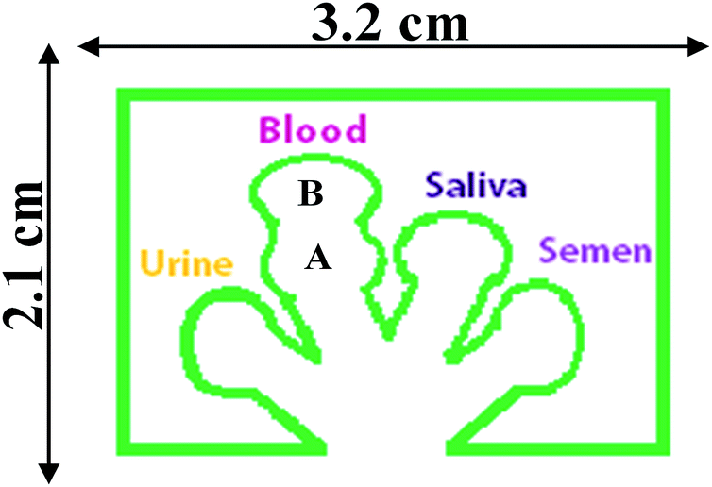
Figure 4.1 Multi-analyte paper microfluidic testing device developed for detecting body fluids. The device consists of 4 channels with 5 locations for reagents. The area labeled A is where sodium perborate tetrahydrate is placed within a thin layer of water-based liquid glue. Area B is the location where phenolphthalein is placed.

A single sample is placed at the base of the device, and capillary action transports the sample up into each individual branch of the device. A different colorimetric reagent is placed at the terminal end of each branch. The advantage of this layout is that both single analytes and mixtures can be assessed using one device.

4.2.3 Serology Colorimetric tests
The initial procedures used for each colorimetric test were developed by examining traditional solution-based forensic serological test methods. These included the Kastle–Meyer test for blood, the starch–iodine test for saliva, Nessler's reagent for urine, and the acid phosphatase (AP) test for semen.³⁴⁻³⁸ These procedures were then modified to achieve compatibility with the paper substrate and the linear capillary flow. Reagent placement was critical for achieving proper mixing and sequential reactivity with the individual analytes.
Samples were prepared through dilution using a v/v ratio of: 1 : 2, 1 : 5, 1 : 10; 1 : 20, 1 : 50, 1 : 100; 1 : 200, 1 : 500, 1 : 1000, while dried samples are cut out to 3 × 10⁻³ cm³ and diluted with 20 μL, 50 μL, 100 μL, 250 μL, 400 μL, 500 μL, 700 μL, 850 μL, 1000 μL of distilled water.
Initial tests were performed on single lane devices. In Table 4.1, the μPAD design and colorimetric reaction test results can be seen for independent testing of each sample lane. Each body fluid specific reagent were spotted into the terminal ends of the hydrophobic channels. This includes Row A: 0.5 μL of Urease-Nessler's reagent (urine), Row B: the Kastle–Meyer test (blood) spotted in two separate locations with 0.5 μL phenolphthalein spotted in location B of the blood lane, and 3 mg sodium perborate tetrahydrate spotted in location A of the blood; Row C: shows the test for saliva involving a mixture of 0.5 μL starch solution and iodine for saliva; and Row D: 0.5 μL acid phosphatase mixture for semen. Each row demonstrates the design of the chip, the color of the prepared device, and the color change that results from a positive test.

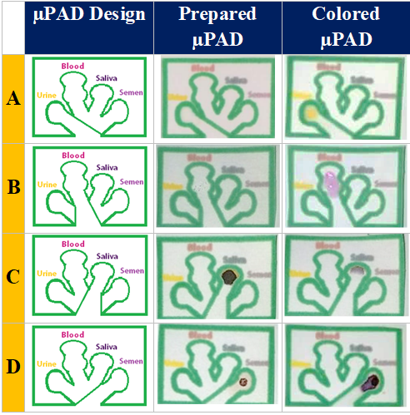
Table 4.1 Each lane of the µPAD has been separated using a hydrophobic barrier lane for initial sensitivity testing. (A) Urine (B) Blood (C) Saliva (D) Semen.

Next, the sensitivity and detection limit of each presumptive test was determined by performing serial dilutions of each analyte. Additional tests were performed for the determination of the effects of sample age and matrix interference.

4.2.3.1 Test development

4.2.3.1.1 Urine
In humans, urea is generally used as a marker for urine due to its high concentration in this biofluid.⁶ A useful test for urea takes advantage of the enzymatic activity of urease, followed by the detection of ammonium with Nessler's reagent.^{3,37,38} The overall hydrolysis of urea is shown in Eqn (1):

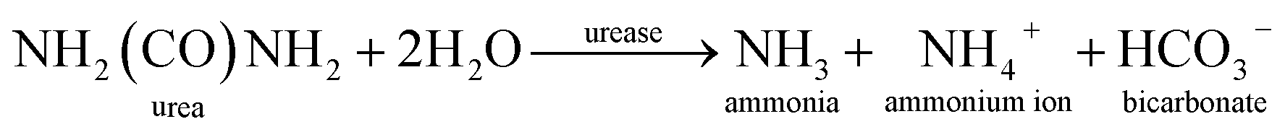

In this experiment, crystalline urease from jack beans was used.^{34,38-42} The hydrolysis involves an enzymatic reaction in which the metalloenzyme binds and degrades the urea into ammonium and carbamate.³⁹⁻⁴⁴ The carbamate then decomposes into ammonia and bicarbonate (Figure 4.2).^{40,43-45}
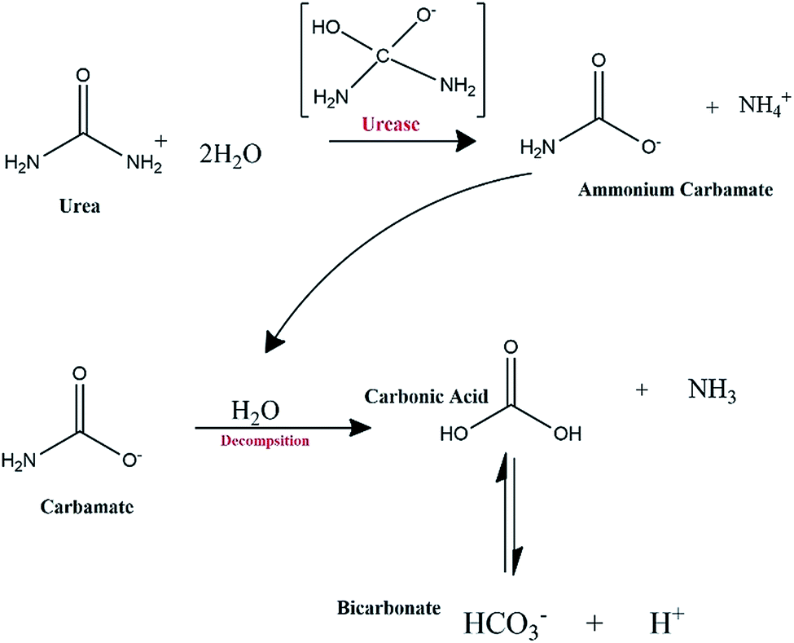
Figure 4.2 The detection of urea in urine is performed using urease to decompose urea into NH₃ and HCO₃⁻ ions.

To detect the presence of the ammonia that is formed from the hydrolysis of urea, a colorimetric method using Nessler's reagent is performed. The Nessler reagent contains mercury(ii) iodide, sodium hydroxide, and potassium iodide in water. Nesslerization occurs when the ammonia subsequently reacts with mercuric iodide to yield a mercuric ammonia complex. This reaction gives off a characteristic of a yellow-brownish color product.⁴⁵⁻⁴⁸ When the presence of ammonia is low, the color product is yellow, whereas when the presence of ammonia is high, the colored product is brown. The Nesslerization of ammonia can be seen in Figure 4.3. To prepare this reagent, powdered urease, 0.034 g, was added to 45 μL of purified water followed by the addition of 1 mL of Nessler's reagent. 0.5 μL of this solution was placed in the distal end of the urine channel.
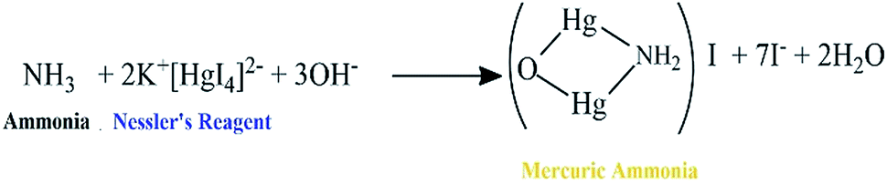
Figure 4.3Ammonia that is produced following the hydrolysis of urea is mixed with Nessler's reagent to produce a colorimetric reaction and a mercuric ammonia product. This process is called Nesslerization

4.2.3.1.2 Blood
For blood identification, forensic laboratories typically utilize oxidation-reduction reactions when performing presumptive testing, followed by a more specific confirmatory test.³ Most of the tests used in the detection of blood are based on the presence of hemoglobin. ^{3,37} A presumptive test that is widely used during criminal investigations when blood is suspected to be present is the Kastle–Meyer Test.^{3,34,35,37} In the Kastle–Meyer test, the presence of hemoglobin in the blood provides a peroxidase-like activity. In the presence of hydrogen peroxide, hemoglobin can oxidize phenolphthalin into phenolphthalein, yielding a pink color.^{3,6,34,35,37,38,49} For this reaction to produce stable results on paper, we substituted the hydrogen peroxide with sodium perborate tetrahydrate because of its enhanced stability and oxidizing ability.^{49,50} The overall reaction can be seen in Figure 4.4, in which the reduction of the sodium perborate simultaneously oxidizes the phenolphthalin. This test yields a fast and efficient result that can alert the user that blood may be present. To prepare the μPAD, (Fig. 1) 0.2–0.6 μm of water based glue was placed in the A section of the blood channel. 3 mg of sodium perborate tetrahydrate crystals were added to water-based glue, and 1.0 μL of the phenolphthalein solution was placed at the distal end of the blood channel (section B). In its solid form sodium perborate contains strong oxidizing properties while maintaining stability with the atmosphere. Mixing the crystalline form of sodium perborate tetrahydrate with small amounts of water-based glue ensures long term stability and avoids the problem of the reagent flaking off the chip.
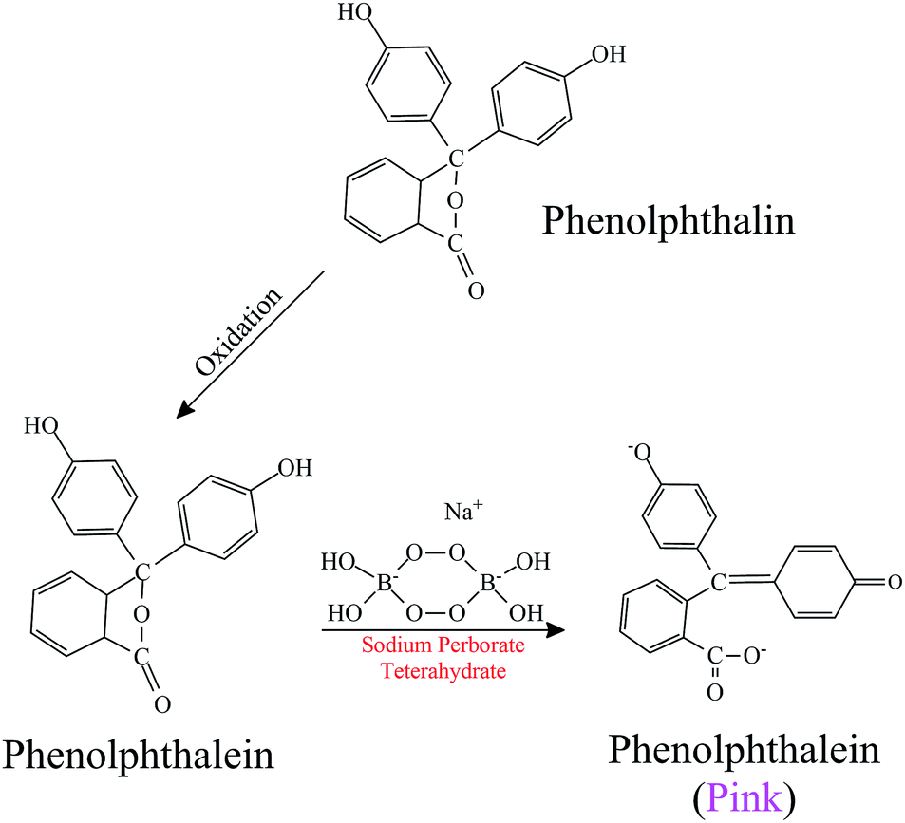
Figure 4.4 Blood can be detected by the Kastle–Meyer test by using the peroxidase-like activity of hemoglobin.

4.2.3.1.3 Saliva
There are several presumptive tests that are used to determine the presence of saliva in forensics.⁶ One of these utilizes the presence of α-amylase in human saliva, which is used to break down starch. Starch from foods contains polysaccharides, and when food is eaten, salivary α-amylase in saliva is used to help to digest these polysaccharides to produce maltose and glucose for the body.⁵¹⁻⁵⁵ A common presumptive test used to detect the presence of saliva is known as the starch–iodine test.^{3,6,34,37} The starch–iodine test results are based on the fact that when starch and iodine react together, a blue/black color appears. During this reaction, iodine attaches to the helices of the polysaccharides. In the presence of α-amylase, saliva hydrolyses the starch by cleaving the α-(1,4)-glycosidic bonds of polysaccharides, causing the starch bond to break down and the loss of the blue color formed begins to disappear.^{3,34,37} According to Gaensslen, this color intensity and shade formation are dependent on the helical chain length found in starch. ³ To prepare this test, 2 g of laboratory-grade starch was brought to a boil in 5 mL of water until it became a clear solution. Once cooled, 0.5 μL of the mixture was placed in the reagent location of the saliva lane, followed by 0.5 μL of 1N iodine solution. This created a blue/black color. Addition of saliva to this mixture produces the color change as the degraded starch releases iodine. Nine samples of saliva were diluted, 1 : 2 to a 1 : 1000 (v/v), using to determine the minimal amount of saliva that can be present and used for detection while using the paper microfluidic devices. Figure 4.5 demonstrates the starch–iodine test reaction that occurs when salivary amylase is present.
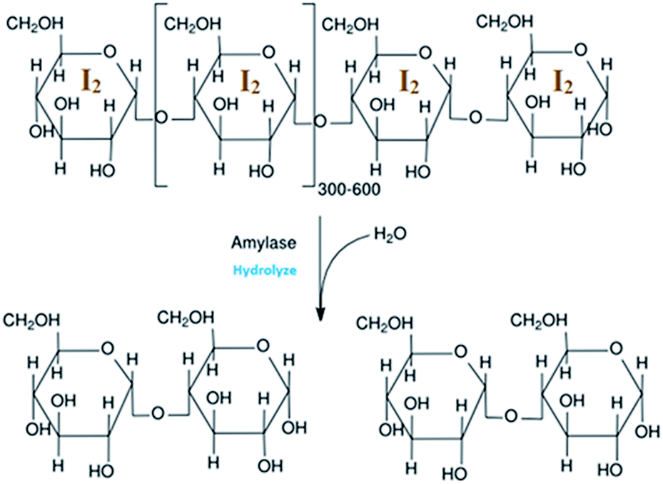
Figure 4.5 Saliva's amylase activity was measured through the hydrolysis of the starch–iodine.

4.2.3.1.4 Semen
In sexual assault cases, unknown biological fluids are many times left behind at a crime scene. One of these fluids is semen. Semen contains citric acid, lipids, acid phosphatase, and other enzymes.⁵⁵⁻⁵⁷ In male humans, semen contains high concentrations of acid phosphatase. A colorimetric test can be implemented in which the presence of acid phosphatase is detected based on its enzymatic function.^{2,3,6,34,37,58,59} Acid phosphatase reagent at pH 5.0 can catalyze the hydrolysis of α-naphthyl acid phosphate to produce naphthol.^{2,6,36,58,59} As seen in Figure 4.6, the naphthol reacts with fast blue B dye, producing a purple azo dye.
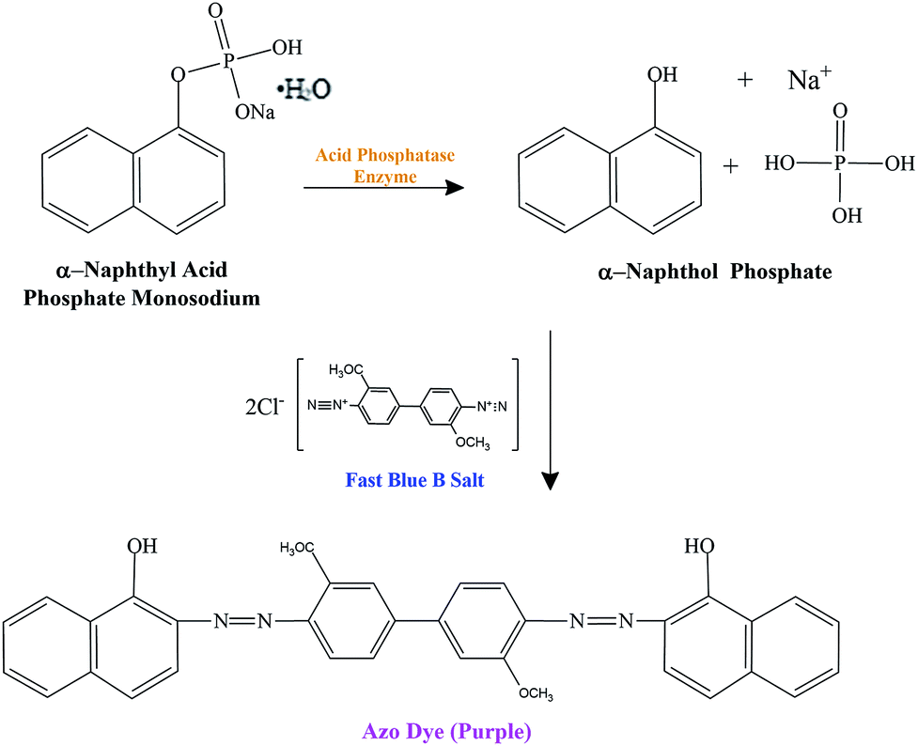
Figure 4.6 Semen was detected using sodium α-naphthyl phosphate with acid phosphatase and fast blue B.

Two solutions – substrate and dye solutions – were prepared using diagnostic test instructions and protocols provided by Arrowhead Forensics and the National Forensic Science Technology Center (NFSTC). The substrate solution included glacial acetic acid, sodium acetate, water and fast blue B.³⁷ A dye solution, including water and alpha-naphthyl phosphate disodium salt were also prepared.³⁷ The solutions were mixed and 0.5 μL of the mixture was placed within the semen reagent location.

4.2.5 Interference testing
Presumptive tests are designed as screening tools and are used mainly determining the potential presence of body fluids. However, depending on the reaction mechanism, there are usually a number of potential interferences in these tests. Some of these contributors include oxidizing agents, thermal denaturants, and certain environmental contaminants.
For example, when using the Urease-Nessler reagents to test for the presence of ammonia in urine; alcohols and ammonia based materials can create interferences.^{60,61} The Sacramento County District Attorney Laboratory of Forensic Services suggested that some interferences to the Kastle–Meyer test for blood were those that contained chemical oxidants, other substances that contained similar peroxidase activity, or materials containing peroxidase. ^{36,62} Additional interferences for the were also suggested by other laboratories.^{34,36,63} For example, raw potatoes may produce false-positive results for the Kastle–Meyer test. ⁶³
When using the starch–iodine test for detecting the presence of amylase, it should be noted that animal and plant amylase can produce false positives when using the starch–iodine enzymatic test.⁶⁴ In addition, amylase can also be detected in breast milk, semen, and perspiration of humans resulting in additional false positives.⁶⁵ However, in general, the levels of amylase in these other body fluids are low when compared to that in saliva. ⁶⁶
The acid phosphatase test has potential interferences which include male urine, saliva, and feces which, however, contain the enzyme acid phosphatase at lower levels than semen.^{34,36,67} It has also been suggested that plants, fungi, and bacteria may contain enzymes similar to those of seminal acid phosphatase that produce a reaction to the AP test.³⁴ For example, teas made from Camellia sinensis display a colorimetric reaction when tested using the acid phosphatase-fast blue test. ³⁶
Biological samples were donated by protected volunteers under the Health Science Institutional Review Board of Florida International University, IRB-16-0279 Based on a survey of the literature, the following substances were examined for interference testing: Hydrastis Canadensis (Goldenseal herbal supplement tea) was purchased from the Vitamin Shoppe (Miami, Florida); Camellia sinensis (Green Tea), bleach (Clorox), glass cleaner (Windex), hand soap (Softsoap), dish detergent (Palmolive), corn starch (Great Value), nail polish remover (Cutex Strength Shield Nail Polish Remover), and potatoes were purchased from supermarkets in Miami, Florida.

4.3 Results and discussion
This study aimed to prepare a multi-analyte μPAD method for the presumptive detection of body fluids. The design permits 4 simultaneous colorimetric tests to be performed, making the method highly specific, as interferences can be discriminated by their relative response in each colorimetric channel. The colorimetric tests used in this study were selected based on their previous application as solution tests and modified as necessary for use with paper microfluidic sensors.
Samples were prepared through dilution using a v/v ratios for non-dried samples and volume flow rate of sample and distilled water for dried samples.
Body fluids are composed of various enzymes and proteins in a wide range of concentrations, the complexity of detecting these fluids in mixtures can increase, and cross-reactivity can become an issue. ⁶⁸ Therefore, initial tests were performed on single lane devices, as seen in Table 4.1. Each body fluid specific reagent that is spotted into the terminal ends of the μPAD is observed in Table 4.1. Urease-Nessler's reagent is used to test for urine, the Kastle–Meyer test is used to test for blood using sodium perborate tetrahydrate; saliva was tested using a starch–iodine solution; and acid phosphatase mixture was used to test for the presence of semen's enzyme acid phosphatase.
Individual fluid tests were taken and 600 μL of the varying sample ratios were prepared, and the μPAD was used for testing. The lane channels are separated to show the difference between the prepared reagent location and the locations in which each reagent reacts with each designated fluid. The μPADs in Table 4.1 were only used to individualize each test for better observations during sensitivity testing. To see the demonstrated microfluidic device used for field testing, refer to Table 4.2.
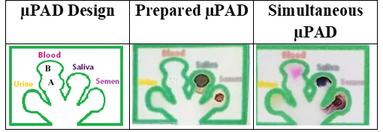
Table 4.2 The μPAD design used for serological analysis. The subsequent figures illustrate the device before and after the simultaneous detection of urine, blood, saliva, and semen.

The time required for a positive response using the μPAD in Tables 1 and 2 was estimated to require 10–15 minutes. Where 150–300 μL of the varying samples were mixed to total a 600 μL prepared sample for the multi-analyte testing. The total time to detection varied depending on the quantity of sample present, the nature of the sample, the dilution of the sample, and the nature of the biological fluid. ⁶⁸
4.3.1 Sensitivity study
A study of the device's sensitivity for each body fluid was performed using sample dilutions from 1 : 2 to 1 : 1000 for each body fluid type, including blood, semen, saliva, and urine. 480 μL of each sample dilution was placed into a designated 1 mL certified glass insert vial during preparation. The μPAD was placed into the vial, and the fluid samples flowed up through the hydrophobic channels until they reached the terminal ends where the reagents were placed. The intensity and spot size of each analysis were recorded using a Samsung Galaxy Note 8 smartphone. Each microfluidic device was photographed using a white background with ambient lighting to avoid external light interference and contamination. A 15 cm distance was maintained between the camera and the microfluidic device. The resultant images of the colorimetric reaction of urine at the various dilutions in water can be seen in Figure 4.7.

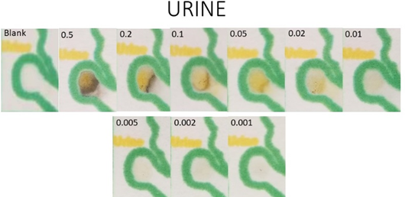
Figure 4.7 Illustrates the presumptive test results using colorimetric testing reagents for urine at dilution ratios of: 1 : 2, 1 : 5, 1 : 10; 1 : 20, 1 : 50, 1 : 100; 1 : 200, 1 : 500, 1 : 1000. The Urease-Nessler test was used in the above figure to detect urine.

The results were processed using the densitometry function of the image processing and analysis software ImageJ program and plotted using Microsoft excel. The data was fit to semilog plots of concentration vs. color density, Figure 4.8
Figure 4.8 ImageJ semilog plots of sample concentration vs. color density

A visual detection limit was determined by polling 33 individuals as to the lowest level of signal for which they could define a positive result.⁶⁹ The lowest level at which 90% of the participants detected a color change was deemed the visual detection limit.
For determination of the LOD based on smartphone data, an analysis of 10 replicate samples of each biofluid was plotted to a curve fit to determine the minimal detectable quantity. Urine was measured at 10 replicates of 0.01 v/v dilution, saliva was measured at 10 replicates of 0.01 v/v dilution, semen was measured at 10 replicates of 0.01 v/v dilution, and blood was measured at 10 replicates of 0.005 v/v dilution. The standard deviation, σ, of the signals obtained from the replicates were then used to determine the minimal detectable dilution of each body fluid. This data is listed in Table 4.3.
Table 4.3 Figures of merit for each body fluid, including the curve fits for the semilog plots, the R² values for each fit, the visual limit of detection (v/v), and the minimum concentration detection limit measured using ImageJ software.
Biological Fluid | Fit | R² | Visual Limit of Detection | Cell phone LODI
Urine | 0.0604 ln(x) + 2.1687 | 0.9402 | 0.01 | 2.2233
Blood | 0.011 ln(x) + 2.2906 | 0.9748 | 0.005 | 2.3001
Saliva | 0.1715 ln(x) + 1.4598 | 0.8969 | 0.01 | 1.6072
Semen | 0.1799 ln(x) + 1.6071 | 0.9363 | 0.01 | 1.7808

4.2.4 Interference testing
Using known colorimetric test interference items and other household items that were available within the laboratory, interference tests were conducted under a blind study. Colorimetric reactions that occurred on the μPAD when a sample was tested were noted. While conducting the blind study, leafy herbal teas (Hydrastis Canadensis, Camellia sinensis, and other Camellia sinensis varieties that were closely related to garden plants)³⁶ and vaginal fluid secretions³⁴ (only after a 2-minute waiting time period) were found to cause a purple color change in the acid phosphatase + fast blue B reagent location of the μPAD designated for semen detection. However, there were no other colorimetric changes in either the blood, saliva, or urine testing locations using these reagents. It should be noted that low amounts of acid phosphatase may be present in vaginal fluids. This can result in the slow development of a weak color change for specific samples after 1–2 minutes. ⁷⁰ Thus, color changes that occur 1 minute or longer after the solution reaches the color pad indicate a potential interference and should be interpreted with caution.
10% concentrated bleach was tested for interference on the μPADs, which resulted in a color change in the Urease-Nessler's and Kastle–Meyer channels. The color change observed in the Urease-Nessler's channel was orange-brown. The color change in the Kastle–Meyer channel was the same color pink as observed when blood was present. Glass cleaner from its commercial bottle produced a yellow and pink color change in the reagent locations with Urease-Nessler's reagent and sodium perborate-phenolphthalein. ^{60,61} 10% hand soap and dish detergent were used to test its interference abilities. The alkali in hand soaps and dish detergent chemically reacted with the phenolphthalein causing an alkylation to occur and produce a slight pink colorimetric change when reacting with the sodium perborate-phenolphthalein reagent location. ⁷¹ Nail polish remover proved to be another interference with the Urease-Nessler's test, causing a yellow-colorimetric change to occur when there was no urine present due to its alcohol component. ^{60,61} The starch–iodine test showed false positives when tested against citrus fruits such as lime, lemon, and oranges at whole fruit concentrations and a 1 : 10 diluted ratio with water.⁶⁴ The results for these experiments are detailed in Table 4.4.

Table 4.4 Common test interferences obtained using the multi-analyte device
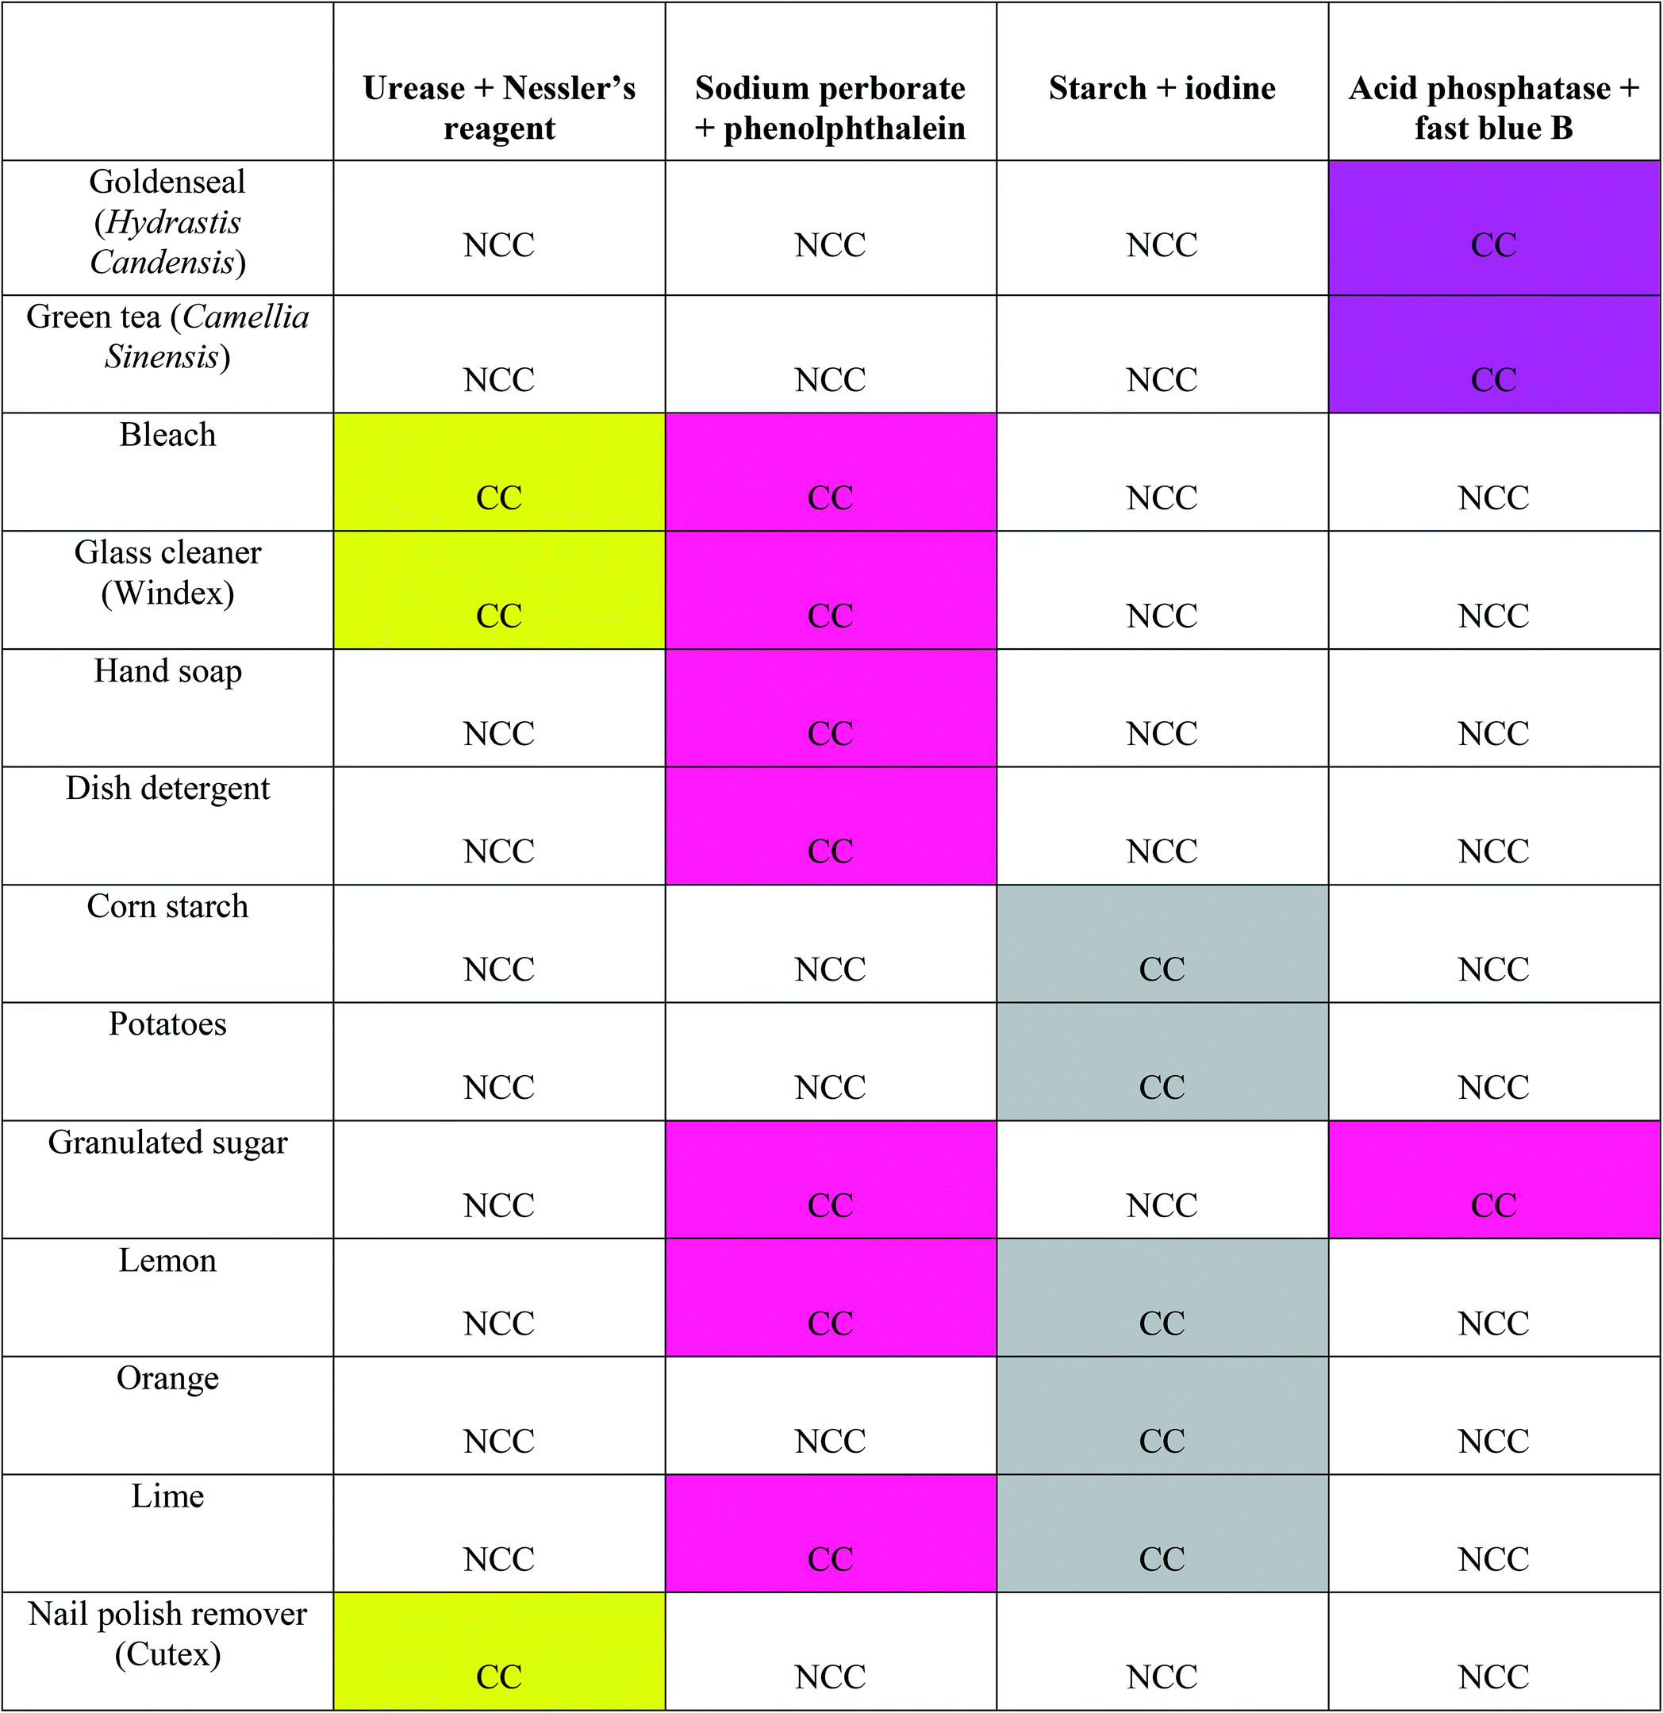

4.3 Conclusion
In conclusion, we have developed a multi-analyte paper-based device (μPAD) that can rapidly and reliably detect serological stains on various substrates. This device should prove useful for presumptive testing of stains at crime scenes and in the laboratory. Initial validation work has shown that the device can simultaneously detect mixtures of biological materials. During the development, we have also demonstrated that the multi-analyte device has up to a two-week shelf life when prepared with reagents and stored in a dry, dark location. The colorimetric response permits sample detection within a 10–15 minute time interval. This device has low sample volume input requirements and is inexpensive to make. The multi-analyte format increases the specificity of the detection method, preserves precious samples, and allows users to distinguish if blood, saliva, semen, or urine is presumptively present prior to more specific confirmation testing.

Acknowledgments
The authors of the paper would like to thank the volunteers who contributed samples to this study and the Bridge to the Doctorate program at Florida International University. Rosa Cromartie was supported by the Bridge to the Doctorate Program at Florida International University, which is funded by the National Science Foundation. Ashley Wardlow was supported by the NIGMS-RISE program at FIU.

References
1. An, J.; Shin, K.; Yang, W.; Lee, H. Body fluid identification in forensics. BMB Reports 2012, 45, 545-553.
2. Mozayani, A.; Noziglia, C. The Forensic Laboratory Handbook Procedures and Practice; Springer Science+Business Media: Totowa, NJ, 2011; .
3. Gaensslen, R. E. Sourcebook in forensic serology, immunology, and biochemistry / R.E. Gaensslen. 1983.
4. Kobilinsky, L.; Kobilinsky, L. Forensic chemistry handbook; WILEY: Hoboken, 2011; .
5. McLaughlin, G.; Doty, K. C.; Lednev, I. K. Discrimination of human and animal blood traces via Raman spectroscopy. Forensic Science International 2014, 238, 91-95.
6. Virkler, K.; Lednev, I. K. Analysis of body fluids for forensic purposes: From laboratory testing to non-destructive rapid confirmatory identification at a crime scene. Forensic science international 2009, 188, 1-17.
7. Harbison, S. A.; Fleming, R. I. Forensic body fluid identification: state of the art. RRFMS 2016, 6, 11-23.
8. Zapata, F.; Gregorio, I. Body Fluids and Spectroscopic Techniques in Forensics: A Perfect Match? Journal of Forensic Medicine 2016, 1.
9. Eilerts, D. F. Beyond DNA: Epigenetics and Proteomics in Forensic Science. Themis: Research Journal of Justice Studies and Forensic Science 2016, 4.
10. Vidaki, A.; Kayser, M. From forensic epigenetics to forensic epigenomics: Broadening DNA investigative intelligence. Genome Biology 2017, 18, 238.
11. Beebe, D. J.; Mensing, G. A.; Walker, G. M. Physics and Applications of Microfluidics in Biology. Annu. Rev. Biomed. Eng. 2002, 4, 261-286.
12. Hansen, C.; Quake, S. R. Microfluidics in structural biology: smaller, faster… better. Current Opinion in Structural Biology 2003, 13, 538-544.
13. Yager, P.; Edwards, T.; Fu, E.; Helton, K.; Nelson, K.; Tam, M. R.; Weigl, B. H. Microfluidic diagnostic technologies for global public health. Nature 2006, 442, 412-418.
14. Whitesides, G. M. The origins and the future of microfluidics. Nature 2006, 442, 368-373.
15. Lisowski, P.; Zarzycki, P. K. Microfluidic Paper-Based Analytical Devices (μPADs) and Micro Total Analysis Systems (μTAS): Development, Applications and Future Trends. Chromatographia 2013, 76, 1201-1214.
16. Carrilho, E.; Martinez, A. W.; Whitesides, G. M. Understanding Wax Printing: A Simple Micropatterning Process for Paper-Based Microfluidics. Anal. Chem. 2009, 81, 7091-7095.
17. Martinez, A. W.; Phillips, S. T.; Whitesides, G. M. Three-dimensional microfluidic devices fabricated in layered paper and tape. Proceedings of the National Academy of Sciences - PNAS , 105, 19606-19611.
18. Martinez, A. W.; Phillips, S. T.; Whitesides, G. M.; Carrilho, E. Diagnostics for the Developing World: Microfluidic Paper-Based Analytical Devices. Anal. Chem. 2010, 82, 3-10.
19. Martinez, A. W.; Phillips, S. T.; Wiley, B. J.; Gupta, M.; Whitesides, G. M. FLASH: A rapid method for prototyping paper-based microfluidic devices. Lab Chip 2008, 8, 2146-2150.
20. Busa, L. S. A.; Mohammadi, S.; Maeki, M.; Ishida, A.; Tani, H.; Tokeshi, M. Advances in Microfluidic Paper-Based Analytical Devices for Food and Water Analysis. Micromachines (Basel) 2016, 7, 86.
21. Sackmann, E. K.; Fulton, A. L.; Beebe, D. J. The present and future role of microfluidics in biomedical research. Nature 2014, 507, 181-189.
22. Rozand, C. Paper-based analytical devices for point-of-care infectious disease testing. Eur. J. Clin. Microbiol. Infect. Dis. 2014, 33, 147-156.
23. Choi, J. R.; Yong, K. W.; Tang, R.; Gong, Y.; Wen, T.; Yang, H.; Li, A.; Chia, Y. C.; Pingguan-Murphy, B.; Xu, F. Lateral Flow Assay Based on Paper–Hydrogel Hybrid Material for Sensitive Point-of-Care Detection of Dengue Virus. Advanced Healthcare Materials 2017, 6, 1600920.
24. Xia, Y.; Si, J.; Li, Z. Fabrication techniques for microfluidic paper-based analytical devices and their applications for biological testing: A review. Biosensors and Bioelectronics 2016, 77, 774-789.
25. Sher, M.; Zhuang, R.; Demirci, U.; Asghar, W. Paper-based analytical devices for clinical diagnosis: recent advances in the fabrication techniques and sensing mechanisms. Expert Review of Molecular Diagnostics 2017, 17, 351-366.
26. Koczula, K.; Gallotta, A. Lateral flow assays. Essays Biochem 2016, 60, 111-120.
27. Zhang, Y.; Fan, J.; Nie, J.; Le, S.; Zhu, W.; Gao, D.; Yang, J.; Zhang, S.; Li, J. Timing readout in paper device for quantitative point-of-use hemin/G-quadruplex DNAzyme-based bioassays. Biosensors and Bioelectronics 2015, 73, 13-18.
28. Chen, A.; Yang, S. Replacing antibodies with aptamers in lateral flow immunoassay. Biosensors and Bioelectronics 2015, 71, 230-242.
29. Bahadır, E. B.; Sezgintürk, M. K. Lateral flow assays: Principles, designs and labels. TrAC Trends in Analytical Chemistry 2016, 82, 286-306.
30. Musile, G.; Wang, L.; Bottoms, J.; Tagliaro, F.; McCord, B. The development of paper microfluidic devices for presumptive drug detection. Anal. Methods 2015, 7, 8025-8033.
31. Peters, K. L.; Corbin, I.; Kaufman, L. M.; Zreibe, K.; Blanes, L.; McCord, B. R. Simultaneous colorimetric detection of improvised explosive compounds using microfluidic paper-based analytical devices (μPADs). Anal. Methods 2014, 7, 63-70.
32. Wang, L.; Musile, G.; McCord, B. R. An aptamer-based paper microfluidic device for the colorimetric determination of cocaine. ELECTROPHORESIS 2018, 39, 470-475.
33. Chabaud, K. R.; Thomas, J. L.; Torres, M. N.; Oliveira, S.; McCord, B. R. Simultaneous colorimetric detection of metallic salts contained in low explosives residue using a microfluidic paper-based analytical device (µPAD). Forensic Chemistry 2018, 9, 35-41.
34. Metropolitan Police Office. Forensic Science Laboratory Biology methods manual; New Scotland Yard: United Kingdom, 1978; .
35. Tobe, S. S.; Watson, N.; Daéid, N. N. Evaluation of Six Presumptive Tests for Blood, Their Specificity, Sensitivity, and Effect on High Molecular-Weight DNA. Journal of Forensic Sciences 2007, 52, 102-109.
36. Vennemann, M.; Scott, G.; Curran, L.; Bittner, F.; Tobe, S. Sensitivity and specificity of presumptive tests for blood, saliva and semen. Forensic Sci Med Pathol 2014, 10, 69-75.
37. AnonymousForensic Resources. http://www.ncids.com/forensic/serology/serology.shtml (accessed Mar 10, 2018).
38. James, S. H.; Nordby Ph.D, J. J. Forensic Science; CRC Press: Boca Raton, 2002; .
39. Nakano, H.; Takenishi, S.; Watanabe, Y. (Osaka-shi. Technical Research Inst. (Japan)) Purification and properties of urease from Brevibacterium ammoniagenes. Agricultural and biological chemistry 1984, 48, 1495-1502.
40. Ray, H.; Saetta, D.; Boyer, T. H. Characterization of urea hydrolysis in fresh human urine and inhibition by chemical addition. Environ. Sci. : Water Res. Technol. 2017, 4, 87-98.
41. Dixon, N. E.; Gazzola, C.; Blakeley, R. L.; Zerner, B. Jack bean urease (EC 3.5.1.5). Metalloenzyme. Simple biological role for nickel. J. Am. Chem. Soc. 1975, 97, 4131-4133.
42. Todd, M. J.; Hausinger, R. P. Competitive Inhibitors of Klebsiella aerogenes Urease. The Journal of biological chemistry 1989, 264, 15835-15842.
43. Amtul, Z.; Rahman, A.; Siddiqui, R. A.; Choudhary, M. I. Chemistry and Mechanism of Urease Inhibition. Current medicinal chemistry 2002, 9, 1323-1348.
44. Kabdaşli, I.; Tünay, O.; Işlek, C.; Erdinç, E.; Hüskalar, S.; Tatli, M. B. Nitrogen recovery by urea hydrolysis and struvite precipitation from anthropogenic urine. Water science and technology 2006, 53, 305-312.
45. Mobley, H. L.; Island, M. D.; Hausinger, R. P. Molecular biology of microbial ureases. Microbiological reviews 1995, 59, 451-480.
46. Sharma, V.; Khurana, J. M.; Muralidhar, K. Spectrophotometric Determination of Urea in Urine Samples by using Bispyrazolone Method. Proceedings of Indian National Science Academy 2013, 79, 51-56.
47. ASTM International ASTM D1426-15 Standard Test Methods for Ammonia Nitrogen in Water. ASTM Standard Test Methods (ASTM International) 2015.
48. Jeong, H.; Park, J.; Kim, H. Determination of NH4+ in Environmental Water with Interfering Substances Using the Modified Nessler Method. Journal of chemistry 2013, 2013, 1-9.
49. Jackson, A. R. W.; Jackson, J. M. Forensic Science; Pearson Prentice Hall, Pearson Education Canada: Harlow, 2011; .
50. Peşman, E.; Ersoy Kalyoncu, E.; Kırcı, H. Sodium perborate usage instead of hydrogen peroxide for the reinforcement of oxygen delignification. 2010.
51. MacGregor, E. A.; Janeček, Š; Svensson, B. Relationship of sequence and structure to specificity in the α-amylase family of enzymes. Biochimica et Biophysica Acta (BBA) - Protein Structure and Molecular Enzymology 2001, 1546, 1-20.
52. Kandra, L.; Gyémánt, G. Examination of the active sites of human salivary α-amylase (HSA). Carbohydrate Research 2000, 329, 579-585.
53. Voet, D.; Voet, J. G. Biochemistry; John Wiley & Sons Inc.: Hoboken, NJ, 2004; .
54. Marini, I. Discovering an accessible enzyme: Salivary α-amylase : Prima digestio fit in ore: A didactic approach for high school students. Biochemistry and Molecular Biology Education 2005, 33, 112-116.
55. Butterworth, P. J.; Warren, F. J.; Ellis, P. R. Human α-amylase and starch digestion: An interesting marriage. Starch - Stärke 2011, 63, 395-405.
56. Jitendra, N.; Piyush, P.; Sangeeta, P.; Bipin, C. Study of Seminal Acid Phosphatase and Alkaline Phosphatase Level in Relation to Sperm Count in Teaching Hospital. NATIONAL JOURNAL OF MEDICAL RESEARCH 2015, 5, 282-285.
57. Owen, D. H.; Katz, D. F. A Review of the Physical and Chemical Properties of Human Semen and the Formulation of a Semen Simulant. Journal of Andrology 2005, 26, 459-469.
58. Singh, B.; Gautam, I.; Yadav, V.; Mohapatra, B. Detection of Human seminal stains in one minute by modified acid phosphatase test. European Journal of Forensic Sciences 2015, 2, 14.
59. Raju, P. S.; Iyengar, N. K. Acid Phosphatase Reaction as a Specific Test for the Identification of Seminal Stains. The Journal of Criminal Law, Criminology, and Police Science 1964, 55, 522-525.
60. Gao, X.; Wen, Y.; Qu, D.; An, L.; Luan, S.; Jiang, W.; Zong, X.; Liu, X.; Sun, Z. Interference Effect of Alcohol on Nessler’s Reagent in Photocatalytic Nitrogen Fixation. ACS Sustainable Chem. Eng. 2018, 6, 5342-5348.
61. Fedoruk, M. J.; Bronstein, R.; Kerger, B. D. Ammonia exposure and hazard assessment for selected household cleaning product uses. J Expo Sci Environ Epidemiol 2005, 15, 534-544.
62. Sacramento County District Attorney Laboratory of Forensic Services Sero: Kastle–Meyer Presumptive Test for Blood. http://www.sacda.org/files/1814/3577/0241/Sero_KM_for_blood.pdf (accessed October 21, 2017).
63. Elkins, K. M. Forensic DNA Biology; Elsevier Science & Technology: San Diego, 2012; , pp 9-25.
64. OHYA, I.; IWASA, M.; KOMORIYA, H.; BUNAI, Y.; SAGISAKA, K. Identification of Human Saliva by Antisera to α-Amylase in Human Salivary Glands. Tohoku journal of experimental medicine 1986, 150, 309-315.
65. Sacramento County District Attorney Laboratory of Forensic Services SER: Saliva-Radial Diffusion for Amylase. http://www.sacda.org/files/4814/3619/8809/Saliva-Radial_Diffusion_for_Amylase.pdf (accessed October 21, 2017).
66. Auvdel, M. Amylase Levels in Semen and Saliva Stains. Journal of forensic sciences 1986, 31, 426-431.
67. Kind, S. S. The Use of the Acid Phosphatase Test in Searching for Seminal Stains. The Journal of Criminal Law, Criminology, and Police Science 1957, 47, 597-600.
68. Prinz, M.; Tang, Y.; Siegel, D.; Yang, H.; Zhou, B.; Deng, H. Establishment of a Fast and Accurate Proteomic Method for Body Fluid/Cell Type
Identification . 2011, NIJ Grant 2008-DN-BX-K011.
69. Scherr, T. F.; Gupta, S.; Wright, D. W.; Haselton, F. R. Mobile phone imaging and cloud-based analysis for standardized malaria detection and reporting. Sci Rep 2016, 6, 1-9.
70. Lewis, J.; Baird, A.; McAlister, C.; Siemieniuk, A.; Blackmore, L.; McCabe, B.; O'Rourke, P.; Parekh, R.; Watson, E.; Wheelhouse, M.; Wilson, N. Improved detection of semen by use of direct acid phosphatase testing. Science & Justice 2013, 53, 385-394.
71. Hubacher, M. H. The Permanent Fading of Alkaline Phenolphthalein Solutions. J. Am. Chem. Soc. 1943, 65, 2097-2098.

An aptamer-based electrochemical biosensor for label-free of codeine with gold nanoparticles amplification
Rosa L. Cromartie, Vivek A. Kamat, Shekhar Bhansali, Bruce R. McCord
Abstract
This paper reports the development of a paper-based electrochemical aptasensor using an anti-codeine aptamer as a biological recognition element for detecting codeine in sweat. The sensitivity of this sensor was achieved by utilizing gold nanoparticles (AuNPs), which were electrodeposited onto the surface of a bare carbon screen-printed electrode increasing the surface area. Next, the surface was modified with DNA aptamers through a thiol attachment. Upon binding to a codeine target, the aptamer changes conformation, blocking access to the ferrocyanide electrolyte and providing indirect detection. Peak current decreased as the concentration of codeine increased. Square wave voltammetry was utilized to determine the presence of codeine in sweat using both screen-printed and paper-based electrodes for detection after surface modification. Bothe aptasensors demonstrated high specificity for codeine with a 29 ng/mL detection limit for the screen screen-printed electrode and 75ng/mL for the paper-based electrode. The ultimate goal of this sensor was to provide a non-invasive sensing mechanism that analyzes sweat samples for the presence of codeine and codeine-like structures. This sensor provides good sensitivity and reproducible analytical performance and was successfully used to detect codeine in spiked human sweat samples.

5.1 Introduction
Over the past three decades, there has been widespread abuse of opioids and a dramatic rise in the use and misuse of these molecules used as APIs (active pharmaceutical ingredients ) in drugs. ¹ The abuse of opioids has resulted in an epidemic of hospitalization and death in the USA and other countries. Much of the initial rise in the rate of abuse is due to the increased availability of prescription opioids, including codeine. Codeine (3-methylmorphine) is a natural opioid and one of the commonly known alkaloids of opium widely used in pain treatments. ²⁻⁴ Although codeine has been presented as a mild sedative drug, it can be dangerous when abused. ² When codeine is consumed through oral dosage, about 10% of the codeine undergoes O-demethylation by CYP2D6 and metabolizes into morphine, leaving the remainder of the drug to be absorbed by the body and processed for elimination. ⁵ To determine the presence and quantity of any consumed opioid, biological samples are collected and analyzed. Typically, analysis of opioids in biological fluids is performed using blood or urine specimens. ^{6,7} This testing process is commonly implemented in workplaces, athletic doping control, forensic investigations, clinical and healthcare monitoring. For many years, facilities have used either blood or urine to detect the presence of drugs of abuse using advanced laboratory instrumentation such as liquid chromatography (LC-MS). However, these tests are invasive and can be lengthy in analysis. Therefore, non-invasive and reliable tests are needed, which can be performed quickly and on-site.
For this reason, we are investigating the development of biosensors for the detection of drugs in sweat. Sweat provides a valuable and non-invasive matrix for detection. Drugs can be detected in sweat due to secretion from eccrine and apocrine glands located on the skin's surface. Sweat patches can be used to collect and detect these compounds and have been previously used to collect and analyze sweat using gas chromatography for codeine. ⁸
This study describes the development of a unique electrochemical sensor for the detection of codeine molecules in sweat. The system utilizes disposable polypropylene screen-printed carbon electrodes and a paper-based carbon electrode modified with aptamer functionalized nanoparticles to capture the codeine molecules. The redox probe solution used for sample analysis was 5mM K₄Fe(CN)₆/K₃Fe(CN)₆ containing 0.1M KCl. Indirect detection occurs as the presence of the aptamer bound codeine blocks access of the K₄Fe(CN)₆/K₃Fe(CN)₆ reaction to the electrode surface.

5.2 Materials and Reagents
All reagents were of molecular biology grade purchased from Sigma-Aldrich unless otherwise stated. Gold chloride trihydrate (HAuCl₄·3H₂O), H₂SO₄ sodium citrate, potassium ferricyanide, and ferrocyanide, phosphate-buffered saline (PBS) pH 7.4, NaCl, KCl, MgCl₂, Tris-EDTA (TE) buffer solution, EDTA, and Tris-HCl were used in this study. 6-Merchato-1-hexanol was obtained from TCI Chemicals (Portland, OR, USA). Tris-(2-carboxyethyl) phosphine hydrochloride (TCEP) was obtained from Alfa Aesar. TCEP was a reducer agent intended to disrupt any disulfide bonds and ensure that free –SH groups are ready to bind with the surface of the gold nanoparticles. All solutions were prepared in Ultrapure water with a resistivity of 18.2 MΩ-cm was generated by a Millipore water purification system. Solutions were prepared using ultra-pure water with a resistance of 18 MΩ cm (Millipore, USA).
Sweat was collected from volunteers with IRB-approval 108708 (Florida International University). Codeine (3-methylmorphine) and other drug substitutes mentioned in this paper were obtained from Cayman Chemical (Ann Arbor, MI) without further purification. The thiolated anti-codeine aptamer was purchased from Integrated DNA Technologies, Inc. (IDT DNA) in Coralville, Iowa, USA. With the sequence of the following oligonucleotide ^{2,3}:
5’-/5ThioMC6-D/CCC CCT GGG TCG GGA AAA GGG GTT GGG GGT GCG G-3'
The lyophilized aptamer was resuspended in Tris-EDTA buffer to a 100μM solution and stored in at -20°C until needed for use. When ready for use, the aptamers were prepared the aptamer by first diluting to 10μM using 20mM Tris-HCl (pH 7.4) and denatured at 90°C for 5 min to dissociate any intermolecular bonds before renatured by cooling down to room temperature. Next, the denatured DNA was further reduced to 2 μM using immobilization buffer containing 1.0 M NaCl, 1mM EDTA, 1 mM TCEP in Tris-HCl (10 mM, pH 8.0) and the binding buffer containing 0.1 M NaCl, 0.2 M KCl, 5 mM MgCl2, 1 mM EDTA in Tris-HCl (20 mM, pH = 7.4) that was subsequently prepared.
*Important Note: Resuspended aptamers were stored at -20°C for future use. Unused unfolded aptamers used can be frozen; however, they will need to undergo the denaturation and renaturation process again*

5.2.1 Apparatus and Instrumentation
Carbon-Graphene Conductive ink (C2131121D3) was purchased from Gwent Electronics Materials Co., Ltd (United Kingdom) Silver conductor paste (DuPont 5025) was purchased from DuPont Microcircuit Materials (Research Triangle Park, NC, USA). Whatman no. 1, Chromatographic paper was purchased from GE Healthcare (United Kingdom). Xerox ColorQube 8570DN printer (Xerox, USA). Disposable polypropylene carbon screen-printed electrode (SPE) (TE-100) (Zensor R&D, Austin, TX, USA); Evolution 201 ThermoFisher UV-Visible spectrophotometer; Scanning electron microscope (SEM; model JOEL SEM 7000); Malvern Zetasizer Nano ZS instrument; Metrohm Autolab analyzer

5.2.1.1 Synthesis of AuNPs
AuNPs were synthesized by the sodium citrate-mediated method, according to previous reports. ^{3,9,10} HAuCl₄ was dissolved in deionized water, gently stirred into the solution to form a yellow solution at 110°C. Trisodium citrate was then vigorously stirred and refluxed for 30 ^{3,9,10} HAuCl₄ was dissolved in deionized water, gently stirred into the solution to form a yellow solution at 110°C. Trisodium citrate was then vigorously stirred and refluxed for 30 minutes. The yellow solution gradually changes from a colorless solution to a wine-red like color; once this color stabilizes, the heat is turned off and the solution is continuously stirred for 30 minutes at room temperature. The average size of these nanoparticles was 50.2 nm ± 0.5nm. The solution of the particles was transferred to a glass storage bottle, wrapped in aluminum foil and stored in the dark at 4°C.

5.2.1.2 Design and Fabrication of the paper-based screen-printed electrode

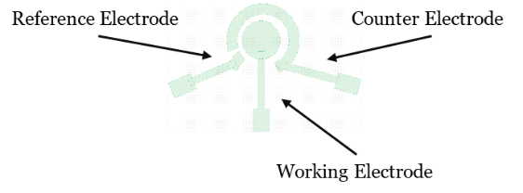
Figure 5.1 Three-electrode system design created using LayoutEditor Software. This electrode pattern was used to create a paper-based screen-printed electrode used as a comparison for the experiment.

The screen-printed electrode was designed based on a three-electrode system that included working, reference, and counter (auxiliary) electrodes. To prepare for the screen-printing of the three-electrode pattern, LayoutEditor Software was used to formulate the design of the screen-printed electrode as seen in Figure 1, and the electrode patterns were cut out using Silhouette Studio v. 4.4 software and a Silhouette Cameo 3 craft cutter printer (Silhouette, Brazil). After designing and cutting the electrode stencil, we proceeded with the electrode fabrication process.
The steps used to fabricate the paper-based screen-printed carbon electrode are shown in Figure 2. The wax barrier was printed with a Xerox ColorQube 8570DN printer (Xerox, USA). After printing, the paper was run through a temperature-controlled laminator three times using aluminum foil as a heat insulation packing pouch to melt the wax into the paper. The laminator temperature was set at 160°C at a motor speed of 2 cm s⁻¹ (Tamerica/Tashin Industrial Corporate, TCC-6000) to ensure that the wax printed would completely melt through each side of the paper, allowing for hydrophobic barriers to be created.
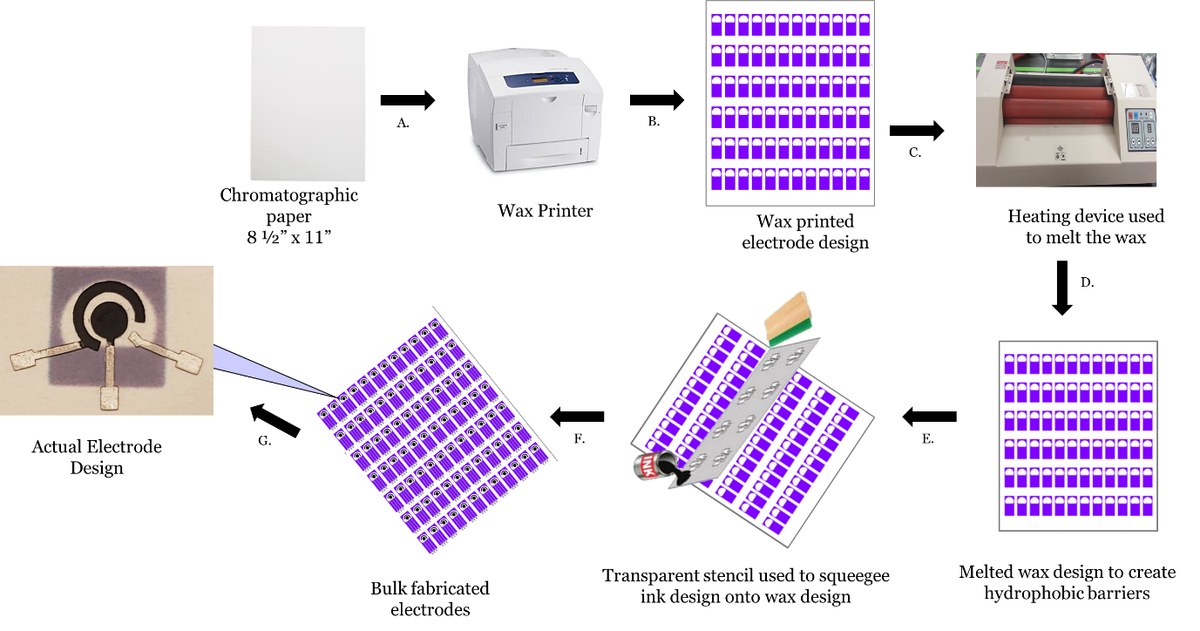
Figure 5.2 Fabrication process involved in the making of the paper-based screen-printed electrode. For details of the various steps. A. Chromatographic paper used with ColorQube wax printer; B. ColorQube wax printed used to print the base electrode design for hydrophobic barrier; C. temperature-controlled laminator to melt the wax into the chromatographic paper; D. The Melted wax design that has formed hydrophobic barriers; E. Using the stencil design created with the Silhouette Cameo, the design is placed on top of the waxed paper, and the conductive ink is squeegeed and cured, F. A bulk of cured and ready to go electrode; G. Photograph of the final paper electrode inserted.

5.3 Experimental

5.3.1 Electrode Preparation
All voltammetric parameters were optimized based on the peak current intensity response profile vs. peak potential produced by codeine. The previously synthesized negatively charged citrate-capped AuNPs were electrochemically deposited on the SPCE using pre-synthesized AuNPs and applying potential using chronoamperometry. ¹¹⁻¹³

5.3.1.1 Optimization of electrodeposition time and potential
Gold nanoparticle electrodeposition on the surface of the carbon electrode can be affected by several parameters, including time and applied potential. In this study, both factors have been optimized to obtain the best performance. Optimization of the applied potential of +0.4V and the electrodeposition time was evaluated within 300-800 seconds. Observations showed that the current increased as the deposition time increased and began to remain constant at 450-800 seconds. Thus, is where the selection of 600 seconds for electrodeposition was selected. Using the electrodeposition time of 600s, we determined the applied potential to the working electrode. Varying between +0.3V to +1.0V, the current showed a decrease throughout the optimization of applied potential from +0.4 until reaching +1.0V. This decrease remained constant until applying a potential greater than +0.3, where the current began to increase. To get a better insight into the selective deposition and growth of the AuNPs on the surface, the electrode is represented by chronoamperometry. Figure 3 This technique provides details of the transient current -time (i-t) curve during the electrochemical deposition of the AuNPs onto the bare electrode. It has been mentioned that negative potentials cause higher currents to be observed at early deposition times due to rapid formation onto the surface of the electrode. Thus, a decrease in the current was observed as an increase in potential was applied. Therefore, an electrodeposition potential of +0.5V was selected for deposition of the gold nanoparticles onto the surface of the electrode.
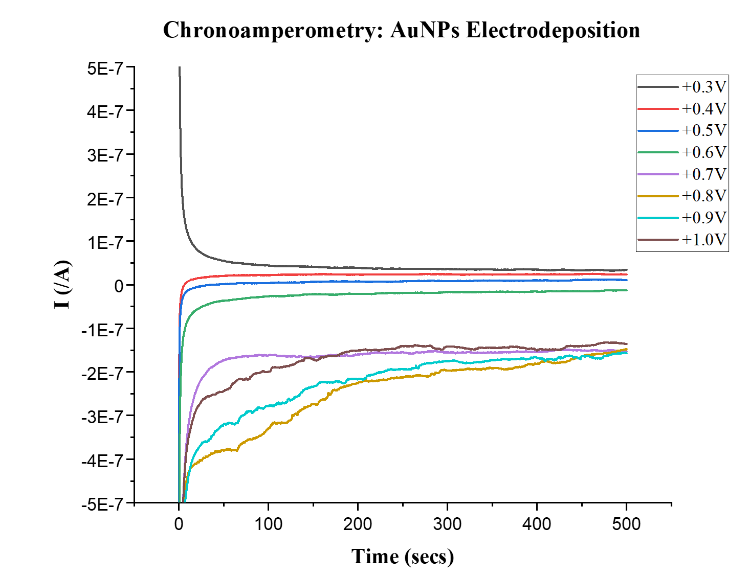
Figure 5.3 Chronoamperometry curves of electrodeposition of gold onto the bare screen-printed carbon electrode by applying different potentials. Effect of electrodeposition time employing AuNPs a standard of 40μL of 25.3μM and an E_{dep} of 500 mV for 600 s was selected.

5.3.2 Codeine sensing principle
A schematic diagram illustrating the codeine electrochemical sensing principle is shown in figure 4. In this process, gold nanoparticles were electrodeposited onto the screen-printed carbon working electrode's surface, followed by the functionalization of the anti-codeine single-stranded DNA aptamer onto the AuNPs at the electrode surface. The aptamer was allowed to incubate in the dark at room temperature (~25°C) on the surface of the electrode overnight (>14 hours). Next, 1mM 6-MCH was added to block any remaining active sites and left to incubate for 1 hour, followed by rinsing the electrode with the binding buffer. 6-MCH is being used as a co-adsorbent to block nonspecific aptamer molecule absorbing sites.
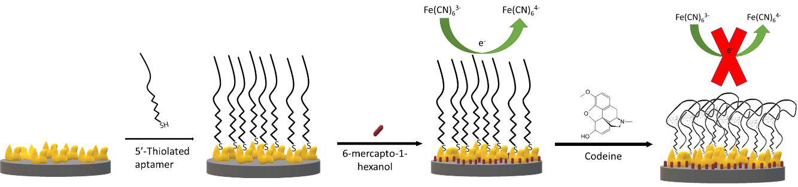
Figure 5.4 Principle of confirmational structure change for the detection of codeine. Aptamers are introduced to the AuNPs that is electrodeposited onto the surface of the working electrode of the carbon screen-printed electrode system for thiol functionalization. After incubation, the electrodes are rinsed with binding buffer to remove unbound aptamers, and 6-mercapto-1-hexanol is used to block any remaining active sites and left to incubate for 1 hour.

5.3.3 Sample Preparation
Biological sweat samples were collected by 8 volunteers with procedures approved by the Health Science Institutional Review Board of Florida International University, IRB-20-0116, and follow relevant federal regulations to protect human subjects in research (45 CFR 46). The sweat used in this experiment was collected using two methods of collection: a polypropylene arm cast bag and a sweat patch (developed in-house) that had not taken any analgesic opioid such as codeine. Subjects were asked not to take any analgesic opioid such as codeine before collection. No further dilution/ purification was used for these collected biological samples, stored at 4°C prior to analysis. A stock solution of 5μg/mL codeine in sweat was prepared. The sweat samples were then spiked with stock solutions to provide 25ng-150ng/mL codeine. When analyzing the spiked codeine-sweat samples, electrochemical impedance spectroscopy (EIS) analysis was used to obtain information on the mechanism of the surface binding. Any modified sensors that were not immediately used were kept at 4°C until ready for use. Before analysis, the aptamer-AuNP sensors were incubated with the sweat containing codeine for 1 hour to allow for analyte-aptamer binding to occur. ^{3,14} This time for incubation was determined after reading literature and examing the difference shift in current after longer incubation periods. All analyses were performed in quadruplicate using the same electrode and recorded. Each modified electrode was used only one time, then disposed of.

5.3.4 Electrochemical Measurements
Electrochemical impedance spectroscopy (EIS) was used to examine the charge transfer process characterize the effect of surface modification occurring at the sensor/sample interface. Nyquist plots of impedance spectra were used to study charge transfer at sensor-solution interfaces following the deposition of gold nanoparticles, the immobilization of aptamers bound to the gold nanoparticles, and the blocking of static sites by MCH. The value of the charge transfer resistance decreased compared with the bare electrode due to an increase in the electron transfer rate between the AuNPs and the carbon electrode. Surface modifications were also recorded by cyclic voltammetry. All electrochemical measurements were conducted using the redox probe solution 5mM K₄Fe(CN)₆/K₃Fe(CN)₆ containing 0.1M KCl.
Voltammetric studies were conducted using a CHI 1230B electrochemical potentiostat workstation (CH Instruments, Inc., Austin, TX, USA) of the electrodes. Square wave voltammetry (SWV) was carried out to compare the commercial disposable Zensor electrode to the paper-based screen-printed electrode sensors. Comparisons were made to assure the accuracy of the measurements collected. SWV measurements were performed to enhance sensitivity, enabling the use of a lower concentration of the aptamer (2μM) as a biological recognition element in developing the biosensor.

5.4 Results and Discussion

5.4.1 Sensor Surface Characterization
The sensor was fabricated by electrochemical deposition of AuNPs prepared by citrate-mediated reduction of HAuCl₄. The surfaces of the sensors containing both Bare AuNPs as well as AuNPs and Aptamers on SPCEs were examined using a JOEL SEM 7000 Scanning Electrode Microscope (SEM) operating at 10kV emission voltage and 9μA probe current and Ultraviolet-Visible (UV-Vis) Spectroscopy in order to understand the morphology of immobilized material's structure. The results of each characterizing method can be seen in Figure 5. SEM analysis was used to assess the electrode's surface and revealed efficienct functionalization of the AuNPs with uniform binding of AuNPs. Figure 5A1 shows unfunctionalized nanoparticles coated on the electrode's surface, whereas A2 shows the functionalization of the modified aptamers being bound to the AuNPs. It can be seen that the aptamers that are bound to the AuNPs on the electrode surface produce an increase in the nanoparticle cluster size. Figure 5B provides the UV/Vis absorption spectra obtained for the unfunctionalized citrate-stabilized gold nanoparticles (AuNPs) and produces a maximum peak at 538 nm with an absorbance of 0.15. After functionalization of the aptamers onto the gold nanoparticles, the AuNP diameter increased from 50.2±5nm to 57.6 ± 5nm, and the absorbance decreased.
Additionally, the surface zeta potential changed from – 30mV to − 45mV, indicating that large amounts of negatively charged nucleic acid have bound onto the surface of the AuNPs. As seen in Figure 5C, when the aptamers become bound to the AuNPs, the size of the molecular combination increases, and the charge decreases. The increase in size means that the scattering of light is absorbed as a result of aptamer binding. According to Sandström et al., this suggests that there is nonspecific binding between the high negative charged backbone of the DNA aptamer and the highly polarizable gold nanoparticles as a result of ion-induced dipole dispersive interactions. ¹⁵ This transition can also be demonstrated by observing the change in zeta (ζ) potential between the unfunctionalized AuNP surface and the aptamer-functionalized gold nanoparticles by DLS. The unfunctionalized gold nanoparticles show a ζ- potential of -45.0mV compared to the aptamer-functionalized gold nanoparticles' ζ -potential of -30.2mV. This indicates that conjugation between the gold nanoparticles and the aptamers has occurred. ¹⁶
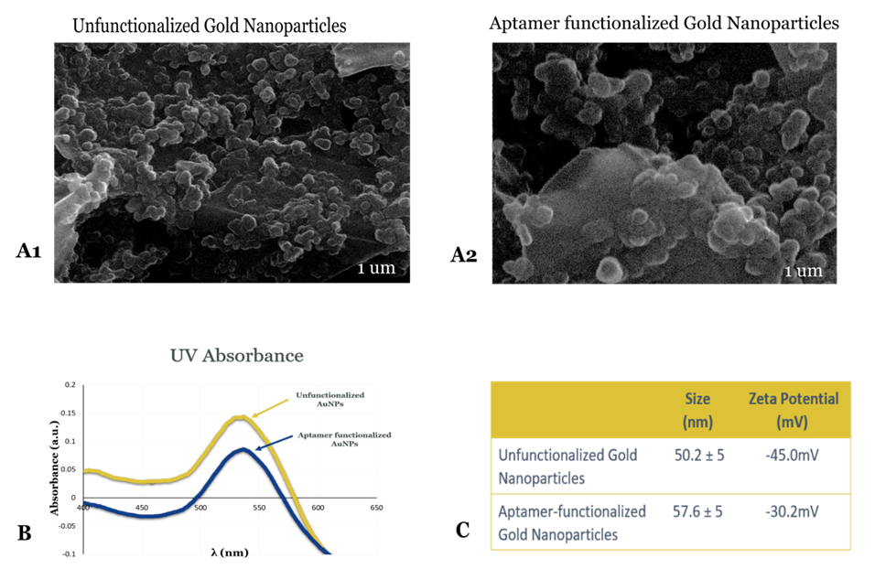
Figure 5.5 SEM images of unfunctionalized AuNPs (A1) and aptamer-functionalized AuNPs (A2). B.) UV-Vis absorbance spectrum of unfunctionalized AuNPs and aptamer-functionalized AuNPs. C. Data of Dynamic light scattering (DLS) showing the size distribution and zeta potential of 50nm unfunctionalized gold nanoparticles and aptamer-functionalized gold nanoparticles.

5.4.2 Aptamer Loading
After functionalizing aptamers on gold nanoparticles, we were able to characterize the loading efficiency. To quantitatively determine the loading of the aptamer, the concentration of the nanoparticles and the aptamers in each sample were measured. The concentration of the gold nanoparticles were determined after performing UV-Vis spectroscopy and obtaining the absorbances of functionalized and unfunctionalized AuNPs. Using Beer’s law, we were able to determine the concentration of the AuNPs. Using the wavelength of 531nm (correcting for the dilution of the AuNPs for absorbance) and the extinction coefficient of 1.5x10¹⁰ L/(mol·cm) we were able to determine the concentration of nanoparticles loaded onto each nanoparticle. In these experiments the unfunctionalized AuNPs showed a decrease absorbance as they become functionalized.
Next, in order to determine the concentration of aptamer loaded onto the gold nanoparticles in each aliquot, we followed the suggested calculation provided by Fernandez et al by taking the initial concentration of the aptamer before loading. ¹⁷ In order to obtain an estimate of the concentration of the aptamers after loading is loaded onto the AuNP, were determined using the Beer’s Law equation as before with the absorbance peak at 260nm, which corresponds to that of DNA absorption. Keeping in mind that absorbance of a solution will increase as attenuation of the bean increases and DNA does not get absorbed, therefore the absorbance will be directly proportional to the we took the obtained an absorbance spectrum to calculate the path length and the concentration of the absorbing species. This helped to obtain the aptamer concentration of aptamer functionalization onto AuNPs in liquid form. Using the following equation, it was determined that the loading capacity of oligos/gold nanoparticle(50nm) was approximately 2600 aptamers per nanoparticle as the concentration of the aptamers were larger than referenced studies. Knowledge of the loading capacity can help determine the average aptamer density loaded onto the sensor's working electrode. In this case, an average of 52% of the aptamers in solution were loaded onto the working electrode.
[Aptamer/mL] = [NP_{conc}] (nanoparticles/mL) × loading capacity (oligos/ particle)
It is important to understand that this is an approximation; the size and surface of each particle vary.

5.4.3 Sensor Sensitivity
While investigating the sensitivity and efficiency of the codeine aptamer-AuNPs sensor, SWV measurements were performed on sweat in the absence and the presence of codeine. The SWV scan parameters used were obtained at an amplitude of 25mV, a frequency of 15 Hz, and a step potential of 0.004 V. All electrochemical measurements were carried out at room temperature (~25°C). Codeine concentrations from 25ng/mL-150ng/mL in sweat were analyzed to determine the effect on peak current, and to confirm the binding of the analyte. As can be seen in figure 6, the peak current of the SWV curves increased as the concentration of the codeine present in sweat increased. Binding of codeine molecules causes a structural change in the aptamer, hindering the access of the redox probe to the working electrode's surface. This results in a significant increase in the peak current of the working electrode in the presence of codeine (-24μA of background to -16 μA). (Figure 6). A calibration curve (Figure 6 insert) of maximum peak heights of the averaged replicated runs vs concentration shows the change in surface redox reaction rate as the aptamer binds to the target. The detection limit using was determined to be 29ng/mL at a concentration producing a signal three times the standard deviation of the blank. .

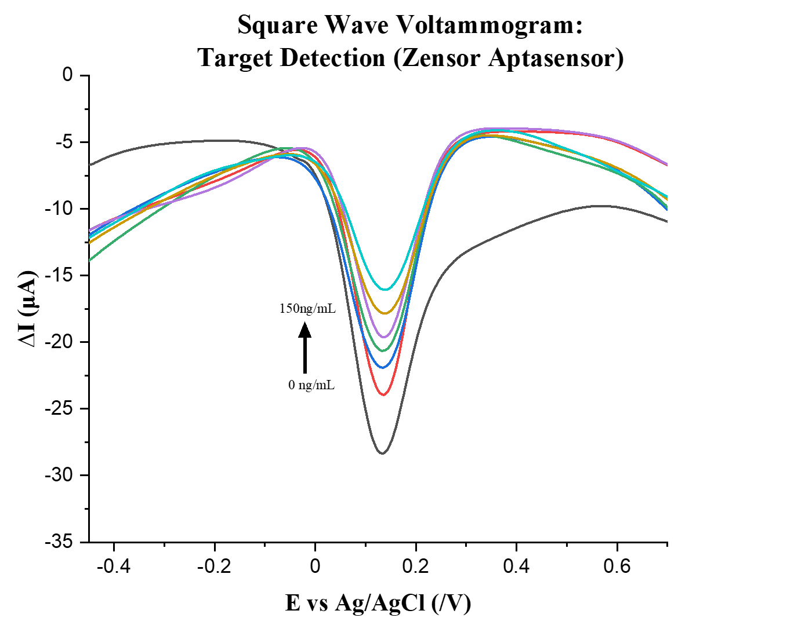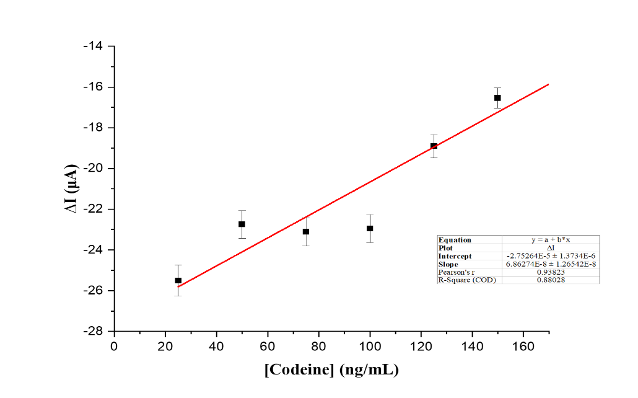
Figure 5.6 Square wave voltammogram showing the detection of codeine spiked in sweat with sweat (lowest level) as a reference. Codeine was spiked in sweat through serial dilution. SWVs detected from 25ng/mL to 150ng/mL in [Fe(CN)₆] ^{3-/4-}/KCl (5 mM /0.1 M) electrolyte solution.

5.4.4 Sensor Specific Binding
Specific binding interactions between the aptamer and codeine forms a complex that hinders electron transfer and increases the charge-transfer resistance (R_{CT}) between the solution-based redox probe [Fe(CN)₆]^{3−/4−} and the electrode surface. The change in ΔR_{CT} (ΔR_{CT} = R_{CT}(after)-R_{CT}(before)) is positively related to the codeine level, so the determination of codeine can be quantitatively tested by EIS and cyclic voltammetry. In figure 7, cyclic voltammogram (A) was recorded over a potential range between -0.8 and +0.8 V with a scan rate of 0.05 V/s. Figure 6A shows the redox probe CV scans of the bare SPCE ( plot a), AuNPs/SPCE (plot b), aptamer/ AuNPs/ SPCE (plot c), and plot MCH/aptamer/ AuNPs/ SPCE (d) . EIS responses represented by the Nyquist Plot (B) are presented, illustrating the response of the modification process of the electrode and the functionalization of the AuNPs with the aptamer. The EIS decreased for the AuNP modification process, which suggested that there is an increase in electrochemical activity on the electrode surface. This also confirms the increase in conductivity seen in figure 7A, where the CV also indicated an increase in the surface area of the working electrode following the deposition of the nanomaterial. The value of electron transfer resistance for the bare electrode is 5000Ω compared to the electrodeposited 50nm AuNPs at 2000Ω, as seen in figure 7B.
Subsequently, the immobilization of the thiolated aptamer and 6-mercaptoethanol onto the AuNP surface of the SPCE caused the diameter of the semicircle in the Nyquist plot to increase significantly. This was determined to be due to the blockage of the electron transfer between the electrode's surface and the redox probe.
After immobilization, the sensor was introduced to sweat and its target—codeine (50ng/mL) with an incubation time of 1 hour. Observations determined that binding of codeine effects caused an increase in the resistance to charge transfer, which confirms the successful fabrication of the aptasensor. The effect of sweat in these electrochemical studies shows that there sweat significantly decreases impedance values which can be due to the substances contained within sweat that interferes with the electrochemical interaction between the electrode and the electrolyte. Therefore, we needed to use an electroactive solution to help enhance the signaling of each sample to obtain a rangable conductivity. The conductivity of sweat and its components are seen in Table 1, can range between 5,000-9,000Ω/cm, which depends on the collection process, contamination, and location of collection on the skin.

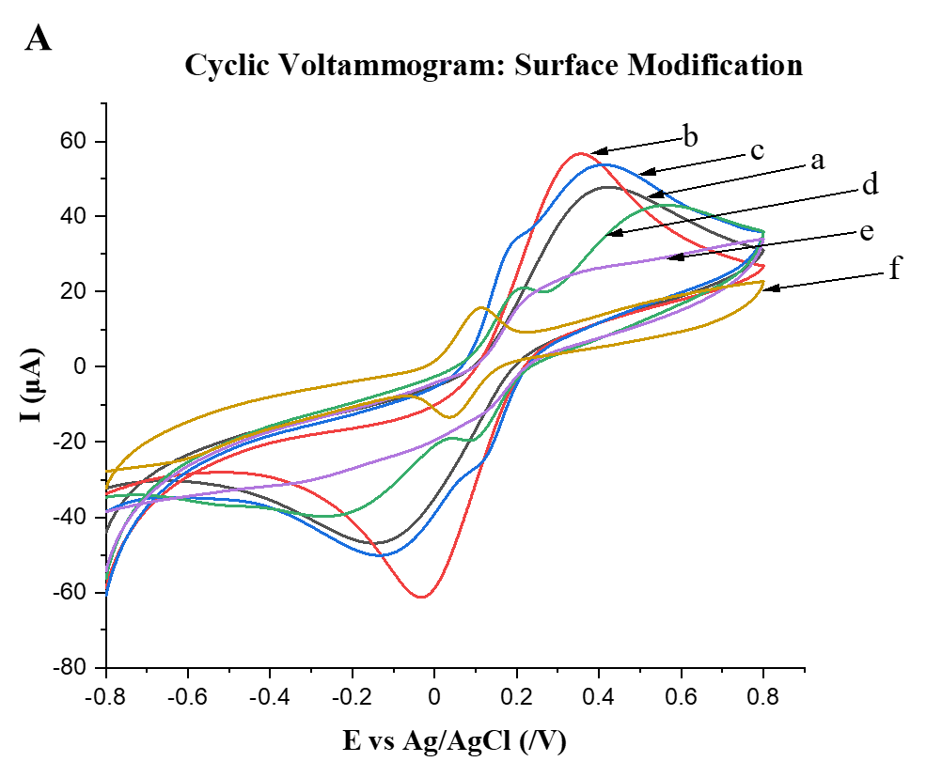
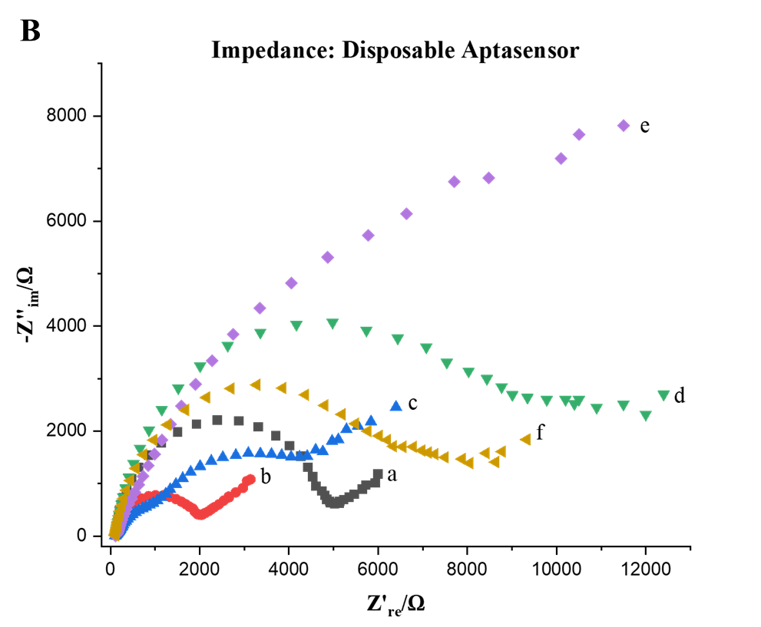

Figure 5.7 A. Cyclic voltammogram used to characterize the surface modification of the electrode.. (a)SPCE ; (b) AuNPs/SPCE (c) aptamer/ AuNPs/ SPCE; (d) MCH/aptamer/ AuNPs/ SPCE; (e) Sweat/MCH/aptamer/AuNPs/SPCE and (f) Codeine (50ng/mL)/MCH/aptamer/AuNPs/SPCE in 5mM [Fe(CN)₆]^{3−/4−} containing 0.1M KCl redox probe solution. B. EIS Representative Nyquist plots (−Z_{im} vs. Z_{re}) for the same samples used in the cyclic voltammogram.

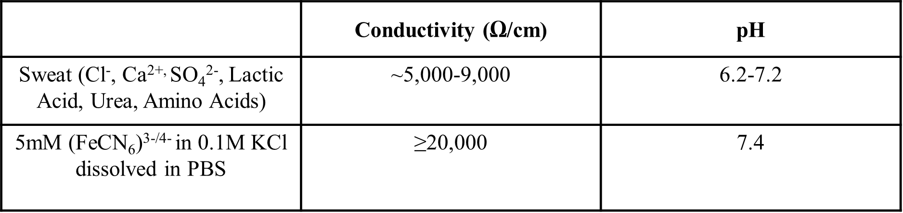
Table 5.1: Conductivity and pH of biological and electrochemical samples used to detect codeine using the aptasensor.

5.4.5 Sensor Selectivity
Selectivity of these sensors is important in determining the specificity of the detection of the analyte of interest in real samples. To assess the selectivity of the proposed aptasensor, other interferential opioids, and drugs that may coexist with codeine in biological samples were chosen for the evaluation. In addition, two concentrations of codeine 50ng/mL (Codeine 1) and 150ng/mL (Codeine 2) were examined in the presence of the tested interferants. (Figure 8) The selected interferants used were (a) Acetaminophen, (b) Cocaine, (c) Diazepam, (d) Fentanyl, (e) Heroin, (f) Hydrocodone, (g) Meperidine, (h) Methamphetamine, (i) Morphine, (j) Nicotine, (k) Oxycodone, (l) Phenobarbital, (m) Thebaine, (n) Tramadol, (o) Caffeine, (p) CaCl₂, and (q) Glucose were evaluated. It was observed that a signal was produced following the addition of codeine and compounds similar in structure, whereas the incubation of the aptasensor with other common drugs. Common sweat components were also selected as interferences to be tested against the binding of the aptasensor. (Figures 8 and 9)
The largest drops in current were achieved with the addition of codeine. Other opioids also showed some cross reactivity. In contrast, the incubation of the aptasensor with other commonly present drugs did not display much a change in currentto show binding to the sensors surface after incubation on the aptasensor. The results shown in figure 8 that 100ng/mL of morphine binds ~37% , 125ng/mL of thebaine binds ~28.9%, heroin 150ng/mL of heroin binds ~38% to the opioid receptor. Theoretically the reason for the binding this binding is these interferences are similar in structure and are similar in structural backbone which shows that there is little binding for the aptamer selected to bind to codeine at certain concentrations.

Figure 5.8 Aptamer selectivity was evaluated of the label-free codeine sensor by incubated 50ng/mL codeine (Codeine 1), 150ng/mL codeine (Codeine 2) and various interferants at the concentration of 200ng/mL(a) Acetaminophen, (b) Cocaine, (c) Diazepam, (d) Fentanyl, (e) Heroin, (f) Hydrocodone, (g) Meperidine, (h) Methamphetamine, (i) Morphine, (j) Nicotine, (k) Oxycodone, (l) Phenobarbital, (m) Thebaine, (n) Tramadol, (o) Caffeine, (p) CaCl₂, and (q) Glucose were evaluated.
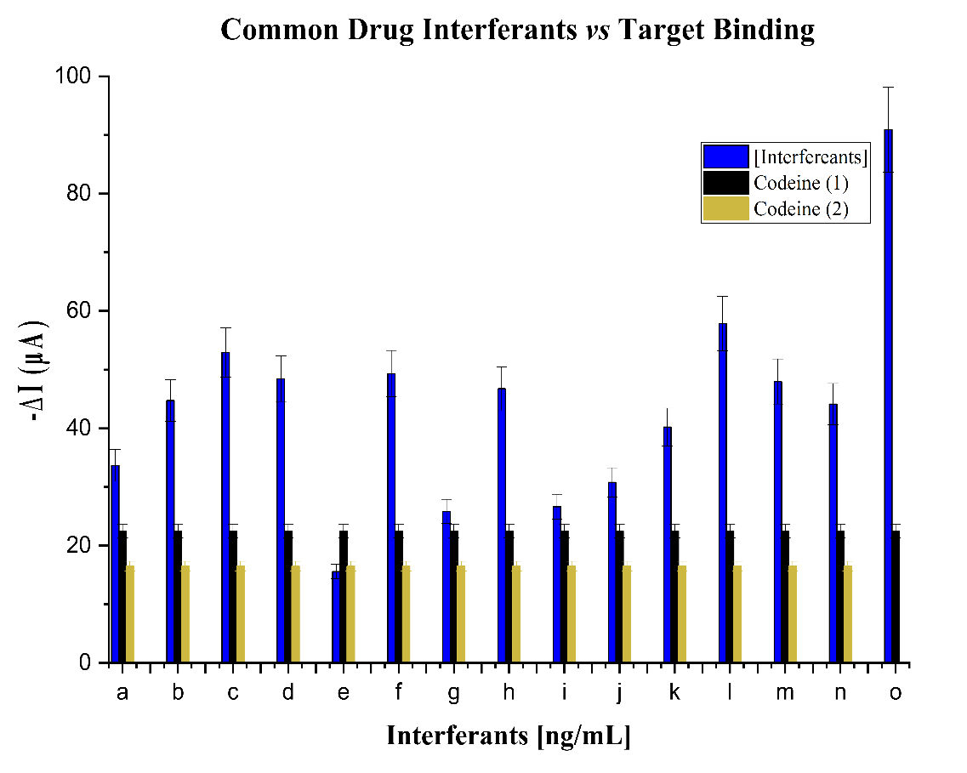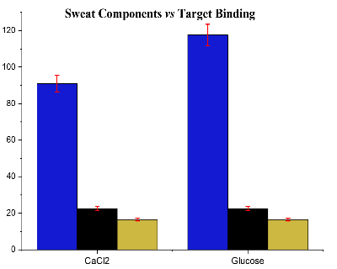
Figure 5.9 Comparison of current change of the label-free codeine sensor by incubated 50ng/mL codeine (Codeine 1), 150ng/mL codeine (Codeine 2) and various interferants at the concentration of (a) 150ng/mL Acetaminophen, (b) 150ng/mL Cocaine, (c) 150ng/mL Diazepam, (d) 150ng/mL Fentanyl, (e) 150ng/mL Heroin, (f) 150g/mL Hydrocodone, (g) 150ng/mL Meperidine, (h) 150ng/mL Methamphetamine, (i) 100ng/mL Morphine, (j) 200ng/mL Nicotine, (k) 125ng/mL Oxycodone, (l) 150ng/mL Phenobarbital, (m) 125ng/mL Thebaine, (n) 150ng/mL Tramadol, (o) 150Caffeine, (p) 150ng/mL CaCl₂, and (q) 150ng/mL Glucose were evaluated

5.4.6 Reproducibility of Sensor
To estimate the fabrication reproducibility of the proposed aptasensor, 4 sensors were prepared consecutively and used to detect a sample of sweat containing 75ng/mL codeine, which resulted in the relative standard deviation (RSD) was obtained, 9.6%, which suggests that the fabrication of the designed aptasensors has good reproducibility. The long-term stability of the developed sensor was also investigated. The aptasensor was stored in the prior to binding of codeine refrigerator at 4 °C temperature and used to determine 75ng/mL codeine spiked in sweat. After 7 days, the aptasensor response decreased to 92%. After a 15-day storage period under dark, dry, temperatures 68-72°F (20-22°C), the sensor retained 81 ± 0.83% of its initial activity after being measure three times.

5.4.7 Validation of paper-based sensor
The performance of the paper-based screen-printed carbon electrode was evaluated using the same procedure as used for the screen-printed sensors. Using SWV (figure 10A) and EIS (Figure 10B) techniques comparison is shown between the aptasensors developed using the disposable Zensor electrode and the paper screen-printed electrode. The linear dynamic detection range was evaluated based on the change in current between the two sensors versus the concentrations applied. The disposable sensor demonstrated a detection limit of 29ng/mL and a linear dynamic range of 50-125ng/mL compared to the paper-based sensor with a range of 50-100 ng/mL. These results indicated that the paper-based sensors were also capable of detecting codeine, albeit with a lower sensitivity. Future studies of this sensor should explore the effect of different levels of AuNPs and how they might affect the sensitivity on paper-based devices. Lower concentrations of aptamers (<2μM) to be functionalized on gold nanomaterials could increase the sensitivity of the electrode, as studies show that heavily loaded aptamers capture less of their targets.

A 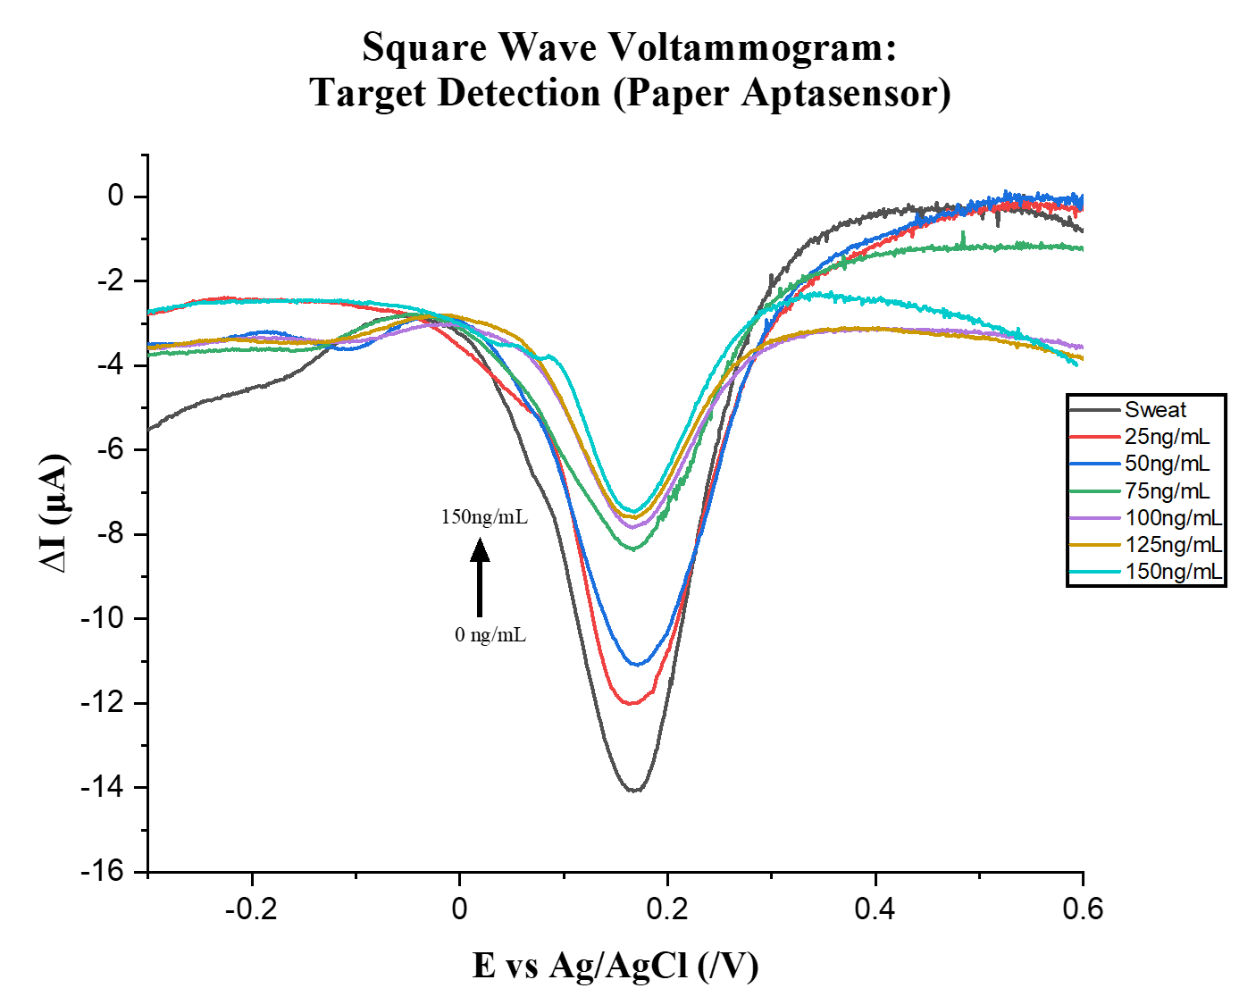
B 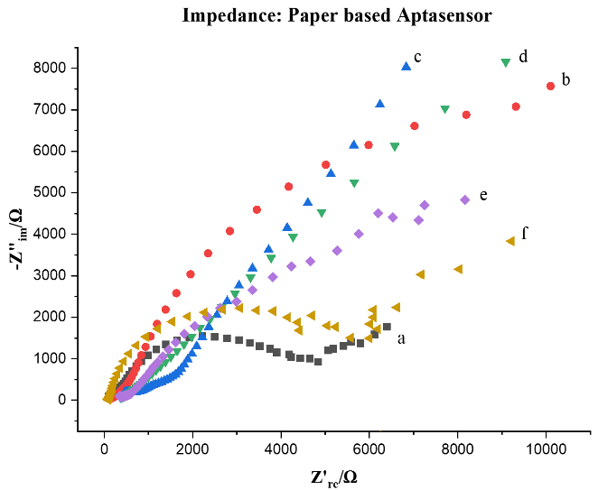
Figure 5.10 A Square wave voltammogram showing the detection of codeine spiked in sweat using the paper based aptasensor. SWVs detected from 25ng/mL to 150ng/mL in [Fe(CN)₆] ^{3-/4-}/KCl (5 mM /0.1 M) electrolyte solution with a shorter change in current at 100-150ng/mL. B EIS Representative Nyquist plots (−Z_{im} vs. Z_{re}) was used to characterize the surface and various functionalization steps of the electrode. (a)SPCE ; (b) AuNPs/SPCE (c) aptamer/ AuNPs/ SPCE; (d) MCH/aptamer/ AuNPs/ SPCE; (e) Sweat/MCH/aptamer/AuNPs/SPCE and (f) Codeine (50ng/mL)/MCH/aptamer/AuNPs/SPCE in 5mM [Fe(CN)₆]^{3−/4−} containing 0.1M KCl redox probe solution.

5.5 Conclusion
In this work, a gold nanoparticle functionalized aptasensor was fabricated and analyzed to determine its performance for detecting codeine in sweat. After successfully building the aptamer-based sensor with AuNPs, aptamers and MCH, we were able to successful detect low concentration levels of codeine in sweat of 29ng/mL. This biosensor displayed many advantages for the detection of codeine within sweat. The sensitivity of the disposable electrode possessed a higher sensitivity of detecting codeine, we obtain a low detection limit closest to the concentrations examined. Using these analyzes we were able to use the detection limit to test interferant drug and compounds that are usually found within sweat to determine if the sensor was selective. The success of the disposable sensor lead to the fabrication of a paper-based AuNP-aptamer modified sensor to determine the ability to the sensibility of the sensor on paper. The performance of the paper-based sensor produces a current approximately 2x less than the commercial disposable sensor with a detection limit of codeine as 75ng/mL. Overall, this aptasensor should provide a credible and economical alternative for detecting codeine in sweat.

Declaration of Interest
There are no conflicts to declare.

Acknowledgments
The authors of the paper would like to thank the volunteers who contributed samples to this study, the Florida Education Fund- McKnight Doctoral Fellowship Program and the Dissertation Year Fellowship, Rosa Cromartie was supported by the McKnight Doctoral Fellowship Program at Florida International University which the Florida Education Fund funds. The Dissertation Year Fellowship also supported Rosa Cromartie at Florida International University to help complete her doctoral work. The authors would also like to thank the National Science Foundation Industry-University Cooperative Research Centers Program (IUCRC) Center for Advanced Research in Forensic Science (CARFS) for helping fund this research project.

References
1. Skolnick, P. The Opioid Epidemic: Crisis and Solutions. Annual Review of Pharmacology & Toxicology 2018, 58, 143-159.
2. Huang, L.; Yang, X.; Qi, C.; Niu, X.; Zhao, C.; Zhao, X.; Shangguan, D.; Yang, Y. A label-free electrochemical biosensor based on a DNA aptamer against codeine. Analytica Chimica Acta 2013, 787, 203-210.
3. Niu, X.; Huang, L.; Zhao, J.; Yin, M.; Luo, D.; Yang, Y. An ultrasensitive aptamer biosensor for the detection of codeine based on a Au nanoparticle/polyamidoamine dendrimer-modified screen-printed carbon electrode. Anal. Methods 2016, 8, 1091-1095.
4. Zhang, X.; Chen, M.; Cao, G.; Hu, G. Determination of Morphine and Codeine in Human Urine by Gas Chromatography-Mass Spectrometry. Journal of analytical methods in chemistry 2013, 2013, 151934-6.
5. Dean, L. Codeine Therapy and CYP2D6 Genotype. In Medical Genetics Summaries; Pratt, V. M., McLeod, H. L., Rubinstein, W. S., Scott, S. A., Dean, L. C., Kattman, B. L. and Malheiro, A. J., Eds.; National Center for Biotechnology Information (US): Bethesda (MD), 2012; .
6. Chronister, C. W.; Gund, A. L.; Goldberger, B. A. Rapid Detection of Opioids in Vitreous Humor by Enzyme Immunoassay. Journal of Analytical Toxicology 2008, 32, 601-604.
7. Xiong, W.; Wu, S. F.; Liao, F. S.; Hong, N.; Fan, H.; Wei, G. B. A ZnS-Nanoparticle-Label-Based Electrochemical Codeine Sensor. Applied Mechanics and Materials 2017, 872, 173-177.
8. Kintz, P.; Tracqui, A.; Jamey, C.; Mangin, P. Detection of Codeine and Phenobarbital in Sweat Collected with a Sweat Patch. Journal of Analytical Toxicology 1996, 20, 197-201.
9. Frens, G. Controlled Nucleation for the Regulation of the Particle Size in Monodisperse Gold Suspensions. Nature Physical Science 1973, 241, 20-22.
10. Turkevich, J.; Stevenson, P. C.; Hillier, J. A study of the nucleation and growth processes in the synthesis of colloidal gold. Discussions of the Faraday Society 1951, 11, 55-75.
11. Hezard, T.; Fajerwerg, K.; Evrard, D.; ColliÃ¨re, V.; Behra, P.; Gros, P. Influence of the gold nanoparticles electrodeposition method on Hg(II) trace electrochemical detection. Electrochim. Acta 2012, 73, 15-22.
12. Bhalla, V.; Carrara, S.; Sharma, P.; Nangia, Y.; Raman Suri, C. Gold nanoparticles mediated label-free capacitance detection of cardiac troponin I. Sensors and Actuators B: Chemical 2012, 161, 761-768.
13. Cui, G.; Yoo, J. H.; Yoo, J.; Lee, S. W.; Nam, H.; Cha, G. S. Differential Thick-Film Amperometric Glucose Sensor with an Enzyme-Immobilized Nitrocellulose Membrane. Electroanalysis 2001, 13, 224-228.
14. Dalirirad, S.; Han, D.; Steckl, A. J. Aptamer-Based Lateral Flow Biosensor for Rapid Detection of Salivary Cortisol. ACS omega 2020, 5, 32890-32898.
15. Sandström, P.; Boncheva, M.; Åkerman, B. Nonspecific and Thiol-Specific Binding of DNA to Gold Nanoparticles. Langmuir 2003, 19, 7537-7543.
16. Bm, D.; P, M.; Cj, M.; R, B. Measuring binding kinetics of aromatic thiolated molecules with nanoparticles via surface-enhanced Raman spectroscopy. Nanoscale 2015, 7, 8766-8775.
17. Fernandez, R. E.; Umasankar, Y.; Manickam, P.; Nickel, J. C.; Iwasaki, L. R.; Kawamoto, B. K.; Todoki, K. C.; Scott, J. M.; Bhansali, S. Disposable aptamer-sensor aided by magnetic nanoparticle enrichment for detection of salivary cortisol variations in obstructive sleep apnea patients. Sci Rep 2017, 7, 1-9.

Conclusion and Future Work
Over the past decade, the United States has witnessed a drastic increase in drug abuse of opioids, resulting in over 700,000 overdose deaths. ¹ As a result of stricter restrictions placed on prescribed opioids, an increase in healthcare needs, the loss in opioid productivity, street drug markets begin developing and distributing their own source of opioids to those who either can not afford pharmaceutical prices or need fast relief. Thus, leading to an increase in the number of drugs illegally being sold on the street.
The increased use and abuse of both pharmaceutical and illicit opioids are causing an immense concern not only in the U.S. but throughout the world. Reaching numerous communities throughout the world, drug abuse of opioids is causing an increase in drug-related crimes, social and health problems, and the number of accidental overdose deaths. With increasing cases of drug abuse, there follows an increase in detection and sensing applications. As a result, new sensing technologies are being developed for detection; however, many of these technologies lack sensitivity and specificity and require complex analytical of these drugs in biological matrices.
Opioids are appearing as lacing agents in drug mixtures or cheaper alternatives in street drugs. As a result, new sensing technologies are being developed for detection; however, many of these technologies lack sensitivity and specificity and require complex analytical of these drugs in biological matrices.
Using an electronic sensing platform for monitoring drug abuse is amongst the most common monitoring and detection methods to date. As electronic sensing evolved, chemical sensing was combined to develop a platform that uses both electronic and chemical sensing—electrochemical sensing. The versatility that electrochemical sensing allows the sensor to be modified using a variety of surface enhancing materials that can be fluorescently tagged, labeled, or label-free, such as aptamers, antibodies, polymers, and/or nanomaterials. These devices can either be fabricated for reuse or inexpensively disposable.
The development and application of label-free, aptamer-based sensing for opioids in biological fluids, such as sweat and saliva, was presented in this dissertation using voltammetric analysis on commercially available disposable screen-printed electrodes as well as paper-based screen printed electrodes. Using the strategies explored for biosensor development has shown that electrochemical-based biosensing is a foreseeable and noninvasive method of analyzing opioids in biofluids. Using gold magnetic nanoparticles to enhance the sensor's surface area for sensing allowed more aptamers to load onto the sensor's surface, capture more of its target, and enhance its sensitivity. We selected these biological fluids because 1) sweat is a vital body fluid that can be used to trap and analyze drugs of abuse; 2) saliva is a multi-constitute oral fluid that has been commonly used to correlation the concentrations of drugs to plasma concentrations; and 3) the collection, storage, and transportation process of these fluids are easy and noninvasive. ²
Many analytical methods have been studied and are continues to be studied for the detection of opioids and how detection can be enhanced for biological fluid detection. This study illustrates the ability to use screen-printed technology and how this application can be used on chromatographic paper to detect pharmaceutical opioids that are often distributed as illicit street drugs. Exploring aptamers and nanoparticles as a strategy for biosensor development has shown that electrochemical-based biosensing is a foreseeable and noninvasive method of analyzing opioids in biofluids. Using gold magnetic nanoparticles to enhance the sensor's surface area for sensing allowed more aptamers to load onto the sensor's surface, capture more of its target, and enhances the sensitivity of the sensor. Although the development of this sensor has shown to provide a low limit of detection using commercially available disposable screen-printed electrodes (29ng/mL of codeine in sweat) and paper-based screen printed electrodes (75ng/mL of codeine in sweat), some limitations can further be explored in the future to confirm the presented success of this sensor.
In the future, we plan to improve upon this work by optimizing additional parameters for these sensors, such as conducting conditional studies for pH, different shapes, sizes, and metallic nanoparticles, different concentrations of the aptamers used in each study. This was a concern for determining the density of the aptamer and the loaded number of aptamers onto the surface of the electrode. Next, we plan to introduce the application of Surface-enhanced Raman Spectroscopy (SERS) as a spectroscopic technique for this biosensing platform. The development of a spectroelectrochemical sensor that can compare the aptamer-based screen printed electrodes with SERS provides enhanced Raman signals of Raman active analytes absorbed on the surface of metal nanostructures. The idea would be to draw out the Raman signals from the target analyte by signaling other compounds present and detecting trace amounts of the target after being captured by aptamers. ³ As SERS has been a success and significant focus of research in our laboratory involving drug detection within biological fluids, this approach could continue to expand in areas of analytical forensic research. With an end goal for using this application for point of care testing, we plan to conduct direct clinical studies by obtaining samples from rehabilitation facilities. We anticipate that the future of this work will be a valuable tool for researchers in analytical forensics who are interested in using these types of sensors for future field analysis, in addition to therapeutic drug monitoring programs as a noninvasive method for point of care analysis. The principal of these sensors is to reduce the detection limit to trace true levels of drugs and to be able to differentiate amongst the results which compounds are active.

References
1. CDC Understanding the Epidemic | Drug Overdose | CDC Injury Center. https://www.cdc.gov/drugoverdose/epidemic/index.html (accessed Mar 16, 2021).
2. Speckl, I. M.; Hallbach, J.; Guder, W. G.; Meyer, L. v.; Zilker, T. Opiate Detection in Saliva and Urine—A Prospective Comparison by Gas Chromatography–Mass Spectrometry. Journal of Toxicology: Clinical Toxicology 1999, 37, 441-445.
3. Pang, S.; Labuza, T. P.; He, L. Development of a single aptamer-based surface enhanced Raman scattering method for rapid detection of multiple pesticides. Analyst 2014, 139, 1895-1901.

VITA

ROSA LASHANTEZ CROMARTIE

Born, Atlanta, Georgia

2010-2015 Bachelor of Science, Biochemistry and Molecular Biology
University of Georgia
Athens, Georgia, USA

2015 Biological Research Aid
United States Department of Agriculture- ARS/CMAVE
Gainesville, Florida, USA

2016-2018 NSF—Bridge to the Doctorate Fellow
Florida International University
Miami, Florida, USA

2016-2019 Master of Science, Forensic Science
Florida International University
Miami, Florida, USA

2019-2021 McKnight Doctoral Fellow
Florida International University
Miami, Florida, USA

2020-2021 Doctoral Candidate, Chemistry with a Forensic Emphasis
Florida International University
Miami, Florida, USA

2021 Teaching Assistant
Florida International University
Miami, Florida, USA

2021 Department of Naval Research Laboratory Intern
Naval Research Laboratory
Washington, District of Columbia, USA

2021 Dissertation Year Fellow
Florida International University
Miami, Florida, USA

2016-2021 Doctor of Philosophy, Chemistry with a Forensic Emphasis
Florida International University
Miami, Florida, USA

PUBLICATIONS AND PRESENTATIONS

Cromartie, R. L., Wardlow, A., Duncan, G., McCord, B. R. Development of a microfluidic device (μPADs) for forensic serological analysis; Analytical Methods, 11, 2019, 587-595

Cromartie, R. L., Kamat, V., Bhansali, S., McCord, B. R.; An aptamer-based electrochemical biosensor for label-free of codeine with gold nanoparticles amplification; 2021, (Submitted)

Shriver-Lake, L. C.; Erickson, J.S.; Myers-Ward, R. L.; Cromartie, R. L., Dean, S.; Trammel, S.; Integrating Electrochemical Sensors with Maritime Platforms; 2021, (in Preparation)

Cromartie, R. L., Bhansali, S., McCord, B. R.; Disposable Label-free Target Inducing Aptamer Switching Conformation Sensor Using Gold Nanoparticle Enrichment for detection of fentanyl in saliva; 2021, (in Preparation)

“Development of Electrochemical Sensing for Opioid Determination”, Crossing Forensic Borders Global Webinar Series, Miami, Florida, 2021.

“The Application of Screen-Printing Electrodes for the Detection of Opioids in Sweat”, International Forensic Research Institute (IFRI) 9th Annual Virtual Forensic Science Symposium, Miami, Florida, 2020.

“The Application of Screen-Printing Electrodes for the Detection of Opioids in Sweat”, American Academy of Forensic Sciences (AAFS) 72nd Annual Scientific Meeting, Anaheim, California, 2020.

“The Development of a Multianalyte Paper-Based Device for Serological”, American Academy of Forensic Sciences (AAFS) 70th Annual Scientific Meeting, Seattle, Washington, 2018.

“The Development of a Multianalyte Paper-Based Device for Serological”, International Forensic Research Institute (IFRI) 7th Annual Forensic Science Symposium, Miami, Florida, 2018

