FLORIDA INTERNATIONAL UNIVERSITY
Miami, Florida

THREE ESSAYS ON DISASTER RISK, HOUSING MARKET AND PUBLIC HEALTH

A dissertation submitted in partial fulfillment of
the requirements for the degree of
DOCTOR OF PHILOSOPHY
in
ECONOMICS
by
Mehrnoosh Asadi

2021
To: Dean John F. Stack, Jr.
Green School of International and Public Affairs

This dissertation, written by Mehrnoosh Asadi, and entitled Three Essays on Disaster Risk, Housing Market and Public Health, having been approved in respect to style and intellectual content, is referred to you for judgment.

We have read this dissertation and recommend that it be approved.

_______________________________________
Mihaela Pintea

_______________________________________
M. Hadi Amini

_______________________________________
Abu Shonchoy

_______________________________________
Pallab Mozumder, Major Professor

Date of Defense: June 25, 2021

The dissertation of Mehrnoosh Asadi is approved.

_______________________________________
Dean John F. Stack, Jr.
Green School of International and Public Affairs

_______________________________________

Andrés G. Gil
Vice President for Research and Economic Development
and Dean of the University Graduate School

Florida International University, 2021

© Copyright 2021 by Mehrnoosh Asadi
All rights reserved.
DEDICATION
This dissertation is dedicated to my parents, and my entire family for their love, support, and encouragement.

ACKNOWLEDGMENTS
Foremost, I would like to express my sincere gratitude to my advisor, Dr. Pallab Mozumder, for the continuous support of my Ph.D. studies and research, for his patience, motivation, enthusiasm, and immense knowledge. His guidance helped me in all the time of research and writing of this dissertation. I also thank my dissertation committee members, Dr. Mihaela Pintea, Dr. M. Hadi Amini, and Dr. Abu Shonchoy, for their support and insightful comments.
I would also like to thank Dr. Cem Karayalcin, Dr. Tobias Pfutze, and Dr. Prasad Bidarkota for their dedication during my Ph.D. studies at Florida International University. I am grateful to the following staffs at the Department of Economics for their generous support during my graduate studies: Mayte Rodriguez, Mariela Delgado, and Victoria Gonzalez.
I also acknowledge the support from the National Science Foundation [Award #1832693: CRISP 2.0 Type 2: Collaborative Research: Organizing Decentralized Resilience in Critical Interdependent-infrastructure Systems and Processes (ORDER-CRISP)].

ABSTRACT OF THE DISSERTATION
THREE ESSAYS ON DISASTER RISK, HOUSING MARKET AND PUBLIC HEALTH

by
Mehrnoosh Asadi
Florida International University, 2021
Miami, Florida
Professor Pallab Mozumder, Major Professor
This dissertation consists of three essays focusing on topics related to environmental and health economics. In the first essay, we look into risk mitigation measures related to public health. More specifically, the focus is on the societal impacts of Superfund Sites and their inundation during extreme weather events. With that objective in mind, we investigate the effect of hurricane-induced discharges from Superfund Sites in terms of residents’ risk perception and its consequence on housing values in the real estate market using the property sales data. The findings suggest that home prices in the vicinity of Superfund Sites experience depreciation. Following the discovery of hurricane-induced discharges from Superfund Sites, we find an additional depreciation of home price near the impacted Superfund Sites.
In the past few decades, the increased frequency and intensity of hurricanes have raised concerns regarding the potential adverse impact of hurricanes on public health. Hurricanes have the potential to cause stress in pregnant women, potentially leading to adverse pregnancy outcomes, including preterm births or low birthweight deliveries. In the second essay, using Florida confidential birth data, we investigate the possible effect of Hurricane Irma as a source of stress on birth outcomes. As for sources of stress, we examine several potential sources, including psychological stress, evacuation, and property damage, and find that on average, the maternal exposure to Hurricane Irma led to 7 grams decrease in birth weights.
In the third essay, using a discrete choice experiment (DCE) survey, we assess public preferences for improvement in the resilience of electricity infrastructures to hurricane risks in Florida. Here the resilience is defined as the reduced time in restoring the interrupted electricity services. The DCE survey consists of two hypothetical scenarios of improvement in the resilience of electricity infrastructures, and a current situation scenario. These scenarios are differentiated based on the improvement in electricity infrastructures in terms of the percentage of customers receiving the service restored within specific days after a hurricane. The estimates of respondents’ average annual willingness to pay suggest that there is a positive support for funding resilience programs in electricity infrastructures to withstand hurricane risks.

TABLE OF CONTENTS

CHAPTER PAGE

1. Introduction 1
2. Hurricane Induced Discharges from Superfund Sites: A Hedonic Price Analysis of Real Estate Market Responses 4
2.1 Introduction 4
2.2 Background 7
2.3 Literature review 9
2.3.1 Hedonic price method to elicit the values of the environmental disamenity 9
2.3.2 The Impacts of hurricanes on property values 10
2.3.3 The effect of hazardous sites on property values 11
2.3.4 Leaking underground storage tanks 11
2.3.5 Superfund Sites 12
2.4 The empirical methodology 15
2.4.1 The econometric model 15
2.4.2 Hedonic Price model 18
2.5 Data 21
2.6 Results 22
2.6.1 Descriptive statistics 22
2.6.2 Empirical results 24
2.6.3 Testing parallel trend 26
2.7 Conclusion 27
REFERENCES 29
TABLES 36
FIGURES 45
3. Analyzing the Effect of Hurricane Irma on Birth Outcomes in Florida 58
3.1 Introduction 58
3.2 Background 61
3.2.1 Hurricane Irma 61
3.3 Literature review 63
3.3.1 Different mechanisms linking prenatal stress and adverse birth outcomes 63
3.4 Data 69
3.5 Methodology 70
3.5.1 First approach 72
3.5.2 Second approach 73
3.5.3 Maternal characteristics and exposure to Hurricane Irma 74
3.6 Results 75
3.6.1 Summary statistics 75
3.6.2 Regression results 75
3.7 Robustness checks 78
3.7.1 Hurricane exposure based on the cutoff of Hurricane Irma’s maximum wind speed (second approach) 78
3.7.2 Estimating the main model using different radii 79
3.8 Causal mechanisms 80
3.8.1 The impact of Hurricane Irma on maternal behavior 80
3.8.2 Including the residential buildings damage rate and evacuation order as additional controls 81
3.9 Conclusion 82
REFERENCES 85
TABLES 91
FIGURES 100
4. Hurricane Induced Power Disruptions: Households’ Preferences for Improving Infrastructure Resilience 105
4.1 Introduction 105
4.1.1 Scope of the study 109
4.2 Literature review 110
4.2.1 Reliability of electricity services 111
4.3 Discrete Choice Experiment 113
4.3.1 Discrete Choice Experiment design 117
4.4 The survey and data collection 119
4.5 Discrete Choice Experiment results 120
4.5.1 Results from the electricity choice sets 121
4.5.2 WTP and economic values for resilience programs in the electricity infrastructures 124
4.6 Conclusion 125
4.7 Appendix 128
REFERENCES 129
TABLES 134
FIGURES 142
5. Conclusion 143
5.1 Contribution of this dissertation 143
5.2 Scope for future research 146
VITA 147

TABLE OF TABLES

TABLES PAGE

2.1: List of the Impacted Superfund Sites in Texas 36
2.2: Attributes of home sales in Harris County, Texas 37
2.3: Diff-in-Diff hedonic price regression results for Harris County, Texas (test for hypothesis one) 38
2.4: Diff-in-Diff hedonic price regression results for Harris County, Texas (test for hypothesis two) 40
2.5: Results of the placebo test 42
3.1: Maternal characteristics and exposure to Hurricane Irma in Florida 91
3.2: Summary statistics of Florida births, 2016–2018 92
3.3: The effect of Hurricane Irma exposure (living within 30 miles of the hurricane path) on birth outcomes 93
3.4: The effect of Hurricane Irma exposure (living within 30 miles of the hurricane path) on birth outcomes by trimester 94
3.5: The effect of Hurricane Irma exposure (living within 30 miles of the hurricane path) on abnormal condition of newborn and complication in labor/delivery 95
3.6: The effect of Hurricane Irma on birth outcomes based on maximum wind speed 96
3.7: The effect of Hurricane Irma exposure on birth outcomes: Different distance cutoffs 97
3.8: Other possible mechanism for the impact of Hurricane Irma 98
3.9: Main results with additional controls including evacuation order and structural damage rates 99
4.1: Attributes and their levels for improving the resilience of electricity infrastructure 134
4.2: Frequency distribution of resilience for power infrastructure choice sets 135
4.3: Descriptive statistics and definition of variables used in the analysis 137
4.4: Parameter estimates for improving the power infrastructure resilience using Hierarchical Bayesian model 138
4.5: Marginal willingness to pay (MWTP) for improvement in the power infrastructure resilience attributes in the power choice design 141

TABLE OF CONTENTS

FIGURE PAGE

2.1: Hurricane Harvey’s track 45
2.2: Federal and state impacted and non-impacted Superfund Sites in Texas 46
2.3: Location of the federal and state impacted and non-impacted Superfund Sites and
single-family home sales in Harris County, Texas 47
2.4: The comparison between median single-family home sales within 2 miles of the impacted Superfund Sites (treatment group) vs. median home sale outside 2 miles distance buffer (control group) 48
2.5: The comparison between median single-family home sales within 3 miles of the impacted Superfund Sites (treatment group) vs. median home sale outside 3 miles distance buffer (control group) 49
2.6: The comparison between median single-family home sales within 4 miles of the impacted Superfund Sites (treatment group) vs. median home sale outside 4 miles distance buffer (control group) 50
2.7: The comparison between median single-family home sales within 5 miles of the impacted Superfund Sites (treatment group) vs. median home sale outside 5 miles distance buffer (control group) 51
2.8: The comparison between median single-family home sales within 6 miles of the impacted Superfund Sites (treatment group) vs. median home sale outside 6 miles distance buffer (control group) 52
2.9: The comparison between median home sale within 2 miles of the impacted Superfund Sites (treatment group) vs. median home sale within 2 miles of the non-impacted Superfund Sites (control group) 53
2.10: The comparison between median home sale within 3 miles of the impacted Superfund Sites (treatment group) vs. median home sale within 3 miles of the non-impacted Superfund Sites (control group) 54
2.11: The comparison between median home sale within 4 miles of the impacted Superfund Sites (treatment group) vs. median home sale within 4 miles of the non-impacted Superfund Sites (control group) 55
2.12: The comparison between median home sale within 5 miles of the impacted Superfund Sites (treatment group) vs. median home sale within 5 miles of the non-impacted Superfund Sites (control group) 56
2.13: The comparison between median home sale within 6 miles of the impacted Superfund Sites (treatment group) vs. median home sale within 6 miles of the non-impacted Superfund Sites (control group) 57
3.1: Hurricane Irma’s Path 100
3.2: Evacuation orders caused by Hurricane Irma, Florida 101
3.3: Economic losses for buildings by census tract 102
3.4: Live births over the period of 2016-2018, Florida 103
3.5: Hurricane Irma – peak wind gusts (mph) by census tract, Florida 104
4.1: Sample choice set for improving the resilience of electricity infrastructures scenario 142

CHAPTER 1
Introduction
During the last few decades, climate change has increased the frequency and intensity of extreme weather events, such as hurricanes (Karl et al., 2008; Mousavi et al., 2011; Duan et al., 2018). Hurricanes can produce heavy precipitation and strong wind leading to substantial flooding and storm surges with devastating effects in coastal areas (NOAA, 2020). People residing in coastal cities have suffered from coastal flooding induced by hurricanes through its adverse impact on their property, health, and local economies (Howarth et al., 2019).
Hurricanes have the potential to induce the releases of hazardous contaminants from toxic waste sites into the environment and nearby communities and cause substantial damages and disruptions to public utility service delivery systems such as electricity utilities due to high wind, storm surge, heavy precipitation, and flooding. Also, hurricanes have the potential to cause stress in pregnant women, potentially leading to adverse pregnancy and birth outcomes, including spontaneous abortions, preterm births, or low birthweight deliveries.
Against this backdrop, this dissertation investigates and assesses: (i) the adverse impact of hurricane-induced discharges from Superfund Sites in terms of residents’ risk perception and its consequence on housing values in the real estate market, (ii) the effect of Hurricane Irma on birth related health outcomes, and (iii) the public preference for improvement in the resilience of electricity infrastructures to withstand hurricane risks.
In the first essay, we investigate the impact of hurricane-induced discharges from Superfund Sites in terms of residents’ risk perception and its consequence on housing values in the real estate market using the Hedonic difference-in-difference approach. To build the empirical model, we interact multiple environmental and technological hazards (hurricane, flood, and discharges from Superfund Sites), and integrate several geo-spatial variables, including maximum wind speed, storm surge inundation, and proximity to impacted and non-impacted Superfund Sites in Harris County, Texas. Then, we use the revealed preference (RP) data of housing sale values to gain insights on how residents update their risk perceptions once they receive information regarding the severity of these multi-hazard risks and whether the updated risk perception is capitalized into the real estate market. We find that home prices in the vicinity of Superfund Sites experience depreciation. Following the discovery of hurricane-induced discharges from Superfund Sites, we find an additional depreciation of home price near the impacted Superfund sites.
In the second essay, we examine the relative effect of different Hurricane-induced stressors on birth outcomes (e.g., low birth weight and preterm birth). We combine two data sources: the 2016-2018 cross-sectional data on childbirth and related maternal health attributes (e.g., gestation age and birth weight), and geospatial characteristics of hurricane risks (e.g., hurricane track, wind speed, rate of damage to residential building, and evacuation order). We estimated models using the difference-in-difference approach. We find that on average, the maternal exposure to Hurricane Irma has led to 7 grams decrease in birth weights. The impact is larger in magnitude if pregnant women were exposed to the hurricane in their third trimester.
In the third essay, we elicit the residents’ preferences (willingness to pay) for improvement in the resilience of electricity infrastructures to hurricane risks in Florida using a discrete choice experiment (DCE) survey. The resilience of infrastructures is defined in terms of time required for restoring disrupted public utility services. Our DCE survey design consists of two hypothetical scenarios of improvements in the resilience of electricity infrastructures, and a status quo scenario. These scenarios are differentiated based on the improvement in electricity infrastructures in terms of the percentage of electricity customers receiving the service 1-2 days, 3-5 days, 1 week, 2 weeks after a strong hurricane like Hurricane Irma. Our results suggest that respondents’ annual WTP ranges from $18.94 to $252.85, suggesting that there is a positive support for enhancing resilience in electricity infrastructures to reduce the impacts of hurricane risks in Florida.
The findings from the first essay of this dissertation can be helpful in understanding how environmental disamenity such as Superfund Sites can affect residents’ environmental risk perception and the property values in the real estate market. The findings from the second essay can be used by health organizations to aid pregnant women to reduce their stress through preparation for hurricanes. Specific preparation measures may include creating a secure place for pregnant women who seek shelter during the pregnancy. It can also inform pregnant women regarding the possible risks of hurricane exposure and prioritize their essential needs such as water, food, etc. The findings from the third essay can help decision makers to develop more resilient infrastructures by incorporating households’ preferences and perspectives in their planning and program design strategies.

CHAPTER 2
Hurricane-Induced Discharges from Superfund Site: A Hedonic Price Analysis of Real Estate Market Responses
2.1 Introduction
Recent studies have demonstrated that climate change may lead to increase the frequency and intensity of extreme weather events such as hurricanes (Karl et al., 2008; Mousavi et al., 2011; Duan et al., 2018). Hurricanes can produce heavy precipitation and strong wind, leading to substantial flooding and storm surges with devastating effects in coastal areas (NOAA, 2020). People residing in coastal cities have suffered from coastal flooding induced by hurricanes through its adverse impact on their property, health, and local economies (Howarth et al., 2019).
In recent decades, the intensity of hurricanes in the Atlantic Ocean has increased significantly (Komar et al., 2008, Elsner et al., 2008), creating costly and destructive effects on the Atlantic and Gulf Coast counties. Besides the direct impact of hurricanes, including the destruction of buildings, capital stock, agricultural and industrial productions (Horwich, 2000), there are hurricanes-related health effects, including death and injuries, infectious diseases, and mental health effects (Bourque et al., 2006). Furthermore, hurricanes may lead to hazardous material releases from industrial facilities. More than 16,000 hazardous material discharges were made by natural hazards in the U.S. from 1990-2000, where hurricanes were responsible for 20 percent of the releases (Sengul et al., 2012). Flooding, high wind, tornado, and lightning spawned by hurricanes can lead to hazardous chemical discharges (Cruz et al., 2001). In August 2017, Hurricane Harvey, a category 4 hurricane, hit Texas (known as the center of the U.S. Petrochemical industry) (see Figure 2.1). It dumped more than 40 inches of rain on Huston, Galveston Bay, and Houston Ship Channel and impacted over 500 industrial facilities in the area (Friedrich, 2017).
According to the Environmental Protection Agency (EPA), 41 toxic waste sites known as Superfund sites were hit by Hurricane Harvey (see Figure 2.2). On August 28, 2017, both EPA and Texas Commission on Environmental Quality (TCEQ) started working with local, federal, and state officials to find the extent of Hurricane Harvey’s impact on human health and the surrounding areas (EPA, 2017a). The EPA has conducted several assessments using aerial images to analyze the possible impact of Hurricane Harvey at the 41 Superfund Sites. They reported that 28 Superfund Sites were not impacted and damaged significantly by the hurricane-induced flooding; however, the remaining 13 Superfund Sites were flooded and may have experienced severe hurricane-induced damage (EPA, 2017a).
Hurricane Harvey-induced damage in the Superfund sites has caused the release of hazardous contaminants from the sites into the environment and the nearby communities. It is assumed that the presence of contaminated land is considered as an environmental disamenity and can be capitalized into housing values in the real estate market (Braden et al., 2011). There is a body of research that analyzes the effect of discovery or cleanup of contaminated land, including Brownfield (Kaufman & Cloutier, 2006; Haninger & Timmins, 2017), underground storage tanks (Simon et al., 1997; Isakson & Ecker, 2010; Guignet, 2013) and Superfund Sites (Greenstone & Gallagher, 2008; Gamper-Rabindran & Timmins, 2013), on housing values in the real estate market. In terms of the contamination of Superfund Sites, several studies estimated the costs and benefits of Superfund Sites cleanups (Viscusi & Hamilton, 1999; Savchenko & Braden, 2019).
The majority of studies that investigated the effect of contamination on housing values have used the two most common methods, which are stated and revealed preferences approaches (Gayer et al., 2000; Earnhart, 2002; Mattia et al., 2010; Guignet et al., 2018). In the stated preference approach, the benefits of Superfund Sites cleanups can be elicited using a hypothetical situation where respondents are asked about how the cleanup of contaminated sites can benefit human health and their surrounding environment. Since the stated preference survey is hypothetical, we do not need to have specific information regarding Superfund Site contamination (Guignet, 2011). However, the downside of this approach is that it does not reflect the real individual’s reaction in response to the cleanup process since it is a hypothetical scenario (Freeman, 1993). The second approach uses the hedonic price method, which estimates the benefits of cleanup contamination from Superfund Sites in a real market situation. In most of these hedonic studies, changes in housing prices are assessed based on the changes in the toxic site status (e.g., national priorities list (NPL) site listing process, cleanup decisions, cleanup action, cleanup completion, and deletion from NPL); (see Kiel & Williams, 2007; Gamper-Rabindran & Timmins, 2011 and 2013). As Changes in the level of contamination take place with remedial actions, this information gets updated, and accordingly, residents update their risk perceptions once they receive such updated information. Finally, the housing market is likely to capitalize the new information through changes in home prices (Moulton et al., 2018).
This paper contributes to the literature of the impact of environmental disamenity on housing values by looking at the effects of Hurricane Harvey-induced impact on Superfund Sites as new information on residents’ environmental risk perception and its consequences on housing values in the real estate market. In this paper, we want to answer the following questions: (1) do residents living close to the Superfund Sites experience lower housing prices; (2) does living close to the impacted Superfund Sites have a negative effect on the housing values? To answer these research questions, I apply a hedonic pricing model (HPM) to analyze the impact of hurricane-induced discharge from Superfund Sites on housing values using the real estate transaction dataset over the period 2013-2019 in Harris County, Texas.
2.2 Background
The Comprehensive Environmental Response, Compensation, and Liability Act (CERCLA) of 1980, which is usually called Superfund, has assigned the Environmental Protection Agency (EPA) to report the most severe environmental emergencies that pose serious threats to public health and the environment locally and nationally (Lester & Rabe, 2009). The EPA is responsible for identifying the potential parties that are liable for the toxic waste dumps, forcing them to do the cleanups or repay the government for the cleanups. Finally, the EPA must inform the communities about the process of cleaning up and its latest status (EPA, 2011). However, extreme weather events such as hurricanes have caused substantial damage to the Superfund Sites and have deterred the performance of remediation. It has also increased the costs for cleanup by the EPA (Lester & Rabe, 2009).
The 2017 Atlantic hurricane season was one of the most active seasons, which created three deadly and destructive hurricanes, including Harvey, Irma, and Maria (Trenberth et al., 2018). Hurricane Harvey, as a category 4 hurricane, made landfall on the Texas coastline on August 25, 2017, and remained over the Gulf of Mexico from August 25 to August 31, causing tremendous damage with intense wind and heavy rain. The inland flooding caused by Hurricane Harvey in the greater Houston area is one of the most destructive flooding since Hurricane Katrina (Risser & Wehner, 2017).
Hurricane Harvey damaged and flooded 13 Superfund Sites. One of the impacted Superfund Sites San Jacinto contains cancer-causing toxic chemicals like Dioxin (which increases the risk for different types of cancers such as soft-tissue malignant tumor, lung cancer, and lymphatic tissue cancer) (see EPA, 2017c). The EPA collected samples from fourteen areas at the San Jacinto River Waste, and one of the sample results showed that the protective cap of the San Jacinto site had been damaged, and a high level of toxic chemicals were released. The sediment sample contained dioxins at 70,000 ng/kg, which is higher than the recommended cleanup level at the site (i.e., 30 ng/kg) (EPA, 2017b).
The EPA is responsible for revealing information regarding the changes in the status of Superfund Sites and any damages or discharges induced by natural hazards like hurricanes (Lester and Rabe, 2009). Also, residents living in the vicinity of the Superfund Sites can access site-specific information from local Superfund public information sources, social media, and government offices (EPA, 2000). In terms of the real estate hazardous waste sites disclosure law, each state has its own specific real estate disclosure laws, where the sellers may be responsible for providing information regarding any toxic pollution nearby the house to potential buyers. In Texas, sellers of residential property must file a disclosure statement, where the seller informs the purchaser of several conditions like the presence of hazardous and toxic wastes (Schnapf, 2011).
2.3 Literature review
2.3.1 Hedonic price method to elicit the values of the environmental disamenity
The practice of eliciting the values of environmental amenity in the real estate market is rapidly increasing. Policymakers and economists are interested in estimating the implicit price of environmental amenities using both stated and revealed preferences techniques. The HPM, a revealed preferences approach, has been increasingly used to estimate the implicit price of environmental amenity as a portion of home prices observed in the real estate market. This method, which was developed by Rosen (1974), regresses the attribute of a differentiated good, which can be a property transacted in the real estate market, on its price in order to estimate an individual’s marginal willingness to pay for changes in nearby environmental amenities (Parmeter & Pope, 2013). The HPM uses statistical analysis to investigate how different attributes such as property structures and environmental amenities can explain the variation in the sales values (Noonan et al., 2009).
The HPM has been used broadly to estimate the effects of environmental disamenities on property values. For example, there is a large body of literature that investigated the effects of air quality (Chay & Greenstone, 2005; Auffhammer et al., 2009; Boyle & Kiel 2001), Brownfield (Linn, 2013, Haninger & Timmins, 2017; Lang & Cavanagh, 2018), and water quality (Leggett & Bockstael, 2000; Poor et al., 2007; Klemick et al., 2018) on housing values in the real estate market. In terms of the effect of Superfund Sites, which is considered as an environmental disamenity, several studies have been conducted to estimate the effect of superfund site cleanup status on housing prices.
2.3.2 The Impacts of hurricanes on property values
There is a body of literature that estimates the impact of hurricanes on the housing market; however, the empirical evidence is mixed and not conclusive. For example, Bin and Polasky (2004) used the HPM to investigate the effect of Hurricane Floyd in 1999 on the housing values in Pitt County, North Carolina. Their result suggested that flooding induced by Hurricane Floyd lowered the price of properties within the Floodplain. On the other hand, Beracha and Prati (2008) studied the effect of several major hurricanes from 2004-2005 on quarterly changes in housing prices in 52 U.S. zip codes. They found that housing prices decreased and then increased to adjust the decline during the first two quarters. In some other studies, hurricanes impacted positively on home prices. For instance, Aqeel (2011) estimated the impact of Hurricane Katrina on the housing prices in 57 Metropolitan areas, using Difference-in-Difference (DID) technique. The author found that housing prices in the metro areas close to the hurricane path experienced an increase by 7% after the hurricane.
Several studies have investigated the effect of information on new hurricanes on housing values. For instance, Hallstrom and Smith (2005) estimated the effect of risk perceptions of Hurricane Andrew on housing prices of Lee County in Florida, which did not experience any damage from the hurricane. Using the DID approach, they found that property values in the flood hazard areas of Lee county decreased by 19%, which showed that households perceived the information as a risk to their wellbeing. Murphy and Strobl (2009) estimated the impact of 13 hurricanes on housing values and local incomes in U.S. coastal cities using a panel dataset from 1988-2005. They showed that the hurricanes increased the housing prices, and the maximum change in property values varied from 3 to 4 percent. The recent study conducted by Zivin et al. (2020) focused on the effect of 15 hurricanes in Florida from 2000-2016. They used a combination of DID and repeat-sales models to deal with the timing and paths of the understudied hurricanes. Like Murphy and Strobl’s (2009) study, she found that property values in affected areas experienced an increase three years after the hurricane, but the transaction probability declined 3 percent on average over a period of three years.
2.3.3 The effect of hazardous sites on property values
Another body of literature estimates the effect of hazardous toxic sites on housing prices, where the distance of the property to the waste sites is considered as a proxy for environmental disamenity. That is, the closer one lives to the site, the worse environmental disamenity she experiences, and accordingly, the price of houses in the vicinity of the toxic waste site would decrease. Several numbers of meta-analysis studies have been conducted in this context. For example, in a meta-analysis study, Farber (1998) reported that housing prices rise on average by $3,500 for every extra mile from a hazardous waste site. However, this estimate varies statistically across studies. For instance, in Michaels and Smith’s (1990) and Smolen et al.’s (1992) studies, the implicit price changes from $190 per mile to $11,450 per mile, respectively.
2.3.4 Leaking underground storage tanks
Several studies have investigated the impact of contaminations at underground storage tanks (UST) on housing values in the United States. Using the HPM, Simon et al. (1997 and 1999) investigated the effect of the leaking underground storage tanks (LUST) on housing prices in Cuyahoga County, Ohio. The former study used only home sales data in 1992 and found that proximity to known storage tanks reduced the selling prices of 83 homes by 17%. In the latter study, they used the housing transaction data for the period of 1994-1996 in the same county and showed that those properties that are close to the LUST experienced 14% to 16% reduction in value. Using the HPM and DID approach, Zabel and Guignet (2012) studied the impact of LUST and the cleanup process on home values in the period of 1996-2007 in three Maryland Counties. They considered two factors under which housing prices would capitalize the risk of proximity to the contaminated UST. The first factor is that a buyer should know about the LUS and its associated risks. The second factor is that the buyer should consider the existence of the LUST as information and consider the LUST as a disamenity. Their results showed that proximity to the more severe LUST by 1 kilometer reduces the housing prices by 12.4%. The recent study by Guignet et al. (2018) considered a wide range of LUST sites across the country. They chose those LUST sites that have received more attention from the public and the news; so that people have enough information about the sites and their contaminations. Using DID-based HPM, they found that the housing prices declined by 2-6% once the release of contaminations is discovered, but after cleanup, housing values experienced an increase by the same magnitude. They concluded that even in the case of notorious sites, the residents nearby the sites did not experience the stigma after cleanup.
2.3.5 Superfund Sites
One of the environmental disamenity of major concern is Superfund Sites. Several studies estimated the impact of nearby toxic waste sites on residents’ risk perception and its consequences on housing values using hedonic price models. In contrast, others focused on evaluating the benefits of Superfund Sites cleanup and the effect of changes in its status (e.g., evaluation of the contamination and its potential health risk for NPL nomination announcement, enlisting the site on the NPL, cleaning up the site, completing the cleanup, and deleting the site from the NPL) on changes in housing values (Guignet, 2011). Each stage provides new information on residents living close to the Superfund Sites, and as a result, it would be reflected in the home price in the real estate market (Guignet, 2011).
Studies conducted by Michaels and Smith (1990), Kohlhase (1991), Greenberg and Hughes (1992), and Ketkar (1992) are some of the earliest studies that examined the effect of proximity to Superfund Sites on property values. They demonstrated that properties close to the sites experience lower prices. However, more recent studies are focused on the effect of Superfund Sites remediation milestones on residents’ perceived risk and resultant changes in property values (Kiel and Williams 2007; Greenstone and Gallagher 2008; Gamper-Rabindran and Timmins 2013). Moreover, some of the early studies focused on one or a few numbers of Superfund Sites (Kiel, 1995; Kiel and Zabel, 2001); however, recent studies investigated the effect of tens of Superfund Sites across the U.S. on housing values in the real estate market (Kiel and William, 2007; Greenstone and Gallangher, 2008; Gamper-Rabindran and Timmins, 2013). Kiel and William (2007) chose all the Superfund Sites in understudied counties across the U.S. since previous studies focused only on the sites that were more notorious to public, so that it was highly probable that areas close to those sites experienced lower housing prices.
Due to the sufficient volume of research regarding the effect of hazardous waste sites on property values, several meta-analysis studies have been conducted (Farber, 1998; Simons & Saginor, 2006; Braden et al., 2011; Sigman and Stafford, 2011). In their meta-analysis, Braden et al. (2011) asserted that there is little evidence that changes in Superfund Sites remediation milestones or cleanup stages had a significant and expected impact on housing prices. Also, based on the meta-analysis, Superfund Sites had a lower estimate of impacts compared to non-Superfund Sites. This may imply that residents expect that Superfund Sites will be cleaned up because they are enlisted on the NPL. Another important part of their result is that the distance variable is not significant, which contradicts the idea that neighborhoods in the vicinity of environmental disamenity will experience it disproportionally.
The empirical evidence regarding whether during the cleanup or after the cleanup, housing prices would rebound back to their former level is mixed and not conclusive. Kiel and Williams (2007) studied the effects of Superfund cleanup using home sales data of 20 counties over the period 1970-1996. They focused on the 57 Superfund Sites and investigated how housing prices change when the site enlisted on NPL. They found that some sites reduced the housing prices, some had a positive, and some had no impact on housing prices. Also, they showed that Superfund Sites with larger size had higher negative effects on housing prices.
Additionally, several studies examined whether the properties close to the Superfund Sites suffer from stigma after the cleanup is complete. Stigmatization occurs when the price of properties close to the Superfund Sites continues to stay low, even after the cleanup is complete. For instance, McCluskey and Rausser (2003) show that properties close to the Superfund Sites suffer from temporary stigma and long-term stigma after enlisted on the NPL and even after cleaning up. However, Kohlhase (1991) showed that once EPA enlisted the toxic sites on the NPL list, the housing prices in the vicinity of those sites decrease, but after cleanup, the property values rebound back to their former level.
To our knowledge, no paper has investigated the effect of an external shock like hurricane-induced discharges from Superfund sites on property values. This paper contributes to the literature by looking at the effects of Hurricane Harvey-induced impact on Superfund Sites as new information on residents’ environmental risk perception and as a result on housing values in the real estate market. Using the hedonic difference-in-difference (DID) approach, we examine the causal effect of the treatment by comparing the outcome between the control and treatment groups before and after the treatment. In our case, the treatment is the discovery of hurricane-induced discharge from the sites, and the outcome is the property values (Zabel & Guignet, 2012). We use single-family property sales data from 2013-2019 to capture the effect of hurricane-induced discharges from the Superfund Sites on housing values in Harris County, Texas.
2.4 The empirical methodology
2.4.1 The econometric model
As explained in the previous section, our goal is to investigate whether the residents living close to the impacted Superfund Sites update their environmental risk perception once they receive new information about impacted sites and whether the updated risk perception is capitalized into the real estate market.
Carbone et al. (2006) explain that households’ response to risks depends on the cost and benefits of removing the source of the risk or reducing its possible adverse effect. They argue that the risk may be correlated with the unknown causes of variation in housing attributes and buyers’/sellers’ characteristics in the real estate market. These unobserved sources could be households’ heterogeneous reactions to risks, their capability to react to risk, and their level of knowledge toward risks. To have a better understanding of how households react to the risk, Hallstrom and Smith (2005) assume that there are state-dependent utility functions with two possible outcomes. The first outcome is that households experience an adverse outcome which is living in the vicinity of hurricane-induced impacted Superfund Sites in our case. The second outcome is that households experience a positive outcome, which in our case is living far away from the impacted Superfund Sites.
To show theoretically how information about discharge from Superfund Sites can affect the households’ perceptions of health and environmental risks, we have modified the model suggested by Hallstrom and Smith (2005) that studied the effect of perceived risk induced by hurricanes on housing prices. Following Hallstrom and Smith (2005), homeowner’s expected utility can be written as:
$$V=(1-p\left(SFS, I\right) . U_{positiveoutcome}(C, SFS, m-H\left(C, SFS,p\left(SFS, I)\right)\right)$$
$+p\left(SFS, I\right) . U_{adverseoutcome}(C, SFS, m-\left(C, SFS,p\left(SFS, I\right))\right)$ (2.1)
Where, $m$ is income that is determined exogenously; $C$ is housing and neighborhood characteristics; SFS represents the proximity to nearby Superfund Site regardless of if the site was impacted by Hurricane Harvey or not; $H\left(.\right)$denotes the hedonic price function; $p\left(SFS,I\right)$ is household’s subjective probability of realizing the adverse outcome; $I$ represents the information received about the impact induced by Hurricane Harvey; $U_{adverseoutcome}\left(.\right)$ is the utility for experiencing adverse health and environmental outcome from Hurricane Harvey-induced impact on Superfund Sites; $U_{positiveoutcome}\left(.\right)$ represents the utility for experiencing no adverse health and environmental outcome from Hurricane Harvey-induced impact on Superfund Sites.
Households maximize their expected utility by selecting the housing bundle $\left[C, SFS, p \left(SFS, I\right)\right]$ and their income $m$. Using Guignet’s (2011) approach, the first-order condition with respect to SFS can be stated as:

$$\frac{∂H}{∂SFS}+\frac{∂H}{∂p}\frac{∂p}{∂SFS}=\left[-\frac{∂p}{∂SFS}\frac{\left[U_{positiveoutcome}\left(.\right)-U_{adverseoutcome}\left(.\right)\right]}{E\left(MUI\right)}\right]+$$
$\left[\frac{\left(1-p\right)\frac{∂U_{positiveoutcome}\left(.\right)}{∂SFS}+p\frac{∂U_{adverseoutcome}\left(.\right)}{∂SFS}}{E\left(MUI\right)}\right]$ (2.2)

Where $E\left(MUI\right)={∂U}_{positiveoutcome}/∂m$ or ${∂U}_{adverseoutcome}/∂m$ is the marginal utility of income. The left-hand side of equation (2.2) represents the implicit price of SFS, and the right-hand side of the equation represents households’ marginal willingness to pay (MWTP) for SFS (Guignet, 2011). The first component on the right-hand side shows the MWTP for marginal change in the perceived probability of understanding the adverse outcome. The second component on the right-hand side shows the MWTP for all undesired amenities of the Superfund Sites (Guignet, 2011). Also, if we take the first order condition of equation (2.1) with respect to I, which is information, we will have (Guignet, 2011):

$\frac{∂H}{∂I}=\frac{∂H}{∂p}\frac{∂p}{∂I}-\frac{∂p}{∂I}\frac{\left[U_{positiveoutcome}\left(.\right)-U_{adverseoutcome}\left(.\right)\right]}{E\left(MUI\right)}$ (2.3)

Equation (2.3) shows that information regarding Hurricane Harvey-induced impact on Superfund Sites affects the expected utility through changes in risk perception. The left-hand side of equation (2.3) shows the marginal implicit price of risk information. The sign of $\frac{∂p}{∂I}$ can determine how the information regarding the impact induced by Hurricane Harvey on Superfund Sites could be perceived as an increased risk by households living in the vicinity of Superfund Sites. If households perceive this information about the impact induced by Hurricane Harvey as an increased risk for their health and their neighborhood, then prices would fall. Also, if households do not receive information regarding the impact on nearby Superfund Sites or do not perceive it as a serious threat, then $\frac{∂p}{∂I}$ is zero, and housing values would not capitalize the risk information and accordingly would not change (Guignet, 2011).
2.4.2 Hedonic Price model
We develop the HPM to estimate the effect of the impacted Superfund Sites on property values. Using the difference-in-difference (DID) approach, we can analyze the causal effect of the treatment by comparing the outcome between the control and treatment groups before and after the treatment. In our case, the treatment is the discovery of hurricane-induced impact on Superfund Sites reported by the EPA, and the outcome is the property values (Zabel & Guignet, 2012). The DID framework is setup here as a spatio-temporal approach that will help us to investigate the effect of changing amenities over time while controlling for spatial amenities that are fixed over time (Dube et al., 2014).
Particularly, we try to identify the causal effects of damage induced by Hurricane Harvey in Superfund Sites on housing values using the spatial DID approach. Based on this approach, we have defined two different control and treatment groups: The first treatment group is the property sales occurred in the vicinity of impacted Superfund Sites before and after the treatment, and the first control group is houses were sold in the vicinity of the non-impacted Superfund Sites before and after the treatment. Additionally, the second treatment group is houses were sold within certain distance buffer of the impacted Superfund Sites, and the second control group is property sales occurred outside the same distance buffer of the impacted Superfund Sites. There are observed and unobserved factors that differentiate the treatment group from the control group. By including explanatory variables in our hedonic model, observable differences will be controlled for. However, the difference in property values between control and treatment groups cannot be explained by only the Hurricane-induced impact on nearby Superfund Sites. This difference can be as a result of the difference in unobserved neighborhood characteristics (Zabel & Guignet, 2012). By including several neighborhood characteristics such as either school district, or census tract fixed effects, we can capture the impact of these unobservable neighborhood factors that are associated with the presence of Superfund Sites (Zabel & Guignet, 2012).
Rosen (1974) introduced a model that studies the market behavior with differentiated goods. In Rosen’s (1974) Hedonic Pricing model, an individual chooses a property to gain the maximum level of utility from her choice. The price of the $i_{th}$ home in $j_{th}$ neighborhood at period t $(P_{ijt}$) is a function of its structural attributes (number of bedrooms, lot size, age of home, etc.), neighborhood characteristics $(C_{ijt}$), local amenities such as Superfund Sites (${SFS}_{ijt}$) and associated health and environmental risk perception ($p_{ijt}$), where the function can be written as (Guignet, 2011):
$P_{ijt}=f\left(C_{ijt}, {SFS}_{ijt}, p_{ijt}\right)$ (2.4)
The risk perception is a function of information and local disamenity, which is proximity to Superfund Sites in our case (Guignet, 2011):
$p_{ijt}=p({Superfund}_{ijt}, I_{ijt}$) (2.5)
where $I_{ijt}$ represents the discovery of damage induced by Hurricane Harvey in Superfund Sites in certain distance from $i_{th}$home at time t. The partial derivative of the hedonic price function with respect to an attribute like $C_{ijt}$ is $\frac{∂p_{ijt}}{∂C_{ijt}}$, which represents the marginal implicit price of that attribute in the total price of the property (Guignet, 2011). Given that, we aim to test the following hypotheses:
Hypothesis 1:
$H_{0}$: Home prices within the k distance buffer of the impacted Superfund Sites follow the same trend as home prices outside the k distance buffer.
Hypothesis 2:
$H_{0}$: Home prices within the k distance buffer of the impacted Superfund Sites follow the same trend as home prices within the k distance buffer of the non-impacted Superfund Sites.
To test the first hypothesis, we use the following DID log-linear Hedonic Price model:
$lnp_{ijt}=α+βC_{ijt}+µ {ISFS}_{kijt}+{∂Hurricane}_{ij}+φ {ISFS}_{kijt}*{Hurricane}_{ijt}+N_{j}+T_{t}+ε_{ijt}, k=$ 0-2, 0-3, 0-4, 0-5, 0-6 (2.6)
Where $lnp_{ijt}$ is the logarithmic price of $i_{th}$ home in neighborhood j in time t; $C_{ijt}$ represents home attributes; dummy variable ${ISFS}_{kijt}$ equals one if a house was sold within the k distance buffer of impacted Superfund Sites, and zero otherwise. Dummy variable ${Hurricane}_{ij}$ equals one if a house was sold after Hurricane Harvey impacted Superfund Sites and zero otherwise. The interaction term ${ISFS}_{kijt}*{Hurricane}_{ij}$ captures the casual effect of hurricane-induced impacted Superfund Sites on property values. We aim to estimate the following coefficients, $α$, $β, δ, µ, ∂, and φ.$To control for the unobserved time-invariant neighborhood effects, we include neighborhood characteristics, which is $N_{j}$. Also, $T_{t}$ and $ε_{ijt}$ represent quarterly dummy fixed effect (to capture the general time trend) and disturbance term, respectively.
To test the second hypothesis, we use the following DID log-linear Hedonic Price model:
$lnp_{ijt}=α+βC_{ijt}+µ {INISFS}_{kijt}+{∂Hurricane}_{ij}+φ {INISFS}_{kijt}*{Hurricane}_{ijt}+N_{j}+T_{t}+ε_{ijt}, k=$ 0-2, 0-3, 0-4, 0-5, 0-6 (2.7)
Where dummy variable ${INISFS}_{kijt}$ equals one if a house was sold within the k distance buffer of the impacted Superfund Sites and equals zero if a house was sold within the k distance buffer of the non-impacted Superfund Sites.
2.5 Data
To estimate the HPM, we use single-family property sales from 2013-2019 (see Figure 2.3). I acquire information regarding the Superfund Sites’ characteristics and the level and types of contaminations released from the affected sites from EPA and TCEQ websites. The data on single-family property sales of Harris County was obtained from a third-party vendor. We also used GIS technology to calculate several neighborhood-related and environmental variables such as distance from properties to nearby Superfund Sites and flooding inundation.

2.6 Results
2.6.1 Descriptive Statistics
We use information reported by the EPA and the Texas Commission on Environmental Quality (TCEQ) regarding the Hurricane Harvey-induced damage and flooding in the State and Federal Superfund Sites in the affected area in Texas on August 25, 2017 (see Table 2.1). Since the majority of impacted Superfund Sites and housing transactions are in Harris County, we focus on the effect of impacted Superfund Sites on the home sales in Harris County, Texas.
The home sales data contains 59,085 single-family home sales with longitude and latitude coordinates over the period 2013-2019. Table 2.2 shows the descriptive statistics of the structural, environmental, and neighborhood characteristics used in the analysis. The home sales data contains a variety of structural and home characteristics, including lot size, number of bathrooms and bedrooms, number of the parking garage, and age of home. I used Geographic Information System (GIS) technology and ArcGIS software to derive several hurricane-related variables such as Hurricane Harvey-induced flood inundation and flood zones. To control for local changes in neighborhoods, I derived several spatial variables such as the nearest distance to schools, parks, and highways using GIS technology. Also, using GIS analysis, I derived neighborhood variables, including Harris County’s school districts and crime indexes based on the zip code level, as well as environmental variables such as distance to the nearest impacted and non-impacted Superfund Sites. Since the distance of properties to the closest Superfund Site is correlated with health and environmental risk caused by the site, we consider the distance as a proxy for the disamenity induced by the sites (Viscusi & Hamilton, 1999).
The results indicate that the mean home prices are $249,656.9 (in 2013), $259,345.9 (in 2014), $264,762.9 (in 2015), $257,909.7 (in 2016), $261,730.8 (in 2017), $234,300.1 (in 2018), and $219,751.9 (in 2019). The mean home price for the entire sample study is $255,381. Of the sample 59,085 home sales, 24.29%, 22.40%, 19.08%, 13.80%, 10.66%, 8.02%, 1.75% happened in 2013, 2014, 2015, 2016, 2017, 2018, and 2019, respectively. Moreover, there are 1,388 sales (2.5%) within 0-2mile, 3,660 sales (6.19 %) within 0-3mile, 6,514 sales (11.02%) within 0-4 mile, 10,885 sales (18.42%) within 0-5 mile, 14,909 sales (25.23%) within 0-6 mile of the impacted Superfund Sites.
Earlier studies found that the impact of Superfund Sites on property values would start decreasing when distances exceed 3 miles (Kiel 1995; Kiel & Williams, 2007; Greenstone & Gallagher, 2008), and the impact is not statistically significant after six miles (Kim et al. 2020). Besides 2-mile and 3-mile buffers, we include buffers more than 3 miles because Hurricane Harvey-induced flooding may have spread the discharges more than 3 miles in the neighborhoods.
There are relatively few numbers of home sales as we get closer to the impacted Superfund Sites after the landfall of Hurricane Harvey (i.e., after August 25, 2017). It may indicate that households residing in the vicinity of Superfund Sites perceive higher risks after receiving the information regarding the hurricane-induced damage and flooding in the sites compared to those living far away from the impacted sites. Thus, this information may deter the buying and selling of homes closer to the impacted Superfund Site.
2.6.2 Empirical results
The dependent variable in our analysis is the log of the home sale price. The independent variables are structural, neighborhood, environmental attributes, as well as the quarter time dummy variables to capture the time trends of the real estate market in the analysis (Guignet, 2011). To capture the perceived hurricane-induced discharges and flooding risks, we construct three dummy variables. Dummy 1- the binary variable equals one if a home sale is within a certain distance buffer (e.g., 2 miles) to the impacted site, and zero otherwise; dummy 2- the binary variable equals one if a home sale is within a certain distance buffer (e.g., 2 miles) of an impacted site, and if a home sale is within that certain distance buffer (e.g., 2 miles) of a non-impacted Superfund Site equals zero; and dummy 3- the binary variable is equal to one if a home sale occurred after the discovery of the hurricane-induced discharges from Superfund Sites (August 25, 2017), and zero otherwise.
Table 2.3 reports the results of the first hypothesis. The estimated coefficients of all structural characteristics are statistically significant, and the direction of their impacts is consistent with our expectations. For instance, the lot size variable has a positive effect on the home price, indicating that one square foot increase of the lot size would cause a rise in the home price of 15% (models 1-5). Also, the age of home variable has a negative effect on the home price, implying that an additional year would decrease the house price by 2% (models 1-5).
The coefficient -0.3409 on distance to ISFS in model 1 indicates that a Superfund Site within 2 miles is linked with 34% decrease in home sale price, and the coefficient 0.0508 on discovery of Hurricane Harvey-induced discharges shows a 5% increase in home values once the hurricane-induced discharge from the Superfund Site was discovered. However, this coefficient is not statistically significant. The estimated coefficients on distance to ISFS in models 2-5 in Table 2.3 show that home sales within 3, 4, 5, and 6 miles of Superfund Sites experience 16.5%, 11%, 2.6%, and 1.5% depreciation, respectively, indicating that the effect of the Superfund Sites on home price would diminish as we move farther away from the sites, which is consistent with Currie et al. (2015). Furthermore, coefficients on discovery of Hurricane Harvey-induced discharges in models 2-5 are negative, statistically significant, and become larger in magnitude, suggesting that as households live close to these Superfund Sites may be well aware of the risk of contaminations and so the new information may not further influence their risk perception.
The results of the second hedonic DID model (second hypothesis) are reported in Table 2.4. We use equation 2.7 to test whether home prices around the impacted sites would have followed the same trend as those around nonimpacted sites. The treatment groups are the home sales within a certain distance buffer (2, 3, 4, 5, 6 miles) to the impacted Superfund Sites, and the control groups are the home sales within 2, 3, 4, 5, 6 miles to the nonimpacted Superfund Sites.
The estimated coefficients of all home-related structural attributes are statistically significant, and the direction of their impacts are in line with our expectations. For instance, in models 1-5, the number of parking garage variable has a positive effect on the home price, indicating that one extra parking garage tends to increase the home price of 12 to 13%. Like the previous results in Table 2.3, the age of home variable has a negative influence on home values, meaning that an additional year would decrease the price of the house by 2 to 3%.
In Table 2.4, the coefficient -0.2989 on distance to INSFS in model 1 indicates that a Superfund Site within 2 miles is associated with a 29.8% decrease in home sale prices. However, the coefficient 0.0588 on discovery of Hurricane Harvey-induced discharges is not statistically significant. The estimated coefficients on the distance to INSFS in models 2-5 in Table 2.4 show that home sales within 3, 4, 5, and 6 miles of the Superfund Sites experience 10%, 2.62%, 2.64%, and 6.5%, depreciation, respectively. The effect diminishes after 3 miles, but it starts rising after 5 miles, showing inconsistency with our expectations. It is possible that other unobserved variables may cause an additional negative impact on home sales within 5, and 6 miles to the impacted Superfund Sites. Furthermore, the coefficients on the discovery of Hurricane Harvey-induced discharges in models 2-5 are negative but statistically insignificant. Thus, we fail to reject the null hypothesis indicating that “homes prices around impacted sites would have followed the same trend as those around nonimpacted sites.”
2.6.3 Testing parallel trend
Since we use DID quasi-experiment, we need to apply a parallel trend test to examine whether the control and treatment groups have the same trend prior to the intervention. The home price time trends (quarters) of the treated and control groups for the first and second DID models (Hypotheses 1 and 2, respectively) are depicted in Figures (2-4) – (2-13). Overall, home prices across the treatment and control groups follow the same trend before the intervention. However, after the intervention, both treatment and control groups experienced a decline in home prices, but most treatment groups experience more depreciation in home prices within 3, 4, 5, and 6 miles of the impacted Superfund Sites. We only test the parallel trend for the first DID model, which examines home prices within certain distance buffers of the impacted sites do not follow the same trend as home sales outside those distance buffers.
In this case, our goal is to assess whether the prices of treatment and control groups follow the same trend before the discovery of Hurricane Harvey-induced discharges from Superfund Sites. If intervention exists, the price trends of the treatment and control groups should have different directions after the intervention (Guignet et al., 2018). We use a placebo test to assess the parallel trend assumption. For this method, we estimate additional DID models by applying mock treatment groups. To create the mock treatment groups, we create a treated group that is not influenced by the intervention (which is the discovery of the impacted Superfund Sites). We perform a DID estimation for buffers including 3, 4, 5, and 6 miles. Then, we interact the binary variable ISFS with time dummies prior and after the intervention to create the mock treatment groups. The results in Table 2.5 indicate that the estimated treatment outcomes could potentially be confounded by local trends in the housing market (Guignet et al., 2018). However, we can apply other methods to examine the parallel trend assumption. For instance, recent studies (Guignet et al., 2018; Haninger & Timmins, 2017) used local polynomial regressions to visually examine whether property values for treatment and control groups follow the same trend over time.
2.7 Conclusion
This study aims to examine two hypotheses using two different hedonic DID models. We used the first hypothesis to examine whether home prices within specific distance buffers (including 2, 3, 4, 5, and 6 miles) of the impacted Superfund Sites will follow the same trend as home prices outside those certain distance buffers. The second hypothesis is set to investigate whether property values within certain distance buffers (including 2, 3, 4, 5, and 6 miles) of the impacted Superfund Sites would have followed the same trend as home prices within the same distance buffers (including 2, 3, 4, 5, and 6 miles) of the nonimpacted Superfund Sites.
Our results show that home sales within distance buffers, including 2, 3, 4, 5, and 6 miles of the Superfund Sites (which was impacted by Hurricane Harvey), decline. It indicates that the effect of Superfund Sites on home price would diminish as we live farther away from the sites, which is consistent with Currie et al. (2015). Furthermore, home sales within 3, 4, 5, and 6 miles of the impacted Superfund Sites experience a decline upon the discovery of Hurricane Harvey-induced discharges in both hedonic DID models; however, the estimated coefficients of interest for the second model are not statistically significant. The homes within 2 miles of the impacted sites in both models rise in value once the Hurricane Harvey-induced discharges discovered, but the estimated coefficient is not statistically significant.
However, the placebo test suggests that there may be some local unobserved factors that could bias our findings. In subsequent research, we plan to try other methods like local polynomial regressions to examine whether property values for treatment and control groups follow the same trend over time. To control for time-varying unobserved heterogeneity, we can use a spatial autoregressive model (Guignet, 2011). We also plan to estimate the repeat sales model, which controls the unobserved time-invariant influences associated with a home and its location (Guignet, 2011).
REFERENCES
Aqeel, S. A. (2011). House prices and vacancies after Hurricane Katrina: Empirical analysis of the search & matching model. Retrieved from:
https://papers.ssrn.com/sol3/papers.cfm?abstract_id=2842732

Auffhammer, M., Bento, A. M., & Lowe, S. E. (2009). Measuring the effects of the Clean Air Act Amendments on ambient PM10 concentrations: The critical importance of a spatially disaggregated analysis. Journal of Environmental Economics and Management, 58(1), 15-26.

Beracha, E., & Prati, R. S. (2008). How major hurricanes impact housing prices and transaction volume. Real Estate Issues-American Society of Real Estate Counselors, 33(1), 45.

Bin, O., & Polasky, S. (2004). Effects of flood hazards on property values: evidence before and after Hurricane Floyd. Land Economics, 80(4), 490-500.

Bourque, L. B., Siegel, J. M., Kano, M., & Wood, M. M. (2006). Weathering the storm: The impact of hurricanes on physical and mental health. The Annals of the American Academy of Political and Social Science, 604(1), 129-151.

Boyle, M., & Kiel, K. (2001). A survey of house price hedonic studies of the impact of environmental externalities. Journal of Real Estate Literature, 9(2), 117-144.

Braden, J. B., Feng, X., & Won, D. (2011). Waste sites and property values: a meta-analysis. Environmental and Resource Economics, 50(2), 175-201.

Carbone, J. C., Hallstrom, D. G., & Smith, V. K. (2006). Can natural experiments measure behavioral responses to environmental risks? Environmental and Resource Economics, 33(3), 273-297.

Chay, K. Y., & Greenstone, M. (2005). Does air quality matter? Evidence from the housing market. Journal of political Economy, 113(2), 376-424.

Cruz, A. M., Steinberg, L. J., & Luna, R. (2001). Identifying hurricane-induced hazardous material release scenarios in a petroleum refinery. Natural Hazards Review, 2(4), 203-210.

Currie, J., Davis, L., Greenstone, M., & Walker, R. (2015). Environmental health risks and housing values: evidence from 1,600 toxic plant openings and closings. American Economic Review, 105(2), 678-709.

Duan, H., Chen, D., & Lie, J. (2018). The impact of global warming on hurricane intensity. In IOP Conference Series: Earth and Environmental Science (Vol. 199, No. 2, pp. 481-494).

Dubé, J., Legros, D., Thériault, M., & Des Rosiers, F. (2014). A spatial Difference-in-Differences estimator to evaluate the effect of change in public mass transit systems on house prices. Transportation Research Part B: Methodological, 64, 24-40.

Earnhart, D. (2002). Combining revealed and stated data to examine housing decisions using discrete choice analysis. Journal of Urban Economics, 51(1), 143-169.

Elsner, J. B., Kossin, J. P., & Jagger, T. H. (2008). The increasing intensity of the strongest tropical cyclones. Nature, 455(7209), 92-95.

Environmental Protection Agency (EPA). (2000). Superfund today: how can a Superfund Site affect my property? Retrieved from:
https://nepis.epa.gov/Exe/ZyPDF.cgi/10001UWG.PDF?Dockey=10001UWG.PDF

Environmental Protection Agency (EPA). (2011). This is Superfund. A community guide to EPA’s Superfund program. Retrieved from:
https://semspub.epa.gov/work/HQ/175197.pdf

Environmental protection Agency (EPA). (2017a). Status of Superfund Sites in areas affected by Harvey. Retrieved from:
https://www.epa.gov/newsreleases/status-superfund-sites-areas-affected-harvey

Environmental Protection Agency (EPA). (2017b). Hurricane Harvey 2017. Retrieved from:
https://response.epa.gov/site/site_profile.aspx?site_id=12353

Environmental Protection Agency (EPA). (2017c). Record of decision San Jacinto River Waste Pits Harris County, Texas. Retrieved from:
https://www.epa.gov/sites/production/files/2017-10/documents/sjrwp_rod_final_10_11-2017_signed.pdf

Farber, S. (1998). Undesirable facilities and property values: A summary of empirical studies. Ecological Economics, 24(1), 1-14.

Freeman, A. M. (1993). The measurement of environmental and resource values resources for the future. Washington, DC, 516.

Friedrich, M. J. (2017). Determining health effects of hazardous materials released during Hurricane Harvey. Jama, 318(23), 2283-2285.

Gamper-Rabindran, S., & Timmins, C. (2011). Hazardous waste cleanup, neighborhood gentrification, and environmental justice: Evidence from restricted access census block data. American Economic Review, 101(3), 620-24.

Gamper-Rabindran, S., & Timmins, C. (2013). Does cleanup of hazardous waste sites raise housing values? Evidence of spatially localized benefits. Journal of Environmental Economics and Management, 65(3), 345-360.

Gayer, T., Hamilton, J. T., & Viscusi, W. K. (2000). Private values of risk tradeoffs at superfund sites: Housing market evidence on learning about risk. Review of Economics and Statistics, 82(3), 439-451.

Greenberg, M., & Hughes, J. (1992). The impact of hazardous waste Superfund sites on the value of houses sold in New Jersey. The Annals of Regional Science, 26(2), 147-153.

Greenstone, M., & Gallagher, J. (2008). Does hazardous waste matter? Evidence from the housing market and the Superfund program. The Quarterly Journal of Economics, 123(3), 951-1003.

Guignet, D. (2011). What do property values really tell us? Evidence from revealed and stated preference studies (Doctoral dissertation, University of Maryland, College Park, MD). Retrieved from:
https://drum.lib.umd.edu/bitstream/handle/1903/11994/Guignet_umd_0117E_12560.pdf?sequence=1&isAllowed=y

Guignet, D. (2013). What do property values really tell us? A Hedonic study of underground storage tanks. Land Economics, 89(2), 211-226.

Guignet, D., Jenkins, R., Ranson, M., & Walsh, P. J. (2018). Contamination and incomplete information: Bounding implicit prices using high-profile leaks. Journal of Environmental Economics and Management, 88, 259-282.

Hallstrom, D. G., & Smith, V. K. (2005). Market responses to hurricanes. Journal of Environmental Economics and Management, 50(3), 541-561.

Haninger, K., Ma, L., & Timmins, C. (2017). The value of brownfield remediation.
Journal of the Association of Environmental and Resource Economists, 4(1), 197-241.

Horwich, G. (2000). Economic lessons of the Kobe earthquake. Economic Development and Cultural Change, 48(3), 521-542.

Howarth, M. E., Thorncroft, C. D., & Bosart, L. F. (2019). Changes in extreme precipitation in the Northeast United States: 1979–2014. Journal of Hydrometeorology, 20(4), 673-689.

Isakson, H., & Ecker, M. D. (2010). The effect of leaking underground storage tanks on the values of nearby homes. Technical Report. Cedar Falls: Department of Mathematics, University of Northern Iowa. Retrieved from: http://faculty. cns. uni. edu/ecker/research. html.

Karl, T. R., Meehl, G. A., Miller, C. D., Hassol, S. J., Waple, A. M., & Murray, W. L. (2008). Weather and climate extremes in a changing climate. US Climate Change Science Program. Retrieved from:
http://lib.riskreductionafrica.org/handle/123456789/637.

Kaufman, D. A., & Cloutier, N. R. (2006). The impact of small brownfields and greenspaces on residential property values. The Journal of Real Estate Finance and Economics, 33(1), 19-30.

Ketkar, K. (1992). Hazardous waste sites and property values in the state of New Jersey. Applied Economics, 24(6), 647-659.

Kiel, K. A. (1995). Measuring the impact of the discovery and cleaning of identified hazardous waste sites on house values. Land Economics, 428-435.

Kiel, K. A., & Williams, M. (2007). The impact of Superfund sites on local property values: Are all sites the same? Journal of Urban Economics, 61(1), 170-192.

Kiel, K., & Zabel, J. (2001). Estimating the economic benefits of cleaning up Superfund sites: The case of Woburn, Massachusetts. The Journal of Real Estate Finance and Economics, 22(2-3), 163-184.

Kim, G., Schieffer, J., & Mark, T. (2020). Do superfund sites affect local property values? Evidence from a spatial hedonic approach. Economic Analysis and Policy, 67, 15-28.

Klemick, H., Griffiths, C., Guignet, D., & Walsh, P. (2018). Improving water quality in an iconic estuary: an internal meta-analysis of property value impacts around the Chesapeake Bay. Environmental and Resource Economics, 69(2), 265-292.

Kohlhase, J. E. (1991). The impact of toxic waste sites on housing values. Journal of Urban Economics, 30(1), 1-26.

Komar, P. D., & Allan, J. C. (2008). Increasing hurricane-generated wave heights along the US East Coast and their climate controls. Journal of Coastal Research, 24(2 (242)), 479-488.

Lang, C., & Cavanagh, P. (2018). Incomplete Information and adverse impacts of environmental cleanup. Land Economics, 94(3), 386-404.

Leggett, C. G., & Bockstael, N. E. (2000). Evidence of the effects of water quality on residential land prices. Journal of Environmental Economics and Management, 39(2), 121-144.

Lester, S., & Rabe, A. (2009). Superfund: in the eye of the storm. Center for Health, Environment and Justice. Retrieved from:
http://chej.org/publications/superfund-in-the-eye-of-the-storm/

Linn, J. (2013). The effect of voluntary brownfields programs on nearby property values: Evidence from Illinois. Journal of Urban Economics, 78, 1-18.

Mattia, S., Oppio, A., & Pandolfi, A. (2010, June). Contingent valuation method and market value: applying stated preference methods in real estate market. In the proceedings of 17th annual European Real Estate Society conference in Milan, Italy.

McCluskey, J. J., & Rausser, G. C. (2003). Stigmatized asset value: Is it temporary or long-term? Review of Economics and Statistics, 85(2), 276-285.

Michaels, R. G., & Smith, V. K. (1990). Market segmentation and valuing amenities with hedonic models: The case of hazardous waste sites. Journal of Urban Economics, 28(2), 223-242.

Moulton, J. G., Sanders, N. J., & Wentland, S. A. (2018). Toxic Assets: How the Housing Market Responds to Environmental Information Shocks. Working paper. Retrieved from:
https://www.aeaweb.org/conference/2019/preliminary/paper/r99KZF6H

Mousavi, M. E., Irish, J. L., Frey, A. E., Olivera, F., & Edge, B. L. (2011). Global warming and hurricanes: The potential impact of hurricane intensification and sea level rise on coastal flooding. Climatic Change, 104(3-4), 575-597.

Murphy, A., & Strobl, E. (2009). The impact of hurricanes on housing prices: Evidence from US coastal cities. Retrieved from:
https://mpra.ub.uni-muenchen.de/19360/3/MPRA_paper_19360.pdf

National Oceanic and Atmospheric Administration (NOAA). (2020). Storm surge overview- National Oceanic and Atmospheric Administration, National Hurricane Center. Retrieved from:
https://www.nhc.noaa.gov/surge/

Noonan, D. S., Turaga, R. M. R., & Baden, B. M. (2009). Superfund, hedonics, and the scales of environmental justice. Environmental Management, 44(5), 909.

Parmeter, C. F., & Pope, J. C. (2013). Quasi-experiments and hedonic property value methods. In Handbook on experimental economics and the environment. Edward Elgar Publishing.

Poor, P. J., Pessagno, K. L., & Paul, R. W. (2007). Exploring the hedonic value of ambient water quality: A local watershed-based study. Ecological Economics, 60(4), 797-806.

Risser, M. D., & Wehner, M. F. (2017). Attributable human‐induced changes in the likelihood and magnitude of the observed extreme precipitation during Hurricane Harvey. Geophysical Research Letters, 44(24), 12-457.

Rosen, S. (1974). Hedonic prices and implicit markets: Product differentiation in pure competition. Journal of Political Economy, 82(1), 34-55.
Savchenko, O. M., & Braden, J. B. (2019). Do public benefits of voluntary cleanup programs justify their public costs? Evidence from New York. Land Economics, 95(3), 369-390.

Schnapf, L. (2011). Environmental liability: managing environmental risks in corporate, real estate and Brownfield transactions. published by Juris Law Publishing. Retrieved from: https://www.environmental-law.net/

Sengul, H., Santella, N., Steinberg, L. J., & Cruz, A. M. (2012). Analysis of hazardous material releases due to natural hazards in the United States. Disasters, 36(4), 723-743.

Sigman, H., & Stafford, S. (2011). Management of hazardous waste and contaminated land. Annual Review of Resource Economics, 3(1), 255-275.

Simons, R. A., Bowen, W. M., & Sementelli, A. J. (1999). The price and liquidity effects of UST leaks from gas stations on adjacent contaminated property. The Appraisal Journal, 67(2), 186.

Simons, R., Levin, W., & Sementelli, A. (1997). The effect of underground storage tanks on residential property values in Cuyahoga County, Ohio. Journal of Real Estate Research, 14(1), 29-42.

Simons, R., & Saginor, J. (2006). A meta-analysis of the effect of environmental contamination and positive amenities on residential real estate values. Journal of Real Estate Research, 28(1), 71-104.

Smolen, G., Moore, G., & Conway, L. (1992). Economic effects of hazardous chemical and proposed radioactive waste landfills on surrounding real estate values. Journal of Real Estate Research, 7(3), 283-295.

Trenberth, K. E., Cheng, L., Jacobs, P., Zhang, Y., & Fasullo, J. (2018). Hurricane Harvey links to ocean heat content and climate change adaptation. Earth's Future, 6(5), 730-744.

Viscusi, W. K., & Hamilton, J. T. (1999). Are risk regulators rational? Evidence from hazardous waste cleanup decisions. American Economic Review, 89(4), 1010-1027.

Zabel, J. E., & Guignet, D. (2012). A hedonic analysis of the impact of LUST sites on house prices. Resource and Energy Economics, 34(4), 549-564.

Zivin, J. S. G., Liao, Y., & Panassie, Y. (2020). How hurricanes sweep up housing markets: evidence from Florida (No. w27542). National Bureau of Economic Research.

TABLES
Table 2.1: List of the Impacted Superfund Sites in Texas
City | County | Site Name | Site Type
Freeport | Brazoria | Gulfco Marine Maintenance | Federal Superfund Site
Pearland | Brazoria | Camtraco Enterprises Inc | State Superfund Site
Dickinson | Galveston | Hall Street | State Superfund Site
Texas City | Galveston | Malone Service Co Inc | Federal Superfund Site
Houston | Harris | Jensen Drive Scrap | State Superfund Site
Houston | Harris | North Cavalcade Street | Federal Superfund Site
Pasadena | Harris | US Oil Recovery | Federal Superfund Site
Highlands | Harris | Highlands Acid Pit | Federal Superfund Site
Houston | Harris | Geneva Industries - Fuhrmann Energy | Federal Superfund Site
Deer Park | Harris | Patrick Bayou | Federal Superfund Site
Highlands | Harris | San Jacinto River Waste Pits | Federal Superfund Site
Crosby | Harris | French Ltd | Federal Superfund Site
Houston | Harris | Federated Metals | State Superfund Site
Houston | Harris | Houston Scrap | State Superfund Site
Beaumont | Jefferson | International Creosoting | State Superfund Site
Port Arthur | Jefferson | Maintech International | State Superfund Site
Liberty | Liberty | Petro-Chemical Systems Inc | Federal Superfund Site
Bridge City | Orange | Triangle Chemical Co | Federal Superfund Site
Bridge City | Orange | Bailey Waste Disposal | Federal Superfund Site
Orange | Orange | Spector Salvage Yard | State Superfund Site

Table 2.2: Attributes of home sales in Harris County, Texas
Variable | Obs | Mean | Std. Dev. | Min | Max
price of home | 59,085 | 255381 | 225563.5 | 30025 | 1983000
lot size (sqft) | 59,085 | 8536 | 9645.029 | 719 | 216998
number of bedrooms | 59,085 | 3.3981 | 0.7058 | 1 | 5
number of bathrooms | 59,085 | 1.0622 | 0.3046 | 1 | 8
age of home | 59,023 | 24.6409 | 22.9431 | 0 | 133
number of parking garage | 59,085 | 1.8713 | 0.7758 | 0 | 5
home sales within 2mile to ISFS (dummy) | 59,085 | 0.0235 | 0.1515 | 0 | 1
home sales within 3mile to ISFS (dummy) | 59,085 | 0.0619 | 0.2411 | 0 | 1
home sales within 4mile to ISFS (dummy) | 59,085 | 0.1102 | 0.3132 | 0 | 1
home sales within 5mile to ISFS (dummy) | 59,085 | 0.1842 | 0.3877 | 0 | 1
home sales within 6mile to ISFS (dummy) | 59,085 | 0.2523 | 0.4344 | 0 | 1
home sales within 7mile to ISFS (dummy) | 59,085 | 0.2931 | 0.4552 | 0 | 1
Flood Inundation (ft) | 59,085 | 3.9678 | 4.1033 | 0 | 18.74
home sales within flood zone 0.2 PCT ANNUAL (dummy) | 59,069 | 0.1356 | 0.3423 | 0 | 1
home sales within flood zone A (dummy) | 59,069 | 0.0020 | 0.0447 | 0 | 1
home sales within flood zone AE (dummy) | 59,069 | 0.1056 | 0.3074 | 0 | 1
home sales within flood zone AO (dummy) | 59,069 | 0.0013 | 0.0365 | 0 | 1
home sales within flood zone VE (dummy) | 59,069 | 0.0001 | 0.0116 | 0 | 1
home sales within flood zone X (dummy) | 59,069 | 0.7553 | 0.4299 | 0 | 1
distance to nearest hospital (mile) (dummy) | 59,085 | 2.2151 | 1.3980 | 0.0340 | 15.76
distance to nearest park (mile) (dummy) | 59,085 | 0.7604 | 0.5424 | 0.0110 | 6.65
distance to nearest highway (mile) (dummy) | 59,085 | 0.7186 | 0.6093 | 0.0001 | 4.34
distance to nearest railroad (mile) (dummy) | 59,085 | 1.5201 | 1.1409 | 0.0004 | 7.12
distance to nearest school (mile) (dummy) | 59,085 | 0.5548 | 0.3631 | 0.01 | 4.84
home sales in Harris County section 1 (dummy) | 59,064 | 0.1816 | 0.3855 | 0 | 1
home sales in Harris County section 2 (dummy) | 59,064 | 0.1438 | 0.3509 | 0 | 1
home sales in Harris County section 3 (dummy) | 59,064 | 0.2787 | 0.4484 | 0 | 1
home sales in Harris County section 4 (dummy) | 59,064 | 0.3959 | 0.4890 | 0 | 1

Table 2.3: Diff-in-Diff hedonic price regression results for Harris County, Texas (test for hypothesis one)
Variables | Model 1 | Model 2 | Model 3 | Model 4 | Model 5
 | within 2  miles | within 3 miles | within 4 miles | within 5 miles | within 6 miles
 | ln(price) | ln(price) | ln(price) | ln(price) | ln(price)
Superfund Site Variables:

distance to ISFS (dummy) | -0.3409*** | -0.1648*** | -0.1096*** | -0.0259*** | -0.0146*
 | (0.0167) | (0.0111) | (0.009) | (0.0085) | (0.0087)
distance to ISFS* discovery of Hurricane Harvey-induced discharges | 0.0508 | -0.0534** | -0.0497*** | -0.0572*** | -0.0573***
 | (0.034) | (0.0233) | (0.0189) | (0.0159) | (0.0143)
Home Characteristics:

ln (lot size) (sqft) | 0.1591*** | 0.1574*** | 0.1556*** | 0.1534*** | 0.1541***
 | (0.0049) | (0.0049) | (0.0049) | (0.0049) | (0.0049)
number of bedrooms | 0.1667*** | 0.1663*** | 0.1662*** | 0.1678*** | 0.1681***
 | (0.0036) | (0.0036) | (0.0036) | (0.0036) | (0.0036)
number of full bathrooms | 0.1983*** | 0.199*** | 0.1975*** | 0.1972*** | 0.197***
 | (0.0078) | (0.0078) | (0.0078) | (0.0078) | (0.0078)
number of Parking garage | 0.1182*** | 0.1196*** | 0.1203*** | 0.1204*** | 0.1203***
 | (0.003) | (0.003) | (0.003) | (0.003) | (0.003)
age of home | -0.0206*** | -0.0209*** | -0.0209*** | -0.0205*** | -0.0204***
 | (0.0003) | (0.0003) | (0.0003) | (0.0003) | (0.0003)
age of home ^2 | 0.0002*** | 0.0002*** | 0.0002*** | 0.0002*** | 0.0002***
 | (0) | (0) | (0) | (0) | (0)
Neighborhood Characteristics:

distance to nearest school (mile) | 0.0205*** | 0.0174** | 0.0151** | 0.0199*** | 0.0205***
 | (0.0068) | (0.0068) | (0.0069) | (0.0069) | (0.0069)
distance to nearest park (mile) | -0.0394*** | -0.0418*** | -0.0417*** | -0.0387*** | -0.038***
 | (0.0048) | (0.0048) | (0.0048) | (0.0049) | (0.0048)
distance to nearest highway (mile) | 0.0133*** | 0.016*** | 0.0169*** | 0.017*** | 0.0177***
 | (0.0041) | (0.0041) | (0.0041) | (0.0042) | (0.0042)
crime index: category 1 | -0.3195*** | -0.3257*** | -0.3269*** | -0.3121*** | -0.3098***
 | (0.013) | (0.0131) | (0.0132) | (0.0136) | (0.014)
crime index: category 2 | -0.4834*** | -0.4877*** | -0.4891*** | -0.4808*** | -0.4813***
 | (0.0122) | -0.0122 | (0.0123) | (0.0125) | (0.0129)
crime index: category 3 | -0.2095*** | -0.2141*** | -0.2137*** | -0.2006*** | -0.1992***
 | (0.0112) | (0.0113) | (0.0114) | (0.0117) | (0.0122)
crime index: category 4 | -0.0833*** | -0.0826*** | -0.0657*** | -0.061*** | -0.0609***
 | (0.0112) | (0.0113) | (0.0112) | (0.0112) | (0.0113)
Hurricane Characteristics:

0.2% annual chance flood zone | -0.0006 | -0.0014 | -0.0022 | 0.0018 | 0.0028
 | (0.0066) | (0.0066) | (0.0066) | (0.0066) | (0.0066)
flood zone A | -0.1744*** | -0.1714*** | -0.1812*** | -0.185*** | -0.1872***
 | (0.0486) | (0.0487) | (0.0487) | (0.0488) | (0.0488)
flood zone AE | -0.0058 | -0.0092 | -0.0107 | -0.0033 | -0.0026
 | (0.0073) | (0.0073) | (0.0073) | (0.0073) | (0.0073)
flood zone AO | -0.0572 | -0.0786 | -0.086 | -0.0917 | -0.093
 | (0.0585) | (0.0586) | (0.0586) | (0.0917) | (0.0587)
flood zone VE | 0.7581*** | 0.7757*** | 0.7667*** | 0.7658*** | 0.7696***
 | (0.1827) | (0.183) | (0.1832) | (0.1834) | (0.1835)
constant | 10.3847*** | 10.4097*** | 10.4539*** | 10.435*** | 10.4233***
 | (0.1024) | (0.1026) | (0.1028) | (0.1037) | (0.1044)
quarterly dummy fixed effect (home time trend) | Yes | Yes | Yes | Yes | Yes
school district fixed effect | Yes | Yes | Yes | Yes | Yes
observations | 59008 | 59008 | 59008 | 59008 | 59008
R-squared | 0.4411 | 0.4393 | 0.4384 | 0.4368 | 0.4367
Note: Standard errors in parentheses. Standard errors are clustered by school district.
*p < 0.1, **p < 0.05, ***p < 0.01.

Table 2.4: Diff-in-Diff hedonic price regression results for Harris County, Texas (test for hypothesis two)
Variables: |  |  | Model 1  (Within 2 miles)  ln(price) |  | Model 2 (Within 3 miles)  ln(price) |  | Model 3  (Within 4 miles)  ln(price) |  | Model 4  (Within 5 miles)  ln(price) | Model 5  (Within 6 miles)  ln(price)
Superfund Site Variables:
distance to INSFS (dummy) |  |  | -0.2989*** (0.0255) |  | -0.0996*** (0.0167) |  | -0.0262** (0.0134) |  | -0.0264**  (0.012) | -0.065*** (0.0116)
distance to INSFS * discovery of Hurricane Harvey-induced discharges |  |  | 0.0588  (0.0443) |  | -0.0388  (0.0321) |  | -0.0208  (0.0253) |  | -0.013  (0.0211) | -0.026  (0.0185)
Home Characteristics:
ln (lot size) (sqft) |  |  | 0.0476*** (0.0167) |  | 0.0024  (0.0117) |  | -0.0024  (0.0095) |  | 0.0459*** (0.0079) | 0.0711*** (0.0071)
number of bedrooms |  |  | 0.1528*** (0.0126) |  | 0.1638*** (0.0093) |  | 0.1705*** (0.0076) |  | 0.1713*** (0.0064) | 0.1679*** (0.0057)
number of full bathrooms |  |  | 0.1388*** (0.0378) |  | 0.2104*** (0.0208) |  | 0.2025*** (0.0156) |  | 0.2013*** (0.0131) | 0.1933*** (0.0114)
number of Parking garage |  |  | 0.1233*** (0.0086) |  | 0.1374*** (0.0064) |  | 0.1362*** (0.0054) |  | 0.1325*** (0.0047) | 0.128***  (0.0043)
age of home |  |  | -0.0238*** (0.0012) |  | -0.0304*** (0.0008) |  | -0.0287*** (0.0007) |  | -0.0256*** (0.0006) | -0.0242*** (0.0005)
age of home ^2 |  |  | 0.0003*** (0.0001) |  | 0.0004*** (0.0001) |  | 0.0003*** (0.0001) |  | 0.0003*** (0.0001) | 0.0003*** (0.0001)
Neighborhood Characteristics:
distance to nearest school (mile) |  |  | 0.0119  (0.0337) |  | -0.0437**  (0.0226) |  | -0.0237  (0.0162) |  | 0.0026  (0.0131) | -0.0018  (0.0116)
distance to nearest park (mile) |  |  | -0.1319*** (0.025) |  | -0.1617***  (0.0192) |  | -0.1967*** (0.0153) |  | -0.1824*** (0.012) | -0.133*** (0.0096)
distance to nearest highway |  |  | -0.0717*** (0.0284) |  | 0.042***  (0.0157) |  | 0.0197  (0.0125) |  | 0.0389*** (0.0097) | 0.0285***  (0.008)
crime index: category 1 |  |  | -0.068  (0.046) |  | 0.0147  (0.0296) |  | 0.0078  (0.0228) |  | -0.1188*** (0.0198) | -0.2023*** (0.0186)
crime index: category 2 |  |  | -0.3922*** (0.0297) |  | -0.4183*** (0.023) |  | -0.4809*** (0.0188) |  | -0.545*** (0.0165) | -0.5396*** (0.0161)
crime index: category 3 |  |  | 0.1077*** (0.0266) |  | 0.1243*** (0.0208) |  | 0.0173  (0.0177) |  | -0.0882*** (0.0158) | -0.1332*** (0.0151)
crime index: category 4 |  |  | -0.0997*** (0.0325) |  | -0.1891*** (0.0208) |  | -0.1311*** (0.0163) |  | -0.0794*** (0.0142) | -0.0392*** (0.0132)
Hurricane Characteristics:
flood Inundation (ft) |  |  | 0.0195*** (0.0021) |  | -0.0049*** (0.0014) |  | -0.0135*** (0.0012) |  | -0.0079*** (0.001) | -0.0047*** (0.0009)
0.2% annual chance flood zone |  |  | 0.0609***  (0.024) |  | 0.0225  (0.0158) |  | 0.0078  (0.0125) |  | -0.0081  (0.0105) | -0.0163** (0.0094)
flood zone A |  |  | -0.5127*** (0.1732) |  | -0.3852*** (0.1198) |  | -0.4486*** (0.0695) |  | -0.4122*** (0.0663) | -0.4141*** (0.0637)
flood zone AE |  |  | -0.1178*** (0.0274) |  | -0.0272  (0.0181) |  | -0.0035  (0.0142) |  | 0.0002  (0.0115) | -0.0045  (0.0104)
flood zone AO |  |  | 0.2118  (0.1822) |  | -0.1443  (0.1604) |  | -0.3013*** (0.1148) |  | -0.2602*** (0.1109) | -0.2576*** (0.0956)
flood zone VE |  |  |  |  | 0.5096  (0.6168) |  | 0.5797  (0.6123) |  | 0.4884  (0.5931) | 0.9917*** (0.2589)
constant |  |  | 11.3751*** (0.1872) |  | 11.721***  (0.15) |  | 11.8137*** (0.1372) |  | 11.3961*** (0.1282) | 11.2789*** (0.123)
quarterly dummy fixed effect (home time trend) |  |  | Yes |  | Yes |  | Yes |  | Yes | Yes
school district fixed effect |  |  | Yes |  | Yes |  | Yes |  | Yes | Yes
observations |  |  | 5825 |  | 12694 |  | 19737 |  | 26289 | 31808
R-squared |  |  | 0.3974 |  | 0.4100 |  | 0.4457 |  | 0.4509 | 0.4506
Note: Standard errors in parentheses. Standard errors are clustered by school district.
*p < 0.1, **p < 0.05, ***p < 0.01.

Table 2.5: Results of the placebo test
Variables | Model 1  within  3 miles  ln(price) | Model 2  within  4 miles ln(price) | Model 3  within  5 miles  ln(price) | Model 4  within  6 miles  ln(price)
Superfund Site Variables:
distance to ISFS (dummy) | -0.1434***  (0.0256) | -0.065***  (0.0187) | 0.0086  (0.0156) | 0.0186  (0.0144)
distance to ISFS (dummy)*year2013 (dummy) | 0.0233  (0.0321) | -0.0023  (0.0232) | 0.001  (0.0184) | 0.0062  (0.0161)
distance to ISFS (dummy)*year2014 (dummy) | -0.0381  (0.032) | -0.0717***  (0.0235) | -0.0457**  (0.0186) | -0.0449***  (0.0164)
distance to ISFS (dummy)*year2015 (dummy) | -0.0613*  (0.0335) | -0.0987***  (0.024 9) | -0.0898***  (0.0201) | -0.0873***  (0.0177)
distance to ISFS (dummy)*year2016 (dummy) | -0.0339  (0.0338) | -0.0563**  (0.0255) | -0.0502**  (0.0208) | -0.0554***  (0.0185)
distance to ISFS (dummy)* discovery of Hurricane Harvey-induced discharges | -0.0691**  (0.036) | -0.0852***  (0.028) | -0.0932***  (0.0231) | -0.0961***  (0.0205)
distance to ISFS (dummy)*×year2018 (dummy) | -0.0882**  (0.0447) | -0.114***  (0.0345) | -0.0921***  (0.029) | -0.0824***  (0.026)
Home Characteristics:
ln (lot size) (sqft) | 0.1574***  (0.005) | 0.1556***  0.005 | 0.1538***  (0.005) | 0.1547***  (0.005)
number of bedrooms | 0.1665***  (0.0037) | 0.1666***  0.0037 | 0.1682***  (0.0037) | 0.1685***  (0.0037)
number of full bathrooms | 0.199***  (0.0079) | 0.1977***  0.0079 | 0.1974***  (0.0079) | 0.1975***  (0.0079)
number of Parking garage | 0.1196***  (0.0031) | 0.1203***  (0.0031) | 0.1203***  (0.0031) | 0.1201***  (0.0031)
age of home | -0.021**  (0.0004) | -0.021***  0.0004 | -0.0206***  (0.0004) | -0.0205***  (0.0004)
age of home ^2 | 0.0002***  (0.0001) | 0.0002***  0.0001 | 0.0002***  (0.0001) | 0.0002***  (0.0001)
Neighborhood Characteristics:
distance to nearest school (mile) | 0.0175**  (0.0069) | 0.0151**  (0.0069) | 0.0196***  (0.0069) | 0.0202***  (0.0069)
distance to nearest park (mile) | -0.0421***  (0.0049) | -0.0419***  (0.0049) | -0.039***  (0.0049) | -0.0383***  (0.0049)
distance to nearest highway (mile) | 0.0159***  (0.0042) | 0.0168***  (0.0042) | 0.0169***  (0.0042) | 0.0176***  (0.0042)
crime index: category 1 | -0.3248***  (0.0132) | -0.3257***  (0.0133) | -0.3096***  (0.0136) | -0.3069***  (0.014)
crime index: category 2 | -0.4866***  (0.0123) | -0.4877***  (0.0123) | -0.4782***  (0.0125) | -0.4781***  (0.013)
crime index: category 3 | -0.2132***  (0.0114) | -0.2124***  (0.0114) | -0.1986***  (0.0118) | -0.1967***  (0.0123)
crime index: category 4 | -0.0822***  (0.0113) | -0.0657***  (0.0113) | -0.0602***  (0.0113) | -0.059***  (0.0113)
Hurricane Characteristics:
0.2% annual chance flood zone | -0.0015  (0.0066) | -0.0021  (0.0066) | 0.0019***  (0.0066) | 0.0029  (0.0066)
flood zone A | -0.1728***  (0.0487) | -0.1833***  (0.0487) | -0.1854**  (0.0488) | -0.187***  (0.0488)
flood zone AE | -0.0093  (0.0074) | -0.0107  (0.0074) | -0.0036***  (0.0074) | -0.003  (0.0074)
flood zone AO | -0.0799  (0.0586) | -0.087  (0.0587) | -0.0927*  (0.0587) | -0.0943  (0.0587)
constant | 10.7022  (0.1207) | 10.7355***  (0.1209) | 10.4217***  (0.1038) | 10.4098***  (0.1044)
quarterly dummy fixed effect (home time trend) | Yes | Yes | Yes | Yes
school district fixed effect | Yes | Yes | Yes | Yes
observations | 59,008 | 59,008 | 59,008 | 59,008
R-squared | 0.4394 | 0.4386 | 0.4371 | 0.4373
Note: Standard errors in parentheses. Standard errors are clustered by school district.
*p < 0.1, **p < 0.05, ***p < 0.01.

FIGURES
Figure 2.1: Hurricane Harvey’s track
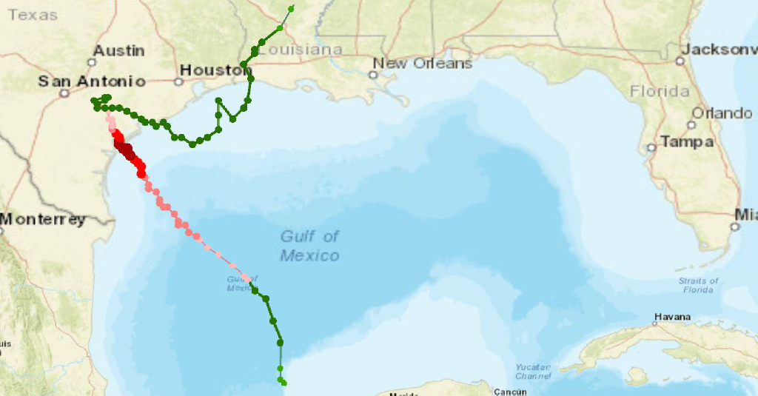

Figure 2.2: Federal and state impacted and non-impacted Superfund Sites in Texas
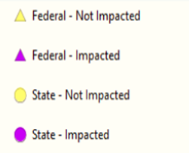

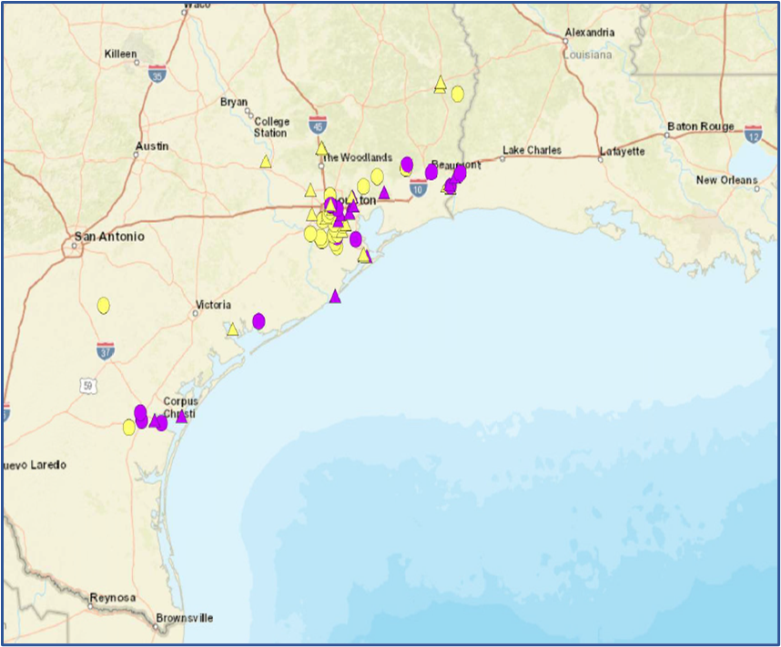
Figure 2.3: Location of the federal and state impacted and non-impacted Superfund Sites and single-family home sales in Harris County, Texas
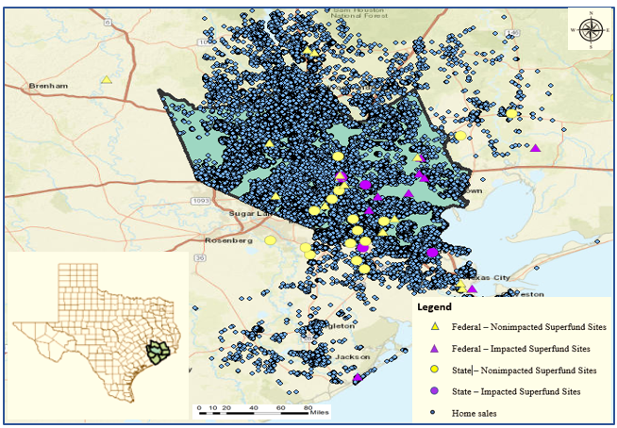
Figure 2.4: The comparison between median single-family home sales within 2 miles of the impacted superfund sites (treatment group) vs. median home sale outside 2miles distance buffer (control group)

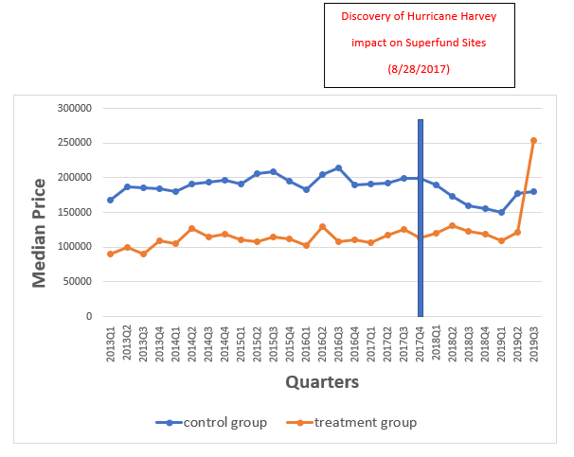

Figure 2.5: The comparison between median single-family home sales within 3 miles of the impacted superfund sites (treatment group) vs. median home sale outside 3 miles distance buffer (control group)
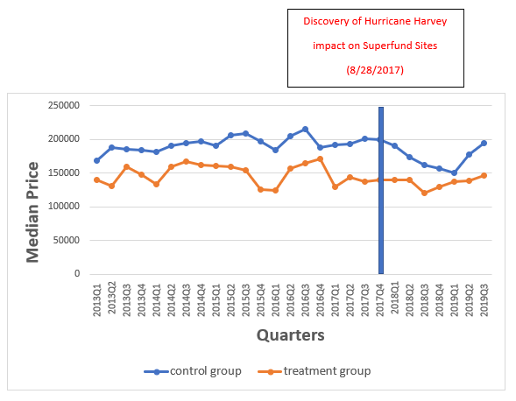

Figure 2.6: The comparison between median single-family home sales within 4 miles of the impacted superfund sites (treatment group) vs. median home sale outside 4 miles distance buffer (control group)
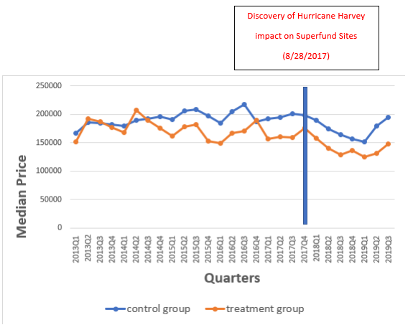

Figure 2.7: The comparison between median single-family home sales within 5 miles of the impacted superfund sites (treatment group) vs. median home sale outside 5 miles distance buffer (control group)
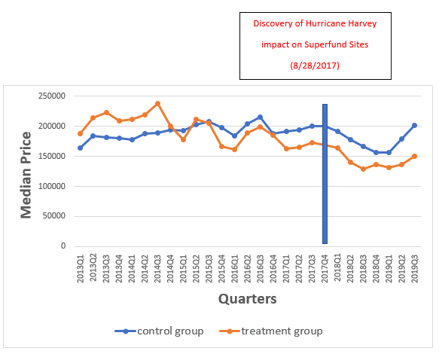

Figure 2.8: The comparison between median single-family home sales within 6 miles of the impacted superfund sites (treatment group) vs. median home sale outside 6 miles distance buffer (control group)
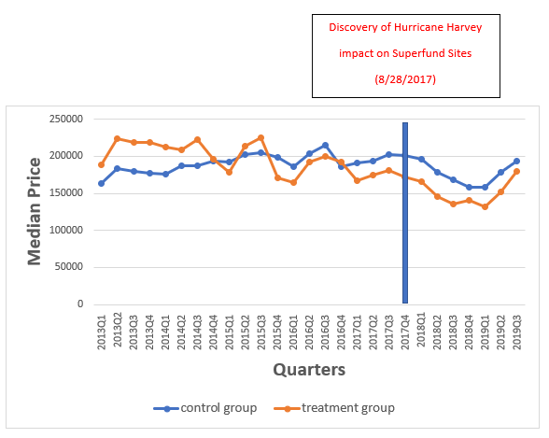

Figure 2.9: The comparison between median home sale within 2 miles of the impacted Superfund Sites (treatment group) vs. median home sale within 2 miles of the non-impacted Superfund Sites (control group)
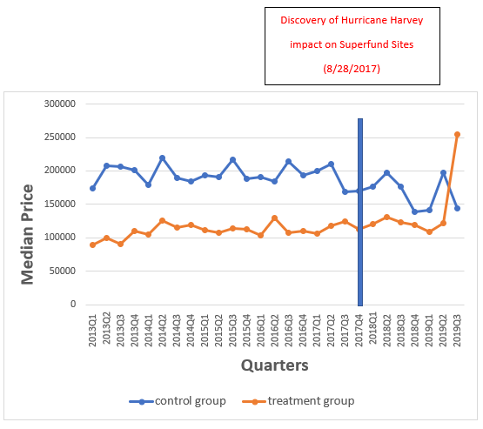

Figure 2.10: The comparison between median home sale within 3 miles of the impacted Superfund Sites (treatment group) vs. median home sale within 3 miles of the non-impacted Superfund Sites (control group)
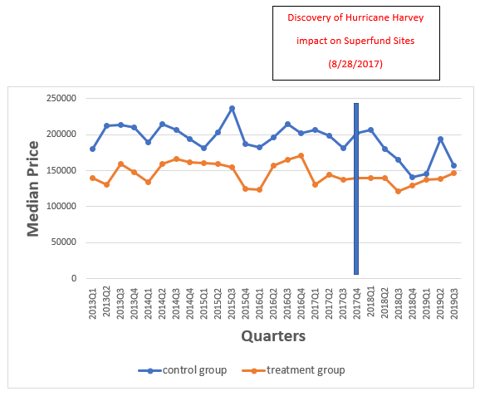

Figure 2.11: The comparison between median home sale within 4 miles of the impacted Superfund Sites (treatment group) vs. median home sale within 4 miles of the non-impacted Superfund Sites (control group)
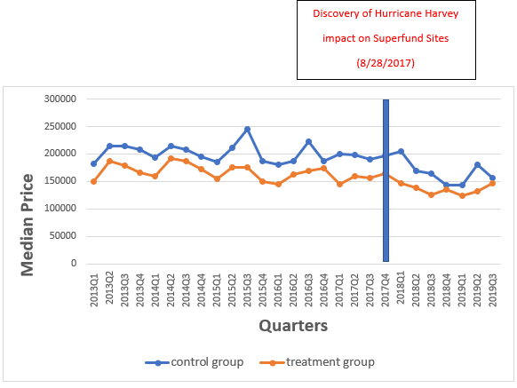

Figure 2.12: The comparison between median home sale within 5 miles of the impacted Superfund Sites (treatment group) vs. median home sale within 5 miles of the non-impacted Superfund Sites (control group)

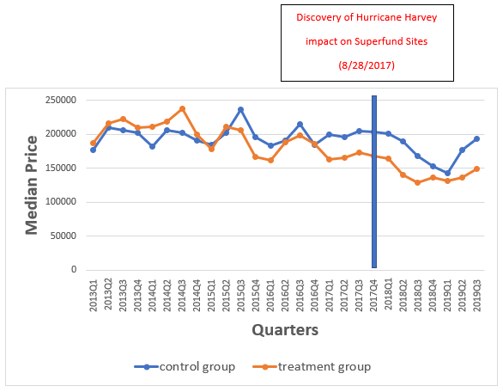

Figure 2.13: The comparison between median home sale within 6 miles of the impacted Superfund Sites (treatment group) vs. median home sale within 6 miles of the non-impacted Superfund Sites (control group)
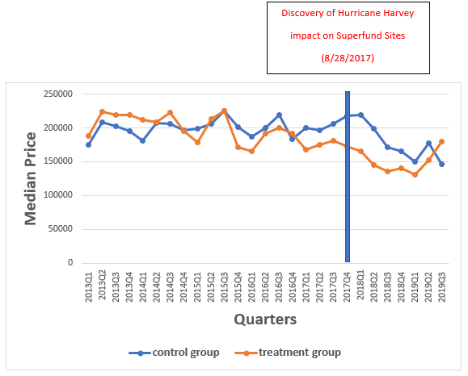

CHAPTER 3
Analyzing The Effect of Hurricane Irma on Birth Outcomes in Florida
3.1 Introduction
During the last few decades, climate change has increased the frequency and intensity of extreme weather events, such as hurricanes (Karl et al., 2008; Mousavi et al., 2011; Duan et al., 2018), affecting death, disease, and/or psychosocial stress among the residents in the U.S. coastal regions (NOAA, 2020; Grabich et al., 2016; Bourque et al., 2006; Doocy et al., 2013; Shultz et al., 2005). Hurricanes mostly affect the Atlantic and Gulf Coast regions, containing the largest centers of the U.S. population. In the coming years, hurricanes will likely affect even more people considering the steady increase in the number of people living in U.S. coastal regions. In fact, according to the 2016 U.S. Census Report, the coastline county population has expanded to 59.6 million in 2016 from 51.9 million in 2000 (Cohen, 2018).
Hurricanes have the potential to cause stress in pregnant women, potentially leading to adverse pregnancy and birth outcomes, including spontaneous abortions, preterm births (defined as birth before 37 weeks of gestation), or low birthweight deliveries (defined as birth weight lower than 2500g). Pregnant women undergoing pregnancy-induced hormonal changes are especially vulnerable to psychological or physical stress (Currie & Rossin-Slater, 2013; Douros et al., 2017). Psychological stress is caused by the fear of the hurricane. Physical stress is generated by injury experiences (Currie and Rossin-Slater, 2013). Further, women may also experience other negative conditions, including limited access to drinkable water, limited access to nutrition, exposure to toxic contaminants, and lack of access to medical care services (Currie and Rossin-Slater, 2013; Cordero, 1993).
Maternal stress has been a cause of concern among practitioners and academicians alike. This is because stress during pregnancy has been linked to a score of adverse pregnancy and childbirth outcomes. The intervention mechanism includes release of stress hormones negatively affecting the fetus through changes in the neuroendocrine and immune system and through changes in maternal behaviors (Dunkel-Schetter, 2011; Currie & Rossin-Slater, 2013). Preterm birth and low birth weight have been systematically linked to developmental delays and mental and behavioral disorders (Zijlmans et al., 2015; Currie & Rossin-Slater, 2013; Kim et al., 2017). However, isolating the hurricane-induced psychological stress from other stressors is not easy. The existing literature on the impact of catastrophic events on birth outcome applies either contextual information or causal mechanisms to conclude that the birth outcome results are more likely derived by psychological stress rather than other related pathways (Kim et al., 2017).
At least 200,000 pregnant women affected by Hurricane Irma may have experienced physical and psychological stress. There are a few studies that examine the impact of Hurricane Irma and Maria on maternal and child health in Puerto Rico (Welton et al., 2020; Rosario et al., 2019). However, to our knowledge, no studies have focused on the impact of Hurricane Irma on prenatal and parental health outcomes. Hence, it is vital to investigate the possible effect of Hurricane Irma as a source of stress on pregnancy outcomes. The current study investigates the impact of Hurricane Irma-induced stress on birth outcomes in Florida. As for sources of stress, we will consider several potential sources, including psychological stress, evacuation, and property damage (Issa et al., 2018; FEMA, 2018). We use cross-sectional birth records (at the longitude and latitude levels) provided by the Florida Department of Health, Bureau of Vital Statistics, over the period of 2016-2018. The birth records include information on birth weight, gestation, abnormal condition of newborn baby, complications in delivery, pregnant women’s residential locations, and parents’ sociodemographic information. Additionally, we apply FEMA damage assessment data and evacuation order data provided by the Florida Division of Emergency Management (FDEM) to investigate the effect of evacuation order and damage in residential buildings on pregnancy outcomes. The geospatial information of Hurricane Irma, such as the hurricane track and maximum wind speed, was obtained from the FDEM and FEMA’s HAZUS program.
Using a difference-in-difference strategy, we stratify pregnant women into two groups: the treatment and control groups. The treatment group includes pregnant women living in the hurricane path (29-mile band around the hurricane path, which represents the diameter of the eye of Hurricane Irma (Pasch, 2017), and the control group consists of pregnant women not living in the hurricane path. Using pregnant women’s residential locations and ArcGIS technology, we calculated the distance of their residential locations to the hurricane path. Also, we employ multiple fixed effects such as county, month, and year fixed effects to isolate the impact of the hurricane-induced stress on birth outcomes. Both binary and continuous measures of birth weight and gestation are examined, and the impact of the hurricane by trimester of exposure is investigated as well.
Our study makes several contributions: First, this is the first study that examines the impact of one of the strongest hurricanes in the Atlantic basin and the first of a major hurricane in Florida since October 2005 (when Hurricane Wilma made landfall on Florida) on pregnancy outcomes. Second, while the majority of existing medical and economic literature examines the impact of hurricanes on the birth outcome using birth records at county levels (Zahran et al., 2013; Grabich et al., 2016, 2017), our study uses the confidential birth records containing latitude and longitude of mothers’ residential locations, which helps us to calculate the accurate distance of pregnant women to hurricane path, and enables us to easily control for geo-special indicators such as maximum wind speed derived from ArcGIS technology. Third, we examine the impact of the potential channels such as changes in mothers’ maternal behaviors on birth outcomes; control for indicators such as hurricane-induced evacuation and residential building damages at the census tract level; and include several fixed effects such as county, birth month, and birth year fixed effects in our estimation.
3.2 Background
3.2.1 Hurricane Irma
On September 10, 2017, Hurricane Irma made landfall at Cudjoe Key, Florida, as a category 4 hurricane with 130 mph winds. Later, it weakened while moving northward and made its second landfall at Marco Island in Collier County, Florida, as a category 3 hurricane with 115 mph winds. Irma continued moving north, northwestward through Florida state, losing its intensity but continued to induce high wind, heavy rainfall, and storm surge inundation (Benfield, 2018) (see Figure 3.1). Hurricane Irma was the first main hurricane that struck Florida since Hurricane Wilma in 2005 and was one of the Atlantic basin’s strongest and costliest hurricanes in U.S. history, which caused catastrophic damages in Florida. NOAA National Centers for Environmental Information (NCEI) approximate that damages caused by hurricane Irma-induced wind, storm surge, and flooding caused almost $50 billion (Cangialosi et al., 2018). The cost estimates were based on the physical damages to residential, governmental, and commercial buildings, interruption in businesses, and the damage to public infrastructures such as roads, bridges, and power utilities (FEMA, 2018).
Estimates from Pacific Disaster Center (PDC) and FEMA’s HAZUS program (2017) indicated that two medical facilities in the Florida Keys were shut down for 1-12 days; more than 350,000 residential buildings were damaged in Florida: 2,200 buildings were destroyed; 3,800 buildings were severely damaged; 58,000 buildings were moderately damaged; 290,000 buildings sustained minor damages. As a result, almost 12,000 households were displaced, and 2,900 had to take short-term shelter. Furthermore, almost 7 million residents who were living mainly in Florida coastal areas had to evacuate, where besides zone A as a mandatory evacuation order, the evacuation zone was expanded to evacuation zone B as well (See Figure 3.2 and Figure 3.3).
In terms of disruption in power, more than 6.7 million customers in the state experienced power outage during and after Hurricane Irma, which denotes almost two-thirds of all customers in Florida. Based on FDEM (2017), in some areas, the customers did not have electricity for more than a week (Chakalian et al., 2018). Power outages endangered the health and safety of millions of residents in Florida, particularly vulnerable groups such as elderly people and pregnant women due to dehydration, exhaustion, and carbon monoxide poisoning. Also, Irma caused the discharge of 28 million gallons of untreated water into the surrounding areas (Smith et al., 2018).
It has been reported that there were hundreds of injuries, seven direct and eighty indirect deaths caused by Hurricane Irma in Florida (Cangialosi et al., 2018). The conditions of deaths associated with Hurricane Irma have been classified into direct hurricane-related conditions (such as drowning from flooding; and electrocution from lightning), and indirect hurricane-related conditions (such as disruption of access to medical and mental health services; disruption of electricity required for medical treatment such as dialysis; disruption of cooling systems; carbon monoxide poisoning caused by using generators) (Issa et al., 2018).
3.3 Literature review
3.3.1 Different mechanisms linking prenatal stress and adverse birth outcomes
Adverse birth outcomes are oftentimes recognized by low birth weight and preterm birth. Low birth weight (which is defined as birth weight less than 5.5 pounds (2500 grams) irrespective of gestational length) can be caused by intrauterine growth restrictions (IUGR) (which is defined as birth weight/birth length below the 10th percentile for gestational length) and preterm birth (which is defined as birth before 37 completed weeks of gestation). Low birth weight and preterm birth can lead to child growth impairment and increase the chances of getting diseases such as hypertension, and cardiovascular, and renal disease later in life (Zohdi et al., 2012).
A large body of epidemiological research and a growing body of economic research has consistently found that maternal stress during pregnancy is a risk factor for the adverse birth outcomes (Hobel et al., 2008; Beijers et al., 2014; Zijlmans et al., 2015; Justus et al., 2004). There are several possible mechanisms by which maternal stress affects birth outcomes.
Hormonal: prenatal stress triggers a rise in the release of glucocorticoids, the key driver of the endocrine response to stress (Whirledge & Cidlowski, 2010). Glucocorticoids are produced by Hypothalamic Pituitary Adrenal (HPA) axis and the placenta (Zijlmans et al., 2015). Although essential for fetal growth, glucocorticoids released excessively can potentially harm the fetus. When the brain perceives an event as a severe stressor, the corticotrophin releasing hormone (CRH), which is the primary molecular regulator of HPA, induces releases of adrenocorticotropin hormone (ACTH) through the pituitary gland (Hobel et al., 2008). The ACTH then stimulates the adrenal gland to release cortisol (which is a glucocorticoid that functions as a major stress hormone) in the body. The cortisol blocks the stress response by inhibiting the release of ACTH and the release of CRH (Gunnar & Quevedo, 2007; Hobel et al., 2008). However, under severe stressful events, the concentration of cortisol will rise in blood leading early parturition and affecting fetal growth (Hobel et al., 2008).
Further, some argue that the timing of maternal exposure to cortisol may modify the extent to which maternal stress is adversarial to birth outcomes. This is because as fetus brain development occurs at different stages, different birth outcomes will be achieved by exposing to stress in different gestational periods (Zijlmans et al., 2015). Davis and Sandman (2010) show that maternal exposure to high levels of cortisol in early pregnancy is associated with slower infant growth. Similarly, Glynn et al. (2001) show that the exposure to stress in early pregnancy is more visible than in later months of pregnancy. In another study, Class et al. (2011) show that exposure to the stress in Months 5 and 6 are more likely to lead to adverse pregnancy outcomes.
Behavioral: Stress-induced maternal behaviors, such as smoking, drinking alcohol, not attending prenatal visits, can also affect adverse birth outcomes (Littleton et al., 2007). Smoking during pregnancy may mediate the association between prenatal stress and birth weight by increasing the levels of catecholamines, CRH, ACTH, and cortisol (Justus et al., 2004). Smoking can affect fetal growth by increasing the level of catecholamines in the body, thus boosting metabolism while suppressing appetite at the same time (Hobel et al., 2008). There is abundant evidence that alcohol consumption could have a potential negative effect on birth weight and preterm birth (Parazzini et al., 2003; Cook & Randal, 1998; Pereira et al., 2019). The alcohol consumption may induce preterm birth by increasing the level of prostaglandins (which play important regulatory roles in different aspects of pregnancy such as fetal growth and development) (Cook & Randal 1998).
Physiological: Extreme drops in barometric pressure can also affect birth outcomes through premature fetal membrane rupture, which induces preterm birth (Akutagawa et al., 2007; Mackenzie et al., 2020, Noller et al., 1996; King et al., 1997). Mackenzie et al. (2020) used a model to examine the strength of the fetal membrane against the stress caused by a drop of barometric pressure during strong hurricanes. Their model showed that the impact of stress on the fetal membrane depends on the barometric pressure and the length of gestation. The author argued that the increased stress induced by a hurricane with low barometric pressure can cause preterm birth through increasing the strength of fetal membrane prior to the full-term gestation. The strength of fetal membrane starts decreasing after week 30 of pregnancy, but the stress caused by the lower barometric pressure can rupture the fetal membrane through increasing the strength of it, which induces preterm birth. However, some other related studies found no relationship between atmospheric pressure and birth outcomes (Trap et al., 1989; Polansky et al., 1985; Marks et al., 1983), leaving open the question about the association between barometric pressure and birth outcomes.
There is a considerable body of research that addresses the effect on birth outcomes of catastrophic events (both manmade and natural disasters) such as earthquakes (Kim et al., 2017; Tan et al., 2009; Torche, 2011), armed conflict (Mansour & Rees, 2012; Maric et al., 2010); terrorist attacks (Engel et al., 2005; Brown, 2013); heat waves (Cil & Cameron, 2017; Wolf & Armstrong, 2012; Strand et al., 2012); and dust storms (Adhvaryu et al., 2019; Currie and Schwandt, 2016; Jones, 2020).
There is a considerable body of epidemiological literature (Harville et al., 2015; Xiong et al., 2008; Hamilton et al., 2009; Grabich et al., 2016, 2017; Christopher et al., 2019) investigating the empirical association between hurricanes and birth outcome. The majority of these studies include few if any control variables, making their causality claims rarely justified (Currie and Rossin-Slater, 2013). However, in the economic literature, the impact of hurricanes and other natural disasters such as earthquake and dust storms on birth outcome were examined using various control variables, difference-in-difference techniques, and instrumental variables to control the omitted variables bias due to other variables that are correlated with stress and birth outcome (Currie and Rossin-Slater, 2013; Zahran et al., 2010, 2013, 2014; Jones, 2020; Kim et al., 2017).
In the context of the impact of an earthquake on birth outcomes, Kim et al. (2017) examined the impact of Northridge earthquake on birth outcomes, including low birth weight and preterm birth. Using a difference-in-difference approach, they found that pregnant women who were exposed to the earthquake were 0.2 percentage point more likely to have infants with low birth weight. Also, the impact was larger when the exposure to the earthquake was in the first and third trimester of pregnancy. However, the impact of earthquake-induced stress was stronger with single and first-time mothers, where the probability of having an infant with low birth weight increased by 0.5 percentage point. The authors concluded that the endogenous migration and disruption of healthcare services did not have a major impact on birth outcomes. Instead, they concluded that maternal psychological stress led to low birth weight.
Another related study is conducted by Jones (2020), which examined the impact of dust storms on U.S. birth outcomes over the period 2010-2017. Using the difference-in-difference approach, several fixed effects, and control variables, the effect of dust storms on birth outcomes was plausibly isolated. The findings showed that the dust storm exposure during pregnancy led to an increase in the probability of low birth weight and preterm birth by 1.4 and 1.8 percentage points, respectively, and the effect is larger when the dust storm exposure happens during the third trimester of pregnancy. Also, he found that mothers who experienced the dust storm for the first time were 0.9 and 1.1 percentage points more likely to have infants with low birth weight and preterm birth, respectively. However, the probability of low birth weight and preterm birth increase by 5.7 and 8.7 percentage points, respectively, when pregnant women experienced six or more dust storms.
The most closely relevant study to our work is Currie and Rossin-Slater (2013), where the effect of multiple hurricanes on birth outcomes was investigated. Currie and Rossin-Slater (2013) used vital statistics records of 485,111 births of pregnant women exposed to several major hurricanes in Texas over the period 1996-2008. They compared the pregnant women who were living in the path of hurricanes to those living farther away from the path (Currie and Rossin-Slater, 2013). They added new indicators of infant health, including abnormal conditions of the infants, and complications of labor aside from birth weight and gestation outcomes to the existing literature (Currie and Rossin-Slater, 2013). They also examined the effect of possible channels, including changes to migration, parental behavior, and interruption of medical care induced by hurricanes on the birth outcome (Currie and Rossin-Slater, 2013). Methodologically, they applied mother fixed effects and instrumental variables estimations to control for time invariant factors that are likely associated with pregnant women’s residential location and pregnancy outcomes (Currie and Rossin-Slater, 2013). They showed that the impact of hurricanes on birth weight and gestation is sensitive to measurements and econometric design, but they found more precise estimates of the impact of hurricane exposure on infant health. Accordingly, the findings indicate that the pregnant women who were exposed to hurricanes were more likely to experience complications during labor and delivery and were more likely to have an infant with abnormal conditions (such as meconium aspiration syndrome) (Currie and Rossin-Slater, 2013). Also, using the placebo test, the exposure to hurricanes six months after childbirth was investigated, but no placebo effects were found. However, they ruled out potential channels, including hurricane-induced migration, disruption of medical care services, and maternal behaviors and thus, concluded that stress might be the only factor to explain the birth outcome results (Currie and Rossin-Slater, 2013).
The current study adds to the existing literature on hurricanes and birth outcomes. We tried to examine the possible effects of hurricane-induced physical mechanisms, including hurricane-induced mandatory migration and residential building damage to isolate the effect of psychological stress caused by hurricane exposure on birth outcomes.
3.4 Data
We obtained data from two sources. First, we obtained confidential birth data over the period 2016-2018 from the Florida Department of Health, Bureau of Vital Statistics. The birth records include information about birth weight, length of gestation, abnormal condition of newborn baby, infant’s sex, complications of labor/delivery, methods of delivery, prenatal care visits, number of previous live births, infant’s birth order, multiple births resulted from the current pregnancy, parents’ sociodemographic information, whether mother smoked during pregnancy, and the longitude/latitude coordinates of pregnant women’s residential locations. Second, we obtained data on Hurricane Irma’s path, maximum wind speed (at the longitude and latitude levels), Irma-induced evacuation orders (at the census tract level), and rate of damage in residential buildings (at census tract level) from the Florida Division of Emergency Management and FEMA’s HAZUS center. Using longitude/latitude coordinates of pregnant women’s residential locations, we estimate the distance to the nearest point on the hurricane path applying Arc GIS technology. We formed a 30-mile band around the hurricane path, which represents the diameter of the eye of Hurricane Irma, where the devastating damages and impact were experienced. The eye of a strong hurricane is usually 19-40 miles in diameter, where the strongest wind occurs (Pasch, 2017).
The main analysis sample consists of 640,649 live births. Our outcomes of interest include continuous and binary measures of birth weight and gestation length. The continuous indicators include birth weight in grams and gestational length in weeks. The binary indicators include preterm birth (which is equal to one if an infant was born before 37 weeks of gestation, and zero otherwise) and low birth weight (which is equal to one if an infant was born weighing less than 2500g, and zero otherwise).
3.5 Methodology
We aim to investigate the causal effect of Hurricane Irma on birth outcomes, including preterm birth, low birth weight, abnormal conditions of newborns, and complication of labor/delivery. Using the difference-in-difference (DID) approach, we examine the causal effect of the treatment by comparing the outcome between the control and treatment groups before and after the treatment. In our study, the treatment is the exposure to Hurricane Irma.
Our DID analyses consider two alternative approaches to measuring the treatment. First, we define the hurricane exposure based on the distance to the eye of the hurricane (in miles). Second, we define hurricane exposure based on the peak wind speed (miles per hour). However, we report the results from the first approach; we report the results from the second by way of robustness check.
Using the first approach, we stratified pregnant women into two groups: the treatment and control groups. Based on the first approach, the treatment group consists of the pregnant women living within 30-mile radius of Hurricane Irma, and the control group consists of the pregnant women living outside the hurricane path. According to the second approach, the treatment group consists of the women who were exposed to Irma’s maximum wind speed of 74 mph (category 1 hurricane) or more during pregnancy, and control group consists of mothers who were exposed to less than 74 mph maximum wind speed (we will look at this measurement closely in the robustness check section).
We examine the following hypotheses for the first and second approaches (where first approach to measuring Hurricane Irma exposure is defined as living within 30-mile radius of Hurricane Irma during pregnancy; and the second approach to measuring Hurricane Irma exposure is defined as being exposed to Irma’s maximum wind speed of 74 mph or more during pregnancy):
Hypothesis 1: $H_{0}$: Exposure of pregnant women to Hurricane Irma has no significant impact on preterm birth and low birth weight.
Hypothesis 2: $H_{0}$: Exposure of pregnant women to Hurricane Irma has no significant impact on abnormal conditions of newborns, and complication of labor/delivery.
3.5.1 First approach
We examine the causal impact of Hurricane Irma on birth outcomes by applying the following DID model (Kim et al., 2017):
${Birthoutcome}_{icdmt}= β_{0}+β_{1}{ BornPost2017}_{icdmt}+β_{2}{HIPath}_{icdmt} +β_{3}\left({BornPost2017}_{icdmt}*{HIPath }_{icdmt}\right)+{β_{4}X}_{icdmt}+M_{m}+Y_{t}+θ_{j}+ε_{icdmt}$ (3.1)
Where $i$ is a newborn, $c$ is the county of the mother’ residence, d, $m$, and $t$ are the day, month, and the year that newborn $i$is born; ${Birthoutcome}_{icdmt}$ represents birth outcomes including birth weight (both continuous and binary measures), gestation (both continuous and binary measures), and abnormal condition of newborn baby, complications in delivery/labor; ${BornPost2017}_{icdmt}$ is an indicator equal to 1 if the birth occurred between Sep 10 2017 and July 15 2018, and 0 otherwise; ${HIPath}_{icdmt}$ is an indicator equal to 1 if the mother lived in the path of Hurricane Irma, and 0 otherwise; $X_{icdmt}$ include infant $i$’s mother’s sociodemographic characteristics such as mother’s age, education, and marital status. The interaction term ${BornPost2017}_{icdmt}*{HIPath }_{icdmt}$ captures the causal impact of Hurricane Irma on birth outcome; $M_{m}$, $Y_{t}$, and $θ_{j}$ are fixed effects for birth month, birth year, and county, respectively; and $ε_{icdmt}$ is an error term.
To investigate the hurricane exposure by the trimester of pregnancy, we estimate the following model:
${Birthoutcome}_{icdmt}= β_{0}+β_{1}{first}_{icdmt}+β_{2}s{econd}_{icdmt}+β_{3}{third}_{icdmt}+β_{4}{HIPath}_{icdmt}+β_{5}\left({HIPath}_{icdmt}*{first }_{icdmt}\right)+β_{6 }\left({HIPath}_{icdmt}*{second}_{icdmt}\right)+β_{7}\left({HIPath}_{icdmt}*{third}_{icdmt}\right)+{β_{8}X}_{icdmt}+M_{m}+Y_{t}+θ_{j}+ε_{icdmt}$ (3.2)
Where ${first }_{ijdmt}$, $s{econd}_{ijdmt}$, and ${third}_{ijdmt}$ represent the mother’s exposure to Hurricane Irma when they were in their ${first }_{ijdmt}$ (infants were conceived between Jun 11, 2017 and Sep 10, 2017), $s{econd}_{ijdmt}$ (infants were conceived between March 12, 2017 and June 10, 2017), and ${third}_{ijdmt}$ trimester (infants were conceived between Dec 16, 2016 and March 11, 2017) of their pregnancy.
3.5.2 Second approach
Using the second approach, our DID analysis is specified according to the cutoff for category 1 hurricane (with winds range from 74 to 95 mph). Using data on Hurricane Irma’s maximum wind speed (miles per hour) at longitude and latitude levels, mothers were stratified into two groups. Mothers living in the area impacted by the wind speed of more than 74 mph were considered as a treatment group, and those affected by wind speed less than 74 mph are considered as a control group.
To analyze the hurricane exposure based on maximum wind speed (mph), the following equation (which is the modified form of Eq. (3.1)) is applied.
${Birthoutcome}_{icdmt}= β_{0}+β_{1}{ BornPost2017}_{icdmt}+β_{2}{WindSp74mph}_{icdmt} +β_{5}\left({BornPost2017}_{icdmt}*{WindSp74mph }_{icdmt}\right)+{β_{8}X}_{icdmt}+M_{m}+Y_{t}+θ_{j}+ε_{icdmt}$ (3.3)
Moreover, to estimate Hurricane Irma’s induced maximum wind speed exposure on birth outcomes by trimester of pregnancy, we defined the following DID model (which is the modified form of Eq. (3.2)).

${Birthoutcome}_{icdmt}= β_{0}+β_{1}{first}_{icdmt}+β_{2}s{econd}_{icdmt}+β_{3}{third}_{icdmt}+β_{4}{HIPath}_{icdmt}+β_{5}\left({WindSp74mph}_{icdmt}*{first }_{icdmt}\right)+β_{6 }\left({WindSp74mph}_{icdmt}*{second}_{icdmt}\right)+β_{7}\left({WindSp74mph}_{icdmt}*{third}_{icdmt}\right)+{β_{8}X}_{icdmt}+M_{m}+Y_{t}+θ_{j}+ε_{icdmt}$ (3.4)
3.5.3 Maternal characteristics and exposure to Hurricane Irma
Following Currie and Rossin-Slater (2013), to investigate whether the birth month, birth year, and county fixed effects are sufficient to control for selection within areas that more likely to be affected by hurricanes, we estimate the following model:
$X_{icdmt}= β_{0}+β_{1}{BornPost2017}_{icdmt}+β_{2}{HIPath}_{icdmt} +β_{5}\left({BornPost2017}_{icdmt}*{HIPath }_{icdmt}\right)++M_{m}+Y_{t}+θ_{j}+ε_{icdmt}$ (3.5)
Based on Eq. (3.5), we evaluate whether there is a relationship between hurricane exposure (living within 30 miles of the hurricane path) and maternal characteristics. The variables are defined as Eq. (3.1) and Eq. (3.2). If the aforementioned fixed effects included in Eq. (3.5) can control for selection, then the interaction coefficient would not be statistically significant. However, the statistically significant interaction coefficient suggests that the fixed effects, including county fixed effect, are not able to control for selection (Currie and Rossin-Slater, 2013). As Table 3.1 depicts, panel (A) estimated Eq. (3.5) without county fixed effect, whereas panel (B) estimated Eq. (3.5) with county fixed effect. Panel (A) shows that mothers exposed to hurricanes were 0.43 percentage points more likely to be African American. As panel (B) shows, by including the county fixed effects, this difference was captured effectively (Currie and Rossin-Slater, 2013). Thus, we conclude that including county fixed effect were effective to control for selection.
3.6 Results
3.6.1 Summary statistics
Table 3.2 reports summary statistics. On average, 12.5% of infants were born prematurely, and 8.17% were born with low birth weight. The mean birth weight is 3251.37 grams, and the mean gestation length is 38.53 weeks. Almost 13% of infants have abnormal conditions, and 4.1% of births have complications during labor/delivery. Also, 71%, 23%, and 34% of mothers are White, Black, and Hispanic, respectively. Figure 3.4 shows mothers’ residential locations (at the longitude and latitude levels) over the period 2016-2018, respectively.
3.6.2 Regression results
Table 3.3 reports the estimated effects of Hurricane Irma exposure (living within 30 miles of the hurricane path) on birthweight (Column 1); gestational age at birth (Column 2); low birthweight (Column 3); premature birth (Column 4) using Eq. (3.1). We included birth year, birth month, and mother’s county fixed effects and clustered the error term at the mother’s county level.
Table 3.3, Column (1) shows the results of continuous measure of birth weight outcome. The estimate of the coefficient interaction term ${BornPost2017}_{icdmt}*{HIPath }_{icdmt}$ is -6.8919 and statistically significant, suggesting that hurricane exposure (living within 30 miles of the hurricane path) decreased birth weight by about 7 grams. Column (2) reports the results of continuous measure of gestation length outcome. The coefficient on the interaction term is -0.0130. However, this coefficient is not statistically significant, indicating that there is no significant gestation length (continuous measure) outcome difference between treatment (mothers living within the hurricane path) and control group (mothers living outside the hurricane path). Moreover, Column (3) and Column (4) show the results for low birth wight and preterm birth outcomes (using a linear probability model). As the results of Column (2), the results for the coefficients on interaction term reported in Column 2 and Column 3 are not statistically significant. It indicates that there is no significant difference between treatment and control groups in terms of preterm birth and a low birthweight outcome.
Table 3.3 also reports coefficients on mother and infant characteristics. The signs and magnitude of the coefficient estimates are in line with our expectations. For instance, married and educated mothers experienced an improvement in the birth outcomes. In contrast, teen mothers (mothers under the age of 19) are more likely to have low birth weight and premature infants. Similarly, African American, Hispanic mothers, and mothers who were smoking during pregnancy experienced higher adverse birth outcomes. In terms of infant characteristics, the estimated coefficients on infant’s gender are negative and statistically significant, indicating that female infants are more likely to be born with low birth weight.
Using Eq. (3.2), we estimate the impact of Hurricane Irma on birth outcomes by trimester. Table 3.4 reports the results of the impact of the hurricane exposure on continuous and binary measures of birth weight and gestational length. The results indicate that there is a higher negative impact on birth outcomes when mothers exposed to the hurricane in their first and third trimester of pregnancy. In Table 3.4, Column (1), and Column (2) show that exposure to the hurricane (coefficients on the interaction term) in the third trimester of pregnancy decreased birth weight, and gestation length by about 12 grams, and 0.07 week, respectively. Moreover, findings in Table 3.4 Column (3) depicts that the exposure to the hurricane during the first and the third trimesters of pregnancy increased the likelihood of low birth weight by 0.52 and 0.46 percentage point, respectively. Our results are in line with the previous studies suggesting that the exposure to natural disasters in the first and third trimesters of pregnancy are linked with a higher risk of low birth weight and preterm birth (Torche, 2011; Currie & Rossin-Slater, 2013; Kim et al., 2017; Jones, 2020). It is worth highlighting that fetal growth can be adversely impacted when the hurricane exposure (as a stressor) occurs in the first and third trimester of pregnancy. It is evident that in the first trimester, the infant’s most critical development occurs. Also, the fetal gains the most weight during the third trimester of pregnancy. Thus, any stressor that restricts the first trimester and third trimester growth can increase the likelihood of low birth weight and preterm birth (Smith, 2004).
Besides investigating the effect of hurricane exposure on birth weight and gestation length, we also look at the impact of Hurricane Irma on abnormal conditions of the infants and complications of labor and/or delivery. The results in Table 3.5 reports that hurricane exposure (living within 30 miles of the hurricane path) is estimated to increase the risk of an abnormal condition in the infants, and complications of labor and delivery by 2.4 and 0.66 percentage points, respectively.

3.7 Robustness check
3.7.1 Hurricane exposure based on the cutoff of Hurricane Irma’s maximum wind speed (second approach)
Besides our main model, which analyzes the hurricane exposure based on the 30 miles symmetrical distance buffer around the hurricane path, we are interested in investigating the hurricane exposure based on the hurricane’s maximum wind speed (miles per hour) (see Figure 3.5).
Table 3.6 reports various estimates of the impact of Hurricane Irma exposure on the birth outcome using Eq. (3.3). Table 3.6, Panel (A), Column (1) and Column (2) report the results of the continuous measure of birth weight, and gestation length outcomes. In Column (1), the estimate of the coefficient on the interaction term ${BornPost2017}_{icdmt}*{WindSp74mph }_{icdmt}$ is -5.0562, but it is not statistically significant. Column (2) reports the results of continuous variable of gestation length. The coefficient estimate on the interaction term is -0.0687 and statistically significant, suggesting that the exposure to the maximum wind speed has decreased the gestation length by 0.0873 weeks. The results for low birth weight, and preterm birth outcomes reported in Column (3) and Column (4); however, the results for the coefficients on the interaction terms are not statistically significant.
Panel (B) of Table 3.6 shows various estimates of the impact of maximum wind speed exposure (induced by Hurricane Irma) on birth outcomes by trimester using Eq. (3.4). The results in Panel (B), Column (1), indicates that exposure to the maximum wind speed in the third trimester of pregnancy decreased birth weight by about 15 grams. However, the estimated impact of wind exposure on birth weight in the first and the second trimester of pregnancy are not statistically significant. The results in Panel (B), Column (2), reports the impact of the wind speed exposure on the gestation length by trimester. The coefficients on the interaction terms are negative and statistically significant, suggesting that the exposure to the maximum wind speed in the first, second, and third trimester of pregnancy decreased gestation length by 0.0873, 0.0517, and 0.0502 weeks, respectively. However, the impact of exposure on gestation is not very strong (lowered gestation length by less than a day). Furthermore, Panel (B) Column (3) and Column (4) show the results for low birth weight, and preterm birth outcomes (using a linear probability model). However, the estimated coefficients in both models are statistically insignificant. In summary, the estimated impact of wind exposure induced by Hurricane Irma on gestation length is more robust to estimation methods. Moreover, both results in Table 3.6 and the results of our main model (reported in Table 3.3 and 3.4) suggest that exposure in the third trimester has a stronger negative impact on birth weight, which varies from -11 to -15 grams.
3.7.2 Estimating the main model using different radii
We estimate the impact of different distance buffers on birth outcomes to investigate how varying distance buffers could affect our main results. We have defined two radii (including 50 miles and 60 miles) around the main distance buffer (30 miles). Panel (B) and Panel (C) of Table 3.7 present the estimated effect of Hurricane Irma on birth outcomes (both binary and continuous measures of birth weight and gestation) based on the 50 miles, and 60 miles symmetrical distance buffer around the hurricane path, respectively. The results show that none of the estimated coefficients on the interaction terms are statistically significant. It may suggest that although the 30 miles distance buffer is an arbitrary measure around the hurricane path, using different radii do not have a significant impact on our main result (presented in Table 3.3).
3.8 Causal mechanisms
We also investigated possible causal mechanism which could stress pregnant women. Following Currie and Rossin-Slater (2013), we look at the behavioral mechanisms that could contribute to the results. Moreover, we analyze the impact of other stressors such as hurricane-led evacuation, and economic loss, which have not been investigated in the previous studies.
3.8.1 The impact of Hurricane Irma on maternal behavior
The hurricane exposure (by living in the path of the hurricane, by the maximum wind speed) can stress pregnant women and consequently could impact the birth outcome. However, it is possible that stress could change maternal behaviors. For instance, stress induced by the hurricane may cause mothers to engage in risky behaviors such as smoking more cigarettes, drinking alcohol, gaining or losing noticeable weight through changing their diet, and negative change in their prenatal care. Table 3.8 presents the analysis of the behavioral mechanisms that could contribute to our results. We investigated whether stress could cause mothers to smoke in the first, second, and third trimester of the pregnancy, gain more than 60 pounds, have inadequate prenatal care. However, all the estimates in Table 3.8 are statistically insignificant, indicating that there is no impact of hurricane exposure on maternal behavior. Thus, we suggest that our findings are due to stress, not because of changes in maternal behavior.
3.8.2 Including the residential buildings damage rate and evacuation order as additional controls
We analyze the impact of physical stressors (evacuation order and rate of damage in mother’s residential buildings (see Figure 3.2 and 3.3)) induced by Hurricane Irma on birth outcome. To bound the impact of the stress on birth outcome more precisely, we estimate the Eq. (3.1) by adding the following control variables: ${Build}_{icdmt}$ is an indicator for the level of damage in mother’s residential building; ${Evacuationorder}_{icdmt}$ is an indicator equal to one if a mother receives mandatory evacuation, and zero otherwise. Table 3.9 reports the estimated coefficients of the impact of hurricane exposure on birth outcomes using Eq. (3.1) and including the aforementioned control variables. Each column of Table 3.9 presents the coefficient estimates of a specific birth outcome regression. We included birth year, birth month, and mother’s county fixed effects and clustered the error term at the mother’s county level. Table 3.9, Column (1) reports the results of birth weight outcome (continuous measure). The estimate of the coefficient interaction term ${BornPost2017}_{icdmt}*{HIPath }_{icdmt}$ is -6.8860 and statistically significant, indicating that hurricane exposure (living within 30 miles of the hurricane path) decreased birth weight by about 7 grams (which is almost the same as the result obtained from Eq. (3.1) presented in Table 3.3 Column (1)). Comparing the results in Tables 3.9 with the main results (presented in Table 3.3 Column (1)), we can suggest that including the aforementioned control variables in the main model had small impact on the birth weight outcome. It indicates that stressors like damage in residential buildings and receiving evacuation orders had small impact on birth outcomes. Thus, it may suggest that our findings are due to stress, not because of other stressors explained above.
3.9 Conclusion
This paper analyzes the causal impact of Hurricane Irma exposure on birth outcomes, including birth weight, gestation, abnormal condition of newborn baby, complications in labor and delivery. We combined Florida confidential birth data (obtained from Florida Department of Health, Bureau of Vital Statistics) over the period 2016-2018 with data on FEMA damage assessment, evacuation order, and maximum wind speed (provided by FDEM). We controlled for indicators such as the rate of damage in residential buildings and evacuation order caused by Hurricane Irma at the census tract level for the first time to bound the impact of stress (living within Hurricane Irma’s path) on birth outcomes more tightly. Moreover, we investigated the impact of maximum wind speed as the second approach on birth outcome.
The findings show that hurricane exposure (living in the path of Hurricane Irma) decreased birth weight by about 7 grams. We also show that exposure to the hurricane in the third trimester of pregnancy causes a 0.46 percentage point increase in the likelihood of low birth weight, and the exposure in the third trimester of pregnancy has the highest negative impact on birth outcomes. In terms of other birth outcomes (complication of labor/delivery and abnormal condition of newborn) the hurricane exposure (living within 30 miles of the hurricane path) is estimated to increase the risk of abnormal condition in the infant, and complications of labor and delivery by 2.4 and 0.66 percentage point, respectively.
The estimated impact of hurricane Irma on birth weight and gestation length (the continuous measure) are robust to estimation methods. It is worth highlighting that the magnitude of the impact of hurricane exposure in our study are smaller than the effects found in the Currie and Rossin-Slater (2013) (1.5, 4.0, and 2.6 percentage point increase in likelihood of low birth weight, abnormal condition of newborn, and complication of labor/delivery, respectively), where they have used several estimation methods (such as OLS with county fixed effects and IV with mother fixed effects).
We investigated the impact of changes in maternal behavior, which could contribute to the results. However, we found no evidence that could account for these impacts. We also assessed the impact of other indicators such as evacuation order, residential building damage rate to isolate the impact of stress on birth outcomes. Comparing the results presented in Table 3.9 (where the aforementioned indicators controlled for) with the main results (shown in Table 3.3), we suggest that including the control variable mentioned above had small impact on the main results (presented in Table 3.3).
This work offers a contribution to the literature on climate change and health economics, by supporting the idea of the association between hurricanes and birth outcomes, where to our knowledge, no studies have tested the impact of a strong hurricane like Hurricane Irma on birth outcome. The findings can inform the public health sectors regarding the possible impact of hurricanes, especially in the State of Florida (where is the most hurricane-prone state in the country), on public health, especially pregnant women’s health. This information can be used by the health organizations to aid pregnant women to reduce their stress through preparation for hurricanes, including creating a secure place for pregnant women who seek shelter during the pregnancy, informing mothers regarding the possible risks after the hurricane, and facilitating access to their essential needs such as water, and foods.

Disclaimer: “Any published findings and conclusions are those of the authors and do not necessarily represent the official position of the Florida Department of Health.”

REFERENCES
Adhvaryu, A., Bharadwaj, P., Fenske, J., Nyshadham, A., & Stanley, R. (2019). Dust and death: evidence from the West African Harmattan (No. w25937). National Bureau of Economic Research. Retrieved from:
https://papers.ssrn.com/sol3/papers.cfm?abstract_id=3406453

Akutagawa, O., Nishi, H., & Isaka, K. (2007). Spontaneous delivery is related to barometric pressure. Archives of Gynecology and Obstetrics, 275(4), 249-254.

Benfield, A., (2018). Hurricane Irma Event Recap Report, March 2018. Retrieved from:
http://thoughtleadership.aonbenfield.com/Documents/20180328-ab-if-hurricane-irma-recap.pdf

Beijers, R., Buitelaar, J. K., & de Weerth, C. (2014). Mechanisms underlying the effects of prenatal psychosocial stress on child outcomes: beyond the HPA axis. European child & adolescent psychiatry, 23(10), 943-956.

Bourque, L. B., Siegel, J. M., Kano, M., & Wood, M. M. (2006). Weathering the storm: The impact of hurricanes on physical and mental health. The Annals of the American Academy of Political and Social Science, 604(1), 129-151.

Brown, R. (2014). The intergenerational impact of terror: Does the 9/11 tragedy reverberate into the outcomes of the next generation?. Households in Conflict Network. https://econpapers. repec. org/paper/hicwpaper/165. htm.

Cangialosi, J. P., Latto, A. S., & Berg, R. (2018). National Hurricane center tropical cyclone report: Hurricane Irma. National Oceanic and Atmospheric Administration. Report no. AL112017.

Cil, G., & Cameron, T. A. (2017). Potential climate change health risks from increases in heat waves: Abnormal birth outcomes and adverse maternal health conditions. Risk Analysis, 37(11), 2066-2079.

Chakalian, P. M., Kurtz, L. C., & Hondula, D. M. (2019). After the Lights Go Out: Household resilience to electrical grid failure following Hurricane Irma. Natural Hazards Review, 20(4), 05019001.

Christopher, K. E., Kitsantas, P., Spooner, K. K., Robare, J. F., & Hanfling, D. (2019). Implications of prenatal exposure to the spring 2011 Alabama and Missouri tornadoes on birth outcomes. Disaster Medicine and Public Health Preparedness, 13(2), 279-286.

Class, Q. A., Lichtenstein, P., Långström, N., & D'onofrio, B. M. (2011). Timing of prenatal maternal exposure to severe life events and adverse pregnancy outcomes: a population study of 2.6 million pregnancies. Psychosomatic Medicine, 73(3), 234.
Cook, J. L., & Randall, C. L. (1998). Ethanol and parturition: a role for prostaglandins. Prostaglandins, Leukotrienes and Essential Fatty Acids, 58(2), 135-142.

Cordero, J. F. (1993). The epidemiology of disasters and adverse reproductive outcomes: lessons learned. Environmental Health Perspectives, 101(suppl 2), 131-136.

Currie, J., & Rossin-Slater, M. (2013). Weathering the storm: Hurricanes and birth outcomes. Journal of Health Economics, 32(3), 487-503.

Currie, J., & Schwandt, H. (2016). The 9/11 dust cloud and pregnancy outcomes: a reconsideration. Journal of Human Resources, 51(4), 805-831.

Davis, E. P., & Sandman, C. A. (2010). The timing of prenatal exposure to maternal cortisol and psychosocial stress is associated with human infant cognitive development. Child Development, 81(1), 131–148. Retrieved from: https://doi.org/10.1111/j.1467-8624.2009.01385.x

Doocy, S., Daniels, A., Murray, S., & Kirsch, T. D. (2013). The human impact of floods: a historical review of events 1980-2009 and systematic literature review. Plos Currents, 5.

Douros, K., Moustaki, M., Tsabouri, S., Papadopoulou, A., Papadopoulos, M., & Priftis, K. N. (2017). Prenatal maternal stress and the risk of asthma in children. Frontiers in Pediatrics, 5, 202.

Duan, H., Chen, D., & Lie, J. (2018). The impact of global warming on hurricane intensity. In IOP Conference Series: Earth and Environmental Science, 199(2), 481-494.

Dunkel Schetter, C. (2011). Psychological science on pregnancy: stress processes, biopsychosocial models, and emerging research issues. Annual Review of Psychology, 62, 531-558.

Engel, S. M., Berkowitz, G. S., Wolff, M. S., & Yehuda, R. (2005). Psychological trauma associated with the World Trade Center attacks and its effect on pregnancy outcome. Paediatric and Perinatal Epidemiology, 19, 334–341.

FEMA (Federal Emergency Management Agency). (2018). Hurricane Irma in Florida building performance observations, recommendations, and technical guidance. Mitigation Assessment Team Report. Retrieved from: https://www.hsdl.org/?view&did=828548

Glynn, L. M., Wadhwa, P. D., Dunkel-Schetter, C., Chicz-DeMet, A., & Sandman, C. A. (2001). When stress happens matters: Effects of earthquake timing on stress responsivity in pregnancy. American Journal of Obstetrics And Gynecology, 184(4), 637-642.
Grabich, S. C., Horney, J., Konrad, C., & Lobdell, D. T. (2016). Measuring the storm: Methods of quantifying hurricane exposure with pregnancy outcomes. Natural Hazards Review, 17(1), 06015002.

Grabich, S. C., Robinson, W. R., Konrad, C. E., & Horney, J. A. (2017). Impact of hurricane exposure on reproductive health outcomes, Florida, 2004. Disaster Med Public Health Prep, 11(4), 407-411.

Gunnar, M., & Quevedo, K. (2007). The neurobiology of stress and development. Annual Review of Psychology, 58, 145-173.

Harville, E. W., Giarratano, G., Savage, J., De Mendoza, V. B., & Zotkiewicz, T. (2015). Birth outcomes in a disaster recovery environment: New Orleans women after Katrina. Maternal And Child Health Journal, 19(11), 2512-2522.

Hamilton, B. E., Martin, J. A., Mathews, T. J., Sutton, P. D., & Ventura, S. J. (2009). The effect of Hurricane Katrina: births in the US Gulf Coast region, before and after the storm. National Vital Statistics Reports, 58(2) 1-28. Hyattsville, Maryland: Centers for Disease Control and Prevention, National Center for Health Statistics.
Retrieved from: http://www.cdc.gov/nchs/data/nvsr/nvsr58/nvsr58_02.pdf

Hobel, C. J., Goldstein, A., & Barrett, E. S. (2008). Psychosocial stress and pregnancy outcome. Clinical Obstetrics and Gynecology, 51(2), 333-348.

Issa, A., Ramadugu, K., Mulay, P., Hamilton, J., Siegel, V., Harrison, C., ... & Boehmer, T. (2018). Deaths related to Hurricane Irma—Florida, Georgia, and North Carolina, September 4–October 10, (2017). Morbidity and Mortality Weekly Report, 67(30), 829.

Jones, B. A. (2020). After the Dust Settles: The Infant Health Impacts of Dust Storms. Journal of the Association of Environmental and Resource Economists, 7(6), 1005-1032.

Justus, K., Arora, C., Sandhu, M., & Hobel, C. (2004). The effect of smoking on the time course release of catecholamines and corticotropin releasing (CRH) hormone. American Journal of Obstetrics & Gynecology, 191(6), S21.

Karl, T. R., Meehl, G. A., Miller, C. D., Hassol, S. J., Waple, A. M., & Murray, W. L. (2008). Weather and climate extremes in a changing climate. US Climate Change Science Program, 3.3, 180 pp.

Kim, B., Carruthers, C. K., & Harris, M. C. (2017). Maternal stress and birth outcomes: Evidence from the 1994 Northridge earthquake. Journal of Economic Behavior & Organization, 140, 354-373.

King, E. A., Fleschler, R. G., & Cohen, S. M. (1997). Association between significant decrease in barometric pressure and onset of labor. Journal of Nurse‐Midwifery, 42(1), 32-34.

Littleton, H. L., Breitkopf, C. R., & Berenson, A. B. (2007). Correlates of anxiety symptoms during pregnancy and association with perinatal outcomes: a meta-analysis. American journal of obstetrics and gynecology, 196(5), 424–432.

Maric, N. P., Dunjic, B., Stojiljkovic, D. J., Britvic, D., & Jasovic-Gasic, M. (2010). Prenatal stress during the 1999 bombing associated with lower birth weight – a study of 3,815 births from Belgrade. Archives of Women’s Mental Health, 13, 83–89.

Mansour, H., & Rees, D. I. (2012). Armed conflict and birth weight: Evidence from the al-Aqsa Intifada. Journal of Development Economics, 99(1), 190-199.

Oyen, M. L., & Wheeler, M. L. (2020). Premature rupture of membranes and severe weather systems. Frontiers in Physiology, 11, 524.

Marks, J., Church, C. K., & Benrubi, G. (1983). Effects of barometric pressure and lunar phases on premature rupture of the membranes. The Journal of Reproductive Medicine, 28(7), 485-488.

Mousavi, M. E., Irish, J. L., Frey, A. E., Olivera, F., & Edge, B. L. (2011). Global warming and hurricanes: the potential impact of hurricane intensification and sea level rise on coastal flooding. Climatic Change, 104(3-4), 575-597.

National Oceanic and Atmospheric Administration (NOAA). (2020). Storm surge overview- National Oceanic and Atmospheric Administration, National Hurricane Center. Retrieved from: https://www.nhc.noaa.gov/surge/

Noller, K. L., Resseguie, L. J., & Vossb, V. (1996). The effect of changes in atmospheric pressure on the occurrence of the spontaneous onset of labor in term pregnancies. American Journal Of Obstetrics And Gynecology, 174(4), 1192-1199.

Pacific Disaster Center (PDC) and FEMA HAZUS program. (2017). Hazus: Estimated Damage and Economic Losses based on Final Wind Observations. Retrieved from: https://www.pdc.org/wpcontent/uploads/older_files/files/events_products/TC_Irma_Final_ASOS_Observations_12SEP17_FL.pdf

Pereira, P. P. D. S., Mata, F. A. F. D., Figueiredo, A. C. M. G., Silva, R. B., & Pereira, M. G. (2019). Maternal Exposure to Alcohol and Low Birthweight: A Systematic Review and Meta-Analysis. Revista Brasileira de Ginecologia e Obstetrícia, 41(5), 333-347.

Parazzini, F., Chatenoud, L., Surace, M., Tozzi, L., Salerio, B., Bettoni, G., & Benzi, G. (2003). Moderate alcohol drinking and risk of preterm birth. European Journal of Clinical Nutrition, 57(10), 1345-1349.

Pasch, R. J., (September 3, 2017). "Hurricane Irma Discussion Number 19". National Hurricane Center. Archived from the original on September 4, 2017. Retrieved from:
https://www.nhc.noaa.gov/archive/2017/al11/al112017.discus.019.shtml

Polansky, G. H., Varner, M. W., & O'Gorman, T. (1985). Premature rupture of the membranes and barometric pressure changes. The Journal of Reproductive Medicine, 30(3), 189-191.

Rosario, Z., Welton, M., Agosto, L., Cardona, N., Vélez, C., Alshawabkeh, A., ... & Díaz, Z. (2019). Maternal Health in the Aftermath of Hurricanes Irma and Maria in Puerto Rico. Environmental Epidemiology, 3, 399.

Smith, J., Banik, S., & Haque, U. (2018). Catastrophic hurricanes and public health dangers: lesson learned. Journal of Public Health and Emergency, 2(2).

Smith, G. C. (2004). First trimester origins of fetal growth impairment. In Seminars in perinatology, 28(1), 41-50.

Shultz, J. M., Russell, J., & Espinel, Z. (2005). Epidemiology of tropical cyclones: The dynamics of disaster, disease, and development. Epidemiologic Reviews, 27(1), 21-35.

Strand, L. B., Barnett, A. G., & Tong, S. (2012). Maternal exposure to ambient temperature and the risks of preterm birth and stillbirth in Brisbane, Australia. American Journal of Epidemiology, 175(2), 99-107.

Tan, C. E., Li, H. J., Zhang, X. G., Zhang, H., Han, P. Y., An, Q., ... & Wang, M. Q. (2009). The impact of the Wenchuan earthquake on birth outcomes. Plos One, 4(12), e8200.

Trap, R., Helm, P., Lidegaard, O., & Helm, E. (1989). Premature rupture of the fetal membranes, the phases of the moon and barometer readings. Gynecologic and Obstetric Investigation, 28(1), 14-18.

Torche, F. (2011). The effect of maternal stress on birth outcomes: exploiting a natural experiment. Demography, 48(4), 1473-1491.

Welton, M., Vega, C. M. V., Murphy, C. B., Rosario, Z., Torres, H., Russell, E., ... & Alshawabkeh, A. (2020). Impact of Hurricanes Irma and Maria on Puerto Rico Maternal and Child Health Research Programs. Maternal and Child Health Journal, 24(1), 22-29.

Whirledge, S., & Cidlowski, J. A. (2010). Glucocorticoids, stress, and fertility. Minerva Endocrinologica, 35(2), 109.

Wolf, J., & Armstrong, B. (2012). The association of season and temperature with adverse pregnancy outcome in two German states, a time-series analysis. Plos One, 7(7), e40228.

Xiong, X. U., Harville, E. W., Buekens, P., Mattison, D. R., Elkind-Hirsch, K., & Pridjian, G. (2008). Exposure to Hurricane Katrina, post-traumatic stress disorder and birth outcomes. The American Journal of the Medical Sciences, 336(2), 111-115.

Zahran, S., Breunig, I. M., Link, B. G., Snodgrass, J. G., Weiler, S., & Mielke, H. W. (2014). Maternal exposure to hurricane destruction and fetal mortality. Journal of Epidemiology and Community Health, 68(8), 760-766.

Zahran, S., Peek, L., Snodgrass, J. G., Weiler, S., & Hempel, L. (2013). Abnormal labor outcomes as a function of maternal exposure to a catastrophic hurricane event during pregnancy. Natural Hazards, 66(1), 61-76.

Zahran, S., Snodgrass, J. G., Peek, L., & Weiler, S. (2010). Maternal hurricane exposure and fetal distress risk. Risk Analysis: An International Journal, 30(10), 1590-1601.

Zijlmans, M. A., Korpela, K., Riksen-Walraven, J. M., de Vos, W. M., & de Weerth, C. (2015). Maternal prenatal stress is associated with the infant intestinal microbiota. Psychoneuroendocrinology, 53, 233-245.

Zohdi, V., Sutherland, M. R., Lim, K., Gubhaju, L., Zimanyi, M. A., & Black, M. J. (2012). Low birth weight due to intrauterine growth restriction and/or preterm birth: effects on nephron number and long-term renal health. International Journal of Nephrology, 2012.

TABLES

Table 3.1: Maternal characteristics and exposure to Hurricane Irma in Florida
Panel A:
NO county fixed effects
 | Mother's age:  <20 | Mother's age:  45+ | Married mother | Mother's ed:  <HS | Mother's ed: HS degree | Mother's ed:  some college | Mother's ed: college+ | Black mother | Hispanic mother
BornPost2017* HIPath | 0.0007  (0.0018) | 0.0002  (0.0003) | 0.0011  (0.0035) | -0.0029  (0.0038) | -0.0047  (0.0053) | 0.0024  (0.0031) | -0.0041  (0.0034) | 0.0043**  (0.0021) | 0.0066  (0.0058)
N | 591058 | 591058 | 591058 | 591058 | 591058 | 591058 | 591058 | 591058 | 591058
$$R^{2}$$ | 0.0008 | 0.0001 | 0.0007 | 0.0015 | 0.0032 | 0.0003 | 0.0045 | 0.0054 | 0.0021
Panel B:
County fixed effects
 | Mother's age <20 | Mother's age 45+ | Married mother | Mother's ed: <HS | Mother's ed: HS degree | Mother's ed: some college | Mother's ed: college+ | Black mother | Hispanic mother
BornPost2017* HIPath | 0.0007  (0.0018) | 0.0001  (0.0003) | 0.0015  (0.0036) | -0.0028  (0.0038) | -0.0050  (0.0052) | 0.0028  (0.0031) | -0.0041  (0.0035) | 0.0036  (0.0022) | 0.0069  (0.0049)
N | 591058 | 591058 | 591058 | 591058 | 591058 | 591058 | 591058 | 591058 | 591058
$$R^{2}$$ | 0.0052 | 0.0004 | 0.0113 | 0.0147 | 0.0168 | 0.0087 | 0.0278 | 0.0505 | 0.1700
Note: Standard errors in parentheses. Standard errors are clustered by mother’s current county of residence. Low birth weight refers to newborn under 2500 gram. Prematurity” refers to gestation age under 37 weeks. *$p$ < 0.1, **$p$ < 0.05, ***$p$ < 0.01.

Table 3.2: Summary statistics of Florida births, 2016–2018

Variable | Mean | Std. Dev. | N
birth weight (g) | 3251.367 | 570.908 | 640,649
Low birth weight (<2500 g) | 0.082 | 0.274 | 640,649
gestation (weeks) | 38.532 | 2.346 | 640,649
premature (<37 weeks) | 0.125 | 0.331 | 640,649
Mother's age <20 | 0.047 | 0.212 | 640,649
Mother's age 20-24 | 0.195 | 0.396 | 640,649
Mother's age 25-34 | 0.577 | 0.494 | 640,649
Mother's age 35-44 | 0.178 | 0.383 | 640,649
Mother's age 45> | 0.002 | 0.049 | 640,649
Mother smoked prior pregnancy | 0.051 | 0.219 | 640,649
Mother smoked in the 1st trimester | 0.039 | 0.194 | 632,417
Mother smoked in the 2nd trimester | 0.036 | 0.187 | 633,515
Mother smoked in the 3rd trimester | 0.035 | 0.184 | 634,522
Mother used alcohol during pregnancy | 0.005 | 0.068 | 636,382
C-section delivery | 0.372 | 0.483 | 640,407
Mother white | 0.712 | 0.453 | 640,649
Mother black | 0.230 | 0.421 | 640,649
Mother Hispanic | 0.341 | 0.474 | 640,649
Mother's education: <HS degree | 0.116 | 0.320 | 640,649
Mother's education: graduated HS | 0.307 | 0.461 | 640,649
Mother's education: some college | 0.289 | 0.453 | 640,649
Mother's education: college+ | 0.277 | 0.448 | 640,649
Multiple birth | 0.031 | 0.173 | 640,591
Female infant | 0.489 | 0.500 | 640,649
Mother married | 0.537 | 0.499 | 640,649
Number of prenatal visits | 10.822 | 3.924 | 603,328
Birth order | 1.511 | 0.515 | 19,891
Mother gained <16 (lbs.) | 0.156 | 0.363 | 640,649
Mother gained >60 (lbs.) | 0.093 | 0.291 | 640,649
Any abnormal condition of newborn | 0.126 | 0.332 | 640,649
Any complication labor/delivery | 0.041 | 0.199 | 640,649

Table 3.3: The effect of Hurricane Irma exposure (living within 30 miles of the hurricane path) on birth outcomes
 | Birthweight (gram) | Gestation (week) | Low birth weight (<2500 gram) | prematurity (<37 weeks)
BornPost2017* HIPath | -6.8919*  (3.9522) | -0.0130  (0.0157) | 0.0003  (0.0013) | 0.0008  (0.0022)
Mother age | -2.3089***  (0.3293) | -0.0309***  (0.0007) | 0.0019***  (0.0001) | 0.0028***  (0.0001)
Teen mother | -45.1641***  (5.3495) | -0.2643***  (0.0177) | 0.0171***  (0.0017) | 0.0291***  (0.0024)
Mother's ed: <HS | -28.9719*  (15.8924) | -0.0316  (0.0362) | 0.0046  (0.0056) | 0.0136***  (0.0051)
Mother's ed: HS degree | -18.7537  (15.3482) | -0.0775**  (0.0351) | -0.0015  (0.0040) | 0.0117**  (0.0050)
Mother's ed: some college | 4.3830  (16.7745) | -0.0250  (0.0350) | -0.0109**  (0.0041) | 0.0002  (0.0049)
Mother's ed: college+ | 26.8950  (18.9913) | 0.0756**  (0.0350) | -0.0236***  (0.0043) | -0.0144***  (0.0049)
Mother Hispanic | -16.0488***  (5.5128) | -0.0627***  (0.0073) | -0.0030**  (0.0013) | 0.0037***  (0.0010)
Mother African American | -68.8117***  (11.6924) | -0.3232***  (0.0141) | 0.0364***  (0.0033) | 0.0380***  (0.0020)
Mother smoked in the 1st trimester | -49.6525***  (13.5217) | -0.0047  (0.0517) | 0.0141**  (0.0055) | 0.0003  (0.0072)
Mother smoked in the 2nd trimester | -80.3426***  (17.6963) | -0.0938  (0.0768) | 0.0184**  (0.0076) | 0.0198*  (0.0105)
Mother smoked in the third trimester | -82.8049***  (20.2248) | -0.0900  (0.0692) | 0.0397***  (0.0070) | 0.0049  (0.0098)
Female infant | -121.5958***  (1.1348) | 0.0798***  (0.0060) | 0.0167***  (0.0006) | -0.0072***  (0.0008)
Mother Married | 42.0681***  (4.6660) | 0.0992***  (0.0071) | -0.0152***  (0.0011) | -0.0136***  (0.0010)
Birth month fixed effect | Yes | Yes | Yes | Yes
Birth year fixed effect | Yes | Yes | Yes | Yes
County fixed effect | Yes | Yes | Yes | Yes
R-squared | 0.1496 | 0.0908 | 0.1259 | 0.0779
Number of observations | 549,244 | 549,244 | 549,244 | 549,244
Note: Standard errors in parentheses. Standard errors are clustered by mother’s current county of residence. Low birth weight refers to newborn under 2500 gram. Prematurity” refers to gestation age under 37 weeks. *$p$ < 0.1, **$p$ < 0.05, ***$p$ < 0.01.
Table 3.4: The effect of Hurricane Irma exposure (living within 30 miles of the hurricane path) on birth outcomes by trimester
 | Birthweight (gram) | Gestation (week) | Low birth weight (<2500 gram) | prematurity (<37 weeks)
1st trimester*HIPath | -8.7823  (6.1658) | -0.0322  (0.0499) | 0.0052*  (0.0026) | 0.0046  (0.0058)
2nd trimester*HIPath | -7.5561  (6.0257) | 0.0148  (0.0638) | -0.0014  (0.0026) | -0.0006  (0.0078)
3rd trimester**HIPath | -11.6522**  (4.7231) | -0.0681***  (0.0237) | 0.0046**  (0.0022) | 0.0060  (0.0042)
Mother age | -2.3080***  (0.3291) | -0.0309***  (0.0017) | 0.0021***  (0.0001) | 0.0028***  (0.0002)
Teen mother | -45.1387***  (5.3509) | -0.2642***  (0.0208) | 0.0155***  (0.0020) | 0.0291***  (0.0033)
Mother's ed: <HS | -28.9279*  (15.8791) | -0.0314  (0.0497) | -0.0017  (0.0041) | 0.0137***  (0.0045)
Mother's ed: HS degree | -18.7071  (15.3429) | -0.0772  (0.0493) | -0.0001  (0.0045) | 0.0117**  (0.0048)
Mother's ed: some college | 4.4328  (16.7604) | -0.0247  (0.0560) | -0.0068  (0.0042) | 0.0002  (0.0052)
Mother's ed: college+ | 26.9406  (18.9790) | 0.0760  (0.0560) | -0.0184***  (0.0041) | -0.0144***  (0.0053)
Mother Hispanic | -16.0474***  (5.5117) | -0.0626***  (0.0163) | -0.0049**  (0.0019) | 0.0037*  (0.0021)
Mother African American | -68.7979***  (11.6862) | -0.3231***  (0.0241) | 0.0344***  (0.0030) | 0.0379***  (0.0033)
Mother smoked in the 1st trimester | -49.6606***  (13.5243) | -0.0048  (0.0554) | 0.0056  (0.0054) | 0.0003  (0.0064)
Mother smoked in the 2nd trimester | -80.3667***  (17.7119) | -0.0930  (0.0789) | 0.0144  (0.0098) | 0.0198**  (0.0087)
Mother smoked in the third trimester | -82.7683***  (20.2234) | -0.0905  (0.0793) | 0.0387***  (0.0107) | 0.0049  (0.0095)
Female infant | -121.5879***  (1.1335) | 0.0799***  (0.0064) | 0.0171***  (0.0008) | -0.0072***  (0.0009)
Mother Married | 42.0753***  (4.6606) | 0.0993***  (0.0116) | -0.0110***  (0.0012) | -0.0136***  (0.0019)
Month of the year fixed effect | Yes | Yes | Yes | Yes
Birth year fixed effect | Yes | Yes | Yes | Yes
County fixed effect | Yes | Yes | Yes | Yes
R-squared | 0.1496 | 0.0908 | 0.1259 | 0.0779
Number of observations | 549,244 | 549,244 | 549,244 | 549,244
Note: Standard errors in parentheses. Standard errors are clustered by mother’s current county of residence. Low birth weight refers to newborn under 2500 gram. Prematurity” refers to gestation age under 37 weeks. *$p$ < 0.1, **$p$ < 0.05, ***$p$ < 0.01.
Table 3.5: The effect of Hurricane Irma exposure (living within 30 miles of the hurricane path) on abnormal condition of newborn and complication in labor/delivery
 | Any abnormal condition of newborn | Any complication of labor/delivery
BornPost2017* HIPath | 0.0246*** | 0.0066***
 | (0.0023) | (0.0013)
Month of the year fixed effect | Yes | Yes
Birth year fixed effect | Yes | Yes
County fixed effect | Yes | Yes
R-squared | 0.0559 | 0.0491
Number of observations | 589070 | 589070
Note: Standard errors in parentheses. Standard errors are clustered by mother’s current county of residence. *$p$ < 0.1, **$p$ < 0.05, ***$p$ < 0.01.

Table 3.6: The effect of Hurricane Irma on birth outcomes based on maximum wind speed
Panel A:

The effect of Hurricane Irma on birth outcomes: The main model (Based on maximum wind speed (mph))

 | Birthweight (gram) | Gestation (week) | Low birth weight (<2500) | prematurity (<37 weeks)
BornPost2017*WindSp74mph | -5.0562  (3.6335) | -0.0687**  (0.0290) | 0.0025  (0.0016) | 0.0023  (0.0035)
Month of the year fixed effect | Yes | Yes | Yes | Yes
Birth year fixed effect | Yes | Yes | Yes | Yes
County fixed effect | Yes | Yes | Yes | Yes
R-squared | 0.1339 | 0.0718 | 0.1145 | 0.0673
Number of observations | 581495 | 581495 | 581495 | 581495
Panel B:
The effect of the Hurricane Irma on birth outcomes: By trimester (Based on maximum wind speed (mph))
 | Birthweight (gram) | Gestation (week) | Low birth weight (<2500 gram) | prematurity (<37 weeks)
1st trimester*WindSp74mph | -8.5376  (6.3051) | -0.0873***  (0.0264) | 0.0038  0.0030 | 0.0066  0.0057
2nd trimester*WindSp74mph | 6.5986  (5.3406) | -0.0517**  (0.0261) | -0.0007  0.0030 | 0.0011  0.0071
3rd trimester*WindSp74mph | -15.1139***  (5.2160) | -0.0502**  (0.0244) | 0.0047  0.0029 | 0.0022  0.0030
Month of the year fixed effect | Yes | Yes | Yes | Yes
Birth year fixed effect | Yes | Yes | Yes | Yes
County fixed effect | Yes | Yes | Yes | Yes
R-squared | 0.1339 | 0.0718 | 0.1145 | 0.0673
Number of observations | 581495 | 581495 | 581495 | 581495
Note: Standard errors in parentheses. Standard errors are clustered by mother’s current county of residence. Low birth weight refers to newborn under 2500 gram. Prematurity” refers to gestation age under 37 weeks. *$p$ < 0.1, **$p$ < 0.05, ***$p$ < 0.01.

Table 3.7: The effect of Hurricane Irma exposure on birth outcomes: Different distance cutoffs
Panel A: Distance buffer =30 mile (Main result)

 | Birthweight (gram) | Gestation (week) | Low birth weight (<2500 gram) | prematurity (<37 weeks)
BornPost2017* HIPath | -6.8919*  (3.9522) | -0.0130  (0.0157) | 0.0003  (0.0013) | 0.0008  (0.0022)
Month of the year fixed effect | Yes | Yes | Yes | Yes
Birth year fixed effect | Yes | Yes | Yes | Yes
County fixed effect | Yes | Yes | Yes | Yes
R-squared | 0.1496 | 0.0908 | 0.1259 | 0.0779
Number of observations | 549244 | 549244 | 549244 | 549244
Panel B: Distance buffer =50 mile
 | Birthweight (gram) | Gestation (week) | Low birth weight (<2500 gram) | prematurity (<37 weeks)
BornPost2017* HIPath | -4.6705  (3.6304) | 0.0080  (0.0407) | 0.0007  (0.0021) | -0.0022  (0.0046)
Month of the year fixed effect | Yes | Yes | Yes | Yes
Birth year fixed effect | Yes | Yes | Yes | Yes
County fixed effect | Yes | Yes | Yes | Yes
R-squared | 0.1496 | 0.0908 | 0.1259 | 0.0779
Number of observations | 549244 | 549244 | 549244 | 549244
Panel C: Distance buffer = 60 mile
 | Birthweight (gram) | Gestation (week) | Low birth weight (<2500 gram) | prematurity (<37 weeks)
BornPost2017* HIPath | -3.0682  (3.5877) | 0.0286  (0.0422) | 0.0003  (0.0019) | -0.0041  (0.0047)
Month of the year fixed effect | Yes | Yes | Yes | Yes
Birth year fixed effect | Yes | Yes | Yes | Yes
County fixed effect | Yes | Yes | Yes | Yes
R-squared | 0.1496 | 0.0908 | 0.1259 | 0.0779
Number of observations | 549244 | 549244 | 549244 | 549244
Note: Standard errors in parentheses. Standard errors are clustered by mother’s current county of residence. Low birth weight refers to newborn under 2500 gram. Prematurity” refers to gestation age under 37 weeks. *$p$ < 0.1, **$p$ < 0.05, ***$p$ < 0.01.

Table 3.8: Other possible mechanism for the impact of Hurricane Irma
 | Mother smoked in the first trimester | Mother smoked in the second trimester | Mother smoked in the third trimester | Number of cigarettes smoked | Weight gain>60 pounds | Number of prenatal visits | Adequate prenatal care (Kessner Index)
BornPost2017* HIPath | 0.0033  (0.0025) | 0.0010  (0.0019) | 0.0004  (0.0018) | 0.0217  (0.7050) | -0.0092  (0.0064) | 0.0391  (0.0922) | 0.0264  (0.0459)
Month of the year fixed effect | Yes | Yes | Yes | Yes | Yes | Yes | Yes
Birth year fixed effect | Yes | Yes | Yes | Yes | Yes | Yes | Yes
County fixed effect | Yes | Yes | Yes | Yes | Yes | Yes | Yes
R-squared | 0.0731 | 0.0713 | 0.0706 | 0.0582 | 0.0244 | 0.0871 | 0.0752
Number of observations | 549644 | 550559 | 551445 | 549101 | 589070 | 555865 | 588674
Note: Standard errors in parentheses. Standard errors are clustered by mother’s current county of residence. *$p$ < 0.1, **$p$ < 0.05, ***$p$ < 0.01.

Table 3.9: Main results with additional controls including evacuation order and structural damage rates
 | Birthweight (gram) | Gestation (week) | Low birth weight (<2500 g) | prematurity (<37 weeks)
BornPost2017* HIPath | -6.8860*  (3.9531) | -0.0127  (0.0371) | 0.0015  (0.0021) | 0.0008  (0.0022)
Month of the year fixed effect | Yes | Yes | Yes | Yes
Birth year fixed effect | Yes | Yes | Yes | Yes
County fixed effect | Yes | Yes | Yes | Yes
R-squared | 0.1496 | 0.0908 | 0.1259 | 0.0779
Number of obs | 549244 | 549,244 | 549244 | 549244
Note: Standard errors in parentheses. Standard errors are clustered by mother’s current county of residence. Low birth weight refers to newborn under 2500 gram. Prematurity” refers to gestation age under 37 weeks. *$p$ < 0.1, **$p$ < 0.05, ***$p$ < 0.01.

FIGURES

Figure 3.1: Hurricane Irma’s Path
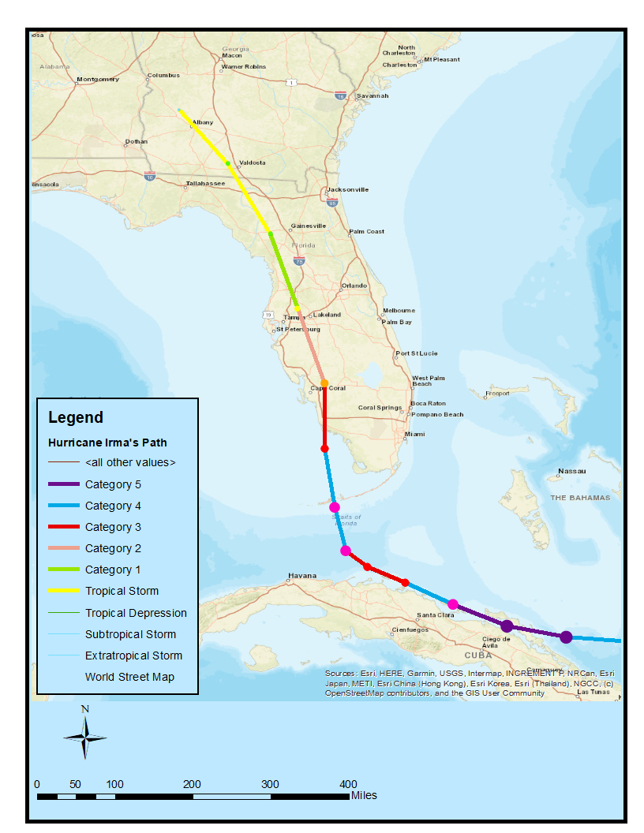

Figure 3.2: Evacuation orders caused by Hurricane Irma, Florida
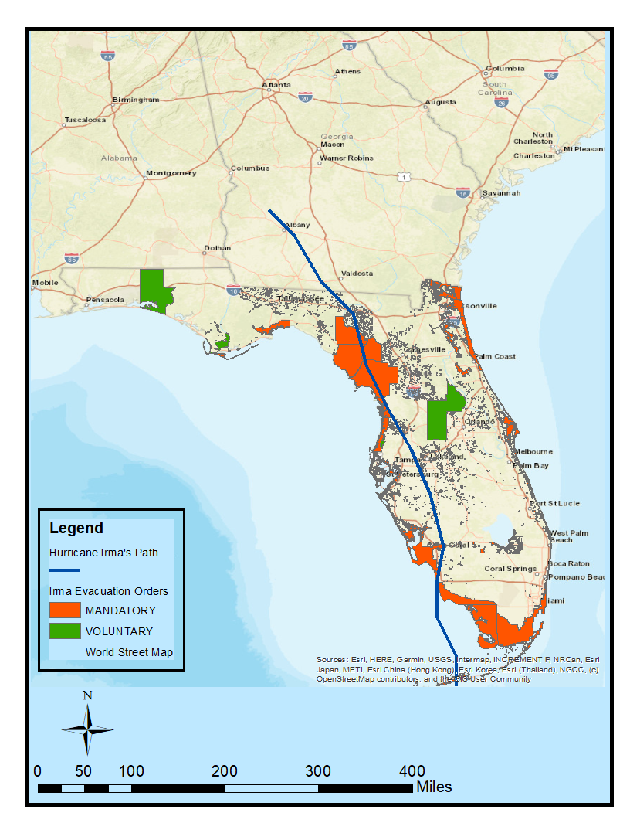

Figure 3.3: Economic losses for buildings by census tract
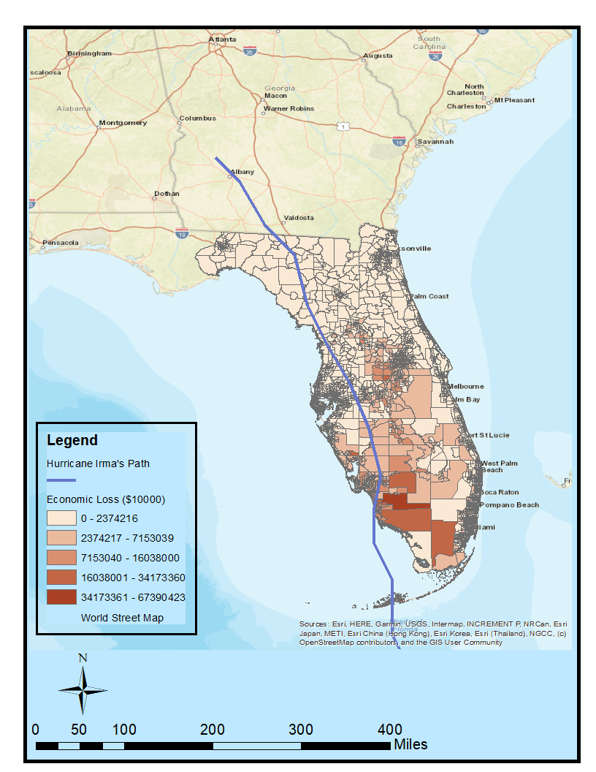

Figure 3.4: Live births over the period of 2016-2018, Florida
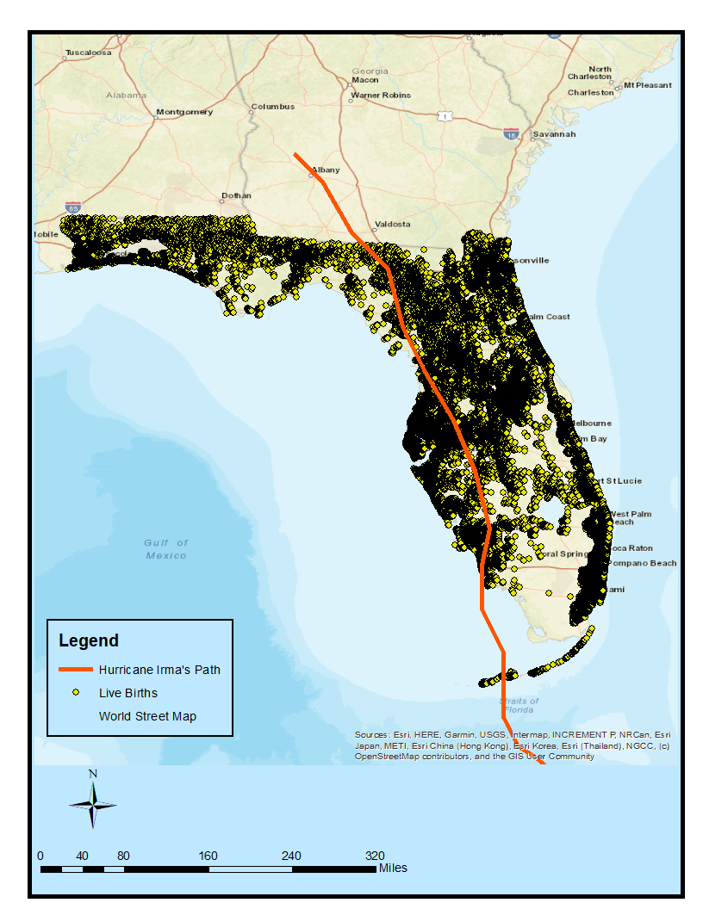

Figure 3.5: Hurricane Irma – peak wind gusts (mph) by census tract, Florida
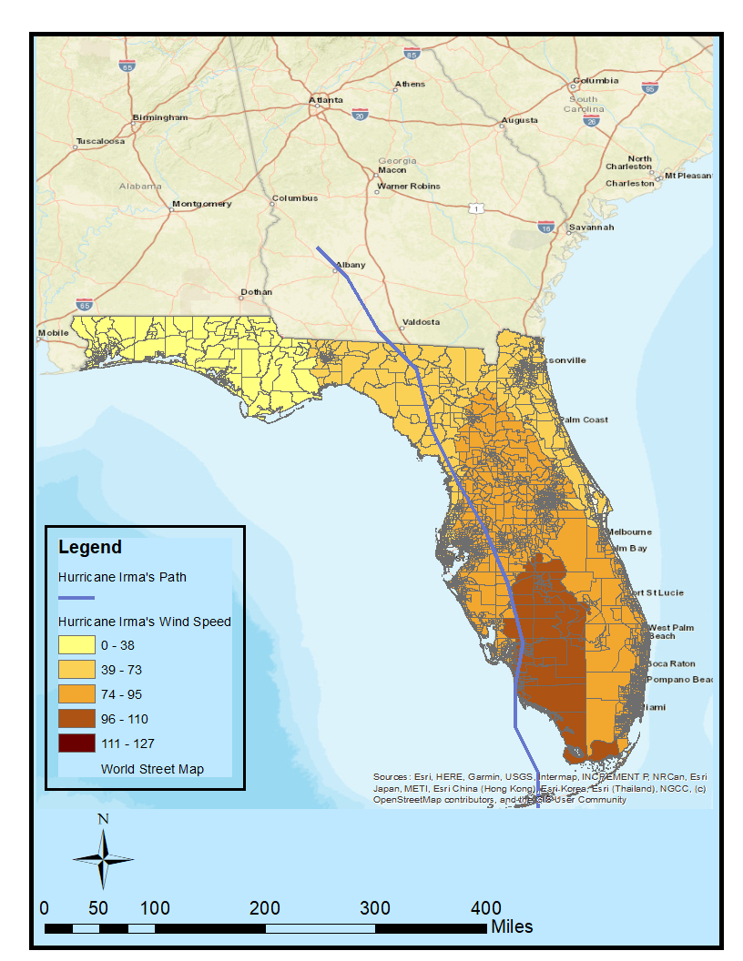

CHAPTER 4
Hurricane Induced Power Disruptions: Households’ Preferences for Improving Infrastructure Resilience
4.1 Introduction
Hurricanes have the potential to cause substantial damage and disruptions to the public utility systems, including electricity, transportation, telecommunications, as well as drinking water and wastewater infrastructures due to high wind, storm surge, heavy rain, and flooding (Kwasinski et al. 2006; Campbell, 2012; Sajadi Bami, 2019). Hurricane-induced winds and rainfall cause power interruptions to a large number of customers. The duration of the hurricane-induced power outage (which can last a few hours to several days depending on the severity of the hurricane) can have substantial impacts on businesses and manufactures, transportation, water supply, healthcare, emergency aids and services, and on the affected communities as a whole (Campbell, 2012; FEMA 2017; Zimmerman et al. 2017).
It is evident that the U.S. economy loses in the range of $20 to $55 billion yearly from hurricane-related power outages, and it is reported that the trend of the extreme weather-induced electricity outage is rising (Campbell, 2012). Furthermore, extreme weather events like hurricanes can disrupt the electricity required to operate drinking water treatment and wastewater systems, and as a result, it could create a serious potable water supply crisis (Duffy, 2013; Zimmerman, 2017; Matthews, 2016). Hurricanes can also cause severe damage to roads, bridges, as well as road closure by hurricane-induced flooding, fallen tree, and downed electricity distribution lines, which can slow down the repairing process and make the transportation services almost unattainable. Finally, hurricanes can damage telecommunication networks through hurricane-induced power outage, causing disruption to access telephone, internet services, and consequently may disrupt the communication with those who need urgent aid or medical care (Kwasinski et al. 2006).
Florida has been hit by some of the most deadly and destructive hurricanes in the past few years. On average, Florida would be hit by at least one hurricane every two years and by a major hurricane every four years (Malmstadt et al. 2009). In 2004, Florida was impacted by four major Hurricanes, including Charley, Frances, Ivan, and Jeanne, and it was impacted by two major Hurricanes, Dennis and Wilma, in 2005 (Baker, 2011). Hurricane Wilma was one of the most destructive hurricanes after Hurricane Katrina in 2005. It made several landfalls and had a destructive impact on Florida, causing more than 3 million electricity outages (Chatterjee and Mozumder, 2015). Hurricane Wilma was ranked the third costliest storm in U.S. history by causing damage estimated at more than $20 billion U.S. dollars (Chatterjee and Mozumder, 2015). Most recently, hurricanes hit Florida in 2016 and 2017. In 2016, Florida was hit by Hurricanes Hermine and Matthew, and in 2017 by Hurricane Irma (Florida Public Service Commission, 2018). Hurricane Irma struck the Florida Keys and southeastern Florida on September 10, 2017, as Category 3 and 4 hurricanes, respectively. The hurricane-related high-speed wind and heavy rainfall left 6.5 million customers without electricity, disrupted access to potable water, and cost an estimated $50 billion damage in the U.S. This has made Hurricane Irma the fifth costliest hurricane in U.S. history (Issa et al., 2018; Cangialosi et al., 2018).
Considering the current risk, where the critical infrastructure is vulnerable to extreme weather events more than ever (due to the increased intensity and frequency of natural disasters in the last few years), it is crucial to consider resilience as a vital factor to protect public infrastructure (National Infrastructure Advisory Council (NIAC), 2009). The definition of resilience is multidimensional, and several factors need to be considered for its quantification (Alam et al., 2019). There is no unique definition for resilience in the literature. Based on Lizarraga (2013), the definition of resilience is a function of the type of analysis (e.g., community resilience, infrastructure resilience), type of disruption (natural disasters, manmade), types of strategies (preparation, response, recovery, mitigation), and goal of usage (evaluation of mitigation, improvement in response). To define critical infrastructures resilience, three factors need to be considered: robustness (defined as the capacity to maintain the critical operations when confronted with disasters), resourcefulness (defined as the capacity to respond and cope with the disaster as it expands), quick recovery (defined as the capacity to go back to normal operations as soon as possible after an interruption caused by a crisis) (NIAC, 2009).
To define infrastructure resilience, the NIAC (2009) formed the following definition:
“Infrastructure resilience is the ability to reduce the magnitude and/or duration of disruptive events. The effectiveness of a resilient infrastructure or enterprise depends upon its ability to anticipate, absorb, adapt to, and/or rapidly recover from a potentially disruptive event.”
In response to the impact of climate change and extreme weather events on critical infrastructure, necessary plans and actions have been taken to improve the resilience of critical infrastructure (such as electricity infrastructure) in the past few years. Following the 2004 and 2005 hurricane seasons, the Florida Public Service Commission adopted several programs to strengthen Florida’s electric infrastructures (including hardening of electrical transmission and distribution lines, vegetation management, placing the electrical distribution and transmission lines underground) to reduce hurricane damage, reduce the restoration costs, reduce the restoration time, and improve the reliability of facilities for the customers (Campbell, 2012; Florida Public Service Commission, 2008 &2018). The Commission also requested investor-owned electric utilities (IOU) to renew hurricane hardening strategies and report those updated plans to the Commission every three years. These hardening plans over the past few years have become a path for improving the electric infrastructure resilience. The 2016 and 2017 hurricane seasons have enabled the Commission to check whether the hardening plans were effective. In 2018, based on the information submitted by IOUs, the Commission reported that the hardened utilities worked better than non-hardened utilities (Florida Public Service Commission, 2018). Finally, in October 2019, Strom Protection Plans (SPP) cost recovery Bill 786 passed by the Florida legislature, and the legislation signed into law by Gov. Ron DeSantis. Accordingly, the Florida Public Service Commission requires IOUs to develop 10-year restoration plans, which need to be updated on a regular basis. In fact, SPPs continue the strategies that have been performing by IOUs over the past few years (since 2004-2005 hurricane seasons) to improve the resilience of electricity infrastructures (Walton, 2020). Regulators approved that SPPs provide benefits to electricity customers since the plans continue to improve the resilience of electricity infrastructure to reduce the duration of power outages, restoration costs related to storms and hurricanes.
However, most of these resilience strategies come with high costs, which need to be adjusted to the perceived benefits. Given the resilience strategies for electricity infrastructures mentioned earlier in Florida, little is known about Floridians’ preferences for improvement in the resilience of electricity systems in response to hurricanes. Thus, it is important that decision makers recognize the community support for the resilience of electricity infrastructures programs to be able to plan their resilience strategies according to households’ preferences and create pricing plans to bring in enough profits for funding future resilience projects (Price et al., 2019). In other words, understanding how much people value the resilience strategies assists in making decisions on investing in resilience systems. In fact, public’s willingness-to-pay (WTP) is a key factor in determining how much investment in the resilience of electricity infrastructure will be accepted by the customers (Baik et al., 2020).
4.1.1 Scope of the study
This paper aims to analyze public preferences for improvement in the resilience of electricity infrastructures to extreme weather events in Florida. More specifically, we use data from discrete choice experiments (DCE) (a monetary valuation technique) embedded in the “household survey on the socioeconomic, health, political and environmental aspects of Hurricane Irma in Florida.” The DCE is a stated preference technique that evaluates the respondents’ preferences for non-market goods and services. In this case, the DCE is implemented through an online survey and focuses on improving the resilience of electricity infrastructure systems to extreme weather events.
Following NIAC (2009), we define resilience as reducing the duration of disruptive events, which are power outages caused by hurricanes in our case. The contributions of this study are as follows. First, to our knowledge, this is the first study that applies the DCE approach to investigate the households’ willingness to pay for improving the resiliency of power infrastructures in response to extreme weather events in one of the most hurricane-prone areas in the U.S. Second, this paper fills the gap in the existing literature to help devise the decision criteria for more effective investment for improving the resilience of critical public infrastructure in response to coastal hazards and vulnerabilities in the State of Florida.
4.2 Literature review
The non-market valuation techniques for estimating households’ preferences (WTP) fall into two main categories: stated preference and revealed preference approaches. In the revealed preference approach, the WTP for improvement in public services (e.g., electricity) can be estimated using data on expenditure spent on goods associated with the corresponding public service. The stated preference methods (e.g., contingent valuation (CV) method and discrete choice experiment (DCE) method) are based on survey-based techniques that use hypothetical scenarios to quantify WTP for improvement in public utilities. While the CV method has been used broadly in the literature, the DCE method is becoming increasingly popular since it allows us to incorporate different alternative choice attributes related to the good or service and quantify the public preferences for each attribute (Ozbafli and Jenkins, 2016).
4.2.1 Reliability of electricity services
There is a strand of literature investigating the households’ WTP and manufacturing firms’ WTP for improvement in reliability of electricity supply to avoid power outages (either short term or long term) using both CV and DCE approaches (Morrissey et al., 2018; Ozbafli and Jenkins, 2016; Sagebiel, 2017; Amoah et al., 2019; Morrison and Nalder, 2009; Ghosh et al., 2017; Kim et al., 2018; Carlsson et al., 2020). Another strand of studies examined the households’ preferences to participate in programs that promote sustainable energy systems or limit peaks in electricity consumption (Srivastava et al., 2020; Mengelkamp et al., 2019). To gain an understanding of how climate change would impact the costs of power outages, Cohen et al. (2018) investigated the effect of global warming on households’ WTP for avoiding power outages across nineteen European countries using a DCE method. Their findings indicate that households’ WTP for uninterrupted power supply is strongly associated with the local temperature. Households are willing to pay more for winter outages than summer outages. However, as global warming intensifies, the WTP for avoiding the summer outages will increase, and WTP for interrupted power supply will decrease in the winter season.
However, very few studies have been conducted to investigate the public’s preferences for improvement in the resilience of critical infrastructure to extreme weather events (Price et al., 2019; Wang et al., 2018; Baik et al., 2020). Price et al. (2019) examined public preferences for improvement in water infrastructures to mitigate the risk of flood events and water outages in Canada. They used two separate DCEs: a flood risk DCE (which evaluates the public’s preferences for improvement in the infrastructures to mitigate the risk of flood events), and water interruption risk DCE (which evaluates public’s preferences for improvement in the infrastructures to reduce the risk of water outages). Each choice set consists of two alternatives, including the status quo option and the hypothetical program option, where each alternative contains several attributes and their related levels. The six attributes of flood risk DCE are: type of facilities (engineering or green infrastructures); cost of the program; annual percentage risk of basement flooding, street flooding, flood-induced power outage, and flood-induced boil water advisory. Similarly, the five attributes of water interruption risk DCE are: short-term water interruption, long-term water interruption, a boil water advisory, type of facilities, and cost of the program. Using the random-effects probit model, they found that households are willing to pay for a policy program that mitigates the flood risks and the water outage risk substantially than modestly. However, they found considerable heterogeneity across the regions and different sociodemographic groups; that is, residents in rural areas and those living in regions with higher housing value have higher WTPs for the policy programs. In a similar study, Baik et al. (2020) investigated the customers’ WTP for improvement in the resilience of electricity services to very cold winters induced by climate change using a CV model, where resilience is defined as providing back-up power services during long-term power outages. Their findings indicate that customers (i.e., households living across the northeast of U.S.), are willing to pay more to support social power backup services than sustaining their own private backup services.
The most relevant study conducted by Wang et al., (2018) quantified public preferences for improvement in the resilience of transportation systems to extreme weather events, where resilience is described as reduced time in restoring the disrupted transportation system. They used the DCE method to gain insight into the households’ preferences for flood risk reduction induced by hurricanes in New York City under a specific payment mechanism. The DCE consists of two hypothetical scenarios of improvement in the resilience of transportation infrastructures and a status quo scenario. These scenarios are differentiated based on the improvement in operative levels of the transportation system in 1-2 days, 3-5 days, 1 week, and 2 weeks. Using different types of mixed logit models, they found that respondents’ WTP ranges from $75 to $775, suggesting that there is positive support for funding resilience programs in transportation systems in New York City.
Following Wang et al. (2018), our study investigates the customers’ preferences for improvement in the resilience of electricity infrastructures to hurricanes in Florida. In this regard, by applying a DCE approach, we examine whether Floridian customers support the funding resilience programs in electricity infrastructures, where resilience in our study is defined as the reduced time in repairing and restoring the interrupted electricity services. To estimate our model, we use a mixed logit model, which allows us to control for preference heterogeneity.
4.3 Discrete Choice Experiment
Discrete choice experiments have been applied first in transportation and marketing disciplines to investigate tradeoffs between different attributes of transportation projects and private goods, respectively. They have also been employed in environmental economics to value non-market goods and services (Alpizar et al., 2001). Adamowicz et al. (1994), Boxall et al. (1996), Adamowicz et al. (1998), Adamowicz et al. (1997), and Hanley et al. (1998) were the first studies that applied DCE to investigate various environmental management issues.
In DCEs, respondents are provided several choice sets containing a number of hypothetical alternatives. Each alternative consists of several attributes with different corresponding levels (such as combination levels of price attribute, which allows us to estimate the marginal WTP for each attribute in the choice sets). The respondents are asked to select an alternative among several proposed alternatives in a choice set that they prefer most. In fact, by making a choice, respondents make trade-offs between different levels of attributes in the proposed alternatives in each choice set (Alpizar et al., 2001).
The DCEs possess several advantages compared to other valuation techniques: first, the DCE method allows us to identify the marginal value of each attribute of an environmental good, which may be difficult to find using revealed preference data (due to collinearity or invariability). Second, the DCE method alleviates estimating the values of attributes that compose an environmental good or service. This is very vital for policy analysis since it usually focuses on the changing attribute levels of environmental goods and services. However, the CV method is more capable of analyzing the loss or gain of an environmental good altogether. Third, the DCE method avoids the “yea-saying” bias in the CV method since individuals are not asked to make a choice on an all-or-nothing basis. Instead, in the DCE method, respondents are asked to select one of two alternatives or a status quo alternative in each choice set. Finally, in the DCE method, respondents receive several choice sets, which give them repeated chances to reveal their preferences (Hanley et al., 1998).
The response to the choice between three choice alternatives can be demonstrated in a Random Utility Maximization (RUM) framework. The RUM model is based on the hypothesis that respondents know and are certain about their utility, but researchers are not able to capture and detect the respondents’ utility. Thus, there exist unobservable factors in the random error term. The overall utility that respondent $k$ obtains from selecting alternative $i$ on choice set $t$ can be written as (Ropars-Collet et al., 2017; Holmes et al., 2017):
$U_{kit}=V_{kit}+ε_{kit}=β_{k}^{ˊ}x_{kit}+ε_{kit} k=(1, …, N)$ (4.1)
Based on Eq. (4.1), the utility is the sum of systematic component $(V)$ and random component $(ε)$ for respondent $k$. In Eq. (4.1), $β_{k}$ is a vector of respondent $k$ preference parameters; $x_{kit}$ represents a vector of attributes related to respondent $k$ and alternative $i$ on choice set $t$; $ε_{kit}$ is the error term, which is presumed to be independently and identically distributed (IID).
The underlying assumption in applying a RUM model is that error terms are independently and identically distributed (IID). This assumption induces a logistic distribution, leading to the multinomial logit model (Holmes et al., 2017). The multinomial logit model (MNL) can be implemented by assuming that a choice set in the DCE contains N alternatives (i = 1, …, N), and the error term is IID extreme value distributed. Accordingly, the likelihood of respondent $k$ selecting alternative $i$ on choice set $t$ is given by:
$P_{kit|β}= \frac{\exp{(β_{k}^{ˊ}x_{kit})}}{\sum_{i=1}^{I}{exp⁡(β_{k}^{ˊ}x_{kit})}}$ (4.2)
The multinomial logit model is popular for its simplicity in terms of estimation; however, there exist two limiting assumptions on the MNL models. First, the alternatives are independent; second, there are restrictions in modeling of variation in taste among respondents. The first issue occurs because it is assumed that the error term is IID extreme value distributed, causing the independence of irrelevant alternatives (IIA) property (which states that changes in alternatives in a choice set do not affect the ratio of chances of choosing between two alternatives in the choice set). If the aforementioned assumption is not satisfied, the MNL model should not be applied. The second issue with the MNL model is dealing with the observed and unobserved heterogeneity. The observed heterogeneity can be included in the model by introducing the interaction terms of sociodemographic characteristics and attributes. However, the IID assumption is so restrictive with regard to unobserved heterogeneity (Alpizar et al., 2001; Holmes et al., 2017).
The MNL model can be generalized to more advanced modeling to overcome its limitations, such as identifying preference heterogeneity (Holmes et al., 2017). The mixed logit (ML) model (also known as random parameters logit) is an extension of the MNL model, which assumes that parameters can vary randomly across respondents. Also, it explicitly accounts for correlation across repeated choices by each respondent (Revelt and Train, 1998). The ML possibility of selecting alternative $i$ for respondent $k$ can be defined as the integral of conditional (standard logit) probability over the distribution of $β$ (Train, 1998):
$P_{ki|θ}= \int{P_{ki|β}}.f\left(β|θ\right).dβ$ (4.3)
Where $f\left(β|θ\right)$ is the density function; $θ$ is a vector of parameters of the distribution.
The goal of DCE is to quantify levels of tradeoffs between attributes in a choice set and to use the measures to assess the respondents’ WTP for a change in levels of attributes while respondents remain better off after the change like before the change. Indeed, DCE allows us to estimate WTP for gain or loss for any combination of alteration in levels of attributes by providing estimates of indirect utility function (Holmes et al., 2017).
The WTP for a marginal change in attribute level of parameter $A$ can be measured as the negative ratio of parameter for the attribute $A$ ($β_{A})$ to parameter for the price attribute ${(B}_{p})$ (Holmes et al., 2017):
${MWTP}_{A} = -\frac{β_{A}}{B_{p}}$ (4.4)
Where $β_{A}$ denotes the marginal utility of attribute $A$, and $B_{p}$ denotes the marginal utility of income for respondent $k$. Indeed, the marginal WTP (which is also known as implicit price) displays how much respondents are willing to pay to sacrifice for a marginal change in the attribute (Ropars-Collet et al., 2017; Holmes et al., 2017).
4.3.1 Discrete Choice Experiment design
To design the DCEs, we select five attributes to define the understudied services (which are the resilience of electricity infrastructures in our case) and their corresponding levels. It is worth highlighting that the attributes and their levels were selected after consultation with the experts from the electricity sectors and following the limited existing literature. Following Wang et al. (2018), our choice sets contain two hypothetical alternatives of improvement in the resilience of electricity infrastructures (option A and Option B) and the status quo alternative, where resilience is defined as the reduced time in restoring the disrupted electricity infrastructures and providing the services to the higher percentage of customers. Our four attributes include improvement in the resiliency of electricity infrastructures in terms of the percentage of electricity customers receiving the service 1-2 days, 3-5 days, 1 week, and 2 weeks after a strong hurricane like Hurricane Irma. The two hypothetical alternatives of improvement in the resilience of infrastructures need a funding mechanism. In this regard, we asked the respondents to suppose that Florida State Government is proposing State “Power Resiliency Fund” (PRF) to support and improve the resiliency of electricity infrastructures to hurricanes. Using PRF, the State Government will be able to minimize the electricity infrastructure damages, outages/disruption, and recovery time for the customers in the future. Under hypothetical annual payment, we asked the respondents whether they are willing to support PRF by paying specific amount of money (depending on the alternatives and their attribute levels) which will be added to their annual electricity bill for 10 years (see appendix for more information). Table 4.1 presents the attributes and their corresponding levels applied to design the choice sets.
In this paper, by employing a Bayesian D-optimal design, we generated 16 electricity choice sets, using diverse combinations of resilience electricity attributes levels. Since DCE models are nonlinear in their parameters, the efficacy of the DCE design hinges on the unknown parameters. Thus, a more sensible approach to overcome the nonlinear design issue is to build partial profile designs by applying the Bayesian design method. The Bayesian design methodology optimizes the DCE design over a prior distribution of possible parameter values. In such a way, it deals with the uncertainty regarding the specified parameters into the problem framing (Kessels et al., 2011). We split the 16 electricity choice sets into 8 surveys, where each respondent receives 1 survey of 2 choice sets from the electricity design randomly. The Bayesian D-optimal design was created by JMP 14 software. Figure 4.1 depicts a sample of hypothetical electricity choice set shown to the respondents.
4.4 The survey and data collection

The survey comprised three sections. Section one provides an introduction about the goal of the questionnaire to respondents. It also consists of a set of questions to collect the socioeconomic characteristics (including age, ethnicity, level of education, gender, marital status, political identity, household income) of the respondents. Section two aimed to identify the respondents’ experience of Hurricane Irma and the evacuation decision. The third section focused on the utility disruptions and concerns about future hurricanes. Also, it provides information about electricity funding mechanisms employed to improve the resilience of electricity infrastructure to withstand hurricane risks (see appendix). In section three, the electricity choice sets were presented to respondents along with a series of questions regarding their WTP to improve the resilience of electricity infrastructures. The questionnaire was distributed online through the Qualtrics platform and was launched from September 2020 until early December 2020. A 400-response pilot was run in September 2020, and the 1429 responses were collected as the main study population in December 2020. The 1429-person survey was determined by Qualtrics to be representative of the Floridian adult population (starting from eighteen years old individuals). It is worth mentioning that the survey was disseminated during the hurricane season in Florida in 2020. The results may or may not be the same if the survey is launched during the non-hurricane season. The respondents may update their hurricane risk perceptions during a hurricane season which may lead to change their preferences for improving the infrastructure resilience.
Across the 16 electricity choice sets shown to the respondents, 34%, 44%, and 22% of respondents chose plan A, plan B, and plan status quo, respectively, showing that respondents prefer plan B over plan A and plan status quo (the attribute choice frequency for each power choice set is reported in Table 4.2). The descriptive statistics of the sample are presented in Table 4.3. As Table 4.3 depicts, 58% of respondents were female, and 38% of them fall in the age of 30 – 45 years. Moreover, more than 40% of the respondents had education attainment more than a bachelors’ degree. More than 40% of the respondents had an average net annual income level between $42,000-$96000.
4.5 Discrete Choice Experiment results
We estimated the panel mixed logit model using the Hierarchical Bayes method (in the JMP Pro 15 software) to elicit the respondents’ marginal utility obtained from choosing an alternative of improvement in the resilience of electricity infrastructures.The panel mixed logit model deal with the heterogeneity across respondents’ preferences since it assumes that preference parameters vary randomly across respondents (Mouter et al., 2021).
4.5.1 Results from the electricity choice sets
Four different panel mixed logit models are estimated, and the parameter estimates are presented in Table 4.4. In Model 1 (in Table 4.4), only the attributes and alternative variables are included. Models 2-4 are the extended Model 1, but account for the preference heterogeneity through assessing the impact of sociodemographic characteristics.
In Model 1, the payment estimate is negative and significant, indicating that the respondents are less likely to support for funding the resilience program in electricity infrastructures if its cost is higher. The coefficients of improvement in power service restored within 4-6 days after a hurricane, improvement in power service restored within 1 week after a hurricane, and improvement in power service restored within 2 weeks after a hurricane are significant with positive signs. However, the coefficient of improvement in power service restored within 2 weeks after a hurricane is higher in magnitude compared with that of other attributes, indicating that the respondents are not mainly concerned with restoring the power immediately. The reason could be that residents in Florida assume that even by improving the resilience of power infrastructures, the power restoration would stretch out for some time after a major hurricane. Moreover, in Model 1, option A was found to be positive and significant, suggesting that either respondents prefer selecting option A compared to option status quo or that respondents did not consider the status quo option as an appealing alternative.
Model 2 (in Table 4.4) is the extended model assessed through interacting the variable payment with respondents’ sociodemographic characteristics, including income and gender. The coefficients of attributes including payment, improvement in power service restored within 1 week after a hurricane, improvement in power service restored within 2 weeks after a hurricane are found to be significant with anticipated signs and higher in magnitude compared to Model 1, suggesting that controlling for sociodemographic factors have increased the magnitude of the effect of attribute levels except for Improvement in power service restored within 4-6 days after a hurricane. The coefficient of the interaction term payment *income [3] was found to be positive, significant, and has a higher magnitude than interaction terms payment *income [1] and payment *income [2], indicating that respondents with higher income were more likely to pay more for the resilience plans. Similarly, the coefficient of payment*gender is positive and significant, suggesting that male respondents were more likely to be willing to pay more to support for funding the resilience of power infrastructures plans, which indicates that male respondents care comparatively more about pricing while the non-pricing factors might be more important for female respondents. This could be related to the fact that based on our results, 21.6% of male respondents earned more than $96,000 annually, whereas only 7.82% of female respondents earned a base salary of $96,000. Lastly, the coefficient of option A was found to be positive and significant as Model 1, but with a higher magnitude, indicating that respondents’ utilities would increase by selecting option A compared to the status quo option.
In Model 3 (in Table 4.4), the interactions of sociodemographic characteristics, including gender and age with payment, the interaction of age with improvement in power service restored within 2 weeks after a hurricane, and the interaction of education with improvement in power service restored within 1 week after a hurricane are included. Like Model 2, the coefficient of payment*gender is positive and significant. The coefficients of the interaction terms between payment and age levels suggest that younger respondents were more likely to be willing to pay more for supporting the resilience program. Moreover, the coefficients of interaction terms between improvement in power service restored within 1 week after a hurricane and education attainment levels indicate that educated people are more likely to choose the Improvement in power service restored within 1 weeks after a hurricane, which as we mentioned earlier, could imply that even educated respondents are not mainly concerned with restoring the power as quickly as possible since they may assume that power restoration would take at least a week even after improvement in the resilience of power infrastructures. The coefficient of interaction term Improvement in power service restored within 2 weeks after a hurricane*age [3] is positive, significant, and higher in magnitude compared with that of other interactions between other age levels and Improvement in power service restored within 2 weeks after a hurricane variable. It may suggest that older respondents are more likely to choose the Improvement in power service restored within 2 weeks after a hurricane since they might exhibit lower concerns regarding the resilience program.
In Model 4 (in Table 4.4), besides including the interaction terms payment*age and payment*gender, the interaction terms between alternatives (i.e., option A and option B) and income levels were included as well, in order to further examine the impact of income on choosing between Option A and option B over status quo option. The coefficients of option A*income [3] and option B*income [3] are positive, significant, and higher in magnitude compared with that of other interactions terms between options (A and B) and income levels, indicating that high-income level may have contributed positively to respondents’ decisions to choose option A and option B over option status quo. Moreover, in Model 4, like Model 3, the interaction terms between payment and age levels suggest that younger respondents are more likely to pay more to support for funding the power resilience program.
4.5.2 WTP and economic values for resilience programs in the electricity infrastructures
Table 4.5 presents the marginal willingness to pay (MWTP) valuations for each attribute level of improvement in the resilience of electricity infrastructures. The calculations are made based on Model 1 (in Table 4.4) of power design. The results in Table 4.5 show that the average household is willing to pay $128.06 for improvement in the power service restored within 4-6 days after a strong hurricane, $229.05 for improvement in the power service restored within 1 week after a strong hurricane, $252.85 for improvement in the power service restored within 2 weeks after a strong hurricane, and $287.95 for choosing Option A.
The economic value for improvement in the resilience of power infrastructures programs can be calculated by assuming that our sample size is representative of Florida’s population. By capturing over all households residing in Florida in the next 10 years, the economic values for improvement in the resilience of electricity infrastructures plan are approximately $11 billion for improvement in the power service restored within 4-6 days after a strong hurricane, $19.6 billion for improvement in the power service restored within 1 week after a strong hurricane, $21.7 billion for improvement in the power service restored within 2 weeks after a strong hurricane, and $24.7 billion for choosing option A.
4.6 Conclusion
Sea level rise (which is likely to induce storm surge and heatwaves), strong hurricanes, and growing population has threatened Florida coastal infrastructures more than ever in the past few years. To face these challenges, projects and funding have been implemented to improve the resilience of electricity infrastructure through enhancing the recovery of disrupted utilities. However, having empirical knowledge on the influence and execution of the infrastructure resilience programs from the residents’ perspectives could help decision makers to improve decision making through human-centered strategies, which could result in more robust and more effective resilience community decision making (Taeby and Zhang 2019).
In this study, a Discrete Choice Experiment was conducted to analyze households’ preferences (through estimating panel mixed logit models) and measure the economic value for improving the resiliency of electricity infrastructure plans in Florida. Our DCE survey was administered in September 2020, and 1429 responses were collected as the main study population. Our empirical results of power choice design showed that respondents are most driven by restoration in power service 2 weeks after a hurricane, which may suggest that households in Florida assume that power restoration would take at least 2 weeks even after implementing the power resilience program. However, the respondents prefer improvement in resilience option A over option status quo, indicating that there is public support for improvement in the resilience of critical infrastructures programs. Also, younger, male, and high-income respondents were found to be willing to pay more for supporting the resilience programs.
Some policy implications can be derived from the results. First, the findings of the households’ preferences regarding public infrastructure resilience programs should be emphasized in order to help decision makers to establish more efficient and cooperative resilient decision making through prioritizing and embodying households’ perspectives when planning and executing the resilience strategies. Second, based on the results, the high-income respondents were more likely to pay for supporting funding for resilience programs in electricity infrastructures, suggesting that income inequality could be a major issue for implementing effective resilience plans. Accordingly, it is crucial to pay attention to vulnerable social groups by providing some exceptions such as discounts and aids when implementing the infrastructure resilience plans.
This study has made a very important contribution to the literature. It has enhanced the limited number of choice modeling studies for analyzing public preferences for the resilience of critical public infrastructures. To our knowledge, this is the first study to analyze the improvement in the resilience of electricity infrastructures in response to extreme weather events. Though the study focuses on enhancing the resilience of power infrastructure to hurricane risks in Florida, the method can be extended elsewhere for improving resilience to this and other types of hazards and extreme events.

4.7 Appendix
Improvement of Electricity Infrastructures Resilience in Florida:
Florida has been hit by some of the most deadly and destructive hurricanes in the past few years. On average, Florida would be hit by at least one hurricane every two years and by a strong hurricane every four years. Hurricane Irma was one of the most destructive and the costliest hurricanes in U.S. history. It struck the Florida Keys and southeastern of Florida on September 10, 2017 as Category 4 hurricane, causing millions of customers to experience electricity outage and water supply disruption in the state during and after the hurricane and caused $50 billion in property damage.
In this regard, SUPPOSE that the Florida State Government is proposing State “Power Resiliency Fund” (PRF). These funds will be managed at the state level and will mobilize resources countrywide to support and improve the resiliency of electricity infrastructures to hurricanes. Using “PRF”, the State Government will be able to minimize the electricity infrastructure damages, outages/disruptions, and recovery time for customers in the future. Against this backdrop, would you be willing to support “PRF” by paying specific amount of money which will be added to your annual electricity bill for 10 years?
Now, you have options that will ensure quick restoration of electricity supply after a hurricane.
Option “A” provides faster restoration of electricity supply compared to Option “Current Situation”, and Option “B” allows even faster restoration than Option “A”. Remember If you choose neither Option “A” nor Option “B”, means you are supporting Option “Current Situation” (Opt-Out Option).
Please select the option that you prefer most for each of the two sets of scenarios presented (see Figure 4.1).

REFERENCES
Adamowicz, W., Louviere, J., & Williams, M. (1994). Combining revealed and stated preference methods for valuing environmental amenities. Journal of Environmental Economics and Management, 26(3), 271-292.

Adamowicz, W., Boxall, P., Williams, M., & Louviere, J. (1998). Stated preference approaches for measuring passive use values: choice experiments and contingent valuation. American Journal of Agricultural Economics, 80(1), 64-75.

Adamowicz, W., Swait, J., Boxall, P., Louviere, J., & Williams, M. (1997). Perceptions versus objective measures of environmental quality in combined revealed and stated preference models of environmental valuation. Journal of Environmental Economics and Management, 32(1), 65-84.

Alam, M. M., Tokgoz, B. E., & Hwang, S. (2019). Framework for measuring the resilience of utility poles of an electric power distribution network. International Journal of Disaster Risk Science, 10(2), 270-281.

Alpizar, F., Carlsson, F., & Martinsson, P. (2001). Using choice experiments for non-market valuation. Working papers in economics/Göteborg University, Dept. of Economics; no. 52.

Amoah, A., Ferrini, S., & Schaafsma, M. (2019). Electricity outages in Ghana: Are contingent valuation estimates valid? Energy Policy, 135, 110996.

Baker, E. J. (2011). Household preparedness for the aftermath of hurricanes in Florida. Applied Geography, 31(1), 46-52.

Baik, S., Davis, A. L., Park, J. W., Sirinterlikci, S., & Morgan, M. G. (2020). Estimating what US residential customers are willing to pay for resilience to large electricity outages of long duration. Nature Energy, 5(3), 250-258.

Boxall, P. C., Adamowicz, W. L., Swait, J., Williams, M., & Louviere, J. (1996). A comparison of stated preference methods for environmental valuation. Ecological Economics, 18(3), 243-253.

Campbell, R. J., & Lowry, S. (2012, August). Weather-related power outages and electric system resiliency. Washington, DC: Congressional Research Service, Library of Congress.

Cangialosi, J. P., Latto, A. S., & Berg, R. (2018). National Hurricane center tropical cyclone report: Hurricane Irma. National Oceanic and Atmospheric Administration. Report no. AL112017.

Carlsson, F., Demeke, E., Martinsson, P., & Tesemma, T. (2020). Cost of power outages for manufacturing firms in Ethiopia: A stated preference study. Energy Economics, 88, 104753.

Chatterjee, C., & Mozumder, P. (2015). Hurricane Wilma, utility disruption, and household wellbeing. International Journal of Disaster Risk Reduction, 14, 395-402.

Cohen, J., Moeltner, K., Reichl, J., & Schmidthaler, M. (2018). Effect of global warming on willingness to pay for uninterrupted electricity supply in European nations. Nature Energy, 3(1), 37-45.

Duffy, M. (2013). The Value of Water. American Water Works Company, Inc. age, 23(11).

Federal Emergency Management Agency (FEMA), 2017. Power outage incident annex to the response and recovery federal interagency operational plans: managing the cascading impacts from a long-term power outage. Retrieved March 2018 from: https://www.fema.gov/media-library/assets/documents/154058

Florida Public Service Commission, (2008). Report to the Legislature on Enhancing the Reliability of Florida’s Distribution and Transmission Grids During Extreme Weather (Update to July 2007 Report). Retrieved from: http://www.psc.state.fl.us/Files/PDF/Utilities/Electricgas/EnergyInfrastructure/UtilityFilings/docs/AddendumSHLegislature.pdf

Florida Public Service Commission, (2018). Review of Florida’s electric utility hurricane preparedness and restoration actions, 2018. State of Florida. Retrieved from: http://www.floridapsc.com/Files/PDF/Publications/Reports/Electricgas/UtilityHurricanePreparednessRestorationActions2018.pdf

Ghosh, R., Goyal, Y., Rommel, J., & Sagebiel, J. (2017). Are small firms willing to pay for improved power supply? Evidence from a contingent valuation study in India. Energy Policy, 109, 659-665.

Hanley, N., MacMillan, D., Wright, R. E., Bullock, C., Simpson, I., Parsisson, D., & Crabtree, B. (1998). Contingent valuation versus choice experiments: estimating the benefits of environmentally sensitive areas in Scotland. Journal of Agricultural Economics, 49(1), 1-15.

Hanley, N., Wright, R. E., & Adamowicz, V. (1998). Using choice experiments to value the environment. Environmental and Resource Economics, 11(3), 413-428.

Holmes, T. P., Adamowicz, W. L., & Carlsson, F. (2017). Choice experiments. In A Primer on Nonmarket Valuation (pp. 133-186). Springer, Dordrecht.

Issa, A., Ramadugu, K., Mulay, P., Hamilton, J., Siegel, V., Harrison, C., ... & Boehmer, T. (2018). Deaths related to Hurricane Irma—Florida, Georgia, and North Carolina, September 4–October 10, 2017. Morbidity and Mortality Weekly Report, 67(30), 829.

Kessels, R., Jones, B., & Goos, P. (2011). Bayesian optimal designs for discrete choice experiments with partial profiles. Journal of Choice Modelling, 4(3), 52-74.

Kim, D. C., Kim, H. J., & Yoo, S. H. (2018). Valuing Improved Power Supply Reliability for Manufacturing Firms in South Korea: Results from a Choice Experiment Survey. Sustainability, 10(12), 4516.

Kwasinski, A., Chapman, P. L., Krein, P. T., & Weaver, W. (2006). Hurricane Katrina: damage assessment of power infrastructure for distribution, telecommunication, and backup. Grainger Center for Electric Machinery and Electromechanics. Technical Report.

Lizarraga, S. A. (2013). The economic consequences of water utility disruptions (Doctoral dissertation, University of Missouri--Columbia). Retrieved from:
https://core.ac.uk/download/pdf/62782309.pdf

Malmstadt, J., Scheitlin, K., & Elsner, J. (2009). Florida hurricanes and damage costs. Southeastern Geographer, 49(2), 108-131.

Matthews, J. C. (2016). Disaster resilience of critical water infrastructure systems. Journal of Structural Engineering, 142(8), C6015001.

McFadden, D. (1974). The measurement of urban travel demand. Journal of public Economics, 3(4), 303-328.

Mengelkamp, E., Schönland, T., Huber, J., & Weinhardt, C. (2019). The value of local electricity-A choice experiment among German residential customers. Energy Policy, 130, 294-303.

Morrison, M., & Nalder, C. (2009). Willingness to pay for improved quality of electricity supply across business type and location. The Energy Journal, 30(2).

Morrissey, K., Plater, A., & Dean, M. (2018). The cost of electric power outages in the residential sector: A willingness to pay approach. Applied Energy, 212, 141-150.

Mouter, N., Collewet, M., de Wit, G. A., Rotteveel, A., Lambooij, M. S., & Kessels, R. (2021). Societal effects are a major factor for the uptake of the coronavirus disease 2019 (COVID-19) digital contact tracing app in the Netherlands. Value in Health.

National Infrastructure Advisory Council (NIAC), (2009). Critical infrastructure resilience final report and recommendations. Retrieved from: https://www.dhs.gov/xlibrary/assets/niac/niac_critical_infrastructure_resilience.pdf

Ozbafli, A., & Jenkins, G. P. (2016). Estimating the willingness to pay for reliable electricity supply: A choice experiment study. Energy Economics, 56, 443-452.

Price, J. I., Lloyd-Smith, P. R., Dupont, D. P., & Adamowicz, W. L. (2019). Floods and water service disruptions: eliciting willingness-to-pay for public utility pricing and infrastructure decisions. Water Economics and Policy, 5(02), 1850021.

Regier, D. A., Ryan, M., Phimister, E., & Marra, C. A. (2009). Bayesian and classical estimation of mixed logit: an application to genetic testing. Journal of Health Economics, 28(3), 598-610.

Revelt, D., & Train, K. (1998). Mixed logit with repeated choices: households' choices of appliance efficiency level. Review of Economics and Statistics, 80(4), 647-657.

Ropars-Collet, C., Leplat, M., & Goffe, P. L. (2017). Commercial fisheries as an asset for recreational demand on the coast: evidence from a choice experiment. Marine Resource Economics, 32(4), 391-409.

Sagebiel, J. (2017). Preference heterogeneity in energy discrete choice experiments: A review on methods for model selection. Renewable and Sustainable Energy Reviews, 69, 804-811.

Sajadi Bami, Fautemeh, "Water scarcity in the face of hurricanes: improving the resilience of potable water supplies in selected Florida counties" (2019). Graduate Theses and Dissertations. https://scholarcommons.usf.edu/etd/7923

Srivastava, A., Van Passel, S., Kessels, R., Valkering, P., & Laes, E. (2020). Reducing winter peaks in electricity consumption: A choice experiment to structure demand response programs. Energy Policy, 137, 111183.

Taeby, M., & Zhang, L. (2019). Exploring stakeholder views on disaster resilience practices of residential communities in South Florida. Natural Hazards Review, 20(1), 04018028.

Train, K. E. (1998). Recreation demand models with taste differences over people. Land Economics, 230-239.

Train, K. E. (2009). Discrete choice methods with simulation. Cambridge university press.

Walton, R. (2020). Florida approves utility storm protection plans; analysts advocate measures beyond undergrounding. Retrieved from: https://www.utilitydive.com/news/florida-approves-utility-storm-protection-plans-analysts-advocate-measures/583360/

Wang, C., Sun, J., Russell Jr, R., & Daziano, R. A. (2018). Analyzing willingness to improve the resilience of New York City's transportation system. Transport Policy, 69, 10-19.

Zimmerman, R., Zhu, Q., De Leon, F., & Guo, Z. (2017). Conceptual modeling framework to integrate resilient and interdependent infrastructure in extreme weather. Journal of Infrastructure Systems, 23(4), 04017034.

TABLES
Table 4.1: Attributes and their levels for improving the resilience of electricity infrastructure
Attributes | Levels
Percentage of electricity customers receiving the power service restored in 1-2 days after a strong hurricane. | 10%, 20%, 30%, 40%, 50%
Percentage of electricity customers receiving the power service restored in 3-5 days after a strong hurricane. | 20%, 30%, 40%, 50%, 60%
Percentage of electricity customers receiving the power service restored in 1 week after a strong hurricane. | 40%, 50%, 60%, 70%, 80%
Percentage of electricity customers receiving the power service in 2 weeks after a strong hurricane | 60%, 70%, 80%, 90%, 100%
Fee for improvement in the resilience of electricity infrastructure (defined as an increase in annual electricity bill) | $0, $60, $80, $100, $120, $140, $160,

Table 4.2: Frequency distribution of resilience for power infrastructure choice sets
Power Choice Set | Alternative | Freq. | Percent
Survey Version 1: Choice set 1
 | Plan A | 46 | 32.62
 | Plan B | 61 | 43.26
 | Status quo | 34 | 24.11
 | Total | 141 | 100
Survey Version 1: Choice set 2
 | Plan A | 46 | 32.62
 | Plan B | 60 | 42.55
 | Status quo | 35 | 24.82
 | Total | 141 | 100
Survey Version 2: Choice set 1
 | Plan A | 46 | 31.08
 | Plan B | 69 | 46.62
 | Status quo | 33 | 22.3
 | Total | 148 | 100
Survey Version 2: Choice set 2
 | Plan A | 53 | 35.81
 | Plan B | 60 | 40.54
 | Status quo | 35 | 23.65
 | Total | 148 | 100
Survey Version 3: Choice set 1
 | Plan A | 49 | 35.25
 | Plan B | 64 | 46.04
 | Status quo | 26 | 18.71
 | Total | 139 | 100
Survey Version 3: Choice set 2
 | Plan A | 46 | 33.09
 | Plan B | 62 | 44.6
 | Status quo | 31 | 22.3
 | Total | 139 | 100
Survey Version 4: Choice set 1
 | Plan A | 43 | 30.07
 | Plan B | 65 | 45.45
 | Status quo | 35 | 24.48
 | Total | 143 | 100
Survey Version 4: Choice set 2
 | Plan A | 64 | 44.76
 | Plan B | 56 | 39.16
 | Status quo | 23 | 16.08
 | Total | 143 | 100
Survey Version 5: Choice set 1
 | Plan A | 54 | 37.76
 | Plan B | 56 | 39.16
 | Status quo | 33 | 23.08
 | Total | 143 | 100
Survey Version 5: Choice set 2
 | Plan A | 39 | 27.46
 | Plan B | 62 | 43.66
 | Status quo | 41 | 28.87
 | Total | 142 | 100
Survey Version 6: Choice set 1
 | Plan A | 49 | 34.75
 | Plan B | 70 | 49.65
 | Status quo | 22 | 15.6
 | Total | 141 | 100
Survey Version 6: Choice set 2
 | Plan A | 58 | 41.13
 | Plan B | 53 | 37.59
 | Status quo | 30 | 21.28
 | Total | 141 | 100
Survey Version 7: Choice set 1
 | Plan A | 47 | 34.81
 | Plan B | 67 | 49.63
 | Status quo | 21 | 15.56
 | Total | 135 | 100
Survey Version 7: Choice set 2
 | Plan A | 36 | 26.67
 | Plan B | 72 | 53.33
 | Status quo | 27 | 20
 | Total | 135 | 100
Survey Version 8: Choice set 1
 | Plan A | 49 | 34.27
 | Plan B | 65 | 45.45
 | Status quo | 29 | 20.28
 | Total | 143 | 100
Survey Version 8: Choice set 2
 | Plan A | 58 | 40.56
 | Plan B | 53 | 37.06
 | Status quo | 32 | 22.38
 | Total | 143 | 100

Table 4.3: Descriptive statistics and definition of variables used in the analysis
Characteristics | Level | Mean | SD | N
Education | Education [1]: Less than a high school diploma | 0.0443 | 0.2058 | 1,138
 | Education [2]: High school degree | 0.2099 | 0.4074 | 1,138
 | Education [3]: College degree | 0.3339 | 0.4718 | 1,138
 | Education [4]: Bachelor’s degree | 0.2046 | 0.4036 | 1,138
 | Education [5]: Postgraduate degree | 0.2073 | 0.4055 | 1,138
 |  |  |  | 1,138
Age (years) | Age [1]: age>=18 & age<30 | 0.2542 | 0.4356 | 1,138
 | Age [2]: age>=30 & age<45 | 0.3853 | 0.4869 | 1,138
 | Age [3]: age>=45 & age<60 | 0.1683 | 0.3743 | 1,138
 | Age [4]: age>=60 | 0.1922 | 0.3942 | 1,138
 |  |  |  | 1,138
Net annual income | Income [1]: Less than $42,000 | 0.1391 | 0.3463 | 1,138
 | Income [2]: Between $42,000-$96000 | 0.4202 | 0.4938 | 1,138
 | Income [3]: more than $96,000 | 0.2987 | 0.4579 | 1,138
Gender | Gender [1]: Male | 0.411 | 0.4922 | 1,138
 | Gender [2]: Female | 0.5846 | 0.493 | 1,138
Race | Race [1]: White | 0.7414 | 0.4381 | 1,138
 | Race [2]: Black or African American | 0.1107 | 0.3139 | 1,138
 | Race [3]: Hispanic or Latino | 0.1019 | 0.3026 | 1,138
 | Race [4]: Native American | 0.0053 | 0.0727 | 1,138
 | Race [5]: Other, please specify | 0.0124 | 0.1107 | 1,138
 | Race [6]: Asian / Pacific Islander | 0.0283 | 0.166 | 1,138
Home ownership | owned | 0.5462 | 0.4981 | 930
 | rented | 0.4538 | 0.4981 | 930

Table 4.4: Parameter estimates for improving the power infrastructure resilience using Hierarchical Bayesian model
 | Model 1 | Model 2 | Model 3 | Model 4
 | Posterior mean  (std dev; subject std dev) | Posterior mean  (std dev; subject  std dev) | Posterior mean  (std dev; subject  std dev) | Posterior mean  (std dev; subject  std dev)
Payment | -0.0454***  (0.0119; 0.1007) | -0.092***  (0.0347; 0.0731) | -0.092***  (0.0255;0.0833) | -0.132***  (0.0269; 0.0967)
Improvement in power service restored within 1-3 days after a hurricane | 0.0215  (0.0484; 0.1736) | 0.0886  (0.0715; 0.3537) | 0.1126  (0.0808; 0.4299) | 0.0481  (0.1544; 0.4595)
Improvement in power service restored within 4-6 days after a hurricane | 0.1453**  (0.0721 ;0.2543) | 0.0428  (0.1504; 0.3584) | -0.0353  (0.0981; 0.3054) | 0.1615  (0.169; 0.2454)
Improvement in power service restored within 1 week after a hurricane | 0.2599***  (0.0707; 0.2377) | 0.3505***  (0.0746; 0.4361) | 0.29***  (0.0953; 0.3415) | 0.5091***  (0.0974; 0.2986)
Improvement in power service restored within 2 weeks after a hurricane | 0.2869***  (0.0678; 0.4704) | 0.5516***  (0.0927; 1.0257) | 0.823***  (0.1152; 0.6237) | 0.5978***  (0.0829; 1.0769)
Option A | 7.13***  (0.481 ;3.4879) | 15.1208***  (1.0154; 7.2246) | 16.3405***  (1.0954; 8.4342) | 16.8803***  (1.1615; 5.9967)
Option B | -1.191  (1.8567; 2.0497) | 2.5301**  (1.2079; 3.2087) | 0.554  (2.2975; 3.2537) | 1.8604  (1.7962; 2.7672)
Payment*gender [1] |  | 0.0404**  (0.0173; 0.079) | 0.0634***  (0.0194; 0.0807) | 0.0321  (0.0206; 0.0919)
Payment*income [1] |  | 0.0038  (0.0295; 0.0846)
Payment*income [2] |  | 0.0853**  (0.0359; 0.0679)
Payment*income [3] |  | 0.1331***  (0.0421; 0.0906)
Payment*age [1] |  |  | 0.106**  (0.0451; 0.0707) | 0.1413***  (0.0286; 0.0743)
Payment*age [2] |  |  | 0.1374***  (0.0341; 0.0757) | 0.0787***  (0.028; 0.0645)
Payment*age [3] |  |  | -0.1404***  (0.0411; 0.1023) | -0.0392  (0.0359; 0.1196)
Improvement in power service restored within 1 week after a hurricane*education [1] |  |  | -0.8277***  (0.1535; 0.0862)
Improvement in power service restored within 1 week after a hurricane*education [2] |  |  | 0.114  (0.1013; 0.0889)
Improvement in power service restored within 1 week after a hurricane*education [3] |  |  | -0.0042  (0.1242; 0.0815)
Improvement in power service restored within 1 week after a hurricane*education [4] |  |  | 0.2676**  (0.1135; 0.1202)
Improvement in power service restored within 2 weeks after a hurricane*age [1] |  |  | 0.1121  (0.1555; 0.1997)
Improvement in power service restored within 2 weeks after a hurricane *age [2] |  |  | -0.4686**  (0.2121; 0.2931)
Improvement in power service restored within 2 weeks after a hurricane *age [3] |  |  | 0.8341***  (0.2417; 0.175)
Option A*income [1] |  |  |  | -1.8236*  (1.1491; 1.2891)
Option A*income [2] |  |  |  | 3.3252***  (1.0727; 0.9745)
Option A*income [3] |  |  |  | 4.575**  (1.8567; 2.1594)
Option B*income [1] |  |  |  | -3.1598**  (1.5306; 0.3242)
Option B*income [2] |  |  |  | 6.1211*  (3.5707; 0.5229)
Option B*income [3] |  |  |  | 9.2459***  (2.9656; 0.6166)
Total Iterations | 10000 | 10000 | 10000 | 10000
Burn-In Iterations | 5000 | 5000 | 5000 | 5000
Number of Respondents | 1138 | 1138 | 1138 | 1138
Avg Log Likelihood After Burn-In | -362.9453 | -216.1446 | -204.236 | -205.5948

Note: Posterior and Standard deviations are reported in parentheses. *p < 0.1, **p < 0.05, ***p < 0.01.

Table 4.5: Marginal willingness to pay (MWTP) for improvement in the power infrastructure resilience attributes in the power choice design

Factor | Price Change | Std Error | P-value
Improvement in the percentage of power customers receiving the power service in 1-3 days after a strong hurricane | 18.94 | 41.1022 | 0.6579
Improvement in the percentage of power customers receiving the power service in 4-6 days after a strong hurricane | 128.06 | 66.6342 | 0.0542
Improvement in the percentage of power customers receiving the power service in 1 week after a strong hurricane | 229.05 | 83.9409 | 0.0064
Improvement in the percentage of power customers receiving the power service in 2 weeks after a strong hurricane | 252.85 | 88.7207 | 0.0044
Option A | 287.95 | 76.4803 | 0.0002
Option B | 104.61 | 79.5997 | 0.19

FIGURES

Figure 4.1: Sample choice set for improving the resilience of electricity infrastructures scenario
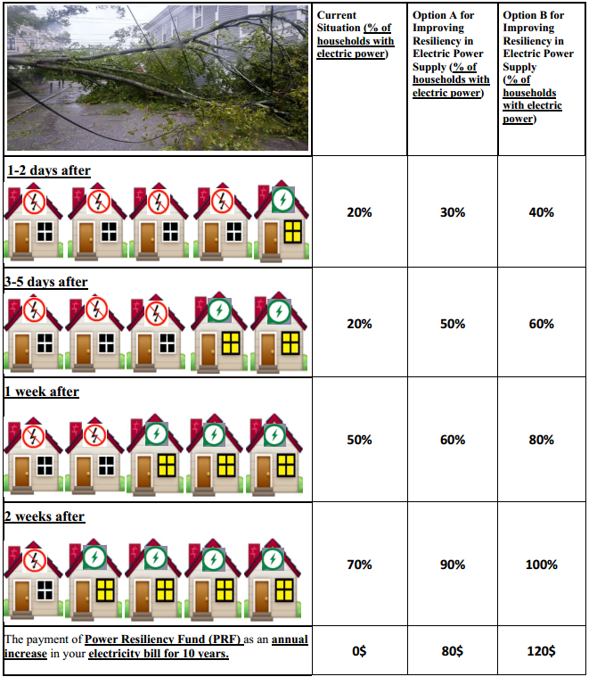

CHAPTER 5
Conclusion
5.1 Contribution of this dissertation
During the last few decades, climate change has increased the frequency and intensity of extreme weather events, such as hurricanes. Hurricanes have caused release of toxic chemicals from hazardous waste sites to the surrounding environment and communities, severe property damages and disruptions to critical infrastructures in the coastal regions in U.S. and around the world. Hurricanes also have the potential to cause health impacts such as creating stress in pregnant women, potentially leading to adverse pregnancy and birth outcomes including spontaneous abortions, preterm births, or low birthweight deliveries.
Having a better understanding of how people react to the hurricane hazards, and how they update their risk perceptions and take measures to reduce their risks from these disasters would facilitate planning and policy design for more effective hazard risk reduction interventions. Against this backdrop, this dissertation focuses on analyzing public responses, their preferences and risk aversion behaviors in diverse hurricane hazard contents. The focus of three essays in this dissertation are different in terms of its objectives, study areas, data sources, and research design process. We have used both primary and secondary data and applied several econometric and spatial analytical approaches to investigate the impact of hurricane risks on public health, and public risk perception, housing market and infrastructure resilience.
In the first essay, we investigated the impact of Hurricane Harvey-induced discharges from Superfund Sites in terms of homeowners’ risk perception and its consequence on housing values in the real estate market using the Hedonic price difference-in-difference approach. To build the empirical model, we interacted multiple environmental and technological hazards (hurricane, flood, and discharges from Superfund Sites), and integrated several geo-spatial variables including maximum wind speed, storm surge inundation and proximity to the impacted and non-impacted Superfund Sites in Harris County, Texas. Then, we used the revealed preference (RP) data of single-family property sale values from Harris County, Texas to gain insights on how residents update their risk perceptions once they receive information regarding the severity of these multi-hazard risks. More specifically, we analyzed whether the updated risk perception is capitalized into the real estate market. We found that home price in the vicinity of Superfund Sites experience depreciation. Following the discovery of hurricane-induced discharges from Superfund Sites, we found an additional depreciation of home price that are close to the impacted Superfund Sites.
In the second essay, we investigated the impact of Hurricane Irma on adverse birth outcomes in Florida. Hurricane Irma was one of the most catastrophic hurricanes in the US history, resulting in evacuation of 7 million Floridians. Maternal exposure to Hurricane Irma can lead to adverse birth outcomes through multiple stress pathways, including psychological stress (i.e., fear of the hurricane) and hurricane-risk management-related stress (i.e., evacuation; damage in residential buildings). Infants born prematurely (<37 weeks) or with low birth weight (<2500 grams) experience health and developmental difficulties throughout their life course, imposing large societal costs. We examined the relative effect of different Hurricane-induced stressors on birth outcomes. We combined two data sources: the 2016-2018, cross-sectional data (consisting of 640,649 live births) on childbirth and maternal health attributes (e.g., gestation age and birth wage) and geospatial data (e.g., hurricane track, the wind speed, rate of damage in residential building, and evacuation order). We estimated models using the difference-in-difference approach. We found that the maternal exposure to Hurricane Irma led to 7 grams decrease in birth weights. The impact was larger in magnitude if the pregnant women were exposed to the hurricane in their third trimester of pregnancy.
In the third essay, we quantified the residents’ preferences (willingness to pay) for improvement in the resilience of electricity infrastructures to withstand hurricane risks in Florida using a discrete choice experiment (DCE) survey. The resilience of infrastructures is defined in terms of time required for restoring disrupted public utility services. Our DCE survey design consists of two hypothetical scenarios of improvements in the resilience of electricity infrastructures, and a status quo scenario. These scenarios are differentiated based on the improvement in electricity infrastructures in terms of the percentage of electricity customers receiving the service 1-2 days, 3-5 days, 1 week, 2 weeks after a strong hurricane event like Hurricane Irma. Our results suggested that respondents’ annual WTP ranges from $18.94 to $252.85, suggesting that there are substantial public supports for enhancing resilience in electricity infrastructure to reduce the impacts of hurricane risks in Florida.

5.2 Scope for future research
As mentioned earlier, this dissertation studies hurricane hazards that influence public risk perception, and public health in diverse contexts. Our results indicate that residents react to natural disaster shocks based on severity and potential adverse impacts. The findings may be useful in establishing effective risk communication and risk management strategies, and policy design in affected communities and beyond.
In terms of the results of first essay, further analysis can be done to investigate the impact of hurricane-induced discharge from toxic waste more effectively by applying other econometric methods (such as local polynomial regressions, spatial autoregressive model, and repeat sales model). For the second essay, future research can be conducted to understand how climate change-related disasters could triggers further adverse health consequences for pregnant women in terms of mental health issues. The DCE approach used in the third essay can be extended to other hurricane prone areas in the USA, which will allow comparing the WTP estimates across regions and guide investment decisions for infrastructural resilience.

VITA
MEHRNOOSH ASADI
2021 | Ph.D., Economics  Florida International University  Miami, FL
2021 | M.A., Economics  Florida International University  Miami, FL
2016 | M.S.S., Environmental Policy and Management  Florida International University  Miami, Florida
2009 | B.S.S., Agricultural Economics  Karaj, Tehran, Iran
2017-2021 | Graduate Teaching Assistant  Department of Economics  Florida International University
2016-2017 | Graduate Research Assistant  Institute of Environment  Florida International University
2014-2016 | Graduate Teaching Assistant  Department of Earth and Environmnet  Florida International University

https://response.epa.gov/site/site_profile.aspx?site_id=12353
https://www.tceq.texas.gov/response/hurricanes/superfund-assessment
First American Data Tree, https://www.datatree.com/
The understudied flood zones include: “flood zone inundated by 0.2% annual chance flooding”, flood zone A, flood zone AE, flood zone AO, flood zone VE, flood zone X. Retrieved from: https://www.fema.gov/glossary/flood-zones
We used Simply Analytics website to derive the crime index variables for Harris County (Texas) in year 2017. Retrieved from: https://simplyanalytics.com/
http://www.floridahealth.gov/statistics-and-data/data-and-statistics/index.html
https://www.floridadisaster.org/
https://msc.fema.gov/portal/resources/hazus
Based on Florida Vital Statistics Code Manual for Birth the abnormal conditions include: “anemia, birth injury, fetal alcohol, syndrome, hyaline membrane disease, meconium, aspiration syndrome, assisted ventilation <30 min, assisted ventilation >30 min, seizures”. For more information, see: http://www.floridahealth.gov/statistics-and-data/data-and statistics/_documents/BirthCodeBookOctober2012.pdf
For more information, see CS/CS/CS/SB 796 — Public Utility Storm Protection Plans: https://www.flsenate.gov/Committees/BillSummaries/2019/html/2013
The panel mixed logit model can be estimated using two frequent approaches, including maximum simulated likelihood (MSL) and Bayesian estimation method. The Hierarchical Bayesian approach applies the Monte Carlo Markov Chain process to calculate the joint posterior distribution of the parameters. The Bayesian approach has several advantages over the MSL approach (Train, 2009; Regier et al., 2009). First, the Bayesian approach delivers more precise information regarding the posterior; however, the MSL provides approximate information about the posterior. Second, the Bayesian approach does not need the maximum of a likelihood function, which resolves the convergence problem. Finally, unlike MSL, in the Bayesian approach, estimators are consistent for a predetermined number of draws employed in the simulation process and remain efficient by increasing the number of draws with the sample size (see Train, 2009 for further details).
Based on the Bureau of Economic and Business Research (BEBR, 2020) at the University of Florida, 8,589,056 households were estimated in Florida by April 1, 2020. For more information, see: https://www.bebr.ufl.edu/sites/default/files/Research%20Reports/households_2020.pdf

