FLORIDA INTERNATIONAL UNIVERSITY
Miami, Florida

CONTROLS ON BENTHIC MICROBIAL COMMUNITY STRUCTURE AND ASSEMBLY IN A KARSTIC COASTAL WETLAND

A thesis submitted in partial fulfillment of
the requirements for the degree of
MASTER OF SCIENCE
in
BIOLOGY
by
Nicholas Ogden Schulte

2016
To: Dean Michael R. Heithaus
College of Arts, Sciences and Education

This thesis, written by Nicholas Ogden Schulte, and entitled Controls on Benthic Microbial Community Structure and Assembly in a Karstic Coastal Wetland, having been approved in respect to style and intellectual content, is referred to you for judgment.

We have read this thesis and recommend that it be approved.

_______________________________________
John Kominoski

_______________________________________
Joel Trexler

_______________________________________
Evelyn Gaiser, Major Professor

Date of Defense: March 31, 2016

The thesis of Nicholas Ogden Schulte is approved.

_______________________________________
Dean Michael R. Heithaus
College of Arts, Sciences and Education

_______________________________________

Andrés G. Gil
Vice President for Research and Economic Development
and Dean of the University Graduate School

Florida International University, 2016

DEDICATION
I dedicate this thesis to my parents, Gail and Randolph Schulte, whose support and enthusiasm motivated me throughout the completion of this work.
ACKNOWLEDGMENTS
I thank my major advisor, Dr. Evelyn Gaiser, for her endless support and willingness to share her expertise. Evelyn challenged me to put forth my best work and introduced me to new worlds to be discovered. I am honored and grateful to have had her as my thesis advisor – thank you, Evelyn! My committee members, Dr. John Kominoski and Dr. Joel Trexler, were integral parts of the preparation and completion of this thesis and my growth as a scientist. This thesis was made possible by the combined efforts of an exceptional group of colleagues, whom I thank: Dr. Brent Bellinger, Dr. Mark Edlund, Dr. Miroslav Gantar, Dr. Vladislav Gulis, Dr. Sylvia Lee, Dr. Kalina Manoylov, Dr. Eric Sokol, Dr. Sarah Spaulding, and Sandro Stumpf. I thank the entire FCE LTER community, particularly Viviana Mazzei, Luca Marazzi, Rafael Travieso, Sean Charles, and Ben Wilson for bearing with me and providing scientific and First Friday support. Shelby Servais was a friend, cheerleader, and critic when I needed it most. Franco Tobias’s assistance with all stages of this thesis was indispensable, and I cannot thank him enough for his enthusiastic support. Finally, I thank my family for their sustained interest and support through the ups and downs and Ashley Peterson for sticking by my side through it all.
I am grateful to funding provided by Sigma Xi and Phycological Society of America Grants In-Aid of Research and research assistantship support from the Army Corps of Engineers cooperative agreement with Florida International University W912HZ-11-2-0048. This thesis was developed in collaboration with the Florida Coastal Everglades Long-Term Ecological Research program under National Science Foundation Grant No. DBI-0620409.
ABSTRACT OF THE THESIS
CONTROLS ON BENTHIC MICROBIAL COMMUNITY STRUCTURE AND ASSEMBLY IN A KARSTIC COASTAL WETLAND
by
Nicholas Ogden Schulte
Florida International University, 2016
Miami, Florida
Professor Evelyn Gaiser, Major Professor
The assembly mechanisms underlying microbial community abundance, biotic interactions, and diversity over space and time are unresolved, particularly in benthic microbial mats distributed along environmental gradients. Experimental enrichment of nutrient-limited microbial mats from the Florida Everglades along a nutrient subsidy-salinity stress gradient stimulated autotrophic and heterotrophic metabolism, growth, and diversity independent of autotroph-heterotroph interactions across treatments and space. These results suggest spatial segregation of autotrophic and heterotrophic components within mats. Considering only the diatom component of Everglades mats over space and time, the subsidy-stress gradient controlled diatom compositional turnover at broad spatial scales while environmental and dispersal-based processes structured diatom communities at the regional scale and environmental processes independent of the environmental gradient at the temporal scale. These results indicate environmental gradients may not necessarily increase connectivity and dispersal across space, and temporal microbial diversity is driven at the local and regional scales by environmental heterogeneity in benthic microbial communities.
TABLE OF CONTENTS

CHAPTER PAGE

- INTRODUCTION 1
Literature Cited 5

- AUTOTROPHIC AND HETEROTROPHIC MICROBIAL RESPONSE TO PHOSPHORUS ENRICHMENT IN KARSTIC MICROBIAL MATS 7
Abstract 7
Introduction 9
Methods 14
Results 21
Discussion 27
Acknowledgments 36
Literature Cited 36
Tables and Figures 42
Appendices 58

- ASSEMBLY MECHANISMS OF PERIPHYTIC DIATOM SPATIAL AND TEMPORAL BETA DIVERSITY ACROSS A SUBSIDY-STRESS
GRADIENT IN A COASTAL WETLAND 81
Abstract 81
Introduction 82
Methods 87
Results 93
Discussion 98
Acknowledgments 104
Literature Cited 105
Tables and Figures 109
Appendices 118

- CONCLUSIONS 123

LIST OF TABLES

TABLE PAGE

2.1. Analysis of similarity (ANOSIM) matrices of (a) functional response variables, (b) total algae composition, and (c) diatom composition between treatments by region. Greater values indicate greater dissimilarity between assemblages 42

2.2. Pearson’s correlation coefficients among functional response variables as heat
map for emphasis. Coefficients near 1 indicate strong positive coupling
between variables and those near -1 indicate strong negative coupling 43

2.3. Mean diversity indices by region, treatment, and treatment by region for (a)
Total algae and (b) diatom assemblages 44

2.4. Pearson’s correlation coefficients among algal composition metrics as heat
map for emphasis. Coefficients near 1 indicate strong positive coupling
between variables and those near -1 indicate strong negative coupling 45

2.5. Pearson’s correlation coefficients between algal composition metrics and
functional response variables as heat map for emphasis. (a) Algal species
richness vs. function, (b) algal group relative abundances vs. function. Coefficients near 1 indicate strong positive coupling between variables and
those near -1 indicate strong negative coupling 46

3.1. Mean diatom diversity partitioning across and within regions over space and
time 109

3.2. Mean environmental conditions for each variable among and within regions 110

3.3. Spatial and temporal coefficients of variation (CVs, in %) for each variable among and within regions. Represented as a heat maps for emphasis of high
CV values 111

3.4. Spearman rank correlation coefficients of bio-env stepwise (BEST) output of environmental correlation with spatial and temporal diatom beta diversity (β)
across and within regions with significant spatial eigenvectors (PCNM)
contributing to pure spatial effects during spatial beta diversity variation
partitioning 112

3.5. Pearson correlation coefficients between environmental variable coefficients
of variation and spatial and temporal beta diversity (β) among and within
regions. Represented as a heat map for emphasis on low and high values 113

LIST OF FIGURES

FIGURE PAGE

2.1. Freshwater and oligohaline sample sites in Everglades National Park 48

2.2. Treatment means across regions for conductivity and functional response variables with analysis of variance (ANOVA) significance results. Gray
bars = freshwater, white bars = oligohaline. Different letters represent significance (p < 0.05) between treatments within a region (lower case = freshwater, upper case = oligohaline), asterisks represent significance
(p < 0.05) between regions within a treatment 49

2.3. Photographic documentation of macroscopic changes among initial (I), control
(C), and enriched (E) benthic microbial mat experimental cores. All initial
core pictures were taken on day one of the experiment, all control and enriched
cores on the final day sixty of the experiment. (a) Freshwater replicates,
numbers 1 – 6, (b) oligohaline replicates, numbers 7 – 12.. 50

2.4. Total algae relative abundance dot plot of taxa >5% relative abundance in at
least one sample, separated by region and treatment. Taxa listed by algal
group notation and catalogued species number for that group, where prefix
Cc = cyanobacteria coccoid, Cf = cyanobacteria filament, Dc = diatom unicell,
Gc = green algae coccoid. FW = freshwater, OH = oligohaline 52

2.5. Total algae dot plot of taxa >1.0 average dissimilarity between treatment and
region group comparisons. Taxa listed by algal group notation and catalogued
species number for that group, where prefix Cc = cyanobacteria coccoid, Cf = cyanobacteria filament, Dc = diatom unicell, Gc = green algae coccoid. FW = freshwater, OH = oligohaline, I = initial, C = control, E = enriched 53

2.6. Diatom relative abundance dot plot of taxa >5% relative abundance in at least
one sample, separated by region and treatment. Species names listed in Figure
2.7. FW = freshwater, OH = oligohaline 54

2.7. Diatom dot plot of species >1.0 average dissimilarity between treatment and
region group comparisons. Taxa listed alphabetically. FW = freshwater,
OH = oligohaline, I = initial, C = control, E = enriched 55

2.8. Non-metric multi-dimensional scaling (NMDS) of total algae composition
with conductivity and functional response vectors and 50% similarity clusters.
(a) Both regions across treatments, (b) freshwater across treatments, (c) oligohaline across treatments. BAC = bacteria cell concentration, CHLA = chlorophyll a, COND = conductivity, ER = ecosystem respiration, FUNGI = fungal biomass, NEP = net ecosystem production, TOC = total organic carbon,
TP = total phosphorus 56

2.9. Non-metric multi-dimensional scaling (NMDS) diatom composition with conductivity and functional response vectors and 50% similarity clusters.
(a) Both regions across treatments, (b) freshwater across treatments,
(c) oligohaline across treatments. BAC = bacteria cell concentration,
CHLA = chlorophyll a, COND = conductivity, ER = ecosystem respiration, FUNGI = fungal biomass, NEP = net ecosystem production, TOC = total
organic carbon, TP = total phosphorus 57

3.1. Mean coordinates of freshwater, transitional, and brackish primary sampling
units in Everglades National Park from 2006-2013. Transitional and brackish
sites combined comprise original oligohaline-designated sites 114

3.2. Non-metric multi-dimensional scaling (NMDS) ordinations overlain with
hierarchical cluster analyses and environmental vectors for the
(A) metacommunity, (B) freshwater, (C) transitional, and (D) brackish regions across sites and years. Key: (A) 1 = freshwater sites, 2 = transitional sites, 3 = brackish sites; (B – D) Individual sites represented by distinct shape.
Vectors > 0.4 Pearson correlation coefficient 115

3.3. Spatial variation partitioning of spatial beta diversity (β) at metacommunity, freshwater, transitional, freshwater-transitional, and transitional-brackish
scales averaged across 8 years: pure environment (E|S), spatially structured environment (E∩S), pure space (S|E), and unexplained (U). Error bars
represent 1 standard error 116

3.4. Spatiotemporal variation partitioning of spatial beta diversity (β) at (A) metacommunity, (B) freshwater, (C) transitional-brackish, and
(D) transitional scales across 8 years. (E|S) = pure environment, (E∩S) =
spatially structured environment, (S|E) = pure space, (U) = unexplained 117

CHAPTER 1: INTRODUCTION

Biotic community function (e.g., metabolism, organism growth) and structure (e.g., physical cohesion, compositional diversity) are responsible for overall ecosystem functioning and biodiversity (Battin et al. 2003, Allan and Castillo 2007). The interactions within communities determine community function and structure (Cole 1982), but the specific interactions within and between communities and the environment are unresolved in many groups of organisms and systems, particularly aquatic microorganisms. To understand overall community and ecosystem sensitivity to environmental disturbance, which is intensifying at rapid rates because of anthropogenic drivers (Smith 2003, Hillebrand and Matthiesen 2009), community and environmental interactions must be considered at appropriate spatial and temporal scales over space and time.
Within a trophic level, local (e.g., environmental) and regional (e.g., dispersal) factors structure community compositional turnover (beta diversity) across space and time (Ricklefs 1987, Chase and Leibold 2002). The regulation of community beta diversity by local and regional processes can be integrated within the metacommunity concept of communities linked by dispersal, in which communities can be singularly or co-regulated by stochastic (neutral model), immigration-emigration (patch dynamics), local environmental (species sorting), or high dispersal (mass effects) processes (Leibold et al. 2004). Each of these assembly mechanisms operates at local (intra-habitat), regional (inter-habitat), and ecosystem (inter-region) spatial and environmental scales over short (e.g., minutes, days), intermediate (e.g., seasons, years), and long (e.g., decades) temporal scales, so it is important to consider the spatial, temporal, and environmental extent of community dynamics to pinpoint the major factors controlling biodiversity (Hillebrand and Matthiesen 2009, Korhonen et al. 2010).
Environmental gradients occur across spatial and temporal scales and can directly influence local community resource availability and stress pressures as well as increase regional and metacommunity connectivity, thereby stimulating dispersal across space (Heino et al. 2015). How community structure and function differ along natural gradients has been well-studied, but comparatively little is known about how the mechanisms underlying community change are structured differently across different regions of a gradient (Scott et al. 2008). The controls on microbial assemblages in particular are understudied despite microorganisms being strongly sensitive to subsidy and stress gradients because of narrow competitive and physiological tolerances to resource availability and stress (McCormick and Stevenson 1998).
Autotrophic and heterotrophic microorganisms often co-occur in aquatic systems as plankton or benthic biofilms, and biofilm metabolism, abundance, and composition have been shown to be dependent upon the balance of autotrophs and heterotrophs in streams and lakes (Rier and Stevenson 2001, Scott et al. 2008). Along nutrient gradients, the coupling between algae and bacteria in streams transitions from strongly positive to independent (Carr et al. 2005, Scott et al. 2008), suggesting under nutrient-poor conditions algal-bacterial coupling is defined by a mutual facilitation for algal-derived carbon exudates and bacterially-regenerated nutrients, rather than by competition for nutrients, and the mutualism breaks down with increased resource availability (Rier and Stevenson 2002, Scott et al. 2008). However, in thick, benthic microbial mats that have high quantities of precipitated inorganic carbon, communities typical of karstic wetlands worldwide, autotrophs and heterotrophs may be spatially segregated within the mat (Davey and Clarke 1992, Pierson et al. 1990, Donar et al. 2004, Sharma et al. 2005), which may correspondingly reduce interactions between autotrophs and heterotrophs. Karstic wetlands are generally phosphorus (P)-limited because of orthophosphate adsorption to calcium carbonate, and P enrichment in these wetlands can break down the physical cohesion of mats and increase algal diversity and growth and community photosynthesis and respiration (Pan et al. 2000, Inglett et al. 2004, Gaiser et al. 2005). However, the underlying biotic interactions associated with overall microbial community change in karstic wetlands are unresolved, particularly across gradients of P enrichment.
In addition to local-scale community interactions with the environment, microbial community diversity can be structured by regional-scale, spatially structured environmental factors like resource-stress gradients and spatial-based processes like dispersal limitation or stimulation (Heino et al. 2015). The relative contributions of local and regional mechanisms to community beta diversity determine ecosystem biodiversity and resilience to change, so it is important to identify the assembly mechanisms of beta diversity across all relevant spatial, temporal, and environmental scales.
The Everglades of South Florida, USA is a P-limited karstic coastal wetland characterized by a high abundance of benthic microbial mat-forming communities, or periphyton, along an increasing P subsidy-salinity stress coastal gradient extending from freshwater marsh through an oligohaline ecotone to saline open water (Davis and Ogden 1994). Benthic mat physical cohesion, metabolism, biomass, and algal diversity become altered in P-enriched regions, but the mechanisms underlying those changes are unresolved. The diversity of diatoms, a major contributor to the biotic component of the mats, varies spatially according to environmental heterogeneity and the coastal gradient, but the relative control of environmental and spatial assembly mechanisms across multiple spatial and temporal extents are unknown.
The main objective of the present study was to determine the biotic, environmental, and spatial controls on benthic microbial mat community metabolism, growth, and compositional turnover along a subsidy-stress gradient of a coastal karstic wetland. In Chapter 2, I experimentally enriched P-limited benthic microbial mats in microcosms to assess how the interactions among algae, bacteria, and fungi affected mat function and structure after P enrichment. I made spatially explicit comparisons between two regions along a P subsidy-salinity stress gradient in the Florida Everglades to determine how autotroph-heterotroph functional and structural coupling differed with P enrichment along an environmental gradient. In Chapter 3, I partitioned the variation in beta diversity of diatoms from Everglades mats over space and time along the coastal gradient into environmental, spatially structured environmental, and spatial assembly mechanisms in order to determine how local, regional, and landscape metacommunity beta diversities were controlled along an environmental gradient. The results from these studies contribute to a growing body of research intent on resolving the mechanisms of aquatic microbial community structure and assembly in order to better assess the effects of natural local and regional disturbance regimes on biodiversity and potential biotic change resulting from anthropogenic disturbance.

Literature Cited
Allan, J. D., & Castillo, M. M. (2007). Detrital energy sources. In Allan, J. D. & Castillo, M. M. (Eds.) Stream Ecology: Structure and Function of Running Waters. Springer Science & Business Media, Netherlands, 135-161.

Battin, T. J., Kaplan, L. A., Newbold, J. D., & Hansen, C. M. (2003). Contributions of microbial biofilms to ecosystem processes in stream mesocosms. Nature, 426(6965), 439-442.

Carr, G. M., Morin, A., & Chambers, P. A. (2005). Bacteria and algae in stream periphyton along a nutrient gradient. Freshwater Biology, 50(8), 1337-1350.

Chase, J. M., & Leibold, M. A. (2002). Spatial scale dictates the productivity–biodiversity relationship. Nature, 416(6879), 427-430.

Cole, J. J. (1982). Interactions between bacteria and algae in aquatic ecosystems. Annual Review of Ecology and Systematics, 13, 291-314.

Davey, M. C., & Clarke, K. J. (1992). Fine structure of a terrestrial cyanobacterial mat from Antarctica. Journal of Phycology, 28(2), 199-202.

Davis, S., & Ogden, J. C. (1994). Everglades: The Ecosystem and Its Restoration. CRC Press, Boca Raton, FL.

Donar, C. M., Condon, K. W., Gantar, M., & Gaiser, E. E. (2004). A new technique for examining the physical structure of Everglades floating periphyton mat. Nova Hedwigia, 78(1-2), 107-119.

Gaiser, E. E., Trexler, J. C., Richards, J. H., Childers, D. L., Lee, D., Edwards, A. L., ... & Jones, R. D. (2005). Cascading ecological effects of low-level phosphorus enrichment in the Florida Everglades. Journal of Environmental Quality, 34(2), 717-723.

Heino, J., Melo, A. S., Siqueira, T., Soininen, J., Valanko, S., & Bini, L. M. (2015). Metacommunity organization, spatial extent and dispersal in aquatic systems: patterns, processes and prospects. Freshwater Biology, 60(5), 845-869.

Hillebrand, H., & Matthiessen, B. (2009). Biodiversity in a complex world: consolidation and progress in functional biodiversity research. Ecology Letters, 12(12), 1405-1419.

Inglett, P. W., Reddy, K. R., & McCormick, P. V. (2004). Periphyton chemistry and nitrogenase activity in a northern Everglades ecosystem. Biogeochemistry, 67(2), 213-233.

Korhonen, J. J., Soininen, J., & Hillebrand, H. (2010). A quantitative analysis of temporal turnover in aquatic species assemblages across ecosystems. Ecology, 91(2), 508-517.

Leibold, M. A., Holyoak, M., Mouquet, N., Amarasekare, P., Chase, J. M., Hoopes, M. F., … & Loreau, M. (2004). The metacommunity concept: a framework for multi‐scale community ecology. Ecology Letters, 7(7), 601-613.

McCormick, P. V., & Stevenson, R. J. (1998). Periphyton as a tool for ecological assessment and management in the Florida Everglades. Journal of Phycology, 34(5), 726-733.

Pan, Y., Stevenson, R. J., Vaithiyanathan, P., Slate, J., & Richardson, C. J. (2000). Changes in algal assemblages along observed and experimental phosphorus gradients in a subtropical wetland, USA. Freshwater Biology, 44(2), 339-353.

Pierson, B. K., Sands, V. M., & Frederick, J. L. (1990). Spectral irradiance and distribution of pigments in a highly layered marine microbial mat. Applied and Environmental Microbiology, 56(8), 2327-2340.

Ricklefs, R. E. (1987). Community diversity: relative roles of local and regional processes. Science, 235(4785), 167-171.

Rier, S. T., & Stevenson, R. J. (2002). Effects of light, dissolved organic carbon, and inorganic nutrients [2pt] on the relationship between algae and heterotrophic bacteria in stream periphyton. Hydrobiologia, 489(1-3), 179-184.

Scott, J. T., Back, J. A., Taylor, J. M., & King, R. S. (2008). Does nutrient enrichment decouple algal-bacterial production in periphyton? Journal of the North American Benthological Society, 27(2), 332-344.

Sharma, K., Inglett, P. W., Reddy, K. R., & Ogram, A. V. (2005). Microscopic examination of photoautotrophic and phosphatase‐producing organisms in phosphorus‐limited Everglades periphyton mats. Limnology and Oceanography, 50(6), 2057-2062.

Smith, V. H. (2003). Eutrophication of freshwater and coastal marine ecosystems a global problem. Environmental Science and Pollution Research, 10(2), 126-139.

CHAPTER 2: AUTOTROPHIC AND HETEROTROPHIC MICROBIAL RESPONSE TO PHOSPHORUS ENRICHMENT IN KARSTIC MICROBIAL MATS

Abstract
In aquatic systems, the function (e.g., metabolism, growth) and structure (e.g., species composition) of microbial communities is underlain by the degree of coupling between autotrophs and heterotrophs. Coupling describes the co-dependency between two groups of organisms and can be approximated using linear correlations. Nutrient enrichment can stimulate autotrophic and heterotrophic function and structure while simultaneously decouple autotroph-heterotroph interactions, leading to broad-scale changes in overall ecosystem health and functioning. Studies based on how microbial interactions within oligotrophic stream biofilms and marine plankton are affected by natural and anthropogenic nutrient inputs along nutrient gradients suggest tight coupling between autotrophs and heterotrophs under oligotrophic conditions is the result of a mutual facilitation between algal-generated extracellular organic carbon and bacterially regenerated nutrients that breaks down with increased nutrient availability. However, the interactions between autotrophs and heterotrophs along nutrient subsidy gradients are poorly studied in vertically laminated benthic microbial mats like those found in phosphorus (P)-limited karstic wetlands worldwide. The present study assessed autotroph and heterotroph function, structure, and coupling within benthic microbial mats from the karstic Florida Everglades, USA at naturally oligotrophic and experimentally P enriched conditions in order to determine how the underlying mechanisms of community function and structure change with nutrient disturbance. I considered benthic mats along a P subsidy-salinity stress coastal gradient within the Everglades to measure variability in response to nutrient enrichment across environmentally distinct regions. Under initial, P-limiting conditions, algal and bacterial biomass coupling and algal composition-bacterial biomass coupling were low despite strong metabolic coupling between net ecosystem production and ecosystem respiration, and fungi were undetectable. Phosphorus additions stimulated algal, bacterial, and fungal growth that resulted in further decoupling within algal-bacterial biomass, metabolism, and composition and increased coupling between algal and fungal biomass. Mats from either end of the subsidy-stress gradient were similarly stimulated by P, but decoupling between algal-bacterial biomass in freshwater, low subsidy-stress mats was slightly higher. Enrichment shifted the dominant algal taxa from cyanobacteria and diatoms to a coccoid green alga, and within the diatom community from endemic, oligotrophic species to cosmopolitan, nutrient-loving species. The change in algal community composition and diversity correlated weakly with primary production and algal and bacterial biomass. Overall, the results from the present study indicated a low degree of coupling between autotrophic and heterotrophic microbial communities in natural Everglades mats along the coastal subsidy-stress gradient that decreased slightly with nutrient enrichment, which is possibly attributable to spatial segregation of autotrophs and heterotrophs within thick, benthic mats. The lack of microbial coupling is inconsistent with strong algal-bacterial coupling in stream biofilms that is decoupled after nutrient enrichment, indicating the mechanisms underlying microbial community function and structure differ across aquatic systems and microbial communities.

Introduction
In aquatic systems, the degree of coupling between microbial autotrophs and heterotrophs in biofilms underlies biofilm function (metabolism and biomass) and structure (physical cohesion and composition) (Cole 1982, Rier and Stevenson 2002, Carr et al. 2005, Scott et al. 2008). Coupling can be considered the co-dependency of biotic groups and can be approximated by linear correlations (Scott et al. 2008). Biofilm metabolism, abundance, and composition regulate aquatic ecosystem nutrient availability (Allan and Castillo 2007), carbon storage (Battin et al. 2003, Hessen et al. 2004, Ishikawa et al. 2014), and consumer dynamics (Worm et al. 2002, Chick et al. 2008) and are therefore necessary to consider in understanding ecosystem drivers of change associated with disturbance. Nutrient mobilization is a global phenomenon affecting aquatic ecosystem structure and function (Smith 2003), and the functional and structural responses of microbial biofilms to nutrient enrichment can be used to measure ecosystem water quality and resilience to change (Pan et al. 1996, McCormick and Stevenson 1998, Gaiser 2009). However, it remains unresolved how the balance of microbial autotrophs and heterotrophs is maintained under oligotrophic conditions, how it is affected by nutrient enrichment, and how those interactions affect biofilm structure and function, particularly in vertically laminated, benthic microbial mats like those formed in karstic wetland systems worldwide.
Benthic biofilms are responsible for the majority of microbial metabolic activity, production, and diversity in low- to mid-order streams, littoral zones of lakes, and wetlands (Scott et al. 2008). Benthic microbial biofilm communities composed of algae, heterotrophic bacteria, aquatic hyphomycete fungi, and extracellular organic carbon (EOC) in the form of organism-derived extracellular polymeric substances (EPS) are good models for microbial biotic and abiotic interactions because of their sensitivity to disturbance and representative, rapid changes in composition; multiple internal trophic levels; and micro-scale carbon dynamics (McCormick and Cairns Jr. 1994). Stromatolites – laminated, calcified, benthic microbial mats – have existed on Earth for 3.5 billion years (Hofmann et al. 1999), actively generate mineralized structures, and were likely the primary contributors to the oxygenation of Earth's atmosphere 2.3 billion years ago (Bekker et al. 2004). Modern carbonate mats found in karstic systems worldwide can exceed 10 cm in vertical thickness and can be laminated into distinct regions of autotrophic and heterotrophic activity and diversity (Davey and Clarke 1992, Pierson et al. 1990, Donar et al. 2004, Sharma et al. 2005, Thomas et al. 2006). Karstic mats are strongly phosphorus (P)-limited in part because of orthophosphate adsorption to and coprecipitation with lithified carbonate (Kitano et al. 1978), and P enrichment has been shown to increase community metabolism and bacterial and algal growth and to promote shifts in algal and bacterial community composition (Rejmánková and Komárková 2000, Gaiser et al. 2006, Stanish et al. 2013, Corman et al. 2015). Stromatolitic mats provide a distinct opportunity to investigate autotrophic-heterotrophic coupling in assemblages representative of ancient interactions with high EOC availability, spatial lamination of autotrophs and heterotrophs, naturally P-limited conditions, and well described algal composition and mat cohesion.
Autotroph-heterotroph linkages have been well-studied between epilithic stream biofilm algae and bacteria, and some fungi, but the microbial interactions underlying autotroph-heterotroph coupling and decoupling remain unresolved (Scott et al. 2008). In oligotrophic biofilms, algae can act both as substrata and sources of EOC for bacteria (Cole 1982), and bacterial and fungal growth and metabolism have been shown to increase in the presence of algae and algal-derived EOC (Kuehn et al. 2014, Wyatt and Turetsky 2015). Bacterial and algal linkages are not driven by competition for nutrients (Carr et al. 2005, Scott et al. 2008) and instead appear to be controlled by a mutual facilitation in which algae depend on bacteria for regenerated nutrients and bacteria on algae for photosynthetically-derived EOC (Rier and Stevenson 2002, Carr et al. 2005, Scott et al. 2008). Nutrient enrichment stimulates algal and bacterial metabolism, growth, and compositional turnover while also decoupling algal and bacterial production (Rier and Stevenson 2001, Stevenson et al. 2006, Scott et al. 2008), which is speculatively attributed to a breakdown of the mutual facilitation between algae and bacteria (Carr et al. 2005, Scott et al. 2008). Scott and Doyle (2006) similarly observed algal-bacterial production to be tightly coupled in nitrogen (N)-limited floating microbial mats in a temperate wetland with decoupling induced by N enrichment despite stimulation of algal and bacterial production. Sharma et al. (2005) described spatial and trophic segregation of phosphatase activity within P-limited floating stromatolitic mats in the subtropical Florida Everglades that indicated possible algal-bacterial coupling mediated by bacterial P regeneration and algal EOC production, suggesting similar processes may underlie autotroph-heterotroph linkages in biofilms and laminated microbial mats.
Biofilm structure and function are sensitive to nutrient subsidies but also chemical stress disturbance, under which community diversity generally decreases with low-level stress and community biomass and metabolism decrease under high stress (Niyogi et al. 2002). Biofilm metabolism and biomass can be reduced in freshwater streams exposed to increased salinity, acidity, and toxicity (Niyogi et al. 2002). Coincident community stimulation from resource subsidy and community depression from chemical stress may increase community resilience to changes in either subsidy or stress. Community diversity in moderately subsidized and stressed communities can exceed that of both oligotrophic, low stress communities and eutrophic, high stress communities because of larger species pools composed of low, moderate, and high subsidy-stress species with broad tolerances. To understand ecosystem-scale sensitivity of biofilms to enrichment, it is necessary to consider environmental subsidy-stress heterogeneity that affects the resilience of communities to change.
The Florida Everglades is a P-limited, karstic coastal wetland characterized by a gradient of increasing P and salinity from the freshwater marsh to Florida Bay, with an oligohaline ecotone between (Gaiser et al. 2012). Benthic stromatolitic mats are abundant throughout the system and are composed primarily of cyanobacteria, diatoms, heterotrophic bacteria, and aquatic hyphomycete fungi laminated in a matrix of EPS, precipitated calcium carbonate, and detritus (McCormick et al. 1997). Strong gradients in mat metabolism, abundance, and composition are found along the coastal gradient, but little is known about the microbial linkages underlying these patterns and how they may be affected by nutrient enrichment, particularly in mats from the oligohaline ecotone. Photosynthesis and respiration are often tightly coupled, and metabolic activity and algal biomass and diversity are elevated in freshwater regions enriched in P (Gaiser et al. 2006, Hagerthey et al. 2011, Gaiser et al. 2014). Algal compositional changes occur at chronic, low-level P enrichment, and the physical cohesion of freshwater mats has been shown to break down after sustained P enrichment (McCormick and O’Dell 1995, Pan et al. 2000, Inglett et al. 2004, Gaiser et al. 2005). Coincident with mat dissolution are increases in autotrophic production and algal species shifts from cyanobacteria and diatoms characteristic of carbonate wetlands to green algae and diatoms with cosmopolitan distributions (Gaiser et al. 2006). These responses suggest strong autotroph-heterotroph coupling under oligotrophic conditions that is mediated by mutual facilitation of nutrients and EOC and is highly modifiable by limiting nutrient additions. The Everglades provides an ideal system to investigate autotrophic-heterotrophic microbial interactions in laminated communities and the consistency of patterns across a natural subsidy (P)–stress (salinity) gradient.
The purpose of the present study was to determine the influence of oligotrophic conditions and nutrient enrichment on the trophic coupling of benthic microbial mat function (metabolism and total mat, autotroph, and heterotroph biomass) and structure (physical cohesion and algal composition) and the consistency of response over a natural subsidy-stress gradient. I tested three hypotheses regarding microbial mat response to the addition of a limiting nutrient (P): (1) P addition stimulates heterotrophy over autotrophy, resulting in reduced microbial mat biomass and metabolism and decoupling between autotrophs and heterotrophs. (2) Heterotrophic stimulation facilitates mat dissolution through EOC decomposition, and autotrophic stimulation is associated with algal species shifts to non-mat forming species independent of heterotrophic nutrient regeneration. (3) Autotroph-heterotroph decoupling is strongest in regions of extreme oligotrophy and low stress. To test these hypotheses, I experimentally manipulated benthic microbial mats from along a P nutrient-salinity gradient with P additions in a microcosm setting.

Methods
Study system
The Florida Everglades is a subtropical, oligotrophic coastal wetland in South Florida, USA covering over 6000 km² and underlain by Cenozoic limestone. The Everglades is canalized into several distinct regions across a fraction of its historic extent, in which water quality and quantity are intensively managed. The southernmost area, Everglades National Park, has two drainages each increasing in P and salinity from the freshwater marsh to an oligohaline ecotone and into the marine waters of Florida Bay (Gaiser et al. 2012). Saltwater containing higher P concentrations than the interior freshwater marsh is projected to intrude into the oligohaline and freshwater regions, thereby affecting the nutrient subsidy available to and chemical stress on the biotic communities across the gradient (Saha et al. 2011). Biotic community shifts have been recorded in enriched areas of Everglades National Park, primarily edge habitats near canals that are generally P-enriched (Gaiser et al. 2011, Gaiser et al. 2014). Benthic microbial mat-forming communities are prevalent throughout the Everglades and have been shown to undergo structural dissociation and algal species replacement in enriched freshwater edge habitats and under experimental enrichment (Gaiser et al. 2005). The effects of nutrient enrichment associated with sea level rise on benthic mats in the oligohaline ecotone, in particular, are unknown. The present study focuses on the effects of increased P subsidy on the biological functional and structural interactions within benthic microbial mats from freshwater and oligohaline regions of the Everglades coastal gradient that differ considerably in natural nutrient levels, environmental stressors, and microbial mat structure.
Experimental design
Benthic microbial mats were collected from six freshwater and six oligohaline sites in Everglades National Park (Figure 2.1). For each site, five 2-cm diameter, 2-5 cm deep microbial mat cores were taken: three for initial values, one as a control, and one as an enriched treatment. The initial cores were frozen at -20°C for laboratory processing. The control and enriched cores were transferred to 300-mL clear biological oxygen demand (BOD) bottles with source water. Natural total P (TP) levels in Everglades mats rarely exceed 500 μg g⁻¹ ash-free dry mass (AFDM) in the freshwater marsh and 1000 μg g⁻¹ AFDM in the oligohaline ecotone, with higher values signifying areas exposed to elevated P loads (Gaiser et al. 2006, 2009). In order to reduce P limitation to microbes in a microcosm setting with mats containing P-adsorbing calcium carbonate, a one-time load of 1000 μg Na₂PO₄◦H₂O was added to each treatment microcosm. Control cores were exposed only to source water and microcosm conditions. Each microcosm was placed in an outdoor water bath and exposed to ambient light and temperature, protected from rain by a transparent acrylic sheet roof, and refilled daily with deionized water to account for evaporative water loss. For twelve hours each day for 60 days the water in each microcosm was internally circulated to mimic surface water movement of the slow-flowing Everglades (<3 cm s⁻¹) during the wet season (He et al. 2010), after which the cores were harvested for laboratory processing. Physical cohesion of each core was assessed macroscopically and qualitatively throughout the study and documented photographically.

Sample collection and processing
Source water from each field site and final microcosm was collected and measured for conductivity as a proxy for salinity. My key metabolic response parameters, net ecosystem production (NEP), gross primary production (GPP), and ecosystem respiration (ER), were measured for initial and final control and enriched cores using the light and dark bottle method (Gaarder and Gran 1927, Hall et al. 2007).
Each initial, control, and enriched core was homogenized using an immersion blender and deionized water, and known-volume aliquots were set aside for individual analyses. Because even at high P loads excess P is sequestered by microbial mats in P-limited wetlands like the Everglades and hence not measurable in the water column (Gaiser et al. 2004), mat nutrient content rather than water column nutrient content was used as a measure of P availability. Mat biomass was measured as total organic carbon (TOC) content. Subsamples were dried (70°C), and mat TOC and total nitrogen (TN) were measured using gas chromatography, and mat TP was measured using mass spectrometry. All biotic response concentrations were calculated per gram of AFDM.
Fungal biomass was estimated from ergosterol with methods adapted from Gulis and Suberkropp (2006). Methanolic KOH was added to the microbial mat homogenate and heated in a water bath. Deioinized water was added, the sample was centrifuged, and the supernatant was removed. Pentane was added to the supernatant, mixed thoroughly, removed as the upper phase, and evaporated to isolate the ergosterol extract. Pentane partitioning was repeated twice, and the evaporated residue was redissolved in methanol, filtered, and analyzed by high-performance liquid chromatography (HPLC) equipped with a Phenomenex Kinetex C18 column and UV detector set at 282 nm. Fungal biomass was calculated assuming an ergosterol concentration of 5.5 μg mg⁻¹ in aquatic hyphomycete dry mass (Gessner and Chauvet 1993).
Bacterial cell concentration was calculated from direct bacterial cell counts. Samples for bacterial analysis were preserved in 2.5% sterilized formalin, serially diluted to 1% homogenate content, stained with 4’, 6-diamidino-2-phylindole (DAPI), and vacuum filtered onto black polycarbonate membrane filters (0.2 μm pore size). The filters were mounted onto glass microscope slides and counted with epifluorescent microscopy. A minimum of 300 bacterial cells and 10 fields of view were counted at 1000x magnification.
Algal biomass was measured from mat chlorophyll a concentrations. Subsamples were filtered onto glass fiber filters, acidified with acetone, and analyzed fluorometrically (Welschmeyer 1994). Homogenates for total algae counts were diluted, dried onto cover slips, mounted onto glass slides with a drop of water, and sealed with nail polish. For each sample, 300 naturally occurring algae units and cells per unit were counted and identified to species by distinct morphologies along random, measured transects using compound light microscopy at 1000x magnification.
Because diatoms can provide a higher-resolution measure of community response than other algae because of their diversity and narrow environmental affinities, subsamples were oxidized to remove organic and inorganic debris to estimate diatom valve total and relative abundances (Hasle and Fryxell 1970). Oxidized diatoms were dried onto cover slips and mounted on slides using Naphrax mounting medium. A minimum of 250 valves were counted and identified along random, measured transects using compound light microscopy at 1000x magnification. An additional 250 valves were observed, recording only taxa not found in the previous 250 counts while doubling the counts of taxa from the first counting effort for a minimum of 500 valves recorded.

Data analysis
Conductivity was compared across treatments to determine microcosm effects on initial conditions. Two categories of treatment response were analyzed: functional (metabolic and total mat, microbial autotroph, and microbial heterotroph biomass) and structural (microbial autotroph composition). Functional response included nutrient content (TP and TN), mat metabolism (NEP, GPP, and ER), and biomass (TOC and algal, bacterial, and fungal biomass). Structural response included total algae and diatom diversity. Values from the three initial cores were averaged for each variable by site. No initial NEP or GPP values are available because of measurement error. Random ergosterol sample loss limited the number of replicates for each treatment and region (for freshwater initials, n = 3; controls and enriched, n = 5 each; oligohaline initials, n = 4; controls, n = 3; enriched, n = 4). For all other samples, n = 6 for each treatment-by-region. For each analysis, samples were analyzed by treatment within region and region within each treatment in order to contrast treatment- and region-specific functional and structural responses to enrichment. Analyses were performed using SPSS v. 23, PC-ORD v.5, and PRIMER v. 9 (McCune and Mefford 1999, Clarke and Gorley 2006).

Functional response
Conductivity and functional response variables were transformed to minimize skewness and kurtosis for each variable. To test how each variable differed among treatments within a region and between regions within a treatment, one-way analysis of variance (ANOVA) was conducted for each variable. To account for unequal variances among groups after transformations, Welch ANOVAs were performed with Games-Howell post hoc tests when ANOVAs were significant. To compare total functional response across treatment and regions, similarity matrices were constructed using Euclidean distances, after removing variables with missing values (NEP, ER, fungal biomass), and analysis of similarity (ANOSIM) was performed. Higher reported R values indicate increasing similarity between groups, and comparisons with p < 0.05 were considered significantly different. In order to approximate the degree of coupling between variables, Pearson’s correlation coefficients were calculated to evaluate the strengths of linear relationships between variables. Comparisons with Bonferroni probabilities of p < 0.05 were considered significantly different.

Structural response
Total algae units were standardized for each taxon by dividing the total number of cells by the total number of units counted across all samples to determine the average number of cells per unit and back-calculating units per sample. For total algae and diatom matrices, the abundance of each taxon in each sample was calculated relative to the total abundance of algae units or diatom valves counted in that sample, respectively. Relative abundances of each taxon were relativized by their total abundance across samples and arcsine square-root transformed to more closely approximate normality and to reduce the relative importance of very abundant taxa (McCune and Grace 2002). From the total algae dataset, relative abundances of cyanobacteria, diatoms, and green algae groups were calculated. Species richness and Shannon’s diversity index were calculated for total algae and diatom datasets across treatments by region in order to assess change in species diversity with enrichment. Pearson’s correlation coefficients were calculated to determine the linear relationships among total algal and diatom species richness and Shannon’s diversity and algal group relative abundances.
For both total algae and diatom relative abundance data, similarity matrices were created using Bray-Curtis similarity measures, and ANOSIMs were performed to determine the similarity within algal and diatom assemblages by treatment and region groups. Non-metric multi-dimensional scaling (NMDS) ordination was used to visualize algae and diatom assemblage composition patterns between regions by treatment and among treatments by region. Agglomerative hierarchical cluster analyses were conducted to identify groups of samples with 50% compositional similarity, which were overlaid on the ordinations. Percentage contributions of taxa to assemblage dissimilarity (SIMPER) were determined among treatments within a region and between regions within a treatment in order to identify the taxa most explanatory of assemblage differences among groups.

Functional-structural coupling
Functional response vectors representing the direction and strength of each functional variable’s correlation with assemblage compositional dissimilarity were overlaid on the NMDS ordinations for total algae and diatoms across region and treatment groups. To assess coupling between algal structure and mat function, algal and diatom richness, diversity, and relative abundances were compared to environmental and functional response variables across treatments by region using Pearson’s correlation coefficients (McCune et al. 2002).

Results
Consistency of experimental enrichment
Initial freshwater and oligohaline mats were representative of each region, with elevated conductivity and mat TOC, TN, and TP in oligohaline mats (Figure 2.2). Conductivity was consistent across all treatments within each region, indicating minimal bottle effects on surface water conductivity.
Phosphorus additions significantly elevated mat TP content in all enriched mats, with no difference between initials and controls (Figure 2.2). Mean TOC:TP and TN:TP molar ratios were correspondingly reduced in enriched mats, in which all freshwater and half of oligohaline mats were consistent with N limitation given the N:P Redfield ratio for benthic algae of 16:1. The remaining three oligohaline enriched mats approached N limitation with less than 30:1 TN:TP.

Functional response to enrichment
Autotrophic and heterotrophic metabolism and biomass were significantly higher in enriched mats than in initials and controls in both regions, with no significant differences in total mat biomass and TN (Figure 2.2). Mean ER was significantly lower in enriched mats than initials and controls, and GPP was higher. Net ecosystem production was greater in enriched mats compared to controls, but significantly so only in freshwater mats. Algal, bacterial, and fungal biomass increased with enrichment in both regions.
Mat functional responses followed the same patterns in both regions but with differences in magnitude (Figure 2.2). Under initial conditions, compared to freshwater mats, oligohaline mats had higher autotrophic, heterotrophic, and mat metabolism and biomass. In enriched mats, oligohaline mats showed a significantly lower treatment effect than freshwater mats in NEP and fungal biomass, with a significantly higher treatment effect in chlorophyll a. Comparing all functional response variables across treatment groups and regions, each treatment-by-region was statistically different except oligohaline initials and controls (Table 2.1).
Pearson correlation coefficients were used to assess coupling among mat total biomass and autotrophic and heterotrophic metabolism and biomass (Table 2.2). Under initial conditions, total mat biomass was weakly, positively correlated with algal biomass and negatively associated with bacterial biomass. The relationships were inversed and weakened with enrichment. Net ecosystem production and ER were tightly coupled together under initial conditions and were decoupled slightly in enriched freshwater mats and moderately in enriched oligohaline mats. Algal and bacterial biomass correlations with NEP and ER decreased with enrichment in both regions. Autotrophic and heterotrophic biomass were weakly coupled under initial freshwater and oligohaline conditions, and enrichment slightly decreased algal-bacterial coupling across regions. Weak coupling between algal and fungal biomass under initial freshwater conditions was inversed and strengthened with enrichment. Enriched oligohaline algal-fungal biomass coupling was strongly negative. Initial bacterial-fungal coupling was weakly negative in freshwater mats and became positive and slightly stronger when enriched, whereas bacterial-fungal biomass coupling was strongly negative in oligohaline mats.
Structural response to enrichment
Qualitative assessments of microbial mat physical cohesion indicated total dissolution of three of twelve enriched mats, each oligohaline, that were benthic, suspended, and amorphous at the end of the study (Figure 2.3). One freshwater and three oligohaline control mats and two freshwater and one oligohaline mat were partially broken up but retained overall initial mat-like structure in each fragment. All other mats retained exterior cohesion and appearance similar to the beginning of the study, except all enriched cores formed small, surficial green globules or green, crust-like coatings to varying extents.

Total algae
A total of 110 algae species across three phyla were identified across all regions and treatments: 20 Bacillariophyta (diatoms), 15 Chlorophyta (green algae, including 4 desmids, 8 coccoid unicells or colonies, and 3 filaments), and 75 Cyanophyta (cyanobacteria, including 54 coccoid unicells or colonies and 21 filaments). Freshwater and oligohaline mean initial taxon richness was roughly equal, and in both regions enriched sample richness was substantially lower than both initials and controls (Table 2.3a). Shannon’s diversity of the assemblages was substantially lower among enriched mats in both regions compared with initials and controls. Oligohaline enriched mats had substantially lower diversity than did freshwater enriched mats.
Total algae species richness was strongly, positively correlated with algae Shannon’s diversity across all treatments and regions (Table 2.4). Algae richness and diversity correlated weakly with cyanobacteria and green algae relative abundance in freshwater and oligohaline initial mats but strongly positively with cyanobacteria in freshwater and oligohaline enriched mats and strongly negatively with green algae in freshwater enriched mats. Algae richness and diversity were strongly negatively correlated with diatom relative abundance in freshwater initial mats, a relationship that weakened with enrichment. Initial diatom relative abundance in oligohaline mats, however, was strongly positively associated with algae richness and diversity and became strongly negatively correlated with enrichment. Across all treatments and regions, cyanobacteria relative abundance was very strongly inversely correlated with green algae abundance, and diatom abundance was only strongly correlated in freshwater and oligohaline controls – negatively with cyanobacteria and positively with green algae.
Enriched total algae assemblage composition was significantly different from initials and controls in both regions, and only initial mats had similar assemblages between regions (Table 2.1b). The difference in freshwater initial and enriched mats was largely explained by decreased abundance of cyanobacteria and increased abundance of green algae (Tables 2.3a, Figures 2.4 & 2.5). Oligohaline enriched mats differed from initials and controls by increased green unicellular algae and cyanobacteria filaments with an overall reduction of coccoid cyanobacteria (Figures 2.4 & 2.5). Assemblage differences between regions were treatment-dependent, with no significant difference between initials. Among controls, oligohaline mats had lower cyanobacteria filament and higher diatom abundances than freshwater mats with a shift in dominant coccoid cyanobacteria taxa. Among enriched mats, oligohaline mats had higher green unicell and cyanobacteria filament abundances with a shift in dominant coccoid cyanobacteria taxa.

Diatoms
A total of 152 diatom species across 41 genera were identified across regions and treatments. Diatom species richness and Shannon’s diversity were strongly positively correlated across all treatments and regions (Table 2.4). Freshwater enriched mats had lower richness and Shannon’s diversity than freshwater initials but not controls, while oligohaline enriched mats were lower than initials and controls in diversity but not richness. Compared to oligohaline mats, freshwater initial mats had substantially higher mean richness and Shannon’s diversity, lower mean richness and diversity in controls, and roughly equivalent richness and diversity among enriched mats (Table 2.3b).
Diatom assemblages across treatments and regions were all significantly different except between freshwater and oligohaline enriched communities (Table 2.1c). Initial freshwater mats were characterized primarily by Mastogloia calcarea, Encyonema evergladianum, and Encyonema silesiacum var. elegans, and dissimilarity with controls was explained largely by increased abundance of Encyonopsis microcephala and Gomphonema intricatum var. vibrio in control mats (Figures 2.6 & 2.7). Enriched freshwater mats differed with large increases in Nitzschia gracilis and Nitzschia palea var. debilis compared to initials and controls. Initial oligohaline mats were predominated by Mastogloia calcarea and Encyonema evergladianum, with elevated Nitzschia palea var. debilis and Nitzschia palaeformis in controls. Enriched oligohaline mats were dominated by Nitzschia palea var. tenuirostris and Nitzschia palea var. debilis.
Diatom species richness and diversity were moderately correlated with freshwater cyanobacteria and green algae relative abundance in initial mats – negatively with cyanobacteria, positively with green algae – and in enriched mats, in which the relationships were inversed (Table 2.4). Diatom richness and diversity were only moderately associated with oligohaline enriched cyanobacteria (positively) and green algae (negatively) relative abundances. Diatom relative abundance was moderate to strongly inversely correlated with diatom richness and diversity in both freshwater and oligohaline enriched mats.

Function-structure coupling
Total algae
Across treatments and regions, total algae assemblage dissimilarity was characterized by a strong gradient in conductivity (Figure 2.8a). Regardless of region, initials and controls clustered together and enriched mats clustered together with 50% compositional similarity (Figure 2.8a-c). Treatment mats were strongly arranged along a TP gradient correlated with metabolism and algae and bacteria biomass. Freshwater-only treatments were strongly associated with a TP gradient and also correlated with NEP and algal, bacterial, and fungal biomass (Figure 2.8b). Initials and controls were widely distributed across relatively weak TOC and ER gradients. Oligohaline treatment mats were distributed along a TP gradient coincident with NEP and algal, bacterial, and fungal biomass (Figure 2.8c). Controls differed from initials by an increasing conductivity gradient. The correlations between algal diversity and environmental and functional response variables were ambiguous, and no broad generalizations could be readily made, as total algae and diatom richness and relative abundance correlated weakly overall across freshwater and oligohaline initial and enriched mats (Table 2.5).
Diatoms
Across treatments and regions, freshwater and oligohaline mat diatom composition differed along a conductivity gradient (Figure 2.9a). Initial and control mats were most correlated with increasing ER, and enriched mats were scattered loosely along an increasing TP gradient correlated with NEP and algal, bacterial, and fungal biomass (Figure 2.9a-c).
Diatom species richness and Shannon’s diversity were moderately correlated with all environmental and functional response variables in initial freshwater mats, and these relationships were all inversed after enrichment and strengthened in the cases of TP and autotroph and heterotroph biomass (Table 2.5). Initial freshwater diatom richness was most strongly related to conductivity (negatively) and TP, ER, and TOC (positively), while enriched diatom richness was most correlated with TP, ER, TOC, bacterial biomass, and fungal biomass (negatively) and algal biomass (positively). Initial oligohaline mat diatom richness was most strongly correlated with conductivity and bacterial biomass (positively) and enriched diatom richness with fungal biomass (negatively). Reversals of the linear correlation from initial to enriched mats in the oligohaline region were observed between diatom richness and conductivity and TP with an overall weakening of correlations with all functional response variables after enrichment except for with fungal biomass.

Discussion
The results from the present study suggest autotroph-heterotroph functional and structural coupling is naturally low in oligotrophic benthic microbial mats of the Florida Everglades, which is possibly attributable to spatial segregation of biotic components within the laminated mats that may inhibit the measurement of or reduce microbial interactions. Algal, bacterial, and fungal growth and metabolism were each stimulated by nutrient enrichment largely independently of strong linear correlations across trophic groups. Algal shifts to increased green algae and cosmopolitan diatoms in enriched mats were associated with increased algal and mat biomass and NEP, but no consistent mat physical structural dissolution was observed. Freshwater and oligotrophic initial and enriched mats differed substantially in the extent of functional stimulation and in representative algal taxa, with a slightly greater degree of autotroph-heterotroph decoupling within freshwater mats after enrichment.

Functional coupling
Algal and bacterial biomass in microbial mats of the Everglades under oligotrophic conditions were overall weakly correlated across both freshwater and oligohaline regions regardless of treatment. Initial freshwater algal and bacterial biomass were moderately coupled, but inversely so (Table 2.2), which indicates competition rather than mutual facilitation between algae and bacteria and contrasts with stream biofilm studies indicating no competition under oligotrophy (Carr et al. 2005, Scott et al. 2008). Algal, bacterial, and fungal biomass were each stimulated with P enrichment, but algal and bacterial correlations with NEP and ER decreased. The weak metabolic coupling under initial conditions despite strong NEP and ER correlations with both algae and bacteria biomass indicate algae and bacteria contributed to initial metabolism relatively independently. Upon enrichment, the weak coupling between algae and bacteria was reduced, as was the correlation between ER and bacterial biomass, indicating a decoupling of heterotrophic biomass and metabolism. Instead, P enrichment caused algal biomass to correlate more strongly with community ER, suggesting a higher degree of coupling between autotrophic biomass and metabolism. Fungal biomass, however, correlated more strongly with ER with enrichment, suggesting enrichment affects fungal biomass and metabolism equitably.
Freshwater and oligohaline benthic microbial mats from the Everglades exhibited a low degree of coupling between autotroph and heterotroph biomass, metabolism, and composition under oligotrophic and enriched conditions. The lack of tight coupling rejects my foundational hypothesis and is inconsistent with Everglades studies that have shown a high degree of correlation between photosynthesis and respiration. I suggest the lack of coupling may be attributable to spatial segregation of algal and bacterial components in carbonate mats despite direct observation by Sharma et al. (2005) of phosphatase-production on cyanobacterial filament sheaths that was attributed to heterotrophic bacteria in Everglades mats.
In thick, laminated microbial mats vertical gradients of light, oxygen, and nutrients may exist (Stal et al. 1985), and autotrophic and heterotrophic organisms are structured in response to these physico-chemical gradients (Cohen and Rosenberg 1989). Everglades benthic microbial mats are generally characterized by an upper, macroscopic yellow layer attributable to photobleaching or the pigment scytonemin, a green middle layer, and a lower gray layer containing organic material and detritus (Sharma et al. 2005, Thomas et al. 2006). In general, at each layer cyanobacteria filaments dominate, and the relative abundances of cyanobacteria filaments and coccoid units and diatoms remains relatively equal across layers (Donar et al. 2004). Along a vertical section of floating Everglades microbial mat, Donar et al. (2004) documented thin films of bacteria on the upper surface and lower layer of the mat with occasional colonies interspersed in other layers. Vertical distribution and segregation of photoautotrophs and heterotrophic bacteria within benthic microbial mats has also been noted in direct observation of cyanobacterial mats from Antarctic glacial meltwater streams (5 mm thick, Davey and Clarke 1992) and artificial marine growths (6 mm thick, Fenchel 2000). In living Bahamian reef stromatolites, distinct lithified layers representative of alternating sedimentation, cyanobacteria lithification, and bacterial decomposition of EPS have been documented (Reid et al. 2000). It seems possible that while cyanobacteria and phosphatase-producing heterotrophic bacteria likely co-occur in Everglades microbial mats, overall vertical distribution of algae and bacteria may reduce measurable interactions between algae and bacteria using the techniques of the present study.
Aquatic fungi are often considered constituents of Everglades microbial mats, but while fungi have been found to be important decomposers in Everglades peat (Hackney et al. 2000) and benthic flocculent material (Bellinger et al. 2012), no studies of which I am aware have effectively quantified the fungal biomass in microbial mats. Fungal biomass was undetectable under initial conditions in both regions, indicating fungi do not significantly contribute to oligotrophic mat structure or function (Figure 2.2). However, P enrichment substantially stimulated fungal biomass (and respiration, but no clear correlation existed between ER and fungal biomass), indicating fungi may play an increasingly larger functional role in disturbed mats of the Everglades contributing to the decomposition of EOC. The ability of some aquatic hyphomycetes to precipitate carbonate (Preat et al. 2003) may provide the opportunity to maintain the calcareous nature of carbonate mats after enrichment. Moderately strong negative coupling between enriched algal and fungal biomass suggests competitive interactions between algae and fungi, in contrast to the lack of a relationship between algae and bacteria, possibly for space or relatively scarce N after P enrichment.

Structural coupling
Only three instances of complete mat dissolution were observed, and the dissolution transformed semi-calcareous, oligohaline mats into gelatinous, benthic matrices inconsistent with the floating, filamentous assemblage observed in Everglades freshwater enrichment experiments and enriched wetland boundary regions (Gaiser et al. 2006, Gaiser et al. 2014). Instead of compositional and biomass dominance of the filamentous green alga Mougeotia sp. in severely enriched freshwater mats found in past studies, both freshwater and oligohaline enriched cores were dominated by an unidentified coccoid green alga species. The lack of consistent mat dissolution with experimental enrichment in microcosms could be attributable to the large P load added to and sequestered by the mats and resultant N limitation that constrained bacterial digestion of the mat EOC similarly to how P limitation hypothetically controlled heterotrophy under natural oligotrophic conditions.
The use of microcosms inherently altered surface area to volume ratio of the mats, water flow, and natural grazer regime, each of which could also have played a role in retention of physical cohesion in the mats. Benthic microbial mats are often firmly attached to substrate and the vertical surface is rarely exposed outside of physical disturbance. The coring process and experimental manipulations exposed the interior, vertical surface of each mat to the water column, thereby exposing all functional layers of the mat that would naturally be covered by a photoautotrophic layer to added nutrients, light, and water flow. As a result, the vertical surface of the mat may have been able to more readily uptake P from the water column while being more light and salinity stressed without an exterior buffer. However, as part of a pilot study, 30-cm² mats were placed in acrylic microcosms that limited vertical surface exposure to water, and dissolution was not observed in freshwater or oligohaline mats over a month-long manipulation.
While microcosm surface water was internally circulated rather than replenished with fresh water, the disturbance slow flow may contribute to mat dissolution was replicated with limited resultant mat dissolution. Invertebrate and fish grazing were not considered in this study, despite their possible role in contributing to mat dissolution. Fish were excluded from the microcosms, and, qualitatively, minimal infauna within the mats (freshwater amphipods, Hyalella azteca, and small gastropods) were observed during sample processing. Benthic microbial mats in the Everglades are considered a relatively poor food source, but grazers preferentially feed upon green algae and diatoms (Chick et al. 2008). If green algae and diatoms increase in abundance, as was the case in our enriched mats, it is likely the mats would be more severely grazed, which could lead to physical disturbance and relaxation of spatial limitation for increased heterotrophy or filamentous algal growth. Regardless of microcosm effects, our results reveal the isolated effects of P on benthic mat structure, function, and autotroph-heterotroph interactions.
While physical structure of the mats remained more or less intact throughout the study, compositional structure was significantly altered. Total algae and diatom taxon richness and diversity were dampened in enriched mats and characterized by increases in a single coccoid green algal species, shifts in dominant coccoid and filamentous cyanobacteria taxa, and shifts from oligotrophic endemic diatoms such as Mastogloia calcarea and Encyonema evergladianum – known dependents on the structure of the periphyton community (Lee et al. 2014) – to nutrient-loving and cosmopolitan species within the genus Nitzschia that can reach large abundances in polluted waters.

Function-structure coupling
Although this study did not quantify bacterial or fungal taxon diversity, no clear relationship was observed between algal diversity and bacterial abundance. Stanish et al. (2013) found no whole-community change in the bacteria assemblage in Antarctic cyanobacterial mats but did observe taxon-specific coupling among cyanobacteria, diatoms, and bacteria. It is possible autotroph-heterotroph compositional coupling is present on a finer scale than was detectable in the present study and that coupling does play a role in algal composition, which appeared to underlie much of total mat function.
The substantial increases in autotroph and heterotroph biomass concurrent with little to no change in mat TOC content in enriched mats suggest the loss of organic carbon from another source, EOC. Although I did not measure EOC in this study, heterotrophic stimulation and algal species change to non-mat forming diatoms and green algae are consistent responses to EOC loss and the hypotheses from stream and Everglades algal-bacterial coupling studies of mutual facilitation between algae and bacteria. Our results of weak coupling between algae and bacteria in initial and enriched mats could be attributable to a relationship between algae and bacteria mediated by EOC that is abundant enough in natural mats to not clearly link together algal production and bacterial decomposition of EPS.

Environmental heterogeneity
Freshwater (low subsidy-stress) and oligohaline (moderate subsidy-stress) mats responded similarly to enrichment despite different initial values, stimulating autotroph and heterotroph metabolism and biomass but not total mat biomass. Algal-bacterial biomass coupling was stronger in freshwater mats under initial conditions with a higher degree of decoupling with enrichment, supporting my hypothesis of more intense decoupling in low subsidy-stress mats. However, oligohaline mats had lower mean diatom species richness and diversity, and the change in total algae and diatom mean species richness and diversity with enrichment was no different between regions. These results contrast with my expectations of higher initial diversity in oligohaline mats and lower enriched diversity in freshwater mats and suggest moderate subsidy-stress mats are equally at risk to biodiversity loss from nutrient enrichment as low subsidy-stress communities.

Conclusions
Low autotroph-heterotroph coupling in initial and enriched benthic microbial mats suggests the possibility that spatial distribution of biological components within mats controls autotroph-heterotroph interactions and overall mat structure and function. I observed moderate to high degrees of decoupling between algae and bacteria biomass and metabolism under initial and enriched conditions, with no substantial decoupling associated with nutrient enrichment alone. Algae community composition did not strongly correlate with bacterial metabolism or biomass. Negative coupling between algae and fungi biomass in enriched mats suggests fungi may compete with algae for nutrients or space in the same region of the mat. This study contrasts with previous stream and wetland biofilm studies that observed tight initial algal-bacterial coupling that was decoupled with enrichment. The lack of algal-bacterial coupling under initial and enriched conditions in Everglades microbial mats suggests neither competition for nutrients (negative correlation) or commensalism (e.g., algae as EOC source or substrata for bacteria) or mutualism (e.g., bacterial nutrient regeneration for algal uptake and algal EOC production for bacterial uptake; both positive correlations) are occurring in oligotrophic or eutrophic conditions. Although not measured, it is possible vertical lamination of biological components within the mat limits algal-bacterial interactions under initial conditions and autotrophs and heterotrophs respond to environmental change independently. The lack of mat dissolution or change in total mat biomass in enriched mats supports this possibility, suggesting vertical lamination may have remained intact with enrichment, thereby maintaining limited algal-bacterial interactions after enrichment. Mats from both low and high nutrient subsidy-salinity stress regions of a coastal environmental gradient responded to enrichment with stimulated community metabolism, organism biomass, and algal species shifts. Autotroph-heterotroph decoupling was only slightly higher in freshwater, low subsidy-stress mats. These results indicate a slightly higher sensitivity of low subsidy-stress mats to enrichment, with chemical stress having little effect on bacterial and algal response. Mat community metabolism, organism biomass, and composition were significantly altered by nutrient enrichment, but autotroph-heterotroph interactions do not appear to underlie autotrophic, heterotrophic, or whole community natural or enriched structure and function in benthic, laminated karstic mats, which may be attributable to segregated autotroph and heterotroph spatial distribution within mats.

Acknowledgments
Funding support for this study was provided by Sigma Xi and Phycological Society of America Grants In-Aid of Research and by Army Corps of Engineers cooperative agreement with Florida International University W912HZ-11-2-0048. This material was developed in collaboration with the Florida Coastal Everglades Long-Term Ecological Research program under National Science Foundation Grant No. DBI-0620409. I thank members of the Gaiser, Kominoski, and Trexler labs at Florida International University for field support and commentary on preliminary drafts. I am grateful to Franco Tobias for his work throughout the project. I also thank Dr. Vladislav Gulis for his assistance collecting ergosterol data, Dr. Brent Bellinger and Dr. Miroslav Gantar for their insights on EPS extraction, and Sandro Stumpf for his assistance with epifluorescent bacteria counts.

Literature Cited
Allan, J. D., & Castillo, M. M. (2007). Detrital energy sources. In Allan, J. D. & Castillo, M. M. (Eds.) Stream Ecology: Structure and Function of Running Waters. Springer Science & Business Media, Netherlands, 135-161.

Battin, T. J., Kaplan, L. A., Newbold, J. D., & Hansen, C. M. (2003). Contributions of microbial biofilms to ecosystem processes in stream mesocosms. Nature, 426, 439-442.

Bekker, A., Holland, H. D., Wang, P. L., Rumble, D. I. I. I., Stein, H. J., Hannah, J. L., ... & Beukes, N. J. (2004). Dating the rise of atmospheric oxygen. Nature, 427(6970), 117-120.

Bellinger, B. J., Hagerthey, S. E., Newman, S., & Cook, M. I. (2012). Detrital floc and surface soil microbial biomarker responses to active management of the nutrient impacted Florida Everglades. Microbial Ecology, 64(4), 893-908.

Carr, G. M., Morin, A., & Chambers, P. A. (2005). Bacteria and algae in stream periphyton along a nutrient gradient. Freshwater Biology, 50(8), 1337-1350.

Chick, J. H., Geddes, P., & Trexler, J. C. (2008). Periphyton mat structure mediates trophic interactions in a subtropical marsh. Wetlands, 28(2), 378-389.

Clarke, K. R., & Gorley, R. N. (2006). PRIMER version 6: user manual/tutorial. PRIMER-E, Plymouth, UK, 192.

Cohen, Y., & Rosenberg, E. (1989). Microbial mats: Physiological ecology of benthic microbial communities. American Society for Microbiology, USA.

Cole, J. J. (1982). Interactions between bacteria and algae in aquatic ecosystems. Annual Review of Ecology and Systematics, 13, 291-314.

Corman, J. R., Poret‐Peterson, A. T., Uchitel, A., & Elser, J. J. (2015). Interaction between lithification and resource availability in the microbialites of Río Mesquites, Cuatro Ciénegas, México. Geobiology, 14(2), 176-189.

Davey, M. C., & Clarke, K. J. (1992). Fine structure of a terrestrial cyanobacterial mat from Antarctica. Journal of Phycology, 28(2), 199-202.

Donar, C. M., Condon, K. W., Gantar, M., & Gaiser, E. E. (2004). A new technique for examining the physical structure of Everglades floating periphyton mat. Nova Hedwigia, 78(1-2), 107-119.

Fenchel, T. (1998). Formation of laminated cyanobacterial mats in the absence of benthic fauna. Aquatic Microbial Ecology, 14(3), 235-240.

Gaarder, T., & Gran, H. H. (1927). Investigations of the production of plankton in the Oslo Fjord. Conseil permanent international pour l'exploration de la mer.

Gaiser, E. (2009). Periphyton as an indicator of restoration in the Florida Everglades. Ecological Indicators, 9(6), S37-S45.

Gaiser, E. E., Childers, D. L., Jones, R. D., Richards, J. H., Scinto, L. J., & Trexler, J. C. (2006). Periphyton responses to eutrophication in the Florida Everglades: Cross‐system patterns of structural and compositional change. Limnology and Oceanography, 51(1), 617-630.

Gaiser, E. E., McCormick, P. V., Hagerthey, S. E., & Gottlieb, A. D. (2011). Landscape patterns of periphyton in the Florida Everglades. Critical Reviews in Environmental Science and Technology, 41(S1), 92-120.

Gaiser, E. E., Scinto, L. J., Richards, J. H., Jayachandran, K., Childers, D. L., Trexler, J. C., & Jones, R. D. (2004). Phosphorus in periphyton mats provides the best metric for detecting low-level P enrichment in an oligotrophic wetland. Water Research, 38(3), 507-516.

Gaiser, E. E., Sullivan, P., Tobias, F. A., Bramburger, A. J., & Trexler, J. C. (2014). Boundary effects on benthic microbial phosphorus concentrations and diatom beta diversity in a hydrologically-modified, nutrient-limited wetland. Wetlands, 34(1), 55-64.

Gaiser, E. E., Trexler, J. C., & Wetzel, P. R. (2012). The Everglades. In Batzer, D. & Baldwin, A. (Eds.), Wetland Habitats of North America: Ecology and Conservation Concerns. University of California Press, Berkeley, 231-252.

Gaiser, E. E., Trexler, J. C., Richards, J. H., Childers, D. L., Lee, D., Edwards, A. L., ... & Jones, R. D. (2005). Cascading ecological effects of low-level phosphorus enrichment in the Florida Everglades. Journal of Environmental Quality, 34(2), 717-723.

Gessner, M. O., & Chauvet, E. (1993). Ergosterol-to-biomass conversion factors for aquatic hyphomycetes. Applied and environmental microbiology, 59(2), 502-507.

Gulis, V., & Suberkropp, K. (2006). Fungi: biomass, production, and sporulation of aquatic hyphomycetes. Methods in Stream Ecology, 311-325.

Hackney, C. T., Padgett, D. E., & Posey, M. H. (2000). Fungal and bacterial contributions to the decomposition of Cladium and Typha leaves in nutrient enriched and nutrient poor areas of the Everglades, with a note on ergosterol concentrations in Everglades soils. Mycological Research, 104(06), 666-670.

Hagerthey, S. E., Bellinger, B. J., Wheeler, K., Gantar, M., & Gaiser, E. (2011). Everglades periphyton: a biogeochemical perspective. Critical Reviews in Environmental Science and Technology, 41(S1), 309-343.

Hall, R. O., Thomas, S., & Gaiser, E. E. (2007). Measuring primary production and respiration in freshwater ecosystems. In: Fahey, T. J. & Knapp, A.K. (Eds.), Principles and Standards for Measuring Primary Production. Oxford University Press, Oxford, UK, 175-203.
Hasle, G. R., & Fryxell, G. A. (1970). Diatoms: cleaning and mounting for light and electron microscopy. Transactions of the American Microscopical Society, 469-474.

He, G., Engel, V., Leonard, L., Croft, A., Childers, D., Laas, M., ... & Solo-Gabriele, H. M. (2010). Factors controlling surface water flow in a low-gradient subtropical wetland. Wetlands, 30(2), 275-286.

Hessen, D. O., Ågren, G. I., Anderson, T. R., Elser, J. J., & de Ruiter, P. C. (2004). Carbon sequestration in ecosystems: the role of stoichiometry. Ecology, 85(5), 1179-1192.

Hofmann, H. J., Grey, K., Hickman, A. H., & Thorpe, R. I. (1999). Origin of 3.45 Ga coniform stromatolites in Warrawoona group, Western Australia. Geological Society of America Bulletin, 111(8), 1256-1262.

Inglett, P. W., Reddy, K. R., & McCormick, P. V. (2004). Periphyton chemistry and nitrogenase activity in a northern Everglades ecosystem. Biogeochemistry, 67(2), 213-233.

Ishikawa, N. F., Uchida, M., Shibata, Y., & Tayasu, I. (2014). Carbon storage reservoirs in watersheds support stream food webs via periphyton production. Ecology, 95(5), 1264-1271.

Kitano, Y., Okumura, M., & Idogaki, M. (1978). Coprecipitation of borate-boron with calcium carbonate. Geochemical Journal, 12(3), 183-189.

Kuehn, K. A., Francoeur, S. N., Findlay, R. H., & Neely, R. K. (2014). Priming in the microbial landscape: periphytic algal stimulation of litter-associated microbial decomposers. Ecology, 95(3), 749-762.

Lee, S. S., Gaiser, E. E., Van De Vijver, B., Edlund, M. B., & Spaulding, S. A. (2014). Morphology and typification of Mastogloia smithii and M. lacustris, with descriptions of two new species from the Florida Everglades and the Caribbean region. Diatom Research, 29(4), 325-350.

McCormick, P. V., & Cairns Jr, J. (1994). Algae as indicators of environmental change. Journal of Applied Phycology, 6(5-6), 509-526.

McCormick, P. V., & O'Dell, M. B. (1996). Quantifying periphyton responses to phosphorus in the Florida Everglades: a synoptic-experimental approach. Journal of the North American Benthological Society, 450-468.

McCormick, P. V., & Stevenson, R. J. (1998). Periphyton as a tool for ecological assessment and management in the Florida Everglades. Journal of Phycology, 34(5), 726-733.

McCormick, P. V., Shuford III, R. B., Backus, J. G., & Kennedy, W. C. (1997). Spatial and seasonal patterns of periphyton biomass and productivity in the northern Everglades, Florida, USA. Hydrobiologia, 362(1-3), 185-210.

McCune, B., and M.J. Mefford. 1999. PC-ORD. Multivariate analysis of ecological data, version 4. Gleneden Beach: MJM Software Design.

McCune, B., Grace, J. B., & Urban, D. L. (2002). Analysis of ecological communities (Vol. 28). Gleneden Beach, OR: MjM software design.

Niyogi, D. K., Lewis Jr, W. M., & McKnight, D. M. (2003). Direct and indirect effects of mine drainage on bacterial processes in mountain streams. Journal of the North American Benthological Society, 22(2), 276-291.

Pan, Y., Stevenson, R. J., Hill, B. H., Herlihy, A. T., & Collins, G. B. (1996). Using diatoms as indicators of ecological conditions in lotic systems: a regional assessment. Journal of the North American Benthological Society, 481-495.

Pan, Y., Stevenson, R. J., Vaithiyanathan, P., Slate, J., & Richardson, C. J. (2000). Changes in algal assemblages along observed and experimental phosphorus gradients in a subtropical wetland, USA. Freshwater Biology, 44(2), 339-353.

Pierson, B. K., Sands, V. M., & Frederick, J. L. (1990). Spectral irradiance and distribution of pigments in a highly layered marine microbial mat. Applied and Environmental Microbiology, 56(8), 2327-2340.

Preat, A., Kolo, K., Mamet, B., Gorbushina, A. A., & Gillan, D. C. (2003). Fossil and subrecent fungal communities in three calcrete series from the Devonian of the Canadian Rocky Mountains, Carboniferous of northern France and Cretaceous of central Italy. In Krumbein, W. E., Paterson, D. M., & Zavarzin, G. A. (Eds.) Fossil and Recent Biofilms. Kluwer Academic Publishers, Netherlands, 291-306.

Reid, R. P., Visscher, P. T., Decho, A. W., Stolz, J. F., Bebout, B. M., Dupraz, C., ... & Steppe, T. F. (2000). The role of microbes in accretion, lamination and early lithification of modern marine stromatolites. Nature, 406(6799), 989-992.

Rejmánková, E., & Komárková, J. (2000). A function of cyanobacterial mats in phosphorus-limited tropical wetlands. Hydrobiologia, 431(2-3), 135-153.

Rier, S. T., & Stevenson, R. J. (2002). Effects of light, dissolved organic carbon, and inorganic nutrients [2pt] on the relationship between algae and heterotrophic bacteria in stream periphyton. Hydrobiologia, 489(1-3), 179-184.

Saha, A. K., Saha, S., Sadle, J., Jiang, J., Ross, M. S., Price, R. M., ... & Wendelberger, K. S. (2011). Sea level rise and South Florida coastal forests. Climatic Change, 107(1-2), 81-108.

Scott, J. T., Back, J. A., Taylor, J. M., & King, R. S. (2008). Does nutrient enrichment decouple algal-bacterial production in periphyton? Journal of the North American Benthological Society, 27(2), 332-344.

Scott, J., & Doyle, R. D. (2006). Coupled photosynthesis and heterotrophic bacterial biomass production in a nutrient-limited wetland periphyton mat. Aquatic Microbial Ecology, 45(1), 69-77.

Sharma, K., Inglett, P. W., Reddy, K. R., & Ogram, A. V. (2005). Microscopic examination of photoautotrophic and phosphatase‐producing organisms in phosphorus‐limited Everglades periphyton mats. Limnology and Oceanography, 50(6), 2057-2062.

Smith, V. H. (2003). Eutrophication of freshwater and coastal marine ecosystems a global problem. Environmental Science and Pollution Research, 10(2), 126-139.

Stal, L. J., van Gemerden, H., & Krumbein, W. E. (1985). Structure and development of a benthic marine microbial mat. FEMS Microbiology Ecology,1(2), 111-125.

Stanish, L. F., O'Neill, S. P., Gonzalez, A., Legg, T. M., Knelman, J., McKnight, D. M., ... & Nemergut, D. R. (2013). Bacteria and diatom co‐occurrence patterns in microbial mats from polar desert streams. Environmental Microbiology, 15(4), 1115-1131.

Thomas, S., Gaiser, E. E., Gantar, M., & Scinto, L. J. (2006). Quantifying the responses of calcareous periphyton crusts to rehydration: a microcosm study (Florida Everglades). Aquatic Botany, 84(4), 317-323.

Welschmeyer, N. A. (1994). Fluorometric analysis of chlorophyll a in the presence of chlorophyll b and pheopigments. Limnology and Oceanography, 39(8), 1985-1992.

Worm, B., Lotze, H. K., Hillebrand, H., & Sommer, U. (2002). Consumer versus resource control of species diversity and ecosystem functioning. Nature, 417(6891), 848-851.

Wyatt, K. H., & Turetsky, M. R. (2015). Algae alleviate carbon limitation of heterotrophic bacteria in a boreal peatland. Journal of Ecology, 103(5), 1165-1171.

Tables and Figures
Table 2.1. Analysis of similarity (ANOSIM) matrices of (a) functional response variables, (b) total algae composition, and (c) diatom composition between treatments by region. Greater values indicate greater dissimilarity between assemblages.

Table 2.2. Pearson’s correlation coefficients among functional response variables as heat map for emphasis. Coefficients near 1 indicate strong positive coupling between variables and those near -1 indicate strong negative coupling.

Table 2.3. Mean diversity indices by region, treatment, and treatment by region for (a) Total algae and (b) diatom assemblages.

Table 2.4. Pearson’s correlation coefficients among algal composition metrics as heat map for emphasis. Coefficients near 1 indicate strong positive coupling between variables and those near -1 indicate strong negative coupling.
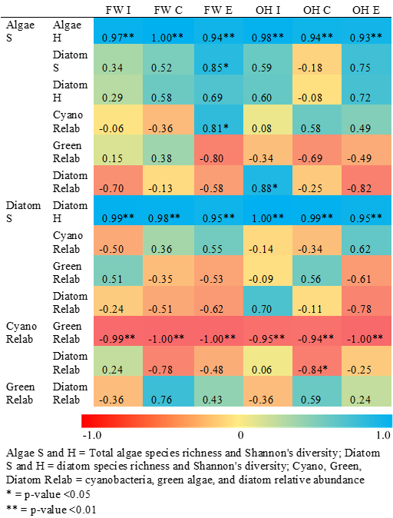

Table 2.5. Pearson’s correlation coefficients between algal composition metrics and functional response variables as heat map for emphasis. (a) Algal species richness vs. function, (b) algal group relative abundances vs. function. Coefficients near 1 indicate strong positive coupling between variables and those near -1 indicate strong negative coupling.

Table 2.5 (continued). (b)

Figure 2.1. Freshwater and oligohaline sample sites in Everglades National Park.
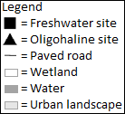
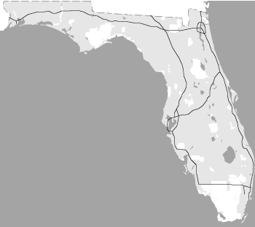
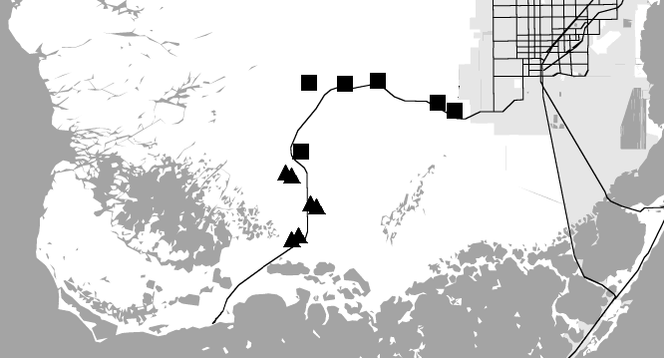

Figure 2.2. Treatment means across regions for conductivity and functional response variables with analysis of variance (ANOVA) significance results. Gray bars = freshwater, white bars = oligohaline. Different letters represent significance (p < 0.05) between treatments within a region (lower case = freshwater, upper case = oligohaline), asterisks represent significance (p < 0.05) between regions within a treatment.
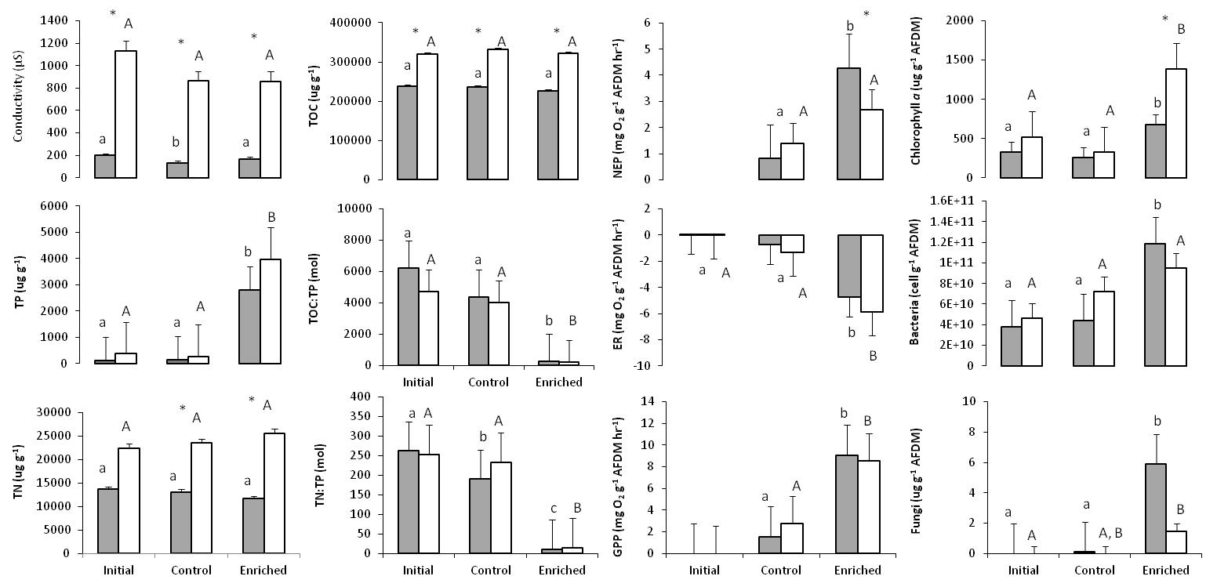

Figure 2.3. Photographic documentation of macroscopic changes among initial (I), control (C), and enriched (E) benthic microbial mat experimental cores. All initial core pictures were taken on day one of the experiment, all control and enriched cores on the final day sixty of the experiment. (a) Freshwater replicates, numbers 1 – 6, (b) oligohaline replicates, numbers 7 – 12.
a. Freshwater mat cores
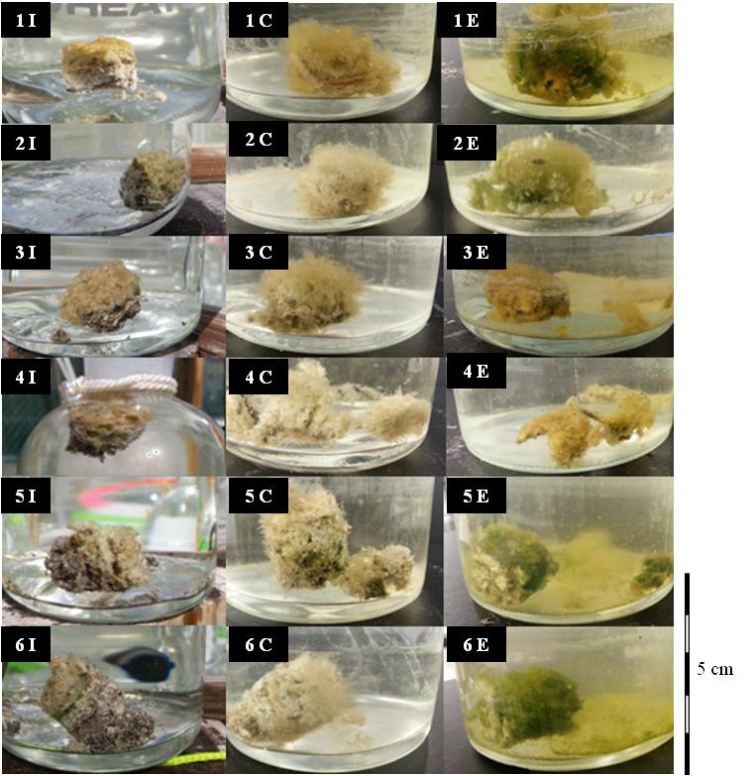

b. Oligohaline mat cores
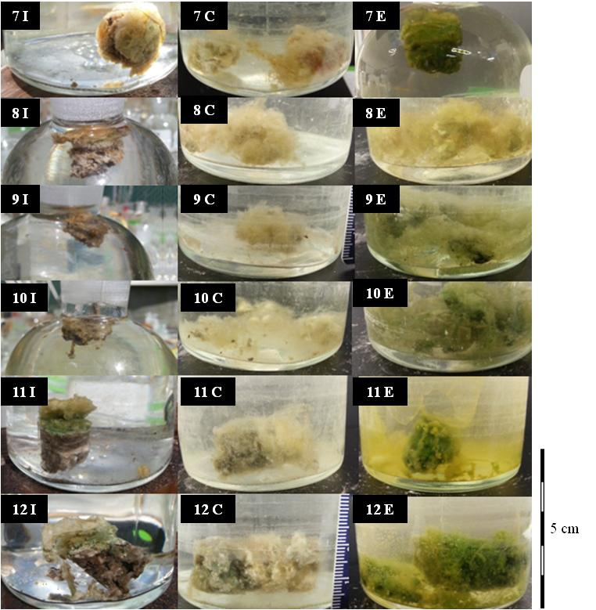

Figure 2.4. Total algae relative abundance dot plot of taxa >5% relative abundance in at least one sample, separated by region and treatment. Taxa listed by algal group notation and catalogued species number for that group, where prefix Cc = cyanobacteria coccoid, Cf = cyanobacteria filament, Dc = diatom unicell, Gc = green algae coccoid. FW = freshwater, OH = oligohaline.
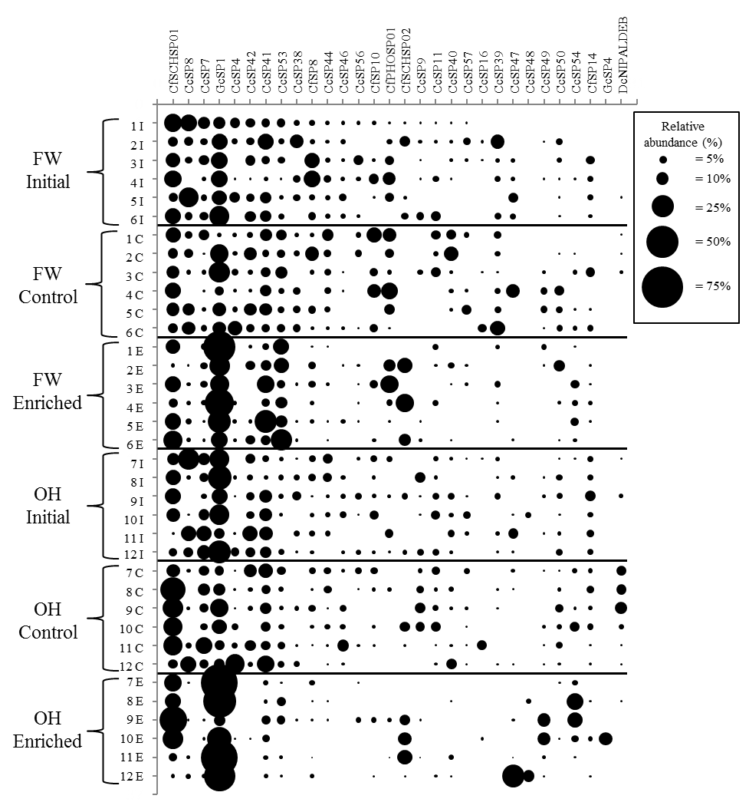

Figure 2.5. Total algae dot plot of taxa >1.0 average dissimilarity between treatment and region group comparisons. Taxa listed by algal group notation and catalogued species number for that group, where prefix Cc = cyanobacteria coccoid, Cf = cyanobacteria filament, Dc = diatom unicell, Gc = green algae coccoid. FW = freshwater, OH = oligohaline, I = initial, C = control, E = enriched.
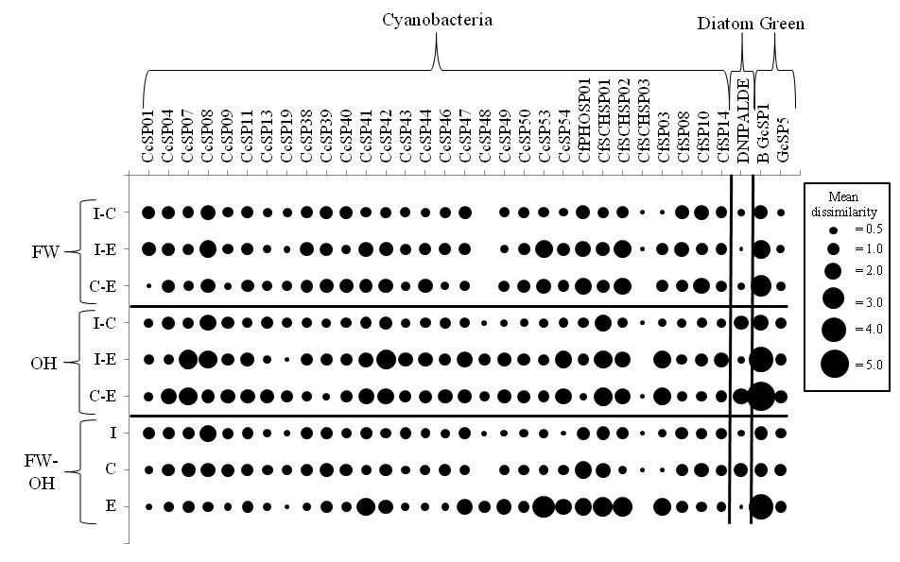

Figure 2.6. Diatom relative abundance dot plot of taxa >5% relative abundance in at least one sample, separated by region and treatment. Species names listed in Figure 2.7. FW = freshwater, OH = oligohaline.
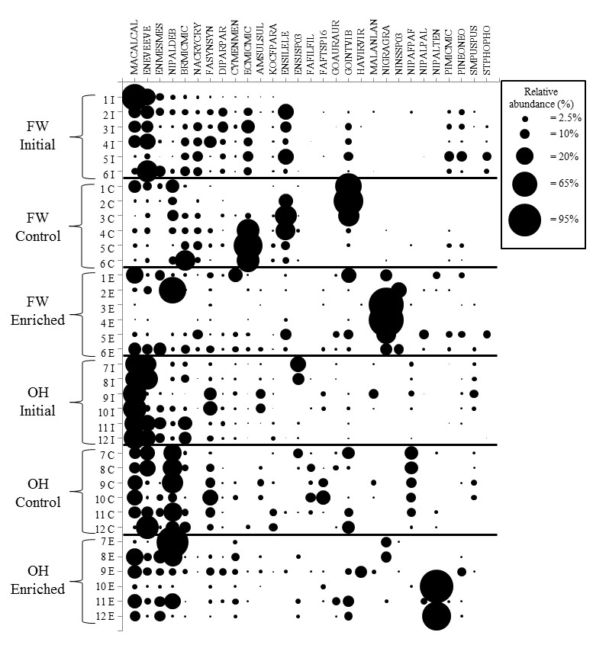

Figure 2.7. Diatom dot plot of species >1.0 average dissimilarity between treatment and region group comparisons. Taxa listed alphabetically. FW = freshwater, OH = oligohaline, I = initial, C = control, E = enriched.
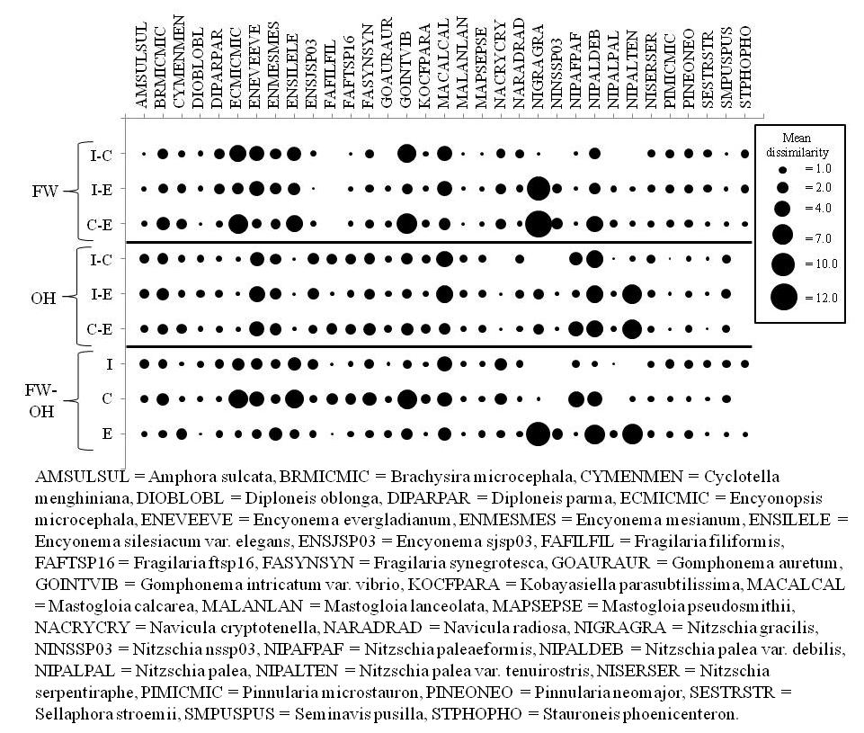

Figure 2.8. Non-metric multidimensional scaling (NMDS) of total algae composition with conductivity and functional response vectors and 50% similarity clusters. (a) Both regions across treatments, (b) freshwater across treatments, (c) oligohaline across treatments. BAC = bacteria cell concentration, CHLA = chlorophyll a, COND = conductivity, ER = ecosystem respiration, FUNGI = fungal biomass, NEP = net ecosystem production, TOC = total organic carbon, TP = total phosphorus.
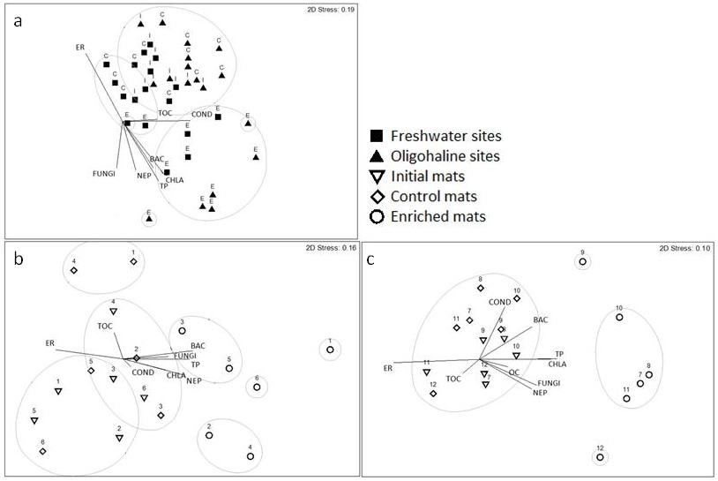
Figure 2.9. Non-metric multidimensional scaling (NMDS) diatom composition with conductivity and functional response vectors and 50% similarity clusters. (a) Both regions across treatments, (b) freshwater across treatments, (c) oligohaline across treatments. BAC = bacteria cell concentration, CHLA = chlorophyll a, COND = conductivity, ER = ecosystem respiration, FUNGI = fungal biomass, NEP = net ecosystem production, TOC = total organic carbon, TP = total phosphorus
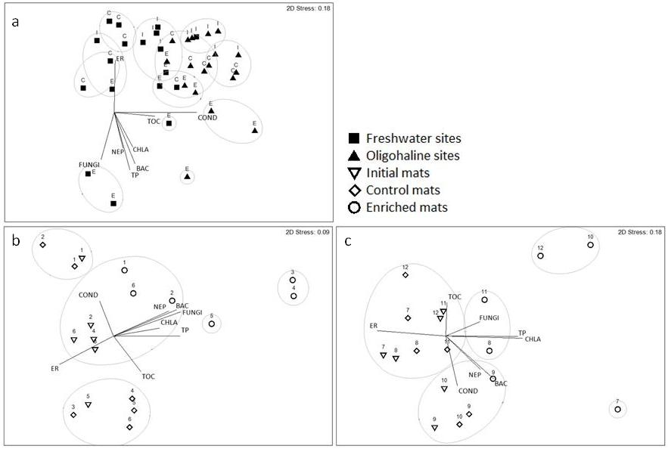
Appendices to Chapter 2
Appendix A
Table 2A.1. Environmental and functional response values for each treatment-by-site. Sample codes indicate site number, treatment (I = initial, C = control, E = enriched) and region (FW = freshwater, OH = oligohaline).
Appendix B
Table 2B.1. Diatom species counts for each treatment-by-site. (a) Freshwater sites and (b) Oligohaline sites. Sample codes indicate site number, treatment (I = initial, C = control, E = enriched) and region (FW = freshwater, OH = oligohaline). Taxon codes are arranged alphabetically by genus and species and, where applicable, variety or forma abbreviations. See Table 2B.2 for taxon names and authorities.

Table 2B.2. Codes and names of diatom taxa.

Appendix C
Table 2C.1. Total algae taxon counts for each treatment-by-site. (a) Freshwater sites and (b) Oligohaline sites. Sample codes indicate site number, treatment (I = initial, C = control, E = enriched) and region (FW = freshwater, OH = oligohaline). Taxon names are unresolved and are listed by algal group (cyanobacteria, green algae, diatoms), shape, and identification number.

CHAPTER 3: ASSEMBLY MECHANISMS OF PERIPHYTIC DIATOM SPATIAL AND TEMPORAL BETA DIVERSITY ACROSS A SUBSIDY-STRESS GRADIENT IN A COASTAL WETLAND

Abstract
The turnover of community composition across space and time – beta diversity – can be differentially influenced by local (e.g., environmental) and regional (e.g., dispersal) assembly mechanisms that can determine how resilient community biodiversity is to change. However, relatively little is known of how the mechanisms underlying beta diversity are affected at multiple spatial and temporal scales along environmental gradients, particularly in microbial communities sensitive to environmental disturbance and physically contained within attached microhabitats. I assessed the beta diversity of a periphytic diatom metacommunity across an environmental subsidy (phosphorus) and chemical stress (salinity) gradient and identified the spatial and temporal extents of the local and regional mechanisms structuring metacommunity turnover at landscape, inter-regional, and regional spatial scales and inter-annual temporal scales. The study was conducted along a freshwater-oligohaline coastal gradient within the Florida Everglades, USA among 16 sites over 8 years. Landscape environmental conditions were defined spatially and temporally by the subsidy-stress gradient. The highest spatial and temporal environmental variation was found within the low subsidy-stress, freshwater region of the gradient and was attributed to high variation in water availability. Spatial beta diversities were highest at the landscape and inter-region scales, but temporal turnover was low across and within regions except for the high subsidy-stress, brackish region. The variation of spatial beta diversity was partitioned into assembly mechanisms for each region: the landscape and inter-regions were environmentally structured, indicative of species sorting processes associated with the environmental gradient. Environmental and spatial factors were both significant within regions, indicative of coincident species sorting and spatial-based processes at the regional scale that fluctuated spatiotemporally. Temporally, the landscape and each region correlated strongly with non-gradient environmental factors and variation in subsidy and water availability. These results indicate environmental gradients can control landscape metacommunity compositional turnover across space with a low degree of control by spatial factors, but environmental and spatial mechanisms independent of the gradient operate at regional spatial and temporal scales.

Introduction
The distributions and abundances of species are controlled by spatially and temporally structured factors that are increasingly affected by anthropogenic disturbance and global climate change (Hillebrand and Matthiesen 2009). The identification of local and regional factors controlling biodiversity is necessary to assess the sensitivity of communities to change across spatial and temporal scales. However, studies are limited that consider species diversity at multiple spatial, temporal, and environmental scales in order to assess the complex mechanisms underlying community assembly that in turn define ecosystem biodiversity and function (Hillebrand and Matthiesen 2009, Lindström and Langenheder 2012). In particular, relatively little is known about how compositional turnover is controlled along environmental gradients over space and time, particularly in microbial communities that are sensitive to environmental disturbance and spatial heterogeneity and are physically contained within biofilm communities.
Beta diversity – the compositional turnover of species over space and time – is regulated by local and regional factors that are nested within the metacommunity concept of interacting communities linked by dispersal-based processes (Ricklefs 1987, Chase and Leibold 2002, Leibold et al. 2004). The extent of control on beta diversity of local, intra-habitat factors (e.g., environmental effects and species interactions) and regional, inter-habitat factors (e.g., dispersal, species pools, and ecological drift) determines community assembly and can be represented by the four frameworks within the metacommunity concept (Leibold et al. 2004). In patch dynamics models, community composition is controlled by the balance of regional immigration-emigration among homogenous local patches. Neutral models predict community assembly is regulated by stochastic processes and dispersal limitation among functionally equivalent species (Hubbell 2001). Individual species response to local environmental conditions controls assembly in species sorting (i.e., environmental filtering) models (Hutchinson 1957), while in mass effects models environmental controls and high dispersal rates interact to regulate variation in community abundance and composition. In order to fully consider all possible mechanisms of community assembly, compositional turnover must be assessed at the spatial, temporal, and environmental scales at which community change operates (Huston 1999, Hillebrand and Matthiesen 2009).
Species sorting and mass effects are largely responsible for spatial beta diversity of macro-organisms at regional, landscape, and ecoregion levels (Cottenie 2005), but microorganism spatial beta diversity has been attributed to species sorting, mass effects, neutral processes, and co-control among mechanisms at ecoregion, ecosystem (or landscape), regional, and local spatial scales. Overall, microorganism spatial beta diversity in aquatic systems has been predominantly attributed to species sorting (Potapova and Charles 2002, Landeiro et al. 2011), but the relative contribution of spatial factors, particularly dispersal-limitation or stimulation, differs by system connectivity, spatial extent considered, and environmental heterogeneity (Heino et al. 2015). In order to assess the mechanisms responsible for ecosystem-wide beta diversity, local, regional, and landscape spatial scales must be considered simultaneously.
Environmental gradients are common across a wide range of spatial scales, but little is known about how beta diversity is controlled along environmental gradients at local, regional, and ecosystem spatial scales. In macro-organisms, the larger the spatial extent of the environmental gradient, the greater environmental control exists (Jackson et al. 2001), but Potapova and Charles (2001) found greater spatial contributions to diatom beta diversity along environmental gradients at the ecoregion scale than the landscape scale, which might be attributed to dispersal limitation generally increasing with increased spatial extent (Soininen 2012). The linkages among spatial scale, environmental gradients, and mechanisms of community assembly have yet to be clearly resolved in microorganisms, particularly when spatial differences in controls are considered with change over time (Heino et al. 2015, Padial et al. 2014).
Few studies have examined the temporal changes in the mechanisms structuring metacommunity composition in either macro- or microorganisms (but see Heino and Mykra 2008, Langenheder et al. 2012, Fernandes et al. 2014, Padial et al. 2014), but environmental and dispersal-based factors operate at temporal scales that must be considered so as not to miscalculate or misattribute spatial effects, particularly in systems with high seasonal or annual environmental variability (Heino and Mykra 2008). Microorganisms can be useful to considering metacommunity diversity change over time because complete compositional turnover and assembly mechanisms at each time step can be considered in a time series of years instead of decades because of their rapid life histories and dispersal ability in response to environmental conditions (Korhonen et al. 2010). Padial et al. (2014) found spatial factors were the dominant structuring process of temporal beta diversity in macro-organisms with low dispersal ability while species sorting was predominant among microorganisms with high dispersal ability, including plankton and periphyton. Langenheder et al. (2012) showed among bacterial communities that relative contributions of species sorting and dispersal-based processes were associated with temporal variation across space.
Strong regional and ecosystem-scale environmental gradients are often associated with strong control of beta diversity by mass effects because of high connectivity across space that engenders high dispersal (Heino et al. 2015), but these studies consider streams and marine systems in which dispersal mediation is high, driven by water flow and seasonal mixing of plankton, respectively. Benthic and periphytic communities in shallow, low-flow aquatic systems may be buffered from dispersal by containment within a structured microhabitat with low degrees of physical displacement despite a high degree of connectivity along an environmental gradient, in which case co-occurrence of species sorting and neutral processes might be expected on a regional scale (Lee et al. in prep). The phosphorus (P)-limited Everglades of South Florida, USA is a coastal wetland with abundant floating, epiphytic, and benthic microbial mats (periphyton) throughout its freshwater marshes and sloughs. The Everglades is characterized by slow surface water flow of two major drainages along a gradient of increasing P (subsidy) and salinity (stress) from an interior freshwater marsh through an oligohaline ecotone to saline open water. Diatoms are contained within thick periphyton predominated by cyanobacteria and precipitated calcium carbonate that change in algae taxon identity and periphyton structural integrity along the subsidy-stress gradient and P-enriched areas (Ross et al. 2001, Gaiser et al. 2006). However, the mechanisms underlying diatom beta diversity within the Everglades remain unresolved.
I investigated the community assembly of periphytic diatoms at the freshwater and oligohaline regions of an increasing nutrient-salinity gradient in the Florida Everglades using data from 16 sites over 8 years. I aimed to determine the natural environmental variation, spatial and temporal diatom beta diversity, and local and regional assembly mechanisms associated with those diversities in two regions separately (freshwater and oligohaline) and together (landscape) at opposite ends of a subsidy-stress gradient. I formed the following hypotheses: (1) Spatial and temporal environmental heterogeneity would be higher in the oligohaline region than freshwater because of high variability in salinity, nutrients, and water depth among sites and years. (2) Oligohaline spatial and temporal diatom beta, alpha, and gamma diversity would exceed those of freshwater because of larger species pools and environmental variation in the ecotonal region. (3) Variation in landscape and oligohaline regional spatial beta diversity would be attributable to species sorting mechanisms of environmental control, while freshwater region variation in beta diversity would be defined more by spatial processes linked to dispersal limitation. (4) Spatial and temporal beta diversity would be most closely associated with the nutrient-salinity gradient at the landscape scale, water availability in the freshwater region, and nutrients and salinity in the oligohaline region.

Methods
Study system
The Florida Everglades is a subtropical, oligotrophic coastal wetland covering over 6000 km² that is canalized into several distinct regions in which water quality and quantity are intensively managed (Davis and Ogden 1994). The southernmost area, Everglades National Park, is characterized by two major drainages, Shark River Slough and Taylor Slough, each of which contains a coastal gradient of increasing P and salinity from the freshwater marsh to marine Florida Bay, with an oligohaline ecotone between the two. In both drainages, the freshwater marsh is characterized by P limitation and physical stress of dry season drought and the oligohaline ecotone by elevated P, brackish surface water salinity, and extended seasonal hydroperiod. Periphyton is abundant throughout the Everglades with metabolic, productivity, and diatom compositional differences along the coastal gradient (Ross et al. 2001, Gaiser et al. 2005). This study used eight years of data across sixteen primary sampling units (PSUs) from the Comprehensive Everglades Restoration Plan Monitoring and Assessment Program (CERP MAP) to assess the assembly mechanisms regulating spatial and temporal diatom beta diversity within and between two regions of the subsidy-stress gradient.

Sample collection and processing
Periphyton was collected from eight freshwater and eight oligohaline sites each year over eight wet seasons (September to December) from 2006 to 2013 as part of CERP MAP (RECOVER 2004). Sites were defined as freshwater and oligohaline by geographic location and proximity to brackish water influence as detected in groundwater salinity surveys (Saha et al. 2011). Sites were chosen by random selection of all regional sites within CERP MAP with environmental and diatom composition data across at least seven of the eight years (Figure 3.1).
Variables known to most affect periphyton ecology were measured for each site per year: hydrology (hydroperiod, surface water depth, conductivity, and pH), periphyton abundance (aerial cover, biovolume, ash-free dry mass [AFDM], and percent organic content [OC]), and periphyton quality (periphyton total P [TP] and diatom diversity) (Gaiser et al. 2006, Lee et al. 2013). Hydroperiod and surface water depth proxy dry season drought duration and affect periphyton desiccation and diatom succession (Gottlieb et al. 2006). Conductivity was used as a proxy for salinity, which is a chemical stress for which diatom species tend to have a narrow range of tolerance (Wachnicka and Gaiser 2007). Ash-free dry mass and periphyton cover and biovolume are measures of periphyton biomass, for which periphytic diatoms have optima (Lee et al. 2013). Surface water pH and periphyton OC were used as proxies for water and periphyton carbonate content, respectively, which are associated with freshwater periphyton-forming diatoms (Lee et al. 2013). Phosphorus is a nutrient required for diatom growth, and diatoms have known optima and tolerance ranges for TP availability (Gaiser et al. 2004).

Hydroperiod (days inundated >5 cm surface water) was determined by surface water depth data from the Everglades Depth Estimation Network (EDEN). Surface water depth was measured as the distance between soil and water surfaces and standardized to EDEN depths. Water conductivity and pH were measured from a 120 mL surface water sample (AP85 meter, Fisher Scientific, New Hampshire, USA). Periphyton aerial cover and biovolume in 1 m² were recorded at each site by direct observation and measurement. A 120 mL subsample of the periphyton biovolume from each site was returned to the laboratory, homogenized, and subsampled for TP, OC, AFDM, and composition. Subsamples were dried (70°C) and weighed and then combusted (500°C) and weighed for AFDM. Organic content was calculated as the proportion of combusted ash mass to dry mass and AFDM as the dry weight of the organic content. Periphyton TP content reflects inflowing P load better than does the water column (Gaiser et al. 2004), so periphyton TP was measured in place of water column TP using mass spectrometry. Ambient TP levels in Everglades periphyton rarely exceed 500 µg g⁻¹ AFDM in the freshwater marsh and 1000 µg g⁻¹ AFDM in the oligohaline ecotone, with anything over signifying enriched areas (Gaiser et al. 2006, Gaiser 2009). Subsamples for diatom analysis were oxidized to remove organic and inorganic debris and preserve diatom valves (Hasle and Fryxell 1970). Oxidized diatoms were dried onto cover slips and mounted on slides using Naphrax mounting medium. A minimum of 250 valves were counted and identified to the lowest taxonomic level along random, measured transects using compound light microscopy at 1000x magnification. An additional 250 valves were observed, recording only taxa not found in the previous 250 counts while doubling the counts of taxa from the first counting effort for a minimum of 500 valves recorded.
Data analysis
For four instances of missing site data, data across the other seven years from the respective PSU were averaged for each variable. Diversity and environmental analyses separated the oligohaline sites into two distinct regions, so all analyses, when possible according to sample size limitations, considered all regions together (the landscape), three regions individually, and two comparisons of regions across all years (inter-region): landscape (n = 16, all sites), freshwater (n = 8, all freshwater sites), transitional (n = 6 of oligohaline sites), and brackish (n = 2 of oligohaline sites) regions, and freshwater-transitional (n = 14) and transitional-brackish (n = 8, all oligohaline sites) combinations.

Diatom diversity partitioning
Diatom species counts were adjusted to relative abundances of the total species of a sample. In order to compare natural diatom species pools and diversity between regions, for each year, diatom species composition was partitioned into alpha (α), beta (β), and gamma (γ) diversities across each region and all regions together using the d function in the vegetarian package in R (Charney and Record 2013). Diversities were based on Hill numbers of order q = 1, by which species were weighed by their frequencies without biasing towards common or rare species, thereby outputting the effective number of species at each diversity level (Hill 1973, Jost 2006, Jost 2007). Diatom spatial β was determined by calculating β among sites within and across regions and averaging β over eight years. Diatom temporal β was determined for each site, region, and metacommunity by calculating β among years within each site, across sites within a region, and across all sites in all regions, respectively.
For multivariate analyses, diatom counts were relativized to zero mean and unit variance and arcsine square root transformed (McCune and Grace 2002, McCune and Mefford 2011). Analyses were conducted in PRIMER v. 9 (Anderson et al. 2008). Bray-Curtis similarity matrices were constructed for species and environmental data across all sites per year. To assess spatial and temporal diatom community dissimilarity, a measure of beta diversity (Legendre and Cáceres 2013), within and among regions, non-metric multi-dimensional scaling (NMDS) ordinations were created and overlain with hierarchical cluster analyses to group compositionally similar sites within and across regions.

Environmental variation
To evaluate regional and metacommunity environmental conditions, means and standard deviations of each environmental variable were calculated for all regions together and separately. Highly correlated variables were determined using principle components analysis, and conductivity, TP, OC, AFDM, and water depth were deemed representative of their respective ecological parameters and were the only variables considered in further analyses. Environmental variables were transformed to reduce skewness and approximate normality (McCune and Grace 2002). As a measure of spatial and temporal environmental variability, coefficients of variation (CVs) were calculated for each variable and averaged across sites within each year (temporally explicit spatial CV) and across years within each site (spatially explicit temporal CV) for all regions and inter-region comparisons. The multivariate dispersions of environmental resemblance matrices were calculated using the PERMDISP function in PRIMER v. 9 (Anderson et al. 2008) in order to measure total environmental dispersion within and across regions over space and time. For temporally explicit spatial measures of variation in environmental dispersion within and across regions, mean distances of the observation from each site from the group centroid were averaged for each year, and CVs were calculated from annual inter-site dispersions. For spatially explicit temporal measures of overall inter-regional and regional environmental variation, mean distances from centroid were averaged for each site across all years, and CVs were calculated from the mean dispersions of all sites.

Factors influencing diatom spatial and temporal beta diversity
To understand the relative contributions of assembly mechanisms in explaining spatial diatom beta diversity, the variation in non-transformed, relative abundance-derived diatom beta diversity was considered across sites within years among and within regions and partitioned into pure environmental (E|S), spatially-structured environmental (E∩S), pure spatial (S|E), and unexplained variation (U) following the methods in Sokol et al. (2013) (Legendre 2008). Magnitudes of assembly mechanisms were averaged over all years for mean spatial beta diversity variation explained among and within regions and also assessed across years for spatiotemporal differences. Variation of brackish region spatial beta diversity was not partitioned because of low sample size (n = 2). Variation partitioning analyses were conducted in R (Sokol et al. 2013).
Environmental variables were normalized by z-scores and diatom community composition averaged across years per site and across sites per year among and within regions. Bio-env stepwise analysis (BEST) was used to conduct Mantel tests on the diatom dissimilarity matrices and environmental data to determine the strength of Spearman rank correlations of each variable and subsets of variables with spatial and temporal diatom assemblage dissimilarity (Clarke and Warwick 2001, Clarke and Gorley 2006) in order to better understand the specific variables responsible for and their extents towards explaining environmental control on beta diversity over space and time. Significant spatial eigenvectors were generated during the variation partitioning analysis in order to assess the spatial scale at which the spatial processes operate. Pearson correlation coefficients between spatial and temporal beta diversity and environmental factor CVs were generated in order to assess the relationship between diversity and environmental variability over space and time. Diatom assemblage NMDS ordinations were fitted with environmental vectors in order to visualize intra-assemblage correlations with environmental variables over space.

Results
Diatom diversity partitioning
Spatially, the landscape was separated into roughly two distinct communities, in which mean local species diversity was about five species and mean regional diversity about nine species (Table 3.1). The freshwater and transitional regions were each categorized as singular communities with about five and seven local and regional species diversity, respectively. The brackish region was characterized by one community with seven and eleven local and regional species diversity, respectively. The freshwater-transitional inter-region comparison diversity was no different from freshwater and transitional regional diversity, while the transitional-brackish region was separated into two distinct communities with a local species diversity of roughly six species and a regional diversity of about ten species. Excluding two outlier sites, the landscape was 30% compositionally similar (Figure 3.2). The freshwater-transitional group was 50% similar, and two brackish groups, which were delineated by site, were 40% similar.
Temporally, the landscape, freshwater, transitional, and freshwater-transitional assemblages were each comprised by a single community, on average (Table 3.1). Local species diversity numbered five species and regional diversity six. The brackish region had the highest temporal beta diversity of any spatial extent but was still composed of a single distinct community with an average of eight and eleven local and regional diversity, respectively. The transitional-brackish inter-region comparison was one distinct community with six local and seven regional species diversity.

Environmental variation
Mean freshwater environmental and periphyton conditions were typical of the freshwater marsh, with low conductivity, high periphyton biomass with low organic content (and correspondingly high carbonate content) and low TP, and seasonal hydroperiod (Table 3.2). The transitional region approximated mean freshwater values for each variable, and with lower conductivity, TP, and OC and higher AFDM than freshwater sites indicated more typical freshwater patterns than did the freshwater region. The brackish region was typical of the oligohaline ecotone with elevated conductivity, TP, and OC and reduced periphyton biomass.
Total spatial environmental variation was highest across the landscape with very low variation across the other groups (Table 3.3). Mean spatial variations in conductivity and TP were slightly higher within the landscape and transitional-brackish inter-region than in other groups, with overall low variation within regions (Table 3.3). Spatial variation in periphyton biomass and surface water depth was moderately high across all groups, with variation in biomass highest in the landscape, freshwater, and transitional-brackish inter-region and variation in water depth highest in the brackish region. Overall temporal environmental variation was moderate at all scales except the freshwater-transitional inter-region and highest in the landscape (Table 3.3). Temporal variation in environmental variables was low except for in periphyton biomass and surface water depth, which resembled values of spatial variation except in the case of extremely high variation in brackish periphyton biomass.

Factors explaining diatom spatial and temporal beta diversity
At the whole-study, landscape scale, the diatom metacommunity was separated into two distinct communities that were explained mostly by environmental and spatially structured environmental factors, with an average of less than 2% of the variation in beta diversity explained by spatial processes (Figure 3.3). Landscape spatial metacommunity beta diversity was most highly correlated with conductivity, TP, and organic content (Table 3.4) and with variation in conductivity, TP, AFDM, and water depth (Table 3.5). The most broadly functioning spatial scale eigenvector, 1, was the most strongly associated spatial factor (Table 3.5).
At the regional scale, spatial factors contributed roughly the same as spatially structured environmental factors to explaining freshwater variation in spatial beta diversity, which was roughly half that explained by environmental variables (Figure 3.3). Total phosphorus, OC, and AFDM were the most highly correlated environmental variables with freshwater spatial beta diversity, and variation in TP and water depth were strongly associated (Table 3.5). Moderate to large spatial scale eigenvectors 1, 3, and 4 were the strongest spatial contributors to explaining variation (Table 3.4).
Transitional spatial beta diversity followed similar patterns as freshwater, though with more environmental and less spatial contribution (Figure 3.3). Spatial beta diversity correlated most strongly with OC and water depth (Table 3.4), and with variation in conductivity and water depth (Table 3.5). The primary, broad spatial scale eigenvector was the most strongly correlated spatial variable (Table 3.4). Freshwater-transitional spatial beta diversity variation was explained similarly as freshwater and transitional regions, with spatial factors explaining roughly half that of both environmental and spatially structured environmental factors (Figure 3.3). Freshwater-transitional spatial beta diversity correlated most strongly with OC, AFDM, and water depth (Table 3.4) and with variation in conductivity and TP (Table 3.5). Significant spatial factors included small, moderate, and large spatial scale eigenvectors, 1, 4, and 9 (Table 3.4).
The transitional-brackish inter-regional comparison was distinguished by two distinct communities. As a whole, spatial factors explained very little variation (0.5%), while environmental and spatially structured environmental factors contributed roughly the same to over 50% of the variation (Figure 3.4). Conductivity, TP, and OC as well as variation in conductivity and AFDM contributed substantially to explaining spatial beta diversity, and the primary eigenvector contributed the most to spatial explanation (Tables 3.4 & 3.5). Despite no calculated environmental or spatial assembly fractions, the spatial beta diversity within the brackish region correlated with conductivity, TP, and OC at a similar strength to environmental correlations within the freshwater and transitional regions (Table 3.4) with weaker, but more even correlations with environmental variation than other regions or spatial scales (Table 3.5).
Between 50 – 55% of the variation in spatial beta diversity was unexplained in the landscape and transitional region, and 64% and 70% of the variation was unexplained in the freshwater region and freshwater-transitional inter-region, respectively. The transitional-brackish inter-region had the lowest unexplained variation of 40% (Figure 3.3). For each comparison of variation partitioning, E|S values were significant on average, whereas S|E was significant in only two comparisons within the freshwater region.
The relative contributions of environmental, spatially structured environmental, spatial, and unexplained factors to spatial beta diversity varied substantially across years within the freshwater and transitional regions but not within the landscape or transitional-brackish inter-region (Figure 3.4). Particularly, the relative dominance of E|S and S|E were strongly temporally variable within regions.
Mean intra-site temporal beta diversity was low within the landscape, freshwater and transitional regions, and each inter-region, and while brackish beta diversity was substantially higher no region indicated more than one distinct diatom community over time (Table 3.1). Landscape and transitional-brackish inter-regional temporal beta diversities were more weakly correlated with environmental variables than were spatial beta diversities, and temporal turnover correlated more strongly with all environmental variables as a group rather than gradient-related variables (Table 3.4). Contrary to the strong negative correlations between landscape and transitional-brackish inter-regional spatial beta diversity and environmental variation, temporal beta diversity was in general moderately positively correlated with environmental variation (Table 3.5). Within regions, temporal beta diversity was correlated more strongly with environmental variables than was spatial beta diversity, and the strongest correlations included a majority of variables independent of the gradient (Table 3.4). However, regional temporal beta diversity was generally more weakly correlated with environmental variation than was spatial turnover (Table 3.5).

Discussion
The present study demonstrated that local species sorting controls spatial beta diversity at the landscape and inter-regional scales along a subsidy-stress gradient, while coincident species sorting and regional spatial processes structure spatial turnover within regions. Regardless of spatial extent and geographic position along the gradient, spatially explicit temporal beta diversity was strongly correlated with species sorting processes. Contrary to my hypothesis, spatial and temporal environmental variability within the low subsidy-stress, freshwater region were roughly equal to that of the brackish region, both of which were attributable to high variability in periphyton biomass and drought stress. Landscape environmental conditions were characterized spatially by the subsidy-stress gradient in addition to periphyton biomass and water availability. Spatial beta diversities were highest among regions, and temporal turnover was consistently low among and within regions except for slightly elevated beta diversity within the brackish region. Spatial beta diversity in the landscape and between regions was environmentally structured and associated with subsidy-stress gradient-related environmental factors, while both local environmental and spatial factors contributed significantly to spatial beta diversity within regions. The relative contributions of environmental and spatial factors to explaining spatial beta diversity varied considerably over time. Temporally, the landscape, inter-regions, and each region correlated moderately with environmental factors and environmental variation independent of the subsidy-stress gradient.
Region determination and site selection by groundwater salinity poorly represented functional environmental and microbial compositional regional differences, as six originally oligohaline sites grouped very closely with freshwater sites in environmental and diatom compositional similarity. The similarity between freshwater and transitional regions indicates a more gradual functional response by biota to the P subsidy-salinity stress gradient across the freshwater marsh than indicated by groundwater salinity as well as a spatially abrupt ecotonal boundary not captured in this study (Ross et al. 2001, Saha et al. 2011).
The reassignment of regions prohibited detailed variation partitioning analysis of brackish diatom spatial beta diversity but enabled a stronger assessment of the effects of environmental gradients on diatom beta diversity over space. Contrary to my hypothesis, spatial environmental heterogeneity was low within freshwater, transitional, and brackish regions but relatively high at the landscape scale. Spatial environmental variation across all sites in a given year was expected and attributable to weakly moderate variation in conductivity and TP along the subsidy-stress gradient, but variation in conductivity and TP across and within regions was low overall. High variation in water depth was strongly correlated with freshwater and transitional spatial beta diversity, indicating that spatial and temporal variation in water availability is a strong control on diatom beta diversity over space and time. These results are consistent with large spatial and temporal heterogeneity in wet season precipitation and dry season drought duration in the freshwater marsh of the Everglades. Drought duration has been shown to differentially affect diatom species relative abundance within mats (Gottlieb et al. 2005) and habitats of short or long hydroperiod (days inundated) have distinct diatom assemblages and taxon richness (Gottlieb et al. 2006).
The two sites in the brackish region were characterized by relatively low variation in conductivity and TP over space and time, which suggests that brackish ecotonal sites in the Everglades may not receive drastically different amounts of P subsidy and salinity stress and that subsidy-stress dynamics do not substantially differ locally from year to year. However, the seemingly low spatial variation in conductivity and TP, along with similar variation in periphyton biomass and surface water depth, within the brackish region was moderately correlated with spatial and temporal diatom beta diversity. These results indicate low degrees of spatial and temporal environmental variation can control diatom community diversity. However, the availability of and variation in TP was most strongly associated with diatom temporal beta diversity in the brackish region, indicating that nutrient availability is a primary control of microbial community diversity in the oligohaline ecotone of the Everglades.
In North American and European boreal stream biofilms and lake phytoplankton, diatom spatial beta diversity generally becomes more spatially structured as spatial extent increases along environmental gradients from intra-ecoregion to continental scales in streams (Potapova and Charles 2002, Soininen et al. 2004, Soininen 2007) and ecoregion to inter-continental scales in lakes (Bennett et al. 2010). Verleyen et al. (2009) found species sorting operated at local and regional scales in lake planktic diatoms and spatial processes, primarily dispersal limitation, became increasingly meaningful after region area exceeded 2000 km². The present study considered the contribution of assembly mechanisms to diatom metacommunity beta diversity from intra-regional (150 – 1300 km²) to inter-regional and landscape (650 – 2400 km²) scales within a subsidy-stress gradient in the Florida Everglades coastal wetland and found that spatial factors decreased in explanatory power as spatial extent increased from intra-region to inter-region scales (Figure 3.3). These results suggest diatom spatial beta diversity is not necessarily structured solely or even primarily by species sorting mechanisms at relatively small, intra-regional scales along environmental gradients and that beta diversity of diatoms across regions characterized by an environmental gradient is primarily structured by species sorting processes related to the gradient.
The decrease of spatial structuring mechanisms at the inter-region scale is likely attributable to dominant control by gradient-associated environmental factors. Meanwhile, intra-regional spatial beta diversity was co-controlled by environmental factors independent of the environmental gradient and undetermined spatial processes. Regional spatial control could be attributable to unmeasured environmental variables, spatial autocorrelation in which geographically proximal sites tend to share diversity patterns (Jongman et al. 1995), or dispersal limitation or stimulation. Surface water flow in Everglades sloughs rarely exceeds 3 cm s⁻¹, and diatoms are confined to periphyton communities with low physical displacement pressure aside from severe storms (Pimm et al. 1994). Instead, local nutrient and water availability control periphyton abundance across the freshwater marsh (Gaiser et al. 2006, Hagerthey et al. 2011), which affects the diatom composition within the assemblage and diatom beta diversity over space and time (Tables 3.4 & 3.5). If freshwater and transitional diatom beta diversity were spatially structured by dispersal limitation associated with periphyton abundance, spatial beta diversity would be expected in part to correlate strongly with periphyton biomass. However, in my study periphyton AFDM was highly variable within regions (Table 3.3), but while local AFDM correlated moderately with spatial beta diversity, the variation in AFDM correlated poorly with freshwater and transitional diatom spatial beta diversity. However, variability in OC (or, conversely, inorganic carbonate content) may be a better measure of habitat suitability for mat-forming, dispersal limited diatoms (Lee et al. in prep), and local OC and variability in OC correlated moderately with freshwater and transitional region spatial beta diversity (Tables 3.4 & 3.5). Therefore, it seems probable that dispersal limitation contributes to spatial control of diatom beta diversity within freshwater and transitional regions of the Everglades.
Temporal variation in assembly mechanisms of spatial beta diversity in a bacterial metacommunity of rock pools was found to be moderately associated with temporal variation in spatial beta diversity, with co-control of species sorting and spatial factors during periods of high environmental variability and correspondingly high beta diversity (Langenheder et al. 2012). While my study did not make temporally explicit comparisons among environmental variation, beta diversity, and assembly mechanisms, I did find that the extent of co-control by environmental and spatial assembly mechanisms of diatom spatial beta diversity fluctuated over time across and within regions, suggesting that mean magnitudes of variation partitioning do not completely capture metacommunity diversity dynamics.
Temporal beta diversity was lower than spatial beta diversity across and within regions and correlated more strongly with environmental factors within regions. At the landscape and inter-region scale, temporal beta diversity correlated more weakly with environmental factors and variability than did spatial turnover, but within regions temporal beta diversity was more strongly correlated with environmental factors than the spatial counterparts. Regardless of spatial extent, temporal beta diversity was correlated most strongly with a combination of most or all environmental factors and their variability. While strong correlation between temporal beta diversity and local environmental factors does not preclude spatial structuring processes, these results provide compelling evidence that metacommunity and regional temporal beta diversity is largely attributable to species sorting independent of the environmental gradient that drives metacommunity spatial turnover.

Conclusions
Beta diversity is an important measure of biodiversity, and the mechanisms underlying spatial and temporal beta diversity are unresolved at multiple spatial, temporal, and environmental scales, particularly with microorganisms that are sensitive to environmental disturbance and thus species sorting. The present study indicates that periphytic diatom spatial beta diversity is driven by species sorting at landscape and inter-regional scales associated with a P subsidy-salinity stress gradient and driven by coincident species sorting and spatial processes at the regional scale. Simultaneous species sorting and spatial processes were strongly associated with reduced beta diversity in comparison to the landscape scale. Moderate spatiotemporal variation in spatial diversity indicated a fluctuation of metacommunity assembly processes over time within regions but not across regions. Local temporal beta diversity was likely driven by species sorting independent of spatial scale and the environmental gradient was most strongly correlated with overall local environmental conditions and increased variation in nutrient availability and periphyton abundance. The findings from the present study suggest environmental gradients structure microbial communities at the landscape spatial scale, while both local, environmental and regional, spatial controls structure communities spatially within a region, and environmental controls regulate community assembly temporally at landscape and regional scales independent of spatial environmental gradients.

Acknowledgments
This project was funded by South Florida Water Management District and CERP RECOVER cooperative agreements CP040130 and 460000108, respectively. Support for N. Schulte during data analysis and manuscript preparation was provided by Army Corps of Engineers cooperative agreement with Florida International University W912HZ-11-2-0048. This material was developed in collaboration with the Florida Coastal Everglades Long-Term Ecological Research program under National Science Foundation Grant No. DBI-0620409. I thank members of the Trexler and Gaiser labs at Florida International University involved in CERP MAP sampling from 2006 – 2013, particularly Franco Tobias for his work throughout the project.

Literature Cited
Anderson, M., Gorley, R. N., & Clarke, R. K. (2008). Permanova+ for Primer: Guide to Software and Statistical Methods.

Chase, J. M., & Leibold, M. A. (2002). Spatial scale dictates the productivity–biodiversity relationship. Nature, 416(6879), 427-430.

Clarke, K. R., & Gorley, R. N. (2006). User manual/tutorial. Primer-E Ltd., Plymouth, 93.

Cottenie, K. (2005). Integrating environmental and spatial processes in ecological community dynamics. Ecology Letters, 8(11), 1175-1182.

Davis, S., & Ogden, J. C. (1994). Everglades: The Ecosystem and Its Restoration. CRC Press, Boca Raton, FL.

Fernandes, I. M., Henriques‐Silva, R., Penha, J., Zuanon, J., & Peres‐Neto, P. R. (2014). Spatiotemporal dynamics in a seasonal metacommunity structure is predictable: the case of floodplain‐fish communities. Ecography, 37(5), 464-475.

Gaiser, E. (2009). Periphyton as an indicator of restoration in the Florida Everglades. Ecological Indicators, 9(6), S37-S45.

Gaiser, E. E., Childers, D. L., Jones, R. D., Richards, J. H., Scinto, L. J., & Trexler, J. C. (2006). Periphyton responses to eutrophication in the Florida Everglades: Cross‐system patterns of structural and compositional change. Limnology and Oceanography, 51(1), 617-630.

Gaiser, E. E., Scinto, L. J., Richards, J. H., Jayachandran, K., Childers, D. L., Trexler, J. C., & Jones, R. D. (2004). Phosphorus in periphyton mats provides the best metric for detecting low-level P enrichment in an oligotrophic wetland. Water Research, 38(3), 507-516.

Gaiser, E., Wachnicka, A., Ruiz, P., Tobias, F., & Ross, M. (2005). Diatom indicators of ecosystem change in subtropical coastal wetlands. Estuarine Indicators. CRC Press, Boca Raton, FL, 127144.

Gottlieb, A., Richards, J., & Gaiser, E. (2005). Effects of desiccation duration on the community structure and nutrient retention of short and long-hydroperiod Everglades periphyton mats. Aquatic Botany, 82(2), 99-112.

Gottlieb, A. D., Richards, J. H., & Gaiser, E. E. (2006). Comparative study of periphyton community structure in long and short-hydroperiod Everglades marshes. Hydrobiologia, 569(1), 195-207.
Hasle, G. R., & Fryxell, G. A. (1970). Diatoms: cleaning and mounting for light and electron microscopy. Transactions of the American Microscopical Society, 469-474.

Heino, J., & Myrkä, H. (2008). Control of stream insect assemblages: roles of spatial configuration and local environmental factors. Ecological Entomology, 33(5), 614-622.

Heino, J., Melo, A. S., Siqueira, T., Soininen, J., Valanko, S., & Bini, L. M. (2015). Metacommunity organization, spatial extent and dispersal in aquatic systems: patterns, processes and prospects. Freshwater Biology, 60(5), 845-869.

Hill, M. O. (1973). Diversity and evenness: a unifying notation and its consequences. Ecology, 54(2), 427-432.

Hillebrand, H., & Matthiessen, B. (2009). Biodiversity in a complex world: consolidation and progress in functional biodiversity research. Ecology Letters, 12(12), 1405-1419.

Hubbell, S. P. (2001). The Unified Neutral Theory of Biodiversity and Biogeography. Princeton University Press, Princeton, NJ, USA.

Huston, M. A. (1999). Local processes and regional patterns: appropriate scales for understanding variation in the diversity of plants and animals. Oikos, 393-401.

Hutchinson, G. E. (1957). A Treatise On Limnolgy. Vol: 1.

Jackson, D. A., Peres-Neto, P. R., & Olden, J. D. (2001). What controls who is where in freshwater fish communities the roles of biotic, abiotic, and spatial factors. Canadian Journal of Fisheries and Aquatic Sciences, 58(1), 157-170.

Jongman R., Ter Braak C.J.F. & Tongeren O.F.R. (1995). Data Analysis in Community and Landscape Ecology. Cambridge University Press, Cambridge, UK.

Jost, L. (2006). Entropy and diversity. Oikos, 113(2), 363-375.

Jost, L. (2007). Partitioning diversity into independent alpha and beta components. Ecology, 88(10), 2427-2439.

Korhonen, J. J., Soininen, J., & Hillebrand, H. (2010). A quantitative analysis of temporal turnover in aquatic species assemblages across ecosystems. Ecology, 91(2), 508-517.

Landeiro, V. L., Magnusson, W. E., Melo, A. S., Espirito-Santo, H. & Bini, L. M. (2011). Spatial eigenfunction analyses in stream networks: do watercourse and overland distances produce different results?. Freshwater Biology, 56(6), 1184-1192.

Langenheder, S., Berga, M., Östman, Ö., & Székely, A. J. (2012). Temporal variation of β-diversity and assembly mechanisms in a bacterial metacommunity. The ISME Journal, 6(6), 1107-1114.

Lee, S. S., Gaiser, E. E., Sokol, E. R., Bramburger, A. J., & Trexler, J. C. (in prep). Benthic diatom metacommunity spatial and temporal beta diversity are related to habitat availability in a hydrologically-managed wetland. Manuscript in preparation.

Lee, S. S., Gaiser, E. E., & Trexler, J. C. (2013). Diatom-based models for inferring hydrology and periphyton abundance in a subtropical karstic wetland: Implications for ecosystem-scale bioassessment. Wetlands, 33(1), 157-173.

Legendre, P. (2008). Studying beta diversity: ecological variation partitioning by multiple regression and canonical analysis. Journal of Plant Ecology,1(1), 3-8.

Legendre, P., & Cáceres, M. (2013). Beta diversity as the variance of community data: dissimilarity coefficients and partitioning. Ecology Letters, 16(8), 951-963.

Leibold, M. A., Holyoak, M., Mouquet, N., Amarasekare, P., Chase, J. M., Hoopes, M. F., … & Loreau, M. (2004). The metacommunity concept: a framework for multi‐scale community ecology. Ecology Letters, 7(7), 601-613.

Lindström, E. S., & Langenheder, S. (2012). Local and regional factors influencing bacterial community assembly. Environmental Microbiology Reports, 4(1), 1-9.

McCune, B., & Mefford, M. J. (2011). PC-ORD v. 6.255 beta. MjM Software. Gleneden Beach, Lincoln.

McCune, B., Grace, J. B., & Urban, D. L. (2002). Analysis of Ecological Communities (Vol. 28). Gleneden Beach, OR: MjM software design.

Padial, A. A., Ceschin, F., Declerck, S. A., De Meester, L., Bonecker, C. C., Lansac-Tôha, F. A., … & Bini, L. M. (2014). Dispersal ability determines the role of environmental, spatial and temporal drivers of metacommunity structure. PloS One, 9(10), e111227.

Pimm, S. L., Davis, G. E., Loope, L., Roman, C. T., Smith, T. J., & Tilmant, J. T. (1994). Hurricane Andrew. BioScience, 44(4), 224-229.

Potapova, M. G., & Charles, D. F. (2002). Benthic diatoms in USA rivers: distributions along spatial and environmental gradients. Journal of Biogeography, 29(2), 167-187.

Record, S., Charney, N. D., Zakaria, R. M., & Ellison, A. M. (2013). Projecting global mangrove species and community distributions under climate change. Ecosphere, 4(3), 34.
RECOVER (2004). CERP Monitoring and Assessment Plan: Part 1. Monitoring and Supporting Research – January 2004. Comprehensive Everglades Restoration Plan, Restoration Coordination and Verification (RECOVER).

Ricklefs, R. E. (1987). Community diversity: relative roles of local and regional processes. Science, 235(4785), 167-171.

Ross, M. S., Gaiser, E. E., Meeder, J. F., & Lewin, M. T. (2001). Multi-taxon analysis of the” white zone”, a common ecotonal feature of South Florida coastal wetlands. In Porter, J. W. & Porter, K. G. (Eds.) The Everglades, Florida Bay, and Coral Reefs of the Florida Keys: An Ecosystem Sourcebook. CRC Press, Boca Raton, FL, 205-238.

Saha, A. K., Saha, S., Sadle, J., Jiang, J., Ross, M. S., Price, R. M., … & Wendelberger, K. S. (2011). Sea level rise and South Florida coastal forests. Climatic Change, 107(1-2), 81-108.

Soininen, J. (2012). Macroecology of unicellular organisms–patterns and processes. Environmental Microbiology Reports, 4(1), 10-22.

Sokol, E. R., Herbold, C. W., Lee, C. K., Cary, S. C., & Barrett, J. E. (2013). Local and regional influences over soil microbial metacommunities in the Transantarctic Mountains. Ecosphere, 4(11), 1-24.

Wachnicka, A. H., & Gaiser, E. E. (2007). Characterization of Amphora and Seminavis from south Florida, USA. Diatom Research, 22(2), 387-455.

Tables and Figures
Table 3.1. Mean diatom diversity partitioning across and within regions over space and time.

Table 3.2. Mean environmental conditions for each variable among and within regions.

Table 3.3 Spatial and temporal coefficients of variation (CVs, in %) for each variable among and within regions. Represented as a heat maps for emphasis of high CV values.

Table 3.4. Spearman rank correlation coefficients of bio-env stepwise (BEST) output of environmental correlation with spatial and temporal diatom beta diversity (β) across and within regions with significant spatial eigenvectors (PCNM) contributing to pure spatial effects during spatial beta diversity variation partitioning.
Table 3.5. Pearson correlation coefficients between environmental variable coefficients of variation and spatial and temporal beta diversity (β) among and within regions. Represented as a heat map for emphasis on low and high values.

Figure 3.1. Mean coordinates of freshwater, transitional, and brackish primary sampling units in Everglades National Park from 2006-2013. Transitional and brackish sites combined comprise original oligohaline-designated sites.
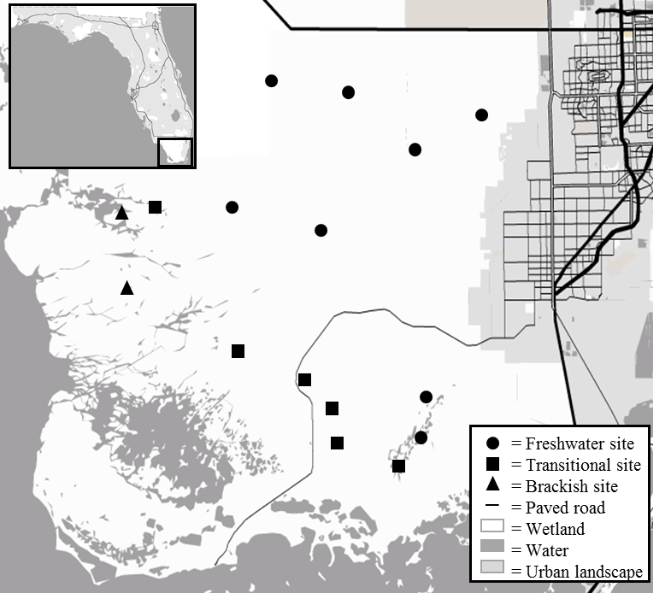

Figure 3.2. Non-metric multi-dimensional scaling (NMDS) ordinations overlain with hierarchical cluster analyses and environmental vectors for the (A) metacommunity, (B) freshwater, (C) transitional, and (D) brackish regions across sites and years. Key: (A) 1 = freshwater sites, 2 = transitional sites, 3 = brackish sites; (B – D) Individual sites represented by distinct shape. Vectors > 0.4 Pearson correlation coefficient.
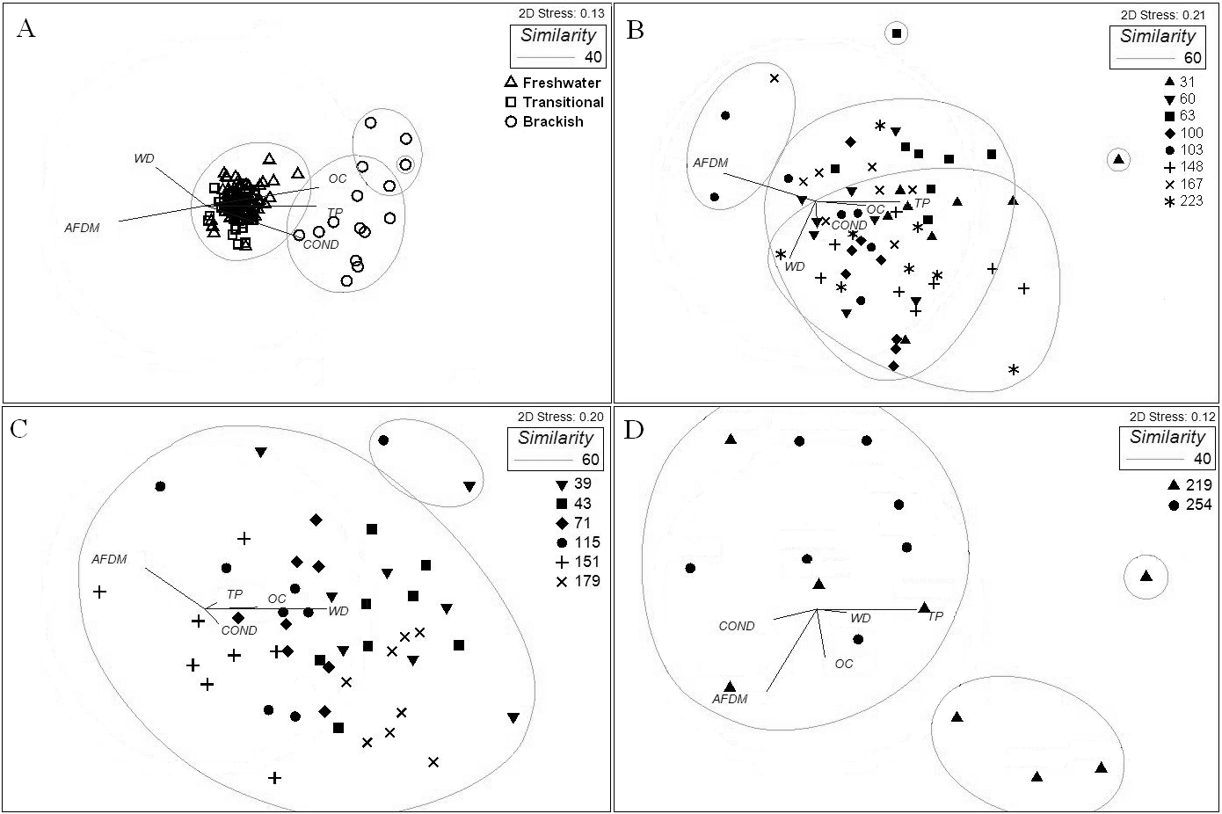
Figure 3.3. Spatial variation partitioning of spatial beta diversity (β) at metacommunity, freshwater, transitional, freshwater-transitional, and transitional-brackish scales averaged across 8 years: pure environment (E|S), spatially structured environment (E∩S), pure space (S|E), and unexplained (U). Error bars represent 1 standard error.
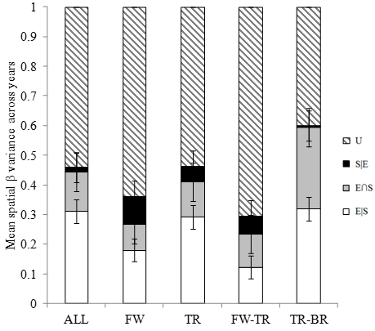

Figure 3.4. Spatiotemporal variation partitioning of spatial beta diversity (β) at (A) metacommunity, (B) freshwater, (C) transitional-brackish, and (D) transitional scales across 8 years. (E|S) = pure environment, (E∩S) = spatially structured environment, (S|E) = pure space, (U) = unexplained.
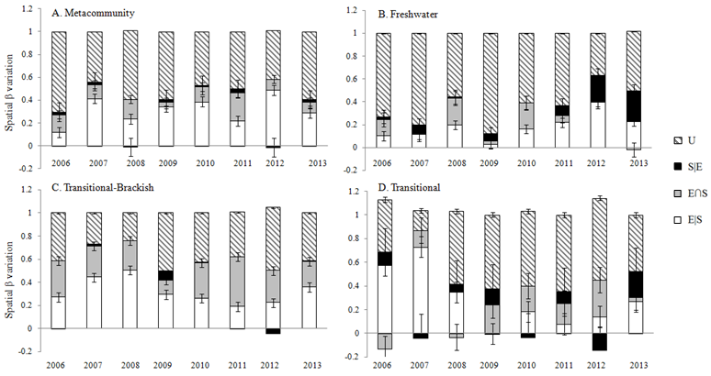

Appendices for Chapter 3
Appendix A
Table 3A.1. Values for environmental variables for each site and year. Sample codes indicate region (F = freshwater, O = oligohaline), three digit primary sampling unit, and two digit year in 2000s. Diatom count data are not included in these appendices but can be accessed through the Comprehensive Everglades Restoration Plan: Monitoring and Assessment Plan.

CHAPTER 4: CONCLUSIONS

The benthic microbial mats, or periphyton, of the karstic Florida Everglades provided a distinct opportunity to assess the mechanisms controlling microbial community function and structure in physically contained micro-habitats along spatial gradients in nutrient subsidy and salinity stress and across temporal environmental heterogeneity. Microbial communities and diatoms in particular are sensitive to environmental disturbance, but this research shows that community functional and structural stimulation by nutrient enrichment can be independent of autotroph and heterotroph interactions regardless of spatial distribution along a subsidy-stress gradient. Also, I showed that diatom community composition is regulated more by environmental heterogeneity and spatial factors at the regional scale than by a spatially structured environmental gradient.
In Chapter 2, my results indicated that algae, bacteria, and fungi can act independently under ambient oligotrophic and disturbed enriched conditions despite each being stimulated metabolically and productively. In Chapter 3, I found at a landscape spatial scale along an environmental gradient that microbial compositional turnover can be almost exclusively environmentally controlled rather than regulated by rates of dispersal as in stream biofilms and lake plankton, and at a regional scale environmental heterogeneity and spatial processes can co-control microbial beta diversity regardless of environmental gradients. At both the landscape and regional scale, temporal beta diversity can be structured primarily by environmental heterogeneity independent of environmental gradients that structure diversity spatially. My research suggests karstic microbial mat-forming communities exhibit intra-community interactions and metacommunity assembly mechanisms that are distinct from other aquatic and microbial systems, and which are likely attributable to the physical structure of the microbial mat that limits microbial trophic interactions and regulates diatom dispersal. The results from the present studies indicate heterogeneity in the mechanisms underlying community structure and assembly that is dependent upon the microbial community, environmental systems, and spatial and temporal extents considered.

