FLORIDA INTERNATIONAL UNIVERSITY

Miami, Florida

Models describing the Sea level rise in Key West, Florida

A thesis submitted in partial fulfillment of the
Requirements for the degree of
MASTER OF SCIENCE

in

STATISTICS

by

Karm-Ervin Jean

2015

To: Dean Michael R. Heithaus
College of Arts and Sciences

This thesis, written by Karm-Ervin Jean and entitled Models Describing the Sea Level Rise in Key West, Florida having been approved in respect to style and intellectual content, is referred to you for judgment.

We have read this thesis and recommended that it be approved.

____________________________________
Florence George

____________________________________
Sneh Gulati, Co-Major Professor

____________________________________
B. M. Golam Kibria, Co-Major Professor

Date of Defense: November 13, 2015
The thesis of Karm-Ervin Jean is approved.

____________________________________
Dean Michael R. Heithaus
College of Arts and Sciences

____________________________________
Dean Lakshmi N. Reddi
University Graduate School

Florida International University, 2015

DEDICATION
I dedicate this thesis to my God, my wife, and my kids. The achievement of this thesis would not have been possible without their love and great support.

ACKNOWLEDGMENTS
I would like to thank my main professors, Dr. B. M. Golam Kibria and Dr. Sneh Gulati, and committee member Dr. Florence George for their guidance in the accomplishment of this study. Overall, I would like to thank all of my Statistics professors who influenced me in many positive ways, and inspired me to go higher in my studies.
Thank you, Florida International University for giving me the opportunity to earn a Master degree in Statistics!
ABSTRACT OF THE THESIS
Models Describing the Sea Level Rise in Key West, Florida
by
Karm-Ervin Jean
Florida International University, 2015
Miami, Florida
Professor B. M. Golam Kibria, Co-Major Professor
Professor Sneh Gulati, Co-Major Professor
Lately, we have been noticing an unusual rise in the sea level near many Floridian cities. By 2060, scientists believe that the sea level in the city of Key West will reach between 22.86 to 60.96 centimeters (Strauss et al. 2012). The consequences of sea level rise are unpleasant by gradually tearing away our beaches and natural resources, destroying our homes and businesses, etc. Definitively, a continual increase of the sea level will affect everyone either directly or indirectly.
In this study, the sea level measurements of four Floridian coastal cities (including Key West) are collected in order to describe their trend toward sea level rise over the past 100 years. After the comparisons, some models describing the sea level rise in the city of Key West, Florida, are developed. Any inferences for these above cities may well be extended to similar ones.
TABLE OF CONTENTS
CHAPTER PAGE
- Introduction 1

- Data Description and Preliminaries 4

- Average Sea Level Comparison among Cities 9

Scheffé’s Method of Multiple Comparisons 12

- Fitting Linear Regression Models in Key West, FL 14

4.1 Fitting Linear Regression Model using Average Sea Level: 15
4.2 Fitting Linear Regression Model using Maximum Sea Level: 19

- Models and the effect of Time 22

5.1 Sea level Regression Models: 22
5.2 Temperature Regression Model: 26
5.3 Rainfall Regression models: 27

- Linear Regression Models and Predictions 28

- Summary and Concluding Remarks 30

References 31

Appendix. 32
LIST OF FIGURES

FIGURE PAGE
Figure 1.1 : Expected Sea level rise for Key West…………..……........……..… 1
Figure 1.2 : Affected homes per sea level rise………………..………..……….. 2
Figure 3.1 : Strategic Locations of the Cities………………..…………....…….. 9
Figure 3.2 : Coastal floods per city…………… …………………….…….…..…. 13
Figure 4.1 : Mean Sea level Normal Probability Test.……...........………..….... 18
Figure 4.2 : Mean Sea level Homogeneity of Variances Test ………….…….... 18
Figure 4.3 : Mean Sea level Cook’s Distance Influential case Test ………….... 18
Figure 4.4 : Maximum sea level Normal Probability Test………....................... 21
Figure 4.5 : Maximum Sea level Homogeneity of Variances Test ..………..…. 21
Figure 4.6 : Maximum Sea level Cook’s Distance Influential Test ………….... 21
Figure 5.1 : Key West Model Plot .…....………..…........................................... 22
Figure 5.2 : Fernandina Model Plot...….……..…............................................... 23
Figure 5.3 : St-Petersburg Model Plot..………..…............................................. 24
Figure 5.4 : Pensacola Model Plot………......….……..….................................. 24
Figure 5.5 : Mean Sea level Plots…………………………...…...……….…..... 25
Figure 5.6 : Temperature Model……………....….……..…............................... 26
Figure 5.7 : Rainfall Model…………….....……………..…............................... 27
Figure 6.1 : Prediction Comparison......……………………..…......................... 29
LIST OF TABLES

TABLE PAGE
Table 2.1 : Mean sea level Descriptive Statistics…..………..……………...…. 4
Table 2.2 : Maximum sea level Descriptive Statistics....................................…. 5
Table 2.3 : Sea level Correlation coefficients…….…....……….………............ 6
Table 2.4 : Mean sea level R-squared changes...…………………..……..……. 7
Table 2.5 : Maximum sea level R-squared changes...…………….………….... 8
Table 3.1 : Test of Homogeneity of Variances……...…………………..…….. 11
Table 3.2 : Analysis of Variances of the cities……………….…………….…. 11
Table 3.3 : Multiple comparisons of the Means …………..…………….……. 12
Table 3.4 : Comparison of the four cities’ averages.……………….................. 12
Table 4.1 : Mean Sea level Regression models …………...…………….……. 15
Table 4.2 : Mean Sea level Model Selection ………………...…………….…. 16
Table 4.3 : Mean Sea level Casewise Diagnostics ………….…..…................. 17
Table 4.4 : Maximum Sea level Regression Models ………..…..................…. 19
Table 4.5 : Maximum Sea level Model Selection….…………..…..………...... 20
Table 6.1a : Mean Temperature ANOVA .…………..…….………………..…. 28
Table 6.1b : Mean Temperature Model Coefficients …....……………….....…. 28
Table 6.1 : Prediction Table………..………….. ………….……................…. 29
Appendix : Data Values of Key West..…..…….. ………….……................…. 32

CHAPTER I

Introduction
The prominent South Florida city, Key West, is about to experience the loss of its seashores which are the source of its beauty and attractiveness. Because the city’s sea level had recently started a rapid acceleration (Figure 1.1), scientists believe its level will reach between 9 to 24 inches by 2060 (Strauss et al. 2012). Actually, most Floridian cities are facing the same fate. According to the Florida Department of Community Affairs, Division of Community Planning, impacts resulting from sea level will include increased flooding and drainage problems, destruction of natural resource habitats, higher storms surge, increased evacuation areas and evacuation periods, increased shoreline erosion, saltwater intrusion, and loss of infrastructure and existing development. Will Key West or similar Floridian cities soon go through all of the above? Will these cities submerge?

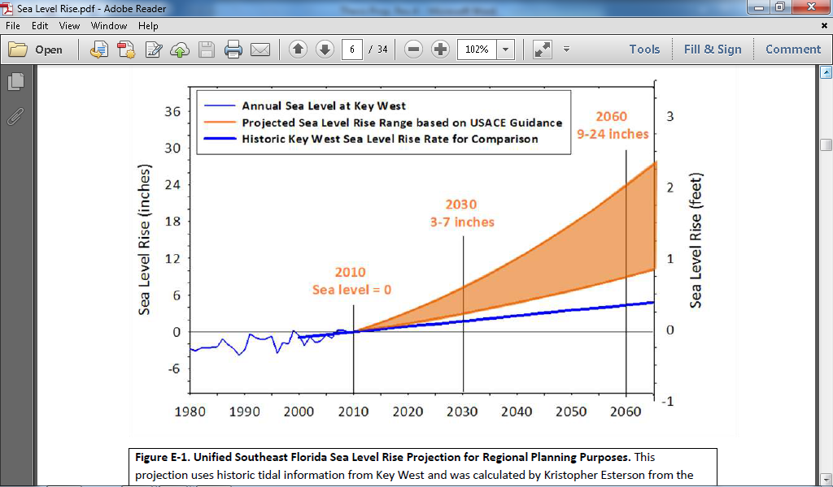
Figure 1.1: Expected Sea level rise for Key West
The annual projected “sea level” rise for the city of Key West (Figure 1.1), for instance, describes that the city is on a path of being completely wiped out of the map. “The projection uses Key West tidal data from 1913-1999 as the foundation of the calculation and references the year 2010 as the starting date of the projection. Two key planning horizons are highlighted: 2030 when SLR is projected to be 3-7 inches and 2060 when SLR is projected to be 9-24 inches. Sea level is projected to rise one foot from the 2010 level between 2040 and 2070, but a two foot rise is possible by 2060.” (USACE 2009)
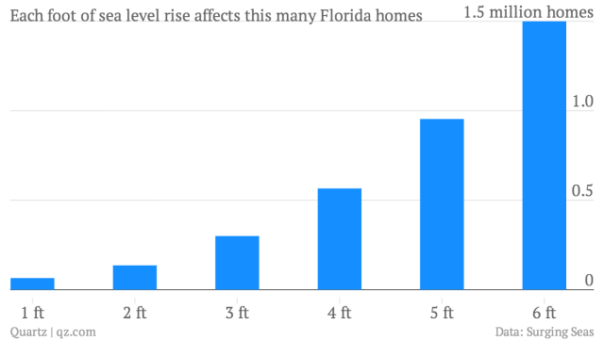
Figure 1.2: Affected homes per sea level rise
It is reported that “one-foot rise affects only about 65,000 homes and about $37 billion in property value, a sea-level increase of three feet would put 300,000 Florida homes—around $156 billion in property value—at risk.” (Guilford 2013) Figure 1.2 above explains that a 4-foot rise affects at most half of a million homes, and a 6-foot rise will affect one and a half million Floridian homes. These, therefore, represent billions of US Dollard that will probably be lost. People will have to think more than twice before investing in Florida Real Estates.
Intriguingly, Florida is rated number one among the states with the largest total population living on land less than 4 feet above high tide (Strauss et al. 2012). Therefore, most its lands are probably defenseless against the devastating effects of sea level rise, and may be wiped out of the map. Writer Jeff Goodell, with Rolling Stone magazine, says, “Miami has spent about $15 million so far constructing new pumps in the lowest lying areas of South Beach, with another $400 to $500 million expected to go into installing 50 or 60 pumps throughout Miami Beach.” Apparently, the government is investing a lot of money on finding adequate and effective measures to overcome the issue of sea level rise. Let us hope that a solution can soon emerge.
However, a detailed look at the Florida littoral coasts, using the last 100 years recorded Sea-Level measurements dataset, may provide some information to the effects of sea level rise. We have selected four coastal cities in Florida, which are Pensacola, St-Petersburg, Key West, and Fernandina. We will compare them with each other based on their individual reactions to sea level rise. Additionally, some models describing “sea level rise” will be executed for the city of Key West for the convenience of this study. Any future “inferences” to Key West can also be extended to these above cities.

The organization of this study is as follows. Data descriptions and preliminaries are presented in Chapter 2. Average Sea levels are compared in Chapter 3. Chapter 4 contains the fitting linear regression model. The variables and effect of time are provided in Chapter 5. The predicted power of the model is given in Chapter 6. Finally, some concluding remarks and possible future research are discussed in Chapter 7.
CHAPTER II

Data Description and Preliminaries
The data were collected from the database of the Southeast Regional Climate Center (SERCC), which is one of the six regional climate centers in the United States that serves Florida and many other states since March 1989. The collected data contained the “monthly” mean, the minimum, the median, and the maximum sea level in feet for a given “year” in the city of Pensacola, St-Petersburg, Fernandina, and Key West. Statistical Package for the Social Science (SPSS) will be used to analyze the data throughout this research. Analysis of Variance (ANOVA) is performed to test for significances and analyze some other essential results. Residual and mean plots were performed to describe variations or changes shown by the data.

2.1 Data for City comparisons:
This study comprises the littoral coast cities: Key West, Pensacola, St-Petersburg, and Fernandina. Their yearly mean sea levels have been calculated. The first objective of this research is to compare the above cities in terms of their average sea levels. Table 2.1 gives an overview of the data for each city.

Table 2.1: Mean seal level Descriptive Statistics
 | N | Mean | Std. Deviation | 95% Confidence Interval |  | Minimum | Maximum
 |  |  |  | Lower Bound | Upper Bound | Minimum | Maximum
Key West | 95 | .69090779 | .238841158 | .64225336 | .73956222 | .246000 | 1.185000
Fernandina | 88 | 3.08269119 | .245128447 | 3.03075344 | 3.13462895 | 2.363833 | 3.498125
St-Petersburg | 68 | 1.10221947 | .184986208 | 1.05744327 | 1.14699568 | .764083 | 1.557500
Pensacola | 92 | .47425678 | .219785769 | .42874043 | .51977312 | -.027917 | .914500
Total | 343 | 1.32797555 | 1.077830349 | 1.21350571 | 1.44244539 | -.027917 | 3.498125
From Table 2.1, we can see that the average sea level for Key West is .6909 ft, for Fernandina 3.0827 ft, for St-Petersburg 1.1022 ft, and Pensacola 4743 ft. Key West and Fernandina have data from 1914 to 2014, but contains some missing values. Pensacola has data from 1923, St-Petersburg from 1947, both with no missing information.

2.2 Data for Key West Models:
The second objective of this project is to construct some models describing the sea level rise in the city of Key West, Florida. The data are the same as previously for the city of Key West. However, we will include the variables year, local temperature, and the local rainfall of Key West, Florida. We will index the years from 1 to 101, for the convenience of this study. Table 2.2 below describes the yearly sea level in feet collected:
Table 2.2: Maximum sea level Descriptive Statistics
 | N | Minimum | Maximum | Mean | Std. Deviation | Skewness
 | Statistic | Statistic | Statistic | Statistic | Statistic | Statistic | Std. Error
Year | 101 | 1914 | 2014 | 1964.00 | 29.300 | .000 | .240
Mean Sea Level | 95 | .24600 | 1.18500 | .6909078 | .23884116 | -.067 | .247
Maximum Sea Level | 95 | .54100 | 1.84500 | 1.1404526 | .29469031 | -.055 | .247
Mean_Temp | 101 | 73.750 | 79.550 | 77.69191 | .896818 | -.720 | .240
Mean_Rain | 101 | .0542 | .1725 | .111084 | .0251525 | .098 | .240
Valid N (listwise) | 95

Table 2.2 indicates that the highest mean sea level recorded is 1.185 feet in 2013. The overall yearly mean sea level is 0.6909 feet with a standard deviation of 0.2388 feet. The average maximum sea level is 1.1405 feet with standard deviation 0.2947 feet. The overall yearly mean temperature is 77.69 degree Fahrenheit. The overall yearly mean rainfall is 0.1111 inches with standard deviation 0.0252 inches. Table 2.3 presents the Pearson’s correlation coefficients among the variables.
Table 2.3: Mean sea level Correlation coefficients
 |  | Sea Level | Year | Mean_Temp | Mean_Rain
Pearson Correlation | Mean Sea Level | 1.000 | .935 | .315 | .148
Pearson Correlation | Year | .935 | 1.000 | .239 | .161
Pearson Correlation | Mean_Temp | .315 | .239 | 1.000 | -.140
Pearson Correlation | Mean_Rain | .148 | .161 | -.140 | 1.000
Sig. (1-tailed) | Mean Sea Level | . | .000 | .001 | .076
Sig. (1-tailed) | Year | .000 | . | .010 | .060
Sig. (1-tailed) | Mean_Temp | .001 | .010 | . | .088
Sig. (1-tailed) | Mean_Rain | .076 | .060 | .088 | .
Pearson Correlation | Maximum Sea Level | 1.000 | .837 | .348 | .099
Pearson Correlation | Year | .837 | 1.000 | .239 | .161
Pearson Correlation | Mean_Temp | .348 | .239 | 1.000 | -.140
Pearson Correlation | Mean_Rain | .099 | .161 | -.140 | 1.000
Sig. (1-tailed) | Maximum Sea Level | . | .000 | .000 | .170
Sig. (1-tailed) | Year | .000 | . | .010 | .060
Sig. (1-tailed) | Mean_Temp | .000 | .010 | . | .088
Sig. (1-tailed) | Mean_Rain | .170 | .060 | .088 | .
N | Sea Level | 95 | 95 | 95 | 95
N | Year | 95 | 95 | 95 | 95
N | Mean_Temp | 95 | 95 | 95 | 95
N | Mean_Rain | 95 | 95 | 95 | 95

From Table 2.3, we observed strong and positive correlation between mean Sea level and year (r =0.935, p-value < 0.001). Mean Sea level is also positively correlated with temperature (r = 0.315, p-value = 0.001), and not significantly correlated to rainfall (r = 0.148, p-value= 0.076). We also observed strong and positive correlation between maximum Sea level and year (r = 0.837, p-value < 0.001). Maximum Sea level is also positively correlated with temperature (r = 0.343, p-value < 0.001), and not significantly correlated to rainfall (r = 0.099, p-value= 0.170).

R-Square Change: Mean Sea level
The R-square Change method is a preliminary approach to determine the effect of variables on mean sea level. First, we built a relationship between “mean sea level” and “year”, and then we check whether the additions of extra variables would provide better explanation of the data.
Table 2.4: Mean sea level R-squared changes
Model |  | R | R Square | Adjusted R Square | Std. Error of the Estimate | Change Statistics |  |  |  |  | Durbin-Watson
 |  |  |  |  |  | R Square Change | F Change | df1 | df2 | Sig. F Change | Durbin-Watson
dimension0 | 1 | .935ª | .873 | .872 | .08544948 | .873 | 641.391 | 1 | 93 | .000
dimension0 | 2 | .939^{b} | .882 | .880 | .08282184 | .009 | 6.995 | 1 | 92 | .010
dimension0 | 3 | .939^{c} | .883 | .879 | .08318235 | .000 | .204 | 1 | 91 | .652 | 1.208
a. Predictors: (Constant), Year
b. Predictors: (Constant), Year, Mean_Temp
c. Predictors: (Constant), Year, Mean_Temp, Mean_Rain
d. Dependent Variable: Mean Sea Level

The “R-Square Change” in Table 2.4 provides the relationships with mean sea level:
- The baseline relationship, “Year” has a R² change of 0.873, with a p-value < 0.001.
- The addition of “Temperature” provides a R² change with p-value= 0.009
- The addition of “Rainfall” provides a R² change with a p-value < 0.001.

The first two “R² change” are statistically significant, but only the second model provides information about the prediction of the sea level rise. Adding rainfall in the presence of year and temperature does not provide any additional information.

R-Square Change: Maximum Sea level
Table 2.5: Maximum sea level R-squared changes
Model |  | R | R Square | Adjusted R Square | Std. Error of the Estimate | Change Statistics |  |  |  |  | Durbin-Watson
 |  |  |  |  |  | R Square Change | F Change | df1 | df2 | Sig. F Change | Durbin-Watson
dimension0 | 1 | .837ª | .701 | .698 | .16196983 | .701 | 218.165 | 1 | 93 | .000
dimension0 | 2 | .851^{b} | .725 | .719 | .15633411 | .023 | 7.826 | 1 | 92 | .006
dimension0 | 3 | .851^{c} | .725 | .716 | .15717468 | .000 | .019 | 1 | 91 | .892 | 1.397
a. Predictors: (Constant), Year
b. Predictors: (Constant), Year, Mean_Temp
c. Predictors: (Constant), Year, Mean_Temp, Mean_Rain
d. Dependent Variable: Maximum Sea Level

The “R-Square Change”, from the above table is evaluated to verify if adding more independent variables to the equation will improve the model.
- “Year” provides a R² change of 0.701 with a p-value < 0.001.
- The addition of “Temperature” provides a R² change of 0.023, with a p-value= 0.006
- The addition of “Rainfall” provides a R² change with a p-value < 0.001.

At alpha 0.05, the “R² change” model 2 is statistically significant, and provides a better estimate of the sample.

In this research, we will construct models based on both the “mean” sea level and the “maximum” sea level against the independent variables: time in year, average temperature and average rainfall. However, let us compare the cities to each other in order to see how they differ in mean sea levels.

CHAPTER III

Average Sea Level Comparison among Cities
Is there a difference in the average sea level $µ_{i}$ of the cities in Florida? It is reported that sea level might already be rising faster than expected. Some, who love Florida, may want to know which city in Florida possesses the highest or the lowest sea level rise. The four coastal cities selected in this study are shown in Figure 3.1.
Key West | Pensacola | N | St-Petersburg | Fernandina
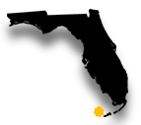 | 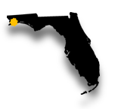 | N | 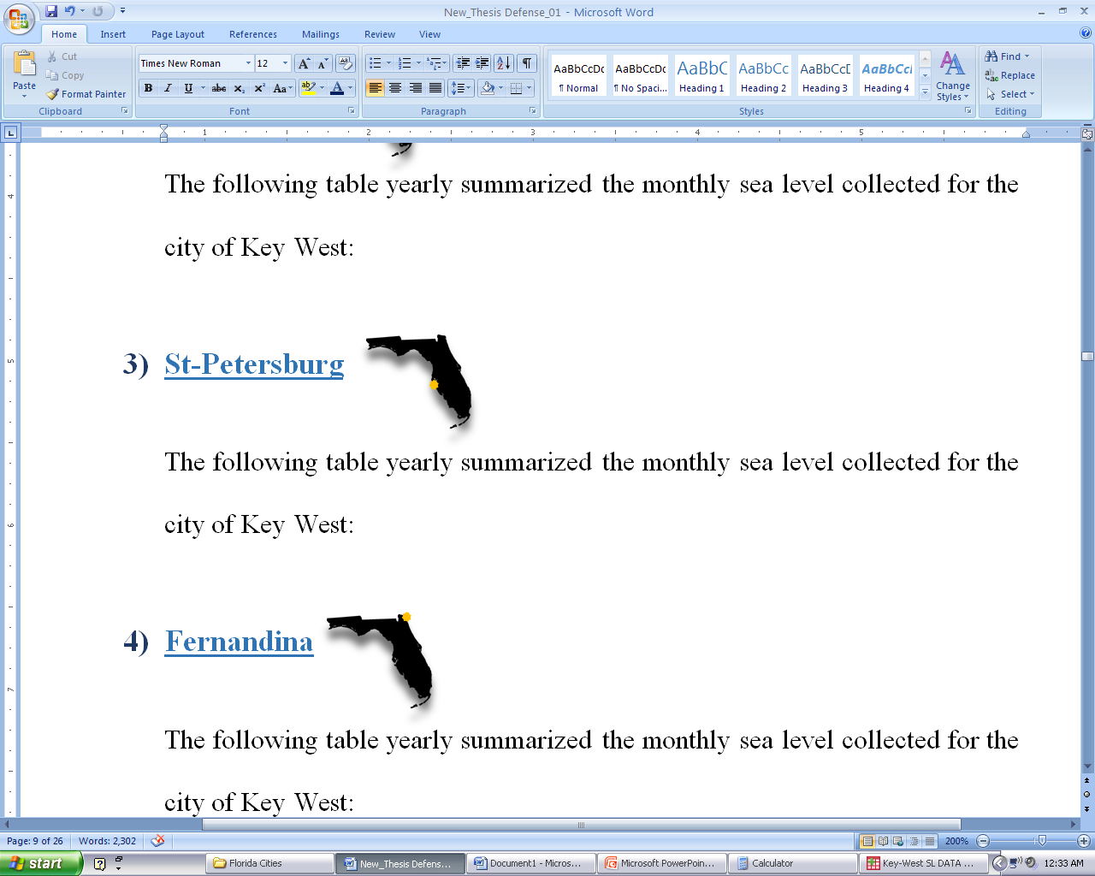
Figure 3.1: Strategic Locations of the Cities
Figure 3.1 shows the different locations of the cities mentioned above. Notice that all four are coastal cities and without any doubt under the influences of sea level rise.
We have t=4 samples or cities taken independently from each other. The sample within a city is independent from the others, and vice versa. We have the following hypothesis:
Sea Level | $H_{0}:$ $µ_{1}=$ $µ_{2}= µ_{3}= µ_{4}$= 0 (no difference between the city means)  (3.1)  $H_{1}:$ $µ_{i}$ ≠0 for at least one i (a difference exists)

The Levene Statistic
We want to compare the sea level rise for the four cities and in order to use ANOVA we need to test if the variances are equal. We can use the Levene test of Homogeneity of variances.
Hypothesis for homogeneity of Variances:

Sea Level | $H_{0}:$ $σ_{1}^{2}=$ $σ_{2}^{2}=σ_{3}^{2}= σ_{4}^{2}$= 0 (equal variances)  (3.2)  $H_{1}:$ $σ_{i}$ ≠0 for at least one i (not all of the variances are equal)

$y_{ij}$=sample observation j from city i ( i=1, 2, 3, 4; and j=1, 2, 3, …, $n_{i}$)
N = $\sum_{i=1}^{4}{n_{i}}$ the total size of all the samples
${\overline{y}}_{i}$= mean of sample of city i
$D_{ij}$=$\left|y_{ij}-{\overline{y}}_{i}\right|$ the absolute deviation of observation j from the city i
${\overline{D}}_{i}$ = the average of the $n_{i}$ absolute deviations from city i
$\overline{D}$= average of all N absolute deviations
The Levene Statistic is then:
$F_{o}$=$\frac{\frac{\sum_{i=1}^{4}{{n_{i}\left({\overline{D}}_{i}-\overline{D}\right)}^{2}}}{t-1}}{\frac{\sum_{i=1}^{4}{\sum_{j=1}^{n_{i}}{{\left(D_{ij}-{\overline{D}}_{i}\right)}^{2}}}}{N-t}}$ (3.3)
$F_{o}$= 1.972

Table 3.1 Test of Homogeneity of Variances
Levene Statistic | df1 | df2 | Sig.
1.972 | 3 | 339 | .118

The Levene Statistic in Table 3.1 is 1.972 with four cities (Degree of freedom: 4-1=3) and 339 measurements (Degree of freedom: 343- 4 cities = 339). We have the p-value of 0.118, which supports the existence of Homogeneity of Variance. We have no strong evidence that the variances are different from each other. The data can be analyzed using ANOVA.
Using SPSS, we obtain the following ANOVA Table:
Table 3.2: Analysis of Variances of the cities
Mean Sea Level | Sum of Squares | df | Mean Square | F | Sig.
Between Groups | 380.029 | 3 | 126.676 | 2485.367 | < 0.001
Within Groups | 17.278 | 339 | .051
Total | 397.308 | 342

From the ANOVA Table 3.2, there is a p-value < 0.001. This implies that we must reject the null hypothesis (3.1) at 0.05 or smaller significance levels. Therefore, we may conclude the mean sea levels of the four cities are different. However, we may want to know which pairs of means are different. Several methods exist to make pairwise comparisons, but we will use the Scheffé’s multiple comparisons.

Scheffé’s Method of Multiple Comparisons
We use the Scheffé method to do pair wise comparisons between the four cities to determine where the differences exist.
Table 3.3: Multiple comparisons of the Means
(I) City | (J) City | Mean Difference (I-J) | Std. Error | Sig. | 95% Confidence Interval
 |  |  |  |  | Lower Bound | Upper Bound
Key West | Fernandina | -2.391783404* | .033402191 | < 0.001 | -2.48562964 | -2.29793717
Key West | St-Petersburg | -.411311685* | .035861636 | < 0.001 | -.51206793 | -.31055544
Key West | Pensacola | .216651013* | .033023085 | < 0.001 | .12386991 | .30943211
Fernandina | Key West | 2.391783404* | .033402191 | < 0.001 | 2.29793717 | 2.48562964
Fernandina | St-Petersburg | 1.980471719* | .036451807 | < 0.001 | 1.87805734 | 2.08288610
Fernandina | Pensacola | 2.608434416* | .033663057 | < 0.001 | 2.51385526 | 2.70301357
St-Petersburg | Key West | .411311685* | .035861636 | < 0.001 | .31055544 | .51206793
St-Petersburg | Fernandina | -1.980471719* | .036451807 | < 0.001 | -2.08288610 | -1.87805734
St-Petersburg | Pensacola | .627962697* | .036104736 | < 0.001 | .52652344 | .72940195
Pensacola | Key West | -.216651013* | .033023085 | < 0.001 | -.30943211 | -.12386991
Pensacola | Fernandina | -2.608434416* | .033663057 | < 0.001 | -2.70301357 | -2.51385526
Pensacola | St-Petersburg | -.627962697* | .036104736 | < 0.001 | -.72940195 | -.52652344
*. The mean difference is significant at the 0.05 level.

From the above Table 3.3 we may conclude that all possible pairs are significantly different from each other. It appears that Fernandina has higher mean sea level measurements than the other cities with a significance level < 0.001.
The next table is a summary of the Scheffé method explained above. It shows that no same cites share the same mean sea level in feet.
Table 3.4: Comparison of the four cities’ averages
City | N | Subset for alpha = 0.05
City | N | 1 | 2 | 3 | 4
Pensacola | 92 | .47425678
Key West | 95 |  | .69090779
St-Petersburg | 68 |  |  | 1.10221947
Fernandina | 88 |  |  |  | 3.08269119
Sig. |  | 1.000 | 1.000 | 1.000 | 1.000
Means for groups in homogeneous subsets are displayed.
Table 3.4 shows that Fernandina has the highest mean sea level (3.08 ft.) followed by St-Petersburg (1.10 ft.), Key West (0.69 ft.), and Pensacola has the lowest (0.74 ft.).
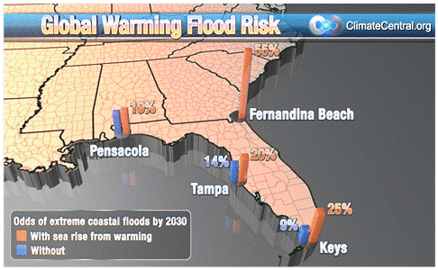
Figure 3.2: Coastal floods per city
Produced by ClimateCentral.org, Figure 3.2 Describes the odds of extreme coastal floods by 2030 with sea rise from warming:
- 55% for Fernandina
- 19% for Pensacola

Will Fernandina face the greater danger of sea level rise? Ideally, if all, the four cities, were identical in every way, a higher sea level rise may represent a danger. Unfortunately, these cities were randomly selected at different locations. Based on the given dataset, we cannot conclude whether or not that Fernandina is or will be affected by higher sea level rise than the others. However, this study can only conclude these cities differed completely in mean sea levels.
CHAPTER IV

Fitting Linear Regression Models in Key West, FL
In this chapter, we want to fit two different kinds of regression models using average and maximum sea levels. We want to see the effect of three independent variables (Year, Temperature and Rainfall) on the sea level rise for the past 100 years. All these variables are locally taken in the city of Key West, FL. We will use SPSS to analyze the data. We assume the following linear regression model,
Y = $β_{0}$+$β_{1}Χ_{1}$+$β_{2}Χ_{2}$+ $β_{3}Χ_{3}$ + ε (4.1)
where Y = Sea Level; $Χ_{1}$=”Year” є [1, 100); $Χ_{2}$=”Temperature”; $Χ_{3}$=”Rainfall”; and $β_{0}$ ,$β_{1}$ ,$β_{2}$ ,$β_{3}$ are called the parameters of the model and need to be estimated from data. Here we assume that the errors (ε) have a normal distribution with mean 0 and constant variance σ².

The determination of $β_{0}$ ,$β_{1}$,$β_{2}$,$β_{3}$ will allow the establishment a multiple linear relationship of the “sea level” with the other variables. Equation (4-1) can be expressed as (given n=100 observations, $X_{ij }$the observed values with 0$≤$j$≤3$ regressors, $Y_{i}$ and the response variables “sea level”) in the matrix form:
Y=Xβ + ε (4.1a)
With Y=$\left[\begin{matrix}Y_{1 } \\ \begin{matrix}Y_{2 } \\ ⋮\end{matrix} \\ Y_{n}\end{matrix}\right]$ , X=$\left[\begin{matrix}\begin{matrix}1 \\ 1 \end{matrix} \\ ⋮ \\ 1 \end{matrix}\begin{matrix}\begin{matrix} X_{11 } \\ X_{21 }\end{matrix} \\ ⋮ \\ X_{n1 }\end{matrix}\begin{matrix}\begin{matrix}X_{12 } \\ X_{22 }\end{matrix} \\ ⋮ \\ X_{n2 }\end{matrix}\begin{matrix}\begin{matrix}X_{13} \\ X_{23 }\end{matrix} \\ ⋮ \\ X_{n3 }\end{matrix}\right], β=\left[\begin{matrix}\begin{matrix}β_{0} \\ β_{1}\end{matrix} \\ β_{2} \\ β_{3}\end{matrix}\right]$ ,$ε=$ $\left[\begin{matrix}ε_{1 } \\ \begin{matrix}ε_{2 } \\ ⋮\end{matrix} \\ ε_{n}\end{matrix}\right]$
The least squared estimator of β is obtained as:
$\hat{β}$= ${(X’X)}^{-1}$XY (4.2)
That gives ${\hat{β}}^{'}$ = $\left[\begin{matrix}{\hat{β}}_{0} & {\hat{β}}_{1} & {\hat{β}}_{2}\end{matrix} {\hat{β}}_{3}\right]$’
We will now fit two models one with dependent variable “average sea level” and another with “maximum sea level”. The independent variables will be the “index year”, “temperature”, and “rainfall”.

Fitting Linear Regression Model using Average Sea Level:
Before fitting the model, we want to see whether a significant relationship exists between the dependent variable “sea level” and the independent variables mentioned above. If a relationship exists, it means the above regression model is significant, and we may go ahead and determine the coefficients of the model.
Mean Sea Level: | Does Average Sea Level increase over time?

Mean Sea Level | $H_{0}:$ $β_{1}=$ $β_{2}= β_{3}$=0 (model is not significant)  (4.3)  $H_{1}:$ $β_{i}$ ≠0 for at least one i (model is significant)

Table 4.1: Mean Sea level Regression models ^{d}
Model |  | Sum of Squares | df | Mean Square | F | Sig.
1 | Regression | 4.683 | 1 | 4.683 | 641.391 | .000ª
1 | Residual | .679 | 93 | .007
1 | Total | 5.362 | 94
2 | Regression | 4.731 | 2 | 2.366 | 344.865 | .000^{b}
2 | Residual | .631 | 92 | .007
2 | Total | 5.362 | 94
3 | Regression | 4.733 | 3 | 1.578 | 227.989 | .000^{c}
3 | Residual | .630 | 91 | .007
3 | Total | 5.362 | 94
a. Predictors: (Constant), Year
b. Predictors: (Constant), Year, Mean_Temp
c. Predictors: (Constant), Year, Mean_Temp, Mean_Rain
d. Dependent Variable: Mean Sea Level

Table 4.1 is to check whether a linear model is significant or not based on hypothesis 4.3. We must reject the null hypothesis, because the p-value is less than the significance level 0.05. Therefore, we have strong evidence a linear model exists. Now, let us find its coefficients.
Table 4.2: Mean Sea level Model Selection
Model |  | Unstandardized Coefficients |  | Standardized Coefficients | t | Sig. | 95.0% Confidence Interval for B |  | Collinearity Statistics
 |  | B | Std. Error | Beta | t | Sig. | Lower Bound | Upper Bound | Tolerance | VIF
1 | (Constant) | .295 | .018 |  | 16.423 | .000 | .259 | .330
1 | Index_Year | .008 | .000 | .935 | 25.326 | .000 | .007 | .008 | 1.000 | 1.000
2 | (Constant) | -1.683 | .748 |  | -2.250 | .027 | -3.168 | -.198
2 | Index_Year | .007 | .000 | .911 | 24.743 | .000 | .007 | .008 | .943 | 1.060
2 | Mean_Temp | .026 | .010 | .097 | 2.645 | .010 | .006 | .045 | .943 | 1.060
3 | (Constant) | -1.764 | .772 |  | -2.284 | .025 | -3.298 | -.230
3 | Index_Year | .007 | .000 | .908 | 24.038 | .000 | .007 | .008 | .905 | 1.105
3 | Mean_Temp | .026 | .010 | .101 | 2.671 | .009 | .007 | .046 | .910 | 1.098
3 | Mean_Rain | .160 | .354 | .017 | .452 | .652 | -.543 | .862 | .941 | 1.063

The final fitted model is
(4.4)
$\hat{Y}$=-1.683 + 0.007X₁ + 0.026X₂
The number -1.683 is the constant Y intercept, the height of the regression line when it crosses the Y-axis. In other words, this is the predicted value of Sea level when the independent variable year is zero. When year is zero, Sea level is decreasing by 1.683 on average. It is significant with p-value of 0.027. The coefficient for year is .007. So for every unit increase in year, an average of 0.007 of mean sea level units is predicted. The index Year varies from 1 to 100. It is significant with p-value of 0.000. Table 4.2 also indicates that the associated regression coefficients are not poorly estimated because of multicollinearity, or Variances Inflation Points (VIF_{j}) are less than 5,

Are there any outliers and influential points? An outlier is an extreme observation with the largest residual (in absolute value), say 3 or 4 standard deviations from the mean. Outliers are data points that are not typical of the rest of the data. Outliers may control many key model properties and may point out inadequacies in the model. Identifying the outliers is based on the maximum normed residual:
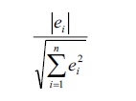
(4.5)
– Effect of outliers on regression may be checked by dropping these points and refitting the regression equation.
– t-, F-statistics, R² and residual mean square may be very sensitive to the outliers.
– Situation in which a relatively small percentage of the data has a significant impact on the model may not be acceptable to the user of the regression equation. In this regard, the mean sea level casewise diagnostics is presented in Table 4.3.
Table 4.3 Mean Sea level Casewise Diagnostics
Case Number |  | Std. Residual | Mean Sea Level | Predicted Value | Residual
 | 51 | -3.258 | .41455 | .6855506 | -.27100059
a. Dependent Variable: Mean Sea Level
In Table 4.3, only one single case № 51 (Year 1964) is outside the ±3 limit. Removing it, did not change anything in the model.
The QQ plot and residual versus fitted values are plotted in Figures 4.1 and 4.2 respectively. From these figures, we observed that both normality assumption and constant variance assumption for residuals have been met.
Figure 4.1: Mean Sea level Normal Probability Test
Figure 4.2: Mean Sea level Homogeneity of Variances Test
Figure 4.3: Mean Sea level Cook’s Distance Influential case Test
Now, we want to see the adequacy of the model. The maximum Cook's Distance is in the range of$± 0.300$. Therefore, no case is influencing the model. We have a sample size of 95; the lowest standard residual is -3.258 which correspond to case № 51.

Fitting Linear Regression Model using Maximum Sea Level:
As previously mentioned, we will check whether a significant relationship exists between the dependent variable “sea level” and the independent variables mentioned above. If a relationship exists, it means the above regression model is also significant for the maximum sea level, and we may go ahead and determine the coefficients of the model.
Sea Level: | Does Maximum Sea Level increase over time?

Table 4.4: Maximum Sea level Regression Models ^{d}
Model |  | Sum of Squares | df | Mean Square | F | Sig.
1 | Regression | 5.723 | 1 | 5.723 | 218.165 | .000ª
1 | Residual | 2.440 | 93 | .026
1 | Total | 8.163 | 94
2 | Regression | 5.915 | 2 | 2.957 | 121.002 | .000^{b}
2 | Residual | 2.249 | 92 | .024
2 | Total | 8.163 | 94
3 | Regression | 5.915 | 3 | 1.972 | 79.814 | .000^{c}
3 | Residual | 2.248 | 91 | .025
3 | Total | 8.163 | 94
a. Predictors: (Constant), Year
b. Predictors: (Constant), Year, Mean_Temp
c. Predictors: (Constant), Year, Mean_Temp, Mean_Rain
d. Dependent Variable: Maximum Sea Level

Table 4.4 above is to check for the existence of a linear trend model. Because the P-value is less than the significance level 0.05 above, we may assume a linear model exists. Model 2 is the best model so far.

Table 4.5: Maximum Sea level Model Selection
Model |  | Unstandardized Coefficients |  | Standardized Coefficients | t | Sig. | 95.0% Confidence Interval for B |  | Collinearity Statistics
 |  | B | Std. Error | Beta | t | Sig. | Lower Bound | Upper Bound | Tolerance | VIF
1 | (Constant) | .702 | .034 |  | 20.656 | .000 | .635 | .770
1 | Index | .008 | .001 | .837 | 14.770 | .000 | .007 | .009 | 1.000 | 1.000
2 | (Constant) | -3.246 | 1.412 |  | -2.299 | .024 | -6.050 | -.442
2 | Index_Year | .008 | .001 | .800 | 14.193 | .000 | .007 | .009 | .943 | 1.060
2 | Mean_Temp | .051 | .018 | .158 | 2.798 | .006 | .015 | .087 | .943 | 1.060
3 | (Constant) | -3.200 | 1.459 |  | -2.193 | .031 | -6.098 | -.302
3 | Index | .008 | .001 | .801 | 13.854 | .000 | .007 | .009 | .905 | 1.105
3 | Mean_Temp | .051 | .019 | .156 | 2.709 | .008 | .013 | .088 | .910 | 1.098
3 | Mean_Rain | -.091 | .668 | -.008 | -.136 | .892 | -1.418 | 1.236 | .941 | 1.063

The final fitted model is
Y = -3.246 + 0.008*X₁ + 0.051X₂ (4.6)
Y = Sea Level; $Χ_{1}$= “Index_Year” є [1, ∞); $Χ_{2}$= “Temperature”;

The number -3.246 is the constant Y intercept, the height of the regression line when it crosses the Y-axis. In other words, this is the predicted value of Sea level when the all the other independent variables are zero. When both Index of the year and Temperature are zero, Sea level is decreasing by 3.246. That is impossible in real life. It is significant with p-value < 0.001. The coefficient for year is .008. So for every unit increase in year, a 0.008 unit increase in mean sea level rise is predicted. Year varies from 1914 to infinity. Both Year and Temperature are significant with p-value < 0.001. Figures 4.4 and Figure 4.5 show normality and constant variances assumptions for residuals respectively. Additionally, Figure 4.6 presents no influential case in the model.

(See Appendix page 32 for detail overview of the two models)
Figure 4.4: Maximum sea level Normal Probability Test
Figure 4.5: Maximum Sea level Homogeneity of Variances Test
Figure 4.6: Maximum Sea level Cook’s Distance Influential Test
CHAPTER V

Models and the effect of Time
The variable “year”, has no real effects on the other variables in this study, but its presence gives a sense of direction in order to make decisions on the behavior of the data. This behavior can be increasing, decreasing, or constant. Future predictions of the sea level rise are depending on the years. The variables, sea level, temperature, and rainfall can all “linearly” interact with “time” or year.

5.1 Sea level Regression Models:
Key West:
The following figure summarized the yearly sea level collected in the city of Key West:
Figure 5.1: Key West Model Plot
The linear relationship:
$y_{sea level}$ = 0.0076$x_{year_index}$ + 0.2946 (5.1)
Figure 5.1 show that sea level has a more visible increasing behavior with time. At least 87.3% of the sea level data is explained by the equation (5.1). At any given year from the data, the sea level may never be less than 0.2496 ft. It will increase by 0.008 ft for every unit year of increase.
Fernandina:
The following figure summarized the yearly sea level collected in the city of Fernandina:
Figure 5.2: Fernandina Model Plot
The linear relationship:
$y_{sea level}$ = 0.0074$x_{year_index}$ + 2.667 (5.2)
Figure 5.2 show that sea level has an increasing behavior with time. At least 73.5% of the sea level data in Fernandina is explained by the equation (5.2). At any given year from the data, the sea level may never be less than 2.667 ft. It will increase by 0.0074 ft for every unit year of increase.
St-Petersburg
The following figure summarized the yearly sea level collected in the city of St-Petersburg:
Figure 5.3: St-Petersburg Model Plot
The linear relationship:
$y_{sea level}$ = 0.0085$x_{year_index}$ + 0.8091 (5.3)
Figure 5.3 show that sea level has an increasing behavior with time. At least 82.5% of the sea level data in St-Petersburg is explained by the equation (5.3). At any given year from the data, the sea level may never be less than 0.8091 ft. It will increase by 0.0085 ft for every unit year of increase.
Pensacola
The following figure summarized the yearly sea level collected in the city of Pensacola:
Figure 5.4: Pensacola Model Plot
The linear relationship:
$y_{sea level}$ = 0.007$x_{year_index}$ + 0.1467 (5.4)
Figure 5.4 shows that sea level has an increasing behavior with time. At least 82.5% of the sea level data in Pensacola is explained by the equation (5.4). At any given year from the data, the sea level may never be less than 0.1467 ft. It will increase by 0.007 ft for every unit year of increase.
Models overview of the cities per year:
This is a visual representation of we discussed above.
Figure 5.5: Mean Sea level Plots
Figure 5.5 gives a visual representation expanded over the years of the cities. Notice that the sea level in Key West is between Pensacola and St-Petersburg. All three of these cities have lower sea level values than Fernandina in the past years. Fernandina has higher sea levels because it starts with a higher sea level. The rise in sea level in Fernandina is actually lower than that in Pensacola and Key West based on their coefficients of the year index. The four cities differ considerably from each other.

This study is about sea level. The following sections are for the city of Key West only, but can also be expressed for the other three cities.

5.2 Temperature Regression Model:
A scatter plot shows the relationship between Temperature and time is as follow:
Figure 5.6: Temperature Model
That linear relationship is:
$y_{temperature}$ = 0.0075$x_{year_index}$ + 77.305 (5.6)

When rounded to three decimal places, the coefficient of x is 0.008. So for every unit increase in year, a 0.008 unit increase in mean sea temperature is predicted. However, only 6.1% of the temperature data is explained by equation (5.6).

5.3 Rainfall Regression models:
A scatter plot shows the relationship between Rainfall and time is as follow:
Figure 5.7: Rainfall Model
This generates the linear relationship:
$y_{rainfall}$ = 0.0001$x_{year_index}$ + 0.105 (5.7)
Notice the coefficient of x, if round to three decimal places, is zero. This implies that rainfall and time may have no relationship. In other words, rainfall may maintain a constant value of 0.105ft each year on average.

CHAPTER VI

Linear Regression Models and Predictions
Table in Appendix A contains the sea level values calculated alongside the observed values of the variables. These values were obtained by either using mean sea levels or maximum sea levels against the independent variables time, temperature, and rainfall. It compiles only values from 1914 until 2014 depending on two independent variables “time or year” and “temperature”. The resulting equations (4.4) and (4.6) may only describe the sea level rise for the city of Key West, and may not be the appropriate models to predict any future values beyond 2014.
As we do not know the future temperature, we may use the equation (5.6) from chapter 5, to predict some future local temperature values for the city of Key West.
  Table 6.1a Mean Temperature ANOVA
  Model |  | Sum of Squares | df | Mean Square | F | Sig.
  1 | Regression | 4.890 | 1 | 4.890 | 6.409 | .013ª
  1 | Residual | 75.538 | 99 | .763
  1 | Total | 80.428 | 100
  a. Predictors: (Constant), Index
  b. Dependent Variable: Mean_Temp
  Table 6.1b Mean Temperature Model Coefficients ª
  Model |  | Unstandardized Coefficients |  | Standardized Coefficients | t | Sig.
   |  | B | Std. Error | Beta | t | Sig.
  1 | (Constant) | 77.307 | .175 |  | 441.418 | .000
  1 | Index | .008 | .003 | .247 | 2.532 | .013
  a. Dependent Variable: Mean_Temp

The ANOVA Table 6.1a shows that, at a 0.05 level of significance, the regression equation (5-2) is significant. At that same level of significance, we may not drop any of its coefficients from Table 6.1b. Thus, using equation (5.6), we have predicted temperatures for the years between 2015 and 2106 and presented them in the third column of Table 6.1. The last two columns of Table 6.1 gave the predicted mean and maximum Sea levels for Key West.

Table 6.1: Prediction Table
From Table 6.1 it appears that for the year 2060 with temperature 78.4Fº has an average mean sea level of 1.385 ft. and maximum seal level of 1.932. Figure 6.1 below shows the mean falls in the range predicted in Figure 1.1 of 1-foot to 2-foot rise for the same year.

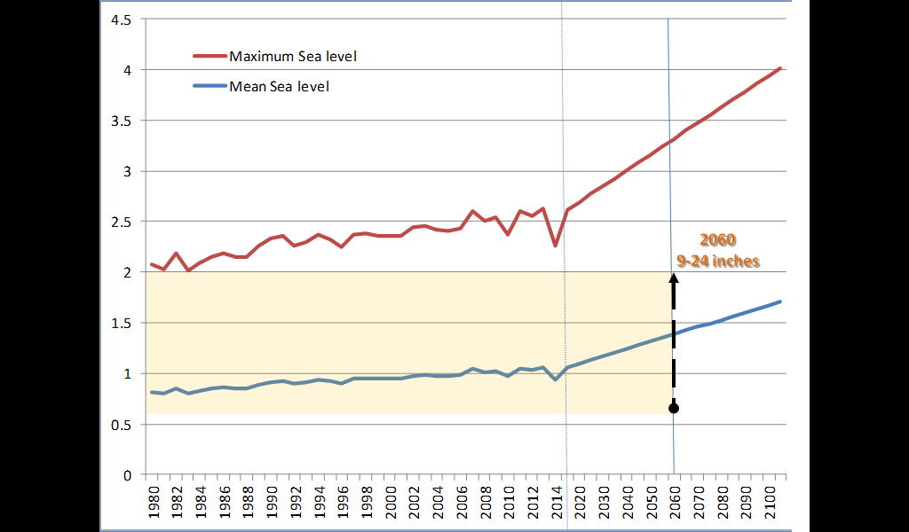
Figure 6.1: Prediction Comparison
CHAPTER 7

Summary and Concluding Remarks
Overall, the sample sizes of the data collected for Key West, Pensacola, St-Petersburg, and Fernandina were reasonable to make inferences. We had few missing values, but they were no greater than 15% of the data. We had outliers, but they did not affect the models
The average sea level in Key West, Pensacola, St-Petersburg, and Fernandina differ considerably from each other. Pensacola has the lowest sea level. Two different approaches were used to the determination of a model describing the sea level rise in Key West against the independent variables, year, temperature, and rainfall. We considered the “average” sea level and the “maximum” sea level, which produced two-linear regressions with independent variables year and temperature. We have made attempt to fit regression models for sea level rise data in Key West. However, following similar procedures that described in Chapter 4, one can fit regression models for sea level in Pensacola, St-Petersburg, and Fernandina.
This study was focused on finding linear relationships between variables, and the comparisons between some selected cities. The conclusions about the future sea levels are restricted to the data sets considered and models developed in this thesis. To make any definite statement, one might need more data and need to fit different kind of models. Some possible models we might consider in the future would be time series exponential regression models.

References
- Cazenave A. and W. Llovel, 2010. Contemporary Sea Level Rise. Annual Review of Marine Science, 2, pp. 145-173.

- Church J A and White N J 2011. Sea-level rise from the late 19th to the early 21st century. Surveys in Geophysics.

- Goodell, Jeff. "Goodbye, Miami." Goodbye, Miami. Rollings Stone, 20 June 2013. Web. 08 Aug. 2015. <http://www.rollingstone.com/politics/news/why-the-city-of-miami-is-doomed-to-drown-20130620>.

- Guilford, Gwynn. "SEA WORLD." Three-foot Higher Sea Levels Could Flood $156 Billion of Florida’s Real Estate (2013). Quartz. Web. 15 July 2015. <http://qz.com/146091/three-foot-higher-sea-levels-could-flood-156-billion-of-floridas-real-estate/>.

- Held, I.M. and B.J. Soden, 2006. Robust responses of the hydrological cycle to global warming. Journal of Climate, vol. 19(14), pp. 3354-3360.

- Rignot, E., I. Velicogna, M.R. van den Broeke, A. Monaghan, and J. Lenaerts, 2011. Acceleration of the contribution of the Greenland and Antarctic ice sheets to sea level rise. Geophysical Research Letters, vol. 38, L05503, DOI: 10.1029/2011GL046583.

- Southeast Florida Regional Climate Change Compact Technical Ad Hoc Work Group. April 2011. A Document prepared for the Southeast Florida Regional Climate Change Compact Steering Committee. 27p. https://southeastfloridaclimatecompact.files.wordpress.com/2014/05/sea-level-rise.pdf

- South Florida Water Management District (SFWMD), 2009. Climate Change and Water Management in South Florida. Interdepartmental Climate Change Group. November 12, 2010. 20p.

- Strauss, B., C. Tebaldi, S. Kulp, S. Cutter, C. Emrich, D. Rizza, and D. Yawitz (2014). “Florida and the Surging Sea: A Vulnerability Assessment With Projections for Sea Level Rise and Coastal Flood Risk.” Climate Central Research Report. pp 1-58.

- Strauss, B., Tebaldi, C., & Ziemlinski, R. (2012, March 14). Surging Seas. Sea Level Rise, Storms & Global Warming's Threat to the US Coast. <http://slr.s3.amazonaws.com/SurgingSeas.pdf>

- USACE, 2009. Water Resource Policies and Authorities Incorporating Sea-Level Change Considerations in Civil Works Programs, Department of the Army Engineering Circular 1165-2-211, July 2009, U.S. Army Corps of Engineers, CECW-CE Washington, DC 20314-1000. 31pp. Link to EC: <http://140.194.76.129/publications/eng-circulars/ec1165-2-211/entire.pdf>

Appendix: Data Values of Key West
YEAR | Index | Temperature | Rainfall | Sea Level | Mean Sea level | Sea Level | Maximum Sea level
X1 | X1 | X2 | X3 | Y_mean | Y=-1.683+0.007*X1+0.026*X2 | Ymax | Y= -3.246+0.008*X1+0.051*X2
1914 | 1 | 76.408 | 0.0942 | 0.49075 | 0.311 | 0.762 | 0.659
1915 | 2 | 76.2 | 0.1242 | 0.33633 | 0.312 | 0.631 | 0.656
1916 | 3 | 76.675 | 0.0892 | 0.38117 | 0.332 | 0.949 | 0.688
1917 | 4 | 76.317 | 0.0783 | 0.44558 | 0.329 | 0.972 | 0.678
1918 | 5 | 77.417 | 0.0808 | 0.35108 | 0.365 | 0.572 | 0.742
1919 | 6 | 77.3 | 0.1475 | 0.354 | 0.369 | 0.782 | 0.744
1920 | 7 | 76.583 | 0.0958 | 0.26925 | 0.357 | 0.651 | 0.716
1921 | 8 | 77.692 | 0.0992 | 0.41083 | 0.393 | 0.880 | 0.780
1922 | 9 | 78.017 | 0.1183 | 0.37017 | 0.408 | 0.720 | 0.805
1923 | 10 | 77.35 | 0.0667 | 0.29692 | 0.398 | 0.592 | 0.779
1924 | 11 | 77.308 | 0.0933 | 0.30858 | 0.404 | 0.772 | 0.785
1925 | 12 | 77.8 | 0.0925 | 0.32664 | 0.424 | 0.710 | 0.818
1926 | 13 | 77.092 | 0.1283 | 0.26983 | 0.412 | 0.821 | 0.790
1927 | 14 | 78.117 | 0.0673 | 0.39173 | 0.446 | 0.691 | 0.850
1928 | 15 | 76.7 | 0.085 | 0.32142 | 0.416 | 0.720 | 0.786
1929 | 16 | 77.608 | 0.1217 | 0.36167 | 0.447 | 0.621 | 0.840
1930 | 17 | 76.775 | 0.1433 | 0.39267 | 0.432 | 0.721 | 0.806
1931 | 18 | 76.192 | 0.1392 | 0.246 | 0.424 | 0.541 | 0.784
1932 | 19 | 78.058 | 0.1092 | 0.40167 | 0.480 | 0.700 | 0.887
1933 | 20 | 77.958 | 0.1425 | 0.50433 | 0.484 | 1.101 | 0.890
1934 | 21 | 77.483 | 0.085 | 0.35017 | 0.479 | 0.841 | 0.874
1935 | 22 | 77.217 | 0.1075 | 0.46017 | 0.479 | 0.981 | 0.868
1936 | 23 | 77.367 | 0.1375 |  | 0.490 |  | 0.884
1937 | 24 | 77.433 | 0.1308 |  | 0.498 |  | 0.895
1938 | 25 | 77.725 | 0.0608 |  | 0.513 |  | 0.918
1939 | 26 | 77.858 | 0.1342 |  | 0.523 |  | 0.933
1940 | 27 | 76.192 | 0.1142 |  | 0.487 |  | 0.856
1941 | 28 | 77.3 | 0.1517 | 0.45133 | 0.523 | 0.851 | 0.920
1942 | 29 | 77.258 | 0.08 | 0.60058 | 0.529 | 1.159 | 0.926
1943 | 30 | 77.383 | 0.1008 | 0.54355 | 0.539 | 1.159 | 0.941
1944 | 31 | 77.742 | 0.0927 | 0.58058 | 0.555 | 1.139 | 0.967
1945 | 32 | 77.858 | 0.1392 | 0.50408 | 0.565 | 0.880 | 0.981
1946 | 33 | 78.792 | 0.0867 | 0.64783 | 0.597 | 1.149 | 1.036
1947 | 34 | 78.133 | 0.1583 | 0.74767 | 0.586 | 1.290 | 1.011
1948 | 35 | 79.292 | 0.1425 | 0.83042 | 0.624 | 1.300 | 1.078
1949 | 36 | 78.442 | 0.09 | 0.61542 | 0.608 | 1.281 | 1.043
1950 | 37 | 78.042 | 0.1017 | 0.59883 | 0.605 | 1.031 | 1.030
1951 | 38 | 78.142 | 0.0733 | 0.5614 | 0.615 | 1.130 | 1.043
1952 | 39 | 77.833 | 0.09 | 0.63317 | 0.614 | 1.012 | 1.035
1953 | 40 | 78.108 | 0.1267 |  | 0.628 |  | 1.058
1954 | 41 | 77.3 | 0.1108 | 0.59792 | 0.614 | 0.972 | 1.024
1955 | 42 | 77.717 | 0.075 | 0.61042 | 0.632 | 1.061 | 1.054
1956 | 43 | 78.117 | 0.0833 | 0.60083 | 0.649 | 1.051 | 1.082
1957 | 44 | 78.883 | 0.1017 | 0.68133 | 0.676 | 1.281 | 1.129
1958 | 45 | 76.525 | 0.1258 | 0.63225 | 0.622 | 1.340 | 1.017
1959 | 46 | 77.842 | 0.125 | 0.676 | 0.663 | 1.021 | 1.092
1960 | 47 | 76.992 | 0.1358 | 0.71718 | 0.648 | 1.110 | 1.057
1961 | 48 | 77.883 | 0.0725 | 0.665 | 0.678 | 1.110 | 1.110
1962 | 49 | 77.35 | 0.0842 | 0.70992 | 0.671 | 1.061 | 1.091
1963 | 50 | 77.208 | 0.1383 | 0.5567 | 0.674 | 1.071 | 1.092
1964 | 51 | 78.042 | 0.09 | 0.41455 | 0.703 | 0.792 | 1.142
1965 | 52 | 79.25 | 0.0908 | 0.58458 | 0.742 | 1.041 | 1.212
1966 | 53 | 76.317 | 0.1467 | 0.6735 | 0.672 | 0.890 | 1.070
1967 | 54 | 79.15 | 0.105 | 0.68242 | 0.753 | 1.002 | 1.223
1968 | 55 | 76.842 | 0.1508 | 0.5655 | 0.700 | 0.890 | 1.113
1969 | 56 | 76.925 | 0.1725 | 0.65142 | 0.709 | 1.090 | 1.125
1970 | 57 | 76.633 | 0.1367 | 0.65208 | 0.708 | 1.172 | 1.118
1971 | 58 | 78.117 | 0.1309 | 0.67408 | 0.754 | 1.300 | 1.202
1972 | 59 | 78.825 | 0.1275 | 0.78825 | 0.779 | 1.120 | 1.246
1973 | 60 | 77.767 | 0.0908 | 0.91683 | 0.759 | 1.441 | 1.200
1974 | 61 | 78.567 | 0.0542 | 0.801 | 0.787 | 1.481 | 1.249
1975 | 62 | 79.283 | 0.0875 | 0.84633 | 0.812 | 1.051 | 1.293
1976 | 63 | 77.475 | 0.1133 | 0.63942 | 0.772 | 1.012 | 1.209
1977 | 64 | 76.808 | 0.1317 | 0.71033 | 0.762 | 1.139 | 1.183
1978 | 65 | 77.525 | 0.1 | 0.78842 | 0.788 | 1.392 | 1.228
1979 | 66 | 78.308 | 0.075 | 0.77258 | 0.815 | 1.192 | 1.276
1980 | 67 | 77.908 | 0.1667 | 0.81317 | 0.812 | 1.090 | 1.263
1981 | 68 | 77.05 | 0.0833 | 0.78 | 0.796 | 1.192 | 1.228
1982 | 69 | 78.95 | 0.1 | 0.81708 | 0.853 | 1.320 | 1.332
1983 | 70 | 76.6 | 0.1425 | 0.81908 | 0.799 | 1.241 | 1.221
1984 | 71 | 77.242 | 0.1283 | 0.82633 | 0.822 | 1.349 | 1.261
1985 | 72 | 77.95 | 0.115 | 0.83642 | 0.848 | 1.392 | 1.305
1986 | 73 | 78.192 | 0.11 | 0.95258 | 0.861 | 1.422 | 1.326
1987 | 74 | 77.442 | 0.1325 | 0.86825 | 0.848 | 1.281 | 1.296
1988 | 75 | 77.317 | 0.0992 | 0.80675 | 0.852 | 1.261 | 1.297
1989 | 76 | 78.592 | 0.085 | 0.75258 | 0.892 | 1.139 | 1.370
1990 | 77 | 79.258 | 0.1091 | 0.807 | 0.917 | 1.222 | 1.412
1991 | 78 | 79.408 | 0.12 | 1.01642 | 0.928 | 1.540 | 1.428
1992 | 79 | 77.975 | 0.1108 | 0.96342 | 0.897 | 1.579 | 1.363
1993 | 80 | 78.183 | 0.0975 | 0.93875 | 0.910 | 1.340 | 1.381
1994 | 81 | 78.983 | 0.1267 | 0.94208 | 0.938 | 1.372 | 1.430
1995 | 82 | 78.133 | 0.1236 | 1.02133 | 0.922 | 1.596 | 1.395
1996 | 83 | 76.983 | 0.1208 | 0.75892 | 0.900 | 1.222 | 1.344
1997 | 84 | 78.458 | 0.1075 | 0.89842 | 0.945 | 1.212 | 1.427
1998 | 85 | 78.408 | 0.105 | 0.88308 | 0.951 | 1.287 | 1.433
1999 | 86 | 77.908 | 0.13 | 1.05917 | 0.945 | 1.582 | 1.415
2000 | 87 | 77.617 | 0.0942 | 0.98933 | 0.944 | 1.497 | 1.408
2001 | 88 | 77.483 | 0.1367 | 0.85958 | 0.948 | 1.454 | 1.410
2002 | 89 | 78.408 | 0.1308 | 0.974 | 0.979 | 1.454 | 1.465
2003 | 90 | 78.333 | 0.1042 | 0.89525 | 0.984 | 1.340 | 1.469
2004 | 91 | 77.683 | 0.0833 | 0.91742 | 0.974 | 1.356 | 1.444
2005 | 92 | 77.375 | 0.1567 | 1.00633 | 0.973 | 1.471 | 1.436
2006 | 93 | 77.492 | 0.1275 | 0.947 | 0.983 | 1.454 | 1.450
2007 | 94 | 79.55 | 0.1042 | 1.054 | 1.043 | 1.573 | 1.563
2008 | 95 | 78.092 | 0.1083 | 1.06567 | 1.012 | 1.845 | 1.497
2009 | 96 | 78.267 | 0.0908 | 1.0395 | 1.024 | 1.717 | 1.514
2010 | 97 | 75.9 | 0.1092 | 1.02225 | 0.969 | 1.612 | 1.401
2011 | 98 | 78.683 | 0.1233 | 1.00292 | 1.049 | 1.445 | 1.551
2012 | 99 | 77.85 | 0.1367 | 1.1515 | 1.034 | 1.618 | 1.516
2013 | 100 | 78.642 | 0.1267 | 1.185 | 1.062 | 1.612 | 1.565
2014 | 101 | 73.75 | 0.0975 | 1.001 | 0.942 | 1.061 | 1.323

